


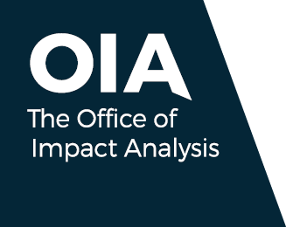
Australian Government Impact Analysis Framework

July 2026
Copyright notice
With the exception of the Commonwealth Coat of Arms, this work is licensed under a Creative Commons Attribution 4.0 International licence
(CC BY 4.0) (https://creativecommons.org/licenses/by/4.0/).

Third party copyright
Wherever a third party holds copyright in this material, the copyright remains with that party. Their permission may be required to use the material. Please contact them directly.
Attribution
This publication should be attributed as follows:
© Commonwealth of Australia, Department of the Prime Minister and Cabinet, Australian Government Impact Analysis Framework.
Use of the Coat of Arms
The terms under which the Coat of Arms can be used are detailed on the following website:
pmc.gov.au/cca
Other uses
Enquiries regarding this document are welcome. Please contact the OIA.

Contents
Foreword 4
About the framework 5
Overview 7
Step 1: Preliminary analysis 9
Step 2: Impact analysis 12
Step 3: Assess the IA 17
Step 4: Policy decision 17
Step 5: Publication 17
Special cases 18


Foreword
The Hon Patrick Gorman MP
Assistant Minister to the Prime Minister
June 2026
The government has improved the Impact Analysis Framework. This will ensure our decisions are informed by the best available analysis and evidence.
The new framework will deliver improved scrutiny of proposals. This will result in faster regulatory advice provided to government as part of the Cabinet process.
This demonstrates our commitment to uplifting the capability of the Australian Public Service to provide analysis on what matters, when it matters. This will mean less work completed by consultants. An agency-led approach, supported by expertise in the Office of Impact Analysis, will help ensure analysis that is timely, accountable and influential.
We have focused impact analysis on informing significant changes to rules and requirements facing consumers, workers, and businesses. Key changes to regulation need to weigh up any compliance
and delay costs with the wider value and benefits to the community.
Impact analysis must demonstrate to businesses, organisations and the community that policies
will deliver an overall benefit to Australia. Our commitment to publishing impact analysis remains unchanged.
The framework will assist the government as it works to deliver for Australians.

About the framework
The Australian Government Impact Analysis Framework (the framework) is designed to support decision-makers to understand the wider impacts, including the intended and potentially unintended effects of a policy proposal and make evidence-based decisions considering trade-offs.
The framework outlines the best practice approaches and requirements for conducting impact analysis (IA) and developing IA products to inform decision-making.

Objectives of the framework
The government is committed to evidence-based policy development and decision-making. Analysis of policy options and their likely effects is critical to support government deliberative processes.
Australia has a strong tradition of using impact analysis to assess policy impacts. Since first introduced in 1986, the government has updated impact analysis frameworks to better support the use of evidence-based analysis in the policy process.
Under this revised framework, regulatory policy proposals and proposals with material competition impacts must be subject to an appropriate level of analysis. The depth of analysis should be proportionate to the expected impacts of the policy proposal.
Agencies are responsible for the development of an IA and identifying the costs and benefits of policy changes — including the regulatory burden, economic, social and competition impacts — and to consider how stakeholders are likely to be impacted. Agencies also need to consider viable non-regulatory policy approaches and their likely impacts.
The framework supports the Cabinet and other government decision-making by providing evidence-based assessment of the likely impacts of regulatory and competition related proposals, as outlined
in the Cabinet Handbook and Budget Process Operational Rules (BPORs) requirements.
The government is committed to providing stakeholders and the community with timely analysis on the expected impacts of significant decisions that change how markets operate and impose new or updated rules. IAs are published following the announcement of the policy.

Practical guidance
For agencies responsible for drafting IAs, this document should be read together with the Practical Guide for Agencies, located on the Office of Impact Analysis (OIA) website.
The practical guide provides more detailed guidance on how to navigate the IA process and how
to develop robust analysis and evidence on the intended and potentially unintended effects of a
policy proposal.
The OIA website also includes supplementary resources which provide further information.
The framework also operates alongside the government’s broader regulatory policy architecture, including the Regulatory Policy, Practice and Performance framework led by the Department
of Finance.

The Office of Impact Analysis
Located in the Department of the Prime Minister and Cabinet, the OIA administers the framework
and assists agencies to use the framework to support policy decisions. The OIA provides expert guidance to agencies on technical issues related to the framework’s use and conducts training to assist policy officers in preparing IAs.
The OIA also administers the Regulatory Impact Analysis Guide for Ministers’ Meetings and National Standard Setting Bodies for decision-making between the Australian Government and state and territory and local governments in specific policy areas.

The OIA can be contacted at helpdesk-OIA@pmc.gov.au.

Overview
The framework outlines best practice approaches to evaluate the likely effects of a policy change. However, not all policy proposals and decisions have significant impacts that require an IA. Agencies should undertake a level of analysis proportionate to the proposal’s potential impacts.
This includes considering the nature of the policy problem and determining if it is in scope of the framework, identifying the policy objective and potential policy solutions, assessing the likely impacts and stakeholder views, and how to monitor and evaluate the policy once implemented. This is formalised in the 7 IA questions.

The process ensures that all significant regulatory and competition-related policy decisions are supported by an appropriate level of analysis, enabling decision‑makers to make policy decisions based on robust analysis.

Impact analysis steps
The IA approach can be summarised in 5 steps.
Early policy development
Early in policy process, consider the policy problem and objective, and alternative
policy options.
Step 1: Preliminary analysis
Assess whether the policy proposal is in scope. That is, any regulatory policy proposals and proposals with material competition impacts. If in scope, assess the proposal against the IA thresholds to determine if the proposal is expected to have moderate or major impacts.

Step 2: Impact analysis
Evaluate the policy proposal using the 7 IA questions, including estimating the regulatory burden. Prepare a Dashboard IA (or a Detailed IA if required by the Prime Minister
or Cabinet).

Step 3: Assess the IA
Agencies assess whether the IA provides sufficient and robust analysis to inform a key decision. Agencies also certify that the IA is sufficient to inform a key decision.
Step 4: Policy decision
The Dashboard (or Detailed) IA is provided to decision-makers to support the key decision.
Step 5: Publication and reporting
After announcement of the policy, the Dashboard (or Detailed) IA is reviewed then published on the OIA website together with the Statement of Sufficiency.

Step 1: Preliminary analysis

When is an IA required?
An IA ensures that robust evidence and analysis on the likely impacts is available to decision-makers to inform a decision.

Impact analysis is only required for:
- regulatory policy proposals, or
- proposals with material competition impacts.

1.2. What policy proposals are in scope?
Regulatory policy proposals: any proposal to establish or reform government rules that set requirements. This includes quasi-regulations, such as industry-government agreements
(co-regulation), which influence the behaviour of people, businesses,
or community organisations.
Proposals with material competition impacts: any proposal expected to have
a material (positive or negative) impact on competition in a market. This includes
material impacts on:
- barriers to set-up (or exit) for businesses, organisations or workers
- the ability or incentives for businesses to compete
- changes to the choices, information, goods or services available to consumers.
Policy proposals to change arrangements for certain government-funded goods
and services (such as, health and education services), taxes and subsidies that may have material competition impacts depending on the nature of the proposal.
For in-scope proposals, Cabinet and other government decision-making process including delegated decisions by ministers, secretaries and heads of agencies are covered by the framework.

1.3. In-scope proposals must also meet the IA thresholds
The IA thresholds provide guidance on where in-scope proposals are likely to have a significant impact on the Australian economy, people, businesses, organisations or the community. Agencies must self-assess if a proposal meets one or more of the IA thresholds. Agencies can seek guidance from the OIA when undertaking these assessments.
In-scope proposals that are expected to meet or exceed one or more of the following IA thresholds require an IA to inform a policy decision.
IA threshold 1 (regulatory burden): proposals likely to change regulatory burden
by $20 million or more in total (over 10 years).
Regulatory burden captures the change in compliance and delay costs imposed by a policy change on people, businesses, and community organisations. The practical guide can support estimating regulatory burden, both for assessing threshold 1 and as part of the IA.
IA threshold 2 (material impacts): proposals likely to have indicative impacts of $200 million or more annually on the economic and social outcomes for people, businesses, or community organisations.
The Practical Guide for Agencies covers how to assess the indicative impacts, including economic, competition and social impacts. This covers guidance for assessing
threshold 2, as well as approaches to assessing these impacts in the IA.
IA threshold 3 (distributional impacts): proposals likely to disproportionately and significantly impact a cohort, including small businesses, where no other impact assessment applies.
Where proposals have disproportionate and significant distributional impacts, these should first be considered within other established Australian Government impact assessment frameworks or similar processes (for example, assessments related to First Nations impacts, gender impacts, or regional impacts), which operate alongside the IA framework to inform decision-making.

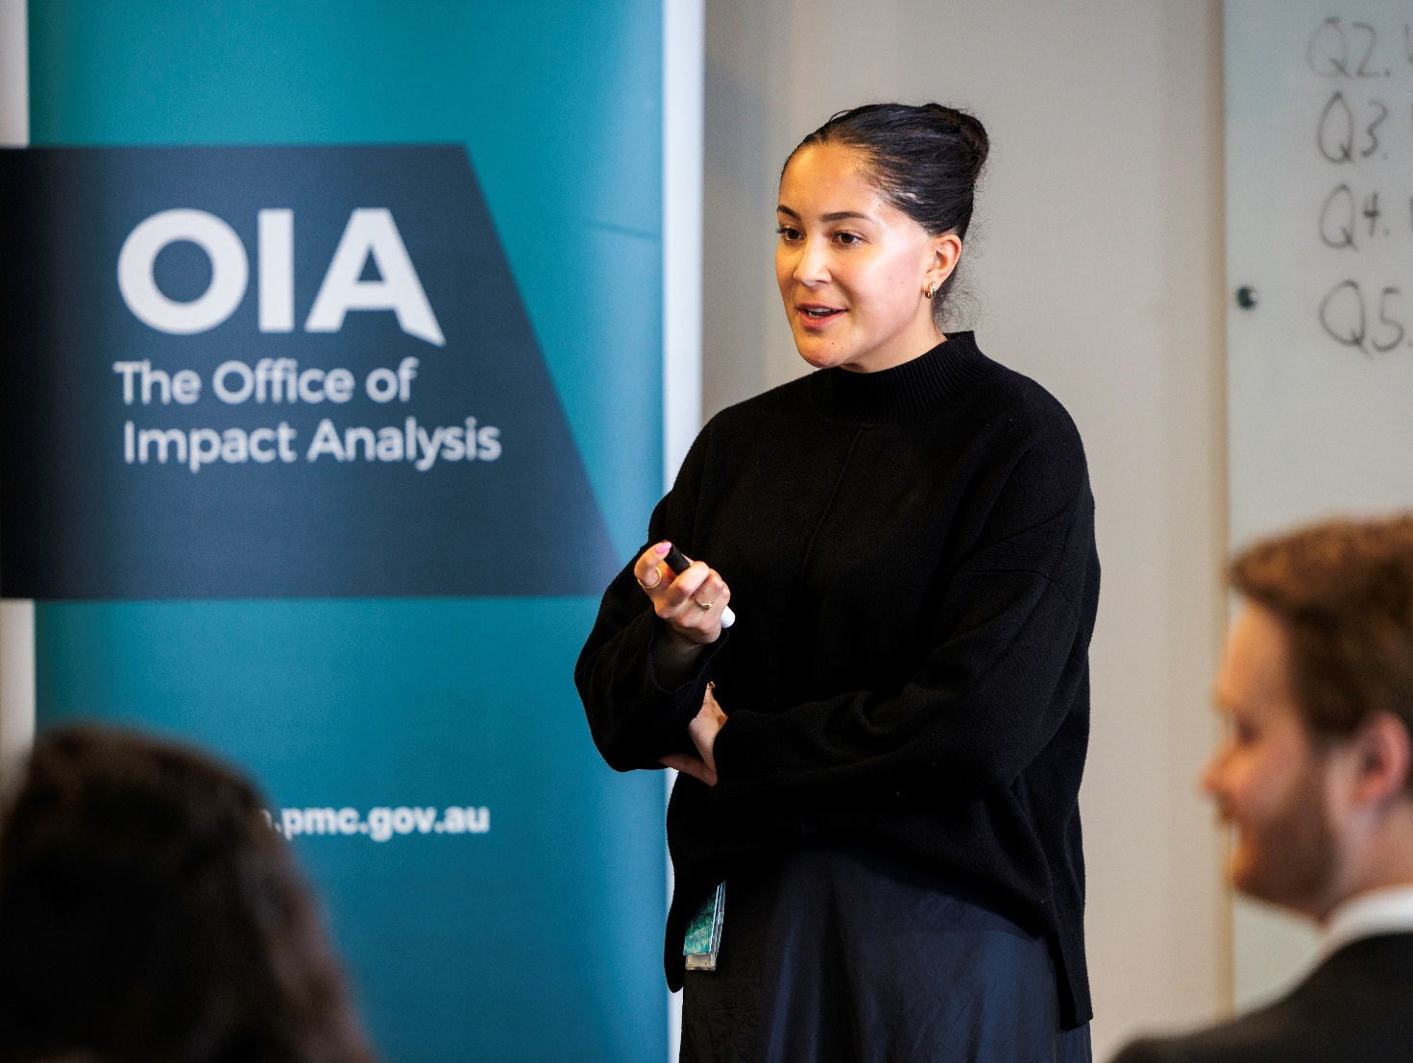
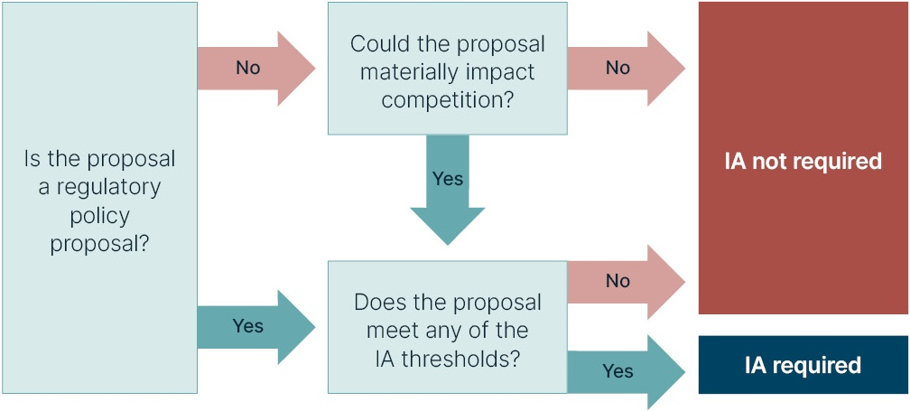
Figure 1. Scope and thresholds

Step 2: Impact analysis
In-scope policy proposals that meet or exceed one or more of the IA thresholds (step 1) require
an IA to inform a key decision.
An IA refers to the product provided to support the policy decision, which is either a Dashboard
or, where required, a Detailed IA.
Templates for both the Dashboard IA and the Detailed IA are on the OIA website.

2.1. Dashboard IA
The Dashboard IA should provide easily accessible analysis of the key likely impacts of a policy proposal. The Dashboard IA should be prepared using the template available
on the OIA website and should be around 3 pages.
The Dashboard IA should provide a concise analysis against the 7 IA questions.
This includes, but is not limited to the:
- policy problem and policy objective, including where appropriate, qualitative or quantitative evidence on the policy problem
- policy options being considered, including the status quo and at least one
non regulatory alternative policy option (unless it can be demonstrated that
a non-regulatory option is not viable)
- analysis of the costs and benefits, including the change in the regulatory burden,
of the policy option(s) under consideration
- implementation and evaluation approach.
The Dashboard IA should also provide a high-level analysis of the policy option(s) against the government’s key strategic priorities.
The Dashboard IA is the primary product used to inform decision-makers at key decision points.
The Dashboard IA must be published following the policy’s announcement. The Dashboard IA must include material with a suitable depth of analysis and evidence, including drawing on consultation with stakeholders. The analysis and evidence should be proportionate to the scale of the proposal and likely impacts.

2.2. Detailed IA
The Prime Minister or the Cabinet may ‘call in’ or require a Detailed IA for in-scope policy proposals with moderate or major impacts. The OIA can provide guidance to agencies on the development of
a Detailed IA.
A Detailed IA must be published following policy announcement and provides in-depth analysis across all 7 IA questions. This includes in-depth analysis and consultation to support policy development. A Detailed IA may be appropriate where policy proposals are expected to have major impacts across the economy, where a range of viable policy options needs to be considered in detail, or where there is a risk of significant unintended consequences.
A Detailed IA is also required for proposals that meet the IA thresholds and involve introducing a mandatory standard that deviates from existing international standards. See Special cases below.

Figure 2. What type of IA is required?
An IA is required
Has the Prime Minister or the Cabinet called-in a Detailed IA? Or is the proposal considering introducing a mandatory standard that deviates from existing international standards?
No: Dashboard IA
The IA should provide high-level analysis, including:
addressing the 7 IA questions
high-level summary analysis of impacts based on cost-benefit analysis and other analysis techniques to, where possible, quantify impacts
evidence from engagement with key affected stakeholders
key strategic priorities discussion.
Yes: Detailed IA
The IA should provide detailed analysis, including:
addressing the 7 IA questions
detailed analysis of impacts based
on cost benefit analysis and other analysis technique to, where possible, quantify impacts
evidence from engagement with
key affected stakeholders
distributional impacts
implementation and evaluation approach.
The executive summary should use the Dashboard IA template.

2.3. The 7 IA questions
The 7 IA questions provide a framework for evaluating the likely impacts — intended and unintended — and for considering alternative ways to address a policy problem. The 7 IA questions need to be considered in all IAs and are a useful framework for
any policy process.

Question 1 - policy problem

What is the policy problem and what data are available?
- Clearly identify and define the policy problem.
- Provide evidence to demonstrate why it is a problem, the magnitude of the problem and the impacts of not doing anything.
- Describe the people, businesses or community organisations affected by the problem.
- Explain which, if any, current government policies have sought to address the problem, and if and why those policies are not sufficiently addressing the policy problem.
- Identify available information and data and consider how to close any gaps that need to be addressed as part of the IA process.

Question 2 - policy objective

What are the policy objectives, why is government intervention needed to achieve them, and how will success be measured?
- Establish the policy rationale for government to intervene, including demonstrating that the government could intervene successfully.
- Clearly identify the policy objectives and intended outcomes.
- Identify any barriers to achieving the policy objective.
- Outline what factors will make this policy change a success and include measurable targets.

Question 3 – policy options

What policy options are being considered?
- Identify genuine and viable alternative policy options, including the status quo and at least one non-regulatory alternative policy option (unless it can be demonstrated that a non-regulatory option is not viable).
- Demonstrate these policy options can achieve the policy objectives.
- Identify the context for the options considered (for example, the policy proposal may be an election commitment).

Question 4 – net benefit

What is the likely net benefit of the option?
- Provide an estimate of the net benefit of each policy option. Where a monetised net benefit cannot be estimated, provide an explanation why this has not been possible (including identifying data and information gaps) and provide qualitative analysis of impacts. This analysis should also draw on evidence from stakeholder engagement and existing evaluations.
- Identify who is likely to be affected by each policy option. Where significant, assess the economic, competition, social, environmental or other impacts as well as how those impacts are likely to be distributed.
- Assess the regulatory burden impacts for people, businesses, organisations or the community using the Regulatory Burden Measurement Framework.
- Provide analysis of impacts based on cost-benefit analysis and other analysis to quantify impacts where possible. Describe the method, assumptions and sensitivity testing used to conduct the analysis.
- Provide information on any applicable international standards and whether the policy proposal differs from or adopts those standards.

Question 5 – consultation

What consultation was undertaken and how was feedback incorporated into
the policy design?
- Explain the purpose and objectives of consultation and outline the process
of consultation.
- Summarise the key feedback from stakeholders, including the areas of agreement as well as areas of difference.
- Describe where the policy option(s) has been modified to account for stakeholder feedback, and where and why stakeholder feedback has not been adopted.
- Consider alternative consultation approaches where the policy proposal is market sensitive, public consultation may compromise the policy, or where key affected stakeholders may require a different consultation approach.

Question 6 – implementation

What is the best policy option and how will it be implemented?
- Indicate the most appropriate policy option to achieve the identified policy objective (question 2) and the reason. Summarise the supporting analysis
and clearly outline any caveats or qualifications, and assumptions.
- Explain how this policy option will be implemented. Assess implementation challenges and risks: their likelihood, consequences and management.
Outline any transitional arrangements and an implementation approach.
- Build on IA question 1, develop a plan to close any relevant data gaps during implementation to support successful monitoring and evaluation of the policy.

Question 7 – evaluation

How will the policy be monitored and evaluated?
- Describe the monitoring activities you will undertake to ensure successful implementation. Specify if a formal evaluation will be conducted and,
if not, provide a rationale for not doing so.
- If a formal evaluation will be conducted:
state when a monitoring and evaluation plan, consistent with
Commonwealth Evaluation Policy, will be finalised
provide a tentative date for completion of the evaluation
state the type of evaluation that is proposed: process evaluation, outcome/impact evaluation and/or economic evaluation
prepare draft key evaluation questions that relate to the policy objective
and success metrics set out in IA question 2
consider undertaking an initial data needs assessment (that is, what data
is needed, what data is already available, and what extra data might need
to be collected)
consider including a draft theory of change.
Refer to guidance by the Australian Centre for Evaluation.

Step 3: Assess the IA
At Step 3, agencies assess the quality of their IA and confirm that the analysis is sufficient to inform
a decision by government.
The Self-Assessment Tool assists agencies to consider whether the IA provides robust and proportionate analysis across the 7 IA questions. The final IA needs to have addressed all 7 IA questions.
For any key decision, the agency must also produce a statement of sufficiency, signed by a senior public servant confirming that the IA addresses the 7 IA questions, including providing a robust analysis and estimate of the regulatory burden.

Step 4: Policy decision
After the agency completes and assesses the IA (steps 2 and 3), the IA is provided to the decision-maker to inform the key decision.
Key decisions are not limited to Cabinet decisions. They may also arise through other processes, including where a minister (or delegate) makes a decision that gives effect to, or implements,
an in-scope proposal.
Key decisions may include decisions to proceed with a preferred policy option, narrow the range
of policy options under consideration, or authorise significant policy or regulatory action.

Step 5: Publication and Reporting
The publication of the IA provides the community with an understanding of the evidence base used
to inform a policy decision.
After the announcement of the policy, the IA provided to the decision-maker (reviewed to exclude confidential information) is published on the OIA website, together with the statement of sufficiency. Agencies should provide these to the OIA as soon as possible after announcement.

The IA must also be included in any explanatory memorandum or statement giving effect to the policy proposal.

Special cases

Prime Minister’s exemptions
The Prime Minister can exempt the need to complete an IA in limited circumstances, including:
- when there are truly urgent and unforeseen events requiring a decision before an IA can be undertaken
- where there is a matter of budget or other sensitivity and the development of an IA could compromise confidentiality and cause unintended market effects or lead to speculative behaviour which would not be in the national interest.
When a decision subject to a Prime Minister exemption is publicly announced, the OIA website will note that the proposal was subject to a Prime Minister’s exemption and the reason. The Prime Minister’s exemption needs to also be noted in any relevant explanatory material and statements.

Reviews and impact analysis equivalent
Where a review or other existing analysis substantially addresses the IA questions, agencies can draw on this analysis to inform an IA. This may include policy whitepapers, royal commission reports or Productivity Commission reports. Agencies should summarise the relevant analysis and findings in the Dashboard IA to inform decision-makers.
Where a Detailed IA has been required, agencies may certify a review, or other similar analysis has undertaken an equivalent process to that required by the IA framework and has substantially addressed the 7 IA questions. In these cases, agencies need to summarise the analysis and findings in a Dashboard IA. Where a review or similar analysis does not fully address the 7 IA questions, agencies should undertake proportionate supplementary analysis to address any gaps in the Dashboard IA, including providing a regulatory burden estimate. The review (or other similar analysis) needs to be published together with the Dashboard IA.
This approach avoids duplication between comprehensive review processes and IAs while ensuring the decision-makers are informed of likely impacts.

Election commitments
IAs covering matters which were the subject of an election commitment will not be required to consider an alternative policy option. Only the specific election commitment relative to the status
quo needs to be considered as part of the IA.

Sunsetting legislative instruments
When remaking a sunsetting legislative instrument, agencies need to assess the instrument against the IA scope and thresholds (step 1) and, if required, prepare and publish a Dashboard IA. Consistent with the sunsetting provisions in the Legislation Act 2003, the status quo for legislative instruments should assume the instrument would sunset.

Deviating from international standards
As outlined in the Best Practice Handbook on Standards and Conformance Policy, if mandatory standards are appropriate to meet a policy objective, then policymakers should use international standards, where one exists, unless demonstrably unsuitable for the Australian context. Policymakers should only deviate from existing standards, including international standards, if the benefit to the community outweighs the cost of deviating from existing standards.
For proposals to introduce a mandatory standard that deviates from an existing international standard that meets the IA thresholds, a Detailed IA is required.

Regulatory Impact Analysis Guide for Ministers’ Meetings and National Standard Setting Bodies
The IA framework applies only to Australian Government decisions, with joint decision-making processes with states and territories having separate requirements.
Specifically, regulation impact statement arrangements apply under the Regulatory Impact Analysis Guide for Ministers’ Meetings and National Standard Setting Bodies to all ministers’ meetings and to those standard-setting bodies set up by the Australian Government and the states and territories.

