final report

Increasing the stringency of the commercial building energy efficiency provisions in the 2025 National Construction Code
Decision Regulation Impact Statement
Prepared for
Australian Building Codes Board
December 2024
The Centre for International Economics
www.TheCIE.com.au
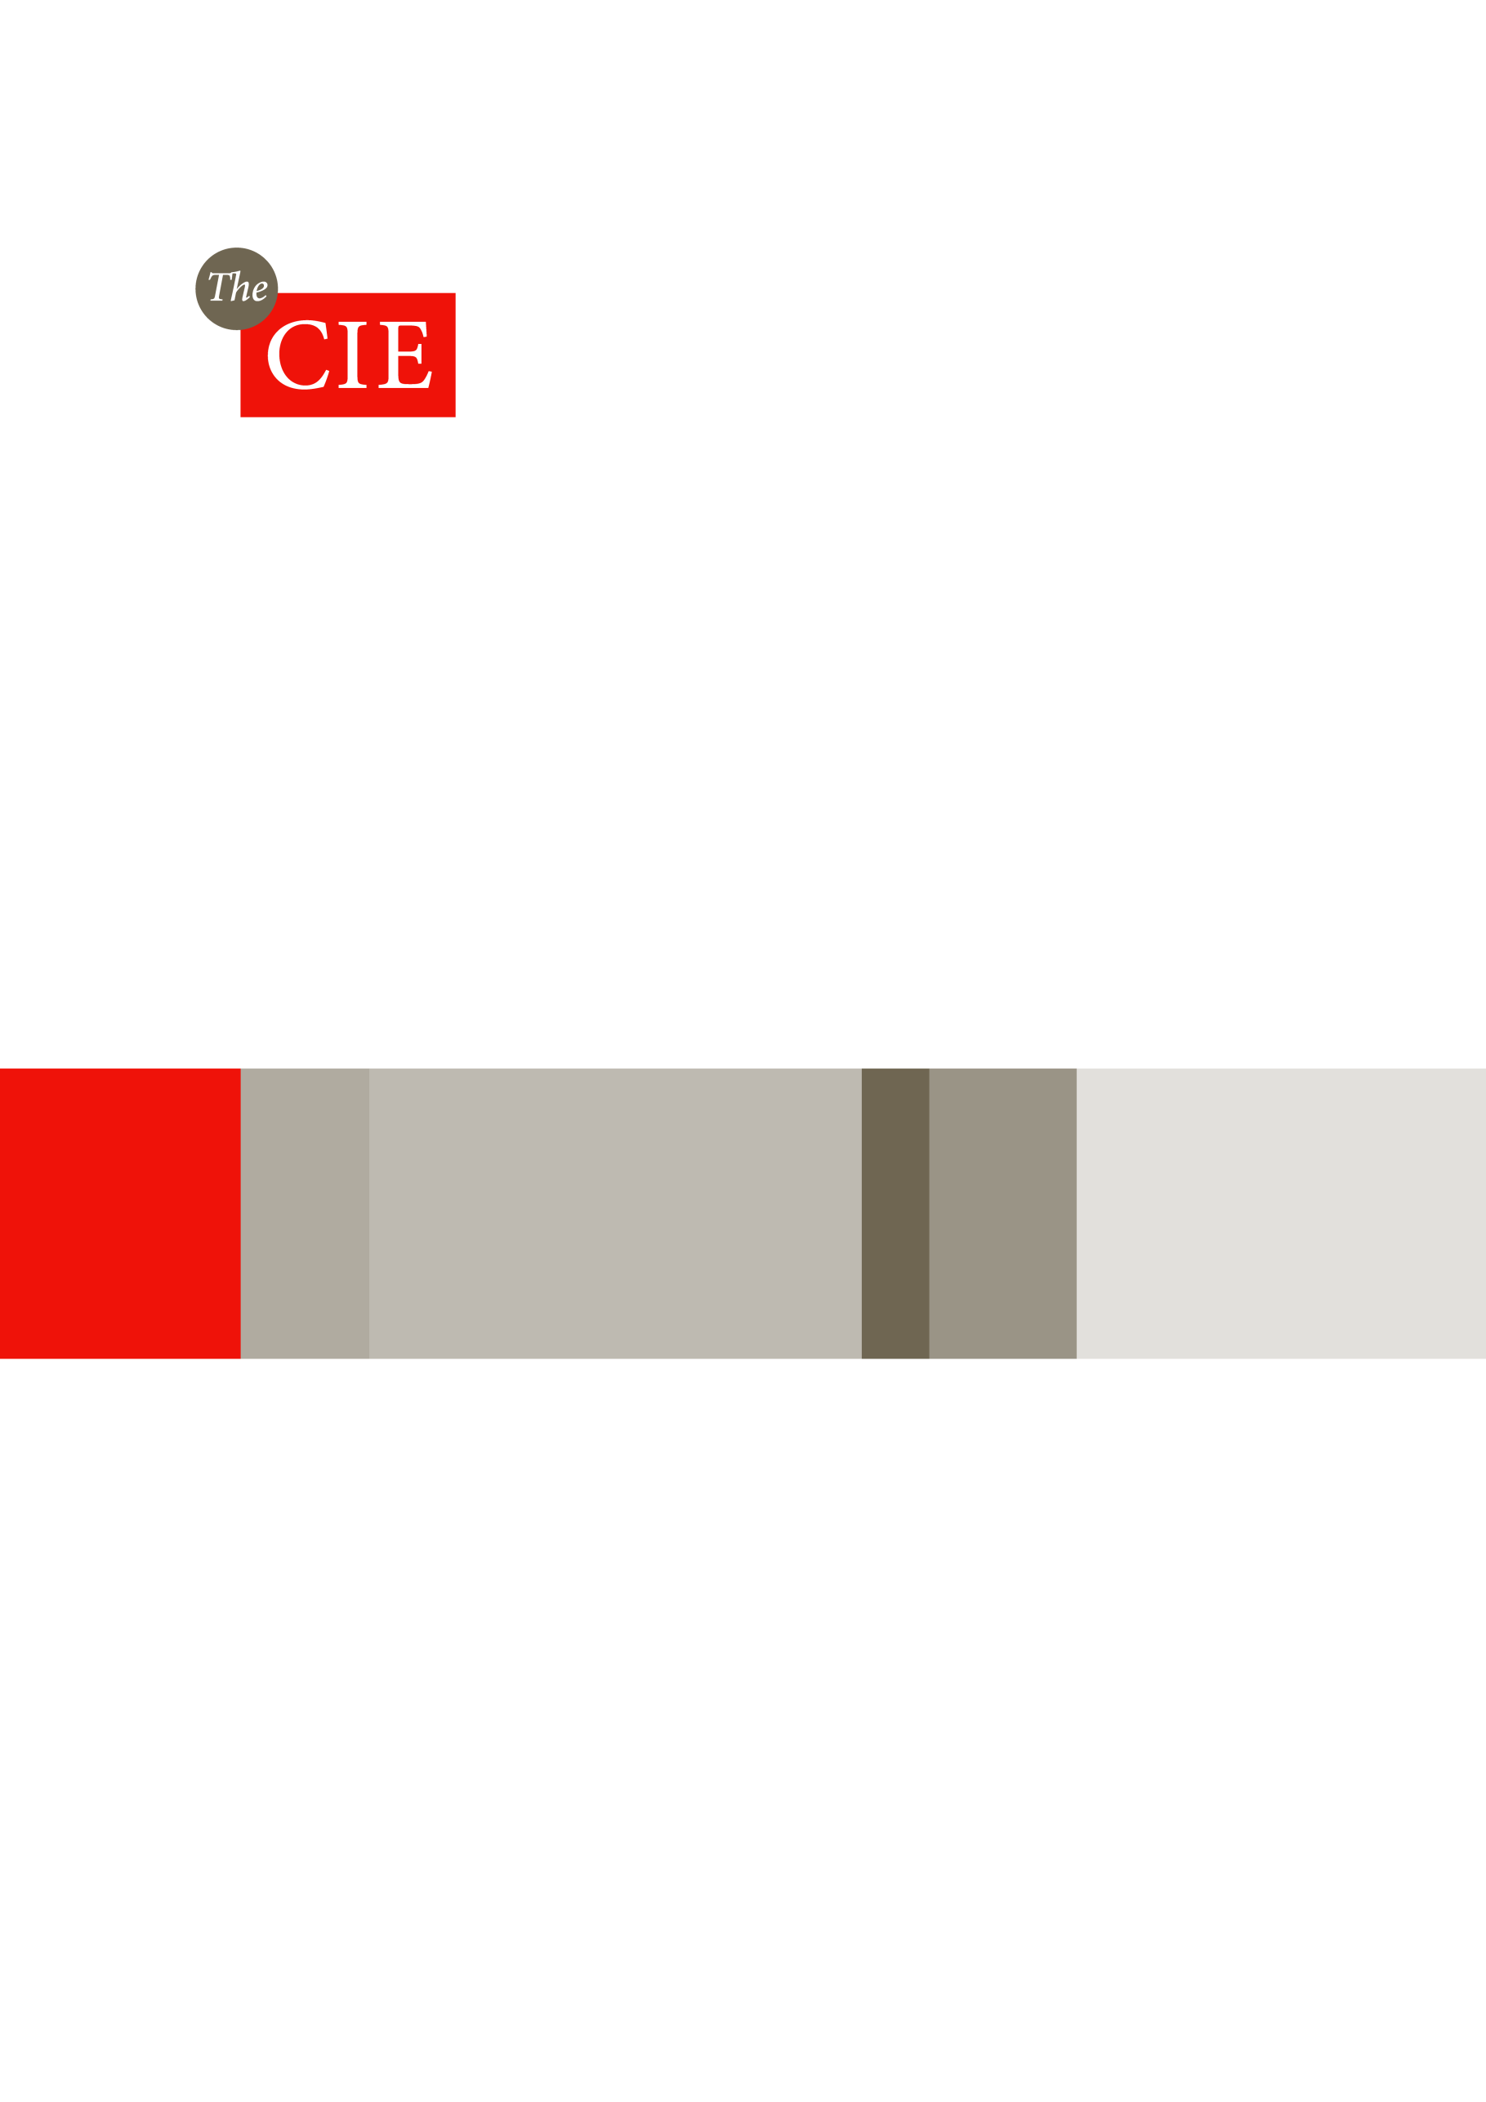

The Centre for International Economics is a private economic research agency that provides professional, independent and timely analysis of international and domestic events and policies.
The CIE’s professional staff arrange, undertake and publish commissioned economic research and analysis for industry, corporations, governments, international agencies and individuals.

© Centre for International Economics 2025
This work is copyright. Individuals, agencies and corporations wishing to reproduce this material should contact the Centre for International Economics at one of the following addresses.
Canberra  Centre for International Economics  Ground Floor, 11 Lancaster Place  Canberra Airport ACT 2609  Telephone +61 2 6245 7800  Facsimile +61 2 6245 7888  Email cie@TheCIE.com.au  Website www.TheCIE.com.au | Sydney  Centre for International Economics  Level 7, 8 Spring Street  Sydney NSW 2000  Telephone +61 2 9250 0800  Email ciesyd@TheCIE.com.au  Website www.TheCIE.com.au
Disclaimer
While the CIE endeavours to provide reliable analysis and believes the material it presents is accurate, it will not be liable for any party acting on such information.

Contents
Abbreviations 1
Executive summary 5
Statement of the problem 5
Energy efficiency requirements 6
Mandatory electric vehicle charging 11
Conclusions 12
1 Introduction 13
Scope 13
Energy efficiency in the NCC 14
Regulation Impact Statement 16
2 Feedback on the Consultation RIS 17
Key issues raised in consultation 17
Approach to address the feedback 21
3 Statement of the problem 28
The rationale for regulation 28
Policy environment 34
The case for change 45
4 Objectives and options 48
Objectives 48
Options: minimum energy efficiency requirements 49
5 Approach to impact analysis 59
Overview of impact analysis methodology 59
Cost-benefit analysis 60
Impacts of more stringent minimum energy efficiency standards 63
Impacts of mandatory rooftop solar requirements 73
Impacts of least cost net zero carbon ready building provisions 76
Impacts of mandating electric vehicle charging facilities 81
Other impacts 84
6 Building-level impacts 88
Building-level energy modelling 88
Stringency Level 1: Cost-effective energy efficiency without mandated on-site PV 89
Stringency Level 2: Cost-effective energy efficiency standards with mandated on-site PV 95
Stringency Level 3: Least cost net zero carbon ready buildings 99
7 Aggregate impacts 103
Summary of aggregate impacts 103
Commercial building projections 105
Building energy impacts 107
Scenario analysis 114
8 Mandatory electric vehicle charging 127
Summary 127
Estimated costs 127
Estimated benefits 131
Sensitivity analysis 138
9 Discussion and conclusions 140
Discussion of results by component 140
Conclusions 144
A Review of direct evidence on market failures and behavioural anomalies 146
B Avoided energy-related costs 158
C Are modelled energy savings realised in practice? 176
D Health and productivity benefits 185
E Impact of EV charging facilities 191
F Modelled building archetypes and climate zones 197
G Modelled electricity savings by time of day 203
H Building-level costs and benefits 210
I Electricity grid impacts 222
Boxes, charts and tables
1 Estimated impacts of proposed options 8
2 Cumulative reduction in GHG emissions 9
2 Mandatory electric vehicle charging — estimated impacts 11
1.1 Commercial buildings 14
2.1 Illustration of estimating the cost with external shading 22
2.2 Comparison of carbon value 25
3.1 Global context 28
3.2 Summary of direct evidence of market failures and behavioural anomalies 31
3.3 Specific policies and the implications for NCC 2025 39
4.1 Options of proposed changes 50
5.1 Relationship between SHGC and price 65
5.2 Indirect scope 1 and 3 combined emissions factors of electricity consumption 68
5.3 Natural gas emissions factors 69
5.4 Social cost of carbon 70
5.5 Share of buildings with rooftop solar 73
5.6 Minimum operational demand challenges 75
5.7 Electrification scenarios — benefits and costs 79
5.8 Projected EV sales share 84
5.9 Projected EV fleet share 84
5.10 Estimated training costs incurred by industry 85
5.11 Allocation of training costs across jurisdictions 85
5.12 Estimated number of stakeholders directly affected by proposed changes 86
5.13 Indicative salaries for relevant professions 87
6.1 Composition of new floor space — selected building classes 89
6.2 Modelled energy consumption and emissions change – Stringency Level 1 89
6.3 Building-level CBA for Stringency Level 1 — C5OL 92
6.4 Building-level net benefits for Stringency Level 1 by archetype 92
6.5 Changes in capital-related costs over building life – Stringency Level 1 94
6.6 Modelled energy consumption and emissions change – Stringency Level 2 95
6.7 Building-level CBA for Stringency Level 2 — C5OL 97
6.8 Building-level net benefits for Stringency Level 2 by archetype 98
6.9 Stringency Level 3 estimated costs and benefits — C5OL 100
6.10 Building-level net benefits for Stringency Level 3 by archetype 100
6.11 Estimate additional savings in energy-related costs over building life under Stringency Level 3 relative to Stringency Level 2 101
6.12 Changes in capital-related costs over building life – Stringency Level 3 101
7.1 Estimated impacts of proposed options 103
7.2 Commercial building stock projections 105
7.3 New construction of commercial buildings: Step change 106
7.4 New construction of commercial buildings by climate zone 106
7.5 New construction of commercial buildings by jurisdiction 107
7.6 Estimated impacts by state/territory — Stringency Level 1 107
7.7 Estimated impacts by state/territory — Stringency Level 2 109
7.8 Estimated impacts by state/territory — Stringency Level 3 110
7.9 Avoided GHG emissions 111
7.10 Cumulative avoided GHG emissions 112
7.11 Forecast minimum operational demand by NEM region 112
7.12 Forecast change in minimum demand by NEM Region 113
7.13 Potential impacts on minimum operational demand 113
7.14 Future electrification scenario — summary 115
7.15 Alternative future electrification scenario — net impacts 116
7.16 Break-even future electrification probability 117
7.17 No voluntary uptake of rooftop solar in base case — summary 117
7.18 Estimated change in glazing costs 118
7.19 Alternative glazing cost estimates — summary 120
7.20 Building level impacts incorporating shading costs — large office buildings 122
7.21 Aggregate impacts with shading costs included 122
7.22 CBA results using realisation rate of 50 per cent 123
7.23 CBA results using realisation rate of 75 per cent 123
7.24 Alternative assumptions for sensitivity testing 124
7.25 CBA results under different sensitivity assumptions — net present value 125
8.1 Net impact of proposed mandatory electric vehicle charging requirements 127
8.2 Estimated cost of EV charging per building — summary 127
8.3 Unit cost of charger installation — Internal car parks 128
8.4 Unit cost of charger installation — External car parks 129
8.5 Additional buildings installing EV charging facilities 130
8.6 Estimated costs of mandatory EV charging requirements 130
8.7 Projected vehicle sales under the base case 132
8.8 Projected electric vehicle share of stock under the base case 132
8.9 Share of new commercial buildings with electric vehicle charging 133
8.10 Share of commercial building stock with electric vehicle charging 134
8.11 Model of vehicle demand 135
8.12 Electric vehicle sales induced by the policy options 135
8.13 Willingness to pay for improved destination charging availability 136
8.14 Emission intensity of new vehicles other than battery electric vehicles 137
8.15 Impact of policy options on emissions from vehicles 137
8.16 Total benefits from mandatory electric vehicle charging 138
8.17 Alternative assumptions for sensitivity testing 138
8.18 CBA results under different sensitivity assumptions — net present value 139
B.1 Avoided energy costs 158
B.2 Average wholesale electricity prices 2019-2021 — NSW 160
B.3 Average wholesale electricity prices 2019-2021 — Victoria 161
B.4 Average wholesale electricity prices 2019-2021 — Queensland 161
B.5 Average wholesale electricity prices 2019-2021 — Western Australia 162
B.6 Average wholesale electricity prices 2019-2021 — South Australia 162
B.7 Average wholesale electricity prices 2019-2021 — Tasmania 163
B.8 Average wholesale electricity prices 2019-2021 — ACT 163
B.9 Average wholesale electricity prices 2019-2021 — Northern Territory 164
B.10 Network capacity charges 166
B.11 Hourly network usage charges across an average week — NSW 167
B.12 Hourly network usage charges across an average week — Victoria 168
B.13 Hourly network charges across an average week — other states and territories 168
B.14 The Large-scale Renewable Energy Target 169
B.15 Hourly feed-in tariffs across an average day by state and territory 171
B.16 Electricity price index for commercial customers under Step Change scenario 173
B.17 Gas delivered price for residential and commercial customers under Step Change scenario 173
B.18 Electricity consumption tariff forecast 174
B.19 Electricity demand/capacity charge forecast 174
B.20 Gas price forecast 175
C.1 Relationship between predicted and actual GHG emissions (from 2018 RIS) 177
C.2 Comparison of actual and modelled NABERS rating 180
C.3 Comparison of actual and modelled NABERS rating — frequency distribution 181
C.4 Comparison of modelled and actual NABERS star rating by modelled star rating 181
D.1 Health cost of coal power stations in 2023 dollar 185
D.2 Health cost per unit of generation for Victorian power stations in 2023 dollar 186
D.3 Health cost by facility in 2023 dollars 187
D.4 Literature on the impacts of energy efficiency on health and productivity 188
D.5 Relationship between NABERS energy rating and thermal comfort score 190
E.1 Market for electric vehicles 192
E.2 Average willingness to pay for a marginal change in vehicle/charging attributes 193
E.3 Average willingness to pay for improvements in availability of charging (2019$) 193
E.4 CSIRO maximum market share prior to internal combustion engine vehicle collapse 194
F.1 Accommodation rooms by type 198
F.2 New accommodation by archetype 198
F.3 Office buildings by floor space 199
F.4 Retail floor space 200
F.5 NCC climate zones 202
G.1 Energy savings by time of day — Stringency Level 1, large office in CZ2 204
G.2 Energy savings by time of day — Stringency Level 2, large office in CZ2 204
G.3 Energy savings by time of day — Stringency Level 1, large office in CZ5 205
G.4 Energy savings by time of day — Stringency Level 2, large office in CZ5 205
G.5 Energy savings by time of day — Stringency Level 1, large office in CZ6 206
G.6 Energy savings by time of day — Stringency Level 2, large office in CZ6 206
G.7 Energy savings by time of day — Stringency Level 1, large hospital ward in CZ2 207
G.8 Energy savings by time of day — Stringency Level 2, large hospital ward in CZ2 207
G.9 Energy savings by time of day — Stringency Level 1, large hospital ward in CZ5 208
G.10 Energy savings by time of day — Stringency Level 2, large hospital ward in CZ5 208
G.11 Energy savings by time of day — Stringency Level 1, large hospital ward in CZ6 209
G.12 Energy savings by time of day — Stringency Level 2, large hospital ward in CZ6 209
H.1 Stringency Level 1 estimated costs and benefits — C3HS 210
H.2 Stringency Level 1 estimated costs and benefits — C3HL 210
H.3 Stringency Level 1 estimated costs and benefits — C5OS 211
H.4 Stringency Level 1 estimated costs and benefits — C5OM 211
H.5 Stringency Level 1 estimated costs and benefits — C6RS 212
H.6 Stringency Level 1 estimated costs and benefits — C6RL 213
H.7 Stringency Level 1 estimated costs and benefits — C9A 213
H.8 Stringency Level 1 estimated costs and benefits — C9B 214
H.9 Stringency Level 1 estimated costs and benefits — C9C 214
H.10 Stringency Level 2 estimated costs and benefits — C3HS 215
H.11 Stringency Level 2 estimated costs and benefits — C3HL 215
H.12 Stringency Level 2 estimated costs and benefits — C5OS 216
H.13 Stringency Level 2 estimated costs and benefits — C5OM 216
H.14 Stringency Level 2 estimated costs and benefits — C6RS 217
H.15 Stringency Level 2 estimated costs and benefits — C6RL 217
H.16 Stringency Level 2 estimated costs and benefits — C9A 218
H.17 Stringency Level 2 estimated costs and benefits — C9B 219
H.18 Stringency Level 2 estimated costs and benefits — C9C 219
H.19 Stringency Level 3 estimated costs and benefits — C3HL 220
H.20 Stringency Level 3 estimated costs and benefits — C9A 220
I.1 Aggregate impact on demand for electricity from the grid by TOU — Stringency 1 223
I.2 Aggregate impact on demand for electricity from the grid by TOU — Stringency 2 223
I.3 Aggregate impact on demand for electricity from the grid by TOU — Stringency 1 224
I.4 Aggregate impact on demand for electricity from the grid by TOU— Stringency 2 224
I.5 Aggregate impact on demand for electricity from the grid by TOU — Stringency 1 225
I.6 Aggregate impact on demand for electricity from the grid by TOU — Stringency 2 225
I.7 Aggregate impact on demand for electricity from the grid by TOU — Stringency 1 226
I.8 Aggregate impact on demand for electricity from the grid by TOU — Stringency 2 226
I.9 Aggregate impact on demand for electricity from the grid by TOU — Stringency 1 227
I.10 Aggregate impact on demand for electricity from the grid by TOU — Stringency 2 227

Abbreviations
AAA Australian Automobile Association
ABCB Australian Building Codes Board
ACCC Australian Competition and Consumer Commission
ACCU Australian carbon credit unit
AEMO Australian Energy Market Operator
AER Australian Energy Regulator
ASBEC Australian Sustainable Built Environment Council
BCA Building Code of Australia. BCA includes the National Construction Code (NCC) Volume One (primarily applies to Class 2 to 9 buildings and structures) and Volume Two (primarily apples to Class 1 buildings and Class 10 structures)
BCR Benefit-cost ratio
BEEC Building Energy Efficiency Certificate
BEET Building Energy Efficiency Taskgroup
CBA Cost-benefit analysis
CBD Commercial Building Disclosure Program
CIE The Centre for International Economics
CO₂-e Carbon dioxide equivalent
COAG The Council of Australian Governments
COP Coefficient of performance
CRIS Consultation Regulation Impact Statement
CZ Climate Zone
DCCEEW Department of Climate Change, Energy, the Environment and Water
DRIS Decision Regulation Impact Statement
DTS Deemed-to-satisfy
DUOS distribution use of system
ESG Environmental, Social and Governance
EV electric vehicle
FCAI Federal Chamber of Automotive Industries
FY financial year (July to June)
GBCA Green Building Council of Australia
GFA Gross Floor Area
GHG Greenhouse gas
GSP Gross state product
GST Goods and services tax
GVA Gross value added
HVAC Heating, ventilation, and air conditioning
ICE internal combustion engine
IEA International Energy Agency
IEQ indoor environmental quality
IPEEC International Partnership for Energy Efficiency Cooperation
ISP Integrated System Plan
JSA jurisdictional scheme amounts
kWh kilowatt hour
kWr kilowatts of refrigeration capacity where kW relates to kilowatts of electrical power
LED Light emitting diode, a semiconductor device that converts electricity into light
LGC Large-scale generation certificates
LRET Large-scale Renewable Energy Target
LRMC Long run marginal cost
MEPS Minimum Energy Performance Standards
NABERS National Australian Built Environment Rating System
NCC National Construction Code. The NCC is comprised of the Building Code of Australia (BCA), Volume One and Two; and the Plumbing Code of Australia (PCA), Volume Three.
NEM National Electricity Market
NEPS National Energy Performance Strategy
NLA Net lettable area
NPV Net present value
NUOS network use of system
OIA Office of Impact Analysis
OCC Opportunity cost of capital
PACS packaged air-conditioning systems
PC Productivity Commission
PCD Public Comment Draft (of NCC 2025)
PJ petajoule
PV photovoltaics
RCP Representative Concentration Pathway
RET Renewable Energy Target
RIS Regulation Impact Statement
R-Value The R-Value is a measure of thermal resistance, or ability of heat to transfer from hot to cold, through materials (such as insulation) and assemblies of materials (such as walls and floors). The higher the R-Value, the more a material prevents heat transfer.
SA Sensitivity analysis
SCC Social cost of carbon
sDA Spatial Daylight Autonomy – a yearly metric that describes the percentage of space that receives sufficient daylight.
SEPP NSW Sustainable Buildings State Environmental Planning Policy
SHGC Solar Heat Gain Coefficient – how readily heat from direct sunlight (solar radiation) flows through a window system. Value between 0 and 1. The lower a window’s SHGC, the less solar heat it transmits.
SRI Solar Reflectance Index
SPR Strategy.Policy.Research
SRET Small-scale Renewable Energy Target
SRMC Short run marginal cost
STC small-scale technology certificate
TLA Tenancy Lighting Assessment
ToU time of use
TRG Technical Reference Group
TUOS transmission use of system
UNFCCC United Nations Framework Convention on Climate Change
USEPA United States Environmental Protection Agency
U-Value The U-Value is the overall heat transfer coefficient that describes how well a building element conducts heat or the rate of transfer of heat (in watts) through one square metre of a structure divided by the difference in temperature across the structure.
It measures how readily a window system conducts heat. It is a measure of the rate of non-solar heat loss or gain through it. The lower a U-Value, the better. U-Value is the reciprocal of R-Value.
VM Verification Method
VRF variable refrigerant flow system
WACC Weighted average cost of capital
WWR Window to wall ratio – calculated based on the window area divided by the total façade area exposed to conditioned air, which includes the plenum space in the same orientation.

Executive summary
Energy efficiency is an important focus of the Australian and state and territory governments’ strategies to improve energy productivity and reduce greenhouse gas (GHG) emissions.
The Australian Building Codes Board (ABCB) is leading work to scope potential changes for commercial buildings in the 2025 edition of the National Construction Code (NCC). As part of the NCC 2025 development process, the ABCB engaged the Centre for International Economics (CIE) to prepare a Decision Regulation Impact Statement (DRIS), which will support decision making on the NCC 2025 changes.
This followed the preparation of a Consultation Regulatory Impact Statement (CRIS), which was released for public comment in May 2025. The DRIS incorporates feedback received from a range of stakeholders.
The commercial buildings covered in this CRIS are defined as common areas of Class 2 (apartments), Class 3 buildings (hotels and other commercial accommodation facilities), Class 5 buildings (offices), Class 6 (retail buildings, such as shops, restaurants and cafes), Class 7 buildings (carparks and warehouses), Class 8 buildings (factories) and Class 9 buildings (health care, education, sporting and aged care buildings).

Statement of the problem
The rationale for minimum energy efficiency standards is based on the proposition that industry would not make socially optimal energy efficiency decisions in commercial buildings without regulation, due to market failures and behavioural anomalies. These include the following:
- Negative externalities associated with energy consumption — energy consumption can impose costs on the community that are not fully reflected in energy prices. This includes costs associated with GHG emissions. As many energy users may not take into account these ‘negative externalities’ in their decisions, they may under-invest in energy efficiency.
- Other market failures and behavioural anomalies — policy measures to improve energy efficiency can arguably deliver net private benefits through bill savings that outweigh the associated capital costs. This implies there are energy efficiency opportunities that are privately cost effective that industry nevertheless fails to adopt. This is often referred as the ‘energy efficiency paradox’.
A suite of policies has been introduced by government to address these market failures and behavioural anomalies. With aligned objectives in improving energy performance, there is a scope for an increase in the energy efficiency requirements in the NCC for commercial buildings on the basis that:
- The national emission targets have been legislated. The Australian Government is committed to net zero emissions by 2050. Consistent with the net-zero emission agendas, the Australian Government is developing sectoral decarbonisation plans. In particular, the sectors of electricity and energy, the built environment, and transport are of high relevance to the NCC.
- High-level strategies set out roadmaps for achieving the net zero target and other related objectives. They include:
  - National Energy Performance Strategy – provides a long-term framework for demand-side action and encapsulates management of energy demand.
  - Trajectory for Low Energy buildings – specifically proposes incremental changes to the NCC to reduce operational energy use and associated GHG emissions of residential and commercial buildings from 2022.
  - National Electric Vehicle Strategy – of most relevance to the NCC is the intention to make it easy to charge an electric vehicle (EV) across Australia. This can be supported by the NCC where charging capabilities in commercial buildings provide an additional charging option, including for households that do not have access to charging at home.
- Specific policies aim to improve energy efficiency and electrification in commercial buildings as well as EV uptake. They include:
  - NABERS – referenced in the NCC as an energy efficiency Verification Method.
  - ACT and Victoria electrification schemes and bans of gas connection.
  - An array of EV uptake incentives and fuel efficiency standards – these will be supported by the NCC’s EV charging provisions.

Energy efficiency requirements

Objectives and options
The more recent energy efficiency changes to the NCC were initiated by the National Energy Productivity Plan in 2015, which was then followed by the Trajectory for Low Energy Buildings (the Trajectory) in 2019. The Trajectory aims to set a trajectory towards zero energy (and carbon) ready buildings. With GHG emission reduction targets legislated in 2022, Energy Ministers agreed to support the changes (shown as Stringency Level 3 below) that achieve a low energy, net zero carbon building sector by 2050.
The objective of the NCC 2025 energy efficiency project is to support the Trajectory. Specifically, the changes are to:
- reduce GHG emissions,
- reduce commercial building running costs,
- make commercial buildings more resilient to heatwaves, and
- assist with the decarbonisation of the electricity grid.
To achieve these objectives, three options have been developed in relation to the minimum energy efficiency standards and on-site solar for commercial buildings:
- Stringency Level 1: Cost-effective energy efficiency — this includes tightening the minimum energy efficiency standards for commercial buildings (including building envelope and equipment), but does not include mandating on-site photovoltaic (PV) energy generation.
- Stringency Level 2: Cost-effective energy efficiency with mandated on-site PV — this includes the tightening the minimum energy efficiency standards for commercial buildings (as for Stringency Level 1), with mandatory on-site PV requirements.
- Stringency Level 3: Least cost zero carbon ready buildings — this covers least cost zero carbon provisions that achieve net zero GHG emission ready buildings (for when the grid decarbonises) with respect to regulated energy (i.e. the energy use of equipment regulated through the NCC). This option extends Stringency Level 2 to provide full electrification readiness and to require additional PV to offset emissions from gas appliances compared with an all-electric equivalent. This means that under Stringency Level 3, a building’s operational carbon emissions will be no higher than an equivalent all-electric building.
The proposed provisions will also be fuel and technology neutral under all options. This means the proposed NCC changes, at each stringency level, will allow the use of suitable electric- and gas-powered equipment, provided the required overall level of efficiency and emissions is achieved.
In the CRIS, mandatory EV charging requirements were bundled in with the above options. This is now considered as a separate option (see below).

Approach to the cost-benefit analysis
The CBA approach for the DRIS is generally consistent with the approach used in the CRIS as follows.
The DRIS model covers the 10-year period between 2025 to 2034 (a standard approach to assess regulatory impacts). However, it is worth noting that there might be a transitional period considered when implementing the NCC. Also, given the time required for building approval and construction, it is unlikely any NCC 2025-compliant buildings will be operational from 2025.
The DRIS also uses AEMO’s Step Change scenario for energy price forecasts, aligning with the recommendations in the paper “Economic parameters for technical work (NCC)”. It is important to note, however, that future energy prices are anticipated to exhibit volatility, with a potential upward trajectory in near term. This implies that the estimated energy cost savings may be conservative due to the dynamic nature of future pricing trends.
Similarly, the assumed GHG emissions factors for future electricity consumption might deviate from the pace of grid decarbonisation. This potential discrepancy yields mixed effects. If decarbonisation of electricity supply from the grid were to happen more slowly than assumed, the reduction in GHG emissions attributed to the proposed changes to the NCC would be greater than estimated. Alternatively, if the electricity grid were to decarbonise faster than assumed, there would be a smaller reduction in GHG emissions attributed to the regulatory change. On the other hand, the accelerated decarbonisation may enhance the appeal of electrification as a more favourable option.

Key findings
All three building energy options under consideration are estimated to deliver significant net benefits (relative to current NCC 2022 requirements).
Table 1 summarises the cost-benefit analysis (CBA) results for each of the three options (compared to current practice under the current NCC 2022 provisions). All costs and benefits are expressed in net present value terms (using a discount rate of 5 per cent) over the life (assumed to be 50 years) of all commercial buildings to be constructed over the 10-year period from 2025 to 2034 (please refer to chapter 4 for detailed CBA parameters). Benefit-cost ratios are not reported in the table because there are capital cost savings under Stringency Level 1.
Key findings are as follows:
- Stringency Level 1 is estimated to deliver net benefits of around $6.8 billion in net present value terms:
- Stringency Level 2 is estimated to deliver the highest net benefits of all the options — around $10.0 billion in net present value terms.
- The estimated impacts of Stringency Level 3 are slightly lower than Stringency Level 2 at around $9.4 billion.
1 Estimated impacts of proposed options
Impacts | Stringency Level 1  ($ million) | Stringency Level 2  ($ million) | Stringency Level 3  ($ million)
Building energy impacts
Avoided electricity network capacity costs | 938.92 | 1 568.49 | 1 440.25
Avoided electricity wholesale costs | 1 838.74 | 3 272.75 | 2 917.15
Avoided electricity network usage costs | 1 768.84 | 3 596.60 | 3 341.81
Avoided electricity retail costs | 681.97 | 1 265.68 | 1 154.88
Electricity exported to grid | 44.96 | 291.44 | 291.48
Electricity exports — network costs | - 10.66 | - 45.74 | - 45.76
Avoided gas costs | - 28.66 | - 28.66 | 432.08
Avoided GHG emissions - electricity | 1 249.57 | 2 366.95 | 2 221.08
Avoided GHG emission — exported electricity | 70.50 | 440.17 | 440.26
Avoided GHG emissions - gas | - 56.11 | - 56.11 | 865.82
Capital costs | 341.68 | -2 610.88 | -3 670.75
Total building energy impacts | 6 839.75 | 10 060.67 | 9 388.30
Other costs
Costs to government to support change | - 0.65 | - 0.65 | - 0.65
Industry training costs | - 15.65 | - 15.65 | - 15.65
Total other costs | - 16.31 | - 16.31 | - 16.31
Total | 6 823.45 | 10 044.36 | 9 371.99
Note: Estimates presented in net present value terms over an assumed 50-year life of all buildings constructed over the 10-year period from 2025 to 2034, using a discount rate of 5 per cent.
Source: CIE based on DeltaQ modelling.
We estimate that the avoided GHG emissions over the life of all commercial buildings to be built over the 10-year regulatory period from 2025-2034 would be around:
- 6.2 Mt CO2-e for Stringency Level 1
- 13.6 Mt CO2-e for Stringency Level 2
- 19.6 Mt CO2-e for Stringency Level 3.
The cumulative difference between Stringency Levels 2 and 3 across the whole period is therefore around 6 Mt CO₂-e.
2 Cumulative reduction in GHG emissions
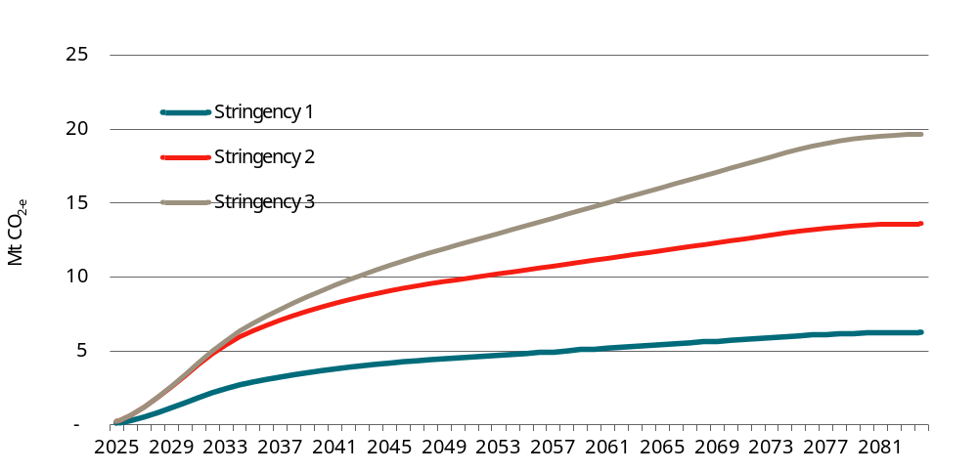
Data source: CIE estimates based on DeltaQ modelling.
The CBA estimates are generally lower than those presented in the CRIS. Key changes from the CRIS include the following:
- The DRIS estimates reflect revised DeltaQ modelling for some archetypes.
- Various inputs including prices and projections for the future GHG intensity of electricity were updated to reflect more recent information.
- Estimates of the network costs associated with additional exports of electricity to the grid have been included.
- Some building types that were not explicitly modelled (including warehouses, factories and laboratories) were included in the aggregate results.
- For building types where multiple archetypes were modelled (i.e. hotels, offices and retail buildings), the shares were updated based on further research.
- For Stringency Level 3 — where owners of dual fuel buildings under the base case are able to choose to either: ‘electrify now’; or to offset gas consumption by installing additional solar panels (mostly ground mounted) — the modelling for the DRIS assumes that 90 per cent would choose to ‘electrify now’ and 10 per cent would choose the ‘dual fuel offset’ (this compares to a 50:50 split assumed in the CRIS). This change largely reflected stakeholder feedback; some stakeholders questioned the practicality of ground-mounted solar panels. This is likely to particularly be an issue in CBD areas where shading may limit the feasibility of this option.
Extensive sensitivity analysis was conducted to test key assumptions. The key findings from the sensitivity analysis are as follows:
- Under all alternative assumptions, all three stringency levels are estimated to deliver a net benefit relative to NCC 2022. This suggests there is a strong case for change.
- Under most alternative assumptions, Stringency Level 2 is estimated to deliver the highest net benefits, consistent with the central case.
- However, the relative merits of Stringency Level 3 compared with Stringency Level 2 depends critically on whether dual fuel buildings will be allowed to continue to operate as dual fuel buildings or will be required to convert to fully electric at some point in the future (which will be necessary to meet net zero targets).
  - As no states or territories have yet announced a formal policy to mandate electrification of dual fuel buildings (although the Victorian and ACT Governments have released plans/roadmaps that move in this direction), the central case assumes dual fuel buildings will be able to operate using both electricity and gas over their full life.
  - Under most scenarios where dual fuel buildings are required to convert to fully electric in the future, the net benefits of Stringency Level 3 exceed Stringency Level 2 (implying Stringency Level 3 is the preferred option).
  - Where the outcome of the current policy choice being considered (i.e. the options for changing the NCC) depends on future policy choices that are uncertain, it can be helpful to think about these uncertain outcomes probabilistically.
    - If the probability that any dual fuel buildings built over the next 10 years will be required to ‘electrify’ in the future is considered greater than 63 per cent, then Stringency Level 3 is likely to be the option that delivers the highest net benefits.
    - On the other hand, if the probability that any dual fuel buildings built over the next 10 years will be required to ‘electrify’ in the future is considered less than 63 per cent, then Stringency Level 2 is likely to be the option that delivers the highest net benefits.
- Under the scenario where all buildings choose the ‘dual fuel offset’ option, the net benefits are higher for Stringency Level 3. However, this option involves installing additional ground-mounted solar panel and may not be feasible in many circumstances.
- The magnitude of the CBA results is most sensitive to:
  - The choice of discount rate.
  - The realisation rate — there is some evidence that modelled energy efficiency benefits are not (on average) fully realised, although there is no reliable evidence on the extent to which actual energy savings fall short of modelled outcomes. This suggests that the true net benefits may be somewhat lower than has been estimated. That said, all stringencies are estimated to deliver a net benefit even under a pessimistic scenario where only 50 per cent of the benefits are realised.

Mandatory electric vehicle charging
An option to mandate EV charging facilities at some commercial buildings is also considered as a separate option (this was bundled with the building energy efficiency options in the CRIS).
These requirements have been proposed to accommodate the increasing uptake of EV in the future, as the grid decarbonises, will reduce GHG emissions. The proposed requirements will also provide convenience for EV owners.
The cost of these proposed requirements is likely to outweigh the benefits (table 2). This result largely reflects evidence (from a previous CIE stated preference survey) that consumers do not place a high value on destination charging, which implies that these changes are unlikely to stimulate uptake of EVs to any significant extent.
3 Mandatory electric vehicle charging — estimated impacts
 | Estimated impact
 | $ million
Improved access to destination charging | 1 560.62
Mitigation of climate change | 84.32
Mitigation of air pollution | 12.14
EV charging equipment installation and maintenance | -3 396.79
Total EV charging | -1 739.71
Note: Estimates presented in net present value terms over an assumed 50-year life of all buildings constructed over the 10-year period from 2025 to 2034, using a discount rate of 5 per cent.
Source: CIE estimates.

Conclusions
- All three options under consideration are estimated to deliver significant net benefits compared with current NCC 2022 requirements. This suggests a strong case for change.
- Based on the central case CBA results, Stringency Level 2 (an increase in the minimum energy efficiency requirements and mandatory rooftop solar) delivers the highest net benefits. However, the net benefits are only slightly (3 per cent) greater than Stringency Level 3.
- The relative merits of Stringency Level 3 compared with Stringency Level 2 depends critically on whether dual fuel buildings will be allowed to continue to operate as dual fuel buildings or will be required to convert to fully electric in the future (which will be necessary to meet net zero targets).
  - If dual fuel buildings built over the next 10 years will be able to operate using both electricity and gas over their full life (as assumed in the central case), the net benefits of Stringency Level 2 are higher than Stringency Level 3.
  - However, under most scenarios where dual fuel buildings are required to convert to fully electric in the future, the net benefits of Stringency Level 3 exceed Stringency Level 2 (implying Stringency Level 3 is the preferred option).
  - Where the outcome of the current policy choice being considered (i.e. the options for changing the NCC) depends on future policy choices that are uncertain, it can be helpful to think about these uncertain outcomes probabilistically.
    - If the probability that any dual fuel buildings built over the next 10 years will be required to ‘electrify’ in the future is considered greater than 63 per cent, then Stringency Level 3 is likely to be the option that delivers the highest net benefits.
    - On the other hand, if the probability that any dual fuel buildings built over the next 10 years will be required to ‘electrify’ in the future is considered less than 63 per cent, then Stringency Level 2 is likely to be the option that delivers the highest net benefits.
- The costs of mandatory EV charging facilities are estimated to outweigh the benefits.

Introduction
Australia has committed to reduce greenhouse gas (GHG) emissions by 43 per cent below the 2005 level by 2030 and achieve net zero emissions by 2050. All Australian states and territories are committed to net zero emissions by 2050 or earlier, with varying interim targets for 2030.
Commercial buildings are a significant energy user and GHG emitter. It is estimated that there were more than 1 million commercial buildings in Australia by the end of financial year of 2020, with a gross floor area (GFA) of 830 million square metres estimated on a primary purpose basis. These buildings consumed 267 petajoules (PJ) in FY2020, including 227 PJ of electricity and 40 PJ of gas, accounting for 23.8 per cent of Australia’s total electricity consumption. They emitted 46.9 Mt CO₂-e of GHGs in the year, representing 9.4 per cent of Australia’s total emissions.
Improving the energy efficiency in commercial buildings is important to achieving emissions reduction targets.

Scope
For the purpose of this work, commercial buildings are defined as Class 2 common areas, Class 3 buildings and Class 5 to 9 buildings (table 1.1). As common areas of Class 2 building have similar characteristics to other commercial building classifications, for example an entrance hall to the lobby area of a hotel, and gyms and swimming facilities to those in Class 9b, they are not separately reported in this RIS.
1.1 Commercial buildings
Building class | Description
Class 2 common areas | Class 2 buildings are apartment buildings. They are typically multi-unit residential buildings where people live above and below each other. Class 2 buildings may also be single storey attached dwellings where there is a common space below. For example, two dwellings above a common basement or carpark.  Only common areas of Class 2 buildings are considered as commercial buildings.
Class 3 | Class 3 buildings are residential buildings other than a Class 1 or Class 2 building. They are a common place of long term or transient living for a number of unrelated people. Examples include a hotel, boarding house, guest house, hostel or backpackers (that are larger than the limits for a Class 1b building (a boarding house, guest house or hostel with a floor area less than 300m² and ordinarily having less than 12 people living in it).
Class 5 | Class 5 buildings are office buildings that are used for professional or commercial purposes, excluding Class 6, 7, 8 or 9 buildings.
Class 6 | Class 6 buildings are typically retail buildings such as shops, restaurants and cafés. They are a place for the sale of retail goods or the supply of services direct to the public.
Class 7 | Class 7 buildings include two subclassifications: Class 7a and Class 7b.
Class 7a | Class 7a buildings are carparks.
Class 7b | Class 7b buildings are typically warehouses, storage buildings or buildings for the display of goods (or produce) that is for wholesale.
Class 8 | A factory is the most common way to describe a Class 8 building. It is a building in which a process (or handicraft) is carried out for trade, sale, or gain. The building can be used for production, assembling, altering, repairing, finishing, packing, or cleaning of goods or produce. It includes buildings such as a mechanic’s workshop. It may also be a building for food manufacture, such as an abattoir. A laboratory is also a Class 8 building.
Class 9 | Class 9 buildings are buildings of a public nature, which include three subclassifications: Class 9a, Class 9b and Class 9c.
Class 9a | Class 9a buildings are generally hospitals which are referred to in the NCC as health-care buildings.
Class 9b | Class 9b buildings are assembly buildings in which people may gather for social, theatrical, political, religious or civil purposes. They include schools, universities, childcare centres, pre-schools, sporting facilities, night clubs, or public transport buildings.
Class 9c | Class 9c buildings are aged care buildings. Aged care buildings are defined as residential accommodation for elderly people who, due to varying degrees of incapacity associated with the ageing process, are provided with personal care services and 24-hour staff assistance to evacuate the building in an emergency.
Source: excerpt from ABCB 2022, Understanding the NCC: Building Classifications.

Energy efficiency in the NCC
Minimum energy efficiency standards for commercial buildings were first introduced into the Building Code of Australia (BCA), which now forms part of the National Construction Code (NCC), in 2006. The minimum energy efficiency standards were subsequently updated, including substantial increases in stringency, in 2010 and 2019.

Proposed changes to the NCC
The Australian Building Codes Board (ABCB) is developing detailed options for updating the minimum energy efficiency requirements for commercial buildings. This effort is in alignment with a set of policies and high-level strategies that focus on energy efficiency, net zero emissions, and the promotion of EV uptake. The overarching goal is to have energy efficiency improvement and make substantial contributions to achieving emission reduction targets at both Commonwealth and jurisdiction levels.
To achieve these objectives, the following options have been developed.
- Three options have been developed in relation to the minimum energy efficiency standards and on-site solar for commercial buildings:
  - Stringency Level 1: Cost-effective energy efficiency — this includes tightening the minimum energy efficiency standards for commercial buildings (including building envelope and equipment), but does not include mandating on-site photovoltaic (PV) energy generation.
  - Stringency Level 2: Cost-effective energy efficiency with mandated on-site PV — this includes the tightening the minimum energy efficiency standards for commercial buildings (as for Stringency Level 1), with mandatory on-site PV requirements.
  - Stringency Level 3: Least cost zero carbon ready buildings — this covers least cost zero carbon provisions that achieve net zero GHG emission ready buildings (for when the grid decarbonises) with respect to regulated energy (i.e. the energy use of equipment regulated through the NCC). This option extends Stringency Level 2 to provide full electrification readiness and to require additional PV to offset emissions from gas appliances compared with an all-electric equivalent. This means that under Stringency Level 3, a building’s operational carbon emissions will be no higher than an equivalent all-electric building.
- Mandatory EV charging facilities in some commercial buildings — this is being considered as a separate option (in the CRIS this option was bundled in with the building energy efficiency options).
The proposed provisions will also be fuel and technology neutral under all options. This means the proposed NCC changes, at each stringency level, allow the use of suitable electric- and gas-powered equipment, provided the required overall level of efficiency and emissions is achieved.
However, noting that energy types will transition at different times for different building and different geographic areas, it is important to understand the impacts of a move to commercial buildings that are fully electric. While the impacts may vary, it is estimated this would not substantially alter the outcome of the analysis, particularly in relation to Stringency Level 3. Being near net zero, Stringency Level 3 requires a level of efficiency and emissions which favours the use of electric-powered equipment. Stakeholder feedback indicated that building industry is already moving towards fully electrifying commercial buildings, particularly office buildings. It is reasonable to adopt the analysis for Stringency Level 3 as also being applicable to fully electric new buildings.

Regulation Impact Statement
The ABCB has engaged the Centre for International Economics (CIE) to prepare a Regulation Impact Statement (RIS) that meets the Commonwealth Office of Impact Analysis (OIA) requirements, which are to answer seven key questions:
- What is the policy problem?
- Why is government action needed?
- What policy options are to be considered?
- What is the likely net benefit of each option?
- Who was consulted and how was their feedback incorporated?
- What is the best option from those considered?
- How will the chosen option be implemented and evaluated?

Consultation RIS and public consultation
The CIE has prepared a Consultation RIS (CRIS) in April 2024, which was released by ABCB for public consultation from 1 May to 1 July 2024. 14 submissions were received, with 72 specific comments being made during the public consultation period.

This report
This report is a draft Decision RIS (DRIS), taking consideration of feedback on the CRIS, and new information which have emerged since the preparation of CRIS, and new energy modelling.

Report structure
The remainder of this report is structured as follows:
- Chapter 2 discusses the feedback on the Consultation RIS
- Chapter 3 discusses the nature and extent of the problems that the proposed changes in the NCC are seeking to address;
- Chapter 4 specifies the objectives and the proposed options;
- Chapter 5 discusses the impacts of the proposed options and approach to quantifying the impacts;
- Chapter 6 discusses the impacts at building level of proposed options;
- Chapter 7 reports aggregate impacts and the cost-benefit analysis (CBA) results for energy efficiency measures;
- Chapter 8 reports the CBA results for mandatory EV charging; and
- Chapter 9 concludes.
More detailed discussions of specific issues are provided in appendixes.

Feedback on the Consultation RIS
As a key step in preparing the DRIS for the proposal to improve the energy efficiency provisions for commercial buildings in the National Construction Code (NCC), the CIE prepared a CRIS.
Public consultation on the CRIS was open from 1 May to 1 July 2024 and conducted through the ABCB’s Consultation Hub platform. Consultation particularly focussed around 22 structured questions (in addition to 7 administrative questions) to assist the public to provide feedback on the Consultation RIS.
During the consultation period, there were 128 visits to the Consultation Hub by 100 users, of which 63 per cent were new users. The supporting documents have been downloaded 279 times. Finally, 14 submissions were received, with 72 specific comments made.
Most submissions support the changes to energy efficiency provisions. For example, most submissions consider the case for changes to the commercial energy efficiency provisions in the NCC has been adequately established in the CRIS.
While some submissions commend the analysis provided in the CRIS which overall, was found to be sound with substantial improvements made to past assumptions and analyses, others have raised various issues about the CRIS and associated energy modelling.
This chapter summarises the key issues raised in the submissions and the approach to address these issues.

Key issues raised in consultation
In considering feedback received during consultation, the CIE identified the following key issues raised by stakeholders:
- glazing selection and external shading,
- internal wall insulation requirement and costing,
- solar PV requirements,
- electrification response,
- EV charging provisions based on too optimistic projections of EV sales,
- cost-benefit analysis parameters,
- training and transition costs required to implement the changes,
- space impacts,
- building archetypes being modelled,
- climate file used in energy modelling,
- performance gap between modelled and realised energy savings, and
- learning rate
These issues are discussed in more detail as follows.

Glazing selection and external shading
Some submissions argued that the glazing design in the energy modelling for CRIS did not reflect other response options to meet the proposed requirements, for example, external shading without changing the clearness (darkness) of windows and/or window-to-wall ratio (WWR) was not considered. As a result, the actual cost of compliance may be understated. In particular, cost of shading, or amenity loss associated with dark visual light transmittance (VLT) and/or smaller windows were not considered in the CRIS.
Some submissions questioned that the energy modelling used products supplied by a limited number of companies, and only a very small percentage of the glass types in the current market have a low enough solar heat gain coefficient (SHGC) to meet the proposed solar admittance at typical WWR levels.

Internal wall insulation
One submission questioned the rationale of removing requirements for internal wall insulations. It argues that there is no supporting evidence provided to show that the removal of the requirement does not affect the energy efficiency of the building, and that the core of the building is at the same temperature as the occupied area.
Further, this submission suggested that internal insulation has a much lower cost than external insulation. Internal insulation is usually batts and is more relevant to the ceiling insulation. It suggests that internal wall insulation should be $12.00 per square metre, compared to an average cost of $48.43 based on prices for metal cladding and Kingspan insulation.

Solar PV requirements
The comments about the solar PV requirements focus on three main issues:
- the practicality of installing solar systems on roof tops and on ground;
- the uptake of roof-top solar in the baseline; and
- the network impact of exported solar electricity.
The submission from the Housing Industry Association (HIA) noticed some discrepancies between DeltaQ's modelling and proposed changes (J9D5) and questioned the practicality of the sizes required for PV to not only cover the operational use of a building, but also to have approximately 50 per cent exported to grid. HIA also questioned the practicality of ground-mount solar PV.
HIA questioned the energy savings assumptions, particularly the difference between Stringency 1 and 2 which were significant at $4.2 billion only because of mandating PV. The results seem to be overoptimistic. HIA asked whether voluntary PV uptake has been considered.
HIA raised questions related to network impact included in Public Comment Draft (PCD) form and questioned the method of calculating avoided network costs. It used NCC 2022 RIS as an example to demonstrate that requiring PV exported to grid may lead to additional network infrastructure costs rather than avoided network costs. HIA asked to consider those issues and model lower or negative export tariffs, particularly recent changes to feed-in tariffs in NSW and ACT.

Electrification response
In response to the proposed net zero carbon ready buildings option, CRIS assumes that: half of the buildings that would have been dual-fuel under current NCC provisions will choose the dual-fuel option (with expanded PV systems to offset emissions from gas consumption); and the other half will choose the fully-electric option.
Anderson Energy Efficiency suggested a lower percentage of dual-fuel buildings at 0-25 per cent, because building owners will ‘see the writing on the wall’ and avoid gas at the outset.

EV charging provisions
HIA questioned the approach to use Commonwealth Scientific and Industrial Research Organisation’s (CSIRO’s) EV sales projection to force commercial buildings to install EV charging facilities and argued the projection is too optimistic.
HIA was concerned about monitoring, allocating, and controlling usage of EV charging facilities for multifunction mixed-use buildings. Also further clarity is needed on how to define 'carparking area'. Safety issues to maintain the facilities and against any damages were also raised.

Cost-benefit analysis parameters

Discount rate
The CRIS used 5 per cent as the central case discount rate with 2 per cent and 7 per cent being used in the sensitivity analysis. HIA pointed out that the discount rates are low compared to the rates used in previous similar RISs. It further argued that higher discount rates should be used because private investments are required to improve energy efficiency and require much higher discount rates than have been used in private investment decisions.

Energy pricing
HIA argued that there is undoubtably an over-estimation from retail savings which needs to be corrected by appropriate price selection.

Carbon valuation
The CRIS used Social Cost of Carbon developed by the US Environmental Protection Agency to value the benefits of reducing GHG emissions. A couple of submissions thought the SCC are overstated.
On the other hand, Anderson Energy Efficiency questioned whether the cost of pollution, such as deaths from poor air quality and cost of sea level rise, due to increased global Greenhouse Gas (GHG) had been considered.

Training and transition costs
HIA highlighted that training and transition costs are required to implement the proposed changes. However, there are no data provided.

Space impact
HIA suggested the proposed space requirement in J8D3 was too costly and longsighted to be practical and should provide a concession like the J9D5 exemption where space or supply capacity is constrained. Alternatively, additional space and reinforcement to accommodate space for alternative heating technology in J8D3 and opportunity cost of the space and electrical capacity must be valued.
JHA Consulting Engineers also suggested that consideration should be made of space impact and constructability. For example, factors such as the potential loss of floor area to accommodate thicker walls, the need for a secondary frame to support additional wall insulation, and the impacts of reduced ceiling space have not been taken into account.

Building archetypes in energy modelling
HIA called for more transparency for building level modelling, for example, why only 3 archetypes were considered for dual fuel buildings and why Class 2 common areas were excluded.

Climate file
The energy modelling for the CRIS used a climate file under the Representative Concentration Pathway with 8.5W/m² increase in radiative forcing – RCP 8.5. It represents a pathway where greenhouse gas emissions continue to grow unmitigated. Some stakeholders (HIA, Anderson Energy Efficiency) therefore questioned why the worst scenario was used for modelling. The modelling was requiring a projected climate which may never happen, resulting in over-designed buildings.
Exemplary Energy’s overriding concern was that all of the simulations done to validate the proposed changes to Section J are unreliable because the CSIRO's solar radiation files were offset by 1 hour. The simulation results are out by 1 hour every day; so the peak demand predicted by the simulations will always also be out by 1 hour. It suggested that, at the very least, a sensitivity analysis is required to establish the size and direction of the error that these simulations incurred.

Performance gap
HIA asked that the performance gap between modelled and actual energy savings be considered, although no specific data or evidence have been provided on this matter.

Learning rate
Technoform ANZ recommend the RIS should include costing for rudimentary external shading options, including projected learning rates.

Approach to address the feedback
Below we provide a brief description of the approach to address the key issues discussed above. More details may be found in the relevant sections in the remaining part of the report.

Glazing selection and external shading
We use the new modelling results by DeltaQ to estimate the implied cost of using external shading. DeltaQ has modelled two sets of stringency levels — one is equivalent to the PCD stringency level (NCC2025-PCD), and the other is equivalent to the Stringency Level 3 of CRIS (NCC2025-CRIS3). These two sets of modelling differ in the following points:
- the stringency levels are different – the PCD is stricter;
- the PCD modelling involves external shading while the CRIS3 excludes shading; and
- accordingly, the capital costs are different.
Chart 2.1 illustrates the approach to estimate the costs to meet the requirement with external shading. The horizontal axis denotes the total energy consumption (an indicator of the stringency) while the vertical axis represents total capital costs.
The line connecting the base NCC2022 (point O) to NCC2025 PCD (point B) represents a relationship between compliance costs and achieving energy efficiency requirement with external shading. Similarly the line connecting point O and point A (NCC 2025 CRIS Stringency Level 3) represents the relationship between costs and achieving energy efficiency requirement without shading. The line OB is above the line OA, illustrates that, for any given level of energy efficiency stringency, compliance cost with external shading is higher than the cost without shading. To meet the same stringency level of CRIS Stringency Level 3 with external shading, the implied cost would be point C on line OB corresponding to the CRIS 3 energy consumption.
2.1 Illustration of estimating the cost with external shading
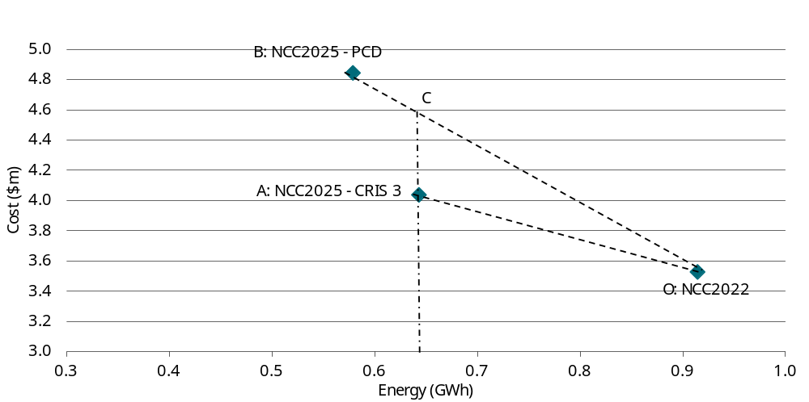
Data source: CIE
More specifically, the compliance cost with external shading can be estimated with the following formula:
$$Capex change with external shading$$
$$= Required energy consumption change×\frac{Capex change in PCD with external shading}{Energy consumption change in PCD}$$
We then use the estimated external shading cost as a scenario of sensitivity analysis.

Internal wall insulation
It is difficult to determine the proportion of insulation materials used for internal wall insulation. It is therefore assumed that the average of previous $48/m² and the stakeholder suggested $12/m² is used in the modelling for DRIS.

Solar PV requirements
The building level modelling by DeltaQ had implicitly addressed the practicalities of installing solar PV system. As such, the buildings are modelled as typical ones which represent the average level of roof top areas available for solar systems, considering practical limitations.
As for the baseline uptake of roof-top solar systems, the CRIS has already considered the voluntary uptake of solar systems based on findings by Strategy.Policy.Research. The DRIS will use the same information to establish the baseline (for more details see table 6.7 and the discussions around the table).
To consider the network impact of exported solar electricity, a new set of feed-in-tariffs will be considered such that there will be a charge of 1.2 cents per kilowatt-hour for exported solar during peak hours.

Electrification response
Following the suggestions in the submission, the DRIS considers a different scenario in the central case of CBA – assuming 10 per cent of the large-hotel, office buildings and hospital buildings (these are duel-fuel building archetypes and other archetypes are all-electric services buildings, see discussion in ‘Building archetypes in energy modelling’ below) choose to keep dual-fuel while using expanded PV systems to offset gas emissions, and 90 per cent of these buildings choosing to electrify immediately.

EV sales projections
The CSIRO provided AEMO with EV sales and fleet share projections up to 2050, encompassing four scenarios. Among these scenarios, the Progressive Change scenario represents the slowest uptake, while the Hydrogen Export scenario exhibits the swiftest uptake (for more details about these projections please see charts 4.11 and chart 4.12).
For the CRIS, we used the Step Change scenario as the central case, which has shown a net negative impact. Lower uptake would tend to reduce the benefits even further. Therefore, we use the same Step Change scenario as the central case in DRIS and do not do any sensitivity analyses of slower uptake.

Cost-benefit analysis parameters

Discount rate
The choice of 5 per cent as the central case for the CBA was due to the following considerations:
- a social discount rate, which is usually lower than the private hurdle rate of return, must be used for the CBA assessing proposed changes with long-term social, economic and environmental implications; and
- it is in line with the mean position of jurisdictions’ individual guidelines on the choice of social discount rate, as the NCC takes effect through state and territory building regulations, and the relevant analysis undertaken and/or oversight by ABCB is on behalf of individual jurisdictions.
To test how discount rate would affect the CBA results, a higher discount rate of 7 per cent has been considered as sensitivity analysis. As shown in the CBA results, the higher discount rate would not change the conclusion about the proposed changes.

Energy pricing
As discussed in the CRIS, using the various components of the retail price (with the exclusion of certain fixed charges which do not change with any change in energy consumption) is an appropriate approach to evaluate the resource cost savings associated with reduced energy consumption.
The DRIS use the same approach with updated pricing information of:
- energy wholesale prices provided by AEMO; and
- electricity network price for 2024-25 provided by AER and energy suppliers.

Carbon valuation
The social cost of carbon (SCC) typically considers a wide range of economic, environmental, and social impacts associated with the emission of one additional ton of carbon dioxide into the atmosphere. This includes both direct and indirect effects that result from climate change. The cost of pollution such as deaths from poor air quality and cost of sea level rise due to global GHG increase, as raised by Anderson Energy Efficiency and Association of Building Sustainability Assessors, have been included in the SCC.
Since the CRIS, Infrastructure Australia (IA) has published a guidance note of valuing emissions for economic analysis using a Marginal Abatement Cost approach, including a set of carbon values up to 2050. The central case IA carbon value is lower than the SCC value (chart 2.2). The DRIS use the IA’s Central series of carbon values for sensitivity analysis.
2.2 Comparison of carbon value
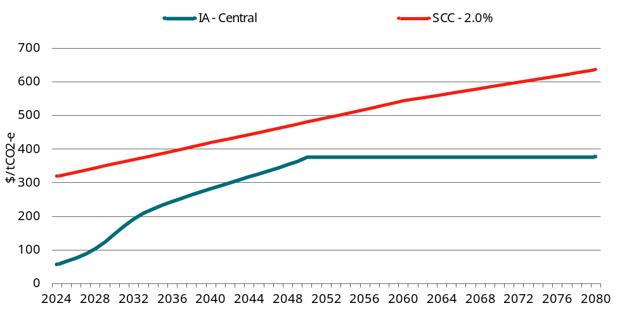
Data source: IA (2024) and USEPA (2023)

Training and transition costs
We will use a similar approach to estimate the cost of getting relevant stakeholders familiar with the changes in the NCC to that employed in the DRIS for the proposed changes in commercial energy efficiency in the NCC 2019, with updated numbers for affected stakeholders and hourly labour costs.

Space impact
The proposed changes are unlikely to have significant impact on spaces, based on the following factors:
- Low rise apartments are unlikely to have a centralised HVAC and water heating systems; rather, units will have dedicated systems. Space can also be left in plant rooms, and where buildings are smaller, such as low rise apartments, there will not be a requirement for a room much larger than the business as usual (BAU) case. While the proposed changes will facilitate a deemed-to-satisfy (DTS) pathway for centralised apartment hot water systems, there is no change to the provisions for sole occupancy units that would increase the space needed for services.
- There was a misunderstanding of the solar PV requirement reflected in the comment received. Essentially there is no minimum amount of solar that must be installed: the limiting factor is either available roof space or square meters of air-conditioned space (whichever is smaller).
- Structural requirements for provision of the reserved rooftop heating plant space were included in the CRIS.
- Concerns about thicker walls may reflect a misunderstanding as in some cases insulation requirements will decrease (e.g. around core).

Building archetypes in energy modelling
The three building archetypes with dual-fuel — hotels (C3HL), large office buildings (C5OL), and large hospital wards (C9A) — were identified by DeltaQ before commencing the energy modelling.
A total of 10 building archetypes have been included in the energy modelling. For others that were not modelled, we apply the results of modelled archetypes according to their conditioned space. More specifically, we assume 15 per cent of floor areas in warehouses, laboratories and factories based on the commercial building baseline study. Carparks are assumed to have no conditioned spaces and thus not affected by the proposed changes (except for the EV charging requirement which is dealt with separately).
As mentioned earlier, common areas of Class 2 building have similar characteristics to other commercial building classifications, for example an entrance hall to the lobby area of a hotel, and gyms and swimming facilities are similar to those in Class 9b. The baseline study did not separately identify Class 2 common areas because energy use was reported for whole apartment buildings and no floor area data is identified to estimate it confidently for common areas. Moreover, some proposed changes, for example PV requirements, are applicable to whole building, rather than common areas alone. As a result, Class 2 common areas are not separately reported in this report.

Climate change file
While countries like Australia have put enormous efforts to reduce greenhouse gas emissions, the emissions at the global level continue to increase. As a result, the RCP 8.5 presents a plausible weather profile for energy modelling.
Furthermore, the weather files prepared by CSIRO have since been aligned with the EnergyPlus standard (which has a different time convention to NatHERS), making the data more assessable and easier to interpret. There was no material impact identified to this RIS.

Performance gap
The performance gap has been considered in the sensitivity analysis. As it has shown, the conclusions about the proposed changes does not change with the inclusion of the performance gap in the CBA. Furthermore, there is no solid data about the magnitude of the performance gap. Therefore, the DRIS will follow the similar approach in dealing with this issue.

Learning rate
Learning rates have been considered in the CRIS, and there have been no changes made to these assumptions in DRIS.
Learning rate for costing of rudimentary external shading options as suggested by Technoform ANZ is not considered because the shading option is considered as an alternative option for the sensitivity analysis rather than for the central case CBA.

Statement of the problem
A key element of a RIS is defining the problem that the Government is trying to address, including the nature and potential size of the problem.

The rationale for regulation
One way that government intervention in a market (including through regulation) can be justified is through identifying market failures and other behavioural anomalies that lead to inefficient outcomes. Market failures and other behavioural anomalies in relation to the energy consumption associated with commercial buildings (including energy consumption associated with building operation and the transport emissions of building users) are discussed below.
A key market failure is that the full societal cost of consuming energy is currently not fully reflected in energy prices. In particular, the costs associated with GHG emissions that contribute to climate change are not directly reflected in energy prices. These costs are borne by the global community (see box 3.1 for a discussion on the global context).

3.1 Global context
Climate change caused by human activity is a global problem, requiring a global solution. GHGs in the atmosphere contribute to warming across the globe, regardless of where the emissions occur. In that sense, GHG abatement has the characteristics of a global public good. Specifically, GHG abatement is:
- non-excludable — individual countries cannot be excluded from receiving the benefits of limiting climate change; and
- non-rival — one country receiving benefits from limiting climate change does not prevent other countries from receiving the same benefits.
These characteristics mean that there is little incentive for each country individually to reduce GHG emissions to a level that will limit climate change. The costs associated with reducing GHG emissions are incurred domestically, while the benefits are spread across the globe. Each country therefore has an incentive to free-ride off the efforts of others.
Therefore, international agreements are a crucial mechanism for achieving global action. The Paris Climate Agreement has been ratified by 195 of 198 Parties to the United Nations Framework Convention on Climate Change (UNFCCC). It aims to limit the increase of global average temperature to less than 2 degrees Celsius above pre-industrial levels and pursue efforts to limit the rise to 1.5 degrees Celsius. In recent years, the need for limiting global warming to 1.5 degrees Celsius by the end of the century has been emphasised. To this end, GHG emissions must peak before 2025 at the latest and decline 43 per cent by 2030.

Minimum energy efficiency standards for commercial buildings
The rationale for minimum energy efficiency standards is based on the proposition that industry would not make socially optimal energy efficiency decisions in commercial buildings without government intervention. That is, there are energy efficiency opportunities where the benefits to the community (including public benefits) outweigh the associated costs that would not be taken up in the absence of regulation. This is often referred to as the ‘energy efficiency gap’.

Market failures and behavioural anomalies relating to energy efficiency
Market failures and behavioural anomalies that could contribute to the energy efficiency gap include the following.
- Negative externalities associated with energy consumption — unpriced negative externalities associated with energy consumption would normally mean that energy users do not take these costs into account in their decisions on whether to invest in energy efficiency. This creates an incentive for the commercial building industry to under-invest in energy efficiency in the absence of government intervention. Minimum energy efficiency standards can therefore encourage more socially efficient energy efficiency decisions. Unpriced negative externalities that have been identified in the literature include:
  - GHG emissions — see discussion above.
  - Peak demand —various studies have also suggested that costs associated with peak demand are not fully reflected in electricity prices. Network capacity and therefore infrastructure costs are driven by peak demand. Where the costs associated with peak demand are not reflected in electricity price, this would limit the incentive to invest in energy efficiency technologies that would reduce peak demand.
- Other market failures and behavioural anomalies — notwithstanding the market failures associated with energy pricing, it is often argued that policy measures to improve energy efficiency can deliver net private benefits through bill savings that outweigh the associated capital costs in addition to a reduction in GHG emissions (sometimes referred to as a ‘win-win’ outcome). This implies there are energy efficiency opportunities that are privately cost effective that industry nevertheless fails to adopt. This is often referred as the ‘energy efficiency paradox’. Frequently cited market and behavioural failures that contribute to the energy efficiency paradox in relation to commercial buildings, include the following:
  - information failures (where the party making energy efficiency decisions does not have sufficient information to make rational decisions);
  - information asymmetries where the seller/landlord may have information on the energy efficiency of a building, but the buyer/tenant does not;
  - systematic behavioural biases (i.e. due to heuristic decision making and/or bounded rationality in the face of the sheer complexity of understanding energy efficiency options).
  - split incentives/principal-agent problem — this arises where the party making energy efficiency investment decisions is not responsible for paying the energy bills and can arise where the incentives affecting the builders making decisions that affect future buyers are not aligned to end-occupant/end-owner.
    - split incentives could occur between building owner or the landlord who bears the cost of any investment in energy efficiency and tenant who pays the energy bills;
    - split incentives may also occur between a building contractor and its owner and occupier. A building contractor makes many energy-related decisions. As energy efficient options usually increase the cost of construction, the contractor has incentives to choose less energy efficient alternatives, especially if the measures are not immediately obvious to the owner or prospective buyers;
    - another type of split incentive could occur within large organisations, where separate parts of the organisation are responsible for capital budgets and paying energy bills.

Review of direct evidence on market failures and behavioural anomalies
Direct evidence on each of the market failures and behavioural anomalies identified above is summarised in table 3.2, with further discussion provided in Appendix A. In general, there is a sound in principle case for minimum energy efficiency standards for commercial buildings on the following grounds.
- The primary justification for minimum energy efficiency standards in commercial buildings is that the external cost of GHG emissions is not reflected in energy prices under current policy settings. Although many commercial building owners have committed to net zero targets in their own operations, not all of these targets are being actioned, and not all owners and tenants have made such commitments. See appendix A for more details.
- In addition, although there is limited direct evidence, it is plausible that the following behavioural/organisational failures prevent privately cost-effective energy efficiency opportunities (i.e. where energy bill savings outweigh the associated capital costs) from being adopted.
  - Split incentives, including:
    - Different parts of an organisation are responsible for capital costs and operating costs (energy bills)
    - Different incentives across different parties in the building process.
  - Behavioural anomalies, such as bounded rationality and heuristic decision making (such as building to code, rather than seeking the optimal mix of capital and ongoing energy costs); and inattention to non-salient energy costs are plausible explanations for the energy efficiency paradox across all building types.
To the extent that behavioural anomalies mean that industry defers to the code, rather than seeking to optimise the balance between capital-related costs and ongoing operating costs, there may be a role for the code to drive industry towards best (or better) practice.
3.2 Summary of direct evidence of market failures and behavioural anomalies
Market failure or behavioural anomaly | Evidence | Existing measures to address | Unaddressed market failure or behavioural anomaly
Energy pricing
External costs relating to GHG emissions | The current externality (i.e. the SCC) is estimated to be around 23.5 c/kWh. | Although there are no policies that directly internalise the social costs associated with GHG emissions, there is some evidence that some building owners and tenants do take GHG emissions into account in their decisions, largely reflecting Environmental, Social and Governance (ESG) commitments. | Not all building owners/tenants take into account GHG emissions in their decisions.
Externalities associated with peak demand | Consistent with AER pricing principles, costs associated with peak demand should be reflected in network pricing (albeit imperfectly). | AER pricing principles require that (i.e. any previous externalities should be address directly through pricing policies). | Although network tariffs may not reflect the costs associated with peak demand perfectly, any previously observed market failures are largely addressed.
Other market failures and behavioural anomalies
Information failures (lack of information) | General evidence on the benefits of energy efficiency freely available.  Project-specific information available commercially. | Governments and energy efficiency advocacy groups provide some information. | No unaddressed market failures.
Information asymmetries | No significant information asymmetries:  The landlord/seller generally discloses ‘outgoings’ (including energy bills) to tenants/buyers. | Requirements to disclose outgoings to tenants.  NABERS tools to benchmark actual energy performance against other similar buildings are available for most building types.  Under the Commercial Building Disclosure (CBD) Program, a NABERS Energy rating is mandatory on sale or lease for office buildings >1000 m² . | No unaddressed market failures.
Landlord-tenant problem | No clear evidence of an information asymmetry problem, so the landlord-tenant problem unlikely to be a significant market failure in commercial buildings.  Some split incentives apply during lease period. | Requirements to disclose outgoings to tenants.  NABERS tools to benchmark actual energy performance against other similar buildings are available for most building types.  Under the CBD Program, a NABERS Energy rating is mandatory on lease for office buildings >1000 m². | Landlord-tenant problem unlikely to be a significant contributor to the uptake of privately cost-effective energy efficiency opportunities.
Other split incentives | Some qualitative evidence of split incentive where:  - Different parts of an organisation are responsible for capital costs and operating costs (energy bills)  - Different incentives across different parties in the building process. |  | Plausible that these split incentives contribute to sub-optimal outcomes.
Bounded rationality and heuristic decision-making | It is difficult to disentangle the role of heuristics and bounded rationality from competing explanations because decision-making processes cannot be directly observed.  Qualitative evidence of heuristic decision-making, including entrenched practices in the construction industry, such as building to code, rather than optimising. | Government and industry awareness-raising efforts. | Plausible that heuristic decision-making — such as the persistence of entrenched practices and ‘building to code’ — is a barrier to the uptake of privately cost-effective energy efficiency opportunities.
Salience and inattention | While there is little direct evidence that inattention to energy costs leads to under-investment in energy efficiency, it is nonetheless a plausible explanation (particularly for small businesses). | Government and industry awareness-raising efforts. | Plausible that salience and inattention is a barrier to the uptake of privately cost-effective energy efficiency opportunities.
Note: See Appendix A for further information.
Source: CIE.

Rationale for government intervention on electric vehicle charging facilities
Passenger cars and light commercial vehicles contribute around 10 per cent of Australia’s total GHG emissions. However, the GHG emissions associated with petrol and diesel-powered combustion engines are not currently reflected in fuel prices (i.e. GHG emissions are an unpriced negative externality). This limits the incentive to transition to less GHG-intensive alternatives, such as electric vehicles (EVs). Transitioning to EVs (together with decarbonising electricity supply) is a key element of the pathway to net zero (see discussion on net zero targets below).
There is an interdependence between EV adoption and investment in public charging facilities referred to as an ‘indirect network effect’ (or the chicken and the egg problem) This is where the benefit of adoption/investment on one side of the market increases with the network size on the other side of the market.
- Although as much as 80 per cent of EV charging takes place at home, the availability of public charging facilities has been identified as a key barrier to widespread uptake of EVs in Australia (along with high purchase price, beliefs around limited range, and long charging times at some stations).
  - Even when EV owners can charge their vehicles overnight at home, some consumers still worry about running out of electricity before reaching their destination. This ‘range anxiety’ (which may partly reflect misunderstanding about EV range) limits adoption of EVs, especially when public charging facilities are scarce.
  - Furthermore, according to the Electric Vehicle Council, it is likely that home charging will be challenging or impossible in around 20 per cent of the current dwelling stock, including:
    - around 7 per cent of the dwelling stock on the market lacks off-street parking (for example, terrace housing)
    - around 14 per cent of the dwelling stock is flats and apartments where retrofitting EV charging facilities would be challenging or impossible.
  - Research from California indicates that around 20 per cent of consumers that had switched to an EV had switched back to petrol/diesel vehicles. Of these, 70 per cent lacked convenient charging facilities at home.
- At the same time, private investors have less incentive to build charging stations if the size of the EV fleet is small.
Most commercial buildings are workplaces. Charging capabilities at work would provide an additional charging option, including for households that do not have access to charging at home.

Policy environment
It is important to understand the policy environment in relation to the NCC. In particular, whether there are existing policies that already address some or all of the market failures outlined above.
As achieving Australia’s targets under the Paris Climate Agreement will require a suite of policies, it is important to understand where the NCC fits into the broader strategy.
The impact of the proposed changes to the NCC also depend on current and future policies.

GHG commitments
In 2022, under the Paris Climate Agreement, the Australian Government updated its Nationally Determined Contribution to target emissions reduction of:
- 43 per cent below 2005 levels by 2030, and
- net zero by 2050.
These targets have been legislated.
All Australian states and territories are committed to net zero emissions by 2050 or earlier, with varying interim targets for 2030. For example,
- Both New South Wales (NSW) and South Australia (SA) have an objective to achieve a 50 per cent reduction in emissions on 2005 levels by 2030;,
- Victoria (VIC) has set a target of 45-50 per cent below 2005 level by 2030, and 75-80 per cent by 2035, and net zero by 2045;
- Queensland (QLD) has set a target of 30 per cent below 2005 level by 2030;
- Western Australia (WA) introduced the interim target of 80 per cent below 2020 levels by 2030 for all government agencies across the State;
- Tasmania (TAS) has set the target to maintain net zero emissions or lower from 2030;
- The Northern Territory (NT) is prioritising clean energy and renewables with its target of 50 per cent renewables for electricity supply by 2030; and
- The Australian Capital Territory (ACT) is committed to achieving net zero by 2045, with targets of 50-60 per cent below 1990 levels by 2025, 65-75 per cent by 2030 and 90-95 per cent by 2040.

High-level strategies
Several high-level strategies have either been developed or are being developed that will set out a roadmap for achieving the net zero target and other related objectives. Some of these high-level strategies that are relevant to the proposed changes to the NCC are set out below.

Sectoral decarbonisation plans
Consistent with the jurisdiction’s net-zero emission agendas, the Australian Government will develop sectoral decarbonisation plans for six sectors, including the followings that are relevant to commercial buildings and the NCC:
- Electricity and energy — decarbonisation of the electricity and energy sectors will reduce the GHG emissions associated with the operation of commercial buildings;
- The built environment — as commercial buildings form part of the built environment, changes to the NCC (including more stringent energy efficiency standards and requirements relating to rooftop solar) could form part of the decarbonisation plan;
- Transport — the decarbonisation plan for the transport sector is likely to involve a transition from diesel and petrol internal combustion engines to EVs. The provision of charging facilities at commercial buildings could assist with the transition.
The other sectors (that are less relevant to commercial buildings and the NCC) are: agriculture and land; resources; and industry and waste.

National Energy Performance Strategy
A consultation paper was released in November 2022 as a step towards a National Energy Performance Strategy. The term ‘energy performance’ encapsulates the broad management of energy demand, including:
- energy efficiency
- load shifting
- fuel switching, and
- behaviour change.
The aim of the National Energy Performance Strategy is to provide a long-term framework for demand-side action to:
- reduce pressure on energy bills
- improve energy reliability
- reduce emissions, and
- deliver a high energy performance economy.
  - The National Energy Performance Strategy aims at a holistic energy system planning for better energy performance that touches every industry of the economy and requires institutional coordination to govern energy performance in forms of industry policy – in the built environment, it sits with the Building Ministers and the ABCB. They are responsible for the development of the NCC that will reflect any plans of action – including energy efficiency and reducing emissions – to be developed under the Strategy.

Trajectory for Low Energy Buildings
The Trajectory for Low Energy Buildings was agreed by Energy Ministers in February 2019. This is a national plan that sets the trajectory towards zero energy and carbon ready buildings for Australia. It proposed incremental changes to the NCC to reduce operational energy use and associated GHG emissions of residential and commercial buildings from 2022.
The trajectory effectively envisaged substantial upgrades to the minimum energy efficiency standards specified in the NCC for both residential and commercial buildings at each triennial update cycle to ensure provisions keep pace with changing technologies and changing energy prices.
In response to the Trajectory, the ABCB released a scoping study titled, Energy efficiency: NCC 2022 and beyond, for public comment. For both commercial and residential buildings, provision for the future installation of on-site renewables and EV charging was supported. For commercial buildings, ABCB investigated moderate changes in NCC 2022, including work that complemented the residential energy efficiency provisions, such as research into the grid impacts of increased uptake of on-site renewable energy and research into provisions that accommodate the future installation of on-site renewable energy and EV charging. The scoping study also envisaged more substantial changes for commercial buildings may be considered in NCC 2025.

National Electric Vehicle Strategy
The nationally agreed National Electric Vehicle Strategy was released in April 2023.
- The vision of the National Electric Vehicle Strategy is to increase the uptake of EVs to reduce emissions and improve the wellbeing of Australians.
- The specific objectives are:
  - Supply — increase supply of affordable and accessible EVs
  - Systems and infrastructure — establish the resources, systems and infrastructure to enable rapid EV uptake
  - Demand — encourage increase in EV demand.
- The intended outcomes include to:
  - Expand EV availability and choice
  - Reduce road transport emissions
  - Make it easy to charge an EV across Australia
  - Increase local manufacturing and recycling
  - Make EVs more affordable
  - Reduce the cost to Australian of running their vehicles.
Of most relevance to the proposed changes to the NCC is the intention to make it easy to charge an EV across Australia. Making it easier for Australians to charge their cars is key to supporting the switch to EVs.

Australian public service Net Zero Roadmap
The Australian public service Net Zero Roadmap sets out actions for the Australian Government to achieve net zero GHG emissions from its operations by 2030, through implementation of the Net Zero in Government Operations Strategy. The strategy outlines the approach and objectives to reduce emissions and transition to net zero in areas such as energy, electrification, EV charging, and fleet management.
Key actions include:
- transitioning to renewable energy, facilitated through a whole-of-government coordinated procurement of electricity, to achieve 100 per cent renewable Commonwealth electricity
- improving building energy efficiency and promoting electrification, and
- transitioning the fleet to low- or zero-emission vehicles, with an objective of 75 per cent of new passenger vehicle orders to be low- or zero-emission vehicles by July 2025.
These actions are aligned with the proposed changes to the NCC which can facilitate the delivery of net zero commitment of the Australian Government to demonstrate leadership in reducing emissions by 2030.

Specific policies
Some specific policies that are relevant to the proposed changes to the NCC are set out below. This includes policies aimed at:
- encouraging greater energy efficiency in commercial buildings
- encouraging or mandating electrification of commercial buildings
- encouraging greater uptake of EVs.
Table 3.3 summarise how proposed changes in the NCC 2025 may support specific policies.
3.3 Specific policies and the implications for NCC 2025
Policies | Implications for NCC
NABERS provides a voluntary benchmarking tool that can encourage improved performance.  Under the CBD Program, a NABERS Energy rating is mandatory for office buildings >1000 m² (along with a Tenancy Lighting Assessment) upon sale or lease. | - Encourages improved energy performance during operation.  - Complements mandatory minimum standards in the NCC.
ACT’s ban of new gas connections to be rolled out in late 2023. | Jurisdictional schemes of electrification and bans of gas connection lay out changes to planning and building regulations. Electrification readiness considerations in NCC 2025 raise standards for commercial buildings will support the transition pathway and provide guidance of electric ready developments in jurisdictions.
Victoria’s Gas Substitution Roadmap – phasing out new residential gas connections.
EV uptake incentives and fuel efficiency standards. For example, Victoria’s Zero Emissions Vehicle Roadmap and the Australian Government’s New Vehicle Efficiency Standard. | Considerations of charging facility installation in NCC 2025 to enhance EV-readiness of buildings, and by improving EV charging availability, they support EV uptake strategies across jurisdictions and the development of the mandatory fuel efficiency standard.
Source: CIE.

NABERS
The National Australian Built Environment Rating System (NABERS) is operated by the NSW Government on behalf of Commonwealth, State and Territory Governments. NABERS essentially provides a range of tools to benchmark performance on a range of sustainability measures against similar buildings. NABERS has been referenced in the NCC as an energy efficiency Verification Method. There are also NABERS tools in relation to: water, waste and indoor environment.
NABERS provides a rating from one to six stars as follows:
- 1 star — making a start
- 2 star — below average
- 3 stars — average
- 4 stars — good
- 5 stars — excellent
- 6 stars — market leading.
Energy efficiency rating tools allow building owners/operators to obtain a rating for their building from an accredited assessor using an established methodology. These arrangements mean that buyers/tenants can have confidence in the energy efficiency rating provided by the seller/landlord.
Compared with 2018 (when the previous commercial energy efficiency RIS was completed) there are now NABERS Energy rating tools available for a broader range of buildings. NABERS Energy tools available for:
- Office buildings and tenancies
- Shopping centres
- Apartment buildings
- Hospitals (public)
- Hotels
- Data centres
- Residential aged care
- Retirement living
- Warehouses and cold stores.

The Commercial Building Disclosure Program
The Commercial Building Disclosure (CBD) Program is a key national-level policy to encourage energy efficiency improvements in existing buildings.
- Under the CBD Program, all office space greater than 1000 m2 must obtain a Building Energy Efficiency Certificate (BEEC) upon sale or lease.
- A BEEC is prepared by an accredited assessor and includes:
  - a NABERS star rating that provides information on energy use, GHG emissions and a benchmark of how energy use compares to similar buildings in similar climatic locations;
  - the lighting efficiency of the tenanted area through a Tenancy Lighting Assessment (TLA). This provides a measure of the energy required to light each of the areas of a building.
- The NABERS rating must be disclosed in all advertising material.
The CBD Program provides benchmarked energy performance information that can be useful to both the building owner (i.e. the landlord) and buyers/tenants.
The CBD Program was intended as a complement to mandatory minimum standards set out in the NCC. Whereas the NCC applies only to new buildings (and buildings undergoing major refurbishment), the CBD Program aims to encourage improved energy performance of existing buildings.

State and territory-based electrification policies
The ACT and Victoria have taken proactive steps in electrification policies.
The ACT government is committed to net-zero emissions target by 2045 with plans of action and transition pathway to electrify fossil fuel energy by 2045. Some milestones that are achieved or to be expected in near future include:
- In 2020 the ACT secured 100 per cent renewable electricity supply.
- Community consultation on a regulation to prevent new gas network connections was held in 2023.
- A regulation to prevent new gas network connect rolled out in December 2023.
- ACT Government released the Integrated Energy Plan Position Paper that proposed approaches to transform ACT energy system for public comments. The Integrated Energy Plan will outline actions to be taken over the short and long term along a transition pathway to an affordable and sustainable energy systems. This plan is expected to be published in 2024.
The Victorian Government set out the Victoria’s Gas Substitution Roadmap to guide the state to meet its net zero emission targets. The roadmap lays out key regulatory steps and support programs as follows.
- From January 1st 2024 onwards, the phase-out policy will be rolled out to limit new gas connection for new dwellings, apartment buildings and residential subdivisions. This policy will affect the construction of new dwellings with planning permits.
- The Roadmap Update in January 2024 reiterates ‘investigating options to progressively electrify all new and existing residential and most commercial buildings’.
- Solar Victoria is launching the residential electrification grants program, offering grants to providers involved in large-scale residential electrification projects across Victoria. These grants will benefit homeowners. Solar Victoria also provides individual rebates for solar PV for new homes under construction. Additionally, they offer training programs to support electricians in designing and installing PV and batteries in new homes.
There appears to be no active consideration of policies to support electrification (or the phasing out of gas) in other states and territories.

Electric vehicle incentives
There are six categories of financial incentives for purchasing zero- or low-emission vehicles across jurisdictions as follows. They encourage uptake of EVs, implying a need for consideration of safe charging in the built environment.
- Rebates with eligibility requirements on dutiable values and/or total household taxable income are offered in NSW, Queensland, SA and WA.
  - The NSW Government offered $3,000 rebates for new full battery EVs and hydrogen fuel cell EVs registered between 1 September 2021 and 1 January 2024.
  - The Victoria Government provided subsidies to just under 10,000 zero emissions vehicles (ZEVs) under the Zero Emissions Vehicle Subsidy Program which was the first such program in Australia and are now closed.
  - The Queensland Government will offer $6,000 rebate for a new eligible zero-emission vehicle.
  - A $3,000 subsidy was available for new battery electric and hydrogen fuel cell vehicles registered in SA between 28 October 2021 and 1 January 2024.
  - The ZEV rebate scheme will provide a ZEV owner with a $3,500 rebate after purchasing an eligible vehicle in WA.
- Registration exemptions or discounts are offered in ACT, NT, Queensland, SA and Victoria.
  - The ACT Government is offering 2 years of free registration for new or used zero-emissions vehicles acquired before 30 June 2024.
  - The NT Government is offering free registration for new and existing battery EVs and plug-in hybrid EVs until 30 June 2027.
  - The Queensland Government offers registration discount on hybrid or EVs.
  - A 3-year registration exemption is offered in SA for eligible new battery electric and hydrogen fuel cell vehicles first registered from 28 October 2021.
  - In Victoria, zero- or low-emission vehicles receive $100 registration concession.
- Stamp duty exemptions or discounts
  - No stamp duty is payable on eligible zero- or low-emission vehicle purchases in ACT, NSW, and NT.
  - In Queensland, zero- or low-emission vehicles are offered a reduced stamp duty cost.
- In ACT an interest free loan up to $15,000 is offered in purchase of eligible energy-efficient projects including EVs in ACT.
- Road user charges:
  - No road user charges are payable except in Victoria. However, the High Court recently overruled the imposition of road user charge to Victorian EV owners. The levy is set to be removed.
  - The High Court’s decision may hold off the introduction of the levy to EV owners in NSW and WA by 2027.
  - Fringe benefits tax exemption — since 1 July 2022 employers do not pay fringe benefits tax on EVs not subject to luxury car tax and associated expenses. Benefits provided under a salary packaging arrangement are included in the exemption.

Fuel efficiency standard
As a key part of the Electric Vehicle Strategy, the Australian Government has committed to introducing a fuel efficiency standard.
A fuel efficiency standard is an obligation on light vehicle suppliers to make sure the new vehicles they bring into the market, on average, meet a particular CO₂ per kilometre standard.
- Where suppliers exceed the standard by selling more efficient vehicles (including EVs), they are rewarded (usually through ‘credits’).
- Where suppliers do not meet the standard, by selling proportionally more higher emissions vehicles, they are penalised (this could include: a requirement to buy credits from other suppliers or pay a fine).
Over 85 per cent of the global car market has vehicle fuel efficiency standards, with Australia one of the only advanced economies without a mandatory one. The absence of a fuel efficiency standard in Australia has been identified as a key reason why EV models are not supplied to the Australian market.
A fuel efficiency standard is expected to improve the supply and variety of EVs coming into the Australian market, and support the increased uptake of EVs.

The case for change
Key drivers for change to the NCC (discussed in detail below) are as follows:
- Governments (including both Commonwealth, state and territory governments) have committed to net zero policy targets, which will require greater ambition across a range of policy areas;
- Increasing the stringency of the minimum energy efficiency standards and mandating EV charging facilities in commercial buildings would represent tangible policy action consistent with emerging strategies to achieve net zero targets; and
- Recent (2022) economic modelling that supports greater cost-effective stringency, coupled with more recent increases in estimates for the cost of both carbon emissions and energy prices that further enhance the economic case.

Policy drivers
A key recent policy development (since the previous change to the NCC minimum energy efficiency standards in 2019) is the net zero commitment, which has been legislated. Achieving the revised target will require greater policy ambition across a range of decarbonisation initiatives, including stationary energy.
In addition, changes to the NCC would represent policy action consistent with broader strategies, including:
- The Trajectory for Low Energy Buildings
- the National Energy Performance Strategy (although this strategy has not been finalised, the proposed changes to the NCC are consistent with improved energy performance)
- the National Electric Vehicle Strategy.

Other developments
The cost effectiveness of energy efficiency measures depends fundamentally on the price of energy, the cost of energy efficient technologies and designs relative to alternatives (which may change due to technological advances).
Despite significant increases over the past couple of years (due in part to global events, such as the Russian invasion of Ukraine), retail electricity prices have declined in real terms since the 2018 RIS (based on the CPI measure), although there has been a significant real increase in retail gas prices.
On the other hand, there is a strong case to place a higher value on reducing GHG emissions on the following grounds:
- Recent advances in the scientific literature on climate change and its economic impacts suggest the damage caused by climate may be worse than previously estimated. For example, Newman and Noy (2023) found that frequently cited estimates of the economic costs of climate changed arrived at by using Integrated Assessment Models may be substantially underestimated. These advances have been reflected in an upward revision in the US Environmental Protection Agency’s estimate of the social cost of carbon.
- As Australia has committed to deeper cuts in carbon emissions the implicit value of abatement will be higher.
As a result of these developments, the range of socially cost-effective energy efficiency opportunities are likely to have changed.

Inefficiencies in the existing code
The technical work conducted by DeltaQ suggests that there are currently several inefficiencies reflected in the current code, including the following:
- The NCC currently treats ‘internal’ walls, such as walls around the lift well to be part of the building envelope. As such, these walls must be insulated to comply with NCC requirements; insulating these walls has little to no impact on the building’s energy efficiency performance.
- The minimum insulation requirements for some buildings are currently excessive, particularly for buildings that typically operate during the daytime only. These excessive insulation requirements may reduce energy performance in warmer climates where cooling requirements dominate. In particular, excessive insulation can trap heat in the building and increase the energy required to cool the building to a comfortable temperature when the air-conditioning is switched on in the morning. This effect can outweigh the benefits from better insulated walls.
- Plant efficiency requirements are not specified in terms of the design loading, which may encourage (or fail to discourage) over-sizing of plant.
Importantly, changes to the code that address these existing inefficiencies create the potential to simultaneously reduce capital-related costs and improve energy performance.

Modelling showing cost effective energy efficiency opportunities in commercial buildings
Modelling of cost-effective options for increasing the minimum standards in the NCC, Achieving Lower Energy Commercial Buildings in Australia, was prepared for the (then) Department of Environment and Energy in 2018 as part of the Trajectory for Low Energy Buildings work program. This modelling was updated in 2022. Key findings from the updated modelling included the following:
- A weighted average reduction in energy intensity of 26 per cent could be achieved cost-effectively through increases in the stringency of the minimum energy efficiency standards in the NCC for commercial buildings.
- Together with future changes to the NCC in 2028 (involving further savings of 9.8 per cent) and 2034 (involving further savings of 9 per cent), this is estimated to deliver:
  - net social benefits of $8.2 billion in net present value terms over an assumed 40-year life (using a discount rate of 7 per cent) of buildings constructed over the period from 2026 to 2050 (meaning that some benefits will persist through to 2090)
  - energy savings reaching 56 PJ by 2050
  - cumulative GHG emission savings of 70 Mt CO₂-e by 2050.

Objectives and options

Objectives
The energy efficiency changes in the NCC initiated from the National Energy Productivity Plan in 2015, which followed by a national plan— Trajectory for Low Energy Buildings (the Trajectory) in 2019 to set a trajectory towards zero energy (and carbon) ready buildings. With the GHG emission reduction targets legislated in 2022, Energy Ministers agreed to support the changes that achieve a low energy, net zero carbon building sector by 2050.
The Guide to Section J1P1 of the NCC (the Performance Requirement in relation to energy efficiency) states that the objective of Section J is to ‘align with policy set by governments in the Trajectory for Low Energy Buildings’, to reduce energy consumption and energy peak demand, to reduce GHG emissions, and to improve occupant health and amenity.
That said, policies aimed at improving energy efficiency often have a broader set of objectives. For example, the consultation paper on the National Energy Performance Strategy notes the following benefits from improving energy performance in addition to reducing GHG emissions:
- lowering consumer energy costs,
- taking pressure off the system, and
- improving health and comfort.
The draft NCC 2025 energy efficiency project briefing has stated that the objectives of energy efficiency work are, in order of importance, to:
- reduce GHG emissions,
- reduce commercial building running costs,
- make commercial buildings more resilient to heatwaves, and
- assist with the decarbonisation of the electricity grid.

Options: minimum energy efficiency requirements

Base case: Maintain the status quo
The base case establishes the baseline against which the proposed changes are compared. It is essentially the status quo, that is, new builds compliant with NCC 2022.
The base case must also account for the extent to which new buildings go beyond the minimum requirement in the NCC 2022, reflecting voluntary adherence to higher standards including voluntary uptake of on-site PV. In this context, the base case may also reflect certain non-regulatory alternatives.

Non-regulatory options
RIS guidelines require that a RIS identifies a range of viable options. These include, as appropriate, non-regulatory, self-regulatory, quasi-regulatory and co-regulatory options.
In this context, a more flexible alternative option to encourage improved energy efficiency performance of commercial buildings would focus on providing relevant information to users and managers of commercial building. This could involve presenting the proposed changes as a voluntary guideline or within a handbook.
However, non-regulatory options do not address the key market and behaviour failures that lead to under-investment in energy efficiency, including: current externalities in relation to energy consumption; and heuristic decision-making (i.e. building to code, rather than optimising costs over the building’s life). Non-regulatory approaches are therefore unlikely to be effective in achieving the objectives.

Policy options
ABCB has developed the following policy options:
- In relation to minimum energy efficiency standards and on-site energy generation for commercial buildings, ABCB has developed three policy options (that are all fuel and technology neutral) reflecting three different stringency levels (see table 4.1):
  - Stringency Level 1: Cost-effective energy efficiency without mandated on-site photovoltaics (PV) — includes proposed energy efficiency provisions for better performance building envelop and equipment.
  - Stringency Level 2: Cost-effective energy efficiency with mandated on-site PV —introduces additional mandated on-site PV requirements to Stringency Level 1.
  - Stringency Level 3: Least-cost zero carbon ready buildings —covers least cost zero carbon provisions that achieve net zero GHG emissions ready buildings (when the grid decarbonises) with respect to regulated energy. This option extends Stringency Level 2 to provide full electrification readiness and to require additional PV to offset emissions from gas appliances compared with an all-electric equivalent. This means that under Stringency Level 3, a building’s operational carbon emissions should be no higher than an equivalent all-electric building.
- Mandatory requirement for EV charging facilities in some commercial buildings — this is being considered as a separate option (this requirement was bundled with the energy efficiency and on-site energy generation options in the CRIS).
Table 4.1 provides a schematic summary of the requirements for each option.
4.1 Options of proposed changes
Proposed changes | Stringency Level 1 | Stringency Level 2 | Stringency Level 3 | Mandatory EV charging facilities
Increased DTS stringency for envelope and services | ü | ü | ü | û
Mandatory on-site PV | û | ü | ü | û
Additional PV requirement to offset gas appliance | û | û | ü | û
Electrification ‘readiness’ requirement | û | û | ü | û
Mandatory requirement for EV charging facilities |  |  |  | ü
Source: ABCB.

Stringency Level 1: Cost-effective energy efficiency without mandated on-site PV
This Stringency Level 1 includes energy efficiency provisions for better performance building envelop and equipment.
This option is expected to reduce energy consumption of a building by between 20 to 50 per cent in comparison to NCC 2022 provisions. In isolation it is insufficient for Australia’s 2050 Net Zero target.

Stringency Level 2: Cost-effective energy efficiency with mandatory on-site PV
This option includes mandatory on-site PV system in addition to 1Stringency Level 1. It requires a PV system size to cover the majority of buildings’ available roof space.
Performance Requirements will allow the use of other forms of on-site renewables.
Battery storage is not considered as it is found not be cost-effective as an individual measure for all stringency levels.
According to the energy modelling that assesses the energy use, GHG emissions and cost implications, mandatory onsite PV would be beneficial, but mandatory onsite battery storage would not be beneficial. Further detail on this investigation is provided in the section below on ‘Summary of changes to provisions’.
Buildings that voluntarily adopt an all-electric approach have the potential to approach a near Net Zero level. However, it is not the case for dual-fuel buildings.

Stringency Level 3: Least- cost net zero carbon ready buildings
This option extends Stringency Level 2 to require additional PV to offset emissions from gas appliances compared with all-electric equivalent and requires electrification readiness, for example gas-powered space heating and domestic hot water systems. This option potentially could lead to higher costs for buildings with gas appliances than full electric buildings. Also considering limitations due to roof size, or orientations, this could drive those buildings to be transitioned to electric, although the proposed changes do not mandate electric buildings.
This option investigates where it is practicable to increase the stringency of the “cost-effective” Deemed-to-Satisfy (DTS) measures. It is found that some refinement to heating, ventilation, and air conditioning (HVAC) controls are able to be increased. It is found, however, that all other areas had reached their technical or market availability limits under Stringency Level 1. For example, it would be cost effective to have more insulation, but this makes it much more impractical to build the wall. Similarly, dark windows save money but getting too dark leads to amenity issues. On market availability, chillers are a good example. The most efficient chiller is cost effective, but if the requirement is set at the most efficient level, only one or two companies could provide equipment. As a result the efficiency level is set where there is diversity in manufacturers providing products.
A broader range of options including higher efficiency envelope and services, or alternate renewable energy sources can be used under the Verification Measures or a Performance Solution.
In the longer term, this option is expected to achieve near net-zero emissions as the electricity grid decarbonises and through the eventual replacement of gas appliances with electric ones.

Summary of changes to provisions

Performance requirement

Performance Requirement J1P1
Three updated versions of J1P1, reflecting each stringency level, were developed for the Public Comment Draft (PCD), but only stringency level 3 was published. For Stringency Levels 2 and 3, the proposed Performance Requirement explicitly addresses operational GHG emissions, aligning with the broader scope of these scenarios which reaches beyond energy efficiency. Quantified near-zero GHG emissions levels are proposed for Stringency Level 3. This approach is fuel-agnostic and would allow for the use of gas if a sufficient level of efficiency and offsets can be achieved overall, or if the gas was from a renewable source, such as green hydrogen.
For all stringency levels, elements relating to solar radiation, energy source and sealing of the building are proposed to be deleted on the basis that the quantified regulated energy Performance Requirement renders them no longer necessary.

Performance Requirement J1P4
J1P4 has been updated to support the mandatory installation of EV chargers in Class 3 and 5 to 9 buildings. This change is proposed for all three stringency levels. The Performance Requirement is quantified through consideration of the distance driven by the building occupants. This allows flexibility across building classifications and locations.
For mandatory on-site PV, the requirement is to achieve the performance target for regulated energy and GHG emissions in Stringency Level 2 and 3 version of J1P1 that can only practically be achieved through the use of an on-site renewable energy system.

Verification Methods
Updates have been incorporated into J1V1 (NABERS) and J1V3 (Verification using a Reference Building). These changes apply across all three stringency scenarios. J1V2 and J1V4 are unchanged.
In J1V1, the changes are to reflect an enhanced overall stringency and to simplify the modelling requirements.
J1V3 has two significant changes proposed. Firstly, it is proposed to remove the ability to offset the performance of a building’s envelope with PV. This was considered no longer appropriate given the higher level of overall stringency now required.
Secondly, it is proposed to introduce a requirement for a building’s total proposed energy use to be at least three per cent better than the reference building. This brings the J1V3 modelling process in line more closely with the requirements of J1V1 and J1V2 and provides more assurance that the proposed building design is in fact more efficient than the reference building, considering uncertainty in the simulation. A number of other minor refinements have also been proposed to improve the accuracy of the energy model and to reflect changes made to the deemed to satisfy provisions.

Building envelopes

Roofs
For roof colour, it is proposed to retain the existing solar absorptance DTS metric but offer an alternative of total solar reflectance, and to add a provision for thermal emittance. Solar Reflectance Index (SRI) may also be used. For general roof areas, the overall level of stringency proposed is equivalent to NCC 2022, except that low-emittance materials such as uncoated metal are no longer permitted under the DTS. The overall number of roof colour choices is equivalent between NCC 2022 and 2025 other than for metal roofs in Climate Zones 1, 2, 3, 5 and 6 which have air-conditioning plant and outside air intakes placed on the roof or within 2m above it. There are specific provisions for higher reflectance and emittance for these roofs to reduce cooling load.
It is proposed to increase the stringency of the roof insulation requirements for overnight-operating building classes. These changes are based on the outcomes of the technical analysis and will not only decrease annual building energy consumption but will also reduce building peak energy demand.

Wall-Glazing construction
Proposed wall-glazing changes aim to reduce solar admittance for wall-glazing in all building classifications and climate zones other than climate zone 8. This revision is based on models that have a higher stringency for façade Solar Admittance in 2025 in comparison to 2022. Importantly, the building archetypes used in the modelling of wall-glazing construction were tested to ensure they had adequate natural light using the Spatial Daylight Autonomy (sDA) metric, rather than daylight factor, which was used to develop the NCC 2019 provisions. sDA is more sensitive to orientation, occupied times and glare, and achieves an “adequate” level of daylighting with a lower combination of glazed area and visual light transmittance than daylight factor. However, the NCC only regulates daylight to Class 2, 3, 4 and 9 buildings (through F6P1), meaning that the existing daylighting requirements of Part F Health and Amenity will be met and likely exceeded in the models that underpin all three stringency levels.
The glazing change values are derived using moderate window-to-wall ratios for each archetype (i.e. building form modelled). Stringency Level 3 values are derived using lower but still realistic window-to-wall ratios for Class 5 office buildings (other classes as per Stringency Level 2).
These changes significantly reduce building cooling requirements and related energy use, and reduce the required cooling system capacity. This reduction in plant capacity represents a significant cost saving for builders, especially in larger builds.
There are also changes to Total System U-Value requirements proposed under each scenario. These are less significant, but will reduce building heating requirements in certain circumstances, but increase it slightly in others. These will have a modest impact on design, with buildings able to maintain window-to-wall ratios and daylighting similar to NCC 2022 compliant buildings.
A back-stop value for the Total System U-Value of glazing has also been proposed to prevent the use of unrealistically high-performing glass. This is analogous to the opaque wall value backstop and also prevents gaming of J1V3.
A change to the defined term ‘envelope’ is also proposed. The proposed change clarifies where the term envelope is meant to apply and will, thereby, reduce construction costs. At present, an envelope wall is defined as building fabric between conditioned space and unconditioned space, including internal walls. Under the present definition, the fabric around any internal unconditioned spaces, that are wholly or mostly enclosed, such as lift shafts or stair wells, are required to meet the minimum Total System U-Value requirements of Part J4D6. This leads to unnecessary installation of insulation against spaces that would be expected to be close to the same temperature as the conditioned areas they adjoin.

Vertical Shading
It is proposed to introduce new DTS Provisions that set minimum standards for vertical shading. Presently DTS Provisions exist for horizontal shading, but only vertical shading that blocks 80 per cent of direct summer solar radiation is accommodated within the DTS. Providing more comprehensive DTS Provisions for vertical shading will facilitate the installation of vertical shading, which is particularly effective in controlling solar gain from the western aspect and will help control air-conditioning peak demand in summer.

Building sealing
Proposed revisions to the building sealing provisions in Part J5 seek to clarify the intent and application of the provisions. The changes remove duplication and align terminology used to describe the location of the thermal boundary with other Parts of Section J. The changes also clarify the scope of the airlock requirements to exempt spaces with moveable external walls, and clarify the scope of sealing walls, ceilings, and floors to include interface to ventilation openings. The intent of the revisions is to clarify rather than change the stringency, although some individual practitioners may adopt more or less stringent practices as the changes promote a more consistent interpretation across the industry. The clarifications are expected to reduce the use of some products in some applications, such as roof lights to provide permanent openings in bathrooms, where the NCC 2022 provisions are ambiguous.

HVAC

Air conditioning controls
The changes to the provisions for air conditioning controls will restrict simultaneous heating and cooling, prevent poor zone design and respond to feedback from industry that the current provisions were subject to gaming in establishing the J1V3 reference building.
A limitation on the heated water temperature reset provision is proposed to avoid imposing the requirement on very low temperature systems, which are expected to become more common with the use of heat pumps. Use of a reheat in these applications would be impractical.
New temperature reset requirements are proposed for condenser water, reflecting typical minimum practice.
Time switch provisions are proposed to be refined in line with refinements for time switches used in lighting controls.
Economy cycle provisions have been revised in line with cost-benefit analysis at the element level.

Mechanical ventilation controls
The existing provisions for mechanical ventilation controls have been clarified to include a requirement for energy reclaim systems to be fitted with a bypass when beneficial.

Fans and duct systems
The fan and duct system changes have aligned with the international standard (EU 327) for peak efficiency. There is also a dedicated provision dealing with the difference between selection efficiency and peak efficiency. In the current provisions, peak efficiency and selection efficiency were integrated into a single provision, reducing transparency.
These changes aim to streamline and simplify the provisions and discourage inappropriate applications of inefficient fan types in air-handlers.
Applications of variable speed operation have been broadened in line with current, cost-effective practice.
In response to feedback from code users, minimum pressure drops for some commonly used ductwork components, have now been specified. Provisions for maximum flexible ductwork length and minimum equivalent diameter for duct connection to fittings have also been clarified.
As per the current provisions, fan equipment can be assessed at the individual component level or system level. A process to allow for assessment at the building level is also proposed, i.e. across all air conditioning and ventilation fans. This improves flexibility and encourages a proportionate approach.

Ductwork insulation
An exemption for equipment complying with MEPS has been deleted. Feedback suggests the deleted provision was incorrectly interpreted as exempting ductwork connected downstream of the unit.

Pumps
The changes to the pump provisions are intended to broaden the application of variable volume systems and the use of variable speed drives for balancing. Variable volume operation is not required for pumps that serve primary heating or cooling plant only, as this equipment generally has very limited capability to vary the flow volume.

Pipework insulation
The proposed changes to the pipework insulation provisions remove an exemption for pipework insulation in equipment covered by MEPS. The MEPS test standard does not fully account for the heat loss through pipework that may be connected downstream of the equipment, as this will vary by application.
Refrigerant pipework has also been removed from the definition of ‘heated fluids’. This reflects the experience of industry after the introduction of the NCC 2019 provisions, which found that the benefits from increasing the insulation requirements did not offset an increase in installation costs. As a result, refrigerant pipework insulation requirements are proposed to revert to the requirements of a cooling fluid, as per NCC 2016.

Space heating
The proposed changes for space heating introduce minimum efficiency requirements for heating systems that use heat pumps and allow greater use of direct electric heating. These proposals apply across all stringency levels and are consistent with the anticipated decarbonisation of the electricity grid. The heat pump stringency requirements are based on the market average because there was no strong relationship between efficiency and performance. Setting an average requirement based on the market average is not expected to unreasonably restrict supply.
Stringency Level 3 also includes measures that will facilitate future conversion of gas-powered equipment to electrically powered equipment.

Chillers
The chiller provisions have been revised based on cost-effectiveness considerations. The changes also allow chillers, which are connected to serve a common load, to be assessed as a system. This allows sizing practices to be taken into account in the assessment, allows greater flexibility for designers, and is a more proportionate approach. However, an equipment-level compliance pathway is also provided, reflecting the same stringency assumptions built into the system-level metric.

Unitary air conditioning equipment
Minimum efficiency for air-cooled packaged air-conditioning systems (PACS) and variable refrigerant flow systems (VRF) are set on the basis of market averages (excluding the bottom quintile for VRF). While even higher stringencies were shown to be cost-effective, they are not proposed to be adopted due to the potential impacts on the availability of stock.
As with chillers, the changes also stipulate that air-cooled air conditioning unit efficiency may be assessed collectively.
Variable capacity compressors and outdoor fans are also proposed based on cost-effectiveness. A compliance pathway based on Total Cooling Seasonal Performance Factor is included as an alternative option that addresses part load efficiency.
It is noted that this is a significant change in scope compared with the current provisions, which only cover units above 65 kW.
There is also a correction to the reference standard AS/NZ 3823.1.2 to AS/NZ ISO 13256.1 for water-cooled unitary equipment, but there is no change to stringency levels for this equipment item.

Heat rejection equipment
Variable speed motors in heat rejection fans are proposed on the basis of cost-effectiveness.

Lighting
No overall increase in stringency is proposed for lighting illumination power densities. However, changes are proposed related to lighting switching and controls. The Lighting Council of Australia and the International Association of Lighting Designers were consulted during the development of these changes. The changes are designed to simplify the language of the provisions and update them so that they are consistent with new lighting control technologies.
In response to comment from the Australian Elevator Association, the maximum/illumination power density for lift car is proposed to be increased to 5.5 W/m² (refer to the last item in Table J7D3a). This value has been calculated on the basis of notes (1)(i) and (ii), (2) and (3) to Table J7D3a; Table J7D3b and Table J7D3c.

Renewable Energy
The technical analysis showed that maximising the amount of PV panels on available roof space was a cost-effective requirement for all building archetypes modelled. The strength of the business case for PV stems primarily from the opportunity to use the solar that is generated onsite to meet loads within the building, thereby reducing the amount of electricity that needs to be purchased from the grid. Under Stringency Level 2, the amount of PV required will depend on the amount of available unshaded roof space and the total energy building demand.
Higher rates of PV installation would be required under Stringency Level 3 if gas is installed, with a high proportion of PV being installed to meet the near net zero energy and GHG abatement requirement.
If a requirement for PV panels was adopted then the existing requirements in Part B for warehouse buildings to ensure that they have the appropriate structural capacity for them would be deleted, given PV would be being installed at the time of construction.

Options: mandatory electric vehicle charging
The installation of Type 2, 7 kW (32A) EV chargers is proposed for 15 per cent of carparking spaces in Class 3 and 9 buildings and for 10 per cent of carparking spaces in Class 5 and 6 buildings. These ratios reflect the projected need for EV chargers, given expected uptake of the technology, and because the power consumption of the equipment will be able to be met with business-as-usual electrical supply limits. Explanatory information has been added to the text explaining how the requirement for charge control equipment affects calculation of maximum demand under ASNZ 3000. The provisions also clarify that the EV chargers for accessible carparking spaces are additional.
The main intent of these provisions is to increase the charging options for people unable to charge an EV at home, especially people living in existing Class 2 buildings where it is difficult to install EV charging equipment or Class 1 buildings without off-street parking. The proposed ratio of EV chargers is the same across all three stringency levels.

Approach to impact analysis
The impact analysis is conducted by comparing the impacts of proposed changes to the NCC (Stringency Levels 1 to 3 and mandatory EV charging facilities) to the baseline business as usual option (base case). The analysis aimed to identify likely impacts from the options through:
- early consultation with stakeholders from industry and government agencies;
- reviewing energy modelling results by DeltaQ; and
- reviewing relevant data from other sources to assist the analysis.

Overview of impact analysis methodology

Early consultation with stakeholders
The purpose of the targeted early consultations was to gather relevant views and information necessary to complete the cost-benefit analysis (CBA), especially the key parameters that likely affect the CBA.
A range of stakeholders covering the major commercial building sectors were contacted to seek their views on potential implications from the proposed changes to Section J of NCC. To assist the consultation, an issues paper including questionnaires was prepared and sent to stakeholders before the interview.
Findings from the consultation are discussed in the relevant parts of this chapter.

Review of DeltaQ modelling
DeltaQ has conducted whole-building modelling of the impacts of the proposed changes to the NCC on energy consumption by fuel type (electricity and gas) as well as electricity exported to the grid (for stringencies where rooftop solar is mandatory). DeltaQ’s modelling compares buildings compliant with NCC 2022 and NCC 2025 (under all stringencies) across:
- 10 building archetypes (see appendix E for further details), including:
  - a small hotel (Class 3)
  - a large hotel (Class 3)
  - a small office building (Class 5)
  - a medium office building (Class 5)
  - a large office building (Class 5)
  - a strip retail building (Class 6)
  - a large shopping centre (Class 6)
  - a large hospital ward (Class 9a)
  - a school (Class 9b)
  - an aged care facility (Class 9c)
- each of the 8 climate zones.

Public consultation on Consultation RIS
Public consultation on the Consultation RIS was open from 1 May to 1 July 2024 and conducted through the ABCB’s Consultation Hub platform. During the consultation period, 14 submissions were received, with 72 specific comments made.
While some submissions commend the analysis provided in the CRIS which, overall, was found to be sound with substantial improvements made to past assumptions and analyses, others have raised various issues about the CRIS assumptions and associated energy modelling. These issues include:
- glazing selection and external shading
- internal wall insulation requirement and costing
- solar PV requirements
- electrification response
- EV charging provisions based on too optimistic projections of EV sales
- cost-benefit analysis parameters
- training and transition costs required to implement the changes
- space impacts
- building archetypes being modelled
- climate file used in energy modelling
- performance gap between modelled and realised energy savings
- learning rate
These issues have been considered in developing this Decision RIS. The approach to deal with these issues are briefly discussed in chapter 2, and in detail in relevant parts of this document.

Cost-benefit analysis
The cost and benefit estimates are broadly based on DeltaQ modelling at the building level. For a range of building archetypes (see appendix E for further details) across all 8 climate zones, DeltaQ has modelled the impact of the proposed changes to the code using the DTS pathway, including the impact on:
- energy consumed from the grid (including electricity and gas);
- export of excess energy generated on-site; and
- capital-related costs.
Building level costs and benefits are aggregated up to the climate zone, state and national level using construction projections for each building type by state.

Presentation of CBA results
The main measures typically used to summarise the results of a CBA are:
- Net present value (NPV) — this measure subtracts the ‘present value’ of the estimated stream of future costs from the present value of the estimated stream of future benefits, where future costs and benefits are discounted back to a common year.
  - An NPV greater than zero (i.e. the NPV is positive) indicates that the present value of the benefits outweigh the present value of the future costs (i.e. the proposal delivers a net benefit to the community).
  - An NPV less than zero (i.e. the NPV is negative) indicates that the present value of future costs outweighs the present value of future benefits (i.e. the proposal delivers a net cost to the community).
- Benefit-cost ratio (BCR) — this measure is the present value of the estimated stream of future benefits divided by the present value of the stream of future costs.
  - A BCR greater than 1 indicates the present value of the benefits outweigh the present value of the future costs (i.e. the proposal delivers a net benefit to the community).
  - A BCR less than 1 indicates the present value of the future costs outweighs the present value of the future benefits (i.e. the proposal delivers a net cost to the community).
For the purposes of the RIS, we focus on the NPV measure. In the context of measures to improve energy efficiency, the BCR would typically compare the benefits associated with reduced future energy consumption with the additional capital-related costs. However, based on DeltaQ’s estimates, the capital-related costs associated with complying with NCC 2025 are actually lower than for NCC 2022 (see further discussion below) for Stringency Level 1 (i.e. there are no measurable costs). In this context, the BCR is not a meaningful measure.

CBA parameters

Time period
RISs typically use a five- or ten-year time horizon for measuring the costs and benefits. However, buildings are typically long-lived assets, with a life of 40 or more years. Following the paper by Hutley (2023) who has investigated the literature on commercial building lifecycle, we will assume a building life of 50 years with 40 years and 60 years for the sensitivity analysis.
For building services, the life is around 20 years, according to DeltaQ. The life of services will be extended to be the same as the life of building, meaning replacement costs will be considered.
Following the previous RISs, we conduct the analysis of costs over a ten-year period but include in the benefits the full life of each building/services constructed or installed during that ten-year regulatory period.

Discount rate
The nature of investments in energy efficiency (i.e. upfront costs in exchange for a stream of future benefits) and the long timeframes involved mean that energy efficiency CBAs are particularly sensitive to the discount rate.
The OIA typically requires a real discount rate of 7 per cent to be used in a RIS, with sensitivity analysis using 3 per cent and 10 per cent. This is intended to reflect the social discount rate.
However, there is a case for deviating from the OIA’s preferred 7 per cent in this context. As for analysis conducted over periods longer than 30 years, OIA suggests using lower discount rates. In particular, for analyses over 31-75 years, OIA recommends using a discount rate of 5.4 per cent.
It is recommended a central case discount rate of 5 per cent, accompanied by 2 per cent and 7 per cent as the sensitivity analysis rates, based on the practice in some jurisdictions and the long-timeframe impact. OIA agreed to the alternative discount rates for this project. Hence, these specified discount rates will be used for conducting the cost-benefit analysis.

Establishing a base case
A key element of cost-benefit analysis is establishing a credible base case (which is generally defined as the scenario that would apply without the regulatory proposal) against which the benefits and costs of various options are assessed. The base case for this study is the status quo (or ‘business as usual’).
Business as usual implies Section J of the NCC to remain as it currently applies. In addition, the base case should incorporate any existing policy measures that affect the energy efficiency decisions in relation to commercial buildings. It should also incorporate any foreseeable new policies that would be implemented regardless of whether the proposed changes to the NCC are implemented.
The base case should also incorporate currently and future available technology for energy efficiency. This will be discussed in more detail below.

Impacts of more stringent minimum energy efficiency standards
The main impacts of changes in the stringency of the minimum energy efficiency standards could include:
- changes in construction costs
- changes in the building design
- avoided energy costs during the building’s operation phase, and
- GHG emission reduction as a consequence of changing energy consumption and fuel mix (electricity and gas).

Energy efficiency under the base case
It is important that the voluntary uptake of energy efficiency over and above existing NCC requirements is included in the base case. As outlined above, if voluntary uptake of higher levels of energy efficiency than is required under the current code is not included in the base case, the CBA will overstate the impact of the regulatory change on energy consumption.
As there are no comprehensive sources of data on the energy efficiency features of commercial buildings, establishing a credible base case is a challenge. Stakeholder feedback on the base case in relation to energy efficiency standards included the following:
- Several stakeholders noted that in general, very few (if any), buildings voluntarily exceed the minimum standards set out in the current code.
- Others noted that some premium CBD offices may choose to exceed minimum standards, but it is unlikely outside this segment of the market.
- Some stakeholders noted that the use of performance solutions to comply with Section J is common, but this is mostly to make trade-offs across different building elements, rather than to exceed the minimum standards. This means that some buildings may exceed the minimum DTS requirements for some elements, but not overall.
Based on this qualitative evidence, we assume that no voluntary exceedance of the existing code is a broadly reasonable base case.
That said, it is important to carefully scrutinise whether there is a plausible reason why any elements of the proposed changes that are both cheaper to implement and are more energy efficient (or have very high benefit-cost ratios) are not being implemented voluntarily.

Change in capital-related costs
More stringent energy efficiency standards affect capital-related costs in various ways, including costs related to: the building envelope; building services; and rooftop solar.

DeltaQ modelling
In general, higher capital costs are associated with higher stringency requirements for energy efficiency. Nevertheless, preliminary modelling indicates that enhancing the performance of the building envelope can potentially reduce the size of HVAC systems. This reduction can lead to a net reduction in overall construction or capital costs, wherein the higher cost for a more efficient envelope is more than offset by the reduced cost associated with HVAC equipment.
However, it is worth noting that stakeholder consultations have highlighted a common practice in HVAC system design which tends to be conservative. This means that the theoretically projected reduction in HVAC size may not always be fully realised in practice.
In some circumstances, more stringent energy efficiency requirements may result in design compromises. For example, more stringent façade requirements may mean in some cases it is not possible to achieve compliance with the proposed NCC requirements using the DTS pathway without reducing the window size, installing external shading, or pursuing a Performance Solution pathway for compliance. To the extent that these design compromises have a material impact on aesthetic/amenity values, this would normally be considered a cost in economic analysis.

Alternative glazing cost estimates
Glazing selection is one of the factors that is driving the counter-intuitive modelling results (i.e. a simultaneous reduction in capital-related costs and an improvement in energy performance) for some buildings. According to DeltaQ modelling, there are glazing choices available that are both cheaper and more energy efficient (i.e. lower SHGC) than the glazing selection under the base case for some building archetypes in some climate zones.
Based on the glazing sample used by DeltaQ, the relationship between price and SHGC is relatively weak (see chart 5.1). This reflects the fact that the cost of different window coatings that affect the SHGC are fairly similar.
- This means that there are some glazing choices that are superior to others on both price and energy performance (i.e. lower SHGC) as reflected in DeltaQ’s modelling.
- However, the negative relationship between price and SHGC (which is statistically significant at the 95 per cent level) suggests that on average, more energy efficient glazing (i.e. lower SHGC) is more expensive (not cheaper as implied by DeltaQ’s modelling).
5.1 Relationship between SHGC and price
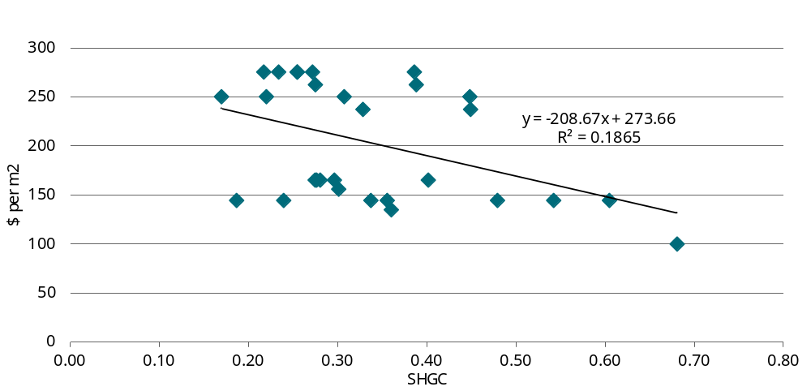
Data source: CIE based on data provided by DeltaQ.
To test the robustness of the results, we model an alternative glazing cost scenario based on the average relationship between price and SHGC (as shown in chart 1 above). This relationship implies that if the SHGC is reduced by 0.1, the price increases by around $20.86 per m². This may be driven by concurrent changes in the U-Value of the products in the sample set. This was not examined in this analysis due to the fact that wall-glazing U-Value changes proposed for NCC 2025 are driven by opaque wall elements. However, the cost relationship identified may be a proxy for the costs that will be incurred, noting that some projects may respond to the wall-glazing changes with better-insulated windows, for example if site-specific factors make higher R-Values for the walls difficult to achieve.
Note that this approach does not address any potential amenity/aesthetic impacts associated with darker windows.

Learning rates
Some analyses of energy efficiency policy changes (such as changes to minimum standards) include a ‘learning rate’. Conceptually, the learning rate reflects how quickly firms adapt and adopt new technologies and techniques, and revise their designs and/or production processes. The premise is that raising the Performance Requirements in the NCC may initially increase costs; however, these additional costs will decline over time as the industry adapts (or learns).
The main ways through which the incremental costs associated with higher performance requirements could decline over time are:
- declining input prices — the price of new technologies can sometimes decline rapidly initially (due to economies of scale resulting from rapid adoption) before levelling off;
- construction techniques and supply chain maturity; and
- innovation and learning in relation to design.
Stakeholders have confirmed that the learning rate is dependent on the maturity of technology. Most of the technologies are now relatively mature, meaning they are not in the rapid learning phase.
The technical consultant, DeltaQ, investigated learning rates for specific technologies, such as roof-top PV and heat pumps, and finds no hard evidence to support or justify a specific learning rate.
Learning rates are therefore not included in the central analysis. However, learning rates have been considered in the sensitivity analysis following the advice from the independent economic adviser.

Avoided energy costs
The primary benefit from more stringent minimum energy efficiency standards is reduced energy consumption, which means the associated costs are avoided. The estimated reduction in energy (electricity and gas) consumption is based on DeltaQ’s building energy modelling for 10 building archetypes in the 8 NCC climate zones (see appendix F for further details).
For each building archetype and climate zone, DeltaQ provided energy consumption estimates for the base case (NCC 2022) and the proposed NCC 2025 options. The simulation model estimates energy consumption in each hourly interval across the year, allowing us to apply time of use electricity prices as an indicator of the avoided energy costs.
The hourly simulation model used by DeltaQ does not include domestic hot water (DHW) . However, moving to a fully electric building under Stringency Level 3 would mean that buildings with gas DHW systems would need to shift to an electric DHW system.
DeltaQ has modelled these impacts outside the simulation model and therefore the associated changes in electricity consumption were not available on an hourly basis. We therefore assumed that the hourly consumption patterns for DHW was the same as the simulated electricity consumption for each building archetype. To the extent that DHW consumption patterns are different to the simulated electricity consumption, this is unlikely to have a material impact on the CBA as DHW is a relatively small component of total energy consumption.

Approach to valuing avoided energy costs
Our approach to valuing avoided energy costs is largely based on the market (and regulated) prices of the various components of retail energy prices in each state, including:
- avoided generation/energy costs (measured using time of use wholesale prices)
- avoided network usage costs (measured based on network usage charges)
- avoided network capacity costs (measured using network capacity charges)
- avoided retail costs (avoided retail costs are reflected in the retail margin).
This is similar to the ‘retail price approach’, but excludes costs that are not likely to vary based on the amount of electricity consumed, including:
- retail costs that are likely to be driven by the number of customers (which is unlikely to change as a result of the proposal), rather than the amount of electricity used; and
- the costs associated with environmental schemes, which form part of the retail price, but are essentially fixed (i.e. unlikely to vary significantly based on the amount of electricity consumed).
Future costs for each component are inflated using the Australian Energy Market Operator’s (AEMO’s) retail price projections (this approach effectively assumes that all price components will increase at the same rate). Appendix B provides more details on the energy price estimates.

Are modelled energy saving realised?
Although the issue remains poorly understood, there is some recent evidence to suggest that modelled energy savings are often not realised in practice (see appendix C for details). In particular:
- A report for the International Partnership for Energy Efficiency Cooperation (IPEEC) Building Energy Efficiency Taskgroup (BEET) noted increasing evidence of expected savings from retrofit projects not being realised.
- Recent data from the Green Building Council of Australia (GBCA) suggests that:
  - less energy efficient buildings are more likely to over-perform relative to the modelled performance;
  - more energy efficient buildings are more likely to under-perform relative to the modelled performance.
However, a recent scoping study investigating the Building Energy Performance Gap (BEPG) found that:
- it is not appropriate to extrapolate from findings in relation to the performance gap based on the GBCA’s 2021 dataset to other building types for the purposes of regulatory impact analysis.
- the performance gap in other types of buildings that are not captured by these rating systems remains unquantified and poorly understood.
- there is no data currently available within industry that could be aggregated to create an appropriate dataset.
Based on these findings it seems unlikely that a robust estimate of the extent to which modelled energy savings associated with more stringent energy efficiency standards will be realised in practice will be available in the short term. As a result, the central case in the cost-benefit analysis of this CRIS uses the full realisation scenario with lower realisation scenarios (50 per cent and 75 per cent realisation) being included in the sensitivity analysis.

Greenhouse gas emissions reductions
Reducing consumption of energy generated through burning fossil fuels through improved energy efficiency will reduce GHG emissions that contribute to climate change.
The DRIS uses a new set of emissions intensity factors projections of electricity consumption updated by Department of Climate Change, Energy, the Environment and Water (DCCEW) in November 2023, which provides projections of scope 2 and 3 combined factors in the baseline scenario up to 2035. We then use a similar approach as in Hutley (2023) to derive emissions intensities from 2036 to 2050, assuming the grid approaching to net zero in 2050. Chart 5.2 shows the indirect scope 2 and 3 combined emissions factors of electricity consumption by state.
5.2 Indirect scope 1 and 3 combined emissions factors of electricity consumption
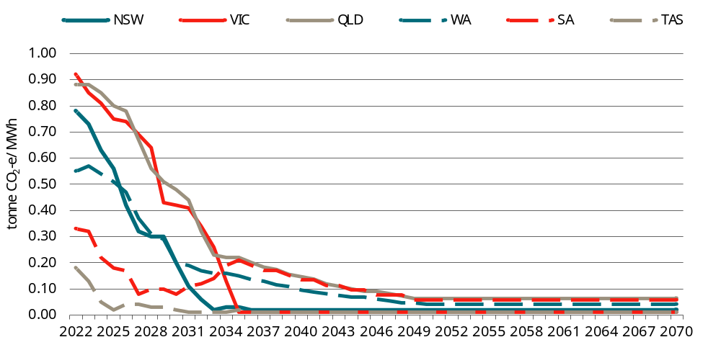
Data source: CIE compilation based on DCCEEW (2023a, Table 46).
Table 5.3 reports the natural gas emissions factors released by DCCEEW in August 2023, with missing information (Scope 3 for Tasmania and NT) taken from Hutley (2023).
5.3 Natural gas emissions factors
Scope | NSW  (Kg CO₂-e/GJ) | VI  (Kg CO₂-e/GJ)C | QLD  (Kg CO₂-e/GJ) | WA  (Kg CO₂-e/GJ) | SA  (Kg CO₂-e/GJ) | TAS  (Kg CO₂-e/GJ) | ACT  (Kg CO₂-e/GJ) | NT  (Kg CO₂-e/GJ)
Scope 1 | 51.5 | 51.5 | 51.5 | 51.5 | 51.5 | 51.5 | 51.5 | 51.5
Scope 3 | 13.1 | 4.0 | 8.8 | 4.1 | 10.7 | 4.0 | 13.1 | 4.1
Total | 64.6 | 55.5 | 60.3 | 62.2 | 55.6 | 55.5 | 64.3 | 55.6
Source: CIE based on DCCEEW (2023b, Table 4 and Table 5) and Hutley (2023, Table 5.6).
We use these inputs to estimate the reduction in GHG emissions based on the DeltaQ energy modelling results.
As for valuing the benefits of reducing GHG emissions, there are also various approaches including:
- A market or shadow carbon price — in principle, an economy-wide carbon price should reflect the marginal cost of abatement. However, as there is effectively no economy-wide carbon price in Australia, approaches have included:
  - carbon prices that apply in other markets (such as the EU),
  - a modelled carbon price to reach emissions reduction target (such as net zero by 2035).
- The social cost of carbon (SCC) approach, such as the SCC series published by the United States Environment Protection Agency (USEPA).
We follow the recommendation in the paper by Hutley (2023) to use SCC published by USEPA (converted to 2023 Australian dollar) for valuation of GHG emissions reduction. Chart 5.4 presents three SCC series, among which the 2 per cent series is used in the central case cost-benefit analysis while the other two series are used for sensitivity analysis.
Since the CRIS was published, Infrastructure Australia (IA) has published a guidance note of valuing emissions for economic analysis, based on a marginal Abatement Cost Curve approach, including a set of carbon values up to 2050. As shown above (see chart 2.2), IA’s Central series of carbon values is lower than the 2 per cent series of SCC value. We use IA’s carbon value series for a sensitivity analysis.
5.4 Social cost of carbon
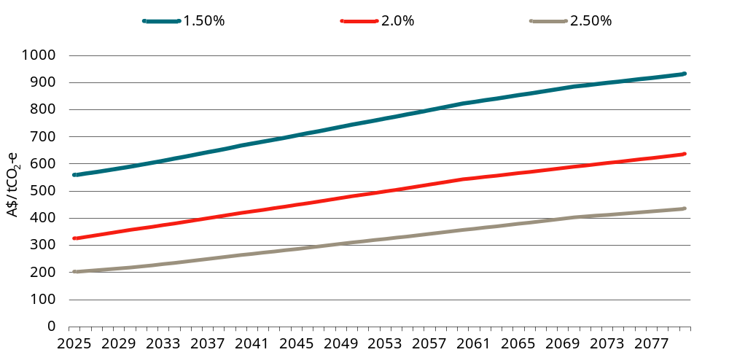
Data source: CIE estimates based on USEPA (2023).

Restrictions on design choices
The proposed changes to the NCC will restrict design choices in several ways, including the following:
- The windows on some buildings will need to be tinted (i.e. have lower visual light transmittance) to achieve compliance with the proposed requirements — although this will still allow an adequate level of daylighting (daylighting requirements are not specified in the NCC), this will be less than what is current practice.
- The maximum window to wall ratio (WWR) that will be achievable without external shading will be reduced from 70 per cent (under NCC 2022) to 58 per cent — although this will not affect most building archetypes (as the WWR for most buildings is lower than this threshold), this will have some impact, particularly on large office buildings where extensive glazing is relatively common.
  - Note that DeltaQ’s modelling assumes the same WWR under the base case and under all stringencies and does not include the cost of shading. This is because the archetypes are intended to reflect a ‘representative’ building based on the average WWR within the building class. Previous work estimated the average WWR for an office tower is around the maximum threshold achievable without shading (around 58 per cent).
  - This means that the proposed requirements will not affect the ‘average’ office tower and therefore these effects are not reflected in the modelling.
  - However, around half of office towers will have higher WWRs than average and would be affected by this restriction and would need to either install external shading (which can be expensive) or reduce the WWR.
- As the minimum standards have been tightened across all building elements there will be fewer opportunities to make trade-offs across elements (including through the use of Performance Solutions) to achieve particular design outcomes.
These restrictions on design choice will impose costs that are hard to measure, which could include the following:
- Loss of aesthetic or amenity value — where design compromises have been made, there may be a loss of aesthetic or amenity value. Although these values are subjective, in principle, design compromises that change either the external appearance or the internal aesthetics for building users is likely to impose a cost on the community.
  - There are no identifiable market failures that would lead building owners and designers to make design choices that are systematically sub-optimal from a communitywide perspective in relation to building aesthetics/amenity (although there are some market and behavioural failures in relation to energy efficiency choices — see appendix A).
  - In the absence of identifiable market failures, a standard assumption in economic analysis is that market participants will make design choices that achieve the optimal combination of cost and building aesthetic/amenity value, particularly where these values are reflected in the market value of the building and/or rents.
  - To the extent that these aesthetic/amenity values are reflected in the market value of these buildings and/or rents, these benefits could in-principle be measured. However, there is no publicly available data that would allow these values to be estimated.
- Additional financial costs — where building owners and their design teams choose to achieve their preferred design outcome through the use of external shading, they will incur an additional financial cost.
  - Although the costs of external shading have not been explicitly modelled, we understand that external shading is costly and likely to outweigh the benefits of greater energy efficiency.
  - The choice to incur the financial costs associated external shading would indicate a strong preference for the relevant design features (i.e. extensive glazing and/or glazing with high visual light transmittance).

Increased rental income and building values
Numerous studies, including Australian studies, have shown that more energy efficient buildings achieve higher rental income (either through higher lease rates or occupancy rates) and sale prices.
Higher rental income and building value would reflect higher demand from tenants for higher rated buildings (relative to lower rated buildings). Tenants are willing to pay more for higher rated buildings due to a combination of factors including:
- lower energy bills (included in outgoings);
- a preference for ‘greener buildings’ to meet environmental, social and governance (ESG) objectives;
- a perception that higher-rated buildings are of superior quality (in terms of building management or other characteristics).
The benefits of lower energy bills and reduced GHG emissions will be measured directly in the CBA (see above), so increased rental incomes and building values should not be included separately in the CBA as this would involve double-counting these benefits.

Broader economic impacts
Some studies refer to a range of broader economic impacts, including industry productivity improvements and the flow-on economic impacts of increased investment in energy efficiency and reduced energy consumption.
These flow-on economic impacts are outside the scope of the partial equilibrium framework typically used for RISs. Only benefits that are additional to the energy savings identified above should be included, for example, productivity gains due to improved thermal comfort (see below section on health).

Health, productivity and societal benefits
Improved health outcomes and productivity improvements are sometimes cited as additional benefits of improved energy efficiency. The benefits could occur in the following ways:
- Improved energy efficiency (as well as increased on-site energy generation) could reduce coal-fired power generation and associated pollutants that have negative health consequences.
- Improved energy efficiency can improved indoor air quality, which is linked to improved health and productivity outcomes for workers.
We have not included these benefits in the CBA for the following reasons (see appendix D for further details):
- The health benefits associated with reducing coal-fired generation are likely to small relative to the other benefits from improved energy efficiency.
- Although there is reliable evidence showing that improved indoor air quality leads to health and productivity improvements, the evidence of a link between energy efficiency and thermal comfort appears to be weak.

Impacts of mandatory rooftop solar requirements
Under Stringency Level 2 and Stringency Level 3, installation of rooftop solar would be mandatory for commercial buildings.

Rooftop solar under base case
Stakeholder feedback suggested there is significant uptake of rooftop solar across many different types of commercial building class. That said, one stakeholder described the level of uptake on commercial buildings as ‘disappointing’.
This qualitative evidence from stakeholders is consistent with the findings of recent research for the then Department of Industry, Science, Energy and Resources (DISER) (see table 5.5).
5.5 Share of buildings with rooftop solar
Building type | Share of buildings with rooftop solar  (Per cent)
Hotels | 47%
Offices | 61%
Retail | 51%
Car parks | 14%
Warehouses | 69%
Factories | 67%
Health care, schools, aged care | 62%
Source: Strategy.Policy.Research. Research report: use of renewable energy to trade-off energy efficiency requirements in Section J of the National Construction Code, Prepared for the Department of Industry, Science, Energy and Resources, 20 January 2022, p. 4.
Voluntary uptake of rooftop solar has been incorporated into the base case. The base case is therefore represented as a weighted average of:
- buildings that comply with the minimum energy efficiency requirements set out in NCC 2022 without rooftop solar
- buildings that comply with the minimum energy efficiency requirements set out in NCC 2022 with rooftop solar (i.e. we assume that the rooftop solar is not used as an offset against other building elements).
For those buildings that voluntarily install rooftop solar, the hourly profile for electricity consumed from the grid (and electricity exported to the grid) is derived from DeltaQ’s hourly energy consumption estimates for NCC 2022 combined with the hourly rooftop solar generation estimates for Stringency Level 2.

Impacts
The main benefits of the renewable energy requirements are:
- the avoided costs associated with reduced electricity consumption from the grid, including:
  - avoided generation costs
  - avoided network capacity costs
  - avoided network usage costs
  - avoided retail costs, and
  - avoided GHG emissions
  - the benefits are measured the same way as for changes to the minimum energy efficiency standards.
- the increase in renewable energy exported to the grid, including:
  - the value of the energy generated (as reflected in the feed-in tariff)
  - avoided GHG emissions (assuming that the GHG intensity of the energy displaced by the additional energy exported to the grid reflects the average GHG intensity of the grid).
The primary costs are the increased capital expenditure, maintenance and disposal expenses linked to the integration of renewable energy systems. In certain instances, additional construction expenses may be necessary, such as strengthening the roof structure to accommodate the installation of PV panels.
As noted in the submission from HIA, there may also be some additional costs incurred by distribution network service providers (DNSPs) associated with accommodating additional solar exports from commercial buildings that were not included in the CRIS. This is consistent with previous discussions with AEMO that indicated that high rooftop solar penetration can create challenges associated with ‘minimum operational demand’ (see box 5.6). AER also refers to expenditure by DNSPs to address increasing rooftop solar penetration on the network.

5.6 Minimum operational demand challenges
High rooftop solar penetration can create challenges associated with minimum operational demand.
- Operational demand is the electricity demand of the power system, which needs to be met by grid-scale generators (such as wind, solar, gas and coal).
- In certain conditions — generally sunny (where rooftop solar generation is high) and mild (where consumption for heating and cooling is low) conditions — operational demand falls, which displaces gas and coal-fired generators.
In addition to meeting electricity demand, these generators provide critical system security services. If AEMO is unable to source these critical system security services, it must intervene in the market to keep the grid in a secure operating state.
As part of the policy response to address this issue, the AEMC made a rule change in 2021 to allow DNSPs to charge a ‘two-way tariff’, including a network usage charge applied to solar exports.
- To date, this rule change has been implemented in NSW (from 1 July 2024), but is expected to be implemented in some other states.
- In NSW, Ausgrid introduced opt-in two-way tariff for new and existing residential and small business customers from July 2024. The two-way tariff will apply to all of these customers from July 2025.
- The two-way tariff applies as follows (although retailers can choose how they structure the two-way tariff for customers):
  - customers are charged 1.2 c/kWh for exports above a free threshold for solar exports during the peak export period (10am to 3pm)
  - customers receive a payment or credit of 2.3 c/kWh for the electricity exported during the peak demand period (4 pm to 9 pm).
Consistent with our general approach to estimating energy-related costs and benefits based on market or regulated prices, we have included the network-related costs associated with accommodating additional exports of rooftop solar in the CBA based on Ausgrid’s charges (although we do not include the impacts of the ‘free threshold’ in our calculations).
Although Ausgrid’s two-way pricing applies only in NSW, we apply the same approach across all jurisdictions on the basis that this is likely to be a reasonable estimate of network costs, regardless of whether two-way pricing is actually implemented in other jurisdictions.

Impacts of least cost net zero carbon ready building provisions
In addition to the more stringent minimum energy efficiency standards and mandatory rooftop solar, Stringency Level 3 aims to achieve net zero buildings in a least cost way.
As discussed above, Australia has committed to achieving net zero emissions by 2050. However, as most of the buildings constructed throughout the 2025-2034 regulatory period will still be operating in 2050, ongoing use of gas is inconsistent with the net zero target.
Buildings that typically use both electricity and gas will have a choice to either:
- move to a fully electric building voluntarily at the time of construction (i.e. ‘electrify now’), or
- choose to use both electricity and gas (at least in the short term) apply a ‘dual fuel offset’ where additional solar can be added to effectively offset the use of gas in the period where there are still significant GHG emissions associated with electricity generation. This option also contains provisions to be ‘ready’ for future conversion to fully electric buildings in the future (i.e. reduce the cost of future electrification).

Future electrification scenario
The dual fuel offset is premised on dual fuel buildings converting to fully electric at some point in the future.
However, the timing and mechanism through which dual fuel buildings will convert to fully electric is currently unknown. Furthermore, the NCC has no control over existing buildings, so policies to encourage future conversion must be treated as external to the decision at hand (i.e. what changes should be made to the NCC).
Some states and territories are moving towards phasing out gas.
- The ACT will transition away from fossil fuel gas to renewable electricity by 2045. The Issues Paper had proposed an initial regulation prohibiting all new fossil gas mains connections in residential and commercial areas across the Territory.
- A Victorian parliamentary committee has recommended the Victorian government consider a ban on gas connections in new homes to help accelerate the state’s transition to renewables. The government has released Victoria’s Gas Substitution Roadmap which indicates that new residential homes should be all-electric from 1 January 2024. The government is continuing to engage and collaborate with the community and industry during the gas sector’s transition to net zero emissions. That means that there is a possibility that some new commercial buildings built from 2025 to 2035 (the proposed period for evaluating the new buildings subject to changes made in NCC 2025) may have already been electrified, meaning there will be no need for the consideration for electrification allowances for the commercial buildings with full electrification. However, this is not clear at the moment. The recently published Roadmap update report simply reiterates ‘investigating options to progressively electrify all new and existing residential and most commercial buildings’.
There has been no indication from the other states and territories that they intend to move in this direction, although this could change over time as ongoing use of gas is inconsistent with net zero emissions commitments.
Stakeholders have also observed that electrification initiatives are possibly underway at the council level in other states. For example, CitySwitch, in partnership with cities of Sydney, Melbourne, Adelaide, Ballarat, Yarra, North Sydney Council, Waverley Council and NABERS, is helping office-based businesses reduce their carbon emissions including switching to 100 per cent renewables. Further data is required to construct a base case of electrification for these regions. However, it has been suggested that any electrification efforts are likely to be on a small scale.
Although CBA should take into account any foreseeable future policy changes, most states have not given any public indication that they are moving in this direction (except ACT and Victoria), even though ongoing gas use is inconsistent with net zero targets. Our central case scenario therefore assumes ongoing use of gas in dual fuel buildings over the life of the building.
That said, it is also plausible that dual fuel buildings will be required to convert to fully electric in the future consistent with the overarching premise of Stringency Level 3 requirements. To obtain a more complete understanding of the potential impacts of Stringency Level 3, we also consider a scenario where dual fuel buildings are required to electrify in the future.
Under this scenario, the timing of future conversion is unclear; we assume that conversion occurs when the gas boiler needs replacing. For consistency with the assumptions in relation to the life of equipment, we assume this would occur after 20 years.

Impacts
The impacts of the net zero provisions will depend on factors such as:
- the choice of compliance approach (i.e. the dual fuel offset or the electrify now option);
- the future electrification scenario (see discussion above).
The impacts could include the following:
- the cost of complying with the net zero provisions, which could include:
  - for the dual fuel offset options, the costs include:
    - the cost of the additional solar (mostly ground-mounted solar);
    - the cost of the ‘electrification readiness’ measures;
    - any loss of aesthetic/amenity value from ground-mounted solar panels.
  - for the ‘electrify now’ option, the compliance costs would include the additional cost of fully-electric HVAC equipment.
- under a future electrification scenario:
  - the cost of converting to fully electric would be lower (relative to the base case) under the dual fuel offset option;
  - under the ‘electrify now’ option, there would be no need for future conversion.
- the energy-related impacts would be as follows:
  - under the ‘dual fuel offset’ option:
    - there would be more electricity generated on-site from the additional PV resulting in less energy consumer from the grid and more energy exported to the grid;
    - the benefits would continue over the life of the building regardless of the future electrification scenario.
  - under the ‘electrify now’ option, there would be:
    - no gas consumption;
    - this would be offset by higher electricity consumption.
It is also important that the future electrification assumption is applied consistently across the various stringencies (including the base case) so that the options are comparable under each scenario (see table 5.7 for a summary of the benefits and costs for each stringency level — including the base case — under each of the future electrification scenarios).
5.7 Electrification scenarios — benefits and costs
Stringency | No future electrification scenario | Future electrification scenario
NCC 2022 (base case) | - Energy consumption based on NCC 2022.  - Costs based on dual fuel installation with like-for-like replacement over life of the building. | - Energy consumption based on:  - NCC 2022 for first 20 years.  - A fully-electric building with NCC 2022 levels of energy efficiency thereafter.  - Future conversion costs (unplanned).
NCC 2025 Stringency Level 1 | - Energy consumption based on NCC 2025 stringency with dual fuel.  - Costs based on dual fuel installation with like-for-like replacement over life of the building. | - Energy consumption based on:  - NCC 20222 with dual fuel for first 20 years.  - A fully-electric building with NCC 2025 levels of energy efficiency thereafter.  - Costs include:  - Initial installation of dual fuel equipment.  - Future conversion costs (unplanned) after 20 years.  - Replacement of all-electric equipment over remaining life of building.
NCC 2025: Stringency Level 2 | - Energy consumption/export based on NCC 2025 stringency (dual fuel) with PV.  - Costs based on dual fuel installation with like-for-like replacement over life of the building. | - Energy consumption based on:  - NCC 2022 with dual fuel with PV for first 20 years.  - a fully-electric building with NCC 2022 levels of energy efficiency and PV thereafter.  - Costs include:  - Initial installation of dual fuel equipment.  - Future conversion costs (unplanned) after 20 years.  - Replacement of all-electric equipment over remaining life of building.
NCC 2025: Stringency Level 3 — dual fuel choice | - Energy consumption/export based on NCC 2025 stringency (dual fuel) with additional PV.  - Costs include:  - dual fuel installation with like-for-like replacement over life of the building.  - additional PV (dual fuel offset).  - cost of electrification readiness. | - Energy consumption based on:  - NCC 2022 with dual fuel with additional PV for first 20 years.  - a fully-electric building with NCC 2022 levels of energy efficiency and additional PV thereafter.  - Costs include:  - Initial installation of dual fuel equipment.  - Future conversion costs (planned) after 20 years.  - Replacement of all-electric equipment over remaining life of building.
NCC 2025: Stringency Level 3 — electrification choice | - Energy consumption/export based on all-electric building with PV.  - Costs include additional cost of all-electric equipment (including replacement costs over life of building). | - Energy consumption/export based on all-electric building with PV (no conversion required).  - Costs include additional cost of all-electric equipment (including replacement costs over life of building).
Source: CIE.
It is clear from table 4.7 that the impacts will be significantly different depending on the choice of the dual fuel offset or the electrify now response. This is likely to depend on factors such as:
- the relative cost of each approach (our modelling suggests that the benefit-cost ratio is better for the duel fuel offset option).
- the feasibility of installing ground-mounted solar (this may not be possible in CBD-type areas where space and shading are likely to limit).
In the CRIS, we assume the choice of approach is split 50:50 across the two options. However, stakeholder feedback reinforced concerns about the practicality of ground-mounted solar in many (or most) circumstances, as well as the associated aesthetic/amenity costs.
Reflecting this feedback from stakeholders, the DRIS modelling assumes:
- the ‘electrify now’ option would be used for 90 per cent of the affected buildings
- the duel fuel offset option would be used for 10 per cent of affected buildings.

Key differences from DeltaQ’s building-level CBA results
Although DeltaQ’s building-level modelling is a key input into the building-level CBA results that feed into the aggregate estimates and are based on the same parameters and used many of the same inputs, there are some key differences as follows:
- Our estimates incorporate voluntary uptake of rooftop solar into the base case:
  - Our base case is therefore a weighted average of:
    - buildings built to comply with NCC 2022 (with no rooftop solar); and
    - buildings built to comply with NCC 2022 with rooftop solar added.
  - By contrast, DeltaQ’s base case assumes no rooftop solar (as rooftop solar is not mandatory under NCC 2022).
- Our estimates of the avoided electricity-related costs incorporate:
  - pricing variations across states and territories (DeltaQ’s results are based on a weighted average price at the national level).
  - time-based variation in prices by hourly interval across the year (the details of time of use estimation and information sources are provided in appendix B).
- Our building-level estimates reflect expected changes in the expected costs and benefits depending on the year of construction.
  - As the CBA covers the period from 2025 to 2034, the costs and benefits vary over time, reflecting expected changes in:
    - energy prices
    - the GHG emissions-intensity of electricity generation
    - the social cost of carbon
  - By contrast, DeltaQ’s building-level CBA results reflect buildings constructed in 2025.

Impacts of mandating electric vehicle charging facilities
The proposed changes to the NCC in relation to EVs are expected to be related to the provision of charging facilities at some commercial buildings, including:
- hotels,
- offices,
- factories,
- warehouses,
- hospitals, and
- aged care facilities.
Uptake of EVs is widely seen as an essential component of reducing transport GHG emissions to reach aggregate net zero emissions by 2050. EV sales in Australia are lower than in many other comparable countries, but are increasing rapidly (in percentage terms). EVs are estimated to have made up around 8 per cent of new car sales in Australia in 2023 — double the share observed in 2022.
All Australian states and territories have agreed to the National Electric Vehicle Strategy framework and key areas for national collaboration to ensure a national approach to EVs. This builds on existing Commonwealth and state governments’ policy measures in place to encourage the uptake of EVs.
The availability of charging facilities has been identified as a key barrier to widespread uptake of EVs in Australia (along with high purchase price, limited supply and beliefs regarding vehicle range and charging time). This interdependence between EV adoption and charging station investment is referred to as an ‘indirect network effect’ (or the chicken and the egg problem): the benefit of adoption/investment on one side of the market increases with the network size of the other side of the market.
- Even when EV owners can charge their vehicles overnight at home, some consumers still worry about running out of electricity before reaching their destination. This ‘range anxiety’ limits adoption of EVs, especially when public charging stations are scarce.
- At the same time, private investors have less incentive to build charging stations if the size of the EV fleet and the market potential are small.
Governments are co-investing with industry to roll out networks of public highway and metropolitan fast charging stations. The availability of destination charging facilities where the car is parked for a period of time (such as office buildings or shopping centres) is also an important factor to encourage EV uptake.
The benefits of mandating EV charging facilities could be measured through:
- additional consumer surplus to
  - consumers using EVs in the base case, and
  - consumers induced to use EVs (using the rule of one half)
- GHG emissions avoided due to induced substitution from internal combustion vehicles to EVs;
- Air pollution avoided due to induced substitution from internal combustion vehicles to EVs.
Benefits to building owners in terms of increased demand for their buildings are reflected in the consumer surplus measures listed above.
Previous CIE work has quantified consumers’ willingness to pay for various characteristics of EVs (such as price, range and operating costs) and the supporting infrastructure (such as availability of charging stations along highways and at destinations, such as shopping centres) through a stated preference survey. This work provides insight into the extent to which availability of charging facilities at commercial building destinations (such as offices and shopping centres) could benefit EV users and affect uptake of EVs, relative to the base case (i.e. with no requirement for charging facilities at commercial buildings). While a more recent study would be ideal, the range of charging availability levels used in the survey are suitable for the forecasts developed in this CRIS and we are not aware of a more recent Australian study quantifying the charging-infrastructure-availability elasticity of demand for EVs. We are also unaware of any evidence indicating this elasticity is likely to have changed over the past five years.
In addition to costs associated with installation of the facilities, stakeholders have indicated that higher load/capacity requirements for charging stations would lead to increased electricity demand. The industry is actively developing a load management system, which is anticipated to mitigate the impact of this cost increase.
Furthermore, charging facilities may pose a fire risk, particularly during the charging process. While data on EV fires are relatively scarce due to the early stage of uptake, it is believed that EV fires are rare and less frequent than petrol and diesel vehicles. Nevertheless, the current state of battery technology renders them difficult to extinguish once ignited, meaning the expected damage may be high. Consequently, additional expenses may be necessary to mitigate this risk, such as implementing structural reinforcements and providing extra buffer space to allow for physical isolation.
The ABCB engaged EV FireSafe to investigate EV risks and published an advisory note to support the safer installation and use of EV chargers. As a result, this CRIS will not separately quantify the costs of mitigating fire risk of EV charging.

EV take up in the base case
The CSIRO provided AEMO with EV sales and fleet share projections up to 2050, encompassing four scenarios. Among these scenarios, the Progressive Change scenario represents the slowest uptake, while the Hydrogen Export scenario exhibits the swiftest uptake (chart 5.8 and 5.9).
For our analysis, we choose the Step Change scenario as the central case. According to this scenario, EV sales are anticipated to account for 99 per cent of all new vehicle sales by 2042 (chart 5.8), with EVs making up 99 per cent of the entire fleet by 2050 (chart 5.9).
5.8 Projected EV sales share
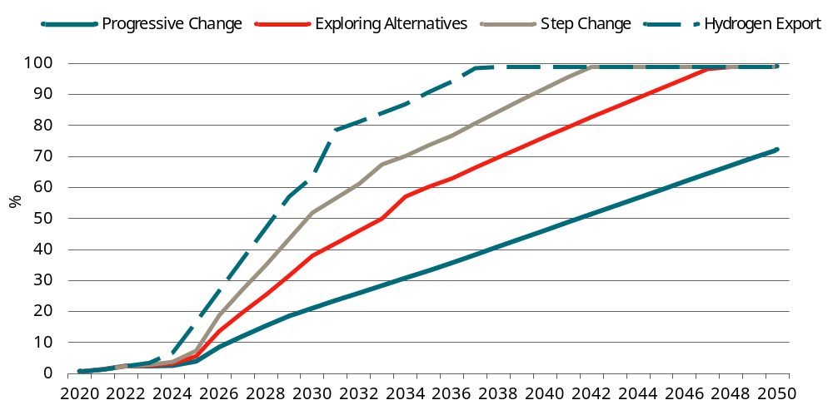
Data source: Graham (2022), Table B.1, 9.59.
5.9 Projected EV fleet share
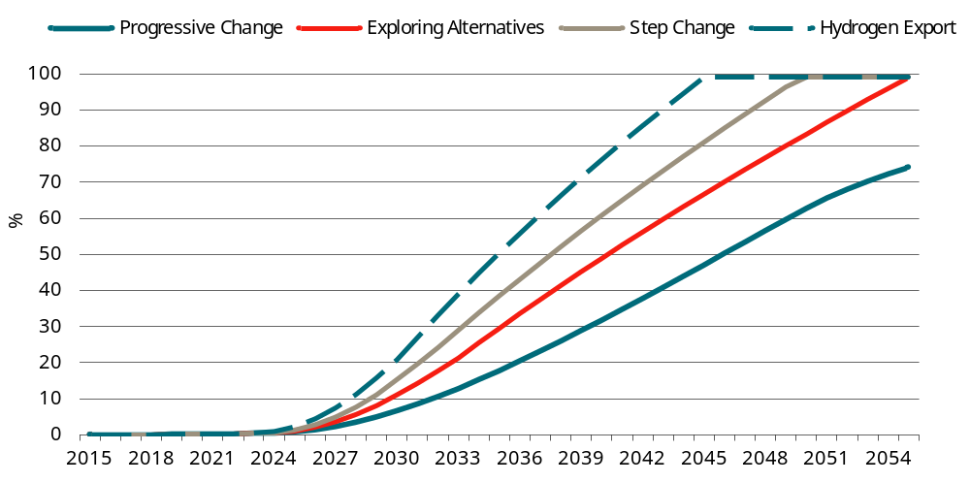
Data source: Graham (2022), Table B.2, p.60
More details of EV assumptions and methodology are provided in the appendix D.

Other impacts

Training and transition costs
As the proposed changes to the NCC are significant, both government and industry would incur some one-off costs associated with raising awareness of the changes and retraining.

Costs to government
Costs to the government are estimated at $250 000, consisting of
- $150 000 for developing education energy efficiency materials such as a handbook, case studies or calculators;
- $60 000 for ongoing maintenance costs for education materials; and
- $40 000 for communication such as organisation information sessions (such as live stream costs)

Costs to industry
Industry stakeholders will also incur one-off costs associated with familiarising themselves with the new code requirements, including:
- the time costs associated with familiarising themselves with the relevant aspects of the new code
- any fees associated with attending associated professional development seminars.
These costs are estimated at around $15.7 million (table 5.10). Details on our approach to estimating these costs are provided below.
5.10 Estimated training costs incurred by industry
 | Number affected a | Seminar  fee b | Time  cost c | Total
 | No. | $'000 | $'000 | $'000
Specialist - energy efficiency | 311 | 15.56 | 184.03 | 199.59
Architecture and design | 8,776 | 438.81 | 7,039.27 | 7,478.08
Engineering | 3,388 | 169.41 | 2,093.07 | 2,262.49
Certification/Surveying | 2,437 | 121.85 | 1,477.26 | 1,599.11
Building Commercial and Residential | 4,400 | 220.00 | 2,404.85 | 2,624.85
Building Commercial | 2,497 | 124.85 | 1,364.77 | 1,489.62
Total | 21,810 | 1,090.49 | 14,563.25 | 15,653.74
a Based on the number of NCC subscribers assuming that the proposed changes will affect around 43.8 per cent of subscribers, based on share from input-output tables (see table 5.10 below). b Assumes seminar fees of $50 per subscriber. c Assumes 10 hours per affected stakeholder (see below for details). Time values are in table 5.4 below).
Source: CIE estimates
These costs are allocated across jurisdictions based on the share of employment of the relevant professions in each jurisdiction (based on 2021 Census data) (table 5.11).
5.11 Allocation of training costs across jurisdictions
 | Costs to industry
 | $ '000
New South Wales | 4,732.19
Victoria | 4,168.08
Queensland | 3,422.98
South Australia | 1,039.71
Western Australia | 1,462.46
Tasmania | 231.19
ACT | 483.52
Northern Territory | 113.61
Total | 15,653.74
Source: ABS 2021 Census, CIE

Industry stakeholders directly affected by the proposed changes
Stakeholders that will be directly affected by the proposed changes to the code (i.e. those that will need to be familiar with some or all of the detail of the changes) are estimated according to the NCC subscription data. These stakeholders who may be affected are working in the following sectors:
- Specialist – energy efficiency;
- Architecture and design;
- Engineering;
- Certification and surveying;
- Building commercial and residential; and
- Building commercial.
There are 46 614 subscribers in these sectors. However, not all these users are involved in the construction of commercial buildings. We use the information in ABS input-output tables to estimate those working with commercial buildings. To allocate the number of NCC subscribers between non-residential and residential buildings, we use the share of the relevant sectors (construction services; and professional, scientific and technical services) used in non-residential building construction sector as share of total building construction. The share is about 43.8 per cent. It is then estimated that 21 810 stakeholders will be directly impacted (table 5.12).
5.12 Estimated number of stakeholders directly affected by proposed changes
 | Number of NCC subscribers | Non-residential building share | Estimated number of affected stakeholders
 | No. | % | No.
Specialist - energy efficiency | 711 | 43.8 | 311
Architecture and design | 20,048 | 43.8 | 8,776
Engineering | 7,740 | 43.8 | 3,388
Certification/Surveying | 5,567 | 43.8 | 2,437
Building Commercial and Residential | 10,051 | 43.8 | 4,400
Building Commercial | 2,497 | 100.0 | 2,497
Total | 46,614 |  | 21,810
Source: ABCB, ABS, CIE

Estimated costs incurred by each stakeholder
It is assumed that each stakeholder directly affected would require 10 hours to familiarise themselves with the relevant changes to the NCC, including attending relevant seminars or workshops.
Time costs are valued based on indicative hourly costs for the relevant professions (table 5.13), assuming:
- a 25 per cent loading for on-costs (such as payroll tax, superannuation etc.) is added to annual salary estimates;
- 230 working days per year; and
- 7.5 hours per working day.
5.13 Indicative salaries for relevant professions
 | Annual  salary a | Annual salary including  on-costs b | Daily salary (including  on-costs) c | Hourly salary (including  on-costs) d
 | $ | $ | $ | $
Architect | 110,687 | 138,359 | 601.56 | 80.21
Service engineer | 85,248 | 106,560 | 463.30 | 61.77
Building surveyors | 83,652 | 104,565 | 454.63 | 60.62
Energy consultant | 81,593 | 101,991 | 443.44 | 59.13
Builder | 75,426 | 94,282 | 409.92 | 54.66
a including bonus; b including 25% loading for on-costs; c 230 working days per year; d 7.5 hours per working day
Source: Association of Consulting Architects; payscale website (www.payscale.com)

Building-level impacts
The evaluation of building-level impacts is derived from a comprehensive analysis that incorporates the findings of energy modelling, alongside previously provided information on energy pricing, emission valuation and baseline uptake of solar PV systems. More specifically, the building-level impacts encompass:
- the modelled changes in energy consumption and emissions; and
- CBA outcomes at the building level, quantifying energy-related cost savings and changes in construction cost per square metre of floor space.
These building-level impacts serves as the foundation for the aggregate impacts, which will be presented in the next chapter. Moreover, the outcomes at the building level plays a crucial role in elucidating the aggregate results.

Building-level energy modelling
As mentioned in the previous chapter, the impact analysis including CBA is based on building level impacts modelled by DeltaQ.
DeltaQ estimates the changes in:
- energy consumption
- GHG emissions, and
- capital-related costs (including both building envelope, HVAC equipment and solar PV systems)
DeltaQ has modelled these key variables:
- for each the three proposed stringency levels
- for 10 building archetypes:
  - Hotels (C3HL)
  - Motels (C3HS)
  - Large office building (C5OL)
  - Medium office building (C5OM)
  - Small office building (C5OS)
  - Big box retail (C6RL)
  - Strip shops (C6RS)
  - Large hospital ward (C9A)
  - School classroom block (C9B)
  - Small hospital (C9AS) which can be applied to Aged care facility (C9C).
- in 8 climate zones (see appendix E for details).
For several NCC building classes (hotels, office buildings and retail buildings) multiple archetypes have been modelled, reflecting different sizes and types of buildings within each NCC class. The DRIS CBA the assumed composition (based on the limited information available — see appendix F for further details) of new floor space across the different modelled archetypes are shown in table 6.1. Note that the CRIS assumed a more even distribution of floor space across the different size categories.
6.1 Composition of new floor space — selected building classes
Size | Hotels | Office buildings | Retail buildings
 | Per cent | Per cent | Per cent
Small | 10 | 10 | 40
Medium | n.a. | 25 | n.a.
Large | 90 | 65 | 60
Total | 100 | 100 | 100
Source: See appendix E for further details.
Based on DeltaQ modelling results, changes in energy-related costs are estimated using state specific time of use price information.

Stringency Level 1: Cost-effective energy efficiency without mandated on-site PV

Modelled changes in energy consumption and emissions
Table 6.2 summarises the percentage change in electricity and gas consumption and GHG emissions under Stringency Level 1 for each archetype and climate zone compared to the reference case (NCC 2022), modelled by DeltaQ.
Note that for each building archetype and climate zone, DeltaQ’s modelling compares a building built to meet the proposed requirements under NCC 2025 with a NCC 2022-compliant building. However, as discussed above, the base case used for the CRIS modelling incorporates voluntary uptake of rooftop solar.
6.2 Modelled energy consumption and emissions change – Stringency Level 1
Fuel or emissions | CZ1  (%) | CZ2  (%) | CZ3  (%) | CZ4  (%) | CZ5  (%) | CZ6  (%) | CZ7  (%) | CZ8  (%)
Hotels (C3HL)
Electricity | -14 | -20 | -17 | -13 | -19 | -14 | -15 | -7
Gas | n/a | 44 | 12 | 8 | 33 | 23 | 12 | 11
GHG | -14 | -16 | -12 | -3 | -11 | 1 | 0 | 6
Motels (C3HS)
Electricity | -21 | -15 | -14 | -12 | -20 | -12 | -13 | -7
Gas | n/a | n/a | n/a | n/a | n/a | n/a | n/a | n/a
GHG | -21 | -15 | -14 | -12 | -20 | -12 | -13 | -7
Large office building (C5OL)
Electricity | -17 | -23 | -23 | -19 | -21 | -19 | -19 | -18
Gas | n/a | -4 | -16 | -2 | 4 | 4 | -3 | 9
GHG | -17 | -22 | -22 | -14 | -20 | -14 | -13 | -1
Medium office building (C5OM)
Electricity | -29 | -29 | -37 | -31 | -31 | -28 | -24 | -18
Gas | n/a | n/a | n/a | n/a | n/a | n/a | n/a | n/a
GHG | -29 | -29 | -37 | -31 | -31 | -28 | -24 | -18
Small office building (C5OS)
Electricity | -17 | -7 | -22 | -17 | -20 | -19 | -14 | -18
Gas | n/a | n/a | n/a | n/a | n/a | n/a | n/a | n/a
GHG | -17 | -7 | -22 | -17 | -20 | -19 | -14 | -18
Big box retail (C6RL)
Electricity | -24 | -28 | -32 | -20 | -25 | -13 | -21 | -16
Gas | n/a | n/a | n/a | n/a | n/a | n/a | n/a | n/a
GHG | -24 | -28 | -32 | -20 | -25 | -13 | -21 | -16
Strip shops (C6RS)
Electricity | -32 | -32 | -38 | -30 | -31 | -24 | -22 | -17
Gas | n/a | n/a | n/a | n/a | n/a | n/a | n/a | n/a
GHG | -32 | -32 | -38 | -30 | -31 | -24 | -22 | -17
Large hospital ward (C9A)
Electricity | -16 | -7 | -14 | -5 | -10 | -3 | -4 | -2
Gas | n/a | -2 | -37 | 14 | 43 | 25 | 4 | 10
GHG | -16 | -7 | -18 | 0 | -9 | 1 | -1 | 5
School classroom block (C9B)
Electricity | -13 | -19 | -17 | -15 | -19 | -17 | -14 | -10
Gas | n/a | n/a | n/a | n/a | n/a | n/a | n/a | n/a
GHG | -13 | -19 | -17 | -15 | -19 | -17 | -14 | -10
Small hospital (C9AS) a
Electricity | -11 | -23 | -14 | -14 | -20 | -24 | -12 | -13
Gas | n/a | n/a | n/a | n/a | n/a | n/a | n/a | n/a
GHG | -11 | -23 | -14 | -14 | -20 | -24 | -12 | -13
a Aged care facility (C9C) is modelled by DeltaQ as a small hospital (C9AS) because aged care building had very short HVAC running hours according to NCC 2022 schedules so wasn't an appropriate test bed.
Note: n/a. – not available, indicates no gas consumption in the baseline
Source: DeltaQ building level modelling
It should be noted that only three archetypes (C3HL, C5OL and C9A) are modelled as dual fuel buildings in the base case. The other seven modelled archetypes do not use gas and therefore there are no changes in gas consumption (entered as ‘n/a’ in the table). Gas is generally used for heating, and thus not relevant for Climate Zone 1.
As can be seen from the table above, the proposed changes in energy efficiency provisions under Stringency Level 1 are estimated to have significant reductions in energy consumption and associated GHG emissions, compared to the reference case (NCC 2022). In most cases, the reduction is estimated to be between 10 and 20 per cent, highest reduction is generally seen in C6RS while lowest reduction in C9A.
As discussed, the avoided electricity-related costs also depend on the time of day those energy savings are expected to occur. The time of day that energy savings are expected to occur varies across different building archetypes, climate zones and seasons.
Charts summarising electricity savings in each hourly interval across an average week in each of the four seasons (for selected building archetype and selected climate zone combination) are presented in appendix F.
In some cases, gas consumption is modelled to increase. This is because the solar admittance measure reduces cooling needs, which achieves overall energy and emissions savings, but increases heating needs in winter. Therefore, some dual-fuel models showed an increase in gas use. This leads to an increase in gas costs in the CBA results (as this is a cost it is shown as a negative number in the CBA below).

Building-level CBA
The building-level CBA for Stringency Level 1 for the large office building archetype (C5OL) for the climate zone that contains the capital city in each state is shown in table 6.3. These estimates are presented in present value terms over the (assumed) 50-year life of the building using a discount rate of 5 per cent.
6.3 Building-level CBA for Stringency Level 1 — C5OL
Impact | NSW (CZ5)  $ per m² | VIC (CZ6)  $ per m² | QLD (CZ2)  $ per m² | WA (CZ5)  $ per m² | SA (CZ5)  $ per m² | TAS (CZ7)  $ per m² | ACT (CZ7)  $ per m² | NT (CZ1)  $ per m²
Change in electricity network capacity costs | 6.01 | 2.07 | 7.38 | 1.48 | 3.36 | 7.40 | 3.37 | 4.89
Change in electricity generation costs | 12.34 | 7.59 | 13.39 | 7.58 | 9.31 | 7.80 | 8.79 | 22.12
Change in electricity network usage costs | 6.78 | 7.18 | 8.08 | 16.89 | 19.33 | 11.41 | 6.91 | 11.40
Change in electricity retail costs | 3.77 | 2.53 | 4.33 | 3.89 | 4.80 | 3.99 | 2.86 | 5.76
Value of electricity exported to the grid | 0.03 | 0.00 | 0.01 | 0.02 | 0.01 | 0.02 | 0.01 | 0.11
Electricity exports — network impacts | -0.01 | 0.00 | -0.01 | -0.01 | -0.01 | 0.00 | 0.00 | -0.01
Change in gas costs | -0.07 | -0.23 | 0.02 | -0.07 | -0.08 | 0.98 | 0.69 | 0.00
Change in GHG emission costs - electricity | 6.86 | 7.91 | 20.62 | 10.15 | 7.37 | 0.66 | 4.50 | 21.89
Change in GHG emission costs – exported electricity | 0.04 | 0.03 | 0.06 | 0.06 | 0.05 | 0.00 | 0.01 | 0.12
Change in GHG emission costs - gas | -0.15 | -0.39 | 0.04 | -0.13 | -0.14 | 1.23 | 1.43 | 0.00
Change in capital-related costs | -19.41 | -12.16 | -34.21 | -19.41 | -19.41 | -14.98 | -14.98 | -31.45
Total | 16.19 | 14.53 | 19.71 | 20.46 | 24.57 | 18.52 | 13.58 | 34.82
Note: Estimates presented in present value terms based on: buildings constructed in 2025 assuming a 50-year life, using a discount rate of 5 per cent.
Source: CIE based on DeltaQ modelling.
The net benefits for all archetypes for each state (capital city climate zone) are summarised in table 6.4. Detailed CBA results for each archetype are provided in appendix H. The proposed changes are estimated to deliver net benefits across all building archetypes.
6.4 Building-level net benefits for Stringency Level 1 by archetype
Building | NSW (CZ5)  $ per m² | VIC (CZ6)  $ per m² | QLD (CZ2)  $ per m² | WA (CZ5)  $ per m² | SA (CZ5)  $ per m² | TAS (CZ7)  $ per m² | ACT (CZ7)  $ per m² | NT (CZ1)  $ per m²
C3HL | 60.89 | 32.32 | 98.06 | 64.10 | 70.86 | 45.62 | 40.83 | 125.77
C3HS | 105.03 | 62.88 | 245.04 | 113.94 | 121.72 | 79.30 | 72.37 | 248.94
C5OL | 16.19 | 14.53 | 19.71 | 20.46 | 24.57 | 18.52 | 13.58 | 34.82
C5OM | 57.24 | 38.99 | 74.22 | 63.88 | 70.32 | 61.18 | 43.28 | 126.91
C5OS | 55.73 | 64.14 | 37.35 | 55.64 | 61.60 | 62.06 | 43.44 | 113.46
C6RL | 189.23 | 56.68 | 328.70 | 208.35 | 234.12 | 245.26 | 182.13 | 404.51
C6RS | 276.91 | 203.29 | 418.59 | 301.94 | 328.60 | 246.74 | 190.69 | 673.48
C9A | 19.62 | 1.92 | 17.00 | 22.56 | 25.13 | 5.62 | 2.59 | 82.46
C9B | 62.16 | 47.90 | 107.85 | 62.22 | 64.87 | 66.37 | 50.38 | 104.83
C9C a | 51.34 | 143.65 | 111.35 | 56.63 | 59.81 | 51.72 | 44.28 | 44.69
a Aged care facility (C9C) is modelled by DeltaQ as a small hospital (C9AS) because aged care building had very short HVAC running hours according to NCC 2022 schedules so wasn’t an appropriate test bed.
Note: Estimates presented in present value terms based on: buildings constructed in 2025 assuming a 50-year life, using a discount rate of 5 per cent.
Source: CIE based on DeltaQ modelling.

Change in energy-related costs
As discussed above, the base case used for the CRIS modelling includes a mix of buildings that voluntarily install rooftop solar and those that do not. Compared with the base case, the increase in the minimum energy efficiency requirements would:
- reduces the consumption of electricity from the grid in some periods
- change the amount of gas consumed — this varies across building archetypes and climate zones:
  - for some building archetypes and climate zones gas consumption increases
  - for other building archetypes and climate zones, gas consumption decreases.
- increase the amount of electricity exported to the grid (due to reduced consumption on site) in some periods for those buildings that voluntarily install rooftop solar.
The value of the avoided costs depends on a range of factors, including: the marginal cost of generation in the relevant location during the relevant periods, the timing of the electricity savings relative to typical network peaks, network capacity and the GHG intensity of electricity in the relevant location.
Although these factors vary across regions, we estimate the change in energy-related costs at the state level. These state-level estimates capture state-based variation in:
- the marginal cost of generation across states (as reflected in differences in the wholesale price);
- typical consumption peaks across states (as reflected in differences in different charging arrangements for peak periods);
- the long-run marginal cost of network supply (as reflected in differences in charging arrangements for peak periods), which in principle should reflect differences in network capacity;
- the emissions intensity of electricity.
The estimated change in energy-related costs per square metre of floor space for each building archetypes that have been modelled (medium office building, large office building, large hospital ward and aged care facility) in each state/territory and in each climate zone are presented below. These estimates are presented in present value terms:
- assuming the building has a life of 50 years;
- using a discount rate of 5 per cent;
- based on a building constructed in 2025 — note that the energy-related benefits vary by the year of construction reflecting:
  - projected changes in the price of energy over time;
  - changes in the social cost of carbon over time;
  - changes in the emissions intensity of electricity over time.

Change in capital-related costs
The proposed changes to the minimum energy efficiency requirements will affect capital-related costs, including:
- costs relating to the building envelope, including:
  - glazing
  - walls (internal and external)
  - roof
- costs relating to HVAC equipment
- costs relating to additional rooftop (and in some cases ground-mounted) solar panels.

DeltaQ cost estimates
Changes in capital-related costs across the ten building archetypes that have been modelled across each climate zone are summarised in table 6.5.
These estimates are presented in present value terms over the (assumed) 50-year life of the building using a discount rate of 5 per cent. Replaceable equipment is assumed to be replaced after 20 years.
6.5 Changes in capital-related costs over building life – Stringency Level 1
Building | 1  $/m² | 2  $/m² | 3  $/m² | 4  $/m² | 5  $/m² | 6  $/m² | 7  $/m² | 8  $/m²
C3HL | 43.89 | 37.99 | 39.16 | 16.96 | 28.36 | 20.91 | 27.20 | 59.46
C3HS | 72.23 | 36.28 | 27.54 | 29.94 | 48.14 | 29.60 | 23.98 | 35.66
C5OL | -31.45 | -34.21 | -33.08 | -10.72 | -19.41 | -12.16 | -14.98 | -9.51
C5OM | -34.32 | -23.84 | -2.84 | -9.46 | -10.82 | -22.19 | -14.77 | -29.42
C5OS | 5.16 | 15.66 | 16.96 | 16.28 | 9.46 | 21.05 | -0.27 | -0.26
C6RL | -54.25 | 7.96 | -1.10 | -71.41 | -3.08 | -52.77 | -46.60 | -135.51
C6RS | 18.90 | 4.16 | 47.56 | 20.51 | 9.38 | -16.25 | -21.21 | -34.74
C9A | -4.79 | -4.90 | -0.67 | -5.18 | -1.51 | -1.78 | -2.00 | 6.07
C9B | 13.10 | 31.83 | 16.36 | 13.13 | 14.74 | 8.09 | 6.68 | 0.67
C9C a | -26.34 | 26.64 | -3.44 | 31.62 | 10.58 | 77.30 | 7.41 | -31.28
a Aged care facility (C9C) is modelled by DeltaQ as a small hospital (C9AS) because aged care building had very short HVAC running hours according to NCC 2022 schedules so wasn't an appropriate test bed.
Note: A positive number indicates that costs are estimated to be lower under proposed changes (i.e. a benefit). A negative number indicates that capital-related costs are estimated to be higher under the proposed changes (i.e. a cost).
Source: DeltaQ modelling, CIE.
A positive number in the table indicates that costs are estimated to be lower under proposed changes compared to the reference case. As shown in the table, there exist capital cost reductions associated with higher energy efficiency stringency requirements for many cases. These peculiar results are due to the following factors:
- to a large extent the capital cost savings are due to smaller HVAC equipment sizes which are in turn a result of better (more energy efficient) building envelopes
- improvements in the Code, for example:
  - clarifying the definition of building envelope to avoid having to install insulation in internal walls
  - relaxation of external wall-glazing U-Value requirements in some building classifications and climate zones.
- some preference changes in glazing selections (i.e. selecting darker windows in the policy case than the base case).
The magnitude of the impacts of these factors may vary across different cost items for different archetypes and climate zones, leading to different total impacts.

Stringency Level 2: Cost-effective energy efficiency standards with mandated on-site PV
Stringency Level 2 involves the same measures to increase the stringency of the minimum energy efficiency standards as for Stringency Level 1, plus a mandatory requirement for rooftop solar.

Modelled changes in energy consumption and emissions
The modelled energy savings under Stringency Level 2 are summarised in table 6.6. Compared with Stringency Level 1, less electricity from the grid is consumed and during some periods, some of the excess electricity generated is exported to the grid.
6.6 Modelled energy consumption and emissions change – Stringency Level 2
Fuel or emissions | CZ1  (%) | CZ2  (%) | CZ3  (%) | CZ4  (%) | CZ5  (%) | CZ6  (%) | CZ7  (%) | CZ8  (%)
Hotels (C3HL)
Electricity | -18 | -27 | -23 | -21 | -27 | -23 | -23 | -16
Gas | n/a | 44 | 12 | 8 | 33 | 23 | 12 | 11
GHG | -18 | -23 | -17 | -7 | -18 | -4 | -3 | 4
Motels (C3HS)
Electricity | -30 | -34 | -29 | -29 | -42 | -36 | -31 | -21
Gas | n/a | n/a | n/a | n/a | n/a | n/a | n/a | n/a
GHG | -57 | -87 | -75 | -74 | -90 | -87 | -77 | -53
Large office building (C5OL)
Electricity | -29 | -38 | -41 | -43 | -40 | -40 | -41 | -44
Gas | n/a | -4 | -16 | -2 | 4 | 4 | -3 | 9
GHG | -29 | -38 | -39 | -32 | -38 | -31 | -25 | -11
Medium office building (C5OM)
Electricity | -72 | -95 | -94 | -100 | -100 | -105 | -102 | -79
Gas | n/a | n/a | n/a | n/a | n/a | n/a | n/a | n/a
GHG | -85 | -117 | -113 | -124 | -122 | -131 | -131 | -101
Small office building (C5OS)
Electricity | -51 | -63 | -68 | -74 | -86 | -86 | -75 | -64
Gas | n/a | n/a | n/a | n/a | n/a | n/a | n/a | n/a
GHG | -74 | -105 | -105 | -113 | -124 | -125 | -115 | -93
Big box retail (C6RL)
Electricity | -49 | -66 | -65 | -58 | -63 | -52 | -57 | -44
Gas | n/a | n/a | n/a | n/a | n/a | n/a | n/a | n/a
GHG | -49 | -67 | -65 | -59 | -64 | -55 | -59 | -45
Strip shops (C6RS)
Electricity | -65 | -72 | -73 | -70 | -72 | -66 | -65 | -48
Gas | n/a | n/a | n/a | n/a | n/a | n/a | n/a | n/a
GHG | -65 | -73 | -74 | -73 | -74 | -71 | -70 | -50
Large hospital ward (C9A)
Electricity | -25 | -26 | -30 | -25 | -29 | -22 | -24 | -22
Gas | n/a | -2 | -37 | 14 | 43 | 25 | 4 | 10
GHG | -25 | -25 | -31 | -15 | -28 | -14 | -14 | -4
School classroom block (C9B)
Electricity | -29 | -47 | -42 | -46 | -54 | -57 | -49 | -34
Gas | n/a | n/a | n/a | n/a | n/a | n/a | n/a | n/a
GHG | -60 | -100 | -94 | -105 | -110 | -122 | -110 | -71
Small hospital (C9AS) b
Electricity | -67 | -69 | -58 | -58 | -72 | -72 | -55 | -41
Gas | n/a | n/a | n/a | n/a | n/a | n/a | n/a | n/a
GHG | -96 | -110 | -97 | -103 | -116 | -117 | -95 | -64
a Change in GHG emissions includes emissions reductions of electricity exported from PV systems to replace electricity from the grid.
b Aged care facility (C9C) is modelled by DeltaQ as a small hospital (C9AS) because aged care building had very short HVAC running hours according to NCC 2022 schedules so wasn't an appropriate test bed.
Note: N/R. – not relevant, indicates no gas consumption in the baseline
Source: DeltaQ building level modelling
Including electricity generated from PV systems exported to the grid to replace grid-wide generation and thus avoiding grid average emissions of electricity generation, the GHG emissions reductions are significantly higher under Stringency Level 2 than under Stringency Level 1.
In many cases, for example motels (C3HS), medium and small office buildings (C5OM and C5OS), classroom blocks (C9B) and aged care facilities (C9C), GHG emissions reduce by more than 100 per cent under Stringency Level 2 compared to the NCC 2022 base case. This is due to exported electricity from solar PV systems which avoids emissions in the grid before it decarbonises.
Gas consumptions in some cases are modelled to increase under Stringency Level 2, for the same reason with Stringency Level 1 mentioned above.
As with Stringency Level 1, charts showing modelled electricity savings by time of day under Stringency Level 2 are presented in appendix F.

Building-level CBA
The building-level CBA for Stringency Level 2 for the large office building archetypes (C5OL) for the climate zone that contains the capital city in each state is shown in table 6.7. These estimates are presented in present value terms over the (assumed) 50-year life of the building using a discount rate of 5 per cent.
6.7 Building-level CBA for Stringency Level 2 — C5OL
Impact | NSW (CZ5)  $ per m² | VIC (CZ6)  $ per m² | QLD (CZ2)  $ per m² | WA (CZ5)  $ per m² | SA (CZ5)  $ per m² | TAS (CZ7)  $ per m² | ACT (CZ7)  $ per m² | NT (CZ1)  $ per m²
Change in network electricity capacity costs | 7.53 | 3.02 | 8.72 | 1.82 | 4.27 | 10.44 | 4.89 | 6.86
Change in electricity generation costs | 15.99 | 10.08 | 15.81 | 9.88 | 11.37 | 10.85 | 11.90 | 28.19
Change in electricity network usage costs | 9.08 | 10.81 | 10.13 | 22.97 | 26.29 | 17.56 | 10.45 | 13.87
Change in electricity retail costs | 4.89 | 3.59 | 5.20 | 5.20 | 6.29 | 5.83 | 4.09 | 7.34
Value of electricity exported to the grid | 0.06 | 0.00 | 0.02 | 0.05 | 0.01 | 0.03 | 0.01 | 0.20
Electricity exports — network impacts | -0.02 | -0.01 | -0.01 | -0.02 | -0.02 | -0.01 | -0.01 | -0.03
Change in gas costs | -0.07 | -0.23 | 0.02 | -0.07 | -0.08 | 0.98 | 0.69 | 0.00
Change in GHG emission costs - electricity | 9.27 | 11.30 | 26.19 | 13.72 | 9.97 | 0.95 | 6.48 | 27.77
Change in GHG emission costs – exported electricity | 0.10 | 0.06 | 0.12 | 0.14 | 0.10 | 0.00 | 0.02 | 0.23
Change in GHG emission costs - gas | -0.15 | -0.39 | 0.04 | -0.13 | -0.14 | 1.23 | 1.43 | 0.00
Change in capital-related costs | -24.65 | -16.46 | -38.30 | -24.65 | -24.65 | -19.02 | -19.02 | -36.39
Total | 22.02 | 21.77 | 27.92 | 28.92 | 33.40 | 28.84 | 20.95 | 48.04
Note: Estimates presented in present value terms based on: buildings constructed in 2025 assuming a 50-year life, using a discount rate of 5 per cent.
Source: CIE based on DeltaQ modelling.
The net benefits for all archetypes for each state and territory (capital city climate zone) are summarised in table 6.8. Detailed CBA results for each archetype are provided in appendix H.
Key findings from the building-level analysis are as follows:
- The proposed changes are estimated to deliver net benefits across all building archetypes.
- The net benefits for each archetype are higher than for Stringency Level 1.
6.8 Building-level net benefits for Stringency Level 2 by archetype
Building | NSW (CZ5)  $ per m² | VIC (CZ6)  $ per m² | QLD (CZ2)  $ per m² | WA (CZ5)  $ per m² | SA (CZ5)  $ per m² | TAS (CZ7)  $ per m² | ACT (CZ7)  $ per m² | NT (CZ1)  $ per m²
C3HL | 64.20 | 37.63 | 103.70 | 69.59 | 76.54 | 51.21 | 45.20 | 134.45
C3HS | 116.29 | 94.76 | 299.19 | 139.58 | 143.60 | 106.35 | 94.10 | 341.09
C5OL | 22.02 | 21.77 | 27.92 | 28.92 | 33.40 | 28.84 | 20.95 | 48.04
C5OM | 83.37 | 83.67 | 127.99 | 104.90 | 110.97 | 118.62 | 85.82 | 200.82
C5OS | 82.84 | 112.69 | 95.25 | 98.50 | 104.27 | 124.08 | 89.06 | 191.71
C6RL | 253.78 | 160.15 | 447.70 | 305.72 | 333.63 | 371.73 | 278.27 | 565.53
C6RS | 355.06 | 323.57 | 562.57 | 416.45 | 444.98 | 395.74 | 303.04 | 907.73
C9A | 25.48 | 9.97 | 25.97 | 31.83 | 34.51 | 15.25 | 10.86 | 94.43
C9B | 88.49 | 89.42 | 166.83 | 100.59 | 101.88 | 119.54 | 92.26 | 187.11
C9C a | 68.60 | 180.81 | 161.74 | 89.73 | 90.37 | 88.74 | 75.00 | 169.48
a Aged care facility (C9C) is modelled by DeltaQ as a small hospital (C9AS) because aged care building had very short HVAC running hours according to NCC 2022 schedules so wasn’t an appropriate test bed.
Note: Estimates presented in present value terms based on: buildings constructed in 2025 assuming a 50-year life, using a discount rate of 5 per cent.
Source: CIE based on DeltaQ modelling.

Change in energy-related costs
The impacts of Stringency Level 2 on energy-related costs are as follows.
- For buildings that would voluntarily install rooftop solar in the base case scenario, the impacts are the same as for Stringency Level 1; an increase in the minimum energy efficiency requirements leading to:
  - a reduction in electricity consumed from the grid
  - an increase in electricity exported to the grid
  - a change in gas consumption (which varies across building archetypes and climate zones).
- For buildings that would not voluntarily install rooftop solar in the base case scenario, the impacts include:
  - a reduction in electricity consumption from the grid (greater than Stringency Level 1)
  - an increase in electricity exported to the grid (greater than Stringency Level 1)
  - a change in gas consumption, which varies across building archetypes and climate zones (the impact on gas consumption would be the same as Stringency Level 1 as the installation of rooftop solar has not impact on gas consumption).
These changes in energy-related costs are measured as previously described.

Change in capital-related costs
The main difference to Stringency Level 1 is PV system-related costs, including the cost of the system (including replacement of the system after 20 years) and the cost of annual maintenance. As a result, capital-related costs are significantly higher under Stringency Level 2, compared with Stringency Level 1.

Stringency Level 3: Least cost net zero carbon ready buildings

Modelled changes in energy consumption and emissions
DeltaQ has modelled Stringency Level 3 with several scenarios to consider the following variations:
- Baseline – dual-fuel forever versus assumed electrification in Year 15
- PV system – rooftop PV only versus rooftop and ground-based PV systems (expanded PV)
- Electrification planning and date in the test case – unplanned electrification in Year 15 (that does not have any ‘electrification readiness’ preparation at the beginning), planned electrification in Year 15 (that has ‘electrification readiness’ preparation at the beginning) and immediate electrification from beginning.
The ground-based PV systems are used under the expanded PV scenario for Stringency Level 3 because, for most archetypes, all the available roof space is already used to accommodate the PV required for Stringency Level 2, with no space left for the additional PV that is used in dual-fuel buildings to offset the incremental emissions associated with the gas-based appliances.
As mentioned previously, only three archetypes (C3HL, C5OL and C9A) have gas consumption in the base case and are thus relevant for the modelling of electrification (i.e. all other archetypes are already fully electrified). For more detailed information, please see DeltaQ’s whole building modelling report.

Building-level CBA
The building-level CBA for Stringency Level 3 for the large office building archetypes (C5OL) for the climate zone that contains the capital city in each state is shown in table 6.9.
6.9 Stringency Level 3 estimated costs and benefits — C5OL
Impact | NSW (CZ5)  $ per m² | VIC (CZ6)  $ per m² | QLD (CZ2)  $ per m² | WA (CZ5)  $ per m² | SA (CZ5)  $ per m² | TAS (CZ7)  $ per m² | ACT (CZ7)  $ per m² | NT (CZ1)  $ per m²
Change in network electricity capacity costs | 6.92 | -1.85 | 8.35 | 1.67 | 4.05 | -37.77 | -16.71 | 6.66
Change in electricity generation costs | 11.79 | 3.99 | 13.80 | 7.27 | 6.65 | -2.62 | -1.61 | 27.79
Change in electricity network usage costs | 7.65 | 6.07 | 9.33 | 19.25 | 21.41 | -0.91 | -0.84 | 13.66
Change in electricity retail costs | 3.95 | 1.23 | 4.72 | 4.23 | 4.82 | -6.20 | -2.87 | 7.22
Value of electricity exported to the grid | 0.06 | 0.01 | 0.02 | 0.05 | 0.01 | 0.05 | 0.02 | 0.20
Electricity exports — network impacts | -0.02 | -0.01 | -0.01 | -0.02 | -0.02 | -0.01 | -0.01 | -0.03
Change in gas costs | 2.68 | 7.12 | 1.41 | 2.78 | 2.89 | 23.60 | 16.53 | 1.01
Change in GHG emission costs - electricity | 7.66 | 6.66 | 24.22 | 11.34 | 8.24 | 0.13 | 0.90 | 27.40
Change in GHG emission costs – exported electricity | 0.09 | 0.07 | 0.11 | 0.14 | 0.10 | 0.01 | 0.04 | 0.23
Change in GHG emission costs - gas | 5.60 | 12.05 | 3.39 | 4.82 | 5.39 | 29.66 | 34.52 | 1.76
Change in capital-related costs | -38.43 | -51.93 | -47.69 | -38.43 | -38.43 | -54.84 | -54.84 | -55.59
Total | 7.95 | -16.60 | 17.66 | 13.09 | 15.11 | -48.91 | -24.88 | 30.33
Note: Costs and benefits estimated in present value terms over the 50-year life of a building constructed in 2025, using a discount rate of 5 per cent.
Source: CIE based on DeltaQ modelling.
The net benefits for all archetypes for each state and territory (capital city climate zone) are summarised in table 6.10. Detailed CBA results for each archetype are provided in appendix H.
Key findings from the building-level analysis are as follows:
- The net benefits for the three relevant archetypes (C3HL, C5OL and C9A) vary across states and territories. Negative impacts are observed for C3HL in NSW, WA and SA; for C5OL in VIC, TAS and ACT; and for C9A in almost all states and territories expect NT.
- Compared to the Stringency Level 2, the net benefits for the three relevant archetypes (C3HL, C5OL and C9A) are lower, whilst other archetypes deliver the same net benefits.
6.10 Building-level net benefits for Stringency Level 3 by archetype
Building | NSW (CZ5)  $ per m² | VIC (CZ6)  $ per m² | QLD (CZ2)  $ per m² | WA (CZ5)  $ per m² | SA (CZ5)  $ per m² | TAS (CZ7)  $ per m² | ACT (CZ7)  $ per m² | NT (CZ1)  $ per m²
C3HL | -6.99 | 34.89 | 19.96 | -6.93 | -8.65 | 10.61 | 28.01 | 123.10
C3HS | 116.29 | 94.76 | 299.19 | 139.58 | 143.60 | 106.35 | 94.10 | 341.09
C5OL | 7.95 | -16.60 | 17.66 | 13.09 | 15.11 | -48.91 | -24.88 | 30.33
C5OM | 83.37 | 83.67 | 127.99 | 104.90 | 110.97 | 118.62 | 85.82 | 200.82
C5OS | 82.84 | 112.69 | 95.25 | 98.50 | 104.27 | 124.08 | 89.06 | 191.71
C6RL | 253.78 | 160.15 | 447.70 | 305.72 | 333.63 | 371.73 | 278.27 | 565.53
C6RS | 355.06 | 323.57 | 562.57 | 416.45 | 444.98 | 395.74 | 303.04 | 907.73
C9A | -54.17 | -18.68 | -69.77 | -53.78 | -52.32 | -28.15 | -19.53 | 71.03
C9B | 88.49 | 89.42 | 166.83 | 100.59 | 101.88 | 119.54 | 92.26 | 187.11
C9C a | 68.60 | 180.81 | 161.74 | 89.73 | 90.37 | 88.74 | 75.00 | 169.48
a Aged care facility (C9C) is modelled by DeltaQ as a small hospital (C9AS) because aged care building had very short HVAC running hours according to NCC 2022 schedules so wasn’t an appropriate test bed.
Note: Estimates presented in present value terms based on: buildings constructed in 2025 assuming a 50-year life, using a discount rate of 5 per cent.
Source: CIE based on DeltaQ modelling.

Saving in energy-related costs
Table 6.11 reports the estimated additional saving in energy-related costs for the three relevant modelled building archetypes in selected climate zone relevant to the capital city in each of the states and territories under Stringency Level 3 relative Stringency Level 2. As can be seen from the table, the savings are lower under Stringency Level 3 (as shown by negative numbers) in some cases. This is because savings in electricity consumption and related costs are lower with electrification readiness requirement.
6.11 Estimate additional savings in energy-related costs over building life under Stringency Level 3 relative to Stringency Level 2
Building | NSW (CZ5)  $ per m² |  |  | VIC (CZ6)  $ per m² |  | QLD (CZ2)  $ per m² |  | WA (CZ5)  $ per m² |  | SA (CZ5)  $ per m² |  | TAS (CZ7)  $ per m² |  | ACT (CZ7)  $ per m² |  | NT (CZ1)  $ per m²
C3HL |  | 10.56 | 50.46 |  | -0.78 |  | 5.23 |  | -3.44 |  | 7.13 |  | 30.55 |  | 29.42
C5OL |  | -0.29 | -2.90 |  | -0.87 |  | -2.05 |  | -4.51 |  | -41.93 |  | -10.00 |  | 1.48
C9A |  | 12.36 | 18.66 |  | -1.07 |  | 6.40 |  | 5.17 |  | -5.96 |  | 7.06 |  | 17.89
a positive numbers indicate further cost savings, while negative numbers indicate less cost savings under Stringency Level 3 than Stringency Level 2.
Note: Estimates presented in present value terms based on: buildings constructed in 2025 assuming a 50-year life, using a discount rate of 5 per cent.
Source: CIE estimates based on DeltaQ modelling.

Change in capital-related costs
Table 6.12 reports estimated additional savings in capital-related costs over each building’s life (assumed to be 50 years) in present value terms using a discount rate of 5 per cent under Stringency Level 3 relative to Stringency Level 2, for the three relevant archetypes.
6.12 Changes in capital-related costs over building life – Stringency Level 3
Building | 1  $/m² | 2  $/m² | 3  $/m² | 4  $/m² | 5  $/m² | 6  $/m² | 7  $/m² | 8  $/m²
C3HL | -40.77 | -82.96 | -24.90 | -45.22 | -81.75 | -53.20 | -47.73 | -78.48
C5OL | -19.20 | -9.39 | -14.55 | -34.15 | -13.78 | -35.48 | -35.82 | -62.04
C9A | -41.29 | -94.68 | -12.18 | -41.74 | -92.00 | -47.31 | -37.44 | -54.20
Note: A positive number indicates that costs are estimated to be lower under Stringency Level 3 than Stringency Level 2. A negative number indicates that capital-related costs are estimated to be higher (i.e. additional cost).
Source: DeltaQ modelling, CIE.
It can be seen that the three archetypes (C3HL, C5OL and C9A) relevant for electrification are all estimated to have higher construction costs under Stringency Level 3 than under Stringency Level 2 due to costs associated with electrification and/or electrification readiness.
This universal increase in capital costs together with some reduction in energy-related cost savings reported above explains lower net benefit under Stringency Level 3 than Stringency Level 2 for the three archetypes.

Aggregate impacts
The building level impacts presented in the previous chapter are aggregated into state and national results, using the commercial building projections by Strategy.Policy.Research (SPR) for Department of Climate Change, Energy, the Environment and Water (DCCEEW), and taking into account solar PV and EV charging in the baseline.

Summary of aggregate impacts
Table 7.1 summarises the CBA results for each of the 3 options (compared to current practice under the current code). All costs and benefits are expressed in net present value terms (using a discount rate of 5 per cent) over the life (assumed to be 50 years) of all commercial buildings to be constructed over the 10-year period from 2025 to 2034. Benefit-cost ratios are not reported in the table because there are capital cost savings under Stringency Level 1.
Key findings are as follows:
- All options under consideration are estimated to deliver significant net benefits (relative to current NCC requirements) indicating a strong case to update the NCC.
- Stringency Level 1 is estimated to deliver net benefits of around $6.8 billion in net present value terms.
- Stringency Level 2 is estimated to deliver the highest net benefits of all the options — around $10 billion in net present value terms — indicating this is the preferred option from a CBA perspective.
- The estimated impacts of Stringency Level 3 are slightly lower than Stringency Level 2 at around $9.4 billion.
7.1 Estimated impacts of proposed options
Impact | Stringency Level 1  $ million | Stringency Level 2  $ million | Stringency Level 3  $ million
Building energy impacts
Avoided electricity network capacity costs | 938.92 | 1 568.49 | 1 440.25
Avoided electricity wholesale costs | 1 838.74 | 3 272.75 | 2 917.15
Avoided electricity network usage costs | 1 768.84 | 3 596.60 | 3 341.81
Avoided electricity retail costs | 681.97 | 1 265.68 | 1 154.88
Electricity exported to grid | 44.96 | 291.44 | 291.48
Electricity exports — network costs | - 10.66 | - 45.74 | - 45.76
Avoided gas costs | - 28.66 | - 28.66 | 432.08
Avoided GHG emissions – electricity | 1 249.57 | 2 366.95 | 2 221.08
Avoided GHG emission — exported electricity | 70.50 | 440.17 | 440.26
Avoided GHG emissions – gas | - 56.11 | - 56.11 | 865.82
Capital costs | 341.68 | -2 610.88 | -3 670.75
Total building energy impacts | 6 839.75 | 10 060.67 | 9 388.30
Other costs
Costs to government to support change | - 0.65 | - 0.65 | - 0.65
Industry training costs | - 15.65 | - 15.65 | - 15.65
Total other costs | - 16.31 | - 16.31 | - 16.31
Total | 6 823.45 | 10 044.37 | 9 371.99
Note: Estimates presented in net present value terms over an assumed 50-year life of all buildings constructed over the 10 year period from 2025 to 2034, using a discount rate of 5 per cent.
Source: CIE based on DeltaQ modelling.
These estimates are generally lower than those presented in the CRIS. Key changes from the CRIS include the following:
- The DRIS estimates reflect revised DeltaQ modelling for some archetypes.
- Various inputs including prices and projections for the future GHG intensity of electricity were updated to reflect more recent information.
- Estimates of the network costs associated with additional exports of electricity to the grid were included.
- Some building types that were not explicitly modelled (including warehouses, factories and laboratories) were included in the aggregate results.
- For building types where multiple archetypes were modelled (i.e. hotels, offices and retail buildings), the shares were updated based on further research.
- For Stringency Level 3 — where owners of dual fuel buildings under the base case are able to choose to either: ‘electrify now’; or to offset gas consumption by installing additional solar panels (mostly ground mounted) — the modelling for the DRIS assumes that 90 per cent would choose to ‘electrify now’ and 10 per cent would choose the ‘dual fuel offset’ (this compares to a 50:50 split assumed in the CRIS). This change largely reflected stakeholder feedback; some stakeholders questioned the practicality of ground-mounted solar panels. This is likely to particularly be an issue in CBD areas where shading may limit the feasibility of this option.

Commercial building projections
The aggregate impacts are based on the building-level costs and benefits (per square metre of floor space) multiplied by projected construction of new buildings over the period from 2025 to 2034.
The most recent, comprehensive projection of commercial buildings has been the Commercial Buildings Energy Consumption baseline study conducted by SPR for DCCEEW in 2022. The study has provided end of financial year commercial building stock projections up to 2050, with granular details of regions, climate zones, and commercial building classifications. It provides three projection scenarios – the initial base case projection, and the two updated projections corresponding to AEMO’s Step Change and Progress Change scenarios (chart 7.2).
We use the Step Change scenario as the basis for the projection of new commercial buildings because the Step Change scenario is identified as the most likely scenario by AEMO.
7.2 Commercial building stock projections
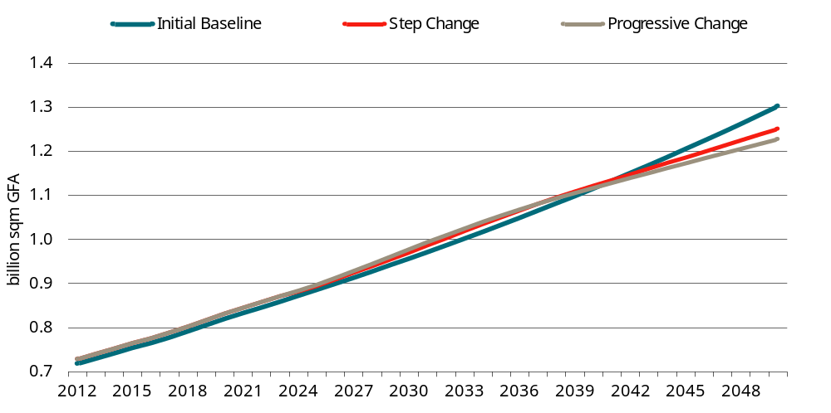
Data source: SPR (2022).
It was projected that, under the Step Change scenario, new construction of commercial buildings will be 14.83 million m² in 2025, growing to a peak of about 18.8 million m² in 2032, before falling to 15.94 million m² by 2050. The largest components of new buildings are assembly/public building (Class 9b), offices (Class 5), warehouses (Class 7b), factories (Class 8(2)) and retail (Class 6) (chart 7.3).
7.3 New construction of commercial buildings: Step change
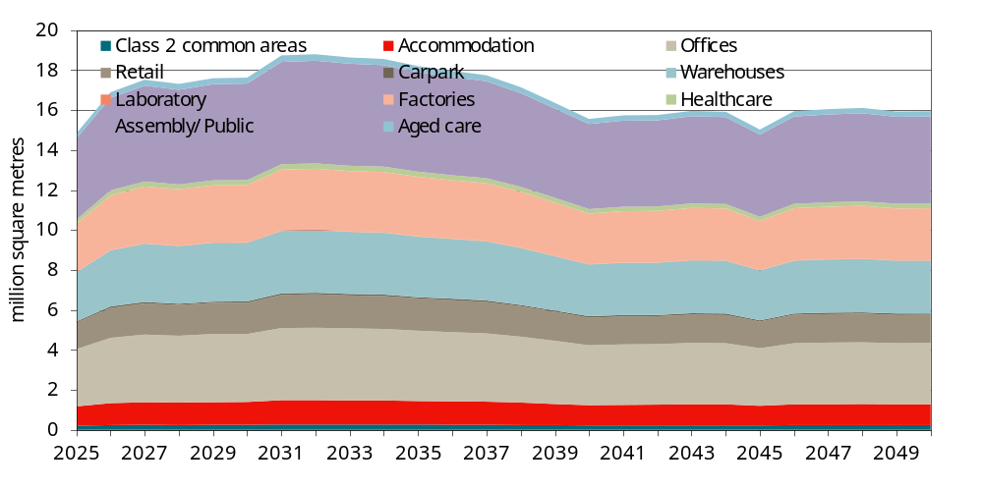
Data source: SPR (2022).
Chart 7.4 provides a breakdown of new commercial building construction by climate zone (CZ). The majority of new constructions, approximately 40 per cent, are situated in CZ 6, followed by CZ 5, which accounts for approximately 25 per cent, and CZ 2 with around 15 per cent. Notably, there is no new construction of commercial buildings in CZ 8.
7.4 New construction of commercial buildings by climate zone
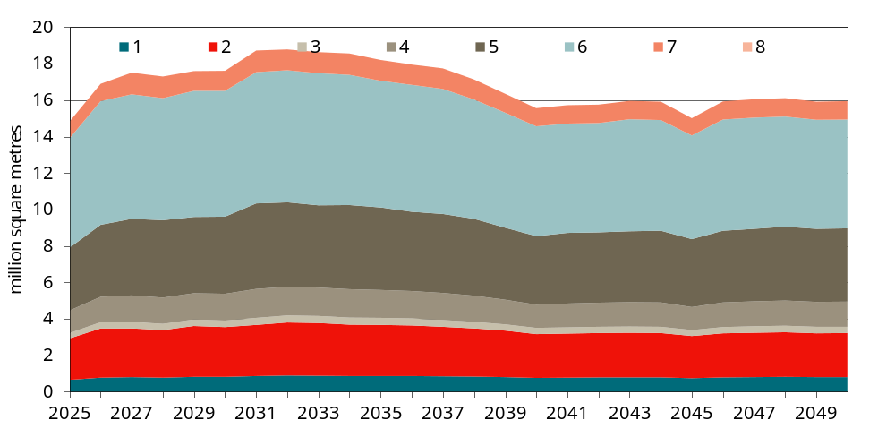
Data source: SPR (2022).
Chart 7.5 reports the distribution of new commercial building construction by state and territory. Victoria leads with the largest share, exceeding 30 per cent, followed by NSW at around 25 per cent, Queensland at around 18 per cent, and WA with a range of 13-16 per cent.
7.5 New construction of commercial buildings by jurisdiction
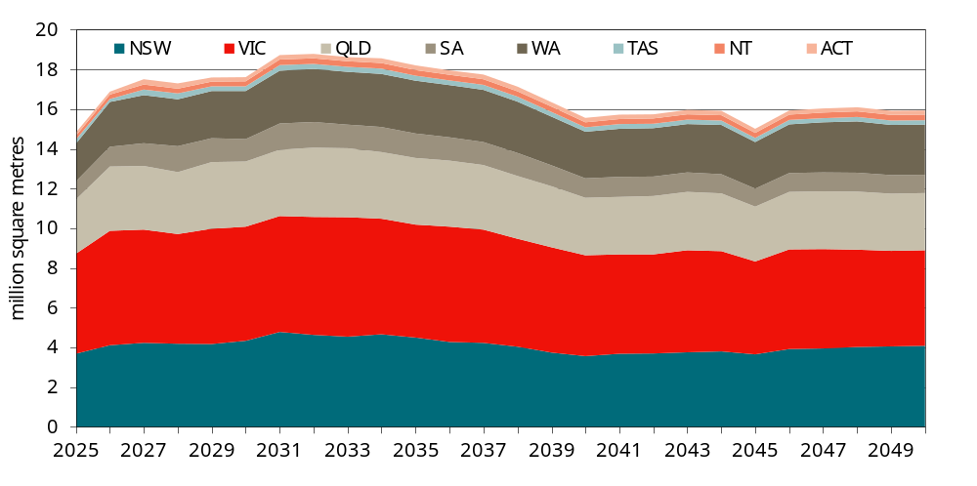
Data source: SPR (2022).

Building energy impacts
The aggregate impacts of the building energy measures across each of the 3 stringencies is discussed below.

Aggregate building energy impacts by state and territory
The aggregate building energy impacts (excluding the requirement for mandatory EV charging, which is discussed below) are estimated by aggregating up from the building-level (on a square metre basis) up to the state and national level using the above building projections.

Stringency Level 1: Cost-effective energy efficiency without mandated on-site PV
The aggregate building energy impacts for each state and territory under Stringency Level 1 are summarised in table 7.6. At the national level, the proposed increase in the minimum energy efficiency standards is estimated to deliver a net benefit of around $6.8 billion in net present value terms over the 50-year life of buildings constructed over the 10-year period from 2025, using a discount rate of 5 per cent.
7.6 Estimated impacts by state/territory — Stringency Level 1
Impact | NSW  $ million | VIC  $ million | QLD  $ million | WA  $ million | SA  $ million | TAS  $ million | ACT  $ million | NT  $ million | Total  $ million
Avoided network capacity costs | 299.7 | 200.7 | 272.7 | 45.3 | 44.3 | 39.2 | 15.5 | 21.6 | 938.9
Avoided wholesale costs | 464.8 | 451.7 | 499.9 | 202.5 | 101.4 | 24.2 | 22.4 | 71.9 | 1 838.7
Avoided network usage costs | 251.9 | 469.1 | 305.2 | 444.9 | 207.4 | 35.5 | 18.3 | 36.6 | 1 768.8
Avoided retail costs | 152.5 | 168.2 | 161.7 | 103.9 | 53.0 | 14.8 | 8.4 | 19.5 | 682.0
Electricity exported to grid | 12.8 | 13.6 | 7.6 | 5.4 | 2.5 | 1.6 | 0.8 | 0.7 | 45.0
Electricity exports — network costs | - 2.7 | - 3.7 | - 1.6 | - 1.5 | - 0.8 | - 0.2 | - 0.2 | 0.0 | - 10.7
Avoided gas costs | - 6.6 | - 14.3 | - 1.1 | - 3.2 | - 2.0 | - 1.2 | - 0.2 | - 0.1 | - 28.7
Avoided GHG emissions – electricity | 127.1 | 247.6 | 540.5 | 188.5 | 79.5 | 1.6 | 5.5 | 59.3 | 1 249.6
Avoided GHG emissions — electricity exported | 9.4 | 25.6 | 19.1 | 9.7 | 5.3 | 0.1 | 0.5 | 0.7 | 70.5
Avoided GHG emissions – gas | - 15.3 | - 25.5 | - 3.0 | - 6.0 | - 4.2 | - 1.5 | - 0.5 | - 0.1 | - 56.1
Capital costs | 67.0 | 3.7 | 172.6 | 70.0 | 27.6 | - 2.9 | - 5.2 | 8.8 | 341.7
Total | 1 360.4 | 1 537.0 | 1 973.6 | 1 059.3 | 514.1 | 111.3 | 65.2 | 218.9 | 6 839.8
Note: Estimates presented in net present value terms over an assumed 50-year life of all buildings constructed over the 10 year period from 2025 to 2034, using a discount rate of 5 per cent.
Source: CIE based on DeltaQ modelling.
Under Stringency Level 1:
- There would be a significant reduction in electricity consumption and therefore electricity-related costs, including reduced GHG emissions.
- There would also be a small increase in electricity exported to the grid — although there is no mandatory requirement for rooftop solar under Stringency Level 1, our base case assumes some voluntary uptake of solar. The increase in the minimum energy efficiency standards would result in these buildings consuming less energy, meaning more of the energy generated from the rooftop solar would be available for export.
- Electricity-related savings would be partly offset by a relatively small increase in gas consumption and a corresponding increase in GHG emissions.
- It is estimated that the improvements in energy efficiency could be achieved with lower capital-related costs than under the base case.

Stringency Level 2: Cost-effective energy efficiency standards with mandated on-site PV
The aggregate impacts of the proposed increase in the minimum energy efficiency standards and mandatory rooftop solar by state and territory are summarised in table 7.7. At the national level, the proposed increase in the minimum energy efficiency standards is estimated to deliver a net benefit of around $10.1 billion in net present value terms over the 50-year life of buildings constructed over the 10-year period from 2025, using a discount rate of 5 per cent.
7.7 Estimated impacts by state/territory — Stringency Level 2
Impact | NSW  $ million | VIC  $ million | QLD  $ million | WA  $ million | SA  $ million | TAS  $ million | ACT  $ million | NT  $ million | Total  $ million
Avoided network capacity costs | 497.6 | 414.4 | 401.7 | 69.8 | 72.0 | 55.3 | 24.0 | 33.6 | 1 568.5
Avoided wholesale costs | 861.2 | 904.3 | 785.9 | 348.4 | 165.5 | 47.8 | 43.8 | 115.8 | 3 272.7
Avoided network usage costs | 503.5 | 1 126.7 | 530.2 | 843.9 | 410.9 | 83.1 | 43.6 | 54.7 | 3 596.6
Avoided retail costs | 279.3 | 366.8 | 257.7 | 189.3 | 97.2 | 27.9 | 16.7 | 30.6 | 1 265.7
Value of electricity exported to grid | 76.9 | 79.7 | 57.3 | 38.2 | 15.1 | 9.5 | 5.0 | 9.7 | 291.4
Electricity exports — network costs | - 10.6 | - 13.3 | - 10.2 | - 6.4 | - 3.0 | - 0.9 | - 0.8 | - 0.5 | - 45.7
Avoided gas costs | - 6.6 | - 14.3 | - 1.1 | - 3.2 | - 2.0 | - 1.2 | - 0.2 | - 0.1 | - 28.7
Avoided GHG emissions – electricity | 253.3 | 542.1 | 961.2 | 346.3 | 153.4 | 3.4 | 12.0 | 95.3 | 2 366.9
Avoided GHG emissions — electricity exported | 54.5 | 146.6 | 136.9 | 59.4 | 29.9 | 0.8 | 3.2 | 8.9 | 440.2
Avoided GHG emissions – gas | - 15.3 | - 25.5 | - 3.0 | - 6.0 | - 4.2 | - 1.5 | - 0.5 | - 0.1 | - 56.1
Capital costs | - 654.0 | - 964.8 | - 374.7 | - 331.7 | - 169.2 | - 42.2 | - 41.7 | - 32.7 | -2 610.9
Total | 1 839.7 | 2 562.8 | 2 741.9 | 1 548.1 | 765.6 | 182.1 | 105.3 | 315.3 | 10 060.7
Note: Estimates presented in net present value terms over an assumed 50-year life of all buildings constructed over the 10 year period from 2025 to 2034, using a discount rate of 5 per cent.
Source: CIE based on DeltaQ modelling.
Compared with Stringency Level 1, capital costs are higher (i.e. there is net increase in capital costs) reflecting the additional costs associated with installation of rooftop solar.
However, these costs are outweighed by significant additional electricity-related savings (including GHG emissions), due to reduced consumption of electricity from the grid and, to a lesser extent, increased export of electricity to the grid. Consumption of gas is unaffected by mandatory rooftop solar (relative to Stringency Level 1).

Stringency Level 3: Least cost net zero carbon ready buildings
Details of the state-level impacts for Stringency Level 3 are summarised in table 7.8. At the national level, net benefits are estimated at around $9.4 billion, slightly lower than the net benefits of Stringency Level 2. This indicates that the incremental impact of Stringency Level 3 (compared with Stringency Level 2) is slightly negative (assuming dual fuel buildings are not required to convert to fully electric in the future).
The incremental impact of Stringency Level 3 is relatively modest (compared to the other elements of the proposal) because only 3 of the 10 archetypes modelled (the large hotel, the large office building and large hospital ward) were modelled as dual fuel buildings.
7.8 Estimated impacts by state/territory — Stringency Level 3
Impact | NSW  $ million | VIC  $ million | QLD  $ million | WA  $ million | SA  $ million | TAS  $ million | ACT  $ million | NT  $ million | Total  $ million
Avoided network capacity costs | 453.1 | 380.8 | 387.8 | 65.9 | 68.3 | 35.5 | 16.0 | 32.8 | 1 440.2
Avoided wholesale costs | 762.5 | 767.5 | 746.5 | 316.8 | 139.9 | 35.4 | 35.1 | 113.5 | 2 917.2
Avoided network usage costs | 463.9 | 1 031.0 | 511.7 | 793.8 | 382.0 | 68.5 | 37.7 | 53.2 | 3 341.8
Avoided retail costs | 251.9 | 326.9 | 246.9 | 176.5 | 88.5 | 20.9 | 13.3 | 29.9 | 1 154.9
Value of electricity exported to grid | 76.9 | 79.7 | 57.3 | 38.2 | 15.1 | 9.5 | 5.0 | 9.7 | 291.5
Electricity exports — network costs | - 10.6 | - 13.3 | - 10.2 | - 6.4 | - 3.0 | - 0.9 | - 0.8 | - 0.5 | - 45.8
Avoided gas costs | 101.2 | 176.8 | 35.7 | 57.8 | 26.3 | 20.1 | 8.7 | 5.5 | 432.1
Avoided GHG emissions – electricity | 232.4 | 487.2 | 930.4 | 323.0 | 141.8 | 2.7 | 10.2 | 93.4 | 2 221.1
Avoided GHG emissions — electricity exported | 54.5 | 146.7 | 136.8 | 59.4 | 29.9 | 0.8 | 3.2 | 8.9 | 440.3
Avoided GHG emissions – gas | 234.2 | 316.0 | 96.7 | 107.9 | 54.1 | 26.4 | 20.2 | 10.2 | 865.8
Capital costs | - 910.8 | -1 341.4 | - 545.4 | - 476.7 | - 240.0 | - 56.7 | - 54.8 | - 44.9 | -3 670.8
Total | 1 709.3 | 2 357.9 | 2 594.2 | 1 456.3 | 703.0 | 162.1 | 93.8 | 311.6 | 9 388.3
Note: Estimates presented in net present value terms over an assumed 50-year life of all buildings constructed over the 10 year period from 2025 to 2034, using a discount rate of 5 per cent.
Source: CIE based on DeltaQ modelling.
Consistent with the objective of these provisions, there is a reduction in the costs associated with gas consumption (including GHG emissions) reflecting a shift towards fully-electric buildings (i.e. 90 per cent of buildings are assumed to choose the ‘electrify now’ option). However, this is offset by a corresponding increase in electricity consumption.
There is also an increase in aggregate costs, reflecting the additional costs associated of complying with the least cost net zero emissions requirements for the relevant buildings.
Note that the central case assumes that these buildings would operate as dual fuel buildings over their full life. This result suggests that based on current technologies, the lifetime cost of dual fuel buildings tends to be lower than ‘fully electric’ buildings for these archetypes.

Aggregate reduction in GHG emissions
Avoided GHG emissions across the different stringency levels are shown in chart 7.9.
- Under all stringency levels:
  - avoided GHG emissions initially increases as the effect of the increasing number of buildings built under the new code requirements outweighs the impact of declining carbon intensity of electricity supply
  - as the number of buildings built under the new codes reaches a peak (at the end of the 10-year regulatory period), avoided GHG emissions start to decline as the grid continues to decarbonise
  - avoided GHG emissions then level off as the GHG-intensity of electricity supply reaches its minimum and then tails off to zero as the buildings built under the new code are assumed to reach the end of their life.
- Avoided GHG emissions are significantly higher for Stringency Levels 2 and 3, compared with Stringency Level 1.
- The difference between Stringency Level 2 and Stringency Level 3 is minimal in the earlier years, with the shift to fully electric buildings initially broadly carbon neutral. As the grid decarbonises, fully electric buildings become less carbon intensive, compared with dual fuel buildings, so more GHG emissions are avoided under Stringency Level 3.
7.9 Avoided GHG emissions
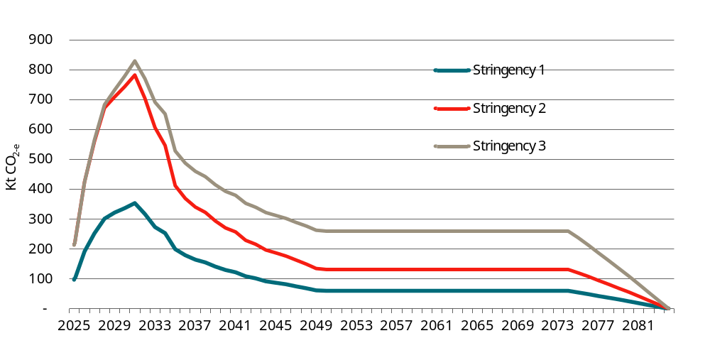
Data source: CIE based on DeltaQ modelling.
On a cumulative basis (see chart 7.10), avoided GHG emissions are estimated at around:
- 6.2 Mt CO2-e for Stringency Level 1
- 13.6 Mt CO2-e for Stringency Level 2
- 19.6 Mt CO2-e for Stringency Level 3.
The cumulative difference between Stringency Levels 2 and 3 across the whole period is therefore around 6 Mt CO_{2-e}.
7.10 Cumulative avoided GHG emissions
Data source: CIE based on DeltaQ modelling.

Electricity grid impacts
The impacts on the electricity grid are broadly captured through the CBA methodology. One of the challenges associated with the energy transition is managing periods of low operational demand (see box 5.6 above). Where there is high rooftop (and possibly ground mounted) solar penetration, in certain conditions this can displace gas and coal-fired generation which provides critical system security service. In these circumstances, AEMO may need to intervene in the market to keep the grid in a secure operating state.
According to AEMO forecasts, minimum demand in NEM regions will decline significantly as the energy transition proceeds (chart 7.11).
7.11 Forecast minimum operational demand by NEM region
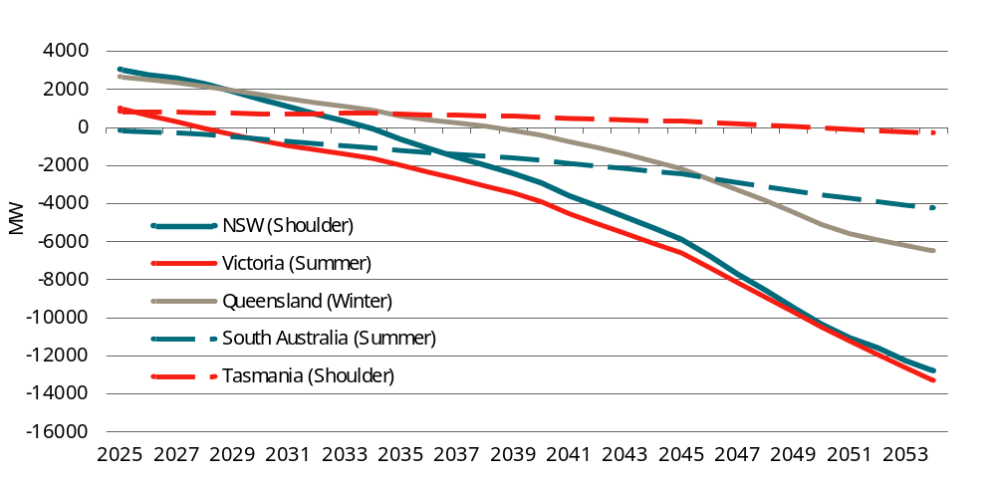
Note: Based on AEMO’s Step Change scenario with a 50 per cent probability of exceedance.
Data source: AEMO forecasts.
The forecast changes in minimum operational demand to 2034 — the end of the 10-year regulatory period when the proposed changes to the NCC will have their maximum impact — in each NEM region is shown in table 7.12.
7.12 Forecast change in minimum demand by NEM Region
 | 2025  MW | 2034  MW | Change  MW
New South Wales | 3049 | -60 | -3109
Victoria | 1013 | -1618 | -2631
Queensland | 2666 | 912 | -1754
South Australia | -163 | -1068 | -905
Tasmania | 836 | 739 | -97
Source: AEMO
The proposed changes to the NCC will contribute to decline in minimum operational demand (and the associated challenges) through both:
- reducing total energy consumption in minimum demand periods (through more stringent minimum energy efficiency requirements)
- increasing energy generated from rooftop (and potentially ground mounted) solar panels, some of which would be exported to the grid.
Our hourly time-of-use model provides some insights into the potential impacts on minimum operational demand at the aggregate level in each of the NEM regions (compared to the base case). Table 7.13 shows the potential impact of the proposed changes to the NCC (Stringency 1 and Stringency 2) on minimum demand by 2034 (see appendix I for further details).
7.13 Potential impacts on minimum operational demand
 | Stringency 1  MW | Share of overall decline - Stringency 1  MW | Stringency Level 2  MW | Share of overall decline - Stringency 2  MW
NSW | 170 | 5.5 | 500 | 16.1
Victoria | 270 | 10.3 | 700 | 26.6
Queensland | 150 | 8.6 | 335 | 19.1
South Australia | 52 | 5.7 | 140 | 15.5
Tasmania | 10 | 10.3 | 26 | 26.7
Source: CIE estimates (see appendix H for further details).
These estimates suggest that the proposed changes to the NCC will make some contribution to the overall decline in minimum operational demand by 2034.
It should be noted that the estimated reduction in minimum operational demand compares to the base case (i.e. under NCC 2022), not current minimum demand. The AEMO forecasts would already factor in new construction and some assumed improvements in energy efficiency in commercial buildings and increased rooftop solar penetration.

Scenario analysis
To more fully understand the results and the extent to which they are sensitive to particular assumptions, extensive sensitivity and scenario analysis has been undertaken, as discussed below.

Future electrification
A key uncertainty relates to the possibility that dual-fuel buildings will be required to convert to fully electric at some point in the future.
As most of the buildings that will be constructed during the 2025-2034 regulatory period will still be operating by 2050, this will be necessary (together with decarbonisation of the electricity grid) to achieve net zero emission buildings, consistent with economywide net zero commitments.
However, as the policy or market mechanisms to encourage or force dual-fuel buildings to convert to fully electric buildings are currently not clear, the central case assumes that dual-fuel buildings will continue to operate with both gas and electricity.
That said, it is also plausible that dual fuel buildings will be forced to convert to fully electric at some point in the future. Policy and market mechanisms that could force dual-fuel buildings to convert in the future include:
- a policy requirement from the relevant state government;
- inability to source gas (at a competitive price) in the future;
- inability to make a like-for-like replacement of the gas-fired boiler in the future.
As a shift towards fully electric buildings (either immediately or at some point in the future) — a key rationale behind Stringency Level 3 — it is important to test the impacts of each of the stringencies under scenarios where dual-fuel buildings are required to convert to fully electric in the future.
As the mechanism that prompts dual fuel buildings to electrify (i.e. convert to fully electric) or the timing is not known, we assume that the conversion occurs at the time that the gas boiler needs to be replaced. For consistency with the assumed life of HVAC equipment used elsewhere, we assume this occurs after 20 years.

Mandatory conversion to fully electric buildings in all states and territories
The first scenario we test is where dual fuel buildings in all states and territories are required to convert to fully electric after 20 years (i.e. around when the gas boiler requires replacing).
A key finding under this scenario, the net benefits of Stringency Level 3 exceed Stringency Level 2, implying Stringency Level 3 is the preferred option (see table 7.14).
- Under Stringency Level 3, the costs associated with the future conversion to fully electric buildings is lower because:
  - most buildings are already fully electric (we assumed that under Stringency Level 3, 90 per cent of buildings would choose to be fully electric from the beginning); and
  - it would be cheaper for the remaining dual fuel buildings to convert to fully electric.
- This finding is relatively insensitive to the assumed timing of the future conversion.
7.14 Future electrification scenario — summary
Impact | Stringency Level 1  $ million | Stringency Level 2  $ million | Stringency Level 3  $ million
Avoided network capacity costs | 932.32 | 1 562.20 | 1 477.15
Avoided wholesale costs | 1 815.27 | 3 249.28 | 3 013.56
Avoided network usage costs | 1 749.98 | 3 577.75 | 3 409.68
Avoided retail costs | 674.63 | 1 258.39 | 1 185.06
Electricity exported to grid | 44.96 | 291.43 | 291.48
Electricity exports — network costs | - 10.66 | - 45.74 | - 45.76
Avoided gas costs | - 19.45 | - 19.45 | 293.65
Avoided GHG emissions – electricity | 1 244.65 | 2 362.03 | 2 233.92
Avoided GHG emissions – exported electricity | 70.49 | 440.17 | 440.26
Avoided GHG emissions – gas | - 34.54 | - 34.54 | 533.01
Capital costs | 338.46 | -2 614.10 | -2 404.51
Total building energy impacts | 6 806.12 | 10 027.42 | 10 427.48
Note: Estimates presented in net present value terms over an assumed 50-year life of all buildings constructed over the 10 year period from 2025 to 2034, using a discount rate of 5 per cent.
Source: CIE based on DeltaQ modelling.
This analysis also demonstrates the results are highly dependent on future policy requirement on electrification which cannot be known with certainty at the present time.

Mandatory future conversion to fully electric buildings in Victoria and the ACT only
It is also possible that a future requirement for dual fuel buildings to convert to fully electric could apply in some states, but not others.
- A future requirement to convert dual fuel buildings to fully electric is arguably more likely in Victoria and the ACT as both governments have a plan/roadmap in place to support electrification of buildings (although neither government has formally announced a policy that mandates future transitioning of dual fuel commercial buildings to fully electric at the present time).
- By contrast, the other jurisdictions have not publicly released any plans to support electrification of commercial building at the present time.
We therefore test the scenario where there is a future requirement for commercial dual fuel buildings to transition to fully electric in Victoria and the ACT only.
Table 7.15 compares the net impacts of Stringency Level 2 and Stringency Level 3 under this scenario. The difference between Stringency Level 2 and Stringency Level 3 can be interpreted as the incremental impact of Stringency Level. Under this scenario:
- There is an incremental net benefit from Stringency 3 in Victoria and the ACT (reflecting lower future conversion costs relative to the base case).
- There would be an incremental net cost from Stringency 3 in the other jurisdictions (as the full lifetime social costs associated with dual fuel buildings are lower than fully electric buildings based on current technologies and energy prices).
- There is a net cost at the national level with the with the net benefits to Victoria and the ACT not enough to outweigh the net costs in the other jurisdictions.
7.15 Alternative future electrification scenario — net impacts
 | NSW  $ million | VIC  $ million | QLD  $ million | WA  $ million | SA  $ million | TAS  $ million | ACT  $ million | NT  $ million | Total  $ million
Stringency 2 | 1 839.7 | 2 557.1 | 2 741.9 | 1 548.1 | 765.6 | 182.1 | 104.9 | 315.3 | 10 054.6
Stringency 3 | 1 709.3 | 2 712.8 | 2 594.2 | 1 456.3 | 703.0 | 162.1 | 107.8 | 311.6 | 9 757.2
Difference | - 130.4 | 155.7 | - 147.7 | - 91.7 | - 62.6 | - 19.9 | 2.9 | - 3.6 | - 297.4
Note: Estimates presented in net present value terms over an assumed 50-year life of all buildings constructed over the 10 year period from 2025 to 2034, using a discount rate of 5 per cent.
Source: CIE based on DeltaQ modelling.

Break-even analysis
Uncertainty about future policy choices can also be considered probabilistically, rather than deterministically. Rather than modelling one ‘future electrification’ scenario or the other, the future policy choice can be conceptualised as a probability; there is some probability that dual fuel buildings will be forced to ‘electrify’ in the future.
Under this approach CBA results can be expressed as an ‘expected value’. The expected value is the probability-weighted average of the different future electrification scenarios.
Although in principle, there is some probability that dual fuel buildings will be forced to electrify in the future, we have no basis to make an assessment on what that probability is. Where a key variable is unknown, break-even analysis can provide some useful insights for decision-makers. In this context, the break-even point is the probability that dual fuel buildings will be forced to electrify in the future where Stringency Level 2 and Stringency Level 3 deliver the same net benefits.
Based on the modelling results, the provisions to achieve net zero buildings at least cost (i.e. Stringency Level 3) ‘breaks even’ (implying the costs are equal to the benefits), where the probability that dual-fuel buildings are required to convert to fully electric in the future is around 63 per cent (where all other assumptions are held constant, including: 10 per cent of buildings would choose the dual fuel offset; and 90 per cent would choose to ‘electrify now’; and all dual fuel buildings would be required to convert to fully electric 20 years after construction).
7.16 Break-even future electrification probability
Future scenario | Probability of scenario occurring  Per cent | Stringency Level 2 – net impact  $ million | Stringency Level 3 – net impact  $ million | Incremental impact of Stringency Level 3  $ million
No future electrification | 37% | 10 060.67 | 9 388.30 | - 672.37
Future electrification | 63% | 10 027.42 | 10 427.48 | 400.06
Expected outcome |  | 10 039.83 | 10 039.83 | 0.00
Note: Estimates presented in net present value terms over an assumed 50-year life of all buildings constructed over the 10 year period from 2025 to 2034, using a discount rate of 5 per cent. Assumes that under Stringency Level 3, 50 per cent of building choose the dual-fuel offset; and 50 per cent choose to electrify now. Also assumes electrification occurs 20 years after construction.
Source: CIE based on DeltaQ modelling.
This implies the following:
- If the probability that dual fuel buildings will be required to convert to fully electric when the gas boiler requires replacement is considered greater than 63 per cent, Stringency Level 3 is likely to deliver the highest net benefits.
- If the probability that dual fuel buildings will be required to convert to fully electric when the gas boiler requires replacement is considered less than 63 per cent, Stringency Level 2 is likely to deliver the highest net benefits.

No uptake of solar in the base case
Although our assumption about the uptake of solar in the base case was based on the best available information, this was based on a limited sample size, and it is not clear to what extent the sample is representative of all buildings at the national level.
To provide an indication of the aggregate net impacts of difference between the NCC 2022 minimum standards and the proposed 2025 options, table 7.17 summarises the CBA results under the scenario where there is no voluntary uptake of rooftop solar. Under this scenario, the impacts of the proposed changes are significantly higher for Stringency Level 2 and Stringency Level 3 (compared with the central case CBA results); note that this reflects the (incorrect) attribution of the impacts of voluntary uptake of rooftop solar to the proposed changes to the NCC.
Although the magnitude of the net benefits from Scenario 2 and Scenario 3 are greater, the ordering of options does not change.
7.17 No voluntary uptake of rooftop solar in base case — summary
Impact | Stringency Level 1  $ million | Stringency Level 2  $ million | Stringency Level 3  $ million
Avoided network capacity costs | 981.64 | 2 536.70 | 2 408.46
Avoided wholesale costs | 1 918.53 | 5 385.65 | 5 030.05
Avoided network usage costs | 1 896.37 | 6 321.43 | 6 066.64
Avoided retail costs | 719.48 | 2 136.57 | 2 025.77
Electricity exported to grid | 0.00 | 640.53 | 640.57
Electricity exports — network costs | 0.00 | - 89.75 | - 89.77
Avoided gas costs | - 28.66 | - 28.66 | 432.08
Avoided GHG emissions – electricity | 1 320.07 | 4 015.41 | 3 869.54
Avoided GHG emissions – exported electricity | 0.00 | 959.49 | 959.59
Avoided GHG emissions – gas | - 56.11 | - 56.11 | 865.82
Capital costs | 341.68 | -6 816.24 | -7 876.11
Total building energy impacts | 7 092.99 | 15 005.02 | 14 332.65
Note: Estimates presented in net present value terms over an assumed 50-year life of all buildings constructed over the 10 year period from 2025 to 2034, using a discount rate of 5 per cent.
Source: CIE based on DeltaQ modelling.

Alternative glazing cost estimates
DeltaQ’s modelling suggests that it is possible to reduce the cost of glazing (relative to the base case), while also improving energy performance (through lower SHGC). However, glazing with lower SHGC is generally (i.e. on average) more expensive.
For each building archetype/climate zone, table 7.18 compares DeltaQ’s estimates of the change in glazing costs, compared to an alternative approach based on the average relationship between price and SHGC. In general, the alternative approach leads to significantly higher glazing costs compared with DeltaQ’s estimates.
7.18 Estimated change in glazing costs
Archetype | Climate zone | DeltaQ estimates ($) | Alternative approach ($)
C3HS | 1 | -1 155 | 0
C3HS | 2 | -1 155 | 2 646
C3HS | 3 | -3 709 | 144
C3HS | 4 | -3 709 | 144
C3HS | 5 | -1 155 | 2 646
C3HS | 6 | -3 709 | 144
C3HS | 7 | -3 709 | 144
C3HS | 8 | -1 155 | 0
C3HL | 1 | -11 776 | 68 632
C3HL | 2 | 9 728 | 67 417
C3HL | 3 | 0 | 14 480
C3HL | 4 | 0 | 14 480
C3HL | 5 | 9 728 | 67 417
C3HL | 6 | 0 | 14 480
C3HL | 7 | -21 504 | 14 584
C3HL | 8 | -11 776 | 68 632
C5OS | 1 | 3 599 | - 203
C5OS | 2 | -1 628 | 0
C5OS | 3 | 1 971 | - 203
C5OS | 4 | -1 628 | 0
C5OS | 5 | -1 628 | 0
C5OS | 6 | -1 628 | 0
C5OS | 7 | -1 628 | 0
C5OS | 8 | -1 628 | 3 728
C5OM | 1 | 7 620 | - 430
C5OM | 2 | -3 447 | 0
C5OM | 3 | 4 173 | - 430
C5OM | 4 | -3 447 | 0
C5OM | 5 | -3 447 | 0
C5OM | 6 | -3 447 | 0
C5OM | 7 | -3 447 | 0
C5OM | 8 | -3 447 | 7 895
C5OL | 1 | 0 | 0
C5OL | 2 | 0 | 39 905
C5OL | 3 | -32 453 | 189 139
C5OL | 4 | 0 | 39 905
C5OL | 5 | 0 | 39 905
C5OL | 6 | 0 | 39 905
C5OL | 7 | 0 | 39 905
C5OL | 8 | 0 | 185 793
C6RS | 1 | -1 952 | 0
C6RS | 2 | 0 | 10 719
C6RS | 3 | 0 | 15 190
C6RS | 4 | 0 | 10 719
C6RS | 5 | -1 952 | 0
C6RS | 6 | 0 | 10 719
C6RS | 7 | -1 952 | 0
C6RS | 8 | -1 952 | 4 471
C6RL | 1 | 0 | 0
C6RL | 2 | 0 | 0
C6RL | 3 | 0 | 0
C6RL | 4 | 0 | 0
C6RL | 5 | 0 | 0
C6RL | 6 | 0 | 0
C6RL | 7 | 0 | 0
C6RL | 8 | 0 | 0
C9A | 1 | 15 120 | - 403
C9A | 2 | -15 120 | 38 075
C9A | 3 | -8 280 | 38 075
C9A | 4 | 6 840 | 38 002
C9A | 5 | -15 120 | 38 075
C9A | 6 | -8 280 | 38 075
C9A | 7 | -8 280 | 38 075
C9A | 8 | 21 960 | 37 148
C9B | 1 | -3 648 | 0
C9B | 2 | -3 648 | 0
C9B | 3 | 4 416 | 7 899
C9B | 4 | -3 648 | 0
C9B | 5 | -3 648 | 0
C9B | 6 | -3 648 | 0
C9B | 7 | -3 648 | 0
C9B | 8 | 8 064 | 7 899
C9C | 1 | 0 | 0
C9C | 2 | -3 606 | 21 018
C9C | 3 | 0 | 0
C9C | 4 | 0 | 0
C9C | 5 | -3 606 | 21 018
C9C | 6 | 0 | 0
C9C | 7 | 0 | 0
C9C | 8 | 0 | 4 435
Note: Negative numbers represent a reduction in the cost of glazing compared with the base case. Positive numbers represent an increase in cost of glazing compared to the base case.
Source: DeltaQ, CIE.
In general, the impact of using these alternative glazing cost estimates in the CBA is relatively modest (table 7.19). As the change in glazing costs is a relatively small component of the total, the overall change in capital-related costs is also generally small relative to the other costs and benefits.
7.19 Alternative glazing cost estimates — summary
Impact | Stringency Level 1  $ million | Stringency Level 2  $ million | Stringency Level 3  $ million
Avoided network capacity costs | 938.92 | 1 568.49 | 1 440.25
Avoided wholesale costs | 1 838.74 | 3 272.75 | 2 917.15
Avoided network usage costs | 1 768.84 | 3 596.60 | 3 341.81
Avoided retail costs | 681.97 | 1 265.68 | 1 154.88
Electricity exported to grid | 44.96 | 291.44 | 291.48
Electricity exports — network costs | - 10.66 | - 45.74 | - 45.76
Avoided gas costs | - 28.66 | - 28.66 | 432.08
Avoided GHG emissions – electricity | 1 249.57 | 2 366.95 | 2 221.08
Avoided GHG emissions – exported electricity | 70.50 | 440.17 | 440.26
Avoided GHG emissions – gas | - 56.11 | - 56.11 | 865.82
Capital costs | 97.52 | -2 855.05 | -3 914.92
Total building energy impacts | 6 595.59 | 9 816.51 | 9 144.14
Note: Estimates presented in net present value terms over an assumed 50-year life of all buildings constructed over the 10 year period from 2025 to 2034, using a discount rate of 5 per cent.
Source: CIE based on DeltaQ modelling.

Additional costs: external shading
There are various ways that buildings would be able to achieve compliance with the proposed changes to the NCC. These approaches could include:
- selecting darker glazing (i.e. the approach modelled by DeltaQ in the central case)
- reducing the window-to-wall ratio
- installing external shading.
The approach modelled by DeltaQ incurs the lowest financial cost.
- However, if the glass is darker (or windows are smaller) than is preferred, there may be some amenity/aesthetic costs that have not been measured.
- Alternatively, some building owners (and their design teams) could choose to preserve their preferred design through installing external shading (which involves additional financial cost).
These design restrictions mainly apply to the large office buildings, which tend to be more extensively glazed than other building types.

Building-level shading costs
Using the approach set out in chapter 2, table 7.20 summarises the additional costs associated with shading (based on Public Comment Draft glazing stringency modelled by DeltaQ) and the building-level impacts when the shading costs are included (for the capital city climate zone in each state/territory).
It is worth noting that based on public consultation feedback, the ABCB has decided to withdraw the glazing stringency to the same level included in the CRIS. Under that stringency level, it is unlikely to anticipate shading will be commonly used due to the NCC requirements:
The technical analysis shows that a building can meet the stringency proposed for solar admittance while maintaining typical window-to-wall ratios without using shading. This means that the proportion of buildings that use shading is expected to be about the same as it is currently.
7.20 Building level impacts incorporating shading costs — large office buildings
 | NSW (CZ5)  $ per m² | VIC (CZ6)  $ per m² | QLD (CZ2)  $ per m² | WA (CZ5)  $ per m² | SA (CZ5)  $ per m² | TAS (CZ7)  $ per m² | ACT (CZ7)  $ per m² | NT (CZ1)  $ per m²
Stringency 1
Net impact | 16.19 | 14.53 | 19.71 | 20.46 | 24.57 | 18.52 | 13.58 | 34.82
Shading costs | - 11.83 | - 45.94 | - 13.44 | - 11.83 | - 11.83 | - 38.04 | - 38.04 | - 55.67
Total | 4.36 | - 31.41 | 6.27 | 8.63 | 12.75 | - 19.52 | - 24.47 | - 20.84
Stringency 2
Net impact | 22.02 | 21.77 | 27.92 | 28.92 | 33.40 | 28.84 | 20.95 | 48.04
Shading costs | - 11.83 | - 45.94 | - 13.44 | - 11.83 | - 11.83 | - 38.04 | - 38.04 | - 55.67
Total | 10.19 | - 24.17 | 14.49 | 17.09 | 21.57 | - 9.20 | - 17.10 | - 7.63
Stringency 3
Net impact | 7.95 | - 16.60 | 17.66 | 13.09 | 15.11 | - 48.91 | - 24.88 | 30.33
Shading costs | - 11.83 | - 45.94 | - 13.44 | - 11.83 | - 11.83 | - 38.04 | - 38.04 | - 55.67
Total | - 3.88 | - 62.54 | 4.23 | 1.26 | 3.28 | - 86.95 | - 62.92 | - 25.34
Note: Estimates presented in net present value terms over an assumed 50-year, using a discount rate of 5 per cent.
Source: CIE based on DeltaQ modelling.

Aggregate impacts
Although the building-level impacts are significant, the aggregate impacts are relatively modest as the proposed changes are likely to materially restrict design choices mostly for large office buildings.
At the aggregate level, external shading would increase capital costs by around $139 million in present value terms over the period from 2025 to 2034, using a discount rate of 5 per cent (assuming only large office buildings would need to install external shading). When these costs are included in the CBA (see table 7.21):
- all options still deliver significant net benefits
- there is no change in the ordering of options.
7.21 Aggregate impacts with shading costs included
 | Stringency 1  $ million | Stringency 2  $ million | Stringency 3  $ million
Net impact (excluding shading costs) | 6 839.8 | 10 060.7 | 9 388.3
Shading costs | - 139.1 | - 139.1 | - 139.1
Total impacts | 6 700.6 | 9 921.5 | 9 249.2
Note: Estimates presented in net present value terms over an assumed 50-year life of all buildings constructed over the 10 year period from 2025 to 2034, using a discount rate of 5 per cent.
Source: CIE based on DeltaQ modelling.

Realisation rate
The central case for the CBA assumes full realisation. However, the extent to which modelled energy savings are realised in practice was identified as a key issue for the CRIS.
Although there is some evidence that modelled energy savings are not fully realised, the extent of the discrepancy between modelled and actual outcomes is not clear. Nevertheless, we test the extent to which this issue affects the CBA outcome using realisation rate of:
- 50 per cent (table 7.22), and
- 75 per cent (table 7.23).
These realisation rates are applied to all energy-related benefits, although the evidence that modelled benefits are not fully realised relates to energy efficiency changes, rather than the benefits from rooftop (or ground-mounted) solar.
7.22 CBA results using realisation rate of 50 per cent
Impact | Stringency Level 1  $ million | Stringency Level 2  $ million | Stringency Level 3  $ million
Avoided network capacity costs | 469.46 | 784.24 | 720.12
Avoided wholesale costs | 919.37 | 1 636.37 | 1 458.58
Avoided network usage costs | 884.42 | 1 798.30 | 1 670.91
Avoided retail costs | 340.99 | 632.84 | 577.44
Electricity exported to grid | 22.48 | 145.72 | 145.74
Electricity exports — network costs | - 5.33 | - 22.87 | - 22.88
Avoided gas costs | - 14.33 | - 14.33 | 216.04
Avoided GHG emissions – electricity | 624.79 | 1 183.47 | 1 110.54
Avoided GHG emissions – exported electricity | 35.25 | 220.08 | 220.13
Avoided GHG emissions – gas | - 28.05 | - 28.05 | 432.91
Capital costs | 341.68 | -2 610.88 | -3 670.75
Total building energy impacts | 3 590.72 | 3 724.89 | 2 858.77
Note: Estimates presented in net present value terms over an assumed 50-year life of all buildings constructed over the 10 year period from 2025 to 2034, using a discount rate of 5 per cent.
Source: CIE based on DeltaQ modelling.
7.23 CBA results using realisation rate of 75 per cent
Impact | Stringency Level 1  $ million | Stringency Level 2  $ million | Stringency Level 3  $ million
Avoided network capacity costs | 704.19 | 1 176.37 | 1 080.19
Avoided wholesale costs | 1 379.05 | 2 454.56 | 2 187.86
Avoided network usage costs | 1 326.63 | 2 697.45 | 2 506.36
Avoided retail costs | 511.48 | 949.26 | 866.16
Electricity exported to grid | 33.72 | 218.58 | 218.61
Electricity exports — network costs | - 8.00 | - 34.31 | - 34.32
Avoided gas costs | - 21.50 | - 21.50 | 324.06
Avoided GHG emissions – electricity | 937.18 | 1 775.21 | 1 665.81
Avoided GHG emissions – exported electricity | 52.87 | 330.12 | 330.20
Avoided GHG emissions – gas | - 42.08 | - 42.08 | 649.37
Capital costs | 341.68 | -2 610.88 | -3 670.75
Total building energy impacts | 5 215.23 | 6 892.78 | 6 123.54
Note: Estimates presented in net present value terms over an assumed 50-year life of all buildings constructed over the 10 year period from 2025 to 2034, using a discount rate of 5 per cent.
Source: CIE based on DeltaQ modelling.
Although the magnitude of the net benefits is relatively sensitive to lower (but broadly plausible) realisation rates, the key conclusions are broadly unchanged. In particular:
- All stringency levels are estimated to deliver net benefits (compared to current arrangements).
- Stringency Level 2 is estimated to deliver the largest net benefits in all scenarios (note that Stringency Level 2 would appear even more favourable if the realisation rates were applied only to the energy efficiency requirements consistent with the evidence).
- When a 50 per cent realisation rate is applied, the net benefits of Stringency Level 1 is greater than Stringency Level 3.

Other sensitivity testing
We also tested the sensitivity of the CBA results to various other input parameters and assumptions as set out in table 7.24.
7.24 Alternative assumptions for sensitivity testing
Parameter/assumption | Central case | Alternative case(s)
Regulatory period | 10 years (2025-2034) | 20 years
Discount rate | 5 per cent | - 2 per cent  - 7 per cent
Building life | 50 years | - 40 years  - 60 years
Equipment life | 20 years | - 15 years
Carbon value | SCC 2.0% discount rate | - SCC 1.5% discount rate  - SCC 2.5% discount rate  - IA (low)  - IA (medium)  - IA (high)
Avoided retail costs | 15% (based on retail margin). | - No avoided retail costs (all retail costs are fixed).
Share of relevant buildings choosing dual fuel offset option (Stringency Level 3) | 10% | - 100%  - 100% with future electrification
Share of relevant buildings choosing ‘electrify now’ option (for Stringency Level 3) | 90% | - 100%  - 100% with future electrification
Learning ratea | No future learning rate | - Future costs decrease by 20% over 10 years (1.8% per year)  - Future PV costs decrease by 10% over 10 years.  - Applied as a reduction in plant costs of 5% over 10 years (0.5 per cent per year)
a Based on advice from the paper by Hutley (2023).
Source: CIE.
The CBA results for each stringency under the alternative assumptions set out in table 7.24 are summarised in table 7.25. Unless otherwise stated (i.e. explicitly varied to test the sensitivity of the results), the CBA results are expressed in net present value terms over the 50-year life of all buildings constructed over the 10-year regulatory period from 2025 to 2034. The stringency with the highest net present value under each of the alternative assumptions are highlighted in blue.
7.25 CBA results under different sensitivity assumptions — net present value
Sensitivity scenario | Stringency Level 1  $ million | Stringency Level 2  $ million | Stringency Level 3  $ million
Central case | 6 840 | 10 061 | 9 388
Regulatory period (20 years) | 10 622 | 15 399 | 14 428
Discount rate (2 per cent) | 12 227 | 18 810 | 18 268
Discount rate (7 per cent) | 5 079 | 7 250 | 6 579
Building life (40 years) | 6 501 | 9 563 | 8 885
Building life (60 years) | 7 049 | 10 368 | 9 702
Equipment life (15 years) | 6 759 | 9 523 | 8 717
Social cost of carbon (1.5%) | 7 631 | 11 783 | 11 549
Social cost of carbon (2.5%) | 6 371 | 9 041 | 8 081
IA Low carbon value | 6 093 | 8 432 | 7 385
IA Medium carbon value | 6 268 | 8 810 | 7 891
IA High carbon value | 6 417 | 9 134 | 8 332
Avoided retail costs (no avoided retail costs) | 6 158 | 8 795 | 8 233
Dual fuel offset option (100%) | 6 840 | 10 061 | 10 119
Dual fuel offset option (100% with mandatory future electrification) | 6 806 | 10 027 | 10 427
Electrify now option (100%) | 6 840 | 10 061 | 7 856
Electrify now option (100% with mandatory future electrification) | 6 806 | 10 027 | 9 455
Solar PV learning rate (1.8% per year) | 6 840 | 10 375 | 9 703
Heat pump learning rate (0.5% per year applied to all plant) | 6 851 | 10 072 | 9 426
Note: Unless stated otherwise, estimates presented in net present value terms over an assumed 50-year life of all buildings constructed over the 10 year period from 2025 to 2034, using a discount rate of 5 per cent.
Source: CIE based on DeltaQ modelling.
Key findings from the sensitivity testing are as follows.
- Under all alternative assumptions, all stringencies are estimated to deliver a net benefit relative to NCC 2022. This suggests that there is a strong case for change.
- Under most alternative assumptions, Stringency Level 2 is estimated to deliver the highest net benefits, consistent with the central case. The key exceptions where the net benefits are higher for Stringency Level 3 are:
  - most scenarios involving future electrification, and
  - where all buildings choose the dual fuel offset option (although the estimates do not take into account any aesthetic costs associated with ground-mounted solar).
- The magnitude of the CBA results is most sensitive to:
  - The choice of discount rate.
  - The realisation rate — as discussed above, there is some evidence that modelled energy efficiency benefits are not (on average) fully realised, although there is no reliable evidence on the extent to which actual energy savings fall short of modelled outcomes. This suggests that the true net benefits may be somewhat lower than has been estimated. That said, all stringencies are estimated to deliver a net benefit even under a pessimistic scenario where only 50 per cent of the benefits are realised.

Mandatory electric vehicle charging

Summary
The proposed mandatory EV charging requirements are estimated to impose a net loss on the community of around $1.7 billion in net present value terms over the 50-year life of buildings constructed over the 10-year period from 2025, using a discount rate of 5 per cent (table 8.1). Details are provided below.
8.1 Net impact of proposed mandatory electric vehicle charging requirements
Impact | Estimate  $ million
Improved access to destination charging | 1,560.6
Mitigation of climate change | 84.1
Mitigation of air pollution | 12.1
EV charging equipment installation and maintenance | -3,396.8
Total | -1,739.7
Note: Estimates presented in net present value terms over the (assumed) 50 years life of buildings constructed over the 10-year period from 2025 to 2034, using a discount rate of 5 per cent.
Source: CIE estimates.

Estimated costs
The estimated cost of providing EV charging facilities per building are summarised in table 8.2, with further details provided below.
8.2 Estimated cost of EV charging per building — summary
Building type | Unit cost per charger a  $ | Number of chargers b  No. | Total a  $
Hotel (Class 3) | 15,223 | 7 | 106,559
Office building (Class 5) | 15,223 | 5 | 76,114
Warehouse (Class 7b) | 15,505 | 10 | 155,045
Laboratory (Class 8(1)) | 15,505 | 10 | 155,045
Factory (Class 8(2)) | 15,505 | 10 | 155,045
Hospital (Class 9a) | 15,223 | 30 | 456,683
Aged care facility (Class 9c) | 15,223 | 30 | 456,683
a Present value calculated over 50-year life of building, using a discount rate of 5 per cent. B Assumes 10-20 per cent of car park spaces are installed with chargers.
Source: See tables 5.14 and 5.15 below.
These costs do not include those associated with obtaining additional electrical capacity. The EV charging provisions are designed to use spare capacity, which is often used for only short periods within a year. As such, EV charging facilities would be configured to switch off in the event that the building is approaching capacity meaning that EV charging would not be available in peak periods. However, this is not expected to significantly reduce availability of EV charging as peak capacity typically occurs for short periods.

Internal car parks
In present value terms, the unit cost of EV charging equipment in an internal carpark is estimated at $15,223 per charger over the life of the building (50 years) using a discount rate of 5 per cent (table 8.3). This includes:
- Upfront costs for equipment and installation of around $3 849, which we assume needs to be replaced every 20 years (in line with the assumptions about other equipment, and using the same treatment of residual values);
- Annual maintenance costs of $500, which is $9 584 in present value terms over the 50-year life of the building, using a discount rate of 5 per cent.
8.3 Unit cost of charger installation — Internal car parks
Cost item | Upfront cost  $ | Annual costs  $ | Present value over building lifea  $
Supply, installation and commissioning (including LMS) | 2,988 | 0 | 4,377
Supply, install data cable | 586 | 0 | 858
Billing platform | 275 | 0 | 403
Maintenance | 0 | 500 | 9,584
Total | 3,849 | 500 | 15,223
a Present value calculated over 50-year life of the building, using a discount rate of 5 per cent.
Source: DeltaQ, NCC 2025 Energy Efficiency — Advice on the technical basis, Initial Measures Development: Electrical Services Report, Prepared for the Australian Building Codes Board, 26 September 2023, pp. 87-90, CIE.
The internal car park costings are relevant for:
- Hotels (Class 3)
- Office buildings (Class 5)
- Hospitals (Class 9a)
- Aged care facilities (Class 9c).

External car parks
Estimates prepared for ABCB are based on an external car park with 100 car spaces, with 10 EV chargers (i.e. 10 per cent of total spaces). The cost of installing EV charging equipment were estimated at $42 000. Annual maintenance cost is assumed to be the same as internal car parks at $500 per charger. This estimate would be relevant to:
- Warehouses (Class 7b)
- Laboratories (Class 8(1))
- Factories (Class 8(2)).
Assuming that all equipment (except for the 5 steel posts) need to be replaced after 20 years (consistent with the assumptions for building equipment), this implies (table 8.4):
- a total cost of around $155 045 per building in present value terms over the life of the building (50 years), using a discount rate of 5 per cent;
- an average cost of $15 505 per charger (in present value terms).
8.4 Unit cost of charger installation — External car parks
Cost item | One-off costs  $ | Replaceable component  $ | Present valuea  $ | Present value per chargerb  $
110m internal cable run, parts and labour | 0 | 6,000 | 8,789 | 879
Distribution board | 0 | 5,000 | 7,325 | 732
Trenching, conduit and underground cable | 0 | 2,500 | 3,662 | 366
EVSE | 0 | 23,500 | 34,425 | 3,443
Steel support posts | 5,000 | 0 | 5,000 | 500
Maintenance | 0 | 5,000c | 95,844 | 9,584
Total | 5,000 | 42,000 | 155,045 | 15,505
a Calculated over the life of the building (50 years), using a discount rate of 5 per cent. b Based on 10 chargers installed in a car park with 100 car spaces (i.e. EV charging in 10 per cent of car spaces). c Annual for 10 chargers.
Source: Estimates prepared for ABCB.

Aggregate costs
To estimate the number of additional buildings that install EV charging as a result of the proposed changes, we divide projected new construction for each of the relevant building types (in square metres) by the floor space of the buildings used in the cost modelling (table 8.5).
We then use the assumed uptake of EV charging (also shown in the table, which is consistent with the assumption used to estimate the benefits) to estimate the additional number of buildings that install EV charging as a result of the proposed changes to the NCC.
8.5 Additional buildings installing EV charging facilities
Year | Uptake in base case  Per cent | Hotela  No. | Office building  No. | Warehousec  No. | Laboratoryd  No. | Factorye  No | Hospitalf  No | Aged care facilityg  No | Total  No
2025 | 1.4 | 943 | 283 | 1,791 | 14 | 2,503 | 104 | 123 | 5,762
2026 | 2.4 | 1,065 | 320 | 2,019 | 16 | 2,820 | 117 | 139 | 6,496
2027 | 3.8 | 1,094 | 325 | 2,062 | 16 | 2,899 | 120 | 142 | 6,658
2028 | 5.6 | 1,061 | 315 | 2,000 | 16 | 2,816 | 116 | 138 | 6,461
2029 | 7.8 | 1,051 | 313 | 1,985 | 15 | 2,786 | 115 | 136 | 6,403
2030 | 10.5 | 1,022 | 305 | 1,928 | 15 | 2,708 | 112 | 132 | 6,222
2031 | 13.5 | 1,054 | 312 | 1,981 | 15 | 2,792 | 115 | 136 | 6,407
2032 | 16.7 | 1,018 | 302 | 1,914 | 15 | 2,694 | 111 | 131 | 6,185
2033 | 20.3 | 965 | 287 | 1,815 | 14 | 2,553 | 106 | 125 | 5,864
2034 | 24.1 | 918 | 272 | 1,723 | 13 | 2,429 | 100 | 118 | 5,573
a Floor space for the cost modelling was 1000 m². B Floor space for the cost modelling was 10 000 m². C The floor space for the external car park cost modelling was not provided. Average floor space for a warehouse is assumed to be 1360 m² (as implied in the Commercial Building Baseline Study) d The floor space for the external car park cost modelling was not provided. Average floor space for a laboratory is assumed to be 948 m² (as implied in the Commercial Building Baseline Study for a factory). E The floor space for the external car park cost modelling was not provided. Average floor space for a factory is assumed to be 948 m² (as implied in the Commercial Building Baseline Study) ². F Floor space for the cost modelling was 2000 m². G Floor space for the cost modelling was 2000 m².
Source: DeltaQ, NCC 2025 Energy Efficiency — Advice on the technical basis, Initial Measures Development: Electrical Services Report, prepared for the Australian Building Codes Board, 26 September 2023, pp. 87-90, Indicative costings for EV charging installations in external car parks, prepared for ABCB, CIE.
The estimated costs of mandatory EV requirements are summarised in table 8.6. These estimates are based on the per building cost estimates (see table 8.4 above) applied to the estimated number of additional buildings that install EV charging (from table 8.5).
8.6 Estimated costs of mandatory EV charging requirements
Year | Estimate lifetime cost  $ million
2025 | 422.5
2026 | 471.5
2027 | 476.1
2028 | 453.2
2029 | 438.5
2030 | 413.7
2031 | 411.8
2032 | 382.7
2033 | 347.2
2034 | 314.5
Net present value | 3,396.8
Note: Table shows estimated costs of providing EV charging facilities over the life (50 years) of all buildings constructed in the relevant year. All net present value calculations use a discount rate of 5 per cent.
Source: CIE estimates

Estimated benefits

Approach
As discussed in chapter 4, there are four components to the benefits of mandatory EV charging:
- improved access to destination charging for EV drivers:
  - who are EV drivers under both the base case and the policy options, and
  - who would be induced to drive an EV by the policy options.
- mitigation of climate change due to reduced GHG emissions from the substitution from internal combustion vehicles to EVs induced by the policy options, and
- mitigation of the health impacts of air pollution from the substitution from internal combustion vehicles to EVs induced by the policy options.
Estimation of these benefits requires projections, for both the base case and the policy options, of EV and non-EV sales, the composition of the vehicle stock, the availability of destination charging, EV battery range, and unit economic values for destination charging availability, GHG emissions and air pollution.

Base case vehicle projections
Base case vehicle projections are estimated by applying CSIRO projections of EV sales as a share of total sales under the step change scenario to historical sales observations and CIE projections of vehicle sales by type (passenger vehicles, SUVs, and light commercial vehicles). The EV category includes battery EVs only. Plug-in and mild hybrid vehicles are included in the ‘other’ category. In the analysis that follows, the composition of the ‘other’ category and changes in that composition over time are accounted for.
8.7 Projected vehicle sales under the base case
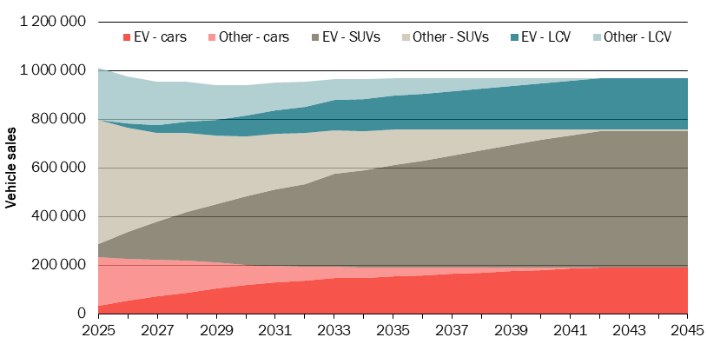
Data source: CSIRO EV projections for EV share of sales, CIE sales projections.
The stock of vehicles was estimated using the following survival curve (Smit et al 2022) where S is the proportion of vehicles surviving to a specific age, A.
$$S=\frac{1}{0.9925+(1-0.9925)e^{0.2840A}}$$
Although EV share of sales reaches 99 per cent by 2042, the EV share of stock is not expected to reach that figure for another 20 years.
8.8 Projected electric vehicle share of stock under the base case
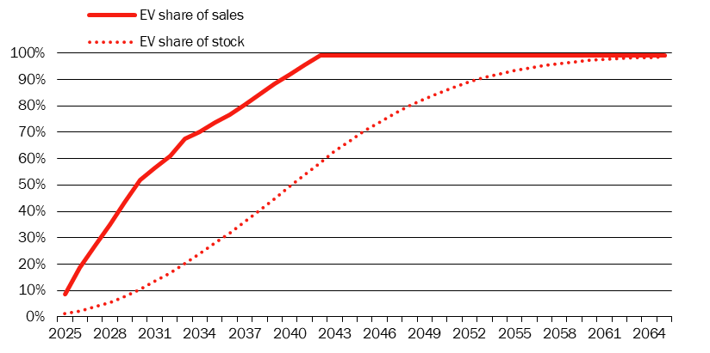
Data source: CSIRO EV projections for EV share of sales, CIE sales projections.

Vehicle and charging attributes
Having established a base case for vehicle demand, we need to estimate how demand would differ under the policy options. Availability of destination charging is the driver of vehicle demand that is changed under the policy options. We consider the value placed by consumers on the ‘availability of destination charging’ attribute in the CIE’s 2019 choice study to be a reasonable measure of the value placed by consumers on improvements in the proportion of commercial buildings offering EV charging. There is little available evidence to inform a forecast of EV charging availability in commercial buildings in the base case. We assume that the proportion of new commercial buildings voluntarily offering EV charging in a given year would be equal to the EV share of the vehicle stock in that year. We consider this to be a reasonably neutral assumption that recognises the incentives for EV uptake to drive installation of EV charging infrastructure and vice versa. Under the policy options, all commercial buildings constructed between 2025 and 2034 would offer EV charging. The proportion of buildings constructed after 2034 with EV charging would be equal to the EV share of the vehicle stock in that year.
8.9 Share of new commercial buildings with electric vehicle charging
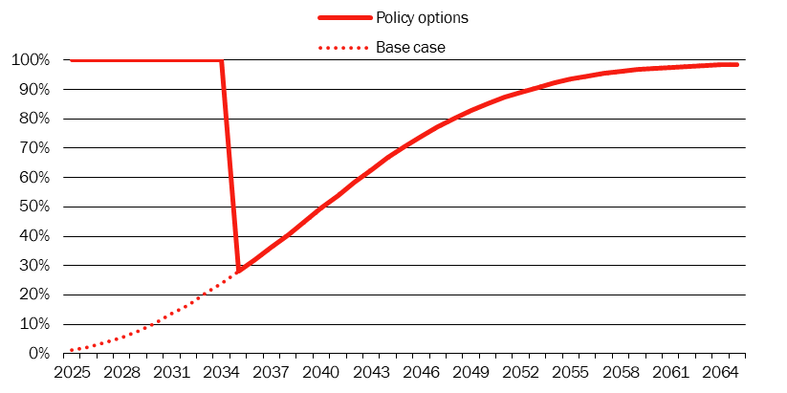
Data source: CIE assumptions.
8.10 Share of commercial building stock with electric vehicle charging
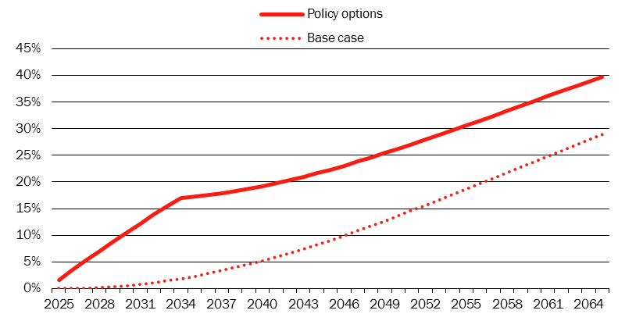
Data source: CIE assumptions.
The CIE’s 2019 study of the demand for EVs found that the value placed by consumers on this availability depends on the battery range of the EV. We therefore need to make assumptions about battery range and how it will change over the next 60 years. Battery range varies significantly across EV models currently on market. Vehicles with longer range tend to be more expensive. Early adopters of EVs have been wealthier than average and the dominance of vehicles, like Teslas, with range greater than 400 km may diminish as lower-income households begin to substitute to EVs. We therefore assume battery range of 300 km in 2025. This range is similar to that offered by the base models of the increasingly popular BYD Atto 3 and the Hyundai Kona. We assume range will increase by 2 km every year over the projection to 420 km by 2085. We also assume battery range is unaffected by the policy options.

Model of vehicle demand
We constructed utility functions for vehicle consumers for each year under the base case and under the policy options using the main model in the CIE’s 2019 choice study. The functions comprised coefficients and levels for the two attributes discussed in the section above — availability of destination charging and battery range — and a constant solved such that the market share predicted by the model for each year in the base case was equal to the CSIRO EV sales projections. These models were used to estimate both the value placed by consumers on increased availability of destination charging and the change in the EV market share under the policy options. Market share is estimated as
$$Pr=\frac{e^{βX}}{e^{βX}+e^{-1.5}}$$
where βX is the sumproduct of the coefficients and levels from the model below.
8.11 Model of vehicle demand
Variable | Coefficient
Constant | Solved for each year such that market share equals the CSIRO projection, where the assumed utility from an alternative non-EV is -1.5
Availability of destination charging (proportion*100) | 0.0086966
Log of battery range (km) * availability of destination charging (proportion*100) | -1.432669
Note: Dependent variable is utility. The price coefficient in the model is -0.0397502. It is included as part of the constant here but used elsewhere to calculate willingness to pay.
Source: CIE 2019. Demand for EVs. A discrete choice survey. Final report for Australian Automobile Association. 22 January.
This is a model of average preferences to be aggregated over all consumers. Some consumers may place little or no value on destination charging. Others will place a high value on destination charging — for example, consumers who are unable to charge at home. All of these consumers are included in the estimation of this model of average preferences.

Vehicle projections under policy options
The demand for EVs induced by the policy options increases to around 1350 vehicles per year in 2033 before declining due to forecast improvements in battery range.
8.12 Electric vehicle sales induced by the policy options
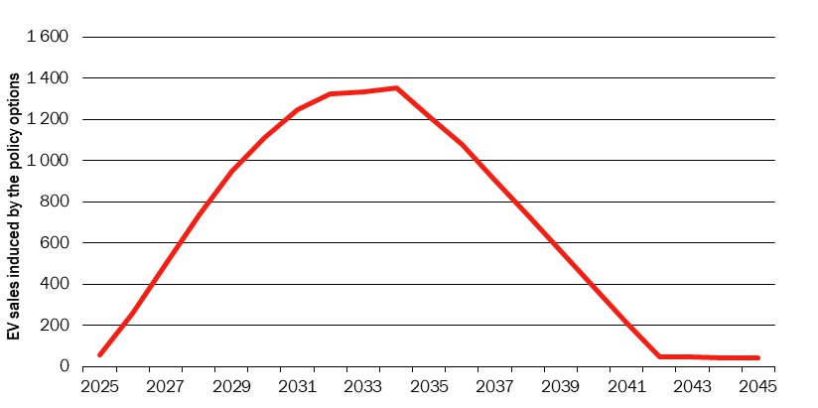
Data source: CIE analysis.

Benefit of improved access to destination charging
The value placed by consumers on improved destination charging is measured as the increase in the amount they would be willing to pay when purchasing the vehicle. We assume the value is based not only on the availability of destination charging at the time the vehicle is purchased, but on the average availability over the subsequent 10 years. Applying the estimated choice model discussed above with these assumptions, the value is estimated at $126 in 2025. It increases with the availability of destination charging over time to $180 in 2032 before gradually declining with forecast improvements in battery range.
8.13 Willingness to pay for improved destination charging availability
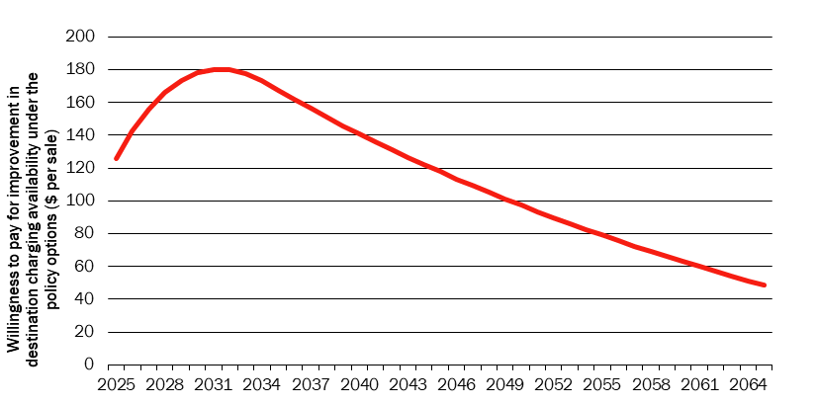
Data source: CIE assumptions.
When aggregated across the projected purchases in the base case (and half of the initial stock of EVs on the assumption they are on average halfway through their useful lives) this amounts to around $1.56 billion in present value terms.
As discussed in chapter 4, half of this per-consumer benefit will also accrue to motorists who substitute from a non-EV to an EV as a result of the policy options. This additional benefit totals to $774 000 in present value terms.

Benefit of climate change mitigation
GHG emissions projections were constructed for both EVs and non-EVs, taking account of the age composition of the stock of vehicles.
For EVs, the projections of emission intensity of electricity from the grid used elsewhere in this report were applied to projections of vehicle kilometres travelled (by vehicle type) and an assumed 16.37 kWh per 100km travelled.
For non-EVs, the age composition of the stock of vehicles was multiplied by the sticker emissions for each respective age (chart 6.26).
8.14 Emission intensity of new vehicles other than battery electric vehicles
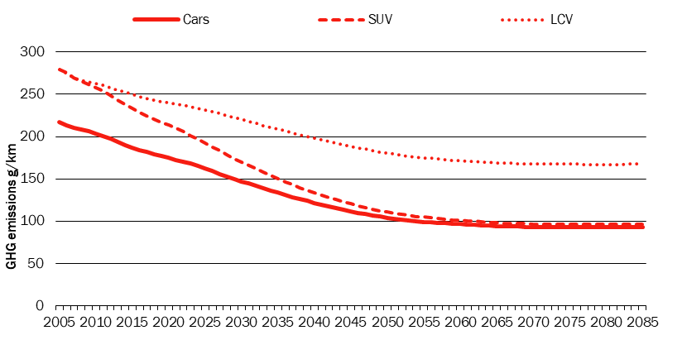
Data source: Sticker emissions.
There is a net reduction in emissions resulting from the substitution to EVs induced by the policy options. When valued at the social cost of carbon, this emission reduction is worth around $84 million in present value terms.
8.15 Impact of policy options on emissions from vehicles
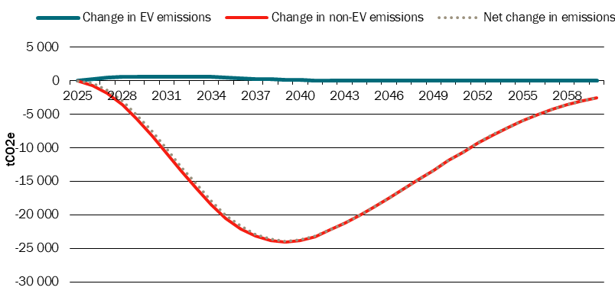
Data source: Sticker emissions.

Benefit of reduced air pollution
There would also be a reduction in air pollution resulting from the substitution to EVs induced by the policy options. Particulate matter and nitrogen oxides from tailpipe emissions can cause adverse health impacts. These emissions are closely correlated with GHG emissions. CIE (2020) calculated, based on work conducted as part of the review of the Fuel Quality Standards Act that the economic value of these impacts is around $60/tCO2e. We apply this figure to the net reduction in emissions discussed above, giving an estimated additional benefit of $12 million in present value terms.

Total benefits from mandatory electric vehicle charging
In total, the estimated benefits of mandatory EV charging in commercial buildings are around $1.7 billion in present value terms (using a discount rate of 5 per cent).
8.16 Total benefits from mandatory electric vehicle charging
Benefit | Estimated benefit  $’000s
Improved access to destination charging | 1,560,617
Mitigation of climate change | 84,059
Mitigation of air pollution | 12,105
Total | 1,656,780
Source: CIE analysis.

Sensitivity analysis
The alternative assumptions used for sensitivity testing are summarised in table 8.17.
8.17 Alternative assumptions for sensitivity testing
Parameter/variable | Central case | Alternative scenario(s)
Discount rate | 5 per cent | - 2 per cent  - 7 per cent
GHG emissions | SCC (2.0% discount rate) | - SCC (1.5% discount rate)  - SCC (2.5% discount rate)  - IA Low carbon value  - IA Medium carbon value  - IA High carbon value
Source: CIE.
The estimated net impact under each of these scenarios is summarised in table 8.18.
8.18 CBA results under different sensitivity assumptions — net present value
Sensitivity scenario | Net impact  $ million
Central case | -1,739.7
Discount rate (2 per cent) | -2 083.6
Discount rate (7 per cent) | -1 617.4
Social cost of carbon (1.5%) | -1 689.5
Social cost of carbon (2.5%) | -1 771.0
IA Low carbon value | -1 781.4
IA Medium carbon value | -1 767.5
IA High carbon value | -1 755.7
Note: Unless stated otherwise, estimates presented in net present value terms over an assumed 50-year life of all buildings constructed over the 10 year period from 2025 to 2034, using a discount rate of 5 per cent.
Source: CIE based on DeltaQ modelling.
Key findings from sensitivity testing are as follows:
- The proposed changes are estimated to deliver a net cost under all scenarios tested, suggesting the finding is relatively robust.
- The results are most sensitive to the discount rate.
- The CBA results are relatively insensitive to the carbon value used. The model suggests that charging facilities at more commercial buildings does little to encourage additional uptake of EVs, which drives the reduction in GHG emissions.

Discussion and conclusions

Discussion of results by component
The CBA results for each element of the proposal (as discussed previously, the options are various combinations of these elements) are discussed below.

Minimum energy efficiency standards
All 3 options under consideration involve more stringent minimum energy efficiency standards. These more stringent minimum energy efficiency standards are estimated to significantly reduce electricity consumption in commercial buildings and therefore avoid:
- generation costs (i.e. wholesale costs)
- network capacity costs
- network usage costs
- retail costs
- associated GHG emissions.
These electricity-related benefits are partly offset by a relatively small increase in gas consumption (and associated GHG emissions).
DeltaQ’s modelling suggests that the significant increase in energy efficiency and reduction in GHG emission can be achieved while also reducing capital-related costs for many (but not all) building archetypes.
These results raise the question: why would building owners (and their design teams) not choose a cheaper and more energy efficient choices without the need for regulation?
There are several plausible explanations, including the following:
- Inefficiencies in the building process (including regulatory processes) mean there is limited opportunities to optimise costs and performance from a whole-of-building perspective. Changes to the code that increase the efficiency of the building envelope allow cost savings through reducing the plant size.
- The proposed changes to the code encourage right-sizing of plant by specifying efficiency at design loading. The modelling assumes this will encourage a 5 per cent reduction in plant size, while still allowing extensive over-sizing to reflect standard practice.
- The proposed changes to the code address existing inefficiencies, including:
  - excessive insulation requirements in some buildings that actually reduces building performance;
  - the current requirement for internal walls to be insulated, which adds to cost while having little to no impact on performance.
However, the proposed changes to the NCC will also restrict design choices in several ways, including the following:
- The windows on some buildings will need to be tinted (i.e. have lower visual light transmittance) to achieve compliance with the proposed requirements — although this will still allow an adequate level of daylighting (daylighting requirements are not specified in the NCC), this will be less than what is current practice.
- The maximum WWR that will be achievable without external shading will be reduced from 70 per cent (under NCC 2022) to 58 per cent — although this will not affect most building archetypes (as the WWR for most buildings is lower than this threshold), this will have some impact, particularly on large office buildings where extensive glazing is relatively common.
  - Note that DeltaQ’s modelling assumes the same WWR under the base case and under all stringencies and does not include the cost of shading. This is because the archetypes are intended to reflect a ‘representative’ building based on the average WWR within the building class. Previous work estimated the average WWR for an office tower is around the maximum threshold achievable without shading (around 58 per cent).
  - This means that the proposed requirements will not affect the ‘average’ office tower and therefore these effects are not reflected in the modelling.
  - However, around half of office towers will have higher WWRs than average and would be affected by this restriction and would need to either install external shading (which can be expensive) or reduce the WWR.
- As the minimum standards have been tightened across all building elements there will be fewer opportunities to make trade-offs across elements (including through the use of Performance Solutions) to achieve particular design outcomes.
These restrictions on design choice will impose costs that have not been included in the central case, which could include the following:
- Loss of aesthetic or amenity value — where design compromises have been made, there may be a loss of aesthetic or amenity value. Although these values are subjective, in principle design compromises that change either the external appearance or the internal aesthetics for building users are likely to involve a net cost to the community.
  - There are no identifiable market failures that would lead building owners and designers to make design choices that are systematically sub-optimal from a communitywide perspective in relation to building aesthetics/amenity (although there are some market and behavioural failures in relation to energy efficiency choices — see appendix A).
  - In the absence of identifiable market failures, a standard assumption in economic analysis is that market participants will make design choices that achieve the optimal combination of cost and building aesthetic/amenity value, particularly where these values are reflected in the market value of the building and/or rents.
  - To the extent that these aesthetic/amenity values are reflected in the market value of these buildings and/or rents, these benefits could in-principle be measured. However, there is no publicly available data that would allow these values to be estimated.
- Additional financial costs — where building owners and their design teams choose to achieve their preferred design outcome through the use of external shading, they will incur an additional financial cost.
  - The indicative costs of external shading were included as a scenario for the large office building archetype only. This suggested that there could be a net cost from the proposed changes for some buildings (in some states and climate zones).
  - The choice to incur the financial costs associated external shading would indicate a strong preference for the relevant design features (i.e. extensive glazing and/or glazing with high visual light transmittance).
  - Nevertheless, there are relatively few buildings that are likely to install external shading as a result of the proposed shading (although many already choose to do so); large office buildings that tend to be more extensively glazed are most likely to be affected. As the proportion of buildings that incur a net cost is likely to be small, the proposed changes would still deliver significant net benefits in aggregate.

Mandatory rooftop solar
Installation of rooftop solar on commercial buildings is a requirement under Stringency Level 2 and Stringency Level 3. This requirement is also estimated to deliver significant net benefits.
Unlike Stringency Level 1, mandatory rooftop solar on commercial buildings is likely to impose additional costs. However, DeltaQ’s modelling indicates that the additional costs are likely to be significantly outweighed by the benefits — including reduced consumption of electricity from the grid, increased export of electricity to the grid and the associated GHG savings.
The net benefits from installing rooftop solar on commercial buildings is reflected in the relatively high voluntary uptake of rooftop solar under current arrangements (where rooftop solar is not mandatory), based on available evidence. This voluntary uptake is incorporated into the base case, which significantly reduces the net benefits attributable to the proposed changes to the NCC.
That said, our modelling may over-estimate the net benefits from mandatory rooftop solar for the following reasons:
- the net benefits from installing rooftop solar may mean greater voluntary uptake of rooftop solar in the future under the base case, meaning that fewer benefits can be attributed to the regulatory change;
- there may be some buildings where installation of rooftop solar is not viable due to shading, alternative uses for the roof or other factors. This has not been taken into account in the modelling (i.e. the modelling assumes that all commercial buildings will install rooftop solar). In most of these cases an exemption will apply.
These factors would reduce both the benefits and costs attributable to the proposed regulatory change proportionately. So although the modelling may overstate the net benefits to some extent, the costs would not outweigh the benefits as a result of these factors.
On the other hand, our modelling does not take into account the amount of rooftop solar in the base case (only considering whether they have solar or not). It is possible that the proposed requirements would increase the amount of rooftop solar on buildings where there is voluntary uptake.
In contrast to the increase in the mandatory energy efficiency requirements, there are less likely to be direct (hidden) aesthetic/amenity impacts associated with mandatory rooftop solar, due in part to the exemptions available.
That said, there may be some indirect impacts as a result of mandating rooftop solar. In particular, installation of rooftop solar is one way that building owners/designers make trade-offs against other elements to achieve preferred design outcomes. Previous work for DISER found that 8 per cent of the buildings surveyed had installed rooftop solar as a trade-off against other elements (around 20 per cent of all buildings that had installed rooftop solar).
If rooftop solar becomes mandatory that trade-off will no longer be available, meaning that building owners/designers may need to make design compromises elsewhere.

Provisions to achieve net zero buildings at least cost
The provisions to achieve net zero buildings apply to Stringency Level 3 only. These provisions have a relatively modest impact (compared to the other elements) at the aggregate level. This is partly because these provisions apply to only 3 building archetypes (the large hotel, the large office building and the large hospital ward) as these are the only dual-fuel archetypes that have been modelled.
The net impact of these requirements depends on whether dual fuel buildings will convert to fully electric in the future.
- Where dual fuel buildings are not required to convert to fully electric buildings in the future, these provisions will result in a net cost.
- Where dual fuel buildings are required to convert to fully electric in the future, these provisions will result in a net benefit.
This future scenario is currently unknown. The expected outcome is the probability-weighted average of these scenarios. Based on the modelling results, the provisions to achieve net zero buildings at least cost ‘breaks even’ (implying the costs are equal to the benefits), where the probability that dual-fuel buildings are required to convert to fully electric in the future is around 63 per cent (where all other assumptions are held constant, including: 10 per cent of buildings would choose the dual fuel offset; and 90 per cent would choose to ‘electrify now’; and all dual fuel buildings would be required to convert to fully electric 20 years after construction). This implies the following.
- If the probability that dual fuel buildings will be required to convert to fully electric in the future is considered greater than 63 per cent, Stringency Level 3 is likely to deliver the highest net benefits.
- If the probability that dual fuel buildings will be required to convert to fully electric is considered less than 63 per cent, Stringency Level 2 is likely to deliver the highest net benefits.

Mandatory EV charging facilities
All of the proposed options require mandatory EV charging facilities to be installed in commercial buildings.
This requirement is estimated to impose a net cost on the community. This result largely reflects the relatively low value that consumers appear to place on destination charging (based on previous CIE estimates from a stated preference survey). This value is also likely to decline further as battery range improves.
As consumers place a relatively low value on charging facilities at the destination, our estimates suggest that greater provision of charging facilities in commercial building car parks is unlikely to induce significant additional uptake of EVs.
The relatively low value that consumers place on charging facilities at the destination is likely to reflect the expectation that most charging will be done at home. The preferences of consumers (or potential consumers) that are unable to install charging facilities at home may be higher than average; however, the results of the stated preference survey suggest that there may be relatively few EV drivers (or potential drivers) in this category. Although an industry estimate suggests that up to 20 per cent of homes may be in this category, it is possible that these households are less likely to be EV drivers.

Conclusions
The updated CBA results for the DRIS, taking into account stakeholder feedback from the CRIS, has not changed the broad conclusions.
- In relation to the options relating to the minimum energy efficiency requirements and on-site energy generation:
  - All three options under consideration are estimated to deliver significant net benefits compared with current NCC 2022 requirements as a baseline.
  - Stringency Level 2 upgraded energy efficiency requirements and mandatory rooftop solar delivers the highest net benefits under most scenarios (including the central case).
  - Stringency Level 3 also achieves significant benefits that are only slightly lower than Stringency Level 2 noting, as shown in the sensitivity analysis, Stringency Level 3 can deliver larger results in some scenarios (particularly if dual fuel buildings are required to convert to fully electric in the future).
- The costs of mandatory EV charging facilities are estimated to outweigh the benefits.

Review of direct evidence on market failures and behavioural anomalies
This appendix provides more detailed discussion on direct evidence on market failures and behavioural anomalies presented in chapter 2 (especially the summary table 2.2).

Direct evidence of market failures in energy pricing
Direct evidence on market failures in energy pricing is summarised below. In summary:
- There is a significant market failure as the external costs associated with GHG emissions are not reflected in energy prices. On average, the external costs associated with electricity consumption are currently estimated at around 23.5 c/kWh.
- Consistent with the Australian Energy Regulator (AER) Guidelines, the costs associated with peak demand are largely reflected in energy prices, albeit imperfectly.

Greenhouse gas emissions
In the current policy environment, the lack of an economy wide carbon price is the clearest market failure in relation to energy consumption. There are various approaches to valuing GHG emissions. Using the internationally recognised SCC approach, the external cost of carbon emissions associated with electricity consumption is currently (2023) estimated at around 21.7 c/kWh based on:
- a social cost of carbon of around $313 per tonne of CO2-e in 2023-dollar terms— this is based on the following:
  - The United State Environment Protection Agency’s (US EPA’s) most recent (2022) estimate of the SCC of US$190 per tonne of CO₂-e (expressed in 2020 US dollar terms using the 2.0 per cent discount rate) is used as the starting point.
  - The US EPA’s US dollar estimate is then converted to Australian dollar terms using an exchange rate of US$0.74.6 per Australian dollar (based on a 10-year average to February 2023).
  - Reflecting the upward trend in the US EPA’s estimates of the SCC over time, this 2020 estimate is inflated by 5.8 per cent (1.9 per cent per year) to obtain a 2023 estimate.
  - This is then inflated to 2023-dollar terms using the Australian national CPI (consumer prices increased by 16 per cent between 2020 and 2023).
- an average carbon intensity of electricity of around 0.71 tonnes of CO2-e per MWh across Australia in 2023.
While the carbon intensity of electricity generation is expected to decline over time, USEPA estimates suggest that the SCC will increase, based on rising populations and economic growth.
GHG emissions are being valued significantly higher in the RIS than in the 2018 RIS (~5 c/KWh), reflecting higher estimates of the SCC in the USEPA’s most recent publication and a lower discount rate used in relation to the SCC estimates. However, this is partly offset by more optimistic projections of the extent to which the electricity grid will decarbonise.
To put this estimate into context, if the SCC were internalised into the wholesale electricity price, it would be more than double (around 114 per cent higher, based on the average National Electricity Market (NEM) wholesale price in 2022 of 19.1 c/KWh). This implies that the externalities associated with electricity consumption are currently higher than the generation costs.
Unpriced negative externalities associated with energy consumption, would normally mean that energy users do not take these costs into account in their decisions on whether to invest in energy efficiency. However, many companies — including some commercial building owners — are committed to reducing GHG emissions as part of ESG commitments in line with Environmental, Social and Governance (ESG) commitments. In particular:
- Research by the Climateworks Centre reported that 84 of the 187 ASX companies assessed (45 per cent) have a scope 1 and 2 net zero target. However, only 16 of the 177 ASX companies assessed (9 per cent) where scope 3 emissions are deemed applicable have set a net zero target for scope 3 emissions in line with a 1.5C pathway.
- Other research has reported that by March 2023, 121 ASX 200 entities had set public commitments to reduce emissions to net zero by 2050 or earlier. The ASX200 is ramping up efforts on climate reporting, with 75 per cent of the companies committing to or reporting against the Taskforce for Climate-related Financial Disclosures framework (66 per cent in 2022 reporting year). There are 9 companies of ASX 200 adopted Say on Climate initiative to disclose annual emissions and plans of action or decarbonisation strategies which are open to annual non-binding votes by shareholders.
This indicates that some companies are already valuing GHG abatement even though it is not internalised into energy prices. However, not all of these targets are being actioned, and not all commercial building owners and tenants have made such commitments. As such, there is a clear role for government intervention.

Externalities associated with peak demand
As electricity network capacity is driven by peak demand, reducing peaks through energy efficiency can potentially defer or remove the need for additional investment to expand network capacity.
However, to a significant extent, the cost of supply during peak periods is reflected in energy prices. As a natural monopoly, network charges are regulated by the AER. Under the AER’s pricing principles, network tariffs must reflect the long run marginal cost (LRMC) of supply.
For network services, the LRMC is a forward-looking concept reflecting both the operating costs associated with an additional unit supplied, and any network expansion costs. As such, the LRMC reflects the avoidable network costs from reducing energy consumption.
Reflecting these pricing principles, electricity tariffs typically include:
- a capacity charge — this is a daily charge based on the maximum usage during specified peak periods over a specified period
- usage charges which could include different peak and off-peak rates to reflect differences in the cost of supply during peak and non-peak periods.
To a large extent, network-related costs are therefore reflected in electricity tariffs. That said, capacity charges may imperfectly reflect network-related costs. Previous work has shown that tariff structures vary significantly across different networks; it is unclear whether this reflects actual cost differences across different network areas or different approaches taken by network operators.

Other market failures and behavioural anomalies
Although there is limited direct evidence, it is plausible that the following behavioural/organisational failures prevent privately cost-effective energy efficiency opportunities (i.e. where energy bill savings outweigh the associated capital costs) from being adopted.
- There are some split incentives that could contribute to sub-optimal outcomes, including where:
- different parts of an organisation are responsible for capital costs and operating costs (energy bills)
- there are different incentives across different parties in the building process.
- Behavioural anomalies, such as bounded rationality and heuristic decision making (such as building to code, rather than seeking the optimal mix of capital and ongoing energy costs); and inattention to non-salient energy costs are plausible explanations for the energy efficiency paradox across all building types.

Information failures
In the context of new commercial buildings, an ‘information failure’ would arise if the party that makes decisions on the energy efficiency of the building design and the associated services installed (such as building owners or developers, architects and engineers acting on their behalf) does not have access to sufficient information to make fully informed decisions.
However, information failures are not a compelling explanation for any failure of industry to adopt privately cost-effective energy efficiency opportunities as relevant information is available.
- General information on the potential benefits of improving energy efficiency in commercial buildings is freely available through a range of sources, including government sources and energy efficiency advocacy groups.
- More project-specific information is commercially available from specialist consultants and energy efficiency modellers (information costs are not a market failure). Performance Solutions, which involve energy efficiency modelling, are frequently used to comply with Section J of the NCC (although some stakeholders reported that the DTS pathway continues to be used for some buildings). Nevertheless, this suggests that energy efficiency modelling is an established part of the building design and construction process.
The extent to which this information is accessed and acted upon is a separate issue addressed below.

Information asymmetries
Another form of information failure is an ‘information asymmetry’. This occurs where one party in a transaction has more information than another. In the context of energy efficiency in commercial buildings, an information asymmetry would arise where a building (or part of a building) is sold or rented and the seller/landlord has information on the associated energy bills, while the buyer/tenant does not. Under these circumstances the buyer/tenant may not be in a position to make informed decisions and higher levels of energy efficiency may not be reflected in leases or sale prices.
However, there is little evidence to suggest a significant information asymmetry problem in relation to energy bills under typical leasing arrangements. The responsibility for paying energy bills can vary depending on the type of lease.
- Where some or all of the energy bills are directly passed onto tenants (referred to as a net lease), expected ‘outgoings’ are typically provided to tenants at the time of choosing office or retail space. This allows tenants to choose the tenancy that offers the preferred mix between lease rates and outgoings (as well as a range of other characteristics).
- Where energy costs are included in the lease, (referred to as a ‘gross lease’), the amount paid by tenants is fully transparent.
In addition, there are several other existing mechanisms to address the potential for these information asymmetries:
- Energy efficiency rating tools allow building owners/operators to obtain a rating for their building from an accredited assessor using an established methodology. These arrangements mean that buyers/tenants can have confidence in the energy efficiency rating provided by the seller/landlord. Existing energy efficiency rating tools include:
  - The National Australian Built Environment Rating System (NABERS) operated by the NSW Government on behalf of Federal, State and Territory Governments. Compared with 2018 (when the previous commercial energy efficiency RIS was completed) there are now NABERS Energy rating tools available for a broader range of buildings. NABERS Energy tools are available for:
    - Office buildings and tenancies
    - Shopping centres
    - Apartment buildings
    - Hospitals (public)
    - Hotels
    - Data centres
    - Residential aged care
    - Retirement living
    - Warehouses and cold stores.
  - The Green Star rating system operated by the GBCA. Green Star is a holistic sustainability rating system.
- In addition, the CBD program requires that sellers and lessors of office space of 1,000 m2 or more to obtain a Building Energy Efficiency Certificate — which includes the building’s NABERS Energy for Offices star rating and a tenancy lighting assessment of the relevant area of the building — before the building goes on the market for sale, lease or sublease.
Stakeholders also reported that investor demand for green buildings provides a significant incentive to achieve high levels of energy efficiency at the premium end of the office market. Investor demand for green buildings is driven by the recognition of the commercial benefits of better energy efficiency (such as lower energy bills, higher rents and lower vacancy rates) as well as corporate social responsibility requirements of large investors. Some stakeholders also reported that NABERS or Green Star ratings are often used as a market proxy for overall building quality.
Previous reviews found that the CBD program had been successful in encouraging energy efficiency improvements, particularly in the least efficient buildings. While the focus of the CBD program is on existing buildings, it nevertheless suggests that existing mechanisms go some way to addressing the information asymmetry problem. However, as noted above, mandatory disclosure of the NABERS energy efficiency rating is applied only to a subset of commercial buildings. As a result, the problem of information failure should be addressed for those commercial buildings not being covered by the CBD.
Evidence of energy bill savings being capitalised into rents and building values would be an indicator that tenants and buyers have sufficient information to make informed decisions. There is some Australian evidence to suggest that more energy efficient buildings tend to attract a premium in both rents and sale prices. However, this mostly applies to prime office buildings.
- A recent (2023) CBRE report compared average rents of 130 office buildings in major Australian cities (Brisbane, Melbourne, Perth and Sydney) based on their NABERS rating.
  - On average, rentals were around 8 per cent higher in 6-star buildings (compared with the average across the same city)
  - An average discount of 6 per cent (relative to the average in the same city) was observed in buildings with a rating of 4 stars (at the lower end of the sample).
- Knight Frank used a hedonic price model to estimate the impact of NABERS rating on the sale price of prime office buildings in Melbourne and Sydney. They found that:
  - Buildings with a NABERS rating of 5+ achieve an average 17.9 per cent premium on sales price compared to equivalent unrated buildings.
  - Buildings with a lower NABERS rating achieve an average 8.3 per cent premium.
- A more comprehensive (albeit older) Australian study for the Australian Property Institute and Property Funds Association also found evidence of energy bill savings associated with higher levels of energy efficiency being capitalised into rents and prices (as well as lower vacancy rates). The study compared rents and prices of 206 NABERS-rated office buildings and 160 office buildings that did not have a NABERS rating in Sydney and Canberra. This study focused mostly (over 97 per cent) on office buildings with an area exceeding 2,000 m2. A key feature of this study is that it controlled for differences in building characteristics to ensure that any identified ‘green premium’ is not a result of green buildings being newer. The study found:
  - Evidence of a green premium in values for buildings with higher NABERS ratings:
    - a 5-star NABERS energy rating delivering a 9 per cent ‘green premium’ in value (relative to unrated buildings), and
    - a 3 to 4.5-star NABERS rating delivering a 2-3 per cent green premium in value.
  - These green premiums were most evident in the Canberra office market and the Sydney suburban office market (North Sydney, Parramatta, Chatswood, St Leonards, South Sydney, Norwest, Macquarie Park, Rhodes and Homebush Bay).
  - Green premiums were also evident in reduced vacancy rates and reduced outgoings.
Note that these studies have used the NABERS rating (based on GHG emissions) as the measure of energy efficiency, rather than energy consumption per se (there is not necessarily a close correlation between NABERS rating and energy consumption). It may be that the observed premiums reflect environmental objectives, rather than direct financial considerations alone.
In this regard, it should be noted that the CBD Program currently covers offices with an area at or above 1,000 m². There may be some information asymmetries (in relation to the NABERS rating) for other commercial buildings.

Split incentives
A subset of information failures discussed above is the issue of split incentives. Split incentives occur when the party making the decision on whether to invest in energy efficiency is not responsible for energy bills.

Landlord-tenant problem¤
The most commonly cited split incentive in relation to commercial buildings is the landlord-tenant problem. This problem potentially applies to leased buildings where:
- the building owner (the landlord) bears the cost of any investment in energy efficiency (including the building façade and central services); and
- energy bills are passed onto tenants (although this is not always the case).
The landlord-tenant problem is potentially most relevant to office and retail buildings where leasing is common. These are the largest commercial users of energy, together accounting for over 40 per cent of the total energy consumed by commercial buildings.
It is less relevant to other types of commercial buildings, such as educational facilities, health-care facilities and hotels, where the building owner and operator are more likely to be the same entity and responsible for both decisions on whether to invest in energy efficiency, and energy bills. However, there may be organisational inefficiencies that limit the appropriate consideration of the longer-term operating cost implications at various levels of capital expenditure decisions for these types of commercial buildings.
In general, a landlord-tenant split incentive problem is more likely to be a significant barrier to the uptake of privately cost-effective energy efficiency opportunities where an information asymmetry is present. Where energy bill savings are understood by tenants, they are likely to be willing to pay higher rents in more energy efficient buildings in exchange for lower energy bills. In these circumstances, the benefits of better energy efficiency are shared between the building owner/manager and the tenant. The capacity to achieve higher rents would also be reflected in the value of the building.
That said, a split incentive may apply within a contract period. The financial incentive for a landlord to improve energy efficiency is muted by having to pass savings on to tenants for part of the tenant base.
As discussed above, disclosure of outgoings (as well as the availability of benchmarking tools such as NABERS) means that information asymmetries and therefore the landlord-tenant problem are not likely to be a significant barrier to greater energy efficiency in commercial buildings in Australia.

Builder and end-user split incentive problem
Another source of split incentives reported by stakeholders in Australia is between a building contractor and its owner/occupier. As discussed in the International Energy Agency (IEA)’s 2007 report, Mind the Gap: Quantifying Principal-Agent Problems in Energy Efficiency, a building contractor makes many energy-related decisions, including the efficiency of the heating system and of the windows, and the building’s resistance to air infiltration. However, given these energy efficient alternatives usually increase the cost of construction, ‘the building contractor has incentives to avoid these measures, especially if the measures are invisible to prospective buyers’. That is, the developer is naturally trying to build for the lowest cost possible, and would incur the capital cost of energy efficiency investments, while the end user is not identified and may potentially not pay the full cost of those investments.
This applies to all building types and particularly to those developments that are completed speculatively, or where there is a fixed-price build and energy efficiency measures may be reduced to increase the builder’s margin. Due to the complexity of observing the compliance to design after building, it may be difficult for the owner to observe the difference between the planned and actual level of energy efficiency during the construction phase.

Other types of split incentives
Another type of split incentive could occur within large organisations, where separate parts of the organisation are responsible for capital budgets and paying energy bills. This is effectively an organisational failure, rather than a market failure. This type of split incentive was previously identified during stakeholder consultations as a key barrier to improved energy efficiency in government buildings, as a result of government budgeting arrangements.

Bounded rationality and heuristic decision-making
In addition to the market failures discussed above, some studies cite behavioural anomalies/failures as a reason for under-investment in improved energy efficiency. Behavioural anomalies cited in the literature include bounded rationality and heuristic decision-making.
Energy efficiency choices in commercial buildings may involve complex trade-offs with factors, such as design preferences as well as cost. In the face of this complexity, some owners/developers may make sub-optimal decisions due to cognitive limitations and/or rely on heuristics (mental short cuts).
In an assessment of the evidence on the causes of the energy efficiency gap, Gerarden et. Al. (2015) noted that cognitive limitations could conceivably contribute to the energy efficiency gap by preventing individuals (or possibly firms) from properly balancing the present value of benefits against costs when investing in energy-using capital goods.
Gerarden et. Al. (2015) note that many empirical studies are consistent with this explanation. However, it is difficult to disentangle the role of heuristics and bounded rationality from competing explanations because consumers’ decision-making processes cannot be directly observed.
Given these challenges, it is difficult to find direct evidence that bounded rationality and heuristic decision-making contributes to the energy efficiency paradox in relation to commercial buildings.
That said, there is qualitative evidence from stakeholders that entrenched practices in the construction industry — a form of heuristic decision making — is a key barrier to greater uptake of energy efficiency in commercial buildings in Australia. Energy efficiency can sometimes be overlooked or ignored as a lower order imperative to life safety.
In particular, current processes for the design and construction of commercial buildings (including the regulatory processes) reportedly precludes optimisation of energy efficiency from a whole building perspective.
- A key early step in the design and construction process is obtaining planning approval. Planning approval is mainly focused on the building envelope.
- This means that in many cases the façade is designed and submitted to the planning authority for planning approval, without any involvement of the energy efficiency consultant or the mechanical engineer that design the HVAC system.
- Once planning permission has been received, the energy efficiency consultant and mechanical engineer will design the HVAC system for the approved façade. Any significant changes to the façade may require a variation to the planning approval, which can result in delays and add to costs.
- This process means that energy efficiency may not be optimised from a whole-of-building perspective. Many buildings are therefore built to comply with the minimum energy efficiency standards specified in the NCC (i.e. ‘building to code’), rather than seeking to optimise between capital and operating costs.
Another way that heuristic decision-making can lead to sub-optimal outcomes is where mechanical engineers are heavily focused on performance and therefore build in significant redundancy when making decisions on the sizing of HVAC equipment.

Inattention and non-salience of energy costs
Some studies have sought to explain the energy efficiency paradox as a result of the inattention of energy users and/or the salience of energy costs. As energy costs are relatively small component of total costs for many businesses, little attention is paid to them, leading to under-investment in energy efficiency.
Gerarden et. Al. (2015) found some evidence that consumer inattention to non-salient costs affect decisions. However, most of the research cited relates to consumers rather than businesses.
While there is little direct evidence that inattention to energy costs leads to under-investment in energy efficiency, it is nonetheless a plausible explanation (particularly for small businesses).

Alternative explanations
As discussed above, the failure of industry (and government) to adopt energy efficiency opportunities that modelling shows is privately cost-effective is often explained through the market and behavioural failures outlined above. However, an alternative view in the international literature is that the perceived energy efficiency gap may be much smaller than it appears because the modelling may not always be accurately reflecting the true costs and benefits of energy efficiency measures.
Some of the potential modelling issues identified in the energy efficiency literature include the following:
- Over-estimation of energy savings — in many CBAs, energy saving estimates are based on engineering estimates, particularly in the case of ex-ante CBAs where actual energy saving cannot be observed. There is some evidence that engineering estimates can significantly overstate the energy savings achieved from improved energy efficiency. Gerarden et. Al. (2015) noted that studies that over-estimate energy savings have persisted, despite improvements in ex-ante engineering-economic methods over time. A review of more recent evidence suggests that the performance gap remains an ongoing issue, although difficult to quantify (see Appendix C for details).
- Under-estimation of energy efficiency improvements under the base case scenario — the Productivity Commission has previously noted that policy makers may overstate the potential for regulation to deliver cost-effective improvements in energy efficiency because their assumed business-as-usual improvements in energy efficiency are too pessimistic and fail to anticipate the responsiveness of consumers to future reductions in the prices of energy-efficient products.
- Heterogeneity across buildings — investments in energy efficiency that appear privately cost effective for the average consumer (or developer in the case of commercial buildings) may not be cost-effective for some consumers due to different preferences, actual usage and/or the cost of capital.
- Risk and uncertainty — investment in energy efficiency involves some degree of risk or uncertainty, including uncertainty in relation to energy savings and future energy prices. Various studies have noted that risk is a common explanation for firms rejecting the recommendations from energy audits. As noted by the Productivity Commission, if the degree of risk and uncertainty facing producers and consumers is not adequately recognised, estimates of the potential for taking up energy efficiency related investments will be overstated.
- Omitted and under-estimated costs — some studies argue that energy efficiency modelling can often omit certain costs and therefore overstate the net impact of investing in energy efficiency. As noted by the Productivity Commission, well-informed purchasers of non-residential buildings may want to forgo the energy savings from a building standard because the standard causes more highly valued characteristics to be lost.
If the apparent energy efficiency gap is due to these modelling issues, regulation could potentially impose a net cost on building owners (energy efficiency investment costs are bigger than the actual energy bill savings). The public benefits of reduced GHG emissions would therefore need to outweigh these private costs for energy efficiency regulations to deliver a net social benefit (the combined benefits of net changes in energy bills plus reduction in GHG emissions are larger than the energy efficiency investment costs).

Avoided energy-related costs
This appendix details the estimation of energy prices to be used in the impact analysis and the CBA in the main body of the report.

Approach to measuring avoided energy costs
A key issue in CBAs of energy efficiency regulation is the approach to measuring the benefits of the energy saved. Conceptually, CBAs of energy efficiency proposals are seeking to measure avoided resource costs (i.e. the avoided resources such as labour inputs, fuels, generation and transmission infrastructure that would have been used to supply electricity and gas).
It is important to note that this benefit is in addition to the benefits of a reduction in GHG emissions associated with energy savings. The benefits of emissions reduction may be valued using a SCC or market or shadow price of carbon. The RIS uses an SCC, as discussed above.
There have been various approaches to valuing energy savings used in RISs and CBAs (box B.1). A standard approach in partial equilibrium analysis (used in most CBAs) is to value avoided resource costs using the market price of goods and services.
- In competitive markets, the market price reflects the opportunity cost of the resources used in the production of the good or service at the margin.
- From a practical perspective, it is also more convenient to observe the price of a good or service than to estimate the opportunity cost of the inputs used in production. For example, it is easier to measure the market price of a loaf of bread than to measure the value of the labour, avoided capital costs associated with the bakery, the costs associated with growing the wheat and milling the flour used in its production.

B.1 Avoided energy costs
As has been discussed elsewhere, there are fundamentally two ways that reduced resource costs to supply electricity and gas have been measured in CBAs:
- The retail price approach — under this approach, energy savings are valued using the retail price. The retail price captures all the components of supply, such as generation, transmission, distribution and retailer costs
- The ‘capacity and energy approach’ — in general, this approach involves assessing to what extent avoided energy consumption reduces the need for investment in energy generation and energy network capacity.
In the context of avoided electricity costs, applying this general principle would lead to the retail price approach. However, there would be a case for adjustment if some components of the retail price are:
- fixed (for example charged based on the days of connection) rather than relating to the energy consumption; or
- likely included in other benefits of energy saving (for example some costs related to climate change policies) to avoid double counting.
We therefore use market (or regulated) prices to value the avoided costs associated with lower energy consumption from more stringent minimum energy efficiency standards for commercial buildings, with some adjustment for fixed charges and avoiding double counting (discussed in more details below).
To ensure the analysis is manageable, we use average energy prices for each jurisdiction or climate zone (where data are available), incorporating relevant weights, in the central case CBA. Furthermore, considering the wide range of tariffs as detailed further in the following discussions and substantial uncertainties around the energy price projections in the future, we will consider different energy prices during the sensitivity analysis.

Components of electricity prices
According to the Australian Competition and Consumer Commission (ACCC), the retail price of electricity includes the following components:
- generation costs (also referred to as energy costs);
- network costs
- environmental costs
- retail and other costs, and
- retail margins.
We will further discuss these components below, delving into their inclusion/exclusion and estimation with greater detail.

Generation costs
The wholesale market is the most competitive segment of the electricity supply chain and therefore market prices are a reasonable indicator of the marginal cost of generation.
For electricity market outside of the NEM, the balancing market price compiled by AEMO provide the basis for the wholesale electricity prices in WA. Historical daily trading data maintained by Northern Territory Electricity System and Market Operator (NTESMO) provide the basis for the wholesale electricity prices in NT.
We construct a price series as a component for use in the analysis drawing on these data sources.
To estimate the time of use prices, we use historical market data from the national electricity market in 2022. The wholesale prices were reported in a 5-miniute interval. We aggregated them into hourly rates (8760 hourly intervals across the year) using relevant volume weights.
Wholesale prices exhibit substantial daily fluctuations as well as seasonal variation. These fluctuations also tend vary across states. Charts B.2 to B.9 shows the wholesale price fluctuations across an average day in each season for each state and territory.
B.2 Average wholesale electricity prices 2019-2021 — NSW
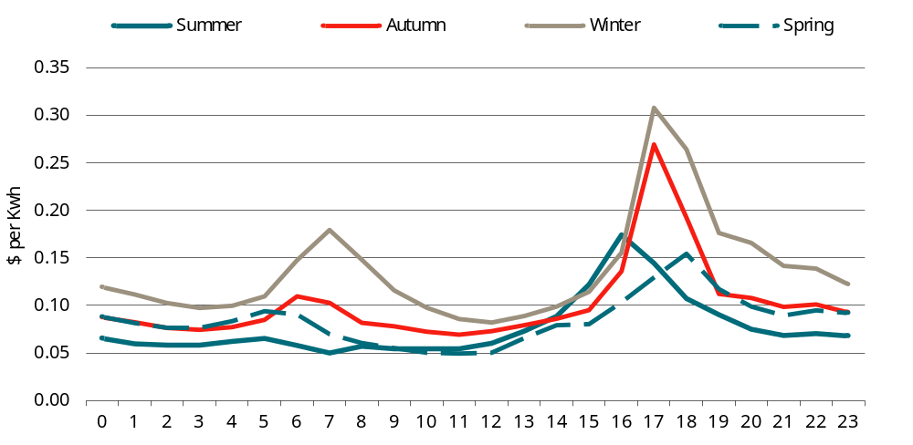
Note: Summer covers December to February. Autumn covers March to May. Winter covers June to August. Spring covers September to November.
Data source: AEMO, ‘NEM data dashboard’, 2023, https://aemo.com.au/en/energy-systems/electricity/national-electricity-market-nem/data-nem/data-dashboard-nem.
B.3 Average wholesale electricity prices 2019-2021 — Victoria
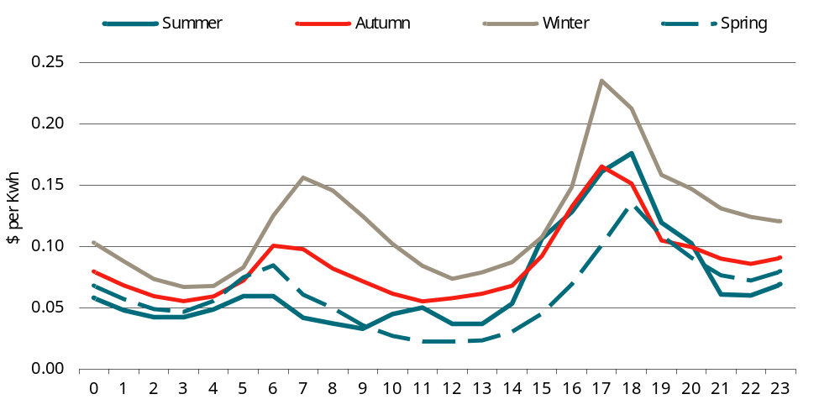
Note: Summer covers December to February. Autumn covers March to May. Winter covers June to August. Spring covers September to November.
Data source: AEMO, ‘NEM data dashboard’, 2023, https://aemo.com.au/en/energy-systems/electricity/national-electricity-market-nem/data-nem/data-dashboard-nem.
B.4 Average wholesale electricity prices 2019-2021 — Queensland
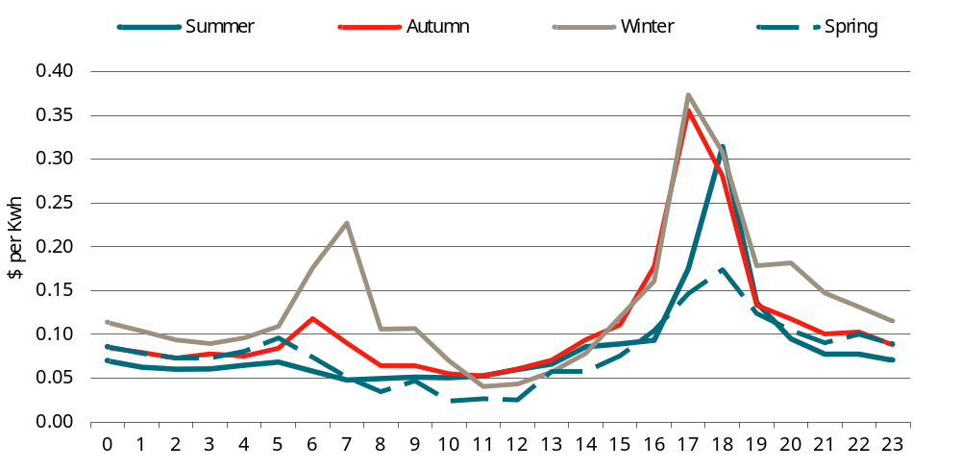
Note: Summer covers December to February. Autumn covers March to May. Winter covers June to August. Spring covers September to November.
Data source: AEMO, ‘NEM data dashboard’, 2023, https://aemo.com.au/en/energy-systems/electricity/national-electricity-market-nem/data-nem/data-dashboard-nem.
B.5 Average wholesale electricity prices 2019-2021 — Western Australia
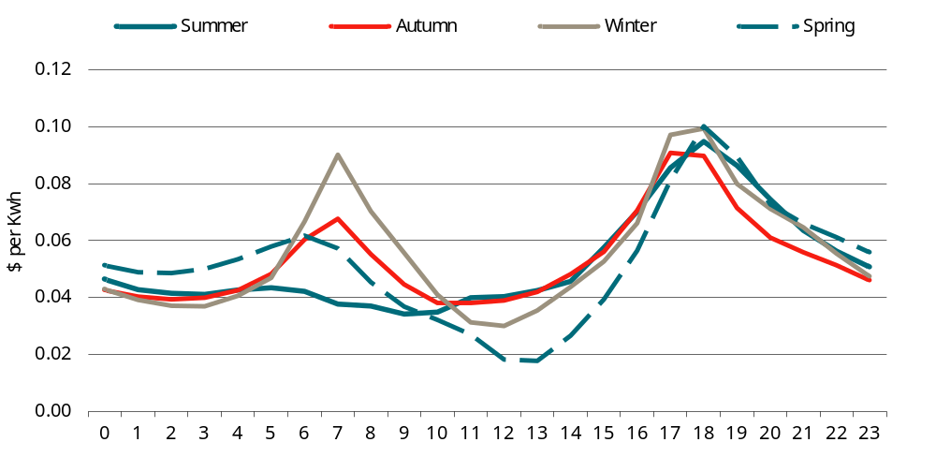
Note: Summer covers December to February. Autumn covers March to May. Winter covers June to August. Spring covers September to November.
Data source: AEMO, ‘Market Data - Western Australia’, in data.wa.aemo.com.au, 2023, https://data.wa.aemo.com.au/#balancing-summary.
B.6 Average wholesale electricity prices 2019-2021 — South Australia
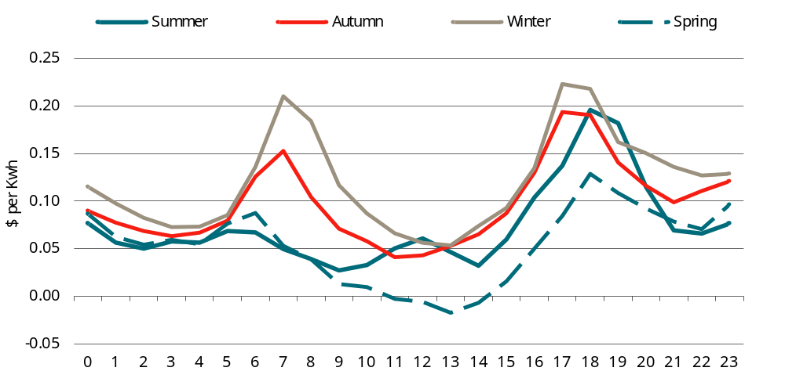
Note: Summer covers December to February. Autumn covers March to May. Winter covers June to August. Spring covers September to November.
Data source: AEMO, ‘NEM data dashboard’, 2023, https://aemo.com.au/en/energy-systems/electricity/national-electricity-market-nem/data-nem/data-dashboard-nem.
B.7 Average wholesale electricity prices 2019-2021 — Tasmania
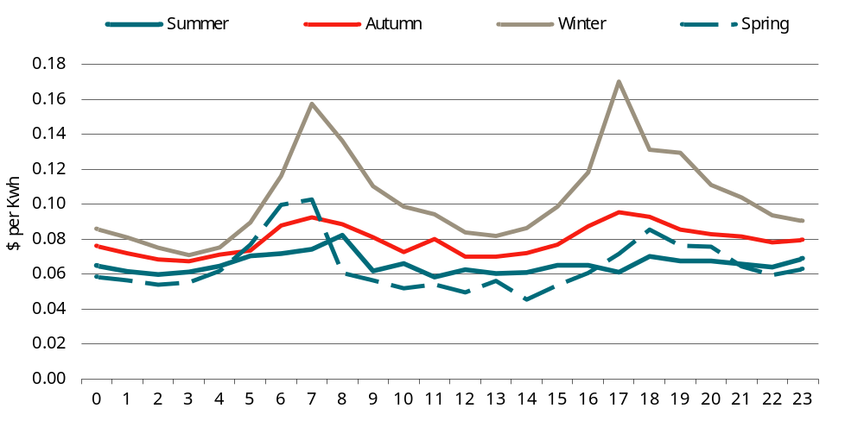
Note: Summer covers December to February. Autumn covers March to May. Winter covers June to August. Spring covers September to November.
Data source: AEMO, ‘NEM data dashboard’, 2023, https://aemo.com.au/en/energy-systems/electricity/national-electricity-market-nem/data-nem/data-dashboard-nem.
B.8 Average wholesale electricity prices 2019-2021 — ACT
Note: Summer covers December to February. Autumn covers March to May. Winter covers June to August. Spring covers September to November.
Data source: AEMO, ‘NEM data dashboard’, 2023, https://aemo.com.au/en/energy-systems/electricity/national-electricity-market-nem/data-nem/data-dashboard-nem.
B.9 Average wholesale electricity prices 2019-2021 — Northern Territory
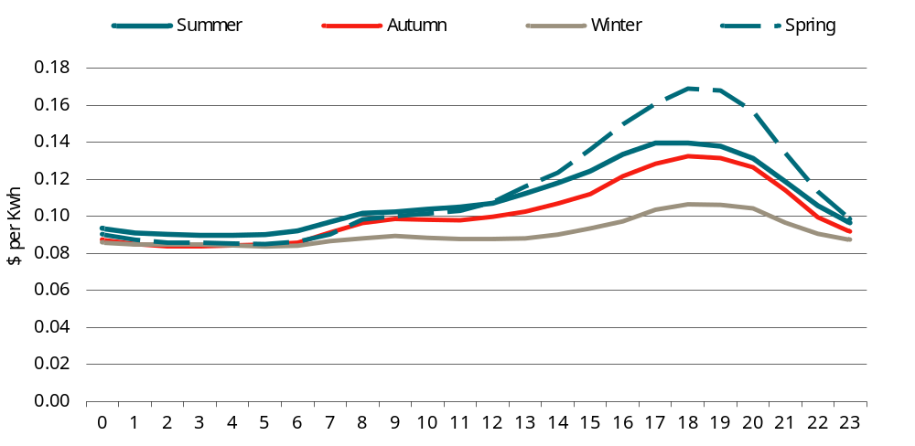
Note: Summer covers December to February. Autumn covers March to May. Winter covers June to August. Spring covers September to November.
Data source: Northern Territory Electricity System and Market Operator (NTESMO) 2022, ‘Historical daily trading data’, https://ntesmo.com.au/data/daily-trading/historical-daily-trading-data

Network costs
To determine network charges, we reviewed the price offerings lodged by each provider with AER, and, in Western Australia, the pricing lodged by Western Power with the Economic Regulation Authority of Western Australia (ERAWA). A thorough examination of pricing from a total of 15 providers or distributors has been conducted.
Network charges are complex and have wide ranges, as shown by the analysis by DeltaQ.
Distributors typically maintain multiple tariff codes to accommodate various user categories (residential, business, etc.) and voltage requirements. For example, Ausgrid has 29 tariff codes in its proposed pricing for 2023-24.
For each tariff code, the total network charges, or network use of system (NUOS), generally have three components:
- distribution use of system (DUOS), which are the charges related to relate to the conveyance of electricity from the transmission network, or generators embedded in the distribution network, to customers, covering the cost of installing and maintaining local electricity distribution networks;
- transmission use of system (TUOS), which are the charges related to the cost of shared network services to convey electricity from sources of generation connected to the transmission network to customers; and
- jurisdictional scheme amounts (JSA), which are the costs of government policies mandated into network tariffs.
The JSAs are mostly, if not all, costs related to government environmental and renewable energy policies. Examples for 2023-24 include:
- the Climate Change Fund, NSW Electricity Infrastructure Roadmap contribution determination and the Roadmap exemption in NSW
- Solar Bonus Scheme in the form of feed-in tariff and Energy Industry Levy in QLD
- PV feed-in tariff and AGL Designated Services Scheme in SA
- Premium PV feed-in tariff and Energy Safe Victoria electricity levies in VIC, and
- Utilities Network Facilities Tax, and Feed-in Tariff (small, medium and large scale) in the ACT.
JSAs are recovered from customers of each distributor through consumption charges and thus included as part of NUOS. According to the 2023-24 pricing proposal of Power and Water Corporation (NT), Western Power (WA) and TasNetworks (Tasmania), there appears no jurisdiction scheme that they administrated and thus no JSA applicable to their customers. Distributors in other jurisdictions cover contributions to state-level schemes through JSA charges ranging from $0.77/kWh to $13.13/kWh.
For DUOS and TUOS, distributors commonly introduce a combination of fixed supply charges, usage or consumption charges, and demand or capacity charges. The fixed supply charges are assessed based on the duration of connection and remain unaffected by variations in energy consumption. Consequently, these fixed charges are not considered in the network charges when evaluating changes in energy consumption resulting from proposed modifications to energy efficiency requirements in the NCC.
Energy usage or consumption is billed based on kilowatt-hours (kWh) or megawatt-hour (MWh) while the demand or capacity charges are determined by kilovolt-amperes (kVA) or kilowatts (kW) per day. kW represents the ‘actual’ power received by a user, indicating the amount of power converted into useful, working output. On the other hand, kVA is the measure of ‘apparent’ power, representing the total power being used in the system.
Most distributors implement time of use pricing for energy consumption and demand/capacity charges to align with the fluctuating energy demand during peak hours, weekdays, weekends and public holidays, through setting up charging windows with different consumption charges in forms of peak, shoulder (if applicable), and off-peak windows defined for a period of time in a day.
Additionally, some distributors incorporate seasonal time of use pricing to account for seasonal variation in energy demand throughout the year. For instance, Ausgrid’s business customers encounter peak window charges between 2pm and 8pm on working weekdays during both summer mouths (from 1 November to 31 March) and winter months (from 1 June to 31 August).

Network capacity costs
Avoided network capacity costs are estimated based on the network capacity charges that apply in each state and territory (table B.10). Although there is some variation in the way network capacity charges are applied, they are typically based on the peak usage during an hourly interval (within a designated peak period) in the relevant billing period (usually monthly).
B.10 Network capacity charges
Month | NSW  $/kVa/day | VIC  $/kVa/day | QLD  $/kVa/day | WA  $/kVa/day | SA  $/kVa/day | TAS  $/kVa/day | ACT  $/kVa/day | NT  $/kVa/day
January | 0.51 | 0.41 | 0.33 | 0.08 | 0.40 | 0.69 | 0.37 | 0.49
February | 0.51 | 0.41 | 0.33 | 0.08 | 0.40 | 0.69 | 0.37 | 0.49
March | 0.51 | 0.41 | 0.33 | 0.08 | 0.40 | 0.69 | 0.37 | 0.49
April | 0.00 | 0.00 | 0.33 | 0.08 | 0.00 | 0.69 | 0.37 | 0.49
May | 0.00 | 0.00 | 0.33 | 0.08 | 0.00 | 0.69 | 0.37 | 0.49
June | 0.51 | 0.00 | 0.33 | 0.08 | 0.00 | 0.69 | 0.37 | 0.49
July | 0.51 | 0.00 | 0.33 | 0.08 | 0.00 | 0.69 | 0.37 | 0.49
August | 0.51 | 0.00 | 0.33 | 0.08 | 0.00 | 0.69 | 0.37 | 0.49
September | 0.00 | 0.00 | 0.33 | 0.08 | 0.00 | 0.69 | 0.37 | 0.49
October | 0.00 | 0.00 | 0.33 | 0.08 | 0.00 | 0.69 | 0.37 | 0.49
November | 0.51 | 0.00 | 0.33 | 0.08 | 0.40 | 0.69 | 0.37 | 0.49
December | 0.51 | 0.41 | 0.33 | 0.08 | 0.40 | 0.69 | 0.37 | 0.49
Source: CIE based on review of network operators’ pricing proposals in each state or territory.
To estimate avoided network capacity costs we use the following approach:
- We first estimate the change in peak hourly usage (in designated peak periods where relevant) each calendar month (in kWh) based on DeltaQ modelling.
- We then convert the peak usage to kVa using a power factor of 0.9.
- We then multiply the change in peak consumption by the capacity charge (in kVa per day).
- Finally, we multiply by the number of days in the relevant month and then sum across months to get an annual estimate of the avoided network capacity costs.

Network usage costs
Avoided network usage costs are estimated based on network usage charges. Network usage charges vary by time of use and in some cases, by time of year. In particular, network usage charges vary by time of year in NSW (see chart B.11) and to a lesser extent Victoria (see chart B.12).
B.11 Hourly network usage charges across an average week — NSW
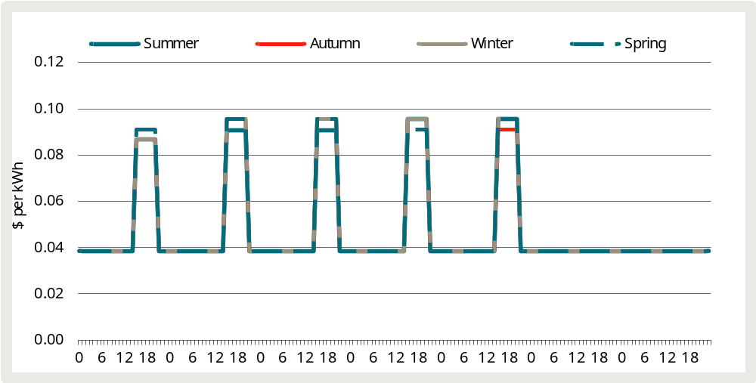
Data source: CIE based on review of network operators’ pricing proposals in each state or territory.
B.12 Hourly network usage charges across an average week — Victoria
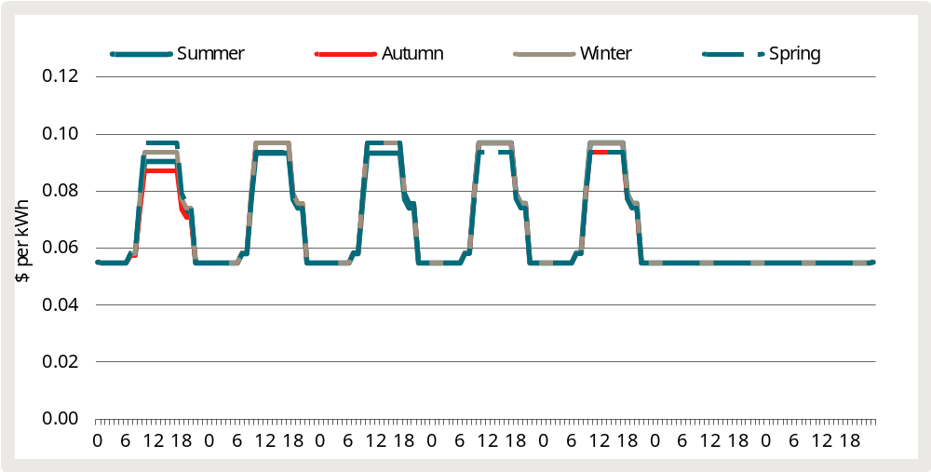
Data source: CIE based on review of network operators’ pricing proposals in each state or territory.
Network usage charges tend to vary less by time of year in other states and territories, but in most cases vary by time of day (see chart B.13).
B.13 Hourly network charges across an average week — other states and territories
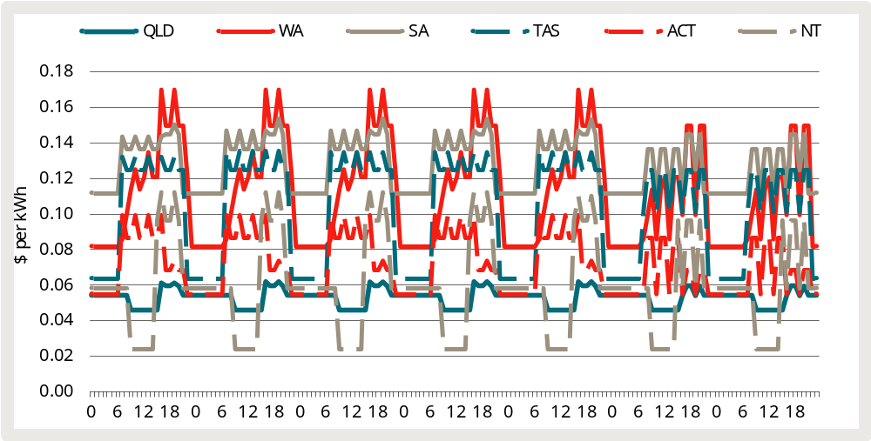
Data source: CIE based on review of network operators’ pricing proposals in each state or territory.

Environmental scheme costs
Another cost component usually included in retail prices is the cost associated with environmental schemes. There are two key environmental schemes:
- the Large-scale Renewable Energy Target (LRET — see box B.14); and
- the Small-scale Renewable Energy Scheme (SRES).
These schemes effectively provide a subsidy to relevant renewable energy generators, with the cost of the subsidy allocated across energy users based on energy usage.

B.14 The Large-scale Renewable Energy Target
The LRET incentivises the development of renewable energy power stations through a Renewable Energy Certificate Market for the creation and sale of certificates called large-scale generation certificates (LGCs).
- LRET-accredited power stations can create LGCs for electricity generated from that power station’s renewable energy source.
- These LGCs can be sold to ‘liable entities’ (mainly electricity retailers).
- Retailers are required to surrender a specified number of LGCs to the Clean Energy Regulator (CER) every year.
The number of LGCs that retailers must surrender is set by the renewable power percentage (RPP). The RPP is effectively set at a level that aims to achieve a specified target. This target was incrementally increased over the period from 2001 to 2020, but has now been fixed at 33 TWh until 2030.
These environmental schemes are policy instruments designed to reduce emissions. They are about to achieve an absolute target while specified in terms of proportion of energy sales. Energy savings may not change the total charges – less consumption is offset by higher unit charges.
In terms of measuring the benefits of reducing energy consumption (through proposed changes to the NCC), we therefore exclude the costs associated with environmental schemes.

Retail costs and margin
The retailer costs comprise the retailer’s operating costs and margin. Retailer’s operating costs (call centres, revenue and billing collection, customer acquisition and retention, and IT systems) are usually driven by the number of customers, rather than energy consumption. As such, these costs would not change as energy usage decreases through the additional energy efficiency requirements in the NCC 2025.
On the other hand, the retail margin is generally assumed to be applied as a percentage of the other costs. If energy costs decrease, then the operating margin applied to those costs would also decrease. As a result, the retail margin should be included as an avoided cost when evaluating the energy savings.
In its final determination on default market offer (DMO) prices for 2022-23, the AER has set a transition of the retail allowance for small business customers to 15 per cent for small business customers because it ‘is at the lower end of previous small business allowances and enables the DMO prices to maintain approximately the same aggregate level of allowance across the DMO regions and customers.’ In its final determination on DMO prices for 2023-24, AER has adhered to this 15 per cent small business customer retail allowance target while adjusting down the allowance in jurisdictions where the existing allowances are higher than 15 per cent.
We therefore use the rate of 15 per cent to estimate the retail margin. This is applied to the change in variable costs as identified above.

Value of exported electricity
In addition to avoiding the consumption of energy from the grid, some options (i.e. Stringency 2 and Stringency 3) mandate rooftop solar panels and there are estimated to be some periods where some buildings export electricity to the grid (i.e. periods where the electricity generated by solar panels exceed the building’s electricity consumption).

Feed-in tariffs
Feed-in tariffs are estimated as a share of the electricity wholesale prices as they are considered as the wholesale energy cost a retailer avoids when it sources exported electricity from solar PV customers rather than from the wholesale markets.
Each year, NSW and Victoria publish the solar feed-in tariff benchmark ranges and the wholesale price forecast that derive the benchmark tariffs. From here, we estimate the ratio of feed-in tariffs over the wholesale price forecast and apply the ratio to estimate the feed-in tariffs for our model. For other states, there is no such information provided to estimate the ratio, so we collated solar feed-in tariffs that are currently available to consumers and derive the ratio of the feed-in tariff over the average wholesale prices estimated in our model. As a result, feed-in tariffs vary by time of a day with the wholesale prices in Queensland and to a lesser extent in other states (see chart B.15).
B.15 Hourly feed-in tariffs across an average day by state and territory
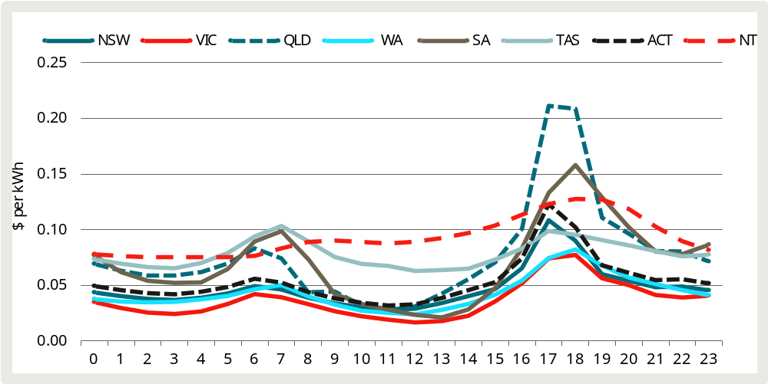
Data source: CIE based on review of solar feed-in tariffs offers in each state or territory.

Network impacts
Consistent with Ausgrid’s two-way tariff, we measure the network impacts of electricity exported to the grid as follows:
- Additional network costs are measured at 1.2 c/kWh for exports during the peak export period (10am to 3pm)
- Network benefits are measured at 2.3 c/kWh for the electricity exported during the peak demand period (4 pm to 9 pm).

Gas costs
AER publishes NEM electricity wholesale prices and East Coast gas wholesale prices in its Wholesale Markets Quarterly. According to the latest issue of the Quarterly, the average quarterly wholesale price in NEM ranged from $64 per MWh in Victoria to $114/MWh in Queensland in March 2023, compared to the highs of $241-344/MWh in June quarter of 2022. For gas, the wholesale prices in the East Coast market has fallen from over $40 per gigajoule (GJ) on average in July 2022 to below $12/GJ in March quarter of 2023.
WA Department of Mines, Industry Regulation and Safety (DMIRS) publishes price data on major commodity resources including domestic gas. The average domestic price in 2022 was $5.46/GJ.

Energy price forecasts
Forecasting energy price is a multifaceted undertaking that exceeds the scope of this analysis. Therefore, we will rely on established energy price forecasts available from reliable sources.
AEMO provides comprehensive price indexes for commercial electricity, extending across a significant time horizon under different scenarios.
As discussed above, the Step Change scenario is most relevant because it is the most likely scenario identified by AEMO. Charts B.16 illustrates the electricity price index for commercial customers by NEM states under the Step Change scenario.
For the 2023 Gas Statement of Opportunities (GSOO), Lewis Grey Advisory (LGA) prepared forecast of wholesale and delivered prices up to 2053 under different scenarios. Chart B.17 illustrates the delivered gas prices (weighted oil indexed) for Eastern Australian markets under the Step Change scenario.
Price forecasts for WA and the NT are unavailable. As a result, we rely on the NEM average price index for these regions.
B.16 Electricity price index for commercial customers under Step Change scenario
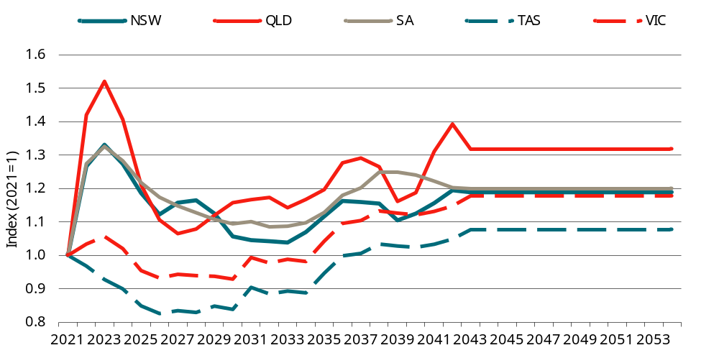
Data source: AEMO (2022).
B.17 Gas delivered price for residential and commercial customers under Step Change scenario
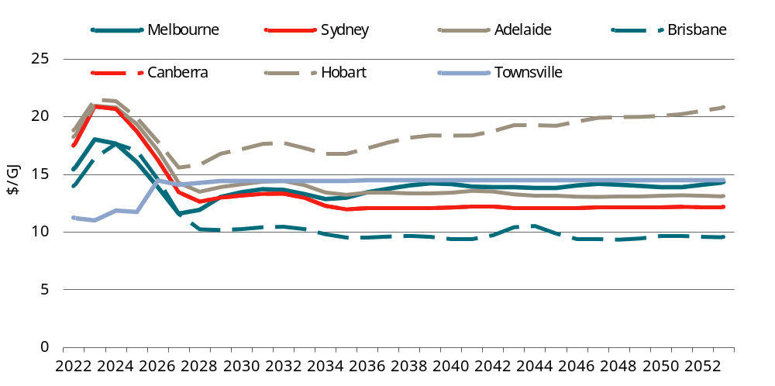
Data source: LGA (2022).
We use these indexes or price forecasts as a basis for forecasting future energy prices. Charts B.18 to B.20 illustrate the national average price series up to 2054.
In the CBA modelling for the RIS, we apply the projected change in the retail price for each jurisdiction across all the relevant components.
B.18 Electricity consumption tariff forecast
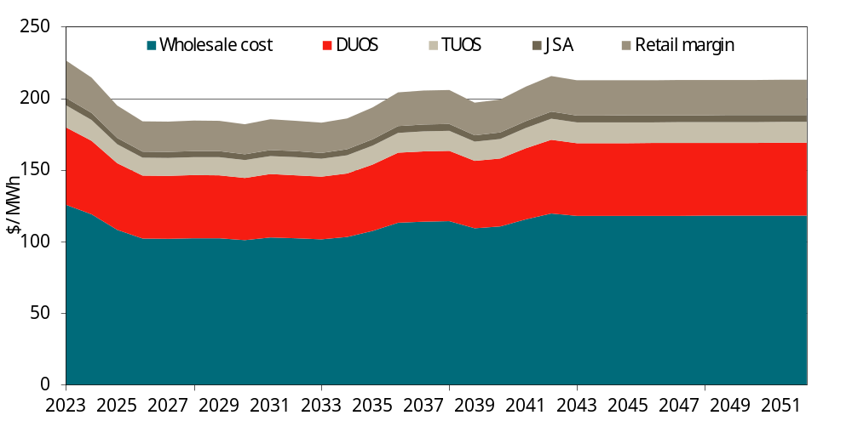
Data source: CIE estimates.
B.19 Electricity demand/capacity charge forecast
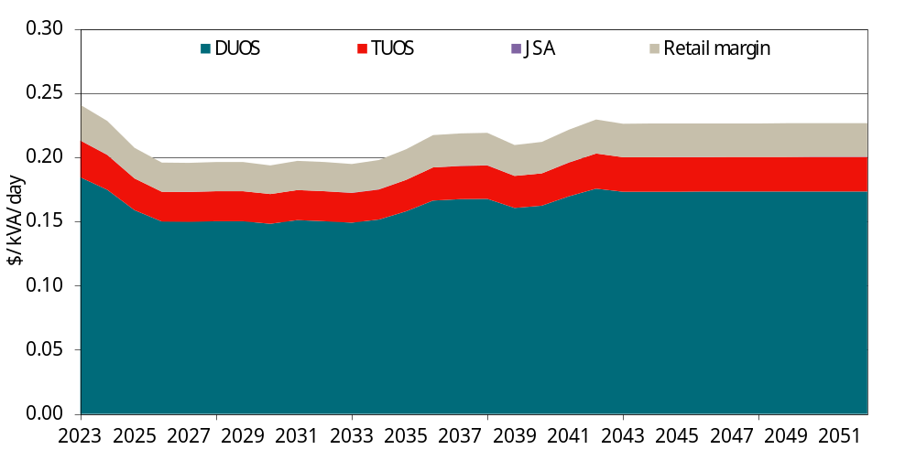
Data source: CIE estimates.
B.20 Gas price forecast
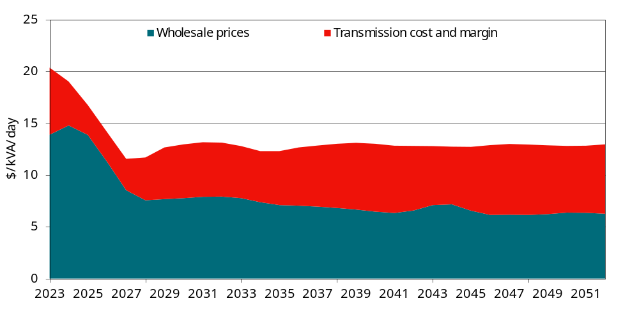
Data source: CIE estimates.

Are modelled energy savings realised in practice?

The performance gap
A well-known issue covered extensively in the international literature is that a building’s actual energy consumption tends to exceed model-based estimates of energy consumption. This is often referred to as the ‘performance gap’. The performance gap appears to be a more significant issue in commercial (non-residential) buildings, compared with residences.

Treatment in the 2018 RIS
Although the performance gap was a well-known issue, the 2018 RIS (prepared by CIE) was the first Australian RIS (or cost-benefit analysis) of energy efficiency regulation to have addressed the issue of whether modelled energy savings are achieved in practice. In particular, the 2018 RIS:
- presented evidence from several international (peer reviewed) papers that suggested that predicted energy savings in buildings designed to be more energy efficient may not be achieved in practice. For example, Frankel and Turner (2008) noted that projects with more aggressive energy performance goals generate overly optimistic predictions of actual energy use. This suggests that predicted energy savings may not be achieved in practice.
- presented a re-analysis of data published by GBCA.
C.1 Relationship between predicted and actual GHG emissions (from 2018 RIS)
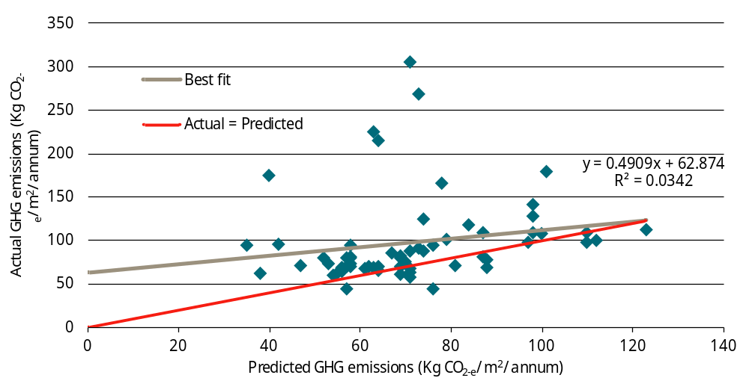
Data source: CIE based on data in Bell, H., Millagre, R. and Sanchez, C. 2013, Achieving the Green Dream: Predicted vs Actual, Green Building Council of Australia, August 2013, pp. 17-20.
Key limitations of the analysis included the following.
- The analysis did not take into account the extent to which the difference between predicted and actual outcomes was due to factors such as actual occupancy patterns varying from the modelling protocols.
- The sample covers only a subset of office buildings (i.e. office buildings with both a Green Star rating and a NABERS rating) and was unlikely to be representative of all commercial buildings.
Given the uncertainty around the performance gap, CBA results were presented under various realisation assumptions, as follows.
- Under the first (low) realisation scenario, it was assumed that 49 per cent of modelled energy savings would be achieved in practice. This was consistent with the relationship between modelled and actual GHG emission savings implied by the Green Star data (see chart C.1 above).
- Under the second (medium) realisation scenario, 75 per cent of modelled energy savings were assumed to be achieved in practice. This was consistent with the relationship between modelled and actual GHG emissions implied by the Green Star data when the five outliers have been excluded from the sample.
- Under the third (high) realisation scenario, modelled energy savings were assumed to be achieved fully in practice.

Relevance of the performance gap to the RIS
As energy modelling forms the primary evidence base to support the proposed changes to the minimum energy efficiency requirements in NCC, it is critical to examine whether this evidence is a reliable indicator of the actual impacts of the proposal.
The modelling for the NCC 2025 update for the Department of Industry, Science and Resources (DISR) argued that any discount applied to energy consumption in the policy case (i.e. the proposed energy efficiency provisions for NCC 2025) should also be applied in the base case (i.e. NCC 2019) to avoid unfairly penalising the policy case.
However, this misinterprets the evidence cited in the RIS.
- In particular, the above analysis (see chart C.1) found that on average, the (absolute) performance gap tends to be much higher in energy efficient buildings (i.e. buildings with low modelled energy intensity), compared with less energy efficient buildings (i.e. building with higher modelled energy intensity).
- This relationship implies that the performance gap is likely to be higher for a building under the policy case (i.e. compliant with NCC 2025), compared with the base case (i.e. compliant with NCC 2019).
- The implication would be that the modelled energy savings (i.e. the difference between NCC 2019 and NCC 2016) are unlikely to be fully realised on average (i.e. the slope of the line of best fit is less than 1).
If, as argued in the commercial buildings update report, the ‘performance gap’ (in absolute terms) is likely to be the same in the base case (i.e. NCC 2019) and the policy case (the NCC 2025 proposal), we would expect the line of best fit (i.e. the grey line in chart C.1) to have a slope close to 1 (i.e. parallel to the red line where actual energy consumption equals predicted energy consumption).

Recent evidence
Over recent years (i.e. since the 2018 RIS), there has been significant research to understand the performance gap from both a technical and a policy perspective.
Much of the literature focuses on estimating the size of the performance gap using various building samples and the causes of the performance gap, rather than the central question to the RIS: whether modelled energy savings are achieved in practice.
Recent work for the International Partnership for Energy Efficiency Cooperation (IPEEC) Building Energy Efficiency Taskgroup (BEET) noted that building energy modelling can be a powerful tool for understanding the likely impacts of different building system alternatives, construction practices, and occupant behaviour issues. However, building energy models are generally not intended to “predict” actual energy performance when the building is operational.
According to the IPEEC report, energy modelling during the building’s design phase is most commonly used to demonstrate compliance with ‘a building code or other regulatory instrument, which typically covers only a subset of energy uses (referred to as ‘regulated uses’). In operation, buildings often incur other loads which are not regulated (such as appliances, elevators, process loads, or other plug loads) which can be significant. These uses are often not captured accurately in compliance-oriented energy models. This implies that comparisons between modelled and actual energy consumption may not be an ‘apples with apples’ comparison.
Of relevance to the RIS, the IPEEC report noted increasing evidence of expected savings from retrofit projects not being realised. The evidence from retrofit projects is important because the ‘base case’ (i.e. the building’s performance prior to the retrofit) can be observed. By contrast, the base case (i.e. a hypothetical less energy efficient alternative building) cannot be directly observed for new buildings (as discussed below it can be challenging to compare across buildings).
In the Australian context, an important recent contribution to understanding the performance gap is the GBCA’s recent report Green Star in focus: Energy performance in Green Star buildings: Closing the performance gap in Australia’s commercial office sector. This report was an update and expansion of a previous (2013) report Achieving the Green Dream: Predicted vs. Actual – Greenhouse Gas Performance in Green Star certified office buildings, the research report that provided the data that CIE used as the basis for our analysis (see chart C.1 above).
The main objective of the new study was to verify how predictive energy modelling applied to the design of Green Star rated buildings translates into performance in operations. The analysis compared modelled and actual performance of 176 office buildings (this compared to a sample of 70 buildings for the 2012 report) with both:
- a Green Star rating (which includes modelled outcomes); and
- a NABERS Energy (base building) rating (which reports actual outcomes).
Modelled energy performance was taken from Green Star project submissions and converted to a NABERS star rating using the NABERS Energy Calculator. This was then compared to the actual NABERS Energy rating from the NABERS database.
The analysis focuses on the NABERS Energy ratings (rather than energy intensity) because it corrects for unavoidable operational factors, such as hours of occupancy (i.e. where a building’s actual hours of occupancy are greater than modelled, the building will use more energy).
The GBCA found that (see chart C.2):
- 88 per cent of buildings in the sample achieved, exceeded or were within reach of their modelled NABERS Energy rating, including:
- 23 per cent improved on their modelled NABERS Energy rating
- 44 per cent achieved their modelled NABERS Energy rating
- 21 per cent were within 0.5 starts of their modelled NABERS Energy rating
- 12 per cent of buildings were more than 0.5 stars from their modelled NABERS Energy rating.
C.2 Comparison of actual and modelled NABERS rating
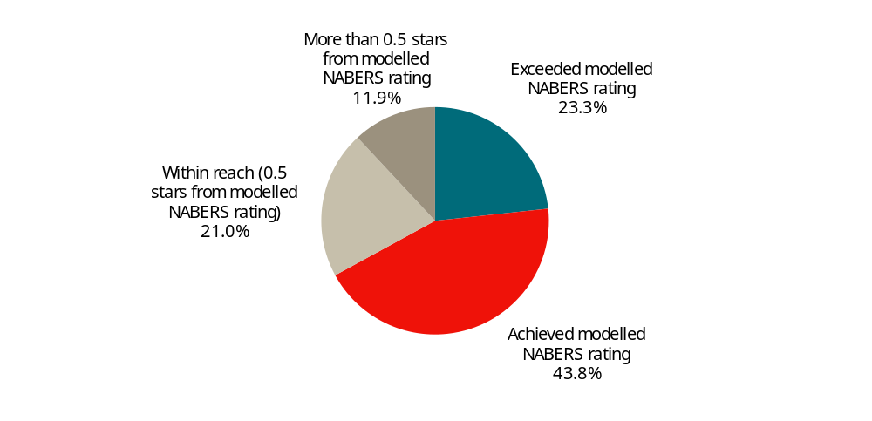
Data source: Green Building Council of Australia, 2021, Green star in focus: Energy performance in Green Star buildings: Closing the performance gap in Australia’s commercial office sector, pp. 56-57.
These results were an improvement from the previous (2012) analysis (see chart C.3):
- a greater proportion of buildings in the sample achieved or exceeded the modelled NABERS rating
- a smaller proportion of buildings in the sample performed significantly below the modelled NABERS rating.
C.3 Comparison of actual and modelled NABERS rating — frequency distribution
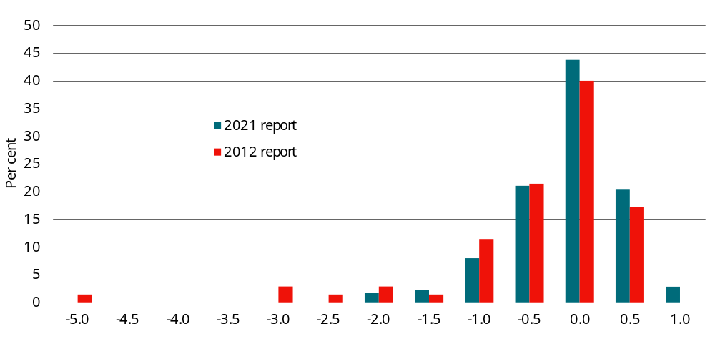
Data source: CIE based on: Green Building Council of Australia, 2021, Green star in focus: Energy performance in Green Star buildings: Closing the performance gap in Australia’s commercial office sector, pp. 56-57; and Bell, H., Millagre, R. and Sanchez, C. 2013, Achieving the Green Dream: Predicted vs Actual, Green Building Council of Australia, August 2013, pp. 17-20.
Although the improvement in actual performance relative to modelled outcomes is a welcome development, there is nonetheless some evidence within the data that buildings designed to be more energy efficient are not achieving the intended savings. As discussed above, this is the key issue of relevance to the RIS.
In particular, the data suggests the following (see chart C.4).
- Buildings that are designed to be less energy efficient (i.e. the modelled star rating is lower) tend to over-perform (i.e. achieve a higher star rating than modelled).
- Buildings that are designed to be more energy efficient (i.e. the modelled star rating is higher) tend to under-perform (i.e. achieve a lower star rating than modelled).
C.4 Comparison of modelled and actual NABERS star rating by modelled star rating
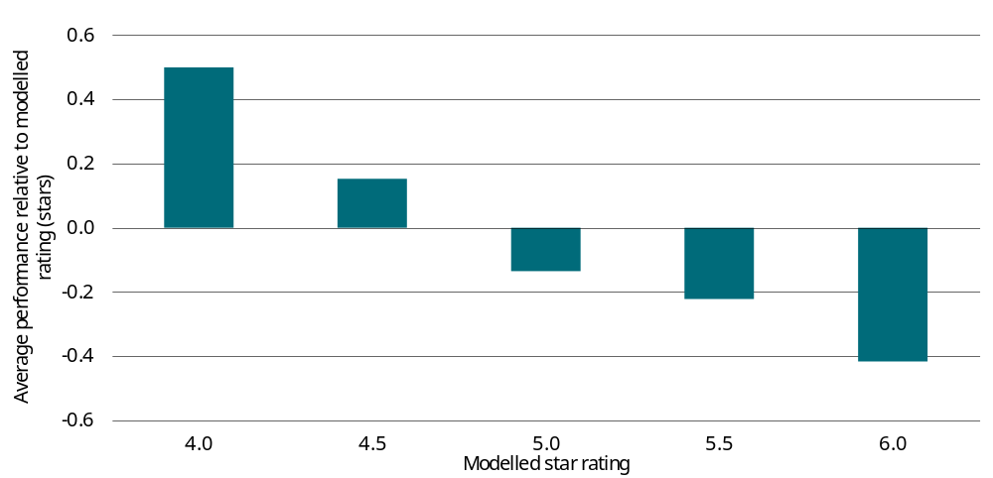
Data source: CIE based on data reported in Green Building Council of Australia, 2021, Green star in focus: Energy performance in Green Star buildings: Closing the performance gap in Australia’s commercial office sector.
An important caveat on this analysis is the small sample of buildings at either end of the spectrum. In particular: there were only 2 buildings that were modelled to achieve 4 stars (both of which achieved 4.5 stars); and only 6 buildings that were modelled to achieve 6 stars. Nevertheless, this bias implies that more energy efficient buildings are unlikely to fully achieve the expected energy savings.
Furthermore, a subsequent scoping study investigating the Building Energy Performance Gap (BEPG) found that it is not appropriate to extrapolate from findings in relation to the performance gap based on the GBCA’s 2021 dataset to other building types for the purposes of regulatory impact analysis.
- The scoping study argues that the BEPG in well-designed and well-managed office buildings has been materially resolved through their participation in rating systems that measure both design and performance.
- The performance gap in other types of buildings that are not captured by these rating systems remains unquantified and poorly understood.
As part of the scoping study, the authors reviewed potential data sources across a broader range of building types that could be used to investigate the issues relating to the performance gap in subsequent phases of the research.
The project encountered significant challenges obtaining relevant data, ultimately concluding that:
- JV3 energy modelling cannot be used to extrapolate total energy use. In particular, the following factors limited the usefulness of JV3 reports for analysing the performance gaps:
  - The typical design and construction process means that the final systems have not been confirmed when the JV3 energy simulation is completed.
  - JV3 is used as a tool to enable comparisons between alternate designs, allowing projects to confirm building aesthetics and tender pricing for building fabric. It is not used by industry as a performance measurement tool.
- This means that a study comparing energy use estimates from JV3 assessment reports with actual outcomes would not be comparing like with like.
- There is no data currently available within industry that could be aggregated to create an appropriate dataset.
Based on these findings it seems unlikely that a robust estimate of the extent to which modelled energy savings associated with more stringent energy efficiency standards will be realised in practice or will be available in the near term.

Reasons for the performance gap
There are a range of explanations for the performance gap at all stages of a building’s life cycle.
- Design and construction phase — the NCC focuses on building design, but there can be gaps between a building’s design and the building actually constructed.
- The National Energy Efficient Buildings Project also noted that anecdotally, energy efficiency features and technologies are eliminated during the design and construction process. Budget constraints often force the building developer (not necessarily the ultimate owner) to choose between energy performance and other design elements that are more highly valued. However, no quantitative evidence on the extent to which this occurs was reported.
- The United Kingdom Carbon Trust also noted that:
  - the aim to make building low carbon in-use is not clearly conveyed to the design team, and
  - design intent is not delivered on-site during construction.
- Operation phase — building operation could contribute to the performance gap, including:
  - A lack of adequate commissioning and maintenance — the National Energy Efficient Buildings Project reported that a perceived lack of adequate commissioning for new and renovated commercial buildings and ongoing maintenance was likely to be contributing to poor energy efficiency outcomes. As buildings aim for higher energy efficiency, integrating all of the relevant systems and ensuring that they deliver intended outcomes, through all seasons and weather conditions becomes more challenging. This means there is often greater scope for high performance buildings to deviate from design energy consumption than simpler, ‘refrigerated boxes’. This finding was based on industry perceptions, rather than quantified evidence.
  - Sub-optimal building operation — one stakeholder noted that there is less ‘margin for error’ in buildings with more energy efficient equipment. This could imply that sub-optimal building operating practices have a greater impact in more energy efficient buildings.
  - Occupancy patterns and behaviour — occupancy patterns can be difficult to predict and where they vary from those modelled, this could contribute to the performance gap. Similarly, the behaviour of building occupants can have a significant impact on energy consumption. Although several reports have found that occupant behaviour was a key driver of the ‘performance gap’, a recent analysis found no conclusive and sufficient empirical evidence supporting the claim that occupants’ behaviour is responsible for the bulk of building-related energy performance gap.
  - Modelling failures — a recent United Kingdom study (albeit in relation to residential buildings) found that a sample of 108 building modellers found that there was little correlation between variables that the modellers considered to be important to annual energy demand and the factors that were objectively found to be important. On this basis, the study concluded that this sample of building modellers, and by implication the population of building modellers cannot be considered ‘modelling literate’. This suggested that the performance of building modellers was contributing to the performance gap. Although these findings have no direct relevance to commercial building energy modellers in Australia, it nonetheless demonstrates that energy modelling involves subjective judgement and modellers are not infallible.

Health and productivity benefits

Health benefits from reduced coal-fired electricity
There are health benefits arising from the improved energy efficiency that reduces energy consumption generated from fossil fuels. Power stations, especially coal-fired power stations, emit a range of toxic pollutants and are the key sources of generating sulphur dioxide, oxides of nitrogen and fine particle pollution (PM2.5). Exposure to such toxic pollutants has a health burden and may cause premature deaths, heart attacks, strokes, asthma attacks, low birth weight infants, lung cancer and type 2 diabetes. Reducing the consumption of energy that involves burning of fossil fuels (particularly coal-fired electricity generation) can therefore reduce the health burden.
There is literature estimating health impacts in terms of damage cost per megawatt hour (table D.1). The cost assessment is often locally specific to metropolitan regions, depending on a range of factors such as local context, electricity generation models and outlooks in the region and the state, the volume and nature of the emissions of the relevant pollutants, how those pollutants are dispersed, and population exposure in the relevant areas.
D.1 Health cost of coal power stations in 2023 dollar
Source | Region | Pollutant | Damage cost (A$/MWh)
M Mazaheri et al. 2021 | NSW Greater Metropolitan Area | PM2.5 | 2.93
CIE 2020 | VIC | SO₂, NO_{X}, PM2.5, PM10 | 14.26 – 22.56
CIE 2019 | Urban areas where coal power stations are located | PM2.5 | 0.0 - 0.52
Source: M Mazaheri et al., ‘Monetising Air Pollution Benefits of Clean Energy Requires Locally Specific Information’, in Energies, vol. 14, 2021, 7622. CIE, Greenhouse gas emissions projections and economic analysis of emissions reduction in Victoria - Whole of the economy modelling, Prepared for the Department of Environment, Land, Water and Planning, 2020, unpublished. CIE, Independent review of the Commercial Building Disclosure Program, Prepared for the Department of the Environment and Energy, 2019, https://www.cbd.gov.au/sites/default/files/2020-09/cbd_review_cie_report_draft.pdf.
Mazaheri et al. (2021) estimated the health damage attributable to long-term exposure to PM2.5 concentrations for the NSW greater metropolitan area which cover over 85 per cent of the NSW population. The health cost per megawatt hour was estimated at $2.40 in 2016 dollar (equivalent to $2.93 in 2023 dollar). It was drawn upon the estimated life years gained in reducing long-term exposure to PM2.5 through clean energy program, under the medium demand shock scenario throughout 2026-2118 (covering the entire period until extinction of the population cohort) using a real social discount factor of 7 per cent. The estimate accounts for dispersion of PM2.5 within the NSW greater metropolitan area and is specific to NSW where coal power stations primarily use black coal.
CIE estimated the health cost per megawatt hour of electricity generated by the VIC coal power stations (using brown coal) based on estimates from J Ward & M Power (2015). The health damage is attributable to long-term exposure to sulphur dioxide, oxides of nitrogen, PM2.5 and PM10. Table D.2 reproduces these estimates in 2023 terms. The estimates considered dispersion and transformation of pollutants using air plume modelling and represent a shadow market value of the health impacts of using willingness-to-pay methodology.
D.2 Health cost per unit of generation for Victorian power stations in 2023 dollar
Power station | Damage cost  (A$/MWh)
Hazelwood | 10.10
Loy Yang A | 22.56
Loy Yang B | 20.17
Yallourn | 14.26
Source: DELWP, Estimating the health costs of air pollution in Victoria, DELWP Economics working paper to inform the Independent Expert Panel on Interim Targets, 2018, table 2, https://www.climatechange.vic.gov.au/__data/assets/pdf_file/0022/421717/Final_Health-costs-of-air-pollution-in-Victoria.pdf, accessed 6 December 2023.
CIE further estimated future local health impacts with the changes in population density and local family income, which translate to projected population growth in the local region and projected gross state product (GSP) growth as an important factor of the future willingness to pay.
CIE had also estimated heath costs associated with operating coal power stations for NCC 2019 (table D.3). The estimates are health damage attributable to exposure to PM2.5 in the urban areas where the stations are located or nearby, but they did not account for dispersion of pollutants.
D.3 Health cost by facility in 2023 dollars
Facility Name | Urban area (nearest) | Emissions intensity  (tPM_{2.5}/  GWh) | Damage cost  ($/tPM_{2.5}) | Damage cost  (A$/MWh)
Eraring Power Station (NSW) | Morisset - Cooranbong | 0.005 | 25 735 | 0.12
Bayswater Power Station (NSW) | Muswellbrook | 0.006 | 18 717 | 0.12
Liddell Power Station (NSW) | Muswellbrook | 0.029 | 18 717 | 0.55
Vales Point Power Station (NSW) | Central Coast | 0.012 | 214 071 | 2.53
Mt Piper Power Station (NSW) | Lithgow | 0.021 | 40 943 | 0.86
Tarong Power Stations (QLD) | NIASUA (QLD) | 0.141 | 175 | 0.02
Gladstone Power Station (QLD) | Gladstone - Tannum Sands | 0.019 | 70 187 | 1.37
Stanwell Power Station (QLD) | Rockhampton | 0.018 | 51 471 | 0.94
Millmerran Power Station (facility) (QLD) | Toowoomba | 0.061 | 85 395 | 5.20
Callide C Power Station (QLD) | NIASUA (QLD) | 0.050 | 175 | 0.01
Callide B Power Station (QLD) | NIASUA (QLD) | 0.070 | 175 | 0.01
Kogan Creek Power Station (QLD) | NIASUA (QLD) | 0.005 | 175 | 0.00
Loy Yang Power Station and Mine (VIC) | Traralgon - Morwell | 0.050 | 66 678 | 3.33
Yallourn Power Station (VIC) | Traralgon - Morwell | 0.070 | 66 678 | 4.67
Loy Yang B Power Station (VIC) | Traralgon - Morwell | 0.030 | 66 678 | 1.99
Muja Power Station (WA) | NIASUA (WA) | 0.054 | 5 | 0.00
Collie Power Station (WA) | NIASUA (WA) | 0.135 | 5 | 0.00
Bluewaters Power Station No 1&2 (WA) | NIASUA (WA) | 0.004 | 5 | 0.00
Source: CIE update based on CIE, Independent review of the Commercial Building Disclosure Program, Prepared for the Department of the Environment and Energy, 2019, <https://www.cbd.gov.au/sites/default/files/2020-09/cbd_review_cie_report_draft.pdf>. The table is based on information sourced from PAEHolmes, 2013, Methodology for valuing the health impacts of changes in particle emissions - final report. For NSW Environment Protection Authority (EPA); Clean Energy Regulator, 2019, Electricity sector emissions and generation data 2021-22; Australian Department of the Environment and Energy, Latest NPI emissions for 2017-2018, http://www.npi.gov.au/npi-data/latest-data CIE, Independent review of the Commercial Building Disclosure Program, Prepared for the Department of the Environment and Energy, 2019, <https://www.cbd.gov.au/sites/default/files/2020-09/cbd_review_cie_report_draft.pdf>.
Whilst we have sought to establish a health burden assessment for coal-fired electricity generation, at this stage we have not included these impacts into the cost-benefit analysis for the following reasons.
- The health cost appears to be small. A damage cost of $10 per MWh is equivalent to 1 cent per kWh. This is relatively small compared to other benefits through improved energy efficiency. In addition, the estimate is regionally constrained or pollutant specific, and estimates at aggregate level are dependent on assumptions and generally interpreted as an indicator of potential health impacts.
- It is difficult to link the reduction in energy consumption via energy efficiency improvements from specific buildings to particular coal fire stations and thus to provide a robust estimate.
- Along with the grid’s decarbonisation and expected closure schedule of several coal power stations in the next 10 years, the health impacts stemming from particle pollution are expected to decrease.
  - Eraring Power Station will be decommissioned in New South Wales in August 2025 and Yallourn Power Station in Victoria in 2028.
  - The currently announced closure timings suggest that 8.4 GW of the current 23 GW of coal capacity will withdraw by 2030. In AEMO’s Step Change scenario, modelling indicates 14 GW of coal-fired generation is likely to withdraw by 2030 to meet tighter carbon budgets for the sector. All coal capacity could close as early as 2040.

Health and productivity benefits
Any health and productivity benefits would be in addition to the energy benefits estimated above. There is literature that investigates the relationship between energy efficient measures and perceptions of wellbeing and/or work performance amongst building occupants, especially the impacts of energy efficient solutions in office buildings on office users. Nevertheless, literature has showed varied perceptions of comfort, wellbeing and productivity in response to the energy efficient offices (box D.4). In general, there appears some correlations between energy efficiency and improved health and performance outcomes, but they are not proof of causal relationships.

D.4 Literature on the impacts of energy efficiency on health and productivity
Steinemann, Wargocki and Rismanchi (2017) examined empirical evidence on whether energy efficient buildings may promote health outcomes of occupants through better indoor air quality (IAQ) and found that perceived IAQ is higher in energy efficient buildings than in comparable conventional buildings. However, in most studies no measurements were performed in parallel to subjective evaluations to explore true differences in pollutant exposure between the investigated buildings. In addition, the perception of better IAQ can be attributed partly to overall high satisfaction of working in a green building, which may propagate on satisfaction with IAQ. While the health outcomes are improved in energy efficient buildings, as perceived by occupants, no sufficient connection is made between the subjective results and objective measurements of exposure.
Wallner et al. (2017) carried out a quasi-experimental field study to investigate differences in self-rated health status between occupants in energy efficient buildings with mechanical ventilation (test group) and those with natural ventilation (control group). Occupants in the test group rated the overall health status of their own and children not significantly higher than occupants in the control group. Adult occupants in the test group reported dry eyes statistically significantly more frequently, compared to the control group. In addition, mechanically ventilated buildings have better self-rated IQA and climate than naturally ventilated buildings.
Kozusznik et al. (2019) conducted a systematic review to identify existing empirical evidence on the relationships between energy efficient solutions in sustainable office buildings and the perceptions of employees’ wellbeing and productivity, as well as the boundary conditions for these relationships to occur. Among the 19 reviewed studies, 9 of them reported significant positive relationship between energy efficient buildings and perceived wellbeing and productivity of occupants. 7 studies reported insignificant positive relationships, and 2 studies found significant negative relationships. 1 study found neutral impact of energy efficient buildings on occupants’ health outcomes. These reviewed studies have different research designs, and the diversity of their results suggest study design is an important factor. That being said, the majority of reviewed studies show positive correlation between energy efficient measures and perceived health outcomes and/or work performance. In addition, some studies pointed out some moderators in the relationship such as degree of occupants’ control over the office environment, users’ adaptive behaviours, effective training provision in high-performing green buildings and the use of private workspaces.
Menadue, Soebarto and Williamson (2014) carried out a comparative post-occupancy internal environment monitoring and occupant survey on buildings with and without Green Star certification in Australia. Green-rated buildings exhibit equal and, in some circumstances, decreased occupant satisfaction of internal thermal conditions, compared to non-green-rated buildings.
Source: MW Kozusznik et al., ‘Decoupling Office Energy Efficiency From Employees’ Well-Being and Performance: A Systematic Review’, in Frontiers in Psychology, vol. 10, 2019. V Menadue, V Soebarto & T Williamson, ‘Perceived and actual thermal conditions: case studies of green-rated and conventional office buildings in the City of Adelaide’, in Architectural Science Review, vol. 57, 2014, 303–319. A Steinemann, P Wargocki & B Rismanchi, ‘Ten questions concerning green buildings and indoor air quality’, in Building and Environment, vol. 112, 2017, 351–358. P Wallner et al., ‘Health and Wellbeing of Occupants in Highly Energy Efficient Buildings: A Field Study’, in International Journal of Environmental Research and Public Health, vol. 14, 2017, 314.
In the 2015 review of the CBD program, ACIL-Allen Consulting found significant productivity benefits of the CBD program even under conservation assumptions. That said, these benefits were reported separately from the main CBA results due to a lack of sufficient data estimating the productivity benefits of energy efficient buildings as well as the high degree of uncertainty in estimation.
In addition, an analysis of the relationship between NABERS Energy rating and the thermal comfort score (the component of the NABERS Indoor Environment Quality (IEQ) rating that is most likely to be associated with energy efficiency) for those buildings that have both ratings suggests a weak (albeit statistically significant) relationship between these variables (chart D.5).
D.5 Relationship between NABERS energy rating and thermal comfort score
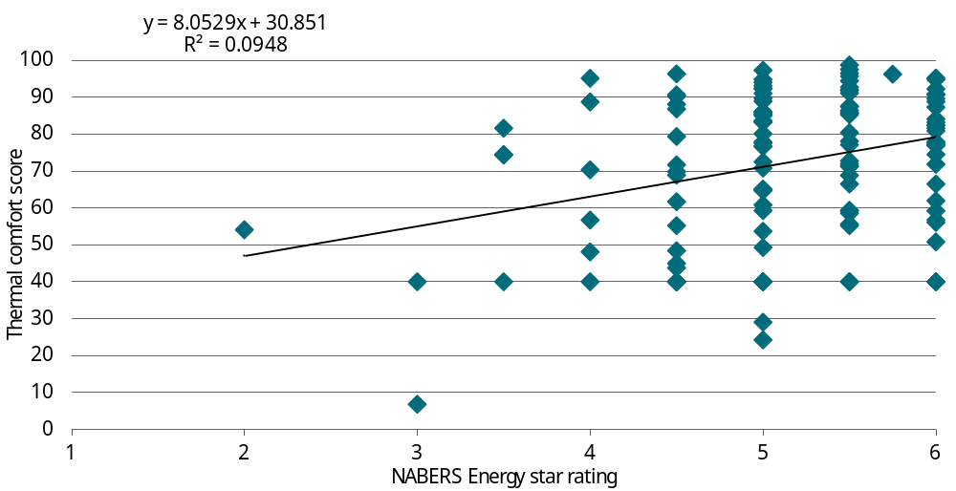
Data source: CIE based on NABERS database.
One caveat here is that there are few buildings with a NABERS Energy rating of less than 4 stars in the dataset. This implies that the weak relationship may be more relevant to the higher-rated buildings rather than lower-rated buildings. There is some evidence to suggest that for low-rated buildings, improvements in the NABERS Energy star rating are associated with increased thermal comfort.
Furthermore, the NABERS IEQ tool has two thermal comfort methodologies. One of these methodologies is only available to buildings with annual tracking and storing of temperature data. The thermal comfort score may be artificially low for buildings that do not store their annual temperature data. This may partly explain the weak relationship between the NABERS Energy rating and the thermal comfort score.

Impact of EV charging facilities
A requirement to provide EV charging infrastructure at commercial buildings may increase or bring forward the provision of such charging infrastructure relative to the base case. Demand for EVs themselves may be increased as a result (due to network effects). Increased market share for EVs relative to internal combustion vehicles will result in fewer carbon emissions in Australia, a trend that will accelerate as electricity generation is decarbonised. This reduction in emissions may increase the likelihood that Australia will meet its obligations under international agreements to successfully reduce global emissions, resulting in mitigation of climate change. This is a positive externality from the provision of EV charging infrastructure at commercial buildings.
The question of whether the requirement to provide charging infrastructure is worthwhile will come down to whether the cost is higher than the forecast value of emissions reduction (using a SCC) or the marginal cost of achieving the abatement another way. Some authors have argued that subsidising charging infrastructure has a greater impact on EV adoption than subsiding EVs themselves and results in fewer distortions.,
The costs and benefits of the proposed NCC requirements would be measured relative to a base case scenario without changes to the Code.
In each year, benefits will be measured as:
- the use value placed on additional charging infrastructure.
  - Base case EV user willingness to pay (WTP) for improved availability/charge times (Area A in figure E.1), plus
  - A proportion (typically half) of the same WTP for users switching from conventional to EV between the base case and change scenarios (Area B in figure E.1, which is around half the area of B+C)
- the value of avoided emissions, which results from the increased market share for EVs and reduced market share for conventional vehicles.
E.1 Market for electric vehicles
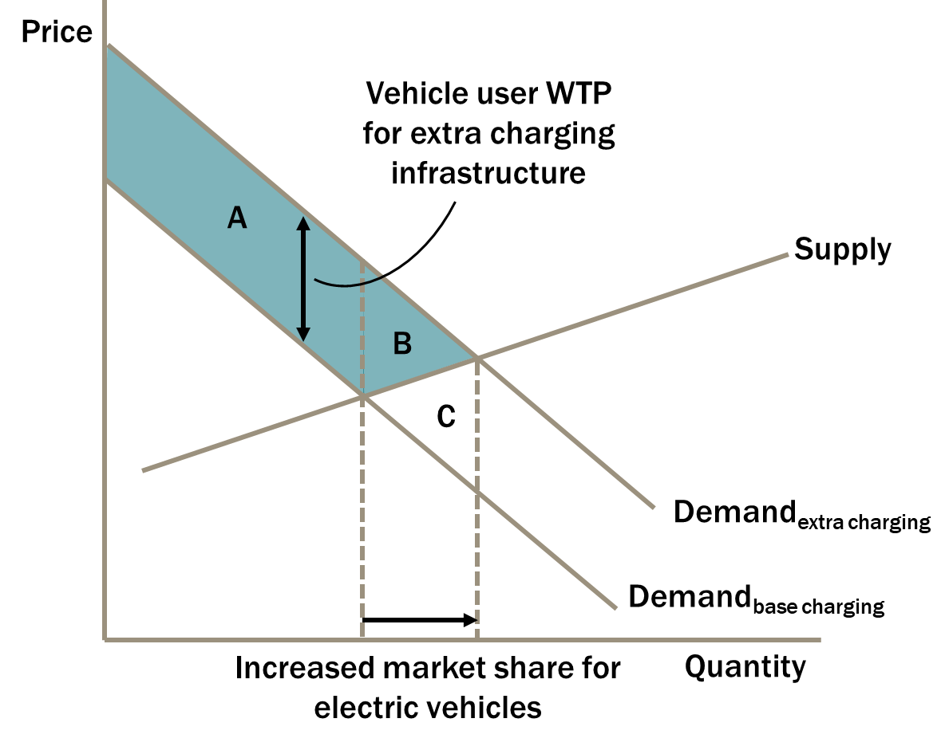
Data source: CIE.
To calculate these benefits, we need to forecast, for both the baseline and change scenarios:
- EV user WTP for charging infrastructure by vehicle type, which requires forecasts of:
  - availability of charging infrastructure
  - charge time at charging infrastructure, and
  - EV battery range by vehicle type
- EV market share/number of users by vehicle type
- emission intensity of conventional vehicles
- emission intensity of EVs, and
- the value of avoided emissions.
Our assumptions in relation to the baseline scenario will be consistent with commitments made in the National Electric Vehicle Strategy released in April 2023. Each of these items is discussed further below.

EV user willingness to pay
EV user WTP for additional charging infrastructure in the change scenarios relative to the baseline scenario will be estimated using the CIE’s 2019 choice modelling study conducted for Australian Automobile Association (AAA). Estimates of average WTP per consumer in the vehicle purchase price (across all vehicle types) for improvements in charging time are set out in table E.2.
E.2 Average willingness to pay for a marginal change in vehicle/charging attributes
Attribute | Unit | Marginal WTP  (2019$ in purchase price)
Carbon emissions | per 50 g/km (decrease) | 244
Destination charging time | Change from 120 to 60 minutes | 686
Destination charging time | Change from 60 to 15 minutes | 25
Highway charging time | Change from 60 to 30 minutes | 1,350
Highway charging time | Change from 30 to 15 minutes | 1,137
Highway charging time | Change from 15 to 5 minutes | 1,120
All vehicle types n=3021, reweighted to account for oversampling of persons with university degrees
Source: CIE 2019. Demand for EVs – a discrete choice survey. Final Report prepared for Australian Automobile Association, 22 January.
In the CIE model, the WTP for additional availability of charging infrastructure depends on EV battery range. Estimates for selected levels of battery range are set out in table E.3.
E.3 Average willingness to pay for improvements in availability of charging (2019$)
Battery range  (km) | Availability of charging on major highways  (every 300 km to every 200 km) | Availability of charging on major highways  (every 200 km to every 100 km) | Availability of charging at major shopping centres and commercial car parks  (per 10 percentage points)
150 | 4,782 | 2,107 | 382
230 | 3,602 | 927 | 228
320 | 2,691 | 16 | 109
All vehicle types n=3021, reweighted to account for oversampling of persons with university degrees
Note: Assumes vehicle is a battery EV, rather than a plug-in hybrid EV
Source: CIE 2019. Demand for EVs – a discrete choice survey. Final Report prepared for Australian Automobile Association, 22 January.

Charging availability
There are many factors influencing the provision of charging infrastructure in new commercial developments, including vehicle manufacturer and energy retailer initiatives and interventions at all levels of government. The starting point for our forecast will be a continuation of the historical trend in availability of charging infrastructure. The forecast will be checked for consistency with the assumptions made by CSIRO in its EV projections for AEMO. CSIRO has not made explicit assumptions about charging availability. However, CSIRO assumes, based on transport analysis and evidence from overseas, that 10 per cent of EV charging will occur at public fast chargers (table E.4). The CIE will review the availability of charging in the countries from which this figure was derived.
E.4 CSIRO maximum market share prior to internal combustion engine vehicle collapse
Scenario | Progressive change  Per cent | Exploring alternatives  Per cent | Step change  Per cent | Hydrogen export  Per cent
Maximum market share prior to ICE vehicle collapse
Public or multi-occupant building charging availabilityª | 40 | 50 | 65 | 80
Off-street parking/private charging availability | 26 | 32 | 35 | 42
Share of charging behaviour
Public charging highway fast charge | 10 | 10 | 10 | 10
Public charging solar aligned | 16 | 19 | 22 | 21
a Availability here means at your work/regular daytime parking area, apartment carpark or in your street outside your house. Assumptions are based on this type of charging being the least financially viable.
Source: CSIRO 2022. EV projections 2022. Commissioned for AEMO’s draft 2023 input, assumptions, and scenarios report. November.
Availability of public charging infrastructure under the change scenarios will be informed by forecasts of new and renovated commercial buildings as a proportion of the stock of commercial buildings and the proposed requirements under the Code.

Charging times
Assumptions about baseline charging times, specifically the time taken to recharge batteries to 80 per cent, will be developed by the CIE with reference to any relevant assumptions made by CSIRO in its EV projections for AEMO. Charge time under change scenarios will be informed by proposed requirements under the Code. If assumptions about charge times are not available from these sources, a range of levels will be used to test sensitivity to this parameter.

Electric vehicle battery range
EV battery range will be forecast based on a review of literature. For example, International Energy Agency (IEA)’s Global EV Outlook 2020 assumed that by 2030 EVs will “reach an average driving range of 350-400 km.”

Number of users by vehicle type
The CIE will establish baseline projections of both the flow of new EV and conventional vehicles and the stock of EV and conventional vehicles based on CSIRO’s EV projections for AEMO.
The increase in EV market share resulting from the increased availability (and potentially charge times) of charging infrastructure under the scenarios being evaluated will be estimated using The CIE’s model of vehicle demand derived using a choice modelling survey conducted for the Australian Automobile Association in 2019. In practical terms, The CIE will construct a vehicle demand model containing baseline levels for the parameters discussed in the sections above and solve for the forecast EV purchase price each year such that the market share is calibrated to the CSIRO forecast. The model will be used to estimate the change in market share that occurs when charging infrastructure attributes are improved under the scenarios (assuming perfectly elastic supply).

Emission intensity of conventional and electric vehicles
Emission intensity of new conventional vehicles will be assumed to improve in line with the historical trend of roughly one per cent per year (driven by improvement in fuel efficiency). The changes in emissions intensity of the stock of conventional vehicles will therefore change very slowly.
Emission intensity of EVs will be forecast based on:
- the emissions trajectory in the ‘Step Change’ scenario of AEMO’s Integrated System Plan 2022, and
- gradual improvement in the efficiency (kWh per km) of new EVs (to be informed by historical trends and a literature review).
It will take account of the load profile for EVs and carbon intensity by time of use to the degree that reliable data are available.

Value of avoided emissions
The value of emission reduction would be applied consistently with the approach taken elsewhere in the RIS.

Avoided electricity costs
If there are significant avoided electricity costs from charging during the day rather than at night, then many of these costs will be avoided in the baseline scenario through voluntary provision of destination charging infrastructure to meet demand for low-cost charging. The drivers who most value daytime charging will utilise it in the baseline scenario. The proposal scenario will involve some switching from conventional to EVs, which will increase demand for electricity and decrease demand for petrol and diesel. It may also shift some electricity load from night to daytime. The difference between off-peak and solar sponge prices is relatively small; however, there is a potential benefit in principle. We will consider whether including this benefit is warranted once the relevant inputs and assumptions have been quantified.

Modelled building archetypes and climate zones

Modelled building archetypes
DeltaQ has modelled 10 building archetypes have been modelled:
- Hotels (C3HL)
- Motels (C3HS)
- Large office building (C5OL)
- Medium office building (C5OM)
- Small office building (C5OS)
- Big box retail (C6RL)
- Strip shops (C6RS)
- Large hospital ward (C9A)
- School classroom block (C9B)
- Aged care facility (C9C)
For more information, please see the mobilisation report by DeltaQ.

Floor space allocation
For some NCC building classes, multiple archetypes have been modelled. Specifically:
- Hotels (Class 3) — DeltaQ has modelled:
  - a large hotel (C3HL), and
  - a small motel (C3HS).
- Offices (Class 5) — DeltaQ has modelled:
  - a small office buildings
  - a medium office building
  - a large office building.
- Retail buildings (Class 6) — DeltaQ has modelled:
  - strip shops (C6RS); and
  - a shopping centre (i.e. ‘big box’ retails)
To aggregate up from the modelled archetypes we need an estimate of the share of the total floor space for each of these types.

Hotels
There is limited information available on the size/type of new hotels. Industry data from several years ago (2020-2021) indicates that the number of accommodation rooms increased by around 21 000, mostly in ‘hotels and resorts’ (table F.1).
F.1 Accommodation rooms by type
Type | 2020 | 2021 | Change
 | No. | No. | No.
Hotels and resorts | 135 078 | 152 764 | 17 686
Motels/private hotels | 61 952 | 63 556 | 1 604
Serviced apartments | 73 122 | 74 338 | 1 216
Holiday parks | 13 549 | 14 107 | 558
Total | 283 701 | 304 765 | 21 064
Source: MaxCap Investment Management, MaxCap Australian Hotel Market Update 2022, May 2022, p. 2, https://maxcapgroup.com.au/wp-content/uploads/2022/05/MAXCAP_HOTEL_UPDATE_2022_FINAL.pdf, accessed 30 August 2024.
We assume the that:
- ‘Hotels and resorts’ and ‘Serviced apartments’ are similar to the ‘large hotel’ archetype modelled by DeltaQ; and
- Motels/private hotels are similar to the ‘small hotel’ (motel) archetype modelled by DeltaQ.
This implies that (excluding ‘Holiday park’ accommodation): around 92 per cent of new accommodation rooms are in large hotel; and around 8 per cent of new accommodation rooms are in small hotels/motels (table F.2).
F.2 New accommodation by archetype
 | Change | Share
 | No. | Per cent
Small hotels | 1 604 | 7.8
Large hotels | 18 902 | 92.2
Total | 20 506 | 100.0
Source: CIE based on: MaxCap Investment Management, MaxCap Australian Hotel Market Update 2022, May 2022, p. 2, https://maxcapgroup.com.au/wp-content/uploads/2022/05/MAXCAP_HOTEL_UPDATE_2022_FINAL.pdf, accessed 30 August 2024.
The composition of new accommodation rooms is likely to be closely (albeit imperfectly) linked to new floor space.

Office buildings
Although not comprehensive, the CBD Program dataset provides an indicator of the size of new office buildings. Under the CBD Program office buildings with floor space greater than 1000 m² must obtain a Building Energy Efficiency Certificate (BEEC) upon sale or lease, which (among a range of other information) records the building’s floor space net lettable area (NLA).
- We analysed a sample of 372 office buildings that obtained a BEEC for the first time over the period from 2022-2024 (as a proxy for ‘new’ buildings). In total, these buildings contained more than 2.6 million m2 NLA.
- We assumed:
  - buildings in the range from 0-1500 m2 NLA are similar to the ‘small’ office building modelled by DeltaQ
  - buildings in the range from 1500-7500 m2 NLA are similar to the ‘medium’ office building modelled by DeltaQ
  - buildings greater than 7500 m2 NLA are similar to the ‘large’ office building modelled by DeltaQ.
This analysis suggested that around two-thirds of all new floor space was in ‘large’ office buildings, with most of the rest (around 30 per cent) in ‘medium’ office buildings (table F.3). Only around 4 per cent of new floor space was in ‘small’ office buildings.
F.3 Office buildings by floor space
Size | Modelled floor space | Assumed range | New buildings in sample | New floor space | Share of floor space | Assumed share in CBA
 |  |  | No. | ‘000 m² | Per cent | Per cent
Small | 578 | 0-1500 m² | 84 | 97.6 | 3.7 | 10.0
Medium | 2304 | 1500-7500 m² | 218 | 783.8 | 30.0 | 25.0
Large | 12250 | >7500 m² | 70 | 1 728.2 | 66.2 | 65.0
Total |  |  | 372 | 2 609.5 | 100.0 | 100.0
Source: CBD Program website, https://www.cbd.gov.au/about-cbd-program/performance-program/download-cbd-program-data, accessed 30 August 2024.
Caveats around this analysis include the following:
- The CBD Program dataset does not include all office buildings. Office buildings not covered include: owner-occupied office buildings (that are not sold or leased), many smaller office buildings that fall below the threshold that triggers the requirement to obtain a BEEC (i.e. 1000 m²), including office buildings where less than 1000 m² is leased at any given time. This means that office buildings in the ‘small’ range would be under-represented in the sample.
- Obtaining a BEEC may not be a good proxy for ‘new’ office buildings; there could be a range of reasons why older buildings had never been required to obtain a BEEC.
As the number of office buildings in the ‘small’ range would be under-represented in the sample, for the purposes of the CBA we adjust the share of small office buildings upwards to 10 per cent (with corresponding downwards adjustments to the other categories).

Retail buildings
Similarly, the share of new retail floor space in shopping centres, compared with strip retail is not known.
Data presented in a report for the Shopping Centre Council of Australia suggested that around 70 per cent of retail floor space was outside of shopping centres (table F.4). However, this included freestanding ‘big boxes’ (such as supercentres and home improvement stores, which may be closer to the ‘large shopping centre’ archetype modelled by DeltaQ, than the small strip retail archetype.
F.4 Retail floor space
 | Square metres per capital | Share
 | m² per capita | Per cent
Shopping centres | 1.02 | 30.7
Retail floorspace outside shopping centres | 2.30 | 69.3
Total | 3.32 | 100.0
Source: Baker Consulting, Australia in the Global Shopping Centre Industry: An international comparison and explanation of retail sales, retail floorspace, sales productivity and occupancy costs in Australia, Canada, New Zealand, UK and USA, Report to Shopping Centre Council of Australia, December 2018, pp. 10-11.
The Productivity Commission also published older data (from 2005-06) showing that:
- 38 per cent of retail floor space in Australia was in shopping centres; and
- 62 per cent of retail floor space in Australia was outside of shopping centres.
However, the shopping centre share of retail floor space had increased significantly since the early 1990s, indicating that the share of new retail floor space in shopping centres is likely to be much higher.

Treatment of building types that were not modelled
The following NCC Building classes were not explicitly modelled:
- Car parks
- Warehouses
- Laboratories
- Factories.
These building classes are included in the CBA based on the following assumptions (based on advice form ABCB):
- Car parks are assumed to contain no conditioned space, so the proposed energy efficiency changes would have minimal impact.
- For warehouses, and factories:
  - we assume that around 15 per cent of total floor space is office space that is conditioned (the rest is not conditioned)
  - we apply DeltaQ’s modelled estimates for the small office archetype to the conditioned floor space.
- For laboratories:
  - we assume that around 90 per cent of total floor space is office space that is conditioned (the rest is not conditioned)
  - we apply DeltaQ’s modelled estimates for the small office archetype to the conditioned floor space.

NCC climate zones
The NCC defines 8 Climate zones as follows (see chart F.5):
- Climate Zone 1 — high humidity summer, warm winter
- Climate Zone 2 — warm humid summer, mild winter
- Climate Zone 3 — hot dry summer, warm winter
- Climate Zone 4 — hot dry summer, cool winter
- Climate Zone 5 — warm temperate
- Climate Zone 6 — mild temperate
- Climate Zone 7 — cool temperate
- Climate Zone 8 — alpine.
F.5 NCC climate zones
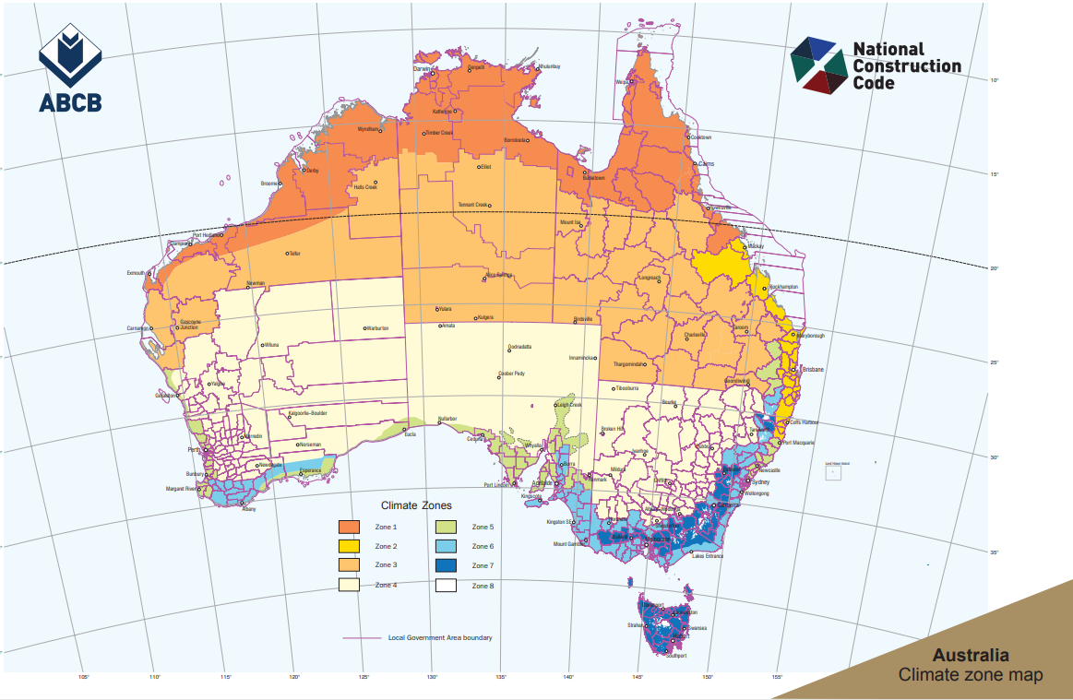
Data source: ABCB website, https://www.abcb.gov.au/sites/default/files/resources/2022/Climate-zone-map-aust.pdf, accessed 3 January 2024.

Modelled electricity savings by time of day
The value of electricity saved depends on the time of day (as reflected in electricity tariffs). This appendix presents charts showing modelled electricity savings by time of day throughout an average week (averaged across every week in each season) for building type and climate zone under Stringency Level 1 and Stringency Level 2. To save space, only electricity savings for large office building and large hospital ward in Climate Zones 2, 5 and 6 are presented.
These charts show clear distinct patterns of energy savings across different time of the day, seasons, building type (mainly daytime only use versus day and night use buildings) and climate zones.
- For the daytime-operating buildings — the large office building (C5OL):
  - the largest savings are estimated to occur during working hours (approximately 7am to 6pm on weekdays), reflecting building occupancy and therefore energy consumption patterns)
  - electricity savings tend to be greatest over the summer months (although this varies across climate zones).
- For the buildings that operate during the daytime and night-time (the hospital ward):
  - electricity savings tend to be greatest during the afternoons and evenings on both weekdays and weekends, although the timing of the peaks varies across climate zones
  - for the aged care facility, there is also a winter peak that occurs during the night from around 10 pm through to around 9 am in some climate zones (reflecting the use of electricity for heating).

Large office building
Energy savings by time of day for the large office building archetype (C5OL) in selected climate zone for Stringency Level 1 and Stringency Level 2 are shown in the charts below.

Climate zone 2
G.1 Energy savings by time of day — Stringency Level 1, large office in CZ2
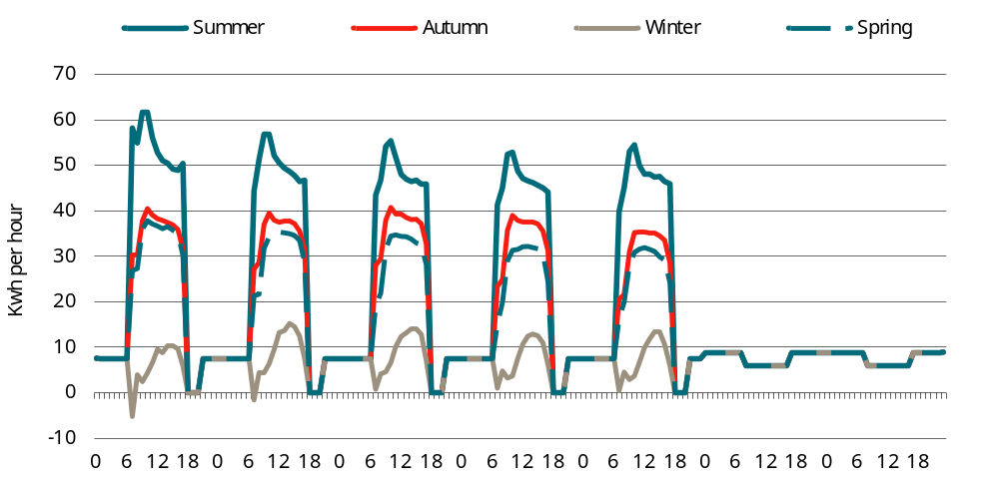
Data source: DeltaQ modelling, CIE.
G.2 Energy savings by time of day — Stringency Level 2, large office in CZ2
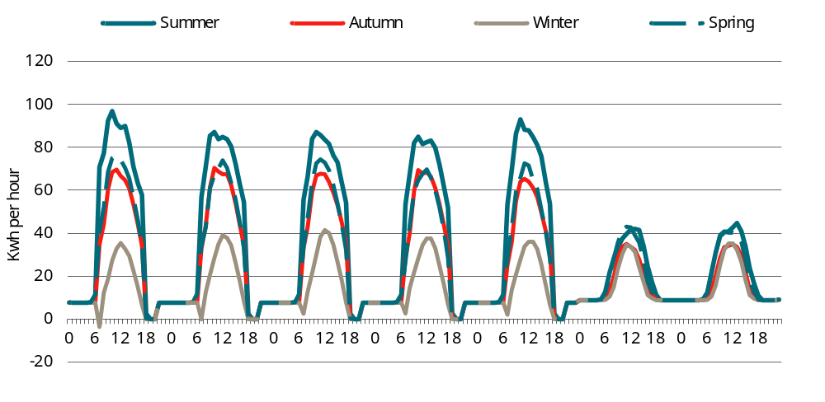
Data source: DeltaQ modelling, CIE.

Climate zone 5
G.3 Energy savings by time of day — Stringency Level 1, large office in CZ5
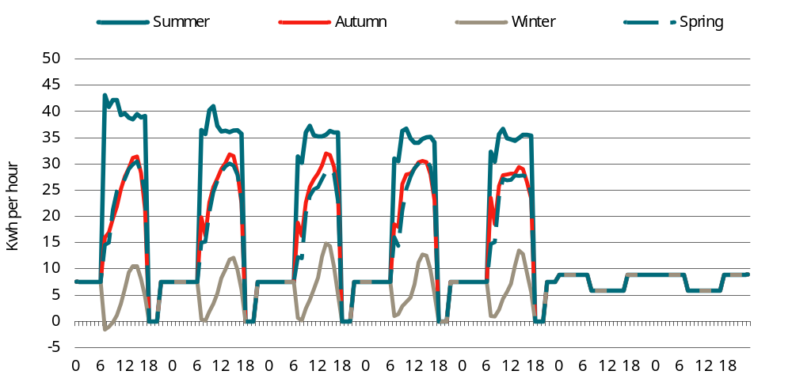
Data source: DeltaQ modelling, CIE.
G.4 Energy savings by time of day — Stringency Level 2, large office in CZ5
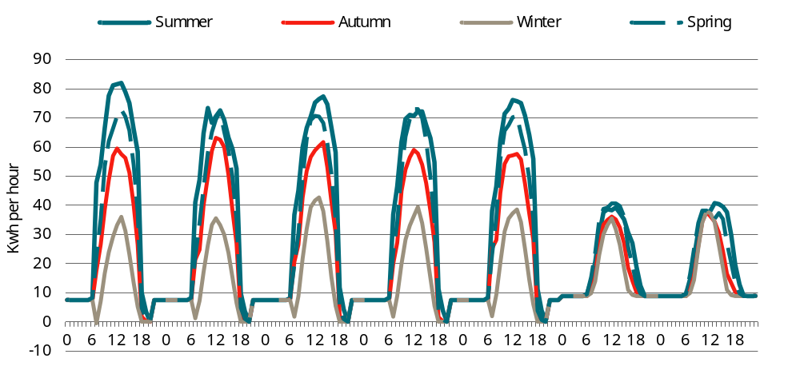
Data source: DeltaQ modelling, CIE.

Climate zone 6
G.5 Energy savings by time of day — Stringency Level 1, large office in CZ6
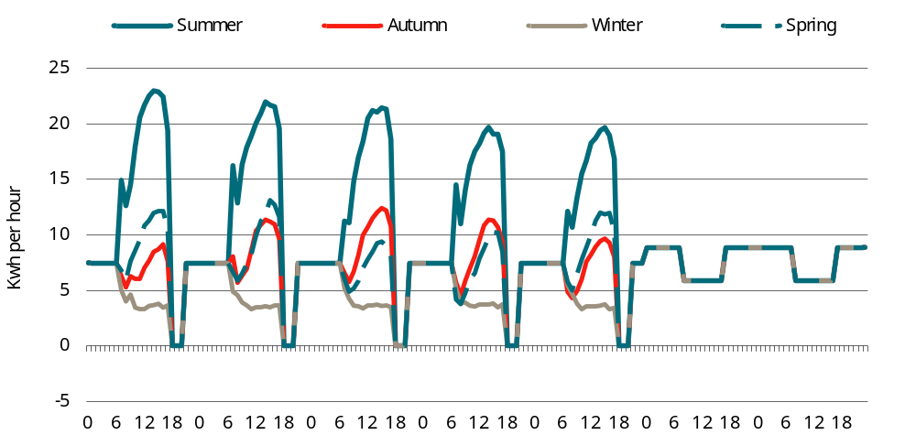
Data source: DeltaQ modelling, CIE.
G.6 Energy savings by time of day — Stringency Level 2, large office in CZ6
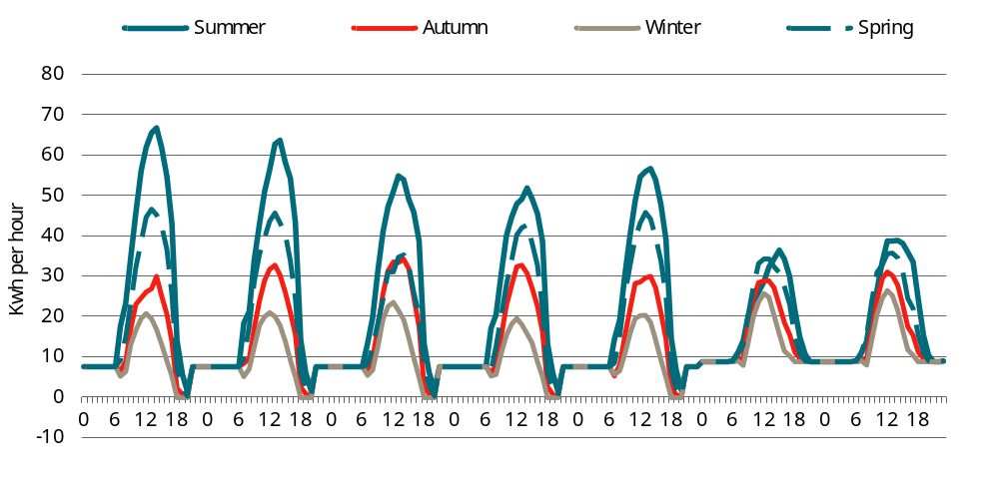
Data source: DeltaQ modelling, CIE.

Large hospital ward
Energy savings by time of day for the large hospital ward archetype (C9A) in each climate zone for Stringency Level 1 and Stringency Level 2 are shown in the charts below.

Climate zone 2
G.7 Energy savings by time of day — Stringency Level 1, large hospital ward in CZ2
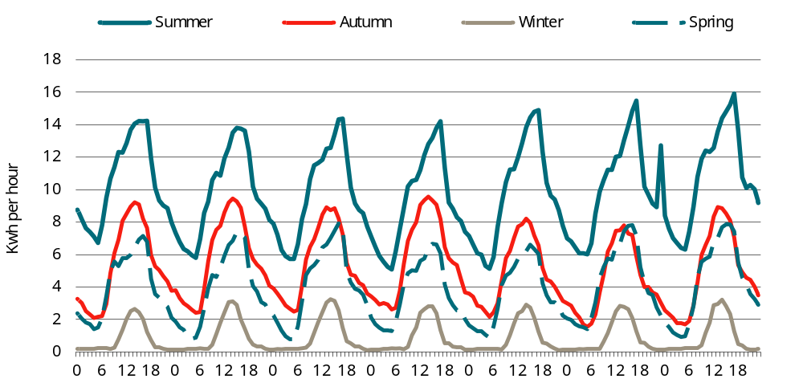
Data source: DeltaQ modelling, CIE.
G.8 Energy savings by time of day — Stringency Level 2, large hospital ward in CZ2
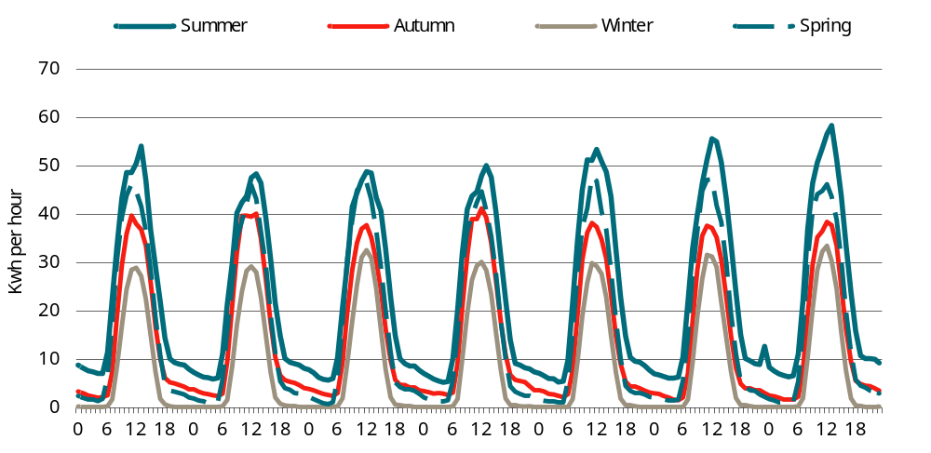
Data source: DeltaQ modelling, CIE.

Climate zone 5
G.9 Energy savings by time of day — Stringency Level 1, large hospital ward in CZ5
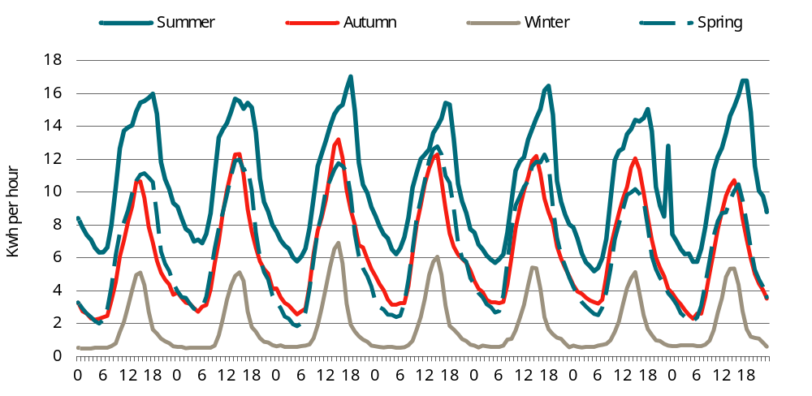
Data source: DeltaQ modelling, CIE.
G.10 Energy savings by time of day — Stringency Level 2, large hospital ward in CZ5
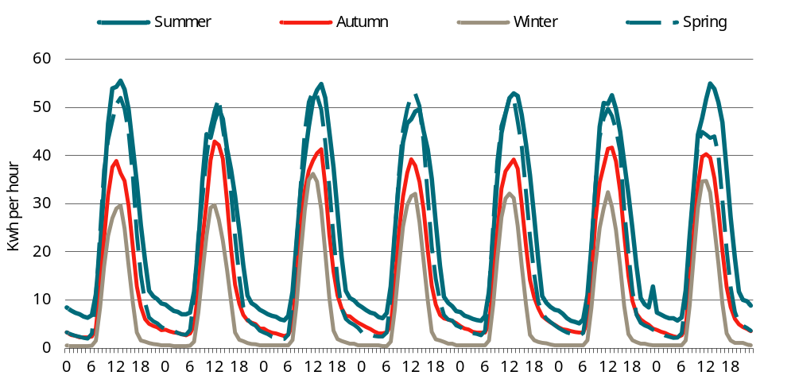
Data source: DeltaQ modelling, CIE.

Climate zone 6
G.11 Energy savings by time of day — Stringency Level 1, large hospital ward in CZ6
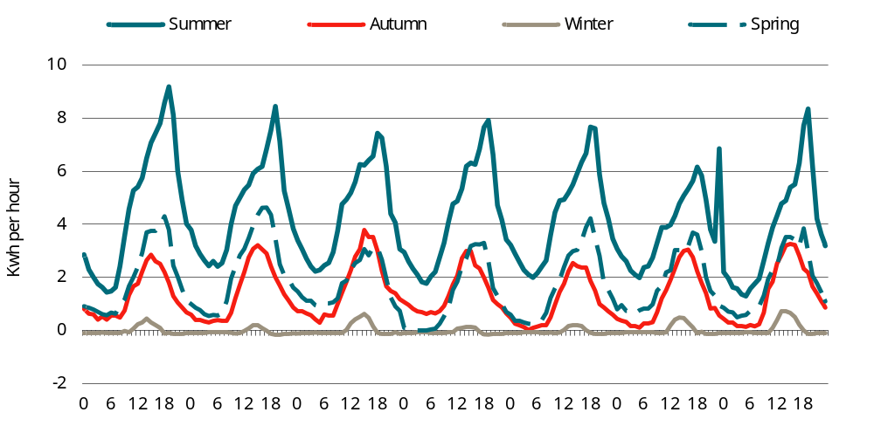
Data source: DeltaQ modelling, CIE.
G.12 Energy savings by time of day — Stringency Level 2, large hospital ward in CZ6
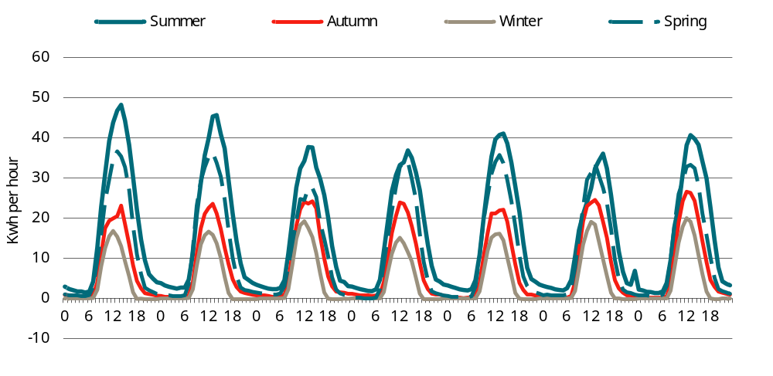
Data source: DeltaQ modelling, CIE.

Building-level costs and benefits

Stringency Level 1
The Stringency Level 1 building-level CBA results for each building archetype (except C5OL which is reported in the main body of the report) are reported in tables H.1 to H.9.
H.1 Stringency Level 1 estimated costs and benefits — C3HS
Impact | NSW (CZ5)  $ per m2 | VIC (CZ6)  $ per m2 | QLD (CZ2)  $ per m2 | WA (CZ5)  $ per m2 | SA (CZ5)  $ per m2 | TAS (CZ7)  $ per m2 | ACT (CZ7)  $ per m2 | NT (CZ1)  $ per m2
Avoided electricity network capacity costs | 6.4 | 1.4 | 26.4 | 1.7 | 4.3 | 13.6 | 6.3 | 9.7
Avoided electricity wholesale costs | 21.1 | 9.8 | 60.7 | 14.5 | 19.9 | 14.7 | 17.2 | 55.5
Avoided electricity network usage costs | 11.3 | 8.0 | 28.6 | 25.5 | 28.5 | 17.7 | 10.6 | 34.0
Avoided electricity retail costs | 5.8 | 2.9 | 17.3 | 6.3 | 7.9 | 6.9 | 5.1 | 14.9
Electricity exported to grid | 0.7 | 0.5 | 2.1 | 0.6 | 0.5 | 1.2 | 0.7 | 3.2
Electricity exports — network costs | -0.1 | 0.0 | -0.4 | -0.1 | -0.1 | 0.0 | 0.0 | -0.3
Avoided gas costs | 0.0 | 0.0 | 0.0 | 0.0 | 0.0 | 0.0 | 0.0 | 0.0
Avoided GHG emissions – electricity | 10.7 | 9.6 | 68.1 | 15.9 | 11.5 | 1.2 | 7.8 | 56.1
Avoided GHG emissions – exported electricity | 0.9 | 1.1 | 5.9 | 1.4 | 1.0 | 0.1 | 0.7 | 3.6
Avoided GHG emissions – gas | 0.0 | 0.0 | 0.0 | 0.0 | 0.0 | 0.0 | 0.0 | 0.0
Capital costs | 48.1 | 29.6 | 36.3 | 48.1 | 48.1 | 24.0 | 24.0 | 72.2
Total | 105.0 | 62.9 | 245.0 | 113.9 | 121.7 | 79.3 | 72.4 | 248.9
Note: Costs and benefits estimated in present value terms over the 50-year life of a building constructed in 2025, using a discount rate of 5 per cent.
Source: CIE based on DeltaQ modelling.
H.2 Stringency Level 1 estimated costs and benefits — C3HL
Impact | NSW (CZ5)  $ per m2 | VIC (CZ6)  $ per m2 | QLD (CZ2)  $ per m2 | WA (CZ5)  $ per m2 | SA (CZ5)  $ per m2 | TAS (CZ7)  $ per m2 | ACT (CZ7)  $ per m2 | NT (CZ1)  $ per m2
Avoided electricity network capacity costs | 6.9 | 0.7 | 7.8 | 1.7 | 4.7 | 9.6 | 4.6 | 6.4
Avoided electricity wholesale costs | 14.0 | 8.1 | 18.4 | 9.3 | 13.0 | 8.6 | 10.1 | 26.3
Avoided electricity network usage costs | 7.3 | 6.6 | 9.4 | 16.6 | 18.7 | 11.7 | 6.9 | 16.6
Avoided electricity retail costs | 4.2 | 2.3 | 5.3 | 4.1 | 5.5 | 4.5 | 3.2 | 7.4
Electricity exported to grid | 0.0 | 0.0 | 0.0 | 0.0 | 0.0 | 0.0 | 0.0 | 0.0
Electricity exports — network costs | 0.0 | 0.0 | 0.0 | 0.0 | 0.0 | 0.0 | 0.0 | 0.0
Avoided gas costs | -2.2 | -5.1 | -0.9 | -2.3 | -2.4 | -7.4 | -5.2 | 0.0
Avoided GHG emissions – electricity | 7.0 | 7.6 | 22.4 | 10.3 | 7.5 | 0.7 | 4.8 | 25.2
Avoided GHG emissions – exported electricity | 0.0 | 0.0 | 0.0 | 0.0 | 0.0 | 0.0 | 0.0 | 0.0
Avoided GHG emissions – gas | -4.6 | -8.7 | -2.2 | -4.0 | -4.4 | -9.3 | -10.9 | 0.0
Capital costs | 28.4 | 20.9 | 38.0 | 28.4 | 28.4 | 27.2 | 27.2 | 43.9
Total | 60.9 | 32.3 | 98.1 | 64.1 | 70.9 | 45.6 | 40.8 | 125.8
Note: Costs and benefits estimated in present value terms over the 50-year life of a building constructed in 2025, using a discount rate of 5 per cent.
Source: CIE based on DeltaQ modelling.
H.3 Stringency Level 1 estimated costs and benefits — C5OS
Impact | NSW (CZ5)  $ per m2 | VIC (CZ6)  $ per m2 | QLD (CZ2)  $ per m2 | WA (CZ5)  $ per m2 | SA (CZ5)  $ per m2 | TAS (CZ7)  $ per m2 | ACT (CZ7)  $ per m2 | NT (CZ1)  $ per m2
Avoided electricity network capacity costs | 11.5 | 4.1 | 1.2 | 2.6 | 6.3 | 26.5 | 10.4 | 15.4
Avoided electricity wholesale costs | 13.8 | 10.8 | 6.1 | 8.4 | 10.4 | 10.7 | 12.2 | 32.9
Avoided electricity network usage costs | 7.6 | 11.1 | 3.4 | 18.5 | 21.0 | 15.3 | 9.4 | 17.3
Avoided electricity retail costs | 4.9 | 3.9 | 1.6 | 4.4 | 5.6 | 7.9 | 4.8 | 9.8
Electricity exported to grid | 0.4 | 0.4 | 0.2 | 0.4 | 0.3 | 1.1 | 0.6 | 0.6
Electricity exports — network costs | -0.1 | -0.1 | 0.0 | -0.1 | -0.1 | -0.1 | -0.1 | 0.0
Avoided gas costs | 0.0 | 0.0 | 0.0 | 0.0 | 0.0 | 0.0 | 0.0 | 0.0
Avoided GHG emissions – electricity | 7.4 | 11.5 | 8.3 | 11.0 | 8.0 | 0.8 | 5.8 | 31.7
Avoided GHG emissions – exported electricity | 0.6 | 1.4 | 0.9 | 0.9 | 0.7 | 0.1 | 0.7 | 0.6
Avoided GHG emissions – gas | 0.0 | 0.0 | 0.0 | 0.0 | 0.0 | 0.0 | 0.0 | 0.0
Capital costs | 9.5 | 21.0 | 15.7 | 9.5 | 9.5 | -0.3 | -0.3 | 5.2
Total | 55.7 | 64.1 | 37.4 | 55.6 | 61.6 | 62.1 | 43.4 | 113.5
Note: Costs and benefits estimated in present value terms over the 50-year life of a building constructed in 2025, using a discount rate of 5 per cent.
Source: CIE based on DeltaQ modelling.
H.4 Stringency Level 1 estimated costs and benefits — C5OM
Impact | NSW (CZ5)  $ per m2 | VIC (CZ6)  $ per m2 | QLD (CZ2)  $ per m2 | WA (CZ5)  $ per m2 | SA (CZ5)  $ per m2 | TAS (CZ7)  $ per m2 | ACT (CZ7)  $ per m2 | NT (CZ1)  $ per m2
Avoided electricity network capacity costs | 12.2 | 6.3 | 13.9 | 3.1 | 6.2 | 25.9 | 11.6 | 15.5
Avoided electricity wholesale costs | 22.7 | 15.0 | 24.2 | 13.4 | 16.8 | 14.5 | 16.3 | 52.9
Avoided electricity network usage costs | 12.9 | 16.6 | 14.1 | 31.8 | 35.5 | 23.5 | 14.3 | 26.8
Avoided electricity retail costs | 7.2 | 5.7 | 7.8 | 7.2 | 8.8 | 9.6 | 6.3 | 14.3
Electricity exported to grid | 0.5 | 0.4 | 0.4 | 0.4 | 0.3 | 1.4 | 0.7 | 0.5
Electricity exports — network costs | -0.1 | -0.2 | -0.1 | -0.1 | -0.1 | -0.2 | -0.2 | 0.0
Avoided gas costs | 0.0 | 0.0 | 0.0 | 0.0 | 0.0 | 0.0 | 0.0 | 0.0
Avoided GHG emissions – electricity | 12.1 | 15.7 | 36.1 | 17.8 | 13.0 | 1.2 | 8.0 | 50.8
Avoided GHG emissions – exported electricity | 0.7 | 1.7 | 1.6 | 1.1 | 0.8 | 0.1 | 1.0 | 0.5
Avoided GHG emissions – gas | 0.0 | 0.0 | 0.0 | 0.0 | 0.0 | 0.0 | 0.0 | 0.0
Capital costs | -10.8 | -22.2 | -23.8 | -10.8 | -10.8 | -14.8 | -14.8 | -34.3
Total | 57.2 | 39.0 | 74.2 | 63.9 | 70.3 | 61.2 | 43.3 | 126.9
Note: Costs and benefits estimated in present value terms over the 50-year life of a building constructed in 2025, using a discount rate of 5 per cent.
Source: CIE based on DeltaQ modelling.
H.5 Stringency Level 1 estimated costs and benefits — C6RS
Impact | NSW (CZ5)  $ per m2 | VIC (CZ6)  $ per m2 | QLD (CZ2)  $ per m2 | WA (CZ5)  $ per m2 | SA (CZ5)  $ per m2 | TAS (CZ7)  $ per m2 | ACT (CZ7)  $ per m2 | NT (CZ1)  $ per m2
Avoided electricity network capacity costs | 45.2 | 20.6 | 45.9 | 11.0 | 24.4 | 82.3 | 36.2 | 46.4
Avoided electricity wholesale costs | 91.8 | 56.2 | 103.6 | 55.7 | 65.1 | 58.2 | 66.1 | 223.8
Avoided electricity network usage costs | 49.7 | 56.9 | 63.9 | 120.1 | 139.2 | 85.7 | 50.7 | 108.7
Avoided electricity retail costs | 28.0 | 20.0 | 32.0 | 28.0 | 34.3 | 33.9 | 22.9 | 56.8
Electricity exported to grid | 1.0 | 1.0 | 0.7 | 0.9 | 0.6 | 3.1 | 1.5 | 0.3
Electricity exports — network costs | -0.3 | -0.3 | -0.3 | -0.4 | -0.4 | -0.5 | -0.4 | 0.0
Avoided gas costs | 0.0 | 0.0 | 0.0 | 0.0 | 0.0 | 0.0 | 0.0 | 0.0
Avoided GHG emissions – electricity | 50.2 | 60.7 | 164.8 | 74.4 | 54.0 | 4.8 | 32.6 | 218.2
Avoided GHG emissions – exported electricity | 1.8 | 4.4 | 3.8 | 2.7 | 2.0 | 0.3 | 2.2 | 0.3
Avoided GHG emissions – gas | 0.0 | 0.0 | 0.0 | 0.0 | 0.0 | 0.0 | 0.0 | 0.0
Capital costs | 9.4 | -16.2 | 4.2 | 9.4 | 9.4 | -21.2 | -21.2 | 18.9
Total | 276.9 | 203.3 | 418.6 | 301.9 | 328.6 | 246.7 | 190.7 | 673.5
Note: Costs and benefits estimated in present value terms over the 50-year life of a building constructed in 2025, using a discount rate of 5 per cent.
Source: CIE based on DeltaQ modelling.
H.6 Stringency Level 1 estimated costs and benefits — C6RL
Impact | NSW (CZ5)  $ per m2 | VIC (CZ6)  $ per m2 | QLD (CZ2)  $ per m2 | WA (CZ5)  $ per m2 | SA (CZ5)  $ per m2 | TAS (CZ7)  $ per m2 | ACT (CZ7)  $ per m2 | NT (CZ1)  $ per m2
Avoided electricity network capacity costs | 30.6 | 7.5 | 32.2 | 7.8 | 19.7 | 92.0 | 41.6 | 25.5
Avoided electricity wholesale costs | 68.0 | 31.4 | 82.8 | 41.6 | 50.8 | 64.6 | 71.6 | 158.6
Avoided electricity network usage costs | 35.7 | 27.2 | 50.3 | 85.8 | 100.4 | 91.6 | 54.3 | 78.5
Avoided electricity retail costs | 20.1 | 9.9 | 24.8 | 20.3 | 25.6 | 37.2 | 25.1 | 39.4
Electricity exported to grid | 0.4 | 0.3 | 0.3 | 0.4 | 0.3 | 1.3 | 0.6 | 0.1
Electricity exports — network costs | -0.1 | 0.0 | -0.1 | -0.1 | -0.1 | -0.2 | -0.2 | 0.0
Avoided gas costs | 0.0 | 0.0 | 0.0 | 0.0 | 0.0 | 0.0 | 0.0 | 0.0
Avoided GHG emissions – electricity | 36.9 | 32.2 | 128.8 | 54.6 | 39.6 | 5.1 | 34.8 | 156.7
Avoided GHG emissions – exported electricity | 0.7 | 0.9 | 1.7 | 1.1 | 0.8 | 0.1 | 0.9 | 0.0
Avoided GHG emissions – gas | 0.0 | 0.0 | 0.0 | 0.0 | 0.0 | 0.0 | 0.0 | 0.0
Capital costs | -3.1 | -52.8 | 8.0 | -3.1 | -3.1 | -46.6 | -46.6 | -54.3
Total | 189.2 | 56.7 | 328.7 | 208.4 | 234.1 | 245.3 | 182.1 | 404.5
Note: Costs and benefits estimated in present value terms over the 50-year life of a building constructed in 2025, using a discount rate of 5 per cent.
Source: CIE based on DeltaQ modelling.
H.7 Stringency Level 1 estimated costs and benefits — C9A
Impact | NSW (CZ5)  $ per m2 | VIC (CZ6)  $ per m2 | QLD (CZ2)  $ per m2 | WA (CZ5)  $ per m2 | SA (CZ5)  $ per m2 | TAS (CZ7)  $ per m2 | ACT (CZ7)  $ per m2 | NT (CZ1)  $ per m2
Avoided electricity network capacity costs | 3.8 | 1.3 | 2.4 | 0.9 | 2.4 | 4.3 | 1.8 | 6.1
Avoided electricity wholesale costs | 7.8 | 2.2 | 6.1 | 5.3 | 6.5 | 2.4 | 2.8 | 29.4
Avoided electricity network usage costs | 4.5 | 2.2 | 3.4 | 10.7 | 11.9 | 4.0 | 2.2 | 16.4
Avoided electricity retail costs | 2.4 | 0.9 | 1.8 | 2.5 | 3.1 | 1.6 | 1.0 | 7.8
Electricity exported to grid | 0.0 | 0.0 | 0.0 | 0.0 | 0.0 | 0.0 | 0.0 | 0.0
Electricity exports — network costs | 0.0 | 0.0 | 0.0 | 0.0 | 0.0 | 0.0 | 0.0 | 0.0
Avoided gas costs | -0.6 | -1.9 | -0.1 | -0.6 | -0.6 | -2.2 | -1.5 | 0.0
Avoided GHG emissions – electricity | 4.3 | 2.3 | 8.5 | 6.3 | 4.6 | 0.2 | 1.4 | 27.6
Avoided GHG emissions – exported electricity | 0.0 | 0.0 | 0.0 | 0.0 | 0.0 | 0.0 | 0.0 | 0.0
Avoided GHG emissions – gas | -1.2 | -3.2 | -0.1 | -1.0 | -1.2 | -2.7 | -3.2 | 0.0
Capital costs | -1.5 | -1.8 | -4.9 | -1.5 | -1.5 | -2.0 | -2.0 | -4.8
Total | 19.6 | 1.9 | 17.0 | 22.6 | 25.1 | 5.6 | 2.6 | 82.5
Note: Costs and benefits estimated in present value terms over the 50-year life of a building constructed in 2025, using a discount rate of 5 per cent.
Source: CIE based on DeltaQ modelling.
H.8 Stringency Level 1 estimated costs and benefits — C9B
Impact | NSW (CZ5)  $ per m2 | VIC (CZ6)  $ per m2 | QLD (CZ2)  $ per m2 | WA (CZ5)  $ per m2 | SA (CZ5)  $ per m2 | TAS (CZ7)  $ per m2 | ACT (CZ7)  $ per m2 | NT (CZ1)  $ per m2
Avoided electricity network capacity costs | 13.3 | 6.8 | 14.3 | 2.8 | 4.5 | 23.3 | 11.3 | 12.3
Avoided electricity wholesale costs | 12.4 | 7.5 | 15.0 | 7.4 | 8.5 | 10.1 | 10.3 | 28.7
Avoided electricity network usage costs | 7.7 | 10.0 | 10.5 | 19.8 | 22.3 | 16.3 | 10.1 | 13.3
Avoided electricity retail costs | 5.0 | 3.6 | 6.0 | 4.5 | 5.3 | 7.5 | 4.8 | 8.2
Electricity exported to grid | 0.7 | 0.6 | 0.6 | 0.6 | 0.5 | 1.8 | 0.9 | 0.4
Electricity exports — network costs | -0.2 | -0.2 | -0.1 | -0.2 | -0.2 | -0.2 | -0.2 | 0.0
Avoided gas costs | 0.0 | 0.0 | 0.0 | 0.0 | 0.0 | 0.0 | 0.0 | 0.0
Avoided GHG emissions – electricity | 7.5 | 9.4 | 27.7 | 11.1 | 8.1 | 0.8 | 5.3 | 28.5
Avoided GHG emissions – exported electricity | 1.0 | 2.1 | 2.0 | 1.5 | 1.1 | 0.2 | 1.2 | 0.4
Avoided GHG emissions – gas | 0.0 | 0.0 | 0.0 | 0.0 | 0.0 | 0.0 | 0.0 | 0.0
Capital costs | 14.7 | 8.1 | 31.8 | 14.7 | 14.7 | 6.7 | 6.7 | 13.1
Total | 62.2 | 47.9 | 107.9 | 62.2 | 64.9 | 66.4 | 50.4 | 104.8
Note: Costs and benefits estimated in present value terms over the 50-year life of a building constructed in 2025, using a discount rate of 5 per cent.
Source: CIE based on DeltaQ modelling.
H.9 Stringency Level 1 estimated costs and benefits — C9C
Impact | NSW (CZ5)  $ per m2 | VIC (CZ6)  $ per m2 | QLD (CZ2)  $ per m2 | WA (CZ5)  $ per m2 | SA (CZ5)  $ per m2 | TAS (CZ7)  $ per m2 | ACT (CZ7)  $ per m2 | NT (CZ1)  $ per m2
Avoided electricity network capacity costs | 5.8 | 7.4 | 7.8 | 1.3 | 3.2 | 11.3 | 4.5 | 3.5
Avoided electricity wholesale costs | 13.3 | 18.2 | 22.7 | 9.1 | 11.5 | 10.9 | 12.6 | 20.0
Avoided electricity network usage costs | 7.5 | 13.8 | 11.0 | 17.1 | 19.0 | 14.0 | 8.1 | 12.2
Avoided electricity retail costs | 4.0 | 5.9 | 6.2 | 4.1 | 5.1 | 5.4 | 3.8 | 5.3
Electricity exported to grid | 1.4 | 1.5 | 2.5 | 1.3 | 0.9 | 1.8 | 1.0 | 5.2
Electricity exports — network costs | -0.3 | 0.0 | -0.6 | -0.3 | -0.3 | -0.1 | -0.1 | -0.3
Avoided gas costs | 0.0 | 0.0 | 0.0 | 0.0 | 0.0 | 0.0 | 0.0 | 0.0
Avoided GHG emissions – electricity | 6.9 | 15.8 | 26.7 | 10.3 | 7.5 | 0.8 | 5.8 | 19.5
Avoided GHG emissions – exported electricity | 2.1 | 3.8 | 8.3 | 3.1 | 2.3 | 0.2 | 1.1 | 5.6
Avoided GHG emissions – gas | 0.0 | 0.0 | 0.0 | 0.0 | 0.0 | 0.0 | 0.0 | 0.0
Capital costs | 10.6 | 77.3 | 26.6 | 10.6 | 10.6 | 7.4 | 7.4 | -26.3
Total | 51.3 | 143.7 | 111.4 | 56.6 | 59.8 | 51.7 | 44.3 | 44.7
Note: Costs and benefits estimated in present value terms over the 50-year life of a building constructed in 2025, using a discount rate of 5 per cent.
Source: CIE based on DeltaQ modelling.

Stringency Level 2
The Stringency Level 2 building-level CBA results for each building archetype (except C5OL which is reported in the main body of the report) are reported in tables H.10 to H.18.
H.10 Stringency Level 2 estimated costs and benefits — C3HS
Impact | NSW (CZ5)  $ per m2 | VIC (CZ6)  $ per m2 | QLD (CZ2)  $ per m2 | WA (CZ5)  $ per m2 | SA (CZ5)  $ per m2 | TAS (CZ7)  $ per m2 | ACT (CZ7)  $ per m2 | NT (CZ1)  $ per m2
Avoided electricity network capacity costs | 10.4 | 6.7 | 28.5 | 2.4 | 7.0 | 19.5 | 9.5 | 17.0
Avoided electricity wholesale costs | 35.4 | 23.5 | 74.1 | 24.2 | 30.6 | 28.5 | 32.1 | 88.8
Avoided electricity network usage costs | 20.0 | 22.1 | 38.2 | 46.5 | 52.3 | 42.5 | 24.6 | 49.9
Avoided electricity retail costs | 9.9 | 7.8 | 21.1 | 11.0 | 13.5 | 13.6 | 9.9 | 23.4
Electricity exported to grid | 9.2 | 6.8 | 13.2 | 8.3 | 6.5 | 24.1 | 12.2 | 24.8
Electricity exports — network costs | -2.6 | -2.2 | -3.4 | -2.6 | -2.6 | -3.1 | -2.6 | -2.9
Avoided gas costs | 0.0 | 0.0 | 0.0 | 0.0 | 0.0 | 0.0 | 0.0 | 0.0
Avoided GHG emissions – electricity | 18.9 | 23.3 | 93.0 | 27.9 | 20.3 | 2.3 | 15.9 | 86.9
Avoided GHG emissions – exported electricity | 14.1 | 24.3 | 45.3 | 20.9 | 15.2 | 2.3 | 15.7 | 28.3
Avoided GHG emissions – gas | 0.0 | 0.0 | 0.0 | 0.0 | 0.0 | 0.0 | 0.0 | 0.0
Capital costs | 0.9 | -17.6 | -10.9 | 0.9 | 0.9 | -23.2 | -23.2 | 25.0
Total | 116.3 | 94.8 | 299.2 | 139.6 | 143.6 | 106.4 | 94.1 | 341.1
Note: Costs and benefits estimated in present value terms over the 50-year life of a building constructed in 2025, using a discount rate of 5 per cent.
Source: CIE based on DeltaQ modelling.
H.11 Stringency Level 2 estimated costs and benefits — C3HL
Impact | NSW (CZ5)  $ per m2 | VIC (CZ6)  $ per m2 | QLD (CZ2)  $ per m2 | WA (CZ5)  $ per m2 | SA (CZ5)  $ per m2 | TAS (CZ7)  $ per m2 | ACT (CZ7)  $ per m2 | NT (CZ1)  $ per m2
Avoided electricity network capacity costs | 7.5 | 1.3 | 8.3 | 1.8 | 5.2 | 10.7 | 5.3 | 7.4
Avoided electricity wholesale costs | 16.5 | 10.0 | 20.2 | 10.8 | 14.4 | 10.6 | 12.2 | 30.6
Avoided electricity network usage costs | 8.9 | 9.3 | 10.9 | 20.7 | 23.5 | 15.8 | 9.2 | 18.3
Avoided electricity retail costs | 4.9 | 3.1 | 5.9 | 5.0 | 6.4 | 5.6 | 4.0 | 8.4
Electricity exported to grid | 0.0 | 0.0 | 0.0 | 0.0 | 0.0 | 0.0 | 0.0 | 0.0
Electricity exports — network costs | 0.0 | 0.0 | 0.0 | 0.0 | 0.0 | 0.0 | 0.0 | 0.0
Avoided gas costs | -2.2 | -5.1 | -0.9 | -2.3 | -2.4 | -7.4 | -5.2 | 0.0
Avoided GHG emissions – electricity | 8.6 | 10.2 | 26.7 | 12.8 | 9.3 | 0.9 | 6.1 | 29.4
Avoided GHG emissions – exported electricity | 0.0 | 0.0 | 0.0 | 0.0 | 0.0 | 0.0 | 0.0 | 0.0
Avoided GHG emissions – gas | -4.6 | -8.7 | -2.2 | -4.0 | -4.4 | -9.3 | -10.9 | 0.0
Capital costs | 24.6 | 17.6 | 34.8 | 24.6 | 24.6 | 24.5 | 24.5 | 40.3
Total | 64.2 | 37.6 | 103.7 | 69.6 | 76.5 | 51.2 | 45.2 | 134.4
Note: Costs and benefits estimated in present value terms over the 50-year life of a building constructed in 2025, using a discount rate of 5 per cent.
Source: CIE based on DeltaQ modelling.
H.12 Stringency Level 2 estimated costs and benefits — C5OS
Impact | NSW (CZ5)  $ per m2 | VIC (CZ6)  $ per m2 | QLD (CZ2)  $ per m2 | WA (CZ5)  $ per m2 | SA (CZ5)  $ per m2 | TAS (CZ7)  $ per m2 | ACT (CZ7)  $ per m2 | NT (CZ1)  $ per m2
Avoided electricity network capacity costs | 19.7 | 11.4 | 7.5 | 4.0 | 10.5 | 42.9 | 18.4 | 22.1
Avoided electricity wholesale costs | 32.9 | 28.2 | 23.5 | 20.3 | 22.1 | 31.1 | 33.1 | 67.3
Avoided electricity network usage costs | 20.0 | 35.2 | 17.1 | 51.7 | 58.0 | 56.8 | 34.3 | 32.1
Avoided electricity retail costs | 10.9 | 11.2 | 7.2 | 11.4 | 13.6 | 19.6 | 12.9 | 18.2
Electricity exported to grid | 3.2 | 2.0 | 3.4 | 3.0 | 2.0 | 8.3 | 4.3 | 9.4
Electricity exports — network costs | -0.7 | -0.6 | -0.7 | -0.7 | -0.7 | -1.0 | -0.8 | -0.6
Avoided gas costs | 0.0 | 0.0 | 0.0 | 0.0 | 0.0 | 0.0 | 0.0 | 0.0
Avoided GHG emissions – electricity | 19.7 | 32.3 | 45.6 | 29.2 | 21.2 | 2.7 | 18.5 | 64.8
Avoided GHG emissions – exported electricity | 4.8 | 9.0 | 13.2 | 7.2 | 5.2 | 0.8 | 5.8 | 10.3
Avoided GHG emissions – gas | 0.0 | 0.0 | 0.0 | 0.0 | 0.0 | 0.0 | 0.0 | 0.0
Capital costs | -27.6 | -16.0 | -21.4 | -27.6 | -27.6 | -37.3 | -37.3 | -31.9
Total | 82.8 | 112.7 | 95.2 | 98.5 | 104.3 | 124.1 | 89.1 | 191.7
Note: Costs and benefits estimated in present value terms over the 50-year life of a building constructed in 2025, using a discount rate of 5 per cent.
Source: CIE based on DeltaQ modelling.
H.13 Stringency Level 2 estimated costs and benefits — C5OM
Impact | NSW (CZ5)  $ per m2 | VIC (CZ6)  $ per m2 | QLD (CZ2)  $ per m2 | WA (CZ5)  $ per m2 | SA (CZ5)  $ per m2 | TAS (CZ7)  $ per m2 | ACT (CZ7)  $ per m2 | NT (CZ1)  $ per m2
Avoided electricity network capacity costs | 19.1 | 11.9 | 19.8 | 4.6 | 10.0 | 40.0 | 18.0 | 23.6
Avoided electricity wholesale costs | 39.8 | 30.5 | 39.5 | 24.1 | 27.3 | 32.9 | 35.1 | 83.3
Avoided electricity network usage costs | 23.9 | 38.1 | 26.2 | 61.5 | 68.7 | 60.8 | 36.7 | 40.0
Avoided electricity retail costs | 12.4 | 12.1 | 12.8 | 13.5 | 15.9 | 20.0 | 13.5 | 22.0
Electricity exported to grid | 2.7 | 1.8 | 3.2 | 2.6 | 1.6 | 7.4 | 3.9 | 8.1
Electricity exports — network costs | -0.6 | -0.6 | -0.7 | -0.6 | -0.6 | -0.9 | -0.8 | -0.5
Avoided gas costs | 0.0 | 0.0 | 0.0 | 0.0 | 0.0 | 0.0 | 0.0 | 0.0
Avoided GHG emissions – electricity | 23.1 | 34.4 | 68.9 | 34.2 | 24.8 | 2.9 | 19.5 | 80.1
Avoided GHG emissions – exported electricity | 4.2 | 8.2 | 12.5 | 6.3 | 4.5 | 0.8 | 5.2 | 8.9
Avoided GHG emissions – gas | 0.0 | 0.0 | 0.0 | 0.0 | 0.0 | 0.0 | 0.0 | 0.0
Capital costs | -41.3 | -52.6 | -54.3 | -41.3 | -41.3 | -45.2 | -45.2 | -64.8
Total | 83.4 | 83.7 | 128.0 | 104.9 | 111.0 | 118.6 | 85.8 | 200.8
Note: Costs and benefits estimated in present value terms over the 50-year life of a building constructed in 2025, using a discount rate of 5 per cent.
Source: CIE based on DeltaQ modelling.
H.14 Stringency Level 2 estimated costs and benefits — C6RS
Impact | NSW (CZ5)  $ per m2 | VIC (CZ6)  $ per m2 | QLD (CZ2)  $ per m2 | WA (CZ5)  $ per m2 | SA (CZ5)  $ per m2 | TAS (CZ7)  $ per m2 | ACT (CZ7)  $ per m2 | NT (CZ1)  $ per m2
Avoided electricity network capacity costs | 65.2 | 37.6 | 61.8 | 15.2 | 34.1 | 109.5 | 48.9 | 70.9
Avoided electricity wholesale costs | 142.5 | 97.6 | 148.4 | 87.6 | 93.6 | 111.9 | 121.3 | 337.9
Avoided electricity network usage costs | 81.3 | 114.9 | 101.5 | 203.2 | 234.5 | 191.6 | 111.7 | 154.7
Avoided retail costs | 43.3 | 37.5 | 46.8 | 45.9 | 54.3 | 62.0 | 42.3 | 84.5
Electricity exported to grid | 2.2 | 2.5 | 1.4 | 2.0 | 1.3 | 8.0 | 3.9 | 0.6
Electricity exports — network costs | -0.7 | -0.8 | -0.5 | -0.7 | -0.7 | -1.4 | -1.2 | 0.0
Avoided gas costs | 0.0 | 0.0 | 0.0 | 0.0 | 0.0 | 0.0 | 0.0 | 0.0
Avoided GHG emissions – electricity | 83.4 | 115.0 | 266.9 | 123.5 | 89.7 | 9.9 | 66.9 | 329.0
Avoided GHG emissions – exported electricity | 3.9 | 10.9 | 7.6 | 5.7 | 4.1 | 0.9 | 5.9 | 0.7
Avoided GHG emissions – gas | 0.0 | 0.0 | 0.0 | 0.0 | 0.0 | 0.0 | 0.0 | 0.0
Capital costs | -66.0 | -91.7 | -71.2 | -66.0 | -66.0 | -96.6 | -96.6 | -70.5
Total | 355.1 | 323.6 | 562.6 | 416.5 | 445.0 | 395.7 | 303.0 | 907.7
Note: Costs and benefits estimated in present value terms over the 50-year life of a building constructed in 2025, using a discount rate of 5 per cent.
Source: CIE based on DeltaQ modelling.
H.15 Stringency Level 2 estimated costs and benefits — C6RL
Impact | NSW (CZ5)  $ per m2 | VIC (CZ6)  $ per m2 | QLD (CZ2)  $ per m2 | WA (CZ5)  $ per m2 | SA (CZ5)  $ per m2 | TAS (CZ7)  $ per m2 | ACT (CZ7)  $ per m2 | NT (CZ1)  $ per m2
Avoided electricity network capacity costs | 46.0 | 21.3 | 44.0 | 10.9 | 27.7 | 111.4 | 50.4 | 43.7
Avoided electricity wholesale costs | 111.4 | 67.3 | 120.8 | 69.0 | 75.0 | 111.7 | 119.8 | 237.7
Avoided electricity network usage costs | 63.0 | 78.6 | 82.4 | 157.7 | 182.9 | 185.7 | 108.5 | 110.4
Avoided electricity retail costs | 33.1 | 25.1 | 37.1 | 35.6 | 42.9 | 61.3 | 41.8 | 58.8
Electricity exported to grid | 0.9 | 1.0 | 0.6 | 0.9 | 0.7 | 3.3 | 1.6 | 0.1
Electricity exports — network costs | -0.2 | -0.1 | -0.2 | -0.2 | -0.2 | -0.5 | -0.4 | 0.0
Avoided gas costs | 0.0 | 0.0 | 0.0 | 0.0 | 0.0 | 0.0 | 0.0 | 0.0
Avoided GHG emissions – electricity | 65.6 | 80.2 | 216.1 | 97.1 | 70.5 | 9.6 | 65.2 | 233.5
Avoided GHG emissions – exported electricity | 1.6 | 4.0 | 3.5 | 2.4 | 1.7 | 0.4 | 2.4 | 0.1
Avoided GHG emissions – gas | 0.0 | 0.0 | 0.0 | 0.0 | 0.0 | 0.0 | 0.0 | 0.0
Capital costs | -67.6 | -117.3 | -56.6 | -67.6 | -67.6 | -111.1 | -111.1 | -118.8
Total | 253.8 | 160.1 | 447.7 | 305.7 | 333.6 | 371.7 | 278.3 | 565.5
Note: Costs and benefits estimated in present value terms over the 50-year life of a building constructed in 2025, using a discount rate of 5 per cent.
Source: CIE based on DeltaQ modelling.
H.16 Stringency Level 2 estimated costs and benefits — C9A
Impact | NSW (CZ5)  $ per m2 | VIC (CZ6)  $ per m2 | QLD (CZ2)  $ per m2 | WA (CZ5)  $ per m2 | SA (CZ5)  $ per m2 | TAS (CZ7)  $ per m2 | ACT (CZ7)  $ per m2 | NT (CZ1)  $ per m2
Avoided electricity network capacity costs | 4.9 | 2.4 | 3.2 | 1.1 | 2.9 | 5.6 | 3.2 | 7.1
Avoided electricity wholesale costs | 12.0 | 5.0 | 9.0 | 7.9 | 8.8 | 6.0 | 6.5 | 35.5
Avoided electricity network usage costs | 7.1 | 6.2 | 5.9 | 17.5 | 19.7 | 11.3 | 6.4 | 18.9
Avoided electricity retail costs | 3.6 | 2.0 | 2.7 | 4.0 | 4.7 | 3.4 | 2.4 | 9.2
Electricity exported to grid | 0.0 | 0.0 | 0.0 | 0.0 | 0.0 | 0.0 | 0.0 | 0.0
Electricity exports — network costs | 0.0 | 0.0 | 0.0 | 0.0 | 0.0 | 0.0 | 0.0 | 0.0
Avoided gas costs | -0.6 | -1.9 | -0.1 | -0.6 | -0.6 | -2.2 | -1.5 | 0.0
Avoided GHG emissions – electricity | 7.0 | 6.0 | 15.2 | 10.3 | 7.5 | 0.6 | 3.8 | 33.5
Avoided GHG emissions – exported electricity | 0.0 | 0.0 | 0.0 | 0.0 | 0.0 | 0.0 | 0.0 | 0.0
Avoided GHG emissions – gas | -1.2 | -3.2 | -0.1 | -1.0 | -1.2 | -2.7 | -3.2 | 0.0
Capital costs | -7.3 | -6.5 | -9.8 | -7.3 | -7.3 | -6.8 | -6.8 | -9.7
Total | 25.5 | 10.0 | 26.0 | 31.8 | 34.5 | 15.3 | 10.9 | 94.4
Note: Costs and benefits estimated in present value terms over the 50-year life of a building constructed in 2025, using a discount rate of 5 per cent.
Source: CIE based on DeltaQ modelling.
H.17 Stringency Level 2 estimated costs and benefits — C9B
Impact | NSW (CZ5)  $ per m2 | VIC (CZ6)  $ per m2 | QLD (CZ2)  $ per m2 | WA (CZ5)  $ per m2 | SA (CZ5)  $ per m2 | TAS (CZ7)  $ per m2 | ACT (CZ7)  $ per m2 | NT (CZ1)  $ per m2
Avoided electricity network capacity costs | 23.0 | 14.2 | 23.2 | 5.1 | 9.0 | 38.9 | 21.1 | 25.5
Avoided electricity wholesale costs | 27.1 | 19.6 | 29.5 | 16.4 | 17.4 | 25.7 | 26.0 | 57.8
Avoided electricity network usage costs | 17.4 | 28.2 | 22.2 | 46.5 | 52.1 | 48.5 | 29.9 | 25.4
Avoided electricity retail costs | 10.1 | 9.3 | 11.2 | 10.2 | 11.8 | 17.0 | 11.6 | 16.3
Electricity exported to grid | 5.0 | 4.2 | 5.1 | 4.8 | 4.0 | 12.7 | 6.8 | 12.0
Electricity exports — network costs | -0.7 | -0.4 | -0.8 | -0.7 | -0.7 | -1.0 | -0.8 | -0.3
Avoided gas costs | 0.0 | 0.0 | 0.0 | 0.0 | 0.0 | 0.0 | 0.0 | 0.0
Avoided GHG emissions – electricity | 17.2 | 24.6 | 59.3 | 25.5 | 18.5 | 2.2 | 15.0 | 56.8
Avoided GHG emissions – exported electricity | 7.0 | 14.0 | 17.6 | 10.4 | 7.5 | 1.2 | 8.4 | 12.8
Avoided GHG emissions – gas | 0.0 | 0.0 | 0.0 | 0.0 | 0.0 | 0.0 | 0.0 | 0.0
Capital costs | -17.7 | -24.3 | -0.6 | -17.7 | -17.7 | -25.7 | -25.7 | -19.3
Total | 88.5 | 89.4 | 166.8 | 100.6 | 101.9 | 119.5 | 92.3 | 187.1
Note: Costs and benefits estimated in present value terms over the 50-year life of a building constructed in 2025, using a discount rate of 5 per cent.
Source: CIE based on DeltaQ modelling.
H.18 Stringency Level 2 estimated costs and benefits — C9C
Impact | NSW (CZ5)  $ per m2 | VIC (CZ6)  $ per m2 | QLD (CZ2)  $ per m2 | WA (CZ5)  $ per m2 | SA (CZ5)  $ per m2 | TAS (CZ7)  $ per m2 | ACT (CZ7)  $ per m2 | NT (CZ1)  $ per m2
Avoided electricity network capacity costs | 8.3 | 12.5 | 8.8 | 1.8 | 4.8 | 15.3 | 6.9 | 6.0
Avoided electricity wholesale costs | 29.1 | 31.9 | 37.4 | 19.3 | 22.0 | 27.3 | 29.9 | 66.3
Avoided electricity network usage costs | 17.2 | 30.4 | 22.0 | 41.5 | 46.8 | 44.7 | 25.7 | 33.5
Avoided electricity retail costs | 8.2 | 11.2 | 10.2 | 9.4 | 11.0 | 13.1 | 9.4 | 15.9
Electricity exported to grid | 5.9 | 5.1 | 8.0 | 5.5 | 3.9 | 13.9 | 7.1 | 34.0
Electricity exports — network costs | -1.5 | -1.1 | -2.1 | -1.5 | -1.6 | -1.7 | -1.4 | -3.1
Avoided gas costs | 0.0 | 0.0 | 0.0 | 0.0 | 0.0 | 0.0 | 0.0 | 0.0
Avoided GHG emissions – electricity | 16.6 | 31.5 | 56.1 | 24.5 | 17.8 | 2.3 | 15.7 | 62.8
Avoided GHG emissions – exported electricity | 9.3 | 17.1 | 29.6 | 13.7 | 10.0 | 1.4 | 9.3 | 38.5
Avoided GHG emissions – gas | 0.0 | 0.0 | 0.0 | 0.0 | 0.0 | 0.0 | 0.0 | 0.0
Capital costs | -24.4 | 42.3 | -8.3 | -24.4 | -24.4 | -27.5 | -27.5 | -84.4
Total | 68.6 | 180.8 | 161.7 | 89.7 | 90.4 | 88.7 | 75.0 | 169.5
Note: Costs and benefits estimated in present value terms over the 50-year life of a building constructed in 2025, using a discount rate of 5 per cent.
Source: CIE based on DeltaQ modelling.

Stringency Level 3
The Stringency Level 3 building-level CBA results for building archetypes C3HL and C9A are reported in tables H.19 and H.20. The results for building archetype C5OL are reported in the main body of the report. As the remaining building archetypes are modelled as fully electric, Stringency Level 3 is not relevant to those archetypes.
H.19 Stringency Level 3 estimated costs and benefits — C3HL
Impact | NSW (CZ5)  $ per m2 | VIC (CZ6)  $ per m2 | QLD (CZ2)  $ per m2 | WA (CZ5)  $ per m2 | SA (CZ5)  $ per m2 | TAS (CZ7)  $ per m2 | ACT (CZ7)  $ per m2 | NT (CZ1)  $ per m2
Avoided electricity network capacity costs | -5.5 | 0.4 | 0.3 | -0.6 | 1.7 | -53.7 | -24.4 | 5.9
Avoided electricity wholesale costs | -15.8 | -20.5 | -0.7 | -7.7 | -16.5 | -44.5 | -53.7 | 24.9
Avoided electricity network usage costs | -4.0 | -10.8 | 0.7 | -8.9 | -11.7 | -46.4 | -28.4 | 14.6
Avoided electricity retail costs | -3.8 | -4.6 | 0.1 | -2.6 | -4.0 | -21.7 | -16.0 | 6.8
Electricity exported to grid | 0.0 | 0.0 | 0.0 | 0.0 | 0.0 | 0.0 | 0.0 | 0.0
Electricity exports — network costs | 0.0 | 0.0 | 0.0 | 0.0 | 0.0 | 0.0 | 0.0 | 0.0
Avoided gas costs | 27.2 | 44.7 | 19.2 | 28.2 | 29.4 | 90.1 | 63.1 | 17.3
Avoided GHG emissions – electricity | -4.9 | -14.1 | 2.2 | -7.2 | -5.3 | -3.1 | -21.1 | 24.0
Avoided GHG emissions – exported electricity | 0.0 | 0.0 | 0.0 | 0.0 | 0.0 | 0.0 | 0.0 | 0.0
Avoided GHG emissions – gas | 56.9 | 75.6 | 46.2 | 48.9 | 54.7 | 113.2 | 131.7 | 30.1
Capital costs | -57.1 | -35.6 | -48.2 | -57.1 | -57.1 | -23.2 | -23.2 | -0.5
Total | -7.0 | 34.9 | 20.0 | -6.9 | -8.6 | 10.6 | 28.0 | 123.1
Note: Costs and benefits estimated in present value terms over the 50-year life of a building constructed in 2025, using a discount rate of 5 per cent.
Source: CIE based on DeltaQ modelling.
H.20 Stringency Level 3 estimated costs and benefits — C9A
Impact | NSW (CZ5)  $ per m2 | VIC (CZ6)  $ per m2 | QLD (CZ2)  $ per m2 | WA (CZ5)  $ per m2 | SA (CZ5)  $ per m2 | TAS (CZ7)  $ per m2 | ACT (CZ7)  $ per m2 | NT (CZ1)  $ per m2
Avoided electricity network capacity costs | 2.2 | 1.5 | 0.1 | 0.5 | 1.7 | -25.5 | -11.5 | 6.8
Avoided electricity wholesale costs | 1.4 | -7.1 | -2.1 | 1.4 | -0.7 | -20.2 | -23.8 | 33.9
Avoided electricity network usage costs | 2.3 | -2.8 | 0.2 | 6.1 | 6.4 | -20.1 | -12.6 | 17.8
Avoided electricity retail costs | 0.9 | -1.3 | -0.3 | 1.2 | 1.1 | -9.9 | -7.2 | 8.8
Electricity exported to grid | 0.0 | 0.0 | 0.0 | 0.0 | 0.0 | 0.0 | 0.0 | 0.0
Electricity exports — network costs | 0.0 | 0.0 | 0.0 | 0.0 | 0.0 | 0.0 | 0.0 | 0.0
Avoided gas costs | 11.8 | 18.3 | 10.4 | 12.2 | 12.7 | 41.3 | 28.9 | 8.4
Avoided GHG emissions – electricity | 2.0 | -4.5 | 1.3 | 3.0 | 2.1 | -1.4 | -9.5 | 31.9
Avoided GHG emissions – exported electricity | 0.0 | 0.0 | 0.0 | 0.0 | 0.0 | 0.0 | 0.0 | 0.0
Avoided GHG emissions – gas | 24.6 | 30.9 | 25.1 | 21.2 | 23.7 | 51.8 | 60.3 | 14.5
Capital costs | -99.3 | -53.8 | -104.5 | -99.3 | -99.3 | -44.2 | -44.2 | -51.0
Total | -54.2 | -18.7 | -69.8 | -53.8 | -52.3 | -28.1 | -19.5 | 71.0
Note: Costs and benefits estimated in present value terms over the 50-year life of a building constructed in 2025, using a discount rate of 5 per cent.
Source: CIE based on DeltaQ modelling.

Electricity grid impacts

Impact on minimum demand
One of the challenges associated with the energy transition is managing periods of low demand. The proposed changes to the NCC can affect minimum demand through both:
- reducing total energy consumption in minimum demand periods through more stringent minimum energy efficiency requirements
- increasing energy generated from rooftop (and potentially ground mounted) solar panels, some of which would be exported to the grid.
The total impact on minimum demand (relative to the base case) is therefore the sum of reduced consumption of electricity from the grid plus any energy exported to the grid.

New South Wales
Charts I.1 and I.2 show the impact of the proposed changes to the NCC on demand for grid-scale electricity in NSW for each hourly interval through the week for each season by 2034 when the proposed NCC changes will reach their maximum impact (i.e. at the end of the 10-year regulatory period). The chart shows the maximum impact across all weeks within each season.
According to AEMO forecasts, minimum demand in NSW will occur in shoulder seasons (i.e. spring or autumn) between around 11am and 1pm.
The potential impact of the proposed changes on minimum demand are as follows:
- Stringency Level 1 could reduce minimum demand by around 170 MW by 2034 compared with the base case
- Stringency Level 2 could decrease minimum demand by around 500 MW by 2034 compared with the base case.
I.1 Aggregate impact on demand for electricity from the grid by TOU — Stringency 1
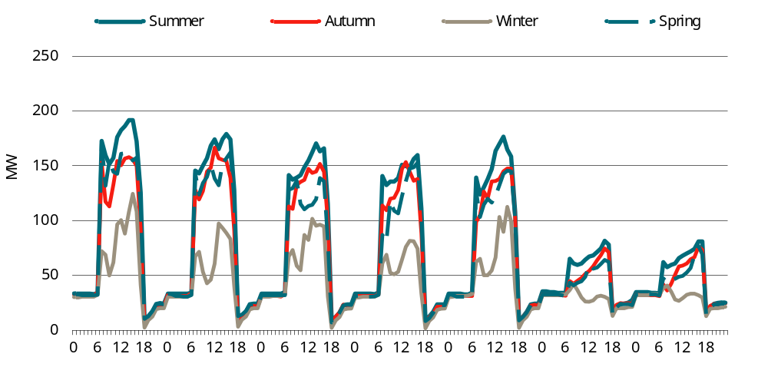
Data source: CIE based on DeltaQ modelling.
I.2 Aggregate impact on demand for electricity from the grid by TOU — Stringency 2
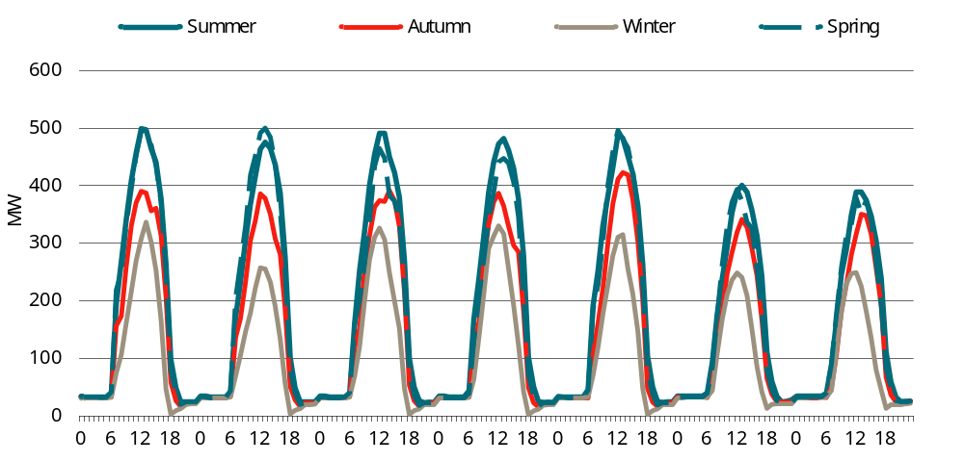
Data source: CIE based on DeltaQ modelling.

Victoria
According to AEMO forecasts, minimum demand in Victoria is expected to occur in summer between around 12:30pm and 2pm.
The potential impact of the proposed changes on minimum demand are as follows:
- Stringency Level 1 could reduce minimum demand by around 270 MW by 2034 compared with the base case (see chart I.3)
- Stringency Level 2 could decrease minimum demand by around 700 MW by 2034 compared with the base case (see chart I.4).
I.3 Aggregate impact on demand for electricity from the grid by TOU — Stringency 1
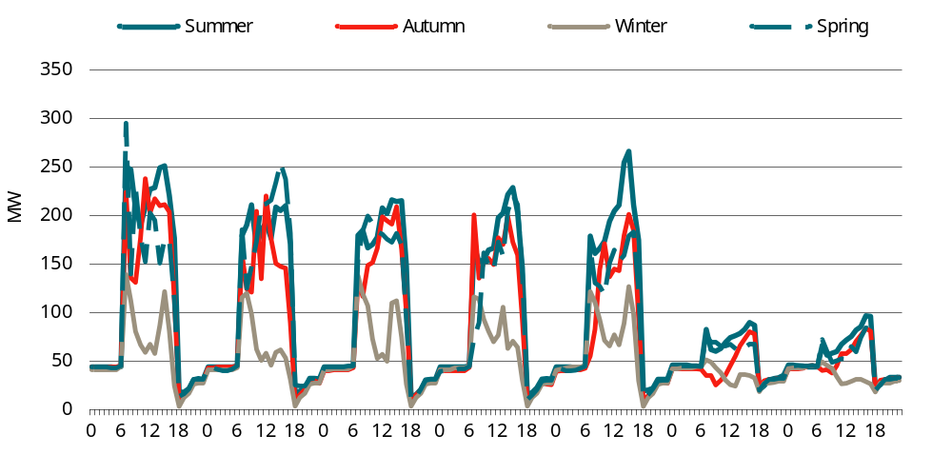
Data source: CIE based on DeltaQ modelling.
I.4 Aggregate impact on demand for electricity from the grid by TOU— Stringency 2
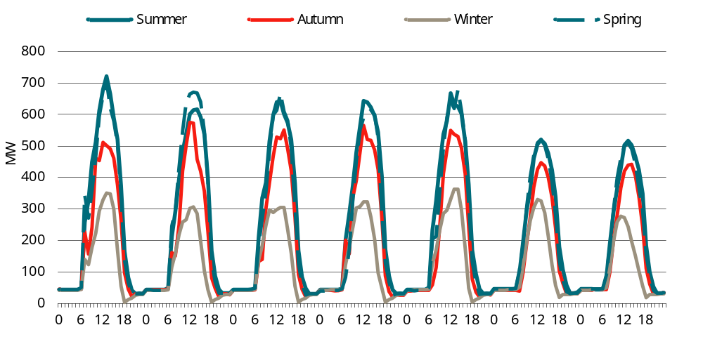
Data source: CIE estimates based on DeltaQ modelling.

Queensland
According to AEMO forecasts, minimum demand in Queensland is expected to occur in winter between around 12pm and 1pm.
The potential impact of the proposed changes on minimum demand are as follows:
- Stringency Level 1 could reduce minimum demand by around 150 MW by 2034 compared with the base case (see chart I.5)
- Stringency Level 2 could decrease minimum demand by around 335 MW by 2034 compared with the base case (see chart I.6).
I.5 Aggregate impact on demand for electricity from the grid by TOU — Stringency 1
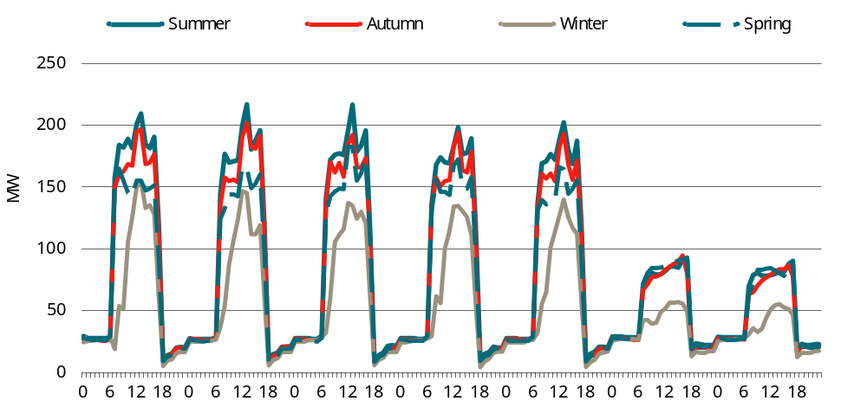
Data source: CIE based on DeltaQ modelling.
I.6 Aggregate impact on demand for electricity from the grid by TOU — Stringency 2
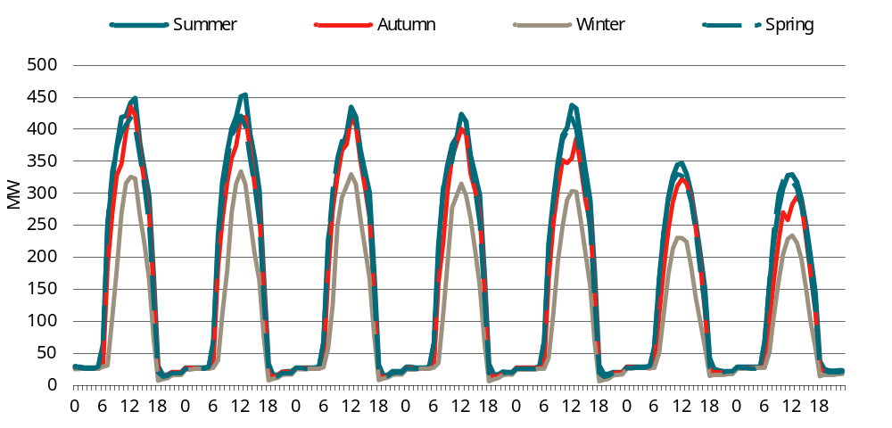
Data source: CIE estimates based on DeltaQ modelling.

South Australia
According to AEMO forecasts, minimum demand in South Australia is expected to occur in summer between around 1pm and 2:30pm.
The potential impact of the proposed changes on minimum demand are as follows:
- Stringency Level 1 could reduce minimum demand by around 52 MW by 2034 compared with the base case (see chart I.7)
- Stringency Level 2 could decrease minimum demand by around 140 MW by 2034 compared with the base case (see chart I.8).
I.7 Aggregate impact on demand for electricity from the grid by TOU — Stringency 1
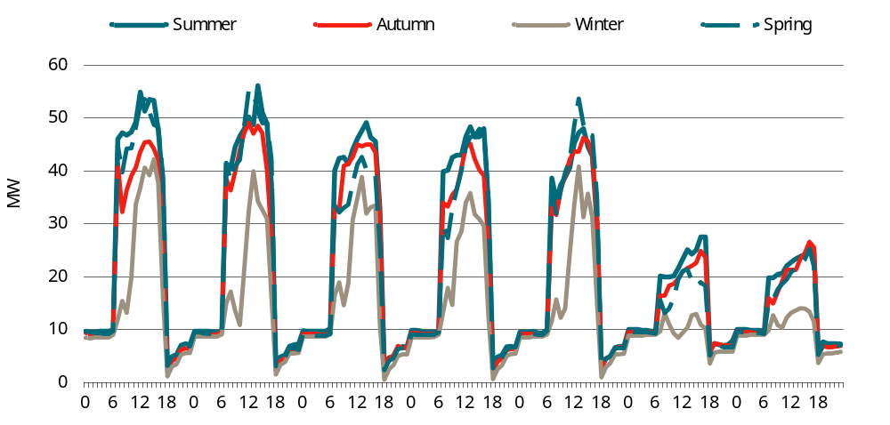
Data source: CIE based on DeltaQ modelling.
I.8 Aggregate impact on demand for electricity from the grid by TOU — Stringency 2
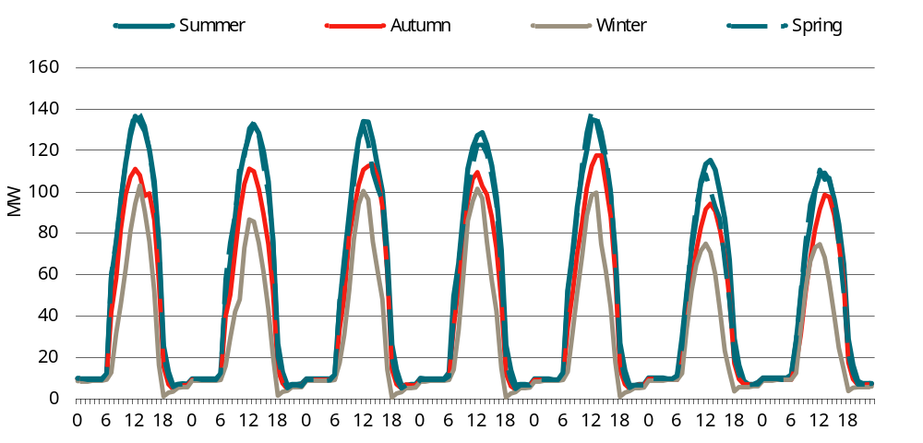
Data source: CIE estimates based on DeltaQ modelling.

Tasmania
According to AEMO forecasts, minimum demand in Tasmania is expected to occur in shoulder seasons (spring and autumn) between around 1pm and 2pm.
The potential impact of the proposed changes on minimum demand are therefore as follows:
- Stringency Level 1 could reduce minimum demand by around 10 MW by 2034 compared with the base case (see chart I.9)
- Stringency Level 2 could decrease minimum demand by around 26 MW by 2034 compared with the base case (see chart I.10).
I.9 Aggregate impact on demand for electricity from the grid by TOU — Stringency 1
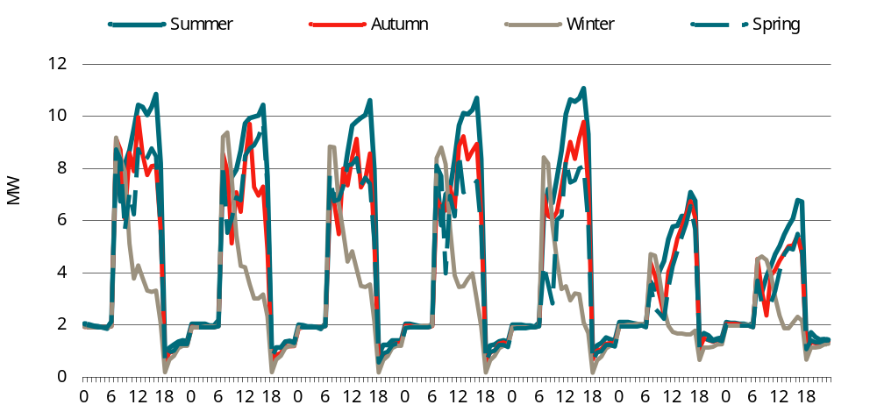
Data source: CIE based on DeltaQ modelling.
I.10 Aggregate impact on demand for electricity from the grid by TOU — Stringency 2
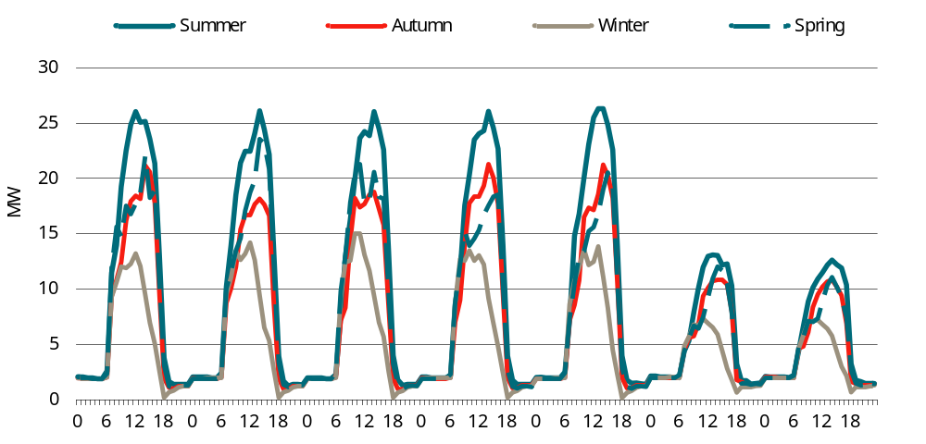
Data source: CIE estimates based on DeltaQ modelling.

Gerarden, T.D., Newell, R.G. and Stavins, R.N. 2015, Assessing the Energy Efficiency Gap, Duke University Energy Initiative and Harvard Environmental Economics Program, January 2015, p. 1.
ABCB 2022, NCC 2025 energy efficiency project: Rationale and Scope, 2022, p.1
Hutley, N. 2023, Economic parameters for technical work (NCC), report for Australian Building Construction Board, Rovingstone Advisory Pty Ltd, p. 4.
Note that the term “offset” is used in this report only relates to on-site renewables.
Under the ‘dual fuel offset’ option, a building can use both gas and electricity but will require additional on-site renewables to balance emissions from gas appliances compared with an all-electric equivalent. Under this stringency, the building’s operational carbon emissions should be no higher than an equivalent all-electric building.
Strategy.Policy.Research. 2022, Commercial Building Baseline Study 2022: Final Report, prepared for Department of Climate Change, Energy, the Environment and Water, https://www.energy.gov.au/publications/commercial-buildings-energy-consumption-baseline-study-2022, pp.iv-v Note that the estimated GFA as at FY 2020 is not comparable to the estimated floor space (360 million square meters) in the CRIS 2019 for energy efficiency of commercial buildings. The 2019 estimate drew on a ‘net lettable area’ concept based on pitt&sherry (pitt&sherry, Baseline Energy Consumption and Greenhouse Gas Emissions In Commercial Buildings in Australia, Department of Climate Change and Energy Efficiency, 2012, https://www.energy.gov.au/sites/default/files/baseline-energy-consumption-part_1-report-2012.pdf, accessed 3 November 2023). GFA is a different concept and was not estimated in the CRIS 2019.
ibid.
ABCB 2016, NCC Volume One Energy Efficiency Provisions Handbook, Fourth Edition, p. 20 and ABCB 2019, Energy efficiency: NCC 2022 and beyond - Scoping study, p. 4.
ibid., p.7
Strategy.Policy.Research. Research report: use of renewable energy to trade-off energy efficiency requirements in Section J of the National Construction Code, Prepared for the Department of Industry, Science, Energy and Resources, 20 January 2022, p. 4, https://www.dcceew.gov.au/sites/default/files/documents/use-%20renewable-energy-%20trade-off-ee-requirements-section-j-national-construction-code.pdf.
Ausgrid, 2024–25 pricing proposal, Australian Energy Regulator, May 2024, https://www.aer.gov.au/industry/networks/pricing-proposals/ausgrid-2024-25-pricing-proposal, accessed 17 September 2024.
P Graham 2022, Electric vehicle projections 2022 - Commissioned for AEMO’s draft 2023 Input, Assumptions and Scenarios Report, CSIRO, 2022, https://aemo.com.au/-/media/files/stakeholder_consultation/consultations/nem-consultations/2022/2023-inputs-assumptions-and-scenarios-consultation/supporting-materials-for-2023/csiro-2022-electric-vehicles-projections-report.pdf?la=en, last accessed 6 February 2024
For example, NSW Treasury recommends a 5 per cent a year central estimate social discount rate (https://www.treasury.nsw.gov.au/sites/default/files/2023-04/tpg23-08_nsw-government-guide-to-cost-benefit-analysis_202304.pdf).
Infrastructure Australia 2024, Valuing emissions for economic analysis, 15 May 2024, https://www.infrastructureaustralia.gov.au/publications/valuing-emissions-economic-analysis
CIE 2018, Decision Regulation Impact Statement: Energy Efficiency of Commercial Buildings, report for Australian Building Codes Board, November 2018, https://www.abcb.gov.au/sites/default/files/resources/2022/Final-RIS-energy-efficiency-of-commercial-buildings.pdf
Strategy.Policy.Research 2022, Commercial Building Baseline Study 2022, Final Report to Department of Climate Change, Energy, the Environment and Water, August 2022, https://www.dcceew.gov.au/sites/default/files/documents/commercial-buildings-energy-consumption-baseline-study-2022.pdf
IPCC 2023, Climate Change 2023: Synthesis Report, Contribution of Working Groups I, II and III to the Sixth Assessment Report of the Intergovernmental Panel on Climate Change [Core Writing Team, H. Lee and J. Romero (eds.)]. IPCC, Geneva, Switzerland, p.44, https://www.ipcc.ch/report/ar6/syr/downloads/report/IPCC_AR6_SYR_LongerReport.pdf.
See: Commonwealth of Australia, Department of Prime Minister and Cabinet, Regulatory Impact Analysis Guide for Ministers’ Meetings and National Standard Setting Bodies, June 2023, p. 13.
United Nations Framework Convention on Climate Change, ‘Paris Agreement - Status of Ratification’, 2023, https://unfccc.int/process/the-paris-agreement/status-of-ratification, accessed 1 November 2023
United Nations Framework Convention on Climate Change, ‘The Paris Agreement’, 2023, https://unfccc.int/process-and-meetings/the-paris-agreement, accessed 1 November 2023
See for example, Gerarden, Todd D., Richard G. Newell, and Robert N. Stavins 2015, “Assessing the Energy Efficiency Gap”, M-RCBG Faculty Working Paper Series, 2015-04, Harvard Environmental Economics Program, January 2015, https://www.hks.harvard.edu/sites/default/files/centers/mrcbg/files/mrcbg.fwp.2015-04.Stavins.efficiency.pdf.
See for example: ACIL-Allen, National Construction Code 2022: Decision Regulation Impact Statement for a proposal to increase residential building energy efficiency requirements, Report to the Australian Building Codes Board, 25 August 2022, p. 32.
See for example former COAG Energy Council, National Energy Productivity Plan 2015-2030: Boosting Competitiveness, managing costs and reducing emissions, December 2015, p. 6.
Gerarden, T.D., Newell, R.G. and Stavins, R.N. 2015, Assessing the Energy Efficiency Gap, Duke University Energy Initiative and Harvard Environmental Economics Program, January 2015, p. 1.
DCCEEW 2023, The National Electric Vehicle Strategy, Department of Climate Change, Energy, the Environment and Water, Canberra, p. 1.
DCCEEW 2023, The National Electric Vehicle Strategy, Department of Climate Change, Energy, the Environment and Water, Canberra, p. 1.
Shanjun Li, Lang Tong, Jianwei Xing and Yiyi Zhou 2017, ‘The Market for Electric Vehicles: Indirect Network Effects and Policy Design’, Journal of the Association of Environmental and Resource Economics, January 2017, p. 88
DCCEEW 2023, The National Electric Vehicle Strategy, Department of Climate Change, Energy, the Environment and Water, Canberra, pp. 13-14.
Ross De Rango, Electric Vehicle Council, pers. comm. 10 October 2023.
Hardman, S. 2021, Understanding discontinuance among California’s electric vehicle owners, Nature Energy 6, pp. 538-545.
Department of Climate Change, Energy, the Environment and Water 2022, ‘Net Zero’, in DCCEEW Emissions Reduction, https://www.dcceew.gov.au/climate-change/emissions-reduction/net-zero, accessed 2 November 2023.
NSW Environment Protection Authority 2020, ‘Net Zero Plan Stage 1: 2020–2030’, in NSW State of the Environment, https://www.soe.epa.nsw.gov.au/all-themes/climate-and-air/net-zero-plan-stage-1-2020-2030, accessed 2 November 2023.
South Australian Department for Environment and Water, ‘Mapping a pathway to net zero’, in Government of South Australia - Government Action on Climate Change, https://www.environment.sa.gov.au/topics/climate-change/net-zero-pathway, accessed 2 November 2023.
Victorian Department of Energy, Environment and Climate Action 2022, ‘Climate action targets’, in Victoria State Government - Climate Change, https://www.climatechange.vic.gov.au/climate-action-targets, accessed 2 November 2023.
Queensland Treasury 2022, Queensland Sustainability Report, in Action on climate change, Queensland Government, December 2022, https://www.qtc.com.au/queenslands-sustainability-initiatives/, accessed 2 November 2023.
Western Australian Department of Water and Environmental Regulation 2022, Government Emissions Interim Target, Western Australian Government, 2022, https://www.wa.gov.au/service/environment/business-and-community-assistance/government-emissions-interim-target,accessed 2 November 2023.
Tasmanian Department of State Growth 2023, ‘Climate Change Action Plan’, in Renewables, Climate and Future Industries, Tasmanian Government, https://recfit.tas.gov.au/climate/climate_change_action_plan,accessed 2 November 2023.
Northern Territory Government 2021, ‘Territory Renewable Energy’, Northern Territory Government, https://territoryrenewableenergy.nt.gov.au/, accessed 2 November 2023.
ACT Government 2021, ‘ACT Climate Change Strategy’, in ACT Government Policy and programs, https://www.climatechoices.act.gov.au/policy-programs/act-climate-change-strategy, accessed 2 November 2023.
Climate Change Authority website, https://www.climatechangeauthority.gov.au/parliament-refers-sectoral-pathways-review-climate-change-authority, accessed 3 November 2023.
Australian Government Department of Climate Change, Energy, the Environment and Water (DCCEEW) 2022, National Energy Performance Strategy: Consultation Paper, p. 3.
Ibid., p.1
Ibid., p.1
Former COAG Energy Council 2018, Trajectory for low energy buildings, December 2018, p. 5.
ABCB 2021, Outcomes report: Energy efficiency NCC 2022 and beyond, ABCB, 2021, pp.2-4.
ibid.
DCCEEW 2023, National Electric Vehicle Strategy, Department of Climate Change, Energy, the Environment and Water, Canberra, p. 3.
DCCEEW (2023), op. cit., p. 26.
Department of Finance 2023, ‘APS Net Zero Emissions by 2030’, in Climate Action In Government Operations, Australian Government , https://www.finance.gov.au/government/climate-action-government-operations/aps-net-zero-emissions-2030, accessed 12 January 2024.
NABERS 2018, ‘What is NABERS?’, Australian Government, 2018, https://www.nabers.gov.au/about/what-nabers, accessed 24 10 2023.
NABERS 2020, ‘NABERS Energy’, Australian Government, 2020, https://www.nabers.gov.au/ratings/our-ratings/nabers-energy, accessed 16 October 2023.
ACT Government 2023, ‘Powering Canberra: Our Pathway to Electrification’, in ACT Government - Canberra is Electrifying, 2023, https://energy.act.gov.au/, accessed 2 November 2023.
ACT Government 2023, Position Paper: Developing ACT’s Integrated Energy Plan - Canberra is electrifying towards a net zero emissions city, ACT Government, August 2023, pp.1-11.
Planning Victoria 2023, ‘Victoria’s Gas Substitution Roadmap’, in the Victorian Government - Renewable energy, 2023, https://www.planning.vic.gov.au/guides-and-resources/strategies-and-initiatives/victorias-gas-substitution-roadmap, accessed 2 November 2023. Victoria State Government 2024, Victoria’s Gas Substitution Roadmap Update: Victoria’s Electrification Pathway, p. 3, https://www.energy.vic.gov.au/__data/assets/pdf_file/0027/691119/Victorias-Gas-Substitution-Roadmap-Update.pdf, accessed 7 February 2024
Electric Vehicle Council 2023, State of Electric Vehicles Report 2023, 31 July 2023, pp. 33–34.
Revenue NSW 2021, ‘Electric Vehicle Rebate’, in Grants and schemes, NSW Government , 2021, https://www.revenue.nsw.gov.au/grants-schemes/electric-vehicle-rebate, accessed 2 November 2023.
https://www.solar.vic.gov.au/zero-emissions-vehicle-subsidy
Queensland Rural and Industry Development Authority 2023, ‘Queensland Zero Emission Vehicle Rebate Scheme’, in Grants and Programs, Queensland Government, 2023, https://www.qrida.qld.gov.au/program/queensland-zero-emission-vehicle-rebate-scheme, accessed 2 November 2023.
Department of Treasury and Finance 2021, ‘Incentives for electric vehicles’, in Growing South Australia, Government of South Australia, 2021, https://www.treasury.sa.gov.au/Growing-South-Australia/incentives-for-electric-vehicles, accessed 2 November 2023.
Department of Transport 2023, ‘Zero Emission Vehicle (ZEV) Rebate’, in Electric vehicles , Government of Western Australia, 2023, https://www.transport.wa.gov.au/projects/zero-emission-vehicle-zev-rebate.asp, accessed 2 November 2023.
Access Canberra 2023, ‘Incentives for low and zero emissions vehicles’, in Registration, ACT Government, 2023, https://www.accesscanberra.act.gov.au/driving-transport-and-parking/registration/incentives-for-low-and-zero-emissions-vehicles, accessed 2 November 2023.
Northern Territory Government 2022, ‘Get registration and stamp duty concessions for electric vehicles’, in Registration and number plates, https://nt.gov.au/driving/rego/getting-an-nt-registration/get-electric-vehicle-registration-and-stamp-duty-concessions>, accessed 2 November 2023.
Queensland Government 2023, ‘Shifting to zero emission vehicles’, in Electric vehicles, 2023, https://www.qld.gov.au/transport/projects/electricvehicles/hitting-the-road, accessed 2 November 2023.
Department of Treasury and Finance, Government of South Australia (2021), op. cit.
VicRoads 2019, ‘Hybrid vehicle registration discount’, in Concessions & discounts, 2019, https://www.vicroads.vic.gov.au/registration/registration-fees/concessions-and-discounts/hybrid-vehicle-registration-discount, accessed 2 November 2023.
Access Canberra (2023), op.cit.
NSW Treasury 2021, ‘No stamp duty payable on electric vehicle purchases’, NSW Government, 2021, https://www.nsw.gov.au/driving-boating-and-transport/nsw-governments-electric-vehicle-strategy/abolish-stamp-duty, accessed 2 November 2023.
Northern Territory Government (2022), op. cit.
Royal Automobile Club of Queensland 2022, ‘Incentives make electric cars more affordable’, in EVs, 2022, https://www.racq.com.au/articles/evs/2022/11/incentives-make-electric-cars-more-affordable, accessed 2 November 2023.
ACT Government 2022, ‘Sustainable Household Scheme’, in Climate Choice, 2022, https://www.climatechoices.act.gov.au/policy-programs/sustainable-household-scheme, accessed 2 November 2023/
VicRoads 2021, ‘ZLEV road-user charge’, https://www.vicroads.vic.gov.au/online-services/help-centre/partner-help-centre/zlev-road-user-charge, accessed 2 November 2023
P Karp & B Kolovos, ‘High court strikes down Victoria’s electric vehicle tax in ruling that could threaten other state levies’, in The Guardian, 18 October 2023, section Environment, https://www.theguardian.com/environment/2023/oct/18/victoria-electric-vehicle-tax-high-court-ruling-could-impact-nsw-wa-western-australia, accessed 3 November 2023.
Zaunmayr, T. 2023, ‘Vic court ruling could scupper WA EV road tax’, in Business News, 18 October 2023, https://www.businessnews.com.au/article/Vic-court-ruling-could-scupper-WA-EV-road-tax, accessed 3 November 2023; and J Skatssoon, ‘NSW reconsiders EV road user charge after High Court decision’, in Government News, 23 October 2023, https://www.governmentnews.com.au/nsw-reconsiders-ev-road-user-charge-after-high-court-decision/, accessed 3 November 2023.
Australian Tax Office 2024, ‘Electric cars exemption’, https://www.ato.gov.au/businesses-and-organisations/hiring-and-paying-your-workers/fringe-benefits-tax/types-of-fringe-benefits/fbt-on-cars-other-vehicles-parking-and-tolls/electric-cars-exemption, accessed 8 February 2024.
Department of Infrastructure, Transport, Regional Development, Communications and the Arts website, https://www.infrastructure.gov.au/infrastructure-transport-vehicles/vehicles/australian-fuel-efficiency-standard-cleaner-cars-australia, accessed 3 November 2023.
Australian Government Department of Infrastructure, Transport, Regional Development, Communications and the Arts 2023, The Fuel Efficiency Standard — Cleaner, Cheaper to Run Cars for Australia, Consultation Paper, 19 April 2023, p. 10.
DCCEEW 2023, National Electric Vehicle Strategy, Department of Climate Change, Energy, the Environment and Water, Canberra, p. 1.
DCCEEW (2023), op. cit., p. 21.
DCCEEW (2023), op. cit., p. 1.
ABS, Consumer Price Index — September Quarter 2023.
Newman, R. and Noy, I. 2023, The global cost of extreme weather that are attributable to climate change, Nature Communications, https://www.nature.com/articles/s41467-023-41888-1, accessed 3 November 2023.
US Environment Protection Agency 2022, Supplementary Material for the Regulatory Impact Analysis for the Supplemental Proposed Rulemaking, “Standards of Performance for New, Reconstructed, and Modified Sources and Emissions Guidelines for Existing Sources: Oil and Natural Gas Sector Climate Review”, EPA External Review Draft of Report on the Social Cost of Greenhouse Gases: Estimates Incorporating Recent Scientific Advances, September 2022, p. 3.
See: DeltaQ and Strategy.Policy.Research. 2018, Achieving Low Energy Commercial Buildings in Australia, Final Report, 9 November 2018.
DeltaQ and Strategy.Policy.Research. 2022, Commercial Buildings Low-Energy Trajectory, NCC 2025 Update to Achieving Low Energy Commercial Buildings in Australia, Final Report, Prepared for the Department of Industry, Science, Energy and Resources on behalf of all States and Territories, 10 March 2022, p. 2.
ABCB 2022, National Construction Code: Housing energy efficiency Handbook, 2022, https://www.abcb.gov.au/sites/default/files/resources/2023/NCC-2022-Housing-energy-efficiency-handbook-fa.pdf, pp. 5-6.
DCCEEW 2022, National Energy Performance Strategy: Consultation Paper, Australian Government Department of Climate Change, Energy, the Environment and Water, November 2022, pp. 3-4.
ABCB 2022, NCC 2025 energy efficiency project: Rationale and Scope, 2022, p.1
Commonwealth of Australia, Regulatory Impact Analysis Guide for Minister’s Meetings and National Standard Setting Bodies, 2023, https://oia.pmc.gov.au/sites/default/files/2023-06/regulatory-impact-analysis-guide.pdf, accessed 16 Oct 2023.
DeltaQ 2023, NCC 2025 Energy Efficiency - Initial Measures Development: Electrical Services Report, The Australian Building Codes Board, September 2023, pp. 39–40.
Following BCC there is now a stand alone EV performance requirement, J1P5. But the intent is the same as what is defined here.
Hutley, N. 2023, Economic parameters for technical work (NCC), report for Australian Building Construction Board, Rovingstone Advisory Pty Ltd, p. 4.
Australian Government Office of Best Practice Regulation, Environmental Valuation and Uncertainty, Guidance Note, July 2014, p. 4.
Hutley (2023), op. cit., p.6.
See for example: DeltaQ and Strategy.Policy.Research. 2022, Commercial Buildings Low-Energy Trajectory, NCC 2025 Update to Achieving Low Energy Commercial Buildings in Australia, Final Report, 10 March 2022, p. 68.
pitt&sherry 2016, Commercial Building Learning Rates, Final Report, Prepared for the Department of Industry, Innovation and Science, 3 August 2016, p. ii.
International Partnership for Energy Efficiency Cooperation (IPEEC) Building Energy Efficiency Taskgroup 2019, Building Energy Performance Gap Issues: An International Review, p. 14.
Green Building Council of Australia 2022, Building Energy Performance Gap NCC 2025 — Scoping Study, August 2022, pp. 5-6.
Green Building Council of Australia (2022), op. cit., p. 7.
DCCEEW 2023a, Australia’s emissions projections 2023, Department of Climate Change, Energy, the Environment and Water, Canberra, November 2023, Table 46, https://www.dcceew.gov.au/sites/default/files/documents/australias-emissions-projections-2023.pdf
Hutley, N. 2023, Economic parameters for technical work (NCC), Rovingstone Advisory Pty Ltd, February 2023, Tables 5.2, 5.3, 5.5 and 5.6.
DCCEEW 2023b, Australian National Greenhouse Accounts Factors: For individuals and organisations estimating greenhouse gas emissions, Department of Climate Change, Energy, the Environment and Water, Canberra, August 2023, https://www.dcceew.gov.au/sites/default/files/documents/national-greenhouse-account-factors-2023.pdf
Australian Carbon Credit Units (ACCUs) are issued by the Clean Energy Regulator for greenhouse gas abatement activities undertaken as part of the Australian Government’s Emissions Reduction Fund. An ACCU represents one tonne of carbon dioxide equivalent stored or avoided by an ‘eligible offsets project’. Because the scheme does not cover all abatement activities, such as abatement in the electricity sector is not covered, it does not represent a comprehensive measure of nationwide abatement, let alone establish an economy-wide carbon price. The spot generic ACCU price is about $38 per unit (Clean Energy Regulator, ‘1. Australian carbon credit units (ACCUs)’, Australian Government, 2023, https://www.cleanenergyregulator.gov.au/Infohub/Markets/Pages/qcmr/march-quarter-2023/Australian-Carbon-Credit-Units.aspx, accessed 3 November 2023).
USEPA 2023, EPA Report on the Social Cost of Greenhouse Gases: Estimates Incorporating Recent Scientific Advances, p.4, https://www.epa.gov/system/files/documents/2023-12/epa_scghg_2023_report_final.pdf
Hutley (2023), op. cit., Table 4.4, p.12.
Infrastructure Australia 2024, Valuing emissions for economic analysis, 15 May 2024, https://www.infrastructureaustralia.gov.au/publications/valuing-emissions-economic-analysis
See for example, Newell, G. MacFarlane, J. and Kok, N. 2011, Building Better Returns: A Study of the Financial Performance of Green Office Buildings in Australia, September 2011. Knight Frank 2022, Active Capital: Trends in Global Real Estate Investment, https://content.knightfrank.com/research/1801/documents/en/active-capital-the-report-2021-8447.pdf
See for example: International Energy Agency (IEA), 2014, Capturing the Multiple Benefits of Energy Efficiency, pp. 45-66.
Strategy.Policy.Research. Research report: use of renewable energy to trade-off energy efficiency requirements in Section J of the National Construction Code, Prepared for the Department of Industry, Science, Energy and Resources, 20 January 2022, p. 4, https://www.dcceew.gov.au/sites/default/files/documents/use-%20renewable-energy-%20trade-off-ee-requirements-section-j-national-construction-code.pdf.
AER refers to penetration of Distributed Energy Resources (DER) generally, but this is mainly rooftop solar.
AER, Submission to draft determination, p. 5.
AEMO, Minimum operational demand, Fact Sheet, https://aemo.com.au/-/media/files/learn/fact-sheets/2024/minimum-operational-demand-fact-sheet.pdf?la=en#:~:text=Operational%20demand%20goes%20down%20when,a%20minimum%20operational%20demand%20scenario., accessed 16 August 2024.
Ausgrid, Two-way pricing for grid exports, https://www.aer.gov.au/system/files/2023-12/Ausgrid%20-%20Revised%20proposal%20-%20Att.%208.14%20-%20Small%20customer%20export%20tariff%20fact%20sheet%20-%2030%20Nov%202023%20-%20Public.pdf, accessed 16 August 2024.
See ACT Government, ‘Powering Canberra: Our Pathway to Electrification’, in ACT Government - Canberra is Electrifying, 2023, https://energy.act.gov.au/, accessed 2 November 2023; and M Mannheim, ‘No new gas connections for Canberra homes and businesses from next year’, in ABC News, 4 August 2022, https://www.abc.net.au/news/2022-08-04/act-no-new-gas-connections-from-2023-new-homes/101299552, accessed 3 November 2023.
ACT Government, Community and Stakeholder Engagement Report - Pathway to Electrification: Regulation to prevent new fossil fuel gas network connections, ACT Government, June 2023, https://yoursayconversations.act.gov.au/pathway-to-electrification/help-inform-regulation-prevent-new-gas-connections, accessed 3 November 2023.
A Ore, ‘Ban on new gas connections will help transition Victoria away from fossil fuels, inquiry finds’, in The Guardian, 26 May 2022, section Environment, https://www.theguardian.com/environment/2022/may/26/ban-on-new-gas-connections-will-help-transition-victoria-away-from-fossil-fuels-inquiry-finds, accessed 3 November 2023.
Planning Victoria, ‘Victoria’s Gas Substitution Roadmap’, in the Victorian Government - Renewable energy, 2023, https://www.planning.vic.gov.au/guides-and-resources/strategies-and-initiatives/victorias-gas-substitution-roadmap, accessed 2 November 2023.
Victoria State Government 2024, Victoria’s Gas Substitution Roadmap Update: Victoria’s Electrification Pathway, p. 3, https://www.energy.vic.gov.au/__data/assets/pdf_file/0027/691119/Victorias-Gas-Substitution-Roadmap-Update.pdf, accessed 7 February 2024
https://cityswitch.net.au/
DCCEEW 2024, ‘Reducing transport emissions’, Australian Government, https://www.dcceew.gov.au/energy/transport, accessed 8 February 2024.
Li, S., L. Tong, J. Xing and Y. Zhou 2017, ‘The Market for Electric Vehicles: Indirect Network Effects and Policy Design’, Journal of the Association of Environmental and Resource Economics, January 2017, p. 88.
CIE 2019, Demand for electric vehicles: A discrete choice survey, report prepared for Australian Automobile Association, The Centre for International Economics, https://www.thecie.com.au/publications-archive/demand-for-electric-vehicles
H Dia, ‘Electric vehicle fires are very rare. The risk for petrol and diesel vehicles is at least 20 times higher’, The Conversation, 2023, https://theconversation.com/electric-vehicle-fires-are-very-rare-the-risk-for-petrol-and-diesel-vehicles-is-at-least-20-times-higher-213468, accessed 3 November 2023.
P Graham 2022, Electric vehicle projections 2022 - Commissioned for AEMO’s draft 2023 Input, Assumptions and Scenarios Report, CSIRO, 2022, https://aemo.com.au/-/media/files/stakeholder_consultation/consultations/nem-consultations/2022/2023-inputs-assumptions-and-scenarios-consultation/supporting-materials-for-2023/csiro-2022-electric-vehicles-projections-report.pdf?la=en, last accessed 6 February 2024
Small hospital (C9AS) was modelled by DeltaQ because aged care building (C9C) has very short HVAC running hours according to NCC 2022 schedules and thus was not an appropriate test bed. The results are applied to aged care facilities in the CBA.
Building-level CBA results have been estimated for each relevant Climate Zones for each state and territory, but are not reported.
Building-level CBA results have been estimated for each relevant Climate Zones for each state and territory, but are not reported.
Building-level CBA results have been estimated for each relevant Climate Zones for each state and territory, but are not reported.
SPR (Strategy.Policy.Research) 2022, Commercial Building Baseline Study 2022, final report for Department of Climate Change, Energy, the Environment and Water, August 2022, https://www.energy.gov.au/publications/commercial-buildings-energy-consumption-baseline-study-2022
SPR (2022), op. cit.
AEMO 2022, AEMO releases 30-year electricity market roadmap, 30 June 2022, https://aemo.com.au/newsroom/media-release/aemo-releases-30-year-electricity-market-roadmap
Strategy.Policy.Research. Research report: use of renewable energy to trade-off energy efficiency requirements in Section J of the National Construction Code, Prepared for the Department of Industry, Science, Energy and Resources, 20 January 2022, p. 4.
DeltaQ, NCC 2025 Energy Efficiency — Advice on the technical basis, Initial Measures Development: Electrical Services Report, Prepared for the Australian Building Codes Board, 26 September 2023, p. 87-90
Smit, R., Mellios, G. and Papadopoulos, G. (2022). Light-Duty Vehicle CO2 Emission Factors, Energy Intensities and Survival Curves for Australia’s Emissions Projections. 30 June.
CIE 2020, Greenhouse gas emissions projections and economic analysis of emissions reduction in Victoria: Whole of the economy modelling, prepared for DELWP. September.
Marsden Jacobs and Pacific Environment Limited (PEL) 2016, Review of the Fuel Quality Standards Act 2000, report prepared for the Australian Government Department of the Environment
See: Strategy.Policy.Research. Research report: use of renewable energy to trade-off energy efficiency requirements in Section J of the National Construction Code, Prepared for the Department of Industry, Science, Energy and Resources, 20 January 2022, p. 4.
Strategy.Policy.Research. Research report: use of renewable energy to trade-off energy efficiency requirements in Section J of the National Construction Code, Prepared for the Department of Industry, Science, Energy and Resources, 20 January 2022, p. 8.
US Environment Protection Agency 2022, Supplementary Material for the Regulatory Impact Analysis for the Supplemental Proposed Rulemaking, “Standards of Performance for New, Reconstructed, and Modified Sources and Emissions Guidelines for Existing Sources: Oil and Natural Gas Sector Climate Review”, EPA External Review Draft of Report on the Social Cost of Greenhouse Gases: Estimates Incorporating Recent Scientific Advances, September 2022, p. 3.
Climateworks Centre, Net Zero Momentum Tracker, 1.50C climate goal: How does the ASX200 stack up in 2022?, Highlights Report, December 2022, p. 6.
Australian Council of Superannuation Investors, Promises, pathways and performance: Climate change disclosure in the ASX200, August 2023, pp. 5–12, https://acsi.org.au/research-reports/promises-pathways-and-performance-climate-change-disclosure-in-the-asx200/, accessed 1 November 2023.
NABERS website, https://www.nabers.gov.au/ratings/our-ratings/nabers-energy, accessed 16 October 2023.
Commercial Building Disclosure website, http://cbd.gov.au/overview-of-the-program/what-is-cbd, accessed 17 October 2017.
Acil Allen Consulting 2015, Commercial Building Disclosure: Program Review, Report to the Department of Industry and Science, March 2015, pp. 42-46.
CBRE 2023, The Green Building Premium: Does It Exist, March 2023, https://www.cbre.com.au/insights/viewpoints/asia-pacific-viewpoint-the-green-building-premium-does-it-exist, accessed 1 November 2023.
V Ormond 2021, Green building value: do green-rated buildings add a premium to sales price?, Knight Frank, 29 September 2021, https://www.knightfrank.com/research/article/2021-09-29-green-building-value-do-greenrated-buildings-add-a-premium-to-sales-price, accessed 1 November 2023.
Newell, Graeme, John MacFarlane and Nils Kok 2011, Building Better Returns: A Study of the Financial Performance of Green Office Buildings in Australia, Research by the University of Western Sydney and the University of Maastricht Netherlands in conjunction with Jones Lang LaSalle and CBRE for The Australian Property Institute and Property Funds Association, p. 22.
ibid, p. 41.
International Energy Agency (IEA), Mind the Gap - Quantifying Principal-Agent Problems in Energy Efficiency, IEA, 2007, https://www.ctc-n.org/sites/www.ctc-n.org/files/resources/mind_the_gap.pdf, accessed 3 November 2023.
Gerarden, Todd D., Richard G. Newell, and Robert N. Stavins 2015, “Assessing the Energy Efficiency Gap” Cambridge, Mass.: Harvard Environmental Economics Program, January 2015, p. 28.
ibid, p. 28.
ibid, pp. 24-26.
For further details see: Gerarden, T.D., Newell, R.G. and Stavins, R.N. 2015, Assessing the Energy Efficiency Gap, Duke University Energy Initiative and Harvard Environmental Economics Program, January 2015, pp. 17-19.
Productivity Commission 2005, The Private Cost Effectiveness of Improving Energy Efficiency, Productivity Commission Inquiry Report No. 36, 31 August 2005, p. 236.
Gillingham, K. and Palmer, K. 2014, “Bridging the Energy Efficiency Gap: Policy Insights from Economic Theory and Empirical Evidence”, Review of Environmental Economics and Policy, 8(1), p. 21.
Productivity Commission 2005, The Private Cost Effectiveness of Improving Energy Efficiency, Productivity Commission Inquiry Report No. 36, 31 August 2005, p. 62.
Gillingham, K. and Palmer, K. 2014, “Bridging the Energy Efficiency Gap: Policy Insights from Economic Theory and Empirical Evidence”, Review of Environmental Economics and Policy, volume 8, issue 1, p. 21.
Productivity Commission 2005, The Private Cost Effectiveness of Improving Energy Efficiency, Productivity Commission Inquiry Report No. 36, 31 August 2005, p. 62.
ibid, p. 236.
ACCC 2022, Inquiry into the National Electricity Market, November 2022 Report, 23 November 2022, p.115.
AEMO, ‘Market Data - Western Australia’, in data.wa.aemo.com.au, 2023, https://data.wa.aemo.com.au/#balancing-summary , accessed 3 November 2023.
Northern Territory Electricity System and Market Operator (NTESMO), ‘Historical daily trading data’, in NTESMO, 2022, https://ntesmo.com.au/data/daily-trading/historical-daily-trading-data, accessed 3 November 2023.
Australian Energy Regulator (AER), ‘Pricing proposals and tariffs’, in Networks and pipelines, 2023, https://www.aer.gov.au/networks-pipelines/determinations-access-arrangements/pricing-proposals-tariffs, accessed 26 May 2023.
Western Power, ‘Network access prices’, in Regulation, 2023, https://www.westernpower.com.au/about/regulation/network-access-prices/,accessed 26 May 2023.
DeltaQ, Electricity Network Tariff Review, report for Department of Industry, Science, Energy and Resources (DISER), 30 March 2022.
Ausgrid 2023, Ausgrid – Annual pricing 2023-24, 31 March 2023, https://www.aer.gov.au/networks-pipelines/determinations-access-arrangements/pricing-proposals-tariffs/ausgrid-annual-pricing-2023%E2%80%9324, accessed 26 October 2023.
Australian Energy Regulator, AER approves SA Power Networks jurisdictional scheme application, 23 January 2023, https://www.aer.gov.au/communication/aer-approves-sa-power-networks-jurisdictional-scheme-application.
Powercor, Pricing Proposal 2023-24, May 2023, p.4, https://media.powercor.com.au/wp-content/uploads/2023/05/17152236/Powercor_2023-2024_Pricing_Proposal.pdf.
ARGYLE Consulting and ENDGAME Economics 2022, Network tariffs for the distributed energy future, final paper for the Australian Energy Regulator, June 2022, p.11, https://www.aer.gov.au/system/files/Argyle%20Consulting%20and%20Endgame%20Economics%20-%20Battery%20tariffs%20-%20Network%20tariffs%20for%20the%20DER%20future_0.pdf, accessed 25 October 2023.
Ausgrid, ‘Time of use pricing - Ausgrid’, 2022, https://www.ausgrid.com.au/Your-energy-use/Meters/Time-of-use-pricing, accessed 26 May 2023.
The power factor (PF) is a value between 0 and 1, indicating how efficiently the power is used in the system – kVA = PF x kW. The value of 0.8 appears a typical approximate value, for example, see https://www.vedantu.com/physics/relation-between-kva-and-kw.
AER, Default market offer prices 2022-23: Final determination, May 2022, Australian Energy Regulator, https://www.aer.gov.au/system/files/AER%20-%20Default%20Market%20Offer-%20Price%20determination%202022-23%20-%20Final%20Determination%20-%2026%20May%202022.pdf, p.45
AER, Default market offer prices 2023-24: Final determination, May 2023, Australian Energy Regulator, https://www.aer.gov.au/system/files/Default%20market%20offer%20prices%202023-24%20final%20determination.pdf, p.42, Table 8.1.
IPART, Methodology to calculate the benchmark ranges for 2024-25, February 2024, https://www.ipart.nsw.gov.au/sites/default/files/cm9_documents/Information-Paper-Solar-feed-in-tariff-benchmark-ranges-February-2024.PDF, accessed 30 August 2024. Engage Victoria, ‘Minimum feed-in tariff review 2024–25’, in Engage Victoria Consultations for Essential Services Commission, 2024, https://engage.vic.gov.au/minimum-feed-in-tariff-review-202425.
A key source of solar feed-in tariff offers are Australian Government, ‘Energy Made Easy’, 2015, https://www.energymadeeasy.gov.au/, accessed 30 August 2024. For WA and NT, we refer to the Distributed Energy Buyback Scheme (DEBS) and Jacana Energy Scheme as Energy Made Easy does not cover information for WA and NT. Western Australian Government, ‘Energy Buyback Schemes’, https://www.wa.gov.au/organisation/energy-policy-wa/energy-buyback-schemes, accessed 30 August 2024. NT Government, ‘Territory Renewable Energy Programs’, 2021, https://territoryrenewableenergy.nt.gov.au/programs, accessed 30 August 2024.
Ausgrid, Two-way pricing for grid exports, https://www.aer.gov.au/system/files/2023-12/Ausgrid%20-%20Revised%20proposal%20-%20Att.%208.14%20-%20Small%20customer%20export%20tariff%20fact%20sheet%20-%2030%20Nov%202023%20-%20Public.pdf, accessed 16 August 2024.
Australian Energy Regulator (AER) 2023a, Wholesale markets quarterly – Q1 2023, 20 April 2023, Figure 1, p.6, https://www.aer.gov.au/wholesale-markets/performance-reporting/wholesale-markets-quarterly-q1-2023, accessed 14 October 2023.
AER 2023b, Wholesale markets quarterly – Q4 2022, 16 February 2023, Figure 1.8, https://www.aer.gov.au/wholesale-markets/performance-reporting/wholesale-markets-quarterly-q4-2022; and AER (2023a), op.cit., Figure 6, p.10.
Department of Mines, Industry Regulation and Safety, ‘Latest statistics release’, in 2022 Major commodities resources data, 2022, https://www.dmp.wa.gov.au/About-Us-Careers/Latest-Statistics-Release-4081.aspx, accessed 3 November 2023.
AEMO, National Electricity and Gas Forecasting, 2022, http://forecasting.aemo.com.au/Electricity/AnnualConsumption/Operational, accessed 2 October 2023.
Lewis Grey Advisory (LGA), Gas Price Projections for Eastern Australia, 2023 Update, prepared for Australian Energy Market Operator, 14 December 2022, https://aemo.com.au/en/energy-systems/gas/gas-forecasting-and-planning/gas-statement-of-opportunities-gsoo, accessed 2 October 2023.
International Partnership for Energy Efficiency Cooperation (IPEEC) Building Energy Efficiency Taskgroup, 2019, Building Energy Performance Gap Issues: An International Review, p. 16.
Frankel, M. and Turner, C. 2008a, “How Accurate is Energy Modelling in the Market”, New Buildings Institute, 2008 ACEEE Summery Study on Energy Efficiency in Buildings, pp. 3-90—3-95.
Note that the report refers to applying a discount to ‘energy savings’ in both the base case and the policy case. However, this makes little sense as ‘energy savings’ refers to the difference between energy consumption in the policy case compared to the base case.
See for example: DeltaQ and Strategy.Policy.Research. Commercial Buildings Low-Energy Trajectory, NCC 2025 Update to Achieving Low Energy Commercial Buildings in Australia, Final Report, 10 March 2022, p. 92.
Although the data relate to GHG emissions, rather than energy consumption, GHG emission estimates are based on the energy consumption and the emissions intensity of the relevant energy sources in each building’s location. The emissions intensity of each energy source is unlikely to have varied significantly from the predictions. The relationship is therefore likely to be indicative of the relationship between predicted and actual energy consumption, unless prediction errors can be explained by a significant shift in the energy mix (i.e. between electricity and gas).
International Partnership for Energy Efficiency Cooperation (IPEEC) Building Energy Efficiency Taskgroup, 2019, Building Energy Performance Gap Issues: An International Review, p. 1.
IPEEC Building Energy Efficiency Taskgroup (2019), op. cit., p. 14.
Green Building Council of Australia (GBCA), 2021, Green Star in focus, Energy performance in Green Star buildings, Closing the performance gap in Australia’s commercial office sector, p. 01.
GBCA (2021), op. cit., p. 3.
Green Building Council of Australia (GBCA) 2022, Building Energy Performance Gap NCC 2025 — Scoping Study, August 2022, pp. 5-6.
GBCA (2022), op. cit., p. 6.
GBCA (2022), op. cit., p. 16.
GBCA (2022), op. cit., p. 7.
pitt&sherry 2014, National Energy Efficient Building Project: Final report, report prepared for Department of State Development, Government of South Australia, November 2014, pp. 65-66.
Carbon Trust 2011, Closing the gap: Lessons learned on realising the potential of low carbon building design, p. 4.
pitt&sherry 2014, National Energy Efficient Building Project: Final report, report prepared for Department of State Development, Government of South Australia, November 2014, pp. 65-66.
A Mahdavi et al., ‘The Role of Occupants in Buildings’ Energy Performance Gap: Myth or Reality?’, in Sustainability, vol. 13, 2021, 3146.
Imam, S. Coley, D.A. and Walker, I. 2017, “The building performance gap: Are modellers literate?”, Journal of Building Services Engineering Research & Technology, 38(3), pp.351-375.
Environmental Justice Australia, ‘The health burden of coal-fired power in NSW’, 2023, https://envirojustice.org.au/legal-work/ending-pollution/the-burden-of-coal-fired-power-in-nsw/, accessed 5 December 2023.
Bertrand, S. 2021, Fact Sheet - Climate, Environmental, and Health Impacts of Fossil Fuels , Environmental and Energy Study Institute, 17 December 2021, https://www.eesi.org/papers/view/fact-sheet-climate-environmental-and-health-impacts-of-fossil-fuels-2021, accessed 3 November 2023
Mazaheri, M., Y. Scorgie, R.A. Broome, G.G. Morgan, B. Jalaludin and M.L. Riley 2021, ‘Monetising Air Pollution Benefits of Clean Energy Requires Locally Specific Information’, Energies, vol. 14(22), 7622, November.
Centre for International Economics (CIE) 2020, Greenhouse gas emissions projections and economic analysis of emissions reduction in Victoria: Whole of the economy modelling, report to the Department of Environment, Land, Water and Planning, September 2020. Ward, J. and M. Power 2015, Cleaning up Victoria’s Power Sector: the full social cost of Hazelwood power station, report to Environment Victoria.
DELWP, Estimating the health costs of air pollution in Victoria, DELWP Economics working paper to inform the Independent Expert Panel on Interim Targets, 2018, https://www.climatechange.vic.gov.au/__data/assets/pdf_file/0022/421717/Final_Health-costs-of-air-pollution-in-Victoria.pdf, accessed 6 December 2023.
J Ward & M Power (2015) identified two major determinant of local impacts – stack height and local population density. It is understood that there will be no new coal power stations in Victoria, and the stack heights of current stations will remain the same over the period to their closure. It is therefore appropriate to consider population density will estimate unit costs beyond 2018.
CIE 2019, Independent review of the Commercial Building Disclosure Program, report to the Department of the Environment and Energy, September 2019, https://www.cbd.gov.au/sites/default/files/2020-09/cbd_review_cie_report_draft.pdf
AEMO, 2022 Integrated System Plan, 2022, p. 49, https://aemo.com.au/-/media/files/major-publications/isp/2022/2022-documents/2022-integrated-system-plan-isp.pdf, accessed 11 December 2023
ACIL-Allen Consulting 2015, Commercial Building Disclosure: Program Review, Department of Industry and Science, 2015, pp. 56-57.
In the Window Film Secondary Glazing Retrofit Trials in Victoria (2017), it is noted that applying the film to existing windows in the living areas of houses resulted in better thermal comfort, increasing from an average energy rating of 3.1 to 3.6 starts. See P Rajagopalan et al., Enhancing home thermal efficiency. Final report of Opportunity Assessment for Enhancing home thermal efficiency, RACE for 2030 Cooperative Research Centre, May 2023, p. 132, https://racefor2030.com.au/wp-content/uploads/2023/05/H2-OA-0199-Final-Report_.pdf, accessed 8 January 2024.
Li, S., Tong, L., Xing, J. and Zhou, Y., 2017, ‘The market for electric vehicles: indirect network effects and policy design’, Journal of the Association of Environmental and Resource Economists, 4(1), pp.89-133.
Remmy, K., 2022, Adjustable product attributes, indirect network effects, and subsidy design: The case of electric vehicles (No. crctr224_2022_335), University of Bonn and University of Mannheim, Germany.
This item (Area A) is presumably below cost, otherwise the charging infrastructure would be provided in the baseline. The question is whether the external benefits of avoided emissions outweigh the shortfall.
CIE, Demand for electric vehicles: A discrete choice survey, a report for Australian Automobile Association, 22 January 2019, https://www.thecie.com.au/s/CIE-AAA-EV-choice-final-report-public.pdf
DeltaQ 2023, EE NCC 2025 – Advice on the technical basis: Mobilisation report, report to the Australian Building Codes Board (ABCB), 14 June 2023.
Baker Consulting, Australia in the Global Shopping Centre Industry: An international comparison and explanation of retail sales, retail floorspace, sales productivity and occupancy costs in Australia, Canada, New Zealand, UK and USA, Report to Shopping Centre Council of Australia, December 2018, pp. 10-11.
Productivity Commission, The Market for Retail Tenancy Leases in Australia, Productivity Commission Inquiry Report No. 43, 31 March 2008, p. XIX.

