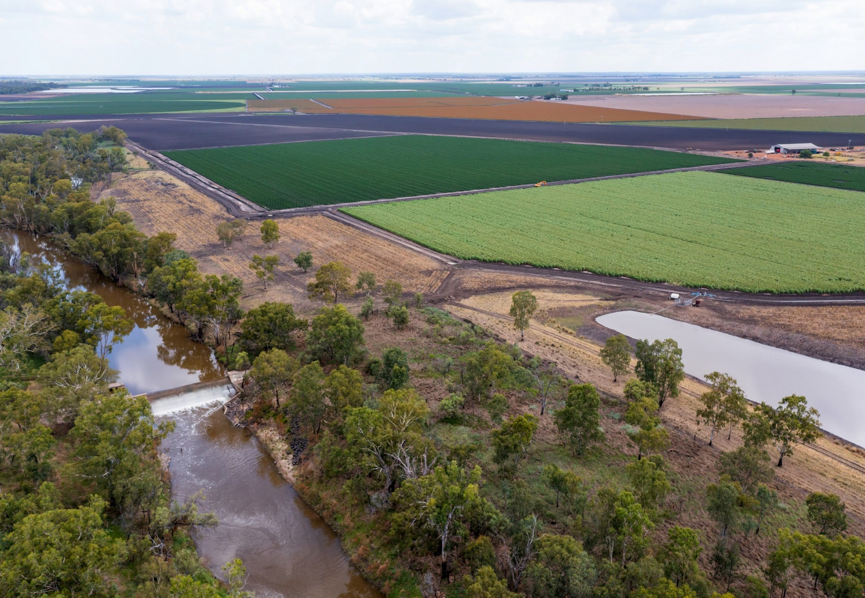

Water market reform: final roadmap report
Daryl Quinlivan AO, Principal Adviser

Letter to the Minister
The Hon Tanya Plibersek MP
Minister for the Environment and Water PO Box 6022
House of Representatives Parliament House

Dear Minister

Murray–Darling Basin water market reform – Implementation roadmap: final report
Attached is my advice on implementation of the Australian Competition and Consumer Commission (ACCC) recommendations on Murray–Darling Basin water market reform.
This advice outlines actions that can be taken to:
- improve the functioning and governance of water markets
- apply safeguards that are in place to regulate the conduct of participants in other comparable trading
markets, with some adjustments to reflect the special circumstances of water markets
- improve confidence in Basin water markets.
This roadmap proposes reforms that are necessary, practical and cost-effective over the short-to-medium term. They are broadly supported by Basin states, the Advisory Group and affected stakeholders, and can be implemented to improve the functioning and governance of water markets. They align with the policy intent of the ACCC’s recommendations, but some have been modified to consider the:
- momentum of related work already happening at the Basin state and Commonwealth level
- established roles and capabilities of the public and private participants in the Basin water market
- need to minimise the regulatory burden and cost to market participants and governments.
The main reforms relate to improved integrity and conduct measures supported by new data collection and reporting responsibilities (and in due course new digital infrastructure), and involve new water market
conduct and integrity legislation, a mandatory code for water market intermediaries and new price reporting requirements.
The Basin states, the Advisory Group and key affected stakeholders broadly support the proposed reforms.
The scope of work is set out in Appendix A.
In time, the reforms should apply nationally wherever possible to ensure that participants in water markets throughout Australia have the same assurances about integrity, professionalism and modern regulatory supervision.
I would like to acknowledge the significant role of the Basin states, the Advisory Group, the Department of Climate Change, Energy, the Environment and Water as secretariat and other interested stakeholders who have invested considerable time and effort into contributing to the report.
Throughout the process we have consulted with irrigation infrastructure operators, exchanges and brokers, as these are the stakeholders directly impacted by the proposed reforms. These consultations have been through webinars, bilateral meetings, and representatives on the expert Advisory Group. While the final report has not been disclosed outside of government, the proposals in the report have been discussed at length with these stakeholders. The position of some stakeholders on these proposals will be influenced by decisions on resourcing assistance. This is a matter for Basin governments, this roadmap process has not been able to provide assurances about resourcing outcomes although there has been extensive work by the Department on resourcing in parallel with the development of the roadmap reform proposals.
It has been my role, as an independent Principal Adviser appointed by the government to consider the ACCC findings and recommendations and the range of views provided during our extensive consultations to develop a phased, practical and cost-effective plan for water market reform in the Basin.

Throughout the process of developing the roadmap, there have been discussions about resourcing and the cost of adjustments required to comply with the proposed recommendations. While this is a matter for the Commonwealth rather than myself, given that the majority of the costs of implementing the reforms fall on the Commonwealth (even though it is a state responsibility), a reasonable approach would be that all parties bear their own costs.
As always with major intergovernmental reforms, effective implementation will rely on a shared commitment by Basin Governments. The positive contributions from those governments to the development of this roadmap suggests the prospects for implementation of effective reforms are strong.

Daryl Quinlivan AO
Principal Adviser, Water Market Reform September 2022

Table of contents

Letter to the Minister 2
Executive summary and recommendations 8
Background 8
ACCC review of water markets 8
Roadmap 9
Areas for reform 10
Where to from here 12
Chapter 1 – Basin water markets 17
  - How water markets operate 17
  - Water markets and water management 22
    - The relationship between water markets and water management 26
    - The value of Australia’s water markets 26
    - Misconceptions about water markets 26
  - ACCC inquiry in context 27
Chapter 2 – Developing the roadmap 28
  - ACCC report 28
    - The ACCC’s findings 28
    - The ACCC’s recommendations for reform 28
  - The roadmap process 29
    - The roadmap process and objectives 29
    - Lessons from other trading markets 30
    - Conditions informing the roadmap process 30
  - Approach 31
    - Consultation and collaboration 31
    - Areas of proposed reform 31
Chapter 3 – Integrity and transparency 32
  - Overview 32
  - Integrity issues to be addressed 34
    - Analysis and insights 35
  - Integrity reforms 36
    - Integrity legislation and market conduct prohibitions 36
    - Water market intermediary code 40
    - Broaden and strengthen price reporting obligations for trade data and require
intermediaries to report pre-trade data 43
  - Transparency issues to be addressed 46
  - Transparency reforms 46
    - Transparency of decisions about water allocations and drivers of water availability 46
    - Transparency about conveyance losses 48
    - Transparency of intergovernmental committees 50
    - Water market education across the Basin 51
Chapter 4 – Data and systems 52
  - Overview 52
  - Data and systems issues to be addressed 53
    - ACCC findings 53
    - Analysis and insights 53
    - Other issues 54
  - Data and digital systems reforms 55
    - Role of the Bureau of Meteorology 58
    - Data standards 59
    - Data sharing agreements 61
    - Automated data capture and transfer 61
    - A National Water Data Hub 61
    - Water market information 62
    - Harmonise and standardise terminology 62
    - Monitor trade approval authority and irrigation infrastructure operator timeframes for processing trades 63
Chapter 5 – Market architecture 64
  - Overview 64
  - Market architecture issues to be addressed 66
    - Analysis and insights 67
    - Other issues 69
  - Market architecture reforms 70
    - Improve hydro-economic modelling 70
    - Improve intervalley trade mechanisms 72
    - Evaluate the impacts of carryover parking trade 76
    - Transparency of trade considerations in river-operations 77
    - Manage delivery shortfalls 78
    - Transparency of environmental water delivery 78
    - Conduct research to inform future water market reforms 80
    - Strengthen metering, measurement and telemetry implementation 81
Chapter 6 – Governance 83
  - Overview 83
  - Governance issues to be addressed 84
    - Analysis and insights 84
  - Governance reforms 85
    - Institutional Arrangements 85
    - Implement better rule-making and decision-making processes 90
Chapter 7 – Next steps 91
  - Overview 91
  - Legislation will be required 92
    - Potential legislative arrangements 92
  - Potential national application of reforms 94
    - Analysis and insights 95
  - Resourcing 95
  - Implementation agreement 96
Appendix A – Scope of works 97
Murray–Darling Basin Water Market Reform – Development of Implementation Roadmap 97
OVERVIEW 97
Appendix B – ACCC recommendations 99
Appendix C – December advice 115
Appendix D – Summary of cost-benefit analysis 142
Cost versus benefits 142
Appendix E – Functions of the main institutional water market actors 144
Glossary 148
References 154

Figures & Maps
Map 1: Northern and southern Murray–Darling Basin water markets 18
Figure 1 – A simple water trade process 20
Figure 2 – The Water Act 2007 (Cth) framework for water markets and trade in the
Murray–Darling Basin at August 2022 23
Figure 3 – Australian water market institutions 25
Figure 4 – Existing water market data flows through Bureau systems and services 58
Figure 5 – Future-state water market data flows through Bureau systems and services 59

Tables
Table 1: Roadmap recommendations for water market reform 13
Table 2: Types of tradeable water rights 19
Table 3: Existing water market digital capabilities in the public and private sectors
mapped against the ACCC digital recommendations 56
Table 4: Roadmap assessment of ACCC proposed functionalities. 57
Table 5: Barmah Choke intervalley trade issues 74
Table 6: Proposed new Basin water markets functions 86
Table 7: Indicative timeframe for integrity and data reforms 92
Table 8: Suitability of extending reforms beyond the Murray–Darling Basin 94
Table 9: Summary of cost benefit analysis results 143
Table 10: Commonwealth, Basin state and other agencies with a role in Murray–Darling Basin water markets 144

Boxes
Box 1: Irrigation infrastructure operators 21
Box 2: Irrigation infrastructure operators hold a significant proportion of water access entitlements in the Basin 44
Box 3: Murray–Darling Basin Water Information Portal and National Water Data Hub 44
Box 4: River managers 67
Box 5: Hydro-economic models and approaches 71
Box 6: Misconceptions and concerns about intervalley trade 75
Box 7: Review of Schedule D of the Murray–Darling Basin Agreement 76
Box 8: Carryover parking 76
Box 9: Misconceptions about held environmental water 79

Executive summary and recommendations

Background
Murray–Darling Basin (Basin) water markets are important to Australian agriculture and the many communities which live and work in the Basin. It is Australia’s largest river system, home to 2.2 million people and producing around 40% of our national food and fibre1. Since the introduction of the Basin Plan water trading activity has grown considerably. Basin markets have an annual average value of more than $1.8 billion per year and rising2, against an underlying value of entitlements estimated at around $30 billion3 and rising.
These markets have allowed the trading of water between users (who are mainly irrigators) in response to fluctuations in irrigator needs, water availability, commodity prices and local conditions. The trade of water can include a range of activities including buying or selling tradeable water rights, which are generally separate from land ownership rights. Trade can also include a range of newer products such as single or multi-year leases, carryover parking and forward contracts.
There is no single Australian water market. Rather, there are independent and related markets that are based on whether and how natural water systems are connected across a wide variety of product types and geographic areas. The largest set of water markets are in the Basin. They are regarded as one of the most developed and efficient water markets in the world. Basin state governments have had primary responsibility for regulating water markets. They create, operate and regulate water entitlements and allocations, and their exchange through markets.
Water can be traded (with some limitations) within and between trading zones in the Southern Basin, including between states. Most water trades occur in Southern Basin water markets in South Australia, Victoria and southern New South Wales. Northern Basin water markets in Queensland and northern New South Wales are much smaller, less developed, and the supply of water is less physically regulated compared to the Southern Basin. Groundwater markets in the Basin are also much smaller than surface water trading in the Southern Basin and have more limitations due to third-party impacts and less hydrological connectivity.
Water rights can be traded freely, except where they are restricted by physical constraints or trading rules. Water is traded by public and private market participants mostly through intermediaries (brokers, water exchange platforms and other entities that facilitate water market trades) and trade approval authorities (state governments and irrigation infrastructure operators (IIOs) in New South Wales and South Australia).
Water markets have become increasingly important as irrigation-dependent activity increases, water reliability falls, and the differences between high and low flows across the Basin become more extreme. During the 2017–19 drought there was widespread concern about access to water and the conduct of market participants in the Basin. Structural changes in the Basin (including the increased environmental water portfolios) were also placing water markets under pressure and revealing some problems with market rules and processes.
The weight of contemporary science points to a future with less average available water in the Basin and increased volatility. This means that Basin water markets will play an increasingly important role in supporting the performance of Australian agricultural businesses and the industries and communities that depend on them.

ACCC review of water markets
For these reasons, in August 2019 the Australian Government directed the Australian Competition and Consumer Commission (ACCC) to review the operation of these markets and recommend reforms. The ACCC’s comprehensive report – with 29 recommendations for water market reform, and 70 proposed actions
- was published in March 2021 (see Appendix B).

The report stated that:
The benefits derived from water trading rely on fair and efficient water markets, underpinned by
an environmentally healthy river system. This depends on:
  - a governance framework that ensures trading rules and regulations are developed and implemented with a Basin-wide perspective, in close connection to the river system’s physical characteristics and appropriately managing the impacts of trade
  - a clear and consistent framework for trading across the Basin
  - regulation that promotes open, fair and transparent trading, which is robustly and consistently enforced across the Basin.4
The ACCC report identified that Basin water markets lack many of the features that make comparable trading markets work effectively. It also identified that water market regulatory and policy frameworks had not kept pace with the growth and economic significance of Basin water markets. Critically, there is insufficient access to quality and timely information. There is also a lack of conduct and integrity regulation to clarify and enforce participant roles and responsibilities. It found these and a range of other administrative and governance shortcomings were eroding trust and confidence in Basin water markets.

Roadmap
Mr Daryl Quinlivan was appointed as the Independent Principal Adviser to develop a roadmap for implementing water market reforms – having regard to the ACCC report and recommendations (see Appendix B). The following principles guided the development of this roadmap:
- Water markets are not broken, but improvements are needed
- Cost-effective and practical options are critical
- Where a better alternative to achieving a reform objective exists it should be considered
- Caution should be exercised when considering market architecture reform proposals, so that broader
water management operations and processes aren’t inadvertently affected.
The Commonwealth and State governments need to work together to achieve these reforms because of their shared regulatory and operational responsibilities. Effective water market reforms cannot be implemented without this cooperation. Basin states have been actively engaged in the development of this roadmap and
in many cases these governments have already made significant progress to improve Basin water markets. This work is documented in both this report and the December advice (Appendix C). The recommendations in this roadmap take into account where Basin states are already delivering relevant outcomes and where the strength of their expertise and experience can be leveraged.
Market participants and an 8-member Advisory Group of technical experts and stakeholder representatives appointed by the minister also contributed to the direction and recommendations of this roadmap. They provided insights into who will be affected by the proposed regulatory reforms (such as water brokers, IIOs, and water exchanges), and helped the Principal Adviser to understand the implications of different reform options.
Government agencies with responsibilities for water market functions and other interested water stakeholders were also regularly consulted. Stakeholders were broadly supportive of the reforms proposed by the ACCC. Understandably, there were concerns about potential regulatory burden, compliance costs and negative impacts on current business models.
This consultation created an information base to assist in developing recommendations that we are confident are widely supported. Many of the proposed reforms align closely with the ACCC recommendations. Others have been modified where more cost effective or implementable alternatives existed. An early understanding that there was little support for creating a new agency guided the thinking on roles and responsibilities.
A cost-benefit analysis by Frontier Economics compared 2 options: the full suite of ACCC’s recommendations and the roadmap recommendations set out in this report (see Appendix D). The analysis anticipated significantly lower costs associated with the roadmap reforms, while maintaining the majority of the benefits. The key beneficiaries are expected to be the water market participants.

Australia’s water markets, particularly outside the Basin and in the northern Basin, are still evolving. The reforms recommended in this roadmap will bring the regulatory arrangements in the Basin’s water markets closer to those we observe in other, comparable, trading markets. However, these reforms will also need to adapt as circumstances change over time, and new reforms will be required in the future. Rather than
attempting the impossible resolution of all the water market issues, the roadmap prioritises reforms to address key gaps which undermine the integrity and credibility of the markets.

Areas for reform
This report identifies reforms in the following 4 policy areas to ensure water markets have integrity safeguards
and participants have access to information to make informed trading decisions:
- Integrity and transparency
- Data and systems
- Market architecture
- Governance
The recommendations set out in the roadmap are broadly, if not explicitly, interdependent. They should be considered and implemented as a whole and not in isolation of each other.
The recommended reforms:
- are practical and supported by feasible actions, as evidenced by feedback from market participants
- can be implemented through clearly identified mechanisms (many of which already exist)
- reduce complexity wherever possible
- are supported by ‘guidance’ to assist in developing the anticipated next steps.
Improved integrity and transparency (Chapter 3) is the foundation of water market reform. Effective markets rely on confidence. Confidence is the product of trusted governance and regulatory arrangements and public access to reliable and timely price and trade data.
The proposed reforms include a series of linked measures that would raise water markets to the professional and regulatory standards of other comparable industries and enable equitable participation in the market.
Integrity reforms include:
- prohibiting market misconduct
- introducing a mandatory code for water market intermediaries
- introducing mandatory rules and processes for water announcements
- broadening and strengthening price reporting obligations.
The transparency reforms will expand on and complete work that is already underway to:
- make information about the management of water more meaningful and accessible
- improve the effectiveness of stakeholder participation in water markets
- increase trust and confidence in water markets
- encourage new entrants into the market. They include increasing:
- transparency of decisions about water allocations and drivers of water availability
- transparency about conveyance losses
- transparency of intergovernmental committees
- community awareness and understanding of Basin water markets through a series of targeted water market education products developed by Basin governments and coordinated by the Commonwealth.
Water market data and systems (Chapter 4) refers to the set of data, standards, protocols and digital system infrastructure that underpin transactions and exchange of information across and within Basin water markets. The data and systems reforms seek to:

- enhance the transparency and availability of market data to improve knowledge and understanding of the market, its activities and prices
- enable regulators to identify and enforce compliance with market conduct rules. It is recommended that a new data and systems framework be developed, including:
- new water market data standards that will require data providers to collect and store specified trade and
pre-trade data
- data sharing agreements between the Bureau of Meteorology (the Bureau) and data providers
- unique identifiers for all parties, and single transaction identifiers for each trade, to enable regulators to effectively trace trades
- reasons for trade and strike date
- a system that regulators and intermediaries can interact with to automate sharing of data with the Bureau (as the national water information agency)
- a single National Water Data Hub which will provide:
» all water trade and pre-trade data to regulators
» de-identified data and data services that third parties could use for analytics or in the development of
innovative information products
- a new web application that provides near-real time pre-trade and trade information
- aggregated trade statistics published on the Murray–Darling Basin Water Information Portal.
Market architecture (Chapter 5) is the intersection of water markets and broader water management. It refers to the framework of laws, rules, policies and arrangements that govern where, when and what water can be traded, and how it is stored and delivered.
Reforms in this area need to avoid adverse impacts – such as overlap or interference with broader water management and river operation matters that also need to consider a broad range of factors.
The proposed market architecture reforms focus on improving transparency and establishing better data and information to ensure water users and decision makers are well-informed. The roadmap also proposes that some issues should be dealt with by existing policy processes and intergovernmental committees.
Changing conditions – such as reduced inflows into the Basin system, and increasing variability, shifts in land use and declining channel capacity – are expected to put further strain on water market architecture settings into the future. They may also increase other potential impacts on water users, such as reducing the reliability of water supply and increasing the risk of delivery shortfall.
Reform proposals include:
- developing a hydro-economic modelling program
- improving intervalley trade mechanisms
- evaluating the implications of changing trade behaviour (including carryover parking trade)
- improving the transparency of trade considerations in river operations
- managing and communicating shortfall risks
- improving the transparency of environmental water delivery
- developing and implementing a long-term research agenda
- strengthening metering, measurement and telemetry implementation.
Governance (Chapter 6) is the structures, administrative processes and institutional arrangements by which water markets (and associated broader water matters) are managed.
The governance of Basin water markets is highly fragmented, with numerous Basin state and Australian Government agencies sharing responsibilities for trade-related functions. This has contributed to complex and duplicative regulatory and administrative frameworks that can be difficult for market participants to understand and navigate.
The ACCC identified transparency of government decision-making and the need for more integrated decision-making for water market rules and policies as a particular area of concern. Decision-making frameworks have been criticised for being too narrow and not providing for adequate consultation.
To address this issue, the roadmap recommends that all decision-making bodies in the Basin should

review their processes for assessing the implications of proposed decisions to ensure that the full range of interests are taken into account. This should include operational water management implications and social, environmental and commercial implications. This would also require improved consultation processes to ensure implications are assessed and understood by decision-makers.
A key ACCC recommendation was to establish a single national water markets agency. There was little support from the Basin states or other stakeholder groups for this proposal. Instead, the roadmap supports ongoing collaborative efforts across existing regulatory and policy agencies – including the ACCC, Inspector- General of Water Compliance, Bureau and the proposed new National Water Commission – to take on the functions proposed by the roadmap.

Where to from here
Negotiations will be needed to implement this advice and recommendations as specific commitments by Basin governments. It is anticipated that Basin governments will enter into an intergovernmental agreement of some form to achieve this. That agreement will set out the activities, milestones, and each jurisdiction’s funding commitments to implement the recommendations, and any other resourcing and implementation matters that could not be fully addressed in this report. While this agreement would not be legally binding, it would express the commitment of governments to work together on stated objectives or goals and illustrate for Basin market participants and other interested parties what those governments envisage happening and when through the implementation processes.
Negotiation on an agreement could start immediately. It would be led by the Commonwealth through the Department of Climate Change, Energy, the Environment and Water.
This market reform process began in 2019. It is essential that implementation is well underway before the Basin experiences the next drought with the stresses that will impose on all water users and the water market’s capacity to moderate those stresses. The past concerns that undermined confidence in water markets – such as the lack of regulatory oversight and mistrust about the behaviour of some market participants – should not be repeated, and the ACCC report and this implementation roadmap provide practical guidance on how to do so.
The recommendations in this roadmap are set out in Table 1.

Table 1: Roadmap recommendations for water market reform

Number | Roadmap recommendation | ACCC  recommendation
Headline integrity and transparency recommendations
1 | Integrity legislation  The Commonwealth should enact Murray–Darling Basin-wide water market conduct and integrity legislation to implement the recommendations set out in this roadmap. | 1
2 | Market conduct prohibitions  The Commonwealth should enact legislation to prohibit price manipulation and insider trading for all tradeable water rights, including water delivery and irrigation rights.  The current mandatory water announcement requirements should largely remain and be extended to irrigation infrastructure operators. These decisions should be provided to the Bureau of Meteorology in a timely way for publication. The detailed requirement will be defined in the process of developing draft legislation to ensure the provisions are practical, have sufficient coverage and are enforceable. | 3, 9
3 | Water market intermediary code  The Commonwealth should implement an enforceable mandatory code for water market intermediaries, at least across the Murray–Darling Basin. The obligations under the code should extend to intermediary services for all tradeable water rights, including water delivery and irrigation rights. The proposed contents of this code are described at Chapter 3. | 2
4 | Broaden and strengthen price reporting requirements for trade data  The Commonwealth should broaden and strengthen the requirement for trade approval authorities and irrigation infrastructure operators who approve trades within their networks, to report price data for all tradeable water rights, including water delivery and irrigation rights. This data should be available to the water market regulators and de-identified data should be publicly available. | 3
5 | Price reporting requirements for pre-trade data  The Commonwealth should require water market intermediaries to report pre-trade price data (buy and sell offers) for all tradeable water rights, including water delivery and irrigation rights. This should apply in a phased way, to water exchanges first and then to other intermediaries. This data should be available to the water market regulators and de-identified data should be publicly available. | 3
6 | Transparency of decisions about water allocations and drivers of water availability  The Bureau of Meteorology’s Water Information Portal should be linked to decisions about Basin state water allocations and information about the drivers of water availability to increase  transparency. This will complement the Murray–Darling Basin catchment-level information that is already on the portal about storages and allocations. | 15
7 | Transparency about conveyance losses  The Murray–Darling Basin Authority and Basin states should continue to improve transparency and understanding of conveyance losses, including their volumes and drivers. The Murray– Darling Basin Authority should continue to publish information on conveyance losses in the Summary of River Operations annual report. Basin states should also continue to improve their communication on conveyance losses to aid understanding and access. | 21
8 | Transparency of intergovernmental committees  The Basin Officials Committee should continue to improve the transparency of the functions and activities of intergovernmental committees, including publishing easily accessible terms of reference. | 29
9 | Water market education across the Basin  Basin governments should develop targeted education products, coordinated by the Commonwealth, to increase community awareness and understanding of Murray–Darling Basin water markets. | 13

Number | Roadmap recommendation | ACCC  recommendation
Headline data and systems recommendations
10 | Data and systems reforms to support integrity and transparency recommendations  The Bureau of Meteorology (the Bureau), as Australia’s lead agency for water information, should develop and implement a data and systems framework which includes:  - new water market data standards that require data providers to collect, store and transmit comprehensive trade and pre-trade data, reasons for trade and strike date to the Bureau. These standards should include unique identifiers for all parties and single transaction identifiers for each trade to enable the data and systems regulator to effectively trace trades  - data sharing agreements entered into (or existing agreements amended) between the Bureau and Basin governments, as well as some irrigation infrastructure operators and water market intermediaries  - a system that regulators and intermediaries can interact with to automate sharing of data with the Bureau  - a single National Water Data Hub which will provide:  » all water trade and pre-trade data to regulators  » de-identified data and data services that third-parties could use for analytics or in the  development of innovative information products  - a new web application that provides near-real time pre-trade and trade information  - aggregated trade statistics published by the Bureau on the Murray–Darling Basin Water Information Portal. | 4, 6, 7, 10, 11, 12
Other data and systems recommendations
11 | Harmonise and standardise terminology  The Bureau of Meteorology should continue to harmonise terminology through the Water Markets Data Standard process and the Murray–Darling Basin Water Information Portal.  Basin state governments should standardise terms, based on the most common usage of these terms. | 7
12 | Monitor trade approval authority and irrigation infrastructure operator timeframes for processing trades  All trade approval authorities and irrigation infrastructure operators should regularly report trade approval processing times to the Bureau of Meteorology for publication. | 8
Headline market architecture recommendations
13 | Improve hydro-economic modelling  The Commonwealth, in consultation with Basin states, should develop and implement a hydro- economic modelling program to improve understanding of the socio-economic impacts of policy options/reforms and future climate scenarios, and to support decision-making. This should be coordinated with the Murray–Darling Basin Authority’s hydrological river modelling uplift program. | 18
14 | Improve intervalley trade (IVT) mechanisms  To improve efficiency and access to intervalley trade opportunities:  - grandfathered tag provisions in the Basin Plan water trading rules should be removed by an amendment to the Basin Plan at the next opportunity  - Victoria and New South Wales should provide clearer guidance and improve transparency about the anticipated timing of IVT openings  - Victoria and New South Wales, in collaboration with the Murray–Darling Basin Authority, should consider options to improve equity of access to IVT opportunities  - the Trade Working Group should consider IVT issues and clarify principles for IVT delivery as part of the existing review of Schedule D of the Murray–Darling Basin Agreement  - the Basin Officials Committee should consider alternative policy approaches and mechanisms for allocating limited trade opportunities in the longer term, beyond the short- medium term work being undertaken as part of the Schedule D review. | 22

Number | Roadmap recommendation | ACCC  recommendation
15 | Evaluate the impacts of carryover parking trade  The Basin states and the Murray–Darling Basin Authority should evaluate the impacts of carryover parking trade to better understand any material impacts on water rights holders, water markets and water management (including accounting for, and attribution of, evaporation losses, state shares and cross border water trade). | 16
16 | Transparency of trade considerations in river-operations  To improve the transparency of how water markets are considered in river operations, the Murray–Darling Basin Authority should publish a report or factsheet (in consultation with Basin states) on how water trade and water markets are considered in river operations  decision-making.  The roadmap supports the Basin Officials Committee’s recent decision to work with the Basin Governments and the Murray–Darling Basin Authority to develop these ideas into a functional Decision Support Framework for further consideration by the Basin Officials Committee and the Ministerial Council. | 20
Other market architecture recommendations
17 | Manage delivery shortfalls  The ongoing River Murray Capacity and Delivery Shortfall Project (which is overseen by the Basin Officials Committee and the Murray–Darling Basin Ministerial Council) and the Basin state river operators should continue to progress the management and communication of shortfall risk across the Murray–Darling Basin.  The Murray–Darling Basin Authority should continue to report on delivery shortfall risks in the River Murray during peak irrigation season in its River Operations Weekly Reports. | 19
18 | Transparency of environmental water delivery  The Basin Officials Committee – in consultation with the Commonwealth, Basin states and environmental water holders – should increase transparency about how held environmental water trade, transfer and delivery is managed and communicated. This should include communicating the volume of environmental and other water flows in the system at any time. | 23
19 | Conduct research to inform future water market reforms  A long-term research agenda should be developed and implemented to continue to inform potential improvements to market architecture and water management. This will be informed by the improved data collected through the implementation of other recommendations set out in this roadmap. | 25
20 | Strengthen metering, measurement and telemetry implementation  The Commonwealth and Basin state governments should work together to develop rules and guidelines that support consistent and accurate metering and telemetry across the Murray– Darling Basin. This includes:  - Basin governments agreeing to the common principles and rules for telemetry across the Murray–Darling Basin. This will include thresholds for telemetry and the priority meters that will need to be telemetered. It will also include data and information requirements to support current water market needs.  - Each Basin state designing and publishing its approach to how telemetry will be used – including the meters that will need telemetry, and any exemptions that will apply. | 17

Number | Roadmap recommendation | ACCC  recommendation
Headline governance recommendations
21 | Institutional arrangements  New water market functions should be allocated as follows:  - Proposed new National Water Commission – leadership role as the water markets expert and roadmap implementation monitor, with the Department of Climate Change, Energy, the Environment and Water to take on appropriate roles in the interim until the proposed new National Water Commission is established.  - Australian Competition and Consumer Commission – regulator for the market conduct prohibitions and water market intermediaries’ code.  - Inspector-General of Water Compliance – regulator for water market data standards, record keeping and data reporting obligations.  - Bureau of Meteorology – data administrator and custodian, including development of water market data standards. | 26
22 | Implement better rule-making and decision-making processes  To improve integrated rule-making and decision-making processes, all decision-making bodies in the Murray–Darling Basin should review their processes for assessing the implications of proposed decisions to ensure that the full range of interests are taken into account.  This should include operational water management implications and social, cultural, environmental and commercial implications.  This would also require improved consultation processes to ensure implications are assessed and understood by decision-makers. | 27
Next steps
23 | Potential national application of reforms  Governments should consider the application of these reforms nationally, with an initial focus on the introduction of:  - a mandatory code for water market intermediaries, and  - market misconduct provisions.

Chapter 1 – Basin water markets
There is no single Australian water market. Rather, there are independent and related markets that are based on how natural water systems are connected across a wide variety of product types and geographic areas.
The largest set of water markets are in the Murray–Darling Basin (Basin). The Basin is Australia’s largest river
system and produces around 40% of our national food and fibre. Most of the water market activity occurs
in the Southern Connected Basin, which is a highly regulated operational system (i.e. the Basin is highly regulated, which means there are several large dams and weirs on the river which control river flow to supply rural and urban water users. The Basin is regarded as one of the most developed and efficient water markets in the world.
This report focuses on the trading of water in the Basin.

How water markets operate
Water markets are how water is traded. This is the process that can include a range of activities including buying and selling tradeable water rights, which are generally separate from land ownership rights. Trade can also include a range of newer products such a single or multi-year leases, carryover parking and forward contracts.
Some formal water trading has been possible since the early 1980s, although neighbours have ‘traded’ water within local districts since irrigation systems were established. From 1996 the Council of Australian
Governments prioritised the development of water markets as part of national competition policy reforms, and then through the National Water Initiative from 2004.
A range of legislative instruments and agreements were developed, including elements of the Water Act 2007 (Cth) and the Basin Plan, to help govern Basin water markets. These reforms complemented other legislative frameworks and water trading requirements that Basin states established in this period.
The regulatory and operational infrastructure for water markets is therefore relatively new, unlike the larger established regulatory and operational arrangements in place for broader water management.
Water can be traded (with some limitations) in and between trading zones in the Southern Basin, including between states. Most water trades occur in Southern Basin water markets in South Australia, Victoria and southern New South Wales. Northern Basin water markets in Queensland and northern New South Wales are much smaller, less developed, and operate within less physically regulated water supply compared to the Southern Basin. Groundwater markets in the Basin are also much smaller than surface water trading in the Southern Basin and has more limitations due to third-party impacts and less hydrological connectivity.


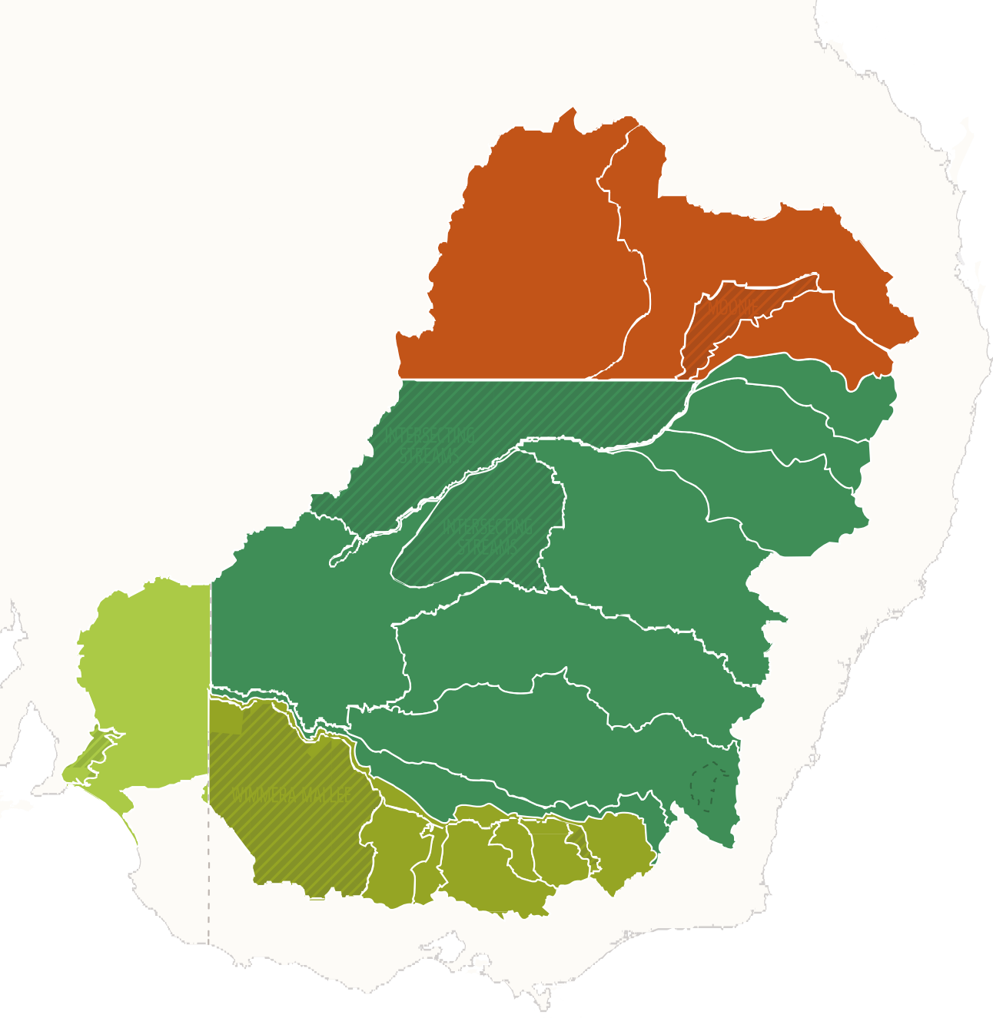



















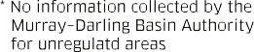


Map 1 Northern and southern Murray–Darling Basin water markets

Brisbane

Sydney

Adelaide

Melbourne
Queensland
Outside of Basin
South Australia Victoria
New South Wales

Source: Water Markets Product Information |Murray–Darling Basin Authority (mdba.gov.au) 5

There are 4 main types of tradeable water rights in the Basin. The type of rights, their characteristics and the terminology used is not uniform across the Basin. State governments create and manage water access entitlement rights and water allocation rights under various statutes. The different types of tradeable water rights, and the definitions used for the purposes of this report, are explained in Table 2.

Table 2: Types of tradeable water rights

Name | Type of right | Type of trade | Example
Water access entitlement | A perpetual or ongoing entitlement, by or under a law of a state, to exclusive access to a share of the water resources of a water resource plan area. Also referred to as a water share (Victoria), water access licence (New South Wales) and water allocation (Queensland). | Permanent trade | An irrigator reduces their water demand and permanently sells a part of their water entitlement.
Water allocation | The specific volume of water allocated to a water access entitlement in a given water accounting period. The size of the allocation depends on how much water is available in the water resource in that season. Also referred to as a seasonal water assignment in Queensland. | Temporary trade | A rice grower decides to fallow their land for a year and sells their annual allocation.
Irrigation right | A person’s right against an irrigation infrastructure operator to receive water,  which is not a water access right or a water delivery right. | Permanent or temporary An irrigation right can  be converted to a water  entitlement through a process of transformation (permanent). | An irrigator has leftover water and decides to sell it to a neighbour who  uses the same water delivery pipeline.
Water delivery right | A right to have water delivered to a location by an irrigation infrastructure operator. It typically represents the holder’s right of access to an irrigation network and can be terminated. | Permanent or temporary | A farmer joins an irrigation infrastructure operator and buys a delivery right to have water delivered to their farm.

The glossary to this report often uses a summary of the definitions of terms in the Commonwealth Water Act. However, a reference in the report to ‘tradeable water rights’ it is a reference to all water rights that can be traded, including but not limited to, those water rights defined in the Water Act.
Water markets also allow for ‘carryover’– which allows holders of water access rights to store some of their unused water allocations in dams for future use.
Water markets are an important management tool for farmers, and tradeable water rights are a significant
asset. They enable irrigators to:
    - maintain agricultural productivity by buying extra water to irrigate crops
    - supplement their income by selling water
    - manage business risk by buying and selling water in line with their business plans
    - efficiently allocate water between users in response to fluctuations in water availability, commodity prices
and local conditions.

Market participants who buy and sell water include:
PRIVATE
PUBLIC
    - irrigators
    - private operators of irrigation infrastructure
    - brokers
    - urban water authorities
    - rural water authorities
    - environmental water holders (Commonwealth, state, and private entities)
    - investors (who may not be directly involved in agricultural production).
Irrigators are the largest water traders by both value and volume. Government environmental water holders also transfer large allocation volumes in a given year, mostly as a small number of non-commercial (zero dollar) transfers between different environmental accounts.
Water is traded by public and private market participants – mostly through intermediaries (brokers, water exchange platforms and other entities that facilitate water market trades) and trade approval authorities (state governments and irrigation infrastructure operators (IIOs) in New South Wales and South Australia).
Figure 1 illustrates a simple water trade process. Irrigation infrastructure operators are important players in water markets. They are explained in Box 1.












Figure 1 – A simple water trade process
Water Owners
Water Owners
1. Buyer and seller matched (either by an intermediary or by direct agreement between the parties)

2. Trade application lodged with a water authority

3. If approved, trade is recorded on the water register

Box 1: Irrigation infrastructure operators

An irrigation infrastructure operator (IIO) owns or operates water service infrastructure that delivers water for the primary purpose of irrigation.
Irrigation infrastructure operators may have multiple roles including water delivery manager, active participant in the trading market, the internal approval of trades, holder of the statutory licence and provider of intermediary services (such as matching and trade administration services).
Irrigation infrastructure operators differ in their governance structures and functions – they range from large statutory corporations to small trusts. This depends on whether they are located in New South Wales, South Australia, Queensland or Victoria.

Irrigation infrastructure operators in New South Wales and South Australia
Irrigation infrastructure operators in New South Wales and South Australia typically hold water access entitlements for their customers. Their customers hold irrigation rights and their IIO allocates water to them.
For example, in South Australia, Central Irrigation Trust (CIT) manages and operates the assets (including the water licences) of 12 irrigation trusts. The trusts own the water, the infrastructure for their district and other assets and manage members’ interests through the CIT Board. CIT customers are the members of the trusts and hold an irrigation right against the trusts (unless their irrigation right has been transformed into a water access entitlement held directly by the irrigator).
However, some New South Wales Joint Water Supply Schemes that are IIOs don’t hold the water access licence. Instead, they manage the irrigation network and provide the water delivery services. The irrigators jointly hold the water access licence.
When temporary irrigation rights are traded in New South Wales and South Australia in an IIO’s irrigation network, the IIO has the function of approving internal trades (rather than the Basin state authority).
Where a temporary irrigation right is traded in or out of the IIO network, 2 processes take place. For example, if a seller in the network wishes to carry out a temporary trade with a buyer outside of the network, they relinquish their irrigation rights to the IIO. The IIO then conducts an allocation trade off its account (or licence in New South Wales) with the external buyer located outside the network.
For this reason, IIOs may appear as trading parties in Basin state registry data. Similarly, IIOs have the function of undertaking the internal approval of trades for the permanent trade of irrigation rights. The trade of permanent irrigation rights in irrigation networks are not captured by Basin state water registers.
Some IIOs within New South Wales and South Australia may also provide intermediary services.

Irrigation infrastructure operators in Victoria and Queensland
Irrigation infrastructure operators in Victoria and Queensland operate through the state water registers and are subject to greater oversight as a result.
In Queensland, SunWater is a government owned corporation.
Victoria’s IIOs are typically rural water corporations. The rural water corporations hold the bulk entitlements, and their customers hold the retail-level entitlements – generally water shares and other rights such as water use licences. These customers can trade allocation rights outside their networks.
In Victoria, when allocation rights are traded within, in or out of an IIO’s irrigation network, the Basin state is the trade approval authority.
Rural water corporations in Victoria do not provide intermediary services.

Water markets and water management
State governments manage and regulate water markets and river operations under long-standing water sharing arrangements agreed to by the states and the Australian Government.
Water management refers to the way rivers in the Basin are operated to reliably store and deliver water to communities, irrigators and the environment, within the physical limits of the river system.
Water rights can be traded freely in a water market, except where they are restricted by physical constraints or trading rules.
States have the primary responsibility for regulating water markets. States have legislation establishing water markets and applicable rules, providing for entitlements to be granted, approvals of trade and the conveyance framework.
At the Commonwealth level, water trade is governed by the Water Act 2007 (Cth), which has enabling provisions that allow the Minister to make Water Market and Charge Rules and the Basin Plan’s water trading rules (Chapter 12 of the Basin Plan). The Murray–Darling Basin Agreement – which is contained in Schedule 1 of the Water Act – governs interstate trade.
There are also numerous relevant intergovernmental agreements in place. There is a bilateral intergovernmental agreement between New South Wales and Queensland relating to interstate trade in the northern Basin Border Rivers.
Figure 2 shows how the Water Act 2007 (Cth) framework currently regulates Basin water markets and trade. Other Commonwealth legislation relevant to water trade includes the Corporations Act 2001 (Cth), the
Competition and Consumer Act 2010 (Cth) and Australian Consumer Law.









Figure 2 – The Water Act 2007 (Cth) framework for water markets and trade in the Murray–Darling Basin at August 2022
Water Act 2007 (Cth)
Provides the basis and process for making and amending the Basin Plan. The Basin Plan includes the water trading rules and requirements for water resource plans. The Australian Competition and Consumer Commision (ACCC) is to give advice on the water trading rules.
Provides the Bureau of Meteorology functions, which include receiving and publishing water information and issuing National Water Information Standards. The Director of Meteorology has the power to require water information.
Establishes the Murray–Darling Basin Authority (MDBA) and its functions and powers (in addition to those contained in the Murray–Darling Basin Agreement).
Establishes the Inspector-General of Water Compliance (IGWC) and its functions and powers.
Provides the basis for making and amending the Basin water charge and water market rules and the ACCC’s role to give advice about, and monitor compliance with, those rules.

Basin Plan 2012 (Cth)
(Made by the Minister under the Water Act)
Contains the water trading rules, which deal with:
- Basin states restrictions on trade
- information about water delivery rights and irrigation rights
- approval processes for trade of water access rights and the activities of an approval authority
- information and reporting requirements.
Contains the requirements for Basin states’ water resource plans, including those relating to the trade of water access rights
Basin Plan water trading rules are enforced by the IGWC
Provides for the MDBA’s role as river operator

Water Regulations 2008 (Cth)
(Made by the Governor General under the Water Act)
Prescribes detailed requirements relating to water information
Prescribes other matters relating to the Water Market Rules and Water Charge Rules

Water Market Rules 2009 (Cth) and Water Charge Rules 2010 (Cth)
(Made by the Minister under the Water Act)
Regulation of irrigation infrastructure
operators – fees, charges, publication of information
about charges, transformation arrangements, restrictions on their ability to discriminate against particular customers
The rules are enforced by the ACCC


Murray–Darling Basin Agreement
(Schedule 1 to the Water Act)
Works out Basin states’ shares of water
Sets out the trading arrangements between Basin states (Southern Connected Basin)
Establishes the Murray–Darling Basin Ministerial Council and Basin Officials Committee
Provides for the MDBA’s role as river operator

Water trade is also constrained by the physical limits of the water systems (e.g., channel capacity) and trade rules that impose trade restrictions between zones. These include the:
    - Barmah choke – where physical river constraints restrict flow to 7,000 ML a day
    - Goulburn–Murray intervalley trade (IVT) trade rules
    - Murrumbidgee to Murray trade rule
    - New South Wales to Victoria trade limit.
These physical limits and trade rules form a complex set of arrangements for how water markets and water management are governed. Physical limits and trade rules also change over time. For example, capacity in the Barmah Choke has declined over time due to an accumulation of sediment in the river. Water
management and water markets are also inextricably linked and dynamic because every season is different.
Figure 3 sets out the main institutional water market actors at the Basin state and Australian Government level.

Figure 3 – Australian water market institutions
Water Division
Department of Climate Change, Energy, the Environment and Water (DCCEEW)
Environmental water holders
Irrigation infrastructure operators (IIOs)
Price regulation bodies
Departments, regulators, authorities, etc.
Department of Treasury





Current Commonwealth governance
Commonwealth departments, portfolio agencies and other entities with Murray–Darling Basin water markets roles and responsibilities
Basin states governance – General
Types of agencies and other entities with Murray–Darling Basin water markets roles and responsibilities

Other:
Murray–Darling Basin Authority (MDBA)
Australian Securities and Investments Commission (ASIC)
Commonwealth Environmental Water Holder (CEWH)
Water registers
Productivity Commission
Inspector- General of Water Compliance (IGWC)
Urban water utilities and corporations
Trade approval authorities
Australian Competition and Consumer Commission (ACCC)

Intergovernmental committees:
Murray–Darling Basin Ministerial Council (MinCo)
Basin Officials Committee (BOC)
See the table at Appendix E: Existing Commonwealth entities with roles relating to Murray–Darling Basin water markets for more detail on relevant roles and responsibilities.
Please note:
This is a general representation only.
Arrangements differ between Basin states.
Australian Bureau of Agricultural and Resource Economics
and Sciences (ABARES)
Bureau of Meteorology (BOM)
Australian Taxation Office (ATO)

The relationship between water markets and water management
The critically important issues of the supply and management of water are usually prioritised over water market issues. This is because water management in the Basin has historically been heavily focused on the construction and operation of infrastructure to supply water for urban and agricultural water use.
The management of water and associated river operations are the priority of Basin state agencies and the Murray–Darling Basin Authority (MDBA). These agencies work together to store and deliver bulk volumes of water within the physical limits of the river system.
Until now, the supervision of water markets has been treated separately from water management. Water markets rules and operations have largely been managed at a regional level by relevant Basin state agencies (Victoria, New South Wales, South Australia, Queensland and the Australian Capital Territory), independently of river operations. However, water trade regularly impacts and involves river operations.
The ACCC found that the expansion of water markets and the evolution of water trading behaviours has strengthened the relationship between water markets and water management. For example, new markets for ‘carryover parking’ may result in increased demand for storage space and changes in evaporative losses, which are typically considered water management issues.
The connection between water markets and water management means they need to be better integrated to manage the impacts and maximise the benefits of water trade. States are already taking some steps towards this through state-based water management programs.

The value of Australia’s water markets
Australia’s water markets have become increasingly valuable over the last 2 decades, reflecting a trend of increasing demand for water and investment in agricultural systems requiring continuity of supply. You could describe these trends as leaving the overall Basin water systems as ‘more highly geared’. Periods of drought, such as 1997–2009, and the 2 years of low rainfall between 2017–2019, have a significant impact on water supply and water markets. There has also been increased participation in water markets by farmers and new entrants, such as investors, and more water is being traded.
Average water inflows into the Basin system have reduced significantly in this period compared to the previous 100 years. At the same time, as the value of agricultural production has increased, so too has the demand for water.
Governments have also acted together under the Basin Plan to address the over-allocation of water to ensure that the Basin river system is environmentally sustainable.
For these reasons, Basin water markets have grown. Trade in water allocation and entitlements has increased significantly since the Millennium drought of 2001–2009. This was particularly evident between January 2017 to December 2019, which were the 3 driest years on record for any 36-month period.
Basin water markets are now very valuable, and are critical to the efficiency of Australian agriculture:
      - Basin-wide markets now have an average annual value of more than $1.8 billion.
      - In 2020–21, the turnover of surface water that was traded in the Southern Basin was worth around $0.5 billion for allocation trade and $3.9 billion for entitlement trade – totalling $4.4 billion.
      - This trade supports the large agricultural output in the Southern Basin, with a gross value of $4.03 billion in 2019–2020.

Misconceptions about water markets
The weight of contemporary science points to a future with less average available water in the Basin. This means that Basin water markets will play an increasingly important role in supporting Australian agricultural businesses.

However, water markets must be better understood if they are to play a greater role and realise their full potential. If the community is not properly informed, misconceptions can interfere with public debates. For example:
      - Water markets are sometimes confused with water privatisation. The two are unrelated. State governments grant entities licenses to use water. Water allocated to that licence can be used to grow any type of agricultural product or traded under relevant legislation.
      - There is ongoing interest in a single water market register under the Water Act. Neither the Water Act nor the National Water Initiative require a single national water register. The ACCC did not recommend one. All state jurisdictions maintain publicly accessible water registers.
      - Some people are concerned about foreign ownership. The Australian Government closely oversees foreign investment decisions – including those in the agricultural sector – and reports on the foreign ownership of water entitlements each year. About 11% of water in the Basin is held by entities with a level of foreign ownership, roughly comparable with foreign ownership of our agriculture sector generally. The top 4 water entitlement holders with a level of foreign ownership by country are:
» Canada (2.0% of total water entitlements)
» the United States of America (1.6%)
» China (1.5%)
» the United Kingdom (1.0%).
      - The main use of foreign-held water is agriculture (66%) and mining (24%), which supports Australia’s economy and the prosperity of local and regional communities.
      - Some market participants are concerned about investor speculation. The ACCC found that investors make up only 7% of high-reliability entitlements in the Southern Basin and provide several benefits – including new sources of capital for irrigated agriculture and water products for the market. Irrigators and agribusinesses are the most significant customers of the large investors.
      - There are misconceptions that environmental flows negatively impact third parties by taking up delivery capacity and in doing so crowd out supply of irrigation water and that the volume of environmental water traded unduly impacts the market. However, environmental water is often delivered outside periods of peak irrigation demands to minimise impacts. Environmental water holders operate under the principles of being a ‘good neighbour’ in the Basin, actively working to limit third party impacts. Their trade to consumptive water users has historically been small. For example, the Commonwealth Environmental Water Holder has delivered 13,000 gigalitres to the environment between 2008 and 2021 and has traded a volume equivalent to only 0.5% of this amount.

ACCC inquiry in context
The strong growth in the water market coincided with the Millennium (1997–2010) and 2017–2019 droughts. Water was increasingly scarce and water prices increased. This fuelled concerns about the operation and performance of Basin water markets and high water prices were not the only issue to emerge.
There were also concerns about the lack of regulatory oversight compared to similar trading markets and there was mistrust about the conduct of some market participants – notably investors and intermediaries. This undermined confidence in water markets more generally. There was concern that investors were using their market power to influence prices and that their trading behaviour was artificially inflating prices.
Another concern was that some brokers were misrepresenting the price and availability of tradeable water rights or giving misleading advice about trends to encourage market participants to pay higher prices and trade higher volumes than the market required.
Structural changes in the Basin were also placing water markets under pressure and revealing some problems with market rules and processes. For example, drought conditions and geographical shifts in irrigation activity had started to push intervalley water trade in the Southern Basin to its physical and administrative limits.
This was leading to frequent intervalley trade closures, so water delivery couldn’t meet irrigator demand and normal expectations.
Recognising these issues, and the importance of an efficient and effective water market for all water users, on 8 August 2019 the then Treasurer, the Hon Josh Frydenberg MP, directed the ACCC to conduct an inquiry into markets for tradeable water rights in the Basin and recommend improvements.

Chapter 2 – Developing the roadmap

ACCC report
The Australian Competition and Consumer Commission’s (ACCC) Murray–Darling Basin water markets inquiry
– final report was comprehensive. It was 706 pages long and included 29 detailed recommendations and 70 proposed actions to reform water markets.

The ACCC’s findings
The ACCC conducted an extensive 18-month research, data collection and consultation process. It obtained detailed trade information from the Australian and Basin state governments and their agencies, irrigation infrastructure operators (IIOs), water exchange platforms, water brokers, institutional investors and agribusinesses.
It concluded that the water market regulatory and policy framework has not kept pace with the growth and economic significance of Murray–Darling Basin (Basin) water markets. The main issues the ACCC identified were:
      - There is a lack of quality, timely and accessible information for water market participants, and this impairs commercial and regulatory decision making.
      - There are inadequate rules governing the conduct of market participants, and no specific body to
oversee trading activities.
      - Trading behaviours that can undermine the integrity of markets (such as market manipulation) are not prohibited, prohibitions on insider trading are insufficient and information gaps make these types of detrimental conduct difficult to detect.
      - Differences in trade processes and water registries between the Basin states prevent participants from
getting a full, timely and accurate picture of the price and supply of, and demand for, water.
      - Irrigators and traders would benefit from better government information about key policies and river
operations.
      - The complex nature of the Basin’s market settings means that trading systems and opportunities favour professional traders and large agribusinesses who have greater capacity to understand and participate in water markets.
      - The way the Southern Basin’s market architecture manages the hydrological characteristics of storages and river systems (such as the physical features of the land, soil type, surface and groundwater water, weather and the type of land use) doesn’t always adequately reflect scarce storage and delivery capacity or signal the cost of trading decisions.
      - Changing conditions – such as reduced inflows, shifts in water use, declining channel capacity and
increasingly binding trade restrictions – are challenging key assumptions behind trade arrangements.

The ACCC’s recommendations for reform
The ACCC recommended a comprehensive package of reforms (Appendix B) under the following 4 themes:
- Better governance
- Stronger market integrity and conduct regulations
- Better trade processes and information about the markets
- Market architecture that better reflects the physical characteristics of the river system.
The centrepiece of the ACCC’s proposed reforms was a new independent Basin-wide water markets agency. The new agency would enhance and centralise the regulation and administration of water markets through a process of legislative change and investment in data and systems.

The functions of the new agency would be to:
      - monitor and regulate market conduct
      - report regularly and publicly
      - evaluate and report on market issues
      - provide a ‘one stop shop’ for market information
      - provide market-focused advice to governments.

The roadmap process
On 25 October 2021 the then Minister for Resources and Water, the Hon Keith Pitt MP, engaged Mr Daryl Quinlivan as Principal Adviser for water market reform. Mr Quinlivan was asked to develop a roadmap to implement the water market reforms, having regard to the ACCC report and its recommendations. The scope of works are set out in Appendix A.
On 11 November 2021 an 8-member advisory group of technical experts and stakeholder representatives was appointed to support the Principal Adviser. They were:
Richard Anderson (Victoria) Dave Appels (Victoria)
Stuart Armitage (Queensland) Rosalie Auricht (South Australia)
Phil Grahame (New South Wales / Victoria) Peter Hendy (New South Wales)
Jenny McLeod (New South Wales)
Andrew Stoeckel (Australian Capital Territory).
The then Department of Agriculture, Water and the Environment was responsible for supporting the Principal Adviser to develop the roadmap, including detailed analysis of the ACCC’s advice and gathering information to support the Advisory Group.
It also carried out a detailed stocktake of existing Commonwealth and Basin state water market reform activities. This identified actions that Basin governments were already taking to improve water markets and transparency for water traders and water users. They show the Commonwealth and Basin state governments’ commitment to water market reform and formed the basis for more options for water market reform in response to the ACCC inquiry.

The roadmap process and objectives
The roadmap process started with briefings and consultations with Basin states and stakeholders on options
for reform. The main policy principles were to:
      - improve the quality of data, transparency and the integration of systems between trade service providers
      - ensure integrity of the market by improving trust and accountability
      - improve market architecture to mitigate the impacts on third parties and better integrate water trading with water management
      - enable participation in the market by reducing barriers to entry and improving transparency and access to information to support informed decision-making.
The roadmap process had 2 broad objectives. They were to improve:
      - how water markets are governed and regulated
      - the functioning of the market to improve commercial outcomes.

Lessons from other trading markets
Most other trading markets have a very long history and global reach (for example, the finance, property and equities markets). We can learn a lot from the large body of accumulated experience that has informed how they have been developed, what conduct we should expect from those who undertake market activities, how they should be regulated and their commercial practices.
Comprehensive governance and regulatory arrangements and public access to real time price and trade data
– particularly in the finance and equities markets – show what can be achieved through reforms that improve
integrity, transparency, and data and systems.
The Basin water markets, by contrast, have developed mostly organically over a short period with very little history or international experience to guide that development. Practical decisions have incrementally built our current markets and many now consider them to be world leading.
Water markets also differ from these older markets because the assets they trade have very different physical characteristics, and, with some limitations, can be used in different ways and in different places around the Basin. This means that a complex set of rules govern water trading opportunities, and limit opportunities
to simply apply the arrangements in these other trading markets to water. The Australian Securities and Investments Commission made this point in its submission to the ACCC inquiry.
As a result our water markets are far from ideal. This has been most revealed when the Basin systems have been stressed by drought and the changing pattern of water demand. It was also exposed by the ACCC
as it systematically analysed the performance of the Basin markets and drew on the lessons of these other markets to identify opportunities for reform.
The roadmap has carefully assessed the experience of other markets and the specific water market circumstances. The roadmap has developed reforms that are practical; can be implemented through clearly identified mechanisms; don’t add to the already excessive complexity of roles, responsibilities and arrangements in the Basin and that reduce that complexity wherever possible.

Conditions informing the roadmap process
The roadmap process was also shaped by these policy and practical factors:
      - In late 2021, the Basin was no longer in drought, had full catchments and lower water prices. This reduced pressure on water systems and allowed a clear-eyed and wide-ranging examination of possible reforms. Droughts will return and stress water systems again. However, these different market conditions (compared to those that existed when the ACCC inquiry was initiated) have provided space for this roadmap and market participants to think through how to improve the regulatory and policy foundations of water markets.
      - The ACCC’s advice was well received by Basin states and other stakeholders, and this created a groundswell of support for water market reform. The advice was informed by extensive research, analysis and consultation. It was comprehensive and clear about the problems that need to be resolved. This enabled the roadmap to consider the best options for change and how to implement them. It also helped us explore the impacts of those options and consider roles, responsibilities, resourcing needs and likely support for the necessary new legislation.
      - There is genuine interest and support for water market reform. But Basin states and stakeholders believe reform should build incrementally on existing arrangements and systems rather than completely overhaul them.
Significantly, while there is an overriding sense that change is needed, Basin water markets are not ‘broken’. The size, scale and strong growth in Basin water markets in recent decades is evidence of this. Progress made already by Basin states and the Commonwealth in implementing various water market and related water management changes since the ACCC report also points to an appetite for pragmatic and cost-effective reforms, including those that may have additional regulatory and associated cost burdens on water users and other participants.

Approach
On 16 December 2021 the Principal Adviser submitted initial advice (known as the ‘December advice’) to the then Minister for Water and Resources, the Hon Keith Pitt MP. This advice focused on 5 reforms that could be implemented within 1 to 2 years to help restore confidence in water markets (see Appendix C). It set out that further and longer-term reforms would be identified and provided in this roadmap once the necessary extensive consultation and analysis was undertaken.

Consultation and collaboration
Extensive consultation on options for, and the impacts of, reform has been a critical part of the roadmap process. The Advisory Group, Basin state water market and water management officials, relevant Australian government agencies, brokers, water exchanges, operators of irrigation infrastructure and other interested stakeholders were consulted.
Strong collaboration with Basin states and the Advisory Group helped shape the process and the recommendations. The ACCC’s proposals were considered in detail. So too were the problems they were intended to solve and the pragmatic and cost-effective options and refinements that would improve the operation of water markets.
We also benefited from the opportunity to review and build on other water market and water management
measures that Basin state and Commonwealth agencies are pursuing outside the scope of this roadmap.

Areas of proposed reform
This report identifies the water market reforms that Basin states support in principle and that we believe are necessary, practical and cost-effective. They are covered under the following 4 policy areas:
      - integrity and transparency
      - data and systems
      - market architecture
      - governance.
The interrelated nature of these policy areas means that the recommendations within each area are often linked. For this reason, it has been necessary to duplicate the discussion of some issues throughout this report to ensure that the reasoning and internal connection behind each recommendation is clear and logical.
It was not possible to resolve some of the policy problems addressed by the ACCC. However, we have:
      - outlined feasible actions in many of these areas
      - proposed directions to address them
      - provided ‘instructions’ that could guide next steps to draft legislation, develop a code for intermediaries and build a modern data system.
Frontier Economics was engaged to undertake a cost-benefit analysis (CBA) of the options for water market
reform (see Appendix D):
      - option 1 — The full suite of ACCC’s recommendations
      - option 2 — Proposed roadmap recommendations.
The analysis identified and quantified, as far as practicable, the costs and benefits of the proposed reforms in a comprehensive and robust CBA framework. The analysis of the potential water market reforms is challenged by identifying robust and defensible assumptions around the expected impact of these reforms.
The roadmap recommendations are expected to have significantly lower implementation costs than the ACCC recommendations. The benefits of the roadmap recommendations are not expected to be as great as
implementing the full suite of ACCC recommendations. However, as the costs are significantly lower this leads to implementation of the roadmap recommendations being identified as the most net beneficial option.
If accepted, much of this work can be implemented, or at least commenced, in a relatively short timeframe. This market reform process began in 2019 and implementation should be well underway before the Basin experiences the next drought, with all the stresses that this will again bring Basin water market participants and markets.

Chapter 3 – Integrity and transparency

Overview
Integrity and transparency are possibly the most important areas of proposed water market reform. This is because effective markets rely on confidence. The measures in this chapter are closely linked and are enabled by the data and systems reforms outlined in Chapter 4.
The integrity reforms would raise water markets to the professional and regulatory standards of other comparable industries and enable equitable participation in the market. They aim to:
    - prohibit market misconduct
    - introduce mandatory rules and processes for water announcements
    - introduce a mandatory code for water market intermediaries
    - broaden and strengthen price reporting obligations.
The transparency reforms acknowledge the work that is already being done to improve transparency and are based on expanding and completing this work to make information about the management of water more meaningful and accessible, improve the effectiveness of stakeholder participation in water markets, increase trust and confidence in water markets, and encourage new entrants into the market. The reforms include increasing:
    - transparency of decisions about water allocations and drivers of water availability
    - transparency about conveyance losses
    - transparency of intergovernmental committees
    - community awareness and understanding of Murray–Darling Basin (Basin) water markets through Commonwealth coordinated development of a series of targeted water market education products by Basin governments.
The integrity and associated transparency reforms are the centrepiece of the roadmap. The roadmap recommendations strike the right balance between ensuring regulatory oversight to improve integrity and confidence in water markets, while making sure that reforms are cost-effective and work for all water market participants.

Integrity and transparency recommendations
      - The Commonwealth should enact Murray–Darling Basin-wide water market conduct and integrity legislation to implement the recommendations set out in this roadmap.
(Roadmap recommendation 1)
      - The Commonwealth should enact legislation to prohibit price manipulation and insider trading for all tradeable water rights including water delivery and irrigation rights. The current mandatory water announcement requirements should largely remain and be extended to irrigation infrastructure operators. These decisions should be provided to the Bureau of Meteorology in a timely way for publication. The detailed requirement for making water announcements ‘generally available’ will be defined in the process of developing draft legislation to ensure the provisions are practical, have sufficient coverage and are enforceable. (Roadmap recommendation 2)
      - The Commonwealth should implement an enforceable mandatory code for water market intermediaries, at least across the Murray–Darling Basin. The obligations under the code should extend to intermediary services for all tradeable water rights, including water delivery and irrigation rights. (Roadmap recommendation 3)
      - The Commonwealth should broaden and strengthen the requirement for trade approval authorities and irrigation infrastructure operators who approve trades within their networks, to report price data for all tradeable water rights, including water delivery and irrigation rights. This data should be available to the water market regulators and de-identified data should be publicly available. (Roadmap recommendation 4)
      - The Commonwealth should require water market intermediaries to report pre-trade price data (buy and sell offers) for all tradeable water rights, including water delivery and irrigation rights. This should apply in a phased way, to water exchanges first and then to other intermediaries. This data should be available to the water market regulators and de-identified data should be publicly available. (Roadmap recommendation 5)
      - The Bureau of Meteorology’s Murray–Darling Water Information Portal should be linked to decisions about Basin state water allocations and information about the drivers of water availability to increase transparency. This will complement the Murray–Darling Basin catchment-level information that is already on the portal about storages and allocations. (Roadmap recommendation 6)
      - The Murray–Darling Basin Authority and Basin states should continue to improve transparency and understanding of conveyance losses, including their volumes and drivers. The Murray–Darling Basin Authority should continue to publish information on conveyance losses in the Summary of River Operations annual report. Basin states should also continue to improve their communication on conveyance losses to aid understanding and access. (Roadmap recommendation 7)
      - The Basin Officials Committee should continue to improve the transparency of the functions and activities of intergovernmental committees, including publishing easily accessible terms of reference. (Roadmap recommendation 8)
      - Basin governments should develop targeted education products, coordinated by the Commonwealth, to increase community awareness and understanding of Murray–Darling Basin water markets. (Roadmap recommendation 9)

Integrity issues to be addressed
The Australian Competition and Consumer Commission (ACCC) found that there is:
    - Insufficient oversight of Basin water market activities to maintain irrigators’ confidence in the integrity and
fairness of these markets over time.
    - Not enough high-quality data and information to provide the transparency that is needed to support equitable market participation or regulatory functions.
This has undermined confidence in the integrity of water markets. It has also allowed concerns about market conduct in the Basin to arise when the system was under stress, despite the lack of evidence to support these concerns.

Market manipulation
The ACCC identified that while there was no evidence of actual misconduct, there is a strong perception that market manipulation has occurred. The opportunity for this conduct to occur does, however, exist and there is not the data and systems in place that allow any such evidence to be available to the regulators.

Insider trading
The Basin Plan water trading rules restrict trade in situations where certain government water announcements are not generally available to market participants. These are often referred to as the ‘insider trading rules’.
Currently the rules only apply to the use of any material information regarding government announcements about allocations, carryover and trading restrictions before it’s made public in order to gain an unfair advantage in the market. The ACCC identified that there are broader concerns about insider trading that the existing rules don’t address.

Water announcements
The ACCC identified that important information, including decisions by irrigation infrastructure operators (IIOs), is not adequately communicated and accessible to irrigators and traders to enable them to make informed business decisions.

Water market intermediaries code
The ACCC identified existing and potential problems with water market intermediaries. There is limited oversight of intermediary behaviour. The regulatory safeguards that apply in other comparable industries don’t apply to water market intermediaries. This gives them opportunities and incentives to engage in conduct that is not in the best interests of their clients and that other markets wouldn’t permit.

Price reporting
The ACCC identified that price reporting on trade forms by the state registers and by other sources was often inaccurate and incomplete. Trading rule 12.48 of the Basin Plan water trading rules requires sellers of water access rights to disclose the price of a trade to the approval authorities, however there is no obligation on the states to collect price data. The ACCC noted that at the time of its interim report, the Murray–Darling Basin Authority (MDBA) held the view that the quality and availability of market data needed to be improved and that:

The development of a trade processing and market reporting framework would need to be supported by a review of the legislated reporting obligations, to ensure reporting requirements match the data sought under the framework (i.e. reporting of irrigation and water delivery rights as well as water access rights) and the responsibility for data collection and reporting is clear and appropriate.

Rule 12.48 also only applies to the trade of water access rights. It doesn’t cover irrigation and water delivery rights.
Following amendments to the Water Act and the Basin Plan, the MDBA is no longer responsible for enforcing compliance with the Basin Plan. This responsibility now belongs to the Inspector-General of Water Compliance which was established on 5 August 2021.

The ACCC further identified that there was a low level of transparency regarding trade that took place within irrigation infrastructure operator networks. It noted that to improve transparency and integrity of Basin water markets, price reporting of trades within these networks is just as important as trade price information for water access rights.

The relevant ACCC recommendations are:
- Implement centralised, Basin-wide water market conduct and integrity legislation
- Incorporate key obligations as part of an enforceable mandatory code for water market intermediaries
- Prohibit price manipulation, broaden price reporting and broaden and strengthen insider trading obligations
- Implement rules and processes for water announcements

Analysis and insights
The ACCC recommended that an integrity reform package be introduced to close the regulatory gap and reduce the scope for harmful practices.
Extensive analysis and engagement with Basin states, Commonwealth water agencies and Advisory Group members has occurred, including with brokers, water exchange platforms and IIOs.
These stakeholders have expressed their strong support for the strengthened and new misconduct prohibitions, the revised water announcement requirements and processes and reporting obligations. Any concerns have been mitigated and addressed by the roadmap recommendations.

      - Irrigation infrastructure operators should be covered by the integrity and price reporting obligations
Some Advisory Group members have questioned the merits of including delivery rights as a tradeable water right under the integrity prohibitions and the data reporting obligations. They have raised some concerns that the market for these rights is often geographically limited within an irrigation infrastructure operator’s network and the compliance costs may outweigh the benefits. However, the roadmap anticipates this market will grow over time and the inclusion of delivery rights under the integrity and price reporting obligations will not impose a significant regulatory burden on IIOs, their customers or members.
Some IIOs have a practice of ‘forced balancing’ their members’ accounts at relevant intervals (for example, each quarter). They do this to ensure that all customers’ accounts are in balance and that customers don’t put the operator at risk of breaching its obligations as the holders of the bulk licence. The operator balances these water accounts by selling allocation to the customer and invoicing their account for the cost of the water. There are concerns that this practice should not be defined as ‘trade’ by the roadmap’s integrity and price reporting recommendations as it is more of an administrative process than a commercial one.
Excluding these transactions could create data gaps that could compromise the central transparency objective. These transactions are necessarily subject to the irrigation infrastructure operator’s internal client accounting and as internal transactions generally will be reported through the Bureau of Meteorology’s (the Bureau) data collection processes, there should be no additional cost involved. Given that these processes generally involve very small volumes, a separate process for this type of transaction may involve a higher practical cost than their inclusion. The roadmap recommends that this practice be regulated as a trade by the proposed integrity and price reporting obligations. However, the ‘reason for trade’ for these transactions
should indicate they were undertaken for the purpose of ‘forced balancing’ rather than as a commercial arms- length transaction.

Integrity reforms

Integrity legislation and market conduct prohibitions

Roadmap recommendation 1

The Commonwealth should enact Basin-wide water market conduct and integrity legislation to implement the recommendations in this roadmap.

Roadmap recommendation 2

The Commonwealth should enact legislation to prohibit price manipulation and insider trading for all tradeable water rights, including water delivery and irrigation rights.
The current mandatory water announcement requirements should largely remain and be extended to irrigation infrastructure operators. These decisions should be provided to the Bureau of Meteorology in a timely way for publication. The detailed requirement for making water announcements ‘generally available’ will be defined in the process of developing draft legislation to ensure the provisions are practical, have sufficient coverage and are enforceable.

The ACCC identified that an absence of a cohesive regulatory framework for Basin water markets creates
opportunities for misconduct to take place.
The introduction of market misconduct prohibitions, together with broadened price reporting obligations and the data and systems reforms, will enable the conduct regulator to monitor the operation of Basin water markets and investigate allegations of misconduct. This will give market participants greater confidence in the efficient and fair operation of these markets.

      - Price manipulation
Price manipulation is conduct that creates or maintains a price that does not reflect genuine forces of supply and demand – an ‘artificial’ price.
The ACCC recommended that:
        - the conduct and integrity legislation should prohibit price manipulation
        - the price reporting obligations should be extended to cover all tradeable water rights – partly to support the conduct regulator’s capacity to enforce the misconduct prohibitions.
The roadmap supports the introduction of a price manipulation prohibition that regulates all tradeable water rights, including those traded within an irrigation infrastructure network.

      - Insider trading
The ACCC identified concerns about insider trading that are not addressed by the Basin Plan water trading rules, including allegations of brokers securing deals by using clients’ information, and parties with access to information about upcoming amendments to irrigation infrastructure operator’s policies using that knowledge to gain an unfair advantage in the market.
To address those concerns, the ACCC recommended that existing prohibition under the Basin Plan water trading rules should be expanded to include using any material information before it is made public to gain unfair advantage of the market, not only Australian and Basin state government water announcements.
It recommended that governments should implement mandatory rules and processes for water announcements. These should be based on the existing rules but broadened to cover all market-sensitive announcements and decisions, including those by non-government entities.
The roadmap supports the ACCC’s recommendation to broaden and strengthen the existing insider trading prohibition. However, the roadmap has recommended some refinements to ensure that this prohibition is cost- effective, enforceable and practical.

The ‘insider trading rule’ in the Basin Plan water trading rules
Water announcements are governed by sections 12.49 to 12.52 of the Basin Plan water trading rules and are often referred to as the ‘insider trading rule’. The rules prohibit the trade of water access rights when a person is aware of a ‘water announcement’ that has not been made ‘generally available’. They also require a person who makes a ‘water announcement’ to ensure it is made in a manner that makes it ‘generally available’.
A ‘water announcement’ includes a decision, or proposed decision, by an Australian and Basin state government agency that could have a material effect on the price or value of a water access right. This may include an allocation announcement, a carryover announcement, or an announcement of a decision about actions the agency is undertaking or will undertake.
The current rules regarding water announcements do not apply to information about decisions made by non-government agencies such as South Australian and New South Wales private irrigation infrastructure
operators or private businesses. However, any party, government or otherwise, trading a water access right is subject to the current insider trading rule set out in section 12.51 of the water trading rules if they are trading (or procuring another person to trade) water access rights.
The Inspector-General of Water Compliance is responsible for enforcing these provisions. There have been no prosecutions under this provision to date.

An insider trading prohibition regarding water announcements
The roadmap recommends that the ‘insider trading rule’ is removed from the Basin Plan water trading rules. The roadmap recommends an insider trading prohibition is included in the new water market conduct and integrity legislation that prohibits the trade of all tradeable water rights when a person is aware of a ‘water announcement’ that has not been made ‘generally available’.
This extends the current coverage in the ‘insider trading rule’ to prohibit the trade of water delivery rights and irrigation rights, not just water access rights.

A water announcement should include decisions made by private irrigation infrastructure operators
The roadmap recommends amending the definition of a ‘water announcement’ to apply to decisions by both private IIOs and government agencies. This would mean, for example, that individuals in IIOs (such as board members) who have access to information about upcoming policy announcements would be prohibited from trading those tradeable water rights if they are aware of relevant decisions before they are announced more generally. The proposed reforms of how such announcements should be made ‘generally available’ are discussed in the water announcements rules and processes section of this report.
These obligations already apply to Victorian state-owned rural water corporations as an agency of a Basin state under section 12.49(2)(c) of the water trading rules. Some of their decisions may meet the definition of ‘water announcement’ under section 12.49 of the water trading rules and they may be a person making a water announcement for the purposes of section 12.50 of the water trading rules.

Information barriers
The roadmap recommends that parties who hold market-sensitive information should use ‘information barriers’
to manage the risk of insider trading and conflicts of interest, where possible. Information barriers enable one part of an organisation to trade freely by limiting its access to information held by another part of the organisation that could materially affect market prices.
Clause 12.52 of the Basin Plan and sections 1043F and 1043G of the Corporations Act give examples of how information barriers can be used to manage these risks.
Some IIOs already place obligations on their board members not to trade water based on privileged information. These obligations should extend to include relevant staff who have privileged access to sensitive water market information.
The roadmap recognises that IIOs undertake diverse functions. We propose that the insider trading prohibition should not prevent an operator from discharging these functions, which may include:
        - providing internal approval of trades
        - holding a statutory entitlement – for example, completing a trade for a customer or member where the customer or member is trading a temporary irrigation right with a counterparty outside the network.

If an IIO is carrying out these specific functions, it should not be liable for insider trading even if it is aware of market-sensitive information that could materially affect market prices.

Whether water announcements should also include decisions made by other market participants
There was strong feedback that a water announcement should not include information about decisions made by other market participants, including private businesses, with the exception of private IIOs.
Basin state representatives, the Advisory Group and other stakeholders, support this departure from the ACCC’s recommendation. There was a strong view that requiring private businesses to make announcements regarding plans to acquire or sell water, before trading themselves, would impose an unreasonable compliance burden, with limited regulatory or transparency benefit.
In particular:
        - Although the Basin water market is large, it is made up of many smaller markets (represented by different products in different trading zones), some with irregular trading. In these markets, the ‘material impact’ threshold may be so low that many businesses would be required to make a water announcement
about their business strategy before they can trade and conduct normal business. It is not practical or reasonable to place this regulatory burden on private businesses.
        - Even in moderately sized water markets it is not clear that imposing this burden on private water market participants is reasonable. For example, it may mean that a decision to develop a new site with
permanent plantings would require an announcement to the water market before the business could start trading, because the announcement would put more pressure on demand.
        - It will often be impractical for small to medium sized intermediaries or other private market participants to
effectively manage this information through ‘information barriers’.
        - The recommended intermediaries’ code will require an intermediary to act in the best interests of their client and to disclose any conflict of interest. However, this obligation doesn’t provide protection to other market participants regarding insider trading conduct an intermediary may engage in.
The roadmap does not recommend expanding the definition of water announcements beyond including
decisions by private IIOs.

An insider trading prohibition regarding the use of material information that is not a water announcement
The roadmap recommends a separate insider trading prohibition relating to the use of material information that does not constitute a water announcement. For example, this prohibition should prohibit the trade of all tradeable water rights when a person is aware of material information which could be expected to affect the price of the water right and that information has not been made public.
It should not include a positive obligation to make all material information public, such as the requirement for all water announcements to be made ‘generally available’.
It should be drafted so that entities would not be required to make their own business information public for that entity to be able to trade water rights. Employees of the entities who are trading their personal water rights, however, should not be exempted.
This general prohibition is more aligned with the insider trading prohibition under the Corporations Act in that it would apply to all persons (both businesses and individuals) and prohibit those with inside information from acting on, or communicating with others for them to act on, that inside information, but with an explicit carve out for an individual or body corporate acting on its own business plans.
This general prohibition would provide private businesses with greater confidence in their investment planning by preventing third parties from gaining an advantage in the market from their privileged access to private information.
The roadmap recommends that the scope of the insider trading prohibitions, along with the water announcement rules and processes, should be monitored and reviewed.

      - Water announcements rules and processes
The Basin Plan water trading rule 12.50 currently requires a person making ‘water announcements’ to ensure they are ‘generally available’.

The ACCC considered whether there should be a more comprehensive process for the disclosure of market- sensitive information. It identified that there should be a consistent process to publish all market-relevant announcements on a proposed central Water Information Platform as well as through other channels.
In considering the ACCC’s recommendation regarding the water announcement rules, the roadmap acknowledges the role of disclosure rules and obligations in enhancing good governance by government agencies and IIOs and providing equity of access for market participants.
There was feedback that the current definition of water announcement should be revised to more clearly
identify the scope of information that must be published and ensure its enforceability.
There will need to be further consideration of the appropriate balance between fostering transparency in water management information while still having information that supports people to make informed trading decisions.
While current mandatory water announcement requirements should largely remain, enhanced water announcement rules and processes should be prepared in close alignment with the strengthened insider trading prohibitions, and the new data and transparency measures recommended by the roadmap. The detailed requirement for making water announcements ‘generally available’ will be defined in the process of developing draft legislation to ensure the provisions are practical, have sufficient coverage and are enforceable.

Existing efforts
Australian and Basin state governments have made significant efforts and investments to promote
transparency and accessibility of water information. This includes:
        - using digital technology to communicate water announcements by SMS and emails to water market participants
        - publishing timely information and announcements on centralised platforms
        - publishing information on a range of websites to suit market participants’ needs
        - conducting state-initiated reviews to improve processes.
The roadmap is promoting further transparency by recommending requirements that a number of decisions (and often the rationale for those decisions) are published centrally by the Bureau. The roadmap is also recommending requiring buy and sell offers to be published by the Bureau, as well as comprehensive data on approved trades. These measures support the transparency and equity of access of information for all water market participants.

Making water announcements ‘generally available’
There is broad support for requiring IIOs to make ‘generally available’ those announcements regarding decisions that will have a material impact on prices. This is understood to be an important measure to enhance transparency within irrigation networks. There is also broad support for continuing to require Basin states to make announcements regarding allocation and carryover decisions given their significance to the market.
While Basin states and some IIOs already have good governance processes to manage any conflict of interest including the use of information barriers, these enhanced water announcement rules and processes will be an additional measure to manage those conflicts and communicate decisions to their members and the public. The broader application of these water announcement processes may also bring about greater consistency of practice within and between Basin states and IIOs.
Stakeholders have suggested that guidelines, previously issued by the MDBA, are not sufficiently clear and should be updated to give government agencies and IIOs greater clarity about making water announcements ‘generally available’.
The roadmap recommends that any water announcement that is required to be made under the legislation should be provided to the Bureau in a timely way for publication. The requirement that water announcements be provided to the Bureau should not prevent entities from continuing to communicate with water market participants through their own notifications or publications if they are otherwise compliant with the market announcement requirements.
The legislation should be supported by guidelines that give governments and IIOs practical examples and direction.

Water market intermediary code

Roadmap recommendation 3

The Commonwealth should implement an enforceable mandatory code for water market intermediaries, at least across the Basin. The obligations under the code should extend to intermediary services for all tradeable water rights, including water delivery and irrigation rights.

The ACCC recommended an enforceable mandatory code for intermediaries, to address the detrimental conduct and practices identified and ensure that they adhere to the standard safeguards that apply in similar markets. It is recommended that the code form part of the new centralised Basin-wide legislation that includes the integrity related provisions.
There is widespread support for an enforceable mandatory code for water market intermediaries that would apply to all tradeable water rights, at least across the Basin. Water market intermediaries have expressed strong support for measures that would promote the professionalisation of their industry and more trust and confidence in their conduct.
A new Commonwealth enforceable mandatory code for water market intermediaries that applies to all tradeable water rights will:
- improve the integrity of, and trust in, water market intermediaries
- give users of those services greater protection and confidence
- help increase participation in water markets
- subject water market intermediaries to broadly comparable regulatory safeguards that apply to intermediaries in other markets – such as stock and station agents, real estate agents and stockbrokers.
It is also the only option that would reduce the duplication of administrative costs and provide a consistent level of protection to water market participants who use intermediary services.
The roadmap recommends that the mandatory code should apply to all parties that provide intermediary services, including IIOs, and all tradeable water rights.

      - Proposed code obligations
The roadmap recommends that the code include the following obligations on those who provide intermediary services:
        - To act in the best interests of a client when providing services typically provided only by brokers
        - To provide the following information in writing to a client at the outset of each engagement:
» the services being provided by the intermediary
» the obligations owed to the client by the intermediary
» the fees/commissions to be charged by the intermediary
        - To inform the client in a timely manner of any reasons for a trade approval authority rejecting or delaying the processing of an application
        - To implement a complaints-handling process, including obligations to keep records relating to complaints or resolution of complaints
        - To hold written authorities to submit trades for approval on behalf of clients
        - To hold written authorities to act as an agent on behalf of clients, when providing services typically provided only by brokers
        - To act in accordance with client instructions, when providing certain services typically provided only by brokers
        - To communicate all buy and sell offers to clients in relation to the proposed trade, when providing certain
services typically provided only by brokers
        - To disclose to the client when receiving multiple fees/commissions in relation to a single trade, when providing certain services typically provided only by brokers, excluding trades matched through an exchange platform

        - To disclose to the client when an intermediary or a related entity has a personal interest in the trade, and that the water rights they have a personal interest in are to be transferred to/from the intermediary’s or related entity’s trading water account (that is, not the intermediary’s broking water account which is used to hold client water rights). The intermediary should then set out the client’s options. Those options may include:
» seeking their own legal advice
» using another broker to complete the trade
» proceeding with the trade as private parties, noting the trade would not be regulated by the code. If the client decides to proceed with the trade as private parties, then the intermediary should:
» not be permitted to charge a fee or commission.
» should get written confirmation from the other party before going ahead with the trade that they understand that the intermediary will engage in the trade as a private party and that the trade will not be regulated by the code.
» keep records to show they have met these requirements.
        - To disclose to the client when water rights are to be transferred to/from the intermediary’s broking water account which holds client water rights
        - To comply with client funds management and accounting obligations such as annual auditing (under statutory trust accounting framework for client funds) and accounting practices
        - To protect third party tradeable water rights by holding those rights in an account (a broking water account) that is separate from the intermediary’s personal tradeable water rights and ensure an independent audit of that account is undertaken once a year
        - To hold professional indemnity insurance
        - To keep records of client instructions, trade details (including strike date) and client details for the period of time (5 years) required under Australian Tax Law
        - To disclose which method the intermediary is using to allocate successfully transferred volumes following an intervalley trade opening (for example, in chronological order or pro rata).
      - Analysis and insights
Some of the roadmap recommendations regarding the code differ from the ACCC’s recommendation. These modifications respond to feedback from Basin states, the Advisory Group and intermediaries.
The differences between the roadmap recommendations and the ACCC’s recommendations relate to
coverage, personal interest and holding client water.

Coverage
        - The ACCC recommended that the code cover 6 types of services that water market intermediaries may provide to their clients. This roadmap has streamlined these into 3 types of services: advisory, matching and trade administration services.
        - The ACCC recommended that the code cover information and advisory services. It is critical that the code covers advisory services where an intermediary provides advice to an individual based on their specific circumstances and requirements. However, the roadmap recommends that the code should not cover general information services that an intermediary gives to their clients or prospective clients.
        - The code should cover all tradeable water rights, including irrigation and water delivery rights within IIO networks in New South Wales and South Australia. Trading of irrigation rights is a large part of the
water market. Irrigation infrastructure operators’ customers or members should have access to the same consumer protections as other water market participants. While the market for water delivery rights
is less mature than other markets, it is likely to develop over time and will need greater transparency and oversight. The code would not apply to Victorian rural water corporations as they do not provide intermediary services.
        - The code should not cover customer assistance services that an IIO provides in its capacity as the statutory holder of the bulk entitlement or as the approver of trades (such as how to complete forms or what supporting documentation is required).

Personal interest
        - The code should provide safeguards when an intermediary wants to trade their own water to a prospective client. Where the intermediary (or a related entity) has a personal interest in the trade, the following steps should be required:
» The intermediary should disclose their personal interest and set out the client’s options. Those options may include seeking their own legal advice; using another broker to complete the trade or proceeding with the trade as private parties, noting the trade would not be regulated by the code.
» If the client decides to proceed with the trade as private parties, then the intermediary should:
          - not be permitted to charge a fee or commission.
          - get written confirmation from the other party before going ahead with the trade that they understand that the intermediary will engage in the trade as a private party and that the trade will not be regulated by the code.
          - keep records to show they have met these requirements.
        - The option to proceed with the trade as private parties without coverage by the code and the prohibition on charging fees or commission in those circumstances goes beyond the ACCC recommendation but stakeholders supported this as a practical approach to address a potential conflict of interest.
Holding client water
        - The roadmap recognises that an intermediary may ‘hold’ client water:
» to facilitate intervalley trade
» when splitting or aggregating water products to cater for small or large orders
» for efficiency reasons (for example, to reduce transaction fees).
        - To protect third party tradeable water rights, the code should require the intermediary to hold those rights in a broking water account that is separate from the intermediary’s personal tradeable water rights. The intermediary should audit that account once a year.
        - This approach departs from the ACCC recommendation that new statutory water accounts be created to provide additional safeguards. The roadmap considers that a separate, audited water account gives third parties enough protection, while minimising the regulatory burden on intermediaries. It is also consistent with the Australian Water Brokers Association’s policy that prohibits the comingling of intermediary and client water in the same account.
      - Code compliance and enforcement
The conduct regulator would monitor compliance with the code and take enforcement action where needed. Possible enforcement action could include litigation, infringement notices, court-enforceable undertakings and administrative resolution. While a breach of the code would not disqualify an intermediary from continuing to operate in the industry, it is likely these enforcement options, with the possibility of significant penalties, would deter any further breaches.
Pecuniary penalties should be included for a breach of the water market intermediaries’ code. Industry codes under the Competition and Consumer Act (Cth) 2010 can prescribe a maximum civil penalty of $133,200 (600 penalty units) for a single breach. However, a breach of some provisions of the Franchising Code can incur the same maximum civil penalties under the Australian Consumer Law, which are significantly higher. Penalties under the water market intermediaries code may be tailored to reflect the nature of a breach for each of the obligations.
The code itself should not require water market intermediaries to report data as part of the data and systems reforms. Intermediaries should only be required to keep records as required by the obligations set out in the code.
Responsibility for regulating compliance with the intermediaries’ code and the associated governance policy issues is discussed in Chapter 6.

      - Alternative approaches to intermediary regulation
The Australian Water Brokers Association (AWBA) have indicated support for a licensing scheme for water market intermediaries to prevent parties who engage in harmful conduct from continuing to operate in the industry.
The roadmap does not recommend a licensing scheme as the appropriate regulatory response to address the
risk identified in the ACCC report at this stage. This is because, at this stage a licensing scheme would:
        - impose barriers to entry and ongoing higher compliance costs, for most intermediaries that don’t engage in harmful conduct. A mandatory code could impose the same obligations without the additional burden of obtaining and maintaining a licence.
        - be regulated by state regulatory agencies rather than the Commonwealth conduct regulator. This would require many intermediaries to hold multiple state licences. Multiple licensing schemes may result in inconsistencies.
Although licensing schemes apply to other types of intermediaries (such as real estate agents), a centralised mandatory code would be more appropriate in the context of water markets.
However, if a mandatory code proves to be insufficient to address the conduct of water market intermediaries
in relation to their clients, then a licensing scheme may be developed based on that evidence.

Broaden and strengthen price reporting obligations for trade data and require intermediaries to report pre-trade data

Roadmap recommendation 4

The Commonwealth should broaden and strengthen the requirement for trade approval authorities and irrigation infrastructure operators who approve trades within their networks, to report price data for all tradeable water rights, including water delivery and irrigation rights. This data should be available to water market regulators and de-identified data should be publicly available.

Roadmap recommendation 5

The Commonwealth should require water market intermediaries to report pre-trade price data (buy and sell offers) for all tradeable water rights, including water delivery and irrigation rights. This should apply in a phased way, to water exchanges first and then to other intermediaries. This data should be available to the water market regulators and de-identified data should be publicly available.

The ACCC recommended that the Basin Plan water trading rule 12.48 should be revised to require prices to be reported for all transactions of tradeable water rights, including irrigation rights and water delivery rights, and not just water access rights.
There was strong support for the ACCC’s recommendation that Commonwealth legislation be introduced to broaden and strengthen the existing obligation in the Basin Plan water trading rules to report prices. The legislation would require the prices of completed or ‘post-trade’ data to be reported for all transactions of all tradeable water rights including irrigation rights and water delivery rights – not only water access rights.
The roadmap acknowledges concerns raised during consultation that the recommended data collection, recording and reporting obligations may impose increased regulatory burden on IIOs in New South Wales and South Australia. It also notes the concern that the trade of water delivery rights is geographically limited and does not currently represent a significant trade activity. However, advice received during this roadmap process indicated that it is likely to mature and increase over time.

Box 2: Irrigation infrastructure operators hold a significant proportion of water access
entitlements in the Basin

The ACCC report noted that ‘there are 21 medium to large IIOs in the Basin, and a number of smaller IIOs such as New South Wales private irrigation trusts and districts. IIOs in New South Wales and South Australia are among the largest holders of water access entitlements within the consumptive pool for the Southern Connected Basin. In 2018–19, IIOs held 72%, 22% and 25% of high security water access entitlements on issue in Murrumbidgee, New South Wales Murray and South Australia Murray, respectively, and 50% and 67% of general security water access entitlements on issue in Murrumbidgee and New South Wales Murray’.

As outlined in Box 2, IIOs hold a large proportion of water access entitlements and conduct a significant proportion of trade in the Basin. The ACCC noted that while some operators currently report information to the Bureau, it is often ‘not delivering good quality, timely or accessible information’ for a range of reasons. This has meant that there is a gap in the information that is available to the market about the many trading activities that take place in irrigation networks, and large segments of the market are opaque.
Trade approval authorities and IIOs who approve trades should be required to collect, record and transmit this trade data to the Bureau in the most efficient and cost-effective manner. For example, given that data from Victorian Water Corporations is currently collected, stored and transmitted from the Victorian Water Register, that Register would be responsible for providing trade data to the Bureau. The data should then be published in a de-identified form by the Bureau (Box 3) to provide increased transparency to the public. The data provided to the Bureau should also be available to the relevant water market regulators.

Box 3: Murray–Darling Basin Water Information Portal and National Water Data Hub

The Bureau of Meteorology plans to upgrade the existing Murray–Darling Basin Water Information Portal. The portal is a central online source of water information for Basin communities, businesses, water licence holders, policy makers and recreational users. It has information on the Basin’s water availability, allocation volumes, water take, weather and climate, guidance material and data on trades submitted to trade approval authorities, including prices. This data is sourced from Basin state registries and some irrigation infrastructure operators. Upgrades to the portal will improve the accessibility of aggregated water market information.
The portal is intended to be an accessible source of information for all people, regardless of whether they are licence holders, experts or interested community members. It is not intended to provide the detailed level of water markets information required for sophisticated market participants.
The Bureau also plans to develop a new National Water Data Hub to replace the Australian Water Resources Information System, which is almost fifteen years old and has limited potential for enhancement. The National Water Data Hub will provide regulators with the detailed data they need to conduct investigations and will provide de-identified data to third parties and the public. Machine to machine data services will be made available which will enable third parties to develop value-adding services and improve data download services to support market analysis.

      - Analysis and insights
Pre-trade data includes the prices and volumes of water rights currently available for purchase or sale (buy and sell offers). Timely pre-trade data is crucial for market participants to understand water prices and market depth (that is, how much water is currently for sale). This information is generally available to customers of private exchange platforms. Pre-trade data is also made available by Waterflow (a platform that aggregates live buy and sell listings from intermediaries with links back to those intermediaries’ websites) and some other trade information service providers.

We considered whether this data should be routinely collected and publicly reported. There are practical challenges that arise from this issue. These include how to define a trade process when there is an obligation to record and report buy and sell offers and when there might be many buy and sell offers in a single transaction. There was consideration of whether all trades should be processed through a single exchange or multiple exchanges, which would capture this data. However, requiring all trades to be posted on an exchange raised a series of other practical issues and would require parties to use an exchange even where they have legitimate reasons to trade directly with another other party.
Some roadmap participants have argued that requiring exchanges to provide their pre-trade data for central publication before other intermediaries are required to do so places them at a competitive disadvantage.
However, the roadmap anticipates that market participants will be able to trace trade opportunities back to the relevant exchange from the public platform, where they can obtain more information or engage in a transaction. This will give those exchanges that provide pre-trade data for central publication with a competitive advantage.
Until the necessary systems can be established, there may be merit in considering an interim measure to ensure pre-trade data access is at least maintained at the current level. Some advice has been provided separately to the Commonwealth Department on this matter.
The roadmap also notes that Basin states, IIOs and water market intermediaries will need to work with the Bureau to ensure appropriate data sharing arrangements for post-trade and pre-trade data are in place as stop gap measures, until the Water Regulations are updated.
The roadmap’s response to the ACCC’s recommendations for price reporting obligations and data sharing arrangements is discussed in more detail in Chapter 4.

      - Pre-trade data availability
Exchange platforms should provide their pre-trade data (buy and sell offers) for all tradeable water rights to a public platform before other intermediaries are required to do so. This is because buy and sell offers on
water market exchange platforms are already available to water market participants and could more readily be provided to a central information platform.
Intermediaries should also make their pre-trade data available on the central information platform. Imposing mandatory reporting of buy and sell offers would impose new regulatory obligations but it would greatly enhance transparency and knowledge of water markets and would provide a regulator of water market conduct with valuable information.
There are limits to what is known about current price and market depth because pre-trade data is dispersed across multiple exchange platforms – including those on IIOs networks and brokers’ websites. Offers may be duplicated or advertised in different sized parcels, obscuring market depth. A small number of trades are not publicised on any platform and are privately traded.
The data should be made fully available by the Bureau (see Data and systems chapter) and include a live link back to the data provider (for example, the exchange that provided the data). Bureau water data and information services already disclose the source of their data so it can be traced. The ability to link back to a data provider was an important part of the ACCC’s recommendation. Water market participants will be able to trace a particular parcel of water back to the exchange or other intermediary where that particular parcel of water is available. This will also benefit those exchanges providing valuable commercial services.

Transparency issues to be addressed
Transparency is an important policy and market principle. Market participants and the regulator need accurate and timely data and information. The ability to make good decisions and confidence in the market depend on reliable transparency.
The ACCC acknowledged improvements that jurisdictions have made in recent years but found that more work is needed to improve the information that is available for market participants engaging more effectively in Basin water markets. The proposed reforms build on this work.
The ACCC recommended there be more transparency about:
    - price
    - how to easily access water information and data
    - how governments make decisions about allocations and drivers of water availability
    - conveyance losses
    - the roles and functions of intergovernmental committees.
It also recommended that a new program for Basin-wide water markets education would increase transparency.

The relevant ACCC recommendations are:
15. Increase the transparency of allocations decisions and the drivers of water availability
21. Improve transparency of conveyance losses and other delivery impacts
29. Increase transparency of roles and functions of intergovernmental committees
13. Implement a Basin-wide Water Market Education Program

Transparency reforms
The roadmap’s transparency recommendations aim to enhance communication and education to bridge
the gap between perceptions of what is occurring in the Basin that influences water markets, and what is actually happening. Stakeholders’ feedback is that some information is available, if you know where to find it. Improving transparency is about making necessary and relevant information available, easy to find and in a format that can be easily understood.

Transparency of decisions about water allocations and drivers of water availability

Roadmap recommendation 6

The Bureau of Meteorology’s Water Information Portal should be linked to decisions about Basin state water allocations and information about the drivers of water availability to increase transparency. This will complement the Basin catchment-level information that is already on the portal about storages and allocations.

The ACCC found a lack of transparency in how decisions are made. It recommended increasing the transparency of inputs and assumptions, and how administrative decisions about allocation announcements are made.
Market participants are particularly concerned about decisions that are made about water allocations and
drivers of water availability. This is because they affect their ability to make predictions and plan ahead.

There is a perception that water management decisions are made from an engineering and operational perspective, and that more attention should be given to economic, commercial, social and environmental considerations. The reasons behind decisions should also be better explained to the public and where there is a change in government policy that will impact allocations, this should be clearly communicated.
States currently make water allocation decisions ‘generally available’ as required. Market participants want to better understand the information and logic that drives allocation decision making. This includes information on model design, assumptions that were made and the variables that were used (for example inflows, dam storage levels, carryover, system losses, future reserves, priority of class of water etc.).
The absence of this information can create mistrust and erode market confidence. With this information, market participants are in a better position to predict water availability and to forward plan. For example, with this information an irrigator can better anticipate water availability and make a more informed decision about what crop to plant.

      - Analysis and insights
The Murray–Darling Basin Water Information Portal already provides Basin catchment-level information about storages, water availability, water allocations and some water markets data. Users can access the water markets dashboard to see and compare water entitlement and allocation trade information. The Murray–Darling Basin Authority (MDBA) website also has links to ’essentials’ including how allocations work in the Basin, each state’s approach to allocations and an explanation of what can affect allocations. It has information about how the river is managed, including the rules that river operators must follow in operating the river and on where decisions are made.
Basin states also provide information about how water allocation decisions are made:
        - New South Wales provides information on the New South Wales water allocation process
        - The Northern Victoria Resource Manager provides information on how Victoria’s water allocations are determined.
        - South Australia provides the South Australia River Murray Water Calculator. The calculator informs licence holders of South Australia’s minimum River Murray Entitlement for the water year (full entitlement for South Australia is 1,850 gigalitres) and allows entitlement holders to enter details of their entitlement to calculate water availability under different scenarios.
The Inspector-General of Water Compliance has acknowledged stakeholder concerns about transparency of decisions in relation to River Murray operations and has commenced a review. The review considers the quality and coverage of the hydrometric data the MDBA relies on for making river operations decisions, the data analysis processes, including modelling, and the use of professional judgement in operating the river. The Inspector-General of Water Compliance has acknowledged stakeholder concerns about transparency of decisions in relation to River Murray operations and has commenced a review. The review considers the quality and coverage of the hydrometric data the MDBA relies on for making river operations decisions, the data analysis processes, including modelling, and the use of professional judgement in operating the river.
Basin states and the MDBA have undertaken considerable work to improve transparency through good communication products. However, the many products, agencies and locations involved also highlights how complex water management and water markets are and how challenging this may be for those trying to find information. This roadmap recommendation builds on the work already undertaken to improve transparency and aims to provide a single-entry point to assist those searching for information.
When this recommendation is implemented, consideration will be given to how the information comes together on the portal, what other information should be included, and how to avoid confusion with alternative information due to overlapping or duplicative information provided at different times.

Transparency about conveyance losses

Roadmap recommendation 7

The Murray–Darling Basin Authority and Basin states should continue to improve transparency and understanding of conveyance losses, including their volumes and drivers. The Murray–Darling Basin Authority should continue to publish information on conveyance losses in the Summary of River Operations annual report. Basin states should also continue to improve their communication on conveyance losses to aid understanding and access.

The ACCC recommended that the MDBA and Basin states should improve the transparency of the treatment of conveyance losses and other delivery impacts – for example, the impact of environmental degradation on third parties as a direct result of delivering water from trade. It recommended that the MDBA should commit to the active and ongoing monitoring of, and communication about, the trends and drivers of conveyance losses. It recommended that it does that through the ‘Losses in the River Murray System’ report, which is published soon after the end of each water year.
These describe the main influences on river losses from Hume dam through to the South Australian Border along the shared River Murray System. It also explains how losses vary from year to year and how climate and river operations in 2018–19 affected river losses.
The ‘Losses in the River Murray 2108–19’ report was the last comprehensive version of this report. The MDBA published a short update for the 2018–19 and 2019–20 water years in March 2021. This update acknowledged that stakeholders want greater transparency about losses and their drivers. It expressed the MDBA’s need and desire to upgrade the tools to support water accounting and improve data on conveyance losses.
Conveyance losses are now published in the MDBA’s annual River Murray System Summary of River Operations document. The most recent report, for the 2020–21 water year, was published in July 2021.
Calculating and accounting for conveyance costs in river systems that sit entirely within a state, including tributaries of the River Murray System (such as the Goulburn and Murrumbidgee), are the individual states’ responsibility. The ACCC also recommended that Basin states should consider releasing similar reports about conveyance losses in other rivers where concerns are present, such as the Murrumbidgee.
Implementation of roadmap recommendation 7 will help water users and their communities better understand the relevant issues and operational considerations around managing conveyance water. It will also provide further evidence to water managers when they consider potential ways to revise how these losses are accounted for within the market architecture.

      - ACCC findings
Stakeholders are concerned about conveyance losses, how they are shared, and decisions about river
operations that may affect these losses.
The MDBA calculates River Murray system conveyance losses before it allocates Basin states their seasonal share of water. Costs are socialised across all users. Managing conveyance losses for systems that sit entirely within a state, such as the Goulburn and Murrumbidgee, is the responsibility of that state. These costs are also socialised.
Stakeholders are concerned that conveyance losses are increasing and that those who generate trade-
associates increases are benefitting while the costs are being unfairly borne by all.
Conveyance losses reduce the amount of water that is available for allocation to everyone. Water is allocated in order of priority, depending on the class of entitlement that is held. This means that holders of lower security entitlements bear the disproportionate cost of conveyance losses.
There is also concern that river operators sometimes increase conveyance losses and other delivery impacts (such as environmental damage) by delivering water in greater volumes to avoid delivery shortfalls. In this situation, those receiving their delivery benefit while the cost is shared by all.

The ACCC investigated these claims but was not able to effectively quantify the impact of trade on conveyance losses. Trade may be increasing losses, but it is very difficult to quantify. This is because a trade does not necessarily reflect the movement of water through the system and the time of trade differs to the time of this movement.
Traded water, and the associated conveyance losses, is also small relative to the total volume of water moving through the system for all purposes, and those associated conveyance losses. Where there is evidence of losses increasing this is closely aligned with periods of reduced inflows and increased temperatures, and it is difficult to separate losses associated with trade from climatic influences.
The ACCC concluded that the impact of trade-related conveyance losses on allocations is likely to be considerably less than stakeholders perceive. It concluded that urgent and major reform to how conveyance losses are accounted was not justified. However, a number of roadmap recommendations to improve market architecture are expected to help improve understanding of the impacts of trade on conveyance losses.
Concerns about trade-offs between managing delivery shortfall and limiting conveyance losses and other delivery impacts could also be reduced through better communication, not just about how these decisions are made, but also the reasons for controversial decisions. Improved transparency and understanding of the
drivers, and decisions that may affect, conveyance losses will increase confidence and trust in water markets.

      - Analysis and insights
Improvements have been made to the transparency of conveyance losses and river operation since the ACCC’s report:
        - New South Wales publishes water balances for each valley in its Water Insights Portal and in the Murrumbidgee River Operations Plan to improve understanding about conveyance losses.
        - The Goulburn Murray Water and the Northern Victorian Resource Manager also offers water balances. These are not dynamic like the New South Wales Water Insights Portal but they do offer a snapshot of water distribution at the time a decision is made.
        - Basin states have given in principle support to publicly release reports on the Basin Water Information Portal. Those reports will explain changes to, and drivers of, conveyance losses for rivers other
than the Murray – particularly in areas where stakeholders have raised concerns (for example, the Murrumbidgee).
        - The MDBA and Basin states also support a coordinated approach for monitoring and reporting conveyance losses for the southern connected system and Border Rivers.

Transparency of intergovernmental committees

Roadmap recommendation 8

The Basin Officials Committee should continue to improve the transparency of the functions and activities of
intergovernmental committees, including publishing easily accessible terms of reference.

The ACCC found there is limited public information about the activities of intergovernmental forums such as the Murray–Darling Basin Ministerial Council or the Basin Officials Committee (BOC) and its subcommittees. Specifically, there is insufficient transparency and accountability about how they deal with water market issues, water markets policy and how that relates to decisions about water management more generally.
The absence of this information adds to misconceptions about how water is managed. Perceptions that water management decisions are made from an engineering and operational perspective, and that more attention should be given to economic, commercial, social and environmental priorities has been raised against Roadmap recommendation 6 regarding transparency of allocation decisions and drivers of water availability.
The Murray–Darling Basin Ministerial Council considers and determines issues on major policy issues of common interest to the Basin governments. The BOC is responsible for providing advice to the Ministerial Council and is supported by a number of other committees.
Stakeholders want transparency about the committees’ programs of work to support the Ministerial Council’s decisions, and the progress of their work.
The ACCC recognised the BOC response to the 2019 Claydon Review findings, which included a number of measures to improve transparency of intergovernmental Committees, however it thought transparency could be further improved.
The ACCC recommended that the Murray–Darling Basin Ministerial Council and BOC publish procedural documents to improve the transparency of the roles, functions and strategic priorities of its intergovernmental committees, with particular regard to how water matters are escalated and decisions are made.

      - Analysis and insights
Work is already underway to improve the transparency of these intergovernmental committees:
        - The BOC has committed to a number of measures as part of the Basin Officials Committee Joint Government Transparency Plan – such as publishing a record of its decisions and activities. Communiques of decisions and activities from BOC meetings can be downloaded from the MDBA website and community members can sign up to receive these on the Communique web page or on the MDBA news feed page.
        - The BOC’s relationship between key forums and decision makers has been strengthened and can be viewed on the MDBA website.
        - The BOC’s functions, powers and proceedings can be accessed at Division 3 of the Murray–Darling Basin Agreement, at Schedule 1 of the Water Act 2007. This information should be made more accessible through the MDBA website.
Water market participants need to be able to easily access material that helps them understand:
        - the terms of reference of each intergovernmental committee
        - which issues are dealt with by which intergovernmental committee
        - how agenda items are decided and completed
        - approval processes
        - the outcomes.
It would be valuable to consider what further transparency measures for the BOC and the Murray–Darling Basin Ministerial Council could be implemented. For example, an annual transparency check in may be appropriate for each of the committees.

Water market education across the Basin

Roadmap recommendation 9

Basin governments should develop targeted education products, coordinated by the Commonwealth, to increase community awareness and understanding of Murray–Darling Basin water markets.

The ACCC recommended a Basin-wide education program to help current and potential market participants (especially irrigators) confidently engage in water markets. It recommended that this be a joint effort between the Australian Government, Basin states, water exchanges, IIOs and water information service providers.
Basin states publish educational material about their own water markets (except the Australian Capital Territory, as its water market is new). The MDBA publishes information on its website about water management, river operations and water markets. It also produces webinars on different aspects of water management and river operations across the Basin.
Although each jurisdiction provides information, they differ in the information they provide and how they provide it. It is also difficult for water users and the community to find information across multiple jurisdictions.
If market participants can’t understand the full framework of rules that apply in their context, or lack trust in water management and water markets, this undermines their ability to participate effectively in the market. Difficulties engaging with different processes can also create barriers to participation and can place a greater burden on those who need to access small volumes of water to manage their usage compliance.
Basin states have given in-principle support for a Basin-wide water markets education program. The biggest need is at the community level. Water users with commercial interests are catered to by the private sector’s targeted information and analysis services.
The first education products will be developed by the Commonwealth, in consultation with Basin states, to provide a Basin wide overview of water markets for communities. Other education products should be scoped and developed as part of the next implementation phase. This should be a joint project between Basin states and the Commonwealth and coordinated by the Commonwealth.

Chapter 4 – Data and systems

Overview
Water market ‘data and systems’ refer to the set of data, standards, protocols and digital system infrastructure that underpins Murray–Darling Basin (Basin) water markets. This includes the digital systems that market participants, governments and regulators use to carry-out trades and exchange information.
Market participants agree that trade processes and water market information must be modernised for the
market to operate efficiently and effectively and for users to have confidence in it.
The roadmap data and systems reform recommendations are based on 2 objectives:
    - To enhance the transparency and availability of market data to improve knowledge and understanding of the market, prices, volumes and other relevant developments.
    - To enable the regulator to identify and enforce compliance with market conduct rules.

Data and systems recommendations

To achieve these objectives the Bureau of Meteorology (the Bureau) – as Australia’s lead agency for water information – should develop and implement a water market data and systems framework which includes:

      - new water market data standards that require data providers to collect, store and transmit comprehensive trade and pre-trade data, reasons for trade and strike date to the Bureau. These standards should include unique identifiers for all parties and single transaction identifiers for each trade to enable the data and systems regulator to effectively trace trades
      - data sharing agreements entered into (or existing agreements amended) between the Bureau and Basin governments, as well as some irrigation infrastructure operators and water market intermediaries
      - a system that regulators and intermediaries can interact with to automate sharing of data with the Bureau
      - a single National Water Data Hub which will provide:
» all water trade and pre-trade data to regulators
» de-identified data and data services that third-parties could use for analytics or in the
development of innovative information products
      - a new web application that provides near-real time pre-trade and trade information
      - aggregated trade statistics published by the Bureau on the Murray–Darling Basin Water Information Portal.
(Roadmap recommendation 10)
The Bureau should continue to harmonise terminology through the Water Markets Data Standard process and the Murray–Darling Basin Water Information Portal. Basin state governments should standardise terms, based on the most common usage of these terms. (Roadmap recommendation 11)
All trade approval authorities and irrigation infrastructure operators should regularly report trade approval processing times to the Bureau for publication. (Roadmap recommendation 12)

Data and systems issues to be addressed
The proposals to improve integrity and transparency set out in Chapter 3 cannot happen without significant
data and systems reform.

ACCC findings
The Australian Competition and Consumer Commission (ACCC) found that:
      - Existing digital infrastructure does not provide the data and information needed by market participants or regulators to make informed decisions about whether to trade, make policy decisions, or take enforcement action.
      - Data is generally incomplete, poor quality, untimely and inaccessible, resulting in information asymmetries and inequities for participants in our water market.
      - Many public and private trade service providers are improving their systems, but in a piecemeal and uncoordinated way
      - New data standards and record-keeping rules are crucial for digital systems to operate efficiently and effectively and to enable effective oversight.
The ACCC recommended that the operation of water markets would benefit from the establishment of these 6
digital infrastructure elements:
- a digital messaging protocol
- a data repository
- a single portal for lodging of trade applications
- a trading rules engine
- a common identity management system
- a single water market information portal.
These are described in Table 4 with the roadmap’s assessment of whether the functions should be progressed.

The relevant ACCC recommendations are:
4. Require identifiers on trade forms
- Reshape current information portal initiatives
- Implement Water Market Data Standards to provide a clear and fit-for-purpose framework for water
market data and water trade services
- Adopt a comprehensive Digital Messaging Protocol for the capture, storage and transfer of water market data and trade applications
- Implement a digital platform (‘Backbone Platform’) to act as a single repository for water market data and a single hub for trade approvals
- Implement a public-facing Water Market Information Platform which harnesses improved data collection and quality
8. Implement mandatory trade approval service standards

Analysis and insights
Generally, market participants agree that trade processes and water market information must be modernised for the market to operate efficiently and effectively and for users to have confidence in it. Significant digital investments are already being made across Basin states to modernise their trade approval systems.
Following the ACCC report, the Commonwealth Scientific and Industrial Research Organisation (CSIRO) was engaged to assess existing water market digital infrastructure across the public and private sectors and to advise on specific options for reform. CSIRO consulted with participants in the water market industry

(trade registries, exchange platforms and irrigation infrastructure operators) and found:
      - there is a big demand for pre-trade information (buy and sell offers), which is currently difficult to obtain
as it is located across multiple sources
      - service providers have different technological capacity, readiness and openness to change. It would not
be possible to lift all participants to the same level at once.
      - the market needs some design improvements to ensure fair access to trading services
      - there is an opportunity to leverage the good work in existing systems and services to minimise costs.
CSIRO recommended the creation of a marketplace based on a federated Application Programming Interface (API) to enable interactions between multiple software programs. This option would take advantage of existing capabilities and allow for flexibility and growth. It could be implemented more quickly than the infrastructure solution proposed by the ACCC. However, without a comprehensive centralised source of accurate market data critical gaps would remain.

4.2.2.1 Current initiatives
New South Wales publishes trade data on its trade dashboard and water allocation trade portal for the New South Wales Murray Regulated River water source. This trade data clearly identifies the water management zones associated with the trade. The trade dashboard also provides entitlement trade data that can be filtered by zone.
New South Wales publishes (and shares with the Bureau) trading zone data for allocation trade and for entitlement trade. Data on the share component by zone for New South Wales Murray is also currently available on the trade dashboard.
South Australia will collect strike date data for all allocation trade and extend collection and publication of ‘reason for trade’ data for all allocation trades as part of its upgrade to its Water Management Solutions program, with an expected timeframe of 1 to 3 years.
South Australia, New South Wales and Victoria have provided their support for the Bureau to collect and publish strike date and reason for trade data from all states, so that – in addition to state-based publication – this information can be made available consistent with other Basin-wide water and water market information published by the Bureau.

Other issues
There were 2 ACCC recommendations that are not addressed or not supported by the roadmap.

      - New South Wales government to consider whether to allow market participants to open water allocation accounts quickly and without cost
The roadmap has not addressed this, as this is a matter for New South Wales. This proposal is inconsistent with the existing framework, where charges for these services are set through an Independent Pricing and Regulatory Tribunal process.

      - Single portal for lodging trade applications
This is not supported by the roadmap. It would duplicate existing state infrastructure and investments and overlap with the role of the state trade approval authorities, and the roadmap has considered alternative approaches to deliver these outcomes. For example, New South Wales is progressing significant upgrades to their Water Added Value Environment program. These are consistent with the ACCC’s recommendation to implement technical and procedural solutions to provide consistency for interzone trade
(see the December advice in Appendix C). This program will:
        - integrate and consolidate WaterNSW applications, data platforms and portals
        - include data platforms for acquiring, licensing, using and monitoring water
        - increase levels of access to data through application

        - provide interfaces that allow applications to talk to each other (for example, with the New South Wales Department of Planning and Environment, the licensing administration system and water ordering and water usage systems)
        - provide model portals to visualise and access model output data.

Data and digital systems reforms

Roadmap recommendation 10

The Bureau of Meteorology, as Australia’s lead agency for water information, should develop and implement a data and systems framework which includes:

    - new water market data standards that require data providers to collect, store and transmit comprehensive trade and pre-trade data, reasons for trade and strike date to the Bureau. These standards should include unique identifiers for all parties and single transaction identifiers for each trade to enable the data and systems regulator to effectively trace trades
    - data sharing agreements entered into (or existing agreements amended) between the Bureau and Basin governments, as well as some irrigation infrastructure operators and water market intermediaries
    - a system that regulators and intermediaries can interact with to automate sharing of data with the Bureau
    - a single National Water Data Hub which will provide:
» all water trade and pre-trade data to regulators
» de-identified data and data services that third-parties could use for analytics or in the
development of innovative information products
    - a new web application that provides near-real time pre-trade and trade information
    - aggregated trade statistics published by the Bureau on the Murray–Darling Basin Water Information Portal.

The roadmap has taken a more incremental approach to data and systems than the ACCC, while still including the critical elements needed to support the integrity and transparency reforms. This approach:
- is consistent with digital improvements already underway or planned by Basin states
- builds on planned enhancements to the Bureau’s water data systems and leverages the Bureau’s expertise as the lead Australian Government agency for water information
- allows for the different stages of market development across the Basin
- involves less change and disruption and will result in a lower regulatory burden for market participants over the medium to long term.
Table 3 sets out the existing water market digital capabilities across the public and private sectors. It shows the large number of existing entities, as well as inconsistencies in uniformity and coverage.
Table 4 lists the ACCC’s proposed functionalities, with the roadmap’s assessment of whether the functions should be progressed.

Table 3: Existing water market digital capabilities in the public and private sectors mapped against the ACCC digital recommendations

 | Public sector | Private sector
Water market data standards | Current water market data standards are not comprehensive , and there are issues with timelines, quality and accessibility of data
 | Each state registry has its own data requirements, but there is limited validation or compliance | Each trade service provider collects data for their own purposes, with some commonalities but with a separate standard
 | Different definitions and no common data  standards | Different definitions and no common standard
Digital messaging protocol | Many different connections with different degrees of digitisation and automation
 | Each state has Application Programming Interfaces or file transfer protocols with the Bureau of Meteorology, MDBA or each other | Some irrigation infrastructure operators provide data through automated data services with the Bureau of Meteorology
 | Different definitions and no data standards | Some private trade service providers have Application Programming Interfaces among themselves and with Waterflow. Waterflow aggregates and disseminates water information from a range of sources. This information is presented in a consolidated and accessible form for market participants.
 |  | Waterflow exchanges data through automated data services with the Bureau of Meteorology and some trade service providers
Data repository | Many siloed data repositories each with their own data
 | Each state has their own database (or databases) for water accounts and trade | Each trade service provider collects their own  data with different degrees of digitisation
 | Bureau of Meteorology aggregates some data from state registers and some private trade service providers | Data siloed at different points of the value  chain
 |  | Trade service providers aggregate data using own methods and store data from multiple sources
Trading rules engine | Digitisation of trading rules for the Southern Basin, although dispersed and no shared framework for trade service providers
 | Some states have digitised trading rules engines to aid trade approvals | Exchanges and Waterflow have their own digitised trading rules engines to help traders understand where they can trade.

 | Public sector | Private sector
Water markets information platform | Many sources of information, but difficult to get overall trade picture. No single place aggregating all buy and sell offers
 | The states and the Bureau of Meteorology provide water market information (dashboards) with different information and degrees of functionality | Exchanges, brokers and Waterflow aggregate  information but no provider has the full picture
Identity management system | Very challenging to track identities across jurisdictions or information systems
 | Each trade approval authority has its own identity management systems, with limited sharing between states to facilities interstate trade | Each broker, exchange or private irrigation infrastructure operator has its own identify management system with limited sharing between trade service providers in the value chain to facilitate trade
The Bureau of Meteorology collects
de-identified data

Table 4: Roadmap assessment of ACCC proposed functionalities.

Functionality | Proceed | Justification for priority
Water market data standards | Yes | Data standards are critical to improve data completeness, market coverage, timeliness and accessibility.
Common identity management system | Yes | Potential market regulators have advised that this is critical for compliance with the integrity reforms as it enables the tracking of transactions and the trade participants.  The roadmap recommends that the unique identifiers be included for all parties in the water market data standards that the Bureau develops. We also recommend each water trade being assigned a single transaction identifier.  This will form part of the water market data standards.
Digital messaging protocol (or similar) | Yes | Having a way to transfer data efficiently and securely to the data repository is  a priority and will support compliance by design.
Data repository | Yes | The collection and storage of market data in a repository will support the market regulator’s compliance activities and will be the source of information initially for the Murray–Darling Basin Water Information Portal and ultimately the National Water Data Hub.
Single water market information portal | Yes | Consistent with the pathway established through the current Murray–Darling Basin Water Information Portal, having data available to the public in a central location will increase transparency. De-identified data from the repository would be published through the Murray–Darling Basin Water Information Portal.
Single portal for lodging of trade applications | No | This function duplicates or affects the viability of Basin states’ digital  capabilities.
Trading rules engine | No | If there is no single portal for lodging trade applications, there is no need for a trading rules engine.

Role of the Bureau of Meteorology

Water Markets Dashboard

Australian Water Resources Information System
The Bureau is the lead Australian Government agency for water information. It has responsibilities under the Water Act and can issue National Water Information Standards that can include standards relating to collection, transmission and storage of water data.
The Bureau collects around 15,000 water data files every day from over 200 data providers. This data is aggregated and made available to users through products and services on the Bureau’s website. State water agencies, utilities and some irrigation infrastructure operators (IIOs) provide water data to the Bureau under the Water Regulations 2008 (Cth), including information about the availability, distribution, quantity, use, trading and price of water.
Building on the Bureau’s institutional expertise and existing data collection arrangements will minimise duplication and the regulatory burden of these reforms for market participants.
Bureau products and services increasingly integrate different types of water information – volume, quality, price and use – to give a holistic view of the state of Australia’s water resources. The Bureau is progressing with upgrades to its water information systems.
Central to these changes is the development of a new National Water Data Hub to replace the existing Australian Water Resources Information System. The National Water Data Hub will be designed to deliver on recommendations made in the roadmap.
Figure 4 shows how water market data flows through the Bureau’s current water information systems.
Figure 5 shows how this information will flow when the new National Water Data Hub is operational.












Figure 4 – Existing water market data flows through Bureau systems and services

Lead state water agencies

Regulators, analysts, market participants, public

Users

Products and services

System

Data providers

Irrigation infrastructure operators

Figure 5 – Future-state water market data flows through Bureau systems and services
Real time data on recent trades and current offers

New Markets Website

Intermediaries

Market participants








Users

Products and services

System

Data providers

Lead state water agencies

New National Water Data Hub
Aggregated insights

Murray–Darling Basin Water Information Portal

General

Data standards
Full dataset
(de-identified)
Full dataset

Regulators

Detailed data services

Detailed data services

Third-party developers, analysts, researchers

Irrigation infrastructure operators
The roadmap supports the ACCC’s recommendation to implement water market data standards to provide a consistent framework for the collection, storage, transmission and publication of water market data and related information.
Data standards should apply to all trade data, including pre-trade data. This will provide identifiable, granular information and will enable the enforcement of market misconduct offences. It will also enhance the volume and quality of water market data available to participants.
Under the Water Regulations the Bureau currently collects data across 10 different categories - including water trades, volume of water available in rivers and dams and water use. It is proposed that the new water market data standards will:
      - require reporting of additional data such as strike date and reason for trade
      - require the implementation of a common identity management system (for both parties and individual trades)
      - result in a larger data set being collected from a wider range of trade approval authorities and other relevant water market participants
      - require reporting of data relating to all tradeable water rights, including irrigation rights and water delivery rights
      - result in pre-trade data being collected and reported by water exchanges and other water market intermediaries
      - address metadata requirements regarding the data fields to be provided to the Bureau
      - define timeframes, frequency, method and any other requirements relating to transmission or transfer of
data to the Bureau.
This will ensure that the expanded price reporting obligations for trade data and pre-trade data needed for market transparency, and compliance and enforcement purposes can be met.

      - Developing data standards
Developing and implementing water market data standards will take 2 to 3 years. It will require effort from a
number of key market participants. Key activities include:
        - extensive consultation with data providers and system operators
        - increasing the functionality of the Murray–Darling Basin Water Information Portal
        - developing the National Water Data Hub
        - developing a dedicated website that will host detailed near real time water markets information, including
pre-trade information such as current offers
        - formalising the standards (potentially through a regulatory instrument under the Water Act). These activities will need to be undertaken in several phases:
Phase 1 – collate post-trade water market data that is already collected through Basin states and IIOs but is not currently provided to the Bureau
Phase 2 – work with IIOs that already supply data to the Bureau to provide additional data, through new
data fields
Phase 3 – onboard new data providers (exchanges, other water market intermediaries and IIOs that do not currently provide data to the Bureau) to provide trade and pre-trade data
Concurrently – formalise this technical work through the development of the national water markets data standard documentation and supporting amendments to the Water Regulations 2008 (Cth), and the execution of data-sharing agreements.
The Bureau will also progress technical and user experience upgrades of the Murray–Darling Basin Water Information Portal. This will enable data to be reported weekly and then daily (as more timely data becomes available through data-sharing agreements).
This process will also enable water markets data to be migrated to the National Water Data Hub when it becomes operational.

      - Unique identifiers on trade forms
The ACCC recommended that traders should have a unique common identifier for use on trade forms. This could be their Australian Business Number, Australian Company Number or a unique identifier issued by a regulator or approval authority.
Unique identifiers will enable the regulator to trace transactions through the market, including across trading zones and multiple accounts. This capability is critical for the regulator to monitor compliance with the market misconduct provisions. Identifiers will not be included in any data that is made available to the public.
The identifiers are also expected to:
        - help ‘cleanse’ the pre-trade data that is provided to the data repository
        - identify if multiple listings relate to the same parcels of water
        - ensure that the water market information published by the Bureau gives a true indication of market depth.
Through the roadmap process it was considered whether it would be necessary to impose a new unique identifier across the Basin at this stage. Most trade approval authorities already issue unique identifiers (for example, entitlement and allocation trade identifiers linked to Water Access Entitlement identifiers).
Following feedback from the proposed data and conduct regulators on the critical nature of unique identifiers, and the complexity of mapping current identifiers from existing systems, the roadmap recommends that unique identifiers for all parties be included in the water market data standards that the Bureau develops.
This will help the data and conduct regulators, to effectively trace trades and monitor market conduct and
compliance with the intermediaries’ code.
We also recommend that each water trade is assigned a single transaction identifier. This will form part of the
water market data standards.
The comprehensive use of identifiers will also facilitate the implementation of lifetime traceability for water allocations (ACCC recommendation 14), if this happens in the future. This issue has not been addressed in the roadmap as it was not identified as a priority at this stage. However, it could be considered in the future - for example, by the proposed National Water Commission.

Data sharing agreements
The Bureau will work with data providers to enter into or amend existing data sharing agreements to deliver key elements of the reforms. The agreements will include:
      - the data standards that will be developed with data providers (Basin states, some IIOs and water market intermediaries)
      - that data provided to the Bureau will be shared with market regulators.
The Bureau has existing data sharing agreements with a number of Basin states. It will create a template data sharing agreement for water exchanges and other intermediaries with relevant peak bodies or other key stakeholders.
The market regulators may also require water registry data (including water account balances, allocation volumes, carryover volumes or entitlement holdings) from Basin state agencies and trade approval authorities for compliance and enforcement purposes. Parties may consider whether a data sharing agreement could be an appropriate tool.

Automated data capture and transfer
Transferring data efficiently and securely to the data repository is a key element of the data and system recommendations. This should accompany the broader enhancements that the Bureau is planning for its water data systems. Stakeholders support this approach as it will build on the momentum of work in progress and minimise disruption and cost to water market participants over the medium to long-term.
The ACCC specifically recommended a Digital Messaging Protocol, however the roadmap recognises that co-design with data providers will be central to developing a workable automated data capture and transfer process. Any solution should have the same transparency and immediate automated outcome as a Digital Messaging Protocol. It should deliver:
      - technical specifications for secure data transmission
      - automated digital (machine to machine) connections between data providers and the data repository
      - automated reporting (collection, storage, cleansing and transfer) of water market data to the data repository
      - improved information flows – which will enable the move toward real time reporting
      - reduced regulatory burden through the ‘doing it once’ principle when the system is set up
      - reduced transaction costs over time.
Digital infrastructure that will support the automatic transfer of providers’ data to the Bureau’s data repository
in a specified format will be needed to implement the solution.

A National Water Data Hub
The roadmap recommends the development of a National Water Data Hub as the single data repository to ensure that the proposed integrity, transparency and information-related reforms can be implemented.
To implement the roadmap recommendation, existing Bureau systems will need to act as a repository for water market data, until they are replaced by the National Water Data Hub.
It is recommended that data held in the repository be made available in these ways:
      - aggregated water market insights at the trading-zone scale are to be published through the Murray– Darling Basin Water Information Portal. This will provide integrated water and climate information and a holistic view of water available to a general user base
      - de-identified data services to be made available to non-regulatory stakeholders who wish to access the
full data set for use in third-party products and services
      - identified data would be made available to the relevant regulators to enable surveillance and
enforcement of data and conduct obligations.

Water market information
The ACCC recommended a public-facing water market information platform so that market participants can access all the up-to-date information they need in one location to make well-informed trading decisions.
The roadmap recommends that the existing Murray–Darling Basin Water Information Portal be upgraded to provide integrated water information that aligns with user needs.
In addition, more detailed near real time water markets information, including pre-trade information such as current offers, should be provided through a new dedicated website. Comprehensive historical markets data should be made available through the National Water Data Hub.
There has been substantial investment by the public and private sectors to improve existing systems with most jurisdictions having only recently launched new or improved online platforms or mobile applications to improve access to data and information. Some states have also started collecting or publishing new data to respond to traders’ and water users’ information needs.
It is recommended that the following information be published by the Bureau:
      - aggregated water market data at the trade zone level
      - information from Basin governments about storages, allocations and trading to increase the transparency of allocations decisions and the drivers of water availability
      - improved information on how held environmental water is delivered and accounted for within Basin states.
      - water announcements from government and IIOs
      - regular reporting of trade approval processing times by trade approval authorities
      - information about how water trade and water market activity is considered in river operation decision- making
      - information about intervalley trade opportunities, including regular updates on intervalley trade openings.

Harmonise and standardise terminology

Roadmap recommendation 11

The Bureau of Meteorology should continue to harmonise terminology through the Water Markets Data Standard process and the Murray–Darling Basin Water Information Portal.
Basin state governments should standardise terms, based on the most common usage of these terms.

The ACCC recommended that terminology be harmonised or standardised where possible.
The differences in terminology used across Basin state jurisdictions are generally well-known and market participants are comfortable with them. The notable exception is the use of the term ‘allocation’ in Queensland which means ‘entitlement’ in New South Wales, Victoria and South Australia. This can cause confusion.
Queensland should adopt the more widely used and understood Basin language.
The Bureau currently provides some guidance for market participants in the form of maps. It also translates terms for publication using a pre-agreed dictionary (see the Bureau’s Australian Water Information Dictionary).
The roadmap’s recommendations provide opportunities to achieve greater harmonisation and standardisation of terminology including through the development and implementation of data standards and the upgrades to the Murray–Darling Basin Water Information Portal.

Monitor trade approval authority and irrigation infrastructure operator timeframes for processing trades

Roadmap recommendation 12

All trade approval authorities and irrigation infrastructure operators should regularly report trade approval processing times to the Bureau of Meteorology for publication.

The ACCC recommended that mandatory trade approval service standards be implemented for all trade approval authorities, including IIOs.
The roadmap’s recommendations provide opportunities to improve approval times through the system upgrades. This would provide greater transparency and encourage competition amongst trade approval authorities to improve processing times.

Chapter 5 – Market architecture

Overview
Market architecture is the intersection of water markets and broader water management. It refers to the framework of laws, rules, policies and arrangements that govern where, when and what water can be traded, and how it is stored and delivered. Reforms in this area need to be carefully considered to avoid unintended adverse impacts and duplication of existing processes.
The market architecture reforms proposed in this roadmap focus on improving transparency and establishing better data and information to ensure water users and decision makers are well-informed.
Two modelling systems are currently used to inform decision-making in water management and water policy:
    - hydrological systems that look at catchments, rivers, dams and the like
    - economic systems that look at water markets, irrigation businesses and other relevant activities.
Recommendations relating to the transparency of allocation decisions and conveyance losses are addressed in Chapter 3 on integrity and transparency.
Consistent with the Australian Competition and Consumer Commission’s (ACCC) recommendations, the roadmap proposes a number of reforms that should be dealt with by existing policy processes and intergovernmental committees through a staged approach:
    - Improving transparency of the connections between water trade and river operations. This will help water rights holders to better understand market settings and river operation processes and make more informed decisions about how to use their water.
    - Establishing better data and information to evaluate the impacts of policy settings and inform future changes to trading rules and market design. This will improve the understanding of the socio-economic impacts of water trade and the trade-offs in operational decision-making and help facilitate future policy discussions.
    - Building on existing processes already in train. This includes existing Basin state working groups and scheduled review processes to address complex issues in river operations and water management. This will reduce duplication of effort and ensure the appropriate technical expertise is used to analyse and progress these issues.
    - Other areas of reform, including future changes to the design of market architecture and further integration of water markets with water management, will require longer-term consideration, research and consultation. Long-term co-ordination of alternative water market settings should be undertaken at the joint government level by the Basin Officials Committee (BOC).

Market architecture recommendations
      - The Commonwealth, in consultation with Basin states, should develop and implement a hydro- economic modelling program to improve understanding of the socio-economic impacts of policy options/reforms and future climate scenarios, and to support decision-making. This should be coordinated with the Murray-Darling Basin Authority’s hydrological river modelling uplift program. (Roadmap recommendation 13)
      - To improve efficiency and access to intervalley trade (IVT) opportunities:
» grandfathered tag provisions in the Basin Plan water trading rules should be removed by an amendment to the Basin Plan at the next opportunity
» Victoria and New South Wales should provide clearer guidance and improve transparency about the anticipated timing of IVT openings
» Victoria and New South Wales, in collaboration with the Murray-Darling Basin Authority, should consider options to improve equity of access to IVT opportunities
» the Trade Working Group should consider IVT issues and clarify principles for IVT delivery as part of the existing review of Schedule D of the Murray–Darling Basin Agreement
» the Basin Officials Committee should consider alternative policy approaches and mechanisms for allocating limited trade opportunities in the longer term, beyond the short-medium term work being undertaken as part of the Schedule D review.
(Roadmap recommendation 14)

      - The Basin states and the Murray–Darling Basin Authority should evaluate the impacts of carryover parking trade to better understand any material impacts on water rights holders, water markets and water management (including accounting for, and attribution of, evaporation losses, state shares and cross border water trade). (Roadmap recommendation 15)
      - To improve the transparency of how water markets are considered in river operations, the Murray–Darling Basin Authority should publish a report or factsheet (in consultation with Basin states) on how water trade and water markets are considered in river operations decision-making. The roadmap supports the Basin Officials Committee’s recent decision to work with the Basin governments and the Murray–Darling Basin Authority to develop these ideas into a functional Decision Support Framework for further consideration by the Basin Officials Committee and the Ministerial Council. (Roadmap recommendation 16)
      - The ongoing River Murray Capacity and Delivery Shortfall Project (which is overseen by the Basin Officials Committee and the Murray–Darling Basin Ministerial Council) and the Basin state river operators should continue to progress the management and communication of shortfall risk across the Murray–Darling Basin. The Murray–Darling Basin Authority should continue to report on delivery shortfall risks in the River Murray during peak irrigation season in its River Operations Weekly Reports. (Roadmap recommendation 17)
      - The Basin Officials Committee – in consultation with the Commonwealth, Basin states and environmental water holders – should increase transparency about how held environmental water trade, transfer and delivery is managed and communicated. This should include communicating the volume of environmental and other water flows in the system at any time.
(Roadmap recommendation 18)
      - A long-term research agenda should be developed and implemented to continue to inform potential improvements to market architecture and water management. This will be informed by the improved data collected through the implementation of other recommendations set out in this roadmap. (Roadmap recommendation 19)
      - The Commonwealth and Basin state governments should work together to develop rules and guidelines that support consistent and accurate metering and telemetry across the Murray–Darling Basin. This includes:
» Basin governments agreeing to the common principles and rules for telemetry across the Basin. This will include thresholds for telemetry and the priority meters that will need to be telemetered. It will also include data and information requirements to support current water market needs.
» Each Basin state designing and publishing its approach to how telemetry will be used – including the meters that will need telemetry, and any exemptions that will apply.
(Roadmap recommendation 20)

Market architecture issues to be addressed
The ACCC found that water markets have evolved in scale and complexity in recent decades, and that market marchitecture settings have not kept pace with their growth and economic significance. This has led to several problems:
    - More restrictive intervalley trade (IVT) limits and unequal access to limited trade opportunities compared to the past. This is because current mechanisms for allocating limited trade opportunities favour well- resourced and well-informed market participants.
    - Potential costs to, and impacts on, third parties by past and current IVT operations. For example, environmental damage from the delivery of water from tributaries to meet demand in the River Murray system which occurred in 2017–18 and 2018–19.
    - Challenges managing potential shortfall risks. This occurs when water that is entitled to be used cannot be delivered to water users when and where it is needed.
    - Difficulties assessing the true costs of carryover because of differences in carryover accounting practices
between states.

The relevant ACCC recommendations are:
18. Improve modelling of delivery and trade
22. Improve intervalley trade mechanisms
16. Improve the efficiency in accounting for the costs of carryover
20. Refine river-operations guidance to more effectively and transparently balance trade-offs
19. Formalise and communicate plans for managing delivery shortfall
- Implement clear and integrated mechanisms for delivery of environmental water
- Assess whether the current configuration of geographical units remain fit-for-purpose
- Progress a long-term reform roadmap that better integrates water market design with water management
17. Strengthen metering and monitoring

The ACCC’s recommendations for water market reform are closely linked with wider water management and river operation objectives.
Water management refers to how rivers and storages are managed so they can reliably store and deliver water to communities, irrigators and the environment within the physical limits of the river system.
This is a technical and dynamic process, and has economic, environmental and social impacts and considerations. It needs to consider factors including:
    - management of water storages
    - delivery of water for critical human needs
    - meeting irrigation water demands
    - delivering water to the environment
    - managing shortfall risk (the risk of not meeting water orders)
    - managing river channel capacity.
Water markets are just one aspect of water management.

Box 4: River managers

The Murray–Darling Basin Authority manages and operates the River Murray system on behalf of the New South Wales, South Australian and Victorian governments because the river flows through all 3 states. The River Murray system is managed in accordance with the Murray–Darling Basin Agreement (incorporated into the Water Act as Schedule 1). Other rivers in the Basin are managed by the relevant state governments and each state manages their rivers differently.
In New South Wales, WaterNSW operates the state’s regulated river systems and bulk water supply systems outside of the River Murray.
In Victoria, the Victorian Minister for Water has delegated the management of physical water resource and water delivery to the rural water corporations. The Department of Environment, Land, Water and Planning has an oversight role and leads policy development for surface and groundwater catchments.
In South Australia, the Department of Environment and Water manages the River Murray system downstream of the South Australian border, and other rivers in the state.
In Queensland, regulated surface water is managed by Resource Operations Licence Holders under their licence conditions, water management protocols and operating manuals. Unregulated surface and groundwater is managed by the Department of Regional Development, Manufacturing and Water.
In the Australian Capital Territory, the Environment, Planning and Sustainable Development Directorate manages the territory’s water resources.

Analysis and insights
The Principal Adviser, Basin state agencies, the Murray–Darling Basin Authority (MDBA), the Commonwealth Environmental Water Office (CEWO) and the Australian Bureau of Agricultural and Resource Economics and Sciences (ABARES) worked together to identify the necessary, pragmatic and cost-effective steps that should be taken to address the ACCC’s recommendations.
As the roadmap was being developed, market architecture emerged as a contentious area of proposed reform due to the ACCC’s recommendations also touching on water management and river operations.
For example, the management of intervalley trade mechanisms by state river operators must consider many factors that can vary over time and across catchments. These include operating limits, managing deliveries to meet River Murray system and tributary demands and managing the environmental impacts of IVT deliveries.
Given this complexity, any changes to water market architecture need to be considered carefully to avoid unintended adverse impacts. Changing conditions – such as reduced inflows into the Murray–Darling Basin (Basin) system, shifts in land use, and declining channel capacity – can put further strain on water market architecture settings. They can also increase potential other impacts on water users, such as reducing water supply reliability and increasing the risk of delivery shortfall.
Basin governments recognise the need for more integrated modelling capabilities to improve understanding of the social, economic, environmental and cultural impacts of policy options, and of market architecture reforms and future climate scenarios. This need will be even greater as the commercial demand for water increases with economic development and population growth across the Basin.
Marsden Jacob Associates and Barma Water Resources were engaged to help identify potential options for developing cost-effective and fit-for-purpose hydro-economic models that build on exiting capabilities and initiatives. Development of hydro-economic modelling capabilities will be crucial to support future water market analysis and water management decisions.

Current initiatives
The roadmap aims to build on the expertise and momentum of activities that are already happening at state and national levels.

Examples of current and imminent initiatives that address some of the market architecture issues that relate to the ACCC’s recommendations include:
      - The Trade Working Group (with membership of all Basin governments and the ACCC) review of Schedule D of the Murray–Darling Basin Agreement. The Murray–Darling Basin Agreement sets out the structures and mechanisms for interstate and intervalley trade in the Southern Basin.
      - The River Murray Capacity and Shortfall Risks Project led by the Capacity Policy Working Group. The MDBA and Basin state governments are working together through the Project to better understand delivery risks and establish formal arrangements to mitigate shortfall events.
      - The Independent Panel for the Capacity Policy Working Group’s development of a decision-making
framework that considers the trade-offs required in decisions about water management.
      - The Murray–Darling Basin Compliance Compact, which commits Basin governments to meter all water take through water entitlements by June 2025. The Australian Government has also committed $29 million to increase consistency and improve metering throughout the Basin.
      - The hydrological modelling uplift program led by the MDBA to support improved modelling of the Basin as a whole.
      - New South Wales’ and Victoria’s updates to their allocation trade forms to require traders to provide a ‘reason for trade’ and publish this data. This will help identify and analyse carryover parking trades. South Australia has committed to collecting and publishing ‘reason for trade’ data in 1 to 3 years.
Other activities that are underway or have been implemented already include:

- Review of Goulburn–Murray intervalley trade
Victoria has completed a review of the Goulburn–Murray trade rule to investigate the environmental damage caused by delivering water from the Goulburn IVT account. This was delivered to support the water requirements of the Murray system in the 2017–18 and 2018–19 irrigation seasons. The Interim Goulburn to Murray trade rule was introduced from 1 July 2021 and the long-term rules came into effect on 1 July 2022. Under the new rules new seasonal trade opportunities will be made available through announcements made at 3 specific times (1 July, 15 October, 15 December) rather than as determined by the trade approval authority. Trade opportunities generated by back trade (from the Murray to the Goulburn) will continue under the new rule.
The new Goulburn–Murray trade rule increases the transparency of relevant trade openings, which makes it easier for market participants to understand and access these intervalley trade opportunities. The rule will also help to improve equity of access to trade opportunities by making more water available at pre-defined intervals, reducing (but not eliminating) the advantage of participants with the ‘fastest finger’ who are able to quickly respond to irregular trade opportunities as they arise.
- Murrumbidgee–Murray intervalley trade
In July 2021, WaterNSW undertook a review of the Murrumbidgee–Murray IVT restriction, including the issues with, and alternative options to, the current processing of IVT applications. WaterNSW is looking at ways to implement improvements for transparency, efficiency, and equity.
- Barmah Choke trade
Victoria and New South Wales are discussing possible approaches for addressing trades across the Barmah Choke and how to create a more equitable system for accessing this water between the states. A default trade restriction is in place at the Barmah Choke to protect water delivery to existing entitlement holders and to reduce unseasonal flooding in the adjacent forest. The restriction means that trade downstream of the Barmah Choke may only occur when:
» there is enough matching trade capacity available in the opposite direction (called ‘back trade’)
» the Barmah Choke water trading rules are relaxed (which occurred between 2007 and 2014 in
response to below long-term average system inflows in these years).
The Barmah Choke trade rule is being considered through the review of Schedule D, with a draft options report expected in late 2022.

- A new decision-making framework
An independent panel of experts for the Capacity Policy Working Group (the Independent Panel) has developed a decision-making framework for the BOC to use in making key River Murray operational and/ or policy decisions. The BOC endorsed the decision-making framework at its meeting in July 2022.

Other issues
Several ACCC recommendations, or parts thereof, are not supported by the roadmap at this stage. Other
longer-term efforts will be required to address them.

Improving accounting practices for the costs of carryover
Each Basin state has different accounting practices to calculate the evaporative losses associated with
carryover:
      - Victoria deducts 5% of the water carried over by each water user from their account
      - South Australia applies the 5% deduction at the bulk level (averaging losses across accounts that access carryover)
      - in New South Wales evaporation is socialised across all consumptive and non-consumptive water users.
The ACCC recommended that evaporation losses associated with carryover should be attributed to individual carryover accounts rather than socialised across water rights holders generally. Specifically, the ACCC recommended that New South Wales and South Australia should update their carryover rules and policies
to account for evaporation losses associated with storing water for future use or trade and attributing those losses to the individual. This will increase equity for market participants and improve commercial decision- making about the use of carryover access.
High level data, policy change and close collaboration with state agencies on storage management will be needed to implement this recommendation. This should form part of a research agenda and more general work relating to accounting for evaporative losses and the optimal use of water storages.

Assessing the current configuration of trading zone boundaries
With some exceptions, trading zones generally align with geographical units for water management.
The ACCC recommended that Basin states and the MDBA should assess if the current spatial definitions of
geographical units used in water management are appropriate as the basis for trading zones.
Consultation with Basin states and the Advisory Group indicated that this is not a priority in the short-term. The Advisory Group noted the large investment that is associated with the existing geographical units for water management (for example, in irrigation infrastructure, water planning documents and rules). It cautioned that changes to trading zone configurations could have major unintended impacts.
The roadmap acknowledges that the assessment of trading zones will require expansive spatial, hydrological, and economic analysis to identify the relative merit of the current trading zones and the impact of potential changes. Given the high level of technical requirements and lower priority level, this should instead be considered over the longer term.

Permanent plantings
Although not addressed in the ACCC inquiry, an issue that was frequently raised in developing the roadmap is the long-term implications for water users of increased plantings of permanent horticultural assets, particularly almonds.
Expansion of ‘greenfields’ horticultural plantings (new developments on previously undisturbed terrain) and the associated increases in irrigation demand are particularly evident in the Lower Murray region, downstream of the Barmah Choke. There has also been significant additional plantings within existing irrigation developments. A number of almond plantations are due to bear fruit in the next 3 to 5 years. This will increase irrigation water demand and is expected to see an increase in water purchases being required to meet this demand.
While owners of horticultural assets should not have their commercial options regulated, there is a widely shared view that not enough consideration has been given to managing the potential other impacts caused

by the increased irrigation demand of expanding horticultural plantings on other water rights holders. These impacts include greater pressure for inter-regional water trade to meet irrigation demands in the Lower Murray, more frequently binding trade limits and large differences in prices between regions.
Increased downstream irrigation has also led to concerns about river operators not being able to meet the water demands in the Lower Murray, especially during dry and drought conditions (i.e. water shortfall events).
This increased demand will likely be met through reduced water use in traditional irrigation sectors, such as dairy and pasture. This will put even more pressure on the intervalley trade system and will increase significantly when dry conditions inevitably return.
To date, temporary water allocation markets have enabled some horticulturalists to meet the water demands of horticultural plantings without needing to purchase permanent water entitlements to cover future requirements. This expansion (without underlying entitlements) raises concerns about whether the temporary allocation market will have enough supply to support the additional purchasing demand during dry years, when allocations granted to entitlements are reduced.
Reliance on water allocations to meet demand will also increase competition in water allocation markets, especially in dry years. The Murray–Darling Basin Ministerial Council has noted the delivery shortfall risks associated with expanding permanent horticultural plantings. Even so, there has been limited regulatory oversight of expanding horticultural irrigation demand in the land use planning systems.
However this issue is viewed or addressed, it is clear that more knowledge about changing patterns in water and land use and the impacts on other participants in the Basin water market will help achieve long- term sustainable decision making and planning outcomes. Greater knowledge and research in this area can be facilitated through improved hydrological and hydro-economic modelling capabilities (Roadmap recommendation 13).
Relevant planning authorities should consider the implications of delivery requirements more fully when assessing relevant development applications.

Market architecture reforms

Improve hydro-economic modelling

Roadmap recommendation 13

The Commonwealth, in consultation with Basin states, should develop and implement a hydro-economic modelling program to improve understanding of the socio-economic impacts of policy options/reforms and future climate scenarios, and to support government decision-making. This should be coordinated with the Murray–Darling Basin Authority’s hydrological river modelling uplift program.

The ACCC recommended that Commonwealth and Basin state agencies continue to improve their modelling capability to improve their knowledge base and inform long-term decision-making.

      - Hydro-economic modelling
The roadmap supports the development of a Commonwealth-led hydro-economic model linked to the MDBA’s hydrological models that are in the process of being uplifted. Governments will need to better integrate water management, regional development and planning for land use, with well-informed decision-making crucial
to the Basin’s future. Currently, hydro-economic modelling of the Basin is in its early stages and existing approaches don’t meet the needs of current or future users.
The roadmap recognises the existing expertise and hydro-economic modelling capability of ABARES. Opportunities to build on ABARES’ expertise and ongoing work on integrated water trade modelling in the Southern Basin should be considered as the hydro-economic model is developed. There may also be an opportunity to work closely with the recently established OneBasin Cooperative Research Centre, which has scope for the development of integrated modelling tools.

The development of a hydro-economic model requires close collaboration with Basin states and the MDBA. This will ensure it is fit for purpose, trusted and can be used for the required range of applications across the Basin. It should also be coordinated with the MDBA’s hydrological modelling uplift program (which should also seek to extend representation of economic variables – for example water use and trading behaviour – in these existing models where appropriate).
Key modelling applications include assessing the impacts of: climate change, permanent plantings, a significantly larger human population in the Basin, and potential changes to water market architecture and trade rules.
The roadmap also supports the establishment of a hydro-economic modelling community of practice. The community of practice should comprise relevant technical expertise (including hydrologists, economists, and modelling experts) to promote inter-disciplinary collaboration, facilitate information exchange and enable peer review. A steering committee of Basin government representatives should oversee and co-ordinate the development of the model to ensure the interests of all jurisdictions are considered.

Box 5: Hydro-economic models and approaches

Hydro-economic modelling combines economic management concepts with engineering knowledge and an understanding of a hydrological system. Hydro-economic models integrate water resources, economic values, infrastructure, water management rules and market policies into a single model so that water planners can look at the economic and hydrological systems together.
Hydro-economic modelling is particularly well suited to longer-term resource modelling of policies, initiatives and climate scenarios which may have both hydrological and socio-economic impacts. This provides insights into broader social and community issues, which is critical to effectively managing the Basin’s water resources.
It can provide new information about the relationships between water markets (for example, water use, water trade, trade rules and carryover behaviour) and important hydrological variables that are relevant for water management (for example, impacts on water delivery, storage and changes in land use). These relationships are not fully considered in current modelling approaches.

      - Hydrological modelling
The MDBA and Basin governments are working together to improve (i.e. ‘uplift’) hydrological modelling of the Basin (see the December advice at Appendix C).
Hydrological modelling is a mathematical simplification of the real-world river system that helps decision-
makers to understand, predict and manage water resources.
The MDBA received $66 million in the Australian Government’s 2021–22 Budget to update the 24 hydrological river models used in the Basin. The model uplift will:
        - provide a more accurate and cohesive picture of the Basin by integrating the information produced by these separate river models
        - improve how the 24 separate models ‘talk’ to each other to enable faster exploration of scenarios
        - invest in better ways to share water data and modelling information.
These improvements will establish a common modelling framework to assess the effects of policy changes, climate impacts and other developments on Basin water markets. This uplift is being delivered over a 4-year period with the integration of all existing MDBA and state government river models expected by mid–2024.
Basin states are also independently progressing improvements to hydrological modelling capability across the Basin. New South Wales hydrological data and models are being updated to better account for climate risks in the Regional Water Strategies program, which outlines how to manage water needs in New South Wales regions over the next 20 to 40 years.

Improve intervalley trade mechanisms

Roadmap recommendation 14

To improve efficiency and access to intervalley trade opportunities:

- grandfathered tag provisions in the Basin Plan water trading rules should be removed by an amendment to the Basin Plan at the next opportunity
- Victoria and New South Wales should provide clearer guidance and improve transparency about the anticipated timing of IVT openings
- Victoria and New South Wales, in collaboration with the Murray–Darling Basin Authority, should consider options to improve equity of access to IVT opportunities
- the Trade Working Group should consider IVT issues and clarify principles for IVT delivery as part of the existing review of Schedule D of the Murray–Darling Basin Agreement
- the Basin Officials Committee should consider alternative policy approaches and mechanisms for
allocating limited trade opportunities in the longer term. This should occur beyond the short-to-medium term work as part of the Schedule D review.

Intervalley trade is one of the most contentious issues faced by Basin states and market participants.
For the purposes of this roadmap, the term intervalley trade (IVT) is used more broadly to encompass interstate and inter-zone trade, and trade between valleys and the River Murray.
There are a range of restrictions on IVT in the Basin which reflect the underlying hydrological limits of the
system.
The ACCC made several recommendations for managing IVT. These focused on:
- improving the efficiency and equity of access to limited trade opportunities
- removing the exemption in Basin Plan water trading rule 12.23 for ‘grandfathered’ tagged water access entitlements
- developing trade rules that better match opportunities to trade with the constraints of the physical system (Roadmap recommendation 22).
      - Remove ‘grandfathered’ tags
Under rule 12.23 of the Basin Plan, orders placed under a ‘tagged water access entitlement’ (to allow water arising from a right in one location to be extracted from a different location) are subject to the same restrictions that apply to any allocation trade between those 2 locations.
However, rule 12.23(2) exempts water access entitlements that were established before 22 October 2010 from this restriction – creating ‘grandfathered’ tags. The ACCC inquiry found that the grandfathered tags exemption in the Basin Plan water trading rules is inequitable, and recommended it be removed. The roadmap supports removing the grandfathered tags exemption.
Basin states have agreed to support legislation to amend the Basin Plan to repeal rule 12.32(2) at the next opportunity (see the December advice at Appendix C).

      - Improve guidance and transparency of openings
The roadmap supports short-to-medium term measures for Victoria and New South Wales to provide clearer guidance and improve transparency about the anticipated timing of IVT openings and how IVT opportunities are allocated. Victoria and New South Wales have already made some progress towards this.
WaterNSW commissioned a review of the IVT system in 2021–22 to identify improvements that could be made based on the principles of efficiency, equity and transparency. WaterNSW is now considering how to improve the transparency of IVT trade operations, including through:
        - education to better describe how the IVT balance is calculated
        - more frequent updates about the IVT balance
        - transparency about the number and volume of successful trades.
In 2021, Victoria published the ‘2021–22 Goulburn IVT Operating Plan’. The plan set out how water was expected to be delivered from the Goulburn IVT during 2021–22, including when trade opportunities were likely to become available.
The MDBA and Victorian river operators are building on their 2021–22 operating plans to provide more transparency and clear guidance on IVT operations.
The roadmap supports ongoing work by Victoria and New South Wales to increase the transparency of IVT operations and recommends that they publish the results of these reviews and any subsequent actions taken.
New South Wales, Victoria and the MDBA have also agreed to work collaboratively to improve the transparency of IVT functions and provide early, regular updates about IVT openings. The MDBA has given in principle support to co-ordinate this work. Information about openings for IVT trades should be published on the MDBA website or the Bureau of Meteorology’s Murray–Darling Basin Water Information Portal (or both) as they are trusted sources of water information.

      - Improve equity of access
Consultation with Basin states, the MDBA and the Advisory Group identified 4 priority issues that relate to intervalley trade (with a focus on the Barmah Choke – see Table 5). Some of these concerns, such as the unpredictability of IVT opportunities, have been addressed in part by Victoria’s recent reforms.
Lack of access to trade opportunities due to the ‘first in, first served’ application processing procedure was identified as the biggest issue, however no other approach that is supported or preferred has yet been identified. Other approaches to allocating IVT access have been considered, including a return to the ‘ballot’ (lottery) system. While this is generally considered to be more equitable it is also slow and without certainty or risk management benefits for stakeholders. More work is therefore required to identify more equitable options.
The Advisory Group also raised the issue of inequitable access to intervalley trade opportunities caused by differences in IVT opening times. In the context of the Barmah Choke trade rule, which governs allocation trade above and below this part of the River Murray, this issue is compounded by differences in states’ digital systems for trade processing, with traders in Victoria able to trade water allocation more quickly due to electronic lodgement facilities, compared to a more manual process used in New South Wales. These differences create an inequity for market participants in the 2 states, particularly in relation to trade through the Barmah Choke. New South Wales, Victoria and the MDBA should work together to provide trade administration processes that remove this structural inequality.
The ACCC recommended that the New South Wales government consider whether to build application programming interface (API) access with the MDBA for automating approval of trades through the Barmah Choke (ACCC recommendation 5). An API with the MDBA is not included in the current stage of the Water Added Value Environment program, but New South Wales has advised that it could be included in future stages if more funding is made available. The roadmap recommends that New South Wales, Victoria and the MDBA work together to consider options for resolving this issue and implement agreed actions. Other proposals could be considered in a more strategic way as part of longer term IVT work.

Table 5: Barmah Choke intervalley trade issues

Key issue | Description
Lack of access to IVT trade opportunities due to the ‘first in, first served’ application processing procedure | Intervalley trade opportunities administered by the MDBA, New South Wales and Victoria use a ‘first in, first served’ process for processing IVT applications. This approach favours well-resourced market participants and has created a technology arms race for market participants to develop the ‘fastest finger’ to be able to access IVT trade opportunities as soon as they arise. This is perceived to be inequitable, as access favours more technologically advanced market participants.
Inequity of access to IVT trade opportunities across states due to differences in state and MDBA digital systems and processes | Water market participants who want to trade through the Barmah Choke must submit their trade application form to either New South Wales or Victoria, depending on which state their water allocation is held. Due to differences in digital systems, traders who use Victoria’s electronic lodgement facilities are able to access trading opportunities through the Barmah Choke more quickly than traders in New South Wales, which uses a manual system.
Unpredictability of IVT opportunities | Opportunities for IVT trade may open when there is back-trade (trade from downstream up to the tributary), an IVT call-out (the process for river operators to call on water  from the tributary to meet downstream demand, up to the amount held in the IVT account), or a change to the IVT account limit. IVT call-outs may occur with limited communications and the timing can be unpredictable. The unpredictability of IVT access benefits well-resourced water market participants who can monitor IVT accounts for trade opportunities and act in a short window of opportunity.
Environmental impacts of IVT call-out | Water in IVT accounts is available to ‘call-out’ by the MDBA to meet water demands in the Murray, up to the amount being held in the account. Environmental impacts can arise from IVT call-outs when large volumes of water are transferred at high and consistent flow rates for extended periods of time. An example is environmental  damage in the lower Goulburn River caused by delivery of water from the Goulburn IVT account to meet water demand in the River Murray system during summer and early autumn.

Box 6: Misconceptions and concerns about intervalley trade

As well as the priority issues identified in Table 5, there are several misconceptions and concerns about the way intervalley trade is managed.
There are concerns that environmental water holders receive priority access to IVT and that they may not be subject to relevant IVT restrictions. Environmental water holders comply with the same rules for intervalley transfers as consumptive water users. All environmental water transfers that could affect intervalley trades are undertaken with consideration of the available IVT capacity to ensure other market participants have equal access to those trade opportunities. The Commonwealth Environmental Water Holder generally undertakes intervalley transfer volumes in proportion with their overall holdings in a catchment. Further discussion on held environmental water is provided in Chapter 5.
There are also concerns about the impacts of the timing of IVT call-out on future trade opportunities and water prices. Historically, opportunities for IVT may occur when there is an IVT call-out. This is when river operators call on water from the tributary to meet downstream demand, up to the amount held in the IVT account. Recent changes to the Goulburn–Murray trade rule de-couples IVT call-out from the creation of new trade opportunities, however IVT call-out and trade opportunities are still linked for the Murrumbidgee–Murray IVT. Further analysis is required to fully investigate this issue and to build on the substantial learnings from the Goulburn–Murray trade rule review.
The unpredictability of IVT opportunities is also a concern. Opportunities for IVT may open when there is back-trade (trade from downstream up to the tributary), an IVT call-out (for example from the Murrumbidgee IVT account), or when there is a change in the IVT limit after the original opportunity has closed and trade is allowed to reopen. These factors can’t always be predicted, so IVT opening times and volumes can be inherently unpredictable. Basin states have taken steps to improve the predictability of IVT openings where possible, for example by setting out regular trade opening times and providing regular updates about IVT openings.

Basin states are already working to address the issues in Table 5.
The roadmap recommends that Victoria and New South Wales continue to review current operations and consider options to improve IVT opportunities. As a priority (and noting that there are several differences between the New South Wales and Victorian trade systems) Victoria, New South Wales and the MDBA must collaborate to reduce inter-jurisdictional differences in IVT administrative processes to improve equity of outcomes for market participants.
The Trade Working Group’s review of Schedule D of the Murray–Darling Basin Agreement should consider other opportunities to improve IVT mechanisms.

      - Principles for delivery
Basin states agree that more work is needed to address the underlying equity issues and third-party impacts associated with IVT trade. This includes improving IVT access and how operations should be carried out
in collaboration with relevant jurisdictions as part of the review of Schedule D of the Murray–Darling Basin Agreement (Box 7).
The review should clarify the principles that guide intervalley trade and delivery decisions, and the consideration of these principles in relevant frameworks, such as the MDBA’s Objectives and Outcomes document.
Basin states and the MDBA agree that the Trade Working Group’s review of Schedule D of the Murray–Darling Basin Agreement is an appropriate way to consider the underlying issues associated with IVT trade (outlined in Table 5). The Trade Working Group is chaired by the MDBA and has the expertise to investigate and consider what changes to IVT rules and processes are needed.

      - Allocating limited trade opportunities
The BOC should consider alternative policy approaches and mechanisms for allocating limited trade opportunities in the longer term, beyond the short-medium term work being undertaken as part of the Schedule D review. This work could be delegated to appropriate sub-committees and existing working groups, including BOC Alternates (BOCA) and the Trade Working Group. Ongoing work in this area should be supported by knowledge developed as part of the long-term water markets research agenda (see Roadmap recommendation 19).

Box 7: Review of Schedule D of the Murray–Darling Basin Agreement

Schedule D of the Murray–Darling Basin Agreement sets out the structures and mechanisms for interstate and intervalley trade. The Trade Working Group is reviewing Schedule D in 2022–2023.
The Trade Working Group includes representatives from Basin state agencies, the Murray–Darling Basin Authority, the Department of Climate Change, Energy, the Environment and Water and the Australian Competition and Consumer Commission. The Trade Working Group advises the Basin Officials Committee Alternates on the policy and technical issues relating to interstate and intervalley trade within the Murray–Darling Basin. It is responsible for advising on matters relating to the improvement, amendment, and maintenance of Schedule D of the Murray–Darling Basin Agreement.

Evaluate the impacts of carryover parking trade

Roadmap recommendation 15

The Basin states and the Murray–Darling Basin Authority should evaluate the impacts of carryover parking trade to better understand any material impacts on water rights holders, water markets and water
management (including accounting for, and attribution of, evaporation losses, state shares and cross border water trade).

Carryover allows water users to store water allocations that are issued in one water year and use or trade them in later water years.
The ACCC identified that markets for carryover parking may be operating inefficiently (Box 8). This is due to limited transparency of market prices for carryover parking, differences between state carryover policies, and unknown consequences of carryover parking on other water rights holders.
The ACCC recommended that Basin states should assess if carryover parking is generating issues that are not being adequately managed. This would determine if carryover policy needs to be updated to better
manage the impacts of carryover parking that may not be currently managed through carryover policy or rule design.

Box 8: Carryover parking

Carryover is a risk management tool that allows water users to store water allocations issued in one water year and use or trade them in later water years. It is a valuable tool to help water users manage supply risks between seasons.
However, carryover is not available to all water users across the Basin. This has led to the development of markets for ‘carryover parking’ where allocations are traded between accounts solely to access the benefits of carryover.
Carryover parking has grown significantly since carryover policies were developed. The full impact of carryover parking on water markets, water management, and other water rights holders is not well understood.

The ACCC recommended Basin states, and in particular South Australia, should update their registers and trade forms to be able to identify carryover parking trades. Basin states support measures to increase the collection of carryover parking data and use this data to evaluate the impacts of carryover parking (see the December advice at Appendix C). New South Wales, Victoria and South Australia have implemented, or are in the process of implementing, these changes in part.
Basin states should use this carryover parking trade data to better understand any material impacts on water rights holders, water markets and water management (for example, whether the increase in carryover parking trade has increased demand for storage space). Basin states should, in collaboration with the MDBA, also use this data to evaluate whether carryover is having any material impacts on state shares and cross border water trade. These evaluations will help inform decisions made about this issue, including whether changes to carryover policy or rules, or accounting rules for evaporative losses, are required.
If changes are needed, the roadmap’s proposed improvements to hydro-economic modelling capabilities (Roadmap recommendation 13) will be valuable in informing the design of carryover policies.

Transparency of trade considerations in river-operations

Roadmap recommendation 16

To improve the transparency of how water markets are considered in river operations, the Murray–Darling Basin Authority should publish a report or factsheet (in consultation with Basin states) on how water trade and water markets are considered in river operations decision-making.
The roadmap supports the Basin Officials Committee’s recent decision recent decision to work with the Basin governments and the Murray–Darling Basin Authority to develop these ideas into a functional Decision Support Framework for further consideration by the Basin Officials Committee and the Ministerial Council.

The ACCC found that there was insufficient guidance for river operators about how to manage potentially conflicting outcomes associated with water management. It recommended that guidance for river operators should be updated to more effectively and transparently balance trade-offs between river operations and potential impacts on market activity and trade opportunity.
The ACCC also concluded there should be a cultural change in how river operation decisions are made. These decisions are mostly influenced by engineering, operation and delivery objectives. It recommended that a wider range of objectives be considered in all Basin decision-making, including market related factors.

      - A new decision-making framework
The water market forms part of the water management framework and can affect river operations decisions. An independent panel of experts for the Capacity Policy Working Group (the Independent Panel) has developed a decision-making framework for the BOC to use in making key River Murray operational and/
or policy decisions. The use of this framework is intended to guide more effective and transparent decision- making when balancing trade-offs between river operations and system management, including through:
        - consideration of impacts on resource security, environment, entitlements and carryover, and in particular consideration of the water market and its interactions with river operations
        - capturing the impacts to water markets and the deliverability of allocation trade, and assigning a risk assessment to these issues.
The BOC endorsed the framework in July 2022 and will now test the framework, undertake a 12 month review
and make agreed refinements as required.
The roadmap accepts that the BOC’s agreed and refined framework should be an effective way to address the ACCC’s concerns regarding the lack of guidance for decision-makers when balancing trade-offs between river operations and system management.
The roadmap recommends that the MDBA and Basin state river operators improve transparency regarding how river operation decisions are made – in particular, how water trade and water market activity is considered. This should include publishing a report or factsheet on how water trade and water markets are

considered in river operations decision-making. Reports and factsheets should be co-ordinated by the MDBA and published on the MDBA website and by the Bureau of Meteorology (the Bureau) (see Chapter 3 on integrity and transparency).

Manage delivery shortfalls

Roadmap recommendation 17

The ongoing River Murray Capacity and Delivery Shortfall Project (which is overseen by the Basin Officials Committee and the Murray–Darling Basin Ministerial Council) and the Basin state river operators should continue to progress the management and communication of shortfall risk across the Murray–Darling Basin.
The Murray–Darling Basin Authority should continue to report on delivery shortfall risks in the River Murray during peak irrigation season in its River Operations Weekly Reports.

The ACCC found that there are currently limited options and decision-making frameworks for addressing water delivery issues and the risk of delivery shortfalls across the Basin. It recommended that Basin states and the MDBA should formalise and communicate plans for managing shortfalls.
Irrigators and industries in the Southern Basin and downstream of the Barmah Choke are concerned about how water delivery and the risks of shortfalls are managed. They have particular concerns about shortfall risk from greater irrigation demand in the Lower Murray region due to new greenfield permanent horticultural plantings.
Basin governments have already commenced working together through the River Murray Capacity and Delivery Shortfall Project (the program) to develop and publish plans to manage shortfall. The program is co-ordinated by the MDBA and overseen by the BOC and the Murray–Darling Basin Ministerial Council. Through the program, Basin states are working to better understand delivery risks and establish formal arrangements for mitigating shortfall events. This includes managing risks for when the MDBA may not be able to meet water demands downstream of the Barmah Choke.
The MDBA has released a Shortfall Response Plan that describes the arrangements for a co-ordinated response to a shortfall in the River Murray system. Basin states are developing their own shortfall response plans that align with the MDBA plan and describe the arrangements for state-level implementation.
During the peak irrigation season, the MDBA reports on the risk of a delivery shortfall in its River Operations Weekly Report. The MDBA also includes information on system and delivery shortfalls in the upcoming water year and the actions taken to minimise shortfall events.

Transparency of environmental water delivery

Roadmap recommendation 18

The Basin Officials Committee – in consultation with the Commonwealth, Basin states and environmental water holders – should increase transparency about how held environmental water trade, transfer and delivery is managed and communicated. This should include communicating the volume of environmental and other water flows in the system at any time.

Held environmental water is water that is held as part of a licensed volumetric entitlement for environmental use. It is owned, managed and delivered by Commonwealth and Basin state environmental water holders to achieve environmental priorities and targets set out under the Basin Plan. Water held by the Commonwealth Environmental Water Holder (CEWH) has been secured through water recovery programs to implement the Basin Plan.
The ACCC found that management of held environmental water, including how it is traded, transferred and delivered, is generally not well understood by water users. Accounting processes and reporting timeframes for held environmental water delivery also vary between Basin states.

This can contribute to a perceived lack of transparency and understanding of how held environmental water is transferred and delivered. It can also contribute to perceptions that the management of held environmental water causes negative impacts on other water users, and that environmental water holders are receiving special treatment (see Box 9).
The ACCC recommended that Basin states, in collaboration with the MDBA and Commonwealth and Basin state environmental water holders, should better integrate environmental watering arrangements into trading arrangements. This includes clearly and consistently accounting for environmental water trade and delivery across the Basin, and improved transparency regarding how held environmental water is traded, transferred and delivered.
Basin states support measures to improve the transparency and communication of held environmental water management.

Box 9: Misconceptions about held environmental water

There are some misconceptions about how environmental water is traded and delivered.
Many stakeholders are concerned that environmental watering is negatively affecting other water users through increased seepage and evaporation losses, or by receiving priority delivery or contributing to shortfall risk for other water users.
Environmental water managers comply with the same rules as other water rights holders. Water traded by environmental water managers is covered by the same trade rules that apply to all other entitlement holders, including the Basin Plan water trading rules and intervalley trade rules.
Water allocation trade by environmental water holders to consumptive water holders has to date only involved very small amounts. For example, the Commonwealth Environmental Water Holder (CEWH) has traded a volume equivalent to 0.5% (approximately 65 gigalitres) of the overall 13,000 gigalitres delivered to the environment. When trades did occur the CEWH used off-market tender approaches to make allocation sales to non-environmental water users. The CEWH also transfers water to
state-based delivery partners, such as the Victorian Environmental Water Holder. These trades are conducted under the standard allocation trade framework, and no exemptions or preferential treatment occurs.
Commonwealth environmental water delivery is also undertaken in line with a ‘good neighbour’ principle. In being a ‘good neighbour’, the CEWH aims to minimise the impacts of environmental water delivery on landowners and other water rights holders in the Basin. This policy means that the CEWH seeks to not take up a disproportionate share of the available delivery capacity when it is limited.
Held environmental water is also typically delivered outside periods of peak irrigation demands, so in practice environmental water managers often free up delivery capacity for other water users.
To make the most of held environmental water, the CEWH and Basin state environmental water holders use a range of measures to ensure environmental water can be used efficiently and remain protected in the river system. This includes protecting environmental water return flows along the River Murray system so it can be used multiple times downstream and ‘piggybacking’ on unregulated events so that environmental water can be released on top of natural flooding to achieve better environmental outcomes. Losses for evaporation and seepage are deducted from the accounts of environmental water holders when required by system rules.
Protection of return flows and ‘piggybacking’ on unregulated flows are both pre-requisite policy measures under the Basin Plan. Pre-requisite policy measures are legislative and operational rules that improve the use and accounting of water for the environment in the Southern Connected Murray–Darling Basin. These practices increase the outcomes that can be achieved from environmental water holdings. Without these measures, more environmental water would be needed to achieve the outcomes sought under the Basin Plan.

      - Transparency and communication
Commonwealth and Basin governments are working to raise awareness of how held environmental water is managed and delivered in the Basin.
The CEWO publicly releases annual environmental watering reports and the identifies the volumes of held environmental water in each catchment. Actions are taken in accordance with its Water Trading Framework and operating rules which are also made publicly available. The Victorian Environmental Water Holder also publishes an annual trading strategy that provides information about how and why environmental water may be traded.
Despite this, it is apparent there is a need for improved transparency and communication about how environmental water is managed in the Basin. Water users are also keen to understand the volumes of environmental water flows being delivered in the system at any point of time (for example the portion of held and planned environmental water in each catchment relative to consumptive water volumes).
The MDBA has made some progress towards this at a broad scale by publishing the report Flows in the River Murray on the MDBA website. The roadmap recommends that the BOC, in consultation with environmental water holders, should improve the transparency and communication of held environmental water trade and delivery mechanisms to promote a common understanding of how it is accounted for within Basin states.
This should include tools to communicate volume of environmental and other water flows in the system at any time. The BOC may delegate this work to the relevant sub-committees and working groups, such as the BOCA, the Environmental Water Group Committee, and/or the Water Liaison Working Group.
These improved disclosures, including increased transparency and reporting of held environmental water volumes, will be published by the Bureau on an appropriate centralised website.
The roadmap recommends that Basin states review their processes for accounting for environmental water. This will determine the actions that are needed to report the delivery of held environmental water more regularly and help improve the transparency of how held environmental water is managed.
The roadmap also supports the principle that consistent trade and delivery rules should apply to both consumptive and held environmental water rights. In the few circumstances where delivery rules are different for consumptive and environmental water, the reasons for these different treatments should be explained and made available to the public.

Conduct research to inform future water market reforms

Roadmap recommendation 19

A long-term research agenda should be developed and implemented to continue to inform potential improvements to market architecture and water management. This will be informed by the improved data collected through the implementation of other recommendations set out in this roadmap.

The ACCC recommended a long-term research agenda and work program to investigate more fundamental water market architecture (i.e. policy, law and practice) reforms.
The roadmap supports the development of a longer-term research agenda to inform potential improvements to market architecture and water management. The improved data collected through the implementation of other recommendations set out in this roadmap will help inform this agenda.
Long term research should look at options to better align market architecture with the hydrological realities of the natural system and the long-term needs of Basin communities. For example, it could include the
ACCC’s recommendations to review the accounting of evaporative losses associated with carryover and how geographical trade boundaries are configured. Research and development priorities will continue to evolve, but current priorities include:
- water accounting that better aligns with the physical transfer of water
- congestion or time-of-use charges
- formal markets for delivery capacity or water extraction rights (or both)

- ‘loss factors’ to trades in the Southern Connected Basin
- ‘capacity sharing’ in the Southern Connected Basin
- developing a water market operator or smart market to operate Southern Basin water markets
- establishing ecological tolerances for water trade in the Southern Connected Basin.
The long-term water markets research agenda should be progressed by the agency with the ‘water markets expert’ function, which includes market evaluation, research, analysis, advisory and advocacy. Recommended governance arrangements for this category of functions are discussed and in Chapter 6.

Strengthen metering, measurement and telemetry implementation

Roadmap recommendation 20

The Commonwealth and Basin state governments agree to contribute to the development of rules and guidelines that support consistent and accurate metering and telemetry across the Murray–Darling Basin. This includes:
- Basin governments agreeing to the common principles and rules for telemetry across the Murray– Darling Basin. This will include thresholds for telemetry and the priority meters that will need to be telemetered. It will also include data and information requirements to support current water market needs.
- Each Basin state designing and making public its approach to telemetry, and how this approach will be used – including identifying the meters that will need telemetry, and any exemptions that will apply.

Accurately metering and measuring water take (the physical extraction of water from a water resource system) is fundamental to effective water management and credible water markets. The ACCC recommended that Australian and Basin state governments should improve how they meter and measure water take across the Basin, including continuous improvement and harmonisation of the metering standards and technology, and implementation of telemetry (where cost-effective) in the Southern Connected Basin.
While there has been progress in recent years, it has been uneven across the Basin, and more is required to ensure that:
- accurate metering is used and widespread across the Basin
- new and replacement meters conform with the requirements of AS4747
- information about water taken is transferred as quickly as possible to regulators and Basin water managers.
The cost of purchasing and installing metering and telemetry equipment has been raised as a potential barrier to compliance. However, resistance to investing in this critical infrastructure cannot be justified when the value of the assets being measured is estimated at $30 billion.

      - Current framework
The National Water Initiative (2004), the National Framework for non-urban water metering (2009), and the Murray–Darling Basin Compliance Compact (2018) support consistent and accurate metering and telemetry across the Basin. Adherence with these frameworks ensures that water is shared relatively equitably and that scarce water resources are protected.

Metering and monitoring
New South Wales, South Australia and Victoria have finalised new metering policies that require new and replacement meters to conform with AS4747 requirements. New meters are also required once a regulator’s metering threshold is met.

The Compliance Compact has largely done its job to set the pathways for metering reform, however there is still some work needed including:
        - ensuring all take under water entitlements is metered by June 2025 [Compact 3.3(i)]
        - developing a program to roll out automated reporting of water take (telemetry) by 2025 [Compact 3.4(i)].
The Compliance Compact also includes exemptions from these requirements that recognise the significant costs and other practical challenges that exist in metering and telemetry roll outs. The Inspector-General of Water Compliance (IGWC) advised that these exemptions have led to inconsistencies between states and have detracted from the intended objective of the provisions.
All governments have agreed to the Metrological Assurance Framework 2 (MAF2) under the Compliance Compact that provides agreed pathways to:
        - an acceptable level of confidence in non-urban water meter performance
        - greater coverage of Pattern Approved non-urban water meters that comply with AS4747
        - a nationally consistent approach to regulate and manage non-urban water meters
        - transition to greater use of risk management to prioritise metering implementation and management requirements.
Telemetry
Basin states are increasing the use of metering telemetry, which quickly transmits data from a meter to the regulator. They are in various stages of introducing telemetry requirements with New South Wales and Victorian water corporations the most progressed.
Common telemetry principles and the installation of agreed telemetry equipment in priority areas are expected to be agreed in 2022–23. Priority telemetry devices will then be installed from 2023–24.
Industry training lacks competencies for meter installers on new technologies, including telemetry. From 2022–23 a comprehensive training review will result in new course material and improved meter installation practices. It is also expected to add to the number of meter installers available for hire.

      - Strengthening implementation
There is broad support for further metering and telemetry reform among governments, industry and stakeholders. The Australian Government has committed to increase compliance and improved metering and monitoring of water take as part of its Five Point Plan to Safeguard the Basin.
The roadmap supports efforts to improve metering telemetry and the widespread use of accurate meters. Real time reporting through telemetry is fundamental for a healthy water market and to manage water across the Basin.
The ACCC recommendation relating to monitoring progress on the measurement and outcomes of overland flows/floodplain harvesting is also supported. New South Wales and Queensland should work together to share technology and develop common standards, where this is feasible.

Chapter 6 – Governance

Overview
Governance is the combined set of structures, administrative processes and institutional arrangements by which water markets (and associated broader water matters) are managed.
The governance of Murray–Darling Basin (Basin) water markets is highly fragmented, with numerous Basin state and Australian Government agencies sharing responsibilities for water trade-related functions. This has contributed to complex and at times duplicative regulatory and administrative frameworks that can be difficult for market participants to understand and navigate.
Transparency of government decision-making and the need for more integrated decision-making for water market rules and policies was identified as an area of concern in the Australian Competition and Consumer Commission’s (ACCC) inquiry and during the roadmap process. Decision-making frameworks were criticised for being too narrow and not providing for adequate consultation. Basin governments should give water markets greater priority in making water management decisions generally.
A key ACCC recommendation was the establishment of a single national water markets agency. There was little support across the Basin states or other stakeholder groups for this reform proposal because of the potential that it would add to an already very complex set of organisational arrangements and systems.
Instead, the roadmap is proposing using and building on existing arrangements and supporting ongoing collaborative efforts across existing regulatory and policy agencies, including the ACCC, Inspector-General of Water Compliance (IGWC) and the Bureau of Meteorology (the Bureau), as well as the proposed new National Water Commission.

Governance recommendations

New water market functions should be allocated as follows:

- Proposed new National Water Commission – leadership role as the water markets expert and roadmap implementation monitor, with the Department of Climate Change, Energy, the
Environment and Water to take on appropriate roles in the interim until the proposed new National Water Commission is established.
- Australian Competition and Consumer Commission – regulator for the market conduct prohibitions and water market intermediaries’ code.
- Inspector-General of Water Compliance – regulator for water market data standards, record keeping and data reporting obligations.
- Bureau of Meteorology – data administrator and custodian, including development of water market data standards.
(Roadmap recommendation 21)
To improve integrated rule-making and decision-making processes, all rule-making and decision- making bodies in the Murray–Darling Basin should review their processes for assessing the implications of proposed decisions to ensure that the full range of interests are taken into account. This should include operational water management implications and social, cultural, environmental and commercial implications. This would also require improved consultation processes to ensure these implications are assessed and understood by decision makers. (Roadmap recommendation 22)

Several ACCC recommendations, or parts thereof, are not supported by the roadmap at this stage. Longer
term efforts will be required to address them.

The roadmap supports the ACCC’s recommendations about better rule-making processes in principle. However, it has not explored them closely as a priority as part of this process. They may be suitable for future consideration.
Any improvements to rule-making processes would be positive. The proposed transparency, education and
governance reforms should bring significant improvements.
At this time, the roadmap does not support the ACCC’s recommendation of changing the range of legislated or otherwise prescribed processes to create one agreed rule-making process between Basin jurisdictions. While this would be worthwhile and perhaps a future project, other water markets reform matters are higher priorities at present. Developing a single agreed process between jurisdictions would require unprecedented cooperation and coordination, and potential legislative changes. It should also be noted that relevant rule- making processes are in most cases broader than relating just to water market rules.

Governance issues to be addressed
The ACCC identified 4 shortcomings in arrangements for water market governance:
    - Insufficient prioritisation of water markets policy in water management generally, which means not
enough consideration is given to commercial implications in decision-making.
    - Not enough focus on delivering administrative functions in a simple way.
    - Differences in rule-making processes and consultation requirements by Basin governance bodies.
    - Insufficient transparency over existing intergovernmental processes and responsibilities.
There is no single agency with overarching responsibility for water markets. If there was, it would be a national or Commonwealth agency, with most of the critical responsibilities resting with state governments. Appendix E sets out in more detail the current water market roles and responsibilities of various Commonwealth agencies.

The relevant ACCC recommendations are:
- Create a Water Markets Agency
- Implement better rule-making processes
- Have regard to advice from the Water Markets Agency

Analysis and insights
The roadmap process considered whether there should be a new single water markets agency as recommended by the ACCC.
The creation of a new water markets agency was intended to consolidate and improve water market governance and administration. The ACCC recommended that this new Commonwealth water markets agency be established through a cooperative legislative scheme involving the Australian and Basin state governments. The new agency was to have the following enhanced or new water market functions:
      - compliance enforcement and surveillance
      - market evaluation
      - research, analysis, advisory and advocacy
      - be a ‘one-stop shop’ for water market information.
This was intended to simplify and strengthen the governance of the water markets and centralise all related policy and administrative functions.
The roadmap found that a new agency would only be the preferred model if we were designing institutional arrangements for the Basin from scratch to regulate efficient water markets. If a proposal for a new water markets agency was part of a wider set of reforms to reduce complexity and create a more coherent set of roles and responsibilities, there may also be some support.
There has been a century of investment in practices and systems that are based on distributed institutional authorities in the Basin, and in water trading in particular. Assets traded are created are managed by 5 state

and territory jurisdictions. At this stage there is no realistic prospect of initiating more general improvements through reform of water market arrangements alone.
There was little support across the Basin states or other stakeholder groups for this reform proposal. Basin states and stakeholders were concerned that creating a new agency without rationalising other responsibilities would only further complicate arrangements. Consequently, the main reference point for the roadmap has been to work with the existing arrangement of Commonwealth water agencies.
The roadmap process considered what mix of existing and enhanced regulatory and oversight functions are needed to improve the governance of the Basin water market. Four proposed new categories of water market functions are considered to be appropriate, as they correspond with gaps in current arrangements. The key issue for the roadmap process to work through was how best to align and assign these functions across existing Commonwealth agencies.

Governance reforms

Institutional Arrangements

Roadmap recommendation 21

New water market functions should be allocated as follows:

- Proposed new National Water Commission – leadership role as the water markets expert and roadmap implementation monitor, with the Department of Climate Change, Energy, the
Environment and Water to take on appropriate roles in the interim until the proposed new National Water Commission is established.
- Australian Competition and Consumer Commission – regulator for the market conduct prohibitions and water market intermediaries’ code.
- Inspector-General of Water Compliance – regulator for water market data standards, record keeping and data reporting obligations.
- Bureau of Meteorology – data administrator and custodian, including development of water market data standards.

      - Roadmap findings
There have been 2 main governance related developments since the ACCC’s final report was released in
March 2021.
First, in mid-2021 the Commonwealth IGWC was established. Its main functions include:
        - monitoring and overseeing water compliance in the Basin, including investigating unauthorised water take
        - strengthening compliance with, and enforcement of parts of the Water Act and the Basin Plan. This includes enforcing the water trading rules in Chapter 12 of the Basin Plan (previously enforced by the MDBA)
        - monitoring and auditing compliance with water resource plans (WRPs)
        - developing and issuing standards for data relating to water trading and guidelines on various matters.
The second development was the election of an Australian government in May 2022 that is committed to establishing a new National Water Commission (NWC). This agency is proposed to be responsible for:
        - advancing water reform
        - renewing the National Water Initiative
        - better preparing Australia for future threats to water security, including climate change and population growth.
A proposed NWC would have a nation-wide focus. It may therefore offer potential to be a leader in the rollout
of national water markets reform over time.

The arrangements for a proposed new NWC, including its functions and how it will operate, are yet to be
finalised and will take some time to implement.
Both these developments create more options for the institutional arrangements for water markets than were available to the ACCC when it was undertaking its inquiry.

      - Governance functions
The roadmap recommends improving governance of water markets by assigning responsibilities across existing Commonwealth agencies that already have relevant responsibilities, and through the proposed new NWC.
The way the roadmap allocates proposed new functions differs slightly from the ACCC’s proposal. The
roadmap proposes 4 functional categories:
- Regulation – Market surveillance, compliance and enforcement functions
- Water market expertise – Market evaluation, advisory and advocacy functions
- Data administration and custody – Information, data and systems reporting functions
- Implementation oversight – Monitor roadmap implementation and performance This is summarised in Table 6.
Table 6: Proposed new Basin water markets functions

CATEGORY 1:  Regulation  Market surveillance, compliance and enforcement functions | CATEGORY 2:  Expertise  Market evaluation, advisory and advocacy functions | CATEGORY 3: Data  administration and custody  Information, data and systems and reporting functions | CATEGORY 4:  Implementation oversight  Monitor roadmap implementation and performance
ACCC preferred as conduct regulator  IGWC preferred as data regulator | New NWC preferred, with DCCEEW to perform any appropriate functions in the interim | The Bureau preferred | New NWC preferred, with DCCEEW to perform this role in the interim
The ‘regulators’  Compliance and enforcement functions and powers relating to the intermediaries’ code and  market conduct prohibitions (ACCC is preferred as conduct regulator)  Compliance and enforcement of water market data standards, record keeping and data reporting obligations, including price reporting requirements (IGWC is preferred as data regulator) | The ‘water markets expert’  Water markets evaluation, research and analysis functions  Provide water markets advice to agencies and governments  Progress a long-term research and development agenda | The ‘data administrator and custodian’  Routinely collect water market data from relevant data providers  Responsible for data systems, developing and maintaining water market information portal and preparing and issuing water market data standards  Responsible for unique identity management system  Data sharing agreements and arrangements to assist data providers to comply with their data obligations | The ‘roadmap implementation monitor’  Provide governance framework to monitor the implementation and performance of the roadmap

There are advantages and disadvantages to assigning the proposed new water markets functions to multiple Commonwealth agencies rather than having a single agency. It may be more pragmatic and less costly in the short-term, with value in harnessing existing roles, skills and capabilities. It would build greater water markets expertise and capacity in a number of agencies. However, governance arrangements are still likely
to be somewhat fragmented and it may still be challenging for market participants to navigate the governance arrangements.
The roadmap is mindful of the ACCC’s view that the full benefit of any one function can only be realised by combining it with the other functions. The proposed division of functional categories would introduce significant improvements on current arrangements.
Functions would not be as neatly streamlined as the ACCC recommended. This will necessitate strong collaborative relationships and suitable mechanisms for referral and information sharing between relevant agencies, as well as access to better data and resources to help market participants and government players navigate the governance arrangements that are also recommended by the roadmap.
The following discussion of the proposed functional categories highlights why the roadmap recommends the proposed allocation of responsibilities. No agency is a ‘perfect fit’ – expertise and capacity building will be needed no matter which agency assumes which roles.

Category 1: Regulation
There was strong support throughout the roadmap process for the ACCC’s view that greater surveillance and regulation of water markets is needed to deter harmful market conduct.

Conduct regulation
The ACCC already has a role in regulating competition and consumer protection. It has extensive experience in markets, compliance, enforcement and prosecutions. It has expertise in conduct and integrity issues. It also has functions that relate to the Water Market and Water Charge Rules, including monitoring and compliance.
The ACCC would be the best fit to regulate the proposed integrity measures. This would include:
        - administering the intermediaries’ code
        - responsibility for ensuring compliance with, and enforcement of, the intermediaries code, prohibitions on insider trading and market manipulation, and water announcement requirements and processes.
Although the ACCC does have relevant expertise, it does not generally regulate market integrity and conduct provisions and would therefore need to develop further expertise. While the Australian Securities and Investments Commission (ASIC) is the general corporate and conduct regulator at the Commonwealth level, it does not do so for other bespoke markets such as the energy market – this is done by the Australian Energy Regulator.

Data regulation
The IGWC has a dedicated water and Basin-wide focus, including a compliance and enforcement role in the Basin. This includes enforcement of parts of the Water Act and the Basin Plan, which includes the water trading rules currently containing the narrow insider trading rule and the price reporting requirement. The IGWC is also responsible for compliance with water resource plans.
The recently released IGWC 2022–23 Annual Workplan states that the IGWC’s first priority is trade enforcement. This includes focusing on the provisions in the Water Act and Basin Plan which require the price of a trade to be reported. This demonstrates a clear alignment with the proposed data regulator functions.
The IGWC is the best fit to regulate compliance with the proposed water markets data measures, that is:
        - the water market data standards
        - new record keeping and data reporting requirements, including price reporting.
This will be an important function. High levels of compliance in these areas will be critical to delivering the water market reform objectives.
Some stakeholders thought the Bureau would be most suitable to be the regulator for water markets data measures. However, it is important to note the Bureau does not have existing compliance and enforcement roles. It is not a regulator in this sense.

Regulatory powers
The conduct and data regulators will require, as appropriate, the standard suite of powers such as those set out in the framework provided by the Regulatory Powers (Standard Provisions) Act 2014 (Cth), or to have powers aligned with those as much as possible.
The regulators would need powers to gather information and the discretion to initiate reviews, within the usual accountability safeguards. The implementing legislation may be able to use and add to the existing framework of regulatory powers these agencies have.
Information access and sharing provisions will be required between the agency with the data and information custody functions and the regulators. It is reasonable to expect that the agency with the water market
expert functions would also require information sharing and access. This will necessitate a strong and clear referrals process between each other. As emphasised elsewhere in this roadmap, effective collaboration and relationships will be critical.

Category 2: Water markets expertise
The lack of a water market ‘expert’ agency has contributed to many of the problems identified by the ACCC.
An expert agency will be critical to long term success of these and future reforms of water markets.
Expert market evaluation, research and analysis are important to proactively identify market issues and to objectively analyse the impacts of policies, rules and conduct on the effectiveness of Basin water markets. Market evaluation can also help ensure that decisions, policies and reforms are informed by evidence and that water markets can continue to be improved.
It is important that a suitable agency be able to advise Commonwealth, Basin state and intergovernmental decision-makers on water markets policy and reform. (This also relates to the ACCC’s recommendation 28 to incorporate a legislative requirement to obtain and have regard to advice from the proposed Water
Market Agency before making changes to trading rules and other decisions with significant impacts on water markets). In comparison, in the finance and equities markets there is clear responsibility for providing advice on ongoing market issues.
The expert agency could provide economic analysis, analysis of market data and information and an understanding of industry behaviours and views. It could also investigate water markets policy and systems issues that may be causing concern.
When making decisions about water trading rules or decisions that may have a significant impact on water markets, governments should seek relevant expert advice where appropriate. The water markets expert agency would be able and expected to provide authoritative advice on water market issues.
The dedicated research and development agenda (see Chapter 5) is critically important and needs to be well-managed. Assigning this role to a specific agency would be warranted because of the multi-jurisdictional nature of the regulatory system. The relevant water markets expert agency should manage the research and development agenda.

Expertise versus regulation
The water market expert and regulator roles are closely related. There would be some merit in assigning both roles to the same agency, on the basis that to regulate a market an agency would need to know the market intimately and have the required expert knowledge.
However, the water markets expert role envisaged in the roadmap is a broader role and the roadmap favours assigning the proposed new NWC the water markets expert role.
The arrangements for the proposed new NWC are not yet finalised. The former NWC (which ceased operating at the end of 2014) monitored implementation of the National Water Initiative and provided independent advice to Commonwealth and state governments. It also led on water market reporting and analysis.
A new NWC could take on this ‘expert’ role, which would be consistent with the continued growth of emerging national water issues and water markets. This would better integrate water markets with broader water management. The proposed new NWC should also become a member of the Trade Working Group.
It will take some time and new legislation to establish the proposed new NWC. The required legislative changes may come later than the legislative changes to commence implementing water markets reforms. Appropriate interim arrangements will therefore be required, and the roadmap suggests the Department of

Climate Change, Energy, the Environment and Water (DCCEEW) be generally responsible until long term arrangements are in place.

Category 3: Data administration and custody
The Bureau is the best placed agency to take on the proposed new water market data and information custodian role.
As outlined in Chapter 4, the Bureau is the lead Australian government agency for water information. It:
        - has existing functions and expertise in water data and information
        - has responsibilities for water information under the Water Act, including the ability to issue National Water Information Standards
        - produces water market information products such as the annual Australian Water Markets Report.
The Bureau currently collects around 15,000 water data files every day from over 200 data providers. This data is aggregated and made available to users through products and services on the Bureau’s website. State water agencies, utilities and irrigation infrastructure operators (IIOs) provide many categories of water information to the Bureau under the Water Regulations.
The Bureau has been closely engaged throughout the roadmap process to ensure that the proposed reforms could be incorporated into its activities.
As outlined in Chapter 4, any reforms should build on the Bureau’s systems and expertise and align with other enhancements that the Bureau is working on.
While the roadmap recommends the Bureau be the Basin-wide ‘data and information custodian’, state jurisdictions are, of course, already ‘data custodians’ in that they already have responsibility for water markets data under state legislation. This should not change.

Category 4: Implementation oversight
Water market reform will be a substantial and lengthy process. There is a need for a suitable agency to have an ongoing role to monitor the implementation of the roadmap and report on its performance. Such an agency should also be responsible for advocating for continuous improvement. The ACCC envisaged this role would be performed by the proposed new water markets agency.
Instead, this function should be assigned to the new NWC as it relates to the water markets expert role. The ACCC recommended that the new water markets agency have the function to develop a reform roadmap for designing and operating efficient markets now and into the future. This roadmap document itself is a first step in this process.
There should be a process to support continuous improvement, to be undertaken by the water markets expert agency. The need for further longer-term reforms makes this particularly important. This includes reforms in the crucial area of market architecture, which should be informed by a dedicated and well-managed research and development agenda (see Chapter 5).
As noted, it will take time and legislation to establish the new NWC. The required legislative changes may come later than when legislation implementing water markets reforms might commence. Appropriate interim arrangements will therefore be required. The DCCEEW should monitor the implementation of the roadmap and report on its performance until the proposed new NWC is established.
Basin water markets are evolving quickly. The many reforms the ACCC recommended, and this roadmap, show just how important ongoing improvements will be.

Implement better rule-making and decision-making processes

Roadmap recommendation 22

To improve integrated rule-making and decision-making processes, all decision-making bodies in the Basin should review their processes for assessing the implications of proposed decisions to ensure that the full range of interests are taken into account.
This should include operational water management implications and social, cultural, environmental and commercial implications.
This would also require improved consultation processes to ensure implications are assessed and understood by decision-makers.

The ACCC noted that the laws, rules, policies and other arrangements that govern water markets are set out
in many different instruments at both the Basin state and Commonwealth levels. This includes:
- statutory instruments
- regulations
- policies
- plans (for example Basin state water resource plans)
- rules and guidelines (for example IIO network rules)
- intergovernmental agreements.
Different entities are responsible for these, and each tends to have its own process for making and changing them. Different rules may also be developed on the same issue in different jurisdictions. This makes it difficult for water market participants to understand the relevant water markets and trading rules that apply to them at a particular point in time.
The ACCC recommended that the Australian and Basin state governments together implement a consistent and transparent process for reviewing and amending water trading rules and other decisions that have significant impacts on water markets. It considered that the details of each review, including when consultation starts, preliminary and final decisions and any other stages in a process that is relevant to market participants should be published through the proposed water markets announcements platform.
The ACCC also recommended that the Australian and Basin state governments incorporate a requirement into relevant legislation that they are to obtain and have regard to advice from the proposed new water markets agency before making any changes to water trading rules and other decisions with significant impacts on water markets.

      - Roadmap findings
Advisory Group members identified the issue of transparency of government decision-making and the need for more integrated decision-making for water market rules and policies. Decision-making frameworks were criticised for being too narrow and not providing for adequate consultation.
Governments should give water markets greater priority in making water management decisions, including in rule-making processes. They should also seek advice from relevant expert agencies as appropriate and when required. In the future this would include advice from the agency with the water markets expert functions (i.e. the NWC). The roadmap does not consider it necessary that this be a mandated legislative requirement.
The unique legislated processes to amend the Basin Plan, the Murray–Darling Basin Agreement, the Water Market and Charge Rules and other instruments could also be considered as part of future reviews of the Water Act.

Chapter 7 – Next steps

Overview
The reforms set out in this roadmap will take time to implement as frameworks, systems and capabilities are developed.
In particular, the data and systems reforms are complex and may take some years to design, develop and implement. Interim arrangements may be appropriate while systems and legislative measures are being formalised.
Some of the measures recommended in this roadmap will require legislative implementation to be led by the Commonwealth.

The relevant ACCC recommendation is:
1. Implement centralised, Basin-wide water market conduct and integrity legislation

Basin jurisdictions will need to reach an agreement on implementation of the roadmap reforms, including resourcing. The roadmap was not able to look at the impact of any proposed reform measures on Basin state jurisdictions’ legislation – including what, if any, legislative changes might be required. An important next step will be for Basin states to assess this and progress any appropriate legislative changes as reforms are agreed and implemented.
The scope of this roadmap is for reform of Murray–Darling Basin (Basin) water markets only. However, there is merit in considering national application of these reforms, noting some measures may be more suitable than others.

Potential national application of reforms

The roadmap recommends governments should consider the application of these reforms nationally, with an initial focus on the introduction of:
- a mandatory code for water market intermediaries
- market misconduct provisions. (Roadmap recommendation 23)

Table 7 gives an indicative timeframe for the implementation of the roadmap recommendations relating to the integrity and data reforms set out in Chapters 3 and 4.

Table 7: Indicative timeframe for integrity and data reforms

2022 | 2023 | 2024 | 2025 | 2026
Roadmap released and recommendations agreed by Basin governments  Transparency changes commence (for example improved decision-making and development  / publication of information products) | Implementation agreement signed with Basin governments  Intermediaries code developed  Water markets integrity and conduct legislation developed  Data standards developed | Intermediaries code commences in the Basin  Digital messaging protocol developed  Data sharing agreements in place  Build of National Water Data Hub and website with pre-trade and trade data to commence | Water Markets Data Standards legislated  Data collection commences | National Water Data Hub fully operational  Website with pre-trade and trade data fully operational  Conduct and data regulation commence in full

Legislation will be required
Some of the reforms recommended in this roadmap will need to be implemented through legislation. This is likely to include:
    - assigning the suite of proposed new water market functions to the relevant Commonwealth agencies and ensuring that all functions and responsibilities are enabled
    - confirming or reassigning existing Commonwealth agency water markets functions, as may be
appropriate
    - extending the new obligations to all tradable water rights, that is, to irrigation rights and water delivery rights
    - a mandatory water markets intermediaries’ code
    - prohibiting market manipulation and insider trading
    - new water announcements requirements and processes
    - water market data standards
    - expanding mandatory price reporting
    - obligations to hold, record and report water markets data, including pre-trade data
    - removing the exemption in the Basin Plan that applies for grandfathered tags.
New offences for the market manipulation and insider trading prohibitions will be required. The civil pecuniary penalties that apply to these prohibitions should be comparable to similar provisions in the financial sector. If these penalties fail to adequately to address the conduct, then criminal provisions could be considered in the future.
Some of the roadmap’s proposed measures may be implemented by agreement rather than through legislation.

Potential legislative arrangements
The suitable legislative approach to implement the proposed reforms is a matter for governments. Options will need to take into account the scale of the reform measures and coverage required, the size of the problems to be addressed and how the scheme will work with Basin states’ existing regimes.
The reforms that may require legislation should be implemented through Commonwealth legislation, in cooperation with the Basin states. If there is a risk that the Commonwealth may not be able to
comprehensively legislate to regulate the conduct and activities of all intended market participants through these reforms, the support and cooperation of the states may be required to ensure comprehensive coverage.

It is expected the roadmap legislative package could be implemented as follows:
      - Amending the Water Act and/or through creating new standalone water markets legislation. Other associated and consequential amendments would need to be made to the Basin Plan and potentially the Water Act.
      - Creating the intermediaries code as a regulation under the amended Water Act or new legislation.
      - Creating the water market data standards as a new legislative instrument.
      - Amending to the Water Regulations 2008 as required.
The roadmap does not recommend any measures that require changes to the Murray–Darling Basin Agreement (Schedule 1 to the Water Act). However, amendments to the Agreement could be proposed by the review of Schedule D of the Agreement that is currently underway and which will look at some of the reforms recommended in this roadmap.
The measures that would potentially require legislative implementation would appear to fit well within the existing framework of the Water Act and its instruments, although changes may be required to expand the bases and objectives of that framework. Stand-alone Commonwealth legislation could also be considered.
The Water Act and Basin Plan already partly regulate Basin water trading to some extent, through provisions for the making of Water Market and Charge Rules and the Basin Plan water trading rules. The Murray–Darling Basin Agreement, incorporated as Schedule 1 to the Water Act, deals with trade of water between states.
See Figure 2 earlier in this roadmap for a broad representation of how the Water Act framework, including the instruments made under it, currently partly regulates Basin water markets and trade.

      - Phasing of legislative implementation
Not all the reforms that require legislative implementation need to take effect at the same time. Government could progress one package or pursue reforms through tranches based on priority and capacity. These tranches could potentially be staged as follows, with indicative timeframes only based on early consultations.
        - Amend the Water Act or put in place alternative new standalone water markets legislation. Drafting could commence in early 2023 and introduction could occur as early as the Spring sitting of the Federal Parliament in 2023.
        - Draft the intermediaries code throughout 2023. The code could commence from mid–2024 to allow the industry time to adapt and make any necessary policy and systems adjustments to facilitate compliance.
        - Co-design the water market data standards throughout 2023–2024. These could then be enforced through a legislative instrument developed in 2025.
        - Amend the Water Regulations to prescribe the water markets data requirements. These formal changes could commence in 2026 to allow the industry time to implement appropriate systems to facilitate compliance.
The data and systems reforms proposed in this roadmap are complex. It may realistically take 3-4 years for the water markets data and systems infrastructure and capabilities to be ready. Without the completion of these reforms it will not be possible for the majority of the integrity and transparency reforms to be
implemented or regulation to be undertaken. It may be desirable for interim arrangements to be put in place in some instances and consideration must be given to what reforms can be implemented without legislative requirements.
Some measures in the roadmap could also be progressed together with later legislative responses to the review of Schedule D of the Murray–Darling Basin Agreement or the future reviews of the Water Act and Basin Plan.

Potential national application of reforms

Roadmap recommendation 23

Governments should consider the application of these reforms nationally, with an initial focus on the introduction of:
- a mandatory code for water market intermediaries
- market misconduct provisions.

The Australian Competition and Consumer Commission (ACCC) inquiry and the scope of this roadmap were limited to Basin water markets only. However, consultations indicated there would be merit in the roadmap measures applying beyond the Basin.
Some Basin states and other stakeholders would like to see the intermediaries’ code and improvements to market conduct and integrity apply to the entirety of the Basin states and/or nationally. Several water markets outside the Basin are maturing, as reflected in the Bureau of Meteorology’s Australian Water Markets Report, 2020–21. It would be sensible for modern integrity and conduct regulation to be applied to water markets elsewhere in Basin states and/or nationally. This would provide greater administrative consistency within Basin states rather than if there was Basin-specific regulation and a separate scheme for other water markets.
Considering national application was not a roadmap requirement. There has been no consultation with non-Basin states during the roadmap process. This needs further investigation and should be given due consideration by governments.
Table 8 is a colour-coded representation of the suitability of the potential extension of the roadmap’s recommended measures.

Table 8: Suitability of extending reforms beyond the Murray–Darling Basin

 | Intermediaries’ code | Transparency Elements (more transparency in decision-making and information) | Other integrity Elements (market manipulation and insider trading offences) | Data and Systems
Murray–Darling Basin
Basin states
National
Table colour coding: Green = suitable. Yellow = may be suitable, with some challenges. Red = not suitable for the near future.

7.3.1 Analysis and insights
Water markets outside of the Basin differ in scale, complexity and maturity. National implementation of relevant roadmap recommendations, in particular, those relating to integrity, misconduct, data and education, would provide for consistency across all water markets and reduce the burden on regulators and market participants that operate across markets (such as intermediaries and state Government agencies).
Extension of the roadmap reforms to all water trading would be administratively appealing. However, the intermediaries’ code and other transparency improvements would be the most feasible.

Regulation needs to suit the context
The proposed integrity elements and associated data and systems upgrades would require greater data and system upgrades. This may be more difficult to justify in the case of more immature water markets. It is possible in some markets that the additional compliance costs would not be offset by the gains to market participants.
It may be suitable, although challenging, to apply the proposed market misconduct offences in small markets with fewer market participants. The relevant threshold misconduct tests could be more easily met without intent. Work would need to be done to consider this and related issues in developing the relevant provisions.
As trading develops in less complex or less mature markets outside the Basin, increased entry to water trade services markets can be expected to occur. This may justify more complex or increased regulation consistent with the ACCC final report and this roadmap.
Increased transaction costs need to be balanced against the potential market failures that can arise from insufficient regulation of the conduct of these trade-related service providers – such as conflicts of interest and asymmetric information.
In some markets a lack of information is a significant barrier to more active trading. At a minimum, in any market, basic trade information – including prices, volumes, dates, locations and product types – should be publicly available.
There are compelling benefits from a regulatory regime that is uniform across all states and territories. It
makes compliance easier and there are economies in administering a uniform regime.

Resourcing
The central principle behind the roadmap is that the reforms recommended are necessary, pragmatic and cost-effective. Basin water market activity is now sufficiently mature and valuable, and the interests of relevant businesses, individuals and communities are sufficiently large that investment in modern regulation and transparency is required. This in turn will require commitment from Basin governments, as well as water market intermediaries in particular, to be successful.
The Australian Government will bear the vast majority of financial burden of resourcing the initial implementation of the integrity, data and systems reforms, as well as the associated regulatory infrastructure. However, beyond this initial phase it may be appropriate for market beneficiaries of these reforms to fund ongoing operations of these systems. Cost recovery options such as a user-pays framework should be explored to fund ongoing operational and system maintenance costs. As this is a trading market, there would be suitable transactions that could be levied for this purpose.
The integrity and accessibility of water markets relies on sustained levels of well-targeted investment. Governments will continuously review the allocation of limited available resources to priority activities, including implementation of the roadmap recommendations. Responsibility for investment in water market operations should be appropriately shared with other water market participants.

Implementation agreement
This market reform process began in 2019 during a drought that severely stressed all parties and systems associated with the Basin. It is essential that implementation of water market reforms be well underway before the Basin experiences the next drought. The concerns of the past that undermined confidence in water markets must be addressed through these measures before then.
Basin states have been actively engaged in the development of this roadmap. Significant progress has
already been made by these governments to improving Basin water markets over recent years.
Water market reform needs strong collaboration between governments because of the shared regulatory and operational responsibilities. Basin state governments operate and regulate water markets. Effective reforms cannot be progressed without their support.
It is anticipated that Basin governments will enter into an intergovernmental agreement that will set out the specific activities, responsibilities, milestones, and resourcing commitments of each jurisdiction required to implement the roadmap recommendations. While these agreements are not legally binding, they express the commitment of governments to work together on certain objectives or goals.
This agreement may be new and standalone, or it may form part of the existing Intergovernmental Agreement on Implementing Water Reform in the Murray Darling Basin that first came into effect in 2013. This agreement between the Commonwealth and states supports the objectives of the Murray–Darling Basin Plan.
Negotiation on an intergovernmental agreement is expected to commence immediately upon release of this roadmap and will be led by the Commonwealth through the Department of Climate Change, Energy, the Environment and Water. These negotiations will also include agreement on data sharing, which is critical for the data and system elements.

Appendix A – Scope of works

Murray–Darling Basin Water Market Reform – Development of Implementation Roadmap

OVERVIEW
The Australian Competition and Consumer Commission (ACCC) released its final inquiry report on Murray–Darling Basin water markets on 26 March 2021 (ACCC report). The ACCC recommended significant and wide-ranging water market reforms.
The Australian Government has engaged an Independent Principal Adviser supported by an advisory group to work with the Australian Government, Basin states, industry, communities and other stakeholders to develop a phased, practical and cost-effective plan for water market reform having regard to the ACCC’s findings and recommendations.

Role of the Principal Adviser
Having regard to the ACCC report, the Principal Adviser is required to:
- Provide advice by December 2021 on actions supported by Basin states that can be implemented
quickly to help restore confidence in water markets.
- Develop a phased implementation plan (‘roadmap’) for water market reform that is practical, cost-
effective and supported by Basin states, by 30 September 2022.
The roadmap must include an outline of the rationale for the design of the roadmap.
Note: In providing the 2 key deliverables, the Principal Adviser must include any dissenting or divergent views of the advisory group to ensure full transparency.

Role of the advisory group
The advisory group, consisting of technical experts and water market stakeholder representatives, is to provide advice to the Principal Adviser on economics, water markets, and anticipated impacts of proposed reforms on water users.

Development of the Implementation Roadmap
In preparing the roadmap, the Principal Adviser is to:
    - work closely with the Australian Government and Murray–Darling Basin states, including via the Basin
Officials Committee and the Ministerial Council
    - seek advice from the advisory group on the proposed roadmap and process for developing it
    - consider appropriate cost-sharing arrangements between the Australian Government and Basin states
and (if appropriate) cost recovery arrangements for water users and other beneficiaries
    - engage with industry, communities and other stakeholders
    - have regard to
» opportunities to build on relevant water market initiatives being progressed by Basin states
» the water trading commitments under the 2004 National Water Initiative, the Productivity Commission inquiry into the National Water Initiative, National Water Reform 2020, the Murray–Darling Basin Compliance Compact and other relevant Commonwealth legislation such as the Water Act 2007, the Basin Plan and the Murray–Darling Basin Agreement
» the potential for unintended consequences of implementing new regulatory arrangements and administrative processes.

The Principal Adviser is to provide advice on initial actions agreed to by Basin states by December 2021, and
a final roadmap to the Minister for the Environment and Water by 30 September 2022.
The Australian Government Department of Agriculture, Water and the Environment will provide secretariat support to the Principal Adviser and advisory group.

Background to Murray–Darling Basin Water Markets Implementation Roadmap
On 26 March 2021, the ACCC released its final report on markets for tradeable water rights within the Murray–Darling Basin. The Australian Government announced the inquiry in August 2019. The ACCC consulted with a wide range of water market participants across the Murray–Darling Basin. The ACCC report concluded that the market had outgrown the underlying governance, regulatory, and information framework, and that these issues are undermining market confidence and diminish the economic output derived from the Basin’s scarce water resources. The ACCC put forward 29 integrated recommendations aimed at enhancing markets for tradeable water rights, restoring confidence in water markets, and improving market operation and efficiency so they work better for participants and the Australian economy.
To enable a clear pathway to be identified for progressing water market reforms it is important that there is consultation and coordination with Basin states and other water market stakeholders. This will ensure that the reforms that are needed meet the expectations of water market participants.
The Australian and state governments share responsibility for the Murray–Darling Basin. Basin state governments are responsible for water licencing arrangements and have regulatory and operational responsibility for water markets under state legislation. Agreement with Basin states and cost sharing will be critical to water market reform, and it will be important that, to the extent appropriate, reforms apply uniformly across the Basin.
The roadmap should clearly identify the initiatives that should be progressed to improve water markets across
the Basin and address the findings of the ACCC Inquiry.

Appendix B – ACCC recommendations
https://www.accc.gov.au/system/files/Murray–Darling Basin - water markets inquiry - Final report_0.pdf
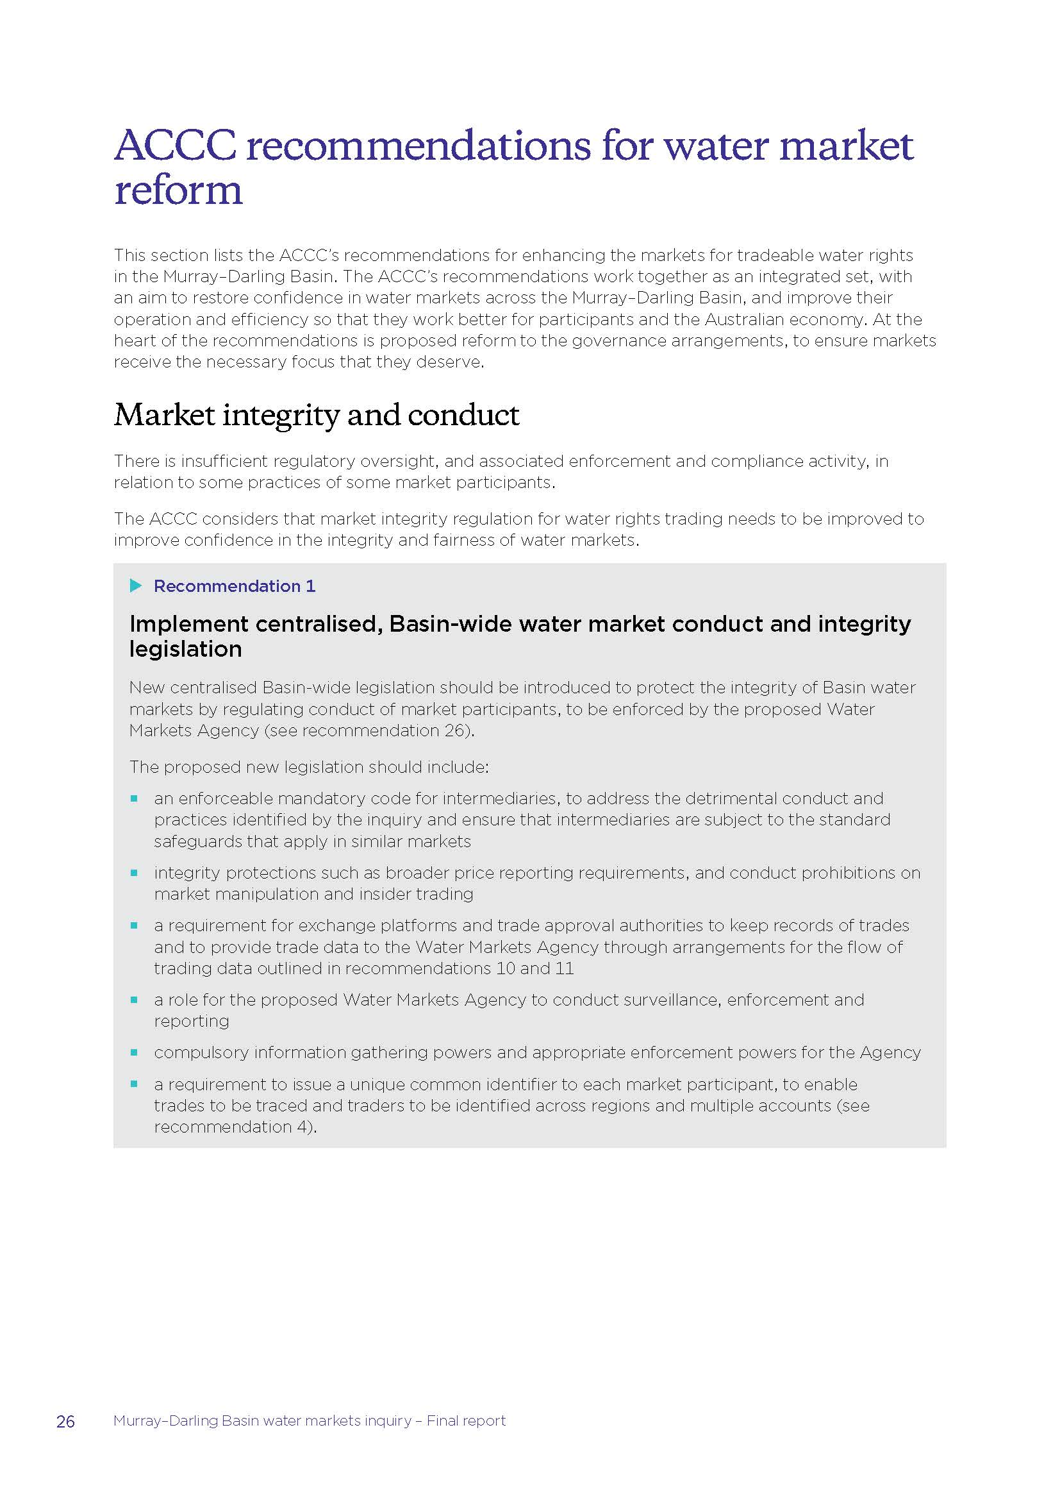

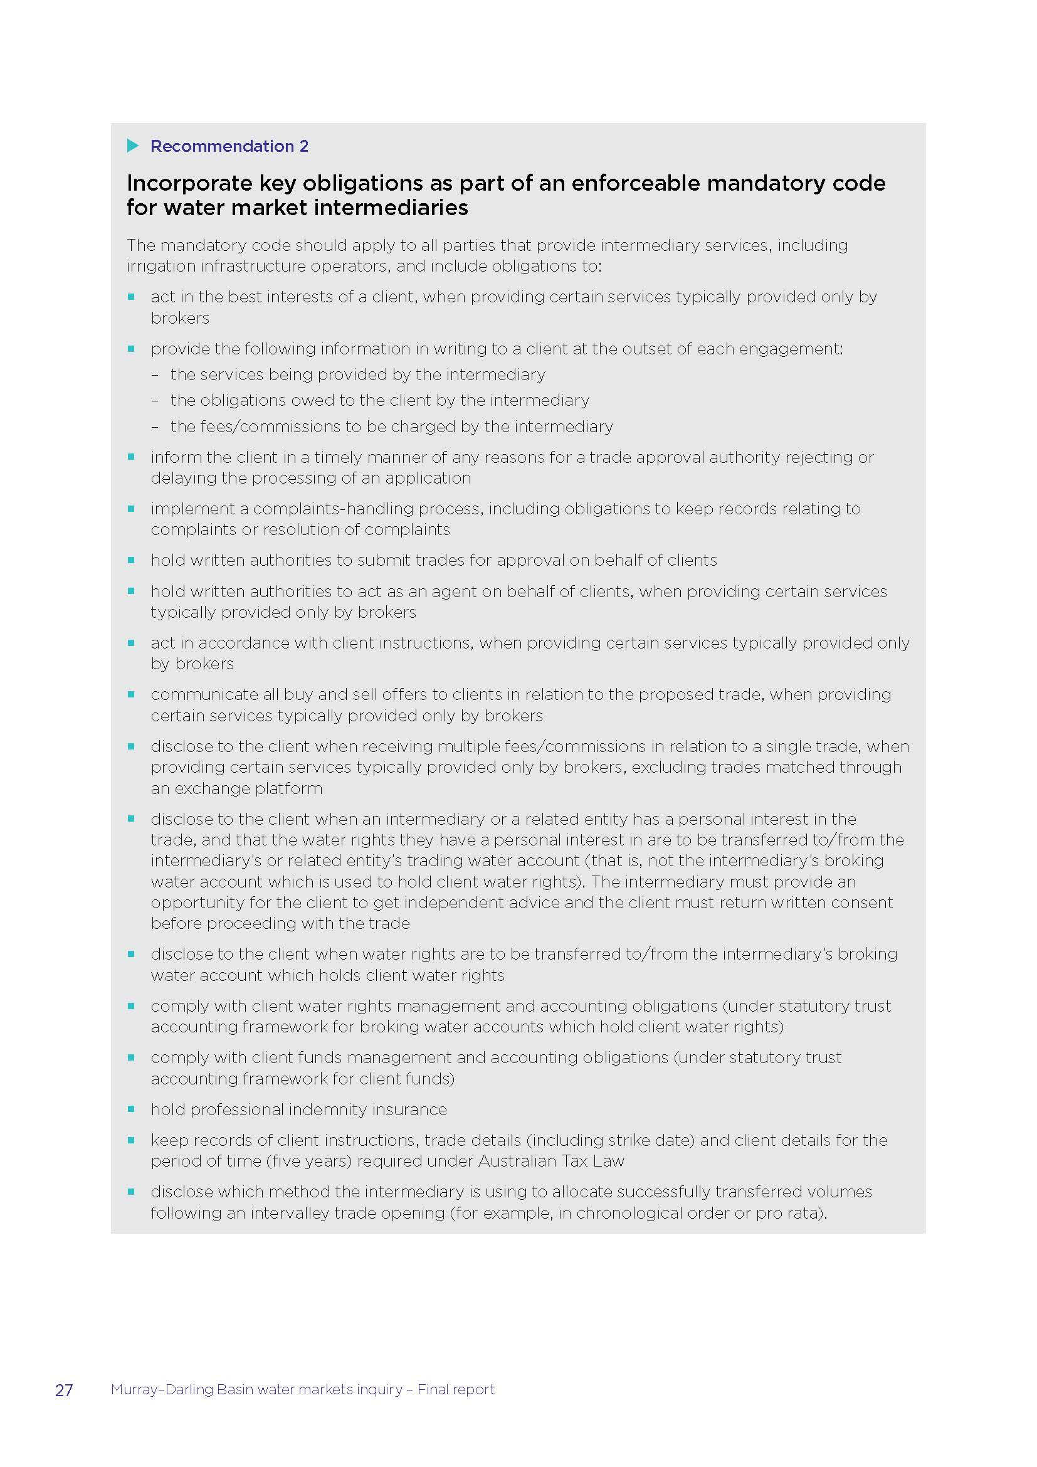
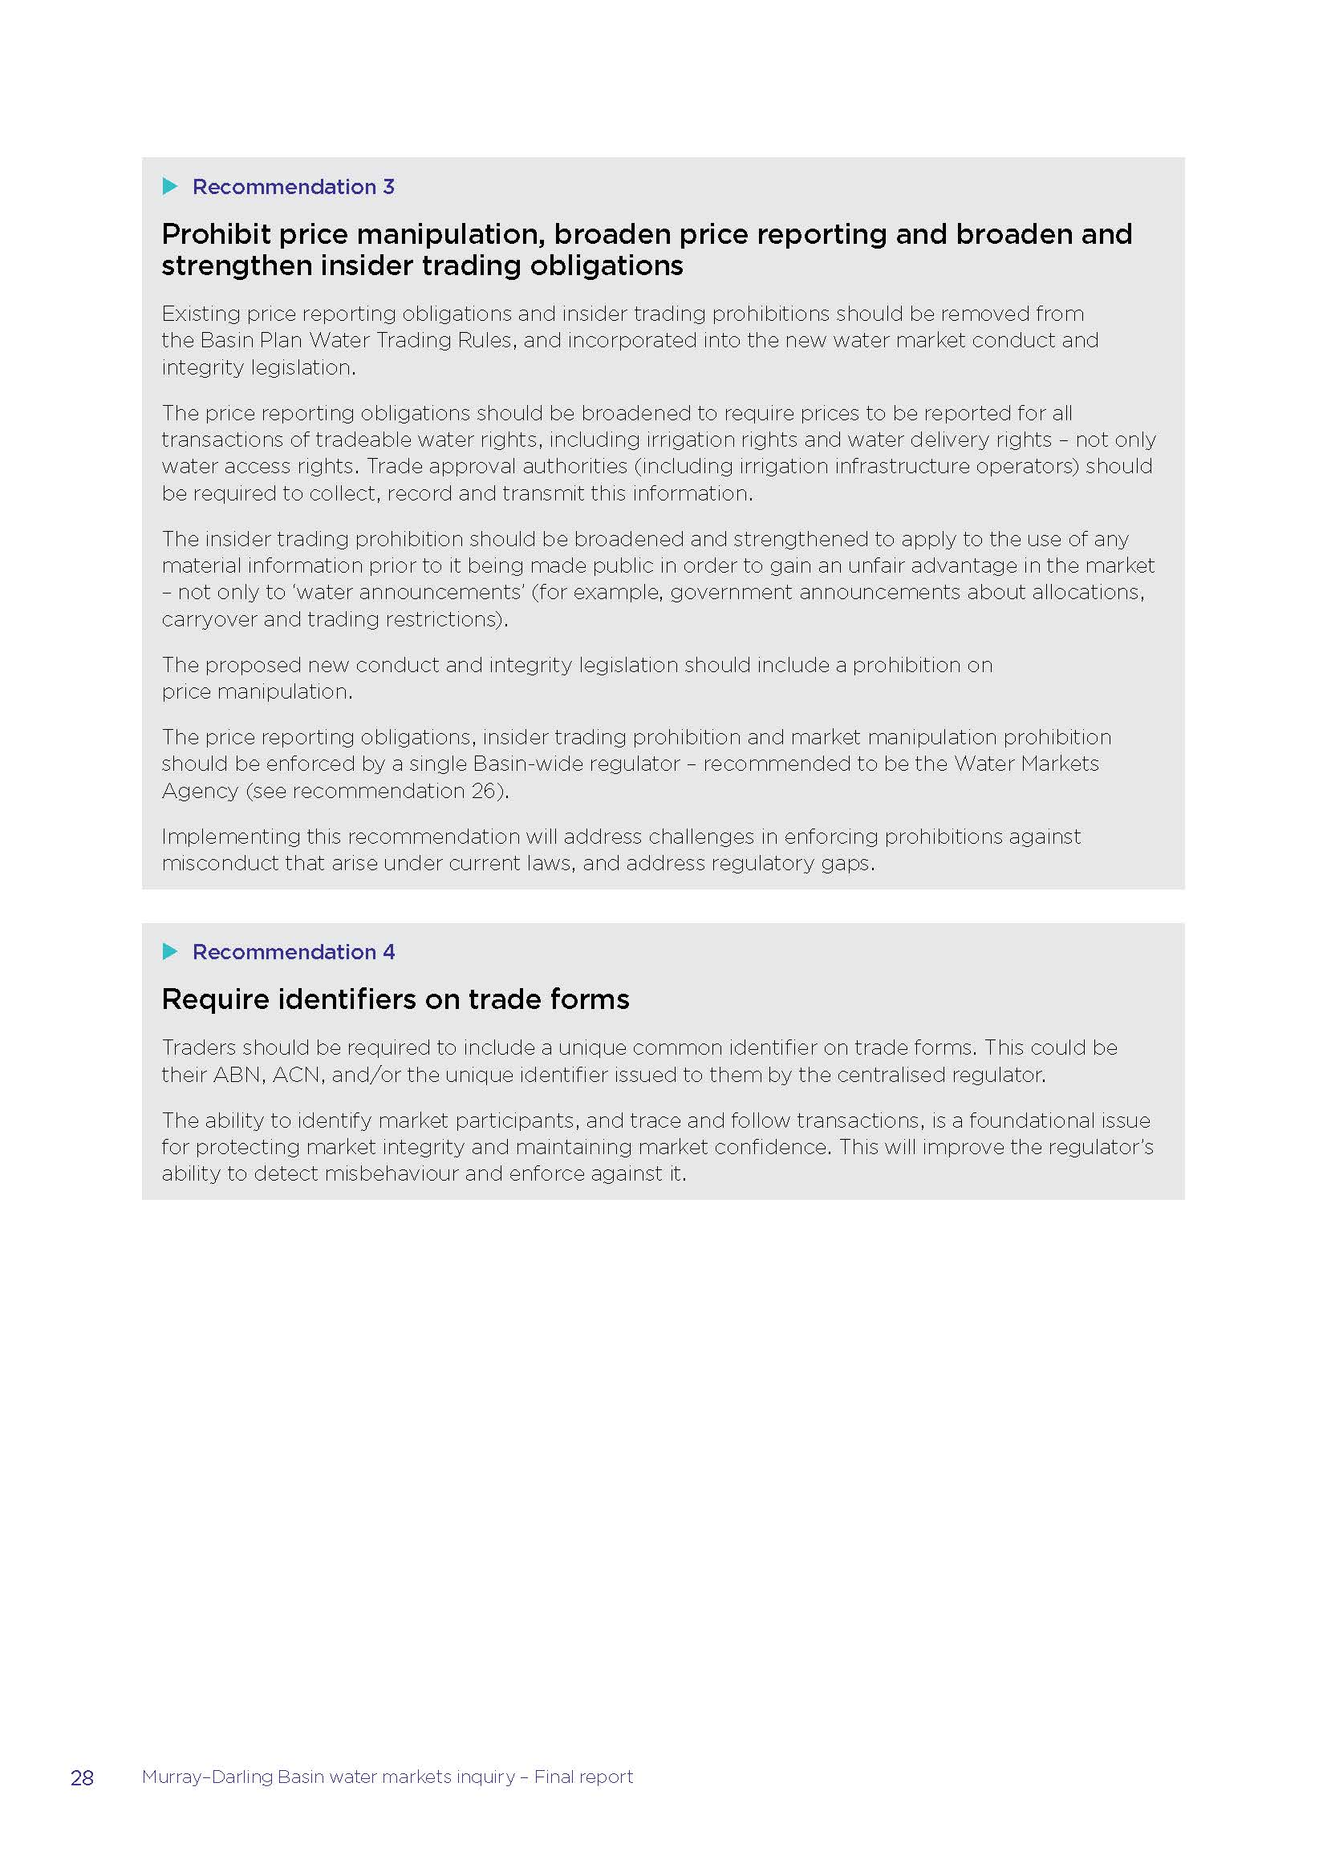

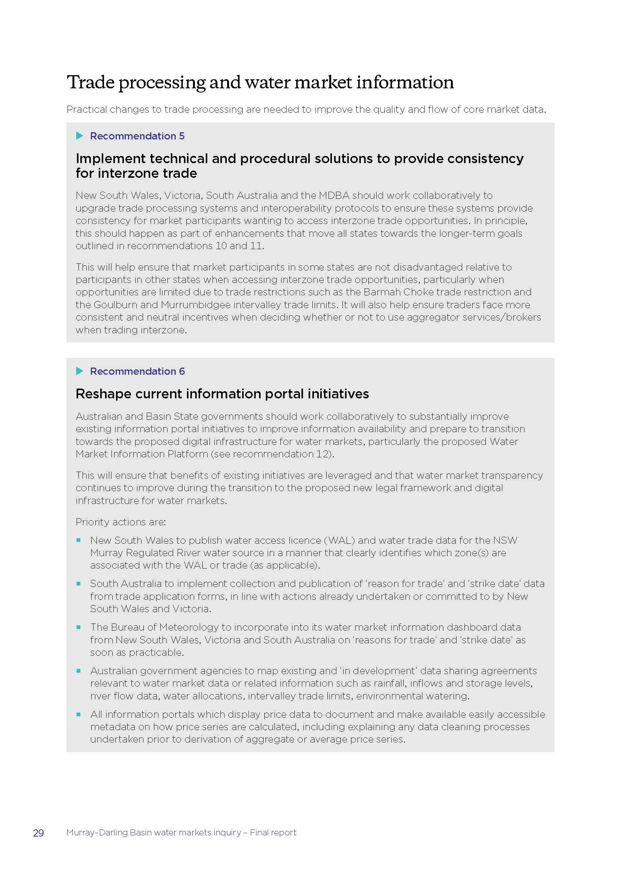
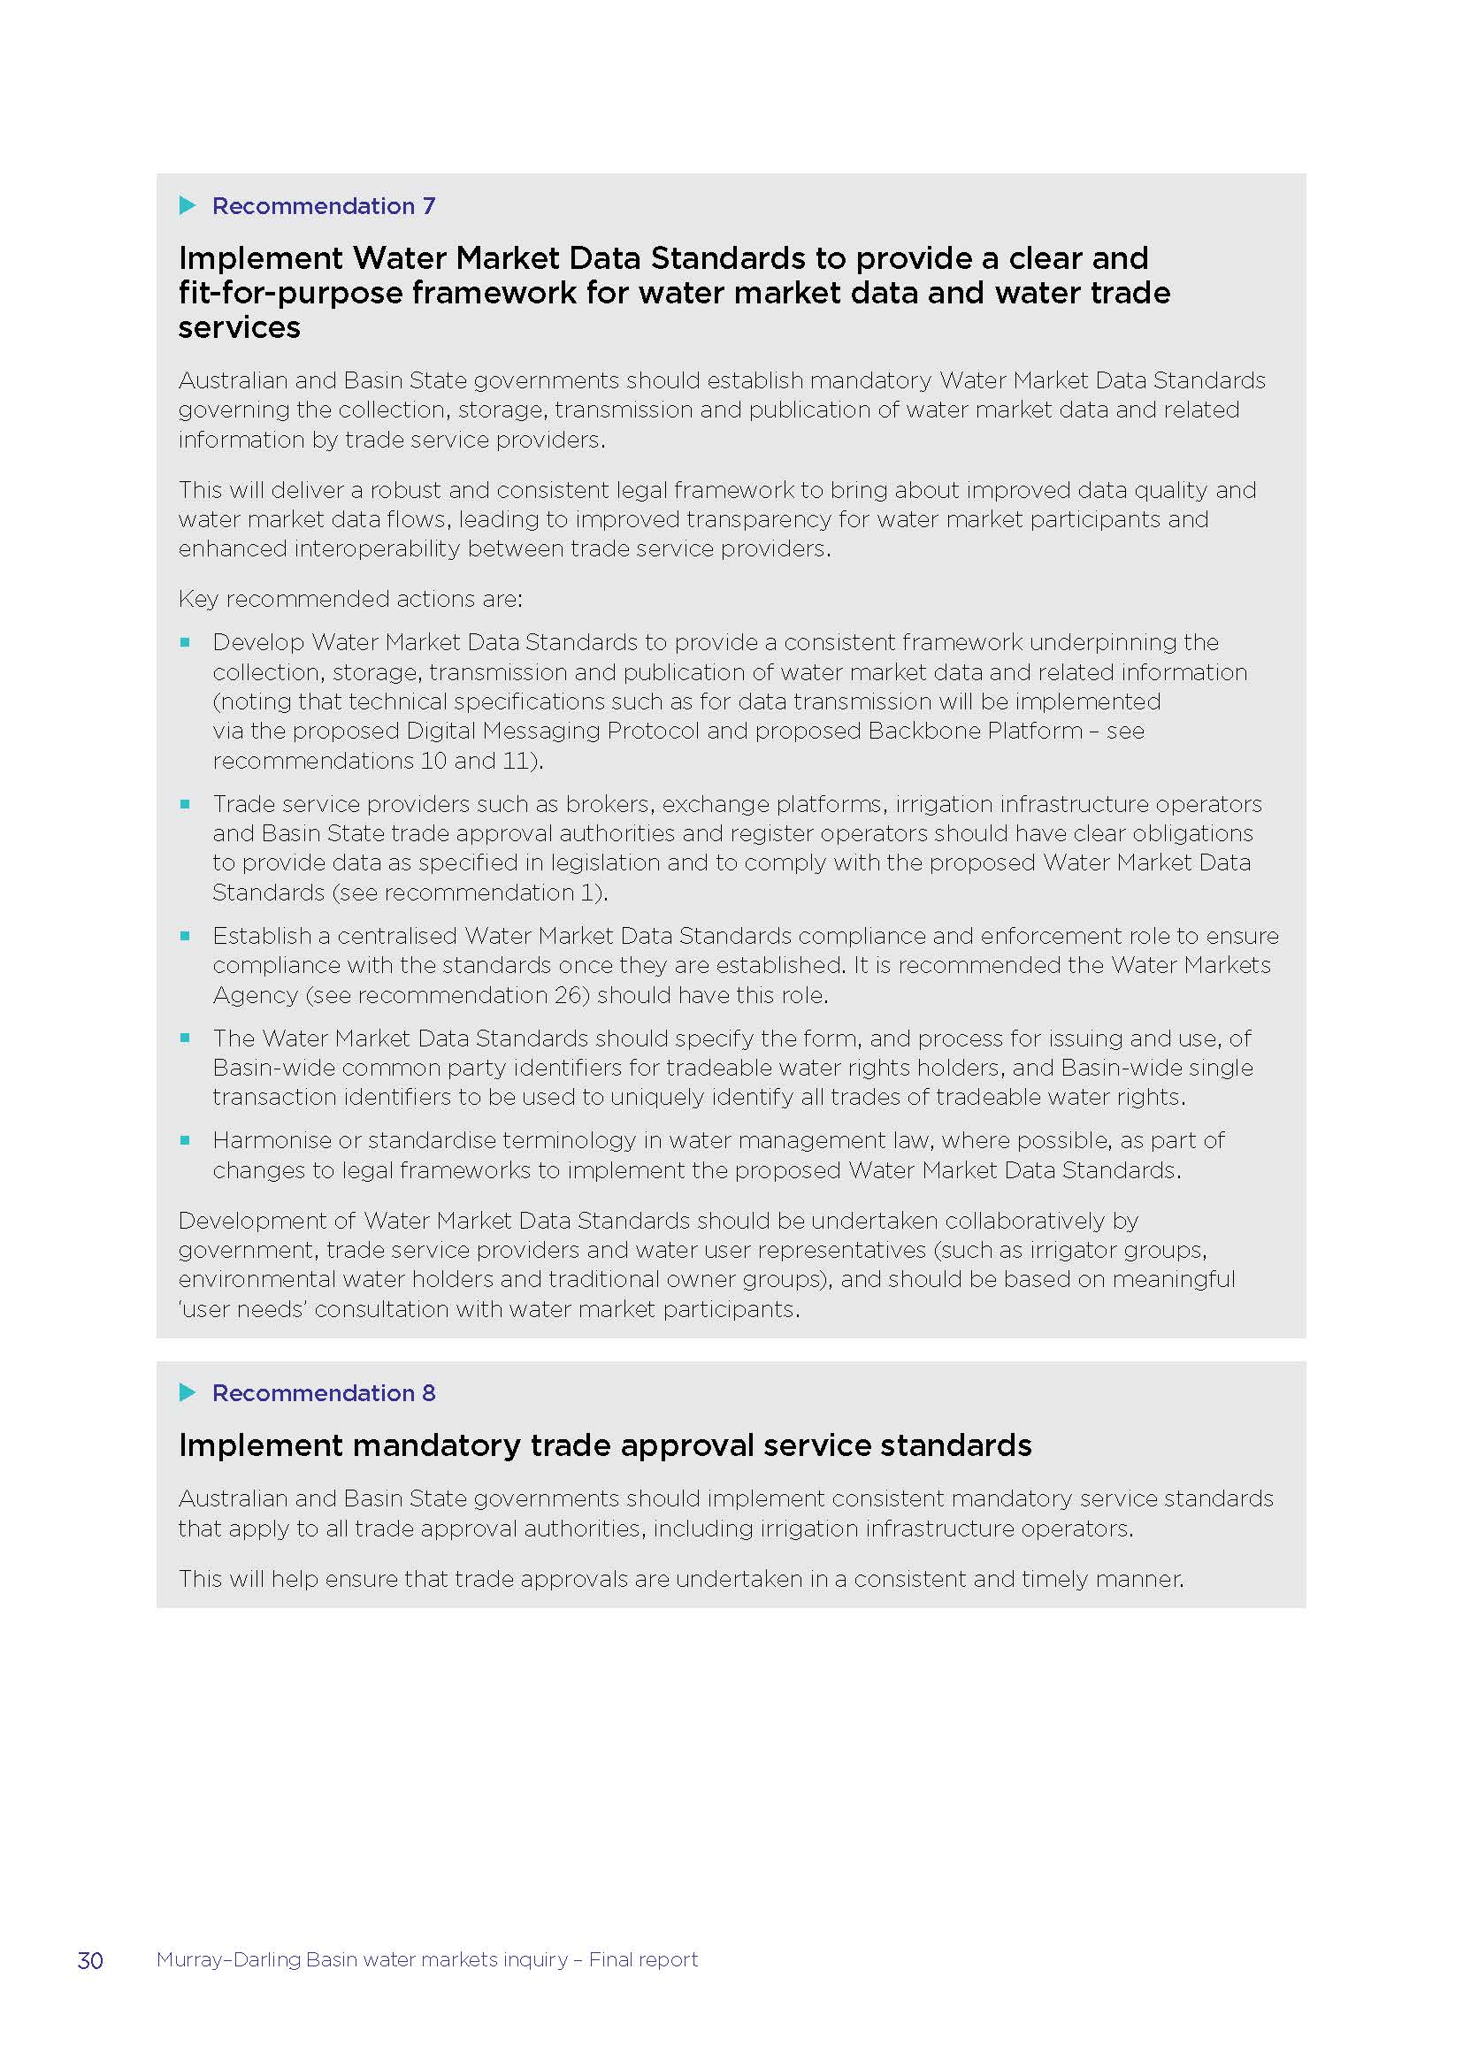
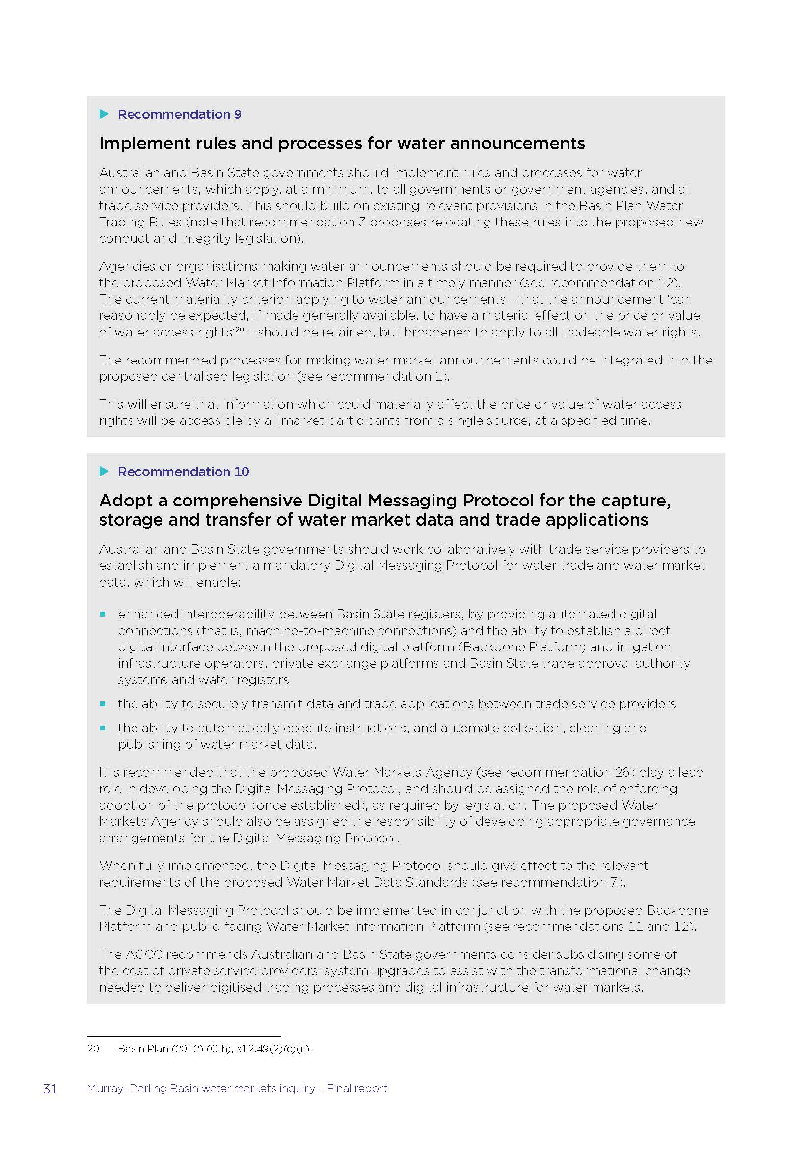
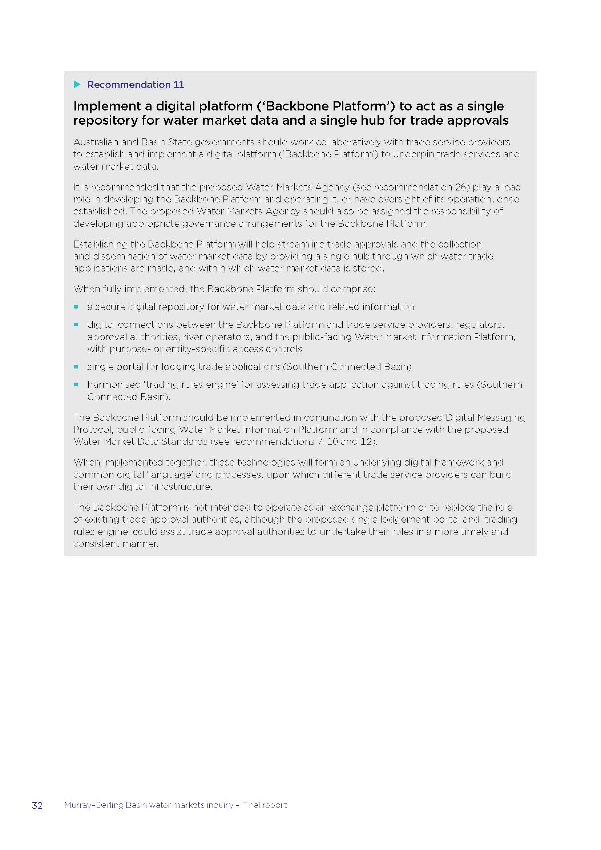
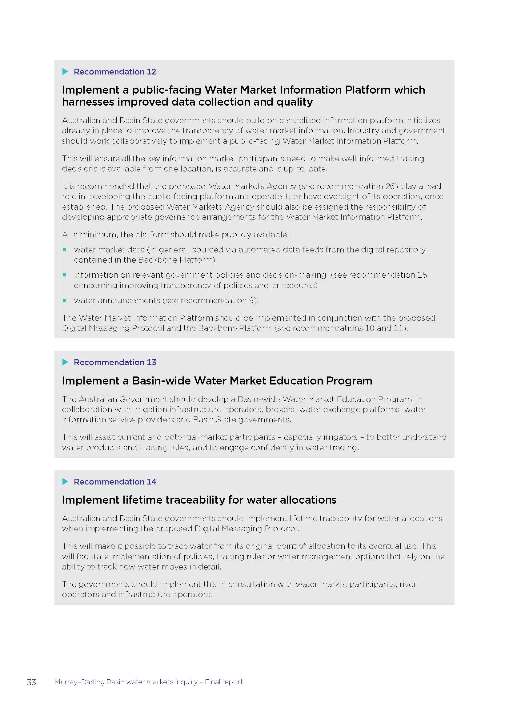
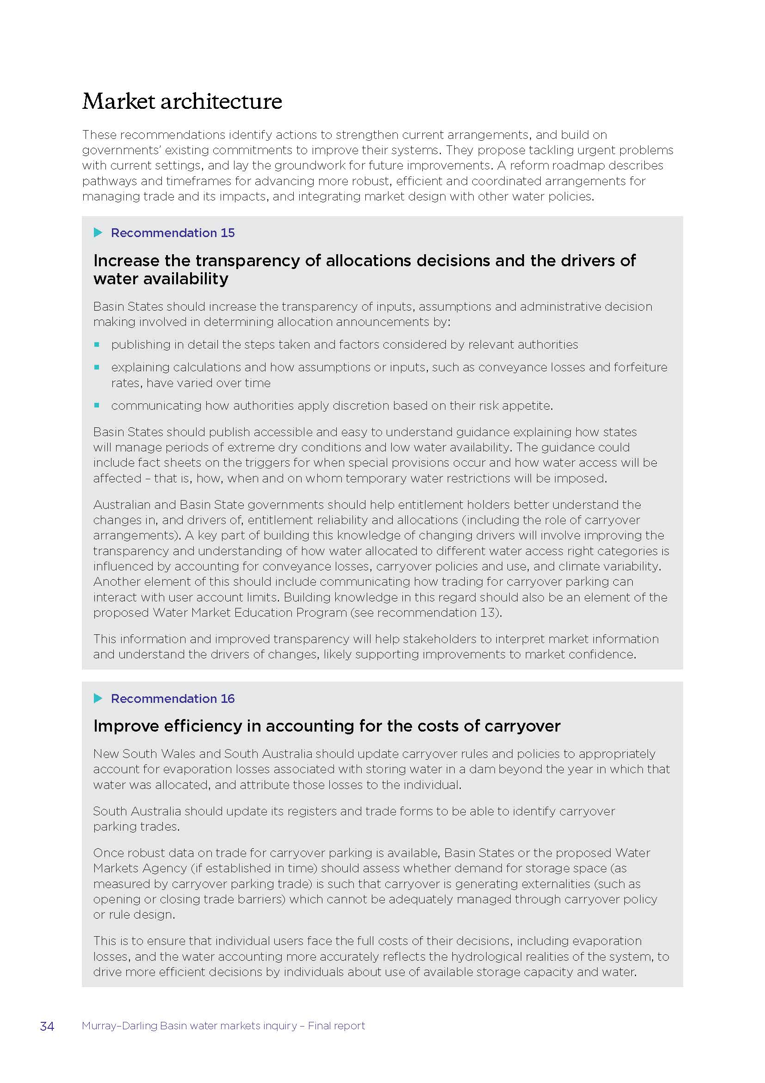
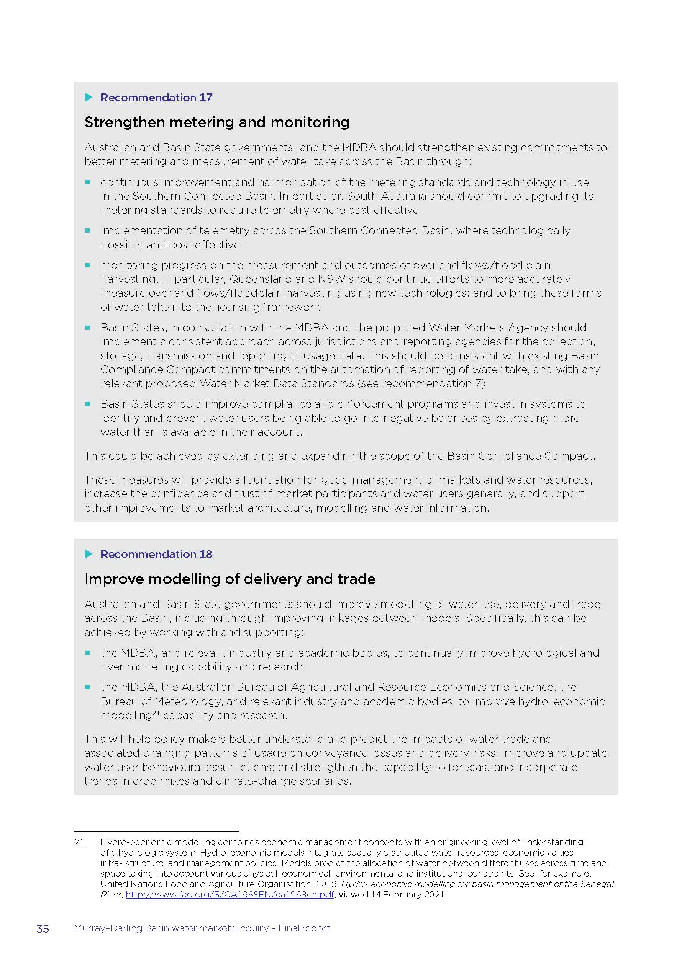
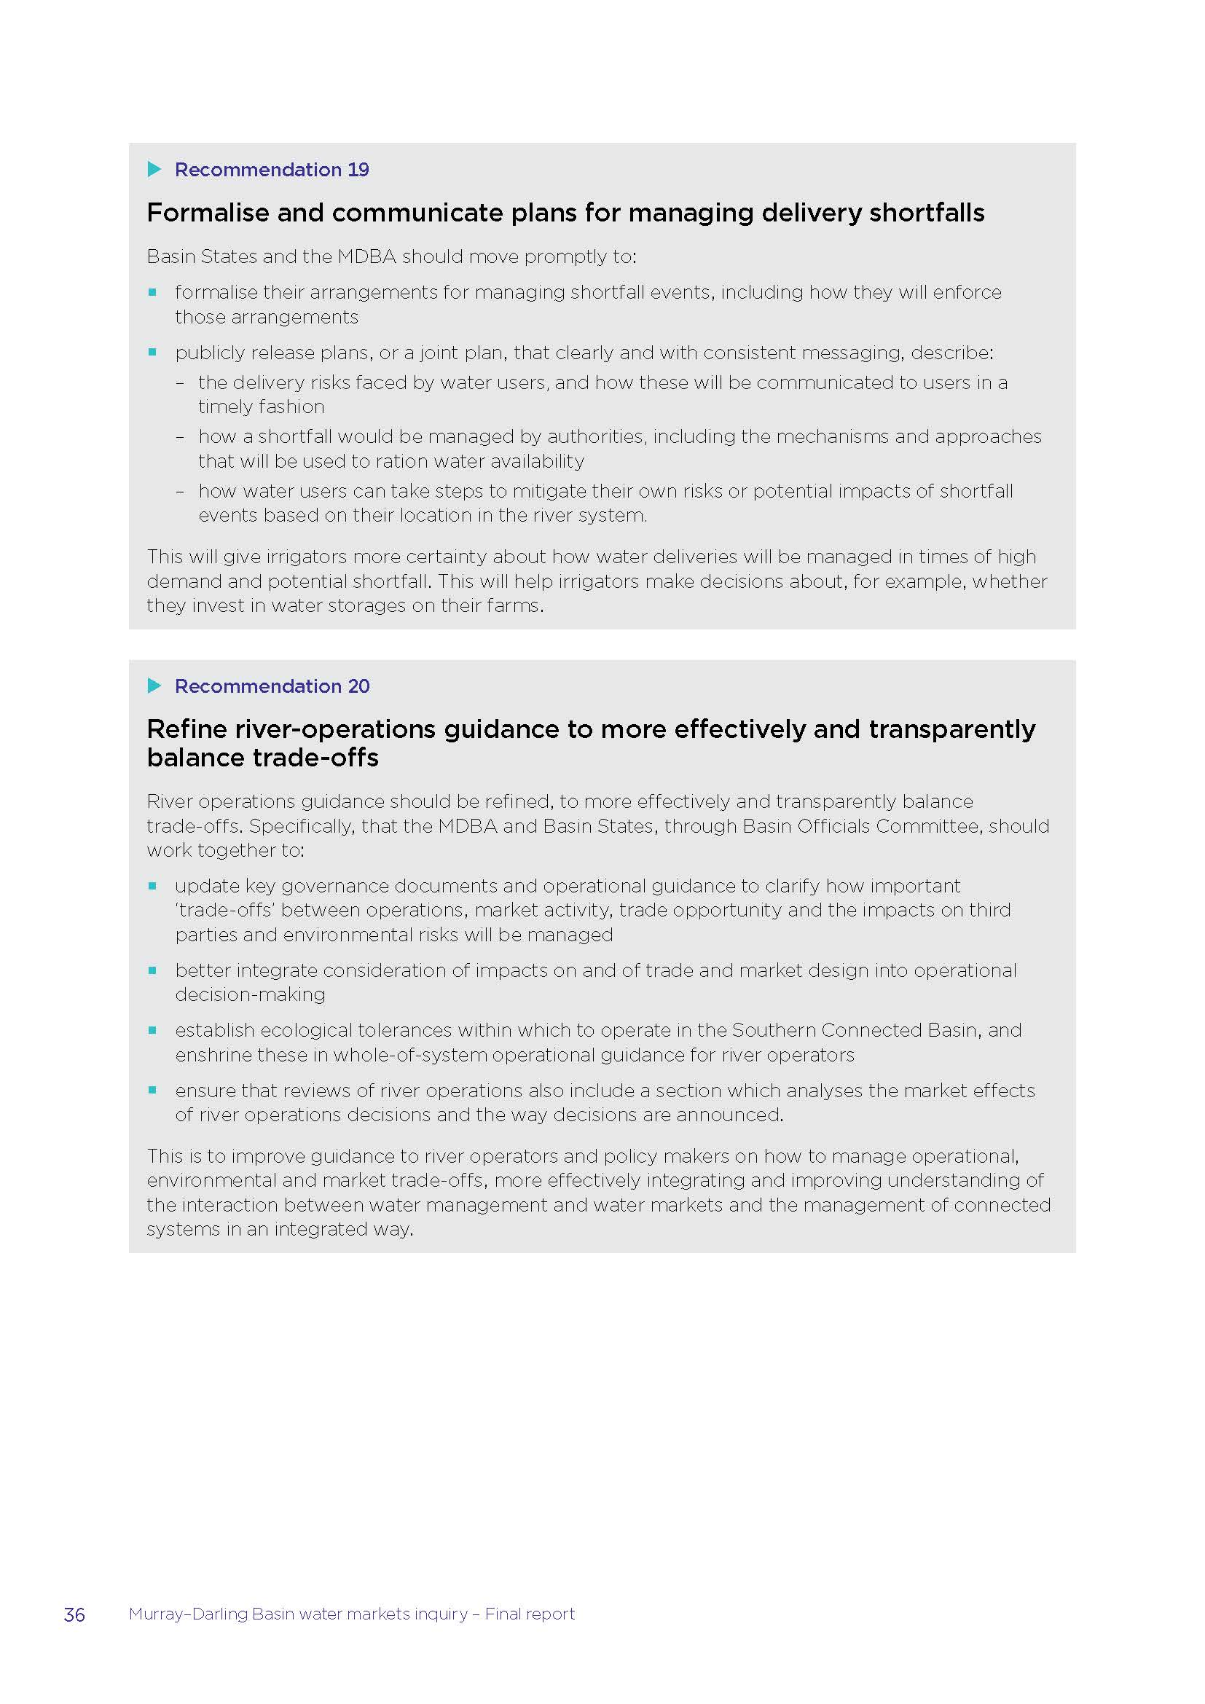
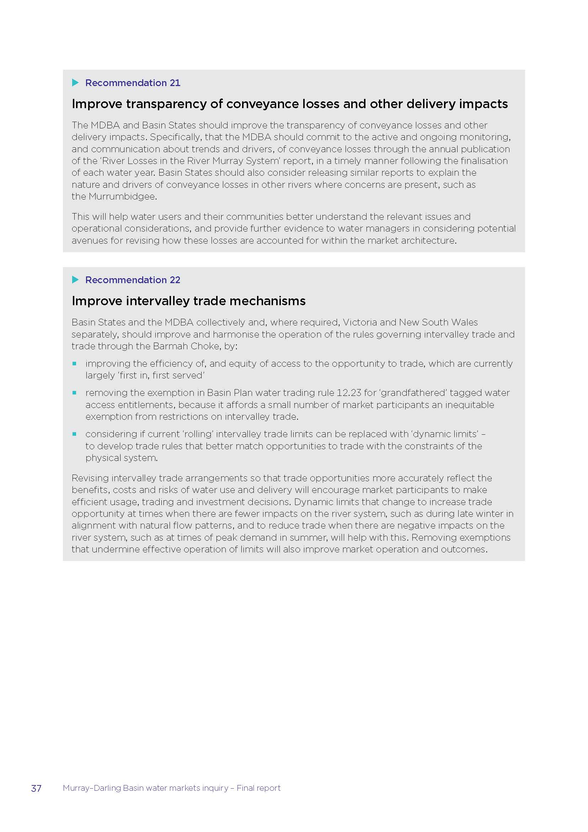
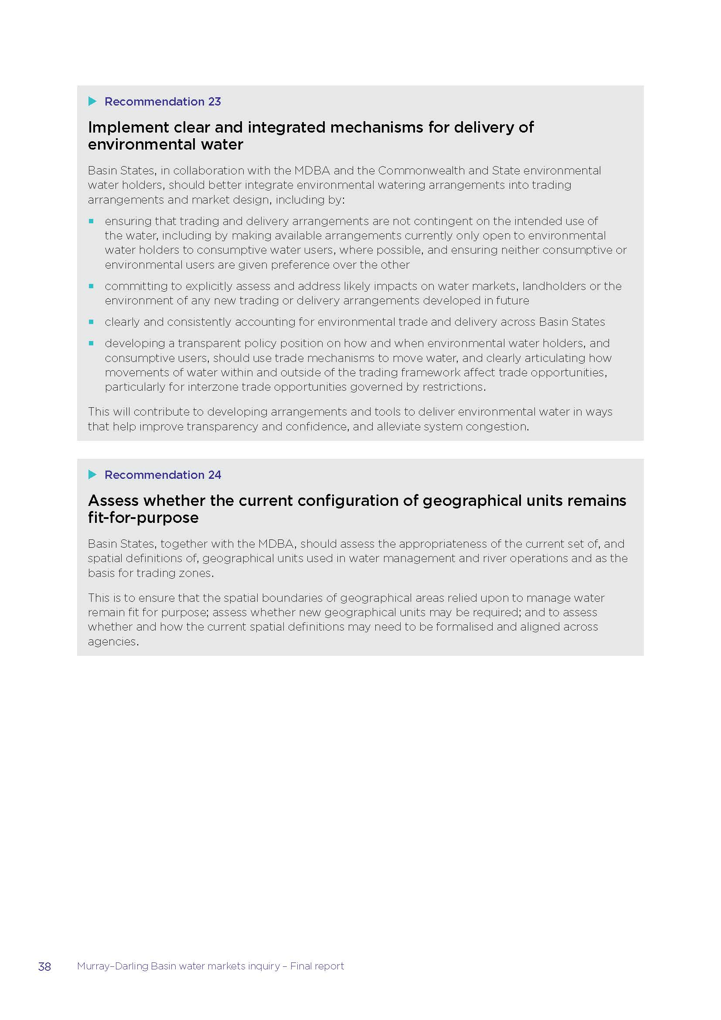
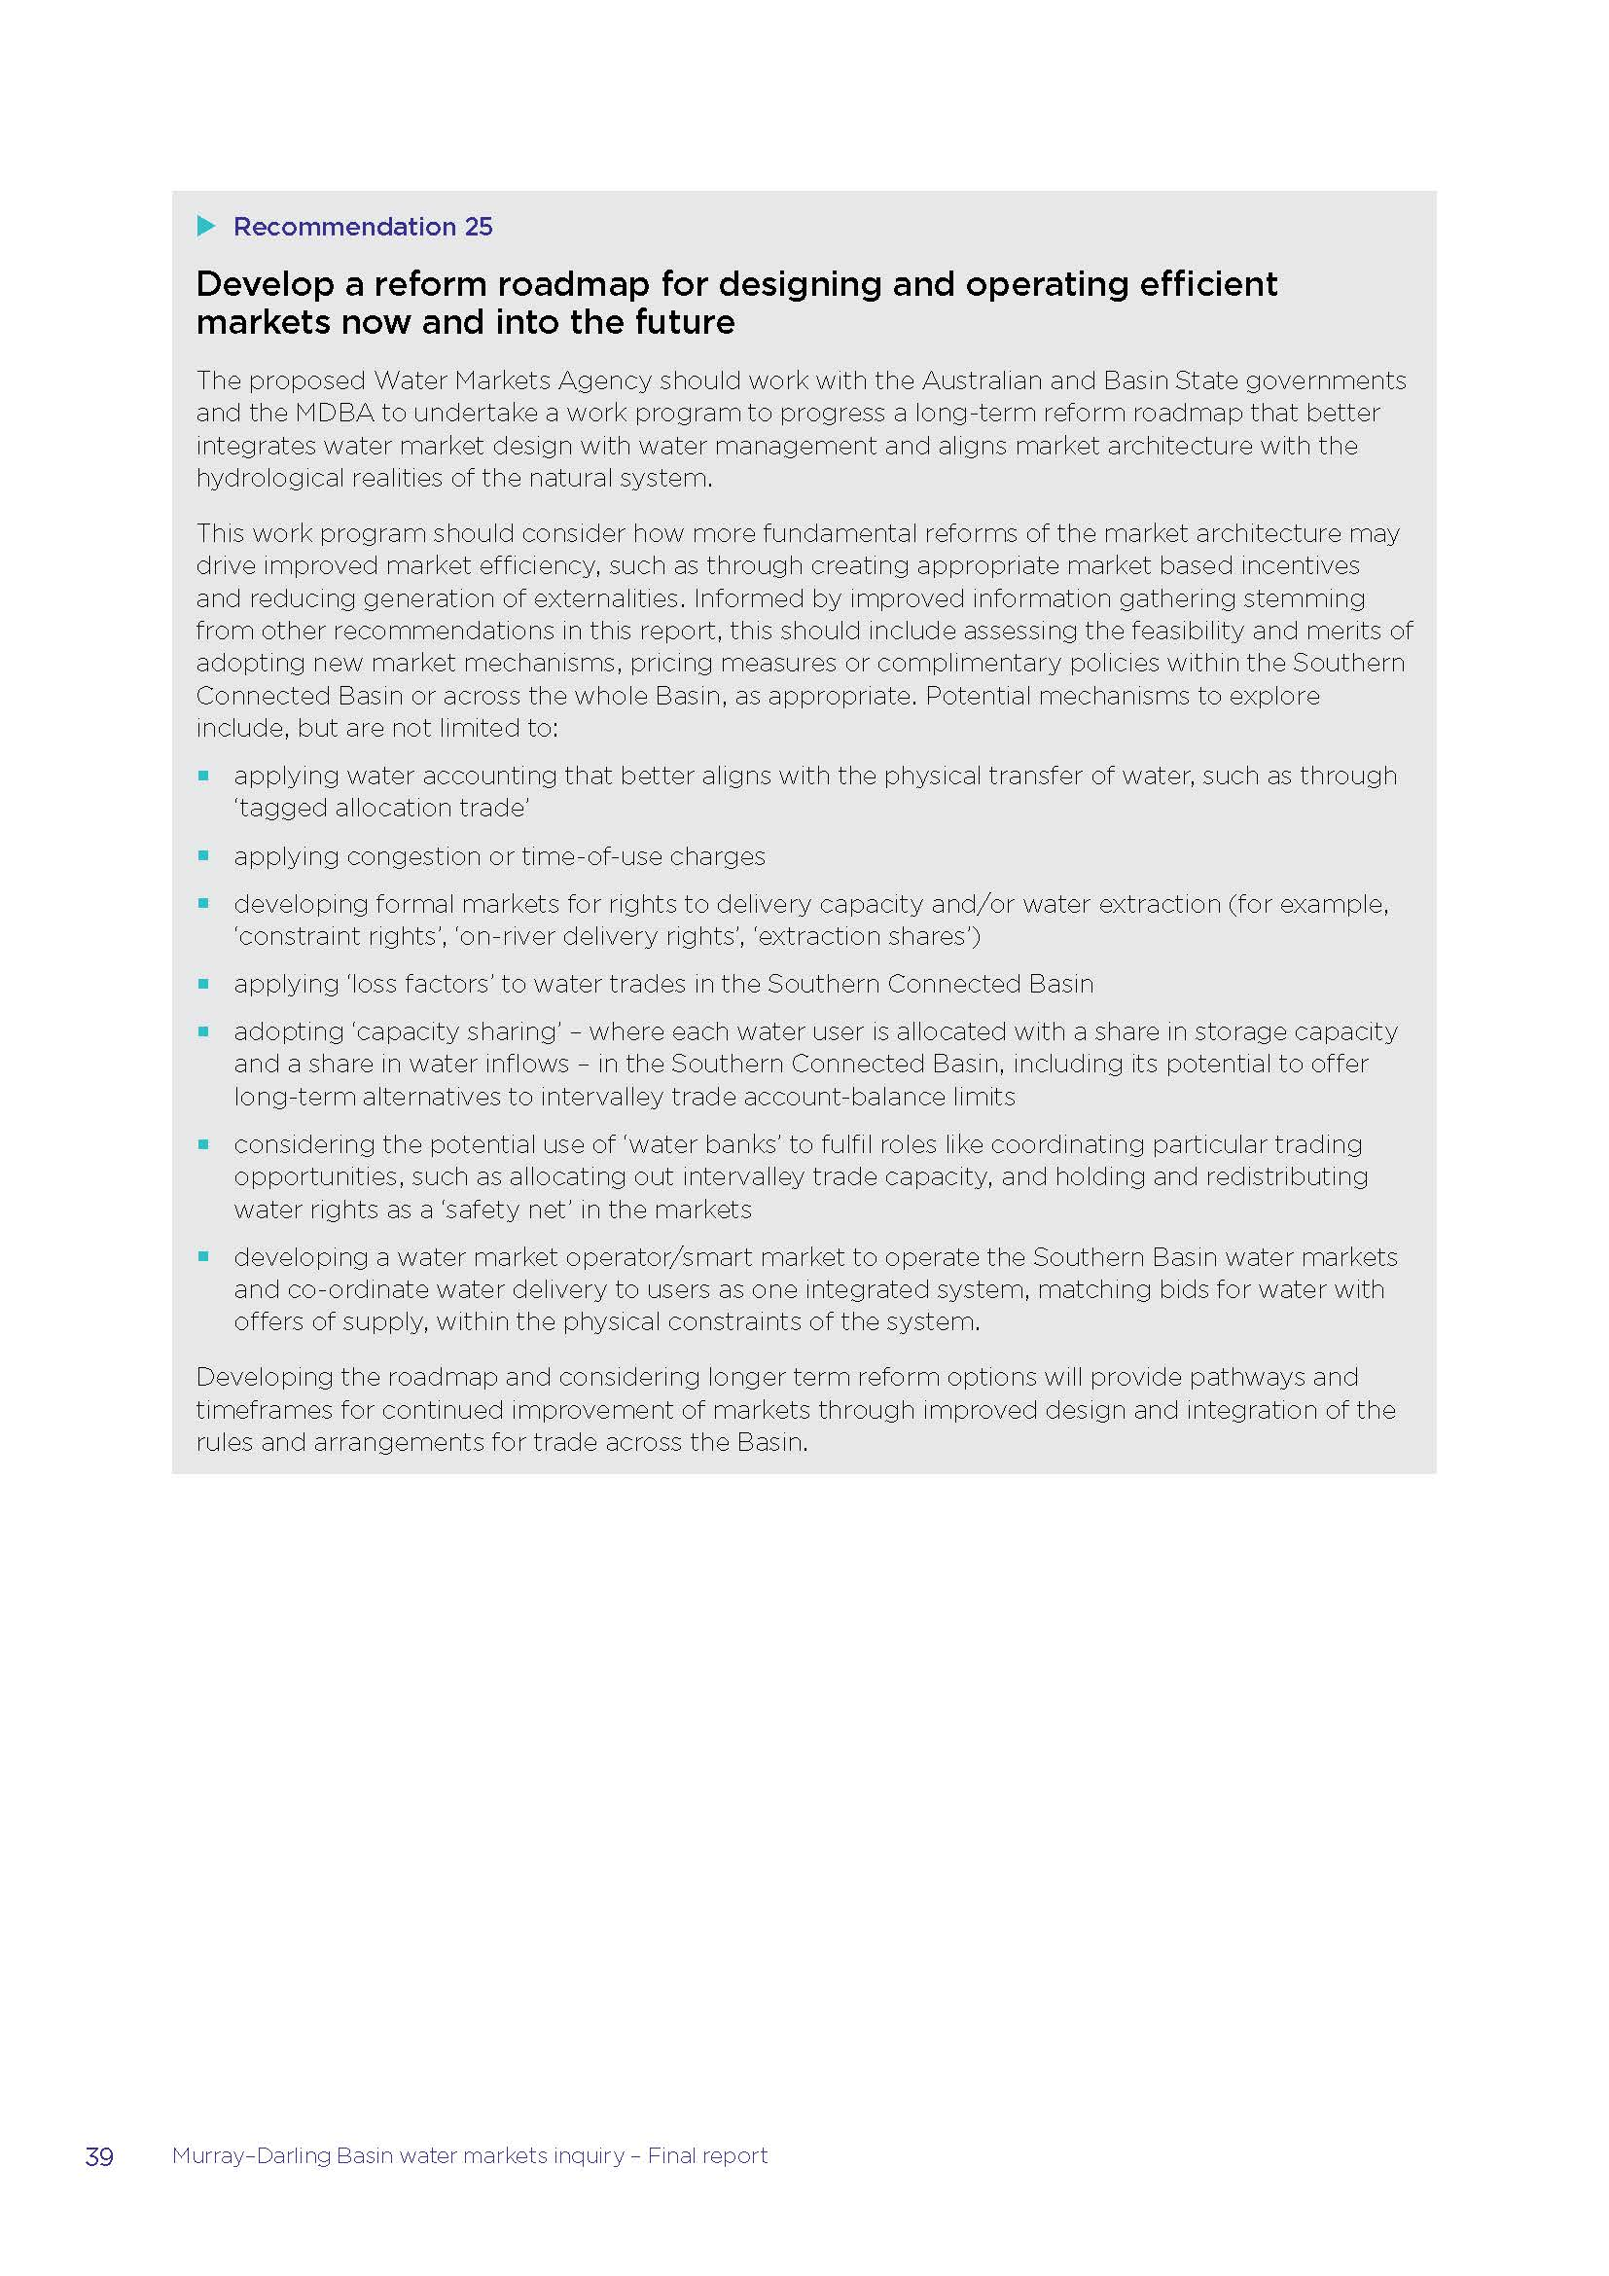
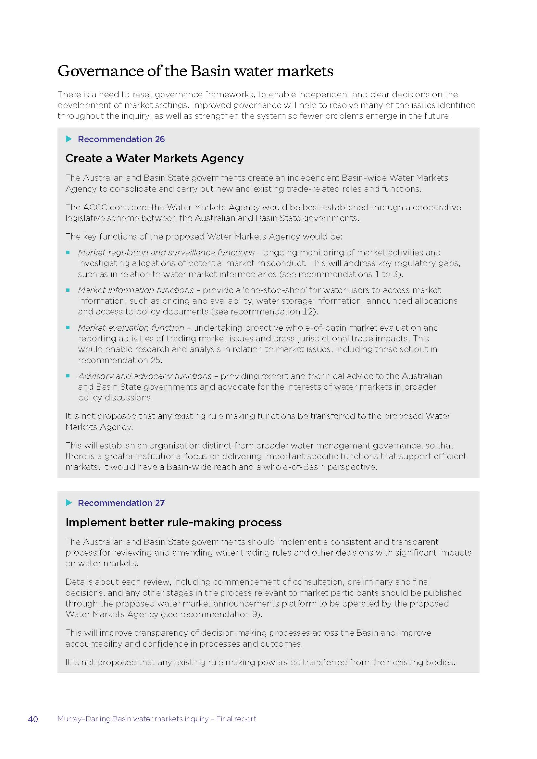
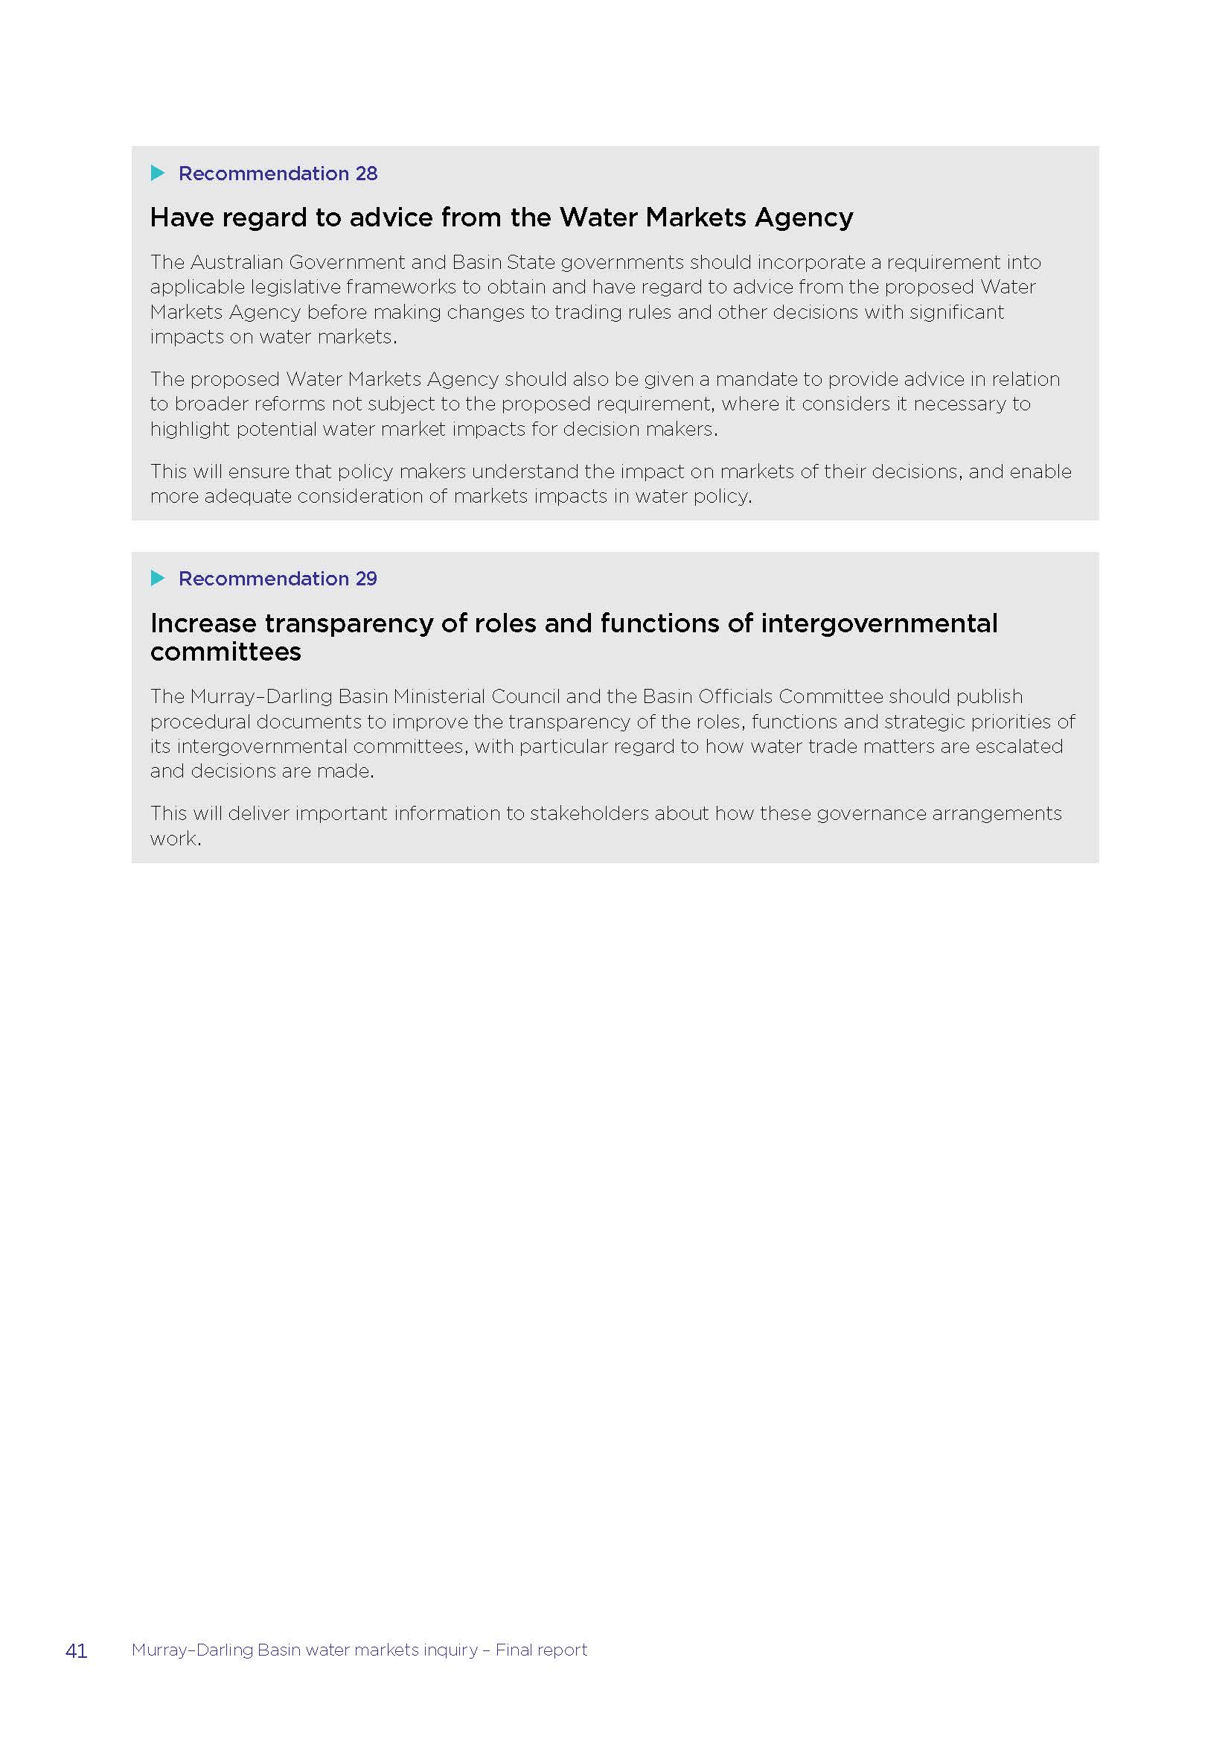

Appendix C – December advice

MURRAY–DARLING BASIN WATER MARKET REFORM

Murray-Darling Basin Water Market Reform – Development of Implementation Roadmap
December advice
Daryl Quinlivan AO, Principal Adviser


Water Market Reform Roadmap—December Advice

Letter to Minister

The Hon. Keith Pitt MP
Minister for Resources, Water and Northern Australia PO Box 6022
House of Representatives Parliament House Canberra ACT 2600

Dear Minister

MURRAY-DARLING BASIN WATER MARKET REFORM – DEVELOPMENT OF IMPLEMENTATION ROADMAP: DECEMBER ADVICE

Attached is my initial advice on a plan for implementing measures in response to findings set out in the Australian Competition and Consumer Commission (ACCC) report on water market reform.

As per the scope of work (set out at Appendix A), this advice sets out actions supported by Basin states that can be implemented quickly to help restore confidence in water markets. It also documents improvements already made or underway by Basin governments in this area and some observations about the planning for final advice to be provided in mid-2022. It has been prepared having regard to advice from the Advisory Group, initial engagement with industry, communities and other stakeholders, and working closely with Basin states.

The Basin states have responded positively to the ACCC inquiry, and the feedback to this roadmap process from all parties so far has supported the Commission’s analysis and
its proposed reforms generally. The concern this process will need to address is whether the Commission’s recommended reforms are the most cost-effective policy responses to the generally accepted problem analyses when resources are limited and the agreement of all Basin governments is required.

Yours sincerely

Daryl Quinlivan
Independent Principal Adviser 16 December 2021

Contents
Water Market Reform Roadmap—December Advice

- Introduction 1
  - Preamble 1
  - Context for the ACCC Inquiry 2
  - Why Basin water markets matter 2
  - What we learnt from the ACCC’s inquiry 3
  - The key task of developing the roadmap 4
- Developing the roadmap: work completed to date 6
  - A collaborative approach to developing the roadmap 6
  - Enhancing the evidence base for a water market reform roadmap 6
- Progress towards reform that is already in train 7
  - Improving transparency and enabling effective participation in water markets 7
  - Improving data and systems for water trading 7
  - Improving administration of interzone trade 7
  - Improving metering and monitoring of water take 8
  - Improving river operations and interactions with water markets 8
  - Improving integration of environmental water delivery and trade 9
  - Improving the evidence base for water market policy: research and development 9
- New commitments: in-principle support to new water market reform measures 10
  - Introduce Commonwealth legislation to establish a Basin-wide mandatory water market intermediaries’ code 10
  - Introduce Commonwealth legislation to prohibit insider trading and market manipulation across the Murray Darling Basin 11
  - Collect and publish further trade data, such as reasons for trade and ‘strike-date’ information 12
  - Develop and deliver a Commonwealth led Basin-wide water markets education program 13
  - Amend the Basin Plan to remove grandfathered tags exemption at the next available opportunity 14
- Further development of the roadmap 15
Appendix A: Scope of Work 17
Appendix B: Actions underway to improve water markets and address issues identified by the ACCC 19

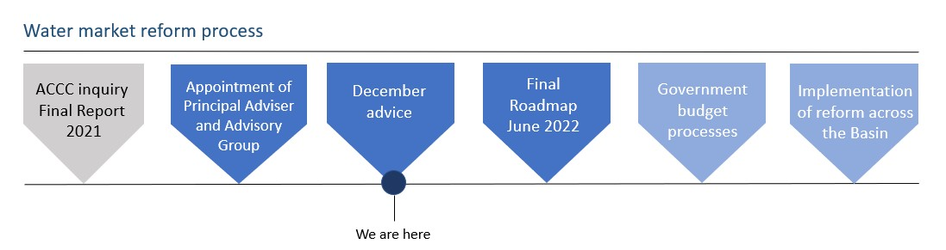

Water Market Reform Roadmap—December Advice

Introduction

Preamble
The Murray–Darling Basin (the Basin) is Australia’s largest river system, home to 2.2 million people and producing around 40% of our national food and fibre.1 But water in the Basin is scarce, becoming more so over time, and where it is valued most changes over time.
Despite current La Nina conditions being experienced in many parts of the Basin, there is inescapable evidence of a very large reduction in the Basin’s water ‘yield’ over the last 20 years, 50% by some estimates. 2 Governments have also reduced the volume of water available for consumption within the Basin, with 2,100 GL/y of surface water and 35.2 GL/y of groundwater recovered for the environment3 to date, targeting a total of 2750 GL by 2024 under the Basin Plan.
We are also seeing strong demand for Australia’s food products, and therefore critical inputs such as water, and the highest levels of profitability in agriculture for many years. Together, these trends have seen substantial increases in water and rural land values.
There is good reason to believe these trends will be sustained for some time. Therefore, an efficient market for trading and accessing Basin water is a high priority, to ensure that Australia makes the most of this frequently scarce asset, and that the water market remains robust and resilient to support water users and communities throughout all stages of climatic cycles.
This advice is largely a progress update on work completed to date to develop a water market reform roadmap for the Murray–Darling Basin since the appointment of the Principal Adviser on 25 October 2021. It also includes an outline of progress outside of this process, which has been pursued by Basin governments, to address the findings of the Australian Competition and Consumer Commission (ACCC) Inquiry since the release of its report in March 2021. It also includes new measures, supported by Basin states, that can be implemented quickly as evidence of Governments’ commitment to improving the functioning of our water markets and to increase confidence in Basin water markets.
Final advice in the form of a roadmap will be provided in accordance with the Principal Adviser’s scope of work (see Appendix A) in June 2022. It will then be up to Basin governments to confirm and support these initiatives and continue to work closely with stakeholders and communities to implement the reforms.

1 This includes including 100% of Australia’s rice production, 80% of Australia’s grape production and 28% of Australia’s dairy production. Source: https://www.mdba.gov.au/importance-murray-darling-basin
2 Interim Inspector-General of Murray–Darling Basin Water Resources 2020, Impact of lower inflows on state shares under the Murray–Darling Basin Agreement, p. 7.
3 As at 30 September 2021. Source: https://www.mdba.gov.au/progress-water-recovery
1

Water Market Reform Roadmap—December Advice

Timeline:
    - ACCC delivered inquiry final report in 2021
    - Appointment of principal adviser and advisory group We are here in the process.
    - December advice
    - Final Roadmap June 2022
    - Government budget processes
    - Implementation of reform across the Basin

Context for the ACCC Inquiry
There have been long standing concerns about the performance of Basin water markets, the conduct of its participants and the systems that support it, despite little tangible evidence to support these concerns on the first two issues. This reflects similar concerns about the efficacy of the Basin reforms generally, and the difficulty that many have had distinguishing between the impacts and efficacy of water reforms, the operation of the water market, reduced water supplies and significantly higher entitlement and allocation prices.
Water markets are still relatively new, with uptake of allocation and entitlement trade only becoming significant during and since the millennium drought. The regulatory system to facilitate trading is similarly new. It is therefore not surprising that there was a perceived need to review that system with the benefit of some experience with its operation in practice.
The regulatory system’s development was in part a response to the pressures of the millennium drought, and it has been further tested by more recent supply stresses. The three years from January 2017 to December 2019 were the driest on record for any 36-month period.4 During this time, the price of water across the Basin reflected limited supplies and raised concerns about the performance of Basin water markets.
In recognition of these concerns and the importance of a well-functioning water market, the Treasurer, the Hon Josh Frydenberg MP, directed the ACCC to investigate these issues and recommend improvements.

Why Basin water markets matter
The ability to trade water helps to ensure people can put it to its best use, among the many alternative agricultural, environmental, urban and cultural water uses. Water in the Basin is critical to the efficiency and productivity of Australian agriculture, which is a major contributor to our regional economies.
Over the past decade, Basin water trading activity has grown considerably. The Basin-wide set of markets now have an average annual value of more than $1.8 billion, with the underpinning value of entitlements in the southern Basin alone estimated to be around $26.5 billion5 and rising.

4 When averaged over the Murray–Darling Basin and New South Wales. Average rainfall for the Murray–Darling Basin was more than 100 mm lower than the second driest period (January 1965 to December 1967). Source: Bureau of Meterology, at http://www.bom.gov.au/climate/drought/knowledge-centre/previous-droughts.shtml
5 Aither, Water Markets Report 2020-21, p.5.
2

Water Market Reform Roadmap—December Advice

Other than economic value, there are several reasons why water markets have rapidly grown from infancy to be increasingly important:
- Irrigated agricultural production in the Basin is changing in response to climatic and regulatory factors (such as land use and planning controls) and strong international food and fibre markets. This has increased the desire to move water between locations and between agricultural sectors for commercial reasons
- New entrants, such as environmental water holders and cultural users, bring different demand and operating needs to water markets
- Governments have invested in better mechanisms for water trading and reduced restrictions on the movement of water access, reducing the costs of trading and increasing the returns from water use
- Water trade service providers such as brokers, exchange platforms and irrigation infrastructure operators have created new products such as leases, forward contracts and carryover parking, which provide increased flexibility for water traders and users
- In response to decreasing long-term water availability and reduced consumptive water shares, water users increasingly rely on water markets to manage their water needs and risks more effectively.

What we learnt from the ACCC’s inquiry
While Basin markets have generally brought strong benefits to water users across the Basin, it is not surprising that there is scope for improvements in many areas. This market has mostly developed over the last 20 years6 and with minimal formal regulation of the kind that has developed in other trading markets over many decades.
The ACCC conducted a thorough research process. It received over 221 submissions, consulted widely, and tested hypotheses about market manipulation against over 8 million water market and water use transactions.7
The Commission’s general conclusions were:

- there is a lack of quality, timely and accessible information for water market participants
- there are inadequate rules governing the conduct of market participants, and no particular body to oversee trading activities
- trading behaviours that can undermine the integrity of markets (such as market manipulation) are not prohibited, insider trading prohibitions are insufficient, and information gaps make these types of detrimental conduct difficult to detect
- differences in trade processes and water registries between the Basin States prevent participants from gaining a full, timely and accurate picture of water trade, including price, supply and demand
- irrigators and traders would benefit from governments providing better information on key policies and river operations

6 ACCC 2021, Murray–Darling Basin water markets inquiry – final report, p. 1.
7 During the course of its inquiry into Murray–Darling Basin water markets, the ACCC compiled a database of over 8 million water market and water use transactions from 2012–2019. Water market transactions were collected from a variety of public and private trade service providers, and a trade may have been represented multiple times in the database depending on its source and destination zones and whether intermediaries were used to facilitate the trade.
3

Water Market Reform Roadmap—December Advice

- the complex nature of the Basin’s market settings means the trading systems and opportunities favour professional traders and large agribusinesses with greater capacity to understand and participate in water markets
- the way the Southern Basin’s market architecture manages the hydrological characteristics of storages and river systems does not always adequately reflect scarce storage and delivery capacity or signal the cost of trading decisions
- changing conditions, such as reduced inflows, shifts in water use, declining channel capacity and increasingly binding trade restrictions are challenging key assumptions that underpin trade arrangements.
Basin water markets are continually evolving and the ACCC found that they have outgrown their regulatory framework and the infrastructure that supports trading. It found that the regulatory and digital infrastructure supporting water markets is not consistently delivering the information needed – to decision-makers, current and potential market participants, and the community more broadly. And as outlined by the ACCC, transparency, and good quality and timely water information, is essential to improving market confidence and enabling better- informed trading decisions.
To ensure water markets can deliver for all users into the future, governments need to improve the frameworks underpinning water markets and invest in the systems and infrastructure that support them. Doing so will support goals for Australian agriculture growth, ensure environmental water can be moved to where it’s needed, and enable new participants to make informed decisions as they enter water markets.
The early feedback during this process is that the Commission’s analysis and findings are widely supported, with queries about the most cost effective ways to implement the proposed improvements.

The key task of developing the roadmap
The Commonwealth Minister for Resources and Water, on behalf of the Murray–Darling Basin Ministers, has asked the Principal Adviser to develop a “roadmap” for implementing water market reforms, having regard to the ACCC report and recommendations. This task is being assisted by the active engagement of the Basin States, evidenced by the significant progress these governments have already made in improving Basin water markets in recent years and documented in this report. The Adviser has also been assisted by market participants and an Advisory Panel appointed by the minister.
The process of developing the roadmap will involve examination of all of the ACCC’s water market advice – spanning 29 recommendations and 70 individual reform actions. In considering this expansive body of work with the Basin states, the Advisory Group, stakeholders and communities, we are keeping front of mind the following policy principles or goals, based on the ACCC’s final report, for water market reform:
- Improving data quality, transparency and system integration between trade service providers
- Ensuring integrity of the market - improving trust & accountability
- Improving market architecture to mitigate third party impacts and better integrate trading with water management

4

Water Market Reform Roadmap—December Advice

- Enabling effective participation by reducing barriers to entry and enabling informed decision-making (improving information resources and transparency of policy).

Each of these policy priorities is important to the roadmap – and the Principal Adviser will be seeking to strike the right balance across them to ensure that the roadmap is cost-effective and can be implemented in practice.
Developing the roadmap does not involve repeating the ACCC inquiry process. Given the ACCC’s extensive analysis and the limited scope of this roadmap, governments will need to undertake further implementation and policy development to implement this set of water market reforms. Decisions on resourcing and the allocation of responsibilities based on this roadmap will be critical elements of this implementation process.
The roadmap will also not involve revisiting the policy decisions that provide the foundations of today’s water markets (such as re-bundling land and water rights or making the ability to trade water conditional on its use) and the investments in increased agricultural production that have resulted.
The roadmap does involve working with Basin states and engaging with stakeholders and communities to develop a phased and practical plan for water market reform based on the ACCC’s advice, and where relevant, alternative options. We will be focusing on:
- What actions should be undertaken as a collective of Basin governments and why – whether that be an action the ACCC recommended, or another, having regard to both costs and benefits of actions
- When the actions should be undertaken (both in terms of sequencing and timeframes), having regard to the key steps involved in implementing actions and the anticipated impacts
- Who should be responsible or involved in taking the action
- What are the likely costs and how should the costs of implementation be funded.

The ACCC proposed wide-ranging and comprehensive reforms to support the future growth of water markets in the Murray–Darling Basin. And while it produced strong and innovative solutions to multi-faceted and complex problems, it did not have the opportunity to really test the practicality of implementing these reforms with government or non-government parties, nor to account for resourcing constraints.
Therefore, the ACCC’s recommendations need to be carefully considered with Basin governments, having regard to those implementation constraints and in the context of an established (if very complex) water management regulatory framework. This is an opportunity for reforms that will help shape the future of the agricultural sector, the communities and natural assets in the Murray–Darling Basin.

5

Water Market Reform Roadmap—December Advice

Developing the roadmap: work completed to date

A collaborative approach to developing the roadmap
Since being appointed in late October, the Principal Adviser has worked with Basin government officials to understand reform priorities and has seen strong engagement and commitment from all governments. This has allowed this advice to include in-principle support for five initial reform actions, outlined below. These are additional to the work that has already been progressed independently by Basin governments since the ACCC’s inquiry that address its findings, also outlined below.
The Principal Adviser has met with the advisory group since their appointment on 11 November 2021, and commenced discussions with irrigation infrastructure operators, water market brokers and community members generally, including to discuss areas of potential reform that could directly affect business models and impose compliance costs.
It is also apparent that the community’s continued access to this roadmap process and ability to provide advice will be important. The Principal Adviser has also reached out to Traditional Owner and environmental groups in respect of this roadmap project and hopes to have the opportunity to hear their views and concerns early next year.
These discussions will continue as the roadmap is developed, with the aim that affected parties understand the impact of proposed reforms, that those impacts are proportionate, and that water reforms deliver benefits to Basin communities.

Enhancing the evidence base for a water market reform roadmap
In addition to the significant evidence gathered by the ACCC, the following actions have been undertaken to help ensure that the roadmap’s reform actions are sound and adequately consider benefits and costs for affected parties:
- Engaging with the ACCC to ensure the ACCC’s recommendations are well-understood.
- CSIRO is consulting with trade service providers (including those administering state water registers) to understand what changes would be required to their systems to improve data flows between trade service providers and enable them to provide government with the necessary information to improve water market data and regulation.
- Work to assess potential costs and benefits has begun. This will provide a basis for comparing proposed and alternative reform measures and assist in guiding judgements about resourcing requirements and minimising complexity.

6

Water Market Reform Roadmap—December Advice

Progress towards reform that is already in train
Basin governments have already made substantial progress in addressing the ACCC’s findings. This work is described below and outlined in further detail in Appendix B to this advice.

Improving transparency and enabling effective participation in water markets
The ACCC recommended several actions to improve the accessibility of meaningful water management and market information, to improve the effectiveness of stakeholder participation in water markets, increase trust and confidence, and encourage new entrant participation. In this regard, Basin states have improved the transparency of how water is managed. Currently, all Basin states and the MDBA publish information on water markets and relevant policy, and regulation within their jurisdictions.
There are also a range of digital resources available, such as online information portals, webinars held by the MDBA and Basin state agencies, and the Waterflow platform developed with funding from the Commonwealth Government.

Improving data and systems for water trading
The ACCC recommended both making incremental improvements and significant new investments to improve the data and systems for water trading. These recommendations underpin a number of benefits, including enabling effective oversight of water market activity, better and more timely data and information for traders, reducing transaction costs of trade and improving competition in trade service provision.
The ACCC’s report acknowledged that significant improvements in water trade data and systems were already underway during the timeframe of the Inquiry. These improvements have carried on into 2021. Most jurisdictions have now launched new or improved online platforms or mobile apps to allow better access to data and information in their jurisdictions, and some states have started collecting and/or publishing new data to respond to traders’ and water users’ information needs. The Commonwealth government is also continuing to invest in the Bureau of Meteorology’s broader water information functions.

Improving administration of interzone trade
Trade between zones, including interstate trade, is subject to a range of restrictions that reflect underlying hydrological limits and water supply and environmental considerations. Trade restrictions are managed by the states and the MDBA. The ACCC found that, generally speaking, Basin water trading systems and opportunities are best understood and leveraged by professional traders and large agribusinesses with the time and knowledge to analyse and navigate them. Further, the ACCC identified that a key area where significant imbalances exist is in relation to inter-zone trade, where trade is restricted by volumetric limits (in particular, the Goulburn and Murrumbidgee IVT limits, and the Barmah Choke downstream trade restriction).

7

Water Market Reform Roadmap—December Advice

Basin states and the MDBA are continually working to improve the administration of interzone trade within the existing rules framework, both jointly and within their respective jurisdictions. Recent actions include providing greater transparency of how trade limits work and when inter- zone trade opportunities are anticipated to open. Southern jurisdictions have also been working together to improve the efficient and effective operation of administrative procedures for interstate trade and water orders.
ACCC recommendations to improve the digital infrastructure supporting interzone trade (and trade more generally) and consider more fundamental changes to the way interzone trade works (to consider whether rules themselves can be improved) will be further considered in the next phase of the roadmap’s development.

Improving metering and monitoring of water take
Robust and consistent metering and measurement requirements provide communities and water users with confidence that rules are being applied equally to all water users and can be enforced appropriately. Inconsistent metering standards and telemetry capabilities across states can lead to actual or perceived unfair advantages in water markets and is a concern for some jurisdictions requiring further analysis.
Nevertheless, Basin states are on the trajectory of continuous improvement and harmonisation of metering standards and technology, and the roll out and monitoring to measure overland flow. All states are in various stages of developing and implementing new metering standards (such as Australian Standard 4747 and Metrological Assurance Framework 2) and telemetry requirements, which are essential steps toward harmonisation and reducing inequities across the Basin. In addition to reporting and other commitments under the Murray Darling Basin Compliance Compact (compliance compact), Basin states are now subject to increased oversight by the Inspector-General of Water Compliance (Inspector General), who can also issue metering standards that must be considered by Basin governments.
Although approaches vary across jurisdictions, Basin states have been improving their processes for enforcing take rules and metering requirements, including to prevent water users being able to go into negative balance. An identified focus of the newly established Inspector General includes addressing barriers that inhibit Basin state compliance and enforcement functions of this nature. These actions go some way towards eliminating the inequity for market participants arising from differing requirements across jurisdictions.

Improving river operations and interactions with water markets
The ACCC identified that delivery issues affect water market outcomes and are influenced by trading activity. Market mechanisms could form part of a suite of solutions to address delivery risk.8
The MDBA and southern Basin states are already progressing work to address delivery risks under the ‘Capacity and Delivery Shortfall’ project. Southern Basin states have emphasised the importance of this work and the opportunity it presents to meaningfully address delivery risk.

8 Delivery risk is the risk that water cannot be delivered according to demand. It can arise from a delivery shortfall (occurring when water cannot be delivered according to demand due to the long travel time between storages and the point of extraction) or a system shortfall (where there is insufficient water available to meet total system demand).
8

Water Market Reform Roadmap—December Advice

Further development of the roadmap will consider how that process can be best supported to ensure it considers the relevant issues raised by the ACCC Inquiry.

Improving integration of environmental water delivery and trade
Although environmental water holders are not significant participants in water markets (despite being large entitlement holders), delivery of environmental water can affect trading frameworks.
In response to advice provided by the ACCC, the MDBA has assessed possible options for the operation of Section 12.02 of the Basin Plan Water Trading Rules as it relates to the movement of environmental water. Some Basin states have also made progress to better clarify delivery rights for environmental water and are joint proponents on programs for enhanced environmental water delivery in the southern Basin.

Improving the evidence base for water market policy: research and development
Water management and policy is an increasingly complex area which relies heavily on the use of models of both hydrological systems (catchments, rivers, dams etc.) and economic systems (water markets, irrigation farms etc). The ACCC recommended that Basin governments collaborate on research to better inform policy decisions and continued improvement and development of modelling tools.
In this regard, the Australian Government’s 2021-22 Budget included new funding to improve the MDBA’s hydrological modelling capacity, and other Basin governments are also continuing efforts to progress and improve hydrological modelling. This work, in combination with hydro- economic modelling capabilities, will be crucial to establishing a common modelling framework for assessing the effects of policy changes, climate impacts and other developments on Basin water markets and water management across the Basin more broadly. This will be important as the Basin’s physical systems experience more stress and a need for more effective risk management in policy, operational and commercial decision making.

9

Water Market Reform Roadmap—December Advice

New commitments: in-principle support to new water market reform measures
Basin states have provided in-principle support to include the actions outlined in sections 4.1 to
4.4 below in the first tranche of implementation measures, with further implementation details to be included in the final roadmap. The action outlined in section 4.5 could be implemented by amending the Basin Plan at the next available opportunity.

Introduce Commonwealth legislation to establish a Basin-wide mandatory water market intermediaries’ code
Water market intermediaries, including brokers, play an important role in water markets. They help potential buyers and sellers assess the market, form price expectations, make decisions and provide exchange platforms that facilitate direct trading between buyers and sellers.
However, water market intermediaries are also currently subject to limited regulation to define the acceptable terms of the relationship between intermediaries and their clients. Regulatory safeguards that apply to intermediaries in other markets (e.g. real estate agents, stock brokers and stock and station agents) do not apply to water market intermediaries. A voluntary code introduced by the Australian Water Brokers Association (AWBA) has not been broadly adopted by the industry and is generally viewed by stakeholders as ineffective.9
Throughout its investigations, the ACCC found the potential for, but little evidence of actual, misconduct by water market intermediaries. However, the lack of oversight has fuelled concerns about intermediary conduct and contributes to the lack of confidence in water markets often expressed by stakeholders. The ACCC therefore recommended an intermediary code be established as a proportionate response to ensure traders can have confidence in intermediaries, without undue regulatory burden for intermediaries.10 This would bring the disciplines existing in other trading markets to water market intermediaries.
The AWBA now considers that enhanced regulation of this kind is a priority to support the reputation and professional standards of intermediaries. Regardless of the actual current extent of unconscionable conduct by intermediaries, increased regulation and clarity of the obligations of those providing these services is seen as a priority by Basin states, irrigator organisations and businesses.

9 While Victoria has a well-established annual audit of water brokers’ use of the Victorian Water Register’s Broker Portal, its scope is limited to the preparation and submission of documents for approval of trade within Victoria.
10 Note that this differs from the licencing option which was the subject of a 2014 COAG consultation RIS on options for
regulation of water market intermediaries. At that time, governments opted to trial an industry-led voluntary code of conduct approach (i.e. the AWBA Voluntary Code of Conduct), due to concerns about regulatory burden and an absence of evidence that a lack of regulation was causing significant concerns for traders. The ACCC considered whether a licensing scheme (with the ability to revoke a licence) would be an appropriate regulatory tool, however it found that licensing would impose a disproportionate regulatory burden on intermediaries, and therefore didn’t recommend this option.
10

Water Market Reform Roadmap—December Advice

As a result, Basin states have provided in-principle support for Commonwealth legislation to be introduced as part of the first tranche of implementation measures to implement an intermediaries code, applicable at least across the Basin. Imposing a new code of conduct on water market intermediaries will improve the integrity of and trust in water market intermediaries, giving users of those services greater protection and confidence, helping to increase participation in water markets. A Commonwealth implemented code will minimise the duplication of administrative costs and provide a consistent level of protection to water users using intermediary services across the Basin.
Basin state support for this action is subject to resolving implementation mechanisms and details being worked out in developing the roadmap. These include:
- the extent to which irrigation infrastructure operators provide water market intermediary services, and how these operators should be subject to the mandatory code
- responsibility for regulating compliance with the intermediaries’ code, and what (if any) additional powers or regulatory tools are required to achieve effective compliance and enforcement
- whether the mandatory Commonwealth water market intermediaries’ code should have broader applicability beyond the Basin, and if so, on what basis, and
- resourcing arrangements.

As with a number of ACCC recommendations, implementation of this commitment raises questions about the ACCC’s recommendation to establish a new central water markets agency to, among other functions, regulate compliance with an intermediary code.
We will also work with Basin states to consider the value of promoting uptake of the voluntary intermediaries’ code, while a mandatory code is developed.

Introduce Commonwealth legislation to prohibit insider trading and market manipulation across the Murray Darling Basin.
There are significant disparities in the capacity of commercial entities to participate in Basin water markets. This has always been the case between larger and smaller agribusiness firms (as in other markets) but has increased with the entry of investors over the last decade. This has led to a lack of trust in their role and conduct, in part because of the inadequate rules governing the conduct of market participants generally.
The ACCC conducted an extensive analysis of trade transactions and did not find evidence that market manipulation, insider trading or collusion had occurred. However, it did conclude that opportunities for market misconduct existed, and that there were insufficient regulatory tools for addressing misconduct if it arose.
As a result, Basin states have provided in-principle support for Commonwealth legislation to be introduced to prohibit insider trading and market manipulation across the Murray–Darling Basin as part of the first tranche of implementation measures. Due to water trading activity crossing state boundaries, a state-based approach to regulating water market conduct would be unwieldy and would likely be insufficient to enable effective compliance and enforcement of all

11

Water Market Reform Roadmap—December Advice

trading activity. This would address an anomaly as these conduct rules do apply to equivalent service providers in other trading markets.
Basin state support for this action is subject to settling implementation details in developing the roadmap. These include:
- whether the regulation should extend beyond the Basin, and if so how
- responsibility for regulating compliance with the conduct offences
- what other reforms should be pursued to ensure the regulator has sufficient powers to ensure compliance and enforcement of water market conduct regulation
- how the regulator will be resourced to carry out its compliance and enforcement functions.

Collect and publish further trade data, such as reasons for trade and ‘strike-date’ information
Strike date information (being information on when a trade was agreed upon) enables market participants to have an understanding of market price and depth, a regulator to monitor market activity (enabling it to match trade data between water registers and trade service providers’ systems) and market analysts and policy makers to understand water market supply and demand fluctuations. Strike date information is particularly important for temporary markets, where in some circumstances, prices can change rapidly. It helps water market participants have a clearer understanding of how much water was traded in different trading zones and to accurately calculate the average/median market price on any given date.
Further, there is generally no clear compliance and monitoring role assigned to state agencies to ensure price reporting by sellers is accurate.11 However, requiring traders to disclose a ‘reason for trade’ on trade forms will enable price reporting to be monitored. For example, it can help understand $0 trades. Capturing ‘reason for trade’ data can also enable more precise price calculations (e.g. filtering out of certain types of trades such as transfers between related parties, forward contracts, carryover parking, etc. when calculating average or median prices for ‘spot’ allocation markets).
Currently, all southern connected Basin states (NSW, Victoria and South Australia) require price data to be reported and only accept $0 trades under limited circumstances, in which case, a reason for trade must be provided. This also applies in Queensland in respect of permanent trades. NSW and Victoria (in relation to its online form) also require all of their allocation trades to be accompanied by ‘strike date’ and a ‘reason for trade’. Both states have recently commenced publishing this data.
To improve the collection and availability of this information, South Australia has also agreed to start collecting strike date and reasons for trade data as part of its upgrades to its soon to be launched Water Management Solutions program, and this will occur in the next 1-3 years.
Further, as part of the first tranche of implementation measures, South Australia, NSW and Victoria have provided their support to making legislative changes to enable the Bureau of Meteorology to collect and publish strike date and reasons for trade information, so that in

11 An exception is in respect of permanent water trades, including water trades associated with property transactions in Queensland. In that circumstance, this role is assigned to Titles Queensland and the Office of State Revenue.
12

Water Market Reform Roadmap—December Advice

addition to state-based publication, this information can be made available consistent with other Basin-wide water and water market information published by the Bureau of Meteorology.

Develop and deliver a Commonwealth led Basin-wide water markets education program
Australian water markets have expanded significantly since the 1990s and become increasingly complex. More than ever, stakeholders need quality, timely and readily accessible information to navigate water markets and operate effectively. A lack of readily accessible (rather than just available) information affects users’ confidence in markets and their willingness to participate.
More broadly, with increasing pressures on water availability and the need to manage supply and price risks, there is a keen interest in understanding how allocation decisions are made by governments and influences on water supply. The current labyrinth of information is an additional and significant barrier to improving water market literacy (and water literacy more broadly) within communities, hindering confidence and trust in water markets. To that end, education and water market literacy will assist stakeholders to make best use of the right information for their circumstances.
The ACCC found that greater transparency around decisions, education and access to meaningful information on water markets would improve confidence in market participation, support better decision making and encourage greater engagement by irrigators and other water users.
Basin states have made progress towards promoting transparency of how water is managed. Currently, all Basin states and the MDBA publish information on water markets and relevant policy and regulation within their jurisdiction. There are also digital resources available containing Basin-wide information such as the Waterflow platform, developed with funding from the Commonwealth Government.
In addition to these recommendations on improving information availability, the ACCC also recommended establishing a Basin-wide education program. This recognises that improving information availability is insufficient – water market participants also need to be enabled to make better use of available information.
Basin states currently publish educational material on water markets individually (except the ACT, given the infancy of its water market). The MDBA produces webinars focused on different aspects of water management and river operations across the Basin.
But while each jurisdiction individually provides information on water trading rule reviews and other decisions affecting water markets, it is difficult for water users and the community more broadly to find information across multiple jurisdictions, and each jurisdiction differs in the level and method of information provided. This can undermine stakeholder confidence that they understand the full framework of rules applying in their context or trust in water management and water markets more generally. The difficulty to engage with different processes can also create barriers to entry to meaningful and individual participation in water markets.
Increasing education, including to ensure accessibility to clear and relevant information, will assist current and potential market participants to better understand water products and

13

Water Market Reform Roadmap—December Advice

trading rules, and to engage confidently in water trading. It will also assist the development of water markets in jurisdictions where those markets are less mature.
Accordingly, all Basin states have provided in-principle support to implement a Basin-wide Water Market Education Program in this first tranche of implementation measures. The details of this initiative will be worked out in developing the roadmap.

Amend the Basin Plan to remove grandfathered tags exemption at the next available opportunity
Rule 12.23 of the Basin Plan generally provides that orders placed under a ‘tagged water access entitlement’ (to allow water arising from a right in one location to be extracted from a different location) are subject to the same restrictions applying to any allocation trade between those two locations. However, clause 12.23(2) exempts water access entitlements established before 22 October 2010 from this restriction – ‘grandfathering’ those entitlements.
Under current arrangements in some states,12 the owners of grandfathered tags may be able to order water for delivery from one zone to another, at times when trade restrictions prevent others from similarly moving their water between these same locations by allocation trade.
This:

- creates an advantage for the grandfathered tag holder, who can access their water in the destination zone when others can’t, and
- influences inter-zone trade opportunities by affecting the relevant inter-valley or interstate account balances, which are credited or debited (depending on the direction of the tag) when water is ordered under a tag (as well as when water is traded).
The ACCC inquiry found the exemption in the Basin Plan water trading rules to be inequitable and that there was broad scale support for its removal. Basin states have agreed with the ACCC recommendation that it should be repealed and support the removal of this exemption at the next available opportunity via an amendment to the Basin Plan.

12 Note that Victoria implemented interim restrictions on tagged use in line with trade restrictions, and on November 20201 announced that these restrictions would become long-term. See Restrictions on tagged use to become long-term from 30 November 2021 - Water Register, accessed November 2021.
14

Water Market Reform Roadmap—December Advice

Further development of the roadmap
This roadmap development project formally commenced on 25 October and there has been substantial progress, with strong engagement and commitment to reform from Basin states in developing this initial advice. This augurs well for the remainder of the project and so too does the positive early engagement with service providers and broader community in the Basin, noting however the more difficult issues are ahead of us.
It seems likely that the most significant measures to be considered will be improving the systems and supporting infrastructure for recording and reporting trade transactions and related market information. Improving both public and private digital infrastructure and the collection of water market data could improve decision making by all market participants and regulators, provide better access to information and improve confidence and participation of water users. Greater transparency will, to some extent, offset the unavoidable complexity in the Basin arrangements, and suspicions about the conduct of others that has affected water management for many years.
However, these improvements will require investment, probably by both governments and water industry participants. The Basin water market remains a small sector and these measures will need to be designed with that in mind, focussing on affordable, cost-effective options. The same considerations will apply in other areas, including new professional services regulation, where care will be required to avoid creating unnecessary barriers to entry. Our engagement with communities, water users and trade service providers will be central in navigating these issues.
On those matters proposed for in-principle agreement in this advice, implementation details still need to be worked out, including responsibility for policy and enforcement.
The ACCC has proposed the creation of a new central Water Markets Agency which undoubtedly has the potential to benefit the operation of Basin water markets and provide much needed clarity to the responsibility for the performance of the water market. Early feedback to this process has highlighted the already congested governance of the Murray–Darling Basin, a desire for less agencies operating in a simplified governance structure where it is clear who is responsible for what functions, and concerns about additional overhead costs on a small industry.
The allocation of existing and new responsibilities, and the resulting accountabilities, is a crucial question for this project, and these considerations will need to be weighed carefully in developing advice for ministers.

15

Water Market Reform Roadmap—December Advice

As this program develops, the secretariat will update the website on opportunities to participate (see www.awe.gov.au/water/policy/markets/reform).
I look forward to providing a practical plan for implementing water market reform in mid-2022. Daryl Quinlivan
Principal Adviser Water market reform 16/12/2021

16

Water Market Reform Roadmap—December Advice

Appendix A
SCOPE OF WORK
Murray-Darling Basin Water Market Reform – Development of Implementation Roadmap

Overview
The Australian Competition and Consumer Commission (ACCC) released its final inquiry report on Murray-Darling Basin water markets on 26 March 2021 (ACCC report). The ACCC recommended significant and wide-ranging water market reforms.
The Minister for Resources and Water has engaged an Independent Principal Adviser supported by an advisory group to work with the Australian Government, Basin states, industry, communities and other stakeholders to develop a phased, practical and cost-effective plan for water market reform having regard to the ACCC’s findings and recommendations.

Role of the Principal Adviser
Having regard to the ACCC report, the Principal Adviser is required to:
- Provide advice by December 2021 on actions supported by Basin states that can be implemented quickly to help restore confidence in water markets.
- Develop a phased implementation plan (‘roadmap’) for water market reform that is practical, cost-effective and supported by Basin states, by June 2022.
The roadmap must include an outline of the rationale for the design of the roadmap.
Note: In providing the two key deliverables, the Principal Adviser must include any dissenting or divergent views of the advisory group to ensure full transparency.

Role of the advisory group
The advisory group, consisting of technical experts and water market stakeholder representatives, is to provide advice to the Principal Adviser on economics, water markets, and anticipated impacts of proposed reforms on water users.

Development of the Implementation Roadmap
In preparing the roadmap, the Principal Adviser is to:
- work closely with the Australian Government and Murray-Darling Basin states, including via the Basin Officials Committee and the Ministerial Council
- seek advice from the advisory group on the proposed roadmap and process for developing it
- consider appropriate cost-sharing arrangements between the Australian Government and Basin states and (if appropriate) cost recovery arrangements for water users and other beneficiaries

17

Water Market Reform Roadmap—December Advice

- engage with industry, communities, and other stakeholders
- have regard to
  - opportunities to build on relevant water market initiatives being progressed by Basin states
  - the water trading commitments under the 2004 National Water Initiative, the Productivity Commission inquiry into the National Water Initiative, National Water Reform 2020, the Murray–Darling Basin Compliance Compact and other relevant Commonwealth legislation such as the Water Act 2007, the Basin Plan and the Murray- Darling Basin Agreement
  - the potential for unintended consequences of implementing new regulatory arrangements and administrative processes.
The Principal Adviser is to provide advice on initial actions agreed to by Basin states to the Minister for Resources and Water by December 2021, and a final roadmap by June 2022.
The Australian Government Department of Agriculture, Water and the Environment will provide secretariat support to the Principal Adviser and advisory group.

Background to Murray-Darling Basin Water Markets Implementation Roadmap
On 26 March 2021, the ACCC released its final report on markets for tradeable water rights within the Murray-Darling Basin. The Australian Government announced the inquiry in August 2019. The ACCC consulted with a wide range of water market participants across the Murray- Darling Basin. The ACCC report concluded that the market had outgrown the underlying governance, regulatory, and information framework, and that these issues are undermining market confidence and diminish the economic output derived from the Basin’s scarce water resources. The ACCC put forward 29 integrated recommendations aimed at enhancing markets for tradeable water rights, restoring confidence in water markets, and improving market operation and efficiency so they work better for participants and the Australian economy.
To enable a clear pathway to be identified for progressing water market reforms it is important that there is consultation and coordination with Basin states and other water market stakeholders. This will ensure that the reforms that are needed meet the expectations of water market participants.
The Australian and state governments share responsibility for the Murray-Darling Basin. Basin state governments are responsible for water licencing arrangements and have regulatory and operational responsibility for water markets under state legislation. Agreement with Basin states and cost sharing will be critical to water market reform, and it will be important that, to the extent appropriate, reforms apply uniformly across the Basin.
The roadmap should clearly identify the initiatives that should be progressed to improve water markets across the Basin and address the findings of the ACCC Inquiry.

18

136
Water Market Reform Roadmap Report
Page
Water Market Reform Roadmap—December Advice

Appendix B: Actions underway to improve water markets and address issues identified by the ACCC
The table below sets out actions Basin governments are already undertaking to improve water markets and transparency for water traders and water users more generally and respond to the issues identified in the ACCC inquiry. Note that the listed actions may not fully address the ACCC’s recommendations; further considerations of the full suite of actions by government to improve water markets will be set out in the final June 2022 roadmap.

Jurisdiction | Actions already underway | Relevant ACCC recommendation(s)
Improving metering and monitoring of water take
Cth | Creation of the Inspector-General of Water Compliance (IGWC) to increase oversight. The Inspector General also has the power to issue metering standards that must be considered by Basin governments. Water metering and measurement is a current compliance priority for the IGWC. | R17–Strengthen metering and monitoring
NSW, VIC, SA | Compliance and enforcement efforts to identify and prevent water users being able to go into negative balances are led at the state level and balanced against other compliance and enforcement priorities within each state. While current approaches vary, NSW, Victoria and South Australia are continuing compliance and enforcement efforts to prevent water being taken when accounts are in negative balance. For example, Victoria has a zero-tolerance policy for unauthorised take, but compliance and enforcement of the policy is the responsibility of each water corporation and different approaches may be taken. In NSW, the Natural Resources Access Regulator (NRAR), with support from WaterNSW, has detected and investigated breaches of overdrawn accounts. Metering and overdrawn accounts are two of NRAR's four regulatory priorities for 2021–22. South Australia’s recent increase in the frequency of meter compliance accounting (from annually to quarterly, with the application of  mandatory financial penalties for any unauthorised use) has also gone some way to improve these matters. | R17–Strengthen metering and monitoring
All | All Basin states continue efforts to harmonise metering standards and NSW and QLD efforts to regulate and measure overland flows. The Commonwealth has committed $25 million to support the delivery of stronger compliance in the northern Basin. The program will provide better access to accurate, near-real water information in both NSW and Queensland. Victoria is prioritising telemetry in high-risk areas, and those with the most active markets as part of this roll-out. The NSW Government has also committed $23.6m to accelerate the implementation of telemetry in the southern Basin in NSW as well as in coastal areas outside of the Basin. This includes $9m of rebates for water users and $14.6m to upgrade government owned meters. | R17–Strengthen metering and monitoring
Improving administration of interzone trade
NSW | WaterNSW has sought feedback from water market participants on issues and options relating to the current application process and administration of the Murrumbidgee IVT. | R5–Implement technical and procedural solutions to

19

Water Market Reform Roadmap—December Advice
137
Water Market Reform Roadmap Report
Page

Jurisdiction | Actions already underway | Relevant ACCC recommendation(s)
VIC | Victoria has announced that interim regulations restricting tagged water use in line with trade are to be made enduring, to keep a level playing field for all types of trade and help protect the health of the lower Goulburn River. Victoria has also improved the information available on the interzone trade limits they manage. | provide consistency for interzone trade; R22–Improve intervalley  trade mechanisms
IGWC | The IGWC is currently finalising an audit into interstate trade in the NSW/Qld Border Rivers.
Cth, NSW, VIC, SA | Tagging water access entitlements for extraction in another location is one form of trade. MDBA has completed a review of tagging arrangements for interstate tags in the southern connected Basin. This will result in an improved manual for authorities involved in administering tagging, and recommendations to improve the protocol (made under Schedule D of the Murray–  Darling Basin agreement) which governs administration of tagging.
Cth, NSW, VIC, SA | MDBA has commenced its review of Schedule D of the Murray-Darling Basin Agreement, which underpins interstate trade in the Southern Connected Basin. Noting the linkages with the development of the water market reform roadmap, this review will be conducted in several phases, with the first phase dealing with Schedule D issues that are less related to the roadmap development
Improving data and systems for water trading
NSW | WaterNSW’s ‘WAVE’ program will improve digital infrastructure for processing trades and managing water accounts in NSW. This upgrade intends to deliver new functionality including an online Customer Portal where customers can submit allocation trade applications online, as well as view their water allocation accounts and access a self-service guided application selection and submission process for Licences, Approvals, Water Trading and Orders including detailed water account information. | R6–Reshape current information portal initiatives;  R15–Increase the transparency of allocations decisions and the drivers of  water availability
NSW | NSW DPIE’s trade dashboard and WaterNSW’s WaterInsights Portal publish detailed water information, including allocation trade data for the NSW Murray Regulated River water source which clearly identifies which water management zone(s) are associated with the trade. | R6–Reshape current information portal initiatives
Victoria | Victoria has recently updated its presentation of aggregated trade data for the Victorian Murray, and now clearly identifies the trading zone(s) associated with the published median prices. | R6–Reshape current information portal initiatives
SA | SA is currently implementing its new online water register and trading system, Water Management Solutions (WMS). Among other features, WMS includes functionality to enable market participants to submit water allocation and entitlement trade applications, licence alterations, enact payment for services, and also includes a customer portal where customers can view their  allocation accounts, approvals and detailed water account information. | R6–Reshape current information portal initiatives
All | Basin states and Commonwealth government information portals now make available easily accessible metadata on how price series are calculated and explain data cleaning processes undertaken prior to derivation of aggregate or average price series. | R6–Reshape current information portal initiatives

20

Water Market Reform Roadmap—December Advice
138
Water Market Reform Roadmap Report
Page

Jurisdiction | Actions already underway | Relevant ACCC recommendation(s)
Improving the evidence base for water market policy: Research and Development
Cth | The MDBA is currently undertaking a series of hydrological modelling update programs, including:  - the Integrated River Modelling Uplift program, to boost modelling capacity and confidently advance water management and transparency in the Basin  - the Sustainable Diversion Limit (SDL) Accounting Improvements Strategy Model Harmonisation project, to ensure harmonisation of Basin sub-models and to ensure best representation of SDL conditions  - Water Resources Core Modelling, to provide technical and modelling support to partner governments. | R18–Improve modelling of delivery and trade
NSW, VIC, SA | NSW, Vic and SA governments are in the process of transitioning from legacy models to the eWater Source modelling platform which allows for the effective linking and interaction between different Basin State and MDBA models. | R18–Improve modelling of delivery and trade
ACT | ACT has invested in hydrological modelling focusing on urban runoff and water quality in Lake Burley Griffin and Lake  Tuggeranong, including work to link urban, hydrology and hydrodynamic models. | R18–Improve modelling of delivery and trade
QLD | In Queensland, the Water Planning Science Plan has identified areas for improvement and collaboration, including future modelling improvements. Routine model updates are also carried out to support annual compliance reporting in Queensland Murray-Darling Basin catchments and state Water Plan reviews. Queensland is also currently working collaboratively with the MDBA and the basin governments to identify the opportunities, collaboration and support of the Integrated Modelling Uplift  Program, Water and Environment Research Program and the Model Harmonisation. | R18–Improve modelling of delivery and trade
VIC | Victoria continues to implement modelling improvements and best practice modelling as part of its ‘business as usual’ modelling program. | R18–Improve modelling of delivery and trade
NSW | NSW is currently developing 12 regional water strategies that brings together a range of tools to plan and manage future water needs, including modelling for future climate projections. Policy or infrastructure options that influence the supply, demand, or allocation of water within a region are evaluated in a linked economic and hydrological model to assess the value of water for key extractive user groups. Economic variables considered in the model include a regional water value function, cost of  proposed options, and a ‘break-even’ analysis of the proposed option. | R18–Improve modelling of delivery and trade
Improving River Operations and interactions between RiverOps and water markets
Cth, NSW, VIC, SA | The MDBA and southern Basin states are progressing work to address delivery risks under the Capacity and Delivery Shortfall Project, which receives advice and peer review from the Independent Panel for Capacity Project Review led by Dr Jane Doolan. The Panel is currently reviewing existing approaches and principles that guide decisions on actions to avoid shortfalls and share impacts where shortfalls cannot be avoided.  As part of the Capacity and Delivery Shortfall Project, the Independent Panel for Capacity Project Review is currently developing a decision-making framework and principles to help the Basin Officials Committee more effectively and transparently balance trade-offs between river operations and broader system management. This includes consideration of impacts on water markets. If approved, this decision-making framework could be included in the Objectives and Outcomes for River Operations in the River Murray System document (‘O&O document’). This is in line with the ACCC’s recommendation that trade and market design be  better integrated into river operations decision making. | R19–Formalise and communicate plans for managing delivery shortfalls

21

Water Market Reform Roadmap—December Advice
139
Water Market Reform Roadmap Report
Page

Jurisdiction | Actions already underway | Relevant ACCC recommendation(s)
VIC | The Victorian Government has commenced a program of work to strengthen its delivery rights framework to make sure that when shortfalls cannot be avoided, management arrangements are clear and effective. This will support better management of the system which delivers water to water users, including managing physical, environmental and operational constraints and empowering water users to manage their own delivery risks through a ‘cap and trade arrangement’. These changes should be implemented from 1 July 2023. Victoria has also produced factsheets on delivery and shortfall risks including what users can do  to prepare for these risks.
VIC | Victoria recently published its operating plan for the delivery of water from the Goulburn IVT for 2021–22. The plan outlines how delivery can occur within ecological thresholds, without restricting trade and without impacting delivery risks in the lower Murray. The plan sets a ‘default delivery pattern’ and details how delivery could be varied depending on seasonal conditions or spill risks, which gives water market participants more information and visibility over river operations decisions that affect trade opportunity.
Cth, VIC, NSW, SA | MDBA is developing its updated shortfall response plan, building on the one published in 2020. Victorian agencies are updating their Shortfall Rationing Plans to align with the MDBA Shortfall Response Plan that was finalised this year and has factsheets available on delivery risks. NSW is also developing a Murray Shortfall Response Plan. Consultation on this is planned in early 2022. SA recently consulted on shortfall management options, with a shortfall response plan to be formalised and published  within 1-2 years.
Cth | The MDBA published the report Losses in the River Murray System 2018–19 in March 2019. The report provided information about the drivers behind the conveyance losses in the River Murray System, how they vary between years and how they were tracking for the 2018-19 water year. The MDBA published an update for 2018-19 and 2019-20 in March 2021 and has  committed to publishing losses data annually. | R21–Improve transparency of conveyance losses and other delivery impacts
Improving transparency and enabling effective participation in water markets
Cth, QLD, NSW, VIC, SA | Basin states (with the exception of the ACT) currently publish educational material on water markets on their individual websites. The MDBA produces webinars, with Basin state representatives where relevant, focused on different aspects of water management and river operations across the Basin. | R13–Implement a Basin- wide Water Market Education Program
Cth | DAWE is beginning a process to create a culturally appropriate document/brochure, including associated Indigenous art/graphics, to translate water market information for Indigenous communities, organisations and businesses. It is envisioned as the first phase of a multi-phased project. | R13–Implement a Basin- wide Water Market Education Program
Cth | The Australian Government has committed $35 million to support an improved hydrometric network in the northern Basin and developing remote sensing and satellite technologies. This includes building a public water information website run by the Bureau of Meteorology. The first version of the website went live on 30 June 2021, and further upgrades are planned for future phases. The website contains a wide range of information about water resources, as well as data on completed trades sourced from Basin state registries and some irrigation infrastructure operators. | R6–Reshape current information portal initiatives; R12–Implement a public- facing Water Market  Information Platform which harnesses improved data collection and quality; R17–Strengthen metering and monitoring

22

Water Market Reform Roadmap —December Advice
140
Water Market Reform Roadmap Report
Page

Jurisdiction | Actions already underway | Relevant ACCC recommendation(s)
Cth | The IGWC has commenced a review of the operation of the Murray and lower Darling Rivers to assess the key drivers of allocation decisions, including how well water is being measured and modelled at the Basin and valley scales for conveyance losses and bulk state water shares. This work also includes an assessment of hydrometric data coverage and quality, and  associated data analysis processes. | R15–Increase the transparency of allocations decisions and the drivers of water availability; R21– Improve transparency of conveyance losses and other delivery impacts
NSW | NSW has recently made significant progress to improve water information transparency through the development of water information dashboards and the WaterInsights Portal. Water balances for each valley are included on the WaterInsights Portal to support improved understanding of conveyance losses, and the WaterNSW publication Murrumbidgee River Operations Plan also includes information of this nature. WaterInsights has created an environment where it is easy to see storage, flow, water availability, allocation, weather outlook and trading in one location. Consistent with the NSW Water Strategy, NSW is currently  pursuing a strong open data framework, taking an ‘if not why not’ approach to publishing information.
SA | SA publishes the South Australia’s River Murray Flow and Use Report quarterly report series containing SA River Murray water flow and use data. Stakeholders can also refer to the SA River Murray Water Calculator to discern how much allocation they will receive under different water availability scenarios.
All Basin states | All Basin states have published guidance as to how water resources are managed during extreme events online
All | All Basin states have published info on how water allocation decisions are made, MDBA has published information on how state shares are divided.
Joint governments | Consistent with the ACCC recommendation to publishing procedural docs for committees, BOC now publishes communiques of its meetings | R29–Increase transparency of roles and functions of intergovernmental  committees
Improving integration of environmental water delivery and trade
Cth | The MDBA has assessed possible future options for the operation of Section 12.02 of the Basin Plan Water Trading Rules (BPWTR) as it relates to the trade of environmental water. The MDBA found that, on balance, it was preferable to retain the Section 12.02 exemption. The MDBA also commissioned a review of the Southern Spring Flow Event of 2019 which found the governance and delivery of environmental water is improving. Separately, the IGWC is currently undertaking a review of the CEWH’s processes for planning and managing environmental water each year.  Held environmental water (HEW) delivery arrangements are considered in the Basin-wide Environmental Water Protection Strategy and Implementation Plan. The plan is due to be reviewed in late 2021. The Capacity Panel Working Group is also working to considering environmental water delivery within the River Murray System aspects as part of the delivery shortfall  work and is working closely with the Environmental Watering Committee. | R23 – Better integrate environmental watering arrangements into trading arrangements and market design
SA, NSW, VIC | SA, NSW, and Vic are joint proponents of the Enhanced Environmental Water Delivery (EEWD) Project under the Sustainable Diversion Limit Adjustment Mechanism. The EEWD project is a multijurisdictional project aimed at improving the outcomes and efficiency of delivery of environmental water. The project will build on the existing knowledge of environmental water managers  and river operators within the southern connected basin to improve coordination of HEW delivery across the southern connected basin.
VIC | Work is underway to better clarify delivery rights for environmental water based on policy principles and embed these rights in the entitlement framework. This program aligns with work identified in consideration the ACCC’s advice on Section 12.02 of the BPWTR.

23

Water Market Reform Roadmap—December Advice
141
Water Market Reform Roadmap Report
Page

Jurisdiction | Actions already underway | Relevant ACCC recommendation(s)
Cth, Qld, NSW | Arrangements have been established to account for the volume of held environmental water crossing the Queensland-NSW border. Queensland, NSW and the Commonwealth Environmental Water Office worked together to develop and successfully trial the accounting method during significant flows in early 2021. The States will now proceed to fully implement the arrangements  according to an agreed procedure and protocols.

Notes: BOC = Basin Officials Committee; Cth = Commonwealth; DAWE = Department of Agriculture, Water and the Environment (Cth); IGWC = Inspector-General of Water Compliance (Cth); MDBA = Murray – Darling Basin Authority (Cth); NRAR = Natural Resources Access Regulator.

24

Appendix D – Summary of
cost-benefit analysis

Cost versus benefits
Frontier Economics was engaged to undertake a cost-benefit analysis of options for water market reform. This provided a cost-benefit analysis (CBA) of:
- Option 1 — The full suite of ACCC’s recommendations
- Option 2 — Proposed roadmap reform options as identified by the Principal Adviser and the Department
(DCCEEW).
The analysis identified and quantified, as far as practicable, the costs and benefits of the proposed reforms in a comprehensive and robust CBA framework. The analysis of the potential water market reforms is challenged by identifying robust and defensible assumptions around the expected impact of these reforms.
There are 3 sources of benefits that are quantified in the CBA:
- The annual incremental benefit of water trade — the following outcomes would be expected to increase the annual benefit of water trade include:
» Ensuring the ‘social licence’ and acceptability of trade
» More efficient price / efficient market outcomes
» Equity and accessibility of trade to ‘smaller’ market participants
» More efficient outcomes from given constraints
- The incremental increase output from irrigated agriculture into the future — the outcomes that would also be expected to enable farm businesses to make better investment decisions (and hence to increase the value-add from irrigated agriculture into the future) include:
» More socially efficient trade-offs
» Increase confidence / willingness to trade
» Reducing risk management costs.
- Avoided costs — these include avoided costs from market participation and market operation costs, which would be expected to be lower due to the reforms. Examples include reduced search and transactions costs and reduced water and shortfall management costs.
The costs considered included costs to new or existing agencies from increased roles, infrastructure costs of digital transformations and information portals, and new legislation (such as integrity and conduct). Costs for funding digital uplift in data providers, to interact with the new arrangements, were also estimated.
The key output measures produced by the cost-benefit analysis are:
- The net benefit: the net present value of total benefits minus the net present value of total costs. If this is a positive value then the benefits outweigh the costs.
- The cost-benefit ratio (BCR): the present value of total benefits divided by the present value of total costs. If this value is greater than one then the proposed alternative is beneficial.
Table 9 presents the summary results for option 1 and option 2.

Table 9: Summary of cost benefit analysis results

 | Option 1: ACCC full set of recommendations | Option 2: Roadmap reforms
Total Benefits | $151.90m | $111.14m
Total Costs | $123.43m | $63.69m
Net Present Value | $28.47m | $47.45m
Benefit-Cost Ratio | 1.23 | 1.75

The 3 most significant drivers of the expected benefits from implementing the ACCC recommendations are the changes to the benefits of trade, changes to the value-add of gross value of irrigated agricultural production (GVIAP) and changes to trade approval/processing costs. The first 2 of these are the result of those recommendations that improve confidence in the water market and the ability for water users to rely on trade to facilitate business decisions. The expected changes to trade approval/processing costs are generated by investments in the data standards and backbone platform to facilitate trade data handling.
In comparison, the roadmap reforms are expected to significantly reduce the implementation costs (reduced by $60m NPV) while having less of a reduction on the expected benefits (reduced by $41m NPV).
This suggests that the preferred option is to pursue the roadmap reforms (option 2). Although the benefits
of the roadmap reform are not expected to be as great (compared to implementing the full suite of ACCC recommendations), the costs are significantly lower and this leads to option 2 being identified as the most net beneficial option.
The key beneficiaries of the set of reforms are expected to be the water users that participate in water trade.
The analysis has been undertaken using conservative assumptions regarding the potential impact of benefit streams, and threshold values of these impacts (where benefits would equate to costs) are quite low and readily achievable. The analysis of costs is based on assumptions agreed with the Department and using data provided by the Department and from publicly available sources. The benefits were more challenging to quantify due to difficulty in estimating the expected impacts. As such, the best available evidence and assumptions were made to quantify the benefits (where possible). The development and application of the
analysis of benefits was undertaken in close consultation with the Department and has been subject to review
by the ACCC and ABARES.
These assessments did not reference the current status quo as a ‘no reform’ scenario was not considered an option given the near universal support for beneficial market reforms, and the progress that is already being made in this area (highlighted in the December advice (Appendix C and in this report). The relevant question for this roadmap process and has been how to realise the potential benefits of the ACCC proposals at a lower cost and this has therefore been the test examined in this CB analysis.

Appendix E – Functions of the main institutional water market actors
NOTE: The agencies and functions listed in Table 10 are not intended to be exhaustive and provide a general overview only.

Table 10: Commonwealth, Basin state and other agencies with a role in Murray–Darling Basin water markets

Commonwealth agency or office | Key roles in water markets in the Murray–Darling Basin (at August 2022)
Australian Bureau of Agricultural and Resource Economics and Sciences (ABARES) | Provides professional analysis, insights and advice on water markets and trading in Australia. Produces the Water Market Outlook.
Australian Competition and Consumer Commission (ACCC) | Monitors, provides advice and has price-setting role relating to the water market rules and water charge rules.  Advises the MDBA on the development of, and changes to, the Basin Plan water trading rules.  Enforces the Australian competition and consumer law. Considers complaints about anticompetitive conduct.
Australian Securities and Investments Commission (ASIC) | Regulates financial services and financial markets. Regulates water market participants who deal in water products that are derivatives.
Australian Taxation Office (ATO) | Maintains Register of Foreign Owned Water Entitlements.
Bureau of Meteorology (BOM) | Compiles and disseminates water information and maintains a repository of water information.  Produces information, resources and analyses about water markets and water availability.
Commonwealth Environmental Water Holder (CEWH) | Manages the portfolio of water rights acquired by the Australian Government for environmental purposes.  Works with Basin state environmental water holders to coordinate and deliver environmental watering activities.
Department of Climate Change, Energy, the Environment and Water (DCCEEW) (formerly the Department of Agriculture, Water and Environment (DAWE)) | Leads the implementation of the national water policy and program and has responsibility for the Water Act. Supports and advises the Commonwealth Minister responsible for water.

Commonwealth agency or office | Key roles in water markets in the Murray–Darling Basin (at August 2022)
Department of Treasury | Leads national economic policy and provides economic advice to government. Responsible for competition and consumer law and policy, including the establishment and role of the Australian Competition and Consumer Commission. Also responsible for corporate, financial services and securities law and policy.
Inspector-General of Water Compliance (IGWC) | Monitors and oversees water compliance in the Murray–Darling Basin and has enforcement role for contraventions of the Basin Plan and some parts of the Water Act.  Can make National Water Information Standards and guidelines on certain matters. Can undertake inquiries and audits and works collaboratively with Basin states.
Murray–Darling Basin Authority (MDBA) | Assesses Basin states’ water resource plans (WRPs) and makes recommendations to the Minister about WRP accreditation.  Manages and provides information on water trading rights and rules.
Productivity Commission | Conducts inquiries every 5 years into the effectiveness of the implementation of the Basin Plan and water resource plans (WRPs).  Conducts assessments every 3 years of the progress of Australian governments against the achievement of the National Water Initiative (NWI) objectives and outcomes.

*State agency, office or other player | Key roles in water markets in the Murray–Darling Basin (general)
Basin state government departments | Relevant Basin state departments are generally responsible for developing law and policy relating to water markets.  Arrangements differ between states. Basin state government departments may grant water licences and entitlements under their legislation and allocate water to entitlement holders each year.  Basin state departments are responsible for the majority of rules governing water trade in the Basin, including intra-zone, inter-zone (or ‘intervalley’) and interstate trading rules.  Basin state departments may also be responsible for approving trades and for compliance with and enforcement of state-based water management frameworks.
Environmental water holders | Environmental water holders (EWHs) can be statutory bodies established by State Governments. There are also private EWHs. EWHs acquire volumes of water entitlements in the Basin and manage the use of this water to achieve environmental outcomes.
Trade approval authorities | Trade approval authorities undertake the trade clearing process, which involves assessing the trade application against criteria set out in the relevant legislation.  State-owned trade approval authorities include WaterNSW, SunWater (Queensland) and Lower Murray Water (Victoria).  Note Basin state government departments may also act as trade approval authorities.
Price regulation bodies | Price regulation bodies may regulate monopoly operators. They may also deal with fixed and variable fees and charges. They do not set market prices.
Irrigation Infrastructure Operators | Irrigation Infrastructure Operators (IIOs) are entities that operate water service infrastructure for the purposes of delivering water for the primary purpose of it being used for irrigation. Some IIOs provide internal approval of trades. Some IIOs hold water rights and are conveyance and bulk license holders on behalf of users who hold irrigation rights.
Urban water utilities and corporations | Urban water utilities can hold water rights. Their role includes planning for urban needs (for example, water supply and demand strategies) and safeguarding water for critical human water needs.
Water registers | Water registers record changes in ownership of water entitlements. They may also record changes in location of use and provide pre- approval services.

Intergovernmental committee | Key roles in water markets in the Murray–Darling Basin (at August 2022)
Murray–Darling Basin Ministerial Council (Ministerial Council) | The Ministerial Council approves infrastructure works on the River Murray and makes decisions on allocation of shared resources and policy issues of common interest to Basin states and the Australian Government. Ministerial Council consists of one minister from each government (the Australian Government and the Basin states)
Basin Officials Committee | The Basin Officials Committee (BOC) facilitates cooperation and coordination between the Commonwealth, the Basin states and the MDBA in funding works and managing the Basin water and other natural resources. The framework within which the BOC operates includes the Basin Plan, the Water Act and the Murray– Darling Basin Agreement.

Glossary
Term | Definition
ABARES | Australian Bureau of Agricultural and Resource Economics and Sciences
ACCC | Australian Competition and Consumer Commission
ACT | Australian Capital Territory
Aggregated trade data | High-level trade data which is acquired by combining individual-level data.
Allocation, water allocation | the specific volume of water allocated to a water access entitlement in  a given water accounting period (Water Act 2007 (Cth), s 4(1)). This is dependent on seasonal water availability. In Queensland this is referred to as seasonal water assignment.
Allocation trade, water allocation trade | an assignment of an allocation from one authorised water user to another, or between water accounts held by the same water user, with or without a change in location.
Approval authority | in relation to the proposed trade of a water access right, means a person whose approval is required under State water management law for the trade to proceed (Basin Plan 2012 (Cth), s 1.07).
Basin Plan | the Basin Plan 2012 (Cth). The Basin Plan is the framework agreed between the Australian Government and Basin states that sets the standard for how the Murray–Darling Basin’s water resources will be managed sustainably in a coordinated way.
Basin Plan water trading rules (BPWTR) | rules that relate to the trade of tradeable water rights that are set out in Part 12 of the Basin Plan. Often referred to as the ‘water trading rules’.
Basin states | the states in which the Murray–Darling Basin is located, including South Australia, the Australian Capital Territory, New South Wales, Victoria, and Queensland.
Basin governments | the state and territory governments of South Australia, the Australian Capital Territory, New South Wales, Victoria, Queensland, and the Commonwealth government.
BOC | Basin Officials Committee
Bureau | Bureau of Meteorology
Carryover | water allocation that is not used in a water accounting period and retained by a water access right holder for use in the next water accounting period.
CEWH | Commonwealth Environmental Water Holder
CEWO | Commonwealth Environmental Water Office
Consumptive water use | use of water for private benefit consumptive purposes including irrigation, industry, urban and stock and domestic use (see definition of ‘consumptive use’, Water Act 2007 (Cth), s 4(1)).
Conveyance water | water needed to enable the delivery of water through water supply networks (see also Water Act 2007 (Cth), ss 4(1) and ss 86A(4)).

Term | Definition
Conveyance losses | conveyance loss refers to the water that is lost as irrigation water travels from. its source to the fields. The factors that lead to conveyance loss include evaporation, evapotranspiration, seepage, and spillage.
DCCEEW | Department of Climate Change, Energy, the Environment and Water
Delivery right, water delivery right | a right to have water delivered by an infrastructure operator (Water Act 2007 (Cth), ‘water delivery right, s 4((1)). It typically represents the holder’s right of access to an irrigation network (there may also be a right to drainage) and can be terminated.
Entitlement, water access entitlement | a perpetual or ongoing entitlement, by or under a law of a state, to exclusive access to a share of the water resources of a water resource plan area (Water Act 2007 (Cth), ‘water access entitlement’, s 4(1)). Also referred to as a water share (Victoria), water access licence (New South Wales) and water allocation (Queensland).
Entitlement trade, water access entitlement trade | a transfer of an entitlement from one legal entity to another, with or without change of location. It includes a transfer of a water licence and the establishment of a tagging arrangement.
Exchange platform | a water market intermediary who operates an online portal facilitating direct trading between sellers and buyers, using algorithms for automated matching, auction style listings, or ‘buy-it-now’ listings for a commission or fee or other form of remuneration or payment.
Gigalitre (GL) | one billion litres
Grandfathered tag | a tagged entitlement which was established prior to 22 October 2010 (and  see definition of ‘tagged entitlement’ in this glossary)
Held environmental water | water available under:  - a water access right; or  - a water delivery right; or  - an irrigation right,  for the purposes of achieving environmental outcomes (including water that is specified in a water access right to be for environmental use) (Water Act 2007 (Cth), s 4(1)).
Hydrological modelling | a mathematical simplification of a real-world system that aids in  understanding, predicting, and managing water resources.
IGWC | Inspector-General of Water Compliance
Infrastructure operator | a person or entity that owns or operates infrastructure for one or more of the following purposes:  - the storage of water  - the delivery of water  - the drainage of water  for the purpose of providing a service to someone who does not own or operate the infrastructure (Water Act 2007 (Cth), ss 4(1) and 7).

Term | Definition
Insider trading | insider trading involves trading in water products based on information that has not been made generally available to all market participants and which can be expected to materially affect the market price of a water product. Insider trading could be undertaken by a person employed by the organisation that has ownership of the information (an ‘insider’), but also by an external person who is informed by an insider either intentionally or inadvertently.
Intermediary, water market intermediary | water market intermediary means any of the following:  - a person who trades tradeable water rights on behalf of another person in exchange for a commission or fee;  - a person who investigates tradeable water right trading possibilities on behalf of a potential water market participant for a commission or fee;  - a person who prepares documents necessary for the trade of a tradeable water right on behalf of a potential water market participant for a commission or fee;  - a person who provides a trading platform or water exchange for tradeable water rights.  (Basin Plan)
Intervalley trade/ transfer (IVT) | trade in water access rights between trading zones or valleys, including trade through the Barmah Choke
Irrigation infrastructure operator (IIO) | an infrastructure operator that owns or operates water service infrastructure for delivering water for the primary purpose of irrigation (see Water Act 2007 (Cth), ss 4(1) and 7(4)).
Irrigation network | the water service infrastructure of an irrigation infrastructure operator (see Water Act 2007 (Cth), ss 4(1) and 7(4). In practice, an irrigation network typically constitutes a network of carriers (open channels, pipes and/or natural waterways) that convey water from a water source through customer service points to customer properties. It may be either a gravity fed network (typically using channels and/or natural waterways) or a pressurised network (using pipes)
Irrigation right | a right that a person has against an irrigation infrastructure operator to receive  water, which is not a water access right or a water delivery right (Water Act 2007 (Cth), s 4(1)).
Market depth | in relation to water markets, the volume of water currently available to trade. It can also refer to a market’s ability to absorb relatively large market orders without significantly impacting the price.
Market manipulation | market manipulation is conduct that results in a price that does not reflect genuine forces of supply and demand. It generally includes creating or maintaining an artificial price.
MDBA | Murray–Darling Basin Authority
Megalitre (ML) | one million litres
Metering | (of water) is the practice of measuring water use
Murray–Darling Basin | has the meaning given in the Water Act 2007 (Cth) (see ss 4(1) and 18A).

Term | Definition
National Water Initiative | Intergovernmental Agreement on a National Water Initiative, between the Australian, state and territory governments (Water Act 2007 (Cth)). It was made in 2004.
Non-consumptive water use | non-consumptive use means the use of water from an aquifer that is returned to the aquifer from which it was withdrawn, at or near the point from which it was withdrawn, without substantial diminution in quantity or quality.
Northern Basin | the Northern Murray–Darling Basin is defined as incorporating tthe following surface water systems: Barwon–Darling, Macquarie–Castlereagh, Gwydir, Namoi, New South Wales Border Rivers, Queensland Border Rivers, Moonie, Condamine–Balonne and Warrego–Paroo–Nebine.
NSW | New South Wales
Permanent trade | permanent trade has the same meaning as entitlement trade, water access entitlement trade.
Post-trade data | information relating to a trade after settlement has occurred, including volume, price, strike date, trading zone, etc.
Pre-trade data | information relating to buy and sell offers including volume, price, trading  zone, etc.
Reasons for trade | the reason that parties decide to trade in water (reasons may include adjust permanent water holdings, change the location to access water, access carryover capacity, access water at a future time, adjust share of network capacity, provide an income stream, etc.).
SA | South Australia
Southern Basin | the Murray, Murrumbidgee, Lachlan and Lower Darling systems in southern New South Wales; the Murray, Goulburn, Broken, Loddon, Campaspe, Ovens and Wimmera–Mallee systems in northern Victoria; and the Murray and Eastern Mount Lofty Ranges systems in South Australia.
Southern Connected Basin | for the purpose of this report, the Southern Connected Murray–Darling Basin is defined as comprising the following trading zones: 1A Greater Goulburn, 1B Boort, 2 Broken, 3 Lower Goulburn, 4A Campaspe—Eppalock to WWC, 4C Lower Campaspe, 5A Loddon—CC/Tull to LWP, 6 VIC Murray—Dart to Barmah, 6B Lower Broken Creek, 7 VIC Murray—Barmah to SA, 10 New South Wales Murray Above Choke, 11 New South Wales Murray Below Choke, 12 SA Murray, 13 Murrumbidgee and 14 Lower Darling
Strike date | the date a trade was agreed to
Telemetry | meters that allow reading to occur remotely, with the data being sent to a centralised database for monitoring
Temporary trade | temporary trade has the same meaning as water allocation trade.
Third party impacts | impacts on the environment or other water users as a result of trade or water management decisions.

Term | Definition
Trade | includes a transfer (that is, a trade that does not involve the payment of consideration; a trade between places under which ownership of the right being traded does not change; the establishment of a leasing arrangement; and the establishment of a tagged water access entitlement). Trade can include transfers of water within an irrigation network, into or out of a network, entirely outside of an irrigation network, within and between trading zones and between states.
Tradeable water rights | for the purposes of this report, means all water rights that can be traded including but not limited to the following rights as defined in s 4(1) of the Water Act 2007 (Cth):  - water access rights (including water access entitlements, and water allocations)  - water delivery rights or  - irrigation rights
Trading zone | zones established to simplify administration of a trade by setting out the known supply source or management arrangements and the physical realities of relevant supply systems within the zone so that trade can occur within and between zones without first having to investigate and establish the details and rules of the system in each zone
Transformation | process by which an irrigator permanently transforms their entitlement to water under an irrigation right against an irrigation infrastructure operator into a water access entitlement held directly by the irrigator (or anybody other than the irrigation infrastructure operator), thereby reducing the volume (for example, the share component) of the infrastructure operator’s water access entitlement.  (see also definition of ‘transformation’ in Basin Plan, s 1.07)
Water access right | any right conferred by or under a law of a state to hold and/or take water from a water resource, including:  - stock and domestic rights  - riparian rights  - water access entitlements  - water allocations  (see definition in s 4(1) of the Water Act 2007 (Cth))
Water Act | the Water Act 2007 (Cth) (the Water Act) provides the legislative framework for how water is managed and traded in the Murray–Darling Basin. Note there is also a Water Act 1989 (Victoria) which is not discussed in this report.
Water account | an account established with an approval authority used to record the account-holder’s water allocation. For example, an allocation account or allocation bank account (Victoria, NSW) or water account (South Australia, Queensland). May also be referred to as a ‘water holding account’.
Water broker | a water market intermediary who, for a commission or fee or other form of  remuneration or payment, offers one or more of the following services:  - providing advice to clients regarding the trading of water rights  - trading tradeable water rights on behalf of another person  - investigating tradeable water right trading possibilities on behalf of another person  - preparing and submitting documents necessary for the trade of a tradeable water right on behalf of another person

Term | Definition
Water Charge Rules (WCR) | made under the Water Act, the Water Charge Rules 2010 (Cth) provide price transparency for infrastructure and related services in the Murray–Darling Basin
Water market participants | includes those persons involved in water markets though the holding, use, leasing, trade, or regulation of tradeable water rights, and includes irrigation farmers, investors, water brokers, exchange platforms, water registries and other service providers that facilitate the trade of water, environmental water holders, urban water authorities, other infrastructure operators, indigenous users and communities, and market advisors and analysts
Water Market Rules (WMR) | Water Market Rules 2009 (Cth). Made under the Water Act, these rules deal with actions or omissions of an IIO that prevent or unreasonably delay transformation arrangements or trade of the resulting water access entitlement.
Water right | a generic term for the range of different tradeable and non-tradeable water rights across Australia. These might include, but are not limited to, water access entitlements, water allocations, water use rights, delivery rights, irrigation rights and works approvals.
Water service infrastructure | infrastructure for one or more of the following purposes:  - the storage of water  - the delivery of water  - the drainage of water for the purpose of providing a service to another person
Water Regulations | Water Regulations 2008 (Cth), made under the Water Act. Prescribe various matters authorised under the Water Act.
Water resource | (a) surface water or ground water; or  (b ) a watercourse, lake, wetland or aquifer (whether or not it currently has water in it);  and includes all aspects of the water resource (including water, organisms and other components and ecosystems that contribute to the physical state and
Water take, take | the physical abstraction of water from a water resource.  See definition of ‘take’ in Water Act 2007 (Cth), s 4(1).

References
- MDBA 2022, The Murray–Darling Basin and why it’s important, Murray–Darling Basin Authority, Canberra, accessed 9 September 2022
This includes 100% of Australia’s rice production, 80% of Australia’s grape production and 28% of Australia’s dairy production.
- ACCC 2021, Murray–Darling Basin water markets inquiry-final report, p. 1, Australian Competition and Consumer Commission, Canberra, accessed 6 September 2022
- Aither 2022, Water Markets Report: 2020–21 Review and 2022–23 Outlook, p. 5, Aither, accessed 9 September 2022
- ACCC 2021, Murray–Darling Basin water markets inquiry-final report, p. 1, Australian Competition and Consumer Commission, Canberra, accessed 6 September 2022
- MDBA 2021, Water Markets Product Information, Murray–Darling Basin Authority, Canberra, accessed 18 August 2022
- Interim Inspector-General of Murray–Darling Basin Water Resources 2020, Impact of lower inflows on state shares under the Murray– Darling Basin Agreement (PDF 2095 KB), p. 7, Interim Inspector-General of Murray–Darling Basin Water Resources, Canberra, accessed 9 September 2022
- BOM 2022, Previous droughts, Bureau of Meteorology, Melbourne, accessed 16 September 2022
- ACCC 2021, Murray–Darling Basin water markets inquiry-final report, p. 80, Australian Competition and Consumer Commission, Canberra, accessed 6 September 2022
- ACCC 2021, Murray–Darling Basin water markets inquiry-final report, p. 344, Australian Competition and Consumer Commission, Canberra, accessed 6 September 2022
- BOM 2022, Australian Water Markets Report 2020–21, p. 10, Bureau of Meteorology, Melbourne, accessed 16 September 2022
- ATO 2022, Register of foreign ownership of water entitlements – Report of registrations as at 30 June 2021, p. 6, Australian Taxation Office, Canberra, accessed 16 September 2022
ATO 2022, Register of foreign ownership of agricultural land – Report of registrations as at 30 June 2021, p. 5, Australian Taxation Office, Canberra, accessed 16 September 2022
- ACCC 2021, Murray–Darling Basin water markets inquiry-final report, Australian Competition and Consumer Commission, Canberra, accessed 6 September 2022
- ACCC 2021, Murray–Darling Basin water markets inquiry-final report, pp. 344, Australian Competition and Consumer Commission, Canberra, accessed 6 September 2022
- ACCC 2021, Murray–Darling Basin water markets inquiry-final report, pp. 126, Australian Competition and Consumer Commission, Canberra, accessed 6 September 2022
- ACCC 2021, Murray–Darling Basin water markets inquiry-final report, pp. 343, Australian Competition and Consumer Commission, Canberra, accessed 6 September 2022
- BOM 2022, Murray–Darling Basin water information, Bureau of Meteorology, Melbourne, accessed 16 September 2022
- MDBA 2022, The Murray–Darling Basin Authority aims to achieve a healthy working Basin for the benefit of all Australians, Murray–Darling Basin Authority, Canberra, accessed 16 September 2022
- NSWDPE, How water is allocated, NSW Department of Planning and Environment, Sydney, accessed 16 September 2022
- RMNV 2022, How Seasonal Determinations Work, Resource Manager Northern Victoria, Tatura Victoria, accessed 16 September 2022
- SADEW 2022, How much water could I have?, South Australia Department for Environment and Water, accessed 18 August 2022
- MDBA 2021, River Murray System Summary of River Operations: 2020–2021 Water Year, Murray–Darling Basin Authority, Canberra, accessed 16 September 2022
- WaterNSW 2022, WATER INSIGHTS, Sydney, accessed 16 September 2022
- Claydon, G 2019, Review of the Murray–Darling Basin Joint Governance Arrangements: Final Report (PDF 3.6 MB), accessed 16 September 2022
- MDBA 2022, Basin Officials Committee decisions and activities, Murray–Darling Basin Authority, Canberra, accessed 16 September
2022
- MDBA 2022, Basin Officials Committee, Murray–Darling Basin Authority, Canberra, accessed 16 September 2022
- BOM 2022, Murray–Darling Basin water information, Bureau of Meteorology, Melbourne, accessed 16 September 2022
- BOM 2022, Australian Water Information Dictionary, Bureau of Meteorology, Melbourne, accessed 16 September 2022
- Victorian Water Register 2022, Long-term Goulburn to Murray trade rule to take effect from 1 July 2022, accessed 16 September 2022
- MBDA 2022, Flows in the River Murray System, Murray–Darling Basin Authority, Canberra, accessed 16 September 2022

