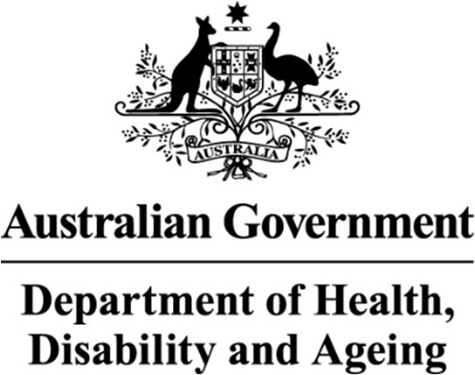

Deputy Secretary

Ms Joanna Abhayaratna Executive Director
Office of Impact Analysis
Department of the Prime Minister and Cabinet 1 National Circuit
BARTON ACT 2600

Email: Helpdesk-OIA@pmc.gov.au
Dear Ms Abhayaratna

Certification of Sunsetting Instrument
I am writing to the Office of Impact Analysis (OIA) regarding the Australian Immunisation Register Rule 2015 (the instrument) which, as per the
Legislation Act 2003, had been scheduled to sunset on 1 April 2026. The Department of Health, Disability and Ageing (the department) has decided that the instrument is to be remade without significant amendment.
In lieu of a detailed Impact Analysis for remaking the instrument, the department has self-assessed the Australian Immunisation Register Rule 2015 and certifies that it is operating effectively and efficiently - consistent with the Government's requirements for Sunsetting Legislative Instruments.
The assessment that the legislation is operating effectively and efficiently has been informed by a consultation process which involved Services Australia, state and territory health departments and internal stakeholders, including the National Immunisation Division. Consultation occurred in November and December 2025 and resulted in agreement to remake the instrument without significant amendment.

I also note that the regulatory burden to people, businesses, and community organisations has been quantified using the Australian Government’s Regulatory Burden Measurement framework. These are provided below.
Average annual regulatory costs (from business as usual)
Change in costs  ($ million) | Business | Community  organisations | People | Total change  in costs
Total, by sector | $0 | $0 | $0 | $0
I acknowledge that the OIA will publish this letter for transparency purposes. Yours sincerely
Dr Liz Develin
Primary Care, Community and First Nations Group 22nd February 2026

