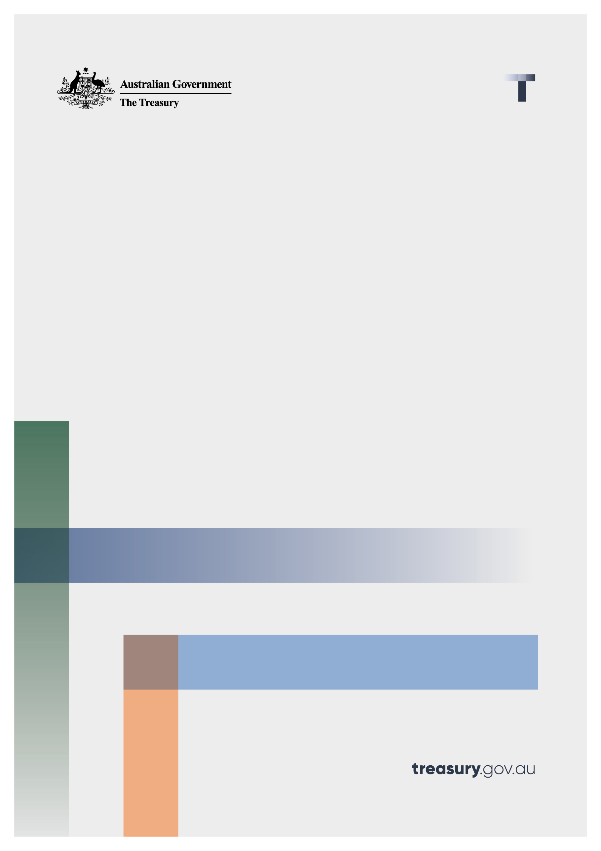
Supplementary Analysis

Capital Gains Tax and Negative Gearing

This Supplementary Analysis has been prepared by the Department of the Treasury (Treasury) to support the Impact Analysis Equivalent – Capital Gains Tax and Negative Gearing for the 2026-27 Budget measure: Tax Reform – Boosting Home Ownership – Reforming negative gearing and capital gains tax.
The Select Committee’s Report on the Operation of the Capital Gains Tax Discount addresses Impact Analysis questions 1, 3, 5 and part of 2.
2026-27 Budget, Budget Paper No. 1 – Budget Statement 4: Tax reform for workers, businesses and future generations accounts for questions 4, 6 and supplements question 2.
This Supplementary Analysis addresses question 7.

Question 7: How will you evaluate your chosen option against the success metrics?
The objectives of the reform are to:
- level the playing field for first home buyers;
- maintain support for investment in new housing supply; and
- better align taxation rates on income from assets more closely with income from work.
Success will be measured through measures of home ownership, particularly among younger Australians, and the degree of alignment of tax rates on income from assets, relative to tax rates for income on work.
Trends in home ownership will be an indicator of the policies’ overall effectiveness, as well as the impact of the broader package of housing initiatives. Consideration of home ownership trends will need to be interpreted carefully and over time, recognising that trends in home ownership are influenced by a range of factors and the impact of policy changes play out over time. The National Housing Supply and Affordability Council publishes the annual State of the Housing System report, which includes data and analysis on trends in the housing system. In the most recent edition of this report, a new Housing Outcomes Framework was introduced, which includes metrics on housing affordability and the home ownership rate for younger households.
A range of information would be drawn on to assess the impact of changes in the tax system.
The Intergenerational Report will serve as a regular evaluation of Australia’s tax system because it tests whether current revenue settings remain adequate, efficient and fair against long-run structural change. These reforms will apply on a prospective basis with transitional arrangements to provide certainty for investment decisions made under previous settings. As investments are brought into the new system and existing investments sold and transitioned out, the outcomes of this policy will become more clearly identifiable.
The annual Tax Expenditure and Insights Statement (TEIS) provides estimates of revenue foregone from the CGT discount (relative to the personal income tax benchmark) and distributional information, allowing comparison of how tax rates compare by income source.
Treasury routinely monitors the trends and insights available from these publications to inform its advice to Government and ensure it’s advice is robust, timely and well informed on matters of tax policy. Treasury will continue to monitor these sources with a particular focus on resolving any issues associated with the transition from the existing to new regimes.

