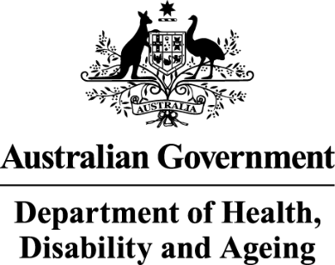

Deputy Secretary
Ms Joanna Abhayaratna
Executive Director
Office of Impact Analysis
Department of the Prime Minister and Cabinet
1 National Circuit
BARTON ACT 2600

Email: Helpdesk-OIA@pmc.gov.au
Dear Ms Abhayaratna

Impact Analysis – National Disability Insurance Scheme Reforms – Second Pass Final Assessment
I am writing in relation to the attached Impact Analysis (IA) prepared for the National Disability Insurance Scheme Reforms.
I am satisfied that the IA addresses the concerns raised in your letter of 7 May 2026 regarding the First Pass Assessment. Specifically, I can confirm that the analysis includes:
- the inclusion of metrics to better quantify what success would look like
- more information about the proposed evaluation plan, noting risks of implementation
- more information about the proposed evaluation plan
- the inclusion of the estimated total of the regulatory burden.
The regulatory burden to business, community organisations or individuals has been quantified using the Australian Government’s Regulatory Burden Measurement framework and is provided below.

Regulatory burden estimate table
Average annual regulatory costs (from business as usual)
Change in costs ($ million) | Business | Community organisations | Individuals | Total change in costs
Total, by sector | $4.44 | $0 | $27.8 | $32.24

The cost estimates in the table relate specifically to reforms to plan management and support coordination. At this time, there are no further known regulatory burdens for remaining reforms covered in this impact analysis.
Accordingly, I am satisfied that the IA is consistent with the six principles for Australian Government policy makers as specified in the Australian Government Guide to Policy Impact Analysis.
I submit the IA to the Office of Impact Analysis for formal final assessment.

Yours sincerely

Mary Wood
Deputy Secretary
Department of Health, Disability and Ageing
11 May 2026

