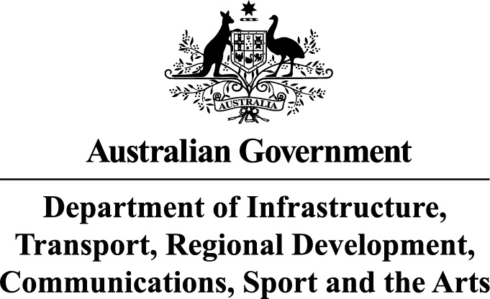

Ms Joanna Abhayaratna
Executive Director
Office of Impact Analysis
Department of the Prime Minister and Cabinet
1 National Circuit
BARTON ACT 2600

Email: Helpdesk-OIA@pmc.gov.au

Dear Ms Abhayaratna

Impact Analysis – Wagering Advertising Reform – Second Pass Final Assessment
I am writing in relation to the attached Impact Analysis (IA) prepared for the proposed Wagering Advertising Reforms.
The IA considers a range of options for restrictions on wagering advertising. It provides in depth analysis of 3 potential reform approaches - the status quo, a balanced approach and a full ban. The IA also incorporates advice previously provided by the Office of Impact Analysis.
As outlined in the IA, Australians lose over $32 billion on legal forms of gambling each year, representing the largest per capita losses in the world (around $1,500) according to the Queensland Treasury’s Australian Gambling Statistics 39th edition.
The Australian community is calling for further action on wagering advertising reform. Ad Standards recently released Community Sentiment Tracker, conducted by Roy Morgan, found that gambling advertising remains the leading issue of advertising concern for Australians (67%), far beyond any other category. Similarly, the Australian Communications and Media Authority (ACMA) noted that the recently concluded review of the Commercial Television Code of Practice highlighted significant community concern regarding wagering advertising on commercial television. These concerns are focused on exposure during children and family programming, and exposure during live sporting events.
Based on these concerns, the Department of Infrastructure, Transport, Regional Development, Communications, Sport and the Arts (department) considers the Government should implement wagering advertising reform to protect children from the harms of wagering advertising, break the association between sports and gambling, and address the saturation of wagering advertising.
In doing so, there is a need to consider the financial impact that advertising restrictions would have on the broadcasting and sports sector to ensure a meaningful reduction of wagering advertisements without unduly impacting the provision of public interest news journalism and grassroots sports.
The department considers that Option 2 in the IA achieves an appropriate balance between meeting the stated policy objectives without unduly impacting the sustainability of the affected sectors.
A comprehensive analysis was conducted to assess the net benefit of the recommended policy option. The recommended option achieves a net benefit of $107.1 million per annum.
The regulatory burden to business under the preferred Option 2 has been quantified using the Australian Government’s Regulatory Burden Measurement framework. These costs are $2.35 million per annum. There is no associated regulatory burden to community organisations or individuals for the proposed wagering advertising reforms.
Accordingly, I am satisfied that the IA is now consistent with the six principles for Australian Government policy makers as specified in the Australian Government Guide to Policy Impact Analysis.
I submit the IA to the Office of Impact Analysis for formal final assessment.

Yours sincerely

David Mackay
Deputy Secretary
Communications and Media Group
1 April 2026

