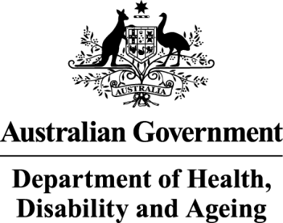

Deputy Secretary
Ms Joanna Abhayaratna
Executive Director
Office of Impact Analysis
Department of the Prime Minister and Cabinet
1 National Circuit
BARTON ACT 2600

Dear Ms Abhayaratna

Sunsetting of National Health (Pharmaceutical benefits—early supply) Instrument 2015

I am writing to the Office of Impact Analysis (OIA) regarding the National Health (Pharmaceutical benefits—early supply) Instrument 2015 (Instrument), which, as per the Legislation Act 2003, is scheduled to sunset on 1 April 2026. It is intended that the Instrument be remade without significant amendments to ensure the continuity of Australia’s Pharmaceutical Benefits Scheme (PBS).

The Department of Health, Disability and Ageing (Department) certifies that the Instrument is operating effectively and efficiently, and that therefore Impact Analysis is not required for this legislation to be remade. Remaking the Instrument will continue to ensure the proper use of PBS funding and support the responsible use of PBS medicines by discouraging stockpiling and reducing the quantity of unused medicines in the community.

Relevant stakeholders, including Services Australia, the Department of Veterans’ Affairs, the Pharmacy Guild of Australia, the Pharmaceutical Society of Australia and the Medical Software Industry Association, were informed in January 2026 of the Department’s intention to remake the Instrument without significant amendments. No substantive issues have been raised by stakeholders, reinforcing the Department’s view that the legislation is operating effectively and efficiently.

I also note that the regulatory burden to people, business, or community
organisations has been quantified using the Australian Government’s Regulatory
Burden Measurement framework. These are provided below.

Average annual regulatory costs (from business as usual)
Change in costs ($million) | Business Community | Community  organisations | People | Total change in costs
Total, by section | $0 | $0 | $0 | $0

I acknowledge that OIA will publish this letter for transparency purposes.

If you have any queries about this advice, please contact PBS Operational Policy at
pbsoperationalpolicy@health.gov.au.

Yours sincerely

Penny Shakespeare
Deputy Secretary
Health Resourcing Group
26 March 2026

