Comprehensive and Progressive Agreement for Trans-Pacific Partnership (CPTPP)
  - Post-Implementation Review

  - January 2025

  - CONTENTS
EXECUTIVE SUMMARY 1
INTRODUCTION 3
QUESTION 1: WHAT WAS CPTPP MEANT TO RESOLVE? 8
QUESTION 2: WHY WAS GOVERNMENT ACTION NEEDED? 11
QUESTION 3: WHAT POLICY OPTIONS WERE CONSIDERED? 14
QUESTION 4: WHAT WERE THE IMPACTS OF CPTPP? 16
QUESTION 5: WHICH STAKEHOLDERS HAVE BEEN CONSULTED? 53
QUESTION 6: HAS CPTPP DELIVERED A NET BENEFIT? 55
QUESTION 7: HOW HAS CPTPP BEEN IMPLEMENTED AND EVALUATED? 57
ATTACHMENT A: REGULATORY BURDEN ESTIMATE 62

EXECUTIVE SUMMARY
The Comprehensive and Progressive Agreement for Trans-Pacific Partnership (CPTPP) was signed on 8 March 2018 in Santiago, Chile by Ministers and Senior Officials representing Australia, Brunei Darussalam, Canada, Chile, Japan, Malaysia, Mexico, New Zealand, Peru, Singapore, and Vietnam. CPTPP entered into force for Australia, Canada, Japan, Mexico, New Zealand, and Singapore on 30 December 2018; 14 January 2019 for Vietnam; 19 September 2021 for Peru; 29 November 2022 for Malaysia; 21 February 2023 for Chile; 12 July 2023 for Brunei; and 15 December 2024 for the United Kingdom.

The Department of Foreign Affairs and Trade (DFAT) has conducted this Post-Implementation Review of the Agreement in accordance with the Australian Government's Guide to Regulation.
This Review has considered Australia’s objectives of negotiating and ratifying CPTPP, noting the policy context leading up to CPTPP’s entry into force, and the outcomes achieved in the five years following its implementation.
Analysis of relevant data outlined in this Post-Implementation Review shows CPTPP has met its objective of expanding economic opportunities with CPTPP members for Australian businesses and creating greater choice for Australian consumers in the five years after entry into force of the Agreement. In particular, since entry into force:
- Trade flows between Australia and CPTPP members have been further liberalised through tariff reductions, including by:
  - Providing our first FTA with Mexico, which led to the elimination of tariffs on barley (115 per cent prior to CPTPP’s entry into force) and the commencement of barley exports to Mexico in 2019. These exports proved vital for Australian barley exporters to diversify markets, and by 2023 barley exports to Mexico were valued at $213.2 million (up 44 per cent from 2022).
  - Gaining new access into Canada’s dairy market, with Canada offering over 100,000 tonnes of access for dairy products per year to CPTPP economies, which further supported Australian agricultural exporters diversifying into new markets.
  - Reducing Japan’s beef tariffs to 9 per cent within 15 years of entry into force (compared to JAEPA’s 23.5 per cent for fresh or chilled carcasses and half-carcasses) and the elimination of tariffs and creation of new quotas for dairy products.
- Total investment stocks into Australia by CPTPP members has increased, and in some cases doubled. For example, Canada’s total investment into Australia was $53.3 billion in 2018, and increased to over $103.8 billion in 2023.
- The average annual value of Australia’s total goods and services exports to CPTPP members was worth $141 billion (over 2019-23), increasing 54.6 per cent from the previous five-year period before CPTPP (which averaged $91.3 billion annually over 2014-18).
- The average annual value of Australia’s total goods and services imports from CPTPP members was worth $92.8 billion (over 2019-23), increasing 16.6 per cent from the previous five-year period before CPTPP (which averaged $79.6 billion annually over 2014-18).
Submissions received from stakeholders for this review provided a range of perspectives on the impact of CPTPP on Australian businesses, business activity, consumers, and civil society organisations. Most stakeholders were positive about the expansion of export opportunities through CPTPP but some noted that Australia’s other trade agreements, such as the Japan-Australia Economic Partnership Agreement, had delivered more significant market access gains in certain areas, and that CPTPP introduced more competition to Australian businesses in some industries.
Overall, CPTPP has delivered a net benefit to Australia in the five years since its entry into force. Notwithstanding the COVID-19 pandemic and corresponding difficulties faced by businesses, DFAT’s assessment is that CPTPP has been successful in liberalising trade and expanding opportunities and choices for Australian businesses and consumers. We expect CPTPP will continue to deliver further benefits in the future following the completion of the CPTPP General Review currently in progress, through increased utilisation of the Agreement, and as a result of the potential expansion of CPTPP’s membership through future accessions.

INTRODUCTION
- This Post-Implementation Review (PIR) relates to the Comprehensive and Progressive Agreement for Trans-Pacific Partnership (CPTPP), which entered into force on 30 December 2018 for Australia, Canada, Japan, Mexico, New Zealand and Singapore; 14 January 2019 for Vietnam; 19 September for Peru; 29 November 2022 for Malaysia; 21 February 2023 for Chile; 12 July 2023 for Brunei Darussalam; and 15 December 2024 for the United Kingdom.
- DFAT has conducted this review in accordance with the Australian Government Guide to Policy Impact Analysis and associated guidance.
- The purpose of this PIR is to assess whether CPTPP remains appropriate and how effective and efficient it has been in meeting its objectives.
- This Post-Implementation Review is required to address seven questions:
- What problem was CPTPP meant to solve?
- Why was Government action needed?
- What policy options were considered?
- What were the impacts of CPTPP?
- Which stakeholders had been consulted?
- Has CPTPP delivered a net benefit?
- How was CPTPP implemented and evaluated?

Background on TPP timelines and processes
- The Trans-Pacific Partnership Agreement (TPP) negotiations commenced in Melbourne, Australia in 2010 and concluded in Atlanta, United States on 5 October 2015. The TPP was signed on 4 February 2016, in Auckland, New Zealand by Ministers from Australia, Brunei Darussalam, Canada, Chile, Japan, Malaysia, Mexico, Peru, New Zealand, Singapore, the United States, and Vietnam.
- DFAT submitted a Regulatory Impact Statement on the TPP to the Office of Best Practice Regulation (OBPR) shortly after the TPP was signed. The text of the TPP and the accompanying National Interest Analysis was tabled in the Australian Parliament on 9 February 2016. On 30 November 2016, the Joint Standing Committee on Treaties (JSCOT) issued a report recommending that Australia take binding treaty action to ratify the TPP.
- At the time the JSCOT report was tabled, it was clear that the chances of the TPP entering into force were slim. The 2016 United States presidential election was being held in the same month the JSCOT report was tabled, and both presidential candidates had committed to withdraw from the TPP if elected. Subsequently, on 30 January 2017, the United States announced it did not intend to become a party to the TPP.
- The TPP provisions under Article 30.5 (Entry into Force) stated the Agreement could not enter into force unless it had been ratified by six signatories which together accounted for at least 85 per cent of the combined GDP of the signatories. This GDP threshold requirement could only be met if the United States ratified the TPP.
From TPP to CPTPP
- After the United States withdrew from the TPP, the remaining 11 signatories (Australia, Brunei Darussalam, Canada, Chile, Japan, Malaysia, Mexico, New Zealand, Peru, Singapore, and Vietnam) reached an agreement to identify pathways to bring the TPP into force amongst themselves.
- On 21 May 2017, Ministers representing the 11 TPP signatories issued a Joint Ministerial Statement reaffirming the potential strategic and economic significance of the TPP to regional economic integration and economic growth. Ministers then agreed to launch a process of consultations among Senior Officials to assess options to bring the TPP into force expeditiously.
- This process culminated in a recommendation on the composition of CPTPP. This would be a separate legal instrument that incorporated nearly all provisions of the TPP and excluded a limited set of suspended provisions. The core elements of CPTPP were announced on 11 November 2017 in Da Nang, Vietnam.
- Negotiations on CPTPP were concluded by Senior Officials on 23 January 2018 in Tokyo, Japan.
- On 8 March 2018, CPTPP was signed by Ministers in Santiago, Chile. DFAT submitted a Regulatory Impact Statement on CPTPP to the OBPR on 21 March 2018, shortly after the Agreement was signed.
- JSCOT received 69 submissions from civil society, peak bodies, industry and State and Territory governments during its consideration of CPTPP.
- The text of the Agreement along with a National Interest Analysis was tabled in the Australian Parliament on 26 March 2018.
- JSCOT tabled the report of its inquiry into CPTPP in Parliament on 22 August 2018. JSCOT made a number of recommendations in its report, including that Australia take binding treaty action to ratify CPTPP.
- On 23 August 2018, the Customs Amendment (Comprehensive and Progressive Agreement for Trans-Pacific Partnership Implementation) Bill 2018, with the Customs Tariff Amendment (Comprehensive and Progressive Agreement for Trans-Pacific Partnership Implementation) Bill 2018 was introduced to the House of Representatives to implement Australia’s obligations under CPTPP.
- Both Bills were introduced to the Senate on 18 September 2018 and were passed by both houses on 17 October 2018. Once enacted, the Customs Amendment (Comprehensive and Progressive Agreement for Trans-Pacific Partnership Implementation) Act 2018 amended the Customs Act 1901 to introduce new rules of origin for goods imported into Australia from a Party to CPTPP.
- On 31 October 2018, Australia notified New Zealand, as Depositary of CPTPP, that Australia had completed its applicable legal procedures necessary for entry into force.
- CPTPP entered into force for Australia on 30 December 2018. The first round of tariff cuts took place on entry into force and the second on 1 January 2019. Subsequent tariff cuts have and will take place every year until eliminated or, for a small number of products, significantly reduced (with the last round of reductions scheduled for 2040).
- The first CPTPP Commission meeting was held in Tokyo, Japan on 19 January 2019 and subsequent Commission meetings have been held annually since. The Eighth CPTPP Commission meeting recently took place in Vancouver, Canada on 28 November 2024.

Context
- In respect of its scope and ambition, the TPP (and CPTPP by extension) was the most significant international trade agreement ever negotiated since the completion of the WTO Uruguay Round in 1994.
- The withdrawal of the United States, the largest economy in the TPP, altered the overall impact of the Agreement. Nonetheless, by retaining almost all provisions of the TPP, CPTPP remains one of the most comprehensive plurilateral free trade agreements (FTAs) to date.
- CPTPP was considered during a period when many in the Australian community were uncertain of the benefits of free trade, and a number of economies were implementing protectionist economic policies.
- By the time CPTPP was signed by Ministers in March 2018, Australia already had bilateral FTAs with a majority of the original signatories, including New Zealand (1983), Singapore (2003), the United States (2005), Chile (2009), Malaysia (2013), and Japan (2015). This was in addition to the ASEAN-Australia-New Zealand Free Trade Area (AANZFTA) agreement (2010), which is a plurilateral FTA with regional partners.
- However, Australia did not have a FTA with Mexico, and the Canada-Australia Trade Agreement (CANATA), was last amended in October 1973 and predated the Harmonised System (HS). As such, Australia’s exporters faced additional barriers accessing both markets, and were disadvantaged due to Mexico’s and Canada’s existing FTAs with our competitors, such as the United States-Mexico-Canada FTA. As a result, CPTPP opened significant market access opportunities for Australian exporters.
- For Australia, the Indo-Pacific was also the appropriate region to define the new rules for global trade that covered all barriers and all sectors. The Indo-Pacific accounts for almost half of global trade and the majority of Australia's top two-way trading partners.
- This made expanding and deepening Australia’s trade and investment relationships in the Indo-Pacific critical to Australia’s future economic growth and prosperity. Considering the region’s growing importance in the world trading system, and the opportunities offered by its growing economies, the absence of a high standard plurilateral FTA with these economies was a risk to Australia’s ability to realise its full trading potential in the region.
- In addition to those chapters generally included in trade agreements, including those relating to the removal of tariff barriers, rules of origin and non-tariff barriers, access for business persons, investment, and intellectual property, CPTPP included new commitments and ambitious rules that went beyond typical FTA practice, including on:
  - government procurement
  - electronic commerce;
  - labour and environmental standards;
  - competition with state-owned enterprises;
  - regulatory coherence;
  - transparency and anti-corruption; and
  - small and medium-sized enterprises.

QUESTION 1: WHAT WAS CPTPP MEANT TO RESOLVE?
- Negotiating and implementing CPTPP - as an extension of the opportunities identified through TPP negotiations - was an opportunity for Australia to shape a high standard and rules-based trading system that spanned the Indo-Pacific region.
- CPTPP also allowed Australia to improve our trade competitiveness through:
- opening further market access opportunities to economies with which Australia already had FTAs;
- securing market access arrangements with economies with which we did not have existing bilateral FTAs such as Mexico; and
- strengthening preferential supply chains among CPTPP economies.
- Notwithstanding the existing trade and investment relationship between Australia and CPTPP economies, Australia’s absence in CPTPP would have forgone opportunities to:
- improve existing market access with FTA partners;
- be a member of the most progressive and ambitious FTA to date and shape its future development;
- secure new market access with Mexico and improve market access to Canada;
- improve trade in services;
- reduce costs to consumers and businesses;
- improve competitiveness for Australian goods exporters;
- increase investment flows;
- strengthen supply chains;
- address non-tariff barriers and transaction costs relating to agri-food trade and advocate for regulatory harmonisation under CPTPP’s committees; and
- strengthen relations with key economies in the region.

Existing market access with FTA partners
- Australia’s existing FTAs with CPTPP economies, while eliminating tariffs and other barriers on Australian exports, did not fully liberalise tariffs, particularly on sensitive goods. By joining CPTPP, Australia was able to expand on preferential access for goods and services exports to these economies.
- For example, although Australia had increased access for many products under the Japan-Australia Economic Partnership Agreement (JAEPA), there were still high tariffs, quota-limited access, and exclusions on many of Japan’s sensitive agricultural products: dairy products still faced ad valorem tariffs ranging up to 40 per cent; tariffs on beef were as high as 23.5 per cent; and wheat, barley, rice and sugar were also all subject to high weight-specific tariffs (between $0.58 to $3.93 per kilogram).
- Likewise, while Australia had at that time two existing FTAs with Malaysia, AANZFTA, and the Malaysia-Australia Free Trade Agreement (MAFTA), Australian exporters still faced high tariffs and quota-limited access into Malaysia on beer, wine, and other alcoholic beverages, as well as liquid milk and pork.
- Our existing FTA with Vietnam under AANZFTA also did not eliminate Vietnamese tariffs on a range of products of interest to Australia, including refined petroleum (20 per cent), iron and steel products (as high as 40 per cent), beer (47 per cent), wine (56 to 59 per cent), and spirits (55 per cent).
Market access into Canada and Mexico
- Prior to CPTPP, Australia did not have a FTA with Mexico and CANATA was last amended in 1973, leaving Australian exporters disadvantaged due to existing FTAs between both countries and competitor economies.
- Under CANATA, Australia’s access into the Canadian dairy market was significantly limited by existing quotas and high tariff arrangements. Canada’s tariff rate quota access for dairy products was incredibly small – for example, 332 tonnes for yoghurt, 394 tonnes for cream and 3,274 tonnes for butter (2,000 tonnes of which were allocated to New Zealand) – while out-of-quota tariffs were as high as 369 per cent. Apart from dairy, Canada also imposed tariffs of up to 94 per cent on barley products, 1.87 cents per litre on wine, and approximately 20 per cent on industrial products.
- Mexico also had high tariffs, particularly on agricultural products: up to 125 per cent on dairy; 115 per cent on barley; 67 per cent on wheat; 25 per cent on beef; and 20 per cent on wine. On industrial products, Mexico’s tariffs ranged from 15 to 30 per cent for automotive parts and mining equipment.
Improved trade in services
- Prior to CPTPP, some Australian businesses found it difficult to compete with local and other providers in a range of services sectors. Australian providers have benefited from CPTPP rules and obligations which require Parties to treat local and foreign service providers equally. Additionally, CPTPP reduced the requirement in many service sectors to establish a local office or have an employee live in the host country. Services providers have also benefitted from increased transparency in regulatory procedures which give businesses a clearer understanding of the operating conditions for the provision of services.
Improved competitiveness for Australian exporters
- CPTPP, in combination with our existing FTAs, helped level the playing field for Australian exporters.
- For example, prior to CPTPP, Australia had been losing wine market share into Japan against some of Japan’s FTA partners who enjoyed better preferential tariff rates. Chile enjoyed a tariff advantage on wine through its Economic Partnership Agreement with Japan, which entered into force in 2007, more than eight years before JAEPA (entry into force in 2015). During this time, Japan’s imports of Chilean wines more than doubled to $178 million, while wine imports from Australia decreased slightly to $46 million. CPTPP allowed Australian wine exporters to enjoy the same preferential access as their Chilean competitors. In this way, CPTPP has helped to improve the competitiveness of Australian exports in the region.
Improved investment
- Prior to CPTPP, there were investment restrictions in place for Australian businesses in CPTPP economies. In Canada, Australian investors were unable to apply for foreign ownership of uranium mines without a Canadian partner. The Agreement altered these conditions by enabling Australian investors to apply for an exemption from the 49 per cent foreign equity limit on foreign ownership of uranium mines, without first seeking a Canadian partner.

QUESTION 2: WHY WAS GOVERNMENT ACTION NEEDED?
- The Government’s objectives for concluding a high-quality CPTPP as soon as practicable were to maintain the high standards of the original TPP and secure and improve Australia’s competitiveness in key markets.
- Joining CPTPP also provided a strong platform to progress Australia’s bilateral relations, deepen regional integration, and advance strategic interests with CPTPP member economies.
Conclusions from CPTPP Regulatory Impact Statement
- The 2018 CPTPP Regulatory Impact Statement concluded it was in Australia’s interests to enter into a regional FTA with Brunei Darussalam, Canada, Chile, Japan, Malaysia, Mexico, Peru, New Zealand, Singapore, and Vietnam, given CPTPP was expected to:
- deliver commercially meaningful market access gains that would benefit Australian agriculture, resources, energy and manufacturing exporters, service providers, consumers, and investors;
- secure Australian exporters’ competitive position in the Indo-Pacific;
- deliver faster and deeper market access gains than would be possible through multilateral WTO negotiations;
- be consistent with WTO requirements for FTAs;
- and complement Australia’s efforts to seek additional trade liberalisation from other CPTPP parties through the WTO and regional mechanisms.
- It was also noted that:
- the removal of tariffs on merchandise imports from Canada and Mexico would lead to reductions in tariff revenue, and thereby affect the Government’s fiscal position, although this would be offset over time by the second-round effects of increased economic activity. The tariff reduction would also result in lower costs to Australian consumers; and
- eliminate Australia’s tariffs on virtually all products within four years following CPTPP’s entry into force. From entry into force of CPTPP, Australia would gradually phase out tariffs on a small number of products, mostly plastics and rubber, and textiles, clothing and footwear, iron and steel, motor vehicle components and some machinery and furniture. The only tariffs in Australia’s offer that would not be eliminated were those on used car imports. These tariffs represented only 0.1 per cent of Australia’s total tariff lines.
CPTPP objectives
- The primary objectives throughout CPTPP negotiations had been to retain the high standards of the original TPP, through maintaining the following outcomes:
- improved goods market access through the elimination of tariffs across the board and setting a regional approach to commitments to strengthen global value chains;
- new and improved market access into Canada and Mexico for our exporters;
- strong investment protections that would provide greater certainty to Australian investors in CPTPP economies, whilst retaining the ability to regulate legitimately on social, environmental or other similar public policy matters;
- arrangement to facilitate the mutual recognition of professional qualifications (such as for architects and engineers) and best practice regulations for foreign lawyers;
- new opportunities and a level playing field for Australian providers of, and investors in, minerals and energy and related services, education, engineering, financial and legal services and logistics, particularly in Malaysia and Vietnam;
- new commitments addressing the importance of the internet to international trade, providing certainty for Australian businesses of all sizes to move and store data across CPTPP economies;
- a permanent moratorium on the imposition of customs duties on electronic transactions;
- commitments to address, for the first time, the high cost of International mobile roaming;
- enhanced opportunities for Australian businesspersons seeking to enter and temporarily stay in other CPTPP countries through expeditious processing of immigration documents, minimised fees and transparency on entry requirements;
- commitments to enable short-term business visitors, intra-corporate transferees, certain independent executives, and contractual service suppliers to enter and stay temporarily in CPTPP countries;
- improved access for Australian suppliers to government procurement markets in other CPTPP countries;
- commitments to ensure rights of Australian intellectual property holders are protected effectively and enforced by other CPTPP countries’ IP regimes;
- new disciplines that address the role of state-owned enterprises in global trade whilst upholding Australia’s right to use state-owned enterprises for public interest purposes;
- commitments to ensure that the benefits of CPTPP are not undermined by anti-competitive practices;
- a new benchmark that will benefit workers across the region by promoting compliance with internationally-recognised labour rights and the effective enforcement of labour laws;
- commitments in areas where trade disciplines can help to address environmental challenges, including through liberalising trade in environmental goods and services and disciplines on fisheries subsidies that contribute to over-fishing;
- promotion of international efforts to combat corruption and bribery of officials and effective enforcement of anti-corruption laws; and
- a framework for settling disputes under CPTPP.

QUESTION 3: WHAT POLICY OPTIONS WERE CONSIDERED?
- The following outlines the policy options, separate to concluding CPTPP, that were considered by the Australian Government.
No action
- There were some modest benefits evident were Australia not to have joined CPTPP. The Australian Government would have made some savings on resources required for negotiating the Agreement.
- However, the opportunity cost of not joining CPTPP was considered significant. No action risked weakening our trade competitiveness in the region by denying Australian exporters and investors improved market access to CPTPP member economies, thereby disadvantaging them against competitors from CPTPP membership.
- CPTPP allowed Australia to take an active role in encouraging competitive liberalisation and eventual consolidation of the various FTAs in the region in a manner that advanced Australia’s trade, economic and foreign policy objectives. It also sent a much-needed signal to the international community that diverse economies could agree historic reductions in trade barriers and support cross-border trade and investment in the 21st century.
- The CPTPP was the highest standard regional FTA in the world. It was, and remains, the most significant force for liberal rules-based standards on trade and trade reform.
Regional Comprehensive Economic Partnership (RCEP)
- When Ministers signed CPTPP, Australia and six other CPTPP members (Brunei Darussalam, Japan, Malaysia, New Zealand, Singapore, and Vietnam) were also participating in RCEP negotiations, an ASEAN initiative that built on its existing FTAs with Australia, China, Japan, New Zealand, the Republic of Korea, and India.
- However, RCEP was not an alternative option for delivering the same outcomes as CPTPP. First, CPTPP was more ambitious than RCEP; it included, for example, chapters on state-owned enterprises, labour, and the environment. Second, although there was some overlap in membership between RCEP and CPTPP, there were important differences that made the two regional FTAs complementary yet distinct. In particular, CPTPP would bring in Canada, Chile, Mexico and Peru, whereas RCEP included all ASEAN countries, as well as China and the Republic of Korea.
- Lastly, RCEP was not signed until 2020, after ten years of negotiations, such that in 2018, when CPTPP was signed, it was not clear when RCEP negotiations would be concluded, or in what form.
Bilateral FTAs
- Australia could have sought to negotiate a separate bilateral FTA with Mexico and to update trading arrangements with Canada, while seeking to enhance our existing bilateral and plurilateral agreements. Nonetheless, negotiating new agreements and renegotiating existing agreements separately would have been resource intensive and would not have guaranteed that CPTPP members would lower their longstanding trade barriers in sensitive sectors such as agriculture. Moreover, bilateral FTAs would not have delivered the supply chain benefits available under a plurilateral FTA.

QUESTION 4: WHAT WERE THE IMPACTS OF CPTPP?
Preliminary discussion
- The analysis below identifies the key stakeholders impacted by CPTPP and considers broad trade and investment trends. It also analyses product-, sector-, and stakeholder-specific outcomes. The analysis draws heavily on data from the Australian Bureau of Statistics (ABS) and compares data before and after the entry into force of CPTPP.
- In considering these outcomes, it should be noted that CPTPP was a negotiated agreement among a diverse group of economies. While the agreement's conclusion represented overall gains for Australia and other CPTPP members, it did not result in universal satisfaction for all stakeholders. This is particularly evident in the case of sensitive agricultural products, where the outcomes reflect the balance of interests negotiated during the Agreement’s formation.
- Unlike some other FTAs, we have not commissioned formal economic modelling to comprehensively assess the net economic benefits resulting from Australia’s participation in CPTPP. Instead, our analysis relies on available statistical data and trends, which provide an indicative—but not exhaustive—view of the outcomes attributable to CPTPP. While economic modelling can provide valuable insights, it is resource-intensive and inherently subject to its own assumptions and limitations. This review seeks to present a balanced assessment by drawing on trade and investment data while acknowledging these constraints.
- Trade and investment flows between economies are influenced by a wide range of external factors beyond the scope of any single trade agreement. These include prevailing global and domestic economic conditions, exchange rate fluctuations, changes in supply and demand, and environmental factors such as weather-related impacts and natural disasters. Broader disruptions, such as the COVID-19 pandemic and geopolitical tensions, have also played a role in shaping recent trade and investment trends.
- Determining a direct causal relationship between an FTA like CPTPP and specific trade or investment outcomes is inherently complex. While this report examines trade and investment statistics before and after entry into force, these data alone do not always reveal the full picture. Trade with CPTPP member economies, for instance, does not necessarily imply utilisation of the Agreement, as overlapping FTAs may offer more competitive access for specific products. Similarly, comparing Australian and partner-country trade data can be challenging due to differences in valuation methodologies, transhipment through third countries, and timing discrepancies in data collection.
- The analysis also considers the influence of historical trends on trade and investment outcomes. For example, the significant expansion of Australia’s resource exports in the years preceding CPTPP’s entry into force had a notable impact on overall trade data trends and time-series analysis. Additionally, non-resource trade and investment flows during this period often reflected business strategies aimed at positioning themselves in key markets ahead of the Agreement’s implementation, with businesses seeking to capitalise on opportunities as the Agreement came into effect.
- This reliance on statistical analysis introduces certain limitations, as discussed in paragraphs 61 and 62. The absence of detailed utilisation data also limits our ability to assess the extent to which businesses have leveraged CPTPP-specific provisions. Some gaps remain in understanding the agreement’s broader economic impacts, such as its influence on productivity, innovation, and longer-term investment flows. These challenges underscore the need to interpret the findings of this review within the broader context of Australia’s overall trade and investment environment.
- In summarising these outcomes, this report seeks to provide a transparent assessment of CPTPP’s impact while acknowledging the methodological and analytical limitations inherent in the approach taken. By highlighting these factors, we aim to ensure a balanced and nuanced understanding of the agreement’s performance to date.

Key Outcomes of CPTPP Negotiations
For Australian goods exporters
- On entry into force of CPTPP for Australia on 30 December 2018, 98 per cent of tariffs were eliminated amongst members with an estimated combined GDP of US$12.1 trillion.
- CPTPP delivered immediate and enhanced tariff reductions across key markets in the Americas and Asia for Australian agricultural and food exports including for wine, beef, dairy, horticulture, seafood, grains, and sugar.
- It has also delivered new market access into Mexico – Australia’s first FTA with this G20 economy – and significantly built on Australia’s existing bilateral FTA with Canada.
- The elimination and reduction of tariffs and creation of new quota access into Japan opened up opportunities for Australian agricultural exports in an export market worth over $5.4 billion in 2017 (worth $6.8 billion in 2023), including by:
- A reduction in Japan’s beef tariffs to 9 per cent within 15 years of entry into force (compared to JAEPA’s 23.5 per cent for fresh or chilled carcasses and half-carcasses) and the elimination of tariffs and creation of new quotas for dairy products.
- New quota access for wheat, barley, malt and rice and a reduction in the levy on high polarity sugar.
- CPTPP tariff eliminations created new export opportunities into Canada and Mexico for beef, sheepmeat, wine, pharmaceuticals, and dairy products. In total, the new opportunities in these export markets were estimated at over $2 billion in 2016-17:
- In 2017, opportunities available to Australian exporters into Canada and Mexico included beef (worth over $126 million in 2017; Australian beef can now enter Canada tariff-free with the elimination of Canadian beef out-of-quota tariffs in 2023), sheepmeat ($96 million in exports), wine ($188 million), and pharmaceuticals ($28 million).
- For the first time, Australia also gained genuine new access into Canada’s dairy market, with Canada offering over 100,000 tonnes of access for dairy products per year to CPTPP economies.
- The elimination of Mexico’s tariffs on barley (115 per cent prior to CPTPP entry into force) became vital for Australian barley exporters seeking to diversify their markets once Australian barley exports to Mexico commenced in 2019. By 2023, the value of Australian barley exports to Mexico had risen to $213.2 million (an increase of 44 per cent from 2022).
- In 2022, Australia made its first shipment of tariff-free oats to Mexico (down from 10 per cent) under CPTPP. In 2023, exports were worth $37.4 million.
- In 2025, Mexico’s sheepmeat tariffs were eliminated (previously 10 per cent prior to entry into force). There continues to be potential for growth with sheepmeat exports to Mexico valued at $19.2 million in 2023, 57 per cent higher than 2022 levels.
- Australian beef exports to Mexico also continued to increase as tariffs under CPTPP continue to fall. From 2025, Mexico’s tariffs on fresh/chilled and frozen beef fell to 4 per cent and 5 per cent respectively, down from 20 per cent and 25 per cent pre-CPTPP. Exports of beef to Mexico were valued at $15.5 million in 2023, an 87 per cent increase from 2022.
- The value of Australian wine exports to Mexico has also steadily increased from $0.8 million in 2017 to $2.2 million in 2023, off the back of the complete elimination of tariffs for high value wines on 1 January 2020.
- The elimination of tariffs on Australian wine and alcoholic beverages into Malaysia and Vietnam provided export opportunities for our highly competitive wine industry. Likewise, tariff elimination on iron and steel products into Vietnam provided new opportunities, with Australia exporting over $224 million of iron and steel products to Vietnam in 2017.
- The geographic locality and the broad range of capabilities of CPTPP members also provided new opportunities for Australian exporters to participate in regional supply chains. Under the rules of origin of the Agreement, production in any one of the CPTPP economies counts towards a good’s originating status.
For Australian services suppliers
- CPTPP contributed to the growth and diversification of Australian exports of services by liberalising barriers and providing more transparent and predictable operating conditions in CPTPP economies.
For investors
- The raising of the Foreign Investment Review Board (FIRB) general screening threshold to $1.4 billion for foreign investment from CPTPP economies in non-sensitive sectors further encouraged investment into Australia from the region, including financial hubs such as Singapore.
- Australian total investment into most CPTPP members has increased since the Agreement entered into force. The Agreement also opened new markets for Australian investors. Prior to CPTPP, Australia did not have investment agreements with some CPTPP members, and Australian investors have benefited from added liberalisations and securities under the Agreement in these economies.
- Similarly, total investment stocks into Australia by CPTPP members has mostly increased, and in some cases doubled – for example, Canadian total investment into Australia was $53 billion prior to CPTPP in 2018 and increased to $100 billion as of 2022.

For Australian consumers and businesses
- Consistent with Australia’s other FTAs, remaining Australian tariffs on imports from CPTPP economies were eliminated, with consumers and businesses benefiting from downward pressure on prices.
- As a regional FTA, CPTPP created additional benefits, including for supply chains. Products created via international supply chains are taxed at the borders over which they cross enroute to Australia. Under CPTPP, producers can use inputs from any of the participating economies and trade under CPTPP preferential trading arrangements. This results in lower tariff rates on both inputs and final products, introduces additional flexibilities in where businesses can source inputs for, and provides greater resilience and security, reducing costs for businesses and consumers.
For business and skilled worker mobility
- CPTPP provided improved access for a range of Australian skilled service providers, investors and business visitors, supporting investment and providing business with greater certainty. CPTPP secured preferential temporary entry arrangements for Australian businesspeople and their spouses into key CPTPP markets, including the waiving of work permits and provision of work rights for spouses in Brunei Darussalam, Canada and Mexico. Reciprocal CPTPP commitments on temporary entry of skilled businesspersons would support greater trade and investment opportunities in the Indo-Pacific region.

Bilateral trade and investment post -CPTPP
CPTPP tariffs
- Analysis included in the CPTPP Regulatory Impact Statement indicated CPTPP eliminated 98 per cent of tariffs on entry into force of the Agreement, with Members combined GDP worth US$12.1 trillion.
- Australia’s own schedule of tariff eliminations was ambitious, with 93 per cent of all tariff lines eliminated or bound at zero immediately upon entry into force. Since then, the remaining tariffs have been phased to elimination over three or four years, and Australia’s specific tariff on used car imports was removed in August 2017.
- The market access outcomes in CPTPP built on those in Australia’s existing bilateral and plurilateral FTAs, and established a new FTA partnership with Mexico. The Agreement eliminated tariffs on more than $4.3 billion of Australia’s dutiable agricultural exports to CPTPP economies. A further $2.1 billion of Australia’s dutiable exports received preferential access through new quotas and tariff reductions.
- Australia’s tariff reductions reduced the overall costs of imported goods, resulting in improved price-competitiveness in the marketplace and benefitting consumers with cheaper prices and greater choices. In simple economic terms, the elimination or reduction of tariffs and other barriers to the bilateral flow of goods reduced the costs of trade and helped increase the competitiveness of the Australian economy.
FTA utilisation
- Total utilisation of Australian FTAs, across both exports and imports, is high.
- Notably, in 2023 there was strong CPTPP utilisation with Canada and Mexico for Australian exports and imports, the result of CPTPP’s function as Australia’s first FTA with Mexico and a significant update on the existing bilateral FTA with Canada. However, when Australia has several overlapping FTAs with a CPTPP economy, both importers and exporters tended to make greater use of older agreements such as bilateral FTAs or AAZNFTA, rather than CPTPP (Table 1 and 2). This is consistent with wider FTA practice, as businesses often require several years to become familiar with newer FTAs and update their preferences.
- Given the enhanced rules of origin procedures under CPTPP, there are also further opportunities to increase its usage as intra-CPTPP supply chains deepen and expand. Australia’s role as chair of CPTPP in 2025 provides another opportunity to uplift the monitoring of utilisation, including improving the fidelity of data.
Table 1: Australia ’s Exports FTA Utilisation (2023)
Country | Utilisation across all preferences | Bilateral FTA | AANZFTA | CPTPP | RCEP
Canada | 60% | - | - | 60% | -
Japan | 96% | 43% |  | 53% | 0%
Chile | 94.2% | 94% | - | 0.02% | -
Mexico | 67.7% | - | - | 67.6% | -
New Zealand | 97.4% | 96.8% | 0.54% | 0.1% | 0.0%
Note: Export utilisation data is incomplete due to the need to exchange data with partners. Totals may not add due to rounding.

Table 2: Australia’s Imports FTA Utilisation Comparison (2023)
Country | Utilisation across all preferences | Bilateral FTA | AANZFTA | CPTPP | RCEP
Canada | 70.4% | - | - | 70.4% | -
Chile | 95.7% | 95.1% | - | 0.6% | -
Japan | 96% | 95.5% | - | 0.4% | 0.0%
Malaysia | 91.5% | 29.3% | 61% | 1.1% | 0.1%
Mexico | 69.6% | - | - | 69.6%
New Zealand | 97.4% | 95.6% | 1.6% | 0.2% | 0.0%
Peru | 79.4% | 67.6% | - | 11.8% | -
Singapore | 84.8% | 5% | 72.7% | 4.3% | 2.8%
Vietnam | 91.9% | - | 81.9% | 6.4% | 3.5%
Note: Export utilisation data is incomplete due to the need to exchange data with partners. Totals may not add due to rounding.
Trade balance with CPTPP members
- Since the Agreement’s entry into force, Australia’s goods and services trade balance with CPTPP members has increased by 164 per cent ($19.6 billion in 2018 to $51.5 billion in 2023), despite a sharp dip in 2023 (Chart 1).
- While this positive movement could be, in part, attributed to CPTPP, it has also been largely consistent with Australia’s overall trade balance, which is highly dependent on current commodity prices.

Chart 1: Australia’s total goods and services balance with CPTPP economies ($ million)
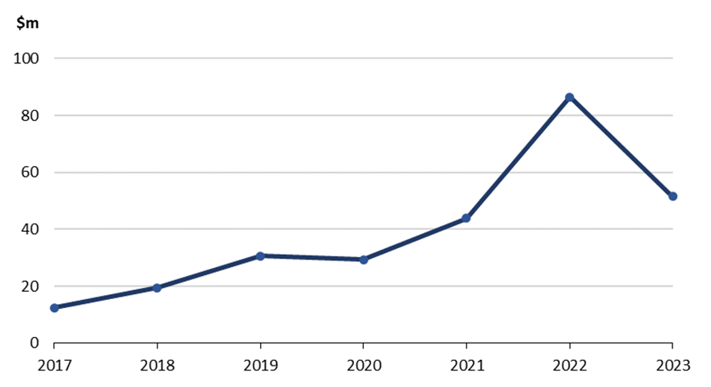
Note: chart reflects current prices, goods recorded on a recorded trade basis, services on a balance of payments basis.
Source: ABS Balance of Payments and International Investment Position (June 2024) and International Trade: Supplementary Information, Calendar Year.
Goods and services exports
- There has been a net increase in Australia’s goods and services exports to CPTPP members since CPTPP’s entry into force (Chart 2), despite a decline in exports in 2020 (due to COVID-19-related disruptions). The annual average value of Australia’s goods and services exports in the 2014-18 period was $91.3 billion, compared to an average of $141 billion in the 2019-23 period (an increase of 54.6 per cent) (Chart 3).
- Factors such as the removal of further tariffs over time in existing FTAs and the entry into force of RCEP in 2022 (to which many CPTPP members are parties) could have also contributed to this result.
Chart 2: Goods and services exports to CPTPP economies ($ billion)
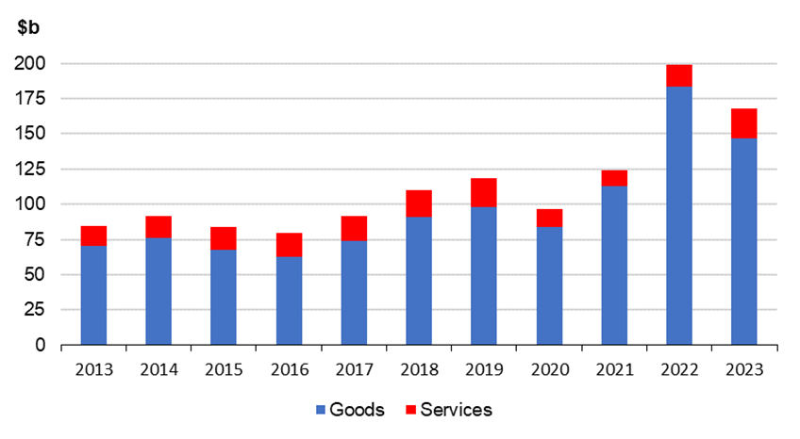
Source: ABS Balance of Payments and International Investment Position (June 2024) and International Trade: Supplementary Information, Calendar Year.
Chart 3: Average goods and services exports to CPTPP economies ($ billion)
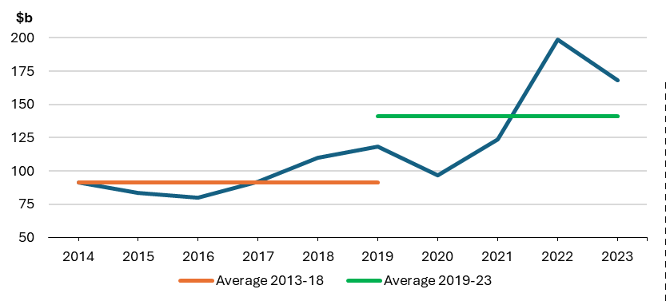
Note: Average period is calculated by data available pre- and post- entry into force of CPTPP (30 December 2018).
Source: ABS, Australia’s goods and services exports, current prices.
Impact on services exports
- Prior to CPTPP entering into force, the value of Australia’s services exports to CPTPP members was $18.8 billion in 2018. The average value of total annual services exports to CPTPP members was $17.1 billion in the 2014-18 period. This value decreased by 6.8 per cent after CPTPP entered into force, with services exports in the 2019-23 period valued at $15.9 billion (Table 3).
- However, this overall reduction can be misleading because there was a significant drop in services exports during both 2020 and 2021 (Table 3), which can be attributed to the impact on trade of the COVID-19 pandemic.
- With Australia’s new FTA partner Mexico, our average annual value of services exports in the 2014-18 period was valued at $113 million. This increased by 24.3 per cent following the entry into force of CPTPP, with the average value of Australia’s exports to Mexico in the 2019-23 period valued at $141 million.
- From 2019-23, there were mixed gains in Australian services exports to CPTPP members from ASEAN countries. Average annual services exports to Brunei Darussalam grew from $60.4 million in the 2013-18 period to $61.0 million in the 2019-23 period, an increase of about 1 per cent. Annual services exports to Vietnam increased on average from $1.5 billion for the 2014-18 period to $1.7 billion during the 2019-23 period, an increase of 14.2 per cent. For Singapore, annual exports reduced from $4.7 billion (2014-2018 period) to $4.4 billion (2018-2023 period), a decrease of 7.6 per cent. Australian exports to Malaysia followed a similar trajectory with annual services exports averaging $2.5 billion in the 2014-2018 period and reducing to $1.85 billion in the 2019-2023 period, a decrease of 24.7 per cent.
- Services exports to other existing bilateral FTA partners from 2019 to 2023 also saw mixed gains. To Chile, average annual services exports grew from $222 million in the 2014-18 period to $262 million in the 2019-23 period, an increase of 17.9 per cent. Exports to Peru rose from an average value of $69.2 million in the 2014-18 period to $87.6 million in the 2019-23 period, an increase of 26.6 per cent. Australia’s average annual exports to Japan was valued at $2.2 billion in the 2014-18 period and reduced to $1.7 billion in the 2019-23 period, a decrease of 21.1 per cent. The average of our annual exports to New Zealand in the 2014-18 period was valued at $4.7 billion and grew to $4.8 billion in the 2018-23 period, an increase of 0.5 per cent.
Impact on goods exports
- Prior to CPTPP entering into force, Australia’s total annual good exports to members were valued at $98.1 billion in 2018. Australia’s average annual goods exports to CPTPP members in the 2014-18 period were valued at $74.2 billion. This increased by 68.8 per cent after CPTPP entered into force, with average goods exports in the 2019-23 period valued at $125 billion (Table 4).
- The average annual value of goods exports to Mexico in the 2014-18 period was $406 million. This increased by 31.2 per cent following entry into force of CPTPP, with the average value of Australia’s exports to Mexico in the 2019-23 period worth $533 million.
- Likewise, goods exports to Canada also increased following the entry into force of CPTPP. The value of Australia’s exports in the 2014-18 period averaged $1.6 billion annually. After entry into force, this value increased by 45.7 per cent for the 2019-23 period and was worth $2.4 billion.
- From 2019-23, there was also a rise in Australian goods exports to ASEAN CPTPP members. The average value of annual goods exports to Brunei Darussalam grew from $44.8 million in the 2013-18 period to $405 million in the 2019-23 period, an increase of 806 per cent. Similarly, the value of annual goods exports to Vietnam increased on average for the 2014-18 period from $4.0 billion to $9.7 billion during the 2019-23 period, an increase of 141 per cent. For Singapore, the value of annual exports rose from $7.5 billion (2014-2018 period) to $15.2 billion (2018-2023 period), an increase of 104 per cent. Australian exports to Malaysia followed a similar path with annual goods exports value averaging $6.2 billion in the 2014-2018 period and growing to $9.9 billion in the 2019-2023 period, an increase of 61.0 per cent.
- Goods exports to other existing bilateral FTA partners within the CPTPP membership from 2019 to 2023 also saw gains. To Chile, the value of average annual goods exports grew from $359 million in the 2014-18 period to $649 million in the 2019-23 period, an increase of 81 per cent. Exports to Peru rose from an average value of $132 million in the 2014-18 period to $190 million in the 2019-23 period, an increase of 43.5 per cent. Australia’s average annual exports to Japan were valued at $45.2 billion in the 2014-18 period and grew to $74.6 billion in the 2019-23 period, an increase of 65.2 per cent. Similarly, the average of our annual exports to New Zealand in the 2014-18 period was valued at $8.8 billion and grew to $11.6 billion in the 2018-23 period, an increase of 31.9 per cent.

Table 3: Value of Australia’s services exports to CPTPP economies ($m)
Source: ABS Australia’s goods and services exports, current prices.

Table 4: Value of Australia’s goods exports to CPTPP economies ($m)
Source: ABS Australia’s goods and services exports, current prices. Analysis prepared by DFAT.

Key agricultural and processed food exports
- Table 5 outlines the key market access outcomes for agricultural products under CPTTP, including a comparison between the value of exports in 2018 (before CPTPP entered into force) and 2023.

Table 5: Key agricultural market access outcomes for Australia
Sector | Summary Outcomes
Beef | Beef exports were worth $11.5 billion in 2023, up from $8.7 billion in 2018. In 2023, 20 per cent of Australia’s beef exports went to CPTPP markets, worth $2.5 billion.  CPTPP market access outcomes for Australian beef producers and exporters include:  - Japan’s beef tariffs will be reduced to 9 per cent within 15 years of entry into force of CPTPP. Australian fresh, chilled and frozen beef exports to Japan were valued at $1.8 billion in 2023;  - The majority of Japan’s tariffs on offal will be eliminated over 10 to 15 years from entry into force of CPTPP, and tariffs on cheek and head meat will significantly reduce to 9 per cent within 15 years of entry into force of CPTPP. Australian offal exports to Japan were valued at $300 million in 2023;  - Elimination of Japanese tariffs on processed meat products within 15 years of entry into force of CPTPP. Australian exports of these products to Japan were valued at $41.9 million in 2023;  - Elimination of Canadian beef tariffs (previously 26.5 per cent) within five years of entry into force of CPTPP. Australian beef exports to Canada were valued at more than $200 million in 2023;  - Elimination of all Mexican tariffs on beef carcasses and cuts (previously up to 25 per cent) within 10 years of entry into force of CPTPP. Australian exports of this product were valued at $15.5 million in 2023; and  - Elimination of Mexico’s tariff (previously 20 per cent) on “other offal” (used for taco meat) from entry into force of CPTPP. Australian exports of this product were valued at around $9.7 million in 2023.
Sheepmeat | Australia exported around $629 million of lamb and mutton to  CPTPP markets, representing 14 per cent of all sheepmeat exports in 2023. This is compared to $559 million in 2018, a total increase of 13 per cent.  Key CPTPP market access outcomes include:  - Tariffs on exports to Mexico will be eliminated within 8 years of entry into force of CPTPP. Australia sheepmeat exports to Mexico were valued at $19.2 million in 2023, 57 per cent higher than 2022 levels; and  - Tariffs on sheepmeat exports to all other CPTPP countries were eliminated on entry into force.
Wool | CPTPP eliminated all remaining tariffs on Australian raw wool exports to CPTPP markets from entry into force of the Agreement.  Total Australian exports of wool were valued at around $3 billion in 2023, of which wool exports to CPTPP market accounted for $26.2 million. This is compared to $56 million in 2018, a total decrease of 53 per cent.  The rules of origin for textiles encourages greater demand for the Australian wool used to produce high quality yarns. Products produced using Australian wool in Malaysia, Vietnam or any other CPTPP partner receive preferential treatment in CPTPP economies’ markets.
Pork | In 2023, 67 per cent of Australia’s pork exports went to CPTPP markets, valued at over $130 million, compared to $89 million in 2018. Key CPTPP market access gains for Australian pork producers and exporters include:  - Building on JAEPA, elimination of the ad valorem component of Japan’s pork tariffs within 10 years of entry into force of CPTPP;  - Building on JAEPA, a 90 per cent reduction in Japan’s specific tariff applied to pork cuts and carcasses within 10 years of entry into force of CPTPP;  - Building on MAFTA and AANZFTA, elimination of all Malaysian pork tariffs within 15 years; and  - Elimination of Mexico’s 20 per cent pork tariff on entry into force of CPTPP.
Cereals and grains | Total Australian exports of cereals and grains were valued at around $18.9 billion in 2023, more than 20 per cent (or $3.9 billion) of which was exported to CPTPP markets. This is in comparison to $1.4 billion worth of exports to CPTPP markets in 2018.  CPTPP market access outcomes for Australian cereals and grains producers and exporters include:  - Significant market access improvements in Japan for wheat, barley and malt, building on JAEPA, including:  - reduction of the mark up on wheat and barley by 45 per cent within 8 years of entry into force of CPTPP;  - the creation of new quota volumes for wheat and barley under the simultaneous buy-sell mechanism. Australia’s exports of these products to Japan were worth $1 billion in 2023; and  - new quota access for Australian malt exports;  - Elimination of Mexican tariffs on wheat (previously 67 per cent) within 10 years of entry into force of CPTPP;  - Elimination of Mexican tariffs on barley (previously 115 per cent) within 5 years of entry into force of CPTPP; and  - Elimination of all Canadian tariffs on cereals and grains upon entry into force of CPTPP.
Dairy | Total Australian dairy products exports were valued at more than $2.9 billion in 2023, and 31 per cent (valued at $919 million) was exported to CPTPP markets. This is compared to $978 million in exports to CPTPP countries in 2018.  Key CPTPP market access outcomes for Australian dairy producers and exporters include:  - Significant market access improvements in Japan for Australian dairy. Australian dairy exports to Japan were worth $397 million in 2023. Building on JAEPA, outcomes include:  - elimination of tariffs on certain cheese products, and tariff reductions and new quota allocations for remaining cheese products;  - new quotas for butter and skim milk powder with the in-quota mark-up eliminated within 10 years of entry into force of CPTPP; and  - new quotas and tariff reductions for a range of dairy products including ice cream, whole milk powder, condensed milk, yoghurt and infant formula;  - Preferential access into the highly protected Canadian market with new quotas for dairy products including, cheese, milk powders and butter. Tariffs on milk protein concentrates were eliminated on entry into force; and  - Mexico will create new quota access, including for butter, cheese and milk powders, and will eliminate tariffs on yoghurt.
Rice | Total Australian rice exports were estimated to be worth $409 million in 2023, up from $315 million in 2018. Despite additional access for rice exports to Japan, this has not yet been utilised by Australian exporters.  Key CPTPP market access outcomes include:  - For the first time since 1995, new quota access for Australia into Japan with a new 6,000 tonne quota from entry into force of CPTPP, growing to 8,400 tonnes after 12 years, for Australian rice and rice flour exports. Japan will also reduce tariffs on a number of rice preparation products; and  - Improvements to Japan’s tendering process for rice. Japan will now offer tenders 6 times a year, including an additional tender in May in line with Australia’s growing season.
Sugar | Total Australian exports of sugar were estimated to be worth $2.2 billion in 2023, compared to $1.8 billion in 2018, and around half of these exports (valued at $1.1 billion) went to CPTPP markets. CPTPP market access gains for Australian sugar producers and exporters include:  - Building on JAEPA, elimination of Japan’s tariff and reduction in the levy on high polarity sugar exports on entry into force of CPTPP. In 2023, Australian sugar exports to Japan were estimated to be valued at $1 billion, up from $364 million in 2018;  - Elimination of Canada’s tariffs on refined sugar (currently CA$30.86 per tonne) within 5 years of entry into force of CPTPP. Australia already has duty free access for raw sugar into Canada;  - Mexico will also apportion Australia a guaranteed 7 per cent of any tariff rate quota for raw sugar in the years in which it is offered. Australia is only the sixth country Mexico has offered such an outcome;  - Elimination of in-quota tariffs on Vietnam’s WTO sugar quota within 11 years of entry into force; and  - Malaysia has committed to allow Australia to engage in the wholesale distribution of refined sugar in Malaysia for use in the food and beverage industry.
Cotton | Total Australian exports of cotton were valued at $1.9 billion in 2023 (44 per cent of which were sent to CPTPP markets), compared to $532 million in 2018.  All tariffs on Australian cotton exports will be eliminated under CPTPP, with most eliminated from entry into force. Australian cotton producers will also benefit from creation of new regional supply chains into the Japanese consumer market. For example, clothing produced in Vietnam from Australian cotton will benefit from the elimination of Japanese tariffs on cotton products over 10 to 15 years – encouraging greater demand for Australian cotton in CPTPP region.
Wine | Total Australian wine exports were valued at more than $2 billion in 2023, down from $2.9 billion in 2018, and around 24 per cent of these exports (valued at $485 million) went to CPTPP economies. CPTPP market access gains for Australian wine producers and exporters include:  - Elimination of Canada’s tariffs (from 1.87 cents per litre to 4.68 cents per litre) upon entry into force of CPTPP. Australian wine exports to Canada were valued at $142 million in 2023, down from $208 million in 2018;  - Elimination of Malaysian tariffs within 15 years of entry into force of CPTPP. Australian wine exports to Malaysia were valued at $42 million in 2023, up from $34 million in 2018;  - Elimination of Vietnamese tariffs within 11 years of entry into force of CPTPP. Australian wine exports to Vietnam were valued at $11.4 million in 2023, up from $6.65 million in 2018; and  - Elimination of Mexican tariffs (currently 20 per cent) within 3 years of entry into force of CPTPP for higher quality wine and elimination of all tariffs within 10 years of entry into force of CPTPP for all wine.
Horticulture | Total Australian horticulture exports were valued at $5.6 billion in 2023, up from $3.3 billion in 2018 and 14 per cent of these exports (valued at $762 million) went to CPTPP countries. CPTPP market access outcomes for Australian horticultural producers and exporters include:  - Building on JAEPA, Japan extended the period by which oranges will face the lower “out of season” tariff (corresponding to the main growing season in Australia) to an 8-month period annually (from 1 April to 30 November), and will eliminate that tariff over 6 years. The higher “in season” tariff will be eliminated over 7 years. Australian orange exports to Japan were valued at $80 million in 2023, up from $69 million in 2018;  - Japan will also eliminate all tariffs on fruit juices within 10 years of entry into force of CPTPP, building on the quota arrangements achieved under JAEPA. Australian fruit juice exports to Japan were valued at $25 million in 2023, up from $10 million in 2018;  - Elimination of all Canada’s horticulture tariffs upon entry into force of CPTPP. Australian horticultural exports to Canada were valued at $39 million in 2023, up from $31 million in 2018; and  - Elimination of most of Mexico’s horticulture tariffs upon entry into force of CPTPP and elimination of all tariffs within 15 years of entry into force.
Seafood | Australia’s total seafood exports in 2023 were worth nearly $1.3 billion, down from $1.4 billion in 2018, with 30 per cent of exports going to CPTPP markets valued at $395 million. CPTPP market access outcomes for Australian seafood producers and exporters include:  - All Japanese seafood tariffs will be eliminated within 15 years of entry into force of CPTPP;  - All Vietnamese seafood tariffs will be eliminated on entry into force of CPTPP;  - Canada will eliminate all tariffs on entry into force of CPTPP; and  - Mexico’s seafood tariffs will be eliminated within 15 years of entry into force of CPTPP, with the majority eliminated on entry into force.
Source: CPTPP, WTO, GACC, ABS

Key resources, energy and industrial exports
- Australian exports of resources, energy, and manufactured products generally faced far lower tariff barriers than those facing agricultural goods. Nonetheless, CPTPP eliminated all remaining tariffs on Australian exports of non-agricultural products to CPTPP economies and created new opportunities for Australian exports, with the exception of a remaining tariff rate quota on used vehicles into Vietnam.
- Australia’s exports of resources and energy products to CPTPP economies were worth $98.5 billion in 2023, up by 72 per cent from 2018 ($57.4 billion). An analysis of the exports of mineral and fuel to CPTPP economies shows a gradual increase in exports since the entry into force of the Agreement before experiencing a decline in 2020 due to the COVID-19 pandemic. There was strong year on year growth from 2021-22 following a trending spike in global energy prices, before dampening in 2023.
- Chart 4 shows the steady growth of mineral and fuel exports to CPTPP economies. Japan was Australia’s largest export market for Australian minerals and fuel, accounting for 74 per cent of exports in 2023, followed by Singapore (11 per cent), Malaysia (6 per cent) and Vietnam (6 per cent).
Chart 4: Australian mineral and fuel exports to CPTPP economies (2013-23, $ billion)
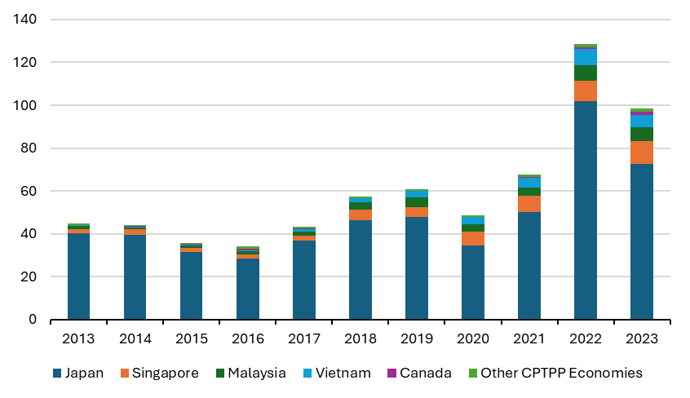
Goods and services imports
- CPTPP benefited consumers by creating a greater choice of goods at lower prices. Australia’s final tariff offer to CPTPP members on goods market access was plurilateral – which means the same offer was made to all members. Consistent with other Australian FTAs and our trade policy settings, Australia’s tariff elimination schedule was ambitious, with 93 per cent of all tariff lines eliminated or bound at zero tariff rates upon entry into force of the Agreement.
- Virtually all Australian tariffs which were not eliminated immediately on entry into force were eliminated within the third or fourth year of the Agreement. Remaining Australian tariffs covered those sectors where Australia was seeking some level of protection against imports from CPTPP members. This included tariffs of mostly 5 per cent on plastics and rubber, textiles, clothing and footwear, iron and steel, motor vehicle components and some machinery, and furniture. The phased elimination of these tariffs aligned with existing FTAs and did not undercut any existing tariff phasing arrangements for sensitive products with existing FTA partners. The only tariff in Australia’s offering that was not eliminated immediately or due to be phased to elimination when CPTPP entered into force was a $12,000 specific tariff on used car imports. However, this tariff was eliminated in August 2017.
- There has been a steady increase in Australia’s goods and services imports from CPTPP members since the Agreement’s entry into force (Chart 5) despite a sharp decline in 2020 (due to COVID-19 related economic disruptions). The average value of Australia’s goods and services imports in the five-year period before CPTPP entered into force (2014-18) was worth an estimated $76.9 billion. There was a significant increase in the average value of services imports during the same length period after CPTPP entered into force (2019-2023) of $92.8 billion, an increase of 16.6 per cent (Chart 6).
- In assessing this outcome, it is noted that other factors such as the removal of further tariffs over time through existing FTAs, and the introduction of RCEP in 2022, could have also contributed to this result.

Chart 5: Goods and services imports from CPTPP economies ($ million)
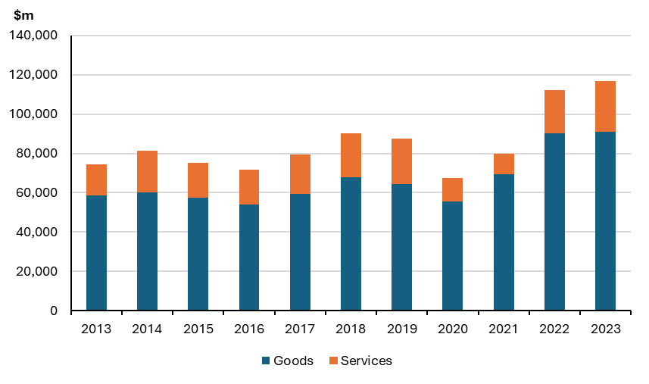
Source: ABS Australia’s goods and services imports, current prices.
Chart 6: Average value of goods and services imports from CPTPP economies ($ billion)
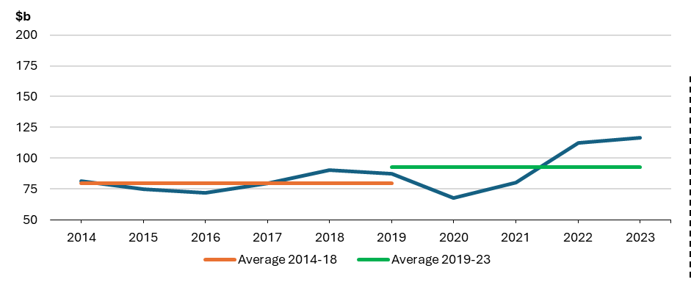
Note: Average period is separated by pre- and post- entry into force of CPTPP (30 December 2018).
Source: ABS Australia’s goods and services imports, current prices.
Impact on goods imports
- Australia’s total goods imports from CPTPP members was valued at $68.1 billion in 2018. Since entry into force, the annual average value of goods imports has risen from $59.9 billion in the 2014-18 period to $74.1 billion in the 2019-23 period, an increase of 23.7 per cent (Table 6).
- The average value of annual goods imports from Mexico grew from $2.6 billion in the 2014-18 period to $3.6 billion in the 2019-23 period, an increase of 39.2 per cent. The average value of imports from Canada grew from $2.2 billion in the 2014-18 period to $3.1 billion in the 2019-23 period, an increase of 43.4 per cent.
- Between 2019 and 2023, there was also a rise in the average annual value of goods imports from ASEAN CPTPP economies to Australia. The average value of goods imports from Brunei Darussalam rose from $539 million in the 2014-18 period to $2.4 billion in the 2019-23 period, an increase of 353 per cent. Imports from Vietnam increased 53.5 per cent from $5.0 billion in the 2014-18 period to $7.7 billion in the 2019-23 period. From Singapore, our imports grew 35.2 per cent from an annual average of $9.8 billion in the 2014-18 period to $13.3 billion in the 2019-23 period. Likewise, goods imports from Malaysia increased 27.1 per from $11.0 billion in the 2014-18 period to $14.0 billion in the 2019-23 period.
- The average annual value of goods imports from other existing bilateral FTA partners within the CPTPP membership in the period between 2019 and 2023 saw mixed gains. In the period after entry into force of the Agreement, imports from Chile decreased 22.6 per cent from a value of $653 million in the 2014-18 period to $506 million in the 2019-23 period. Imports from Peru decreased 31.8 per cent from a value of $263 million in the 2014-18 period to $179 million in the 2019-23 period. Australia’s imports from Japan increased by 10.0 per cent from the annual average of $20.1 billion in the 2014-18 period to $22.1 billion in the 2019-23 period. Our imports from New Zealand reduced from $7.8 billion in the 2014-18 period to $7.2 billion in the 2019-23 period, a decrease of 7.2 per cent.
Impact on services imports
- Australia’s services imports from CPTPP members were worth $22.1 billion in 2018. Since entry into force, the annual average value of services imports fell from $19.7 billion in the 2014-18 period to $18.7 billion in the 2019-23 period, a decrease of 5.0 per cent (Table 6).
- The average value of annual services imports from Mexico reduced from $179 million in the 2014-18 period to $106 million in the 2019-23 period, a decrease of 40.8 per cent. The average value of imports from Canada reduced from $1.8 billion in the 2014-18 period to $1.6 billion in the 2019-23 period, a decrease of 15.5 per cent.
- Between 2019 and 2023, there were mixed gains in the average annual value of services imports from ASEAN CPTPP members to Australia. The average value of services imports from Brunei Darussalam decreased from $62.4 million in the 2014-18 period to $29.8 million in the 2019-23 period, a decrease of 52.2 per cent. Imports from Vietnam decreased 28.5 per cent from $1.3 billion in the 2014-18 period to $941 million in the 2019-23 period. From Singapore, our imports grew 0.6 per cent from an annual average of $6.3 billion in the 2014-18 period to $6.3 billion in the 2019-23 period. Likewise, services imports from Malaysia have not fluctuated significantly, but have grown marginally at a rate of 0.05 per cent from $1.106 billion in the 2014-18 period to $1.107 billion in the 2019-23 period.
- The average annual value of services imports from CPTPP members where there are existing bilateral FTAs in place also saw mixed gains in the 2019-23 period. Imports from Chile decreased 49.9 per cent from an average value of $290 million in the 2014-18 period to $145.2 million in the 2019-23 period. Imports from Peru decreased 60.2 per cent from a value of $152.4 million in the 2014-18 period to $60.6 million in the 2019-23 period. Australia’s imports from Japan decreased by 7.7 per cent from the annual average of $3.4 billion in the 2014-18 period to $3.2 billion in the 2019-23 period. Imports from New Zealand increased from $5.0 billion in the 2014-18 period to $5.3 billion in the 2019-23 period, a decrease of 7.7 per cent.

Table 6: Goods Imports by CPTPP Economy
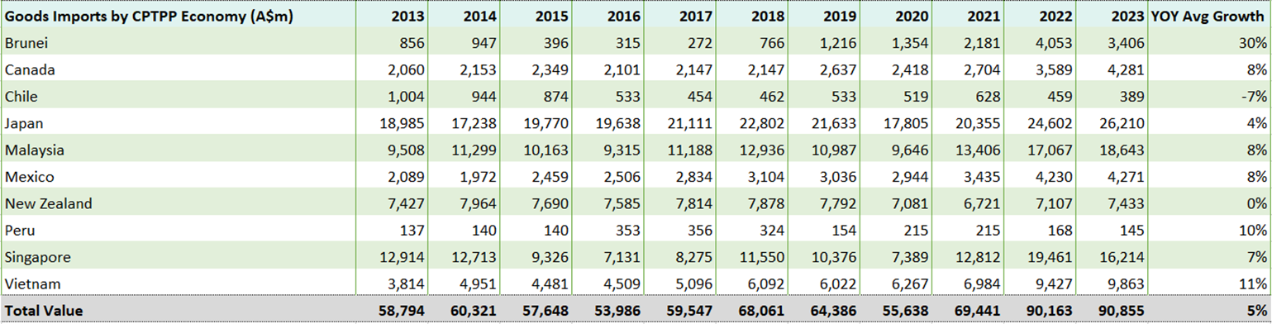
Source: ABS Australia’s goods and services imports, current prices.

Table 7: Service Imports by CPTPP Economy
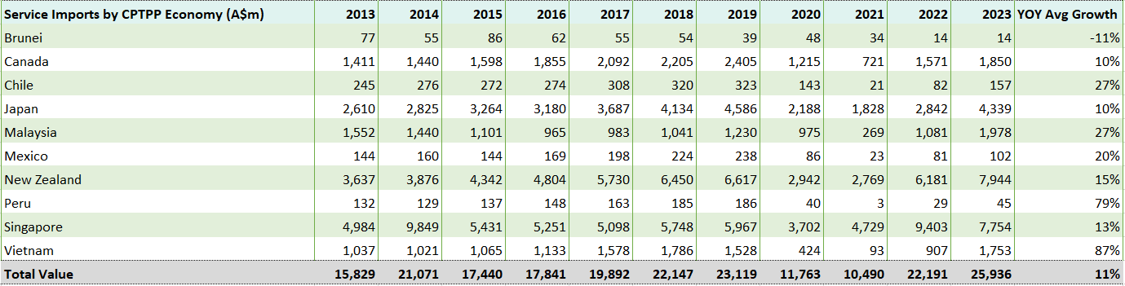
Source: ABS Australia’s goods and services imports, current prices.
Education-related travel services
- Chart 7 indicates that the value of Australian education-related travel services exports to CPTPP member economies continued to rise steadily between 2013 to 2019 (up 2.6 per cent from $4.5 billion in 2018) before experiencing a sharp decline between 2019 and 2021 (down 42.8 per cent), which can be attributed directly to the COVID-19 pandemic and associated travel restrictions. In 2023, the value of education-related travel services exports to CPTPP members was recorded to be higher than pre-pandemic levels, rising 91.9 per cent from $2.7 billion in 2021 to $5.2 billion in 2023 and surpassing pre-CPTPP annual data. Similarly, this rebound can be attributed to the recovery from the global pandemic, with many members, including Australia, reopening their borders.
Chart 7: Education-related travel services ($ million)
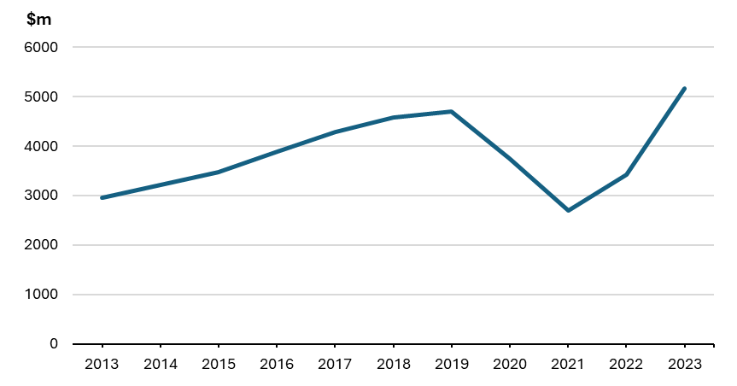
Source: Australian Bureau of Statistics, International Trade: Supplementary Information, Calendar Year, 2023.
Recreational travel services (personal travel excluding education)
- Recreational travel services were heavily impacted by the travel restrictions responding to the COVID-19 pandemic. Following CPTPP’s entry into force, Chart 8 shows that Australia’s recreational travel services exports to member economies grew steadily at 8.2 per cent from 2018 to 2019 ($5.4 billion to $5.8 billion), before declining sharply at 96.5 per cent between 2019 and 2021 ($5.8 billion to $206 million). Between 2021 and 2023, recreational travel services saw a rebound with an increase of 2,575 per cent ($206 million to $5.5 billion).

Chart 8: Recreational travel services ($ million)
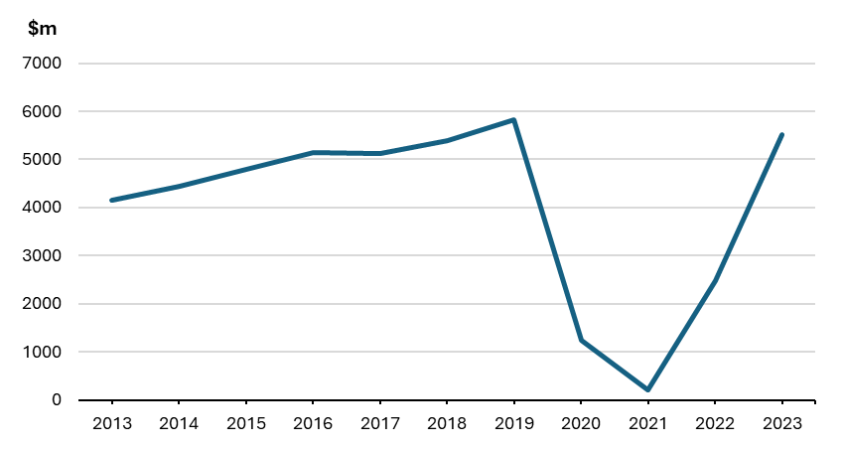
Source: Australian Bureau of Statistics, International Trade: Supplementary Information, Calendar Year, 2023.
Transport services
- Chart 9 shows that Australia continued to experience a consistent and steady rise in transport services exports with CPTPP members following the Agreement’s entry into force, with exports growing 9.1 per cent from 2018 ($2.2 billion) to 2019 ($2.4 billion). During the COVID-19 pandemic, exports declined by 53.3 per cent between 2019 and 2021 ($2.4 billion to $1.1 billion), followed by a rebound of strong growth at 138 per cent from 2021 to 2023 ($1.1 billion to $2.7 billion) and returning to pre-pandemic export levels.
Chart 9: Transport services ($ million)
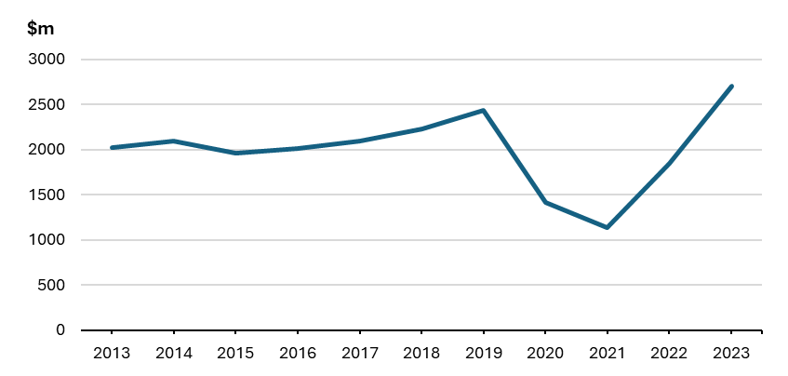
Source: Australian Bureau of Statistics, International Trade: Supplementary Information, Calendar Year, 2023.
Professional, technical and other business services
- The value of professional, technical and other business services trade with CPTPP members between 2017 and 2018 dropped by 23.4 per cent ($3.9 billion to $2.4 billion). Following the Agreement’s entry into force in December 2018, professional, technical and other business services trade has steadily risen into 2023, growing 36.1 per cent (from 2018), despite the impact of the COVID-19 pandemic.
Chart 10: Professional, technical & other business services ($ million)
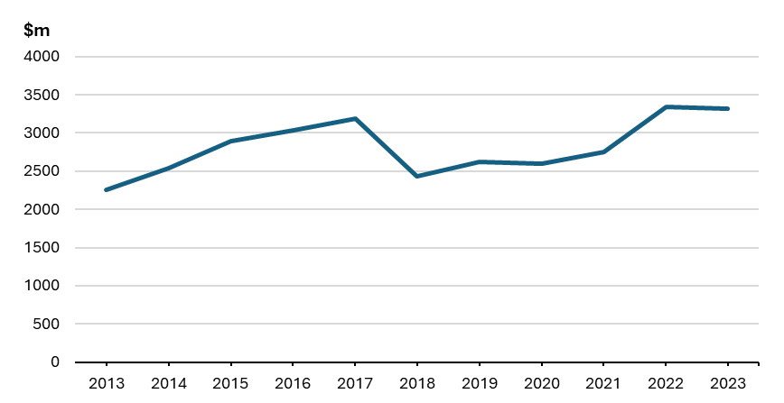
Source: Australian Bureau of Statistics, International Trade: Supplementary Information, Calendar Year, 2023.
Financial services exports
- Chart 11 shows that the value of Australia’s financial services exports between 2018 and 2021 increased 35 per cent ($569 million to $767 million) after the Agreement’s entry into force, compared to a slower 19.5 per cent of growth between 2013 and 2018 ($476 million to $569 million). This was followed by a 19.4 per cent decrease in financial services exports in 2022 (from $767 million to $618 million), before exports rebounded in 2023 to $806 million (30.4 per cent growth).

Chart 11: Financial services exports ($ million)
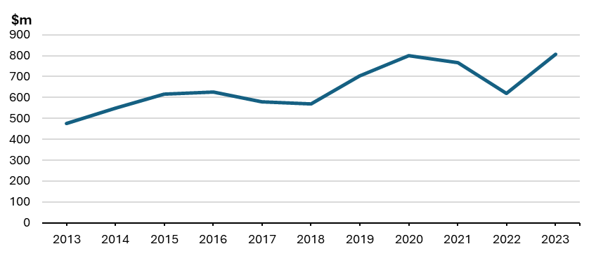
Source: Australian Bureau of Statistics, International Trade: Supplementary Information, Calendar Year, 2023.
Telecommunications, computer, and information services
- Before the entry into force of CPTPP, Australia’s telecommunications, computer, and information services exports to CPTPP economies grew 147 per cent in the 2014-18 period ($327 million to $809 million) (Chart 12). After entry into force, Australia’s exports grew by 11.0 per cent ($809 million to $909 million) between 2018 and 2019, however, these exports declined by 23.1 per cent from 2019 to 2020 ($909 million to $699 million). Exports increased 39.1 per cent from 2020 to 2023 ($699 million to $972 million), and in 2023 were the highest they had been since the peak in 2019.
Chart 12: Telecommunication, computer, and information services ($ million)
Source: ABS, International Trade: Supplementary Information, Calendar Year, 2023.
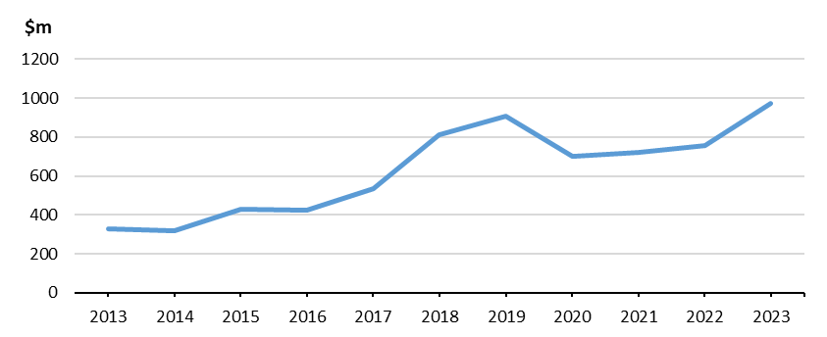
Outward foreign investment
- CPTPP provides additional protections to Australian investors operating in CPTPP economies. These protections include a minimum standard of treatment, the right to compensation for certain types of expropriation, and protection against discrimination.
- The Investor-State Dispute Settlement (ISDS) mechanism provides Australian investors with the ability to enforce these protections in many of Australia's key capital export markets, as well as many of the rapidly growing economies in the Asia-Pacific region.
- Overall, Australian outward investment in CPTPP economies has generally increased since the Agreement entered into force.
Inward foreign investment
- CPTPP promotes further foreign investment in Australia by liberalising the screening threshold at which private foreign investments in non-sensitive sectors are reviewed by the Foreign Investment Review Board, increasing the threshold from $261 million to $1.4 billion for all CPTPP members.
- Under CPTPP, Australia retains the ability to screen investments in sensitive sectors to ensure they are not contrary to the national interest. Proposed investments by foreign governments will continue to be examined and lower screening thresholds of $15 million and $57 million apply to investments in agricultural land and agribusiness respectively.
- Chart 13 and Table 8 show that the level of Australia’s inwards foreign investment stock from CPTPP members has grown steadily before, and since, the entry into force of CPTPP. The total average annual investment in Australia by CPTPP members grew from $415 billion (2014-18) to $559 billion (2019-23), a 34.7 per cent increase.
Chart 13: Foreign Investment Stocks in Australia by CPTPP Member ($m)
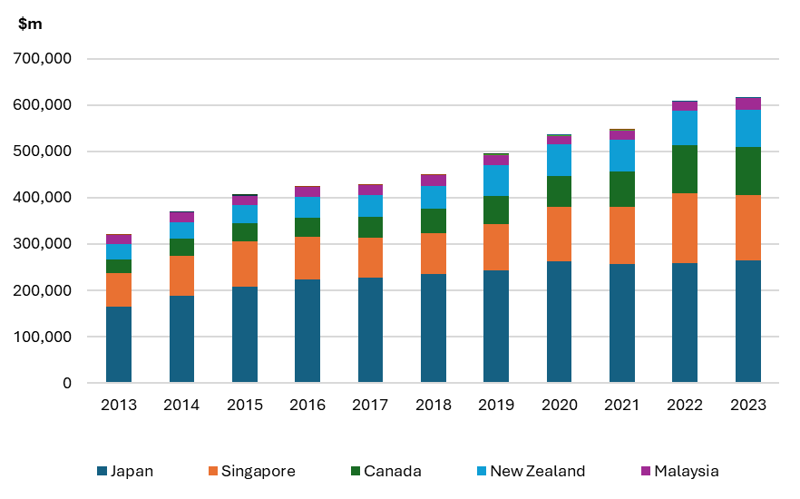
Source: ABS, 5352.0 International Investment Position, Australia: Supplementary Statistics 2023. DFAT analysis.

Table 8: Foreign Investment Stocks in Australia by CPTPP Member ($m)
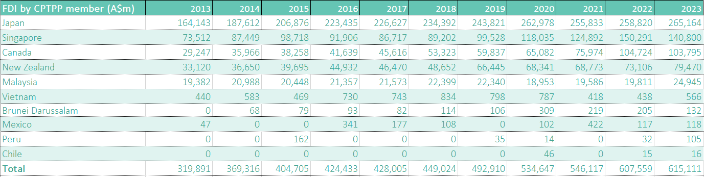
Source: ABS, FDI into Australia by country.
Movement of natural persons
- Australia's CPTPP commitments for intra-corporate transferees, contractual service suppliers and independent executives are implemented through the Skills in Demand (SID) visa programme, which allows skilled workers to come to Australia and work for an approved business. In accordance with the Skills in Demand (SID) visa programme, businesses still need to sponsor skilled foreign workers, meet market salary rates, and offer employment conditions as required under Australia’s workplace law, and equivalent to those accorded to Australian workers performing similar duties. Under SID, skilled foreign workers are required to meet minimum qualification requirements, including any relevant skills testing and existing professional licensing requirements at the Federal, State and Territory Government level.
- Australian intra-corporate transferees, being those businesspersons seeking to work in an overseas branch or subsidiary of their company, benefited from guaranteed initial lengths of stay in CPTPP economies of between one and five years, without being subject to quotas or economic needs tests such as labour market testing.
- Australian businesspersons who possess specialist trade, professional and technical knowledge and who have a contract to deliver services will benefit from guaranteed initial lengths of stay in CPTPP economies of between three months to five years without being subject to quotas or economic needs tests.
- Australian investors and independent executives will benefit from guaranteed lengths of initial stay in CPTPP economies of between three months to five years without being subject to quotas or economic needs tests.
- Australians providing services relating to installation and servicing of machinery or equipment will benefit from the following temporary entry commitments offered by other CPTPP economies:
- guaranteed lengths of stay for up to three months in Brunei Darussalam (extendable for up to 12 months), Chile, New Zealand, Peru (renewable for one year), and the UK; and
- guaranteed lengths of stay for up to six months in Canada (with the possibility of extensions), Malaysia and Mexico.
Impact on small businesses
- Quantitative data on the impact of CPTPP on small businesses is not available. Our qualitative assessment is that CPTPP has had a positive impact on many small businesses due to increased business activity, a greater range of competitively priced inputs imported from CPTPP economies, and improved access and competitiveness of Australian goods and services in CPTPP markets.
- Small businesses, including those providing goods and services to the tourism sector, have benefitted from the increased numbers of visitors from CPTPP economies since entry into force of the Agreement. The impact of CPTPP on small businesses is consistent with the expected outcomes articulated in the CPTPP Regulatory Impact Statement.
Impact of CPTPP on Government Revenue
- As part of the analysis of Regulatory Impact of CPTPP on Australia, it was estimated that the loss of tariff revenue for Australia would be approximately $30 million in 2018-19 and $220 million over the forward estimates period (2018-19 to 2021-22). This estimate, however, did not account for the potential domestic economic growth that CPTPP-related trade was expected to generate and any additional taxation revenue resulting from such growth.
- A recent internal DFAT assessment of the 2019-23 period which utilised ABS clearance data (for the same period) estimated the loss of tariff revenue for Australia from CPTPP to total approximately $266 million (Table 9).
Table 9: Estimated loss of tariff revenue for Australia (A$)
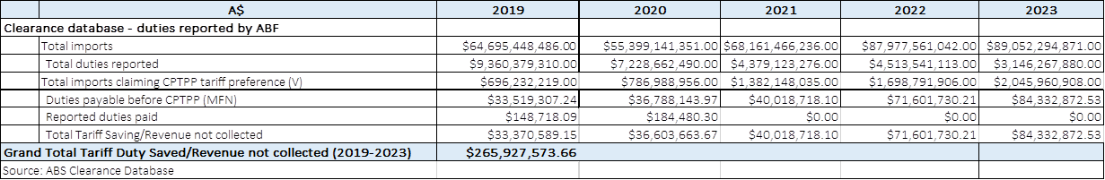

Compliance costs associated with CPTPP
- In order to access the preferential trade arrangements for goods under CPTPP, goods must meet Rules of Origin (ROO) and certification documentation requirements. The ROOs provide criteria for determining whether a good is ‘originating’ in a CPTPP Party and is therefore eligible for preferential tariff treatment.
- A claim for CPTPP preferential tariff treatment for Australian goods exported to CPTPP can be made on the basis of a certification of origin completed by the exporter, producer or importer, or issued by an authorised body (usually at a fee for the service) depending on the importing party’s preferences.
- Certificates of Origin (COOs) are issued under the Free Trade Agreement Certificate of Origin Recognition Scheme by an authorised body such as the Australian Chamber of Commerce and Industry, the Australian Industry Group or Trade Window Origin.

What other impacts have there been from CPTPP?
- The conclusion of CPTPP negotiations in 2018, taken together with the conclusion of bilateral FTA negotiations with China, Korea, Peru, and Japan, has had a positive impact on some of Australia’s other trade and economic priorities.
- On 15 December 2024, the United Kingdom (UK) acceded to the Agreement. Negotiations for the UK’s accession to CPTPP commenced in June 2021, and concluded in March 2023. Ministers from CPTPP economies and the UK signed the Protocol on the Accession of the United Kingdom of Great Britain and Northern Ireland to CPTPP on 16 July 2023.
- The UK is the first economy to accede to CPTPP, which grew the trade area covered by the Agreement from 12.4 per cent to 15.6 per cent of global GDP, an increase of 3.2 per cent. The UK’s accession has economic and strategic benefits by enhancing the UK’s engagement in the Indo-Pacific region, and expanding trade and investment ties for CPTPP members that did not have an existing FTA with the UK. It also brings the world’s 6th largest economy (by GDP) into a network of nations committed to high-standard, liberalised trade rules.
- Australia already had an existing FTA in place with the UK which contained strong market access outcomes. Therefore, the economic gains resulting from the UK’s accession to CPTPP were modest for Australia, and Australia did not incur any additional costs. Nonetheless, the supply chain benefits resulting from the UK’s accession will increase economic growth by expanding opportunities for Australian manufacturers. For example, Australian manufacturers are now able to use UK-made components in their production processes and export to CPTPP economies at preferential CPTPP tariff rates. Significant economic gains were realised by CPTPP members that did not have a FTA with the UK, such as Brunei Darussalam and Malaysia.

QUESTION 5: WHICH STAKEHOLDERS HAVE BEEN CONSULTED?

Ongoing stakeholder engagement
- DFAT has an ongoing stakeholder engagement process, including six-monthly stakeholder meetings to update interested parties on the progress of FTAs under negotiation or implementation (including through the six-monthly peak bodies in-person and virtual updates across 2023 and 2024). DFAT trade negotiators also meet on an ad hoc or periodic basis with stakeholders to discuss sector- or business-specific issues.
- State and Territory Governments have been consulted on the implementation of CPTPP through meetings of the Trade and Investment Ministers Meeting (TIMM) (before 2020), Ministerial Council on Trade and Investment (MCTI) from 2023 (with public facing Communiqué references listed below ), and the Senior Officials Trade and Investment Group (SOTIG). In accordance with a Whole-of-Government approach to trade policy, DFAT has also consulted with relevant Federal Government agencies on CPTPP implementation.

Post-Implementation Review call for submissions
- DFAT issued a call on its website for submissions from businesses and other interested stakeholders in July 2022 to prepare for this PIR. DFAT also sent out a request for feedback on CPTPP to over 200 stakeholders. This was followed by weekly updates on the DFAT social media platform as well as a reminder, closer to the due date.
- DFAT received a total of four PIR submissions from Australian stakeholders:
- the Australian Meat Industry Council (AMIC).
- Australian Pork;
- Australian Fair Trade and Investment Network (AFTINET);
- the Australian Dairy Industry Council (ADIC);
- DFAT greatly appreciates the efforts of stakeholders in providing submissions.
- DFAT also received a submission from AFTINET in response to a call for submissions on both the UK Accession to CPTPP and CPTPP General Review.

Discussion
- The stakeholder PIR submissions portrayed a diverse range of views. While many highlighted the positive outcomes under CPTPP including new market access opportunities in Canada and Mexico, some noted that bilateral FTAs such as JAEPA, ChAFTA, KAFTA and A-UKFTA had delivered more significant gains in certain areas when compared to CPTPP.
- Stakeholders also highlighted that CPTPP, in some cases, had superseded our bilateral FTAs and therefore eroded Australia’s previously competitive position in certain markets by providing improved market access to competitors within the membership.
- Furthermore, some stakeholders raised concerns about the expansion of international investor rights (e.g., ISDS mechanism) at the expense of governments’ right to regulate and human rights issues with CPTPP, such as access to medicines, labour rights, and environmental standards. It was noted in CPTPP Australia secured exemptions from ISDS mechanisms applying within Australia.

QUESTION 6: HAS CPTPP DELIVERED A NET BENEFIT?
- CPTPP has delivered a net benefit in the five years since its entry into force. The analysis of relevant data shows CPTPP has, to date, met its objective of expanding economic opportunities for Australian businesses and creating greater choices for Australian consumers.
- Relevant evidence of the net benefits flowing from CPTPP’s entry into force includes:
- Trade and investment flows between Australia and CPTPP members have been further liberalised through tariff reductions:
  - Securing our first FTA with Mexico, where the elimination of tariffs on barley (115 per cent prior to CPTPP coming into force) proved to be vital for Australian barley exporters seeking to diversify markets. Australia began exporting barley to Mexico in 2019; by 2023 barley exports to Mexico were worth $213.2 million (an increase of 44 per cent from 2022).
  - Gaining new access into Canada’s dairy market, with Canada offering over 100,000 tonnes of access for dairy products per year to CPTPP economies, which further supported Australian agricultural exporters diversifying into new markets.
  - Reducing Japan’s beef tariffs to 9 per cent within 15 years of entry into force (compared to JAEPA’s 23.5 per cent for fresh or chilled carcasses and half-carcasses) and the elimination of tariffs and creation of new quotas for dairy products.
- Total investment stocks into Australia by CPTPP members has increased, and in some cases doubled. For example, Canada’s total investment into Australia was $53 billion in 2018, and increased to over $100 billion in 2023.
- The average annual value of Australia’s total goods and services exports to CPTPP members was worth $141 billion (over 2019-23), increasing 54.6 per cent from the period before CPTPP (which averaged $91.3 billion annually over 2014-18).
- The average annual value of Australia’s total goods and services imports from CPTPP members was worth $92.8 billion in the 2019-23 period, increasing 16.6 per cent from $79.6 billion in the 2014-18 period prior to CPTPP.
- Other positive aspects of implementation of the Agreement are clear:
- the compliance costs associated with Certificates of Origin issued through Authorised Bodies have been relatively low, with positive cost/benefit outcomes for most traders;
- uptake of CPTPP by Australian businesses has been supported by government assistance programs, including the FTA information seminars, the FTA Portal, and Austrade programs;
- submissions from stakeholders highlighted the positive impact of CPTPP on improving export opportunities for Australian businesses, notwithstanding difficulties with operating during the COVID-19 pandemic; and
- CPTPP provides opportunities to progress initiatives to help facilitate trade for Australian agricultural exporters by addressing non-tariff barriers and reducing trade transactions costs by advocating for regulatory harmonisation and alignment, particularly through the SPS Committee.

QUESTION 7: HOW HAS CPTPP BEEN IMPLEMENTED AND EVALUATED?

Parliamentary scrutiny, and legal implementation of CPTPP
- The comprehensive processes (including Parliamentary processes) leading up to the entry into force of CPTPP are detailed in the Introduction of this PIR.
- The implementation of CPTPP required legislative changes to the Customs Act 1901; the Customs Tariff Act 1995 and associated regulations; the Foreign Acquisitions and Takeovers Regulations 1989; and the Life Insurance Regulations 1995.

CPTPP implementation mechanisms
- CPTPP includes a structure of regular meetings intended to create an ongoing dialogue between Australia and CPTPP members and a built-in agenda of reviews, which provide avenues to address issues and increase two-way trade opportunities. The CPTPP Commission is tasked with monitoring the overall implementation of CPTPP with responsibility for:
- considering matters relating to the implementation of the Agreement;
- considering issues referred to it by the committees and working groups established under the Agreement or by either Party;
- exploring measures for the further expansion of trade and investment between the Parties;
- considering any proposal to amend the Agreement and make recommendations to the Parties; and
- considering any other matter that may affect the operation of the Agreement.
- To date, the CPTPP Commission has met on eight occasions.
- The First CPTPP Commission meeting was held in Tokyo, Japan on 19 January 2019 and adopted a Joint Statement with four decisions: an approach to the administration of the Agreement, rules of procedures for dispute settlement panels, code of conduct review for ISDS, and the establishment of a process for dealing with accession requests.
- The Second CPTPP Commission meeting was held in Auckland, New Zealand on 9 October 2019. The Commission adopted decisions on its Rules of Procedure and established a roster of individuals who may be selected to serve as panel chairs to address state-to-state disputes.
- The Third CPTPP Commission meeting was held virtually on 6 August 2020 and hosted by Mexico. The Commission instructed Senior Officials to work towards the establishment of a committee on digital trade, and to consider a consolidated plan to advance work on CPTPP-focused initiatives to respond to COVID-19.
- The Fourth CPTPP Commission meeting was held virtually on 2 June 2021 and hosted by Japan. The purpose of the Fourth Commission meeting was to consider the United Kingdom’s formal request to accede to CPTPP. The Commission agreed to commence accession negotiations with the UK and to establish an Accession Working Group.
- The Fifth CPTPP Commission meeting was held virtually on 1 September 2021 and hosted by Japan. The Commission reaffirmed their commitment to achieve a successful outcome at the 12th WTO Ministerial Conference and took note of the progress to date on the UK's accession to CPTPP.
- The Sixth CPTPP Commission meeting was held in Singapore on 8 October 2022. The meeting was an opportunity for the Commission to reflect on implementation of the Agreement against the backdrop of COVID-19 economic recovery and increasing global uncertainty.
- The Seventh CPTPP Commission meeting was held in Auckland, New Zealand on 16 July 2023. The meeting was an opportunity to reflect on the continuing implementation of the Agreement. The Membership also welcomed the United Kingdom as CPTPP’s newest signatory.
- The Eight CPTPP Commission meeting was held in Vancouver, Canada on 29 November 2024. Member announced that an Accession Working Group would be started for Costa Rica to commence negotiations with CPTPP members.
- Joint Ministerial Statements and summaries are published on the DFAT website.

CPTPP General Review
- On 15 November 2023, CPTPP members agreed to the Terms of Reference for Conducting a General Review of CPTPP with a view to updating and enhancing the Agreement by the 2025 CPTPP Commission Meeting.
- The objectives of the CPTPP General Review are to:
- Review the operation of CPTPP to ensure the disciplines contained in the Agreement remain relevant to the trade and investment issues and challenges confronting the Members.
- Identify provisions that would benefit from revision or updating, and the potential for the development of new provisions or Chapters.
- Review the operation of CPTPP with a view to identifying ways to facilitate maximum utilisation of CPTPP by traders and investors and to improve the uptake of the Agreement.
- Ensure the Agreement remains of the highest possible standard.
- To achieve the objectives of the General Review, it would consider how CPTPP could:
- Facilitate maximum utilisation of CPTPP by traders and investors and to improve the uptake of the Agreement, particularly by micro, small and medium enterprises (MSMEs).
- Continue to promote trade and investment to bring economic growth and social benefits, create new opportunities for workers and businesses, contribute to raising living standards, benefit consumers, reduce poverty and promote sustainable growth.
- Reinforce the links between trade, CPTPP, and evolving global environmental issues including climate change and biodiversity loss.
- Continue to uphold labour rights improve working conditions and living standards, strengthen cooperation and capacity on labour issues.
- Take into account developments in international fora and the level of ambition in other agreements concluded by Members.
- Demonstrate leadership on emerging issues in areas such as the digital and the green economy.
- Explore opportunities to promote inclusive and sustainable outcomes, including with respect to trade and Indigenous Peoples, where applicable to the Members.
- Support global value chains, and strengthen supply chain resilience to help Members to withstand external shocks and disruption.
- Explore ways to further address the challenges posed by market-distorting practices.
- Further reflect on Members' interests in the context of CPTPP's Investor-State Dispute Settlement mechanism.
- Identify areas of mutual interest to ensure the Agreement remains the gold standard for trade agreements.
- Affirm the Agreement's full implementation and identify areas for cooperation towards better operation of the Agreement.
- Identify ways to improve the monitoring mechanism of CPTPP to ensure effective implementation and operation of the Agreement as well as any related side instruments between Members (as decided by the parties to each instrument).
- Further complement the rules based multilateral trading system, with the World Trade Organisation (WTO) at its core, including as a means for responding to economic coercion.

FTA Seminars, FTA Portal and other support for businesses on FTAs
- Implementation of Australia’s FTAs have been supported through a significant investment by the Government to promote increased business awareness and use of opportunities under Australia’s FTAs.
- The Government has sought to increase SMEs and other businesses’ awareness and use of CPTPP and other FTAs including through:
- FTA information seminars and webinars;
- bespoke advocacy for domestic stakeholders;
- detailed on-line CPTPP information, including business guides and case studies;
- FTA-specific email inboxes where businesses and members of the public can contact experts with specific questions or issues relating to CPTPP and other FTAs; and
- developing a modern online FTA Portal for businesses, that includes comparisons on product specific rules by relevant FTAs.
- In relation to the FTA information seminars about CPTPP and other FTAs, DFAT and Austrade delivered over 130 seminars since March 2015, engaging with more than 5,500 business and other representatives, with around two-thirds of the seminars held in regional areas. Due to COVID-19, the seminars were adapted to webinars from early 2020. Between May and November 2020 12 FTA webinars have been held involving over 5,000 participants. Feedback from seminars and webinars indicates that they are highly valued by the participants.
- The FTA Portal assists businesses to access information on Australia’s FTAs in a user-friendly way. Launched in March 2016, the FTA Portal initially covered goods for JAEPA, ChAFTA and KAFTA. It has since expanded to include comprehensive information on all of Australia’s in-force FTAs (including CPTPP). Information on FTA services commitments, including under CPTPP, was included in the FTA Portal from 2018. Since its launch, the FTA Portal has attracted over 300,000 users.
- The FTA Portal features a sophisticated tariff finder, rules of origin guide, trade data on individual markets and relevant links to help businesses make informed decisions. It also helps businesses make comparisons where there may be more than one available FTA, such as will be the case for CPTPP.
- DFAT and partner agencies have received many positive comments about the FTA Portal, including from business groups and customs brokers, noting the easy-to-use interface and search function. The FTA Portal was awarded ‘Best Application Development’ at the 2016 Government ICT Awards.
- In addition to the FTA information seminars outlined above, Austrade has supported CPTPP implementation through its services to businesses and investors, including the TradeStart network and the Export Market Development Grant scheme. The Austrade website includes CPTPP-specific video case studies and other material to assist businesses. In November 2020, Austrade launched the Free Trade Advantage online platform. This new platform brings together a range of practical advice and resources to help Australian businesses access the benefits of Australia’s FTAs. Export Finance Australia also assists businesses develop export opportunities.

Evaluation – Export outcomes and CPTPP preference utilisation
- Following the entry into force of CPTPP, DFAT initiated an ongoing program of work to analyse and evaluate export trends for key products benefiting from CPTPP tariff cuts, and CPTPP preference utilisation. These analyses have informed FTA advocacy and policy, and stakeholder engagement (including targeted outreach on tariff preference uptake for specific products and sectors).

What other relevant inquiries or reports have taken place since CPTPP entered into force?
- In February 2022, the Joint Standing Committee on Foreign Affairs, Defence and Trade published a report titled “Expanding membership of the Comprehensive and Progressive Agreement for Trans-Pacific Partnership” and which makes eight recommendations in considering potential new CPTPP members.

ATTACHMENT A: REGULATORY BURDEN ESTIMATE
- The entry into force of the Comprehensive and Progressive Agreement for Trans-Pacific Partnership (CPTPP) may result in a reduction in ongoing business compliance costs for Australian exporters to CPTPP Parties. Any reduction would stem from the ability for exporters to use one set of documentary procedures to export to eleven other markets instead of separate documentation for nine different FTAs plus two non-FTA partners. Further reductions will be realised by businesses that previously sought and obtained non-preferential certificates of origin (COOs) at a cost, who will now be able to self-certify the origin of their goods for exports to Parties who did not previously have self-certification arrangements in place including Brunei Darussalam, Canada, New Zealand, Mexico, and Vietnam.
- As some CPTPP Parties already allow self-certification, it is not possible to have an accurate view of the number and composition of COOs issued in respect of Australian exports into CPTPP Parties. Therefore, any estimates of the compliance costs under the existing agreement, as well as any projected change under any updated agreement, are based on previous trends using existing COO data and should be interpreted as such. However, based on the available data, it is possible to gain an appreciation of the scale of these changes.

Direct Costs
Certificates of Origin
- Where businesses seek third-party certification from industry groups, the cost of each certificate varies from between $20-70 at an average of $33. The cost of a certificate depends on a range of factors, such as whether an applicant is a member of the issuing body and the level of complexity. However, this cost can be alleviated where countries allow for COOs to be completed by importer, exporter or producer.
Administrative costs
- The ongoing administrative costs incurred by a business in preparing the documentation to obtain a COO are likely to be relatively low. The bulk of Australian exports to CPTPP Parties are ‘wholly obtained’ goods. Further, while new businesses may expend considerable time applying for certification for their initial consignment, as a matter of practice this information is re-submitted for subsequent certifications. In addition, much of the information required would be collected for other purposes. The administrative time burden for each application is therefore estimated to be modest.
- Similarly, the records related to a COO are required to be kept for five years by most foreign customs agencies. However, businesses are required under Australian Tax Law to retain these records for seven years. The incremental compliance burden associated with record keeping for COOs is therefore assessed as nil.

Overall compliance burden estimate
- Table A shows CPTPP is assessed as reducing the compliance burden by an annual amount of $10,000. The direct and administrative costs associated with compliance through preferential COOs have been more than offset by reductions in overall costs due to the increase in the FIRB thresholds.
Table A - Regulatory Burden and Estimate Table
Average annual compliance costs (from business as usual) Costs | Business | Community organisations | Individuals | Total cost
Total by sector | ($10,000) | - | - | ($10,000)

JSCOT, Report 181: Comprehensive and Progressive Agreement for Trans-Pacific Partnership between the Government of Australia and the Governments of: Brunei Darussalam, Canada, Chile, Japan, Malaysia, Mexico, New Zealand, Peru, Singapore and Vietnam and associated side letters (Santiago, 8 March 2018).
Copy of the letter available at The United States Officially Withdraws from the Trans-Pacific Partnership | United States Trade Representative (ustr.gov).
Trans-Pacific Partnership Agreement between the Government of Australia and the Governments of: Brunei Darussalam, Canada, Chile, Japan, Malaysia, Mexico, New Zealand, Peru, Singapore, the United States of America, and Vietnam and associated side letters.
Note: Article 30.5.3 (Entry into Force) of the TPP provides that should not all original TPP signatories have ratified the TPP within two years of the date of signature of the TPP, the Agreement “shall enter into force 60 days after the date on which at least six of the original signatories, which together account for at least 85 per cent of the combined gross domestic product of the original signatories in 2013.
Trans-Pacific Partnership Ministerial Statement of 21 May 2017, Hanoi, available at: http://dfat.gov.au/trade/agreements/tpp/news/Pages/news.aspx#tpp-news-170521
Trans-Pacific Partnership Ministerial Statement of 11 November 2017, Da Nang, available at: http://dfat.gov.au/trade/agreements/tpp/news/Pages/trans-pacific-partnership-ministerial-statement.aspx
Comprehensive and Progressive Agreement for Trans-Pacific Partnership Analysis of Regulatory Impact on Australia national-interest-analysis-including-analysis-of-regulatory-impact-on-australia.pdf
JSCOT Report 181 1. Introduction – Parliament of Australia
TPP-11 implementing legislation introduced in Parliament CPTPP news | Australian Government Department of Foreign Affairs and Trade
The Parliament of the Commonwealth Of Australia, House of Representatives, Explanatory Memorandum, Customs Amendment (Comprehensive And Progressive Agreement For Trans-Pacific Partnership Implementation) Bill 2018.
CPTPP Commission meetings CPTPP Commission meetings | Australian Government Department of Foreign Affairs and Trade
Joint Standing Committee on Treaties (JSCOT), Report 165: Trans-Pacific Partnership Agreement, November 2016, Canberra, p. 1.
JSCOT, Report 181: Comprehensive and Progressive Agreement for Trans-Pacific Partnership between the Government of Australia and the Governments of: Brunei Darussalam, Canada, Chile, Japan, Malaysia, Mexico, New Zealand, Peru, Singapore and Vietnam and associated side letters (Santiago, 8 March 2018).
Free trade agreements in force | Australian Government Department of Foreign Affairs and Trade
Note: The Peru-Australia FTA entered into force on 11 February 2020. Source: Peru-Australia Free Trade Agreement | Australian Government Department of Foreign Affairs and Trade
Australia’s top two-way trading partners 2018-19 Trade and investment at a glance 2020 | Australian Government Department of Foreign Affairs and Trade
JSCOT, Report 165, pp. 4–5.
Note: The Canada-Australia Trade Agreement (CANATA) is an historic trade agreement that entered into force on 30 June 1960. The agreement predates the Harmonised System (HS).
Japan-Australia Economic Partnership Agreement Post-Implementation Review final_version_-_jaepa_pir.pdf
Comprehensive and Progressive Agreement for Trans-Pacific Partnership Analysis of Regulatory Impact on Australia national-interest-analysis-including-analysis-of-regulatory-impact-on-australia.pdf
Comprehensive and Progressive Agreement for Trans-Pacific Partnership Analysis of Regulatory Impact on Australia national-interest-analysis-including-analysis-of-regulatory-impact-on-australia.pdf
Note: India withdrew from RCEP negotiations in 2019.
Note: adjusted ABS value.
CPTPP Analysis of Regulatory Impact on Australia national-interest-analysis-including-analysis-of-regulatory-impact-on-australia.pdf
Federal Register of Legislation - Customs Tariff Amendment (Incorporation of Proposal and Other Measures) Act 2017
Australian Bureau of Statistics Media Release Australia records a current account deficit | Australian Bureau of Statistics
Note: At the time of writing, the Australian Government does not have time series data on CPTPP utilisation rates for all members. This increase in trade therefore cannot be attributed entirely to CPTPP.
Note: The July 2023 entry into force for Brunei means only 6 months (July – December 2023) of data would be relevant to CPTPP.
Note: The November 2022 entry into force for Malaysia means only 13 months (November 2022 – December 2023) of the review period is relevant.
Note: The February 2023 entry into force date for Chile means only a 9 month (February – December 2023) of the review period is relevant.
Note: The September 2021 entry into force for Peru means only 27 months (September 2021 – December 2023) of the review period is relevant.
Note: For agriculture exports, this rise could have also been attributed to AANZFTA.
Note: The July 2023 entry into force for Brunei means only 6 months (July – December 2023) of data would be relevant to CPTPP.
Note: The November 2022 entry into force for Malaysia means only 13 months (November 2022 – December 2023) of the review period is relevant.
Note: The February 2023 entry into force date for Chile means only a 9 month (February – December 2023) of the review period is relevant.
Note: The September 2021 entry into force for Peru means only 27 months (September 2021 – December 2023) of the review period is relevant.
Note: CPTPP market access outcomes for resources and energy products that are additional to Australia’s existing FTAs include tariff elimination on: butane, propane and liquified natural gas exports to Vietnam within 7 years of entry into force of CPTPP; and refined petroleum exports to Vietnam within 10 years of entry into force of CPTPP. From 2019 to 2023, refined petroleum exports to Vietnam increased from $14.5 million to $27.5 million, an increase of 90 per cent.
Austrade How global energy prices are affecting the price of Australian farm inputs | Austrade
Federal Register of Legislation - Customs Tariff Amendment (Incorporation of Proposal and Other Measures) Act 2017
Note: Despite goods imports decreasing between 2020 as a result of COVID-19-related disruptions, the total value of goods imports since 2020 has remained above pre-pandemic levels.
Note: The July 2023 entry into force for Brunei means only 6 months (July – December 2023) of data would be relevant to CPTPP.
Note: The November 2022 entry into force for Malaysia means only 13 months (November 2022 – December 2023) of the review period is relevant.
Note: The February 2023 entry into force date for Chile means only a 9 month (February – December 2023) of the review period is relevant.
Note: The September 2021 entry into force for Peru means only 27 months (September 2021 – December 2023) of the review period is relevant.
Note: Despite goods imports decreasing between 2020 as a result of COVID-19-related disruptions, the total value of goods imports since 2020 has remained above pre-pandemic levels.
Note: The July 2023 entry into force for Brunei means only 6 months (July – December 2023) of data would be relevant to CPTPP.
Note: The November 2022 entry into force for Malaysia means only 13 months (November 2022 – December 2023) of the review period is relevant.
Note: The February 2023 entry into force date for Chile means only a 9 month (February – December 2023) of the review period is relevant.
Note: The September 2021 entry into force for Peru means only 27 months (September 2021 – December 2023) of the review period is relevant.
Certain data has been omitted to protect confidentiality.
Note. Five CPTPP members rank amongst the leading sources of foreign investment to Australia. The following members were in the top 20 sources of foreign investment by country in 2023: Japan (4th), Singapore (6th), Canada (8th), New Zealand (8th), and Malaysia (20th).
CPTPP Analysis of Regulatory Impact on Australia national-interest-analysis-including-analysis-of-regulatory-impact-on-australia.pdf
WTO Committee on Regional Trade Agreements, Note on the Meeting of 18 November 2024 - CPTPP – Entry into Force for Brunei Darussalam, Chile and Malaysia (Goods and Services), WTO, 2024.
Communique – Third Meeting of the Ministerial Council on Trade and Investment | Minister for Trade and Tourism
Communique – Fourth Meeting of the Ministerial Council on Trade and Investment | Minister for Trade and Tourism
CPTPP Commission meetings CPTPP Commission meetings | Australian Government Department of Foreign Affairs and Trade
Terms of Reference for CPTPP General Review Terms of Reference for Conducting the General Review of the Comprehensive and Progressive Agreement for Trans-Pacific Partnership (CPTPP) endorsed at CPTPP Ministerial meeting on 15 November 2023 PST | Australian Government Department of Foreign Affairs and Trade
Joint Standing Committee on Foreign Affairs, Defence, and Trade: Expanding the membership of the Comprehensive and Progressive Trans-Pacific Partnership – Parliament of Australia, February 2022.

