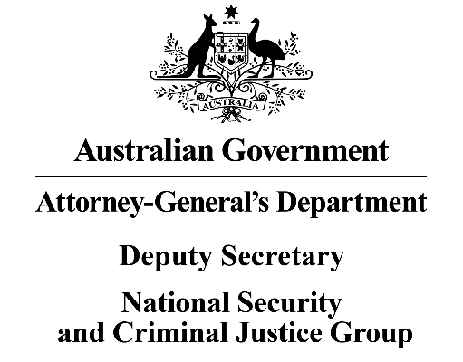
OIA25-10104
Integrity and Security Group

Ms Joanna Abhayaratna
Executive Director
Office of Impact Analysis
Department of the Prime Minister and Cabinet
1 National Circuit
BARTON ACT 2600
Email: Helpdesk-OIA@pmc.gov.au
Dear Ms Abhayaratna
Certification of Sunsetting Instrument – Privacy Regulation 2013
I am writing to the Office of Impact Analysis (OIA) regarding the Privacy Regulation 2013, which, as per the Legislation Act 2003 and the Legislation (Deferral of Sunsetting – Privacy Regulation) Certificate 2024, had been scheduled to sunset on 1 April 2026. It has been decided that the instrument is to be remade without significant amendment.
In lieu of a detailed Impact Analysis for remaking the regulation, the Attorney-General’s Department has self-assessed the Privacy Regulation 2013, and certifies that it is operating effectively and efficiently.
The assessment that the legislation is operating effectively and efficiently has been informed by a targeted consultation process which involved relevant Commonwealth Government entities, including Treasury, who has policy responsibility for the credit reporting related regulations, state and territory authorities and instrumentalities prescribed under the regulations, prescribed superannuation providers, and the Association of Superannuation Funds of Australia, over the period from April-September 2025.
The regulatory burden to people, businesses, and community organisations has been quantified using the Australian Government’s Regulatory Burden Measurement framework. As the changes do not substantially alter the policy or have been assessed as not requiring costing under the Regulatory Burden Measurement framework, the additional cost of compliance for each category is nil.

Average annual regulatory costs (from business as usual)
Change in costs ($ million) | Business | Community organisations | People | Total change in costs
Total, by sector | NIL | NIL | NIL | NIL
I acknowledge that the OIA will publish this letter for transparency purposes.
Yours sincerely
Anne Sheehan
Acting Deputy Secretary
26 November 2025

