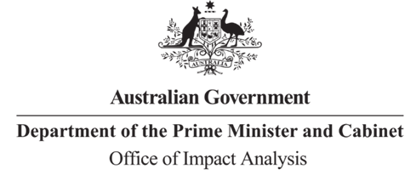
Reference: OBPR22-02555
Telephone: 6271 6270
e-mail: helpdesk-oia@pmc.gov.au
Mr Richard Windeyer
Deputy Secretary
Department of Infrastructure, Transport, Regional Development, Communications and the Arts
Dear Mr Windeyer
Impact Analysis – Second Pass Final Assessment – Australia Post Modernisation and Long Term Financial Sustainability

Thank you for your letter of 26 October 2023 submitting an Impact Analysis (IA) for formal Second Pass Final Assessment. I note the IA has been formally certified at the Deputy Secretary level consistent with the Australian Government Guide to Policy Impact Analysis (the Guide).
I appreciate the Department’s constructive engagement on the IA.

The Office of Impact Analysis’ (OIA) assessment is that the quality of the analysis in the IA is adequate to support a high level decision on reform.

To be considered ‘good practice’ as per the Guide, the IA would have benefited from further examination of the likely workforce implications of the proposal and the anticipated effects on
Australians – particularly customers in regional and remote areas.

I note an estimate of the change to regulatory burden for each of the options has been presented as negligible or nil. Because one of the objectives of the proposal is to make regulatory changes to improve Australia Post’s financial position, understanding the elements of the regulatory settings that would change and how these changes would reduce costs to Australia Post will be central to the ongoing monitoring and evaluation of the success of these reforms.

Because of the significant uncertainty around the costs and benefits, and the difficulties in determining the likely effects of the proposal ahead of the settling of fine implementation details, further analysis on the likely effects of the specific implementation arrangements will be necessary.

Considering the possible widespread impacts associated with this reform and the importance of the long-term viability of Australia Post to the community, OIA will determine whether a post-implementation review is also necessary to examine and quantify the felt effect of the changes once they have been made.
Next steps

After a final decision has been announced, I ask that your agency work with OIA to finalise this material for public release. This includes providing a copy of the IA in Word and PDF format for web accessibility purposes. The IA must be included in any Explanatory Memorandum or Statement giving effect to the proposals in the IA.
If you have any further queries, please do not hesitate to contact me.
Yours sincerely

Rob Reilly
A/g Executive Director
Office of Impact Analysis
27 October 2023
1 National Circuit, Barton ACT 2600 • Telephone 02 6271 6270 • Internet oia.pmc.gov.au

