Reference: OIA23-05771
Telephone: 6271 6270 e-mail: helpdesk-oia@pmc.gov.au
Mr Ben Rimmer
Deputy Secretary
Higher Education, Research and International Group
Department of Education
Dear Mr Rimmer

Impact Analysis – Second Pass Final Assessment – National Higher Education Code to Prevent and Respond to Gender-based Violence
Thank you for your letter of 3 September 2025 submitting an Impact Analysis (IA) for formal Second Pass Final Assessment. I note the IA has been formally certified at the Deputy Secretary level consistent with the Australian Government Guide to Policy Impact Analysis (the Guide).
I appreciate the Department of Education's constructive engagement on the IA. The Office of
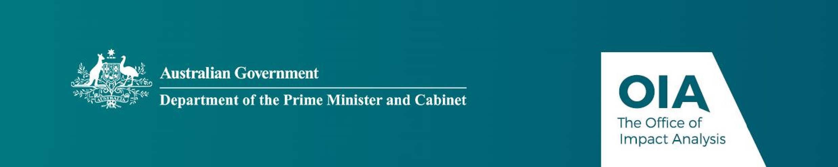
Impact Analysis’ (OIA) assessment is that the quality of the analysis in the IA is ‘good practice’. The IA addresses the seven IA questions and follows an appropriate policy development process commensurate with the significance of the problem and magnitude of the proposed intervention. In particular, the IA has a particularly strong problem definition and consultation sections. To achieve an ‘exemplary’ rating as per the Guide, the IA would have benefited from a more detailed evaluation plan.
The IA may now be provided to the decision-maker to inform their decision.

Next steps
Ahead of the final decision being announced we would appreciate a copy of the IA in a form meeting the Government’s web accessibility requirements, and a one-page Impact Analysis Summary of the IA. The OIA will then publish the IA and Summary, along with your certification, on the OIA’s website at oia.pmc.gov.au. The IA must also be included in any Explanatory Memorandum or Statement giving effect to the proposals in the IA.
If you have any further queries, please do not hesitate to contact me.
Yours sincerely

Joanna Abhayaratna
Executive Director
Office of Impact Analysis
8 September 2025

1 National Circuit, Barton ACT 2600 • Telephone 02 6271 6270 • Internet oia.pmc.gov.au

