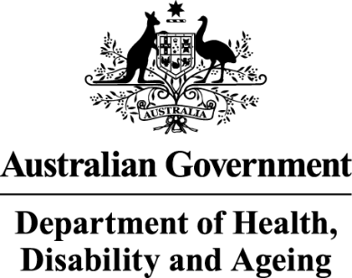

Deputy Secretary
Ms Joanna Abhayaratna
Executive Director
Office of Impact Analysis
Department of the Prime Minister and Cabinet
1 National Circuit
BARTON ACT 2600

Email: Helpdesk-OIA@pmc.gov.au

Dear Ms Abhayaratna

Certification of Sunsetting Instrument
I am writing to the Office of Impact Analysis (OIA) regarding the National Health (Closing the Gap – PBS Co-payment Program) Special Arrangement 2016, which, as per the Legislation Act 2003, had been scheduled to sunset on 1 April 2026. It is intended this instrument will be remade without significant amendment to ensure eligible First Nations people have continued access to medicines on the Pharmaceutical Benefits Scheme (PBS) at the concessional rate, or for a concession card holder, free of charge.
The Department of Health, Disability and Ageing certifies that the National Health (Closing the Gap – PBS Co-payment Program) Special Arrangement 2016 is operating effectively and efficiently, and that an Impact Analysis is not required for this legislation to be remade.
The assessment that the legislation is operating effectively and efficiently has been informed by a consultation process, including circulation of proposed instrument amendments, with Services Australia, the National Aboriginal Community Controlled Health Organisation (NACCHO) and internal stakeholders including the First Nations Division, Pricing and Policy Branch and Community Access Programs Branch. Consultation was conducted over the period 2 July 2025 to 8 July 2025 with two minor amendments agreed.
The minor amendments include revising the reference to the Human Services (Medicare) Regulations 1973 to the Human Services (Medicare) Regulations 2017 and updating the link to information available on the Services Australia website for registering practitioners.

Consultation for the sunsetting of this instrument followed a significant amount of consultation, over a period of months, to expand the instrument to include all PBS medicines dispensed by community pharmacies, approved medical practitioners and private hospitals. This was implemented on 1 July 2024. On 1 January 2025 the instrument was further expanded to include all PBS medicines dispensed by public hospitals.

I also note that the regulatory burden to people, business, or community organisations has been quantified using the Australian Government’s Regulatory Burden Measurement framework. These are provided below.

Average annual regulatory costs (from business as usual):
Change in costs ($ million) | Business | Community organisations | People | Total change in costs
Total, by sector | $0.00 | $0.00 | $0.00 | $0.00
I acknowledge that the OIA will publish this letter for transparency purposes.

Yours sincerely

Penny Shakespeare
Health Resourcing Group
August 2025

