Home Guarantee Scheme Expansion –

*Supplementary Analysis*

## Introduction

#### Government Commitment

This Impact Analysis has been prepared by the Department of the Treasury to inform the Government’s decision to implement the 5% deposits for all first home buyers election commitment. Under the commitment, announced on 13 April 2025, all first home buyers will be able to access 5 per cent deposits through an expanded Home Guarantee Scheme (HGS). There will be no caps on how many people can apply and no limit on how much an applicant, or their partner, can earn. Property price caps will also increase and are provided at Appendix A. The Government has committed to industry consultation to support implementation.

#### About this Supplementary Analysis

An Impact Analysis is required when a policy proposal or action of government, with an expectation of compliance, would result in a more than minor change in behaviour or impact for people, businesses or community organisations.

The Office of Impact Analysis has assessed that the Government’s commitment to expand the HGS will have more than a minor impact.

In special cases where a comprehensive review has already been undertaken, an Impact Analysis Equivalent is able to meet the requirement for an Impact Analysis. Given an Impact Analysis has been completed to support an earlier government decision to expand the HGS (as published [here](https://oia.pmc.gov.au/published-impact-analyses-and-reports/home-guarantee-scheme)), the Office of Impact Analysis has agreed to Treasury certifying this previous analysis together with supplementary analysis to form an Impact Analysis Equivalent.

To ensure the impacts of this commitment’s specific parameters are considered, this supplementary analysis will consider:

* impacts on lenders mortgage insurance (LMI) providers;
* impacts on small and regional banks; and
* impacts on low-income buyers.

#### *Market conditions have made it challenging for many Australians to achieve home ownership*

Home ownership rates have been falling in Australia over recent decades. While a variety of factors, including changing societal attitudes and norms, have impacted home ownership rates, the relative affordability of housing has fallen substantially over the past 4 decades. Strong and sustained increases in housing prices, particularly compared to growth in incomes, have made both saving for a deposit and servicing a mortgage significantly more challenging. Between 1994 and 2021, rates of home ownership declined from 71.4 per cent to 66.3 per cent.[1]

The factors contributing to strong and sustained increases in housing prices are well documented and include declining nominal interest rates, financial liberalisation, higher rates of population growth and rising incomes. Housing price growth has, on average, significantly exceeded income growth. As a result, the ratio of both housing prices and household debt to household disposable incomes has increased substantially in Australia over recent decades (Figure 1.1).

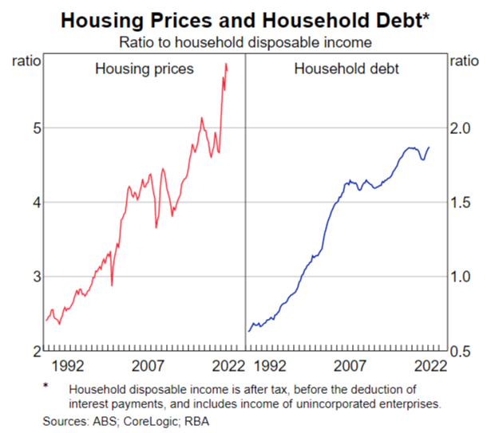**Figure 1.1: Housing prices and household debt to income**

|  |
| --- |
|  |

#### *A high deposit hurdle*

As a result of rising housing price to income ratios, the ‘deposit hurdle’ – the challenge of accumulating a sufficiently-sized deposit to purchase a home (and to support a home loan application) – has grown significantly (Figure 1.2). The average time needed for a median household to save a 20 per cent deposit remains at elevated levels, with the national figure currently at 10.6 years as of September 2024. This has fallen from a post-Covid peak of 11.4 years in the March quarter 2022 but remains well above the average of the past two decades (9.0 years) and has been increasing over recent quarters.[2]

**Figure 1.2: Years required to save a 20 per cent deposit**

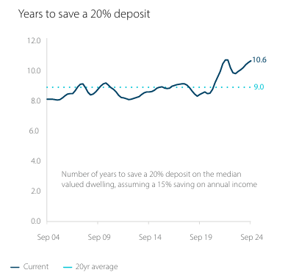

Source: CoreLogic, ANZ

#### A broad range of households, particularly younger cohorts, face challenges in saving a deposit

There have been considerable falls in home ownership rates across most working-age groups. Between 1981 and 2021, home ownership rates for households aged 25-34 fell from 62 per cent to 44 per cent, including a fall of 10 percentage points for households in the top income quintile of this age cohort. In contrast, among those aged 45-54 and 55-64, rates of home ownership among the top two income quintiles have remained largely unchanged.[3] While declining rates of home ownership are an acute problem for low- and middle-income households, declining affordability has impacted the ability of even those with relatively high incomes to purchase a home.

While home ownership rates have fallen across age groups, the substantial reductions in rates for all income quintiles among younger cohorts demonstrates that achieving home ownership is no longer a challenge solely for low-income earners but extends to a significant portion of young Australians.

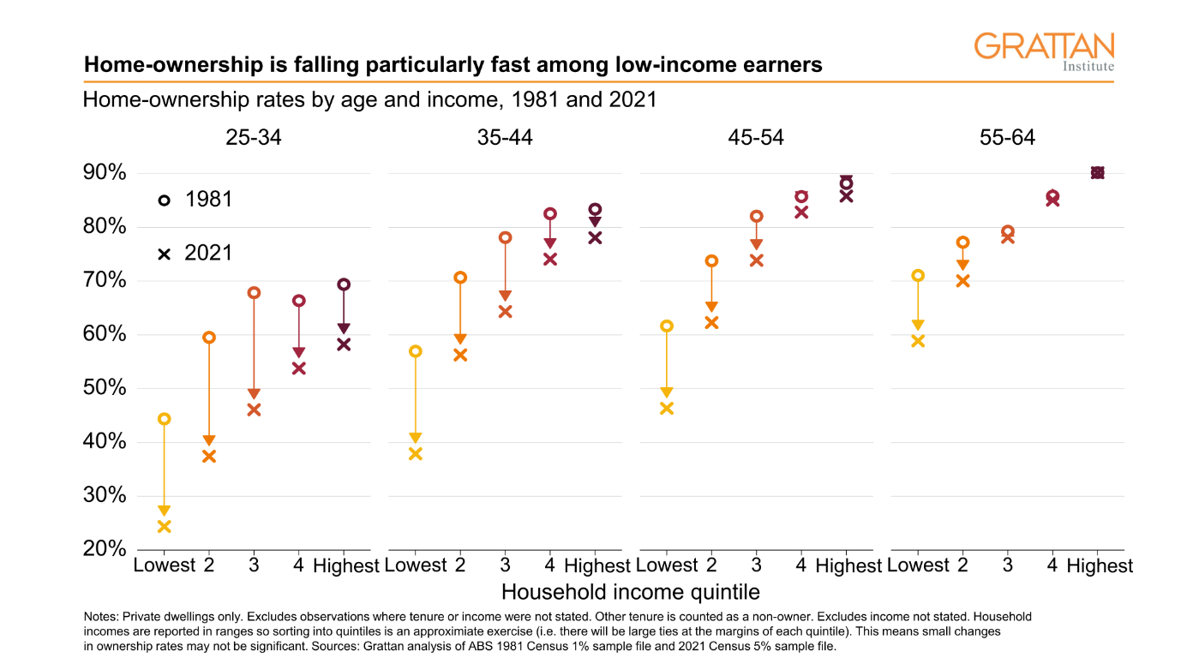**Figure 1.3: Home ownership rates by age and income, 1981 and 2021**

Source: Grattan Institute

Given the significant affordability challenges, increasing numbers of young Australians are relying on family support to purchase a dwelling. In 2025, 17 per cent of first home buyers said they received financial support from parents, compared to 11 per cent in 2022.[4] Where family members are unable to provide direct financial assistance, they may instead agree to act as a guarantor. This allows individuals to purchase a property with a deposit of less than 20 per cent without being required to obtain LMI.

This results in individuals who are able to secure this form of financial support from family members being significantly advantaged over those who are not. In the absence of Government intervention, this would result in a significant divergence in housing outcomes even among Australians with similar income levels.

*The Home Guarantee Scheme has been effective in supporting Australians into home ownership*

The Government’s HGS assists individuals into home ownership by providing a government guarantee of up to 15 per cent (or 18 per cent for the Family Home Guarantee). This allows individuals to purchase a home with a deposit of as low as 5 per cent (or 2 per cent for the Family Home Guarantee), without being required to pay for LMI. The HGS has supported approximately 237,000 Australians into home ownership since the scheme was launched.

As previously noted, the average time needed to save a 20 per cent deposit has increased substantially to 10.6 years as of September 2024, compared to the long-run average of 9.0 years. For many young Australians, this represents a significant hurdle in achieving home ownership. By reducing the required deposit to only 5 per cent, HGS will significantly reduce the time needed to save for a deposit, improving the likelihood that participants will be able to purchase a dwelling.

While aspiring first home buyers without access to HGS can purchase a dwelling with a deposit of less than 20 per cent, they will typically be required to obtain LMI coverage to do so. For many first home buyers the cost involved can be prohibitive. For example, for an individual seeking to purchase an $800,000 property with a 5 per cent deposit of $40,000, an upfront LMI premium could be up to $32,000.[5] In many cases, this additional cost can push home ownership out of reach or delay it by many years.

*An expanded Home Guarantee Scheme will support more Australians into home ownership, reflecting changed market conditions and demand*

The existing Home Guarantee Scheme offers a maximum of 50,000 places each financial year, with the First Home Guarantee offering 35,000 places, the Regional First Home Buyer Guarantee offering 10,000 places and the Family Home Guarantee providing 5,000 places each financial year. However, both the First Home Guarantee and Regional Home Buyer Guarantee streams are likely to be almost fully subscribed over the 2024-25 financial year, an increase from approximately 95 per cent subscription for these two streams combined in 2023-24 and approximately 67 per cent subscription for these streams combined in 2022-23.[6] This means that it is likely that if demand for the scheme continues to increase, eligible Australians will be unable to access the support of the HGS, to enable them to enter home ownership sooner, unless the caps on places are increased or removed.

Currently, to be eligible for the scheme, applicants must have a taxable income that does not exceed $125,000 for individuals or a combined $200,000 for joint applicants. The distribution of HGS participants’ income levels has shifted increasingly closer to the income caps over time. Over the 2023-24 financial year approximately 26 per cent of single participants and 23 per cent of joint participants had incomes of between 80 per cent and 100 per cent of the income caps, compared with 18 per cent and 15 per cent respectively in 2022-23. The existing income caps have remained unchanged since the scheme was established in 2020, while house prices and wages have both increased over this period. As noted above, given the increasing affordability challenges facing even high-income young Australians, it is likely individuals earning above the existing income caps would benefit from support through HGS.

Finally, under the scheme, the purchase price of a property must not exceed the relevant price cap for the area within which the property is located (current price caps are provided at Appendix A). However, significant price growth since the price caps were established has begun to limit the ability of participants to purchase an appropriate property for their circumstances, limiting choice under the scheme and potentially concentrating any demand impacts at the lower end of the property market. In 2023-24, approximately 47 per cent of purchases were valued at the equivalent of least 80 per cent of the current price cap in the relevant area, an increase from 34 per cent in 2022-23. This has been driven particularly by significant increases in prices in South Australia, Western Australia and Tasmania over the past 3 years. It is likely that this issue will be exacerbated, combined with an increasing number of properties becoming ineligible under the scheme, if the price caps are not updated to reflect market conditions.

While the existing HGS program has been successful in supporting low- and middle-income earners into home ownership, falls in levels of home ownership across all income quintiles demonstrates the ongoing challenges Australians face securing a first home. Expanding Government support through HGS to all first home buyers will allow more individuals to achieve home ownership sooner, significantly reduce the time required to save a deposit, reduce the additional costs associated with obtaining LMI coverage, and level the playing field between those who are able to access support from family members and those who are not.

### Lenders mortgage insurance industry – Impacts and implications

LMI is a form of credit protection insurance that protects a lender from losses in the event of borrower default on a home loan. Under prudential standards, where a borrower’s deposit is less than 20 per cent of the property value, lenders are required to either obtain LMI, paid for by the borrower, or carry additional capital to cover the higher risk associated with issuing a high loan-to-value ratio (LVR) loan. The additional capital held increases borrowing costs and is generally passed on to the borrower through higher interest rates.

While LMI offers protection to the lender over the life of the mortgage, the premiums are generally paid by the borrower upfront as a lump sum which is often then capitalised into the total value of a mortgage, rather than in regular periodic payments over the life of the contract (as occurs with most insurance products). As such, this can add significantly to the overall cost of purchasing a home. Further detail on LMI is included in the [earlier HGS impact analysis](https://oia.pmc.gov.au/published-impact-analyses-and-reports/home-guarantee-scheme).

The Home Guarantee Scheme supports eligible home buyers to purchase a home without paying for LMI, enabling them to enter home ownership sooner at a lower cost with a lower deposit. In the event of a default, where the lender exercises its rights under the loan agreement to sell the property, if there is a shortfall in the sale proceeds of the property, the guarantee applies and the shortfall becomes payable to the lender. However, in contrast to LMI, coverage provided by the guarantee ceases once the LVR of the HGS-backed loan falls below 80 per cent.

*Overview of the LMI market*

Private LMI providers in Australia have experienced a slowing in the LMI market, particularly in recent years. During the interest rate tightening cycle of 2022 to 2024, new LMI policies written decreased substantially, with the Insurance Council of Australia noting that LMI gross written premiums declined by 39 per cent between 2019 and 2023.[7] This indicates the sector has, and continues to, experience slowing growth. While changes to the Home Guarantee Scheme may have contributed to this, there are also other contributing factors including rising interest rates for much of the period, tightening of serviceability criteria and an increasing number of banks waiving serviceability requirements across a range of professions.

#### Impact of an expanded Home Guarantee Scheme on the LMI market

Given the cost of LMI to borrowers, Treasury would expect a larger portion of first home buyers to use HGS to support their purchase of a home, in place of LMI. As noted by the Insurance Council of Australia in their submission to Treasury on the proposed expansion, between 10,000 and 15,000 first home buyers make use of LMI each year.[8]

As HGS is only available to first home buyers, investors and non-first home buyers would continue to generate demand for LMI products in the market. For private LMI providers, the ongoing level of demand for their products, particularly from first home buyers, would likely be a key consideration in the commercial attractiveness of the Australian market. While ultimately it is a commercial decision for private LMI providers, the HGS changes have the potential to result in future consolidation of the industry in Australia.

The extent of any potential consolidation in the LMI sector may give rise to possible impacts on those borrowers who are ineligible to access HGS (generally, investors and non-first home buyers). If LMI was difficult to obtain, fewer lenders may offer high LVR loans and those that continue to do so would likely incur additional costs because of the higher capital requirements for the loan. Consequently, they could choose to pass on those costs to borrowers through higher interest rates. This would make it more difficult or costly for borrowers who are ineligible for HGS to obtain finance to support their purchase.

Smaller lenders could also be disproportionately affected by LMI sector consolidation. This is discussed in the section below on the competition implications for small and regional banks.

#### Increasing Government exposure to the housing market

To date, the HGS portfolio has performed above industry standards, with lower hardship and arrears rates than the general market. Approximately 1.0 per cent of the HGS portfolio is accessing hardship support, and 0.3 per cent of the portfolio is in arrears. This is in comparison with over 0.5 per cent of the general population of first home buyers in arrears and over 2 per cent of other high-LVR borrowers in arrears in early 2024.[9] Since the scheme began in 2020, the Commonwealth has provided approximately 155,000 guarantees. Of these, 5 guarantees have been paid out so far, at a total cost of $240,673. It is difficult to ascertain why the HGS portfolio has typically outperformed the market with respect to hardship and arrears. While it is expected that claims would increase under an expanded scheme, particularly in the event conditions in the housing market deteriorate, previous HGS trends may still provide some positive indication of potential future HGS portfolio performance under an expanded scheme.

Giving all first home buyers access to 5 per cent deposits by expanding HGS may also impact the housing market. High LVR lending is typically associated with higher arrears rates in downturns. Low-deposit lending incrementally increases household indebtedness and the potential for negative equity for some purchasers. It also lowers the behavioural impact on creditworthiness of requiring borrowers to save a meaningful deposit. Taken together, these factors have the potential to also amplify the Government’s exposure to the housing market.

### Small and regional banks – competition implications

A diverse and competitive banking sector is critical to ensuring Australians can access finance, particularly mortgage finance, at competitive rates. Small and regional lenders play a central role in supporting diversity and competition in the sector.

For many lenders, attracting first home buyers is critical to their business as it typically enables lenders to acquire and build long-term relationships with new customers.[10] This occurs both through the initial long-term lending involved in mortgage finance, but also through other relationships which may result from this initial interaction. The expansion of the HGS is likely to result in a larger proportion of the first home buyer market participating in and entering into mortgages via the scheme. Consequently, for many small and regional lenders, participation in the HGS panel will become critical to enabling them to compete in the first home buyer segment of the market.

#### Impacts on small and regional banks due to potential LMI industry consolidation/exit

With an expected larger proportion of first home buyers accessing high LVR loans through HGS, smaller lenders could be disproportionately affected by LMI sector consolidation given their heavier reliance (than larger lenders) on LMI to support them to offer high LVR loans and competitive rates. Major lenders generally have greater capacity to ‘self-insure’ high LVR loans (demonstrated by the LMI waivers offered to selected professions by some lenders) as they have greater access to capital. They may also have greater ability to charge the borrower a premium directly to absorb the additional credit risk of high LVR lending.

For small and regional banks, who typically have more limited options to access additional capital, LMI facilitates their ability to offer high LVR lending by:

* reducing the amount of capital they are required to hold against high LVR loans, making them more commercially attractive – the Australian Prudential Regulation Authority’s (APRA) capital requirements are lower for high LVR loans with LMI cover
* enabling lenders to securitise these loans, which takes the loans off their balance sheets and enables them to reallocate the capital they would have otherwise been required to hold against these loans – loans covered by HGS cannot be securitised.

An active LMI market may, therefore, help to support the competitiveness of smaller lenders and competition in the banking sector more broadly. Access to the LMI market will be important for low-deposit customers who cannot access HGS (for example, prospective buyers who have purchased a home in the previous 10 years).

#### Impacts on small and regional banks’ risk exposures

HGS backed loans pose different risks to those covered by LMI so switching to a higher proportion of HGS backed loans may have implications for small and regional banks’ risk exposures. Small and regional banks have noted that when they lend using HGS rather than LMI, they bear the risk of the HGS guarantee being invalidated due to borrower actions beyond their control. This can leave the bank unexpectedly without HGS coverage on high LVR loans, which is a risk they do not face when offering LMI backed loans. While very few claims made under HGS have been subject to this issue, it presents a risk to small and regional banks if offering more HGS-backed loans.

Additionally, LMI is structured to cover a loan through its lifecycle until it is repaid, whereas HGS coverage ceases when a loan falls below 80 per cent LVR (i.e. HGS covers up to 15 per cent, or 18 per cent for the Family Home Guarantee, of the value of the loan). However, the strength of the Government’s standing as a guarantor is reflected in APRA’s capital settings, which require lenders to hold less capital against HGS backed loans than LMI backed loans. This preferential capital treatment could incentivise small and regional lenders to offer more HGS-backed loans.

#### Enabling small and regional bank participation in HGS

Small and regional banks are significant contributors to competition in the banking sector, so it is important that they continue to be supported to participate in HGS. As part of the implementation process for the expansion of HGS, Housing Australia will consider approaches to expanding the current panel of lenders. Small and regional lenders who are not currently part of the lender panel will have the opportunity to become participants in the scheme, assisting to ameliorate competition concerns that may arise in relation to lender access to the panel.

### Impacts on low- to middle- income home buyers

The support provided by HGS has two key impacts for home buyers. First, it increases the purchasing capacity of eligible applicants by allowing individuals to avoid the cost of purchasing LMI. Second, it enables households to bring forward their purchase and enter the property market sooner. As a result, the support provided by HGS may lead to an increase in demand for housing.

Policies that increase demand for housing without a corresponding increase in supply can put upward pressure on housing prices, impacting affordability. The ability of many low- and middle-income earners to enter the market is heavily dependent on broader housing affordability. As such, policy interventions that harm housing affordability can be counterproductive for these Australians, including some who may currently be eligible for HGS.

As noted previously, the high LVR lending supported by HGS will incrementally increase household indebtedness and increase the potential for negative equity for some purchasers. However, this impact will be mitigated to some extent by the need for participants to secure a mortgage from a lender and therefore satisfy all the ordinary requirements involved in obtaining finance.

#### Overall demand impacts are expected to be limited

While the expansion of HGS is likely to place some upward pressure on demand for housing, it is expected that these impacts will be relatively modest. The existing scheme supported approximately 45,000 eligible home buyers in 2024-25, this represents approximately 40 per cent of the around 110,000 annual first home buyers.[11] While the additional support provided by the expansion of HGS will increase the size of this market, it is unlikely to be of sufficient scale to represent more than a small proportion of the 555,000 residential property transactions that occurred in Australia in 2024.[12]

Additionally, as has been noted, the existing scheme income and property price caps were set at levels which would concentrate any price impacts at the entry level segment of the property market. Removing the existing scheme income caps and substantially increasing the property price caps is likely to dilute the impact of the increased demand, spreading it across a broader segment of the market.

#### Uncapping the scheme ensures access remains possible for all low and middle income first home buyers

As has previously been noted, the existing FHBG and RFHBG streams of HGS are likely to be fully (or almost fully) subscribed for the 2024-25 financial year, with approximately 95 per cent of places in both streams having been allocated in 2023-24.[13] In the absence of an increase in the maximum number of places available under the scheme it is likely that some eligible Australians would be unable to access support in the 2025-26 financial year. The removal of the cap on places allows all eligible Australians to receive support, ensuring that individuals who are eligible for the existing scheme are not displaced by individuals who will become eligible under the expanded scheme.

### Consultation

### Treasury undertook targeted consultation with key stakeholders including from the banking and LMI sectors, and the Australia Prudential Regulation Authority. 5 meetings were held and 7 written submissions received from stakeholders, including 4 confidential submissions. Treasury sought stakeholder views on:

* the potential impact of the expansion of HGS on the LMI industry, and particularly demand for LMI products amongst first home buyers;
* the potential impact on competition in the banking sector if certain lenders were excluded from the HGS lender panel;
* the potential impact on low and middle income first home buyers of the expansion of the scheme.

During this consultation process, stakeholders noted particular concerns relating to:

* the impacts on the LMI sector, particularly relating to the impact of a reduction in gross written premiums from first home buyer;
* the potential impacts on small lenders of the expansion of the scheme where lenders are not included in the HGS lender panel; and
* the potential impact on demand in the housing market of additional first home buyers purchasing a dwelling.

Stakeholders also noted the importance of maintaining a competitive banking sector and first home buyer lending market, including for small and regional lenders.

The Government has noted these concerns raised by stakeholders, which have informed the implementation of the Home Guarantee Scheme expansion election commitment.

### Estimated Regulatory Cost of HGS Expansion

*Methodology used to estimate annual regulatory costs to individuals*

Under the HGS expansion option, regulatory costs to individuals come from the additional time it takes individuals to understand the requirements of the guarantee schemes.

Based on industry estimates and experience with the existing scheme, the following assumptions were made to determine the regulatory costs to individuals under the HGS expansion options:

* Individuals spend 1 additional hour to understand the requirements of the guarantee schemes.
* Using the Office of Impact Analysis estimate for individual costs at $37.00 per hour.

The total estimated average regulatory costs to individuals under the HGS expansion option will be dependent on the extent of uptake of the expanded scheme. While it is not possible to determine the exact size of this uptake, if all existing first home buyers made use of the scheme the total regulatory cost to individuals would be approximately $2.405 million. A more realistic estimate of uptake numbers would lead to an estimate of approximately $0.925 million in additional regulatory costs for individuals.

*Methodology used to estimate annual regulatory costs to businesses*

The following assumptions were made to estimate the regulatory costs associated with ongoing administrative costs to lenders through processing additional loans:

* Additional two hours for a lender to process an additional guarantee loan
* Using the Office of Impact Analysis estimate for business costs at $85.17 per hour.

Estimated average regulatory costs associated with ongoing administrative costs to lenders through processing additional loans is $4.286 million per year.

The following additional assumptions were made to estimate the regulatory costs associated with processing defaults on additional loans:

* Default claim rate of 2 per cent (based on actuarial modelling of the scheme, noting the existing scheme has had substantially lower default rates)
* Additional 5 hours for a lender to process default.

Estimated average regulatory costs associated with processing defaults on additional loans is $0.213 million per year.

This results in a total estimated average regulatory cost to lenders and brokers of $4.499 million per year.

Treasury notes that while the 2022 Home Guarantee Scheme Impact Analysis included the cost of the additional time it would take to educate front-line lenders and brokers and update systems, given the expanded scheme does not differ significantly from an operational perspective, this supplementary impact analysis does not consider these costs to be material.

|  |  |  |  |  |
| --- | --- | --- | --- | --- |
| **Average annual regulatory costs (from business as usual)** | | | | |
| Change in costs ($ million) | Business | Community organisations | Individuals | Total change in cost |
| Total, by sector | $4.45 | $0 | $0.93 | $5.38 |

### Conclusion

In an environment of increasing housing prices, falling home ownership rates across all income quintiles among young Australians, and the available scheme places for the 2024-2025 financial year close to fully utilised (for all streams excluding the Family Home Guarantee), the expansion of the HGS is an appropriate way of encouraging home ownership. Providing expanded Government support through HGS will allow more individuals to achieve home ownership sooner, significantly reduce the time required to save a deposit, reduce the additional costs associated with obtaining LMI coverage, and level the playing field between those who are able to access support from family members and those who are not.

However, it is worth noting that the HGS expansion may potentially lead to consolidation in the LMI industry, potentially making accessing high LVR loans for those ineligible for HGS more expensive, and reducing competition within the banking sector. The LMI industry is expected to continue to be viable and all eligible first home buyers will be able to access the HGS as an alternative. Housing Australia will also work to expand their lender panel, enabling more small and regional lenders to offer HGS backed loans.

While the expansion of HGS is likely to have some impact on demand for housing, it is expected that these impacts will be relatively modest and the removal of existing scheme income caps and increases to property price caps will dilute any price impacts at the lower end of the property market.

### Appendix A

*New Property Price Caps*

The price caps will be increased to reflect changes in the median house price in each locality. The price cap on the value of residential property for a HGS supported loan will be as follows:

|  |  |  |
| --- | --- | --- |
| Locality | Current HGS property price caps | New HGS property price caps |
| NSW – capital city and regional centre | $900,000 | $1,500,000 |
| NSW – other | $750,000 | $800,000 |
| VIC – capital city and regional centre | $800,000 | $950,000 |
| VIC – other | $650,000 | $650,000 |
| QLD – capital city and regional centre | $700,000 | $1,000,000 |
| QLD – other | $550,000 | $700,000 |
| WA – capital city | $600,000 | $850,000 |
| WA – other | $450,000 | $600,000 |
| SA – capital city | $600,000 | $900,000 |
| SA – other | $450,000 | $500,000 |
| TAS – capital city | $600,000 | $700,000 |
| TAS– other | $450,000 | $550,000 |
| ACT | $750,000 | $1,000,000 |
| NT | $600,000 | $600,000 |
| Jervis Bay Territory and Norfolk Island | $550,000 | $550,000 |
| Christmas Island and Cocos (Keeling) Islands | $400,000 | $400,000 |

1. Australian Bureau of Statistics, Survey of Income and Housing, https://www.abs.gov.au/statistics/people/housing/housing-census/latest-release.
2. ANZ – CoreLogic (2024), https://www.anz.com.au/content/dam/anzcomau/bluenotes/documents/ANZ_CoreLogic_%20Housing_Affordability%20Report_November-2024.pdf.
3. Australian Bureau of Statistics, Survey of Income and Housing, https://www.abs.gov.au/statistics/people/housing/housing-census/latest-release.
4. First Home Buyer Report 2025, https://cdn.finder.com.au/finder-au/wp-uploads/2025/06/Finder-First-Home-Buyer-Report-2025.pdf?_gl=1*13hou9f*_gcl_au*MTM1NTIyMDE4MS4xNzUxNjEwODA1.
5. Helia LMI Fee Estimator, https://helia.com.au/the-hub/calculators-estimators/lmi-fee-estimator.
6. Housing Australia, Home Guarantee Scheme Trends and Insights Report 2023-24, <https://www.housingaustralia.gov.au/research-data-analytics/hgs-trends-and-insights-report-2023-24>.

   Housing Australia, Home Guarantee Scheme Trends and Insights Report 2022-23, https://www.housingaustralia.gov.au/research-data-analytics/hgs-trends-and-insights-report-2022-23.
7. Insurance Council of Australia Submission to Treasury on the proposed expansion of HGS
8. Insurance Council of Australia Submission to Treasury on the proposed expansion of HGS
9. Reserve Bank of Australia, Recent Drivers of Housing Loan Arrears, <https://www.rba.gov.au/publications/bulletin/2024/jul/pdf/recent-drivers-of-housing-loan-arrears.pdf>; Reserve Bank of Australia, Financial Stability Review, https://www.rba.gov.au/publications/fsr/2024/sep/resilience-of-australian-households-and-businesses.html.
10. Customer Owned Banking Association Submission to Treasury on the proposed expansion of HGS
11. Australian Bureau of Statistics, Lending Indicators, https://www.abs.gov.au/statistics/economy/finance/lending-indicators/latest-release.
12. Australian Bureau of Statistics, Total Value of Dwellings, https://www.abs.gov.au/statistics/economy/price-indexes-and-inflation/total-value-dwellings/latest-release.
13. Housing Australia, Home Guarantee Scheme Trends and Insights Report 2023-24, https://www.housingaustralia.gov.au/research-data-analytics/hgs-trends-and-insights-report-2023-24.