30 July 2025

**Ref:** EC25-002268

**File:** OIA25-09108

Ms Joanna Abhayaratna

Executive Director

Office of Impact Analysis

Department of the Prime Minister and Cabinet

1 National Circuit

BARTON ACT 2600

Email: [Helpdesk-OIA@pmc.gov.au](mailto:Helpdesk-OIA@pmc.gov.au)

Dear Ms Abhayaratna

I am writing to certify that the attached 2022 Home Guarantee Scheme Impact Analysis, alongside the Home Guarantee Scheme Expansion Supplementary Analysis, has been undertaken via a process and analysis equivalent to an Impact Analysis.

I certify that this document adequately addresses all seven Impact Analysis questions for the purposes of informing a final policy decision on the expansion of the scheme.

The scope of the Impact Analysis Equivalent covers the scope of the policy proposal. To address the additional impacts of the further expansion of the scheme on lenders mortgage insurance providers, small and regional banks, and low-income buyers, I also certify the Home Guarantee Scheme Expansion Supplementary Analysis. Therefore, I am satisfied that with this addition, the scope of the certified documents matches the policy proposal.

I further certify that fewer than three policy options are examined in accordance with the Office of Impact Analysis guidance on the Impact Analysis process for election commitments.

The regulatory burden to business, community organisations or individuals is quantified using the Australian Government’s *Regulatory Burden Measurement* framework and is provided below.

Regulatory burden estimate table

|  |  |  |  |  |
| --- | --- | --- | --- | --- |
| Average annual regulatory costs (from business as usual) | | | | |
| Sector | Business | Community organisations | Individuals | Total change in costs |
| Change in costs ($ million) | $4.45 | $0.00 | $0.93 | $5.38 |

Accordingly, I am satisfied that the attached report is consistent with the *Australian Government Guide to Policy Impact Analysis*.

Yours sincerely

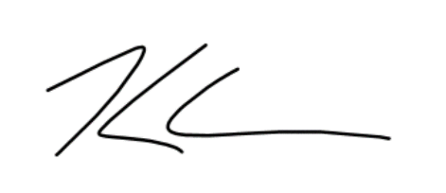

Kerren Crosthwaite

A/g Deputy Secretary, Housing Group  
The Treasury  
30/07/2025