### Report Heading: "National Child Safety Review"

Decision Regulation Impact Statement

­

29 August 2025

*This Decision Regulation Impact Statement (DRIS) has been prepared on behalf of all Australian Education Ministers with the assistance of Deloitte Access Economics. It includes data, consultation information and cost modelling analysis undertaken by Deloitte Access Economics in consultation with the Australian Government and all state and territory governments.*

**Copyright and Terms of Use**

© Education Services Australia, as the legal entity for the Education Ministers Meeting, 2025.

Picture outlines creative commons license that enables reusers to distribute, remix, adapt, and build upon the material in any medium or format for noncommercial purposes only, and only so long as attribution is given to the creator. 

*National* *Child Safety Review Decision Regulation Impact Statement* is licensed by the Education Ministers Meeting under a Creative Commons Attribution, Non Commercial 4.0 International License.

Intergovernmental Support Team: [Emmsupport@education.gov.au](mailto:Emmsupport@education.gov.au)

2

# Contents

Contents 4

Acronyms 12

Glossary 14

Executive Summary 16

Management of Digital Devices 19

Child Safety Training 20

Responding to educator and staff member conduct 22

Working with Children Checks 26

Improving the safety of the physical service environment 28

Guide to the Child Safety Review Decision Regulation Impact Statement 35

What is a regulation impact statement? 35

Guide to the DRIS 36

1. Introduction 39

1.1 The National Quality Framework 40

1.2 The education and care sector 44

1.3 What is the case for change? 46

2. The case for government intervention 52

3. Summary of public consultation process 56

3.1 Pre-CRIS consultations 57

3.2 Public consultation 58

3.3 Evaluating the public consultation evidence base 62

3.4 General insights from public consultation 64

4. Approach to impact analysis 66

Multi-criteria analysis approach 66

Break-even analysis approach 70

Analysis by area of reform 75

3

5. Management of digital devices 76

5.1 Managing the use of digital devices 77

6. Child safety training 102

6.1 Introducing mandatory child safety training 102

7. Responding to educator and staff member conduct 132

7.1 Making inappropriate conduct an offence 134

7.2 Enhancing Regulatory Authorities’ ability to share information with approved providers 152

7.3 Expansion of regulatory responses to educator and staff member conduct 161

8. Working with Children Checks 176

8.1 Requiring an approved WWCC prior to commencing paid or volunteer work at an education and care service 176

8.2 Requiring approved providers and Regulatory Authorities to be notified about changes in WWCC status 191

9. Improving the safety of the physical service environment 203

9.1 Service and temporary waivers for the design of premises (to facilitate supervision of children) 204

9.2 Requiring approved providers to assess not just the FDC residence, but areas near the residence 217

9.3 Enabling authorised officers to access areas of a FDC residence or property, beyond the service premises, in specific instances or for specific purposes 233

10. Additional recommendations 248

10.1 Effective identification, monitoring and regulation of ‘related providers’ 248

10.2 Extending the limitation period for commencing proceedings under the National Law 256

10.3 Information sharing provisions for recruitment agencies 260

11. Implementing and evaluating the recommended options 269

Combined impact of the recommended options 269

Implementing the recommended options 274

Evaluating the recommended options 274

Next steps 296

12.1 List of recommended options 298

12.2 Evolution of CSR recommendations to the proposed options 314

12.3 Survey findings 320

12.4 The National Model Code and Guidelines 365

12.5 Child protection training and Child Safe Standards 367

12.6 Overview of jurisdictional WWCCs 370

12.7 Summary of relevant WWCC legislation and requirements 372

12.8 Family Assistance Law (FAL) 378

Figures, Charts and Tables

Figure I: Phases of the Child Safety Review RIS 36

Table I: Guide to the document 36

Figure 1.1: The National Quality Framework structure 41

Table 1.1: Different service types and attendance, 2023-24 44

Figure 1.2: Number and proportion of services by provider management type, 1 April 2025 46

Table 3.1: Overview of consultation and engagement 58

Table 3.2: Submissions by stakeholder group 60

Chart 3.1: Proportion of survey responses by jurisdiction compared to proportion of education and care services across Australia 63

Table 4.1: Approach to MCA 68

Table 4.2: Approach to measuring impact for each reform area 72

Table 5.1: Uptake of the National Model Code and Guidelines by service type 80

Table 5.2: Policy options under consideration – Managing the use of digital devices 81

Table 5.3: MCA outcomes – Managing the use of digital devices 82

Chart 5.1: Approved provider responses to “How much do you think each option will reduce the risk of harm to children?” 84

Chart 5.2: Workforce responses to “How much do you think each option will reduce the risk of harm to children?” 85

Table 4.4: Summary of assumptions involved in estimating the cost of options 2 and 3 89

Table 4.5: Cost of options 2 and 3 by jurisdiction, present value, 2025 to 2034 90

Table 5.6: BEA – Managing the use of digital devices 97

Table 5.7: Regulatory burden estimate – Managing the use of digital devices, NPV 2025 to 2034, 7% discount rate 98

Chart 5.3: Approved provider responses to “What is your preferred option or combination of options?”, by service type 99

Chart 5.4: Workforce responses to “What is your preferred option or combination of options?”, by service type 100

Table 6.1: Policy options under consideration – Child safety training 107

Table 6.2: MCA outcomes – Child safety training 109

Chart 6.1 Approved provider responses to “How much do you think each option will reduce the risk of harm to children?” 111

Table 6.3: Costing estimates for option 3 to 5 for Child Safety Training reform area 117

Table 6.4: Monetised cost of options 3, 4, and 5, by jurisdiction 121

Table 6.5: BEA – Child safety training 128

Table 6.6: Regulatory burden estimate – Child safety training, NPV 2025 to 2034, 7% discount rate 129

Chart 6.2: Support for options in written responses 130

Chart 7.1: Approved provider responses to “How often do you hear about reports of inappropriate conduct?” 137

Chart 7.2: Approved provider responses to “How often do you hear about reports of inappropriate conduct that haven't resulted in a prohibition?” 138

Table 7.1: Policy options under consideration – Making inappropriate conduct an offence 139

Table 7.2: MCA outcomes – Making inappropriate conduct an offence 141

Chart 7.3: Approved provider responses to “How much do you think each option will reduce the risk of harm to children?” 143

Table 7.3: Policy options under consideration – Enhancing Regulatory Authorities’ ability to share information with approved providers 155

Chart 7.4: Approved provider responses to “How much do you think each option will reduce the risk of harm to children?” 157

Table 7.4: Policy options under consideration – Expansion of regulatory responses to educator and staff member conduct 164

Table 7.5: MCA outcomes – Expansion of regulatory responses to educator and staff member conduct 166

Chart 7.5: Approved provider responses to “How much do you think each option will reduce the risk of harm to children?” 167

Table 8.1: Overview of WWCC legislation, regulation, and standards 178

Table 8.2: High-level overview of key differences in jurisdictional legislation for commencing roles with WWCCs 179

Table 8.3: Policy options under consideration – Requiring an approved WWCC prior to commencing paid or volunteer work at an education and care service 181

Table 8.4: MCA outcomes – Requiring an approved WWCC prior to commencing paid or volunteer work at an education and care service 183

Chart 8.1: Approved provider responses to “How much do you think each option will reduce the risk of harm to children?” 184

Chart 8.2: Approved provider responses to “What is your preferred option or combination of options?”, by jurisdiction 190

Table 8.5: High-level overview of key differences in jurisdictional notification requirements 194

Table 8.6: Policy options under consideration – Requiring approved providers and Regulatory Authorities to be notified about changes in WWCC status 195

Table 8.7: MCA outcomes – Requiring approved providers and Regulatory Authorities to be notified about changes in WWCC status 196

Chart 8.3: Approved provider responses to “How much do you think each option will reduce the risk of harm to children?” 198

Chart 8.4: Approved provider responses to “What is your preferred option or combination of options?”, by jurisdiction 201

Table 9.1: Quantity of all waivers of regulation 115 by status and waiver type, 2009-2024 207

Table 9.2: Quantity of all waivers of regulation 115 by service and waiver type, 2009-2024 208

Table 9.3: Policy options under consideration – Service and temporary waivers for the design of premises (to facilitate supervision of children) 209

Table 9.4: MCA outcomes – Service and temporary waivers for the design of premises (to facilitate supervision of children) 210

Chart 9.1: Family, carers, and parent responses to “How much do you think each option will reduce the risk of harm to children?” 212

Chart 9.2: Approved provider responses to “How much do you think each option will reduce the risk of harm to children?” 212

Chart 9.3: Approved provider responses to “What is your preferred option or combination of options?” 216

Chart 9.4: Family, carer, and parent responses to “What is your preferred option or combination of options?” 217

Figure 9.1: Diagram example of the boundaries of an FDC service premises and FDC residence relative to property boundary 219

Table 9.5: Policy options under consideration – Requiring approved providers to assess not just the FDC residence, but areas near the residence 221

Table 9.6: MCA outcomes – Requiring approved providers to assess not just the FDC residence, but areas near the residence 222

Chart 9.5: Approved provider responses by service type to “How much do you think each option will reduce the risk of harm to children?” 223

Chart 9.6: Approved provider responses by service type to “Are areas broader than the FDC residence ever assessed at your service?” 224

Table 9.7: Cost of option 3 and option 4, by jurisdiction 227

Table 9.8: BEA – Requiring approved providers to assess not just the FDC residence, but areas near the residence 231

Table 9.9: Regulatory burden estimate – Requiring approved providers to assess not just the FDC residence, but areas near the residence, NPV 2025 to 2034, 7% discount rate 232

Chart 9.7: Approved provider responses to “What is your preferred option or combination of options?” – FDCs only 233

Table 9.10: Policy options under consideration – Enabling authorised officers to access areas of a FDC residence or property, beyond the service premises, in specific instances or for specific purposes 237

Table 9.11: MCA outcomes – Enabling authorised officers to access areas of a FDC residence or property, beyond the service premises, in specific instances or for specific purposes 238

Table 9.12: Approved provider responses by service type to “How much do you think each option will reduce the risk of harm to children?” 239

Chart 9.8: Approved provider responses by service type to “To what extent are you concerned that the expansion of the powers of entry granted to authorised officers would impact your right to privacy or the privacy of those living in the FDC residence?” 242

Chart 9.9: Approved provider responses to “What is your preferred option or combination of options?” - FDCs 245

Chart 9.10: Approved provider responses to “What is your preferred option or combination of options?” – all approved providers 245

Chart 9.11: Workforce responses to “What is your preferred option or combination of options?” 246

Chart 9.12: Family, carer, and parent responses to “What is your preferred option or combination of options?” 246

Table 10.1: Policy options under consideration – Effective identification, monitoring and regulation of ‘related providers’ 251

Chart 10.1: Approved provider responses to “What is your preferred option or combination of options?” 253

Table 10.2: Policy options under consideration – Extending the limitation period for commencing proceedings under the National Law 258

Chart 10.2 Approved provider responses to “How much do you think each option will reduce the risk of harm to children?” 259

Table 10.3: Policy options under consideration – Information sharing provisions for recruitment agencies 263

Chart 10.3: Approved provider responses to “How much do you think each option will reduce the risk of harm to children?” 265

Table 11.1: Regulatory burden estimate – all monetised recommended options, NPV 2025 to 2034, 7% discount rate 273

Table 11.2: Cost by jurisdiction – all monetised recommended options, NPV 2025 to 2034, 7% discount rate 273

Table 11.5: Status of the impact analysis at each major decision point 296

# Acronyms

| **Acronym/term** | **Name** |
| --- | --- |
| ACECQA | Australian Children's Education and Care Quality Authority |
| ACT | Australian Capital Territory |
| BEA | Break-even analysis |
| CBA | Cost-benefit analysis |
| CCTV | Closed-circuit television |
| CRIS | Consultation Regulation Impact Statement |
| CSR | Review of Child Safety Arrangements under the National Quality Framework |
| DRIS | Decision Regulation Impact Statement |
| FAL | Family Assistance Law |
| FDC | Family day care |
| LDC | Long day care |
| MCA | Multi-criteria analysis |
| National Law | Education and Care Services National Law |
| National Principles | National Principles for Child Safe Organisations |
| National Regulations | Education and Care Services National Regulations |
| NQF | National Quality Framework |
| NQS | National Quality Standard |
| NSW | New South Wales |
| NT | Northern Territory |
| OSHC | Outside school hours care |
| PCRG | Parents and carers reference group |
| PMC | Person with Management or Control |
| QLD | Queensland |
| RIS | Regulation Impact Statement |
| RPC | Regulatory Practice Committee |
| SA | South Australia |
| SNAICC | The National Voice for Aboriginal and Torres Strait Islander Children |
| TAS | Tasmania |
| VET | Vocational education and training |
| VIC | Victoria |
| VPN | Virtual private network |
| WA | Western Australia |
| WWCC | Working with Children Check or Clearance |
| WWVPR | Working with Vulnerable Persons Registration |

# Glossary

| **Term** | **Description** |
| --- | --- |
| Administrative costs | Costs incurred in complying with a regulation that relate to record keeping, reporting or other administrative processes or systems. |
| Business | Any organisation engaged in commercial, industrial or professional activities operating under Australian law for the purpose of making a profit. |
| Burden | The cumulative effect of government regulation on business, community organisations or individuals. |
| Business-as-usual costs | Costs incurred as part of normal business practices that would be undertaken regardless of regulatory change. |
| Centre-based services | Centre-based services refers to preschool/kindergartens, long day cares, and outside of school hours care services. |
| Community organisation | Any organisation engaged in charitable or other community-based activity operating under Australian law and not established for the purpose of making a profit. In the 2019 NQF Review DRIS, community organisations are assumed to be not-for-profit, community and government providers of education and care services. |
| Compliance costs | The direct costs incurred by a regulated entity to comply with regulation. Compliance costs can be further categorised into *administrative, substantive,* or *financial* compliance costs. |
| Consultation | The practice of advising stakeholders of an intention to regulate which involves information sharing, dialogue and genuine consideration of feedback received. |
| Education and care | Refers to the services provided by preschools/kindergartens, long day cares, family day cares, and outside of school hours care services. |
| Financial costs | The fees and charges attached to a regulation that are payable to government. |
| Impact | A positive or negative effect caused by regulation. |
| Individual | Any person subject to Australian law who interacts with government or is impacted by regulation, and whose activities have an impact in Australia. |
| Legislative change | A change that involves formal amendments to existing legislation and regulations. |
| Minor change | Changes that do not substantially alter the existing regulatory arrangements. |
| Non-regulatory change | A change that does not involve formal amendments to existing legislation and regulations but is nonetheless intended to regulate the sector. An example is the development of communications and guidance to improve stakeholder awareness and knowledge of legislative and regulatory requirements and to enable compliance. |
| Regulation | Any rule endorsed by government where there is an expectation of compliance. This includes legislation, regulations, quasi-regulations and any other aspect of regulator behaviour which can influence or compel specific behaviour by business, community organisations or individuals. This includes red tape burden imposed by the Commonwealth’s procurement, grants and cost recovery frameworks. |
| Regulation Impact Statement (RIS) | A statement government agencies must produce as part of the policy-making process when a decision is likely to have a regulatory impact on business, community organisations or individuals. |
| Status quo option | A policy option in which all current policy settings remain as they are, also in the absence of non-regulatory intervention. A RIS must analyse the net benefit of the status quo option as a benchmark against which other options can be assessed. |

# Executive Summary

The National Quality Framework (NQF) is Australia’s system for regulating education and care services and for improving outcomes for children. The first and foremost objective of the NQF is to ensure the safety, health and wellbeing of all children attending an education and care service.

The safety and protection of children is also the highest priority for all Australian governments who agreed in 2023 to undertake the Child Safety Review. The Final Report of the Child Safety Review, the [Review of Child Safety Arrangements under the National Quality Framework](https://www.acecqa.gov.au/sites/default/files/2023-12/Review%20of%20Child%20Safety%20Arrangements%20under%20the%20National%20Quality%20Framework-full_report.pdf) (CSR)[1], was published in December 2023.

The CSR examined new or refined systemic safeguards to better support services to protect children who attend an education and care service. The CSR made 16 recommendations to address emerging issues, close loopholes, strengthen policies and practices, child safe cultures, recruitment processes and information handling, supporting staff capabilities, and improving protections around the use of new, online technologies.[2]

Based on the findings and recommendations of the CSR and the culmination of work by all governments to develop appropriate policy responses, this Decision Regulation Impact Statement (DRIS) analyses the potential impacts for all the options proposed to improve child safety in education and care services operating under the NQF and provides an agreed set of reforms to implement, based on the sum of the regulatory impact analysis activities undertaken.

The DRIS has been informed by comprehensive consultation with the sector and the community, including public consultation undertaken following the publication of a Consultation Regulation Impact Statement (CRIS). Public consultation on the CRIS was undertaken by Deloitte Access Economics and SNAICC - the National Voice for Aboriginal and Torres Strait Islander Children over a six-week period from 28 April to 11 June 2025.[3] Further information on public consultation is provided in Chapter 3.

Public engagement with the CRIS was high, with over 1500 individuals and organisations providing their views, including over 500 members of the education and care workforce, over 200 family members, parents and carers, and over 300 approved provider representatives. Public consultation was representative of a range of service types, including long day care (LDC), preschool/kindergarten, family day care (FDC) and Outside School Hours Care (OSHC), as well as provider types and sizes, stakeholder demographics, jurisdictions, and remoteness. Governments are grateful to all stakeholders who provided input during the public consultation.

A range of regulatory options (e.g., legislative changes) and non-regulatory options (e.g., the provision of guidance materials) aimed at improving child safety are considered throughout this DRIS. The impact of proposed policy options is assessed through a multi-criteria analysis (MCA) framework, which evaluates each policy option against four criteria. These criteria are weighted, which means that some of the criteria count for more in the overall score. In line with government and stakeholder priorities, the MCA places higher weights on benefits (*improvement to child safety outcomes*) compared to cost-related criteria (*net cost, implementation consideration and distributional impacts*). The four criteria and their weightings are:

* the improvement in child safety outcomes (50% weighting)
* the net cost of the policy option (30% weighting)
* the implementation considerations (10% weighting)

the distributional impact of the option on stakeholders (10% weighting).

The options that are recommended to be implemented are those that are considered likely to provide the greatest improvement to child safety. Education Ministers met on 22 August 2025 for a special purpose Education Ministers Meeting and agreed to the reforms outlined in the DRIS, noting the Minister decision taken for Additional Recommendation - Extending the limitation period for commencing proceedings under the National Law, was different to the recommended option in this DRIS.

A summary of all agreed policy options, as well as the options that are not recommended for implementation, can be found in Appendix 12.1.[4] The following sections outline the recommended options for implementation, by reform area.

## Management of Digital Devices

Management of digital devices is discussed in further detail in Chapter 5.

#### Managing the use of digital devices

|  |  |
| --- | --- |
| **Summary of recommended policy options to be provided to Education Ministers for consideration** | **Implementation approach** |
| **Option 2 (Regulatory):** Amend the National Law and National Regulations to enact standalone provisions to mandate that:   * Only service-issued digital devices can be used when taking images or videos of children while providing education and care.   This amendment would be an offence provision with a penalty attached.  This will apply to approved providers, nominated supervisors, family day care educators and educators. | To be implemented in full |
| **Option 3 (Regulatory):** Amend the National Law and National Regulations to enact standalone provisions for centre-based services to mandate that other than in the case of defined exempt circumstances:   * personal devices that can take images or videos (such as tablets, phones, digital cameras, and smart watches) and personal storage and file transfer media (such as SD cards, USB drives, hard drives, and cloud storage) cannot be in the possession of any person while providing education and care and working directly with children.   This amendment would be an offence provision with a penalty attached.  This will apply to centre-based, approved providers, nominated supervisors, and educators. | To be implemented in centre-based settings only, with excursions to be included as an exempt circumstance, and other potential exemptions to be considered. |

Based on analysis included in this DRIS, the options with the highest net benefit to be provided to Education Ministers for consideration are Options 2 and 3, with further clarity and definition regarding the scope of option 3. These options are selected on the basis that they would generate the largest net benefits to child safety outcomes, even after accounting for implementation costs.

## Child Safety Training

Child safety training is discussed in further detail in Chapter 6.

Introducing mandatory child safety training

|  |  |
| --- | --- |
| **Summary of recommended policy options to be provided to Education Ministers for consideration** | **Implementation approach** |
| **Option 4 (Regulatory):** Amend section 162A of the National Law to require staff who work with children, including FDC educators, volunteers and students, in addition to nominated supervisors, persons in day-to-day charge and FDC coordinators, to complete child protection training, removing the dependency on other jurisdictional law or government protocol.  This would be supported by publication of an approved list of child protection training for the purposes of compliance with this section, as for first aid training (made up of national or state accredited units of competency or short courses) through amendment to regulation 137. | To be implemented in full |
| **Option 5 (Regulatory):** To expand the requirement in regulation 84 so that all staff and volunteers, whether or not they work with children, must be made aware of:   * existence and application of the current child protection law * any obligations that the person may have under that law.   (i.e. remove the limitation to staff who work with children) | To be implemented in full |
| **Option 6 (Regulatory):** Legislative change to require:   1. Mandatory child safety training.   Which is nationally consistent, approved, of a high quality, and tailored for all people involved in the provision of education and care services (including people who do not directly work with children), with a requirement to complete refresher training every two years.  This change should be subject to governments undertaking further research, costing and impact analysis of any proposed training and the implementation approach.  Mandatory child safety training may feature matters including, but not limited to:   * creating a child safe culture in education and care services * identifying, reporting, and responding to child maltreatment through trauma informed practice * differences in behaviour and responding appropriately, along with identifying grooming behaviour in children and adults around them * understanding the difference between developmentally expected sexual behaviour and concerning or harmful behaviour by children or between children * effective supervision and behaviour guidance, including the offence of using inappropriate discipline, and potentially inappropriate conduct (refer to Chapter 7.1). | To be implemented in full |

Based on analysis included in this DRIS, the options with the highest net benefit to be provided to Education Ministers for consideration are the regulatory options 4, 5, and 6. These options introduce the highest standards of child protection knowledge and training and child safety training and will provide a nationally consistent approach and expectation across the whole education and care sector. While there is strong in-principle support for regulatory options, stakeholder feedback highlighted a range of considerations that would need to be taken into account in implementing these options. If these options are implemented, state and territory governments would need to undertake additional work to provide greater clarity on the scope, scale, content and format of child safety and child protection training.

## Responding to educator and staff member conduct

Responding to educator and staff member conduct is discussed in further detail in Chapter 7.

#### Making inappropriate conduct an offence

|  |  |
| --- | --- |
| **Summary of recommended policy options to be provided to Education Ministers for consideration** | **Implementation approach** |
| **Option 2 (Non-regulatory):** Develop more communications and resources on encouraging approved providers to address appropriate and inappropriate conduct within their contracts of employment, Code of Conduct and policies and procedures required under regulation 168(2) of the National Regulations. | To be implemented in full |
| **Option 3 (Regulatory):** Amend the National Law to introduce ‘inappropriate conduct’ as an offence applicable to approved providers, nominated supervisors, educators, other staff members, volunteers and FDC educators as follows:   * The approved provider and a nominated supervisor must ensure that no child being educated and cared for by the service is subjected to any form of inappropriate conduct   and   * A staff member of, or volunteer at an education and care service, or FDC educator must not subject any child being educated and cared for by the service to any form of inappropriate conduct. | To be implemented in full, with definition of inappropriate conduct to be determined |

Based on analysis included in this DRIS, the options with the highest net benefit to be provided to Education Ministers for consideration are options 2 and 3. This is on the basis that these options would most improve child safety by strengthening the responses available for inappropriate conduct. State and territory governments would need to undertake further policy work to determine the specific definitions and design of any legislative instrument to prescribe inappropriate conduct as an offence.

#### Enhancing Regulatory Authorities’ ability to share information with approved providers

|  |  |
| --- | --- |
| **Summary of recommended policy options to be provided to Education Ministers for consideration** | **Implementation approach** |
| **Option 3 (Regulatory):** Amend section 272 of the National Law to allow the Regulatory Authority to share information about a prohibited person or suspended FDC educator with that person’s current approved provider, without a request from the approved provider. | To be implemented in full |
| **Option 4 (Regulatory):** Amend the National Law to allow a Regulatory Authority to share information about a person’s current enforceable undertaking with that person’s current approved provider, without a request. | To be implemented in full |

Based on analysis included in this DRIS, the options with the highest net benefit to be provided to Education Ministers for consideration are the regulatory options (options 3 and 4). This combination of options is on the basis they would improve providers’ awareness of prohibitions, suspensions or enforceable undertakings which are important to preserve child safety. In implementing the recommended options, state and territory governments would need to consider mechanisms to account for procedural fairness and any required additional guidance to support consistent sector understanding of the scope of regulatory changes.

#### Expansion of regulatory responses to educator and staff member conduct

|  |  |
| --- | --- |
| **Summary of recommended policy options to be provided to Education Ministers for consideration** | **Implementation approach** |
| **Option 3 (Regulatory):** Amend the National Law to enable the Regulatory Authority to impose:  *a suspension notice/order on approved providers from providing education and care to children for a specified period of time, applicable to educators, other staff members and volunteers, where a certain threshold of risk has been met*  to address an alleged contravention or contravention of the National Law, where the person does not pose an unacceptable risk of harm to children.  A show cause process may apply and the action would be internally and externally reviewable. | To be implemented with the suspension order being imposed on approved providers in relation to a named educator/s.  Suspension without show cause will be available in situations involving immediate risk to children.  The threshold for imposing a suspension order will be consistent with the existing threshold for suspension of FDC educators:  If the Regulatory Authority is satisfied that because of the conduct of, or the inadequacy of the service provided by, an educator (a) the approved provider or a nominated supervisor of the service is not complying with any provision of this Law; or (b) there is a risk to the safety, health or wellbeing of children being educated and cared for by the educator. |
| **Option 4 (Regulatory):** Amend the National Law to enable the Regulatory Authority to impose:  *a supervision order on approved providers, applicable where a staff member or volunteer has contravened the National Law and where that contravention also sits with the approved provider (for example, section 166 – Offence to use inappropriate discipline and any new offence provision under Chapter 7.1).*  This is to keep approved providers accountable in addressing conduct that contravenes the National Law but the person does not pose an unacceptable risk of harm to children.  A show cause process may apply and the action would be internally and externally reviewable. | To be implemented in full. As with suspension orders, the supervision order will be imposed on approved providers in relation to a named educator/s.  Suspension without show cause will be available in situations involving immediate risk to children. |
| **Option 5 (Regulatory):** Amend the National Law to enable the Regulatory Authority to impose:  *mandatory training/re-training for staff members (with the staff member paying for the cost of any training/re-training).*  to address staff member conduct that contravenes the National Law but the staff member does not pose an unacceptable risk of harm to children. The individual educator will be subject to the mandatory training order.  A show cause process would apply and the action would be internally and externally reviewable. | To be implemented in full |

Based on analysis included in this DRIS, the options with the highest net benefit to be provided to Education Ministers for consideration are the regulatory options 3, 4 and 5. These three options would generate the most significant improvements to child safety. If proceeding to implement these options, state and territory governments would develop a detailed implementation plan that specifies the threshold at which the regulatory responses can be exercised.

## Working with Children Checks

Working with Children Checks (WWCCs) is discussed in further detail in Chapter 8.

#### Requiring an approved WWCC prior to commencing paid or volunteer work at an education and care service

|  |  |
| --- | --- |
| **Summary of recommended policy options to be provided to Education Ministers for consideration** | **Implementation approach** |
| **Option 2 (Non-regulatory):** Additional guidance about WWCC and teacher registration/accreditation requirements and the importance of WWCCs in conjunction with the implementation of child safety training (refer to Chapter 6). The guidance should include recommended ‘best practice’ approaches.  Guidance to include the following recommended best practice approaches:   * confirmation of a WWCC record in staff file prior to working in a service (all staff and volunteers) * check WWCC status every 6 months (in jurisdictions where approved providers are not already notified by the relevant WWCC agency). | To be implemented in full |
| **Option 3 (Regulatory):** Jurisdiction specific National Regulation amendment in WA, ACT and the NT to require that an approved provider of an education and care service must ensure that staff, students, and volunteers of that service hold a valid WWCC before they can be engaged/commence their roles. In addition, a jurisdiction specific amendment in NSW will clarify this same requirement beyond doubt. | To be implemented in full |

Based on analysis included in this DRIS, the options with the highest net benefit to be provided to Education Ministers for consideration are Options 2 and 3 (for NSW). Due to the commitment to improve child safety across all jurisdictions, option 3 (for WA, NT, and ACT) is also recommended to be provided to Education Ministers for consideration.

#### Requiring approved providers and Regulatory Authorities to be notified about changes in WWCC status

|  |  |
| --- | --- |
| **Summary of recommended policy options to be provided to Education Ministers for consideration** | **Implementation approach** |
| **Option 2 (Non-regulatory):** Additional guidance about current WWCC and teacher registration/accreditation requirements and the importance of WWCCs in conjunction with the implementation of child safety training (refer to Chapter 6).  Guidance to include the following recommended ‘best practice’ approaches:   * confirmation of a WWCC record in staff file prior to working in a service (all staff and volunteers) * check WWCC status every 6 months (in jurisdictions where approved providers are not already notified by the relevant WWCC agency). | To be implemented in full |
| **Option 3 (Regulatory):** Amend the National Regulations and National Law :   1. New requirement for all centre-based staff and FDC educators to notify their approved provider of a change in WWCC or teacher registration/ accreditation status (in NSW, TAS, ACT and NT only).  **AND** | To be implemented in full |
| 1. New requirement for approved providers to notify the Regulatory Authority of a change in WWCC or teacher registration/accreditation status for all staff with penalties/offences for non-compliance, (in all jurisdictions except QLD and WA. Also, an exemption in SA in instances where changes to WWCC status is directly communicated to the Regulatory Authority). | To be implemented in full |

Based on analysis included in this DRIS, the options with the highest net benefit to be provided to Education Ministers for consideration are options 2, 3A and 3B. The MCA analysis indicates that these options in tandem would generate the most significant improvements to child safety and provide a nationally consistent approach in education and care services under the NQF. If implementing these options, individual states and territories would undertake additional work to support implementation of regulatory options, given jurisdictional variances in WWCC processes.

## Improving the safety of the physical service environment

Improving the safety of the physical service environment is discussed in further detail in Chapter 9.

#### Service and temporary waivers for the design of premises (to facilitate supervision of children)

|  |  |
| --- | --- |
| **Summary of recommended policy options to be provided to Education Ministers for consideration** | **Implementation approach** |
| **Option 2 (Non-regulatory):** Providing guidance to promote the importance of designing and maintaining premises in a way that facilitates supervision of children at all times. | To be implemented in full |
| **Option 3 (Regulatory):** Amend the National Regulations to remove the ability to apply for service waivers of regulation 115. This option means the ability to apply for a temporary waiver of regulation 115 remains in place for short-term emergent circumstances, with suitable risk mitigation required.  This amendment will have no impact on existing regulation 115 waivers. | To be implemented in full |

Based on analysis included in this DRIS, the options with the highest net benefit to be provided to Education Ministers for consideration are options 2 and 3. This preference is on the basis that these options that would generate most significant improvements to child safety even after accounting for potential implementation costs. If proceeding to implement this option, state and territory governments would develop communication to confirm that option 3 removes the ability to apply for a service waiver but will not impact any an existing waiver of regulation 115. This limits the impact of proposed reforms on education and care services with an existing waiver in place.

#### Requiring approved providers to assess not just the FDC residence, but areas near the residence

|  |  |
| --- | --- |
| **Summary of recommended policy options to be provided to Education Ministers for consideration** | **Implementation approach** |
| **Option 3 (Regulatory):** Amend the National Regulations (regulation 116) to explicitly require assessment of not just the FDC residence but areas near the residence that may be accessible to children. Changes to apply to new assessments and each annual reassessment (not retrospectively), both of which are undertaken by approved providers. | To be implemented in full |
| **Option 4 (Regulatory):** Amend the National Regulations (e.g. regulation 116) to formalise an approval process for the FDC service premises, as part of the FDC residence i.e. explicit requirement for approval from the approved provider to confirm areas that are used as the FDC service premises. This approval would apply to new FDC service premises. For existing premises, the approval should be confirmed or amended at each annual assessment undertaken by approved providers. | To be implemented in full |

Based on analysis included in this DRIS, the options to be provided to Education Ministers for consideration are options 3 and 4. In terms of benefits, these options are expected to improve the consistency of FDC assessments and provide greater clarity to FDC educators on where education and care services are to take place and which in which areas all risks to child safety need to be mitigated. If proceeding to implementation, state and territory governments would work closely with the FDC sector to address a range of identified implementation considerations. This includes the provision of more prescriptive guidance alongside regulatory changes.

#### Enabling authorised officers to access areas of a FDC residence or property, beyond the service premises, in specific instances or for specific purposes

|  |  |
| --- | --- |
| **Summary of recommended policy options to be provided to Education Ministers for consideration** | **Implementation approach** |
| **Option 3 (Regulatory):** Amend the National Law to enable authorised officers’ access to areas of a FDC residence or property, beyond the service premises, in specific instances or for specific purposes. The specific instances or purposes are:   * a serious incident has occurred, or the authorised officer reasonably suspects that a serious incident has occurred; * to assess or monitor compliance with regulation 116; * to assess or monitor compliance with regulation 97. | To be implemented in full |

Based on analysis included in this DRIS, the option with the highest net benefit to be provided to Education Ministers for consideration is option 3. This option was viewed to fill a critical gap in Regulatory Authorities’ current powers to undertake quality and compliance checks in FDC services and to be able to investigate potential incidents pertaining to alleged or suspected breaches of the National Law or National Regulations. If proceeding to implement this option, only specified entry powers will enable an authorised officer to enter beyond the FDC service premises.

Additional recommendations

Additional recommendations are discussed in further detail in Chapter 10.

#### Effective identification, monitoring and regulation of ‘related providers’

|  |  |
| --- | --- |
| **Summary of recommended policy options to be provided to Education Ministers for consideration** | **Implementation approach** |
| **Option 2 (Non-regulatory):** Guidance for the sector and families to improve awareness of an increase in the number of services delivered by approved providers that are operated by a single controlling entity and/or have PMCs in common. | To be implemented in full |
| **Option 3A (Regulatory):** Legislative amendment to add a definition of related providers that is designed to help Regulatory Authorities efficiently and effectively identify and monitor related providers. Powers for Regulatory Authorities to take compliance and enforcement action at the related provider level would be needed, as well as requirements for providers to disclose they are related. | To be implemented in full |
| **Option 3B (Regulatory):** Legislative amendment to require notice of acquisition to the Regulatory Authority when ownership of an approved provider is transferred to another entity. | To be implemented in full |

Based on analysis included in this DRIS, the options with the highest net benefit to be provided to Education Ministers for consideration are options 2, 3A and 3B. If implementing the recommended options, state and territory governments would develop a more explicit definition of related providers for inclusion in the National Law. Governments will also establish protocols by which related provider relationships need to be reported to Regulatory Authorities, both at the onset of the legislative change and for any mergers or acquisitions that subsequently occur.

#### Extending the limitation period for commencing proceedings under the National Law

|  |  |
| --- | --- |
| **Summary of recommended policy options to be provided to Education Ministers for consideration** | **Implementation approach** |
| **Option 2 (Regulatory):** Amend section 284 of the National Law so that the limitation period ends two years from the date that the alleged offence comes to the notice of the Regulatory Authority in the jurisdiction in which the offence is committed. | To be implemented in full, noting that the change in legislation will apply retrospectively, subject to legal advice on jurisdiction-specific implications. |

Based on analysis included in this DRIS, the option with the highest net benefit to be provided to Education Ministers for consideration is option 2, noting Education Ministers’ decision to apply this change retrospectively was different to the recommended option outlined in this DRIS. This preference is based on the expected benefits to child safety outcomes and limited evidence of potential costs.

#### Information sharing provisions for recruitment agencies

|  |  |
| --- | --- |
| **Summary of recommended policy options to be provided to Education Ministers for consideration** | **Implementation approach** |
| **Option 2 (Non-regulatory):** Guidance/messaging for approved providers regarding the requirement to keep staff records for agency educators. | To be implemented in full |
| **Option 3 (Regulatory):** Amend section 206(4) of the National Law to include recruitment agencies supplying educators to education and care services. Recruitment agencies would be added to the list of specified persons under the National Law that can be required by written notice to provide information specified in that notice. | To be implemented in full |
| **Option 4 (Regulatory):** Amend section 272 of the National Law to allow a Regulatory Authority to share information about an agency educator with that person’s recruitment agency (including mirroring any amendments to section 272 regarding proactive sharing with providers) and consider whether recruitment agencies may have access to the prohibited persons register. | To be implemented in full |
| **Option 5 (Regulatory):** Amend section 188A of the National Law to make it an offence for anyone subject to a prohibition notice to give a recruitment agency false or misleading information about the content or existence of the prohibition notice. | To be implemented in full |

Based on analysis included in this DRIS, the options with the highest net benefit to be provided to Education Ministers for consideration are options 2, 3, 4 and 5. This recommendation is due to the expectation that these options will reduce the risk of harm to children and incur limited implementation costs.

Total costs associated with regulatory burden

Public consultation found that the majority of the proposed options were supported by stakeholders as being timely and appropriate. While some regulatory options would lead to increased cost and administrative or regulatory burden, it was broadly acknowledged that these options would enhance child safety. In some instances, stakeholders felt unable to provide definitive responses, both in terms of identifying a preferred option or combination of options or providing cost estimates. This was often in relation to areas of uncertainty about the nature of the problem and current levels of risk or harm, or in relation to specific aspects of proposed policy options and their implementation.

The final chapter of the DRIS, Chapter 11, provides insights on the impact of the full suite of preferred policy reforms, implementation considerations and evaluation approaches. Chapter 11 also provides a combined regulatory burden estimate for monetised costs of recommended options, which was estimated to be $54.7 million – though only a small number of costs were able to be monetised.

# Guide to the Child Safety Review Decision Regulation Impact Statement

## What is a regulation impact statement?

A regulation impact statement (RIS) assesses the impact of potential changes in regulation for Australia. Regulation is any rule endorsed by government where there is an expectation of compliance.[5] A RIS is required for any policy proposal or action of government, with an expectation of compliance, that would result in more than minor change in behaviour or impact for people, businesses or community organisations.[6] The policy proposals included within this RIS, propose changes to the Education and Care Services National Law (National Law) and Education and Care Services National Regulations (National Regulations)[7], and would require more than a minor change in behaviour or impact for people, businesses and community organisations in the education and care sector.

A RIS is guided by advice from the Office of Impact Analysis (OIA), within the Department of Prime Minister and Cabinet. OIA recommends best practice RIS development must consider seven key questions to enable decision-makers to understand the potential impact of major decisions and the total effect of the proposal/s on the community. The seven RIS questions include:[8]

1. What is the policy problem?
2. Why is government action needed?
3. What policy options are to be considered?
4. What is the likely net benefit of each option?
5. Who was consulted and how was their feedback incorporated?
6. What is the best option from those considered and how will it be implemented?
7. How will the chosen option be evaluated?

To support the successful delivery of a comprehensive and robust analysis of these questions, a RIS is comprised of two key elements, namely a:

* A CRIS, which is primarily intended to provide background information on proposed reforms which largely stem from recommendations from the Review of Child Safety Arrangements under the National Quality Framework and inform public consultation responses and data collection.
* A final RIS to inform the decision-making body (referred to as a ‘decision RIS’ or DRIS), follows the public consultation period, and includes a cost-benefit analysis (CBA) to evaluate the impacts of each regulatory proposal. The DRIS is treated as the final RIS document, which provides recommended options for the consideration of Education Ministers.

The CRIS was published in April 2025 and subject to a six-week public consultation period which occurred between 28 April and 11 June 2025.[9] Following the public consultation, stakeholder views and data were incorporated into the analysis underpinning this DRIS. Chapter 3 provides a summary of the consultation process undertaken on the CRIS.

Figure I: Phases of the Child Safety Review RIS

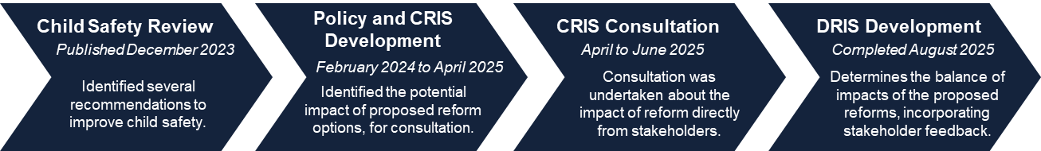

## Guide to the DRIS

Table I: Guide to the document

| **Chapter** | **Content and alignment to the CSR[10]** |
| --- | --- |
| Chapter 1: Introduction | Provides background on the National Quality Framework (NQF), the education and care sector, the CSR, and the case for change identified through the CSR. |
| Chapter 2: The case for government intervention | Outlines the need for government intervention as a means to fulfil the CSR recommendations. |
| Chapter 3: Summary of public consultation process | Provides an overview of the consultation activities undertaken and key views and perspectives. |
| Chapter 4: Approach to impact analysis | Outlines the approach to measure the impact of each option. |
| Chapter 5: Management of digital devices | Provides the impact assessment for policy options stemming from CSR recommendations 2.3 and 2.4. |
| Chapter 6: Child safety training | Provides the impact assessment for policy options stemming from CSR recommendation 12. |
| Chapter 7: Responding to educator and staff member conduct | Provides the impact assessment for policy options stemming from CSR recommendations 10 and 11. |
| Chapter 8: Working with children checks[11] | Provides the impact assessment for policy options stemming from CSR recommendations 9.1 and 9.2. |
| Chapter 9: Improving the safety of the physical service environment | Provides the impact assessment for policy options stemming from CSR recommendations 2.1, 4.2, and 5. |
| Chapter 10: Additional recommendations | Provides the impact assessment for additional recommendations 1, 2, and 3 that arose subsequent to the CSR. |
| Chapter 11: Evaluating the implemented options | Outlines the combined impact and implementation of the recommended options and describes how to monitor and evaluate these reforms in the future. |
| Chapter 12: Appendix | Provides supplementary information including a full list of recommended options, additional background information and further details about some reform areas. |

# 1. Introduction

The education and care sector aims to provide all children who attend an education and care service with high-quality, accessible, equitable, and affordable education and care, to support education and development outcomes and support parents’ and carers’ workforce participation. As of March 2024, over 1.4 million Australian children aged 12 and under attended some form of approved education and care service, of which over half a million children aged 3-6 were enrolled in a preschool program.[12]

In December 2023, the Australian Children's Education and Care Quality Authority (ACECQA) published the [Review of Child Safety Arrangements under the National Quality Framework](https://www.acecqa.gov.au/sites/default/files/2023-12/Review%20of%20Child%20Safety%20Arrangements%20under%20the%20National%20Quality%20Framework-full_report.pdf)[13] which examined new or refined systemic safeguards to better support services to protect children who attend an education and care service.

While the CSR confirmed the NQF remains a robust regulatory scheme for the education and care sector, with a strong focus on continuous quality improvement, it noted more can be done to strengthen and refine the NQF and the National Quality Standard (NQS) with respect to child safety.

The CSR identified 16 recommendations which seek to strengthen national approaches for improving child safe cultures, safer online environments, more effective information sharing systems across jurisdictions, and building workforce knowledge and capabilities in the education and care sector.

In February 2024, Education Ministers agreed to the implementation of recommendations from the CSR, subject to expert advice, broad consultation, and regulatory impact analysis. The CSR recommendations are to be achieved through multiple and complementary avenues, including regulatory changes, alignment of current complex child safety mechanisms, and provision of high-quality professional guidance and sector resources. The CSR identifies opportunities to refresh and bolster the intent of the NQF and other child safety mechanisms by addressing emerging issues, closing loopholes, strengthening policies and practices, child safe cultures, recruitment processes and information handling, supporting staff capabilities, and improving protections around the use of new, online technologies.

This DRIS considers the potential impact of several recommendations arising from the CSR, including regulatory and non-regulatory options to achieving each recommendation’s intended outcome. Additional recommendations explored through this DRIS have arisen from further analysis or as supplementary findings to reviews of critical incidents which have occurred over the past 12 months, in accordance with CSR recommendation 16 (see Chapter 10).

This DRIS has been informed by comprehensive consultation with the sector and the community, including public consultation undertaken following the publication of a CRIS.

## 1.1 The National Quality Framework

The NQF is the national system for regulating education and care services. Its objectives are to:

* ensure the safety, health, and wellbeing of all children attending education and care services,
* improve the educational and developmental outcomes for children attending education and care services,
* promote continuous improvement in the provision of quality education and care services,
* establish a system of national integration and shared responsibility between participating jurisdictions and the Australian Government in the administration of the NQF,
* improve public knowledge, and access to information, about the quality of education and care services,
* reduce the regulatory and administrative burden for education and care services by enabling information to be shared between participating jurisdictions and the Australian Government.

The NQF is jointly governed by the Australian Government and all state and territory governments. The Regulatory Authority in each state and territory is responsible for approving, monitoring and quality assessing education and care services as well as enforcing compliance with the National Law and National Regulations in their jurisdiction. Governments and Regulatory Authorities are supported by ACECQA, the independent national body that guides the implementation of the NQF and works with Regulatory Authorities.

The NQF is a regulatory framework that encompasses:

* the National Law and National Regulations,
* the NQS,
* an assessment and quality rating process, based on the NQS,
* approved learning frameworks.

Figure 1.1: The National Quality Framework structure

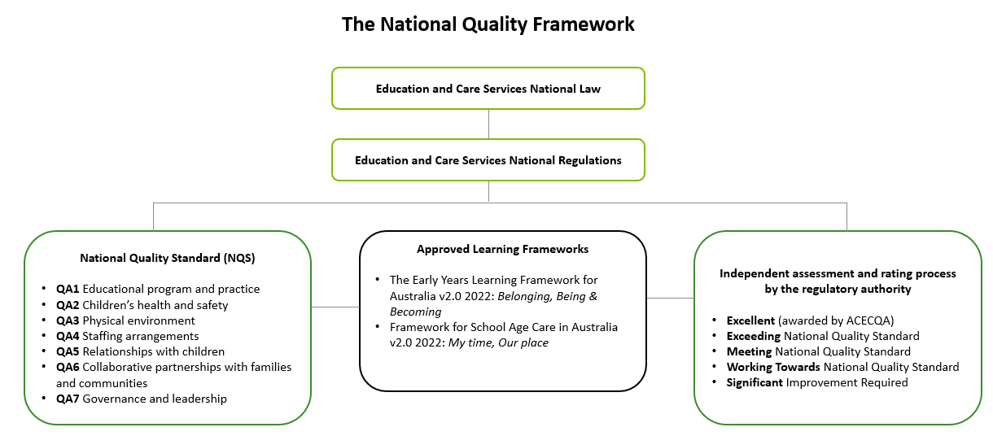

Source: ACECQA (2025).

#### Child safety arrangements under the NQF

All components of the NQF consider and prioritise children’s safety. First and foremost, child safety is addressed throughout the National Law, which obliges approved providers to ensure that a service is operating in a way that ensures the safety, health, and wellbeing of children being educated and cared for by the service. It is up to each approved provider to determine how they meet their obligations under the National Law.

Furthermore, it is an offence for an approved provider, nominated supervisor, or FDC educator to fail to take reasonable precautions to protect children from harm and any hazard likely to cause injury. The National Regulations operationalise the National Law by prescribing specific requirements for the safety, health, and wellbeing of children related to the physical service premises and environment, and operational matters such as educator qualifications and training, knowledge, and awareness of child protection law, the supervision of children and relationships between educators and children.

The NQS sets the benchmark for the quality of education and care services. All quality areas are inter-related and important for children’s safety, as highlighted below:

* *Quality Area 1 – Educational program and practices* ensures that the educational program and practice is stimulating and engaging, and enhances children’s learning and development.
* *Quality Area 2 – Children’s Health and Safety* safeguards and promotes children’s health and safety, minimises risks and protects children from harm and hazard by maintaining adequate supervision of children; configuring groupings of children to minimise the risk of overcrowding, injury and illness; monitoring and minimising hazards and safety risks in the environment; effectively managing illness and injuries; and understanding obligations under state and territory child protection legislation.
* *Quality Area 3 – Physical Environment* reflects the principle that the physical environment is safe, suitable and provides a rich and diverse range of experiences that promote children’s learning and development.
* *Quality Area 4 – Staffing Arrangements* contributes to child safe environments through qualified, skilled and experienced professionals developing warm, respectful relationships with children to create safe and predictable environments.
* *Quality Area 5 – Relationships with Children* reflects the importance of relationships with children that are responsive, consistent, respectful and promote children’s sense of security and belonging and maintain their dignity and rights. It also focuses on relationships between children and how educators can build children’s capacity to form and maintain these relationships.
* *Quality Area 6 – Collaborative partnerships with families and communities* recognises that collaborative relationships with families are fundamental to achieving quality outcomes for children and that community partnerships that are based on active communication, consultation and collaboration are also essential.
* *Quality Area 7 – Governance and Leadership* is important to creating a child safe culture through effective leadership and governance of the service that contributes to quality environments.[14]

The National Law requires approved providers to align their learning program to approved learning frameworks.

The two national approved learning frameworks – *Belonging, Being & Becoming: The Early Years Learning Framework for Australia* and *My Time, Our Place: Framework for School Age Care in Australia* – guide the learning programs of education and care services. The principles, practices and learning outcomes for the approved learning frameworks emphasise a strong focus on environments that promote child safety, recognising the importance of children’s safety in supporting and promoting educational experiences.

The two approved learning frameworks were refreshed and released by ACECQA in early 2023, following the 2019 NQF review, with a stronger emphasis on child safety, among other refinements. Updates include the expansion of the approved learning frameworks to cover teaching and learning about personal and cultural safety, assisting children and families with e-safety, and engaging other professionals to enhance the learning of children affected by trauma.

The state of Victoria (VIC) has a third, jurisdiction specific approved learning framework: *Victorian Early Years Learning and Development Framework*. This framework provides outcomes and practices to guide early childhood professionals in their work with families and children from birth to eight years old.

#### 2019 NQF Review

The 2019 NQF Review identified several opportunities to embed a greater culture of child safety into the education and care sector. A key outcome of the 2019 NQF Review was to embed the National Principles for Child Safe Organisations (National Principles) into the NQF. The National Principles reflect 10 child safe standards that were recommended by the Royal Commission into Institutional Responses to Child Abuse.

In 2019, the National Principles were endorsed by all state and territory governments and the Australian Government, with the aim of providing a nationally consistent approach to supporting organisational cultures that foster child safety, health, and wellbeing. Since 1 October 2023, the National Principles were embedded through changes to the Education and Care Services National Law and National Regulations.

In addition to introducing the National Principles, the 2019 NQF Review also recommended a suite of regulatory changes, many of which have a strong focus on child safety. Reforms span areas such as safe arrival of children at services, sleep and rest safety, transportation of children, services operating in multi-storey buildings, record keeping requirements, family day care (FDC) registers, water hazards (and safety glass requirements) near FDCs, assessment and rating of outside of school hours care (OSHC) services, workforce qualification requirements, fees to Regulatory Authorities, oversight of services and personnel, and additional technical amendments. Several of the proposed reforms are still in the process of being implemented.

## 1.2 The education and care sector

Education and care services are provided through a variety of different service types and organisational structures. As of 1 April 2025, approximately 7,200 approved providers[15] operated 18,013 NQF-approved education and care services across Australia.[16] 79% of approved providers operate a single education and care service (designated as a ‘small’ provider), while only 1% of providers operate more than 25 services (designated a ‘large’ provider).

There are four main service types regulated under the NQF (Table 1.1).

Table 1.: Different service types and attendance, 2023-24[17]

| **Service type** | **Definition** | **No. of children attending (%)[18]** | **Share of services by type** |
| --- | --- | --- | --- |
| Long day are (LDC) | A centre-based service aimed primarily at children aged 0–5 years, with children usually grouped with others of their own age. LDC services provide extended operating hours, typically from 7am to 6pm each weekday, and operate at least 48 weeks per year. | 851,161 (42.6%) | 9,421 (52.3%) |
| OSHC | A centre-based service that provides care for school aged children before school, after school, during school holidays, and on pupil free days. OSHC may use stand‑alone facilities, share school buildings and grounds and/or share facilities such as community halls. | 564,755 (28.3%) | 5.094 (28.3%) |
| Preschool/ kindergarten[19],[20],[21] | A centre-based service with a preschool program delivered by a degree qualified early childhood teacher, aimed primarily at children in the year or two before they commence full-time schooling. A preschool program can be delivered in a variety of settings such as stand-alone preschools, preschools co-located with a school (both government and non-government), and LDC services. | 574,939 (28.8%) | 3,083 (17.1%) |
| FDC | A service providing small group education and care services for children, generally in the home environment of an educator or an approved venue. FDC is primarily aimed at children aged 0–5 years, but primary school aged children may also receive the service before and after school, and during school holidays. FDC educators are supported by a FDC co-ordinator. | 73,826 (3.7%) | 412 (2.3%) |

*Source: Productivity Commission (2025); ACECQA (2025).*

LDC, OSHC and preschool services are collectively referred to as centre-based services under the NQF.

There are a range of other service types that are not regulated under the NQF but may, or may not, be regulated under jurisdiction-based legislation. These include, occasional care, mobile preschools, playschools, some vacation care, crèches and some In Home Care services. There are also a small number of services currently regulated by the Australian Government that are excluded from the definition of an ‘education and care service’ and are not within scope of the NQF; coming under Minister’s Rules. These include a small number of In Home Care services, and a number of former Budget Based Funded services and former Indigenous Advancement Strategy funded services predominantly located in the Northern Territory (NT) and South Australia (SA).

A variety of provider management types operate education and care services, as shown in Figure 1.2.

Figure 1.2: Number and proportion of services by provider management type, 1 April 2025

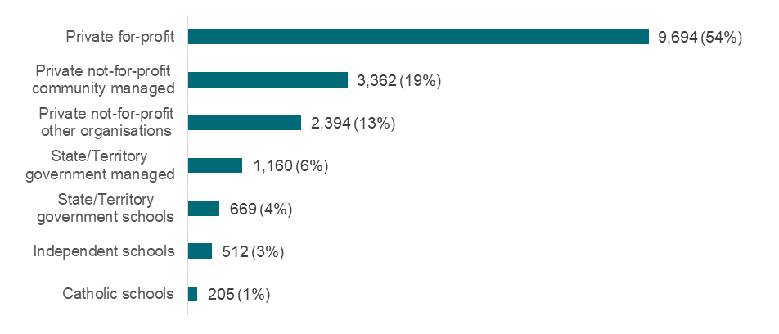

Source: ACECQA: NQF Snapshot Q1 2025[22]

## 1.3 What is the case for change?

Child safety is the first objective under the NQF and is supported by a focus on continuous quality improvement to ensure children are safe, healthy and thriving in approved education and care services. The need and urgency for additional protections is reflected not only by CSR findings but also by ongoing reported critical incidents and allegations.

The CSR found that instances of harm could be reduced by introducing additional child safety measures and evolving the requirements of the NQF in line with technological and other advances. For example, improving practices regarding the use of digital devices within education and care settings to remain current with technological advances and associated risks.

### CSR progress to date

Since the release of the CSR report in December 2023, several actions have been progressed to respond to certain recommendations, including:

* The development of the National Model Code and Guidelines, released by ACECQA on 1 July 2024, addressing child safe practices for the use of electronic devices while providing education and care.
* Guides developed by ACECQA on embedding child safe cultures and online safety in education and care services, published on 16 June 2025.
* Regulatory changes that will take effect from 1 September 2025:
  + a requirement for services to have new policies and procedures relating to the safe use of digital devices (including the use of closed-circuit television (CCTV);
  + a reduction in notification timeframes for reporting allegations or incidents of physical or sexual abuse from 7 days to 24 hours; and
  + service environments to be free from the use of vaping devices and vaping substances.
* Refinements to explicitly reference child safety in Quality Area 2 and Quality Area 7 in the National Quality Standards, commencing 1 January 2026.
* The Australian Institute for Teaching and School Leadership has published materials to support early childhood teachers, leaders and employers to apply the Australian Professional Standards for Teachers in non-school settings.
* The regulatory and non-regulatory options analysed through this DRIS were informed by targeted consultation with the sector and experts, including through an Expert Advisory Panel (EAP), established to provide subject matter expertise, advice and guidance to inform the agreed recommendation of the CSR.

### CSR recommendations included in this DRIS

Several other recommendations arising from the CSR[23] and ongoing reported critical incidents relate to:

* managing the use of digital devices (related to CSR recommendation 2.3 and 2.4)
* child safety training (related to CSR recommendation 12),
* improving responses to educator and staff member conduct (related to CSR recommendations 10 and 11),
* strengthening the obligations and reporting requirements around WWCCs (related to CSR recommendations 9.1 and 9.2),
* improving the safety of the physical service environment (related to CSR recommendations 2.1, 4, and 5),
* additional recommendations to improve child safety (three additional recommendations, identified subsequent to CSR publication).

**These proposed areas for reform are the focus of this DRIS.**

A high-level overview of the proposed areas for reform is provided below. Links are included to the relevant chapter of this document where each reform area is explored in further detail. Significant regulatory and policy analysis, informed by expert advice, has occurred since the release of the CSR report to inform the areas of reform and options for consideration in this DRIS. The rationale for any changes to the implementation approach for CSR recommendations is provided in Appendix 12.2.

#### Management of digital devices

The use of digital images and videos can be helpful in documenting children’s learning and participation in an educational program. However, improper capture, retention, storage, sharing and destruction of images and videos can result in an increased risk of harm to children. Lack of appropriate controls and procedures can enable an environment where individuals may use devices inappropriately and/or for illicit purposes. Even if images are appropriate, they may be accessed and used in an inappropriate way by other individuals if storage practices are unsecure.

There is an opportunity to increase protections around the use of digital devices among those working with children, with a particular focus on the use of personal digital devices.

The impact of this proposed area for reform is explored in Chapter 5.

#### Child safety training

Current requirements for child safety training and knowledge under the NQF relates specifically to child protection and the individuals required to undertake such training is limited. While constituting an element of child safety, child protection entails a narrow scope of topics such as mandatory reporting and serves a distinct purpose of identification and response. Child safety training extends beyond child protection training by including topics such as creating an organisational child safe culture, policies and procedures, and expectations for staff conduct (online and offline) (including trauma informed practice). Due to this distinction, a clear knowledge and training gap exists in the education and care sector, raising a potential risk to children where sector understanding and capability are inadequate and outdated.

There is an opportunity to strengthen child protection provisions and simultaneously introduce nationally consistent and potentially mandatory child safety training to ensure those individuals involved in the provision of education and care are equipped with the knowledge and expertise to uphold and enact principles of child safety in everyday practice and service culture, ensuring children are safeguarded and any cases of abuse are responded to effectively.

The impact of this proposed area for reform is explored in Chapter 6.

#### Responding to educator and staff member conduct

There is only one child-related offence for which educators can be held liable under the National Law, which is the use of inappropriate discipline.[24] This offence directly correlates to the immediate safety, health, and wellbeing of the children being educated and cared for within a service. There are instances where an educator has engaged in another form of inappropriate conduct, which does not constitute a contravention of the National Law.

In some cases, the threshold for prohibition is met by such inappropriate conduct, which enables Regulatory Authorities to prohibit an individual from being involved in the education and care sector. It generally results in a cancellation of an individual’s WWCC registration.[25] However, in circumstances where the threshold for prohibition has not been met, Regulatory Authorities have limited tools available to address inappropriate conduct. This enables an environment where conduct may often be left untreated and the likelihood of similar behaviour re-occurring is a genuine risk.

This limitation also applies where an individual has engaged in low level inappropriate discipline but the threshold to prohibit has not been reached.

There is an opportunity to more efficiently identify and respond more appropriately and proactively to risk posed by educators who have or may have engaged in conduct harmful to children by:

* expanding information sharing powers of Regulatory Authorities,
* expanding offence provisions to cover a broader range of inappropriate conduct, and
* expanding enforcement options.

The impact of these proposed areas for reform is explored in Chapter 7.

#### Strengthening the obligations and reporting requirements around WWCCs

WWCCs[26] are an important part of ensuring that only suitable persons are able to work with children in Australia. As it stands, there are inconsistencies across jurisdictions in allowing persons to commence work with children when they have applied, but are not yet approved for a WWCC. Similarly, a change in status of a person’s WWCC or teacher registration/accreditation is not necessarily communicated to those responsible for ensuring staff remain suitable to work in education and care services, depending on the ability to screen and monitor by jurisdiction. These issues may result in children being exposed to persons who are not suitable to work or volunteer in education and care services.

There is an opportunity to reduce the risk of children’s exposure to unsuitable individuals by introducing nationally consistent and stringent requirements on:

* the need for an approved WWCC prior to commencing a role,
* reporting requirements when the status of a WWCC or teacher registration/accreditation changes.

The impact of these proposed areas for reform is explored in Chapter 8.

#### Improving safety of the physical service environment

The design and safety of the physical service environment in which children receive education and care has significant bearing on the potential for risks to child safety. The physical environment can impact the ability of educators to adequately supervise children and can also pose risks if there are hazards in or nearby a service premises. There are opportunities to reduce the risks associated with the physical environment in services by:

* designing premises to better facilitate supervision,
* broadening the scope of approved provider assessments of FDC residences,
* enabling authorised officers to enter areas beyond the FDC service premises.

Each of these proposed reforms has the potential to reduce the risk of harm to children.

The impact of these proposed areas for reform is explored in Chapter 9.

#### Additional recommendations to strengthen the NQF and improve child safety

It is important for services to be vigilant in identifying and responding to signs of child maltreatment. With this context in mind, a number of additional areas to strengthen child safety arrangements under the NQF were identified subsequent to the publication of the CSR and as a result of a review of cases of child maltreatment in the education and care sector and ongoing analysis.

Areas identified for proposed reform include:

* allowing for the efficient identification, monitoring, and regulation of ‘related providers’,
* extending the limitation period for prosecuting National Law offences,
* introducing information sharing and evidence gathering provisions with educator recruitment agencies.

The impact of these proposed areas for reform is explored in Chapter 10.

# 2. The case for government intervention

Government action signals to the education and care sector, families and community that there is no greater priority than the safety of children in education and care services. Government intervention is required to ensure child safety and improve quality in the education and care sector, by helping to build safe environments for children, support educators and providers, and ensure that legislation keeps up to date with new and emerging risks.

While strengthening the NQF is crucial, doing so in isolation will be insufficient to deliver the best outcomes for children, families, and educators. Addressing systemic issues will require collaborative reform across jurisdictions, along with greater alignment and clarity across existing child safety systems. In addition, providing high-quality professional guidance and sector resources will ensure that safety practices evolve to meet emerging challenges.

Successful reform would involve a reduction in child safety incidents across the sector. For example, fewer instances of misconduct relating to the use of digital devices, consistent treatment of misconduct under the National Law, improved safety of the physical environment, and an overall improvement in understanding of child safe culture.

Global standards also provide a useful benchmark for defining success through ideal child safety objectives to minimise harm. For example, The International Child Safeguarding Standards produced by independent non-profit Keeping Children Safe covers four areas of obligation for all organisations working with children: developing and publicising a child safety policy, impressing clear responsibilities and expectations upon its people, implementing integrated child safeguarding procedures across all processes and systems, and consistently monitoring, reviewing and reporting safeguarding measures to ensure accountability.[27] Government led reform can ensure that Australia meets its obligations to apply these standards consistently and effectively.

Some aspects of reform are more nuanced and complex to measure, and success targets may vary over different time horizons. For example, in the short term a higher number of suspension and/or supervision orders may indicate success in strengthening provider accountability to appropriately address conduct which contravenes the National Law. However, a longer-term fall in the number of suspension and/or supervision orders may represent evidence of success in reducing instances of misconduct in the first place (due to improved child safety training and other regulatory reforms).

The 2023 NQF Annual Performance Report outlined the types of issues that make it challenging to measure performance based on changes in the rate of reported serious incidents across service types or financial years (given the likely ‘over’ and ‘under’ reporting of serious incidents from different parts of the sector).[28] The report provided examples such as that:

* an approved provider might report a relatively high number of serious incidents because of:
  + robust and comprehensive reporting mechanisms
  + overly cautious reporting procedures
  + unique child cohorts and service circumstances
  + lack of understanding of what constitutes a serious incident, and/or
  + poor health and safety standards, but that equally
* an approved provider might report a relatively low number of serious incidents because of:
  + exceptional health and safety standards
  + lax reporting procedures
  + lack of understanding of what constitutes a serious incident
  + concern around reputational impact, and/or
  + restrictive and risk averse learning and development opportunities for children.

In the context of these challenges and noting the complex interactions between the proposed reforms, achieving consistent improvements in child safety across Australia through the stated policy objectives will require timely legislative reform, broad provider awareness, and coordinated behaviour change. These success factors will depend on clear government direction and intervention.

***Rationale for government intervention***

The CSR identified several recommendations through which child safety could be improved, through regulatory and/or non-regulatory government intervention.

The rationale for introducing regulatory or non-regulatory government intervention differs, depending on the nature of the problem and the objectives of the proposed reform.

**Non-regulatory interventions** can include sector guidance, targeted training, and communication strategies to help services meet existing obligations and promote consistent child safe practices. Non-regulatory interventions are critical for the following reasons:

* Ensure there is **sufficient awareness and understanding of existing expectations and obligations** under the National Law, National Regulations, the NQF, and government protocols. For example, option 2 to respond to recommendation 4.2 involves providing more guidance to approved FDC providers on their obligations to assess areas near FDC residences (regulation 116).
* **Promote national consistency** in the implementation of effective and contemporary child protection and safety practices. For example, option 2 to respond to recommendation 10 involves developing more communications and resources to encourage and aid approved providers to identify and address inappropriate conduct by staff and volunteers in an education and care service.
* To **promote the importance of child protection and safety practices**. For example, option 2 to respond to recommendation 9.1 involves providing guidance to highlight the importance of WWCCs and detail ‘best practice’ approaches.

**Regulatory interventions** involve legislative or policy changes to ensure that regulatory gaps or areas where legislation has not evolved with emerging risks are addressed to enable stronger enforcement of child safety principles. By implementing regulatory measures (such as financial or other penalties), the government can mandate behavioural or practical changes that enhance child safe practices within education and care services. In some instances, regulatory interventions may have greater effectiveness, as amendments to the National Law and National Regulations allow for stricter enforcement and national consistency.

Regulatory options are critical to address the following identified issues:

* Some sections of the **National Law are** **not keeping pace with corporate structures**. For example, additional recommendation 1 identifies that certain provisions of the National Law have not kept up with modern business structures, limiting regulators’ ability to identify and manage risks at the provider level.
* Some sections of the **National Law** **are not sufficiently proactive**. For example, recommendation 11 highlights that in the absence of proactive notification systems, an individual with a suspended or prohibited status may continue working undetected, creating an unacceptable risk.

In some instances, regulatory intervention may also be the **most effective option**. For example, recommendation 9.2 identifies that providing additional guidance about current WWCC and teacher registration/accreditation notification requirements, in isolation, would not resolve existing regulatory gaps or inconsistencies which pose risks to child safety. Additionally, there are also circumstances in which regulatory intervention may be the **only option** to address identified gaps in current practices and/or strengthen safeguard measures. For example, regulatory intervention is the only available intervention for additional recommendation 2, which seeks to change the limitation period following an alleged offence.

***Potential alternatives to government action***

As outlined in Chapter 1.1 – The National Quality Framework, the NQF sets out a consistent national approach to ensuring the safety, health, and wellbeing of children in education and care services. While many providers are proactive in managing risks, relying solely on individual services creates inconsistency and gaps.

Individual providers or sector bodies may not have the reach or resources to implement widespread reform by expanding their Codes of Conduct or industry agreements. For example, some providers may lack the training, insight, or resources, to appropriately expand their Code of Conduct while accounting for the cultural needs of all staff and settings, such as in small or single educator model services. Fragmented efforts can leave gaps in safety for children attending services in less-resourced areas.

Additionally, the outcomes of approved providers’ actions may be limited in comparison to standardised and enforced government interventions, leading to inconsistent application across the sector.

Most of the sector work hard every day to provide safe, high-quality education and care to children; however, Governments across Australia agree that the risk to children’s safety is too significant to leave to voluntary action alone. A nationally coordinated, enforceable approach is essential.

# 3. Summary of public consultation process

A comprehensive consultation process, facilitated by Deloitte Access Economics, was undertaken on the CRIS to inform the government’s understanding of the feasible impacts of the options under consideration, and to provide an evidence base for governments to determine their recommended options.

Public consultation on the CRIS took place over a six-week period from 28 April to 11 June 2025.[29]

The purpose of consultation was to engage with education and care service stakeholders to ensure that:

* important voices of stakeholders who will be most affected by these proposed changes were captured,
* evidence was collected (where available) to demonstrate the risk of harm across options,
* a comprehensive list of incremental impacts (costs and benefits) is considered for each policy option,
* estimates of incremental costs (where quantified) are reflective of the actual (or likely) costs that stakeholders expect to bear from the implementation of the proposed options.

In accordance with the above purpose, the consultation process sought to provide adequate opportunity for any stakeholders that may be impacted by the proposed changes to understand these changes and to provide input. Simultaneously, the consultation process sought to generate a robust evidence base to support the DRIS. A mid-point review was held during the consultation period to highlight any gaps in the evidence collected, refine the approach, and support both these objectives being met. The outcomes of the mid-point review informed the planning of focus groups and targeted consultations with specific groups that were either under-represented at the mid-point review, held information that was critical to inform the DRIS, or may have faced barriers to participation.

SNAICC has played an important role in enabling Aboriginal and Torres Strait Islander voices to be heard and incorporated throughout the consultation process in a culturally safe environment.

Findings from the consultation process are reflected in the analysis section in each reform area (see chapters 5 to 10). Stakeholder perceptions of the reduction in risk of harm to children are weighted heavily in analysis (see Chapter 4 - Multi-criteria analysis approach). Stakeholder preferences (including concerns regarding implementation) and cost also feature in option analysis. Minority views, including from stakeholder groups that have different opinions to stakeholders on average, are reported in each area of reform, and often form part of the ‘distributional impacts’ analysis of each option (see Chapter 4 - Approach to measuring impact for each reform area). Where there are relevant Aboriginal and Torres Strait Islander People Stakeholder Views, these are highlighted in boxes throughout chapters 5 to 10.

## 3.1 Pre-CRIS consultations

#### Developing policy options for consultation

Following the CSR, the Australian Government and jurisdictions undertook targeted consultations with experts, including Regulatory Authorities, the National Office for Child Safety, within the Commonwealth Attorney-General’s Department, the Department of Social Services, the eSafety Commissioner, jurisdictional children’s commissioners and academics. These consultations were undertaken for the purposes of informing the policy options under the areas of reform covered in this DRIS. This was supported by ongoing policy analysis and engagement with experts.

Testing the consultation and communication approach

Deloitte Access Economics conducted four virtual focus groups on the initial consultation and communication approach. The focus groups were held with the education and care stakeholder group, the Parents and Carers Reference Group (PCRG)[30] and the Regulatory Practice Committee (RPC), which is convened by ACECQA and includes all state and territory Regulatory Authorities and the Australian Government. These groups focused on ensuring that the methods for engagement would adequately provide opportunity for those impacted by the changes to input their views and perspectives and ensure the consultation instruments were designed to maximise engagement in an accessible and inclusive manner.

Feedback from these initial consultations informed further refinements to consultation and communication materials, data collection tools, and the overarching approach to public consultation.

## 3.2 Public consultation

### Consultation approach

The consultation approach involved a range of consultative activities over three phases:

* engage stakeholders – using information webinars, a public webpage and summary documents of the CRIS,
* seek broad public feedback – using virtual forums (eight forums by state and territory and two national forums), surveys and submissions,
* targeted consultation – targeting voices that were critical to understanding impacts and may be less heard through focus groups and consultations.

Table 3.1: Overview of consultation and engagement

| **Consultation mechanism** | **Number held** | **Number of individuals engaged** | | |
| --- | --- | --- | --- | --- |
| Pre-CRIS consultations | 5 focus groups | 39, in addition to PCRG members | |
| Jurisdictional and National virtual forums | 10 | 207 | |
| Surveys | 3 surveys | 295 approved provider surveys completed*  522 workforce surveys completed*  190 family, carer and parent surveys completed | |
| Submissions | N/A | 145** | |
| Focus Groups | 11 | 64 (excluding SNAICC-facilitated consultation) | |
| Targeted consultation | 5 | 8 | |
| **Total individuals providing input** | | 1,470** |
| Information webinars | 9 | 913 |
| Webpage | N/A | 12,715 webpage visitors | |
| **Total individuals engaged** | | 13,628 |

Source: Deloitte Access Economics (2025). *Survey responses indicate responses submitted by 11 June and do not include any incomplete survey responses. Surveys were anonymous and could be completed multiple times if a stakeholder chose to. ** This also includes individuals representing groups and membership bodies.

#### Information webinars

The consultation process began with a series of eight jurisdictional information webinars and one national information webinar which were hosted and delivered by the Deloitte Access Economics team from 5 May 2025 to 8 May 2025. Information webinars were open to the public and were advertised by jurisdictions and peak bodies.

The webinars explained the RIS purpose and process, the policy options under consideration and ways to engage. **In total, 913 stakeholders participated in webinars.**

#### Virtual forums

A series of eight jurisdictional virtual forums and two national virtual forums were facilitated by Deloitte Access Economics from 12 May 2025 to 20 May 2025 to gather input regarding impacts and costs which inform the evidence base, and to communicate consultation activity distribution strategies with relevant stakeholders.

Participants in the virtual forums were suggested by jurisdictions, and typically included larger providers, peak bodies, unions, and Registered Training Organisations (RTOs). General workforce stakeholders and families were not invited to participate in the jurisdictional and national forums, as the sessions were focused on obtaining inputs to inform the analysis of impacts of proposed reform areas on service providers and regulators. Forum participants also represented a range of stakeholder types and were encouraged to support other educators and families, parents and carers to participate in the public consultation process through surveys and submissions.

Each forum included the option for SNAICC to facilitate breakout rooms. This was requested in one forum.

**In total 207 stakeholders attended virtual forums.**

#### Surveys

The public consultation phase included the distribution of three surveys:

* a survey for approved providers, persons with management or control (PMCs) or nominated supervisors,
* a survey for the education and care workforce,
* a survey for families, parents, and carers.

Each survey was open from 5 May 2025 to 11 June 2025, for a period of five weeks and three days. The survey links were distributed through ACECQA and jurisdictions. Services and providers who participated in information webinars and forums were also encouraged to distribute the education and care workforce survey link through internal newsletters or by staff contacting individual services. These services were also able to distribute the families survey through online links and printed Quick Response (QR) codes. Telephone surveys were available on request. For additional reference, 16 approved provider survey respondents reported that they provided services that are outside the scope of the NQF. This survey question was not asked in the workforce or families, parents and carers surveys.

The final number of responses for each survey are as follows:

* 295 approved provider surveys completed,
* 522 workforce surveys completed,
* 190 family, carer and parent surveys completed.

#### Submissions

The public consultation process also included an online submissions portal through a web platform. This enabled two types of submissions: free text responses into dedicated fields (specific questions or prompts), and document submissions from organisations and others (individual submissions).[31] Hard copy submissions were also accepted, and participants were able to request a telephone submission.

Sixty-nine complete free text submissions were received. Seventy-seven complete and useable long form submissions were received in total, which often represented organisations or larger member organisations.

**In total, 146 submissions were received.**

Table 3.2: Submissions by stakeholder group

|  | **# Free text submissions** | **# Long form submissions** | **% of total** |
| --- | --- | --- | --- |
| Approved provider | 11 | 15 | 18% |
| Peak body | 2 | 23 | 18% |
| Education and care service | 34 | 16 | 34% |
| Family member, parent, carer | 12 | 5 | 12% |
| Higher education institutions | 0 | 1 | 1% |
| Other (please specify)[32] | 7 | 17 | 16% |
| General public | 1 |  | 1% |
| Recruitment Agency | 1 |  | 1% |
| Registered Training Organisation | 0 |  | 0% |
| Academic | 1 |  | 1% |
| *Total* | *69* | *77* | *100%* |

Source: Deloitte Access Economics (2025). All submissions could be made anonymously. These are the numbers of complete and useable responses, with duplicates removed. Please note that numbers may not sum to 100 due to rounding.

#### Targeted consultation

The key stakeholder groups to be engaged through targeted consultation was informed by a review of the evidence at the midpoint of the consultation period. Eleven 1–2-hour focus groups were held with:

* FDC services (8 individuals)
* recruitment agencies (3 individuals)
* registered training organisations (5 individuals)
* OSHC services (8 individuals)
* the PCRG (20 individuals)
* Working With Children Check (WWCC) screening agencies (11 individuals).

As part of this consultation, SNAICC facilitated two yarning circles: one with SNAICC Early Years Services (EYS) located in Victoria, and one with Aboriginal Community-Controlled Organisations (ACCOs) across all states and territories. These yarning circles used similar materials to the focus groups, and were led by Aboriginal facilitators in an open discussion format. Stakeholders were able to choose which areas of reform to discuss in the most detail, including those considered most relevant to Aboriginal and Torres Strait Islander services, families and children.

In addition to the focus groups, five virtual consultations were held across a range of stakeholder groups. Jurisdictions nominated individuals for targeted consultations, and experts who provided input to the policy development were also invited. Consultation was also offered to some individuals who could not attend focus groups due to scheduling issues.

#### Analysis of consultation evidence

A mixed-method approach was used to analyse the varying consultation-based evidence sources.

In the case of the three surveys, descriptive statistics were calculated for all questions deemed useful to the understanding of themes, including for questions around the perceived reduction in risk of harm, preferred option, and frequency of behaviours. These descriptive statistics were also provided by jurisdiction and service types where relevant to the context of the recommendation.

Long form written submissions were coded regarding support for each option, including where support was implied, where support was in principle or with conditions, where there were mixed responses, and where submissions did not comment, or a preference could not be determined.

For jurisdictional forums, submissions, targeted consultation, and focus groups, evidence was thematically assessed to highlight any key themes or overarching takeaways, noting that in some consultations, stakeholders were asked questions that were particularly relevant to their perspective. This means that not all stakeholders were asked the same questions throughout interviews and focus groups. Findings from this qualitative analysis were aggregated to form understandings of perspectives and costs for service-types, jurisdictions, and other categories.

## 3.3 Evaluating the public consultation evidence base

As outlined above, the consultation process sought to provide adequate opportunity for any stakeholders that may be impacted by the proposed changes to understand these changes and to provide input, and to generate a robust evidence base to support the DRIS. The consultation process saw high engagement across the sector, as illustrated by the volume of responses, the quality and depth of responses, and the diversity of stakeholders. Education Ministers are grateful to all stakeholders who provided input into the DRIS through public consultation.

Public consultation – as proxied through survey responses - achieved coverage of all key areas of interest across service types, provider types and sizes, stakeholder demographics, jurisdictions, and remoteness (see Chart 3.1).

Chart 3.1: Proportion of survey responses by jurisdiction compared to proportion of education and care services across Australia

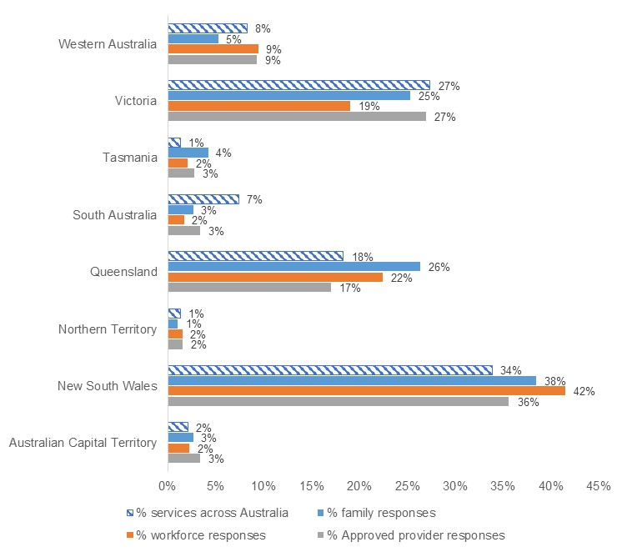

Source: Approved provider survey, n=295, Workforce survey, n=522, Families, parents and carers survey, n=190, ACECQA National Register data <https://www.acecqa.gov.au/resources/national-registers/services?s=&nocache=1752628667210>. Note that survey respondents could choose multiple jurisdictions. Note that these percentages may not add up to 100% due to rounding, and the fact that survey respondents could choose multiple jurisdictions.

In terms of the representativeness of different stakeholder types in the consultation process:

* FDC was overrepresented in the education and care workforce survey and the family survey in a way that was disproportionate to the size of the sector. Analysis therefore reports on the FDC sector separately where relevant, to demonstrate sentiments that are specific to these services. The high level of engagement (disproportionate compared to other service types) may be due to perceived disproportionate and negative impacts on the FDC sector of some options in the proposed areas of reform.
* Regional and remote services and approved providers were underrepresented in focus groups, forums and consultations. Regional and remote services were broadly proportionately represented in survey responses and through submissions, compared to the proportion of services across Australia located in regional and remote areas. It may be that the short timeframes of the public consultation process limited the ability of regional and remote services to engage in these ‘real time’ consultation activities. Regional or remote approved providers were more likely to be smaller operators and therefore faced additional challenges to participate in real time consultation activities without potential disruption to their services. This is supported by a small number of stakeholder responses to consultation invites. It was not suggested that regional and remote services and approved providers would be less impacted by reforms.

The overall timeframe for the consultation process was perceived by some stakeholder groups to be short considering the complexity of the policy options presented and the detailed feedback (e.g. on cost estimates) that was requested as part of this process. Further opportunities to engage regional and remote stakeholders in designing and implementing guidance could be considered in the future. Consultation summary documents, videos and visual aids were seen as useful in aiding this engagement.

In some instances, stakeholders felt unable to provide definitive responses to the CRIS, both in terms of identifying a preferred option or combination of options or providing cost estimates. This was often in relation to areas of uncertainty about the nature of the problem and current levels of risk or harm, or in relation to specific aspects of proposed policy options and their implementation. These instances are outlined in more detail in further chapters, where relevant. Further consultation with the sector as the proposed reforms are designed and implemented will be valuable in ensuring a more thorough understanding of potential impacts – as well as any other implementation considerations or unintended consequences – and to take these into account as regulatory options are formalised and put into practice.

The nature of the available evidence regarding each reform area was also considered in identifying the most appropriate and proportionate approach to impact analysis of options in this DRIS, as outlined in Chapter 4. This means that stakeholder concerns and views were incorporated into the evidence for each recommended option to differing degrees, depending on the quality, quantity, and robustness of insights.

## 3.4 General insights from public consultation

Stakeholder engagement across themes

Some reforms areas received higher levels of engagement across public consultation than others. In general, *Management of digital devices* received the most engagement of all themes, followed by *Child safety training*, *Responding to educator and staff member conduct*, and *Working with children checks*. *Improving the safety of the physical service environment* and *additional recommendations* received comparatively lower levels of engagement than other themes.

#### Level of support for reform

Across most stakeholder groups, there was a strong preference for reforms seen to increase child safety in education and care services, including, but not limited to, the areas of reform outlined in this DRIS. Stakeholders tended to see regulatory options as associated with greater reduction of risk of harm to children across all areas of reform. However, a significant number of stakeholders, across multiple stakeholder groups, suggested that further measures could, or should, be taken to further improve child safety. This means that while some survey response feedback suggests that reforms would ‘greatly reduce’ risk of harm to children, qualitative data or other administrative data often provided nuance or further evidence that the effects may be smaller in terms of volume or scale of reduction of risk. This is outlined through the analysis by area of reform where relevant.

An exception to the general support for reforms outlined in this DRIS is the FDC workforce, some families using FDC services, and FDC sector peak bodies. These stakeholder groups largely opposed regulatory reforms during the public consultation process.

#### Implementation considerations

One significant theme of feedback was that cost or regulatory burden, even if somewhat large, should not be considered a reason not to progress reforms. However, some stakeholders noted that for reforms to be effectively implemented, further consultation with the sector should be undertaken, with clear guidance as to the timelines of new regulation and practical considerations for what this means for services and approved providers. This guidance was often seen as a necessary and mitigating step alongside cost and regulatory burden considerations. This informed the analysis for the DRIS, which weights impacts on child safety highest, and costs and implementation risks less.

# 4. Approach to impact analysis

The purpose of a RIS is to assess the potential costs and benefits of a regulatory proposal for the purposes of informing decision making. This involves the development of a comprehensive approach to considering costs and benefits, to determine which costs and benefits can be estimated and quantified in monetary terms, and whether the available evidence is sufficient to measure these costs and benefits. All estimated costs and benefits are measured incrementally against the status quo (no change) to ensure business-as-usual costs that are already expected to be incurred under the NQF are not considered as part of decision making.

Where a limited number of costs and benefits can be estimated and quantified in monetary terms, a multi-criteria analysis (MCA) can be used to assess both quantitative and qualitative costs and benefits of each option. Where either costs or benefits (but not both) can be measured, break-even analysis (BEA) can also support decision making.

Some policy options impose costs only in relation to misconduct, for which there is insufficient data to calculate frequency to support costing. Similarly, data was not available on the potential costs of the policy options to Regulatory Authorities, and as a result, these costs are not quantified in the analysis.

Based on the nature of costs and benefits associated with the proposed child safety reforms and the data and stakeholder input received, the impact of the proposed policy options will primarily be measured using MCA. This approach will support identification of the recommended option.

Where costs can be adequately quantified, BEA will also be conducted to support decision making. Only a select number of costs can be quantified based on the data and evidence collected. This primarily includes estimated implementation costs to approved providers in instances where the proposed policy option imposes an upfront cost for compliance.

Several proposed reforms had logic to suggest that the regulatory burden or costs of the proposed option are likely to be minimal, and evidence from a wide range of stakeholders indicate that the regulatory option can be implemented without creating material impacts or trade-offs. In these instances, qualitative commentary on the rationale for adopting the regulatory option(s) as the recommended option is sufficient for decision making.

## Multi-criteria analysis approach

MCA is a method of calculating weighted scores against a framework of assessment criteria to identify the recommended option. This is supported by a qualitative discussion which explains the rationale behind each score, however there may also be instances when a score is wholly or partially informed by quantitative information. MCA is used when it is not possible to reliably quantify and value the main costs and benefits of options. This includes situations where some data is available, but the specific effects of the proposed options cannot be isolated. While an MCA is not capable of quantifying the net benefits of the proposed change or the ratio of benefits to costs, it does allow for options to be scored and ranked.

An MCA approach tailored to the proposed child safety policy options has been developed. The approach was agreed on by relevant government forums and includes assessment against the following four criteria:

* the improvement in child safety outcomes
* the net cost of the policy option
* the implementation considerations
* the distributional impact of the option on stakeholders.

The MCA method sees each option scored against each criterion on a scale from -10 to +10, based on how each option performs against that criterion in comparison with option 1, the status quo (no change). The status quo always receives a score of zero for each criterion and therefore provides a baseline. The MCA is intended to assess the incremental costs or benefits relative to the status quo – scores of zero for the status quo should not be interpreted as implying that the current regulatory framework imposes no costs or yields no benefits. A negative score (-10 to -1) indicates a poorer performance relative to the status quo while positive score (1 to 10) indicates a stronger performance. Additionally, the scores assigned to each option are intended to demonstrate the relativity between options (e.g., if a non-regulatory option results in a smaller improvement in child safety relative to a regulatory option, the scoring should be reflective of this).

Scores assigned to options should only be compared within each reform area, rather than between reform areas, because the scale that defines what is better than the status quo will also depend on the scale of the problem being addressed in each reform area and the extent to which the options can improve outcomes.

A description of each criterion, the applied weighting, and an interpretation of how the option is scored is provided in Table 4.1, followed by an explanation of the rationale for the chosen weights.

Table 4.1: Approach to MCA

| **Criteria and weighting** | **Description of approach to measuring performance against criteria** | **Interpretation of scoring** |
| --- | --- | --- |
| **Improvement in child safety outcomes**  **(50%)** | This is a measure of the degree to which proposed policy options are expected to contribute to a reduction in the risk of harm to children. This includes consideration of the avoided harms of child abuse, neglect, and maltreatment. | If the option is considered to improve child safety outcomes from the status quo, it will result in a score from 0 to 10. If the option is considered to reduce child safety (noting this is not a likely outcome), the score may range from -10 to 0. |
| **Net cost of the policy option**  **(30%)** | The net cost will be estimated through a quantification (where possible) of total costs to implement policy options minus any avoided costs (in terms of administrative and other associated costs).  Several policy options may also result in qualitative costs or costs that cannot be quantified due to data limitations. Where these qualitative costs arise, they should be considered alongside the monetised costs (if any) when assigning a score to this criterion. | If there is a net cost, the option will be scored from -10 to 0 (-10 implying a higher net cost). If the option presents a net cost saving, the option will be scored from 0 to 10 (10 implying a higher cost saving). This criterion will also be scored based on a range of financial and non-financial costs (e.g., staffing costs, administrative burden, privacy concerns), including costs that can only be discussed qualitatively. |
| **Implementation considerations**  **(10%)** | This criterion has been developed on the basis that the implementation considerations may influence the likelihood that the benefits of implementing policy options will be realised. | This criterion will assess the degree to which there are implementation considerations if a policy option is implemented. If the policy option is associated with more significant adverse implementation considerations or risks, this option will receive a negative score from -10 to 0. If the option is expected to generate the desired benefits due to a lack of implementation risks, this option will receive a score from 0 to 10. |
| **Distributional impact of the  option on stakeholders**  **(10%)** | This criterion has been developed to assess any disproportionate impact the policy option may have, including the degree to which the option would impose proportionately higher costs on smaller stakeholder groups.  Specific stakeholder groups that are of particular interest may include (but are not limited to) Aboriginal and Torres Strait Islander peoples or organisations, regional or remote communities, or a singular provider type (e.g. FDC services, OSHC services). | If the option disproportionately impacts one group, this option should be scored from -10 to 0. Policy options that are assessed to generate fewer disproportionate impacts to particular stakeholder cohorts would be assigned a higher score. Alternatively, policy options that are assessed to generate more significant disproportionate impacts on particular stakeholder cohorts would be assigned a lower score. Negative disproportionate impacts will be scored between -10 to 0, with the actual score depending on the magnitude of the impact. |

The first criterion, the improvement in child safety outcomes, represents the core benefit of the policy options. The remaining three criteria are more aligned to potential costs associated with the policy options, noting only one criterion aligns explicitly to costs. When undertaking MCA, costs and benefits should be assigned ‘neutral weights’ to ensure that MCA outcomes equally represent both costs and benefits. As such, the improvement in child safety outcomes has been assigned a weighting of 50%, while the remaining three criteria have a combined weighting of 50%.

While placing equal weights on benefits and costs is a conventional approach for MCA, in this context child safety is a critical concern and priority. This is reflected in the weight placed on child safety (50%) being much greater than the weight being placed on any other consideration, including the potential compliance and administration costs of the proposed reforms (30%). These weights have been assigned to reflect the priorities of governments in identifying and progressing those reforms most likely to improve child safety.

This approach to weighting is also consistent with many points of stakeholder feedback across all reform areas. While stakeholders often noted that there are likely to be costs as well as risks of unintended consequences or distributional impacts associated with at least some options, these observations were often paired with the view that finding a way to proceed with reform while managing or mitigating these costs and risks was important given the high value that should be placed on child safety. The lower weights placed on implementation considerations (10%) and distributional impacts (10%) reflect the fact that in comparing two or more options that are otherwise similar in terms of their feasible impact on child safety and potential costs, governments would prefer options that also minimise risks of unintended consequences or detrimental distributional impacts.

In this DRIS, most of the recommended options are also expected to have the biggest reduction in the risk to children and result in the highest potential improvement in child safety, noting that in some cases this will require further work to ensure implementation considerations and distributional impacts are carefully managed and mitigated where possible. This is consistent with the overarching objectives of governments and the MCA weights discussed above.

## Break-even analysis approach

BEA is a technique that is used when the benefits, or magnitude of the likely benefits, are uncertain and/or difficult to reliably quantify. It involves utilising a CBA framework to estimate the value of benefits that would need to be generated to offset the estimated costs of the proposed change. It is mostly used when costs can be quantified but many of the benefits associated with the proposed changes are intangible in nature. In some instances, sensitivity analysis can be undertaken to test the sensitivity of the breakeven point to changes in specific assumptions or inputs for the estimated costs.

BEA is only undertaken for the proposed reforms that have sufficient quantifiable costs. When undertaking BEA for policy options with quantified costs, the estimated costs of the proposed option are compared to the total cost of child maltreatment in Australia. BEA provides a measure of the size of the benefit required to ‘break even’ – in this context, it is a measure of the ‘extent to which harm to children would need to be avoided’.

For the purpose of this analysis, this DRIS uses an estimate of the ‘lifetime economic and social costs of child maltreatment in Australia’, developed by McCarthy et al. (2016), as the total cost of child maltreatment in Australia to support breakeven analyses of selected reform areas where some costs can be monetised.[33] This cost was estimated to be $26.7 billion in 2016 dollars, which is valued at $34.6 billion in real, 2025 dollars.[34] This measure was selected as it is a true measure of economic costs, incorporating both financial and non-financial costs. While the study is specifically a measure of the costs associated with child maltreatment in Australia, it is not specific to maltreatment that occurred in education and care settings. No studies were identified that measured the cost of child maltreatment that occurred in an education and care setting in Australia. While the breakeven analysis in this context relies on a proxy measure that does not focus specifically on the education and care sector, it remains an appropriate tool for assessing the broader value of child safety reforms relative to the costs of child maltreatment. The proxy captures key societal and economic impacts of child maltreatment—such as healthcare, justice system involvement, and lost productivity—which are relevant regardless of the specific intervention sector. Although this approach may not fully reflect the unique benefits associated with education and care settings, such as developmental gains and early intervention outcomes, it still offers a conservative estimate of the potential return on investment.

Approach to measuring impact for each reform area

Where there was available data on potential impacts to measure the impact of a proposed option, MCA and BEA were undertaken to inform the recommended option(s). Where there was lower data availability but a likely material impact from reform, MCA (with no BEA) was undertaken to inform the recommended option(s).

For reforms where stakeholders identified no material impacts and implementation risks associated with regulatory options, qualitative discussion was used to inform the recommended option(s). This approach was determined to be sufficient for decision making in instances where stakeholder preferences reached a strong consensus for regulatory change and the costs, implementation considerations, and distributional impacts were minor or did not raise concerns among affected stakeholders.

The approach to analysis for each reform area is outlined in Table 4.2.

Table 4.2: Approach to measuring impact for each reform area

| **Reform area** | **Proposed analytical approach** | **Rationale for proposed analytical approach** |
| --- | --- | --- |
| Managing the use of digital devices | MCA, supported by monetisation of some costs with BEA | Data availability (e.g. device costs) |
| Introducing mandatory child safety training | MCA, supported by monetisation of some costs with BEA | Data availability (e.g. training costs and costs of including training resources in qualifications) |
| Making inappropriate conduct an offence | MCA | Limited quantitative data but available qualitative data |
| Enhancing Regulatory Authorities’ ability to share information with approved providers | Qualitative discussion identifying the regulatory option(s) as the recommended option(s) | Stakeholder input identified no material impacts, implementation risks or serious trade-offs, and reflected strong consensus for the regulatory option on the basis of its potential benefits. |
| Expansion of regulatory responses to educator and staff member conduct | MCA | Limited quantitative data but available qualitative data |
| Requiring an approved WWCC prior to commencing paid or volunteer work at an education and care service | MCA | Limited quantitative data but available qualitative data |
| Requiring approved providers and Regulatory Authorities to be notified about changes in WWCC status | MCA | Limited quantitative data but available qualitative data |
| Service and temporary waivers for the design of premises | MCA | Limited quantitative data but available qualitative data |
| Requiring approved providers to assess not just the FDC residence, but areas near the residence | MCA, supported by monetisation of some costs with BEA | Data availability (e.g. staffing cost to undertake longer risk assessments) |
| Enabling authorised officers to access areas of a FDC residence or property, beyond the service premises | MCA | Limited quantitative data but available qualitative data |
| Effective identification, monitoring and regulation of ‘related providers’ | Qualitative discussion identifying the regulatory option(s) as the recommended option(s) | Stakeholder input identified no material impacts, implementation risks or serious trade-offs, and reflected strong consensus for the regulatory option on the basis of its potential benefits. |
| Extending the limitation period for commencing proceedings under the National Law | Qualitative discussion identifying the regulatory option(s) as the recommended option(s) | Stakeholder input identified no material impacts, implementation risks or serious trade-offs, and reflected strong consensus for the regulatory option on the basis of its potential benefits. |
| Information sharing provisions for recruitment agencies | Qualitative discussion identifying the regulatory option(s) as the recommended option(s) | Stakeholder input identified no material impacts, implementation risks or serious trade-offs, and reflected strong consensus for the regulatory option on the basis of its potential benefits. |

# Analysis by area of reform

Chapters 5 to 10 details the analysis by each area of reform as described in the CRIS.

**Structure of analysis by area of reform**

Each area of reform uses the following structure based on several key RIS questions outlined in the Regulatory Impact Analysis Guide for Ministers’ Meetings and National Standard Setting Bodies:[35]

* What is the problem?
* What were the policy options consulted on?[36]
* What are the impacts of each option?
* What is the recommended option(s) and how will it be implemented?

# 5. Management of digital devices

There is currently no legislative mechanism under the National Law and National Regulations to address the use of digital devices, including personal devices, when taking images and videos of children in an education and care service. At the time of developing the DRIS there was no legislative mechanism in place, however from 1 September 2025, there will be a requirement for services to have new policies and procedures relating to the safe use of digital devices (including the use of closed-circuit television (CCTV)). Further, ACECQA has developed non-regulatory [guides](https://www.acecqa.gov.au/nqf-child-safety-guides) on embedding child safe cultures and online safety in education and care services, published on 16 June 2025.

While the use of images and videos provides tangible evidence of a child’s development and learning for families, there are also significant potential risks associated with inappropriate usage of digital devices. The most pertinent potential risks include the infringement upon a child’s agency and right to privacy and that individuals use devices inappropriately. In recognition of these risks, some reforms have been progressed such as the development of sector wide guidance and regulatory amendments in this area.

Throughout this chapter, consideration is given to the impact of non-regulatory and regulatory changes to address the inappropriate use of digital devices in education and care settings, including the possession and use of personal devices while providing education and care to children.

The reform area in this chapter aims to:

* mitigate the risk of harm to children connected to the taking, sharing, and storing of images or videos of children,
* manage risks to child safety that continue to evolve with technological advancements.

The specific reforms discussed in chapter 5.1 are managing the use of digital devices in education and care services, by:

* requiring only service-issued digital devices to be used when taking images or videos of children in education and care, and/or
* mandating that personal devices that can take images or videos cannot be in the possession of any person while providing education and care and working directly with children, except in defined circumstances.

## 5.1 Managing the use of digital devices

|  |
| --- |
| **Key Insights**  *Problem*   * The use of personal digital devices to take and store images and videos of children in education and care presents risks to child safety (including the risks that individuals may inappropriately take, store, retain and share images or videos of children, or that staff members or volunteers may take, store and use photos of children on personal devices without considering children’s consent, privacy, voice and rights). * Most approved providers report that they have either implemented the National Model Code and Guidelines or are planning to do so. However, the policy options for this reform area present a greater shift from the status quo particularly for FDC and OSHC – noting that, while the National Model Code and Guidelines are capable of being applied in any service type as appropriate but were developed specifically for use in centre-based services.   *Impacts of each option*   * The MCA analysis shows that when working with children both options 2 (mandate the use of service-issued devices only) and 3 (no personal devices) are expected to have a net positive impact on improvement in child safety even after accounting for some potentially large costs and implementation considerations. * Option 2 was the preferred option among most stakeholder groups, including centre-based approved providers, the education and care workforce, families, peak bodies, and unions. * Option 3 was perceived to result in a greater improvement to child safety, however stakeholder feedback highlighted that there are significant implementation barriers within FDC services, such as higher costs and difficulties around compliance and monitoring.   *Recommended option*   * Based on analysis included in this DRIS, the options with the highest net benefit to be provided to Education Ministers for consideration are Options 2 and 3, with further clarity and definition regarding the scope of option 3. Based on stakeholder feedback, consideration of expert advice on child safety outcomes, and the intent of the original CSR recommendation, option 3 will be recommended for implementation in centre-based services only. |

Currently, National Regulations 74, 177(1)(a) and 178(1)(a) require documentation of children’s learning and participation in the educational program. Typically, digital photos and videos are used to document this learning.

While some services have policies, procedures and authorisations surrounding the appropriate capture, retention/storage, disposal and sharing of digital documentation, the National Regulations are limited in their specificity around these requirements:[37]

* National Regulations 181 and 182 require approved providers and FDC educators to ensure that information kept in a prescribed record is not divulged nor communicated, directly or indirectly, to another person other than in a way specified by the regulations; and
* National Regulation 183 requires records to be stored in a safe and secure place and be kept for the relevant retention period.

ACECQA developed the [National Model Code and Guidelines](https://www.acecqa.gov.au/national-model-code-taking-images-early-childhood-education-and-care), released on 1 July 2024, to address child safe practices for the use of digital devices while providing education and care in centre-based services. More information on the National Model Code and Guidelines is available in Appendix 12.4.

In addition, a number of regulatory changes will come into effect from 1 September 2025 including an amendment to regulation 168 of the National Regulations to require education and care services to have policies and procedures relating to the safe use of digital devices, including:

* the taking, use, storage and destruction of images and videos of children,
* the use of any digital devices issued by the service,
* the use of any digital devices by children being educated and cared for by the service.[38]

Accompanying this regulatory amendment is the [NQF Online Safety Guide](https://www.acecqa.gov.au/nqf-online-safety-guide) which was released to the education and care sector on 16 June 2025. The NQF Online Safety Guide is designed to increase the knowledge and skills of education and care service staff about how to use devices safely.

### What is the problem?

The use of personal digital devices to take and store images and videos of children in education and care presents risks to child safety. These risks include, but are not limited to:

* Child harm, particularly where personal devices are used by individuals to inappropriately take, store, retain and share images or videos of children.
* Staff members or volunteers taking, storing and using photos of children on personal devices without considering children’s consent, privacy, voice and rights. The use of personal devices increases the risk of children’s images being shared and stored for long periods, either deliberately or inadvertently, beyond their initial intended purpose.

There have been cases in which these risks to child safety have resulted in instances of harm to children being educated and cared for. For example, Operation Tenterfield highlighted instances where an individual utilised a personal digital device to record and distribute child abuse offences. When instances of child abuse are recorded and distributed, this deepens the harm experienced by children, as their trauma is exploited by other persons who were not involved in the initial offence.

Approved providers need to be vigilant and have oversight and control of who has access to images of children. However, the use of personal digital devices to take images or videos of children in education and care services creates challenges in maintaining this oversight.

To date, voluntary measures such as the National Model Code and Guidelines have supported services in reducing the number of education and care services that use personal digital devices to take and store images and videos. The Code and Guidelines are voluntary and designed for adoption by centre-based services, excluding OSHC. FDCs may choose to adopt similar practices. Its recommended practices include restriction to service-issued devices and a ban on possession of personal devices during education and care except in exceptional circumstances.

Among the approved providers that responded to the survey, approximately 57% indicated that they have adopted the National Model Code and Guidelines and an additional 27% of respondents stated that they are planning to adopt these guidelines.[39] This uptake does, however, vary by service type, and is substantially lower among FDCs, noting that the National Model Code and Guidelines are capable of being applied in any service type as appropriate but were specifically developed for use in centre-based services, given the unique home-based context of FDC (refer to Table 5.1).

Approved providers in forums and focus groups (other than FDC stakeholders) had also largely adopted the National Model Code and Guidelines and spoke to the importance and benefits of adopting these guidelines. It is also possible that upcoming regulatory changes (e.g., the requirement from 1 September 2025 to have new policies and procedures relating to the safe use of digital devices) may also accelerate National Model Code and Guideline uptake in the near future.

Table 5.1: Uptake of the National Model Code and Guidelines by service type

| **Status of National Model Code and Guidelines adoption** | **Total** | **Total excluding FDC** | **By service type offered** | | | |
| --- | --- | --- | --- | --- | --- | --- |
| **Preschool / kindergarten** | **LDC** | **FDC** | **OSHC** |
| Adopted | 57% | 66% | 71% | 67% | 27% | 54% |
| Planning to adopt or currently in the process of adopting | 27% | 25% | 21% | 25% | 33% | 29% |
| Not adopted | 5% | 3% | 1% | 2% | 14% | 7% |
| Other[40] | 10% | 7% | 6% | 6% | 27% | 10% |

Source: Approved provider survey, as of 11 June 2025, n=216.

Note: Figures may not sum due to rounding.

While the uptake of voluntary measures is strong, there remains a sizeable number of approved providers (e.g., around 15% of all approved providers and a higher share among FDCs and OSHCs, given the National Model Code and Guidelines were not designed for these service types) who have not adopted the National Model Code and Guidelines. This is proxied through the number of survey respondents who have not adopted the National Model Code and Guidelines, noting that survey respondents may be more inclined to adopt child safety measures than other services. For these providers, there remains a greater risk to the safety of children through the potential inappropriate use of personal devices. Some providers may have adopted alternative measures around the use of devices for their service type that also improve child safety outcomes. For example, FDC Australia developed targeted guidance for FDC services in response to the model code to aim to achieve the same child safety outcomes. It cannot be determined from the survey data whether FDCs that adopted this guidance responded with ‘adopted’ or ‘other’ in relation to National Model Code and Guideline adoption.

### What were the policy options consulted on?

Three options, including the status quo and two regulatory options are under consideration. Options 2 and 3 are not mutually exclusive and the recommended option may be a combination of these two regulatory responses.

Table 5.2: Policy options under consideration – Managing the use of digital devices

| **Option** | **Description** |
| --- | --- |
| 1 | **Status quo (no change)**  The status quo includes recent guidance for the education and care sector and a regulatory amendment proceeding to implementation in response to the CSR. In particular, it includes:   * National Model Code and Guidelines * Development of the NQF Online Safety Guide * Amendments to regulation 168 of the National Regulations.[41] |
| 2 | **Regulatory**  Amend the National Law and National Regulations to enact standalone provisions to mandate that:   * Only service-issued digital devices can be used when taking images or videos of children while providing education and care.   This amendment would be an offence provision with a penalty attached. |
| 3 | **Regulatory**  Amend the National Law and National Regulations to enact standalone provisions for all education and care services (including FDC settings) to mandate that other than in the case of defined exempt circumstances:   * personal devices that can take images or videos (such as tablets, phones, digital cameras, and smart watches) and personal storage and file transfer media (such as SD cards, USB drives, hard drives, and cloud storage) cannot be in the possession of any person while providing education and care and working directly with children. Including penalties for non-compliance (i.e. create offence provisions).   This amendment would be an offence provision with a penalty attached. |

### What are the impacts of each option?

The sections below provide an MCA assessment of the potential impacts of the proposed options on child safety outcomes, costs to stakeholders, implementation considerations, and distributional impacts, in line with the approach outlined in Chapter 4.

#### Multi-criteria analysis

The MCA assesses the expected impact of each option by accounting for potential costs, child safety outcomes, implementation considerations, and distributional impacts. A detailed overview of the MCA framework underpinning this analysis is available in Chapter 4.

Table 5.3: MCA outcomes – Managing the use of digital devices

| **Criteria** | **Weight** | **Option 1** | **Option 2** | **Option 3** |
| --- | --- | --- | --- | --- |
| Improvement in child safety | 50% | 0 | 5 | 7 |
| Net cost of policy option | 30% | 0 | -5 | -6 |
| Implementation considerations | 10% | 0 | -2 | -6 |
| Distributional impact | 10% | 0 | -5 | -5 |
| **Weighted score** |  | **0** | **0.3** | **0.6** |

Note: Option 1 - the status quo - receives a score of zero across all criteria, as explained in Chapter 4.

These weighted scores show that both options 2 and 3 are expected to have a net positive impact on improvement in child safety even after accounting for some potentially large costs and implementation risks. While option 2 receives a lower weighted score than option 3 reflecting the lower benefits to child safety relative to the cost of the option, it is still a net positive score, based on the higher weight placed on child safety than other criterion, consistent with the preferences and objectives of governments.

It should be noted that while the MCA currently applies scores based on the options that were outlined in the CRIS, the design and implementation of these options may in practice reduce costs or mitigate implementation considerations, and distributional impacts, particularly related to FDC settings and excursions. These implementation considerations are outlined in *What is the recommended option(s) and how will it be implemented?* Further consultation with the sector during the design and implementation of regulatory options will support efforts to mitigate such impacts.

#### Impact on child safety

It is acknowledged that the status quo (as described in Table 5.2) may reduce the likelihood of inappropriate usage of digital devices – however, the potential benefits generated will be dependent on several factors, including the number of providers who choose to implement guidance included in the National Model Code and Guidelines and the NQF Online Safety Guide.

Option 2 and option 3 both generate incremental benefits compared to the status quo by reducing the likelihood that images and videos of children attending education and care services are handled inappropriately. If only service-issued devices are used to take and store images and videos involving children, it should reduce the potential risk that individuals could obtain and distribute images and videos inappropriately. Moreover, approved providers will have greater oversight about the nature of digital content generated in services, as well as the quantity of content being produced and how it is being appropriately stored and disposed of.

Option 3 goes further by requiring that personal devices capable of taking and storing images and videos (such as tablets, phones, digital cameras and smart watches) may not be in the possession of persons providing education and care for children except in the case of defined exempt circumstances. This makes it relatively more difficult for individuals providing education and care to use their personal device to generate inappropriate digital content relating to children attending education and care services. It also makes it easier for approved providers to monitor device use if personal digital devices are not in a person’s possession. Further, it reduces the risk that images or videos of children (including inappropriate content) will be distributed, intentionally or unintentionally.

The proposed changes to the National Law and National Regulations under options 2 and 3 would provide national consistency regarding the use of service-issued devices and make clear that the use of personal devices to take images or videos of children in education and care services is not appropriate. The penalty for a breach of the National Law would likely be significant and may act as an incentive for compliance.

Survey respondents shared sentiment that options 2 and 3 would result in improvements to child safety (noting the view of stakeholders was not entirely reflected in expert advice, provided later in this section). Approved providers indicated that options 2 and 3 would either ‘somewhat reduce’ or ‘greatly reduce’ the risk of harm to children, with a higher share of respondents nominating that option 3 would ‘greatly reduce’ the risk of harm (refer to Chart 5.1). Families, parents, and caregivers mostly indicated that option 2 would ‘somewhat reduce’ the risk of harm (53%) and 52% indicated that option 3 would ‘greatly reduce’ the risk of harm to children (refer to Appendix Chart 12.3.1.3). At the approved provider level, survey responses did not significantly vary among provider type.

Chart 5.1: Approved provider responses to “How much do you think each option will reduce the risk of harm to children?”

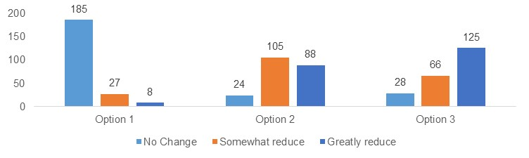

Source: Approved provider survey, as of 11 June 2025, option 1 n=220, option 2 n=217, option 3 n=219.

Respondents to the workforce survey indicated that they believed that both options 2 and 3 were more likely to only ‘somewhat reduce’ the risk of harm to children (refer to Chart 5.2). However, this view is swayed by a disproportionate number of the FDC workforce responding to the survey (over half of total workforce respondents), who were not in favour of the regulatory options. Stakeholder feedback collected through consultative activities indicate that FDCs do not perceive there to be a risk to the safety of children from personal device use in their settings compared to other provider settings (e.g. centre-based settings).

Chart 5.2: Workforce responses to “How much do you think each option will reduce the risk of harm to children?”

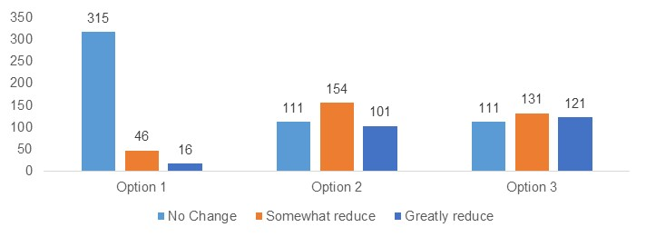

Source: Workforce survey, as of 11 June 2025, Q13, option 1 n=377, option 2 n=366, option 3 n=363.

Through consultative activities and the provision of expert advice, some groups of stakeholders expressed views that the proposed options may not have a significant impact on child safety outcomes on the basis that:

1. Some stakeholders reflected that the vast majority of the sector are already doing the right thing in relation to appropriate usage of digital devices.
2. Further regulation may not necessarily prevent an unscrupulous individual from actively seeking to do the wrong thing – though it may reduce their opportunity to do so.
3. The current regulatory options would not eliminate potential risks associated with ineffective monitoring of service-issued devices – for example, processes to ensure service-issued digital devices are used appropriately and not brought out of education and care settings.
4. The absence of access to personal devices may not prevent individuals from harming children, but it would prevent the distribution of images and videos of such harm.

Notwithstanding the above considerations, survey responses and overall stakeholder feedback on the potential benefits of proposed options indicate that the proposed policy options would contribute to lower risk of child harm. Based on the balance of evidence presented, option 2 has been assigned an MCA score of five, while option 3 has been assigned a score of seven. The main difference between the options is a result of option 3 further removing the opportunity for personal devices to be used in a way that may harm children.

#### Cost of each option

Services that have already fully adopted the National Model Code and Guidelines would only incur minor costs from options 2 and 3, such as updating policies and procedures, rather than purchasing devices. Services that are already in the process of adopting or were planning to adopt the National Model Code and Guidelines would under the status quo (option 1) already be incurring the associated costs and achieving the expected improvements in child safety. Therefore, only stakeholders who have not adopted and are not yet planning to adopt the National Model Code and Guidelines would incur incremental costs under options 2 or 3 compared to option 1. Similarly, a greater cost burden may also be borne by services that do not currently fully align with the National Model Code and Guidelines, even if the service aligns with some code elements (e.g., FDCs who have adopted FDC Australia guidelines).

Stakeholders who have not adopted the National Model Code and Guidelines reported a range of expected costs associated with options 2 and 3, including:

* The initial purchase of service-issued digital devices (approved providers indicated a need for 1 to 2 devices per room in centre-based care settings).
* Maintenance, repair, and replacement of digital devices (including insurance costs associated with physical damage to digital devices).
* Software, network, storage, and cybersecurity costs, including apps for secure communication with families, internet and mobile plans, storage such as memory cards or cloud storage, and security such as virtual private networks (VPNs) and firewalls.
* Technical implementation or modifications, such as enabling or disabling software and device features such as ‘sharing’ permissions, USB functions, or applying camera covers (for devices not used for taking images or videos). This may also include branding or marking devices so that there is clear visual identification of service-issued devices.
* Costs for approved providers to monitor compliance.
* Costs to deliver training and communication activities to raise awareness among staff and visitors.
* Costs to ensure educators can complete child-related documentation on service-issued devices.
* Costs to establish a location such as secure lockers to securely store personal devices (option 3 only).

These costs would vary by services depending on the type and cost of devices purchased, the existing software programs and network at the service, the use of insurance, and the frequency by which devices are maintained, repaired, or require replacement.

While there will be variance in the cost of the policy options by service, costs of the initial purchase of digital devices and the cost to maintain, repair, and replace digital devices is provided below. Software and network costs, insurance costs[42], and costs for approved providers to monitor compliance are not measured quantitatively, as there is likely to be very significant variation in these costs by provider size and depending on existing technologies and policies in place. These costs are still, however, expected to impose costs for services and are qualitatively considered alongside monetised costs.

**The initial purchase of service issued digital devices for the 10%[43] of centre-based services[44] and 41%[45] of FDC educators who have not adopted (or are not planning to adopt) the National Model Code and Guidelines is estimated to cost $9.7 million in present value terms from 2025 to 2034**.[46] As detailed in Table 4.4, these cost estimates are premised on a range of assumptions:

* While services are not required to purchase devices as a result of options 2 and/or 3, it is assumed that 10% of centre-based services (around 1,760 in total) will choose to purchase digital devices due to option 2 and/or option 3 to meet parent / carers’ expectations for videos / photos of their children. The remainder of services have indicated their adoption of the National Model Code and Guidelines or are planning to adopt it.
* The average purchase price of a device is assumed to cost $647.[47]
* The number of devices per service varies by service size. Stakeholder feedback indicated that a small centre-based service would be likely to purchase 2-4 devices as a result of the changes (a mid-point of 3 devices was used), while a larger centre-based service might purchase around 10 devices. Based on these figures, it was assumed that a medium-sized centre-based service would purchase 6 devices to comply with option 2 and/or option 3.[48] ACECQA data on the approved places per service provides an indication of whether the service fits into the small, medium, or large category. Across Australia, approximately 25% of centre-based services are small (have approved places for less than 40 children), 45% of centre-based services are medium-sized (have approved places for 40 to 80 children), and 30% are large (have approved places for more than 80 children).[49] It is assumed that these shares of small, medium, or large centre-based services are required to purchase 3, 6, or 10 digital devices respectively.
* It is assumed that 41% of FDC educators (around 3,792[50]) are likely to purchase devices due to option 2 and/or option 3, as the remainder of FDC services have indicated their adoption of the National Model Code and Guidelines or are planning to adopt it (refer to Table 5.1).
* It is assumed that one device is required per FDC educator.[51]
* It is assumed that all services will choose to continue to take images and videos of children and therefore purchase service-issued devices if they do not already have them. This is assumed on the basis that the sector widely used images and videos to document children’s learning currently.

Combined, these figures provide an indication of the upfront purchase cost of option 2 and/or option 3.

**The ongoing maintenance, repair, and replacement of service-issued digital devices is estimated to cost $31.5 million in present value terms from 2025 to 2034.** This assumes that the same 10% of centre-based services and 41% of FDC educators that are yet to adopt (or are not planning to adopt) the National Model Code and Guidelines will likely bear this cost, as all other services are assumed to continue using, maintaining, and replacing service-issued devices. To consider maintenance, repair, and replacement costs collectively, which will vary in practice, a conservative estimate of replacement frequency has been applied. It has been assumed that digital devices would need to be replaced every two-years, in line with the Australian Taxation Office’s estimated effective life of a tablet (for depreciation purposes).[52] The device purchase cost is assumed to be the same $647 value as used for the initial purchase of devices. Since this is the ongoing cost of replacing devices over a longer timeframe, this cost exceeds the initial cost of purchasing devices. It should be noted that services with insured devices may not bear replacement costs.

If devices are well maintained and not damaged, they may last longer (e.g., four or more years), which could more than half this estimated cost. For example smaller or lower use FDCs may be less likely to heavily rely on devices and may replace them less frequently.

Table 4.4: Summary of assumptions involved in estimating the cost of options 2 and 3

| **Assumption** | **Value** | **Source** |
| --- | --- | --- |
| Number of devices to be purchases | 3 for a small service (less than 40 children)  6 for a medium-sized service (40 to 80 children)  10 for a large service (more than 80 children)  1 per FDC educator in all jurisdictions except WA[53] | The number of devices were from a written submission, with the number for a medium-sized service inferred.  Service size thresholds were assumed. |
| Services required to purchase digital devices | 10% of centre-based services  41% of FDC educators | Approved provider survey, services who responded ‘no’ or ‘other’ to National Model Code and Guideline adoption. |
| Device cost | $647 | Assumption, based on the cost of tablets and mid-tier phone models. It is assumed that 70% of devices purchased are tablets (tablets were frequently referred to in consultation) and 30% of devices are phones. |
| Number of services | 18,013 in total, 17,610 with data on the number of approved places | ACECQA data |
| Frequency in which devices are replaced | Every two years | Australian Taxation Office (estimated effective life of a tablet) |

The monetised cost of options 2 and 3 is approximately proportionate to the number of education and care services operating in each jurisdiction. However, jurisdictions with a higher volume of FDCs relative to population (e.g., VIC, Queensland (QLD)) do experience a higher overall cost relative to the total number of education and care services. As a result, the greatest cost is expected to be borne by education and care services in New South Wales (NSW), followed by VIC (refer to Table 4.5).

Table 4.5: Cost of options 2 and 3 by jurisdiction, present value, 2025 to 2034

| **State or territory** | **Cost of initial purchase of service-issued digital devices** | | **Cost of ongoing maintenance, repair, and replacement of service-issued digital devices** | | **Total cost** |
| --- | --- | --- | --- | --- | --- |
| **Centre-based** | **FDC** | **Centre-based** | **FDC** |  |
| NSW | $2,328,812 | $732,457 | $7,586,375 | $2,386,063 | **$13,033,706** |
| VIC | $2,069,235 | $797,961 | $6,740,775 | $2,599,450 | **$12,207,421** |
| QLD | $1,468,625 | $565,719 | $4,784,217 | $1,842,894 | **$8,661,455** |
| WA | $614,391 | $0 | $2,001,451 | $0 | **$2,615,842** |
| SA | $540,504 | $101,234 | $1,760,754 | $329,781 | **$2,732,273** |
| TAS | $92,845 | $29,775 | $302,452 | $96,994 | **$522,065** |
| ACT | $179,737 | $29,775 | $585,513 | $96,994 | **$892,019** |
| NT | $91,939 | $17,865 | $299,501 | $58,197 | **$467,501** |

Note: Numbers may not sum due to rounding.

In addition to the monetised costs, option 3 would generate additional administrative and compliance costs around ensuring that service educators and other staff adhere to the regulated use of their personal devices. These costs have not been quantified as (1) they are expected to vary quite substantially by provider since existing administrative processes and available storage spaces will differ, and (2) cost estimates were not provided by stakeholders, particularly as the defined exempt circumstances that would determine some of these costs were not specified. These costs may include (but are not limited to):

* Developing additional administrative processes to determine if any educators or other staff members qualify for personal device use in the case of a defined exempt circumstance. For example, if an educator has a personal health requirement that requires the use of a personal device, it will fall to the approved provider to ensure that this educator can use their personal device as it relates to their health requirement, and not for the purpose of generating images and videos of children attending the service.
* Ensuring there are suitable storage arrangements for personal devices away from areas where educators are working directly with children.
* Ensuring educators are immediately contactable in other ways, in case of family emergency, for example.

These considerations may impose additional costs for approved providers, depending on the administration staffing and storage for personal items already available in education and care services.

Based on the costs identified, option 2 has been assigned an MCA score of negative five for this criterion, while option 3 was assigned a score of negative six. This was based on the premise that option 3 is expected to incur additional costs associated with monitoring personal device use, ensuring there are adequate storage arrangements for devices, and ensuring staff members can be contacted through an alternative means. These costs were broadly perceived to be outweighed by child safety benefits, in most education and care settings.

#### Implementation considerations

Both options 2 and 3 raised substantial concerns among stakeholders regarding the affordability of the proposed reforms. Some stakeholders indicated that the reforms may result in services choosing not to use images and videos to document children’s learning (noting for cost estimation purposes, it was assumed that most services would choose to purchase devices), which could also improve child safety outcomes. However, the use of images and videos is also an accessible method of communicating with families, particularly those with language barriers or disabilities, meaning child safety benefits need to be balanced with family engagement and pedagogical needs. Some stakeholders also indicated that the costs of the proposed regulatory options would ultimately be passed on to families utilising the education and care services.

A small number of family survey responses and submissions spoke to valuing images and videos received throughout the day, and that this supported them to feel comfortable with their child attending education and care services. Some approved providers and their services also described how images and videos can support access and inclusion for regional and remote families, families who use English as a second language, and families with disability; by allowing family engagement through visual media. This means that while images and videos are not required to document children’s learning under the NQF, they can play an important role for many services in delivering Element 1.3.3 (Information for families - families are informed about the program and their children’s progress) and Standard 6.1 (Supportive relationships with families - Respectful relationships with families are developed and maintained and families are supported in their parenting role) under the National Quality Standard.

I get regular updates on my child and am able to feel connected to them even if I’m not with them. It helps ease the mum guilt of returning to work. – Family survey response

A national public awareness campaign to shift parent expectations about digital documentation in education and care settings—framing reduced reliance on photos and videos as a child safety, educator workload, and quality-of-interaction issue. The campaign should highlight how constant device use increases risk, reduces educators’ focus on children, and places undue pressure on staff to produce digital content rather than engage in real time teaching and care – Written submission response

Options 2 and 3 may also impose an indirect consequence of diverting staffing and financial resources to personal and service-issued device management, rather than engaging with children and effectively supervising staff to minimise the risk of harm to children. This risk was raised by sector stakeholders and child safety experts. This has the potential to reduce direct supervision and engagement with children, particularly in smaller or lower-staffed services. This could increase other risks to children arising from less supervision.

Stakeholders raised concerns over approved providers being potentially liable for managing and monitoring the use of personal digital devices in education and care services, particularly if penalties may be applied. Stakeholders suggested it would be difficult to monitor possession of personal digital devices to the extent required by regulation – suggesting that it would be impractical to implement.

Stakeholders also raised concerns that option 3 would have implications on recruitment, retention, and the perceived professionalism of the sector (while this could be an issue with option 2, it was raised as a much more pertinent issue for option 3). From desktop research conducted, option 3 would set a precedent nationally and internationally for explicitly prohibiting personal devices in education and care services (and other human services sectors) as stipulated by the National Law and National Regulations. As a result, option 3 has potential to adversely impact recruitment and retention.

Stakeholders reflected that option 3 may also impose further impacts or unintended consequences, depending on the defined exempt circumstances in which individuals may have personal devices in their possession. The circumstances frequently mentioned by stakeholders as important for inclusion as defined exempt circumstances included all of those outlined in the National Model Code and Guidelines. Other commonly defined exempt circumstances that are recommended to be considered for inclusion relate to excursions, emergency situations, network outages, and any other travel initiated by the service (e.g., some regional/remote services may assist in transporting children in their care). If excursions are not included as defined exempt circumstances, some stakeholder emphasised that more digital devices might be required only when excursions are undertaken.

Some stakeholders also highlighted potential adverse wellbeing impacts to educators from not having access to personal devices. Most stakeholders expected medical conditions to be an exemption for option 3, however preventing the use of devices (including smartwatches, if included as a personal device under option 3) to monitor health and wellbeing elements was raised.

Additionally, challenges exist to implementing option 3 in the home-based environment of FDCs. This was recognised in the scope of recommendation 2.4 of the CSR, which was limited to centre-based services, and in the scope of the National Model Code and Guidelines. The practicalities of securely storing away all devices and monitoring devices used by educators and anyone else who may enter the FDC residence (and specifically the service premises) during operational hours will be very difficult.[54] All free text submission comments, except one,[55] related to the topic of FDCs in this reform area provided negative feedback, for example:

“The two proposed options regarding digital device usage appear to have been designed solely with centre-based care in mind and have not considered the unique operational context of FDC. While we support these options for LDC, they are not suitable for FDC settings”. – Free text submission response

“Implementing a rule like this — especially with added costs like mandatory “service-issued” devices — will be the final straw for many. It is not just unreasonable — it is unsustainable. Many educators are already under pressure from over-regulation, inconsistent support, and rising costs. This kind of policy, designed for centre-based models, shows a lack of understanding for the unique nature of FDC. If this passes, you will not only lose experienced educators — you will lose entire services.” - Free text submission response

FDCs expressed a firm view against option 3 (and a lesser extent, option 2) due to deep concerns around the practicalities of managing personal device access in the home environment, in addition to concern around cost pressures (explored further under *Distributional impacts*). There were concerns that option 3 in FDC settings was a regulatory overstep and may reduce the ability of FDC educators to respond to emergencies, for example.

Option 3 would also present implementation challenges in environments such as schools where different requirements may be in place for school-based educators. For example, educators in preschool/kindergarten rooms would not be allowed access to their personal device, whereas this restriction would not apply to educators in classes with older students, with composite class settings presenting additional complexity. Further, OSHC services may operate across a larger portion of the school site (e.g., using classrooms, halls, and sporting fields) which can mean OSHC educators and the children in their care may be spread out. This could mean OSHC services need a larger number of devices to effectively communicate and document learning.

Based on the implementation risks identified through stakeholder consultation, option 2 has been assigned a score of negative two for this criterion, while option 3 has been assigned a score of negative six. This score reflects the fact that option 3 is much more likely to incur additional costs or create other unintended consequences relative to option 2. While negative six is a large score in absolute terms, this does not offset the potential benefits of option 3 since the weight placed on implementation risks (10%) is much lower than the weight placed on child safety (50%), consistent with the objectives and preferences of governments (see Chapter 4).

It should be noted that while the MCA scores currently consider the implementation considerations based on the options that were consulted on, the recommended implementation of these options will alleviate some of these risks, particularly related to FDC settings and excursions. These implementation considerations are outlined in *What is the recommended option(s) and how will it be implemented?*

#### Distributional impacts

Throughout the public consultation, stakeholders identified that there was potential for options 2 and 3 to be prohibitively costly for any services operating with low or no margins including not-for-profits, smaller services (e.g., sole operations, remote services), FDCs, ACCOs, and OSHCs. As mentioned previously, these costs might be passed to families, who could be disproportionately impacted.

ACCOs reflected that if they had not already implemented option 2, it was because of the cost to the service more so than reluctance. As a result, option 2 could result in images and videos not being taken in these services.

Given the National Model Code and Guidelines were developed for use in centre-based service,a higher share of FDC services have not purchased service-issued digital devices. As a result, FDC services will bear a greater cost of the proposed reforms. These costs were reported to be prohibitive by the sector.

Some services may also bear disproportionately higher costs depending on their existing technology, cloud storage, and other IT systems used by each service – regardless of the status of National Model Code and Guidelines adoption. If any service needs to implement a full IT system to comply with the regulatory options and ensure devices are sufficiently monitored, this will be more costly for services that have little to no cloud infrastructure currently in place.

|  |
| --- |
| **Box 5.1: Aboriginal and Torres Strait Islander People Stakeholder Views[56]**  Aboriginal and Torres Strait Islander stakeholders raised that the ability to document children’s education and care through images and videos is important for accessibility for families, parents and carers with a disability or who do not have English as a first language. These media options are important and beneficial as they allow for families to engage in their children’s learning and development in different ways. This is particularly the case for remote services where children often attend education and care by bus, meaning that images and videos are a key mechanism to engage families who may not be able to physically attend a service.  There were mixed views on the providers’ ability to implement regulatory options. While some Aboriginal and Torres Strait Islander services or ACCOs can financially afford to implement service issued devices and policies similar to the regulatory options proposed, other services indicated limited financial capacity to purchase service-issued devices. For services in the former category, public consultation heard that some individual ACCOs have already implemented the National Model Code and Guidelines. For individual services in the latter category, the potential implication is these services would either require financial investment to purchase service-issued devices or to stop documenting children’s education and care through images and videos, despite this being a highly effective communication method. Yarning circles indicated that several ACCOs have limited financial capacity to purchase service-issued devices, but did not estimate the proportion of ACCOs that fall in this category. |

Based on the evidence presented by stakeholders, options 2 and 3 have been assigned an MCA score of negative five for this criterion. These scores reflect that the two options have broadly similar distributional impacts, since most implications regarding the affordability of the regulatory options for certain stakeholders apply to both options 2 and 3.

#### Break-even analysis

The BEA provides an estimate of the extent to which the total cost of harm to children in Australia, estimated at $34.6 billion (2025 dollars)[57], would need to be reduced for the cost of the policy option to break even with the potential benefit. The BEA framework is also described in further detail in Chapter 4.

While BEA necessitates putting a dollar figure to the estimated harm to children, it is not possible to quantify the real life harm to children, families, and communities affected.

Based on the breakeven value shown in Table 5.6, options 2 and 3 would need to reduce the cost of harm due to child maltreatment in Australia by at least 0.12%[58] to break even. It should be noted that this breakeven value accounts for only the monetised costs of options 2 and 3. Evidence collected through public consultation indicates that this breakeven point can feasibly be achieved if either regulatory option was implemented. Based on feedback received, multiple stakeholders agreed that the improvement to child safety would outweigh the potential costs as the regulatory options would reduce instances of inappropriate usage of digital devices. It is noted that there are variations in costs across provider types. For instance, the costs or efforts for smaller services may be higher and underestimated.

Table 5.6: BEA – Managing the use of digital devices

|  | **Option 2 and option 3** |
| --- | --- |
| Estimated cost of the policy option | $41.1 million |
| Break-even reduction in child maltreatment in Australia | 0.12% |

Estimate of regulatory burden

All monetised costs estimated under the ‘Cost of each option’ are compliance costs that would be accrued by approved providers. Of these approved providers, approximately 57% are considered businesses (private, for-profit organisations and independent schools), 33% are community organisations (not-for-profit organisations and catholic schools), and 10% are government-managed or government schools.[59] Based on OIA’s guidance on regulatory burden measurement, the costs incurred by businesses, community organisations, and individuals contribute to the regulatory burden associated with options 2 and 3.[60] Both options 2 and 3 are estimated to impose regulatory burden on businesses of $23.4 million and community organisations of $13.6 million, which is 90% of the total monetised cost of these options (refer to Table 5.7). The remaining 10% of the cost would be borne by approved providers managed by the government. The similarity between option 2 and 3 costs is on the basis that both options will incur the same compliance costs to providers (purchase and maintenance of service-issued devices). Incremental costs associated with option 3 could not be quantified due to the significant variability in these cost categories (e.g. cost to store personal devices across different provider settings). These costs should be considered together with the additional regulatory burden stemming from the costs that could not be quantified (e.g., the cost of monitoring personal device use).

As it stands the regulatory burden estimates in Table 5.7 assume that the affected approved provider will bear the cost. However, in the event that government funding is available, a higher share of the potential costs may be borne by the government, alleviating the cost to approved providers. As this stage, no decisions regarding the availability of government funding have been made, and such decisions may be at the discretion of individual state and territory governments. Any funding decisions would change who bears the regulatory burden associated with the regulatory options.

Table 5.7: Regulatory burden estimate – Managing the use of digital devices, NPV 2025 to 2034, 7% discount rate

|  | **Business** | **Community organisations** | **Individuals** | **Government** | **Total change in costs** |
| --- | --- | --- | --- | --- | --- |
| Option 1 | - | - | - | - | **-** |
| Option 2 | $23,445,401 | $13,573,653 | - | $4,113,228 | **$41,132,282** |
| Option 3 | $23,445,401 | $13,573,653 | - | $4,113,228 | **$41,132,282** |

Stakeholders’ preferred option

Option 2 reflects the most frequently preferred options among approved providers and families, parents and carers, followed by option 3 (refer to Appendix 12.3.1). Option 2 was the preferred option among all approved provider types, including FDCs and OSHCs (refer to Chart 5.3).

Despite the preference for option 2 among families, parents and carer survey respondents overall, many families, parents and carers using FDC services preferred the status quo. Similarly, most survey respondents and focus group participants from the FDC sector provided feedback that they perceive the proposed regulatory options as not appropriate for the FDC sector and cost-prohibitive to implement, except for some approved providers and peak bodies. FDC peak body submissions did not support option 2 or 3 for FDC services on the grounds that they are inappropriate for FDC settings, do not address risks in FDC settings, would increase risk in other areas, is prohibitively expensive, and that the status quo’s upcoming regulatory changes and additional guidance provide a strong basis for increasing child safety without further regulatory change.

Chart 5.3: Approved provider responses to “What is your preferred option or combination of options?”, by service type

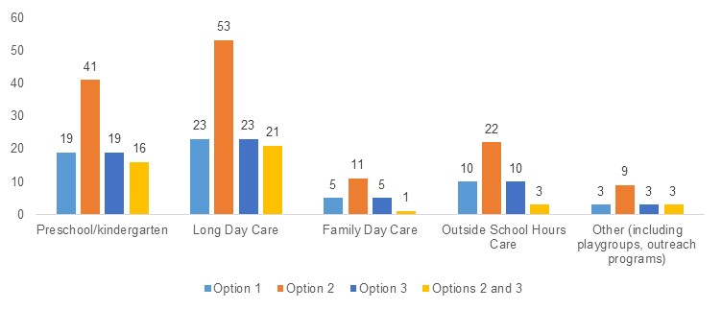

Source: Approved provider survey, as of 11 June 2025, Q15, Unique respondents n=208. Note that respondents were able to select multiple service types.

Workforce survey respondents were characterised by very disproportionate representation from FDCs, who expressed strong opposition to the proposed regulatory options in consultation for the reasons outlined in the distributional impacts discussion above. When breaking down workforce survey responses by service type, the preference for option 1 sits largely with FDCs, while the remainder of the workforce has the highest preference for option 2, followed by option 3 and options 2 and 3 in combination, respectively (refer to Chart 5.4). FDCs’ preference for the status quo (option 1) is due to expectation that the upcoming regulatory changes (amendments of regulation 168) will already provide a strong foundation for improved child safety in relation to the use of digital devices in an FDC context, especially where other tailored digital device policies are in place. Additional prescriptive measures around the use of devices may be unlikely to yield further safety benefits in these settings.

Options 2 and 3 are perceived by FDCs to be more appropriate for centre-based settings compared to FDC settings, where FDC educators work alone, are responsible for emergency responses and rely on personal devices for both professional and personal purposes. Stakeholder feedback has consistently identified FDCs as a unique context requiring bespoke policy responses. The ability to use personal devices for both safety and communication is essential when educators work alone. A blanket ban could increase risks rather than mitigate them.

As such, FDC considers option 1 (including the amendments to regulation 168 of the National Regulations, in effect from 1 September 2025, requiring services to have policies and procedures for the use of digital devices) to be a more balanced and context-appropriate approach.

Chart 5.4: Workforce responses to “What is your preferred option or combination of options?”, by service type

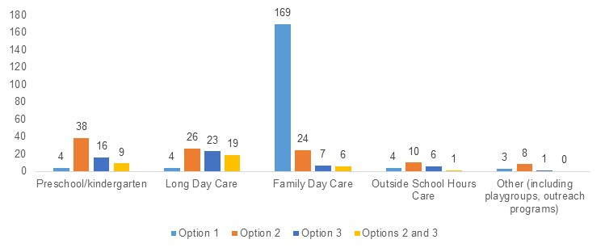

Source: Workforce survey, as of 11 June 2025, Q15, Unique respondents n=343. Note that respondents were able to select multiple service types.

Long form submissions also preferred option 2, with mixed support for option 3. All large provider long form submissions supported option 2, and most also supported option 3, with some stating that funding support would be required. Long form submissions that did not support regulatory change were from peak bodies and education and care services, and mostly represented the FDC sector, with others including a peak body representing remote families.

### What is the recommended option(s) and how will it be implemented?

Based on analysis included in this DRIS, the options with the highest net benefit to be provided to Education Ministers for consideration are options 2 and 3, with further clarity and definition regarding the scope of option 3. Based on stakeholder feedback, consideration of expert advice on child safety outcomes, and the intent of the original CSR recommendation, option 3 will be recommended for implementation in centre-based services only. As FDC services comprise only 2% of the education and care sector, this means option 3 will still apply to the vast majority of the sector.

The list of defined exempt circumstances under option 3 will also be subject to further consideration on implementation. Stakeholder advice has indicated that for educators to not have access to personal digital devices could pose safety risks during excursions, and this will be addressed through implementation.

The implementation of option 3 should also consider the scope of personal devices that cannot be possessed by an individual when working with children. For example, the inclusion of smartwatches that cannot take, but can store, images and videos may not yield sufficient child safety benefits to offset the cost to educator and staff members’ wellbeing.

# 6. Child safety training

Current training requirements (i.e. training that is in addition to required minimum educator qualifications) under the NQF are limited to ‘child protection’ and are reliant on jurisdictional law or protocol. While this is an element of child safety, child protection is more narrowly and responsively focused on topics such as mandatory reporting and serves a distinct purpose. Child safety, in comparison, encompasses a broader and more proactive spectrum of topics focusing on child wellbeing. This distinction highlights a knowledge and training gap in the education and care sector, raising a potential risk to children where sector understanding and capability is inadequate and outdated.

This chapter details policy options to strengthen and ensure the longevity of existing child protection provisions under the NQF while concurrently recommending a transitioned approach to implementing and delivering nationally consistent and mandatory child safety training including a renewal requirement.

The specific reform area discussed in this chapter is Chapter 6.1 – Introducing mandatory child safety training.

## 6.1 Introducing mandatory child safety training

|  |
| --- |
| **Key Insights**  *Problem*   * Under the National Law and National Regulations:   + the requirement to complete child protection training is dependent upon jurisdictional law or protocol; therefore, certain individuals in some jurisdictions are not required to complete such training   + education and care staff who do not have direct contact with children may have limited awareness of the existence and application of jurisdictional child protection laws and their obligations under such law   + no requirement exists for nationally consistent child safety training which differs from and goes beyond child protection training and knowledge. * These issues contribute to knowledge and capability gaps across jurisdictions and across different staff who work within the education and care sector. As a result, some staff may lack awareness or understanding of effective child safety practices and child protection laws including reporting obligations.   *Impacts of each option*   * The MCA analysis shows that all options would deliver a net benefit compared to the status quo. Despite expectation that option 6 (mandatory child safety training for all staff) will incur the highest cost, it has the highest weighted score as the scope of training delivered under this option is expected to result in the most significant incremental improvement to child safety. * Options 4 and 6, followed by option 5, also received the highest levels of support from families, parents, and carers and the workforce * Options 3, 4 and 5 received a lower weighted score than option 6, reflecting they have a narrower scope (relate to child protection training, rather than child safety training).   *Recommended option*   * Based on analysis included in this DRIS, the options with the highest net benefit to be provided to Education Ministers for consideration are the regulatory options 4, 5, and 6. These options introduce the highest standards of child protection knowledge and training and child safety training and will provide a nationally consistent approach and expectation across the whole education and care sector. * Stakeholder feedback highlighted a range of considerations that need to be taken into account for the implementation of these options. Governments will undertake additional work to provide greater clarity on the scope, scale, content and format of child safety and child protection training. |

Through section 162A of the National Law and regulation 84 of the National Regulations, there are specific requirements regarding child protection, knowledge, and training. However, these provisions do not encompass all aspects of child safety and only require some staff who work directly with children in education and care services to complete training. Excluding the broader concept of child safety from the National Law leaves a significant gap in workforce capability and understanding, therefore posing a risk to the wellbeing and safety of children attending education and care services.

Section 162A requires nominated supervisors and persons in day-to-day charge to undertake child protection training only if mandated by jurisdictional legislation or government protocol.[61] In all jurisdictions except for WA, FDC coordinators are also subject to mandated child protection training and related government protocols under section 162A. This amendment to include FDC coordinators in the scope of section 162A eventuated from the 2019 NQF Review, which WA is yet to implement.

The depth, breadth, and mandating of child protection training and reporting obligations differ across jurisdictions. A high-level overview of these differences is captured in Appendix 12.5.

Child safety training – which centres on children’s rights, harm prevention, and promoting the safety, health, and wellbeing of children including child protection – is of a broader scope than child protection training, which deals primarily with responses to harm, the risk of harm to a child and, the issue of mandatory reporting. However, child safety training is not mandated by law in any jurisdiction.

Under regulation 84, approved providers are required to ensure that any person who works with children in an education and care service, except for those who do not have contact with children (e.g., administrative staff), are advised of the existence and application of the current child protection law and any obligations that the person may have under the law. However, those that work in a service but do not have contact with children may still have obligations under jurisdictional law.

To practically reinforce the National Principles, Child Safe Standards are at various stages of implementation across jurisdictions. The standards enshrine child safety principles and values in organisations and their policies and practices, including the education and care sector and promote a culture that prioritises children’s safety and wellbeing through effective, unanimously applied principles. There are four principles that are especially relevant to child safety training and can provide guidance and an established framework for the content in child safety courses, and those required to complete training. Relevant principles include:

* Principle 1: Calls for child safety and wellbeing to be embedded in organisational leadership, governance and culture.
* Principle 4. Equity is upheld and diverse needs are respected in policy and practice
* Principle 5: Requires that people working with children are suitable and supported to reflect child safety and wellbeing values in practice.
* Principle 7: Requires that staff and volunteers are equipped with the knowledge, skills and awareness to keep children and young people safe through ongoing education and training.

For the status of jurisdictional implementation of the National Principles, see Appendix 12.5.

### What is the problem?

Under the National Law and National Regulations:

* the requirement to complete child protection training is dependent upon jurisdictional law or protocol; therefore, certain individuals in some jurisdictions are not required to complete such training
* education and care staff who do not have direct contact with children may have limited awareness of the existence and application of jurisdictional child protection laws and their obligations under such laws
* no requirement exists for nationally consistent child safety training which differs from and goes beyond child protection training and knowledge.

These issues contribute to knowledge and capability gaps across jurisdictions and across different staff who work within the education and care sector. As a result, some staff may lack awareness or understanding of effective child safety practices and child protection laws including reporting obligations.

The mechanisms of harm arising from the identified issues are elaborated below.

**Jurisdictional dependent requirements for child protection training**

* **Staff required to undertake training:** Section 162A of National Law mandates that nominated supervisors, persons in day-to-day charge, and FDC coordinators[62] must undertake child protection training if required by jurisdictional laws or protocol. The scope of individuals required to complete the training varies across jurisdictions and in some jurisdictions this variance is substantial compared to other jurisdictions. For example, SA requires volunteers in services to complete child protection training, while NSW does not. Differences in jurisdictional laws mean that volunteers, students, and certain staff may not be obligated to undertake child protection training in some jurisdictions. There is therefore a risk that some volunteers, students, and staff may lack the knowledge or understanding of how to effectively follow child protection laws, policies, and procedures, such as identifying, managing, or reporting risks or occurrences of child maltreatment.

**Scope of child protection law obligations**

* **Staff obligations:** Regulation 84 of the National Regulations only mandates that staff who work with children are advised of the existence and application of child protection laws and any obligations they have under such laws. This means there may be staff who work in education and care settings (e.g. administrative staff) who do not have awareness of child protection laws in their jurisdiction. These staff may play a role in complying with child protection laws, even if they do not work directly with children (e.g. undertaking mandatory reporting). As such, a lack of understanding of child protection laws and associated policies and procedures may lead to non-compliance, hence increasing the risk of harm, or the risk that harm goes unaddressed and leads to repeat offences.

**Introduction of nationally consistent child safety training**

* **Lack of child safety coverage under the National Law:** Child safety training differs to child protection training and therefore, development of new content is required. Child safety training goes beyond the current legislative requirements under section 162A of the National Law, encompassing crucial issues for which there is currently a knowledge gap in the sector. Excluding the broader concept of child safety from the National Law leaves a significant gap in workforce capability and understanding, therefore posing a risk to the wellbeing and safety of children attending education and care services.
* **Access to child safety material in education and care qualifications:** The Vocational Education and Training (VET) and Higher Education sectors are limited in their course content which cover issues of child safety. Further, in some jurisdictions, the requirement to attain VET qualifications to work in certain service types does not currently exist (for example, OSHC educators in NSW and Tasmania (TAS).

Implementing more uniform and additional training in the education and care sector will increase confidence and capability within the workforce. This will reduce gaps in knowledge regarding child safety, creating a consensus of understanding on how to keep children safe. Where issues or incidents occur, there should be a shared ability across a service for appropriately and effectively responding to harm or risk of harm to a child.

* **currency requirements:** Section 162A of the National Law does not specify expiry periods for child protection training, or the need for certifications to demonstrate the period in which the training was undertaken. In the context of child safety, currency is crucial where legislative and expert understanding of the concept is still developing and evolving, particularly as technological advancements pose additional risks of harm in online contexts. Evolving risks necessitate that child safety training be continuously updated and undertaken, such that the education and care workforce has contemporary knowledge and understanding of how to uphold child safety practices and principles in the education and care sector.

Training that is regularly updated and required to be kept current will support the education and care sector to achieve collective competency in child safety practices, therefore strengthening the workforce and promoting a culture of prioritising children’s safety, heath, and wellbeing while attending education and care services.

### What were the policy options consulted on?

Six options, including the status quo, a non-regulatory option, and four regulatory options are under consideration. Options 1, 3 and 4 are mutually exclusive, however the remaining are not. The recommended option for these recommendations can be any combination of the proposed regulatory and non-regulatory approaches, aside from implementing any two that are mutually exclusive.

Table 6.1: Policy options under consideration – Child safety training

| **Option** | **Description** |
| --- | --- |
| 1 | Status quo (no change). |
| 2 | **Non-regulatory**  Improved, nationally consistent resource and training guidance materials that can be provided to Registered Training Organisations and Higher Education institutions to insert into courses. |
| 3 | **Regulatory**  Amend section 162A of the National Law to require nominated supervisors, persons in day-to-day charge and FDC coordinators to complete child protection training, removing the dependency on other jurisdictional law or government protocol.  This would be supported by publication of an approved list of child protection training for the purposes of compliance with this section, as for first aid training (made up of national or state accredited units of competency or short courses) through amendment to regulation 137. |
| 4 | **Regulatory**  Amend section 162A of the National Law to require staff who work with children, including FDC educators, volunteers and students, in addition to nominated supervisors, persons in day-to-day charge and FDC coordinators, to complete child protection training, removing the dependency on other jurisdictional law or government protocol.  This would be supported by publication of an approved list of child protection training for the purposes of compliance with this section, as for first aid training (made up of national or state accredited units of competency or short courses) through amendment to regulation 137. |
| 5 | **Regulatory**  Amend regulation 84 so that all staff and volunteers, whether or not they work with children, must be made aware of:   * existence and application of the current child protection law * any obligations that the person may have under that law.   (i.e. remove the limitation to staff who work with children) |
| 6 | **Regulatory**  Legislative change to require:   1. Mandatory child safety training.   Which is nationally consistent, of a high quality, and tailored for all people involved in the provision of education and care services (including people who do not directly work with children), with a requirement to complete refresher training every two years.  This change should be subject to governments undertaking further research, costing and impact analysis of any proposed training and the implementation approach.  Mandatory child safety training may feature matters including, but not limited to:   * creating a child safe culture in education and care services * identifying, reporting, and responding to child maltreatment through trauma informed practice * differences in behaviour and responding appropriately, along with identifying grooming behaviour in children and adults around them * understanding the difference between developmentally expected sexual behaviour and concerning or harmful behaviour by children or between children * effective supervision and behaviour guidance, including the offence of using inappropriate discipline, and potentially inappropriate conduct (refer to Chapter 7.1). |

### What are the impacts of each option?

The sections below provide an MCA assessing the potential impacts of the proposed options. A detailed overview of the MCA framework underpinning this analysis is available in Chapter 4.

#### Multi-criteria analysis

In MCA assigning scores to reflect the relative benefits and costs of each option, the score for improvement in child safety has been scaled with a zero for option 1 representing no change, and score of eight for option 6 representing the biggest impact on child safety. Other options have been scored between these values based on the assessment of qualitative input from stakeholders. Scores for other categories relating to costs, risks, and distributional considerations have been scaled in relation to these benefits.

Table 6.2: MCA outcomes – Child safety training

| **Criteria** | **Weight** | **Option 1** | **Option 2** | **Option 3** | **Option 4** | **Option 5** | **Option 6** |
| --- | --- | --- | --- | --- | --- | --- | --- |
| Improvement in child safety | 50% | 0 | 2 | 3 | 5 | 4 | 8 |
| Net cost of policy option | 30% | 0 | -2 | -2 | -4 | -3 | -7 |
| Implementation considerations | 10% | 0 | -1 | -1 | -4 | -2 | -5 |
| Distributional impact | 10% | 0 | 0 | -1 | -3 | -2 | -5 |
| **Weighted score** |  | **0** | **0.3** | **0.7** | **0.6** | **0.7** | **0.9** |

Note: Option 1 - the status quo - receives a score of zero across all criteria, as explained in Chapter 4.

The weighted average scores for these options suggest that, based on stakeholder input received through the consultation process, all options would deliver a net benefit compared to the status quo. Despite expectation that option 6 will incur the highest cost, it has the highest weighted score as the scope of training delivered under this option is expected to result in the most significant incremental improvement to child safety. The weighted scores for options 3, 4 and 5 are broadly consistent and are lower compared to option 6 as they relate to child protection training (a narrower scope compared to child safety training). This MCA outcome, in addition to understanding which options are mutually exclusive and can be implemented in combination, has informed governments of the recommended options outlined in the next section. Further detail on the rationale for each score is outlined in the sub-sections below.

#### Impact on child safety

Option 2 encourages consistency in the child protection and child safety content covered in all qualifications and courses delivered by RTOs and Higher Education institutes which may reduce knowledge gaps and inconsistencies in the emerging workforce’s knowledge of child safety and child protection. This is a non-regulatory option that hinges on RTOs and Higher Education institutions to opt-in, access, and implement the new course material into courses. In consultative activity, the majority of stakeholders held strong support for option 2. There is a strong consensus that at a minimum, child safety and child protection training and guidance material should be nationally consistent and to a high quality across all jurisdictions to support workforce capability and confidence. Stakeholders noted that there are inconsistencies in how child protection is covered across training providers, having consequences for the preparedness and confidence of the workforce. Some stakeholders were concerned that option 2 may be too narrow in scope if only RTOs and Higher Education institutions receive training and guidance materials. There was desire across stakeholders for materials to be distributed more broadly across the sector to include services and the workforce. Some stakeholders did note that option 2 is limited as a non-regulatory option as it does not require training to be completed:

*“This option would ensure that training content is standardised across all qualifications and courses, regardless of location. Students entering the workforce would have foundational, consistent knowledge of child protection and child safety – reducing variability in understanding between educators from different states or training backgrounds… However, it is not sufficient as a stand-alone solution as it does not reach the current workforce or address the need for ongoing, practical, context-aware training and refreshers” – Approved provider survey*

*“[Option 2] will improve awareness and understanding, however, there is no requirement for action.” – Approved provider survey*

Respondents to all three surveys indicated that option 2 would somewhat reduce the risk of harm to children (refer to Chart 6.1 and Appendix 12.3.2).

Chart 6.1 Approved provider responses to “How much do you think each option will reduce the risk of harm to children?”

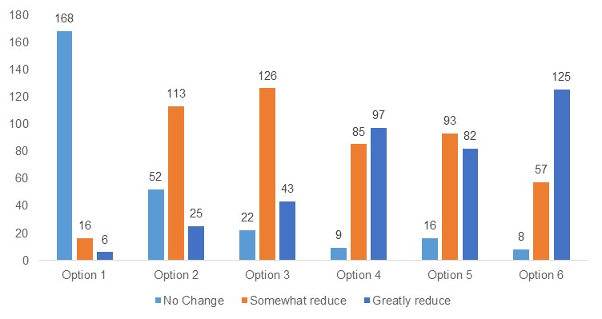

Source: Approved provider survey, as of 11 June 2025, Q27, option 1 n=190, option 2 n=190, option 3 n=191, option 4 n=191, option 5 n=191, option 6 n=190.

Based on the evidence presented, option 2 has been assigned an MCA score of two for this criterion.

Option 3 would reduce uneven standards and improve consistency in child protection training requirements across jurisdictions by requiring all nominated supervisors, persons in day-to-day charge and FDC co-ordinators to undertake child protection training across Australia. This improves child safety by ensuring that there is a consistent minimum standard for those in leadership roles to complete child protection training. However, option 3 does not require child protection training for all staff members working directly with children which will create an imbalance in understanding, level of knowledge and capability of the workforce. Compared to options 4 and 6, this option would newly require a smaller share of the workforce to undertake child protection or child safety training. Similarly, many approved providers require their workforce to undertake child protection training even when not legally required. In the approved provider survey, 61% of respondents indicated that all staff members in their service have completed child protection training.

During consultations, stakeholders noted that this option is important to achieve national consistency and that a published list of approved training reduces ambiguity around what qualifies as acceptable training, but there are more roles and staff members within a service that work with children and should be trained.

*“Chain of responsibility can potentially be compromised if only specific persons working with and alongside children have this training. It is everyone’s responsibility to ensure a safe environment is provided. This should align with the child safe standards, specifically standard 7” – Approved provider survey*

Respondents to all three surveys indicated that option 3 would somewhat reduce the risk of harm to children, however there was a slight increase in the survey responses that nominated ‘greatly reduce’ for this option relative to option 2 (refer to Chart 6.1 for approved provider survey responses and Appendix 12.3.2 for workforce and families, parents and carers survey responses).

The impact of this option on child safety outcomes would be larger than option 2 due to the requirement for multiple staff roles to complete child protection training, and likely relatively smaller compared to options 4 and 6 due to a smaller number of roles required to undertake child protection or child safety training. As such, option 3 has been assigned an MCA score of three for this criterion.

Option 4 improves child safety through two mechanisms. First, by improving consistency across jurisdictions in the roles that are required to undertake child protection training by requiring it in all jurisdictions, and second, by encouraging a cultural shift in responsibility for child protection across services by broadening the scope of roles that are required to undertake child protection training therefore recognising the important role all educators and staff, irrespective of their position, play in protecting children. Further, option 4 encourages the education and care sector to help services across Australia achieve principle 7 of the National Principles, by equipping staff and volunteers with the knowledge skills, and awareness to keep children safe through ongoing education and training.[63]

*“Reinforces that child protection is everyone’s responsibility, not just that of coordinators or supervisors. It encourages a more confident and informed workforce – particularly for new or less experienced educators, student son placement, and casual staff” – Approved provider survey*

Option 4 improves child safety by requiring those working with children at all levels of an organisation to be well equipped to respond to child protection risks. This expands the remit of the requirement to complete child protection training to substantially more individuals than under option 3. Similarly to option 3, the jurisdictional differences in what is included in each state and territory’s child protection training remain with option 4. From consultative activity, stakeholders have noted that option 4’s breadth ensures that more people who interact with children have improved confidence and capability to respond to signs of child maltreatment. Stakeholders have also noted that option 4 improves the professionalism and safeguards the reputation of the education and care sector.

*“Ensures all persons working directly with children have undertaken child protection training and understand their obligations and sector expectation.” – Approved provider survey*

Option 4 affects significantly more of the workforce compared to option 3 and has been assigned a higher MCA score of five for the child safety criterion. This also reflects survey responses that option 4 is more likely to greatly reduce the risk of harm to children (refer to Chart 6.1 and Appendix 12.3.2).

Option 5 improves child safety by expanding the coverage of people within an education and care service who are required to be made aware of the existence and application of current child protection law in their jurisdiction and their obligations under that law. Under option 5, the approved provider of an education and care service must ensure all staff and volunteers, whether or not they work with children are made aware of the current child protection law and their obligations under it. This will support the sector and improve child safety by assisting all staff members to better recognise potential child maltreatment and understand how to respond and report instances of maltreatment. While option 5 will support staff, across a larger share of the education and care workforce, to better understand the relevant child protection law and ensure awareness of appropriate reporting channels, including any mandatory reporting requirements, it is less likely to be impactful on reducing harm to children than training. Some stakeholders raised that awareness of child protection law does not necessarily translate into a more knowledgeable and capable workforce, whereas training has a stronger focus on building knowledge and capability through practical application of skills.

*“Awareness does not equal knowledge.” – Approved provider survey*

Responses from all three surveys indicated that stakeholders believe that option 5 could greatly reduce the risk of harm to children – though confidence in this option for reducing the risk of harm to children was slightly lower than for options 4 and 6 refer to Chart 6.1 and Appendix 12.3.2).

Based on this evidence, option 5 has a smaller impact on improving the depth of child protection knowledge of the workforce compared to option 3 and 4 but affects a larger proportion of the workforce compared to options 3 and 4. It has been assigned an MCA score of four for this criterion, between options 3 and 4.

Option 6 improves child safety through several mechanisms.

* Firstly, option 6 proposes to introduce nationally consistent and mandatory child safety training. This will address the existing gap in sector capability and understanding of how the broader concept of child safety differs from and goes beyond child protection.
* Secondly, this option requires all people involved in the provision of education and care services (including those who do not directly work with children) to undertake child safety training. Option 6 requires a broader range of roles to undertake child safety training compared to the range of roles required to undertake child protection training under option 4, by requiring those who do not work directly with children to also complete child safety training.
* Thirdly, option 6 requires refresher training every two years. This maintains the currency of child safety knowledge and capability across the sector including evolving risks such as those presented by technological advancement. By requiring refresher training, the knowledge and capability of the workforce will evolve to reflect the changing risks to child safety within the sector.

*“This will have the biggest positive impact as it will ensure all staff working at the service have relevant and current training.” – Approved provider survey*

*“Creates a nationally consistent baseline of understanding, every person working in education and care would receive the same high-quality, up-to-date training, ensuring sector wide consistency across states and service types” – Approved provider survey*

In consultative activity, stakeholders agreed that national consistency for child protection and child safety training is important. There was agreement from all stakeholders that option 6 would have the greatest impact on child safety out of all options (refer to Chart 6.1 and Appendix 12.3.2), however, stakeholders across all jurisdictions noted that further clarity on the mode of delivery, the provider of training, and the contents of the child protection or child safety training would impact the improvement to child safety outcomes of each of the options. Overall, stakeholders agree that of all the policy options, option 6 improves, promotes and safeguards the reputation and professionalism of the education and care sector the most.

Option 6 is the broadest and most comprehensive policy option that improves child safety in terms of scale of individuals required to undertake training, and breadth of child safety training content compared to options 2, 3, 4 and 5. As such, it has been assigned a higher MCA score of eight for this criterion.

#### Cost of each option

Under option 2, there may be costs to develop nationally consistent resources and training guidance materials. Incremental costs will be more significant if relevant materials cannot be developed with the support of existing government resources and as part of business-as-usual activities. Option 2 is non-regulatory and depends on the uptake and implementation of resources and materials by RTOs and higher education institutes. Depending on the scale and level of uptake, this option would incur costs for RTOs and higher education institutes to change or update their courses to include additional materials.

In consultation with RTOs, stakeholders noted that if additional materials provided to them required a change to their unit competency, they may need to reapply for their accreditation status and incur significant costs as a result. Stakeholders noted that they would require further specificity and clarity on what the training resources and materials would be before they could anticipate the scale of change needed or provide input to any quantification of the cost of option 2. While the cost of option 2 may be substantial for an RTO, uptake is voluntary and the cost would impact a relatively smaller number of stakeholders than options 3 to 6. As a result, option 2 has been assigned an MCA score of negative two.

Options 3 to 6 incur similar types of costs, with the difference resulting from the scale and breadth of roles that are required to undertake the relevant training. In consultative activities, stakeholders identified several different types of cost that would be incurred by a range of stakeholder types, to implement options 3 to 6, including:

* the cost of accessing training materials and programs
* the costs of an individual’s time to undertake training (which may require staff backfill, overtime pay or leisure time for students),
* travel costs, in instances where in-person training is required and if training is only delivered at specific locations,
* administrative costs to monitor completion of training, of which the burden might be reduced if additional training could be implemented together with existing training and monitoring processes,
* costs to develop a published list of approved child protection training (this cost would be incurred by the government and applies to options 3 and 4),
* costs to develop suitable training and facilitate the training.

The magnitude of costs incurred is dependent on the content, mode, duration and format of training. The additional costs would vary by services and jurisdictions depending on jurisdictional law and the scale of training currently delivered to their service staff.

Stakeholder input indicates that stakeholders were not able to provide estimates of costs without further detail or definition of these aspects of the training requirements. For example, stakeholders indicated that costs would be significantly higher if in-person training is required under any option, however this is not explicit in the current description of the options. As such, stakeholders did not provide estimates of the potential costs of the options.

To provide an indicative example of one scenario of costs, this DRIS includes the estimated cost of individuals undertaking child protection training and the associated cost of backfilling that individual, based on the length of courses that have been deemed sufficient to fulfill child protection training requirements in some jurisdictions. It is important to note that estimated costs are indicative only and estimates would change depending on clarifications on the implementation of options and changes in assumptions.

The potential child protection training costs that were able to be quantified are summarised in Table 6.3, in present value over ten years. These costs would be incurred by approved providers and services in the first instance; however, stakeholders reflected that the cost would ultimately be passed on to families who access the services. In cases where government funding is provided, the costs to providers and families could be reduced. Travel costs were excluded due to limited stakeholder data on their expected expenses and the national scale of these costs. There could be potential for some costs to be reduced if options are implemented together. For example, if option 4 and option 6 are implemented together, there might be efficiencies in the amount of training required – however this depends on how the two trainings are implemented. The MCA scores for options 3, 4, and 5 are outlined in Table 6.3 and were assigned based on the incremental cost between the proposed options. Further, the cost of option 6 has not been quantified as the requirements for this training are yet to be determined (e.g., the required length of training). However, estimates are available on the approximate number of individuals that the training might apply to (e.g., all employees in the education and care sector), enabling the rough magnitude of the cost, relative to the other options, to be estimated for MCA scoring.

Table 6.3: Costing estimates for option 3 to 5 for Child Safety Training reform area

|  | **Option 3** | **Option 4** | **Option 5** |
| --- | --- | --- | --- |
| **Cost to complete required training (educators, staff members, and volunteers)[64]** | $244,000 | $2.7 million | N/A |
| **Cost to notify staff of child protection law** | N/A | N/A | $799,000 |
| **Cost to complete required training (students)** | N/A | $3.4 million | N/A |
| **Cost of backfill staff** | $305,000 | $3.4 million | N/A |
| **Total quantified cost of option** | $549,000 | $9.5 million | $799,000 |
| **Assigned MCA score** | **-2** | **-4** | **-3** |

Source: Deloitte Access Economics analysis. Note: All estimates are presented in present value terms for the cost over 10 years. Travel costs were not included in costing estimates, this would have implications for option 3 and option 4. Figures have been rounded to the nearest thousand.

Note: Figures may not sum due to rounding.

The cost of individual’s time to undertake training and the associated cost of backfill staff (relevant to options 3 and 4 only) is outlined and monetised for each option below.

**The cost for the specified roles to complete child protection training under option 3, including the cost of backfill staff, is estimated to be $549,000 in present value terms over a 10-year period.[65]**

Under option 3, only nominated supervisors, persons in day-to-day charge, and FDC coordinators are required to undertake child protection training. Volunteers, students, and other employees are not affected under option 3, unlike option 4, 5, and 6, which include requirements for a broader range of individuals. For option 3, it is assumed that approved providers in NSW, VIC, QLD and SA incur no additional costs due to jurisdictional law or protocol that already requires the specified roles to undertake training. For the remaining jurisdictions (WA, TAS, NT and the Australian Capital Territory (ACT)), it is assumed that 13%[66] of the specified roles have not completed child protection training. This is on the basis that most approved providers indicated they already require their staff to undertake child protection or child safety training. Using data provided by ACECQA on the number of nominated supervisors, FDC coordinator to educator ratios of 1:15[67], and an assumption that the number of persons in day-to-day charge is double the number of nominated supervisors, just under 1,400 additional persons would be required to undertake additional child protection training. It is also assumed that child protection training requires 3 hours to complete across all jurisdictions.[68] A value of time per hour of service staff is assumed to be $60.60, which uses the $34.63 minimum award wage for a level 5.1 staff member[69] and applies a 1.75 multiplier to account for on-costs, in line with OIA guidance.[70] Based on these costs, the incremental cost for staff to fulfill the child protection training requirements of option 3 is estimated to be $244,000.

In addition to this cost, staff may be required to be paid overtime rates to complete this training or require backfill staff for their time off the floor. Backfill staff could cost 25% to two to three times more[71] than normal wages, if backfill staff are employed on a casual basis or are agency educators. Using the more conservative estimate of casual staff wage rates (e.g., 25% more than normal staff costs), if every staff member required backfill this would increase the cost of option 3 by a further $305,000.

**The cost for all who work with children to complete child protection training under option 4, including the cost of backfill staff, and the cost for students to undertake training, is estimated to be $9.5 million in present value terms.**

Approved providers are expected to incur the same types of costs under option 4 when compared to option 3, however a substantially larger share of the workforce would be required to undertake the child protection training, including all individuals who work with children, such as educators, volunteers, and students. The assumptions of baseline training for nominated supervisors, FDC coordinators, and persons in day-to-day charge remains the same as under option 3, with 100% of staff already undertaking this training in NSW, VIC, QLD, and SA and 87% of staff undertaking this training in ACT, NT, TAS and WA[72]. This equates to just under 1,400 additional persons undertaking training. In addition, it is estimated that there are close to 130,000 additional staff[73] who work with children in the education and care workforce among services that are in scope of the NQF. Since approved providers indicated high levels of adoption of child protection training without regulatory requirements, it has been assumed that 87%[74] of these staff have already received child protection training. In total, over 17,000 additional persons are estimated to be required to undertake child protection training under option 4. Based on the time to undertake training and the hourly rate used under option 3, option 4 is estimated to incur total costs of $2.7 million for staff to undertake child protection training and an additional $3.4 million to backfill staff while they undertake training.

Under option 4, students enrolled in an education and care qualification undertaking placement at an education and care service would be required to undertake child protection training.[75] The approach to estimating the cost to students assumes that all students enrolled in a current education and care qualification will be required to complete child protection training, and that students who commence an education and care qualification in future years will also be required to undertake this training in future years. Costing is based on a three-year average of VET enrolments and commencements, assuming there are 78,000 current VET enrolments, and 14,000 new commencements annually over the next decade. Further, an estimated 29,000 students are understood to be enrolled in a relevant bachelor program and 5,000 commencements are estimated to occur each year.[76] Based on analysis of survey responses, it is assumed that 13% of students would be newly required to undertake child protection training, while 87% of students are already receiving this training when on placement with approved providers, or through their course.[77] Using OIA guidance that an hour of an individual’s leisure time is valued at $37, and assuming that child protection training requires 3 hours to complete, the estimated cost per student to complete child protection training is $111. It is estimated that the total cost of training to students over a 10-year period is $3.4 million in present value terms.

**The cost for all individuals, including those who do not work directly with children, to be made aware of the existence and application of current child protection law and their obligations under that law under option 5 is estimated to be $799,000.**

Option 5 expands existing requirements from all who work directly with children to include those who do not work directly with children. The education and care sector is estimated to employ approximately 26,000 persons who do not work directly with children.[78] It is assumed that approximately 50% of approved providers would already ensure that staff who do not work with children are aware of their obligations under the relevant child protection law. Under a conservative estimate that making staff aware of the existence and application of current child protection law and their obligations under that law requires 1 hour to notify staff,[79] and using the wage rate applied to options 3 and 4, this requirement would equate to a cost of $799,000.

Under option 5, ensuring all staff are aware of current child protection law and their legal obligations does not result in backfill costs, as it does not affect staffing ratios within education and care services.

The cost for options 3, 4, and 5 also vary by jurisdiction, depending on existing requirements for staff to undertake training. The total monetised cost of options 3, 4, and 5 is presented in Table 6.4. The total cost of the three proposed options has not been presented, as options 3 and 4 are mutually exclusive and cannot be implemented together.

Table 6.4: Monetised cost of options 3, 4, and 5, by jurisdiction

|  |  |  |  |
| --- | --- | --- | --- |
|  | **Option 3** | **Option 4** | **Option 5** |
| NSW | $0 | $3,197,068 | $263,450 |
| VIC | $0 | $1,738,242 | $202,420 |
| QLD | $0 | $2,256,894 | $182,840 |
| WA | $358,266 | $1,222,573 | $62,317 |
| SA | $0 | $382,610 | $48,693 |
| TAS | $64,391 | $209,477 | $12,122 |
| ACT | $73,165 | $333,567 | $18,926 |
| NT | $53,376 | $145,390 | $8,189 |

**The cost for individuals to complete child safety training and biennial refresher training required under option 6 has not been estimated, as the requirements of the training, including the length of time it may take to complete, are yet to be determined.**

The costs of option 6 would be substantial, as child safety training is not currently required in any jurisdiction, meaning this option would likely impose additional training for the greatest number of individuals. However, in consultations, some stakeholders indicated they do provide child safety training and refresher training for staff members. This training could apply to upwards of 200,000 individuals who are employed across LDC, preschool/kindergarten, FDC and OSHC services,[80] depending on the extent of child safety training currently delivered and the adequacy of this training. Requirements to undertake refresher training could also increase the cost of this option.

Based on the large number of additional individuals who would likely be required to undertake child safety training under option 6, this option has been assigned an MCA score of negative seven. This reflects what is likely to be a substantial increase in costs when compared to options 3, 4, and 5, however many approved providers indicated they perceived this cost to be worthwhile due to the child safety benefits this training delivers.

Each proposed option will also include associated costs to develop and deliver the training program itself, potential fees charged for training, costs of monitoring training requirements or to account for time taken to inform staff of child protection laws and obligations. Some stakeholders indicated the fees charged for current training available ranges from $60 to $150 per person, however the training could be free under the proposed options if provided by the government.

While stakeholders identified many potential costs associated with undertaking training during the consultation process, they were not able to provide sufficiently detailed or confident estimates of the scale of these costs to support quantitative analysis in this DRIS, in the absence of further detail on the nature of the training requirements for each option. Stakeholders also noted that there would be substantial variation in these costs depending on implementation factors (e.g., requiring training to be in-person). The limited amount of detailed specification on the requirements of each option resulted in limitations for available cost estimates in this DRIS.

There is some ambiguity in the proposed policy options that could change the MCA score of each of the options. Depending on the mode of delivery (online or in person), and length of training, the time required, and cost of training may be greater or smaller. This has implications for option 3, option 4, and in particular option 6. Further implications may be relevant to option 6, some advice received from child safety experts has indicated that child safety refresher training should be delivered annually, rather than biennially. As a result, changes to the requirements of options 3 to 6 could impact the estimated costs.

#### Implementation considerations

Across the proposed options, stakeholders highlighted several risks associated with implementation.

If option 2 is to be implemented, there could be delays to implementation in the event that courses require reaccreditation for course content to be updated. Similarly, barriers to uptake of the guidance materials could arise from a need for reaccreditation. It would also not provide training for those already in the workforce or for the educators who are not required to hold a qualification.

Stakeholders highlighted concern that the costs of training, particularly under options 4 and 6, may be prohibitive. The operational impact of releasing staff, coordinating backfill staff, adjusting rosters, and the costs for staff to undertake training can be a significant cost. Refresher training places additional pressure on these costs to services. Some stakeholders have suggested that funding support could facilitate the implementation of mandatory training and refresher requirements.

Many stakeholders highlighted the format of training would significantly affect the cost of implementing options 3, 4, and 6. If in-person training is mandated, it would incur substantial travel and time costs, particularly for rural and remote services. Similarly, the training would need to be suitably accessible for culturally diverse staff and staff with other accessibility needs.

*“There are training accessibility barriers for rural, remote, and CALD educators and volunteers. They may face difficulties accessing approved training, especially if online options are limited or not available in multiple languages” – Approved provider survey*

*“To be meaningful, services must provide the information in a clear, accessible, and contextualised format, especially for diverse staff or non-English speakers” – approved provider survey*

In FDC settings, there is typically one educator per premise, making it difficult to arrange backfill. Some FDC services noted in consultation that if in-person training were required, they may need to pause care to attend training.

There was some uncertainty among stakeholders about the expected duration of training across jurisdictions due to the range of training courses available and the differing time. In Queensland, current child protection training from accredited providers ranges from 2 hours to 9 hours. The length of time required will directly impact the cost of implementing options 3, 4 and 6, particularly in relation to the need for backfill staff and overall service disruption.

There was some concern that options 3 and 4 do not require standardisation of the contents of child protection training across jurisdictions, as each jurisdiction has different child protection laws and systems in place meaning those required to complete the training will learn different content across the jurisdictions. To some extent, this may be addressed through the published list of approved training.

For options 4, 5, and 6, some stakeholders raised concern about requiring a broad scope of individuals in education and care services to complete child protection or child safety training or to be made aware of the existence and application of child protection law and their obligations under it. This included volunteers, students, and (for options 5 and 6) other staff such as gardeners, cleaners, and board members. In consultative activity, stakeholders noted that these requirements could lead to a reduction in the number of support staff and volunteers, limiting the additional support services receive. They also raised the risk that excursions and enrichment activities could decline, if parents, volunteers and external organisations face increased barriers to engaging with services.

*“Making volunteers do the training could be restrictive to the assistance that centres get” – Approved provider survey*

*“There is a risk of resistance or turnover from staff... volunteers and students might be deterred from participating due to mandatory training requirements, leading to a potential loss of workforce support. Some educators may perceive this as overregulation, potentially increasing dissatisfaction or attrition” – Approved provider survey*

*“I think there’s a risk of going too far with anyone who steps into the service has to have the training first, because that rules out, cultural advisors, visitors, theatre… the administration required to have everybody who walks in the door, every parent that volunteers to read stories, everybody to have up to date [training]. I think potentially services will close their doors and say nobody’s allowed on site. We would not do any of those community visits or engagement activities because this is too hard.” – Jurisdictional Forum Participant*

In the absence of refresher training under options 3 and 4, stakeholders noted that there is a risk that workforce knowledge and preparedness may become outdated over time. Without ongoing child protection training, it may be difficult to ensure that staff are equipped with the most current knowledge regarding child protection law as these evolve.

Some stakeholders raised considerations around the consistency of refresher training, with some stakeholders indicating they already require refresher child safety training annually.

Finally, adopting national consistency around child safety principles might be challenging for option 6. As it stands, child protection training varies across states and territories, in part due to the different child protection laws and systems in place. Consequently, there may be training costs, and delivery challenges across jurisdictions, particularly in the absence of existing national accreditation.

Aboriginal and Torres Strait Islander stakeholders also raised some implementation considerations associated with the proposed options, outlined below.

|  |
| --- |
| **Box 6.1: Aboriginal and Torres Strait Islander People Stakeholder Views**  Aboriginal and Torres Strait Islander stakeholders raised that child safety training must go beyond physical safety to include cultural safety and emotional safety, which includes consideration of place and community.  Aboriginal and Torres Strait Islander stakeholders make clear that child safety training must be culturally appropriate, and that best practice would be for child safety training materials to be co-designed with Aboriginal and Torres Strait Islander stakeholders. One submission, based on consultation with Aboriginal and Torres Strait Islander stakeholder highlighted the need for training that is ‘informative, practical, strengths-based, and designed by Aboriginal people for Aboriginal people.’  While Aboriginal and Torres support the concept of nationally consistent training, these training resources must take into account place-based and cultural differences.  Aboriginal and Torres Strait Islander stakeholders raised that as awareness and knowledge of child protection and child safety increases, increased supports should be put in place for educators and staff members to have complex and sensitive conversations with family members, manage the risk of vicarious trauma, and successfully navigate any reporting obligations required. All staff (including non-Aboriginal and Torres Strait Islander workforce) should be aware of Aboriginal and Torres Strait Islander negative and traumatic experiences with child protection systems. Where child protection issues (and child protection training) may have a more deficit-based approach, child safety may provide more proactive ways to promote wellbeing, leading to greater benefits for Aboriginal and Torres Strait Islander children. It is unclear the extent to which this would change the nature or volume of sensitive conversations with family members.  Please note that considerations of cultural safety are also relevant to the broader workforce. |

The implementation risks associated with the proposed policy options are the lowest for options 2 and 3, followed by option 5. As such, options 2 and 3 have been assigned MCA scores of negative one, while option 5 has been assigned an MCA score of negative two.

Option 4 presents greater implementation risks, particularly through the need for substantially more staff backfill to maintain educator and staff member to children ratios. As such, option 4 has been assigned an MCA score of negative four for this criterion. Option 6 builds on this greater implementation risk by extending training requirements to include individuals who do not work directly with children and requires biennial refresher training. Reflecting this higher risk, Option 6 has been assigned an MCA score of negative five for this criterion.

It should be noted that while the MCA scores currently consider the implementation considerations based on the options that were consulted on, the recommended implementation of these options could alleviate some of these risks, for example, by setting reasonable timelines before training requirements are expected to be fulfilled, which could reduce reliance on backfill staff.

#### Distributional impacts

Stakeholders identified some distributional impacts associated with the options – largely attributable to options 3, 4, 5, and 6. Generally, the distributional impact was expected to be somewhat proportionate to the incremental cost of the options, however the types of impacts were identified to be similar.

Regional, rural and remote services identified a potential disproportionate impact if training is required to be undertaken in-person. For these services, travelling to a central location for training (or having a facilitator travel to their service) would be much more costly than for services located in metropolitan areas. The realisation of this distributional impact is dependent on whether implementation of the recommended options would require in-person or online training formats.

Some OSHC stakeholders identified that they are more constrained by standard working hours, which could limit the ability of staff to undertake training within contracted hours. As a result, requiring staff to complete their training outside of these hours might be more costly if staff must be paid overtime rates.

FDC stakeholders raised similar concerns to OSHC providers, having concerns that FDC educators would be required to undertake training outside of work hours, given the availability of other staff to cover the supervision of children is very limited in FDC settings.

“Cost and accessibility are issues for FDC educators, many of whom are sole traders or work part-time may face financial barriers to accessing training, difficulty attending in-person sessions (especially in remote areas), time constraints around fitting training into their work schedule.” – Approved provider survey response

For small and not-for-profit approved providers, training may be prohibitively costly if funding is not available to cover staff backfill and travel costs.

“Funding would be required to develop, deliver, and maintain high-quality training programs, potentially impacting smaller not-for-profit organisations” – Approved Provider Survey response

|  |
| --- |
| **Box 6.2: Aboriginal and Torres Strait Islander People Stakeholder Views**  Aboriginal and Torres Strait Islander stakeholders highlighted the impacts of systemic racism within the child protection sector and how this has resulted in systematic misrecognition of incidences of child maltreatment, misunderstanding of care and child raising practices, and the disproportionate representation of Aboriginal and Torres Strait Islander children in out of home care. Within the context of child protection and mandatory reporting, careful consideration must be given to the implementation of any option, to ensure that this does not further exacerbate the disproportionate removal of Aboriginal and Torres Strait Islander children from their families. |

Option 2 is not expected to result in distributional impacts for the education and care sector and has therefore been assigned an MCA score of zero for this criterion.

Given option 3 applies to a much smaller subset of staff (including FDC coordinators, rather than FDC educators), option 3 will have lower distributional impacts and has been assigned an MCA score of negative one for this criterion. Options 4, 5, and 6 impose similar distributional impacts, which would be scaled to the number of individuals required to undertake the training and the number of hours required to complete the training, or the number of individuals required to be made aware of child protection law and relevant obligations under it. As such, option 4 has been assigned an MCA score of negative three, option 5 has been assigned an MCA score of negative two, and option 6 has been assigned an MCA score of negative five.

#### Break-even analysis

The BEA provides an estimate of the extent to which the total cost of harm to children in Australia, estimated at $34.6 billion (2025 dollars)[81], would need to be reduced for the cost of the policy option to break even with the potential benefit. The BEA framework is also described in further detail in Chapter 4.

While BEA necessitates putting a dollar figure to the estimated harm to children, it is not possible to quantify the real life harm to children, families, and communities affected.

Based on the breakeven value shown in Table 6.5, options 4 would need to reduce the cost of harm due to child maltreatment in Australia by at least 0.03%[82] to break even. It should be noted that this breakeven value accounts for only the monetised costs of option 3. Evidence collected through public consultation indicates that this breakeven point can feasibly be achieved by implementing broader child protection training. Based on feedback received, multiple stakeholders agreed that the improvement to child safety would outweigh the potential costs associated with training, and many approved providers already require their staff to undertake child protection training (even when not legally obliged to) on this basis.

Table 6.5: BEA – Child safety training

|  | **Option 3** | **Option 4** | **Option 5** |
| --- | --- | --- | --- |
| Estimated cost of the policy option | $549,000 | $8.4 million | $799,000 |
| Break-even reduction in child maltreatment in Australia | 0.002% | 0.03% | 0.002% |

Estimate of regulatory burden

All monetised costs estimated under the ‘Cost of each option’ are compliance costs that would accrue to approved providers. Of these approved providers, approximately 57% are considered businesses (private, for-profit organisations and independent schools). 33% are community organisations (not-for-profit organisations and catholic schools), and 10% are government-managed or government schools.[83]Based on OIA’s guidance on regulatory burden measurement, the costs incurred by businesses, community organisations, individuals, and government contribute to the regulatory burden associated with options 3 to 5.[84] The regulatory burden estimate associated with options 3 to 5 is outlined in Table 6.6, however it should be noted that the costs that could not be quantified (e.g., the administrative cost of tracking completion of additional training requirements) would also contribute to compliance costs on businesses, community organisations and government. Similarly, it is possible that the costs to approved providers would be passed on to families (individuals) through higher fees to access education and care. The regulatory burden is not included for option 2 or option 6, as costs are not monetised at this stage.

As it stands the regulatory burden estimates in Table 11.1 assume that the affected approved provider or individual will bear the cost. However, in the event that government funding is available, some of the potential costs may be borne by the government, alleviating the cost to approved providers. As this stage, no decisions regarding the availability of government funding have been made, and such decisions may be at the discretion of individual state and territory governments. Any funding decisions would change who bears the regulatory burden associated with the regulatory options.

Table 6.6: Regulatory burden estimate – Child safety training, NPV 2025 to 2034, 7% discount rate

|  | **Business** | **Community organisations** | **Individuals** | **Government** | **Total change in costs** |
| --- | --- | --- | --- | --- | --- |
| Option 1 | - | - | - | **-** | **-** |
| Option 3 | $313,043 | $181,235 | - | $54,920 | **$549,198** |
| Option 4 | $3,457,248 | $2,001,565 | $3,420,473 | $606,535 | **$9,485,820** |
| Option 5 | $455,406 | $263,656 | - | $79,896 | **$798,957** |

Stakeholders’ preferred option

Options 4 and 6 were often nominated by stakeholders as the preferred options, often as implemented together. Among approved provider survey respondents who selected a larger number of preferred options in combination, option 5 was often included (refer to Appendix Chart 12.3.2.1). Approved providers’ preferences were also relatively uniform across jurisdiction and provider type, despite existing jurisdictional differences in current training requirements. Options 4 and 6, followed by option 5, also received the highest levels of support from families, parents, and carers and the workforce (refer to Appendix Chart 12.3.2.1).

When indicating support for different options through written submissions, respondents indicated the highest levels of support for options 4, 5, and 6 (refer to Chart 6.2). All large provider long form submissions supported option 5 and around half supported options 4 and 6 or supported them in principle. Options 4 and 6 were seen by these large providers to require significant financial and administrative burden as regulatory measures.

Chart 6.2: Support for options in written responses

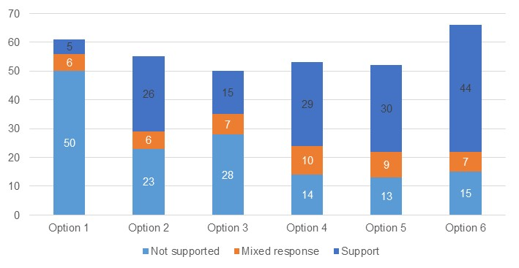 Source: Written responses to the CRIS consultation.

### What is the recommended option(s) and how will it be implemented?

Based on analysis included in this DRIS, the options with the highest net benefit to be provided to Education Ministers for consideration are Options 4, 5 and 6. These options introduce the highest standards of child protection knowledge and training and child safety training across the whole education and care sector.

While there is strong in-principle support for regulatory options, stakeholder feedback highlighted a range of considerations that would need to be taken into account in implementing these options. This includes feedback for greater clarification on:

* the proposed duration of child safety and protection training,
* whether training can be delivered in-person or online to address accessibility concerns for educators who work in regional, rural and remote locations,
* the suite of staff and volunteers that are required to undertake training (for example, if this includes those who directly or do not directly work with children),
* the frequency of refresher training,
* the approach to develop culturally appropriate child safety and child protection training materials which considers historical and cultural contexts and does not exacerbate the disproportionate removal of Aboriginal and Torres Strait Islander children from their families, and
* the cost of training and the extent to which these costs will be covered by Government.

The abovementioned implementation considerations would have material impacts on the total costs of the policy options. If these options are implemented, the governments will undertake additional work to provide greater clarity on the scope, scale and nature of child safety and child protection training, which require further engagement with the sector to address the considerations noted above.

# 7. Responding to educator and staff member conduct

There is only one child-related offence for which educators can be held liable under the National Law, which is the use of inappropriate discipline. Pursuant to section 166(3)(4) of the National Law, it is an offence for a staff member, volunteer or FDC educator[85] to use inappropriate discipline.

Other instances where a staff member, volunteer or FDC educator has interacted with children in a way that is serious, inappropriate and requires Regulatory Authority intervention however, do not constitute a breach of section 166.

Under section 182 of the National Law, the Regulatory Authority may intervene with administrative action against an educator, FDC educator, employee, contractor or volunteer[86] where that individual may pose an *unacceptable risk of harm* to a child or children. In those instances, the Regulatory Authority is able to prohibit a person without a contravention, or alleged contravention, of section 166 of the National Law. Prohibiting a person is a significant exercise of regulatory power because it prevents a person from working in the education and care sector, therefore affecting their livelihood and reputation. Whilst reserved for the most serious of circumstances, this mechanism is crucial to mitigating risk of harm to children in education and care services by the few individuals who may present such an unacceptable risk.

An individual may offer an enforceable undertaking[87] to the Regulatory Authority as an alternative to prohibition, after a show cause process, pursuant to section 184(3) of the National Law. An enforceable undertaking is an agreement between that individual and the Regulatory Authority, where the individual agrees to take certain actions, or refrain from certain actions, to comply with the National Law.

With specific regard to FDC educators, section 178 of the National Law enables the Regulatory Authority to issue a ‘notice to suspend education and care by a FDC educator’ after a show cause process. A notice to suspend education and care by a FDC educator is an instruction to an approved provider to cease engaging or allowing a FDC educator to be registered with their service.

Unlike a prohibition notice, a notice to suspend education and care by a FDC educator is issued to the approved provider, does not prevent the educator from any involvement with another service, and only applies to a specific education and care service.

Where the conduct does not meet the threshold for prohibition of the person, Regulatory Authorities have limited legislative mechanisms available to sufficiently address the risk of harm to children.

Additionally, early intervention and oversight of conduct that is not conducive to the safety, health, and wellbeing of children is imperative to mitigating that risk of harm. Currently, Regulatory Authorities may only disclose information about individuals who have been issued a prohibition notice, or who are suspended FDC educators, if requested by an approved provider.

There is also currently no legislative mechanism to enable the Regulatory Authority to disclose details of a person’s current enforceable undertaking with that person’s current approved provider, without the express consent of that person or it being a condition of that person’s enforceable undertaking. An approved provider would typically be unaware of such conduct where it has occurred in a previous service. This is not conducive to approved providers being able to support that employee to fulfil their enforceable undertaking if needed or identify non-compliant conduct as a pattern of behaviour rather than a standalone incident.

Given the close correlation and intersections of these reform areas, policy options in this chapter are recommended to be considered jointly. Together, these reform areas consider:

* creation of an offence provision to capture inappropriate conduct (see Chapter 7.1)
* enhancing the ability of Regulatory Authorities to share information with approved providers (see Chapter 7.2)
* expansion of regulatory responses to educator and staff member conduct (see Chapter 7.3).

## 7.1 Making inappropriate conduct an offence

|  |
| --- |
| **Key Insights**  *Problem*   * There are instances where a staff member, volunteer or FDC educator has behaved in a way that is serious, inappropriate and requires Regulatory Authority intervention, is not captured under the National Law offence of inappropriate discipline. * When inappropriate conduct occurs, there are limited legislative provisions to empower the Regulatory Authority to take action. * Evidence from Regulatory Authorities indicates there has been an increase in the number of inappropriate conduct incidents that do not constitute an offence in the National Law.   *Impacts of each option*   * The MCA analysis shows that both options 2 (non-regulatory guidance) and 3 (making inappropriate conduct an offence) represent an improvement on the status quo (option 1), due to the improvement in child safety outcomes offsetting potential costs of the proposed options. Option 3 resulted in the highest weighted MCA score, indicating this option results in the greatest improvement in child safety outcomes, relative to the costs and other potential negative impacts. * Option 3 was the preferred option among most stakeholder groups, including centre-based approved providers, the education and care workforce and families. * Option 2 received a lower weighted score than option 3, reflecting the costs incurred by governments in developing communication materials and resources, and the costs incurred by providers in additional administrative responsibilities.   *Recommended option*   * Based on analysis included in this DRIS, the options with the highest net benefit to be provided to Education Ministers for consideration are options 2 and 3. This is on the basis that these options would most improve child safety by strengthening the responses available for inappropriate conduct. * Governments will seek to engage in further policy work to determine the specific definition and design of the legislative amendment to prescribe inappropriate conduct as an offence. |

There are instances where a staff member, volunteer or FDC educator has behaved in a way that is serious, inappropriate and requires Regulatory Authority intervention, is not captured under the National Law offence of inappropriate discipline*.*A draft definition of inappropriate conduct was set out in the CRIS and consulted on. Feedback was received that a legislated definition should include a refined list of proposed offences, which will be determined following further policy work.This list should reduce potential overlap between existing offences in other jurisdictions and the definition of inappropriate conduct that would be in the National Law (with the intent that no act already prescribed as an offence in other legislation would also be prescribed as an offence under a definition of inappropriate conduct).

This draft definition of inappropriate conduct shared through CRIS consultation included, but was not limited to one or more:

* A child sexual offence.
* Sexual misconduct committed in relation to, or in the presence of a child, including verbal discussions, flirtatious gestures and comments.
* Inappropriate verbal interactions, that is, conversations with, or comments to children or conversations in the presence of children in relation to sexuality or sexual contact, including excessive flattering, conversations of a sexual nature, making sexual jokes or evoking children’s curiosity about sexuality.
* Ill-treatment of a child.
* Neglect of a child.
* Physical or verbal violence (including threats) committed in relation to, or in the presence of a child.
* Behaviour that is likely to cause emotional or psychological harm to a child.
* Any form of inappropriate physical contact. For example, unwarranted, invasive, or unnecessary for the child’s age and developmental stage, such as kissing, massage, ‘tickling games’, inappropriate touching).
* Any form of inappropriate online contact or online harm. For example, exposing children to sexual or violent content inappropriate for their age and stage of development, and technology-facilitated abuse.
* Correspondence, communication of a personal nature or capturing of images of children via any medium (phone, text message, social media, within apps, internet postings) unrelated to the staff members role or endorsed communication channels.
* Manipulating or coercing a child emotionally to meet the educator’s personal needs or to create inappropriate dependencies.
* Grooming, being any form of conduct, online or offline, that facilitates child sexual abuse. For example, making a child feel special through favouritism or special privileges and rewards or receiving / giving gifts of an inappropriate nature.

The list of abovementioned behaviours was informed by key academics in the child safety and harm prevention field; as well as the Regulatory Authority from each jurisdiction, who keep records of contraventions and alleged contraventions of the National Law and reports of conduct that may not meet the threshold for prohibition.

Persons displaying some of the behaviours listed above, such as conduct amounting to child sexual offences, would meet the threshold for prohibition, namely that the person poses an unacceptable risk of harm to a child or children[88]. In those instances, the Regulatory Authority is able to prohibit a person even when they have not contravened the National Law (although they are likely to be offences in criminal law). However, a person displaying some of the behaviours listed above may not necessarily meet the threshold for prohibition but could still pose a risk to children and require further investigation if observed and/or reported.

### What is the problem?

#### Existence of inappropriate conduct

The survey indicates that respondents had heard about inappropriate conduct (as defined above) in the sector. The survey showed that 68%[89] of approved providers reported hearing about inappropriate conduct at least once a year (refer to Chart 7.1). In comparison, the education and care workforce survey found that 30% of respondents heard about reports of inappropriate conduct at least once a year (see Appendix Chart 12.3.3.17).

It should be emphasised that while many approved providers and members of the workforce indicated they hear about inappropriate conduct, this does not always necessarily mean that the inappropriate conduct is occurring in survey’s respondents’ services. Many survey respondents indicated they heard about inappropriate conduct through the media.

“I haven't observed inappropriate conduct, I've heard about it occurring in the media” – Approved provider survey response

“We regularly hear reports from industry engagement, news reports etc. We have no formal contact with staff who report these issues.” – Approved provider survey response

Chart 7.1: Approved provider responses to “How often do you hear about reports of inappropriate conduct?”

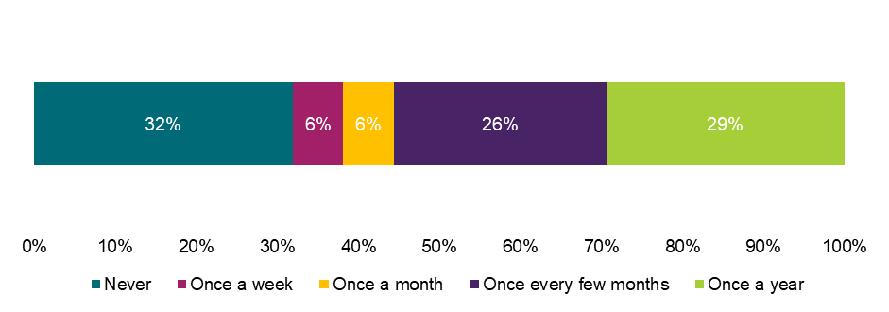

Source: Approved provider survey, as of 11 June 2025, Q145, n=160.

Note: Figures may not sum due to rounding.

Respondents also reported having heard about inappropriate conduct that did not result in a prohibition. As shown in Chart 7.2, 39% of approved providers reported hearing about inappropriate conduct that did not result in a prohibition (i.e., it fell below the threshold where an individual poses an unacceptable risk of harm to a child or children) at least once a year. Approved providers indicated that the most common type of inappropriate conduct where the person did not meet the threshold for prohibition that approved providers had heard about, was behaviour that is likely to cause emotional or psychological harm to a child (21%), ill-treatment of a child (18%), neglect of a child (11%), or physical or verbal violence (including threats) (11%).

“With the current qualifications being offered by some RTOs and the lack of prescriptive conduct expectations in the law, there is room for educators to conduct themselves in ways that are not in line with professional conduct expectations, more aligned with ‘old school parenting’ methods.” – Free text submission response

In comparison, 17% of the education and care workforce reported hearing about reports of inappropriate conduct that did not result in a prohibition at least once a year (refer to Appendix Chart 12.3.3.18).

Chart 7.2: Approved provider responses to “How often do you hear about reports of inappropriate conduct that haven't resulted in a prohibition?”

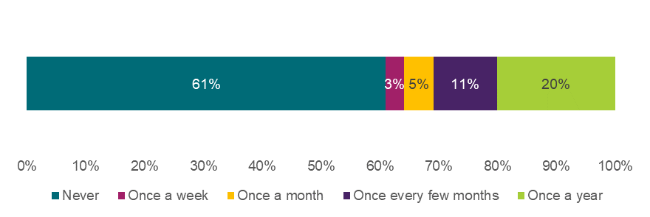

Source: Approved provider survey, as of 11 June 2025, Q145, n=159.

Note: Figures may not sum due to rounding.

Limited provisions to address conduct

When inappropriate conduct occurs, there are limited legislative provisions to empower the Regulatory Authority to take action. As noted above, some inappropriate conduct may not meet the threshold for prohibition. This enables an environment where:

* persons who have displayed or allegedly displayed inappropriate conduct can continue operating within the education and care sector without proportionate legal responses or consequences by the Regulatory Authority
* the Regulatory Authority is unable to intervene, and approved providers are responsible for addressing serious behaviour of their employees under the employment contract and Code of Conduct
* if the approved provider terminates the person’s employment, that person may move on to the next approved provider without safeguards in place and no formal record.

Evidence from Regulatory Authorities indicates there has been an increase in the number of inappropriate conduct incidents that do not constitute an offence in the National Law. This evidence indicates that the current provisions under the National Law are insufficient for protecting children from harm and do not allow appropriate intervention and oversight by the Regulatory Authority when a threshold for prohibition has not been met.

Despite sector reports on the prevalence of observations of inappropriate conduct, stakeholders noted that there is a general lack of clarity around what constitutes inappropriate conduct in education and care settings, in the absence of a National Law definition.

### What were the policy options consulted on?

Three options, including the status quo, a non-regulatory option, and a regulatory option are under consideration. Options 2 and 3 are not mutually exclusive, and the recommended option for these recommendations can be a combination of the proposed regulatory and non-regulatory approaches.

Options to address reform areas covered in Chapter 7.1 should be considered alongside reform areas covered in Chapter 7.2 (enhancing the ability of Regulatory Authorities to share information with approved providers) and reform areas covered in Chapter 7.3 (expansion of regulatory responses to educator and staff member conduct).

Regarding option 3, a draft definition of inappropriate conduct was set out in the CRIS and consulted on, noting feedback received will result in amendments.

Table 7.1: Policy options under consideration – Making inappropriate conduct an offence

| **Option** | **Description** |
| --- | --- |
| 1 | Status quo (no change). |
| 2 | **Non-regulatory**  Develop more communications and resources on encouraging approved providers to address appropriate and inappropriate conduct within their contracts of employment, Code of Conduct and policies and procedures required under regulation 168(2) of the National Regulations. |
| 3 | **Regulatory**  Amend the National Law to introduce ‘inappropriate conduct’ as an offence applicable to approved providers, nominated supervisors, educators, other staff members, volunteers and FDC educators as follows:  *The approved provider and a nominated supervisor must ensure that no child being educated and cared for by the service is subjected to any form of inappropriate conduct:*  and  *A staff member of, or volunteer at an education and care service, or FDC educator must not subject any child being educated and cared for by the service to any form of inappropriate conduct.*  The CRIS set out the following as potential examples of inappropriate conduct:   * a child sexual offence * sexual misconduct committed in relation to, or in the presence of a child, including verbal discussions, flirtatious gestures and comments * inappropriate verbal interactions, that is, conversations with, or comments to children or conversations in the presence of children in relation to sexuality or sexual contact, including excessive flattering, conversations of a sexual nature, making sexual jokes or evoking children’s curiosity about sexuality * ill-treatment of a child * neglect of a child * physical or verbal violence (including threats) committed in relation to, or in the presence of a child * behaviour that is likely to cause emotional or psychological harm to a child * any form of inappropriate physical contact. This may include physical contact that is unwarranted, invasive or unnecessary for the child’s age and developmental stage, such as kissing, massage, ‘tickling games’, inappropriate touching * any form of inappropriate online contact. This also may include online harm such as exposing children to sexual or violent content inappropriate for their age and stage of development, and technology facilitated abuse * correspondence, communication of a personal nature or capturing of images of children via any medium (phone, text message, social media, within apps, internet postings) unrelated to the staff members role or endorsed communication channels * manipulating or coercing a child emotionally to meet the educator’s personal needs or to create inappropriate dependencies * grooming, being any form of conduct, online or offline, that facilitates child sexual abuse, for example, making a child feel special through favouritism or special privileges and rewards or receiving/giving gifts of an inappropriate nature. |

### What are the impacts of each option?

The sections below provide an MCA assessing the potential impacts of the proposed options on child safety outcomes, costs to stakeholders, implementation considerations, and distributional impacts, in line with the approach outlined in Chapter 4.

#### Multi-criteria analysis

In assigning MCA scores to reflect the relative benefits and costs of each option, the score for improvement in child safety has been scaled with a zero for option 1 representing no change, and score of seven for option 3 representing the biggest impact on child safety. Other options have been scored between these values based on the assessment of qualitative input from stakeholders. Scores for other categories relating to costs, risks, and distributional considerations have been scaled in relation to these benefits.

Table 7.2: MCA outcomes – Making inappropriate conduct an offence

| **Criteria** | **Weight** | **Option 1** | **Option 2** | **Option 3** |
| --- | --- | --- | --- | --- |
| Improvement in child safety | 50% | 0 | 2 | 7 |
| Net cost of policy option | 30% | 0 | -2 | -4 |
| Implementation considerations | 10% | 0 | -2 | -6 |
| Distributional impact | 10% | 0 | -1 | -4 |
| **Weighted score** |  | **0** | **0.1** | **1.3** |

The MCA scores suggest that both options 2 and 3 represent an improvement on the status quo (option 1), due to the improvement in child safety outcomes offsetting potential costs of the proposed options. Option 3 resulted in the highest weighted MCA score, indicating this option results in the greatest improvement in child safety outcomes, relative to the costs and other potential negative impacts. The rationale for each MCA score is outlined in the sections below.

#### Impact on child safety

Communication materials and resources under option 2 could help approved providers clarify what constitutes inappropriate behaviour in their Code of Conduct. This would also create a more nationally consistent understanding of what constitutes inappropriate conduct across education and care services and may facilitate more consistent treatment of such conduct among approved providers. As a result, there is the potential that greater awareness and understanding of how to identify, prevent, and manage inappropriate conduct may reduce risks to child safety. However, option 2 is opt-in, so only those services who choose to implement recommended guidance included in the communication materials and resources may observe improvements in child safety. Similarly, the extent to which child safety is improved may rely on cultural changes in services to set precedence on expected behaviours, in addition to adoption of a more robust Code of Conduct.

Through the survey, 97% of approved providers indicated that they have robust Codes of Conduct and employment contracts which adequately address inappropriate conduct in the status quo.[90] As a result, the impact of option 2 on harm reduction is anticipated to be less than that of option 3. Across all surveys, ‘somewhat reduce’ was the most common response to the question about how much option 2 would reduce the risk of harm to children (refer to Chart 7.3 and Appendix 12.3.3).

Chart 7.3: Approved provider responses to “How much do you think each option will reduce the risk of harm to children?”

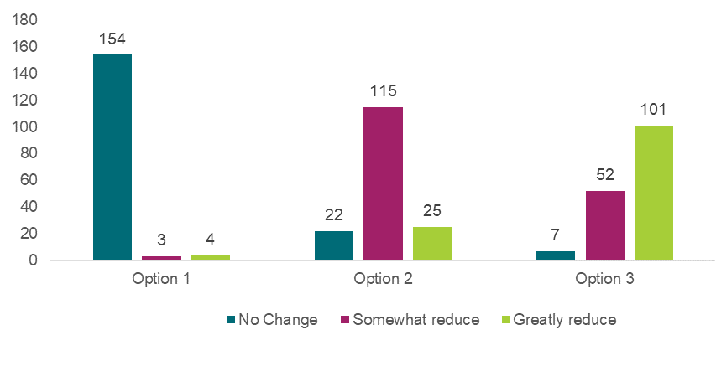

Source: Approved provider survey, as of 11 June 2025, Q36, option 1 n=161, option 2 n=162, option 3 n=160.

Option 3 may improve child safety outcomes through several mechanisms. First, it may enable Regulatory Authorities to address a greater range of inappropriate behaviours which have the potential to cause physical, emotional and/or psychological harm to a child. Secondly, placing the onus of compliance on individuals as well as approved providers and nominated supervisors may encourage approved providers to uphold a higher standard of conduct among the education and care workforce. The regulatory nature of this option (and the potential risk of compliance actions or incurring financial penalties if successfully prosecuted) may reduce the risk that some staff engage in inappropriate conduct, leading to improved child safety outcomes. The legislative mechanisms discussed in Chapter 7.3 would also apply to this offence if endorsed to allow a greater range of regulatory responses commensurate to the seriousness of the inappropriate conduct.

Option 3 would also provide the sector with greater clarity and consistent expectations of what constitutes inappropriate conduct. This would reduce the reliance on individual approved providers’ Codes of Conduct and ensure a similar standard of conduct is maintained across the sector.

Option 3 gives Regulatory Authorities the ability to intervene where conduct is inappropriate but does not currently meet the threshold of prohibition. This closes loopholes where a behaviour may not be (able to be) sufficiently addressed by either approved providers or Regulatory Authorities, especially if there is insufficient coverage of inappropriate behaviours in approved providers’ Codes of Conduct.

In jurisdictional forums, stakeholders strongly agreed that option 3 would be the most effective in improving child safety. This was consistent with survey responses, where “greatly reduce” was the most common response to the question about the extent to which option 3 would reduce the risk of harm to children (refer to Chart 7.3).

“This option [option 3] will:

* Close the current gap where serious but non-criminal conduct cannot be acted upon by Regulatory Authorities Support services and FDC coordination units by providing a clear legal backing to respond to conduct that poses risk to child safety
* Create national consistency in defining and responding to inappropriate conduct, helping to uphold a shared child protection standard across all jurisdictions and service types
* Send a strong message that emotional, psychological, and verbal harm is not tolerated in education and care” – Approved provider survey response

As participation in option 2 is voluntary, some approved providers may not implement the guidance, based on the perception that their existing Codes of Conduct and employee contracts already meet best practice standards. As such, option 2 has been assigned an MCA score of two for this criterion, as this option is expected to have a smaller impact on child safety, relative to option 3.

Option 3 has been assigned a score of seven for this criterion, due to the seriousness of the risks posed to child safety and the potential for enhanced regulatory powers to deter inappropriate conduct and address a wider range of behaviours.

#### Cost of each option

Under option 2, the government would incur costs to develop communication materials and resources. Incremental costs will be more significant if relevant materials cannot be developed with the support of existing government resources and as part of business-as-usual activities.

In the approved provider survey, 46% of respondents noted that option 2 would generate additional administrative costs. This could reflect the number of approved providers that would review and consider updating their own Codes of Conduct to be more effective in addressing inappropriate conduct.[91] If Codes of Conduct are updated, they may reflect a larger number of behaviours that are considered inappropriate, which could then result in an increased number of cases where the approved providers need to address such conduct (noting that this cost would be offset by an improvement in child safety). Based on these potential administrative costs, option 2 has been assigned an MCA score of negative two for this criterion.

Approved providers would incur compliance costs associated with relevant monitoring and enforcement activities associated with the implementation of option 3. The exact cost of compliance would depend on the extent to which approved providers already monitor and manage inappropriate conduct through Codes of Conduct and employee contracts – to which stakeholder feedback suggests that most approved providers advised that they already sufficiently monitor and address inappropriate conduct.

Further, Regulatory Authorities would expect to incur costs associated with monitoring compliance and ensuring that instances of inappropriate conduct are sufficiently dealt with under the National Law. The extent of this cost would depend on the prevalence of inappropriate conduct in education and care settings, the extent to which such conduct would be dealt with under changes to the National Law, and the number of investigations that would be reviewable (internal and external).

Over half (53%) of approved providers who responded to the survey note that option 3 would create additional administrative costs.[92] This cost could result from a range of factors, such as:

* a definition of inappropriate conduct that is more extensive than the behaviours included in an approved providers’ Code of Conduct, requiring an overall increase in disciplinary action
* the involvement of Regulatory Authorities, alongside the approved provider, for any disciplinary measures or investigations
* needing to upskill staff on new expectations regarding conduct that is considered inappropriate.

Despite these costs, stakeholders generally agreed that the potential benefits to child safety would likely outweigh costs.

While only a small increase in the number of approved providers thought that option 3 would impose incremental administrative costs to the status quo, relative to option 2, option 3 is also likely to impose a higher cost for Regulatory Authorities. Further the costs associated with option 3 are largely ongoing in nature. As such option 3 has been assigned an MCA score of negative four for this criterion, while option 2 was assigned an MCA score of negative two.

#### Implementation considerations

During the consultation process, stakeholders noted concerns and risks regarding the implementation of the proposed options. While many of the key risks raised by stakeholders are noted below, some of these concerns could be alleviated through considered implementation and some may arise from stakeholders misinterpreting the intent or impacts of the options. Some of the implementation risks raised for option 3 include:

* The specificity and appropriateness of the current draft definition of ‘inappropriate conduct’ (see Table 7.2). Stakeholders noted that the sector should be consulted about the definition to ensure it is appropriate, sufficiently specific, clear, and well informed (including clear examples, where possible). This definition should also consider cultural differences in what may be considered inappropriate across demographics and service types.
* Liability implications for approved providers and nominated supervisors. Some stakeholders noted it may not be appropriate or fair for approved providers and nominated supervisors to be held liable for the inappropriate conduct of educators or staff, particularly in circumstances where appropriate processes to prevent, identify, and manage inappropriate conduct have been implemented within the service and appropriate training has been provided. If approved providers and nominated supervisors are concerned they will be held liable for conduct outside their control, there is a risk that some inappropriate conduct could go unreported. Despite this concern, it should be noted that this liability provision already applies to the offence for inappropriate discipline.
* Concerns that this legislative change may prohibit nurturing behaviours and interactions which educators and other staff have with children. For example, stakeholders noted that interactions such as cuddling and hand holding are important for relationship building and overall child development, particularly for babies and infants. Stakeholders noted that cultural implications of nurturing behaviour and interactions of option 3 would need to be considered further.
* Perceived overregulation or increased regulatory burden which may discourage individuals from seeking employment in the sector. This is a significant concern given current workforce shortages.

“I think serious offences with factual evidence, absolutely people should be held accountable. I have concerns for leading staff in these areas; do we therefore get charged as we are the Responsible Person in Charge? (RPIC). Will this mean staff back out of this RPIC role” – Written submission response

Given the extensive list of implementation risks identified, option 3 has been assigned a score of negative six for this criterion.

There are also implementation risks associated with option 2, however they are less substantial given the non-regulatory nature of the option. One risk is that many approved providers believe they already have robust Codes of Conduct and employment contracts which adequately address inappropriate conduct in the status quo. As a result, there is a risk that approved providers would not be responsive to option 2 in isolation and hence the effectiveness of this option in reducing the risk of harm to children would be lower than under the regulatory option.

In addition, option 2 may be subject to similar limitations to option 3 in terms of drafting an appropriate definition of inappropriate conduct to include in guidance materials. Sector stakeholders should be consulted to ensure the guidance materials include a definition that is appropriate, sufficiently specific, clear, and well informed (including clear examples, where possible). This will enable approved providers to have the greatest clarity and adopt consistent practices in addressing inappropriate conduct.

Based on these implementation risks, option 2 has been assigned an MCA of negative two for this criterion, as the implementation risks are material but not as substantial as those identified for option 3.

It should be noted that while the MCA scores currently consider the implementation considerations based on the options that were consulted on from the CRIS, the recommended implementation of these options will alleviate some of these risks, particularly regarding the definition of inappropriate conduct. These implementation considerations are outlined in *What is the recommended option(s) and how will it be implemented?*

#### Distributional impacts

The policy options may have a greater impact on services who recruit predominantly culturally diverse educators and/or service culturally diverse families. A small number of forum participants raised that culturally diverse educators or staff members may have different cultural beliefs about what constitutes inappropriate behaviour in the context of caring for children.

“We have definitely seen experiences of educators from different CALD backgrounds and different cultures who have different ways of interacting or different understandings of what's appropriate to the mainstream Western culture. Or from families from different backgrounds who have a different understanding of what's expected with their children.” Forum participant

Examples given through consultation included around approach to disciplining children, behaviour management and language used around or with children.

The policy options may also have a greater impact on services that operate with a single educator model, such as FDCs. The adoption of single-educator models with limited on-site oversight has raised concerns that accusations and reports of inappropriate conduct could have severe reputational and professional consequences. These concerns were reflected in survey findings and through consultations.

Option 3 may also result in disproportionate impacts for Aboriginal and Torres Strait Islander Peoples and ACCO education and care services, which are outlined below.

|  |
| --- |
| **Box 7.1: Aboriginal and Torres Strait Islander People Stakeholder Views**  Aboriginal and Torres Strait Islander stakeholders highlighted that any definition of an offence or conduct needs to be clear and consider the provision of culturally appropriate education and care for Aboriginal and Torres Strait Islander children. Stakeholders did not provide specific examples here of phrases or elements that should be removed or what a better definition might be, but identified how the current definition could be misinterpreted or misapplied in certain cultural contexts. This includes if certain language or behaviours are taken out of context or observed by someone without understanding of the educator/child relationship or culture, this may be misconstrued as an offence. This is similar to concerns raised by non-Aboriginal and Torres Strait Islander stakeholders, however it is amplified due to low understanding by the general public and western settings of Aboriginal and Torres Strait Islander cultures. A definition that comes directly from Aboriginal and Torres Strait Islander peoples, instead of responding to an existing list of behaviours, may support greater clarification on the types of behaviours that should be considered under the definition.  Aboriginal and Torres Strait Islander stakeholders also raised that ACCO education and care services, particularly in many remote services, can look different to the ‘mainstream’ education and care services as educators can be family members, Elders and community leaders. Their roles go beyond that of an education and care service employee and this situation requires additional consideration when developing offence definitions to mitigate any unintended consequences on the community and their ways of working. |

In response to this feedback, the definition of what would constitute inappropriate conduct under the National Law, for option 3 will be determined through legislative drafting. This will reduce overlap with criminal law and serious offences and introduce a more limited scope for inappropriate conduct. It is intended that the definition will minimise unintended consequences to sector stakeholders while still seeking to obtain a higher child safety standard.

Option 2 is less likely to result in negative distributional impacts, as any changes to Codes of Conduct will be at the discretion of approved providers. Some approved providers may impose a Code of Conduct that is not sufficiently tailored to the cultural contexts of staff members and the children in their care. However, this is less likely to be an issue than the widespread adoption of a single legislated definition of inappropriate conduct.

Based on the identified impacts, option 2 has been assigned an MCA score of negative one for this criterion, and option 3 has been assigned an MCA score of negative four for this criterion.

#### Stakeholders’ preferred option

Across survey respondents, option 3 was the preferred option for this recommendation. Approximately 72% of approved providers identified option 3 as their preferred option – some of these preferences being in conjunction with option 2, as shown in Chart 7.4 below. In consultation, some approved providers indicated that they supported option 3 in principle but did not agree with the draft definition of inappropriate conduct (which is subject to be determined). Similarly, 48% of the education and care workforce identified option 3 as their preferred option – an additional 22% preferred option 3 in conjunction with option 2 (Appendix Chart 12.3.3.5). Finally, 76% of surveyed parents, families and carers identified option 3 as their preferred option – an additional 18% preferred option 3 in conjunction with option 2 (Appendix Chart 12.3.3.6).

Among long form written submissions there was also majority support for option 3. Most large provider long form written submissions expressed support for option 2. Around half of the large provider long form written submissions expressed support for option 3, reflecting concerns regarding the definition of inappropriate conduct and potential scope for ‘disproportionate’ responses to educator behaviours.

*Chart 7.4 Approved provider responses to “What is your preferred option or combination of options?”*

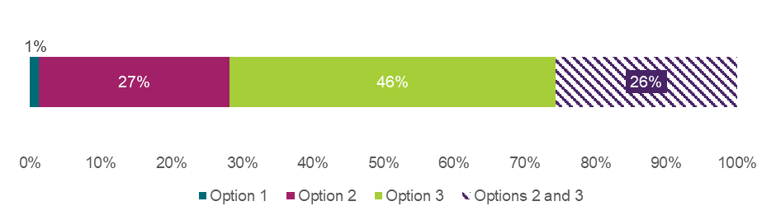 Source: Approved provider survey, as of 11 June 2025, Q34, n=156 unique respondents. Note that if a respondent selected a combination of options, that selection is treated as a unique preference and not double-counted in the singular options.

### What is the recommended option(s) and how will it be implemented?

Based on analysis included in this DRIS, the options with the highest net benefit to be provided to Education Ministers for consideration are options 2 (non-regulatory guidance) and 3 (making inappropriate conduct an offence). This is on the basis that these options will most improve child safety by strengthening the responses to inappropriate conduct.

Stakeholder feedback reinforced a range of considerations that would need to be considered in implementing these options. This included, for example, feedback that:

* The preferred definition of inappropriate conduct will need to be clarified.
* The legislative approach should align with current legislation and processes related to inappropriate conduct, including the alignment with the Fair Work Act and jurisdictional reportable conduct schemes.
* The requirement for confirmed definitions of inappropriate conduct to be communicated in and integrated within mandatory child safety training (Chapter 6.1), such that stakeholders are well informed about what constitutes inappropriate conduct, and how to prevent and manage it appropriately.

In proceeding to implement option 3, the governments will ensure that the provisions prescribing inappropriate conduct as an offence are consistent with fundamental legislative principles. For example, taking into consideration potential overlap between existing offences in other legislation and the definition of inappropriate conduct (with the intent that no act already prescribed as an offence in other legislation would also be prescribed as an offence under a definition of inappropriate conduct).

In response to this feedback, further policy work will be undertaken to determine the specific definition and design of any legislative instrument to prescribe inappropriate conduct as an offence, to alleviate potential risks and concerns of stakeholders noted above.

## 7.2 Enhancing Regulatory Authorities’ ability to share information with approved providers

|  |
| --- |
| **Key Insights**  *Problem*   * Currently, there is no legislative power to enable Regulatory Authorities (or ACECQA) to disclose information regarding a prohibition status or suspension in the case of an FDC educator to a person’s current approved provider, without that approved provider’s request. * Where Regulatory Authorities (or ACECQA) are made aware of a prohibited person operating in an education and care service or suspended FDC educator, Regulatory Authorities are restricted in its powers and is unable to disclose this crucial information to support early intervention and mitigation of harm to children.   *Impacts of each option*   * Both options 3 and 4 were viewed as important measures for improving child safety to ensure approved providers are always aware of prohibitions, suspensions (for FDC educators), or enforceable undertakings that apply to an individual. * Option 4 was the recommended option among most stakeholder groups, usually in combination with option 3 or options 2 and 3.   *Recommended option*   * Based on analysis included in this DRIS, the options with the highest net benefit to be provided to Education Ministers for consideration are the regulatory options 3 and 4. This combination of options is on the basis they would improve providers’ awareness of prohibitions, suspensions or enforceable undertakings which are important to preserve child safety. * Governments will consider mechanisms to account for procedural fairness and any additional guidance to support consistent sector understanding of the scope of regulatory changes. |

***Prohibition notices and notice to suspend FDC educators***

The NQF is structured to ensure approved providers are accountable and responsible for ensuring consistent and effective prioritising of children’s safety, health, and wellbeing. Obligations include:

* An approved provider must not engage a person as an educator, FDC educator, employee, contractor or staff member of, or allow a person to perform volunteer services for, an education and care service if the provider knows, or ought reasonably to know, a prohibition notice is in force under the National Law in any jurisdiction (section 188(1) of the National Law).
* Complying with a notice to suspend education and care by a FDC educator (section 178 of the National Law).

Approved providers are responsible for undertaking appropriate steps to comply with these obligations and may request the Regulatory Authority (or National Authority – ACECQA) to disclose whether a person named in the request is the subject of a prohibition notice or has been suspended in the case of FDC educators.

The most efficient way for approved providers to access this information is by accessing the register located within the National Quality Agenda Information Technology System (NQA ITS) and verifying with the relevant Regulatory Authority whether a person is a prohibited person or suspended FDC educator.

ACECQA and Regulatory Authorities cannot disclose this information without a request from an approved provider. This protocol is to ensure approved providers remain responsible for implementing and maintaining appropriate and rigorous recruitment processes and screening criteria.

Despite approved providers undertaking the necessary steps to avoid employing prohibited persons or suspended FDC educators in a particular service, there is a small possibility in the current legislative environment that may inadvertently enable these persons to operate in a service. This is more likely to occur where a person has been issued a prohibition notice, or where an FDC educator has been suspended due to conduct that occurred at a different service. In these instances, the approved provider would not be aware of the prohibition or suspension status of that individual, despite undertaking the initial appropriate checks and fulfilling their obligations under the National Law. The risk would only be apparent for a brief period of time, until one of the below instances takes place:

* the approved provider undertakes a subsequent request to ACECQA, the Regulatory Authority; or
* in some jurisdictions, an approved provider may be notified by the relevant WWCC agency if an educator has had a change in their WWCC status as a result of prohibition action.[93]

Whilst the instance of this occurring is low and the period in which it presents is limited, there is a significant risk of harm present to children should a prohibited individual or suspended FDC educator be found operating in a service.

***Enforceable undertakings***

An enforceable undertaking is an agreement between the Regulatory Authority and the person who is engaged with the enforceable undertaking. Given the nature of this agreement, approved providers are not made aware of the existence of an enforceable undertaking other than:

* at the express consent of the person who is engaged with the enforceable undertaking, or
* it is a condition of the enforceable undertaking.

In most cases, a person engages with an enforceable undertaking due to conduct reported to the Regulatory Authority by the approved provider. In these instances, the approved provider is aware of non-compliant conduct or risk posed by the person and can subsequently monitor that person’s ongoing behaviour (even if they aren’t aware of the existence of the enforceable undertaking). In other cases, the person subject to a current enforceable undertaking will move between services and even jurisdictions with a different approved provider. In this scenario, the new approved provider would not be aware of that person’s current enforceable undertaking or the conduct which resulted in the enforceable undertaking unless disclosed by one of the aforementioned means.

This limits the ability for approved providers to:

* support persons engaged in their service to successfully fulfil the requirements of their enforceable undertaking (noting this is not a requirement of the approved provider)
* maintain oversight of persons who have engaged in non-compliant conduct
* identify and assess any future non-compliant conduct as a potential pattern of behaviour, rather than a standalone incident.

### What is the problem?

Currently, there is no legislative power to enable Regulatory Authorities (or ACECQA) to disclose information regarding a prohibition status or suspension in the case of an FDC educator to a person’s current approved provider, without that approved provider’s request. Additionally, there are no legislative provisions that enable Regulatory Authorities to share information regarding a person’s current enforceable undertaking with that person’s current approved provider, unless it is a condition of the enforceable undertaking or with the express consent of that person.

There are instances where an approved provider has undertaken all the appropriate recruitment checks and screening processes, however due to conduct at a previous service, a person has been prohibited, after commencing employment with a different service. Where Regulatory Authorities (or ACECQA) are made aware of a prohibited person operating in an education and care service or suspended FDC educator, Regulatory Authorities are restricted in its powers and is unable to disclose this crucial information to support early intervention and mitigation of harm to children.

There is at least one known incident where a person was working while prohibited at a service, having commenced work at the new service before being prohibited for conduct at their previous employer. In this specific incident, the individual was later prosecuted for working in an education and care service while prohibited.

The current parameters which restrict disclosure by the Regulatory Authority regarding a current enforceable undertaking are not conducive to supporting and retaining staff who may require further assistance or maintaining clear oversight of persons’ who have recently displayed non-compliant conduct.

There are opportunities to support the early intervention and oversight of non-compliant conduct by educators whilst also supporting educators to fulfil the requirements of their enforceable undertaking, and ultimately minimise the risk of harm to children attending education and care services.

### What were the policy options consulted on?

Four options, including the status quo, a non-regulatory option, and two regulatory options are under consideration.

Options to address this Chapter 7.2 should be considered alongside Chapter 7.1 (making inappropriate conduct an offence) and Chapter 7.3 (expansion of regulatory responses to educator and staff member conduct).

Table 7.3: Policy options under consideration – Enhancing Regulatory Authorities’ ability to share information with approved providers

| **Option** | **Description** |
| --- | --- |
| 1 | Status quo (no change). |
| 2 | **Non-regulatory**  Develop more communications on the current process for accessing the NQA ITS solution that provides an approved provider with the ability to perform an initial check and subsequent prohibition checks. |
| 3 | **Regulatory**  Amend section 272 of the National Law to allow the Regulatory Authority to share information about a prohibited person or suspended FDC educator with that person’s current approved provider, without a request from the approved provider. |
| 4 | **Regulatory**  Amend the National Law to allow a Regulatory Authority to share information about a person’s current enforceable undertaking with that person’s current approved provider, without a request. |

### What are the impacts of each option?

The sections below provide a qualitative discussion on the potential impacts of the proposed options on child safety outcomes, costs to stakeholders, implementation considerations, and distributional impacts, in line with the approach outlined in Chapter 4.

#### Impact on child safety

Option 2 can improve use of the NQA ITS to undertake initial and subsequent prohibition and suspension of FDC educator checks. Where current practices are lacking, this could reduce the risk that unsuitable individuals are present in education and care settings. Through consultation, stakeholders consistently reported that option 2 would be somewhat effective in improving child safety. This includes survey results where approved providers, members of the education and care workforce, families, parents, and caregivers most frequently indicated that option 2 would somewhat reduce the risk of harm to children (refer to Chart 7.4).

Chart 7.4: Approved provider responses to “How much do you think each option will reduce the risk of harm to children?”

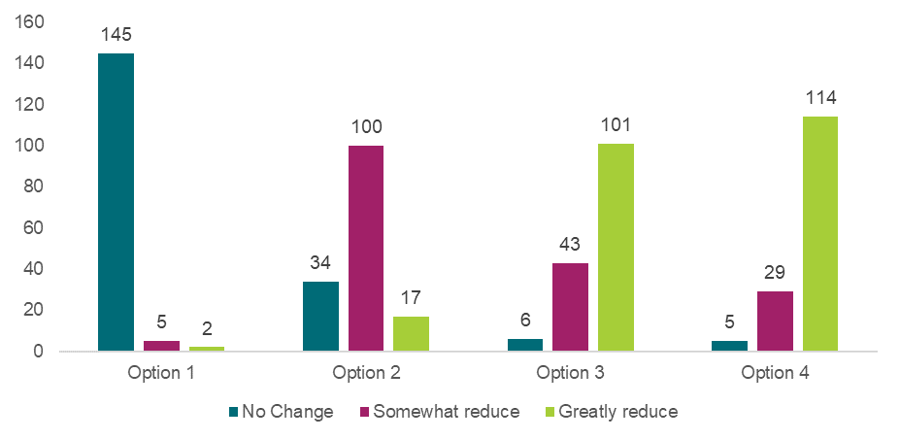

Source: Approved provider survey, as of 11 June 2025, Q54, option 1 n=152, option 2 n=151, option 3 n=150, option 4 n=148.

Both options 3 and 4 were viewed as important measures for improving child safety to ensure approved providers are always aware of prohibitions, suspensions (for FDC educators), or enforceable undertakings that apply to an individual. Despite the importance of these regulatory changes for child safety outcomes, approved providers believed there were very limited circumstances that could lead to a prohibition of FDC educator suspension being unknown to them. It was considered more likely that an enforceable undertaking may be unknown to an approved provider given this information cannot be requested through NQA ITS. Across the surveys, most respondents indicated that option 3 and option 4 would greatly reduce the risk of harm to children (refer to Chart 7.4).

#### Cost of each option

Under option 2, there is potential that the guidance would prompt approved providers to undertake more regular checks of the NQA ITS. Stakeholders noted that option 2 may encourage more approved providers to undertake additional prohibition and suspension checks after the initial screening processes. While there are benefits associated with these checks, providers may incur additional administration costs. The survey indicates that approximately two-thirds of approved providers do not check the prohibition or suspension status of a staff member after the initial employment screening. Approved providers did not explicitly state why they do not check the prohibition or suspension status of a staff member. However, a small number of consulted stakeholders suggested operational issues such as the process of checking being complex, and involving multiple attempts to follow up, limited access to the NQA ITS among staff prohibited frequent checks, and the lack of real time notifications was a disincentive for regular checks. This suggests that this option may have a material incremental cost if more frequent NQA ITS checks are undertaken, particularly for larger providers who need to screen more individuals. The total cost for providers would depend on the number of additional checks made through the NQA ITS. Approved providers indicated through the survey that individual checks take approximately 2-10 minutes, which indicates that the cost of each check is minimal and may therefore not impose material cost pressures on approved providers.

Under options 3 and 4, Regulatory Authorities indicated that information sharing processes would likely be manual and would impose some time costs. However, Regulatory Authorities did not view this cost to be too substantial. The proposed regulatory reforms are addressing a regulatory gap for where current communicative practices are not sufficient (e.g., an individual is issued a prohibition notice subsequent to their employment with a new approved provider) and would therefore not require frequent additional communications. Regulatory Authorities were of the view that any additional costs involved in manually sharing this information would be outweighed by improvements in child safety.

Approved providers did not identify costs that they may bear as a result of options 3 and 4. However, there could be a small administrative cost associated with approved providers receiving additional information and responding to this information.

#### Implementation considerations

The implementation considerations associated with the proposed policy options are limited. Under option 2, the effectiveness of the guidance in improving child safety outcomes is entirely subject to voluntary uptake among approved providers. This results in risks to child safety outcomes, as outlined above.

Under options 3 and 4, there is a risk that approved providers will reduce their current practices of checking the NQA ITS and may instead increase their reliance on Regulatory Authorities to proactively share information. This is not the intent of the reform and could result in greater risks to child safety if approved providers perceive the reforms to reduce approved providers’ existing responsibilities under the National Law to not employ a prohibited person or suspended FDC educator. This risk may be greater under option 3 as it pertains directly to prohibitions and FDC suspensions which approved providers are currently required to know about, while enforceable undertakings could currently be unknown to current approved providers. However, approved providers may still perceive themselves to have less responsibility to undertake regular NQA ITS checks under option 4.

Some stakeholders raised concerns that option 4 may have implications for the privacy of educators, as enforceable undertakings are (1) not currently required to be known by current approved providers and (2) are between an individual and a Regulatory Authority and an individual may not desire this information to be shared. However, many other stakeholders did believe that these potential concerns would be outweighed by benefits to child safety, particularly as an approved provider may support an individual to uphold the conditions of their enforceable undertaking.

|  |
| --- |
| **Box 7.2: Aboriginal and Torres Strait Islander People Stakeholder Views**  Aboriginal and Torres Strait Islander stakeholders reported that while there was general support for options to enhance information sharing across the sector, they raised some concerns about the right to privacy for individuals and the need for procedural fairness where only necessary or relevant information was shared. Aboriginal and Torres Strait Islander stakeholders emphasised that limitations on the detail of information provided should be ensured in any implementation to balance protection and privacy considerations. |

#### Distributional impacts

Stakeholders who engaged in consultative activities did not note any material distributional impacts associated with the proposed options, aside from the potential for individuals who are subject to prohibition notices, FDC educator suspensions, and enforceable undertakings to experience a reduction in their privacy (discussed further under ‘Implementation considerations’).

#### Stakeholders’ preferences

Across survey respondents, option 4 was the preferred option for this recommendation. Approximately 32% of approved providers identified option 4 as their preferred option – with an additional 24% preferring option 3 in conjunction with option 4, and 21% preferring options 2, 3 and 4 in conjunction.

*Chart 7.5: Approved provider responses to “What is your preferred option or combination of options?” – Recommendation 3.2*

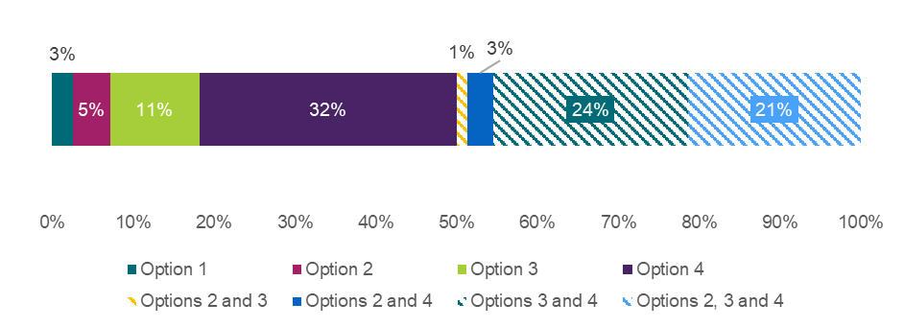

Source: Approved provider survey, as of 11 June 2025, Q44, n=121 unique respondents. Note that if a respondent selected a combination of options, that selection is treated as a unique preference and not double-counted in the singular options.

Similarly, 26% of the education and care workforce identified option 4 as their preferred option – an additional 21% preferred option 3 in conjunction with option 4, and 19% preferred options 2,3 and 4 in conjunction (Appendix Chart 12.3.3.11). Finally, 27% of surveyed parents, families and carers identified option 4 as their preferred option – an additional 38% preferred option 3 in conjunction with option 4, and 12% preferred options 2,3 and 4 in conjunction (Appendix Chart 12.3.3.12).

Long form written submissions also expressed support for options 3 and 4, with option 2 receiving some support when commented on. These includes all approved providers expressing support for options 3 and 4.

### What is the recommended option(s) and how will it be implemented?

Based on analysis included in this DRIS, the options with the highest net benefit to be provided to Education Ministers for consideration are the regulatory options (Options 3 and 4). This is on the basis they would improve providers’ awareness of prohibitions, suspensions or enforceable undertakings which are important to preserve child safety. These options were also frequently preferred in combination by stakeholders, due to their complementary nature. If recommended options are implemented, governments will consider embedding procedural fairness considerations to ensure information is only shared where it meets the intent of the legislation and is in the interests of child safety. Guidance will also be provided to clearly communicate that the responsibility for NQA ITS[94] checks on recruiting an individual still sits with an approved provider and that this reform does not replace any current checking processes.

## 7.3 Expansion of regulatory responses to educator and staff member conduct

|  |
| --- |
| **Key Insights**  *Problem*   * Where the threshold for prohibition has not been met, the Regulatory Authority has limited powers that can be used to directly address educator and staff member conduct that is non-compliant. This is not conducive to an environment that promotes the safety, health, and wellbeing of children in education and care services, noting that:   + educators and staff members who engage in non-compliant conduct are not required to undertake training or professional development activities to directly address that conduct.   + approved providers are left to manage non-compliant educator or staff member conduct without the support of the Regulatory Authority.   *Impacts of each option*   * The MCA analysis shows that options 2, 3, 4 and 5 represent an improvement on the status quo (option 1), due to the improvement in child safety outcomes offsetting potential costs of the proposed options. Option 5 (mandatory training) resulted in the highest weighted MCA score, indicating this option results in the greatest improvement in child safety outcomes, relative to the costs and other potential negative impacts.   *Recommended option*   * Based on analysis included in this DRIS, the options with the highest net benefit to be provided to Education Ministers for consideration are the regulatory options 3, 4 and 5. These three options would generate the most significant improvements to child safety. |

As noted in Chapters 7.1 and 7.2, the NQF is structured to keep approved providers accountable and responsible for meeting their obligations under the framework, including management of educators, other staff members and volunteers. Typically, approved providers will manage and respond to educator conduct through their Code of Conduct or contracts of employment. Some educator conduct[95] may not be, or may no longer be, appropriate to manage through these means alone, such as conduct amounting to, or alleging to amount to, an offence under the National Law or where an educator may pose a risk of harm. In these instances, the Regulatory Authority have limited tools available to respond to this conduct.

Presently, the Regulatory Authority can:

* issue a prohibition notice if the Regulatory Authority considers that the educator may present an unacceptable risk of harm if that person were allowed to remain at the service premises or provide education and care to children.[96] That prohibition notice will state the person is prohibited from one or more of the following[97]:
  + providing education and care to children for an education and care service
  + being engaged as an educator, FDC educator, employee, contractor or staff member of, or volunteer at an education and care service
  + carrying out any other activity relating to an education and care service.
* accept an enforceable undertaking from a person who has contravened, or is alleged to have contravened, the National Law[98] or as an alternative to prohibition[99]
* issue a notice to suspend to an FDC educators’ approved provider. This will direct approved providers to suspend that educator from their service. It does not prohibit that FDC educator from gaining employment with a different provider, to whom the notice of suspension was not directed
* initiate prosecutions and impose penalties in the case of a substantiated contravention
* record the breach and send a “Reminder of Obligations” or caution letter in the case of a substantiated contravention. This is an administrative tool that acts as a warning.

Where an educator or staff member may pose an unacceptable risk of harm to children, the Regulatory Authority can prohibit and enable the swift removal of that individual from not only the service in which they operate, but the entire education and care sector. The respective WWCC agency will also be informed of the prohibition which may result in a change to their WWCC status.

The incentive for an educator or staff member to voluntarily offer and enter into an enforceable undertaking when they are facing prohibition is clear, as they may be prohibited unless they enter into an enforceable undertaking. However, where an individual’s conduct does not meet the threshold for prohibition, but they have contravened or allegedly contravened the National Law, there is less of an incentive for the individual to voluntarily offer and enter into an enforceable undertaking. There are minimal consequences of not offering an enforceable undertaking (other than a monetary penalty if successfully prosecuted). Arguably, prosecution and subsequent penalties may be a deterrent for some educators or staff members although they still do not address the underlying behaviour which resulted in the contravention in the first instance.

In the instances an enforceable undertaking is voluntarily offered by the educator or staff member, it generally includes mitigation strategies put forward by the individual, the impact of which are hard to assess or quantify. Specifically, at the present time[100] there are no nationally recognised training courses that address behaviours which contravene the National Law – or any mechanism available to validate and measure the learning and behavioural change to indicate the enforceable undertaking has had the desired outcome.

### What is the problem?

As it stands, where the threshold for prohibition has not been met, the Regulatory Authority has limited powers that can be used to directly address educator and staff member conduct that is non-compliant. This is not conducive to an environment that promotes the safety, health, and wellbeing of children in education and care services, noting that:

* Educators and staff members who engage in non-compliant conduct are not required to undertake training or professional development activities to directly address that conduct. This is a concern for two primary reasons:
  + First, the educator or staff member is more likely to repeat that behaviour if their professional knowledge has not increased.
  + Second, without opportunity for correction of non-compliant behaviour, the educator or staff member may later face prohibition or have their employment terminated by the approved provider. This is not conducive towards supporting educators and staff members to develop their skills within the sector.
* Approved providers are left to manage non-compliant educator or staff member conduct without the support of the Regulatory Authority.

### What were the policy options consulted on?

Five options, including the status quo, a non-regulatory option, and three regulatory options are under consideration. These options are consistent with the CRIS options, however stakeholder feedback has resulted in some slight changes to the intended implementation of the recommended options, outlined further under *What is the recommended option(s) and how will it be implemented?*

Options to address this Chapter 7.3 should be considered alongside Chapter 7.1 (making inappropriate conduct an offence) and Chapter 7.2 (enhancing the ability of Regulatory Authorities to share information with approved providers).

Options 2 to 5 are not mutually exclusive and could be implemented concurrently.

Table 7.4: Policy options under consideration – Expansion of regulatory responses to educator and staff member conduct

| **Option** | **Description** |
| --- | --- |
| 1 | Status quo (no change). |
| 2 | **Non-regulatory**  Develop more communications and guidance to encourage approved providers to address appropriate and inappropriate conduct within their contracts of employment and their required Code of Conduct and policies and procedures under regulation 168(2) of the National Regulations. |
| 3 | **Regulatory**  Amend the National Law to enable the Regulatory Authority to impose:  *a suspension notice/order from providing education and care to children for a specified period of time, applicable to educators, other staff members and volunteers, where a certain threshold of risk has been met*  to address an alleged contravention or contravention of the National Law, where the person does not pose an unacceptable risk of harm to children.  A show cause process would apply and the action would be internally and externally reviewable. |
| 4 | **Regulatory**  Amend the National Law to enable the Regulatory Authority to impose:  *a supervision order on approved providers, applicable where a staff member or volunteer has contravened the National Law and where that contravention also sits with the approved provider (for example, section 166 – Offence to use inappropriate discipline and any new offence provision under Chapter 7.1).*  This is to keep approved providers accountable in addressing conduct that contravenes the National Law but the person does not pose an unacceptable risk of harm to children.  A show cause process would apply and the action would be internally and externally reviewable. |
| 5 | **Regulatory**  Amend the National Law to enable the Regulatory Authority to impose:  *mandatory training/re-training for staff members (with the staff member paying for the cost of any training/re-training).*  to address staff member conduct that contravenes the National Law but the staff member does not pose an unacceptable risk of harm to children  A show cause process would apply and the action would be internally and externally reviewable. |

### What are the impacts of each option?

The sections below provide an MCA assessing the potential impacts of the proposed options on child safety outcomes, costs to stakeholders, implementation considerations, and distributional impacts. A detailed overview of the MCA framework underpinning this analysis is available in Chapter 4.

#### Multi-criteria analysis

In assigning MCA scores to reflect the relative benefits and costs of each option, the score for improvement in child safety has been scaled with a zero for option 1 representing no change, and score of six for options 3 to 5, representing the biggest impact on child safety. Other options have been scored between these values based on the assessment of qualitative input from stakeholders. Scores for other categories relating to costs, risks, and distributional considerations have been scaled in relation to these benefits.

Table 7.5: MCA outcomes – Expansion of regulatory responses to educator and staff member conduct

| **Criteria** | **Weight** | **Option 1** | **Option 2** | **Option 3** | **Option 4** | **Option 5** |
| --- | --- | --- | --- | --- | --- | --- |
| Improvement in child safety | 50% | 0 | 2 | 6 | 6 | 6 |
| Net cost of policy option | 30% | 0 | -2 | -6 | -6 | -4 |
| Implementation considerations | 10% | 0 | -2 | -3 | -4 | -3 |
| Distributional impact | 10% | 0 | -1 | -4 | -3 | -4 |
| **Weighted score** |  | **0** | **0.1** | **0.5** | **0.5** | **1.1** |

The MCA scores reflect that options 2 to 5 represent an improvement on the status quo (option 1), due to the improvement in child safety outcomes offsetting potential costs of the proposed options. Option 5 resulted in the highest weighted MCA score, indicating this option results in the greatest improvement in child safety outcomes, relative to the costs and other potential negative impacts. The preferred option among stakeholders also leaned towards option 5, however more clarity is needed on delivery models, content standards and cost responsibilities. The rationale for each MCA score is outlined in the sections below.

#### Impact on child safety

Option 2 is a non-regulatory option and is the same as the non-regulatory option (option 2) in Chapter 7.1. As previously noted, while option 2 could help approved providers prevent, identify, and manage inappropriate conduct, it is opt-in meaning only those services who choose to act on the communication materials and resources may observe improvements in child safety. Further, stakeholders noted in consultative activities that some approved providers already have robust Codes of Conduct[101] and employment contracts which enable approved providers to adequately respond to inappropriate conduct in the status quo. Surveyed stakeholders believed that option 2 may ‘somewhat reduce’ harm (refer to Chart 7.5). Based on this assessment, option 2 has been assigned an MCA score of two for this criterion.

Chart 7.5: Approved provider responses to “How much do you think each option will reduce the risk of harm to children?”

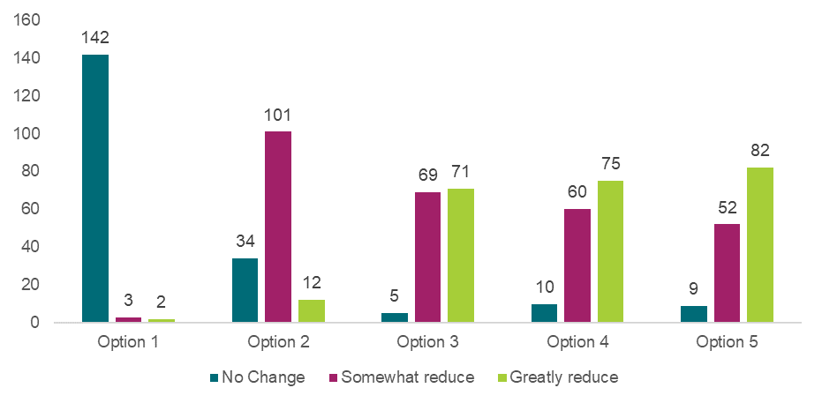

Source: Approved provider survey, as of 11 June 2025, Q54, option 1 n=147, option 2 n=147, option 3 n=145, option 4 n=145, option 5 n=143.

Option 3 seeks to mitigate the immediate risk of harm to children by enabling swift regulatory responses to non-compliant or alleged non-compliant conduct where the threshold of risk for prohibition is not met. It would enable the Regulatory Authority to require an approved provider to temporarily suspend an individual from a service for a period of time, for example, while re-training takes place or the terms of an enforceable undertaking are met, while minimising the risk to children by that person remaining in the service.

Option 4 would support the Regulatory Authority’s ability to hold approved providers accountable for supervising educators, staff members, or volunteers who pose a risk to children at a level that falls short of the threshold for prohibition.

Both options 3 and 4 could create safer environments for children as:

* Approved providers would have a more specific legislative obligations to address non-compliant behaviour. This may encourage timelier and more effective management of risks.
* The regulatory nature of this option may (1) deter educators, other staff members and volunteers from engaging in inappropriate behaviour and/or (2) may encourage approved providers to set clearer expectations or undertake additional monitoring processes to ensure compliance. Both behavioural responses would support safer environments for children.

In relation to option 5, Regulatory Authorities would direct staff members to address their inappropriate conduct by undertaking a course that is tailored to the specific conduct in question. This training is anticipated to assist staff members in examining and reflecting upon their inappropriate conduct and develop their professional skills to minimise the likelihood of it reoccurring. This option offers intervention to address non-compliant conduct by an individual staff member that may result in termination or prohibition in the future if left unaddressed, in addition to minimising the risk of harm to children. Despite these intended outcomes, decisions are outstanding on how this training would be accredited and assessed to ensure it contributes to improving child safety outcomes.

In consultative activities, stakeholders frequently reflected on the importance of regulatory responses to manage inappropriate conduct. As such, options 3, 4 and 5 were all viewed as important mechanisms to improve child safety. As shown in Chart 7.5, a greater proportion of approved providers believed that option 5 would ‘greatly reduce’ the risk of harm to children, relative to option 4 and 3. A moderate, albeit smaller, proportion of approved providers also believed that option 4 would ‘greatly reduce’ the risk of harm to children, while approved providers had mixed views about whether option 3 would ‘somewhat’ or ‘greatly reduce’ the risk of harm to children.

Under the assumption that the regulatory tools introduced in options 3, 4, and 5 would be applied in a way that is commensurate to the risk child of harm to children presented by the inappropriate conduct, each regulatory option has been assigned the same MCA score of six for this criterion.

#### Cost of each option

As noted in Chapter 7.1, approved providers and government are likely to incur administrative costs under option 2. For approved providers, the scale of such costs would depend on the extent of changes made to current Codes of Conduct. For government, incremental costs will be more significant if relevant materials cannot be developed with the support of existing government resources and as part of business-as-usual activities. In line with option 2 of chapter 7.1, option 2 has been assigned an MCA score of negative two for this criterion.

Under option 3, Regulatory Authorities would likely bear administrative costs associated with issuing and monitoring suspension notices. The approved provider is anticipated to bear compliance costs associated with the suspension, including implementing mitigation strategies and temporary staffing costs associated with replacing a suspended person for a period of time. The scale of costs would depend on the number of suspensions issued, the reason the suspension was issued (noting this will impact the required mitigation strategies) and the length of the suspension.

Regulatory Authorities would bear administrative costs associated with issuing and monitoring supervision orders under option 4. If a supervision order is placed on an approved provider, additional costs may be incurred due to creation of a supervision plan for the relevant staff member(s), service, or groups of services under the affected approved provider. This may require the approved provider to engage additional staff or reallocate staff from current responsibilities to ensure the conditions of the supervision order are being adequately met.

Under option 5, it is intended that the costs of retraining would be borne by the staff member, as it is their misconduct that is being addressed. In jurisdictional forums, there was mixed sentiment regarding who should be liable for the cost of retraining. Most stakeholders were not supportive of staff and educators being liable for the cost of retraining. Many thought this would disincentivise staff and educators from undertaking mandatory retraining and result in some individuals choosing to exit the sector. If this occurs, it would exacerbate current workforce shortages faced by the sector.

Irrespective of which party is liable for the cost of retraining, approved providers are likely to incur flow on costs as a result of an educator or staff member undertaking mandatory re-training, including:

* arranging temporary staff to cover the responsibilities/duties of staff members who are required to retrain,
* costs associated with data collection and record keeping of mandatory training.[102]

For option 3, 4 and 5 the scale of costs would depend on the number and complexity of regulatory responses deployed to manage inappropriate conduct. In consultative activities, stakeholders also noted that the length of the show cause process[103] may also impact the scale of costs incurred by approved providers. For example, stakeholders explained that the length of a show cause process can impact the length of time a provider needs to backfill a suspended position for, in circumstances where an individual may present an immediate risk to children. Similarly, the show cause process itself imposes costs (administrative time) on the individual to whom the allegations apply, approved providers, and the Regulatory Authority.

One example provided by Aboriginal and Torres Strait Islander stakeholders suggested that standing a staff member down led to a cost of around $40,000 to the service for 14 weeks of staff backfill and the cost of an investigator. Another submission referred to approximately $45,000 of costs including consultants, staff time, backfilling, and a staff member being off work for 10 weeks. This was a significant cost to a small service provider. The submission also referred to the emotional turmoil across the service, the staff member and the family involved.

“It was quite a shock to me in terms of all the steps and implications of going through that. It was extremely costly, but the trauma for the person, who was stood down for a whole term, the trauma for everyone was immense. You don’t know what it all means till you go through it.” – Written submission response

Based on these costs, options 3 and 4 have been assigned MCA scores of negative 6 for this criterion, due to the likely longer timeframes that additional staff may be required to support due to regulatory responses to conduct. Option 5 has been assigned an MCA score of negative 4 for this criterion, as staff backfill may also be required however for a shorter timeframe. Similarly, educators and staff members may bear costs under this option.

#### Implementation considerations

As previously noted, there is a risk that approved providers will not be responsive to option 2 as they believe they already have robust Codes of Conduct and employment contracts which adequately address inappropriate conduct. In line with Chapter 7.1, option two was assigned an MCA score of negative two for this criterion.

In consultative activities, stakeholders noted that implementing options 3, 4, or 5 would require consideration of Regulatory Authorities' capacity and resourcing to manage expanded functions. Stakeholders were concerned that the Regulatory Authorities may not have sufficient capacity to undertake additional legislative functions in a timely manner.

Under option 3, approved providers indicates that the timeframes in which an approved provider could be suspended should be clarified to minimise implementation risks. There was also some concern that an individual could be impacted by the actions of an approved provider, if the suspension order were to apply at the approved provider level. Regulatory Authorities indicated they may be placed under some pressure to complete investigations quickly if a suspension order is made before an investigation can be completed due to risks to the safety of children. Based on these potential risks, option 3 has been assigned an MCA score of negative three for this criterion.

In consultative activities, there was mixed sentiment expressed by stakeholders with regards to option 4. Some stakeholders believed that supervision orders are an appropriate regulatory mechanism as the onus should be on both the approved provider and educator or staff member to address inappropriate conduct. Other stakeholders expressed concern at the idea that an approved provider would be held responsible for acts of an individual (despite the show cause process) – however, this liability is already in place for the inappropriate discipline offence. Some stakeholders perceived supervision orders to be excessive due to the potential additional costs and burden associated with the implementation of supervision orders. Stakeholders were also uncertain over the additional actions that would be expected from an approved provider subject to the supervision order. As a result, option 4 has been assigned an MCA score of negative four for this criterion.

While stakeholders were generally supportive of mandatory training (option 5) as a mechanism to address non-compliant behaviour and increase professional knowledge, there was mixed sentiment regarding who should be liable for the cost of retraining (see cost section for further details). In jurisdictional forums, stakeholders noted that there is a risk that educators and staff members may leave the sector if they are financially liable for mandatory retraining. However, in some jurisdictions there is an expectation that teachers in the schooling sector pay for mandatory retraining, and stakeholders noted that there are currently no major concerns or risks with this arrangement. Further, educators and staff members subject to an enforceable undertaking are also usually required to pay for their own mandated training or retraining (though the conditions of the enforceable undertaking are agreed on, rather than mandated). Hence, the materiality of the risk associated with making educators and staff liable for retraining costs is unclear. As a result, option 5 has been assigned an MCA score of negative three for this criterion. This is on the basis that it has similar implementation risks to option 3.

It should be noted that while the MCA scores currently consider the implementation considerations based on the options that were consulted on, the recommended implementation of these options will alleviate some of these risks. These implementation considerations are outlined in *What is the recommended option(s) and how will it be implemented?*

#### Distributional impacts

Stakeholders who engaged in consultative activities noted that policy options 3, 4 and 5 are likely to have greater impacts on smaller approved providers, including those in regional and remote areas. This is because these approved providers may not have access to additional staff to backfill suspended positions (option 3), comply with any additional requirements mandated under supervision orders, noting that a staff member who engaged in inappropriate conduct should be supervised and mentored under existing National Law obligations (option 4) or backfill positions while staff undertake mandatory retraining (option 5). In extreme circumstances, this may inhibit an approved provider’s ability to operate due to minimum staffing requirements.

In jurisdictional forums, stakeholders also noted that option 5 is likely to have disproportionate impacts on educators and staff members who will be financially liable for mandatory training/ re-training.

Option 2 is less likely to result in negative distributional impacts, as any changes to Codes of Conduct and the associated consequences would be at the discretion of approved providers. This would enable approved providers to take action that they perceive as commensurate to the risk presented. If implemented in conjunction to a change in the Code of Conduct that more closely aligns to the definition of inappropriate conduct in Chapter 7.1, there is a chance that some approved providers may introduce a Code of Conduct that is not suitable to the cultural needs of all staff and service contexts, which could result in a disproportionate share of disciplinary action impacting people from culturally diverse backgrounds.

“At present, we do not believe the sector is uniformly equipped with the systems, training or cultural maturity required to undertake conduct investigations in a way that is truly just, trauma informed and free from bias. We remain concerned that power imbalances and inconsistent leadership capability may lead to premature, unfair or harmful outcomes for educators, particularly in the absence of strong safeguards or oversight. Inappropriate or poorly handled investigations can have lasting impacts on educator wellbeing, morale, and professional reputation. Instead, we advocate for a focus on educating, upskilling and culture building at all levels of the workforce.” – Free text submission response

It is anticipated that options 3 and 4 will have similar negative distributional impact, particularly given their application at the approved provider level, and hence have both been assigned an MCA score of negative three for this criterion.

Option 3 is expected to have a greater distributional impact to option 4 as the suspension is intended to apply at the approved provider level, which could result in a large volume of staff being impacted at any one time. As a result, option 3 has been assigned an MCA score of negative four for this criterion. Option 4 also applies at the approved provider level, however a supervision order is expected to have a less severe impact on staff directly. As a result, this option has been assigned an MCA score of negative three for this criterion.

It is anticipated that option 5 will have a greater distributional impact relative to option 4, as individuals become liable under this provision. As a result, it has been assigned an MCA score of negative four for this criterion. Option 2 has been assigned an MCA score of negative one for this criterion, due to the relatively small risk of disproportionate costs for culturally diverse staff.

|  |
| --- |
| **Box 7.3: Aboriginal and Torres Strait Islander People Stakeholder Views**  Aboriginal and Torres Strait Islander stakeholders reported that while there was general support for appropriate responses to inappropriate conduct, ACCOs and Aboriginal and Torres Strait Islander services described underlying feelings of mistrust of regulatory systems due to their negative prior experiences with regulators. This was followed by some mixed responses for regulatory options (options 3 to 5), spoken about in relation to these experiences with the regulatory system. This means that services reported broad support for measures to increase child safety but have strong levels of systemic mistrust based on past experiences. This mistrust of the system resulted in a general reluctance to fully support regulatory policy options in relation to this area of reform. |
| Stakeholders’ preferred option  The combination of option 3, 4 and 5 (sometimes also in combination with option 2) received the most support from approved provider survey respondents (see Appendix Tables 12.3.3.1-3). This sentiment was further reflected in jurisdictional forums, where stakeholders preferred regulatory options and were generally supportive of greater legislative powers for Regulatory Authorities to support the management of inappropriate conduct which does not meet the threshold for prohibition or suspension.  Across survey respondents, 15% of approved providers identified options 3, 4 and 5 in conjunction as their preferred option – with an additional 16% preferring options 2, 3, 4 and 5 in conjunction (Appendix Table 12.3.3.1). Similarly, 17% of the education and care workforce identified options 3, 4 and 5 in conjunction as their preferred option – with an additional 17% preferring options 2, 3, 4 and 5 in conjunction (Appendix Table 12.3.3.2). Finally, 26% of surveyed parents, families and carers identified options 3, 4 and 5 in conjunction as their preferred option – with an additional 11% preferring options 2, 3, 4 and 5 in conjunction. 18% of parents, families and carers preferred option 3 on its own, whilst 12% preferred option 4 on its own (Appendix Table 12.3.3.3).  Most long form written submissions also expressed support for options 3, 4 and 5, sometimes in conjunction with support for option 2. Large approved provider long form written submissions expressed more support for option 2 and option 3, and mostly did not support option 4. |

### What is the recommended option(s) and how will it be implemented?

Based on analysis included in this DRIS, the options with the highest net benefit to be provided to Education Ministers for consideration are the regulatory options 3, 4 and 5. The MCA analysis indicates that these three options would generate the most significant improvements to child safety. Further work to address identified implementation considerations related to:

* who the regulatory response can be applied to
* the threshold that must be met for the proposed regulatory responses to be exercised

Some of these implementation considerations have been agreed for option 3, such that:

* option 3 would apply to approved providers (not individual staff directly)
* option 3 would apply the same risk threshold that is currently in place for suspension of FDC educators (non-compliance, or risk to safety, health or wellbeing of children)
* option 3 would apply the same requirement for a show cause notice that is currently in place for suspension of approved provider/service approval (which is not required if there is an immediate risk to safety, health or wellbeing of children).

# 8. Working with Children Checks

This chapter addresses potential reforms to reduce complexity and provide clarity and consistency with WWCC[104] requirements under the NQF, to ensure that only suitable people work or volunteer in the education and care sector.

In Australia, people who work or volunteer with children are screened for suitability through a WWCC process. Having a valid WWCC as an employee or volunteer in an education and care setting and maintaining records of WWCCs as an approved provider is an important safeguard to maintaining a child safe environment. However, there are different jurisdictional WWCC requirements across Australia that mean (1) some states and territories permit a person to commence in a role prior to having an approved WWCC, if certain requirements are met; and (2) not all states and territories require that any change in a person’s WWCC status is shared with their employer and/or the relevant Regulatory Authority, either by the individual or the WWCC agency. These gaps mean that unsuitable people may enter the sector and place children at risk.

To address these potential gaps and this risk, the potential reforms discussed in this chapter are creating national consistency by requiring:

* Chapter 8.1 – that an approved provider cannot allow a person to commence work, or work as a volunteer, in an approved education and care service without an approved WWCC or confirmed teacher registration/accreditation, where otherwise not required by existing legislation.
* Chapter 8.2 – all staff in education and care services, regardless of their role or service type, to notify their approved provider of a change in their WWCC status or teacher registration/accreditation status, with the approved provider then required to notify the Regulatory Authority, where otherwise not required by existing legislation.

## 8.1 Requiring an approved WWCC prior to commencing paid or volunteer work at an education and care service

|  |
| --- |
| **Key Insights**  *Problem*   * Differences in jurisdictional legislation governing WWCC processes give rise to two foreseeable mechanisms of harm to children.   + First, inconsistencies across jurisdictions can create confusion for approved providers, service leaders, educators and staff leading to non-compliance with WWCC requirements.   + Second, legislative exemptions and inconsistencies could enable individuals with a known history of criminal or inappropriate behaviour to work or volunteer in education and care services. In jurisdictions where a person can start prior to receiving an approved WWCC, there may be a higher likelihood of exposing children to people with known histories of misconduct or harm.   *Impacts of each option*   * The MCA analysis shows that option 2 and option 3 (for NSW only) represent an improvement on the status quo (option 1), due to the improvement in child safety outcomes offsetting potential costs of the proposed options. For NSW, option 3 imposes no cost as the sector already requires an individual to hold a valid WWCC, but this reform is seeking to clarify this requirement beyond doubt. However, option 3 is expected to be more costly if applied in WA, NT and ACT, as there is the potential it could have an impact on current workforce shortages where individuals cannot obtain a valid WWCC prior to commencing at a service. * Despite different impacts, similarly high levels of support for the regulatory option was indicated by approved providers, including in the affected jurisdictions. This indicates the broad support for WWCCs as a child safety measure, despite the challenges that could arise upon implementing the recommended option in several jurisdictions. This survey response may be reflective of in-principle support, with implementation risks later raised by several stakeholders. * Option 3 received a lower weighted score than option 2 for WA, NT and ACT, reflecting that some approved providers in WA, NT and ACT may incur temporary staffing costs (i.e., a delay cost) while staff, students, or volunteers lack a valid WWCC and must wait to commence work until their application is processed. The scale of cost will depend on the number of approved providers who do not currently require staff members or volunteers hold a valid WWCC before commencement.   *Recommended option*   * Based on analysis included in this DRIS, the options to be provided to Education Ministers for consideration are options 2 and 3. Option 3 is recommended to be implemented in all jurisdictions that do not currently have this requirement in legislation (NSW, WA, NT and ACT). |

There are various legislation, regulation, and standards governing WWCC requirements in education and care settings (refer Table 8.1).

Table 8.1: Overview of WWCC legislation, regulation, and standards

| **Mechanism** | **Details** |
| --- | --- |
| Jurisdictional legislation | Each state and territory has its own legislation which mandates and regulates WWCCs, and various teacher registration/accreditation requirements. Each jurisdiction has its own naming convention, screening agency, application process, and validity period (see Appendix 12.6 for further details). |
| National Regulations | These regulations govern approved provider applications and staff reporting requirements, to ensure providers comply with the National Law.  Current Education and Care Services National Regulations requirements for WWCC records to be stored include, nominated supervisors (regulation 146), all educators (regulation 147), volunteers and students (regulation 149) and FDC coordinators, educators, assistants and residents (regulations 153, 163 and 164). WWCC requirements for the application of an approved provider are provided in regulations 14, 16, 20, 22. WWCCs need to be read by the approved provider or nominated supervisor for all staff in Victoria only (regulation 358). |
| National standards for WWCCs | The National Standards for WWCCs (National Standards) will establish nationally consistent parameters for the screening of persons who propose to engage in child-related work. These National Standards were endorsed by state and territory ministers in 2019 and are in various stages of being implemented.  Specifically, National Standard 8 stipulates that a WWCC applicant may begin child-related work under the safeguards that the applicant does not withdraw their WWCC application, the employer verifies the application with the screening agency prior to engaging the applicant, and the screening agency has the capacity to impose interim bars on applicants where information held by the screening agency indicates a risk which requires further assessment. |

Across jurisdictions, there are fundamental differences in the exemptions and conditions under which persons can start working or volunteering in the education and care sector while WWCC applications are being processed. Key differences include:

* **Ability to commence child-related work or volunteering with WWCC application only:** The legal position in some jurisdictions may currently allow staff, students, and volunteers to commence work in an approved service while their WWCC application is being processed. While individuals typically need to provide proof that a WWCC application has been lodged (e.g. an application number), it is not always certain that an approved check or registration is required before commencing a role in these jurisdictions (refer Table 8.2). Certain conditions must be met however, such as supervision requirements
* **WWCC age exemptions**: In some jurisdictions there are WWCC age exemptions. For example, in NSW and VIC persons under 18 years old do not require a WWCC to work or volunteer in child-related services (however, as per the NQF they would not be able to work with children unsupervised). In jurisdictions where persons under 18 years old are required to have a WWCC, there are still various exemptions given based on age *and* working status. For example, in WA employed persons under 18 year of age require a WWCC, but persons under 18 years old who are undertaking an unpaid student placement are exempt from WWCCs. See Appendix 12.7 for further details about WWCC exemptions
* Only VIC currently has specific provisions in the National Regulations for WWCCs to be read before a person is engaged or permitted to be a volunteer.

Table 8.2: High-level overview of key differences in jurisdictional legislation for commencing roles with WWCCs

|  | NSW | VIC | QLD | WA | SA | TAS | NT | ACT |
| --- | --- | --- | --- | --- | --- | --- | --- | --- |
| Are there exemptions or conditions under which a person might start working or volunteering in the education and care sector before they have a current WWCC? | **Yes[105]** | No | No | **Yes** | No | No[106] | **Yes** | **Yes** |
| Is teacher registration/accreditation currently compulsory for all early childhood teachers? | Yes | Yes | **No** | Yes | Yes | **No[107]** | **No[108]** | **No** |

*Source: Information sourced from various jurisdictional WWCC (or equivalent) agencies and education departments. For more information on detailed sources, refer to Appendix 12.7.*

The National Regulations recognise the importance of WWCCs through a range of additional requirements for education and care services.[109] The implementation of this recommendation has the potential to introduce more stringent safeguards under the NQF that extend beyond the interventions introduced to date.

### What is the problem?

Differences in jurisdictional legislation governing WWCC processes give rise to two foreseeable mechanisms of harm to children.

First, inconsistencies across jurisdictions can create confusion for approved providers, service leaders, educators and staff leading to non-compliance with WWCC requirements. Non-compliance may result in inadequate vetting, checking, and monitoring during recruitment processes. This increases the risk that some individuals who do not meet the necessary requirements are allowed to work or volunteer in education and care services.

Second, legislative exemptions and inconsistencies could enable individuals with a known history of criminal or inappropriate behaviour to work or volunteer in education and care services. In jurisdictions where a person can start prior to receiving an approved WWCC, there may be a higher likelihood of exposing children to people with known histories of misconduct or harm.

The resulting harm may manifest in several ways, including increased exposure of children to individuals with a history of misconduct, or who otherwise may not have been approved for a WWCC, the potential for abuse or neglect, and a loss of trust in education and care services among families and communities.

In consultative activities, stakeholders from various jurisdictions (including those outside of WA, NT, NSW, and ACT) noted that there is no anecdotal evidence to suggest that people who commence employment or volunteering without a valid WWCC are at higher risk of receiving a rejection or later cancellation. Likewise, jurisdictional Regulatory Authorities did not report any instances where someone commenced in a role working directly with children while awaiting a WWCC outcome and an incident of harm to a child occurred. However, consulted WWCC agencies did acknowledge that they sometimes receive applications from individuals who very clearly do not meet the requirements to hold a WWCC but apply regardless as this is a condition to gain employment in various occupations and sectors. These individuals are identified through pre-screening and interim barring processes. Representatives were unable to disclose the prevalence of this issue and its relevance to the education and care sector.

Although teacher registration/accreditation processes in some jurisdictions already effectively screen, monitor, record and share disciplinary action about early childhood teachers, it is not required in all jurisdictions or in all education and care settings. For this reason, an option to provide national consistency of teacher registration/accreditation arrangements for services under the NQF is not yet possible and not included here.

### What were the policy options consulted on?

Three options, including the status quo, a non-regulatory option, and a regulatory option are under consideration. Options 2 and 3 are not mutually exclusive, and the recommended option for these recommendations can be a combination of the proposed regulatory and non-regulatory approaches.

Table 8.3: Policy options under consideration – Requiring an approved WWCC prior to commencing paid or volunteer work at an education and care service

| **Option** | **Description** |
| --- | --- |
| 1 | Status quo (no change). |
| 2 | **Non-regulatory**  Additional guidance about WWCC and teacher registration/accreditation requirements and the importance of WWCCs in conjunction with the implementation of child safety training (refer to Chapter 6). The guidance should include recommended ‘best practice’ approaches.  Guidance to include the following recommended best practice approaches:   * confirmation of a WWCC record in staff file prior to working in a service (all staff and volunteers) * check WWCC status every 6 months (in jurisdictions where approved providers are not already notified by the relevant WWCC agency). |
| 3 | **Regulatory**  *Jurisdiction specific National Regulation amendment in WA, the ACT and the NT to require that an approved provider of an education and care service must ensure that staff, students, and volunteers of that service hold a valid WWCC before they can be engaged/commence their roles. In addition, a jurisdiction specific National Regulation amendment in NSW will clarify this same requirement beyond doubt.* |

### What are the impacts of each option?

The sections below provide an MCA assessing the potential impacts of the proposed options on child safety outcomes, costs to stakeholders, implementation considerations, and distributional impacts. A detailed overview of the MCA framework underpinning this analysis is available in Chapter 4.

#### Multi-criteria analysis

In assigning MCA scores to reflect the relative benefits and costs of each option, the score for improvement in child safety has been scaled with a zero for option 1 representing no change, and score of three for option 3 (for WA, NT and ACT) representing the biggest impact on child safety. Other options have been scored between these values based on the assessment of qualitative input from stakeholders. Scores for other categories relating to costs, risks, and distributional considerations have been scaled in relation to these benefits.

Table 8.4: MCA outcomes – Requiring an approved WWCC prior to commencing paid or volunteer work at an education and care service

| **Criteria** | **Weight** | **Option 1** | **Option 2** | **Option 3 (for WA, NT and ACT)** | **Option 3 (for NSW)** |
| --- | --- | --- | --- | --- | --- |
| Improvement in child safety | 50% | 0 | 2 | 3 | 1 |
| Net cost of policy option | 30% | 0 | -2 | -4 | 0 |
| Implementation considerations | 10% | 0 | -1 | -5 | 0 |
| Distributional impact | 10% | 0 | 0 | -3 | 0 |
| **Weighted score** |  | **0** | **0.3** | **-0.5** | **0.5** |

The MCA scores suggest that option 2 and option 3 (for NSW) represent an improvement on the status quo (option 1), due to the improvement in child safety outcomes offsetting potential costs of the proposed options. For NSW, option 3 (for NSW) imposes no cost as the sector already requires an individual to hold a valid WWCC, but this reform is seeking to clarify this requirement beyond doubt. However, option 3 (for WA, NT and ACT) is expected to be more costly if applied in WA, NT and ACT, as it could result in workforce shortages. Further, option 3 (for WA, NT and ACT) was not perceived to result in a marked improvement in child safety outcomes, as there is no anecdotal evidence that allowing an individual to commence in a role without an approved WWCC has historically posed a risk to the safety of children. The rationale for each MCA score is outlined in the sections below.

#### Impact on child safety

Under option 2, it is anticipated that clear and specific guidance would support approved providers to better understand WWCC requirements, including differences in requirements for multi-jurisdictional providers. This would reduce administrative burden (particularly for approved providers who operate across jurisdictions) and support approved providers to meet their obligations under relevant jurisdictional legislation and the NQF. Further, option 2 could encourage greater adoption of ‘best practices’ regarding WWCCs, which could result in child safety improvements, depending on the practices adopted. Consulted stakeholders believed that option 2 would somewhat reduce the risk of harm to children (refer to Chart 8.1).

Chart 8.1: Approved provider responses to “How much do you think each option will reduce the risk of harm to c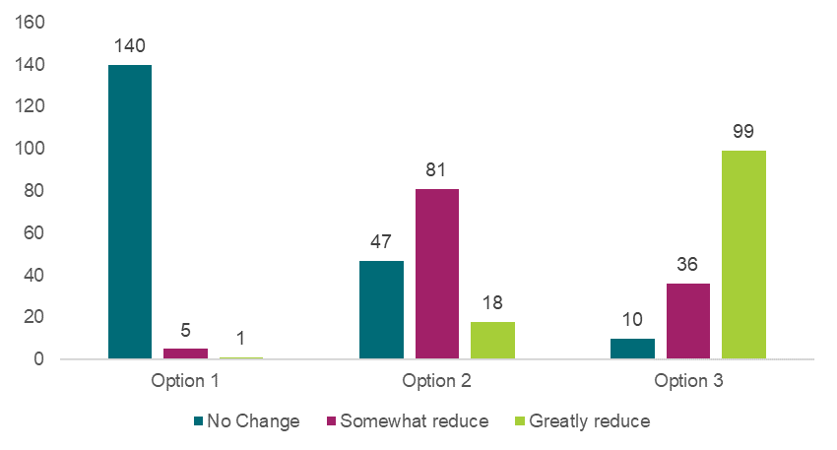hildren?”

Source: Approved provider survey, as of 11 June 2025, Q59, option 1 n=146, option 2 n=146, option 3 n=145.

Option 3 would promote national consistency and clarity of WWCC requirements in the education and care sector, whereby no one can work or volunteer in a service until they have received their WWCC. This option would reduce the risk of an unsuitable individual being able to work in an education and care setting, however this risk is broader than what is covered by WWCC checks. As such, this impact of this option could be minimal.

In consultations, representatives from several jurisdictions (including some impacted and not impacted by the change) expressed doubts about the option’s impact on reducing harm to children. WWCC screening agencies believed that pre-screening and interim barring processes in place across jurisdictions are sufficient for reducing the risk that an individual with a known history of harm would be able to work in an education and care setting. In addition to these interim barring processes, most approved providers in jurisdictions that allow commencement of work while a WWCC application is being processed, indicated that individuals without an approved WWCC are required to be supervised by a staff member with an approved WWCC.

Further, Regulatory Authorities and WWCC screening agencies from impacted jurisdictions could not recall any instances where enabling someone to work without an approved WWCC has resulted in harm to children.

Despite this, most survey respondents reported that option 3 would ‘greatly reduce’ the risk of harm to children (refer to Chart 8.1). Stakeholders frequently noted that national consistency would help reduce the risks of harm. However, stakeholders responding to the survey would have been largely unaware that the current process by which individuals commence in roles without an approved WWCC (1) is subject to interim screening processes and (2) has not resulted in known harm to children to date.

Based on the balance of evidence collected, option 2 has been assigned an MCA score of one for this criterion and option 3 (for WA, NT and ACT) has been assigned an MCA score of two. Option 2 has been assigned a lower MCA score on the basis that it is ‘opt-in’ and hence requires approved providers to actively implement best practice approaches. While there is mixed sentiment regarding the impact of option 3 (for WA, NT and ACT), there is greater potential that it reduces the risk of harm to children relative to option 2, since all individuals working with children would have a WWCC.

The NSW education and care sector has been operating with a position that an approved WWCC is required prior to commencing a role and this option seeks to put this practice beyond doubt. The regulatory option would have a different impact on NSW when compared to other jurisdictions – in this case option 3 (for NSW) aligns with current practices in NSW, however requiring a valid WWCC beyond doubt will ensure no changes to this practice emerge in the future. As such, option 3 (for NSW) has been assigned an MCA score of one for this criterion.

#### Cost of each option

Under option 2, the government would incur costs associated with the development of guidance to improve awareness of WWCC requirements. Incremental costs will be more significant if relevant materials cannot be developed with the support of existing government resources and as part of business-as-usual activities. Any approved providers that choose to adopt this guidance may incur additional costs associated with checking WWCC statuses (beyond the checks that are already undertaken) to ensure staff have a valid WWCC on file prior to employment. The latter component could be costly in the event that (1) an individual does not have a valid WWCC and (2) there is a long wait time to receive a WWCC.

Under option 3, some approved providers in WA, NT and ACT may incur temporary staffing costs (i.e., a delay cost) while staff, students, or volunteers lack a valid WWCC and must wait to commence work until their application is processed. The scale of cost will depend on the number of approved providers who do not currently require that staff members or volunteers hold a valid WWCC before commencement. In consultations, representatives from WA, NT, and ACT reported that it is common for staff and volunteers to commence work while their WWCC application is being processed[110], which suggests the impact and associated costs may be material. In NSW, it is current practice to require staff to have a valid WWCC, meaning the cost for this jurisdiction will be minimal.

Based on the evidence above, option 2 has been assigned an MCA score of negative three for this criterion. Option 3 has been assigned an MCA score of negative four for WA, NT and ACT for this criterion, while for NSW it has been assigned a score of zero (as requiring a WWCC is current practice). These scores reflect that stakeholders in WA, NT and ACT are likely to incur greater costs (both intentional and unintentional) under option 3.

#### Implementation considerations

Under option 2, consulted parents, families, and carers raised concerns that the proposed six-monthly WWCC status check is inadequate, with many indicating more frequent status checks is preferred for ‘best practice’. Given this sentiment, there may be a lack of stakeholder support for option 2, with a preference instead for more frequent WWCC status checks to be considered best practice. This would reduce the risk that a change in WWCC status could go unnoticed for several months.

Several potential consequences have been identified for option 3, including:

* **Workforce shortages:** Option 3 may unintentionally exacerbate current workforce shortages if there are delays to processing WWCC in jurisdictions where this is not currently required prior to commencement in a service. Stakeholders noted that WWCC processing times can take up to three months – as such, requirements for a valid WWCC before commencing employment will likely delay recruitment and onboarding and hence exacerbate workforce shortages. Stakeholders also expressed concern about WWCC screening agencies’ capacity to meet increased demand for faster approval times as a result of option 3. It is anticipated that without additional funding or other resources, application processing times may inhibit receiving a WWCC in a timely manner, which could exacerbate workforce shortages.
* **Legislative inconsistencies:** In consultative activities, stakeholders reported concerns that legislative amendments at the national level may create inconsistencies with state and territory legislation in WA, NT, ACT and NSW, particularly in adjacent sectors such as schooling and disability support, and with the National Standards (in response to the Royal Commission into Institutional Responses to Child Sexual Abuse), stipulating that staff need to apply for, not hold, a WWCC. However, the National Standards also highlight the need for more consistency across jurisdictions. As such, stakeholders reported concerns that this regulatory change would cause confusion within the sector.

Based on the evidence above, option 2 has been assigned an MCA score of negative one for this criterion. For WA, NT and ACT, option 3 has been assigned an MCA score of negative five, largely due to risks emerging from legislative inconsistencies in each jurisdiction and the potential for education and care workforce shortages to emerge (which could be exacerbated if WWCC application processing times cannot be reduced). NSW was given an implementation risk rating of zero for this criterion, as option 3 reflects current practices in the state.

It should be noted that while the MCA scores currently consider the implementation considerations based on the options that were consulted on, the recommended implementation of these options may alleviate some of these risks. These implementation considerations are outlined in *What is the recommended option(s) and how will it be implemented?*

#### Distributional impacts

Option 2 was not expected to generate substantial distributional impacts for stakeholders, particularly as option 2 is unlikely to have a material impact on workforce availability unless there is widespread adoption of best practices across WA, ACT, NT, and to a lesser extent, NSW.

Option 3 is likely to generate distributional impacts largely where the proposed reforms will have implications for staffing availability – which is largely expected to be in WA, NT and ACT. In NSW, it is current practice to require a valid WWCC on commencement, and therefore there is not likely to be a distributional impact in this jurisdiction.

Representatives from WA and the NT raised concerns about the distributional effects, particularly in rural and remote areas which typically experience greater workforce shortages.

*“There may be short-term workforce pressures, especially in regional/remote services where WWCC processing takes time and staffing is already stretched.” – Approved Provider Survey*

However, one forum participant noted that in regional and remote areas, having strong safeguards is just as, or more, important:

“Hearing some of the challenges with navigating time frames, bureaucracy, staffing issues…[for] regional areas, population groups experiencing disadvantage, that impacts the access that children have to quality care by not having high enough provisions or safety protocols in place. People who use violence will seek out the most vulnerable, so closing any gaps where there isn’t enforcement of regulation [is supported].” - Focus group participant

Regional and remote areas are also located where there is a higher share of ACCO services in operation, which could result in disproportionate impacts for Aboriginal and Torres Strait Islander Peoples and services. While the first issue raised in Box 8.1 would apply to all education and care services located in border towns, it was largely raised by ACCO services.

|  |
| --- |
| **Box 8.1: Aboriginal and Torres Strait Islander People Stakeholder Views**  Some Aboriginal and Torres Strait Islander stakeholders raised that the lack of consistent approaches to WWCC is an issue for ACCO education and care services, particularly for services located on border towns with two jurisdictional remits. Stakeholders raised similar concerns to those above regarding delayed checks and impacts on the workforce. One submission suggested that if regulatory options were implemented, there could be exemptions for small communities in remote and rural locations.  A submission from an Aboriginal and Torres Strait Islander organisation also highlighted that due to systemic discrimination, Aboriginal and Torres Strait Islander are incarcerated at higher rates compared to the general population, and therefore disproportionately impacted by WWCCs. |

Based on the distributional impacts identified, both option 2 and option 3 (for NSW) have been assigned an MCA score of zero for this criterion. Option 3 (for WA, NT and ACT) has been assigned an MCA score of negative three for this criterion, given the implications for the workforce, particularly in regional and remote areas which is also where a higher share of ACCO services operate.

#### Stakeholders’ preferred option

Support from governments in affected jurisdictions is high for those who will experience less impact from option 3, and lower among those who may experience substantial workforce shortages from option 3.

The impacts identified are substantially different for NSW when compared to WA, NT and ACT (as reflected in the MCA scoring) and each jurisdiction will have a different view to the existing risk, depending on initial risk screening processes undertaken by WWCC screening agencies in each affected jurisdiction.

Despite these substantially different impacts, most jurisdictions reported similarly high levels of support for the regulatory option among approved providers, including in the affected jurisdictions (refer Chart 8.2). This finding indicates the broad support for WWCCs as a child safety measure, despite the challenges that would arise upon implementing the preferred option in several jurisdictions. It is important to consider that this survey response may be reflective of in-principle support, with implementation risks later raised by several stakeholders. For some stakeholders, support was contingent on reduced waiting time for WWCC results; for others the assumption of current waiting times meant that they did not express support for the options. One stakeholder expressed that if the regulatory option were to be introduced, their service may need to apply for waivers for their staffing requirements due to being unable to recruit staff, leading to other impacts on child safety and service delivery.

The number and level of concerns about waiting times varied somewhat by jurisdiction, with higher levels of concern from stakeholders in the WA, NT and ACT.

Chart 8.2: Approved provider responses to “What is your preferred option or combination of options?”, by jurisdiction

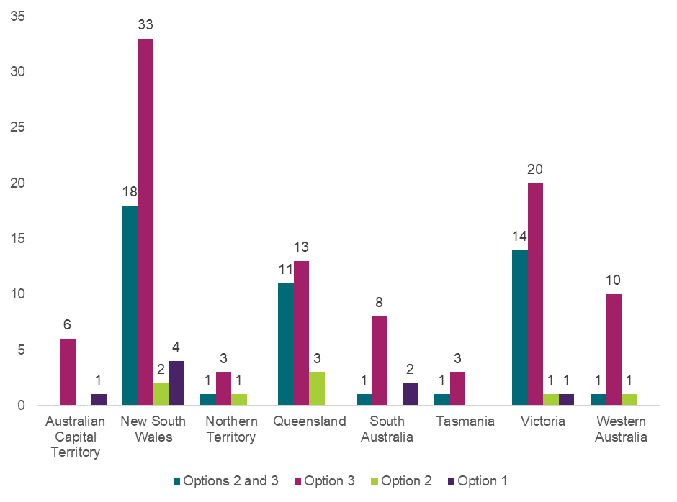

Source: Approved provider survey, as of 11 June 2025, Q61, n=159. Note respondents could identify with more than one jurisdiction.

If implemented, it is expected that the requirements would mirror existing ‘no card, no start’ policies in other Australian jurisdictions (VIC, QLD, SA, and TAS). However, the changes may result in inconsistencies between the education and care sector and other sectors requiring a WWCC in affected jurisdictions.

Across survey respondents more generally, option 3 was the preferred option for this recommendation. Approximately 61% of approved providers identified option 3 as their preferred option – with an additional 29% preferring option 3 in conjunction with option 2 (Appendix Chart 12.3.4.4). Similarly, 52% of the education and care workforce identified option 3 as their preferred option – an additional 29% preferred option 3 in conjunction with option 2 (Appendix Chart 12.3.4.5). 63% of surveyed parents, families and carers identified option 3 as their preferred option – an additional 26% preferred option 3 in conjunction with option 2 (Appendix Chart 12.3.6).

Similarly, long form written submissions expressed support for reform, with nearly all submissions supporting option 3, and a small number of responses with mixed support. Free text comments expressed strong support for WWCC changes to regulation and sometimes expressed direct support for the regulatory option under consideration.

### What is the recommended option(s) and how will it be implemented?

Based on analysis included in this DRIS, the options to be provided to Education Ministers for consideration are options 2 and 3. Option 3 is recommended to be implemented in all jurisdictions that do not currently have this requirement in legislation (NSW, WA, NT and ACT).

Individual states and territories will undertake additional work to support implementation of regulatory options, given jurisdictional variances in WWCC processes. This approach may reduce implementation risks, such as potential staffing shortages from the introduction of the reforms, which was the greatest concern among most stakeholders who were not in favour of option 3.

## 8.2 Requiring approved providers and Regulatory Authorities to be notified about changes in WWCC status

|  |
| --- |
| **Key Insights**  *Problem*   * There is currently no systematically reported evidence which identifies the nature, scale, or prevalence of harm caused by regulatory inconsistencies in notification obligations related to changes in WWCC status. Conceptually, the absence of nationally consistent and comprehensive notification requirements increases the risk of unsuitable individuals remaining in education and care settings. * The variance in notification requirements across jurisdictions has the potential to result in harm to children in any jurisdiction with potential gaps in notification requirements. This harm is most likely to result from changes in a person’s WWCC status being unknown to an approved provider and/or Regulatory Authority, and a person continuing to work in an education and care role.   *Impacts of each option*   * The MCA analysis shows that option 2 and option 3A and 3B represent an improvement on the status quo (option 1), due to the improvement in child safety outcomes offsetting potential costs of the proposed options. Option 3A and 3B presents the highest MCA score, indicating the improvement in child safety more greatly offsets the potential negative impacts (costs, implementation risks, and distributional impacts). * Option 3A and 3B was the preferred option among all surveyed stakeholder groups, including approved providers, the education and care workforce, and families. Regulatory Authorities advised that Option 3A and 3B need to be implemented together to be effective. * Option 2 received a lower weighted score than option 3A and 3B, reflecting that regulatory authorities may incur incremental costs if involved in the development of guidance materials under option 2 (despite higher implementation risks for option 3A and 3B.   *Recommended option*   * Based on analysis included in this DRIS, the options with the highest net benefit to be provided to Education Ministers for consideration are options 2, 3A and 3B. The MCA analysis indicates that these options in tandem would generate the most significant improvements to child safety and provide a nationally consistent approach in education and care services under the NQF. Individual states and territories will undertake additional work to support implementation of regulatory options, given jurisdictional variances in WWCC processes. |

There are a range of different notification requirements regarding the communication of a change in in WWCC status from an individual to an approved provider, an approved provider to a Regulatory Authority, or for an individual to report a change in employer to the WWCC screening agency.

Jurisdiction-specific WWCC legislation mandates:

* employees must communicate WWCC status changes to their employer (VIC, WA and SA),
* WWCC holders must communicate changes in their employer to the WWCC screening agency (VIC, NSW, QLD, WA and TAS)[111],
* approved providers or WWCC screening agencies are obligated to notify Regulatory Authorities of changes in all employees’ WWCC status or teacher registration/accreditation status (WA, QLD, and in some circumstances, SA).[112]

The National Law stipulates that Regulatory Authorities must be notified of changes in WWCC status for nominated supervisors, FDC educators and FDC residents over 18 years old. Under section 173 of the National Law, approved providers must notify the Regulatory Authority if the nominated supervisor’s WWCC card or teacher registration/accreditation is suspended or cancelled. Further, section 271 requires Regulatory Authorities to disclose the suspension or cancellation of a WWCC card or teacher registration of a nominated supervisor to other Regulatory Authorities.

The National Regulations also set requirements for reporting changes in WWCC status in limited circumstances. Specifically, regulation 163 requires FDC educators to notify approved providers of any new person aged over 18 years old who resides or intends to reside at the residence and notify them of any circumstance that may affect whether they are fit and proper to be in the company of children.[113]

Government intervention to date has recognised the importance of WWCCs by working towards greater standardisation across jurisdictions and encouraging data sharing initiatives. Specifically, National Standard 30 (of the National Standards for WWCC) specifies that it should be a criminal offence in all jurisdictions if a person, as an applicant or WWCC holder, fails to notify screening agencies of relevant changes to their circumstances including a change of relevant criminal history, a change of employer, or a change of personal information. However, state and territory governments are at different stages of implementing National Standard 30.

### What is the problem?

There is currently no systematically reported evidence which identifies the nature, scale, or prevalence of harm caused by regulatory inconsistencies in notification obligations related to changes in WWCC status. Conceptually, the absence of nationally consistent and comprehensive notification requirements increases the risk of unsuitable individuals remaining in education and care settings.

In addition, the absence of nationally consistent and comprehensive notification requirements has the potential to create additional regulatory burden in navigating interjurisdictional requirements – particularly for approved providers that operate across several jurisdictions. These requirements are illustrated in Table 8.5.

The variance in notification requirements across jurisdictions has the potential to result in harm to children in any jurisdiction with potential gaps in notification requirements. This harm is most likely to result from a change in a person’s WWCC status being unknown to an approved provider and/or Regulatory Authority, and a person continuing to work in an education and care role. Further, the ability of WWCC screening agencies to notify approved providers[114] and/or Regulatory Authorities[115] of changes to a person’s WWCC status (in jurisdictions where the WWCC screening agency makes this notification[116]) is compromised in states where individuals are not required to notify WWCC screening agencies of a change in employer.

Table 8.5: High-level overview of key differences in jurisdictional notification requirements

|  | NSW | VIC | QLD | WA | SA | TAS | NT | ACT |
| --- | --- | --- | --- | --- | --- | --- | --- | --- |
| Individuals are required to notify their approved provider of a change in WWCC (or equivalent) status | **No** | Yes | **No** | Yes | Yes | **No** | **No** | **No** |
| WWCC agency notifies the approved provider of changes to a person’s WWCC status | Yes | Yes | Yes | Yes[117] | Yes | Yes | Yes | Yes |
| Individuals are required to notify WWCC screening agencies of a change in employer | Yes | Yes | Yes | Yes | **No** | Yes | **No** | **No** |
| Approved providers or WWCC screening agencies are required to notify Regulatory Authorities of a change in an any employee, volunteer, or FDC resident’s WWCC status (or equivalent) | **No** | **No** | Yes | Yes | Yes[118] | **No** | **No** | **No** |

*Source: Information source from various jurisdictional WWCC (or equivalent) agencies and education departments. For more information on detailed sources, refer to Appendix 12.6.*

Although teacher registration/accreditation processes in some jurisdictions already effectively screen, monitor, record and share disciplinary action about early childhood teachers, it is not required in all jurisdictions or in all education and care settings. For this reason, an option to provide national consistency of teacher registration/accreditation arrangements for services under the NQF is not yet possible and not included here.

### What were the policy options consulted on?

Three options, including the status quo, a non-regulatory option, and a regulatory option are under consideration. Options 2 and 3 are not mutually exclusive, and the recommended option can be a combination of the proposed regulatory and non-regulatory approaches. Option 3 comprises of two parts (A and B) that cannot be split.

Table 8.6: Policy options under consideration – Requiring approved providers and Regulatory Authorities to be notified about changes in WWCC status

| **Option** | **Description** |
| --- | --- |
| 1 | Status quo (no change). |
| 2 | **Non-regulatory**  Additional guidanceabout current WWCC and teacher registration/accreditation notification requirements and the importance of WWCCs in conjunction with the implementation of child safety training (refer to Chapter 6)  Guidance to include the following recommended ‘best practice’ approaches:   * confirmation of a WWCC record in staff files prior to working in a service (all staff and volunteers) * check WWCC status every six months (in jurisdictions where approved providers are not already notified by the relevant WWCC agency). |
| 3A and 3B | **Regulatory**  Amend the National Regulations and National Law   * 3A: New requirement for all centre-based staff and FDC educators to notify their approved provider of a change in WWCC or teacher registration/accreditation status (in NSW, TAS, ACT and NT only).[119]   **and**   * 3B: New requirement for approved providers to notify the Regulatory Authority of a change in WWCC or teacher registration/accreditation status for all staff with penalties/offences for non-compliance, (in all jurisdictions except QLD and WA.[120] Also, an exemption in SA in instances where changes to WWCC status is directly communicated to the Regulatory Authority). |

### What are the impacts of each option?

The sections below provide an MCA assessing the potential impacts of the proposed options on child safety outcomes, costs to stakeholders, implementation considerations, and distributional impacts. A detailed overview of the MCA framework underpinning this analysis is available in Chapter 4.

#### Multi-criteria analysis

In assigning MCA scores to reflect the relative benefits and costs of each option, the score for improvement in child safety has been scaled with a zero for option 1 representing no change, and score of three for option 3A and 3B, representing the biggest impact on child safety. Other options have been scored between these values based on the assessment of qualitative input from stakeholders. Scores for other categories relating to costs, risks, and distributional considerations have been scaled in relation to these benefits.

Table 8.7: MCA outcomes – Requiring approved providers and Regulatory Authorities to be notified about changes in WWCC status

| **Criteria** | **Weight** | **Option 1** | **Option 2** | **Option 3A and 3B** |
| --- | --- | --- | --- | --- |
| Improvement in child safety | 50% | 0 | 2 | 3 |
| Net cost of policy option | 30% | 0 | -1 | -1 |
| Implementation considerations | 10% | 0 | -1 | -2 |
| Distributional impact | 10% | 0 | 0 | 0 |
| **Weighted score** |  | **0** | **0.6** | **1** |

The MCA scores suggest that option 2 and option 3A and 3B represent an improvement on the status quo (option 1), due to the improvement in child safety outcomes offsetting potential costs of the proposed options. Option 3A and 3B presents the highest MCA score, indicating the improvement in child safety more greatly offsets the potential negative impacts (costs, implementation risks, and distributional impacts). The rationale for each MCA score is outlined in the sections below.

#### Impact on child safety

Option 2 could improve compliance with jurisdictional WWCC requirements and improve awareness of a change in WWCC status, depending on the uptake of practices outlined in the guidance materials by approved providers.

Options 3A and 3B would improve the clarity of staff and approved provider notification obligations. Where the additional obligations on staff to report a change in status to their approved provider leads to an increase in reporting, approved providers will have greater capacity to make informed decisions and take timely action, reducing the potential that unsuitable individuals are present in education and care settings. Similarly, if changes in status are more frequently reported to Regulatory Authorities, Regulatory Authorities will have greater opportunity to evaluate potential risks presented by the staff member who has experienced a change in the WWCC status and potentially remove them from an education and care setting.

While stakeholders acknowledged the potential for these legislative changes to reduce harm in theory, there was uncertainty and scepticism regarding their practical impact on child safety. As a result, there was a general sense that while the options proposed here may be important, they may not adequately address risks identified with the current system. This was framed as (1) unscrupulous individuals are unlikely to notify either their provider or others about changes in their WWCC status (though enforcement of penalties for non-compliance may improve reporting behaviours) and (2) WWCCs are not sufficient mechanisms to prohibit unsuitable individuals joining the sector.

“I think this is a good idea, but how do you force someone to disclose something they don't want to. it would have to work with the centre verifying every six months too.” – Education and care workforce survey response

“This relies on staff to communicate changes. Do you really think an abuser is going to rush to communicate changes in … status/registration?” – Family Survey response

A small number of stakeholders (largely WWCC agencies) sought clarification on the rationale for this suite of policy options, including the current risks or drivers underpinning them.

Support for the regulatory option was more definitive in the survey where respondents were asked to report on the extent to which they believed the proposed option would improve child safety. Most respondents believed that option 3A and 3B would ‘greatly reduce’ the risk of harm to children, while option 2 would ‘somewhat reduce’ the risk of harm to children (refer to Chart 8.3).

Chart 8.3: Approved provider responses to “How much do you think each option will reduce the risk of harm to children?”

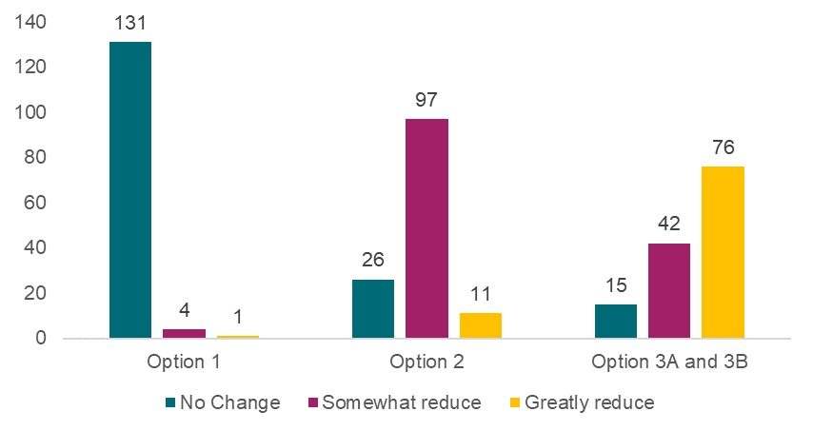

Source: Approved provider survey, as of 11 June 2025, Q59, option 1 n=136, option 2 n=134, option 3A and 3B n=133.

Based on the balance of evidence collected, option 2 has been assigned an MCA score of two for this criterion and option 3A and 3B has been assigned an MCA of three. Option 2 has been assigned a lower MCA score on the basis that it is ‘opt-in’ and hence requires approved providers to actively implement best practice approaches. While there is mixed sentiment regarding the impact of option 3A and 3B, conceptually there is greater potential that it reduces the risk of harm to children relative to option 2, as individuals are more likely to respond to regulatory guidance, particularly if there is a penalty for non-compliance.

#### Cost of each option

The costs of the policy options are broadly considered to be manageable to individuals, approved providers, and Regulatory Authorities.

Regulatory Authorities are not expected to bear material costs from receiving additional information on changes in WWCC status from approved providers under option 3A and 3B and may incur incremental costs if involved in the development of guidance materials under option 2. Incremental costs will be more significant if relevant materials cannot be developed with the support of existing government resources and as part of business-as-usual activities.

Options 3A and 3B would result in administrative burden for individuals and approved providers who are newly required to notify and provide records detailing changes in WWCC and teacher registration/accreditation status. Approved providers did not indicate substantial costs for themselves or their staff members from any options. Some approved providers indicated that notifying Regulatory Authorities of changes in WWCC status is not a lengthy process (the most common survey response indicated this may take less than two minutes in each instance) and the survey indicated this is already common practice across many approved providers (68% of approved providers indicated they ‘always’ inform Regulatory Authorities of a change in WWCC status). As a result, option 3 would have a minimal incremental cost.

Regulatory Authorities indicated that the number of status changes is not substantial, particularly when WWCC renewals are properly managed by individuals and approved providers. As a result, neither option 2 nor option 3A or 3B is expected to impose material costs.

Based on the low perceived costs of all options, both option 2 and options 3A and 3B have been assigned MCA scores of negative one for this criterion.

#### Implementation considerations

Under option 2, consulted parents, families, and carers raised concerns that the proposed six-monthly WWCC status check is inadequate, with many indicating more frequent status checks is preferred for ‘best practice’. Given this sentiment, there may be a lack of stakeholder support for option 2, with a preference instead for more frequent WWCC status checks to be considered best practice. This would reduce the risk that a change in WWCC status could go unnoticed for several months.

As outlined under the impact on child safety, stakeholders were uncertain on whether unscrupulous individuals are likely to notify their approved provider about changes in their WWCC status. This may result in implementation risks where approved providers cannot effectively rely on individuals to report on a change in WWCC status and notify Regulatory Authorities of this change.

The proposed notification requirements also create additional complexities in WWCC requirements that will vary by sector. This reform would also only apply where there are insufficient reporting requirements currently, meaning some jurisdictions would still not require an individual to report a change in their status. Combined, these inconsistencies create an added risk of non-compliance since an individual may not be aware of their obligations.

If options 3A and 3B are implemented, approved providers were concerned about potential consequences if they cannot notify a Regulatory Authority of a change due to failing of an individual to fulfill their reporting obligations.

*“Approved providers would have to be responsible for making staff aware of the need to self-report any changes in WWCC statuses. Staff could easily forget that this is a requirement, and in the case of a malicious staff member they could simply ignore the requirement, hence not achieving the intended goal anyway.”* *– Approved Provider Survey*

Based on the evidence above, option 2 has been assigned an MCA score of negative one for this criterion and options 3A and 3B have been assigned an MCA score of negative two. These scores reflect options 3A and 3B having greater perceived implementation risk compared to option 2.

Aboriginal and Torres Strait Islander stakeholders also shared implementation considerations. While shared by Aboriginal and Torres Strait Islander stakeholders, this consideration has relevance to all education and care stakeholders.

|  |
| --- |
| **Box 8.2: Aboriginal and Torres Strait Islander People Stakeholder Views**  Aboriginal and Torres Strait Islander stakeholders reported feedback from stakeholders that information sharing should go both ways; that Approved Providers can inform Regulatory Authorities about changes in WWCCs, Regulatory Authorities should also inform Approved Providers and services about changes to WWCC (in addition to enforceable undertakings and prohibitions). |

#### Distributional impacts

Stakeholders who engaged in consultative activities did not note any material distributional impacts associated with option 2 or options 3A and 3B. As a result, both options have been assigned an MCA score of zero for this criterion.

#### Stakeholders’ preferred option

Across all surveys, options 3A and 3B was the preferred option for this recommendation. Approximately 49% of approved providers identified options 3A and 3B as their preferred option – with an additional 30% preferring options 3A and 3B in conjunction with option 2 (Appendix Chart 12.3.4.10). Similarly, 39% of the education and care workforce identified option 3A and 3B as their preferred option – an additional 31% preferred options 3A and 3B in conjunction with option 2 (Appendix Chart 12.3.4.11). Finally, 59% of surveyed parents, families and carers identified options 3A and 3B as their preferred option – an additional 27% preferred options 3A and 3B in conjunction with option 2 (Appendix Chart 12.3.4.12).

Most approved providers indicated support for options 3A and 3B or option 2 in combination with options 3A and 3B as their preferred option through the survey (refer to Chart 8.4). Only one approved provider (of a large organisation) did not express support for regulatory options through the long form written submissions. Support for regulatory intervention was strong in all jurisdictions, though the sample size of respondents was small for TAS, NT, and ACT, combining to only 8% of total feedback received.

Chart 8.4: Approved provider responses to “What is your preferred option or combination of options?”, by jurisdiction

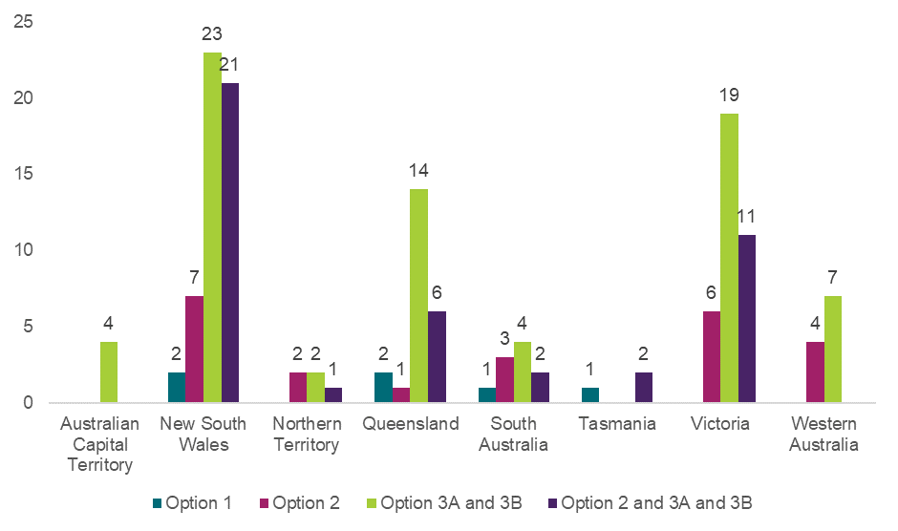

Source: Approved provider survey, as of 11 June 2025, Q54, n=145.

### What is the recommended option(s) and how will it be implemented?

Based on analysis included in this DRIS, the options with the highest net benefit to be provided to Education Ministers for consideration are options 2, and options 3A and 3B. The MCA analysis indicates that these options would generate the most significant improvements to child safety. If implemented, individual states and territories will undertake additional work to support implementation of regulatory options, given jurisdictional variances in WWCC processes.

# 9. Improving the safety of the physical service environment

In relation to centre-based services, this chapter highlights that it is critical for service premises and environments to be designed, built, and maintained in a way that facilitates supervision of children at all times. This is reflected in regulation 115 of the National Regulations. Options for change considered during consultation on the CRIS involve:

* providing guidance to promote the importance of designing and maintaining premises in a way that facilitates supervision of children at all times,
* removing the ability for approved providers to apply for waivers from this critical requirement.

Additionally, this chapter considers how FDC environments could be safer for children, whilst recognising that each FDC residence or approved venue is unique. Options for change considered during consultation on the CRIS involve:

* determining how providers should assess the FDC residence and approve the FDC premises,
* allowing authorised officers to enter all areas of the FDC residence or property in limited and specific situations, including when a serious incident is reasonably believed to have occurred.

Collectively, the reform areas outlined in this chapter aim to improve child safety by ensuring that:

* all children attending education and care services are provided with a child-safe physical environment that meets regulatory requirements,
* providers have clear guidelines to support them to identify and mitigate child safety risks in the physical environment,
* authorised officers have suitable powers of entry to respond to situations impacting children’s safety.

The specific reform areas discussed in this chapter are:

* Chapter 9.1 – Service and temporary waivers for the design of premises (to facilitate supervision of children) (*waivers of regulation 115*),
* Chapter 9.2 – Requiring approved providers to assess not just the FDC residence but areas near the residence *(expanding regulation 116),*
* Chapter 9.3 – Enabling authorised officers to access areas of a FDC residence or property, beyond the service premises, in specific instances or for specific purposes (*amending Division 2 of Part 9 of the National Law*).

## 9.1 Service and temporary waivers for the design of premises (to facilitate supervision of children)

|  |
| --- |
| **Key Insights**  *Problem*   * The approval of waivers for regulation 115 may lead to an increased occurrence of inadequate supervision, which may increase instances in which children experience harm; particularly if additional supervision measures put in place for a waivered service (e.g., the placement of mirrors or CCTV for better supervision or additional staffing) are not fully or consistently complied with. * Nine waivers of regulation 115 were in place as of October 2024 – all service waivers and no temporary waivers.   *Impacts of each option*   * The MCA analysis shows that based on stakeholder input received through the consultation process, all options would deliver a net benefit compared to the status quo. Stakeholders identified greater implementation risks and distributional impacts associated with option 4. * Most stakeholders from the education and care sector were aware that the use of regulation 115 waivers is not common and therefore the proposed options would not lead to sector wide improvements in child safety outcomes. However, options 2 and 3 were the preferred options among surveyed stakeholder groups, including approved providers, the education and care workforce, and families. * Option 3 received a lower weighted score than option 4, reflecting that under option 4 there is a risk that some services may not be able to operate or undertake temporary works to improve facilities, since a service would be unable to apply for a temporary waiver when they may require one due an emergency or other unforeseen circumstances.   *Recommended option*   * Based on analysis included in this DRIS, the options with the highest net benefit to be provided to Education Ministers for consideration are options 2 and 3. This preference is on the basis that these options that would generate most significant improvements to child safety even after accounting for potential implementation costs. Option 4 will not be implemented, largely due to the greater risks associated with being unable to apply for temporary waivers in any circumstance, including emergencies. * Governments will develop communication to confirm that option 3 removes the ability to apply for a service waiver but will not impact any an existing waiver of regulation 115. This limits the impact of proposed reforms on education and care services with an existing waiver in place. |

Supervision is recognised as the most critical element of child safety. Accordingly, section 165 of the National Law mandates that approved providers of education and care services must ensure that all children being educated and cared for by the service are adequately supervised at all times while in their care.

Regulation 115 of the National Regulations requires the approved provider of a centre-based service[121] to ensure that the education and care service premises (including toilets and nappy change facilities) are designed and maintained in a way that facilitates supervision of children at all times that they are being educated and cared for by the service, having regard to the need to maintain the rights and dignity of children.

Approved providers of centre-based service premises that do not comply with regulation 115 are able to apply for a temporary or service waiver[122] if the design and maintenance of premises do not facilitate supervision of children, and under any proposed modifications, the premises would still not meet regulatory requirements. This could be the case, for example, if a service is operating in premises that were not designed for education and care or to facilitate the adequate supervision of children or the building is heritage listed, which limits the modifications that can be undertaken. Alternatively, waivers may be granted if the service must relocate to a temporary premises that does not satisfy regulation 115 due to some circumstance (e.g., having suffered damage due to a natural disaster) which impacts the original premises of the service. A temporary waiver may also be used whilst services premises are undergoing renovation or repair that may impact the ability to supervise children for a limited time.

When applying for a waiver of regulation 115, the approved provider must demonstrate exceptional circumstances and any proposed alternative methods of facilitating the supervision of all children at all times.

### What is the problem?

Waivers for regulation 115 could increase the likelihood of harm to children through the following causal chain:

* the design and maintenance of a centre-based service premises does not comply with regulation 115, which leads to
* a failure to ensure adequate supervision of children in service premises, which leads to
* an increased likelihood that children attending the service will experience harm.

While the number of reported occurrences linking the approval of regulation 115 waivers to instances of child harm is inconclusive, it is foreseeable that such an event could result in significant harm to a child. For example, harm could occur if inadequate supervision results in a child encountering a hazard and suffering an injury or creates increased opportunities for potential offenders to harm children by seeking to exploit gaps in supervision.

The approval of waivers for regulation 115 may lead to an increased occurrence of inadequate supervision, which may increase instances in which children experience harm; particularly if additional supervision measures put in place for a waivered service (e.g., the placement of mirrors or CCTV for better supervision or additional staffing) are not fully or consistently complied with. A key question is whether services can sufficiently maintain supervision of children at all times when a waiver of regulation of 115 is approved. In determining this, it is important to consider:

* how prevalent the service and temporary waivers are for regulation 115,
* if the waivers of regulation 115 are associated with instances of inadequate supervision.

#### Number of service and temporary waivers for regulation 115

Since 2009, 87 applications have been lodged for a waiver of regulation 115 (see Table 9.1). Nine waivers of regulation 115 were in place as of October 2024 – all service waivers and no temporary waivers. Approximately one third of all waivers were temporary waivers that have since expired. Another third were service waiver applications that have since been withdrawn by the service. The remaining applications were invalid, were refused, or were revoked by the Regulatory Authority.

Table 9.1: Quantity of all waivers of regulation 115 by status and waiver type, 2009-2024

| **Waiver status** | **Number of service waivers** | **Number of temporary waivers** | **Total** |
| --- | --- | --- | --- |
| In force | 9 | - | 9 |
| Expired | 2 | 27 | 29 |
| Invalid | 4 | 12 | 16 |
| Refused | - | 2 | 2 |
| Revoked by RA | - | 1 | 1 |
| Withdrawn | 8 | 22 | 30 |
| **Total** | **23** | **64** | **87** |

Source: Information provided by ACECQA.

The number of approved waivers each year has remained relatively stable over time. Since 2013, nine out of ten years have had five or fewer approved waivers of regulation 115.[123] Waivers are only granted by Regulatory Authorities in instances where the approved provider can demonstrate an adequate plan to mitigate identified supervision risks arising from premises design.

Regulatory Authorities indicated that the services that are likely to have waivers for regulation 115 operate out of older premises with design features that cannot be easily altered, for example, strangely shaped yards. These services were generally designed prior to the regulation 115 requirements coming into the National Regulations. Stakeholder input from Regulatory Authorities suggested that most services designed since the introduction of Regulation 115 do not require waivers to operate, as the design of service premises enable supervision of children at all times. Further, services with a regulation 115 waiver are usually LDCs, with some reliance from OSHC services and preschools/kindergartens (refer to Table 9.2). Stakeholders indicated that OSHC services are generally able to address supervisory concerns (i.e., bathrooms not being located close to the provided OSHC space) with a risk assessment and management plan, effective staffing arrangements and policies and procedures that reflect the age of the children they educate and care for. Consulted providers noted that all regulation 115 waivers require detailed risk mitigation and waivers are only granted if the service can demonstrate that child supervision and safety will be maintained through alternative measures (e.g., increased staffing, the use of mirrors to improve supervision, etc.). This supports improved child safety outcomes, even when the design of the premises requires a waiver for regulation 115.

Table 9.2: Quantity of all waivers of regulation 115 by service and waiver type, 2009-2024

| **Service type** | **Number of service waivers** | **Number of temporary waivers** | **Total** |
| --- | --- | --- | --- |
| LDC | 12 | 47 | 59 |
| OSHC | 8 | 11 | 19 |
| Preschool/Kindergarten | 3 | 6 | 9 |
| **Total** | **23** | **64** | **87** |

Source: Information provided by ACECQA.

#### Relationship between regulation 115 and inadequate supervision

A waiver indicates that a building’s structural characteristics may not facilitate the supervision of children at all times, which can increase the risk of harm to children. To date, there is limited systematically reported evidence or data on whether the presence of regulation 115 waivers leads to greater instances of inadequate supervision and actual child harm. This is because breaches of section 165 of the National Law have grown since 2016/17 in a way that is not consistent with the relatively stable and very small number of approved waivers for regulation 115 of the National Regulations.

There were four known breaches of adequate supervision (section 165) among the 11 services that had a waiver in place at any point from 2021-22 to 2023-24 (of which ten waivers are current). This equates to approximately 0.36 breaches per service with a waiver, which appears to be fewer in number than breaches among non-waivered services, although comparability of the data is limited.[124] However, with a very low sample size this relationship cannot be definitively established. In addition, data is not available to indicate whether these four breaches were also associated with harm to children.

Given the relatively low reliance on service waivers currently, it is expected that most service premises are designed to facilitate the supervision of children at all times.

Removing the ability for centre-based services to apply for an ongoing and/or temporary waiver under regulation 115 may, however, help reduce the risk of inadequate supervision of children due to the design of the built environment. This is expected to improve child safety.

### What were the policy options consulted on?

Four options for reform have been developed, including the status quo, a non-regulatory option, and two regulatory options. While options 3 and 4 are mutually exclusive, option 2 can be implemented alongside either regulatory option.

Table 9.3: Policy options under consideration – Service and temporary waivers for the design of premises (to facilitate supervision of children)

| **Option** | **Description** |
| --- | --- |
| 1 | Status quo (no change). |
| 2 | **Non-regulatory**  Providing guidance to promote the importance of designing and maintaining premises in a way that facilitates supervision of children at all times. |
| 3 | **Regulatory**  Amend the National Regulations to remove the ability to apply for service waivers of regulation 115. This option means the ability to apply for a temporary waiver of regulation 115 remains in place for short-term emergent circumstances, with suitable risk mitigation required.  This amendment will have no impact on existing regulation 115 waivers. |
| 4 | **Regulatory**  Amend the National Regulations to remove the ability to apply for service and temporary waivers of regulation 115.  This amendment will have no impact on existing regulation 115 waivers. |

### What are the impacts of each option?

The sections below provide an MCA assessing the potential impacts of the proposed options on child safety outcomes, costs to stakeholders, implementation considerations, and distributional impacts. A detailed overview of the MCA framework underpinning this analysis is available in Chapter 4.

#### Multi-criteria analysis

In assigning MCA scores to reflect the relative benefits and costs of each option, the score for improvement in child safety has been scaled with a zero for option 1 representing no change, and score of three for options 3 and 4, representing the biggest impact on child safety. Other options have been scored between these values based on the assessment of qualitative input from stakeholders. Scores for other categories relating to costs, risks, and distributional considerations have been scaled in relation to these benefits.

Table 9.4: MCA outcomes – Service and temporary waivers for the design of premises (to facilitate supervision of children)

|  |  |  |  |  |  |
| --- | --- | --- | --- | --- | --- |
| **Criteria** | **Weight** | **Option 1** | **Option 2** | **Option 3** | **Option 4** |
| Improvement in child safety | 50% | 0 | 2 | 3 | 3 |
| Net cost of policy option | 30% | 0 | -1 | -2 | -2 |
| Implementation considerations | 10% | 0 | -1 | -2 | -4 |
| Distributional impact | 10% | 0 | 0 | -2 | -3 |
| **Weighted score** |  | **0** | **0.6** | **0.5** | **0.2** |

Note: Option 1 - the status quo - receives a score of zero across all criteria, as explained in Chapter 4.

The weighted average scores for these options suggest that, based on stakeholder input received through the consultation process, all options would deliver a net benefit compared to the status quo. Stakeholders identified greater implementation risks and distributional impacts associated with option 4. The rationale for each MCA score is outlined in the sections below.

#### Impact on child safety

It is expected that the implementation of options 2, 3, and 4 would promote better design of service premises such that supervision of children can be maintained at all times. The extent to which child safety is improved under option 2 will depend on uptake of the guidance materials and the extent to which the current design of premises has impacted the level of supervision of children. There are mixed views among stakeholders on the potential impacts of option 2. Some stakeholders noted that the provision of additional guidance will enable them to interpret regulation more consistently and effectively and therefore better comply with premises design requirements to ensure the supervision of children at all times. Other stakeholders noted that most services have implemented alternative measures to ensure continuous supervision of children during instances where they are not compliant with regulation 115. As such, option 2 may result in a small improvement in child safety.

Options 3 and 4 remove the ability for any new service to apply for service (option 3) and/or temporary (option 4) waivers of regulation 115, which would better enforce premises design for the purposes of adequate supervision of children. Without the option to apply for a waiver of regulation 115, service premises must comply with regulation 115 requirements to operate, which would result in a greater uplift in child safety outcomes than achieved under option 2 where there may still be exemptions in place. Option 4 removes the ability for any service to obtain a permanent and temporary waiver of regulation 115 and therefore may prompt the highest level of regulatory compliance.

Through the consultation, most stakeholders from the education and care sector were aware that the use of regulation 115 waivers is not common and therefore would not lead to sector wide improvements in child safety outcomes. Stakeholders were, however, supportive of reducing existing reliance on regulation 115 waivers where measures could be taken to improve supervision in services and agreed that this would likely contribute to the establishment of child safe environments in the sector.

These views were reflected in the survey, where a large proportion of survey respondents expected options 2, 3, and 4 to ‘somewhat reduce’ the risk of harm to children, with the exception of families and the education and care workforce where the survey respondents expected option 4 would ‘greatly reduce’ the risk of harm (refer to Chart 9.1). Approved provider survey respondents most frequently indicated that each option would ‘somewhat reduce’ the risk of harm to children, though option 4 had the most responses indicating that it may ‘greatly reduce’ the risk of harm. This outcome might be reflective of lower awareness among families and the education and care workforce of the very low reliance on regulation 115 waiver use currently.

Chart 9.1: Family, carers, and parent responses to “How much do you think each option will reduce the risk of harm to children?”

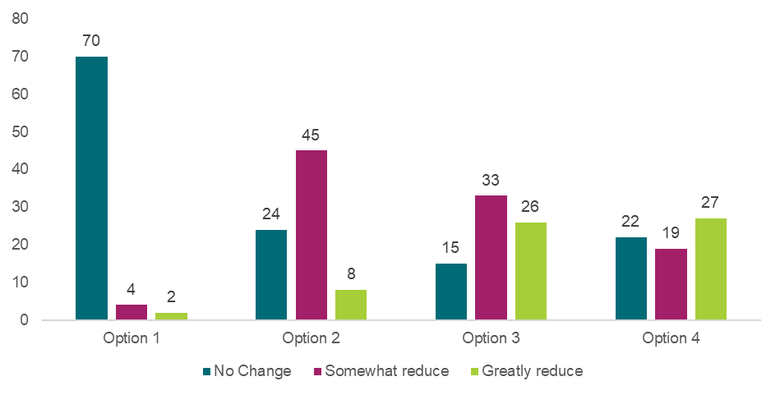

Source: Families, carers and parents survey, as of 11 June 2025, Q80, option 1 n=76, option 2 n=77, option 3 n=74, option 4 n=68.

Chart 9.2: Approved provider responses to “How much do you think each option will reduce the risk of harm to children?”

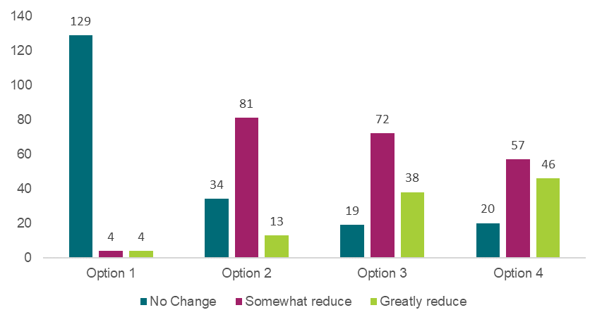

Source: Approved provider survey, as of 11 June 2025, option 1 n=137, option 2 n=128, option 3 n=129, option 4 n=123.

Some stakeholders expressed sentiment that the likely improvement in child safety outcomes achieved by the regulatory options would not be outweighed by potential costs that could be incurred if the regulatory options prevent renovations from being undertaken. On that basis renovations to a premises to comply with regulation 115 could result in temporary disruptions in the quality of supervision in a service but would ultimately improve the quality of the service premises in the long run to allow for adequate supervision of children.

Based on evidence regarding the prevalence of non-compliance and stakeholders’ views, option 2 has been assigned a score of two for this criterion. Options 3 and 4 are expected to result in similar impact to child safety, as both remove the ability to apply for permanent waivers of regulation 115, while only option 4 applies to temporary waivers. However, historical reliance on temporary waivers has been very limited. On this basis, options 3 and 4 have been assigned the same MCA score of three for this criterion, as the benefit applies to a similarly small subset of services.

#### Cost of each option

Under option 2, the development and distribution of guidance materials to promote premises design for supervision may incur costs for government, depending on the complexity of the guidance and the extent to which it cannot be developed with the support of existing government resources and as part of business-as-usual activity. Approved providers may also experience costs under option 2, in the event that they choose to adopt recommended guidance and undertake changes to the design of their premises to improve the supervision of children. The magnitude of costs is challenging to estimate as it depends on the level of changes required to the physical environment of service premises to align with best practice.

The costs of options 3 and 4 would only be borne by services required to comply with regulation 115. Since 2013, 38 waivers (total service and temporary) for regulation 115 have been approved – an average of just over three approvals per year.[125] Assuming the application rate for these waivers would remain consistent, this equates to a relatively small sector-wide cost if options 3 or 4 are implemented.

Under options 3 and 4, services that may have sought to request a regulation 115 waivers in the future may bear costs from having to seek alternative arrangements. In many cases, this may require changing building plans and/or undertaking building works to ensure premises that are currently under construction are adequately designed to facilitate supervision of children at all times. If changes are required after a building is constructed, this could incur a substantial cost, depending on the magnitude of renovation / reconstruction changes required. For example, stakeholders indicated that the cost to add in a window to a sleep room would likely be low (e.g., a few thousand dollars), while reconfiguring an internal room layout would likely be substantially more expensive.

However, if design elements requiring change are identified early in the stages of planning a premises design, it is possible that compliance with regulation 115 would incur little to no additional cost for services. Stakeholders indicated this is usually how approved providers ensure their premises are compliant with regulation 115 and is likely why the use of waivers is generally among services that were designed prior to the introduction of regulation 115. As building design requirements have become clearer since many older services were initially designed, it is possible that existing use of waivers will decline in the future.

Stakeholders indicated that there may also be instances where building works cannot be undertaken under option 4, which could then require a service to move to an alternative compliant building or premises to continue to provide education and care. This cost would also be substantial, but there would be significant variance depending on the size of the service and the leasing costs of alternative building or premises.

Based on the cost evidence available, option 2 has been assigned a score of negative one for this criterion. This reflects the non-regulatory nature of this option, and the relatively low prevalence of inadequate supervision created by premises design. Options 3 and 4 have been assigned the same MCA score of negative two for this criterion. This reflects the low reliance on waivers currently (which would likely continue into the future, without intervention). However, costs for services that would have otherwise relied on waivers could be substantial.

#### Implementation considerations

Due to the non-regulatory nature of option 2, the sector may choose not to follow guidance materials and instead continue to rely on waivers for regulation 115. As a result, option 2 has been assigned an MCA score of negative one for this criterion.

Options 3 and 4 have the potential to impose more substantial risks, particularly if a suitable premises for education and care services cannot be found and budget does not allow for a new building to be constructed (this may be more likely for not-for-profit services or services located in low socio-economic areas). In extreme cases, options 3 and 4 could prevent a service from providing education and care (likely on a temporary basis) if suitable premises are not found, resulting in a reduction in the provision of education and care.

“We operate out of an older building, and we already know we would be unable to find a suitable building to relocate to when we have to renovate.” – Approved provider survey response

The removal of both service and temporary waivers (option 4) is perceived to have more significant impacts. The inability to request a temporary waiver may require services to either undertake building works or temporarily close a service to allow renovations to ensure building design complies with the requirements of regulation 115. This could have significant impacts for children and families that are reliant on that service. Similarly, the removal of the ability to apply for a temporary waivers could also have an unintended consequence of preventing any services relocating temporarily, due to an emergency or natural disaster, from operating.

“To refurbish and/or increase licence capacity at services requires waivers as there is limited facilities to move the program for the works to occur.” – Approved provider survey response

While the abovementioned implementation considerations could be material, statistics on the number of waiver applications indicate that these changes would affect a small subset of the wider education and care sector. As a result, option 3 has been assigned a score of negative two for this criterion, while option 4 has been assigned a score of negative four. The higher score for option 4 is a reflection of a service being unable to apply for a temporary waiver when they may require one, due to an emergency or other unforeseen circumstances.

It should be noted that while the MCA scores currently consider the implementation considerations based on the options that were consulted on, the recommended implementation of these options may alleviate some of these risks. For example, communications to the sector that current waivers will not be affected may reduce concern among stakeholders. These implementation considerations are outlined in *What is the recommended option(s) and how will it be implemented?*

#### Distributional impacts

Stakeholders held the view that the removal of the ability to apply for regulation 115 waivers under options 3 and 4 could disproportionately impact OSHC services and regional and remote services.

Consulted stakeholders from OSHC services indicated that they typically have less control over the design of the physical built environments that they operate in. As such, these stakeholders reported concern that removing the ability to apply for regulation 115 waivers would have a disproportionately larger impact on OSHC services. However, options 3 and 4 would only apply to the application of new waivers, noting existing service and temporary waivers would not be impacted. Given that the current reliance on regulation 115 waivers among OSHC services is very limited, this impact may not materialise in practice.

Stakeholders also reflected that the removal of the ability to apply for a waiver of regulation 115 could have a disproportionate impact on providers operating services in regional and remote areas, due to the limited availability of tradespersons to resolve any issuing impacting supervision at a premises. The availability of tradespersons could also impact services located in disaster-affected areas, which may be reliant on a temporary waiver due to the need for temporary relocation of a service following a disaster event.

Based on the identified impacts, option 3 has been assigned an MCA score of negative two, while option 4 has been assigned a score of negative three. This is on the basis that option 4 could have a slightly higher disproportionate impact for disaster-affected areas.

Stakeholders identified no distributional impacts associated with option 2. As a result, it has been assigned an MCA score of zero for this criterion.

#### Stakeholders’ preferred option

Most approved providers, the broader education and care workforce and families, parents and carers preferred options 2 and 3, often in combination (refer to Chart 9.3 and Appendix Charts 12.3.5.4-6). Families, parents and carers expressed the strongest preference for option 4 among stakeholder groups but still nominated an overall preference for options 2 and 3 when accounting for individual option preferences and combined option preferences (refer to Chart 9.4). Only one, small local council approved provider expressed support for option 4 in a long form written submission,

Chart 9.3: Approved provider responses to “What is your preferred option or combination of options?”

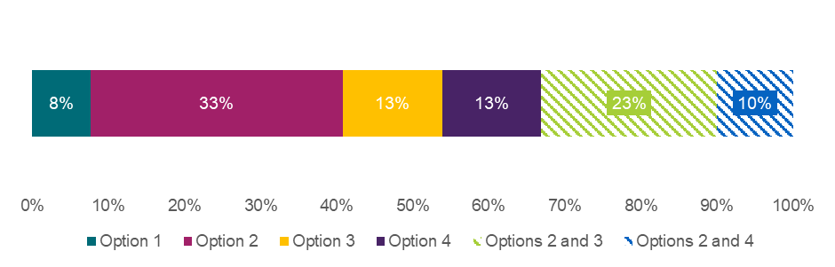

Source: Approved provider survey, as of 11 June 2025, Q78, n=130. Note that no respondents selected the following combinations of options: 3 and 4, 2, 3 and 4. Note that if a respondent selected a combination of options, that selection is treated as a unique preference and not double-counted in each individual option.

Note: Figures may not sum due to rounding.

Chart 9.4: Family, carer, and parent responses to “What is your preferred option or combination of options?”

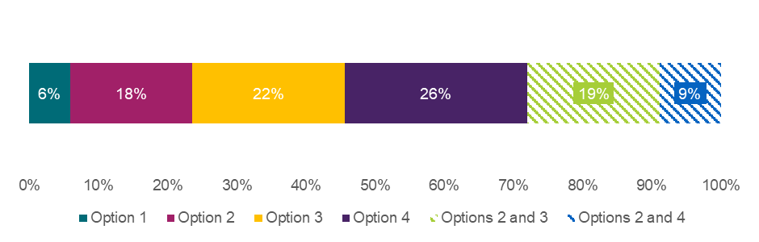

Source: Families, carers and parents survey, as of 11 June 2025, Q78, n=68. Note that no respondents selected the following combinations of options: 3 and 4, 2, 3 and 4. Note that if a respondent selected a combination of options, that selection is treated as a unique preference and not double-counted in each individual option.

Note: Figures may not sum due to rounding.

### What is the recommended option(s) and how will it be implemented?

Options 2 and 3 are the options to be provided to Education Ministers for consideration. This is on the basis that these options would generate the most significant improvements to child safety even after accounting for potential implementation costs. Option 4 has not been included as a recommended option, largely due to the greater implementation risks associated with being unable to apply for temporary waivers in any circumstance, including emergencies.

If the recommended options are implemented, the governments will develop communication to confirm that option 3 removes the ability to apply for a service waiver but will not impact any an existing waiver of regulation 115. This limits the impact of proposed reforms on education and care services with an existing waiver in place.

## 9.2 Requiring approved providers to assess not just the FDC residence, but areas near the residence

|  |
| --- |
| **Key Insights**  *Problem*   * Regulation 116 currently requires approved providers to assess the FDC ‘residence’. It does not consider different configurations and layouts of residences (e.g. multiple dwellings on one property, property type) or the outside spaces that surround residences. This may lead to varying expectations and practices across states and territories for the boundaries of assessment of FDC residences. * There are anecdotal reports across states and territories that children attending FDCs have been able to access garages, sheds, or outdoor locations in which hazards such as machinery, chemicals, and insect nests were present. The presence of these hazards, and other foreseeable items, located near the FDC residence raises concerns for children’s safety.   *Impacts of each option*   * The MCA analysis shows that all proposed changes are expected to have a net positive impact on improvement in child safety even after accounting for costs and implementation risks, with option 4 having the highest weighted score (0.3), and option 2 and 3 being equal (0.1). * Options 2, 3 and 4 were the preferred option among most providers, however it is noted that FDC services expressed strong preferences against option 3 due to the sector’s perspective that the impact of option 3 would be limited in reducing the risk of harm to children in these services. * Option 3 received a lower weighted score than option 4, reflecting the substantial implementation risks identified by FDC stakeholders.   *Recommended option*   * Based on analysis included in this DRIS, the options to be provided to Education Ministers for consideration are options 3 and 4. In terms of benefits, these options are expected to improve the consistency of FDC assessments and provide greater clarity to FDC educators on where education and care services are to take place and which in which areas all risks to child safety need to be mitigated. * Governments will work closely with the FDC sector to address a range of identified implementation considerations. This includes the provision of more prescriptive guidance alongside regulatory changes. |

Regulation 116 of the National Regulations requires the approved provider of an FDC to conduct an assessment (which includes a risk assessment) of each proposed FDC residence or venue, before education and care is provided to children at the residence or venue, and on an annual basis.

For FDCs operating from a residence, the assessment is required to encompass the entire FDC residence (i.e., the habitable part of the dwelling), rather than just the areas where education and care is provided (referred to as the FDC ‘service premises’) (refer Figure 9.1). The assessment is not required to include other spaces, such as sheds and outdoor spaces.

Figure 9.1: Diagram example of the boundaries of an FDC service premises and FDC residence relative to property boundary

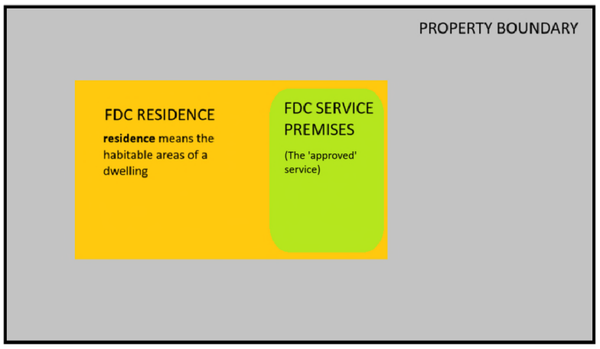

### What is the problem?

Regulation 116 currently requires approved providers to assess the FDC ‘residence’. It does not consider different configurations and layouts of residences (e.g. multiple dwellings on one property, property type) or the outside spaces that surround residences. This may lead to varying expectations and practices across states and territories for the boundaries of assessment of FDC residences.

There are anecdotal reports across states and territories that children attending FDCs have been able to access garages, sheds, or outdoor locations in which hazards such as machinery, chemicals, and insect nests were present. The presence of these hazards, and other foreseeable items, located near the FDC residence raises concerns for children’s safety.

Serious risks to children’s physical, emotional, and overall wellbeing could arise if they access areas within the broader environment (i.e., beyond the FDC service premises and residence) that contain hazards. Children may suffer physical harm from injuries or accidents due to exposure to hazardous materials or equipment found in garages, sheds, in areas of an FDC environment outside of the FDC residence.

Where one or more areas around an FDC residence have not been assessed by an approved provider, the FDC service’s risk mitigation strategies may not address the full extent of potential hazards or risks that children may encounter while attending an FDC. Approved providers support FDC educators in implementing risk mitigation strategies within the areas that they have assessed. The absence of a risk assessment for some areas can increase the risk of harm to children if they access these areas, particularly if they are not subject to the same risk mitigations in place within the service premises.

There could be a range of ways in which children access areas outside of an FDC residence, such as:

* FDC educators taking children to parts of the property that have not been assessed as part of the residence (e.g., visiting a shed on a property to engage in a tinkering activity),
* inadequate supervision of children may lead to children accessing areas outside of the service premises. This could lead to children accessing hazardous materials or areas outside of the FDC residence, raising concern for their safety and being exposed to other harms.

Over the last five years, there were 75 confirmed breaches of regulation 99 (children leaving the education and care service premises) in FDCs.[126] While data was not obtained on the number of times this also coincided with an incident of harm to a child, taking a precautionary approach assumes that the risk of harm has the potential to be greater in areas that have not been assessed for risks and have a mitigation strategy in place.

In addition, the current National Law and National Regulations do not require approved providers to formally approve the boundary between the FDC service premises and the broader FDC residence. This can result in a lack of clarity among FDC educators and families around which areas of the FDC residence are allowed to be accessed for the purposes of undertaking education and care.

This has previously resulted in children accessing areas of a FDC residence or surrounding property that have not been formally approved as suitable for the provision of education and care, including:

* an FDC educator using a shed (outside of the residence) to provide education and care,
* an educator changing nappies in a private area (i.e., not the approved service premises) of a residence.

Since these events were reported, there has been a regulatory change (since 1 October 2023) that requires approved providers to display a diagram clearly identifying spaces in which children will be educated and cared for and the existence of any water hazards, water features or swimming pools at or near the residence or venue.[127] There may remain a gap in the regulations for a formalised approval process to determine the service premises within an FDC residence and for this to be updated on a regular basis as risks change.

### What were the policy options consulted on?

Four options, including the status quo, a non-regulatory option, and two regulatory options are under consideration. Options 2 to 4 are not mutually exclusive, and the recommended option for these recommendations can be any combination of the proposed regulatory and non-regulatory approaches.

Table 9.5: Policy options under consideration – Requiring approved providers to assess not just the FDC residence, but areas near the residence

| **Option** | **Description** |
| --- | --- |
| 1 | Status quo (no change). |
| 2 | **Non-regulatory**  Provide more explicit national guidance to FDC approved providers on their obligations under the current regulation 116, including the areas to be assessed and risk assessment/mitigations to prevent children from accessing areas beyond the FDC service premises, and consideration of risks near the residence other than water hazards. |
| 3 | **Regulatory**  Amend the National Regulations (regulation 116) to *explicitly require assessment* of not just the FDC residence but areas near the residence that may be accessible to children. Changes to apply to new assessments and each annual reassessment (not retrospectively), both of which are undertaken by approved providers. |
| 4 | **Regulatory**  Amend the National Regulations (e.g. regulation 116) to *formalise an approval process* for the FDC service premises, as part of the FDC residence i.e. explicit requirement for approval from the approved provider to confirm areas that are used as the FDC service premises. This approval would apply to new FDC service premises. For existing premises, the approval should be confirmed or amended at each annual assessment undertaken by approved providers. |

### What are the impacts of each option?

The sections below provide an MCA assessing the potential impacts of the proposed options on child safety outcomes, costs to stakeholders, implementation considerations, and distributional impacts. A detailed overview of the MCA framework underpinning this analysis is available in Chapter 4.

#### Multi-criteria analysis

In assigning MCA scores to reflect the relative benefits and costs of each option, the score for improvement in child safety has been scaled with a zero for option 1 representing no change, and score of three for option 3, representing the biggest impact on child safety. Other options have been scored between these values based on the assessment of qualitative input from stakeholders. Scores for other categories relating to costs, risks, and distributional considerations have been scaled in relation to these benefits.

Table 9.6: MCA outcomes – Requiring approved providers to assess not just the FDC residence, but areas near the residence

| **Criteria** | **Weight** | **Option 1** | **Option 2** | **Option 3** | **Option 4** |
| --- | --- | --- | --- | --- | --- |
| Improvement in child safety | 50% | 0 | 2 | 3 | 2 |
| Net cost of policy option | 30% | 0 | -1 | -3 | -2 |
| Implementation considerations | 10% | 0 | -1 | -3 | -2 |
| Distributional impact | 10% | 0 | -1 | -2 | -1 |
| **Weighted score** |  | **0** | **0.5** | **0.1** | **0.1** |

Note: Option 1 - the status quo - receives a score of zero across all criteria, as explained in Chapter 4.

These weighted scores show that all proposed changes are expected to have a net positive impact on improvement in child safety even after accounting for costs and implementation risks. While options 3 and 4 received a lower weighted score than option 2, they still achieve a net positive score, based on the higher weight placed on child safety than other criteria. The main reason for the lower overall score for option 3 is the substantial implementation risks identified by FDC stakeholders.

The rationale for each MCA score is outlined in the sections below.

#### Impact on child safety

With the provision of explicit national guidance provided to FDC approved providers, option 2 could help them understand their obligations for the specific areas to be assessed, and the risk mitigation needed to prevent children from accessing areas beyond the service premise. This could improve the quality and coverage of risk assessments and the mitigation strategies thereafter to improve the safety of children attending the service. However, option 2 is non-regulatory and the improvement to child safety is contingent on the scale and level of uptake by approved providers.

Across all surveys, ‘somewhat reduce’ was the most common response to the question of how much option 2 would reduce the risk of harm to children (refer to Chart 9.5). This view was shared between FDCs and all other service types. As such, option 2 has been assigned an MCA score of two for this criterion.

Chart 9.5: Approved provider responses by service type to “How much do you think each option will reduce the risk of harm to children?”

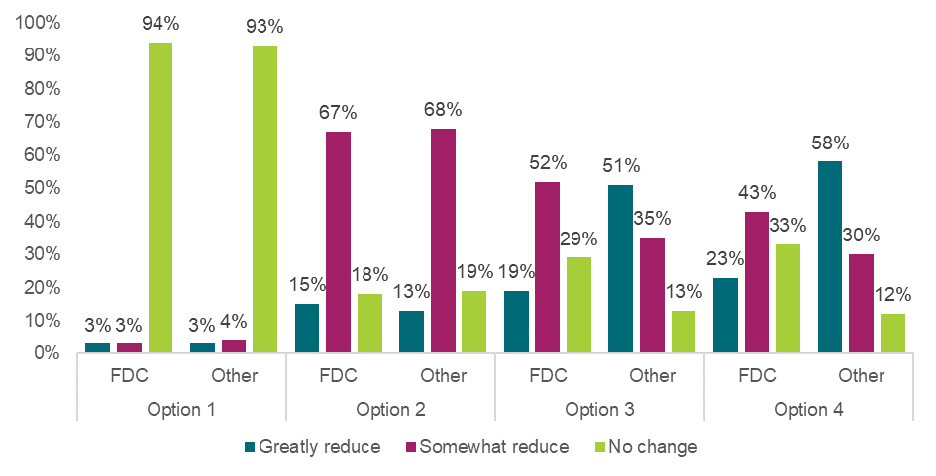

Source: Approved provider survey, as of 11 June 2025, Q85, FDC (option 1 n =34, option 2 n=33, option 3 n=31, option 4 n=30), Other (option 1 n =71, option 2 n=69, option 3 n=68, option 4 n=69). Note “Other” includes all service types except FDC. Columns may not sum to 100% due to rounding.

Option 3 may improve child safety outcomes by expanding risk assessments and mitigation strategies to all areas of the residence and beyond the FDC residence. The scale of impact on child safety for this option is constrained by (1) the residual risk from the base case, where 65% of approved provider survey respondents indicated they already assess broader areas of the residence (refer to Chart 9.6) and 85% of approved providers survey respondents indicated they have risk mitigation strategies in place for potential hazards,[128] and (2) the definition adopted for ‘areas near the residence that may be accessible to children’. Option 3 could help close remaining gaps in risk assessment and mitigation practice nationwide.

Chart 9.6: Approved provider responses by service type to “Are areas broader than the FDC residence ever assessed at your service?”

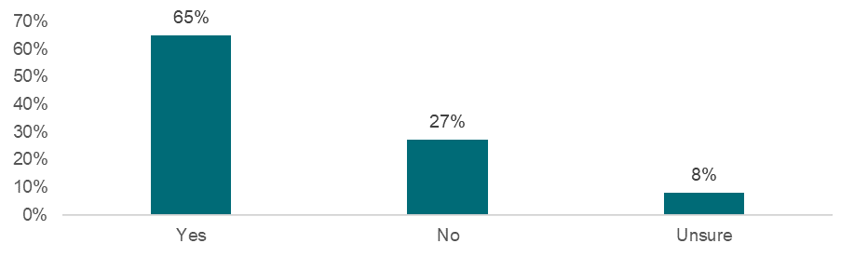

Source: Approved provider, as of 11 June 2025, Q210, n=37. Note that all respondents identified as FDCs.

The diverse range of properties that FDC services operate on will experience varying levels of improvements to child safety depending on their location and setting. For example, FDC service premises located on larger farms or within an apartment complex present different risks to child safety.

The impact of option 3 is anticipated to be more than option 2 and option 4 due to its regulatory approach to require risk assessments and mitigation strategies for broader areas of the FDC residence. In the approved provider survey, FDCs largely indicated option 3 would only somewhat reduce the risk of harm, while all other service types most frequently expected option 3 to greatly reduce the risk of harm (refer to Chart 9.5). Differences in survey responses between FDCs and other service types may reflect FDCs’ practical understanding of how the options would affect their service, whereas responses from other service types may be more speculative. Respondents to the workforce and family surveys most frequently expected that option 3 would ‘greatly reduce’ the risk of harm (refer to Appendix Charts 12.3.5.11-12). Based on this evidence, option 3 has been assigned an MCA score of three for this criterion.

Under option 4, the National Regulations would need to be amended to formalise an approval process for the FDC service premise. This formalisation of the boundaries of the FDC service premises would clarify beyond doubt which areas are approved for the provision of education and care. In consultative activity, stakeholders noted that this option would strike a good balance between maintaining the privacy of FDC educators and clarifying which areas of the FDC residence are used as the service premises.

The impact of option 4 on child safety outcomes is anticipated to be less than option 3 across all surveys except the family survey where option 4 was perceived to have the greatest impact on reducing the risk of harm (refer to Appendix Chart 12.3.5.9). FDC providers and educators held a view that option 4 would be less impactful than perceived by other types of services and largely expected option 4 to either ‘somewhat reduce’ or have ‘no change’ on the risk of harm to children (refer to Chart 9.5). However, the residual risk that is targeted through this reform is relatively low. Based on this evidence, option 4 has been assigned an MCA score of two for this criterion, as it will be likely less impactful than option 3.

#### Cost of each option

Under option 2, the government may incur costs to develop communication materials and national guidance. Incremental costs will be more significant if relevant materials cannot be developed with the support of existing government resources and as part of business-as-usual activities.

Option 2 may also prompt approved providers to undertake assessments of the areas near the FDC residence in cases where current practices involve assessing only the service premises. Noting some uncertainty around implementation, costs would only be incurred among approved providers who choose to act on this guidance and may therefore undertake longer assessments. As a result, option 2 has been assigned an MCA score of negative one for this criterion.

Under option 3, some approved providers would incur additional compliance costs associated with the additional time required to conduct a risk assessment of areas near the FDC residence. FDC services also incur additional compliance costs as a staff member would need to supervise and guide the risk assessor for the duration of the risk assessment, while ensuring continuous supervision of children. Consultative activity with FDC educators across jurisdictions indicated that option 3 could require an additional 1 to 5 hours to complete the risk assessment. The exact cost will depend on (1) the additional time required to complete the risk assessment for a given FDC service, (2) how ‘areas near the FDC residence’ is defined, and (3) the cost of implementing the risk mitigation strategy.

**The cost of assessing FDC residence and areas near the residence under option 3 is estimated to be $2.9 million in present value terms from 2025 to 2034.[129]** This estimate assumes that each assessment would take an additional hour to complete, requiring an hour from an FDC educator, and an hour from the approved provider per assessment and that the total number of assessments undertaken per year aligns to the estimated number of FDC educators – 9,249.[130] From the approved provider survey, 65% of respondents answered that they assess areas beyond the FDC residence at their service, which indicates that only 35% of assessments may experience an incremental cost under option 3. It is assumed that each assessment is attended by one FDC educator and one staff member representing the approved provider. Based on the time taken to undertake the assessments, and the education sector wage rate of $60.60 (including on-costs)[131], each additional assessment would come at a cost of $121 dollars.

Based on the estimated cost, option 3 has been assigned an MCA score of negative three. The cost of option 3 exceeds the cost of option 4 and is similarly expected to exceed the cost of option 2 (given the voluntary nature of this option).

**The cost of formalising an approval process for the FDC service premises under option 4 is estimated to be $2.2 million in present value terms from 2025 to 2034.** Under option 4, the approved provider would incur administrative costs when formalising the areas to be used as the FDC service premises. FDC services would incur a small administrative cost each year to undertake administrative processes for the approval of the service premises. Under the assumption that administrative processes take 15 minutes for an FDC educator to complete and 15 minutes to review by an approved provider, 9,249 FDC educators go through this approval process, and applying the same wage rate as under option 3, the additional cost to the FDC sector in present value terms over a 10-year period is estimated to be approximately $2.6 million. Based on this cost, option 4 has been assigned an MCA score of negative two, as it is likely to exceed the cost of option 2 but is less than the cost of option 3.

The total cost of option 3 and option 4, by jurisdiction, is outlined in Table 9.7.

Table 9.7: Cost of option 3 and option 4, by jurisdiction

|  |  |  |  |
| --- | --- | --- | --- |
|  | **Cost to complete FDC assessments (option 3)** | **Cost to formalise FDC service premises (option 4** | **Total cost** |
| NSW | $880,288 | $646,837 | **$1,527,125** |
| VIC | $959,013 | $704,684 | **$1,663,697** |
| QLD | $679,897 | $499,589 | **$1,179,487** |
| WA | $214,704 | $157,765 | **$372,469** |
| SA | $121,666 | $89,400 | **$211,066** |
| TAS | $35,784 | $26,294 | **$62,078** |
| ACT | $35,784 | $26,294 | **$62,078** |
| NT | $21,470 | $15,777 | **$37,247** |

#### Implementation considerations

During the consultation process, many FDC stakeholders noted concerns and risks regarding implementation, primarily for option 3, including:

* How “areas near the residence that may be accessible to children” is defined would impact the time taken to complete risk assessments and may be limited in its usefulness, particularly if areas near the residence extend to neighbouring properties, for which FDC services are unlikely have control over.
* While approved providers are already required to assess the educator’s entire residence, and not just the premises from which education and care is provided, some respondents expressed concerns that expanding the assessment to areas near the residence would further impact on educators’ privacy. Stakeholders noted that the number of FDCs are declining and an unintended consequence of option 3 could be that some FDCs are deterred from operating, reducing the opportunities for children to receive education and care in FDC services. FDC educators noted that the impact on their right to privacy and the privacy of those living in the FDC residence make it less attractive for people to continue to operate, or to start operating, an FDC.

*“I think that clearly defining the FDC service premises area and ensuring its security (gates, locks), combined with educator identifying wider environmental hazards with risk assessments and mitigation (like locks on garage/shed/animal pens and bedroom doors etc) with the guidance of their approved provider and reviewed annually is sufficient. Having to fully assess and make safe the entire property (window glass on the entire house? Locked cupboards within already locked sheds in ‘out of bounds’ areas?) and surrounding areas (street, neighbouring properties?) is too much paperwork and often very unlikely to help with safety as multiple safety measures will have had to have failed to have a child unsupervised outside of the safe ‘service premises’. It also impeaches on family privacy to not be able to close off private areas of the home and say ‘this area is not accessible to children’ and so should not be under investigation.” – Education and care workforce survey*

*“For many educators, their home is also their workplace. Expanding regulatory oversight into non-operational areas may deter educators – especially those in rental housing or with limited control over structural modifications – from remaining in or joining the sector.” – Written Submission*

* Assessors of FDC premises are not experts in all types of risks. For example, assessors may not be able to identify all risks in areas near the FDC residence which have not been assessed (identifying toxic chemicals or dangerous equipment in outdoor sheds or personal bathrooms).
* There were suggestions from stakeholders that child safety could be improved by ensuring that areas of the FDC premises which are not assessed are inaccessible, noting that demonstrating inaccessibility would meet the requirement of the proposed assessment.

Based on the identified implementation risks, option 3 has been assigned an MCA score of negative three for this criterion. This score reflects the fact that option 3 has reasonable potential to create other unintended consequences. While negative three is a large score in absolute terms, this does not offset the potential benefits of option 3 since the weight placed on implementation risks (10%) is much lower than the weight placed on child safety (50%) (see Chapter 4).

Option 4 had fewer identified implementation risks, however FDC stakeholders did identify some. For example:

* Stakeholders were concerned that they would no longer be able to temporarily change or expand the areas used (e.g. opening another room during wet weather) without formal re-approval, limiting their ability to be responsive and adaptable to changing needs of the service.
* Stakeholders were concerned this could lead to removal or restriction of areas that have previously been used to safely deliver education and care, in the event that safety standards are raised between annual assessments.
* Without clear guidance on requirements under option 4, there is a risk of inconsistent application among approved providers. Some providers may become overly cautious or interpret option 4 differently, resulting in greater restrictions on what areas can be approved.

These implementation risks are expected to be lower than those for option 3, particularly given the existing requirement to display a map of the premises. As a result, option 4 has been assigned an MCA score of negative two for this criterion.

If approved providers chose to adopt practices outlined in guidance materials, option 2 could result in many of the same implementation risks as outlined for option 3, such as breaches in FDC educator privacy. However, since option 2 is voluntary, the uptake of practices and extent of the implementation risks will likely be lower. As a result, option 2 has been assigned an MCA score of negative one for this criterion.

It should be noted that while the MCA scores currently consider the implementation considerations based on the options that were consulted on, the recommended implementation of these options may alleviate some of these risks. These implementation considerations are outlined in *What is the recommended option(s) and how will it be implemented?*

#### Distributional impacts

Stakeholders who engaged in consultative activities noted that option 3 could have some distributional impacts for regional and remote FDCs and for FDCs that operate in rental properties.

For regional and remote FDC services, there may be greater uncertainty how ‘areas near the residence that may be accessible to children’ should be defined, due to the size of some rural properties. Stakeholders have noted that some regional and remote FDC services, particularly those that live on or next to a farm, could be impacted to a greater extent.

For FDC services that operate on a rental property, there are limitations to the legal authority that educators have for all areas of the property on which they operate on. Stakeholders raised concern that there may be some risk mitigation strategies to areas near the FDC residence that are infeasible due to their inability to make changes to their rental property.

Based on these potential distributional concerns, option 3 has been assigned an MCA score of negative two for this criterion. On the basis that some (but not all) approved providers may choose to undertake more expansive FDC assessments due to the guidance materials published under option 2, option 2 has been assigned an MCA score of negative one for this criterion.

There were limited distributional impacts identified for option 4. In the event that explicit approval from an approved provider is required to confirm the areas of an FDC residence that will be used as the FDC service premises, smaller FDC services may experience greater difficultly in fulfilling requirements, particularly if they have less administrative support. As such, option 4 was assigned an MCA score of negative one for this criterion.

|  |
| --- |
| **Box 9.1: Aboriginal and Torres Strait Islander People Stakeholder Views**  It is understood that there are a limited number of ACCO FDC and/or Aboriginal and Torres Strait Islander operated FDC services. However, in consultation with Aboriginal and Torres Strait Islander peak bodies, concern was raised that the perceived regulatory overreach could impact the likelihood of ACCO FDC services to open and continue operations in the future. This could reduce culturally relevant day care options, and flexible care options for families with Aboriginal or Torres Strait Islander backgrounds in the future. |

#### Break-even analysis

The BEA provides an estimate of the extent to which the total cost of child maltreatment in Australia, estimated at $34.6 billion (2025 dollars)[132], would need to be reduced for the cost of the policy option to break even with the potential benefit. The BEA framework is also described in further detail in Chapter 4.

While BEA necessitates putting a dollar figure to the estimated harm to children, it is not possible to quantify the real life harm to children, families, and communities affected.

Table 9.8 identifies break even values for option 3 and option 4. Under option 3, for example, the cost of harm to children in Australia would need to reduce by 0.009% to break even with the estimated cost the option may impose on stakeholders. Given the breadth of the total cost of child maltreatment in Australia and the relatively low evidence base regarding existing harm to children in the status quo (option 1), it is difficult to confirm if the benefits to child safety may outweigh the costs for option 3. Similarly for option 4, it is difficult to determine if the potential improvement in child safety that could be achieved would outweigh costs.

Table 9.8: BEA – Requiring approved providers to assess not just the FDC residence, but areas near the residence

|  | **Option 3** | **Option 4** |
| --- | --- | --- |
| Estimated cost of the policy option | $2.9 million | $2.2 million |
| Break-even reduction in child maltreatment in Australia | 0.009% | 0.006% |

Estimate of regulatory burden

All monetised costs estimated under the ‘Cost of each option’ are compliance costs that would accrue to approved providers. Based on OIA’s guidance on regulatory burden measurement, these costs contribute to the regulatory burden experienced by businesses[133] as a result of options 3 and 4.[134] The regulatory burden estimate associated with options 3 and 4 are $2.9 million and $2.2 million respectively (refer to Table 9.9), however it should be noted that the costs that could not be quantified (e.g., the cost of mitigating any risks identified in areas near the FDC residence) would also contribute to overall regulatory burden costs. The regulatory burden is not included for option 2, as costs are not monetised at this stage.

As it stands the regulatory burden estimates in Table 9.9 assume that the affected approved provider will bear the cost. However, in the event that government funding is available, some of the potential costs may be borne by the government, alleviating the cost to approved providers. As this stage, no decisions regarding the availability of government funding have been made, and such decisions may be at the discretion of individual state and territory governments. Any funding decisions would change who bears the regulatory burden associated with the regulatory options.

Table 9.9: Regulatory burden estimate – Requiring approved providers to assess not just the FDC residence, but areas near the residence, NPV 2025 to 2034, 7% discount rate

|  | **Business** | **Community organisations** | **Individuals** | **Government** | **Total change in costs** |
| --- | --- | --- | --- | --- | --- |
| Option 1 | - | - | - | - | **-** |
| Option 3 | $2,948,607 | - | - | - | **$2,948,607** |
| Option 4 | $2,166,640 | - | - | - | **$2,166,640** |

Note: Some approved providers may be considered community organisations, particularly those that are not-for-profit. For the purposes of this analysis, all approved providers have been classified as businesses.

#### Stakeholders’ preferred option

FDC providers expressed strong preferences against option 3 due to the sector’s perspective that the impact of option 3 would be limited in reducing the risk of harm to children in these services (refer to Chart 9.7). Approved providers as a whole also were in support of options 2 and 4 over option 3 which received low levels of support overall. Respondents to the workforce survey (which was very heavily represented by FDCs) indicated preferences for option 1, 2, and/or 4. Families expressed the highest levels of support for option 3 among all stakeholder groups, but still expressed a stronger preference for options 2 and 4 (refer to Appendix Chart 12.3.5.12). Option 3 received comparatively more support from long form written submissions, including from one large approved provider and FDC peak body. No FDC educators providing a long form written submission expressed support for option 3 or 4.

Overall, these preferences indicate that options 2 and 4 are broadly supported, while option 3 has very low levels of support – particularly from those with day-to-day interactions with FDCs.

Chart 9.7: Approved provider responses to “What is your preferred option or combination of options?” – FDCs only

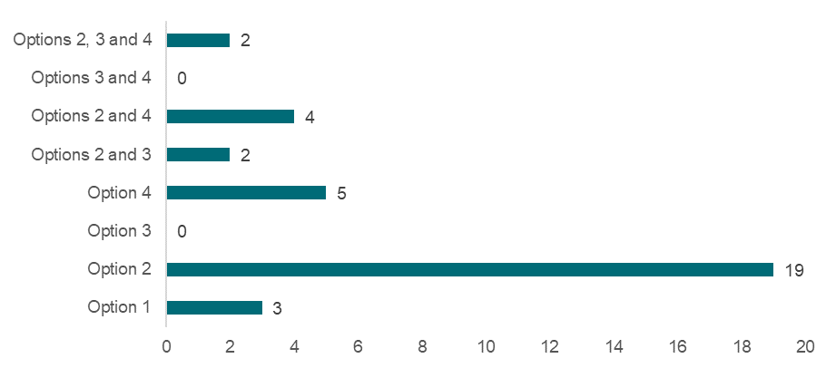

Source: Approved provider survey, as of 11 June 2025, Q87, n(FDC) =35.

### What is the recommended option(s) and how will it be implemented?

Options 3 and 4 are the options to be provided to Education Ministers for consideration. This is on the basis that these options would generate the most significant improvements to child safety even after accounting for potential implementation costs. In terms of benefits, these options are expected to improve the consistency of FDC assessments and provide greater clarity to FDC educators on where education and care services are to take place and which in which areas all risks to child safety need to be mitigated.

Governments will work closely with the FDC sector to address a range of identified implementation considerations and reduce the potential risks identified by stakeholders. This includes the provision of more prescriptive guidance alongside regulatory changes on:

* requirements to rectify any risks identified following an assessment, such as ensuring an area of the FDC residence is ‘inaccessible to children’,
* the processes by which the areas to be used for the provision of education and care are approved.

## 9.3 Enabling authorised officers to access areas of a FDC residence or property, beyond the service premises, in specific instances or for specific purposes

|  |
| --- |
| **Key Insights**  *Problem*   * Without provisions for an authorised officer to access areas of the residence or surrounding property outside the FDC service premises that is in the possession or control of the FDC educator, the ability of Regulatory Authorities to intervene to preserve the safety, health, and wellbeing of children is limited. If hazards are present, there is a significant potential risk that children are exposed to harm, which could be prevented with expanded entry powers. * The scale and magnitude of this problem is presently unknown.   *Impacts of each option*   * The MCA analysis shows that all proposed changes are expected to have a net positive impact on improvement in child safety even after accounting for costs and implementation risks. Option 3 had the highest weighted score (0.7). * Option 3 was the preferred option among most stakeholder groups, including approved providers, the education and care workforce, and families. However, FDC services expressed strong preferences against option 3, with the most preferred option being option 2. This divergent view between FDCs and approved providers overall is expected to be a result of the costs and implementation concerns exclusively impacting FDCs. * Option 2 received a lower weighted score than option 3, reflecting the higher weight placed on child safety compared to other criteria.   *Recommended option*   * Based on analysis included in this DRIS, the option with the highest net benefit to be provided to Education Ministers for consideration is option 3. This option was viewed to fill a critical gap in Regulatory Authorities’ current powers to undertake quality and compliance checks in FDC services and investigate potential incidents pertaining to alleged or suspected breaches of the National Law or National Regulations. * Governments will provide more specific guidance with the implementation of this change which confirms that entry powers can only be exercised under the listed instances and purposes identified. |

Part 9, Division 2 of the National Law provides detail on the powers of an authorised officer to enter an approved education and care service premises. An authorised officer is a person authorised by the relevant Regulatory Authority to carry out specific functions under the National Law. Authorised officers have the power to enter, inspect and search a service premises to carry out the following:

* assess and monitor the service (section 197),
* investigate the service (section 199).

These powers have specific requirements that must be met for the entry to be considered lawful. Importantly, the powers refer to the ability for an authorised officer to enter an approved education and care service *premises*. For a FDC service, an education and care service premises consists of:

* an office of the FDC service,
* an approved FDC venue,
* each part of a residence[135] used to provide education and care to children as part of a FDC service or used to provide access to the part of the residence used to provide that education and care.

In practice, for FDCs operating from a residence, authorised officers across states and territories currently seek consent from the FDC educator to view or enter areas beyond the FDC service premises, if necessary to the investigation or visit. Consent is usually sought in a written format.

### What is the problem?

For FDCs operating from a residence, there is potential that areas of a FDC residence or property outside the FDC service premises may contain hazards to the safety, health, and wellbeing of children.[136] Without provisions for an authorised officer to access areas of the residence or surrounding property outside the FDC service premises that is in the possession or control of the FDC educator, the ability of Regulatory Authorities to intervene to preserve the safety, health, and wellbeing of children is limited. If hazards are present, there is a significant potential risk that children are exposed to harm, which could be prevented with expanded entry powers.

At present, authorised officers are conducting around 1,300 visits per year[137] to FDC services[138] around the country. The purposes for these visits are wide ranging and include reasons such as:

* checking the service’s compliance with the NQF (similar to the quality checks undertaken for the rest of the sector),
* responding to a complaint,
* to respond to an incident,
* to undertake an investigation,
* for assessment and rating,
* for educational purposes,
* to approve a service,
* for other purposes.

During each of these visits, the authorised officer may not have reason to go beyond the FDC service premises or will otherwise request permission to go beyond the service premises. If denied, authorised officers cannot go beyond the service premises, even if a serious incident has occurred or they reasonably suspect that a serious incident has occurred. Additionally, authorised officers would be unable to assess or monitor compliance with regulation 97 for emergency evacuation compliance, or regulation 116 for assessing risks at an FDC service premise.

The scale and magnitude of this problem is presently unknown, as there is no systematically reported evidence on:

* how often authorised officers obtain written consent from FDC educators to view, enter and inspect areas of the broader residence or property beyond the FDC service premises,
* how often FDC educators refuse to provide consent for authorised officers to inspect areas of the broader residence or property beyond the FDC service premises,
* how often children being educated and cared for in a FDC service enter areas outside of the service premises, and the extent to which this leads to harm (other than prescribed notifications of serious incidents where children leave FDC service premises).

There have been instances where FDC residences have had significant risks to the safety, health, and wellbeing of children beyond the service premises, but the current powers of entry have inhibited investigation. In more severe cases, law enforcement can become involved in investigating such risks, and police have the power to enter with a warrant. However, most incidents classified as serious incidents under the National Law do not involve criminal activity and therefore do not warrant police involvement.

### What were the policy options consulted on?

Three options, including the status quo, a non-regulatory option, and a regulatory option are under consideration. Options 2 and 3 are not mutually exclusive, and the recommended option for these recommendations can be any combination of the proposed regulatory and non-regulatory approaches.

These options are consistent with the CRIS options, however stakeholder feedback has resulted in explicitly outlining the circumstances in which option 3 would apply, outlined further under What is the recommended option(s) and how will it be implemented?

Table 9.10: Policy options under consideration – Enabling authorised officers to access areas of a FDC residence or property, beyond the service premises, in specific instances or for specific purposes

| **Option** | **Description** |
| --- | --- |
| 1 | Status quo (no change). |
| 2 | **Non-regulatory**  Short guidance or information sheet aimed at authorised officers, FDC approved providers and FDC educators to explain powers of entry in relation to FDC and nationally agreed practices for authorised officers’ access to areas of an FDC residence or property that are not part of the service premises. |
| 3 | **Regulatory**  Amend the National Law to enable authorised officers’ access to areas of a FDC residence or property, beyond the service premises, in specific instances or for specific purposes. These instances or purposes may include:   * a serious incident has occurred, or the authorised officer reasonably suspects that a serious incident has occurred; * to assess or monitor compliance with regulation 116; * to assess or monitor compliance with regulation 97. |

### What are the impacts of each option?

The sections below provide an MCA assessing the potential impacts of the proposed options on child safety outcomes, costs to stakeholders, implementation considerations, and distributional impacts. A detailed overview of the MCA framework underpinning this analysis is available in Chapter 4.

#### Multi-criteria analysis

In assigning MCA scores to reflect the relative benefits and costs of each option, the score for improvement in child safety has been scaled with a zero for option 1 representing no change, and score of four for option 3, representing the biggest impact on child safety. Other options have been scored between these values based on the assessment of qualitative input from stakeholders. Scores for other categories relating to costs, risks, and distributional considerations have been scaled in relation to these benefits.

Table 9.11: MCA outcomes – Enabling authorised officers to access areas of a FDC residence or property, beyond the service premises, in specific instances or for specific purposes

| **Criteria** | **Weight** | **Option 1** | **Option 2** | **Option 3** |
| --- | --- | --- | --- | --- |
| Improvement in child safety | 50% | 0 | 2 | 4 |
| Net cost of policy option | 30% | 0 | -1 | -2 |
| Implementation considerations | 10% | 0 | -1 | -5 |
| Distributional impact | 10% | 0 | 0 | -2 |
| **Weighted score** |  | **0** | **0.6** | **0.7** |

Note: Option 1 - the status quo - receives a score of zero across all criteria, as explained in Chapter 4.

These weighted scores show that all proposed changes are expected to have a net positive impact on improvement in child safety even after accounting for costs and implementation risks. While option 2 received a lower weighted score than option 3, it still achieves a net positive score, and is consistent with the preferences and objectives of the Education Ministers. The main reason for the higher overall score for option 3 is the higher weight placed on child safety than other criteria.

The rationale for each MCA score is outlined in the sections below.

#### Impact on child safety

The development of guidance under option 2 on the powers of entry of authorised officers would provide greater clarity for FDC educators, authorised officers, and Regulatory authorities. Clear guidance will create a shared understanding between FDC educators and authorised officers around the nationally agreed practices of authorised officers to view and enter areas of an FDC residence they are permitted to access under the National Law or National Regulations. This option is non-regulatory and would be dependent on authorised officers’ and FDC approved providers’ uptake and access to the developed guidance materials.

*“This option would somewhat reduce the risk by improving understanding and consistency in current enforcement practices, without requiring legal changes… promotes transparency and shared understanding. This option provides education before escalation” – Approved provider survey (FDC)*

Across the approved provider survey, ‘somewhat reduce’ was the most common response to the question about how much option 2 would reduce the risk of harm to children, and this sentiment was shared between FDC services and other service types (refer to Table 9.12). Families, parents and carers and workforce survey respondents also indicated that option 2 was only likely to somewhat reduce the risk of harm. Based on this evidence, option 2 has been assigned an MCA score of two for this criterion.

Table 9.12: Approved provider responses by service type to “How much do you think each option will reduce the risk of harm to children?”

|  | **Option 1** | | **Option 2** | | **Option 3** | |
| --- | --- | --- | --- | --- | --- | --- |
| **Service type** | **FDC** | **Other** | **FDC** | **Other** | **FDC** | **Other** |
| Greatly reduce | 3% | 3% | 23% | 21% | 32% | 65% |
| Somewhat reduce | 2% | 3% | 46% | 56% | 44% | 29% |
| No change | 94% | 94% | 31% | 24% | 24% | 6% |

Source: Approved provider survey, as of 11 June 2025, Q97, FDC (option 1 n =35, option 2 n=35, option 3 n=34), Other (option 1 n =65, option 2 n=63, option 3 n=63). Note “Other” includes all service types except FDC.

Note: Figures may not sum due to rounding.

Option 3 may improve child safety through a few mechanisms. Expansion of entry powers granted to authorised officers (in defined circumstances only) to areas beyond the FDC service premises may reduce risk of harm to children attending an FDC service by enabling remedial action if hazards are identified in areas beyond the service premises, or if incidents have occurred. This is particularly relevant in situations where areas of the FDC residence or property external to FDC service premises represent some hazard to the safety, health, and wellbeing of children, but where consent from the FDC educator for the authorised officer to investigate these areas cannot or will not be granted. Additionally, option 3 would enable timely investigation and inspection of relevant areas of the FDC residence without delays.

Approved provider survey respondents had mixed views on the extent to which harm to children might be reduced under option 3. FDCs indicated option 3 was only somewhat likely to reduce the risk of harm, while all other services indicated that option 3 could greatly reduce the risk of harm (refer to Table 9.10). Respondents to the families, parents and carers survey echoed very similar sentiment on the effectiveness of the proposed options to approved providers, while workforce survey respondents echoed similar sentiment but with a larger number of respondents indicating that option 3 could greatly reduce the risk of harm (refer to Appendix Chart 12.3.5.14).

Based on the balance of evidence collected, option 3 has been assigned an MCA score of four for this criterion, as it is likely to be more impactful than option 2 but some respondents still believed that option 3 may have limited impact.

#### Cost of each option

Under option 2, the government may incur costs to develop communication materials and resources. Incremental costs will be more significant if relevant materials cannot be developed with the support of existing government resources as part of business-as-usual activities. Based on this, option 2 has been assigned an MCA score of negative one for this criterion.

Option 3 imposes additional costs to government for the time taken for authorised officers to enter, access and monitor compliance of the areas beyond the FDC service premises. The threshold to allow officers access is intended to **only include** the following specific circumstances:

* a serious incident has occurred, or the authorised officer reasonably suspects that a serious incident has occurred
* to assess or monitor compliance with regulation 116 (assessments of the FDC residences and approved FDC venues),
* to assess or monitor compliance with regulation 97 (emergency and evacuation procedures).[139]

The scale of the cost hinges on the number of entrances authorised officers undertake in the areas beyond the service premises. The costs of option 3 in financial terms are expected to exceed those imposed by option 2, however they are not expected to be significant. As such, option 3 has been assigned an MCA score of negative two for this criterion. Further, option 3 also imposes non-financial costs, such as concerns for FDC residents’ privacy which are covered below in ‘implementation considerations’.

#### Implementation considerations

This section assigns MCA scores based on implementation considerations for the options that were consulted on from the CRIS. The recommended implementation of these options will alleviate some of these risks, largely by specifying the exact circumstances in which entry powers are granted. These implementation considerations are outlined in *What is the recommended option(s) and how will it be implemented?*

During the consultation process, stakeholders from the FDC sector noted a few concerns and risks regarding the implementation of option 3 as it was described in the CRIS.

First, FDC services often operate at a private home of the FDC educator that may have other residents such as the educator’s family. Option 3 may infringe on the educator’s and other residents’ privacy by entering private living areas of the FDC residence without the requirement to seek prior consent. Across consultative activity, most FDC approved providers and educators agreed that option 3 intrudes on the privacy of FDC educators and their family by allowing authorised officers access to areas beyond the approved service premises. 87% of approved providers in the survey agreed they were ‘highly concerned’ or ‘somewhat concerned’ that expanding the powers of entry granted to authorised officers would directly affect their right to privacy and other residents’ right to privacy (refer to Chart 9.8).

*“Allowing access into bedrooms, family spaces, private gardens – risks infringing on the privacy of not just the educator, but their entire household including children, and other family members. Educators may feel as though they are under constant surveillance even outside of working hours.” – Approved provider survey (FDC)*

However, some stakeholders representing FDCs held different views, indicating that FDCs agree to uphold a certain standard when using a residence to provide education and care.

*“Under a service Code of Conduct, FDC service providers and all people residing in the FDC residence are required to sign a household members agreement. This agreement confirms the residents’ acknowledgement of the standards they are expected to uphold within the FDC residence during education and care service hours. It also confirms that the FDC residence is subject to necessary assessments to ensure compliance with relevant safety standards.” – Written submission (FDC)*

Chart 9.8: Approved provider responses by service type to “To what extent are you concerned that the expansion of the powers of entry granted to authorised officers would impact your right to privacy or the privacy of those living in the FDC residence?”

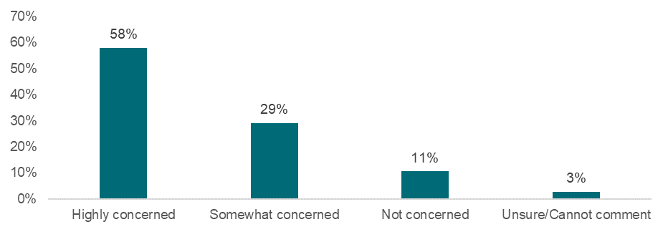

Source: Approved provider survey, as of 11 June 2025, Q36, n=38. Note that all respondents identified as FDCs.

Note: Figures may not sum due to rounding.

FDC stakeholders also reported that option 3 causes increased stress due to potential disruptions and inspections to their private household and family areas, with the effect of undermining trust in the FDC sector. This has negative costs on both the FDC sector, families, and children as the FDC sector would struggle to retain and attract educators, impacting the number of flexible child education and care options for families.

*“Educators might feel their private home life is being invaded or potential for being invaded. Could result in educators leaving the sector and services losing educator numbers. This would threaten viability of the service as services need a minimum number of educators to remain in operation.” Approved provider survey (FDC)*

Stakeholders also identified an implementation risk from the ambiguous phrasing of option 3 (as it currently stands). As the policy option is currently written, entry powers for “specific incidents” and “specific purposes” provides unclear boundaries for FDC stakeholders, causing concern for the potential for disruption to private areas of the FDC residence. Clear legislative drafting and definitions to limit when, why, and how entry is permitted would provide clarity to the FDC sector. From the approved provider survey, FDC stakeholders noted a concern that there is a risk of disproportionate use of powers from authorised officers unless the power is narrowly and clearly defined that is supported with strict procedural safeguards.

Option 3 risks damaging trust and professional relationships between FDC educators and Regulatory Authorities. This could lead to less proactive engagement from FDC services to Regulatory Authorities and reluctance to seek support for fear of being unfairly scrutinised.

*“For a workforce already managing high expectations in isolated settings, this change would be viewed not as a safety improvement, but as a breach of trust and an unacceptable extension of power into personal living spaces.” – Approved provider survey (FDC)*

Finally, several FDC stakeholders indicated that option 3 reduces the attractiveness of remaining in the FDC sector and could exacerbate the declining number of FDC services in the sector.

*“Such regulatory creep risks exacerbating educator attrition and compounding accessibility issues in an already contracting sector.”- Written Submission*

*“We would lose FDC educators… They feel that they have the right to keep their family protected and safe, including their privacy, they consider their home is a safe place for their children. FDC is not Centre Based Care.” – Approved provider survey (FDC)*

Based on the identified implementation risks, option 3 has been assigned an MCA score of negative five for this criterion. This is on the basis that FDC educators held high levels of concern over potential breaches to their privacy. However, if implemented in a way that reduces concerns to FDC resident’s privacy and avoids the likelihood that any human rights charters could be breached (e.g., by being very explicit on the conditions that grant the expanded entry powers), then the implementation risk would be lower and may warrant a higher MCA score. While negative five is a large score in absolute terms, this does not offset the potential benefits of option 3 since the weight placed on implementation risks (10%) is much lower than the weight placed on child safety (50%), (see Chapter 4).

#### Distributional impacts

In consultative activities, FDC stakeholders noted a few potential distributional impacts associated with option 3 including:

* For FDC educators who share the FDC residence with other residents (family, or flatmates), the intrusion of privacy would extend to more people.
* For FDC services that operate on rental properties, educators may not have legal authority over all areas that are beyond the FDC residence. Some remedial actions that could be identified by authorised officers (and were not identified through approved provider inspections required under regulation 116) may be infeasible due to FDC educators’ inability to make changes to some areas of the landlord’s property, or neighbouring properties.
* In culturally diverse communities, entry of authorised officers may be sensitive for certain spaces and areas with cultural or religious significance.

Based on these potential impacts, Option 3 has been assigned an MCA score of negative two for this criterion. No distributional impacts were identified for option 2 and it has therefore been assigned an MCA score of zero for this criterion.

|  |
| --- |
| **Box 9.2: Aboriginal and Torres Strait Islander People Stakeholder Views**  Aboriginal and Torres Strait Islander Peoples held similar concerns for the adoption of option 3 as they did for option 3 in Chapter 9.2. This sentiment is echoed below.  It is understood that there are a limited number of ACCO FDC and/or Aboriginal and Torres Strait Islander operated FDC services. However, in consultation with Aboriginal and Torres Strait Islander peak bodies, concern was raised that the perceived regulatory overreach could impact the likelihood of ACCO FDC services to open and continue operations in the future. This could reduce culturally relevant day care options, and flexible care options for families with Aboriginal or Torres Strait Islander backgrounds in the future. |

#### Stakeholders’ preferred option

FDC services expressed strong preferences against option 3, with the most preferred option being option 2 (refer to Chart 9.9). This reflects the concerns from the FDC sector has about option 3 if it is implemented. Notably, FDC preferences differ from the broader approved providers who expressed a preferences for option 3, followed by option 2 and 3 in combination, in the survey (refer to Chart 9.10). This diverging view between FDCs and approved providers overall is expected to be a result of the costs and implementation concerns exclusively impacting FDCs.

Chart 9.9: Approved provider responses to “What is your preferred option or combination of options?” - FDCs

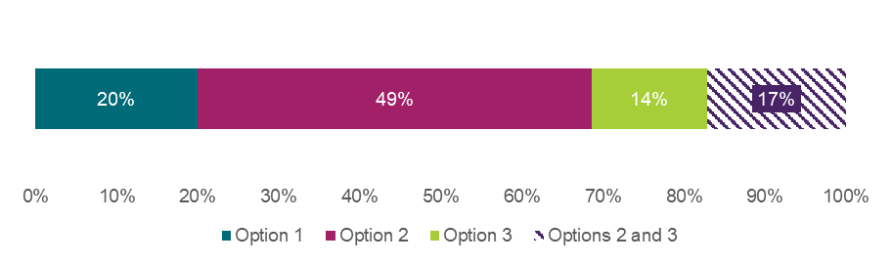

Source: Approved provider survey, responses self-identified as FDC, as of 11 June 2025, Q121, n=35.

Note: Figures may not sum due to rounding.

Chart 9.10: Approved provider responses to “What is your preferred option or combination of options?” – all approved providers

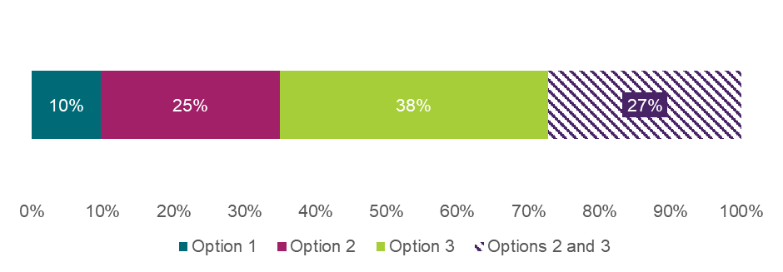

Source: Approved provider survey, as of 11 June 2025, Q121, n=103

Note: Figures may not sum due to rounding.

Respondents to the workforce survey (to which a disproportionate share of members from the FDC workforce responded) expressed a strong preference for option 1. Following option 1, there was a similar number of preferences for options 2 and 3 (refer to Chart 9.11).

Chart 9.11: Workforce responses to “What is your preferred option or combination of options?”

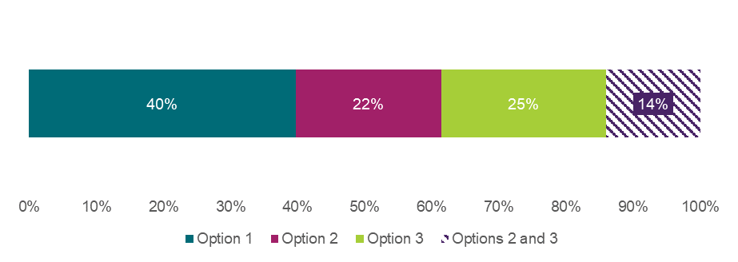

Source: Workforce survey, as of 11 June 2025, Q96, n=171. Note that if a respondent selected a combination of options, that selection is treated as a unique preference and not double-counted in each individual option.

Note: Figures may not sum due to rounding.

Families expressed a very strong preference for option 3 (refer to Chart 9.12).

Chart 9.12: Family, carer, and parent responses to “What is your preferred option or combination of options?”

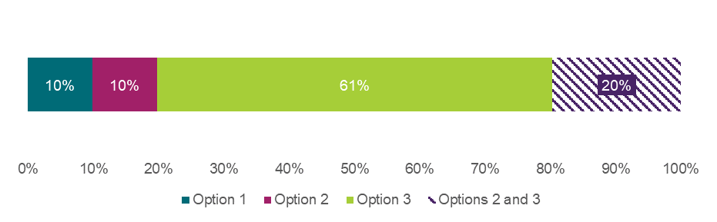

Source: Families, carers and parents survey, as of 11 June 2025, Q96, n=71. Note that if a respondent selected a combination of options, that selection is treated as a unique preference and not double-counted in each individual option.

Note: Figures may not sum due to rounding.

Long form written submissions also largely supported option 3, with a small number of FDC stakeholders not supporting regulatory change.

### What is the recommended option(s) and how will it be implemented?

Option 3 is the option to be provided to Education Ministers for consideration. This is on the basis that this option would generate the most significant improvements to child safety even after accounting for potential implementation costs. This option was viewed to fill a critical gap in Regulatory Authorities’ current powers to undertake quality and compliance checks in FDC services and to be able to investigate potential incidents pertaining to alleged or suspected breaches of the National Law or National Regulations.

If the recommended option is implemented, governments will provide more specific guidance which confirms that entry powers can only be exercised under the listed instances and purposes identified. Specific instances and specific purposes will comprise:

* if a serious incident has occurred, or the authorised officer reasonably suspects that a serious incident has occurred (for example, if a child leaves the FDC service premises, this may need to be investigated by an authorised officer) [140]
* to assess or monitor compliance with regulation 116 (for example, an authorised officer may check to see that hazards in the FDC residence are sufficiently inaccessible to children)[141]
* to assess or monitor compliance with regulation 97 (for example, an authorised officer may need to physically observe evacuation routes).[142]

The provision of this guidance will help to alleviate the concerns around privacy breaches among FDC educators and their family members and set clear expectations around when the expanded entry powers under option 3 can be exercised.

# 10. Additional recommendations

The CSR introduced multiple recommendations intended to uphold child safety in education and care services. Recommendation 16 of the CSR proposes a supplementary child safety review informed by ongoing learning and analysis. This chapter outlines additional recommendations to bolster areas in the education and care sector where opportunities to strengthen the NQF have been identified subsequent to the publication of the CSR.

These additional recommendations seek to:

* enable Regulatory Authorities to more effectively regulate related providers;
* amend the limitation period for commencing prosecution of offences under the National Law; and
* strengthen Regulatory Authorities’ ability to regulate agency educators.

This aims to ensure the NQF maintains a high regulatory standard, fulfilling its intended purpose and prioritising children’s safety and protection in education and care services.

The proposed reform areas discussed in this chapter are:

* Chapter 10.1 – Effective identification, monitoring, and regulation of ‘related providers’,
* Chapter 10.2 – Extending the limitation period for commencing proceedings under the National Law,
* Chapter 10.3 – Improving information sharing requirements for recruitment agencies.

## 10.1 Effective identification, monitoring and regulation of ‘related providers’

|  |
| --- |
| **Key Insights**  *Problem*   * The risks to child safety can be significant when the connections or relatedness of approved providers and services is unknown to Regulatory Authorities. For example, when monitoring the compliance of a single approved provider, or when a single approved provider is seeking to expand its education and care services, the compliance history of the approved provider is known and taken into account in regulatory decision making. * Regulatory oversight of related providers is made more challenging by ‘invisible’ transfers of service approvals, when an entity purchases a corporate provider entity. * There are also jurisdictional inconsistencies in how related providers are identified, monitored, and regulated using varying strategies and approaches. Some jurisdictions use PMCs in common to impact on licensing decisions, others address PMC failings through fitness and priority reassessments of the PMC.   *Impacts of each option*   * Overall, option 3A and 3B is expected to result in the greatest reduction in harm to children, with most stakeholders indicating that this option would ‘greatly reduce’ or ‘somewhat reduce’ the likelihood of harm. * Option 3A and 3B is expected to impose more costs, largely for Regulatory Authorities and approved providers operating with a related provider structure. These would include costs associated with:   + training and upskilling staff on new protocols for related provider issues   + notifying and recording related provider relationships in appropriate systems. * Option 3A and 3B was unequivocally the preferred option of stakeholders consulted and survey respondents and was agreed on by governments.   *Recommended option*   * Based on analysis included in this DRIS, the options with the highest net benefit to be provided to Education Ministers for consideration are options 2, 3A and 3B. If implementing the recommended options, state and territory governments would develop a more explicit definition of related providers for inclusion in the National Law. Governments will also establish protocols by which related provider relationships need to be reported to Regulatory Authorities, both at the onset of the legislative change and for any mergers or acquisitions that subsequently occur. |

There is a risk that Regulatory Authorities cannot effectively monitor compliance with the NQF when there is an increasing number of services operating under different providers approved under the NQF that are held by the same entity or with the same (or some of the same) PMCs (i.e., a person upon whom the legal obligations of an education and care provider are imposed). Providers of this nature are referred to as ‘related providers’.[143]

The current structures and powers under the NQF do not reflect the actual provider structures that have evolved within the sector, do not allow Regulatory Authorities to identify systemic risks at the related provider level, and when risk is identified, do not enable appropriate action to be taken against groups of related providers. The National Law is structured on the assumption of one provider approval to multiple services and is not conceptually set up to deal with groups of related providers.

The National Law sets out processes for obtaining provider approvals, service approvals, and service transfers, and applies provisions for compliance tools[144] under this assumption. Under a related provider structure, when a quality or compliance issue exists at the system level of the related provider, enforcement action can only be taken at the level of an individual provider approval, leaving the risk across the system unaddressed.

The NQA ITS is also not designed to easily uncover or record potential linkages between approved providers, as it records and presents information for individual approved providers only.

A similar problem was identified under Family Assistance Law (FAL), whereby steps have already been taken to include a related provider definition. The definition introduced for FAL (refer to Appendix 12.8) provides a starting point for a potential definition that could be introduced into the National Law, with amendments to ensure it is suitable for the NQF context.

### What is the problem?

The risks to child safety can be significant when the connections or relatedness of approved providers and services is unknown to Regulatory Authorities. For example, when monitoring the compliance of a single approved provider, or when a single approved provider is seeking to expand its education and care services, the compliance history of the approved provider is known and taken into account in regulatory decision making. It is, however, difficult to obtain a similar overall picture for related providers and so regulatory decisions may be made on limited and/or incomplete regulatory intelligence. There are risks to child safety if Regulatory Authorities cannot accurately assess the risk of an approved provider’s expansion if their services under a separate (but related) provider are demonstrating poor quality and/or have a history of non-compliance.

Regulatory oversight of related providers is made more challenging by ‘invisible’ transfers of service approvals, when an entity purchases a corporate provider entity. When an education and care service is transferred from one approved provider to another, the Regulatory Authority has oversight and ability to intervene under Part 3, Division 3 of the National Law. When ownership of the provider entity is instead transferred to another entity, the Regulatory Authority is reliant on a notification of change of PMCs if one is made.

There are also jurisdictional inconsistencies in how related providers are identified, monitored, and regulated using varying strategies and approaches. Some jurisdictions use PMCs in common to impact on licensing decisions, others address PMC failings through fitness and priority reassessments of the PMC. Inconsistencies in how the compliance history of PMCs is taken into account by different Regulatory Authorities, as well as varying risk appetites and thresholds for compliance action, may also impact how coordinated action is taken in relation to multi-jurisdictional providers.

Jurisdictions have experienced tangible, real-world challenges with regulating related providers, which have indicated additional risks to child safety. These investigations have required significant manual effort for jurisdictional Regulatory Authorities to identify related providers. While these investigations have led to the identification of substantial risks to child safety across related providers’ education and care services, enforcement action has only been able to be taken at the individual approved provider level.

### What were the policy options consulted on?

Three options, including one non-regulatory option and one regulatory option are under consideration. Options 2 and 3A and 3B are not mutually exclusive, and the recommended option for these recommendations can be any combination of the proposed regulatory and non-regulatory approaches.

Table 10.1: Policy options under consideration – Effective identification, monitoring and regulation of ‘related providers’

| **Option** | **Description** |
| --- | --- |
| 1 | Status quo (no change). |
| 2 | **Non-regulatory**  Guidance for the sector and families to improve awareness of an increase in the number of services with multiple approved providers that are being operated by a single controlling entity and/or PMCs in common. |
| 3 | **Option 3A (regulatory)**  Legislative amendment to add a definition of related providers that is designed to help Regulatory Authorities efficiently and effectively identify and monitor related providers. Powers for Regulatory Authorities to take compliance and enforcement action at the related provider level would be needed, as well as requirements for providers to disclose they are related. |
| **Option 3B (regulatory)**  Legislative amendment to require notice of acquisition to the Regulatory Authority when ownership of an approved provider is transferred to another entity. |

### What are the impacts of each option?

#### Impact on child safety

Under option 2, guidance would be provided to the education and care sector and to families regarding related providers, offering transparency and assistance that may help families and other stakeholders make decisions about the appropriateness of a service provider. However, relying solely on non-regulatory actions is unlikely to effectively address the challenges in monitoring and enforcing compliance among related providers. As such, this option may not materially improve child safety outcomes.

Option 3A, a regulatory approach, would provide a definition of related providers, powers for Regulatory Authorities to take compliance and enforcement action at the related provider level and establish requirements for providers to disclose they are related. Enacting regulatory powers at the related provider level will support greater monitoring and compliance for related providers effectively reducing child harm while resources are used more efficiently.

Option 3B complements option 3A by requiring notifications to Regulatory Authorities when related provider groups are created or expanded. Mandating notifications of acquisitions to the Regulatory Authority would enhance oversight of related providers, reducing the time required for a Regulatory Authorities to manually identify related providers when considering compliance measures.

Overall, option 3A and 3B is expected to result in the greatest reduction in harm to children, with most stakeholders indicating this option would ‘greatly reduce’ or ‘somewhat reduce’ the likelihood of harm (refer to Chart 10.1).

Chart 10.1: Approved provider responses to “What is your preferred option or combination of options?”

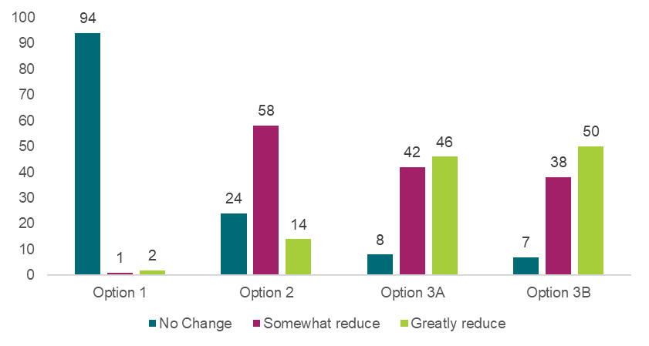

Source: Approved provider survey, as of 11 June 2025, Q103, option 1 n=97, option 2 n=96, option 3A n=96, option 3B n=95.

#### Cost of each option

The government would incur incremental costs associated with developing guidance materials under option 2. Incremental costs will be more significant if relevant materials cannot be developed with the support of existing government resources and as part of business-as-usual activities.

Options 3A and 3B are expected to impose more costs, largely for Regulatory Authorities and approved providers operating with a related provider structure.

The costs of options 3A and 3B for Regulatory Authorities are likely to encompass:

* training and upskilling staff on new protocols for related provider issues,
* notifying and recording related provider relationships in appropriate systems.

Regulatory Authorities noted that investigation and monitoring costs may increase, as there could be additional effort expended in undertaking monitoring related provider relationships, undertaking investigations and issuing compliance actions to related providers. This cost might be partially offset by a reduction in effort required to identify related provider relationships.

Regulatory Authorities were consulted on these potential costs. While noting uncertainty as to the number of related provider relationships and the extent of compliance issues among related providers, Regulatory Authorities indicated that these costs would not be prohibitive.

For any approved providers operating in a group of related providers, option 3A and 3B would impose costs associated with identifying and reporting this related provider relationship. There would also be additional costs for any approved provider seeking to merge with or acquire another approved provider, whereby the change in ownership is subject to reporting requirements. While the actual protocol by which related provider relationships are to be reported is yet to be determined, the cost of making these disclosures is not expected to be too onerous and is therefore not likely to impose a substantial cost. Approved providers operating in a group of related providers or those who might be operating in a group of related providers will need to understand the definition of related providers as defined in the National Law in order to comply with reporting requirements. While consultation did not provide cost estimates due to the definition yet to be determined, there was no feedback that this cost would be onerous.

#### Implementation considerations

Being non-regulatory in nature, option 2 is unlikely to realise substantial implementation risks. There is a reasonable chance that uptake of the guidance will be limited, meaning the effectiveness of this option in improving child safety risks is limited.

Options 3A and 3B are more likely to generate implementation risks. The most substantial risk is that the definition of related providers will need to be carefully drafted to ensure it captures all current related provider structures and is sufficiently future proofed as sophisticated corporate structures continue to evolve. Without carefully considered drafting, the legislated definition of related providers may not capture all related provider relationships that exist presently or may evolve in the future. There is a risk that approved providers will alter their corporate behaviour to avoid being classified as a related provider. Some stakeholders suggested using existing definitions for related entities and corporations, including the adoption of Corporations Law definitions for common control. Others suggested that consideration of family relationships should be taken into account, such as a married couple being on the boards of different approved providers, noting the prevalence of this is currently unclear.

#### Distributional impacts

No material distributional impacts were identified for any of the proposed policy options. While Regulatory Authorities are expected to incur the most costs, they did not indicate that these costs are likely to be prohibitive. The cost impact on approved providers that will need to report related provider relationships is expected to be relatively small.

Overall, these policy options are not expected to generate significant trade-offs for any stakeholder group.

#### Stakeholders’ preferred option

Across all surveys, option 3A and 3B was the preferred option for this recommendation, with some support for option 2. Approximately 70% of approved providers identified option 3A and 3B in their preferred option (with approximately 30% choosing option 3A and 3B only and 42% choosing option 3A and 3B in combination with option 2, see Appendix Chart 12.3.6.4). Similarly, 44% of the education and care workforce identified option 3A and 3B as their preferred option – an additional 49% preferred option 3A and 3B in conjunction with option 2 (Appendix Chart 12.3.6.5). Finally, 34% of surveyed parents, families and carers identified option 3A and 3B as their preferred option – an additional 24% preferred option 3A and 3B in conjunction with option 2 (Appendix Chart 12.3.6.6).

Approved providers in the education and care sector were also highly supportive of option 3A and 3B during consultation. However, it cannot be determined how many approved providers that could be impacted (i.e., those operating with a related provider structure) participated in consultative activities.[145] Stakeholders reflected that providers who may be inclined to do the wrong thing are less likely to engage in public consultation processes. As a result, the overwhelming preference to adopt option 3A and 3B may not be reflective of all impacted stakeholders.

### What is the recommended option(s) and how will it be implemented?

Based on analysis included in this DRIS, the options expected to result in the greatest child safety outcomes for stakeholders to be provided to Education Ministers for consideration are Options 2 and 3A and 3B. These options were unequivocally the preferred option of stakeholders consulted, submissions, and survey respondents. In implementing the recommended options, governments will develop a more explicit definition of related providers for inclusion in the National Law. Governments will also establish protocols by which related provider relationships need to be reported to Regulatory Authorities, both at the onset of the legislative change and for any mergers or acquisitions that take place.

## 10.2 Extending the limitation period for commencing proceedings under the National Law

|  |
| --- |
| **Key Insights**  *Problem*   * The current limitation period does not consider circumstances where there is a reasonable delay in reporting and investigation due to the nature of the offence, such as child abuse. This delay prevents Regulatory Authorities from commencing prosecution proceedings within the two-year limitation period. * There have been matters involving serious harm to children attending an education and care service where prosecution would have been a proportionate sanction in the public interest, however prosecution did not commence because the statute of limitation had expired.   *Impacts of each option*   * Stakeholder input suggests that option 2 would either ‘somewhat reduce’ or ‘greatly reduce’ the risk of harm to children, although approximately 10-20% of survey respondents indicated that they believe this option may have no impact on child safety. Given the small number of instances in which the limitation period expires before an alleged offence comes to the notice of the Regulatory Authority, option 2 is unlikely to impose substantial costs on stakeholders. * Option 2 was unequivocally the preferred option of stakeholders. It was the overwhelming preference among all stakeholders consulted and survey respondents.   *Recommended option*   * Based on analysis included in this DRIS, the option with the highest net benefit to be provided to Education Ministers for consideration is option 2. This preference is based on the expected benefits to child safety outcomes and limited evidence of potential costs. If implementing the recommended option, state and territory governments would develop guidance to clarify that option 2 will not apply to alleged offences that have already occurred (i.e. will not retrospectively apply) and inform approved providers about the recommended record keeping practices for this new requirement. |

Under the National Law there is a two-year statute of limitations on prosecutions for offences contained in the National Law and National Regulations. This means that under section 284 of the National Law, proceedings for an offence under the National Law must commence within two years of the date of the alleged offence. This ensures that legal action is taken within a reasonable timeframe, allowing for timely resolution.[146]

The extended period recognises there are complexities involved with investigating and preparing legal action for offences under the National Law when compared to other summary offences. It also recognises that Regulatory Authorities face limited resourcing relative to law enforcement agencies.

It is proposed that Regulatory Authorities have a longer time period in which to prosecute, including in cases where children have suffered serious harm due to the failure of approved providers, nominated supervisors or educators.

Regulatory Authorities can commence proceedings against an approved provider for regulatory breaches, such as inadequate supervision or failing to report concerns, even while police proceedings against a defendant are ongoing for a criminal offence. In such cases, both proceedings occur simultaneously but address different offences arising from the same incident.

### What is the problem?

The current limitation period does not consider circumstances where there is a reasonable delay in reporting and investigation due to the nature of the offence, such as child abuse. This delay prevents Regulatory Authorities from commencing prosecution proceedings within the two-year limitation period.

There have been matters involving serious harm to children attending an education and care service where prosecution would have been a proportionate sanction in the public interest, however prosecution did not commence because the statute of limitation had expired. While the vast majority of alleged incidents are reported within the two year limitation period from the date of the alleged offence, some Regulatory Authorities from Australian states and territories did recall incidents in the last five years where the limitation period had expired when the incident was reported.

The Royal Commission into Institutional Responses to Child Sexual Abuse found that it takes on average 23.9 years for survivors to disclose childhood abuse.[147] These timeframes present a significant obstacle to Regulatory Authorities taking prosecution action against providers and individuals, unless the limitation period in the National Law is amended.[148]

### What were the policy options consulted on?

Two options, including the status quo and one regulatory option are under consideration.

Table 10.2: Policy options under consideration – Extending the limitation period for commencing proceedings under the National Law

| **Option** | **Description** |
| --- | --- |
| 1 | Status quo (no change). |
| 2 | **Regulatory**  Amend section 284 of the National Law so that the limitation period commences two years from the date that the alleged offence comes to the notice of the Regulatory Authority of each jurisdiction. |

### What are the impacts of each option?

The sections below provide a qualitative discussion on the potential impacts of the proposed options on child safety outcomes, costs to stakeholders, implementation considerations, and distributional impacts, in line with the approach outlined in Chapter 4.

#### Impact on child safety

Option 2 amends the National Law so the limitation period would take effect two years from the date that the alleged offence comes to the notice of the relevant Regulatory Authority, rather than two years after the alleged offence occurs. This change would allow prosecution to occur even if there is a significant delay in reporting, and it would apply to all offences under the National Law and National Regulations.

The proposed adjustment aligns with other regulatory frameworks, which also have a two-year limitation period and follows recent trends in Australian law to remove limitation periods for childhood sexual and physical abuse claims.

Stakeholder input suggests that option 2 would either ‘somewhat reduce’ or ‘greatly reduce’ the risk of harm to children, although approximately 10-20% of survey respondents indicated that they believe this option may have no impact on child safety (refer to Chart 10.2 for approved provider survey input). Ultimately, this amendment is likely to lead to a relatively small increase in prosecutions for breaches of the National Law, however there may be a secondary benefit if potential perpetrators perceive a higher risk of prosecution and are therefore deterred from committing an offence.

Chart 10.2 Approved provider responses to “How much do you think each option will reduce the risk of harm to children?”

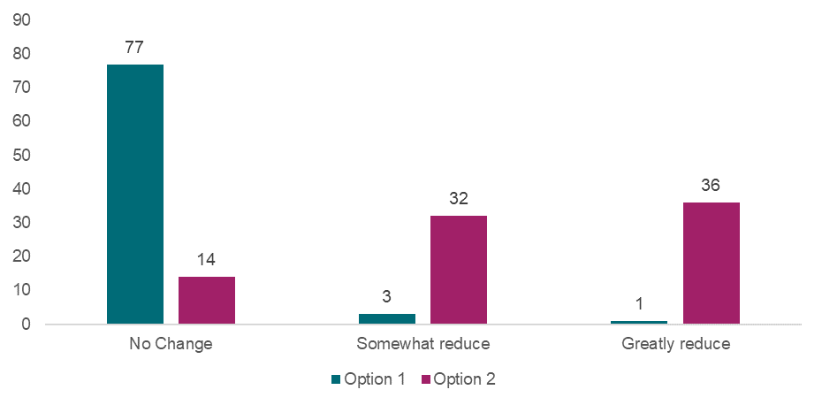

Source: Approved provider survey, as of 11 June 2025, Q111, option 1 n=81, option 2 n=82.

#### Cost of each option

Given the small number of instances in which the limitation period expires before an alleged offence comes to the notice of the Regulatory Authority, option 2 is unlikely to impose substantial costs on any stakeholder. However, Regulatory Authorities may face a larger caseload should the proposed change result in a higher volume of proceedings. This increase in workload could also impose additional costs on the justice system, since investigations by Regulatory Authorities may lead to court cases and possible prosecutions. However, this option is not expected to incur costs for approved providers or other stakeholders, except in cases where approved providers need to provide evidence or support court cases (e.g., as a witness) in cases that would have not proceeded to commencement with the status quo limitation period.

#### Implementation considerations

There are unlikely to be substantial implementation risks associated with option 2. There is a chance that the longer window for prosecution would reduce the likelihood that approved providers can present sufficient evidence in cases where an alleged offence is reported to a Regulatory Authority at a later date. However, this risk is already present for legal proceedings under different laws, including criminal law.

#### Distributional impacts

Stakeholders did not identify any significant distributional impacts associated with this policy option. Regulatory Authorities are expected to be the most impacted in terms of costs, however they did not report these costs being prohibitive. The cost impact on any providers that need to provide evidence for investigations that might have previously been uncollected is expected to occur infrequently; however, no information was gathered regarding the magnitude of this cost.

Overall, option 2 is not expected to generate significant trade-offs for any stakeholder group.

#### Stakeholders’ preferred option

Among approved providers who responded to the survey, option 2 was the preferred option of 88% of respondents (Appendix Chart 12.3.6.10). Similarly, 78% and 94% of workforce and family respondents preferred option 2 (Appendix Charts12.3.6.11-12). Nearly all submissions supported option 2 across a range of respondent types.

### What is the recommended option(s) and how will it be implemented?

Based on analysis included in this DRIS, the option that is likely to result in the highest net benefit to be provided to Education Ministers for consideration is option 2. This preference is based on the expected benefits to child safety outcomes and limited evidence of potential costs. This option was unequivocally the preferred option of stakeholders consulted and survey respondents.

This regulatory change will not apply retrospectively, due to the principle of legal certainty and fairness.

## 10.3 Information sharing provisions for recruitment agencies

|  |
| --- |
| **Key Insights**  *Problem*   * Where an allegation is made against an agency educator and a host provider has an incomplete staff record, Regulatory Authorities have no power to promptly obtain additional information about agency educators from recruitment agencies, such as contact details or copies of qualifications. * There is no ability for a Regulatory Authority to advise a recruitment agency that one of their employed/engaged agency educators is prohibited, nor ability for a Regulatory Authority to proactively advise a host provider that they have a prohibited agency educator working at one of their services. The Regulatory Authority is restricted to advising the relevant WWCC agency and awaiting those processes to take effect; such processes vary across jurisdictions. In the meantime, prohibited agency educators may still be working with children across multiple services.   *Impacts of each option*   * A significant share of stakeholders indicated that the regulatory options would ‘greatly reduce’ the risk of harm to children, with options 3, 4 and 5 expected to more likely to result in progressively greater reductions in the risk of harm to children than option 2. * Options 2, 3, 4 and 5 (all of the regulatory options associated with this reform and the non-regulatory option) are the preferred options. There is strong support for this suite of regulatory options as the preferred options for implementation from all stakeholders, including Regulatory Authorities and recruitment agencies (likely to be the two most impacted stakeholders).   *Recommended option*   * Based on analysis included in this DRIS, the options with the highest net benefit to be provided to Education Ministers for consideration are options 2, 3, 4 and 5. This recommendation is due to the expectation that these options will reduce the risk of harm to children and incur limited implementation costs. |

The use of educators under labour hire arrangements (agency educators) from recruitment agencies to meet prescribed staffing requirements is very common, especially given the workforce shortages across Australia. Agency educators often work across multiple services, for multiple approved providers (host providers) at minimal notice, and for very short periods of time.

The CSR highlights the importance of strong recruitment processes to ensure educators working with children are suitable and appropriate.

### What is the problem?

The current recruitment strategies adopted by some approved providers for agency educators are insufficiently rigorous. Additionally, recruitment agencies may not provide the same levels of oversight, vetting processes, mentoring, professional development, and ongoing monitoring of educators as approved providers do. Despite providing significant numbers of agency educators to education and care services, recruitment agencies may not be aware of required qualification and other regulatory requirements, with no accountability under the National Law and no reporting function. This potentially poses risks of child harm.

***Inclusion of recruitment agencies as specified persons***

Agency educators are staff members under the National Law. The National Law (section 175) requires approved providers to keep staff records, including contact information, evidence of relevant qualifications and training and documents relating to WWCCs. This practice is inconsistent across approved providers, and it is common for providers to keep minimal staff records for agency educators.

Where an allegation is made against an agency educator and a host provider has an incomplete staff record, Regulatory Authorities have no power to promptly obtain additional information about agency educators from recruitment agencies, such as contact details or copies of qualifications.

Authorised officers have the power to gather from ‘specified persons’ any relevant information required for monitoring compliance or other prescribed purposes (section 206). Further, Regulatory Authorities can, by written notice, gather relevant information from specified persons if there are reasonable grounds to suspect an offence has or may have been committed (section 215). A specified person means a person who is or has been:

1. an approved provider, a nominated supervisor, or a staff member of, or a volunteer at, an approved education and care service; or
2. an FDC educator (section 206(4)).

Currently, agency educators who have worked at an education and care service are specified persons under the National Law; however, the recruitment agency through which an agency educator is engaged under labour hire arrangements *is not* a specified person.

Recruitment agencies subject to the *Privacy Act 1988* (Cth) or equivalent, may be prevented from disclosing personal information to Regulatory Authorities, in the absence of an authorising law.

Without complete records or the power to obtain them from recruitment agencies, Regulatory Authorities can be hampered in their ability to promptly obtain evidence from agency educators and in their ability to take urgent action to mitigate risks to children. Through consultation, Regulatory Authorities indicated that they do encounter instances where they need to request information from recruitment agencies. Without inclusion as specified persons in the National Law, recruitment agencies are not obligated to comply.

***Sharing information about prohibited educators***

Under section 188 of the National Law, an approved provider must not engage a person as an educator, FDC educator, employee, contractor, or staff member of, or allow a person to perform volunteer services for, an education and care service if the provider knows, or ought to reasonably know, a prohibition notice[149] is in force under the National Law in any jurisdiction.

Under the National Law, ACECQA and Regulatory Authorities are not permitted to publish information about individuals who are prohibited under section 182 or permitted to share information about prohibited educators with recruitment agencies to ensure they are no longer working with children.

There is no ability for a Regulatory Authority to advise a recruitment agency that one of their employed/engaged agency educators is prohibited, nor ability for a Regulatory Authority to *proactively* advise a host provider that they have a prohibited agency educator working at one of their services. The Regulatory Authority is restricted to advising the relevant WWCC agency and awaiting those processes to take effect; such processes vary across jurisdictions. In the meantime, prohibited agency educators may still be working with children across multiple services.

### What were the policy options consulted on?

Five options, including the status quo, one non-regulatory option, and three regulatory options are under consideration. Options 2 to 5 are not mutually exclusive, and the recommended option for these recommendations can be any combination of the proposed regulatory and non-regulatory approaches.

This recommendation should be considered alongside the potential policy options detailed in Chapter 7.2, so that policy options concerning sharing information about agency educators with their recruitment agency or host provider mirror policy options concerning sharing information about a person (such as whether they’re subject to a prohibition notice, suspension order, or enforceable undertaking) with that person’s approved provider.

Table 10.3: Policy options under consideration – Information sharing provisions for recruitment agencies

| **Option** | **Description** |
| --- | --- |
| 1 | Status quo (no change) |
| 2 | **Non-regulatory**  Guidance/messaging for approved providers regarding the requirement to keep staff records for agency educators. |
| 3 | **Regulatory**  Amend section 206(4) of the National Law to include recruitment agencies supplying educators to education and care services. |
| 4 | **Regulatory**  Amend section 272 of the National Law to allow a Regulatory Authority to share information about an agency educator with that person’s recruitment agency (including mirroring any amendments to section 272 regarding proactive sharing with providers) and consider whether recruitment agencies may have access to the prohibited persons register. |
| 5 | **Regulatory**  Amend section 188A of the National Law to include giving an approved provider or recruitment agency any information about the content or existence of the prohibition notice that is false or misleading in any material particular. |

### What are the impacts of each option?

The sections below provide a qualitative discussion on the potential impacts of the proposed options on child safety outcomes, costs to stakeholders, implementation considerations, and distributional impacts, in line with the approach outlined in Chapter 4.

#### Impact on child safety

Option 2 has the potential to reduce the risk of harm to children and, where it results in increased compliance among approved providers in keeping complete and compliant staff records for agency educators. This would reduce the risk that an agency educator exhibits behaviours that are harmful to children and those behaviours cannot be traced to the correct educator or agency due to poor record keeping.

Options 3 to 5 all improve information sharing with recruitment agencies, which would enable Regulatory Authorities to share information on alleged incidents involving agency educators, in addition to information on prohibition notices, FDC educator suspensions, or enforceable undertakings (refer to Chapter 7.2 for more information on reforms enabling proactive information sharing). These proposed changes are expected to result in a reduction to the risk of harm to children in several ways, including:

* improving the efficiency of investigations into agency educator conduct, through the introduction of recruitment agencies as a specified person, enabling information to be obtained from recruitment agencies,
* reducing the likelihood that a prohibited or suspended agency educator attains employment,
* reducing the likelihood that an agency educator contravenes any enforceable undertaking that applies to them,
* introducing penalties for agency educators who provide false or misleading information about a prohibition notice to an approved provider or recruitment agency, leading to a potential reduction in false or misleading information that is shared.

Through the survey, stakeholders echoed sentiment that option 2 could ‘somewhat reduce’ the risk of harm to children. A significant share of stakeholders indicated that the regulatory options would ‘greatly reduce’ the risk of harm to children, with options 3, 4 and 5 to more likely result in progressively greater reductions in the risk of harm to children (refer to Chart 10.3). Despite this, a large share of stakeholders (between 25% and 58%) also indicated that the regulatory options (options 3, 4 and 5) may only ‘somewhat reduce’ the risk of harm (refer to Chart 10.3), which may be a result of approved providers experiencing varying levels of reliance on agency educators (for example, there is no knowledge of services in Tasmania using agency educators).

Chart 10.3: Approved provider responses to “How much do you think each option will reduce the risk of harm to children?”

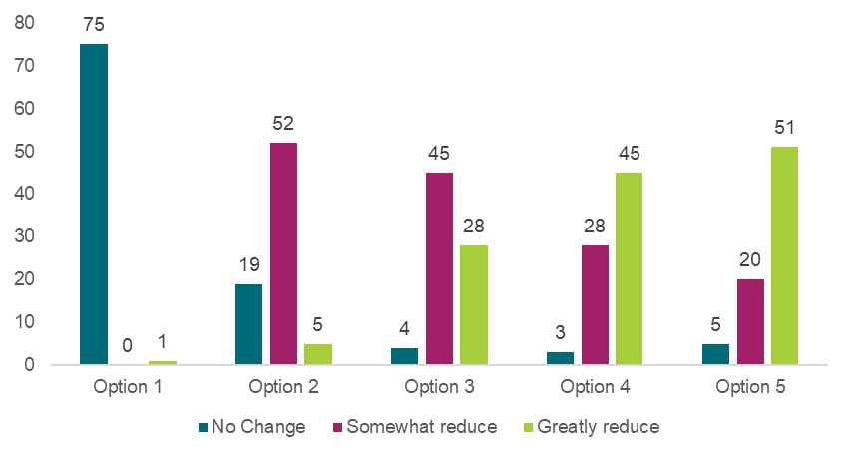

Source: Approved provider survey, as of 11 June 2025, Q119, option 1 n=76, option 2 n=76, option 3 n=77, option 4 n=76, option 5 n=76.

#### Cost of each option

Option 2 could result in an increase in costs for approved providers, in instances where current staff records are non-compliant and the guidance results in improved and more time-consuming practices from the approved provider. However, the cost of this option is subject to the extent to which guidance improves compliance.[150] Under option 2, the government would incur costs to develop guidance and messaging. Incremental costs will be more significant if relevant materials cannot be developed with the support of existing government resources and as part of business-as-usual activities.

Option 3 may generate administrative costs for recruitment agencies. For example, recruitment agencies may need to devote comparatively more time collecting information on agency educators – since they would need to provide any relevant information required by Regulatory Authorities in certain circumstances.[151] Through consultation, recruitment agencies did not indicate that this cost would be substantial and were in favour of the reforms.[152]

Option 4 may result in administrative costs for Regulatory Authorities, as sharing prohibition or other enforcement information with recruitment agencies will require regulatory resources. As outlined in Chapter 7.2, this may be a manual process for Regulatory Authorities, though the scale of the cost would depend on the frequency by which information is shared. On balance, Regulatory Authorities were in favour of the proposed regulatory options which indicates that the potential improvement in child safety would outweigh any costs.

Option 5 is not expected to impose costs for any stakeholder.

In general, there was limited feedback provided on the potential costs of the policy options; however, they were not reported to impose significant or prohibitive costs for any stakeholder.

#### Implementation considerations

There is potential for some risks to arise through the implementation of the proposed options. The most pertinent risk is that the definition of recruitment agencies that is included in the National Law has the potential to exclude some businesses or organisational structures that are intended to be captured in the proposed reforms. As such, the definition of ‘recruitment agencies’ must be carefully considered so that it is relevant to current and future corporate structures of businesses operating in the capacity of a recruitment agency. Where this definition is insufficient, there is a risk to the implementation of options 3 to 5, which rely on recruitment agencies being sufficiently defined as a ‘specified person’ under the National Law.

Under option 2, the most likely risk is that actions outlined in the guidance material are not adopted, which would limit the effectiveness of this option in improving current approved provider record keeping practices for agency educator information. This would reduce the effectiveness of this option in improving child safety outcomes. It is also important to consider that this guidance would outline current regulatory requirements that may not always be followed in practice. A more targeted educational campaign may be required to support approved providers to understand their responsibilities.

#### Distributional impacts

The combination of options 2, 3, 4 and 5 is likely to have the greatest impact on recruitment agencies and Regulatory Authorities; however, neither stakeholder group outlined any prohibitive costs associated with the regulatory options.

#### Stakeholders’ preferred option

There is strong support for this suite of options 2, 3, 4 and 5 as the preferred options for implementation from all stakeholders, including Regulatory Authorities and recruitment agencies (the two stakeholder groups that would be most likely impacted by the implementation of these options).

Across 77 approved provider survey responses, the preferred option was either a combination of options 3, 4, and 5 (29%) or options 2, 3, 4, and 5 (another 29%) (refer to Appendix Table 12.3.6.1). The latter includes the non-regulatory option alongside the regulatory options. Similarly, across the survey to the workforce, the preferred option was either a combination of options 3, 4, and 5 (27% of respondents) or options 2, 3, 4, and 5 (27% of respondents) (refer to Appendix Table 12.3.6.2). Finally, across the survey to families, parents and carers, the preferred option was either a combination of options 3, 4, and 5 (21% of respondents) or options 2, 3, 4, and 5 (25% of respondents) (refer to Appendix Table 12.3.6.3). This was consistent with submission responses.

### What is the recommended option(s) and how will it be implemented?

Based on analysis included in this DRIS, the options with the highest net benefit to be provided to Education Ministers for consideration are options 2, 3, 4, and 5. This preference is due to the expectation that the regulatory options will reduce the risk of harm to children and incur limited implementation costs.

# 11. Implementing and evaluating the recommended options

## Combined impact of the recommended options

This section outlines potential collective or compounding impacts that go beyond the impacts of each individual reform, as heard over the consultation phase.

A culture of child safety

Multiple stakeholder groups expressed the importance of growing and supporting a ‘culture of child safety’ in reducing the risk of child safety. Some spoke directly to the ways that some areas of reform could reinforce others, such as child safety training incorporating guidance around appropriate and inappropriate conduct. Others spoke to the cumulative impacts of a suite of child safety reforms.

### Trust in the sector

A number of submissions, survey responses and consultation/forum participants spoke about the role for this suite of reforms to increase the public’s trust in the sector in respect to child safety and government priorities. Families, parents and carers’ trust and confidence in the safety of education and care services is considered an important enabler for access and participation in education and care services, which can lead to improved child outcomes. The cumulative impact of the preferred policy options will not only increase child safety, but also respond to family, parent and carer concerns about the importance of child safety.

“Regulatory reform…is the best practical way to ensure positive outcomes for children, and for the success of government policy objectives for a universal childcare system, including public confidence in the system.” – Written submission response

In addition, a number of submissions, survey responses and consultation/forum participants expressed support for further regulatory reforms to increase child safety, and further support the public’s trust in the sector. Some spoke to the limitations of proposed reforms in addressing challenges with trust in the sector, noting the scope of this DRIS. This includes the need for stronger safeguards for children which extend beyond current arrangements which sit outside the scope of this review.

Workforce and sector impacts

Several stakeholders expressed concern over individual and collective impacts on the education and care workforce and sector resulting from regulatory changes. These were sometimes described as affecting the professional standing of education and care workforce, particularly in relation to schools and teachers, and therefore impacting motivation and desire to stay in the sector. While many stakeholders outlined the deep commitment of the large majority of the workforce to child safety, there were some concerns that in attempting to regulate for ‘a few’ individuals, the regulations could negatively impact the fulfilling nature of the work. This should be considered within the context of national workforce shortages.

All stakeholders consulted agreed that child safety is paramount. However, some stakeholders, including from peak bodies and individuals from education and care services or providers, felt that some of the proposed changes, particularly when viewed collectively, are associated with a significant regulatory impact. This was perceived in some instances to be undermining trust in educators, teachers, services and the sector as a whole to deliver safe education and care. These stakeholders urged decision-makers to consider the cumulative impact for an already highly regulated sector (in comparison to similar professions), where the risk of harm may be most commonly centred in a few individuals, services or providers, and where the regulatory response could focus on those higher-risk individuals rather than the sector as a whole.

Potential negative impacts on the recruitment and retention of the FDC workforce were mentioned regularly by FDC services and providers (see below).

“Please don't add to our workload - many people are doing the right thing and deserve to be treated as professionals. Make things practical and simple, otherwise people will switch off or walk away” – Free text submission response

In addition, some of the proposed reforms could have implications for workforce shortages, particularly the requirement to have an approved WWCC prior to providing education and care and the expansion of child protection and child safety training to a wider subset of the education and care workforce. The likelihood of workforce shortages emerging may be subject to implementation considerations, such as whether there will be sufficient implementation timeframes for the workforce to fulfil training requirements or whether WWCC screening agencies may be supported with additional resourcing to reduce processing times on WWCC applications.

Risk of over-regulation

Some stakeholders across individual themes noted associated ‘red tape’ with policy options. Most submissions received to date see the associated regulation and administrative burden as acceptable in the context of child safety.

However, others, including Aboriginal and Torres Strait Islander respondents were hesitant of strict regulations and regulatory approaches alongside the potential that training and the application of regulation may not be culturally informed. There was concern that regulatory powers may be used disproportionately with ‘non-mainstream’ services if particular care is not taken to mitigate against this.

Impact on the FDC sector

A large number of survey responses from FDC approved providers, services and families that attend FDC, and submissions responses from FDC peak bodies, educators and approved providers expressed concern for the impact of proposed policy changes on the FDC sector, particularly in relation to the management of digital devices and improving the safety of the physical service environment. Comments were frequently made that FDC needs to be treated as distinct from LDC and that the policy options do not give adequate consideration to the FDC delivery model, and that:

* cumulatively and individually, the proposed areas of reform may negatively impact the home-based environment that families seek through FDC,
* cumulatively and individually, the proposed areas of reform may lead to the closure of FDC services, including due to unsustainable costs,
* some services feel that this is a trend of intervention contributing to a national decline in FDC services, impacting family choice in the mixed market of education and care.

Impacts on volunteers and students

The topic of volunteers came up frequently across many themes. Volunteers can range from regular volunteers to one off incursion/excursion volunteers, to elders working with education and care services to adults living in FDC services.[153] Many stakeholders urged decision makers and policy writers to consider impacts on volunteers, where regulatory burden can impact their propensity to volunteer, with potential negative impacts on children. Often the idea of ‘supervision’ by trained staff was raised as a potential risk mitigation strategy, including in relation to managing digital devices, child protection and child safety, and conduct.

Some stakeholders also raised impacts on students on placement, for instance, ensuring that appropriate training and guidance are covered in courses *before* placements through appropriately structuring course content and sequencing.

Impact on the cost of education and care

Each option that imposes a cost for approved providers has the potential to be passed through in the form of higher fees for families. The risk of cost passthrough is high in the absence of government funding – for which decisions may be at the discretion of individual state and territory governments. The degree to which costs for families will increase has not been measured, since only a select number of costs were monetised.

Impact on regulatory burden

The combined regulatory burden of the recommended options is largely estimated to impact approved providers (businesses, community organisations, and some government owned operations), however approved providers may ultimately pass on this burden to families (individuals) through higher prices for the provision of education and care.

The combined regulatory burden estimates for all monetised costs of recommended options is provided in Table 11.1, noting that for many reform areas, costs were not able to be monetised. As such, this regulatory burden estimate will be lower than the regulatory burden actually imposed on the education and care sector as a result of implementing the recommended options.

As it stands, the regulatory burden estimates in Table 11.1 assume that the affected approved provider or individual will bear the cost. However, in the event that government funding is available, some of the potential costs may be borne by the government, alleviating the cost to approved providers. At this stage, no decisions regarding the availability of government funding have been made, and such decisions may be at the discretion of individual state and territory governments. Any funding decisions would change who bears the regulatory burden associated with the regulatory options.

Table 11.1: Regulatory burden estimate – all monetised recommended options, NPV 2025 to 2034, 7% discount rate

|  | **Business** | **Community organisations** | **Individuals** | **Government** | **Total change in costs** |
| --- | --- | --- | --- | --- | --- |
| *Managing the use of digital devices* | | | | | |
| Option 2 and/or option 3[154] | $23,445,401 | $13,573,653 | - | $4,113,228 | **$41,132,282** |
| *Introducing mandatory child safety training* | | | | | |
| Option 4 | $3,457,248 | $2,001,565 | $3,420,473 | $606,535 | **$9,485,820** |
| Option 5 | $455,406 | $263,656 | - | $79,896 | **$798,957** |
| *Requiring approved providers to assess not just the FDC residence, but areas near the residence* | | | | | |
| Option 3 | $2,948,607 | - | - | - | **$2,948,607** |
| Option 4 | $2,166,640 | - | - | - | **$2,166,640** |
| **Total** | **$32,473,302** | **$15,838,874** | **$3,420,473** | **$4,799,659** | **$56,532,306** |

Note: Numbers may not sum due to rounding.

This regulatory burden is split across Australian states and territories in a way that is roughly proportionate to the number of education and care services in each state and territory. Table 11.2 demonstrates the estimated monetised cost, by jurisdiction, noting that actual costs would be higher once the costs that could not be monetised are accounted for.

Table 11.2: Cost by jurisdiction – all monetised recommended options, NPV 2025 to 2034, 7% discount rate

|  | **Managing the use of digital devices** | **Introducing mandatory child safety training** | | **Requiring approved providers to assess not just the FDC residence, but areas near the residence** | | **Total** |
| --- | --- | --- | --- | --- | --- | --- |
| **Options 2 and 3** | **Option 4** | **Option 5** | **Option 3** | **Option 4** |
| NSW | $13,033,706 | $3,197,068 | $263,450 | $880,288 | $646,837 | $18,021,349 |
| VIC | $12,207,421 | $1,738,242 | $202,420 | $959,013 | $704,684 | $15,811,780 |
| QLD | $8,661,455 | $2,256,894 | $182,840 | $679,897 | $499,589 | $12,280,676 |
| WA | $2,615,842 | $1,222,573 | $62,317 | $214,704 | $157,765 | $4,273,201 |
| SA | $2,732,273 | $382,610 | $48,693 | $121,666 | $89,400 | $3,374,642 |
| TAS | $522,065 | $209,477 | $12,122 | $35,784 | $26,294 | $805,742 |
| ACT | $892,019 | $333,567 | $18,926 | $35,784 | $26,294 | $1,306,590 |
| NT | $467,501 | $145,390 | $8,189 | $21,470 | $15,777 | $658,327 |
| Total | **$41,132,282** | **$9,485,820** | **$798,957** | **$2,948,607** | **$2,166,640** | **$56,532,306** |

Note: Numbers may not sum due to rounding.

## Implementing the recommended options

Implementing the recommended options will involve all state and territory governments, the Australian Government and ACECQA. In some areas of reform, phased implementation may be considered, including guidance and supporting materials developed prior to regulatory change. Multiple stakeholders emphasised the importance of not just guidance but communication materials and engagement with the sector about areas of reform and adequate notice and transition periods. Timing for implementation will be dependent on when legislation can be passed through Parliament in Victoria (the host jurisdiction of the National Law)[155], and the making of amendment regulations by the Ministerial Council.

To support the sector and provide clear communication to the wider community, implementation of recommended options will be considered and aligned with implementation of further recommendations of the CSR and other national child safety policy responses currently in progress.

It is proposed the implementation process for the recommended options will involve all State and Territory governments, the Australian Government and ACECQA and will involve:

* public communication of the outcomes of the Child Safety Review DRIS
* changes to legislation, operational policy and administrative approaches
* modifications to the NQA ITS (the national information technology system)
* Regulatory Authority staff training and resources
* revising national and jurisdiction-specific guidance, supports and information for the sector and the community sector preparation for compliance to regulatory requirements
* sector preparation for compliance with changes to regulatory requirements.

## Evaluating the recommended options

The recommended options will be monitored and evaluated over time by governments and ACECQA, as part of their national oversight role in guiding the implementation and administration of the NQF and monitoring and promoting consistency in the outcomes of its implementation and administration. A nested evaluation (or multi-layered evaluation) is recommended to assess both the individual impact of recommended option(s) as well as the collective impact of implementing a series of child safety reforms on child safety outcomes. This approach is suitable for multi-agency child safety reforms, where governance structures, community environments, and provider contexts differ significantly. Nested evaluations allow evaluators to monitor how recommended options are implemented across different settings, investigate how mechanisms of change may vary across contexts and integrate process, and impact evaluations within one coherent framework.

Noting the challenges in measuring success outlined in Chapter 2, a full evaluation plan will be developed in line with the implementation plan outlined in the section above. The evaluation plan will include the following components:

* An overarching theory of change which will explains how the series of recommended options within reform areas are expected to lead to desired outcomes
* A program logic model (system-level and individual program logic models) which explains the link between inputs, activities, outputs, and outcomes (short-, medium- and long-term outcomes)
* A series of evaluation questions (see below) which define the scope and focus of the evaluation which will seek to test the assumptions within the program logic models.
* A performance indicator framework which identifies measures which will be used to determine performance against each of the evaluation questions. The framework will be informed by both qualitative and quantitative data gathered from both primary data collection and secondary data sources (see below for more information on data sources).

The nested evaluation would comprise three key components:

1. A short-term **process evaluation** to assess the fidelity of the initial implementation of recommended options. The process evaluation is intended to identify initial enablers and barriers and recommend corrective actions to address any identified issues. Formative insights regarding the implementation of proposed options may support education and care services and providers to comply with regulatory changes and support stronger uptake of non-regulatory guidance.
2. A medium-term **intermediate evaluation** to assess the progress of recommended options in supporting the achievement of the short- and medium-term outcomes and contributing to the NQF’s key objective of ensuring the safety, health and wellbeing of all children attending an approved education and care service.
3. A long-term **impact evaluation** to assess the overall impact of recommended options in achieving its key objective. This is ideally tested against a counterfactual of a scenario where recommended options were not implemented. The outcome evaluation will also assess the value for money and cost effectiveness of recommended changes.

Consistent with the objectives of the CSR, the purpose of the evaluation is to assess the degree to which the recommended options have contributed to the achievement of the following overarching objectives:

* establishment of a child safe environment to minimise the risk of harm and hazard to children attending early childhood education and care services
* reduced harm, abuse and neglect in approved early childhood education and care service settings
* the current child safety provisions and arrangements are better aligned with contemporary best practice international standards for child safe environments in early childhood education and care services settings.

The list of evaluation questions provided in Table 11.3 are mapped to the relevant type(s) of evaluation. Evaluation questions have been grouped into three key evaluation domains:

1. Design – examining the degree to which the design of the recommended option(s) is appropriate to meet its overarching objectives.
2. Efficiency – examining the degree to which the recommended option(s) were implemented efficiently and effectively.
3. Impact – examining the degree to which the objectives of the recommended option(s) were achieved and the impact it had. This will also consider the magnitude and distribution of the impacts observed, the extent to which they could be directly attributed to the recommended option(s) and the cost effectiveness of the recommended option(s) as a whole.

*Table 11.3: Evaluation questions*

| **Evaluation domain** | **Evaluation type** | **Evaluation question** |
| --- | --- | --- |
| **Design** | **Impact evaluation** | 1. How appropriate is the design of the recommended option(s) in addressing the problem or opportunity? 2. To what extent have changes in the nature and magnitude of the problem during the implementation period warranted a change in the design of the recommended option(s)? 3. To what extent is the rationale for government intervention via regulatory changes (for relevant reform areas) still appropriate? Why / why not? 4. To what extent do the design of recommended option(s) align with best practice international standards for child safe environments in education and care services settings? |
| **All evaluations** | 1. To what extent are the objectives of recommended option(s) clear and consistent? 2. To what extent are there clear evidence-based links between the recommended option(s)’s inputs, activities and its expected outcomes? 3. To what extent were recommended option(s) adequately resourced to be implemented consistent with initial design decisions? 4. Have any changes or improvements been made to the design of the recommended option(s) since its initial implementation (for example, as a result of continuous improvements or earlier evaluations)? How effective are these changes? 5. To what extent are governance arrangements for the implementation of recommended option(s) effective?    1. Are the roles and responsibilities of all parties involved in the administration of recommended option(s) clearly defined?    2. Are the lines of accountability clear for all parties involved in the administration of the recommended option(s)? |
| **Efficiency** | **Process evaluation** | 1. To what extent has recommended option(s) implemented within scope, timeline and budget? 2. What challenges were encountered during implementation and what actions were taken to overcome them? |
| **All evaluations** | 1. Are there areas in which the operations and procedures could have been more efficient? What changes or improvements have been introduced? How effective are they? 2. To what extent are there clear and consistent guidelines to enable consistent implementation across different context(s) – e.g. different jurisdictions, provider types 3. What are the major risks associated with the implementation of recommended option(s)? How well have the design of recommended option(s) anticipated and mitigated these risks? 4. To what extent do the characteristics of participants (e.g. child safety training participants) match those of the recommended option(s)’s target cohort? 5. To what extent have the recommended option(s) adopted sound data collection and reporting methodologies to track the achievement of identified targets and outcomes? |
| **Impact** | **Process evaluation** | 1. Have any issues or developments emerged that might limit the achievement of intended outcomes? If so, what actions have been taken to address them? |
| **Intermediate evaluation** | 1. To what extent are there early outcomes or indications of future outcome(s) being achieved as a result of the implementation of recommended option(s)? 2. What are the external factors which have impacted the achievement of intended outcomes? If so, is mitigating action required? |
| **Impact evaluation** | 1. To what extent have the recommended option(s) achieved its intended outcomes?    1. What was the magnitude of the changes that occurred?    2. Did the outcomes meet the targets established for specific reform areas?    3. Was the reach of recommended options sufficient to realise the required scale of change? 2. What were the characteristics of participants and/or beneficiaries (e.g. participation by provider type and service location )? 3. To what extent have the outcomes differed by provider management type, service type, service location and staff member type? 4. Were any specific groups (e.g. priority population cohorts, provider types) that were negatively affected by the implementation of recommended option(s)? If so, how? 5. What were the key factors which supported or hindered the achievement of outcomes? What was done to reduce the impact of identified obstacles? 6. Did the implementation of recommended options have any unintended consequences (positive or negative)? How and why did they occur?    1. What action, if any, was taken to reinforce positive unintended consequences and reduce negative ones? 7. To what extent can the return on investment be quantified for the recommended option(s)?    1. For recommended options where benefits and costs can be monetised, to what extent did the benefits of the recommended option(s) outweigh the costs? 8. To what extent were the recommended option(s) cost-effective? |

All evaluations will adopt a mixed-methods approach which comprise primary data collection via semi-structured interviews and surveys as well as relevant secondary data sources. Examples of potential data sources are summarised in Table 11.4. The parties responsible for the collection of new data have not been decided at this stage but will be confirmed prior to implementation of recommended option(s).

As articulated in Table 11.4, examples of measures of impact may include:

* downloads, visits, and other measures of engagement with guidance materials and supporting resources
* changes in the safety of environments, as measured through regulatory assessments (including through assessments and rating against the NQS), perceptions of the workforce and perceptions of families and children
* changes in compliance data
* changes in the number and outcomes of suspension or supervision orders
* assessing changes in WWCC status notifications, enforceable undertakings, prohibitions and use of legislative and regulatory powers
* assessing changes in reports made through reportable conduct schemes, and the likelihood that these are related to regulatory changes
* the number of incidents at education and care services, using regulatory incident data sets.

It is recognised that the implementation of recommended options is occurring alongside other ongoing reforms occurring at a jurisdiction and system level. The proposed evaluation will address this through the development of clear baseline measurements which establishes a clear ‘before’ picture, establishment of multiple data sources to gather insights from stakeholder groups who are most directly affected by the change, and the completion of contextual analysis to identify confounding variables that may affect the achievement of outcomes.

Findings and recommendations from the three evaluations (including detailed analysis of all relevant primary and secondary data) will be captured in the following reporting deliverables:

* Process evaluation report (~1 year after implementation)
* Intermediate evaluation report (~3 years after implementation)
* Impact and outcome evaluation report (~5 years after evaluation)

The evaluation’s governance arrangements will mirror those adopted for the CSR. It is proposed to use existing and targeted mechanisms across relevant portfolios and agencies to ensure that this project is both time and cost efficient. The NQF Regulatory Practice Committee, the Early Childhood Policy Group, the Australian Education Senior Officials Committee and Education Ministers will be briefed on all evaluation report findings and recommendations. The Australian Education Senior Officials Committee will oversee the implementation of evaluation recommendations.

*Table 11.4: Evaluation – Measures to report on, existing data collected, and potential sources of new data*

*Note: Measures and data sources have only been identified for options that are recommended to be provided to Education Ministers for consideration. A full description of each option is available in Appendix 12.1. The extent to which these measures can provide a robust assessment of impact will in some cases depend on the specific drafting of legislation, regulation or other instruments. This is because the specific drafting can determine what types of non-compliance are recorded in current datasets and to what level of detail.*

#### Managing the use of digital devices

| **Option** | **Measures** | **Existing data sources** | **New data sources (to be collected)** |
| --- | --- | --- | --- |
| **Option 2 (Regulatory)** | * Compliance data - Number of providers who utilise service-issued digital devices when taking images or videos of children while providing education and care * Number of instances of non-compliance, by provider management type, service type and service location * Regulatory Authorities and approved providers report reduced likelihood that images and videos of children attending education and care services are handled inappropriately * Approved providers report improved oversight on the storage, disposal and nature of digital content generated in services * Approved providers report reduced likelihood that personal devices are used inappropriately in education and care services settings | * Survey data on National Model Code and Guideline adoption | * Survey to approved providers * Survey to education and care workforce * Survey to parents / carers * Stakeholder consultation with Regulatory Authorities * Compliance data (e.g. confirmed breaches and compliance action taken) on new requirements |
| **Option 3 (Regulatory)** | * Compliance data - Number of approved providers that have implemented policies that ban the possession of personal devices during the provision of education and care and working directly with children * Non-compliance data - Number of penalties for non-compliance, by provider management type, service type and service location * Approved providers and Regulatory Authorities report reduced likelihood that personal devices are used inappropriately in education and care services settings | * Survey data on National Model Code and Guideline adoption | * Survey to approved providers * Survey to education and care workforce * Survey to parents / carers * Stakeholder consultation with Regulatory Authorities * Compliance data (e.g. confirmed breaches and compliance action taken) on new requirements |

#### Child Safety Training

| **Option** | **Measures** | **Existing data sources** | **New data sources (to be collected)** |
| --- | --- | --- | --- |
| **Option 4 (Regulatory)** | * Compliance data - Number of staff members who have completed child protection training (by staff member type, service type, provider management type and service location) * Evidence of improved national consistency in child protection training approaches * Evidence of improved workplace culture on the collective responsibilities of all staff members to keep children safe * Evidence of improved understanding on the role and obligations of staff members to respond to signs of child maltreatment * Staff members report improved knowledge skills, awareness and ability to keep children safe as a direct result of child protection training received | * Compliance data on section 162A | * Survey to education and care workforce * Survey to approved providers * Survey to parents / carers * Stakeholder consultation with Regulatory Authorities and training providers |
| **Option 5 (Regulatory)** | * Number of staff members (including those who do not work with directly with children) who have reported improved awareness and understanding of current child protection laws and their obligations under it * Staff members report improved ability to recognise signs of child maltreatment * Staff members report improved ability to respond and report instances of child maltreatment | * Compliance data on regulation 84 | * Survey to education and care workforce * Survey to approved providers * Survey to education and care workforce |
| **Option 6 (Regulatory)** | * Number of staff members who have completed child safety training * Number of staff members who have reported improved knowledge and capability in maintaining child safety * Evidence of improved quality and national consistency in the delivery of child safety training in ECEC settings * Evidence that the currency of child safety knowledge and capability across the sector is maintained, including knowledge of evolving risks such as those presented by technological advancement * Evidence of improved workplace culture in the sector which prioritises child safety * Staff members report improved ability to detect and response to signs of child harm, abuse, neglect or maltreatment | None identified | * Survey to educators * Survey to approved providers * Survey to education and care workforce * Stakeholder consultation with Regulatory Authorities and training providers * Compliance data on new law and regulatory provisions * Information on completion of new training |

***Responding to educator and staff member conduct - Making inappropriate conduct an offence***

| **Option** | **Measures** | **Existing data sources** | **New data sources (to be collected)** |
| --- | --- | --- | --- |
| **Option 2  (Non-regulatory)** | * Number of approved providers who adopt recommended guidance to address appropriate and inappropriate conduct within contracts of employment and Code of Conduct * Sector stakeholders (including parents / carers) report improved awareness and understanding of what constitutes appropriate and inappropriate behaviours in the providers’ Code of Conduct * Reduced risk and instances of staff member engaging in inappropriate conduct * Number of downloads of guidance materials | None identified | * Survey to approved providers * Survey to education and care workforce * Survey to parents/carers * Data on engagement/download of new resources if housed on ACECQA website * Compliance data on regulation168(2) |
| **Option 3 (Regulatory)** | * Number of instances of non-compliance with regulatory change * Number of instances Regulatory Authorities reported improved ability to address a greater range of inappropriate behaviours which have the potential to cause physical, emotional and/or psychological harm to a child * Evidence that approved providers uphold a higher standard of conduct among the education and care workforce, as evidenced by changes to Code of Conduct * Evidence of reduced risk and instances of staff member engaging in inappropriate conduct * Evidence of improved sector clarity and more consistent expectations of what constitutes inappropriate conduct, leading to adoption of higher standards of conduct across the sector. | None identified | * Survey to approved providers * Survey to education and care workforce * Survey to parents/carers * Compliance data on new requirement * Notification of complaint / allegation / incident data related to the new offence |

***Responding to educator and staff member conduct - Enhancing Regulatory Authorities’ ability to share information with approved providers***

| **Option** | **Measures** | **Existing data sources** | **New data sources (to be collected)** |
| --- | --- | --- | --- |
| **Option 3 (Regulatory)** | * Evidence that providers undertake more comprehensive pre-employment checks (e.g. undertaking prohibition checks / suspension checks for FDC educators) * Approved providers have improved awareness of prohibitions or suspensions (for FDC educators) * Reduced risk and instances of unsuitable individuals being employed in the ECEC sector as a result of more proactive information sharing with approved providers | None identified | * Survey of approved providers * Consultation with Regulatory Authorities |
| **Option 4 (Regulatory)** | * Evidence that providers undertake more comprehensive pre-employment checks (e.g. requesting information on a person’s enforceable undertaking) * Approved providers have improved awareness of a person’s enforceable undertaking * Reduced risk and instances of unsuitable individuals being employed in the ECEC sector as a result of more proactive information sharing with approved providers | None identified | * Survey of approved providers * Consultation with Regulatory Authorities * Number of disclosures |

Responding to educator and staff member conduct - Expansion of regulatory responses to educator and staff member conduct

| **Option** | **Measures** | **Existing data sources** | **New data sources (to be collected)** |
| --- | --- | --- | --- |
| **Option 3 (Regulatory)** | * Number of instances of non-compliance with regulation (e.g. number of suspension orders issued by provider management type, service type and service location) * More rapid regulatory responses to non-compliant or alleged non-compliant conduct where the threshold of risk for prohibition is not met * Evidence that approved providers take more rapid and effective action to manage potential risks of non-compliant behaviours. * Reduced likelihood of educators, staff members and volunteers engaging in inappropriate behaviour * Approved providers establish clearer expectation or implement additional monitoring processes to deter instances of inappropriate conduct. | None identified | * Survey of approved providers * Survey to education and care workforce * Consultation with Regulatory Authorities * Compliance action data – Suspension notice/order * Compliance data on show cause processes |
| **Option 4 (Regulatory)** | * Number of instances of non-compliance with regulation (e.g. number of supervision orders issued by provider management type, service type and service location) * Regulatory Authorities reported improved ability to hold approved providers accountable for supervising educators, staff members or volunteers who pose a risk to children at a level that falls short of the threshold for prohibition. * Evidence that approved providers take more rapid and effective action to manage potential risks of non-compliant behaviours. * Reduced likelihood of educators, staff members and volunteers engaging in inappropriate behaviour * Evidence that approved providers establish clearer expectation or implement additional monitoring processes to deter instances of inappropriate conduct. | None identified | * Survey of approved providers * Survey to education and care workforce * Consultation with Regulatory Authorities * Compliance action data – Supervision order * Compliance data on show cause processes |
| **Option 5 (Regulatory)** | * Staff members who undertake mandatory training / re-training report improved awareness of inappropriate conduct and how to minimise the likelihood of it reoccurring. * Evidence that staff members who complete mandatory training do not cause further harm to children | None identified | * Survey of selected approved providers with staff members who have completed mandatory training / re-training * Survey of selected individuals who have completed mandatory training / re-training * Consultation with Regulatory Authorities and selected training providers * Compliance action data – Training order * Compliance data on show cause processes |

#### Working with Children Checks (WWCC) - Requiring an approved WWCC prior to commencing paid or volunteer work at an education and care service

| **Option** | **Measures** | **Existing data sources** | **New data sources (to be collected)** |
| --- | --- | --- | --- |
| **Option 2 (Non-regulatory)** | * Approved providers report improved understanding on WWCC requirements, including differences in requirements for multi-jurisdictional providers * Evidence that approved providers adopt ‘best practice’ approaches regarding WWCCs * Reduction in the number of staff and volunteers who are allowed to commence in a role prior to their WWCC being on file with an approved provider * Number of downloads of guidance materials | None identified | * Survey to approved providers * Consultation with Regulatory Authorities * Data on engagement/ download of new resources if housed on ACECQA website |
| **Option 3 (Regulatory)** | * Evidence of improved national consistency and clarity of WWCC requirements in the education and care sector, whereby no one can work or volunteer in a service until they have received their WWCC * Reduction in the number of staff and volunteers who are allowed to commence in a role prior to their WWCC being on file with an approved provider * The sector wide practice of completing WWCC as part of pre-employment screening contributes to reduced risk of unsuitable individual(s) being able to work in an education and care setting | None identified | * Survey to approved providers * Survey to education and care workforce * Consultation with Regulatory Authorities and WWCC screening agencies * Compliance data on new requirement |

#### Working with Children Checks (WWCC) - Requiring approved providers and Regulatory Authorities to be notified about changes in WWCC status

| **Option** | **Measures** | **Existing data sources** | **New data sources (to be collected)** |
| --- | --- | --- | --- |
| **Option 2 (Non-regulatory)** | * Evidence of more approved providers adopting ‘best practice’ approaches – including increased instances of providers checking WWCC status every six months (in jurisdictions where approved providers are not already notified by the relevant WWCC agency) and confirmation of a WWCC record in staff files prior to working in a service for all staff and volunteers. * Evidence of compliance with jurisdictional WWCC requirements * Reduction in the number of WWCC status changes that are unknown to approved providers and/or the Regulatory Authority * Reduction in the number of staff and volunteers who are allowed to commence in a role prior to their WWCC being on file with an approved provider * Number of downloads of guidance materials | None identified | * Survey to approved providers * Consultation with Regulatory Authorities and WWCC screening agencies * Data on engagement/ download of new resources if housed on ACECQA website |
| **Option 3A and 3B (Regulatory)** | * [For option 3A] Improved understanding among centre-based staff and FDC educators of their obligations to report WWCC status changes * [For option 3A] Improved reporting of WWCC status changes among staff and volunteers * [For option 3B] Increased reporting of WWCC status changes from approved providers to Regulatory Authorities * Reduction in the number of WWCC status changes that are unknown to approved providers and/or the Regulatory Authority * Evidence that approved providers are able to make more rapid and informed decisions due to information on WWCC status changes * Evidence that Regulatory Authorities are able to undertake more rapid evaluation of potential risks presented by staff member(s) who experienced a change in WWCC status, leading to more rapid regulatory responses * Evidence that regulatory changes have reduced the risk of unsuitable individuals being employed in education and care settings | None identified | * Survey to approved providers * Survey to education and care workforce * Consultation with Regulatory Authorities |

#### Improving safety of the physical service environment - Service and temporary waivers for the design of premises (to facilitate supervision of children)

| **Option** | **Measures** | **Existing data sources** | **New data sources (to be collected)** |
| --- | --- | --- | --- |
| **Option 2 (Non-regulatory)** | * Evidence of increased uptake of voluntary guidance, leading to modifications in premise design to facilitate supervision of children at all times * Staff members report improved capacity to supervise children at all times * Number of downloads of guidance materials | None identified | * Survey to approved providers * Consultation with Regulatory Authorities * Data on engagement/ download of new resources if housed on ACECQA website |
| **Option 3 (Regulatory)** | * Reduced application and reliance on regulation 115 waivers * Increased number of providers who adopt service design that facilitates the supervision of children at all times * Staff members report improved capacity to supervise children at all times | * Compliance data on regulation 115 waiver and temporary reliance * Number of breaches of adequate supervision * Number of regulation 115 breaches | * Survey to approved providers * Consultation with Regulatory Authorities |

#### Improving safety of the physical service environment - Requiring approved providers to assess not just the FDC residence, but areas near the residence

| **Option** | **Measures** | **Existing data sources** | **New data sources (to be collected)** |
| --- | --- | --- | --- |
| **Option 3 (Regulatory)** | * Evidence of changes in risk assessments and mitigation practices among FDC providers to assess all areas of the residence * Evidence of improved clarity among approved providers on the definition for ‘areas near the residence that may be accessible to children’, leading to improved risk assessment and mitigation practices * Evidence of reduced instances of harm to children from risks in the wider FDC residence or areas around the residence | * Number of reported harmful incidents that have occurred at FDCs * Number of incidents where a child has left the FDC premises | * Survey to FDC providers * Survey to FDC workforce * Consultation with Regulatory Authorities * Compliance data on regulation 116 |
| **Option 4 (Regulatory)** | * Evidence of improved understanding among all sector stakeholders (approved provider, Regulatory Authorities, parents / carers) on the boundaries of the FDC service premises * Evidence of reduced risk and incidences of child harm occurring at unapproved areas of the FDC residences or areas near the FDC residence. | * Number of reported harmful incidents that have occurred at FDCs * Number of incidents where a child has left the FDC premises | * Survey to approved providers * Survey to FDC workforce * Survey to parents / carers * Consultation with Regulatory Authorities |

#### Improving safety of the physical service environment - Enabling authorised officers to access areas of a FDC residence or property, beyond the service premises, in specific instances or for specific purposes

| **Option** | **Measures** | **Existing data sources** | **New data sources (to be collected)** |
| --- | --- | --- | --- |
| **Option 3 (Regulatory)** | * Reduced circumstances in which an authorised officer cannot fulfil their role in checking compliance in the wider FDC residence and investigating alleged incidents * Evidence of more rapid regulatory responses if hazards are identified in areas beyond the service premises, or if incidents have occurred. * Regulatory Authorities are able to undertake more timely investigation and inspection of relevant areas of FDC areas | * Number of times an authorised officers has visited an FDC * Purpose of visits to FDCs * FDC compliance data (including breach data) on regulation 116 and regulation 97 * FDC compliance data (including breach data) on section 165 and section 167 * Notifications - Serious Incident data from FDC | * Survey to approved providers * Consultation with Regulatory Authorities |

#### Additional recommendations - Effective identification, monitoring and regulation of ‘related providers’

| **Option** | **Measures** | **Existing data sources** | **New data sources (to be collected)** |
| --- | --- | --- | --- |
| **Option 2 (Non-regulatory)** | * Improved uptake of developed guidance on related providers * The improved transparency on related providers enable parents/carers to make more informed decisions on the appropriateness of a service provider * Number of downloads of guidance materials | None identified | * Survey to parents / carers * Data on engagement/ download of new resources if housed on ACECQA website |
| **Option 3A and 3B (Regulatory)** | * Regulatory Authorities are able to take more rapid regulatory responses (e.g. compliance and enforcement action) at the related provider level * Improved sector transparency on the prevalence of related providers due to increased reporting of related provider relationships to Regulatory Authorities * Evidence that awareness of related provider relationships contribute to reduction in child harm * Regulatory Authorities report more efficient evaluation and regulatory responses due to reduced time taken to identify related provider relationships | None identified | * Number of reported related provider relationships * Number of related provider compliance actions taken * Number of related providers created through acquisitions * Consultation with Regulatory Authorities * Survey to approved providers * Survey to parents / carers |

#### Additional recommendations - Extending the limitation period for commencing proceedings under the National Law

| **Option** | **Measures** | **Existing data sources** | **New data sources (to be collected)** |
| --- | --- | --- | --- |
| **Option 2 (Regulatory)** | * All sector stakeholders (Regulatory Authorities, parents / carers, staff members and approved providers) report improved ability to commence proceedings under the National Law for offences or alleged offences | * Average time between alleged offence and the provision of notice to Regulatory Authorities | * Consultation with Regulatory Authorities * Survey to parents / carers * Survey to approved providers * Survey to education and care workforce |

#### Additional recommendations - Information sharing provisions for recruitment agencies

| **Option** | **Measures** | **Existing data sources** | **New data sources (to be collected)** |
| --- | --- | --- | --- |
| **Option 2 (Non-regulatory)** | * Evidence of approved providers improving record keeping practices regarding the use of agency educators * Number of downloads of guidance materials | None identified | * Survey to approved providers * Data on engagement/ download of new resources if housed on ACECQA website |
| **Option 3 (Regulatory)** | * Evidence of improved information sharing between Regulatory Authorities and recruitment agencies on alleged incidents involving agency educations * Regulatory Authorities report improved efficiency of investigations into agency educator conduct * Evidence of improvement in record keeping practices among recruitment agencies and approved providers on agency educators * Evidence that improved information sharing practices reduce the likelihood that a prohibited or suspended agency educator attains employment * Evidence that improved information sharing practices reduce the likelihood of agency educators contravening any enforceable undertaking that applies to them * Evidence of reduced likelihood of agency educators providing false or misleading information about a prohibition notice to an approved provider or recruitment agency | None identified | * Survey to recruitment agencies * Consultation with Regulatory Authorities * Survey to approved providers * Compliance data on section 118A |
| **Option 4 (Regulatory)** |
| **Option 5 (Regulatory)** |

## Next steps

This DRIS will be endorsed by the Child Safety Review Group, followed by the Australian Education Senior Officials Committee, before it is presented to Education Ministers for decision making.

Education Ministers convene in mid-August 2025 where they will be presented with the DRIS to make a decision on the implementation of the recommended options. The options that are agreed on by Education Ministers will proceed to legislation through the Victorian Parliament, as the host jurisdiction of the National Law. The timeframes for legislative amendments to take effect will be determined by Education Ministers.

Table 11.5: Status of the impact analysis at each major decision point

| **Decision point** | **Timeframe** | **Status of the regulatory impact analysis** |
| --- | --- | --- |
| Development of the Child Safety Review | March to December 2023 | Undeveloped |
| Education Minister agreement on Child Safety Review recommendations | February 2024 | Undeveloped |
| Child Safety Group endorsement of policy options to inform development of CRIS | November 2024 | Undeveloped |
| Australian Education Senior Officials Committee endorsement of policy options to inform development of CRIS | February 2025 | Undeveloped |
| Education Ministers agreed policy options to inform development of CRIS | February 2025 | Undeveloped |
| Pre-CRIS consultation | March 2025 | CRIS in development |
| Child Safety Review Group endorsement of the CRIS | April 2025 | CRIS developed, awaiting OIA assessment |
| Australian Education Senior Officials Committee endorsement of the CRIS | April 2025 | CRIS developed and assessed as compliant by OIA |
| Public consultation | April to June 2025 | CRIS developed and approved by OIA, input from this phase were used to inform the DRIS |
| Child Safety Review Group endorsement of the DRIS | August 2025 | DRIS developed, awaiting OIA assessment |
| Australian Education Senior Officials Committee endorsement of the DRIS | August 2025 | DRIS developed and approved by OIA |
| DRIS presented to Education Ministers | August 2025 | DRIS developed and approved by OIA |

12. Appendix

## 12.1 List of recommended options

This appendix outlines a summary of all policy options, including recommended options to be provided to Education Ministers for consideration, as well as the options that are not recommended for implementation.

#### Managing the use of digital devices

| **Option** | **Description** | **Implementation approach** |
| --- | --- | --- |
| 1 | **Status quo (no change)**  The status quo includes recent guidance for the education and care sector and a regulatory amendment proceeding to implementation in response to the CSR. In particular, it includes:   * National Model Code and Guidelines * Development of the NQF Online Safety Guide * Amendments to regulation 168 of the National Regulations. | Not to be implemented |
| 2 | **Regulatory**  Amend the National Law and National Regulations to enact standalone provisions to mandate that:   * Only service-issued digital devices can be used when taking images or videos of children while providing education and care.   This amendment would be an offence provision with a penalty attached.  This will apply to approved providers, nominated supervisors, family day care educators and educators. | To be implemented in full |
| 3 | **Regulatory**  Amend the National Law and National Regulations to enact standalone provisions for all centre-based services to mandate that other than in the case of defined exempt circumstances:   * personal devices that can take images or videos (such as tablets, phones, digital cameras, and smart watches) and personal storage and file transfer media (such as SD cards, USB drives, hard drives, and cloud storage) cannot be in the possession of any person while providing education and care and working directly with children.   This amendment would be an offence provision with a penalty attached.  This will apply to centre-based, approved providers, nominated supervisors, and educators. | To be implemented in centre-based settings only, with excursions to be included as an exempt circumstance, and other potential exemptions to be considered. |

#### Introducing mandatory child safety training

| **Option** | **Description** | **Implementation approach** |
| --- | --- | --- |
| 1 | Status quo (no change). | Not to be implemented |
| 2 | **Non-regulatory**  Improved, nationally consistent resource and training guidance materials that can be provided to Registered Training Organisations and Higher Education institutions to insert into courses. | Not to be implemented |
| 3 | **Regulatory**  Amend section 162A of the National Law to require nominated supervisors, persons in day-to-day charge and FDC coordinators to complete child protection training, removing the dependency on other jurisdictional law or government protocol.  This would be supported by publication of an approved list of child protection training for the purposes of compliance with this section, as for first aid training (made up of national or state accredited units of competency or short courses) through amendment to regulation 137. | Not to be implemented |
| 4 | **Regulatory**  Amend section 162A of the National Law to require staff who work with children, including FDC educators, volunteers and students, in addition to nominated supervisors, persons in day-to-day charge and FDC coordinators, to complete child protection training, removing the dependency on other jurisdictional law or government protocol.  This would be supported by publication of an approved list of child protection training for the purposes of compliance with this section, as for first aid training (made up of national or state accredited units of competency or short courses) through amendment to regulation 137. | To be implemented in full |
| 5 | **Regulatory**  To expand the requirement in regulation 84 so that all staff and volunteers, whether or not they work with children, must be made aware of:   * existence and application of the current child protection law * any obligations that the person may have under that law.   (i.e. remove the limitation to staff who work with children) | To be implemented in full |
| 6 | **Regulatory**  Legislative change to require:   1. Mandatory child safety training.   Which is nationally consistent, approved, of a high quality, and tailored for all people involved in the provision of education and care services (including people who do not directly work with children), with a requirement to complete refresher training every two years.  This change should be subject to governments undertaking further research, costing and impact analysis of any proposed training and the implementation approach.  Mandatory child safety training may feature matters including, but not limited to:   * creating a child safe culture in education and care services * identifying, reporting, and responding to child maltreatment through trauma informed practice * differences in behaviour and responding appropriately, along with identifying grooming behaviour in children and adults around them * understanding the difference between developmentally expected sexual behaviour and concerning or harmful behaviour by children or between children * effective supervision and behaviour guidance, including the offence of using inappropriate discipline, and potentially inappropriate conduct (refer to Chapter 7.1). | To be implemented in full |

#### Responding to educator and staff member conduct - Making inappropriate conduct an offence

| **Option** | **Description** | **Implementation approach** |
| --- | --- | --- |
| 1 | Status quo (no change). | Not to be implemented |
| 2 | **Non-regulatory**  Develop more communications and resources on encouraging approved providers to address appropriate and inappropriate conduct within their contracts of employment, Code of Conduct and policies and procedures required under regulation 168(2) of the National Regulations. | To be implemented in full |
| 3 | **Regulatory**  Amend the National Law to introduce ‘inappropriate conduct’ as an offence applicable to approved providers, nominated supervisors, educators, other staff members, volunteers and FDC educators as follows:  *The approved provider and a nominated supervisor must ensure that no child being educated and cared for by the service is subjected to any form of inappropriate conduct:*  and  *A staff member of, or volunteer at an education and care service, or FDC educator must not subject any child being educated and cared for by the service to any form of inappropriate conduct.* | To be implemented in full, with definition of inappropriate conduct to be determined |

#### Responding to educator and staff member conduct - Enhancing Regulatory Authorities’ ability to share information with approved providers

| **Option** | **Description** | **Implementation approach** |
| --- | --- | --- |
| 1 | Status quo (no change). | Not to be implemented |
| 2 | **Non-regulatory**  Develop more communications on the current process for accessing the NQA ITS solution that provides an approved provider with the ability to perform an initial check and subsequent prohibition checks. | Not to be implemented |
| 3 | **Regulatory**  Amend section 272 of the National Law to allow the Regulatory Authority to share information about a prohibited person or suspended FDC educator with that person’s current approved provider, without a request from the approved provider. | To be implemented in full |
| 4 | **Regulatory**  Amend the National Law to allow a Regulatory Authority to share information about a person’s current enforceable undertaking with that person’s current approved provider, without a request. | To be implemented in full |

#### Responding to educator and staff member conduct - Expansion of regulatory responses to educator and staff member conduct

| **Option** | **Description** | **Implementation approach** |
| --- | --- | --- |
| 1 | Status quo (no change). | Not to be implemented |
| 2 | **Non-regulatory**  Develop more communications and guidance to encourage approved providers to address appropriate and inappropriate conduct within their contracts of employment and their required Code of Conduct and policies and procedures under regulation 168(2) of the National Regulations. | Not to be implemented |
| 3 | **Regulatory**  Amend the National Law to enable the Regulatory Authority to impose:  *a suspension notice/order on approved providers from providing education and care to children for a specified period of time, applicable to educators, other staff members and volunteers, where a certain threshold of risk has been met*  to address an alleged contravention or contravention of the National Law, where the person does not pose an unacceptable risk of harm to children.  A show cause process may apply and the action would be internally and externally reviewable. | To be implemented with the suspension order being imposed on approved providers in relation to a named educator/s. Suspension without show cause will be available in situations involving immediate risk to children.  The threshold for imposing a suspension order will be consistent with the existing threshold for suspension of FDC educators:  If the Regulatory Authority is satisfied that because of the conduct of, or the inadequacy of the service provided by, an educator (a) the approved provider or a nominated supervisor of the service is not complying with any provision of this Law; or (b) there is a risk to the safety, health or wellbeing of children being educated and cared for by the educator. |
| 4 | **Regulatory**  Amend the National Law to enable the Regulatory Authority to impose:  *a supervision order on approved providers, applicable where a staff member or volunteer has contravened the National Law and where that contravention also sits with the approved provider (for example, section 166 – Offence to use inappropriate discipline and any new offence provision under Chapter 7.1).*  This is to keep approved providers accountable in addressing conduct that contravenes the National Law but the person does not pose an unacceptable risk of harm to children.  A show cause process may apply and the action would be internally and externally reviewable. | To be implemented in full. As with suspension orders, the supervision order will be imposed on approved providers in relation to a named educator/s.  Supervision without show cause will be available in situations involving immediate risk to children. |
| 5 | **Regulatory**  Amend the National Law to enable the Regulatory Authority to impose:  *mandatory training/re-training for staff members (with the staff member paying for the cost of any training/re-training).*  to address staff member conduct that contravenes the National Law but the staff member does not pose an unacceptable risk of harm to children. The individual educator will be subject to the mandatory training order.  A show cause process would apply and the action would be internally and externally reviewable. | To be implemented in full |

#### Working with Children Checks (WWCC) - Requiring an approved WWCC prior to commencing paid or volunteer work at an education and care service

| **Option** | **Description** | **Implementation approach** |
| --- | --- | --- |
| 1 | Status quo (no change). | Not to be implemented. |
| 2 | **Non-regulatory**  Additional guidance about WWCC and teacher registration/accreditation requirements and the importance of WWCCs in conjunction with the implementation of child safety training (refer to Chapter 6). The guidance should include recommended ‘best practice’ approaches.  Guidance to include the following recommended best practice approaches:   * confirmation of a WWCC record in staff file prior to working in a service (all staff and volunteers) * check WWCC status every 6 months (in jurisdictions where approved providers are not already notified by the relevant WWCC agency). | To be implemented in full |
| 3 | **Regulatory**  Jurisdiction specific National Regulation amendment in WA, the ACT and the NT to require that an approved provider of an education and care service must ensure that staff, students, and volunteers of that service hold a valid WWCC before they can be engaged/commence their roles. In addition, a jurisdiction specific National Regulation amendment in NSW will clarify this same requirement beyond doubt. | To be implemented in full |

#### Working with Children Checks (WWCC) - Requiring approved providers and Regulatory Authorities to be notified about changes in WWCC status

| **Option** | **Description** | **Implementation approach** |
| --- | --- | --- |
| 1 | Status quo (no change). | Not to be implemented |
| 2 | **Non-regulatory**  Additional guidanceabout current WWCC and teacher registration/accreditation notification requirements and the importance of WWCCs in conjunction with the implementation of child safety training (refer to Chapter 6).  Guidance to include the following recommended ‘best practice’ approaches:   * confirmation of a WWCC record in staff files prior to working in a service (all staff and volunteers) * check WWCC status every six months (in jurisdictions where approved providers are not already notified by the relevant WWCC agency). | To be implemented in full |
| 3A and 3B | **Regulatory**  Amend the National Regulations and National Law   * 3A: New requirement for all centre-based staff and FDC educators to notify their approved provider of a change in WWCC or teacher registration/accreditation status (in NSW, TAS, ACT and NT only).   **and**   * 3B: New requirement for approved providers to notify the Regulatory Authority of a change in WWCC or teacher registration/accreditation status for all staff with penalties/offences for non-compliance, (in all jurisdictions except QLD and WA. Also, an exemption in SA in instances where changes to WWCC status is directly communicated to the Regulatory Authority). | To be implemented in full |

#### Improving safety of the physical service environment - Service and temporary waivers for the design of premises (to facilitate supervision of children)

| **Option** | **Description** | **Implementation approach** |
| --- | --- | --- |
| 1 | Status quo (no change). | Not to be implemented |
| 2 | **Non-regulatory**  Providing guidance to promote the importance of designing and maintaining premises in a way that facilitates supervision of children at all times. | To be implemented in full. |
| 3 | **Regulatory**  Amend the National Regulations to remove the ability to apply for service waivers of regulation 115. This option means the ability to apply for a temporary waiver of regulation 115 remains in place for short-term emergent circumstances, with suitable risk mitigation required.  This amendment will have no impact on existing regulation 115 waivers. | To be implemented in full. |
| 4 | **Regulatory**  Amend the National Regulations to remove the ability to apply for service and temporary waivers of regulation 115.  This amendment will have no impact on existing regulation 115 waivers. | Not to be implemented |

#### Improving safety of the physical service environment - Requiring approved providers to assess not just the FDC residence, but areas near the residence

| **Option** | **Description** | **Implementation approach** |
| --- | --- | --- |
| 1 | Status quo (no change). | Not to be implemented |
| 2 | **Non-regulatory**  Provide more explicit national guidance to FDC approved providers on their obligations under the current regulation 116, including the areas to be assessed and risk assessment/mitigations to prevent children from accessing areas beyond the FDC service premises, and consideration of risks near the residence other than water hazards. | Not to be implemented |
| 3 | **Regulatory**  Amend the National Regulations (regulation 116) to explicitly require assessment of not just the FDC residence but areas near the residence that may be accessible to children. Changes to apply to new assessments and each annual reassessment (not retrospectively), both of which are undertaken by approved providers. | To be implemented in full |
| 4 | **Regulatory**  Amend the National Regulations (e.g. regulation 116) to *formalise an approval process* for the FDC service premises, as part of the FDC residence i.e. explicit requirement for approval from the approved provider to confirm areas that are used as the FDC service premises. This approval would apply to new FDC service premises. For existing premises, the approval should be confirmed or amended at each annual assessment undertaken by approved providers. | To be implemented in full |

#### Improving safety of the physical service environment - Enabling authorised officers to access areas of a FDC residence or property, beyond the service premises, in specific instances or for specific purposes

| **Option** | **Description** | **Implementation approach** |
| --- | --- | --- |
| 1 | Status quo (no change). | Not to be implemented |
| 2 | **Non-regulatory**  Short guidance or information sheet aimed at authorised officers, FDC approved providers and FDC educators to explain powers of entry in relation to FDC and nationally agreed practices for authorised officers’ access to areas of an FDC residence or property that are not part of the service premises. | Not to be implemented |
| 3 | **Regulatory**  Amend the National Law to enable authorised officers’ access to areas of a FDC residence or property, beyond the service premises, in specific instances or for specific purposes. The specific instances or purposes are:   * a serious incident has occurred, or the authorised officer reasonably suspects that a serious incident has occurred; * to assess or monitor compliance with regulation 116; * to assess or monitor compliance with regulation 97. | To be implemented in full |

#### Additional recommendations - Effective identification, monitoring and regulation of ‘related providers’

| **Option** | **Description** | **Implementation approach** |
| --- | --- | --- |
| 1 | Status quo (no change). | Not to be implemented |
| 2 | **Non-regulatory**  Guidance for the sector and families to improve awareness of an increase in the number of services delivered by approved providers that are operated by a single controlling entity and/or have PMCs in common. | To be implemented in full |
| 3A | **Option 3A (regulatory)**  Legislative amendment to add a definition of related providers that is designed to help Regulatory Authorities efficiently and effectively identify and monitor related providers. Powers for Regulatory Authorities to take compliance and enforcement action at the related provider level would be needed, as well as requirements for providers to disclose they are related. | To be implemented in full |
| 3B | **Option 3B (regulatory)**  Legislative amendment to require notice of acquisition to the Regulatory Authority when ownership of an approved provider is transferred to another entity. | To be implemented in full |

#### Additional recommendations - Extending the limitation period for commencing proceedings under the National Law

| **Option** | **Description** | **Implementation approach** |
| --- | --- | --- |
| 1 | Status quo (no change). | Not to be implemented |
| 2 | **Regulatory**  Amend section 284 of the National Law so that the limitation period ends two years from the date that the alleged offence comes to the notice of the Regulatory Authority in the jurisdiction in which the offence is committed. | To be implemented in full, noting that the change in legislation will apply retrospectively, subject to legal advice on jurisdiction specific implications. |

#### Additional recommendations - Information sharing provisions for recruitment agencies

| **Option** | **Description** | **Implementation approach** |
| --- | --- | --- |
| 1 | Status quo (no change) | Not to be implemented |
| 2 | **Non-regulatory**  Guidance/messaging for approved providers regarding the requirement to keep staff records for agency educators. | To be implemented in full |
| 3 | **Regulatory**  Amend section 206(4) of the National Law to include recruitment agencies supplying educators to education and care services. Recruitment agencies would be added to the list of specified persons under the National Law that can be required by written notice to provide information specified in that notice. | To be implemented in full |
| 4 | **Regulatory**  Amend section 272 of the National Law to allow a Regulatory Authority to share information about an agency educator with that person’s recruitment agency (including mirroring any amendments to section 272 regarding proactive sharing with providers) and consider whether recruitment agencies may have access to the prohibited persons register. | To be implemented in full |
| 5 | **Regulatory**  Amend section 188A of the National Law to make it an offence for anyone subject to a prohibition notice to give a recruitment agency false or misleading information about the content or existence of the prohibition notice. | To be implemented in full |

## 12.2 Evolution of CSR recommendations to the proposed options

Appendix Table 12.2.1: Overview of CSR recommendations and proposed options

| **CSR recommendation** | **Summary of proposed policy options[156]** | **Clarification of changes** |
| --- | --- | --- |
| **Recommendation 2.1**  **Removal of building waivers**  Remove the ability to apply for a waiver of Reg 115, except in exceptional circumstances.  [Regulation 115 - Approved provider of a centre-based service must ensure the premises (including toilets and nappy change facilities) are designed and maintained to facilitate supervision of children at all times.] | 1. No change/status quo. 2. Non-regulatory: Providing guidance to promote the importance of designing and maintaining premises in a way that facilitates supervision of children at all times. 3. Regulatory: Amend the National Regulations to remove the ability to apply for a *service* waiver of regulation 115. 4. Regulatory: Amend the National Regulations to remove the ability to apply for *service and temporary* waivers of regulation 115. | * Additional options proposed for RIA. * CSR recommendation is option 4. |
| **Recommendation 2.3 & 2.4 Management of electronic devices**  **Recommendation 2.3**  Amend the National Regulations to mandate only service-issued /approved devices may be used in centre-based services when taking images or videos of children, with further requirements for approved providers to have strict controls in place for the appropriate storage and retention of images.  and  **Recommendation 2.4**  Amend the National Regulations so that anyone who is working or engaged in a centre-based service in any capacity is prohibited from having personal electronic devices that can take images or video, such as tablets and phones, on their person whilst with children. | *[Joint implementation of Recs 2.3 & 2.4]*   1. No change/status quo. 2. Regulatory: Amend the National Law/Regulations to enact standalone provisions to mandate that only service issued digital devices can be used when taking images/video of children whilst providing education and care. This amendment would be an offence provision with a penalty attached. 3. Regulatory: Amend the National Law/Regulations to enact standalone provisions for all education and care services (including FDC settings) to mandate that other than in the case of defined exempt circumstances, personal devices that can take images or videos (such as tablets, phones, digital cameras, and smart watches) and personal storage and file transfer media (such as SD cards, USB drives, hard drives and cloud storage) cannot be in the possession of any person while providing education and care and working directly with children. Including penalties for non-compliance (i.e. create offence provisions). This amendment would be an offence provision with a penalty attached. | * No change except the inclusion of FDC settings in both options to consider if in scope for delivery. |
| **Recommendation 4.2**  **Areas of access in FDC**  Require approved providers to conduct risk assessments on all areas of an FDC during the initial assessment and all subsequent visits and approvals of all areas of the residence and place (expand National Regulation 116). | 1. No change/status quo. 2. Non-regulatory: Guidance to FDC approved providers on obligations under the current National Regulations (reg 116). 3. Regulatory: Amend the National Regulations (reg 116) to explicitly require assessment of not just the FDC residence but areas near the residence that may be accessible to children. These changes would apply to new assessments and the next annual reassessment (not retrospectively). 4. Regulatory: Amend the National Regulations (e.g. reg 116) to formalise an approval process for the FDC service premises, as part of the FDC residence, i.e., explicitly require approval from the approved provider to confirm areas that are used as the FDC service premises. For existing premises, the approval should be confirmed or amended at the next annual assessment. | * Additional options proposed for RIA. * The CSR recommendation is split between options 3 and 4. |
| **Recommendation 5**  **Areas of access in FDCs**  Amend the powers of entry in the National Law to enable authorised officers’ access to all areas of an FDC residence and venue, not just the area being used as part of the approved service (service premises). | 1. No change, status quo. 2. Non-regulatory: Short guidance or information sheet aimed at authorised officers, FDC approved providers and FDC educators to explain powers of entry and nationally agreed practices. 3. Regulatory: Amend the National Law to enable authorised officers’ access to areas of a FDC residence or property, beyond the service premises, in specific instances or for specific purposes which may include: a serious incident has occurred/ suspected to have occurred; to assess or monitor compliance with reg 116; and to assess or monitor compliance with reg 97. | * Additional options proposed for the RIS with CSR recommendation amended to seek access only for ‘specified instances’ as described in option 3. |
| **Recommendation 9.1**  **WWCCs**  Clarifying beyond doubt that an approved provider cannot allow a person to commence work or volunteer in an approved education and care service without a current WWCC or confirmed teacher registration/accreditation. | 1. No change, status quo. 2. A Non-regulatory: Additional guidance about WWCC and teacher registration/ accreditation requirements and the importance of WWCCs in conjunction with the implementation of child safety training. Guidance to include best practice approaches. 3. Regulatory: Jurisdiction specific National Regulation amendment in WA, NT and ACT to require that an approved provider of an education and care service must ensure that staff, students, and volunteers of that service hold a valid WWCC before they can be engaged/commence their roles. In addition, a jurisdiction specific National Regulation amendment in NSW will clarify this same requirement beyond doubt. | * All options are additional or different to the CSR recommendation. |
| **Recommendation 9.2**  **WWCCs**  Requiring all staff regardless of roles/service types to notify their approved provider of a change in status to their WWCC or teacher registration/accreditation obligations and the approved provider to notify the Regulatory Authority. | 1. No change, status quo. 2. Non-regulatory: Additional guidance about current WWCC and teacher registration/ accreditation notification requirements and the importance of WWCCs in conjunction with the implementation of child safety training. Guidance to include best practice approaches. 3. Regulatory: 4. New requirement for all centre-based staff (and FDC educators) to notify their approved provider of a change in WWCC or teacher registration/ accreditation status (in NSW, TAS, ACT and NT only).   and   1. New requirement for approved providers to notify the RA of a change in WWCC or teacher registration/ accreditation status for all staff with penalties/offences for non-compliance (in all jurisdictions except QLD and WA and including an exemption in SA in instances where the change to WWCC status is directly communicated with the RA. | * All options are additional or different to the CSR Review recommendation. |
| **Recommendation 10**  **Inappropriate conduct**  Expand section 166 of the National Law (inappropriate discipline – corporal punishment and unreasonable discipline) to include inappropriate interactions as an offence.    **Note: To be read in conjunction with Recs 11A and 11B.** | 1. No change, status quo. 2. Non-regulatory: Develop more communications and resources encouraging approved providers to address appropriate and inappropriate conduct within their contracts of employment, Code of Conduct and policies and procedures under regulation168(2) of the National Regulations. 3. Regulatory: Amend the National Law to introduce ‘inappropriate conduct’ as an offence applicable to approved providers, nominated supervisors, educators, other staff members and FDC educators as follows:   The approved provider and a nominated supervisor must ensure that no child being educated and cared for by the service is subjected to any form of inappropriate conduct:  and  A staff member of, or volunteer at an education and care service, or FDC educator must not subject any child being educated and cared for by the service to any form of inappropriate conduct. | * All options are additional or different to the CSR recommendation. |
| **Recommendation 11(A)**  **Information Sharing**  ***The original CSR Review recommendation 11 has been separated into two parts, Rec 11(A) and Rec 11(B)***  Consider enhancing the ability to prohibit and share information e.g. enabling the RA to share information about a prohibition with a prospective educator’s approved provider, without a request being received from the approved provider. | 1. No change, status quo. 2. Non-regulatory: Develop more communications on the current process for accessing the NQA ITS solution that provides an approved provider with the ability to perform an initial check and subsequent prohibition checks. 3. Regulatory: Amend s272 of National Law to allow the RA to share information about a prohibited person or suspected FDC educator with that person’s current approved provider, without a request from the approved provider. 4. Regulatory: Amend National Law to allow the RA to share information about a person’s current enforceable undertaking with that person’s current approved provider, without a request. | * All options are additional or different to the CSR recommendation. |
| **Recommendation 11 (B) Enforceable Undertakings**  Potential expansion of the use of enforceable undertakings with educators, including in situations where the threshold for prohibition is not met, could be used as another risk management strategy.  (An enforceable undertaking is an agreement between the Regulatory Authority and an individual educator who agrees to undertake or refrain from certain actions to comply with National Law.) | 1. No change, status quo. 2. Non-regulatory: Develop more communication and guidance to encourage approved providers to address appropriate and inappropriate conduct within their contracts of employment and their required Code of Conduct and policies and procedures under regulation 168(2) of National Regulations. 3. Regulatory: Amend the National Law to enable RAs to impose a suspension notice/order from providing education and care to children for a specified period of time, applicable to educators, other staff members and volunteers, where a certain threshold of risk has been met to address an alleged contravention of contravention of the National Law, where the person does not pose an unacceptable risk of harm to children, A show cause process would apply and the action would be internally and externally reviewed. 4. Regulatory: Amend the National Law to enable the RA to impose a supervision order on approved providers, applicable where a staff member or volunteer has contravened the National Law and where that contravention also sits with the approved provider. This is to keep approved providers accountable in addressing conduct that contravenes the National Law but the person does not pose an unacceptable risk of harm to children. A show cause process would apply and the action would be internally and externally reviewed. 5. Regulatory: Amend the National Law to enable the RA to impose mandatory training/re-training for staff members (with the staff member paying for the cost of any training/re-training) to address staff member conduct that contravenes the National Law but the staff member does not pose an unacceptable risk of harm to children. A show cause process would apply and the action would be internally and externally reviewed. | * All options are additional or different to the CSR recommendation. |
| **Recommendation 12**  **Mandatory child safety training**  Amend s162A of the National Law to require mandatory child safe training for any Approved Providers, Persons with Management or Control (PMCs), nominated supervisors and staff who work with children, including volunteers.  Describes four topics that must be included to be provided through a combination of pre-service qualifications and in-service professional development (micro-credentials) with a refresher course every two years. | 1. No change, status quo. 2. Non-regulatory: Improved, nationally consistent resource and training guidance materials to provide to Registered Training Organisations (RTOs) and Higher Education institutions to insert into courses. 3. Regulatory: Amend s162A of the National Law to *require nominated supervisors, persons in day-to-day charge and FDC coordinators* to complete child protection training. This would be supported by publication of approved list of child protection training with an amendment to reg 137. 4. Regulatory: Amend s162A of the National Law to require *staff who work with children including FDC educators, volunteers and students* to complete child protection training.   This would be supported by publication of approved list of child protection training with an amendment to reg 137.   1. Regulatory: Amend reg 84 so all staff and volunteers (whether or not they work with children) *must be made aware* of the existence and application and obligations of current child protection law. 2. Regulatory: Legislative change to require mandatory child safety training, which is nationally consistent, of a high quality and tailored *for all people involved in the provision of education and care services* (including people who do not directly work with children) with a requirement to complete refresher training every two years. | * All options are additional or different to the CSR recommendation. |
| **Additional Recommendation AR1**  **Related providers**  Increasing Regulatory Authority powers to identify, investigate and take appropriate action to address systemic child safety risks with services operating under multiple provider approvals. | 1. No change, status quo. 2. Non-regulatory: Guidance for the sector and families to improve awareness of an increase in the number of services with multiple approved providers that are being operated by a single controlling entity and/or Persons with Management or Control (PMCs) in common. 3. Regulatory: 4. Legislative amendment to add a definition of related providers to help RA efficiently and effectively identify and monitor related providers. Powers for RAs to take compliance and enforcement action at the related provider level would be needed, as well as requirements for providers to disclose they are related. 5. Legislative amendment to require notice of acquisition to the Regulatory Authority when ownership of an approved provider is transferred to another entity. | * This additional recommendation was identified subsequent to the publication of the CSR. |
| **Additional Recommendation AR2**  **Extend limitation period**  Extend the limitation period for offences within the National Law and National Regulations (primarily cases of physical or sexual abuse) to ensure prosecution can be undertaken.  [This would change the time when the limitation period commences from the date the education and care Regulatory Authority is aware of the alleged offence.] | 1. No change, status quo. 2. Regulatory: Amend s284 of the National Law so that the limitation period commences two years from the date that the alleged offence comes to the notice of the RA of each jurisdiction. | * This additional recommendation was identified subsequent to the publication of the CSR. |
| **Additional Recommendation AR3**  **Recruitment agencies**  Ensuring Regulatory Authorities (RA) have the appropriate powers to engage with recruitment agencies, including the ability to access staff records and share information regarding with agencies regarding prohibited persons. | 1. No change, status quo. 2. Non-regulatory: Guidance/messaging for approved providers regarding the requirement to keep staff records for agency educators. 3. Regulatory: Amend s206 (4) of the National Law to include recruitment agencies supplying educators to education and care services. 4. Regulatory: Amend s272 of the National Law to allow a RA to share information about an agency educator with that person’s recruitment agency (including mirroring any amendments to s272 regarding proactive sharing with providers) and consider whether recruitment agencies may have access to the prohibited persons register. 5. Regulatory: Amend s188A of the National Law to include giving an approved provider or recruitment agency any information about the content or existence of the prohibition notice that is false or misleading in any material particular. | * This additional recommendation was identified subsequent to the publication of the CSR. |

## 12.3 Survey findings

The public consultation phase included the distribution of three surveys:

* a survey for approved providers, persons with management or control (PMCs) or nominated supervisors,
* a survey for the education and care workforce,
* a survey for families, parents, and carers.

Each survey was open from 5 May 2025 to 11 June 2025, for a period of five weeks and three days. The survey links were distributed through ACECQA and jurisdictions. Services and providers who participated in information webinars and forums were also encouraged to distribute the education and care workforce survey link through internal newsletters or by staff contacting individual services. These services were also able to distribute the families survey through online links and printed Quick Response (QR) codes. Telephone surveys were available on request. For additional reference, 16 approved provider survey respondents reported that they provided services that are outside the scope of the NQF. This survey question was not asked in the workforce or families, parents and carers surveys.

The final number of responses for each survey are as follows:

* 295 approved provider surveys completed,
* 522 workforce surveys completed,
* 190 family, carer and parent surveys completed.

This section includes thematic charts and tables from all three surveys on the following survey questions:

* How much do you think each option will reduce the risk of harm to children?
* What is your preferred option or combination of options?

This appendix also includes additional questions and cuts of responses where relevant to the recommendation.

Charts are grouped by theme and recommendation, with responses from each survey included in these sections.

There are a number of factors that should be considered when interpreting the data in this Appendix:

* As none of the themed survey questions were forced response, the denominators of different elements of the same question may differ. For example, in a question that asks what the reduction in risk of harm may be for each policy option, a respondent would be able to answer for some of the policy options, and not others. To clarify this, the precise number of respondents for each policy option has been placed as a note below each chart, where relevant.
* Respondents were able to select multiple of some demographic categories, including jurisdiction, service type, and role.
* The data in this appendix is as of 11 June 2025 and represents all completed surveys.

### 12.3.1 Managing the use of digital devices

Managing the use of digital devices – Reduction of the risk of harm

Appendix Chart 12.3.1.1 Approved provider responses to “How much do you think each option will reduce the risk of harm to children?”

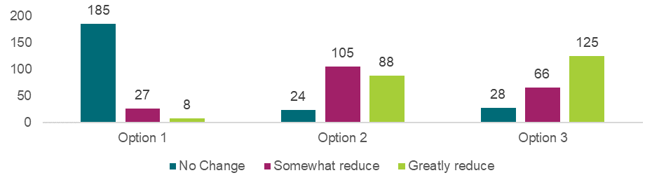

Source: Approved provider survey, as of 11 June 2025, Q17, option 1 n=220, option 2 n=217, option 3 n=219.

Appendix Chart 12.3.1.2 Workforce responses to “How much do you think each option will reduce the risk of harm to children?”

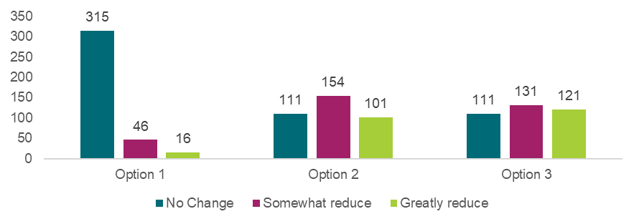

Source: Workforce survey, as of 11 June 2025, Q13, option 1 n=377, option 2 n=366, option 3 n=363.

Appendix Chart 12.3.1.3 Family, carer and parent responses to “How much do you think each option will reduce the risk of harm to children?”

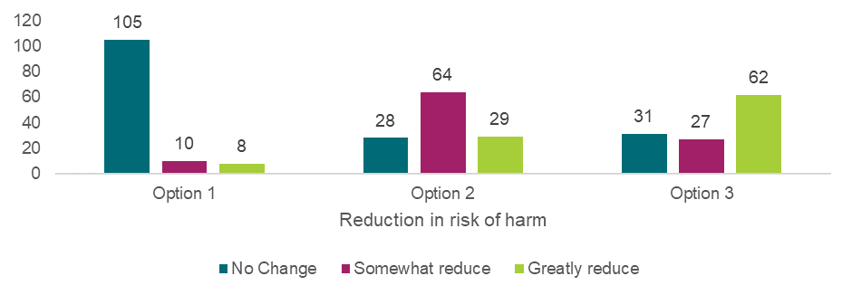

Source: Families, carers and parents survey, as of 11 June 2025, Q17, option 1 n=123, option 2 n=121, option 3 n=120.

Managing the use of digital devices – Preferred option or combination of options

Appendix Chart 12.3.1.4 Approved provider responses to “What is your preferred option or combination of options?”

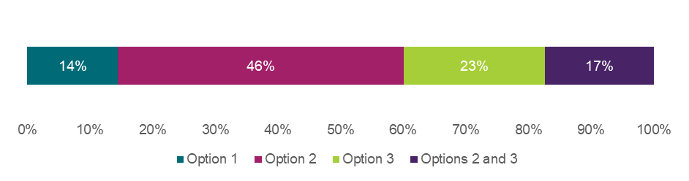

Source: Approved provider survey, as of 11 June 2025, Q17, n=208 respondents. Note that if a respondent selected a combination of options, that selection is treated as a unique preference and not double-counted in the singular options.

Appendix Chart 12.3.1.5 Workforce responses to “What is your preferred option or combination of options?”

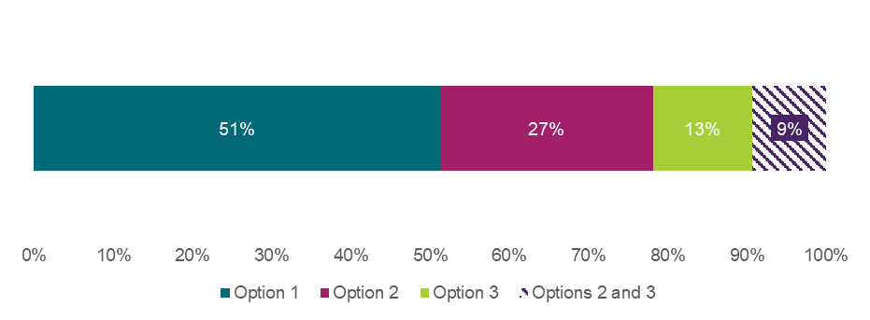

Source: Approved provider survey, as of 11 June 2025, Q15, n=343. Note that if a respondent selected a combination of options, that selection is treated as a unique preference and not double-counted in the singular options.

Appendix Chart 12.3.1.6 Family, carer, and parent responses to “What is your preferred option or combination of options?”

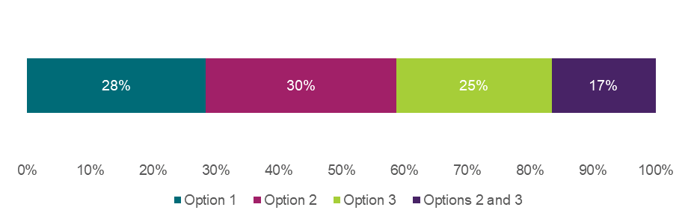

Source: Approved provider survey, as of 11 June 2025, Q15, n=109. Note that if a respondent selected a combination of options, that selection is treated as a unique preference and not double-counted in the singular options.

### 12.3.2 Child safety training

Introducing mandatory child safety training – Reduction of the risk of harm

Appendix Chart 12.3.2.1 Approved provider responses to “How much do you think each option will reduce the risk of harm to children?”

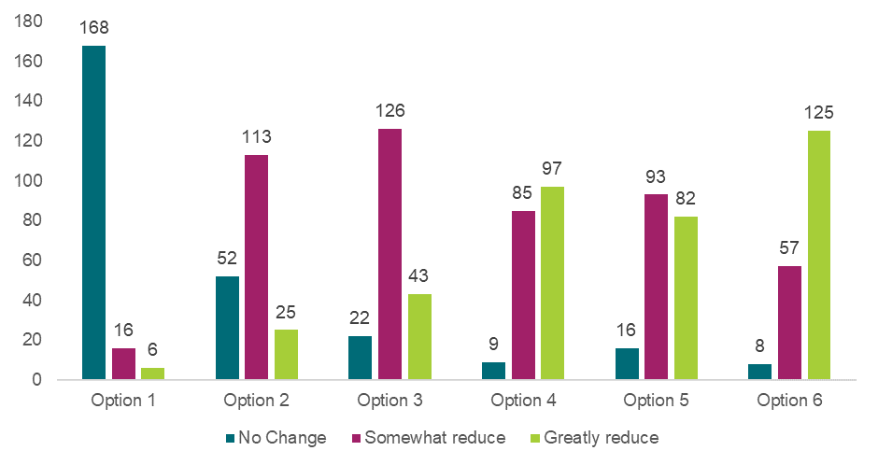

Source: Approved provider survey, as of 11 June 2025, Q27, option 1 n=190, option 2 n=190, option 3 n=191, option 4 n=191, option 5 n=191, option 6 n=190.

Appendix Chart 12.3.2.2 Workforce responses to “How much do you think each option will reduce the risk of harm to children?”

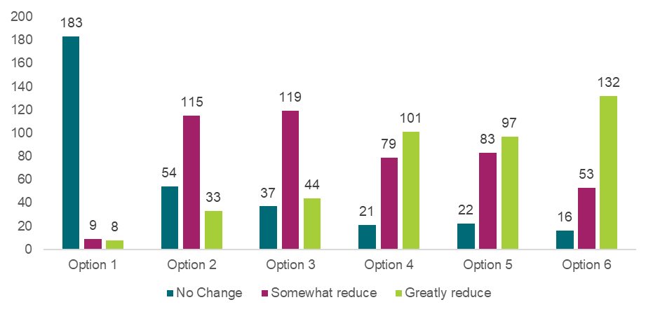

Source: Workforce survey, as of 11 June 2025, Q23, option 1 n= 200, option 2 n=202, option 3 n=200, option 4 n=201, option 5 n=202, option 6 n=201.

Appendix Chart 12.3.2.3 Family, carer and parent responses to “How much do you think each option will reduce the risk of harm to children?”

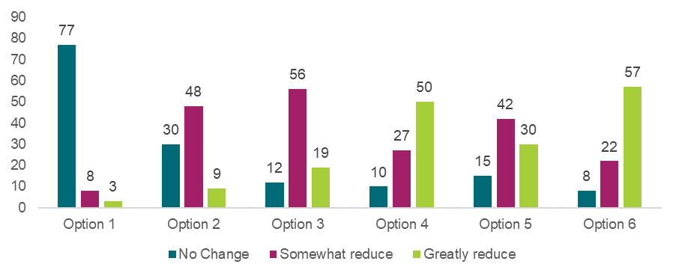

Source: Families, carers and parents survey, as of 11 June 2025, Q27, Option 1 n = 88, options 2-5 n=87.

Introducing mandatory child safety training – Preferred option or combination of options

Appendix Table 12.3.2.1 Approved provider responses to “What is your preferred option or combination of options?”

|  |  |  |
| --- | --- | --- |
| **Preferred option or combination of options** | **Number of responses** | **Proportion of respondents** |
| Option 1 | 3 | 2% |
| Option 2 | 2 | 1% |
| Option 3 | 9 | 5% |
| Option 4 | 10 | 5% |
| Option 5 | 3 | 2% |
| Option 6 | 36 | 19% |
| Options 2 and 3 | 8 | 4% |
| Options 2 and 4 | 8 | 4% |
| Options 2 and 5 | 2 | 1% |
| Options 2 and 6 | 1 | 1% |
| Options 3 and 5 | 0 | 0% |
| Options 3 and 6 | 9 | 5% |
| Options 4 and 5 | 6 | 3% |
| Options 4 and 6 | 30 | 16% |
| Options 5 and 6 | 6 | 3% |
| Options 2, 3 and 5 | 4 | 2% |
| Options 2, 3 and 6 | 0 | 0% |
| Options 2, 4 and 5 | 1 | 1% |
| Options 2, 4 and 6 | 8 | 4% |
| Options 2, 5 and 6 | 10 | 5% |
| Options 3, 5 and 6 | 2 | 1% |
| Options 4, 5 and 6 | 4 | 2% |
| Options 2, 3, 5 and 6 | 3 | 2% |
| Options 2, 4, 5 and 6 | 23 | 12% |

Source: Approved provider survey, as of 11 June 2025, Q25, n=188 unique respondents. The three popular options or combination of options are highlighted in green. Note that if a respondent selected a combination of options, that selection is treated as a unique preference and not double-counted in the singular options.

Appendix Table 12.3.2.2 Workforce responses to “What is your preferred option or combination of options?” – Recommendation 2.1

|  |  |  |
| --- | --- | --- |
| **Preferred option or combination of options** | **Number of responses** | **Proportion of respondents** |
| Option 1 | 9 | 5% |
| Option 2 | 1 | 1% |
| Option 3 | 13 | 7% |
| Option 4 | 7 | 4% |
| Option 5 | 3 | 2% |
| Option 6 | 31 | 17% |
| Options 2 and 3 | 6 | 3% |
| Options 2 and 4 | 8 | 4% |
| Options 2 and 5 | 1 | 1% |
| Options 2 and 6 | 4 | 2% |
| Options 3 and 5 | 5 | 3% |
| Options 3 and 6 | 4 | 2% |
| Options 4 and 5 | 3 | 2% |
| Options 4 and 6 | 22 | 12% |
| Options 5 and 6 | 6 | 3% |
| Options 2, 3 and 5 | 1 | 1% |
| Options 2, 3 and 6 | 4 | 2% |
| Options 2, 4 and 5 | 5 | 3% |
| Options 2, 4 and 6 | 6 | 3% |
| Options 2, 5 and 6 | 13 | 7% |
| Options 3, 5 and 6 | 2 | 1% |
| Options 4, 5 and 6 | 8 | 4% |
| Options 2, 3, 5 and 6 | 4 | 2% |
| Options 2, 4, 5 and 6 | 20 | 11% |

Source: Workforce survey, as of 11 June 2025, Q25, n=186. The three popular options or combination of options are highlighted in green. Note that if a respondent selected a combination of options, that selection is treated as a unique preference and not double-counted in the singular options. Note that these percentages do not add to 100% due to rounding.

Appendix Table 12.3.2.3 Family, carer, and parent responses to “What is your preferred option or combination of options?” – Recommendation 2.1

|  |  |  |
| --- | --- | --- |
| **Preferred option or combination of options** | **Number of responses** | **Proportion of respondents** |
| Option 1 | 3 | 4% |
| Option 2 | 1 | 1% |
| Option 3 | 2 | 3% |
| Option 4 | 2 | 3% |
| Option 5 | 2 | 3% |
| Option 6 | 18 | 23% |
| Options 2 and 3 | 2 | 3% |
| Options 2 and 4 | 1 | 1% |
| Options 2 and 5 | 0 | 0% |
| Options 2 and 6 | 1 | 1% |
| Options 3 and 5 | 1 | 1% |
| Options 3 and 6 | 1 | 1% |
| Options 4 and 5 | 0 | 0% |
| Options 4 and 6 | 12 | 16% |
| Options 5 and 6 | 4 | 5% |
| Options 2, 3 and 5 | 2 | 3% |
| Options 2, 3 and 6 | 0 | 0% |
| Options 2, 4 and 5 | 1 | 1% |
| Options 2, 4 and 6 | 4 | 5% |
| Options 2, 5 and 6 | 2 | 3% |
| Options 3, 5 and 6 | 1 | 1% |
| Options 4, 5 and 6 | 4 | 5% |
| Options 2, 3, 5 and 6 | 0 | 0% |
| Options 2, 4, 5 and 6 | 13 | 17% |

Source: Families, carers and parents survey, as of 11 June 2025, Q29, n=77 unique respondents. The three popular options or combination of options are highlighted in green. Note that if a respondent selected a combination of options, that selection is treated as a unique preference and not double-counted in the singular options.

### 12.3.3 Responding to educator and staff member conduct

Making inappropriate conduct an offence – Reduction of the risk of harm

Appendix Chart 12.3.3.1 Approved provider responses to “How much do you think each option will reduce the risk of harm to children?”

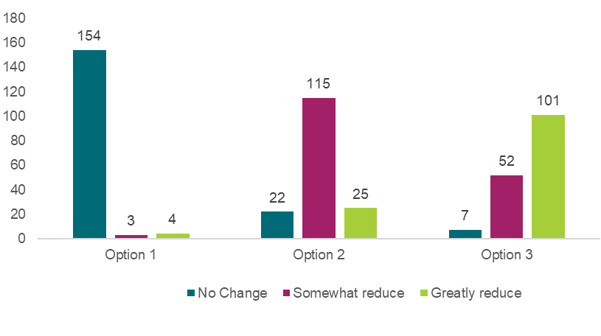

Source: Approved provider survey, as of 11 June 2025, Q36, option 1 n=161, option 2 n=162, option 3 n=160.

Appendix Chart 12.3.3.2 Workforce responses to “How much do you think each option will reduce the risk of harm to children?”

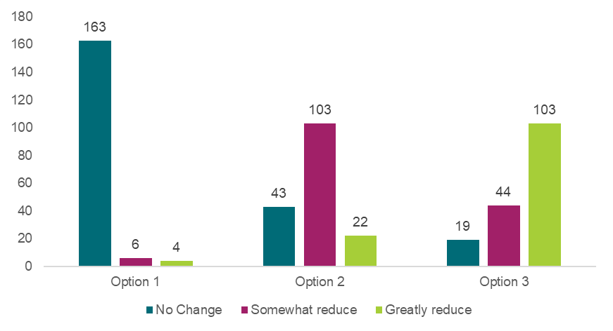

Source: Workforce survey, as of 11 June 2025, Q32, option 1 n=173, option 2 n=168, option 3 n=166.

Appendix Chart 12.3.3.3 Family, carer and parent responses to “How much do you think each option will reduce the risk of harm to children?”

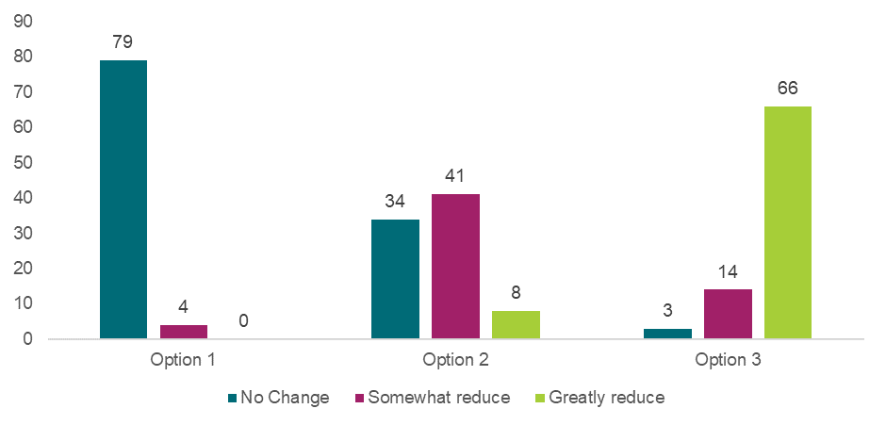

Source: Families, carers and parents survey, as of 11 June 2025, Q32, n=83 for all options.

Making inappropriate conduct an offence – Preferred option or combination of options

Appendix Chart 12.3.3.4 Approved provider responses to “What is your preferred option or combination of options?”

 Source: Approved provider survey, as of 11 June 2025, Q34, n=156 unique respondents. Note that if a respondent selected a combination of options, that selection is treated as a unique preference and not double-counted in the singular options.

Appendix Chart 12.3.3.5 Workforce responses to “What is your preferred option or combination of options?”

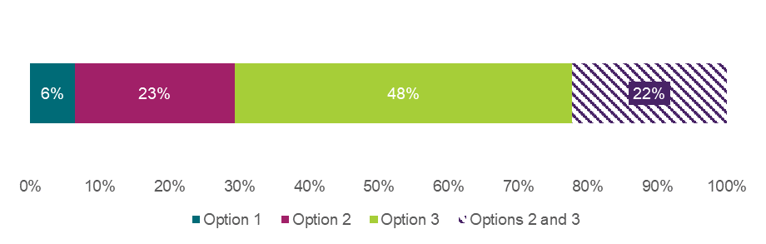

Source: Workforce survey, as of 11 June 2025, Q34, n=157. Note that if a respondent selected a combination of options, that selection is treated as a unique preference and not double-counted in the singular options. Note that these percentages do not add to 100% due to rounding.

Appendix Chart 12.3.3.6 Family, carer, and parent responses to “What is your preferred option or combination of options?”

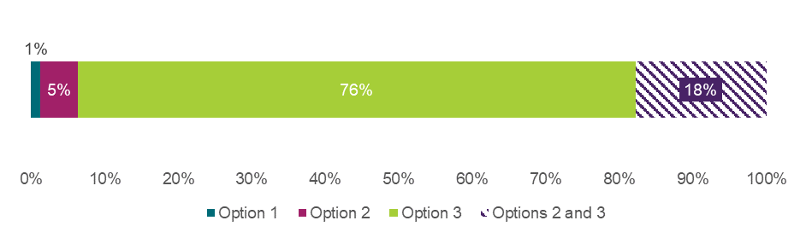

Source: Families, carers and parents survey, as of 11 June 2025, Q34, n=79. Note that if a respondent selected a combination of options, that selection is treated as a unique preference and not double-counted in the singular options.

Enhancing Regulatory Authorities’ ability to share information with approved providers – Reduction of the risk of harm

Appendix Chart 12.3.3.7 Approved provider responses to “How much do you think each option will reduce the risk of harm to children?”

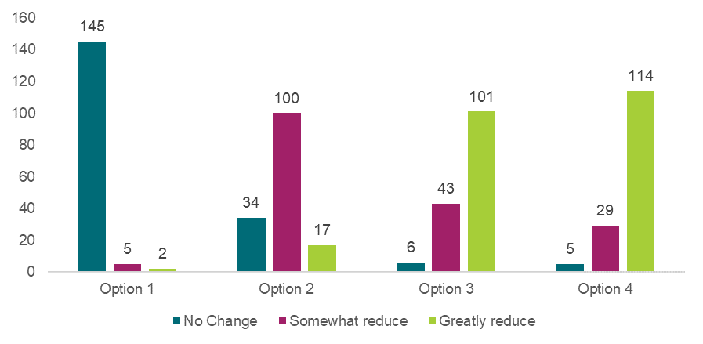

Source: Approved provider survey, as of 11 June 2025, Q46, option 1 n=152, option 2 n=151, option 3 n=150, option 4 n=148.

Appendix Chart 12.3.3.8 Workforce responses to “How much do you think each option will reduce the risk of harm to children?”

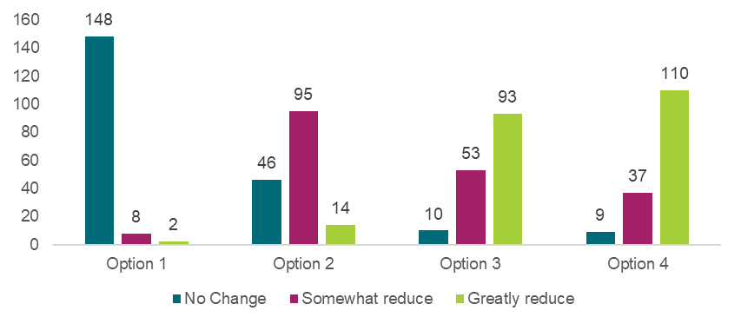

Source: Workforce survey, as of 11 June 2025, Q42, option 1 n=158, option 2 n=155, option 3 n=156, option 4 n=156.

Appendix Chart 12.3.3.9 Family, carer and parent responses to “How much do you think each option will reduce the risk of harm to children?”

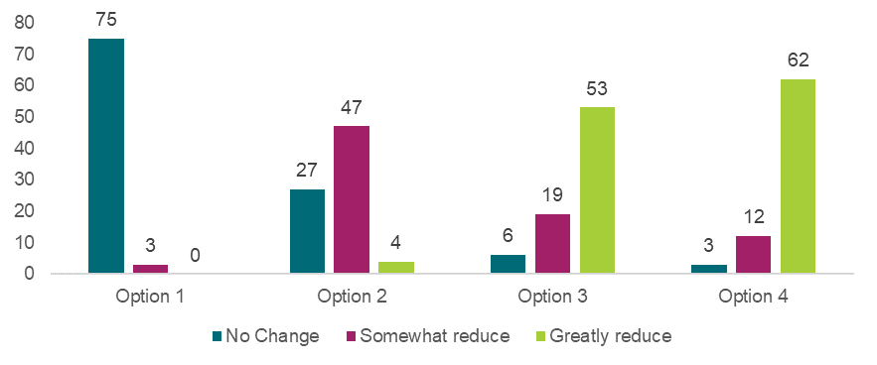

Source: Families, carers and parents survey, as of 11 June 2025, Q46, option 1 n=78, option 2 n=78, option 3 n=78, option 4 n=77.

Enhancing Regulatory Authorities’ ability to share information with approved providers – Preferred option or combination of options

Appendix Chart 12.3.3.10 Approved provider responses to “What is your preferred option or combination of options?”



Source: Approved provider survey, as of 11 June 2025, Q44, n=121 unique respondents. Note that if a respondent selected a combination of options, that selection is treated as a unique preference and not double-counted in the singular options.

Appendix Chart 12.3.3.11 Workforce responses to “What is your preferred option or combination of options?”

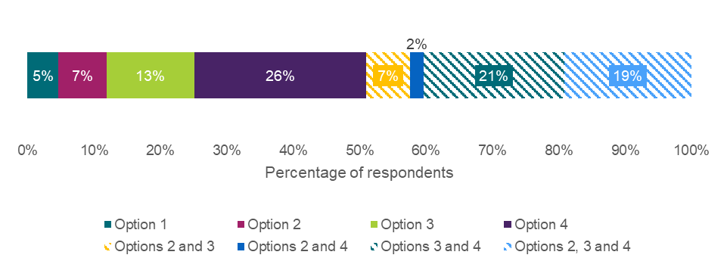

Source: Workforce survey, as of 11 June 2025, Q44, n=151. Note that if a respondent selected a combination of options, that selection is treated as a unique preference and not double-counted in the singular options.

Appendix Chart 12.3.3.12 Family, carer, and parent responses to “What is your preferred option or combination of options?”

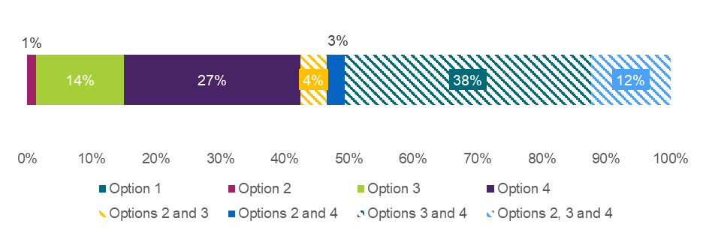

Source: Families, carers and parents survey, as of 11 June 2025, Q44, n=73 unique respondents. Note that if a respondent selected a combination of options, that selection is treated as a unique preference and not double-counted in the singular options. Note that no respondents selected option 1 as their recommended option. Note that due to rounding, percentages may not add to 100%.

Expansion of regulatory responses to educator and staff member conduct – Reduction of the risk of harm

Appendix Chart 12.3.3.13 Approved provider responses to “How much do you think each option will reduce the risk of harm to children?”

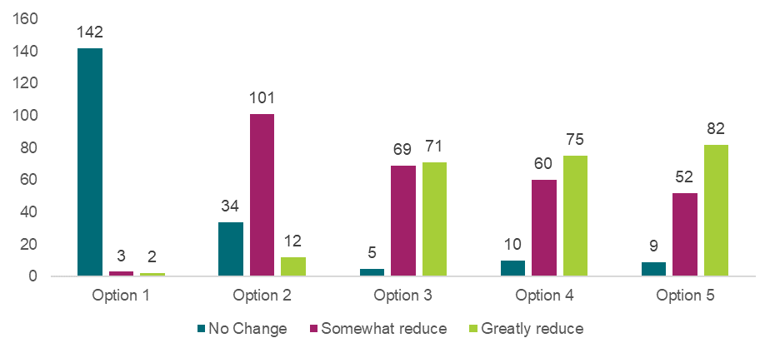

Source: Approved provider survey, as of 11 June 2025, Q54 option 1 n=147, option 2 n=147, option 3 n=145, option 4 n=145, option 5 n=143.

Appendix Chart 12.3.3.14 Workforce responses to “How much do you think each option will reduce the risk of harm to children?”

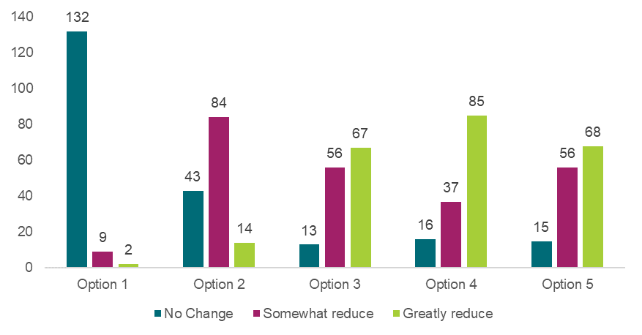

Source: Workforce survey, as of 11 June 2025, Q50, option 1 n=143, option 2 n=141, option 3 n=136, option 4 n=138, option 5 n=139.

Appendix Chart 12.3.3.15 Family, carer and parent responses to “How much do you think each option will reduce the risk of harm to children?”

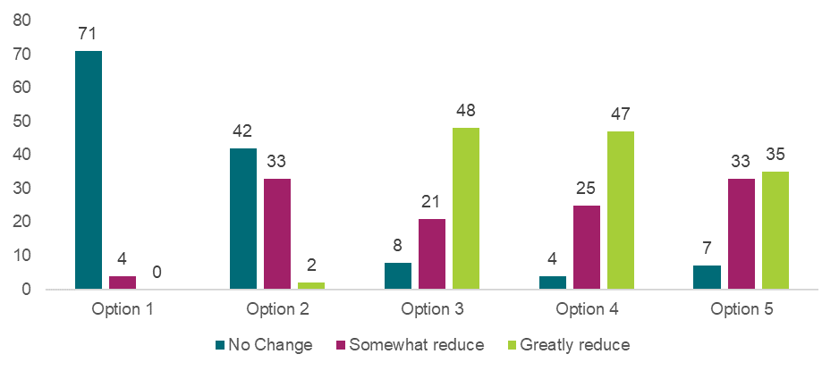

Source: Families, carers and parents survey, as of 11 June 2025, Q54, option 1 n= 75, option 2 n=77, option 3 n=77, option 4 n=76, option 5 n=75.

Expansion of regulatory responses to educator and staff member conduct – Preferred option or combination of options

Appendix Table 12.3.3.1 Approved provider responses to “What is your preferred option or combination of options?”

|  |  |  |
| --- | --- | --- |
| **Preferred option or combination of options** | **Number of responses** | **Proportion of respondents** |
| Option 1 | 5 | 3% |
| Option 2 | 11 | 8% |
| Option 3 | 12 | 8% |
| Option 4 | 6 | 4% |
| Option 5 | 13 | 9% |
| Options 2 and 3 | 2 | 1% |
| Options 2 and 4 | 3 | 2% |
| Options 2 and 5 | 8 | 6% |
| Options 3 and 4 | 6 | 4% |
| Options 3 and 5 | 9 | 6% |
| Options 4 and 5 | 9 | 6% |
| Options 2, 3 and 5 | 11 | 8% |
| Options 2, 4 and 5 | 2 | 1% |
| Options 2, 3 and 4 | 3 | 2% |
| Options 3, 4 and 5 | 21 | 15% |
| Options 2, 3, 4 and 5 | 23 | 16% |

Source: Approved provider survey, as of 11 June 2025, Q52, n=144 respondents. Most popular options or combination of options are highlighted in green. Note that if a respondent selected a combination of options, that selection is treated as a unique preference and not double-counted in the singular options. Note that due to rounding, percentages may not add to 100%.

Appendix Table 12.3.3.2 Workforce responses to “What is your preferred option or combination of options?”

|  |  |  |
| --- | --- | --- |
| **Preferred option or combination of options** | **Number of responses** | **Proportion of respondents** |
| Option 1 | 8 | 6% |
| Option 2 | 11 | 8% |
| Option 3 | 11 | 8% |
| Option 4 | 8 | 6% |
| Option 5 | 13 | 9% |
| Options 2 and 3 | 4 | 3% |
| Options 2 and 4 | 2 | 1% |
| Options 2 and 5 | 2 | 1% |
| Options 3 and 4 | 8 | 6% |
| Options 3 and 5 | 2 | 1% |
| Options 4 and 5 | 8 | 6% |
| Options 2, 3 and 5 | 6 | 4% |
| Options 2, 4 and 5 | 4 | 3% |
| Options 2, 3 and 4 | 4 | 3% |
| Options 3, 4 and 5 | 23 | 17% |
| Options 2, 3, 4 and 5 | 23 | 17% |

Source: Workforce survey, as of 11 June 2025, Q52, n=137 unique respondents. Most popular options or combination of options are highlighted in green. Note that if a respondent selected a combination of options, that selection is treated as a unique preference and not double-counted in the singular options. Note that due to rounding, percentages may not add to 100%.

Appendix Table 12.3.3.3 Family, carer, and parent responses to “What is your preferred option or combination of options?”

|  |  |  |
| --- | --- | --- |
| **Preferred option or combination of options** | **Number of responses** | **Proportion of respondents** |
| Option 1 | 2 | 3% |
| Option 2 | 2 | 3% |
| Option 3 | 13 | 18% |
| Option 4 | 9 | 12% |
| Option 5 | 6 | 8% |
| Options 2 and 3 | 0 | 0% |
| Options 2 and 4 | 0 | 0% |
| Options 2 and 5 | 0 | 0% |
| Options 3 and 4 | 7 | 9% |
| Options 3 and 5 | 1 | 1% |
| Options 4 and 5 | 6 | 8% |
| Options 2, 3 and 5 | 0 | 0% |
| Options 2, 4 and 5 | 0 | 0% |
| Options 2, 3 and 4 | 1 | 1% |
| Options 3, 4 and 5 | 19 | 26% |
| Options 2, 3, 4 and 5 | 8 | 11% |

Source: Families, carers and parents survey, as of 11 June 2025, Q52, n=74 unique respondents. Most popular options or combination of options are highlighted in green. Note that if a respondent selected a combination of options, that selection is treated as a unique preference and not double-counted in the singular options.

Responding to educator and staff member conduct – Additional Questions

Appendix Chart 12.3.3.16Approved provider responses to “How often do you hear about reports of inappropriate conduct?”

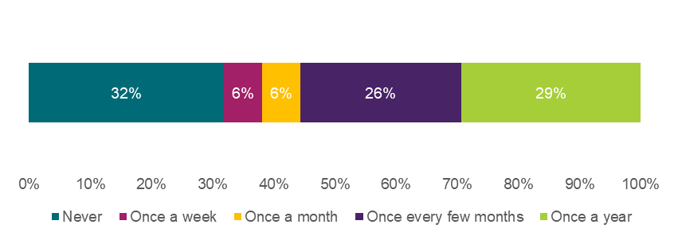

Source: Approved provider survey, as of 11 June 2025, Q144, n=160. Note Approved providers could select multiple options. Note that due to rounding, percentages may not add to 100%.

Appendix Chart 12.3.3.17Education and care workforce responses to “How often do you hear about reports of inappropriate conduct at your service?”

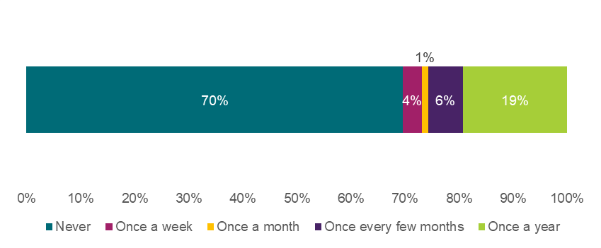

Source: Education and care workforce survey, as of 11 June 2025, Q135, n=171. Note Approved providers could select multiple options.

Appendix Chart 12.3.3.18 *Education and care workforce responses to “How often do you hear about reports of inappropriate conduct that haven't resulted in a prohibition?”*

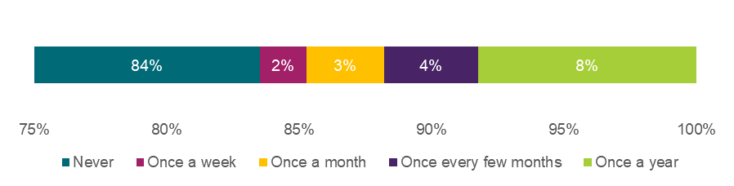

Source: Education and care workforce survey, as of 11 June 2025, Q136, n=170. Note Approved providers could select multiple options. Note that due to rounding, percentages may not add to 100%.

Appendix Table 12.3.3.4 Approved provider responses to “Where you have observed inappropriate conduct which does not meet the threshold for prohibition, how is this best described?”

|  |  |
| --- | --- |
| **Type of inappropriate conduct** | **% of respondents** |
| Ill-treatment of a child | 18% |
| Neglect of a child | 11% |
| Physical or verbal violence (including threats) committed in relation to, or in the presence of a child | 11% |
| Behaviour that is likely to cause emotional or psychological harm to a child | 21% |
| A child sexual offence | 3% |
| Sexual misconduct committed in relation to, or in the presence of a child, including verbal discussions, flirtatious gestures and comments | 2% |
| Inappropriate verbal interactions, that is, conversations with, or comments to children or conversations in the presence of children in relation to sexuality or sexual contact, including excessive flattering, conversations of a sexual nature, making sexual jokes or evoking children's curiosity about sexuality | 3% |
| Any form of inappropriate physical contact. For example, unwarranted, invasive, or unnecessary for the child’s age and developmental stage, such as kissing, massage, tickling games, inappropriate touching) | 6% |
| Any form of inappropriate online contact or online harm. For example, exposing children to sexual or violent content inappropriate for their age and stage of development, and technology-facilitated abuse | 1% |
| Correspondence, communication of a personal nature or capturing of images of children via any medium (phone, text message, social media, within apps, internet postings) unrelated to the staff members role or endorsed communication channels | 4% |
| Manipulating or coercing a child emotionally to meet the educator’s personal needs or to create inappropriate dependencies | 8% |
| Grooming, being any form of conduct, online or offline, that facilitates child sexual abuse. For example, making a child feel special through favouritism or special privileges and rewards or receiving / giving gifts of an inappropriate nature | 3% |
| Other (please specify) | 11% |

Source: Approved provider survey, as of 11 June 2025, Q146, n=159. Note Approved providers could select multiple options.

Appendix Chart 12.3.*3.18* Approved providers responses to “To what extent does your service’s Code of Conduct already address inappropriate conduct of the kinds outlined in the CRIS (Chapter 5)?”

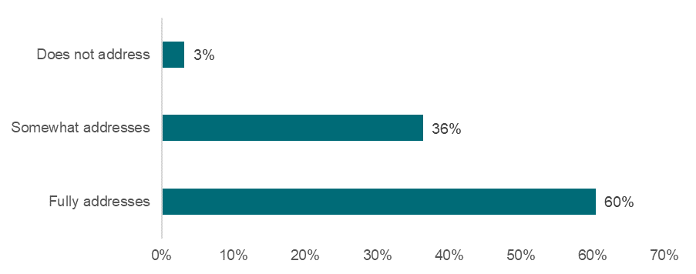

Source: Approved provider survey, as of 11 June 2025, Q142, n=162. Note Approved providers could select multiple options.

Appendix Chart 12.3.*3.19* Education and care workforce responses to “My provider’s current Code of Conduct has effectively set expectations regarding what constitutes inappropriate conduct.”

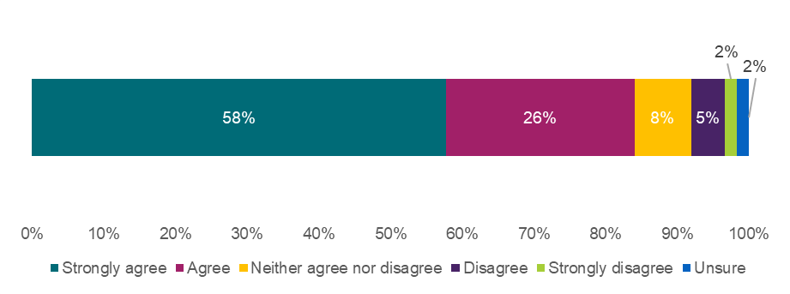

Source: Education and care workforce survey, as of 11 June 2025, Q163, n=175. Note Approved providers could select multiple options. Note that due to rounding, percentages may not add to 100%.

### 12.3.4 Working with Children Checks

Requiring an approved WWCC prior to commencing paid or volunteer work at an education and care service – Reduction of the risk of harm

Appendix Chart 12.3.4.1 Approved provider responses to “How much do you think each option will reduce the risk of harm to children?”

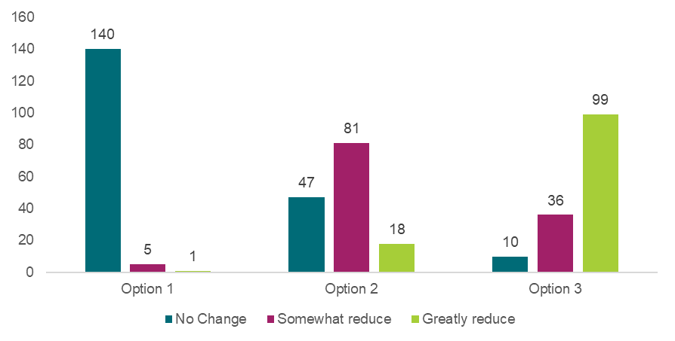

Source: Approved provider survey, as of 11 June 2025, Q63, Option 1 n=146, option 2 n=146, option 3 n=145.

Appendix Chart 12.3.4.2 Workforce responses to “How much do you think each option will reduce the risk of harm to children?”

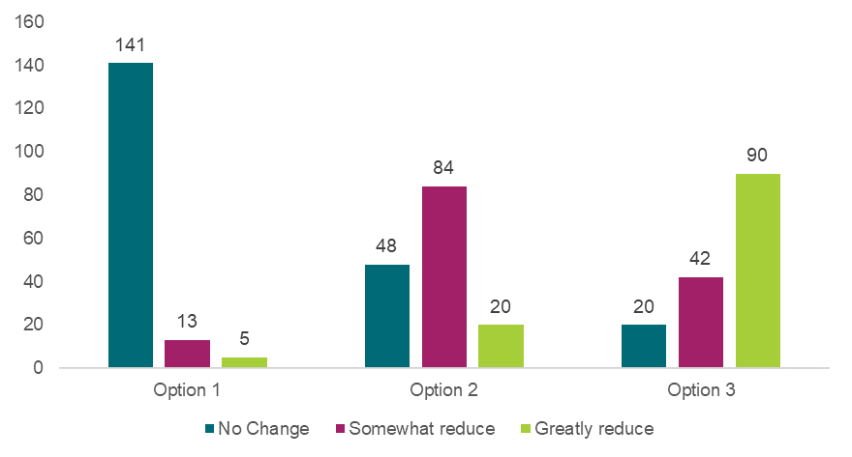

Source: Workforce survey, as of 11 June 2025, Q59, option 1 n=159, option 2 n=152, option 3 n=152.

Appendix Chart 12.3.4.3 Family, carer and parent responses to “How much do you think each option will reduce the risk of harm to children?”

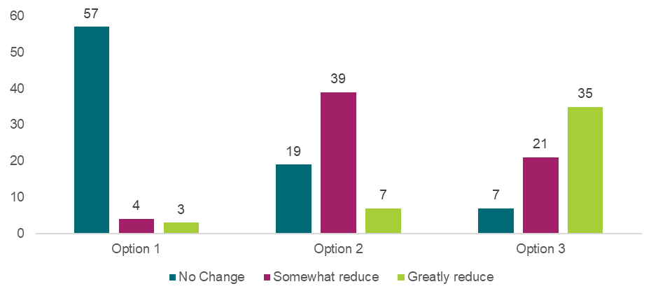

Source: Families, carers and parents survey, as of 11 June 2025, Q63, option 1 n=64, option 2 n=65, option 3 n=63.

Requiring an approved WWCC prior to commencing paid or volunteer work at an education and care service – Preferred option or combination of options

Appendix Chart 12.3.4.4 Approved provider responses to “What is your preferred option or combination of options?”

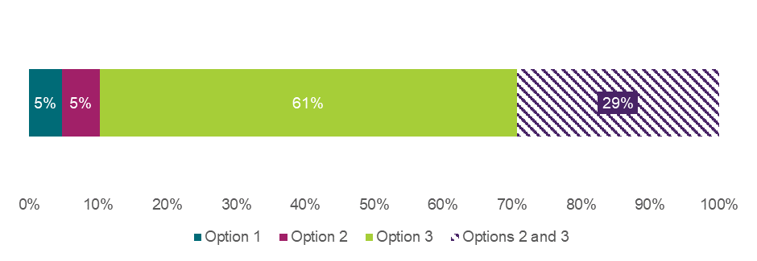

Source: Approved provider survey, as of 11 June 2025, Q63, n=147. Note that if a respondent selected a combination of options, that selection is treated as a unique preference and not double-counted in the singular options.

Appendix Chart 12.3.4.5 Workforce responses to “What is your preferred option or combination of options?”

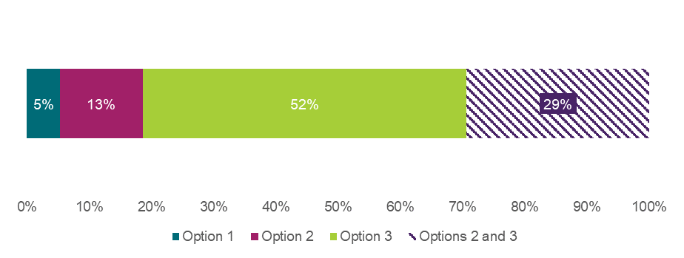

Source: Workforce survey, as of 11 June 2025, Q61, n=150. Note that if a respondent selected a combination of options, that selection is treated as a unique preference and not double-counted in the singular options. Note that due to rounding, percentages may not add to 100%.

Appendix Chart 12.3.4.6 Family, carer, and parent responses to “What is your preferred option or combination of options?”

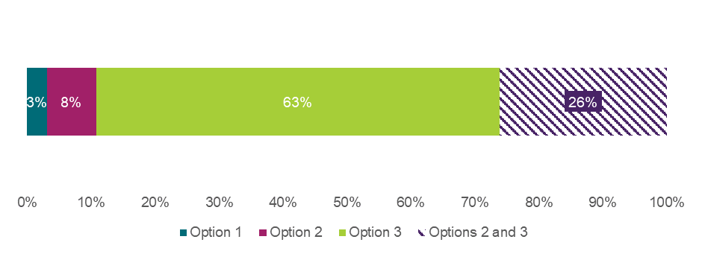

Source: Families, carers and parents survey, as of 11 June 2025, Q61, n=65. Note that if a respondent selected a combination of options, that selection is treated as a unique preference and not double-counted in the singular options.

Requiring approved providers and Regulatory Authorities to be notified about changes in WWCC status – Reduction of the risk of harm

Appendix Chart 12.3.4.7 Approved provider responses to “How much do you think each option will reduce the risk of harm to children?”

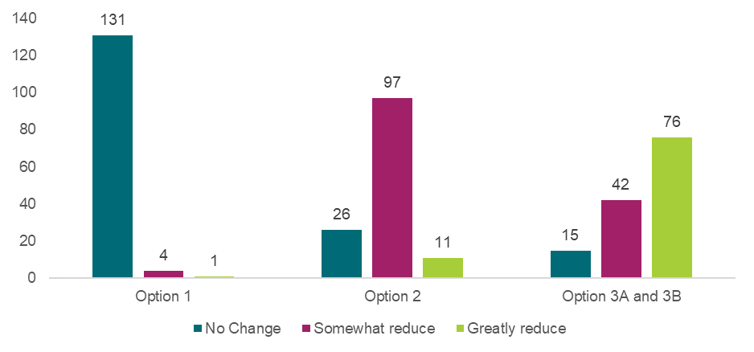

Source: Approved provider survey, as of 11 June 2025, Q72, option 1 n=136, option 2 n=134, option 3A and 3B n=133.

Appendix Chart 12.3.4.8 Workforce responses to “How much do you think each option will reduce the risk of harm to children?”

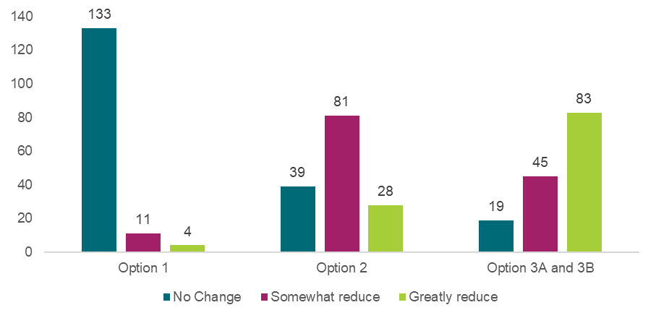

Source: Workforce survey, as of 11 June 2025, Q68, option 1 n=148, option 2 n=148, option 3A and 3B n=147.

Appendix Chart 12.3.4.9 Family, carer and parent responses to “How much do you think each option will reduce the risk of harm to children?”

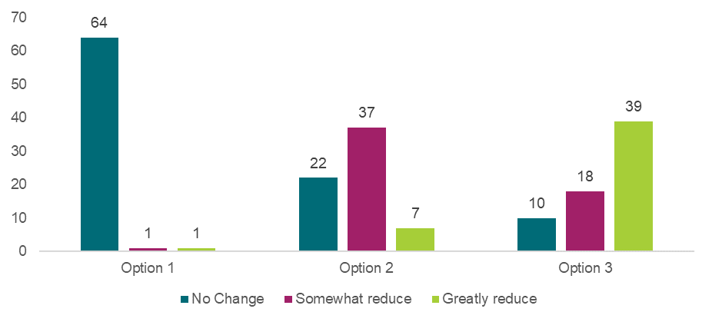

Source: Families, carers and parents survey, as of 11 June 2025, Q72, option 1 n=66, option 2 n=66, option 3 n=67.

Requiring approved providers and Regulatory Authorities to be notified about changes in WWCC status – Preferred option or combination of options

Appendix Chart 12.3.4.10 Approved provider responses to “What is your preferred option or combination of options?”

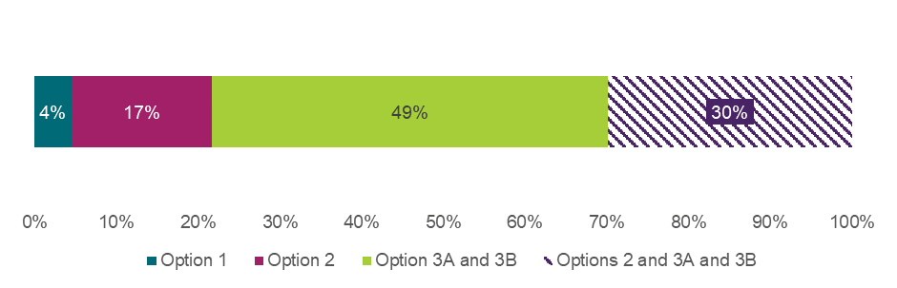

Source: Approved provider survey, as of 11 June 2025, Q70, n=134. Note that if a respondent selected a combination of options, that selection is treated as a unique preference and not double-counted in the singular options.

Appendix Chart 12.3.4.11 Workforce responses to “What is your preferred option or combination of options?”

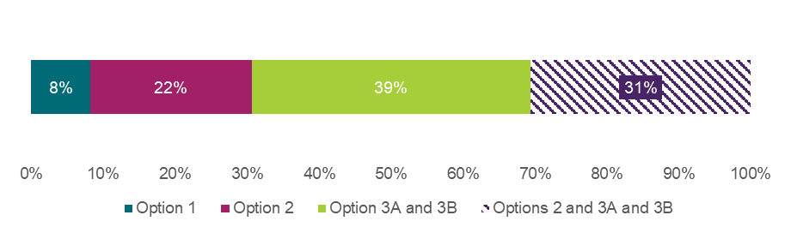

Source: Workforce survey, as of 11 June 2025, Q70, n=134. Note that if a respondent selected a combination of options, that selection is treated as a unique preference and not double-counted in the singular options.

Appendix Chart 12.3.4.12 Family, carer, and parent responses to “What is your preferred option or combination of options?”

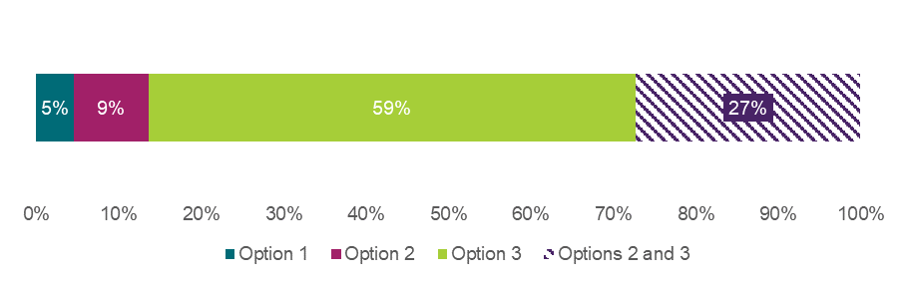

Source: Families, carers and parents survey, as of 11 June 2025, Q70, n=66. Note that if a respondent selected a combination of options, that selection is treated as a unique preference and not double-counted in the singular options.

### 12.3.5 Improving the safety of the physical service environment

Service and temporary waivers for the design of premises (to facilitate supervision of children) – Reduction of the risk of harm

Appendix Chart 12.3.5.1 Approved provider responses to “How much do you think each option will reduce the risk of harm to children?”

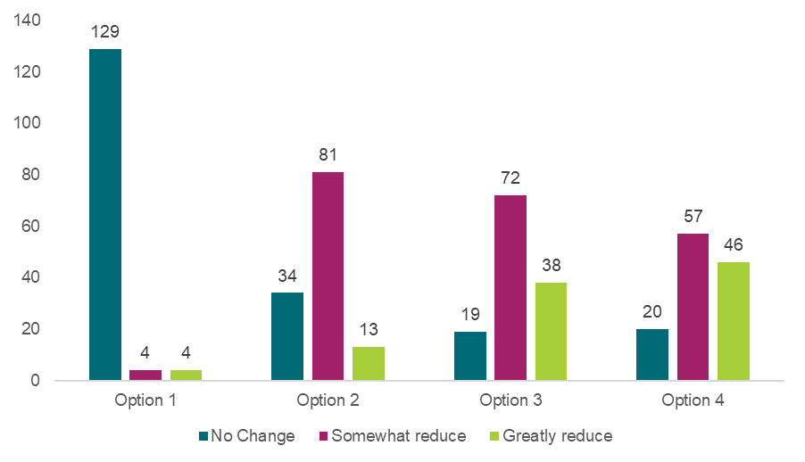

Source: Approved provider survey, as of 11 June 2025, Q80, option 1 n=137, option 2 n=128, option 3 n=129, option 4 n=123.

Appendix Chart 12.3.5.2 Workforce responses to “How much do you think each option will reduce the risk of harm to children?”

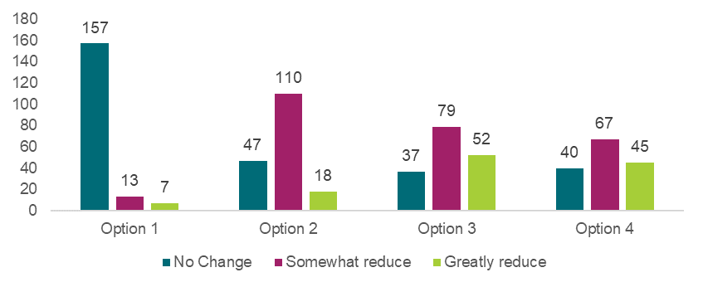

Source: Workforce survey, as of 11 June 2025, Q76, option 1 n=177, option 2 n=175, option 3 n=168, option 4 n=152.

Appendix Chart 12.3.5.3 Family, carer and parent responses to “How much do you think each option will reduce the risk of harm to children?”



Source: Families, carers and parents survey, as of 11 June 2025, Q80, option 1 n=76, option 2 n=77, option 3 n=74, option 4 n=68.

Service and temporary waivers for the design of premises (to facilitate supervision of children) – Preferred option or combination of options

Appendix Chart 12.3.5.4 Approved provider responses to “What is your preferred option or combination of options?”

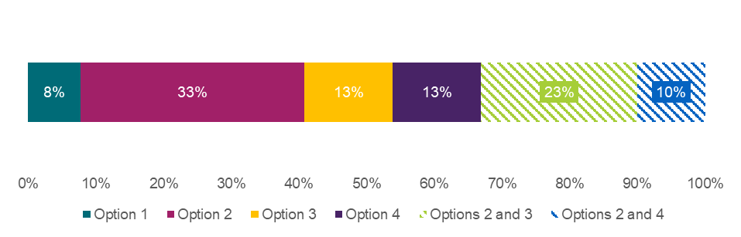

Source: Approved provider survey, as of 11 June 2025, Q78, n=130. Note that no respondents selected the following combinations of options: 3 and 4, 2, 3 and 4. Note that if a respondent selected a combination of options, that selection is treated as a unique preference and not double-counted in each individual option.

Appendix Chart 12.3.5.5 Workforce responses to “What is your preferred option or combination of options?”

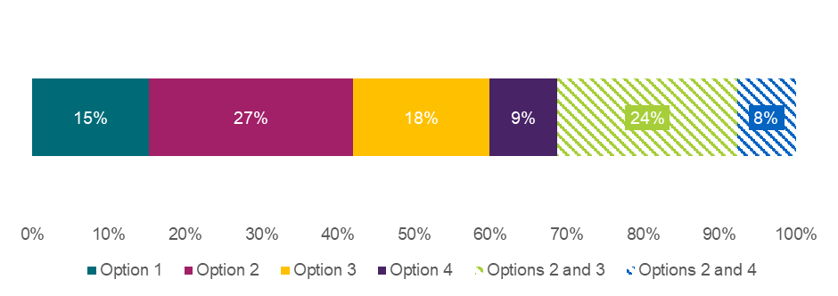

Source: Workforce survey, as of 11 June 2025, Q78, n=157 unique respondents. Note no respondents selected combinations 3 and 4 or 2, 3 and 4. Note that if a respondent selected a combination of options, that selection is treated as a unique preference and not double-counted in each individual option. Note that due to rounding, percentages may not add to 100%.

Appendix Chart 12.3.5.6 Family, carer, and parent responses to “What is your preferred option or combination of options?”



Source: Families, carers and parents survey, as of 11 June 2025, Q78, n=68. Note that no respondents selected the following combinations of options: 3 and 4, 2, 3 and 4. Note that if a respondent selected a combination of options, that selection is treated as a unique preference and not double-counted in each individual option. Note that due to rounding, percentages may not add to 100%.

Requiring approved providers to assess not just the FDC residence, but areas near the residence – Reduction of the risk of harm

Appendix Chart 12.3.5.7 Approved provider responses to “How much do you think each option will reduce the risk of harm to children?”

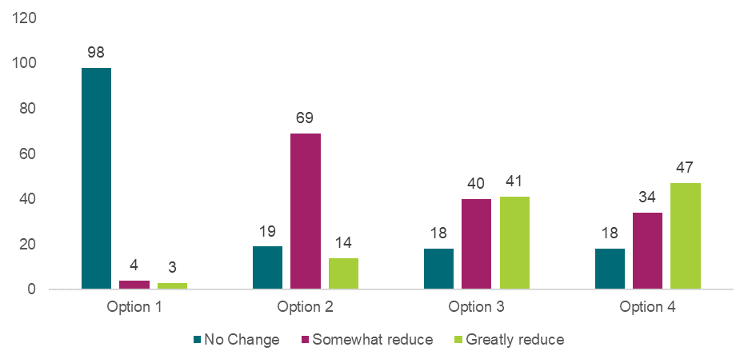

Source: Approved provider survey, as of 11 June 2025, Q89, option 1 n=105, option 2 n=102, option 3 n=99, option 4 n=99.

Appendix Chart 12.3.5.8 Workforce responses to “How much do you think each option will reduce the risk of harm to children?”

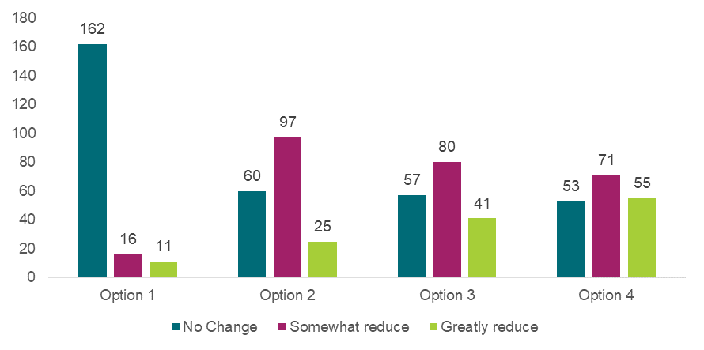

Source: Workforce survey, as of 11 June 2025, Q85, option 1 n=189, option 2 n=182, option 3 n=178, option 4 n=179.

Appendix Chart 12.3.5.9 Family, carer and parent responses to “How much do you think each option will reduce the risk of harm to children?”

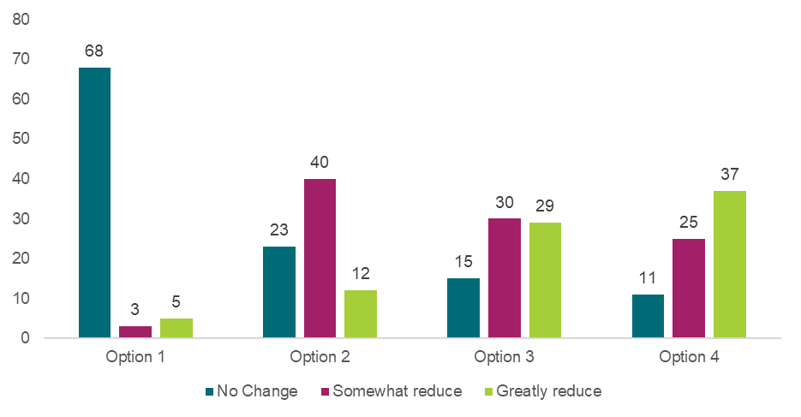

Source: Families, carers and parents survey, as of 11 June 2025, Q89, option 1 n=76, option 2 n=75, option 3 n=74, option 4 n=73.

Requiring approved providers to assess not just the FDC residence, but areas near the residence – Preferred option or combination of options

Appendix Chart 12.3.5.10 Approved provider responses to “What is your preferred option or combination of options?”

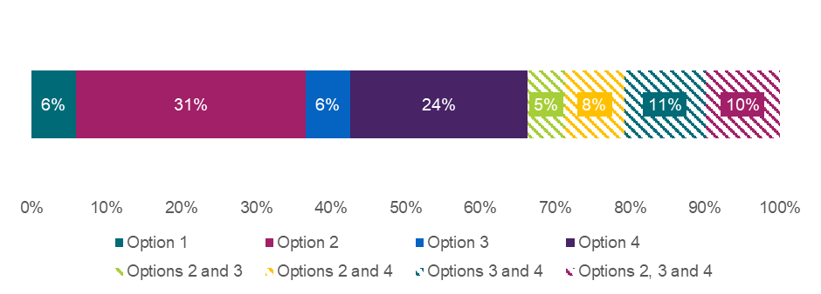

Source: Approved provider survey, as of 11 June 2025, Q87, n=101 unique respondents. Note that if a respondent selected a combination of options, that selection is treated as a unique preference and not double-counted in each individual option. Note that due to rounding, percentages may not add to 100%.

Appendix Chart 12.3.5.11 Workforce responses to “What is your preferred option or combination of options?”

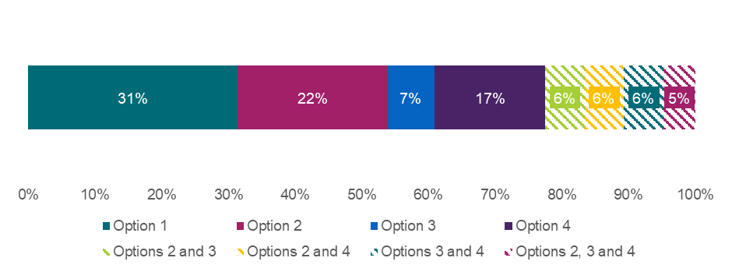

Source: Workforce survey, as of 11 June 2025, Q87, n=169. Note that if a respondent selected a combination of options, that selection is treated as a unique preference and not double-counted in each individual option. Note that due to rounding, percentages may not add to 100%.

Appendix Chart 12.3.5.12 Family, carer, and parent responses to “What is your preferred option or combination of options?”

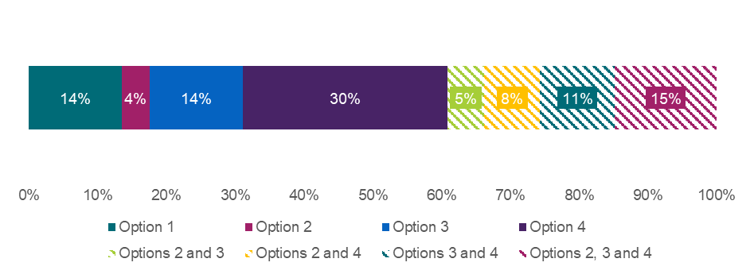

Source: Families, carers and parents survey, as of 11 June 2025, Q87, n=74. Note that if a respondent selected a combination of options, that selection is treated as a unique preference and not double-counted in each individual option. Note that due to rounding, percentages may not add to 100%.

Enabling authorised officers to access a FDC residence or property, beyond the service premises, in specific instances or for specific purposes – Reduction of the risk of harm

Appendix Chart 12.3.5.13 Approved provider responses to “How much do you think each option will reduce the risk of harm to children?”

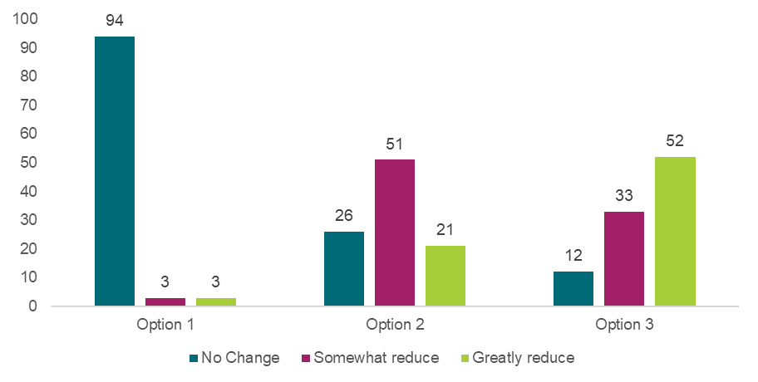

Source: Approved provider survey, as of 11 June 2025, Q98, option 1 n=100, option 2 n=98, option 3 n=97.

Appendix Chart 12.3.5.14 Workforce responses to “How much do you think each option will reduce the risk of harm to children?”

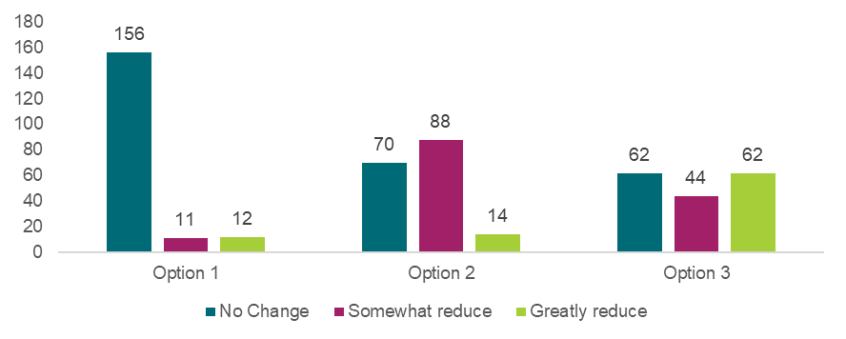

Source: Workforce survey, as of 11 June 2025, Q94, option 1 n=179, option 2 n=172, option 3 n=168.

Appendix Chart 12.3.5.15 Family, carer and parent responses to “How much do you think each option will reduce the risk of harm to children?”

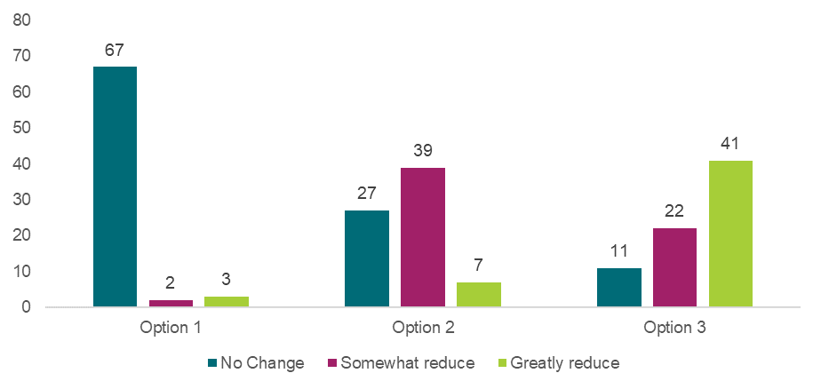

Source: Families, carers and parents survey, as of 11 June 2025, Q98, option 1 n=72, option 2 n=73, option 3 n=74.

Enabling authorised officers to access a FDC residence or property, beyond the service premises, in specific instances or for specific purposes – Preferred option or combination of options

Appendix Chart 12.3.5.16 Approved provider responses to “What is your preferred option or combination of options?”

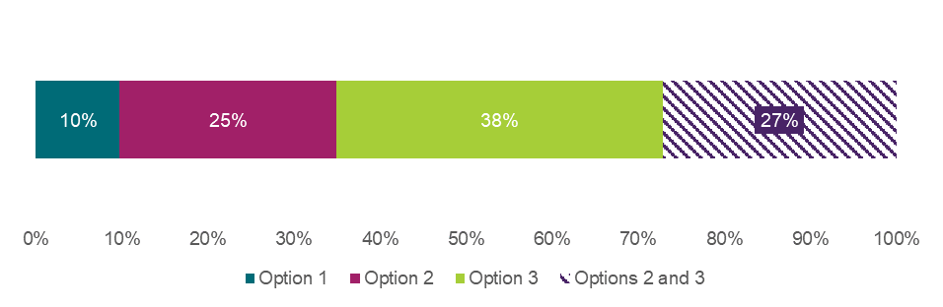

Source: Approved provider survey, as of 11 June 2025, Q96, n=103 unique respondents. Note that if a respondent selected a combination of options, that selection is treated as a unique preference and not double-counted in each individual option. Note that due to rounding, percentages may not add to 100%.

Appendix Chart 12.3.5.17 Workforce responses to “What is your preferred option or combination of options?”



Source: Workforce survey, as of 11 June 2025, Q96, n=171. Note that if a respondent selected a combination of options, that selection is treated as a unique preference and not double-counted in each individual option. Note that due to rounding, percentages may not add to 100%.

Appendix Chart 12.3.5.18 Family, carer, and parent responses to “What is your preferred option or combination of options?”



Source: Families, carers and parents survey, as of 11 June 2025, Q96, n=71. Note that if a respondent selected a combination of options, that selection is treated as a unique preference and not double-counted in each individual option. Note that due to rounding, percentages may not add to 100%.

### 12.3.6 Additional recommendations

Effective identification, monitoring and regulation of ‘related providers’ – Reduction of the risk of harm

Appendix Chart 12.3.6.1 Approved provider responses to “How much do you think each option will reduce the risk of harm to children?”

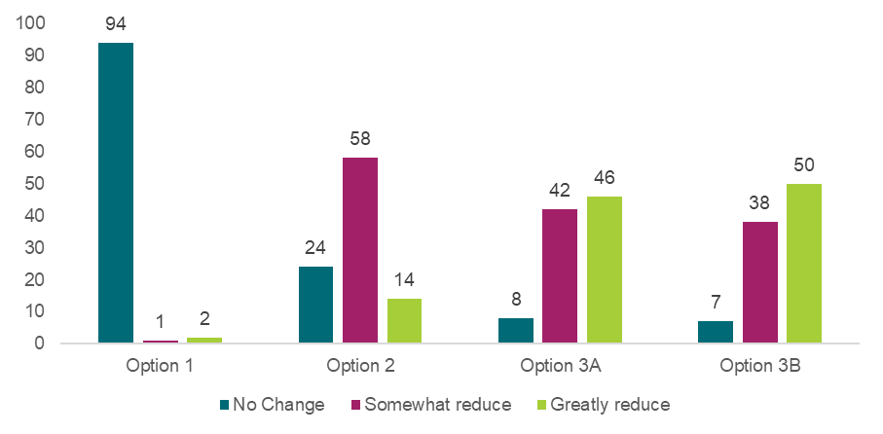

Source: Approved provider survey, as of 11 June 2025, Q107, option 1 n=97, option 2 n=96, option 3A n=96, option 3B n=95.

Appendix Chart 12.3.6.2 Workforce responses to “How much do you think each option will reduce the risk of harm to children?”

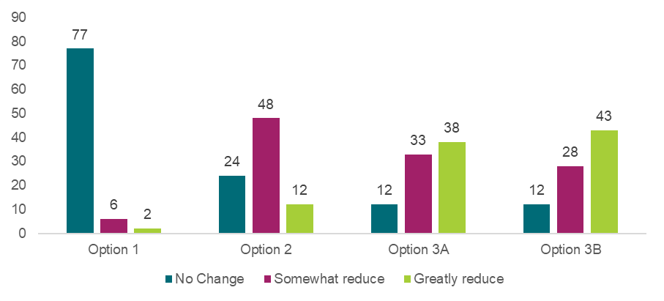

Source: Workforce survey, as of 11 June 2025, Q103, option 1 n=85, option 2 n=84, option 3A n=83, option 3B n=83.

Appendix Chart 12.3.6.3 Family, carer and parent responses to “How much do you think each option will reduce the risk of harm to children?”

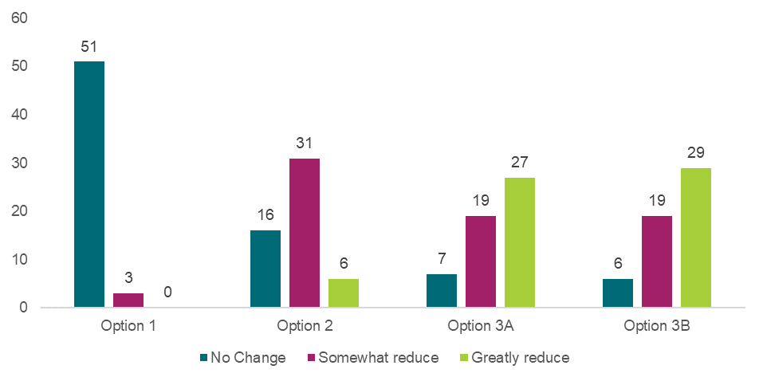

Source: Families, carers and parents survey, as of 11 June 2025, Q107, option 1 n=54, option 2 n=53, option 3A n=53, option 3B n=54.

Effective identification, monitoring and regulation of ‘related providers’ – Preferred option or combination of options

Appendix Chart 12.3.6.4 Approved provider responses to “What is your preferred option or combination of options?”

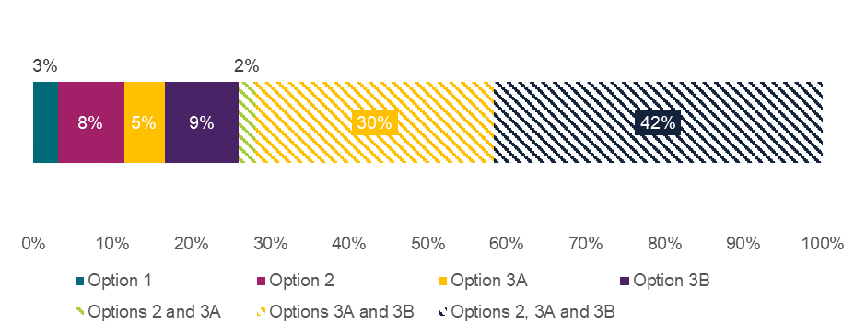

Source: Approved provider survey, as of 11 June 2025, Q105, n=96. Note that if a respondent selected a combination of options, that selection is treated as a unique preference and not double-counted in each individual option. Note that no respondents selected the combination of options 2 and 3B. Note that due to rounding, percentages may not add to 100%.

Appendix Chart 12.3.6.5 Workforce responses to “What is your preferred option or combination of options?”

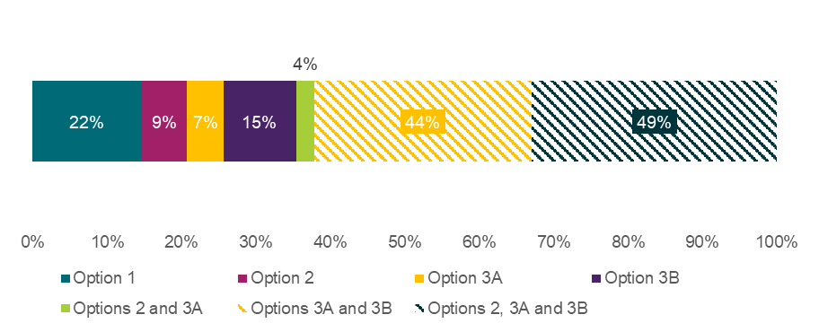

Source: Workforce survey, as of 11 June 2025, Q105, n=55. Note that no respondents selected a combination of option 2 and 3B. Note that if a respondent selected a combination of options, that selection is treated as a unique preference and not double-counted in each individual option. Note that no respondents selected the combination of option 2 and 3B. Note that due to rounding, percentages may not add to 100%. Percentages add to more than 100% since respondents were able to select more than one option or combination of options.

Appendix Chart 12.3.6.6 Family, carer, and parent responses to “What is your preferred option or combination of options?”

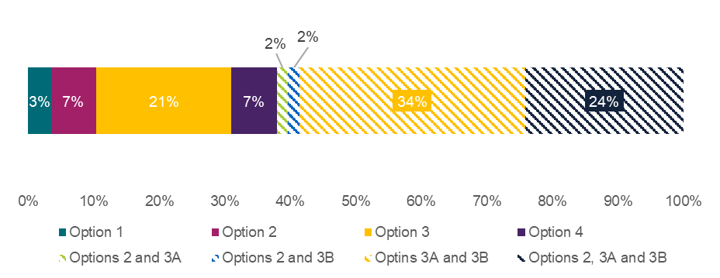

Source: Families, carers and parents survey, as of 11 June 2025, Q105, n=58 unique respondents. Note that if a respondent selected a combination of options, that selection is treated as a unique preference and not double-counted in each individual option. Note that due to rounding, percentages may not add to 100%.

Extending the limitation period for commencing proceedings under the National Law – Reduction of the risk of harm

Appendix Chart 12.3.6.7 Approved provider responses to “How much do you think each option will reduce the risk of harm to children?”

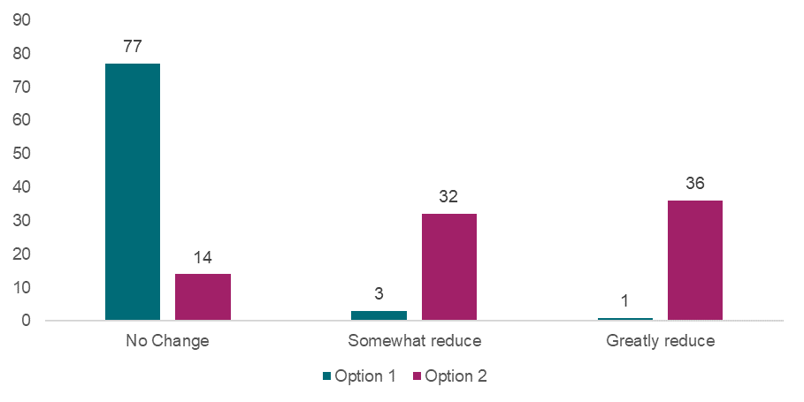

Source: Approved provider survey, as of 11 June 2025, Q115, option 1 n=81, option 2 n=82.

Appendix Chart 12.3.6.8 Workforce responses to “How much do you think each option will reduce the risk of harm to children?”

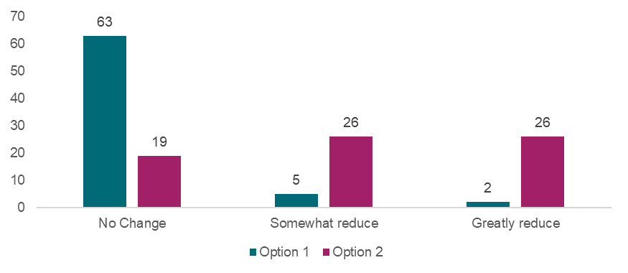

Source: Workforce survey, as of 11 June 2025, Q111, option 1 n=70, option 2 n=71.

Appendix Chart 12.3.6.9 Family, carer and parent responses to “How much do you think each option will reduce the risk of harm to children?”

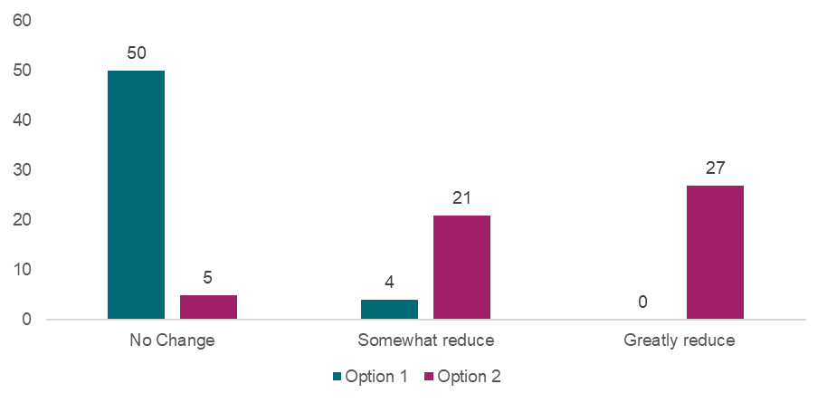

Source: Families, carers and parents survey, as of 11 June 2025, Q115, option 1 n=54, option 2 n=53.

Extending the limitation period for commencing proceedings under the National Law – Preferred option or combination of options

Appendix Chart 12.3.6.10 Approved provider responses to “What is your preferred option or combination of options?”

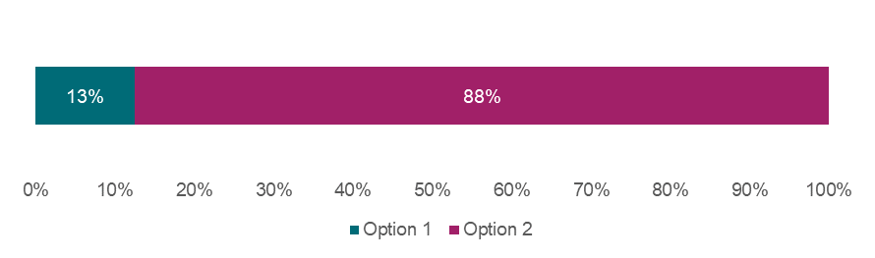

Source: Approved provider survey, as of 11 June 2025, Q115, n=80. Note that due to rounding, percentages may not add to 100%.

Appendix Chart 12.3.6.11 Workforce responses to “What is your preferred option or combination of options?”

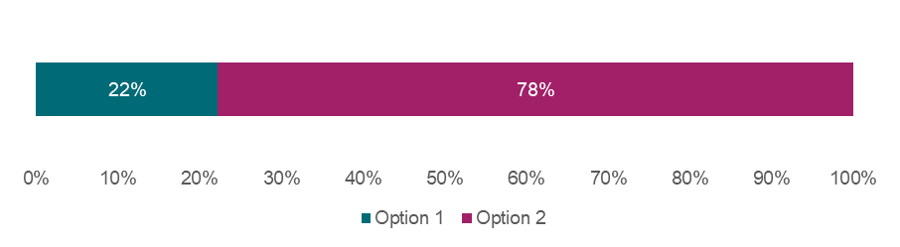

Source: Workforce survey, as of 11 June 2025, Q113, n=63. Note that due to rounding, percentages may not add to 100%.

Appendix Chart 12.3.6.12 Family, carer, and parent responses to “What is your preferred option or combination of options?”

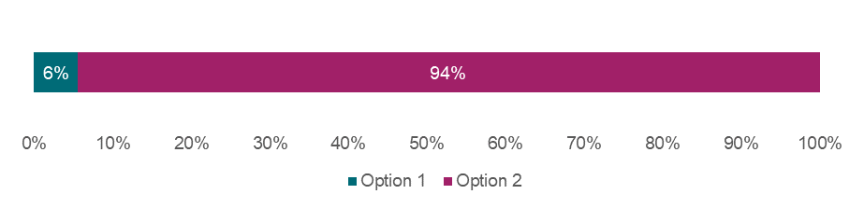

Source: Families, carers and parents survey, as of 11 June 2025, Q113, n=54. Note that due to rounding, percentages may not add to 100%.

Information sharing provisions for recruitment agencies – Reduction of the risk of harm

Appendix Chart 12.3.6.13 Approved provider responses to “How much do you think each option will reduce the risk of harm to children?”

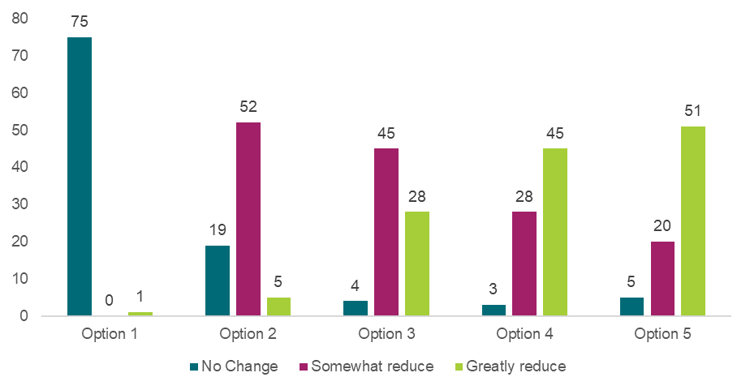

Source: Approved provider survey, as of 11 June 2025, Q123, option 1 n=76, option 2 n=76, option 3 n=77, option 4 n=76, option 5 n=76.

Appendix Chart 12.3.6.14 Workforce responses to “How much do you think each option will reduce the risk of harm to children?”

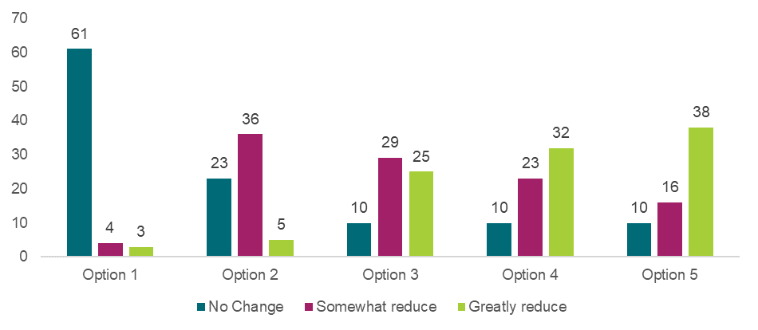

Source: Workforce survey, as of 11 June 2025, Q119, option 1 n=68, option 2 n=64, option 3 n=64, option 4 n=65, option 5 n=64.

Appendix Chart 12.3.6.15 Family, carer and parent responses to “How much do you think each option will reduce the risk of harm to children?”

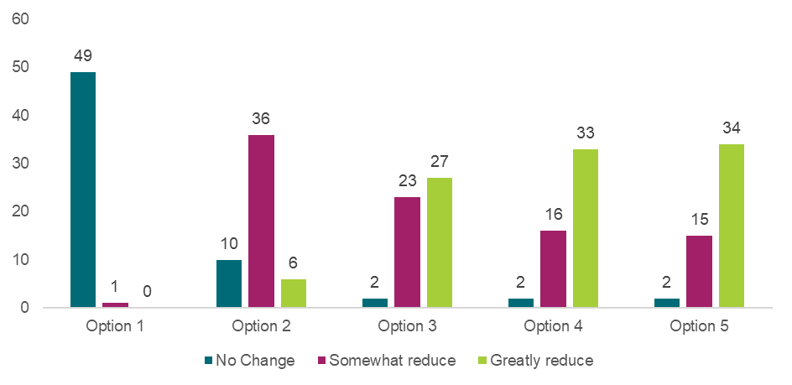

Source: Families, carers and parents survey, as of 11 June 2025, Q123, option 1 n=50, option 2 n=52, option 3 n=52, option 4 n=51, option 5 n=51.

Information sharing provisions for recruitment agencies – Preferred option or combination of options

Appendix Table 12.3.6.1 Approved provider responses to “What is your preferred option or combination of options?”

|  |  |  |
| --- | --- | --- |
| **Preferred option or combination of options** | **Number of responses** | **Proportion of respondents** |
| Option 1 | 1 | 1% |
| Option 2 | 3 | 4% |
| Option 3 | 2 | 3% |
| Option 4 | 4 | 5% |
| Option 5 | 10 | 13% |
| Options 2 and 3 | 0 | 0% |
| Options 2 and 4 | 0 | 0% |
| Options 2 and 5 | 0 | 0% |
| Options 3 and 4 | 4 | 5% |
| Options 3 and 5 | 0 | 0% |
| Options 4 and 5 | 8 | 10% |
| Options 2, 3 and 5 | 0 | 0% |
| Options 2, 4 and 5 | 0 | 0% |
| Options 2, 3 and 4 | 1 | 1% |
| Options 3, 4 and 5 | 22 | 29% |
| Options 2, 3, 4 and 5 | 22 | 29% |

Source: Approved provider survey, as of 11 June 2025, Q123, n=77 unique respondents. Most popular options or combination of options are highlighted in green. Note that if a respondent selected a combination of options, that selection is treated as a unique preference and not double-counted in the singular options. Note that due to rounding, percentages may not add to 100%.

Appendix Table 12.3.6.2 Workforce responses to “What is your preferred option or combination of options?”

|  |  |  |
| --- | --- | --- |
| **Preferred option or combination of options** | **Number of responses** | **Proportion of respondents** |
| Option 1 | 8 | 13% |
| Option 2 | 1 | 2% |
| Option 3 | 4 | 6% |
| Option 4 | 0 | 0% |
| Option 5 | 5 | 8% |
| Options 2 and 3 | 1 | 2% |
| Options 2 and 4 | 1 | 2% |
| Options 2 and 5 | 0 | 0% |
| Options 3 and 4 | 2 | 3% |
| Options 3 and 5 | 0 | 0% |
| Options 4 and 5 | 7 | 11% |
| Options 2, 3 and 5 | 0 | 0% |
| Options 2, 4 and 5 | 1 | 2% |
| Options 2, 3 and 4 | 0 | 0% |
| Options 3, 4 and 5 | 17 | 27% |
| Options 2, 3, 4 and 5 | 17 | 27% |

Source: Workforce survey, as of 11 June 2025, Q121, n=64. Most popular options or combination of options are highlighted in green. Note that if a respondent selected a combination of options, that selection is treated as a unique preference and not double-counted in the singular options. Note that due to rounding, percentages may not add to 100%.

Appendix Table 12.3.6.3 Family, carer, and parent responses to “What is your preferred option or combination of options?”

|  |  |  |
| --- | --- | --- |
| **Preferred option or combination of options** | **Number of responses** | **Proportion of respondents** |
| Option 1 | 1 | 2% |
| Option 2 | 1 | 2% |
| Option 3 | 1 | 2% |
| Option 4 | 8 | 15% |
| Option 5 | 7 | 13% |
| Options 2 and 3 | 0 | 0% |
| Options 2 and 4 | 0 | 0% |
| Options 2 and 5 | 1 | 2% |
| Options 3 and 4 | 1 | 2% |
| Options 3 and 5 | 0 | 0% |
| Options 4 and 5 | 8 | 15% |
| Options 2, 3 and 5 | 1 | 2% |
| Options 2, 4 and 5 | 0 | 0% |
| Options 2, 3 and 4 | 0 | 0% |
| Options 3, 4 and 5 | 11 | 21% |
| Options 2, 3, 4 and 5 | 13 | 25% |

Source: Families, carers and parents survey, as of 11 June 2025, Q121, n=53 unique respondents. Most popular options or combination of options are highlighted in green. Note that if a respondent selected a combination of options, that selection is treated as a unique preference and not double-counted in the singular options. Note that due to rounding, percentages may not add to 100%.

## 12.4 The National Model Code and Guidelines[157]

ACECQA, in partnership with all governments, developed the National Model Code and Guidelines. These documents were released on 1 July 2024 and address child safe practices for the use of electronic devices while providing education and care. Adopting the National Model Code is voluntary and designed for centre-based services, excluding OSHC services. In addition to OSHC, FDC is not covered by current documentation; however, they may choose to adopt similar practices.[158] The National Model Code consists of four parts:

1. Only service-issued electronic devices should be used when taking images or videos of children while providing education and care. The appropriate use of service-issued electronic devices should be clearly outlined in policies and procedures.
2. Personal electronic devices that can take images or videos, and personal storage and file transfer media, should not be in the possession of any person while providing education and care that is working directly with children. Any exceptions should be for limited, *essential purposes* that are authorised in writing by the approved provider of the service.
3. Essential purposes for use and/or possession of a personal electronic device in an education and care setting include personal health requirements, disability, family necessity or technological failure.
4. Approved providers and their services should have strict controls in place for the appropriate storage and retention of images and videos of children.

The National Model Code and Guidelines were intended as a first step while regulatory amendments are considered. While the National Model Code and Guidelines are voluntary in nature, initial consultation[159] with stakeholders during their development suggests there is strong supportfor greater education and regulationin this space – with some approved providers indicating they would prefer governments to introduce legislation to restrict personal device use in education and care settings. However, some stakeholders also raised concerns about the impact in regional and remote areas, on non-profit community-based providers, and on a feminised workforce, many of whom are primary caregivers in their families.

## 12.5 Child protection training and Child Safe Standards

Appendix Table 12.5.1: Overview of jurisdictional child protection training and status of Child Safe Standards implementation

|  | Child protection training | Child Safe Standards implementation status |
| --- | --- | --- |
| NSW | * Nominated supervisors, persons in day-to-day charge, and FDC coordinators are required to complete an approved child protection course. * Approved child protection training courses include[160]:   + CHCPRT002 – Support the rights and safety of children and young people   + CHCPRT025 – Identify and report children and young people at risk   + CHCPRT026 – Support the rights and safety of children and young people   + NSW Department of Education’s Child Protection Awareness Training (this can be completed instead of CHCPRT002). | * NSW introduced the Child Safe Standards in 2020 and legislated the statewide framework in 2022 under the NSW Child Safe Scheme.[161] |
| VIC | * Nominated supervisors, persons in day-to-day charge, FDC coordinators and early childhood teachers are required to complete an approved child protection course. * The VIC Department of Education encourages all early childhood professionals to complete training on child protection and other obligations. Victoria offers a free online eLearning module Protecting Children – Mandatory Reporting and Other Obligations for the Early Childhood Sector (PROTECT). | * Victoria introduced Child Safe Standards in 2016 and amended them in 2022 to reflect the National Principles.[162] |
| QLD | * Persons in day-to-day charge, nominated supervisors and FDC coordinators are required to complete a child protection course. * Approved child protection training courses include[163]:   + CHCPRT025 – Identify and report children and young people at risk   + CHCPRT026 – Support the rights and safety of children and young people   + CHCECE057 – Use collaborative practices to uphold child protection principles. | * QLD passed the Child Safe Organisations Act 2024, with standards to be implemented from October 2025.[164] |
| WA | * The Regulatory Authority for WA (Department of Communities) does not specify that child protection training is mandatory. * No training courses are specified on the Department of Communities website. | * WA has yet to fully implement the Child Safe Standards or the National Principles into legislation.[165] |
| SA | * To work or volunteer in education, people must undergo mandatory notification training about child protection in education. * Approved child protection training courses include:[166]   + Fundamentals course: Responding to risks of harm, abuse and neglect – education and care   + Masterclass course: Responding to risks of harm, abuse and neglect – education and care. | * SA has adopted the National Principles as well as state-informed policy. [167] |
| TAS | * The Department for Education, Children and Young People offers state-specific safeguarding training on its website. This training has been shared with the Tasmanian education and care sector. The Tasmanian Government is currently developing a suite of safeguarding training packages for use across both government and community organisations.[168] | * TAS implemented the National Principles as their ten Child and Youth Safe Standards, mandatory and applicable to education and care services as of January 2024.[169] |
| NT | * The Regulatory Authority for NT (Department of Education) does not specify that child protection training is mandatory. | * The NT is still yet to implement the National Child Safe Standards. |
| ACT | * The Regulatory Authority for ACT (Education Directorate) does not specify that child protection training is mandatory. * Workers and volunteers may need to undertake training if they work for a state government organisation that works for children and are a mandatory reporter.[170] * State-specific training is available for government or non-government staff who work with children and are mandatory reporters: Training to respond to child abuse and neglect. | * The ACT adopted the National Principles as their ten Child Safe Standards, mandatory as of August 2024.[171] |

## 12.6 Overview of jurisdictional WWCCs

Appendix Table 12.6.1: Summary of jurisdictional WWCC details

|  | Name of WWCC or equivalent | WWCC screening agency | WWCC duration | Cost to apply for a WWCC or equivalent |
| --- | --- | --- | --- | --- |
| NSW | Working With Children Check | Office of the Children’s Guardian | 5 years | $105.00 for paid workers and free for volunteers.[172] |
| VIC | Working with Children Clearance | Department of Justice and Community Safety | 5 years | $131.60 for employees and free for volunteers.[173] |
| QLD | Working with Children Check – Blue Card | Blue Card Services | 3 years | $101.30 for all applicants except for volunteers, students and exemption card holders who incur no fee.[174] |
| WA | Working with Children Check | Department of Communities, WWC Screening Unit | 3 years | $87.00 for employees and self-employed people. $11.00 for volunteers, unpaid people and students on unpaid placement.[175] |
| SA | Working with Children Check | Department of Human Services, SA Screening Unit | 5 years | $117.00 for employees, $64.50 for tertiary students and free for volunteers.[176] |
| TAS | Working with Vulnerable People registration | Department of Justice | 5 years | $133.70 for employees and $22.92 for volunteers.[177] |
| ACT | Working with Vulnerable People registration | Access Canberra | 5 years | $151.60 for paid employment purposes and free for volunteering purposes.[178] |
| NT | Working with Children Check clearance | Northern Territory Screening Authority | 2 years | $84 for paid employment (including student placement) and $8 for volunteering purposes.[179] |

Source: Information provided by the Department of Education in each jurisdiction unless otherwise stated.

## 12.7 Summary of relevant WWCC legislation and requirements

Appendix Table 12.7.1: Summary of WWCC legislation and key requirements relevant to education and care contexts

|  | Legislation | Who requires a WWCC in an education and care context? | WWCC employment requirements | Teacher registration/accreditation requirements |
| --- | --- | --- | --- | --- |
| NSW | * *Child Protection (Working with Children) Act 2012* (NSW) No.51 * *Child Protection (Working with Children) Regulation 2013* (NSW) | * Adults undertaking child-related employment or volunteering require a WWCC.[180] * Under 18s are exempt and are not required to hold a WWCC.[181] | * A person can start working with children once they have an application number for a WWCC. However, some employers may require workers to hold a valid WWCC clearance before they commence paid child-related employment.[182] | * All teachers must be NESA- accredited to work in a school or centre-based early childhood service.[183] * A WWCC clearance is a mandatory requirement for teacher accreditation.[184] |
| VIC | * The *Worker Screening Act 2020* (Vic) * *Worker Screening Regulations 2021* (Vic) | * Adults undertaking child-related employment or volunteering require a WWCC.[185] * Under 18s are exempt and are not required to hold a WWCC.[186] | * Services cannot engage anyone in child-related work who does not have a valid WWCC or has lodged an application that’s currently being assessed.[187] | * Early childhood teachers require teacher registration/accreditation prior to working in educational settings. * All teachers registered with the Victorian Institute of Teaching (including early childhood teachers) are exempt from the WWCC if undertaking child-related work in a school or early childhood service.[188] |
| QLD | * *Working with Children (Risk Management and Screening) Act 2000* (Qld) * *Working with Children (Risk and management and Screening) Regulation 2020* (Qld) | * Adults working or volunteering with children require a blue card (i.e. a WWCC). Employed persons under 18 years old also require a blue card.[189] * A key exemption includes volunteers who are under 18 and are not restricted persons.[190] | * A person must have a blue card before working or volunteering with children.[191] | * Teacher registration is not compulsory for early childhood teachers in QLD.[192] * Registered teachers do not require a blue card when teaching in schools. However, registered teachers do need a blue card if providing other child-related services such as working at an early childcare centre.[193] |
| WA | * *Working with Children (Criminal Record Checking) Act 2004* (WA) * *Working with Children (Criminal Record Checking) Amendment Regulations 2023* (WA) * *Working with Children (Screening) Act 2004* (WA) * *Working with Children (Screening) Regulations 2005* (WA) | * Adults undertaking child-related work on a paid, unpaid or volunteering basis require a WWCC. Employed persons under 18 years old undertaking paid work also require a WWCC.[194] * Persons under 18 undertaking volunteering roles or unpaid student placements are exempt from WWCCs.[195] | * A person can start working with children while their WWCC application is being processed if they are not otherwise prohibited under the Act (Section 22) (noting the Australia Post application receipt is required as proof).[196] | * Early childhood teachers are required to be registered with the Teacher Registration Board of WA.[197] * Registered teachers require a current WWCC.[198] |
| SA | * *Child Safety (Prohibited Persons) Act 2016* (SA) * *Children’s Protection Law Reform (Transitional Arrangements and Related Amendments) Act 2017* (SA) * *Child Safety (Prohibited Persons Regulations 2019* (SA) | * Persons require a WWCC if they are over 14 years and undertake child-related work as a volunteer or employee for more than seven days per year, or any work that involves an overnight stay or close contact with a child with disability.[199] | * A person must have a valid WWCC before working or volunteering with children.[200] | * Early childhood teachers must be registered as a teacher with the Teachers Registration Board of SA.[201] * Registered teachers require a current WWCC.[202] |
| TAS | * *Registration to Work with Vulnerable People Act 2013* (Tas) * *Registration to work with Vulnerable People Regulations 2014* (Tas) * *Registration to Work with Vulnerable People (Risk Assessment for Child-Related Activities) Order 2014* (Tas) | * Persons over 16 years old who work or volunteer with children require a Working with Vulnerable People (WWVP) registration.[203] | * Persons can begin work once they have applied for a WWVP registration if they meet certain obligations. However, in the Education and Care sector (unrelated to WWVP legislation), staff, students and volunteers must hold a registration before they can engage in child-related work (regulation 344).[204] | * Teacher registration is not compulsory for early childhood teachers in education and care in TAS.[205] * Registered teachers require a current WWVP registration.[206] |
| ACT | * *Working with Vulnerable People (Background Checking) Act 2011* (ACT) * *Working with Vulnerable people (Background Checking) Regulation 2012* (ACT) * *Working with Vulnerable People (Background Checking) Risk Assessment Guidelines 2021* (ACT) | * Persons over 16 years old who work or volunteer with children require a Working WWVP registration.[207] | * Persons may work or volunteer in a regulated activity if (1) their employer agrees, and they are supervised when undertaking regulated activities or (2) are a kinship carer and have not been previously refused registration or had a previous registration cancelled.[208] * Persons aged under 16 can begin working or volunteering without a WWVP check. | * From 1 April 2024, early childhood teachers are eligible for teacher registration under a voluntary scheme. However, early childhood teacher registration is not currently mandated.[209] * Registered teachers require a current WWVP registration.[210] |
| NT | * *Care and Protection of Children Act 2007* (NT) * *Care and Protection of Children (Screening) Regulations* (NT) | * Persons over 15 years old who work or volunteer with children require a WWCC.[211] | * Some conditions and exemptions exist which allow a person to begin working or volunteering without a WWCC. For example, an employer can apply for a short-term temporary exemption.[212] | * Currently only early childhood educators in working in school settings require teacher registration. However, under the Shaping our Future – National Early Childhood Education and Care Workforce Strategy, teacher registration will be required for early childhood teachers from 2026 (first phase of implementation).[213] * Registered teachers require a WWCC.[214] |

## 12.8 Family Assistance Law (FAL)

Identifying related providers has also proven challenging in relation to Family Assistance Law (FAL). After large structural changes in the education and care sector, a provision was established which allows the Australian Government to have better visibility over ‘related providers’ where certain thresholds are reached or there is overlap across entities’ PMCs.

Related providers are defined in relation to two concepts in the FAL. Subsection 4A(1) of the FAL considers a provider as a *large* provider if:

* the provider operates 25 or more approved child care services; or
* the provider is one of 2 or more related providers who together operate 25 or more approved child care services; or
* the provider proposes to operate, or is one of 2 or more related providers who propose to together operate, 25 or more child care services.

Subsection 4A(3) of the FAL then identifies related providers in circumstances where 25 or more services are held collectively across the approved providers:

* the providers have in common 25% or more of the persons who are concerned in, or take part in, their management (PMCs); or
* one provider owns 15% or more of the other provider; or
* one provider is entitled to receive 15% or more of any dividends paid by the other provider.

Jurisdictions have explored the idea of incorporating a definition of related providers into the National Law to align with the FAL definition. However, Regulatory Authorities have determined that strict alignment with the FAL may not be sufficient because:

* the definition would not capture all related providers operating under the National Law (as it only covers those receiving the Child Care Subsidy). Data suggests that 16.5% of services operating under the NQF do not receive the Child Care Subsidy[215], and so would not be covered by this definition.
* the FAL definition only captures related providers with more than 25 services collectively, which would not provide sufficient intelligence about smaller, but problematic, providers.
* the FAL model relies on self-reporting by providers which may not be appropriate under the National Law.
* any amendments to the definition under FAL would have implications for the National Law.
* there remain differences in personnel captured under the PMC definitions for both pieces of legislation, due to the differing purposes of the legislation. This is driven by whether these individuals have responsibilities for the operation of the approved provider (FAL) or in relation to an approved service (National Law). While one outcome of the 2019 NQF Review led to improvements in the alignment between the definitions of PMCs under both pieces of legislation, incorporating an existing definition of related providers that relies on the FAL definition may not provide sufficient oversight under the National Law.

1. *ACECQA, (2023), Review of Child Safety Arrangements under the National Quality Framework, <https://www.acecqa.gov.au/sites/default/files/2023-12/Review%20of%20Child%20Safety%20Arrangements%20under%20the%20National%20Quality%20Framework-full_report.pdf>.*
2. *Additional recommendations explored through this DRIS have arisen from further analysis or as supplementary findings to reviews of critical incidents which have occurred over the past 12 months, in accordance with CSR recommendation 16*
3. *The CRIS was published on 28 April, which is the formal commencement date of the consultation period. However, data collection activities (including the launch of the surveys) commenced from 5 May.*
4. *Tasmania has been in caretaker during the endorsement of the recommended policy options and final confirmation on recommended options will be provided once a government is formed. Tasmanian policy officers who have engaged with the Child Safety Review Group work will brief the incoming minister as required.*
5. *Australian Government Guide to Regulatory Impact Analysis (2020), < https://oia.pmc.gov.au/sites/default/files/2021-06/australian-government-guide-to-regulatory-impact-analysis.pdf>.*
6. *The Office of Impact Analysis, (2023), Regulatory Impact Analysis Guide for Ministers’ Meetings and National Standard Setting Bodies, <https://oia.pmc.gov.au/sites/default/files/2024-09/regulatory-impact-analysis-guide-for-ministers-meetings-and-national-standard-setting-bodies.pdf>.*
7. *This RIS also applies to the Education and Care Services National Law (Western Australia), see section 4 of the Education and Care Services National Law (WA) Act 2012.*
8. *The Office of Impact Analysis, (2023), Regulatory Impact Analysis Guide for Ministers’ Meetings and National Standard Setting Bodies, <https://oia.pmc.gov.au/sites/default/files/2024-09/regulatory-impact-analysis-guide-for-ministers-meetings-and-national-standard-setting-bodies.pdf>.*
9. *The CRIS was published on 28 April, which is the formal commencement date of the consultation period. However, data collection activities (including the launch of the surveys) commenced from 5 May.*
10. *Appendix 12.2 provides an overview of the recommendations of the CSR that are being considered as part of this DRIS.*
11. *WWCC is used to represent working with children checks and working with vulnerable persons registration (WWVPR), in addition to equivalent checks across jurisdictions, in this document.*
12. *Productivity Commission (2025), Report on Government Services 2025 Part B Section 3, <https: / / www.pc.gov.au / ongoing / report-on-government-services / 2025 / child-care-education-and-training / early-childhood-education-and-care>.*
13. *ACECQA, (2023), Review of Child Safety Arrangements under the National Quality Framework, <https://www.acecqa.gov.au/sites/default/files/2023-12/Review%20of%20Child%20Safety%20Arrangements%20under%20the%20National%20Quality%20Framework-full_report.pdf>.*
14. *On 1 January 2026, the preamble to Quality Area 7 will explicitly make reference to child safety by including ‘the ethical management of a quality service that is child safe’.*
15. *An approved provider is defined in the National Law as a person who holds a provider approval, which authorises them to apply for one or more service approvals. Approved providers are responsible under the National Law for managing an education and care service they are approved to operate, across areas such as health and safety of children, staffing and documentation. An approved service is the site at which children attend and are educated and cared for by teachers and educators.*
16. *ACECQA, (2025), NQF Snapshot Q1 2025, <* *https://www.acecqa.gov.au/sites/default/files/2025-05/NQF%20Snapshot%20Q1%202025%20FINAL.PDF >.*
17. *Unless otherwise stated, numbers here refer to the number of children aged 0-12 attending a Child Care Subsidy approved childcare service (excluding the preschool category). Some children attend more than one service.*
18. *Productivity Commission (2025), Report on Government Services 2025, <* *https://www.pc.gov.au/ongoing/report-on-government-services/2025/child-care-education-and-training/early-childhood-education-and-care >. Percentages are in relation to the total number of children attending childcare as in the previous footnote and the number of children attending preschool.*
19. *Preschool is called ‘kindergarten’ in VIC, Queensland (QLD), Western Australia (WA) and Tasmania (TAS).*
20. *The majority of preschools/kindergartens operating in WA and TAS are out of scope of the NQF, as they have oversight via the schooling system in these states.*
21. *The number of children enrolled in a preschool program is the number of children aged 3-6 enrolled in a preschool program as of 2023.*
22. *NQA ITS data collected on provider management type is self-reported by providers when applying for service approval. The service profile can vary significantly between provider management types. For example, Private for Profit’ managed services are predominantly LDC services, while ‘State/Territory and local government’ managed services are predominantly preschools/kindergartens.*
23. *Implementation of further recommendations from the CSR are being progressed concurrently to the policy options included in the DRIS. These further recommendations are either outside the scope of the NQF but within the remit of Education Ministers (Recommendations 6, 7, 8) or are outside the scope of the NQF and outside the remit of Education Ministers (Recommendations 2.2, 13, 14, 15.1-15.6 and possibly 16). For a full description of these recommendations, refer to the* [*CSR full report*](https://www.acecqa.gov.au/sites/default/files/2023-12/Review%20of%20Child%20Safety%20Arrangements%20under%20the%20National%20Quality%20Framework-full_report.pdf)*.*
24. *Noting there are a number of offences for which FDC educators are liable.* 
25. *In jurisdictions with a working with vulnerable persons registration (WWVPR) that does not only cover children, this cancellation may only apply to an individual’s ability to work with children, specifically.*
26. *WWCC is used to represent working with children checks and working with vulnerable persons registration (WWVPR), in addition to equivalent checks across jurisdictions, in this document.*
27. *Keeping Children Safe (2025), The International Child Safeguarding Standards, <https://www.keepingchildrensafe.global/international-child-safeguarding-standards/>*
28. *NQF Annual Performance Report (2023), <https://www.acecqa.gov.au/sites/default/files/2023-11/2023-NQF-Annual-Performance-Report-FINAL_0.pdf>* *Keeping Children Safe (2025), The International Child Safeguarding Standards, <https://www.keepingchildrensafe.global/international-child-safeguarding-standards/>.*
29. *The CRIS was published on 28 April, which is the formal commencement date of the consultation period. However, data collection activities (including the launch of the surveys) commenced from 5 May.*
30. *The Australian Government established the PCRG to provide parents and carers an opportunity to have a say on what the government is doing to support our youngest children. The Department of Social Services provides secretariat services for the PCRG. The PCRG includes representatives of peak parenting bodies and parents and/or carers from diverse backgrounds.* 
31. *One document submission included a video submission, and one included the results of a child voice activity.* 
32. *Other included, for example, private organisations, government agencies, and a student.*
33. *See McCarthy, M., Taylor, P., Norman, R. E., Pezzullo, L., Tucci, J., & Goddard, C., (2016), The lifetime economic and social costs of child maltreatment in Australia, Children and Youth Services Review, 71, 217-226. DOI:* [*https://doi.org/10.1016/j.childyouth.2016.11.014*](https://doi.org/10.1016/j.childyouth.2016.11.014)*.* 
34. *This cost has been inflated to 2025 dollars using CPI figures published by the Australian Bureau of Statistics.*
35. *See <https://oia.pmc.gov.au/resources/guidance-impact-analysis/regulatory-impact-analysis-guide-ministers-meetings-and-national>.*
36. *OIA’s guidance specifically asks the RIS question ‘What are the policy options under consideration?’, however this subsection of each chapter has been slightly amended as some of the recommended options incorporate changes to the consulted option based on stakeholder feedback.*
37. *The National Regulations will be more specific in these requirements* *from 1 September 2025, when there will be a requirement for services to have new policies and procedures relating to the safe use of digital devices (including the use of closed-circuit television (CCTV).*
38. *Additional matters include:*

    *the use of optical surveillance devices at the service*

    *obtaining authorisation from parents to take, use, and store images and videos of children.*
39. *Survey respondents and forum participants did not provide information on the expected timeframes to implement the National Model and Code Guidelines.* 
40. *Free text responses for ’other’ included a range of statuses including: the approved provider had policies and processes that predated the National Model Code and Guidelines; the approved provider has their own policies and processes that somewhat align to the National Model Code and Guidelines (particularly for FDC); the approved provider has adopted a modified version of the National Model Code and Guidelines; and one instance where a Nominated Supervisor reported that their service has adopted the National Model Code and Guidelines but the approved provider is still in the process of adopting formally.*
41. *These amendments have been progressed separately to this Regulation Impact Analysis (RIA) process and will commence on 1 September 2025, and are therefore considered to form part of the status quo.*
42. *If devices are insured, services may not bear the same replacement costs as estimated above.*
43. *10% was the share of centre-based services (preschool/kindergarten, LDC, and OSHC services) that had not yet adopted the National Model Code and Guidelines, based on survey responses shown in Table 5.1.*
44. *This includes preschool/kindergarten, LDC, and OSHC services.*
45. *41% was the share of FDC services that had not yet adopted the National Model Code and Guidelines, based on survey responses shown in Table 5.1.*
46. *The present value is calculated based on a 7% discount rate (OIA’s preferred discount rate for impact analysis). This discount rate is used throughout the report for any present value estimates.*
47. *This assumes that 70% of devices purchased are tablets priced at $587, while the remaining 30% of devices purchased are mid-tier phones priced $787. This is based on the majority of services indicating they use tablets but understanding that devices may also be required for making calls. Some services may choose to purchase cheaper devices, however there are also several more expensive devices on the market, so this has been selected as a reasonable average price point.*
48. *Stakeholders also provided feedback that around one device would likely be required per room. This advice was used when determining a likely size (in terms of approved places) of a small, medium, and large service, in the absence of data on the number of rooms per service.*
49. *Data on approved places per service was obtained from the ACECQA website.*
50. *The number of educators is estimated to be 9,249, estimated is based on the size of the FDC workforce of 9,688 as reported in the 2024 National Workforce Census, adjusted for an estimated 439 FDC coordinators, who oversee educators at a 1:15 or 1:25 ratio, depending on the age of the service. 41% of this figure equates to 3,792.*
51. *The jurisdiction specific requirement in WA (Education and Care Services National Regulations 2012 (WA) chapter 7, division 3A, regulation 373A) requires educators providing education and care at a FDC residence or venue must have ready access to at least two operating telephones or other similar means of communication to enable immediate communication to and from parents, family members, other adults who may need to be in contact about a child and emergency services. At least one of these devices would be considered service-issued and could be used to take images and videos of children, and as a result, it is assumed that WA-based FDCs do not need to purchase devices.*
52. *See <*[*https://www.ato.gov.au/law/view/document?DocID=ITD/EF20151C8/00001&PiT=99991231235958*](https://www.ato.gov.au/law/view/document?DocID=ITD/EF20151C8/00001&PiT=99991231235958)*>. While the useful life of a tablet may be longer, tablets are also prone to breaking, particularly in education and care settings, and therefore this replacement frequency was considered sufficient for the analysis.*
53. *As previously stated,* *by law, FDC educators in WA must already have two devices, see National Regulations (WA) section 373A. At least one of these devices would be considered service-issued and could be used to take images and videos of children.*
54. *Given the unique home-based context of FDC, phone access is critical to child safety, as evident through the jurisdiction specific requirement in WA for FDC educators to have access to at least two operating telephones or similar.*
55. *The free text submission that was not negatively coded was from a third party training organisation.*
56. *While this feedback was received from Aboriginal and Torres Strait Islander families, it may also be relevant for a range of families and services.*
57. *Further information on this estimate is available in Chapter 4.*
58. *This value, multiplied by the total cost of harm to children in Australia, equates to the monetised cost of options 2 and 3.*
59. *Based on Figure 6 in ACECQA’s NQF Snapshot Q1 2025, see <https://www.acecqa.gov.au/sites/default/files/2025-05/NQF%20Snapshot%20Q1%202025%20FINAL.PDF>.*
60. *See <https://oia.pmc.gov.au/resources/guidance-assessing-impacts/regulatory-burden-measurement-framework>.*
61. *‘Government Protocol’ refers to a set of established rules, procedures or guidelines that govern how government interacts with other entities.*
62. *In WA, FDC coordinators are currently not obligated under jurisdictional legislation to undertake child protection training, however this is expected to be implemented in the foreseeable future.*
63. National Office for Child Safety, *National Principles for Child Safe Organisations,* <https://www.childsafety.gov.au/resources/national-principles-child-safe-organisations>.

    .
64. *The estimate of the number of educators and staff members required to undertake training also includes unpaid staff (i.e., volunteers), which is based on 2024 National Workforce Census data.*
65. *Present value costs are calculated at a discount rate of 7%. This specific cost estimate does not account for staff attrition and training of staff stepping into these roles, as staff turnover in these roles was not specified.*
66. *This is based on an analysis of survey responses where approved providers indicated whether child protection training was delivered to 10% up to 100% of staff (in 10% intervals). 61% of approved providers indicated all staff received child protection training and the weighted average training completion was 87%.*
67. *This ratio applies to new services, while a larger ratio of 1:25 is allowed for services that have been operating for over a year. 1:15 has been adopted as a conservative estimate.*
68. *The assumption that child protection training will take 3 hours has been used for the purposes of costing. The length of time required for child protection training delivered by accredited training providers ranges between 2 to 9 hours across jurisdictions, with three hours being a common timeframe.*
69. *See <https://awards.fairwork.gov.au/MA000120.html#_Toc201561810>.*
70. *This wage rate is also used throughout this report, when estimating the value of time for education and care sector staff.*
71. *The cost of agency educators was quoted to be in the range of two to three times higher than normal wages in consultation.*
72. *This is based on an analysis of survey responses where approved providers indicated whether child protection training was delivered to 10% up to 100% of staff (in 10% intervals). 61% of approved providers indicated all staff received child protection training and the weighted average training completion was 87%.*
73. *This figure was estimated based on 2024 National Workforce Census data, which indicated that 208,356 workers were employed across centre-based day care (includes LDCs and preschool/kindergarten), FDCs, and OSHCs. From an analysis of employment in the education and care services and preschool education sectors in the 2021 ABS Census of population and housing, approximately 87% of staff had occupations that were likely to involve working with children in care settings, with a higher ratio of 92% in education settings. These ratios were applied to overall workforce size estimates (with nominated supervisors, FDC coordinators, and persons in day-to-day charge excluded) to obtain the estimate of approximately 130,000 workers requiring training under option 4.*
74. *This is based on an analysis of survey responses where approved providers indicated whether child protection training was delivered to 10% up to 100% of staff (in 10% intervals). 61% of approved providers indicated all staff received child protection training and the weighted average training completion was 87%. Since SA already requires all staff and volunteers who work in Government education and care services to undertake this training, and 10% of education and care services are government operated, a higher share of 88.3% existing uptake of training has been assumed for SA.* 
75. *It is understood that all levels of early childhood education qualifications require some form of placement, although the precise number of hours varies by qualification, jurisdiction, and institution.*
76. *This is based on a 2022 estimate of enrolments from AITSL (https://www.aitsl.edu.au/research/australian-teacher-workforce-data/atwd-reports/national-trends-ite-pipeline-dec2024) and commencements have been estimated based on the relative share of VET to higher education enrolments and the proportion of VET commencements to VET enrolments, in the absence of a better available estimate.*
77. *This is based on an analysis of survey responses where approved providers indicated whether child protection training was delivered to 10% up to 100% of staff (in 10% intervals). 61% of approved providers indicated all staff received child protection training and the weighted average training completion was 87%. 13% is the remaining number of people required to do the training. While this survey statistic is not specific to training providers, it is considered reasonable to assume that approved providers may require students to do the same training that applies to staff, based on sentiment shared during stakeholder consultation.*
78. *Based on the aforementioned analysis of* *employment in the education and care services and preschool education sectors in the 2021 ABS Census of population and housing, approximately 13% of staff had occupations that were less likely to involve working with children in care settings, with a lower ratio of 8% in education settings.*
79. *Advice was provided that this requirement can be fulfilled in a shorter timeframe than child protection training. As such, an assumption of 1 hour was applied.*
80. *2024 National Workforce Census* 
81. *Further information on this estimate is available in Chapter 4.*
82. *This value, multiplied by the total cost of harm to children in Australia, equates to the monetised cost of option 3.*
83. *Based on Figure 6 in ACECQA’s NQF Snapshot Q1 2025, see <https://www.acecqa.gov.au/sites/default/files/2025-05/NQF%20Snapshot%20Q1%202025%20FINAL.PDF>.*
84. *See <https://oia.pmc.gov.au/resources/guidance-assessing-impacts/regulatory-burden-measurement-framework>.*
85. *Section 166 of the National Law imposes a legal obligation on approved providers and nominated supervisors to ensure that children being educated and cared for are not subjected to inappropriate discipline. If a child is subjected to inappropriate discipline by a staff member, volunteer or FDC educator whilst in the care of a service, then the approved provider and nominated supervisor will have also failed in their obligations, in addition to the person who inappropriately disciplined, and contravened section 166 of the National Law.*
86. *This section also applies to other persons in any way involved in the provision of an education and care service, such as approved providers, persons with management or control, and nominated supervisors.*
87. *An enforceable undertaking is an agreement between a person and the Regulatory Authority, where the person agrees to take certain actions, or refrain from certain actions, to comply with the National Law. For example, an enforceable undertaking may require a person to undertake training.*
88. *See Chapter 7.3 for further information on prohibitions.*
89. *The corresponding numbers form Chart 7.1 do not sum due to rounding.*
90. *There is also a legal requirement for all approved providers to have a Code of Conduct. However, this requirement does not determine the quality or robustness of these Codes of Conduct.*
91. *While this option may still impose incremental costs, approved providers are already required to have a Code of Conduct and review it regularly.*
92. *This survey question did not specify who would be responsible for the administrative costs*.
93. *Under the National Law, the Regulatory Authority is required to notify the respective jurisdictions’ WWCC agency when they issue a prohibition notice.*
94. *NQA ITS is ACECQA’s online system to manage and oversee education and care services, which can be accessed by approved providers (or prospective providers) to make applications and undertake other functions.*
95. *In the instance where educator conduct falls under an offence under the National Law, it often connects to a failing of the approved provider and nominated supervisor, as seen in section 166 of the National Law – Offence to use inappropriate discipline.*
96. *National Law s182(1)*
97. *National Law s185*
98. *National Law 179A(1)*
99. *National Law s184(3)*
100. *Refer to Chapter 6, noting this Chapter seeks to mandate child safety training.*
101. *There is also a legal requirement for all approved providers to have a Code of Conduct. However, this requirement does not determine the quality or robustness of these Codes of Conduct.* 
102. *Given that many current enforceable undertakings require an educator or staff member to undertake training or retraining, the costs associated with data collection and record keeping of mandatory training may be lower for some approved providers that have managed enforceable undertakings and therefore have established processes.*
103. *A show cause process is a formal procedure where an individual is required to explain or justify their actions or conduct, usually in response to allegations or concerns raised by an employer or Regulatory Authority.* 
104. *WWCC is used to represent working with children checks and working with vulnerable persons registration (WWVPR), in addition to equivalent checks across jurisdictions, in this document.*
105. *NSW Regulatory Authority has, in consultation with the NSW Office of the Children’s Guardian, interpreted requirements as meaning NSW requires a WWCC to work in education and care, however is seeking this amendment through this DRIS to put it beyond doubt.*
106. *Exemptions exist in TAS and the jurisdiction specific requirement (reg 344) is an important safeguard to ensure that all persons hold a current WWCC prior to being employed/engaged.*
107. *A teacher registration/accreditation is, however, required for early childhood teachers working in school settings.*
108. *Ibid*
109. *Government initiatives have included: requiring WWCC details to be noted on volunteer staff records and existing student records (regulation 149); requiring volunteers to be aware of how to comply with all child protection laws and any obligations held under them (regulation 84).*
110. *Noting it is often individuals who are new to the sector (including trainees) who commence without a valid WWCC.* 
111. *In some jurisdictions, the new employer is responsible for advising a change, not the individual.* 
112. *Holding a valid WWCC is a requirement of teacher registration in SA. As such, the SA Department of Human Services Screening Unit notifies the Teacher Registration Board of any changes in a registered teacher’s WWCC status. The Department of Education do not notify the Teacher Registration Board of changes in status, as they receive the notification straight from the SA Department of Human Services.*
113. *For example, this may include notification of whether the person is charged with or convicted of an offence of a sexual or violent nature, involving drugs or a weapon, or if the person’s application for a WWCC, card or registration has been rejected, revoked or suspended, or if they are prohibited from working with children.*
114. *Across all jurisdictions, the WWCC screening agency notifies the verified or listed employer of changes in WWCC status, except for WA where it is a requirement for the employee to notify their employer of a change in criminal record.*
115. *In some states, such as QLD, Regulatory Authorities are notified by WWCC screening agencies directly of any changes to an employee or volunteer’s WWCC status. In such instances, notification of any changes in WWCC status from approved providers is not required.*
116. *As per note 55.* 
117. *In consultation, the WA WWCC screening agency indicated that they do make notifications when they are able to.*
118. *Holding a valid WWCC is a requirement of teacher registration in South Australia. As such, the DHS Screening Unit notifies the Teacher Registration Board of any changes in a registered teachers WWCC status. The Department of Education do not notify the Teacher Registration Board of changes in status, as they receive the notification straight from DHS.*
119. *Noting in QLD, Blue Card Services, the WWCC screening agency, makes this notification.*
120. *QLD and WA already require this, as demonstrated in Table 7.4.*
121. *A centre-based service means an education and care service other than a FDC service. This includes most LDC, preschool and OSHC services that are delivered at a centre.*
122. *There are two types of waivers: (1) temporary waivers, which may be granted for up to 12 months, and (2) service waivers, which may be granted if a provider is unable to meet requirements for an ongoing period. There is no specific expiry date for a service waiver.*
123. *In 2019, 10 waivers of regulation 115 were approved; 8 of these waivers were for services operating in QLD.*
124. *There were an estimated 0.39 breaches of section 165 per non-waivered service from 2021/22 to 2023/24. However, this is based on 6,753 breaches over time – across the three-year period from 2021/22 to 2023/24 - and 17,423 LDC, OSHC, and preschool/kindergarten services operating at a point in time, in 2024. As some services may have closed and others opened over the* *reporting period for section 165 breaches, the number of breaches per service may not be directly comparable.*
125. *Data provided by ACECQA.*
126. *Data provided by ACECQA*
127. *This has been implemented in most jurisdictions. WA has not yet implemented this in their regulations, but services may be voluntarily complying with the National Regulations.*
128. *This question was included in the approved provider survey.*
129. *The present value is calculated based on a 7% discount rate (OIA’s preferred discount rate for impact analysis).* 
130. *This estimated is based on the size of the FDC workforce of 9,688 as reported in the 2024 National Workforce Census, adjusted for an estimated 439 FDC coordinators, who oversee educators at a 1:15 or 1:25 ratio, depending on the age of the service.*
131. *This uses the minimum award wage for a level 5.1 employee of $34.63 in the education and care sector and applies a multiplier of 1.75 to account for on-costs, in line with OIA guidance.*
132. *Further information on this estimate is available in Chapter 4.*
133. *For the purposes of measuring regulatory burden, it has been assumed that all FDCs operate on a for-profit basis. While relevant data is not reported at the service type level, it is possible that some FDCs operate on a not-for-profit basis and could be considered community organisations.*
134. *See <https://oia.pmc.gov.au/resources/guidance-assessing-impacts/regulatory-burden-measurement-framework>.*
135. *The residence refers to the habitable areas of a dwelling.*
136. *For example, a FDC service premises may be located on farmland with a nearby shed that stores dangerous farming equipment. Another example may be a room outside the FDC service premises but still part of the FDC residence, which is being or has been used for inappropriate or illegal activity.*
137. *It should be noted that the true number of visits to services will vary based on how data is collected. Some states and territories may count FDC visits to various FDC services under one approved provider as one visit, while other jurisdictions will count each individual FDC service visit.*
138. *The number of visits per year is recorded in the NQA ITS as visits to an FDC service, this could include visits to a principal office of the FDC service, a residence, or to a venue.*
139. *Regulation 97 of the National Regulations sets out requirements for emergency and evacuation procedures.* 
140. *Legislative provisions could mirror section 215 of the National Law, which grants the Regulatory Authority the power to obtain information, documents, and evidence from individuals or entities when they reasonably suspect an offense has been, or may be, committed under the National Law.*
141. *Regulation 116 is concerned with assessments of FDC residences and approved venues.*
142. *Regulation 97 is concerned with emergency and evacuation procedures.*
143. *Currently, there is no legal definition of a related provider in the National Law. Hence, when this document refers to related providers, it is referring to approved providers under the National Law that have been identified as related in the assessment of a relevant Regulatory Authority.*
144. *Existing compliance tools to regulate approved providers include the use of infringement notices, emergency action notices, compliance directions, compliance notices, and conditions on provider or service approvals. However, the issue remains that the Regulatory Authority can only apply these at the individual provider level and often cannot identify the relatedness of providers.* 
145. *At least one large approved provider identified that it would be affected by the proposed reform.*
146. *Note that this period of two years takes precedence over limitation periods typically applied to summary offences in states and territories. Limitation periods vary between 6 and 12 months, across jurisdictions. See Criminal Procedure Act 1986 (NSW) s 179(1); Criminal Procedure Act 2009 (VIC) s 7(1)(a); Justices Act 1886 (QLD) s 52(1); Local Court (Criminal Procedure) Act 1928 (NT) s 52; Justices Act 1959 (TAS) s 26(1); Criminal Procedure Act 2004 (WA) s 21; Criminal Procedure Act 1921 (SA) s 52, Legislation Act 2001 (ACT), s 192(2).*
147. *Royal Commission into Institutional Responses to Child Sexual Abuse (2017). Volume 4, Identifying and disclosing child sexual abuse.* [*https://www.childabuseroyalcommission.gov.au/identifying-and-disclosing-child-sexual-abuse*](https://www.childabuseroyalcommission.gov.au/identifying-and-disclosing-child-sexual-abuse)
148. *Even if a limitation period applies under the National Law, it should be noted that a statute of limitations does not generally apply for indictable criminal offences i.e. a person can be charged and prosecuted many years after the alleged offence*.
149. *A prohibition notice in the education and care sector means a person is barred from working in or holding a specific role within an approved education and care service, as they may pose an unacceptable risk of harm to children.*
150. *While compliance with record keeping requirements is already legislated, only the extent to which compliance may improve as a result of the guidance are factored into cost considerations for the DRIS. This is in line with OIA requirements.*
151. *An authorised officer may obtain relevant information from a specified person for any of the following purposes (s206):*

     *monitoring compliance with the National Law*

     *a rating assessment of an approved education and care service*

     *obtaining information requested under other sections of the National Law*

     *Additionally, Regulatory Authorities (under s215 of the National Law) have the power to obtain information, documents and evidence by notice (s215) where there is a reasonable suspicion that an offence under the National Law may have been committed.*
152. *A small number of recruitment agencies participated in the consultation process, meaning this insight is from a small sample size.*
153. *This was noted as both volunteering in practice at the service, and, in WA, because FDC residents may apply for their mandated WWCC under ‘volunteer’ status.* 
154. *While OIA typically requires a separate regulatory burden estimate for each option, the monetised costs of options 2 and 3 were identified to be the same and would not increase if both options are implemented together. As such, these options have been combined in this table so that the total cost is not overrepresented.*
155. *WA arrangements will differ, if WA remains under corresponding law at that time, legislative change in WA will commence once National Law changes have passed in Victoria.*
156. *Based on advice from OIA, a status quo option and at least one non-regulatory option and a regulatory option is proposed for each recommendation for public consultation, where possible.*
157. *The full title of this document is The National Model Code and Guidelines for Taking Images or Videos of Children While Providing Early Childhood Education and Care.*
158. *The National Model Code states that while it targets centre-based services – and in particular LDC and preschool/kindergarten services), providers of other types of education and care services may wish to adopt similar practices fit for their own context.*
159. *When developing the National Model Code and Guidelines, ACECQA communicated with education and care peaks, large providers, employee representatives and subject matter experts. SNAICC was also consulted to gain a First Nations’ perspective on the intent and practical application of the National Model Code in the context of Aboriginal Community Controlled Organisations. These consultations occurred in the first half of 2024.*
160. *Department of Education NSW, (February 2025), Child protection training requirements – Government Protocol, <*[*https://education.nsw.gov.au/early-childhood-education/regulation-and-compliance/regulation-assessment-and-rating/child-safety/child-protection-training-requirements#Refresher3*](https://education.nsw.gov.au/early-childhood-education/regulation-and-compliance/regulation-assessment-and-rating/child-safety/child-protection-training-requirements#Refresher3)*>.*
161. *Safe Space Legal, (n.d), Australian child Safe Standards – A state by state guide 2025, <*[*https://www.safespacelegal.com.au/australian-child-safe-standards-a-state-by-state-guide-2025/*](https://www.safespacelegal.com.au/australian-child-safe-standards-a-state-by-state-guide-2025/)*>.*
162. *Ibid.*
163. [*Queensland Government, (November 2024), Child protection requirements, <https://earlychildhood.qld.gov.au/regulation/health-and-safety/child-protection-requirements*](https://earlychildhood.qld.gov.au/regulation/health-and-safety/child-protection-requirements)*>.*
164. *Ibid.*
165. *Safe Space Legal, (n.d), Australian child Safe Standards – A state by state guide 2025, <*[*https://www.safespacelegal.com.au/australian-child-safe-standards-a-state-by-state-guide-2025/*](https://www.safespacelegal.com.au/australian-child-safe-standards-a-state-by-state-guide-2025/)*>.*
166. *Department of Education SA, (January 2025), RRHAN-EC mandatory notification training – list of courses, <*[*https://www.education.sa.gov.au/working-us/rrhan-ec/rrhan-ec-mandatory-notification-training-list-courses*](https://www.education.sa.gov.au/working-us/rrhan-ec/rrhan-ec-mandatory-notification-training-list-courses)*>.*
167. *Safe Space Legal, (n.d), Australian child Safe Standards – A state by state guide 2025, <*[*https://www.safespacelegal.com.au/australian-child-safe-standards-a-state-by-state-guide-2025/*](https://www.safespacelegal.com.au/australian-child-safe-standards-a-state-by-state-guide-2025/)*>.*
168. *See <https://keepingchildrensafe.tas.gov.au/news/new-safeguarding-training-package-coming-for-organisations-to-use-across-tasmania/>.*
169. *Tasmanian Legislation, Child and Youth Safe Organisations Act 2023, <https://www.legislation.tas.gov.au/view/whole/html/asmade/act-2023-006#:~:text=This%20Act%20may%20be%20cited,Youth%20Safe%20Organisations%20Act%202023%20.&text=This%20Act%20commences%20on%201%20July%202023.&text=Without%20limiting%20the%20provisions%20of,the%20best%20interests%20of%20children>.*
170. *ACT Government, (February 2024), Training to respond to child abuse and neglect, <*[*https://www.act.gov.au/community/child-protection-and-youth-justice/training-to-respond-to-child-abuse-and-neglect*](https://www.act.gov.au/community/child-protection-and-youth-justice/training-to-respond-to-child-abuse-and-neglect)*>.*
171. *Ibid.*
172. *Service NSW (2025), Apply for a Working with Children Check <*[*https://www.service.nsw.gov.au/transaction/apply-for-a-working-with-children-check#:~:text=The%20outcome%20of%20a%20check,and%20is%20free%20for%20volunteers*](https://www.service.nsw.gov.au/transaction/apply-for-a-working-with-children-check#:~:text=The%20outcome%20of%20a%20check,and%20is%20free%20for%20volunteers)*>.* 
173. *Victorian Government (2025), The Working with Children Check explained, <*[*https://www.vic.gov.au/check-explained#fees-valid-until-30-june-2024*](https://www.vic.gov.au/check-explained#fees-valid-until-30-june-2024)*>.*
174. *Queensland Government (2024), Pay for your blue card application, <*[*https://www.qld.gov.au/law/laws-regulated-industries-and-accountability/queensland-laws-and-regulations/regulated-industries-and-licensing/blue-card/applications/payment*](https://www.qld.gov.au/law/laws-regulated-industries-and-accountability/queensland-laws-and-regulations/regulated-industries-and-licensing/blue-card/applications/payment)*>.* 
175. *Western Australian Government (2025), Working with Children Check – Application and renewal process, <*[*https://www.wa.gov.au/organisation/department-of-communities/working-children-check-application-and-renewal-process#fees*](https://www.wa.gov.au/organisation/department-of-communities/working-children-check-application-and-renewal-process#fees)*>.*
176. *South Australian Government (2024), Fees, <*[*https://www.sa.gov.au/topics/rights-and-law/rights-and-responsibilities/screening-checks/apply-for-a-screening-check/fees*](https://www.sa.gov.au/topics/rights-and-law/rights-and-responsibilities/screening-checks/apply-for-a-screening-check/fees)*>.*
177. *Service TAS (2024), Apply for a registration to work with vulnerable people, <*[*https://www.service.tas.gov.au/services/education-and-skills/working-with-vulnerable-people-including-children/apply-for-registration-to-work-with-vulnerable-people#fpo_fees*](https://www.service.tas.gov.au/services/education-and-skills/working-with-vulnerable-people-including-children/apply-for-registration-to-work-with-vulnerable-people#fpo_fees)*>.*
178. *Access Canberra (n.d), Apply for or renew a WWVP registration, <*[*https://www.accesscanberra.act.gov.au/business-and-work/working-with-vulnerable-people/apply-for-or-renew-a-wwvp-registration#:~:text=If%20you're%20seeking%20WWVP,payment%20by%20VISA%20or%20MasterCard*](https://www.accesscanberra.act.gov.au/business-and-work/working-with-vulnerable-people/apply-for-or-renew-a-wwvp-registration#:~:text=If%20you're%20seeking%20WWVP,payment%20by%20VISA%20or%20MasterCard)*>.* 
179. *NT Government (2025), Working with children clearance: apply and renew, <*[*https://nt.gov.au/emergency/child-safety/apply-for-a-working-with-children-clearance#:~:text=To%20work%20or%20volunteer%20with,%248%20%2D%20if%20volunteering*](https://nt.gov.au/emergency/child-safety/apply-for-a-working-with-children-clearance#:~:text=To%20work%20or%20volunteer%20with,%248%20%2D%20if%20volunteering)*>.*
180. *NSW Office of the Children’s Guardian (2024), Who needs a Check, <*[*https:// ocg.nsw.gov.au/working-children-check/who-needs-check*](https://ocg.nsw.gov.au/working-children-check/who-needs-check)*>.*
181. *Ibid.* 
182. *Ibid.* 
183. *NSW Government (2025), Teacher Accreditation, <https://www.nsw.gov.au/education-and-training/nesa/teacher-accreditation>.* 
184. *NSW Government (2025), Working with Children Check, <https://ocg.nsw.gov.au/working-children-check>.*
185. *Victorian Government (2025), Do I need a Working with Children Check? <https://www.vic.gov.au/do-i-need-check>.*
186. *Ibid*
187. *Victorian Government (2025), Legal Obligations of organisations re Working with Children Check, <https://www.vic.gov.au/legal-obligations-organisations>.*
188. *Ibid.* 
189. *Queensland Government (2025), Individuals requiring a blue card, <https://www.qld.gov.au/law/laws-regulated-industries-and-accountability/queensland-laws-and-regulations/regulated-industries-and-licensing/blue-card/required/individuals>.*
190. *Queensland Government (2025), Blue cards for young people, <*[*https:// www.qld.gov.au/law/laws-regulated-industries-and-accountability/queensland-laws-and-regulations/regulated-industries-and-licensing/blue-card/required/industries/young-people*](https://www.qld.gov.au/law/laws-regulated-industries-and-accountability/queensland-laws-and-regulations/regulated-industries-and-licensing/blue-card/required/industries/young-people)*>.*
191. *Australian Business Licence and Information Service (2025), Working with children card (blue card) – Queensland, <https:// ablis.business.gov.au/service/qld/blue-card-system-for-child-related-employment-and-businesses-also-known-as-the-working-with-children-check/4234>.*
192. *Queensland Government (2025), Become an early childhood teacher, <*[*https:// www.qld.gov.au/education/jobs/teacher/childhood#:~:text=and%20industry%20news.-,Registration,childhood%20education%20and%20care%20qualification*](https://www.qld.gov.au/education/jobs/teacher/childhood#:~:text=and%20industry%20news.-,Registration,childhood%20education%20and%20care%20qualification)*>.* 
193. *QLD College of Teachers (2025), Blue Card and Exemption Card, <https://www.qct.edu.au/registration/blue-card>.*
194. *Government of WA (2025), Working with Children Check – Who needs a WWC Check? <https://www.wa.gov.au/organisation/department-of-communities/working-children-check-who-needs-wwc-check>.*
195. *Ibid.* 
196. *Western Australian Department of Education (n.d), Working with Children Check, <https://www.wa.gov.au/organisation/department-of-communities/working-children-check>.* 
197. *Teacher Registration Board of WA (2025), Teaching in a centre-based education and care service, <https:// www.trb.wa.gov.au/Teacher-Registration/Becoming-registered/Early-childhood>.* 
198. *Western Australian Department of Education (2023), Working with Children Checks in Department of Education Sites Policy, <*[*https:// www.education.wa.edu.au/web/policies/-/working-with-children-checks-in-department-of-education-sites-policy*](https://www.education.wa.edu.au/web/policies/-/working-with-children-checks-in-department-of-education-sites-policy)*>.*
199. *South Australian Government (2025), Who needs a Working with Children Check? <https:// www.sa.gov.au/topics/rights-and-law/rights-and-responsibilities/screening-checks/screening-wwcc/who-needs-a-working-with-children-checky>.* 
200. *South Australian Government (2025), Working with Children Checks, <https://www.sa.gov.au/topics/rights-and-law/rights-and-responsibilities/screening-checks/screening-wwcc>.* 
201. *Education Standards Board SA (2023), Early childhood teacher requirements, <https://www.esb.sa.gov.au/advice-and-guidance/early-childhood-teacher-requirements>.*
202. *Teachers Registration Board of SA (n.d), Working With Children Checks, <https://www.trb.sa.edu.au/home/working-with-children-checks>.*
203. *Australian National Character Check (2025), Working with Vulnerable People check (WWVP) requirements across Australia, <https://www.australiannationalcharactercheck.com.au/working-with-vulnerable-people-registration.html?srsltid=AfmBOopNFfsxKfY2q1dKmHj6rzgMtwwXFW54P6ao65YnGyiTaRmevg-v>.*
204. *Department of Education (n.d), Requirements for registration to work with vulnerable people when working in the Education and Care sector in Tasmania, <*[*https:// publicdocumentcentre.education.tas.gov.au/library/Shared%20Documents/Information-Sheet-Working-With-Vulnerable-People.pdf*](https://publicdocumentcentre.education.tas.gov.au/library/Shared%20Documents/Information-Sheet-Working-With-Vulnerable-People.pdf)*>.* 
205. *Teacher Registration Board TAS (n.d.), Types of Registration, <https:// trb.tas.gov.au/types-of-registration/>.*
206. *Teacher Registration Board TAS (n.d), Registration to Work with Vulnerable People, <*[*https:// trb.tas.gov.au/wp-content/uploads/2022/10/Update-your-TRB-record-with-your-Registration-to-Work-with-Vulnerable-People-details.pdf*](https://trb.tas.gov.au/wp-content/uploads/2022/10/Update-your-TRB-record-with-your-Registration-to-Work-with-Vulnerable-People-details.pdf)*>.* 
207. *Access Canberra (n.d), Apply for or renew a WWVP registration, <https://www.accesscanberra.act.gov.au/business-and-work/working-with-vulnerable-people/apply-for-or-renew-a-wwvp-registration>.* 
208. *ACT Government Justice and Community Safety (2015), A Guide to Working with vulnerable people in the ACT, <https://www.centresupport.com.au/wp-content/uploads/2020/06/Child-Protection-Guide-to-Working-with-Vulnerable-People-in-the-ACT.pdf>.* 
209. *ACT Teacher Quality Institute (2024), ECT Registration, <https://www.tqi.act.edu.au/registration/ECT-registration>.*
210. *Teacher Quality Institute (n.d), Working with Vulnerable People (WWVP) Registration, <https://www.tqi.act.edu.au/_nocache?a=2163357>.*
211. *NT Government (2025), Working with children clearance: before you apply, <*[*https:// nt.gov.au/emergency/child-safety/working-with-children-clearance-before-you-apply*](https://nt.gov.au/emergency/child-safety/working-with-children-clearance-before-you-apply)*>.*
212. *Ibid.* 
213. *NT Government (n.d), Early Childhood Teacher Registration in the NT, <https:// haveyoursay.nt.gov.au/early-childhood-teacher-registration-in-the-nt>.* 
214. *NT Department of Education and Training (2025), Working with children clearance, <https:// education.nt.gov.au/careers-in-education/working-with-children-clearance>.*
215. *14,732 childcare services were approved to receive the Child Care Subsidy in March 2024, while 17,651 services were operating under the NQF over the same period (Productivity Commission (2025); ACECQA (2024)).*