Healthcare Identifiers Framework Reform Impact Analysis

July 2025

Office of Impact Analysis reference: OBPR23-042382



Contents

List of Abbreviations and Terminology 2

Executive Summary 3

Background 10

Current state 15

Question 1: What is the policy problem we are trying to solve? 20

Question 2: Case for government action 25

Question 3: What policy options are you considering? 34

Option 1 – The status quo 36

Option 2 – Enhancing the current HI Framework 38

Option 3 – Expand and optimise the HI Framework 41

Question 4: What is the likely net benefit of each option? 46

Question 5: Who did you consult and how did you incorporate their feedback? 68

Question 6: What is the best option from those you have considered and how will it be implemented? 76

Question 7: How will you evaluate your chosen option against the success metrics? 81

Appendix A – Healthcare Identifiers Service usage statistics 89

Appendix B - The broader digital health context 91

Appendix C – Findings from previous reviews of the HI Framework 96

Appendix D – Cost and benefit assumptions 101

Appendix E – Implementation actions, risks and mitigations 114

Appendix F – Success metrics and evaluation outcomes 118

# List of Abbreviations and Terminology

|  |  |
| --- | --- |
| Term | Full term |
| Agency | Australian Digital Health Agency |
| Ahpra | Australian Health Practitioner Regulation Agency |
| AIR | Australian Immunisation Register |
| AIHW | Australian Institute of Health and Welfare |
| CQR | Clinical Quality Registries |
| CSP | Contracted Service Provider |
| DVA | Department of Veterans’ Affairs |
| HCEF | Health Chief Executives Forum |
| HDDTC | Health Data and Digital Transformation Collaboration |
| HDM | Health Delivery Modernisation |
| HI | Healthcare Identifiers |
| HIR | Healthcare Identifier Repository |
| HPD | Healthcare Provider Directory |
| HPI-I | Healthcare Provider Identifier Individual |
| HPI-O | Healthcare Provider Identifier Organisation |
| HAE | Health Administration Entity |
| HSP | Healthcare Support Provider |
| IA | Impact Analysis |
| IGA | Intergovernmental Agreement |
| IHACPA | Independent Health and Aged Care Pricing Authority |
| IHI | Individual Healthcare Identifier |
| MHR | My Health Record |
| NDIS | National Disability Insurance Scheme |
| NHSD | National Health Services Directory |
| OAIC | Office of the Australian Information Commissioner |
| PBS | Pharmaceutical Benefits Scheme |
| PHN | Primary Health Network |

# Executive Summary

## The Healthcare Identifiers Framework

The Healthcare Identifiers Framework (HI Framework) stems from the 2009 National Partnership Agreement on E-Health. In the Agreement, the Commonwealth, states and territories recognised that accurate identification of consumers, providers and provider organisations is the key enabler of a safe, efficient and digitally connected health system.[1]

The following year, the *Healthcare Identifiers Act 2010* (Cth) (HI Act) commenced. The HI Act established the Health Identifiers Service (HI Service) and authorised the assignment of unique identifiers to individual consumers, healthcare providers (including general practitioners, nurses, specialists, allied health providers, and pharmacists) and healthcare organisations (such as hospitals and general practices) in traditional practice settings. The use of these unique identifiers is intended to ensure information is connected to the right individual and available to the right provider at the point of care. This gives both healthcare providers and consumers confidence they are using correctly matched information, reducing risks of incorrect treatment, diagnostic testing duplication, medication errors and poor clinical handover, compromising quality and safety of care. Correct identification is also a prerequisite for payment and claims systems, managing safety net schemes, effective patient recalls, electronic communications and monitoring the outcomes of care.

The HI Framework provides Australia with the foundational settings to deliver an interoperable healthcare system, where information consistently and safely follows a consumer wherever they present in the health system. HIs support the delivery of important digital health initiatives, including the My Health Record (MHR) system, electronic prescribing (ePrescribing) and the recording of vaccinations through the Australian Immunisation Register (AIR). However, application of HIs to some other bespoke solutions such as eRequesting and secure messaging, is not consistent across the health sector. This is partly because the current provisions of the HI Act are not as clear as they could be, and also because the Act does not consistently cover the broader healthcare sector, e.g., only ‘traditional’ providers are included as described in table 1 below, and not providers of ancillary aged care and disability support services.

### Use of healthcare identifiers by healthcare practitioners

The table below reflects the latest data (2023) from the Health Workforce data collection[2] and the 2023 Aged Care Provider Workforce Survey[3] on provider numbers, and information on the known use of HIs by healthcare provider groups connected to the HI Service.

The green depicts providers who are active users of HIs, showing that most general practitioners, pathologists and pharmacists regularly use HIs to connect to MHR, the AIR and ePrescribing. Orange reflects those providers who use HIs in some communications. Red reflects those providers who have, or are eligible to have, an HI but are not using it. Blue indicates providers who are not currently eligible to have or to use HIs.

Table 1: Use of healthcare identifiers by healthcare provider type

|  |  |  |
| --- | --- | --- |
| **Provider type** | **Workforce size** | **Current HI user status** |
| General practitioners | 28,331 | High |
| Specialist practitioners | 90,629 | Partial |
| Nurses and Midwives | 391,241 | HI assigned but minimal use |
| Radiology | 17,233 | Partial |
| Pathology | 2,352 | High |
| Psychologists | 34,919 | HI assigned but minimal use |
| Dentists | 23,731 | HI assigned but minimal use |
| Optometrists | 6,275 | HI assigned but minimal use |
| Occupational Therapists | 26,973 | HI assigned but minimal use |
| Chinese Medicine | 4,128 | HI assigned but minimal use |
| Aboriginal and Torres Strait Islander Health Practitioners | 716 | Partial |
| Pharmacists | 29,582 | High |
| Chiropractors | 5,602 | HI assigned but minimal use |
| Paramedicine | 20,929 | HI assigned but minimal use |
| Physiotherapists | 35,889 | HI assigned but minimal use |
| Podiatrists | 5,479 | HI assigned but minimal use |
| Aged care RAC workers | 217,000 | No |
| Home care workers | 128,000 | No |
| Home support staff | 63,200 | No |

## Policy problem

Australia’s health system is fragmented, with information about the health services delivered to consumers contained in siloed clinical information systems. This means information is not easily accessible when consumers move between public and private settings, from primary to acute care, or across state and territory borders. Multiple identifiers are also used in different state and territory systems and by different providers. This makes it difficult to uniquely match consumers across these different care settings to identify or share information on the range of health interventions that a person may have accessed.

A single national unique identifier is needed to identify consumers across different datasets. A number of national identifiers exist (e.g. Medicare and Tax File Numbers), but are not fit for purpose as unique healthcare identifiers. For example, not everyone has a Tax File Number, and it would not be appropriate to link a person’s health information to their tax record. Similarly, people may have several Medicare numbers over their lifetime if their circumstances change, e.g. they transition from their parent’s card to their own, or they share a card with a partner and/or children. On the other hand, healthcare identifiers (HIs) are purpose-built for healthcare settings, persist throughout an individual’s entire life and can consistently and uniquely identify and connect consumers to providers and provider organisations.

The ability to consistently and accurately identify consumers is essential as the basis for a clinically safe and digitally connected healthcare system. The current siloed nature of Australia’s health system means that consumers need to keep providing their information repeatedly at each point of care. This creates a privacy risk due to information being held and possibly not updated across multiple systems. Furthermore, providers lack a consistent, holistic view of consumers’ care needs which can negatively impact diagnosis and care planning. A number of digital health initiatives aimed at addressing these silos are in development, but they will be difficult to achieve without the ability to uniquely and reliably identify and connect consumers and providers through widespread use of consistent identifiers, which HIs can provide.

Having the capacity to uniquely identify individuals across the full span of the health system also supports a more holistic view of how healthcare is being delivered nationally, which can be used to improve service planning and policy development. Currently, health information is often captured within siloed service provider systems or systems built by funding agencies. Because of the different ways information about patients is captured by different healthcare providers, it can be difficult to accurate identify and link individuals’ data between these different health and care systems. This makes it difficult or impossible to understand how use (or lack of use) of different health services contributes to health outcomes. Use of a common identifier for every healthcare encounter means that health information can be accurately linked at the individual level. In turn, this allows analysis of health journeys and provides better quality evidence to support decision-making.

A national system to uniquely identify consumers and healthcare providers was established in 2010 to support the emerging capabilities offered by technology and electronic communications. HIs are assigned to all people in Australia who are eligible for Medicare, or veterans’ benefits. Others, such as temporary residents, can apply for a HI. HIs are also assigned to all healthcare providers registered with the Australian Health Practitioner Regulation Agency (Ahpra). Other allied health professionals can apply for a HI if they meet certain criteria.

The introduction of unique HIs means that the same number can be used across all health settings and data sets, regardless of jurisdiction and whether services are provided in the public or private sector, for both individual healthcare recipients and healthcare providers. HIs provide confidence that health information is connected to the right consumer, and available to the right provider at the point of care. They also support the operation of security and access frameworks, including authentication to access national digital health services, such as the My Health Record (MHR) system. HIs are a key enabler of the MHR system, which provides digital access to key health information by consumers and their healthcare providers.

Despite the benefits of HIs, use of HIs outside of key initiatives, such as those noted above, has been limited. Feedback on possible barriers to HI adoption has been sought from key stakeholders, including healthcare providers, consumers, peak provider and consumer advocacy bodies, and health representatives from states and territories. Analysis has also been conducted. Feedback and review findings indicate that the HI Act is too complex and prescriptive in the way it authorises collection, use and disclosure of HIs and other identifying information. Penalties in the Act for misuse of HIs further deters providers, most of whom have HIs, from using them.

Findings also highlight difficulties and gaps with the current scope of the HI Act, which is limited to traditional healthcare providers. This is particularly problematic for people receiving support from disability and aged care organisations that are not currently eligible for an HI or to handle HIs. The inability to seamlessly connect traditional healthcare provision with information from these support services hampers a healthcare provider’s ability to provide effective treatment and care planning, or even know if the consumer is receiving the right services. It also disempowers vulnerable members of the community and places the onus on them to advocate for and manage their healthcare.

Insights gained from stakeholder feedback are explored further in the Consultation section of this Impact Analysis (IA).

## Consultation

Public consultation in relation to the need for reform occurred over late 2022 to early 2023.[4] The public consultation paper was informed by feedback from stakeholders gathered during previous reviews of the HI Framework[5] and early targeted consultation conducted in 2022.

Responses to the public and targeted consultations provided strong support for the proposals recommended in this analysis. In particular, the consultation supported the need for a shift to clear principles-based authorisations. Feedback suggested that this would provide more confidence to embed the use of HIs into health and health administration workflows. The 2023 consultation also confirmed earlier suggestions that authorisation to use HIs should expand to the care and support sectors, in recognition of the important role of these services in contributing to health and wellbeing outcomes and to support connected healthcare. The policy options developed through this process were refined through targeted consultation, in particular informing the proposal for a new category of identifiers for support service providers. Such an approach would provide support for different levels of access to health and care information via digital health capabilities.

The consultation confirmed support for regulatory reform, as policy and other settings alone could not achieve the needed expansion and clarification of permitted uses of HIs. Accordingly, after considering the options outlined below, the preferred option would see the HI Framework updated to respond to feedback on the need for a principles-based approach to authorisations, with authorised entities able to handle HIs for health and health-related purposes. The changes will provide clear support to use HIs to underpin the sharing and management of health information, and deliver real-time information sharing capabilities to better connect Australia’s siloed health system.

## Policy options

The key objective of the proposed reforms reviewed in this IA is to ensure that the HI Framework is fit for purpose to support and underpin digital health reform and greater interoperability of the Australian healthcare system.

Actions to achieve this objective sit across three broad areas:

* **Legislative:** amendments will ensure the legislation provides the regulatory support and clarity necessary to meet current and emerging strategic, policy, program and operational goals.
* **Policy**: future government policy initiatives should leverage and require the use of HIs, where appropriate, as the foundation for the realisation of broader digital health reforms.
* **Practical:** supporting industry to embed HIs into technical solutions to connect health and health-related data for individuals, providers, and provider organisations across health, aged care and disability services. This will underpin health system interoperability and data quality, enabling the provision of high-quality and sustainable healthcare.

This analysis has considered and compared three options:

1. **Status quo**
   * no change to current state
2. **Enhancing current HI Framework**
   * enable better workflow clarity to support health information sharing among those healthcare providers already able to get and use HIs
   * recognise changing service delivery models and technology solutions not clearly authorised by the current HI Act but necessary to support better use of HIs in traditional health settings
   * create a more comprehensive Healthcare Provider Directory (HPD) by changing the current opt-in model to an opt-out one for providers’ professional and business details
   * authorise other provider directories to use HIs to support health/clinical workflows
3. **Expand and optimise the HI Framework**
   * deliver reforms in option 2
   * establish a new type of HI (to be known as a Health Support Provider identifier, or HSP) for aged care and disability organisations that provide health-related support services that contribute to wellbeing (e.g. in-home visits, personal care) but are not able to get an HI currently
   * authorise HIs to be used for health administration purposes, such as assessing the need for, delivery and monitoring of, and reporting on, health and care programs and services
   * provide clear purpose-based authorisations for when HIs and identifying information can be handled and by whom
   * information/education campaign to support stakeholders to understand the benefits of unique identifiers for health and care and apply the changes

Efforts are already underway to drive HI uptake and prevent the future creation of multiple identifiers (where possible) by promoting the benefits of a single national unique identifier. These activities are occurring under the auspices of the National Healthcare Identifiers RoadmapHealthcare Identifiers Roadmap,[6] which is a key deliverable of the National Healthcare Interoperability Plan.[7] These efforts will support the implementation of the preferred option.

The use of policy levers (such as requiring the use of HIs to participate in certain health programs or as part of clinical workflows - an example might be a requirement to use HIs when generating a request or referral, or as part of electronic requesting solutions, as is required for electronic prescriptions currently) and education campaigns has the potential to drive implementation and increased use of HIs.

This analysis suggests that the current problem statements around legislative complexity and scope cannot be addressed without legislative change.

Option 2 would provide greater legislative clarity to support the use of HIs in current clinical workflows, deliver directory reforms to enable a more digitally connected provider network, and clarify the application of the HI Act to technology providers. However, it would provide little impetus for change versus the current state. By contrast, the broader reforms proposed under option 3 would provide greater impetus for change, in particular due to the expansion for use by the care and support sector and for health administration purposes and functions which support the delivery of health and care services. Allowing HIs to underpin communications in both the clinical and broader care sectors, and to support the administration of health and care services, will support the success of Australia’s health and care ecosystem by enabling key players to use HIs to better access connected information to support clinical treatment, care planning and to inform health system policy responses and interventions.

Both options presented in this analysis are enabling in nature, and do not involve mandating the use of HIs. While mandating use was considered as part of this IA, the challenges in monitoring and enforcing compliance are so significant that this should not be pursued, at least not at this time. Instead, the preferred approach is to provide clear legislative authority, supported by tools and guidance material, to enable participants in the health and care systems to have the confidence to voluntarily use HIs to support their service delivery and administration. Mandating the use of HIs as a prerequisite for participating in future policy programs, initiatives and digital health capabilities may be built into the design of those programs and initiatives, with assessment of impact to occur at that time.

Option 3 is intended to deliver efficiencies which lead to better processes, service delivery methods and advances in data analysis. These will contribute to streamlined national programs, system efficiencies, innovative models of care and well-coordinated healthcare delivery between the Commonwealth, states, territories and the private sector. While HIs are a key enabler to the achievement of these broader benefits, better use of HIs alone will not deliver interoperability. Other supporting settings and technology investment will be needed. However, the opportunities presented by more tangible digital health investments will be harder to realise if this key foundational element is not in place.

# Background

## Australia’s digital health vision

In the 2023-24 budget, the Australian Government invested $1 billion in digital health, highlighting that digital reforms are essential to strengthen Medicare and ensure the health system meets the needs of Australians today and into the future.[8] This investment commenced the work to transition Australia’s health system to a digitally integrated system with the objective that health information safely follows the healthcare recipient no matter where they present, in near real-time.

Digital enablement also represents one of the greatest opportunities to position a healthcare system as a world class learning and intelligent system that is more productive and enables early interventions to prevent and manage health conditions.[9]

The Digital Health Blueprint 2023 – 2033[10] is the core document outlining the vision for digital health in Australia. The Blueprint identifies the key role for the Department of Health, Disability and Ageing in stewarding the development of digital health foundations and capabilities that will:

* drive unified, national approaches to healthcare
* support long-term health reform priorities
* help Australians to access and manage their health information
* support a learning health system through trusted and secure sharing and reuse of data to deliver healthcare improvements and encourage innovation.

One action area outlined in the Blueprint relates to the foundational capabilities delivered by HIs, which help to connect data to the right person. The Blueprint calls for the strengthening and modernisation of the HI Framework to enable more efficient connections between consumers and healthcare teams across various services and locations.

HIs play a key role in supporting the achievement of this vision. Ensuring information is matched to the right person, and able to be safely, securely and seamlessly accessed in real time by a consumer’s healthcare providers will support better use of multidisciplinary care models, promoting better visibility of individuals’ presentations across the health system and the outcomes of different healthcare interventions.

Other strategies and plans that inform the broader digital health reform agenda, including the National Healthcare Interoperability Plan 2023-2028 and the National Healthcare Identifiers Roadmap 2023-2028 are summarised in Appendix B.

## History of the HI Framework

When the HI Act was passed in 2010, the then Minister for Health and Ageing noted that the new identifier system would ‘facilitate reliable healthcare related communications, support the management of consumer information in an electronic environment and provide the foundations necessary to support the development of a national e-health record system’.[11]

At the time the HI Framework was established, HIs were considered to be foundational to healthcare reform and the ability to take advantage of the opportunities presented by information and communication technology in the health sector. A major barrier to the progress of national e-health initiatives at the time, was the lack of a single process to accurately and consistently identify consumers and healthcare providers. HIs were designed to address this issue.

Prior to implementation of the HI Framework, different identifying numbers were used for a person when they visited different health settings and accessed different health services. Similarly, healthcare providers have different identifying numbers which are used by different entities – professional and registration bodies, employers, Medicare and other government programs each use different methods to identify providers within their own systems. Introduction of unique HIs meant that the same unique number could be applied across all health settings and data sets for both individual healthcare recipients and healthcare providers.

To confidently and securely share health information electronically, there must be confidence that the information is attached to the right person and provider. In 2006, the Council of Australian Governments agreed on the approach to implement a national identifier framework for health to form part of the core infrastructure needed to support secure electronic communications across Australia’s varied healthcare settings, including public and private settings and across borders.

## HI Framework reviews

There have been two previous reviews of the HI Framework:

* in 2013, which was required after the initial period of operation of the HI Act,
* in 2018, which was required within 3 years after the commencement of the *Health Legislation Amendment (eHealth) Act 2015*.[12]

Key relevant findings from those reviews, which have not to date been addressed through legislative change, include:

* many stakeholders, including state and territory public sector healthcare providers, found the HI Act and HI Service difficult to understand and engage with
* some instances where HIs cannot meet specific requirements for a program or service (e.g. because of restrictions in the Act which generally limit use to the provision of healthcare and a limited number of other uses)
* a duplication in the functions of the Healthcare Provider Directory established under the HI Act, and the National Health Services Directory (NHSD) operated by Healthdirect Australia (jointly funded by the Commonwealth and the states and territories)
* ongoing issues with match rates (i.e. ensuring that individuals are matched to the correct HI) and issue resolution where a match cannot be made
* a need to identify and allow greater use of HIs by organisations that provide services that support healthcare, such as home care services, and individuals who do not provide healthcare directly but still support an individual’s overall health needs
* a need to identify, and allow greater use of, HIs by organisations involved in the administration of healthcare, and
* legislative limitations on the adoption, collection, use and disclose of HIs by Services Australia where HIs need to be linked to Services Australia’s own identifiers relevant to the management and funding of health programs and initiatives (and separate from its role as the HI service operator).

These previous reviews identified a mixture of strategic opportunities for improvement and specific actions for remediation that would require changes to policy, legislation, operational processes and technology. In terms of legislative change, recommendations included:

* amendments to expand permitted uses to clearly include the health administration, management, monitoring and support activities performed by Commonwealth, state and territory health departments, and organisations such as the Australian Institute of Health and Welfare (AIHW), Healthdirect and Primary Health Networks (PHNs), that may also handle HIs
* ensuring that legislative provisions clearly support the use of HIs in an expanded range of healthcare, healthcare support and health administration scenarios – e.g. healthcare, aged care and disability care policy evaluation and planning, and
* reducing barriers for software vendors to adopt, collect, use and disclose HIs with consent.

The reviews highlighted other key opportunities that would drive better adoption, including actions to increase and improve the use of HPI-Os and HPI-Is and the suggestion that the use of HIs should be encouraged, and over time directed, in existing and new services and programs.

As well as consultation undertaken to inform the current analysis, this analysis has considered the consultation findings and recommendations of these previous reviews in identifying the policy problem and developing options.

### My Health Records Review 2020

The 2020 Review of the My Health Records Legislation, while focused on the operation of the MHR system, also considered the interaction of the HI Act with the MHR Act, noting that HIs have been described as ‘a key building block for the MHR system’ and as ‘a foundational service for the broader digital health ecosystem in Australia’.[13]

The review highlighted the earlier findings of the 2018 Healthcare Identifiers Legislation review which had noted that MHR has been a primary driver for the use of the HI Service by healthcare organisations.

The MHR Review also highlighted earlier observations that IHIs are strictly regulated by the HI Act, which acts as an impediment to broader use. However, the strict regulation was due to the concern that HIs would include health information and therefore warranted highly prescriptive permissions. IHIs themselves do not include health information, so a more flexible regulatory model could be considered for the HI Act.

The Review also suggested changes to the prohibited purposes provisions in the MHR Act and noted the need for alignment with the prohibited purposes provisions in the HI Act.

### Healthcare Identifiers Wider Adoption Discussion Paper 2021

A discussion paper was developed by the Australian Digital Health Agency and provided to the National Interoperability Steering Committee to inform the National Health Interoperability Plan and support discussions and decisions on where HIs should be used. It outlined a significant number of opportunities to increase the use of HIs, including promoting better use in current services and programs, potential additional use cases, and ways to enhance the quality of the HI Service. Key recommendations include:

* directing the use of HIs in new services and programs
* leveraging and supporting initiatives in the Aged Care Transformation and Health Delivery Modernisation Programs (e.g. Aged Care Transfer Summary, and MyGP (now MyMedicare))
* ensuring that the HI Act clearly supports the use of HIs for secondary purposes (such as policy evaluation and planning), and
* reducing barriers for software vendors to connect to the HI Service.

## Background to this Impact Analysis (IA)

The work undertaken to inform this IA was established under the government’s Health Delivery Modernisation (HDM) program. The HDM program was designed to address and contribute to a stronger Medicare, ensuring the sustainability and integrity of the system. Key elements of the program include the delivery of new digital health services and modernisation of the health payment system. In addition to work to make more health services available digitally, the HDM program has focused on expanding system capabilities to deliver emerging health policies and reforms.

A key role for HIs to support HDM objectives was identified, and a review of the current legislative framework was initiated, to ensure the policy and legislative settings for HIs are fit for purpose to support modern healthcare delivery models.

# Current state

## The role of HIs

The HI Framework enables the safe and secure connection of health information across the health sector by using unique HIs for consumers, healthcare providers (general practitioners/specialists/allied health providers) and healthcare organisations (hospitals/practices).

The role of HIs is to:

* provide healthcare providers and consumers with confidence by consistently ensuring health information is connected to the right consumer and available to the right provider at the point of care
* drive quality and consistency in identification of individuals, providers and healthcare organisations for healthcare purposes to mitigate the risks to clinical quality and safety, and poor consumer experience that occur due to inefficient identification and issues in connection of information to the correct individual
* provide a national identifier that can be used as a consistent identifier across each part of the health system, regardless of jurisdiction and whether services are provided in the public or private sector, and contribute to improving the overall quality of the health system
* support the operation of security and access frameworks, including authentication to access national digital healthcare services such as the MHR system. MHR enables key electronic health records to be stored in and accessed via a safe and secure digital space using the IHI for each MHR-registered healthcare recipient.

It should be noted that while HIs are designed to play a key role in supporting healthcare delivery, a person is not required to obtain or use an IHI to obtain healthcare.

The HI Framework consists of the HI Act, the Healthcare Identifiers Regulations 2020 (the Regulations) and the key policy settings for the Healthcare Identifiers Service (HI Service). The handling of HIs is regulated through the HI Act, the HI Regulations, and the *Privacy Act 1988* (Privacy Act).

The HI Act is highly prescriptive about when healthcare providers and others may adopt, use, collect and disclose HIs and other identifying information. If an HI is used or disclosed in circumstances not permitted by the HI Act or HI Regulations, criminal and civil penalties may apply. Unauthorised use or disclosure of HIs will also be an interference with or breach of privacy under the Privacy Act.

## The HI Service

In 2009, the Commonwealth, states and territories agreed the National Partnership Agreement on E-Health, which included the agreed governance arrangements for the national HI Service. The objective of the HI Service was:[14]

“to provide a national capability to accurately and uniquely identify individuals and healthcare providers to enable reliable healthcare-related communication between individuals, providers and provider organisations …[and]… underpin the development of a nationally consistent electronic health system by removing technological and organisational impediments to the effective sharing of health information, resulting from poor patient and provider identification.”

The HI Framework provides the regulatory settings for the allocation and use of these identifiers and the governance framework to ensure secure implementation.

The Chief Executive Medicare is the HI Service operator, administered through Services Australia. The HI Service facilitates the assigning of identifiers to individuals, healthcare providers and healthcare provider organisations. It also supports healthcare providers to check and validate IHIs to ensure matching to the right individual, to support the communication of health information.

As well as Services Australia, other key stakeholders involved in the delivery of the HI Service are:

* Australian Digital Health Agency (the Agency) acts as the product Manager and represents the interests of HI Service users
* Department of Health, Disability and Ageing develops policy and implements legislation on behalf of the Minister
* Office of the Australian Information Commissioner (OAIC) is the independent regulator of the privacy aspects of the HI Act and the Regulations.

## Types of HIs

There are currently three types of HIs:

***Individual Healthcare Identifier (IHI)***

* Used to identify an individual healthcare recipient for healthcare purposes
* Automatically assigned to individuals eligible for Medicare and Department of Veterans’ Affairs (DVA) benefits, but available on request to other healthcare consumers in Australia (such as temporary visa holders). As at 30 June 2024, almost 1.1 million individuals not eligible for Medicare and or DVA benefits had been assigned an IHI, including approximately 110,000 assigned in the 2023-24 financial year).

***Healthcare Provider Identifier – Individual (HPI-I)***

* Used to identify an individual healthcare provider (e.g. a general practitioner, specialist or allied health practitioner)
* Automatically assigned to an individual provider at the point of Australian Health Practitioner Regulation Agency (Ahpra) registration, and available on application to the HI Service to other providers who are members of a professional association with certain characteristics.

***Healthcare Provider Identifier – Organisation (HPI-O)***

* Used to identify a healthcare provider organisation (e.g. a hospital or general practice)
* Organisations must obtain an HPI-O to use the HI Service and MHR
* There are two types of HPI-Os: seed and network. A single practice requires a ‘seed’ HPI-O and a larger organisation may adopt ‘seed’ and ‘network’ HPI-Os for subordinate organisations
* An organisation is the seed organisation for a network if there is at least one other healthcare provider organisation that is part of, or subordinate to, the organisation, and the organisation is not itself part of, or subordinate to, another healthcare provider organisation. A seed organisation is a legal entity that provides or controls the delivery of healthcare services
* Organisations with an HPI-O can create a hierarchy or ‘network’ of HPI-Os according to the organisation’s requirements. For example, to identify important business areas or functions, or for grouping healthcare organisations such as franchises. A healthcare provider organisation is a network organisation if it is part of, or subordinate to, another healthcare provider organisation within the network
* To be eligible for either a seed or a network HPI-O, an organisation must employ at least one provider with an HPI-I.

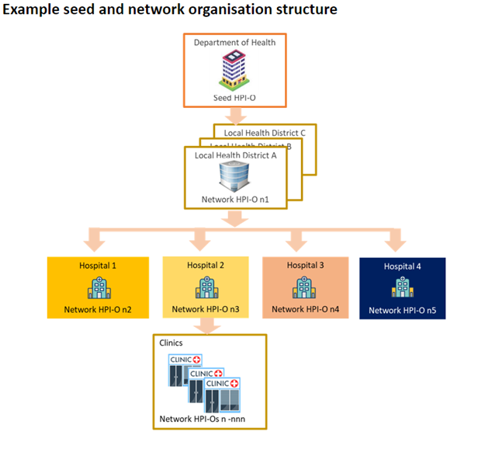

## Successful use of HIs to date

The current Intergovernmental Agreement on National Digital Health 2023-2027 (IGA) recognises the HI Service as critical national infrastructure, with all states and territories and the Commonwealth confirming their continued commitment to this important capability.

HIs have been central to the delivery of key digital health capabilities in Australia, including the MHR system, ePrescribing, and the recording of vaccinations through the Australian Immunisation Register. HIs underpin these digital health mechanisms as follows:

* **MHR**: The MHR contains healthcare recipients’ key health information securely in one place. Anyone in Australia with a Medicare number or an individual healthcare identifier (IHI) can register to have an MHR. MHR uses IHIs to create a health record, add information to the correct record and uses healthcare provider identifiers (HPI-Is) and organisation identifiers (HPI-Os) to control access to the information and ensure the correct provider is connected to the correct consumer’s information. As of December 2024, 24.2 million people had an MHR.[15]
* **Australian Immunisation Register (**AIR**)**: records healthcare recipients’ vaccinations.[16] It uses IHIs to assign and retrieve proof of vaccination. This was critical during the COVID-19 pandemic.
* **ePrescribing**: uses IHIs to identify the consumer, HPI-Is and HPI-Os to identify the prescriber and HPI-Is and HPI-Os to authenticate authorised dispensers (pharmacists).[17] Between May 2020 and April 2024, over 219 million electronic prescriptions were issued by almost 86,000 prescribers (general practice healthcare providers and nurse practitioners).[18]

Outside of these national initiatives, there are some examples of the use of HIs in some eReferral and secure messaging solutions. However, these are not universal or widespread and the use of HIs generally, to communicate and manage information about the healthcare received by individuals, is low.

# Question 1: What is the policy problem we are trying to solve?

Data from the latest Healthcare Identifiers Service Annual Report from Services Australia reveals that approximately 1.1 million individual providers have been assigned an HPI-I and 31,253 provider organisations have been assigned an HPI-O since the inception of the HI Service in 2010. Since 2010, over 32 million IHIs have been assigned to consumers. Data also shows a marked increase in assignment of consumer/healthcare recipient identifiers (IHIs) since 2020.[19] Further information on these statistics is detailed at Appendix A of this IA. Despite the high number of providers and consumers holding an HI, findings in previous reviews had indicated that HIs were not being used to their fullest extent and therefore the full benefits of health system interoperability and information sharing could not be realised.[20] This was reinforced during consultation for this IA, and in a baseline analysis report commissioned by the Department that indicated generally low usage of HIs to support interoperability.[21]

Low HI uptake compromises the ability of healthcare providers and consumers to confidently and consistently exchange health information using digital capabilities. Lack of interoperability between siloed health and care systems causes problems for consumers, providers and the broader healthcare environment as detailed further in this section of the IA.

Feedback has indicated that many healthcare providers could use HIs. However, the lack of clarity in the current legislative authorisations, specifically concern about whether use of HIs is permitted, has prevented widespread use of these identifiers to support broader health information sharing. There are significant penalties for misuse of HIs, which providers cite as a deterrent. This is detailed in the consultation section of this IA. Further, some key stakeholders across the health and care systems are not currently permitted to use HIs. HIs cannot be used to support administrative matters related to health service delivery, which lessens the value proposition for HIs overall, as other identifiers are required and used for these purposes.

## Impact of low HI use on consumers

While the direct impact on consumers of not sharing health information is hard to quantify, there is increasing realisation that lack of coordination leads to poor health outcomes for consumers, particularly more vulnerable consumers.[22] When health information cannot be readily shared, the onus is on consumers (and/or their carers) to keep a record of their health history, including significant test results and interventions, and provide that history multiple times to different providers. They also need to keep relevant providers updated when a health event occurs, such as a hospital admission. This can be frustrating and can also be particularly challenging for consumers with communication or memory loss issues.

Availability of key health information is important when consumers move between different healthcare providers and healthcare settings, particularly in emergency situations and for the management of chronic conditions through multidisciplinary models of care. Lack of communication and information sharing between providers and between providers and consumers contributes to fragmented care and can result in suboptimal clinical outcomes.

Placing the burden on consumers or their carers to keep healthcare professionals connected to health events increases the potential for medical errors as important health information, such as diagnoses, or dispensed medicines could be missed or misinterpreted through inaccurate, incomplete, or inconsistent verbal sharing, and runs counter to the patient-centred care model. This can lead to unnecessary or duplicative investigations and avoidable health interventions, and can also contribute to misadventure, delayed diagnosis, and inappropriate treatments.

In an increasingly digital world, consumers expect that their healthcare professionals have much richer and connected access to their health history, medicines and allergies, diagnostic investigations, and treatment plans. Consumers increasingly expect all providers with a role in their healthcare treatment and management to have knowledge of key information that supports their treatment. This is particularly the case for consumers with complex healthcare needs, who see multiple healthcare providers across different settings and rely on those providers to be aware of their holistic healthcare needs.

More widespread use of HIs by all providers would help with effective and timely communication, as information about a person would be more readily identifiable and accessible across different data sets. The increasing recognition of the important role of support services, such as in-home care supports, also means there is an increasing need for information about the demand for and delivery of services designed to improve wellbeing and assist individuals to stay at home for longer. The Royal Australian College of General Practitioners has also highlighted that lack of information sharing about disability support services hampers clinical treatment.[23] The HI Act currently does not support healthcare providers having an integrated view of the support their consumers receive from aged and disability care organisations as the Act does not allow these organisations to handle HIs. Accordingly, even if all providers currently eligible for HIs began integrating them into their clinical workflows, there would still be a gap.

Complex billing for private and public health services performed in hospital is also a burden on consumers. Enabling health administration entities to use IHIs for claims and payments would help to simplify the billing process for consumers and providers. The use of common identifiers could support aggregating bills and remove sthe need for consumers to submit claims to both Medicare and private health insurers.

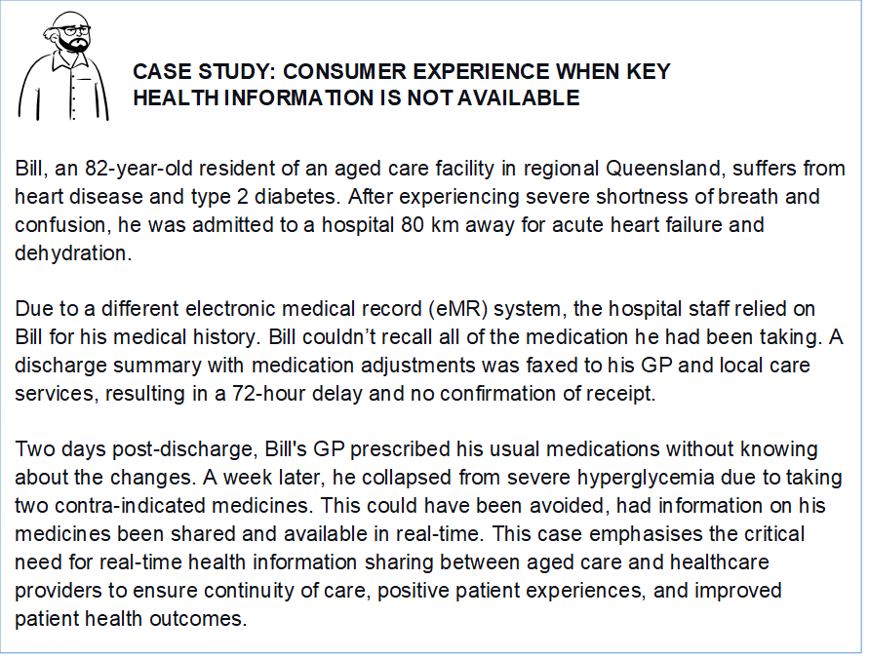

### Privacy risks

Without linkage and accessibility of information between the right consumers and providers at the right time, significant amounts of personal and health information need to be captured and held in multiple clinical information systems. In addition to this contributing to sub-optimal outcomes for consumers, it also presents a privacy risk, with information unnecessarily duplicated across multiple systems, and potentially becoming inaccurate due to lack of updating. The absence of unique identifiers to connect information across the system increases the potential for consumer information to go to the wrong provider, either by mistake, or because records have not been updated. Conversely, the inability to accurately identify a patient can result in information not being available to a provider when needed at the point of care.

## Impact on providers

Due to the fragmentation of Australia’s health system, there are significant inefficiencies for healthcare providers who have limited visibility of their patient’s history outside of the information held within their own clinical information systems. Significant time can be spent trying to track down information on previous health interventions, such as test results or discharge summaries, taking time out from the delivery of care. Better interoperability and seamless and timely access to relevant information about a consumer has the potential to reduce administrative inefficiencies and burden for healthcare providers, contributing to greater productivity for this large and growing sector of the economy.

Further, healthcare providers (individuals and organisations) and health administration entities (HAEs) who provide support for the delivery of healthcare, are not clearly authorised to handle healthcare identifiers and identifying information. This limits their ability to undertake necessary health-related and health administration activities, such as managing claims and payment processes, managing incidents, complaints, undertaking analysis of health programs and for population-health purposes.

This causes inefficiencies, particularly for Commonwealth-funded Primary Health Networks (PHNs) that facilitate access to health care, and implement, monitor and report on healthcare programs, and for state and territory hospital services which often run separate clinical and administration systems.

## Case study showing inefficiencies and inaccuracies caused because primary health networks cannot guarantee the accuracy of health information from services that report to them. This is because they are unable to use health identifiers to correctly match the right information to the right people.

## Impact on the health system

A lack of consistently and easily shared key health information between healthcare providers also creates a cost burden on the health system. When providers cannot readily see a consumer’s health history, this can lead to unnecessary or duplicative investigations and avoidable health interventions. These cost burdens are especially felt by those with chronic conditions, disabilities and older Australians, but are also borne by the health system and the taxpayer. The Productivity Commission estimates that better integration and visibility of information through a digitally connected health system could result in savings of more than $5 billion a year and reduce pressure on the health system through reductions in duplicate testing and shorter hospital stays.[24]

Low HI usage, combined with actual and perceived restrictions in the current legislative framework, means that the use of HIs for research and public health purposes has been limited. Lack of a consistently used unique identifier creates cost and time inefficiencies as linkage of disparate data sets involves the need to deploy more complex research methodologies. It also means that research organisations may need to hold more personally identifiable data to be used in probabilistic matching rather than being able to match through an HI.

Lack of clarity in the HI Act around authorisations to handle HIs for secondary research purposes also impacts the ability of organisations such as the AIHW to efficiently use and link data for research, policy and service planning purposes.

# Question 2: Case for government action

All Australian governments are committed to interoperability through the National Healthcare Interoperability Plan.[25] Health ministers have committed to improving care pathways and health outcomes through better use of digital technology and data. This is a whole of economy and productivity issue that will require better and consistent identification of consumers across health settings. This could be achieved through a more effective use of HIs. It is important that the HI legislative framework keeps pace with the way that healthcare and supporting services are being delivered, and to support more seamless access to richer health information by healthcare recipients and healthcare providers.

Government action is required as the HI Service is jointly funded, governed and operated by the Commonwealth Government in partnership with the states and territories as set out in the Intergovernmental Agreement on National Digital Health. Should legislative change be the preferred option, the Commonwealth will lead proposed changes, in consultation with states and territories and other key stakeholders. The HI Framework was borne out of an intergovernmental agreement[26], and requires continued support from states and territories to ensure successful use across the whole health and care system.

The Digital Health Oversight Committee (DHOC) with representatives from the Commonwealth and state and territory health departments, as well as key Commonwealth delivery partners, was established to provide governance over the Digital Health Intergovernmental Agreement (IGA). Regular meetings of the DHOC have included discussion of the need for reform of the HI Framework, to ensure it supports emerging digital health capabilities.

There is strong support through the DHOC for the need for a legislative framework that provides clarity and confidence in the use of HIs to support health information communications, information management and use for research and population health purposes into the future. States and territories will also play a key role in identifying and supporting implementation of the policy initiatives that should require the use of HIs into the future.

## Why legislative change is needed

Action is needed to ensure the current legislation and policy settings are clear and effective to support current and emerging healthcare delivery and real-time access to health information. Without legislative change, HIs are not able to be used for the broad range of digital and data capabilities that will support better information sharing, decision-making and care planning, and improved analysis into the future. In particular, legislative change is needed to address the following issues identified as holding back the more widespread uptake of HIs.

### HI Act is too complex and fear of inadvertently incurring penalties is a deterrent to HI use

A key issue that was raised during the broad and targeted consultation undertaken to inform this IA identified the difficulties that stakeholders have in understanding the legislation as it is currently drafted. The HI Act is highly prescriptive, containing a complex series of provisions authorising specific exchanges of HIs and identifying information between identified parties. The HI Act also contains significant penalties for misuse. The consultation highlighted healthcare provider reluctance to use HIs outside of the specifically mandated use cases, e.g. MHR and ePrescribing, due to concerns about inadvertently misusing a HI and triggering a penalty. Healthcare providers report difficulty in understanding and interpreting when information exchange is authorised, by whom and for what purpose under the Act.

Legislative change providing clearer, principle-based – rather than complex and prescriptive - authorisations for handling HIs would provide greater clarity about what the HI Act permits. This would increase providers’ confidence in their ability to comply with the Act and their willingness to use HIs.

### The scope of authorisations is too narrow

Not all entities involved in providing or supporting the provision of healthcare are authorised to have or handle HIs due to the narrow scope of the HI Act. The HI Act largely limits use of HIs to clinical workflows initiated by a traditional healthcare provider (including general practitioners, nurses, specialists, allied health providers, and pharmacists) and healthcare organisations operating in traditional healthcare settings (such as hospitals and general practices).

There is increasing recognition that health is more than the treatment of disease and injury. There is also recognition that a complex range of social, psychological, and environmental factors contribute to individuals’ overall health and wellbeing. Individuals with chronic and complex health conditions are increasingly likely to seek support from a range of care providers, who may not operate in traditional health settings. This could include support services in the home such as help with tasks of daily living, personal care, and home modifications. However, these support organisations are largely excluded from the operation of the HI Act because they do not employ a healthcare provider with an HPI-I, which is an eligibility requirement under the HI Act.

In recognition of the broader cohort of entities and providers who may provide care-related services to support an individual’s health and wellbeing, a number of stakeholders have flagged the need to expand the range of service providers that should be eligible to handle HIs. In particular, it has been suggested that authorisations to handle HIs and related information should be clearly expanded to support information sharing across settings that directly provide traditional healthcare and those services that indirectly support health and wellbeing, e.g. disability and aged care support services. For example, information about the in-home care supports provided to a person may provide valuable information to a general practitioner in developing ongoing care plans.

Currently, support organisations providing support services cannot handle HIs, which precludes them from easily and consistently contributing health-related information about the person. This means that if an individual receives care from multiple providers, they don’t have a shared or holistic picture of services that are being received. This makes it difficult to coordinate care or identify what other services are needed by the individual to optimise their health and wellbeing outcomes. This has been cited as a gap,[27] inhibiting better connected care going forward.

Feedback from states and territories also indicates that the current legislative framework presents barriers to better use of HIs within their health services, due to the inability to use HIs across both clinical and health administration/payment systems. Because of the uncertainty as to when HIs can be used for health administration purposes, states and territories have continued to use alternative local identifiers for these purposes and in their clinical systems. Correct and consistent identification is a prerequisite for managing payment and claims systems and safety net schemes.

Furthermore, some allied health providers who do not belong to a professional association - as defined in the HI Act - are not eligible for an HPI-I. Also, the narrow definition of a healthcare provider organisation makes it unclear whether the authority to handle HIs extends to entities managing and/or providing premises and infrastructure (including technology services), that enable individual healthcare providers to operate as a collective business or service.

### No comprehensive reliable directory of provider information

The use of HIs is hindered by the absence of a directory that provides a ‘single source of truth’ of all provider HIs and associated professional and business details. Such a directory would make it easier for providers to adopt digital practices to connect with each other and use existing digital services such as ePrescribing and adopt emerging and new digital services such as eReferrals.

The HI Act requires the HI Service to maintain a Healthcare Provider Directory (HPD) containing professional and business details of healthcare provider individuals and organisations. The HPD is crucial to the ability to link providers and organisations with relevant end point location services to support use cases such as addressing clinical documents to specific providers. However, the number of healthcare providers with an HPI-I published in the HPD is low compared to the total number of healthcare providers (approximately only 3 per cent of providers are published in the HPD).[28] This is despite most providers having an online presence in multiple other service directories and booking systems. The lack of participation in the HPD represents a barrier to the success of other digital health services dependent on access to a comprehensive directory.

Previous reviews cited reasons for the lack of participation in the HPD,[29] including the requirement in the HI Act to obtain consent from providers for inclusion of their details in the HPD. The disconnect between the assignment of HPI-Is by Aphra, and the management of the HPD by the HI Service Operator is a factor in the low rate of providers giving consent to being included in the HPD. Ahpra automatically assigns an HPI-I to a provider when the provider registers. The process for providing consent to publish their information to the HPD requires providers to manually access a separate system operated by a different entity. Providers must access their profile in the HI Service to agree to publication to the HPD. By contrast, the non-Aphra registered professionals apply directly to the HI Service to seek an HPI-I, and their consent to have their business details published is sought at the point of application. Both the application and consent processes are managed in a single transaction, by the same provider. The result is that few Ahpra-registered providers are currently in the HPD, with the 3% referred to above being non-Ahpra registered allied health providers who typically provide consent when applying for a HPI-I.

## Key objective

The key objective of this work is to *ensure that the HI legislative and policy framework supports and underpins digital health reform and greater interoperability of the Australian healthcare system.*

Achieving this requires:

* increased and consistent use of HIs
* greater clarity in the authorised uses of HIs through a principle-based, rather than prescriptive, legislative framework
* extending access to use of HIs by entities and providers who deliver services that contribute to an individual’s health and wellbeing, but are not delivered by traditional healthcare providers, or in traditional healthcare settings
* ensuring that there is a single source of truth for all healthcare providers’ information.

The key aim of this IA is to address the policy problems identified in the response to Question 1, by aligning the HI Framework with the expectations of healthcare consumers and providers so that:

* health information can safely follow consumers throughout their whole health and wellbeing journey
* healthcare providers gain better access to a consumer s health and related care information at the point of care, enabling greater insights to support their consumers resulting in better clinical outcomes and connected care
* system efficiencies can boost productivity
* richer data is available to support population health and planning, and
* the foundations are laid for the government to deliver a world-class interoperable health system.

Actions to achieve this objective sit across three broad areas:

* **Legislative:** amendments will ensure the legislation provides the regulatory support and clarity necessary to meet current and emerging strategic, policy, program and operational goals.
* **Policy**: future government policy initiatives should leverage and require the use of HIs, where appropriate, as the foundation for the realisation of broader digital health reforms.
* **Practical:** supporting industry to embed HIs into technical solutions to connect health and health-related data for individuals, providers, and provider organisations across health, aged care and disability services. This will underpin health system interoperability and data quality, enabling the provision of high-quality and sustainable healthcare.

The reforms proposed through the HI Framework are essential to support future change. They will signal to industry and all levels of government that they also need to invest in digital health reforms to support better health and wellbeing outcomes for the Australian population, and to increase productivity for individuals requiring health care and more broadly in this large and growing sector of the Australian economy.

Success would see:

* increased use of HIs:
  + in clinical and health administration workflows
  + by organisations providing support services
  + for research and population health analysis, including for data linkage
* HIs embedded into programs, technical solutions and clinical workflows across the health and care ecosystem supported by policy levers and clear, relevant guidance
* better health outcomes and enhanced clinical decision-making leading to efficiencies as well as improved provider confidence and consumer sentiment, and
* more effective sharing of health information and demonstrable resulting benefits to consumers, providers and the broader health system, including reduced costs and richer research data
* more streamlined delivery of future digital health initiatives.

Noting the key role of HIs in consistent and secure identification of key actors across the health system, the following is a high-level and indicative list of the broader benefit categories that can be realised through increased use and usability of HIs, which will support interoperability and better clinical care and increased productivity:

* **Improved Clinical Safety and Outcomes** – improved consumer identification will enable better coordination and continuity of care for consumers as they access a range of services across care settings, for example as they transfer from hospital to residential aged care. It will also support providers securely use data for administrative processes, monitoring performance against quality standards and continuous improvement activities.
* **Improved Service Efficiency** – simplified registration, reduced data errors, improved data governance, enhanced validation capabilities, lower overhead of managing multiple identifiers.
* **Improved Healthcare Policy** – improved ability to use data for planning, monitoring, evaluation and research purposes.
* **Improved Consumer Experience and Protections** – reduced requirement to repeatedly provide and update personal information across multiple services, and reduced risk of incorrect or unauthorised use of personal information.

## Perceived or actual constraints/barriers to government action

There is agreement across the Commonwealth and state and territory governments through the Digital Health IGA, the National Health Reform Agreement 2020-2025 and the National Digital Health Strategy 2023-2028 to better enable interoperability and connected data across Australia’s healthcare settings. These agreements and strategies highlight that adoption and use of a common identifier across the health system will be key to enabling the objectives of better-connected care for people in Australia.

The time and cost associated with system uplift to embed HIs into clinical workflows is cited as a barrier to widespread adoption and use of HIs. This is particularly the case where there is an absence of other policy drivers requiring such system changes (for example, requirements to use HIs as a prerequisite for participation in a funded health program). It is unlikely that increased use will occur without ongoing intervention to require HI use as a key component of participation in digital health reforms going forward.

While HIs are a key enabler for broader digital health reforms, better use of HIs alone will not deliver interoperability. It will require investment in technology and other supports so that HIs can be seamlessly embedded into clinical workflows and reduce administrative burdens on a workforce already under pressure. This will be particularly important for the aged care and disability support sectors, which do not currently interact with HIs and will require additional technological investment and other change and adoption support. However, the opportunities presented by more tangible digital health investments will be harder to realise if the key foundational element – secure, accurate and trusted identification processes – is not in place.

### Overcoming barriers and constraints

All Australian governments will need to work to support industry and health program delivery to understand the case for better use of HIs to realise the benefits of broader health reforms. Legislative reform can go some way towards removing barriers to increased use, by enabling clearer and expanded authorisations for use across the whole health and care system. However, governments will need to identify relevant policy levers to encourage and embed the use of HIs. Legislative change, policy enablers, and system supports will be critical to achieve success in setting the foundations for broader digital health reforms. Interoperability initiatives where HIs have been successfully embedded, such as MHR and ePrescribing, can serve as models for future programs to encourage uplift and support providers.

## Risks of not taking government action

As highlighted above, increased use of HIs has been flagged as a key dependency for broader digital health reforms aimed at creating efficiencies and delivering better and safer healthcare for consumers. In a sector with a workforce under pressure, improved interoperability and availability of information in near-real time will reduce current inefficiencies that result when clinicians have to rely on the imperfect recall of consumers to obtain relevant medical information, spend time sourcing existing information held in other systems, and/or requiring patients to have duplicate tests and appointments to fill the gaps when information is unavailable.

The HI Roadmap contains a series of regulatory and non-regulatory actions to be implemented over the next few years intended to uplift healthcare, administrative and care and support organisations and government programs to use HIs in the most consistent and effective way to maximise their benefits. The Roadmap calls out the need for legislative reform to the HI Framework as a key action area to enable the success of the other non-regulatory activities and to resolve existing barriers to better use and adoption.

Consultation undertaken for this analysis has highlighted the need for legislative reform to ensure HIs can clearly and confidently be used to support healthcare providers and recipients at the point of care, as well as to support better monitoring and analysis of health outcomes and trends.

While current authorisations support the use of HIs in clinical workflows initiated by healthcare providers, broader use cases are not clearly supported by the current legislation. This is despite the planned intent that HIs would be used to support the monitoring, management and funding of healthcare. Despite those intentions, the current narrow authorisations are preventing the ability to realise the benefits of HIs to drive broader system reform, including to support health data and trend analysis.

Further, without legislative change, the broader care sector, incorporating key services delivered by aged care and disability services providers, cannot use HIs to share or receive important information about a person’s planned and received care services. Without such changes, the use of HIs will remain limited to the narrower provision of health services and not leverage the insights into care planning that could be provided by the broader care and support services being accessed by consumers.

Not taking action to address these gaps and issues with the current legislation, will make it more difficult to realise the benefits of digital health capabilities that will rely on unique and consistent identification of consumers and providers. Increased interoperability will be harder to achieve if common identifiers across the health system are not able to underpin connections across the whole health and care system, thereby supporting clinical decisions and care planning as well as broader insights into health and care needs across the population.

Maintaining the current state will also result in lost opportunities for data generated at the point of care to be re-used within a learning health system to inform continuous improvement to policy and service delivery. Currently the siloed nature of data held by different service providers, and the inconsistencies in data between systems makes it resource-intensive (and in some cases impossible) to link information from multiple systems to form a person-centric view of data. This limits the ability of policy makers, service planners, researchers and others to understand how people interact with the whole of the health and care system and what outcomes are achieved as a result of these interactions. In turn, this limits the evidence available to inform decision-making, and improvements in care and productivity.

## The alternative to government action

The result of no government action would be the continuation of existing barriers to wider HI uptake and the consequential negative impacts outlined in the answer to Question 1. Concerns expressed by healthcare providers and the software vendors who provide solutions to support health service delivery would not be addressed, and the uncertainty raised by the current nature of authorisations in the HI Act would be perpetuated. In response to those concerns, some non-regulatory actions could improve the current state, and these are detailed below. However, without regulatory action, the framework for the assignment and use of unique identifiers for health services would remain confined to clinical workflows. HIs also could not efficiently be used to support research and analysis to provide insights into broader population health needs. The use of multiple identifiers across the care and support sector would remain.

### Improved guidance on the application of the legislative framework

If government action is not taken to expand and enhance the current legislative framework, some of the identified barriers to broader HI uptake could be managed by the education and information initiative already underway via actions in the HI Roadmap providing improved guidance on the application of the HI Act and permitted uses, to assist with the interpretation of areas of the HI Act that are considered difficult to understand or apply. As noted above, work in this regard is already underway to improve HI uptake. Feedback from previous stakeholder engagement as well as the public consultation conducted as part of this IA process, indicated that many healthcare providers (and sometimes their legal advisers) consider that the HI Act is difficult to understand and apply, and healthcare providers are worried that they will inadvertently breach the HI Act exposing themselves to civil and/or criminal penalties. This has been one of the factors in the proliferation and/or continued use of other health-related identifiers (including, for example, at the Commonwealth level, multiple Medicare provider numbers for healthcare providers), and a less-than-optimal uptake of HIs, as various entities shy away from adopting or using them due to uncertainty of how relevant authorisations should be interpreted. A proliferation of, or continued reliance on, other identifiers will perpetuate fragmentation of health information, and increased costs and clinical risks, as entities involved in the provision of healthcare and healthcare support services struggle to accurately match individuals to their information.

The improved guidance and education currently in development sits alongside all three considered options. However, while improving education and guidance would assist in supporting some increased adoption, this alone would not realise the foundations for better connections across the health system.

Without legislative or regulatory change, guidance would only apply to the existing authorisations. Without legislative amendment, the HI Framework could not apply beyond the healthcare sector, to incorporate aged and disability and other support service providers.

Further, even with improved guidance, the current narrow authorisations for the use of HIs do not support their use to improve insights for population health and research purposes.

### Require HIs in health programs and capabilities

As noted above, there has been success in the use of HIs to underpin some existing digital health initiatives. Where they have been required to be used to participate in key programs, we have seen connection by clinical information systems to the HI service and use of HIs to communicate information – key examples being use for the purpose of sharing key data and health information to MHR, and to send and process electronic prescriptions and immunisation records, as well as some eRequesting and secure messaging solutions with more limited application.

Future national programs and digital health initiatives could also require HIs into the future – for example, they might be a requirement for sending an eRequest or e-referral or for other sharing of clinical information between healthcare providers.

However, without a broader legislative underpinning, use in these programs would be siloed and fragmented, and would not cover programs in the broader care economy which would remain outside of the HI Framework.

The alternative measures would also not support the use of HIs to gain better insights into health trends and demand for services, nor support the development of a learning health and care system, where consumers can be identified consistently across health and care settings, with data sets brought together using HIs as a linkage key to inform analysis and research. The existing legislative framework does not support using HIs to achieve these purposes.

# Question 3: What policy options are you considering?

The key aim of this IA is to address the policy problems identified in the response to Question 1, by aligning the HI Framework with the expectations of healthcare consumers and providers so that:

* health information can safely follow consumers throughout their whole health and wellbeing journey
* healthcare providers gain better access to a consumer’s health and related care information at the point of care, enabling greater insights to support their consumers, resulting in better clinical outcomes and connected care
* system efficiencies can boost productivity and health outcomes
* richer data is available to support population health and planning, and
* the foundations are laid for the government to deliver a world-class interoperable health system.

Consistent with the objectives and desired outcomes identified, two reform options have been considered and compared with the status quo. Additionally, a further option was considered early on but discarded:

Table 2: Summary of reform options considered

|  |  |  |  |
| --- | --- | --- | --- |
| Option 1 | Option 2 | Option 3 | Discarded |
| **Status quo** | **Enhancing the current HI framework** | **Expand and optimise the HI framework** | **Mandate for HI use by default** |
| * no legislative change | * enable better workflow clarity to support health information sharing among healthcare providers already able to get and use HIs * recognise changing service delivery models and technology solutions in traditional health settings by clearly authorising technology providers and Contracted Service Providers * help healthcare providers by creating a more comprehensive Healthcare Provider Directory by authorising the professional and business details already held in the HI Service to be used for directory purposes * authorise other provider directories to use HIs to support health/clinical workflows | * deliver reforms in option 2 * establish a new type of HI (to be known as a Health Support Provider identifier, or HSP) for aged care and disability organisations that provide health-related support services that contribute to wellbeing (e.g. meal delivery, cleaning, mowing, in-home visits) but are not able to get an HI currently * authorise HIs to be used for health administration purposes, such as assessing the need for, delivery and monitoring of, and reporting on, health and care programs and services * provide clear purpose-based authorisations for when HIs and identifying information can be handled and by whom | * mandating the use of HIs in all or some key program areas |

## Early option considered but not progressed

### General mandate for HI use by default

The 2022 consultation paper relevant to this analysis[30] noted that while the government strongly encouraged the use of HIs, there is currently no general mandate on when and where HIs must be incorporated into programs, services, and systems by default (other than where they are a mandatory component of specific digital health solutions or participation requirements). As a result, health systems and programs have continued to use their own alternative unique identifiers. This creates barriers to a connected care environment.

The consultation paper also identified that a further objective was to ensure that, over time, HIs can be used in the place of other government-related identifiers to give healthcare recipients and providers fewer identifiers to manage and maintain.

Stakeholders were asked about specific situations, systems, or areas of healthcare where HIs should not be used by default and the most effective and achievable policy levers for increasing the use of HIs in public and private health systems, including by allied health providers and small providers.

Stakeholders were also asked to identify what alternative identifiers for healthcare recipients or healthcare providers could be replaced by HIs and, given the importance of unique identification to increasing health system interoperability and overcoming several current challenges, what would be an appropriate timeframe to expect services and programs to transition to the use of HIs.

Responses to the public consultation identified that while there was strong support for HIs to be used by default across key programs, services and systems to enable better patient identification and information sharing, stakeholders questioned how they would work with local identifiers currently used for operational purposes.

Stakeholders also identified several situations where HIs should not be used by default to ensure the upholding of the privacy and security of consumer’s information, particularly for vulnerable populations. For example, stakeholders queried how HIs would be used for people experiencing vulnerability that seek healthcare for sexual health services, child health services and domestic and family violence services where anonymity may be needed. When the HI Framework was established, it was clearly stated that the introduction of HIs would not prevent people from seeking healthcare anonymously.

All of the options presented in this analysis are enabling in nature, and do not involve mandating the use of HIs. While mandating use was considered as part of this IA, the challenges in monitoring and enforcing compliance that would be required, resulted in the view that this should not be pursued as an element of this reform. Instead, the preferred approach is to provide clear legislative authority, supported by tools and guidance material, to enable participants in the health system to have the confidence to use HIs to support their service delivery and administration.

Mandating the use of HIs may be built into the design of future policy programs, initiatives and digital health capabilities as a prerequisite for participation, in the same way it has for programs such as ePrescribing. Assessment of the impact of mandatory use of HIs by default will occur when relevant programs and initiatives are being considered in the future. Accordingly, broadly mandating use of HIs was discarded early as a reform option for this IA process, with other enabling options to improve HI uptake preferred and analysed in further detail, as outlined below.

## Non-regulatory activity already proceeding

### Education and information campaign

As already noted, work is underway to develop an information/education campaign to drive HI uptake among providers and prevent the future creation of multiple identifiers (where possible) by promoting the benefits of a single national unique identifier.

This option is already proceeding under the HI Roadmap and has been costed and allocated a budget. Also, this campaign is intended to complement all three options identified and is not proposed as an alternative. While clearer guidance in such a complex environment is critical, education alone will not achieve the desired goals of this IA. As such, the campaign is not considered in this IA as a standalone option.

## Option 1 – The status quo

While consultation has highlighted barriers to more widespread adoption and use of HIs, the current HI Framework has successfully supported a number of key digital health initiatives, as outlined earlier in the analysis.

However, as noted earlier, many providers consider that the HI Act is difficult to understand and apply, and as a result, are worried that they will inadvertently breach the Act, exposing themselves to civil and/or criminal penalties. In consultation, providers cited this as one of the factors contributing to them not using HIs apart from when legally required and clearly permissible, driven by requirements to participate in digital health initiatives. Reluctance to use HIs due to the legislative complexity and fear of misuse has also contributed to the creation and perpetuation of other health-related identifiers that are ineffective in connecting people across multiple data sets but are perceived as less risky. These include local system identifiers, Medicare numbers (which as noted above are not unique as a person may legitimately have multiple Medicare numbers over their life, and in use at the same time),Veterans Cards, and provider registration numbers (which are not unique as a provider may have more than one where they are registered for multiple professions), and prescriber numbers and Medicare provider numbers. A key reason for the proliferation of provider identifiers is that HIs are not currently able to be used for health-related purposes, such as claims and payments, which Medicare provider and prescriber numbers support.

However, leaving the current legislative framework unchanged would mean that the existing limitations which have reduced uptake would remain. Current identified pain points around the narrow authorisations and uncertainty about the scope of those authorisations would persist, such that there would continue to be limited use of HIs to support activities such as the monitoring of health outcomes, and analysis and research into trends and demand for different health services. It was also intended that HIs should be able to be used in relation to health payments and funding, however again the narrowly drafted authorisations have not supported this in practice.

Finally, and most persuasively, there is strong stakeholder support, which has been evident from early in the life of the HI Framework, for the inclusion of aged care and disability services. The current Act does not support the use of HIs in relation to ancillary care and support services outside of traditional health service delivery. Without legislative reform it would not be possible to bring the care sector into the HI Framework. This means that consumers of disability and/or aged care services will continue to receive siloed care and support without the benefits of integrated care planning. It would also undermine attempts to bring the care sector into broader digital health infrastructure, as it would mean different identification processes would apply for these support services.

If the status quo is maintained, the existing prescriptive data flow approach would be continued, with limited flexibility to respond to changes in health service delivery, including benefiting from supporting technology solutions, or to support the monitoring and management of health services. This has effectively limited the use of HIs outside of clinical workflows.

Adoption and use of HIs would also continue to be limited to the traditional health sector. The effect of this is to limit the ability for individuals and their healthcare providers to have access to all their health and health-related information linked through their individual HI, increasing the risk that important information to support health and care planning will not be available at the point of care.

The status quo also limits the use of HIs in the administration of health service delivery, such as the management of claims and payments, and use for analysis, research, and population health purposes.

This option would undermine the investment in digital health nationally, reducing the benefits able to be achieved through other digital health capabilities.

## Option 2 – Enhancing the current HI Framework

This option would result in the HI Act remaining applicable to ‘traditional’ healthcare providers, i.e., general practitioners, specialists, hospitals, dentists, pharmacists, most allied health professionals, and not extend to broader health and care settings that offer ancillary care. However, it would clarify and enhance existing HI coverage by better supporting the exchange of health information between practitioners and consumers.

### Authorisations for contracted services and technology providers

Many healthcare providers contract out aspects of their service delivery, such as telehealth, information management or online booking facilities. These service providers may need to handle HIs and other identifying information on behalf of the healthcare provider. However, the HI Act provisions are not sufficiently clear in this regard, or broad enough to support changing practitioner needs.

Under option 2, the approach to defining and expanding authorisations to CSPs (Contracted Service Provider) would be revised, to ensure coverage of all healthcare functions, and subcontractors, to align with the current healthcare delivery and administration landscape. The policy intent would be for relevant technology solutions to be authorised to support the use of HIs for healthcare purposes that are authorised under the HI Act. The Act would be amended to provide authorisations for CSPs and technology providers by:

* expanding the types of health-related functions that a party can be contracted for and to reflect the ability to outsource functions that may otherwise be undertaken by the healthcare provider
* expanding the purposes for which a CSP can be engaged, to be inclusive of the different types of service providers that may be engaged to support the delivery of healthcare
* extending the authorisation of any entity to use HIs to a CSP of that entity.

### Streamlined processes for allied health professionals

The HI Act currently provides for the Australian Health Practitioner Regulation Agency (Ahpra) to assign HPI-Is to its registrants in bulk.[31] However, some allied health professionals not covered by Ahpra[32] must apply individually to the HI Service Operator for an individual healthcare practitioner identifier (HPI-I) where their applications are assessed manually to ensure the practitioner’s relevant professional body meets the criteria in the Act.

This reform would amend the HI Act to provide for a more streamlined process for non-Ahpra registered allied health professionals to be assigned an HPI-I. Under this option, professional bodies meeting specified criteria would be permitted to apply to the HI Service Operator on behalf of health professionals and to manage the requirement to update the HI Service Operator when a health professional’s information changes. This change would be expected to drive adoption by non-Aphra registered allied health providers as it would support automated, digital exchanges of information for these providers. The amendments would make the process to obtain and maintain an HPI-I more efficient for both the HI Service Operator and for individual allied health professionals, while maintaining the important criteria for eligibility to be assigned an HPI-I, such as being subject to professional standards and ethics and sanctions for breaches, and requirements to maintain skills and knowledge such as participation in ongoing professional development. Support for more allied health professionals to easily connect with the HI framework will support their integration with other digital health initiatives and contribute to the overall vision of connected care, across the health and wellbeing landscape.

### Authorisations for provider directories

A complete and accurate directory of healthcare provider professional and business details linked to their HPI-I and HPI-O is critical for information exchange between providers and is an essential element to support future initiatives such as eReferrals and eRequesting.

The HI Act currently provides for the HI Service Operator to maintain a Healthcare Provider Directory (HPD) of healthcare providers’ professional and business details to help healthcare providers to find information about other healthcare providers. The Act provides that it may only collect, use and disclose personal information for the purposes of the directory if the individual to whom the information relates has expressly consented. As discussed under Question 2, the way the current provisions work creates an anomaly in that Ahpra-registered providers’ details are not included in the directory. The way in which their HPI-Is are assigned by Ahpra means their consent to be included in the directory is not captured, even though Ahpra sends this provider information to the HI Service Operator.

The proposed option would amend the HI Act to enable the practitioner information currently held in the HI Service, to be collected, used and disclosed for directory purposes. A process will be developed for practitioners to request that their information not be made available to other practitioners.

This option will also enable integration between the HI Service, national digital health infrastructure and other existing and emerging directories to ensure that the information is complete and up to date. It will allow other directories, for example the National Health Services Directory operated by Healthdirect Australia, to associate HIs with healthcare provider organisations and individual healthcare providers and healthcare services, and to provide authorisation for information flows between directories and registries, to support a single, accurate record of healthcare providers. This will support future digital health initiatives relying on accurate information and authentication processes to connect healthcare providers and support information sharing.

These proposed changes to the directory will enable healthcare providers to identify and communicate with one another. It will also facilitate information flows to make it easier for healthcare providers to maintain their information. By putting in place settings to enable the Healthcare Provider Directory to be the primary directory of healthcare providers, the wasted cost and effort associated with having duplicate directories will be reduced. Where they play a useful continuing role in the ecosystem, other directories will also be authorised to use HIs.

The diagram below shows the contribution of option 2 to supporting more streamlined and efficient clinical information flows and health communications. Greyed out icons are **not** supported by this option.

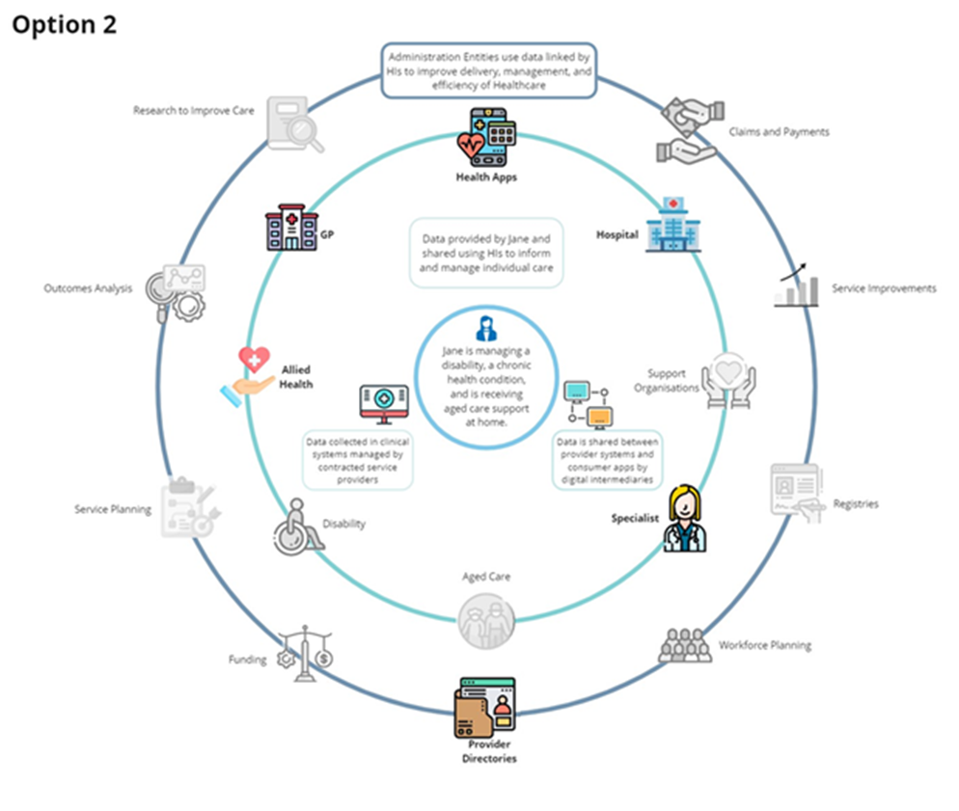

The changes to the HI Act would be supplemented with guidance materials to assist users, in particular healthcare providers, professional associations and technology vendors, to interpret the HI Act and Regulations.

Under this option, the legislation will remain applicable to traditional healthcare providers, but it will be amended to extend authorisations to CSPs and technology providers, to recognise that the delivery of healthcare by a healthcare provider relies upon a range of different technology and service providers whose products and services may require access to and use of HIs.

Clear and expanded authorisations for CSPs and technology providers, and to underpin technology solutions, would provide increased confidence for the use of HIs in existing and emerging workflows.

The legislation would also provide for allied health professional associations to support the assignment to and maintenance of HPI-Is for their members.

Across all options, better use of HIs could be driven by the inclusion of requirements for their use in different programs and initiatives. Should such policy levers expand so as to require the use of HIs by a wide range of allied health professionals, it will be important that the process for assigning identifiers to non-Ahpra registered providers is able to be streamlined. This option would address the current manual, resource-intensive approach to assignment of HIs in the allied health sector.

### Limitations of option 2

As with option 1, this option would result in the broader care sector (including aged and disability organisations) remaining outside of the HI framework. This would mean there would be a need for continued use of alternate identifiers for the health and care sectors, making it more difficult to join up information across the health and care system, to drive more informed planning and outcomes for consumers. This option would also not address the lack of clear authorisations necessary for HIs to support health administration activities and re-use of health data for analysis, research and public health.

## Option 3 – Expand and optimise the HI Framework

This option would expand the application of the HI Framework to a broader range of health-related/care settings, and build in additional flexibility, supporting the needs of the health and care system and development of emerging national digital health capabilities and infrastructure.

The amendments proposed under this option would address the policy problems identified in the answer to Question 1 by facilitating better connected care and clinical outcomes through greater adoption and use of HIs to uniquely identify consumers and providers across the health and care system. It would deliver this through:

* Expanding the range of entities that may handle HIs. Health Administration Entity (HAE)s[33] are not, or are not clearly enough, authorised to handle HIs and identifying information for a range of healthcare-related purposes including managing identity and authentication, managing data quality, managing claims and payment processes, managing incidents and complaints, and similar matters. Healthcare providers, support organisations and health administration entities need to be authorised to handle HIs and identifying information where this is necessary for health-related and health administration purposes.
* Creating a new category of provider identifiers, to uniquely identify HSP organisations that are not eligible for an HPI-O.[34] In addition, healthcare support organisations should be authorised to use HIs for their clients. Better communication of the care and supports planned and delivered by support organisations can help healthcare providers to better treat and undertake clinical care plans and facilitate better coordination of care.
* Clarifying the purposes for which HIs may be collected, used, disclosed and adopted and the entities which may do so, to include HSPs and HAEs.
* Extend authorisations for the use of HIs for purposes related to the delivery of healthcare and support services, such as assessing the need for, delivery and monitoring of, and reporting on, health and care programs and services. This will enhance service efficiency, effectiveness, and data quality, including by helping reduce data fragmentation and errors in matching data across datasets.
* Enable HIs to be used for lodging a claim and claiming medical benefits from Medicare and private health funds through processes such as simplified billing. [Simplified billing](https://www.servicesaustralia.gov.au/simplified-billing?context=22886) helps to simplify paying private service hospital bills (whether performed in a public or private hospital) for consumers by:
* aggregating consumer medical bills for in-hospital care into a single comprehensive account
* providing informed financial consent to make sure the consumer is aware of any out-of-pocket expenses, and
* streamlining the claiming process for the consumer by removing the need for consumers to submit claims to Medicare and private health insurers themselves.
* This option will also enable the rationalisation of alternative identifiers and allow for HIs to be used instead.
* Clarifying and streamlining the HI Act to provide for purpose-based authorisations, making it easier, and more certain for users of HIs to understand and apply the HI Act without fear of breach. This would also include clear authorisation to use HIs for health-related purposes, such as supporting the administration of health, and not just clinical communications. It would also clearly allow HIs to be used for population health and research purposes, including data linkage. Clear authorisations to use HIs for purposes related to the analysis of health programs, monitoring of outcomes and population health purposes will support the development of a learning health system where data and insights are used to inform workforce planning, develop informed policy responses to emerging health issues and needs, and support innovation and continuous improvement in clinical practice.
* Clearly authorising information technology providers and platforms to use IHIs, with the individual’s consent, for the self-management of health across platforms such as mobile applications and health monitoring devices including wearables, noting:
  + enhanced technology and digital health have brought about the ability for an individual to manage their health by using technology in ways that were not previously possible. There has been a rapid increase in services that are provided by technology service providers such as mobile health applications (mobile device apps), online computer applications, wearable devices for health monitoring and other in-home health monitoring equipment available for healthcare recipients.
  + technology service providers will generally not fall within the definition of a healthcare provider. However, the solutions supplied by technology service providers frequently send information to a healthcare provider to provide remote monitoring, assessment or recording of an individual’s condition. Clear authorisations to enable HIs to support these use cases, with a consumer’s consent, can support better connection of data for an individual across health and care datasets to effectively monitor their health and wellbeing.
* Enable further flexibility and agility by providing for delegated legislation to specify which health administration entities may use HIs, and the processes for allied health professional associations to apply for and provide updates on their members’ eligibility to hold an HPI-I. This will support more dynamic change where use cases for HIs emerge or evolve.

The diagram below shows the contribution of option 3 to supporting integration between the range of services that may be accessed by an individual and the health-related purposes HIs could be used for, to improve management of the health system and support enhanced analysis, monitoring and evaluation of health system interventions and outcomes.

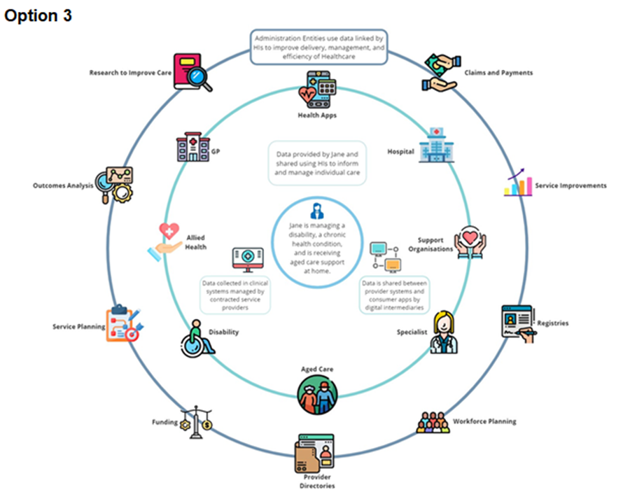

This option would involve legislative change to expand authorisations to enable greater adoption, collection, use and disclosure of HIs, to enable interoperability across the health and care system, including for health and health-related purposes.

The policy intent behind this approach is to remove some of the greatest barriers to the use of HIs, with clear, broad authorisations allowing HIs to be used for health and health-related purposes, as compared to the existing narrow and prescriptive authorisations for specific scenarios. The option will also recognise the important role of the broader care and support sector in contributing to health outcomes for consumers, with expanded authorisations for healthcare support organisations to use HIs. The expanded authorisations within the HI Act will be supported by guidance and education.

As with the other options, use of policy levers to drive implementation and increased uptake will also complement this option. The benefit of this option is that the use of such policy levers will occur alongside authorisations for HI use by the broader care sector and for health administration, research and analysis purposes. Expanding categories to support health administration and increased uptake of HIs in clinical and support workflows will boost the quality and the availability of data to inform care planning and interventions for individuals, and to inform whole-of-population research and analysis.

Option 3 would provide clear authorisations for expanded application of HIs, which would not be possible without legislative change. Allowing HIs to underpin communications in both the clinical and care sectors, and to support the administration of health and related services, will contribute to the following broader health system outcomes, ensuring HIs could play their intended enabling role in digital health reforms and initiatives:

1. Improved Clinical Safety and Outcomes – facilitating improved transfers of care across care settings through improved consumer identification, and enhancing provider accountability and government preparedness.
2. Improved Service Efficiency – simplified registration, reduced data errors, improved data governance, enhanced validation capabilities, lower overhead of managing multiple identifiers.
3. Improved Healthcare Policy – improved ability to use data for planning, monitoring, evaluation and research.

As such, Option 3 is the recommended approach.

### Challenges with option 3

Option 3 will help deliver more connected, comprehensive care by extending the use of HIs across health-related support services in the disability and aged care sectors. However, because these sectors are not currently enabled to use HIs, their clinical information systems will need configuring to embed HIs into their workflows. There is also a high number of localised, siloed systems, and a low level of digital maturity in the health support sector.

Given these challenges, there is a risk that the take up of HIs will be slow. A clear policy direction will be needed to achieve the full benefit of the reform. Implementation challenges and how they might be addressed are discussed further in Question 6.

# Question 4: What is the likely net benefit of each option?

## Regulatory burden estimate

Table 3: Regulatory burden estimate - Average annual regulatory costs (in addition to business as usual)

|  |  |  |  |  |
| --- | --- | --- | --- | --- |
| **Change in Costs ($m)** | **Business** | **Community Organisations** | **Individuals** | **Total change in cost** |
| **Option 2** | $0.33 | $0 | $0 | $0.33 |
| **Option 3** | $2.50 | $0 | $0 | $2.50 |

The table above shows the average annual impact of the reforms over a 5 year period. The proposed reforms under both options 2 and 3, would be enabling only – that is, it will not be mandatory or required for stakeholders to change their systems or practice as a result of the reforms under either option. There is no enforcement or penalty for failure to build HIs into systems, proposed to accompany the enabling amendments. However, the regulatory burden estimate assumes that software vendors would act to build connections to the HI Service and capability to collect, store, validate and share HIs, in preparation for future use cases where HIs may be a required data element.

No costs have been attributed to community organisations or individuals. Community organisations are not in scope for the changes.[35] Individuals are not expected to bear costs as a result of these changes. While there is estimated cost associated with software uplift enabled by the proposed reforms, the burden estimate assumes this will not be passed on to health practitioners, or further to consumers. This is because it is expected that vendors who adjust their products to utilise HIs would make those products available to a number of health or care stakeholders. In turn, those health and care service providers service multiple consumers, such that any additional cost would be spread widely, with minimal, if any, individual additional cost burden.

The average annual regulatory cost has been estimated over a 5-year period, based on the assumption that those system products that would be enabled to use HIs would be updated over this time. They are considered to be start-up costs. Once HI functionality is embedded into systems, ongoing maintenance and updates are assumed to form part of business as usual costs – that is the ordinary costs of maintaining those products. As business as usual costs do not form part of the regulatory burden framework, there is no cost assumed for this in the figures in table 3 above.

### Overview of regulatory burden

The proposed changes under options 2 and 3 would be enabling only – that is they would provide greater clarity on, or expanded authorisation for, the handling of HIs. Based on the legislative changes alone, stakeholders would not be required to implement changes or incur costs. However, the cost estimates assume that the health and care sector would uplift their technology solutions to enable them to use HIs and set themselves up to participate in future digital health initiatives reliant on HIs. It is assumed businesses would build the change into their technology roadmaps, and set up their systems over this period, to integrate with the HI Service and position themselves to be able to retrieve, store and send HIs. The net benefit analysis section below notes there is a risk to realisation of the estimated benefits, if this expected uplift does not occur.

On the basis of the above, each of options 2 and 3 are associated with increased regulatory cost, estimated to be incurred over the first 5 years following the commencement of the changes. Table 3 on the previous page showed the average annual regulatory impact of the changes under each option. Table 4 below shows the anticipated costs to business for each year over the 5 year implementation period. As noted in the section above, the cost has been assumed to fall to the software sector which supports health and care service providers by providing relevant clinical and client management systems and health administration entities which indirectly support the delivery, management, oversight and analysis of healthcare. The assumptions used to arrive at this estimated cost for the sector are detailed further below the table.

Table 4: Breakdown of costs to business

|  |  |  |  |  |  |
| --- | --- | --- | --- | --- | --- |
| **Change in Costs ($m)** | **Year 1** | **Year 2** | **Year 3** | **Year 4** | **Year 5** |
| **Option 2** | $0.41 | $0.39 | $0.36 | $0.34 | $0.18 |
| **Option 3** | $3.09 | $2.89 | $2.70 | $2.52 | $1.31 |

Most healthcare providers are already connected to the HI Service and have software to enable them to collect, store and use HIs.[36] For providers with existing HI integration, no additional costs are anticipated as a result of either option 2 or 3.

It is also assumed that existing products are uplifted to include HI functionality, not that whole new systems need to be established. Health and care service providers using client management systems would be expected to have HI connectivity built into them - new products are not expected to be needed as a result of these changes. Rather it is assumed that existing products would need uplift to include HI functionality, with the associated costs included in the regulatory burden estimated for the purposes of this analysis.

As an example, 88% of GP vendor products are HI service conformant.[37] In 2023, there were almost 40,000 GPs in primary care servicing over 22 million patients. The software market for the primary care sector in Australia is quite concentrated, with general practices serviced by a small number of software vendors who provide the clinical systems used across the sector. While there would be an initial uplift in cost for some who are not yet HI enabled, ongoing there would not be an additional cost associated with HIs, as business as usual software maintenance costs would apply for the broader product.

While the changes proposed under options 2 and 3 would enable more providers to handle HIs, as noted above, there would be no requirement to do so as a result of these changes alone. As other programs and policies are developed and implemented over time, changes to technology workflows and communications to support those initiatives may require uplift. Should HIs be required as part of a future initiative, that would be built into those future policies. Accordingly, any cost associated with change to support future policies requiring use of HIs are not included in the regulatory cost estimates. The workflow and other system changes to support a new initiative, such as e-Referrals, which might include HIs as a key data element, would be costed and analysed as a whole initiative, not attributed to the enabling HI reforms considered for the purposes of this analysis.

Here then, the regulatory burden largely lies with those in the support sector and entities supporting health administration activities, and some health systems, that are not yet connected with the HI Service.

The cost of software uplift assumes that each software product requiring uplift would require 1 developer and 1 test analyst for 25 days to build the required changes and prepare and execute testing, respectively. In addition, 4 test resources over 4 days would be involved in supporting conformance testing processes.[38]

While uplift of software to support integration with the HI Service and use of HIs will have a regulatory cost at the outset, there is not an ongoing regulatory burden, as it is assumed that ongoing maintenance of technical solutions and digital platforms, once HI enabled, would form part of routine software maintenance, upgrades, etc.

There is no cost to individuals or community organisations under either option 2 or 3. However, as noted above, individuals will benefit from better use of HIs across the health and/or care sector, as HIs will underpin digital solutions that will ensure their health information follows them, regardless of where they present in the sector. Further analysis of the broader costs and benefits of the policy options are set out below.

Some cost has been attributed to software uplift for client systems used in the support sector. However, it is also assumed that most small support at home providers would not need to directly integrate with the HI Service. Rather it is expected that administrators such as Aged Care within the department and the National Disability Insurance Agency would integrate with the HI Service and assign and manage healthcare identifiers for most of the support sector. It is expected the support at home providers would continue to interact with existing claims and reporting processes, but that HIs would be integrated into those systems operated by the administrators and regulators of support at home and community care programs going forward. As HIs are designed to be backend identifiers, there has not been a cost for training attributed to support providers and other end users, as HIs would be attributed to client records in the background, and then be associated with documentation or system records, such as reports on care provided. Once HIs are associated with these records and documents, they will be able to be made available and matched to other digital records via other digital health capabilities, to achieve the benefits of more complete records of health and care services planned and received by consumers. The costs for administrators and regulators of support at home and community care is attributed to government, and therefore not included in the regulatory burden estimate. The costs have been considered in the net benefit analysis, in the next section of this document.

## Net benefit assessment

This section outlines the costs associated with implementation of the HI reforms, and the benefits that would flow from national adoption and effective use of HIs over a 5-year period, for each of the options under consideration.

It should be noted that:

* The legislative reform proposed does not in itself require technical changes to the way that HIs are used in systems – the proposed changes would be enabling only. Accordingly, there is a risk that the benefits estimated for this IA may not be realised if system change by those who are not yet using HIs, did not occur following these proposed changes.
* The use of the HI Service only requires frontline staff to apply existing good practice client registration standards and processes – there is not an additional change burden placed on staff where the HI Service is being used correctly.
* The critical issue to be addressed is take up of the HI Service and integration of HIs into all health and care services and their use as the common identifier to support any health information exchange between providers or settings. This is a key prerequisite for a connected health system, where unnecessary duplication is avoided and all information about an individual is available to their health teams to support informed clinical decisions and care planning.
* It is important to note that alone, legislative authorisations to use HIs in an expanded range of use cases may not drive increased adoption and use. However, particularly for those entities which are currently outside the HI Framework, legislative reform is critical as the first step to widespread use across the health and care system. Legislative reform to increase authorisations will provide a signal to entities authorised to use HIs, and the software providers that support them, that they can build these changes into their technology and information management solutions with confidence and in preparation for other digital health initiatives. The costs also assume that government operated and funded health administrators will incorporate HIs into their systems over the implementation period.
* Further, while the proposed amendments to the HI Act would not mandate the use of HIs in local systems, future policy options and initiatives might require HIs to participate. This could indirectly require organisations to use HIs into the future. The proposed amendments under options 2 and 3 will enable connection to and use of HIs to support improved health communications, and in preparation for future policy initiatives where use of HIs may be required.
* The major regulatory cost impact for HI expansion relates to the development cost to software vendors to achieve conformance with the HI Service and implement connections into their client’s technology solutions. As noted in the regulatory burden section above, the majority of clinical information systems are already conformant. There will be a need for uplift in the care sector and by HAEs.

The regulatory burden estimate above considered the costs to business as a result of the proposed changes to enable and clarify the permitted uses of HIs. That estimate did not include costs to the Commonwealth or state and territory governments, which will both support HI infrastructure, and use HIs in clinical settings and for health-related purposes. This section considers the costs and benefits across the sector, including costs incurred by government, applying a health system lens.

The following table 5 shows the total anticipated net benefit.[39]

Table 5: Anticipated net benefit

|  |  |  |  |  |  |
| --- | --- | --- | --- | --- | --- |
|  | Estimated net benefit over five years ($ million) | | | | |
|  | **Year 1** | **Year 2** | **Year 3** | **Year 4** | **Year 5** |
| **Option 2** |  |  |  |  |  |
| Total cost | $0.69 | $0.71 | $0.42 | $0.39 | $0.23 |
| Total benefit | $0.06 | $0.12 | $0.33 | $0.72 | $0.96 |
| **Net benefit** | **-$0.62** | **-$0.59** | **$0.09** | **$0.33** | **$0.74** |
|  |  |  |  |  |  |
| **Option 3** |  |  |  |  |  |
| Total cost | $6.39 | $6.07 | $5.99 | $4.70 | $1.99 |
| Total benefit | $0.64 | $1.20 | $3.34 | $7.22 | $9.62 |
| **Net benefit** | **-$5.74** | **-$4.87** | **-$2.66** | **$2.52** | **$7.63** |

The net benefit analysis is also shown in the graphs below. These highlight that while costs will outweigh benefits in the early implementation years, both options result in a net benefit by the end of the implementation period. Under option 3, the net benefit realised by the end of the implementation period, is significantly higher than under option 2.

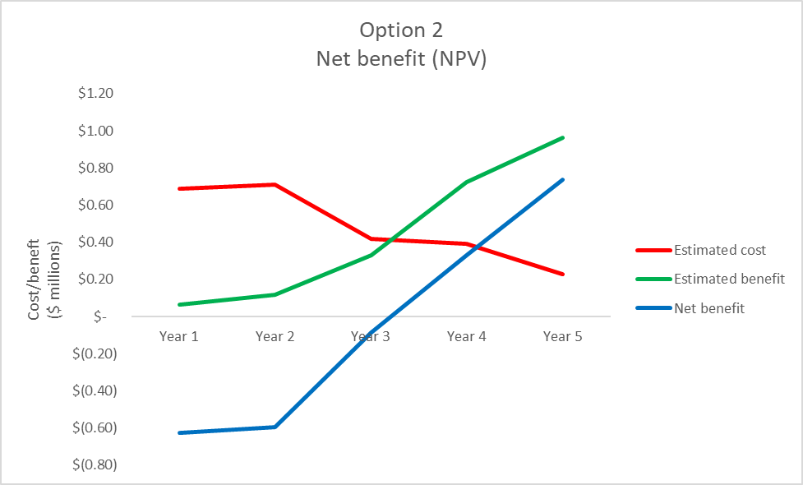

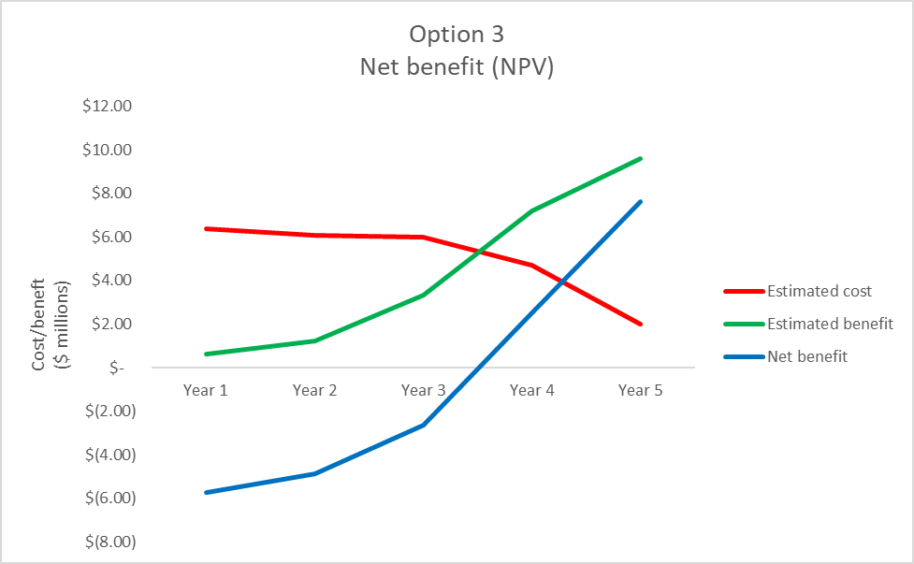

Further information on the costs and benefits is included below. In relation to the benefits, it is assumed that these will largely fall to the health system, with efficiencies in administration processes associated with more streamlined identification processes and matching of data. Efficiencies also are expected to result from digital health products and programs being able to use HIs, and therefore not having to create bespoke identifiers and provide for more complex development effort to interoperate with other systems. There is also some quantified benefit attributed to consumers, who are expected to see better health outcomes because of enhanced identification and matching of data and health information. As discussed further below, there are also expected benefits associated with better access to all health and care information about a consumer, which is made possible by uniquely and consistently identifying them across data sets and health systems. These benefits relate to avoidance of duplicate consultations, tests and procedures due to better availability of information at the point of care. As these benefits are reliant on other changes, in addition to the foundational element of better identification, they have not been quantified in the net benefit analysis. Although not quantified, realisation of those benefits would mean even greater positive outcomes as a result of these enabling reforms.

## Sensitivity analysis

Sensitivity analysis has been conducted in relation to the HI uptake rates, to assess the impact if the assumed uptake rates are not realised. This is particularly important, given the enabling nature of these reforms, rather than new obligations that will require stakeholders to take action in response to the reforms.

For option 2, alternative rates of 5% and 3% were modelled, and for option 3, alternative rates of 50% and 25% uptake, with the impact on the net benefit shown in the graphs below.[40]

The graph reflects that lower rates of uptake would delay the period before which benefits would overtake costs. However, for option 2, even if uptake were as low as 3%, by the end of the implementation period, it is expected that the reforms would achieve a positive benefit. Similarly, with lower uptake rates for option 3, there would still be a positive benefit from the reforms by the end of the implementation period, with benefits continuing to accrue beyond the implementation period.

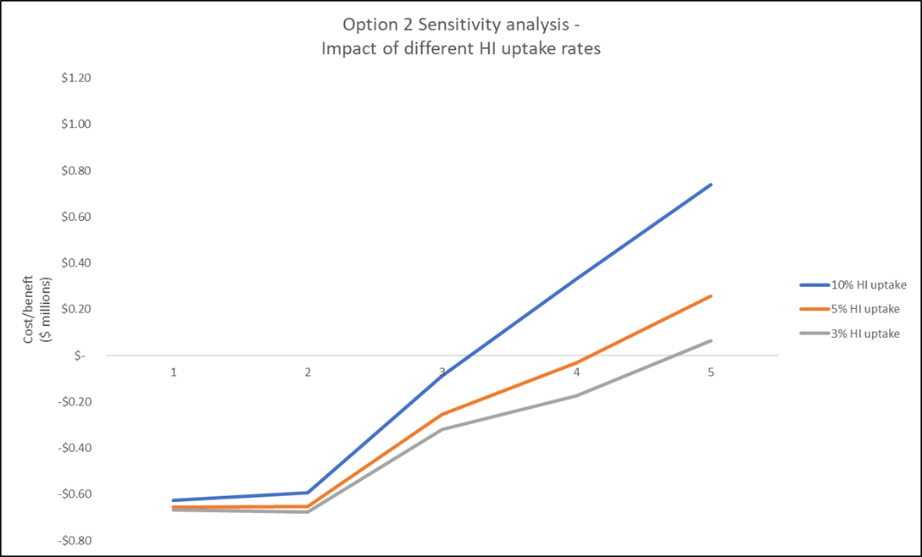

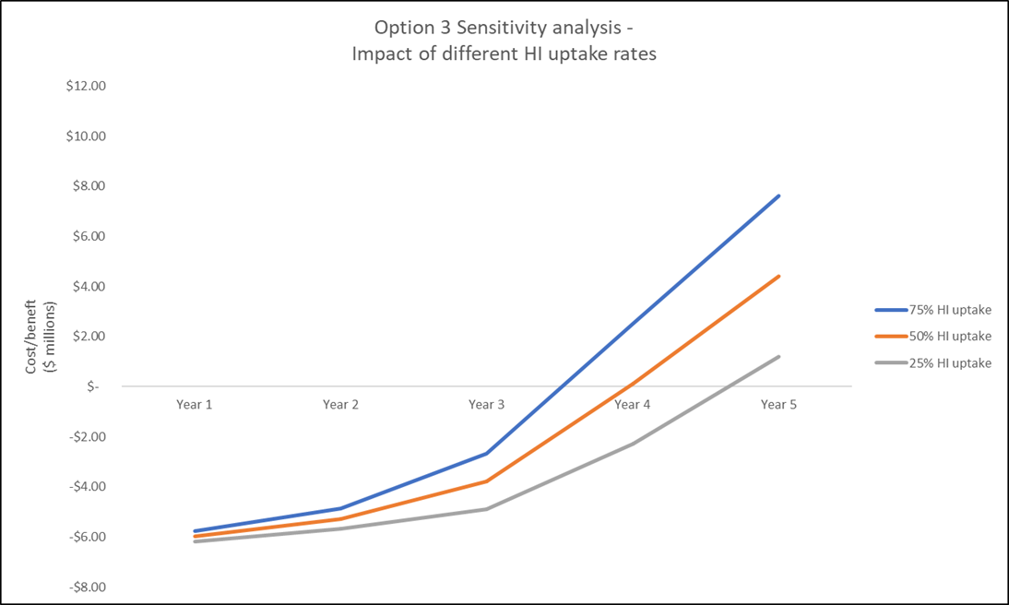

## Options and assumptions

The assumptions underpinning the estimated costs and benefits of each option are summarised below.[41]

As noted above and in the evaluation section of this IA, it is known that the proposed enabling changes under options 2 and 3 may not alone be sufficient to drive change and increase use of HIs. Rather, other policy levers are likely to be required to drive change that will see increased use of HIs in clinical information workflows and to support health information sharing, or for other health programs, administration and payments processes.

While the cost estimates assume that the health and care sector would uplift their technology solutions to enable them to use HIs, if they did not do so in anticipation of future digital health initiatives, then the time at which cost to uplift systems would be incurred would shift. The costs would instead accrue at the point of change to also support other digital initiatives. This would mean the benefits would also not be realised until that later time (or not at all if future levers were ultimately not forthcoming).

As referenced earlier in this IA, there is significant investment in digital uplift and greater interoperability for the health sector underway, as flagged in documents such as the Digital Health Blueprint and National Digital Health Strategy. [42] Many of the initiatives under analysis and in development are reliant on a unique identifier for healthcare recipients and providers. Accordingly, other digital health capabilities with expected benefits for patient outcomes and public health would be harder to realise if these enabling changes were not put in place to allow the existing national identifiers to be leveraged across the health and care sector. Without legislative change, future policy levers could not demand HIs be used as a core data element, which will have the flow on benefits to enabling greater access to health information in real-time to inform patient care and a learning health system.

Accordingly, while there is a risk that no action will be taken in response to these enabling reforms alone, the costs and benefits assume gradual uptake over a 5-year implementation period.

### Option 1 – Status Quo

Use of HIs will continue to be limited to the existing health professionals and services in the health system, and the individuals that receive care from those professionals and services. This impacts the ability for individuals to have access to all their health and health-related information and the ability for clinicians to improve consumer health outcomes via access to rich health and health-related data. This will also prevent government services from connecting health information to support more efficiency in administrative activities, such as health-related claims, payments, research and analysis. This option will limit the investment in digital health nationally and reduce the benefits able to be achieved through other digital health reforms.

**Costing impacts:** No additional costs associated with this option have been considered.

**Benefit impacts**: No additional benefits are projected as there is no clear policy driver for changes in adoption being proposed.

### Option 2 – Enhancing the current HI Framework

This option would result in the HI Act remaining applicable to traditional health providers but better supporting the exchange of health information in clinical settings. Authorisations for healthcare providers will be clarified to reduce barriers associated with uncertainty as to scope of current authorisations. The HI Act will expand the definition of contracted service providers to cover all healthcare functions and will provide authorisations for the technology providers and solutions involved in clinical communication workflows between healthcare providers. Streamlined conformance processes and additional guidance for connection to the HI Service will be established to support legislative changes. It would also support streamlined processes to support assignment of healthcare provider identifiers to non-Ahpra-registered allied health professionals. There are a number of allied health professions not regulated by Ahpra. For the self-regulating professions, the accreditation process is managed by the relevant professional peak body. The professional associations certify qualifications, set and maintain standards and oversee professional development. This option would recognise the role of the relevant professional bodies and enable them to apply for HPI-Is on behalf of their members.

This option will also implement mechanisms to ensure a consolidated and current directory of healthcare providers is available to support future digital health capabilities.

This limited reform would address existing barriers to some health sector participants in using HIs across clinical workflows. However, this option would not support expansion to the care sector, with the corresponding benefits associated with streamlined communication of health and health-related information across all health and broader care services. This is because much of the care sector would remain outside the HI framework. This option would also not provide the ability for clinicians to improve consumer health outcomes using comprehensive health and health-related data. This will also prevent efficiencies in government services from connecting health information to support administrative activities, such as claims, payments, holistic service planning, research and analysis. This option would underdeliver the outcomes from investment in digital health nationally, reducing the ability to achieve the desired interoperability across the health and care ecosystem and to reduce duplication of identifiers used across clinical and health administration workflows and systems.

**Costing impacts:** Additional conformance costs for the Australian Digital Health Agency to streamline the process to make it less onerous for software vendors. Development costs for health vendors who are not currently conformant with the HI Service. Costs for Services Australia to build bulk exchange processes. Otherwise, minimal costs expected – there may be increases in use of HIs by healthcare providers and therefore some additional cost for Services Australia associated with support for higher volumes of HI Service validation, however infrastructure uplift to support enhanced capacity is underway separate from this work, and expected to cover any increase that might result from this option. No cost has been included for training providers to use HIs. This is because HIs are largely intended to apply in the background, with system processes performing the connection to the HI service to bring back or validate HIs, and system workflows attaching HIs to documents or electronic communications. Early work to establish a baseline for HI use at the time of this IA suggest that approximately 88% of GP vendor products and one third of allied health software products are HI service-conformant[43].

**Benefit impacts**: In estimating the benefits of this option, it is assumed that there would be a 10% uplift in HI use as a result of the proposed changes,[44] with benefit incrementally achieved over the 5 years post implementation as additional products and providers build HIs into their systems and workflows. The benefits anticipated as a result of the enabling reforms under this option largely relate to efficiency and improvements in health administration. For example, there would be anticipated time and labour savings associated with reduced collection of and reference to multiple identifiers and streamlined registration processes. There is also benefit associated with the potential for HIs to support decreased rates of error, and a reduction in time in episodes of care, due to better identification to support access to existing information. More detail about the benefits analysed is included in Appendix D.

### Option 3: Expand and optimise the HI Framework

This option would expand authorisations for use across the broader health and care system, with authorisations supporting use of HIs for health and health-related purposes. The option includes the changes outlined in option 2 and:

* expanding eligibility for HIs to incorporate organisations providing care services, such as aged care and disability services
* authorisations for the use of HIs for care and support and health administration purposes, including monitoring, analysis and research
* provide authorisations for individuals to disclose their own identifier to technology services/providers to facilitate sharing of information to healthcare providers
* in-built flexibility with rule-making powers to expand authorisations for use of HIs to other use cases in future.

**Costing impacts**: Additional vendor development for expanded scope of health support services; vendor and Australian Digital Health Agency conformance costs. Services Australia system uplift to support new entity types. Additional Australian Digital Health Agency communications/change staff to support. No cost has been included for training providers to use HIs. This is because HIs are largely intended to apply in the background, with system processes performing the connection to the HI service to bring back or validate HIs, and system workflows attaching HIs to documents or electronic communications. Separate from this analysis, Services Australia and the Australian Digital Health Agency are undertaking analysis to identify options to improve match rates, with exploration of how software offerings might surface errors so that users could respond and take appropriate action. As that is occurring separately, and system and end user changes that might result are as yet unknown, they have not been attributed to this reform.

**Benefits impacts:** This option will benefit comprehensive care by extending the use of identifiers across health-related support services. A clear policy direction will be needed to achieve the full benefit, as without this there is a risk of the slow take up that has impacted the health sector. However, the enabling reforms will assist providers and supporting administration entities, to position themselves to use HIs into the future, for example, to report on care provision. Future policy levers will also be able to drive adoption within the care sector, by requiring the use of HIs in appropriate policies and programs.

This option also estimates significant efficiency and benefit associated with the ability to use HIs for health administration purposes, such as claims and payments, monitoring and analysis and population health purposes. In estimating the benefits of this option,[45] it is assumed that there would be a 75% uplift in HI use as a result of the proposed changes, with benefit incrementally achieved over the 5 years post implementation. The benefits anticipated as a result of the enabling reforms under this option relate to efficiencies in health administration, as with option 2, as a result of better identification and streamlined registration processes. Benefits are anticipated to contribute to reduced adverse events associated with patient identification, medication management and monitoring, and reduced time in health service episodes due to better identification of and availability of existing information. Greater uptake leading to increased benefits is also anticipated as a result of authorisations permitting HIs to be used to support the administration processes associated with the delivery of and payment for health services. For example, state and territory health services and hospitals would benefit from being able to use HIs across their patient administration systems and clinical information management systems, rather than having to link via alternative identifiers. Software development projects would also benefit as a result of confidence to embed healthcare identifiers into the products used by healthcare providers, rather than maintaining bespoke identifiers and matching processes and the need for alternate identifiers for clinical and payments purposes. For data analysis and research, there are benefits in the use of HIs to bring together data from different assets, with efficiency in not having to undertake probabilistic matching, prior to commencing actual analysis of trends and outcomes. Further detail in relation to the benefits analysed is included in Appendix D.

## Costings

Reform to HI legislation and policy will have a potential impact on any entity in Australia involved in the delivery of healthcare and related care to individuals. The extent and nature of that impact has many dependencies, with various actors across government and the private sector having different requirements for taking up HIs and different levels of maturity in system functionality and process flexibility. There are also differing levels of understanding of the role and benefit of HIs among software and systems providers, health and care service providers, consumers and other stakeholders. A number of assumptions have been made to scope the costing across such a diverse environment, and these are outlined below.

Furthermore, digital health is an area which experiences rapid changes in market diversity, product availability, economies of scale and standardisation of functionality and processes. Costs will change depending on how the sector reacts in the medium term to the reform and wider take up of HIs more broadly. Estimations of costs beyond the short term may lead to inaccurate and invalid assumptions, or levels of uncertainty that make analysis less useful. As such, the costing assessments for the IA have only factored in the costs across the five years from the enacting of the policy and legislative reforms. As noted, the changes under options 2 and 3 would enable HIs to be used by additional entities to support the delivery of health and care services. They will support HIs to underpin other digital health capabilities, which will deliver benefits associated with increased health system interoperability. The range of benefits associated with interoperability which HIs enable has not been estimated as directly linked to the options. Further intangible benefits associated with greater interoperability would be additional to the estimates for the purposes of this IA.

The costs and benefits discussed below assume adoption by those additional entities who will be enabled to use HIs, as compared to the status quo, and related efficiency gains. As noted above, there is a risk that the newly enabled entities may not act to adopt HIs, which would impact on realisation of the corresponding benefits. Sensitivity analysis has been conducted to assess the impact of less than anticipated uptake on the potential benefits realisation.

Costing assumptions have been broken down by service entity type, to identify the costs that will be incurred across the different actors in HI use cases. Not all service entities are in scope for each option.

Some service entities do not incur a cost in any option. This is because the costs involved for these entity types are accounted for under existing system improvement or identifier implementation programs. For example, there will be costs incurred to states and territories to accommodate HPI-Is in relevant systems. However, there has been an active program of work over a number of years to drive this change to support MHR and other digital health initiatives that are separate from, but complementary to this reform program. Further, implementation of HIs in a health service generally occurs as a part of another program, rather than as standalone functionality, or is available as an integral part of software and requires no additional training/implementation effort. These costs have not been included as they are a pre-existing cost tied to other requirements.

### Service entities in scope for costs

The following healthcare ‘service entities’ have been considered in scope for the net benefit analysis:

#### Non-government

1. Aged Care providers
2. Allied Health Services
3. Community Nursing Services
4. Diagnostic Services (Pathology and Radiology)[46]
5. Disability Services providers
6. Primary care/General Practice services
7. Community Pharmacies
8. Private Hospitals (note that Private hospitals are partially government-funded).
9. Specialists
10. Vendors

#### Government and government-funded

1. Australian Digital Health Agency
2. Clinical Quality Registries[47]
3. Health Administration Entities (Department of Health, Disability and Ageing, state/territory health departments, AIHW, PHNs, etc)
4. Public hospitals
5. Services Australia (in its capacity as the HI Service Operator)

## Benefits

Assigning unique identifiers to individuals, healthcare providers, and provider organisations across the health ecosystem will facilitate connecting the right information with the right individual at the point of care. It gives both healthcare providers and consumers, confidence that they are using the correct information and improves the ability to use data for population health planning, monitoring, evaluation and research. Unique identifiers support accurate communication of and access to information through other technologies which support connections between healthcare settings and datasets.

Adoption of HIs beyond MHR, and more recent digital initiatives such as ePrescribing services, has been slower than expected in part due to legislative and operational challenges. The legislative reform options put forward in this proposal are projected to impact the health system and subsequently address adoption of HIs to varying degrees.

Benefits from the HI Service will be achieved proportionately to the number of users of the Service across a broad range of health and aged care service types, and the number of programs that require the use of HIs as a prerequisite for participation in the program. The establishment of a clear policy environment that drives active use is therefore a dependency for wider benefit realisation beyond those efficiency gains estimated for the net benefit analysis.

The realisation of benefits is directly related to the scope and extent of the reform proposed in each policy option. New benefits are projected to be largely in the areas of planning, evaluation and efficiency.

The reform outlined in Option 2 provides little impetus for change versus the current state. As noted above, it is estimated that there might be a 10% uplift in HI use as a result of the changes proposed under Option 2. As such, analysis shows minimal material benefits are expected to be realised. The expanded scope outlined in Option 3 would provide more impetus for change due to the broadened scope, in particular to include support service providers and health administration entities. This is expected to accelerate the impetus for change and estimated to create an amplification of benefits to be realised across the health system. This accords with an estimated 75% uplift in HI usage, as described above, compared to the status quo.

Widespread use of HIs will generate improvements across the Australian healthcare sector. Many of these improvements will be iterative, as efficiencies which lead to better processes, service delivery methods and advances in data analysis will contribute to streamlined national programs, innovative models of care and well-coordinated healthcare delivery between the Commonwealth, states, territories and the private sector. Many of the long-term benefits delivered by the reform will drive improvements to quality of care and health system efficiency. These types of benefits have not been costed for the purposes of this analysis and would represent additional non-tangible outcome improvements beyond the estimated benefits outlined below. However, there will be multiple factors that will contribute to the scale of benefit and quantifying the specific proportion of the benefit attributable to HIs is complex. Where HIs are an enabler of a benefit that has been claimed in other business cases, these have not been included in this IA.

For the purpose of this IA, only benefits which are a direct consequence of the reform objective of widespread use of HIs have been identified and assessed.

The following additional benefit assumptions have been made:

* Benefits will increase as the number of alternate identifiers in common use across Australia for individuals and providers is reduced. This rationalisation process is outside the scope of the IA, and the benefits that will be delivered from the outcomes of identifier rationalisation are not included. The only benefit component included in this IA is the impact of **availability** of HIs on the design and implementation of these programs, with corresponding efficiency in program design and development.
* There is a variable level of increased use assumed for each option. While additional education and communication and the expansion to support services will drive some level of increase in use, the major impact on uptake will be driven by policy initiatives where HIs will be required to be used. The proposed amendments under options 2 and 3 will allow for different types of policy levers to be used – option 2 will provide greater confidence over scenarios where HIs could be required to support clinical communications, and option 3 will enable policy levers to require HI use more broadly, following authorisation of use across the care and support sector and for health administration workflows.
* Benefits for use of HIs in digital health initiatives such as MHR and ePrescribing, and other clinical contexts can be achieved with the HI Service operating in its current form, with some clarifications and improvements as provided for in option 2.
* The major additional benefits to be driven by this reform would come from the proposed expansion, under option 3, to health administration entities and support service providers.
  + Use of HIs by health administration entities and for health administration purposes will see benefits related to operational efficiency and cost savings and downstream impacts from improved planning and research. The expansion to health administration entities is anticipated to drive policy reform at a state and territory level due to the significant potential benefit for more efficient integration of health administration and clinical functions. This in turn is also expected to drive use within their clinical services.
  + The expansion to HSPs will drive benefits by enabling better connected care across all the related services accessed by individuals which impact on their overall health and wellbeing. The use of accurate and consistent identifiers across all health and care settings means that individuals and providers can be accurately identified, improving the accuracy and availability of information shared between providers and with consumers themselves. Benefits for consumers relate to reduced time and burden associated with maintaining and producing health documents or having to retell their story when they see different providers. The current system often relies on consumers to be good historians and coordinators of their own care - able to understand and retell information about previous health encounters. In high stress health encounters, and for people with multiple chronic conditions, this can present significant challenges and barriers to good outcomes. Good information sharing and reliable and accurate access to information by their care teams reduces this burden for consumers. It can avoid the need for multiple tests or repeat encounters. For consumers who wish to do so, access to their own information, enabled by a consistent identifier, helps them to advocate for their own health and care needs. While these benefits flow from consistent identification across health and care settings, given the dependency on other changes to make information more readily available, and the difficulty in ascribing a quantifiable benefit, they have not been included in the quantified benefits for the purposes of this net benefit analysis.

In each benefit type, increases to the scope of the healthcare delivery use cases for which identifiers could be taken up (as represented by a percentage of total individuals and providers involved in all use cases able to be identified using HIs) has a positive increase in the benefits realised.

A gradual take-up of benefits has been applied over the 5 years post implementation of changes, as more systems become HI-enabled over this time. This IA has noted the assumption that realising the full potential of HIs would require other policy levers, which may be introduced following the greater enablement of key stakeholders in the health and care sector being to use HIs (as a result of the reforms analysed here) and building that capability into their systems. Accordingly, further benefits may be realised due to HI use being reinforced by both other policy levers and the availability of new digital health solutions and services that require their use. Given the challenge of forecasting these future changes and their impacts, the benefits in this IA are limited to the 5 years post implementation where efficiencies could be realised due to increased use of unique identifiers.

## Cost benefit summary

Table 6 below shows a breakdown of the total costs and benefits which make up the costs and benefits shown in the Anticipated net benefit in table 5 above, and which are based on the assumptions outlined above. Given the dependencies with external policy decisions on HIs take-up, the benefit total included in this IA is based on a conservative 10% of the estimated maximum benefits.

Table 6: Total costs and benefits based on the assumptions

| Total costs and benefits based on the assumptions | Option 2 | Option 3 |
| --- | --- | --- |
| **Costs** | *Component total by entity type($ millions)* | |
| Software Vendors | $1.67 | $12.51 |
| HI Service (Services Australia) | $0.13 | $0.16 |
| Australian Digital Health Agency | $0.63 | $2.37 |
| Public Health Services, Private Hospitals, GPs, Diagnostic Services, Pharmacy | $0 | $0 |
| Aged Care | $0 | $0 |
| Allied Health, Medical Specialists, and Community Nursing | $0 | $0 |
| Clinical Quality Registries | $0 | $1.88 |
| Health Administration Entities | $0 | $8.21 |
| Disability Services | $0 | $0 |
| **Total costs** | **$2.43** | **$25.14** |
| **Benefits** | *Assumed additional* ***10%*** *HI uptake* | *Assumed additional* ***75%*** *HI uptake* |
| 1 – Enablement of Healthcare Delivery Modernisation (HDM) program benefits | N/A | $0.07 |
| 2 – Flow on effects to other govt systems interacting with health data | N/A | $0.29 |
| 3 – Accelerated development and implementation timeframe for future digital health projects | $0.06 | $0.46 |
| 4 – Increased effectiveness of benefits arising from future digital services/products | $0.09 | $0.69 |
| 5 – Reduced cost of resource maintaining multiple identifiers across non-HDM national digital health infrastructure | $0.03 | $0.22 |
| 6 – Reduced cost involved in probabilistic data linkage for research, monitoring and evaluation | N/A | $0.16 |
| 7 – Improved ability to track and manage outcomes of care/treatment (reduction in adverse events) | N/A | $5.00 |
| 8 – Reduced duplicate procedures as external results can be located and confirmed to relate to the individual | $1.63 | $12.20 |
| 9 – Time saving from not needing to re-enter patient registration details | $0.39 | $2.94 |
| **Total benefit (NPV over 5 years) (@7% discount rate)[48]** | **$2.20** | **$22.02** |

The majority of quantified benefits accrue to the health system, with improved efficiencies associated with better identification and streamlined administration due to access to consistent identifiers and consumer information. Some benefit is also estimated to be gained by consumers, under benefits 7 and 8, as better identification is expected to support a reduction in adverse events and duplicate encounters and procedures. Greater benefits for consumers are expected, although not quantified, as better identification will support the development of other digital health capabilities that will deliver improved outcomes for consumers associated with better access to all information relevant to their clinical decisions at the point of care, and better care planning to improve overall health and wellbeing.

Table 7: Costs and benefits accruing to relevant entities under each option

| Stakeholder group | Type of impact | |
| --- | --- | --- |
|  | **Option 2** | **Option 3** |
| **Australian Digital Health Agency** | ***Costs***   * **Economic**: Cost of updating conformance processes   ***Benefits***   * **Efficiency**: More streamlined process enabling greater throughput of vendors * **Client satisfaction**: Improved process and reduced cost for vendors will have reputational/experience benefits | ***Costs***   * **Economic**: Cost of updating conformance processes; staff cost to support increasing support requirements as number of participating vendors increase   ***Benefits***   * **Efficiency**: More streamlined process enabling greater throughput of vendors * **Client satisfaction**: Improved process and reduced cost for vendors will have reputational / experience benefits |
| **Services Australia** | ***Costs***   * **Economic**: Cost of building bulk exchange processes with allied health professional associations. Otherwise minimal costs expected – there may be increases in use of HIs by healthcare providers and therefore some additional cost associated with support for higher volumes of HI Service validation, however infrastructure uplift to support enhanced capacity is underway separate from this work, and expected to cover any increase that might result from this option   ***Benefits***   * Reduction of manual processing resourcing and costs – streamlined processing of applications for non-Aphra registered allied health providers | ***Costs***   * **Economic**: * Infrastructure uplift to support increase in volumes * Potential additional resource cost for provider support * HI Service functional changes to support additional service/entity types * Functional changes to other health program systems to support transition to HIs   ***Benefits***   * **Efficiency:** * Lower cost and effort in maintaining multiple program identifiers * Improved data quality * **Customer Service**: Improved visibility of all health and aged care programs an individual is participating in, to provide more integrated service |
| **Health, Aged Care and Disability Software Vendors (not currently conformant with HI Service)**  **Note: aged care and disability support providers out of scope for option 2** | ***Costs***   * **Economic**: Cost of development and testing   ***Benefits***   * **Competition**: Enabling vendors to compete in market by providing access to national digital health services * **Risk reduction**: Greater clarity for Contracted Service Providers reducing potential risk of breach | ***Costs***   * **Economic**: Cost of development and testing for HI conformance   ***Benefits***   * **Competition**: Enabling vendors to compete in market by providing access to national digital health services * **Risk reduction**: Greater clarity for Contracted Service Providers reducing potential risk of breach |
| **Health Services (public and private)** | ***Costs***   * No additional costs (note: there is no charge associated with validation of HIs with the HI Service) as most health services are already enabled to use HIs and where not, the cost is reflected in the software vendors cost element.   ***Benefits***   * **Risk reduction**: Greater clarity on use increasing confidence in use * **Quality of care and efficiency**: Improved patient data flows * **Efficiency**: Consolidated provider directory supports efficient and secure communications between providers | ***Costs***   * No additional costs, as most health services are already enabled to use HIs and where not, the cost is reflected in the software vendors cost element. Future costs would be driven by other policy or digital health participation requirements.   ***Benefits***   * **Risk reduction**: Greater clarity on authorised use, increasing confidence in use * **Quality of care and efficiency**: Improved patient data flow and relationship with aged and disability care providers, reducing inappropriate admissions and delayed discharge, reducing bed block * **Service delivery and patient experience**: Improved service to consumer as information is available when needed. * **Cost reduction:** Reduced administrative burden of maintaining state/regional identifiers, data cleaning, duplicate resolution |
| **Aged care and disability support providers**  **Note: Out of scope for option 2** | ***Costs***   * No additional costs   ***Benefits***   * No additional benefits | ***Costs***   * No additional costs for clinical care functions, as covered in the software vendor and Health Administration Entities cost elements. For example, it is anticipated that most support at home and community based aged care and disability providers would access HIs via aged care and disability systems (such as operated by the NDIA/NDIS Commission) and minor changes to reporting tools could be made to include HIs * Minor cost for inclusion of HIs in warehouses, (i.e. sharing of HIs and associated information to databases or repositories for analysis), reporting extracts to include HIs for monitoring/analysis purposes   ***Benefits***   * **Quality of care and efficiency**: Improved data flow and relationship with healthcare providers, reducing unnecessary transfers and delayed return to residential aged care facility * **Service delivery and resident experience**: Improved service to individuals as information is available when needed. * **Access** – improved access to healthcare providers as support for virtual care and supporting data sharing is enhanced |
| **Health Administration Entities**  **Note: not in scope for option 2** | ***Costs***   * No additional costs   ***Benefits***   * No additional benefits | ***Costs***   * Modification of warehouses, extracts, transform and load (ETL)[49] processes, reporting. * Further detail is included in appendix D, and involves the cost of developers and analysts to build data gathering, cleansing and storage capabilities and updated reporting and analytics capabilities including the use of HIs as common identifier.   ***Benefits***   * Ability to monitor outcomes of patient care * Reduced costs and risks associated with data linkage for performance, epidemiology, planning and research * Improved visibility of health workforce for planning and performance |
| **Consumers** | ***Costs***   * No additional costs   ***Benefits***   * **Quality of care** benefit through increased data sharing between traditional healthcare providers. * **Improved patient experience** through reduced need to repeat information. * **Access benefit** though improved capacity for virtual care and associated data sharing. | ***Costs***   * No additional costs   ***Benefits***   * **Quality of care and efficiency**: Improved quality of care as clinical information is shared across health, aged care and disability settings. * **Service delivery and resident experience**: Improved service to individuals as information is available when needed. * **Access** – improved access to healthcare providers as support for virtual care and supporting data sharing is enhanced. * **Improved health services**: Use of identifiers to better understand service use patterns and impact of different models of care will benefit consumers through improved service delivery |

# Question 5: Who did you consult and how did you incorporate their feedback?

## Consultation approach

The Department conducted both public and targeted consultation to inform this work.

### Public consultation

Public consultation was conducted from December 2022 to February 2023. The public consultation paper[50] was informed by research and analysis, and feedback from stakeholders gathered during previous reviews of the HI Framework. The paper provided a background to the HI Framework and set out why improving connectivity and integrating health information is important for the future of affordable, high-quality healthcare. The consultation paper sought views on both legislative and non-legislative mechanisms to improve the operation of the HI Framework focused around eight problem statements that were identified through previous reviews and research papers:

1. Use of HIs in programs, services and systems by default
2. Scope of what healthcare means and broader provider eligibility
3. Clarity around use for health administration purposes
4. More straightforward HPI-O and HPI-I structures
5. Empowering consumers to use their own IHI for broader purposes to optimise their health outcomes
6. Enabling technology services to use HIs to support consumers
7. Greater clarity around permitted uses
8. Greater flexibility to support emerging use cases and operational models.

In total, the Department received 49 submissions in response to the public consultation. These submissions came from a diverse range of organisations and individuals, including government, peak/professional bodies, health and care providers, research institutes, software providers, technology companies, private health insurers, administrators, consumers, and representatives from the not-for-profit sector. The Department published a report on the consultation outcomes.[51]

### Targeted consultations

Targeted consultations were then conducted with the following key groups to test the findings and proposals for amendment developed in response to the public consultation.

* + - * Commonwealth government departments, including Department of Finance, and the Health Branch in the Department of Prime Minister and Cabinet, the Australian Digital Health Agency, Services Australia, Aged Care, NDIA.
      * State and territory governments
      * Regulators
      * Health peak bodies
      * Software vendors
      * Consumer representatives
      * Research organisations.

Consultation leveraged existing forums bringing together health and support service stakeholders, including aged care and disability representatives, and states and territories. Engagement with states and territories occurs on a regular basis, including through established governance groups such as the Digital Health Oversight Committee, which reports to the Health Chief Executives Forum. Consultation also included the Council for Connected Care which comprises the Consumer Health Forum of Australia, the National Aboriginal Community Controlled Health Organisation, research organisations and government and practitioner representatives.[52] The Council for Connected Care was established to facilitate and support the implementation of the National Healthcare Interoperability Plan 2023-2028. Its remit includes working to identify opportunities to accelerate interoperability in various parts of the health system and ways to harness these opportunities; promoting and garnering support for digital health initiatives that drive connected care; and identifying barriers to achieving interoperability and ways to overcome them.

In addition, engagement on privacy impacts has been occurring with the Office of the Australian Information Commissioner, the regulator of the My Health Record system, and Services Australia, noting its role in supporting Medicare services and operating the HI Service. A Privacy Impact Assessment has also been conducted by the Australian Government Solicitor’s office.

## Consultation outcomes

Overall, the consultations supported changing the HI Act to connect health, aged care, disability and allied health care. They also favoured enabling support providers and administration entities to use HIs, broadening authorisations to allow use if HIs in technology services, allowing consumers to integrate their IHIs with more health-related services and programs, and provider directory reforms. Consultations also supported providing more clarity around the authorisations and penalties in the HI Act, through legislative reform and also through the education campaign already underway.

Two options were distilled from these views:

* clarify and enhance authorisations for consumers and providers currently able to get HPI-Is and HPI-Os to support more purposes (Option 2), and
* in addition, extend the ability to obtain and use HIs to cover more providers in the aged care, disability and allied health sectors (Option 3).

While there was support for use of HIs by default in key programs, systems and services, consultations highlighted several difficulties around implementing these reforms, including the right of consumers to receive healthcare services anonymously, signalling the need for further consideration. As a result of the risks raised, the option of pursuing mandatory HI use by default was not progressed as part of this IA.[53]

There was little to no support in consultations for retaining the status quo and not making any legislative change. For this reason, option 1 was not preferred.

Consultation responses shaped the assessment of the options and their impacts by highlighting the clear benefits to consumers and providers of extending coverage of the HI Framework to providers of personal care and wellbeing support. The risks of this approach were also raised, namely, granting broader care and support providers the same access rights to health information as traditional healthcare providers. This led directly to option 3 providing for a new identifier for healthcare support providers so that access to information and to systems such as MHR can be tiered and restricted, and appropriately controlled by the patient/consumer to whom the information relates.

‘The proposed Healthcare Identifiers reforms are critical to creating an interoperable health system into the future, and to improving connectivity and patient care.

To achieve the maximum benefit, HIs need to be universally and nationally applied and replace as many other government identifiers as possible.’

*Australian Clinical Trials Alliance*

### Responses aligned to option 2

Consultation responses supported the following policy positions proposed under option 2 aimed at enhancing the current HI Framework:

#### Clarify current narrow authorisations

A clear message from the public and targeted consultations on the current HI Framework is that the existing narrow authorisations, coupled with the significant penalties for misuse, have acted as a barrier to widespread adoption and use.

Proposed amendments will revise the strict and narrow authorisation approach through:

* clarifying that contracted service providers of healthcare providers have the same authorisation to handle HIs as the contracting healthcare provider during the term of the contract
* clarifying the role of registration authorities by streamlining the process for assigning HPI-Is to allied health providers who are not Ahpra members
* authorising better information flows to strengthen the Healthcare Provider Directory.[54]

‘As the backbone of Australia’s healthcare system, GPs require broad adoption of Healthcare Provider Identifier – Individual (HPI-Is) and Healthcare Provider Identifier – Organisation (HPI-Os). As unique identifiers they ensure a consistent way of identifying healthcare organisations and providers and their services. GPs should feel confident information communicated to or received from other healthcare providers outside of the general practice is current and up to date, with the provider clearly identifiable to ensure data provenance.

A consistent identifier could greatly minimise the need to manage multiple systems and passwords’.

*Royal Australian College of General Practitioners*

#### Use of HIs to underpin technology solutions

Consultation responses also supported the use of HIs by technology providers. This included both consumer-facing software, which consumers directly interact with, such as health apps on wearable devices, and intermediary software, which facilitates communication and data exchange between systems or services, like the Prescription Exchange service and the Active Script List service.

However, this support was accompanied by feedback that there should be strong legislation and regulation applicable to consumer-facing and intermediary software. It was suggested that the authorisation for such health technology providers to use HIs should also only apply for the specific purpose at time of application. There was also strong support for the proposal that any solution integrating with the HI Service should be required to undergo conformance testing processes.

For systems or solutions that rely on one component integrating with the HI Service and then passing information to other technology components to facilitate the transfer or communication of information, those other components would not necessarily be required to undergo conformance assessments. Rather, stakeholders suggested other clinical and data quality processes should be able to be relied on to ensure the correct passage of data from one system or component to another.

Work is underway to develop agreed technology standards and consistent national clinical terminology to support the transfer of health information. It is proposed that HIs will form a key part of the data set making up the national standards for healthcare. This work will also support progress in designing national infrastructure to support near real-time exchange of health information, regardless of where it is located across the health and care ecosystem. Significant consultation on the development of the technology standards has been underway since August 2023.[55] Representatives from health peaks, software providers, industry, and consumer organisations, as well as Commonwealth and state and territory governments, are working to develop and agree the national standards to support consistent and clear health information sharing, with HIs proposed as a key data element. Proposed changes to the HI Act to ensure technology solutions are authorised to use HIs will be important to support the significant work on standards alignment being achieved in parallel with this IA.

### Responses aligned to option 3

In addition to proposals under option 2, there was significant support from stakeholders, including Commonwealth departments, state and territory governments, peak bodies, and consumers, for the policy positions outlined in option 3:

#### Expansion of the HI Framework to support health-related support providers

Echoing feedback from previous reviews, there was strong support for the proposal to expand eligibility to use HIs to connect health, aged care, disability services and allied healthcare.[56] A major area identified for reform was expansion of the HI Framework to incorporate aged and disability care service provider organisations that contribute to the health and wellbeing of consumers, but fall outside the current HI Framework due to their ineligibility for an HPI-O. Recommendations for legislative change to improve the adoption of HIs to support transitions between care settings were also made by the First Secretaries Group through the *Improving Care Pathways Project* which National Cabinet endorsed.

Responses identified an extensive list of professions, organisations and services that should be included in the ‘healthcare support provider’ category. In addition, they identified a list of healthcare providers for possible inclusion as being eligible for an HPI-I. On the other hand, stakeholders also identified that volunteer-staffed organisations, system administrators, and unregulated health support providers were the types of professionals that should not be able to use HIs. There was clear support for the inclusion of services providing broader aged care and disability support. Other examples of support providers raised included entities supporting people experiencing homelessness or children in the child protection system, although support for these broader examples was not as widespread.

‘I agree for providers who support someone managing their health but don’t deliver it, to obtain and use their type of healthcare identifiers, ensuring the privacy and security of an individual’s information.’

*Consumer Health Forum Organisation representative*

Targeted consultation occurred after the public consultation feedback was analysed to consider options that would facilitate the incorporation of support service providers into the HI Framework. There was also support for the proposal that these support service providers should be authorised to use HIs to contribute relevant information about the care planned and provided to health and care recipients, which will assist clinicians in supporting clinical decision-making and healthcare planning.

#### Use of HIs to support health administration activities and functions

The earlier reviews highlighted gaps that prevented the use of HIs for key health administration functions, and by organisations who support the delivery of health services, but do not directly deliver health services themselves.

It was intended that HIs would be used for purposes such as the funding and monitoring of health; however narrowly construed authorisations have prevented this from occurring. Consultation identified a broad range of government health or health service delivery agencies and individual and private entities that would benefit from clear authorisations to use HIs.

There have also been discussions with states and territories, which have identified the importance of embedding HIs into clinical and health administration systems to support interoperability and to attain better insights into health trends and demands. There is widespread acknowledgement amongst all states and territories of the importance of interoperability and increasing the use of digital health capabilities and technologies. The National Digital Health Strategy was collaboratively developed and agreed by all states and territories and the Commonwealth. Notwithstanding, feedback from states and territories indicates that the current legislative framework presents barriers to better use of HIs within their health services, due to the perceived inability to use them across both clinical and health administration/payment systems. Because of the uncertainty as to when HIs can be used for health administration purposes, states and territories have continued to use alternative local identifiers for these purposes. Consultations have confirmed support for the original intention to use HIs to support monitoring, analysis and funding of healthcare programs and outcomes.

Consultation for this IA and earlier reviews has reinforced the importance of clarity that HIs themselves are not sensitive health information. The risk associated with disclosure of an IHI alone, as opposed to the health information attached to it, is seen as minimal by most stakeholders. Expansion of eligibility to use HIs does not give relevant entities new authorisations to access health information. Rather, it allows them to attach an HI to health information or health administration data that they are already creating or using, to help create a more joined up view of all health information about a person, which can be accessible to those with appropriate authorisations, noting these sit outside the HI Act – for example, use, storage and disclosure of health information by healthcare providers is governed by the Privacy Act, state and territory laws and professional and ethical standards. Access to health information in an individual’s MHR is governed by the MHR Act.

#### Introducing broader purpose-based authorisations

Responses to the public consultation for this IA supported a shift to a broader authorisation model, with parameters regarding the purpose for which HIs are to be used and clear stipulation as to which entities are authorised to use them for such purposes. In response to this feedback, the proposed amendments would see authorisation for the collection, use and disclosure of HIs by authorised entities for broader health and health-related purposes, e.g., claims and payments.

As noted above, an authorisation to use an HI does not provide access to the health information attached to that identifier. Other laws such as the Privacy Act, MHR Act and relevant state and territory laws govern access to health information. The intent of the proposed revision of the authorisation approach for HIs is to facilitate that where a person has or is communicating health or care/support information about a healthcare recipient for a health or health-related purpose, they will be able to attach an HI to that information. Those who receive the health or care/support information will be authorised to collect the HI (attached to the health/care/support information).

Access to health information, via digital health infrastructure such as MHR, will only be available to trusted users. The assignment of an HI will provide scope for ensuring only trusted users get access to information via the MHR system. For example, assignment of an HPI-O is currently required to access MHR.

## Dissenting views and how they were incorporated

Initially, views were sought on whether aged care and disability support workers and organisations should be able to be assigned HPI-s and HPI-Os. As noted above, a number of stakeholders were in support of such a proposal. However, other stakeholders expressed concern at the idea of expanding the framework beyond the current scope which supports communication between healthcare providers. Targeted consultation following the public consultation response occurred to identify options to best use HIs into the future. Some stakeholders who had expressed concern at expansion, acknowledged there was support for aged care and disability service providers to be included in the HI Framework. In response they suggested that this should not result in such providers having full access to a healthcare recipient’s sensitive health information, such as via the recipient’s MHR.

The public and targeted consultation responses informed the proposal that expansion to include the support/care sector should be supported by a different identifier category. This would be to ensure differentiation between fully trained healthcare providers, who provide primary or acute healthcare services, and employees or carers whose primary function is to provide support services that improve quality of life.

Consultation confirmed that the proposed changes to who can be allocated and use HIs would not automatically grant care providers access to the health information attached to an HI. Other authorisations, such as via amendment to the MHR Act, would be needed. The proposed enabling reforms to the HI Framework will ensure that healthcare support organisations are positioned to build the necessary system changes into their technology roadmaps, while further consultation progresses on the nature of information on care provision that healthcare support organisations should share to a healthcare recipient’s digital health records.

Based on the feedback, option 3 was adjusted to recommend creating a new category of identifier specifically for healthcare support services providers (HSPs), with authorisations for identified providers also to be able to use HIs. Initially, this will be limited to aged care and disability services providers, with the potential to include other service provider types via regulation, but with further consultation and analysis to inform any proposal for expansion.

In addition, as noted in the section on IA Question 3 above, the discussion paper prepared for the public consultation on possible HI framework reforms had canvassed the potential to mandate or require the use of HIs by default. As noted in the earlier discussion, this was not further pursued due to reservations raised by stakeholders and queries about how such a broad requirement would be implemented and monitored in practice. Rather, the options in this analysis include reforms that would enable enhanced and expanded use of HIs. Mandating the use of HIs may be built into the design of future policy programs and initiatives, with the proposed reforms considered by this analysis enabling this for future policy settings.

# Question 6: What is the best option from those you have considered and how will it be implemented?

As discussed in response to Question 3, this analysis has considered three options for reform of the HI Framework:

* Option 1 – the status quo – no change to the current legislation
* Option 2 – enhancing the current system - minor changes to the legislative framework to improve useability of HIs in the traditional health sector to better support clinical workflows and health programs
* Option 3 – expand and optimise the HI Framework - more significant changes to the legislation to support use of HIs by the care and support sector (aged care and disability services) and for health administration purposes.

## Assessment of options

In identifying the preferred option, the consultation feedback and cost-benefit analysis were assessed against the key policy objective:

*ensure that the HI legislative and policy framework supports and underpins digital health reform and greater interoperability of the Australian healthcare system.*

While option 1 has supported some key digital health initiatives to date, it is not fit for purpose to support evolving healthcare delivery models and technical solutions that will underpin future digital health infrastructure. No change to the legislation means that key care providers will remain outside the HI Framework, with potentially adverse impacts for consumers as health and care information will be more difficult.

By comparison, option 2 would introduce clearer authorisations to support clinical workflows in the traditional healthcare services the HI Act already covers. It would also support current and evolving health service delivery and business models and the role for technology solutions to support healthcare delivery. In this way, option 2 would achieve many of the reform objectives by delivering service efficiencies through digital streamlining. Clearer authorisations, supported by education and other policy levers, would likely increase the use of HIs by the current group of healthcare providers and result in improved clinical decision-making through better visibility and linking of health information between these healthcare providers.

However, option 2 is limited in application to traditional healthcare settings and providers.

### Why option 3 is preferred

The preferred option is option 3. This option will deliver everything in option 2, plus expand the scope of the HI Framework beyond the traditional health sector to incorporate aged care and disability organisations that provide ancillary care that contributes to wellbeing. Under this option, the approach to authorisations will be changed from the current narrow permission style, to clearly allow these entities to use HIs for health, broader care and health-related administrative purposes. This will support use of the national digital health systems by all relevant participants involved in the delivery, administration, funding, monitoring and analysis of healthcare and support services.

Most significantly, of all options considered, option 3 is best placed to achieve positive outcomes for consumers and providers by enabling better information sharing and joined-up data to enhance information availability for purposes such as clinical decisions, multidisciplinary care and monitoring of health interventions and outcomes.

Option 3 would also better facilitate the original objectives of the HI Framework, including underpinning digital health reforms, which are intended to provide better information and data sharing that can support enhanced monitoring and analysis of health data to better inform health interventions and program design.

Option 3 alone will require future policy levers to achieve all the desired objectives of HI Framework reform. However, this option will facilitate the success of those future levers by enabling a broader range of health and related care services to use HIs and build HI capability into existing workflows. This will also make it easier for more health, aged care and disability support services to take advantage of new digital health solutions and services that require HI use, thereby achieving greater provider efficiency and enabling more connected care for consumers.

Option 3 also supports real progress toward the rationalisation of identifiers nationally. This will drive measurable benefits in reduction in administrative time, including time associated with data linkage, maintenance of identifiers and duplication in services.

Where benefits have been quantified, option 3 achieves a much higher net benefit by the end of the implementation period. This includes the alternative assumptions modelled through the sensitivity analysis, by comparison to option 2. The net benefits are higher because the reforms proposed under option 3 are expected to provide greater impetus for change and adoption. Further, while they are not able to be quantified, additional benefits are expected to accrue across the health and care system, enabled by the reforms under option 3. In particular, increased use of HIs, enabled by these reforms, would allow providers to build common identifiers into systems and digital products, reducing the effort associated with creating bespoke identifiers and making them interoperate with other systems. Better interoperability is the foundation for improved patient outcomes resulting from reduced duplication in encounters, tests and procedures and better access to all key health information to inform clinical care and planning.

## Implementation of recommended option

Because the preferred option involves legislative change that clarifies and enables rather than mandates activity, the overall regulatory impact of implementing the option is low. There is no specific implementation timeline by which health and support services need to be using HIs on a regular basis. Rather, these enabling reforms to the HI Framework will ensure care providers are positioned to build the necessary system changes into their technology roadmaps, while further consultation progresses on the nature of information on health and care provision that should be shared by care providers to a healthcare recipient’s digital health records.

Implementation will be supported by three key elements that will complement each other as they are phased in over the next few years:

1. Legislative and regulatory enablement – changes to the HI Act and Regulations will occur in tranches as indicated below
2. Technological enablement – clinical systems used by healthcare support service providers, health administration entities and other allied health providers newly enabled to use HIs will need to be reconfigured to embed and support HI use. Providers currently able to use HIs will not be affected as they already have system capability. The HI Service will need to accommodate the new identifier for healthcare support providers.
3. Education and communication – as already noted, a targeted education and information campaign to help key stakeholders better understand the HI Framework and the changes made as a result of legislation reform is already underway and funded as part of the HI Roadmap. This campaign will support the implementation of the preferred option.

See Appendix E for implementation actions, timing, risks and mitigations.

## Interim and final decision points

The interim decision point for the preferred option will be when the Minister considers the proposal. The Final Decision Point for the Government will be when legislative amendments are introduced. It is proposed to introduce the amendment in a series of tranches, noting that whether legislation is passed and ultimately takes effect is a matter for the Australian Parliament:

1. Tranche 1 – legislation to amend the HI Act will be introduced to Parliament to:
   1. define ‘Health Support Service Provider’ and ‘Health Administration Entity’ for the purposes of the HI Act
   2. provide for the creation of a new identifier type for Health Support Service Providers
   3. provide clear authorisations for the use of HIs for health and support and health administration purposes
   4. streamline the HPI-I assignment process for non-Ahpra allied health professionals.
2. Tranche 2 – the Government will seek to amend the HI Regulations to complement changes to the Act
3. Tranche 3 – further changes to the HI Act will be proposed by the introduction of amending legislation to Parliament to:
   1. authorise consumers to use their IHIs in programs and applications to support better health outcomes
   2. authorise technology providers and contracted service providers to handle HIs
   3. make changes to the Healthcare Provider Directory.

A First Pass assessment was undertaken in May 2025 with a Second Pass assessment to be completed prior to the Final Decision Point.

The status of the IA at each major decision point is shown in table 8 below.

Table 8: Status of IA at each major decision point

| Decision point | Timeframe | Status of IA |
| --- | --- | --- |
| Public and targeted consultation | December 2022-February 2023 | Preliminary IA undertaken – February-March 2023 |
| Test feedback and outcomes of public consultation via targeted consultation | March 2023-December 2024 | Consultation with OIA  Early assessment draft reviewed December 2023  Informal feedback on drafts received January/February 2025 and May/June 2025 |
| Minister considers proposed option | July 2025 | First Pass IA completed June 2025 |
| Legislation introduced | Tranche 1 – mid-late 2025  Tranche 2 – late-2025  Tranche 3 – late-2025 to early-2026 | Second Pass completed July 2025 |

Note that the legislative tranches and timeframes are indicative only.

# Question 7: How will you evaluate your chosen option against the success metrics?

## Monitoring and evaluation approach

A comprehensive monitoring and evaluation plan will be developed and implemented by the Department in collaboration with the Australian Digital Health Agency and Services Australia, to assess whether the preferred option 3 is successful in meeting the program objectives. This plan will be developed in line with the Commonwealth Evaluation Policy which provides for a principles-based evaluation approach that is fit-for-purpose, useful, robust, ethical, culturally appropriate, credible, and transparent where appropriate.

The evaluation will look at evidence about the extent to which health and related care providers have embedded protocols, practices and behaviours that are driving use of HIs consistently and routinely. It will also seek to identify preliminary evidence on medium (3-5 years) and longer term (5-10 years) outcomes of the HI Framework reforms, such as system efficiencies and improvements in consumer experiences of care.

The evaluation outputs will serve to provide evidence of the impact of the HI Framework reforms, both during and after implementation. It will consider the impact of the legislative, policy and practical interventions on increasing use of HIs to support communication and workflows across the existing and broadened set of authorised health service parties.

The evaluation also aims to provide preliminary evidence and insights to inform future initiatives which could further progress Australia toward a truly ‘connected care’ environment.

## Defining success

As noted in the response to Question 2, success would see:

Success would see:

* increased use of HIs:
  + in clinical and health administration workflows
  + by organisations providing support services
  + for research and population health analysis, including for data linkage
* HIs embedded into programs, technical solutions and clinical workflows across the health and care ecosystem supported by policy levers and clear, relevant guidance
* better health outcomes and enhanced clinical decision-making leading to efficiencies as well as improved provider confidence and consumer sentiment
* more effective sharing of health information and demonstrable resulting benefits to consumers, providers and the broader health system, including reduced costs and richer research data
* more streamlined delivery of future digital health initiatives.

Figure 1 below outlines the program logic with intended aims and how the activities and outputs contribute to achieving sustained outcomes over time

Figure 1: HI Act reform program logic

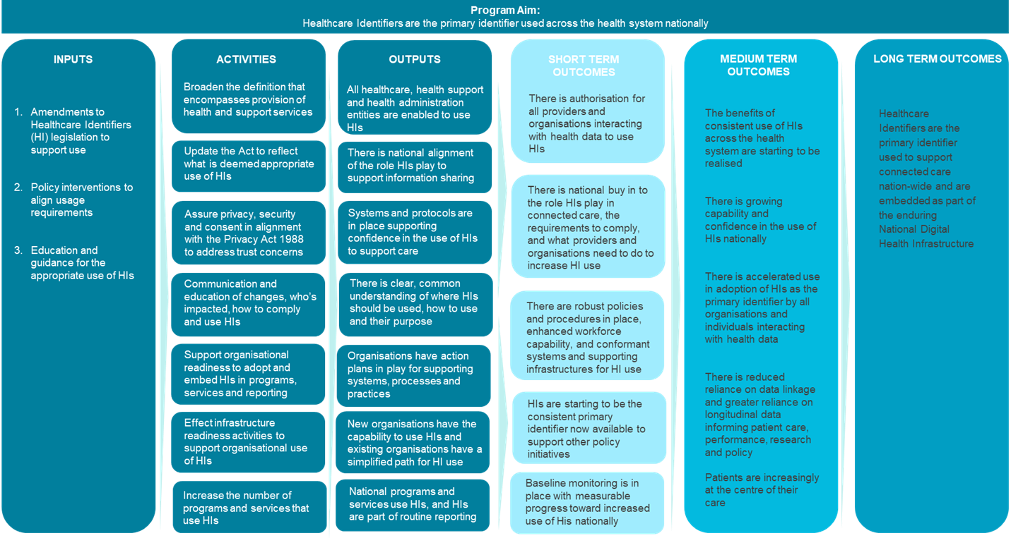

Figure 2 below outlines how implementation success will be demonstrated by a more holistic approach and effectiveness and efficiency gains at a health service or practice level, and for consumers, their carers and families.

Figure 2: Implementation success of the HI Act reforms

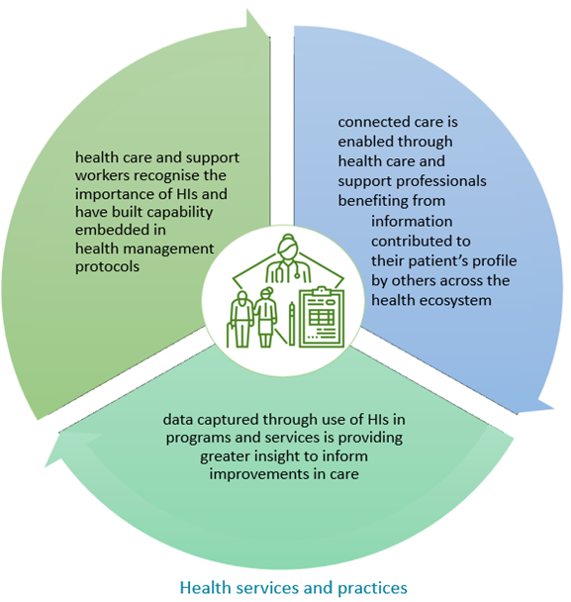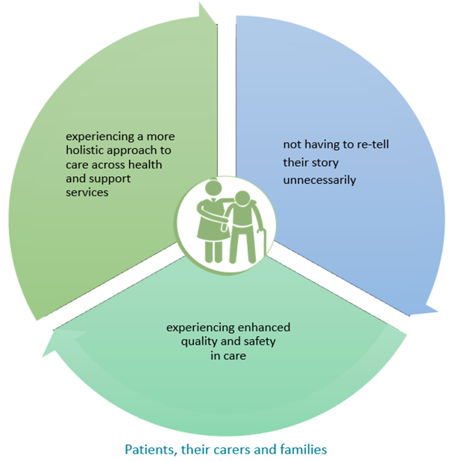

## Data sources

To inform the impact assessment, baseline metrics will be collected across existing health system structures, processes and practices to identify current HI use. These baselines will be used to track evidence of progress for ongoing monitoring and insight gathering over the term of the evaluation.

The Department has done some work to identify accessible existing data to establish a baseline for the use of healthcare identifiers from which to measure success. The baselining work helps to understand current capabilities and behaviours before legislative changes to inform ongoing progress monitoring, assess the benefits of reforms and create a sector-wide data baseline to promote awareness and adoption of HIs for improved healthcare.

The baseline analysis revealed limited technical capability and behavioural use of healthcare identifiers across the health ecosystem and supporting sectors outside of those programs where use of HIs is mandated.

While the exact nature and approach to evaluation data collection and sourcing is yet to be determined, it is anticipated that insights will be drawn from the HI Service, the Agency as regulator of the MHR system, software vendors and healthcare provider and consumer feedback.

Table 9: Evaluation data sources and collection milestones

| Data source | Data owner | Data type | Collection milestones |
| --- | --- | --- | --- |
| MHR usage *(eg. counts, numbers, type of users, patient journey service interactions etc.)* | Australian Digital Health Agency | Quantitative, e.g, output counts, trends, error rate | Baseline and agreed periodic intervals |
| HI usage reports | Services Australia | Quantitative, e.g., output counts, trends, errors | Baseline and agreed periodic intervals |
| HI Services Annual report | Services Australia | Quantitative, e.g., output counts | Annually |
| Health Performance Framework | AIHW | Quantitative, e.g., HI usage output counts, trends, errors  Time for matching and linking across programs by statutory reporting, research, etc | Baseline and agreed periodic intervals |
| Activity Based Funding (ABF) data sets / reports | IHACPA | Data linkage counts  Time for matching and linking across programs by statutory reporting, research, etc | Baseline and agreed periodic intervals |
| Software Vendors/Providers | Vendor | Quantitative and Qualitative, e.g. count, conformance process feedback | Adhoc |
| Research/Literature reviews | Published Sources e.g. Productivity Commission publications | Quantitative and Qualitative | Adhoc |
| Stakeholder engagements i.e. individuals, focus group or forum participants, key professional associations, departments and agencies | Health and support workers, Health programs, individuals, vendors etc. | Qualitative e.g. surveys, interviews, consumer stories, process improvement | Baseline and agreed periodic intervals |

## Success metrics and benchmarks

The data collected will be used to establish whether the HI Framework reforms are achieving their goals. The table in Appendix F outlines the success indicators and metrics aligned to the desired outcomes.

Digital health is a dynamic environment and many factors combine to contribute to successful outcomes. During the evaluation process, the Department in collaboration with the Agency will refine methods of identifying benefits and outcomes directly attributable to the HI Framework reforms.

Since the reforms are enabling in nature and are not imposing regulatory compliance requirements on a particular go-live date, a flexible approach to evaluation timing and cadence is preferred, e.g. regular statistical monitoring of HI use to be combined with consumer and provider surveys that will occur at appropriate intervals.

### Key evaluation questions

The program logic model (Figure 1) identifies the activities to be evaluated and has been used to determine the key evaluation questions and the data required to address these questions:

1. **Capability** – the extent to which all healthcare providers and organisations interacting with health data have the ability to use HIs.

Based on analysis of the evidence around the program implementation, the evaluation should identify ways in which the preferred option has enabled the capability for accurate and consistent identification of individuals across settings and systems to enhance quality and safety in care delivery.

At the *system level* this means HIs are the primary identifier which can be used across the health ecosystem and requires data on legislative amendments and enterprise architectures to measure evidence of change enablers.

At the *service or practice level* this means HIs are able to be used as the primary identifier in care management protocols and requires data on systems compliance and practice protocols to measure evidence of change enablers.

At the *healthcare recipient, carer and family level* this means there is the capability for their health information to be shared across providers, locations and settings and requires data on systems integrations to measure evidence of change enablers.

1. **Capacity** – the degree to which there is common understanding of the role that HIs play in supporting connecting care.

Inputs required for this purpose are the information and education campaign and stakeholder engagements for which the implementation is reliant to achieve the intended outcomes.

Based on analysis of the evidence around the program implementation, the evaluation should identify ways in which the program has impacted awareness, understanding and buy-in to the purpose and requirements for accurate and consistent identification of individuals across settings and systems to enhance quality and safety in care delivery.

At the *system level* this means simplification of the HI Act and alignment as to appropriate use of HIs enables organisations interacting with health data with evidenced capacity to use HIs appropriately, with trust and confidence as to their intended purpose for system wide benefits to be realised.

At the *service or practice level* this means there is the knowledge and supporting practices for HIs to be used as the primary identifier routinely and consistently in care management protocols and requires system reporting data and practice protocols to measure evidence of change enablers.

At the *healthcare recipient, carer and family level* this means there is common understanding of how their identifying personal information can be shared across providers, locations and settings and requires cross-systems reporting data to measure evidence of change enablers.

1. **Behaviour** – the degree to which actions are reflecting the routine use of HIs as the primary identifier amongst all health ecosystem organisations and entities

At the *system level* this means administration entity reporting data includes consistent use of HIs demonstrated by associated efficiencies in such areas as the need for data linkage, service provision and avoidable service duplication. It requires national reporting and claims data to measure evidence of change enablers.

At the *service or practice level* this means health and support workers have reliable personal identity information they can use to support practice and service efficiencies, consumer engagement and experiences.

At the *healthcare recipient, carer and family level* this means health and support engagements, services and payment processes are streamlined, and unnecessary burdens removed.

## Post-implementation monitoring, review and continuous improvement

Ongoing monitoring and review will occur to ensure that the preferred option continues to meet objectives over time and adapts to changing circumstances. Data collected from ongoing monitoring will be used to identify areas of underperformance and opportunity, and to make iterative improvements.

Regular engagement with consumers, providers and software vendors through consultation and surveys will be used to identify if any additional guidance or educational support is needed, or if further regulation is appropriate or required.

HI usage data captured in HI Service Annual Reports will also inform future decisions on what policy levers may needed or appropriate, e.g., if use remains consistently low, the government may require HIs to be used is specific programs, systems or services. The impacts of introducing those changes will be assessed at the time.

## Reporting and accountability

Apart from the annual reports produced by the HI Service in Services Australia, the Department will regularly report through existing program governance and oversight mechanisms, including the HI Sub Committee, and the Digital Health Oversight Committee, which comprises representatives from the Commonwealth and all states and territories. DHOC is accountable to the Health Chief Executives Forum and is required to ensure transparency and accountability in its operations and ensure alignment with priorities set by the National Cabinet and the Health Ministers Meeting.

As well as this formal engagement, the Department will regularly engage with and report evaluation findings to key stakeholders including consumers and providers as well as states and territories. Feedback from this engagement will be integrated into the evaluation process and channeled into continuous improvement.

# Appendix A – Healthcare Identifiers Service usage statistics

## Assignment of healthcare identifiers

The HI Service Annual Report contains the following statistics on the numbers of HIs assigned and disclosed.[57]

Table 10: Number of identifiers assigned since inception of the HI Service

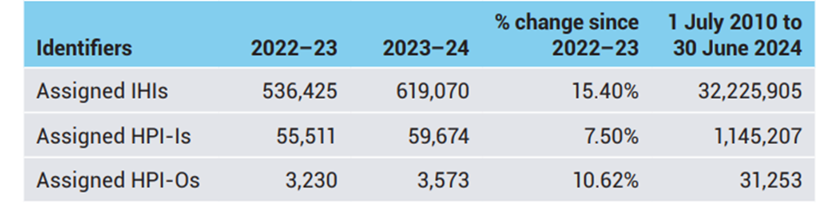

Table 11: Number of IHIs assigned to people who are not Medicare eligible

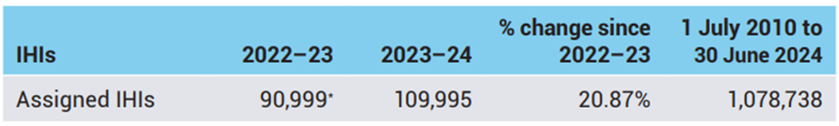

This is a subset of the number of identifiers assigned in Table 10. The increase in 2021-22 resulted largely from the requirement for people in Australia, including those not eligible for Medicare, to provide evidence of COVID-19 vaccination during 2021–22.

## Disclosure of healthcare identifiers for individuals

Registered healthcare providers and healthcare organisations access consumer’s IHIs when their health system software interacts with the HI Service using the authorised web service channel. Appropriate software and approved authentication technology is required to use the web service channel.

People can also access their own IHI by contacting the HI Service.

Each time the HI Service discloses an IHI, it counts as a disclosure under the HI Act. The number of disclosures does not represent the number of people who have an IHI. For example, a healthcare provider may search for a consumer’s IHI each time they have an appointment. Each search is counted as a disclosure.

Table 12: Number of Individual Healthcare Identifiers disclosed

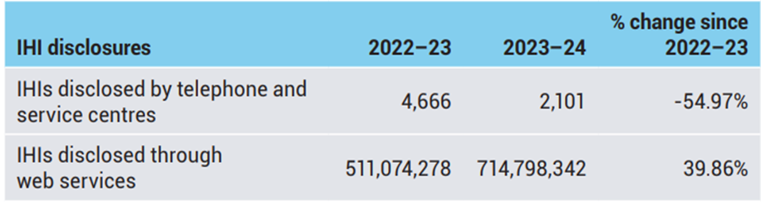

The number of IHIs disclosed by telephone and service centres increased significantly in 2021–22. This was driven by people who were not eligible for Medicare registering for an IHI to access proof of their COVID-19 vaccinations. Disclosures then dropped the following year when proof of vaccination was no longer necessary.

## Disclosure of healthcare identifiers for healthcare providers and organisations

The HI Service Operator makes disclosures to entities that authenticate healthcare providers and organisations in digital health transmissions. Data shows that in the year 2023-24, 1.233 million disclosures were made, up from the previous year’s figures. This highlights an increased use of healthcare identifiers in digital transmissions. While much of this increase can be attributed to the implementation of digital initiatives such as ePrescribing, it does not necessarily indicate increased use across the healthcare system as some software systems are set up to automatically validate or confirm all HIs via a bulk process every 24 hours which counts as a disclosure.

Table 13: Number of HPI-Is and HPI-Os disclosed

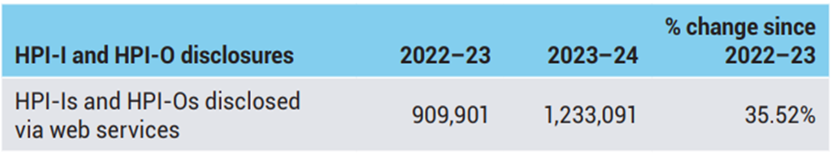

# Appendix B - The broader digital health context

A number of other strategies and plans supplement the Digital Health Blueprint discussed in the Background section of this IA.

## Australia’s National Digital Health Strategy: 2023-2028

The National Digital Health Strategy is a collaboration between the Commonwealth and state and territory governments. The Agency is the custodian of the strategy, with responsibility for leading and coordinating implementation of the Strategy

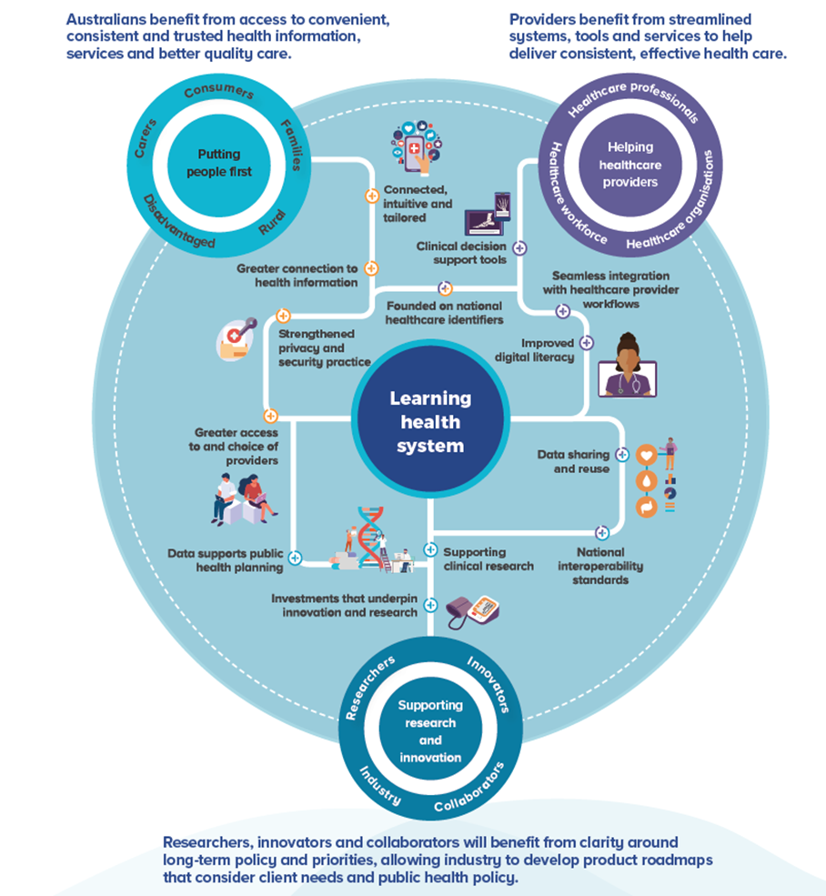

The vision of the Strategy is an *inclusive, sustainable and healthier future for all Australians through a connected and digitally enabled health system*.

The Strategy identifies key change enablers to realise the vision, including ensuring that appropriate policy and regulatory settings are in place to cultivate digital health adoption, use and innovation. The health system outcomes enhanced by digital health, outlined in the Strategy, include:

* + - 1. Digitally enabled: health and wellbeing services are connected, safe, secure and sustainable
      2. Person centred: Australians are empowered to look after their health and wellbeing, equipped with the right information and tools
      3. Inclusive: Australians have equitable access to health services when and where they need them
      4. Data-driven: Readily available data informs decision making at the individual, community and national levels, contributing to a sustainable health system.

The Strategy notes that the HI Service, together with other capabilities, is a foundation to provide Australians with the ability to access their health information when and where they need it. It will be critical that relevant entities can confidently and easily use HIs as part of their workflows to achieve the outcomes of a more digital enabled and connected Australian healthcare system.

## Other initiatives and strategic opportunities to drive HI adoption

In addition to the Commonwealth and state and territory governments clearly articulating an intention to increase the use and usability of HIs through strategic planning documents, there are several major digital health initiatives in-flight that are already driving, or can be used to drive, HI uptake. The following list is not exhaustive but highlights the opportunities for better use of HIs.

### National Healthcare Interoperability Plan: 2023-2028

The Connecting Australian Healthcare – National Healthcare Interoperability Plan[58] identifies five priority areas to advance digital health interoperability in Australia. Of relevance here is the *Identity* priority area, which ensures health information is associated with the right people. The Plan calls to leverage the HI Service and promote adoption of HIs to ensure that individuals, healthcare providers and healthcare provider organisations are uniquely and correctly identified when exchanging health information.

The Interoperability Plan highlights objectives for the future state of the HI Service, including:

* HIs are readily available and universally used by all individuals and healthcare providers in all heath information exchanges
* HIs are adopted and used in future digital health initiatives involving health information sharing
* Mismatch of individuals’ identification is reduced or eliminated
* Management of identifiers and associated artefacts is simple, streamlined and effective
* Individuals use identifiers to control their information, manage their privacy and receive better and safer care.

Under the National Healthcare Interoperability Plan, priority area 1 includes an action to develop a National Healthcare Identifiers Roadmap to support the wider take-up of HIs and associated benefits and move Australia from the current state of the HI Service to the desired future state.

### National Healthcare Identifiers Roadmap: 2023-2028

The National Healthcare Identifiers Roadmap 2023-2028 released in July 2024 identifies a number of activities intended to enhance the operation and effectiveness of the HI Service and to support healthcare, administrative and care and support organisations and government programs to implement integration with the HI Service and to use HIs in the most consistent and effective way to maximise their benefits.

The need for legislative reform to the HI Framework is called out as a key action area in the Roadmap to resolve existing barriers to better use and adoption.

### Health Data and Digital Transformation Collaboration (HDDTC) 2020-2023

In 2020 the Health Chief Executive Forum (HCEF) established the Health Data and Digital Transformation Collaboration (HDDTC). This forum was established to set the strategic direction and support for national data and digital initiatives and policies and acted as an interface between the Agency and the HCEF and National Cabinet governance.

An issue, highlighted in the 2021 Final Report from the Royal Commission: Aged Care Quality and Safety,[59] is the lack of integration between the aged care system and the healthcare system, leading to those within the aged care system not receiving the same access to healthcare services, such as medical services, hospital services, specialist palliative care services and subacute rehabilitation services, as other people in Australia. As one of the two identified priorities for 2022-2023, the HDDTC committed to investigating pain points that restrict the more comprehensive sharing of health information between care settings, particularly between primary, acute and aged care.

### Strengthening Medicare

The Strengthening Medicare Taskforce was established to make recommendations on priority areas for investment to ensure Australia’s primary care system can meet current and future challenges and reflect new models of care.

The Strengthening Medicare Taskforce looked at opportunities to improve functionality and connectivity of consumer information across information systems and to lift the capability to use data to improve consumer care by primary care and healthcare professionals. The Strengthening Medicare Taskforce Report outlined a vision for Australia’s primary care system of the future and recommended significant changes to how primary care is funded and delivered to enable high quality, integrated and person-centred care for all Australians.[60] The vision for primary care relevantly included:

1. coordinated multidisciplinary teams of healthcare providers work to their full scope of practice to provide quality person-centred continuity of care, including prevention and early intervention; and primary care is incentivised to improve population health, work with other parts of the health and care systems, under appropriate clinical governance, to reduce fragmentation and duplication and deliver better health outcomes.
2. data and digital technology are better used to inform value-based care, safely share critical healthcare recipient information to support better diagnosis and healthcare management, empower people to participate in their own healthcare, and drive insights for planning, resourcing, and continuous quality improvement.

The report highlighted that continued investment is required in infrastructure that improves interoperability between systems. At a system level, there are opportunities to use data to improve the journey of a healthcare recipient across the health system and plan for the health needs of Australians.

HIs have the opportunity to play a key role in supporting the achievement of these outcomes. Ensuring information is matched to the right person, and able to be safely, securely and seamlessly accessed by an individual’s healthcare providers, wherever they present in the system, will support better use of multidisciplinary care models. It will also support population health and planning, promoting better visibility of individuals’ presentations across the health system and the outcomes of different healthcare interventions.

The Taskforce made a number of relevant recommendations, including:

1. Better connect health data across all parts of the health system, underpinned by robust national governance and legislative frameworks, regulation of clinical software and improved technology.
2. Invest in better health data for research and evaluation of models of care and to support health system planning. This includes ensuring consumers can give informed consent and withdraw it, and ensuring sensitive health information is protected from breach or misuse.
3. Provide an uplift in primary care IT infrastructure, and education and support to primary care practices including comparative feedback on their practice, so that they can maximise the benefits of data and digital reforms, mitigate risks and undertake continuous quality improvement.
4. Make it easier for all Australians to access, manage, understand and share their own health information and find the right care to keep them healthy for longer through strengthened digital health literacy and navigation.

HI reforms alone will not deliver a more connected, digitally enabled and data-driven health system. However, those objectives will be more difficult to realise without leveraging the capabilities of unique national identifiers.

# Appendix C – Findings from previous reviews of the HI Framework

When it was first enacted, the HI Act included a built-in requirement for an independent review to be conducted two years after its implementation.

The purpose of the 2013 review was to ensure that the Act provided the necessary regulatory support for the HI Service to operate efficiently and effectively while facilitating the sharing of clinical information in practice. Additionally, the review aimed to identify any legislative or administrative barriers that might hinder the Act from achieving its objectives. This review conducted document analysis, stakeholder interviews, and written submissions for its findings.

Another review of the HI legislation and the HI Service was required within three years of the commencement of the *Health Legislation Amendment (eHealth) Act 2015*. The subsequent review conducted in 2018 found that the HI Service was meeting its core objectives; however, it still was not being fully utilised to realise the full range of benefits offered by a unique identification service for healthcare.

Some of the findings identified in previous reviews are summarised below.

Table 14: Summary of findings from previous reviews of the HI Framework

| Themes | Findings |
| --- | --- |
| Healthcare Identifiers and Privacy | * Clinical stakeholders strongly stated that privacy and clinical efficiency must be balanced and that privacy protections must be appropriate to the level of risk to an individual from disclosure of information. |
| * Most stakeholders saw the risk associated with disclosure of an IHI or HPI-I as minimal compared to the health information attached to it. |
| * Recognition that HIs need to be seen as an integral component of a much larger system, and the way they are handled should be considered in that context. |
| Healthcare Provider Directory (HPD) | * Narrow authorisations for disclosure of HPI-Is and the opt-in basis of the HPD were barriers to digital health take up. |
| * The implementation posed challenges in searching for or verifying a healthcare provider’s HPI-I, which hindered processes like electronic referrals, discharge summaries, and the transfer of electronic prescriptions. Although some improvements to search functionality were made to address this issue, the opt-in requirement for the HPD continued to be identified as a barrier to participation in the directory. The HPD was considered crucial to the ability to link providers and organisations with relevant end point location services and certificates to support use cases such as addressing clinical documents to specific providers. The lack of participation in the HPD was thus cited as also representing a barrier to other e-health services dependent on the HPD, such as secure messaging. |
| * The context for the HPD opt-in approach was that clinicians had cited concerns about the risk of exposure of their contact details. However, in practice, the HPD is only intended to include business, and not personal, contact details (unless a private address or contact is provided as the business address and/or contact details). |
| * Feedback from the 2013 review revealed that many healthcare providers did not understand the purpose of the HPD and its criticality for digital health initiatives. However, once healthcare providers understood its purpose, the nature of the information held, and the fact that it was limited to the provider community, no concerns were cited about participating. |
| * Most stakeholders interviewed for the 2013 review supported a change to an opt-out model or mandatory inclusion in the HPD for providers wishing to utilise digital systems. It was agreed that it was low risk to providers to have the information published, and that much of the information was already available on the Ahpra website (without a HPI-I). |
| * The reviews identified duplication between the role and infrastructure for the HPD and the National Health Services Directory (NHSD). It was highlighted that having multiple directories with similar data, but with different maintenance processes and structures increases costs and has the potential to reduce utility, as users must update and/or navigate between multiple directories. It was recommended that assessment be undertaken of the need for both, noting the potential to rationalise directories, such as through integration between the NHSD and the HI service. * An assessment was undertaken and a functional decision made to publish organisation’s business details in the HPD automatically. This was supported because neither the HI Act nor the Privacy Act prevent the disclosure of organisation details, including HPI-O, as these do not relate to personal information of an individual. The HI Act was amended in 2015 to incorporate that change.[61] |
| * The 2018 review identified that the HPD continued to fail to deliver its intended benefits. As recommended in 2013, integration with the NHSD was suggested to rationalise national directory infrastructure. It was flagged that legislative change would be needed to achieve that. It was noted that there was a lack of a clear strategic direction for the directory, despite consensus on the need for an up-to-date provider directory. * Since the reviews, significant analysis of current directory infrastructure has been undertaken. In support of analysis for options to deliver national real-time health information sharing capabilities, it has been identified that a single source of truth of authorised healthcare providers will be needed. There is no single access point that contains consolidated, accurate and trusted information about individual providers and organisational healthcare services that can be queried in real-time. Directories currently provide different information and different amounts of information, about a provider resulting in healthcare providers and organisations needing to source information from multiple directories and/or create their own local provider directories. HIs will be key to the success of this consolidated directory solution. |
| Use of HIs by aged care and disability service providers | * The definition of "health service" was often unclear or too restrictive, especially for services providing health and social care, like aged and disability services. Stakeholders noted that consumers in these areas frequently use the health system and could benefit from better coordination through digital health initiatives. However, concerns were raised about non-healthcare staff accessing Integrated Health Information Systems (IHIS). The authors stated that similar situations already occur in clinical settings and are managed with role-based access and security measures. |
|  | * Stakeholders indicated that a barrier to adoption was the inability of non-healthcare organisations supporting providers to access HPI-Is from the HI service operator. The assignment criteria for HPI-Os were identified as problematic; for example, general practice providers and specialists operate as contractors rather than direct employees, and the HI Act did not permit these entities to apply for a HPI-O, despite this being a common service structure. |
| * Stakeholders concern about penalties, which were seen as a deterrent to participation in digital health. Clinicians expressed real anxiety about their obligations and the possibility of unintentionally disclosing sensitive information. |
| * Missed opportunities in using health identifiers (HIs) for population health, clinical registries, and trials, which could enhance healthcare by linking data across services to monitor outcomes and trends. The lack of unique individual identifiers has hindered effective data access and the assessment of treatment effectiveness, population health status, and risk factors. Improved access to connected data could facilitate better health program structuring, targeted funding, and informed policy making. These goals were initially intended in the establishment of the national HI system but were not achieved due to strict authorisation provisions in the Act. A recommendation was made to consider specific authority for disclosing HIs for research and population health purposes. |
| * Rationalising provider numbers depended on consent to use HPI-I. Stakeholders questioned the need for multiple provider numbers, suggesting benefits to simplifying them with HPI-I as the sole identifier. However, barriers exist, such as the potential need for non-HPI-I numbers for MBS and PBS if a provider lacks an HPI-I. System enhancements would also be necessary to associate a single number with different information across contexts. Evaluation of this proposal's feasibility was recommended. |
| Contract Service Provider (CSP) authorisations | * Requirement to review of the CSP provisions, and to consider provision for the use of HIs by a broader range of organisations that support the delivery of healthcare and the operation of national infrastructure services. Such entities include PHNS, prescription exchanges and real-time prescription monitoring services. It was also noted that the current CSP arrangement would benefit from review as to whether it was the most fit-for-purpose approach to support future use cases for the HI service. |
| Other Matters | The 2018 review:   * Highlighted the ongoing use and creation of different identifiers for specific purposes across the health system, reducing the effectiveness of HIs. MHR was cited as the primary reason for healthcare organisations to interact with the HI Service and usage had increased with increased participation in MHR. It was noted that the implementation of other initiatives would likely also see expanded use of the HI Service. * Recommended that a strategy and roadmap for the HI Service should be developed, to cover matters such as the alignment of the HI business architecture and future uses, the projected impact of new digital initiatives and strategies to extend uptake and participation. The HI Roadmap has since been delivered as an action under the National Interoperability Plan, with a number of initiatives highlighted to improve understanding of and access to the HI Service. * Suggested consideration should also be given to allow an individual to consent to the use and disclosure of their IHI for a purpose not specifically defined by the Act. This would support the ability for IHIs to be used for beneficial uses such as evaluation or quality assurance, and the linkage of data from personal devices, apps and implantable or wearable devices to other health data.   Match rates for the retrieval of IHIs was cited as a barrier to further adoption in the earlier reviews. Work to improve match rates was undertaken after the 2013 review and positively received by stakeholders. When consulted during the second review, most stakeholders indicated there should be a program of continuous improvement to improve matching accuracy, particularly to support vulnerable populations. Significant work has since been undertaken, and is continuing, under the Health Delivery Modernisation Program to monitor and improve match rates and ensure the HI Service is fit for purpose to deliver on its objectives. |

# Appendix D – Cost and benefit assumptions

This appendix sets out the cost and benefit assumptions used to inform the regulatory burden estimate and the net benefit analysis for this IA. Cost assumptions are set out, followed by benefit assumptions. Further tables in this appendix set out the resource rates used for the cost estimates and the sensitivity analysis conducted in relation to the estimated benefits.

## Cost assumptions

The following is the set of cost assumptions for each of the identified service entity types. The policy option considerations demonstrate how each of these assumptions apply to each of the policy options. Costs were indexed by the discount rate of 7%, with sensitivity analysis at discount rates of 3% and 10%[62]. These cost assumptions were used to inform the regulatory burden estimate (which considers the impact to business, community organisations and individuals) as well as the net benefit analysis (which includes the estimated wider costs to government associated with implementation of the proposed reforms).

Table 15: Cost assumptions

|  | Entity/Sector | Assumptions | HI Policy Option Considerations and Costs |
| --- | --- | --- | --- |
| 1 | Software vendors  (Included in Regulatory Burden Estimate and Net Benefit Analysis) | A review of known software products across the medical software, allied health, aged care and community nursing sectors was reviewed to inform estimated costs under this cost element. The review included consideration of software product market share in Australia, and type of functionality offered in the product to identify those which would be candidates for inclusion of HI functionality, where they are not currently HI-enabled (some products identified are very narrowly focused and would have a limited value proposition for use of HIs, so were excluded from the count of products needing enhancement to support HI functionality). As a result of this analysis, 97 products were identified as in-scope for costs to uplift to use HIs for option 2. It was assumed 10% would change as a result of the proposed amendments. For option 3, 311 products were identified as in-scope for costs to uplift to use HIs. It was assumed 75% would change as a result of the proposed amendments.  For each product to become HI enabled, the cost components are as follows:   * Development of HI functionality – 1 developer x 25 days * Testing preparation and execution – 1 test analyst x 25 days * Conformance testing – 4 developer/senior test analyst resources x 4 days | **Option 1 (Status Quo)** – no change.  **Total cost** (including indexation and sensitivity analysis (over 5 years)   |  |  |  | | --- | --- | --- | | Discount rate | **Option 2** | **Option 3** | | 3% | $1.85m | $13.88m | | 7% | $1.67m | $12.51m | | 10% | $1.55m | $11.62m | |
| 2 | HI Service  (Included in Net Benefit Analysis) | No costs have been included for any changes to systems supporting health programs operated by Services Australia, other than the HI Service itself.  The following assumptions were used to cost the impact for the HI Service under each option:  Option 2   * Developer to uplift system and load minimum HPD data, make minor system change to include new IHI attributes – (16 days) * Solution architect to support Infrastructure uplift for increased service calls (60 days) * Senior solution architect to update HPD and interfaces (5 days) * Test resources for preparation and execution of testing (26 days) * Change and adoption lead to support changes and strengthen conformance (2 days)   Option 3   * Costs above, plus Developer to develop calls for HAEs and registers, build new entity types (20 days) and Testing resources for this functionality (10 days)   No costs are associated with the following changes, as existing web services could be used to meet requirements.   * Authorisations for health administration, directories and registries purposes (existing functionality, which may see uplift in call volumes with greater clarity – factored above) * Authority for individuals to use and disclose their own IHI and providers to disclose their own HPI-I (no HI Service system change required) | **Option 1 (Status Quo)** – no change (Note: The HI Service currently has an operational cost of $9.7m per annum).  **Total cost** (including indexation and sensitivity analysis (over 5 years)   |  |  |  | | --- | --- | --- | | Discount rate | **Option 2** | **Option 3** | | 3% | $0.14 | $0.17 | | 7% | $0.13 | $0.16 | | 10% | $0.12 | $0.15 | |
| 3 | Australian Digital Health Agency  (Included in the Net Benefit Analysis) | Costs assume streamlining of conformance requirements across both options 2 and 3. Option 3 additionally involves the cost of establishing new conformance requirements for new eligible participants.  Cost components associated with conformance requirements review/uplift are as follows:  Option 2   * Senior business analyst to review and developed streamlined conformance requirements (122 days) * Test analyst to support existing vendor conformance re-testing (2 days x 50 products) * Learning and development specialist to lead comms and engagement (122 days) * Technical analyst to support incident management (61 days)   Option 3   * Costs above plus, Senior test analyst to support new vendor conformance testing (5 days x 300 products)   Note that development and review of conformance requirements includes consultation with industry | **Option 1 (Status Quo)** – no change  **Total cost** (including indexation and sensitivity analysis (over 5 years)   |  |  |  | | --- | --- | --- | | Discount rate | **Option 2** | **Option 3** | | 3% | $0.69m | $2.57m | | 7% | $0.63m | $2.37m | | 10% | $0.60m | $2.24m | |
| 4 | Public Health Services (hospital inpatient, outpatient, emergency, community health and supporting allied health services)  Private Hospital  General Practice  Diagnostic Services  Pharmacy | No costs have been allocated for these services as HIs are already widely implemented, although not widely used. Use is driven by other digital health programs or policies such as ePrescribing and upcoming mandates for diagnostic imaging and pathology uploads to MHR. The changes proposed to the HI Act will not require changes to current processes or existing systems.  All states and territories need to uplift their use of HPI-Is which will incur a cost. However, this is required for other purposes and is not a consequence of the HI legislative reform. This is a requirement of other digital health programs, reinforced by the changes to the HI Act. These costs are **not** included.  All states and territories have IHIs in use but for limited use cases, and in some cases they are not managed in a way that supports broad use. The cost of changes to patient administration systems to display the IHI and any error messages returned by the HI service operator have not been included in the estimates as this is a pre-existing requirement andnot a direct consequence of the changes considered in this analysis.  Costs for amendments to conformance requirements for these provider types have been captured under vendor costs. | No additional costs for these services that are directly attributable to the options analysed. |
| 5 | Aged Care | No costs have been allocated to Aged Care as a consequence of HI reform, as implementation of HIs is being driven by recommendations of the Aged Care Royal Commission. This reform will not add additional cost requirements.  Costs for enhancements to aged care software have been included in software vendor costs. | No additional costs, as software uplift is captured under vendor costs |
| 6 | Medical Specialists  Allied Health  Community nursing | **Specialists**  Most products targeting specialists are not currently conformant with the HI Service. The product conformance cost will be incurred by the vendor and is included as a vendor cost.  Costs are based on the assumption that all specialists have some form of patient management system. This means they would not need to procure a new system to be able to use HIs following these reforms. Rather, their existing systems would be uplifted to enable integration with the HI Service is included in the estimates.  Communication and engagement with specialists is already being undertaken by the Agency for uptake of digital health as part of the Agency’s core role. No additional cost has been added as HI information would be provided as part of this existing process.  **Allied Health**  Communication and engagement with allied health is already being undertaken by the Agency to support uptake of digital health. Therefore no additional cost has been added for engagement with the sector as HI information is provided as part of this existing process.  Allied health vendor product compliance has been included under software provider cost.  **Community nursing**  Focus will be on private community nursing services (e.g., Silverchain, Royal District Nursing Service, Anglicare); public community health nurses will be covered under jurisdictional capability.  Costs for enhancements to software used by community care providers have been included in software vendor costs. | No additional costs, as software uplift is captured under vendor costs  No costs included as communications are a core Agency function  No costs included as core Agency function  No additional costs, as software uplift is captured under vendor costs  No additional costs, as software uplift is captured under vendor costs |
| 7 | Clinical registries  (Included in the Net Benefit Analysis) | A list of nationally recognised CQRs was identified from the Australian Commission on Safety and Quality in Healthcare Australian Register of Clinical Registries (n=130). Of the existing national registries, only 2 currently incorporate IHIs.  CQRs are databases, i.e. where the data is stored, rather than clinical systems.  Cost assumptions include:   * HIs will be introduced from a ‘point in time’ forward i.e., no data migration, matching, cleansing costs have been included – no historical data conversion. * Cost of adding IHI, HPI-Is and HPI-Os to database front end, tables, reporting and data warehouse changes. * Cost of enabling validation with the HI service and conformance processes * Change to supporting processes and procedures, change management and communications activities   Resourcing for these costs assumes 5 days effort x 130 products for a Senior Business Analyst, Business Analysts and a Change and Adoption Analyst. | No cost for options 1 (Status Quo) or option 2.  **Total cost** (including indexation and sensitivity analysis (over 5 years)   |  |  |  | | --- | --- | --- | | Discount rate | **Option 2** | **Option 3** | | 3% | n/a | $2.07m | | 7% | n/a | $1.88m | | 10% | n/a | $1.76m | |
| 8 | Health Administration Entities (HAEs)  (Included in the Net Benefit Analysis) | In general, HAEs will be using HIs for secondary purposes of planning, evaluation, funding, public health etc. The costs included are to enable HIs to be stored in data warehouses, and costs of policy and procedure updates on collection and use of HIs.  Resources costed for HAE uplift are as follows across 47 systems:   * Communications lead x 3 x 20 days * Project manager x 20 days * Senior Developer x 40 days * Developer x 5 days * Senior integration analyst x 10 days * Test analyst x 20 days * Communications lead x 40 days | No cost for options 1 (Status Quo) or option 2.  **Total cost** (including indexation and sensitivity analysis (over 5 years)   |  |  |  | | --- | --- | --- | | Discount rate | **Option 2** | **Option 3** | | 3% | n/a | $9.10m | | 7% | n/a | $8.21m | | 10% | n/a | $7.64m | |
| 9 | Disability Services | The majority of health/health related services provided in the disability sector are covered by other service types (general practice, allied health, hospital).  The additional services that are provided are healthcare support services, similar to those provided for home based aged care or community-based nursing care and provided by the same provider type. It is assumed that if these providers are covered under aged/community care costings that they will also cover disability services’ needs and software uplift is already included in vendor costs. | No additional costs, as software uplift is captured under vendor costs |

## Benefit assumptions

The following is the set of benefit assumptions for the alternative policy options. The policy option considerations demonstrate how each of these assumptions apply to each of the policy options. Given the dependencies with external policy decisions on HI take-up, the benefit total used to estimate the net benefit, is based on a conservative 10% of the estimated maximum benefits. Gradual take up of HIs following legislative change has been assumed, with benefit increasing incrementally over the 5 years following the reform.

Table 16: Benefit assumptions

| Benefits | Option 2  *Assumed additional 10% HI take up*  (NPV $ millions) | Option 3  *Assumed additional 75% HI take up*  (NPV $ millions) |
| --- | --- | --- |
| 1 – Enablement of Healthcare Delivery Modernisation (HDM) program benefits: Dependency on the delivery of the HDM program and resulting benefits. Provides a path for rationalisation of identifiers to support HDM and the anticipated resulting benefits  **Measurement Description:** Efficiency gains:1% of realised program benefits due to reduced time and effort | N/A | $0.07 |
| 2 – Flow on effects to other govt systems interacting with health data through streamlined data matching e.g. Medicare, Centrelink, MyAgedCare, NDIA, National Cancer Registry.  **Measurement Description:** Efficiency gains:1% increase in the effectiveness of government systems where HIs can be used | N/A | $0.29 |
| 3 – Accelerated development and implementation timeframe for future digital health projects - Decrease in development and delivery timeframes for future digital health projects through the ability to use HIs.  **Measurement Description:** Efficiency gains: 5% reduction in project cost due to reduced timeframes across all key project phases. Assumes 300 digital health projects nationally costing approximately $250,000 per project, with benefit limited based on assumed HI uptake across each option. | $0.06 | $0.46 |
| 4 – Increased effectiveness of benefits arising from future digital services/products - Increases to the scope of benefit recipients for future digital health projects.  **Measurement Description:** Improved patient outcomes and provider administration efficiencies: benefit due to better matching/integration with increased HI usage:5% increase in project benefits. Assumes 300 digital health projects nationally with average benefit of $375,000, with benefit limited based on assumed HI uptake across each option | $0.09 | $0.69 |
| 5 – Reduced cost of resource maintaining multiple identifiers across non-HDM national digital health infrastructure - Decrease in costs relating to the development, maintenance, and future change to separate identifiers to support non-HDM national digital infrastructure  **Measurement Description:** Efficiency gains. Assumes maintenance of health records is resourced by 4 staff per state/territory, and 0.25 FTE per hospital nationally, at $100,000 per person. 5% reduction in workload assumed, with benefit limited based on assumed HI uptake across each option. The benefit is limited based on assumed HI uptake across each option. | $0.03 | $0.22 |
| 6 – Reduced cost involved in probabilistic data linkage for research, monitoring and evaluation - Reduction in time spent on data-linkage activities including the use of probabilistic matching across research, monitoring and evaluation stakeholders  **Measurement Description:** Efficiency gains.Assumes a reduction in time spent on data linkage activities, as matching using HIs reduces effort of conducting probabilistic matching. Time savings could be reallocated to other research, monitoring and evaluation activities. Assumes 2000 data linkage projects nationally per annum (25% small at $8,000 per project and 75% medium, at $15,000 per project) Assumes 5% reduction in workload associated with simpler data matching processes. The benefit is limited based on assumed HI uptake across each option. | N/A | $0.16 |
| 7 – Improved ability to track and manage outcomes of care/treatment (reduction in adverse events)  **Measurement Description:** Improved patient outcomes. Assumes 1% reduction in impact of errors in care/treatment initiatives. Assumptions: ‘The State of Patient Safety and Quality in Australian Hospitals 2019’ Report cited estimates that adverse events in public hospitals cost $4.1 billion in the 2017-18 financial year. This benefit assumes 1% reduction in that cost associated with adverse events as HIs may improve issues associated with patient identification, medication management and monitoring. The benefit is limited based on assumed HI uptake across each option. | N/A | $5.00 |
| 8 – Reduced duplicate procedures as external results can be located and confirmed to relate to the individual  **Measurement Description:** Improved patient outcomes.Reduction in number of diagnostic procedures. Assumptions: American College of Physicians and American College of Surgeons report concluded that cost of repeated care due to lack of a unique identifier was an average of $1950 per inpatient stay and $1700 per emergency department visit. 2021-22 data reports 2.6 million adults were admitted to hospital, and 2.9 million adults presented to emergency departments nationally in Australia. This benefit assumes a 1% cost reduction based on better identification through HI use. The benefit is limited based on assumed HI uptake across each option. | $1.63 | $12.19 |
| 9 – Time saving from not needing to re-enter consumer registration details - Reduction in time spent on registering consumers due to access to information for consumers already registered elsewhere within provider organisations  **Measurement Description:** Efficiency gains.Assumedtime saving from not needing to re-enter consumer registration details where they are already registered elsewhere and HI matched. Assumptions: 2021-22 data reports 2.6 million adults were admitted to hospital, and 2.9 million adults presented to emergency departments nationally in Australia. This benefit assumes a 5 minute time saving per registration on presentation to hospital, where administration officer cost is $52.60 per hour. The benefit is limited based on assumed HI uptake across each option. | $0.39 | $2.94 |

# Appendix E – Implementation actions, risks and mitigations

Table 17: Implementation actions, risks and mitigations

|  | Actions | Responsibility | Potential risks | Likelihood | Mitigation/  Management | Responsibility | Timing |
| --- | --- | --- | --- | --- | --- | --- | --- |
| Legislative | Identify, draft and progress amendments to HI Act and Regulations to authorise changes  Amendments to progress in tranches.  Following legislative enablement, further consultation to occur to determine entities to be prescribed as HSPs/HAEs/  technology providers, etc | Department | Tight timeframes  Legislation is delayed or does not progress or is not prioritised.  Legislative change does not address policy problem  Legislation is misapplied or insufficiently understood leading to mishandling of information | Low/ Medium | Seek legal advice, conduct Policy Impact Assessment and Privacy Impact Assessment on proposed changes  Stakeholder consultation on initial changes  Ongoing consultation and monitoring | Department | 2025-2026  Ongoing |
| Technological | HI Service to facilitate system changes aligned to new authorisations and other legislative changes, e.g. create new identifier profile for HSPs, expand authorisations to HSPs, HAEs and directories, HPD changes, etc | Services Australia | Technical impediment  Time slippage | Low/ Medium | Regular stakeholder engagement and consultation  Regular progress monitoring and reporting | Services Australia | 2025-2028 |
| Software vendors to facilitate necessary capabilities | Vendors | Cost to software vendors  Slow take-up by vendors | Regular stakeholder engagement and consultation  Regular progress monitoring and reporting | Australian Digital Health Agency/  Department |
| Healthcare providers and support services to make any necessary changes to clinical information systems | Providers | Slow provider adoption due to low digital literacy | Regular stakeholder engagement and consultation  Regular progress monitoring and reporting  Development of incentives and policy levers to encourage/require HI use in key programs or systems | Australian Digital Health Agency/  Department |
| Educational | Prepare general plain English guidance material to improve understanding of HI Framework  Targeted comms for impacted or new provider/customer segments, e.g. aged care and disability service providers and consumers.  Targeted comms for software vendors | Department | Stakeholder dissatisfaction  Some target groups missed  Messaging not clear | Low | Regular stakeholder engagement and consultation  Regular progress monitoring and reporting | Department  Department/ Australian Digital Health Agency | 2025-2026 |

# Appendix F – Success metrics and evaluation outcomes

Table 18 relates to Question 7. It explains the metrics that will be used to determine if the HI Framework reforms are achieving the desired outcomes based on success indicators. Note that some metrics e.g., surveys, can be conducted simultaneously to reduce consultation fatigue.

Table 18: Success metrics and evaluation outcomes

| Success indicator | Metric | Desired outcome | Responsible | Indicative timing/ frequency |
| --- | --- | --- | --- | --- |
| Increased use of HIs | Statistics on increased use by providers currently able to use HIs as well as those newly authorised by option 3 implementation  Reduction in creation/use of other/duplicate identifiers | Success will be measured on increases from baseline research | Services Australia | Annually from 2026 |
| HIs embedded into systems/programs/workflows | Greater use of HI conformant software based on vendor and provider surveys across all healthcare sectors | Success will be measured on increases from baseline research | Australian Digital Health Agency | Annually from 2026 |
| Consumer sentiment | Collect feedback from consumers regarding their satisfaction with sharing and controlling their health information. This will include, surveys, focus groups, and user experience research | Success will be measured by an increase in consumer satisfaction from the baseline views expressed in previous reviews and consultation for this IA | Australian Digital Health Agency and Department | Annually from 2026 |
| Provider confidence | Survey providers about awareness of and attitudes to HIs, perceived benefits and remaining barriers | Providers’ concerns about handling HIs have been addressed. | Australian Digital Health Agency and Department | Annually from 2026 |
| Greater provider efficiency | Survey providers, HAEs and practice managers about experiences using HIs and any resulting efficiency and time saving. | Providers spend less time manually searching for other providers and consumer information and re-entering consumer information.  Administrative efficiencies achieved through HAEs being to handle HIs | Australian Digital Health Agency and Department | Annually from 2026 |
| Enhanced health information sharing | Survey consumers and providers about experiences exchanging information between multiple providers  Source available system data | Health information not siloed.  Consumers feel more empowered and supported by their care team and don’t have to relay their information to each provider multiple times.  More holistic, coordinated care provided due to providers having improved visibility of health information across the consumer’s health journey and enhanced communication between providers | Department | Annually from 2026 |
| Enhanced clinical decision-making | Conduct provider experience survey.  Source available system data | Providers have access to accurate up to date health information wherever located and linked to each consumer, leading to better diagnosis and treatment options and improved ability to track and manage outcomes  Fewer errors and reduction in adverse incidents. | Australian Digital Health Agency and Department | Annually from 2026 |
| Better research data | Survey major research organisations, e.g. AIHW, IHACPA, universities, etc | Richer data sources are available to provide greater health insights | Australian Digital Health Agency and Department | Annually from 2026 |
| Cost savings | Collect data on length of hospital stays, reduction in duplicate testing, etc | Cost savings for consumers as timely and efficient health information sharing reduces the need for duplicate testing  Efficiencies and savings for the health system due to speedier access to information leading to less administrative burden, faster diagnosis and treatment and shorter hospital stays. | Australian Digital Health Agency and Department | Annually from 2026 |
| More streamlined delivery of future digital health initiatives | HIs embedded as foundational element in future digital health initiatives | Accurate data linking facilitates more successful digital health initiatives | Australian Digital Health Agency and Department | As initiatives are in development, starting 2025 |

Health.gov.au

All information in this publication is correct as at July 2025

1. Council of Australian Governments, [*National Partnership Agreement on E-Health*](https://federalfinancialrelations.gov.au/sites/federalfinancialrelations.gov.au/files/2021-07/e_health_NP.pdf)signed 7 December 2009.
2. [Department of Health, Disability and Ageing, Health Workforce Data](https://hwd.health.gov.au/)
3. [Australian Institute of Health and Welfare, 2023 Aged Care Provider Workforce Survey](https://www.gen-agedcaredata.gov.au/resources/publications/2024/august/2023-aged-care-provider-workforce-survey)
4. Department of Health and Aged Care, [*Healthcare Identifiers Project Public Consultation*, December 2022](https://consultations.health.gov.au/digital-health/healthcare-identifiers-framework-project/supporting_documents/Healthcare%20Identifiers%20Framework%20Project%20Public%20consultation.pdf).
5. See Appendix C.
6. Australian Digital Health Agency, [*National Healthcare Identifiers Roadmap* 2023-2028](https://www.digitalhealth.gov.au/sites/default/files/documents/national-healthcare-identifiers-roadmap-2023-2028-v1.1.pdf).
7. Australian Digital Health Agency, [*Connecting Australian Healthcare: National Healthcare Interoperability Plan* 2023-2028](https://www.digitalhealth.gov.au/sites/default/files/documents/national-healthcare-interoperability-plan-2023-2028.pdf).
8. The Hon Mark Butler MP, Budget 2023–⁠24: Building a stronger Medicare, [Budget 2023–⁠24: Building a stronger Medicare | Health, Disability and Ageing Ministers | Australian Government Department of Health, Disability and Ageing](https://www.health.gov.au/ministers/the-hon-mark-butler-mp/media/budget-2023-24-building-a-stronger-medicare).
9. The [Australian Institution for Health and Welfare (AIHW)](https://www.aihw.gov.au/reports/australias-health/digital-health), for example, suggests: “*Digital health underpins a modern learning health system and supports a continuous cycle of improvement. Timely and accurate information-sharing is key to enabling the health system to be responsive to public health emergencies and other challenges”*

   *The consistent recording, use and reuse of data will enable researchers, innovators, collaborators and industry to contribute to growing a learning health system. Greater connection through better utilisation of data will also support public health planning and investment, identify opportunities for workforce efficiencies, inform system planning and optimise resource allocation.*”
10. Department of Health and Aged Care, [*Digital Health Blueprint 2023-2033*](https://www.health.gov.au/sites/default/files/2024-01/the-digital-health-blueprint-and-action-plan-2023-2033_0.pdf).
11. Roxon, Nicola, MP, Second Reading Speech, House of Representatives, 20 February 2010, p. 917.
12. See *Healthcare Identifiers Act and Service Review: Final Report,* June 2013; [*Healthcare Identifiers Act and Service Review: Final Report*](https://www.health.gov.au/sites/default/files/documents/2022/02/healthcare-identifiers-act-and-service-review-final-report-november-2018.pdf)*,* November 2018*.*
13. McMillan J*,* [*Review of the My Health Records Legislation: Final Report*](https://www.health.gov.au/sites/default/files/documents/2021/02/review-of-the-my-health-records-legislation-final-report.pdf), 1 December 2020, p. 57.
14. Council of Australian Governments, [National Partnership Agreement on e-Health](https://federalfinancialrelations.gov.au/sites/federalfinancialrelations.gov.au/files/2021-07/e_health_NP.pdf), signed 7 December 2009, Schedule A, p. A1.
15. Statistics and insights on MHR are updated each month and can be found here <https://www.digitalhealth.gov.au/initiatives-and-programs/my-health-record/statistics>
16. See [Australian Immunisation Register - Services Australia](https://www.servicesaustralia.gov.au/australian-immunisation-register)
17. See [Electronic prescribing | Australian Government Department of Health and Aged Care](https://www.health.gov.au/our-work/electronic-prescribing)
18. Statistic from the Australian Digital Health Agency <https://www.digitalhealth.gov.au/initiatives-and-programs/electronic-prescriptions>
19. Services Australia [Healthcare Identifiers Service Annual Report 2023-2024](https://www.servicesaustralia.gov.au/sites/default/files/2024-10/8101-2410.pdf) at p10. Note in relation to identifiers assigned to consumers, this reflects the total number assigned since the HI Service commenced, not the current number of individuals with an identifier. Individuals eligible for Medicare and Veterans Affairs benefits are automatically assigned an individual identifier. Other individuals, such as visa holders who are not eligible for Medicare, may apply to the HI Service to be assigned an identifier. Over 1 million individuals who were not Medicare eligible or veterans have applied for an individual identifier. There was a large spike in applications during the COVID-19 pandemic period, as individuals required an identifier in order to access COVID vaccination certificates.
20. See Department of Health and Aged Care (2018), [Healthcare Identifiers Act and Service Review – Final report](https://www.health.gov.au/sites/default/files/documents/2022/02/healthcare-identifiers-act-and-service-review-final-report-november-2018.pdf).
21. Customer Science Group, *Healthcare Identifiers Legislative Reform Baselining – Phase 1 outputs and recommendations*, 7 April 2025.
22. See University of South Australia, [Dismissed and discharged: health systems still failing people with poor mental health](https://www.unisa.edu.au/media-centre/Releases/2024/dismissed-and-discharged-health-systems-still-failing--people-with-poor-mental-health/) 2024.
23. Royal Australian College of General Practitioners, Care and support for people with disability, [RACGP - Care and support for people with disability](https://www.racgp.org.au/advocacy/position-statements/view-all-position-statements/health-systems-and-environmental/care-and-support-for-people-with-disability).
24. Productivity Commission, [*Leveraging Digital Technology in Healthcare*](https://www.pc.gov.au/research/completed/digital-healthcare/digital-healthcare.pdf)Research Paper, May 2024 at p2.
25. See Appendix B for more information.
26. See Council of Australian Governments, [National Partnership Agreement on E-Health](https://federalfinancialrelations.gov.au/sites/federalfinancialrelations.gov.au/files/2021-07/e_health_NP.pdf), signed 7 December 2009.
27. See also [Connecting Australian Healthcare – National Healthcare Interoperability Plan 2023-2028](https://www.digitalhealth.gov.au/sites/default/files/documents/national-healthcare-interoperability-plan-2023-2028.pdf)*.*
28. Services Australia, [Healthcare Identifiers Service Annual Report 2023-24](https://www.servicesaustralia.gov.au/sites/default/files/2024-10/8101-2410.pdf) at p11.
29. See Appendix C of this IA.
30. See Department of Health and Aged Care, [Healthcare Identifiers Framework Project: Public Consultation](https://consultations.health.gov.au/digital-health/healthcare-identifiers-framework-project/supporting_documents/Healthcare%20Identifiers%20Framework%20Project%20Public%20consultation.pdf), at p.13.
31. Health professionals registered by Ahpra include doctors, dentists, nurses, midwives, psychologists, chiropractors, pharmacists, optometrists, occupational therapists, medical radiation practitioners, paramedics, physiotherapists, podiatrists, and Chinese medicine and Aboriginal and the Torres Strait Islander Health practitioners.
32. There are a number of allied health professionals who are not regulated by Ahpra. For the self-regulating professions, the accreditation process is managed by the relevant professional peak body. The professional associations certify qualifications, settle and maintain standards and oversee professional development. Non-Ahpra practitioners include speech pathologists, ophthalmologists, sonographers, audiologists, dietitians, naturopaths, homeopaths, and massage therapists.
33. Health Administration will be defined in the legislation with specific entities to be determined by the Minister for Health, Ageing and Disability.
34. Healthcare support service providers would include funded aged care services or registered NDIS providers, and cover the provision of personal care and support, e.g., cleaning, meal delivery, home maintenance services that contribute to wellbeing.
35. It is acknowledged that some community organisations may provide support services and therefore may be in scope to use HIs under option 3, however it is not expected they would bear direct costs, or that any costs associated with software uplift would be minimal.
36. This estimate is based on analysis to establish a baseline for HI use at the time of this IA. It involved of counts of products on the published HI Conformance Register. The Agency maintains and regularly publishes the updated Healthcare Identifiers Register of Conformance on a regular basis. One hundred and forty software products were listed as being conformant on the Agency’s Healthcare identifiers Register of Conformance, as of December 2024.Note that publication in the Conformance register is ‘opt in’.
37. This estimate is based on analysis of counts of products on the published HI Conformance Register. The Agency maintains and regularly publishes the updated Healthcare Identifiers Register of Conformance on a regular basis. One hundred and forty software products were listed as being conformant on the ADHA Healthcare identifiers Register of Conformance, as of December 2024.Note that publication in the Conformance register is ‘opt in’.
38. As required by the Office of Impact Analysis (OIA), the costs were indexed with a discount rate of 7% applied. In line with OIA guidance, sensitivity testing at discount rates of 3% and 10% were also applied, with average regulatory burden in the range of $0.31m to $0.37m for option 2, and $2.33m to $2.78m for option 3. See Office of Impact Analysis, Cost Benefit Analysis Guidance note, available at: https://oia.pmc.gov.au/resources/guidance-assessing-impacts/cost-benefit-analysis
39. This table shows the net present value of the estimated costs and benefits, based on the assumptions outlined above, and detailed further below, indexed at a discount rate of 7%. Given the dependencies with external policy decisions on HIs take-up, the benefit total used to estimate the net benefit, is based on a conservative 10% of the estimated maximum benefits.
40. A table showing the costs and benefits over the 5-year implementation period is included at Appendix D.
41. See also Appendix D for additional detail on the assumptions informing the cost impacts and estimated benefits.
42. Department of Health and Aged Care, [*Digital Health Blueprint 2023-2033*](https://www.health.gov.au/sites/default/files/2024-01/the-digital-health-blueprint-and-action-plan-2023-2033_0.pdf); and Australian Digital Health Agency, [National Digital Health Strategy](https://www.digitalhealth.gov.au/sites/default/files/2020-11/Australia%27s%20National%20Digital%20Health%20Strategy%20-%20Safe%2C%20seamless%20and%20secure.pdf).
43. This estimate is based on analysis of counts of products on the published HI Conformance Register. The Australian Digital Health Agency maintains and regularly publishes the updated Healthcare Identifiers Register of Conformance. 140 software products were listed as being conformant on the ADHA Healthcare identifiers Register of Conformance, as of December 2024.Note that publication in the Conformance register is ‘opt in’.
44. The assumed 10% increase in HI use is on the basis that the amendments would allow some additional providers to use, or more confidently use, HIs in clinical workflows, particularly where HIs are already part of that workflow. For example, HIs are required to be used for electronic prescriptions. Those providers authorised to use HIs would thus be able to build them into their systems to support access to existing digital health capabilities, and position them to leverage new capabilities as they emerge.
45. The assumed 75% uplift in HI use is on the basis that the amendments would authorise a number of additional participants to use HIs beyond clinical workflows, and to support health administration, health program participation, communication about broader care services and supports, and health data analysis and research. With increased ability to use HIs by relevant stakeholders in the sector, it is expected that there would increased uptake. For example, with HIs able to be used for health administration and research, it is expected more stakeholders would participate.
46. HI conformance and use will be mandated through the policy on mandatory uploads to MHR and costed under that policy.
47. Clinical Quality Registries (CQRs) are Commonwealth-funded organisations that monitor the quality of health care by collecting information about patients who undergo certain medical procedures. CQRs track the safety and performance of treatments and devices and provide performance reporting for clinicians and hospitals.
48. As required by the Office of Impact Analysis (OIA), the costs were indexed with a discount rate of 7% applied. See Office of Impact Analysis, Cost Benefit Analysis Guidance note, available at: https://oia.pmc.gov.au/resources/guidance-assessing-impacts/cost-benefit-analysis
49. The ‘Extract, Transform and Load’ process involves the preparation of raw data from different sources, for storage, analysis and reporting in a central data warehouse. It provides for data sourced from multiple sources to be combined, cleaned and organised.
50. [Department of Health and Aged Care (2022), Healthcare Identifiers Framework Project: Public consultation](https://consultations.health.gov.au/digital-health/healthcare-identifiers-framework-project/supporting_documents/Healthcare%20Identifiers%20Framework%20Project%20Public%20consultation.pdf).
51. [Department of Health and Aged Care (2023), Healthcare Identifiers Framework Project, Public consultation outcomes summary](https://consultations.health.gov.au/digital-health/healthcare-identifiers-framework-project/supporting_documents/Healthcare%20Identifiers%20Framework%20Project%20%20Public%20consultation%20outcomes%20summary.pdf).
52. Australian Digital Health Agency, [Council for Connected Care, Communique, 10 August 2023](https://www.digitalhealth.gov.au/sites/default/files/documents/council-for-connected-care-10-august-2023-meeting-communique.pdf). For a full member list, see [Council for Connected Care](https://www.digitalhealth.gov.au/healthcare-providers/initiatives-and-programs/interoperability/council-for-connected-care).
53. See Question 3 for more detail.
54. See Question 3 for more detail.
55. The Sparked initiative is a community comprising government, providers and provider organisations, peak bodies and technology experts and vendors accelerating the creation and development of standards for health information exchange: see [Sparked](https://sparked.csiro.au/).
56. In particular, support came from the Australian Commission on Safety and Quality in Healthcare, Aged and Community Care Providers Associations, National Disability Services, NDIS registered providers, Department of Veterans’ Affairs, Commonwealth Allied Health Branch, the Australian Podiatry Association and the Bolton Clarke Research Institute.
57. Services Australia, [Healthcare Identifiers Service Annual Report 2023-24](https://www.servicesaustralia.gov.au/sites/default/files/2024-10/8101-2410.pdf) at pp.10-11.
58. Australian Digital Health Agency, [*Connecting Australian Healthcare: National Healthcare Interoperability Plan 2023-2028*](https://www.digitalhealth.gov.au/sites/default/files/documents/national-healthcare-interoperability-plan-2023-2028.pdf)*.* The Plan was approved by the Health Chief Executives Forum in April 2023 and published in July 2023.
59. <https://www.royalcommission.gov.au/system/files/2021-03/final-report-volume-1.pdf> at p9
60. Australian Government, [Strengthening Medicare Taskforce Report](https://www.health.gov.au/sites/default/files/2023-02/strengthening-medicare-taskforce-report_0.pdf), December 2022.
61. *Health Legislation Amendment (eHealth) Act 2015* (Cth).
62. As required by the Office of Impact Analysis (OIA), the costs were indexed with a discount rate of 7% applied. In line with OIA guidance, sensitivity testing at discount rates of 3% and 10% were also applied, with average regulatory burden in the range of $0.31m to $0.37m for option 2, and $2.33m to $2.78m for option 3. See Office of Impact Analysis, Cost Benefit Analysis Guidance note, available at: https://oia.pmc.gov.au/resources/guidance-assessing-impacts/cost-benefit-analysis