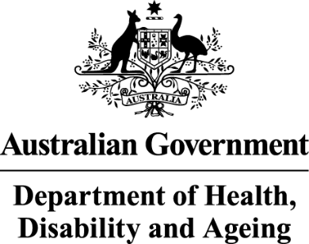

**Deputy Secretary**

Ms Joanna Abhayaratna   
Executive Director   
Office of Impact Analysis   
Department of the Prime Minister and Cabinet   
1 National Circuit   
BARTON ACT 2600

Email: Helpdesk-OIA@pmc.gov.au

Dear Ms Abhayaratna

**Impact Analysis – Reduction of the PBS General Patient Co-Payment to $25 – Second Pass Final Assessment**

I am writing in relation to the attached Impact Analysis (IA) prepared for the National Health Amendments (Cheaper Medicines) Bill 2025.

I am satisfied that the IA addresses the concerns raised in your letter of 9 July 2025, specifically:

* adding success factors and key assumption
* clarifying no further stakeholder consultation, beyond that already conducted within the context of the 2025 Federal election, will be conducted by the Department of Health, Disability and Ageing prior to submitting the Bill to Parliament
* adding stakeholder views of the innovator pharmaceutical industry
* providing details on negligible implementation risks, and
* providing additional information on the evaluation approach and post-evaluation policy considerations. The regulatory burden to business, community organisations or individuals, in terms of savings and costs, is provided below.

**Regulatory Burden Estimate Table**

|  |  |  |  |
| --- | --- | --- | --- |
| Total Regulatory Costs ($ million) 2025-26 to 2034-35 | | | |
| Individuals | Business | Community organisations | Total change in cost |
| $2,206.0  (save) | $285.1  (cost) | $0 | $1,1920.9  (save) |

Accordingly, I am satisfied that the IA is consistent with the six principles for Australian Government policy makers as specified in the *Australian Government Guide to Policy Impact Analysis*.

I submit the IA to the Office of Impact Analysis for formal final assessment.

Yours sincerely

Penny Shakespeare

Health Resourcing Group  
11 July 2025