# Independent Panel report: Phase out of live sheep exports by sea

P Glyde, S Middleton, H Neil and W Snowdon

October 2023

© Commonwealth of Australia 2023

**Ownership of intellectual property rights**

Unless otherwise noted, copyright (and any other intellectual property rights) in this publication is owned by the Commonwealth of Australia (referred to as the Commonwealth).

**Creative Commons licence**

All material in this publication is licensed under a [Creative Commons Attribution 4.0 International Licence](https://creativecommons.org/licenses/by/4.0/legalcode) except content supplied by third parties, logos and the Commonwealth Coat of Arms.



**Cataloguing data**

This publication (and any material sourced from it) should be attributed as: Glyde, P, Middleton, S, Neil, H, Snowdon, W, 2023, *Independent Panel report: Phase out of live sheep exports by sea*, Department of Agriculture, Fisheries and Forestry, Canberra, October. CC BY 4.0.

This publication is available at [agriculture.gov.au/live-sheep-phase-out](http://agriculture.gov.au/live-sheep-phase-out).

Department of Agriculture, Fisheries and Forestry

GPO Box 858 Canberra ACT 2601

Telephone 1800 900 090

Web [agriculture.gov.au](https://www.agriculture.gov.au/)

**Disclaimer**

The Australian Government acting through the Department of Agriculture, Fisheries and Forestry has exercised due care and skill in preparing and compiling the information and data in this publication. Notwithstanding, the Department of Agriculture, Fisheries and Forestry, its employees and advisers disclaim all liability, including liability for negligence and for any loss, damage, injury, expense or cost incurred by any person as a result of accessing, using or relying on any of the information or data in this publication to the maximum extent permitted by law.

**Acknowledgement of Country**

We acknowledge the Traditional Custodians of Australia and their continuing connection to land and sea, waters, environment and community. We pay our respects to the Traditional Custodians of the lands we live and work on, their culture, and their Elders past and present.

Cover image: Shutterstock

## Letter from the Panel Chair

On behalf of Panel members Ms Sue Middleton, Ms Heather Neil, and the Hon Warren Snowdon, I am pleased to present our report following consultations on the phase out of live sheep exports by sea.

The sheep industry is a cornerstone for many individuals and communities in Western Australia. Sheep production retains a foundational and iconic role in Western Australia even as farming systems and communities continue to change. During consultations in regional Western Australia this passion for sheep production was evident.

Live exports play an important role in Western Australia’s sheep industry. Even though businesses have been adjusting to a historical decline in live sheep exports by sea, ending this trading option will have an impact on individuals, businesses in the supply chain, and regional communities.

The Panel also heard how the suffering of animals has had a negative impact on many Australians who hold significant concerns for sheep exported by sea. The importance of maintaining and improving Australia’s regulation of animal welfare standards in the lead-up to the cessation was prominent when discussing the policy.

You asked us to consider and reflect all viewpoints on this issue. We met with over 2,000 individuals, held 96 stakeholder meetings, and received more than 800 submissions and 3,300 survey responses. These reflections were combined with existing research and commissioned advice to inform our deliberations.

We present a comprehensive list of recommendations for your consideration. Our focus has been to establish a profitable and sustainable value chain for Western Australian sheep producers in the absence of live sheep exports by sea. The Panel believes that there is a strong future for the Western Australian sheep industry and its supply chain participants. There are opportunities to grow employment and value adding through increased onshore processing. We believe that with clear announcements, early actions and appropriate support, the adverse impacts of the transition away from live sheep exports by sea can be moderated.

The Panel expresses its gratitude to the members of the Live Sheep Phase Out Secretariat, who coordinated meetings, facilitated the written contributions to the consultation process, and supported the preparation of this report.

I thank my fellow Panel members, who each brought invaluable perspectives and unique experiences to the task, approaching each challenge we faced with professionalism, empathy and responsiveness.

We acknowledge and thank all who contributed to the consultation process for their insight, honesty and engagement. We appreciate the respect shown to us, given the serious concerns some people had about the potential impact of this policy.

In June 2022, you first met with Western Australian producers and live sheep export supply chain participants to confirm the government’s intention to deliver on its election commitment. Your appointment of the Panel in March 2023 to undertake consultation about how and when to phase out live sheep exports by sea initiated broader discussions about the implementation of the policy. The completion of this report is a further milestone to assist the government in its deliberations about how it can deliver on its commitment while supporting the future of the Western Australian sheep industry.

I commend our report and its recommendations to you.

Yours sincerely,



Phillip Glyde

Panel Chair

Independent Panel consulting on the phase out of live sheep exports by sea

25 October 2023

Contents

Letter from the Panel Chair iii

Executive summary xii

Recommendations xvii

Farm and other supply chain businesses xvii

Infrastructure and logistics xvii

Competition xvii

Labour and training xvii

Individuals and communities xviii

Trade and international relations xviii

Research, development, extension and adoption xviii

Animal welfare xix

Managing the transition xix

Timing and mechanism xx

Introduction 1

Government commitments 1

Terms of reference 1

Independent panel 2

Panel’s approach 3

Consultation and stakeholder views 6

Consultation 6

Channels 8

Issues raised 10

Background 22

Australian agriculture 22

Australia’s sheep industry 23

Wool 24

Sheep meat 24

Live sheep exports 27

WA agriculture industry 29

WA sheep industry 30

Community overview 38

Impacts 41

A changing and challenging context 41

Identifying potential effects 42

Quantifying the impacts 47

Key variables influencing the strength of the WA sheep industry 56

Looking to the future 59

Four action areas to strengthen the WA sheep industry and support individuals, businesses and communities 60

Farm businesses 61

Strong businesses, strong industry 61

Resilience 61

Changing production model 62

Supporting businesses to be resilient 63

Principles for promotion and delivery 65

Relevant recommendations 66

Sheep supply and value chains 67

The need for increased sheep processing in WA 67

More than abattoirs – about an entire value chain 67

Farm businesses 70

Feedlots and feed millers 70

Abattoirs and cold storage 74

Freight 77

Competition and sale arrangements 80

Relevant recommendations 82

Sheep processing labour 84

The need to expand the workforce 84

Competition for suitable workers is strong 85

Immigration – a solution with challenges 86

More than finding suitable workers 91

First Nations employment part of the solution 93

Training and upskilling 95

Worker protections 95

Government initiatives 96

Relevant recommendations 96

Markets 98

Limits of domestic markets 98

Sheep meat 99

Increasing trade opportunities 106

Growing foreign investment 113

Relevant recommendations 114

Individuals and communities 115

Resilient individuals and communities 115

Community context 116

Impacts from the end of live sheep exports by sea 118

Supporting individuals and communities to be resilient 120

Focus on mental wellbeing 120

Focus on communities 121

Principles for promotion and delivery 123

Relevant recommendations 124

Broadacre cropping 125

WA grain production 125

Links between cropping and sheep farming 127

Farm income and commercial considerations 127

Risks 128

Relevant recommendations 130

International relations 131

Australia is a trading nation 131

A domestic policy 132

Growing trade and investment 133

Influencing global animal welfare 134

Relevant recommendations 136

Research and development corporations 137

Rural research and development corporations 137

LiveCorp 138

Australian Wool Innovation 140

Meat & Livestock Australia 142

Australian Meat Processor Corporation 144

Grains Research and Development Corporation 145

Relevant recommendations 146

Australian Government live export regulatory activities 148

Community concerns about live sheep exports by sea 148

Regulation of live sheep exports 149

Cost recovery for live animal export services 159

Additional regulatory activities 160

Relevant recommendations 160

Timing 161

The need for certainty 161

Timing options 162

Supporting animal welfare 165

Finding a balance 165

Relevant recommendations 166

Mechanism to end live sheep exports by sea 167

Determining the ‘how’ 167

Current arrangement 167

Gradually reduce exports (‘quota’ option) 168

Expanding the Northern Hemisphere Summer Prohibition period (‘prohibition option’) 169

Firm ending (‘set a date’ option) 169

Relevant recommendations 172

Managing the transition 173

Regional experience to inform change 173

Transition principles 174

Transition phases and governance considerations 175

Relevant recommendations 180

Appendix 1: Labor’s 2022 Election commitment 182

Strengthening animal welfare 182

Appendix 2: Stakeholders who participated in consultations 183

Appendix 3: Update from the independent panel consulting on the phase out of live sheep exports by sea, 27 July 2023 187

Engagement 187

What we heard 187

Market trends 190

Ideas for the future 191

Next steps 192

Appendix 4: Survey and written submission analysis 193

Survey responses 193

Written submission analysis 193

Appendix 5: Support programs and measures 195

Farm business supports 195

Individual supports 196

Community supports 197

Glossary 198

References 200

**Tables**

Table 1 Public forums in WA 8

Table 2 LGAs with highest employment proportion in agriculture, fisheries and forestry sector, 2021 39

Table 3 Top 3 industry sectors by output (percentage of total economy), 2022 39

Table 4 LGAs with working-age population growth in Great Southern, Mid West–Gascoyne and Wheatbelt, 2018 to 2022 40

Table 5 LGAs with working-age population decrease in Great Southern, Mid West–Gascoyne and Wheatbelt, 2017 to 2021 40

Table 6 Forecast employment impacts expressed in reports 54

Table 7 Forecast economic impacts expressed in reports 55

Table 8 Modelling of flock size 56

Table 9 Seasonal variation in WA slaughter rates, 2022 71

Table 10 Regional workforce pool 86

Table 11 Visa processing times 90

Table 12 Australian Government initiatives for First Nations employment 94

Table 13 Sheep exports and mortalities during exports by sea, 2016 to 2022 158

Table A1 Top 3 issues raised by stakeholder groups, by percentage of responses 194

**Figures**

Figure 1 Action areas xiii

Figure 2 Panel’s approach 4

Figure 3 WA Regional Development Australia regions 20

Figure 4 WA sheep distribution, 2021 21

Figure 5 Agriculture, fisheries and forestry value of production (2022–23 real value), by commodity, 2000–01 to 2022–23 22

Figure 6 Value of Australian exports for sheep meat, wool and live sheep exports, 1988–89 to 2022–23 (real value) 24

Figure 7 Australian sheep meat exports, by volume and state, 2022–23 25

Figure 8 Australian sheep meat exports, top destinations in 2022–23, and percentage change from 2021–22 to 2022–23 26

Figure 9 Australian sheep meat exports, by volume and value, 2000–01 to 2022–23 27

Figure 10 Australian live sheep exports by sea, 2001–02 to 2022–23 28

Figure 11 Volume of live sheep exported from Australia by sea, 2010–11 to 2022–23 29

Figure 12 Contribution of sheep (live exports, sheep meat and wool) to WA agricultural exports 30

Figure 13 WA sheep flock and sheep farm numbers, 1997–98 to 2021–22 31

Figure 14 WA sheep flock versus cropping area, 1989–90 to 2021–22 31

Figure 15 WA farm businesses, by type, 2021–22 32

Figure 16 WA farm business average rate of return (including capital appreciation), by farm type, 2009–10 to 2021–22 (real value) 33

Figure 17 Composition of the WA sheep flock (%), 2004–05 to 2021–22 34

Figure 18 Typical seasonal activities in a WA sheep and cropping enterprise 35

Figure 19 Value of WA live sheep, sheep meat and wool exports, 1988–89 to 2022–23 (real value) 36

Figure 20 WA sheep turn-off, 2010–11 to 2022–23 37

Figure 21 National versus WA sheep indicator prices (mutton and lamb), 2000 to 2023 37

Figure 22 Employment by sheep farming occupation in Great Southern, Mid West–Gascoyne and Wheatbelt regions, 2016 and 2021 38

Figure 23 Sheep supply chain 43

Figure 24 Reliance on the live sheep export trade, by participant category, 2018 and 2023 44

Figure 25 Resilient companies enjoy better outcomes on 3 fronts 62

Figure 26 Sheep value chain 69

Figure 27 Lamb and sheep slaughter, by quarter, WA, January 2017 to June 2023 71

Figure 28 WA and national sheep meat exports by air (volume and proportion), 2015–16 to 2022–23 79

Figure 29 Multi-species and cattle-only shipments from Fremantle to the Middle East, 2014–15 to 2022–23 80

Figure 30 Value share of WA live sheep (by sea) and sheep meat exports, 2010–11 to 2022–23 (real value) 99

Figure 31 Australian sheep and sheep meat exports, unit value comparison (A$/kg) 100

Figure 32 Price of live sheep exports and wethers for domestic processing in WA, 1999–2000 to 2022–23 (real value) 101

Figure 33 Australian lamb exports by region, 2010–11 to 2022–23 (real value) 102

Figure 34 Australian mutton exports by region, 2010–11 to 2022–23 (real value) 102

Figure 35 Global sheep meat exports, 2011 to 2021, USD million 103

Figure 36 Actual and forecast New Zealand sheep numbers and export volumes, 2018–19 to 2026–27 104

Figure 37 Number of markets for lamb and mutton, national and WA, 2014–15 to 2022–23 109

Figure 38 Global sheep skin exports, 2012 to 2021, USD thousands 112

Figure 39 Global edible sheep offal exports, 2012 to 2021, USD thousands 112

Figure 40 Internal migration in Australian states and the NT, 2006 to 2021 116

Figure 41 Unemployment rate, Perth and WA regions, March 2023 117

Figure 42 Map of WA regions and cropping production 125

Figure 43 WA lupin production, 2000–01 to 2022–23 126

Figure 44 Average total closing capital per farm, for WA cropping, mixed and sheep farms, 2011–12 to 2021–22 (real value) 128

Figure 45 Australian agricultural exports to Israel, Jordan, Kuwait, Oman, Qatar, Saudi Arabia and the UAE, 2022–23 132

Figure 46 LiveCorp levy income, 2021–22 138

Figure 47 LiveCorp revenue and expenditure, 2017–18 to 2021–22 139

Figure 48 LiveCorp income and source, 2014–15 to 2021–22 140

Figure 49 AWI revenue and expenditure, 2017–18 to 2021–22 141

Figure 50 MLA revenue and expenditure, 2017–18 to 2021–22 143

Figure 51 AMPC revenue and expenditure, 2017–18 to 2021–22 144

Figure 52 GRDC revenue and expenditure, 2017–18 to 2021–22 146

Figure 53 Adoption of change over time 174

Figure 54 Steps in the transition away from live sheep exports by sea 177

Figure A1 Value and share of WA live sheep exports compared with value of sheep meat exports 190

Figure A2 Sheep turnoff from WA farms, 2021–22 191

Figure A3 Volume of national vs WA wool exports 191

**Boxes**

Box 1 Summary of main findings of reports 49

Box 2 Confinement feeding trials in WA 73

Box 3 Sheep meat processing in WA 84

Box 4 Migrant workers 87

Box 5 Worker accommodation 92

Box 6 Investing in people 95

Box 7 MindSpot and Head to Health 121

Box 8 A strategy for long-term community recovery 123

Box 9 AWI programs for producers 141

Box 10 New Zealand phase out of livestock exports by sea 171

## Executive summary

Live sheep exports by sea have been a part of the Australian sheep industry for generations. The trade was valued at $76.9 million in 2022–23. Australia has historically supplied a large volume of live sheep to the Middle East, which peaked in 2002–03. Western Australia (WA) has been Australia’s only source of live sheep exports by sea since 2019–20. The overall volume of live sheep exports by sea has been decreasing over the last 2 decades, dropping 27% between 2018–19 and 2022–23. Although live exports accounted for only 12% of WA turn-off in 2022–23, many WA producers spoke in consultations of their reliance on the live sheep trade as an option for turning off large numbers of stock or to manage risks when feed or water is scarce. For many in sheep-producing communities, maintaining a viable sheep flock is a source of income that supports employment and a critical mass of people to sustain services and social fabric of communities.

There have been ongoing community concerns about the treatment and conditions sheep experience once they leave Australia. Repeated animal welfare incidents have led to reviews, regulatory changes and eventually the government’s election commitment to phase out live sheep exports by sea.

This commitment has polarised opinion, with the range of views evident in the Panel’s consultations. Producers, animal welfare organisations, supply chain businesses, community and industry representatives, trading partners, processors and government officials were just some of those who contributed to the Panel’s process. The government’s policy was rejected by many in the WA sheep supply chain, while others in the community and animal welfare advocates supported it.

A common theme raised by WA sheep producers during consultations was the lack of confidence in the future of the WA sheep industry. The significant decline in prices, limited access to processing, build-up of sheep on farm, rising input costs, deteriorating seasonal conditions in some WA regions and eastern Australia and concerns over federal and state government policy changes were contributing to uncertainty about the future.

The potential impacts of the end of live sheep exports by sea were raised by supply chain businesses during the Panel’s consultations. There are concerns about ongoing business viability, processing capacity, a lack of competition in the market, job losses and flow-on effects to individuals and communities once the live trade ends.

Quantifying the potential impacts has been challenging and the Panel considered a variety of analyses to inform its work. No one study provided a definitive assessment of the impacts and each used different assumptions. The Panel placed greater weight on the WA Government’s submission due to its consideration of potential effects over time. The WA Government pointed to a potential impact of $123 million per year from the loss of the trade, or a $22 million annual impact if land is reallocated to cropping. This analysis assumes a 2025 phase out.

The Panel believes that the WA sheep industry can be profitable and sustainable during the transition period and beyond the end of live sheep exports by sea. Early actions by government will be required to moderate the economic and social consequences of the cessation.

The Panel recommends a focus on 4 action areas, with individuals and communities part of any solution (Figure 1):

* farm businesses
* sheep supply and value chains
* sheep processing labour
* markets.

Figure 1 Action areas

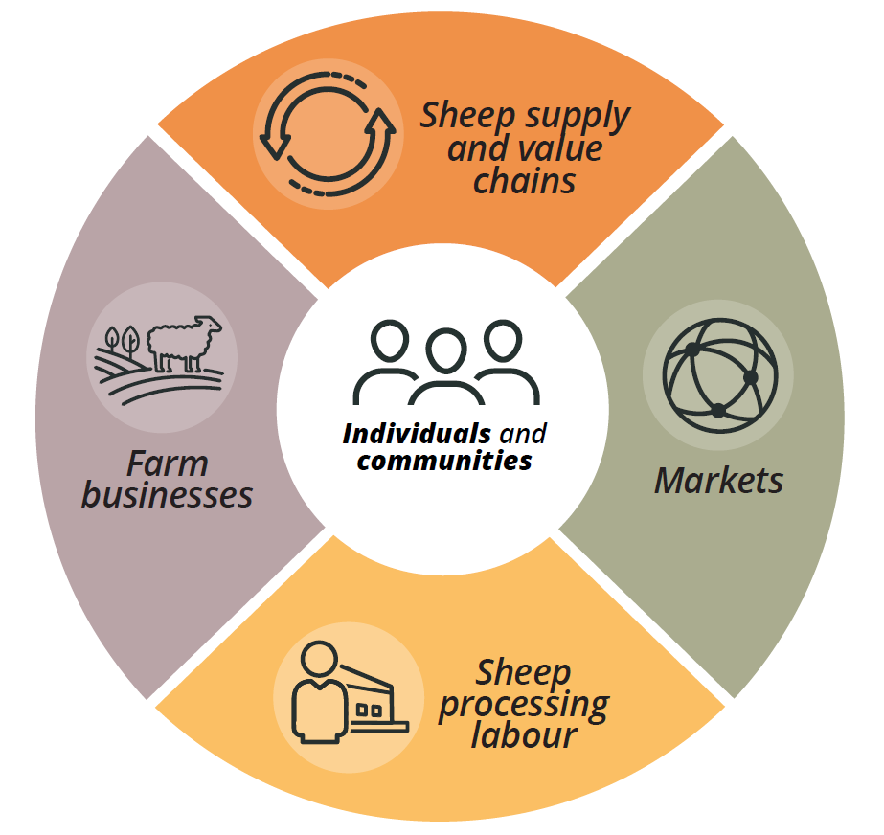

Individuals and communities need to be at the centre of any actions to drive the transition of the WA sheep industry. Many stakeholders pointed to mental health concerns arising from current pressures and future uncertainty. The ongoing viability of communities in sheep-producing areas was often raised with the Panel. Building community and individual resilience, fostering connection and stimulating regional economies in the transition period will assist adaptation to a future without live sheep exports by sea. The Panel believes that failure to adequately address all 4 action areas risks a greater contraction of the WA sheep flock, which would have an adverse impact on individuals, businesses and communities.

WA farm businesses running sheep will face disruption from the removal of live sheep exports by sea. Many, including those with limited or only occasional use of the trade, may need to adapt their planning and their operational decisions. The WA flock composition indicates that a gradual shift to first-cross lamb production has already been occurring, with the share of wethers dropping to 5.5% in 2021–22 from 10.8% in 2011–12. This transition has happened without a substantial decrease in the proportion of Merinos, which remains above 80% in WA. Producers may need support as they make decisions and prepare for change during the transition period.

Ending live sheep exports by sea will require additional onshore sheep processing and cold storage capacity if the WA sheep flock remains near current levels. Changes to on-farm production methods and greater use of feedlotting will be needed to help finish stock before slaughter. Scaling up of infrastructure will take time to secure capital, confirm approvals and finalise construction. An early announcement about the cessation date for live sheep exports by sea will be particularly important for driving investment and growth in the processing industry. Processors also have a role to play in communicating with producers about preferred animal specifications and working together to move from a supply chain to a value chain model.

Any increase to sheep processing capacity will need to be accompanied by access to a sufficient skilled labour supply. The national shortage of reliable and skilled labour is magnified for the WA meat processing industry, where regional, rural and remote locations, demography and competition from the mining sector make jobs harder to fill. Securing workers through the migration system, providing sufficient suitable housing, training and worker retention initiatives all require attention to lift sheep processing capacity and may deliver other benefits for rural communities.

Australia is the world’s largest exporter of sheep meat and there is sustained demand for our sheep meat internationally. The growth in Australia’s sheep meat exports has occurred as live sheep export volumes have decreased. In WA, processors slaughtered nearly 4.5 million head of sheep in 2022–23, the highest number in over 10 years. Increased access to international markets for sheep meat, wool and sheep co-products is essential for the WA sheep industry. Australia should not expect that processed sheep meat will always be a direct substitute for live sheep in Australia’s existing export markets. Expanded markets will be required to drive demand and create opportunities for the industry in the absence of live sheep exports by sea. This work needs to accelerate before the cessation occurs, to build the customer base, support adjustments to logistics and facilitate market access audits and approvals. There are also opportunities for Australia to build its trade in other agricultural products and grow bilateral investment with Middle Eastern trading partners.

Animal welfare is at the heart of the government’s policy and should continue to be a focus in the transition away from live exports by sea. Maintaining and enforcing animal welfare standards in the existing live sheep export trade is important for animals, producers selling into those markets, and the many Australians who have advocated for live sheep exports by sea to end. Attention to animal welfare in west–east land transport and in sheep feedlotting arrangements is also required. The welfare of sheep on farm in WA should remain a priority, including by ensuring sufficient sheep processing capacity is in place by the end of live sheep exports by sea. Australia should also continue its strong engagement in the World Organisation for Animal Health to advocate for and influence improved global animal welfare standards for sheep and other livestock.

Other businesses connected to live sheep exports by sea should also be considered. Cattle producers who export cattle via mixed-species shipments, feed millers who supply pellets for sheep on journeys, and shearers and sheep husbandry contractors who support the current trade are just some of those who will also be affected by the transition. If there is a significant change from sheep to broadacre cropping, there may be increased pressure on grain, road and rail infrastructure. The role of fodder crops in existing rotations may be diminished without grazing sheep, potentially affecting input use, soil quality and condition, biodiversity or carbon emissions.

The rural research and development corporations (RDCs) also have a role to play in supporting the transition away from live sheep exports by sea. Extension activities to promote the move to sheep meat production, market development for sheep meat and co-products, and market transparency are areas for RDC attention. Levy incomes will need to be monitored by the livestock RDCs, particularly if any change, up or down, affects their future activities.

The question of when to end live sheep exports by sea is about finding balance. There needs to be sufficient time for producers and other businesses to make decisions and adjust their operations, but not so long that there is little impetus for action. In the interests of animal welfare and industry certainty, the transition should not be prolonged. The cessation should occur when there is sufficient sheep processing capacity in WA.

The Panel considered 3 timing options in detail – short (mid-2025), medium (mid-2028) and long (mid-2033) – each occurring in line with the Northern Hemisphere Summer Prohibition in that year. Mid-2025 would be the shortest possible transition given the government’s commitments. The Panel considers that this would be highly destabilising for the industry and communities, without time to plan or put additional sheep processing capacity in place. A prolonged phase out (10 years or more) was suggested by some industry stakeholders, but the Panel feels that this time frame would not create an incentive for businesses to adjust or investments to occur. In the Panel’s view, the time needed to plan, make operational changes, increase sheep processing capacity and ensure markets are in place, without prolonging uncertainty, is best achieved by ending the trade at the beginning of the Northern Hemisphere Summer Prohibition in 2028. An early announcement about this date is important to all stakeholders.

The Panel also has concern for the impacts on individuals, businesses and communities in the transition period. The early actions outlined by the Panel are intended to facilitate an orderly adjustment away from live sheep exports by sea and are particularly important if the recommended time frame is to be achieved with minimal impacts. The Panel believes there should be a review in 2026 to assess whether processing capacity and markets are on track to manage WA sheep turn-off by the cessation date. A Transition Action Group and Transition Advocate are also suggested to help drive the implementation of ameliorating measures. Carefully managing the transition will be important for reducing impacts, speeding recovery and strengthening the WA sheep industry into the future.

The Panel recommends that legislation be used to end live exports by sea. The clarity and public accountability of a legislated cessation date are essential for delivering certainty, encouraging investment and prompting change.

The end of live sheep exports by sea is disruptive for the WA sheep industry and it will require businesses to plan and adapt to change. The potential impacts of the cessation on individuals and communities can be moderated with support for farm businesses, the sheep processing industry, labour supply and market development. The recommended time frame allows for support to be given, resilience to grow and adjustments to be made. Prompt announcements and early actions by government will be crucial for lifting confidence and making progress towards a strong future for the WA sheep industry for the benefit of individuals, businesses and communities.

## Recommendations

Initiatives requiring early action or funding: 1, 4, 14, 22, 24, 27 and 28.

### Farm and other supply chain businesses

1. The Australian Government should provide funding to enable businesses in the WA sheep supply chain to prepare a business plan for their adjustment away from live sheep exports by sea. This could be via existing initiatives and should also be available to cattle producers who may be affected by the end of live sheep exports by sea.
2. The Australian Government should establish transition funding arrangements accessible to businesses in the supply chain to prepare for and adjust to the absence of live sheep exports by sea. Funds should be contingent on businesses preparing a plan, perhaps drawing on the opportunity provided by Recommendation 1. Consideration should also be given to the needs of non-supply-chain businesses affected by the cessation.
3. The Australian Government should consider what support is needed for supply chain businesses with a high reliance on live sheep exports by sea to exit the industry if they are unable to transition by the cessation date. Support should follow businesses completing a business planning process.

### Infrastructure and logistics

1. Governments should provide access to funds or concessional loans to improve the capacity and efficiency of the WA sheep supply chain. Ideally, any government funding should be accompanied by private investment. Possible projects could include, among others, the expansion of processing facilities, installation of feedlots, addition of cold storage, improvements to transport or logistics infrastructure that support sheep product exports, or the supply of worker accommodation.
2. All levels of government should streamline planning and approval processes to facilitate infrastructure improvements in the WA sheep supply chain.
3. Governments should look for ways to increase air freight capacity for sheep products from WA, including consideration of time-limited assistance for air freight costs.

### Competition

1. Market integrity and competition should be strengthened through the entire WA sheep supply chain. This could include close monitoring by the Australian Competition and Consumer Commission, WA Department of Mines, Industry Regulation and Safety and WA Meat Industry Authority, and promotion of existing price transparency tools.

### Labour and training

1. The Australian Government should allocate a high priority to the meat processing industry to accelerate processing of skilled visa applications.
2. The Australian Government should consider increasing WA’s allocation through the skilled migration program to supply additional workers to the sheep processing industry in regional WA.
3. The Australian Government should work with the affected regions to establish Designated Area Migration Agreements (DAMAs) if not already in place or expand existing DAMAs to include sheep industry workers.
4. The Australian Government should ensure workers who need to change their skill set or employment due to the end of live sheep exports by sea are aware of and have access to appropriate training and support to aid their transition.
5. Governments should ensure initiatives are available to businesses in the WA sheep industry to attract, train and retain First Nations workers.

### Individuals and communities

1. The Australian and WA governments should assess the demand on existing mental health and other support and advisory services and ensure they are appropriate to the needs of communities. These services should:
   1. be adequately resourced to conduct outreach and manage any increase in demand due to the end of live sheep exports by sea
   2. be promoted in the regions affected by the end of live sheep exports by sea
   3. include funding for community events and activities in the affected regions to foster mental wellness, build connections and strengthen communities.

### Trade and international relations

1. The Australian Government should provide access to additional funding for:
   1. industry-linked organisations to grow new and deepen existing markets for Australian sheep products, particularly from WA
   2. the Department of Agriculture, Fisheries and Forestry to support market access and growth for Australian sheep products, particularly from WA.
2. The Australian Government should continue to engage with trading partners on the development of the sheep meat trade in the Middle East during the transition away from live sheep exports by sea.

### Research, development, extension and adoption

1. The Australian Government should support the transition away from live sheep exports by sea, including by:
   1. encouraging the rural research and development corporations to accelerate their activities that support the WA industry to transition away from live sheep exports by sea
   2. making funds available for extension and adoption to assist producers to create a value chain without live sheep exports by sea.
2. The Australian Government should consider the role and financial position of the affected rural research and development corporations during and following the transition away from live sheep exports by sea.

### Animal welfare

1. The Australian Government should ensure that the Department of Agriculture, Fisheries and Forestry and the Australian Maritime Safety Authority have the funds needed to fulfil their regulatory obligations and assurance requirements for live sheep exports by sea.
2. The Australian, state and territory governments should work together to review and enforce the Australian Animal Welfare Standards and Guidelines – Land Transport of Livestock.
3. Australia should maintain its strong engagement in the World Organisation for Animal Health’s international standard setting processes, through technical input and ongoing consultation with Australian experts. Australia should look for opportunities to influence improved global animal welfare standards through bilateral forums and agreements.
4. The Australian sheep industry should be encouraged and supported to:
   1. establish a national accreditation scheme for sheep feedlots, to include standalone and on farm intensive feeding systems
   2. develop a complementary national sheep meat quality assurance scheme (similar to AUS-MEAT) for meat produced from sheep finished in feedlots.

### Managing the transition

1. The Australian Government should make an announcement in 2023 stating when the end of live sheep exports by sea will occur.
2. A review should be conducted in 2026 to ensure farm businesses, the WA sheep supply chain and market development are on track to achieve the onshore processing of the WA sheep turn-off expected by the cessation date for live sheep exports by sea. This review should include recommendations about any adjustments needed, any change to the timeline and further actions to support a smooth transition by individuals, businesses and communities.
3. The Australian Government should fund and commence implementation of early actions as soon as practicable to restore confidence in the WA sheep industry and drive a quick and strong adaptation to the end of live sheep exports by sea. The priorities for early action by the first half of 2024 are:
   1. farm business planning (Recommendation 1)
   2. processing and cold storage infrastructure (Recommendation 4)
   3. market opportunities (Recommendation 14).
4. The Australian and WA governments should establish a group to co-design the development and delivery of transition activities including projects in the affected regions to stimulate regional economies and support local communities. This would not include the early actions (Recommendation 24). This group should include members with experience in the WA sheep supply chain, regional development and the WA grower group network. Where possible, priority should be given to using WA agencies and organisations for delivery of initiatives arising from this report to enhance uptake and place-based solutions.
5. The position of Transition Advocate should be created and funded to monitor transition initiatives and provide advice on progress to the Australian Minister for Agriculture, Fisheries and Forestry and the WA Minister for Agriculture and Food.

### Timing and mechanism

1. The end of live sheep exports by sea from Australia should occur at the beginning of the Northern Hemisphere Summer Prohibition in 2028.
2. The end of live sheep exports by sea should be legislated during this term of the Australian Parliament (47th Parliament). Legislation should describe the date from when live sheep exports by sea will be prohibited and should not apply additional restrictions such as quotas or caps during the transition period.

## Introduction

### Government commitments

#### Phasing out live sheep exports by sea

The Australian Government committed to phasing out live sheep exports by sea as part of its 2022 election campaign Plan for Strengthening Animal Welfare (Appendix 1). This was in response to community concern about the treatment of sheep during exports by sea and when in importing countries. Community and regulator concerns about animal welfare incidents had prompted reviews of the trade including the 1985 Senate Select Committee on Animal Welfare, 2003 Keniry Review, 2011 Farmer Review and 2018 McCarthy and Moss reviews.

In June 2022 the Prime Minister, the Hon Anthony Albanese MP, and Senator the Hon Murray Watt, Minister for Agriculture, Fisheries and Forestry, clarified that the transition will not take place during the current (47th) term of the Australian Parliament (Borrello, Cooper & Gunders 2022). This will allow for appropriate consideration of options and give those affected by the commitment the time to prepare for, adjust and move away from the trade.

The commitment to end live sheep exports by sea began to garner media and industry attention around the time Minister Watt visited Western Australia in June 2022. The minister was interviewed on WA and national media including ABC *Landline*, Sky News and ABC Radio Perth, and met with WA industry representative bodies, exporters, meat processors and other industry stakeholders.

Media reporting on the election commitment continued through the rest of 2022 and into 2023 via print, online and television media. In the same period, numerous WA state members of parliament and federal members, senators and stakeholders canvassed the issue in parliamentary speeches, Senate Estimates hearings, media statements, interviews and opinion pieces.

On 3 March 2023, Minister Watt announced a 4-person independent panel to commence consultation on how and when to phase out live sheep exports by sea. Minister Watt noted that:

[the] consultation process is an important step towards developing a considered and orderly implementation plan that advances animal welfare, examines the needs of impacted individuals, businesses and local communities and identifies opportunities for future sheep industry growth (Watt 2023c).

In May 2023, Minister Watt noted that animal welfare is important not only to the agriculture sector but to the wider public and increasingly will ‘underpin our access to international markets’ (Watt 2023a).

#### Live cattle and other live exports

The policy does not apply to other livestock export industries, including live cattle exports by sea; nor does it apply to live sheep exports by air.

### Terms of reference

Minister Watt appointed an independent panel (the Panel) to consult with stakeholders to inform how and when the government could implement the phase out of live sheep exports by sea.

In conducting the consultation, the Panel was commissioned to consider:

* potential mechanisms to phase out live sheep exports by sea
* a suggested time frame and options for implementation
* potential ways to support the transition, including but not limited to consideration of markets, processing facilities and other opportunities
* other matters as appropriate.

The Panel was asked to examine matters including but not limited to:

* the economic impact of the phase out
* agricultural production systems and on-farm management
* supply chain arrangements
* trade and market access
* lessons learnt from countries that have phased out live sheep exports by sea, and states and territories that no longer export live sheep by sea.

The Panel was required to engage with various stakeholders, including exporters, farmers, supply chain participants, communities, trading partners, animal welfare organisations, First Nations Australians, state and territory governments, and academics. The Panel held face-to-face meetings and online forums and considered survey responses and written submissions (see Consultation and stakeholder views).

The Panel’s consultation was not to consider the merits or otherwise of the government’s policy to phase out live sheep exports by sea. This was made clear by the Panel in all its meetings and forums.

The Panel was required to provide its report to Minister Watt for the government’s consideration by 25 October 2023. On 15 September 2023, the minister granted an extension from the original submission date of 30 September 2023.

### Independent panel

The independent panel comprised Mr Phillip Glyde (Chair), Ms Sue Middleton, Ms Heather Neil and the Hon Warren Snowdon. The Panel’s task was defined by its terms of reference.

The Panel members were selected for their diverse and relevant skills and experience.

#### Mr Phillip Glyde (Chair)

Mr Phillip Glyde has 42 years’ experience as a senior executive in the Australian Public Service. As a former Deputy Secretary of the Department of Agriculture, Fisheries and Forestry, Executive Director of ABARES, and Chief Executive Officer of the Murray–Darling Basin Authority, Mr Glyde brings a wealth of experience in advising governments, an economics background, and a strong understanding of the agriculture sector.

#### Ms Sue Middleton

Ms Sue Middleton is a farmer and respected agribusiness leader. She is a passionate advocate for regional Western Australia and has a deep understanding of government policy, agribusiness and regional development.

Ms Middleton has held extensive board and leadership roles in agriculture and regional development including the Council of Australian Governments Reform Council, the National Regional Women’s Advisory Council, the Australian Research Council, the National Rural Advisory Council and the WA Agricultural Produce Commission.

#### Ms Heather Neil

Ms Heather Neil is an experienced chief executive officer and director with a deep understanding of community governance and of animal welfare science and advocacy. She has extensive experience in public policy, regulation and reform in the area of social change. Ms Neil’s prior appointments include Chief Executive Officer of RSPCA Australia for 12 years and Director of Stewardship at CropLife Australia for 4 years.

#### The Hon Warren Snowdon

The Hon Warren Snowdon is a former federal minister with 32 years’ experience in the Australian Parliament serving as a representative for the Northern Territory. During this time Mr Snowdon held several ministerial portfolios, including being the first to take the role of Minister for Indigenous Health, and was, for a time, also responsible for rural and regional health and regional service delivery. Mr Snowdon brings significant understanding of and connection to the Australian agriculture sector and rural and regional communities.

### Panel’s approach

The Panel carefully considered its approach to this task, wanting to ensure that stakeholders were heard, evidence was gathered, and information was synthesised to produce tangible recommendations. Figure 2 illustrates some of the steps taken by the Panel and their links to the chapters of this report.

Figure 2 Panel’s approach

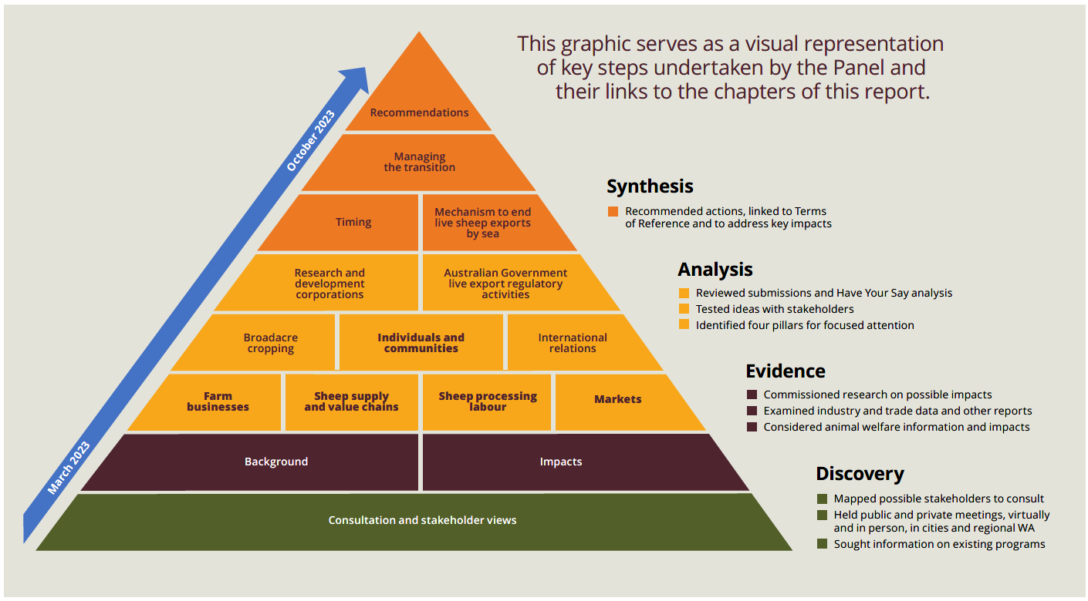

#### A note on terminology

The Panel has sought to avoid use of the term ‘phase out’ in this report, recognising that it can be open to interpretation. Instead, the Panel has used terms such as ‘end’, ‘cessation’ or ‘close’ to describe the point at which there will be no further exports of live sheep by sea from Australia. Where ‘phase out’ is used, this is usually in the context of describing the government’s policy.

The Glossary contains a selection of terms used in the report.

## Consultation and stakeholder views

The Panel sought broad views about the potential impacts and opportunities surrounding the end of live sheep exports by sea. Extensive engagement, including different approaches, enabled the Panel to hear from a variety of stakeholders. Regardless of whether stakeholders supported or opposed the end of live sheep exports by sea, common issues were raised. These included recognising there will be impacts on producers, supply chain participants and other local businesses, and a need to support people and communities managing this transition. The need to address and manage animal welfare in the transition and beyond was also recognised.

The Panel notes that stakeholder estimations relating to employment and economic effects of the end of live sheep exports by sea varied widely. This was particularly pronounced when considering the level of potential impact that different parts of the supply chain may face, and the different scenarios that could occur in the lead-up to and beyond the cessation of the live sheep trade. Impacts considers these potential effects.

### Consultation

The Panel consulted a range of stakeholders to ensure different points of view were considered when providing advice on how and when the government could phase out live sheep exports by sea. This approach was consistent with the Panel’s terms of reference (see Introduction).

The Panel undertook face-to-face consultation, delivered virtual forums, and sought and considered written and survey submissions. The Panel conducted a stakeholder mapping exercise and identified stakeholders to be engaged and prioritised those that would be the most impacted or interested or had shared responsibility in generating solutions, including:

* farmers
* exporters
* supply chain participants
* animal welfare organisations
* international trading partners
* industry representative bodies
* research and development corporations
* regional development organisations
* health organisations and practitioners
* community members
* New Zealand Government officials
* Australian state, territory and local government officials
* financial institutions and financial counsellors
* other experts.

The Panel sought out stakeholders that were involved in, or had an understanding of, the live sheep export supply chain or WA sheep farming systems, as well as those linked to communities in WA sheep-producing regions. To support its discovery phase, the Panel initially engaged with industry representative bodies, animal welfare organisations, and other experts. Data sets such as the WA Department of Primary Industries and Regional Development (DPIRD) Sheep Enterprise and Sheep Density maps helped identify the locations and communities to target (see also Figure 3 and Figure 4. The Panel was also approached by individuals, businesses and groups keen to provide information. Additional stakeholders were contacted throughout the consultation process as issues arose that warranted further investigation.

Participation in consultation was strong and robust, and the overall tone of engagement was respectful. The Panel appreciates all who gave their time and insights to the consultation process. A list of the stakeholders the Panel met with is at Appendix 2. In all, the Panel met with over 2,000 individuals, many of whom attended public forums; held 96 stakeholder meetings, 14 public forums and 8 virtual forums; and conducted a written and survey submission process as part of its consultation.

On 27 July 2023, the Panel released a statement (Appendix 3) updating stakeholders on its consultation to date, as well as publishing 615 (of 810 total) of the written submissions for which people gave permission to publish.

In the week commencing 21 August 2023, the Panel travelled to Perth to conclude its consultations. The Panel met with key industry representatives across the live sheep export supply chain as well as animal welfare organisations and WA Government representatives to test ideas and receive feedback on possible transition options for the industry.

During consultations, the Panel met with government and industry representatives from the following trading partners: Jordan, Kuwait, Oman, Qatar, Saudi Arabia and the United Arab Emirates.

The Panel consulted the WA Minster for Agriculture and Food and NT Minister for Agribusiness and Fisheries.

The Panel also engaged with Australian Government agencies including the Australian Competition and Consumer Commission; the Australian Trade and Investment Commission (Austrade); Department of Agriculture, Fisheries and Forestry including the Australian Bureau of Agricultural and Resource Economics and Sciences; Department of Employment and Workplace Relations; Department of Finance; Department of Foreign Affairs and Trade; Department of Health and Aged Care; Department of Home Affairs; Department of Industry, Science and Resources; Department of Infrastructure, Transport, Regional Development, Communications and the Arts; and Department of the Treasury.

State government agencies and officials were also consulted including the WA Department of Primary Industries and Regional Development; the South Australia Department for Environment and Water and Department of Primary Industries and Regions; and the NT Chief Veterinary Officer.

### Channels

#### Face-to-face and online meetings

The Panel engaged in targeted consultations with organisations and representative groups, as well as meetings open to the public, to ensure it heard a range of views. The Panel travelled to WA, Canberra, Sydney and Darwin and undertook 96 stakeholder meetings in these locations. Some meetings were held online to enable engagement with geographically dispersed stakeholders.

Face-to-face meetings were prioritised in WA, as that state is expected to be the most impacted by the end of live sheep exports by sea.

#### Public forums

The Panel held 14 public forums in WA, where more than 2,000 attendees are estimated to have participated (Table 1).

Table 1 Public forums in WA

| Location | Date | Estimated number of attendees |
| --- | --- | --- |
| Moora | 17/4/2023 | 80 |
| York | 17/4/2023 | 120 |
| Narrogin | 18/4/2023 | 110 |
| Wagin | 18/4/2023 | 100 |
| Katanning | 19/4/2023 | 210 |
| Cranbrook | 19/4/2023 | 120 |
| Albany | 20/4/2023 | 100 |
| Esperance | 21/4/2023 | 120 |
| Geraldton | 19/6/2023 | 120 |
| Merredin | 20/6/2023 | 240 |
| Kondinin | 21/6/2023 | 120 |
| Lake Grace | 21/6/2023 | 180 |
| Darkan | 22/6/2023 | 240 |
| Perth | 23/6/2023 | 170 |
| **Total** | **n/a** | **2,030** |

**n/a** Not applicable.

#### Online forums

The Panel conducted 8 public online forums, comprising broadcast sessions and discussion forums. The broadcast sessions were intended for a large audience to hear from the Panel, and attendees submitted questions via the Teams Live moderated Q&A tool. The discussion forums supported engagement focusing on specific topics or stakeholders: animal welfare, supply chain businesses, producers, exporters and port managers, and researchers and First Nations People. More than 330 attendees participated in these forums.

Across all face-to-face and online meetings and public forums, the Panel encouraged participants to speak freely, knowing they would not be directly quoted in the report unless they provided a written submission or survey response.

#### Survey and written submissions

From 3 March 2023 to 31 May 2023, written submissions were open and a survey was available for the public to provide their views on the cessation of live sheep exports by sea.

The Panel sought input from all interested stakeholders on:

* how the government should phase out live sheep exports by sea
* an appropriate time frame to implement the phase out
* how the phase out will impact exporters, farmers and other businesses across the supply chain
* support and adjustment options for those impacted by the phase out
* opportunities that the government and industry should pursue following the transition out of live sheep exports by sea.

The Panel received 810 written submissions, including from industry representative bodies, animal welfare organisations, producers, supply chain businesses and members of the community. Of the 85 submissions received from people identifying as producers, 82 were from WA, highlighting the specific regional impact and interest in the phase out. In total, 80% of the submissions noted their support for the phase out policy, 16% noted their opposition and 4% did not state a position on the policy itself or provided a neutral response. The Panel considered the input provided and did not apply a weighting based on the proportion of responses of a particular view. Information about written submissions is at Appendix 4.

The Panel was interested in gaining responses to its questions to assist its analysis, particularly views on the potential impacts of the end of live sheep exports by sea and proposals for opportunities to pursue because of the cessation. The Panel observed that most written submissions provided an opinion on the election commitment, primarily stating their support. Consideration of the merits of the policy was outside the Panel’s terms of reference.

The Panel also received 3,308 survey responses. Further information about the survey submissions is at Appendix 4.

#### Expert advice

The Panel drew on existing information related to live sheep exports, such as reports prepared for previous reviews of the live sheep export trade, as well as data published by a range of organisations. These included DPIRD, Meat & Livestock Australia (MLA), the Australian Bureau of Agricultural and Resource Economics and Sciences (ABARES), the Australian Bureau of Statistics (ABS) and the Australian Government Department of Agriculture, Fisheries and Forestry (DAFF) among others.

The Panel also commissioned 2 consultancies to assist its understanding of the potential effects of the phase out. This included economic and agronomic advice and input related to effects on regional communities in WA.

The Panel used this information, along with the submissions, surveys and advice provided in meetings, as input to its analysis. The Panel also tested the forecasted impacts of ending the export of live sheep by sea against the range of input. No single source was solely relied upon, including the research commissioned by the Panel.

The Panel notes that several reports have been commissioned by various parties about the live sheep export industry. These reports used different methodologies and were based on a wide range of assumptions and forecasted effects. As a consequence, there were differences in their findings and limited commonality among the reports. Submissions that referenced potential employment or economic effects generally only quoted from a limited number of reports, rather than the full range available. The use of findings from these reports is explored in Impacts.

#### Public surveys

The Panel is aware of surveys conducted and published during its consultation period that identified views about the live sheep export industry. Some stakeholders raised the survey findings with the Panel to validate their own positions.

In May 2023, the RSPCA released polling it had commissioned which found:

71% of Western Australians support the Australian Government’s policy to phase out live sheep export by sea. This includes 72% of people in metropolitan areas, and 69% in rural and regional Western Australia (RSPCA 2023).

Also in May 2023, the third in a series of community sentiment research pieces commissioned by LiveCorp about the live sheep and cattle export industry was released. Among other questions, it asked if Australia should stop the export of live animals to overseas markets, regardless of the impacts on Australian farmers (Voconiq 2023). 42% of respondents either disagreed or strongly disagreed with this statement, in comparison to 29% agreeing or strongly agreeing. The remaining respondents were neutral on the question.

This survey also found that:

the voyage and processing of animals in destination markets remain the locations of greatest concern (Voconiq 2023).

Further, community views about animal welfare continue to evolve to being about more than mortality rates, with:

70% of Australians in 2023 in agreement that animal welfare is about more than the absence of harm to animals, compared to 63% in 2021 (Voconiq 2023).

The Panel notes that the community concerns identified in the Voconiq survey relate to the treatment of sheep when they leave Australia and not their treatment by Australian farmers.

### Issues raised

Throughout its consultation, the Panel heard how those consulted thought the phase out could impact individuals, businesses, communities and animal welfare. The Panel also heard what might be needed to help supply chain participants transition to other opportunities. There were repeated themes expressed among different stakeholder groups.

At the WA regional public face-to-face meetings (which were primarily attended by people who operated in the live sheep export supply chain or related industries), an overwhelming majority of those who attended expressed a strong objection to the end of live sheep exports by sea.

In contrast, the written submissions and survey responses were dominated by those welcoming an end to live sheep exports by sea.

A selection of views expressed by stakeholders during consultations appear in this section. These views reflect what the Panel heard from stakeholders and capture commonly raised issues. They do not represent the Panel’s views or conclusions.

#### WA production systems

Industry stakeholders explained how wool, sheep meat, live export trade and grain production and their associated supply chains are interconnected. These stakeholders observed that the removal of live sheep exports by sea cannot be discussed in isolation and that a whole-of-supply chain view is needed.

The sheep supply chain, both in WA and nationally, is a complex and interconnected system. Disruption or removal of a component diminishes competition and can have far-reaching and unintended consequences across the entire industry. Submission 824, Sheep Producers Australia.

To disable the Live Export is to effectively cut the throats of the entire West Australian Agricultural integrated farming system. Survey response, deidentified response.

Producers explained how the live export trade is important to their businesses as WA is different from the eastern states due to its proximity to the Middle East markets, distance from larger east coast markets, Mediterranean climate and varied geography. Producers indicated they use live exports to mitigate risk and diversify farm operations.

In our relatively low rainfall location, we cannot run the risk of not having a market to sell our wethers. Submission 769, deidentified submission.

WA is very remote and is an export focused producer. We do not have access to the domestic markets found in the east coast of Australia. Survey response, deidentified response.

The Panel heard that some producers will not be able to readily adapt or change practices, for example, farms that run sheep on land that is not suitable for cropping.

Our farm is a mixed farming enterprise, we crop around 50% of our land and we use the balance of our land to run livestock, in particular sheep for meat processing. Not all of our land is suitable to crop, therefore a reduction in livestock production and income from livestock production would make a large portion of our farmland unprofitable. Submission 720, deidentified submission.

WA sheep producers expressed a lack of confidence in the sheep industry. Prevailing conditions included decline in prices, limited access to processing, build-up of sheep on farm, rising input costs, deteriorating seasonal conditions in some WA regions and eastern Australia, and concerns over federal and state government policy changes. The end of live sheep exports by sea was seen by those consulted as compounding this lack of confidence.

Sheep prices have already dramatically dropped in the lead up to the ban, these will just continue to drop. There will be a massive oversupply of wethers and mutton held back here in WA. Survey response, Ruth Seskas.

#### Wool industry

Consultations highlighted the challenges facing the WA wool industry when live export ceases. Many producers were concerned that without live exports, farmers would not run the same number of Merinos for wool. This may impact the availability of services associated with wool production, such as shearing or the presence of wool testing or sale facilities in WA.

Shearing contractors will disappear, there is already difficulties in obtaining shearers and costs will blow out. Survey response, deidentified response.

We will also likely have less shearers as producers either move out of wool production or out of sheep altogether. I assume shearers will either move interstate or need to retrain. Survey response, deidentified response.

It should be noted that a reduction in wool production in WA would have negative impacts on both the Western Wool Selling Centre and Western Australian AWTA facility, with some industry people suggesting that the live sheep ban and predicted reduction in sheep numbers may see the closure of the selling centre. Submission 801, Wool Producers Australia.

Producers explained how live exports by sea provide an option for farmers to turn off older wethers, and expressed concern about ensuring there is an alternative market for these sheep.

We are primarily a merino producer. We rely on live export by sea as an outlet for our Wethers. Survey response, deidentified response.

The Panel heard how businesses in the supply chain such as shearers will also be impacted by the absence of live sheep exports by sea.

My business alone for myself and my family rely on the live export trade. I shear the smaller mobs that bigger contractors can’t get to and I would think that 40% or more of my income will go if live export ceases to operate. Submission 169, Shane Argent.

The flow-on effects for us is very real. Decisions will have to be made around country based staff and stores as we budget on a significant downturn in bale numbers over the next few years. Submission 515, Dyson Jones Wool Marketing.

#### Broadacre cropping industry

The Panel also heard from stakeholders that the risk carried by farming businesses may increase if more producers turn to cropping to replace live exports.

We will have to reduce sheep numbers and will likely plant more crop. This will increase risk for our farm business as seasonal variations can often mean crops fail or break even and sheep enterprises have been instrumental in keeping the business going. We use sheep to manage our paddocks, resting paddocks from crop and putting sheep in to organically fertilise and allow quality pasture to regenerate our soils. Survey response, Leanne Watts.

Producers expressed concern that prices would be affected if grain production increases in WA as a result of ceasing live exports of sheep by sea.

Grain prices will plummet as sheep farmers get out of sheep and into cropping, oversupplying that industry. Survey response, Katie Daw.

#### Cattle industry

Some stakeholders were worried about the consequences for cattle currently transported to the Middle East on mixed livestock consignments.

If the live export of sheep by sea is phased out these ships will not carry enough cattle to make the journey profitable. Consequently, exports of live cattle from the southern rangelands will also suffer from a phase out of live sheep export by sea. Submission 665, Pastoralists & Graziers Association of Western Australia.

#### Sheep meat processing and transport

The Panel heard views that WA abattoir capacity is limited and there would be challenges processing additional sheep. These included short-term and long-term challenges. While not common to all processors, issues identified included difficulties attracting and retaining labour, regional housing, cold chain and logistics infrastructure, air freight costs and capacity and environmental regulations.

Over the past few years, we have explored our options with our stock agents and buyers, who all assured us that the local processors would be able to take our wethers as mutton. This has turned out not to be the case – they do not have the required capacity. Submission 188, deidentified submission.

The issues raised by the processing sector … especially the shortage of a skilled and reliable workforce, will need to be overcome for processors to operate at capacity and hence avoid the situation where lack of a market becomes a bottleneck in the supply chain, even if for only a short period. WA Government submission.

Some of those consulted saw that increasing sheep processing in WA would be beneficial for animal welfare and the local economy.

… the welfare of animals used for food can be better protected by processing them locally, as close to the farmgate as possible. Submission 683, RSPCA Western Australia.

Economic analyses have shown that killing sheep in Australia will provide more economic benefits than live export does, as exporting chilled meat is more profitable. Submission 491, deidentified submission.

Others raised concerns that existing transport infrastructure may not be able to handle an increase in transport of sheep meat and grain if producers shift to onshore sheep processing or increase grain production.

Freight networks (roads, ports and shipping capacity) will need to be substantially upgraded to ensure these additional chilled and frozen sheep meat reaches overseas destination in a timely manner. Survey response, deidentified response.

There was also concern that the end of live sheep exports by sea would affect the profitability of the livestock transport industry.

Phasing out live sheep exports by sea will impact rural transporters’ bottom line by between 30-40%. Despite claims to the contrary, there is no reliable evidence that local processing will replace the activity that transporters derive from live sheep exports. Trucks and equipment will be sold, but the value of equipment will be significantly diminished. Drivers will be terminated. Sponsorship of local community and sporting groups will be affected as will small businesses in rural towns that benefit from the support of transport companies and their employees. Submission 786, Livestock and Rural Transport Association of Western Australia (Inc).

#### Market development

In addition to supporting expanding WA’s processing capacity, stakeholders noted that having sufficient markets for sheep products is key for an ongoing and sustainable sheep industry. Markets need to be grown for the sheep meat that will be processed in Australia that would otherwise have been exported live.

There is no other markets that can take these sheep. Hence why back in 1984 the live sheep market was started. There is limited markets for merino wethers as they grow out slower then cross breed. The local market is fussy with their meat and like younger cuts. Therefore, that is why this market is so important to wool producers. You will have to change the taste of people in Aus to create something here. Survey response, Annette Syred.

I would expect the Government … investigate the international market for processed meat and look to expand this market including discussions with Countries Australia currently engages with for live animals and incentivising a transition to processed meat products. Submission 181, deidentified submission.

#### Mental health and community impacts

There was significant concern expressed throughout consultations about the effects of uncertainty about the end of live exports by sea on the mental health of producers and community members.

The mental stress is already impacting on my decision going forward. Submission 203, Tim George.

The impact on people who have identified as, and been proud of being, sheep farmers cannot be underestimated. There is a significant difference between exiting the industry because you are ready and it is your decision, and having your identity and livelihood unjustifiably ripped away. Submission 244, deidentified submission.

Stakeholders argued that there will be further flow-on impacts to the economies and populations of towns and their regional services, schools and volunteer activities if live sheep exports by sea cease.

Rural communities will be drastically affected, from sporting teams, to schools, to health services, and so on. It is hard enough to obtain government and other services in rural areas of WA as it is. A ban on live export will be a death knell for many rural communities. Survey response, deidentified response.

Rural population decline is the biggest challenge facing regional WA and the phase out of live ex and resulting decline in the sheep industry will accelerate this. Less people means less kids in schools, sporting teams, volunteer roles, less viability for Health service providers, community services such as grocery store, etc etc. Survey response, deidentified response.

#### Trade and relationships

Some stakeholders were concerned that Australia’s overall reputation as a trusted trading partner will be damaged if the export of live sheep by sea ceases, or that trading partners may take retaliatory action towards Australia’s other export commodities. A view was expressed that the absence of live imports could impact trading partners’ food security, particularly if these countries had cultural requirements or preferences for live animals.

Countries in the Middle East require live animals to meet their needs and Australia has the capacity to supply high quality animals in a supply chain assured scheme. It is a win-win trade arrangement which benefits our economy. Submission 739, deidentified submission.

In these times of respecting and being inclusive of all cultures and stages of economic development, live export is important for diverse overseas communities. Many of the countries to which we export rely on wet markets for their animal protein. This reliance can be for cultural and/or economic reasons all of which Australia should strongly support. Submission 698, WA Farmers Dairy Council.

#### Animal welfare

Producers and exporters opposed to the end of live sheep exports by sea noted Australia’s high animal welfare export standards compared to other nations and that exporters and supply chain participants must meet the regulatory requirements under the Exporter Supply Chain Assurance System (ESCAS). They also noted that regulatory changes made since the 2018 *Awassi Express* disaster have improved sheep welfare on board ships, and stated that Australia’s presence in the live trade benefits animal welfare internationally.

The Australian live sheep trade only loses 0.16% of sheep. That is extremely low and not very different to the sheep mortality rate in Australian paddocks. Submission 174, Mark Fowler.

Heat stress is no longer an adverse animal welfare issue on live export ships. It has been addressed. Submission 665, Pastoralists & Graziers Association of Western Australia.

Without Australian supply of high-quality live sheep, these customers [in the Middle East] will negotiate alternative supply chain pathways elsewhere around the world, none of which will have the same rigorous animal welfare standards that Australia boasts. Animal welfare outside of Australia are expected to deteriorate significantly, with Middle Eastern countries no longer required to adhere to ESCAS regulations, leading to poorer handling of live animals and a loss for global animal welfare. Submission 817, AgForce.

Other stakeholders said the risks to animal welfare on board live export vessels and in export markets were not able to be resolved even with the additional regulatory requirements that have been implemented.

Reforms have not overcome the animal welfare issues inherent to the trade, which are the products of physiology, climate, and deeply held cultural practices. These issues are inevitable and cannot be managed or overcome. The fact that the trade is incapable of adequate regulation is ultimately the reason the trade is being phased out. Submission 637, Australian Alliance for Animals.

Once the sheep arrive at their destination to the Middle East, Australian sheep are slaughtered while fully conscious which HSI strongly opposes. If they were instead processed in Australia, the Halal-accredited slaughter here requires stunning. Submission 128, Humane Society International Australia.

Live sheep export by sea is inherently dangerous to the animals involved due to heat stress (which cannot be overcome by ventilation), ship movement, 24-hour lighting and 90dB noise, restricted food and water access, faecal contamination and potential catastrophes such as adverse weather events and mechanical failures. Submission 572, Sentient, The Veterinary Institute of Animal Ethics.

The Panel heard concerns from some stakeholders about the effectiveness of the regulatory framework and the regulator’s (DAFF’s) performance overseeing live sheep exports. Stakeholders raised concerns that adherence to animal welfare requirements may decline as the cessation date nears, such as through the loss of trained and knowledgeable staff, reduced funding support or diminished focus on live sheep exports by sea. Some submissions wanted to ensure there is not a decline in practices during the transition period leading to animal welfare compromises, and so advocated for enhanced regulatory oversight.

At a minimum, the Committee urges that the following identified matters of regulatory compliance and enforcement be addressed during the phase-out period: Requiring Independent Observers on all ships carrying live sheep; Publishing Independent Observer reports (without redaction, other than in relation to the identity of the Independent Observers); and taking enforcement action in respect of regulatory non-compliance. Submission 706, Law Council of Australia.

The primary goal should always be to process sheep as close as possible to the farmgate to minimise the welfare impacts of transport. For this reason, priority should be given to maximising opportunities for processing in WA, rather than transporting sheep on long road journeys. Submission 721, RSPCA Australia.

Other submissions sought to ensure on-farm animal welfare and human mental health are supported.

The future for the sheep we would normally send on live export vessels is worrying. At what stage does this become an animal welfare issue on farm? We cannot allow a repeat of the early 90’s where sheep were euthanized because farmers didn’t have any other options. Farmers had to put down thousands of sheep when the wool market crashed because there was not enough food on farm for them. Submission 380, Alexandra Coole.

#### A certain date

A majority of stakeholders agreed that setting a date for the end of live exports by sea will help provide certainty to businesses and give confidence that the trade will be ceased.

Most importantly right now, the Government must legislate an end date in this term of Parliament and end this trade for good. Australian farmers will have certainty, so that they can plan and make necessary changes for the future. Submission 217, Marie Humphries.

Passing legislation in this term of government with a specific end date is imperative to ensure a definitive end to the trade, to improve animal welfare and to provide certainty for Australian producers and other supply chain stakeholders. Submission 721, RSPCA Australia.

It is difficult to define timeframe because the road ahead is uncertain. Individuals may have a tentatively planned response to a phase out but this can only be firmed by a knowledge of the imposed timeframe and how other participants and communities will respond because they are interdependent. Survey response, Adrian Baker.

Australians want certainty that this trade will end. The phase out should be legislated in this term of parliament. The phase out should begin and end as soon as possible. Survey response, Ruth Heydon.

#### Time frame linked to industry adjustment

Many industry participants suggested they will need a long period to adjust to operating without the option of live sheep exports by sea. A longer time frame was often linked to adjusting flock genetics or completing infrastructure works, including those associated with increasing abattoir capacity.

Government’s timeframe should be long-term, and in any case, no shorter than 10–15 years. Only a long-term phase out allows all industry participants to adequately plan for the transition that is required, and to readjust the very substantial financial commitments made to their businesses in response. Government must be cognizant of the immediate effect that an eventual ban will have on a businesses ability to finance and depreciate its assets over a long period of time. Submission 300, Wellard Ltd.

Ensure that all live export farmers are adequately supported financially to either exit the industry or remain viable. Provide infrastructure grants for drought feed lotting and silos to breach the autumn feed gap. Build government feedlots to ensure the welfare of sheep in drought situations. Submission 145, deidentified submission.

After attending your meeting in Wagin I felt it important to point out that the phase out must be over a long period, preferably 15 to 20 years. Why may you ask? Not enough slaughter facilities in WA to handle a larger number of sheep. To run even 2 shifts. Labor is not easily found. Submission 200, James West.

The phase out needs to have a long timeframe of at least 10–15 years to allow breeding programs and production systems to adapt to the new market conditions. Submission 744, deidentified submission.

#### Time frame linked to animal welfare

Animal welfare advocates stated that there should be a short time frame until the end of the trade to reduce the number of sheep exported by sea.

The phase-out must begin and end as soon as possible. Every delay – including the industry’s tactic of refusing to engage with the Panel in an attempt to interfere with the phase-out – means more sheep are subjected to inexcusable suffering – from the daily stresses of sea transport to fully conscious slaughter in importing countries. Submission 411, deidentified submission.

For every year the transition period continues, thousands of additional animals will be subjected to the very outcomes the phase-out policy is intended to avoid. Submission 637, Alliance for Animals.

I believe that the phase-out needs to be legislated and commenced in this term of parliament. This is the right thing to do from an animal welfare perspective and any policies developed must not be about political expediency. Survey response, deidentified response.

#### Opportunities for support

The Panel also received ideas from stakeholders about potential opportunities and the range of support needed to create a sustainable WA sheep industry following the cessation of live exports by sea. These suggested actions primarily focused on supporting increased meat processing capacity through investments in infrastructure, as well as support to assist farmers to transition away from live sheep exports by sea.

The government should consider providing financial support to affected businesses, as well as investing in programs to help farmers transition to other forms of farming. Additionally, the government should work with industry to develop new market opportunities. Submission 123, deidentified submission.

Government help to set up new infrastructure. Survey response, deidentified response.

Support the abattoirs and support the training of new staff. Survey response, deidentified response.

New jobs would be a great start. Monetary compensation to assist in the transition to a new industry or skills training. Farmers would require subsidies to transition their genetics. Survey response, Tim O’Meara.

Investment into improving processing capabilities and chilled export markets. Survey response, deidentified response.

Figure 3 WA Regional Development Australia regions

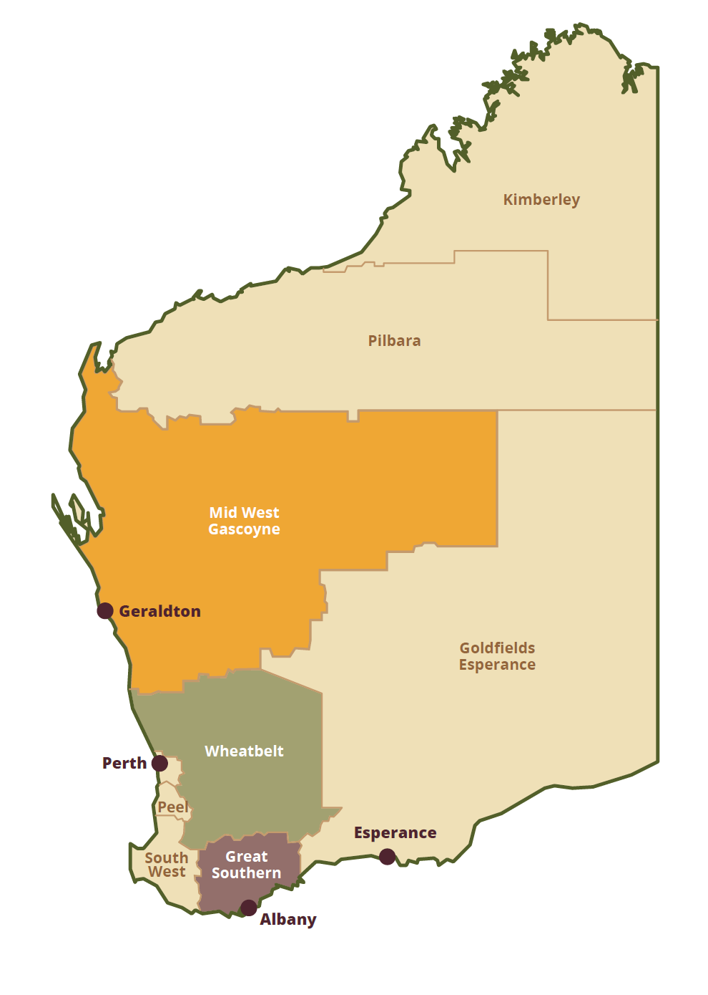

Source: Infrastructure WA 2014

Figure 4 WA sheep distribution, 2021

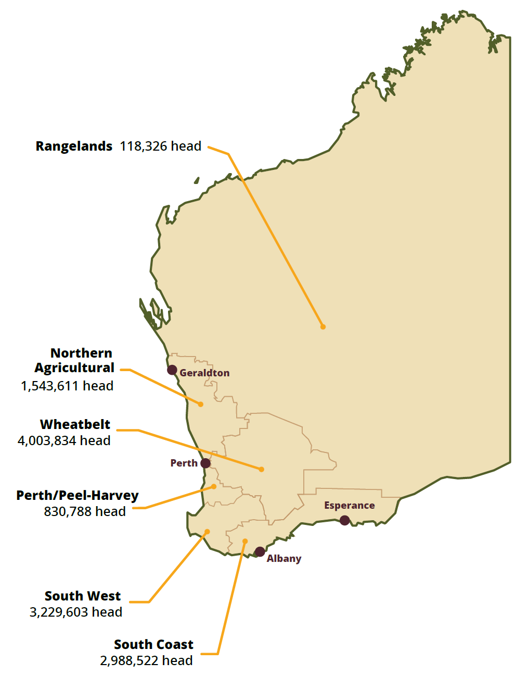

Source: MLA 2021

## Background

### Australian agriculture

Australia’s diverse agriculture, fisheries and forestry industries produce a range of crop and livestock products (Figure 5). Australia’s agricultural, fisheries and forestry production was estimated to be $98.4 billion in 2022–23, of which $92 billion was from agriculture (ABARES 2023b). Agriculture is a significant contributor to the Australian economy and contributes around 2.4% of Australia’s value-added gross domestic product (GDP) (ABARES 2023i).

Figure 5 Agriculture, fisheries and forestry value of production (2022–23 real value), by commodity, 2000–01 to 2022–23

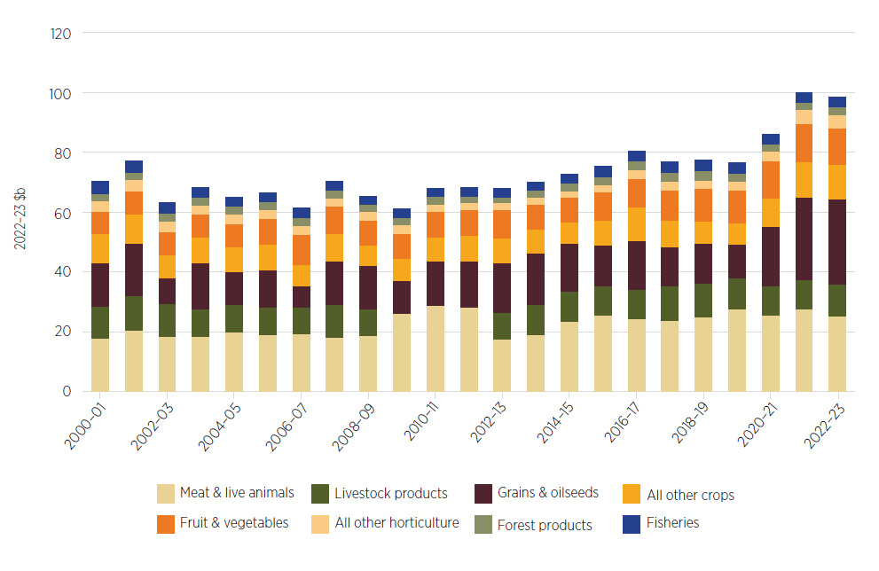

Note: Values are measured at the farm gate prior to processing. Livestock products include wool, milk, eggs, honey and beeswax.

Source: ABARES; ABS

In 2021–22, there were approximately 87,787 agricultural businesses with an estimated value of agricultural operations of $40,000 or more in Australia (ABS 2023a). This includes approximately 31,488 businesses that held sheep (ABARES 2023c).

#### Australia’s agricultural exports

Australia exports around 70% of the total value of its agricultural, fisheries and forestry production (ABARES 2023i), with the value of exports reaching a record $80 billion in 2022–23 (ABARES 2023j).

Grains, oilseeds and pulses have been the fastest-growing export segment, growing at an average annual rate of 12% in value terms between 2002–03 and 2022–23, followed by other horticulture (excluding fruit and vegetables) (5%), and meat and live animals (4%) (ABARES 2023i).

Australia exports agricultural products to almost 200 destinations, with particularly strong trade to countries across Asia. By value, Australia’s top 3 agricultural export destinations in 2022–23 were:

* China ($16.8 billion)
* Japan ($6.5 billion)
* the United States ($5.9 billion) (ABARES 2023j).

In 2021, Australia was the world’s second-largest exporter of wheat, the largest exporter of barley, the largest exporter of greasy wool and the fifth-largest exporter of live sheep in terms of quantity (FAO 2023). In 2021 Australia was also the largest exporter of sheep meat in terms of volume and value (WITS 2023).

### Australia’s sheep industry

Sheep arrived in Australia with the First Fleet and famously became more populous than the country’s people. Australia’s prosperity was said to ‘ride on the sheep’s back’, with sheep and shearing deeply ingrained in our national story. The sheep industry continues to contribute to many rural economies.

In 2022–23 Australia’s sheep industry accounted for approximately 10% ($7.98 billion) of the total value of agricultural, fisheries and forestry exports through the export of wool, sheep meat and live sheep (ABARES 2023j), comprising:

* sheep meat ($4.5 billion)
* wool ($3.4 billion)
* live sheep exports by sea ($76.9 million)
* live sheep exports by air ($8 million) (ABARES 2023b).

In 2019–20 sheep meat surpassed wool as the most valuable export of Australia’s sheep industry (Figure 6).

By comparison, Australia’s 2 most valuable agricultural export commodities in 2022–23 were wheat ($16.7 billion), and beef and veal ($10.7 billion) (ABARES 2023a, 2023b).

Figure 6 Value of Australian exports for sheep meat, wool and live sheep exports, 1988–89 to 2022–23 (real value)

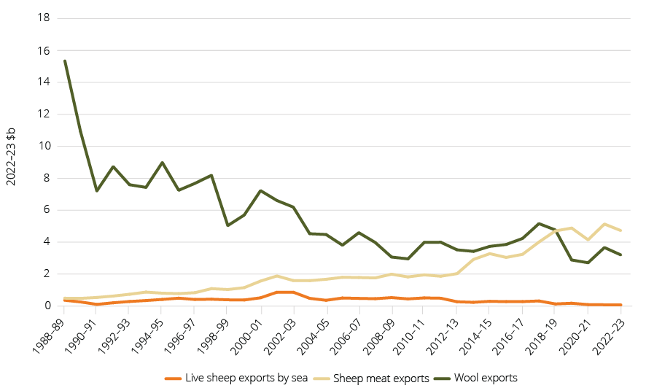

Source: ABARES; ABS

### Wool

Merino sheep were imported to New South Wales in 1797 and by the late 1800s wool had become Australia’s major export (NMA 2023).

Historically wool production was the most valuable part of the sheep industry. The price of wool fell following the removal of the reserve price in 1990, and since then many wool producers have transitioned towards sheep meat production or other agricultural activities or have exited farming.

Australia remains one of the world’s largest wool producers, supplying around 25% of greasy wool sold on the world market and producing the majority of the world’s Merino wool (DAFF 2022c). Most of the wool produced in Australia is exported to China for processing, with over 80% of Australian wool produced (by volume) in 2022–23 headed for China (ABARES 2023j, AWI 2023c).

### Sheep meat

Sheep producers have increasingly changed their focus from wool to sheep meat production (MLA 2015b). This growth has been supported by strong global demand for sheep meat and a continued move towards high-value lamb products (DAFF 2023e).

Sheep meat encompasses a range of products including prime lamb and mutton. Australians are some of the largest per capita consumers of sheep meat in the world, at approximately 6 kg per person annually (MLA 2023d). The domestic market consumes about 35% of Australia’s total sheep meat production (MLA 2023d). Australian consumer preference is strongly in favour of lamb, which accounts for 95% of domestic distribution. Most mutton produced in Australia is exported to overseas markets (MLA 2023d).

#### Sheep meat export markets

Australia is the largest sheep meat exporter by volume and value in the world (WITS 2023, DAFF 2023e). Victoria is the top sheep meat exporting state, despite having a smaller flock than New South Wales (14.6 million and 27.2 million head respectively as at 30 June 2022) (Figure 7).

Australia is the world’s largest exporter of edible sheep offal and sheep skins, for which China is the major importer. Australia is also the largest exporter of tallow and the third-largest exporter of meat meal (FAO 2023).

Figure 7 Australian sheep meat exports, by volume and state, 2022–23

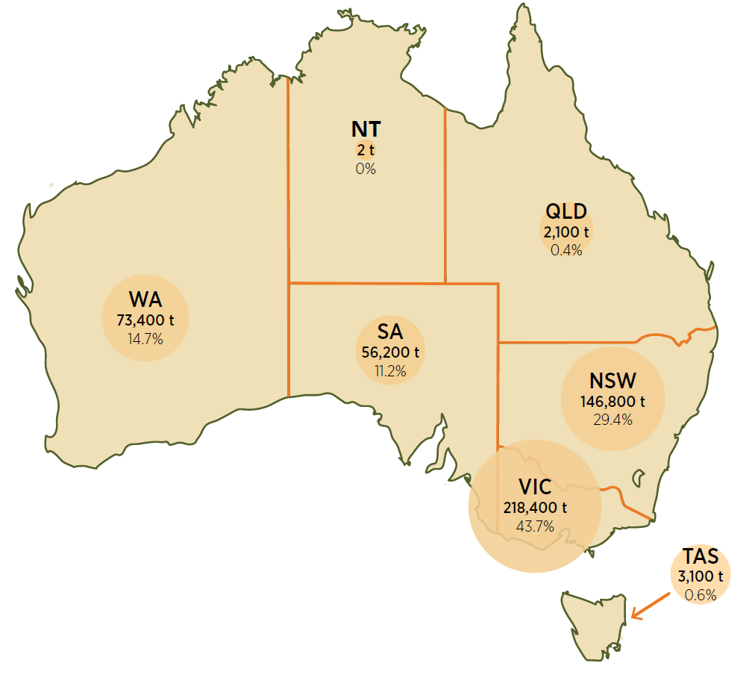

Note: Data is representative of port of export and not animal state of origin. The percentages do not add to 100 because re-exports account for 48.7 kt (9%) of the volume of Australian sheep meat exports.

Source: ABARES; ABS

As discussed in Markets, Australia’s top sheep meat export markets are China, North America, the Middle East and South-East Asia, with strong growth into markets such as the Republic of Korea and Japan. China is Australia’s largest mutton export market, and the United States is Australia’s largest lamb export market (MLA 2023d) (Figure 8).

Figure 8 Australian sheep meat exports, top destinations in 2022–23, and percentage change from 2021–22 to 2022–23

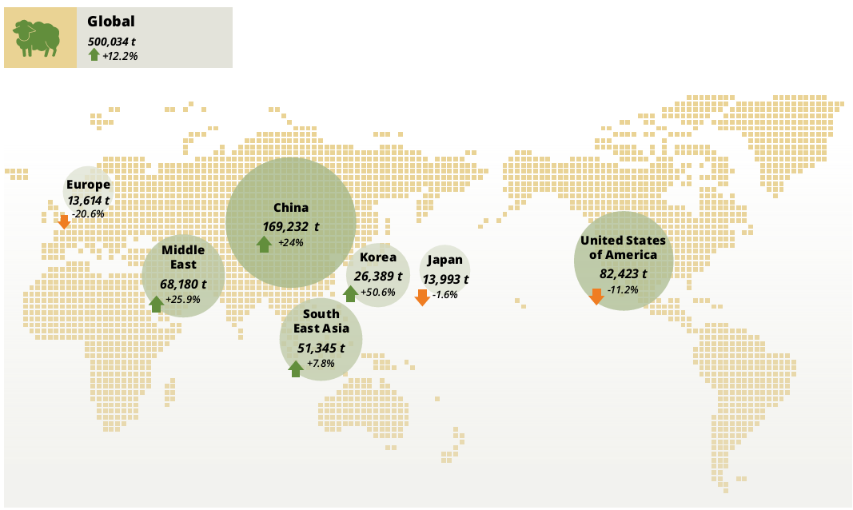

Source: ABS

Figure 9 Australian sheep meat exports, by volume and value, 2000–01 to 2022–23

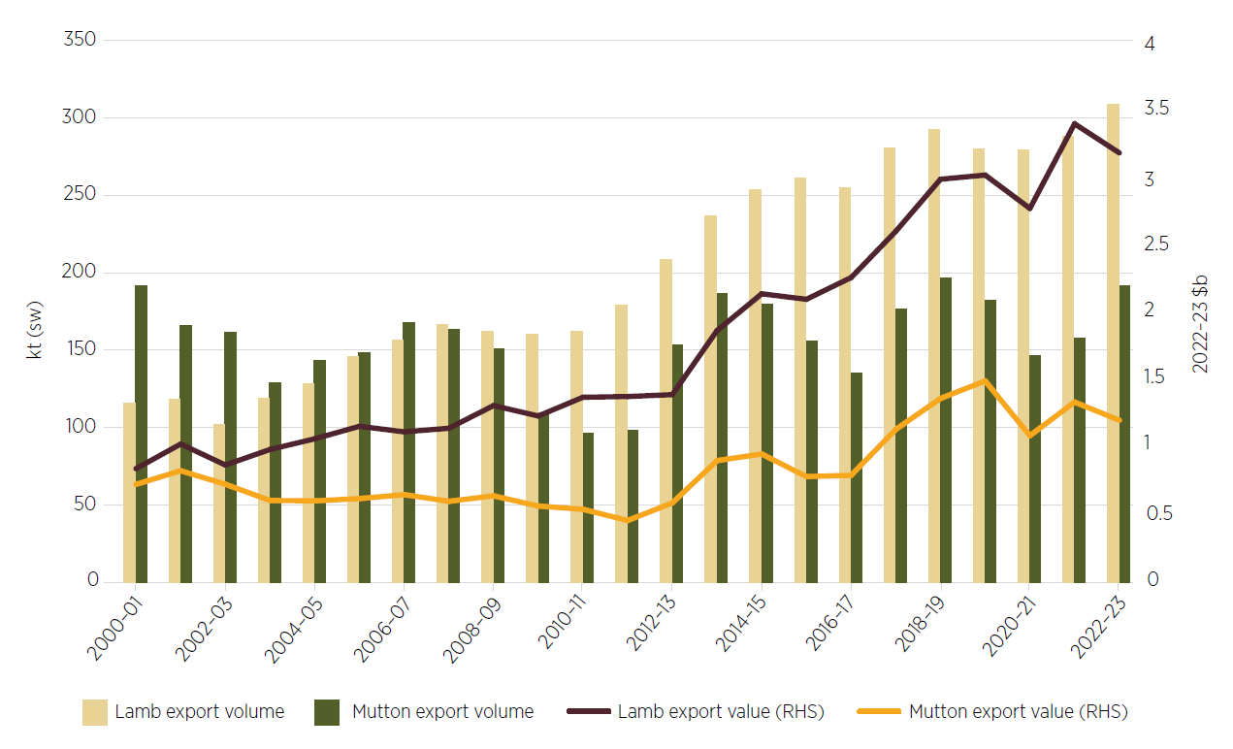

Note: ‘sw’ is slaughter weight.

Source: ABARES; ABS

Global demand for sheep meat, and specifically Australian sheep meat exports, continues to trend upwards in both value and volume (Figure 9). Australia’s export opportunities are increasing through strong trading relationships with high-consumption growth markets, and trade agreements including the Australia–United Kingdom Free Trade Agreement and Australia–India Economic Cooperation and Trade Agreement.

Markets highlights changing consumption trends and forecast demand to inform trade and market advancement opportunities. These observations emphasise the need to protect existing trading partnerships such as China, MENA (the Middle East and North Africa), North America and South-East Asia; but also to capitalise on newer markets in India and Sri Lanka and the EU.

### Live sheep exports

#### The live sheep export industry in Australia

Australia exported live sheep as early as the 1830s but it was not until the 1960s, with the introduction of ships with greater capacity, that the industry expanded (Petrie 2019). Australian live sheep exports grew substantially during the 1970s, as rising incomes and population growth resulted in increased meat demand from the Middle East (Deards et al. 2014). At its peak in 1983 the Australian live sheep industry exported 7.3 million head of sheep (Deards et al. 2014).

Australian live sheep exports have reduced significantly over the past 2 decades (Figure 10) (Dalgleish & Agar 2019) as alternative income sources, including cropping and domestic slaughter, have become more profitable. Australia changed its regulatory rules for live export in 2019 with the introduction of the Northern Hemisphere Summer Prohibition, which also contributed to a reduction in the overall volume of live sheep exports by sea (see Australian Government live export regulatory activities).

In 2022–23 Australia exported around 676,000 live sheep by sea and air (including approximately 652,000 by sea), valued at $84.9 million (ABARES 2023j). This represented 1% of the total value of Australia’s sheep meat and wool exports, and around 0.1% of the total value of Australia's agricultural exports (ABARES 2023h). Approximately 664,000 live sheep were exported from WA in 2022–23 (including approximately 652,000 by sea), valued at more than $80 million. This represented 6% of the total value of WA sheep meat and wool exports, and around 0.5% of the total value of WA agricultural exports (ABARES 2023j).

Since 2020 all sheep exported from Australia by sea have been exported from the Port of Fremantle in WA (DAFF 2023b).

Figure 10 Australian live sheep exports by sea, 2001–02 to 2022–23

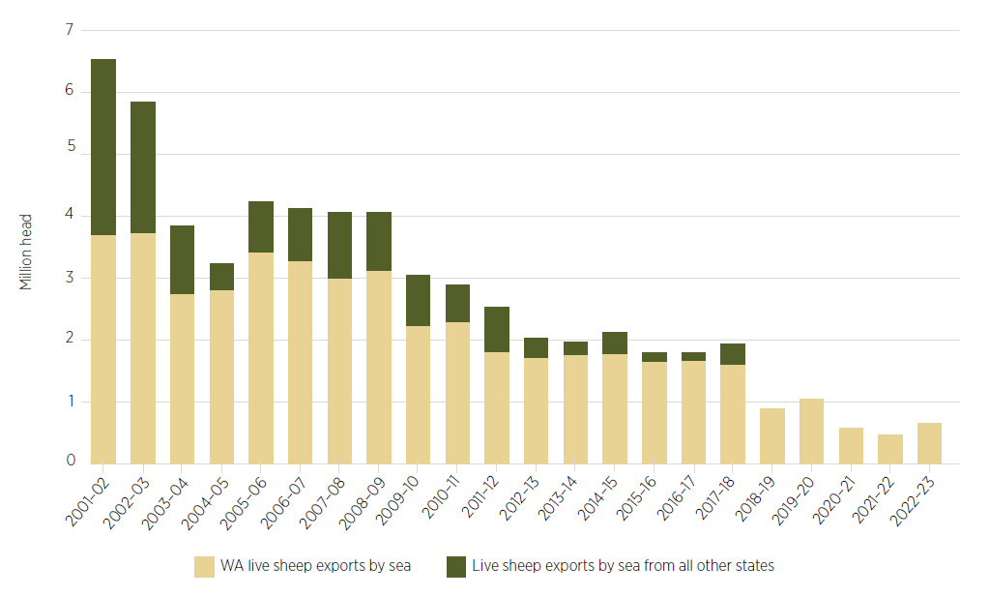

Source: ABARES Trade Dashboard

In 2022–23 Australia’s 3 most valuable export destinations for live sheep transported by sea were Kuwait, Israel and the United Arab Emirates (ABARES 2023h). Australia’s largest export market for live sheep by sea is Kuwait, but the volume of this trade has decreased from 1.1 million sheep in 2010–11 worth $136 million (not adjusted for inflation), to almost 292,000 sheep in 2022–23 worth $35 million (ABARES 2023j) (Figure 11).

As live exports by sea have reduced, so too have the number of destinations. Saudi Arabia has not imported live sheep from Australia since 2012–13, while Bahrain last imported live sheep from Australia in 2015–16. Both Saudi Arabia and Bahrain imported boxed meat from Australia at the time of ending live sheep imports and continue to do so. Figure 11 shows the decline in export markets from more than 10 destinations in 2010–11 to 6 in 2022–23.

Figure 11 Volume of live sheep exported from Australia by sea, 2010–11 to 2022–23

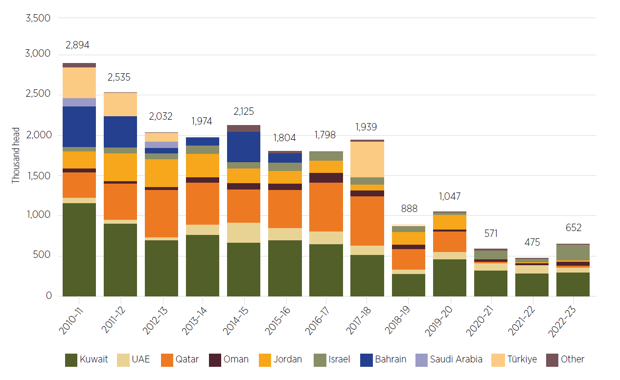

Source: ABARES Trade Dashboard

##### Multi-species voyages

Single-species voyages are the most common method used to export livestock from Australia. Exports consisting of 2 or more species are sometimes used to suit the commercial requirements of importers. The most common multi-species livestock shipments are for cattle and sheep. This is discussed further in Sheep supply and value chains.

#### Live sheep exports supply chain

The supply chain for live sheep exports goes beyond exporters and producers: it includes livestock agents, shearers and wool agents, veterinarians, ship owners and operators, livestock transporters, stock feed growers and manufacturers, and others involved and employed in or alongside the trade (see Figure 23 in Impacts).

#### Animal welfare

Many people in the Australian community continue to be concerned about the treatment of sheep during exports by sea and about conditions in importing countries. A range of reviews of the live sheep export trade have been undertaken following specific incidents and in response to community and regulator concerns.

The reviews have led to greater regulatory requirements, such as the introduction of the Exporter Supply Chain Assurance System (see Australian Government live export regulatory activities) and increased animal welfare standards. The Australian Parliamentary Library’s extensive ‘Live export – a chronology’ identifies key events in Australia’s animal welfare regulation (Petrie 2019).

### WA agriculture industry

WA is a significant producer of meat and livestock, dairy, wool, horticulture and honey products as well as being the nation’s largest grain-producing state. Agriculture is WA’s second biggest export industry after minerals. Around 80% of the state’s agricultural production is exported (DPRID 2023c). In 2022–23 WA exported an estimated $16.3 billion in agriculture, fisheries and forestry products (ABARES 2023j). Asia is the destination for about 70% of the state’s agrifood exports (DPIRD 2023j).

The WA grains industry is the largest contributor to the sector, with wheat ($6.6 billion), canola seeds ($3.2 billion) and barley ($2.0 billion) being the main crops (DAFF 2023f). Figure 12 shows the decreasing contribution of sheep (meat, wool and live exports) to WA’s agricultural exports in contrast to the growth in overall value of WA agricultural exports. A notable factor in the large increases in overall value in 2021–22 and 2022–23 was high grain export values, which were underpinned by good seasonal conditions and high global prices.

Figure 12 Contribution of sheep (live exports, sheep meat and wool) to WA agricultural exports

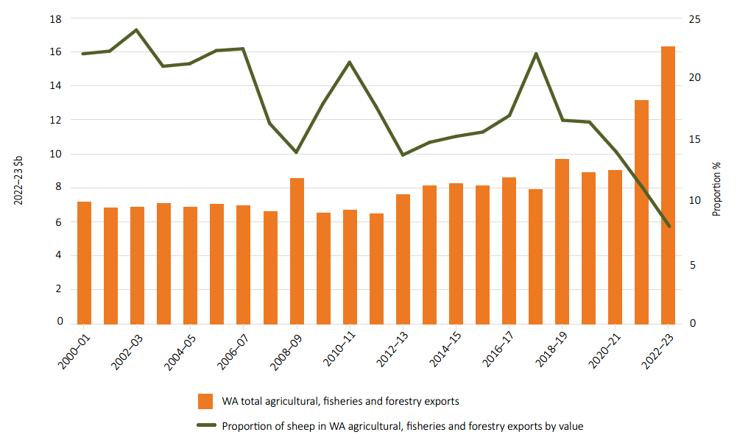

Source: ABARES Trade Dashboard

### WA sheep industry

Sheep have long been a part of the WA agriculture sector. Both the number of WA sheep farms and the size of the WA sheep flock have fallen over the past 3 decades (Figure 13). The reduction in the sheep flock has corresponded to an increase in the area under cropping (Figure 14).

Figure 13 WA sheep flock and sheep farm numbers, 1997–98 to 2021–22

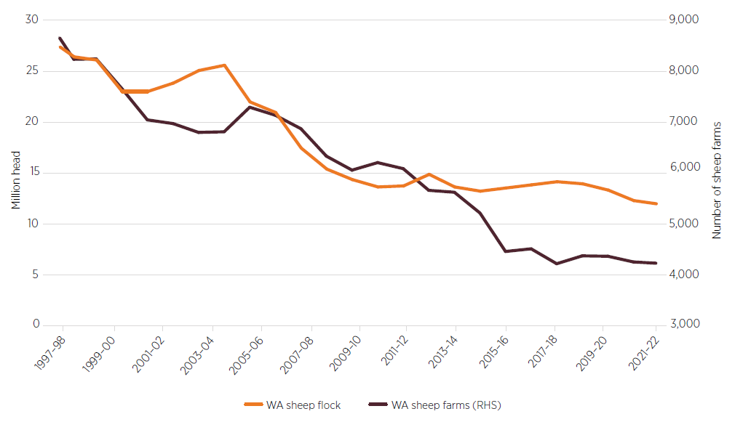

Source: ABS

Figure 14 WA sheep flock versus cropping area, 1989–90 to 2021–22

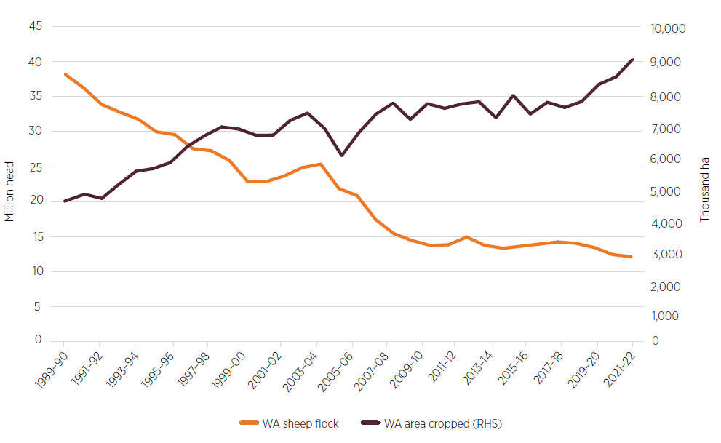

Source: ABARES; ABS

In 2021–22 there were 8,233 commercial-scale agricultural businesses in WA (ABS 2023a). Of these businesses, the ABS estimates that 4,281 had a sheep flock and ABARES estimates that around 4,000 had a sheep flock of at least 100 (a rough lower bound for commercial-scale sheep farming) (ABS 2023a, ABARES 2023c). Of these 4,000, around 2,200 are specialist sheep farms that derive at least 50% of farm receipts from sheep meat and/or wool but may also derive income from other livestock or cropping. The other 1,800 farms with at least 100 sheep are mixed farms primarily deriving their income from cropping (ABARES 2023c) (Figure 15). See Glossary for definitions of farm types.

Figure 15 WA farm businesses, by type, 2021–22

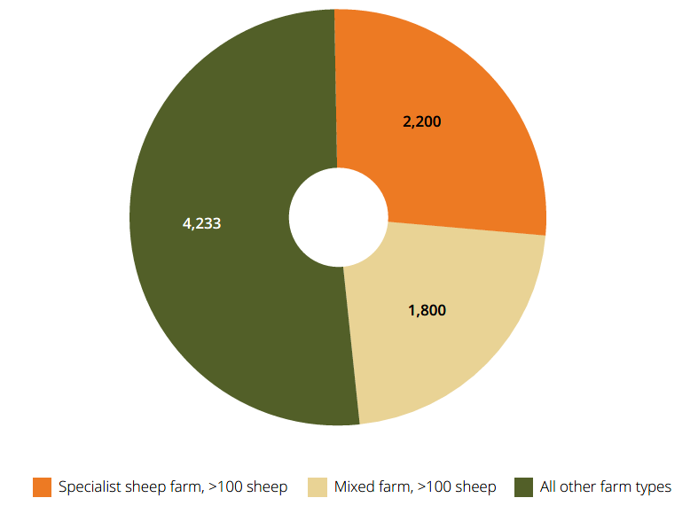

Source: ABARES 2023c; ABS

#### Sheep farm incomes

Wool production in WA has reduced over the past 2 decades, while sheep meat and cropping production have increased. As shown in Figure 16, there has been a marked increase in the profitability of cropping relative to sheep production in WA in the past 10 years (ABARES 2023h).

Figure 16 WA farm business average rate of return (including capital appreciation), by farm type, 2009–10 to 2021–22 (real value)

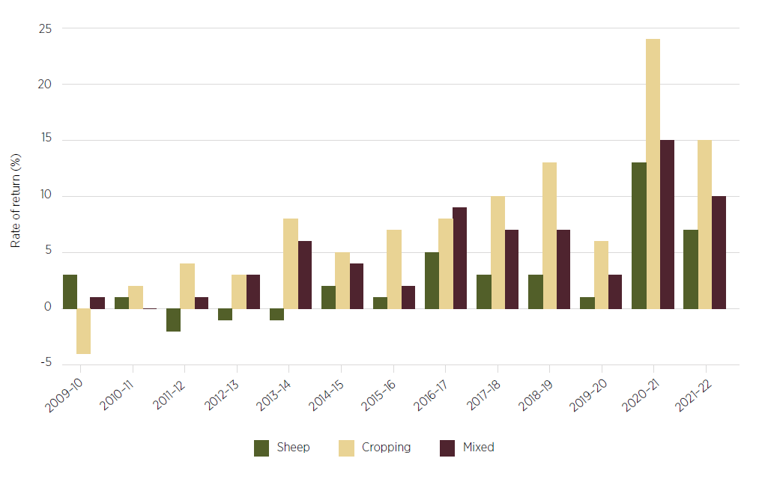

Notes: ‘Mixed’ denotes mixed livestock–cropping farms. Per farm averages, expressed in 2022–23 dollars. Calculated by expressing profit at full equity as a percentage of total opening capital. Rate of return represents the ability of the business to generate a return to all capital used by the business, including capital that is borrowed or leased. Figure 16 has no bar line for farms where the rate of return is zero (that is, the farm covers costs but makes no profit).

Source: ABARES 2023e

#### Sheep in WA

Sheep in WA are concentrated in the south-west of the state, with 80% contained in the Wheatbelt (31.5%), South West (25.4%) and Great Southern (23.5%) regions (MLA 2021) (Figure 3 and Figure 4). Very few sheep remain in the rangelands areas. Most sheep in the state are farmed in a mixed farming system producing sheep and crops (DPIRD 2023h).

#### Flock overview

In 2021–22 the WA flock was 12.4 million head, approximately 50% lower than in the early 2000s (DPIRD 2023h) (Figure 14) and dramatically lower than at its peak of 38 million head in 1990 (Ashton & Russell 2003). This reduction in sheep numbers occurred before many of the current live export animal welfare requirements were introduced. Merino sheep make up 80% of the state’s flock, with the remainder being meat-specific breeds such as Dorper (DPIRD 2023e).

The composition of the WA sheep flock has evolved over the past 2 decades, with more lambs and fewer wethers, largely in response to the growing demand for lamb to process as sheep meat (DAFF 2016, DPIRD 2023h) (Figure 17). These changes are reflected in the rise of sheep meat exports and the drop in live exports and wool production.

Figure 17 Composition of the WA sheep flock (%), 2004–05 to 2021–22

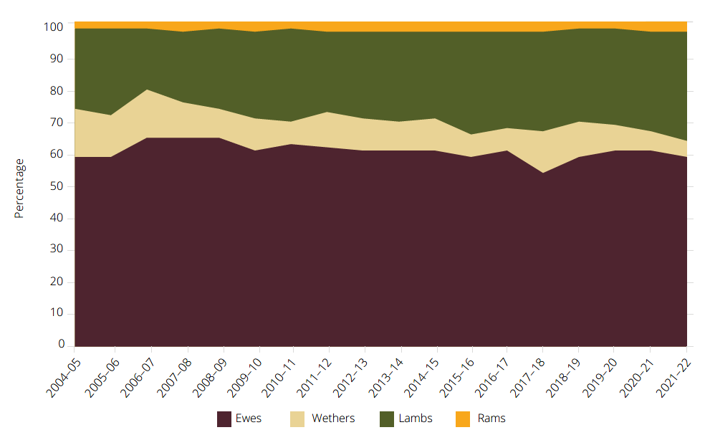

Note: Reflects the composition of the WA sheep flock at 30 June in each respective financial year.

Source: ABARES 2023e

#### WA mixed farming system

Sheep are commonly used in mixed enterprises in WA to provide a useful break in the cropping cycle and graze stubble after grain harvest, while taking advantage of the Mediterranean climate favoured by Merinos (DAF 2016). Use of sheep promotes sowing legume-based pastures in rotation with grains and oilseeds, thereby contributing to improved soil health, reduced reliance on synthetic inputs, and better weed management. The non-grain income stream is considered a useful risk management tool by many producers, particularly where sheep are used to graze land not suited to cropping.

In the rangelands and other non-arable land, sheep are used to help manage pasture and weed growth and provide a useful income stream.

The prevalence of mixed cropping–sheep enterprises in WA leads some producers to balance their activities to avoid peak periods in grain and livestock coinciding. Figure 18 describes some typical seasonal activities on a WA mixed farm with sheep.

Figure 18 Typical seasonal activities in a WA sheep and cropping enterprise

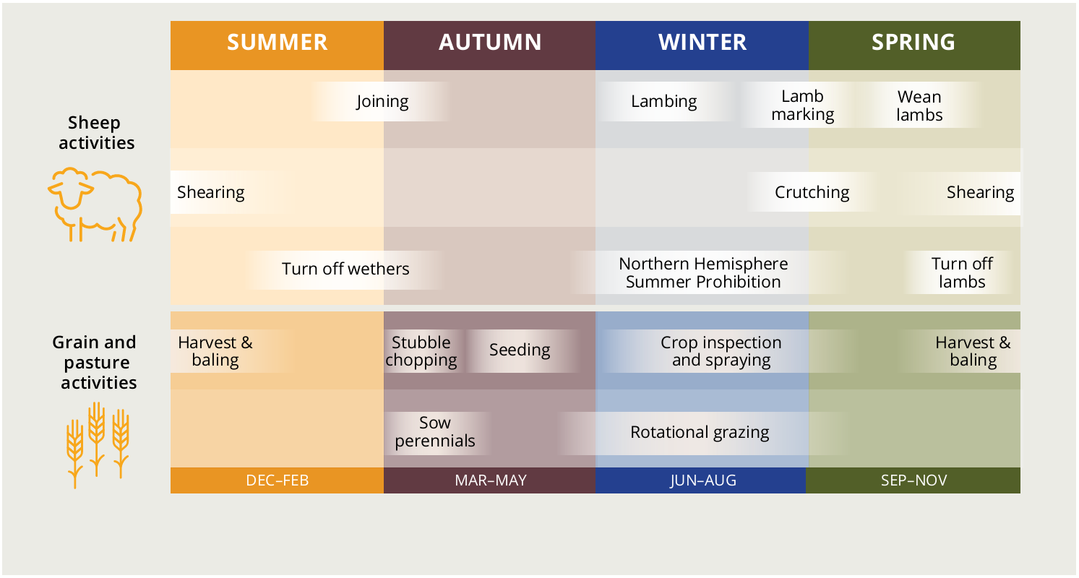

Note: Activities will not be identical for every enterprise. Climatic variation, disease cycles, business plans and personal preferences, among other factors, can all influence the operations and timing used. Shearing may also occur in autumn for sheep being exported live by sea.

#### WA sheep industry exports

In addition to its live sheep exports, WA also exports wool and sheep meat. The value of WA’s wool exports exceeds the value of its sheep meat exports, although since 2019–20 the difference in value of these 2 commodities has been very small. In 2022–23 exports of wool were valued at $694 million, and sheep meat at $649 million. In 2022–23 WA supplied 20% of Australia’s total value of wool production ($3.4 billion). Around 91% of wool from WA is exported to China.

Figure 19 shows that live sheep exports continue to decrease as a proportion of WA’s total export value from the sheep industry. In 2022–23 live sheep exports by sea from WA were valued at $76.9 million and accounted for 5.4% of the total export value from WA’s sheep industry.

Figure 19 Value of WA live sheep, sheep meat and wool exports, 1988–89 to 2022–23 (real value)

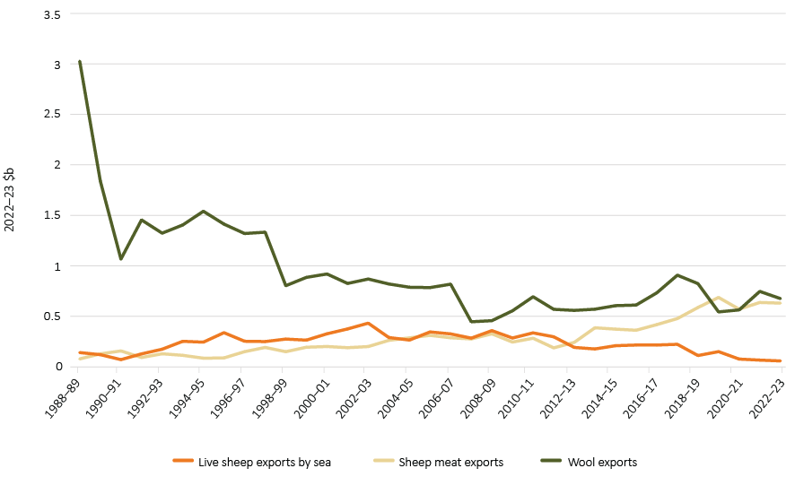

Source: ABARES; ABS

#### WA sheep meat industry

The decreasing proportion of live sheep exports in WA’s total export value is also borne out in the sheep turn-off. As shown in Figure 20, the emphasis on live exports has lessened since the introduction of the Northern Hemisphere Summer Prohibition in 2019 (see Australian Government live export regulatory activities). The increased numbers of sheep turned off to slaughter in 2022–23 reflects a range of factors including lambing rates, flock increase, seasonal conditions and relative price movements (see Sheep supply and value chains).

Figure 20 WA sheep turn-off, 2010–11 to 2022–23

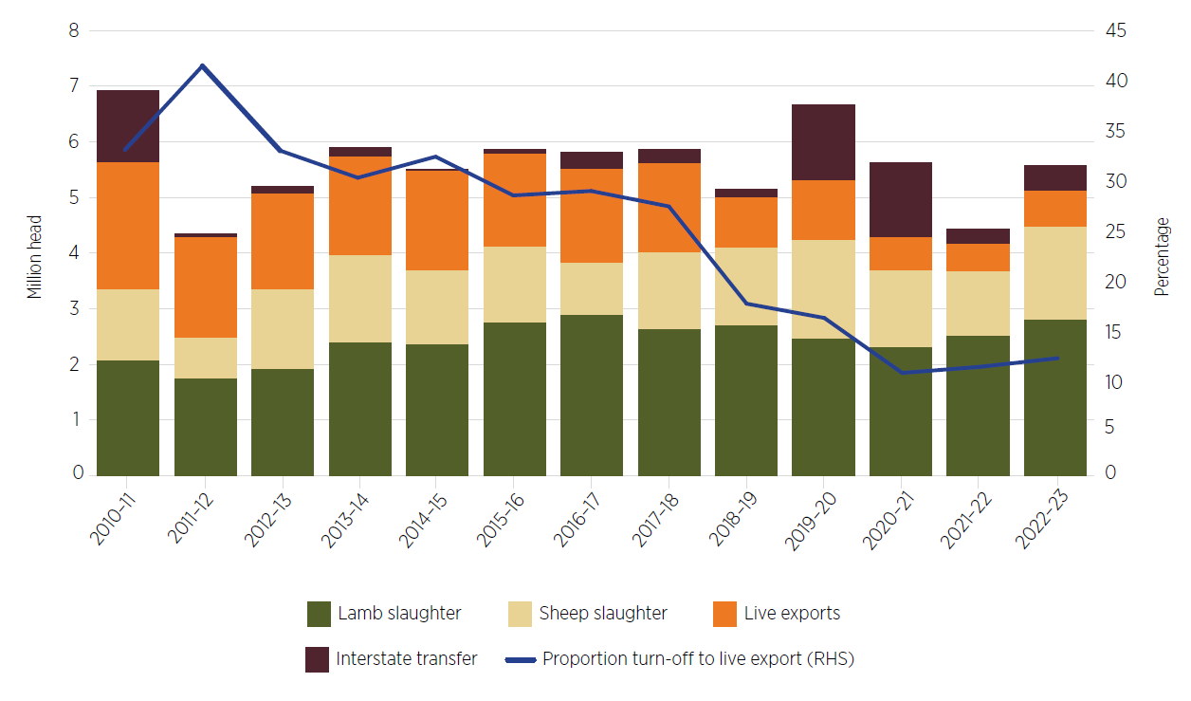

Source: ABARES

There is a long-term trend for WA mutton and lamb prices to track below the national prices (Figure 21). As noted in Markets, Australia’s sheep meat prices are heavily influenced by global prices and economic circumstances.

Figure 21 National versus WA sheep indicator prices (mutton and lamb), 2000 to 2023

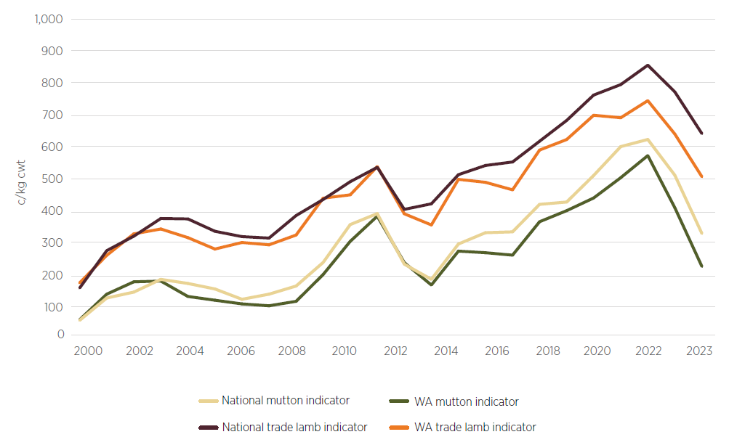

Note: Monthly data was averaged to determine a yearly average for each indicator.

Source: MLA 2023b

### Community overview

The main sheep production regions are based in or near communities in the south-west of WA, roughly from Geraldton in the north-west to Esperance in the south-east and inland to Merredin (Figure 4). The Great Southern, Mid West–Gascoyne and Wheatbelt Regional Development Australia (RDA) regions of WA (Figure 3) comprise the local government areas (LGAs) most involved in the live sheep export trade. Key centres or towns in these areas include Albany, Bunbury, Esperance, Gingin, Katanning, Kojonup and Narrogin (RAI 2023). Community issues for these areas are discussed in Individuals and communities.

#### Occupations

These communities include workers in fields directly related to sheep production, including livestock farmers and farm workers; mixed crop and livestock farmers and farm workers; shearers; other animal husbandry contractors; and other workers in the supply chain and transport logistics. Figure 22 shows the number of people employed in occupations related to sheep farming in the Great Southern, Mid West–Gascoyne and Wheatbelt regions.

Figure 22 Employment by sheep farming occupation in Great Southern, Mid West–Gascoyne and Wheatbelt regions, 2016 and 2021

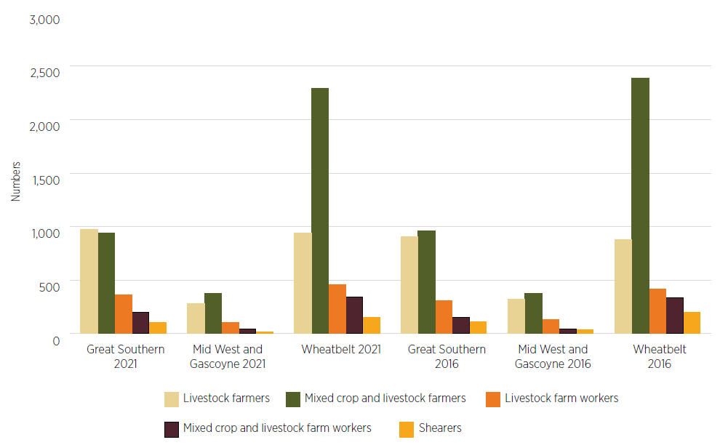

Source: RAI 2023

Some LGAs have over half of their working-age population employed in the agriculture, fishing and forestry sector (Table 2). These LGAs tend to be more sparsely populated, as they are in regions where agriculture remains a primary source of employment and economic growth. LGAs that are more densely populated, such as Albany or Greater Geraldton, have a more diverse spread of employment across industries.

Table 2 LGAs with highest employment proportion in agriculture, fisheries and forestry sector, 2021

| Region | LGA | Employment in agriculture, fisheries and forestry (%) | Number |
| --- | --- | --- | --- |
| Great Southern | Kent | 67.2 | 166 |
| Cranbrook | 56.1 | 286 |
| Mid West–Gascoyne | Mingenew | 50.8 | 94 |
| Murchison | 47.6 | 20 |
| Wheatbelt | West Arthur | 60.9 | 229 |
| Chittering | 56.7 | 89 |

Source: RAI 2023

Other industries such as mining, construction, tourism and healthcare also make up a significant proportion of regional employment and contribution to regional economies. For the Great Southern, Mid West–Gascoyne and Wheatbelt regions, the agriculture, fishing and forestry sector features in their top 3 sectors (Table 3).

Table 3 Top 3 industry sectors by output (percentage of total economy), 2022

| Region | Sector | Output (% of total economy) |
| --- | --- | --- |
| Great Southern | Agriculture, fishing and forestry | 19 |
| Manufacturing | 14 |
| Construction | 13 |
| Mid West–Gascoyne | Mining | 19 |
| Construction | 8 |
| Agriculture, fishing and forestry | 6 |
| Wheatbelt | Agriculture, fishing and forestry | 25 |
| Mining | 25 |
| Construction | 7 |

Source: RAI 2023

The labour dynamics of these areas are further explored in Sheep-processing labour.

#### Population

All 3 focus regions have experienced low but consistent growth from 2018 to 2022. This growth has been driven by natural increase (births), net internal migration (from elsewhere in Australia) and net migration from overseas.

Larger LGAs have experienced growth in their working-age populations (Table 4); by contrast, more sparsely populated LGAs have seen reduced working-age populations (Table 5). Future workforce availability and retention will depend on and be steered by LGAs having a sustainable working-age population.

Table 4 and Table 5 demonstrate the localised nature of population variation.

Table 4 LGAs with working-age population growth in Great Southern, Mid West–Gascoyne and Wheatbelt, 2018 to 2022

| Region | LGA | Growth rate (%) | Population number change |
| --- | --- | --- | --- |
| Great Southern | Albany | 3.4 | 166 |
| Plantagenet | 2.7 | 286 |
| Mid West–Gascoyne | Mount Magnet | 31.7 | 94 |
| Greater Geraldton | 1.4 | 20 |
| Wheatbelt | Wandering | 25.3 | 229 |
| Chittering | 6.6 | 89 |

Source: RAI 2023

Table 5 LGAs with working-age population decrease in Great Southern, Mid West–Gascoyne and Wheatbelt, 2017 to 2021

| Region | LGA | Growth rate (%) | Population number change |
| --- | --- | --- | --- |
| Great Southern | Kojonup | −3.7 | −42 |
| Gnowangerup | −5.0 | −41 |
| Mid West–Gascoyne | Murchison | −38.1 | −40 |
| Upper Gascoyne | −37.5 | −60 |
| Wheatbelt | Westonia | −41.4 | −84 |
| Corrigin | −18.0 | −122 |

Source: RAI 2023

## Impacts

The Panel acknowledges that removing the option of live sheep exports by sea will have an impact on those involved in the WA sheep supply chain and dependent communities. However, confidently quantifying those possible impacts is challenging. This chapter discusses the types of impacts and the groups most likely to be affected by the end of live sheep exports by sea. The Panel has received input from a variety of sources and considered data and analysis alongside information collected from the consultation process (see Consultation and stakeholder views). This chapter provides a range of possible impacts resulting from the end of live sheep exports by sea.

Three variables were consistently highlighted as being key to the degree and range of impacts likely to be felt due to the cessation, flock size, flock composition and prices for sheep meat and wool. Mitigating potential negative impacts resulting from changes to each of these variables will be important to avoid substantial negative impacts from the cessation. The Panel has identified 4 action areas to support the WA sheep industry: farm businesses, sheep supply and value chains, sheep processing labour, and markets. Strengthening these areas will help support individuals and communities and position the industry for the future.

### A changing and challenging context

Agricultural producers operate in a constantly changing environment. Seasonal conditions, prices, macroeconomic settings, government policies and geopolitical issues all fluctuate and have a bearing on the industry at multiple points along the supply chain. In this challenging context, producers are adept at making changes, taking advantage of opportunities, and seeking to minimise negative impacts.

The live sheep export trade from WA is itself an example of WA producers adjusting. Since the 1960s producers and exporters have taken a market opportunity to focus more on the Middle East, a trade that has served them for many decades. Other examples of adaptation include low (or zero) till agriculture, water-efficiency measures and improved crop and livestock genetics.

These changes have been accompanied by demographic and structural changes at the farm level. As highlighted in Background, the number of farms in WA has been decreasing, while the size of those farms has increased. Consolidation and economies of scale have been delivered through greater use of technology and innovation, in turn reducing reliance on human labour. This is just one of many reasons why rural communities often bear the brunt of change, with fewer individuals and families remaining to help sustain local services, businesses, schools and sporting teams.

#### Low sentiment in the WA sheep industry

The Panel heard many comments about the low sentiment and confidence in the WA sheep industry at the time of its consultations. Producers spoke of the reduced prices for sheep they were receiving compared to the previous year. This drop was not confined to WA but was occurring in sheep and livestock prices across the country due to a build-up of sheep on farm and deteriorating seasonal conditions in some WA regions and eastern Australia. These market and seasonal changes were weighing on producers who were making difficult decisions, such as destocking, in advance of forecast dry conditions, leading to increased supply of available sheep, which could further depress local prices. The Panel is concerned that these factors are being conflated by some stakeholders with the policy commitment, which is exacerbating current low industry sentiment.

In 2023–24 the gross value of production of sheep meat in Australia is forecast to fall 14% to $3.9 billion (ABARES 2023g). Prices for mutton and lamb have been decreasing in WA since their respective peaks in July 2021 and February 2022, and nationally they have been falling since July and September 2021 respectively. Anticipation of the end of live sheep exports by sea is further contributing to industry concerns in WA, even though the trade has not yet closed, the date for the cessation of the trade has yet to be determined, and price reductions are occurring nationally.

Another source of concern raised by producers during the Panel’s consultations was the difficulty of accessing space in abattoirs and the backlog of stock that producers were unable to move off farm. Data published by the ABS shows that WA processors slaughtered nearly 4.5 million sheep and lambs in 2022–23. This was more than 20% above the previous year and the highest level since 2008–09. In 2022–23 nearly 5.6 million head of sheep were turned off in WA through domestic slaughter, live export and west–east transport, 26% higher than WA’s 2021–22 turn-off.

#### Animal welfare considerations

The Panel’s consultations identified a group of stakeholders who were distressed by the treatment of sheep throughout the live export process, from when they leave Australia to the point of slaughter. The end of live sheep exports by sea will benefit these stakeholders and the welfare of Australian sheep.

### Identifying potential effects

The impacts of the end of live sheep exports by sea will be felt along the supply chain, in varying ways and degrees. The Panel has sought to understand these impacts while noting there will be differences among businesses, individuals and communities, including differences due to factors such as rainfall zones, enterprise mix and reliance on live sheep exports by sea.

Throughout its consultations the Panel heard how the end of live sheep exports by sea may impact a range of stakeholders. The need to consider the interconnected relationship between wool, sheep meat, the live export trade and grain production was emphasised, to ensure that unintended consequences for businesses along the supply chain are avoided. The need to consider the unique characteristics of farming in WA was also regularly raised given the differences between the east and west coast farming systems. The challenge highlighted was that WA abattoir capacity is limited and that increasing it would require addressing a range of factors.

#### Businesses in the sheep supply chain

The sheep industry supply chain has many participants, some of which are represented in Figure 23.

Figure 23 Sheep supply chain

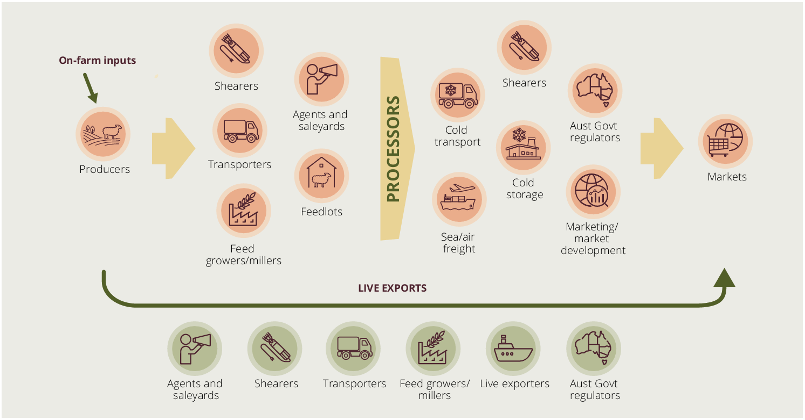

Note: This is a simplified representation of a supply chain to show the key elements discussed in this report. It does not capture all on-farm activities or all the businesses involved at each step of the process.

Drawing on insights from Episode 3, the Panel expects that a limited number of individual businesses will have significant exposure to the live sheep export trade or a limited ability to reorient their business. This is due in part to the large reduction in export volumes that has occurred over the last decade and particularly since the introduction of the Northern Hemisphere Summer Prohibition and the transitions that producers and supply chain businesses have made in response.

Businesses supporting the live trade that may be significantly affected include feed millers supplying pellets to live sheep vessels, shearers who shear sheep before they go on ships, livestock transporters and live exporters. However, as highlighted in Figure 24, Episode 3 found that no businesses surveyed relied on the live sheep export trade for greater than 50% of their income, including exporters.

The Panel notes that all supply chain businesses have been operating in an environment of decreasing sheep exports and adapting their businesses accordingly. The Panel sees that ongoing adjustment will be important for these businesses to lessen the impacts of the cessation, including to uphold business function and value.

In the coming years there may be an increase in opportunities for feed millers to further reorient their businesses towards supplying feedlots established to support the local processing industry and other animal production. Shearers will still be required if the sheep flock size, composition (ewes/lambs/wethers), breeds and genetics remain close to current levels. There will, however, be a drop in demand for shearers currently operating at pre-export premises.

Figure 24 Reliance on the live sheep export trade, by participant category, 2018 and 2023

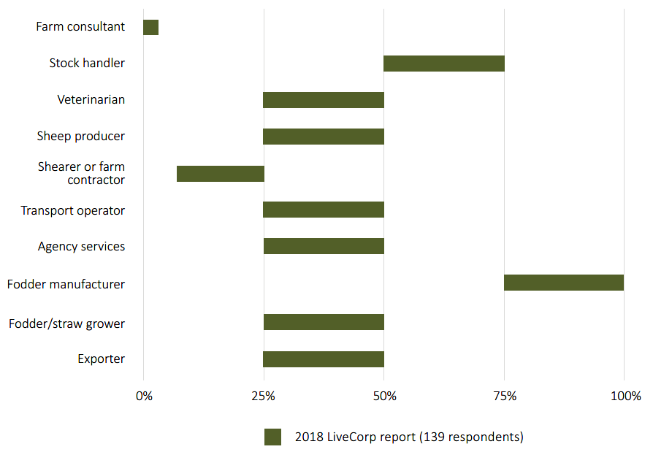

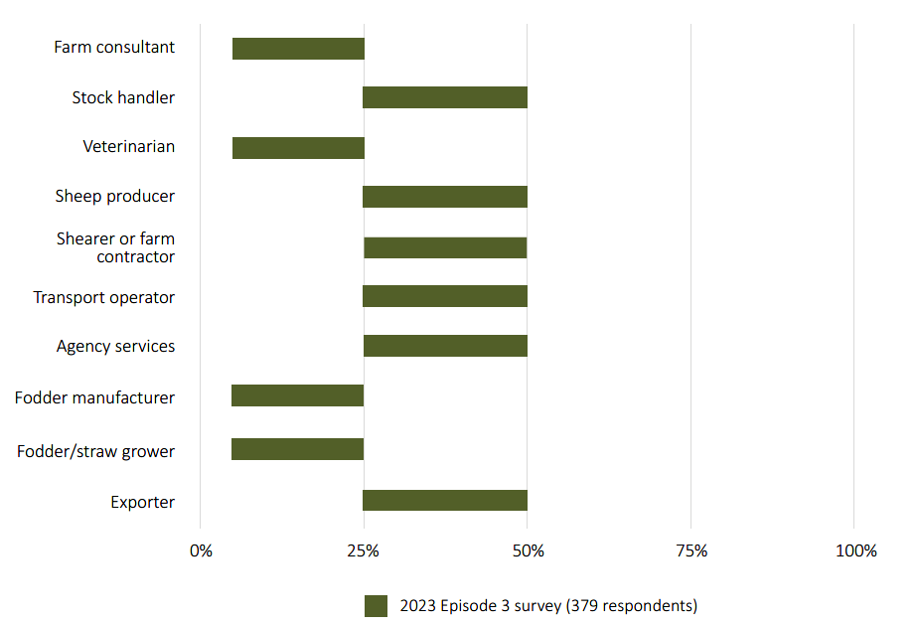

Source: Dalgleish, Whitelaw & Lean 2023

Livestock trucking businesses will also be affected by the end of live sheep exports by sea. A sheep that is being exported will be transported on average 3.5 times, compared to a sheep that will be processed in WA which is moved 1.5 times (Dalgleish, Whitelaw & Lean 2023). There is a shortage of truck drivers across the economy and there is an opportunity to shift these drivers and businesses into other transport sectors. The Panel notes this could create social dislocation and economic hardship for the livestock businesses that have a large dependence on transporting sheep. There will also be impacts for the small communities where these transport businesses are based. Some livestock trucking businesses may be able to adjust from moving sheep to live export preparation facilities to instead moving sheep to feedlots or processors, or could increase their transportation of other species and/or reconfigure their trucks to enable them to move other products. This may result in the sale of livestock crates, though possibly at a reduced price.

The impacts on exporters will be lower for those that are also involved in the live cattle trade or have other source countries for sheep or other business interests in Australia. Some exporters and cattle producers will need to reconsider their existing use of mixed shipments from Fremantle Port as they prepare to transition out of any reliance on sheep shipments. In 2022–23, 35% of all cattle that departed from Fremantle were exported with sheep, compared to 65% on cattle-only vessels. Of the cattle that travelled to the Middle East from Fremantle in 2022–23, 25% were exported on cattle-only vessels, compared to 75% exported with sheep (DAFF 2023d) (see Figure 29 in Sheep supply and value chains). The cessation will disrupt these businesses, but the Panel notes that cattle-only export shipments could continue and increase in the absence of live sheep exports but that supply chain changes may be required to support this trade.

Sheep producers will need to, at a minimum, update their planning or reconsider their supply chains – even those that have not been using live exports. This planning will need to reflect the new operating environment to include considerations such as when to turn off sheep, potential wider use of feedlotting, and how they can best produce sheep to meet processor specifications. These actions are explored in Farm businesses and Sheep supply and value chains. Some sheep producers will be more exposed to the cessation including but not limited to pastoral small stock producers, producers that are unable to convert to cropping, Merino ram production businesses, producers that need to turn off large numbers of stock at once, particularly those that deliver all their sheep to live exporters.

Other supply chain businesses will also need to plan effectively for when live sheep exports by sea cease.

#### Individuals and communities

Individuals and communities dependent on sheep production or live sheep exports by sea will experience an adjustment with the shift away from live sheep exports by sea and will need to be supported through this change. The level of impact will vary among communities. The Panel expects that in areas where there is minimal change in the overall sheep flock size and its composition, there will be fewer impacts. However, if the sheep flock contracts considerably, especially if it goes beyond the WA Government modelling of a 15% drop over the 10-year horizon from 2025 to 2035 (Box 1), the individual and community impacts in sheep-producing regions could be expected to be more pronounced.

The decisions of farm businesses in response to the pending end of live sheep exports by sea will have a significant impact on their communities. If most sheep producers elect to continue with sheep production, the flow-on impacts will be reduced for associated industries such as shearers, transporters and animal husbandry contractors. Conversely, if producers cease farming sheep in favour of grain or exit farming, this could affect the number of people and families in small towns.

As noted in Background and Individuals and communities, the WA regions that supply the live sheep export trade have experienced mild population growth, with net internal migration and natural growth (births) the main drivers (RAI 2023). Despite this population growth, these areas have experienced labour shortages, a common issue across many parts of Australia. If individuals exit their current work due to a drop in demand for services, it is expected they will have other options open to them, due to their transferable skills or the availability of occupations with low entry requirements. The Panel notes that change could still be difficult, unsettling, could lead to a loss of community connection and costly for these individuals if they are required to relocate. These individuals may require specific support through the transition.

For producers, farming is closely tied to identity, housing and lifestyle (RAI 2023). If producers no longer view sheep farming as a viable option, there could be a significant emotional, practical and financial upheaval.

#### Individual wellbeing

The uncertainty regarding the end of live sheep exports by sea is adding to concerns already discussed. These combined factors can impact on the mental health of individuals who feel they have a lack of control over these decisions and limited opportunities for the future. The Panel heard of similar periods of increased supply and low prices, particularly during the 1990s following the end of the Wool Reserve Price Scheme. In consultations, the Panel heard from producers who at the time took the drastic action of shooting sheep, which was more economical than keeping or selling them. For some, the fear of experiencing this again is likely to further impact mental wellbeing.

Farming is a physically demanding way of life with long hours and often carried out in isolation. There are many external stressors which can compound and result in significant stress and anxiety. A concerning statistic from the first national study of farmer suicide rates is that one farmer dies by suicide in Australia every 10 days. This equates to a suicide rate almost 59% higher than among non-farmers (NHRA 2021).

Limited access to mental health and other support services in rural and remote areas and the need to travel long distances to access support can magnify stressors. While there are increasingly more options for online and telephone counselling services, this is not always the preferred option and can be hampered where digital connectivity is an issue. Stigma around seeking mental health support also remains a barrier. Outreach and ensuring accessibility and awareness of services, including at community events to reach a wider range of people, are important elements of supporting individuals and communities to deal with the uncertainty.

The end of live sheep exports by sea will come in this complex context for producers and other businesses. As explored in Farm businesses and Individuals and communities, businesses and individuals that are more resilient will likely be able to better plan for, respond to and adapt to the cessation. Support for affected individuals and businesses will be important to underpin resilience in the transition period and beyond.

### Quantifying the impacts

#### Considering the range of research

The Panel examined a range of other reports that have considered the potential effects of the end of live sheep exports by sea or the potential or observed changes related to the Northern Hemisphere Summer Prohibition. These included those regularly cited in submissions to the consultation process:

* WA Government, Department of Primary Industries and Regional Development, submission to the Panel, July 2023
* Mecardo, *Value analysis of the Australian live sheep export trade*, September 2019
* Mecardo, *Impact of the live sheep export trade’s self-imposed moratorium and regulatory changes*, January 2020
* Mecardo, *Analysis of domestic fundamentals influencing the national sheep flock*, August 2020
* Pegasus Economics, *Economic implications of phasing out the live sheep export trade*, April 2022
* ACIL Allen, *Performance and value of the live sheep export trade*, August 2023
* ABARES, *The economic impacts of regulating live sheep exports*, February 2021.

The Panel commissioned advice from Episode 3 on the potential impact of the end of live sheep exports by sea on the WA sheep industry supply chain, and strategies to minimise the impact on stakeholders. In addition, the Panel appointed the Regional Australia Institute (RAI) to conduct research on the WA regions most likely to be affected by the phase out to capture potential impacts and transition considerations at a community level. The Panel used these reports, previous studies, available data and research on the trade, and information provided in submissions, meetings and consultations.

These reports and commissioned work are underpinned by differing assumptions and time frames which make a direct comparison difficult. The lack of agreed baseline data is amplified when additional forecasts or extrapolations are made, such as for supply chain impacts. The report predictions have limitations such as:

* using a transition period that is shorter than the government’s minimum period – that is, before the end of this term of the parliament
* existing in a steady state or using a straight-line approach that does not consider market adjustments, seasonal conditions or other potential market disruptions that could happen before the end of the trade
* applying multipliers to data without external reference points
* considering industry settings prior to the introduction of the Northern Hemisphere Summer Prohibition.

The main findings of the reports listed Quantifiying the impacts are summarised in Box 1, focusing on flock size, economic impacts and labour impacts. The wide range of assumptions, the scenarios that flow from them and estimated impacts highlight the difficulty of being definitive about the size and nature of impacts likely to be caused by the cessation of live sheep exports by sea. Nonetheless, these studies provide insights into the possible impacts of the end of live sheep exports by sea. In some cases, the range of possible impacts is included to illustrate both the difficulty in forecasting and the potential consequences of the cessation.

Box 1 Summary of main findings of reports

The summaries in Box 1 are provided in the context of the Panel’s considerations and are not intended to be comprehensive overviews of each report’s content or conclusions endorsed by the report authors.

WA Government

The WA Government, through the Department of Primary Industries and Regional Development (DPIRD) provided a submission to the Panel that included a value-chain analysis to assess how WA farming systems could be impacted by the transition out of live sheep exports over a 10-year period (DPIRD 2023i). DPIRD considered the possibility of some land being reallocated to grain production to produce alternative scenarios. The analysis assumed a phase out date in 2025, which is the earliest possible date consistent with the Australian Government’s commitment that the trade will not end in the current parliamentary term.

**Assumptions:** In addition to the current situation (Scenario A), 2 scenarios were considered as a comparison to understand the impact of the cessation of live sheep exports on the WA sheep value chain.

**Scenario A:** Current flock of 12.4 million head, turning off 5.1 million sheep and lambs, of which 600,000 are exported live, and harvesting 53 million kg of wool.

**Scenario B:** No sheep are exported live and negative sentiments in the industry lead to a 15% drop in flock size over 10 years (to 10.5 million head) and harvesting 43 million kg of wool. Impacted producers do not reallocate land previously used for sheep production to another enterprise.

* Potential consequence of up to approximately $123 million annually (value added, which measures gross production value and gross and net value added) and a reduction of 690 full-time equivalent jobs (FTEs) along the supply chain – based on no reallocation of land assets to other purposes such as cereal cropping.

**Scenario C:** No sheep are exported live, leading to the same impact on the sheep and wool industry as Scenario B (15% reduction); however, farmers change their land use on 400,000 hectares of land that was previously grazed to grow a combination of wheat, barley and canola.

* Potential consequence of up to approximately $22 million annually and a reduction of 387 FTEs along the supply chain – based on reallocation of land to cereal cropping.

**Meat processing capacity:** Overall capacity calculated to be 471,200 head per month.

The submission concluded that sufficient time is crucial for the transition out of live sheep exports, to ensure adjustments can be made in the processing sector and along the entire supply chain. If WA is faced with an oversupply problem due to the phase out, prices are likely to drop and all sheep enterprises will experience reduced profits, not just those turning off to live export. Modelling indicates the greatest economic impact will be on sheep producers and on businesses directly supporting the sheep supply chain, from both an economic and an employment perspective. Importantly, the WA submission assumed a phase out by 2025, which would likely result in a more severe impact than would be felt with a longer transition period. Support, resources and a longer transition period are seen as critical to ensure potential risks are minimised and that WA farming systems remain diversified and sustainable.

Mercado

A value analysis of the Australian live sheep export trade was conducted in 2019 (Dalgleish & Agar 2019) and 2020 (Dalgleish, Agar & Herrmann 2020; Agar, Dalgleish & Herrmann 2020) to assess the economic benefit flowing from the live sheep export trade to participants in the Australian supply chain. It also included an economic analysis of the industry’s self-imposed 3-month moratorium, regulatory changes introduced in 2019, and farm-level decision-making options influencing national sheep flock numbers, with a primary focus on WA.

**Assumptions:** An employment multiplier of 3.32 was used to arrive at labour figures.

**Labour (direct):** 798 FTEs, based on the FTEs located in WA involved in live sheep exports.

**Labour (direct and indirect):** 2,651 FTEs located in WA involved in live sheep exports, based on an economic multiplier of 3.32.

The reports concluded that the full impact of the moratorium on the WA value chain would result in rationalisation in service sectors and equate to a loss of revenue to the farm gate in WA of between $9.3 million and $15.4 million during the 2018 season and between $7.3 million and $12.1 million during the 2019 moratorium season. The loss of revenue was not the only concern to businesses along the value chain; cited as additional strains were distorted workloads, cashflow issues, asset devaluation and competition for labour. The unique characteristics of the WA sheep industry highlighted the risk of moving away from wool and sheep meat production towards cropping, which would lead to less diversity in WA farm enterprises.

The job losses and economic impact described by Mecardo were not expressed in net terms and did not allow for individuals and businesses seeking alternative income sources in the absence of live exports. These impacts were also modelled on an immediate stop to the trade.

Pegasus Economics

An analysis of the economic impacts arising from the prohibition on live sheep exports to the Middle East during the Northern Hemisphere Summer Prohibition and the economic implications arising from a gradual phasing out of the live sheep export trade (primarily focusing on WA sheep farmers) was conducted in April 2022 (Davey, Fisher & Morley 2022). An earlier assessment of the economic issues associated with the WA live sheep export trade was undertaken in 2018. Pegasus was also commissioned in 2020 to provide economic analysis of the draft regulation impact statement to assess live sheep exports to or through the Middle East in the Northern Hemisphere summer.

**Assumptions:** The 2022 report used pricing from January 2010 until December 2021 and weekly price data from the Meat & Livestock Australia (MLA) Statistics Database in the same period. Prices were then converted into 2020 real or constant prices. The report assumed that the cessation of the trade will provide a redirection of some sheep to domestic processors, in time enabling them to raise capacity and employment levels. It is also assumed that the increased value adding from more sheep processing would improve economies of scale and increase employment of unemployed and/or underemployed people to generate higher economic growth and reduction in unemployment benefits.

**Economic:** $11.8 million price impact on WA sheep farmers in 2020–21, with an average cost per sheep farmer in the order of less than $2,800 in 2020–21. The increased value adding could be worth an additional $18 million, delivering a net benefit.

**Labour:** A cessation could facilitate the engagement of approximately 350 FTEs. In the 2020 review of the Draft Regulation Impact Statement, Pegasus found that if on-farm labour is allocated on the basis of total receipts received by activity, the total number of WA on-farm jobs directly attributable to the live sheep export industry falls from 798 (from the Mecardo report) to around 191, only 33 of which relate to hired labour.

The 2022 report concluded that the fact that the live sheep export trade was now one-third of its 2017 size in volume terms implied that most of the adjustment costs for WA sheep farmers to transition away from the live sheep export trade had already been incurred. It found that transition costs would be significantly reduced if the live sheep export trade were to be gradually phased out over time. It proposed 3 years, as this would give WA sheep farmers further time to adjust their operations.

ACIL Allen

A point-in-time estimate of the impact of ceasing live sheep exports was conducted in 2023 (ACIL Allen 2023). The 3 main outputs of the report were an assessment of the value and importance of the sheep industry supply chain to the Australian and WA economies, a point-in-time estimate of the impact of a cessation of the live sheep export industry’s activities, and an assessment of Australia’s key live sheep export markets.

**Assumptions:** The analysis was conducted using an average of the last 5 financial years (2017–18 to 2021–22). Two scenarios were analysed to quantify the impact of the cessation. It assumed an immediate (within 12 months) cessation of live sheep exports.

**Scenario 1:** No change to the current situation (Merino wether production system ‘as is’ or business as usual forms the baseline for comparison).

**Scenario 2:** The immediate cessation of live sheep exports, with and without price responses.

**Economic (direct):** The WA live export industry provides $45 million of value added annually. This measures the impact on wages and salaries, profits and indirect taxes, and measures the contribution to gross regional product.

**Labour (direct):** Employment of 152 FTEs post farm gate annually.

**Economic (indirect plus direct):** Between $62 million and $71 million value added annually.

**Labour (indirect plus direct):** Employment of between 200 and 249 FTEs annually.

**Real options analysis:** Estimated 19.19% or $21.84 reduction in the per head value of a male sheep in WA. If the cessation were to occur during a period of high supply and low demand, the price difference could be as high as 32.90% or $37.44 per head.

The report concluded that over the last 5 years the WA sheep industry, including sheep farming (meat and wool), feedlots, abattoirs and live exports, has on average directly contributed $737.2 million of value added annually and employed 1,770 direct FTEs. It forecasted that domestic prices paid for animals could respond quickly to market changes and that the cessation of live sheep exports should be expected to put downward pressure on prices, particularly with the assumption of no time for the industry to adjust resources.

Australian Bureau of Agricultural and Resource Economics and Sciences

The report provided (in 2021) an economic analysis of the likely impacts of restricting live sheep exports by the WA industry due to the introduction of the Northern Hemisphere Summer Prohibition (Nelson et al. 2021). It also compared its analysis with that commissioned by other groups. ABARES identified the potential financial effects on WA sheep farmers during the first 3 years of the prohibition. It noted that even if 50% of the number of sheep that were exported in 2017 were instead slaughtered domestically, the amount of sheep meat traded globally would only increase by 1.5%. This reflects the small size of the Australian live export trade compared to the overall sheep meat trade worldwide.

**Assumptions:** The report assumed that there was a sudden implementation of a 6-month prohibition restriction, with 25% of sheep in the first year that were to be live exported diverted to prime lamb production and 50% of sheep diverted in the following years to prime lamb production.

**Labour (direct):** Not assessed, although the report notes that increased feedlotting to meet processor specifications is likely to require additional staff compared to turn-off through live export.

**Labour (indirect):** Not assessed.

The report concluded that across WA farms, there would be forgone income loss of $68 million in the first year, $36 million in the second year and $12 million in the third and subsequent years. The reduction in losses would be due to farmers switching to alternative production or marketing strategies over time. The report also compared its forecast effects against those prepared by industry and animal welfare groups. It stated that those prepared by industry groups overstated the potential impacts and those by animal welfare groups underestimated the potential impacts compared to the ABARES forecast.

Episode 3

The report was commissioned by the Panel to outline the potential effects of phasing out live sheep exports by sea on WA farmers, businesses and other participants in the supply chain (Dalgleish, Whitelaw & Lean 2023).

**Assumptions:** The analysis was confined to alternative livestock enterprises and mostly avoided the interaction of those enterprises with the cropping program, as they are already occurring within the current sheep enterprise. Time frames assumed time for full implementation of changes such as the genetic changeover in flock composition. Episode 3 nominated 2 time frames for analysis:

**Short term (5–8 years):** Episode 3 proposed that this would likely result in a quicker adaptation to global market trends in some high-value markets favouring processed meat, and that short-term discomfort could lead to faster realisation of new market opportunities. It indicated that significant financial transition assistance would be needed but that the rapid pace may also result in more social disruptions and economic uncertainty, especially in regions that are heavily reliant on the live export industry. It noted that there are risks if markets are not developed in time and if expansion of domestic processing capacities does not occur quickly enough.

**Long term (8–12 years):** Episode 3 proposed that a longer time frame would provide for smoother shifts in business models, markets and supply chain adjustments but noted the risk of complacency with longer transition periods resulting in slower progress. This time frame would also allow for the full adoption of genetic changeover of the sheep flock and provide time to conduct research and field trials and to adopt findings for new production systems.

**Potential drop in flock size:** Across the main cropping areas in WA there is an estimated range of 3.3 million to 6.7 million head of sheep. Sheep producer intention surveys suggested that around 14% of farmers have indicated they will exit sheep farming due to the cessation. This could equate to a reduction in the flock in these regions of 450,000 to 900,000 head. Some producer intention surveys have suggested that the proportion of exits could be as high as 44%, which could result in a reduction in the WA flock of 1.4 million to 2.9 million head.

**Meat processing capacity:** WA processors were asked as part of the Episode 3 consultations to provide an estimate of their capacity under the assumption that access to labour (including accommodation) was not a barrier, offshore demand for their product was adequate and freight/logistics downstream of the plant were not problematic. The reported current limit for monthly slaughter rates in WA is 424,000 head, with potential monthly capacity of 560,000 head.

The report concluded that a gradual implementation phase is crucial and needs to be conducted over several years to allow producers and those in the supply chain to fully adapt. Identification of appropriate alternative industries that can provide the same flexibility as live sheep exports was also highlighted, including expansion of the sheep feedlot industry in WA, further development of the domestic processing industry, ongoing support for an eastern transportation corridor, and redevelopment of the air freight and sea freight sheep meat export capacity. A well-trained workforce ready for the transition, and financial compensation and government assistance were identified as helping to mitigate the economic impacts.

The timelines for this report did not reflect that producers and supply chain businesses have already made large adjustments, particularly since the introduction of the Northern Hemisphere Summer Prohibition. Assumptions about time taken to commence research and development trials do not allow for the large volume of research already completed by RDCs and its adoption by farmers.

#### Key variations in these studies

These reports forecast a wide spread of potential effects, particularly related to the employment and economic consequences.

The most severe impacts on the WA industry and communities are found in the Mecardo report, particularly its forecast of a loss of 798 FTEs in direct employment and 2,651 through the supply chain. There are 2 key limitations to note:

* The figure of 798 FTE jobs is based on the size of the WA industry prior to the reduction in export volumes since 2018.
* The figure of 2,651 FTE for supply chain employment is based on an economic multiplier of 3.2. This is significantly higher than the economic multiplier used in other reports by the Red Meat Advisory Council/MLA (which is the referenced source of this data), which range from 2.25 to 2.35 in subsequent reports.

The smallest forecast negative effect was in the ACIL Allen report which forecast impacts on discrete components within the live sheep export production system, along with forecasting an effect across a broad range of related businesses. However, the ACIL Allen report also identified that these impacts would arise from the live trade ending within 12 months, which is sooner than the government’s commitment to not have it end during the current term of the parliament. In contrast, the 2018 Pegasus report forecast a positive effect on employment.

#### A view to positive impacts

These studies generally do not express impacts in net terms and do not account for positive impacts such as market opportunities, efficiency gains or product diversification. While jobs may be lost in one part of the supply chain, there are opportunities in other areas, particularly an increase in employment to bolster meat processing capacity. For example, forecasts of impacts on supply chain businesses such as road transporters do not consider the potential substitution of transporting sheep to slaughter or increasing refrigerated transport. Likewise, investment in expanded processing facilities or accommodation for workers is likely to boost employment and economic growth in the impacted areas of regional WA. On top of meat exports, increased production of rendered products may generate further employment and value added for WA.

Table 6 and Table 7 are provided to summarise the data from the various reports but should be used with care given the different underlying assumptions and ways of expressing impacts.

Table 6 Forecast employment impacts expressed in reports

| Report | Direct labour (FTE) | Indirect labour (FTE) |
| --- | --- | --- |
| WA Government | Loss of 690 (with no reallocation of land)  Loss of 387 (with reallocation of land) | n/a |
| Mecardo | Loss of 798 | Loss of 2,651 |
| Episode 3 | Not quantified | n/a |
| ACIL Allen | Existing industry directly contributes 152 | Existing industry directly contributes between 200 and 249 |
| ABARES | Not quantified | n/a |
| Pegasus | Addition of 350 (2018) | n/a |

Note: Each report was based on different assumptions and is not readily comparable with other studies.

**n/a** Not applicable.

Table 7 Forecast economic impacts expressed in reports

| Report | Direct | Indirect |
| --- | --- | --- |
| WA Government | $123 million per year (no land reallocation)  $22 million per year (with reallocation of land) | n/a |
| Pegasus | $11.8 million price impact on WA sheep farmers in 2020–21 | n/a |
| ACIL Allen | Existing industry directly contributes $45 million of value added annually | Total (indirect plus direct) contribution for the existing live sheep export industry upper bound of $71 million value added annually and a lower bound of $62 million value added |
| ABARES | Forgone income loss of $68 million in the first year, $36 million in the second year and $12 million in the third and subsequent years | n/a |
| Episode 3 | Not quantified | n/a |

Note: Each report was based on different assumptions and is not readily comparable with other studies.

**n/a** Not applicable.

#### Using the analysis

All of the reports provided insights of value and were used to indicate a potential range of impacts or to support evidence of an impact. The Panel is aware that the forecast effects included in these reports are primarily based on assumptions, which can limit their utility.

The Panel has placed a greater weight on the analysis in the WA Government submission, in part due to its analysis including potential effects over time. It also accounts for the reutilisation of land and resources to the next highest economic value, which is underpinned by a depth of understanding of the WA agricultural system. The analysis provides a balanced consideration of the compounding issues affecting sheep producers, albeit assuming a 2025 phase out period.

The data and insights from the other reports were utilised where they identified specific insights such as an assessment of the range of indirect effects on employment or the proportion of a business’s exposure to live sheep exports.

Great care needs to be used in referencing and quoting from the range of past studies and the studies commissioned by the Panel. No single study or report provided a definitive answer, and caution needs to be taken in interpreting and extrapolating from these studies given their necessary reliance on simplifying assumptions (such as time until the cessation) and the great difficulty in assessing the inevitable market reactions that will occur following the government’s confirmation of the parameters of the phase out.

While the studies available to the Panel cannot accurately forecast the actions towards adjustment, they do provide a spectrum of possible outcomes ranging from large adverse impacts to positive impacts. The Panel is confident, however, that early action by governments to support the industry to transition to a new value chain without live export will minimise adverse impacts.

### Key variables influencing the strength of the WA sheep industry

The Panel recognises that there will be a variety of impacts from the end of live sheep exports by sea as identified through consultation and analysis of various reports. While the exact effects may be unknown, the Panel identified key variables that influence the strength of the WA sheep industry and supply chain. These are:

* flock size
* flock composition and changes
* pricing for sheep meat (lamb and mutton) and wool.

If these 3 key variables remain at viable levels and arrangements, the consequence to producers, the supply chain and communities will be more limited, and opportunities for improvements may become more evident. Conversely, a strong negative change in any or all of these variables will have social and economic consequences.

#### Flock size

In 2021–22 the WA sheep flock was 12.4 million head, having experienced a decline between the early 1990s and mid-2000s, since which there has been some stabilisation at around 12 million to 13 million head. In this context, the WA Government and Episode 3 modelled a potential reduction in the flock due to the cessation of live sheep exports by sea. The WA Government modelled this change over 10 years, noting that two-thirds of the reduction could occur in the first 2 years. Episode 3’s data was derived from producer intention surveys in which a proportion of contributors indicated they would stop farming sheep (Table 8).

Table 8 Modelling of flock size

| Category | WA Government | Episode 3 |
| --- | --- | --- |
| Percentage flock size change | −15% | −14% to −44% |
| Quoted head change | −1.9 million | −450,000 to −2.9 million |

Note: Episode 3 modelled the flock size in the main cropping areas of WA, not the entire flock.

#### Flock size risks

There are around 4,000 commercial-scale farm businesses in WA with a sheep flock of at least 100 (ABARES 2023h). For the 1,800 non-specialist sheep farms with at least 100 sheep, income is mostly derived from cropping, which has increased substantially in recent years (see Broadacre cropping). The WA Government submission identified that a shift to other income streams can offset some of the losses that may result from reducing sheep numbers or exiting the industry.

If, however, many producers exit sheep farming, a swift or large change in flock size would have flow-on impacts to allied industries and communities that currently rely on the trade for some aspect of their business and stability. The WA Government identified that – as became evident to the Panel – a decrease in the flock size is likely to have a negative economic and social impact not only on producers but on the entirety of the value chain. The Panel’s view, informed by these modelling efforts, is that a substantial or swift exit from the WA sheep industry should be avoided.

At a more indirect level, if the number of producers or allied businesses drops significantly, this could also translate to a lack of membership in community or industry groups. For example, producers and their families are often part of local sporting clubs that provide social benefits for the community. Likewise, producers and other supply chain businesses can help drive industry representative bodies. Operation of these groups and the engagement they provide could be weakened if individuals leave the sheep industry or their region. Substantial reduction in the capacity or capability of these groups will affect the support they provide to individuals and businesses and may contribute to poorer outcomes for communities or industries. The Panel notes this scenario assumes producers and other individuals in the supply chain leave the sheep-producing regions.

Producers typically adjust their flock size between years due to factors including expected seasonal conditions and forecast prices. If producers do not progressively consider and make changes to their flock during the transition period, they may find there are more consequences at the time of the cessation. For example, if producers choose to exit the sheep industry quickly when the live trade ends, there could be a risk of an excess of animals waiting for slaughter, leading to animal welfare and human mental health concerns. A flood of sheep onto the market would also put downward pressure on prices, potentially causing more farm businesses to move out of sheep, further adding to the price and slaughter capacity pressure.

#### Flock composition

Composition of the flock will influence the ongoing sustainability of the sheep and wool industry in WA. As highlighted in Background, the WA sheep flock has been changing over decades to a greater proportion of lambs and fewer wethers. This is largely in response to an increased demand for lamb, improvements in on-farm feeding and management strategies and a greater focus on meat production for the WA flock.

If there is a pronounced increase in the sale of breeding ewes in the WA flock due to the end of live sheep exports by sea, this would result in the current flock size declining and would decrease the ability to rebuild the flock in coming years. Indeed, 2019 modelling by WA DPIRD pointed to the breeding ewe as ‘the largest driver of flock productivity and growth’ given ‘the effect on the number of lambs available for slaughter and replacement, and the volume of sheep meat and wool produced’ (Pritchett 2019).

Producer sentiment regarding poor seasonal forecasts and the uncertainty about the transition date were reflected in the MLA and Australian Wool Innovation (AWI) Sheep Producers Intentions Survey in May 2023. The survey indicated that WA producer intentions will result in a drop in the number of breeding ewes by 18% in 2024, and wethers by 33% (MLA & AWI 2023b). Breeding ewes as at April 2023 comprised 68% of the total WA flock size, so an 18% drop would have a large bearing on present flock composition and future flock size.

The current WA flock consists of 80% Merino breed, so this shift to meat production has been managed with first-cross lambs rather than a substantial move away from Merinos. Wool is an integral part of the business model for most producers. Historically, adult sheep that are farmed for wool tend to be destined for the live sheep export trade given that this class of sheep is not desired by local processors due to their larger, leaner frame compared to other animals.

#### Flock composition risks

If the closure of live sheep exports by sea, in combination with other market conditions, brings about a significant drop in Merinos in the WA flock, this could impact negatively on WA’s wool production and income. With any large drop in wool production, there will be a ripple effect to allied industries associated with the trade, such as shearing and wool-handling services, and the communities that support them. Shearing sheep prior to live export is a requirement. The loss of this work will have a direct impact on those providing shearing services, many of whom have indicated they will exit the industry if work is not available throughout the season (Dalgleish, Whitelaw & Lean 2023). The WA Shearing Industry Association calculated that a reduced flock size of 2 million head of sheep, which is similar to the drop predicted by the WA Government, would result in 80 fewer shearers and 80 fewer shedhands, comprising 20% of the shearing workforce (WA Shearing Industry Association, Submission 500).

As identified in Sheep processing labour, the ability to attract and retain staff is not unique to the sheep supply chain and is an economy-wide problem. This has been felt most acutely in regional and remote areas where it can be more difficult to compete for workers given the pull of the mining sector, regional housing shortages and the small pool of workers to fill a range of unskilled positions. A further consideration if there is a shift away from Merinos is that there may be even greater pressure on processing capacity as more lambs are turned off each season. The need for improved processing options is explored in Sheep supply and value chains. There is the potential for people displaced from a role related to wool production to take up a different opportunity in the sheep value chain.

Additionally, stud breeders may experience variable effects depending on the breeds of rams they own. Those that have Merino rams may find demand and prices for their animals and services decrease, while those with meat breeds may find they have increased demand, provided the overall flock size is upheld.

#### Prices and price risks

There are multiple factors that influence pricing that are out of the control of producers, such as global demand, seasonal conditions and sheep supply levels. Navigating price fluctuations is not new for producers as they are largely price takers. The live sheep export market is small compared to the value of Australia’s global lamb and mutton markets (less than 2% in 2022–23), so converting Australia’s live sheep exports to sheep meat would not be considered to have a material impact on global supply or prices (ABARES 2023h). Even though WA’s sheep meat production and value have increased, there is a long-term trend in WA prices for mutton and lamb to track below the national prices (see Figure 21 in Background). As noted in Markets, Australia’s sheep meat prices are heavily influenced by global prices and economic circumstances.

There are activities that can help underpin prices or achieve better prices for stock even as the industry goes through change. These include better targeting of products to market preferences, which will require producers to make changes to their stock management (see Farm businesses and Sheep supply and value chains). Increasing demand for sheep meat globally and domestically may also help maintain prices (see Markets). Conversely, failure to understand the market dynamics and plan and act accordingly will magnify any negative effects.

The WA Government analysis sought to quantify some of the changes associated with better targeting the meat processing market. In the absence of live exports, farmers would derive the greatest income from Merino sheep by employing improved nutrition to quickly (10–12 months) grow Merino wether lambs to processing market specifications. Delays in meeting these requirements (and selling older, larger animals) or failure to sell into the heavy lamb market would lead to reduced prices and/or increased costs.

The removal of live sheep exports may encourage producers to destock, potentially placing downward pressure on prices. If a large price drop occurs, there is a greater risk of producers exiting sheep farming, leading to the economic and social consequences raised elsewhere. Price risks would not be confined to WA, as a sharp change in prices in the west may flow to prices for sheep producers elsewhere in Australia. These risks emphasise the need to rebuild confidence in the industry and uphold demand for sheep products through the market development activities described in Markets. If successful, these activities may support the ongoing success of the WA sheep industry, spurring producers to maintain, or even increase, their sheep flocks and avoid the negative outcomes that could otherwise occur.

### Looking to the future

The end of live sheep exports by sea is likely to see a range of behaviours. Decisions will be made around flock size and composition which will dictate the extent of impacts along the value chain. Adding certainty to the time frame for ceasing the trade and ensuring producers are aware of options throughout the transition will help individuals and businesses to make decisions that maximise their opportunity and avoid capital losses where possible. Episode 3 identified that most businesses now have no greater than a 50% reliance on live sheep exports by sea. The Panel cautions that this reflects an average across the whole industry, whereas some individual businesses may experience a greater impact depending on their use of live sheep exports by sea and their ability to change their business operations.

If confidence in the WA sheep industry remains low and the number of farms exiting agriculture is significant, the flow on economic and social consequences are expected to be far more severe. For this reason, the Panel recommends that early action is taken to rebuild confidence, avoid a rapid exit from the sheep industry and help maintain businesses and communities. It will be important to ensure sheep processing capacity exists to match the expected increase in sheep turn-off and to support growth in overseas markets. Maintaining a profitable sheep industry will lessen the effects on employment, particularly in allied industries such as shearing and animal husbandry, and any flow-on to regional communities. The size of the WA sheep flock and changes in domestic sheep prices will fluctuate and be determined in time by market forces in the transition to a new equilibrium. Investment in business planning and assistance to encourage increased processing capacity is also hoped to mitigate the risk of producers unnecessarily leaving the industry.

### Four action areas to strengthen the WA sheep industry and support individuals, businesses and communities

Exports of live sheep by sea were valued at $76.9 million in 2022–23. This figure is based on the sale of the sheep on a per head basis. Other benefits, such as employment, feed production and conversion to pellets, shearing prior to export, reduced processing waste on shore, operation of community businesses and social benefits are not included in this figure. The cessation of live sheep exports will have an impact at each of these points, potentially leading to greater impacts following the end of the trade, some of which were expressed in the reports cited in Considering the range of research.

Some of the studies reviewed by the Panel talk about substitution to other methods of production or other sources of employment. The degree to which the WA industry either maintains its existing sheep flock or shifts to other income sources – and the success of these changes ¬– will determine the severity of impacts felt by individuals, businesses and communities.

The Panel’s view, informed by the modelling, is that a substantial or swift drop in the WA flock size should be avoided and any fluctuations in flock composition or prices should be carefully monitored. The assumption about likely economic effect assumes that any flock reduction is within the 15% to 50% range – noting that if confidence in the industry is particularly low and a flock reduction occurs at the upper bound of the forecast range, the consequences would be far more severe for the WA sheep industry and associated supply chain businesses and regional communities.

The Panel has identified 4 action areas that need to be collectively addressed to support the ongoing functioning of WA’s sheep and wool industry and help drive the industry to a strong future:

* farm businesses
* sheep supply and value chains
* sheep processing labour
* markets.

Failure to address these action areas, or an unbalanced focus on one or more areas, is likely to see a greater contraction of the WA sheep flock, leading to social and economic impacts that would flow to more individuals, businesses and communities. Indeed, the more severe outcomes expressed by some stakeholders in the Panel’s consultations, and covered in some of the analysed reports, are more likely to be realised if these actions are not taken. These 4 action areas are fully addressed in subsequent chapters, alongside the opportunities presented by addressing each successfully.

## Farm businesses

### Strong businesses, strong industry

The live export trade has been a part of the WA sheep industry for many decades. The end of live exports by sea will require farm businesses to adapt their operations. A focus on these businesses is needed to promote a sustainable and profitable sheep industry and avoid a substantial exit from sheep farming, with the resultant economic and social impacts. The Panel’s view is that for the industry to grow in confidence, continue to navigate change and emerge stronger, efforts must start with farm businesses.

#### A volatile industry

The global operating environment requires farmers to be highly adaptive and implement strategies to plan for and manage risk. Farmers need to be resilient to climate, economic and supply chain risks, and manage in volatile global markets.

Agriculture has a level of volatility not experienced by other sectors. According to the Australian Farm Institute, farm business returns experience almost twice the volatility of other parts of the economy (AFI 2017). It is in this context that the end of live sheep exports poses another potential shock to the WA sheep industry.

### Resilience

Resilience is the ability to plan for, manage during, and recover from challenging circumstances. Individual resilience is the capacity of any individual to cope with stress, overcome adversity or adapt positively to change. The ability to ‘bounce back’ from negative experiences can reflect personal characteristics of individuals or can be the result of learning and experience. Both personal and business resilience can be built and can be eroded. This chapter focuses on business resilience, while individual resilience is considered in Individuals and communities.

A business’s starting point will greatly influence its ability to navigate change and adapt. For businesses and their owners, this could be about the business’s financial position, planning strategies including succession, diversity of income sources, professional networks, and the stage of life of the key members of the business.

The BCG Henderson Institute, a thinktank of Boston Consulting Group (BCG), highlights the starting point for businesses as being key to their ability to prepare for threats, withstand change, recover and then shape their business in the post-shock environment. Resilient businesses are those that will have these advantages in place ahead of time, helping them to achieve better and faster outcomes than non-resilient companies (Reeves et al. 2020) (Figure 25).

A business’s decisions and performance prior to any shocks will impact their ability to prepare for and be resilient to shock situations. For farm businesses, this could include previous performance or general access to capital. It may also extend to the business manager’s history of adaptation and willingness to interpret and act on market signals.

Figure 25 Resilient companies enjoy better outcomes on 3 fronts

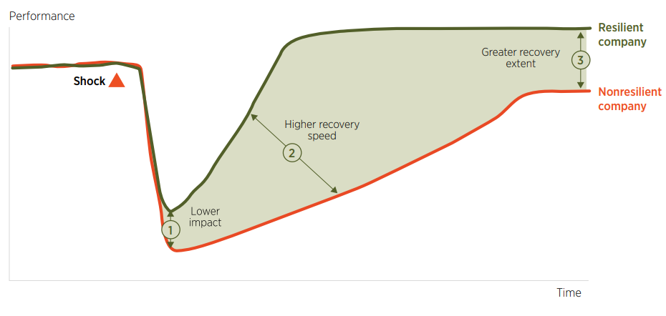

Source: BCG Henderson Institute

The Panel notes the importance of business resilience ahead of, during and after the end of live sheep exports by sea and to support businesses to adapt to change and manage impacts as constructively as possible. Any early supports would be aimed at reducing impacts from the end of live sheep exports by sea, speeding recovery and positioning businesses to take up opportunities for longer-term success.

### Changing production model

WA sheep producers use live exports in their production system as a readily available stock turn-off option. For some, the live export trade makes it easy to sell large numbers of sheep at once or the need to access large bookings in abattoirs. Other producers use live exports when stock do not meet specifications for processing, including older, leaner animals. Many producers consulted pointed to live exports as a risk management tool in dry seasons when large numbers of stock need to be turned off quickly. Transitioning away from live exports will impact these businesses and their operations.

There may be some businesses that are more vulnerable to the effects of the removal of live export as a trade option. This could include businesses with a greater reliance on the trade or businesses under financial stress. Less resilient businesses are likely to have fewer options and resources to adapt their business in a sustainable way.

Other businesses draw assurance from having the option of live exports if they need to turn off stock quickly, even if they use it infrequently. This includes farm businesses that use sheep to provide diversity in their business model and help manage production risks such as drought and frost, to manage grazing and rotation strategies or improve cashflow management. These businesses will need to refocus their planning for sheep turn-off during the transition phase and once the live trade ends.

The Panel observed that change has already occurred for many businesses due to the Northern Hemisphere Summer Prohibition. Producers now have fewer turn-off options available to them at some times of the year. Despite this, many producers have not yet adjusted their operations or expectations due to the high restocking demand from eastern Australia in 2019–20 and 2020–21. At the same time, broader worldwide market demand masked the impact of the prohibition and helped maintain high prices.

The Panel reflects that sheep production will remain an option for many producers following the cessation of live sheep exports by sea. The high rate of sheep slaughter in WA in 2022–23 points to opportunities for Merinos to be used in first-cross lamb enterprises, rather than requiring producers to exit Merinos altogether, which was a fear expressed in consultations. Submissions also pointed to the possibility of feedlotting or confinement feeding to help bring animals to slaughter specifications. Producers making these adjustments may benefit from expert input or advice to understand the necessary steps to achieve this transition. The Panel notes that the value chain concept would have particular benefit for these producers, especially if processors could convey their timing and specification needs to help producers best target slaughter bookings or price points. These ideas are further discussed in Sheep supply and value chains and Research and development corporations.

#### Early decisions and actions

Farm businesses need to plan and make forward-looking decisions surrounding their business model and business health. Decisions around livestock and cropping programs are influenced by a range of interacting factors including market pricing, input costs, seasonal forecasts and individual circumstances. Many producers plan their operations a year or more in advance to aid their resilience and build confidence in their long-run decision-making. According to the Royal Agricultural Society of WA, 40% of WA farmers use farm management consultants (RASWA 2023), contributing to a long-term and annual review and planning cycle in many farming businesses. This enables informed decision-making that considers both immediate prices and conditions and responds to long-range forecasts and risks.

It is crucial to equip producers to make production and business decisions soon and well ahead of the close of live sheep exports by sea. The Panel does not believe that producers should delay making decisions in the hope that the government policy to end the live export trade of sheep may be overturned. Instead, clear and early communication will enable producers to plan for the future. Indeed, the Panel recognises that producers are highly adaptive and have responded and others will respond to the announcement with strategies that address the risk of this policy to their businesses.

The Panel further considers the announcement and early actions in Managing the transition.

### Supporting businesses to be resilient

#### Planning and advice

In the context of resilience, the Panel wants to ensure that those who are particularly vulnerable to the end of the live export trade are supported to plan for change in their business. The preferred outcome is for producers and supply chain businesses to effectively plan for and look beyond the end of live sheep exports by sea.

As noted in Sheep supply and value chains, the Panel sees the opportunity for the WA sheep industry to better function as a value chain, rather than purely as a supply chain. One of the key aspects of shifting to a value chain is sharing information so each part of the chain is driving towards the sale of the product and adding value with every step. However, supply chain opportunities in the future will be different for each business.

The Panel sees value in ensuring farmers and other businesses reliant on live sheep exports can effectively plan for the future, drawing on specialist advice or training to consider the different aspects of their enterprise and production system. There are some existing initiatives in these areas (Appendix 5). These include the Farm Business Resilience Program provided through the Future Drought Fund and in partnership with the WA Government, funding provided to Farm Household Allowance recipients to access training and/or professional advice, and the Rural Financial Counselling Service. Research and development corporations also offer courses such as Making More From Sheep (a joint MLA/AWI program) and Lifetime Ewe Management (AWI) to grow producers’ production and business management skills.

The Panel notes it will be important to ensure those at all points of the supply chain can access support if needed, particularly given that some existing supports have narrow eligibility criteria. This could include, but is not limited to, producers, shearers, transporters, feed suppliers, lot feeders, feed millers and sheep husbandry contractors, as well as local retail stores and service providers. The Panel heard about the former Professional Services Fund established under the Regional Small Business Support Program Pilot and notes this may provide a template for a future initiative.

#### Peer-to-peer learning

The Panel recognises that producers are adept at learning and adjusting ‘on the job’ and gain a lot of knowledge through interaction with other producers and trusted experts. The Panel heard from producers who indicated they no longer or infrequently used live export and had already adjusted their business and production models to accommodate this change. The Panel also met with a range of farmer and grower groups that already engaged in peer learning. Peer learning has the advantage of being applicable to specific locations, acknowledges existing knowledge and practices, provides ongoing engagement, and increases confidence that change can be made. On top of organised knowledge-sharing events, the community initiatives raised in Individuals and communities may provide opportunities to bring producers together for informal sharing of experiences and insights.

#### Support during transition

Many business decisions, including production changes, cannot happen quickly. Time will be required for businesses to plan and then enact change. For many, this could result in higher costs or a drop in income during the transition period – for example, as they make infrastructure investments or change their flock composition. The Panel highlights that additional financial transition assistance may be beneficial for some of these producers, especially if infrastructure improvements are required. Such assistance would be best available for a limited time in the transition period to encourage more rapid take-up and implementation. The Panel saw value in the approach taken for some past assistance, including through the WA Drought Pilot, which required participants to complete farm business planning before receiving financial support.

The Panel notes that some businesses with a high reliance on live sheep exports by sea may find it difficult to transition to a new operating model in time for the cessation. The Panel welcomes efforts by governments, RDCs and trusted advisers to support these businesses to plan for change or consider exiting the industry.

### Principles for promotion and delivery

The Panel is mindful that any advice or support measures to businesses in the live sheep export supply chain need to be delivered in a way that is accessible to and trusted by WA producers and businesses. For some in the affected regions, there may be a level of distrust towards programs, based on their previous experiences, including a perceived lack of understanding of the WA regional experience by those involved in program delivery. The end of live sheep exports by sea presents an opportunity for the different stakeholder groups including governments, industry representative bodies, animal welfare organisations, community groups and service providers to encourage uptake of initiatives that will help businesses prepare for the closure.

The Panel emphasises that any implementation efforts should be underpinned by local delivery and promotion via trusted sources such as farm consultants and grower groups. Where possible, funding should be channelled through WA-based organisations or in partnership with the WA Government and/or local government and other local organisations and structures, further contributing to the economic strength of local areas and increasing the likelihood of uptake by businesses. This is further addressed in Managing the transition.

The Panel considers that timeliness is a factor in implementing any programs aimed at building business resilience. Through the consultations it was clear that producers and businesses are already concerned about the end of live sheep exports by sea. This process is causing additional situational distress and the mental health of some individuals is being impacted. Businesses need to be planning now for their future. The Panel is concerned any delay in delivering support could magnify the shock of the end of live sheep exports by sea, delay recovery and leave more lasting impacts.

The Panel believes that business supports in response to the end of live sheep exports by sea should be:

* delivered as much as possible through local organisations experienced in delivering support in the affected communities
* activated well in advance of the end of live sheep exports, to enable businesses to adapt
* promoted via existing communication channels, drawing on trusted sources in the affected communities and industries.

#### Trusted advisers

Many WA producers already have links to consultants and advisers for their production and business planning. These people keep abreast of developments and help guide producers as they make decisions. Examples include conditions affecting financial management, such as changes to taxation law; and production developments, such as new crop varieties or stock management practices.

The Panel sees value in drawing on these trusted sources in supporting producers and associated businesses to make changes ahead of the end of live sheep exports by sea. Communication about support initiatives should be channelled through these advisers and grower group networks. RDCs should continue their existing work, including where they fund local research or extension initiatives. Where gaps are identified, the RDCs should seek to expand their initiatives to help in extension and adoption efforts (see Research and development corporations).

### Relevant recommendations

Initiatives requiring early action or funding: 1.

1)The Australian Government should provide funding to enable businesses in the WA sheep supply chain to prepare a business plan for their adjustment away from live sheep exports by sea. This could be via existing initiatives and should also be available to cattle producers who may be affected by the end of live sheep exports by sea.

2) The Australian Government should establish transition funding arrangements accessible to businesses in the supply chain to prepare for and adjust to the absence of live sheep exports by sea. Funds should be contingent on businesses preparing a plan, perhaps drawing on the opportunity provided by Recommendation 1. Consideration should also be given to the needs of non-supply-chain businesses affected by the cessation.

3) The Australian Government should consider what support is needed for supply chain businesses with a high reliance on live sheep exports by sea to exit the industry if they are unable to transition by the cessation date. Support should follow businesses completing a business planning process.

11) The Australian Government should ensure workers who need to change their skill set or employment due to the end of live sheep exports by sea are aware of and have access to appropriate training and support to aid their transition.

## Sheep supply and value chains

### The need for increased sheep processing in WA

Consultations and expert advice consistently identified the need for increased sheep processing in WA in the absence of live sheep exports by sea. Lifting processing capacity in WA in the lead-up to the end of the trade is critical to return confidence to the sheep industry and to capture future opportunities. Regardless of the producer, unless sheep are exported live by air or trucked to the eastern states, stock will need to be slaughtered onshore once live exports by sea stop. Increasing local processing in the transition period is crucial to support having a WA sheep flock at a profitable and sustainable level. If capacity is not grown in the transition, the flock size is likely to drop due to industry uncertainty. As noted in Impacts, failure to ensure that adequate processing can occur in WA will risk significant economic and social impacts, as well as potential animal welfare issues due to the build-up of sheep on farm.

### More than abattoirs – about an entire value chain

Increasing the number of sheep processed in WA will require more than lifting throughput in WA abattoirs. The entire supply chain will need to adapt to manage a new approach to turn-off. This will include:

* farm businesses (largely covered in Farm businesses)
* feedlots and feed millers
* abattoirs and cold storage
* transport of live animals by road or air
* freight of meat by sea or air
* competition and sale arrangements.

The Panel observed that price transparency and information does not flow well through the sheep supply chain in WA, which can be detrimental for producers who are forced to take price risk in downturns. The Panel saw the opportunity for the WA sheep industry, including producers and processors, to use the transition period to adjust to better function as a value chain, rather than as a supply chain.

A supply chain can be broadly described as a system of people and things involved in producing and distributing a product to a consumer. In contrast, in a value chain each stage adds to the value of the product. A value chain generally encompasses the concept that adding value creates a competitive advantage.

One of the key aspects of shifting to a value chain is sharing information so each part of the chain is driving towards the sale of the product and adding value with every step. No individual or business operates in true isolation, and improvements derive benefit (value) for all involved. For the WA sheep industry, this requires a level of communication and feedback not observed by the Panel in its consultations. Indeed, there were some industry participants who openly acknowledged they do not communicate product or market intelligence to other points of the supply chain. The Panel notes that small value chains may exist within the industry but that these were not operating more broadly.

The Panel saw particular opportunities for market preferences to be better communicated. Processors could inform producers about product and timing requirements so that slaughter specifications could be more readily met. This concept is illustrated in Figure 26, where the chain incorporates feedback loops, creating a more holistic system.

Figure 26 Sheep value chain

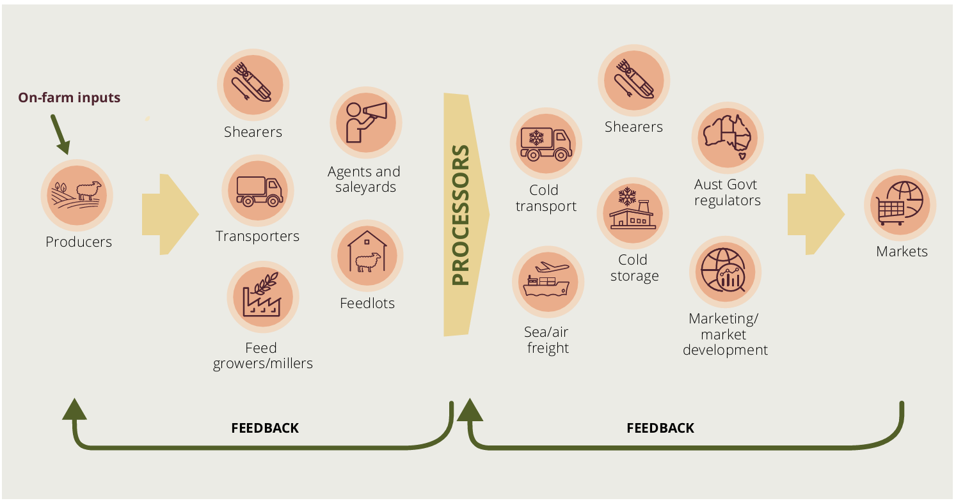

Note: This is a simplified representation of a value chain to show the key elements discussed in this report. It does not capture all on-farm activities or all the businesses involved at each step of the process.

The Panel considers that Meat & Livestock Australia (MLA) and the Australian Meat Processor Corporation could have a facilitating role in these future feedback loops. This could extend to the use of feedlotting to finish animals for slaughter (see Box 2 as an example of MLA’s contribution to a potential sheep value chain).

### Farm businesses

Farm businesses are a crucial part of supplying a WA sheep value chain. Producers need to make production decisions building on information and intelligence about market requirements. In the absence of the live trade, the Panel expects it will not be enough for producers, without updating their management, to sell the stock they would otherwise have exported live. Instead producers will increasingly need to prepare animals with a specification or timing in mind, or risk attracting a much lower price or not being favoured by onshore processors.

The Panel recognises that future supply chain opportunities will be different depending on the business and its operations. Not everyone will choose to move into a value chain model. The Panel suggests that embracing the change to live exports as an opportunity for renewal and growth would be preferable.

### Feedlots and feed millers

#### Meeting processing specifications

The Panel heard many comments that sheep usually exported live from WA tend not to be those that are aligned with slaughter specifications for the domestic or export markets. It was pointed out that animals that are exported live would otherwise be sold to processors at a heavily reduced price compared to finished lambs. In consultations the Panel was informed there had been an increase in lambs being exported live and a decrease in the proportion of wethers in live shipments, pointing to a shift in the animals being turned off in WA.

Despite some producers expressing a belief that most WA abattoirs only process lambs, the Panel received advice that all export-registered abattoirs can process both sheep and lambs, but it considers there may be a revenue advantage in processing lambs. Figure 27 illustrates the sheep and lamb slaughter numbers in WA since 2017.

According to the 2023 MLA and AWI Sheep Producers Intentions Survey, 85% of the WA breeding ewes are Merino sheep (MLA & AWI 2023b) and therefore the majority of the sheep meat processed is from Merinos. The remaining 20% are meat and specialty breeds. Some consultation participants suggested Merino lambs took too long to finish to market specifications, and questioned whether they would be acceptable to export processors. MLA research (MLA 2015a) provides a balancing view showing that sheep meat ‘eating quality is not greatly affected by breed’. MLA notes that other breeds ‘generally have better growth rates, better reproductive performance and more heavily muscled carcases which are better suited to meat production’ but ‘Provided that nutrition is adequate and animals are finished to a minimum fat score of 2, the intramuscular fat concentration of Merinos is either the same or higher than that of other breeds’ (MLA 2015a).

As covered in Impacts, the Panel expects that producers will respond to the end of the live sheep trade in a range of ways. Some producers will elect to stay with the same flock management (both breed and age at turn-off), while others will make changes to deliberately target meat markets. Some consultation feedback suggests that changing breeds will be required. The Panel observes that high levels of Merinos in the WA flock, increasing proportions of breeding ewes, and current high slaughter rates of both lambs and adult sheep in WA suggest that this may not be necessary and that adapting to a different turn-off age or feeding regime will be more critical.

#### Smoothing supply to processing facilities

Sheep processing in WA experiences seasonal variability as producers seek to balance stock numbers with feed on the ground. Slaughter volumes are highest in spring when lambs from the previous one or 2 seasons are turned off and are usually lowest prior to winter when less feed is available (Figure 27).

Figure 27 Lamb and sheep slaughter, by quarter, WA, January 2017 to June 2023

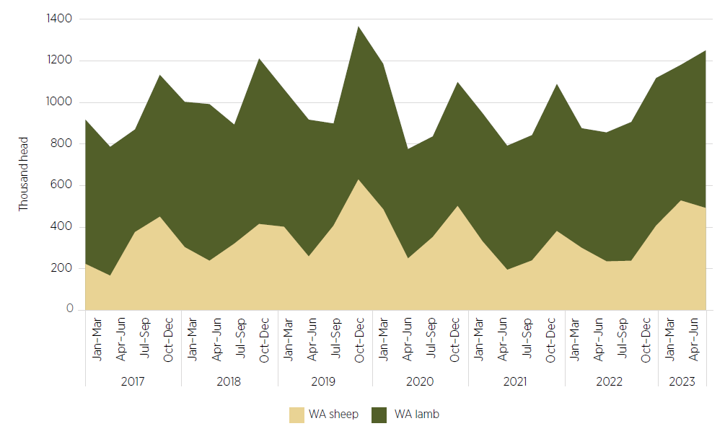

Source: ABS

In month-to-month comparisons the difference between the high and low points of the year can be quite dramatic, as shown in the volumes in Table 9 (DPIRD 2023g).

Table 9 Seasonal variation in WA slaughter rates, 2022

| Category | High (head) | High (month) | Low (head) | Low (month) |
| --- | --- | --- | --- | --- |
| Lamb | 214,900 | September | 159,240 | March |
| Sheep | 137,490 | October | 27,890 | July |

These fluctuations make it difficult for processors to manage capacity and labour. Maintaining larger facilities and workforces helps deal with the peaks but may be more costly in periods of low supply. Feedlots can provide a useful mechanism for smoothing out months of peak turn-off when slaughter capacity is stretched and months of low sheep supply when facilities have capacity.

#### Using feedlots to finish stock for slaughter

While sheep feedlotting is not a widespread practice in most of Australia, WA processors already source lambs and sheep from feedlots, with some looking to expand their investment in feedlot operations. Feedlots provide an opportunity to finish sheep with an intensive feeding system to bring them up to an abattoir’s preferred specifications. Several factors point to the potential to increase the role of feedlots in the WA industry:

* the shift away from live exports by sea
* the need to address the seasonal fluctuations in supply to processing facilities
* the benefits of producing animals that target market specifications.

The current extent of sheep feedlotting in WA may need to expand to accommodate a shift to more onshore processing. This could also differ from the east coast, where more processing facilities are available and greater variation in seasonal conditions exists between states. Any growth in feedlotting could be accompanied by extension and education to ensure producers and other businesses are well equipped for this change in production – possibly supported by MLA as the industry owned research and development corporation.

In addition to processor-owned feedlots, the Panel notes the option for producers to establish or expand on-farm feedlots, either on an ongoing basis or at particular times in the season. The Panel considers on-farm feedlots (also known as confinement or intensive feeding depending on the arrangement) can be attractive for producers waiting for processing space or higher prices, or needing to navigate periods with less feed on the ground. This will, however, require sufficient stored feed or capital to purchase supplementary feed, and to set aside land, which may not be possible for some producers. Box 2 outlines 2 WA projects exploring the economic and emissions reduction benefits of confinement feeding, which may be useful for producers adapting their production systems.

Some submissions suggested existing holding facilities for live export could be repurposed to hold and finish sheep while there is a bottleneck in processing space. The Panel acknowledges this option but also expects that when live export is phased out, operators will reassess the use of key facilities from the live export supply chain. This could mean existing facilities are repurposed to support the processing industry. Alternatively, some facilities may be directed away from sheep production or redeveloped to take advantage of completely different commercial opportunities.

One constraint on feedlot expansion is local and state government approvals. Research commissioned by the Panel from Episode 3 provided evidence from 2 feedlots, whose combined annual capacity is 98,000 to 118,000 head (Dalgleish, Whitelaw & Lean 2023). Both noted lengthy delays in their Environmental Protection Authority (EPA) applications to expand. If successful, their combined annual capacity would rise to 328,000 to 428,000 head. One of these feedlots noted that construction would take 18 months to 2 years after EPA approval. There are opportunities for regulatory authorities to ensure that development requirements are well understood and that administrative and approval processes are streamlined to reduce delays. The same applies to other expansions which support the intensification of the sheep industry in WA.

Box 2 Confinement feeding trials in WA

Confinement feeding and deferred grazing management system

This MLA project in the Wickepin region of WA will demonstrate the production and economic benefits of supplementary feeding of pregnant ewes in confinement. The project will measure the economic benefit ($/head) of confinement feeding and calculate gains from deferring grazing pastures. Benefits will be measured by weighing the supplementary feed and labour costs of confinement feeding and deferred grazing against the gains compared to those of mobs not managed under this system. The project runs until March 2025 (MLA 2023c).

Feed conversion efficiency of sheep

A research project led by the WA Department of Primary Industries and Regional Development in partnership with MLA aims to improve the feed conversion efficiency of sheep, requiring less feed to produce more meat and low-emission wool.

Over 5 years the project will measure feed intake, gas production and body composition of 4,000 lambs from the Genetic Resource Flock at Katanning Research Station. Their initial diet will feature a high-growth feed regime, such as feedlot grower pellets, to provide a benchmark (DPIRD 2022).

#### Feedlots – an opportunity for feed millers and broadacre cropping

Feed millers are one of the allied industries referenced in consultations as being closely linked with live sheep exports by sea. Stakeholders are concerned that in the absence of live exports, feed millers will not have a market for their pellets, and producers of ingredients will also lack a market.

Research from Episode 3 notes there has already been a marginal increase in grain/feed pellet use by the WA sheep industry, from 0.95 million tonnes in 2018 to 1.05 million tonnes in 2022 (Dalgleish, Whitelaw & Lean 2023). In this time, live exports have decreased and processors have increased their links to lamb feedlotting.

Bringing lambs to specification in feedlots potentially means an increased demand for pellets. The Panel heard feedlotting is generally undertaken for 40 to 60 days, whereas animals exported in the live trade usually need pellets for up to 27 days (in the holding yards before loading and during the voyage).

The Panel was informed that since the introduction of the Northern Hemisphere Summer Prohibition, some pellet manufacturers have already shifted their focus away from the sheep trade to domestic (largely cattle) markets. The Panel considers that this existing shift, combined with the rise in WA sheep feedlot operations, could see ongoing demand for milled products. The Panel notes that different businesses may experience this demand to different degrees. Some feed mills are heavily geared to production of export pellets and therefore may have lower capacity to adapt.

During live export voyages sheep are fed pellets composed of approximately 50% hay or straw, 30% barley grain and 10% lupins, with the remaining portion consisting of bulk roughage and urea. The Panel notes there could be opportunities to continue using lupins in milled products in WA (see Broadacre cropping).

#### Animal welfare in sheep feedlotting

A concern shared with the Panel during consultations was the absence of standards for feedlotting for sheep compared with cattle. As the peak national body for the grain-fed cattle industry, the Australian Lot Feeders’ Association (ALFA) aims to improve the industry through the development and delivery of standards. ALFA developed the National Feedlot Accreditation Scheme (NFAS), an independently audited quality assurance program that ensures compliance with cattle welfare, environmental and food safety legislation now run by AUS-MEAT. The Handbook of best practice guidelines for the Australian feedlot industry is an industry-developed tool to assist in alignment with the NFAS.

The WA Department of Primary Industries and Regional Development recommends using feedlotting as part of a whole-farm livestock, pasture and erosion management program (DPIRD 2023a). It refers to an industry guide, the National procedures and guidelines for intensive sheep and lamb feeding systems (MLA 2020b), which references the Model Code of Practice for the Welfare of Animals: The Sheep, which has since been replaced by the Australian Animal Welfare Standards and Guidelines for Sheep endorsed in 2016. There is no equivalent independent accreditation scheme specifically to ensure compliance with current animal welfare standards and legislation.

An opportunity exists to use the end of the live sheep trade, itself driven by animal welfare concerns, to also improve animal welfare outcomes in the domestic processing industry. The Panel considers a sheep feedlot accreditation scheme, like the AUS-MEAT NFSA, to be a desirable element of a future WA sheep value chain. Indeed, the use of AUS-MEAT (or equivalent) standards would enable meat from feedlots to be marketed for a premium, as has been done with grain-fed beef.

### Abattoirs and cold storage

#### WA sheep meat processors

Australia has more than 80 establishments registered to process sheep meat for export. There are 9 export-registered ovine (sheep) processing establishments in WA:

* Two Tier 1 establishments, meaning importing countries rely on Australia’s domestic slaughter and processing standards. These establishments have international market opportunities including Middle Eastern countries such as Kuwait, Jordan, Oman and Qatar.
* Seven Tier 2 establishments, meaning they require greater oversight, including the presence of an on-plant veterinarian. These establishments can supply Tier 1 markets plus others such as China, Japan, the United States and the European Union.

There are also 3 independent boning rooms (one Tier 1, two Tier 2), which do not perform slaughter but take carcases from other abattoirs for further processing.

All these processing facilities are located in the main sheep producing areas in south-west WA.

#### Processor capacity

The issue of processor capacity was often cited during consultations. Many producers were concerned they are already unable to access bookings at abattoirs when there is a build up of sheep on farm and could foresee competition for slots being even tighter, or impossible, in the absence of live exports.

If the WA flock stays at current levels at or around 12 million head and with a similar ewe/lamb/wether composition, there could be up to an additional 1 million to 2 million head of sheep requiring processing in any year in the absence of live exports and high west–east transfer. This is well above throughput in each of the past 10 years (see Figure 20 in Background). If the flock composition favours more breeding ewes, and therefore lambs for slaughter, the processing need will be greater. If the flock size were to drop by 15%, as modelled in the WA Government submission (DPIRD 2023i), particularly if coupled with worsening seasonal conditions, the existing capacity could be sufficient.

Some export processors indicated they had additional facility capacity to process more sheep than their current numbers, if they had more labour. This view is supported by the processing levels in 2019–20, when 4.2 million head were slaughtered in WA facilities, compared to 3.7 million in 2020–21 (ABS 2023e). In 2022–23 processing throughput was the highest in more than 10 years, at 4.5 million head (see Figure 20 in Background), suggesting a positive outlook for the WA processing industry.

The Panel met with export processors in WA and understands they have investment plans for the future which the Panel takes to be a sign of confidence in the industry. The Panel notes in September 2023 Minerva advised that its Esperance facility was undergoing an extended shutdown but that processing there is anticipated to recommence in the future.

A major constraint identified in relation to increasing processing across all facilities is an adequate supply of skilled labour, either from Australia or overseas. The lack of suitable regional worker housing for extra workers is a compounding factor that is inhibiting an increase in labour supply. These issues are explored in Sheep processing labour.

#### Cold storage

Cold storage was identified as a particularly limiting factor in processors’ ability to increase their level of production. Some stakeholders pointed to the liquidation of Scott’s Refrigerated Logistics in April 2023 (Ritchie & Chisholm 2023) as being a disruption but the Panel understands that many of these sites are expected to be operating again under new ownership. Other stakeholders pointed to competitive pressures from other sectors also using cold storage.

Two chilling methods are used to freeze sheep meat:

* chillers take products to −6°C, extending shelf life to up to 120 days
* blast or plate freezers rapidly chill products to −18°C, extending shelf life to up to 2 years.

In both cases, products are then stored frozen on-site at the facility, trucked to another cold storage site owned by the company, or trucked and held in an independent cold storage facility. There are cold stores in Perth and Fremantle that are independent of an exporting facility.

The Panel heard that while both methods are used commercially, the longer shelf life offered by plate freezers increases options for export processors in accessing markets. It allows them to store products for short or long periods to capitalise on market demand and to ship products by sea at lower cost than by air. If facilities are to process additional animals, storage space for frozen products will be essential so they can manage their stock in a profitable manner.

#### Expansion investment

Some export processors advised the Panel that they are or hope soon to be increasing capacity at their facilities. Examples of investment to expand capacity included:

* cold storage
* lairage (holding pens used in the day/s immediately prior to slaughter)
* cryovac and regular boning rooms
* carton and packaging management
* worker accommodation.

The Panel sees processor and cold storage capacity as a key factor in supporting the WA industry in moving away from live sheep exports. Any expansion of facilities or storage will require a commensurate increase in labour to support the additional activity. Similarly, exports of rendered products, sheep skins and edible offal, while a small part of WA’s sheep industry, will also benefit from upgrades to existing facilities and access to additional labour. This issue is explored in Sheep processing labour.

The Panel emphasises that any expansion of processing or storage capacity needs to be made prior to the end of live exports by sea. This will help give producers confidence in the future of the WA sheep industry value chain. Capacity will need to increase in time for the end of live sheep exports by sea. Waiting to invest in these facilities, or relying on commercial investment, which is often staggered to spread costs over multiple years, will be counterproductive. Projects will need to be accelerated and online for when live exports by sea end.

Concessional loans were noted to be potentially advantageous for bringing projects forward. The Panel supports a co-investment approach to demonstrate the Australian Government’s commitment to the industry and help bring investments and projects forward, while still requiring industry investment in private infrastructure.

The Panel anticipates that the National Reconstruction Fund may provide industry with opportunities to co-invest in value-adding projects. At the time of writing, the fund is still in the planning phase. The Panel understands that other concessional loan products have been delivered by the Regional Investment Corporation and also by the WA Rural Business Development Corporation. The Panel suggests that these avenues for support be explored.

#### Further constraints

The Panel notes that both time and regulatory approvals are needed to facilitate any processor expansion activities. One export processor indicated that after regulatory approvals (which can be at local, state or federal levels), 2 years is the minimum time needed to bring new parts of facilities online. As with feedlots, the Panel encourages any efforts to streamline regulatory approval processes or communication to ensure companies can readily meet the stated requirements. For example, government could address access to capital to help streamline the time taken to plan, approve and build any expansions.

The Panel acknowledges that the shortage of skilled tradespeople and construction workers is an indirect constraint on the construction of new facilities or worker accommodation and may also require attention.

On the regulatory side, environmental regulations, particularly wastewater treatment, can be a significant restriction on a facility’s capacity and ability to expand. The Panel encourages efforts by the WA Government and WA local governments to work with processors to better manage their wastewater and consider options to manage increased waste. There may also be longer-term opportunities for AMPC to fund research and projects into better processing management in WA, including waste management.

#### Additional improvements

Aside from expansion activities, investment in new technology could also aid processors in increasing their throughput. Automation, remote operation and artificial intelligence are already research areas for the AMPC and will be worthy of ongoing investment to increase capacity and reduce reliance on labour. Automation can assist in the processing facility as well as in packing and moving for export. One export processor indicated it is planning a cold storage facility with a high degree of automation built in from the start.

### Freight

The move away from live sheep exports by sea to onshore processing will necessitate a change in freight arrangements, both for live sheep moving to feedlots and processing facilities and for meat moving from processing facilities to cold storage and on to sea and airports. There may also be an increase in road transport of stock to the eastern states when prices suit, or in live sheep going via air to overseas destinations.

#### Road transport in WA

During consultations the Panel heard concerns about the future viability of transporters and stock handlers involved in moving sheep after live exports by sea end. Research by Episode 3 describes sheep movements (instances on a truck) for sheep. On average, the sale of sheep from farm to the live export trade requires 3.5 movements. In comparison, sheep sold to a WA processor would be moved 1.5 times on average (Dalgleish, Whitelaw & Lean 2023).

The Panel notes that these numbers represent the current practice in WA and do not consider the potential use of increased feedlotting or a different producer finishing stock prior to slaughter. Further, if the WA flock remains close to existing levels and is processed onshore, there will be additional cold transport required when meat is moved from the processing facility to cold storage and later to export.

#### Road transport interstate

The high levels of interstate transfer from WA in 2019–20 and 2020–21 (see Figure 20 in Background) highlight the potential for WA sheep to restock the eastern states after disruptions such as drought, fire or flood. In the absence of live exports by sea, it is also possible interstate transfers will be used to process animals at east coast abattoirs. This is particularly the case during peak periods or to respond to worsening seasonal conditions in WA.

The Panel heard concerns about animal welfare on these journeys, and a need for greater monitoring and enforcement of the Australian Animal Welfare Standards and Guidelines – Land Transport of Livestock (DAFF 2012) for sheep welfare on long road journeys. RSPCA Australia, for example, raised concerns:

… investment would need to be ramped up if sheep are to be transported from WA to eastern states because of the live export phase out. A well overdue review of the Standards & Guidelines would also provide further opportunity to strengthen key aspects of the transport process that impact livestock welfare, including time off water, space requirements, curfews, temperature limits, and animal handling. Submission 721, RSPCA Australia.

The Australian Animal Welfare Standards and Guidelines – Land Transport of Livestock agreed in 2012 have been implemented into all state and territory regulatory frameworks. Monitoring and enforcement is the responsibility of each jurisdiction. The Panel recognises that South Australia is in a particularly difficult position in the west–east transfer whereby spelling and animal welfare oversight is likely to be needed through SA, even though the animals are continuing on to Victoria and New South Wales.

The Animal Welfare Task Group, which consists of representatives from each state and territory and the Commonwealth, is responsible for the development and review of Australian Animal Welfare Standards and Guidelines. The task group has a workplan, with priorities determined in consultation with stakeholders. One of the considerations for a review is to incorporate contemporary, science-based animal welfare actions or to respond to evidence of animal welfare incidents. Review of the Australian Animal Welfare Standards and Guidelines – Land Transport of Livestock is on the group’s workplan. For work to commence, a jurisdiction will need to volunteer to lead the project. To be successful, this work will also need the buy-in of all stakeholders including industry. The Panel believes that this could be an area for Australian Government investment or leadership.

#### Air freight

The Panel heard that air freight is important to access chilled meat markets overseas. Over the past 8 years WA has generally sent a higher proportion of sheep meat exports by air than the national average (Figure 28).

Figure 28 WA and national sheep meat exports by air (volume and proportion), 2015–16 to 2022–23

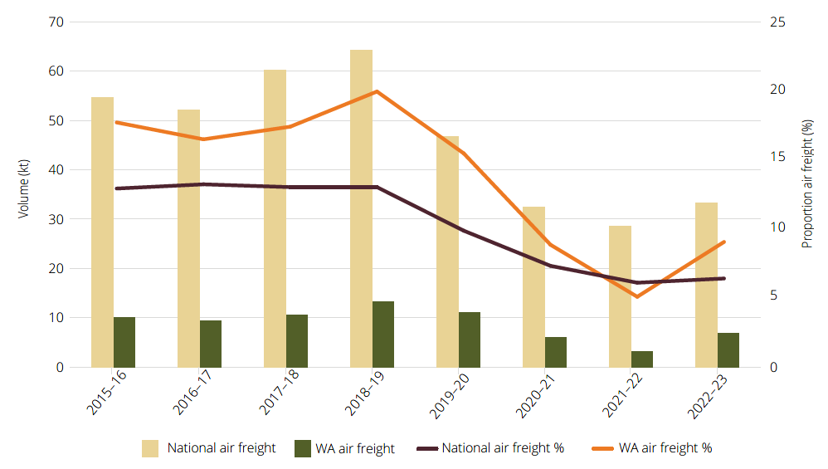

Source: ABARES Trade Dashboard

Nationally the value of sheep meat exports by air has returned to and exceeded pre-COVID-19 levels. Overall flight capacity nationally has returned to more than 90% of pre-COVID levels but this varies between key export markets (Austrade 2023a).

Unfortunately for WA exporters, flights out of Perth have not returned to their earlier volume or pattern, with fewer flights overall and fewer stopping in transit hubs in the Middle East or South-East Asia (DITRDCA 2023b). The lack of export freight space has increased the cost of exporting by air from Perth, to the point where some export processors indicated it was more cost-effective to transport products domestically and then export from east coast airports than it was from Perth.

The Panel also learnt, however, that air cargo capacity from Perth to the east coast is also still limited post-COVID due to changes in airlines’ operating models. There are fewer flights and a higher proportion of narrow-body passenger planes, which are not suited to carrying as much freight as wide-body planes. The Panel sought advice on capacity and believes that if the issue is not resolved it will be a limiting factor in increasing boxed meat exports from WA. Addressing access to cost-effective and consistent flights to desirable destinations is key to expanding the chilled sheep meat trade out of WA.

#### Sea freight

In October 2022, MLA’s *Global sheep meat industry and trade report* highlighted the value of changes to the shelf-life requirements for Australian sheep meat into key Middle Eastern markets (MLA 2022b). These changes in mid-2022, which included key sheep meat trading partners such as the United Arab Emirates, have seen Australian frozen red meat exports acknowledged as eligible for shelf life of greater than 12 months, as backed by food safety science (DAFF 2022a). In addition, in September 2023 the Gulf Standards Organisation of the Gulf Cooperation Council recognised extended shelf-life for chilled vacuum-packed red meat, including 90 days for sheep meat (Watt 2023b). Combined with expanded cold storage, , this provides export processors with greater options for export, including an ability to ship product by sea at lower cost than by air. The Panel notes that similar arrangements could be pursued with other trading partners.

The Panel notes the current consultation by the WA Government on proposed changes to the Port of Fremantle, including relocating Perth’s container port to Kwinana. This may alleviate some of the concerns raised with the Panel about the Port of Fremantle’s amenity for sea freight.

#### Cattle in the live sheep export freight chain

In 2022–23 around 5% of Australia’s total live cattle exports were sent on sheep ships to the Middle East from Fremantle (DAFF 2023d). Since 2014–15 the number of cattle travelling to the Middle East from Fremantle on mixed-species vessels has been much greater than those on cattle-only vessels. However, of all cattle travelling to the Middle East from Fremantle each year since 2014–15, an average of 18% still depart on cattle-only voyages (Figure 29). The Panel recognises that the end of the live sheep export trade means some cattle exporters will need to find alternative transport options, but notes that there are currently single-species voyages.

Figure 29 Multi-species and cattle-only shipments from Fremantle to the Middle East, 2014–15 to 2022–23

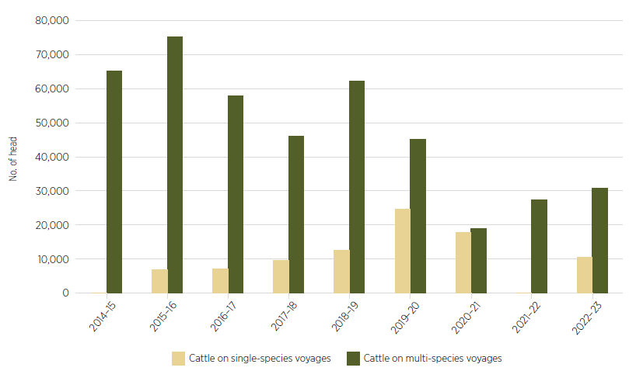

Note: Some shipments had multiple ports of origin.

Source: DAFF 2023d

### Competition and sale arrangements

#### Buyer behaviours

In face-to-face consultations in regional WA, participants voiced concerns about a perceived lack of competition among buyers in saleyards, leading to reduced prices for producers.

In a similar vein, the Australian Competition and Consumer Commission (ACCC) raised the risk of reduced competition among buyers once the live trade closes:

The loss of access to live export markets and the potential reduction in competition due to fewer buyers of WA sheep may lead to poorer outcomes for sheep producers by increasing the market power of remaining buyers in a relatively concentrated market. Submission 825, ACCC.

Further, in its cattle and beef market study final report (2017), the ACCC found that livestock agents may represent multiple buyers and sellers, or both buyers and sellers, in a single transaction.

In certain circumstances, this may create a conflict of interest for the agent and could potentially suppress competition between buyers and sellers which may lead to artificial prices for livestock (ACCC 2017).

The ACCC market study also identified the reduction in competition that arises when a single commission buyer acts on behalf of multiple meat processors or exporters in purchasing livestock at saleyards. The ACCC cautions that:

The reduction in potential purchasers at livestock sales (due to the removal of live export buyers) may further exacerbate the reduced level of competition arising from the operation of commission buyers. Submission 825, ACCC.

The ACCC submission noted that licensing of livestock agents differs between states and territories. The ACCC recommended that livestock agent licensing should be consistent across the country, to assist compliance with the *Competition and Consumer Act 2010* and general professionalism in the industry.

Based on the ACCC’s findings in the cattle market study, and the possibility that the number of livestock agents could decline, the Panel considers more transparency in, and oversight of, the activities of livestock agents and commission buyers will be beneficial.

#### Price transparency

The Panel heard concerns from producers about how readily they could access price information to inform their business decisions. The Panel notes that MLA publishes a range of market analyses and statistics on its website, including forecast reports and the most recent saleyard prices for a range of products such as mutton and Merino lamb. Producers seeking more market information may benefit from greater promotion of these reports and information as part of working towards a profitable value chain.

#### Forward contracts

In the context of sheep meat markets, a forward contract is an agreement between relevant parties (generally processors and producers) for an agreed quantity of sheep at an agreed price and specification (such as weight and age) at a specified time in the future.

The Panel observes that while mixed-enterprise farmers commonly have forward contracts or other contract arrangements for their grain, WA sheep producers often trade on spot prices. In 2018 DPIRD published a study of forward supply contracts in the WA meat sector (DPIRD 2023b). The study concluded forward supply arrangements and contracts could assist supply chain participants and investors, including by better managing risk, smoothing peak seasonal production supply, and encouraging production of higher quality meat to consumer specifications.

The Panel received analysis from ABARES that only 1% of sheep sales are through forward price contracts (MLA & AWI 2023a) and WA sheep producers typically do not use forward contracts. This points to an opportunity for processors and producers to better work together in smoothing and guaranteeing supply to processing establishments, while also helping producers to plan and manage their stock and income. The Panel notes that the seasonal nature of turn-off in WA may not lend itself to forward contracts unless coupled with other strategies such as feedlotting. Nonetheless, producers in the rangelands may be particularly suited to forward contracts so they can turn off large numbers of stock simultaneously. The Panel notes that the use of forward contracts is also consistent with the intent of creating a value chain as farmers and processors can lock in prices and requirements in advance.

Any increase in the use of forward contracts may require producers to seek financial risk management products or insurance to address the risks of contracts not being fulfilled. This could include risks such as disease outbreak, natural disaster or processor temporary closure that may hinder producers or processors meeting the forward contract. The Panel heard that forward contracting is used widely and is familiar to mixed enterprises in the broadacre cropping industry in WA. In contrast, use of forward contracts for sheep in WA is negligible and some producers may need to be supported to understand the risks and benefits of both forward contracts and risk management products.

### Relevant recommendations

Initiatives requiring early action or funding: 4.

2) The Australian Government should establish transition funding arrangements accessible to businesses in the supply chain to prepare for and adjust to the absence of live sheep exports by sea. Funds should be contingent on businesses preparing a plan, perhaps drawing on the opportunity provided by Recommendation 1. Consideration should also be given to the needs of non-supply-chain businesses affected by the cessation.

4) Governments should provide access to funds or concessional loans to improve the capacity and efficiency of the WA sheep supply chain. Ideally, any government funding should be accompanied by private investment. Possible projects could include, among others, the expansion of processing facilities, installation of feedlots, addition of cold storage, improvements to transport or logistics infrastructure that support sheep product exports, or the supply of worker accommodation.

5) All levels of government should streamline planning and approval processes to facilitate infrastructure improvements in the WA sheep supply chain.

6) Governments should look for ways to increase air freight capacity for sheep products from WA, including consideration of time-limited assistance for air freight costs.

7) Market integrity and competition should be strengthened through the entire WA sheep supply chain. This could include close monitoring by the Australian Competition and Consumer Commission, WA Department of Mines, Industry Regulation and Safety and WA Meat Industry Authority, and promotion of existing price transparency tools.

19) The Australian, state and territory governments should work together to review and enforce the Australian Animal Welfare Standards and Guidelines – Land Transport of Livestock.

21) The Australian sheep industry should be encouraged and supported to:

a) establish a national accreditation scheme for sheep feedlots, to include standalone and on farm intensive feeding systems

b) develop a complementary national sheep meat quality assurance scheme (similar to AUS-MEAT) for meat produced from sheep finished in feedlots.

## Sheep processing labour

Expanding meat processing in WA to support the ongoing success of the sheep industry will rely on infrastructure improvements (see Sheep supply and value chains) and access to a sustainable workforce. The Panel heard from a range of stakeholders that labour is an existing constraint to processing volumes, a situation likely to be magnified with the shift to increased onshore processing in the absence of live sheep exports by sea. Low unemployment in the affected regions, difficulties in attracting and retaining workers, and associated factors such as access to housing, childcare and public transport, are all contributing to the industry’s worker shortfall and provide avenues for future attention (RAI 2023). There are opportunities presented by increased sheep processing in WA, including for First Nations peoples and embedding of worker retention strategies, which are worthy of investment.

### The need to expand the workforce

The Panel heard that producers are already concerned about current capacity constraints of meat processors, with a backlog of sheep waiting for space at abattoirs. It also heard about opportunities to increase processing capacity. Some processors indicated they have capacity to process more sheep if they have more labour, and some outlined the potential for investment to create additional capacity if supported by access to a workforce to use it.

However, the Panel also heard from meat processors and industry bodies that there are significant challenges to attracting and retaining meat processing workers. This includes ensuring a stable, long term pool of workers to support year-round operations as well as access to a more flexible pool to meet seasonal demand during peak turn-off period (October to March). The Panel heard from processors and unions about the potential economic and social benefits to regions from increasing numbers of permanent (or near-permanent) workers.

Labour shortages across all parts of the WA sheep supply chain featured prominently during consultations. The Panel heard that there was strong competition from the mining and resources sector in WA which contributed to the difficulty of attracting and retaining people in agricultural and processing roles. While this section of the report focuses on the challenges of attracting and retaining a suitably skilled and reliable workforce to support the additional processing capacity, the shortage of skilled labour extends to related industries such as shearing. Further detail about WA’s sheep meat processing sector is in Box 3.

Box 3 Sheep meat processing in WA

As at September 2023, there are 9 export-registered sheep processing establishments in WA and an additional 3 independent boning rooms. All these establishments are in the main sheep producing areas in south-west WA. They range from small processors (handling less than 10,000 head per year) to large processors (handling more than 300,000 head per year). In addition, there are some non-export accredited sheep processing establishments.

Episode 3’s survey identified that abattoirs processing sheep and lambs in WA currently employ approximately 1,750 full-time equivalent (FTE) workers, ranging from 110 to 800 FTE per facility (Dalgleish, Whitelaw & Lean 2023). The abattoir workforce would need to increase in the absence of live sheep exports to accommodate increased demand for processing.

Annual slaughter of sheep in WA has averaged 3.97 million head per year across the past decade, with a high of 4.46 million in 2022–23. However, DAFF (2023c) observes there is no simple relationship between slaughter numbers and employment in processing establishments. Establishments require a minimum workforce to maintain capacity but above this there is considerable scope to trade off the return from the time taken for further processing against the volume and return achievable from less processing. Thus, establishments can stop their least profitable activities as the cost of labour approaches the value of the activity and use workers for less processed products.

### Competition for suitable workers is strong

#### Meat processing workers are in demand in Australia

Workforce shortages in the meat processing industry are not unique to WA and are being felt across the country. Employment in the meat processing industry has been growing since the early 2000s, as the industry has become better at value adding (DAFF 2023c). This growth in the meat processing workforce indicates that current pathways are capable of progressively building a suitable workforce. However, it also raises questions about why there continues to be a deficit.

Notwithstanding this steady growth, the processing industry has continued to report widespread workforce shortages, even before COVID-19. In 2018 the Australian Meat Industry Council (AMIC) estimated that about 60% of meat processing plants were operating at or below 90% capacity, due to a combination of livestock and workforce shortages, and required an additional 3,700 workers to operate at 100% capacity (AMIC 2018). A 2022 survey for the Australian Meat Processor Corporation (AMPC 2022) identified 2,802 vacancies in the meat processing industry, with the largest numbers of vacancies being in the boning room and on the slaughter floor. The Skills Priority List (NSC 2022) also highlights nationwide shortages of meat inspectors, slaughterers, and meat boners and slicers.

AMPC (2021) notes that annual workforce turnover rates in the Australian meat processing industry have been reported to range from 37% to 90%, with an average of 58%. A study of 5 plants to guide AMPC’s efforts to develop a workforce retention strategy found that one-third of employees left within their first 3 months of employment. This data suggests a potentially significant role for retention strategies, including orientation and induction programs to help ensure a soft landing for new workers. The Panel welcomes AMPC’s work to develop a best practice model for employee retention (AMPC 2021) and considers that implementation of such programs will be vital to efforts to build the meat processing workforce. The Panel also welcomes work by AMPC to promote careers in meat processing within the regions. AMPC is seeking to attract a workforce from within the regions themselves, based on research that indicated the domestic workforce saw meat processing as an industry for short-term employment.

#### Regional populations are growing but the working age population is not keeping pace

As discussed in Background and presented by the Regional Australia Institute, all 3 of the focus regions expected to be most affected by the end of live sheep exports by sea experienced population growth from 2018 to 2022. However, this growth in the residential population was not reflected in the working age population. In these regions the working age population has been growing at a much slower rate (and contracting in the case of the Wheatbelt region) as seen in Table 10. The lack of workers is resulting in greater competition for employees and growth in job vacancies in these regions. RAI reported that challenges securing workers are widespread in regional Australia, with 68% of recruiters in regional Australia reporting difficulty filling advertised jobs in December 2022 (RAI 2022). RAI also reported strong growth in job vacancies in regional Australia in December 2022, with regional vacancies increasing 10% year on year (compared to 3% vacancy increase in metropolitan areas).

From 2017 to 2021 the total working age population growth in Great Southern was 2.2%, whereas Wheatbelt declined by 2.0% and Mid West–Gascoyne saw smaller growth of 0.8%.

Table 10 Regional workforce pool

| Category | Great Southern (%) | Wheatbelt (%) | Mid West–Gascoyne (%) |
| --- | --- | --- | --- |
| Population (2018–2022) | +4.3 | +1.9 | +3.8 |
| Working age population (2017–2021) | +2.2 | −2.0 | 0.8 |
| Unemployment rate (2021) | 2.2 | 2.4 | 2.8 |

Source: RAI 2023

At March 2023, the average unemployment rate for the 3 regions was 3.2% (discussed in Individuals and communities). Given the limited pool of workers in the regions and expected continued demand for workers, sheep meat processors looking to expand production in the affected regions will face strong competition for suitable workers. The Panel notes the possibility that workers involved in the live sheep export supply chain may be diverted to meat processing in the lead-up to and beyond the cessation, but that these workers may also be sought after by other sectors.

### Immigration – a solution with challenges

The Panel heard from unions and processors that migration would be a necessary part of meeting the workforce challenge. The Panel also heard unions emphasise the importance of moving to a stable, long-term workforce, rather than staying in a cycle of ongoing reliance on temporary migrant workers. Ensuring the availability of training and skills development and permanent settlement options will be part of this transition. Processors also commented on the importance of a pathway to permanent residency as part of the migration system, and the costs of training and skills development where temporary workers do not have options to stay.

Consistent with reported local labour shortfalls, meat processors across Australia look to temporary migration as an important pathway to boost numbers and utilise throughput capacity. Processors draw on a range of visa pathways as described in Box 4. As noted in Box 4, the Department of Employment and Workplace Relations confirmed for the Panel that as at 31 August 2023 over 10,000 Pacific Australia Labour Mobility (PALM) workers were engaged in the meat processing industry across Australia.

Box 4 Migrant workers

Working holiday makers (subclasses 417 and 462)

The Working holiday maker (WHM) programs are reciprocal, cultural exchange programs agreed bilaterally by Australia with other countries. These programs allow young adults to holiday in Australia for up to 12 months, during which they can undertake short-term work and study. There is no obligation for WHMs to do work while in Australia but they can work in any occupation or industry, though generally they cannot work for one employer for more than 6 months. WHM visas can be extended to a second and third year, generally by WHMs undertaking specified work in approved industries (this includes immediate processing of animal products including shearing, butchery, packing and tanning) in regional Australia.

Labour agreements (subclasses 186 and 482)

A labour agreement is a formal agreement with the Australian Government that provides flexibility for Australian businesses employing migrant workers where there is a demonstrated need that cannot be met in the Australian labour market or through standard skilled visa programs. These agreements can allow variation to standard occupations and skills lists and concessions to the standard skilled visa program requirements such as on the level of the Temporary Skilled Migration Income Threshold and English language requirements.

In respect of meat processing, only Meat Inspectors (ANZSCO code 311312) are eligible for a visa under the Temporary Skills Shortage Visa (subclass 482). However, the Meat Industry Labour Agreement facilitates sponsorship of ‘skilled meat workers’ for a temporary period of up to 4 years and/or for permanent residency. There is no Australian and New Zealand Standard Classification of Occupations (ANZSCO) code for this occupation; the tasks of a skilled meat worker include the duties of ANZSCO occupations Slaughterer, and Meat Boner and Slicer.

While Industry Labour Agreements are between an employer and the Australian Government, Designated Area Migration Agreements (DAMA) are between the Australian Government and a Designated Area Representative. Once a DAMA head agreement is established, endorsed employers operating within the region can reach individual DAMA labour agreements with the Australian Government under the head agreement’s terms and concessions.

Special Category Visa (subclass 444)

The Special Category Visa allows New Zealand citizens to visit, study, stay and work in Australia. New Zealand has a well-developed meat processing industry and is therefore an additional source for skilled workers.

Pacific Australia Labour Mobility scheme (subclass 403)

The Pacific Australia Labour Mobility (PALM) scheme allows businesses to recruit workers from 9 Pacific Islands and Timor-Leste for seasonal jobs or longer-term roles of up to 4 years. The scheme aims to fill labour gaps in rural and regional Australia and nationally for the agriculture sector. It also targets a range of agriculture-related food product manufacturing industries, including the meat processing industry, in a range of low-skilled and semi-skilled roles.

The PALM scheme provides skills development funding to support training for workers while they are working in Australia. Training can increase workers’ technical knowledge and abilities, such as forklift driving or food safety training, and increase lifestyle skills such as English language or health and wellbeing skills.

In the 2023–24 federal Budget the government announced it will further expand and improve the PALM scheme, including increasing the scheme’s regional footprint and ensuring sufficient support for smaller operators (Australian Aid 2023).

#### Migration review

In recognition of Australia’s complex migration system, in 2022 the Australian Government commissioned a comprehensive review of Australia’s migration system (Home Affairs 2023a). An expert review panel consulted stakeholders and made recommendations on directions and options for the future of the system. Informed by the review, the government considered the panel’s recommendations and released an outline of a migration strategy for consultation, with a final strategy to be released later in 2023. The initial strategy outline indicates the government is considering changes to the structure and settings of the migration system to:

* simplify the system to make it easier and faster for employers to get the people with the skills they need
* ensure the migration system responds to the needs of all Australia, including those in the regions, while ensuring proper investment in housing, infrastructure and services to secure the benefits of migration
* focus on integrity measures to rid the system of abuse and ensure migrants will have clearer pathways to permanent residency.

With the release of the Outline of the Government’s Migration Strategy in April 2023, Minister O’Neil announced that by the end of 2023 all temporary skilled workers will have a pathway to permanent residency (O’Neil 2023).

The Panel notes that the migration review may provide further avenues for the industry to source labour. However, the Panel also considers it important that any changes to the migration system take account of the unique situation of the agriculture sector and rural and regional employers.

Further to the future Migration Strategy, the roadmap in the Australian Government’s White Paper on Jobs and Opportunities identifies further reform directions to better target skilled migration, including an improved occupation list and new permanent skilled visa settings (Treasury 2023b).

#### Working holiday makers

WHMs are a significant element of the migrant worker workforce. AMPC (2022) reports that during 2020–21 there were 764 WHMs working in the meat processing industry.

WHMs are generally unskilled workers and so require training to perform many roles in a meat processing facility. In addition, the restrictions on the length of time WHMs can work for a single employer mean they are required to move on quickly, contributing to reported high annual turnover rates for meat processors. However, despite the training costs and high turnover rates, they are valued for their contribution to flexibility to help manage seasonal and other short-term surges in demand.

The review of Australia’s migration system notes that the incentive for WHMs to work in regional Australia has been the subject of numerous inquiries and reviews. These reviews found that incentivising WHMs to work in regional Australia is a key driver of exploitation (Home Affairs 2023a). The Panel notes that the WHM program was established as a cultural exchange program and that, as part of the review of the migration system, the government is considering a recommendation to eliminate the option for WHMs to extend their visa by undertaking specified work in regional Australia. Changes to the requirements for WHMs from the United Kingdom arising from the Australia–United Kingdom Free Trade Agreement may also change the processing industry’s access to and reliance on WHMs.

The Panel notes the important contribution of WHMs, particularly the flexibility to respond to seasonal demand. The Panel encourages the government to work with the meat processing industry, if it decides to remove the specified work option for WHMs, to ensure that alternative pathways are developed.

#### Pathway to permanency

A large number of migrants come to Australia on temporary visas. While some of these temporary migrants do not intend to become permanent residents, others wish to remain in Australia and extend their stay by applying for additional temporary visas or applying to remain in Australia with a permanent residency visa. The Panel recognises the value of a clear pathway to permanent residency for building a stable, long-term workforce that contributes to growth and prosperity of regions.

Movements, or ‘transitions’, through different visas can involve many steps (and hence time and money) and are dependent on policy settings, with some pathways being significantly quicker than others.

The Productivity Commission (PC 2016) found migrants transitioning from a temporary visa to a permanent visa are granted an average of 3.3 visas and that the average duration of multi-step pathways is approximately 6.4 years. The Treasury’s Centre for Population (CP 2023) found that for temporary skilled migrants the average time taken to process a permanent visa was 2.9 years and they were granted one intermediate visa. These workers had a high rate of transition to permanent residency, with 69% of those who arrived in 2006–07 being granted a permanent visa by 2016–17.

The review of Australia’s migration system also notes that access to permanent and temporary skilled visas has generally been limited to migrants in highly skilled occupations (ANZSCO levels 1–3) and with salaries above the Temporary Skilled Migration Income Threshold (TSMIT) (Home Affairs 2023a). Labour Agreements and DAMAs can include pathways to permanent residency; however, permanent residency applications are only permitted after working in a plant for 3 years, require a sponsor and impose application and levy costs on employers. The Panel notes that there may be value in investigating the processing industry’s uptake of permanency through this pathway, and any barriers to use that may warrant further attention.

The average wage for a skilled meat worker nationally is around $62,000 (JSA 2021). The Panel heard concerns from processors that raising the TSMIT from $53,900 to $70,000 on 1 July 2023 may make the scheme unattractive for processors, further compounding any labour shortage. However, under labour agreements, employers can access up to a 10% concession to the TSMIT (noting that overseas workers must also receive a top-up to their salary if, over an annual period, an Australian worker performing equivalent work in the sponsor’s workplace at the same location under different salary arrangements receives a higher amount). The Panel considers that this concession may make it more suitable for processors to employ skilled migrant workers but notes that any further increase to the TSMIT or removal of the concession is unlikely to be met favourably by processors.

#### Visa processing

The Panel notes industry concerns about lengthy and complex processes for accessing migrant workers. Processors reported that the time taken to secure migrant workers, including sometimes to bring spouses and children to Australia, was considered excessive. Skilled visa applications are processed according to government policy priorities, which are outlined in ministerial directions (Home Affairs 2023c). Under the Temporary Skills Shortage Visa (subclass 482, Labour Agreement Stream) the median time to process a visa application is 33 days but it can take several months (Table 11). The current priorities for skilled visa processing are (Home Affairs 2023c):

* visa applications in relation to a healthcare or teaching occupation
* for employer-sponsored visas, visa applications where the applicant is nominated by an approved sponsor with Accredited Status
* visa applications in relation to an occupation to be carried out in a designated regional area
* for permanent and provisional visa subclasses, visa applications that count towards the migration program, excluding the Subclass 188 (Business Innovation and Investment (Provisional)) visa
* all other visa applications.

Prioritising visa applications in relation to meat processing occupations would make a useful contribution to building the sheep meat processing workforce in the affected regions. Such a change would be broadly applicable to all Australian meat processors looking to recruit migrant workers but is considered worthwhile for its potential to ease worker shortages.

Table 11 Visa processing times

| Visa | 25% of visas finalised | 50% of visas finalised | 75% of visas finalised | 90% of visas finalised |
| --- | --- | --- | --- | --- |
| 403 – Temporary Work (International Relations) Visa (subclass 403)  Pacific Australia Labour Mobility Scheme Stream | 1 day | 6 days | 10 days | 22 days |
| 482 – Temporary Skills Shortage Visa (subclass 482)  Labour Agreement Stream | 8 days | 33 days | 86 days | 5 months |

Source: Home Affairs 2023b

#### Dedicated Area Migration Agreements

There are 3 DAMAs in WA that have some proximity to key regions likely to be affected by phasing out live sheep exports. These are the South-West, Goldfields and Pilbara DAMAs. These DAMAs cover a wide range of occupations, though only the Goldfields DAMA includes meat processing specific occupations. The DAMAs provide a pathway to permanent residency for workers and make use of a range of concessions (such as a reduced TSMIT). DAMAs are regularly reviewed and there is scope to add additional occupations.

The Panel considers that additional DAMAs for the key regions likely to be affected by the end of live sheep exports by sea could be an effective means for meat processors to supplement domestic recruitment efforts. Any new DAMAs could also provide an umbrella for other occupations in demand in the regions, further strengthening local economies. A body such as the local government or RDA would need to establish itself as the Designated Area Representative to apply for and manage the DAMA.

#### Pacific Australia Labour Mobility scheme

Under the PALM scheme, Australian businesses can recruit workers directly once they have become an approved employer. Eligibility criteria include evidence that an employer has been unable to recruit Australian workers, a history of compliance with Australian workplace laws, and proven financial stability. The Department of Employment and Workplace Relations (PALM 2023) notes that processing an application to become an approved employer takes at least 3 months once the documentation has been assembled and provided. In its submission to the 2022 consultations on expanding and improving the PALM scheme, AMIC reported that its members find the requirements challenging and that many access the scheme via labour hire providers (AMIC 2022). This may be an area where the Australian Government could provide greater education and communication to support potential employers in their application efforts.

As at 31 August 2023, over 10,000 PALM workers were engaged in the meat processing industry, reflecting the importance the PALM scheme took on as a means to secure meat processing workers during the pandemic.

### More than finding suitable workers

Meat processing facilities are commonly located in outer urban and regional areas which provide a range of benefits such as lower land costs and efficiency of livestock supply and transport. However, alongside these locational benefits there are challenges with attracting and retaining suitable workers.

#### Accommodation

Many regional locations in WA have a scarcity of affordable and available accommodation, making it difficult for new workers to establish themselves and creating a barrier to attracting and retaining workers. The Australian Government’s White Paper on Jobs and Opportunities notes that secure and affordable housing is a basic human need and an important part of finding and maintaining employment (Australian Government 2023).

Providing convenient, appropriate and affordable housing options is not just about rural workers being close to work but also about providing services and appropriate accommodation that keep and attract rural workers, in particular suitable housing for families.

RAI (2023) advised the Panel that the recent growth in population in the 3 key regions is being felt in limited housing availability. There is a scarcity of houses for sale or rent, and significant price rises have accompanied this in the 8 LGAs surrounding WA abattoirs. Of these LGAs, 5 have rental vacancy rates below 1.5%, highlighting the difficulty in finding or affording accommodation. Episode 3 (2023) reported that the shortage of suitable accommodation has prompted some processors to invest in existing housing facilities or even to build their own to provide accommodation for their workers. Box 5 provides examples in WA of a meat processor investing in worker accommodation, along with examples from Victoria and Queensland.

Box 5 Worker accommodation

Abattoir worker facilities in Katanning

The ABC reported (Johnson 2023) that Katanning-based WA Meat Marketing Co-Operative (WAMMCO) has bought a hotel to build a mining-type village to house abattoir workers. WAMMCO stated this move would allow extra staff to run a second shift.

The accommodation is part of a planned $70 million to $80 million investment to upgrade both the plant and accommodation facilities.

Horticulture worker accommodation in Robinvale

In 2021 the Victorian Government announced it was supporting 4 pilot projects in regions experiencing high demand for workers and challenges in attracting them, including a horticulture worker accommodation initiative in Robinvale.

Under the program construction of a new suite of housing was completed in 2023 (Shing 2023). Swan Hill Rural City Council has plans to further develop the site.

In the Mallee, the Victorian Government also committed $1.9 million to provide more accommodation options. This included the Ramsay Court Worker Accommodation facility in Mildura, which opened in 2021 with space for up to 56 seasonal workers and featuring 25 rooms, a communal kitchen, a laundry and an outdoor area.

Queensland Rural Workers’ Accommodation Initiative

In 2022 the Queensland Government announced an initiative to support repurposing of existing underutilised facilities as an interim solution for rural workers’ accommodation, where they are on premises nominated by Queensland’s Planning Minister and used for accommodating employees for the initiative (Queensland Planning 2022).

The initiative and associated amendments to the planning framework also allow for small-scale rural workers’ accommodation to proceed without a material change of use development approval.

The Panel also notes research by Deloitte (Coles 2022) on accommodation for horticulture workers, particularly those employed under the PALM scheme, that provides lessons for the WA processing industry. The report was commissioned by Coles, the Australian Workers’ Union and the Shop, Distributive and Allied Employees’ Association.

The study found a variety of accommodation types for horticulture workers (including share houses, caravans, hostels and purpose-built camps) and variability in the conditions and amenities across all types of accommodation. However, there is no common standard for accommodation for horticulture workers in Australia.

The Panel was informed that in September 2021 the WA Government and WA Planning Commission published a position statement ‘to ensure that where practicable, workforce accommodation should be provided in established towns, in locations suitable to its context, to facilitate their ongoing sustainability’ (DPLH 2018). This framework aims to assist in planning and development considerations for workforce accommodation, which is already a common issue in regional WA.

The research canvassed some possible solutions to the accommodation shortage including:

* expedited approvals for building new housing
* planning permissions for higher density/high-occupancy accommodation
* encouraging the provision of affordable housing in local planning schedules
* temporary accommodation permissions for abattoir workers, such as ‘mine site’ style accommodation.

The Panel notes that the challenge of worker accommodation is not just limited to meat processing businesses and that solutions are more likely to be successful if they can be progressed through a broad coalition of interested parties, including processors and regional development commissions. These partnerships could explore new approaches to housing. Local towns would benefit economically and socially from having additional workers (and their families) integrated into the community. The Panel further notes that accommodation challenges may differ in smaller towns compared to larger centres.

#### Accessing services

RAI (2023) also advised the Panel that challenges with access to childcare in the regions are limiting the participation of underemployed workers in the economy. RAI considered that addressing childcare shortages could contribute to growing the domestic workforce in the Mid West–Gascoyne, Wheatbelt and Great Southern regions. Some of the challenges to the sustainability of childcare services in parts of these regions are common to those facing meat processors, namely the difficulty of attracting childcare workers to the regions and lack of affordable housing for that workforce.

Episode 3 (2023) reports that travel is another logistical challenge for potential workers. It notes that work shifts tend to commence at around 5:30am, before public transport begins operating. Ride-sharing agreements are difficult to maintain as people may live significant distances from one another.

The Local Jobs Plan for the Great Southern–Wheatbelt region recognises the importance of promoting and supporting programs and solutions that address structural barriers to employment, such as access to transport (DEWR 2023a).

#### Other workers

The Panel recognises that some challenges of attracting and retaining meat processing workers apply to a range of industries. These shortages have a bearing on the attractiveness of local towns and the practicality of employment in meat processing and other sheep-related industries. It will be important to attract and retain workers to build and maintain infrastructure including housing, childcare workers to support agricultural industry members, and local business owners to help provide services, among other service offerings. Further development of the processing industry may also be frustrated by a lack of skilled workers such as engineers, electricians and builders. The Panel sees an opportunity to increase the use of DAMAs in the affected regions to assist in addressing some of these broader regional challenges, with flow-on benefits to the meat processing industry.

### First Nations employment part of the solution

The Panel heard from meat processors that there are opportunities to expand the meat processing workforce through engagement with First Nations people (see Box 6).

The National Partnership Agreement on Closing the Gap (PM&C 2020) identifies strong economic participation and development of Aboriginal and Torres Strait Islander peoples and communities as one of its key outcomes. Governments, industry, communities and others have a role to work together to achieve this and increase the number of First Nations Australians in the workforce.

The Commonwealth’s Closing the Gap Implementation Plan (NIAA 2023a) notes that attainment will rely on practical actions to increase employment opportunities for Aboriginal and Torres Strait Islander people. Given that First Nations Australians constitute 2.6% of employment in meat and meat product manufacturing (compared to 2.1% of employment across all industries and 1.8% in agriculture), the meat processing industry is well positioned to contribute to the growth of employment opportunities for First Nations Australians.

A range of government and industry initiatives are in place to support employment opportunities for First Nations Australians. Key Australian Government initiatives are at Table 12. Under the Local Jobs Program, the Great Southern–Wheatbelt Local Jobs Plan recognises that First Nations participants face additional barriers to entering the workforce and need customised support and mentoring. The plan intends to develop and support customised mentoring and job readiness programs for First Nations people. The Panel encourages meat processors and other potential employers in the region to make use of these programs.

Table 12 Australian Government initiatives for First Nations employment

| Initiative | Description |
| --- | --- |
| Indigenous Skills and Employment Program | The [Indigenous Skills and Employment Program](https://deptagriculture.sharepoint.com/teams/DAFF-LiveSheepExportsPhaseOutTaskforce/Shared%20Documents/General/Independent%20Panel/%5bDeliberative%20draft%5d%20Report/2.%20Back%20from%20editor/Indigenous%20Skills%20and%20Employment%20Program%20(ISEP) (ISEP) is about connecting First Nations people to jobs, to career advancement opportunities, and to new training and job-ready activities (NIAA 2023b).  ISEP is consistent with the aims of the Closing the Gap Agreement and especially priority reform 3, which seeks a transformation in the way government operates – including by delivering services in partnership with Aboriginal and Torres Strait Islander peoples. |
| Local Jobs Program | The [Local Jobs Program](https://www.dewr.gov.au/local-jobs/employment-facilitators/western-australia/great-southern-wheatbelt) is a $276.3 million place-based initiative delivered in 51 Employment Regions through facilitators across Australia that commenced in 2020–21 and runs until 2024–25 (DEWR 2023b).  The Employment Facilitators chair local community taskforces that assist in identifying local labour market challenges and collaborate to design solutions. Each taskforce works to create a Local Jobs Plan that identifies key priorities for action.  39 Employment Regions identify First Nations peoples as a priority in their Local Jobs Plans, including the [Great Southern – Wheatbelt](https://www.dewr.gov.au/local-jobs/employment-facilitators/western-australia/great-southern-wheatbelt) (DEWR 2023a). |
| 1,000 Jobs Package | The [1,000 Jobs Package](https://www.niaa.gov.au/resource-centre/indigenous-affairs/1000-jobs-package-resources) increases employment opportunities in remote Australia for Community Development Program (CDP) participants (NIAA 2022).  Eligible employers can receive financial support of up to $61,058.36 (GST exclusive) over 2 years, including retention bonuses, to help them hire a CDP participant in a new, ongoing job located in a CDP region. |
| Remote Engagement Program | The [Remote Engagement Program](https://www.servicesaustralia.gov.au/sites/default/files/2022-23-budget-rural-and-remote-remote-engagement-program.pdf) aims to provide improved employment pathways and economic opportunities for people in remote communities (SA 2022). Its development will be informed by lessons learnt from pilots conducted in 5 remote regions. |

Box 6 Investing in people

Fletcher International Exports

Fletcher is a family-owned business that operates meat processors on the east coast and in WA and includes farms and logistics in its operations. The company sends processed meat to countries such as China and the US and has been exporting to the Middle East for more than 40 years (Fletcher 2014, 2023).

A key limiting factor to increased processing capacity is the availability of workers, particularly in WA, where the mining industry attracts a lot of the workforce. In response, the company developed one of Australia’s largest Indigenous and youth training programs as part of its business strategy. Fletcher became the first Registered Training Organisation accredited to deliver nationally recognised training qualifications in the Australian meat industry (Westpac 2014).

The company has also supported Merriman Station, a sheep station in north-west NSW, that was the venue for an innovative shearing school to train young First Nations people in the wool industry (Westpac 2014).

### Training and upskilling

The Panel recognises that the shift away from live exports and to greater onshore processing will require processing workers and others in the supply chain to be skilled for new tasks. Processors and AMPC will play a large role in upskilling workers, alongside existing initiatives such as Fee-Free TAFE or training funded or conducted by research and development corporations or state and territory governments.

The need for deliberate training and support is pertinent for young, First Nations and migrant workers. Wherever possible, the industry should look to embed skills in these workers and show the pathway to further skilling or broader industry opportunities. The Panel sees opportunities for the processing industry to have this longer-term goal in mind when recruiting workers, which may also contribute to more successful onboarding and retention.

Outside the processing industry, there will be supply chain participants and others who may need to increase their skill mix to take advantages of opportunities presented by the end of live sheep exports by sea. These could include producers increasing their understanding of how to finish sheep for processing, or crop growers considering how to manage rotations if they turn off sheep at new times in the year to meet processing windows. These training opportunities will sit alongside existing initiatives such as Australian Wool Innovation’s training of shearers and wool handlers, which was highlighted to the Panel.

There may also be workers who need to change their skill set or employment due to the end of live sheep exports by sea. The Australian and WA governments have a range of initiatives to train workers and support them while retraining or upskilling. The Panel considers it important that affected workers are aware of and have access to training and support to aid their transition.

### Worker protections

The Panel highlights the ongoing importance of worker welfare and protection from exploitation in meat processing establishments and throughout the sheep supply chain. The Panel welcomes efforts by the Agricultural Workforce Working Group to bring government, industry and unions together to approach these issues collectively. The Panel also notes the protections built into the PALM scheme to ensure workers can operate in a positive and productive environment, with welfare checks built into the program. The review of Australia’s migration system (Home Affairs 2023a) notes that migrants are inherently more vulnerable to exploitation than domestic workers. The Panel notes that the Australian Government has announced measures to target employers who seek to exploit temporary visa holders (Giles et al. 2023). The Panel considers that the government’s response to the migration system review may provide an additional opportunity to find a better balance between supporting businesses to grow and preventing harm to workers.

During consultations, the Panel heard that it will be important to build a skilled workforce and establish the necessary infrastructure for an expanded meat processing industry. This would include ensuring that the workforce has the capacity, skills and knowledge to meet the demands of additional meat processing. The Panel notes that in building capacity, reskilling or training will be an important step and that the processing industry is already training unskilled employees. Others are also considering future training needs such as for employees assuming management positions and to increase work safety.

### Government initiatives

The Australian Government is progressing initiatives and actions to support the agricultural and processing workforce. This includes the 2022 Jobs and Skills Summit, which brought together stakeholders to prepare a White Paper related to employment, workforce and skills development, improving migration settings, and other longer-term actions to support productivity and income growth.

The Panel notes that on 17 October 2023 the National Skills Agreement between the Commonwealth, states and territories to strengthen the vocational education and training sector was announced. This 5-year agreement comes into effect 1 January 2024. The Panel welcomes the additional Commonwealth funds the agreement provides to deliver high-quality, responsive and accessible education and training to boost productivity.

The government also convened an Agricultural Workforce Working Group, led by Minister Watt, to address short-term and long-term workforce issues in the agricultural supply chain. This group met between October 2022 and September 2023 (DAFF 2023a). In September 2023 the government announced that a Food Supply Chain Workforce Capacity Study would be undertaken by Jobs and Skills Australia to identify opportunities to grow a targeted workforce in the agriculture sector (O’Connor & Watt 2023). This will be completed by June 2024. The Panel’s findings and recommendations to support the WA agriculture and processing sector are consistent with those identified by other groups such as the Agricultural Workforce Working Group and may support consideration by Jobs and Skills Australia in its Food Supply Chain Workforce Capacity Study.

### Relevant recommendations

Initiatives requiring early action or funding: 4.

4) Governments should provide access to funds or concessional loans to improve the capacity and efficiency of the WA sheep supply chain. Ideally, any government funding should be accompanied by private investment. Possible projects could include, among others, the expansion of processing facilities, installation of feedlots, addition of cold storage, improvements to transport or logistics infrastructure that support sheep product exports, or the supply of worker accommodation.

8) The Australian Government should allocate a high priority to the meat processing industry to accelerate processing of skilled visa applications.

9) The Australian Government should consider increasing WA’s allocation through the skilled migration program to supply additional workers to the sheep processing industry in regional WA.

10) The Australian Government should work with the affected regions to establish Designated Area Migration Agreements (DAMAs) if not already in place or expand existing DAMAs to include sheep industry workers.

11) The Australian Government should ensure workers who need to change their skill set or employment due to the end of live sheep exports by sea are aware of and have access to appropriate training and support to aid their transition.

12) Governments should ensure initiatives are available to businesses in the WA sheep industry to attract, train and retain First Nations workers.

## Markets

As noted in Background, in 2022–23 Australia’s sheep industry accounted for approximately 10% ($7.96 billion) of the total value of agricultural exports through the export of sheep meat, wool and live sheep exports (ABARES 2023j), comprising:

* sheep meat ($4.5 billion nationally, $649 million from WA)
* wool ($3.4 billion nationally, $694 million from WA)
* live sheep exports by sea only ($77 million – all national exports leave from WA)
* live sheep exports by air ($8 million nationally, $3.9 million from WA).

In 2012–13 sheep meat exports from WA surpassed live exports in value (refer to Figure 19 in Background), and they have risen to now be on par with wool exports from the state.

Growing demand for sheep meat, wool and other sheep co-products (or by-products) in export markets will be key to the future of the sheep industry in WA. Market growth is interdependent with increased processing capacity (see Sheep supply and value chains). Failure to drive and secure additional demand for these products is likely to reduce prices, affecting business viability.

The Panel identified the following topics for consideration to be explored in this chapter:

* limits of domestic markets
* increasing trade opportunities for WA sheep meat, wool and other sheep products
* growing foreign investment in the WA sheep industry.

The Panel foresees market growth opportunities for WA sheep meat. This will be driven by growth in consumption, predominantly in developing countries, and favourable market access which sees Australia have access and proximity to countries that are projected to make up almost 65% of sheep meat consumption over the next decade (OECD-FAO 2022). Key markets are to be found in the Middle East and North Africa (MENA), China and South-East Asia.

The Panel notes that wool and other sheep products such as tallow, meal, and hides and skins will be produced in greater quantities in WA with the growth in onshore processing after the end of live sheep exports by sea. Domestic markets are unlikely to be an option given most of these products are already exported. The need to find markets for these non-wool sheep co-products may be worthy of particular attention alongside efforts to grow meat markets.

### Limits of domestic markets

One of the themes identified during consultations was the need to grow processing capacity in WA and ensure there are suitable markets for the additional processed products.

The growth will need to primarily be into export markets given:

* the Australian domestic consumption of sheep meat is about 6 kg of sheep meat per person per year (MLA 2023d) and, while still high by global standards, has been trending down on average
* the size of the Australian domestic mutton market is marginal ($50 million in 2022) compared to the domestic lamb market ($3.4 billion in 2022) (MLA 2023d) and cannot be reasonably expected to absorb significant growth at the end of live sheep exports by sea.

The Panel also heard that transporting either live sheep to the eastern states for processing and sale is unlikely to be viable given the high cost of freight, competition for processing space, and likely downward pressure on pricing if this were to occur. Sheep Producers Australia cited a Mercado analysis which indicated that transport costs to move live sheep to eastern states had increased 60% since 2017 (SPA 2023). While this is still considered an option to turn off large numbers of sheep quickly, such as during drought, the Panel appreciates that it is not realistically a sustainable commercial business strategy to mitigate the cessation of the live trade. As noted in Sheep supply and value chains, there are also animal welfare considerations to the west–east trade.

There is a need to focus on growing existing and establishing new export markets for sheep meat and creating growth opportunities for exporters (noting that sheep meat exporters do not necessarily have to be processors as well) to support the additional processing capacity in WA.

### Sheep meat

#### Export values

Sheep exports from WA have increasingly favoured sheep meat over live sheep exports by sea, with lamb and mutton exports now being valued at $647.8 million, compared to $76.9 million for the value of live sheep exports by sea from the state, as shown in Figure 30 (ABARES 2023j).

Figure 30 Value share of WA live sheep (by sea) and sheep meat exports, 2010–11 to 2022–23 (real value)

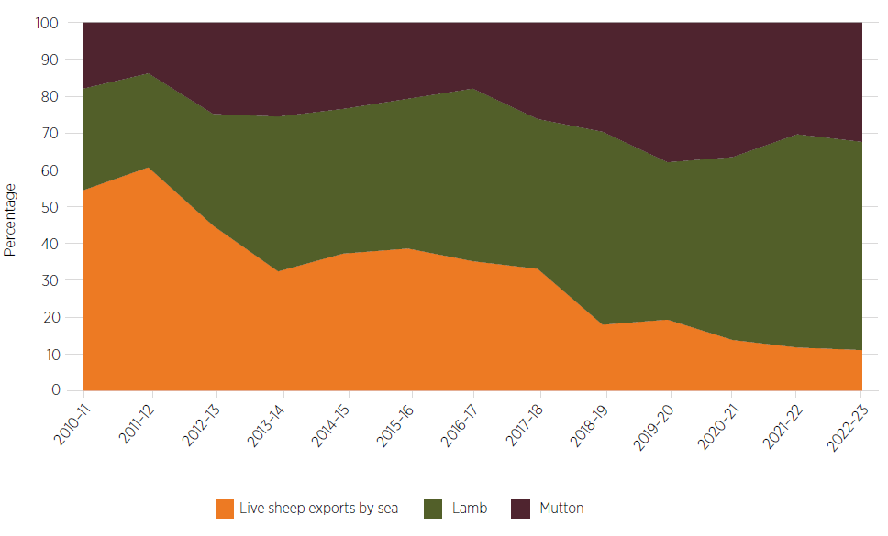

Source: ABARES Trade Dashboard

The shift in exports has been driven by a range of factors, including price. Figure 31 highlights the unit value growth of Australian lamb and mutton exports over live sheep exports over the 10-year period to 2022. Sheep meat (mutton) unit value has almost doubled in the 10 years, compared to far more modest growth in the live sheep unit value over this period (S&P Global 2023).

Figure 31 Australian sheep and sheep meat exports, unit value comparison (A$/kg)

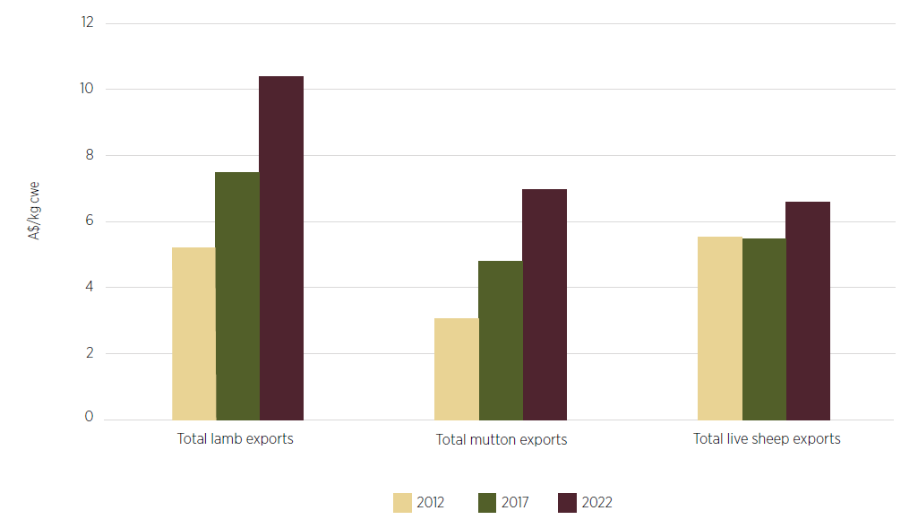

Note: Live sheep carcase weight equivalent price (cwe) is based on gross export weight. Carcase weight equivalent is the weight of a live sheep as its equivalent weight as a dressed carcase.

Source: S&P Global 2023

While many factors such as seasonal conditions, trade conditions, international demand and domestic demand for restocking affect sale prices, live export wether sale prices broadly track average processor prices in the saleyard, as outlined in Figure 32. These prices will generally move together, as sellers will seek the best price and buyers (live exporters, processors and restockers) will respond by offering a more competitive price to secure a supply of sheep. Indeed, the importance of competition in the WA sheep market was regularly raised in the Panel’s consultations and is covered in Sheep supply and value chains.

Figure 32 Price of live sheep exports and wethers for domestic processing in WA, 1999–2000 to 2022–23 (real value)

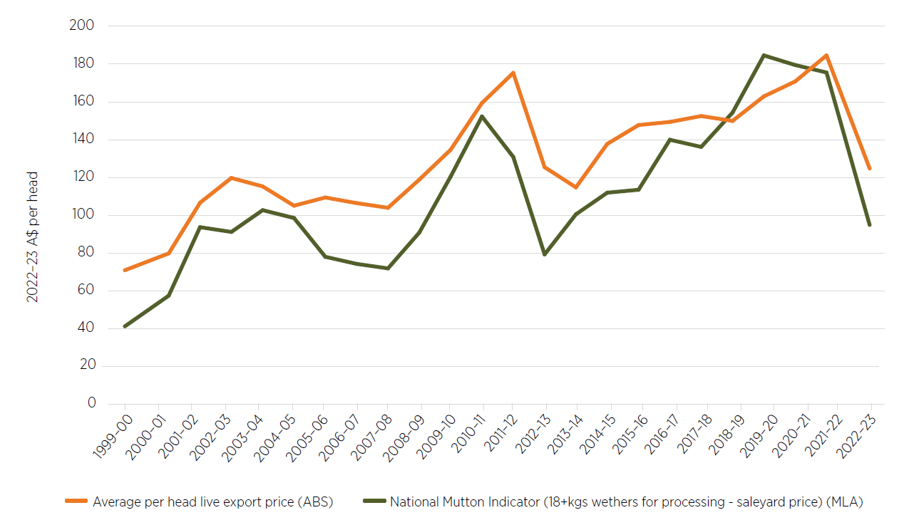

Source: ABS 2023d and MLA 2023b

#### Export destinations

Figure 33 and Figure 34 depict Australia’s major sheep meat export destinations. There are differences between lamb and mutton markets, generally with greater value from lamb markets, even if volumes are smaller. As discussed in Background, the US continues to be Australia’s most valuable market for lamb, while mutton exports are dominated by China. Most of Australia’s lamb and mutton markets dropped in 2020–21 due to freight and demand disruptions due to COVID-19. These markets regained strength in 2021–22, though they have more recently dropped due to global sheep meat supply being high.

In 2021 Australia provided 44% of the Middle East’s sheep meat imports, principally as fresh or chilled lamb carcases or half carcases (12%), fresh or chilled cuts of sheep (9%), and frozen cuts of sheep with the bone in (9%) (UN Comtrade 2023a).

Sheep supply and value chains provides an overview of modes of freight transport, including air freight, noting that over the past 8 years WA has generally sent a higher proportion of sheep meat exports by air than the national average. Continued growth of this mode is challenged given that the numbers of flights out of Perth have not returned to pre-COVID levels and fewer flights are stopping in transit hubs in the Middle East or South-East Asia.

Figure 33 Australian lamb exports by region, 2010–11 to 2022–23 (real value)

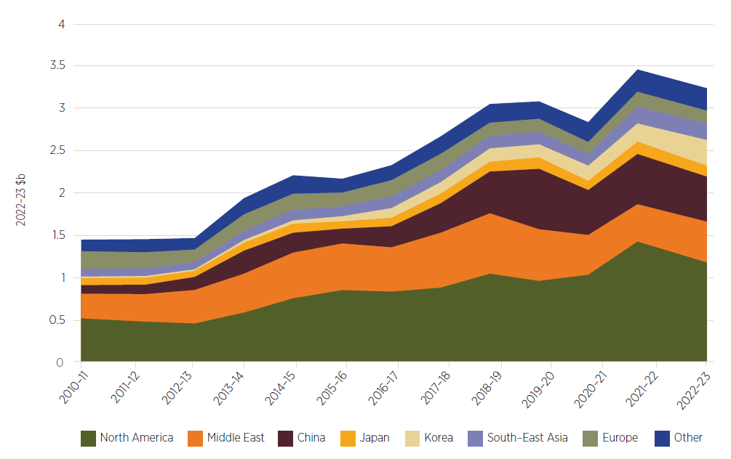

Source: ABARES Trade Dashboard

Figure 34 Australian mutton exports by region, 2010–11 to 2022–23 (real value)

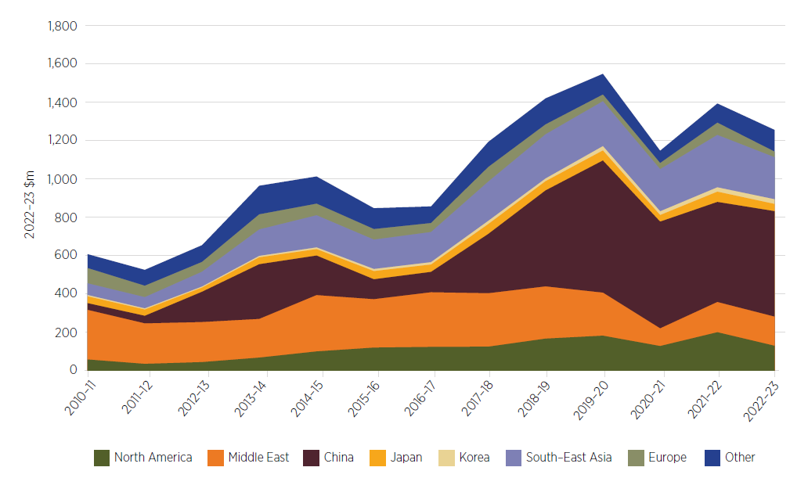

Source: ABARES Trade Dashboard

#### Global sheep meat exports

The largest exporters of sheep meat are Australia and New Zealand, comprising approximately 75% of the global market annually by value. Other major exporters include the United Kingdom, the EU and Uruguay (Figure 35).

Figure 35 Global sheep meat exports, 2011 to 2021, USD million

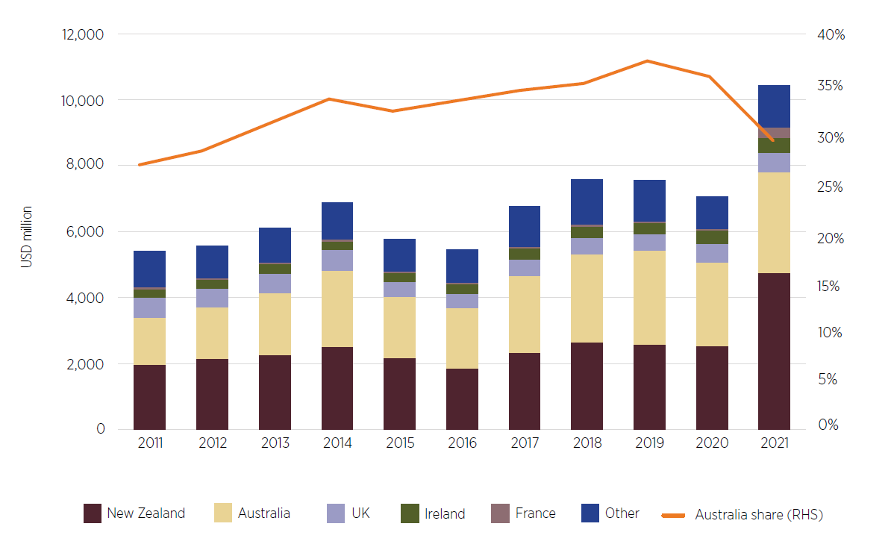

Source: OECD-FAO 2022

The New Zealand industry is undergoing significant change which has seen sheep slaughter fall by 5.4% in 2021–22, following a 1.8% fall in 2020–21. This has been brought about by a broader shift to dairying, environmental offset planting, and urban expansion around key population centres, reducing the land used by sheep-focused enterprises by 29% between 2002 and 2019 (MLA 2022b, OECD-FAO 2023).

While New Zealand contributed 32% of global exported sheep meat in 2021–22, it was at the expense of domestic supply, which has shrunk from 18% of production in the early 2000s to 4–6% in 2021–22 (MLA 2022b), reflecting an export-focused market.

The New Zealand Ministry for Primary Industries forecasts these trends to continue, with total sheep numbers to fall to 23.6 million in 2026–27, down 8.2% on 2022 sheep numbers (25.7 million) (MPI 2023) (Figure 36).

The Panel observes that if the New Zealand sheep flock continues to decrease, this will likely have a bearing on New Zealand’s export volumes in the longer term, potentially creating more openings in the global market for Australian exports.

Figure 36 Actual and forecast New Zealand sheep numbers and export volumes, 2018–19 to 2026–27

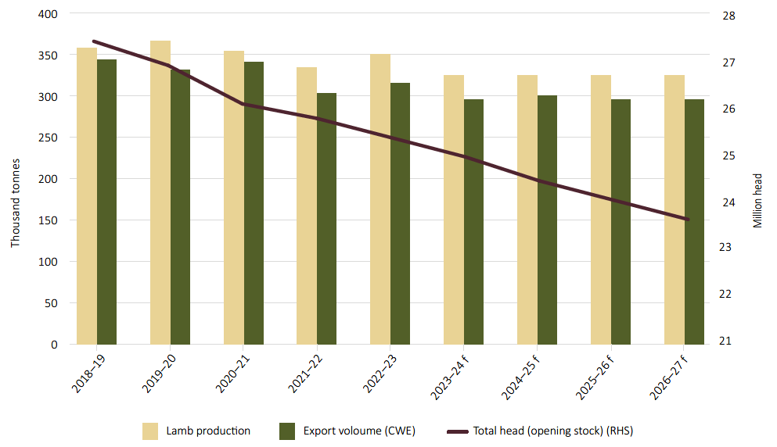

Source: MPI 2023

#### Global consumption and demand forecasts

The Organisation for Economic Co-operation and Development (OECD) and the Food and Agriculture Organization of the United Nations (FAO) forecast that global sheep meat consumption is to grow to 18.7 million tonnes (up 15%) over the 10-year period to 2032 (OECD-FAO 2023).

Most of the sheep meat consumption growth is forecast to be in developing countries, where sheep meat as a percentage of protein consumption is higher (3.7%) than in developed countries (1.7%) (MLA 2022b). As economic growth occurs it enables consumers to buy higher quality proteins like sheep meat more often. This growth is further bolstered by the scale of population growth, particularly in China, India and Pakistan (OECD-FAO 2022).

Growth in consumption does not directly equate to increased demand for imports, as countries such as China, India and Pakistan have significant sheep production growth for domestic sheep meat markets.

OECD-FAO forecasts worldwide demand (imports) for sheep meat to have a marginal increase over the period to 2032 at 0.7% per annum. This is driven by developing countries where growth is forecast at an average rate of 1.5% per annum.

In contrast, demand in developed countries is somewhat subdued at −0.7% per annum, given falling per capita consumption and modest population growth (OECD-FAO 2023).

There will be stronger growth in MENA and Asian markets. For example, Saudi Arabia is forecast to have demand growth of 2.5% per annum while Malaysia is forecast to have demand growth of 1.7% per annum (OECD-FAO 2023).

Analysis suggests that boxed sheep meat is not directly substituting live sheep in Middle Eastern countries, indicating that the cessation of live export trade does not mean Australia’s boxed meat will automatically increase or decrease in value.

As an example, the Panel notes that Bahrain last imported live sheep from Australia in 2015–16. During the period 2016 to 2021 Bahrain’s main suppliers of live sheep have been Jordan and Somalia. The value of Bahrain’s imports of Australian sheep meat have also declined over this period, though Australia was still the second largest supplier of sheep meat by value in 2021. The same trend applies when viewed by volume rather than value (ABARES 2023j).

Slightly differently, Saudi Arabia last imported live sheep from Australia in 2012–13 and has since increased its imports of Australian sheep meat from $16.9 million in 2012–13 to a peak of $34.3 million in 2021–22 (ABARES 2023j).

These examples highlight the global nature of trade and the need for Australia to grow new and deepen existing markets for Australian sheep products, and not necessarily those with existing live sheep markets.

The Panel also heard commentary that some Middle Eastern countries do not have sufficient refrigeration to sustain increased imports of sheep meat, but the ongoing imports suggest this is not a – or is only a limited – concern. Indeed, Meat & Livestock Australia’s (MLA’s) analysis is that over half of Australia’s sheep meat exports to the MENA region go to the food service sector, where cold chain infrastructure is already in place. Young populations with high disposable incomes in these countries are also driving demand for premium lamb. Frozen mutton is also drawn on in catering for migrant workers in some of the MENA countries (MLA 2022c).

#### Pricing, competition and market signals

The Panel heard from many WA producers concerned that they were price takers when selling their sheep. Many felt that the live export trade provides a floor under prices that would leave them worse off in the absence of the trade. WA producers contrasted their situation with farmers in eastern states where the number of processing facilities and a significant domestic market help maintain demand and competitive pressure without exported live sheep by sea since 2018–19.

The Panel received advice from ABARES that Australia’s sheep meat prices are largely set in world markets, where Australia is a major exporter but a price taker. Accordingly, the medium-term and long-term prices for live sheep and processed lamb and sheep products are largely set by global conditions. The Panel also notes that live export wether sale prices broadly track average processor prices in the saleyard (see Figure 32).

The Panel is aware that prices for sheep meat and lamb both in WA and nationally have reduced significantly since coming off historical high points. For WA, lamb prices peaked in February 2022, and mutton in July 2021; nationally, lamb prices peaked in September 2021, and mutton in July 2021. The price drops have been difficult for producers to navigate given the sharp and significant reductions from the recent historical highs. At the same time, forecast poor seasonal conditions for 2023–24 and associated destocking, and fluctuations in global supply and demand, have compounded price effects. The Panel recognises the difficult financial position that such a change may create for producers around the country.

In 2022–23 the value of Australia’s live sheep exports by sea was less than 2% of the value of lamb and mutton exports. Converting Australia’s live sheep exports to sheep meat would therefore not be expected to have a material impact on global supply or prices.

More broadly (across Australia, not just WA), global sheep meat export prices are expected to continue to decrease in 2023–24 as a backlog in global supply more than offsets an increase in global demand. Indeed, the Panel heard of this global oversupply in its consultations. Drier seasonal conditions and a larger sheep flock are expected to increase turn-off, slaughter rates and sheep meat production, further contributing to this challenge. The value of Australian sheep meat exports is forecast to fall to $3.8 billion in 2023–24, down by 16% from an estimated $4.5 billion in 2022–23 as lower export prices outweigh higher export volumes (ABARES 2023g). This forecast was echoed in consultations with exporters, who are expecting to export more live sheep from Australia in the next season as the drop in global sheep prices makes the price of Australian sheep more competitive. The live export numbers for 2022–23 illustrate this shift in prices and volumes, with close to 200,000 more head exported live between 2021–22 and 2022–23 but the value of the trade dropping by $0.69 million (ABARES 2023j).

Despite the decreases in the average saleyard prices for lamb and sheep, the OECD forecasts moderate price growth over the period from 2025 to 2031, increasing by about 8.3% over the average sheep meat price in 2022 (OECD-FAO 2023).

The Panel acknowledges that global price settings will be the main factor in setting prices for WA producers; however, there are likely to be some more localised price variations that still have a bearing on producers. Some of these issues are explored in Sheep supply and value chains.

### Increasing trade opportunities

#### Australia’s trade goals

Increasing processing of sheep in Australia and growing demand in new and existing markets for sheep meat, particularly for older sheep and the lightweight wether Merino, will likely be crucial for supporting the WA sheep industry. Sustaining wool demand or seeking increased market options if the WA wool clip becomes broader will also be important.

The Australian Minister for Trade and Tourism has identified trade diversification as the central plank of the Australian Government’s trade policy strategy. The government is seeking to deepen and diversify Australia’s network of trading partners and create new opportunities for Australia exporters and investors (Farrell 2022).

The government’s focus on diversifying and deepening Australia’s trade interests may assist in pursuing new opportunities, such as expanding investment in sheep meat processing in Australia and increasing exports of quality sheep meat to the world.

Trade diversification is also reflected in the 2023 strategy Invested: Australia’s Southeast Asia Economic Strategy to 2040, which sets out a pathway to increase trade and investment with South East Asia, with specific agriculture and food actions to raise awareness, remove blockages, build capability and deepen investment (Moore AO 2023).

#### Market access

Australia already exports sheep meat to over 80 destinations, and has favourable market access and proximity to countries that are projected to make up almost 65% of global sheep meat consumption over the next decade (OECD-FAO 2022), including:

* China: 0% tariff for lamb and mutton under the China–Australia Free Trade Agreement
* India: 0% tariff for lamb and mutton under the Australia–India Economic Cooperation and Trade Agreement
* UK: 0% tariff for in-quota lamb and mutton trade up to 75,000 tonnes by 2032 under the Australia–United Kingdom Free Trade Agreement
* US: 0% tariff under the Australia–United States Free Trade Agreement
* Indonesia: 0% tariff under the Indonesia–Australia Comprehensive Economic Partnership Agreement.

The Panel notes that preferential access needs to be coupled with technical market access. While Australia has access to most markets for sheep meat and meat products, this access may rely on individual processing and exporting establishments being listed for these products by the relevant market before trade can occur. Listing may be a protracted process, and in some markets is dependent on a trading partner’s ability to conduct onsite audits of establishments. The Panel sees this as a possible area for ongoing Australian Government attention in supporting importing country audits and approvals.

#### New and recent free trade agreement opportunities

The Australia–United Kingdom Free Trade Agreement entered into force on 31 May 2023. One of the benefits to Australian producers is the significant market access uplift for Australian sheep meat exporters to the UK.

In addition to the existing World Trade Organization quota (13,335 tonnes per annum), from entry into force, Australian exporters can access an additional 14,726 tonnes of sheep meat to the UK duty free. This quota will increase to 30,556 tonnes in 2024, before reaching 75,000 tonnes by 2032. Exports outside of the quota will still be subject to an out-of-quota duty until 2033, when both the tariff and quota will be fully eliminated.

The Australia–India Economic Cooperation and Trade Agreement, which entered into force on 29 December 2022, unlocks access to the world’s fastest growing major economy and most populous nation. Demand for red meat in India is growing, with sheep meat consumption expected to increase by 14% by 2031.

Australian sheep meat, which was previously subject to a tariff of 30%, can now enter India duty free. The removal of the tariff gives Australia a price advantage over other exporters of sheep meat, such as New Zealand.

#### Target markets

Growing market opportunities for Australian lamb and mutton will be key to supporting the WA sheep industry through change. Mutton may need to be a particular focus given the age and type of animal typically being exported live. It will be important to stretch and maximise existing markets such as China, MENA and South-East Asia, while looking for new opportunities in South Asia and Europe.

##### MENA markets

Noting the significant growth in demand for processed sheep meat in the MENA market, there needs to also be consideration of market preferences to maximise market share of that growth. Many MENA countries prefer a lean, smaller carcase. This type of market specification highlights the opportunity for increased feedback from exporters and processors to producers to better grow animals to market specifications and better encapsulate the value chain concept (see Sheep supply and value chains).

Marketing and promotional activities, increased presence of Australian personnel in markets – the Department of Agriculture, Fisheries and Forestry (DAFF) and Department of Foreign Affairs and Trade officials, state government trade representatives, MLA staff, Austrade officers, and Australian company representatives and contributions to large events such as Gulfood – could all add to the readiness of Middle Eastern trading partners to look to Australia for ongoing food supply in both sheep meat and other commodities. The Panel sees value in these different opportunities being pursued to grow demand for Australian sheep products.

##### Traditional New Zealand markets

As noted in Global sheep meat exports, the flat forecasts for New Zealand exports and the predominance of lamb in those exports present real opportunities for growth for Australian sheep products into markets typically dominated by New Zealand exports, such as China and European countries. This could see Australia’s share of global sheep meat exports grow from 40.6% in 2023 to 44.7% in 2031 (OCED-FAO 2023).

##### Additional markets

There is also an opportunity to broaden the number of markets for WA sheep products compared with the number of markets accessed nationally. In 2022–23 WA-produced mutton was exported into 29 markets while mutton from all of Australia was exported into 62 markets. This could be an area for further exploration by MLA and DAFF. A similar trend is evident for WA lamb, as shown in Figure 27.

Figure 37 Number of markets for lamb and mutton, national and WA, 2014–15 to 2022–23

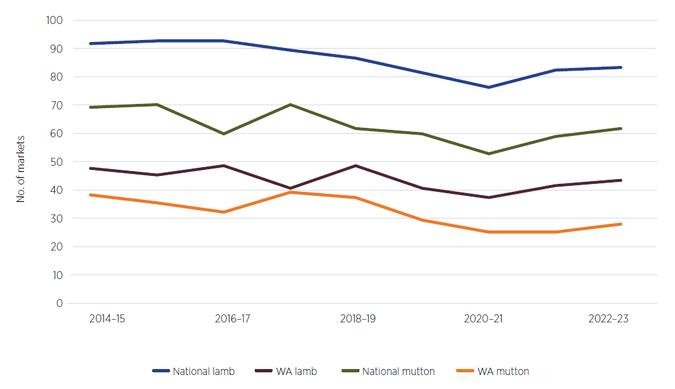

Source: ABARES 2023j

#### Market advancement

Growing demand for Australian sheep meat is not simply about assuming that trading partners will substitute live sheep for sheep meat. There is a need to drive interest in Australian products – lamb, mutton and co-products – in multiple markets, including those that are not live sheep destinations.

As noted in International relations, the Panel encourages ongoing engagement with trading partners throughout the transition away from live sheep exports by sea to provide a clear understanding of the changes and their implications, particularly given the value trading partners place on the bilateral relationship and history of trade.

The Panel heard how MLA and Austrade work in markets to promote their presence around the world and to assist in growing Australia’s market presence and opportunities, often alongside Australian companies seeking to grow their market share. Austrade’s efforts are useful in making connections to advance niche products or new players in the Australian export scene. MLA is very active in promotion and education activities to ensure customers know the value and quality of our products, while also understanding how to use cuts of meat. The Panel observes that MLA’s role in markets appears more aligned with the needs of the WA export market, though there may still be occasions where Austrade’s connections and insight are valued, particularly by new or smaller companies.

Between 2020–21 and 2022–23, MLA received $1.665 million under the Agricultural Trade and Market Access Cooperation program (ATMAC) to develop markets for Australian red meat in Saudi Arabia, Thailand, Vietnam and India. The Panel considers MLA could be similarly funded to grow demand for Australian sheep meat as the industry transitions away from live sheep exports by sea. There could be value in focusing on both existing live export markets and growing demand for Australian sheep meat in other locations.

Australia also needs to be aware of the potential growth of exports from other (non-New Zealand) sheep meat exporting countries into target markets that Australia could pursue. Ongoing engagement with trading partners provides the opportunity to maintain and grow these markets but also to reinforce the benefits of Australian sheep meat products in comparison to other nations. For example, in January–June 2023, UK sheep meat exports including offal, while coming from a low base, increased by 122% to Jordan, 20.9% to Kuwait, and 2.8% to the UAE from the year before (Harley 2023).

Early, deliberate investment in promotional activities may also contribute to growing certainty for producers and processors considering their plans ahead of the end of the live sheep trade. The Panel feels that in the longer term MLA could continue its regular marketing activities, including in any expanded markets, drawing on levy revenue.

#### Australian wool

Australia also has opportunities in the global wool market. Although the value of sheep meat exports has overtaken wool, wool exports still have significant value for the Australian agriculture sector, including in WA, where wool and sheep meat exports are close to equal in value. Australia is one of the world’s largest wool producers, supplying around 25% of greasy wool sold on the world market and producing the majority of the world’s Merino wool (UN Comtrade 2023b).

Short-term forecasts by Australian Wool Innovation (AWI) are that global wool imports will likely remain stable over the coming years due to mitigating market forces, particularly the subdued Chinese economy and broader retail market demand (AWI 2023a).

In 2022–23, 20% of Australia’s total value of wool exports ($3.4 billion) came from WA ($693 million). Over 64,000 tonnes of greasy wool was exported from WA in 2022–23 (ABARES 2023j).

The AWI WA Committee’s estimate of shorn wool production for 2022–23 is 60.6kt greasy, down 1.0% on 2021–22. The committee anticipates that a sell-off of held-over sheep and a reduction in breeding ewe numbers will have a large impact (−6.3%) on shorn wool production in the 2024–25 season (AWI 2023b).

A risk during the transition period will be the WA flock size and breed composition. As noted in Impacts, any significant drop in Merinos in the WA flock could impact negatively on WA’s wool production and income. With any large drop in wool production, there will be a ripple effect to allied industries associated with the trade such as shearing and contractor services (including activities such as lamb marking and wool classing) and the communities that support them. If more meat breeds are introduced to the WA flock, the overall quality of the wool clip could also decline, affecting the profitability of those allied industries.

As for sheep meat, there may be opportunities to expand Australia’s wool trade via promotional or investment activities. Any such activities could specifically consider the WA wool industry, including its proximity to South-East Asia and South Asia, and be based on partnerships with AWI and MLA, along with the WA Department of Primary Industries and Regional Development.

#### Other sheep products

The Panel recognises that increasing sheep meat processing in Australia will likely result in more co-products that will also require export destinations.

##### Rendered products

Exported rendered product is a significant income source for Australian agriculture. Rendered products, such as meat and bone meals and tallows, are used for livestock and pet food and in production of soaps, lubricants, cooking oils, fertiliser and pharmaceutical ingredients. In 2022–23 Australia’s exports of ovine flours, meals and pellets (unfit for human consumption) were valued at more than $135 million, including an estimated $15 million of exports from WA (ABARES 2023j). It is somewhat harder to distinguish sheep tallow exports, as trade data mixes beef and mutton tallow. Though an imperfect example, Australian exports of beef and mutton tallow were valued at over $800 million in 2022–23, including $69 million from WA (ABS 2023b).

The rise of pet ownership in Asia points to ongoing market opportunities for rendered products. WA processors are generally already involved in processing rendered products and, with increased throughput, will need new or expanded markets for these products. Australian exports will require market access and the necessary audits and approvals by the importing countries. The Panel sees this as an area for Australian Government attention.

##### Sheep skin and edible offal

Worldwide trade data for sheep skin and edible offal is available through the Food and Agriculture Organisation (FAOSTAT database). This section uses the FAO data (in USD) rather than ABS data, to allow comparison of Australian exports with other country exports worldwide.

Sheep skins and edible offal are small markets compared to sheep meat, with total exports worth US$513,000 and US$258,000 in 2021, respectively (FAO 2023). Australia was the largest global exporter of both sheep skins (58,000 tonnes, or 42% of exports by value – Figure 38) and edible sheep offal (33,000 tonnes, or 39% of exports by value – Figure 39) in 2021.

The overall value and volume of sheep skin exports has declined since 2014. Australia exported 58,000 tonnes in 2021, compared to 200,000 tonnes in 2014. The largest global importers of sheep skins in 2021, by value, were China (65%), Italy (9%) and Türkiye (8%). Australia exported US$201,000 worth of sheep skins to China in 2021, making up 94% of our sheep skin exports.

Australia has consistently exported between 30,000 and 40,000 tonnes of sheep offal each year between 2012 and 2022. It is the largest exporter of sheep offal, followed closely by New Zealand. The value of edible sheep offal exports has remained steady over the past 10 years (Figure 39). Major importers in 2021 were China (53%), the UK (9%), and the USA (8%). Australia exported US$47,000 worth of offal to China and Hong Kong in 2021, making up 47% of our sheep offal exports.

The volume and value of sheep skin and edible offal exports is small compared to sheep meat, wool and rendered products, and will be even smaller for WA, but is worth considering in any future market development activities. Through consultations, WA skins processors pointed to opportunities to increase processing capacity if access to labour could be improved (see also Sheep supply and value chains and Sheep processing labour).

Figure 38 Global sheep skin exports, 2012 to 2021, USD thousands

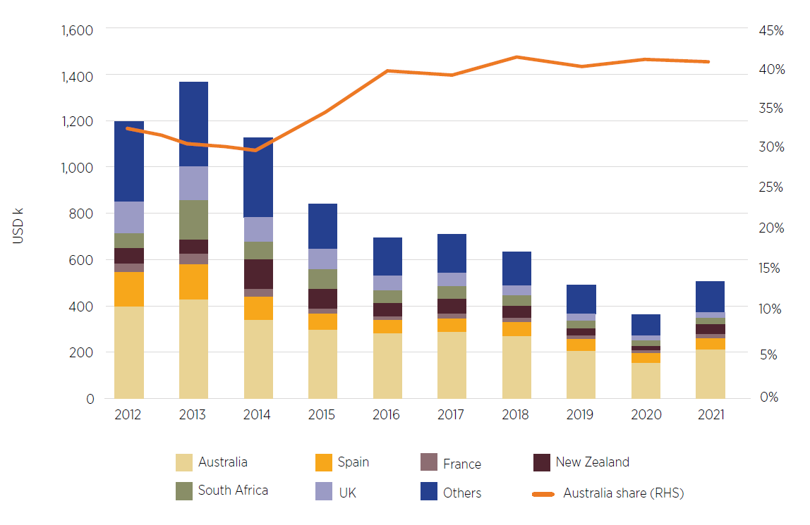

Source: FAO 2023

Figure 39 Global edible sheep offal exports, 2012 to 2021, USD thousands

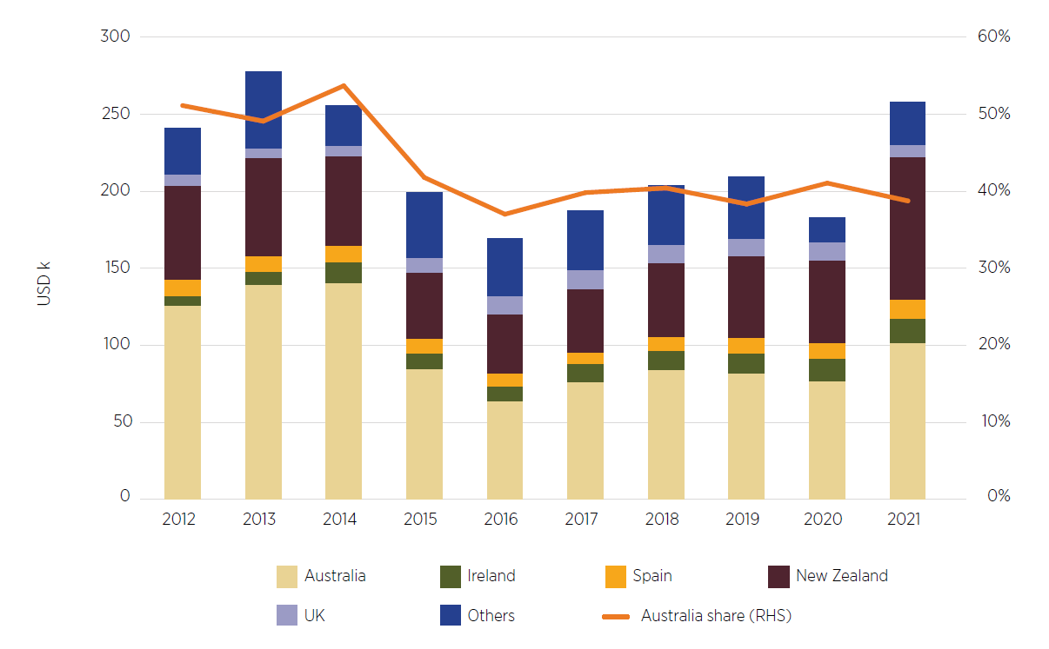

Source: FAO 2023

#### Fodder

Australia currently exports fodder for animal feed. Export fodder is predominantly oaten hay but includes hay and silage of all types (pasture, cereal, lucerne, clover), chaff (coarsely chopped dried whole plants), vetch and pelletised feed.

In 2022–23 Australia exported A$553.6 million of fodder for animal feed, with WA accounting for 52% of the value. The main markets for Australia and WA were Japan, the Republic of Korea, Taiwan, China, Vietnam, and ship and aircraft stores. In 2022–23 Japan accounted for 58% of WA’s total fodder for animal feed exports of A$285.4 million. Other key importers from WA in the same period were the Republic of Korea (21%) and Taiwan (16%) (ABS 2023c).

Australia is the second-largest exporter of fodder for animal feed globally after the United States. In 2021 Australia accounted for 14% of the total global fodder for animal feed of US$3.9 billion. The main importer of fodder for animal feed is Japan. In 2021 Japan accounted for 24% of global fodder for animal feed imports, followed by China (19%), UAE (10%), the Republic of Korea (9%) and Saudi Arabia (8%). All these key importers already import fodder from Australia (FAO 2023).

The Australian Fodder Industry Association notes that current exports of oat hay are close to 1 million tonnes and that AgriFutures Australia forecasts an expected market growth to 1.8 million in the coming years (AFIA 2023).

As noted in Broadacre cropping, there are commercial drivers for WA sheep-only producers to transition to a mixed livestock and cropping operation or to a full cropping enterprise where land is suitable. Shifting to or increasing fodder production presents another market opportunity for such existing sheep producers. Similarly, for producers who provide fodder to live export ships, there are alternative domestic markets (including feedlots) as well as the growing export markets.

### Growing foreign investment

#### Investment in meat processing

As noted in Sheep processing labour and Sheep supply and value chains, increasing domestic processing capacity will be key to the long-term sustainability of the industry.

Meat processing is energy and labour intensive, with extensive environmental, construction, food safety and worker safety requirements to ensure infrastructure, staff and products are safe. Each of these elements, while necessary, adds cost and time to establishing or growing a meat processing facility.

The Panel considers that foreign investment could be an option for increasing the capacity of the industry, noting that Australia has a strong record of foreign investment in agriculture and agribusiness. Approved foreign investment in the Australian agriculture sector was valued at $8.5 billion in 2021–22 (Treasury 2023a).

The Panel heard that Austrade fulfils an important role in attracting foreign investment by promoting investment opportunities; providing market and policy intelligence; facilitating introductions to government agencies; and assisting with regulatory processes. The Panel welcomes Austrade’s efforts to attract investment to the WA sheep industry. The Panel notes that the presence of investment – foreign or domestic – in the sheep industry, and particularly processing, could support increased competition for WA sheep, lifting prices and contributing to a more economically sustainable industry.

### Relevant recommendations

Initiatives requiring early action or funding: 14.

14) The Australian Government should provide access to additional funding for:

a) industry-linked organisations to grow new and deepen existing markets for Australian sheep products, particularly from WA

b) the Department of Agriculture, Fisheries and Forestry to support market access and growth for Australian sheep products, particularly from WA.

15) The Australian Government should continue to engage with trading partners on the development of the sheep meat trade in the Middle East during the transition away from live sheep exports by sea.

## Individuals and communities

The Panel prioritised consultation activities that enabled individuals to give their perspectives on the possible impacts of the government’s commitment to end live sheep exports by sea, as well as to provide suggestions for how the transition could be managed. Many people pointed to potential mental health impacts, either arising from animal welfare concerns about the existing trade or arising from their uncertainty about when the trade would end and what it would mean for their business or community.

Throughout the Panel’s consultations a clear link was made between strong businesses and healthy individuals and communities. Submissions to the Panel raised concerns about how WA communities have changed over time and how the end of live sheep exports by sea may accelerate these changes if people exit sheep farming. As noted in Impacts, the concern is that if the WA sheep flock contracts too much, businesses may close and community members may move elsewhere, further affecting availability and delivery of local services and social fabric.

The Panel is focused on seeking to avoid significant impacts from the end of live sheep exports by sea, recognising that individuals and communities will bear the brunt of the negative consequences if there is inadequate support, planning or early action.

The Regional Australia Institute (RAI) provided case studies to show that building social and local capital can result in better responses to policy changes. In the case of the end of live sheep exports by sea, early announcements and investment in resilience and capability will contribute to better outcomes for the affected individuals and communities.

### Resilient individuals and communities

Resilience is the ability to plan for, manage during and recover from challenging circumstances (see Farm businesses). The importance of resilient individuals and communities will be critical to navigating the change brought by the end of the live sheep export trade.

Communities create a sense of purpose, build social connections and offer a support network. They can also help individuals to respond to change, boost empathy and ease mental health issues (MasterClass 2022). The Australian Local Government Association defines community resilience as the sustained ability of communities to withstand, adapt to and recover from adversity. A resilient community will be socially connected and have the infrastructure to withstand disaster and foster community recovery (ALGA 2023).

Social resilience also helps to promote individual and community wellbeing and cohesion. The Productivity Commission’s inquiry report from its Review of Part 3 of the Future Drought Fund, identifies the importance of social resilience. Although viewed from a drought perspective, the report highlights that improving social capital and connectivity can help communities withstand negative impacts (PC 2023).

The Australian Government’s White Paper on Jobs and Opportunities includes a resilience index which provides a relative measure of a region’s potential ability to adapt to and recover from an external change, referred to as adaptive capacity (Treasury 2023b). The Panel notes that metropolitan areas typically have higher adaptive capacity than regional areas (Treasury 2023b). In this context, the Panel emphasises the importance of having frameworks and support measures in place for individuals and communities that enable them to plan and flexibly respond to the change.

### Community context

The Panel’s consideration of individuals and communities focuses on 3 Regional Development Australia (RDA) regions (see Figure 3 in Background) whose links to sheep production make them more likely to be affected by the end of live sheep exports by sea:

* Mid West–Gascoyne
* Wheatbelt
* Great Southern.

The Panel recognises that the end of live sheep exports by sea will also affect businesses and communities outside these regions, but these impacts may be more localised such as in the Goldfields Esperance region (Figure 3) or Rangelands (Figure 4). A focus on the areas with a greater concentration of sheep is intended to guide policy responses rather than exclude other locations or individuals.

#### Population

The trend in WA at a statewide level has been for people to move away from regional areas (ABS 2022) (Figure 40). Regional WA saw a net loss of 3,040 people between 2011 and 2016, and 9,017 people between 2016 and 2021.

Figure 40 Internal migration in Australian states and the NT, 2006 to 2021

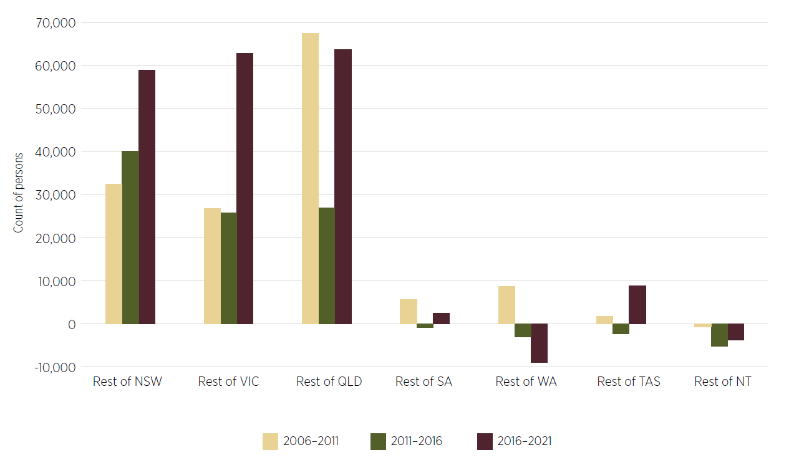

Note: Positive values indicate movement from cities to regional locations. Negative values indicate moves from regions to cities.

Source: ABS 2022

In 2020–21 WA was the only state where capital city population growth overtook non-capital city growth (Robertson 2022). Although at a state level more people are moving away from regional WA, the 3 focus RDA regions have experienced low but consistent population growth from 2018 to 2022 (as discussed in Background and Sheep processing labour). However, this does not reflect the level of growth of the working age population. Between 2017 and 2021, Mid West–Gascoyne grew by an average 0.2% per year, the Wheatbelt declined by an average 0.5% per year, and Great Southern grew by an average 0.5% per year.

#### Employment

In March 2023 the unemployment rate in the main sheep producing regions was below that of Perth and the non-metropolitan average (Figure 41).

Figure 41 Unemployment rate, Perth and WA regions, March 2023

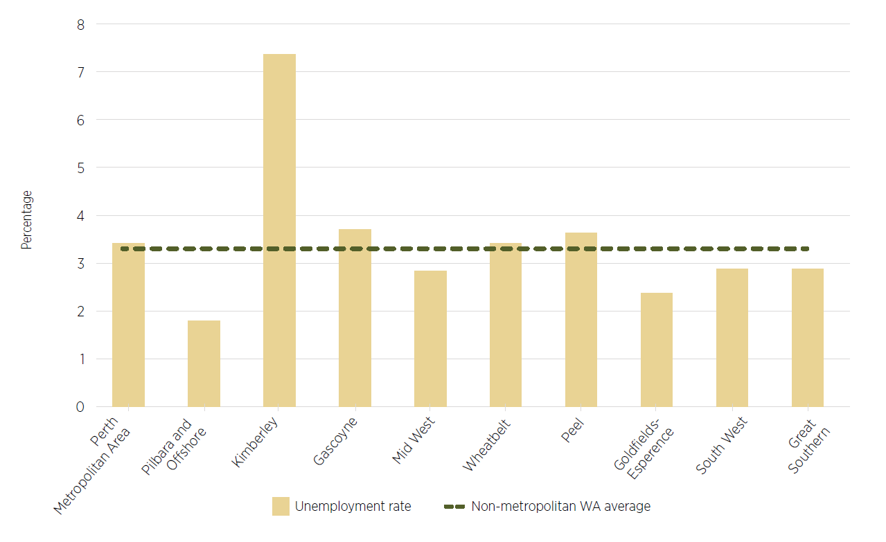

Source: DJTSI

RAI reports that of these 3 regions, the greatest concern for the agriculture, fisheries and forestry sector is in the Wheatbelt, which has seen employment drop from nearly 20,000 in 2020–21 to 13,000 in 2022–23. The issues surrounding labour attraction and retention are further explored in Sheep processing labour.

#### Access to services

The Panel was presented with examples of poor access to services, which is an ongoing concern for regional communities in WA. Access to health care, education and digital connectivity is already constrained, particularly with greater distance from regional centres. The Panel heard concerns that services already under-represented in these areas will be at greater risk if populations shrink due to the end of live sheep exports by sea. This result could delay or restrict assistance delivered to those affected, as well as compounding issues for individuals and communities affected by the transition.

The regional WA experience reported to the Panel was consistent with other national information and data. The Australian Institute for Health and Wellbeing reports that Australians living in rural and remote areas have shorter lives, higher levels of disease and injury and poorer access to and use of health services, compared with people living in metropolitan areas (AIHW 2023). The National Farmer Wellbeing Report 2023 states that more than a quarter of farmers (27%) say feelings of loneliness or isolation, combined with limited access to mental health services, have had the biggest impact on their mental health over the past 5 years’ (NFF 2023).

#### External factors

The end of live sheep exports by sea comes in a broader context for many individuals and businesses. Various issues are presenting challenges, including increasing costs of inputs, limited access to and retention of skilled workers (including shearers), demographic shifts as farms increase crop production at the expense of more labour-intensive livestock production, lower levels of service availability in regional locations, other regulatory changes affecting agriculture, and climate variability. The end of live sheep exports is not one factor in isolation. The net impact of the changes that have occurred and concerns about future changes are stressors for individuals and communities involved.

The Panel notes that the impact of minor and major stressors on psychological and physical health is well documented. It is clear from literature that stressors include events and behaviour that can evoke strong negative emotions and feelings (that is, psychological stress) – noting that ‘the effect of a psychological stressor is primarily related to the level of perceived stress severity’ (Palamarchuk & Vaillancourt 2021). Untreated, this can lead to detrimental mental and physical health outcomes. The Panel is eager to see supports delivered to individuals and communities to help reduce the uncertainty they face and arrest negative outcomes.

The Panel also heard from individuals that are distressed by the knowledge and awareness of the treatment that sheep encounter as part of being exported.

A list of mental health and other support services is included at Appendix 5, in addition to those described at Box 7.

### Impacts from the end of live sheep exports by sea

#### Individual health and wellbeing

The Panel regularly heard of mental health impacts caused by the announcement that live sheep exports by sea would end. There are concerns about income certainty and business viability in the absence of the live sheep export trade. Producers are worried about how they will manage their sheep, especially without the back-up of live exports, if a season quickly deteriorates. These business concerns are often coupled with predictions of future poor mental health outcomes for individuals.

Research indicates that gender can also play a role in how mental health issues are managed by individuals. The National Farmer Wellbeing Report found that ‘women tend to report depression and anxiety in greater numbers, while men posed a greater risk to self-harm or suicide’. The report noted that of farmers experiencing mental health concerns, 17% did not want to seek or receive help, while 11% felt too embarrassed to do so (Norco 2023). The Panel acknowledges the importance of supporting producers, particularly men, to seek mental health assistance.

Individuals and representative groups point to the unknown end date of the trade and the future reduced options for turning off stock as causing personal distress. It is difficult to isolate the end of live sheep exports by sea as the primary or only reason for mental ill health, especially given the many factors noted earlier. However, the Panel is conscious of the need to uphold the mental and physical wellbeing of industry participants. The Panel notes the depth of feeling and concern for the potential mental health impacts cited by many of those consulted.

The general lack of confidence in the WA sheep industry is reflected in the MLA and AWI Sheep Producers Intentions survey, in which WA producers’ sentiment about the outlook for sheep meat went from +42 in October 2022 to −48 in May 2023 (MLA & AWI 2023b). The survey notes that the decision to end the live sheep export trade is a contributing factor to this decline in confidence, along with predicted seasonal conditions. The Panel notes that since the May survey, prices for wool, lamb and mutton have declined across Australia due to seasonal and other reasons (noted in Markets), which is further weighing on producers.

Many producers likely to be directly affected by the end of live sheep exports by sea have their identity closely linked to their profession. Producers can be part of families that have farmed sheep for generations, and in some cases had relatives who helped establish WA’s live export trade. Many of those consulted feel personally aggrieved by the decision to stop live sheep exports, and this is affecting their mental health. Producers’ business, housing, lifestyle and families are often tied up in their farming activities, resulting in business uncertainty being connected to personal anxiety. Further, individuals may not readily be able to relocate or seek alternative employment if they elect to stop farming or face decreased income, given the degree of capital tied up in their farm businesses. As noted by RAI (2023):

Jobs can form the identity of a person and be an emotional trigger when these are being viewed as taken away, making the transition to new industries difficult.

#### Community businesses and allied industries

The live sheep industry is not a single enterprise system. The market is made up of large and small contributors with different levels of involvement. Consequently, the relative impact on and the subsequent responses from each enterprise will vary (RAI 2023). There are also small and medium enterprises that will be affected by the end of live sheep exports even though they are not directly involved in the trade. As noted in Impacts, there are varying estimates of the number of employees directly or indirectly linked to live sheep exports by sea.

Indirect impacts may present themselves in communities through a decline in local spending, particularly if there is a substantial change in the size or composition of the sheep flock. For example, hairdressers and cafés may see a reduced customer base, with not as many transport drivers or producers coming into town. Similarly, although only a small proportion of veterinarians will be directly impacted, it is an occupation involved across the entire live sheep export supply chain. Any reduction in veterinarians could limit access to general rural veterinary services and the support they provide to the agriculture sector.

Businesses and contractors that partially rely on the live sheep export trade, such as feed millers, shearers, mulesing and animal husbandry contractors and transporters, will likely see a disruption to their income stream. The degree of shock felt by these businesses will be closely linked to their exposure to live exports, their ability to reorientate their business and implement changes, and the size of any flock reduction due to the end of live sheep exports by sea. Any impacts will come on top of any adjustments they have made arising from the Northern Hemisphere Summer Prohibition.

Flow-on effects from lost revenue in the community can also change local demographics and access to service delivery. For example, childcare centres or schools may not have sufficient staff and therefore have reduced capacity, or may lack a critical mass of students and face potential closure. It also acts as an impediment to attracting people to a region if these services are not available. Additional workers (such as in health, professional or retail services) may migrate to regional centres or metropolitan areas to find alternative employment. The Panel notes that an ongoing concern for agricultural regions in WA is the competition for workers with the mining sector. In addition, the small starting population of many WA towns means even small shifts in population size or structure can change social and community fabric, such as reducing the number of players for local sporting teams or volunteers for community activities. Any reduction in the informal networks and groups in a community can have a wide negative impact on individuals’ wellbeing, and this was cited as a concern by many participants in consultations.

### Supporting individuals and communities to be resilient

The Panel’s concern for individuals and communities likely to be affected by the end of live sheep exports by sea spans from the initial announcement of the government’s policy, throughout the transition period, to when the trade ceases and beyond. Earlier investment will help reduce the depth of the resilience curve (the shock) (Figure 25 in Farm businesses) and drive improvements beyond the end of live sheep exports by sea (the recovery). More prolonged supports will also be needed, recognising that different individuals will have different rates of adaptation to change, and that the extent of the impacts of the cessation will not be known immediately.

#### Existing individual and community supports

A range of existing programs (Appendix 5) are helping communities build resilience and manage financial and personal hardship. These programs include providing a financial safety net for individuals, training in business or life planning, or community initiatives to bring people together for mutual support. Government-funded (Commonwealth or state) programs often work in tandem with specialist services or non-government organisations active in communities, or provide online or phone support.

The Panel considers there may be increased demand for many services in WA prior to the end of live sheep exports by sea. The immediate term could see a peak as individuals and businesses react to the announcement and seek to make plans while also navigating the other pressures mentioned earlier. The Panel sees value in governments assessing the demand for advice and support services and providing sufficient funds and staff to avoid delays when affected individuals access support. Such delays could be seen in mental health services or in financial counselling and support.

### Focus on mental wellbeing

Many of those consulted pointed to mental health concerns arising from the announcement that live sheep exports by sea would be ending. The individuals and communities likely to be impacted are spread over a large geographic area and may face difficulty accessing mental health supports. Mental health pressures can take time to surface, and people can be affected in different ways and at different times. Ensuring the supports are available before, during and after the end of live sheep exports by sea will demonstrate an ongoing commitment to the affected communities.

Two programs the Panel heard about and considered worthy of further promotion and uptake were MindSpot (and MindSpot GP) and Head to Health (Box 7). These are free, confidential services available nationally, including in regional and remote areas. The initiatives provide options for self-assessment and either treatment or referral to a specialist for further assessment and advice. It will be important that these and other mental health programs and initiatives are promoted in and beyond the transition period.

Box 7 MindSpot and Head to Health

**MindSpot** is a free and confidential service that allows individuals to complete an online assessment of their mental health and receive assistance from a MindSpot therapist within 2 days. Participants can then undertake online treatment courses under the guidance of a therapist or participate in up to 4 teletherapy sessions. Face-to-face sessions are also available.

**MindSpot GP** provides the same service as MindSpot but starts with a general practitioner referral, fostering an ongoing local link and support structure for participants.

**Head to Health** is an online and telephone platform to help individuals access mental health and wellbeing services that are right for them. Participants can complete an online quiz to begin directing them to services or call the central number and be connected to a local intake team based on their postcode.

### Focus on communities

RAI’s work identifies the importance of building community resilience. Resilient communities will be better able to weather shocks and land in an improved position even after disruptions. To highlight the critical nature of early action, in one case study by RAI, community supports were slow to be delivered and this resulted in a decrease in regional productivity and an increase in people leaving the area (RAI 2023). The Panel is conscious that early investment and positive messages pointing to opportunities in the WA sheep industry will help guard regional communities against decline.

#### Accepting change

The RAI research examines the need for change to be accepted before adaptation can begin. The Panel’s early consultation in regional WA involved a large degree of opposition to the end of live sheep exports by sea and a desire to change the government’s position. For these stakeholders, accepting the change will be the first step towards adjustment. Community and industry leaders will be crucial in communicating the next steps for the policy implementation and helping industry and community participants plan for and adjust to the end of live sheep exports by sea. The Panel also emphasises the importance of a clear and early announcement about when live sheep exports by sea will end, in order to prompt acceptance, adjustment and planning (see also Managing the transition).

#### Empowering communities

Empowering communities to engage with the process of change can lead to feelings of support and engagement in their own development and can establish collective agency (RAI 2023). The Panel considers there will be better outcomes if the affected regions are involved in building confidence and identifying ways to stabilise and grow their communities up to and beyond the end of live sheep exports by sea.

One way to involve communities in driving the change process is through place-based design. Community members will have a better understanding of the starting position and future needs of their communities than outsiders and so will be important for tailoring solutions for the regions affected by the end of live sheep exports by sea (RAI 2023). Indeed, the complex nature of the WA sheep supply chain and the different levels of reliance on live exports across the state point to area-specific initiatives rather than a ‘one size fits all’ approach. Tailoring programs to suit the regions, individuals and existing service mix can accelerate implementation, enhance acceptance by local communities and deliver longer-lasting benefits.

The Panel considers that the Transition Action Group (see Managing the transition) should include representatives from the affected communities. These participants will understand the local dependence on live sheep exports by sea, the existing employment mix, and infrastructure and systems needs, and help design any actions around these needs and their communities’ future directions.

As identified by RAI, community leadership can make the most of existing social, human and natural capital assets in a way that external advisers cannot. International transition packages have demonstrated that place-based leadership is essential to success and building collective agency (RAI 2023). Any transition support associated with the end of live sheep exports by sea should consider the role of these local leaders in helping their communities navigate change. The Panel heard of the Building Resilient Regional Leaders Initiative (Pilot) and considers that it may be a useful platform for equipping local leaders to help boost the resilience of their communities (DITRDCA 2023a). Reviews of the pilot, particularly in the 2 WA pilot regions of Midwest coastal–Geraldton and Goldfields–Esperance, may help inform any future use of this program.

#### Bringing communities together

The Panel understands the importance of bringing people together in communities to build connections, foster resilience and give and receive support, particularly as individuals and businesses continue to adjust to the end of live sheep exports by sea. Community events build social cohesion and, importantly, provide soft entry points to mental health wellbeing services in a relaxed environment (NEMA 2020). The Panel considers that all levels of government (Australian, state and local) have a role in assisting communities through the live sheep export transition, which could include community events and information sessions.

Examples of initiatives that contribute to community connections and resilience include Future Drought Fund programs such as the Regional Drought Resilience Planning program and the Helping Regional Communities Prepare for Drought initiative. These programs support regions to identify region-specific actions needed to prepare for drought, including strengthening local networks.

Likewise, the National Emergency Management Agency sponsors community events such as agricultural shows, field days and exhibitions to help build resilience and to support people living through the immediate and longer-term effects of natural disasters and drought (NEMA 2023).

Growing Regions Australia also has the potential to assist communities impacted by the phase out, as well as stakeholders working in the supply chain. The Growing Regions Australia Program provides grants of between $500,000 and $15 million to local government entities and not-for-profit organisations for capital works projects that deliver community and economic infrastructure projects across regional and rural Australia.

Lessons can also be learnt from past responses such as the North Queensland flood response (Box 8).

Box 8 A strategy for long-term community recovery

2019 Queensland Monsoon Trough

Following the flood event experienced in North Queensland in early 2019, communities developed a strategy for long-term recovery with the former National Drought and North Queensland Flood Response and Recovery Agency. Although the strategy focused on the impacts of floods, it provided good insights into how to re-establish strong community cohesion and the importance of mental health in recovering from large events.

The strategy stated ‘Building greater connection and cohesion not only results in improved physical and mental health outcomes, but can also improve social and economic recovery and help halt population decline’ (NEMA 2020).

It also indicated that building and supporting the leadership capabilities of the affected regions will support vibrant, sustainable and adaptive communities. Building broader local leadership and capability is also important to promote innovation and economic prosperity.

#### Equipping communities

RAI pointed to the dominance of agriculture as an employer in the affected regions, particularly in the Wheatbelt (RAI 2023). The potential impacts from the end of live sheep exports by sea could therefore be felt more strongly in these areas. Economic diversification beyond agriculture may be one avenue to equip communities to withstand this and future shocks, including drought, which can have a more pronounced effect on agriculture-reliant areas. This could be an area of focus for regional development commissions, local governments or local chambers of commerce.

Access to digital connectivity was often cited in the Panel’s consultations and by RAI. The Panel observes that improving access to digital technology, including mobile phone coverage, could help improve business performance and development, community liveability, and uptake of mental wellbeing services. This may be an area for future government investment in the context of the end of live sheep exports by sea.

### Principles for promotion and delivery

Any supports delivered to individuals and communities will need to be initiated early, have local input, and be communicated in ways that promote uptake. These principles are further explored in Managing the transition.

Given the current limited access to qualified service professionals in regional Australia, steps to enhance professional services should not be delayed, especially as onboarding can be a lengthy process. Examples of where this may be important include Rural Financial Counsellors and mental health providers. Similarly, the National Emergency Management Agency supports communities impacted by disasters through Coordination and Planning Officers who live in the regions they support and play an on-the-ground role in outreach.

### Relevant recommendations

Initiatives requiring early action or funding: 22.

13) The Australian and WA governments should assess the demand on existing mental health and other support and advisory services and ensure they are appropriate to the needs of communities. These services should:

a) be adequately resourced to conduct outreach and manage any increase in demand due to the end of live sheep exports by sea

b) be promoted in the regions affected by the end of live sheep exports by sea

c) include funding for community events and activities in the affected regions to foster mental wellness, build connections and strengthen communities.

22) The Australian Government should make an announcement in 2023 stating when the end of live sheep exports by sea will occur.

25) The Australian and WA governments should establish a group to co-design the development and delivery of transition activities including projects in the affected regions to stimulate regional economies and support local communities. This would not include the early actions (Recommendation 24). This group should include members with experience in the WA sheep supply chain, regional development and the WA grower group network. Where possible, priority should be given to using WA agencies and organisations for delivery of initiatives arising from this report to enhance uptake and place-based solutions.

## Broadacre cropping

The Panel acknowledges that the end of live sheep exports by sea could prompt more producers to reduce their sheep flock in favour of expanded cropping operations. This would continue a trend that has been occurring in WA over several decades. This shift is expected to benefit some producers but there are risks from reduced diversity in production systems and additional pressure on grain and road infrastructure. This change could also reduce the level of direct and indirect employment compared to sheep production, which stakeholders have noted as a concern. Of note, the WA Government’s submission pointed to a lower adverse economic impact due to the end of live sheep exports by sea if land is redeployed to cropping rather than if the land previously used for sheep is not used for another purpose (see Impacts).

### WA grain production

Grain production in WA occurs in the arable land across the south-west corner of the state (Figure 42). There were 8.9 million hectares sown across the Kwinana (East and West), Albany, Esperance and Geraldton port areas for the 2023 season (GIWA 2023a). There are about 2,900 mostly family-run farms that range in size from 1,000 to 20,000 hectares (DPIRD 2023m, ABARES 2022b), of which almost 48% are mixed farms (either grain and sheep or grain and cattle) (ABARES 2022b).

Figure 42 Map of WA regions and cropping production

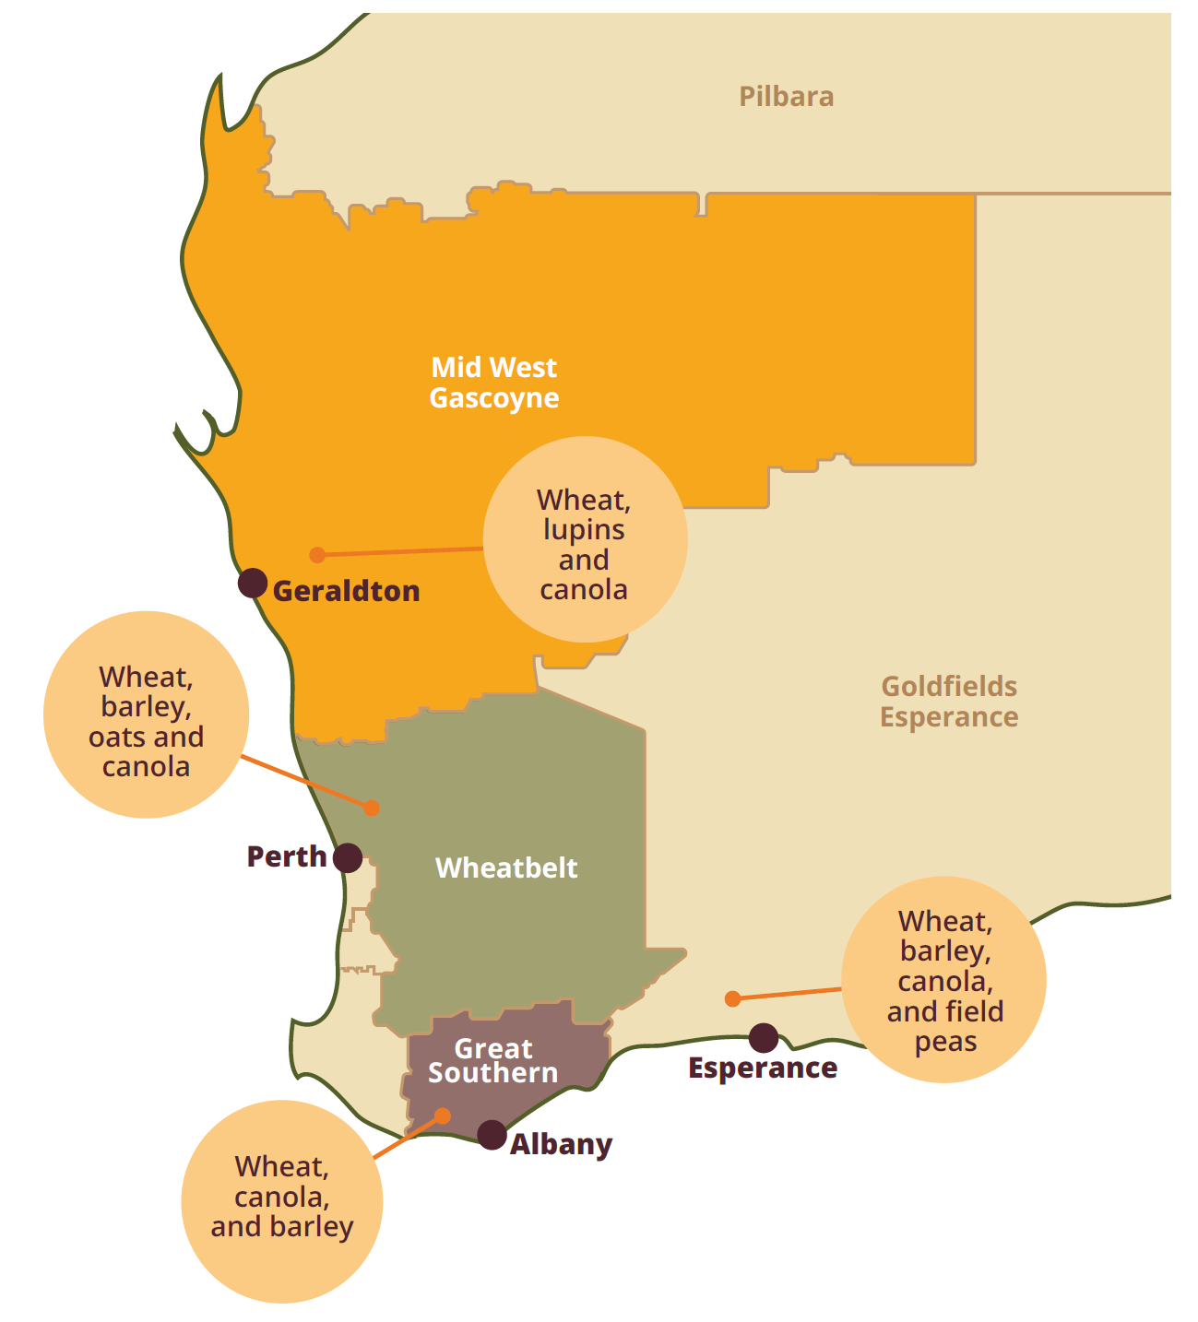

Source: DPIRD 2023c

Total grain production in WA was just over 26 million tonnes in 2022–23, up 8% compared to 2021 and 31% higher than 2016. WA has produced just over 50 million tonnes of grain in the last 2 years combined, compared to about 60 million tonnes in the previous 4 years combined. This record production resulted from a higher area sown (8.9 million hectares) (GIWA 2023a), driven by high global grain prices. Around 80% to 90% of annual WA grain production is exported to more than 50 countries, with the largest markets in Asia and the Middle East (DPIRD 2023k).

18.1 million tonnes of grain are forecast to be produced for the 2023–24 season, down on the previous season though consistent with the 5-year average of 19.4 million tonnes (GIWA 2023c). Wheat continues to be the predominant grain crop, with 9.9 million tonnes forecast. Other grain crops include barley (4.75 million tonnes), canola (2.59 million tonnes), oats (425,000 tonnes), lupins (380,000 tonnes) and pulses (94,000 tonnes) (GIWA 2023b). Low levels of soil moisture in 2023 have discouraged planting in some regions, especially for high-risk crops such as canola (DAFF 2023i).

Lupins are a well-established crop grown in many South West Land Division crop rotations, although they are not suited to all soil types. As a legume, lupins are a beneficial crop to use in rotations to break pest and disease cycles, fix nitrogen in the soil and reduce other input costs.

Most of the lupins grown in WA (Figure 43) that are sold into the domestic market are used by stockfeed manufacturers for animal feed, including for sheep. About 40% of lupin production in WA is retained on farm as stockfeed and seed or sold to supply domestic livestock industries. The balance is exported – the Republic of Korea is a major buyer and other markets include the Netherlands, Vietnam and Belgium (DPIRD 2023l).

Figure 43 WA lupin production, 2000–01 to 2022–23

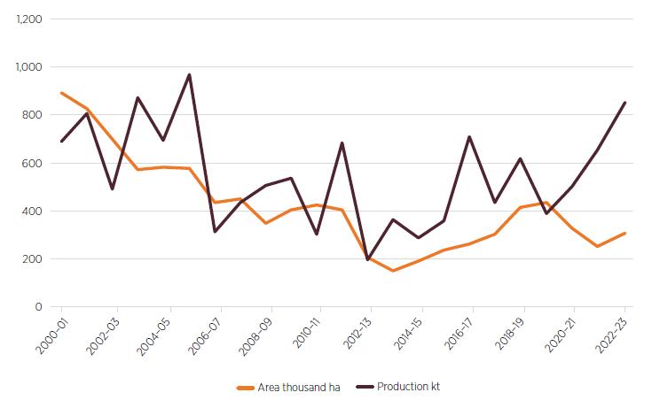

Source: ABARES 2023d

### Links between cropping and sheep farming

There are productive synergies between cropping and sheep farming, including commercial risk mitigation, improved land use efficiency, and soil management. Sheep in enterprise mixes usually lead to pastures or fodder crops being sown in rotations, contributing to improved nitrogen and carbon levels in the soil.

Some producers in consultations pointed to agronomic and economic benefits from farming sheep in combination with cropping. These included reduced use of fertiliser and herbicides, and the associated saving in fuel needed to apply these inputs.

There are also emotional and historic links to sheep farming, even as grains have become comparably more profitable. The Panel heard from producers who continue farming sheep in line with their family tradition or to maintain the genetics that have developed over generations. Others expressed their enthusiasm for animal husbandry as contributing positively to their lifestyle.

Despite the connection many producers have to sheep, the WA sheep flock has declined in favour of putting more area to cropping, driven by high grain prices and other factors. Between 1989–90 and 2021–22, the WA sheep flock dropped by 68%, while the area cropped grew by 80% (see Figure 14 in Background).

### Farm income and commercial considerations

In the last decade there has been a higher business rate of return for cropping farms, and to a lesser extent mixed livestock–cropping farms, compared to those only running sheep (see Figure 16 in Background).

The relative rate of return of the different operations underlines the expectation that some producers, where they have suitable land, will continue to increase the area of their farm that is cropped.

The end of live sheep exports by sea is likely to expedite this trend, particularly in areas such as the Wheatbelt and Mid West where producers have already adjusted their enterprise mix between cropping and sheep production. The WA Government’s submission to the Panel reflected this expectation by modelling the economic impact of the end of the live sheep exports when assuming some redeployment of land to cropping.

The Panel observes that not all producers will have this option available to them due to the land tenure, soil type and climatic conditions applicable to their location.

In addition to an understanding of agronomic practices and rotations, growing grain requires significant capital investment. ABARES data indicates that total closing capital for mixed farms in WA was more than double the value for sheep farms on average in 2021–22 (Figure 44), and total farm costs were over 4 times as high (ABARES 2023f) (see Glossary for total farm capital and total farm costs).

Figure 44 Average total closing capital per farm, for WA cropping, mixed and sheep farms, 2011–12 to 2021–22 (real value)

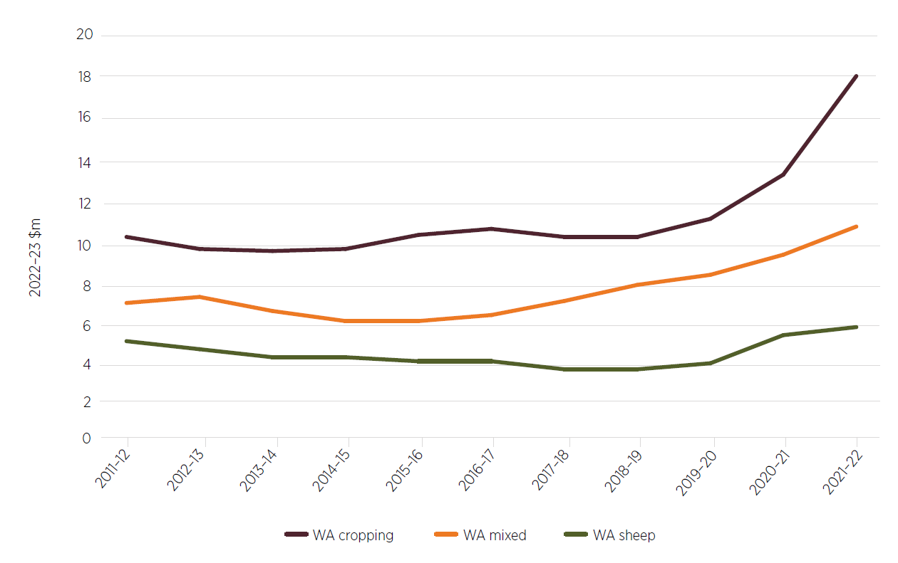

Note: Rolling 3-year average.

Source: ABARES 2023e

The need for capital to shift to cropping may leave some producers without sufficient resources to change their enterprise mix. Indeed, there were contributions to the consultation process that spoke of an inability to purchase additional machinery to make the change to cropping. The investment needed to increase cropping area, such as purchasing additional land, and removal of fencing, watering points and other infrastructure, was also raised, including because these changes are not easily reversed. The Panel was conscious of the need to support producers to plan for when live sheep exports end, whether or not cropping is an option available given their land, climate and access to capital.

As discussed in Research and development corporations, there is a clear role for organisations such as the Grains Research and Development Corporation to work with producers in supporting them through this change.

### Risks

There are commercial drivers for WA sheep-dominant producers to transition to a mixed livestock and cropping operation or to a full cropping enterprise where land is suitable for broadacre grains such as wheat and barley, canola and lupins. This transition is one that farmers have already been making, including to realise benefits such as reduced reliance on labour. However, there are risks that should be considered.

One such risk will be the different exposure to disruptions such as drought, extreme weather events, and pest and disease cycles. In good years, cropping producers will yield substantial benefit, with a flow-on to local economies. However, in poor seasons the high rate of cropping and low income diversity will have a bearing on individuals, farm employees and local businesses and communities. Conversely, although producers will generally reduce numbers or destock in poorer seasons, sheep can still be fed in a supplementary manner, which while costly does see income still being generated in those years.

Similarly, there needs to be careful consideration of capital investment in shifting the emphasis of farming activities to cropping to ensure the suitability of the land for cropping – which, if marginal, may not result in significant yield or financial benefits.

There are already pressures on WA grains infrastructure following years of record production. An Infrastructure Australia proposal in 2020 noted that the WA freight network was facing challenges including ‘ageing and under-performing road and rail infrastructure’ (Infrastructure Australia 2020). As a further example, a WA Government media release in May 2023 (Saffioti & Jarvis 2023) pointed to a rail upgrade project underway to improve grain receival sites because the Broomehill receival site did not have the rail loading capability to handle the bumper harvests. If there is a shift away from sheep and to more grains production, there may be a need to accelerate infrastructure improvements to support the trade. This includes larger-scale infrastructure such as rail projects through to localised road improvements to support increased trucking of grain.

The increasing focus on carbon capture in agricultural production systems is also worth considering in the shift to cropping. Benefits from increased soil organic carbon include improved nutrient cycling, increased water-holding capacity, increased potential plant yield, and sequestered carbon (DPIRD 2023d, DPIRD 2023f). Pastures in rotations, and particularly perennial pastures, have been shown to increase likely soil organic carbon more than ongoing cropping, although there are many variabilities including in rainfall, temperature and soil type. Further work may be warranted in this area, particularly if more producers shift from mixed enterprises with pastures to being more grain focused.

Greater grain production in WA following the end of live sheep exports will likely have a bearing on the mix of crops grown in the state. As noted earlier in this section, lupin production has broadly declined over the past 2 decades, in part due to the dropping sheep numbers but also due to the relative price advantage of growing other crops. While the Panel expects opportunities to continue using lupins in milled products for feedlotting, if there is a significant drop in the sheep flock once live sheep exports by sea end, there will be less motivation for producers to grow this fodder crop, potentially increasing the industry’s risk of exposure to disease cycles. The reduced natural nitrogen input – due to lupins being a legume and fixing nitrogen in the soil – and increased artificial inputs could have a bearing on gross margins, carbon emissions and run-off as producers turn to artificial sources of nitrogen.

The above list is not exhaustive but points to some considerations for producers considering adjusting their operations due to the end of live sheep exports by sea. These risks highlight the importance of supporting producers to assess their options in the transition period. There are also opportunities for research, development, extension and adoption to support and inform producers in these changes.

### Relevant recommendations

Initiatives requiring early action or funding: 1.

1) The Australian Government should provide funding to enable businesses in the WA sheep supply chain to prepare a business plan for their adjustment away from live sheep exports by sea. This could be via existing initiatives and should also be available to cattle producers who may be affected by the end of live sheep exports by sea.

2) The Australian Government should establish transition funding arrangements accessible to businesses in the supply chain to prepare for and adjust to the absence of live sheep exports by sea. Funds should be contingent on businesses preparing a plan, perhaps drawing on the opportunity provided by Recommendation 1. Consideration should also be given to the needs of non-supply-chain businesses affected by the cessation.

16) The Australian Government should support the transition away from live sheep exports by sea, including by:

a) encouraging the rural research and development corporations to accelerate their activities that support the WA industry to transition away from live sheep exports by sea

b) making funds available for extension and adoption to assist producers to create a value chain without live sheep exports by sea.

## International relations

### Australia is a trading nation

Australia is a highly globalised economy with a reputation built on its strong export performance. Our prosperity comes from being an open and adaptable trading nation that is deeply connected to the global economy. Trade represents around 45% of Australia’s economy (Austrade 2023b).

Australia takes an active approach to advancing its trade interests by engaging with other countries on multilateral, regional and bilateral bases. Australia is a strong participant in the World Trade Organization and has 17 bilateral and regional free trade agreements covering 29 countries. Australia recognises that international trade supports bilateral and regional relations, stability and security.

Australia is a trusted and reliable supplier of quality agricultural products to the world. As noted in Background, Australia exports agricultural products to almost 200 destinations. We have a reputation for producing safe, healthy and high-quality products that meet the needs and preferences of consumers. In 2022–23 Australia exported a record $80 billion of agricultural, fisheries and forestry products (ABARES 2023j).

#### Trade and food security

The Panel heard concerns that ending the live sheep export trade could have a detrimental effect on the food security of importing counties such as Kuwait, Israel, the United Arab Emirates (UAE) and Oman.

Food security is an important international policy goal. In 2015, the Member States of the United Nations adopted the 2030 Agenda for Sustainable Development as a blueprint to achieve sustainable economic, social and environmental development. The second development goal is to ‘End hunger, achieve food security and improved nutrition and promote sustainable agriculture’.

According to ABARES open trade is a big part of long-term food security (ABARES 2022a). Trade helps to improve food security by connecting regions with insufficient agricultural capacity to countries such as Australia with comparative advantages in agriculture. Trade can also provide consumers access to a more diversified and nutritious food basket. Trade stability is essential for regional and global food security, economic prosperity and sustainable development.

Australia is a ‘food secure’ country (FAO 2006). Over 90% of the daily food consumed in Australia is grown in Australia. In contrast, many Middle Eastern countries are food insecure, importing much of the food they consume. In consultations with the Panel, some of the existing importers of live sheep spoke of the importance of the live sheep trade to their food security.

The Panel views these concerns in the context of declining live sheep exports by sea from Australia and a decline in Australia’s share of the global live sheep export market from 12.4% in 2017 to 6.5% in 2021. Australia is already playing a reducing role in Middle Eastern live sheep imports and so the impact of the end of the Australian trade may be less critical for these nations in the future.

Australia’s combined agricultural exports to Israel, Jordan, Kuwait, Oman, Qatar, Saudi Arabia and the UAE in 2022–23, which included grains, sheep meat and beef, dairy products, horticulture products and other agricultural products, was worth a collective $5.2 billion (Figure 45). Combined live sheep exports to Israel, Jordan, Kuwait, Oman, Qatar and the UAE in 2022–23 were worth $76.9 million and live cattle exports to these countries were worth $77.9 million (Australia did not export live sheep or cattle to Saudi Arabia in 2022–23). Collectively, grains, oilseeds and pulses are the most significant exports to these 7 countries, worth over $3.4 billion in 2022–23.

Middle Eastern countries are significant customers for Australian chilled carcase and boxed sheep meat, behind China and USA. Combined, the 7 Middle Eastern countries imported more than $630 million worth of Australian chilled carcase and boxed sheep meat in 2022–23. The prospects for these products are explored in Markets.

Australia’s most valuable markets for live sheep exported by sea in 2022–23 were Kuwait and Israel. In 2022–23 Australia’s total agricultural exports to Kuwait were worth more than $600 million, and to Israel more than $160 million. Live sheep comprise 6% and 15% of the value of total agricultural trade to Kuwait and Israel respectively.

The Panel notes that Middle Eastern countries also import live cattle from Australia, with some cattle shipped on voyages that also contain sheep. Cattle-only export shipments are already occurring and can continue in the absence of live sheep exports. The need for cattle producers using mixed shipments from Fremantle Port to transition out of any reliance on sheep shipments is discussed in Sheep supply and value chains and Impacts.

Figure 45 Australian agricultural exports to Israel, Jordan, Kuwait, Oman, Qatar, Saudi Arabia and the UAE, 2022–23

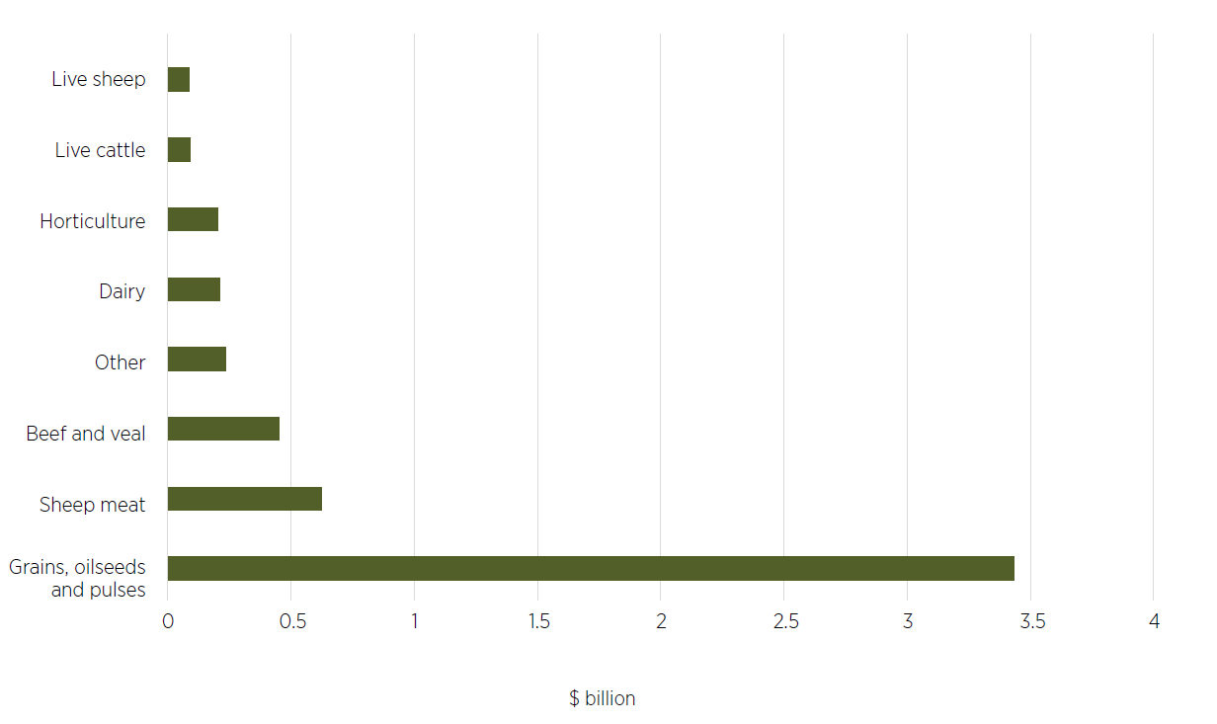

Source: ABARES Trade Dashboard

### A domestic policy

The Australian Government’s decision to phase out live sheep exports by sea is an Australian domestic policy based on the community’s concerns about animal welfare and is not directed at any trading partners. Notwithstanding the domestic drivers for the policy, the government’s decision will have an impact on some of Australia’s trading partners. The Panel heard of the value trading partners place on the bilateral relationship and history of trade with Australia. For example, the Panel is aware of representations by the Kuwaiti Commerce and Industry Minister, His Excellency Mohammad Othman Al Aiban, that the policy threatened to damage broader trade and economic ties between Australia and the region (AFR 2023). The Panel hopes that Australia’s reputation as a reliable supplier of quality agricultural produce will stand it in good stead for future trade and investment opportunities.

The Panel encourages the government to engage with trading partners throughout the transition away from live sheep exports by sea to provide a clear understanding of the changes and their implications. Taking a proactive approach will demonstrate respect for our partners’ interests and allow them to seek clarification before misunderstandings arise. The government should tailor its communication to address specific impacts on each partner and highlight how the existing trade relationship can be strengthened.

### Growing trade and investment

Australia’s 2-way trade with the Middle East is diverse and growing, reaching $19.9 billion in 2021–22. Australia’s services trade exports to the Middle East were valued at $1.1 billion in 2022, rebounding from COVID-19 towards its high of $1.9 billion in 2017–18 (DFAT 2023b). The services sectors provide many opportunities and may contribute to attracting investment and increasing trade.

Middle Eastern countries have significant investments in Australia with opportunities for growth. This includes growing non-agricultural trade and engaging in dialogue and partnership on other issues of mutual interest, such as agribusiness, energy, education, tourism, health, mining services and engineering.

For example, the Kuwait Investment Authority has an investment portfolio of over $12.7 billion in Australia, covering agriculture, property, energy and infrastructure. UAE investment in Australia was estimated at $13.8 billion in 2022, including investment in agribusiness, tourism, health and aged care, and resources sectors. Saudi Arabia’s investment in Australia is over $1.3 billion, with significant potential for economic ties to grow, given mutual interests in areas such as agriculture, mining services, education and construction (DFAT 2023a).

Australia’s contribution to trade with countries in the Middle East is diverse, with potential for further expansion of trade in the agriculture and food sectors. Australia could also work with importing countries to identify other partnerships that could support their future food security. This could include sharing knowledge and expertise, investment in infrastructure, collaboration on research and development, or other actions depending on each country’s needs.

The Panel believes that Australia should continue to advance trade and investment with Middle Eastern countries by focusing on strong relationships. Diplomatic engagement, trade missions and business delegations can all add to a positive relationship and should be continued.

#### Bilateral and regional agreements

One potential avenue to increase trade and investment is through formal agreements. Australia does not have any free trade agreements (FTAs) in place with Middle Eastern countries.

On 17 March 2022, Australia and the UAE jointly announced their intention to pursue a Comprehensive Economic Partnership Agreement. Australian domestic consultations on both a UAE CEPA and a potential Gulf Cooperation Council (GCC, which includes Bahrain, Kuwait, Oman Qatar, Saudi Arabia and the UAE) free trade agreement are ongoing.

A 2016 parliamentary report on Australia’s trade and investment relationship with the Middle East recommended the government pursue regional or bilateral FTAs with GCC countries to liberalise goods and services trade and facilitate investment (JSCFADT 2016). The Panel recognises that progressing formal trade agreements with trading partners in the Middle East is another channel to expand trade and investment between Australia and countries in the Middle East.

#### Building cultural connections

Australia should also look for ways to share knowledge, experience or services. For example, Australia has been involved in various cultural exchange programs with countries in the Middle East. These programs aim to promote mutual understanding, foster people-to-people connections, and facilitate cultural exchange between Australia and the Middle East region. An example includes the Council for Australian-Arab Relations that provides grants to support people-to-people and institutional engagement between Australia and Arab countries.

Australia has a multifaceted educational relationship with Middle Eastern countries, with scope for growth. Several Australian universities and educational institutions have partnerships in the Middle East centred on student and teacher exchange and research collaboration. Some have campuses located in Middle Eastern countries. For example, the University of Wollongong, Murdoch University, Curtin University and SAE Institute all have campuses in Dubai, and Box Hill College Kuwait operates as an extended campus of Box Hill Institute in Australia.

Australian school curriculum is taught in some schools in the UAE, including the Victoria International School and the Australian International School. The Middle East also presents an important source for international students coming to Australia. Australian universities actively recruit students from Middle Eastern countries. Australia offers various scholarships and educational exchange programs to students from Middle Eastern countries (JSCFADT 2016, Cormack 2023).

### Influencing global animal welfare

Australia’s role in enhancing and promoting animal welfare standards for live animal exports globally was discussed from 2 viewpoints during consultations:

* Australia’s presence in the trade raises the collective animal welfare standards.
* Australia’s decision to exit the trade sets a new standard for other countries to emulate.

The first viewpoint is based on Australia’s regulatory system for live animal exports. As discussed in Australian Government live export regulatory activities, exports of live sheep must comply with the ESCAS and ASEL regulations. Australia is the only country in the world with this kind of regulatory system.

The Panel heard that Australian exporters and foreign importers had made significant investments to meet these requirements and had improved animal welfare through to the point of slaughter for Australian sheep. The Panel also heard concerns that if Australia withdraws from the market, other countries with lesser standards may fill the gap.

The alternative view is that Australia can lead by example and positively influence other countries by transitioning out of the trade. Some countries have already ended or taken steps to end live animal exports by sea. Australia has significant influence as a major agricultural producer. In this view, taking a clear stand by ending live sheep exports by sea could help influence the welfare of animals beyond our own borders.

The Panel notes that both perspectives could have value. Australia’s standards for export and slaughter have resulted in improvements to vessels and processing facilities in importing countries. However, the Panel also notes that importing countries have not applied this standard as a requirement for all sheep imported from other nations. While there have been improvements, animal welfare conditions in importing countries differ from the standards that operate in the Australian context. This is explored further in Australian Government live export regulatory activities.

The Panel considers that Australia can play an important role in influencing global animal welfare standards up to and beyond the closure of live sheep exports by sea. Australia can contribute to improved global animal welfare standards without participating in the trade, by raising awareness through its diplomatic channels and through international forums and agreements, as it has done on other animal welfare issues. Australia will also continue to have a presence in markets where it exports sheep by air, or other livestock such as cattle.

The Australian Government is an active member of the World Organisation for Animal Health (WOAH, founded as the Office International des Epizooties, OIE), an intergovernmental organisation with 183 members (nations and organisations). WOAH seeks to improve animal health and welfare worldwide. It develops guidelines, recommendations and standards that aim to ensure the health and welfare of animals across the globe. WOAH regularly updates its international standards in accordance with new scientific information and technological advances. A new or revised standard can only be adopted via approval of the World Assembly of Delegates at the WOAH General Assembly each year.

Within WOAH, the Terrestrial Animal Health Standards Commission (the Code Commission) is responsible for ensuring that the Terrestrial Animal Health Code (Terrestrial Code) reflects current scientific information. The Terrestrial Code provides international standards for the improvement of animal health and welfare. The Code Commission is currently reviewing Chapter 7.5 of the Terrestrial Code. This chapter (slaughter of animals) addresses the humane handling of animals during pre-slaughter and slaughter, including guidance on stunning animals before slaughter. The Code Commission also has the revision of Terrestrial Code Chapters 7.2 (transport of animals by sea) and 7.3 (transport of animals by land) on its work plan.

Australia is a strong contributor to WOAH processes to protect our animal health status and substantial trade in animals and animal products. The Department of Agriculture, Fisheries and Forestry coordinates technical advice and consults stakeholders when developing Australia’s position on matters to be considered by WOAH, including input to international standards. The Panel welcomes the Australian Government’s ongoing role in WOAH, including in the review of these chapters, to safeguard animal welfare in global trade.

Animal welfare is of increasing importance to many of Australia’s trading partners. Several countries have taken steps to end or limit live exports by sea. The Australia–UK Free Trade Agreement, which entered into force on 31 May 2023, includes a chapter on animal welfare – a first for Australia. The Panel believes that Australia could continue to use bilateral agreements as a forum for discussing and advancing positive animal welfare outcomes.

### Relevant recommendations

15) The Australian Government should continue to engage with trading partners on the development of the sheep meat trade in the Middle East during the transition away from live sheep exports by sea.

20) Australia should maintain its strong engagement in the World Organisation for Animal Health’s international standard setting processes, through technical input and ongoing consultation with Australian experts. Australia should look for opportunities to influence improved global animal welfare standards through bilateral forums and agreements.

## Research and development corporations

### Rural research and development corporations

Australia’s 15 RDCs undertake research, development and extension (RD&E) activities intended to improve productivity, efficiency, competitiveness and innovation in the agriculture sector. This government–industry partnership model has been operating successfully for over 30 years and has contributed to the success of the Australian agriculture sector.

Each year the RDCs receive around $500 million in levies from industry through sales of commodities, and around $300 million in funding from the Australian Government. Government funding to RDCs can only be used on research, development, extension and administration activities. A levy to support marketing activities performed by the RDC can also be applied but this does not receive matched government funding. ABARES has found every $1 invested in research and development in Australian agriculture generates a $7.82 return for farmers (Chancellor 2023).

RDCs typically provide funding to state government departments, universities, the CSIRO, private consultants or grower groups that are responsible for on-ground research, delivery and extension services.

Producers involved in the live sheep export trade contribute levies to Australian Wool Innovation (on wool transactions) and/or Meat & Livestock Australia (on domestic sheep transactions). They may also contribute to other RDCs relevant to their enterprise mix – for example, the Grains Research and Development Corporation. Sheep exported from Australia attract a livestock (exporters) charge, paid by the exporter of the sheep at the time of export and distributed to LiveCorp (LiveCorp 2023b). Sheep meat processors pay a levy to the Australian Meat Processor Corporation for each animal slaughtered at an abattoir for human consumption.

The Panel considers that intermediaries such as RDCs will have an important role in not only assisting the WA industry to successfully navigate the transition away from the live export trade (see Sheep supply and value chains) but also continuing to promote learning opportunities in partnership with other intermediaries such as the Grower Group Alliance.

#### Affected RDCs

Five RDCs will be affected by and be influential in the transition away from live sheep exports by sea:

* Australian Livestock Export Corporation (LiveCorp)
* Australian Wool Innovation (AWI)
* Meat & Livestock Australia (MLA)
* Australian Meat Processor Corporation (AMPC)
* Grains Research and Development Corporation (GRDC).

For some, this will result in a reduction in levy income; for others, there may be an increase. For all, there are roles to play in supporting their members during the transition away from the live sheep export trade, particularly as sources of information, tools and education, including adoption and extension opportunities for businesses along the supply chain. Examples of current adoption and extension activities are explored in Sheep supply and value chains, Box 2.

### LiveCorp

#### Role and financial position

LiveCorp collects levies from exporters on exported beef and dairy cattle, sheep and goats, and uses these funds to provide research and development (R&D) activities for the live export supply chain. LiveCorp also receives matching Australian Government funds for the R&D proportion of the levies paid. It receives this funding by pooling its R&D levies through an arrangement with MLA through the Live Export Program.

LiveCorp’s income fluctuates depending on the volume of livestock exported. In 2021–22 LiveCorp’s income was $4.805 million, more than half of which was derived from levy payments. Only 11% of levies income was generated from sheep exports, with the majority from beef cattle (66%) and dairy cattle (23%) exports (LiveCorp 2022) (Figure 46).

Figure 46 LiveCorp levy income, 2021–22

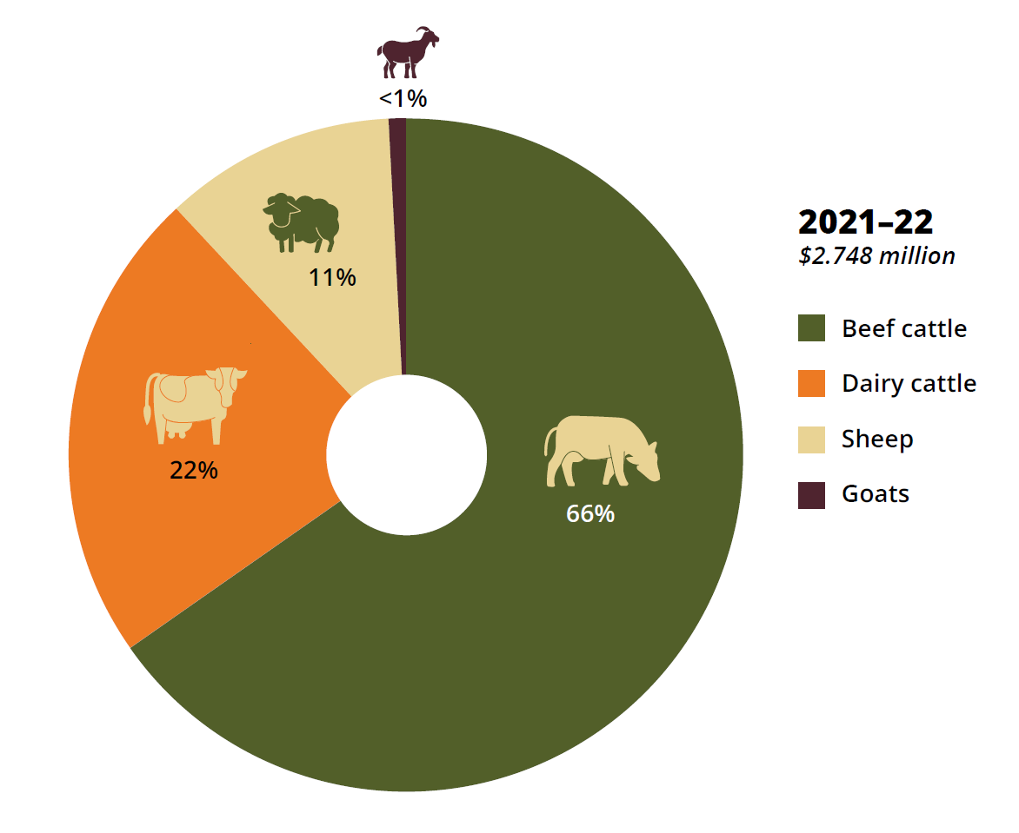

Source: LiveCorp 2022

LiveCorp’s income has been declining due to a slowdown in cattle and sheep exports, driven by multiple factors including the detection of foot-and-mouth disease and lumpy skin disease in Indonesia, COVID-19 trade disruptions, and high prices for beef cattle and sheep (LiveCorp 2022) (Figure 47). This decline saw LiveCorp’s expenditure exceed revenue in 2 of the last 3 years, and it has accessed its financial reserves to meet operating expenses. At the end of the 2021–22 financial year, LiveCorp held $7.1 million in equity (LiveCorp 2022).

Figure 47 LiveCorp revenue and expenditure, 2017–18 to 2021–22

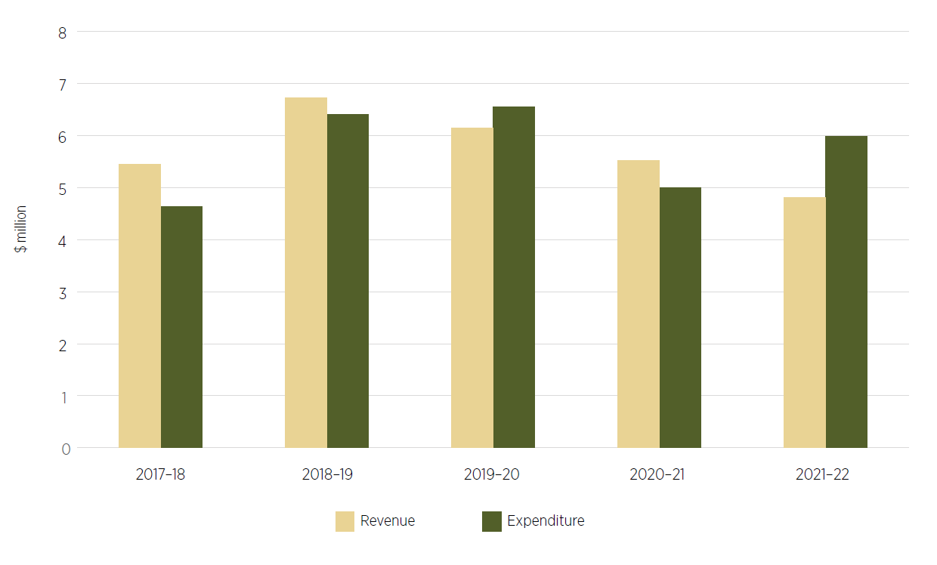

Source: LiveCorp 2022

Although sheep exports contribute significantly less levy funding to LiveCorp than beef and dairy cattle, the end of live sheep exports will remove approximately $300,000 from LiveCorp’s income (based on 2021–22 income). The Panel observes that if live beef cattle exports return to normal levels and/or the rise in dairy cattle exports continues (Figure 48), particularly if Australia picks up demand previously met by New Zealand, this may be sufficient to cushion any ill-effects from the end of live sheep exports. If, however, levy incomes continue to drop, there would be merit in government and industry considering LiveCorp’s future role and funding.

Figure 48 LiveCorp income and source, 2014–15 to 2021–22

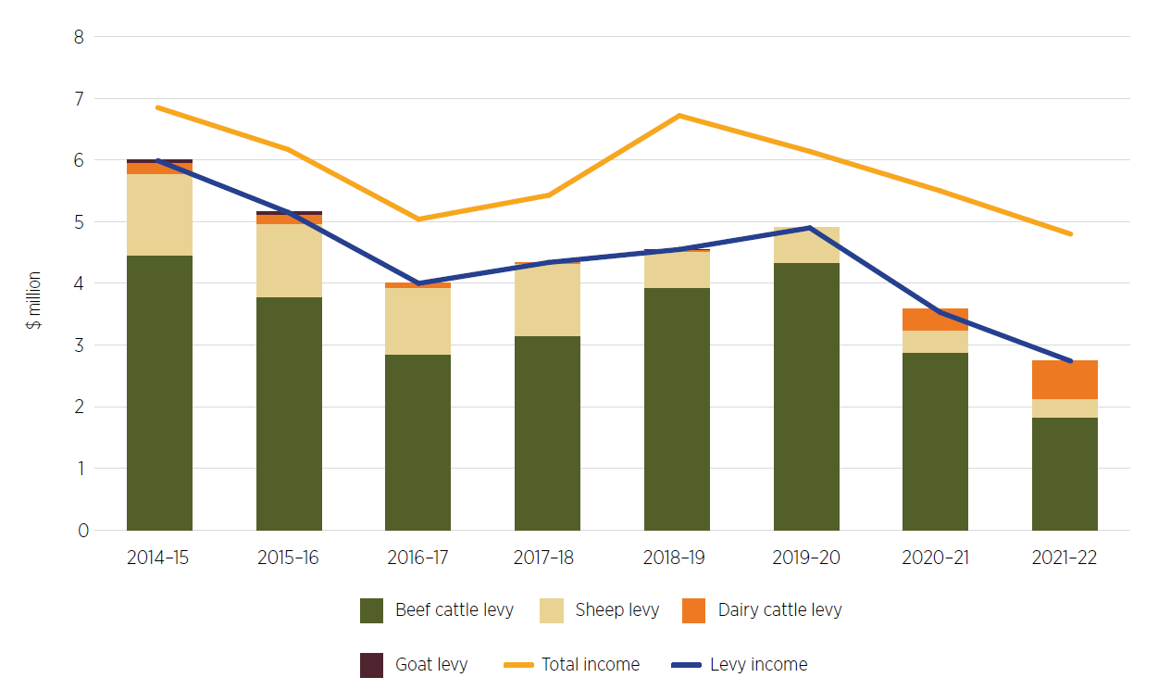

Source: LiveCorp 2023a

#### Supporting the transition away from live sheep exports

LiveCorp will continue to collect levies from live sheep exporters until the end of the trade. The company will need to ensure it continues delivering for these stakeholders even as the trade comes to an end.

The Panel is encouraged that LiveCorp has featured animal welfare for live exports by air (for all breeds) in its 2021–22 key deliverables. Market expansion and RD&E support for live sheep exports by air could be an area for ongoing development in the lead-up to and beyond the end of live sheep exports by sea.

### Australian Wool Innovation

#### Role and financial position

AWI works along the supply chain with woolgrowers, manufacturers and the fashion industry to improve the long-term profitability of Australian woolgrowers. AWI also uses its marketing subsidiary the Woolmark Company to grow demand for wool around the world.

AWI’s work covers sustainable and profitable use of natural resources, animal welfare and genetic improvements. Programs such as Making More From Sheep, Lifetime Ewe and novice shearing courses were mentioned to the Panel in consultations (Box 9) as helping producers make informed production decisions leading to improved business performance. These programs have direct applicability to WA in the period prior to and soon after the end of live sheep exports by sea and may benefit from targeted local delivery in the affected regions.

AWI’s expenditure for the past 3 years has outweighed its revenue (Figure 49), with that trend forecast to continue in 2023–24 (AWI 2023a). AWI has stated that this level of drawdown cannot continue and that cuts in programs are likely in 2024–25. From a WA perspective, any decline in the quantity or value of the wool clip in WA due to the end of live sheep exports by sea will have a further negative impact on AWI’s operating position and ability to deliver for the industry. Further, if AWI revenue continues to decline, there may be fewer opportunities and incentives for AWI to continue its training programs for shearers and wool handlers (such as described in Box 9), which could affect shearer numbers or capability.

Box 9 AWI programs for producers

Shearer and wool handler training

AWI’s novice shearer and wool handler course provides practical training for participants to gain skills in handling sheep, use of equipment, maintaining health and wellbeing, budgeting and wool handling. On completion of the course, participants may be employable as a ‘learner shearer’ (AWI 2023e).

Lifetime Ewe Management

The Lifetime Ewe Management training program provides hands-on sessions to groups of 5 to 7 sheep producers through farm visits 6 times per year. Participants are guided by a professional facilitator and learn skills in condition scoring, pasture assessment and best practice ewe and lamb management. Participants report increased stocking rates and marking and weaning percentages following the course (AWI 2023d).

Figure 49 AWI revenue and expenditure, 2017–18 to 2021–22

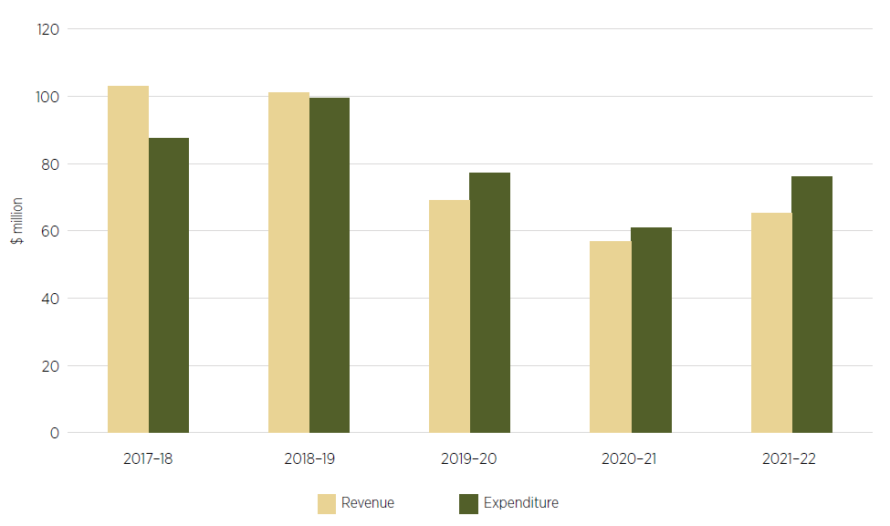

Source: AWI 2023a

#### Supporting the transition away from live sheep exports

Through its consultations, the Panel is aware that some WA woolgrowers are considering reducing their flock size or shifting to more meat breeds in the absence of live exports as an option for turn-off. Possible challenges arising from these shifts include:

* lack of critical mass to attract and retain specialist sheep workers such as shearers or animal husbandry contractors
  + the Panel knows that farmers are already having difficulty accessing shearers now for the current volume of the flock, so this concern may even out if the flock is marginally reduced provided skill development and income security are in place
* increase in the percentage of coarser wool (larger fibre diameter) as the proportion of cross bred wool increases, potentially limiting avenues to sell at an acceptable price.

AWI will have a significant role to play in supporting WA producers as they prepare for and seek to be profitable following the end of the live sheep trade. In its 2023–24 Annual Operating Plan (AWI 2023a), AWI identifies some priority areas that link well to the transition WA will experience in the coming years:

* wool harvesting, including attracting and retaining staff (shearers and wool handlers) and biological harvesting
* sheep health and welfare
* genetic improvements
* ewe reproductive efficiency
* on-farm automation.

The Panel notes that AWI’s work in marketing and promotion is also important for the ongoing success of the industry, especially if the WA wool clip incorporates more broad merino or cross-bred wool following the cessation. AWI should research and expand markets for these wool grades, particularly if exported from WA.

AWI’s existing work to support producers in their business planning, risk management and decision-making should continue, perhaps with a deliberate focus on WA producers as they plan their transition away from live exports by sea. As noted in Farm businesses, building business resilience will be critical in navigating the close of the live export trade and ensuring an earlier and stronger recovery.

### Meat & Livestock Australia

#### Role and financial position

MLA delivers marketing, research and development products and services to beef, sheep and goat producers, with the core purpose of fostering the prosperity of the red meat industry.

MLA’s strategic focus areas cover issues including animal health and welfare, sustainability, market access, workforce development and consumer preferences. MLA has emphasised the need for clear adoption and extension pathways to ensure producers and others in the supply chain can implement research and development outcomes (MLA 2020a). Existing initiatives for producers include the Making More From Sheep course (in partnership with AWI), BredWell FedWell workshops and the Profitable Grazing Systems program, which target different parts of production and business decision-making.

In 2021–22 MLA received $288.2 million in revenue, with expenditure recorded as $310.7 million (Figure 50) (MLA 2022a). Lamb and mutton levies contributed $36.6 million, representing 37% of levy income. MLA’s deficit in 2021–22 was the result of high spending combined with deliberate drawdown from reserves and reduced income due to the impacts of COVID-19 processing restrictions, floods in Queensland and northern NSW and the resulting herd rebuilding (MLA 2022a).

Figure 50 MLA revenue and expenditure, 2017–18 to 2021–22

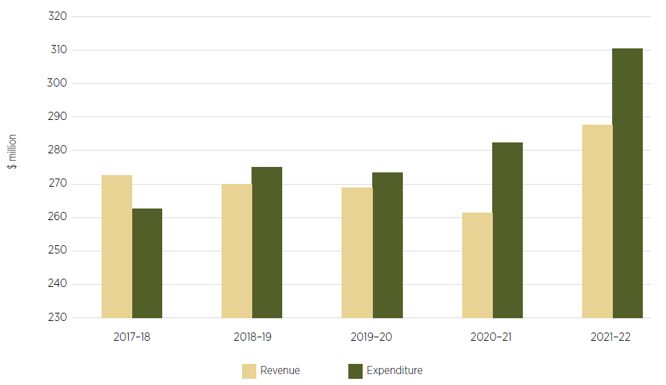

Source: MLA 2023a

#### Supporting the transition away from live sheep exports

An increase in sheep meat production in WA due to the cessation of the trade could positively affect MLA’s income base. WA’s processing infrastructure, processing labour and market needs are discussed in Sheep supply and value chains, but MLA also has a role to play in on-farm improvements and business development ahead of and beyond the end of the live sheep trade.

Possible areas of focus that could be useful include:

* research and extension to provide guidance for on-farm and standalone sheep feedlot systems specific to the WA seasonal cycle
* feed-base management to strengthen producers’ knowledge and practices for understanding natural resource management, nutritional requirements for stock and carrying capacity
* production planning to help strengthen producers’ knowledge of and practices for managing production categories, managing flock size and composition, weaning and cull rates, flock nutrition, genetics, and fertility and reproductive efficiency, such as the existing MeatUp forums
* business planning to assist producers to manage profitability, grow their business and manage risk, particularly in the absence of live exports as a risk management and income diversification tool
* market research and expansion, and associated feedback to producers, for producers shifting to increased meat production
* investigation of the role of sheep in improving soil carbon and pursuing opportunities for year-round pasture management to contribute to carbon sequestration, including extension to enable producers to access carbon credits. Existing programs on this topic such as the WA Department of Primary Industries and Regional Development’s Carbon Farming and Land Restoration Program may be of assistance.

### Australian Meat Processor Corporation

#### Role and financial position

AMPC provides research, development and extension services for the meat processing industry (AMPC 2023a). AMPC supports 110 members operating 140 meat processing plants, through its strategic focus areas including advancing manufacturing, improving sustainability, and attracting and protecting workers in the industry.

In 2021–22 AMPC received income of $37.2 million, of which 42% ($15.8 million) was from levies. Total expenditure was $46.8 million. The shortfall in levy revenue was due to lower than expected slaughter rates (AMPC 2022) (Figure 51).

Figure 51 AMPC revenue and expenditure, 2017–18 to 2021–22

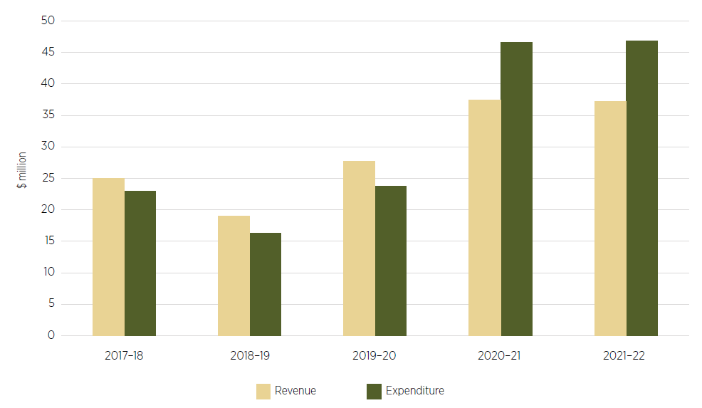

Source: AMPC 2023b

#### Supporting the transition away from live sheep exports

As for MLA, the removal of live sheep exports by sea may lead to an increase in the amount of sheep meat processing in WA, creating both opportunities and responsibilities for AMPC in supporting the industry through change. AMPC has existing programs in areas that will require increased focus in the lead-up to and beyond the end of live sheep exports by sea, particularly if greater processing volumes are to be accommodated:

* automation, remote operation and artificial intelligence
* worker safety, including knife safety and use of exoskeletons
* animal welfare, including in lairage and slaughter
* extending sheep meat shelf life
* sustainability, including emissions, water and waste management.

AMPC will need to work with WA processors as they consider and implement expansions to their operations. Where possible, whole-of-industry efforts should be used to maximise efficiencies and improve timeliness and cost-effectiveness. This could include AMPC helping processors navigate regulatory requirements for expansion and working across the industry to attract and retain staff. Pilot programs of automation initiatives could be rolled out in member establishments to accelerate development and uptake of technologies.

AMPC should also partner with MLA to understand market preferences so these can be met by producers and processors. The Panel often heard of the need to establish or improve the feedback loop so producers better understand how to grow animals to processor (and possibly niche market) requirements. Improving transparency and the amount of market information available to producers, such as product destination, specifications and price, could enable producers to become more actively engaged in the market and adjust their flock or farming practices as discussed in Sheep supply and value chains.

### Grains Research and Development Corporation

#### Role and financial position

GRDC is responsible for planning, investing in and overseeing research, development and extension for the $81 billion Australian grains industry. GRDC’s objectives focus on yield, price, input costs, post-farmgate costs, and managing risk to maximise profit and minimise losses.

GRDC’s commitment to extension and adoption activities is seen through partnerships with organisations such as Grower Group Alliance. In collaboration with GRDC, Grower Group Alliance is delivering the Best Practice Grain Storage Extension project. The project supports growers with extension support around on-farm grain storage capacity and best practice grain storage procedures to help growers maximise grain quality retention and seed germination (GGA 2022).

GRDC levies are collected at the first point of sale and based on the net farmgate value. Total revenue in 2021–22, including government contributions and other income, was $343.4 million, including a 42% increase in levy revenue compared to the previous year (Figure 52). The increase reflects the outstanding grain-growing and market conditions in the past year. GRDC returned an operating surplus of $131 million in 2021–22 (GRDC 2022).

Figure 52 GRDC revenue and expenditure, 2017–18 to 2021–22

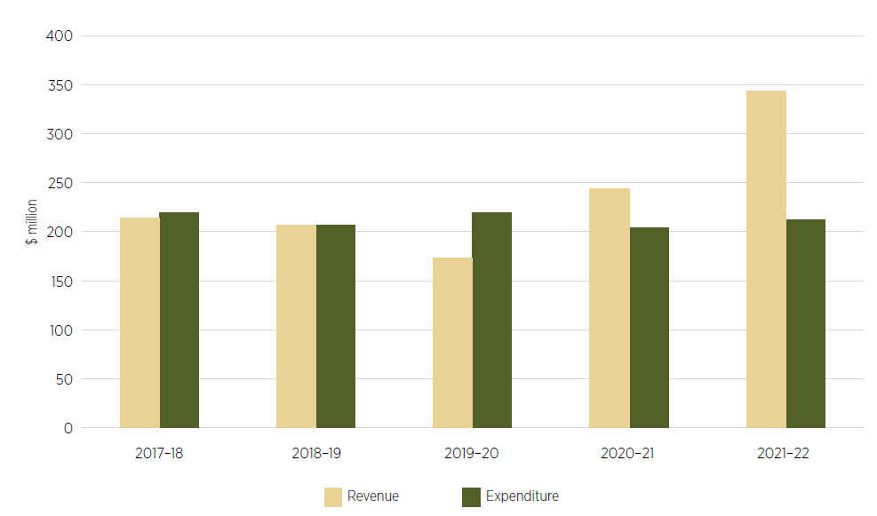

Source: GRDC 2023

#### Supporting the transition away from live sheep exports

The Panel is conscious that some farmers expect to increase the proportion of grains in their production due to the end of live sheep exports. GRDC will therefore have a role to play in supporting these producers through change, while limiting any negative impact for them or other producers. Some possible areas of focus include:

* research and extension to best manage soil moisture, fertiliser and herbicide use, including in the absence of sheep grazing or fodder crops being used in rotation
* assessment of market impacts and opportunities due to changes in grain quantities or crop mix
* identification of WA infrastructure needs due to increased grain production, including road, rail, storage and port needs
* education and extension to support amending farm business plans (this could be in partnership with other RDCs and/or industry groups)

The disruption caused by the transition away from and the end of live sheep exports by sea provides an opportunity for GRDC to deliberately direct additional efforts to WA producers and production systems.

### Relevant recommendations

16) The Australian Government should support the transition away from live sheep exports by sea, including by:

a) encouraging the rural research and development corporations to accelerate their activities that support the WA industry to transition away from live sheep exports by sea

b) making funds available for extension and adoption to assist producers to create a value chain without live sheep exports by sea.

17) The Australian Government should consider the role and financial position of the affected rural research and development corporations during and following the transition away from live sheep exports by sea.

## Australian Government live export regulatory activities

### Community concerns about live sheep exports by sea

By their nature, live sheep exports by sea present a risk to animal health and welfare. There has been ongoing concern among many in the Australian community about how sheep are treated on live export journeys and in export destinations. Documented incidents of poor animal welfare, sheep deaths and cruelty have driven concerns within the community about the continued operation of this trade.

Since the 1980s, specific incidents or concerns about the treatment of exported sheep have led to reviews being undertaken. These reviews have prompted further regulatory requirements including increased welfare standards and mandatory reporting of non-compliance.

Allegations of non-compliance, particularly when reported in the media, can have a dramatic impact on the public’s confidence in the Australian Government’s ability to fully regulate the live sheep trade to expectations (Shine 2023). Public concern remains about live sheep exports by sea, despite improvements achieved through increasingly prescriptive regulatory interventions, improved industry practices and a reduction in mortality statistics.

#### Independent reviews of live sheep exports

A high level of public scrutiny of the live sheep export industry has occurred for decades and was recounted in many submissions to the Panel. The 1985 Senate Select Committee on Animal Welfare’s *The Export of Live Sheep from Australia* report concluded that:

if a decision on the future of the trade were made on animal welfare grounds alone, there was enough evidence to stop the trade.

However, the committee did not call for an end to the trade but sought significant animal welfare improvements and a long-term solution, concluding that:

the Federal Government should promote and encourage the expansion of the refrigerated trade to the Middle East and other countries, with the aim of eventually substituting it for the live sheep trade (Senate Select Committee on Animal Welfare 1985).

In 2003 the *Cormo Express* disaster occurred, with nearly 5,700 sheep out of a shipment of almost 58,000 dying following Saudi Arabia’s rejection of the sheep due to some of them being infected with scabby mouth, coupled with ongoing delays in finding an alternative country that was willing to receive the shipment. Following this incident, the Australian Government commissioned the Keniry Review and suspended live sheep exports to Saudi Arabia for the following 2 years. The Keniry Review recommended further regulatory requirements, including enhancing the role of veterinarians in the preparation of sheep and on board vessels, and increasing the role and responsibilities of the then Australian Quarantine and Inspection Service (Keniry 2003).

Following the airing of footage in 2011 of the slaughter of Australian cattle in Indonesia, there was strong public outcry about the handling and treatment of animals in that market. In response, the Australian Government created the Exporter Supply Chain Assurance System (ESCAS) framework, initially for cattle exports to Indonesia. Following the 2011 Farmer Review, ESCAS was expanded to other live animal exports and markets. Since April 2018, following the public broadcast of footage taken on 5 voyages on the *Awassi Express* in 2017, there have been 2 significant independent reviews of livestock exports:

* the Independent Review of Conditions for the Export of Sheep to the Middle East during the Northern Hemisphere Summer (McCarthy Review)
* the Review of the Regulatory Capability and Culture of the Department of Agriculture and Water Resources in the Regulation of Live Animal Exports (Moss Review).

The implementation of recommendations from these reviews led to significant regulatory changes.

### Regulation of live sheep exports

Live sheep exports are primarily regulated by the Department of Agriculture, Fisheries and Forestry (DAFF). The regulation of livestock export vessels is undertaken by the Australian Maritime Safety Authority (AMSA).

The Australian regulatory framework for live sheep exports is structured to ensure:

* exported livestock comply with relevant Australian legislation, are described accurately and are traceable
* exported livestock meet importing country requirements to enable and maintain overseas market access
* the integrity and animal health and welfare of livestock exported from Australia.

The animal health and welfare requirements to export live sheep by sea from Australia include compliance with:

* the *Export Control Act 2020* and Export Control (Animals) Rules 2021, including the Australian Standards for the Export of Livestock (ASEL) (all classes of livestock), introduced in 2005, which outline the minimum animal health and welfare requirements that exporters must meet when exporting livestock
* ESCAS, which requires exporters to have arrangements for the control, traceability and animal welfare of feeder and slaughter livestock from arrival in the importing country up to and including the point of slaughter
* the *Navigation Act 2012* and Marine Order 43 (Cargo and cargo handling – livestock) 2018.

ASEL outlines the minimum animal health and welfare requirements that the Australian livestock export industry must meet throughout the supply chain, from sourcing to completion of disembarkation overseas (DAWE 2021a). It details standards for:

* sourcing and preparation of livestock for export by sea
* land transport of livestock, under the Australian Land Transport Standards
* management of livestock in registered establishments
* vessel preparation and general management for export by sea
* loading and on-board management
* air transport of livestock.

ASEL operates in Australia and until animals are disembarked overseas. The standards apply to cattle, sheep, goats, buffalo, deer and camelids exported by air or sea. The standards are enforceable under the *Export Control Act 2020* and the Export Control (Animals) Rules 2021. The Australian approach is consistent with that taken by international bodies, such as the World Organisation for Animal Health (WOAH), involved in determining criteria for the health and welfare of livestock. The standards must be read in conjunction with Commonwealth, state and territory laws, regulations, standards and guidelines relevant to the health, welfare, handling, treatment, transport and carriage (sea or air) of livestock. Importing country requirements relevant to the export consignment must also be met (DAWE 2021a).

ESCAS is a regulatory requirement under the Export Control (Animals) Rules 2021. Exporters must meet requirements in ESCAS to export feeder or slaughter livestock from Australia, including sheep. ESCAS requires exporters to have arrangements in place for the humane handling and slaughter of livestock in the importing country. Australia is the only country in the world with this kind of regulatory system.

ESCAS is a unique assurance system, based on 4 key principles:

* Animal welfare – animal handling and slaughter in the importing country must be in accordance with WOAH animal welfare recommendations. ESCAS animal welfare standards are based on these recommendations (note: the WOAH standards are not equivalent to the Australian standards and in some circumstances provide a lower level of animal welfare).
* Control through the supply chain – the exporter must control all supply chain arrangements, including transport, handling and husbandry, and slaughter. All livestock must remain within the approved ESCAS supply chain up to and including slaughter.
* Traceability through the export supply chain – the exporter must be able to trace all livestock at all points in the supply chain from when they are unloaded overseas, to their slaughter at an approved abattoir.
* Independent auditing – the supply chain in the importing country must be independently audited.

ESCAS applies from the point of disembarkation in the importing country through to the confirmation of death at the point of slaughter. Upon arrival in the importing country, livestock are in a foreign jurisdiction and subject to the importing country’s domestic laws. The Australian Government is unable to regulate overseas; therefore under ESCAS, Australian licensed exporters are responsible for the accountability and welfare of livestock through to slaughter, including where they are on-sold several times before slaughter (IGLAE 2021).

Under ESCAS, Australian exporters are required to provide information to DAFF about:

* the species of livestock
* each port or landing place where the livestock will be unloaded
* transport, handling and slaughter of the livestock
* feedlots
* identification, tracking, accounting and reconciliation of the livestock
* access to premises where livestock will be held
* related operations and facilities
* independent auditing of the supply chain (via documentation)
* compliance with control and traceability requirements (via documentation).

In relation to ESCAS and reportable mortality events, where a complaint is made or an event occurs, an investigation is undertaken, and DAFF publishes a final report on its website.

DAFF commenced a review of ESCAS in 2022 to ensure that the regulatory framework is robust, functional and effective. The review is focusing on:

* addressing the recommendations from the Inspector-General of Live Animal Exports’ (IGLAE) review of ESCAS conducted in 2021
* developing a control and traceability standard
* enhancing mechanisms for monitoring and verifying ongoing compliance between independent performance audits
* updating the guideline for management of non-compliance to incorporate a proportionate escalating non-compliance framework
* streamlining and improving internal administrative processes.

Following the completion of the review, it is intended that the reviewed ESCAS framework will provide a consolidated and better-articulated set of outcomes-focused requirements for control, traceability and animal welfare for feeder and slaughter livestock. It will remain the responsibility of livestock exporters to ensure their ESCAS arrangements continue to meet requirements.

The Panel wants to ensure animal welfare requirements are achieving their objective of upholding animal welfare standards until live sheep exports by sea end. The Panel believes completing the ESCAS review and implementing recommendations in a timely manner would support this outcome.

#### Inspector-General of Live Animal Exports

The IGLAE position was established as part of the government’s response to the Moss Review, specifically Recommendation 15. The review found:

The inherent risk to animal health and welfare and the special challenges associated with the regulation of live animal exports necessitate the need for additional oversight measures, not necessarily applicable to other agricultural products (Moss 2018).

Accordingly, the inaugural IGLAE’s work plan was informed by the findings of the Moss Review and the department’s response (IGLAE 2023b).

The main function of the IGLAE, as set out in the *Inspector-General of Live Animal Exports Act 2019*, is to:

review the performance of functions, or exercise of powers, by live-stock export officials under the *Export Control Act 2020*, or an instrument made under that Act, in relation to the export of live-stock. The IGLAE must publish a report on each review.

The IGLAE published 6 reviews between 2020 and 2023:

* Communication and engagement in livestock export regulation – published 6 April 2023
* Livestock export licences and approved arrangements – published 11 October 2022
* Livestock export permit systems and processes – published 24 November 2021
* Review of the Exporter Supply Chain Assurance System – published 28 June 2021
* Implementation of Moss Review recommendations – published 15 December 2020
* Monitoring and reporting during livestock export voyages – published 2 March 2020.

Implementation of the Moss Review and IGLAE recommendations has been gradual. As at 19 September 2023, the regulator has closed 28 of 31 recommendations from the Moss Review and 12 of 41 recommendations from the IGLAE reviews. The regulator has advised that considerable progress has been made towards closing many of the outstanding recommendations. Some of the recommendations are being considered through further review and reform activities being undertaken by the regulator, including the current ESCAS review.

The Australian Government has made a further commitment to establish an Inspector-General of Animal Welfare and Live Animal Exports to strengthen animal welfare and increase accountability and transparency for animal welfare in livestock exports. This will be implemented by expanding the office of the IGLAE to include animal welfare related objectives, functions and reviews.

Under the Inspector-General of Live Animal Exports Amendment (Animal Welfare) Bill 2023 (which is before the Senate as at 22 October 2023), the functions of the new Inspector-General will include conducting reviews of:

* the effectiveness of Commonwealth systems for the administration of livestock exports under the animal welfare and live animal export legislation and standards for maintaining and enhancing the welfare of exported livestock
* the effectiveness of the ASEL, as a part of such systems
* the effectiveness of Commonwealth reporting of any or all of the following:
  + the welfare of exported livestock
  + livestock export investigations related to animal welfare
  + non-compliance with the animal welfare and live animal export legislation and standards in relation to the export of livestock
  + the information covered by section 424 of the Export Control Act 2020 (report to parliament about export of livestock)
  + potential non-compliance with state and territory laws relating to animal welfare, as reported to state and territory governments.

These expanded functions are intended to help ensure that Commonwealth systems are appropriately reviewed and operating effectively, in particular in achieving animal welfare outcomes.

#### Vessel regulation

The *Navigation Act 2012* and Marine Order 43 (Cargo and cargo handling – livestock) 2018 (MO43), prescribes minimum standards for all vessels carrying livestock from Australia and the systems on those vessels providing livestock services.

MO43 prescribes requirements to ensure the safe loading, stowage and carriage of livestock. MO43 includes that a vessel’s master must notify AMSA of the intention to load livestock and that, once notified, AMSA must inspect a vessel before livestock loading can commence. Where the results of an inspection warrant it, AMSA can issue a notice setting out the deficiencies that must be rectified before livestock can be loaded.

Compliance and enforcement action can be taken under the provisions of MO43 itself, or under the *Navigation Act 2012*. The Act includes a suite of compliance and enforcement tools for non-compliance, including improvement or prohibition notices, powers to detain the vessel, and financial penalties.

#### Changed regulatory settings for live sheep exports

The McCarthy Review recommended that regulation ‘should move from a risk assessment based on mortality to a risk assessment based on animal welfare’. In response, new regulations were introduced to address the risk of heat stress more adequately during sheep exports by sea during the Northern Hemisphere summer. Following the recommendations of the Moss Review, the Animal Welfare Branch was re-established in DAFF to ensure animal welfare is at the centre of regulatory activities for live sheep exports.

Revised regulatory requirements included changes to pen air turnover verification, increased pen space allowances, and requirements for automated watering systems on all vessels and for exporters to have a heat stress management plan in place for each voyage. Regulations were also amended to implement a reduction in the reportable mortality rate in ASEL from 2% to 1%.

#### Northern Hemisphere Summer Prohibition

In December 2018 the Australian Livestock Exporters’ Council announced a 3-month moratorium for its member organisations on live sheep exports by sea during June, July and August, recognising the heightened risk of heat stress during the Northern Hemisphere summer (ALEC 2018).

As an interim measure, while the regulator was conducting a regulatory impact process, further regulatory amendments were made. These changes prevented exports of sheep consignments departing from Australia by sea between 1 June 2019 and 22 September 2019 (inclusive) that would travel through waters in the Arabian Sea north of latitude 11˚N at any time during the voyage.

A prohibition period was introduced at the completion of the regulatory impact statement process. The amendment came into force on 1 May 2020 and included a prohibition on departures of live sheep exports from Australia to or through the Middle East for a period of 3.5 months (1 June to 14 September). The order included extended periods of prohibition for departures from Australia to Oman and Qatar.

In 2022 and 2023 DAFF undertook a further review of live sheep exports to or through the Middle East during the Northern Hemisphere summer (NHS review). The review concluded that to maintain or improve the welfare of exported sheep, an absolute prohibition period during the hottest, most humid part of the Northern Hemisphere summer should remain and that additional conditions to mitigate heat stress (during a conditional prohibition period) for some Persian Gulf destinations should be introduced. The review also found, following an evaluation of scientific evidence and historical temperature data provided by the Australian Bureau of Meteorology, that the welfare of exported sheep could be maintained with a shortening of the length of the absolute prohibition period for Qatar, Oman and destinations to or through the Red Sea. Regulatory settings were updated through amendments to the Export Control (Animals) Rules in 2020, 2022 and 2023.

The regulatory settings for the export of live sheep during the Northern Hemisphere summer include that:

* sheep must not be exported to Oman between 8 May and 14 September
* sheep must not be exported to Qatar between 1 June and 21 September
* sheep must not be exported to Bahrain, Iran, Iraq, Saudi Arabia, Kuwait or the United Arab Emirates on a vessel that leaves an Australian port between 1 June and 14 September
* sheep must not be exported to or through the Red Sea by sea on a vessel that leaves an Australian port between 15 June and 14 September
* sheep must not be exported to certain Persian Gulf destinations (Bahrain, Iran, Iraq, Saudi Arabia, Qatar or the United Arab Emirates) by sea on a vessel that leaves an Australian port from 22 May to 31 May unless additional conditions to mitigate heat stress risks are met
* sheep must be fed a minimum of 3% of their live weight daily while on vessels travelling to or through the Middle East during the non-prohibited periods of the Northern Hemisphere summer
* each vessel exporting sheep must deploy a minimum of one data logger on the bridge to record ambient wet bulb temperature (in addition to the requirement for environmental recording on decks holding sheep).

Notwithstanding these amendments, some submissions to the Panel called for the prohibition period to be expanded until the live sheep export trade ends.

#### Independent Observer program

DAFF’s Independent Observer program commenced in April 2018. The program is intended to provide assurance to government, industry and the public that the health and welfare of all livestock being exported on ships is being appropriately managed. The program requires an observer, employed and selected by DAFF, to monitor and report on activities with regard to regulatory requirements. The cost of the observer is recovered by the department from the exporter.

The program commenced as part of the government’s immediate response to footage of live sheep on board the *Awassi Express*. Observers monitor, review and/or audit exporter arrangements on board livestock export vessels.

Independent Observers’ focus is to verify and report on the:

* implementation of individual exporter’s arrangements, including its approved arrangement (AA) and approved export program
* activities undertaken by the on-board accredited veterinarian (AAV) or accredited stockpersons
* exporter’s effectiveness at managing animal health and welfare, including meeting the ASEL.

Observers do not take an active role in animal management during the voyage. Observers are deployed in the following circumstances:

* the voyage departs from ports south of latitude 26˚S (including Fremantle) and crossing the equator
* it is the first voyage undertaken by an exporter following a notifiable mortality incident
* it is the first voyage of any new exporter or vessel
* the voyage is considered a long-haul voyage with any complex arrangements, including those with multiple ports of discharge, carrying buffalo or enacting management plans (for example, for heavy cattle).

The master of the vessel has discretion regarding whether an observer may board the vessel; however, no observer has been prevented from boarding a vessel except where an exemption has been sought by the exporter and granted by the regulator. Circumstances in which an exemption may be granted include an inability to accommodate an observer due to space or safety equipment limitations.

The deployment of observers was paused in March 2020 due to COVID-19 travel restrictions, risks to the health and safety of the observers, and the impracticality of international travel. Deployments recommenced from 1 May 2022. From 1 May 2022 to 30 June 2023, there were 15 voyages carrying sheep and 12 of these voyages carried an observer.

#### Compliance and enforcement

The Australian Government, through the relevant legislation, requires that DAFF exercise the necessary powers, regulatory capabilities and investigative capacity to ensure that animal welfare standards are met and importing country requirements are met. The regulator works to ensure that participants in the trade understand and comply with their regulatory obligations and that appropriate and proportionate action can be taken when non-compliance is suspected or detected (DAWE 2021b).

The Panel received submissions noting concerns about breaches and alleged breaches of animal welfare regulations and the importance of strengthening compliance while live sheep exports by sea continue, as well as proposing additional regulatory requirements in the transition period.

Compliance monitoring is an essential part of regulating live sheep exports. It enables the regulator to determine the level of compliance within the industry. The department’s compliance statement for the export of livestock (DAWE 2021b) states that the regulator receives compliance information from sources including:

* DAFF Regional Veterinary Officers
* independent audit reports (ESCAS)
* DAFF audits of the regulated entity
* reports from third parties such as other regulated entities, industry bodies, animal welfare organisations, members of the public and the media.

The department’s compliance statement (DAWE 2021b) further states that the regulator undertakes assurance activities to effectively determine compliance levels in the livestock export industry. The assurance activities include:

* physical inspection of livestock to ensure health, welfare and importing country requirements are observed
* physical on-site, virtual or desktop audits of an exporter’s approved arrangement to ensure suitable controls are in place, the approved arrangement is effective and all requirements are complied with
* audits of registered establishments for the purposes of registration and renewal of registration
* audits of AAVs
* audits of the licensed exporter’s ESCAS arrangements
* reviews of core export documents or all export documents, depending on the licensed exporter’s performance
* risk-based, targeted audits or reviews of consignments, AAVs, approved arrangements, registered establishments and ESCAS approved supply chains in response to identified issues or other incidents as appropriate
* increased frequency and complexity of audits in response to non-compliance or where a risk of non-compliance has been detected.

The department applies a range of regulatory responses to address non-compliance. This may occur prior to, during and/or at the end of an investigation.

Depending on the circumstances, regulatory actions (as set out in the Export Control Act 2020) may include:

* requiring an exporter to provide more information about their export consignment or other arrangements
* applying extra conditions to an approval
* varying, suspending or revoking an approved arrangement, registered establishment and/or export licence
* in cases of serious or sustained history of non-compliance, refusing to approve an application
* issuing an exporter or other regulated entity (for example, occupier of a registered establishment) with a formal direction (in the exercise of particular powers under the *Export Control Act 2020*)
* issuing an infringement notice for an alleged contravention of the *Export Control Act 2020*
* seeking an injunction requiring someone to do something or refrain from doing something
* seeking a civil penalty order for an alleged contravention of the *Export Control Act 2020*
* referring a matter to the Director of Public Prosecutions for criminal prosecution, which may result in conviction and, for example, a fine or imprisonment. Relevant offences are set out in the *Export Control Act 2020* and the Criminal Code (Cth), which is the schedule to the *Criminal Code Act 1995*.

The regulator publishes a limited range of enforcement information on its website. The regulator also publishes a list of recent and ongoing ESCAS investigations on its website.

#### Reported on-board animal welfare outcomes

The Australian Government has engaged in a continual improvement process to ensure that the regulatory settings for live sheep exports are as scientifically valid and effective as possible.

* The department’s most recent review (2022 NHS Review) made various findings.
* Behavioural and physiological response to heat (including panting) was reported on 60% of voyages to the Middle East during the review period (9 out of 15 voyages – 2019–2021).
* No mortalities due to heat stress were reported on the 15 voyages. The most frequently reported causes of mortality during 2019–2021 were inanition and gastro-enteric diseases.
* Underlying health conditions, including inanition and respiratory disease, were reported to possibly contribute to mortalities during elevated wet bulb temperatures on one voyage.
* Inconsistent reporting of heat stress symptoms was identified on some voyages:
  + independent observers generally recorded higher panting scores than AAVs when observing the same pens of sheep
  + a number of different scoring systems were used to assess heat stress.
* There has been a 77.5% reduction in sheep mortality rates during the Northern Hemisphere summer (1 May to 31 October inclusive) since specific regulatory changes to mitigate heat stress and improve animal welfare were introduced over the period 2018 to 2020.
* Voyage mortality rates for Northern Hemisphere summer voyages have now stabilised within a narrow range, averaging 0.2%. This indicates that regulatory changes have been effective in reducing the risk of heat stress and associated mortalities.
* In May, September and October (Northern Hemisphere summer shoulder months outside the prohibition period) there has been a 67% reduction in sheep mortality rates. This indicates that, independent to a prohibition, regulatory changes have been effective in reducing the risk of heat stress and heat stress mortalities.
* In 2015–17 the highest mortality rates occurred during June, July and August. The subsequent prohibition has prevented exports departing Australia during these high-risk months.

In summary, the NHS Review concluded that the regulatory settings introduced in 2020 have been effective in minimising the risk of heat stress and heat stress mortalities and improving animal welfare outcomes for sheep exported to the Middle East during the Northern Hemisphere summer.

#### Animal mortality on-board ship statistics

Community expectations about the treatment of sheep during the export journey are broader than a single metric and reflect an increasing range of concerns. Mortality is one of several metrics used to measure animal welfare. The regulator has acknowledged that lower mortality rates alone do not reflect adequate animal welfare outcomes during live export by sea. However, in the view of the regulator, ‘if mortality rates significantly decline it is reasonable to deduce that morbidity rates will also have declined and that other welfare parameters will have improved’ (DAFF 2022b).

From 2016 to 2022 a total of 7,625,700 head of sheep were exported by sea from Australia. During this period, mortalities totalled 39,516 head, with the annual mortality rate varying from a high of 0.80% in 2016 to a low of 0.14% in 2022. Table 13 illustrates the average annual mortality rate of sheep exported by sea from 2016 to 2022.

Table 13 Sheep exports and mortalities during exports by sea, 2016 to 2022

| Year of export | 2016 | 2017 | 2018 | 2019 | 2020 | 2021 | 2022 |
| --- | --- | --- | --- | --- | --- | --- | --- |
| Sheep exported | 1,759,340 | 1,741,314 | 1,259,860 | 1,047,080 | 775,606 | 662,630 | 379,870 |
| Sheep mortalities | 14,094 | 12,377 | 6,629 | 2,701 | 1,791 | 1,381 | 543 |
| Total mortality rate | 0.80% | 0.71% | 0.53% | 0.25% | 0.23% | 0.21% | 0.14% |

Source: DAFF 2023d. Data from the reports to parliament published every 6 months on the department’s [website](https://www.agriculture.gov.au/biosecurity-trade/export/controlled-goods/live-animals/live-animal-export-statistics/reports-to-parliament#:~:text=Every%20six%20months%2C%20the%20minister,mortalities%20on%20every%20sea%20voyage.)

#### Handling and slaughter in importing countries

Under ESCAS, livestock handling and slaughter in the importing country must be in accordance with WOAH standards. Conscious (unstunned) slaughter is permitted under the WOAH Terrestrial Code and is therefore also permitted under ESCAS. The ESCAS standards require that animals are handled and moved in a manner that must be carried out calmly and effectively, avoiding harm, distress or injury. Where breaches of the standards are reported, DAFF investigates and takes regulatory action. Details regarding the regulatory action taken can be found on the DAFF website.

Although it is possible under ESCAS, many stakeholders in the Panel’s consultations registered concerns about the presence of slaughter without stunning in markets to which Australia exports. The Australian Government as a matter of law cannot regulate practices in importing countries but seeks to ensure good animal welfare practices are upheld through placing responsibility on exporters to control all aspects of the supply chain. Exporters, can however, choose to go beyond ESCAS requirements.

### Cost recovery for live animal export services

The Australian Government recovers some of the costs of delivering export regulatory services from exporters, including of live animals. This also includes registration costs for operators of registered establishments where livestock are prepared for export, and accredited veterinarians who have specific statutory roles. The Australian Government’s overarching cost recovery policy is that, where appropriate, non-government recipients of specific government activities should be charged some or all of the costs of those activities. The cost recovery policy promotes consistent, transparent and accountable charging for government activities and supports the proper use of public resources. The department determines the costs to be recovered through a combination of forecasted export volumes for different export commodities and assessment of other costs related to accreditation of establishments, compliance activities and veterinary inspections.

The live animal exports cost recovery arrangement was forecast to have an operating deficit of $7.7 million in 2022–23 (Cost recovery implementation statement: live animal exports 2022–23). This follows successive years of operating at a deficit. Any cost recovery deficit is funded by the Australian Government (through a reallocation of resources from the department’s internal budget) to ensure that the appropriate level of funding is available.

The Panel notes the view of the IGLAE in the most recent review report:

The Moss review, and the inspector-general, have noted the antecedent reduction in resourcing and capability that preceded the *Awassi* incident. In effect this represented depreciation of the underlying capital asset of regulatory capability and capacity. Recent reports of the department’s dire financial position mean that it is unlikely that the department will have sufficient resourcing from operational cost recovery alone to be able to acquit these recommendations and move towards better regulatory practice in the medium term. While the inspector-general considers cost recovery to be best practice for regulators, this is predicated on a regulator being at an effective and efficient level of regulatory maturity. As livestock exports regulation is yet to achieve this level of maturity, it is the inspector-general’s view that there is a case for public investment in the underpinning capability and capacity required. Cost recovery can then support the operations and ongoing maintenance (IGLAE 2023a).

The Panel is concerned about the shortfall in funding flowing to DAFF as the regulator of live animal exports. Insufficient funding will limit the regulator’s ability to carry out oversight and compliance functions. Alternatively, redirection of departmental appropriation could undermine the agency’s other policy, regulatory and research functions to the detriment of the agriculture sector. The Panel notes that progressive declines in the live sheep export trade may be exacerbating the funding shortfall, particularly where there are fixed costs that cannot respond to changing trade volumes.

On top of existing shortfalls, the transition away from and eventual closure of live sheep exports by sea will further impact on the regulator’s cost recovery model and revenue. For example, it will be difficult to forecast sheep export volumes and therefore pricing for the fees and charges as the trade nears its end and the industry increasingly transitions to an onshore processing model.

The Panel believes that it is important that exporters of other live export species, notably the live cattle industry, are not required to offset the revenue losses arising from ending live sheep exports by sea. Instead, the government should ensure that the regulator is sufficiently funded until the trade ceases. This funding will support the regulator to at least maintain, but preferably increase, its service levels, enforcement activity and focus on animal welfare outcomes. The Panel also notes that fees and charges for other livestock exports will need to be reassessed once live sheep exports by sea cease, given that the sheep trade will no longer be part of paying for fixed regulatory costs.

### Additional regulatory activities

Collection of research and development levies and the implications for LiveCorp are addressed in Research and development corporations.

Animal welfare standards for land transport and sheep feedlotting are addressed in Sheep supply and value chains.

### Relevant recommendations

18) The Australian Government should ensure that the Department of Agriculture, Fisheries and Forestry and the Australian Maritime Safety Authority have the funds needed to fulfil their regulatory obligations and assurance requirements for live sheep exports by sea.

20) Australia should maintain its strong engagement in the World Organisation for Animal Health’s international standard setting processes, through technical input and ongoing consultation with Australian experts. Australia should look for opportunities to influence improved global animal welfare standards through bilateral forums and agreements.

## Timing

### The need for certainty

The Panel consistently heard, from those in favour of and those opposed to the policy, of the importance of knowing when live sheep exports by sea will end.

Those involved in the existing live sheep trade regularly attributed emotional strain or business pressure to the lack of a clearly defined time frame for the cessation. This was not just noted at the farm level; businesses throughout the supply chain also needed clarity to plan and invest appropriately in the current trade and in the future.

Individuals and organisations with an animal welfare focus also spoke of the need to establish certainty about when the end of live sheep exports by sea would occur, so they could be assured that the policy would be implemented.

The Panel’s recommendation is that by the end of 2023 the Australian Government should announce when it will be ending live sheep exports by sea. Providing clarity around this end date will help kickstart investment, particularly in sheep meat processing in WA, along with market development efforts to grow additional avenues for exported sheep products.

The announcement is expected to prompt businesses in the supply chain to begin their planning efforts and adaptation. For example, farmers may begin to assess the portion of ewes in their flock, anticipating a shift to greater lamb production; transporters may use fleet renewal to opt for more refrigerated trucks to support meat transport; and processors may begin recruitment and training activities to grow their skilled labour force.

At an international level, announcing the end date for the trade will give importing countries an ability to plan for their food security needs, knowing there will be a period in which sheep from Australia will still be available, but also at what point this will not be the case.

The Panel recognises that, based on historical data linked to the reduction in Australian live sheep exports, some countries will want to increase their focus on Australian sheep meat imports, while others will look to source live sheep from elsewhere. In either case, providing certainty to these stakeholders will enable their planning and investment and may help lessen this issue as a focus in bilateral relations. In this context the Panel noted that New Zealand continued exporting live cattle by sea up to the end of its transition period and that there was no drop-off in its trade in that time.

The Panel’s support for an early announcement also reflects its desire to see government support rolled out without delay. The low level of confidence in the WA sheep industry at the time of consultations points to the critical need for action to demonstrate that there is a future in sheep farming in the state. Failure to lift confidence and affirm future opportunities will risk a pronounced exit from sheep production, contributing to economic and social difficulties for sheep-producing regions.

Delaying the announcement of the date for the end of the trade could add to existing uncertainty and low confidence in the WA sheep industry. Announcing the end date will reinforce to stakeholders the government’s commitment to this policy and encourage individuals and businesses to plan and implement changes to transition by this date.

### Timing options

The Panel considered 3 main options for when live sheep exports by sea should end. Recognising that a duration – such as ‘in 5 years’ – could be open to interpretation, the Panel has provided dates to illustrate when each option would occur. In each case, the middle of the calendar year is put forward, recognising that the Northern Hemisphere Summer Prohibition provides a break in the exporting season that is already known to all involved in the trade and will enable normal planning cycles to proceed. The options considered by the Panel are:

* short – mid-2025
* medium – mid-2028
* long – mid-2033.

#### A short transition to mid-2025

Noting the government’s commitment that the trade would not end in this term of the parliament, and that the next election is to be held between 3 August 2024 and 17 May 2025 (assuming a simultaneous half-Senate and House of Representatives election) (Muller 2022), the earliest the trade could end would be during the Northern Hemisphere Summer Prohibition in mid-2025. This cessation date is favoured by stakeholders who expressed concern about the animal welfare implications of the existing live trade, and in some cases is later than their preferred date.

The Panel considers that a benefit to a shorter transition period is that fewer live sheep will be exported on vessels, leading to improved animal welfare outcomes. This sends a clear signal to the market of the government’s commitment to addressing the views of many constituents about live sheep exports by sea. However, the Panel notes that many stakeholders, including some animal welfare advocates, recognise the need to ensure an orderly transition so that there are other avenues for turning off sheep or sufficient time for producers to move away from sheep production.

The large numbers of stock on farms in WA at the time of the Panel’s consultations provides something of a case study for considering the implications of exiting the live trade in a short time frame. The Panel regularly heard of high stocking rates following successive years of good prices and conditions, and the difficulty in turning off those stock when demand from the eastern states abated and the live export trade was in the Northern Hemisphere Summer Prohibition period.

Many producers were finding it difficult to access ‘kill space’ at WA abattoirs and were concerned about whether they would have sufficient feed to sustain existing stock, let alone new lambs. The higher-than-desired number of sheep on farms, combined with a reduction in their price as they aged, was causing significant mental anguish to many in the industry. While these concerns were largely not caused by the potential cessation, the Panel was frequently alerted to the potential similarities if the end of the trade is not well timed.

Indeed, the time needed for processors to adjust their business models to meet increased volumes was one of the Panel’s main considerations. Capital works (funding, government approvals and construction), sourcing and training additional employees and securing markets for processed products will all take time. Drawing on consultations with processors, the Panel does not believe that these changes could be made prior to, or sufficiently implemented by, mid-2025.

The Panel is also conscious of the breeding and production cycles of many WA sheep producers and that sheep that will be ready for sale in mid-2025 may already be in the breeding cycle. This makes it difficult for businesses to adjust their planning ahead of an early cessation and may push them to accept a lower price for their stock. Alternatively, if sheep are to remain on farm in the transition period and if sufficient processing capacity is not in place once the live trade ends, there could be significant animal and human welfare risks for sheep and businesses in WA.

Without a turn-off option and with too many animals in the market, some producers may elect to shoot stock on farm, which would have mental health and environmental health (disposal) consequences. Alternatively, producers may seek to transport more stock interstate. However, as noted in Sheep supply and value chains, interstate transfers also present risks to animal welfare and highlight the need for greater regulation and enforcement of standards. The Panel’s view is that both these outcomes should be avoided.

The Panel considers that a short transition period, to mid-2025, will not be sufficient to allow for business adjustments and may result in a greater, and more negative, impact on those involved in or reliant on the current live trade by sea. The Panel foresees that in this scenario, businesses and individuals may need higher levels of assistance to support them through the change, particularly if the mental health or community-level economic impacts are severe. The Panel’s view is that this approach could cause unnecessary hardship and require undue levels of government investment and is therefore not preferred.

#### A medium transition to mid-2028

A medium-term transition in mid-2028 seeks to balance the interests of all stakeholders and aligns with some calls to end the trade in 5 years (if counting from the time of the Panel’s appointment).

The Panel considers that this time frame provides animal welfare advocates with certainty about the end of the trade alongside assurances that animal welfare protections remain in place during the transition period.

Recognising the large numbers of stock on farms in WA at the time of the Panel’s consultations, ending the trade in mid-2028 allows for these stock to enter live export or slaughter pathways, and gives time to manage breeding decisions ahead of the cessation. Producers will have enough opportunity to plan and adjust their businesses before the end of live sheep exports by sea. In the interim, live export by sea remains a turn-off option for current stock, helping address the existing backlog.

The Panel also considers that this end date provides time for producers to commence sheep flock or genetic changes to be more targeted at sheep meat. The high numbers of lamb being processed in WA indicates that this shift to meat production is already occurring for some producers. For others, they may take additional time to adjust their flock which may not be complete by mid-2028, particularly if they opt for meat breeds instead of first cross (Merino/terminal sire) lambs.

As with a short time frame, the Panel recognises that for processors, capital works and sourcing and training additional employees will all take time. The Panel sees mid-2028 as providing a more achievable time frame for processors to adjust their business models and increase processing and cold storage capacities. The Panel expects that some changes will be complete by mid-2028, while others may still be in train. In this context the Panel notes that both the WA Government and Episode 3 reports pointed to a buffer in existing processing capacity for most of the year (see Impacts), so the pressure to fully complete works by the cessation date may not be critical.

The Panel acknowledges the need to allow for market development prior to the end of the trade. Growing existing and emerging markets to create sustainable demand for sheep meat, wool and other sheep by-products will be vital to ensuring the ongoing success of the WA sheep industry. This process can take several years with some markets, and this time frame allows market access and marketing efforts to begin and for information to flow back to producers to support their breeding and other production decisions to better meet the market requirements.

The additional time provided by this option may allow businesses to adapt and change at natural points. For example, transporters may use fleet renewal to opt for more refrigerated trucks to support meat transport, or use the time to seek new clients and markets. Producers upgrading yards on their property may elect to add capacity for confinement feeding, while processors may use scheduled upgrades to increase the size of their cold storage.

While the Panel is confident that the medium transition period, to mid-2028, provides sufficient time for a successful transition, it relies on processing capacity and markets being in place to support increased onshore sheep slaughter and exports of sheep products from WA. As described in earlier chapters, government investment in both these activities will help to achieve a successful outcome for the WA sheep industry.

Importantly this time frame gives a clear market signal to producers, processors, allied industries and trading partners that live sheep exports by sea will be ending. The time frame is considered short enough to spur action and long enough for these actions to occur or to be substantially implemented.

#### A long transition to mid-2033

A longer-term transition in mid-2033 (10 years after the Panel’s commencement) provides industry every opportunity for a successful transition. The Panel considers that this time frame provides sufficient time for:

* producers to adjust their planning, including significantly progressing flock or genetic changes, well ahead of the cessation
* processors and related businesses to adjust their business models and increase processing and cold storage capacities
* markets to be opened or deepened, underpinning demand and prices for sheep products.

The Panel recognises that many producer and supply chain stakeholders would prefer a longer transition phase to reduce business impacts in the short to medium term and to lighten the mental load caused by navigating change. However, the Panel believes that this time frame could have unintended consequences and contribute to further, long-term uncertainty for the industry.

A long transition could give the impression that live sheep exports by sea may not be stopped, leading to a lack of action to prepare for the change. Any delay to adjustment actions creates a risk that the necessary changes and investment will not be completed in time, particularly for processors increasing their capacity and producers amending their business plans to remove their reliance on live exports. Once momentum is lost in the transition, it will be challenging to recover.

Uncertainty around the end of the trade could also potentially restrict investment in industry research, development and extension. This could reduce industry readiness for change, limit knowledge of how to approach a new market dynamic or delay any further market development efforts for the additional sheep meat that is being processed on shore. For example, if producers believe that live exports may continue, they may not purchase rams to enable them to tap into the lamb export market. By the time the trade closes, they may not be able to access favourable prices and kill space in abattoirs for their less valued stock.

The Panel considers that there may be reduced incentive for governments to provide support to enable change over a long transition. If businesses have time to adjust, governments may rely on changing market conditions to effect the change. While some may regard this as a suitable economic response, it may be counter to many industry expectations of government support to underpin the policy decision.

A risk with this longer-term option is that exporters exit the Australian live sheep trade before the cessation date, pre-emptively leaving producers with reduced turn-off options. The New Zealand experience of stopping live animal exports was only a 2-year transition in which the trade continued until the cessation. A longer transition may prompt exporters to secure new sources of livestock in the interim period, particularly given the cost of maintaining Australia’s animal welfare requirements. The Panel acknowledges that exporter decisions will largely be driven by prices and that it is difficult to know if this possibility will eventuate.

### Supporting animal welfare

The Panel recognises that the existing animal welfare requirements need to be maintained in the transition period to avoid undermining the policy. Indeed, some stakeholders requested that requirements be strengthened in this time. The Panel is conscious that the period prior to the end of live sheep exports by sea should see animal health and welfare upheld, even as there may be less incentive to invest in these aspects of the trade. The Panel is encouraged by New Zealand’s experience prior to closing its live export trade, which was that, in partnership with producers and exporters, animal welfare standards were increased (to be equivalent to Australia’s requirements) even as the closure approached.

### Finding a balance

The Panel is concerned with finding the right balance in its timing recommendation. Too soon, and many businesses may be caught without having made changes to their production systems or income sources and not be able to respond to the market as the transition occurs. Too long, and businesses may act with insufficient urgency, fail to make necessary adjustments and, as a result, be similarly unprepared.

The Panel considered the benefits of an appropriate time frame for enabling investment in the agriculture sector. A short time frame may not give companies time to direct capital to enhance processing or secure customers for additional sheep meat in overseas markets. Conversely, in a too-long time frame investment may not be offered for the existing or future industry because neither would carry sufficient certainty of operation.

The Panel recognises that governments will play a role in supporting individuals, businesses and communities ahead of and beyond the cessation. This report contains many recommendations for actions that may facilitate the shift away from live sheep exports by sea. If accepted, these initiatives will take time to implement. The Panel is not suggesting that the end of the trade can only occur after certain support measures are fully completed; rather it is suggesting that the path towards the end of the live sheep trade may be smoothed by these actions. Managing the transition outlines the actions recommended for early attention.

The Panel acknowledges the different views proffered in consultations and the expert advice received. The Panel is hesitant to embrace a short phase out (that is, by mid-2025), as it is likely that stock to be sold at that point are already in the breeding cycle now and farmers may have limited options for turning them off. The Panel is also reluctant to adopt a prolonged phase out (10 years or more) that would give little incentive for existing businesses to adjust away from the live export trade.

The Panel also has concern about the impacts on communities from the different time frame options. In any of the options, if businesses exit the agriculture sector there will be flow-on effects to communities. The Panel regards a smooth transition as being key to supporting community cohesion and viability. The short and long options risk a lack of preparedness for change, either through insufficient time for adjustment or through delayed action hampering adjustment.

The Panel recommends that the end of live sheep exports by sea from Australia occur at the beginning of the Northern Hemisphere Summer Prohibition in 2028.

### Relevant recommendations

Initiatives requiring early action or funding: 22, 27 and 28.

22) The Australian Government should make an announcement in 2023 stating when the end of live sheep exports by sea will occur.

27) The end of live sheep exports by sea from Australia should occur at the beginning of the Northern Hemisphere Summer Prohibition in 2028.

28) The end of live sheep exports by sea should be legislated during this term of the Australian Parliament (47th Parliament). Legislation should describe the date from when live sheep exports by sea will be prohibited and should not apply additional restrictions such as quotas or caps during the transition period.

## Mechanism to end live sheep exports by sea

### Determining the ‘how’

The Panel’s consultation process highlighted that the method for ceasing live sheep exports by sea is closely linked to the timing, with certainty for the present and future being a primary concern.

The Panel wants a smooth transition for impacted producers, businesses and other supply chain participants in the WA sheep regions. The mechanism by which the trade is ceased will have an impact on businesses’ decisions and investing confidence throughout the supply chain. The Panel emphasises the need for an orderly transition process for those involved in the trade.

The Panel identified 3 possible options to transition and ultimately end the trade. It considered the administration and consequences of each approach, using the current arrangement as a point of comparison. The options considered were:

* gradually reducing exports (‘quota’ option)
* expanding the Northern Hemisphere Summer Prohibition period (‘prohibition option’)
* firm ending (‘set a date’ option).

### Current arrangement

As noted in Background, live sheep exports from Australia have been decreasing for the past 2 decades and Australian sheep now go to fewer destinations. This decrease has been caused by multiple factors including sustained high grain prices leading to farmers switching from sheep to cropping, increased numbers of sheep moving east to rebuild flocks post drought and flood, increased regulatory costs including Exporter Supply Chain Assurance System (ESCAS) and Australian Maritime Safety Authority (AMSA) requirements, an increase in sheep prices causing Australian sheep to be less competitive in global markets, and changes in importing countries.

The Panel heard that the volume of sheep exported by sea is closely linked to the price of stock. When prices are high, fewer sheep tend to be exported, but when prices drop the trade becomes more viable and extends to more locations. This price volatility, combined with broader market dynamics and the factors mentioned here, could eventually make the trade unattractive to maintain, particularly given the investment required for vessels and slaughter establishments in importing countries to meet Australia’s animal welfare requirements.

The Panel did not consult on maintaining the trade until it becomes unviable, as this was beyond the terms of reference, but heard from many who did not want the government to intervene. While not setting a clear end date would allow an organic end to the industry, this approach does not provide certainty about the trade. In this scenario, some businesses would be unlikely to develop plans to transition away from live exports, in the hope that they could continue exporting indefinitely. Others concerned about uncertainty might avoid investing in their business. If exporters felt that the trade was becoming unviable, they could exit the Australian market, even temporarily, with limited warning.

### Gradually reduce exports (‘quota’ option)

This option allows exporters and sheep producers to transition away from the trade at a regulated rate as limits (quotas) would determine the number of live sheep or number of consignments that could be exported each year until zero exports are realised.

In considering this option, the Panel noted that quotas operate elsewhere in Australia’s trade environment. These quotas are enabled by the Export Control Act 2020. They tend to be associated with preferential access, such as concessional tariff rates, and where available quantities are usually static or growing. In these examples, exporters who do not receive quota allocation can access an alternative market for their product or accept a higher tariff rate. In the case of live sheep exports, failure to secure a portion of the export quota would exacerbate uncertainty about animal turn-off, alongside business and individual outcomes.

While the Panel notes that this option may be considered in line with the ‘phase out’ language used by the government in its communications about this policy, there are significant drawbacks to the approach. Imposing additional market restrictions will interfere in the market’s functionality, reducing confidence and adding risk.

The Panel considers many decisions would need to be made about how a quota would operate, including:

* whether a quota system is based on allocations to exporters or to producers and, if exporter based, whether quotas are allocated by number of consignments or by sheep volumes
* the baseline for calculating the first year of the quota, whether based on the most recent year of trade or a longer-term average (and what years would be included in the calculation)
* the total available industry quota each year, and individually granted quotas, as both would need to be in commercially viable units, which may vary by ship or exporter
* when a quota would operate – for example, for a calendar year or from the end of one Northern Hemisphere Summer Prohibition to the beginning of the next
* how a quota would be distributed among quota recipients in the supply chain
* how quota not used by one business could be reallocated
* who would pay for the cost of monitoring and administering the system
* the potential for a merits review of a quota allocation decision, which would delay its implementation.

This is not an exhaustive list but gives a sense of the number and complexity of decisions to be considered in implementing this option. Additional time and resources would be required to design, communicate and administer this approach, resulting in additional uncertainty for the industry. There would also be the possibility of misinformation growing in the industry, further diminishing confidence. The Panel is particularly concerned by the lack of equity in this option, which could create ‘winners’ and ‘losers’.

Adopting a quota model would require an equal or larger expansion in alternative turn-off options (such as increased processing capacity) to be available in line with the quota reductions. This would potentially delay the start of a quota system. It would also introduce risk if processing capacity has not sufficiently expanded in time.

#### Not increasing sheep exports during the transition (quota variation)

The Panel also heard suggestions that the trade be capped at existing levels, rather than allowing exports by sea to grow or expand to new markets, in the lead-up to the conclusion of the trade. For some stakeholders, this was about reducing adverse animal welfare outcomes in the transition period.

There is a potential disconnect between a policy to end the trade and any potential increase in the interim. However, the Panel’s view is that capping the trade is a quota by a different name, requiring answers to the same questions listed in Gradually reduce exports (‘quota’ option) and producing many of the same negative outcomes. The Panel agrees that while the trade continues, animal welfare requirements must continue to be upheld and enforced.

Overall, the Panel believes that a cap option could result in greater uncertainty in the industry and increase market risk and so does not support this approach.

### Expanding the Northern Hemisphere Summer Prohibition period (‘prohibition option’)

Some stakeholders suggested expanding the months in which the Northern Hemisphere Summer Prohibition applies, thereby reducing animal welfare concerns and creating a further incentive to end the trade. This could be achieved through a single increase to expand the period (perhaps 6 months open and 6 months closed) or alternatively add additional time each year until eventually the prohibition covers all 12 months.

The Panel acknowledges that this option may impact the economics of the trade to such an extent that it could cause exporters and importers to end the trade with Australia prematurely, impacting producers, businesses and communities. The uncertainty of the trade continuing if the available window decreases would exacerbate uncertainty and risk. The end to the trade could come with little warning, leaving producers without an option for turning off sheep, and causing more immediate impacts to those involved in the trade. The Panel does not support this approach.

If the transition were to occur over a very long period, expanding the Northern Hemisphere Summer Prohibition period may be a way to offset any increase in export numbers and mitigate the potential policy disconnect. However, the same issues around the economics of the trade and resulting uncertainty would apply.

### Firm ending (‘set a date’ option)

Many stakeholders advocated for a clear date for the end of live sheep exports by sea, to restore confidence and underpin future decisions. This would address the disruption and uncertainty for the industry caused by the current lack of a time frame.

This option would set a date without relying on changes to other regulatory arrangements or introduction of quotas. The existing trade could continue up to the declared date. Producers, businesses and markets could make decisions with a level of certainty and work within a clearly defined time frame for the closure of the trade. All participants in the trade could plan and invest without having to consider additional regulatory complexity in their operations. This is the administratively simplest and easiest to understand option.

For producers a stated end to the trade allows time for adjustment, including considerations such as decisions around breeding, farm enterprise structure and practices. For processors it provides a clear signal to kickstart or bring forward investments, in facility upgrades, cold storage, labour and accommodation. For those seeking the animal welfare benefits from ending exports by sea, a firm end date manages the risks of on-farm animal welfare issues in Australia caused by current excess supply of sheep on the assumption live exports can act as a ‘relief valve’ when needed in the lead up to the cessation.

Establishing certainty by setting an end date to the trade will allow time for businesses in the supply chain to consider when and how they might adjust their business plans, while removing a level of risk associated with any new investments they wish to make. Setting an end date will provide certainty for Australia’s trading partners, providing time for market development and trade access activities by the Australian Government.

The Panel’s view is that setting a clear end date for live sheep exports by sea is the most likely approach to enable an orderly transition process for those involved in the trade. As discussed in Managing the transition, announcing the end date for live sheep exports by sea as soon as possible will avoid a protracted period of uncertainty and enable individuals, businesses and communities to consider the decisions needed prior to the end of the trade.

The Panel considered 3 options for establishing a clear date to end the export of live sheep by sea:

A. ceasing facilitation of export-enabling activities after a set date

B. amendments to rules under existing legislation, prohibiting further exports of sheep after a set date

C. new or amended primary legislation, prohibiting further exports of sheep by sea after a set date.

#### A. Ceasing export-enabling services

The Department of Agriculture, Fisheries and Forestry (DAFF) enables exports of agricultural products from Australia through audit, certification and assurance activities. These actions ensure goods meet Australia’s export regulations and requirements and importing countries’ requirements. Without these actions, some goods cannot lawfully depart Australia and/or successfully enter the receiving country.

To give effect to the cessation after the announced date, DAFF would stop these export-enabling activities, such as stopping issuing export certificates, effectively neutralising the trade akin to the method used by the New Zealand Government for ending livestock exports by sea (see Box 10). This theoretical approach is not available under the scheme set out in the *Export Control Act 2020* and associated rules. The legislated scheme provides for the Secretary of DAFF to refuse to issue export certificates in certain circumstances, including where the DAFF Secretary is not satisfied that the goods meet the relevant requirements of the *Export Control Act 2020* and associated Export Control Rules, any importing country requirements and any other matters as specified on the certificate. The scheme also allows for judicial review of decisions. The Panel notes that preventing issue of export certificates is not possible under the existing legal framework.

The Panel believes this method for ending live sheep exports by sea would be counter to Australia's usual facilitative approach to exports and may damage Australia's reputation for evidence-based export certification. Given legislative change would be required to provide a basis for this method, the Panel sees this method as still requiring the steps of option [(‘set a date’)](#_Firm_ending_(‘set) C, while carrying additional risks.

The Panel does not support ending the trade by ceasing export-enabling services.

Box 10 New Zealand phase out of livestock exports by sea

New Zealand phase out of livestock exports by sea

The New Zealand (NZ) Government prohibited the export of livestock by sea from 30 April 2023 following a 2-year transition period. This applies to cattle, deer, goats and sheep. The prohibition does not apply to export by air.

The NZ Government prohibited export of livestock for slaughter in December 2007. Since 2008 the New Zealand live export trade has been for breeding stock only. According to the Regulatory Impact Statement provided with the implementing legislation, NZ exported 4,008 sheep and goats and 39,700 cattle in 2019 (MPI 2021).

In 2019 the NZ Government began a review of the livestock export trade in response to concerns the trade could be a risk to New Zealand’s reputation on animal welfare. In 2020 the sinking of the Gulf Livestock 1 resulted in the death of 41 of the 43 crew and all 5,867 live cattle onboard. In response to this event, the NZ Government temporarily suspended the export of livestock by sea and initiated an independent review of the assurances received for the safe transport of livestock by sea (MPI 2020).

On 14 April 2021, the NZ Government announced it would end the export of cattle, deer, goats, and sheep by sea, with a transition period of up to 24 months. Exporters were required to meet additional requirements in the lead up to the end of the trade.

In September 2022 the New Zealand Animal Welfare Act 1999 was amended to prevent animal welfare export certificates being granted for the exportation of cattle, deer, sheep or goats by sea after 30 April 2023, effectively prohibiting livestock exports by sea.

The 2-year transition period was intended to allow those impacted by the change ‘sufficient time to adjust their business models and supply chains to account for the removal of the trade’ (O’Connor 2022).

#### B. Delegated legislation

The government could end the live sheep exports by sea through amendments to rules under an existing Act, such as the Export Control (Animals) Rules 2021. In this case, the DAFF Secretary would make a rule to give effect to the transition, such as prohibiting the export of live sheep from Australia by sea or imposing conditions on export licences for sheep so they could only be exported by air.

These arrangements would likely be quicker to enact than primary legislation and therefore could be seen by some as an attractive option. Further, rule changes are usually accompanied by public consultation, ensuring stakeholder engagement and transparency. However, rules can be disallowed by the parliament, potentially creating new uncertainty about the trade’s future if a disallowance motion were to be successful. There are additional risks as any decisions made under the rules can be reviewed, which again creates uncertainty for the supply chain.

The Panel sees the delegated legislation approach as carrying risks and uncertainties that are difficult to sufficiently address. The Panel believes that it will be important to build confidence and certainty in the industry and provide assurance that animal welfare interests are managed. This approach to establishing an end date does not readily satisfy these objectives and is not supported by the Panel.

#### C. Legislating a date through primary legislation changes

Primary legislation was frequently cited by stakeholders as a preferred option to end live sheep exports by sea, often in conjunction with a comment about the timing of the cessation.

The Panel notes that a legislated mechanism identifying an absolute cessation date would be easily understood, enable clear communication, and avoid the confusion potentially associated with other options. The Panel also sees benefit in the public transparency associated with primary legislation being approved through the parliament. The Panel notes that a mechanism included in an Act of parliament cannot be as quickly reversed as other methods explored here. This may increase certainty for the supply chain that the end of live sheep exports by sea will be implemented.

The Panel sees benefit in passing legislation before the end of this term of the parliament to provide a clear signal about the government’s intentions for the live trade.

This method for ceasing the trade does come with risks, notably that the introduction and passage of a Bill may not be supported by sufficient members or senators, or that parliamentary and committee processes may delay passage or seek to modify the Bill. There will be ongoing uncertainty for the industry until the legislation is passed. If passage through the parliament were delayed, the government could pursue some of the mentioned options as a fallback approach.

### Relevant recommendations

Initiatives requiring early action or funding: 22, 27 and 28.

22) The Australian Government should make an announcement in 2023 stating when the end of live sheep exports by sea will occur.

27) The end of live sheep exports by sea from Australia should occur at the beginning of the Northern Hemisphere Summer Prohibition in 2028.

28) The end of live sheep exports by sea should be legislated during this term of the Australian Parliament (47th Parliament). Legislation should describe the date from when live sheep exports by sea will be prohibited and should not apply additional restrictions such as quotas or caps during the transition period.

## Managing the transition

The Panel is eager to ensure that the transition to an end of live sheep exports by sea is carefully managed to ensure human and animal welfare are upheld to the date of and after the final shipment. A successful transition is dependent on an implementation approach that provides all stakeholders with certainty about the time frame and support available.

Producers and other supply chain businesses need to plan for their future. The Panel notes that changes in the WA sheep industry are already occurring and certainty about the future trade and supports available will help drive the change process even further. Support should be delivered quickly and effectively to prepare individuals, businesses and communities for change, reduce the shock of the cessation of live exports by sea, accelerate recovery, reduce the potential for negative animal welfare outcomes and leave positive lasting impacts.

The expectation is that early advice and action now will contribute to improved outcomes and reduce long-run social and community impacts. Additionally, while there may be negative effects in the short term, a well-managed transition may limit these consequences. Arrangements can be established in advance that enable individuals, businesses and communities to prepare for opportunities in the medium to longer term.

### Regional experience to inform change

The Panel commissioned research from the Regional Australia Institute (RAI 2023) that considered regional transitions, specifically in the context of the Mid West–Gascoyne, Wheatbelt, and Great Southern Regional Development Australia regions in WA, to inform its recommendations about the end of live sheep exports by sea.

This research found that early notification to industry and communities is vital for providing certainty in the initial stages of the transition period. It also emphasised the benefits of place-based partnerships, involving on-ground industry and regional specialists and members of the affected communities in the design and implementation stages of the transition to ensure fit-for-purpose and efficient outcomes.

The Panel heard that individuals, families, businesses and communities in the affected regions are already experiencing pressure from a range of factors. The end of live sheep exports by sea will therefore occur in a complex context and it is important that changes are managed sensitively. Regional communities will likely need to lean on their existing resilience and local leadership to approach change and pursue opportunities.

As identified by RAI, as the transition away from live sheep exports by sea can be anticipated, initiatives can and should be implemented early to reduce negative impacts. Governance and information dissemination needs to be driven by those who are going to be impacted. They should be provided ownership of the transition plan and kept informed (RAI 2023).

One of the examples in the RAI research, which the Panel also heard about during consultations, was the transition of the economy in Collie, WA, away from a dependency on coal power stations for employment and local income. A key mechanism in enabling and supporting this transition was the establishment of Collie’s Just Transition Working Group, a dedicated group which includes members from across industry, government and the community. The Panel recognises the benefits of a process in which affected people are involved in decision-making and can be part of early actions to minimise negative impacts and foster confidence in the transition process. Collie’s Just Transition Working Group had a significant role in influencing the transition plan, which was released in late 2020 and is now in the implementation phase (DPC 2023).

There can be a range of responses to any change process. The Panel considers that supports and promotion efforts should be focused on the short to medium term and be aimed at helping producers and businesses shift towards the early majority point (or better) in the change process curve (Figure 53). Ideally, these efforts incentivise actions in the next couple of years before the end of live exports of sheep by sea and so avoid people being in or rewarded for remaining in the later categories.

Figure 53 Adoption of change over time

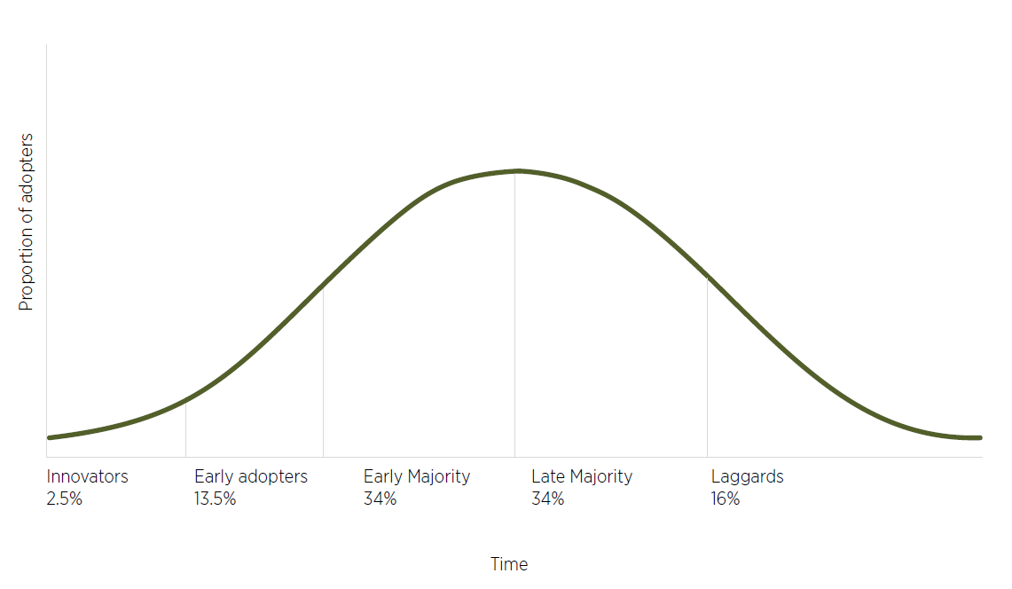

Source: Rogers Everett/Wikimedia Commons/public domain

This approach is consistent with the modernising industry and regional policy theme of the Australian Government’s White Paper on Jobs and Opportunities. The White Paper advocates for empowering people and regions going through a transition to adapt to change and take advantage of opportunities through government investment in people, places and industry (Treasury 2023b).

### Transition principles

The Panel nominates 4 principles to underpin the approach to the transition phase.

#### Certainty

Providing certainty to all stakeholders will be the catalyst for navigating change. Announcing the end date for live sheep exports by sea as soon as possible, and preferably before the end of 2023, will enable individuals, businesses and communities to consider the decisions needed prior to the end of the trade. Certainty will provide a foundation for investment decisions that will further move the industry towards a new way of operating (see also Timing).

#### Timeliness

Early actions to further the shift to onshore processing will help foster confidence in the WA sheep industry and drive actions to move towards longer-term success. The Panel understands stakeholders often need to make decisions surrounding their business well in advance. Early communication and program delivery will be important to equip stakeholders to adapt well before the cessation of the trade. Conversely, delays in delivering support could hinder change readiness, stymie confidence and lead to a more substantial drop in the WA flock size if businesses have not planned how to turn off their sheep, if processors are not ready to manage increased throughput or if demand for sheep products has not grown sufficiently in overseas markets.

#### Local, place-based partnerships

Empowering communities to engage with the process of change can lead to feelings of support and engagement in their own development and can establish collective agency (RAI 2023) – broadly speaking, a group of people making decisions together that affect them. The Panel considers that there will be better outcomes if the affected regions are involved in building confidence and identifying ways to stabilise and grow their communities up to and beyond the end of live sheep exports by sea.

Implementation efforts should be underpinned by local delivery and promotion via trusted sources. Where possible, funding should be channelled through WA-based organisations, further contributing to the economic strength of local areas, leveraging local expertise and knowledge, and increasing the likelihood of uptake by individuals and businesses.

#### Clear and consistent communication

Good communication is fundamental to achieving a successful transition. The Australian Government needs to clearly communicate the date live sheep exports by sea will end and the corresponding transition initiatives. This will contribute to certainty for all stakeholders.

Key information should be communicated using familiar channels – for example:

* trusted advisers, such as farm business consultants, research and development corporations, and industry representatives
* local government and community leaders
* local media.

Using trusted advisers to communicate updates through the transition process also links businesses in the supply chain with the people who can help them navigate change. This may help accelerate extension and adoption towards a value chain without live sheep exports by sea.

### Transition phases and governance considerations

The Panel wants to avoid a ‘set and forget’ mentality for supporting the WA sheep industry and associated businesses and communities up to and beyond the end of live sheep exports by sea. The Panel has identified several phases, roles and requirements to support program delivery and oversight. Effective implementation and responsiveness at each phase will be important to achieving a successful transition (Figure 54).

Figure 54 Steps in the transition away from live sheep exports by sea

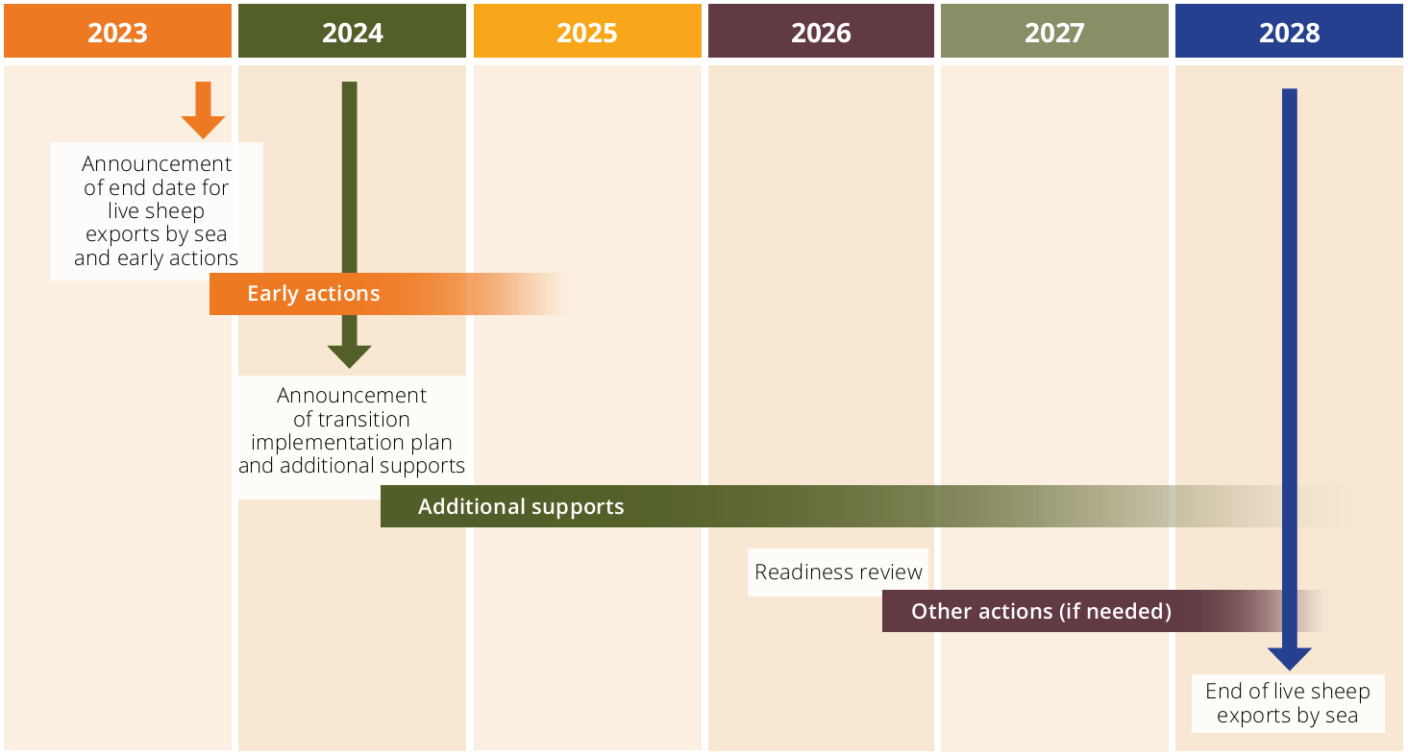

#### Announcing the change and early actions

Announcing the end date for the phase out of live sheep exports by sea will be key to avoiding a protracted period of uncertainty for the WA sheep industry. Before the end of 2023, the Australian Government should:

* announce the date at which time no further live export of sheep by sea will be permitted
* confirm the mechanism the government will use to end the trade
* announce early initiatives to build confidence and kickstart investment and change activities
* publicly release this report, its recommendations and the research commissioned by the Panel.

The Panel also recommends that the Australian Government fund and commence implementation of early actions in the first half of 2024 to restore confidence in the WA sheep industry and drive a quick and strong adaptation to the end of live sheep exports by sea.

Specific early action priorities should be focused on:

* supporting businesses in the WA sheep supply chain to prepare a business plan for their adjustment away from live sheep exports by sea
* providing funding or beneficial loan arrangements to increase capacity of processing and cold storage infrastructure
* accelerating the growth of new and deepening of existing markets for Australian sheep products, particularly from WA.

These 3 priorities should be addressed in conjunction with raising awareness of mental health and wellbeing services already funded by governments. These early actions will lead into the transition activities identified through the designing support phase.

#### Leading implementation

The Panel anticipates that the Australian Government Minister for Agriculture, Fisheries and Forestry will lead the implementation in close consultation with the WA Minister for Agriculture and Food. The Department of Agriculture, Fisheries and Forestry (DAFF) should coordinate implementation in consultation with other Australian Government agencies, WA Government officials and other delivery partners.

#### Designing support

A Transition Action Group should be established to provide advice on the implementation of transition activities, aside from early actions that should not be delayed. The group should comprise stakeholder representatives from along the value chain and from the affected regional communities able to advise government on local needs (as noted in Local, place-based partnerships). The Panel anticipates that the Transition Advocate (see Advocating through change) would be an ex officio member of the Transition Action Group.

Examples of initiatives where the Transition Action Group could provide input are:

* advising on eligibility criteria for supply chain business support or community initiatives
* nominating possible service providers for extension activities
* identifying gaps in support programs or services affecting industry adjustment.

The exact role of the Transition Action Group will hinge on the type, level and timing of supports being provided through this process. The Panel recommends that DAFF provide secretariat services to the Transition Action Group.

#### An implementation plan

DAFF as the lead agency, in collaboration with the WA Department of Primary Industries and Regional Development and the Transition Action Group, should prepare a transition implementation plan within the first half of 2024 that:

* details support initiatives
* confirms implementation partners
* describes key performance indicators to track transition performance over time, with mitigation actions to keep the transition on track.

The Panel sees value in WA agencies and organisations being used for delivery of initiatives to enhance uptake and tailor place-based solutions. This model already exists for the Rural Financial Counselling Service, elements of the Future Drought Fund, and some industry development funded by the RDCs. Support initiatives should roll out from the second half of 2024, building on the momentum of early actions.

The Panel sees an ongoing role for DAFF throughout this phase, including:

* oversight of the transition implementation plan
* ongoing communication with all stakeholders
* reporting to the Australian Minister for Agriculture, Fisheries and Forestry, and in turn to the WA Minister for Agriculture and Food on transition progress.

#### Delivering support

The Panel is cognisant of the importance of service providers being in place in WA with local knowledge and connections. Wherever possible, service providers should be local organisations, experienced in the communities so that they can tailor the support provided rather than taking time to become established in the affected regions. Initiatives should be promoted via existing communication channels, drawing on trusted sources in the affected communities and industries. For example, Rural West is a trusted presence in the WA community that delivers the Rural Financial Counselling Service WA on behalf of the Australian Government.

#### Funding support

The Panel suggests that funding be delivered:

* via transparent requirements and assessment processes
* with low administration and overhead costs
* quickly, clearly and effectively so as to encourage investment, adoption and change
* with a view to the needs of the recipients, preferably via a WA presence that can leverage local experience and enhance client service.

There are recent examples that demonstrate these principles, such as the Northern Rivers Recovery and Resiliency Program, which saw projects prioritised by the CSIRO and Australian Government funding delivered through the NSW Government in a little over 6 months (CSIRO 2023).

The Panel notes that the Australian Government may elect to draw on the WA Government’s experience in funding and delivering initiatives in regional areas by providing funding directly to the WA Government for use in priority areas for change. The Transition Action Group could be involved in identifying how to use these funds to good effect.

#### Advocating through change

A Transition Advocate should be appointed to provide advice to the Australian Minister for Agriculture, Fisheries and Forestry and the WA Minister for Agriculture and Food on progress of transition initiatives.

The Transition Advocate should be an individual who is a trusted presence in the WA sheep industry or associated businesses and communities and who can represent their interests and viewpoints while working toward a successful transition period.

The Transition Advocate will:

* participate in the Transition Action Group as an ex officio member
* advocate for collaboration across the Australian and WA governments and with industry
* advise the Australian Minister for Agriculture, Fisheries and Forestry and the WA Minister for Agriculture and Food on progress and recommend ongoing improvements to implementation activities.

#### Reviewing change

Industry progress and readiness should be assessed in 2026, ahead of the proposed end of live sheep exports by sea in mid-2028. This review is to ensure that the WA sheep supply chain and market development are on track to achieve the onshore processing of the WA sheep turn-off expected in mid-2028. This review should include recommendations about any adjustments needed, change to timelines and further actions to support a smooth transition by individuals, businesses and communities.

A further review should occur after the end of live sheep exports by sea to assess the success of support measures, identify lessons to be learnt from implementation, and make recommendations about any shortcomings in government support or stakeholder transition.

### Relevant recommendations

Initiatives requiring early action or funding: 22 and 24.

22) The Australian Government should make an announcement in 2023 stating when the end of live sheep exports by sea will occur.

23) A review should be conducted in 2026 to ensure farm businesses, the WA sheep supply chain and market development are on track to achieve the onshore processing of the WA sheep turn-off expected by the cessation date for live sheep exports by sea. This review should include recommendations about any adjustments needed, any change to timeline and further actions to support a smooth transition by individuals, businesses and communities.

24) The Australian Government should fund and commence implementation of early actions as soon as practicable to restore confidence in the WA sheep industry and drive a quick and strong adaptation to the end of live sheep exports by sea. The priorities for early action by the first half of 2024 are:

a) farm business planning (Recommendation 1)

b) processing and cold storage infrastructure (Recommendation 4)

c) market opportunities (Recommendation 14).

25) The Australian and WA governments should establish a group to co-design the development and delivery of transition activities including projects in the affected regions to stimulate regional economies and support local communities. This would not include the early actions (Recommendation 24). This group should include members with experience in the WA sheep supply chain, regional development and the WA grower group network. Where possible, priority should be given to using WA agencies and organisations for delivery of initiatives arising from this report to enhance uptake and place-based solutions.

26) The position of Transition Advocate should be created and funded to monitor transition initiatives and provide advice on progress to the Australian Minister for Agriculture, Fisheries and Forestry and the WA Minister for Agriculture and Food.

## Appendix 1: Labor’s 2022 Election commitment

### Strengthening animal welfare

Labor supports strong animal welfare standards. We believe all animals should be treated humanely and that it is the responsibility of all governments, state and federal, to ensure that this is done.

To ensure the highest standards of animal welfare are maintained, governments and industry must remain vigilant and be guided by the best available science.

An Albanese Labor Government will provide $1 million a year to establish the office of the independent Inspector-General for Animal Welfare and increase accountability and transparency for reporting of animal welfare breaches. We will work with the State and Territory Governments and allocate $5 million over four years to renew the Animal Welfare Strategy.

The Inspector-General of Animal Welfare will strengthen reports to the Parliament on:

* New and emerging live export markets.
* The number of head exported and mortalities.
* Any allegations of breaches of animal welfare standards and investigations undertaken.
* Any sanctions or other action taken for breaches of Australia’s animal welfare standards.

Currently, only mortalities and actions taken in relation to those mortalities are reported on. We propose to increase transparency and reporting through these measures.

Labor remains committed to the Northern summer live sheep export trade ban based on the scientific evidence included in the draft report by the Department of Agriculture, Water and Environment.

The Morrison Government’s draft report has recommended that the Northern Hemisphere Summer ban on live sheep exports ban continue. Labor supports the continuation of the ban based on the evidence contained in the draft report. Despite this, the Morrison Government has flagged its intention to roll back the ban.

Labor acknowledges the live sheep export trade is in decline and will phase out live sheep exports in consultation with the industry and the West Australian Government, including consideration of the impacts for the entire value chain of the industry. Labor supports value adding more here in Australia and believes this will create more job opportunities. We do not believe setting a deadline on the industry is appropriate. Labor will not ban cattle exports. The scientific advice does not support a ban on cattle exports as long as strong animal welfare standards are in place.

An Albanese Government is committed to improving animal welfare through the measures outlined above. Increased reporting and transparency and an independent Inspector-General for Animal Welfare are critical to delivering that.

## Appendix 2: Stakeholders who participated in consultations

The Panel met with the following stakeholders as part of its consultations:

* AgForce
* AgKnowledge
* Agora Livestock
* Agrarian Management
* AgricUltra
* AgZero2030
* Animals Australia
* ASHEEP (Association for Sheep Husbandry, Excellence, Evaluation and Production)
* Australian Competition and Consumer Commission
* Australian Government Department of Agriculture, Fisheries and Forestry, including the Australian Bureau of Agricultural and Resource Economics and Sciences (ABARES)
* Australian Government Department of Employment and Workplace Relations
* Australian Government Department of Finance
* Australian Government Department of Foreign Affairs and Trade
* Australian Government Department of Health and Aged Care
* Australian Government Department of Home Affairs
* Australian Government Department of Industry, Science and Resources
* Australian Government Department of Infrastructure, Transport, Regional Development, Communications and the Arts
* Australian Government Department of the Treasury
* Australian Trade and Investment Commission (Austrade)
* Australian Alliance for Animals
* Australian Livestock Exporters’ Council (ALEC)
* Australian Livestock and Rural Transporters Association
* Australian Livestock and Property Agents Association
* Australian Meat Industry Council
* Australian Meat Processor Corporation
* Australian Veterinary Association
* Australian Workers’ Union (National)
* Australian Wool Innovation
* AusVision Meat Processors Pty Ltd
* CBH Group
* Compass Agricultural Alliance
* Craig Mostyn Group (V&V Walsh)
* Cranbrook Shire Council
* Elders
* Emanuel Exports
* Episode 3
* Fletcher International Exports
* Grain Producers Australia
* GrainGrowers
* Grains Research and Development Corporation
* Grower Group Alliance
* Hashemite Kingdom of Jordan
* Humane Society
* Icon Agriculture
* International Livestock Export Pty Ltd
* The Hon Jackie Jarvis MLC, Western Australia Minister for Agriculture and Food
* Kingdom of Saudi Arabia
* The Hon Paul Kirby MLA, Northern Territory Minister for Agribusiness and Fisheries
* Kuwait Livestock Transport and Trading Co. (KLTT, an Al Mawashi company) and Rural Export and Trading (WA) Pty Ltd (RETWA), a subsidiary of Kuwait Livestock Transport and Trading Co.
* LiveCorp (Australian Livestock Export Corporation Ltd)
* Livestock and Rural Transport Association of Western Australia Inc
* Livestock SA
* Livestock Shipping Services
* Macco Feeds Australia
* Meat & Livestock Australia
* Mid West Development Commission
* Minerva Foods Australia
* NAB
* National Emergency Management Agency
* National Farmers’ Federation
* New Zealand Ministry for Primary Industries
* North-Eastern Wheatbelt Regional Organisation of Councils (NEWROC)
* Northern Territory Chief Veterinary Officer
* Northern Agricultural Catchments Council
* Northern Territory Cattlemen’s Association
* Northern Territory Livestock Exporters Association
* North Stirling Downs Agriculture
* NSW Farmers
* NT Farmers
* Nutrien Ag Solutions
* Pastoralists and Graziers Association of Western Australia
* Penrose Poll Merino Stud
* Red Meat Advisory Council
* Regional Development Australia – Wheatbelt
* RSPCA Australia
* RSPCA Western Australia
* Mr Peter Rundle MLA, WA Member for Roe
* Rural West
* Saudi Agricultural and Livestock Investment Company (SALIC)
* Sheep Producers Australia
* South Australia Department for Environment and Water
* South Australia Department of Primary Industries and Regions
* Southern Rangelands Pastoral Alliance
* SPCA (New Zealand)
* State of Kuwait
* State of Qatar
* Stop Live Exports
* Stud Merino Breeders’ Association of Western Australia
* Sultanate of Oman
* The Livestock Collective
* The Sheep’s Back
* United Arab Emirates
* Veterinarians for Animal Welfare Aotearoa
* Vets Against Live Exports
* WA Farmers
* WAMMCO International
* WA Primary Health Alliance
* WA Shearing Industry Association
* Western Australia Department of Primary Industries and Regional Development
* Western Australian Meat Industry Authority
* Western Australian Livestock Exporters’ Association
* Mr Rick Wilson MP, Federal Member for O’Connor
* Wool Producers Australia
* World Animal Protection.

The Panel also met with other individuals, including farm business owners, that have not been listed here at their request.

The Panel’s secretariat on behalf of the Panel met with the Australian Renderers Association, the Australian Hide, Skin and Leather Exporters Association and Stockair, and received information from the Shire of Victoria Plains and WEROC (Wheatbelt East Regional Organisation of Councils Incorporated).

## Appendix 3: Update from the independent panel consulting on the phase out of live sheep exports by sea, 27 July 2023

Consultation to help inform how and when to phase out live sheep exports by sea has largely been completed. We would like to acknowledge and thank all who have contributed to our consultation process, and now provide some insights into what we heard.

### Engagement

As noted in our 24 April 2023 [statement](https://www.agriculture.gov.au/about/news/phase-out-of-live-sheep-exports-by-sea), our initial approach to consultations did not meet the expectations of those interested in this process. We learnt from that feedback and adjusted our approach. We are pleased to report that since then we have engaged with over 2,000 attendees at our in-person forums and over 330 at our virtual forums, as well as holding over 80 meetings with organisations and farmer groups. We appreciate that these consultations have been conducted in a constructive and respectful manner. We have also received over 800 written submissions and 3,300 survey responses.

The submissions received, which people have given permission for publication, are available to view on the [Have Your Say](https://haveyoursay.agriculture.gov.au/live-sheep-phase-out) webpage.

We met with a broad range of stakeholders to gain their insights on potential effects of the policy, when live exports by sea should be stopped, and options to support a transition to other markets and forms of production. These included producers, supply chain participants, industry representative bodies, exporting businesses, community groups and small business operators in regional areas, animal welfare organisations, state and territory governments, and trading partners.

We acknowledge this is an uncertain time for many. We heard and recognise the unease about the future of the sheep and related industries in Western Australia. Discussing the policy and its potential impacts on livelihoods has been unsettling for many people. We encourage anyone needing support – or who wants to help others – to follow up these [social support and wellbeing resources](https://www.agriculture.gov.au/biosecurity-trade/export/controlled-goods/live-animals/livestock/live-sheep-exports-phase-out#socialsupport). Services specific to WA include free financial counselling through [Rural West](https://www.ruralwest.com.au/), and [WA-based mental health support services](https://www.agric.wa.gov.au/climate-land-water/western-australia%E2%80%99s-rural-support-services#247support).

We found immense value in hearing the firsthand experiences of those we met and those who contributed in writing, and building our understanding of how this policy may affect people in the supply chain, their businesses and their communities. We also appreciated the ideas offered for how to approach the move away from live sheep exports by sea.

### What we heard

Throughout the consultations, we heard how the phase out may affect individuals, businesses, communities and animals. An overwhelming majority of those people who attended our public meetings voiced their opposition to the government’s decision to implement its election commitment and phase out live sheep exports by sea.

Other stakeholders expressed their opposition via the survey or written submissions. We also heard the effects regional communities may face with the end of live sheep exports by sea. On the other hand, we heard from some stakeholders that the government’s decision to phase out should be implemented as soon as possible.

We have sought expert advice to support our consideration about how and when the phase out could be implemented, including what might be needed to help supply chain participants and communities to transition.

During consultations, common issues were raised relating to the phase out, including:

* **Sheep producers** – Live export is used in WA to mitigate risk and diversify farm operations. This is due in part to the different climate, geography and limited domestic market opportunities in the west compared to the eastern states. We also learnt about the different production systems in WA and heard from some producers who have successfully shifted their businesses away from a reliance on the live export trade. Removing live exports will require producers to use a different avenue for turning off stock and make alternative production decisions.
* **Wool industry** – Consultations highlighted potential challenges that may affect the wool industry when live export ceases. Many were concerned that without live export, farmers would not run the same number of Merinos for wool and this may erode prices or services associated with wool production such as shearing. There was also concern about the future viability of the wool exchange in WA if the state’s wool clip drops. Live export provides an option for farmers turning off older wethers or culled ewes and producers will need an alternative outlet for these sheep.
* **Cattle producers** – Cattle producers were concerned about the future absence of mixed-species (cattle and sheep) voyages to the Middle East from Fremantle. They were also anxious about whether the closure of live sheep exports would be a precursor to changes for live cattle exports, noting the government has committed that the phase out will only apply to live sheep exports by sea.
* **Other businesses in the supply chain** – Our consultations highlighted that there are many businesses and industries with some reliance on the live sheep trade. These include shearers, feed millers, animal husbandry contractors, agency services and veterinarians, as well as non-agricultural businesses that depend on economically sound local communities.
* **Broadacre cropping industry** – Some producers who use live export are suggesting they will change their enterprise mix, reduce their sheep operations and increase grain production. They were concerned this may increase their exposure to drought and other climatic events, and broader risks. Other producers were worried about the phase out because of the potential flow-on impact to their businesses. For example, if grain production increases in WA, this may put downward pressure on grain prices and stretch the capacity of grain logistic supply chains which are reportedly already under pressure particularly in long-haul grain production areas of the state. Fewer sheep may decrease the demand for hay, straw and lupins, impacting other producers.
* **Processing industry** – There is a current lack of capacity in the WA processing sector. Existing abattoirs are limited by factors such as access to labour, employee accommodation and cold storage capacity both at abattoirs and at ports. There are also concerns about the downward effect on prices paid by processors if live export is removed as a source of competition. The strong view was that exporters in the market put upward pressure on prices being paid by other buyers.
* **Community impact** – Phasing out the live export industry may have consequences for the social and economic fabric of WA towns and regional services, continuing a trend of declining populations in some places. Communities may feel the broader effects of the phase out as businesses in the supply chain, such as transporters and shearers and other local retail and service sectors are also affected.
* **Wellbeing** – The uncertainty regarding the implementation and transition arrangements of the phase out is adding to other concerns such as climate change, cost of input pressures, and other government policy and program changes. These combined factors may have a detrimental effect on the mental health of farmers who feel they have a lack of control over these decisions and their impact on their businesses and their communities. We also heard that wellbeing is impacted by current market and deteriorating seasonal conditions.
* **Infrastructure and logistics** – Concern was expressed about the quality of existing infrastructure and its ability to accommodate a shift from sheep to more cropping. A growth in grain production may mean additional trucks on the road, impacting road conditions and safety. Other infrastructure such as feedlots or pre-export shearing facilities may need to be re-purposed or new facilities constructed. We also heard there are already substantial differentials in airfreight prices and capacity for sheep meat exported from WA compared to the eastern states.
* **Trade and exports** – We were told that growing demand from new and existing markets for sheep meat, particularly from older sheep and the lightweight wether Merino, will likely be crucial for supporting the WA sheep industry. Existing trading partners would prefer the live trade to continue for food security and cultural preference reasons, complementing Australian meat imports. We heard that trading partners have made investments to meet Australian animal welfare requirements in support of the existing trade.
* **Animal welfare** – We heard from people who are distressed by the long history of animal welfare incidents that have occurred on vessels and in importing countries, notwithstanding the Australian Standards for the Export of Livestock (ASEL) and the Exporter Supply Chain Assurance System (ESCAS). There was strong support for an early end to live sheep exports by sea. There was recognition that producers need time to adjust, or adverse circumstances could be created for existing stock. Animal welfare groups noted the importance of sheep being slaughtered as close to their point of origin as possible. They also emphasised there will need to be greater monitoring of sheep welfare and enforcement of the [Australian Land Transport of Livestock standards](https://www.agriculture.gov.au/agriculture-land/animal/welfare/standards-guidelines) if stock are moved by truck from western to eastern Australia.

### Market trends

Market trends are informing our deliberations.

* Australia exports sheep meat to over 80 countries.
* WA’s live sheep exports have been declining due to many factors and sheep meat exports have been increasing.
* A high proportion of sheep in WA are processed domestically.
* There is ongoing demand for WA wool. In 2021–22, WA wool exports were valued at $715 million.

Figure A Value and share of WA live sheep exports compared with value of sheep meat exports

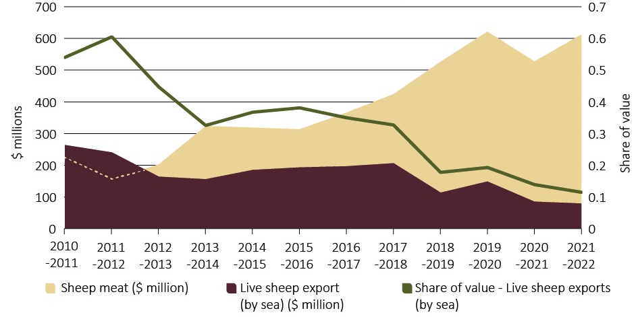

Source: [ABARES Trade Dashboard](https://www.agriculture.gov.au/node/20594)

Figure A Sheep turnoff from WA farms, 2021–22

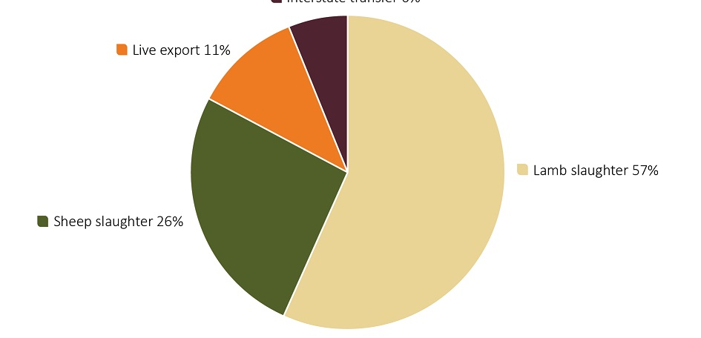

Source: [WA Government: The Western Australian sheep and wool industries](https://www.agric.wa.gov.au/sheep/western-australian-sheep-and-wool-industries)

Figure A Volume of national vs WA wool exports

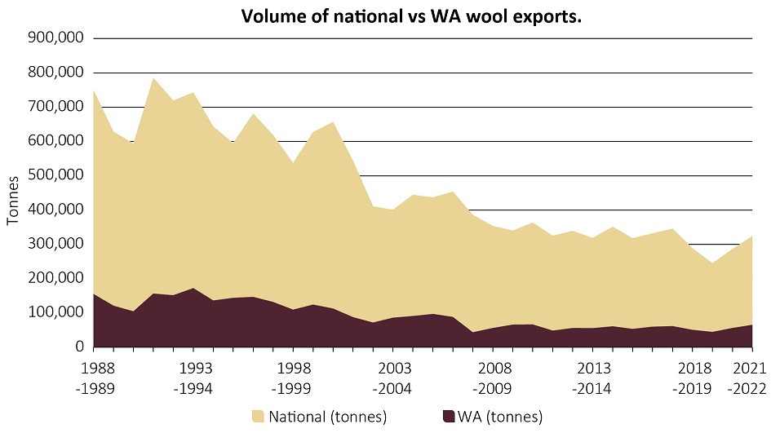

Source: [ABARES Trade Dashboard](https://www.agriculture.gov.au/node/20594)

### Ideas for the future

Through consultations and in written submissions, stakeholders offered suggestions for how to approach the transition away from live exports. Broadly, these ideas included:

* increasing sheep meat processing capacity in WA
* expanding international market opportunities for sheep meat
* supporting individuals facing change
* helping businesses including farmers plan and reinvest for the future
* supporting regional communities affected by the phase out
* encouraging industry to build a future whole of supply chain strategy for sheep in WA
* sustaining or improving animal welfare outcomes in the lead up to the phase out
* the potential for financial support for those affected by the phase out.

### Next steps

We are considering the feedback from public consultations (verbal and written), as well as expert analysis on the potential economic, agronomic and other impacts of the phase out. We expect our report to the Minister for Agriculture, Fisheries and Forestry will describe what we heard and outline our recommendations on how and when to phase out live sheep exports by sea. It will be provided to the Minister by 30 September 2023.

Updated: The 30 September 2023 timeline has been extended and the panel will provide its report to the Minister for Agriculture, Fisheries and Forestry by 25 October 2023.

Phillip Glyde (Panel Chair), Sue Middleton, Heather Neil and Warren Snowdon.

## Appendix 4: Survey and written submission analysis

### Survey responses

The Have Your Say survey contained 13 written response questions. Participants were asked about how the phase out might impact them, how and when they thought the phase out should be implemented and how the government could support the transition away from the trade. Respondents were not required to answer all the questions in the survey.

Approximately 3,300 individuals or organisations responded to the survey. The responses were individually categorised into key themes by the Panel secretariat. The data was consolidated and analysed to draw insights for this report. Contrasting with the in-person consultations, the survey respondents were overwhelmingly in favour of the end of live sheep exports by sea.

The suggested time frame for the end of the trade was heavily influenced by whether the respondent was involved in the sheep industry or supply chain. Of the respondents who indicated a possible time frame for the phase out, 92% suggested it should happen within 3 years. However, none of these respondents identified as being impacted by the phase out or as a part of the supply chain. Respondents who indicated they would be impacted by the end of the trade offered other possible time frames, with some suggesting the trade should continue for at least 20 years.

Most responses acknowledged there were barriers to a smooth exit from live sheep exports by sea. A resistance to change featured in 47% of responses that addressed this question. Financial constraints were next, accounting for 30%. Other reasons included insufficient skills, a lack of infrastructure to enable domestic processing, and the convenience of the live sheep export market.

Insufficient processing capacity was a key concern expressed by those directly affected by the phase out. Of this group, 69% highlighted issues surrounding current processing capacity throughout the survey. Of the same group, 58% also expressed concern about the lack of alternative markets to enable a transition away from live sheep exports by sea.

Most individuals and organisations affected by the phase out addressed the need for farming practices to change to enable them to stop exporting live sheep by sea. Around a quarter of these respondents mentioned the need to reduce their flock size or change its composition.

### Written submission analysis

The Panel received 810 written submissions, including from animal welfare organisations, producers, supply chain businesses, trading partners and members of the community. Of the 85 submissions received from producers, 82 were from WA, highlighting the specific regional impact and interest in the phase out. In total 80% of the submissions noted their support for the phase out policy, 16% noted their opposition and 4% did not state a supportive/opposing view or provided a neutral response.

The written submissions received by the Panel covered a wide range of views from different groups of stakeholders. Table A1 indicates the top 3 issues raised by key stakeholder groups in their written submissions.

Table A Top 3 issues raised by stakeholder groups, by percentage of responses

| Stakeholder group | Issue | Percentage (%) |
| --- | --- | --- |
| Agriculture producer/farmer or supply chain business | Processing capacity | 54 |
| Workforce/labour issues | 41 |
| Climate/land issues (e.g. land not suited to cropping) | 40 |
| Industry representative body | Processing capacity | 56 |
| Workforce/labour issues | 50 |
| Increase sheep meat production/exports | 50 |
| Animal welfare organisation | Need financial support | 39 |
| Processing capacity | 26 |
| Increase sheep meat production/exports | 23 |
| Academic/researcher/industry expert | Need financial support | 35 |
| Processing capacity | 35 |
| Increase sheep meat production/exports | 27 |

## Appendix 5: Support programs and measures

### Farm business supports

#### Regional Investment Corporation

Farmers can apply for low-interest loans of up to $2 million.

* Farm Investment Loan: to strengthen farm businesses to access markets interstate or outside Australia.
* AgriStarter Loan: to assist in buying or establishing a new farm and for farm succession arrangements.
* AgBiz drought loans: up to $500,000 for eligible drought-affected small businesses.
* Drought Loan: for drought preparedness, management and recovery activities.
* Plantation Loan: up to $2.5 million to support new plantations and the replanting of bushfire-damaged plantation.

The RIC also offers a Farm Relief Tool that connects farmers with Australian Government financial assistance and community support to help prepare for and recover from drought, natural disaster or biosecurity events.

#### Farm Management Deposit Scheme

The Farm Management Deposit Scheme allows eligible farmers to deposit up to $800,000 in pre-tax income from primary production in years of high income. Farmers can draw on this money in future years. Income deposited in an FMD account is tax deductible in the year the deposit is made. The FMD becomes part of a farmer’s taxable income in the year it is withdrawn (repaid).

#### Primary production asset depreciation

Accelerated depreciation enables primary producers to fully deduct capital expenditure on new water facilities, fodder storage assets and fencing assets used in primary production.

#### Income tax averaging

Income tax averaging allows primary producers to even out their high-income and low-income years and the tax payable over a maximum of 5 years, ensuring they do not pay more tax over time than taxpayers on similar but steady incomes.

#### Profit from forced disposal or death of livestock

If producers make a profit from the forced disposal or death of livestock, they can elect to either:

* spread the profit earned over a period of 5 years
* defer the profit and use it to reduce the cost of replacement livestock in the disposal year or any of the next 5 income years.

#### Future Drought Fund

The Future Drought Fund provides secure, continuous funding for drought resilience initiatives.

* Farm Business Resilience Program: gives farmers access to subsidised learning and development opportunities. Focuses on strategic business management, farm risk management and decision-making, natural resource management, and personal and social resilience. Helps farmers develop or update their farm business plans.
* Drought Resilience Adoption and Innovation Hubs: support farmers and communities to prepare for drought.

#### Rural Financial Counselling Service

The RFCS provides free financial counselling to farmers, fishing enterprises, forestry growers and harvesters, and related small businesses experiencing, or at risk of, financial hardship. The RFCS aims to transition clients out of financial crisis, improve clients’ financial wellbeing and resilience, and improve clients’ business profitability or facilitate a dignified exit through sale or succession.

### Individual supports

#### Farm Household Allowance program

The FHA program helps farmers and their partners in financial hardship by providing income to the household and thereby reducing the strain on the business. It includes a fortnightly income support payment, up to $10,000 Activity Supplement per person to pay for professional advice and/or training, up to $1,500 for an independent financial assessment of the farm enterprise, and ancillary allowances where applicable (for example, rent assistance, telephone allowance, pharmaceutical allowance, and remote area allowance). Recipients are not expected to navigate the program alone – individual case support is available from specially trained and regionally based Services Australia staff.

#### Coordination and Planning Officers

Coordination and Planning Officers are located across Australia in metropolitan and key regional locations, working in partnership with states and territories. Their role includes supporting disaster-affected communities, to collectively build resilience, reduce risk and harm, and effectively respond to and recover from disasters.

#### Head to Health

Head to Health provides mental health and wellbeing services. It makes it easier to navigate and choose the most suitable care options, whether that is face-to-face, via phone, or online.

#### MindSpot and MindSpot GP

MindSpot is a free and confidential service that allows individuals to complete an online assessment of their mental health and receive assistance from a MindSpot therapist within 2 days. Participants can undertake online treatment courses under the guidance of a therapist or participate in up to 4 teletherapy sessions. Face-to-face sessions are also available.

MindSpot GP provides the same service as MindSpot but starts with a general practitioner referral.

#### Other services

Additional non-government services are available to provide support to individuals. These include the [Lifeline Support Toolkit](https://toolkit.lifeline.org.au/), an online library that provides a variety of tools, techniques applications, services and stories regarding mental health.

### Community supports

#### Future Drought Fund

The Future Drought Fund provides secure, continuous funding for drought resilience initiatives.

* Farm Business Resilience Program: gives farmers access to subsidised learning and development opportunities. Focuses on strategic business management, farm risk management and decision-making, natural resource management, and personal and social resilience. Helps farmers develop or update their farm business plans.
* Drought Resilience Adoption and Innovation Hubs: support farmers and communities to prepare for drought.
* Regional Drought Resilience Planning program: is a community-led process to consider regional needs and priorities to inform future investments, through development of plans to manage drought risks through best practice approaches to resilience, adaptation and transformation. In WA, planning has already commenced in the Mid West, the Wheatbelt (southern region) and the Great Southern region. More regions will commence planning in 2024 and 2025.
* Helping Regional Communities Prepare for Drought Initiative: enables agriculture-dependent communities to identify and act on their drought preparedness priorities at a grassroots level. Invests in projects that seek to strengthen social and community networking, support, engagement and wellbeing by delivering a tailored package of support.

#### Regional Precincts and Partnerships Program

The Regional Precincts and Partnerships Program provides a nationally consistent mechanism for funding and coordinating projects that transform a place, to benefit communities in regions, regional cities and rural Australia. It will also be the mechanism for delivering all future regional partnerships.

#### Growing Regions Program

The Growing Regions Program provides grants of between $500,000 and $15 million to local government entities and not-for-profit organisations for capital works projects that deliver community and economic infrastructure projects across regional and rural Australia. Projects must be delivered in a set window, be aligned to identified regional priorities and have committed co-funding partners.

#### Stronger Communities Program

The Stronger Communities Program provides grants of between $2,500 and $20,000 to community organisations and local governments for small capital projects that deliver social benefits for local communities.

The input of the community is a key element of the Stronger Communities Program. Projects are selected by members of parliament and their community consultation committees and are then submitted to the government for assessment.

## Glossary

| Term | Definition |
| --- | --- |
| ABARES | Australian Bureau of Agricultural and Resource Economics and Sciences. |
| AWI | Australian Wool Innovation, a producer-owned company providing research, development and marketing services to Australian woolgrowers. |
| Broadacre cropping | A farming system that includes cereals, oilseeds, legumes, hops, cotton, hay and silage. |
| CAGR | Compound annual growth rate. |
| Confinement feeding | See Feedlotting. |
| Crop farming | Growing cereals, oilseeds, legumes, hops, cotton, hay, silage, sugar cane and/or horticultural crops. In Western Australia the predominant farmed crops are wheat, barley, oats, canola, cereal hay and straw, field peas, chickpeas and white lupins. |
| cwe | Carcase weight equivalent. Expresses the weight of a live sheep as its equivalent weight as a dressed carcase. The measure allows for price or volume comparisons between different commodities. |
| DAFF | Department of Agriculture, Fisheries and Forestry, the Australian Government agency responsible for matters relating to agricultural, pastoral, fishing, food and forest industries. The department regulates agricultural goods (including livestock) exported from Australia. |
| Feedlotting | An intensive feeding system in a conﬁned area where all or the majority of feed and water is supplied to contained animals (DPIRD 2023a).  Variations include confined paddock feeding, conﬁnement feeding and lot feeding. |
| GCC | The 6 Gulf Cooperation Council members: Bahrain, Kuwait, Oman, Qatar, Saudi Arabia and United Arab Emirates (UAE). |
| kt | Kilotonne (1,000 tonnes). |
| Lamb | Meat derived from an ovine animal that (a) is under 12 months of age; or (b) does not have any permanent incisor teeth in wear (AMIC & AWI 2019). |
| LiveCorp | Australian Livestock Export Corporation, a livestock export industry-owned company providing marketing and research and development services to livestock exporters. |
| MENA | The geographic region of the Middle East and North Africa, generally taken to include Algeria, Bahrain, Egypt, Iran, Iraq, Israel, Jordan, Kuwait, Lebanon, Libya, Morocco, Oman, Qatar, Saudi Arabia, Sudan, Syria, Tunisia, UAE, the Occupied Palestinian Territories and Yemen. |
| Mixed farming | A mix of cropping and livestock. Primary activities can include grain growing and sheep or beef cattle farming. |
| MLA | Meat & Livestock Australia, a producer-owned company providing marketing and research and development services to Australian cattle, sheep and goat producers. |
| Mutton | Meat derived from (a) a female ovine animal that has at least one permanent incisor tooth in wear; or (b) a castrated male ovine animal that (i) has at least one permanent incisor tooth in wear; and (ii) shows no evidence of secondary sexual characteristics (Export Control (Meat and Meat Products) Rules 2021). |
| Northern Hemisphere Summer Prohibition | In place since 2020, there is a prohibition on the export of Australian sheep by sea to or through the Middle East during the hottest, most humid part of the Northern Hemisphere summer. The dates for the prohibition are set out in the Export Control (Animals) Rules 2021 and vary depending on the destination or route.  There is an ‘absolute prohibition’ (when no sheep may be exported by sea) and other dates (effectively either side of the absolute prohibition period, depending on destination or route) when sheep may be exported if certain conditions are satisfied. |
| RDA | Regional Development Australia or a Regional Development Australia region. |
| Rendered products | Animal co-products (by-products) that are heat treated to remove water and/or liberate fat for the purpose of processing into fats, oils, processed animal protein, fertiliser or pharmaceutical ingredients. |
| Real value | Price or value adjusted for inflation to show the equivalent value in 2022–23 Australian dollars. Values throughout this report are expressed in 2022–23 Australian dollars unless stated otherwise. |
| Sheep | An ovine animal. |
| Sheep meat | Meat derived from an ovine animal. |
| Specialist sheep farm | A primary production business with at least 50% of farm receipts derived from sheep meat (including lambs) and wool. Also known as ‘sheep-dominant’. |
| Supply chain | A system of people and things involved in producing and distributing a product to a consumer. |
| Total farm capital | The value of farm capital is the value of all the assets used on a farm, including the value of land and fixed improvements (including residences on farm), plant and machinery, vehicles, livestock and stocks of grain and wool. |
| Total farm costs | Payments made by the farm business for materials and services and for permanent and casual hired labour (excluding owner–manager, partner and other family labour). Includes all fixed costs, such as electricity. |
| Turn off | To sell livestock, usually to another producer (such as for breeding or finishing before slaughter), a meat processor or live exporter. |
| Value chain | A supply chain where value is added to the product at each stage of production and distribution. |
| Wether | A castrated male sheep, regardless of age. |

## References

ABARES 2022a, [Food security: the role of international trade and support](https://www.agriculture.gov.au/abares/products/insights/food-security-the-role-of-international-trade-and-support), Australian Bureau of Agricultural and Resource Economics and Sciences, Canberra, accessed 11 August 2023.

——2022b, [My region dashboard (Wheatbelt)](https://public.tableau.com/app/profile/australian.bureau.of.agricultural.and.resource.economics.and.sci/viz/AMR_v9_A3L/Dashboard1), accessed 6 September 2023.

——2023a, [Agricultural Commodities: June quarter 2023 – Statistical tables](https://www.agriculture.gov.au/abares/research-topics/agricultural-outlook/data#agricultural-commodities), accessed 3 July 2023.

——2023b, [Agricultural Commodities: September quarter 2023 – Statistical tables](https://www.agriculture.gov.au/abares/research-topics/agricultural-outlook/data#agricultural-commodities), accessed 12 September 2023.

——2023c, [Australian Agricultural and Grazing Industries Survey](https://www.agriculture.gov.au/abares/research-topics/surveys/farm-definitions-methods), accessed 20 September 2023.

——2023d, [Australian Crop Report: September 2023](https://daff.ent.sirsidynix.net.au/client/en_AU/ABARES/search/detailnonmodal/ent:$002f$002fSD_ASSET$002f0$002fSD_ASSET:1035041/one), accessed 3 October 2023.

——2023e, [Farm data portal – beta](https://www.agriculture.gov.au/abares/data/farm-data-portal#daff-page-main), accessed 15 September 2023.

——2023f, [Financial performance of cropping farms](https://www.agriculture.gov.au/abares/research-topics/surveys/cropping#farm-cash-income), accessed 11 August 2023.

——2023g, [Outlook for sheep meat](https://www.agriculture.gov.au/abares/research-topics/agricultural-outlook/sheep-meat), accessed 18 September 2023.

——2023h, Phase out of live sheep exports by sea: Background information and analysis, report to the Independent Panel for the Phase Out of Live Sheep Exports by Sea by Australian Bureau of Agricultural and Resource Economics and Sciences, Canberra, accessed 25 September 2023. Unpublished.

——2023i, [Snapshot of Australian agriculture 2023](https://www.agriculture.gov.au/abares/products/insights/snapshot-of-australian-agriculture#agricultural-production-is-growing), accessed 12 July 2023.

——2023j, [Trade dashboard (beta)](https://aus01.safelinks.protection.outlook.com/?url=https%3A%2F%2Fwww.agriculture.gov.au%2Fabares%2Fresearch-topics%2Ftrade%2Fdashboard&data=05%7C01%7CJulie.Hamilton%40aff.gov.au%7Caa32483822c2433b502008db8f10fa55%7C2be67eb7400c4b3fa5a11258c0da0696%7C0%7C0%7C638261075296230455%7CUnknown%7CTWFpbGZsb3d8eyJWIjoiMC4wLjAwMDAiLCJQIjoiV2luMzIiLCJBTiI6Ik1haWwiLCJXVCI6Mn0%3D%7C3000%7C%7C%7C&sdata=zqaxqPmhX4JewWp3AqzvNIwSOBWXodSFDNFv%2BDQ13rc%3D&reserved=0), accessed 7 July 2023.

ABS 2022, [Population movement in Australia](https://www.abs.gov.au/articles/population-movement-australia), Australian Bureau of Statistics, Canberra, accessed 2 August 2023.

——2023a, [Agricultural Commodities, Australia, 2021–22](https://www.abs.gov.au/statistics/industry/agriculture/agricultural-commodities-australia/latest-release), accessed 7 July 2023.

——2023b, Australian exports of bovine and ovine rendered products, Catalogue 9920.0, accessed 6 September 2023.

——2023c, Exports of Fodder for Animal Feed, Catalogue 9920.0, accessed 20 September 2023.

——2023d, [International Trade in Goods and Services](https://www.abs.gov.au/statistics/economy/international-trade/international-trade-goods-and-services-australia/latest-release), accessed 20 September 2023.

——2023e, [Livestock Products, Australia, March 2023](https://www.abs.gov.au/statistics/industry/agriculture/livestock-products-australia/latest-release#:~:text=The%20gross%20value%20of%20cattle,decreased%201.4%25%20to%20%24910%20million.), accessed 14 July 2023.

ACCC 2017, [Cattle and beef market study – final report](https://www.accc.gov.au/by-industry/agriculture/cattle-and-beef-market-study-2016-17), Australian Competition and Consumer Commission, Canberra, accessed 14 July 2023.

ACIL Allen 2023, [Performance and value of the live sheep export trade – Final report (PDF 2022 MB)](https://www.mla.com.au/globalassets/mla-corporate/research-and-development/final-reports/acil-allen_-final-report_live-sheep-trade_aug23_update-final.pdf), LiveCorp, North Sydney, & Meat & Livestock Australia, North Sydney, accessed 1 September 2023.

AFI 2017, [Despite the good times, risk remains the key feature of farming in Australia](https://www.farminstitute.org.au/despite-the-good-times-risk-remains-the-key-feature-of-farming-in-australia/), Australian Farm Institute, Eveleigh, NSW, accessed 6 September 2023.

AFIA 2023, [The fodder industry in Australia](https://afia.org.au/about-fodder/#exporting-fodder), Australian Fodder Industry Association, accessed 25 September 2023.

AFR 2023, [Live sheep ban is ‘futile’, Kuwait warns Australia](https://www.google.com/url?sa=t&rct=j&q=&esrc=s&source=web&cd=&cad=rja&uact=8&ved=2ahUKEwjtjZzArtaBAxXa0mEKHX8ZAC8QFnoECAwQAQ&url=https%3A%2F%2Fwww.afr.com%2Fcompanies%2Fagriculture%2Flive-sheep-ban-is-futile-emirate-warns-australia-20230914-p5e4t0&usg=AOvVaw1KRNh-VCD9MSR2s_JhUYnH&opi=89978449), The Australian Financial Review, Sydney, 15 September 2023.

Agar, O, Dalgleish, M & Herrmann, R 2020, [Analysis of domestic fundamentals influencing the national sheep flock (PDF 2.57 MB)](https://www.mla.com.au/globalassets/mla-corporate/research-and-development/final-reports/2020/w.liv.1001_mecardo-sheep-phase-3.pdf), LiveCorp, North Sydney, & Meat & Livestock Australia, North Sydney, accessed 1 September 2023.

AIHW 2023, [Rural & remote Australians](https://www.aihw.gov.au/reports-data/population-groups/rural-remote-australians/overview#:~:text=challenges%20in%20accessing%20health%20care,tobacco%20smoking%20and%20alcohol%20use), Australian Institute of Health and Welfare, Canberra, accessed 2 August 2023.

ALEC 2018, [Sheep moratorium part of industry re-set](https://auslivestockexport.com/news/10-news/122-sheep-moratorium-part-of-industry-re-set), Australian Livestock Exporters’ Council, Canberra, accessed 15 August 2023.

ALGA 2023, [Stronger community resilience](https://alga.com.au/policy-centre/community-resilience/), Australian Local Government Association, Canberra, accessed 2 August 2023.

AMIC 2018, [Submission to the Senate Standing Committee on Legal and Constitutional Affairs](https://www.aph.gov.au/Parliamentary_Business/Committees/Senate/Legal_and_Constitutional_Affairs/SkilledVisaSystem/Submissions), submission no 21 to the Senate Standing Committee on Legal and Constitutional Affairs inquiry into the effectiveness of the current temporary skilled visa system in targeting genuine skills shortages, Australian Meat Industry Council, December, accessed 14 August 2023.

——2022, [Pacific labour mobility](https://www.dfat.gov.au/geo/pacific/engagement/pacific-labour-mobility), accessed 6 September 2023.

AMIC & AWI 2019, [Australia’s new definition of lamb (PDF 658 KB)](https://amic.org.au/wp-content/uploads/2019/06/Factsheet-Lamb-Definition.pdf), Australian Meat Industry Council, Sydney, & Sheep Producers Australia, Canberra, accessed 16 August 2023.

AMPC 2021, [Employee retention in the red meat industry (PDF 560 KB)](https://www.ampc.com.au/getmedia/f97bfd5e-a96e-4f45-bc4b-595f2e5427aa/AMPC-Final-Report-Employee-Retention.pdf), Australian Meat Processor Corporation, North Sydney, accessed 30 August 2023.

——2022, [AMPC Annual Report 2021–2022 (PDF 9.1 MB)](https://www.ampc.com.au/getmedia/b8294834-cfbd-4626-b2a8-a8592a16c3c5/AMPC-Annual-Report-2021-2022.pdf), accessed 17 August 2023.

——2023a, [About the Australian Meat Processor Corporation](https://www.ampc.com.au/about-us), accessed 17 August 2023.

——2023b, [Corporate reports](https://www.ampc.com.au/about-us/corporate-reports), accessed 17 August 2023.

Ashton, D & Russell, B 2003, [Sheep Updates 2003 – Keynotes (PDF 635 KB)](https://library.dpird.wa.gov.au/cgi/viewcontent.cgi?article=1006&context=sheep_conf), Department of Primary Industries and Regional Development, South Perth, accessed 20 June 2023.

Austrade 2022, [Insight – Australian exporters to benefit from growing global appetite for sheepmeat](https://www.austrade.gov.au/news/insights/insight-australian-exporters-to-benefit-from-growing-global-appetite-for-sheepmeat), accessed 12 July 2023.

——2023a, [Export Supply Chain Service – Supply Chain Wrap Up](https://www.austrade.gov.au/ArticleDocuments/5860/ESCS-Supply-Chain-Snapshot.pdf.aspx?Embed=Y), Australian Trade and Investment Commission, Canberra, accessed 22 August 2023.

——2023b, [Why Australia Benchmark Report 2023](https://www.globalaustralia.gov.au/why-australia/benchmark-report-2023#:~:text=Key%20findings,attractive%20destination%20for%20global%20business.), accessed 31 March 2023.

Australian Aid 2023, [Budget 2023–24 – reforming the PALM scheme](https://www.palmscheme.gov.au/resources/budget-2023-24-reforming-palm-scheme), Department of Foreign Affairs and Trade, Canberra, accessed 6 July 2023.

AWI 2023a, [Annual Operating Plan 2023–2024 (PDF 31 MB)](https://www.wool.com/globalassets/wool/about-awi/how-we-consult/stakeholder-consultation/awi-annual-operating-plan-2023-2024.pdf), Australian Wool Innovation, Sydney, accessed 8 August 2023.

——2023b, [Australian Wool Forecast Production Report August 2023](https://www.wool.com/globalassets/wool/market-intelligence/wool-production-forecasts/australian-wool-production-forecast-report---august-2023.pdf), accessed 23 August 2023.

——2023c, [June Market Intelligence](https://www.wool.com/globalassets/wool/market-intelligence/monthly-market-reports/awi_monthlymarketreport_jun23.pdf), accessed 23 August 2023.

——2023d, [Learning about sheep nutrition](https://www.wool.com/sheep/reproduction/best-practice-management-courses/), accessed 17 August 2023.

——2023e, [Upcoming WA shearer training courses](https://www.wool.com/training-extension/training-courses/upcoming-wa-shearer-training-courses/), accessed 2 October 2023.

Borrello, E, Cooper, L & Gunders, J 2022, [Live sheep trade ban won’t happen this term, Prime Minister Albanese says](https://www.abc.net.au/news/2022-06-03/sheep-live-export-ban-labor-agriculture-minister-confirms/101119752), ABC News, 3 June, accessed 27 June 2023.

Chancellor, W 2023, [Agricultural research and development investment in Australia](https://www.agriculture.gov.au/abares/research-topics/productivity/related-research/agricultural-research-and-development-investment-in-australia), Australian Bureau of Agricultural and Resource Economics and Sciences, Canberra, accessed 8 August 2023.

Coles 2022, [Accommodation for horticulture workers (PDF 892 KB)](https://www.colesgroup.com.au/FormBuilder/_Resource/_module/ir5sKeTxxEOndzdh00hWJw/file/Horticulture-Worker-Accommodation.pdf), Coles Group Limited, Melbourne, accessed 11 September 2023.

Cormack, L 2023, [A small slice of Wollongong in Dubai, where the export of Australian education is big business](https://www.smh.com.au/world/middle-east/a-small-slice-of-wollongong-in-dubai-where-the-export-of-australian-education-is-big-business-20230616-p5dh9f.html), *Sydney Morning Herald*, 6 August, accessed 13 September 2023.

CP 2023, [Pathways from temporary visas to permanent residency: a case study of migrants that arrived in 2006–07](https://population.gov.au/publications/research/pathways-temporary-visas-permanent-residency-case-study-migrants-arrived-2006), Centre for Population, The Treasury, Canberra, accessed 6 September 2023.

CSIRO 2023,[Northern Rivers Resilience Initiative](https://www.csiro.au/en/research/natural-disasters/floods/northern-nsw-resilience-initiative)**,** CSIRO, Canberra, accessed 15 August 2023.

DAF 2016, [The Western Australian sheep industry (PDF 2.3 MB)](https://www.agric.wa.gov.au/sites/gateway/files/WA%20Sheep%20Industry%20booklet%202017.pdf), Department of Agriculture and Food, Perth, accessed 22 May 2023.

DAFF 2012, [Australian Animal Welfare Standards and Guidelines: Land Transport of Livestock](https://www.animalwelfarestandards.net.au/land-transport/), Department of Agriculture, Fisheries and Forestry, Canberra, accessed 16 August 2023.

——2022a, Market Access Advice (MAA 2250), United Arab Emirates – Determination of shelf life for exports of frozen red meat to the Emirate of Dubai, accessed 10 August 2023. Unpublished.

——2022b, [Northern Hemisphere summer review](https://www.agriculture.gov.au/biosecurity-trade/export/controlled-goods/live-animals/animal-welfare/livestock-welfare-reviews/northern-hemisphere-review#:~:text=Interim%20measures%20for%202022&text=Data%20indicated%20a%20greater%20heat,Red%20Sea%20during%20early%20June.), accessed 15 August 2023.

——2022c, [Wool](https://www.agriculture.gov.au/agriculture-land/farm-food-drought/meat-wool-dairy/wool#other-links), accessed 19 May 2023.

——2023a, [Agricultural Workforce Working Group – 15 September 2023](https://www.agriculture.gov.au/about/news/stay-informed/communiques/ag-workforce-working-group-september-2023), communiqué, accessed 17 September 2023.

——2023b, [All Livestock Exports 2018 to 2023](https://www.agriculture.gov.au/biosecurity-trade/export/controlled-goods/live-animals/live-animal-export-statistics/livestock-exports-by-market), accessed 17 April 2023.

——2023c, [Meat processing labour](https://www.agriculture.gov.au/abares/research-topics/agricultural-outlook/meat-processing-labour#workforce-issues-unlikely-to-impact-slaughter-capacity), accessed 3 July 2023.

——2023d, [Reports to parliament](https://www.agriculture.gov.au/biosecurity-trade/export/controlled-goods/live-animals/live-animal-export-statistics/reports-to-parliament), accessed 25 October 2023.

——2023e, [Snapshot – Australian sheepmeat exports](https://www.agriculture.gov.au/about/news/australian-sheepmeat-export-snapshot), accessed 12 July 2023.

——2023f, [Western Australia agricultural exports snapshot 2022](https://www.agriculture.gov.au/about/news/western-australia-agricultural-export-snapshot-2022), accessed 18 August 2023.

Dalgleish, M & Agar, O 2019, [Value analysis of the Australian live sheep trade (2019)](https://www.mla.com.au/research-and-development/reports/2020/value-analysis-of-the-australian-live-sheep--trade-2019/), Meat & Livestock Australia, North Sydney, accessed 30 May 2023.

Dalgleish, M, Agar, O & Herrmann, R 2020, [Impact of the live sheep export trade’s self-imposed moratorium and regulatory changes](https://www.mla.com.au/research-and-development/reports/2020/impact-of-the-live-sheep-export-trades-self-imposed-moratorium-and-regulatory-changes/), Meat & Livestock Australia, North Sydney, accessed 22 May 2023.

Dalgleish, M, Whitelaw, A & Lean, G 2023, Phasing out live sheep exports from Australia: Strategies to target minimal impact upon farmers and supply chain participants, report to the Independent Panel for the Phase Out of Live Sheep Exports by Episode 3 Pty Ltd, Melbourne, accessed 4 September 2023. Unpublished.

Davey, A, Fisher, R & Morley, M 2022, Economic implications of phasing out the live sheep export trade, Pegasus Economics, Canberra, accessed 30 May 2023.

DAWE 2021a, [Australian Standards for the Export of Livestock 3.2 (PDF 1.8MB)](https://www.agriculture.gov.au/sites/default/files/documents/asel-3-2-a5.pdf), Department of Agriculture, Water and the Environment, Canberra, accessed 28 September 2023.

——2021b, [Compliance statement for the export of livestock (PDF 1.59 MB)](https://www.agriculture.gov.au/sites/default/files/documents/compliance-statement-export-livestock-dec-2021.pdf), accessed 18 August 2023.

Deards, B, Leith, R, Mifsud, C, Murray, C, Martin, P & Gleeson, T 2014, [Live export trade assessment (PDF 2.9 MB)](https://daff.ent.sirsidynix.net.au/client/en_AU/search/asset/1031281/0), ABARES report to client prepared for the Live Animal Exports Reform taskforce of the Department of Agriculture, Canberra, July, accessed 14 July 2023.

DEWR 2023a, [Great Southern – Wheatbelt](https://www.dewr.gov.au/local-jobs/employment-facilitators/western-australia/great-southern-wheatbelt), Department of Employment and Workplace Relations, Canberra, accessed 6 September 2023.

——2023b, [Local Jobs: a Workforce Australia program](https://www.dewr.gov.au/local-jobs), accessed 6 September 2023.

DFAT 2023a, [Countries, economies and regions](https://www.dfat.gov.au/geo/countries-economies-and-regions#listing-index-item-12), country briefs and country fact sheets for Kuwait, UAE and Saudi Arabia, Department of Foreign Affairs and Trade, Canberra, accessed 13 September 2023.

——2023b, [Trade statistics: Trade time series data](https://www.dfat.gov.au/trade/trade-and-investment-data-information-and-publications/trade-statistics/trade-time-series-data), Direction of goods and services trade, accessed 22 August 2023.

DITRDCA 2023a, [Building Resilient Regional Leaders Initiative (Pilot)](https://www.infrastructure.gov.au/territories-regions-cities/regional-australia/regional-and-community-programs/building-resilient-regional-leaders-initiative-pilot), Department of Infrastructure, Transport, Regional Development, Communications and the Arts, Canberra, accessed 30 August 2023.

——2023b, [International airline activity – time series](https://www.bitre.gov.au/publications/ongoing/international_airline_activity-time_series), accessed 25 September 2023.

DJTSI 2023, [Western Australia Economic Profile – July 2023 (Word 781 KB)](https://www.wa.gov.au/system/files/2023-07/waeconomicprofilejuly2023.docx), Department of Jobs, Tourism, Science and Innovation, Perth, accessed 18 August 2023.

**DPC 2023,** [Collie Just Transition](https://www.wa.gov.au/organisation/department-of-the-premier-and-cabinet/collie-just-transition)**, Department of the Premer and Cabinet, Perth, accessed 31**August 2023**.**

DPIRD 2022, [Sheep research opens gate to lowering emissions and increasing efficiency](https://www.agric.wa.gov.au/news/media-releases/sheep-research-opens-gate-lowering-emissions-and-increasing-efficiency), Department of Primary Industries and Regional Development, South Perth, accessed 24 August 2023.

——2023a, [Confined paddock feeding and feedlotting of sheep](https://www.agric.wa.gov.au/autumn/confined-paddock-feeding-and-feedlotting), accessed 11 August 2023.

——2023b, [Forward supply contracts for the WA sheep meat sector](https://www.agric.wa.gov.au/forward-supply-contracts-wa-sheep-meat-sector?nopaging=1), accessed 27 June 2023.

——2023c, [Grain production in Western Australia map](https://www.agric.wa.gov.au/wheat/grain-production-western-australia-map), accessed 18 August 2023.

——2023d, [Report card on sustainable natural resource use in agriculture](https://library.dpird.wa.gov.au/books/12/), accessed 29 August 2023.

——2023e, [Sheep](https://www.agric.wa.gov.au/livestock-animals/livestock-species/sheep), accessed 20 June 2023.

——2023f, [Soil organic carbon in Western Australia](https://www.agric.wa.gov.au/managing-soils/soil-organic-carbon-western-australian), accessed 21 August 2023.

——2023g, [Summary of sheep disposals by volume and value in WA](https://www.agric.wa.gov.au/sheep/western-australian-sheep-and-wool-industries), accessed 22 May 2023.

——2023h, [The Western Australian sheep and wool industries](https://www.agric.wa.gov.au/sheep/western-australian-sheep-and-wool-industries), accessed 9 August 2023.

——2023i, [WA Government submission: Live sheep export phase-out](https://www.agric.wa.gov.au/sites/gateway/files/WA%20Govt%20submission%20-%20live%20sheep%20export%20-%20July%202023.pdf), accessed 11 August 2023.

——2023j, [Western Australia’s agriculture and food sector](https://www.agric.wa.gov.au/western-australias-agriculture-and-food-sector), accessed 15 August 2023.

——2023k, [Western Australian grains industry](https://www.agric.wa.gov.au/grains-research-development/western-australian-grains-industry), accessed 18 August 2023.

——2023l, [Western Australian lupin industry](https://www.agric.wa.gov.au/investment/western-australian-lupin-industry), accessed 11 August 2023.

——2023m, [Western Australian wheat industry](https://www.agric.wa.gov.au/export-services/western-australian-wheat-industry), accessed 18 August 2023.

DPLH 2018, [Planning Position Statement – Workforce accommodation](https://www.wa.gov.au/government/publications/planning-position-statement-workforce-accommodation), Department of Planning, Lands and Heritage, Perth, accessed 28 June 2023.

——2019, [WA Tomorrow Population Report No. 11](https://www.wa.gov.au/system/files/2021-07/LSD-WAT-Population-Report-No-11.pdf), accessed 2 August 2023.

FAO 2006, [Food security, Policy Brief Issue 2](https://www.fao.org/forestry/13128-0e6f36f27e0091055bec28ebe830f46b3.pdf), June 2006, accessed 14 August 2023.

FAO 2023, [FAOSTAT](https://www.fao.org/faostat/en/#rankings/countries_by_commodity), Food and Agriculture Organization of the United Nations, accessed 12 September 2023.

Farrell, D 2022, [Trading our way to greater prosperity and security](https://www.trademinister.gov.au/minister/don-farrell/speech/trading-our-way-greater-prosperity-and-security?), speech to the Australian APEC Study Centre, RMIT, Melbourne, 14 November, accessed 14 August 2023.

Fletcher 2014, [Submission – Fletcher International Exports](https://www.aph.gov.au/Parliamentary_Business/Committees/Joint/Foreign_Affairs_Defence_and_Trade/Middle_East_trade_and_investment/Submissions), submission no 29 to the Joint Standing Committee on Foreign Affairs, Defence and Trade inquiry into Australia’s trade and investment relationships with countries of the Middle East, Fletcher International Exports, May, accessed 14 September 2023.

——2023, [Fletcher International Exports](https://www.fletchint.com.au/), accessed 14 September 2023.

GGA 2022, [Best practice grain storage extension](https://www.gga.org.au/activity/best-practice-grain-storage-management/), Grower Group Alliance, Perth, accessed 31 August 2023.

Giles, A, Burke, T and O’Neil, C 2023, [Albanese Government to tackle worker exploitation](https://minister.homeaffairs.gov.au/AndrewGiles/Pages/albanese-govt-to-tackle-worker-exploitation.aspx), media release, Department of Home Affairs, Canberra, 5 June, accessed 28 September 2023.

GIWA 2023a, [GIWA Crop Report – February 2023](https://www.giwa.org.au/wa-crop-reports/2022-season/giwa-crop-report-february-2023/), Grain Industry Association of Western Australia, Kensington, WA, accessed 11 August 2023.

——2023b, [GIWA Crop Report – July 2023](https://www.giwa.org.au/wa-crop-reports/2023-season/giwa-crop-report-july-2023/), accessed 18 August 2023.

——2023c, [GIWA Crop Report production estimates (5 year average)](https://www.giwa.org.au/wp-content/uploads/2023/02/GIWA-Crop-Report-Production-Estimates-2022-Season.jpg), accessed 18 August 2023.

GRDC 2022, [GRDC Annual Report 2021–22 (PDF 7.1 MB)](https://grdc.com.au/__data/assets/pdf_file/0028/581275/22712-GRDC-Annual-Report-2021-22-Accessible.pdf), Grains Research and Development Corporation, Canberra, accessed 17 August 2023.

——2023, [Annual reports](https://grdc.com.au/about/who-we-are/corporate-governance/annual-reports), accessed 17 August 2023.

Harley, N 2023, [British mutton and lamb sales to the Middle East soar](https://www.thenationalnews.com/world/uk-news/2023/09/18/british-mutton-and-lamb-sales-to-the-middle-east-soar/#:~:text=UK%20sold%20sheep%20meat%20worth,up%2020.9%25%20on%20the%20year&text=British%20sheep%20meat%20sales%20to,week%20to%20promote%20British%20lamb.), The National, 18 September, accessed 20 September 2023.

Home Affairs 2023a, [A migration system for Australia’s future](https://www.homeaffairs.gov.au/reports-and-publications/reviews-and-inquiries/departmental-reviews/migration-system-for-australias-future), Department of Home Affairs, Canberra, accessed 30 August 2023.

——2023b, [Global visa processing times](https://immi.homeaffairs.gov.au/visas/getting-a-visa/visa-processing-times/global-visa-processing-times), accessed 30 August 2023.

——2023c, [Skilled visa processing priorities](https://immi.homeaffairs.gov.au/visas/getting-a-visa/visa-processing-times/skilled-visa-processing-priorities), accessed 6 September 2023.

IGLAE 2021, [Review of the Exporter Supply Chain Assurance System](https://www.iglae.gov.au/current-reviews), Inspector-General of Live Animal Exports, Department of Agriculture, Fisheries and Forestry, accessed 25 August 2023.

——2023a, [Communication and engagement in livestock export regulation](https://www.iglae.gov.au/current-reviews), accessed 25 August 2023.

——2023b, [Inspector-General of Live Animal Exports](https://www.iglae.gov.au/), accessed 25 August 2023.

Infrastructure Australia 2020, [Western Australia agricultural supply chain improvements](https://www.infrastructureaustralia.gov.au/map/western-australia-agricultural-supply-chain-improvements), Infrastructure Australia, Canberra, accessed 28 August 2023.

Infrastructure WA 2014, [WA's regions](https://www.infrastructure.wa.gov.au/state-infrastructure-strategy/was-regions), Infrastructure Western Australia, Perth, accessed 17 October 2023.

Johnson, S 2023, [WA abattoir plans to build worker camp, expand plant and staff numbers to fight backlog of sheep orders](https://www.abc.net.au/news/rural/2023-05-01/abattoir-plans-to-build-worker-camp-and-expand-operations/102279974), ABC *News*, accessed 6 September 2023.

JSA 2021, [Meat boners and slicers, and slaughterers](https://labourmarketinsights.gov.au/occupation-profile/meat-boners-and-slicers-and-slaughterers?occupationCode=8312), Jobs and Skills Australia, Department of Employment and Workplace Relations, Canberra, accessed 11 September 2023.

JSCFADT 2016, [Australia’s trade and investment relationships with countries of the Middle East](https://www.aph.gov.au/Parliamentary_Business/Committees/Joint/Foreign_Affairs_Defence_and_Trade/Middle_East_trade_and_investment/Report), Joint Standing Committee on Foreign Affairs, Defence and Trade, Commonwealth of Australia, accessed 21 August 2023.

Keniry, J 2003, [Livestock export review: final report (PDF 1.5 MB)](https://www.agriculture.gov.au/sites/default/files/sitecollectiondocuments/animal-plant/animal-welfare/trade/export-transport-review/keniry_review_jan_04.pdf), Department of Agriculture, Fisheries and Forestry, Canberra, accessed 4 October 2023.

LiveCorp 2022, [Annual Report 2021–22](https://livecorp.com.au/publication/1m4XMoYfvLYx1lUWRgXshb), Australian Livestock Export Corporation Ltd, North Sydney, accessed 15 June 2023.

——2023a, [Annual report](https://livecorp.com.au/article/2irWvEVpR3XeeBTcDe3cnb), accessed 15 June 2023.

——2023b, [Overview](https://livecorp.com.au/about), accessed 15 June 2023.

MasterClass 2022, [The importance of community: why community matters](https://www.masterclass.com/articles/importance-of-community), Yanka Industries Inc, San Francisco, accessed 2 August 2023.

MLA 2015a, [The effect of breed and age on sheepmeat eating quality (PDF 278 KB)](https://www.mla.com.au/globalassets/mla-corporate/blocks/marketing-beef-and-lamb/msa_s4_web.pdf), Meat & Livestock Australia, North Sydney, accessed 31 July 2023.

——2015b, [The transitioning Australian sheep flock – where have we come from? Where are we now?,](https://www.mla.com.au/prices-markets/market-news/2015/the-transitioning-australian-sheep-flock--where-have-we-come-from-where-are-we-now/) accessed 30 May 2023.

——2020a, [MLA Strategic Plan 2025: Creating opportunities](https://www.mla.com.au/news-and-events/industry-news/mla-strategic-plan-2025-creating-opportunities/), accessed 17 August 2023.

——2020b, [National procedures and guidelines for intensive sheep and lamb feeding systems](https://www.mla.com.au/research-and-development/reports/2020/national-procedures-and-guidelines-for-intensive-sheep-and-lamb-feeding-systems/), accessed 11 August 2023.

——2021, [Sheep numbers – as at June 2021 (PDF 106 KB)](https://www.mla.com.au/globalassets/mla-corporate/prices--markets/documents/trends--analysis/fast-facts--maps/mla_sheep-distribution-map-june-2021_v02-final.pdf), accessed 17 October 2023.

——2022a, [Annual Report 2021–22 (PDF 10.6 MB)](https://www.mla.com.au/globalassets/mla-corporate/about-mla/documents/planning--reporting/new-2021-22_mla-annual-report_web-final.pdf), accessed 17 August 2023.

——2022b, [Global Sheepmeat Industry and Trade Report](https://www.mla.com.au/globalassets/mla-corporate/prices--markets/documents/os-markets/mla-mi-global-industry-trade-report-sheep.pdf), accessed 22 August 2023.

——2022c, [Market snapshot – Beef & sheepmeat – MENA (PDF 745 KB)](https://www.mla.com.au/contentassets/079ba13d266c42a28c90463d33f50103/mena_2022-mla-industry-insights-market-snapshot_310123.pdf), accessed 17 September 2023.

——2023a, [Annual reporting](https://www.mla.com.au/about-mla/how-we-are-governed/Planning-reporting/annual-reporting/#annualreport), accessed 17 August 2023.

——2023b, [Australian NLRS Livestock Indicators](https://www.mla.com.au/prices-markets/statistics/nlrs-indicators/), accessed 20 September 2023.

——2023c, [Confinement deeding and deferred grazing management system](https://www.mla.com.au/extension-training-and-tools/search-pds/pds-data/confinement-feeding-and-deferred-grazing-management-system/?_t_tags=language%3Aen%2Csiteid%3A4988ec6d-1845-4951-b859-a2586f428d99&_t_hit.id=Isobar_EpiServer_RDS_Domain_Models_PageTypes_FinalReportPage/_049ed8e3-5244-443a-abe3-930c1d5a4705_en-AU&_t_hit.pos=5), accessed 24 August 2023.

——2023d, [Fast facts: Australia sheepmeat industry 2023 (PDF 384 KB)](https://www.mla.com.au/globalassets/mla-corporate/prices--markets/documents/trends--analysis/fast-facts--maps/mla_sheep-fast-facts-2023_300523.pdf), accessed 30 May 2023.

MLA & AWI 2023a, [Sheep Producer Intentions Survey – February 2023 (PDF 628 KB)](https://www.mla.com.au/globalassets/mla-corporate/prices--markets/documents/trends--analysis/sheepmeat-survey/spis---02-february-2023---final-report.pdf), Meat & Livestock Australia, North Sydney, & Australian Wool Innovation Limited, Sydney, accessed 10 August 2023.

——2023b, [Sheep Producer Intentions Survey – May 2023 (PDF 1.23 MB)](https://www.mla.com.au/globalassets/mla-corporate/prices--markets/documents/trends--analysis/sheepmeat-survey/spis---03-may-2023---final-report.pdf?utm_campaign=421675_Producer%20sentiment%20in%20the%20sheepmeat%20sector%20declines%3A%20Sheep%20Producer%20Intentions%20Survey&utm_medium=email&utm_source=Meat%20%26%20Livestock%20Australia&dm_i=4PKB,91D7,X641R,11387,1), accessed 10 August 2023.

Moore AO, N 2023, [Invested: Australia’s Southeast Asia Economic Strategy to 2040](https://www.dfat.gov.au/southeastasiaeconomicstrategy), Department of Foreign Affairs and Trade, Canberra, accessed 2 October 2023.

Moss, P 2018, [Review of the Regulatory Capability and Culture of the Department of Agriculture and Water Resources in the Regulation of Live Animal Exports (PDF 1.2 MB)](https://www.agriculture.gov.au/sites/default/files/sitecollectiondocuments/export/moss-review.pdf), Department of Agriculture and Water Resources, Canberra, accessed 15 August 2023.

MPI 2020, [Independent review launched into animal welfare assurances for safe transport of livestock by sea](https://www.mpi.govt.nz/news/media-releases/independent-review-launched-into-animal-welfare-assurances-for-safe-transport-of-livestock-by-sea/), media release, Ministry for Primary Industries New Zealand, Wellington, 11 September, accessed 10 October 2023.

——2021, [Livestock Export Review (PDF 4.1 MB)](https://www.mpi.govt.nz/dmsdocument/46549-Livestock-export-review-Regulatory-Impact-Statement), accessed 10 October 2023.

——2023, [Situation and outlook for primary industries](https://www.mpi.govt.nz/dmsdocument/57298-Situation-and-Outlook-for-Primary-Industries-SOPI-June-2023), accessed 5 September 2023.

Muller, D 2022, [So when is the next federal election? A quick guide](https://www.aph.gov.au/About_Parliament/Parliamentary_departments/Parliamentary_Library/pubs/rp/rp2223/Quick_Guides/WhenIsTheNextElection2022), Research paper, Parliamentary Library, Canberra, accessed 5 September 2023.

Nelson, R, Mornement, C, Bruce, M, Weragoda, A, Litchfield, F & Collins, P 2021, [The economic impacts of regulating live sheep exports](https://parlinfo.aph.gov.au/parlInfo/search/display/display.w3p;query=Id%3A%22library%2Flcatalog%2F01324422%22;src1=sm1), Australian Bureau of Agricultural and Resource Economics and Sciences, Canberra, accessed 4 October 2023.

NEMA 2020, [2019 Queensland Monsoon Trough – After the flood: A strategy for long-term recovery](https://nema.gov.au/programs/queensland-monsoon-trough), National Emergency Management Agency, Canberra, accessed 30 August 2023.

——2023, [Sponsored events](https://nema.gov.au/get-support/events-sponsorship/sponsored-events), accessed 30 August 2023.

NFF 2023, [Farmers in crisis: Depression and anxiety rife among Aussie farmers](https://nff.org.au/media-release/farmers-in-crisis-depression-and-anxiety-rife-among-aussie-farmers/), National Farmers Federation, Canberra, accessed 2 August 2023.

NHRA 2021, [First national study of farmer suicide rates using coronial data](https://www.ruralhealth.org.au/news/first-national-study-farmer-suicide-rates-using-coronial-data), National Rural Health Alliance, Canberra, accessed 4 September 2023.

NIAA 2022, [1000 Jobs Package resources](https://www.niaa.gov.au/resource-centre/indigenous-affairs/1000-jobs-package-resources) National Indigenous Australians Agency, Canberra, accessed 6 September 2023.

——2023a, [2023 Commonwealth Closing the Gap Implementation Plan](https://www.niaa.gov.au/2023-commonwealth-closing-gap-implementation-plan), accessed 6 September 2023.

——2023b, [Indigenous Skills and Employment Program](https://deptagriculture.sharepoint.com/teams/DAFF-LiveSheepExportsPhaseOutTaskforce/Shared%20Documents/General/Independent%20Panel/%5bDeliberative%20draft%5d%20Report/Indigenous%20Skills%20and%20Employment%20Program%20(ISEP), accessed 6 September 2023.

NMA 2023, [Merino sheep introduced](https://www.nma.gov.au/defining-moments/resources/merino-sheep-introduced), National Museum of Australia, Canberra, accessed 19 May 2023.

Norco 2023, [National Farmer Wellbeing Report 2023](https://norcofoods.com.au/wp-content/uploads/2023/03/1212_Farmer-wellbeing-report_Navigation_FINAL.pdf?x64161), Norco, Lismore, & National Farmers Federation, Canberra, accessed 28 September 2023.

NSC 2022, [2022 Skills Priority List](https://www.nationalskillscommission.gov.au/sites/default/files/2022-10/2022%20SPL%20Key%20Findings%20Report%20-%206%20October%202022_0.pdf), National Skills Commission, accessed 19 September 2023.

O’Connor, B & Watt, M 2023, [Building a stronger workforce for a stronger industry](https://ministers.dewr.gov.au/oconnor/building-stronger-workforce-stronger-industry), media release, Department of Employment and Workplace Relations, Canberra, 15 September, accessed 17 September 2023.

O’Connor, D 2022, [Livestock exports by sea to cease](https://www.beehive.govt.nz/release/livestock-exports-sea-cease), media release, New Zealand Government, Wellington, 28 September, accessed 10 October 2023.

OECD-FAO 2022, [OECD-FAO Agricultural Outlook 2022–2031](https://www.oecd-ilibrary.org/agriculture-and-food/oecd-fao-agricultural-outlook-2022-2031_f1b0b29c-en), Organisation for Economic Co-operation and Development, Paris, & Food and Agriculture Organization, Rome, accessed 11 August 2023.

——2023, [OECD-FAO Agricultural Outlook 2023–2031](https://www.oecd-ilibrary.org/docserver/08801ab7-en.pdf?expires=1693890155&id=id&accname=guest&checksum=892DE4FA0AD00AFBA33CAB47EBA31F5D), accessed 5 September 2023.

O‘Neil, C 2023, [National Press Club address – Australia’s migration system](https://minister.homeaffairs.gov.au/ClareONeil/Pages/national-press-club-address-australias-migration-system-27042023.aspx), Minister for Home Affairs, Canberra, accessed 28 September 2023.

Palamarchuk, S & Vaillancourt, T 2021, [Mental resilience and coping with stress: a comprehensive, multi-level model of cognitive processing, decision making, and behavior](https://www.frontiersin.org/articles/10.3389/fnbeh.2021.719674/full#B191), Frontiers in Behavioral Neuroscience, Volume 15, DOI: 10.3389/fnbeh.2021.719674, accessed 30 August 2023.

PALM 2023, [How to recruit PALM scheme workers (PDF 1.4 MB)](https://www.palmscheme.gov.au/sites/default/files/2023-05/How%20to%20recruit%20PALM%20scheme%20workers%20-%20March%202023.pdf), Department of Foreign Affairs and Trade, Canberra, accessed 6 August 2023.

PC 2016, [Inquiry report – Migrant intake into Australia](https://www.pc.gov.au/inquiries/completed/migrant-intake/report), Productivity Commission, Canberra, accessed 6 September 2023.

——2023, [Review of Part 3 of the Future Drought Fund Act – Inquiry report](https://www.pc.gov.au/inquiries/completed/future-drought-fund/report), accessed 28 September 2023.

Petrie, C 2019, [Live export – a chronology](https://aus01.safelinks.protection.outlook.com/?url=https%3A%2F%2Fwww.aph.gov.au%2FAbout_Parliament%2FParliamentary_Departments%2FParliamentary_Library%2Fpubs%2Frp%2Frp1920%2FChronologies%2FLiveExport&data=05%7C01%7CJulie.Hamilton%40aff.gov.au%7C7367e10bbb6a45b1b36708db8f0c1965%7C2be67eb7400c4b3fa5a11258c0da0696%7C0%7C0%7C638261054342608717%7CUnknown%7CTWFpbGZsb3d8eyJWIjoiMC4wLjAwMDAiLCJQIjoiV2luMzIiLCJBTiI6Ik1haWwiLCJXVCI6Mn0%3D%7C3000%7C%7C%7C&sdata=0g04WR7RJId43EXGvNu8xeV8DXGcAtLyPfBmfkn201U%3D&reserved=0), Research paper, Parliamentary Library, Canberra, accessed 28 July 2023.

PM&C 2020, [National Agreement on Closing the Gap](https://www.closingthegap.gov.au/national-agreement), Department of the Prime Minister and Cabinet, Canberra, accessed 12 September 2023.

Pritchett, K 2019, [Implications of management decisions on the WA sheep flock in response to changing markets (PDF 453 KB)](https://www.agric.wa.gov.au/sites/gateway/files/LiveExModellingReport_Final.pdf), Department of Primary Industries and Regional Development, South Perth, accessed 14 October 2023.

Queensland Planning 2022, [Queensland Rural Workers’ Accommodation Initiative](https://planning.statedevelopment.qld.gov.au/planning-issues-and-interests/queensland-rural-workers-accommodation-initiative), The State of Queensland (Planning), Brisbane, accessed 28 September 2023.

RAI 2022, [Regional Jobs 2022: The big skills challenge](https://www.regionalaustralia.org.au/common/Uploaded%20files/Files/Regional%20Job%20Updates/The_Big_Skills_Challenge_Report.pdf), Regional Australia Institute, Canberra, accessed 21 September 2023.

——2023, Responding to regional transition – Australian live sheep export transition, report to the Independent Panel for the Phase Out of Live Sheep Exports, accessed 17 August 2023. Unpublished.

RASWA 2023, [Peter McKenzie Falconer OAM](https://www.raswa.org.au/hall_of_fame/falconer-oam-peter-mckenzie/#:~:text=From%20a%20modest%20but%20successful,of%20the%20State%27s%20agricultural%20produce.), The Royal Agricultural Society of WA, Perth, accessed 25 September 2023.

Reeves, M, Nanda, S, Whitaker, K & Wesselink, E 2020, [Becoming an all-weather company](https://bcghendersoninstitute.com/becoming-an-all-weather-company/), BCG Henderson Institute, Boston, accessed 22 July 2023.

Ritchie, R & Chisholm, A 2023, [Scott’s Refrigerated Logistics enters liquidation, losing $8m a month](https://www.abc.net.au/news/2023-04-03/scotts-logistics-liquidation-coles-creditors-refrigerated-trucks/102178838), ABC Goulburn Murray, 3 April, accessed 14 July 2023.

Robertson, G 2022, [Australia’s population: recent changes](https://www.aph.gov.au/About_Parliament/Parliamentary_departments/Parliamentary_Library/pubs/BriefingBook47p/AustraliasPopulationRecentChanges), Parliamentary Library Briefing Book, Parliamentary Library, Canberra, accessed 16 June 2023.

RSPCA 2023, [More than 7 in 10 Western Australians still want live sheep export to end](https://www.rspca.org.au/media-centre/news/2023/breaking-news-more-7-10-western-australians-still-want-live-sheep-export-end), media statement, RSPCA Australia, Canberra, 19 June, accessed 29 August 2023.

S&P Global 2023, [Global Trade Atlas](https://www.spglobal.com/marketintelligence/en/mi/products/maritime-global-trade-atlas.html), S&P Global Market Intelligence, New York, via Meat & Livestock Australia, accessed 29 September 2023.

SA 2022, [Remote Engagement Program (PDF 195 KB)](https://www.servicesaustralia.gov.au/sites/default/files/2022-23-budget-rural-and-remote-remote-engagement-program.pdf), Services Australia, Canberra, accessed 6 September 2023.

Saffioti, R & Jarvis, J 2023, [Second rail upgrade project underway to improve grain transport](https://www.wa.gov.au/government/media-statements/McGowan-Labor-Government/Second-rail-upgrade-project-underway-to-improve-grain-transport-20230512), media release, Department of Transport & Department of Primary Industries and Regional Development, Perth, 12 May, accessed 28 August 2023.

Senate Select Committee on Animal Welfare 1985, [Export of live sheep from Australia](https://parlinfo.aph.gov.au/parlInfo/search/display/display.w3p;query=Id%3A%22publications%2Ftabledpapers%2FHPP032016002632%22), Commonwealth of Australia, Canberra, accessed 2 October 2023.

Shine, R 2023, [Undercover footage reveals alleged breaches in live export regulations affecting Australian sheep](https://www.abc.net.au/news/2023-08-28/undercover-footage-alleged-breaches-live-export-regulations-730/102731162), ABC News, 28 August, accessed 29 August 2023.

Shing, H 2023, [New homes help Mallee businesses attract vital workers](https://www.premier.vic.gov.au/site-4/new-homes-help-mallee-businesses-attract-vital-workers), media release, Regional Development Victoria, Shepparton, accessed 6 September 2023.

Treasury 2023a, [Quarterly Report on Foreign Investment 1 January – 31 March 2023](https://foreigninvestment.gov.au/sites/foreigninvestment.gov.au/files/2023-06/quarterly-report-january-march-2023.pdf), The Treasury, Canberra, accessed 4 September 2023.

——2023b, [Working Future: The Australian Government’s White Paper on Jobs and Opportunities](https://treasury.gov.au/employment-whitepaper/final-report), accessed 25 September 2023.

UN Comtrade 2023a, [Middle East imports of sheep meat from Australia](https://comtradeplus.un.org/), United Nations Comtrade Database, United Nations, New York, accessed 8 September 2023.

——2023b, [Worldwide wool exports](https://comtradeplus.un.org/), accessed 23 August 2023.

Voconiq 2023, [Live exports and the Australian community 2019–2023 (PDF 1.5 MB)](https://voconiq.com/wp-content/uploads/2023/06/Live_Exports_and_the_Australian_Community_2019_2023-web-single-202306.pdf), Reflexivity Pty Ltd t/a Voconiq, Bowen Hills, Queensland, accessed 25 August 2023.

Watt, M 2023a, [Address to the CropLife post-Budget breakfast](https://minister.agriculture.gov.au/Watt/speeches-and-transcripts/address-to-the-CropLife-post-Budget-Breakfast), 10 May, Senator the Hon Murray Watt, Canberra, accessed 2 June 2023.

——2023b, [Better access for chilled meat to the Middle East](https://minister.agriculture.gov.au/watt/media-releases/better-access-chilled-meat-middle-east), media release, 23 October, accessed 23 October 2023.

——2023c, [Panel underway on live sheep export phase out](https://minister.agriculture.gov.au/watt/media-releases/panel-underway-live-sheep-export-phase-out), media release, 3 March, accessed 22 July 2023.

Westpac 2014, [Enabling prosperity: success factors for Indigenous economic development (PDF 3.8 MB)](https://www.westpac.com.au/docs/pdf/aw/Enabling_Prosperity_Success_Factors_for_Indigenous_Economic_Development.pdf), Westpac Group, Sydney, accessed 14 September 2023.

**Wikimedia Commons 2023,** [Diffusion of ideas](https://commons.wikimedia.org/wiki/File:Diffusion_of_ideas.svg#:~:text=Summary&text=English%3A%20The%20diffusion%20of%20innovations,eventually%20reach%20the%20saturation%20level.)**, accessed 21 August 2023.**

WITS 2023, [Meat; of sheep (including lamb), boneless cuts, frozen exports by country in 2021](https://wits.worldbank.org/trade/comtrade/en/country/ALL/year/2021/tradeflow/Exports/partner/WLD/product/020443#:~:text=In%202021%2C%20Top%20exporters%20of,30%2C430.42K%20%2C%205%2C390%2C110%20Kg), World Integrated Trade Solution, World Bank, Washington DC, accessed 30 May 2023.