Reference: OIA24-07916

Telephone: 6271 6270 email: helpdesk-oia@pmc.gov.au

Ms Penny Shakespeare

Deputy Secretary

Health Resourcing Group

Department of Health and Aged Care

Dear Ms Shakespeare

# Impact Analysis (IA) – Second Pass Final Assessment – Bulk Billing for all Australians

Thank you for your letter of 22 February 2025 submitting an Impact Analysis (IA) for formal Second Pass Final Assessment. I note the IA has been formally certified at the Deputy Secretary level consistent with the Australian Government Guide to Policy Impact Analysis (the Guide).

The Office of Impact Analysis’ (OIA) assessment is that the quality of the analysis in the IA is Adequate. The IA addresses the seven IA questions and provides a detailed outlined of the role of government, policy objectives and consultation. To achieve a Good Practice as per the Guide, the IA would have benefited from further analysis of potential options and the likely impacts.

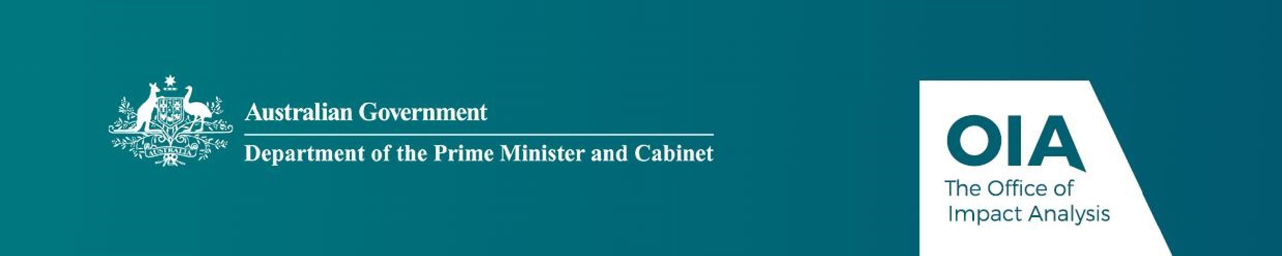The IA may now be provided to the decision-maker to inform their decision.

# Next steps

After the final decision is announced, the OIA will publish the IA in a form meeting the

Government’s web accessibility requirements, along with your certification, at oia.pmc.gov.au. The IA must be included in any Explanatory Memorandum or Statement giving effect to the proposals.

If you have any further queries, please do not hesitate to contact me.

Yours sincerely

Joanna Abhayaratna

Executive Director

Office of Impact Analysis

22 February 2025