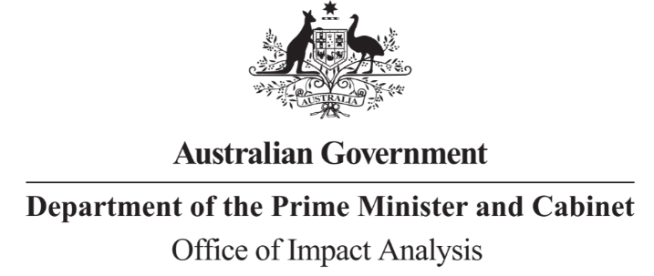

Reference: OBPR21-01126  
Telephone: 6271 6270  
e-mail: [helpdesk-oia@pmc.gov.au](mailto:helpdesk-obpr@pmc.gov.au)

Mr Toby Robinson

Acting Assistant Secretary  
Market Conduct Division   
Department of the Treasury   
  
Dear Mr Robinson  
                                              
**Decision RIS – Supporting business through improvements to mandatory standards regulation under the Australian Consumer Law**

Thank you for forwarding the amended draft of the above Decision Regulation Impact Statement (RIS) for assessment by the Office of Impact Analysis (OIA).

OIA’s assessment is that the quality of the impact analysis in the RIS is compliant with the guidelines as set out in the [*Regulatory Impact Analysis Guide for Ministers’ Meetings and National Standard Setting Bodies (May 2021)*](https://oia.pmc.gov.au/resources/guidance-impact-analysis/regulatory-impact-analysis-guide-ministers-meetings-and-national) (the Guide).

The RIS contains an adequate level of analysis, commensurate with the significance of the impacts for a Decision RIS.

Please note that, as per the Guide, OIA will publish your Decision RIS at oia.pmc.gov.au upon announcement of a decision.

If you have any queries please feel free to contact OIA.

Yours sincerely  
  
  
  
Jason Lange  
Executive Director  
Office of Impact Analysis  
21 November 2022