Summary

The Australian Defence Force (Defence) undertakes aviation and naval activities outside Australian territory within Australian administered airspace. To ensure there is an acceptable level of safety during these activities CASA declares restricted areas that are controlled by Defence. The publication of restricted areas precludes Australian and foreign civil registered aircraft from entering these areas unless they have a clearance to enter from Defence. CASA can lawfully preclude Australian registered aircraft from entering airspace outside Australian territory but cannot prevent foreign registered aircraft from entering restricted airspace outside Australian territory. In November 2019, the International Civil Aviation Organization (ICAO) issued a notice of deficiency for non-compliance due to the publication of restricted areas outside Australian territory within Australian-administered airspace.
In accordance with international law and ICAO standards and practices related to administration of airspace outside a State’s territory, danger areas can be published as a means of alerting airspace users to a potential hazard to safe flight. Danger areas do not preclude aircraft from entering the area within which operations may be hazardous to safe flight. The Airspace Act 2007 enables publication of danger areas outside Australian territory within Australian-administered airspace, but the power to declare danger areas in such airspace is not currently provided for in the Airspace Regulations 2007 (the Regulations). This unnecessarily limits options to address airspace risk.
In 2021 CASA implemented a temporary arrangement to mitigate risk to airspace users during military activity pending regulatory change. The arrangement was supported by a legislative instrument that:
- Removes the restrictions on the passage of aircraft other than Australian registered aircraft through airspace published as permanent restricted areas/temporary restricted areas within Australian- administered airspace but outside of Australian territory, whilst actively discouraging foreign registered aircraft from flying in those areas.
- Continues to restrict Australian registered aircraft entering airspace published as a restricted area or temporary restricted area within Australian-administered airspace but outside of Australian territory.
This instrument expires in November 2022 and this RIS presents options for a permanent solution.

The removal of military restricted areas outside of Australian territory would significantly inhibit or preclude the Defence from conducting military training or exercises that are critical to ensuring capability is maintained. Defence would be unable to safely undertake activities in these areas.

To enhance the safety of airspace users during military training or exercise activity, CASA proposes an amendment to the Regulations that will enable the Office of Airspace Regulation (OAR) of CASA to publish danger areas outside Australian territory within Australian-administered airspace. CASA also proposes the introduction of a new type of danger area known as Military Operating Areas (MOAs), to better define the nature of the risk to other airspace users. This would improve situational awareness and better inform decision making by non-participating aircraft in the vicinity of military airspace activity and not contravene ICAO standards and international law.

In addition to the regulation change, implementation of the preferred option requires the Aeronautical Information Publication (AIP) to be amended prior to a commencement date of 1 December 2022. CASA and Airservices Australia (Airservices) would provide information to all civil aviation operators to ensure that they are informed of the changes and the conditions that apply.

Glossary of technical terms
There are several terms with definitions that will be used throughout this RIS:
Restricted area – An airspace of defined dimensions, above the land areas or territorial waters of a State, within which the flight of aircraft is restricted in accordance with certain specified conditions.
Danger area – An airspace of defined dimensions within which activities dangerous to the flight of aircraft may exist at specified times.
Australian territory – refers to:
(a) the territory of Australia and of every external Territory; and
(b) the territorial sea of Australia and of every external Territory; and
(c) the air space over any such territory or sea.
Australian-administered airspace – refers to
(a) the airspace over Australian territory; and
(b) airspace that has been allocated to Australia by ICAO under the Chicago Convention and for which Australia has accepted responsibility; and
(c) airspace administered by Australia at the request of another country.

Problem
Airspace outside Australian territory in Australian-administered airspace is required for Defence training and exercise activity. Naval training and joint flying training exercises are conducted in the maritime environment. The offshore training activity is designed to minimise impact and risk generated closer to the Australian mainland by civil aviation activity and it also provides greater freedom of movement and flexibility for modern military aviation training. Defence aviation activities are not compatible with civil aviation and whilst there are smaller overland military restricted areas these are not adequate for large scale or high energy military training requirements, or exercises that involve naval assets.
In November 2019, ICAO issued a notice of deficiency against Australia for declaring restricted areas outside Australian territory. Australia currently has approximately 100 declarations of restricted areas in Australian-administered airspace outside Australian territory. The restriction of international aviation activity outside Australian territory is not presently supported by the Regulations.
Non-compliance with ICAO standards generates confusion and risk for international civil aviation while also having consequential economic impact if foreign registered aircraft are unlawfully required to avoid military restricted areas. There is a corresponding safety risk if airlines do not adhere to the existing danger area requirements, if those requirements are not lawfully imposed. Whilst filing a difference against one ICAO standard is unlikely to result in negative consequences, the cumulative effect of non-conformance with ICAO standards could result in other countries imposing restrictions on Australia aviation. There is not a precise number of differences Australia could file before such restrictions would be imposed, it is in Australia’s interest to comply with ICAO standards unless there is a compelling reason to file a difference.
ICAO will undertake an audit of Australia in 2023. Australia is preparing to defend the outcomes of a validation audit in 2017 and is striving to maximise its level of compliance consistent with Australia’s safety policy objectives. Recent audits of other countries have resulted in lower than expected results due to changes in the ICAO audit methodology.
There are benefits from Australia achieving a high degree of compliance with international standards, including an enhanced reputation internationally and an increased ability to advance Australia’s aviation interests within the ICAO framework. These benefits extend to increased influence in ICAO’s setting of new aviation safety standards.
It is not possible to quantify the impacts of the problem. Although two other countries in the Asia-Pacific were made aware of similar issues of non-compliance at the same time as Australia, there is no other known example of prolonged non-compliance from the relevant requirement. However, the potential for adverse consequences to arise from non-compliance with treaty requirements is consistent with analogous diplomatic engagements, both within the ICAO framework and generally.
The declaration of danger areas in Australian-administered airspace outside of Australian territory is not permitted by the Regulations. This limits the options available to CASA to address airspace risk in Australian-administered airspace and there are currently 16 danger areas declared outside Australian territory.
Objective
The objectives of any options considered are to:
- maintain the safe operation of Defence and civil aviation activities
- maintain the same capacity of civil operations to use Australian airspace
- comply with ICAO standards and international law, and
- limit negative financial consequences for industry.

Only the Australian Government can achieve these aims and meet ICAO standards due to its responsibility for management of Australian airspace; without Australian Government regulations Australia will not be compliant with ICAO standards.
There are constraints on the extent to which Government action can change the architecture of Australian airspace to meet these objectives. These constraints relate to:
- geographic characteristics affecting aviation operations over land,
- the locations of established civil aviation activities,
- Defence capability to maintain Australia’s national security,
- aircraft requirements (eg. Supersonic flight can only be conducted overwater. The new Joint Strike Fighter requires significant manoeuvring room etc), and
- the locations of existing Defence sites.
There are certain geographic features, such as mountainous and heavily forested areas, that present a higher risk to Defence aviation activities. Most areas of land also do not adequately represent the maritime aviation environment, thus rendering practice exercises less effective. Importantly, Defence activities undertaken in conjunction with Defence watercraft cannot be conducted over land.
In addition, aviation activities have generally established around populous areas (such as capital city aerodromes) and these act as an effective constraint on the government to make airspace changes. It is inappropriate to redesign Australian airspace to permit Defence operations that are currently conducted over sea to be conducted over populous areas.
The existing location of Defence sites act as an effective constraint for government decisions about military airspace. It is impractical to redesign Australian airspace to require Defence operations to be undertaken a significant distance from current Defence locations that act as a base for aviation assets.
Options
Option one: status quo
The status quo option would leave the Airspace Regulations unchanged and allow the current temporary instrument to expire in November 2022. CASA would continue to maintain the practice of declaring military restricted areas outside Australian territory in Australian-administered airspace. This option would not address the notice of non-compliance issued against Australia by ICAO. It would also maintain the current regulations that do not permit the declaration of danger areas outside Australian territory in Australian-administered airspace.
Option two: Removal of military restricted and danger areas
Option 2 proposes achievement of ICAO compliance by removing all permanent restricted and danger areas outside Australian territory and prohibiting the declaration of any new restricted or danger areas outside Australian territory in Australian-administered airspace.
Option three: Regulatory amendments to permit the declaration of danger areas
Option three proposes achievement of ICAO compliance through regulatory amendments that permit the declaration of danger areas outside Australian territory. This option requires an additional regulatory mechanism to regularise existing practice and:
- enhances safety for all airspace users in the vicinity of military airspace activity
- removes the risk of commercial impact on international aviation activity, and
- enables Defence to continue airspace activity outside Australian territory.
This would be achieved by:
- Introducing Military Operating Areas (MOAs) as a subset of danger areas under regulation 6.
- Amending regulation 7 to allow danger areas (including MOAs) to be subject to further conditions as detailed in the Designation of Prohibited, Restricted and Danger Areas Declaration and Determination Instrument.
- Allowing the lawful declaration of any type of danger areas within Australian-administered airspace under regulation 6 and variations to air traffic services in danger areas outside Australian territory in regulation 9.
- Amending regulation 6 to replace the term security with national security as that is the term used in the Airspace Act 2007.
- Amending regulation 13 to make it clearer that powers under regulations 5, 8 and 14 can be delegated. This is not related to the main issues.

Impact
Option one
The option of maintaining the practice of declaring military restricted areas outside Australian territory. There are undesirable outcomes associated with this option:
- Australia would continue being in contravention of international law by restricting passage of international aircraft outside Australian territory. As such, it may generate claims for compensation by international operators. Such unlawful publications may also raise the question of liability and compensation in the event of a collision.
- The issue of non-compliance with ICAO will not be resolved.
- Australia may suffer reputational damage and set a precedent for other countries to also declare restricted airspace unlawfully outside their territories.
There is also a degree of uncertainty as to the extent of these impacts as there is no readily available research applicable to this current issue.
Option two
This option would not require amendments to the Regulations, but it would also limit safety mitigation in support of military aviation activities outside Australian territory and would significantly limit Australian Defence Force training capability and the subsequent impact on national security.
The removal of permanent restricted areas outside Australian territory would significantly reduce the capability of Defence to undertake aviation and naval activities.
Defence may seek the declaration of permanent restricted areas within Australian territory and compete with other airspace users for priority airspace while also reducing the opportunity for equitable airspace use and greater flexibility with flight paths. Defence may also need to relocate their flying units to minimise transit times to larger volumes of training areas. Movement of Defence assets away from current bases near Australia’s major population centres could degrade Defence’s capability to defend those centres.
The diagram below highlights the airspace outside Australian territory currently used by Defence that would no longer be available. The diagram shows the location of the permanent restricted and danger areas (in red) controlled airspace (in blue) and the boundary of Australian territory (in white).

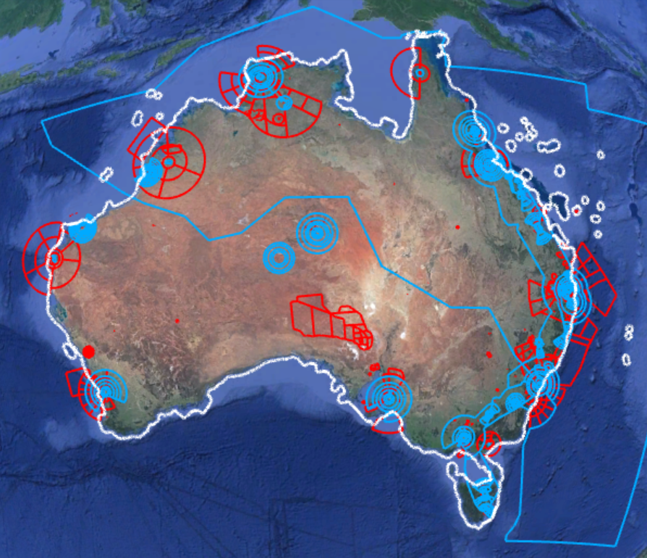
Defence may seek to relocate most of the red areas outside the white line to be within the white line. The relocation of these areas will impact civil air routes (see air route structure below), airport operations and flight path flexibility. The reduced flight path flexibility may result in passenger flights over Australia having an increased duration, which incurs costs for passengers in terms of their time and increased operational costs for the aircraft operating business. Also, if airspace users need to access Defence’s restricted areas for commercial purposes, it will be harder to obtain clearance to enter due to higher intensity of usage.
This option may force the relocation or closure of pilot training schools that are located in areas where Defence seeks to relocate their activities.
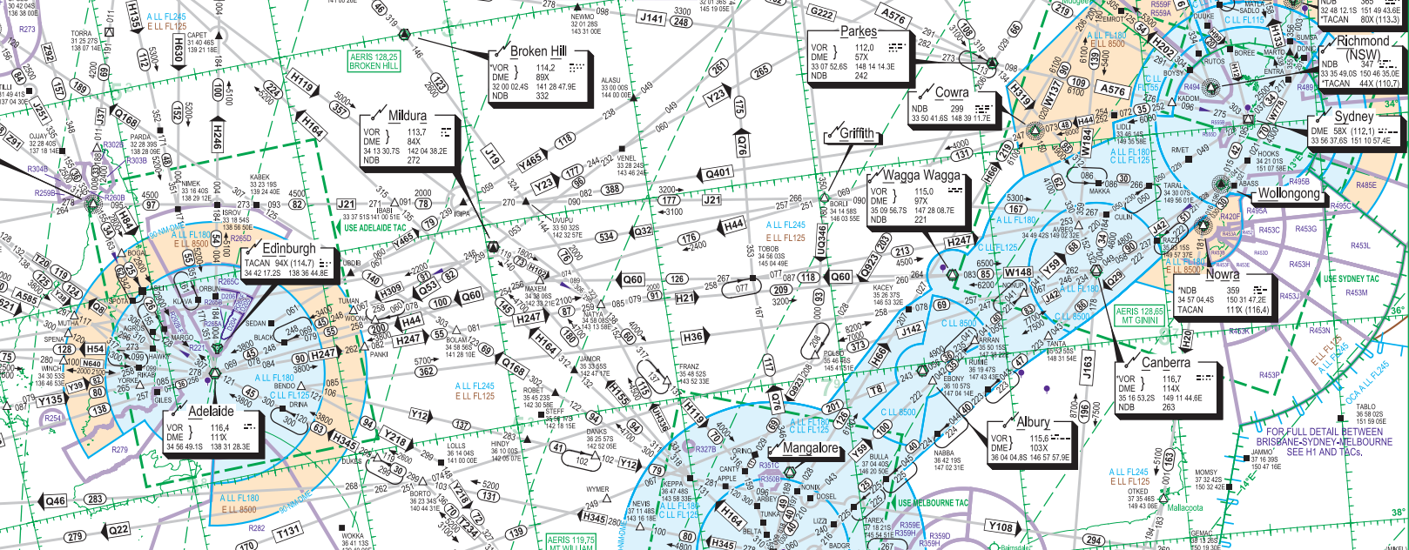
The lack of suitable available airspace over Australian territory near Australia’s east coast population centres makes this option undesirable as Defence would be unable to secure enough airspace over Australian territory to conduct their required training and exercises. Furthermore, naval operations involving aviation components conducted by Defence would create increased risk to airspace users if they were moved closer to shore.
It is also not practical for some operations that are conducted over sea to be conducted over land, or close to land, as they involve the interaction of aircraft and naval vessels.
Whilst there was no available research to specifically support the impact of this option, the impacts outlined are consistent with informal stakeholder feedback as outlined in the Consultation section.
Option three
This option expands the use of danger areas outside Australian territory, introduces MOAs as a subset of danger areas and removes the need for restricted areas outside Australian territory. MOAs will be subject to further conditions which will preclude Australian registered aircraft from entering these areas. The use of danger area declarations in Australian-administered airspace outside Australian territory is consistent with ICAO standards and international law.
Historically, Danger Areas in Australia tend to be associated with low-hazard activities, they are activated regularly, including over regional aerodromes, and flight within them by non-participating aircraft is common. However, the nature of military activities is often beyond the hazard level normally associated with these standard Danger Areas and may include live firing, remotely piloted aircraft systems, open-category activities, super-sonic flight, high-speed and abrupt manoeuvring, and nil-broadcast operations. Therefore, it is critical to aviation safety that Australia clearly distinguishes the volumes of airspace used for high-hazard military activities from Danger Areas. Without this distinction, (foreign) aircraft will not be sufficiently warned of the potential danger of operating within or transiting such areas.
This option allows Defence to continue using Australian-administered airspace outside Australian territory to conduct military exercises and training. This will facilitate large scale training activity between Australia and other countries
This option will create a minor compliance cost for industry, in the form of updating operator expositions and other documentation to reflect the introduction of MOAs into the airspace system. Airspace users are required to update this documentation in accordance with Aeronautical Information Regulation and Control (AIRAC) cycles and this is a business-as-usual activity. However, this will not affect all airspace users as most conduct domestic operations only:
- Private operators – The vast majority conduct operations within Australian territory, negligible impact.
- Charter operators – Mostly only conduct operations within Australian territory, negligible impact.
- Sport and Recreational – Only conduct operations within Australian territory, negligible impact.
- Air Transport – Regularly conduct operations outside Australian territory, most of the impact is within this group as outlined below.

These impacts are based on CASA research, including stakeholder feedback to inform the potential magnitude of the impact. Indicatively, the Qantas Group advised that to update documentation across six of their airlines would require 140 hours of work and cost approximately $10,000 AUD. Using these figures, the cost per airline to update documentation can be estimated as 23.3 hours at a wage rate of $71.50 AUD. Whilst the actual number may vary over time, CASA estimates that in addition to the Qantas group there are 14 other airlines that may be affected. The total costs to industry are estimated as below:
23.3 (hours taken to update expositions) x 71.50 AUD (wage rate including overheads) x 20 (entities affected – 6 Qantas Group entities plus 14) equals around $33,000 AUD.
Option three ensures CASA has the capability to treat airspace risk in Australian-administered airspace and legalises current danger area declarations. This will:
- Ensure an acceptable level of safety for all airspace users in volumes of airspace used by Defence.
- Protect operations to and from offshore oil rigs.
- Treat airspace risk associated with debris from space operations over the Indian and Pacific oceans and commercial space launching originating from Australia.
- Any other circumstances such as volcanic ash or other disasters which could require treatment.
Recommended option
Option one is not recommended since it does not achieve the objective of bringing Australia into compliance with the relevant ICAO obligation nor does it comply with International law.
Option two addresses the problem of Australia’s current non-conformance to ICAO standards and international law by mostly stopping current military activities outside of Australian territory. Whilst this effectively addresses that problem relative to the status quo option, option two does not achieve the objectives as effectively as option three because it will either lead to a reduction in military training exercises or the imposition of restrictions and/or costs on civil operations by the reduction of their available airspace.
Option three is recommended because:
- Relative to the status quo option, it resolves the problem of non-compliance with international law and removes the ICAO deficiency through use of a type of danger area which will not restrict foreign registered aircraft from entry.
- It meets the objectives by allowing Defence to safely continue conducting aviation and naval activities outside Australian territory in Australian administered airspace and facilitates large scale joint International and coalition exercises. The use of the term MOA will advise other airspace users of the type of hazards present.
- It meets the objectives in terms of maintaining civil operations by minimising financial impacts to industry and to Defence. Defence will not have to significantly adjust their operations and airspace over Australian territory will not come under increased pressure for military usage at the expense of civil access.
- CASA will be able to use danger areas in Australian-administered airspace outside Australian territory to alert airspace users to a potential hazard to safe flight in accordance with ICAO standards and international law.
Regulatory change also gives CASA the opportunity to improve the Regulations and better align them with the Airspace Act 2007.
Consultation
After the notice of deficiency against Australia was issued by ICAO, CASA conducted preliminary consultation with Defence and researched how the issue has been approached by other countries to determine how to resolve the issue. This preliminary consultation and research led to the formation of a policy proposal which was further consulted with various bodies, as below. No negative feedback has been received in relation to the policy proposal.
The Aviation Implementation Group (AIG) and Aviation Policy Group (APG) (CEO Airservices, Chief of Air Force, Secretary of the Department of Infrastructure, Transport, Regional Development and Communications and CEO CASA) have been briefed on the proposed changes, with no negative feedback received.
Informal consultation was conducted with the operators that represent the overwhelming majority of international flights in Australian airspace: Qantas, Virgin and The Board of Airline Representatives of Australia to understand potential cost implications. Only Qantas engaged with this request with potential costs noted above.
Formal consultation occurred in November 2021 with the proposed changes published on the CASA consultation hub for stakeholder comment and feedback. No comment or feedback was received.
CASA has formed a working group involving Airservices, Defence and personnel from other areas in CASA to examine the issues associated with amending the restricted areas outside Australian territory. These discussions have not resulted in changes to the policy proposal.
ICAO was informed of the proposed solution in November 2021 and supported the proposal.
Any changes to airspace in Australia must be fully consulted with airspace users and their feedback incorporated before such changes can be approved by CASA. If the regulation changes are approved, CASA will follow the Airspace Change Process for any changes to airspace outside Australian Territory.

Implementation
There are several processes to be undertaken to implement the recommended option and the OAR working group is continuing to work toward implementation.
Changes to Australian airspace architecture are made through the airspace change process. Permanent airspace changes require consultation and analysis in support of any decision-making process by the CASA. This work will be conducted in sufficient time to meet Aeronautical Information Publication (AIP) deadlines. The production of AIPs such as aeronautical charts or the Designated Airspace Handbook have significant lead times. For a permanent airspace change to be promulgated in these documents the legislative framework must be in place.
The pilot education plan will be developed and commence delivery in late 2022, continuing until June 2023. Defence have developed a staged approach to review the airspace and submit airspace change proposals over the next two years. Metrics associated with uptake of the information will be monitored to ensure an acceptable awareness of the changes and new operating conditions have been created. Ongoing guidance will be provided via CASA and OAR communication channels.
The Airspace Act 2007 identifies that CASA must conduct regular reviews of Australian-administered airspace and changes made as result of the regulatory change will be reviewed in accordance with established procedures. CASA also maintains an ongoing watch of incidents and risks in airspace and any issues arising from the changes will be scrutinised.
The main risks to this implementation plan are that there could be delays to either the required regulatory changes or changes to airspace. CASA can manage such issues if they arise.
Implementation metrics
Along with the metrics associated with the uptake of information by pilots, an important metric for the successful implementation of the changes will be ICAO’s assessment as to whether Australia conforms to international standards. The other metric CASA can collect is feedback from the international airlines and other airspace users as to whether the use of the new danger areas compromises the efficiency of their operations. The impacts are expected to be minor.

Conclusion
In November 2019, ICAO issued a notice of deficiency for non-compliance against Australia due to declarations of restricted areas in Australian-administered airspace outside Australian territory. These areas are currently used by Defence for military operations.
To address the non-compliance with ICAO standards CASA is proposing the declaration of danger areas in Australian-administered airspace with a specific descriptor for the nature of operations in these areas. This would enable Defence to continue to conduct training in a safe manner.

CASA 26/21 – Direction – Australian Aircraft and Foreign Registered Aircraft in Australian-administered Airspace Instrument 2021

