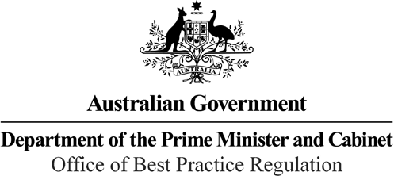

Reference: 20489 and 42904

Telephone: 6271 6270

e-mail: [helpdesk-obpr@pmc.gov.au](mailto:helpdesk-obpr@pmc.gov.au)

Mr Sean Sullivan Deputy Secretary

Department of Industry, Science, Energy and Resources Dear Mr Sullivan

Regulation Impact Statement – Second Pass Final Assessment – Securing

Australia’s Domestic Fuel Stocks and Refining Capacity

Thank you for your letter received on 21 May 2021 submitting a Regulation Impact Statement (RIS) on Securing Australia’s Domestic Fuel Stocks and Refining Capacity for formal Second Pass Final Assessment. I note you have formally certified the RIS consistent with the *Australian Government Guide to Regulatory Impact Analysis*.

I appreciate the Department’s constructive engagement on the RIS.

The Office of Best Practice Regulation’s (OBPR’s) assessment is that the RIS contains an adequate level of analysis to support a decision by Government.

While the RIS sets out the basis for the proposal and alternative approaches to addressing the problem, shortcomings exist in the analysis of the costs and benefits of the preferred option. For the RIS to be considered ‘good practice’ against the Government’s Regulatory Impact Analysis (RIA) requirements, the analysis could have been further improved by including estimates of the pass-through costs to consumers, either in a cents per litre or aggregated form. Justification for not including this analysis is unclear, and we anticipate there would be reasonable expectations from stakeholders for such analysis to be included.

I note the RIS foreshadows further work on quantifying costs will be prepared as an addendum to the RIS as Ministerial Rules are developed.

The addendum for each rule should comprehensively set out the financial costs and benefits to industry and consumers, and be tested through consultation with the public and affected stakeholders (for example transport and logistics companies and commercial aviation fuel consumers). For increased fuel costs, this addendum should present costs in aggregated form and in cents per litre for each category of regulated fuel.

The increased consumer costs should be directly set against government expenditure and monetised benefits to refiners, fuel companies, businesses and the general public.

The collection and presentation of this information may be challenging and I encourage the Department to enegage early with OBPR to ensure the RIA requirements are fully met.

1 National Circuit, Barton ACT 2600 • Telephone 02 6271 6270 • Internet [www.pmc.gov.au/regulation](http://www.pmc.gov.au/regulation)

The RIS may now be provided to the decision-maker to inform their decision.

We would appreciate you advising us when a final decision has been announced and forwarding versions of the RIS in a form meeting the Government’s accessibility requirements. The OBPR will publish the RIS, along with your certification and this assessment, on the OBPR’s website https://ris.pmc.gov.au/.

If you have any further queries, please do not hesitate to contact me. Yours sincerely

Jason Lange Executive Director 21 May 2021