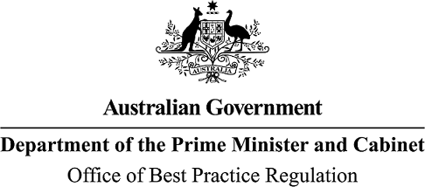

Reference: OBPR22-02706 Telephone: 6271 6270

e-mail: [helpdesk-obpr@pmc.gov.au](mailto:helpdesk-obpr@pmc.gov.au)

Ms Jane Urquhart Deputy Secretary

Resources and Enabling Services

Department of Industry, Science and Resources Dear Ms Urquhart

# Regulation Impact Statement – Second Pass Final Assessment – Strengthening the Australian Domestic Gas Security Mechanism (ADGSM)

Thank you for your letter submitting a Regulation Impact Statement (RIS) for formal Second Pass Final Assessment. I note the RIS has been formally certified by yourself, at the Deputy Secretary level, consistent with the *Australian Government Guide to Regulatory Impact Analysis*.

The Office of Best Practice Regulation’s (OBPR’s) assessment is that the quality of the regulatory impact analysis in the RIS is adequate.

To be considered ‘good practice’ as per the *Australian Government Guide to Regulatory Impact Analysis*, the RIS would have benefitted from:

* A description of the likely impacts on a wider range of stakeholders, including householders.
* A discussion on how the method of economic analysis differs from cost-benefit analysis, as the Australian Government’s preferred method for assessing regulatory proposals.
* The inclusion of a regulatory burden estimate consistent with OBPR’s Regulatory Burden Measurement Framework.

As there is significant uncertainty associated with this matter, and because the impacts are potentially widespread, OBPR advises that a Post Implementation Review is required within five years of the final decision. OBPR suggests it would be appropriate to conduct this review after the first activation of the mechanism or concurrently with the scheduled review of the ADGSM.

The RIS may now be provided to the decision-maker to inform a final decision.

# Next steps

After a final decision has been announced, I ask that your agency work with OBPR to finalise this material for public release. This includes providing a copy of the RIS in Word and PDF format for web accessibility purposes. The RIS must be included in any Explanatory Memorandum or Statement giving effect to the proposals in the RIS.

If you have any further queries, please do not hesitate to contact me. Yours sincerely

Jason Lange Executive Director 21 September 2022

1 National Circuit, Barton ACT 2600 • Telephone 02 6271 6270 • Internet obpr.pmc.gov.au