Future use of the upper 6 GHz band

Options paper

JUNE 2024

Canberra

Level 3  
40 Cameron Avenue   
Belconnen ACT

PO Box 78  
Belconnen ACT 2616

T +61 2 6219 5555  
F +61 2 6219 5353

Melbourne

Level 32   
Melbourne Central Tower  
360 Elizabeth Street   
Melbourne VIC

PO Box 13112  
Law Courts   
Melbourne VIC 8010

T +61 3 9963 6800  
F +61 3 9963 6899

Sydney

Level 5   
The Bay Centre  
65 Pirrama Road   
Pyrmont NSW

PO Box Q500  
Queen Victoria Building   
NSW 1230

T +61 2 9334 7700  
F +61 2 9334 7799

Copyright notice

[Creative Commons logo](http://i.creativecommons.org/l/by/3.0/88x31.png)

<https://creativecommons.org/licenses/by/4.0/>

Except for the Commonwealth Coat of Arms, logos, emblems, images, other third-party material or devices protected by a trademark, this content is made available under the terms of the Creative Commons Attribution 4.0 International (CC BY 4.0) licence.

All other rights are reserved.

The Australian Communications and Media Authority has undertaken reasonable enquiries to identify material owned by third parties and secure permission for its reproduction. Permission may need to be obtained from third parties to re-use their material.

We request attribution as © Commonwealth of Australia (Australian Communications and Media Authority) 2024.

Executive summary 1

Issues for comment 4

Introduction 5

Purpose of this paper 5

Legislative and policy environment 6

Desirable planning outcomes 6

Developing spectrum planning options 7

Next steps 8

The case for action 9

Technological developments and international harmonisation 9

Existing services in the upper 6 GHz band 11

Coexistence between prospective and existing services 12

Planning options for the upper 6 GHz band 15

Overview of planning options 15

Discussion of hybrid options 16

Models for enabling higher-power RLAN use 30

Invitation to comment 32

Making a submission 32

Appendix A: Automated Frequency Coordination 33

Considerations for implementing AFC 33

Executive summary

The ACMA began work on the 6 GHz band in 2021 by exploring whether to support Radio Local Area Network (RLAN) use in the band. The outcome of this work was to vary the Radiocommunications (Low Interference Potential Devices) Class Licence 2015 (the LIPD Class Licence) to enable RLANs in the lower 6 GHz band (5925–6425 MHz).

Those [consultation processes](https://www.acma.gov.au/consultations/2021-10/radio-local-area-networks-rlans-6-ghz-band-consultation-372021) also raised discussion on potential new uses for the upper 6 GHz band (6425–7125 MHz). Whether the band should support RLANs or wide-area wireless broadband (WA WBB) services was posed as part of the April 2021 consultation, and many responses included views on the future use of the upper band. Industry views were sharply divided.

This paper identifies domestic and international considerations for the future use of the upper 6 GHz band and presents options for potential planning arrangements to enable RLAN and/or WA WBB use in the band. It also explores the potential use of dynamic spectrum allocations systems, such as Automated Frequency Coordination (AFC), to lessen power restrictions on RLAN use in existing (and potentially future) RLAN frequency bands.

While we do not expect to reach any planning decisions on introducing arrangements for higher-power RLANs by the conclusion of upper 6 GHz band considerations, we are taking this opportunity to seek further comment on its introduction, ahead of a possible further, separate consultation process.

In conducting our planning activities, we are informed by the object of the [*Radiocommunications Act 1992*](https://www.legislation.gov.au/Details/C2021C00462). Consistent with that object, and following previous consultations, we’ve identified the following desirable planning outcomes:

… to optimise the use of the upper 6 GHz band, through introducing arrangements for RLAN and/or WA WBB services, while maintaining arrangements for – and coexistence with – existing services to the extent possible.

In considering the different pathways to meeting these outcomes, including balancing existing services with optimising the overall public benefit of uses of the band, we have identified 4 broad replanning options for the upper 6 GHz band:

* **Option 1:** Maintain existing arrangements, with potential reconsideration at a later date.
* **Option 2:** Introduce arrangements to enable RLAN access to some or all of the upper 6 GHz band, via a variation to the LIPD Class Licence. There would be no arrangements introduced for WA WBB.
* **Option 3:** Introduce arrangements to enable WA WBB access to some or all of the upper 6 GHz band, under apparatus and/or spectrum licensing. There would be no arrangements introduced for RLANs.

**Option 4:** Introduce arrangements to enable both RLAN and WA WBB access to different frequency segments within the upper 6 GHz band, using the respective authorisation arrangements in options 2 and 3.

Different options will have different implications for coexistence with other services and potential licensing models and, by extension, implementation timeframes. For example, Option 2 could be implemented using a routine update to the LIPD class licence, allowing a near-term rollout of RLAN devices.

Conversely, options that may require displacement or modification of existing services, particularly those that involve a partial or full allocation of the band to WA WBB services, are likely to take considerably longer to implement than those that do not. Determining licence types, areas and tenures (including potential alignment of expiry dates with other licences) for WA WBB, which would need further consultation if we decide to enable those services (including forming a technical liaison group to establish conditions to assure coexistence with other services), can be a protracted process in itself. Moreover, the potential clearance and/or restack of an incumbent service generally triggers a minimum 2-year process or longer, depending on the complexity.[1]

Option 4 can be considered a ‘hybrid’ option. Frequency segmentation is just one means of enabling shared access to the band. Area-based segmentation, including geographic segmentation of licence areas, or even limitations to indoor (RLAN) and outdoor (WA WBB) use, were also considered, along with non-traditional sharing models such as dynamically allocated and/or coordinated access systems.

However, apart from the frequency segmentation model proposed under Option 4, other hybrid models were discarded for enabling shared access to the band, not just because of potential implementation complexity and challenges, but also because of how the resultant ‘products’ may be affected. For example, while frequency segmentation would have a linear effect on the product offered, more spectrum available to one service would come at the expense of the same amount of spectrum not being offered to the other service. Conversely, there is a risk that geographic segmentation or non-traditional models could have a non-linear impact on those products, to the extent that the relative value of the spectrum offering to a prospective licensee might be eroded much more than the amount of spectrum, area or time compromised under that sharing model. It is also difficult to accurately estimate this impact pre-implementation.

Our view is that introducing arrangements that carry a high level of uncertainty can materially affect spectrum value, especially for allocations intended to support wide-area deployments. Hybrid model-enabled sharing scenarios are examined later in this paper.

Separately, frequency segmentation could also be used to prohibit or constrain use of WA WBB and/or RLAN use in the 7100–7125 MHz range, which is currently used for television outside broadcast (TOB) purposes.

Feedback on the issues presented in this paper will help inform which option best meets the above desirable planning outcomes, and ultimately the higher-level objective of promoting the long‑term public interest derived from the use of the upper 6 GHz band. We will assess feedback against those desirable outcomes with a view to determine the optimally efficient use of the band and what measures will ultimately best place us to assist in meeting emerging consumer and industry needs.

The upper 6 GHz band is highly contested, and views on the future use of the band are polarised and diverse. Consequently, we welcome industry views on the services proposed to be delivered, how they will likely benefit end users and whether there is any evidence of demand for those services.

# Issues for comment

Along with general comments and suggestions on the future use of the upper 6 GHz band, we invite comments on the following specific issues set out in this paper:

What are your views on the 4 broad planning options identified for the upper 6 GHz band?

If we decide to divide the band into different RLAN and WA WBB segments, should the WA WBB segment:

1. be a multiple of 100 MHz? This would align with the largest 3GPP channel size (noting that the ability for WA WBB operators to deploy one or more 100 MHz channels will depend on the outcome of the assignment process)
2. align with the 160/320 MHz wi-fi channel raster? This would maximise the number of the larger wi-fi channels available (by avoiding options that would split these channels).

Of the segmentation options based on wi-fi channels (options 1–3 in this paper), what is the preferred option and why?

Is it appropriate to limit our consideration of hybrid options for accommodating multiple services to frequency segmentation only? For example, should geographic segmentation or less traditional sharing models be considered when determining models for enabling access to the upper 6 GHz band by both WA WBB and RLAN services?

#### Suggestions for submissions

To inform our consideration of the future use of the band relative to the object of the Radiocommunications Act, and the outcomes listed in the *Desirable planning outcomes* section, submissions to this paper should also include:

detailed information on the services that are proposed to be delivered using the upper 6 GHz band

how the proposed services will likely benefit end users

evidence of demand for those services.

Submitters should also refer to information about submissions under the *Desirable planning outcomes* section on page 6.

# Introduction

As detailed in our [draft *Five-year spectrum outlook 2024–29*](https://www.acma.gov.au/consultations/2024-03/draft-five-year-spectrum-outlook-2024-29), there have been significant international developments in the 6 GHz band (5925–7125 MHz), with many jurisdictions introducing or considering the introduction of radio local area networks (RLANs) and/or wide-area (WA) wireless broadband (WBB) services in parts or all of the band.

In April 2021, we consulted on the use of the 6 GHz band for RLAN use in Australia. That consultation led to the ACMA proposing a [variation](https://www.acma.gov.au/consultations/2021-10/radio-local-area-networks-rlans-6-ghz-band-consultation-372021) to the Radiocommunications (Low Interference Potential Devices) Class Licence 2015 (LIPD Class Licence) to support the use of RLAN devices in the lower 6 GHz band. After consultation in October 2021, the LIPD class licence was updated to implement the change.

In the lower 6 GHz band, low power is defined as 250 mW maximum EIRP, with a limitation of 12.5 mW per MHz. Very low power has been defined as a 25 mW maximum EIRP with a limitation of 1.25 mW per MHz. These definitions would also apply to the upper 6 GHz band. Standard power devices, defined as a 1W maximum EIRP, are not currently permitted in the 6 GHz band in Australia.

The April consultation also considered whether the upper 6 GHz band (6425–7125 MHz) should be planned for RLANs or support WA WBB services, such as those deployed under the International Mobile Telecommunications (IMT) regulatory model, in a manner suitable for wide-area networks operated by mobile network operators.

Industry responses were sharply divided and, given the lack of maturity of both international harmonisation and standardisation arrangements for the 2 main prospective services, changes to the upper band were not proposed during the October 2021 LIPD class licence consultation. The question of ‘RLAN vs WA WBB’ in the upper 6 GHz band was therefore not pursued, however many submitters reiterated their views on this issue in their responses to that process.

The ACMA held a [spectrum tune-up](https://www.acma.gov.au/spectrum-tune-6-ghz-band" \l ":~:text=Our%206%20GHz%20band%20tune,and%2For%20wireless%20broadband%20use.) on 29 February 2024 to progress potential planning options for the upper 6 GHz band, including potential hybrid options for shared RLAN and WA WBB use. The tune-up featured industry presentations and also explored the suitability of Automated Frequency Coordination (AFC) for enabling the expanded use of RLANs in existing RLAN spectrum, noting that such arrangements could also translate across to the upper 6 GHz band if ultimately made available for RLANs.

## Purpose of this paper

This paper identifies domestic and internationally informed considerations for the future use of the upper 6 GHz band and presents options for domestic planning arrangements to enable RLAN and/or WA WBB use in the band. This paper also continues to examine further enhancements to existing RLAN arrangements, such as potentially permitting the operation of standard-power (1 watt EIRP) devices, subject to an appropriate interference management regime being in place.

This paper is informed by responses to previous consultations on use of the broader 6 GHz band and by discussions held at an ACMA spectrum tune-up in February 2024.

## Legislative and policy environment

Maximising the economic and social benefits of communications infrastructure, content and services for Australia is the ACMA’s [key purpose](https://www.acma.gov.au/publications/2022-08/plan/corporate-plan-2022-23).

### Guiding legislation and policy

The ACMA’s decisions are guided by the object of the Radiocommunications Act, which is to:

… promote the long‑term public interest derived from the use of the spectrum by providing for the management of the spectrum in a manner that will:

(a)  facilitate the efficient planning, allocation, and use of the spectrum; and

(b)  facilitate the use of the spectrum for:

(i)  commercial purposes; and

(ii) defence purposes, national security purposes and other non‑commercial purposes (including public safety and community purposes); and

(c)  support the communications policy objectives of the Commonwealth Government.

## Desirable planning outcomes

In our planning activities, we are informed by the object of the [*Radiocommunications Act 1992*](https://www.legislation.gov.au/Details/C2021C00462). Consistent with that object and previous consultation on the matter, this paper proposes the following desirable planning outcomes:

1. Optimise the efficiency and utility of the upper 6 GHz band by introducing arrangements for RLAN and/or WA WBB services.
2. Maintain regulatory arrangements to the extent possible for existing services within the upper 6 GHz band when optimising its utility.
3. Ensure coexistence with other services in the upper 6 GHz band.
4. Maintain coexistence with adjacent band services.

These desirable planning outcomes, taken in the context of domestic and overseas developments, have informed the planning options identified in this paper. Respondents are encouraged to articulate how their preferred planning options could facilitate these outcomes.

The upper 6 GHz band is highly contested and, as demonstrated through our [spectrum tune-up](https://www.acma.gov.au/spectrum-tune-6-ghz-band#:~:text=Our%206%20GHz%20band%20tune,and%2For%20wireless%20broadband%20use.), views on the future use of the band are polarised and diverse. To inform our consideration of future use of the band relative to the object of the Radiocommunications Act, and the outcomes listed above, submissions to this options paper should include:

detailed information on the services that are proposed to be delivered

how proposed services will likely benefit end users

any evidence of demand for those services.

The utility of both the band and spectrum in general is a key input to whether change of use is warranted, and if so, what new use should be (and how should it be) introduced into the band.

An understanding of the underlying consumer and industry drivers for making the upper 6 GHz band available for RLAN and/or WA WBB services will help inform decision making. This includes consideration of whether existing spectrum holdings are sufficient to meet emerging consumer and industry needs, and if not, why and how the upper 6 GHz band should be repurposed to help meet those needs.

Useful input might go beyond the types of applications that could be introduced or enhanced, and could extend to an indicative ‘roadmap’ setting out the type of infrastructure/service deployment envisaged and broad outcomes for consumers.

## Developing spectrum planning options

We promote the object of the Radiocommunications Act and relevant government policy through a balanced application of market and regulatory mechanisms.

Figure 1 describes the approach the ACMA uses to develop and assess preliminary replanning options. We will continue to apply this general approach as we consider the responses to this paper and decide on the outcomes for the upper 6 GHz band.

1. Spectrum planning options framework

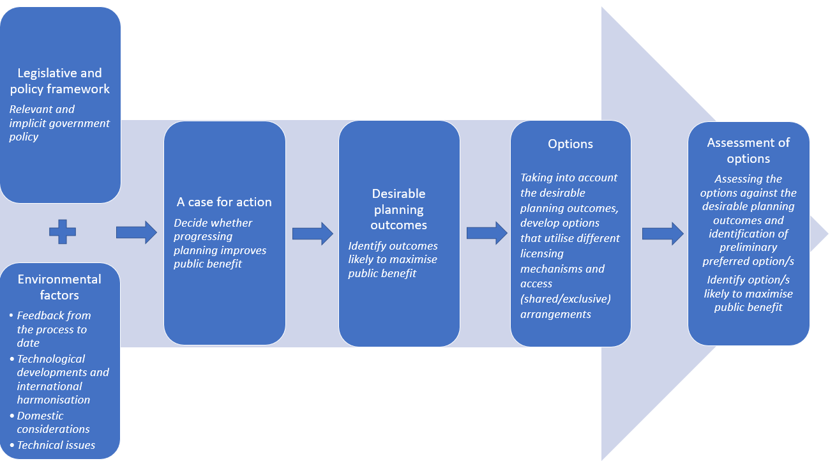

### Licensing arrangements

There are 3 licensing approaches available to us to authorise access to spectrum – via spectrum, apparatus and class licences. These approaches influence how changes to spectrum use can be developed and implemented.

A spectrum licence authorises the operation of devices within a defined frequency range and geographic area, with a high degree of exclusivity. The geographic area can vary in size and comprise the entire country. Spectrum licences are usually allocated by an auction and have historically been utilised for most bands used to deploy commercial mobile broadband networks. Spectrum licences may be allocated for up to 20 years and are generally more suited to wide-area – including up to Australia-wide – service deployments.

An inherent feature of spectrum licensing is technological flexibility – that is, the licence conditions and associated technical framework, while usually optimised for an expected technology, specify generic technical conditions[2] and do not usually expressly mandate or limit specific technologies or services. This allows a licensee to deploy any technology that complies with the conditions of the licence. It is the licensee’s responsibility to manage interference between their devices (the alignment with international standards within the technical framework mitigates the potential for interference between devices). Spectrum licences are more conducive to secondary trading than apparatus licences, due to design features such as their generally longer tenure and their ability to be sub-divided.

An apparatus licence authorises the use of a radiocommunications device (or group of devices) operating under a specific radiocommunications service type, in a specific frequency range, and traditionally at one or more specific geographic locations for up to 20 years (although most apparatus licences are renewed annually). They are typically issued ‘over the counter’ in accordance with coordination rules developed by the ACMA. We [charge fees and taxes](https://www.acma.gov.au/fees-apparatus-licences) for apparatus licences, which cover our costs and incentivise people to use spectrum efficiently.

We recently [introduced](https://www.legislation.gov.au/Details/F2020C01124) a new apparatus licence type called an area-wide licence (AWL). An AWL transmitter licence authorises the operation of one or more radiocommunications devices within a defined geographic area within frequencies specified on the licence, subject to the conditions included in the licence. Unlike spectrum licensing, AWLs are designed to be scalable, enabling its use in different-sized geographic areas and bandwidths. Unlike other apparatus licence types – which typically align with specific uses and purposes – the AWL is capable of authorising a variety of services, uses, applications and technologies.

Class licences are a standing authorisation to access spectrum without the need to apply to the ACMA for an individual licence (no fees or taxes are paid), subject to the conditions of the relevant class licence. These conditions can be technical, geographic and/or pertain to the type of use or class of user.

Depending on which of the planning options in this paper is ultimately chosen, implementation may involve some combination of any or all of the above-mentioned licensing models.

## Next steps

A decision on whether any of the upper 6 GHz band will be progressed to the implementation stage is expected in the third quarter of 2024, with the release of an outcomes paper. This timeframe will depend on several factors, including feedback to this consultation, complexity of coexistence studies, international progress on equipment standards and potentially broader discussions within government. We will develop a more detailed timeline following consultation.

# The case for action

## Technological developments and international harmonisation

The ongoing evolution in wireless communication technologies continues to improve the net benefit derived from the radiofrequency spectrum by allowing for more efficient use of existing technologies and/or enabling new services to be delivered. By using the spectrum more efficiently, there is potential for more value to be derived from its use.

### Evolving technology

International spectrum harmonisation, undertaken at the highest level by the ITU-R but also influenced by decisions by national regulators, reflects the extent to which spectrum is used for common purposes globally or regionally. Collectively, harmonisation, equipment standardisation and international regulatory developments are important indicators of global trends, informing factors such as economies of scale and global roaming.

While there has been significant international work undertaken towards the harmonising the use of the 6 GHz band, there is not yet a single, globally harmonised arrangement for the band.

### WA WBB

There is increasing demand for additional WA WBB spectrum (known as ‘IMT’ internationally), particularly in ‘mid bands’ that are highly conducive to deployments of 5G and 6G technologies. Proponents of WA WBB advise that access to the upper 6 GHz band will be required to meet increasing consumer demand for WA WBB services, suggesting that the upper 6 GHz band is the most suitable mid-band spectrum available to meet their future needs.

An outcome of WRC-23 (the ITU’s World Radiocommunication Conference 2023) was the identification of the upper 6 GHz band for IMT in ITU-R Region 1 and the sub-band 7025–7125 MHz for IMT in Region 3.[3] In terms of equipment standards, 3GPP (a collection of standard development organisations) has standardised the upper 6 GHz band for 5G technologies and assigned the band number n105 (‘n’ being shorthand for ‘new radio’, 3GPP parlance for 5G technologies).

### RLANs (including wi-fi)

There is also increasing demand for spectrum for wi-fi. Enabling access to the upper 6 GHz band – to go with the already provisioned lower 6 GHz band – would facilitate deployment of the latest technology standards in the 6 GHz band, including the suite of Wi-Fi 6e RLAN technologies that can provide speeds of greater than 1 Gbps.

Some administrations have already implemented arrangements for RLANs in the upper 6 GHz band:

* In the US, unlicensed use of the entire 6 GHz band (5925–7125 MHz) is permitted.[4] The whole band is available for low power indoor use, and most of the band also can be used by devices at higher-power levels – both indoor and outdoor – by using an Automated Frequency Coordination (AFC) system. The US regulator, the FCC states that:

The combination of lower power and indoor operations would protect all 6 GHz band licensed services (which include point-to-point microwave links as well as broadcast auxiliary and cable television relay licenses) from harmful interference.[5]

The FCC apportions its unlicensed use of the upper 6 GHz band as:

6425–6525 MHz for low-power and very-low power indoor use only

6525–6875 MHz for standard power access subject to use of an AFC system

6875–7125 MHz for low-power and very-low power indoor use only

Canada has adopted a similar arrangement to the US, but with different segmentation of the band for standard, low and very low power RLANs.

# Existing services in the upper 6 GHz band

The upper 6 GHz band is allocated to services as shown in Table 1. This is an extract from the *Australian Radiofrequency Spectrum Plan 2021*.

Australian allocations in the upper 6 GHz band

|  |
| --- |
| Australian table of allocations |
| |  | | --- | | 5.925 – 6.7 GHz  Fixed 457  Fixed-Satellite (Earth-to-space) 457A  Mobile | | AUS87 149 440 458 | |
| |  | | --- | | 6.7 – 7.075 GHz  Fixed  Fixed-Satellite (Earth-to-space) (space-to-Earth) 441  Mobile | | 458 458A 458B | |
| |  | | --- | | 7.075 – 7.145 GHz  Fixed  Mobile | | 458 | |

Total frequency assignments (as of 30 May 2024) in the band is shown in Table 2.

Frequency assignments by service – upper 6 GHz band

| Licence type | Number of assignments |
| --- | --- |
| Earth Receive | 9 |
| Fixed Earth | 31 |
| Point to Point | 12,118 |
| Radiodetermination | 7 |
| Scientific Assigned | 12 |
| **Total** | **12,178** |

## Coexistence between prospective and existing services

This section discusses the potential impact of the introduction of new RLAN or WA WBB services on existing services, which is a key factor in our consideration of the future use of the upper 6 GHz band.

### Fixed-Satellite Service (FSS) uplinks (Earth-to-space)

#### Potential interference from WA WBB

Coexistence between WA WBB (termed ‘IMT’ in international studies) and FSS satellite receivers was considered under Agenda Item 1.2 of WRC-23, which examined potential new IMT identifications in a number of frequency bands, including the upper 6 GHz band in some parts of the world. Twenty studies were carried out under that agenda item, which assessed the potential aggregate interference from IMT transmitters into satellite receivers operating in the geostationary orbit (GSO).

A summary of these studies is in the [Report of Conference Preparatory Meeting to WRC-23](https://www.itu.int/md/R19-CPM23.2-R-0001/en) (CPM 23-2 Report). The results of these studies were mixed, with some indicating that IMT services would cause interference to satellite services, while others indicated that FSS protection requirements would not be exceeded. The use of different study parameters (such as different numbers/densities of IMT deployments) was a key reason for these divergent results.

Taking these sharing studies into account, and further deliberations at the conference, WRC-23 agreed that implementation of an EIRP mask, as a function of elevation angle, on IMT base stations would be needed to ensure the protection of satellite receivers. This mask is detailed in *resolves 2* of Resolution 220 (WRC-23). The ACMA’s preliminary view is that, if WA WBB services are introduced into the upper 6 GHz band in Australia, base stations would be also required to implement the EIRP mask.

#### Potential interference from RLANs

Studies by administrations that have authorised very low power (VLP) and low power indoor (LPI) RLANs in the upper 6 GHz band have concluded that sharing is possible with FSS uplinks.[6] As part of our consideration to introduce higher-power (that is, ‘standard power’) RLAN devices – not currently permitted in the lower 6 GHz band in Australia – we will examine if additional interference mitigation is needed to manage aggregate interference into FSS uplinks (see the *Discussion of models for enabling higher-power RLAN use* chapter for further details).

### FSS downlinks (space-to-Earth)

#### Potential interference from WA WBB

Studies carried out under WRC-23 Agenda Item 1.2 indicate that geographic separation between IMT stations and FSS Earth stations would be required to protect earth station receivers. Proposed separation distances resulting from those studies ranged between a few kilometres to tens of kilometres. Those distances are site-specific and depend on several elements such as the propagation parameters, local terrain topography, surrounding clutter (including vegetation losses as appropriate, for example, during seasonal changes), station and orbital parameters of the non-GSO system, and satellite selection strategy. Geographic separation can be implemented domestically in technical frameworks, if necessary.

#### Potential interference from RLANs

Studies by administrations that have authorised RLANs in the upper 6 GHz band conclude that coexistence between RLAN systems and FSS Earth station receivers is feasible, if RLAN systems are deployed with adequate power limitations and/or deployment constraints, such as indoor use only (as is the case with existing VLP/LPI models).[7]

### Fixed (point-to-point) including Television Outside Broadcast (TOB)

#### Potential interference from WA WBB to Fixed (point-to-point)

Several sharing studies were performed under WRC-23 Agenda Item 1.2. Separation distances required to ensure coexistence ranged from 1.5 to 68 km (main lobe interference scenario) and 1 to 10 km (side lobe interference scenario). The studies showed that IMT and point-to-point links could coexist in the upper 6 GHz band, but site-by-site coordination would be required. The required separation distances indicated by sharing studies suggest that any IMT macro cell (higher-power and/or antenna height) deployments could be significantly constrained by existing point-to-point links. As such, given the number of existing point-to-point links in the band, the potential introduction of WA WBB is likely to require the clearance of co-channel point-to-point links in areas allocated for WA WBB.

#### Potential interference from RLANs to Fixed (point-to-point)

Studies by administrations that have authorised RLANs in the upper 6 GHz band conclude that coexistence between RLAN systems and fixed point-to-point stations is feasible if RLAN systems are deployed with adequate power limitations and/or deployment constraints, such as indoor use only (such as the VLP/LPI model adopted in Australia). These studies formed the basis for introducing RLAN arrangements in the lower 6 GHz band, which currently coexist with fixed point-to-point services. International arrangements also enable the operation of RLAN access points at standard power levels in coexistence with point-to-point services by implementing additional interference management mechanisms, such as AFC systems (see the *Discussion of models for enabling higher-power RLAN use* chapter for more detail).

#### Potential interference to TOB operations in the 7100–7125 MHz

TOB services operate on an itinerant basis in the frequency range 7100–7425 MHz, with the lower 25 MHz portion (7100–7125 MHz) overlapping the upper 6 GHz band.[8]

The ability of RLAN and WA WBB to coexistence with TOB services in 7100–7125 MHz is expected to be similar to the coexistence scenarios for fixed (point-to-point) services described above. That is, VLP/LPI RLANs would likely be able to coexist with co-frequency TOB services in the 7100–7125 MHz range, but the introduction of WA WBB in 7100–7125 MHz would likely require TOB services to cease using this frequency range in areas allocated for WA WBB. One alternative could be that a potential WA WBB allocation is limited to below 7100 MHz, which would allow TOB services to continue to operate in the 7100–7125 MHz range.

### Radiodetermination

The potential for interference into existing sited radiodetermination systems from WA WBB could be managed through geographic exclusion codified in technical frameworks. As there isn’t an allocation to the radiodetermination service in the ARSP in the upper 6 GHz band, we may consider the future assignment of those services in the band (for example, limiting future radiodetermination assignments to a ‘no interference/no protection’ basis).

### General observations on coexistence with other services

It is reasonable to assume that if their use is supported in the upper 6 GHz band, the number of RLAN devices in operation will increase over time, so the aggregate power contributed by these devices will also increase. There have been concerns from industry groups and other regulators that this might lead to unacceptable interference to other services in the longer term, although international and domestic experience does not support this hypothesis under current VLP/LPI-based RLAN deployment models. In any case, future projections of device proliferation should be accounted for when assessing coexistence scenarios involving any prospective new service.

As detailed above, some incumbent services may need to stop operating in the band, or geographic restrictions may need to be implemented to manage coexistence with existing users. The level of impact that these measures will have on both existing and new services will depend in part on the number of existing users. Therefore, to help minimise the effect that the possible re-planning of the band will have on existing use, and to help preserve future planning options, we have placed an embargo on issuing new apparatus licences in the upper 6 GHz band.[9] Exemptions to the embargo can still be considered on a case-by-case basis.

# Planning options for the upper 6 GHz band

## Overview of planning options

Introducing new services into a band often requires balancing the provision of multiple and flexible spectrum uses with the complexity of technical and licensing frameworks that are needed to support such increased utility. As a starting point, our preferred option would ultimately maximise flexibility of use and hence utility, at the expense of increased complexity in the relevant technical and licensing arrangements. However, there are limits to how much complexity can be accepted. As such, went deciding which planning option to adopt, we will consider it the balance is appropriate to ensure the planning option is fit for purpose and represents the optimal use of the spectrum.

Apart from the default ‘no change’ option, there are clearly 2 ‘bookend’ options for the future use of the upper 6 GHz band – making all of the band available for additional RLAN services or for new WA WBB services. As detailed in the previous chapter, both options have different coexistence implications with existing services, and in the case of WA WBB services, clearance or relocation of some services would be necessary to accommodate them, which would in-turn affect implementation timeframes.

For example, a planning decision to make the band available for RLAN services would simply require a routine update to the LIPD class licence without displacement of existing services (noting that standard power wi-fi enabled by AFC will be considered at a later date). However, WA WBB introduction would require clearance of co-frequency/area fixed links over time (usually not less than two years) and further consideration of licence type/areas and potential allocation processes.

During the spectrum tune-up, we also broached the idea of a ‘hybrid’ option that could accommodate both RLAN and WA WBB services, involving some form of frequency, geographic and/or technology-based sharing mechanism. While we considered all possible permutations of a hybrid model, for a number of reasons set out in the following sections, we have determined that the only readily implementable form of hybrid option is based on a frequency-segmentation model.

With that in mind, 4 broad planning options remain open to consideration, being the no change option (Option 1), the two bookend options (options 2 and 3), and a frequency-segmentation-based hybrid option (Option 4):

* **Option 1:** Maintain existing arrangements, with potential reconsideration at a later date.
* **Option 2:** Introduce arrangements to enable RLAN access to some or all of the upper 6 GHz band, via a variation to the LIPD Class Licence. There would be no introduction of arrangements introduced for WA WBB.
* **Option 3:** Introduce arrangements to enable WA WBB access to some or all of the upper 6 GHz band, using apparatus and/or spectrum licensing. There would be no arrangements introduced for RLANs.

**Option 4:** Introduce arrangements to enable both RLAN and WA WBB access to different frequency segments within the upper 6 GHz band, using the respective authorisation arrangements in options 2 and 3.

|  |
| --- |
| **Questions for comment**   1. What are your views on the 4 broad planning options identified for the upper 6 GHz band? |

## Discussion of hybrid options

This chapter explores the various potential options considered for shared access to the upper 6 GHz band by both RLAN and WA WBB applications. These options include:

traditional sharing options:

frequency segmentation

geographic segmentation

non-traditional sharing – combining mitigation measures to enable co-frequency/same-area sharing.

Some non-traditional sharing models have been explored in Europe, notably by Ofcom (the UK spectrum regulator) and the Electronic Communications Committee (ECC). The current progress on these sharing models is outlined later in this chapter.

While we have decided on frequency segmentation as the hybrid option for enabling both RLAN and WA WBB services, the following sections outline our reasoning why other options were discarded as formal planning options.

### Frequency segmentation

Under the frequency segmentation model, the band would be segmented into dedicated, mutually exclusive RLAN and WA WBB frequency allocations. This would provide some benefit to both service types, however, the relative utility of each would depend on bandwidth of the respective segments and the extent to which segmentation would provide sufficient benefit to either or both services to justify the segmentation. As such, we would need to decide on which apportionments of spectrum for each service would maximise the public benefit of the upper 6 GHz band through the determination of an appropriate frequency boundary between RLAN and WA WBB allocations.

#### Segmentation based on channelling arrangements

Broad options for frequency segmentation can be based on the relevant channel sizes and rasters of either application. This alignment would help increase the utility of the spectrum.

3GPP standards provide channel sizes in multiples of 5 and 10 MHz, however throughput can be maximised (on a per MHz basis) when the largest channel size is available (which is 100 MHz for bands below 7125 MHz).[10] Wi-fi standards prescribe more defined channels sizes and rasters, with the latest versions of wi-fi providing 20, 40, 80, 160 and 320 MHz channels (wider channels are limited to the 6 GHz band).

Figure 2 shows wi-fi channels overlayed with different WA WBB frequency segment options based on 100 MHz multiples. As evident in this figure, such a configuration does not align well with the wi-fi channel raster, and segmenting the band based on multiples of 100 MHz would ‘split’ some wi-fi channels, resulting in the entire channel being unavailable and compromising overall efficiency – this would be particularly apparent for the wider 160 and 320 MHz channels. For example, a 300 MHz WA WBB segment (6825–7125 MHz) would deny access to an entire 320 MHz wi-fi channel because of an 80 MHz overlap between 6825–6905 MHz. Table 3 shows the available wi-fi channels for each hypothetical WA WBB allocation.

Conversely, the frequency segmentation boundary could be determined based on the wi-fi channel raster. This is shown in Figure 3, where the WA WBB segment options are aligned with the 160 and 320 MHz wi-fi channels. This method would maximise the number of available (whole) wi-fi channels, however, the resultant WA WBB segment would no longer be a whole-multiple of 100 MHz (although each segment example could still be fully used with a range of smaller WA WBB channel sizes). Table 4 shows the number of available wi-fi channels for each WA WBB segment option.

Band segmentation options based on 100 MHz WA WBB segments

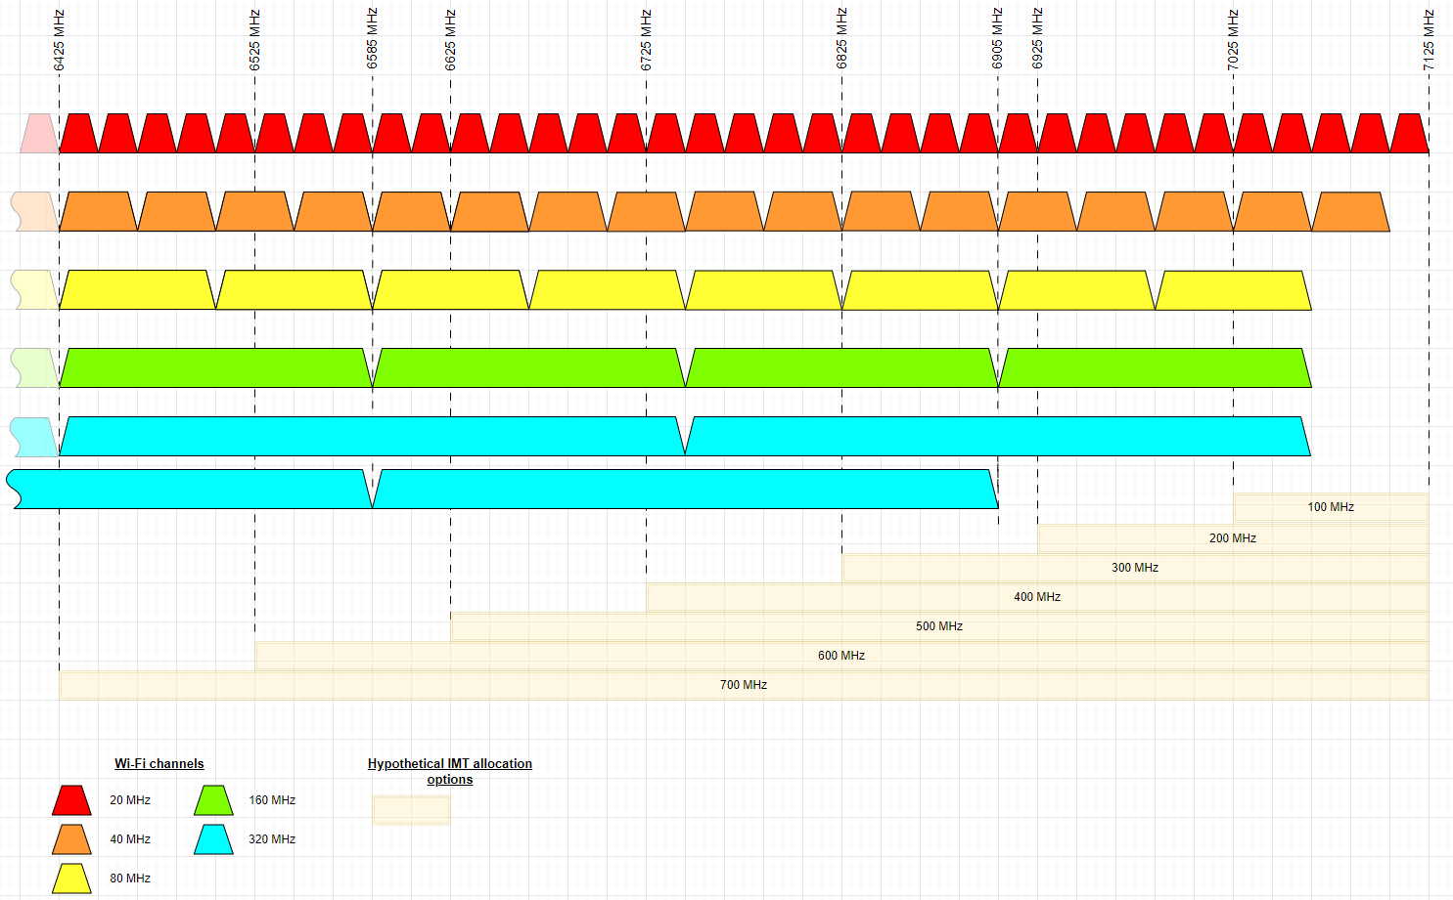

Number of available wi-fi channels for each WA WBB segment option (WA WBB segment in 100 MHz multiples)

|  |  |  |  |  |  |  |  |
| --- | --- | --- | --- | --- | --- | --- | --- |
| **WA WBB allocation** | **6425–7125 MHz**  **(700 MHz)** | **6525–7125 MHz**  **(600 MHz)** | **6625–7125 MHz**  **(500 MHz)** | **6725–7125 MHz**  **(400 MHz)** | **6825–7125 MHz**  **(300 MHz)** | **6925–7125 MHz**  **(200 MHz)** | **No WA WBB allocation** |
| **Wi-fi channel size** | **Additional wi-fi channels** | | | | | | |
| 20 MHz | 0 | 5 | 10 | 15 | 20 | 24 | 35 |
| 40 MHz | 0 | 2 | 5 | 7 | 10 | 12 | 17 |
| 80 MHz | 0 | 1 | 2 | 3 | 5 | 6 | 8 |
| 160 MHz | 0 | 0 | 1 | 1 | 2 | 3 | 4 |
| 320 MHz | 0 | 0 | 1 | 1 | 1  (+1 interleaved) | 2  (+1 interleaved) | 2  (+2 interleaved) |

Band segmentation options based on the wi-fi channel raster

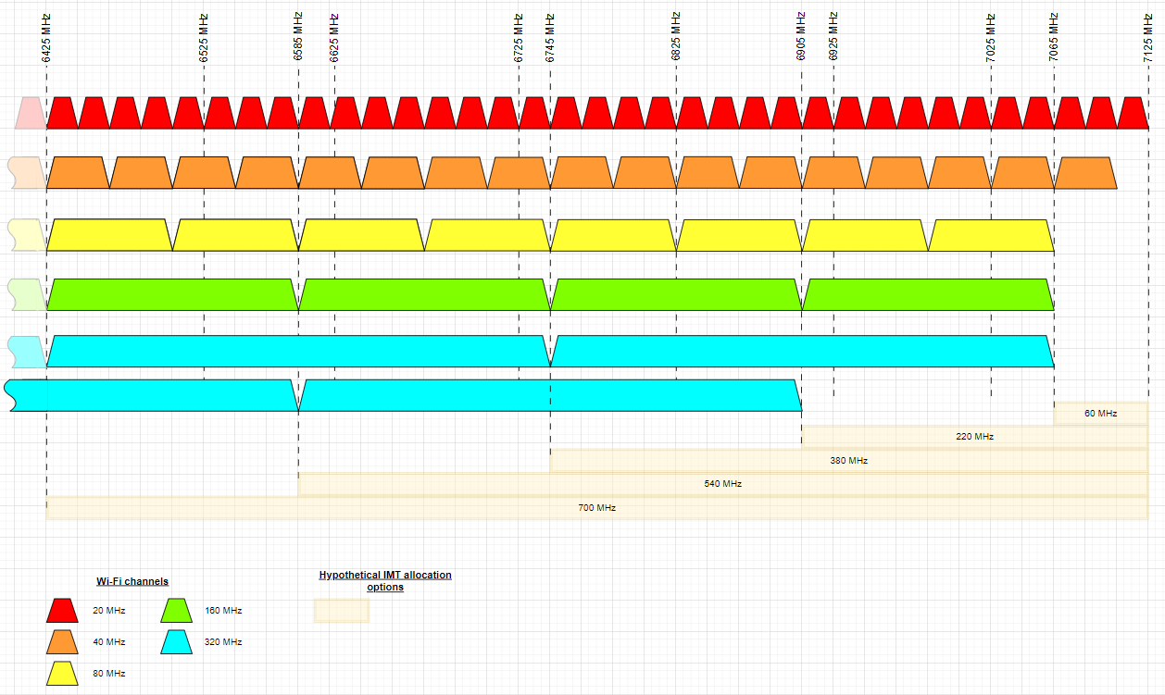

Number of available wi-fi channels for each WA WBB segment option (WA WBB segment options aligned with wi-fi 160/320 MHz channel raster)

|  |  |  |  |  |  |  |
| --- | --- | --- | --- | --- | --- | --- |
| **WA WBB allocation** | **6425–7125 MHz**  **(700 MHz)** | **6585–7125 MHz**  **(540 MHz)** | **6745–7125 MHz**  **(380 MHz)** | **6905–7125 MHz**  **(220 MHz)** | **7065–7125 MHz**  **(60 MHz)** | **No WA WBB allocation** |
| **Wi-fi channel size** | **Additional wi-fi channels** | | | | | |
| 20 MHz | 0 | 8 | 16 | 24 | 32 | 35 |
| 40 MHz | 0 | 4 | 8 | 12 | 16 | 17 |
| 80 MHz | 0 | 2 | 4 | 6 | 8 | 8 |
| 160 MHz | 0 | 1 | 2 | 3 | 4 | 4 |
| 320 MHz | 0 | 1 | 1  (+ 1 interleaved) | 2  (+ 1 interleaved) | 2  (+ 2 interleaved) | 2  (+ 2 interleaved) |

#### Preliminary view – frequency segmentation

If we decide to segment the band, our preliminary view is that the segmentation should be based on the 160/320 MHz wi-fi channel raster. This option would take into account the existing 500 MHz already provisioned in the LIPD class licence, and assume that the new additional RLAN spectrum would be at the lower end of the upper 6 GHz band to be contiguous with that existing provision.

Depending on the assignment process for WA WBB services, those licensees may not be awarded whole multiples of 100 MHz (even if the WA WBB segment is based on those multiples). Moreover, those technologies do not rely so heavily on discrete bandwidth allocations, so under a hybrid model, planning the WA WBB segment in 100 MHz integrals might provide limited overall benefit compared with setting the frequency boundary to align with the standard RLAN channel raster.

There are 4 frequency segmentation options shown in Table 4 (when the first and last columns are discounted as they don’t constitute hybrid/segmentation options and are already represented as non-hybrid planning options). For these 4 options, a 60 MHz allocation for WA WBB would not present a material benefit for that sector, particularly if allocated between numerous licensees.[11] As the existing 500 MHz already allows 3 x 160 MHz, or 1 x 320 MHz plus 1 x 160 MHz wi-fi channels, we see the viable frequency segmentation schemes as follows:

Scheme 1: RLAN gains an extra 160 MHz channel to enable 4 x 160 MHz or 2 x 320 MHz channels in total, requiring an additional 160 MHz (6425–6585 MHz). WA WBB could then be allocated up to 540 MHz (6585–7125* MHz).

Scheme 2: RLAN gains an extra 2 x 160 MHz channels to enable 5 x 160 MHz or 2 x 320 MHz in total plus an additional 160 MHz channel, requiring an additional 320 MHz (6425–6745 MHz). WA WBB could then be allocated up to 380 MHz (6745–7125* MHz).

Scheme 3: RLAN gains an extra 3 x 160 MHz channels to enable 6 x 160 MHz or 3 x 320 MHz, requiring an additional 480 MHz (6425–6905 MHz). WA WBB could then be allocated up to 220 MHz (6905–7125* MHz).

* Note that a variant of all of the above schemes is to limit WA WBB to an upper frequency of 7100 MHz to avoid the need to relocate incumbent TOB services from the 7100–7125 MHz range.

|  |
| --- |
| **Questions for comment**   1. If we decide to divide the band into different RLAN and WA WBB segments, should the WA WBB segment:    1. be planned based on multiples of 100 MHz? This would align with the largest WA WBB channel size (noting that the ability for WA WBB operators to deploy one or more 100 MHz channels will depend on the outcome of the assignment process).    2. align with the 160/320 MHz wi-fi channel raster? This would maximise the number of larger wi-fi channels available (by avoiding options that would split these channels).   Of the segmentation options based on wi-fi channels (schemes 1–3 above), which is the preferred option and why? |

### Geographic segmentation

Spectrum planning arrangements sometimes utilise geographic segmentation to facilitate co-channel access by different users/uses in different areas. An example of this might be allocating a band for spectrum licensing, optimised for wireless broadband use in high-population areas, while separately assigning apparatus licences in regional/remote areas. For the upper 6 GHz band, using the entire band to for *both* RLAN and WA WBB deployments, with geographic separation aligned with the specific use-cases of each service type, may have been an option. However, for reasons described below, it is not considered a viable planning option for the band.

#### Key considerations

For traditional deployments, the upper 6 GHz band can be categorised as a ‘capacity’ band – as opposed to a ‘coverage’ band – and would be likely predominately used in areas of higher population density. However, if the band was segmented across large areas (for example, following the broad descriptions of metro, regional and remote area geotypes used in spectrum planning), it is expected that the requirement for upper 6 GHz band spectrum for WA WBB and RLAN use would be similar for each area, that is, high need in metro areas, lower need in remote areas. As such, geographically segmenting the band across broad metro/regional/remote areas, for example, WA WBB in metro areas and RLAN in regional areas (or vice versa), is unlikely to meet the needs of both applications.

At a more granular level, it is expected that the WA WBB sector would use the upper 6 GHz band to provide smaller ‘capacity’ cells and not wide-area coverage. Likewise, RLAN access points would be limited to hotspot coverage, primarily owing to the power restrictions. It follows that these deployment models may provide scope for localised area segmentation-based sharing options. Figure 4 provides an example of localised areas where RLAN deployments could operate in localised areas that have no 6 GHz WA WBB coverage. The example assumes that 6 GHz WA WBB base stations have been co-sited with current 3.4/3.6 GHz band base stations (MNO registrations only, not NBN) and serving cell sizes of 300m (urban) and 600m (suburban).[12] As expected, there is a high concentration of WA WBB deployments in CBD and inner-city areas.

Indicative WA WBB coverage areas in metro Melbourne, based on current 3.4/3.6 GHz band MNO deployments

300m urban coverage

600m suburban coverage

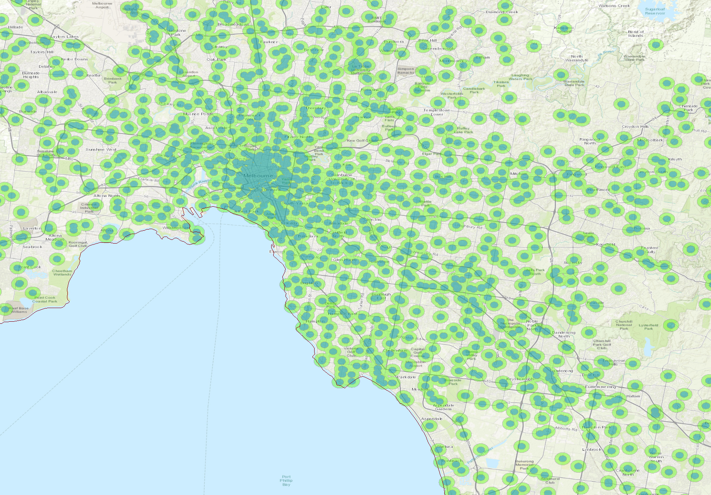

Another option for localised geographic segmentation could be to designate specific locations/venues as limited to one technology (for example, designating key sporting stadiums for RLAN use only). Areas outside these designated locations could then be available for WA WBB use.

Mechanisms to facilitate this localised-geographic segmentation may include:

user/licensee-based restrictions that set out the applicable areas (and necessary conditions to manage adjacent-area interference), potentially reflected as licence conditions, which the licensee must adhere to

device-based restrictions that require the device itself to automatically determine compliance, for example by interrogating a database to determine if it is in a location where operation is/is not permitted.

Under both of these mechanisms, it would be necessary to define the relevant areas and then determine which application should be afforded access in the area.

As a variation of this, the UK’s spectrum regulator Ofcom explored the use of the upper 6 GHz band for low-power indoor communications up to 250 mW EIRP (without specifying the technology used) concurrent with wide-area outdoor deployments, forming a preliminary view that ‘… without any changes to the technologies or without any enabling mechanisms, it is unlikely that mobile and wi-fi could effectively coexist and share spectrum resources’. Many respondents to that consultation concurred with this view and Ofcom undertook to complete that work.

#### Preliminary view – geographic segmentation

Our preliminary view is that geographic segmentation using large areas (for example, metro/regional/remote) is not a viable planning option, as the level of demand for both RLANs and WA WBB applications in each geotype is expected to be similar.

Given the relatively small WA WBB and RLAN coverage areas expected in the upper 6 GHz band, a more localised geographic segmentation could have some potential as an option, however, the possible benefits seem questionable. For example, it is difficult to see the benefits from allowing RLAN devices in some, but not all parts of, say, an urban area, especially if both the WA WBB coverage area and the necessarily conservative sharing algorithm didn’t leave much area available for RLANs.

In addition, while there are existing technology offerings that could be used to implement localised geographic segmentation, we are not aware any such arrangements being implemented in regulatory regimes elsewhere in the world at this point. It would be difficult to facilitate such a scheme without practical examples of the database/technology or licensing schemes that would be required.

When we considered both the wide-area and local-area-based geographic segmentation options in some detail, there was not sufficient merit in either scheme to warrant proposing geographic segmentation as a planning option for the band.

### Non-traditional sharing models

Non-traditional sharing generally refers to enabling shared access to a band using methods outside of established static spatial and frequency separation models. Some non-traditional sharing concepts that are currently being studied internationally take advantage of the ‘typical’ use-cases of RLAN and WA WBB in the upper 6 GHz band, combined with additional mitigation measures, to enable co-channel and same-area sharing. Under a non-traditional model, the dynamic application of mitigation measures, for example, those that consider specific deployment scenarios and/or signal propagation conditions, could be used to facilitate more efficient spectrum access through sharing.

The key assumption in these non-traditional models is the ‘typical’ deployment modes of both prospective applications. In this case, and consistent with the assumptions used in international studies, it is assumed that RLANs would primarily be deployed indoors for indoor access, and WA WBB base stations will be deployed outdoors, providing predominately outdoor coverage (noting this is a generalisation and other deployment configurations may eventuate in the absence of any regulatory restrictions).[13] Additional mitigation measures that may also be required are discussed in the following sections.

#### International studies

There is some ongoing work internationally, particularly in Europe, examining how a non-traditional sharing concept might work. The Electronic Communications Committee (ECC) started studying WA WBB/RLAN sharing options under work item PT1-50 in March 2023.[14] In general, these studies have indicated that sharing would not be feasible without additional mitigations, such as reduced WA WBB base station power, more advanced signal detection mechanisms and/or the use of database-assisted sharing. Submissions to the ECC meetings noted that more studies are needed, including consideration of additional scenarios (such as interference to/from/between WA WBB UEs and RLAN user terminals and direct communication between RLAN user stations). More consideration was also needed on the effect of non-traditional sharing arrangements on WA WBB and RLAN network capacity, and whether the overall benefit is greater than if the band was allocated to only a single service type.

ECC studies are ongoing, with the work item planned to finish by March 2025.

In June 2023, Ofcom, the UK spectrum regulator, released a [discussion paper](https://www.ofcom.org.uk/__data/assets/pdf_file/0031/263776/condoc-upper-6ghz-review-june23-v2.pdf) that considered appropriate sharing mechanisms, including technology-based coexistence solutions. One of the key observations in the paper was that international harmonisation is particularly important for a successful non-traditional sharing model, as additional equipment features and capabilities to enable sharing would need to be implemented via equipment standards.

Ofcom released its [response to submissions](https://www.ofcom.org.uk/__data/assets/pdf_file/0032/269564/Summary-of-responses.pdf) for the paper in October 2023. It found that much of the opposition to non-traditional sharing was based on the view that the need for upper 6 GHz band spectrum by one application was greater than the other, and, as such, that application should be provided exclusive (or near-exclusive) access. There was, however, significant support for sharing options being explored further. The feasibility of a non-traditional solution was also raised, and it was generally agreed that mechanisms should be developed via industry collaboration and that international harmonisation would be crucial for sharing to become a viable implementation option.

More recently, Ofcom released its [vision for the upper 6 GHz band](https://www.ofcom.org.uk/consultations-and-statements/category-1/hybrid-sharing-to-access-the-upper-6-ghz-band?utm_medium=email&utm_campaign=Vision%20for%20sharing%20upper%206%20GHz%20spectrum%20between%20Wi-Fi%20and%20mobile&utm_content=Vision%20for%20sharing%20upper%206%20GHz%20spectrum%20between%20Wi-Fi%20and%20mobile+CID_47440bc6a41aa061a9117841af63084f&utm_source=updates&utm_term=set%20out%20its%20vision), which explored options that would enable ‘hybrid sharing’ for RLAN and WA WBB, while noting that equipment standardisation and regulatory harmonisation would be key to its viability.

#### Discussion of potential non-traditional sharing mechanisms

This section provides commentary on some of the mechanisms identified in international forums that may be needed for the successful introduction of a non-traditional sharing model. These include:

indoor/outdoor separation

reduced WA WBB base station power

database-assisted coordination

spectrum sensing.

#### Indoor/outdoor separation

As noted above, while both applications are likely to be deployed in the same general geographic area (high-density, metro), there may be a natural indoor/outdoor split, with RLANs typically indoors and WA WBB base stations typically outdoors.

The indoor/outdoor separation is one of the key aspects of this sharing model as it will provide a level of isolation between the applications. The distribution of calculated building entry loss at 6425 MHz, based on Recommendation ITU-R P.2109-1, is shown in Figure 5. As an example, using the models in this recommendation for traditional and thermally efficient buildings, the average building entry loss is 16.5 dB and 32 dB, respectively.

Distribution of building entry loss at 6425 MHz – based on Recommendation ITU-R P.2109-1 (red line depicts 50%)

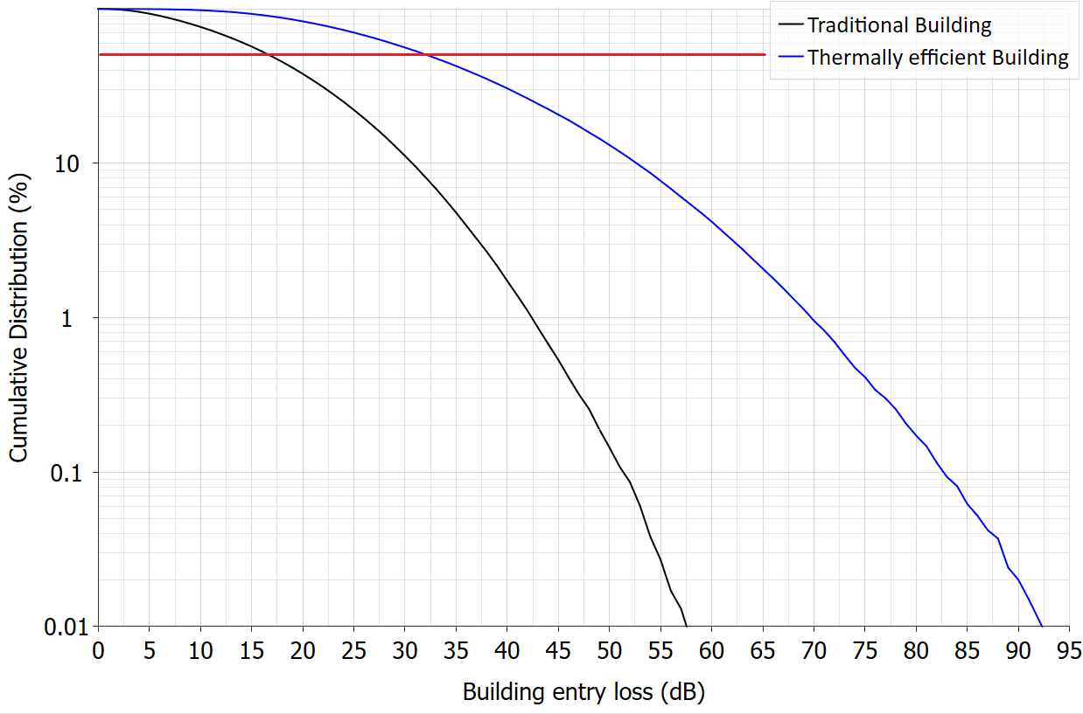

#### Reduced WA WBB base station power

As indicated above, some of the initial studies being undertaken by the ECC indicate that building entry loss alone will not be able provide sufficient isolation to manage interference. An additional measure being considered is restricting the EIRP of WA WBB base stations. Placing an upper limit on WA WBB EIRP is a potential regulatory measure that could reduce the likelihood of interference to RLAN stations. This measure has been considered in a number of European studies, with mixed results.

For example, [one study](https://cept.org/ecc/groups/ecc/ecc-pt1/client/meeting-documents/file-history/?fid=79567) considered a 10 dB power reduction for WA WBB base stations that reduced the level of interference to RLANs, however, this also resulted in a 66% decrease in WA WBB indoor cell radius. [Another study](https://cept.org/ecc/groups/ecc/ecc-pt1/client/meeting-documents/file-history/?fid=79462) found that a 15 dB WA WBB power reduction limited RLAN SNIR to 10 dB without a notable impact on the WA WBB downlink. While these preliminary results provide some insight into the benefits and cost of reduced WA WBB power, they remain at an early stage and only consider a limited number of deployment scenarios. Furthermore, they assume that WA WBB coverage would only be available to indoor users that don’t choose to deploy RLAN hotspots within their premises.

#### Databases

Databases, containing relevant data such as station location and protection requirements, could be used to provide a sharing arrangement, where a device would interrogate the database to determine if operation at a particular location would not impact existing stations.

Examples of databases include Automated Frequency Coordination (AFC), used to manage interference between RLAN devices and fixed links in the US (more detail is provided on this systems in the *Discussion of models for enabling higher-power RLAN use* chapter of this paper, and in Appendix A) and the Spectrum Access System (SAS), used in the US to enable sharing spectrum between mobile WBB services and incumbent services in the 3550–3700 MHz band (also known as the Citizens Broadband Radio Service (CBRS)). These database systems can operate under a tiered-model, where details of the primary-tiered users are included in the database, and the second-tier user cannot operate until granted permission by the database.

The rules used to implement database sharing are often based on a generic sharing model that does not take into account the specific, localised environment in which devices are operating (for example, signal propagation is based on a model that is likely to differ from actual propagation on specific paths). This can result in the implementation of overly conservative sharing parameters and inefficient use of spectrum. Database coordination also relies on the location of the proposed user, which may be difficult to accurately determine in some situations (for example, in indoor locations where satellite positioning is unavailable). In addition, existing database systems have been designed based on the technology and systems in the specific band/scenario and may not be suitable (without modification) to enable sharing between WA WBB and RLANs in the upper 6 GHz band.

There are also additional considerations such as costs associated with implementing and running the databases, as well as establishing/identifying a suitable entity to manage it.

#### Spectrum sensing

Spectrum sensing (also known as a ‘listen-before-talk’ concept) is where a device will automatically monitor a channel to determine if it is vacant before it starts transmitting. Examples of spectrum sensing include Automatic Channel Selection (ACS) and Dynamic Frequency Selection (DFS), which are already implemented to enable spectrum sharing between wi-fi devices and between other users.

A common issue observed in European studies is that the standard energy detection threshold, which is set at a relative high level to optimise sharing between RLANs, is not sensitive enough to detect the presence of a WA WBB service in some scenarios. This would result in the RLAN transmitting ‘over-the-top’ of an WA WBB signal and causing interference. [Studies](https://cept.org/Documents/ecc-pt1/79552/ecc-pt1-23-205_huawei-feasibility-of-shared-use-of-6425-7125-mhz-by-mfcn-and-rlan) found that lowering the sensitivity would reduce the risk of interference, however, this may have a flow-on effect on sharing between different RLAN devices (that is, more RLAN services may be detected, leading to additional channels being deemed ‘occupied’).

Noting the above, European studies are considering whether additional sensing features specifically designed for coexistence between RLAN and WA WBB could be implemented in RLAN or WA WBB devices. Options include WA WBB base stations transmitting a ‘channel avoid request’, which signals that the channel shouldn’t be used by nearby RLAN devices, and using smartphones to detect the nearby presence of a RLAN or WA WBB network.

#### Preliminary view – non-traditional sharing model

Our preliminary view is that there remains a number of issues that would need to be resolved before a non-traditional sharing model could become viable in Australia. While studies are still ongoing, the abovementioned sharing options would require further international harmonisation and equipment standardisation to ensure compatible ‘off-the-shelf’ equipment is available to the Australian market.

A key issue is the availability of RLAN devices with the necessary capabilities to enable sharing. Initial international studies indicate the use of device-based mitigations (namely spectrum sensing and/or databased-assisted access) are likely to be needed under a non-traditional sharing model. However, we understand that suitable capabilities are not currently available in standardised RLAN or WA WBB devices. As such, a sharing regime that requires the use of these capabilities cannot be introduced in Australia until, as a minimum, the device-based mitigations are internationally harmonised and suitable devices are (or will soon be) available on the international market. At this stage, based on the timeframe of ECC studies, this is not likely to occur before 2025 (if at all).

In addition to the harmonisation of device-based mitigations, there are other factors that still need further consideration, such as:

The appropriate quantum of WA WBB power reduction and energy detection levels, and the affect these reductions will have on coverage/capacity of WA WBB and RLAN systems.

Measures that could be implemented (technological and/or regulatory) to maintain an appropriate indoor/outdoor spilt.

Whether shared access for both WA WBB and RLAN, noting the degradations as a result of the additional mitigations, would provide a net-benefit gain compared to if the band was allocated for a single application (WA WBB or RLAN only). This is a difficult aspect to measure pre-implementation and, as such, there is a high risk that the net benefit is less than if the band was allocated via traditional methods.

It is expected that the above issues will continue to be studied internationally. We will continue to monitor the progress of these studies, and may consider the introduction of a non-traditional sharing model domestically once international harmonisation is achieved.

|  |
| --- |
| **Questions for comment**   1. Is it appropriate to limit our consideration of hybrid options for accommodating multiple services to frequency segmentation only? For example, should geographic segmentation or less traditional sharing models be considered when determining models for enabling access to the upper 6 GHz band by both WA WBB and RLAN services? |

# Models for enabling higher-power RLAN use

The potential to permit higher power/EIRP RLAN use than the current very low power (VLP, 14 dBm total power) and low power indoor (LPI, 24 dBm total power) provisions set out in the LIPD class licence for the 5 GHz and lower 6 GHz bands is an ongoing discussion. Feedback to previous consultations on the LIPD class licence has proposed increasing the power limit to ‘standard power’ (30 dBm) and/or allowing directional antennas to increase device EIRP.

Our assessment is that neither of these expanded provisions could be implemented through a simple addition to the LIPD without causing unacceptable interference to incumbent services in the absence of additional mitigations. At a high level, there are 2 primary mitigation models that could be applied to enable the deployment of higher-power devices: one is traditional over-the-counter, coordinated apparatus licensing and the other is a form of a delegated band-management regime, where a licensee coordinates access to the band by individual devices, either through manual device-by-device coordination or some form of automated dynamic spectrum access (DSA) system.

Both options would allow device-to-device coordination with incumbent terrestrial services (for example, fixed links) but importantly, would also enable records of registration numbers in case a limitation on the number of devices within a certain area is needed to protect co-frequency satellite uplinks from aggregate interference.

Implementation of the first option would require that the ACMA specify the coordination and licensing requirements, usually in a Radiocommunications Assignment and Licensing Instruction (RALI), and then device operators could apply for licences (either individually or through an accredited person), in accordance with the processes set out in that RALI.

The second option is potentially far more complex, but also far more efficient in terms of being able to purchase an off-the-shelf RLAN device and have the coordination and channel assignment undertaken by a third-party band manager, particularly if that band manager is using a DSA-type system. The form of DSA that is gaining popularity in some other jurisdictions for seamless coordination of RLAN devices is Automatic Frequency Control (AFC).

Appendix A contains specific details on the operation and implementation considerations of AFC, however, very broadly it allows higher-power operation of RLAN devices by seamlessly connecting the device to the AFC controller, which assigns a channel(s) to operate on, subject to coordination with other devices (both RLAN and other services) in the local area.

As described in Appendix A, many questions continue to surround how AFC could be implemented in Australia, including what the breakdown of roles between government and industry would be, how cost recovery might work, and the extent to which, and by what means, AFC system requirements might be mandated and enforced.

While this topic is worthy of further exploration, it is clear that a significant body of work would be needed to bring a regime like AFC into use in Australia. As it is not on the critical path for deciding on the future use of the upper 6 GHz band, we recognise that including it as part of the same process could unnecessarily delay decisions on the upper 6 GHz band. We may consult further on options for enabling higher-power RLAN use at a later date. While we’re not asking any specific questions on higher-power RLAN operation, AFC or any other related element, any comments received in response to this consultation may help inform that future process.

We also welcome industry proposals to trial an AFC system in existing RLAN bands at any time. Such a trial could assist the ACMA in exploring some of the regulatory/implementation considerations and enable industry to help shape a future consultation on the issue.

# Invitation to comment

## Making a submission

We invite comments on the issues set out in this paper.

[Online submissions](https://www.acma.gov.au/have-your-say) can be made by uploading a document. Submissions in PDF, Microsoft Word or Rich Text Format are preferred.

Submissions by post can be sent to:

The Manager

Spectrum Planning Section

Australian Communications and Media Authority

PO Box 78

Belconnen ACT 2616

The closing date for submissions is COB, **Tuesday** **2 July 2024**.

Consultation enquiries can be emailed to [freqplan@acma.gov.au](mailto:freqplan@acma.gov.au).

#### Publication of submissions

We publish submissions on our website, including personal information (such as names and contact details), except for information that you have claimed (and we have accepted) is confidential.

Confidential information will not be published or otherwise released unless required or authorised by law.

#### Privacy

View information about our policy on the [publication of submissions](https://www.acma.gov.au/publication-submissions), including collection of personal information during consultation and how we handle that information.

Information on the *Privacy Act 1988,* how to access or correct personal information, how to make a privacy complaint and how we will deal with any complaints, is available in our [privacy policy](https://www.acma.gov.au/privacy-policy).

# Appendix A: Automated Frequency Coordination

AFC is a form of Dynamic Spectrum Access (DSA) system that coordinates access to specific bands by specific technologies. It usually consists of a database that describes the usage at a detailed device level within the band and area that it services. Before transmitting, a connected device consults with the relevant AFC system.

When an AFC device wishes to operate (transmit), it first must communicate with the AFC system, which will analyse the request, complete coordination calculations, and provide a response to the device indicating if – and under what conditions – it may operate. For example, it may indicate what frequency ranges and/or power limits might need to apply.

The database would also contain details of all devices that are to be afforded protection by the system, including already-licensed devices and updates as new devices are authorised or licensed. This might include devices that are also being authorised by the AFC system, if they are to be afforded protection.

AFC systems for the 6 GHz band work by maintaining a database of device information that is required to coordinate the various radiocommunication systems – such as the location, power levels and antenna patterns for incumbent and/or dynamically-assigned (AFC-enabled) users.

AFC systems are currently in-use in the US, Canada and Saudi Arabia. South Korea, Chile, Guatemala, Honduras and, most recently, Brazil, are some of the countries who have allocated the full 6 GHz band to wi-fi. Wi-Fi.org have an up-to-date list of those [countries that are enabling wi-fi in 6 GHz](https://www.wi-fi.org/countries-enabling-wi-fi-in-6-ghz-wi-fi-6e) and the ranges they are utilising.

The US is utilising AFC in the 6525–6875 MHz portion of the 6 GHz band and recently approved a further 7 applications for wi-fi management systems operating in the 6 GHz band.[15] Canada is utilising AFC in the 5925–6875 MHz portion of the 6 GHz band.

## Considerations for implementing AFC

### Government versus industry roles

Existing AFC systems in other jurisdictions are operated by entities authorised by the regulator, while the regulator itself provides the required data and decides on the key system parameters to be implemented. This is one of a number of potential structural options for implementing an AFC system, depending on what level of regulatory intervention versus responsibility delegated to third parties is considered appropriate.

One approach is for a national regulator to take full responsibility for not only developing but also implementing and operating the system. They would set up, control, administer and operate a single system, without delegating band management to a third party. The major benefits of this model would be that the regulator has full control over how the system operates and can easily make any desired changes. Downsides include the additional workload on the regulator and, having only one system would result in a single point of failure that could prevent all devices requiring system authorisation being unable to operate. It is also a potential missed opportunity for industry to play a role in managing access to spectrum.

The other model, which is used in existing AFC systems in the US and Canada, is one where the regulator authorises one or more external AFC operators, as appropriate, and sets the specifications of the AFC’s operation, which might include coordination criteria and data on licensed devices to be protected. AFC operators would need to demonstrate that they have an AFC system in place that is fit for purpose and apply to the regulator. The regulator might also specify additional requirements such as coordination methods, specific interfaces to link devices and ensuring system’s security is sufficient.

The degree of government and industry involvement would also have implications for how AFC is funded, and the costs recouped. As a minimum, a certain amount of government/regulatory intervention would be necessary to facilitate industry operation, and by extension, business opportunities. This would trigger discussions around issues including government funding, agency budget provisions and/or cost recovery that are beyond the scope of this paper.

It is worth noting that AFC concepts have some overlap with ‘band manager’ ideas where the regulator could hand over responsibility to third party (industry-based) operators and let them decide how to manage access to the band. In a ‘traditional’ band manager approach, discretion on what services to authorise is deferred to the band manager. In the case of the AFC model, the regulator would hand over some responsibilities but include certain obligations for authorising access to subscribers of the service.

### Data integrity/accuracy and ownership

For spectrum coordination to be effective, data on the characteristics of both incumbent and incoming systems should be as accurate as possible to enable sufficient accurate coordination between systems. Existing data stored on the ACMA’s Register of Radiocommunications Licences (RRL) detailing device operating parameters is not always complete or accurate – especially for some older assignments. So, there may be times when the information required for automated coordination calculations is not available or inaccurate.

If access to a band was managed using an automated system for coordinating new devices, it would be in the interest of incumbent users to ensure that they have the most accurate data available on their system to coordinate against, to reduce the chance of harmful interference to or from dynamically authorised devices. It may be desirable to allow incumbent users to update their system data if there are any gaps or inaccuracies.

Conversely, legacy data that is overly conservative in nature (for example, data that contains generalised antenna patterns from ITU-R Recommendations instead of measured radiation patterns) might unnecessarily ‘over protect’ incumbent services and degrade the efficiency that dynamic access aims to deliver.

Furthermore, for AFC systems where a database is maintained and operated by industry, using data originally from the ACMA, but updated over the system lifetime, the question of data ownership would need to be considered.

1. We have placed an embargo on the issue of new apparatus licences in the upper 6 GHz band to help preserve future planning options and minimise the effect that the possible re-planning of the band will have on existing use.
2. Technical conditions include maximum power, frequency range, out-of-band emissions limits, geographical licence area and out-of-area emission limits.
3. An IMT identification was also made in 6425–7125 MHz in Brazil and Mexico in 6425–7025 MHz in Cambodia, Laos and the Maldives.
4. Federal Communications Commission (FCC), [*FCC Opens 6 GHz Band to Wi-Fi and Other Unlicensed Uses*](https://www.fcc.gov/document/fcc-opens-6-ghz-band-wi-fi-and-other-unlicensed-uses-0), FCC website, 2020, accessed 1 April 2021.
5. FCC, [*FCC Fact Sheet Unlicensed Use of the 6 GHz Band* [PDF]](https://docs.fcc.gov/public/attachments/DOC-363490A1.pdf), FCC website, 2020, accessed 29 May 2024.
6. For example, see FCC, [*FCC Fact Sheet Unlicensed Use of the 6 GHz Band* [PDF]](https://docs.fcc.gov/public/attachments/DOC-363490A1.pdf).
7. For example, see FCC, [*FCC Fact Sheet Unlicensed Use of the 6 GHz Band* [PDF]](https://docs.fcc.gov/public/attachments/DOC-363490A1.pdf).
8. The 7.2 GHz band TOB arrangements are detailed in [Appendix 1 of RALI FX3](https://www.acma.gov.au/publications/2019-11/instruction/72-ghz-7100-7425-mhz).
9. See Spectrum Embargo 81, available on the [ACMA website](https://www.acma.gov.au/current-and-past-spectrum-embargoes).
10. See [3GPP TS 38.104](https://portal.3gpp.org/desktopmodules/Specifications/SpecificationDetails.aspx?specificationId=3202).
11. Noting that the number of licensees will depend on the licence assignment process.
12. See Table 7-1 of Annex 4.4 to Document 5D/716.
13. Noting that lower frequency bands are likely to provide better indoor coverage from an outdoor WBB base station than the upper 6 GHz band.
14. European Communications Office (ECO), [*Feasibility and sharing studies on the potential shared use of the 6425-7125 MHz frequency band by MFCN and WAS/RLAN*](https://eccwp.cept.org/WI_Detail.aspx?wiid=829), ECC Work Program Database, 2023, accessed 29 May 2024.
15. FCC, [*FCC Approves Wi-Fi Management Systems to Operate in 6 GHz Band*](https://www.fcc.gov/document/fcc-approves-wi-fi-management-systems-operate-6-ghz-band), FCC website, 2024, accessed 29 May 2024.