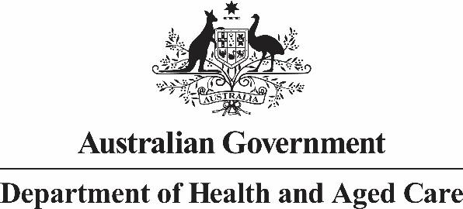

**Deputy Secretary**

Mr Daniel Craig

A/g Executive Director

Office of Impact Analysis

Department of Prime Minister and Cabinet

Dear Mr Craig

**Sunsetting of *National Health (Listing of Pharmaceutical Benefits) Instrument 2012* and *National Health (Prescriber bag supplies) Determination 2012***

I am writing to the Office of Impact Analysis (OIA) regarding the *National Health (Listing of Pharmaceutical Benefits) Instrument 2012* and *National Health (Prescriber bag supplies) Determination 2012*, which, as per the Legislation Act 2003, have been scheduled to sunset on 1 April 2024. It is intended that the instruments are to be remade without significant amendments to ensure the continuity of Australia’s Pharmaceutical Benefits Scheme (PBS).

The Department of Health and Aged Care certifies that the *National Health (Listing of Pharmaceutical Benefits) Instrument 2012* and *National Health (Prescriber bag supplies) Determination 2012* are operating effectively and efficiently, and that therefore Impact Analysis is not required for this legislation to be remade. Without remaking the *National Health (Listing of Pharmaceutical Benefits) Instrument 2012* the Pharmaceutical Benefits Scheme which supplies Australians with many subsidised medicines would not exist.

The assessment that the legislation is operating effectively and efficiently has been informed by a consultation process which involved Services Australia, the Department of Veterans’ Affairs, the Pharmacy Guild of Australia, Pharmaceutical Society of Australia and the Medical Software Industry Association, over a period of several months commencing June 2023. The revised draft instruments have also been circulated for comment. No significant issues were raised during consultations.

I also note that the regulatory burden to people, business, or community organisations has been quantified using the Australian Government’s Regulatory Burden Measurement framework. These are provided below.

Average annual regulatory costs (from business as usual)

| Change in costs ($ million) | Business | Community organisations | People | Total change in costs |
| --- | --- | --- | --- | --- |
| Total, by sector | $0 | $0 | $0 | $0 |

I acknowledge that OIA will publish this letter for transparency purposes.

If you have any queries about this advice, please contact PBS Thematic Review on [pbsthematicreview@health.gov.au](mailto:pbsthematicreview@health.gov.au) .

Yours sincerely

Penny Shakespeare  
Deputy Secretary  
Health Resourcing Group

March 2024