Reference: OIA23-05874

Telephone: 6271 6270 email: helpdesk-oia@pmc.gov.au

Ms Penny Shakespeare

Deputy Secretary

Health Resourcing Group

Department of Health and Aged Care

Dear Ms Shakespeare,

# Impact Analysis – Second Pass Final Assessment – Sharing Pathology and Diagnostic Imaging Reports to My Health Record by Default

Thank you for your letter of 8 November 2024 submitting an Impact Analysis (IA) for formal Second Pass Final Assessment. I note the IA has been formally certified at the Deputy Secretary level consistent with the Australian Government Guide to Policy Impact Analysis (the Guide).

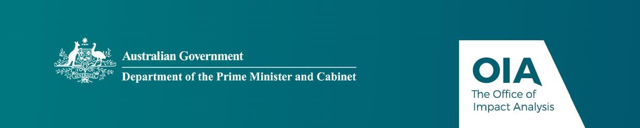I appreciate the Department’s constructive engagement on the IA. The Office of Impact Analysis’ (OIA) assessment is that the quality of the analysis in the IA is good practice. The IA addresses the seven IA questions and follows an appropriate policy development process commensurate with the significance of the problem and magnitude of the proposed intervention. In particular, the IA includes a good canvassing of the problem, and analysis of the costs and benefits. To be considered exemplary as per the Guide, the IA would have benefited from including further detail on the consultation process as well as the implementation and evaluation plan.

The IA may now be provided to the decision-maker to inform their decision.

# Next steps

Ahead of the final decision being announced we would appreciate a copy of the IA in a format meeting the Government’s web accessibility requirements. The OIA will then publish the IA, along with your certification, on the OIA’s website at oia.pmc.gov.au. The IA must also be included in any Explanatory Memorandum or Statement giving effect to the proposals in the IA, as stipulated in the User Guide to the Australian Government Guide to Policy Impact Analysis.

1 National Circuit, Barton ACT 2600 • Telephone 02 6271 6270 • Internet oia.pmc.gov.au

If you have any further queries, please do not hesitate to contact me.

Yours sincerely

Joanna Abhayaratna

Executive Director

Office of Impact Analysis

14 November 2024

1 National Circuit, Barton ACT 2600 • Telephone 02 6271 6270 • Internet oia.pmc.gov.au