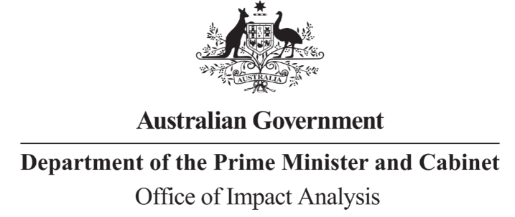

Reference: OIA23-04892  
Telephone: 6271 6270  
e-mail: [helpdesk-oia@pmc.gov.au](mailto:helpdesk-obpr@pmc.gov.au)

Martin Hehir

Deputy Secretary

Workplace Relations Group

Department of Employment and Workplace Relations

Dear Mr Hehir,

**Certification of Impact Analysis Equivalent: Import Ban on Engineered Stone**

Thank you for your letter of 13 September 2023 certifying the following reviews undertook a process and analysis equivalent to an Impact Analysis (IA):

* Decision Regulation Impact Statement: Managing the risks of respirable crystalline silica at work (Safe Work Australia)
* Decision Regulation Impact Statement: Prohibition on the use of engineered stone (Safe Work Australia).

The Office of Impact Analysis (OIA) acknowledges the certification as an Impact Analysis Equivalent (IAE). Under the Australian Government Guide to Policy Impact Analysis, the OIA does not assess the adequacy of the analysis contained in an IAE but does assess whether the options analysed in the certified documents are relevant to the policy proposal. The OIA also assesses the IAE for the coverage of the seven IA questions conducted.  
  
In this case, the OIA’s assessment is that the options analysed in the IAE are sufficiently relevant to the regulatory proposal. The IAE contains additional analysis prepared by the Department to address IA questions one, three, four, six and seven.

We would appreciate you advising us when a final decision has been announced and forwarding a copy of the IAE in a form meeting the Government’s accessibility requirements. The OIA will publish the IAE, along with your certification, on the OIA’s website at oia.pmc.gov.au.

Further, where a regulation is tabled in Parliament, your IAE needs to be included in the Explanatory Memorandum or Statement, as stipulated in the User Guide to the Australian Government Guide to Policy Impact Analysis.

Yours sincerely  
  
  
  
Jason Lange  
Executive Director  
Office of Impact Analysis  
14 September 2023

|  |  |  |  |
| --- | --- | --- | --- |
| |  | | --- | | **PROTECTED, CABINET**  **OIA23-04892**  **DEPARTMENT OF THE PRIME MINISTER AND CABINET** | | |  | | --- | | 1 National Circuit, Barton ACT 2600 • Telephone 02 6271 6270 • Internet oia.pmc.gov.au | |