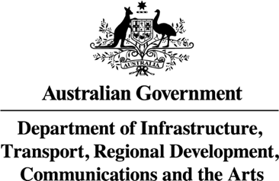

Ms Joanna Abhayaratna
Executive Director
Office of Impact Analysis
Department of the Prime Minister and Cabinet
1 National Circuit
BARTON ACT 2600
Email: Helpdesk-OIA@pmc.gov.au

Dear Ms Abhayaratna

Certification as Impact Analysis Equivalent – Social Media Age Limit (OIA24-08210)
I am writing to certify that the attached reports have undertaken a process and analysis equivalent to an Impact Analysis (IA). The documents are:
- South Australian Report of the Independent Legal Examination into Banning Children’s Access to Social Media;
- BETA Rapid Literature Review – Young people and social media – September 2024;
- Queensland Chief Health Officer – Position statement on social media and the mental health and wellbeing of young Queenslanders; and
- DITRDCA Age Assurance Trial Stakeholder Roundtables Summary.
I certify that these documents adequately address all seven IA questions for the purposes of informing enforcement of a minimum age of 16 (without parental consent) for accessing social media.
The scope of the Impact Analysis Equivalent covers the scope of the policy proposal with the exceptions of the regulatory burden estimate, the likely net benefit of a status quo option, and the implementation and evaluation of the policy. To address these gaps in the analysis I also certify the Supplementary Analysis. I am satisfied that with this addition, the scope of the certified documents matches the policy proposal.
The regulatory burden to business, community organisations or individuals over a 10-year duration is quantified using the Australian Government’s Regulatory Burden Measurement framework and is provided below.

Regulatory burden estimate table
Average annual regulatory costs (from business as usual)
Change in costs ($ million) | Business | Community organisations | Individuals | Total change in costs
Total, by sector | $6.69 | $0 | $0 | $6.69

Accordingly, I am satisfied that the attached report is consistent with the Australian Government Guide to Policy Impact Analysis.

Yours sincerely

James Chisholm
Deputy Secretary, Communications and Media
Department of Infrastructure, Transport, Regional Development, Communications and the Arts
6 November 2024

