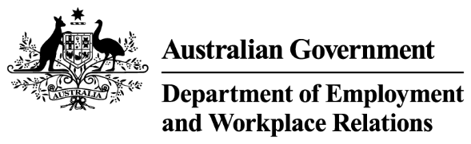

Your Ref OIA23-04892

Deputy Secretary, Workplace Relations Group

Martin Hehir

Mr Jason Lange

Executive Director

Office of Impact Analysis

Department of the Prime Minister and Cabinet

1 National Circuit

BARTON ACT 2600  
Email: [helpdesk-OIA@pmc.gov.au](mailto:helpdesk-OIA@pmc.gov.au)

Dear Mr Lange

**Certification as Impact Analysis Equivalent – Prohibition on the use of engineered stone**

I am writing to certify that the Safe Work Australia (2023) Decision Regulation Impact Statement: *Managing the risks of respirable crystalline* silica at work (Silica Decision RIS) and the Safe Work Australia (2023) Decision Regulation Impact Statement: *Prohibition on the use of engineered stone* (Prohibition Decision RIS) as processes and analysis equivalent to an Impact Analysis for the Australian Government’s position on a prohibition on the use of engineered stone, and complementary border measures such as a customs ban. The Office of Impact Analysis has previously advised that both decision regulation impact statements are consistent with the guidelines set out in the *Regulatory Impact Analysis Guide for Ministers’ Meetings* and the *National Standard Setting Bodies* (June 2023).

I certify that the Silica Decision RIS and the Prohibition Decision RIS adequately address the Impact Analysis questions, and that additional supplementary analysis at Annexure A, specifically addressing complementary border measures such as a customs ban on engineered stone, has been provided for questions 1,3,4,6 and 7.

The recommended option outlined in the Impact Analysis Equivalent provides for a prohibition on the use of engineered stone to reduce workplace exposure to respirable crystalline silica from engineered stone in Australia, with the aim of significantly reducing the incidence of silicosis and other silica-related diseases. The Prohibition Decision RIS, designed to be read in conjunction with the Silica Decision RIS, measures the impacts, and made recommendations in relation to, a prohibition on the use of engineered stone under the model work health and safety laws. The supplementary analysis recommends complementary border measures, modelled on a customs ban, to support the efforts of state and territory work health and safety regulators by providing an additional layer of enforcement and deterrence given engineered stone in Australia is predominantly supplied from other nations.

Implementation of the position proposed in the supplementary analysis is estimated to have a regulatory impact of approximately $14.3 million per annum. The regulatory burden to business, community organisations or individuals is quantified using the Australian Government’s Regulatory Burden Measurement framework and is provided below. The methodology is comprehensively described in the Prohibition Decision RIS.

| Regulatory burden estimate table  Average annual regulatory costs ($m, from business as usual)* | | | | |
| --- | --- | --- | --- | --- |
| Change in costs | Business | Community organisations | Individuals | Total change in costs |
| Total | $14.0 | $0.0 | $0.3 | $14.3 |

*\*The figures in this table are annual averages for estimated costs over the 10 year appraisal period identified in table 7 of the Prohibition Decision RIS.*

I am satisfied that the Prohibition Decision RIS and Silica Decision RIS, together with the supplementary analysis provided at Annexure A, are consistent with Impact Analysis Equivalent requirements under the *Australian Government Guide to Policy Impact Analysis*.

Yours sincerely

Martin Hehir

Deputy Secretary, Workplace Relations   
Department of Employment and Workplace Relations   
13 September 2023