Regulation Impact Statement for Consultation: MEPS and other measures for Commercial Ice Makers

This work is licensed under the Creative Commons Attribution 3.0 Australia Licence. To view a copy of this license, visit the creative commons website.

Office of Energy and Climate Change, NSW Treasury, on behalf of the Equipment Energy Efficiency Program asserts the right to be recognised as author of the original material in the following manner:



© Commonwealth of Australia and Office of Energy and Climate Change, NSW Treasury 2023.

The material in this publication is provided for general information only, and on the understanding that the Government is providing professional advice. Before any action or decision is taken on the basis of this material the reader should obtain appropriate independent professional advice.

This document is available at the Energy Rating website.

While reasonable efforts have been made to ensure that the contents of this publication are factually correct, E3 does not accept responsibility for the accuracy or completeness of the content and shall not be liable for any loss or damage that may be occasioned directly or indirectly through the use of, or reliance on, the contents of this publication.

Table of Contents

Table of Contents 3

Table of Illustrations 5

Glossary 7

Executive Summary 8

1. Background 14

Commercial Ice Makers 14

Technology 14

Product categories 14

The demand for ice 17

Energy efficiency 18

Refrigerants 20

Efficiency regulations and standards 21

Previous Australian Investigation 24

The Ice Maker Market 26

Global supply chains 26

The Australian Market 26

The New Zealand Market 27

Energy efficiency in the purchase decision 28

2. The Problem and Options to Address It 32

The Problem 32

Options Considered 33

No intervention 33

Non-regulatory measures 33

Mandatory disclosure of information 35

Minimum Energy Performance Standards (MEPS) 36

Review of Options 36

3. Projected Costs, Benefits and Impacts 38

MEPS & HEPS levels considered 38

Deciding on the optimum approach 41

Modelling Assumptions 41

Projected Benefits 42

Energy savings 42

Projected Costs 48

Testing 48

Registration and Administration 48

Costs of efficiency improvements 48

Benefit/Cost Analysis 49

Australia 49

New Zealand 49

Uncertainty and Sensitivity 52

Stakeholder Impacts 54

Suppliers 54

Purchasers and consumers 55

Regulators and Administrators 56

Impacts on Competition 57

4. Implementation and Timing 58

Recommended Option 58

Preliminary Recommendations 58

Implementation 60

Determination under the GEMS Act and Regulations under the EEC Act 60

Compliance 60

Designers and specifiers 61

Minimising Compliance Costs 61

Next Steps 62

Evaluation 62

5. Questions for Stakeholders 64

References 66

Appendix A – Companies Consulted to Date 67

Appendix B – Proposed MEPS levels 68

Appendix C – Modelling Assumptions 70

Table of Illustrations

Table 1 Category structure for CBA 17

Table 2 Energy efficiency values for selected ice maker models available in Australia 19

Table 3 Ratio of output capacity of ice makers at various rating points, compared with 32/21 24

Table 4 Survey responses from business owning commercial kitchen equipment, including ice makers 31

Table 5 Impact of options considered on market failures affecting commercial ice makers 37

Table 6 Summary of projected impacts, costs and benefits, ice maker MEPS. Australia 50

Table 7 Summary of projected impacts, costs and benefits, ice maker MEPS only, New Zealand 50

Table 8 Sensitivity to discount rates, Australia (base P/E ratio assumptions) 53

Table 9 Sensitivity to discount rates, New Zealand (base P/E ratio assumptions) 53

Table 10 Sensitivity to discount rates, Australia (double P/E ratio assumptions) 53

Table 11 Sensitivity to discount rates, New Zealand (double P/E ratio assumptions) 53

Table 12 Sensitivity to projected CO2-e values, New Zealand (base P/E ratio assumptions) 54

Table 13 Estimated share of current (2020) models meeting MEPS levels 54

Table 14 Average costs, savings and payback periods for purchasers in Australia, MEPS at US DOE level 56

Table 15 Proposed MEPS Formulae for Ice Makers (Stage 1 and 2) 68

Table 16 Estimated lifetime capital and operating costs for icemakers 71

Table 17 Mt CO2-e emissions avoided Option 1 (AS/NZS 4865 MEPS) 78

Table 18 Mt CO2-e emissions avoided Option 2 (AS/NZS 4865 HEPS) 78

Table 19 Mt CO2-e emissions avoided Option 3 (USDOE) 79

Table 20 Mt CO2-e emissions avoided Option 3a (USDOE + selected HEPS) 79

Table 21 Mt CO2-e emissions avoided Option 4 (USEPA Energy Star) 80

Figure 1 Ice maker refrigeration cycle 14

Figure 2 Self-contained ice maker, modular ice maker with ice storage bin and ice maker with dispenser 15

Figure 3 Typical shapes and types of commercial ice 16

Figure 4 Typical production vs temperature map for a single ice maker 24

Figure 5 Imports of commercial ice makers by country of origin 27

Figure 6 Estimated lifetime capital and operating costs for icemakers 30

Figure 7 Comparison of MEPS and HEPS levels 39

Figure 8 Performance of selected models on the Australian market in relation to AS/NZS 4865 MEPS and HEPS 40

Figure 9 Performance of selected models on the Australian market in relation to AS/NZS 4865, USDOE and ES MEPS and HEPS 40

Figure 10 Projected BAU and post-implementation energy efficiency trends, AS/NZS 4865 HEPS levels, air-cooled SCU 43

Figure 11 Projected BAU and post-implementation energy efficiency trends, AS/NZS 4865 HEPS levels, air-cooled IMH 44

Figure 12 Projected annual energy consumption, commercial ice makers sold 2022-2037, Australia 45

Figure 13 Projected annual energy saving for various MEPS, commercial ice makers sold 2022-2037, Australia 45

Figure 14 Projected annual energy use of total ice maker stock, Australia, 2022-2037 46

Figure 15 Projected annual energy consumption, commercial ice makers sold 2022-2037, New Zealand 46

Figure 16 Projected annual energy saving for various MEPS, commercial ice makers sold 2022-2037, New Zealand 47

Figure 17 Projected annual energy use of total ice maker stock, New Zealand, 2022-2037 47

Figure 18 Costs and Benefits, Australia, Ice maker MEPS 51

Figure 19 Costs and Benefits, New Zealand, Ice maker MEPS 51

Figure 20 Annual imports of ice makers by DCV category 70

Figure 21 Projected real electricity prices 76

Figure 22 Projected greenhouse gas coefficients 76

Figure 23 Projected value of greenhouse gas emissions avoided 77

Glossary

|  |  |
| --- | --- |
| 32/21 | The rating point of 32°C ambient and 21°C water temperature (other rating points are in similar format) |
| AHRI | Air Conditioning, Heating and Refrigeration Institute (USA) |
| ASHRAE | American Society of Heating, Refrigerating and Air-Conditioning Engineers |
| BAU | Business as usual |
| COP | Coefficient of Performance. Indicates the energy-efficiency of a compressor or an entire cooling system |
| CRIS | Consultation Regulation Impact Statement |
| DCCEEW | Department of Climate Change, Energy, Environment and Water (Commonwealth) |
| DCV | Declared customs value |
| DOE | Department of Energy (USA) |
| DPE | Department of Planning and Environment (NSW) |
| E3 | Equipment Energy Efficiency program (of the Commonwealth, State, Territory and New Zealand governments) |
| EEC | Energy Efficiency and Conservation (New Zealand Act, 2000) |
| EECA | Energy Efficiency and Conservation Authority (New Zealand) |
| EPA | Environmental Protection Authority (USA) |
| GEMS | Greenhouse and Energy Minimum Standards (Commonwealth Act, 2012) |
| GWP | Global warming potential |
| HC | Hydro-carbon (class of refrigerant) |
| HCFC | Hydro-chloro-fluoro-carbon (class of refrigerant) |
| HFC | Hydro-fluoro-carbon (class of refrigerant) |
| HFO | Hydro-fluoro-olefin (class of refrigerant) |
| IEC | International Electrotechnical Commission |
| IMH | Ice making head (modular) – lacks inbuilt ice storage |
| ISO | International Standardization Organization |
| kg/24hrs | Maximum production capacity of an ice maker (at stated rating point) |
| kWh/kg | Electrical energy consumed to produce a kg of ice (at stated rating point) |
| MEPS | Minimum energy performance standards |
| MWPS | Minimum water performance standards |
| NPV | Net present value |
| ODP | Ozone depletion potential |
| RCRC | Remote compressor and condenser |
| RCU | Remote condenser unit |
| SCU | Self-contained unit |
| Rating point | The set of air and water temperature conditions under which ice maker performance is determined |
| WELS | Water Efficiency Labelling and Standards (Commonwealth Act, 2005) |

Executive Summary

This Consultation Regulation Impact Statement considers policy options to improve the energy efficiency of commercial ice makers supplied in Australia and New Zealand.

Many refrigeration products, including commercial ice makers, are available across a wide range of energy-efficiencies. Buyers are not always aware of the energy consumption or operating costs of the models they are considering because the information is either unavailable or presented in ways that make it difficult or impossible to compare models. Furthermore, some commercial ice makers are purchased by intermediaries who may be unconcerned with the operating costs, which will be borne by the end user.

About 10,000 commercial ice makers are sold in Australia each year, with an estimated installed stock of about 60,000. A further 1500 to 1700 units are sold in New Zealand each year, with an estimated installed stock of about 10,000. There is only one Australian manufacturer, and the great majority of the market is supplied by imports from Europe, China and the USA.

Energy use from commercial ice makers is increasing in Australia and New Zealand due to growth in population and in the foodservice and food retailing sectors. Annual energy use from commercial ice makers is estimated at about 400 GWh per year in Australia, and about 55 GWh per year in New Zealand.

The cost of energy use over the life of an ice maker is several times the initial price, so purchasing a less efficient model (even at an upfront price saving) will significantly disadvantage the end user. The payback period of a more energy-efficient ice maker is typically less than a year. Purchasers are unable to identify more efficient models because of lack of information, but information alone is not likely to overcome indifference to running costs. In the absence of measures to address these problems, the economic and financial costs of commercial ice-making in Australia and New Zealand will remain significantly higher than the optimum. The environmental externalities associated with electricity supply will also be higher.

The Commonwealth *Greenhouse and Energy Minimum Standards Act 2012* provides for the regulation of products with regard to energy labelling and minimum energy performance standards (MEPS) in Australia. The equivalent in New Zealand is the *Energy Efficiency (Energy Using Products) Regulations 2002*. At present, over 20 product types are regulated with regard to energy labelling, MEPS, or both.[1] The program is overseen by the Equipment Energy Efficiency (E3) Committee, comprising representatives of the Commonwealth, State, Territory and New Zealand governments.

The E3 Committee regularly reviews energy-using products in the market and assesses whether to include them in the E3 program. The committee last reviewed commercial ice makers in 2004.[2] This led to the development of joint Australian and New Zealand Standard AS/NZS 4865:2008 *Performance of commercial ice makers and ice storage bins.*[3]The standard envisaged that MEPS would become a mandatory requirement in 2009, but this did not occur.

The E3 Committee has again examined the case for improving the energy efficiency of commercial ice makers. The project was led by the NSW Department of Planning and Environment, which commissioned extensive research on the commercial ice maker market, reviewed energy efficiency standards for ice makers in other countries and consulted with 15 major suppliers, who between them represent over 90% of the market. Consultations took the form of a structured interview following a template sent in advance, to give respondents opportunity to assemble the requested data.

**Policy options**

This Consultation Regulation Impact Statement (CRIS) identifies several policy options to address these market failures and so improve the energy efficiency of commercial ice makers. The conclusion is that MEPS, supported by information measures to drive efficiency beyond the MEPS level, are the most effective means of addressing excessive energy use in commercial ice makers. The CRIS considers four feasible MEPS levels (in order of increasing stringency):

1. The MEPS levels in AS/NZS 4865.3:2008
2. The HE levels in AS/NZS 4865.3:2008
3. The United States of America’s MEPS levels
4. The United States of America’s Energy Star levels.

Each MEPS scheme assigns a maximum allowable energy consumption value (in kWh/100kg ice) to models depending on their production capacity (in kg/24hrs) as determined on a standard test. The MEPS rules classify ice makers in different ways according to their production capacity range, configuration (self-contained, modular, or split), cooling medium (air or water) and the method of ice production (batch or continuous).

There are several factors bearing on which of the four available MEPS levels represents the best policy option. The optimum approach may also involve a planned transition from less to more stringent levels. The main decision factors are:

* The quantum of projected energy and greenhouse gas emission savings compared with the no-intervention “business as usual” (BAU) case
* Benefits: the value of the projected energy, peak demand and emission savings
* Costs: testing, administration and any increases in the cost of the products
* Net benefits (benefits less costs) and Benefit/Cost (B/C) ratios
* Market impacts, in terms of limitations on consumer choice and any reductions in competition
* Effectiveness, efficiency and enforceability of any regulation
* Risk: how sensitive are the conclusions in relation to uncertainty and imperfect information?

These factors are quantified and modelled in this CRIS. The estimates for Australia are summarised in Tables E1 and E3 and the estimates for New Zealand are summarised in Tables E2 and E4. Cost and benefit calculations are based on projected electricity (for Australia) or the Long Run Marginal Cost of electricity production (for New Zealand), the value of emission savings and the price of ice makers.

It is estimated that the recommended MEPS will increase the average price of commercial ice makers by about 12% (AUD $412 and NZD $485) and reduce average annual electricity costs by AUD $882 and NZD $452, giving a simple payback of about half a year in Australia and just over a year in New Zealand. The service life of ice makers is typically 7 to 10 years, so this is highly cost-effective for users.

It is also estimated that, during the first 23 years of regulation, the recommended MEPS would reduce electricity consumption in Australia by 1160 GWh, which is equivalent to the electricity used by 180,325 households in 1 year.[4] In New Zealand, electricity consumption over the same period would be reduced by 160 GWh, which is equivalent to the electricity used by 22,600 households in 1 year.[5]

Table E1 Summary of projected costs and benefits, Australia

|  |  |  |  |  |  |  |  |  |  |
| --- | --- | --- | --- | --- | --- | --- | --- | --- | --- |
| MEPS Option | Extra  Cap Cost | Admin Cost | Total  Cost | Energy  Benefit (a) | Emission Benefit (b) | Demand Benefit (c) | Total Benefit | Net Benefit | Benefit/ cost ratio |
| 1. AS/NZS 4865 MEPS | $8.8 | $4.0 | $12.8 | $105.2 | $7.1 | $0.0 | $112.2 | $99.4 | 8.8 |
| 2. AS/NZS 4865 HEPS | $19.4 | $4.0 | $23.4 | $199.0 | $13.1 | $0.0 | $212.0 | $188.6 | 9.1 |
| 3. USDOE | $32.1 | $4.0 | $36.2 | $258.0 | $16.8 | $0.0 | $274.8 | $238.6 | 7.6 |
| 3a. USDOE+selected HEPS (d) | $32.7 | $4.0 | $36.7 | $265.9 | $17.3 | $0.0 | $283.3 | $246.6 | 7.7 |
| 4. USEPA Energy Star | $49.6 | $4.0 | $53.6 | $382.4 | $24.8 | $0.0 | $407.2 | $353.6 | 7.6 |

All values million $ NPV for costs incurred 2022-37 and benefits accrued 2022-45, at 7% discount rate. (a) NPV of retail energy cost savings (b) NPV of value of reductions in CO2-e emissions. (c) Not separately costed; included in energy benefit. (d) AS/NZS 4865 HEPS levels for categories where these are more stringent than USDOE MEPS.

Table E2 Summary of projected impacts, costs and benefits, New Zealand

|  |  |  |  |  |  |  |  |  |  |
| --- | --- | --- | --- | --- | --- | --- | --- | --- | --- |
| MEPS Option | Extra  Cap Cost (a) | Admin Cost | Total  Cost | Energy  Benefit (b) | Emission Benefit (c) | Demand Benefit | Total Benefit | Net Benefit | Benefit/ cost ratio |
| 1. AS/NZS 4865 MEPS | $1.0 | $0.3 | $1.3 | $4.3 | $0.3 | $0.9 | $5.6 | $4.3 | 4.3 |
| 2. AS/NZS 4865 HEPS | $2.2 | $0.3 | $2.5 | $8.2 | $0.6 | $1.8 | $10.6 | $8.1 | 4.2 |
| 3. USDOE | $3.7 | $0.3 | $4.0 | $10.8 | $0.8 | $2.3 | $13.9 | $9.9 | 3.5 |
| 3a. USDOE+selected HEPS (d) | $3.8 | $0.3 | $4.0 | $11.1 | $0.9 | $2.4 | $14.3 | $10.3 | 3.5 |
| 4. USEPA Energy Star | $5.7 | $0.3 | $6.0 | $16.1 | $1.2 | $3.4 | $20.8 | $14.8 | 3.5 |

All values million $ NPV for costs incurred 2022-37 and benefits accrued 2022-45, at 5% discount rate. (a) Nominal supplier cost is 50% of retail price (b) NPV of LRMC savings (c) NPV of reductions in CO2-e emissions at medium value. (d) AS/NZS 4865 HEPS levels for categories where these are more stringent than USDOE MEPS.

Table E3 Impacts and sensitivity of benefits to discount rates, Australia

|  |  |  |  |  |  |  |  |  |
| --- | --- | --- | --- | --- | --- | --- | --- | --- |
|  | 4% discount rate | | 7% discount rate | | 10% discount rate | | GWh  saved  2022-45 | kt CO2-e  saved  2022-45 |
|  | $M Net Benefit | Benefit/ cost | $M Net Benefit | Benefit/ cost | $M Net Benefit | Benefit/ cost |
| 1. AS/NZS 4865 MEPS | $145.5 | 9.8 | $99.4 | 8.8 | $69.6 | 7.9 | 466 | 152 |
| 2. AS/NZS 4865 HEPS | $277.0 | 10.0 | $188.6 | 9.1 | $131.6 | 8.3 | 871 | 282 |
| 3. USDOE | $351.7 | 8.3 | $238.6 | 7.6 | $165.9 | 7.0 | 1125 | 363 |
| 3a. USDOE+Selected HEPS | $363.3 | 8.5 | $246.6 | 7.7 | $171.5 | 7.1 | 1160 | 375 |
| 4. USEPA Energy Star | $521.7 | 8.3 | $353.6 | 7.6 | $245.7 | 7.0 | 1662 | 536 |

Table E4 Impacts and sensitivity of benefits to discount rates, New Zealand

|  |  |  |  |  |  |  |  |  |
| --- | --- | --- | --- | --- | --- | --- | --- | --- |
|  | 2% discount rate | | 5% discount rate | | 8% discount rate | | GWh  saved  2022-45 | kt CO2-e  saved  2022-45 |
|  | $M Net Benefit | Benefit/ cost | $M Net Benefit | Benefit/ cost | $M Net Benefit | Benefit/ cost |
| 1. AS/NZS 4865 MEPS | $6.4 | 4.8 | $4.3 | 4.3 | $2.9 | 3.9 | 63 | 4 |
| 2. AS/NZS 4865 HEPS | $12.1 | 4.6 | $8.1 | 4.2 | $5.5 | 3.9 | 119 | 7 |
| 3. USDOE | $15.0 | 3.8 | $9.9 | 3.5 | $6.7 | 3.2 | 156 | 9 |
| 3a. USDOE+Selected HEPS | $15.6 | 3.9 | $10.3 | 3.5 | $7.0 | 3.3 | 160 | 9 |
| 4. USEPA Energy Star | $22.4 | 3.8 | $14.8 | 3.5 | $10.0 | 3.2 | 231 | 13 |

The impact on model availability and competition has also been considered. Based on analysis of the 188 models (out of about 340) for which performance data are available, adoption of the AS/NZS 4865 MEPS levels would exclude about 9% of models, the HE levels would exclude nearly 30%, the US DOE MEPS levels would exclude over 40% and the US EPA Energy Star levels could exclude over 60%. The burden on suppliers also depends on the lead time for implementation.

**Preliminary Recommendations**

A two-stage approach is proposed, with MEPS to be introduced from the end of 2024 (Stage 1) and strengthened two years later (Stage 2). Standardised information on performance and efficiency would be collected and disclosed during Stage 1, and enhanced measures to inform consumers in Stage 2.

Of the MEPS options modelled, the one with the highest projected net benefit is the US EPA Energy Star level. However, Energy Star is stringent even by the standards of the US market, which has had over a decade of mandatory MEPS, and Energy Star is voluntary rather than mandatory. Adopting the Energy Star levels as the initial MEPS for Australia and New Zealand would risk disrupting the market to an unacceptable degree and leaving many segments without available models, possibly for some years.

If Energy Star is excluded, adoption of the US DOE MEPS, adjusted for configurations where AS/NZS 4865 HEPS are more stringent (Option 3a) has the highest net benefit ($246.6 million in Australia, $10.3 million in New Zealand). Proceeding to this option in a single step carries some risk, given that the information on model performance is incomplete. Adopting the AS/NZS 4865 HEPS level (Option 2) as an intermediate step would reduce the market disruption risk by allowing for the collection of complete information about the models on the market before proceeding to Option 3a.

A phased approach would also help give industry certainty and set out a blueprint for achieving the highest practical net benefit. Therefore, the following two-stage strategy is recommended.

**Stage 1,** to take effect at the end of 2024:

* All commercial ice maker models to meet MEPS, set at the HE levels in AS/NZS 4865:2008 Part 3
* MEPS to be based on the product categories in AS/NZS 4865 (i.e. air-cooled and water-cooled configurations to have different MEPS formulae but batch and continuous units to have the same MEPS formulae)
* Suppliers to register all models by the implementation date, using either the AS/NZS 4865:2008 test, the US ASHRAE 29-2009 (or 2015) test or the ISO test (if published by then), provided the tests are undertaken at 230V/50Hz and at the at 32/21 rating point
* As a cost saving option for suppliers, regulators should consider accepting ASHRAE test reports undertaken on 115V/60Hz variants, if the supplier accepts the risk that compliance check tests using AS/NZS 4865.1 could show 230V/50Hz variants as supplied in Australia and New Zealand to be non-compliant (and so would be de-registered)
* For all commercial ice maker models within scope, suppliers must register the production capacity (kg/24hrs) and energy consumption (kWh/100kg) measured at the 32/21 rating point
* Invite suppliers to voluntarily register potable water consumption (l/100kg) and (if applicable) cooling water use (l/100 kg). The cost of obtaining this data would be minimal, as the standard tests require water use to be measured at the same time as energy use
* Include the US DOE MEPS levels as “HE” levels in the initial GEMS Determination and Regulations and permit suppliers to designate models that achieve the HE levels as “High Efficiency”
* Disclose registered performance data for each model on [www.energyrating.gov.au](http://www.energyrating.gov.au), with methods for calculating operating costs and for ranking models in order of energy-efficiency (e.g. lowest to highest kWh/kg ice).

**Stage 2**, to take effect for new models registered two years (at least) after initial implementation:

* MEPS levels to rise to the new HE levels (i.e. the present US DOE levels), except where the existing HE levels in AS/NZS 4865 are already more stringent
* Further differentiate product categories in AS/NZS 4865 so that batch and continuous models have different MEPS formulae, as in the USA
* Consider implementing additional forms of information, beyond the disclosure of registered performance data on [www.energyrating.gov.au](http://www.energyrating.gov.au) (part of Stage 1): on-product energy labelling and/or mandatory disclosure of information in brochures and advertising.

The MEPS formulae proposed for Stage 1 and Stage 2 are in Appendix B – Proposed MEPS levels.

These recommendations may change as a result of feedback during consultations.

**Implementation**

The proposed requirements for Stage 1 would be implemented via a GEMS Determination under the Commonwealth *Greenhouse and Energy Minimum Standards Act 2012* (GEMS Act). In New Zealand the Energy Efficiency (Energy Using Products) Regulations 2002 would be used. If Ministers agree to proceed with measures for commercial ice makers, a draft GEMS Determination covering Stage 1 could be published in by September 2023 and a final Determination in early 2024. This would give a year’s lead time to the implementation of the Stage 1 measures at the end of 2024. Stage 2 would involve more stringent ice maker MEPS level and redefined product categories, with implementation to take effect at the end of 2026 or later. Stage 2 would require a second Determination (and amended regulations in New Zealand) but not necessarily a second RIS.

It is intended that the commencement of Energy Efficiency (Energy Using Products) Regulations 2002 in New Zealand would follow the Australian Determination. The implementation of New Zealand regulations would not commence before the Australian Determination.

**Have your say**

The release of this CRIS marks the beginning of a public consultation period. Section 5, Questions for Stakeholders, lists specific questions to which stakeholders are invited to respond. [6] The responses will inform the preparation of a final Decision RIS to be submitted to Ministers.

Submissions and enquiries can be directed to:

Australia: for submissions see [https://consult.dcceew.gov.au/gems-commercial-ice-makers-consultation-paper](https://aus01.safelinks.protection.outlook.com/?url=https%3A%2F%2Fconsult.dcceew.gov.au%2Fgems-commercial-ice-makers-consultation-paper&data=05%7C01%7CMelody.Coutman%40dcceew.gov.au%7C1060adc9154e4b589d9308db50438378%7C2be67eb7400c4b3fa5a11258c0da0696%7C0%7C0%7C638192023120017720%7CUnknown%7CTWFpbGZsb3d8eyJWIjoiMC4wLjAwMDAiLCJQIjoiV2luMzIiLCJBTiI6Ik1haWwiLCJXVCI6Mn0%3D%7C3000%7C%7C%7C&sdata=NWC1khMQ1GDTP3a2CSpmG5AFiQ1KPx6Pn4FUPDNLW3E%3D&reserved=0) and for enquiries contact icemakers@dcceew.gov.au

New Zealand: [star@eeca.govt.nz](mailto:star@eeca.govt.nz)

Submissions on this document close on: 12 June 2023.

It is envisaged that information sessions will be held (by videoconference) on 31 May 2023.

*****

1. Background

## Commercial Ice Makers

Technology

Ice is used for a wide range of applications in the production, transport, preparation, display and service of food, beverages, medicines, and other perishable products. Common uses include cubed ice served in drinks, and flaked ice as a bed for displaying fish and seafoods. Ice makers generally use potable water to produce food-grade ice, although there is also non-potable industrial ice, for specialised uses such as slowing the curing of concrete.

Ice is made by freezing water, essentially using the same refrigeration cycle as other freezers. Water is run or sprayed over a shaped panel that is cooled by evaporation of a refrigerant gas. The gas absorbs heat from the evaporator and is pumped around a closed circuit to a condenser, where it transfers the heat to the ambient air (or in some cases, water) and condenses to a liquid (Figure 1)[7]. The process consumes electrical energy in a number of ways: mainly in the motor driving the refrigeration compressor, but also in other fans, pumps and heaters, depending on the design of the ice maker.

Figure 1 Ice maker refrigeration cycle

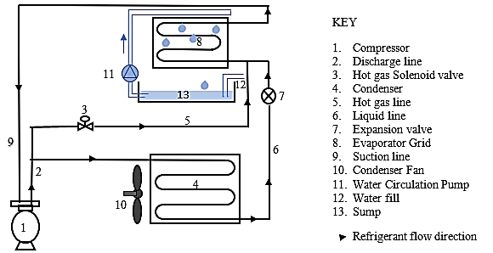

Product categories

There are many different ways to categorise ice makers – by type of ice made, production capacity (usually expressed in kg ice/24 hrs), physical configuration and other factors. For the purposes of this document, the products in scope are ice makers with plumbed connections and capable of producing up to 1,000 kg of ice per 24 hrs, when tested in accordance with standard AS/NZS 4865 or equivalent.[8] The following types of ice maker are considered out of scope:

* Manual-fill ice makers: these lack a water supply connection point and a drain point
* Ice makers built into domestic refrigerators.

Of the ice makers within scope, self-contained units have both the ice maker and the storage bin built into the one cabinet (Figure 2, left). The storage bin capacity is typically a third to a half of the 24hr production capacity. Most self-contained units are designed for under counter installation, but there are also dispenser models designed to sit on countertops for high-turnover beverage service applications. Modular ice makers (Figure 2, centre) are designed to sit on top of separate ice storage bins, so production capacities and bin volumes can be matched according to usage patterns. All ice makers are designed to automatically cease operation once the bin is full, and resume once the ice level in the bin falls (whether from usage or melting). The storage may be designed so that ice is removed manually or dispensed automatically without being handled (Figure 2, right).

Figure 2 Self-contained ice maker, modular ice maker with ice storage bin and ice maker with dispenser

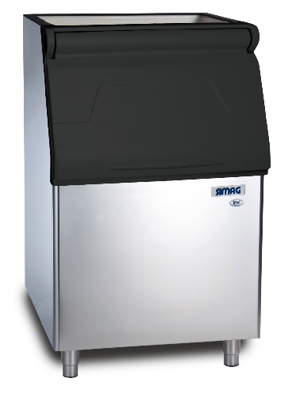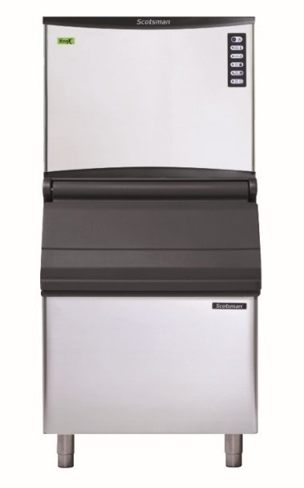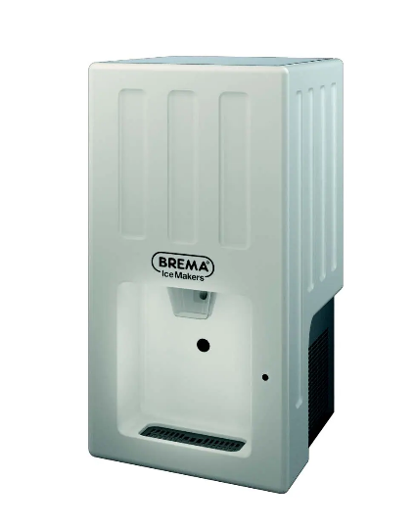

Most ice makers sold use air to cool the condenser, but models where cooling water is run over the condenser are also available. These use less energy per kg of ice made but consume prohibitive quantities of cooling water if continuously run to waste. Their most efficient use is in installations with chilled water recirculation system coupled with cooling towers, serving several ice makers as well as air conditioner heat exchangers. Water cooling also reduces the sensible heat load where ice makers are installed in air-conditioned spaces. Another way to reduce heat load is to locate the condenser remotely from the ice maker and link the two by refrigerant lines. The compressor can be housed either with the ice making head or with the remote condenser.

Apart from physical configuration, ice makers are also classified by the type of ice they make and how they make it. Figure 3 illustrates the most common ice types. Cubed or shaped ice is hard, clear and dry, and intended mainly for adding to beverages. It is slow melting, and can be produced in a range of sizes and shapes such as dice, crescents, balls, cylinders etc. It is made in “batches.’’ Water is sprayed or run on to a shaped evaporator, and once the ice reaches the required shape and size it is “harvested” by either momentarily heating the evaporator with hot refrigerant gas or running warmer inlet water behind the ice, which has the advantage of pre-cooling the water for the next batch. Some of the potable water used for batch ice is flushed away to remove impurities, but this loses both the water and the energy used to cool it. One design objective is to minimise water loss while maintaining ice quality. The sound of harvested ice falling into the bin means that batch ice makers tend to be noisy in operation.

Flaked or granular ice is shapeless and contains some entrapped water and air. It is ideal for preserving and displaying perishable foods such as fish or vegetables, since it accommodates to irregular shapes and the water content means it does not bruise or dry the produce. However, it melts faster than hard cube ice. Flaked ice is made by a “continuous” process in which water is sprayed on to or inside a rotating cylindrical evaporator and removed as it forms by a scraper or augur. The manufacture of flaked ice is less energy-intensive and quieter than for cubed ice and there is very little potable water wastage.

Nugget or tubular ice is generally made by a continuous process, and the ice is then shaped or compressed by a secondary operation. Nugget ice is often used in lower-value soft drinks, in quick service restaurants and in hospitals, where it is easier for patients to chew.

Figure 3 Typical shapes and types of commercial ice

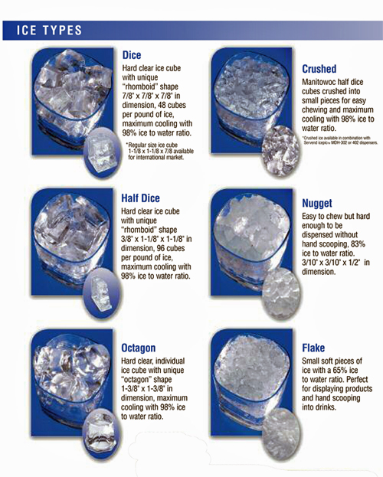

Source: Manitowoc

The joint Australian and New Zealand test standard for ice makers, AS/NZS 4865, defines six product categories according to their configuration and whether they are air-cooled or water-cooled, as indicated in Table 1. The test standard used in the USA, published by the Air Conditioning, Heating and Refrigeration Institute (AHRI), divides each configuration into two further categories according to whether the ice is made by a batch or a continuous process. Ice makers are further divided by output capacity for the purposes of setting minimum standards for their performance.

Table 1 Category structure for CBA

|  |  |  |  |  |
| --- | --- | --- | --- | --- |
| AS/NZS 4865 Configuration categories | US DOE (AHRI) Configuration categories | AS/NZS 4865 Capacity categories (kg ice per 24 hrs)  - based on US DOE categories (expressed in lbs ice per 24 hrs) | | |
| Modular – air-cooled (1-4) | IMH - Batch – Air (1-2) | < 200 (1) | >= 200 (2) | |
| IMH – Cont – Air (3-4) | < 200 (3) | >= 200 (4) | |
| Modular – water-cooled (5-10) | IMH - Batch – Water (5-7) | < 225 (5) | 225-465 (6) | >465 (7) |
| IMH - Cont – Water (8-10) | < 225 (8) | 225-465 (9) | >465 (10) |
| Split system – remote condensing and remote compressor (11-14) | RCRC - Batch – Air (11-12) | < 420 (11) | >= 420 (12) | |
| RCRC - Cont – Air (13-14) | < 420 (13) | >= 420 (14) | |
| Split system – remote condensing but not remote compressor (15-18) | RCU - Batch – Air (15-16) | < 450 (15) | >= 450 (16) | |
| RCU - Cont – Air (17-18) | < 450 (17) | >= 450 (18) | |
| Self-contained – air-cooled (19-22) | SCU - Batch – Air (19-20) | < 80 (19) | >= 80 (20) | |
| SCU - Cont – Air (21-22) | < 80 (21) | >= 80 (22) | |
| Self-contained – water-cooled (23-26) | SC U- Batch – Water (23-24) | < 90 (23) | >= 90 (24) | |
| SCU - Cont – Water (25-26) | < 90 (25) | >= 90 (26) | |

IMH = Ice-making-head (i.e. modular) RCU = Remote condenser unit, SCU = self-contained. RCRC = Remote compressor & condenser. Batch = cube or shaped ice. Cont = Flaked ice. Numbers in parenthesis are categories adopted for convenience in this Consultation RIS.

The demand for ice

The primary market for commercial ice makers is the hospitality and food services industry: hotels, bars, restaurants and cafes. Quick service restaurants and juice bars consume large volumes of lower-quality ice (e.g. nuggets), whereas bars, hotels and restaurants mainly use cubed or shaped ice. Some venues prefer smaller cubes that can be more easily crushed and blended into drinks. Institutional residential facilities such as hospitals and aged care also use ice.

As with all perishable products (including electricity) ice is subject to problems of peak demand, storage and distribution. Ice makers are usually left on continuously. The bin is generally full when a shift or trading session starts and ice making resumes as ice is drawn off steadily over the session. Over a 24hr period, an ice maker will typically make 70 to 75% of its rated 24hr production capacity. There may be separate ice makers at each main point of use, or ice may be distributed from a central machine by an automated transport system or by hand. For example, a busy hotel may have a number of distributed storages or ‘’ice wells” at each bar, manually filled from a central ice machine. However, the more handling the greater the risks of contamination.

Some facilities will have ice demand that peaks weekly or irregularly – for example, event venues or convention centres. In such cases the ice makers may be run for several days to build up ice stocks, which are then stored in freezers, either bagged or in bins (so needing multiple storage bins per modular ice maker).

In recent year the mining and construction industries have emerged as major markets for ice makers. Workers typically fill their personal drink and food coolers with ice from dispensing bins at the beginning of their shift, so ice production capacity must be adequate to supply two or even three shift starts each day.

Flake ice is produced and used at all stages in the food production, processing and delivery chain. Fishing boats have on-board ice makers or go to sea with ice on board. Perishables may be packed in ice for transport, if suitable chilled-space transport is not available. Many supermarkets and food retailers have flaked ice makers for daily fish, meat, and vegetable display.

There is also extensive non-food use of ice in healthcare, scientific and pathology applications, to preserve tissue and samples and to control temperatures for chemical reactions.

The daily ice needs of households have traditionally been met by domestic refrigerators – ice trays in the freezer or, more recently, through-the-door ice dispensers in more expensive models. The occasional demand for larger quantities is generally supplied by bagged ice, available from supermarkets, bottle shops and service stations. With rising incomes, and falling product prices, there is now a significant market for home ice makers, which are manually filled and emptied. These have relatively low production capacity, and tend to be used irregularly, so limiting their total energy and water consumption. However, the industry reports a limited market for small commercial ice makers for installation in larger, more expensive homes.

Discussions with industry indicate that ice makers with output capacity above about 1,000 kg/24hr tend to be used in industrial rather than commercial applications, including the production of bagged ice. One of the marketing points for the sale of commercial ice makers to smaller food service establishments is the cost savings compared with the purchase, storage, and handling of bagged ice. Furthermore, in more remote towns and worksites an ice maker will insure against disruptions in bagged ice supply that relies on road freight.

Energy efficiency

The energy efficiency of an ice maker is a function of many factors, including the design of the compressor, the efficiency of the electric motor driving it, the design of the evaporator and condenser and the properties of the refrigerant gas. In addition, ice makers use a number of components including fans, pumps, switches and controls, each involving energy consumption and efficiency losses. [9]

Table 2 summarises the energy efficiency of ice production for about half the ice maker models on the Australian market in 2020. Most of the models were also available in New Zealand. Data were not available for the rest of the market. These values should be interpreted with some caution, because:

* This data set only covers models for which it was possible to identify energy use (kWh/100kg ice) data for the 32/21 rating point (the one used for testing compliance with MEPS in the USA). While suppliers usually publish production values (kg ice/24 hr) at 32/21 (and other rating points), they rarely publish energy use data
* In many cases the USA test data for that model was used, on the assumption that the 230V/50Hz variant sold in Australia had similar performance to the 115V/60Hz model tested in the USA.[10]

Table 2 Energy efficiency values for selected ice maker models available in Australia

|  |  |  |  |  |  |
| --- | --- | --- | --- | --- | --- |
| Configuration, Ice production method and cooling mode | Number analysed | Average kg/24 hrs | Max kWh/100kg | Min kWh/100kg | Average kWh/100kg |
| SCU - Batch - Air | 45 | 66 | 45.0 | 11.3 | 21.9 |
| SCU - Batch - Water | 12 | 54 | 37.5 | 13.3 | 20.3 |
| SCU - Continuous - Air | 2 | 97 | 12.5 | 10.4 | 11.5 |
| SCU - Continuous - Water | 2 | 87 | 9.8 | 8.0 | 8.9 |
| IMH - Batch - Air | 54 | 305 | 20.0 | 7.9 | 13.0 |
| IMH - Batch - Water | 36 | 267 | 13.6 | 8.5 | 10.2 |
| IMH - Continuous - Air | 12 | 436 | 14.7 | 7.2 | 10.8 |
| IMH - Continuous - Water | 7 | 306 | 11.3 | 8.0 | 9.1 |
| RCU - Batch - Air | 17 | 427 | 12.9 | 9.4 | 11.0 |
| All products analysed | 187 | 227 | NA | NA | 13.0 |

IMH = Ice-making-head (i.e. modular) RCU = Remote condenser unit, SCU = self-contained unit. All values nominally at 32/21 rating point.

Table 2 indicates that:

* For most configurations there is a significant range between the most and least efficient
* Water-cooled variants are, on average, significantly more energy-efficient than air-cooled variants
* Continuous ice production (flake ice) is more energy-efficient than batch production (cube ice)
* The most common type of ice makers – air-cooled batch SCUs – have the highest average electricity use per kg and the widest range (over 4:1).

However, it should be noted that unavoidable ‘’overheads’’ such as standby energy and start-up losses mean that, all else being equal, an ice maker with a smaller output capacity will use more electricity per kg of ice than a larger one, even when both are operating at maximum output, and an ice maker producing less ice during a 24hr period than its rated capacity will use more electricity per kg if ice than at full output.

In general, prospective users will narrow their search based on the ice type they need, the configuration (air- or water-cooled) and whether the stated production and storage capacity matches their ice demand. Once they have narrowed the field they would consider factors such as warranty, capital cost and – sometimes – running cost. However, the lack of consistent and accessible data makes it difficult for buyers in Australia and New Zealand to compare models, whether on the basis of production capacity or energy efficiency. It took considerable searching of global supplier websites to compile the data in Table 2; few local suppliers provide the data in their product specification sheets. Furthermore, it is likely that the products for which suppliers do *not* publish data are *less* efficient than those covered.

The 2004 study of ice makers identified a range of technical improvements which could improve energy efficiency:

* appropriate thermostatic controls, time-clocks and/or switches to control the operation of the ice maker
* capacitor start compressors: these increase compressor efficiency from around 45% to between 50% and 55%
* using incoming water to help loosen ice rather than heating already chilled water
* high-efficiency motors for the condenser fans, where relevant
* high efficiency fan blades
* mechanical assist de-frost
* a heat exchanger to pre-cool the incoming water, using the cold drain water
* higher insulation levels for ice storage bins
* careful selection of the correct size of machine and bin.

Some of these features have been incorporated in designs since, and the average energy efficiency of ice makers has increased over the past 17 years (at least in the USA, where reliable data are available). There have also been significant changes in refrigerants, in favour of those with higher energy-efficiency, lower global warming potential (GWP) and negligible Ozone Depletion Potential (ODP).

Refrigerants

After hydro-chloro-fluoro-carbon (HCFC) refrigerants were banned due to their high ODP, they were succeeded by hydro-fluoro-carbons (HFC), sometimes blended with hydro-fluoro-olefins (HFO). More recently there has been a further change to hydro-carbon (HC) refrigerants, principally propane (designated R290). This has zero ODP, negligible GWP and high efficiency, but is flammable if leaked and mixed with air. Because of this, electrical safety standards have restricted the total ‘’charge’’ in a sealed refrigeration system to 150g. This is enough for smaller ice makers, and many European manufacturers are now using it instead of HFC134a, with claimed energy efficiency improvements up to 20%. However, larger capacity ice makers continue to use HFC 404a, 410a and the HFC/HFO blend 457a.[11]

In May 2019 the HC charge threshold was increased to around 500g in Europe. In June 2020, a revised AS/NZS electrical safety standard was published, allowing up to 494g of R290 in commercial refrigeration appliances.[12] If the revision of the standard flows through into the relevant regulations throughout Australia and New Zealand, it may enable the introduction of significantly more energy-efficient ice makers of larger capacities, but there are several barriers to overcome:

* The need for refrigeration mechanics to be separately certified to handle flammable refrigerants complicates the servicing of units installed outside major cities, where certified mechanics are scarce
* Some customer segments such as mining and construction prohibit equipment with flammable refrigerants, however low the risk.

While some of these barriers will be hard to overcome, the demand for and take-up of R290 in ice makers will depend largely on consumer demand for energy efficient products. Ice makers using CO2 as a refrigerant (R744) are also becoming available. This refrigerant gives energy efficiency similar to R290, but is not flammable.

Efficiency regulations and standards

#### USA and Canada

The USA and Canada are currently the only countries with regulated minimum energy performance standards (MEPS) and minimum water performance standards (MWPS) for ice makers, and the only countries with energy test standards to support the regulations. The US MEPS and MWPS levels are specified in the Code of Federal Regulations, along with test procedure set by the US Department of Energy (USDOE).[13] The original MEPS levels adopted in 2010 were made more stringent in 2018.

The current US ice maker test procedure, in use since 7 January 2013, references two standards:

* ANSI/AHRI 810–2007 *Standard for Performance Rating of Automatic Commercial Ice Makers*
* ANSI/ASHRAE 29–2009 *Method of Testing Automatic Ice Makers.* This provides for testing at any combination of voltage and frequency, provided that the conditions are controlled and recorded.

The Canadian test procedure is set by Natural Resources Canada, by reference to standard CSA C742-15.[14]

Under its governing legislation the USDOE is required to review test standards every 7 years. In March 2019 USDOE gave notice of some proposed changes to the test procedure.[15] Among other things it proposed that the test standards referenced in the regulation be updated to the 2016 version of AHRI Standard 810 and the 2015 version of ASHRAE Standard 29. It concluded that:

Based on DOE’s review, the changes to AHRI 810–2016 and ASHRAE 29–2015 serve primarily to improve the consistency and specificity of the test procedure and would not fundamentally alter the test method or test parameters. As such, these updates would not result in a change to the measured energy consumption of covered equipment. DOE seeks comment and data on this preliminary determination (DOE RFI 2019, p4/9).

This suggests that using the newer versions of the standards is acceptable, and the results should replicate energy and water consumption values reported for models currently on the market.[16]

In the USA, ice makers are also covered by the Environmental Protection Authority (EPA) Energy Star program. This grants Energy Star endorsement to ice makers that exceed the USDOE MEPS requirements by specified margins, enabling those models to be included in the EPA’s list of qualifying products, and for the Energy Star logo to be included in the model’s advertising and documentation. Energy Star relies on the same energy and water tests as the USDOE MEPS program, but only covers air-cooled ice makers. Energy Star has maximum potable water consumption criteria, which the DOE does not. (The DOE standards have maximum condenser water use criteria, which Energy Star does not, since it does not cover water-cooled products).

#### Australian and New Zealand Standards

When MEPS for ice makers in Australia were considered in 2004, there were no local test standards.[17] In 2008 Standards Australia published AS/NZS 4865 *Performance of commercial ice makers and ice storage bins*. This consists of three parts:

* *Part 1: Test methods for ice makers—Environmental performance* describes a method of test based on ANSI/ASHRAE 29 and ANSI/AHRI 810. In particular, the test conditions (32°C ambient/21°C inlet water) mimic the US test conditions (90°F ambient/50°F inlet water), but testing must be at 230V and 50Hz (+2%). The test measures ice production, energy use, potable water use and (if applicable) condenser water use
* *Part 2: Test methods for ice storage bins—Environmental performance* also follows ANSI/ASHRAE 29 and ANSI/AHRI 820. It measures the rate of ice melt in storage bins
* *Part 3: Minimum energy performance standard (MEPS) requirements* specifies MEPS levels for ice makers and for ice storage bins, as well as high efficiency performance standards (HEPS) for ice makers. These are described as separate formulae for each of the configurations set out in Table 15 (see Appendix B).

Part 3 states: “Regulatory authorities have advised that it is intended to introduce regulations making the requirements of this Standard mandatory in Australia and New Zealand no earlier than 1 October 2009.” It was intended that ice makers which also met the more stringent HEPS levels could be designated by their suppliers as ‘’High Efficiency” to advantage them in the market. In the event, no regulations were introduced and AS/NZS 4865 has never been widely used. Nevertheless, Parts 1 and 2 appear to be technically sound and suitable for referencing in regulations.[18] While Part 3 references the test procedures in Parts 1 and 2, it is in effect an independent document. If MEPS and/or HEPS levels are incorporated in legislation, they do not need to be those in Part 3.

The GEMS Act empowers the Commonwealth Minister to make GEMS Determinations regarding GEMS level requirements and/or GEMS labelling requirements for products supplied throughout Australia. Determinations usually call up published test standards with regard to actual test procedures. However, they are free to depart from – or supplement – standards with regard to MEPS levels and scope limitations (e.g. the Determination could cover a broader or a narrower range of models than the standard).

The equivalent New Zealand legislation is the *Energy Efficiency and Conservation Act 2000*, and regulations made under that Act are analogous to GEMS Determinations. The New Zealand Cabinet has the power to introduce new or amended regulations.

#### International Standards

The preference of the E3 Program is to call up international (IEC or ISO) test standards if these are available and suitable. At present there are no international standards covering ice makers. In April 2002 the ISO published draft international standard ISO/DIS 16522 *Performance testing and rating of factory-made refrigeration systems — Automatic commercial ice makers and storage bins*, but the draft did not proceed to finalisation, for unknown reasons.[19] Significantly, the single rating point proposed in the draft was 32/21, the same as in the subsequent US, Canadian and AS/NZS standards.

In April 2021 the ISO again approved the development of an ice maker test standard.[20] In February 2022 Standards Australia nominated an Australian expert to the drafting working group (TC86/SC7/WG1). The final draft was completed in September 2022 and, subject to vote, the target date for publication is October 2023. It is understood that the ISO standard will be sufficiently similar to AS/NZS 4865 to permit the tests to be used interchangeably for regulatory purposes.

#### Significance of Rating Points

The production capacity, energy and water performance values for an ice maker are only meaningful if related to a specified rating point. A given ice maker will naturally produce less ice under warmer test conditions (e.g. 32/21) than under colder conditions (e.g. 10/10) because the same refrigeration system will have to remove more heat from warmer water to freeze it, and also remove more heat gain from ambient air. Furthermore, an increase in room temperature reduces overall refrigeration system efficiency by increasing the difference between the evaporating and condensing temperature.[21]

Suppliers advertise a production capacity for every model, since that is the main criterion for customer choice, but do not always disclose the rating point. Where they do, it tends to be a relatively cool rating point, which gives a higher production value. For example, a number of European-based suppliers quote output at 10/10, without referencing any published test standard.

Other suppliers publish production vs temperature data, as either diagrams or tables. Figure 4 shows an example for a model that produces 1,150 kg of ice/24 hrs at 10/10, but only about 870 kg at 32/21. The specification sheet headlines the 1,150 kg value, and indeed that number forms part of the model designation. Some suppliers quote production at warmer rating points in order to give a more realistic indication of actual performance under common operating conditions. However, this puts them at a commercial disadvantage with those consumers who focus on the ‘’headline’’ production capacity without knowing the significance of rating conditions.

Figure 4 Typical production vs temperature map for a single ice maker

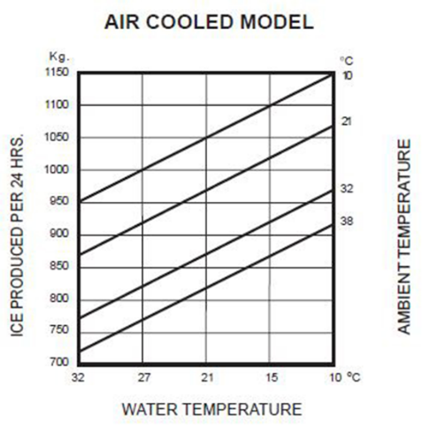

Table 3 illustrates the relationship between rating point and capacity for 129 models on the Australian market for which data are available at two or more rating points. For example, 19 of the 129 models gave data at 10/10 as well as 32/21, 57 models gave data at 21/10 and so on. On average, output at 10/10 is 43% higher than output at 32/21, and output at 21/15 (the most commonly headlined rating point) is 25% higher than at 32/21. Information about how energy varies with rating point use is even harder to find. Only a minority of the 129 models quoted energy consumption (in kWh/100kg), and then only at the single rating point of 32/21.[22]

Table 3 Ratio of output capacity of ice makers at various rating points, compared with 32/21

|  |  |  |  |  |  |  |  |
| --- | --- | --- | --- | --- | --- | --- | --- |
|  | 10/10 | 21/10 | 21/15 | 21/21 | 32/21 | 32/32 | 38/21 |
| Number of data points available | 19 | 57 | 74 | 15 | 129 | 52 | 12 |
| Ratio of output compared with 32/21 | 1.43 | 1.25 | 1.25 | 1.14 | 1.00 | 0.88 | 0.91 |

Each rating point is a combination of ambient air temp/inlet water temp (°C)

Previous Australian Investigation

In 2004 the then Australian Greenhouse Office commissioned an analysis of the potential for minimum energy performance standards for ice maker and ice storage bins, for the National Appliance and Equipment Energy Efficiency Program (NAEEEP). It pre-dated the adoption of ice maker MEPS in the USA. The NAEEEP accepted the findings of the analysis and published the following proposals in October 2004:

* “minimum energy performance standards (MEPS) should be implemented for commercial ice makers with an ice harvest rate up to 2,500 kg/24hrs, applying to all new products sold from October 2006;
* ice maker MEPS should be equivalent to those due for implementation in California from 1/1/2006…
* factory-made ice storage bins should also be regulated for heat loss by MEPS…
* potable water consumption of ice makers should not exceed 22.5 litres/10 kg ice (27 gals/100 lbs), but no limits should be set for condenser water consumption;
* high efficiency levels should be set for promoting the best performing ice makers…and consideration should be given to establishing a similar high efficiency category for ice storage bins once further data becomes available;
* An additional requirement for high efficiency products should be that potable water consumption will not exceed 12 litres/10 kg ice (15 gals/100 lbs) for all ice makers;
* MEPS and high efficiency levels should be published in a new Australian Standard based on the ARI 810 and ARI 820 test methods. Once published, the Australian test methods should be proposed as the new ISO international test methods.” (NAEEEP 2004)

An Australian/New Zealand Standard was developed with the active participation of industry representatives and published in 2008. However, the other recommendations were not progressed, and the project lapsed.

## The Ice Maker Market

Global supply chains

Information on the market was obtained from a range of sources, including import statistics, company and brand websites and interviews with 15 Australian and New Zealand companies that between them supply over 90% of the commercial ice maker market. A list of interviews is included in Appendix A.

The great majority of ice makers sold in Australia and all the ice makers sold in New Zealand are imported. The one company still manufacturing commercial ice makers in Australia (Stuart) also imports a number of models to supplement its locally made range.

The ice maker industry is dominated by global brands including Scotsman and Manitowoc (originally based in the USA), Hoshizaki (Japan), Brema, Simag, Icematic and Ice-o-matic (Italy) and ITV (Spain). These companies have expanded their manufacturing to Mexico, Britain and China. Some supply models for rebadging by local importers, while also selling under their own brands. Many imports from China are sold under the major brand names, although there are China-only brands such as Blizzard, Polar, Devanti and Linkrich. In some cases, variants of the same model may be made in different company-owned factories, depending on the market for which they are intended.[23] Some importers have supply contracts for the same model with a number of different Chinese factories.

At a higher level of aggregation, the Italian Ali Group owns a large number of global commercial cooking equipment and refrigeration brands, including the ice maker brands Scotsman, Icematic, Ice-o-matic, Simag and Kold-Draft, which together account for about a third of the Australia and New Zealand market.

The Australian Market

The Australian market for commercial ice makers (units with water supply and drainage connections, with production capacity up to 1,000 kg/24 hr at 32/21) is currently about 9,800 to10,000 units per year. According to industry sources, the typical service life of each unit is 7 to 10 years. Combined with the import data, this indicates an estimated total stock of about 60,000 units. Appendix C details the modelling assumptions, including the relationship between Declared Customs Value (DCV) and the category of ice maker (industrial, commercial, and home use).

The imports of commercial ice makers increased at an average of 5% per annum between 2016 and 2020, with dips in some years. Figure 5 indicates the country of origin and average DCV. Over the five-year period about half of imports came from Europe, a third from China and the rest from North America. However, the Europe share is falling, while the China and North America shares are growing. The rising average DCV suggest that growth in imports from China has not lowered average prices overall (as has been the case for many manufactured products). Most come from facilities operated by (or contracted to) the established global brands. However, there is a growing market niche for low-price “commercial” products from China.

Figure 5 Imports of commercial ice makers by country of origin

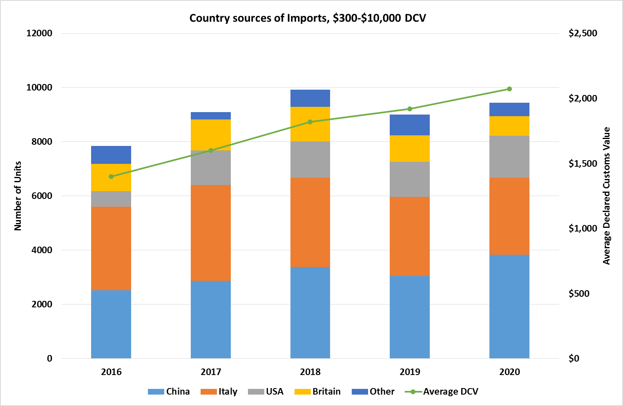

The ice maker supply chain within Australia comprises 4 main groups:

* The importing companies, which tend to be established firms with long-standing ties to particular brands, although brand links have shifted over time due to corporate acquisitions. This group of companies sells to end users as well as to commercial refrigeration distributors
* Commercial refrigeration specialists, which retail a range of ice maker brands supplied by the major importers, and who may import some product themselves
* Commercial kitchen equipment companies, which import a limited range of lesser-known ice maker brands from China, but may also carry one or two major brands
* General on-line retailers, which mainly sell manual-fill residential ice makers but also offer a few low-price “commercial” models, which they import from China.

In addition, there are a few niche imports by companies for their own operations (not for retail) and those with contracts for complete equipment fit-outs with global quick service restaurant brands.

According to industry sources, the largest state markets are NSW, due to population, and Queensland, due to climate, the mining industry and also its widely dispersed population and long transport distances, which makes it riskier for users to rely on the distribution of bagged ice. WA and Victoria are roughly equal markets despite the difference in population, due to WA’s climate and the demand from the mining sector. Sales in the other states and territories are much lower.

The New Zealand Market

It is estimated that the New Zealand market is about a sixth the size of Australia’s (for about a fifth the population). This equates to 1500 to 1700 units per year, and national stock of about 10,000 commercial ice makers.

The same international brands dominate the market as in Australia. The products are mostly imported direct to New Zealand from the country of manufacture, although some Australian companies ship to New Zealand as well.

The commercial catering supplier Southern Hospitality imports Scotsman brand ice makers from China and Italy. Other leading brands in New Zealand are:

* Hoshizaki (imported by Steelfort)
* Manitowoc (imported by Reward Hospitality, formerly Burns & Ferrall)
* ITV (imported by Skope)
* Icematic (imported by Moffatt)
* Brema (imported by Honar)
* Icepro (imported by Icetec).

Eurotec New Zealand imports the German brands Funk, Maja and Ziegra for the fishing industry, food production and industrial applications, although many of the models would meet the criteria for commercial ice makers. Other brands available in New Zealand are Icesta (from China) and Maxx (from USA).

As in Australia, the primary importers supply to other distributors as well. In November 2022 Southern Hospitality was acquired by the private equity firm ECF Asia Pacific, which incorporates Reward Hospitality. This brings the Scotsman and Manitowoc brands under common corporate ownership in New Zealand.

Energy efficiency in the purchase decision

Ice maker buyers fall into several categories. Some purchases are made on the advice of kitchen or building designers, who may research the available performance data or alternatively choose to ignore it, as they will not be bearing the running costs. Sales to global brand quick service restaurants or national brand supermarkets are usually limited to a pre-approved list of models compiled by their in-house specification teams. The majority of purchases, however, are by end users and business owners.

Ice maker suppliers were asked about the extent to which running cost influenced the purchase decisions of these groups. They indicated that they rarely received inquiries about running cost, let alone requests for data about energy- or water-efficiency. They indicated that the main factors which purchasers consider are, in rough order of priority:

1. Ice type
2. Physical size constraints (e.g. whether the ice maker is to be located under a counter, or if replacing a previous unit whether it will fit into the space)
3. Output capacity – cheaper models are marketed on the “headline” capacity, without mentioning the rating point at all, while some suppliers try to explain that higher temperature rating points are a better indication of performance
4. Configuration: higher ice demand can only be met by modular units, and if the ice maker is to be installed in an unventilated room, or noise is a problem, remote condensing units are required
5. Capital cost per output capacity
6. Warranty (or brand reputation – more important for professional and repeat buyers).

In 2020 DPE commissioned a survey of businesses owning commercial cooking equipment, to assess how they acquired equipment and their purchase priorities. Of the respondents, 30 owned ice makers. When asked to rank purchase criteria (relating to all the equipment they owned, not specific types) respondents nominated the following order:

1. Operational fit (not defined, but probably encompassing factors 1 to 4 above)
2. Purchase price (corresponding to factor 5 above)
3. Running cost
4. Availability
5. Visual appearance.

In the event of an emergency replacement, “Availability” and “Running Cost” changed order.

The buyer survey confirms the suppliers’ assessment that running costs and efficiency are low priorities for ice maker purchasers. Indifference to running costs would be rational behaviour if these costs represented a minor component of lifetime ownership costs. However, this is not the case. Figure 6 illustrates the average

capital and lifetime energy and water costs, based on sales-weighted average output capacity and daily ice production. For air-cooled self-contained units (the most common type sold), energy and water costs represent about two thirds of lifetime costs. For air-cooled modular units (the second most common type) energy and water costs represent 83 to 85% of lifetime operating costs.

For water-cooled types, adding the costs of condensing water, if purchased at potable water prices and used once-through without re-circulation, would increase operating costs to over 90% of lifetime costs. There would be a reduction in energy cost, but this would be outweighed by cooling water costs. If, however the cooling water were free and/or could be recirculated, the savings in energy costs for the same output capacity would be significant.

Figure 6 Estimated lifetime capital and operating costs for icemakers

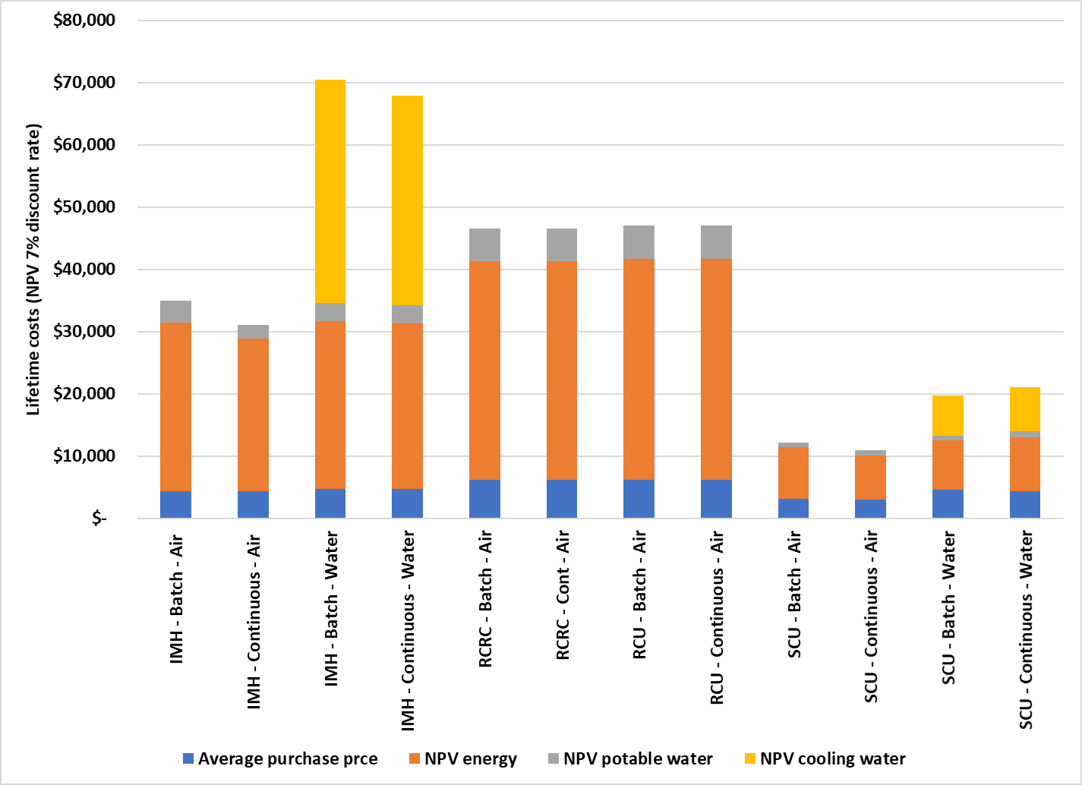

Source: Table 16 (Appendix C)

As Table 2 indicates, there is a significant range in the energy efficiency of models on the market. Given that running costs dominate lifetime ownership costs, purchasing a more energy-efficient model, even at a premium in capital cost, would in almost all cases be to the financial advantage of the buyer.

This finding is consistent with the 2004 analysis of the Australian ice maker market, which observed that:

Such a situation, where customers are unwilling to invest in activities which would result in clear financial benefits is usually taken to be evidence of market failure, and justification for Government action such as regulation (NAEEEC 2004, 18).

Even buyers interested in evaluating and comparing the efficiency of ice maker models would find the task almost impossible given the inaccessibility of reliable information. Nearly two-thirds of survey respondents said they wanted more information about commercial equipment running costs and 90% favoured government action to make that information available (Table 4). Over two-thirds also expressed a preference for MEPS.

Table 4 Survey responses from business owning commercial kitchen equipment, including ice makers

|  |  |
| --- | --- |
| **Q: Can you get information that explains the running costs (electricity and gas costs) of equipment you are considering, when making the purchase?** | |
| No, and I would like that information | 35% |
| Yes, but I would like more information | 27% |
| Yes, I have all the information I need | 35% |
| No, but I don't want that information | 3% |
| Total indicating desire for more information | 62% |
| **Q: Preferred Government Action** | |
| Minimum Energy Performance Standard (MEPS) | 10% |
| Energy information (Labelling) | 31% |
| MEPS and Energy Labelling | 59% |
| No Government intervention | 0% |
| Total that would be satisfied with government action for MEPS | 69% |
| Total that would be satisfied with government action for labelling | 90% |

Source: 2020 survey commissioned by DPE. Responses from ice maker owners (n=30).

1. The Problem and Options to Address It

## The Problem

Commercial ice makers consume significant quantities of electricity – about 380 GWh per annum in Australia, more than the entire residential clothes dryer stock, for example (340 GWh).[24] Product energy-efficiency varies widely (see Table 2) and purchasers could make substantial lifetime savings if they compared the energy efficiency of alternative models and selected the more efficient models on offer. However, they do not, because:

* Information about energy performance is difficult to access
* Where information is provided, it is in a form that makes comparisons across models very difficult (e.g. suppliers usually select rating points that show their own model in the best light)
* As a group, purchasers are relatively uninterested in operating costs, even though these make up at least two thirds of time-discounted lifetime ownership costs (Table 16).

There is evidence of several categories of market failure:

* Information asymmetry
* Negative externalities
* Irrational market behaviour, or ‘bounded rationality’[25]

As a consequence, the users of ice makers are significantly worse off financially than if they had been aware and responded to information about energy efficiency. At the level of the economy, this also results in an inefficient allocation of resources and higher negative externalities, in particular the emissions of greenhouse gases and other pollutants related to the production of electricity.

This finding is consistent with the 2004 study of the ice maker market, which observed that:

Such a situation, where customers are unwilling to invest in activities which would result in clear financial benefits is usually taken to be evidence of market failure, and justification for Government action such as regulation. (NAEEEC 2004, 18).

The 2004 study concluded:

…it is feasible that ice maker energy consumption can be reduced by 15 – 20% with a 2 – 3 year payback. However there seems to be little market interest in or knowledge of these potential savings.

Given this lack of market incentive to improve product efficiency, and the significant growth rate predicted for ice makers and storage bins in Australia, NAEEEC considers the introduction of efficiency standards for ice makers a priority. (NAEEEP, 2004, 2)

The following sections consider a range of options to address the problem and their likelihood of success.

## Options Considered

No intervention

There has been, and will continue to be, a gradual increase in the average energy efficiency of ice makers on the Australian and New Zealand markets. This is because most units are designed and manufactured for markets where there are more drivers for increasing energy efficiency.

The North American market is subject to MEPS. Although the levels have not increased since 2013, the additional measure of Energy Star certification has led to the introduction of some models that are significantly more efficient than the MEPS level. While 230V/50Hz variants are not eligible for formal certification to Energy Star, some of the design changes could find their way into 230V/50Hz variants.

The European ice maker market is not subject to MEPS for the time being. However, energy-efficient innovations such as electronic controls and R290 refrigeration are being adopted by a number of suppliers, and some of these should find their way to the Australian and New Zealand markets, given similar voltage and frequency standards. Conversely, the apparent lack of interest in energy efficiency in Australia may provide a continuing market for the older, less-efficient models.

These trends would apply to products manufactured by mainstream ice maker suppliers in China as well, but probably not to the low-cost models from lesser-known manufacturers that are gaining market share, which are marketed primarily on their low cost per (claimed) output capacity. There is little reliable data on any aspects of their performance, but the available information indicates that their energy efficiency is likely to be low.

In the absence of external intervention in the market, the resultant of these trends – some towards greater and some to lesser energy efficiency – is projected to be a gradual improvement in energy efficiency. This is quantified in Appendix C, as the Business as Usual (BAU) case against which projected impacts are measured.

Non-regulatory measures

Information about the energy efficiency of ice makers is both inconsistent and difficult to access. Are there ways to make it more accessible without regulation? To achieve this, suppliers would need to agree to a common approach to testing and to disclosing the information on websites and in product documentation, preferably in a uniform format.

The few examples of voluntary standardisation of energy performance information have involved leadership by a strong industry association, an energy utility or both. In the 1980s, for example, the Australian Gas Association (AGA) was able to introduce gas appliance energy labelling without regulation, but there were special circumstances which no longer exist:

* The gas utilities were able to set conditions of connection specifying that appliances connected to the gas network had to be installed by licenced gasfitters and had to comply with published gas product standards, which included energy labelling requirements
* The AGA had near universal coverage of the gas equipment industry, through its affiliate Gas Appliance Manufacturers Association of Australia (GAMAA), so there was a forum for all suppliers to negotiate the tests and label formats
* Mandatory energy labelling for electric appliances had just been introduced, and the gas industry was aware that governments could act if the industry did not.

These conditions do not apply in the case of ice makers. Electricity utilities cannot set conditions of connection for plug loads (as nearly all commercial size ice makers are) and few powers even in the case of three-phase fixed wired equipment. Where conditions can be set, they are limited to either electrical safety or protecting the network, not product performance.

There is a Trans-Tasman industry association, the National Association of Food Equipment Suppliers (NAFES), and its membership includes five of the 15 main ice maker suppliers, accounting for about 40% of sales. Even if these firms could be persuaded by government, via their industry association, to adopt voluntary standardisation of information, the majority of sales would not be covered. This would place the participating firms at a disadvantage, because the others would be free to market products on the basis of the most commercially advantageous information – claiming the highest possible ice production capacity without disclosing the rating conditions, and remaining silent on energy efficiency, as is the case at present.

The E3 Program has had experience with a Voluntary Energy Rating Label Program (VERLP) for swimming pool pump-units. Suppliers were invited to voluntarily test products to AS/NZS 5102, register them on energyrating.gov.au and disclose their performance on a standard energy label. When the program began in April 2010 it was announced as a transitional step to mandatory MEPS and labelling. A Decision RIS in 2018 observed that:

Most pool pumps are not registered under the VERLP. Typically, more energy efficient pumps are labelled, leaving around 70 per cent without a label. Limited registration of products is a common feature of voluntary labelling or rating schemes, both in Australia and overseas.[26] Due to the partial coverage of pumps on the market, the consumer benefits of the labelling scheme are limited (E3 2018, p18/27).

Sustained, near-universal coverage by either physical labelling or consistent data disclosure would be necessary to sensitise buyers to the value of selecting more energy-efficient ice makers. Without this, the market would continue to ‘behave irrationally’ and discount running costs, even though these make up the majority of lifetime ownership costs.

There is no indication that a voluntary program to standardise testing and disclosure of performance information for ice makers would be any more successful than it has been for other products. The industry association covers only a minority of the commercial ice maker market, and even if those firms could be persuaded to participate, there is a high risk that non-participants would ignore or undermine the scheme.

On the basis of these precedents, efforts to implement a voluntary information program would be ineffective and would only delay the need to consider other options to address the problem.

Mandatory disclosure of information

The likely mode of implementation in Australia would be a GEMS determination, and in New Zealand a regulation using the EEC Act 2000 Energy Efficiency (Energy Using Products) Regulations 2002.

Measures would set requirements to:

* have each model tested to a prescribed standard (e.g. AS/NZS 4865 or similar)
* register the key performance data (ice production (kg/24 hrs) and energy efficiency (kWh/kg ice) under standard conditions)
* disclose the standardised performance data when making performance claims for that model.

This would place compliance obligations on all suppliers of commercial ice makers and also on the regulators, who would need to resource a monitoring, check testing and compliance effort to ensure the effectiveness of the scheme. The GEMS Regulator and EECA routinely manage these issues for other products.

A mandatory disclosure requirement would be more effective in ensuring that performance data were available for all models, including the less efficient ones. However, there would still be barriers to bringing this information to bear at the purchaser’s point of decision.

The key objectives of an energy information disclosure system are:

1. to encourage prospective purchasers to take energy consumption and efficiency into consideration in the product selection process
2. to indicate that there is a range in energy efficiency for products of this type
3. to locate the specific model along that range (notionally, if not precisely)
4. to facilitate the calculation of operating costs, so the purchaser can consider them alongside the purchase price in making an informed decision.

On-product energy labelling can achieve these objectives in cases where purchasers view products in showrooms prior to their final decision (even if they do preliminary research online), because appearance and “feel” are important attributes. Household appliance showrooms display different brands and models next to each other, so facilitating label comparison. The star rating design of the label gives a visual indication of where the model sits along the scale of energy efficiency, and the kWh values are there to facilitate running cost calculations. The label also provides a link to the [www.energyrating.gov.au](http://www.energyrating.gov.au) website, which automates the calculation process and can make the purchaser aware of even more models that may be suitable.

Unlike household appliances however, commercial products are rarely selected on the basis of a visit to a showroom where several brands are displayed side by side. Therefore, the scope for physical energy labels is limited, and other channels for information disclosure, and indeed other measures, may need to be considered. For commercial equipment, MEPS has been the main market intervention measure, and information disclosure has played a supplementary role.

The simplest way to disseminate energy-related information for each model is to publish it on the [www.energyrating.gov.au](http://www.energyrating.gov.au) website, without requiring on-product labels. This is currently the case with several non-residential products including electric motors, transformers and commercial refrigeration cabinets, all of which are subject to MEPS.

Another approach is to permit optional on-product labelling, but within standardised parameters. This is currently the case for the larger capacity air conditioners covered by GEMS. They must meet MEPS but labelling is not mandatory for air conditioners above 30 kW. If they are labelled however, the standard format must be used.

Minimum Energy Performance Standards (MEPS)

This option involves regulating MEPS levels for all commercial ice makers supplied in Australia and New Zealand. It would apply to all imports (whether offered for sale or for a firm’s own use) as well locally made products.[27] The likely mode of implementation in Australia would be a GEMS determination, and in New Zealand a regulation using the Energy Efficiency (Energy Using Products) Regulations 2002.

The natural limitations on the market impacts of mandatory disclosure for commercial products make it difficult to fully address the general indifference of ice maker buyers to energy efficiency and running cost through information disclosure alone. Many segments of the market would continue to operate with bounded rationality and others would remain subject to split incentives, because immediate purchasers (e.g. kitchen fit-out services) would not be motivated to take running costs into account even if they were fully informed about them. MEPS would remove the least efficient products from the market, irrespective of the level of buyer engagement. Depending on the level of MEPS, there would still be scope for engaged buyers to identify and prefer more efficient models.

Review of Options

Table 5 summarises the likely effectiveness of the options considered in relation to the problem: that without market intervention, users of ice makers are significantly worse off financially and there is an inefficient allocation of economic resources and higher negative externalities, in particular the emissions of greenhouse gases related to the production of electricity.

In the BAU case there would be no rectification of market failures, but a very small improvement in energy efficiency, and hence a fall in negative externalities, due to ongoing technological change. Voluntary agreement on disclosing product information on a consistent basis across all models would have little chance of successful implementation and would be only slightly more effective than BAU.

Mandatory disclosure of product information would be more effective, but subject to limitations due to the way that commercial equipment is purchased. MEPS would be effective because it addresses all categories of market failure: purchasers cannot ignore or avoid buying more efficient products once the less efficient are excluded from the market.

The most effective option is a combination of MEPS and mandatory information disclosure. Once the basis for MEPS is established – testing to a standard and reporting the data to a regulator – the marginal cost of disclosing performance information on a website is very low. Once information about the efficiency range of the entire post-MEPS market becomes available it will be possible to devise more effective ways of disseminating it. The options would include mandatory inclusion of standardised data in ice maker brochures and online advertising and perhaps forms of physical labelling.

Even without physical labelling, a publicly accessible register of standardised data would help prevent misleading information (e.g. advertising a higher production capacity than the value on the register) and would give a commercial advantage to the more efficient models: there will still be a range of energy efficiencies even with MEPS.

The testing and registration obligations on suppliers would be the same as for mandatory standardisation and disclosure of information (see above), with the additional proviso that products less energy-efficient than the prescribed cut-off level could not be registered and so would be excluded from the market. In practice a MEPS requirement could coexist with mandatory standardisation and disclosure of information because the information would need to be obtained and disclosed to the regulator in any case to demonstrate compliance with MEPS. Therefore, the additional costs of information disclosure would be negligible, and the potential benefits significant.

The combination of MEPS and a form of information disclosure was the option recommended in NAEEEP (2004). It remains the most effective option, for the reasons stated above. It is also the option favoured by ice maker purchasers themselves (see Table 4). The question remains what level of MEPS would be the most effective and cost-effective. This is considered in the following chapter.

Table 5 Impact of options considered on market failures affecting commercial ice makers

|  |  |  |  |  |  |
| --- | --- | --- | --- | --- | --- |
| Type of market failure | BAU | Voluntary information disclosure | Mandatory information disclosure | MEPS alone | MEPS + disclosure/ labelling |
| Information asymmetry | None | Very low | Moderate | Low | Moderate |
| Split incentives | None | None | None | High | High |
| Bounded rationality | None | None | None | High | High |
| Negative externalities | Very low | Low | Moderate | High | High |

1. Projected Costs, Benefits and Impacts

## MEPS & HEPS levels considered

The preceding chapter indicates that a combination of MEPS and mandatory disclosure of information would be the most effective strategy to address the key problems affecting the commercial ice maker market. This raises the question of how a MEPS level might be set.

There are four relevant MEPS levels in the public domain:

1. The MEPS levels in AS/NZS 4865:2008 Part 3
2. The HEPS level in AS/NZS 4865:2008 Part 3
3. The USDOE MEPS levels
4. The US EPA Energy Star levels (which are effectively HEPS levels based on the USDOE MEPS).

There are also certification levels adopted by other entities, such as the Consortium for Energy Efficiency[28] but these are little known outside the USA and Canada.

The four MEPS schemes above all assign a maximum allowable energy consumption value (in kWh/100kg ice) to units depending on the production capacity (in kg/24hrs) as determined on a standard test. The test referenced in AS/NZS 4865 Part 3 is Part 1 of the same standard. The tests referenced by the USDOE and Energy Star are the physical tests in ANSI/ASHRAE 29 combined with the rating rules in ANSI/AHRI 810.

The standards and MEPS rules classify ice makers in different ways according to their production capacity range, configuration (self-contained, modular or split), cooling medium (air or water) and the method of ice production (batch or continuous). This results in 26 product categories, as detailed in Table 1. All four schemes apply different formulae according to production capacity and cooling medium. USDOE and Energy Star further distinguish units by method of ice production, but AS/NZS 4865 does not.

Figure 7 compares the MEPS and HEPS levels for self-contained air-cooled models. The lines are produced from the formulae in Appendix B. The AS/NZS 4865 MEPS level is the least stringent (the top solid line), then the AS/NZS 4865 HEPS level. The USDOE MEPS level is significantly more stringent, and the Energy Star certification level (the bottom solid line) is the most demanding of all. This order of stringency applies to all configurations except for air-cooled batch production modular units (categories 3 and 4 in Table 1), where the AS/NZS 4865 HEPS levels are more stringent than the US DOE MEPS levels. Therefore, an additional MEPS scenario (numbered 3a) involves adopting US DOE MEPS levels except for those product categories where the AS/NZS HEPS levels are already more stringent.

USDOE and Energy Star further distinguish by method of ice production: the lower dotted lines indicate that greater energy efficiency is required for models with continuous ice production than batch models. AS/NZS 4865 does not distinguish, so the same MEPS and HEPS lines apply to both types.

Ice makers, like other electrical equipment, need a certain minimum energy consumption to function, so they appear to become more energy-efficient as their production capacity increases. Therefore, models with production capacities below 100 kg/24hrs are permitted higher kWh/100kg limit values than larger units.

In all four schemes, water-cooled models are required to use less energy than air-cooled models of the same configuration and production capacity. Figure 8 illustrates this for modular ice makers in relation to AS/NZS 4865. The upper set of solid and dashed lines indicate the MEPS limits for air- and water-cooled models respectively, and the lower pair the HEPS limits. The diagram also plots the energy consumption and production capacity values for those modular units on the Australian market for which data at the 32/21 rating point are available. This indicates that relatively few of these models would fail MEPS, but a significant number would fail HEPS.

Complete performance data (production and energy use at 32/21) are only available for about half the models on Australian market. The data are based almost entirely on US tests on 115V/60Hz variants, and it is possible that 230V/50Hz variants are slightly less efficient. Also, it is likely that the models for which performance data are unavailable are significantly less efficient than the tested cohort. Therefore, a large share of that half would probably fail AS/NZS 4865 MEPS and an even greater share would fail HEPS.

Figure 9 illustrates the differences between the energy efficiency of selected Energy Star certified modular ice makers and those of similar configuration (batch, air-cooled) available in Australia and New Zealand. The ES-certified models are all, by definition, more efficient than the ES line (the bottom solid line). The local models span a wide efficiency range, from below the AS/NZS 4865 MEPS level to, apparently, much more efficient than the ES level in a few cases – casting further doubt on the accuracy of the available data.

However, all four MEPS and HEPS options appear to be practical options. The following sections examine and compare the projected costs, benefits and risks of adopting each.

Figure 7 Comparison of MEPS and HEPS levels

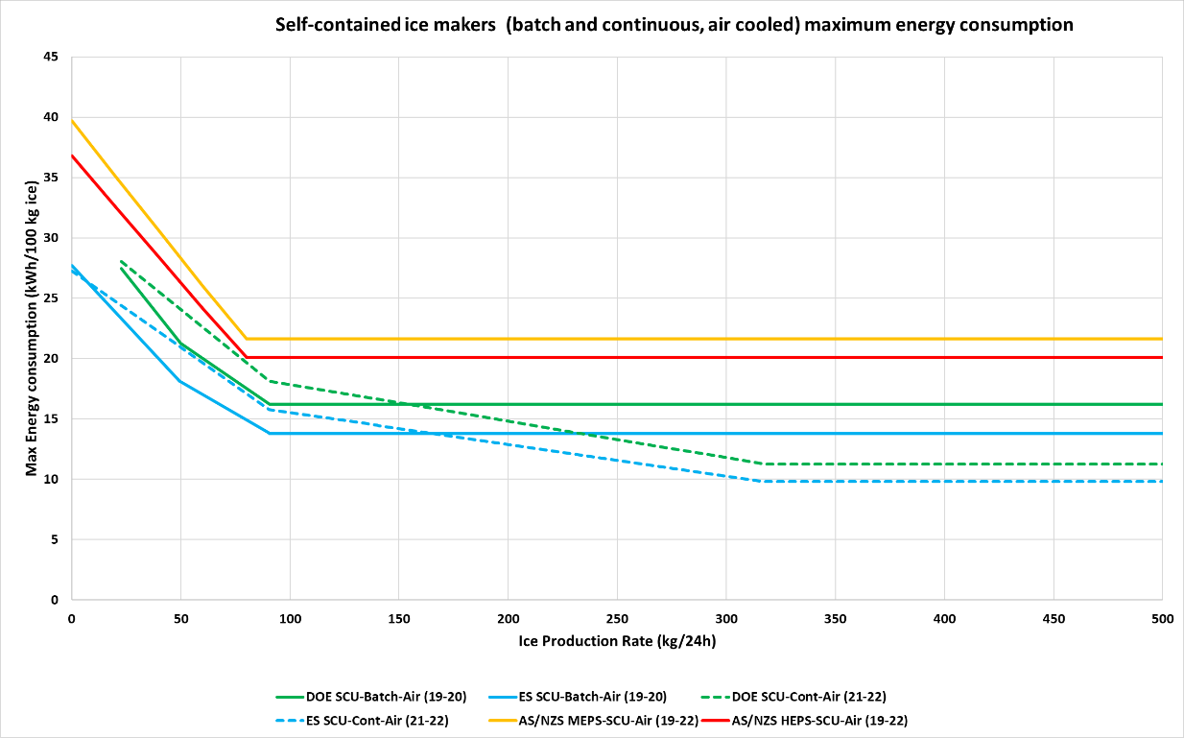

Figure 8 Performance of selected models on the Australian market in relation to AS/NZS 4865 MEPS and HEPS

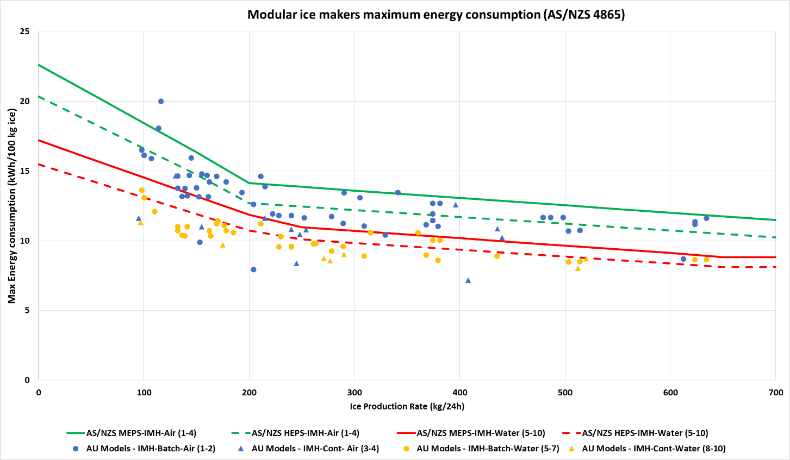

Figure 9 Performance of selected models on the Australian market in relation to AS/NZS 4865, USDOE and ES MEPS and HEPS

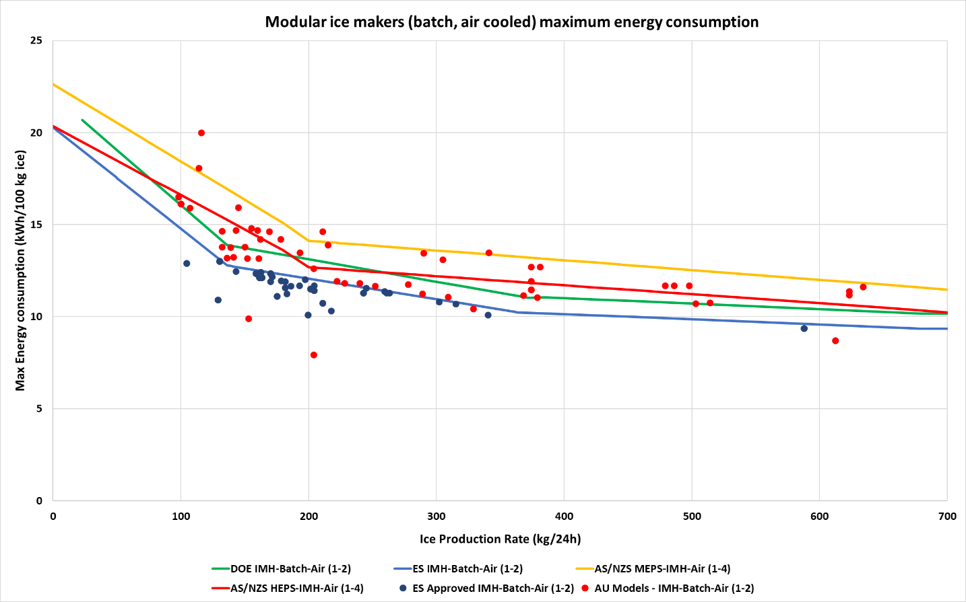

### Deciding on the optimum approach

There are several factors bearing on which of the four available MEPS/HEPS levels represents the best policy option. The optimum strategy may also involve a planned transition from less to more stringent levels. The main decision factors are:

* The quantum of projected energy savings compared with BAU, and the reduction in greenhouse gas emissions
* Benefits: the value of the projected energy, peak demand and emission savings
* Costs: testing, administration and any increases in the cost of the products
* Net benefits (benefits less costs) and Benefit/Cost (B/C) ratios
* Market impacts, in terms of limitation on consumer choice and any reductions in competition
* Risk: how sensitive are the conclusion in relation to uncertainty and imperfect information?

These factors are analysed in the following sections. In general, the option with the highest net benefit is preferable, but this should take into account non-quantifiable as well as quantified costs and benefits. [29]

### Modelling Assumptions

The cost-benefit modelling takes into account the capital costs and lifetime operating costs of all the commercial ice makers that are expected to be purchased in Australia and New Zealand from 2022 to 2037. The assumptions are detailed in Appendix C.

It is assumed that MEPS levels are announced at the end of 2023 and take effect at the end of 2024; i.e. a lead time of about two years from the date of this Consultation RIS. The primary benefit is the net present (NPV) value of the projected energy saved by the operation of more energy-efficient ice makers due to MEPS, as compared with the Business as Usual (BAU) or no-intervention case. This includes the air conditioning energy saved where ice makers are installed in conditioned spaces.

The value of energy saved is calculated at retail prices in Australia, but a long run marginal cost (LRMC) of production in New Zealand, reflecting the different methodologies adopted for assessing E3 program measures in the two countries. The average reduction in electricity demand is calculated from the energy saved and assigned a separate value in New Zealand but not in Australia, since retail prices are assumed to cover all costs of electricity supply including distribution. The greenhouse gas emissions reductions associated with projected energy savings are also estimated and assigned different a monetary value in each country.

The quantified costs comprise:

1. the NPV of the estimated increases in purchase price as a result of the exclusion of less efficient, and presumably less expensive models
2. the NPV of testing costs borne by suppliers
3. the NPV of GEMS registration fees borne by suppliers registering products in Australia (there are no fees to register products in New Zealand)
4. the NPV of the share of Australian administrative costs that exceeds income from registration fees (on the assumption that fees recover 80% of the administrative costs)
5. the NPV of New Zealand administrative costs, pro-rated from Australian administrative costs according to number of ice maker sales.

It is assumed that cost components 1, 2 and 3 above are passed on from suppliers to buyers, and components 4 and 5 are borne by taxpayers, as part of the E3 program.

Potential water savings due to MEPS can also be estimated but are not assigned a monetary value. Some of the energy savings will be achieved by better management of water wastage. If less chilled water is run to waste during the ice making process, and less ice melted before it can be used – e.g. due to better cabinet insulation – then the potable water savings would be a cost-free additional benefit of MEPS. However, if, suppliers respond to MEPS by concentrating on the efficiency of the refrigeration cycle alone the water savings would be small.

The US has adopted mandatory minimum water performance standards (MWPS) for ice makers as well as MEPS. Each ice maker model has to meet both criteria. The energy test in AS/NZS 4865.1 also measures water use, so there would be no additional testing costs. However, the GEMS Act does not provide for MWPS to be set in GEMS determinations, so enforcing MWPS in Australia would require a regulation under the Water Efficiency Labelling and Standards (WELS) Act. The New Zealand Energy Efficiency and Conservation Act does not have the scope to regulate water efficiency. Therefore, water savings estimates from potential MWPS for ice makers are excluded from the analysis.

Once an ice maker manufactures the ice it stores it in an insulated bin, within the same cabinet in the case of self-contained units (SCUs) or externally in the case of ice-making heads (IMHs). The bins are made with external and internal metal or plastic liners and a layer of insulation sandwiched between. The thickness and performance of the insulation material determines the rate of heat gain and ice melt, and hence the total volume of ice that needs to be manufactured to meet a given ice demand.

Differences in bin insulation do not show up in the ice maker energy tests in AS/NZS 4865.1. However, both AS/NZS 4865.3 and the USDOE include tests and MEPS for external ice storage bins. It is understood that the GEMS Act as it stands precludes making GEMS determinations for ice storage bins. Therefore, the energy savings estimates from potential MEPS for ice storage bins are excluded from the analysis.

## Projected Benefits

Energy savings

The total energy consumed by new ice makers added to the stock each year depends on their energy-efficiency. Figure 10 and Figure 11 illustrate projected average energy efficiencies for the two largest selling segments of the market: smaller air-cooled batch SCUs and larger air-cooled batch IMHs. The downward slope of the BAU line indicates that energy-efficiency is expected to increase even in the no-intervention case. The other lines indicate the applicable MEPS and HEPS levels. Although each of these remains fixed over time, it is expected that the average capacity of units will increase (see right hand axis), so the MEPS/HEPS levels applicable to the average size of unit sold will fall (i.e. they move to the right along the sloping sections of the graphs in Figure 7).

The line with the downward kink indicates the effect of adopting a mandatory efficiency standard at the end of 2024 (i.e. in the middle of the 2025 financial year). For air-cooled SCUs (Figure 10) adopting the AS/NZS 4865 MEPS levels would have negligible effects on the market average efficiency, because the BAU average efficiency levels are projected to have caught up (although the few models less efficient than MEPS would be excluded). For air-cooled IMHs (Figure 11) the AS/NZS 4865 MEPS levels would have some impact.

Both diagrams illustrate the projected impact of adopting the AS/NZS 4865 HEPS levels. The average kWh/100kg trend line would fall slightly below the target level. Previous experience with adoption of MEPS for other products indicates that the average post-MEPS efficiency of affected products will be about 5% better than the MEPS level. Very few suppliers will bother to introduce (or have access to) models that exactly meet the MEPS level, so the replacement models will be significantly better. Model replacement typically starts in the year before the MEPS legally take effect, because suppliers do not want to be in the position of having to test and register every model at the last minute. Hence the trend to greater efficiency begins in 2024.

Each model configuration has a different starting efficiency and so is affected to a different extent by any given MEPS level. For example, it is projected that the post-implementation efficiency of the group of models covered by Figure 10 is still short of the USDOE MEPS levels, whereas for the group of models covered by Figure 11 it is close to the USDOE MEPS levels.

Figure 10 Projected BAU and post-implementation energy efficiency trends, AS/NZS 4865 HEPS levels, air-cooled SCU

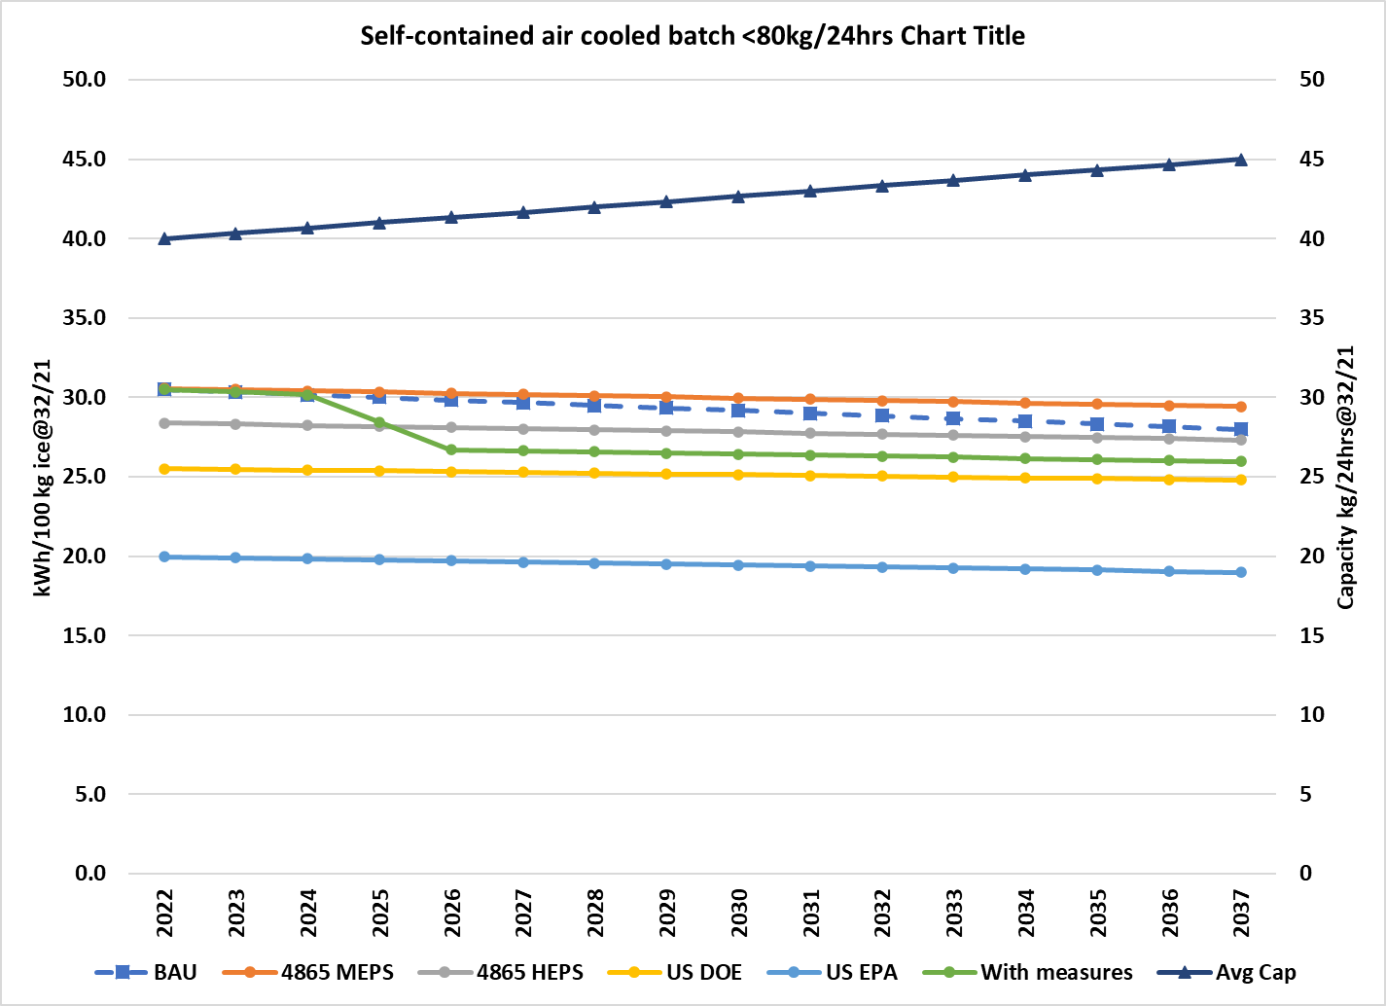

Figure 11 Projected BAU and post-implementation energy efficiency trends, AS/NZS 4865 HEPS levels, air-cooled IMH

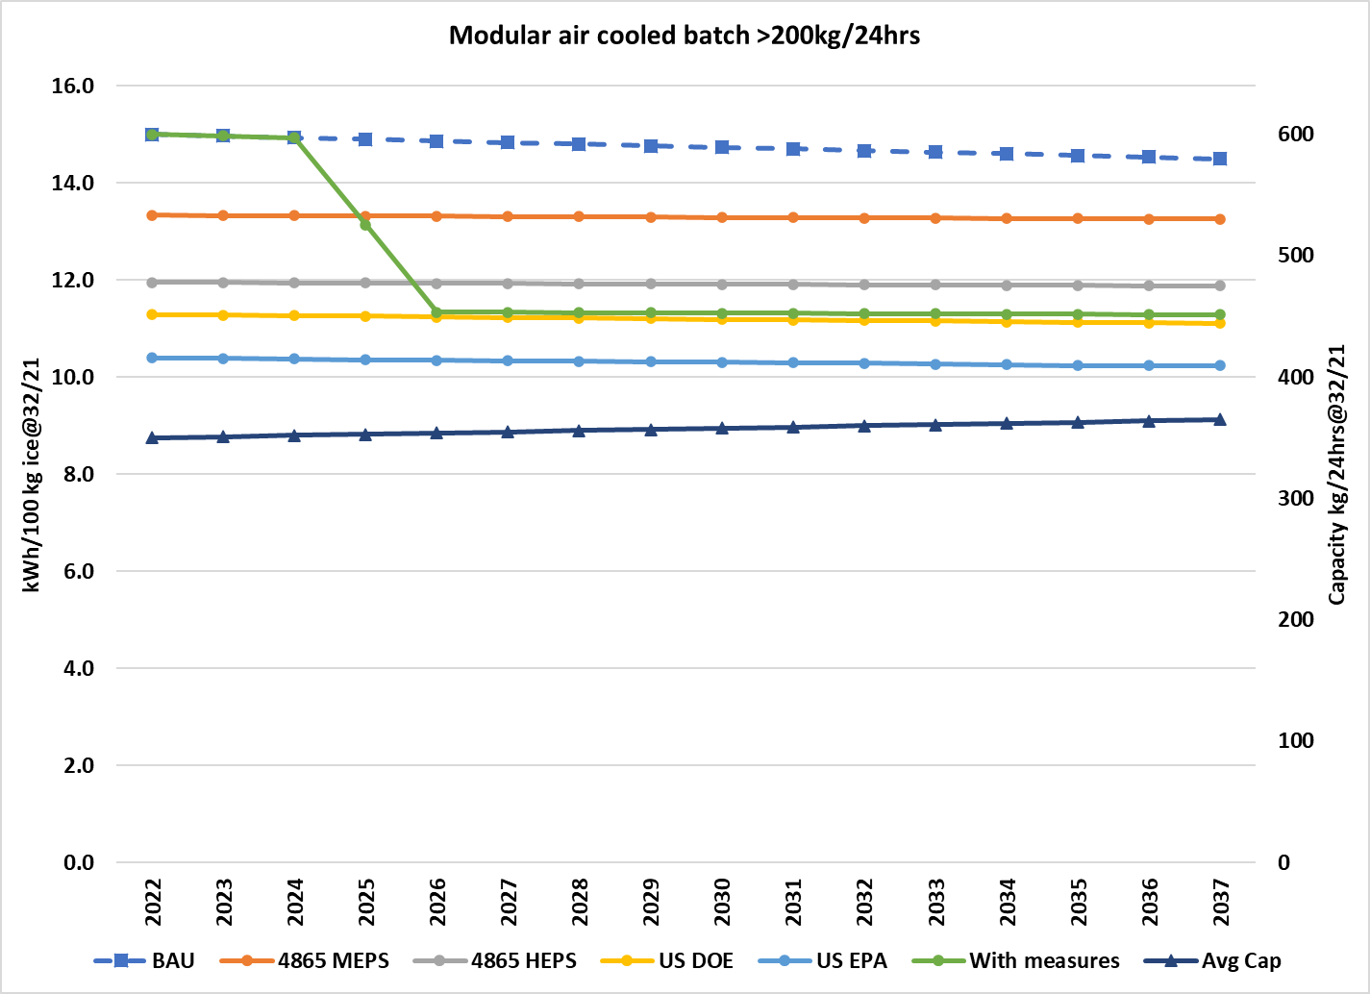

Once the energy-efficiency of new ice makers sold in each year is estimated, it is possible to calculate the total energy use of the entire cohort entering service in that year. Figure 12 indicates the projected electricity consumption by all commercial ice makers expected to be sold in Australia between 2022 and 2037, under BAU (the top line) and the increasingly stringent MEPS options. Figure 13 illustrates the annual energy savings from each MEPS option compared with BAU. Adoption of the HEPS levels in AS/NZS 4865 (option 2) would lead to energy use of commercial ice makers being about 103 GWh less in 2036 than under the no-measures BAU case. Adoption of the US EPA level (option 4) would save about 202 GWh per annum in 2037.

The corresponding savings for New Zealand (Figure 16) under option 2 would be about 14 GWh in 2037 compared with the no-measures BAU case, and adoption of the US EPA level (option 4) would save about 28 GWh per annum in 2037. However, the magnitude of energy savings is only one consideration. The cost of achieving those savings, including the potential impact on the market, also need to be considered.

Cost-benefit analysis does not require modelling of the energy use of the total stock of ice makers, because units installed prior to the introduction of MEPS will not be affected. Figure 12 and   
Figure 15 only cover products purchased in 2022 and later. At first the curve rises as the energy use of each additional year’s cohort is added, but flattens after 2030 as ice makers installed in 2022 and later start to retire.

The total ice maker stock continues to increase with population and economic growth, and BAU energy use rises as illustrated in Figure 14 and Figure 17. Adopting the AS/NZS 4865 HEPS levels would lead to total stock energy being about 20% lower than BAU in 2037, and even lower than the 2022 level. In other words, average energy efficiency would increase even faster than the number of ice makers. Adoption of the Energy Star levels would lower energy use by about 39%.

Figure 12 Projected annual energy consumption, commercial ice makers sold 2022-2037, Australia

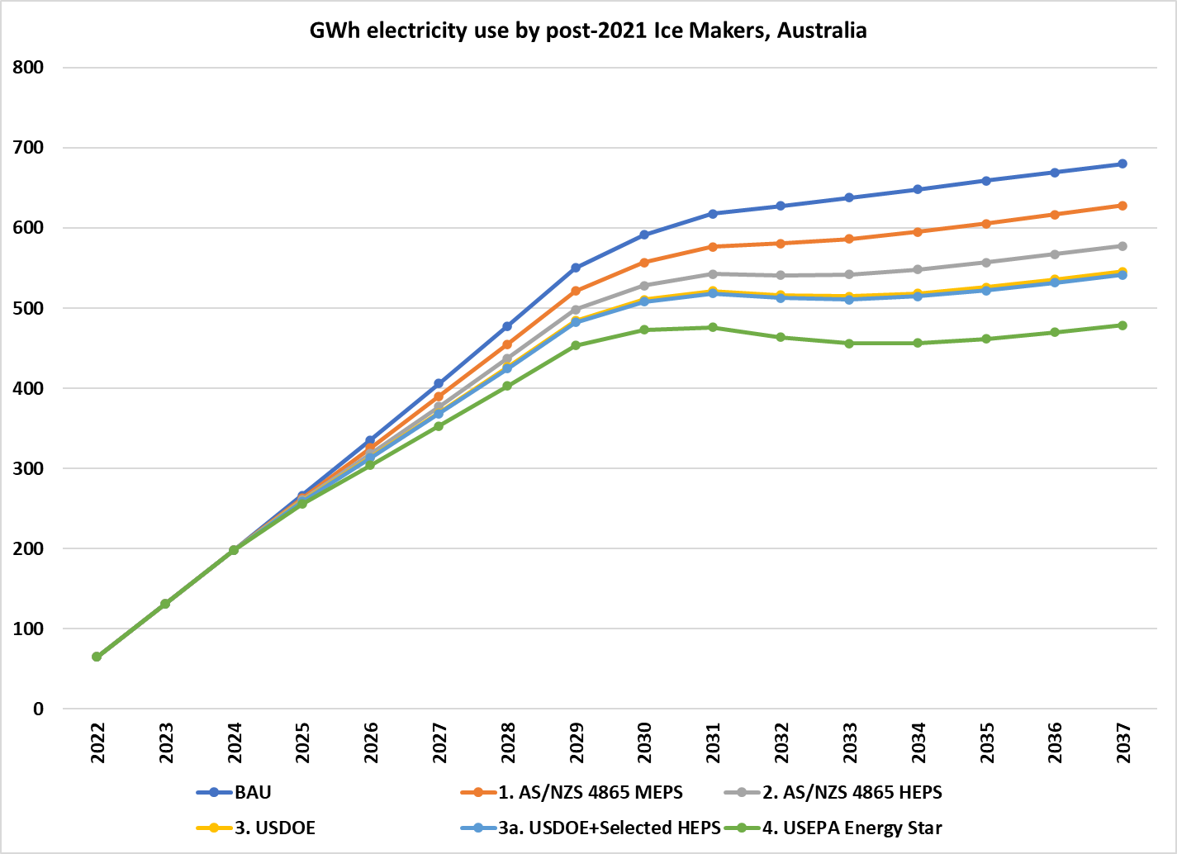

Figure 13 Projected annual energy saving for various MEPS, commercial ice makers sold 2022-2037, Australia

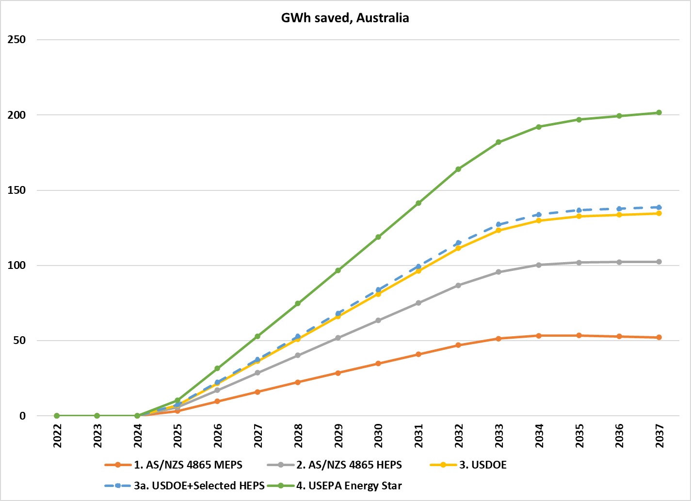

Figure 14 Projected annual energy use of total ice maker stock, Australia, 2022-2037

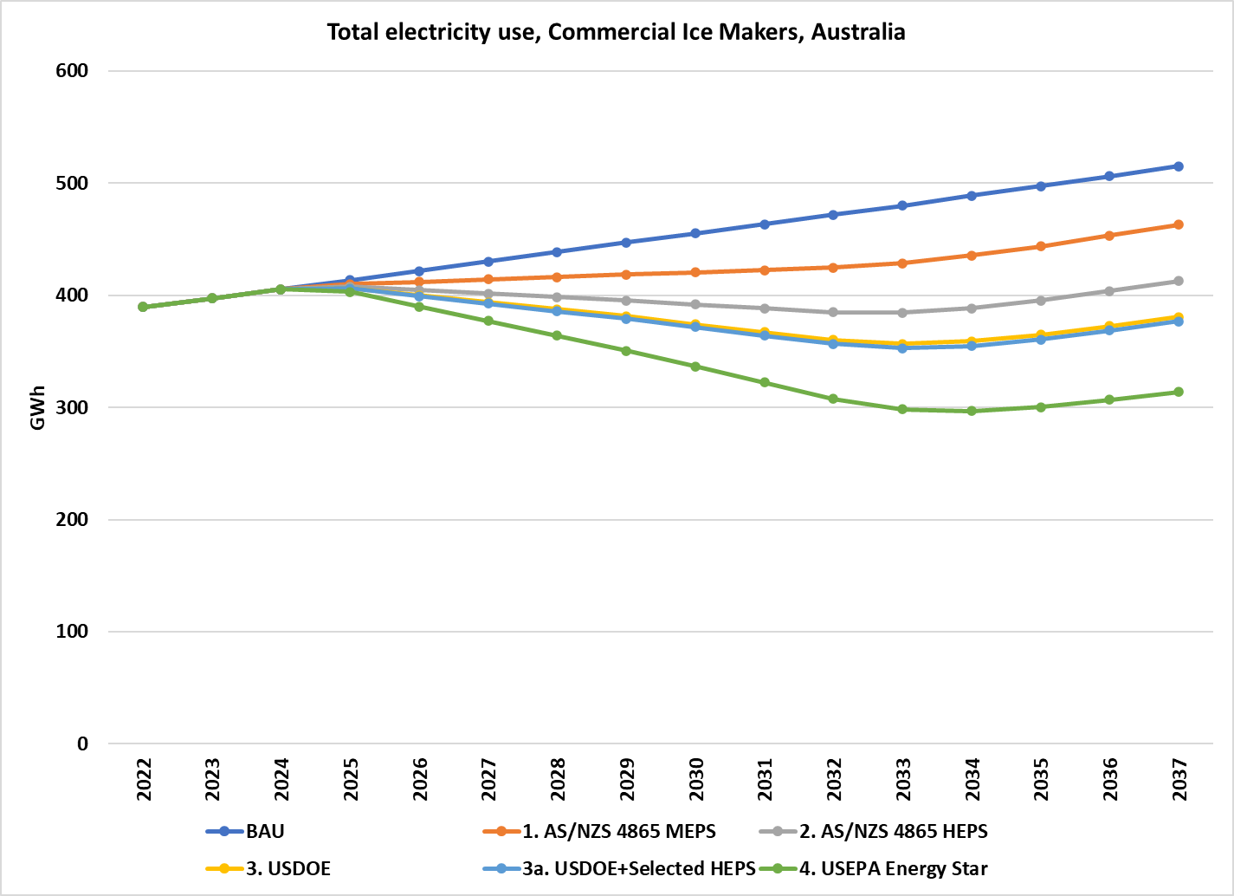

Figure 15 Projected annual energy consumption, commercial ice makers sold 2022-2037, New Zealand

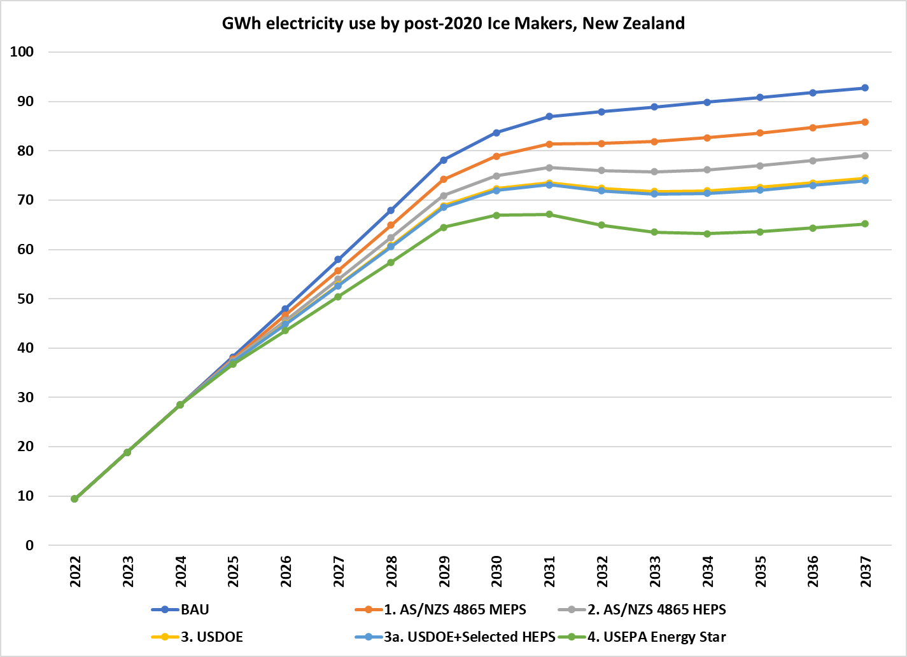

Figure 16 Projected annual energy saving for various MEPS, commercial ice makers sold 2022-2037, New Zealand

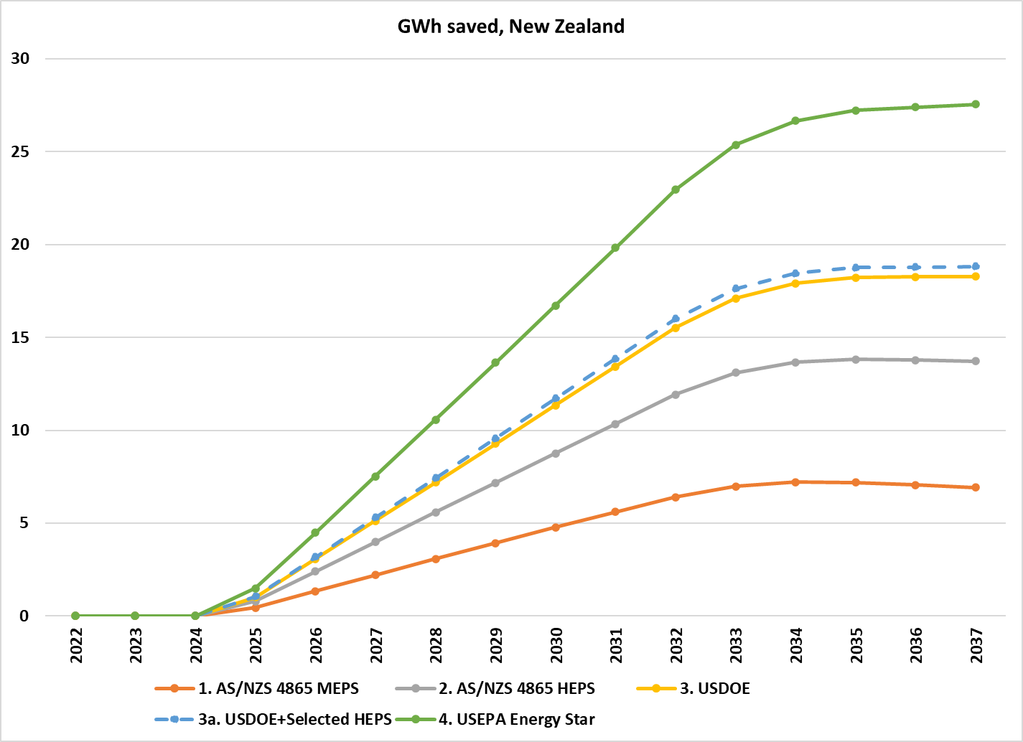

Figure 17 Projected annual energy use of total ice maker stock, New Zealand, 2022-2037

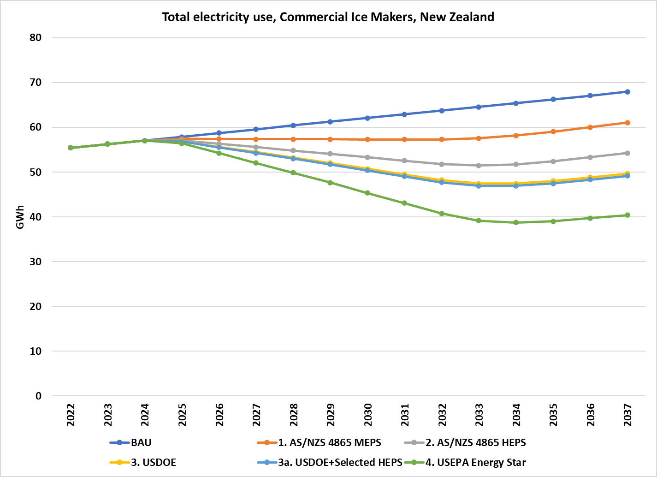

## Projected Costs

Testing

It is assumed that suppliers would need to submit a test report when applying to register each model or family of models.[30] Tests could be undertaken in the supplier’s own laboratory or an independent laboratory qualified to undertake the required test. The test need not be undertaken in Australia or New Zealand and the laboratory need not be accredited with the National Association of Testing Associations (NATA) or its international affiliates. It is assumed that there would soon be at least one laboratory in Australia or New Zealand that is NATA accredited for the standard test, so governments can commission check tests and as a resource for product suppliers with no other testing options. Testing costs are detailed in Appendix C.

It is assumed that models available in New Zealand are a subset of those available in Australia, so there will be no additional testing costs for New Zealand.

Registration and Administration

In accordance with the Australian Government Charging Framework, the GEMS Regulator charges fees for the registration of product models. These fees recover the costs incurred in processing registration applications and monitoring compliance with the GEMS Act.

As part of the development of the GEMS determination, the GEMS Regulator will determine the appropriate registration fees for ice makers. This will be based on analysis of expected registration volumes and compliance activities, which will include consultation with industry to ensure the analysis and proposed fees accurately represent the costs of administering the program.

Registration fees currently range from $440 to $780 per model or family, depending on product type. For the purpose of the cost-benefit analysis in this CRIS, a fee value of $780 per model for ice makers was used. This value was used for modelling purposes only and does not indicate what actual fee values would be determined by the GEMS Regulator.

It is assumed that over 95% of all the models offered in Australia and New Zealand will be registered with the Australian GEMS Regulator and the rest in New Zealand. Models registered only in New Zealand cannot be supplied in Australia unless they are manufactured in or exported from New Zealand. There is no manufacture of ice makers in New Zealand, and any trans-Tasman product flows tend to be from Australia to New Zealand. New Zealand registrations will incur no fees, but there will be some administrative costs for the New Zealand regulator.

Costs of efficiency improvements

To determine the total costs of the policy options, the average incremental price of products that meet the policy were estimated. This relationship is used in the model to assess the costs of increased efficiency (due to the policy options, i.e. MEPS) for each category.

The relationship between price and energy-efficiency can be captured in modelling by assuming a Price/Efficiency (P/E) ratio. A P/E ratio of 1.0 implies that a 10% increase in energy-efficiency brings about a 10% increase in price. A P/E ratio of 0.5 implies a 5% price increase for every 10% increase in efficiency and so on.

Based on discussion with suppliers, it has been assumed that P/E ratios in 2022 range between 0.3 and 0.6, depending in the category of ice maker, rising to 0.5 to 0.8 in 2037. This is consistent with the P/E ratio of 0.5 used in the previous *Decision RIS: Refrigerated display and storage cabinets* (E3 2017). The sensitivity of B/C ratios to higher P/E is also tested.

## Benefit/Cost Analysis

Australia

The value of the projected energy savings for each State and Territory at each MEPS levels are calculated by multiplying the energy saved in each year (i.e. the equivalent of Figure 13 for that jurisdiction) by the projected retail electricity price (Figure 21 in Appendix C). The value of emissions savings is calculated by multiplying the energy saved in each year by its emissions intensity (Figure 22) and the value per tonne of emissions saved (Figure 23). Constant 2022 prices are used, ignoring inflation. The NPV of the stream of savings is then calculated using a 7% discount rate.

Table 6 and Figure 18 summarise the projected costs and benefits for Australia of adopting each of the four potential ice maker MEPS levels, as well the mixed level (Option 3a). The “Extra Capital Costs” compared with BAU are due to the assumption that as average efficiency increases with more stringent MEPS levels, so does the average price of ice makers. The “Administrative” costs depend on the number of models that need to be tested and registered each year, so are independent of MEPS levels. The “Energy Benefit” is the present value of the projected savings in electricity costs over the period 2022-2045. While costs are incurred in the year of ice maker purchase (2022-37), the reductions in running cost persist for the operating life of the ice maker. Assuming an 8year service life, ice makers purchased in 2037, the last year of the projection series, will return savings up to 2045.

Table 6 also summarises the projected electricity and greenhouse gas savings under each option. For example, adoption of the HEPS levels in AS/NZS 4865 as the MEPS level is projected to save about 871 GWh (kWh x 106) of electricity and 282 kt CO2-e of emissions over the period 2022-45.

Net benefit increases with rising MEPS levels, but B/C ratio falls. This is illustrated in Figure 18. Other considerations also need to be taken into account in determining the recommended option, as discussed in the next section.

New Zealand

Table 7 and Figure 19 summarises the projected costs and benefits for New Zealand of adopting each of the four potential ice maker MEPS levels, as well the mixed level (Option 3a). The value of energy savings is calculated at the LRMC of electricity production as advised by EECA. This is roughly equivalent to the wholesale price of electricity, rather than the retail price as used in the Australian analysis. Accordingly, the projected change in ice maker costs is also estimated as supplier prices rather than retail prices, using a ratio of 0.5, as in the RIS for refrigerated display cabinets (E3 2017).

Table 6 Summary of projected impacts, costs and benefits, ice maker MEPS. Australia

|  |  |  |  |  |  |  |  |  |  |  |  |
| --- | --- | --- | --- | --- | --- | --- | --- | --- | --- | --- | --- |
| MEPS Option | Extra  Cap Cost | Admin Cost | Total  Cost | Energy  Benefit (a) | Emission Benefit (b) | Demand Benefit (c) | Total Benefit | Net Benefit | Benefit/ cost ratio | GWh saved 2022-45 | kt CO2-e saved 2022-45 |
| 1. AS/NZS 4865 MEPS | $8.8 | $4.0 | $12.8 | $105.2 | $7.1 | $0.0 | $112.2 | $99.4 | 8.8 | 466 | 152 |
| 2. AS/NZS 4865 HEPS | $19.4 | $4.0 | $23.4 | $199.0 | $13.1 | $0.0 | $212.0 | $188.6 | 9.1 | 871 | 282 |
| 3. USDOE | $32.1 | $4.0 | $36.2 | $258.0 | $16.8 | $0.0 | $274.8 | $238.6 | 7.6 | 1125 | 363 |
| 3a. USDOE+selected HEPS (d) | $32.7 | $4.0 | $36.7 | $265.9 | $17.3 | $0.0 | $283.3 | $246.6 | 7.7 | 1160 | 375 |
| 4. USEPA Energy Star | $49.6 | $4.0 | $53.6 | $382.4 | $24.8 | $0.0 | $407.2 | $353.6 | 7.6 | 1662 | 536 |

All values million $ NPV for costs incurred 2022-37 and benefits accrued 2022-45, at 7% discount rate. (a) NPV of retail energy cost savings (b) NPV of value of reductions in CO2-e emissions. (c) Not separately costed; included in energy benefit. (d) AS/NZS 4865 HEPS levels for categories where these are more stringent than USDOE MEPS.

Table 7 Summary of projected impacts, costs and benefits, ice maker MEPS only, New Zealand

|  |  |  |  |  |  |  |  |  |  |  |  |
| --- | --- | --- | --- | --- | --- | --- | --- | --- | --- | --- | --- |
| MEPS Option | Extra  Cap Cost (a) | Admin Cost | Total  Cost | Energy  Benefit (b) | Emission Benefit (c) | Demand Benefit | Total Benefit | Net Benefit | Benefit/ cost ratio | GWh saved 2022-45 | kt CO2-e saved 2022-45 |
| 1. AS/NZS 4865 MEPS | $1.0 | $0.3 | $1.3 | $4.3 | $0.3 | $0.9 | $5.6 | $4.3 | 4.3 | 63 | 4 |
| 2. AS/NZS 4865 HEPS | $2.2 | $0.3 | $2.5 | $8.2 | $0.6 | $1.8 | $10.6 | $8.1 | 4.2 | 119 | 7 |
| 3. USDOE | $3.7 | $0.3 | $4.0 | $10.8 | $0.8 | $2.3 | $13.9 | $9.9 | 3.5 | 156 | 9 |
| 3a. USDOE+selected HEPS (d) | $3.8 | $0.3 | $4.0 | $11.1 | $0.9 | $2.4 | $14.3 | $10.3 | 3.5 | 160 | 9 |
| 4. USEPA Energy Star | $5.7 | $0.3 | $6.0 | $16.1 | $1.2 | $3.4 | $20.8 | $14.8 | 3.5 | 231 | 13 |

All values million $ NPV for costs incurred 2022-37 and benefits accrued 2022-45, at 5% discount rate. (a) Nominal supplier cost is 50% of retail price (b) NPV of LRMC savings (c) NPV of reductions in CO2-e emissions at medium value. (d) AS/NZS 4865 HEPS levels for categories where these are more stringent than USDOE MEPS.

Figure 18 Costs and Benefits, Australia, Ice maker MEPS

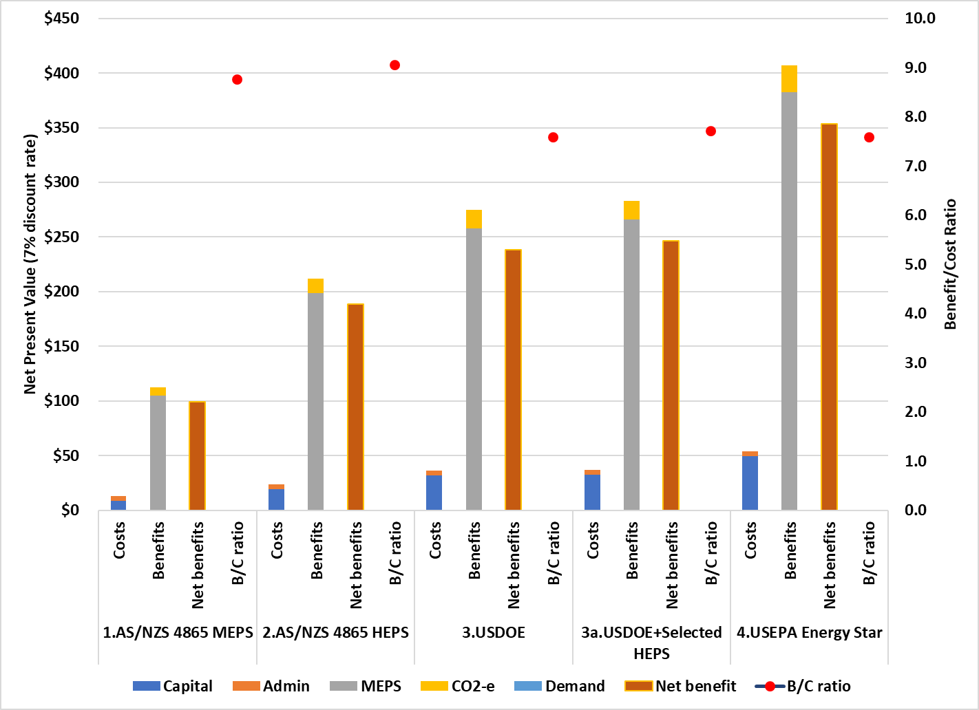

Figure 19 Costs and Benefits, New Zealand, Ice maker MEPS

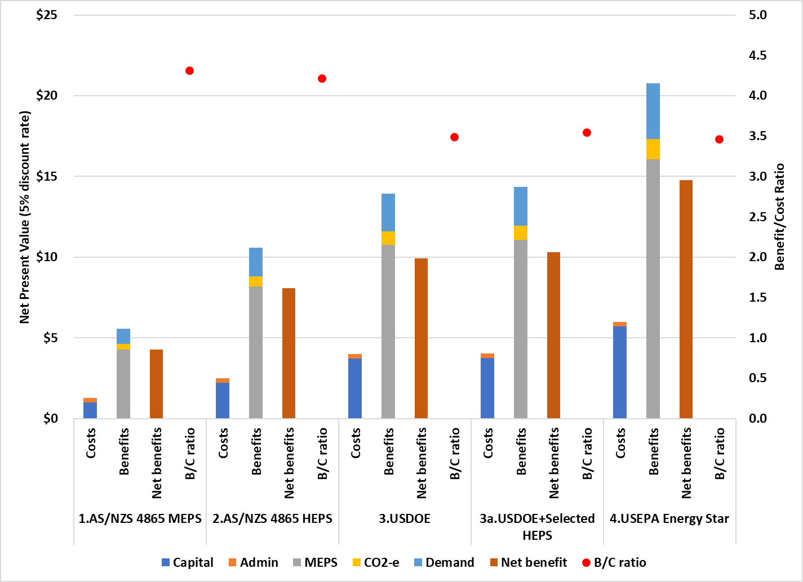

The use of wholesale rather than retail prices means that the monetary values of savings are lower in New Zealand than in Australia, even after accounting for the differences in market size. The number of ice makers sold is estimated to be about one seventh the number sold in Australia (for one fifth the population) and the climatic conditions are less demanding. The emissions saving projections are also significantly lower, due to the high renewables-intensity of New Zealand’s electricity supply.

The composition of the benefits is similar for Australia and New Zealand. In Australia, electricity price-related energy benefits, including demand reductions, account for about 94% of the projected benefits and the value of CO2-e avoided for 6%. In New Zealand, electricity price-related energy benefits also account for about 94% of the benefits (77% electricity production, 17% demand reductions) and the value of CO2-e avoided accounts for 6%. Although significantly higher values are assigned to each tonne of emission reductions in New Zealand (Figure 23) the emissions-intensity of electricity supply is much lower (Figure 22).

Uncertainty and Sensitivity

As with all projections, there are uncertainties due to both imperfect information about the present and assumptions about the future. It is impossible to calculate statistical uncertainties of the impacts of any given MEPS option without reliable information about whether the available sample of ice maker energy efficiency data points is representative of the entire model population. This information will only become available once all ice makers on the market are tested to the same standard and their performance is disclosed. Qualitatively, it is reasonable to assume that the impact of adopting any given MEPS level could range from as low as the next lowest level, or as high as the next highest. For example, the NPV of adopting the AS/NZS 4865 HEPS level could range from $99 million to $239 million for Australia.

Calculating sensitivity to discount rate assumptions is more straightforward. Table 8 summarises the NPV of net benefits and B/C ratios for Australia, at discount rates of 4% and 10%, as well as the central rate of 7%. The lower the discount rate the higher the net benefit, because the value of future energy savings are not discounted as heavily. Future capital costs due to efficiency increases are also discounted less (and so have a higher NPV) but running costs predominate in the lifetime costs of ice makers. The lowest NPVs are at the highest discount rates (10%). Table 9 presents the impact of discount rates for New Zealand.

The projected outcomes are moderately sensitive to discount rates, but B/C ratios are highly favourable even at the highest discount rates. They are comparable to estimates for other products for which MEPS have been implemented in recent years:

* Refrigerated cabinets: B/C ratio of 7.9 and net benefit of $M 1,339 at 7% discount rate (Australia). B/C ratio of 4.7 and net benefit of $M 87 at 6% discount rate (New Zealand) (E3 2017)
* Swimming pool pump-units: B/C ratio of 8.3 and net benefit of $M 658 at 7% discount rate (Australia) (E3 2018).

Another significant source of uncertainty is the relationship between purchase price and energy efficiency, expressed as P/E ratios (see Appendix C). Table 10 and Table 11 illustrate the effects of assuming that the impact of MEPS on purchase price is double what it is in the base assumptions. The projected benefits remain the same, but the costs of achieving them rise, so the net benefits are significantly lower. Even so, the B/C ratios for all options are still well above 1, the breakeven point.

Table 8 Sensitivity to discount rates, Australia (base P/E ratio assumptions)

|  |  |  |  |  |  |  |
| --- | --- | --- | --- | --- | --- | --- |
|  | 4% discount rate | | 7% discount rate (a) | | 10% discount rate | |
|  | $M Net Benefit | Benefit/ cost | $M Net Benefit | Benefit/ cost | $M Net Benefit | Benefit/ cost |
| 1. AS/NZS 4865 MEPS | $145.5 | 9.8 | $99.4 | 8.8 | $69.6 | 7.9 |
| 2. AS/NZS 4865 HEPS | $277.0 | 10.0 | $188.6 | 9.1 | $131.6 | 8.3 |
| 3. USDOE | $351.7 | 8.3 | $238.6 | 7.6 | $165.9 | 7.0 |
| 3a. USDOE + Selected HEPS | $363.3 | 8.5 | $246.6 | 7.7 | $171.5 | 7.1 |
| 4. USEPA Energy Star | $521.7 | 8.3 | $353.6 | 7.6 | $245.7 | 7.0 |

1. From Table 6

Table 9 Sensitivity to discount rates, New Zealand (base P/E ratio assumptions)

|  |  |  |  |  |  |  |
| --- | --- | --- | --- | --- | --- | --- |
|  | 2% discount rate | | 5% discount rate(a) | | 8% discount rate | |
|  | $M Net Benefit | Benefit/ cost | $M Net Benefit | Benefit/ cost | $M Net Benefit | Benefit/ cost |
| 1. AS/NZS 4865 MEPS | $6.4 | 4.8 | $4.3 | 4.3 | $2.9 | 3.9 |
| 2. AS/NZS 4865 HEPS | $12.1 | 4.6 | $8.1 | 4.2 | $5.5 | 3.9 |
| 3. USDOE | $15.0 | 3.8 | $9.9 | 3.5 | $6.7 | 3.2 |
| 3a. USDOE + Selected HEPS | $15.6 | 3.9 | $10.3 | 3.5 | $7.0 | 3.3 |
| 4. USEPA Energy Star | $22.4 | 3.8 | $14.8 | 3.5 | $10.0 | 3.2 |

1. From Table 7

Table 10 Sensitivity to discount rates, Australia (double P/E ratio assumptions)

|  |  |  |  |  |  |  |
| --- | --- | --- | --- | --- | --- | --- |
|  | 4% discount rate | | 7% discount rate (a) | | 10% discount rate | |
|  | $M Net Benefit | Benefit/ cost | $M Net Benefit | Benefit/ cost | $M Net Benefit | Benefit/ cost |
| 1. AS/NZS 4865 MEPS | $134.0 | 5.8 | $90.6 | 5.2 | $62.8 | 4.7 |
| 2. AS/NZS 4865 HEPS | $251.2 | 5.4 | $169.2 | 5.0 | $116.8 | 4.5 |
| 3. USDOE | $308.8 | 4.4 | $206.4 | 4.0 | $141.4 | 3.7 |
| 3a. USDOE + Selected HEPS | $319.7 | 4.5 | $213.9 | 4.1 | $146.6 | 3.8 |
| 4. USEPA Energy Star | $455.5 | 4.3 | $304.0 | 3.9 | $207.9 | 3.6 |

Table 11 Sensitivity to discount rates, New Zealand (double P/E ratio assumptions)

|  |  |  |  |  |  |  |
| --- | --- | --- | --- | --- | --- | --- |
|  | 2% discount rate | | 5% discount rate(a) | | 8% discount rate | |
|  | $M Net Benefit | Benefit/ cost | $M Net Benefit | Benefit/ cost | $M Net Benefit | Benefit/ cost |
| 1. AS/NZS 4865 MEPS | $5.1 | 2.7 | $3.3 | 2.4 | $2.2 | 2.2 |
| 2. AS/NZS 4865 HEPS | $9.2 | 2.4 | $5.9 | 2.2 | $3.8 | 2.1 |
| 3. USDOE | $10.1 | 2.0 | $6.2 | 1.8 | $3.9 | 1.7 |
| 3a. USDOE + Selected HEPS | $10.5 | 2.0 | $6.5 | 1.8 | $4.1 | 1.7 |
| 4. USEPA Energy Star | $14.7 | 1.9 | $9.0 | 1.8 | $5.7 | 1.6 |

The New Zealand Treasury projects high, medium and low price trends for the value of CO2-e emissions avoided (see Figure 23). Table 7, Table 9 and Table 11 are based on the medium values. Table 12 illustrates the impact of adopting the higher or lower CO2-e values. Given the relatively small contribution of CO2-e values to the overall benefits, changing the price has minimal effect on the Benefit/Cost ratios.

Table 12 Sensitivity to projected CO2-e values, New Zealand (base P/E ratio assumptions)

|  |  |  |  |  |  |  |
| --- | --- | --- | --- | --- | --- | --- |
|  | Low CO2-e price | | Medium CO2-e price(a) | | High CO2-e price | |
|  | $M Net Benefit | Benefit/Cost | $M Net Benefit | Benefit/ Cost | $M Net Benefit | Benefit/ Cost |
| 1. AS/NZS 4865 MEPS | $4.2 | 4.2 | $4.3 | 4.3 | $4.4 | 4.4 |
| 2. AS/NZS 4865 HEPS | $7.9 | 4.1 | $8.1 | 4.2 | $8.4 | 4.3 |
| 3. USDOE | $9.7 | 3.4 | $9.9 | 3.5 | $10.3 | 3.6 |
| 3a. USDOE + Selected HEPS | $10.0 | 3.5 | $10.3 | 3.5 | $10.7 | 3.6 |
| 4. USEPA Energy Star | $14.3 | 3.4 | $14.8 | 3.5 | $15.3 | 3.6 |

(a) From Table 7

## Stakeholder Impacts

Suppliers

Importers and the one local manufacturer would be the first group to have to respond to adoption of a mandatory MEPS. They will have to obtain information on the performance of each model at the standard rating point (32/21) to determine whether it meets the MEPS level, and decide what to do if not. Importers of global brands should be able to obtain this information from the manufacturers and change their orders to substitute MEPS-compliant models in the manufacturer’s existing range for non-compliant ones. Most models sold are imported from global suppliers, which offer a range of models of different efficiencies; they will have options to change their local offerings to the higher efficiency models without retooling.

The higher the MEPS level the greater the risk that there will not be compliant models available. Adoption of the EPA Energy Star levels would carry a high risk, but adoption of the AS/NZS HEPS levels less so.

Table 13 presents estimates of the proportion of the models on the market that would pass various MEPS levels. This is based on analysis of the 188 models (out of about 340) for which performance data were available in 2020; average efficiency will probably be higher by the time MEPS takes effect, so fewer models would fail. Adoption of the AS/NZS 4865 MEPS levels would exclude only 9% of this group, while adoption of the US DOE MEPS levels would exclude about 40%. The market share that fails US EPA Energy Star levels is more difficult to estimate, but it could well be more than 60%.

Table 13 Estimated share of current (2020) models meeting MEPS levels

|  |  |  |  |
| --- | --- | --- | --- |
|  | Pass | Fail | Pass % |
| AS/NZS 4865 MEPS | 172 | 16 | 91% |
| AS/NZS 4865 HEPS | 133 | 55 | 71% |
| USDOE MEPS (2018) | 109 | 79 | 58% |

The estimates in Table 13 may not be representative of the whole market. On the one hand they are based on 2020 data; average efficiency will probably be higher by the time MEPS takes effect, so fewer models would fail. On the other hand the energy-efficiency of products *without* performance data is likely to be lower. The majority of models without performance data are smaller capacity, lower-price models imported in large numbers by general merchants rather than ice maker specialists. These importers may have more difficulty in getting reliable test data, especially as the same model may be made in more than one factory with slightly different components. They may have to rely on testing in Australia or New Zealand, and will need to decide whether the cost is warranted in relation to expected future sales and profits.

It is likely that some of these models will be excluded, due to either lack of test data or failure to meet the MEPS level. They will be hard to replace at the same price point, so forcing the withdrawal of their importers from the ice maker market and an increase in the average price of ice makers (which has been factored into the cost-benefit modelling). However, the companies that would be affected offer a wide range of other commercial catering and general products, including non-commercial (i.e. manual fill) ice makers. Several also act as agents for the global brands. Selling commercial ice makers which they import themselves is only a small part of their business.

The burden on suppliers also depends on the lead time for implementation. If the rules are finalised by the middle of 2023 there would be a reasonable lead time to the end of 2024, the proposed date of compliance. A mid-year implementation may be more convenient for the industry, since it would allow more orderly stock changes by avoiding the summer period, traditionally the peak period for refrigeration product purchases.

Purchasers and consumers

Consumers purchasing ice makers from the major suppliers or importers may face higher average prices but would benefit from a greater savings in running costs. Table 14 indicates the projected increases in average energy-efficiency from adopting the US DOE MEPS levels, as well as the accompanying increase in purchase price, given the base Price/Efficiency ratios detailed in Appendix C. The payback periods are typically less than half a year for modular units, and between 1 and 1.5 years for air-cooled units. Even at the extreme assumption of doubled P/E ratios, the payback periods are typically around 8 months for modular units, and between 1.5 and 3 years for air-cooled units. Commercial catering businesses surveyed by the NSW DOE in 2020 indicated that they would expect a 2 to 4-year payback for investment in more energy efficient equipment, so ice maker MEPS would meet that criterion, even under extreme assumptions.

Ice makers are essential equipment for restaurant, hospitality, foodservices, food retail and similar businesses, and it is unlikely that they would hesitate to purchase a new or replacement unit because of a few hundred dollars higher price. At the margins, however, some businesses that currently rely on bagged ice may defer purchasing an ice machine if they face higher purchase costs. It is estimated that the proposed MEPS will increases the sales-weighted average price of commercial ice makers by about 12% (AUD $412 and NZD $485) and reduce annual electricity costs by AUD $882 in Australia NZD $452 in New Zealand, giving a simple payback of about half a year in Australia and just over a year in New Zealand. There is some correlation between energy efficiency and product quality, so users may also benefit from an improvement in average service lifetimes and reduced maintenance costs. These have not been quantified.

Table 14 Average costs, savings and payback periods for purchasers in Australia, MEPS at US DOE level

|  |  |  |  |  |  |  |  |
| --- | --- | --- | --- | --- | --- | --- | --- |
|  | BAU  Energy  $/yr | Increase  in Efficiency | Saving  $/yr energy | Base P/E ratios | | Doubled P/E ratios | |
| Increase  Purchase price | Payback  years | Increase  Purchase price | Payback  years |
| IMH - Batch - Air | $ 5,902 | 29% | $ 1,729 | $ 398 | 0.2 | $ 796 | 0.5 |
| IMH - Continuous - Air | $ 5,337 | 8% | $ 435 | $ 144 | 0.3 | $ 288 | 0.7 |
| IMH - Batch - Water | $ 5,860 | 35% | $ 2,039 | $ 481 | 0.2 | $ 962 | 0.5 |
| IMH - Continuous - Water | $ 5,776 | 29% | $ 1,662 | $ 427 | 0.3 | $ 853 | 0.5 |
| RCRC - Batch - Air | $ 7,646 | 21% | $ 1,599 | $ 412 | 0.3 | $ 824 | 0.5 |
| RCRC - Cont - Air | $ 7,646 | 12% | $ 941 | $ 263 | 0.3 | $ 527 | 0.6 |
| RCU - Batch - Air | $ 7,718 | 25% | $ 1,922 | $ 474 | 0.2 | $ 949 | 0.5 |
| RCU - Continuous - Air | $ 7,718 | 16% | $ 1,263 | $ 337 | 0.3 | $ 675 | 0.5 |
| SCU - Batch - Air | $ 2,047 | 29% | $ 594 | $ 478 | 0.8 | $ 955 | 1.6 |
| SCU - Continuous - Air | $ 1,754 | 2.6% | $ 46 | $ 64 | 1.4 | $ 129 | 2.8 |
| SCU - Batch - Water | $ 1,974 | 44% | $ 867 | $ 909 | 1.0 | $ 1,818 | 2.1 |
| SCU - Continuous - Water | $ 2,142 | 21% | $ 441 | $ 490 | 1.1 | $ 980 | 2.2 |
| Sales-weighted, Australia | $ 3,579(a) | 26% | $ 882 | $ 412 | 0.6 | $ 824 | 1.3 |
| Sales-weighted, New Zealand | $ 1,835(b) | 26% | $ 452 | $ 485 | 1.1 |  | 2.4 |

(a) Based on average commercial sector electricity tariff of AUD $0.30/kWh. (b) Based on commercial sector electricity tariff of NZD 18.5 c/kWh.

Regulators and Administrators

It is expected that ice maker MEPS and energy labelling requirements would be introduced via the GEMS Act. This would require the drafting of a Ministerial Determination under the GEMS Act, its release for comment and then the making of a final Determination. No new administrative arrangements would be required. In New Zealand they would be implemented by amending the Energy Efficiency (Energy Using Products) Regulations 2002.

Commercial ice makers (plumbed models up to 1,000 kg/day output capacity) are distinct mass-produced models, not built to order. This simplifies the process of identifying and registering models, without the complications of providing for bespoke and made-to-order models. Some models are sold under a number of brand names, so the family registration provisions of the GEMS Act would apply.

As with all other products subject to MEPS and energy labelling, there will be administrative costs for processing registrations, operating the website, check testing and enforcement. These are projected to cost the GEMS Regulator an average of AUD $66,000 per year between 2024 and 2037. It is estimated that 80% of the costs will be covered from registration fee income and 20% will need to be made up from Government budgets. There are no registration fees in New Zealand, where it is estimated that costs to the regulator will average about NZD $16,000 per year between 2024 and 2037.

Check testing will rely on accredited independent laboratories. In 2022 the NSW DPE commissioned trial testing at an Australian laboratory, which confirmed the practicability of the AS/NZS 4865.1 test and confirmed that the results were very close to the ASHRAE test. While a number of laboratories could test ice makers using their existing facilities, they would need to have reasonable expectation of testing income from suppliers and regulators before incurring the required accreditation costs.

## Impacts on Competition

Some impacts are likely to increase market competition while others might reduce it. In the short term, the withdrawal of the least efficient models could reduce the range of models on the market, at least until importers secure supplies of more efficient ones, which are known to exist on the global market.

On the other hand, reliable information about the energy- and water-efficiency of every model will be available for the first time, which should enhance competition based on product efficiency. Permitting suppliers to also register water use will further enhance competition.

There are no apparent negative or anti-competitive implications for international trade. The MEPS regulations would apply equally to both imports and locally manufactured products, and the test standards are essentially identical to those used in the US and Canada. It is intended that international test standards will be adopted in due course. Therefore, the impact on supplier and model competition is likely to be negligible.

1. Implementation and Timing

## Recommended Option

Preliminary Recommendations

According to the RIS Guide: “Regulation should not be the default option: the policy option offering the greatest net benefit — regulatory or non-regulatory — should be the recommended option.” The preceding chapters have established that a combination of mandatory MEPS and information disclosure (by website registration or energy labelling) would be effective in addressing the problem, but non-regulatory options would not.

Of the MEPS options modelled, the one with the highest quantified net benefit is the US EPA Energy Star level (Figure 18 and Figure 19). However, this would be a risky approach. Energy Star is stringent even by the standards of the US market, which has had over a decade of mandatory MEPS, and is voluntary rather than mandatory. Adopting the Energy Star levels as mandatory for Australia and New Zealand risks disrupting the market to an unacceptable degree and leaving many segments without available models, possibly for some years.

If Energy Star is excluded, adoption of the US DOE MEPS, adjusted for configurations where AS/NZS 4865 HEPS are more stringent, has the highest net benefit ($246.6 million in Australia, $13.9 million in New Zealand). Proceeding to this option in one step also carries significant risk at present, with the potential to exclude well over 40% of current models (see Table 13). Adopting the AS/NZS 4865 HEPS level as an intermediate step would reduce the market disruption risk by allowing for the collection of complete information about the models on the market before proceeding to US DOE levels.

While a two-stage process might forgo some energy savings from MEPS during stage 1, these could be more than compensated by the introduction of forms of energy information or labelling, enabling purchasers to identify products that are more efficient than the MEPS level. Including the US DOE MEPS levels as “High Efficiency” designations in a Stage 1 Determination would constitute an initial information measure, which could be expanded to a more graduated labelling scheme in Stage 2.

A phased approach would help to manage the risks, while at the same time giving industry certainty and setting out a predictable approach for achieving the highest practical net benefit. Therefore, the following two-stage strategy is recommended.

**Stage 1,** to take effect at the end of 2024:

* All commercial ice maker models to meet MEPS, set at the HE levels in AS/NZS 4865:2008 Part 3
* MEPS to be based on the product categories in AS/NZS 4865 (i.e. air-cooled and water-cooled configurations to have different MEPS formulae but batch and continuous units to have the same MEPS formulae)
* Suppliers to register all models by the implementation date, using either the AS/NZS 4865:2008 test, the US ASHRAE 29-2009 (or 2015) test or the ISO test (if published by then); provided tests are undertaken at 230V/50Hz and at the at 32/21 rating point
* As a cost saving option for suppliers, regulators should consider accepting ASHRAE test reports undertaken on 115V/60Hz variants, if the supplier accepts the risk that compliance tests using AS/NZS 4865.1 could show 230V/50Hz variants as supplied in Australia and New Zealand to be non-compliant (and so would be de-registered)
* For all commercial ice maker models within scope, suppliers must register the production capacity (kg/24hrs) and energy consumption (kWh/100kg) measured at the 32/21 rating point
* Invite suppliers to voluntarily register potable water consumption (l/100kg) and (if applicable) cooling water use (l/100 kg). The cost of obtaining this data would be minimal, as the standard tests require water use to be measured at the same time as energy use
* Include the present US DOE MEPS levels as “HE” levels in the initial GEMS Determination and Regulations and permit suppliers to designate models that achieve the HE levels as “High Efficiency”
* Disclose registered performance data for each model on [www.energyrating.gov.au](http://www.energyrating.gov.au), with methods for calculating operating costs and for ranking models in order of energy-efficiency (e.g. lowest to highest kWh/kg ice).

**Stage 2**, to take effect for new models registered two years (at least) after initial implementation:

* MEPS levels to rise to the new HE levels (i.e. the present US DOE levels), except where the existing HE levels in AS/NZS 4865 are already more stringent
* Further differentiate product categories in AS/NZS 4865 so that batch and continuous models have different MEPS formulae, as in the USA
* Consider implementing additional forms of information, beyond the disclosure of registered performance data on [www.energyrating.gov.au](http://www.energyrating.gov.au) (part of Stage 1): on-product energy labelling and/or mandatory disclosure of information in brochures and advertising.

The MEPS formulae proposed for Stage 1 and Stage 2 are in Appendix B. Models registered in Australia during Stage 1 could remain on the register, and therefore continue to be lawfully supplied, until their 5-year registration period ends (unless check testing finds them to be non-compliant with their stated performance). In New Zealand, Stage 1 registrations that do not meet the Stage 2 MEPS requirements would be superseded[31] if and when Stage 2 MEPS are adopted, and this could create complications under the Trans-Tasman Mutual Recognition Agreement (TTMRA).

Staged MEPS implementation has been used for other commercial products, including electric motors and refrigerated cabinets. The determinations for those products specified both MEPS and HE levels, and some years later new determinations adopted the HE levels as the new MEPS levels. In this case, the AS/NZS 4865 HE levels would be the initial MEPS levels and the US DOE level would be, in effect, the HE level.

The previous RIS for ice makers also recommended a 2-stage approach, starting with moderate MEPS levels and then moving to the HE levels about 3 years later (NAEEEC 2004).

## Implementation

Determination under the GEMS Act and Regulations under the EEC Act

The proposed requirements for Stage 1 would be implemented in Australia via a GEMS Determination under the Commonwealth *Greenhouse and Energy Minimum Standards (GEMS) Act 2012*. In New Zealand the Energy Efficiency (Energy Using Products) Regulations 2002 would be used.

It is intended that the commencement of Energy Efficiency (Energy Using Products) Regulations 2002 in New Zealand would follow the Australian Determination. The implementation of New Zealand regulations would not commence before the Australian Determination.

If Ministers agree to proceed with measures for commercial ice makers, a draft GEMS Determination covering Stage 1 could be published by September 2023 and a final Determination by early 2024. This would give a year’s lead time to the implementation of the Stage 1 measures at the end of 2024. Stage 2 would involve more stringent ice maker MEPS level and redefined product categories, with implementation to take effect at the end of 2026 or later. Stage 2 would require a second GEMS Determination and revision of the New Zealand regulation but not necessarily another Regulation Impact Statement, given that the present RIS indicates a very high net benefit.

The GEMS Act provides for the regulation of on-product labelling, but this may not be appropriate for a commercial product like ice makers. The interval to Stage 2 would allow time for analysis of the market data to be collected during Stage 1 and for consideration of the case for on-product energy labelling and mandatory disclosure of information in brochures and advertising.

## Compliance

Registration of ice maker models would be straightforward because the products within the scope of the regulation are off-the-shelf models (analogous to household appliances) rather than built to order (as is often the case for air conditioning chiller units, for example). Models are clearly differentiated by unique numbers and on-product identifiers. There would be scope for family registrations: groups of models that have identical tested energy and water consumption but are differentiated by features such as automatic sanitising capabilities. Where models are identical apart from brand names and numbers, as is the case with re-badged products, each model would still need to be registered separately, but the same test report can be used for each registration.

Suppliers will need to identify models that are within the scope of the regulation. One criterion for defining a commercial ice maker is physical and so easy to verify: it must have both a point of connection to a water supply and a water drainage point. Manual fill ice makers do not meet this criterion, and so are out of scope. The boundary between a commercial ice maker (within scope) and an industrial ice maker (out of scope) is defined by the production capacity (kg/24hrs) as determined under an AS/NZS 4865 or ASHRAE 29 test, at an ambient temperature of 32°C and with water supplied at 21°C. If the production capacity at these conditions is 1,000 kg/24hrs or less then the ice maker is within scope.

It will be the responsibility of suppliers to ascertain whether a model is in scope and should be registered, and the Regulator will need to scan the market from time to time to identify models that should have been registered but have not. At present, commercial ice maker suppliers always advertise the highest possible kg/24hr value they feel is defensible and commercially advantageous.

Some suppliers quote production values that may not be referenced to any published test procedure, or at a less stringent rating point which returns a higher production value. Market analysis (Table 3) indicates that commercial ice makers tested at the lowest commonly quoted rating point (10°C air, 10°C water) will produce about 40% more ice per 24hrs than at the specified rating point (32°C air, 21°C water). Therefore, ice makers currently advertised at up to 1,400 kg/24hr could be caught by the regulation. The same firms generally supply these larger ice makers as well as the sizes defined in this CRIS as ‘’commercial” so they should be able to determine production capacity issues for themselves. If an ice maker model turns out to fall within scope of the regulation but is not registered the GEMS Regulator could take action under the GEMS Act. Suppliers could also be liable under the Trade Practices Act for deliberately over-stating production capacity in order to gain commercial advantage. New Zealand takes a similar approach under the Energy Efficiency (Energy Using Products) Regulations 2002.[32]

The compliance regime requires the availability of test laboratories certified to undertake tests to AS/NZS 4865. The NSW Department of Planning and Environment has identified two Australian laboratories that have indicated capability and willingness to undertake AS/NZS 4865 tests, and has commissioned a number of trial tests. Once a GEMS Determination is made test laboratories will have the incentive to obtain NATA certification for AS/NZS 4865, as they can be reasonably confident of on-going demand from the industry and from the Regulator.

Mandatory physical labelling would be considered in Stage 2. In order to ensure that consumers have access to consistent information, suppliers could be required to include the registered performance data in all data sheets and advertising for that model.

Designers and specifiers

Larger buyers such as quick service restaurant and supermarket chains use kitchen layout designers or central purchasing departments to select equipment, including ice makers. Unlike general purchasers, designers and specifiers tend to research and make decisions on the basis of running costs and warranty, not just initial capital cost. Once reliable information becomes available for all ice makers, it is possible that this group of ‘’professional purchasers’’ will be able to identify lower-price models that meet their performance criteria.

Minimising Compliance Costs

Suppliers would not have to undertake the tests required for registration in Australia or New Zealand, or in an independent test laboratory. As is the case for other regulated products they may undertake tests in their own laboratories in the country of manufacture. Regulator-initiated check tests would however need to be carried out in an accredited independent laboratory.

The ASHRAE 29 test is sufficiently similar to AS/NZS 4865:2008 for an ASHRAE 29 test report to be acceptable for registration, provided it is undertaken on the same 230V/50Hz model variant as is supplied in Australia and New Zealand. The forthcoming ISO test is similar to both the AS/NZS 4865 test and the ASHRAE test.

As a cost saving option for suppliers, it is recommended that the Determination permit the GEMS Regulator to accept ASHRAE test reports undertaken on 115V/60Hz variants for the purposes of registration, if the supplier accepts the risk that compliance tests using AS/NZS 4865 could show 230V/50Hz variants as supplied in Australia and New Zealand to be non-compliant.

## Next Steps

Following publication of this Consultation RIS, there will be a period for public comment, during which there will be a public information session (as a web-conference, to be organised by the Australian Department of Climate Change, Energy, Environment and Water (DCCEEW)). Written responses to the Questions to Stakeholders or any other matters in the Consultation RIS are invited. These should be submitted by the nominated date to the addresses indicated in the Preface.

At the conclusion of the comment period DCCEEW will consider all comments, refine the analysis and recommendations in the Consultation RIS accordingly and prepare a Decision RIS for consideration by Energy Ministers.

If Ministers decide to proceed with the proposals then a draft GEMS Determination can be published by September 2023 and a final GEMS Determination by early 2024. This would give a year’s notice before the MEPS provisions in the Determination come into force at the end of 2024. It is usual for registration of complying products to be possible from the time that the Final Determination is published as long as the test standard is available, as it is in this case.

## Evaluation

A staged implementation gives the opportunity to evaluate the initial impacts and fine-tune the second stage. The preparation of this Consultation RIS has generated a partial list of models available on the Australian and New Zealand markets. Comparison of the model ranges available pre- and post-implementation will indicate the accuracy of market impact projections. This can be evaluated prior to the implementation of the second stage, giving opportunity for fine tuning if necessary.

In the longer term, the E3 Program uses various sources of information to evaluate the effectiveness of the program and product requirements. These sources include:

* retrospective reviews, to compare the actual impacts of measures with what was projected
* surveys of product purchasers and users, to assess whether the extent to which the availability of information about ice maker energy efficiency has affected their awareness and purchase behaviour
* monitoring of activity on the Energy Rating website; e.g. trends in the number searches of the ice maker database.

GEMS determination and MEPS settings are evaluated and reviewed regularly. Section 176 of the GEMS Act states that the Act itself must be independently reviewed at least every 10 years.[33]

1. Questions for Stakeholders

Written submissions are invited on any aspect of this Consultation RIS, but particularly on the following questions. These questions will help us to better understand the accuracy of our market and modelling assumptions, analysis and impacts on industry, energy use and trade implications. We would be grateful if you could please provide us with any relevant data or evidence to support your submissions.

**General**

1. Do you support the principle that the production capacity (kg/24 hrs), as measured in a standard test at a common rating point, should be clearly disclosed for all models of commercial ice makers? If not, please give reasons.
2. Do you support the principle that the electricity consumption (kWh/100 kg ice), as measured in a standard test at a common rating point, should be clearly disclosed for all models of commercial ice makers? If not, please give reasons.
3. Do you agree with the assumptions in this Consultation RIS regarding market size, energy efficiency, costs or any other aspects of the analysis? Can you provide better or additional data (in confidence if necessary)?

**Standards and Testing**

1. (If yes to either Q 1 or Q 2) Do you agree that AS/NZS 4865:2008 Part 1 should be adopted as the standard test for the production capacity and electricity and water use for commercial ice makers? If not, what other standard/s should be adopted?
2. Do you agree that performance should be measured at an ambient temperature 32°C and 21°C inlet water temperature? If not, what other rating point/s should be used?
3. Do you support the proposal to set different MEPS levels for batch and continuous production ice makers (as in the USA)?
4. Do you support permitting the results of ASHRAE tests and ISO tests (when that standard is published) to be accepted as proof that a model complies? If so, should test results on 110V/60Hz variants be accepted, or only tests results for 230V/50Hz variants? Please give reasons for your answer.

**Regulatory Proposals**

1. Do you support the definition of “commercial ice maker” as (a) having both a water supply and a drainage point and (b) having an ice production capacity of up to and including 1,000 kg/24 hrs, (measured on the AS/NZS 4865:2008 Part 1 test, at the 32/21 rating point)? If not, what other definitions do you suggest? How difficult is it to determine whether an ice maker falls within the proposed scope of energy efficiency regulation?
2. Do you support the principle that there should be mandatory minimum energy performance standards (MEPS) for commercial ice makers, expressed as maximum kWh/100 kg ice in relation to production capacity? If not, please give reasons.
3. If yes to Q 9, do you support the proposed MEPS levels proposed for introduction in 2024 and 2026? (see details, Appendix B). If not, what alternative do you propose and why?
4. Can you suggest other measures that would help to overcome the problem identified in Section 2 of this Consultation Regulation Impact Statement?
5. Do you support a 2-stage process for the introduction of MEPS?
6. Are the target implementation dates feasible? If not, can you suggest alternative dates or timelines, and indicate why they would be preferable?
7. What opportunities or difficulties would the proposed measures create for your company?
8. Are there any product types or categories falling within the proposed definition of commercial ice makers that should be excluded?
9. Do you think that it should be possible to group models together and register them as a family? If so, what characteristics would models in a family have to share (e.g. product classification, production capacity in kg/24hrs, energy efficiency in kWh/100kg)?

**Information Disclosure and Labelling**

1. Do you support the introduction of an energy rating label for commercial ice makers? Please give reasons.
2. If you support an energy label, what visual form should it take? A star rating label (similar to other products covered by GEMS?), or some other type? Please give reasons.
3. If you support an energy label, should it be mandatory (or optional) to affix a label to all units offered for sale? Please give reasons.
4. If you support an energy label, should it be mandatory (or optional) to display an image of the label in advertising and brochures for that model, including on the internet? Please give reasons.
5. Do you support the principle that the potable water consumption of commercial ice makers, and cooling water consumption where relevant (expressed as litres/kg ice) should be publicly available? Please give reasons.
6. Would you voluntarily report the water consumption (l/100 kg ice) of ice maker models that you supply, even if not required to do so by law?

*****

# References

ACIL Allen (2022) *National Construction Code 2022; Decision Regulation Impact Statement for a proposal to increase residential building energy efficiency requirements*, 25 August 2022

Alviss (2022) Analysis of small business retail energy bills in Australia Final Report, Alviss Consulting with Energy Consumers Associations, December 2022

ANSI/AHRI 810–2007 *Standard for Performance Rating of Automatic Commercial Ice Makers*

ANSI/AHRI 820–2017 *Standard for Performance Rating of Ice Storage Bins*

ANSI/ASHRAE 29–2009 *Method of Testing Automatic Ice Makers*

AS/NZS 4865:2008 *Performance of commercial ice makers and ice storage bins,   
Part 1: Test methods for ice makers—Environmental performance  
Part 2: Test methods for ice storage bins—Environmental performance  
Part 3:*  Minimum energy performance standard (MEPS) requirements

CSA-C742-2015 *Energy Performance of Automatic Icemakers and Ice Storage Bins*

CFR 431 USA Code of Federal Regulations PART 431—Energy Efficiency Program for Certain Commercial and Industrial Equipment, Subpart H—Automatic Commercial Ice Makers

DISER (2021*) Australia’s emissions projections 2021*, Department of Industry, Science, Energy and Resources, October 2021

E3 (2011) *Retrospective Review of the E3 Program: Lessons learnt from two reviews*, E3 Committee, September 2018

E3 (2017) *Decision RIS: Refrigerated display and storage cabinets*, E3 Committee, November 2017

E3 (2018) *Decision Regulation Impact Statement: Swimming pool pumps. Proposed Energy Labelling and Minimum Energy Performance Standards*, E3 Committee, September 2018

EnergyConsult (2015) *Residential Energy Baseline Study: Australia*, EnergyConsult for Department of Industry and Science on behalf of the trans-Tasman Equipment Energy Efficiency (E3) Program, August 2015

Energy Star (2017) *ENERGY STAR Program Requirements for Automatic Commercial Ice Makers: Partner Commitments*, 2017 (effective 28 January 2018)

NAEEEP (2004) *Minimum Energy Performance Standards: Ice Makers and Ice Storage Bins*, Prepared for the National Appliance & Equipment Energy Efficiency Program by Mark Ellis & Associates, October 2004

PMC (2020) *The Australian Government Guide to Regulatory Impact Analysis*, Second Edition, Department of Prime Minister and Cabinet

Treasury (2022) Budget Strategy and Outlook; Budget Paper No 1, Commonwealth of Australia, 25 October 2022

# Appendix A – Companies Consulted to Date

A.J Baker

Bromic

Coast Distributors

Comcater

Federal Hospitality Equipment

H&K Restaurant Systems

Frostline (SJD Family Trust)

Hoshizaki Lancer

Lake Macquarie Refrigeration

Moffatt

Nisbets

Scots Ice

Skope (New Zealand)

Southern Hospitality (New Zealand)

Stuart Ice

# Appendix B – Proposed MEPS levels

Table 15 Proposed MEPS Formulae for Ice Makers (Stage 1 and 2)

|  |  |  |  |  |  |  |  |  |
| --- | --- | --- | --- | --- | --- | --- | --- | --- |
| **Proposed Stage 1 MEPS (a,b)** | | | | | **Proposed Stage 2 MEPS (a,c)** | | | |
| Configuration | Cooling Mode | kg/24hrs H | Max kWh/100kg (d) | | Production mode (e) | kg/24hrs H | Max kWh/100 kg (d) | |
|  |  |  | Constant | Variable |  |  | Constant | Variable |
| Modular | Air | <200 | 20.35 | -0.0374 | Batch | <136 | 22.05 | -0.02718 |
|  |  | >=200 | 13.67 | -0.0049 |  | 136-363 | 15.54 | -0.00551 |
|  |  |  |  |  |  | 363-680 | 12.24 | -0.00139 |
|  |  |  |  |  |  | >680 | 10.16 | 0 |
|  |  |  |  |  | Continuous(f) | <200 | 20.35 | -0.0374 |
|  |  |  |  |  |  | >=200 | 13.67 | -0.0049 |
| Modular | Water | <225 | 15.48 | -0.0238 | Batch | <136 | 15.17 | -0.01213 |
|  |  | 225-645 | 11.31 | -0.0049 |  | 136-386 | 12.79 | -0.00419 |
|  |  | >645 | 8.11 | 0 |  | 386-680 | 9.74 | -0.00062 |
|  |  |  |  |  |  | >680 | 8.82 | 0 |
|  |  |  |  |  | Continuous | <363 | 14.29 | -0.00589 |
|  |  |  |  |  |  | >=363 | 9.57 | 0 |
| Self-contained | Air | <80 | 36.82 | -0.2119 | Batch | <50 | 32.61 | -0.10340 |
|  |  | >=80 | 20.08 | 0 |  | 50-91 | 27.38 | -0.05584 |
|  |  |  |  |  |  | >91 | 16.20 | 0 |
|  |  |  |  |  | Continuous | <91 | 31.35 | -0.06614 |
|  |  |  |  |  |  | 91-318 | 20.88 | -0.01376 |
|  |  |  |  |  |  | >318 | 11.24 | 0 |
| Self-contained | Water | <90 | 23.37 | -0.0860 | Batch | <91 | 20.94 | -0.04189 |
|  |  | >=90 | 15.59 | 0 |  | >=91 | 12.57 | 0 |
|  |  |  |  |  | Continuous | <408 | 16.75 | -0.00666 |
|  |  |  |  |  |  | >=408 | 10.76 | 0 |
| Remote condensing  Not remote compressor | Air | <450 | 17.75 | -0.0170 | Batch | <448 | 17.57 | -0.00754 |
|  |  | >=450 | 10.23 | 0 |  | >=448 | 10.12 | 0 |
|  |  |  |  |  | Continuous | <363 | 21.38 | -0.01279 |
|  |  |  |  |  |  | >=363 | 11.16 | 0 |
| Remote condensing and remote compressor | Air | <420 | 17.75 | -0.0170 | Batch | <422 | 17.57 | -0.00754 |
|  |  | >=420 | 10.23 | 0 |  | >=422 | 10.56 | 0 |
|  |  |  |  |  | Continuous | <363 | 21.83 | -0.01279 |
|  |  |  |  |  |  | >=363 | 11.60 | 0 |

1. When measured in accordance with AS/NZS 4865:2008 Part 1, Rating point 32/21.
2. Corresponds to HEPS levels in AS/NZS 4865:2008 Part 3.
3. Metric conversion of 2018 US DOE MEPS levels.
4. Follows (M = Constant + H x Variable), where M = Max permitted kWh/100kg, H = kg/24hrs.
5. No differentiation between production modes in Stage 1, but introduced in Stage 2.
6. Stage 1 MEPS retained, because more stringent than US DOE level.

# Appendix C – Modelling Assumptions

**Market Size**

The Australian market for commercial ice makers (units with water supply and drainage connections, with production capacity up to 1000 kg/24 hr at 32/21) is currently about 9,800 to 10,000 units per year. Given that the typical service life of each unit is 7 to 10 years, and taking into account stock growth of about 1.5% per annum, the estimated total stock is currently about 60,000 units.[34]

Customs data obtained from the Commonwealth Department of Home Affairs indicate the date of import, the name of the importer, the number of units, the country of origin and the declared customs value (DCV) of each shipment. As the same customs code covers ice cream and ‘’slushie” drink equipment, as well as ice makers for marine and transport applications, the data set was cleaned to remove these products. Some import records indicate the actual model numbers, but in general the division between commercial, residential and industrial ice makers had to be made on the basis of average DCV. Products with DCV of less than $300 were classified as residential while those with DCV of $10,000 or more as industrial.[35] It was possible to match DCV with retail prices for a number of models, and this indicated an average ratio of retail price (without GST) to DCV of about 1.9.

Figure 20 indicates the number of ice maker imports to Australia in the calendar years 2016 to 2020. The number of imports with average DCV below $300 grew at nearly 24% per annum to 37,000 units in 2020, to meet a growing market for manual fill ice makers for home and occasional use. Over 99% of this low-value market is supplied from China. The imports of high-value industrial scale ice makers (average over $10,000 DCV) was fairly static, at about 60 units per year – too few to show clearly on the graph.

Figure 20 Annual imports of ice makers by DCV category

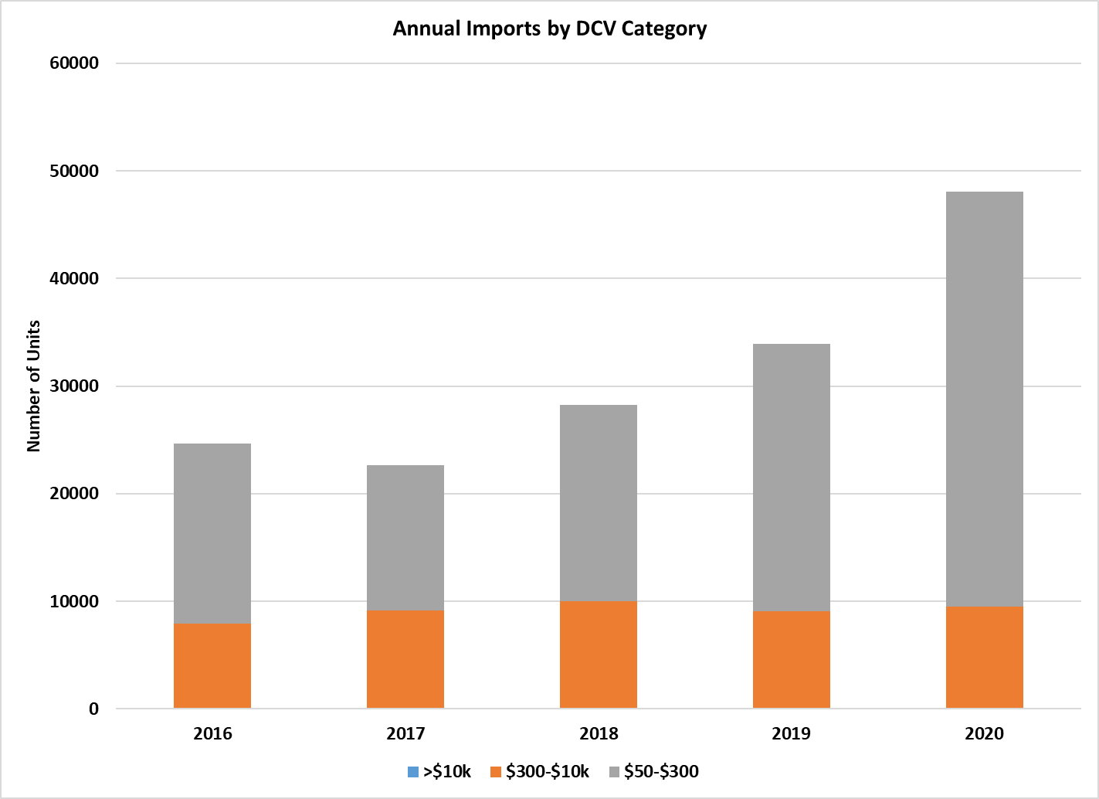

Table 16 Estimated lifetime capital and operating costs for icemakers

|  |  |  |  |  |  |  |  |  |  |  |  |
| --- | --- | --- | --- | --- | --- | --- | --- | --- | --- | --- | --- |
|  | Rated kg/day (a) | Purchase cost $ (b) | NPV $ energy (c) | NPV $ potable water (c)(d) | NPV $ lifetime costs (d) | Capital/ lifetime costs | Operating/ lifetime costs | NPV $ Condensing  water (e) | NPV $ life costs | Capital/ life costs | Operating/ lifetime costs |
| IMH - Batch - Air | 281 | $ 4,287 | $27,139 | $3,513 | $34,939 | 12% | 88% | NA |  |  |  |
| IMH - Cont - Air | 281 | $ 4,323 | $24,541 | $2,143 | $31,008 | 14% | 86% | NA |  |  |  |
| IMH - Batch - Water | 330 | $ 4,734 | $26,946 | $2,888 | $34,568 | 14% | 86% | $35,856 | $ 70,424 | 7% | 93% |
| IMH - Cont - Water | 330 | $ 4,734 | $26,560 | $2,888 | $34,182 | 14% | 86% | $33,756 | $ 67,937 | 7% | 93% |
| RCRC - Batch - Air | 420 | $ 6,120 | $35,156 | $5,251 | $46,526 | 13% | 87% | NA |  |  |  |
| RCRC - Cont - Air | 420 | $ 6,120 | $35,156 | $5,251 | $46,526 | 13% | 87% | NA |  |  |  |
| RCU - Batch - Air | 424 | $ 6,184 | $35,490 | $5,301 | $46,975 | 13% | 87% | NA |  |  |  |
| RCU - Cont - Air | 424 | $ 6,184 | $35,490 | $5,301 | $46,975 | 13% | 87% | NA |  |  |  |
| SCU - Batch - Air | 55 | $ 3,165 | $8,234 | $752 | $12,151 | 26% | 74% | NA |  |  |  |
| SCU - Cont - Air | 65 | $ 3,025 | $7,056 | $889 | $10,970 | 28% | 72% | NA |  |  |  |
| SCU - Batch - Water | 72 | $ 4,530 | $7,944 | $788 | $13,261 | 34% | 66% | $6,423 | $ 19,684 | 23% | 77% |
| SCU - Cont - Water | 85 | $ 4,400 | $8,620 | $930 | $13,950 | 32% | 68% | $7,136 | $ 21,086 | 21% | 79% |

IMH = Ice-making-head (i.e. modular) RCU = Remote condenser unit, SCU = self-contained unit. RCRC = Remote compressor & condenser. Al values nominally at 32/21 rating point.   
(a) Estimated average rated output of units of this configuration sold in 2020. (b) Based on average rated output. (c) Running costs are Net Present Value (at 7% discount rate) of 8 years of energy costs (at Australian average of 28.6 c/kWh for small business users) and water costs (at Australian average of $3.53 per kilolitre). (d) If condensing water is free. (e) If condensing water is purchased at potable water rates and used once only, rather than recirculated.

As customs import data were not available for New Zealand, the size of the New Zealand market was estimated based on population and information from New Zealand suppliers.

The modelling takes into account the projected capital costs of the commercial ice makers that are expected to be purchased in Australia and New Zealand from 2022 to 2037 (i.e. 16 calendar years). The assumptions are detailed below. It is assumed that 100% of each year’s cohort survives to the 8th year, 50% in year 9, 25% in year 10 and none in year 11. This implies an average service life of 8.75 years.

The cohort of ice makers purchased in 2037, the last year of the capital cost horizon, will all survive and continue to consume energy and water until 2045 when the last units of the cohort leave service. Therefore the model calculates the net present value (NPV) of ice maker energy and water use as far as 2045, using the range of discount rates required by the Office of Impact Analysis (formerly Office of Best Practice Regulation) in Australia (4%, 7% and 10%) and the New Zealand Treasury (2%, 5% and 8%).

**Background improvements in energy efficiency**

In the absence of external intervention in the market, the resultant of these trends – some towards greater and some to lesser energy efficiency – is projected to be a gradual improvement in energy efficiency of about 0.6% per annum for self-contained units and about 0.3% per annum for modular units. This is modelled as the Business as Usual (BAU) case.

**Costs and Benefits**

For Australia, costs and benefits are calculated from the viewpoint of the end user. The value of the projected energy savings for each State and Territory at each MEPS levels are calculated by multiplying the energy saved in each year (i.e. the equivalent of Figure 13 for that jurisdiction) by the projected retail electricity price (Figure 21). The value of emissions savings is calculated by multiplying the energy saved in each year by its emissions intensity (Figure 22) and the value per tonne of emissions saved (Figure 23). Constant 2022 prices are used, ignoring inflation. The NPV of the stream of savings is then calculated using a 7% discount rate.

The goods and services tax (GST) component of prices is omitted, as this represents a transfer payment that would in any case be netted out by businesses. Administrative costs of compliance to suppliers are separately identified, but it is assumed that they are ultimately passed on to ice maker purchasers as an increase in the retail price. The relationship between price and energy-efficiency is captured by assuming a Price/Efficiency (P/E) ratio of 0.5, implying a 5% price increase for every 10% increase in efficiency and so on.

For New Zealand, the value of energy savings is calculated at the LRMC of electricity production as advised by EECA. This is roughly equivalent to the wholesale price of electricity, rather than the retail price as used in the Australian analysis. Accordingly, the projected change in ice maker costs are also estimated as supplier prices rather than retail prices, using a ratio of 0.5, as in the RIS for refrigerated display cabinets (E3 2017).

The ice maker load resembles refrigerators in that units are plugged in and making ice 24 hrs/day, so time of peak use is not an issue as it would be for, say, cooking or lighting loads. Nevertheless, a reduction in energy use implies a reduction in average electricity demand. The value of this is calculated separately for New Zealand, at $230,000 per MW per year (as advised by EECA). No separate value of demand reduction is calculated for Australia, since that all supply costs, including distribution, are covered by the retail tariff.

**In-service Operating Costs**

Ice makers consume electricity directly and also indirectly, in that many are installed in air-conditioned spaces and the heat rejected from the evaporator and other components must be removed. It is estimated that about 45% of ice makers are installed in air-conditioned spaces: about 60% of SCUs, many of which are used in bars and restaurants, but only about 20% of IMHs, which are bulkier and tend to be installed in storerooms. It is estimated that SCUs operate 70% of the time (i.e. an average of 16.8 hrs per 24 hrs) and IMs 80%.

Although ice makers would be tested at the 32/21 rating point for compliance purposes, only units installed in unconditioned spaces in the warmer parts of Australia would be operating at those average conditions year-round. Therefore the following assumptions have been applied to estimate actual energy use:

* Climate-related energy factors are applied to each jurisdiction: 1.2 for the NT, 1.1 for Queensland and WA, 1.0 for NSW and SA, 0.9 for ACT and Victoria and 0.8 for Tasmania and New Zealand
* Ice makers installed in unconditioned spaces use 90% of their climate-corrected rated value
* Ice makers installed in conditioned spaces use 65% of their rated value (without climate correction) but this energy load must be removed at an estimated air conditioner COP of 2.8 (e.g. if a unit consumes 20 kWh during a 24 hr period the additional indirect consumption is 20/2.8 = 7.1 kWh).

**Water savings**

All commercial ice makers use potable water to make ice, and some models also use water instead of air to cool the condenser. While there are reasonable data on the energy efficiency of the ice maker models available on the market, there is very little published information on their water efficiency. AS/NZS 4865 calls for water use to be measured during the same test as energy use, but does not set minimum water performance standards (MWPS). The USDOE sets MWPS for condenser water use, but not potable water use. The EPA Energy Star program covers only air-cooled configurations, and sets MPWS for potable water use.

Water-cooled models use significantly less electricity per 100kg of ice than air-cooled models, because their compressors can be smaller and condenser cooling fans are not needed. Within technology types, however, there is no clear correlation between energy and water efficiency, so it is not clear whether MEPS would lead to water savings. As neither the GEMS Act nor the Energy Efficiency and Conservation Act provide for regulation of water use, water savings have not been modelled.

**Testing Costs**

It is estimated that the cost of a test to AS/NZS 4865.1 will be $5,000 per model. There are about 340 models of commercial ice makers currently available on the market. by the time. Suppliers will have a good idea of which will fail MEPS, so this number may fall in the lead-up to implementation. It is assumed that 100 models will be tested for registration during FY 2024, 200 during FY 2025. Thereafter testing will be undertaken at a rate of about 70 per year, as new models are introduced (this corresponds to a model life of about 5 years).

It is expected that relatively few models will be registered in New Zealand, given the balance of the market and supply chains: 5 in FY 2024, 5 on FY 2025 and 2 per year thereafter. Models registered only in New Zealand cannot be supplied in Australia unless they are manufactured in or exported from New Zealand. There is no manufacture of ice makers in New Zealand, and any trans-Tasman product flows tend to be from Australia to New Zealand.

**Registration and Administration**

In accordance with the Australian Government Charging Framework, the GEMS Regulator charges fees for the registration of product models. These fees recover the costs incurred in processing registration applications and monitoring compliance with the GEMS Act.[36] There is no registration fee in New Zealand.

As part of the development of the GEMS determination, the GEMS Regulator will determine the appropriate registration fees for ice makers. This will be based on analysis of expected registration volumes and compliance activities, which will include consultation with industry to ensure the analysis and proposed fees accurately represent the costs of administering the program.

Registration fees currently range from $440 to $780 per model or family, depending on product type. For the purpose of the cost-benefit analysis in this CRIS, a fee value of $780 per model for ice makers was used. This value was used for modelling purposes only and does not indicate what actual fee values would be determined by the GEMS Regulator.

While New Zealand registrations will incur no fees, there will be some administrative costs to the New Zealand regulator.

**Price Increase due to Greater Energy Efficiency**

It is prudent to assume that there is a relationship between the energy-efficiency of a product and its cost of production. A more energy-efficient product may contain higher quality components (e.g. compressors) or more and better materials (e.g. insulation). The costs of research and development will also need to be recovered.

If MEPS is effective in increasing the average energy-efficiency of products, it would follow that average production costs and hence prices to consumers would also increase. In fact, these relationships have been found to be more complex in practice, and for some products the introduction of MEPS had no apparent impact on prices (E3 2011). The re-engineering of products can lead to material and production savings, and the replacement of electro-mechanical with electronic controls may bring both energy and cost savings (although sometimes with offsetting reductions in reliability and repairability). Furthermore, changes in production costs may not be passed on at all if the market is highly competitive, or over-recovered by charging a premium for high-efficiency products.

The relationship between price and energy-efficiency can be captured in modelling by assuming a Price/Efficiency (P/E) ratio. A P/E ratio of 1.0 implies that a 10% increase in energy-efficiency brings about a 10% increase in price. A P/E ratio of 0.5 implies a 5% price increase for every 10% increase in efficiency and so on. The following P/E ratios have been assumed for ice makers:

* For modular models (IMH), 0.3 in 2001, rising linearly to 0.5 in 2036
* For self-contained models (SCU), 0.5 in 2001, rising linearly to 0.8 in 2036.

These assumptions are based on the experiences of suppliers who have recently introduced SCU models using R290 refrigerant, some of whom reported energy-efficiency increase of up to 20% compared with the models they replaced. Some suppliers reported that the wholesale costs to them increased by 10 to 20% (implying a crude P/E ratio of 0.5 to 1.0) while others reported no change at all (i.e. a P/E ratio of 0). Therefore, a ratio of 0.5 is a reasonable starting assumption, increasing over time as further gains become harder to achieve.

The change to new refrigerants in IMHs has been inhibited by the 150 g limitation on flammable refrigerant charges, and now the limit has been lifted to 500g, another tranche of models is likely to be converted to R290 (or other new refrigerants) at relatively low cost, since the R&D work has been done for SCUs. Hence the assumption of a lower initial P/E ratio than for SCUs, also increasing over time.

The sensitivity of B/C outcomes to these assumptions has also been tested by doubling the P/E ratios:

* For modular models (IMH), 0.6 in 2001, rising linearly to 1.0 in 2036
* For self-contained models (SCU), 1.0 in 2001, rising linearly to 1.6 in 2036.

The impact of any given MEPS level on product purchase price in any year is calculated separately for each of the 26 product categories as follows:

BAU average kWh/100kg – post-MEPS average kWh/100kg x BAU average $/unit x P/E ratio  
 BAU average kWh/100kg

**Energy prices, CO2-e Intensities and prices**

Figure 21 illustrates the projected electricity prices used in the modelling. These values are used to calculate the value of energy and water saved under each MEPS scenario. For the next 3 years, Australian retail electricity prices are projected to increase in line with Treasury projections, and at 0.5% per annum (real) thereafter. The goods and services tax (GST) component of prices is omitted, as this represents a transfer payment that would in any case be netted out by businesses.

Figure 22 illustrates the projected greenhouse gas emission-intensity of electricity supplied. These values are used to calculate the quantity of greenhouse gas emissions water saved under each MEPS scenario. Table 17 to Table 21 indicate the projected emissions savings in each jurisdiction, for Options 1 to 4.

Figure 23 illustrates the projected value of CO2-e emissions: a single trend line for Australia and high, medium and low value trend lines for New Zealand.

Figure 21 Projected real electricity prices

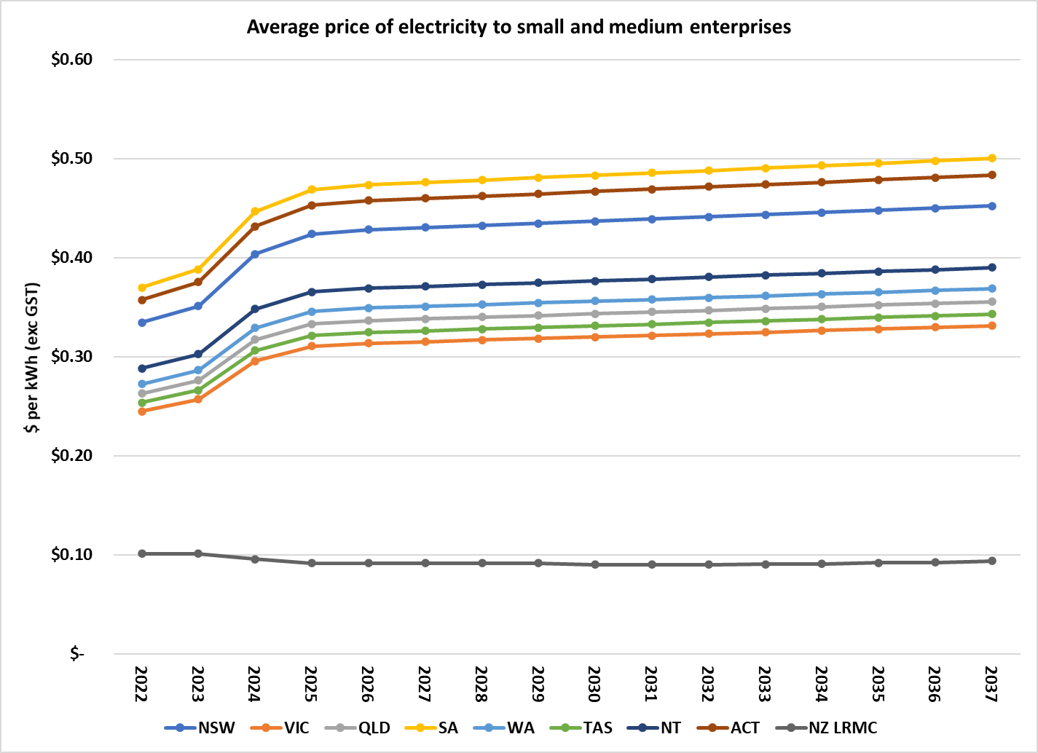

Source: Starting prices in 2022 from Alviss (2022). Projected real retail price increases in 2023-2024 from Treasury (2022, p57). Rate of change beyond 2025 is author’s estimate.

Figure 22 Projected greenhouse gas coefficients

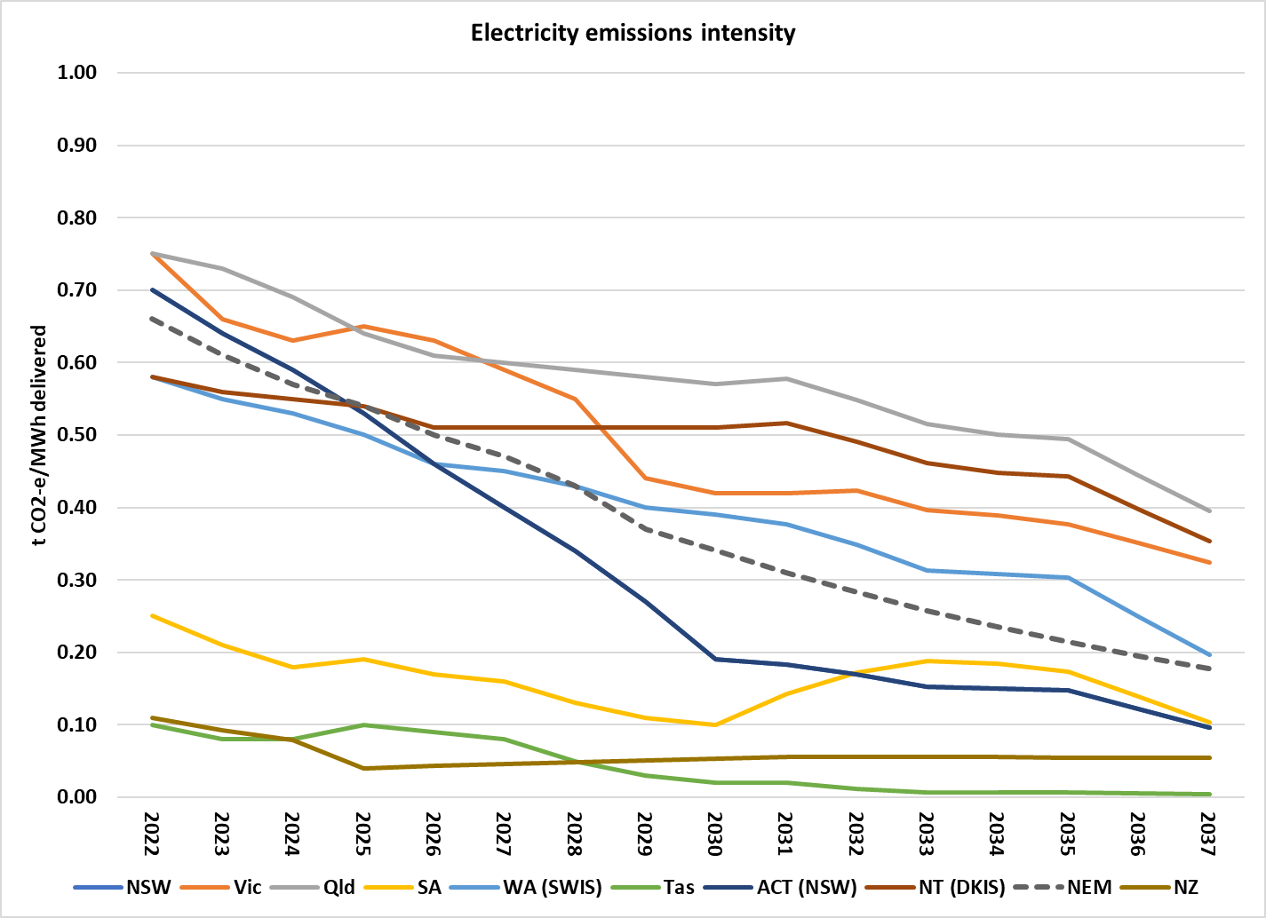

Source: DISER (2021); NZ projection from EECA (personal communication, 2022)

Figure 23 Projected value of greenhouse gas emissions avoided

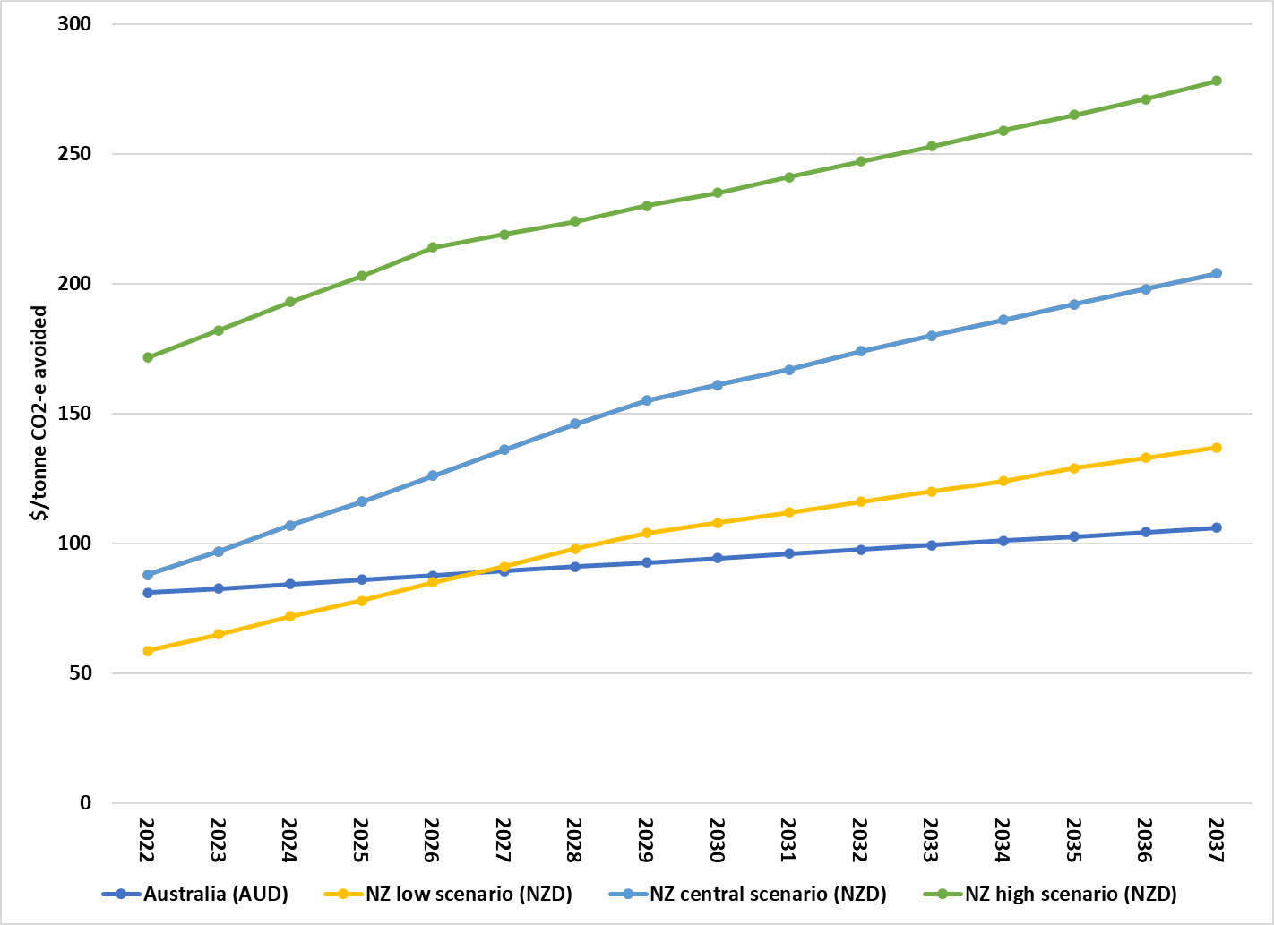

Source: ACIL Allen 2022; NZ projection from EECA (personal communication, 2022)

Table 17 kt CO2-e emissions avoided Option 1 (AS/NZS 4865 MEPS)

|  |  |  |  |  |  |  |  |  |  |  |  |  |  |  |  |  |  |
| --- | --- | --- | --- | --- | --- | --- | --- | --- | --- | --- | --- | --- | --- | --- | --- | --- | --- |
|  | **2022** | **2023** | **2024** | **2025** | **2026** | **2027** | **2028** | **2029** | **2030** | **2031** | **2032** | **2033** | **2034** | **2035** | **2036** | **2037** | **2022-37** |
| NSW | 0.0 | 0.0 | 0.0 | 0.5 | 1.4 | 2.1 | 2.5 | 2.5 | 2.1 | 2.4 | 2.6 | 2.5 | 2.6 | 2.5 | 2.1 | 1.6 | 27.4 |
| VIC | 0.0 | 0.0 | 0.0 | 0.3 | 1.0 | 1.6 | 2.0 | 2.1 | 2.4 | 2.9 | 3.3 | 3.4 | 3.5 | 3.4 | 3.1 | 2.8 | 31.8 |
| QLD | 0.0 | 0.0 | 0.0 | 0.5 | 1.4 | 2.2 | 3.1 | 3.9 | 4.7 | 5.5 | 6.1 | 6.2 | 6.3 | 6.2 | 5.5 | 4.9 | 56.4 |
| SA | 0.0 | 0.0 | 0.0 | 0.0 | 0.1 | 0.1 | 0.2 | 0.2 | 0.2 | 0.3 | 0.5 | 0.5 | 0.5 | 0.5 | 0.4 | 0.3 | 3.9 |
| WA | 0.0 | 0.0 | 0.0 | 0.3 | 0.8 | 1.2 | 1.6 | 2.0 | 2.3 | 2.6 | 2.8 | 2.8 | 2.8 | 2.8 | 2.3 | 1.8 | 26.0 |
| TAS | 0.0 | 0.0 | 0.0 | 0.0 | 0.0 | 0.0 | 0.0 | 0.0 | 0.0 | 0.0 | 0.0 | 0.0 | 0.0 | 0.0 | 0.0 | 0.0 | 0.1 |
| NT | 0.0 | 0.0 | 0.0 | 0.0 | 0.1 | 0.1 | 0.2 | 0.2 | 0.1 | 0.2 | 0.2 | 0.2 | 0.2 | 0.2 | 0.1 | 0.1 | 1.9 |
| ACT | 0.0 | 0.0 | 0.0 | 0.0 | 0.1 | 0.1 | 0.2 | 0.3 | 0.3 | 0.4 | 0.4 | 0.4 | 0.4 | 0.4 | 0.4 | 0.3 | 3.9 |
| Aust | 0.0 | 0.0 | 0.0 | 1.7 | 4.8 | 7.5 | 9.8 | 11.0 | 12.2 | 14.4 | 15.8 | 16.1 | 16.3 | 16.1 | 13.9 | 11.8 | 151.5 |
| NZ | 0.0 | 0.0 | 0.0 | 0.0 | 0.1 | 0.1 | 0.1 | 0.2 | 0.3 | 0.3 | 0.4 | 0.4 | 0.4 | 0.4 | 0.4 | 0.4 | 3.4 |

Table 18 kt CO2-e emissions avoided Option 2 (AS/NZS 4865 HEPS)

|  |  |  |  |  |  |  |  |  |  |  |  |  |  |  |  |  |  |
| --- | --- | --- | --- | --- | --- | --- | --- | --- | --- | --- | --- | --- | --- | --- | --- | --- | --- |
|  | **2022** | **2023** | **2024** | **2025** | **2026** | **2027** | **2028** | **2029** | **2030** | **2031** | **2032** | **2033** | **2034** | **2035** | **2036** | **2037** | **2022-37** |
| NSW | 0.0 | 0.0 | 0.0 | 1.0 | 2.5 | 3.7 | 4.4 | 4.5 | 3.9 | 4.5 | 4.8 | 4.7 | 4.9 | 4.8 | 4.0 | 3.1 | 50.8 |
| VIC | 0.0 | 0.0 | 0.0 | 0.6 | 1.8 | 2.8 | 3.7 | 3.8 | 4.4 | 5.3 | 6.1 | 6.4 | 6.6 | 6.5 | 6.1 | 5.6 | 59.6 |
| QLD | 0.0 | 0.0 | 0.0 | 0.8 | 2.4 | 4.0 | 5.5 | 7.0 | 8.5 | 10.2 | 11.1 | 11.6 | 11.8 | 11.8 | 10.7 | 9.5 | 105.0 |
| SA | 0.0 | 0.0 | 0.0 | 0.1 | 0.2 | 0.3 | 0.3 | 0.3 | 0.4 | 0.6 | 0.8 | 1.0 | 1.0 | 1.0 | 0.8 | 0.6 | 7.3 |
| WA | 0.0 | 0.0 | 0.0 | 0.5 | 1.3 | 2.2 | 2.9 | 3.5 | 4.2 | 4.8 | 5.2 | 5.1 | 5.3 | 5.3 | 4.4 | 3.4 | 48.1 |
| TAS | 0.0 | 0.0 | 0.0 | 0.0 | 0.0 | 0.0 | 0.0 | 0.0 | 0.0 | 0.0 | 0.0 | 0.0 | 0.0 | 0.0 | 0.0 | 0.0 | 0.1 |
| NT | 0.0 | 0.0 | 0.0 | 0.1 | 0.2 | 0.3 | 0.3 | 0.3 | 0.3 | 0.3 | 0.3 | 0.3 | 0.3 | 0.3 | 0.3 | 0.2 | 3.5 |
| ACT | 0.0 | 0.0 | 0.0 | 0.1 | 0.2 | 0.3 | 0.4 | 0.5 | 0.6 | 0.7 | 0.8 | 0.8 | 0.8 | 0.8 | 0.8 | 0.7 | 7.4 |
| Aust | 0.0 | 0.0 | 0.0 | 3.1 | 8.6 | 13.5 | 17.6 | 20.0 | 22.3 | 26.3 | 29.2 | 29.9 | 30.7 | 30.6 | 26.9 | 23.2 | 281.9 |
| NZ | 0.0 | 0.0 | 0.0 | 0.0 | 0.1 | 0.2 | 0.3 | 0.4 | 0.5 | 0.6 | 0.7 | 0.7 | 0.8 | 0.8 | 0.7 | 0.7 | 6.4 |

Table 19 kt CO2-e emissions avoided Option 3 (USDOE)

|  |  |  |  |  |  |  |  |  |  |  |  |  |  |  |  |  |  |
| --- | --- | --- | --- | --- | --- | --- | --- | --- | --- | --- | --- | --- | --- | --- | --- | --- | --- |
|  | **2022** | **2023** | **2024** | **2025** | **2026** | **2027** | **2028** | **2029** | **2030** | **2031** | **2032** | **2033** | **2034** | **2035** | **2036** | **2037** | **2022-37** |
| NSW | 0.0 | 0.0 | 0.0 | 1.2 | 3.2 | 4.7 | 5.6 | 5.8 | 5.0 | 5.7 | 6.1 | 6.1 | 6.3 | 6.3 | 5.2 | 4.1 | 65.4 |
| VIC | 0.0 | 0.0 | 0.0 | 0.8 | 2.3 | 3.6 | 4.7 | 4.9 | 5.7 | 6.8 | 8.0 | 8.2 | 8.6 | 8.5 | 8.0 | 7.4 | 77.4 |
| QLD | 0.0 | 0.0 | 0.0 | 1.1 | 3.1 | 5.1 | 7.0 | 8.9 | 10.8 | 13.0 | 14.3 | 14.8 | 15.2 | 15.3 | 13.9 | 12.4 | 134.9 |
| SA | 0.0 | 0.0 | 0.0 | 0.1 | 0.2 | 0.3 | 0.4 | 0.4 | 0.5 | 0.8 | 1.1 | 1.3 | 1.3 | 1.3 | 1.0 | 0.8 | 9.4 |
| WA | 0.0 | 0.0 | 0.0 | 0.6 | 1.7 | 2.8 | 3.7 | 4.5 | 5.4 | 6.2 | 6.6 | 6.6 | 6.8 | 6.8 | 5.7 | 4.5 | 61.8 |
| TAS | 0.0 | 0.0 | 0.0 | 0.0 | 0.0 | 0.0 | 0.0 | 0.0 | 0.0 | 0.0 | 0.0 | 0.0 | 0.0 | 0.0 | 0.0 | 0.0 | 0.2 |
| NT | 0.0 | 0.0 | 0.0 | 0.1 | 0.2 | 0.3 | 0.4 | 0.4 | 0.3 | 0.4 | 0.4 | 0.4 | 0.4 | 0.4 | 0.4 | 0.3 | 4.5 |
| ACT | 0.0 | 0.0 | 0.0 | 0.1 | 0.2 | 0.3 | 0.5 | 0.6 | 0.8 | 0.9 | 1.0 | 1.1 | 1.1 | 1.1 | 1.0 | 0.9 | 9.6 |
| Aust | 0.0 | 0.0 | 0.0 | 3.9 | 10.9 | 17.2 | 22.4 | 25.5 | 28.4 | 33.7 | 37.5 | 38.5 | 39.7 | 39.8 | 35.2 | 30.4 | 363.1 |
| NZ | 0.0 | 0.0 | 0.0 | 0.0 | 0.1 | 0.2 | 0.3 | 0.5 | 0.6 | 0.8 | 0.9 | 0.9 | 1.0 | 1.0 | 1.0 | 1.0 | 8.4 |

Table 20 kt CO2-e emissions avoided Option 3a (USDOE + selected HEPS)

|  |  |  |  |  |  |  |  |  |  |  |  |  |  |  |  |  |  |
| --- | --- | --- | --- | --- | --- | --- | --- | --- | --- | --- | --- | --- | --- | --- | --- | --- | --- |
|  | **2022** | **2023** | **2024** | **2025** | **2026** | **2027** | **2028** | **2029** | **2030** | **2031** | **2032** | **2033** | **2034** | **2035** | **2036** | **2037** | **2022-37** |
| NSW | 0.0 | 0.0 | 0.0 | 1.3 | 3.3 | 4.9 | 5.8 | 6.0 | 5.1 | 5.9 | 6.3 | 6.3 | 6.5 | 6.5 | 5.4 | 4.3 | 67.5 |
| VIC | 0.0 | 0.0 | 0.0 | 0.8 | 2.4 | 3.7 | 4.9 | 5.0 | 5.9 | 7.0 | 8.2 | 8.5 | 8.8 | 8.7 | 8.2 | 7.7 | 79.8 |
| QLD | 0.0 | 0.0 | 0.0 | 1.1 | 3.2 | 5.2 | 7.3 | 9.2 | 11.1 | 13.4 | 14.7 | 15.3 | 15.7 | 15.8 | 14.3 | 12.8 | 139.1 |
| SA | 0.0 | 0.0 | 0.0 | 0.1 | 0.2 | 0.3 | 0.4 | 0.4 | 0.5 | 0.8 | 1.1 | 1.3 | 1.4 | 1.3 | 1.1 | 0.8 | 9.7 |
| WA | 0.0 | 0.0 | 0.0 | 0.6 | 1.7 | 2.9 | 3.8 | 4.6 | 5.5 | 6.4 | 6.8 | 6.8 | 7.0 | 7.0 | 5.9 | 4.6 | 63.7 |
| TAS | 0.0 | 0.0 | 0.0 | 0.0 | 0.0 | 0.0 | 0.0 | 0.0 | 0.0 | 0.0 | 0.0 | 0.0 | 0.0 | 0.0 | 0.0 | 0.0 | 0.2 |
| NT | 0.0 | 0.0 | 0.0 | 0.1 | 0.2 | 0.3 | 0.4 | 0.4 | 0.4 | 0.4 | 0.4 | 0.4 | 0.4 | 0.4 | 0.4 | 0.3 | 4.7 |
| ACT | 0.0 | 0.0 | 0.0 | 0.1 | 0.2 | 0.4 | 0.5 | 0.6 | 0.8 | 1.0 | 1.0 | 1.1 | 1.1 | 1.1 | 1.0 | 0.9 | 9.9 |
| Aust | 0.0 | 0.0 | 0.0 | 4.0 | 11.3 | 17.7 | 23.1 | 26.3 | 29.3 | 34.8 | 38.7 | 39.7 | 40.9 | 41.0 | 36.2 | 31.4 | 374.5 |
| NZ | 0.0 | 0.0 | 0.0 | 0.0 | 0.1 | 0.2 | 0.4 | 0.5 | 0.6 | 0.8 | 0.9 | 1.0 | 1.0 | 1.0 | 1.0 | 1.0 | 8.6 |

Table 21 kt CO2-e emissions avoided Option 4 (USEPA Energy Star)

|  |  |  |  |  |  |  |  |  |  |  |  |  |  |  |  |  |  |
| --- | --- | --- | --- | --- | --- | --- | --- | --- | --- | --- | --- | --- | --- | --- | --- | --- | --- |
|  | **2022** | **2023** | **2024** | **2025** | **2026** | **2027** | **2028** | **2029** | **2030** | **2031** | **2032** | **2033** | **2034** | **2035** | **2036** | **2037** | **2022-37** |
| NSW | 0.0 | 0.0 | 0.0 | 1.8 | 4.7 | 6.9 | 8.2 | 8.4 | 7.3 | 8.4 | 9.0 | 9.0 | 9.3 | 9.4 | 7.8 | 6.2 | 96.4 |
| VIC | 0.0 | 0.0 | 0.0 | 1.1 | 3.3 | 5.2 | 6.9 | 7.2 | 8.4 | 10.0 | 11.7 | 12.2 | 12.7 | 12.7 | 11.9 | 11.2 | 114.6 |
| QLD | 0.0 | 0.0 | 0.0 | 1.5 | 4.5 | 7.4 | 10.2 | 13.0 | 15.8 | 19.0 | 21.0 | 21.8 | 22.4 | 22.8 | 20.7 | 18.6 | 198.7 |
| SA | 0.0 | 0.0 | 0.0 | 0.1 | 0.3 | 0.5 | 0.6 | 0.6 | 0.7 | 1.1 | 1.6 | 1.9 | 2.0 | 1.9 | 1.5 | 1.1 | 14.0 |
| WA | 0.0 | 0.0 | 0.0 | 0.9 | 2.5 | 4.0 | 5.4 | 6.5 | 7.9 | 9.0 | 9.7 | 9.7 | 10.0 | 10.1 | 8.5 | 6.7 | 91.0 |
| TAS | 0.0 | 0.0 | 0.0 | 0.0 | 0.0 | 0.0 | 0.0 | 0.0 | 0.0 | 0.0 | 0.0 | 0.0 | 0.0 | 0.0 | 0.0 | 0.0 | 0.2 |
| NT | 0.0 | 0.0 | 0.0 | 0.1 | 0.3 | 0.5 | 0.6 | 0.6 | 0.5 | 0.6 | 0.6 | 0.6 | 0.6 | 0.6 | 0.5 | 0.4 | 6.6 |
| ACT | 0.0 | 0.0 | 0.0 | 0.1 | 0.3 | 0.5 | 0.7 | 0.9 | 1.1 | 1.4 | 1.5 | 1.6 | 1.6 | 1.6 | 1.5 | 1.3 | 14.2 |
| Aust | 0.0 | 0.0 | 0.0 | 5.7 | 15.9 | 25.0 | 32.7 | 37.3 | 41.7 | 49.5 | 55.2 | 56.8 | 58.7 | 59.1 | 52.4 | 45.6 | 535.6 |
| NZ | 0.0 | 0.0 | 0.0 | 0.1 | 0.2 | 0.3 | 0.5 | 0.7 | 0.9 | 1.1 | 1.3 | 1.4 | 1.5 | 1.5 | 1.5 | 1.5 | 12.4 |

1. <https://www.energyrating.gov.au/about-e3-program>
2. *Minimum Energy Performance Standards: Ice Makers and Ice Storage Bins* Prepared for the Australian Greenhouse Office under the National Appliance & Equipment Energy Efficiency Program by Mark Ellis & Associates, October 2004
3. An International test standard is currently being developed by the ISO.
4. Based on the average home using 23 gigajoules of electricity in 2019-20. Calculated using figures obtained from [Australian Energy Update 2022](https://www.energy.gov.au/sites/default/files/Australian%20Energy%20Statistics%202022%20Energy%20Update%20Report.pdf)
5. Calculated from the [MBIE Energy Balance](https://www.mbie.govt.nz/assets/Data-Files/Energy/nz-energy-quarterly-and-energy-in-nz/energy-balance-tables.xlsx) and [Stats NZ Household Estimate](https://www.stats.govt.nz/assets/Uploads/Dwelling-and-household-estimates/Dwelling-and-household-estimates-March-2021-quarter/Download-data/dwelling-and-household-estimates-march-2021-quarter.xlsx)
6. This Consultation RIS has been prepared in accordance with the *Regulatory Impact Analysis Guide for Ministers’ Meetings and National Standard Setting Bodies, May 2021* <https://pmc.gov.au/resource-centre/regulation/regulatory-impact-analysis-guide-ministers-meetings-national-standard-setting-bodies>
7. Ice may also be used as a thermal storage medium, e.g. to reduce air conditioner peak loads by making ice at off-peak times. In those cases the water/ice is usually contained in a closed circuit as well. The present report deals with equipment where the ice is consumed and lost.
8. Most commercial ice maker advertising claims production capacities at rating points (combinations of air and water temperature) that are more favourable than the rating point in AS/NZS 4865. This means that models commonly advertised with production capacities up to 1,400 kg/24hrs could be within scope.
9. Heat energy needs to be extracted from water to cool it to its freezing point (0°C) and then to freeze it. The specific heat of pure water is 4.18 kilojoules per °C and its latent heat of fusion is 334 kj per kg, so cooling a kg of water from 21°C and freezing it would require the removal of (21 x 4.18) + 334 = 422 kj. This equates to 0.117 kWh per kg of ice (11.7 kWh/100 kg). In addition, heat gained from the surroundings must be constantly removed, but the electrical energy required is usually much less than the quantum of heat removed, because the process utilises heat pumps with coefficients of performance (COP) well over 2. In air conditioners capable of both heating and cooling, the performance on the cooling cycle is often termed the Energy Efficiency Ratio (EER) while performance on the heating cycle is termed Coefficient of Performance (COP). In the case of ice makers, which only cool, the term COP is used to denote cooling performance. If a compressor (or a complete refrigeration cycle) has a COP of 2 it means that it removes twice as much heat energy as the electrical energy it consumes.
10. NAEEEP (2004) examined this issue at length, and concluded: “the total effect on the coefficient or performance (COP) of the compressor is extremely small, and would have a negligible effect when comparing the efficiency of equivalent models operating under the different electricity supply conditions.”
11. NAEEEP (2004) reported the refrigerant used in several hundred ice maker models. All used HFC404a except for two, which used HFC134a.
12. *AS/NZS 60335.2.89:2020, Household and similar electrical appliances - Safety, Part 2.89: Particular requirements for commercial refrigerating appliances and ice-makers with an incorporated or remote refrigerant unit or motor-compressor (supersedes AS/NZS 60335.2.89: 2010).* 
13. <https://www.ecfr.gov/cgi-bin/text-idx?SID=a25116a0785a0c488243d01bddb84f90&mc=true&node=se10.3.431_1134&rgn=div8>
14. [Ice-makers (nrcan.gc.ca)](https://www.nrcan.gc.ca/energy/regulations-codes-standards/products/6893)
15. Department of Energy 10 CFR Part 431 [EERE–2017–BT–TP–0006]
16. The comment period closed in April 2019, but there is no timetable for when these matters will be determined or when a revised test might be published <https://www.reginfo.gov/public/do/eAgendaViewRule?pubId=201910&RIN=1904-AE47>
17. The analysis (NAEEEP 2004) covered costs and benefits for Australia only, not New Zealand.
18. The NSW Department of Planning and Environment (DPE) has commissioned a number of tests to AS/NZS 4865 at an Australian laboratory to confirm the test procedure’s fitness for purpose and to help develop an independent testing capability for the purpose of possible future compliance testing.
19. <https://cdn.standards.iteh.ai/samples/32244/399fc4dff6574194a35da0ddac03d2d6/ISO-DIS-16522.pdf>
20. <https://www.iso.org/standard/82227.html?browse=tc>
21. <https://www.sciencedirect.com/science/article/abs/pii/S0306261917316586>
22. Some models quote a wattage value, mainly as an aid to electrical circuit design. In the absence of further information it is not possible to relate this wattage value to energy use in production.
23. One major design variant relates to the electricity supply in the target market. Europe, China, Australasia and eastern Japan are all 230V/50Hz regions. North America is a 115V/60Hz region. Western Japan has 230V/60Hz supply.
24. 2020 estimate for clothes dryer use extracted from EnergyConsult 2015. See next Chapter for ice maker stock usage estimates. Estimated ice maker use in New Zealand in 2020 was about 60 GWh.
25. These are set out in the Australian Government Guide to Regulatory Impact Analysis (PMC 2020), which adds that “Experience with behavioural insights tells us that people do not always make rational, considered decisions even in an otherwise efficiently functioning market.” (p26)
26. For example, Australia’s Water Efficiency Labelling and Standards (WELS) scheme originated in a voluntary industry-led labelling program. Following a review, the partial coverage and limited take up was one factor leading to the adoption of the current legislated WELS scheme.
27. The New Zealand regulations only covers products for sale, lease, hire, or hire-purchase.
28. <https://library.cee1.org/system/files/library/4280/CEE_Ice_Machines_Spec_Final_Effective_01Jul2011_-_updated_July_7_2015.pdf>
29. PMC (2020, p48) states: “Take into account the costs and benefits. The option with the highest net benefit should always be your recommended option, though in every case the reasons for your choice must be transparent and defensible. Any areas of uncertainty must be weighed openly and honestly. Any assumptions you have made must be disclosed, discussed and assessed for their impact on the final decision”.
30. Following the precedent of other products regulated for energy efficiency, all members of a family would need to be of the same classification (SCU, Modular, air-cooled etc.) and have identical production capacity and energy efficiency.
31. Superseded means only existing stock manufactured in New Zealand or imported before the enforcement date can be sold. Any stock imported into (or manufactured in) New Zealand from the enforcement date must meet the new requirements.
32. Energy Efficiency (Energy Using Products) Regulations 2002 (SR 2002/9) (as at 12 April 2022) Section 8 *Requirement for representations to be in accordance with standards* – New Zealand Legislation
33. The first review – completed in 2019 – was required after 5 years, and the next review is due in 2027.
34. A 2015 survey of restaurants, foodservices and hospitality venues by Food Industry Foresight indicated a stock of about 31,000 ice makers, but it did not survey user sectors such as food processing, transport and retailing, supermarkets, construction and mining etc.
35. Imports with average DCV of less than $50 per unit were treated as spare parts or accessories.
36. <https://www.energyrating.gov.au/sites/default/files/2020-11/gems_registration_fees_fact_sheet.pdf>