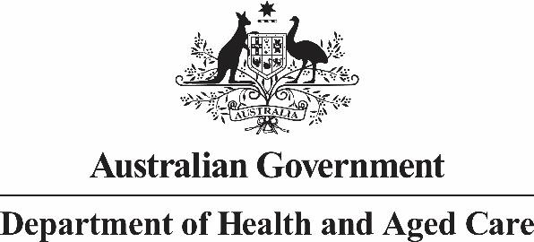

# Deputy Secretary

Mr Daniel Craig

A/g Executive Director

Office of Impact Analysis

Department of the Prime Minister and Cabinet

1 National Circuit

BARTON ACT 2600

Email: helpdesk-OIA@pmc.gov.au

Dear Mr Craig

# Impact Analysis – Negotiation of a New Community Pharmacy Agreement – Second Pass Final Assessment

I am writing in relation to the attached Impact Analysis (IA) prepared for Negotiation of an Eighth Community Pharmacy Agreement (8CPA).

Please note that negotiations for an 8CPA are ongoing, however, I am satisfied that the IA addresses the concerns raised in your letter of 22 November 2023 and meets the requirements to achieve “good practice”. Specifically;

* The policy problem outlined in Question One has been restructured to more clearly articulate the problem Government is aiming to address. Evidence has also been provided in relation to the scale of the issue, particularly for regional areas from a consumer and business perspective.
* A multi-criteria analysis method has been established and applied in Question Four to compare each option and establish a ‘net benefit’.
* Question Six demonstrates that the preferred option meets the criteria of analysis and the objective of Government.
* The key milestones for implementation of the preferred option are outlined and the proposed evaluation method to be utilised is identified in Question Seven.

The IA also includes a description of the status of the IA at each major decision point in the proposal’s development. This has included an early assessment IA in October 2023 and a First Pass IA which was provided to Government to aide in the consideration of the detailed negotiation parameters for an 8CPA, based on the options provided. It is anticipated that the final certified IA will support the final decision of Government to enter into an 8CPA.

Accordingly, I am satisfied that the IA is now consistent with the six principles for Australian Government policy makers as specified in the *Australian Government Guide to Policy Impact Analysis*.

I submit the IA to the Office of Impact Analysis for formal final assessment.

Yours sincerely

Penny Shakespeare

Health Resourcing Group

17 May 2024