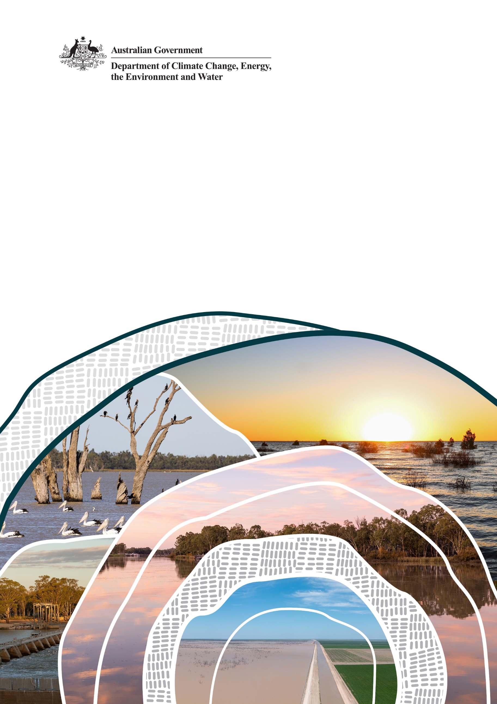
Addendum to the 2012 Basin Plan Regulation Impact Statement.

June 2024
Department of Climate Change, Energy, the Environment and Water

© Commonwealth of Australia 2024
Ownership of intellectual property rights
Unless otherwise noted, copyright (and any other intellectual property rights) in this publication is owned by the Commonwealth of Australia (referred to as the Commonwealth).
Creative Commons licence
All material in this publication is licensed under a Creative Commons Attribution 4.0 International Licence except content supplied by third parties, logos and the Commonwealth Coat of Arms.
Inquiries about the licence and any use of this document should be emailed to copyright@dcceew.gov.au.

Cataloguing data
This publication (and any material sourced from it) should be attributed as: DCCEEW 2024 Addendum to the Basin Plan Regulation Impact Statement, Department of Climate Change, Energy, the Environment and Water, Canberra, Month. CC BY 4.0.
This publication is available at https://oia.pmc.gov.au/published-impact-analyses-and-reports
Department of Climate Change, Energy, the Environment and Water
GPO Box 3090 Canberra ACT 2601
Telephone 1800 900 090
Web dcceew.gov.au
Disclaimer
The Australian Government acting through the Department of Climate Change, Energy, the Environment and Water has exercised due care and skill in preparing and compiling the information and data in this publication. Notwithstanding, the Department of Climate Change, Energy, the Environment and Water, its employees and advisers disclaim all liability, including liability for negligence and for any loss, damage, injury, expense or cost incurred by any person as a result of accessing, using or relying on any of the information or data in this publication to the maximum extent permitted by law.
Acknowledgement of Country
We acknowledge the Traditional Owners of Country throughout Australia and recognise their continuing connection to land, waters and Culture. We pay our respects to their Elders past and present.
A note on terminology: throughout this document, the terms ‘First Nations,’ and ‘First Nations Peoples’ are primarily used. Other terms including ‘Aboriginal and Torres Strait Islander’ and ‘Indigenous’ are used where they originate directly from references.

Contents
Executive Summary 5
1. Introduction 7
2. Basin Plan reforms 11
Legislative changes 11
Progress on Basin Plan implementation 12
Restoring Our Rivers: a refreshed approach 17
3. Observed changes in the Basin 19
Environmental 19
Socio-economic 21
Socio-Economic: Basin Plan impacts 25
Climate change 27
4. Water recovery options 30
Enhanced environmental outcomes 30
Socio-economic impacts 31
Government response – measures to minimise adverse economic and social impacts 37
Value for money 38
Conclusions 40
5. Stakeholder consultation 42
Public consultation 42
Senate inquiry 42
Targeted workshops 43
Consultation on the draft 450 GL framework 43
6. Evaluating the Basin Plan 45
2025 Basin Plan evaluation 45
2026 Basin Plan review 45
Third Water for the Environment Special Account review 45
Water Act review 45
Reporting on socio-economic impacts 45
7. Next steps 46
Resilient Rivers Program 46
Appendix A: Basin Snapshot 47
Appendix B: Timeline of notable policy and legislative reforms since 2012 48
Appendix C: Commonwealth water recovery in the Murray-Darling Basin 49
Appendix D: Commonwealth water recovery in the Murray-Darling Basin by SDL resource unit and type 51
Appendix E: Commonwealth water recovery expenditure in Murray-Darling Basin by method 52
Appendix F: Commonwealth water recovery in Murray-Darling Basin by method 53
Appendix G: GVIAP for the Murray–Darling Basin, 2005-06 to 2020-21 (nominal $m) 54
Appendix H: Average annual gross value of irrigated agricultural production in the southern Basin by industry ($m) 55
Appendix I: Average annual gross value of irrigated agricultural production in the southern Basin by region ($m) 57
References 58

Tables
Table 1 Comparison of RIS Questions and Addendum………………………………………………………………………..8
Table 2 Progress towards the 450 GL/y water recovery target……………………………………………………………9
Table 3 Progress towards all water recovery targets and anticipated shortfalls at 30 June 2024……...17
Table 4 Summary results for the southern Basin ………….……………………………………..…………………………..33
Figures
Figure 1 Draft 450 GL Framework consultation responses………………………………………………………………..43

Executive Summary
The Basin Plan 2012 (Cth) (the Basin Plan) sets the amount of water that can be taken from Murray-Darling Basin (Basin) rivers for industry, agriculture and community use, while aiming to leave enough to maintain and restore a healthy environment and river system. In the face of changing climate, which presents challenges for all the values of the Basin, full delivery of the Basin Plan is more important than ever.
Since its introduction more than a decade ago, the Basin Plan has achieved significant benefits for the environment by improving connectivity along many rivers and between rivers and wetlands, improving habitat and ecosystem health, and the protection of water-dependent species while also supporting cultural and community values.
Over 2,000 gigalitres per year (GL/y) of water, in long-term diversion limit equivalent terms, has been recovered for the environment under the Basin Plan. Water entitlements recovered for the environment are held and managed by the Basin’s environmental water holders and applied across the Basin to achieve healthy river system outcomes (MDBA 2020a). This water is used strategically on important environmental sites across the Basin and throughout the river system. While there has been significant progress on Basin Plan implementation, considerable volumes of water remain to be recovered to meet targets.
In August 2023, the Australian, New South Wales, Queensland, South Australian, and Australian Capital Territory governments agreed a new pathway forward for Basin Plan implementation through the Agreement of Murray–Darling Basin Ministers to deliver the Basin Plan in full (the Basin Ministers’ Agreement). The Water Amendment (Restoring Our Rivers) Act 2023 (Cth) (Restoring Our Rivers Act) commenced in December 2023, providing more options, more time, more funding, and more accountability to deliver the Basin Plan in full. The Victorian government has now also acknowledged that the legislation is in effect and applies to all Basin jurisdictions.
The Australian Government released the Restoring our Rivers: Draft framework for delivering the 450 GL of additional environmental water (draft 450 GL framework) on 30 January 2024. The draft 450 GL framework sets out the 3 key principles that will guide the approach to water recovery: enhancing environmental outcomes, minimising socio-economic impacts and achieving value for money. Consultation on the draft framework was open to 4 March 2024 to enable communities, industries, farmers, First Nations and environmental groups to comment on draft principles. The updated 450 GL framework is expected to be released in June 2024.
As committed to in the draft 450 GL framework, the Australian Government has prepared an Impact Analysis that updates the 2012 Basin Plan Regulation Impact Statement (RIS), referred to in this document as the ‘addendum to the RIS’. The addendum to the RIS supports decision-making on water recovery options and incorporates available evidence and insights from consultation. It is supported by publicly available information from a suite of sources, including updated modelling by the Australian Bureau of Agricultural and Resource Economics and Sciences (ABARES).
There are positive and negative socio-economic implications from implementing the Basin Plan and these will differ between communities. Minimising negative impacts, while achieving value for money for taxpayers and environmental benefits, will require a multi-faceted approach, noting that no single method can achieve the 450 GL/y target and mitigate socio-economic impacts.
The Restoring our Rivers Act will facilitate the delivery of the Basin Plan in full, including the 450 GL/y of additional environmental water, by providing more time, more options, more funding and more accountability to deliver the Basin Plan and remaining water recovery targets in full. It will require ongoing commitment and leadership from Basin governments and success will require close engagement with Basin communities.
The addendum to the RIS concludes that there is no additional regulatory burden associated with the Restoring Our Rivers Act amendments relating to Basin Plan delivery compared to the RIS. The regulatory burden associated with these reforms will continue to be borne by the Commonwealth and Basin states who will administer and report on the programs to deliver the Basin Plan in full.
The Australian Government has made significant funding available to Basin states and Commonwealth water agencies to undertake these responsibilities, including through the Sustainable Diversion Limit Adjustment Mechanism (SDLAM), Northern Basin Toolkit Program and Resilient Rivers Water Infrastructure Program, amongst others.

Introduction
The Basin is of significant environmental, cultural and economic value to Australia (see Appendix A for a Basin snapshot). Recognising the importance of maintaining the Basin as a healthy, working river system for all Australians, the Australian Government passed the Water Act 2007 (Cth) (Water Act). The Water Act provides for the Commonwealth, in conjunction with Basin states, to manage the water resources of the Basin in the national interest.
In 2012, there was widespread agreement across governments that a plan was needed to manage water carefully and protect the Basin for future generations (MDBA 2024a). On 22 November 2012, the Basin Plan became law. The aim of the Basin Plan is to bring water use across the Basin back to sustainable levels.
To support the Australian Government’s decision making at the time, the Murray–Darling Basin Authority (MDBA) prepared a RIS that detailed the policy objectives, options and net benefits of the Basin Plan (MDBA 2012a). Over a decade has passed since the publication of the RIS. There have been significant legislative and policy developments (see Appendix B and Section 2) that have affected some of the assumptions made in the RIS, including the Restoring Our Rivers Act. In addition, southeast Australia has experienced the impacts of climate change first-hand, with an increase in extreme events such as droughts, floods, fires, and mass fish deaths.
Based on advice from the Office of Impact Analysis (OIA), the Department of Climate Change, Energy, the Environment and Water (DCCEEW) has prepared an addendum to the RIS to support decision-making on water recovery options to deliver the Basin Plan in full. This addendum to the RIS does not replace the RIS but provides supplementary information based on significant reforms. The RIS will be retained, unedited, on the OIA website along with this addendum to the RIS. The Australian Government will continue to consider impacts and consult with Basin governments, First Nations, industry, irrigation infrastructure operators, and communities about the best way forward to implement the Basin Plan.
The scope of the addendum to the RIS is outlined below, along with a summary table (Table 1) of how the OIA’s seven standard RIS questions relate to the addendum.
In scope
- Basin Plan reforms since the 2012 RIS was published
- Observed changes in the Basin since the 2012 RIS was published
- Water recovery options and scenarios
- Evidence and insights from consultation on Basin Plan delivery and water recovery options
- An overview of next steps.
Out of scope
- Reconsidering the impacts of water recovery scenarios presented in the 2012 RIS
- Water market reforms under the Restoring Our Rivers Act, as these reforms were certified as a RIS-like process
- Satisfying the new statutory requirement under section 86ADB of the Water Act that before approving a water purchase program for the 450 GL/y target, the Minister must consider the socio-economic impact on communities.
Table 1: Comparison of RIS Questions and Addendum
Standard RIS Questions | Corresponding Addendum Section(s)
1. What is the policy problem you are trying to solve and what data is available? | Section 1 – Introduction  Section 2 – Basin Plan reforms  Section 3 – Observed changes in the Basin
2. What are the objectives, why is government intervention needed to achieve them, and how will success be measured? | Section 2 – Basin Plan reforms  Section 3 – Observed changes in the Basin
3. What policy options are you considering? | Section 4 – Water recovery options
4. What is the likely net benefit of each option? | Section 4 – Water recovery options
5. Who did you consult and how did you incorporate their feedback? | Section 5 – Stakeholder consultation
6. What is the best option from those you have considered and how will it be implemented? | Section 4 – Water recovery options
7. How will you evaluate your chosen option against the success metrics? | Section 6 – Evaluating the Basin Plan

The Basin Plan 2012 and Regulation Impact Statement
Under the Basin Plan, water recovered is to be used to restore and maintain a healthy environment and river system and ensure an appropriate balance between consumptive use and environmental use after decades of overconsumption. The Basin Plan set a Sustainable Diversion Limit (SDL) for the Basin to limit the amount of water taken each year for consumptive uses including water for town, industrial and agricultural use (DCCEEW 2024e). The SDL was set at approximately 10,873 GL/y. As the annual average extraction before the Basin Plan was 13,623 GL/y, the SDL required the recovery of 2,750 GL/y of surface water. This recovery target is known as the ‘Bridging the Gap’ target. Under Bridging the Gap there is also a target for groundwater recovery of 38.45 GL/y.
The RIS detailed the scope of the Basin Plan with a particular focus on recovery of 2,750 GL/y of water for the environment to achieve the SDL. The Basin Plan set an additional target for the recovery 450 GL/y additional environmental water to deliver enhanced environmental outcomes (as outlined in section 86AA of the Water Act).
A target scenario of 3,200 GL/y of recovered water was examined in the RIS to account for the additional 450 GL/y water for the environment. The RIS also explored a third scenario of a lower water recovery target of 2,400 GL/y, which was found not to meet the environmental objectives of the Basin Plan without other policy interventions (MDBA 2012a).
As noted above, more than a decade has passed since the publication of the RIS. Throughout this period, there have been significant legislative and policy developments that affect some of the assumptions made in the RIS (see Appendix B for a timeline of notable legislative and policy reforms since 2012).
While there has been significant progress on Basin Plan implementation, it has not all gone as expected. A considerable volume of water remains to be recovered to deliver targets and meet the environmental objectives of the Basin Plan.
To date, 2,184.6 GL/y has been recovered for the environment across all targets, which is significantly less than the 2,750 GL/y that was the focus of the RIS. Water recovery towards the Bridging the Gap surface water target, Bridging the Gap groundwater target, and the 450 GL/y target is outlined below in Table 2.
Table 2 Progress towards the water recovery targets, as of 29 February 2024
Target | Total water recovery registered | Total water recovery contracted | Remaining recovery
Bridging the Gap surface water target (2,075.0 GL/y) | 2,112.5 GL/y* | 2123.4 GL/y | 30.0 GL/y**
Bridging the Gap groundwater target (38.45 GL/y) | 35.25 GL/y | Nil | 3.20 GL/y
450.0 GL/y target | 14.5 GL/y | 26.0 GL/y | 424.0 GL/y
Notes: *Includes state held Surface Water recovery of 168.0 GL/y; **While it would appear that the total target of 2,075 GL/y has been exceeded, there remains a need to recover 38 GL/y. This is because some SDL resource units have recovered water above their targets, while other units are yet to achieve their target in full.
In 2017, the MDBA determined the same Basin Plan environmental outcomes could be reached with less water, keeping 605 GL/y of water for communities through the SDL adjustment mechanism (SDLAM) offset. The SDLAM increased SDLs by 605 GL/y to reflect 36 supply measures that are being delivered to achieve equivalent environmental outcomes to water recovery, with less water. If these projects are implemented, more water can remain in the system for consumptive uses. Only 15 measures are nominally complete.
The 2023 MDBA Authority advice on Basin Plan implementation to the Minister for the Environment and Water, the Hon Tanya Plibersek MP, found that, based on progress towards water recovery, SDLAM projects, water resource plans (WRPs) and northern Basin initiatives, the Basin Plan would not achieve its intended outcomes by the 30 June 2024 deadline (MDBA 2023a).
To address these implementation challenges and safeguard the Basin for the future, the Australian Government secured the passage of the Restoring Our Rivers Act, which provides more options, more time, more funding and more accountability to deliver the Basin Plan in full.
Significantly, section 85AC of the Water Act now requires the Minister to take all reasonable steps to increase the volume of the Basin water resources that is available for environmental use by 450 GL/y before 31 December 2027.
The amendments to the Water Act and Basin Plan do not change the existing water recovery targets and are within the scope of or consistent with the RIS. Instead, they change how the additional 450 GL/y can be recovered.

Basin Plan reforms
The Water Act and Basin Plan set two water recovery targets to reach a total target of 3,200 GL/y:
- a target of 2,750 GL/y to Bridge the Gap to long-term average sustainable diversion limits (SDLs). This reflects the difference between the amount of water that had previously been taken from the Basin for consumptive use before 2012 and the SDLs set by the Basin Plan to reduce that take to environmentally sustainable levels.
- a target to recover 450 GL/y of additional environmental water (‘the 450 GL/y target’) to achieve enhanced environmental outcomes to protect and restore environmental assets across the Basin and protect biodiversity dependent on the Basin water resources.
The RIS, published alongside the Basin Plan, focused on a water recovery target of 2,750 GL/y, with comparisons to water recovery targets of 2,400 GL/y and 3,200 GL/y (MDBA 2012a). Since the publication of the RIS, there have been notable policy and legislative reforms to the Basin Plan landscape (see following and Appendix B for a timeline of notable legislative and policy reforms since 2012).

Legislative changes

SDL adjustment mechanism
The Basin Plan provides flexibility for the SDL to be adjusted up or down (by no more than 5%) to achieve environmental outcomes with less water via the SDLAM. The SDLAM allows offsetting measures that deliver environmental outcomes without needing to recover as much water.
- Supply measures enable equivalent environmental outcomes to be achieved with less water through changes to operating rules, as well as environmental works, such as building or improving river or water management structures.
- Constraints measures are activities that remove or ease constraints on the capacity to deliver water, such as adjusting crossings and bridges. Easing or removing constraints allows for better outcomes to be achieved from the use of environmental water.
- Efficiency projects improve water delivery systems, including urban and on-farm infrastructure.
The Basin Plan includes a default method that the MDBA must apply to assess how much water is being saved through the SDLAM supply projects. In 2017, Basin governments nominated 36 supply and constraints projects under the SDLAM that were to be completed by 30 June 2024, which the MDBA assessed for an equivalent contribution of 605 GL/y to the Bridging the Gap target. With the most recent legislative amendments made through the Restoring Our Rivers Act, the original deadline of 30 June 2024 has been extended to 31 December 2026.
It has been recognised that even with an extension of time, constraints easing measures will take an additional 5–10 years to complete. The Restoring Our Rivers Act requires the MDBA to prepare a Constraints Relaxation Implementation Roadmap (the roadmap), in consultation with states, to improve delivery and coordination across states. The roadmap will seek closer alignment between the Basin states on their approaches to stakeholder negotiations, community consultations and consideration of risks to third parties. The MDBA is required to publish the roadmap by the end of December 2024, following consultation.

Northern Basin Review
In 2012, there was recognition that knowledge about the northern Basin and its specific requirements could be improved. The MDBA, with the support of Basin governments, committed to a review of the targets in the northern Basin (MDBA 2016). The Northern Basin Review was conducted by the MDBA between 2012 and 2016 and recommended amendments to the Basin Plan to account for the improved understanding of the northern Basin (MDBA 2016). The amendments were adopted which reduced the volume of water required to be recovered from consumptive uses by 70 GL/y and introduced a range of other measures that could support the environmental health of the northern Basin, known as the Northern Basin Toolkit.
Together, the outcomes of the Northern Basin Review and the SDLAM projects reduced the Bridging the Gap surface water target to 2,075 GL/y.

Progress on Basin Plan implementation

Bridging the gap to Sustainable Diversion Limits
Different government-initiated mechanisms for water recovery have been attempted with varying degrees of community support, political support, costs and outcomes. Water recovery methods used can be split broadly into four categories:
- water recovery through voluntary water purchase – the Australian or state governments purchase water entitlements from entitlement holders.
- water recovery through on-farm infrastructure – irrigators modernise their on-farm irrigation infrastructure and return a portion of water savings to the environment.
- water recovery through off-farm infrastructure – improving the efficiency of how, where and when water is delivered to farms through irrigation networks, with water savings transferred to the Commonwealth.
- water recovery through rules-based changes – states make rules-based changes that reduce the volume of water available to water entitlements to meet the SDLs (for example, actions taken by the Queensland Government in the Central Condamine Alluvium in 2019).
Water recovery started before the Basin Plan was finalised in 2012 and initially occurred mostly through water purchase. The focus of water recovery programs shifted towards infrastructure investment around 2012–13 before progress on all forms of water recovery slowed considerably.
Appendix C shows Commonwealth water recovery by financial year from 2007–08 to 2022–23.
Appendix D shows Commonwealth water recovery to 31 December 2023 by state and SDL resource units.
Key policy decisions that have changed the nature and progress of water recovery include:
- the shift away from voluntary water purchase towards water infrastructure investment as outlined in the former Australian Government’s Water Recovery Strategy for the Murray-Darling Basin (2014)
- the Australian Parliament’s 1,500 GL/y legislated cap on surface water voluntary purchases (2015)
- the agreement to the socio-economic criteria for efficiency measures projects by the Murray–Darling Basin Ministerial Council (2018), which imposed regulatory burden on applicants (Farrier et al. 2020)
- the former Australian Government’s decision to rule out additional voluntary water purchase (2020)
- allocating the bulk of the available funding under the Off-farm Efficiency Program (OFEP) to off-farm projects, with only limited monies available for on-farm projects (Lewis et al. 2021).
The RIS estimated that investments in water-saving infrastructure projects through Water for the Future would recover about 600 GL/y of water (around 22% of all water recovery to bridge the gap to SDLs), reducing the impacts of water recovery (MDBA 2012a). To date, 693 GL/y of water (around 32.1% of all water recovery to bridge the gap to SDLs) has been through water-saving infrastructure projects (DCCEEW 2024c). This does not include the contribution from SDLAM projects, once complete. Appendices E and F show Commonwealth water recovery and water recovery expenditure by method.

SDL adjustment mechanism
An important reason for the reduced water recovery relative to that contemplated in the RIS is the MDBA’s SDLAM determination. An assessment of the associated costs and benefits of the SDLAM was not within the scope of the RIS, as the details of the projects were not known at the time (MDBA 2012a). The RIS noted that social and economic implications of the SDLs would be influenced by governments’ water recovery and management decisions, and by actions of irrigators (MDBA 2012a). In 2017, when the MDBA made its SDLAM determination, cost and benefit assumptions of the measures were considered. The MDBA’s SDLAM determination assumed the SDLAM projects would deliver equivalent environmental outcomes with less water and with neutral or improved socio-economic outcomes.
Since 2022, the MDBA has published annual assurance reports on the progress of the 36 supply projects and highlighted any changes to operational delivery. In the Sustainable Diversion Limit Adjustment Mechanism: 2023 Assurance Report, the MDBA made the following observations (MDBA 2023h):
- 14 projects were operational
- 6 projects were likely to be operable by 30 June 2024
- 16 projects would not or were unlikely to be operable by 30 June 2024.
In 2022, the MDBA estimated a shortfall of between 190 to 315 GL/y against the 605 GL/y target by 30 June 2024. The 2023 assurance report found that several measures had been delayed further, making the shortfall closer to the upper limit of the 2022 estimate. The shortfall is driven by the supply projects that will not be operational by 30 June 2024 (MDBA 2023g).
Legislative changes made through the Restoring Our Rivers Act include an extension of time from 30 June 2024 to 31 December 2026 for state-led SDLAM projects to be delivered. The Restoring Our Rivers Act also provides an opportunity for states to bring forward new projects until 2025 and amend projects until 30 June 2026. The MDBA will undertake SDLAM reconciliation and propose a new SDL adjustment by 31 December 2026.
The Basin Plan requires the MDBA to undertake a reconciliation of the 2017 adjustment to SDLs, if it considers that the result as at 31 December 2026 would be different to that determined in 2017. Reconciliation tests whether the package of supply projects, as implemented in 2026, is capable of delivering the expected environmental outcomes; accounting also for completion of efficiency measures and additional Held Environmental Water (HEW) entitlements (which are discussed below).
The SDLAM Reconciliation Framework sets out what is required and the MDBA’s approach to reconciliation in accordance with the Basin Plan (MDBA 2024).

450 GL/y for enhanced environmental outcomes
The Water for the Environment Special Account (WESA) was established in 2013 through the addition of Part 2AA of the Water Act. The object of this part is to enhance the environmental outcomes that can be achieved by the Basin Plan. This object is to be achieved by:
- increasing the volume of Basin water resources available for environmental use by 450 GL/y
- easing or removing constraints on delivering environmental water to the environmental assets of the Basin.
The Second Review of the Water for the Environment Special Account (Lewis et al. 2021) found that:
- it was not possible to reach the 450 GL/y target through the efficiency measures program even if the budget and timing constraints of the WESA were removed
- only 2.6 GL/y water had been recovered
- the total technical potential for water recovery through the OFEP was up to 330 GL/y
- putting aside program and timing limitations, the estimated cost to recover the maximum amount of water through efficiency measures was between $3.4 and $10.8 billion.
At 29 February 2024, only 14.5 GL/y, or less than 3%, has been registered towards the 450 GL/y target, with a further 11.5 GL/y contracted (DCCEEW 2024b).
The Restoring Our Rivers Act made several amendments to the WESA (Part 2AA of the Water Act) to ensure that the 450 GL/y of additional environmental water would be delivered. Key amendments included:
- extending the timeframe to deliver the 450 GL/y target to 31 December 2027
- expanding the types of projects that can deliver the 450 GL/y target, including voluntary water purchase
- requiring the Minister to take all reasonable steps to increase the volume of Basin water resources available for the environmental use by 450 GL/y.

Water Resource Plans
Water Resource Plans (WRPs) are integral to the implementation of the Basin Plan. WRPs establish extraction volumes and water resource management in each catchment within the Basin and enable the enforcement of the SDLs. They also provide for the protection of water for the environment, cultural values and uses, and water quality. The Commonwealth Inspector-General of Water Compliance (IGWC) is responsible for monitoring, investigating and enforcing compliance with water management obligations under WRPs. There are to be 33 WRPs across the Basin.
All WRPs were due to be accredited by 1 July 2019. WRPs from every state were late in getting accredited, which meant the formal Basin Plan arrangements did not come into effect on the date the RIS envisioned.
Amendments arising from the Restoring Our Rivers Act now allow the MDBA to make a one-off adjustment to the Register of Take for surface water SDL resource units for WRPs commencing after 1 July 2019. This change addresses the previous inequity where states with delayed commencement of WRPs did not have their take assessed for the purpose of compliance with the SDL.
All WRPs for Queensland, South Australia, Victoria and the Australian Capital Territory have been accredited and are in operation. This accounts for 13 of the 33 WRPs. The remaining 20 WRPs are for New South Wales and as of 21 May 2024, 14 have been accredited (MDBA 2024c). As an interim measure, the MDBA established transitional Registers of Take to monitor SDLs where accredited WRPs were not in place. These transitional arrangements will continue in NSW until the Registers of Take commence following WRP accreditation.

2017–2019 drought
An extended and unprecedented drought between 2017 and 2019 had a large impact on water availability in the Basin (Bureau of Meteorology 2020a).
- Rainfall in most of the Basin was substantially below average in 2017, 2018 and 2019.
- The 3 years from January 2017 to December 2019 were the driest on record for any 36-month period starting in January, when averaged over the Basin and New South Wales. Average rainfall for the Basin was more than 100 mm less than the second driest period (January 1965 to December 1967). New South Wales received around 170 mm less rainfall than the next driest period.
- The most extreme rainfall deficiencies over multi-year periods occurred in the northern half of New South Wales. This is the reverse of the situation during the Millennium Drought, when the most extreme rainfall deficiencies were in the southern basin with more modest deficits in the north.
Drought conditions caused cease-to-flow events in the Barwon–Darling and upstream catchments. The river stopped flowing for greater than 320 days at Walgett and 555 days in the lower Darling (Baaka) River (NSW Government 2022).
Three tragic fish death events in the lower Darling–Baaka near Menindee in December 2018 and January 2019 were attributed to low flows, poor water quality and a sudden change in temperature (Vertessy et al. 2019).
Commonwealth and NSW environmental water was used to reconnect major rivers in the northern Basin and fill town weir pools (DCCEEW 2020). For example, the cease-to-flow event at Walgett, on the Barwon-Darling River, was broken with Commonwealth and New South Wales environmental water. Without intervention, it is estimated that this period would have lasted 666 days (CEWH 2023). While these environmental flows provided a critical lifeline until conditions improved, Commonwealth environmental water holdings are not enough to meet the Basin’s environmental needs, with forecasts of warmer and drier conditions across the Basin in the future (NSW Government 2022) and growing demands to deal with water quality issues that impact environmental, cultural and community values.

Failure to deliver
Achieving the water recovery targets set by the Basin Plan are critical to restoring the environmental health of the Basin. The MDBA’s 2020 Basin Plan Evaluation found that Basin Plan implementation remained incomplete with progress lagging in crucial areas that are critical to modernising the river system and improving river health (MDBA 2020a).
The first and second independent reviews of the Water for Environment Special Account (2020 and 2021) highlighted fundamental issues with delivering the 450 GL/y of environmental water through existing frameworks. The reviews found that neither the 450 GL/y nor the constraints measures program would be delivered in full by 30 June 2024 (Farrier et al. 2020; Lewis et al. 2021).
The Productivity Commission’s (PC) 2018 Murray–Darling Basin Plan: Five-year assessment and the 2023 Murray–Darling Basin Plan: Implementation review found, that while progress has been made in implementing the Basin Plan, significant challenges remain.
- The 2018 assessment noted challenges around the package of supply measures, the 450 GL/y target, the delayed development and accreditation of WRPs and Basin Plan implementation and governance arrangements (PC 2018).
- The 2023 review highlighted that, while positive reforms have occurred around acceptance of the Basin Plan, the provision of environmental water, governance and reporting and WRPs, key supply measures will not be delivered, projects to ease constraints are progressing slowly and water recovery towards the 450 GL/y target remains well short of its target. Despite these risks to Basin Plan implementation, the PC noted that recent amendments through the Restoring Our Rivers Act provide necessary timeframe extensions and allow for new supply measures and voluntary water purchases (PC 2023).
This was confirmed in the 2023 Authority advice on Basin Plan implementation to the Minister, which found that, based on progress towards water recovery, SDLAM projects, WRPs and northern Basin initiatives, the Basin Plan would not achieve its intended outcomes by 30 June 2024 (MDBA 2023a).
Table 3 shows progress towards all Basin Plan water recovery targets and anticipated shortfalls at 30 June 2024.
Table 3 Progress towards all Basin Plan water recovery targets and anticipated shortfalls at 30 June 2024.
Target | Total water recovered | Remaining recovery* | Likely shortfall at 30 June 2024
Bridging the Gap surface water target (2,075 GL/y) | 2,123.4 GL/y | 30.0 GL/y | Recovered
Bridging the Gap groundwater target (38.45 GL/y)** | 35.25 GL/y | 3.20 GL/y | Recovered
450.0 GL/y target | 26.0 GL/y*** | 424.0 GL/y | 424.0 GL/y
Supply measures 605 GL/y offset |  |  | 315.0 GL/y
*Based on recovery as at 29 February 2024, **Under ‘Bridging the Gap’ there is also a 38.45 GL/y target for groundwater recovery, ***includes 12.3 GL/y of water contracted.

Restoring Our Rivers: a refreshed approach
In August 2023, the Australian, New South Wales, Queensland, South Australian, and the Australian Capital Territory governments agreed to support amendments to the Water Act and the Basin Plan to deliver the plan in full. This set a new pathway to achieving full Basin Plan implementation (Basin Ministers 2023).
To give effect to the Basin Ministers’ agreement and provide the best chance of meeting the Basin Plan’s intended environmental outcomes, amendments were made to the Water Act and Basin Plan through the Restoring Our Rivers Act to support the implementation of the Basin Plan in full. The reforms introduce flexibility and remove barriers to Basin Plan delivery by:
- removing the statutory 1,500 GL/y cap on voluntary water purchase
- supporting delivery of viable SDLAM projects by moving the current reconciliation deadline by two and a half years, from 30 June 2024 to 31 December 2026
- extending the deadline to allow for consideration of new and amended SDLAM projects that can deliver an offset by December 2026
- broadening the 450 GL/y program to include a range of new measures, including voluntary water purchase, and enabling the WESA to fund these measures
- introducing a new requirement for the Minister to consider socio-economic impacts before approving a voluntary water purchase program for the 450 GL/y target
- requiring the MDBA to develop a Constraints Relaxation Implementation Roadmap in consultation with states. This will seek closer alignment between the Basin states on their approaches to stakeholder negotiations, community consultations and consideration of risks to third parties.
- including more accountability and transparency measures, including strengthened powers for the IGWC, a third WESA review, and a requirement for the tabling of an annual progress report on achieving water recovery targets
- including an explicit recognition of First Nations’ matters and mandating consideration of First Nations’ issues in the Basin Plan and Water Act reviews
- providing equity between Basin states for compliance with the SDLs
- requiring the Basin Plan review to consider and report on the management of climate change risks
- moving the Water Act review to follow the Basin Plan review to ensure it is informed by the latest science and research.
The Australian Government is committed to achieving long-term sustainable outcomes for the Basin by implementing the Basin Plan in full. The legislative changes outlined above do not change what the Basin Plan aims to achieve: a sustainable balance between water use to maintain a healthy environment and consumptive uses. The outcomes and water recovery targets remain the same; the reforms provide more flexibility, more tools and extended timeframes to deliver the Basin Plan as intended.
While water recovery is required to restore the balance, there must be a careful consideration of impacts to ensure the Basin Plan achieves its purpose of balancing water between consumptive and environmental uses.

First Nations
First Nations outcomes are critical to the delivery of the Basin Plan. The Restoring Our Rivers Act represents a significant step change for First Nations under the Water Act framework. Legislative measures made by the Restoring Our Rivers Act include:
- a new object in the Water Act and purpose of the Basin Plan to ensure that the use and management of Basin water resources takes into account spiritual, cultural, environmental, social and economic matters relevant to Indigenous Peoples
- a requirement that the Basin Plan Review identifies opportunities for greater representation and involvement of First Nations in decision making, as reflected in the United Nations Declaration on the Rights of Indigenous Peoples
- an additional First Nations member of the MDBA
- new reporting requirements to Parliament that will increase transparency on engagement with First Nations, in particular, how Indigenous values and uses were considered in the planning for environmental watering
- a new requirement that the review of the Water Act identify opportunities under the Act to promote the principles in the United Nations Declaration on the Rights of Indigenous Peoples

Observed changes in the Basin
The Basin is complex, diverse and constantly changing in response to climatic and human activities (MDBA 2024c). Since 2012, the Basin has seen significant change, some that can be associated with Basin Plan reforms and much that is unrelated.
The following section is an overview of observed environmental and socio-economic changes across the Basin during the past decade, drawing on public information available in a suite of government-led or independent reports. Direct attribution of observed changes across the Basin to implementation of the Basin Plan is difficult due to the range of external influences involved.
This is consistent with the assumptions made in the RIS that, while modest impacts on the Basin economy were expected under a 2,750 GL/y water recovery scenario, longer-term social and economic outcomes in the Basin will be driven mostly by external factors including commodity prices, technology change, climatic events and regional demographic change and continuing growth in productivity (MDBA 2012a).

Environmental
The RIS estimated that reductions in consumptive water use under the Basin Plan would increase the resilience of water-dependent ecosystems and enable the environment to adapt to climate change (MDBA 2012a).
Since its introduction, the Basin Plan has achieved significant benefits for the environment, improving connectivity along many rivers and between rivers and wetlands by improving habitat and ecosystem health and ensuring the protection of water-dependent species while also supporting cultural and community values.
Water recovered for the environment is held and managed by the Basin’s environmental water holders and is being applied across the Basin to achieve healthy river system outcomes (MDBA, 2020a). The majority of the recovered water is managed by the Commonwealth Environmental Water Holder (CEWH) to ensure effective management at a Basin scale. This water is used strategically on important environmental sites across the Basin and throughout the river system.
As part of the 2020 Basin Plan Evaluation, the MDBA identified the following environmental benefits from the Basin Plan (MDBA 2020a):
- The Basin Plan has protected flow regimes across much of the southern Basin, including base and fresh flows in some rivers. This has resulted in positive ecological responses across the southern Basin.
- In regulated rivers of the northern Basin, the Basin Plan protected some rivers from the worst impacts of the 2017 to 2019 drought, including improvements to the flow regimes, reductions in the effects from the severity and duration of dry spells, and protection of the first flows of water after rain.
- The Basin Plan has enabled the delivery of water to support the Coorong, Lower Lakes, and Murray Mouth ecosystems through the 2017 to 2019 drought, substantially avoiding the environmental degradation that occurred during the Millennium Drought.
Most of the monitoring of ecologically significant sites has shown environmental improvements even in dry seasons due to the delivery of environmental water (e.g. Barmah–Millewa Forest); however, some sites that have received limited environmental water due to constraints on flows have yet to demonstrate significant improvements (e.g. Koondrook–Perricoota Forest) (MDBA 2023f).
After more than 15 years’ managing environmental water, the evidence from the CEWH’s science program demonstrates that Commonwealth environmental water is playing a critical role in supporting and improving the health and conditions for native fish, waterbirds, vegetation communities and connectivity of the system (Flett et al. 2023).
In dry years, Commonwealth environmental water has restored flows to rivers and creeks, replenished and reconnected water holes, supported native fish survival, and maintained refuge habitats and wetland plants until conditions improved (Flett et al. 2023).
In wet years, Commonwealth environmental water has supported waterbird breeding, native fish spawning and migration, extended inundation of wetlands and floodplains and provided refuge for native fish from low oxygen floodwaters (Flett et al. 2023).
Monitoring results (Flett et al. 2023) show that since 2014, Commonwealth environmental water has supported:
- more than 26,000 km of waterways
- the inundation of over 420,000 ha of lakes, wetlands, estuarine ecosystems and floodplains
- building resilience of 11 internationally significant Ramsar wetlands
- the survival, spawning and migration of native fish, including nationally listed threatened species such as silver perch, Murray cod and Murray hardyhead
- waterbird breeding, and providing habitat for food and shelter
- flushing more than 4 million tonnes of salt through the barrages, and reducing salt import by almost 26 million tonnes, and mitigating poor water quality.
While some localised improvements to the environmental health of the Basin are starting to be realised, it is important to note that on a whole-of-Basin level, the story is not as positive. As concluded in the Murray–Darling Basin 2023 Outlook Environmental Values – Technical Literature Report the overall environmental health of the Basin remains in decline (King et al. 2022). Despite efforts to date to secure more environmental water, existing altered flow regimes and inadequate hydrological connectivity have resulted in continued environmental degradation. Similarly, the 2021 State of the Environment Report stated that the Basin’s rivers and catchments are mostly in poor condition, and native fish populations have declined by more than 90% in the past 150 years (Cresswell et al. 2021). Delivery against water recovery targets of the Basin Plan in full are critical for stabilising and restoring the environmental health of the Basin.
In 2022, the Sixth Assessment Report of the Intergovernmental Panel on Climate Change (IPCC 2022) noted that Basin Plan reforms have resulted in substantive achievements, including returning an equivalent of about one-fifth of consumptive water to the environment through the purchase of irrigation water entitlements and infrastructure projects (Hart 2016; Gawne et al. 2020; MDBA 2020). Despite this, the overall impacts of these water management initiatives are difficult to measure due to hydroclimatic variability, time lags and environmental, social and institutional complexity (Crase 2011; Bark et al. 2014; Docker and Robinson 2014; MDBA 2020).
While achievements to date under the Basin Plan have been crucial for sustaining water-dependent ecosystems from the impacts of drought, it is unlikely to be sufficient to achieve long-term outcomes unless implementation and other actions are fast-tracked. With the persistent threat of extreme climatic events, Basin governments and the Basin Plan need to continue to adapt and improve approaches to managing water quality and salinity; particularly in the context of low- or no-flow conditions (MDBA 2020a).
While Commonwealth environmental water is achieving significant outcomes, waterbird populations have been declining over the past 40 years and native fish populations are below historical records. A greater share of water for the environment is needed to ensure the health of the Basin and water recovery will seek to enhance the environmental outcomes that can be achieved under the Basin Plan (DCCEEW 2024b).

Socio-economic
The MDBA has established a number of projects which will help to improve understanding of social and economic conditions, trends and challenges in the Basin. In 2022, Aither prepared the Murray-Darling Basin Social and Economic Conditions Report as part of this work. The report drew on data held by governments, universities and private organisations that describe the condition of Basin communities and economies – including economic activity, value of water, employment, community wellbeing, and First Nations’ water and enterprise ownership. It was not an evaluation of water policy or the Basin Plan but an evidence-based description of conditions in the Basin (Aither 2022).
The key findings of the report are summarised below and in following sections (Aither 2022):
- Gross regional product has been growing in the Basin over the long-term. This was $231 billion in 2021 (Up 11.5% from 2011).
- There were 1.6 million local jobs in Basin local government areas (LGAs) in 2021 (up 6.2% from 2011)
- Outcomes were highly variable between different communities, with about half of Basin LGAs experiencing a decrease in gross regional product from 2016 to 2021.
- The total regional population was 2.3 million in 2021 (up 7.8% from 2011). This is slightly lower than population growth across regional Australia during the same period (10.0%).
- Population growth in regional areas has been mixed, with some experiencing significant population growth and others experiencing a decline. This aligns with trends in gross regional product (that is, GRP has increased in areas where population has increased).
- Basin communities report higher average personal and community wellbeing than the average across regional Australia.

Irrigated agriculture
The Gross Value of Irrigated Agricultural Production (GVIAP) in the Basin increased over the years from 2005 to 2017 and has varied significantly in line with dry and wet conditions in recent years (see Appendix G). GVIAP increased by about 12% between 2013 and 2018, despite the volume of water used in irrigation declining by over 16% over the same period (Downham and Gupta 2021). The impacts of the 2017 to 2019 drought meant that overall GVIAP in the Basin fell for two consecutive years from a peak of $8.6 billion in 2018, before bouncing back to $8.4 billion in 2021. Irrigated farm profitability was similarly variable based on wet and dry conditions.
At an industry-level, GVIAP from horticultural industries in the Basin grew by 39% from 2011 to 2020. This growth was consistent across the 10-year period and persisted despite a downturn in overall GVIAP during the latest drought. Conversely, GVIAP from cotton and rice in the Basin decreased significantly during the drought period. GVIAP from dairy and pasture remained relatively stable between 2011 and 2020 (Aither 2022).

First Nations
Water management and caring for Country are a vital part of First Nations’ cultural, spiritual and economic wellbeing (MDBA 2020a). For many First Nations Peoples, water and waterways are central to livelihoods, socio-cultural practices, and identities (Hartwig and Jackson 2020). However, the impacts of colonisation have deeply affected access to water with First Nations owning less than 0.2% of surface water entitlements (DCCEEW 2023a).
The report titled The status of Aboriginal water holdings in the Murray–Darling Basin (Hartwig and Jackson 2020) found that:
- In 2016, the Indigenous Estimated Resident Population (ERP) in the Basin was 120,487 people, representing 5.3% of the total Basin population (2,252,123 people).
- The largest proportion of the Basin’s Indigenous population resides in NSW (65.1%), where Indigenous Peoples constitute 9.3% of the total population.
The report recommends any policies or programs aimed at facilitating First Nations’ self-determination regarding water must be comprehensive and address more than water rights acquisition alone.
The RIS noted that prior to implementation of the Basin Plan, there were suggestions that First Nations Peoples’ wellbeing had been eroded in line with environmental degradation and expressed concern about how the Basin Plan would protect Aboriginal uses and values (MDBA 2012a).
The Basin Plan contains mechanisms for First Nations Peoples to provide input into the development and implementation of water management arrangements — including in the areas of water resource planning, environmental management, and knowledge building (PC 2023). However, the Basin Plan still needs to do more to recognise and deliver the values and interests of First Nations Peoples (PC 2023).
The 2020 Basin Plan Evaluation found that while incorporating First Nations Peoples’ views into the management of Basin resources had achieved a range of outcomes for the Basin Plan, there is still a need to provide First Nations with a clearer pathway to achieve enhanced cultural outcomes in the Basin. The MDBA also acknowledged opportunities to further draw on and learn from First Nations’ knowledge and understanding of the river systems and natural resource management (MDBA 2020a).
Aither’s Murray–Darling Basin Social and Economic Conditions Report found that Indigenous employment participation rates in the Basin are much lower than non-Indigenous employment rates, reflecting a broader social and economic gap between Indigenous and non-Indigenous people across Australia. The report also found that water ownership by Indigenous corporations is low and has decreased in recent years (Aither 2022).
The MDBA provides an annual report on how First Nations Peoples’ values and water uses are considered in the planning and delivery of water for the environment in the Basin. In the December 2023 report, the MDBA noted that First Nations’ knowledge, values and perspectives are being progressively included in water planning. While there has been progress over recent years, there continues to be much to learn from these initiatives to enable First Nations to collaborate with Basin governments to improve river health (MDBA 2023c).
The National Agreement on Closing the Gap Target 15 aims for First Nations Peoples to maintain a distinctive cultural, spiritual, physical and economic relationship with their land and waters. The 2023 Annual Report on Closing the Gap found that progress toward achieving Target 15 has improved but is not on-track (NIAA 2024). Improving how First Nations Peoples’ values and interests are addressed and implemented in the Basin Plan is a crucial component in achieving Target 15 of the National Agreement on Closing the Gap.
While significant work remains to address First Nations Peoples’ values and interests in water management in the Basin, the 2023 Basin Plan Implementation Review Inquiry Report noted improvements in how Basin governments work, engage and partner with First Nations Peoples in the Basin (PC 2023).
Restoring Our Rivers - Significant reforms for First Nations
- Significant legislative and policy reforms to further recognise the values and interests of First Nations in water management activities within the Basin were made in the Restoring Our Rivers Act (DCCEEW 2024b). Notably:
  - There is a new object in the Water Act and purpose in the Basin Plan to ensure that the use and management of Basin water resources takes into account spiritual, cultural, environmental, social and economic matters relevant to First Nations Peoples, including in relation to their knowledge, values, uses, traditions and customs.
  - The Basin Plan Review will now identify opportunities for greater representation and involvement of First Nations in decision making, as reflected in the United Nations Declaration on the Rights of Indigenous Peoples.
  - There will be a second First Nations member of the Murray–Darling Basin Authority Board.
  - The Minister is required to table an annual report in Parliament on engagement and other activities with First Nations Peoples.
  - Under the Water Act, the MDBA is required to prepare annual information on consideration of First Nations’ matters.
  - Under the Water Act, the Secretary of DCCEEW must prepare an annual report about activities relating to First Nations Peoples.
  - The 2027 Review of the Water Act will now be required to identify opportunities under the Act to promote the principles in the United Nations Declaration on the Rights of Indigenous Peoples.
- The Australian Government:
  - has increased funding for the AWEP from $40 million to $100 million. An additional $10.1 million has been committed to support transaction costs, interim holding and administration arrangements associated with the purchase of water entitlements under the AWEP.
  - has provided $20 million in funding for Basin First Nations Peoples to develop Cultural flows planning and Cultural economies.
- The MDBA’s 2026 Basin Plan Review will also explore how the Basin Plan can be improved to better recognise First Nations’ values in water management and enhance their involvement, building on the principle of free, prior and informed consent.

Recreational fishing
Recreational fishing is a significant social and economic activity within the Basin. Nearly 40% of people living in the Basin within NSW fish; and over 25% of people in the Victorian area (Cottingham et al. 2020). The population of recreational fishers in the Basin is estimated at between 430,000 and 830,000 (Aither 2022). In 2018, the estimated total gross output of recreational fishing in the Basin was $108 million (MJA 2018). This is aligned with the estimated economic contributions of recreational fishing for 2010–11 outlined in the RIS.
Native species such as Murray cod, golden perch (also known as yellowbelly and callop) and mulloway are a major regional drawcard, helping to provide jobs, and tourism income to regional communities (NSW Government 2018). There is increasing awareness of the mental health benefits of being able to experience a healthy river, undertake cultural practices, fish for food, or be a part of a recreational club (Cottingham et al. 2020).
Fishing is an important cultural practice for First Nations and the recovery of native fish is closely linked to community health and wellbeing. For thousands of generations, First Nations’ elders have passed on their knowledge of caring for and managing native fish for subsistence, recreation, and Cultural reasons. First Nations Peoples’ Culture, health and wellbeing, as well as traditions and stories, are threatened by fish deaths and ongoing decline of native fish populations (Cottingham et al. 2020).
Recreational fishing provides social and economic benefits for Basin communities and is supported by water availability and management by improving riverine ecology and supporting fish populations (Aither 2022). For example, the CEWH may use the proceeds from the sale of annual water allocations, under specific circumstances outlined in the Water Act, to fund environmental activities. There are a range of environmental activities that could improve the capacity of the Commonwealth environmental water holdings to meet the objectives of the relevant environmental watering plan. Projects funded to date by the CEWH include the installation of fish protection-screens, improving fish habitat, and addressing barriers to fish passage. Through this mechanism, the CEWH has contributed funding towards a range of environmental activities that support native fish movement and habitat, and as a result has improved the potential for recreational fishing (CEWH 2022).
However, as noted in the 2020 Basin Plan Evaluation, the full benefits for recreational fishing from implementing the Basin Plan are not expected to be realised until water recovery is complete, and there has been sufficient time for fish numbers and fishing conditions to respond (MDBA 2020a).

Tourism
Tourism activities across the Basin are a significant contributor to local communities. River-based tourism, including fishing, boating and eco-tourism, have flow-on effects such as job creation and support for food and beverage businesses. As noted in the 2022 Murray–Darling Basin Social and Economic Conditions Report, tourism in some Basin regions is more reliant on water systems than others. This is particularly evident in the NSW, Victorian and South Australian regions bordering the Murray River, where recreational camping, hiking, fishing and boating are common (Aither 2022).
Basin tourism has trended upward over the long-term but saw a decrease in 2019–20. The gross value added from tourism in Basin tourism regions was $6 billion in 2019–20 down 16% from $7.2 billion in 2017–18. COVID-19 is likely to have contributed to this decline. Despite the downturn in 2019–20, tourism value added in 2019–20 was equal to or greater than tourism value added in 2011–12 in all regions (Aither 2022).
This positive trend is consistent with assumptions made in the RIS that estimated Basin Plan water recovery of 2,750 GL/y would result in an increase in tourism expenditure of $162 million (MDBA 2012a).

Socio-Economic: Basin Plan impacts
The Independent assessment of socio-economic conditions in the Basin (Sefton Review) found that overall, agriculture and the economy across the Basin has benefited from reforms to water entitlements, markets and planning, but the benefits have not been evenly distributed across regions and sectors (Sefton et al. 2020). Regarding water recovery programs, the Sefton Review identified that investments into Basin regions have acted as a regional economic stimulus and that buybacks have had mixed impacts on Basin irrigators and communities. Until all components of the Basin Plan are in operation, the full range of benefits to water users and the environment will not be delivered (MDBA 2020a).
The RIS recognised that there are social and economic implications associated with the implementation of SDLs on consumptive water use, brought about through the effects on irrigated agricultural production, associated industries and suppliers, and Basin communities (MDBA 2012a).
To assess these impacts, the RIS cited modelling of economic metrics and the potential for variable impacts on different industries and communities. Several major reviews have considered the outcomes since 2012, notably the Sefton Review, the 2020 Basin Plan Evaluation, and the Murray-Darling Basin Social and Economic Conditions Report (Sefton et al. 2020; MDBA 2020a; Aither 2022). These reviews highlighted the challenges in retrospectively isolating the impacts of water recovery under the Basin Plan from the many other factors influencing socio-economic conditions in Basin communities. Other drivers of change include trends in the water market, trade and global commodity prices, drought, natural disasters, the COVID-19 pandemic, competition for labour and movements in other input costs (Sefton et al. 2020).
As set out above, assessment of changing socio-economic conditions over the same period show gross regional product, local jobs and population have steadily increased in the Basin over the last 10 years, although outcomes are highly variable between different communities (Aither 2022). Similarly, and as set out above, there have been variable results for different irrigated agriculture sectors, particularly during the 2017 to 2019 drought (MDBA 2020a; Aither 2022).
Noting the limitations discussed above, the findings of these reviews are generally consistent with predicted outcomes from the 2012 RIS that:
- with or without a Basin Plan, in the longer-term, social and economic outcomes in the Basin will be driven largely by external factors (such as commodity prices) and continuing variable in productivity
- the Basin economy is still expected to grow under the Basin Plan
- some communities in the Basin are likely to face more adjustment than others as a result of the Basin Plan. Communities will experience relatively greater potential impacts if they are more reliant on irrigated agriculture and are exposed to larger reductions in water availability (as a result of moving to SDLs and/or expected patterns of water trade).
The RIS also identified offsetting socio-economic benefits of an estimated $100 million per annum. These include benefits to tourism, floodplain agriculture and commercial fishing (MDBA 2012a).
A metric which was not directly assessed in the RIS was the impact of water recovery on water prices. Feedback on the Draft framework for delivering the 450 GL of additional environmental water (draft 450 GL framework) (DCCEEW 2024b) indicated strong interest in assessing the impact on water prices as these will have flow-on effects to economic viability of some agricultural activity. Higher water allocation prices are not an indicator of social and economic impacts but do have distributional consequences. For example, higher water allocation prices may be beneficial for sellers and detrimental for buyers.
ABARES estimated the impact of all water recovery from 2005 to 2019 on allocation prices across the southern Basin was on average of $72/ML. However, it found that while water recovery affects allocation prices, seasonal conditions are the dominant driver of prices, particularly in dry years. For example, average water prices in dry years are about 3 times the average price in typical years, with prices $383–$402 more per ML (with and without water recovery) (Whittle et al. 2020).
A range of other economic studies have been conducted on the impacts of water recovery. A review of these studies found that the highest quality water recovery studies (incorporating computable general equilibrium (CGE) modelling and peer review) reported far less economic impacts than lower quality studies (Wheeler, 2023). Many of the lower quality studies undertaken have not reported on the potential benefits of Commonwealth payments (such as water purchase expenditure and investments in irrigation infrastructure) in local Basin economies.
Several programs to support Basin communities have been implemented, such as the delivery of 3 rounds of the Murray–Darling Basin Economic Development Program. The program helped eligible communities to undertake activities to offset the negative impacts of past water recovery under the Basin Plan. The program provided $72.7 million for 132 projects across 3 rounds (DCCEEW 2023b). A review of the effectiveness of the program is scheduled for this year.

Climate change
The Basin Plan was developed to ensure climate variability and climate change would be considered in real-time, and climate change patterns, as measured over decades, are considered through regular reviews (MDBA 2023e). Regular 10-yearly reviews of the Basin Plan are required to allow for emerging climate change patterns to be considered. This is consistent with commentary in the RIS that, in implementing the Basin Plan, there would be opportunities for further assessment of the implications of climate change (MDBA 2012a).
The RIS also noted the probability that without management change in the Basin, there would be ongoing and increasing degradation of the Basin’s water-dependent ecosystems and a likelihood of reduced resilience to drought and climate change (MDBA, 2012a). The Basin Plan has helped cushion the impact of a warming climate during extremely dry periods, through emergency releases of water for the environment, strengthening connectivity and flushing stagnant water (MDBA 2023e).
Since the Basin Plan was established in 2012, knowledge and understanding of climate change and its impacts has grown significantly. In the past decade, southeast Australia has experienced first-hand the impacts of climate change, with an increase in extreme events such as drought, floods, fires, and mass fish deaths.
The climate of the Basin is changing with forecasts of warmer and drier future conditions across the Basin and more frequent severe droughts and weather events. Analysis by the Bureau of Meteorology (Bureau of Meteorology 2020c) and CSIRO (Chiew et al. 2022) found that key changes include:
- rising temperatures throughout the Basin, with a 1.4 degrees Celsius increase over the past 100 years, mostly occurring since 1970
- a decline in rainfall across the Basin, particularly in the winter months across the southern Basin, which has been partly attributed to climate change
- a decline in winter and annual streamflow and runoff
- variability in rainfall across the Basin
- declining soil moisture content across the Basin.
The State of the Climate 2022 report (Bureau of Meteorology and CSIRO 2022) noted that nearly half of the long-term streamflow gauges in the Basin show a declining trend since records began in 1970. This is more severe in the northern Basin where most gauges show a declining trend in streamflow.
The 3 years from January 2017 to December 2019 were the hottest and driest 3-year period on record for the Basin, which saw record low inflows, towns running out of water, mass fish deaths, extensive bushfires, and significant water quality issues (MDBA 2020a). Average rainfall for the Basin was more than 100 mm lower than the second driest period (January 1965 to December 1967). During these years, all three April to September periods ranged in the 10 driest on record for the Basin. Rainfall for the northern Basin for these periods was lowest on record by a substantial margin, breaking records originally set during the Federation Drought in 1900 −1902 (Bureau of Meteorology 2020c).
In late 2022 and early 2023, intense rainfall led to severe riverine flooding across the Basin, causing widespread damage to communities, personal property, agriculture and the environment. In the aftermath of the floods, there were numerous fish death events reported in the southern Basin due to low concentrations of dissolved oxygen. The flooding conditions triggered regeneration of the environment as floodplains were inundated with water, some for the first time since the 1970s. This rejuvenated floodplain vegetation and provided habitat and breeding opportunities for many plants and animals, including the most widespread waterbird breeding in 20 years.
Modelling by CSIRO indicates that a warmer and drier climate scenario will lead to less favourable conditions with decreases in key flow metrics across the Basin (Zhang et al. 2020). This will have impacts on the availability and demand for water, the viability of some agricultural systems and the frequency and intensity of bushfires (Zhang et al 2020).
The likely implications of climate change for the Basin include (MDBA 2023e):
- less water available for users
- increased pressure for efficient water use
- reduced water quality
- river ecosystems under stress and changing
- competing water demands across sectors
- growing liveability challenges in regions.
Basin communities will be vulnerable to direct impacts of climate change as well as being impacted by the changes in ecosystem services and local and regional economies. Climate change will add to the ecological vulnerabilities already experienced from years of over-extraction and river regulation in the Basin and there is a greater risk that Basin ecosystem tipping points will be reached (MDBA 2020b). The reality of likely climate change scenarios means water users will need to adapt to changing conditions and reduce dependency on water, regardless of any activities driven by the Basin Plan.
Climate change will affect all water users. The 2020 Basin Plan Evaluation (MDBA 2020a) found that the combination of decreased (and more variable) rainfall, combined with higher temperatures, will impact the water market, leading to increased prices and market instability. In the southern Basin, there is a risk of supply shortfalls during years of hotter temperatures but high-water availability (e.g. during the first two years of a dry period). In the northern Basin, remote irrigation communities in western NSW and south-western Queensland are among the most climate change-vulnerable small and regional towns in Australia (Beer et al. 2013). Water availability and water quality issues are likely to cascade through to demographic pressures, such that small and remote towns will find that holding and growing their populations is more difficult.
The Restoring Our Rivers Act amendments include new requirements that the Basin Plan review in 2026 will consider the management of climate change risks. Future changes to the Basin Plan will need to consider adapting to climate change.

Water recovery options
The Restoring Our Rivers Act commenced in December 2023. The reforms provide more time, more options, more funding and more accountability to deliver the Basin Plan in full. They do not change water recovery targets or Basin Plan outcomes. Significantly, section 85AC of the Water Act now requires the Minister to take all reasonable steps to increase the volume of the Basin water resources that is available for environmental use by 450 GL/y before 31 December 2027. Among other things, the legislation expands the way in which water can be recovered to contribute to the 450 GL/y environmental water target, including purchasing water entitlements. It also extends the timeframe, from 30 June 2024 to 31 December 2027, for the government to enter contracts to achieve additional water towards the 450 GL/y target.
On 30 January 2024, the Australian Government released the draft 450 GL framework, which outlines 3 new programs that the government will establish to deliver the 450 GL/y:
- Resilient Rivers Program: infrastructure projects, rules changes, land and water partnerships, and other ways to recover water
- Voluntary Water Purchase Program: purchase of water entitlements from willing sellers
- Sustainable Communities Program: adjustment assistance for Basin communities impacted by voluntary water purchase.
The draft 450 GL framework also outlines the 3 key principles that will guide the approach to water recovery: enhancing environmental outcomes, minimising socio-economic impacts and achieving value for money.
Consultation on the draft 450 GL framework ran from 30 January 2024 to 4 March 2024 to enable people to comment on draft principles, program guidelines and potential impacts on communities (DCCEEW 2024a).
A summary of the issues raised during consultation is available at Water public engagement

Enhanced environmental outcomes
The importance of additional water for the environment was supported in the development of the Basin Plan.
In 2012, the MDBA undertook modelling to assess what additional environmental benefits could be achieved with water recovery of 3,200 GL/y if major river operating constraints in the southern connected system were relaxed (MDBA, 2012b). The modelling found that the combination of constraint relaxation and an additional 400 GL/y of available environmental water through a 3,200 GL/y recovery scenario:
- could substantially increase the environmental benefits for flood-dependent ecosystems by achieving 17 of the 18 active management flow indicator targets in the River Murray
- could provide the capacity to water more of the floodplain in the Lower Murray, with the potential to benefit wetlands and floodplains.
These outcomes rely on the full 450 GL/y to be recovered in locations where it can be used by the environmental water holders to deliver enhanced environmental outcomes.
Before the Restoring Our Rivers Act commenced, the only way to recover water under the WESA towards to the 450 GL/y target was through infrastructure projects. Successive reviews of the WESA and the MDBA’s 2023 advice to the Minister confirmed that water recovery through the existing Commonwealth infrastructure program, OFEP, would not deliver the required volume of water (Lewis et al. 2021; MDBA 2023a). The Second Review of the Water for the Environment Special Account found that, at most, only 330 GL/y could be recovered through the OFEP. The report found that putting aside the program and timing limitations, the estimated cost of recovering the full 450 GL/y through efficiency measures was between $3.4 and $10.8 billion (Lewis et al. 2021).
Given that only 26 GL/y has been recovered towards the 450 GL/y target, recovery of the remaining 424 GL/y by the original legislated deadline of 30 June 2024 would not have been possible and recovery over any timeline through infrastructure investments alone, unlikely.
The Restoring Our Rivers Act provides an additional 3.5 years and makes available a range of additional tools, including recovery through changes to water sharing rules, land and water partnerships, counting water recovered in excess of sustainable diversion limits, and voluntary water purchases to provide the best opportunity for the 450 GL/y to be recovered in full and the benefits set out in the Basin Plan to be realised.

Socio-economic impacts

How program design can influence socio-economic outcomes
The programs in the draft 450 GL framework involve three main activities:
- Infrastructure investments
- Voluntary water purchases
- Community adjustment funding
These activities can influence social and economic outcomes through the following causal pathways:
- Reduction in water available to the irrigation sector
- Improvements in efficiency of water use
- Economic stimulus from payments for water entitlements
- Projects and services provided from community adjustment funding
- Ecosystem benefits, including improved water quality, tourism and recreational fishing.

These flow through to local and regional socio-economic outcomes; both positive and negative.
There are many other factors beyond water recovery programs which influence socio-economic outcomes. Key drivers of change in Basin communities are drought, commodity markets, technology and broader demographic trends. These influences are evident in regional communities outside of the Basin. Major reviews such as the Sefton Report and academic economic modelling have demonstrated the challenges in separating the specific impacts of Basin Plan water reform from these broader factors.
As described in section 3; the overall economy and agriculture sector in the Basin has grown since 2012, although outcomes have been highly variable between different communities and the drought from 2017 to 2019 was a major negative shock.
This being the case, a focus of this assessment and new approach to community adjustment assistance funding is to identify potential drivers and characteristics of adverse community socio-economic outcomes and focus adjustment support in those regions. This is distinct from the type of economic modelling which attempts to assess all the positive and negative impacts in aggregate which, as further described below, has not provided a firm basis to quantify socio-economic impacts of previous water recovery programs.
This approach has been taken to practically inform the commitment to minimising socio-economic impacts on communities in delivering the 450 GL/y of additional environmental water by:
- Considering all options for how the 450 GL/y is recovered
- Learning from outcomes of previous water recovery and community adjustment assistance programs
- In relation to water purchase towards the 450 GL/y, providing funding for community adjustment assistance and working with Basin governments in delivering this assistance.

Impacts on irrigated agriculture
Analysis of additional voluntary water purchase scenarios has been undertaken by ABARES to estimate the specific impacts on irrigated agricultural production in the southern Basin (Downham et al. 2024). The ABARES model is only applicable to the southern Basin and separate approaches are required to estimate impacts in the northern Basin, bespoke to the water recovery options proposed to be implemented.
The ABARES Water Trade Model was used to simulate voluntary water purchase scenarios of 125 GL/y, 225 GL/y and 325 GL/y in the southern Basin, as well as a baseline scenario involving no additional water recovery. These scenarios were chosen to present a range of possible outcomes, noting that the actual amounts to be recovered through purchase are not yet known and dependent on the outcomes of other water recovery options. The results for the purchase scenarios were then compared with the results for the baseline scenario to estimate the impacts on water allocation prices, water use, and GVIAP.
A summary of the results of this analysis follows. Refer to Appendices H and I for a comparison of the 225 GL/y scenario compared to the baseline scenario involving no additional water recovery.
There are several caveats that are important for the interpretation of the results of this analysis. First, any reduction in the value of irrigated production is likely to be (at least partially) offset by an increase in dryland production as farmers shift from irrigated agriculture to dryland agriculture. This is not included in the modelled results presented in this report. Second, the analysis did not consider any up or downstream flow-on impacts resulting from reduced agricultural production, such as the movement of resources towards other industries within the same community or towards other communities. Third, it did not consider any of the benefits associated with money paid to water entitlement sellers or recipients of any adjustment assistance.

Water allocation prices will increase
Voluntary water purchase reduces the supply of water available for irrigation, increasing water allocation prices. In the 225 GL/y buyback scenario, average water allocation prices across the southern Basin are estimated to increase by $45/ML (9.5%) (Downham et al. 2024). Higher water allocation prices are not a direct indicator of social and economic impacts but do have distributional consequences, being good for irrigators who are sellers of water allocations and bad for irrigators who are buyers.

Water use will decrease
Higher water allocation prices reduce surface water use. In the 225 GL/y buyback scenario, average surface water use across the southern Basin is estimated to decrease by 132 GL/y (3.5%). The reduction in water use is less than 225 GL/y for several reasons, including the climate, substitution of other sources of water and changes in carryover behaviour of irrigators.
In percentage terms, surface water use in the southern Basin is estimated to decrease the most for rice (8.4%) and pastures (5.9%), and least for almonds (0.1%) and other horticulture (0.9%). From a regional perspective in the southern Basin, the largest estimated reduction in water use occurs in northern Victoria (7.8%).

Production value will decrease to a lesser extent
Lower surface water use reduces the gross value of irrigated agricultural production. In the 225 GL/y buyback scenario, the average value of irrigated production is estimated to decrease across the southern Basin by $111 million/year (1.6%).
The value of irrigated production is estimated to decrease the most for rice (8.9%), and least for almonds (0%) and other horticulture (1.1%). The largest estimated regional impacts are in the Murrumbidgee (2.2%) and Murray above the Barmah Choke (2.2%).
The value of irrigated production in the Basin varies significantly from year to year in line with dry and wet conditions. To put the estimated 1.6% GVIAP decrease in the 225 GL/y buyback scenario in context, average annual variation in GVIAP between 2005–06 and 2020–21 was around 11%; and GVIAP increased by 31% between 2019–20 and 2020–21 (Australian Bureau of Statistics 2023). Appendix G shows this variation.

Table 4: Summary results for the southern Murray–Darling Basin
Variable | Baseline scenario  (No further recovery) | Water recovery scenarios (purchase)
 |  | 125 GL/y | 225 GL/y | 325 GL/y
Average water allocation prices ($/ML) | 474 | 498 | 519 | 545
% change in average water allocation prices |  | 5.0 | 9.5 | 15.0
Average surface water use (GL/y) | 3,748 | 3,675 | 3,616 | 3,571
% change in average surface water use |  | -2.0 | -3.5 | -4.7
Average GVIAP ($b/yr) | 6.87 | 6.81 | 6.76 | 6.72
% change in average GVIAP |  | -0.9 | -1.6 | -2.2
Note: Values reported in $2022–23 dollars. ‘No further recovery’ includes all water recovery to October 2023, but no additional recovery. Water recovery volumes expressed as long-term average annual yield. GVIAP denotes gross value of irrigated agricultural production.
Further information about the regional and industry results of the ABARES analysis for the southern Basin are at Appendices H and I.

Broader economic impacts of water recovery
In terms of the broader economic implications, changes in the value of irrigated agricultural production can provide an indication of the potential magnitude of flow on effects to regional communities. However, this modelling is not able to assess all the potential flow on impacts. The modelling also does not account for the movement of resources (e.g. labour, capital, etc.) towards other industries within the same community or other communities that would offset some of the impacts on the affected community.
Analysis by Aither for the NSW Government found that:
‘Aside from on-farm impacts, at the Basin scale, CGE modelling has broadly concluded that the impacts of water recovery (with respect to regional employment and community economic outcomes) are negligible. However, these economic models cannot capture all the localised socio-economic impacts, and the impacts on individual businesses and people as well as the potential intangible impacts of uncertainty on investment and people’s mental and physical health’ (Aither 2024).
This being the case, there is a need for further community and industry engagement to understand and respond to local impacts as water recovery options are developed and implemented.
The Sustainable Communities Program aims to support community adjustment and minimise adverse socio-economic impacts. Monitoring and review points will be incorporated to consider further evidence and any observed impacts over the course of the program.
The Basin Condition Monitoring Program is an Australian Government commitment to develop and deliver new monitoring and reporting of economic, social, cultural, and environmental conditions in the Basin. This program is being delivered by the MDBA and will assess and, where possible, quantify the relationship between social and economic indicators and water recovery. The findings of this research will be considered as they become available.

Community vulnerability to adverse socio-economic impacts
Social and economic characteristics of communities are important to understanding the potential impacts of changes in access to water, and the ability of communities to respond or adapt to these changes.
When the Basin Plan was being established, the MDBA commissioned ABARES to develop a framework to measure the relative vulnerability, resilience and adaptive capacity of Basin communities to changes in water availability (Stenekes et al. 2012).
The 2012 RIS included this analysis to identify potential communities in the Basin that were likely to face more adjustment than others as a result of the Basin Plan. ABARES has updated that analysis using an index that ranks remote, rural or regional communities in the Basin by their relative potential to be adversely affected by changes in access to water for agriculture.
This analysis found that baseline community vulnerability to changes in water availability varies widely across the Basin, depending on the adaptive capacities and sensitivities of communities. The LGAs of Carrathool (NSW), Murrumbidgee (NSW), Renmark Paringa (SA), Balonne (QLD), Balranald (NSW), Warren (NSW) and Southern Mallee (SA) are ranked as having the highest relative baseline community vulnerability in the Basin (Stenekes et al. 2024).
These communities are likely to be more affected by changes in access to water for agriculture because of a combination of their relatively higher sensitivity (higher ranked scores of reliance on irrigation water use and dependence on agricultural industry employment) and relatively lower adaptive capacity (lower ranked scores of human capital, social capital and economic diversity) compared to other Basin communities (Stenekes et al. 2024).
The ABARES framework and results provide a relative measure of vulnerability, not an absolute measure; that is, they should not be used to say a specific area or community is, or is not, vulnerable. They could, however, be used to inform relative targeting of community adjustment assistance to where the socio-economic impacts of water recovery could be more acutely felt.

Socio-economic benefits of environmental water
While monitoring by the MDBA since 2012 has not focussed on the social and economic benefits of environmental water, there is evidence to suggest that environmental watering activities since 2012 have contributed to increased regional economic outcomes (Sefton et al. 2020; PC 2018). Environmental watering of rivers, lakes and wetlands can provide coincidental benefits by contributing to the strength of local economies and to the health and wellbeing of community members (PC 2023).
The recently published Ecosystem Accounts for the Murray–Darling Basin project is an Australian Government initiative between DCCEEW and CSIRO supporting researching into ecosystem accounting. This project tested approaches to track environmental change across the Basin and show its contribution to a range of ecosystem services that benefit people. The data will inform the MDBA’s Sustainable Rivers Audit. The project found that in 2018–19:
- Almost $2.0 billion worth of slaughtered sheep and lambs were raised in the Basin, with almost $500 million due to the grassland ecosystems, and the remainder due to human inputs such as transport and labour.
- The terrestrial ecosystems in the Basin stored a total of 36,700 million tonnes of carbon dioxide equivalent. If these greenhouse gases were released into the atmosphere, it would be equivalent to 72 years of Australia’s emissions at 2019 levels.
- Ecosystems contributed an estimated $190 million to recreational fishing experiences (Schmidt et al. 2023).
However, the positive socio-economic impacts of environmental water recovery for Basin communities are not clearly evidenced, partially because environmental change takes time (Sefton et al. 2020). As knowledge of ecosystem services improves, more evidence will be available to better understand how a healthy riverine environment can provide multiple benefits. The 2020 Basin Plan Evaluation also emphasised the need to develop effective monitoring and evaluation frameworks that attribute First Nations Peoples’ social and economic outcomes to the implementation of the Basin Plan (MDBA 2020a).
As part of the Basin Condition Monitoring Program, the MDBA is examining whether benefits of the Basin Plan can be detected for economic values beyond irrigated agriculture, such as floodplain grazing economic activity and the recreational/tourism sector. The results of this work are expected in 2025.
Social impacts
The economic impacts of further water recovery can create consequential social issues. The Sefton Review considered regional demographic and social wellbeing changes across the Basin. It identified mixed results (some improving and some declining) and challenges in accessing data to describe the social impacts relating to water management (Sefton et al. 2020, Schirmer et al. 2020).
The PC’s 2023 Basin Plan Implementation Review Inquiry Report noted that the size and speed of water purchases appears to influence whether communities adapt relatively quickly (through other economic development and diversification) or experience more severe and lasting economic disruption (PC 2023).
The Sefton Review consulted widely across the Basin and found the ways in which water is recovered have had significant and varied implications for Basin communities, their competitive advantages, their long-term resilience, adaptive capacity and development potential (Sefton et al. 2020). It concluded that water recovery through purchase is the least preferred option in regional communities due to the potential for adverse third-party impacts such as:
- other irrigators who then shoulder greater burden of infrastructure maintenance and renewal
- service industries and businesses negatively affected by flow-on changes in the supply chain demand
- loss of community wherewithal where there is also a loss of human capital and where liquid assets exit the region.
This is consistent with feedback received on the Restoring Our Rivers Act.

Limitations
While the economic costs of different scenarios can be modelled, and inferences drawn about flow-on social impacts, the potential offsetting benefits from adaptation, reallocation of resources and environmental impacts are more difficult to predict.
There are challenges in estimated community-level impacts of further water recovery when the quantities for each method, timing, location and type of water entitlement are not fixed. These variables will affect the distribution and magnitude of impacts.
As such, the modelled scenarios and results of consultation to date can be used to inform program design and consider potential impacts but should not be considered a final predication of actual impacts. This will require additional analysis to be undertaken on specific water recovery initiatives as they are determined.

Government response – measures to minimise adverse economic and social impacts
The Australian Government has committed to minimising negative socio-economic impacts as one of three guiding principles for recovery of 450 GL/y of additional environmental water. The other two being enhanced environmental outcomes and achieving value for money.
The Water Act and Basin Plan require that social and economic impacts are considered in water recovery programs. Before approving a water purchase program to contribute towards the 450 GL/y target, the Minister must consider the socio‑economic impact on communities (Water Act, section 86ADBB). The matters considered must be included in the annual report on progress of water recovery. The Restoring Our Rivers Act makes this a statutory requirement.

A new approach – Sustainable Communities Program
The Australian Government has committed to minimising socio-economic impacts on communities in delivering the Basin Plan through the Agreement with Basin states. This includes through:
- considering how the 450 GL/y of additional environmental water is recovered, with all options considered
- providing an additional three and half years to deliver the Basin Plan so that water recovery can be gradual and communities have more time to adjust
- working with Basin governments and communities to draw on local knowledge
- learning from outcomes of previous water recovery and community adjustment programs
- in the case of water purchase towards the 450 GL/y, providing funding for community adjustment assistance and working with Basin governments in delivering this assistance.
Community adjustment assistance will be delivered through the Sustainable Communities Program which will operate concurrently with water recovery programs. This is a new approach and aims to minimise socio-economic impacts by supporting diversification and resilience in regional communities while they transition to a future with less consumptive water. Linking community adjustment assistance to water recovery will provide the opportunity to target investment to directly support this transition compared to previous ad-hoc assistance provided in some cases many years after water recovery had occurred and impacts felt in communities.
The approach to delivering community assistance through the Sustainable Communities Program is informed by consultation and feedback provided on the draft 450 GL framework, including on principles to guide investment and provide appropriate community participation in the program.
The approach outlined in the draft 450 GL framework provides more time to develop options to minimise socio‑economic impacts and the design of community adjustment assistance.
The proposed approach set out in the draft 450 GL framework is to:
- prioritise the Resilient Rivers Program to maximise non‑water purchase recovery options
- allow more time to consult with industry, irrigation infrastructure operators and communities about minimising socio‑economic impacts and designing community adjustment assistance
- prioritise voluntary water purchase options that have the least unintended socio-economic impacts; and
- start water recovery from all options early to allow for a steady and staged approach that avoids unnecessary water market impacts.
This approach provides scope for further analytical and monitoring frameworks to be established over the life of the program, including mechanisms for regular community, industry and local government participation in developing and adapting practical approaches to minimise negative socio-economic impacts.
Consultation on the draft 450 GL framework closed on 4 March 2024. Stakeholders and community members have proposed a range of sources for measuring socio-economic impacts and approaches to minimising adverse impacts through program design. These inputs will inform the development of an updated 450 GL framework, which is expected to be released in June 2024.
Under the Restoring Our Rivers Act, the Minister is required to consider the social and economic impacts on communities before approving a water purchase program that will contribute to the 450 GL/y target. A report setting out the matters the Minister took into account has to be tabled in Parliament.

Value for money
Achieving value for money is critical in ensuring taxpayers’ money is used in the most efficient, effective, ethical and economic manner. The enhanced environmental outcomes and socio-economic impacts associated with different water recovery options inform the value for money consideration, as does the cost of each option.

Cost
Since 2007 the Australian Government has committed $13.4 billion to implement water reform in the Basin to restore rivers and wetlands to a healthier and sustainable level, while supporting strong regional communities and sustainable food production. In relation to water recovery, there are 3 areas of investment (as at 29 February 2024):
- Infrastructure: off- and on-farm irrigation infrastructure – to date more than $3.6 billion has been spent on or committed to recover 547 GL/y of water for the environment.
- Land and water partnerships: for example, $171 million was spent on the Nimmie-Caira (Gayini) project to recover 174 GL/y of water for the environment.
- Purchase (purchase of water entitlements): more than $3 billion has been spent or is publicly committed to water purchase to recovery 1,282 GL/y of water towards the Bridging the Gap target (including surface water and groundwater).
The Australian Government has also committed $1.4 billion to supply and constraints projects under the SDLAM that reduce the volume of water recovery required, and further funding for environmental projects, community, water security and compliance programs throughout the Basin.
On a dollars per gigalitre basis, the cost of various water recovery options has been markedly different.
- Water recovery through on-farm infrastructure is significantly more expensive for the taxpayer than water purchase and has the largest impact on water prices (ABARES 2020).
- Water recovery through off-farm infrastructure projects is typically the most expensive form of water recovery for the taxpayer, but has little impact on water prices (ABARES 2020).
- The PC noted that many inquiry participants emphasised the reliability and cost-effectiveness of voluntary water purchases, compared to other water recovery options (PC 2023).
The cost of water recovery, across infrastructure and purchase, has also increased significantly over the life of the Basin Plan. This is, in part, associated with an increase in the value of water in the Basin over the period. Since 2012, the value weighted average price of water in the Basin has increased three-fold. In line with this trend, the price the government has paid for water recovery infrastructure has increased; however, the price paid for this infrastructure relative to the market value of water remains consistent with 2012.
The draft 450 GL framework also contemplates novel water recovery options, such as the use of commercial mechanisms. These are leasing or other mechanisms with willing water market participants to contribute to targets temporarily. The water market is continually evolving with products such as leasing, and options that are considered new offerings, enabled through private arrangements. As the water market continues to mature, including planned improvements in water market regulation by the IGWC and the Australian Competition and Consumer Commission (ACCC), the confidence and security in these offerings is expected to improve (DCCEEW 2023c). While the effectiveness of these options in achieving Basin Plan water recovery targets require further investigation, cost will be a key consideration, along with the need for (enduring) environmental outcomes.

Conclusions
The 2012 RIS was published over a decade ago to support key implementation decisions about the Basin Plan. Since then, there have been significant legislative and policy developments that have affected some of the assumptions in the RIS, including the Restoring Our Rivers Act.
- Under SDLAM, Basin governments nominated 36 projects that the MDBA assessed for an equivalent contribution of 605 GL/y to the bridging the gap target
- The volume of water purchase (1,247 GL/y) to bridge the gap to SDLs is significantly less than assumed (2,200 GL/y plus), given SDLAM and increased infrastructure investment
- None of the water recovery targets set out in the Basin Plan will be achieved by the original deadline of 30 June 2024, as water recovery slowed significantly after 2013.
The Basin has also experienced environmental and socio-economic changes, some associated with Basin Plan reforms and much that is unrelated.
- Environmental water is playing a critical role in supporting and improving the health and conditions for native fish, waterbirds, vegetation communities and system connectivity.
- Despite some localised improvements to the environmental health of the Basin, the overall environmental health of the Basin remains in decline.
- Gross regional product, local jobs and population have steadily increased in the Basin, although outcomes are highly variable between different communities.
- Drivers of change in the Basin have included water market trends, trade and global commodity prices, drought, natural disasters, COVID-19, and competition for labour.
- While significant work remains to address First Nations Peoples’ value and interests in Basin water resource management, there have been some improvements.
Direct attribution of changes in the Basin to the Basin Plan is difficult and, as set out in the RIS, longer-term outcomes will be driven mostly by external factors.
Further, the Basin climate is changing with forecasts of warmer and drier future conditions and more frequent severe droughts and weather events. The extended and unprecedented drought from 2017 and 2019 helps to demonstrate the effects of more extreme weather events.
- Drought conditions caused cease-to-flow events in the Barwon-Darling and upstream catchments. The river stopped flowing for 555 days in the lower Darling (Baaka) River.
- Three tragic fish death events in the lower Darling (Baaka) near Menindee were attributed to low flows, poor water quality and a sudden change in temperature.
- Drought impacts caused the gross value of irrigated agricultural production in the Basin to fall from a peak of $8.6 billion in 2018 for two consecutive years, before bouncing back to $8.4 billion in 2021.
The importance of 3,200 GL/y water recovery was supported in developing the Basin Plan, shown to substantially increase environmental benefits for flood-dependent ecosystems. Given that only 26 GL/y has been recovered towards the 450 GL/y target to date, these outcomes would not have been achieved under previous Basin Plan settings.
The Restoring Our Rivers Act provides more time, more options, more funding and more accountability to deliver the Basin Plan. It did not change the water recovery targets, only how they could be achieved. The Restoring Our Rivers Act also represents a step change for First Nations in the Water Act framework and ensures consideration of climate change risks in the Basin Plan review.
When considering socio-economic outcomes and financial costs, contemporary evidence indicates that no single water recovery method can achieve the 450 GL/y target and mitigate impacts. Each method has its trade off.
- While off-farm infrastructure projects may have lower socio-economic impacts, there are limited opportunities remaining and these are much more expensive than other methods.
- Water purchase is less expensive, but there are likely to be some socio-economic impacts on irrigated agricultural production, and irrigation dependent communities.
- These impacts can be offset by an increase in dryland production, benefits associated with money paid to willing sellers or through adjustment assistance.
The RIS identified that there are socio-economic implications from Basin Plan implementation in full and these will differ between communities. This has been demonstrated through lived experience. While the economic costs of different scenarios can be modelled, and inferences drawn about flow-on social impacts, the potential offsetting benefits from adaptation, reallocation of resources and environmental impacts are most difficult to predict.
The Australian Government’s approach to recovering water has been developed through extensive consultation. It is clear that recovering the 450 GL/y to enhance environmental outcomes across the Basin requires a multi-faceted approach, drawing on community insights and lessons from past programs.
- A mix of water recovery options should be pursued, including water purchase. This will ensure value-for-money can be achieved, while minimising socio-economic impacts.
- Community adjustment assistance provides an opportunity to target investment in impacted Basin communities directly to help the transition to a future with less water.
There is no additional regulatory burden associated with the Restoring Our Rivers Act. The regulatory burden will continue to be borne by the Commonwealth and Basin states who will administer and report on the programs that will deliver the Basin Plan in full, and the associated costs are consistent with those presented in the RIS.

Stakeholder consultation
The development of options to deliver the Basin Plan have been shaped through public consultation during 2023 and 2024. A summary of key consultation undertaken is outlined here.

Public consultation
DCCEEW ran a 5-week public consultation from 29 May 2023 to 3 July 2023 seeking ideas to deliver the Basin Plan in full. The public consultation was undertaken through a variety of mechanisms including the opportunity to provide detailed written submissions, an online survey, a public webinar and a series of independently facilitated virtual workshops. Stakeholders involved throughout the public consultation included irrigators, environmentalists, academics, First Nations representatives and local government peak organisations. The public consultation informed the government’s position and development of the Water Amendment (Restoring Our Rivers) Bill 2023 (the Bill).
A total of 131 written submissions were received during the public consultation. The submissions captured a range of ideas and views, including support for extending the Basin Plan deadlines, allowing a wider range of options to achieve water recovery targets, and the improved use of science, data, information and technology. Some key messages from the consultation follow, and further detail can be found in the What We Heard Report (DCCEEW 2023c).
- The community made it clear they wanted greater flexibility in delivering against the water recovery targets of the Basin Plan.
- There was a call for an extension of time to complete SDLAM projects and an ability to bring forward new SDLAM projects.
- Additional options were also put forward to recover water for the environment including water purchases, off- and on-farm investments, and land and water packages.
- Views were provided on the impacts of delivering the Basin Plan on local communities and economies. There was interest in greater involvement in decision making and project design and calls for investment in understanding and responding to impacts.
- There was support for creating opportunities for First Nations to have greater involvement in water policy and management.

Senate inquiry
The Bill was tabled in Parliament in September 2023 and referred to the Senate Environment and Communications Legislation Committee for inquiry and by 10 November 2023. The committee received 120 submissions and 100 witnesses appeared before the committee over two days. Witnesses came from 45 organisations representing government at all levels, industry including irrigator and agriculture interests, environmental groups, First Nations representatives, and scientists. Submissions received throughout the inquiry shaped the government’s final legislative amendments.
The senate report made 15 recommendations in relation to the Bill and broader Basin Plan issues. Many of these were addressed through the Restoring Our Rivers Act and associated commitments. The government is considering the other recommendations and will provide a response in due course.

Targeted workshops
From October to December 2023, DCCEEW continued conversations and workshops with key stakeholders in person and via online forums. These forums sought to understand views on the 450 GL water recovery program design. Workshops were held with representatives from the following groups:
- Irrigated agriculture and farming
- Environmental
- First Nations, including the Committee on Aboriginal and Torres Strait Islander Water Interests (CAWI)
- Local government
- Victorian Catchment Management Authorities (CMA)
- Irrigation Infrastructure Operators (IIOs)
- Australian Water Brokers Association (AWBA)
- Basin Community Committee (BCC).

Consultation on the draft 450 GL framework
Consultation on the draft 450 GL framework was open from 30 January to 4 March 2024 to allow communities, industries, farmers, First Nations and environmental groups to have their say on draft principles, program guidelines and potential impacts on communities. Engagement included public online feedback opportunities and conversations with stakeholder and community groups.
The government asked for feedback on the following aspects of the draft 450 GL framework:
- Water Recovery Toolbox – Leasing Opportunities
- Water Recovery Toolbox – Land and Water Partnerships
- Understanding impacts on communities
- Proposed Sustainable Communities Program.
DCCEEW received 102 submissions in response to this engagement and held conversations with more than 20 representative groups. Responses came from various locations and sectors as summarised at Figure 1.
The consultation report is available on the public engagement section of our website at Water public engagement
Further information about the outcomes of previous consultation activities and how they have been incorporated into the draft 450 GL framework are also available on this page including the Draft Restoring our Rivers Framework - Supporting Information (DCCEEW 2024d).

Figure 1: draft 450 GL framework consultation responses
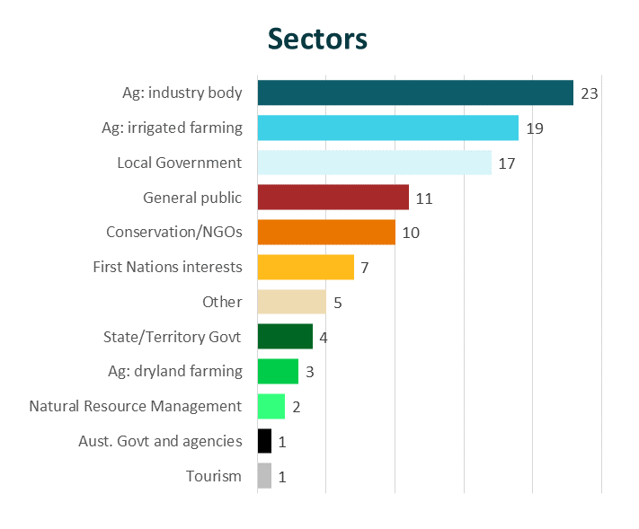

Evaluating the Basin Plan
The changes made to the Basin Plan to deliver it in full will have several review points over the coming years. The 2026 Basin Plan review and the third independent review of the WESA in 2025 will provide opportunities to review the impacts the Basin Plan and successive changes have had and whether the costs and benefits detailed in the RIS and this addendum have materialised since 2012.

2025 Basin Plan evaluation
The Basin Plan must be evaluated every 5 years. The next Basin Plan evaluation will be completed in 2025 in time to inform the review of the Basin Plan in 2026. This will be an opportunity to carefully evaluate the effect the Basin Plan has had on environmental, social, economic and cultural outcomes across the Basin to date The MDBA has prepared a framework and roadmap to guide planning for the 2025 evaluation.

2026 Basin Plan review
The MDBA will review the Basin Plan in 2026. The review will focus on 4 key themes: climate change, sustainable water limits, First Nations, and regulatory design. It will consider the changes needed to ensure a sustainable and healthy Basin for the future and may recommend amendments to the Basin Plan. The MDBA has prepared a roadmap for the delivery of the 2026 review and will release 6-monthly updates on progress (MDBA 2023g).

Third Water for the Environment Special Account review
As part of the extension of time for the Basin Plan, a third independent review of the WESA (building on the reviews in 2020 and 2021) is to be provided to the Minister by 30 September 2025. This will be an important assessment on how flexibility in recovering water is enabling progress against the 450 GL/y target.

Water Act review
The Water Act requires the MDBA to develop a Basin Plan in accordance with the requirements of the Water Act. The next review of the Water Act must be undertaken before the end of 2027. The review will assess the operation of the Water Act and the extent to which the objects of the Act have been achieved and may influence future iterations of the Basin Plan.

Reporting on socio-economic impacts
The Restoring Our Rivers Act reforms introduce new statutory requirements to consider and report on socio-economic impacts. The new requirements include:
- considering socio-economic impacts prior to purchase program
- reporting to Parliament annually on socio-economic impacts
- including the effectiveness of transitional assistance funding to support communities in the third WESA review report.

Next steps
The Australian Government is committed to achieving long-term sustainable outcomes for the Basin and will continue to work with Basin states, communities, industries, farmers, First Nations and environmental groups to deliver the Basin Plan in full.
The Water Act, as amended, provides for the recovery of 450 GL/y of water for the environment to achieve enhanced environmental outcomes. As legislated, the Minister must take all reasonable steps to meet the 450 GL/y target by 31 December 2027.
On 30 January 2024, the government released the draft 450 GL framework. The draft 450 GL framework was the first step in delivery of the Basin Plan under the new deadlines. The draft 450 GL framework outlines 3 new programs that the government will establish to deliver the 450 GL/y target:
- Resilient Rivers Program: infrastructure projects, rules changes, land and water partnerships, and other ways to recover water
- Voluntary Water Purchase Program: purchase of water entitlements from willing sellers
- Sustainable Communities Program: adjustment assistance for Basin communities impacted by voluntary water purchase.

Resilient Rivers Program
The Resilient Rivers Program Water Infrastructure Program (RRWIP – state led) is now open. This program will provide Australian Government funding for Basin states to propose state-led water recovery projects that will improve water management, reduce water losses in the management and delivery of water for production, and return water to the environment.
The program was developed following significant consultation with Basin states and stakeholders. Feedback was also received through the 5-week public consultation and during engagement sessions as part of the development of the Bill. The RRWIP builds on and replaces the Off-farm Efficiency Program.
Up to $494 million over 4 years from 2023–24 will be provided through the RRWIP to fund projects that assist in the recovery of 450 GL/y of additional water for the environment. Funding will be provided to Basin states via Federation Funding Agreements. It aims to provide a more flexible approach for investment than previous programs to meet the 450 GL/y water recovery target.
More information is available at Resilient Rivers Water Infrastructure Program – DCCEEW.

Appendix A: Basin Snapshot
The Murray–Darling Basin is of significant environmental, cultural and economic value to Australia.
- The Basin covers more than 1 million sq km of rivers, lakes, wetlands, floodplains, and dams across New South Wales, Victoria, Queensland, South Australia and the Australian Capital Territory.
- The total length of the Basin’s rivers is 77,000 km. It includes the Murray River, which is Australia’s longest river.
- It is home to 16 internationally significant wetlands, 120 specifies of birds, more than 50 species of fish, 31 frog species, 46 snake varieties, 100 types of lizards, and 3 species of turtle.
- More than 2.3 million people live in the Basin, including more than 50 different First Nations.
- The Basin attracts visitors from around the world for bushwalking, camping, swimming, fishing and bird watching. The tourism industry in the Basin is worth more than $15 billion a year.
- Water from the Basin helps in the production of $30 billion in agricultural production each year – more than one third of the nation’s food.
- 40% of Australia’s farms are within the Basin. Growing things like rice, grapes, cotton and milk need more water more reliably than natural rain can deliver.

Appendix B: Timeline of notable policy and legislative reforms since 2012
2012
- Basin Plan adopted and received bipartisan support in Australian Parliament (November)
- Release of the MDBA’s Basin Plan Regulation Impact Statement (November)
2016
- Release of the MDBA’s Northern Basin Review
2017
- Basin governments nominate supply projects (June)
- MDBA completes assessment of supply package and determines SDL adjustment for public consultation (July)
2018
- SDL adjustment tabled in Australian Parliament
2019
- PC’s Murray–Darling Basin Plan: Five-year assessment 2018 released (January)
- Sustainable diversion limits come into effect (where there are accredited water resource plans)
2020
- 5-yearly Basin Plan Evaluation
- All Queensland, South Australian, Victorian and Australian Capital Territory water resource plans accredited (June)
2021
- Inspector-General of Water Compliance established.
2022
- Release of second independent review of the Water for the Environment Special Account
2023
- Strategic water purchase program opened to bridge the gap to sustainable diversion limits (March)
- Community ideas sought to deliver the Basin Plan in full (May)
- MDBA advises the Basin Plan will not be delivered on time (July)
- Agreement between Murray–Darling Basin Ministers (August)
- Water Amendment (Restoring Our Rivers) Act 2023 receives Royal Assent (7 December)
2024
- Draft Restoring our Rivers framework to deliver 450 GL released (January)
- Resilient Rivers Water Infrastructure Program opens (January)
- PC’s Murray–Darling Basin Plan: Implementation review 2023 released (February)

Appendix C: Commonwealth water recovery in the Murray–Darling Basin

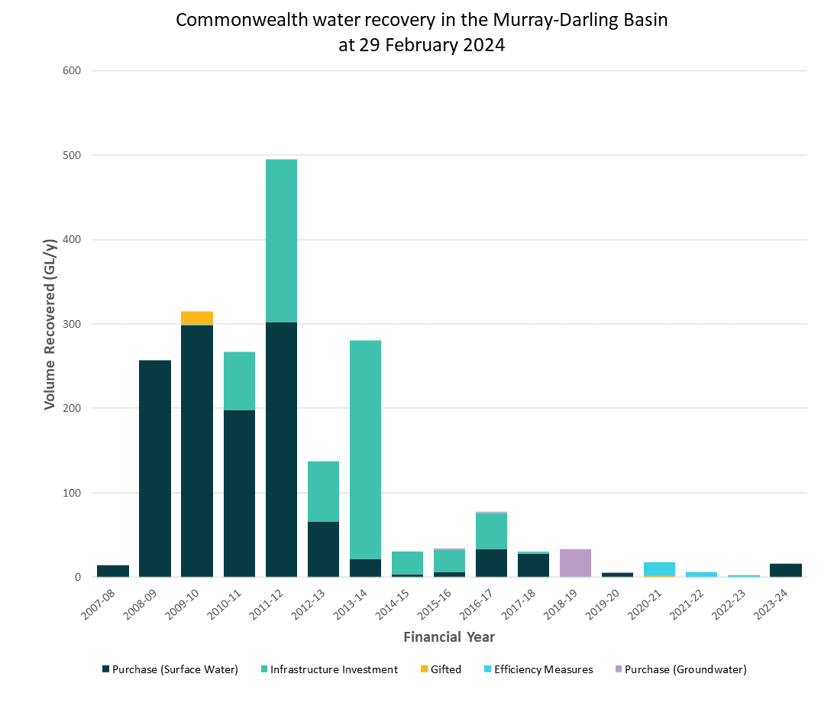

Notes
1. For total water recoveries allow for minor rounding. All water recovery figures are expressed in gigalitres per year long-term diversion limit equivalence (GL/y) terms.
2. Water recovery is reported at the point at which water savings or purchase have been received, estimated or agreed under contract. Until water transfer contracts have been exchanged however, these figures may be subject to change.
3. Estimates of water recovery are calculated using water recovery factors that allow for comparison with Basin Plan targets. The factors are subject to revision during the Water Resource Plan accreditation process to account for the best available information. This table has been prepared consistent with accredited WRPs and revised NSW factors as at 29 February 2024, which may change when those WRPs are finalised. Further information is available at dcceew.gov.au/water/policy/mdb/water-recovery/progress-recovery/accounting.
4. The ‘gifted’ category includes water entitlements that were not recovered through the Sustainable Rural Water Use and Infrastructure Program (SRWUIP). This includes entitlements gifted to the Commonwealth by the Queensland Government in 2009–10 and entitlements recovered through the Mitiamo Pipeline project in 2020–21, funded by the National Water Grid Fund
5. The Queensland Government conducted compulsory license reductions to achieve the SDL target in the QLD Upper Condamine Alluvium (CCA) groundwater resource unit in 2019, recovering 0.5 GL/y. This has been included in the groundwater purchase recovery figures.

Appendix D: Commonwealth water recovery in the Murray–Darling Basin by SDL resource unit and type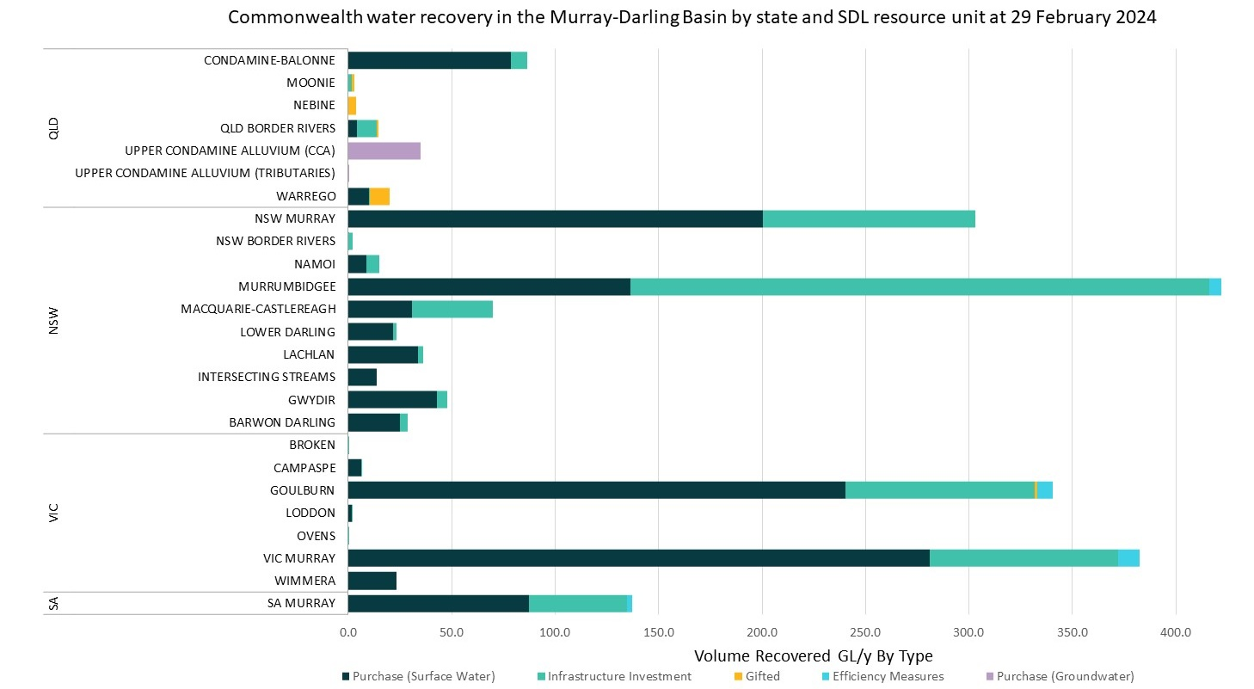

Appendix E: Commonwealth water recovery expenditure in
Murray–Darling Basin by method
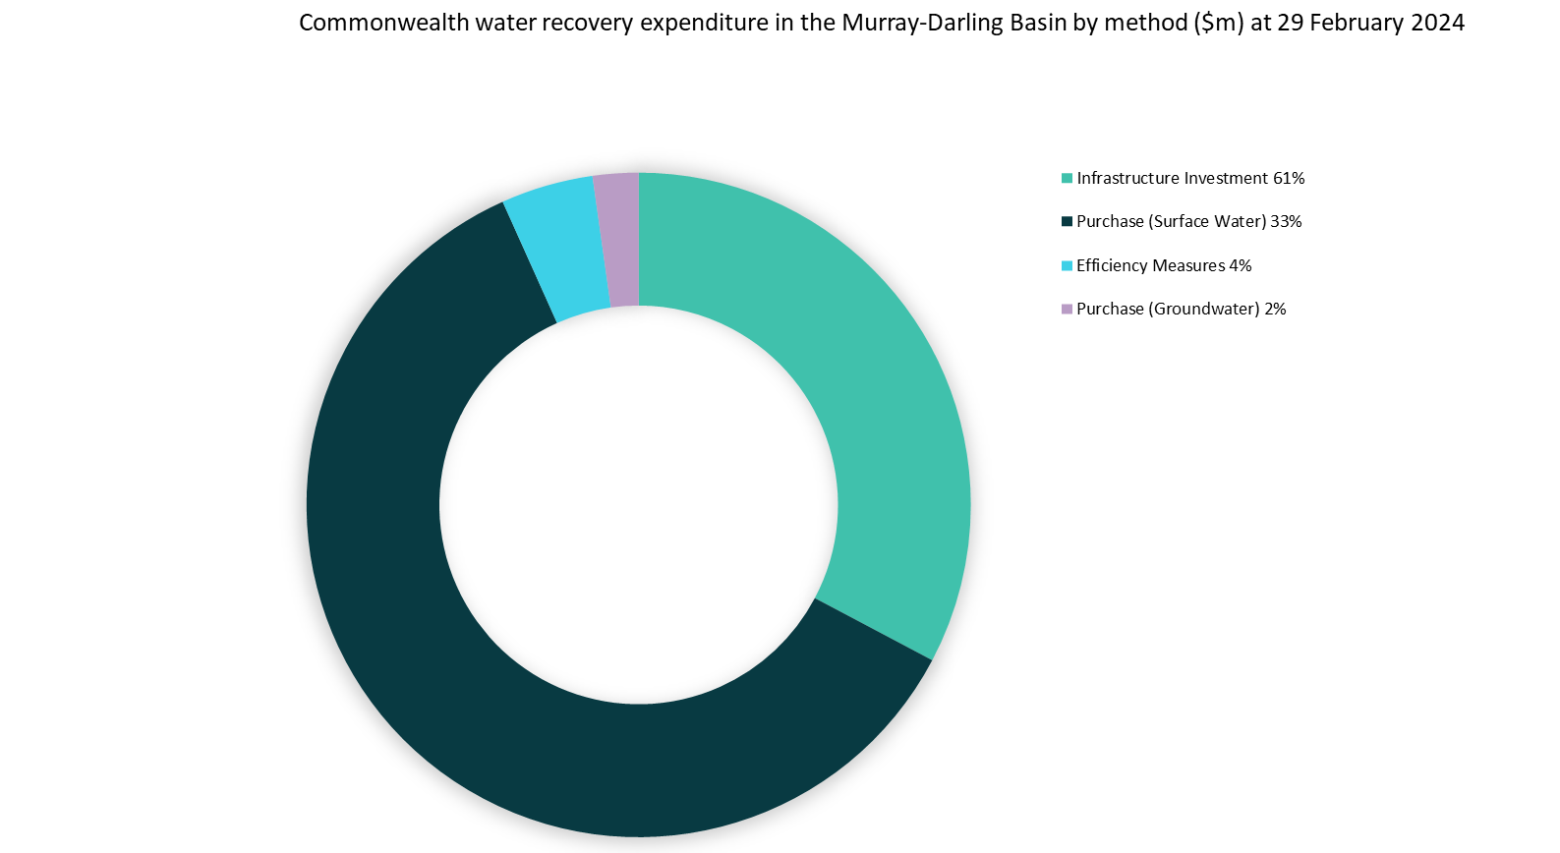

Appendix F: Commonwealth water recovery in Murray–Darling Basin by method

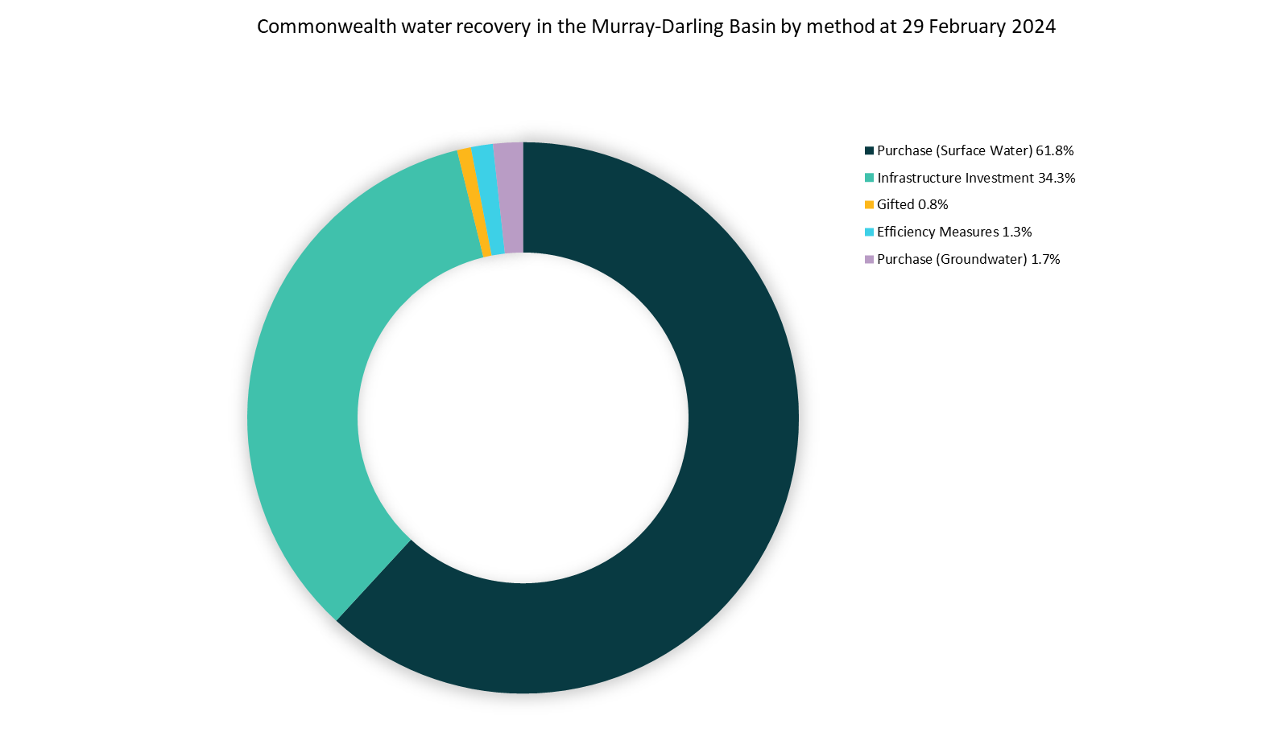

Appendix G: GVIAP for the Murray–Darling Basin, 2005–06 to 2020–21 (nominal $m)
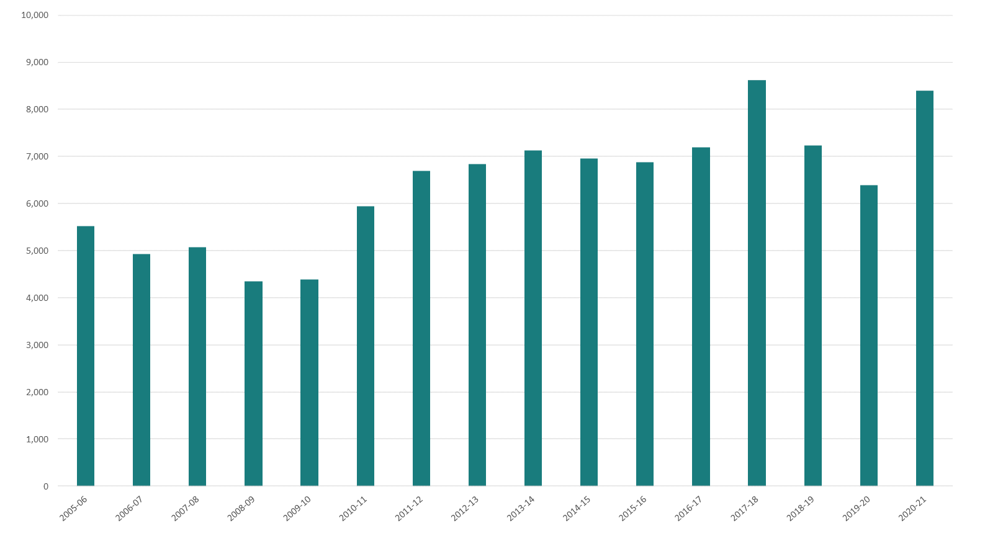

Appendix H: Average annual gross value of irrigated agricultural production in the southern Basin by industry ($m)
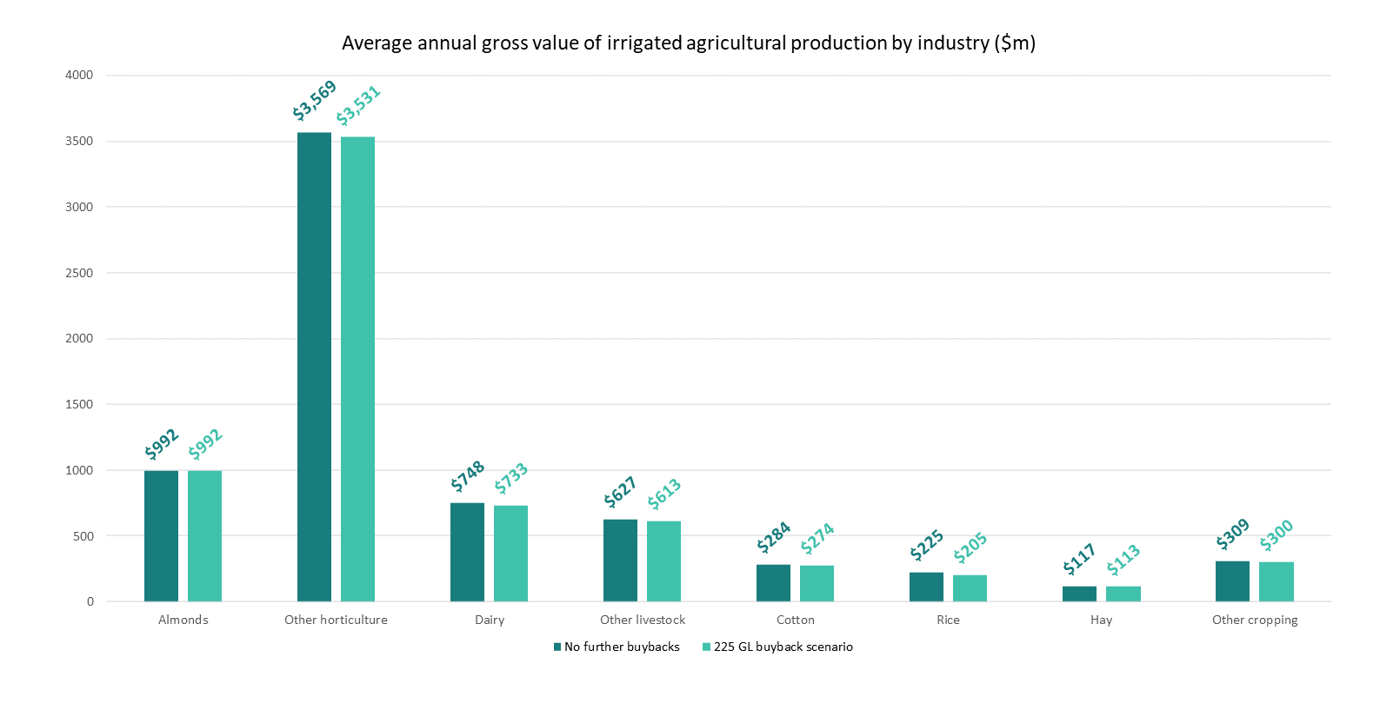

Notes:
1. Values reported in 2022–23 dollars.
2. Dairy and other livestock both fall under the ‘pastures grazing’ water use category, reported above.
3. Percentage impact on dairy assumed to be equal to percentage impact on other livestock in each region.
4. ‘No further recovery’ includes all water recovery to date as of October 2023, but no additional recovery.

Appendix I: Average annual gross value of irrigated agricultural production in the southern Basin by region ($m)
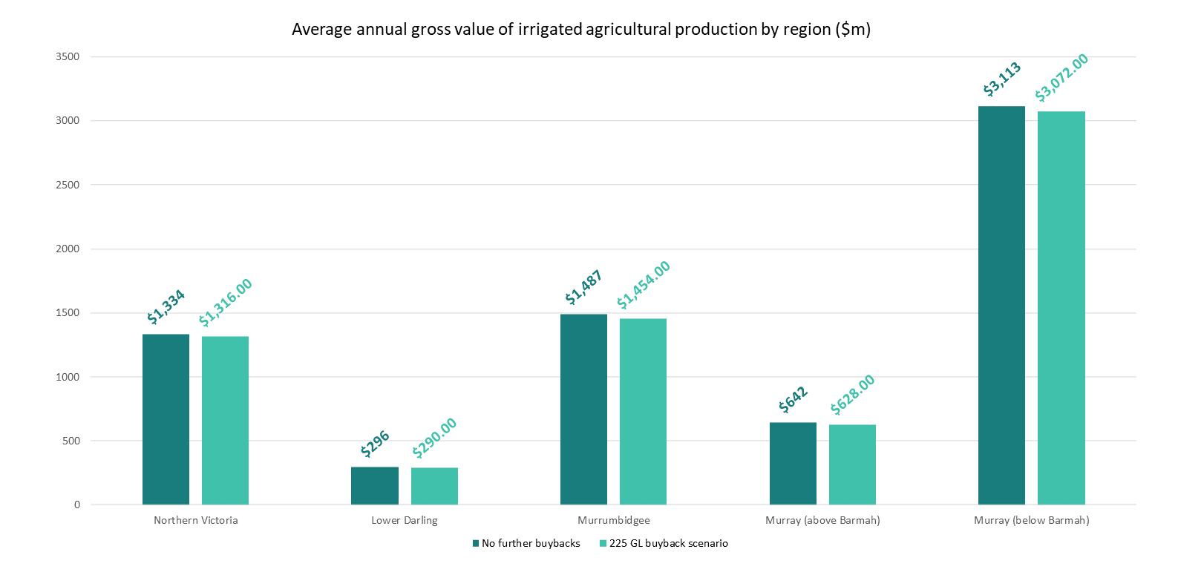
Notes:
1. Values reported in 2022–23 dollars.
2. Estimates for the Lower Darling-Baaka are less reliable but have been included for completeness.
3. ‘No further recovery’ includes all water recovery to date as of October 2023, but no additional recovery.

References
ABS (Australian Bureau of Statistics) (2023), Water Account, Australia, 2021-22 financial year, ABS, Australian Government, accessed 10 April 2024.
ACCC (Australian Competition and Consumer Commission) (2021), Murray-Darling Basin water markets inquiry 2019-21 Final Report, ACCC, Australian Government, accessed 14 November 2024.
Aither (2022), Murray–Darling Basin social and economic conditions report, report to the MDBA, Aither, accessed 29 January 2024.
Aither (2024), Water purchasing programs, report to the New South Wales Department of Climate Change, Energy, the Environment and Water, Aither, accessed 12 February 2024.
ANAO (Australian National Audit Office) (2015), Funding and Management of the Nimmie-Caira System Enhanced Environmental Water Delivery Project, ANAO, Australian Government, accessed 12 February 2024.
Basin Ministers (2023), Deal to guarantee a future for the Murray–Darling Basin, DCCEEW website, accessed 2 February 2024.
Beer AP, Tually S, Kroehn M, Martin J, Gerritsen R, Taylor M, McLean Graymore and Law J (2013), Australia’s country towns 2050: What will a climate adapted settlement pattern look like?, National Climate Change Adaptation Research Facility, Gold Coast, ISBN: 978-1-925039-73-3.
Bureau of Meteorology (2020a), Previous droughts, Bureau of Meteorology website, accessed 3 April 2024.
Bureau of Meteorology (2020b), Special Climate Statement 70 update-drought conditions in Australia and impact on water resources in the Murray–Darling Basin, Bureau of Meteorology, Australian Government, accessed 3 April 2024.
Bureau of Meteorology (2020c), Trends and historical conditions in the Murray-Darling Basin, report to the MDBA, Bureau of Meteorology, Australian Government, accessed 5 January 2024.
Bureau of Meteorology and CSIRO (Commonwealth Scientific and Industrial Research Organisation) (2022), State of the Climate 2022, Bureau of Meteorology and CSIRO, Australian Government, accessed 2 February 2024.
2022), Environmental Activities Framework, DCCEEW, Australian Government, accessed 10 April 2024.
CEWH (Commonwealth Environmental Water Holder) (2023), Submission to the Productivity Commission’s Murray-Darling Basin Plan: Implementation Review 2023, DCCEEW, Australian Government, accessed 10 April 2024.
Chiew FHS, Zheng H, Post DA, Robertson DE and Rojas R (2022), Hydroclimate trends and future projections in the Murray-Darling Basin, report to the MDBA, CSIRO, accessed 11 January 2024.
Cottingham P, Butcher R, Joyce M, Little S, Fenton A, Duncan ME, Newton G, Ringwood G, Kaminskas S, Roseby S and Gawne B (2020), Native Fish Recovery Strategy, accessed 9 April 2024.
CSIRO (Commonwealth Scientific and Industrial Research Organisation) (2008), Water availability in the Murray, report to the Australian Government, CSIRO, accessed 15 February 2024.
CSIRO (Commonwealth Scientific and Industrial Research Organisation) (2011), Murray-Darling Basin sustainable yields project, CSIRO website, accessed on 14 November 2023.
CSIRO (Commonwealth Scientific and Industrial Research Organisation) (2020), Science solutions for the Murray-Darling Basin, CSIRO website, accessed 2 February 2024.
CSIRO (Commonwealth Scientific and Industrial Research Organisation) (2022), Murray–Darling Water and Environment Research Program Annual Progress Update 2021-22, CSIRO, Australian Government, accessed 5 January 2024.
Cresswell I, Janke T and Johnston E (2021), 2021 State of the Environment report, DCCEEW, Australian Government, accessed 3 April 2024.
DCCEEW (Department of Climate Change, Energy, the Environment and Water) (2020), Northern Basin 2019–20 Summary, DCCEEW, Australian Government, accessed 17 March 2024.
DCCEEW (Department of Climate Change, Energy, the Environment and Water) (2023a), Murray-Darling Basin Aboriginal Water Entitlements Program, DCCEEW website, accessed 2 February 2024.
DCCEEW (Department of Climate Change, Energy, the Environment and Water) (2023b), Murray–Darling Basin Economic Development Program, DCCEEW website, accessed 2 February 2024.
DCCEEW (Department of Climate Change, Energy, the Environment and Water) (2023c), What we heard: Delivering the Murray-Darling Basin Plan, DCCEEW, Australian Government, accessed 2 February 2024.
DCCEEW (Department of Climate Change, Energy, the Environment and Water) (2024a), Australian water markets, DCCEEW website, accessed 9 February 2024.
DCCEEW (Department of Climate Change, Energy, the Environment and Water) (2024b), Draft Restoring our Rivers Framework, DCCEEW, Australian Government, accessed 2 February 2024.
DCCEEW (Department of Climate Change, Energy, the Environment and Water) (2024c), Progress on Murray-Darling Basin water recovery, DCCEEW website, accessed 14 March 2024.
DCCEEW (Department of Climate Change, Energy, the Environment and Water) (2024d), Supporting Information – Restoring Our Rivers, DCCEEW website, accessed 19 February 2024.
DCCEEW (Department of Climate Change, Energy, the Environment and Water) (2024e), Sustainable Diversion Limits, DCCEEW website, accessed 20 March 2024.
Downham R and Gupta M (2021), Trends in water entitlement holdings and trade: Analysis of ABARES survey data, ABARES, Australian Government, accessed 13 January 2024.
Downham R, Walsh J, Gupta M, Galeano D and Hone S (2024), The impacts of further water recovery in the southern Murray–Darling Basin, ABARES, Australian Government.
Farrier S, Lewis S and Kelsall M (2020), First Review of the Water for the Environment Special Account, report to Commonwealth Minister for Water Resources, Australian Government, accessed 7 January 2024.
Flett D, Cuddy SM, Brooks S, Campbell C, Doody T, Dyer F, Guarino F, Hladyz S, McGinness H, McInerney P, O’Sullivan J, Rees G, Sengupta A, Tonkin Z, Thurgate N, Wassens S (2023) Basin-scale evaluation of 2021-22 Commonwealth environmental water: synthesis, CEWH, Australian Government, accessed 27 May 2024.
Hartwig L and Jackson S (2020), The status of Aboriginal water holdings in the Murray-Darling Basin, report to the MDBA, Australian Rivers Institute, Griffith University, accessed 15 February 2024.
King A, Mynott J, Bond N, Grieger R, Hamilton D, Hawke T, Johnston-Bates J, Kennard M, King G, Kingsford R, Klunzinger M, Lewis S, Sheldon F, Silvester E and Zivec P (2022), Murray–Darling Basin Outlook literature reviews, report for the MDBA, La Trobe University, Centre for Freshwater Ecosystems, accessed 2 February 2024.
Lawrence J, Mackey B, Chiew F, Costello MJ, Hennessy K, Lansbury N, Nidumolu UB, Pecl G, Rickards L, Tapper N, Woodward A and Wreford A (2022), Chapter 11: Australasia, Climate Change 2022: Impacts, Adaptation and Vulnerability, IPPC (Intergovernmental Panel on Climate Change), accessed 3 April 2024.
Lewis S, Farrier S and Kelsall M (2021), Second Review of the Water for the Environment Special Account, report to the Commonwealth Minister for Water Resources, Australian Government, accessed 7 January 2024.
MDBA (Murray–Darling Basin Authority) (2012a), Murray-Darling Basin Plan – Regulation Impact Statement, MDBA, Australian Government, accessed 29 January 2024.
MDBA (Murray–Darling Basin Authority) (2012b), Hydrologic modelling relaxed constraints October 2012, MDBA, Australian Government, accessed 12 February 2024.
MDBA (Murray–Darling Basin Authority) (2016), Northern Basin Review report, MDBA, Australian Government, accessed 4 January 2024.
MDBA (Murray–Darling Basin Authority) (2020a), 2020 Basin Plan Evaluation, MDBA, Australian Government, accessed 13 January 2024.
MDBA (Murray–Darling Basin Authority) (2020b), Vulnerabilities to climate change in the Murray-Darling Basin, MDBA, Australian Government, accessed 20 February 2024.
MDBA (Murray–Darling Basin Authority) (2023a), Authority advice on Basin Plan implementation, response to Minister’s request for advice, MDBA, Australian Government, accessed 2 February 2024.
MDBA (Murray–Darling Basin Authority) (2023b), Barmah–Millewa Forest Report Card 2021–22, MDBA, Australian Government, accessed 13 November 2023.
MDBA (Murray–Darling Basin Authority) (2023c), First Nations participation in environmental watering 2022-23 report, MDBA, Australian Government, accessed 13 March 2024.
MDBA (Murray–Darling Basin Authority) (2023d), 2023 mid-year Basin Plan Report Card, MDBA, Australian Government, accessed 16 February 2024.
MDBA (Murray–Darling Basin Authority) (2023e), Our climate workplan, MDBA website, accessed 20 February 2024.
MDBA (Murray–Darling Basin Authority) (2023f), Progress and outcomes – an improving system, MDBA website, accessed 2 February 2024.
MDBA (Murray–Darling Basin Authority) (2023g), Roadmap to the 2026 Basin Plan Review, MDBA, Australian Government, accessed 22 May 2024.
MDBA (Murray–Darling Basin Authority) (2023h), Sustainable diversion limit adjustment mechanism annual assurance report July 2023, MDBA, Australian Government, accessed 13 January 2024.
MDBA (Murray–Darling Basin Authority) (2023i), The Basin, MDBA website, accessed 9 February 2024.
MDBA (Murray–Darling Basin Authority) (2024a), Basin Plan timeline and history, MDBA website, accessed 13 January 2024.
MDBA (Murray–Darling Basin Authority) (2024b), Climate Change, MDBA website, accessed 14 November 2023.
MDBA (Murray–Darling Basin Authority) (2024c), List of state water resource plans, MDBA website, accessed 9 January 2024.
MDBA (Murray–Darling Basin Authority) (2024d), Progress of sustainable diversion limit adjustment mechanism projects, MDBA website, accessed 22 February 2024.
MJA (Marsden Jacob Associates) (2018), Recreational fishing in the Murray-Darling Basin, Case study supporting the Independent Assessment of Economic and Social Conditions in the Murray–Darling Basin, MJA, accessed 3 April 2024.
Murray Regional Tourism (2023), Murray Region Snapshot YE June 2023, Murray Regional Tourism, accessed 7 January 2024.
NIAA (National Indigenous Australians Agency) (2024), Closing the Gap 2023 Annual Report and 2024 Implementation Plan, NIAA, Australian Government, accessed 15 March 2024.
NSW Government (New South Wales Government) (2018), Murray-Darling Basin Socio-Economic Values of Native Fish and Recreational Fishing – Scoping Project – Final Report, NSW Government, accessed 5 April 2024.
NSW Government (New South Wales Government) (2022), Western Regional Water Strategy, NSW Government, accessed 3 April 2024.
NSW Government (New South Wales Government( (2024), Northern Basin Connectivity Program, NSW Government, accessed 22 May 2024.
PC (Productivity Commission) (2018), Inquiry report – Murray-Darling Basin Plan: Five-year assessment, report to the Treasurer, PC, Australian Government, accessed 30 January 2024.
PC (Productivity Commission) (2023), Inquiry Report – Murray-Darling Basin Plan: Implementation review 2023, report to the Treasurer, PC, Australian Government, accessed 15 March 2024.
Schirmer J and Mylek M (2020), Thriving, surviving, or declining communities: socio-economic change in Murray-Darling Basin communities, University of Canberra, accessed 2 February 2024.
Schmidt B, Brandon C, Mokany K, Richards A, Smith G, Stewart S, Williams K, Evans D, Ferrier S, Giljohann K, Harwood T, Johnson S, Khan S, Lehmann E, Liu N, McIlgorm A, Newnham G, Nichols R, Pascoe S, Roxburgh S, Scheufele G, Tetreault Campbell S and Ware (2023), Experimental ecosystem accounts for the Murray-Darling Basin, A synthesis report from the Regional Ecosystem Accounting Pilot projects, CSIRO, Australian Government, accessed 17 March 2024.
Sefton R, Woods R, Kassebaum A, McKenzie D, Peterson D, Ramsay M and Simpson B (2020), Independent assessment of the social and economic conditions in the Basin, report to the Australian Government, accessed 14 November 2023.
Stenekes N, Kancans R, Randall L, Lawson K, Reeve I and Stayner R (2012), Revised indicators of community vulnerability and adaptive capacity across the Murray-Darling Basin, report to the MDBA, ABARES, Australian Government, accessed 20 March 2024.
Stenekes N, Kancans R, Randall L and Aither (2024), Baseline relative community vulnerability and adaptive capacity—Murray-Darling Basin, ABARES and Aither.
Vertessy R, Barma D, Baumgartner L, Mitrovic S, Sheldon F and Bond N (2019), Final report of the Independent Panel into fish deaths in the Lower Darling, report to the Australian Government, independent panel, accessed 3 April 2024.
Wheeler SA, Xu Y, Zuo A, Haensch J and Seidl C (2023), Identifying the water-related economic values of the Murray-Darling Basin and rating the quality of water economic studies, report for the MDBA, School of Economics and Public Policy, University of Adelaide, accessed 7 January 2024.
Whittle L, Galeano D, Hughes N, Gupta M, Legg P, Westwood T, Jackson T and Hatfield-Dodds S (2020), Analysis of economic effects of water recovery in the Murray–Darling Basin, ABARES, Australian Government, accessed 15 January 2024.
Zhang Z, Zheng H, Teng J, Chiew F and Post D (2020), Plausible hydroclimate futures for the Murray-Darling Basin, report for the MDBA, CSIRO, accessed 11 November 2023.

Long-term diversion limit equivalent factors were established to accurately assess how much water has been recovered for the environment, and to guide future water recovery decisions. The factors provide a consistent accounting system to ensure water recovery has occurred as planned and indicate where any future water recovery may be required. See https://www.mdba.gov.au/climate-and-river-health/water-environment/water-recovery/factors-water-recovery.
The water markets reforms part of the Restoring Our Rivers Act amendments have different commencement arrangements and are not within the scope of this addendum to the RIS.
Refer to Section 2 for an explanation of the Bridging the Gap target.
Refer to Section 2 for an explanation of the 2,075 GL/y target.
Refer to Section 2 for an explanation of supply and constraints measures.
Refer to Section 2 for an explanation of Water Resource Plans.
Water Amendment (Restoring Our Rivers) Act 2023 (Cth)
Refer to Section 2 for more information.
Defined as the potential for further water recovery through efficiency measures across the Basin, irrespective of the cost of recovery, the location of the recovery, and the time required for recovery.
See section 106(3)(c) of the Water Act
The water markets reforms part of the Restoring Our Rivers Act amendments have different commencement arrangements and are not within the scope of this addendum to the RIS.

