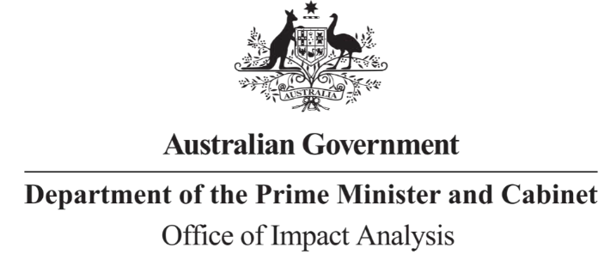

Reference: OBPR22-02601

Telephone: 6271 6270 e-mail: [helpdesk-oia@pmc.gov.au](mailto:helpdesk-oia@pmc.gov.au)

Ms Kirsty Gowans

A/g Deputy Secretary - Energy

Department of Climate Change, Energy, the Environment and Water Dear Ms Gowans

# Impact Analysis – Second Pass Final Assessment – New Generation and Storage

**Capacity Options**

Thank you for your letter of 13 October 2023 submitting an Impact Analysis (IA) for formal Second Pass Final Assessment. I note the IA has been formally certified at *the Deputy Secretary* level consistent with the *Australian Government Guide to Policy Impact Analysis*.

I appreciate the Department’s constructive engagement on the IA. The Office of Impact Analysis’ (OIA’s) assessment is that the quality of the analysis in the IA is adequate. To achieve a good rating, the IA could have included:

* Additional detail on the rationale for government intervention, based on a clear description of the government’s role in the energy sector.
* Improved coherence of the analytical framework being applied in the analysis.
* More detailed evaluation planning, including key evaluation questions, responsibilities for data collection, data management and program governance.

# Next steps

After a final decision has been announced, I ask that your agency work with OIA to finalise this material for public release. This includes providing a copy of the IA in Word and PDF format for web accessibility purposes. The IA must be included in any Explanatory Memorandum or Statement giving effect to the proposals in the IA.

If you have any further queries, please do not hesitate to contact me. Yours sincerely

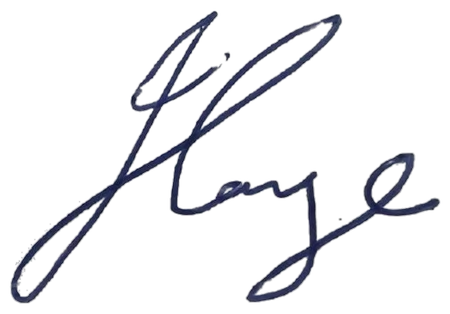

Jason Lange Executive Director

Office of Impact Analysis 17 October 2023