Cleaner, Cheaper to Run Cars:

The Australian New Vehicle Efficiency Standard

  - Impact Analysis
March 2024

ISBN: 978-1-922879-19-6
January 2024 / INFRASTRUCTURE 2024
© Commonwealth of Australia 2024

Ownership of intellectual property rights in this publication
Unless otherwise noted, copyright (and any other intellectual property rights, if any) in this publication is owned by the Commonwealth of Australia (referred to below as the Commonwealth).

Disclaimer
The material contained in this publication is made available on the understanding that the Commonwealth is not providing professional advice, and that users exercise their own skill and care with respect to its use, and seek independent advice if necessary.
The Commonwealth makes no representations or warranties as to the contents or accuracy of the information contained in this publication. To the extent permitted by law, the Commonwealth disclaims liability to any person or organisation in respect of anything done, or omitted to be done, in reliance upon information contained in this publication.

Creative Commons licence
With the exception of (a) the Coat of Arms; (b) the Department of Infrastructure, Transport, Regional Development and Communications photos and graphics; copyright in this publication is licensed under a Creative Commons Attribution 4.0 Australia Licence.
Creative Commons Attribution 4.0 Australia Licence is a standard form licence agreement that allows you to copy, communicate and adapt this publication provided that you attribute the work to the Commonwealth and abide by the other licence terms.
Further information on the licence terms is available from https://creativecommons.org/licenses/by/4.0/.
This publication should be attributed in the following way: © Commonwealth of Australia 2023.

Use of the Coat of Arms
The Department of the Prime Minister and Cabinet sets the terms under which the Coat of Arms is used. Please refer to the Commonwealth Coat of Arms — Information and Guidelines publication available at www.pmc.gov.au.

Contact us
This publication is available in PDF format. All other rights are reserved, including in relation to any departmental logos or trademarks which may exist. For enquiries regarding the licence and any use of this publication, please contact:
Director—Creative Services
Communication Branch
Department of Infrastructure, Transport, Regional Development, Communications and the Arts
GPO Box 594
Canberra ACT 2601
Australia
Email: creative.services@infrastructure.gov.au
Website: www.infrastructure.gov.au
Table of Contents
Key Terms 7
Foreword 10
Executive Summary 11
1. Background 14
1.1. History of light vehicle emissions regulation in Australia 14
1.2. What is a car (light vehicle)? 15
1.3. Process to date and next steps 15
2. What is the policy problem you are trying to solve and what data is available? 16
2.1. Australians don’t currently have access to the same fuel-efficient cars as other jurisdictions… 16
2.2. …and we’re spending more on fuel than ever before 17
2.3. Australian cars are highly polluting 19
3. What are the objectives, why is Government intervention needed to achieve them, and how will success be measured? 23
3.1. Government is committed to cut CO₂ emissions 23
3.1.1 Alternatives to Government action – such as a voluntary scheme – will not deliver more fuel-efficient new cars 24
3.1.2 The Government can build on an existing regulatory framework to regulate CO₂ emissions 24
3.1.3 Success measures were established through the Cleaner Cars consultation paper and consulted on again 25
3.1.4 There are a range of other factors, that could become barriers to achieving our objectives 27
4. What policy options are you considering? 28
4.1. Overview 28
4.2. What is the business-as-usual scenario? 29
4.2.1 Do EVs release more emissions than ICE vehicles over their lifetime? 31
4.2.2 What other Government policies will act on emissions from light vehicles and complement this policy intervention? 32
4.3. What is a New Vehicle Efficiency Standard? 33
4.3.1 How does a NVES work? 34
4.3.2 Common features of a NVES 36
4.4. NVES options compared 38
4.4.1. What changes could be considered? 48
5. What is the likely net benefit of each option? 50
5.1. Any viable option must compare well against the principles established 50
5.2. The options analysed all have a net benefit 54
5.2.1 Option A – slow start 56
5.2.2 Option B – fast but flexible 56
5.2.3 Option C – fast start 57
5.2.4 The best option from those considered 57
5.2.5 How do the different options impact stakeholders? 58
5.2.6 What sensitivity tests were considered? 61
5.3. Regulatory burden estimate (RBE) table 63
6. Who did you consult and how did you incorporate their feedback? 64
6.1. Extensive public consultation has informed the design of an Australian NVES 64
6.1.1. Initial consultation for the National Electric Vehicle Strategy - Sep to Oct 2022 65
6.1.2. Phase 1 consultation on the design of the New Vehicle Efficiency Standard - Apr to May 2023 65
6.1.3. Phase 2 consultation on the design of the NVES - Feb to Mar 2024 70
Targeted discussions 72
Who contributed their views to the consultation? 72
So which option was preferred by consultation participants overall? 72
6.1.4. Consultation outcome by option - what we heard 81
7. What is the best option from those you have considered and how will it be implemented? 82
7.1. The best option for a New Vehicle Efficiency Standard 82
7.2. What entities should be regulated 83
7.3. Regulatory apparatus 84
7.4. Timeline and transitional arrangements 88
7.5. Implementation challenges and impacts 89
8. How will you evaluate your chosen option against the success metrics? 91
8.1. Program monitoring and evaluation 92
8.1.1 Monitoring of ongoing NVES operations 93
8.1.2 Program evaluation 93
Appendix A: The Australian Car Market 95
Appendix B: Key assumptions in CBA 99
Appendix C: Outcome calculation methodology and examples 107
Appendix D: Implementation Program Risk Matrix 109

List of Figures and Tables
Figure 1 – Actions to consider a new vehicle efficiency standard (referred to above as a fuel efficiency standard) and CO₂ equivalent emissions, over time. 14
Figure 2 – Process to date 15
Figure 3 – Petrol and diesel price over time 18
Figure 4 – Transport emissions sources – Australia’s emissions projections, DCCEEW 2023 20
Figure 5 – International passenger vehicle emissions trajectories 21
Figure 6 – International light commercial vehicle emissions trajectories 22
Table 1 – Principles against which the Government’s option is assessed 26
Figure 7 – Total amount of emissions expected from BAU 30
Figure 8 – BAU EV uptake 31
Figure 9 - Light vehicle options to increase fuel efficiency 33
Table 2 – Slope and reference mass 34
Figure 10 – How a NVES applies (sample data for illustrative purposes only) 35
Table 3 – NVES options compared 42
Figure 11 – Passenger vehicle headline targets for options relative to US EPA proposed targets. 44
Figure 12 – Light commercial vehicle headline targets for options relative to other country’s targets. 45
Figure 13 – Cumulative abatement of all options to 2030 46
Figure 14 – Cumulative abatement of all options to 2050 46
Figure 15 – Cumulative fuel cost saving of all options to 2050 47
Table 4 – Considered changes to Option B 49
Table 5 – Assessment of options vs principles 53
Table 6 – Benefits and costs of options 54
Table 7 – Key benefits 54
Table 8 – Key costs 55
Table 9 – Benefits and costs of Option A 56
Table 10 – Benefits and costs of Option B 56
Table 11 – Benefits and costs of Option C 57
Table 12 – Benefits and costs of the best option 57
Table 13 – Definition of stakeholders 58
Table 14 – Stakeholder impacts of options 59
Table 15 – Benefits and costs for states and territories 60
Table 16 – Benefits and costs for different locations 60
Table 17 – Sensitivity analysis 62
Table 18 – Consumer welfare loss analysis 63
Table 19 – Regulatory burden estimate 63
Figure 16 – NVES consultation timeline 64
Figure 17 – Key themes from the Phase 1 consultation 66
Figure 18 – Organisation category for Phase 1 consultation 67
Figure 19 – Digital outreach 71
Figure 20 – Phase 2 Consultation – Questionnaire results 72
Figure 21 – Individual responses themes 73
Figure 22 – Organisation types for Phase 2 75
Figure 24 – Proposed regulatory timeframe 87
Table 20 – Proposed timetable for implementation 89
Table 21 – Success Measures and Associated Evaluation Metrics 92
Table 22 – Slope and reference mass 108

Key Terms
Term | Definition
ABS | The Australian Bureau of Statistics is the central statistical authority for the Australian Government and, by legal arrangements, provider of statistical services to Australian state and territory governments.
ADR | The Australian Design Rules are the national standards for vehicle safety, anti-theft and emissions.
Attribute-based standard | Is a standard that is based on an attribute of a vehicle such as mass, or footprint (i.e. length and width), which is further defined by the limit curve.
BAU | Business as usual.
BCR | Benefit-cost ratio.
Car parc | A term that refers to all registered vehicles in Australia.
CO₂ | Carbon dioxide, the key greenhouse gas expelled from the exhaust systems of internal combustion engines.
CO₂-e | Carbon dioxide equivalent (in terms of global warming potential).
CBA | Cost-benefit analysis.
Credits | A mechanism to track when a supplier beats its target.
DCCEEW | Department of Climate Change, Energy, the Environment and Water.
The department | Department of Infrastructure, Transport, Regional Development, Communications and the Arts.
EV | A vehicle that exclusively uses chemical energy stored in rechargeable battery packs to power at least one electric motor with no secondary source of propulsion.
FCEV | A hydrogen fuel cell electric vehicle, is an electric vehicle that is powered by electricity generated by a fuel cell that uses compressed hydrogen, as opposed to being powered by externally sourced electricity stored in an onboard battery like in a BEV.
Fleet limit curve | Defines the amount of CO₂ a supplier’s fleet of cars is able to emit on average, over time and is often drawn on a graph against vehicle mass.
GVM | Gross vehicle mass is the maximum loaded weight of a vehicle while driving on the road.
GHGs | A greenhouse gas is any gas that contributes to global climate change. CO₂ is one of the key GHGs emitted by ICE-powered vehicles.
GWP | Global-warming potential is used to describe the relative potency, molecule for molecule, of a greenhouse gas, taking account of how long it remains active in the atmosphere.
Hybrid / HEV | A hybrid electric vehicle is a vehicle that is powered by the combination of an internal combustion engine and an electric motor, which is not able to plugged into an external source of power to charge its internal battery.
ICE | An internal combustion engine-powered vehicle solely utilises the power from its internal combustion engine and no other source of propulsion. ICE engines power cars that most Australians have historically driven and generally consume carbon-based fuels such as petrol or diesel. ‘Advanced’ ICE refers to ICE vehicles that have improved efficiency above what is currently available on the Australian market.
Intensity | The carbon dioxide emissions intensity for vehicles is calculated using the method described in Vehicle Standard (Australian Design Rule 81/02 – fuel consumption labelling for light vehicles) and expressed in grams of carbon dioxide per kilometre (g/km).  Vehicle emissions intensity is a measure of vehicle efficiency, not actual vehicle emissions, which depend on many real-world factors, such as the distance travelled, the nature of the driving, and road and traffic conditions.
IEV | Interim Emissions Value. A supplier’s interim emissions value for a year is worked out by measuring the performance of each vehicle for the person for the year against the set emissions targets for the year. A positive value indicates that the vehicle has underperformed against its targets (the vehicle produces emissions over its target), whereas a negative value indicates overperformance (the vehicle produces fewer emissions than its target). These numbers are summated to obtain the supplier’s interim emissions value for the year.
LCV | Light commercial vehicles are utes and vans. Under the relevant legislative framework (see Vehicle Standard (Australian Design Rule – Definitions and Vehicle Categories) 2005), we place NA (light goods vehicles) and NB1 (medium goods vehicles) in the light commercial vehicle category with exemptions available for some NB1 vehicles.
LZEV | Low and Zero Emission Vehicles is a catch-all term to describe, BEVs, HEVs and PHEVs.
MIRO | Mass In Running Order is mass of the vehicle with all fluids, standard equipment and 75kg for the driver.
Net zero | The United Nations defines net zero as cutting GHG emissions to as close to zero as possible, and where any remaining emissions are re-absorbed from the atmosphere, for example by forests or seas.
NEVS | The National Electric Vehicle Strategy sets out Australia’s ambition to improve supply and access to EVs, improve EV infrastructure and increase demand for EVs.
NVES | A new vehicle efficiency standard is a legislative framework that regulates CO₂ emissions from vehicles, usually by applying an average CO₂ target to a suppliers’ fleet of new vehicles. A NVES usually becomes more stringent over time. We previously referred to this policy as a Fuel Efficiency Standard.
PVs | Passenger vehicles are sedans, hatch backs, SUVs and most 4WDs. Under Australian legislation (see Vehicle Standard (Australian Design Rule – Definitions and Vehicle Categories) 2005) cars are further sub-categorised. Using the legislative categories, we generally put MA (passenger cars), MB (forward-control passenger vehicles) and MC (Off-road passenger vehicles) categories in the passenger vehicle category.
PHEV | A plug-in hybrid electric vehicle is a vehicle that is propelled by a combination of power from a battery that can be recharged by plugging it into an external source of electric power, in addition to its on-board ICE engine, which also acts as a generator to recharge the battery.
ROVER | ROVER (Road Vehicle Regulator) is an administration system for the Road Vehicle Standards Act 2018 within the Department of Infrastructure, Transport, Regional Development, Communications and the Arts.
Supplier | An entity that holds an approval under the Road Vehicle Standards Act 2018 to provide vehicles to the Australian market (for example, a company that imports cars into Australia).
ZEV | A vehicle with no tailpipe emissions.  Where reference is made in this document to a zero emissions vehicle for the purposes of a new vehicle efficiency standard, it is taken to mean a vehicle that does not have an internal combustion engine and therefore does not produce CO₂ while driving. There may be other emissions, such as grid emissions from charging an EV or hydrogen electrolysis, and lifecycle emissions from manufacturing processes. See Chapter 4 for more analysis on this aspect.

Foreword
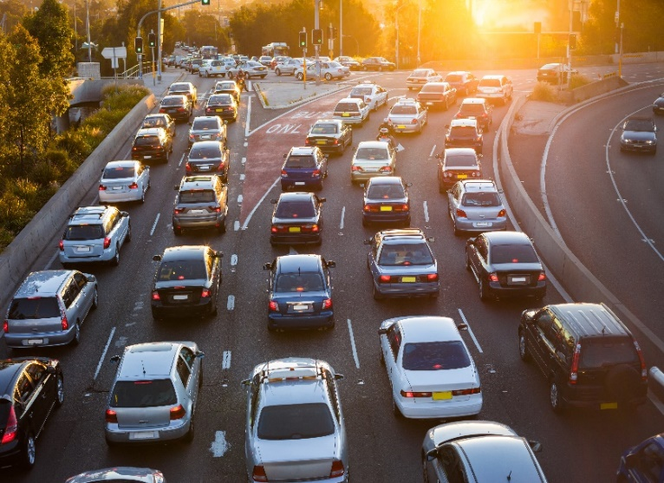
Australia is a nation of drivers.
In 2020, Australia was in the top five car owning nations globally and, there were nearly twenty million cars in Australia. We bought more fuel for passenger carrying vehicles than we did for vehicles carrying freight, and almost 80% of our fuel consumption was petrol.
Yet, Australians are being left behind as the major economies of the world benefit from more fuel-efficient cars and greater access to new low and zero emissions technology. Australia and Russia are among the only advanced economies without a new vehicle efficiency standard (also known as a fuel efficiency standard), so we spend more on fuel and have fewer choices of cleaner, cheaper-to-run cars.
Over 85% of cars sold worldwide are covered by a new vehicle efficiency standard, but in contrast, the 1.1 million new cars sold in Australia in 2023 were not required to meet any level of fuel efficiency. Because of this, Australian new cars use significantly more fuel than new cars on the road in the United States. In fact, passenger cars in Australia on average, use 20% more fuel than passenger cars in the US. The inefficiency of our vehicles means that for every litre of fuel we buy, we drive fewer kilometres.
In 2023, the cars we drove were responsible for more megatonnes of greenhouse gas emissions (particularly carbon dioxide (CO₂)) than from any other form of transport, and cars represent 11.4% of Australia’s total emissions. The impact of these emissions on Australia’s climate outlook, within our lifetime, cannot be ignored.
Our vision is for a future where the Australian community can benefit from a stronger climate outlook, health benefits through reduced emissions, savings on fuel costs, and access to a wider choice of vehicles from a car industry that is vibrant and sustainable.
We recognise that there are a range of different views in the community – especially given the cultural place that cars play in our society. That is why we have undertaken multiple rounds of consultation to calibrate this Impact Analysis for a policy that is right for Australia.

Executive Summary

This Impact Analysis sets out the Government’s final design for an Australian New Vehicle Efficiency Standard (NVES). As many readers will be familiar with, long standing Australian Government policy is that substantive regulatory decisions should be accompanied by an Impact Assessment (previously known as a Regulation Impact Statement, or RIS).

An Impact Analysis helps policymakers consider how proposals affect businesses, individuals and community organisations, as well as broader economic and other impacts. A strong evidence-based impact analysis is a powerful tool when applied intentionally and consistently. The Australian Government’s Policy Impact Analysis Framework ensures that decision makers are supported with the necessary evidence base, and that policy is well-designed, well-targeted and fit-for-purpose.

All impact analyses follow the Australian Government requirements, addressing seven key questions. In this paper, we have provided content in line with these questions. The final Impact Analysis will be published on the Office for Impact Analysis’ (OIA) website.

The OIA’s seven Impact Analysis questions are:

Question | Related chapters in this document
- What is the policy problem you are trying to solve and what data is available? | Chapter 2
- What are the objectives, why is Government intervention needed to achieve them, and how will success be measured? | Chapter 3
- What policy options are you considering? | Chapter 4
- What is the likely net benefit of each option? | Chapter 5
- Who did you consult and how did you incorporate their feedback? | Chapter 6
- What is the best option from those you have considered and how will it be implemented? | Chapter 7
- How will you evaluate your chosen option against the success metrics? | Chapter 8

Following more than 12 months of consultation with the community and industry which attracted more than 11,000 submissions in total and featured two roundtables with industry and other stakeholders, extensive economic modelling and consideration of a range of options, the Government has identified a best option for the design of the NVES. The three earlier options, and the best option, are set out in detail in this Impact Analysis. Legislation enabling the introduction of the NVES, the New Vehicle Efficiency Standard Bill 2024, will be introduced in Parliament in the first half of 2024.
The options considered by Government in February 2024 varied in their settings, which resulted in different potential levels of fuel savings, carbon dioxide (CO₂) abatement and health benefits as well as variations in costs. One of the options was do-nothing, that is, no policy intervention by Government. Our modelling showed that this ‘do nothing’ option would lead to a gradual emissions reduction as efficiency of internal combustion engine (ICE) vehicles slowly increases, and that sales of zero emissions vehicles reach 100% of new car sales by around 2046.
Option A provided the lowest fuel savings, abatement, and health benefits. It was also the least likely to incentivise the supply of fuel-efficient, low and zero emissions vehicles to the Australian market.
Option B, the Government’s previously best option as published in the Consultation Impact Analysis in February 2024, found that Australia would catch up with the currently proposed US average vehicle emissions intensity by around 2028. This option was estimated to deliver abatement of 369 million tonnes of CO₂ by 2050, and close to 100 million tonnes of CO₂ abatement by 2035.
Option C, offered larger fuel savings and emissions reductions, but higher quantitative technology costs and a higher qualitatively assessed risk of disruption to the availability of the kinds of vehicles Australians use for work and leisure. The resulted in both a high net benefit and greater abatement.
The consultation process identified some specific and targeted amendments to Option B that would improve the option based on the need to achieve a balance between abatement, consumer needs and the sustainability and vibrancy of the Australian car market. The decision maker can adopt none, some, or all of these changes, or alternative settings. The impact of each of these on the abatement achieved relative to Option B and change to the benefit-cost ratio are at Chapter 4 in this Impact Analysis.
These were:
- Changes to the Light Commercial Vehicle headline limit: A recalibration of the Light Commercial Vehicle (LCV) headline limit;
- Breakpoints: Adjustments to the upper breakpoint limits in both the Passenger Vehicle (PV) and LCV categories;
- Category shift: Move a small number of very large 4WDs to the LCV category; and
- Implementation timing: Have the NVES commence from 1 January 2025, but adjust the timing so that no credits and debits can be accrued until 1 July 2025.
The proposed best option incorporates all of these potential changes. The best option aims to maximise consumer fuel savings health benefits and potential CO₂ abatement, while ensuring Australia’s car industry is vibrant and can supply Australians with the cars they like to drive.
This option is estimated to deliver abatement of 20Mt to 2030, 80 Mt to 2035, and 321 million tonnes of CO₂ by 2050. Our modelling shows that Australians will accrue around $86.04 billion in net benefits out to 2050, including over $95 billion in fuel savings to 2050 for everyday Australians.
The best option is an ambitious approach, but one that balances ambition with achievability. It responds to consultation feedback and addresses key implementation risks by allowing sufficient time for the establishment and embedding of technical systems needed to operate the NVES, and providing a slight extension of time for manufacturers to adjust their product offerings to meet the targets in the standard.
Importantly, the passenger vehicle headline limit which covers the vast majority of vehicles sold, remains unchanged which will drive substantial emissions reductions in the category of vehicles with advanced hybrid, low and zero emission options. Supercredits, off-cycle credits and air conditioning credits are not part of this standard - maintaining simplicity and transparency.

Background

History of light vehicle emissions regulation in Australia
Since at least 2008, successive Australian governments have considered measures that would improve the fuel efficiency of cars. These efforts have not yet translated into action. While vehicle fuel efficiency technology has improved over time, it has not been enough to offset emissions from the increasing number of cars that Australians drive.

Figure 2 in section 1.3 shows that, over time, Australia’s transport sector (light vehicles, heavy vehicles, domestic aviation, domestic maritime etc.) emissions (depicted as millions of tons (Megatons or Mt)) of carbon dioxide equivalent (CO₂-e) have been steadily rising, against a range of initiatives by both government and industry. This work has failed to translate into effective abatement of emissions.

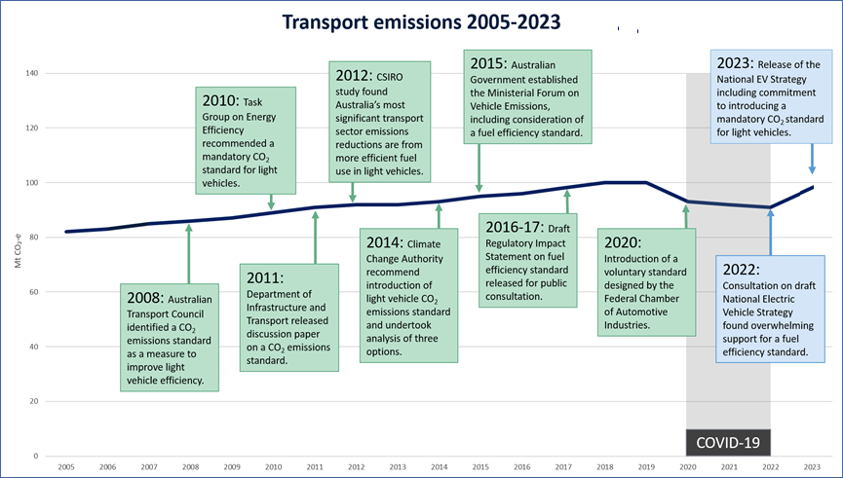

Figure 1 – Actions to consider a new vehicle efficiency standard (referred to above as a fuel efficiency standard) and CO₂ equivalent emissions, over time.

What is a car (light vehicle)?
In this document, we use the word ‘car’ to refer to a ‘light vehicle’, which (with some exceptions) are generally cars that are up to 4.5 tonnes. We refer to two different categories of cars in this document – passenger vehicles (or PVs) and light commercial vehicles (or LCVs).
- Passenger vehicles are sedans, hatch backs, SUVs and 4WDs. Under Australian legislation (see Vehicle Standard (Australian Design Rule – Definitions and Vehicle Categories) 2005) cars are further sub-categorised. Using the legislative categories, we put MA (passenger cars), MB (forward-control passenger vehicles) and the majority of MC (off-road passenger vehicles) categories in the passenger vehicle category. Note that one of the changes we made to Option B, is that a small category of MC vehicles be moved to the LCV category.
- Light commercial vehicles are utes and vans (and under our best option, a small number of large 4WDs). Under the legislative framework we place NA (light goods vehicles with a GVM not exceeding 3.5 tonnes) and NB1 (medium goods vehicles with GVM over 3.5 tonnes up to 4.5 tonnes) in the light commercial vehicle category as well as a small category of MC vehicles.

Process to date and next steps
In submissions to the National Electric Vehicle Strategy in September 2022, there was strong support for an Australian new vehicle efficiency standard. In April 2023, the Government released a consultation paper seeking views on the design of a standard – and by June 2023, around 2,700 submissions were received, with the majority supporting a new vehicle efficiency standard.
In February 2024, the Government published the Cleaner, Cheaper to Run Cars: An Australian New Vehicle Efficiency Standard Consultation Impact Analysis (the Consultation Impact Analysis) and launched a four-week phase of consultation on 4 February. By 4 March, around 8,900 submissions had been received from individuals and a range of organisations, including the car manufacturing and automotive sector.
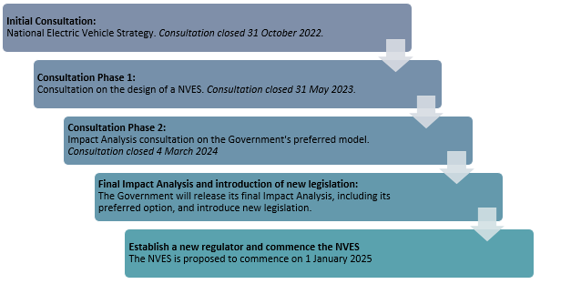
This document represents the final phase of analysis informing Government’s policy and new legislation, as set out in Figure 2.

Figure 2 – Process to date

What is the policy problem you are trying to solve and what data is available?
The primary problems that Government is trying to solve is how to:
- save Australians money on fuel
- reduce CO₂ emissions from new cars
- stimulate the supply of more fuel-efficient, low and zero emissions vehicles into the Australian market.
We want to maximise access to the best vehicle technology and to reduce consumer fuel costs. An intended outcome is reducing how much Australian consumers pay at the bowser by improving the efficiency of the vehicle fleet over time.
This will support achievement of the emissions reduction targets established under the Climate Change Act 2022 and Australia’s updated Nationally Determined Contribution under Article 4 of the Paris Agreement.
Secondary considerations are improvements to the air that Australians breathe, and to improve fuel security.
This analysis considers options within the bounds of what we think is possible. The analysis we present below is on the basis that it is not feasible to ‘mandate’ the use of certain types of cars.
This chapter seeks to outline:
- The level of carbon pollution from new Australian cars, in the context of the transport sector overall;
- The lack of zero or low emissions vehicle choices in Australia, compared to other markets;
- The impact that high fuel prices are having on everyday Australians; and
- The data that is available about vehicle use and emissions in Australia and around the world.

Australians don’t currently have access to the same fuel-efficient cars as other jurisdictions…
Globally, and for decades, car manufacturers have been developing new technologies and materials designed to improve the fuel efficiency of cars. However, the type of vehicles and technologies vary depending on where the vehicle is manufactured and to which market the cars are supplied.
Compared to cars in other jurisdictions, new cars supplied to Australia use more fuel per kilometre. As outlined above, manufacturers supply cars to the Australian market that aren’t as fuel-efficient as the cars they supply to other markets. Global vehicle manufacturers are not currently offering the same range of fuel-efficient vehicles, including plug-in hybrid electric vehicles (PHEV), hybrid electric vehicle (HEV) models, and electric vehicles (EVs), for distribution in Australia. In 2022, there were 500 EV models available globally, compared to around 100 EV models available for sale in Australia (56 BEVs, 43 PHEVs). The US, NZ, the EU, the UK, and China all had higher numbers of EV models available than Australia. Compared to other markets, Australia also lacks access to more efficient ICE vehicles (as the average CO₂ g/km of different jurisdictions is testament to).
Stakeholders have made clear that the driver for this lack of supply is the absence of a mandatory NVES in Australia, placing Australian consumers at a disadvantage compared to those overseas. For example, in 2021, the former head of VW Group Australia, Michael Bartsch stated that “unless a CO₂ target is set [in Australia], manufacturers will continue to prioritise modern markets both for zero emission vehicles and the most efficient conventional engines” and that “markets where there are punitive fines if they don’t are naturally first in line for zero emission vehicles”. ,
The lack of improvement at the same rate as other jurisdictions is not for technical reasons. On the contrary, the fuel efficiency of a vehicle with an internal combustion engine can be improved in a number of ways, from engine design to a vehicle’s weight, the type of tyres and its aerodynamics. Figure 9 demonstrates some of the technological options available to improve fuel efficiency. There are two other possibilities for why the fuel efficiency of new vehicles being sold into Australia has not improved:
- Demand side: Over time, consumers have come to prefer larger, less fuel-efficient vehicles. Consumers tend to undervalue fuel cost savings when purchasing. In order to make a choice, individuals may rely on pertinent information such as relying on a brand or model they have previously purchased; accepting personal recommendations from friends or family; or focussing on simplified choice criteria on a subset of features. Similarly, the Australian Competition and Consumer Commission finds that purchase price and vehicle type have the strongest influence on purchasing decisions, and fuel efficiency is regarded as just a consideration.

- Supply side: Suppliers preference other markets with effective mandatory CO₂ reduction regimes and may seek more time to recoup the production and development costs of existing ICE vehicles in markets where there are no standards, such as Australia. Suppliers to the Australian car market have acknowledged that the lack of a federally regulated mechanism to reduce tailpipe CO₂ emissions is a strong driver of their inability to secure a greater supply of fuel saving technology, hybrids and EVs for Australian consumers., We can see in our own analysis that it can be advantageous financially for suppliers to preference jurisdictions with regulations in place over Australia (i.e. if a supplier fails to meet its obligations in the EU, it faces substantial financial penalties). On top of this, vehicle suppliers have told us that they place a very high value on being compliant with jurisdictions’ CO₂ emissions standards (far beyond the financial cost of penalties) because of the reputational harm of having penalties applied against them.
What is clear is that demand side and supply side measures need to work together to deliver a real reduction in fuel costs and car emissions, and to get the best technology for Australian consumers. The Government has already put in place programs to address demand side failures by improving consumer knowledge of fuel efficiency of vehicles. In particular, there are already regulatory obligations for suppliers to put in place fuel consumption labels, the Green Vehicle Guide has been updated and is functioning well (see www.greenvehicleguide.gov.au) and the Government has recently put in place a Real-World Testing (RWT) program (see www.aaa.asn.au/realworld). As these programs are already in place, and in the case of the RWT program, nascent, it would be premature to consider their effectiveness. Therefore, we proceed in this document mostly focussed on supply side failures.

…and we’re spending more on fuel than ever before
The price Australian households pay for fuel has been steadily increasing for decades, and we’re driving more kilometres each year than ever before. According to the ABS Survey of Motor Vehicle Use, Australians drove 215,212 million kilometres in 2020. Even allowing for population and car number increases, the fact remains, Australia is a country that relies on cars.
Australian Institute of Petroleum figures show that in September 2023, the national average fuel price hit a high of 204.4 cents a litre, putting pressure on the budgets of households and businesses alike. Figure 3 demonstrates that prices have risen sharply since the COVID-19-induced downturn.
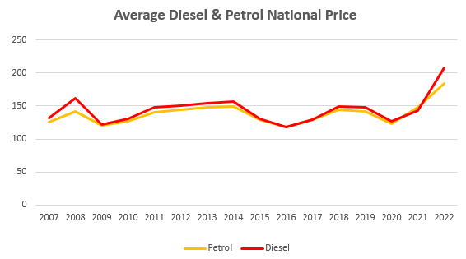

Figure 3 – Petrol and diesel price over time
Fuel prices can be influenced by a myriad of global and local factors; most recently, Australian fuel prices have been affected by the COVID-19 pandemic and global supply issues because of the war in Ukraine and events in the Middle East. Domestically, location also plays a part, with fuel prices in regional locations being more stable. But automotive fuel expenses in regional areas are also affected by other factors that increase the cost of fuel and do not apply to city locations, such as:
- less competition and discounting due to smaller demand
- higher storage and transportation costs
- less demand for convenience sales (which act to keep fuel prices down)
- highway locations of outlets.
The Australian Automobile Association publishes a transport affordability index. The most recent results for that index show that on average, motorists in capital cities are paying around $100 a week in fuel costs or around $5,215 per year. The regional average is around $103 per week or $5,380 per year. According to this index fuel is the second largest expense faced by motorists, behind car loan payments.
Reducing Australia’s exposure to the volatile international liquid fuel market not only provides monetary benefits to consumers as identified above, but also reinforces the Government’s commitment to ensuring Australia’s fuel security. The Government’s existing fuel security measures largely relate to ensuring Australia has a resilient supply, storage and refining capacity. Despite these measures, Australia is not immune to the price shocks caused by the actions of international actors or events including the Russian invasion of Ukraine or instability in the Middle East. Over time, a NVES could reduce consumer demand for imported oil as the supply of more fuel-efficient vehicles increases.

Will a NVES make cars more expensive?
Some stakeholders have asked if a NVES will make cars more expensive. The intention of the NVES is to require vehicle suppliers include more modern fuel-saving technology in the new cars sold to Australian consumers, and for suppliers to provide an increasing range of hybrid variants and EVs. Evidence to date consistently finds no purchase price impact, or a negligible purchase price impact, for consumers.
The experience in the US and EU, which have long standing fuel efficiency regulations, and New Zealand, which implemented an ambitious fuel efficiency standard in 2023, doesn’t show a vehicle purchase price increase. A 2023 study in the US by the consumer organization Consumer Reports found “after adjusting for inflation, vehicle prices didn’t increase during the time period studied – model years 2003 through to 2021 – even as average fuel economy increased 30% and proven lifesaving technologies became common.”
Similarly, a 2017 report by the International Council on Clean Transportation found “fuel economy standards in the United States – a technology forcer – do not appear to have had any significant effect on real vehicle prices faced by consumers.” A report to the European Union of the actual performance of EU Regulations 443/2009 and 510/2011 in 2015 found that comparing car retail prices is challenging because consumers are offered numerous features and discounts.
This report also stated “It is difficult to find evidence that legislation has actually led to real-world increases in end user prices, and indeed data from ICCT (2014c) suggests that retail prices adjusted for inflation have remained the same or slightly decreased for most segments, with the exception of sports cars (which are unlikely to be relevant to low-income consumers). In addition, when assessed in terms of maximum engine power output (a measure of vehicle performance), there does not appear to have been any compromise in consumer utility.”
The same study found that the technology costs to manufacturers were much lower than anticipated. The empirical costs of meeting the standard were estimated at EU€183 per car for passenger vehicles (approximately AUD $300), and EU€115 (approximately AUD $190) for light commercial vehicles. As noted above, this study did not find evidence that even this very small cost was passed on to consumers in the form of higher prices.

Australian cars are highly polluting
Increasing concentrations of greenhouse gases in the atmosphere are warming our climate, and will continue to impact on Australia over coming decades. Land and ocean temperatures are rising, and rainfall is declining in southern Australia and increasing in northern Australia. Droughts and periods of extreme fire weather are expected to become more common, as are more intense rainfall events. The Australian Government’s 2021 State of the Environment (SOE) report found that:
‘long-term changes in the climate, particularly the changed incidence of extreme events such as cyclones and bushfires, place pressure on many aspects of the Australian environment. Further changes in the climate, driven by past and future emissions of greenhouse gases, will continue to make climate a major pressure on the Australian environment and communities for the foreseeable future’
The need to reduce greenhouse gases is clear, and every sector of the economy, including the transport sector, has a role to play.
Transport is Australia’s third largest source of greenhouse gas emissions and will soon become the largest source if nothing is done. In 2023, transport emitted 98 Mt CO₂-e of greenhouse gases, representing 21% of Australia’s total greenhouse gas emissions. Passenger cars emitted 41 Mt CO₂-e (42% of all transport emissions) and light commercial vehicles emitted 18 Mt CO₂-e (18% of all transport emissions). Overall, cars make up about 60% of transport emissions. Passenger cars and light commercial vehicles combined account for 11.4% of Australia’s total carbon emissions.
The 2023 Emissions Projections Report (Figure 4) found that while restrictions during the early period of the COVID-19 pandemic resulted in a measurable decrease in transport emissions, the pre-2019 emissions trajectory has largely resumed and is projected to increase from 98 Mt in 2023 to a peak of 103 Mt in 2027.
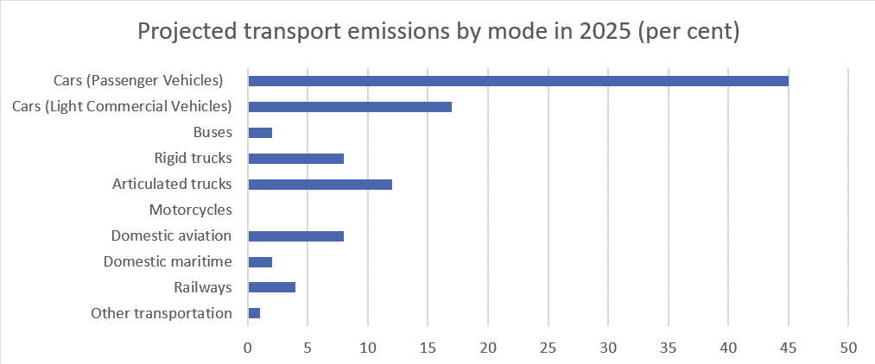
Figure 4 – Transport emissions sources – Australia’s emissions projections, DCCEEW 2023
Growth in car emissions is driven by two factors – the number of vehicles on our roads, and the amount of emissions from each car. Over the last few decades, both have increased:

- The number of cars on Australian roads has increased from 11.9 million in 2002 to 18.3 million in 2021.
- Despite technological advances to increase the emissions efficiency of new vehicles, the voluntary fuel efficiency standard for light vehicles adopted by the Federal Chamber of Automotive Industries (FCAI) and its members in 2020, and the more recent increases in the uptake of low and zero emissions vehicles in Australia, Australia’s overall vehicle emissions have not decreased, instead remaining relatively steady in recent years. In 2019 (for instance), the average new light vehicle sold in Australia produced 181 grams of CO₂ per kilometre (g/km).

Australia’s fleet-average CO₂ emissions for new vehicles in 2020 on the New European Driving Cycle (NEDC) are higher than the US by 31% for cars and 24% for LCVs (utes, light trucks and vans).
Cars in Australia are more emissions intensive compared to many other countries. Analysis by the department shows in 2022, the average CO₂ intensity for new passenger vehicles (cars) in Australia was 179.1g CO₂/km, made up of 161.9g CO₂/km for passenger vehicles and 230.3g CO₂/km for light commercial vehicles. As Figure 5 shows, this compares to 169 g CO₂/km in the United States.
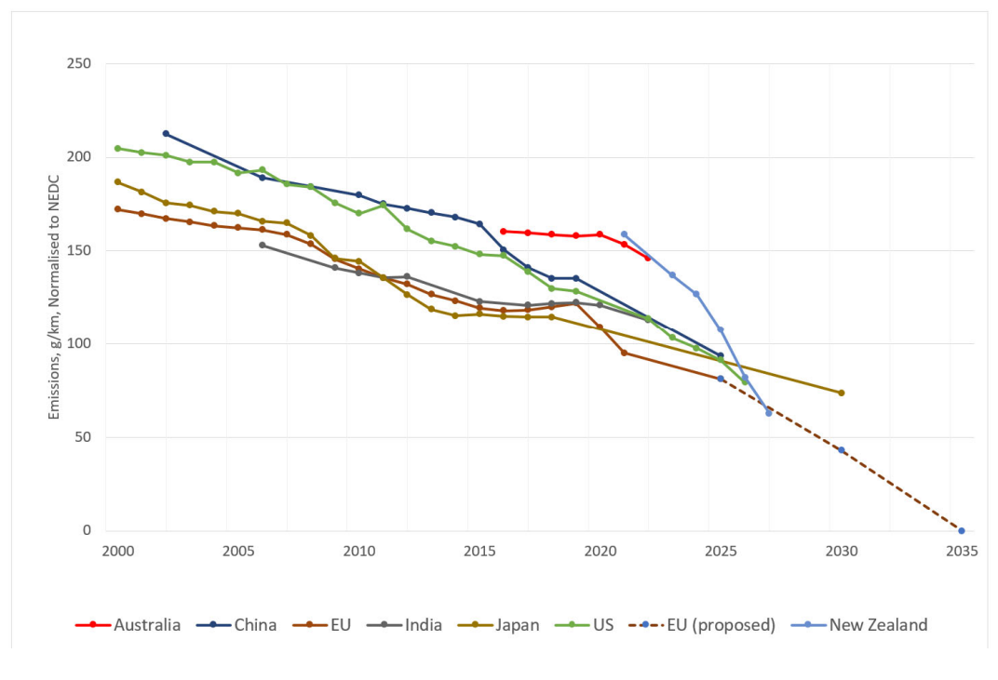
Figure 5 – International passenger vehicle emissions trajectories

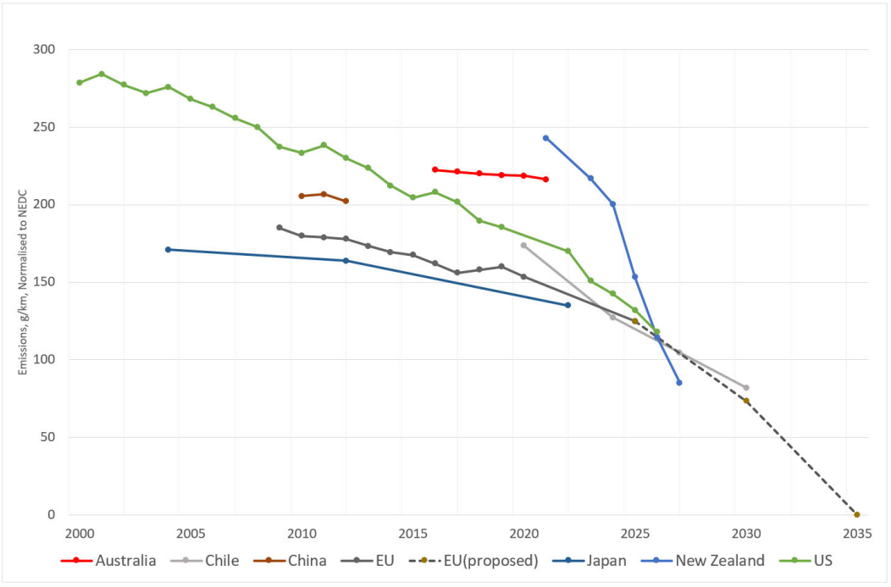

Figure 6 – International light commercial vehicle emissions trajectories

What are the objectives, why is Government intervention needed to achieve them, and how will success be measured?
In this chapter we explain:
- the context of the Government’s commitment to act on climate change
- alternatives to Government action
- the ability for Government to act
- the objectives of Government’s actions;
- the barriers to action; and
- how success against the Guiding Principles will be measured.

Government is committed to cut CO₂ emissions
Australia’s policy is to reach net zero by 2050. The Government is committed to reducing greenhouse gas emissions and is party to a number of international partnerships and agreements, such as the Paris Agreement and the Kyoto Protocol. The Paris Agreement aims to strengthen the global response to the threat of climate change by holding the increase in the global average temperature to well below 2°C above pre-industrial levels and pursuing efforts to limit temperature increase to 1.5°C.
Australia needed to act, and in June 2022 the Australian Government updated its Nationally Determined Contribution (NDC) to the United Nations Framework Convention on Climate Change (UNFCCC), committing to reduce greenhouse gas emissions to 43% below 2005 levels by 2030. In September 2022, the passage of the Climate Change Act 2022 enshrined this in law, as well as our most significant commitment yet—net zero by 2050.
To achieve these objectives, the Government must pursue emissions reductions across every sector, including from light passenger and light commercial vehicles. According to Australia’s Emissions Projections 2023 (DCCEEW, November 2023), transport represents the third largest source of emissions in Australia, behind electricity generation (35%) and stationary energy (20%) and is projected to be Australia’s largest source of emissions by 2030.

Alternatives to Government action – such as a voluntary scheme – will not deliver more fuel-efficient new cars
Over time, manufacturers of cars have made incremental improvements that provide some increases to fuel efficiency. However, the rate of these business-as-usual improvements has been modest and projections suggest they will fall significantly short of achieving whole of economy legislated emissions targets. In 2020, car manufacturers adopted a voluntary new vehicle efficiency standard (voluntary standard) designed by the (Australian) Federal Chamber of Automotive Industries (FCAI). Under the FCAI’s voluntary standard, its members have agreed to meet year-on-year CO₂ emissions reduction targets.
Because it is voluntary, and there’s an absence of monetary consequence if the standards are not met, the voluntary standard has not provided sufficient incentive to introduce more effective fuel efficiency technology to cars supplied to the Australian market., Even if the targets under the voluntary standard were made more stringent with the objective of lowering projected CO₂ emissions, it is very unlikely that manufacturers would strive to meet the targets and supply more fuel efficient, low and zero emissions cars because there is no incentive to do so in the form of tradeable credits or financial disincentives such as penalties.
The FCAI noted in its release of 2022 results for its voluntary standard that “the 2022 results demonstrated the challenges of transitioning to a zero-emission light vehicle sector in Australia, especially in the absence of a Government mandated CO₂ standard.” The voluntary standard has not been effective at substantially reducing emissions.
The existing industry voluntary standard is not providing sufficient incentive for global car manufacturers to provide the best fuel saving technology to the cars Australians buy. While the incremental rate of technological improvements and business as usual increases to EV uptake is modestly reducing emissions intensity in the passenger vehicle category, it is also not providing sufficient abatement to support the Government’s economy wide emissions reduction targets. Specifically, this is around a 5% reduction in emissions on the PV category from 2019 to 2022, this is far below the 4% per annum targets sought under this standard.
The rate at which electric vehicles, hybrids and other more fuel-efficient vehicles are supplied to the Australian market is improving with time (for electric vehicles - 8.4% in the first three quarters of 2023, up from 3.4% of total vehicle sales in the same period of 2022). However this remains well below the necessary rate to achieve substantive emissions reduction. Consequently, we conclude that the New Vehicle Efficiency Standard is the most effective available action to encourage the supply of fuel saving technology.

The Government can build on an existing regulatory framework to regulate CO₂ emissions
The Australian Government does not currently regulate the CO₂ emissions of cars directly. The Road Vehicle Standards Act 2018 (RVSA) was put in place in 2018, and replaces the Motor Vehicle Standards Act 1989. Under the RVSA, a range of vehicle standards can be established, covering:
- safety;
- the control of the emission of gas, particles or noise from road vehicles;
- security against theft;
- security markings; and
- energy savings.
In particular, while the department does not regulate CO₂ emissions, it does regulate other emissions including sulfur, particulates and other noxious emissions though the RVSA. The department also operates the Green Vehicle Guide website, which provides consumers up to date information about CO₂ emissions from new cars. The department’s established role as a regulator of light vehicles demonstrates the capacity for Government to intervene successfully in regulating emissions from cars. Fuel efficiency standards are also in place around the world, including the EU, US, UK and New Zealand, and the department engages with counterparts around the world on NVES policy design and implementation. Work is underway to develop the relevant regulatory schema, and additional information on this aspect is available in Chapter 7.

Success measures were established through the Cleaner Cars consultation paper and consulted on again
As outlined in Chapter 2, the Government is acting to reduce CO₂ emissions from new cars, save Australians money on fuel and stimulate the supply of more efficient vehicles into the Australian market to increase consumer choice and maintain the vibrancy of the Australian car market. In the Cleaner Cars consultation paper (April 2023), we set out a range of principles, and sought feedback on those principles. We propose, along with standard cost benefit analysis outputs, to use those principles to assist us in assessing the merits, or otherwise, of the proposed option. An outline of those principles, and how we measure success against those measures is set out in Table 1 below.

Guiding Principle | Guiding Principle success measure
Effective: Effective in reducing CO₂ transport emissions from new cars. | The percentage reduction in average CO₂ emissions and fuel costs from Australia's new cars, out to 2050.
Equitable: All Australians can access the vehicles they need for work and leisure. Intervention needs to be equitable, and not unduly negatively impact any particular group of people or part of Australia. | A design which does not disadvantage small or affordable vehicles, to protect the continued supply of these vehicles to the Australian market. Ensure that people generally, and specific cohorts, have access to fuel-efficient vehicles.
Simple and transparent: Intervention emphasises simplicity and transparency in design and operation. | Design and implement a process which leverages existing regulatory frameworks and touch points with Government, while providing accessible information to both consumers and industry stakeholders. A streamlined NVES design which avoids design features which add complexity, increase administrative complexity, and reduce transparency.
Credible and robust: Intervention should be designed with the latest and best analysis available, drawing on the expertise of industry, the environmental community, academia and others. | Analysis is of a high quality, and is accepted by the Office of Impact Analysis. Consultation is broad and includes all key stakeholders. Ongoing opportunity for stakeholders to provide feedback on operational matters, and ability to influence policy settings through reviews.
Enabling: Vehicles with the best emissions and safety technology to be available to Australians. Avoid increasing the average age of vehicles in the fleet so there are no inadvertent safety impacts. | Consider scrappage rates, and whether the average age of the car parc will increase.
Table 1 – Principles against which the Government’s option is assessed

There are a range of other factors, that could become barriers to achieving our objectives
Beyond the issues outlined in this paper to date (as well as implementation risks at Appendix D), there are also a range of other barriers that could give rise to challenges in achieving the Government’s policy objectives.
- Infrastructure limitations: Improving the take up of fuel-efficient vehicles may be hindered by inadequate infrastructure – particularly in the short term. This includes limited access to charging infrastructure for electric vehicles and the limited availability of alternative fuels. Government and private sector investment is anticipated to continue to address this barrier over time, and is unlikely to represent over the medium term.

- Supply chain complexities: Manufacturers may encounter supply chain challenges in relation to the critical minerals and other resources needed for the manufacture of zero emissions vehicles. As all new cars sold in Australia (that are registered on the Register of Approved Vehicles (RAV)) are manufactured outside of Australia, any global instability can have an adverse impact on supply to Australia overall, and not just for fuel-efficient vehicles. Ongoing Australian Government trade negotiations, as well as defined initiatives such as The Critical Minerals Strategy, aim to address supply chain complexity and critical mineral supply in the short term, with a view to introducing greater stability in the long term.

- Consumer awareness and education: A lack of awareness and understanding about the fuel efficiency of cars as well as new zero emissions technology, could mean that consumers are hesitant to take up new technology such as hybrids or electric vehicles. The department will use its cleanercars.gov.au website to provide specific consumer information about the fuel efficiency of cars in the short term. The National Electric Vehicle Strategy contains specific actions to ensure nationally consistent information on the benefits and realities of driving an EV in Australia. This will help Australian households and businesses to make informed purchasing decisions and reap the benefits of cheaper, low emissions transport. In the longer term, out to 2050, greater take up of EVs is likely to organically improve consumer and community awareness about the technology.

- Technological advancements: Rapid technological advancements can both help and hinder progress. While new innovations provide opportunities for fuel efficiency, they can also render existing technologies obsolete. Introducing consequential or other financial incentives to develop and supply new technology has the potential to catalyse technological advancements, and ensure that greater volumes of advanced technology (and fuel efficient, low or zero emissions) are supplied and become substitutable for technology that becomes obsolete.

What policy options are you considering?
As outlined in so far, the primary objective of Government action is to reduce CO₂ emissions from new cars. This chapter sets out:
- A brief overview of options
- What the baseline, or business as usual/do nothing, scenario is.
- The key mechanism under review - a New Vehicle Efficiency Standard (NVES), and how that mechanism works; and
- How we developed the options.

Overview
In the Cleaner Cars consultation paper (April 2023), we asked what NVES options we should consider. The responses we received discussed individual design features, and in some cases offered a comprehensive model. We considered the merits of each design feature individually, and collectively, based on stakeholder feedback and analysis of the best international research on NEVSs to inform the options we developed.
Based on submissions received during our first consultation in 2023, along with our own analysis, we developed three options as set out below and published these in February 2024. None of the options precisely mirrored any particular stakeholder’s views, but represented groups of positions.
- Baseline was the do-nothing scenario which is the forecast of a scenario without a NVES. There are no additional benefits or costs associated with this scenario, and the options below are measured as change against this scenario.
- Option A was the ‘slow start’ option. It is an amalgamation of views of stakeholders that would prefer a more modest and cautious approach.
- Option B was the fast but flexible start option, and was presented as the Government’s best option in the Consultation Impact Analysis (February 2024). It sought to balance ambition and achievability.
- Option C is the fast start option, and is an amalgamation of views of stakeholders that would prefer the most stringent and ambitious approach possible.
In February 2024, we published the consultation version of this Impact Analysis, and set out the detail of these three options. By the end of the consultation period on 4 March, close to 8,900 submissions were received from the Australian community and industry. Following analysis of this feedback and additional economic modelling, the Government has developed a further option that is considered to be the best model for the New Vehicle Efficiency Standard. In this document, we have referred to as the best option.
The best option is based on Option B, with the addition of some measures that are intended to maintain the vibrancy and sustainability of the Australian light vehicle market. This includes a series of modest revisions to provide greater flexibility to the vehicle industry to design its compliance approach, particularly for large 4wds and utes. More detail on each of these options is at Chapter 4.4.
As part of developing primary and secondary legislation, detailed work is being undertaken to confirm those vehicle types that will be exempted from a NVES. For the purposes of this document, readers should assume that heavy vehicles and vehicles subject to heavy vehicle emissions tests (i.e. large trucks), military vehicles, law enforcement vehicles, emergency service vehicles, agricultural, construction or mining equipment, motorhomes, horse trucks and motorcycles, would be exempt. It is our intention to capture vehicles sold to the general public - we intend that any vehicle that would require a special licence (such as a heavy vehicle licence) would not be captured. Note that our focus has been on vehicles entered into the Register of Approved Vehicles through the type approval pathway. See Chapter 7 for more detail.

What is the business-as-usual scenario?
The Government requires all impact analyses to include an analysis of a business-as-usual (BAU) option to act as a benchmark. The cost benefit analysis (CBA) for any remaining options is then calculated relative to this, so what would have happened under existing policy settings is not attributed to any proposed intervention.
Under a BAU option, the Government would not intervene further and instead rely on existing policies (or lack thereof) to improve abatement from new cars. There is no existing Government policy to require any form of CO₂ performance by vehicle manufacturers, or their Australian suppliers.
The Federal Chamber of Automotive Industries (FCAI) and its member entities (car manufacturers) adopted a voluntary fuel efficiency standard for new cars in 2020. Government analysis of the design settings of the voluntary standard and the lack of penalties to incentivise behaviour change, suggest that if the voluntary standard (which is part of this baseline scenario) remains the only fuel efficiency standard in Australia, that the outcome would be as follows:
- All reduction in emission intensity would be attributed to a modest improvement in ICE efficiency and organic increased LZEV uptake as Australia follows (but lags) global movement to low emissions vehicles.
- A growing proportion of vehicles entering the Australian market will be hybrids and EVs by virtue of their adoption in overseas markets. However, this would occur at a much slower rate than under a mandated standard, as pressures encourage manufacturers to direct their most efficient vehicles to countries with NVESs.
- EV uptake would be constrained by the limited supply of these vehicles to Australia and the fact that suppliers have strong incentives to divert any supply of EVs and ZEVs into markets with fuel efficiency standards for new vehicles.

Under a baseline scenario where the FCAI’s voluntary standard is the only fuel efficiency standard, Figure 7 below represents the total amount of emissions expected under BAU.

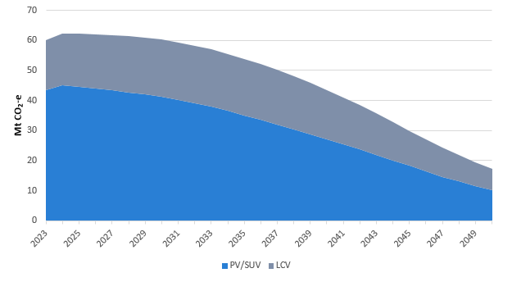
Figure 7 – Total amount of emissions expected from BAU
This forecast is based on a synthesis of projections from Bloomberg New Energy Finance and the Department of Climate Change, Energy, the Environment and Water (see Appendix B for a full list of assumptions). Assumptions that lead to a higher take up of lower emissions vehicles, would lead to higher benefits and lower costs.
In the chart below, we have plotted what we think the total emissions from PVs and LCVs are out to 2050 under a BAU/FCAI voluntary standard scenario. This shows while emission do reduce over time, as consumers gradually take up more efficient vehicles, the CO₂ reduction under this scenario will not help Australia to meet its emissions reduction targets and achieve net zero by 2050. Given its importance, we have also plotted the BAU take up of EVs in Figure 8 below.
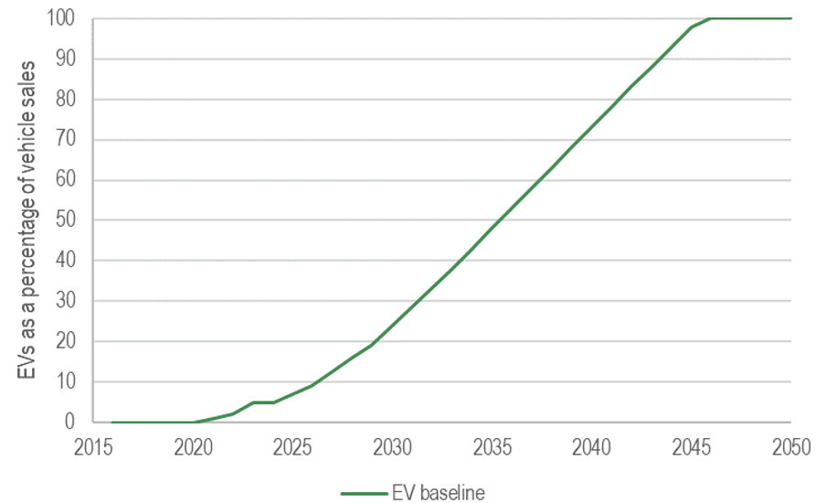
Figure 8 – BAU EV uptake

Under the BAU option, uptake of EVs will continue to increase, however overseas vehicle manufacturers will not have the added incentive to send the best low and zero emissions technology to Australia.
There are no additional benefits or costs associated with this as the baseline proposes no change to existing policy settings. Note that all costs and benefits, including abatement, is calculated relative to the baseline.

Do EVs release more emissions than ICE vehicles over their lifetime?
We have heard concerns that EVs don’t add up environmentally over the life of the vehicle. NVESs focus on vehicle tailpipe emissions, encouraging the sales of vehicles that use less fuel per kilometre to increase the sale of cleaner, cheaper to run cars. This includes EVs, but also more hybrids and fuel-efficient ICE vehicles. The operation of NVESs in other global markets do not generally consider the emissions that may be generated in the manufacturing of the vehicle, charging an EV or at the end of a vehicle’s life. There are a number of reputable sources that provide good evidence that EVs have much lower emission than ICE vehicles over their whole lifecycle:

- Modelling by the Bureau of Infrastructure and Transport Research Economics finds that while manufacturing a new EV may produce more GHG emissions than an internal combustion engine vehicle, this is more than offset after about one year if the vehicle is charged entirely from renewably-sourced electricity (e.g. home solar) and two years if charged from the grid (using a mix of electricity generation sources).

- International studies also find EVs purchased today produce far fewer emissions over their lifetime than ICE vehicles, even when factoring in battery and car manufacturing emissions, electricity grid emissions from charging, and the emissions from comparable fuel production. This was found in countries with a range of NVES settings, including 66–69% lower in Europe, 65% lower in the UK, 60–69% lower in the United States, 37–45% lower in China, and 19–34% lower in India.,,

- Fully electric vehicles also reduce emissions more than hybrids. Battery electric vehicles reduced CO₂ emissions on average by 69% compared to a petrol engine, while hybrids only reduced CO₂ emissions on average by 21% and plug-in hybrids saw on average a 26% reduction in CO₂ emissions over their lifecycle. ICCT’s analysis of Europe, US, China and India found that of all vehicle types, battery electric vehicles provided the highest certainty for emissions reduction over the lifetime of vehicles.

- Australian research in 2018 found CO₂ emissions were 29-41% lower for an EV than for a petrol car. The analysis found emissions vary depending on your location – for example, the greener Tasmanian energy grid, saw 70-77% less emissions per kilometre driven. As the Australian electricity grid further transitions to renewable energy, the emissions from charging a vehicle will continue to reduce. Future improvements in battery technology, battery manufacturing and end-of-life treatment are also expected to continue to reduce the emissions.

- In 2023, the UN established a working group to develop global standards for measuring the carbon footprint of different vehicles. The latest EU regulations also include a requirement that a lifecycle assessment methodology is developed for manufactures to use by January 2026. While questions have been raised about the emissions from making vehicles, particularly battery production and recycling, as well as charging an EV using fossil-fuel powered sources, it is clear there are environmental benefits to be gained today, and even more to be gained in the future.

The IPCC and IEA have both identified that EVs powered by renewable electricity as having the largest emissions reduction potential for land transport. This technology will be crucial for achieving Australian and global emissions reduction targets.

What other Government policies will act on emissions from light vehicles and complement this policy intervention?
The Government is undertaking a range of measures to reduce other emissions from light vehicles, such as noxious emissions. These emissions include particulate matter, oxides of nitrogen (NOx), volatile organic compounds (VOC) and carbon monoxide (CO) and are a major source of air pollution. In Australia, noxious emissions from vehicles are regulated by the current Euro 5/V standards and the Government has announced that it will phase in Euro6 standards for light vehicles from December 2025 to July 2028.
Government is also making changes to fuel quality standards to reduce allowable levels of aromatics in petrol sold in Australia. This will have the benefit of enabling new, more efficient engine technology to enter the Australian market and provides manufacturers with more options to lower their fleet CO₂ average under a NVES.

What is a New Vehicle Efficiency Standard?
NVESs have been used across the globe as a way of reducing emissions while also improving consumer outcomes through fuel savings, better vehicle technology and better vehicle choice. The US, the UK, Canada, Japan, South Korea, the EU, NZ and China all have a NVES in place. Australia, along with Russia, is one of the only advanced economies to not have a NVES in place.
A NVES works by imposing a limit on CO₂ (measured in grams per kilometre or CO₂ g/km) each year across the fleet of vehicles that a supplier brings into the country. Each year the limit is reduced, so the standard becomes more stringent. Suppliers can still sell any vehicle they like, but will need to sell more clean cars to offset higher emission cars they sell. If suppliers sell more fuel-efficient cars than the target, they get credits. If they sell more polluting cars than the target, they need to offset this by credits they earn in a later year, buy credits from a different supplier or, eventually, pay a penalty. Unlike some other regulated requirements in the vehicle sector which are binary (i.e. either the vehicle meets the standard or it does not), the settings and stringency of a NVES can be set at a range of different stringency levels.
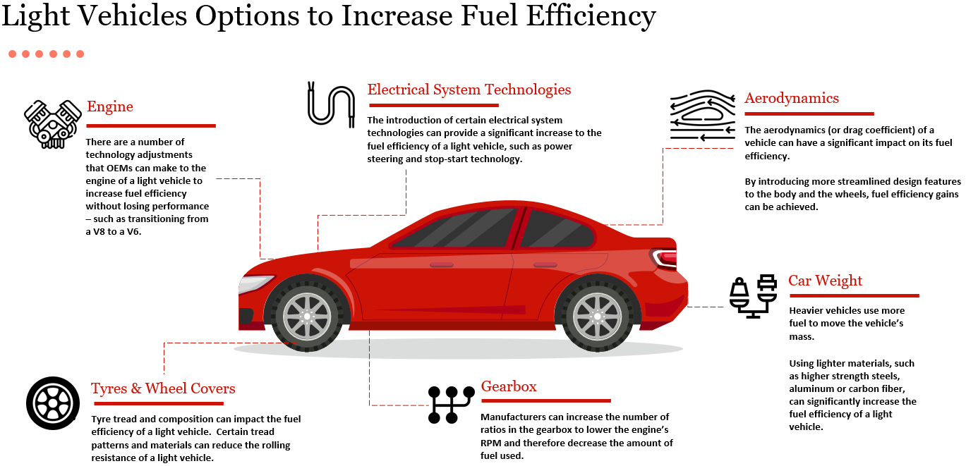
To help meet their emissions target, there are a range of technological improvements that manufacturers can make (and are making) to improve the fuel efficiency of internal combustion engine cars (or utes, vans or 4WDs), as well as supplying other low or zero emissions technology such as hybrids, plug in hybrids or electric vehicles.
Figure 9 - Light vehicle options to increase fuel efficiency

How does a NVES work?
There are a number of critical elements within a NVES, which in combination will inform how stringent the standard is and how vehicles are captured. These are:
- Mass: Mass refers to the weight of a vehicle. For the purposes of this analysis we generally refer to the concept of ‘mass in running order’ or MIRO, which is the weight of a vehicle with fluids, accessories, plus the weight of a person in the vehicle.
- CO₂ g/km: This is the number of grams of carbon dioxide emitted by a vehicle per kilometre. For example, a car with 150 CO₂ g/km emits 150 grams of CO₂ for every kilometre it is driven, in the laboratory emissions test.
- Headline target: The headline target is the CO₂ g/km (sometimes referred to as g CO₂/km – these are interchangeable) target that a NVES sets for a supplier. Usually, a standard sets a target beyond which more (or less) of a thing is not permitted. For example, in Australia we have fuel quality standards that require there to be up to 150 parts per million of sulphur in regular unleaded petrol. Unlike the fuel quality standard, a NVES is an attribute-based standard, in that the target for each vehicle supplier (the permitted level of CO₂ g/km) is adjusted by the average mass of the vehicles sold (so a higher target generally applies to a heavier vehicle fleet). There are penalties applied for a fleet being above the target. No car is prohibited.
- Passenger vehicle/light commercial vehicle: In Australia and around the world, cars are categorised. There are two basic categories (we explore a greater number of categories below) – passenger vehicles (PVs) and light commercial vehicles (LCVs).
With that terminology understood, the development of the technical NVES settings needs to be undertaken in steps. We have sought to break down how a NVES applies into the four steps in Figure 10. This same process can be undertaken every year, or at each regulated review – usually so that the standard becomes more stringent over time and suppliers need to continually improve the efficiency of the vehicles that they sell.
Note that Figure 10 (below) is simplified. In particular, the diagram does not show the application of break points and the process in step 4 is undertaken continuously over a given year (in the Australian context, when a supplier places a vehicle on the Register of Approved Vehicles (RAV)).
Because they are not policy settings per se, we have already calculated the reference mass, along with the slope of the line of best fit for the fleet curve. The results are in the table below.
Element | Passenger vehicles | Light commercial vehicles
Slope | 0.0663 | 0.0324
Reference mass (Mass In Running Order) | 1,723 kg | 2,155 kg
Table 2 – Slope and reference mass

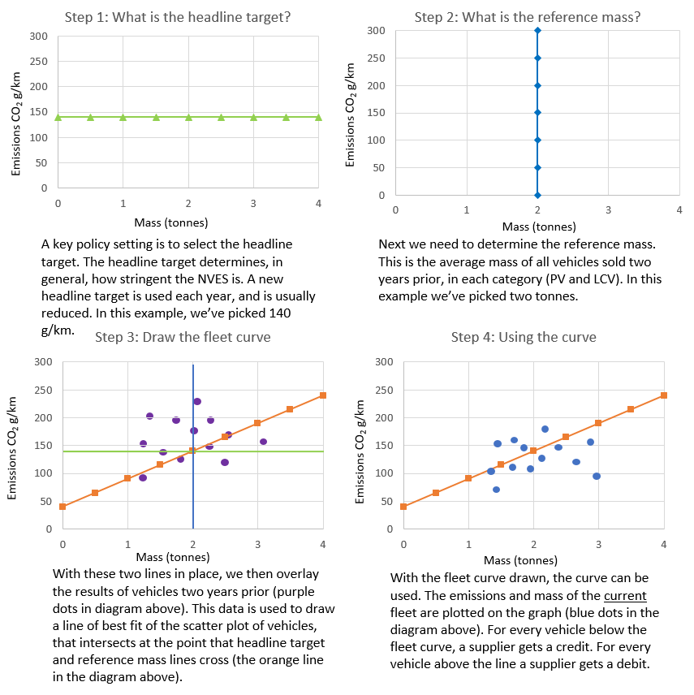
Figure 10 – How a NVES applies (sample data for illustrative purposes only)

Common features of a NVES
While the settings can be complex, what a NVES seeks to do is straightforward – reduce the average level of emissions from cars over time. NVESs across the globe share a range of different additional features, and there are some assumptions and key features which we think are suitable in the Australian context.
- A NVES only applies to new cars: A NVES only applies to new cars – so once sold for the first time a car would no longer be captured. In the Australian context, a NVES would apply at the point at which a vehicle is entered onto the RAV which is a register of vehicles imported and manufactured in Australia, through the type approval pathway under paragraph 15(2)(a) of the RVSA. We recommend that consideration is given to expanding the NVES to Specialist and Enthusiast Vehicles in the future.
- Exceptions apply: As part of developing legislation, work has commenced to identify those vehicle categories that will be exempted from a NVES. For the purposes of this document, readers should assume that vehicles that are heavy vehicles and vehicles subject to heavy vehicle emissions tests (i.e. large freight trucks), military vehicles, law enforcement vehicles, emergency service vehicles, agricultural, construction or mining equipment, motorhomes, horse trucks and motorcycles, at the time of import, would be exempt.

- A target is set each year: In each year of a NVES, a target is set. In the options identified, five years of targets are set (from 2025-2029), with a review in 2026. Separate headline targets are established for both Passenger Vehicles (PVs) and for Light Commercial Vehicles (LCVs)

- Suppliers that beat the target get credits which can be traded and suppliers that do not meet the target will eventually have penalties to pay if they don’t acquire credits or balance their fleet with lower emitting vehicles: When a supplier enters a vehicle on the Register of Approved Vehicles (RAV) the characteristics of that vehicle will determine change to that supplier’s Interim Emissions Value (IEV). The IEV will go up if the vehicle misses the target, and will go down if the vehicle beats the target. Over a year, a suppliers’ IEV will go up and down based on the characteristics of the vehicles that they enter onto the RAV. On the 1st of February after a year, the IEV will reconcile. From that point on, if the IEV is less than zero, the supplier will be awarded credits, however if the IEV is more than zero, the supplier will have two years to bring the value down to zero, by acquiring credits from others or by generating credits itself.

- Adjusted for vehicle weight: A NVES gives heavier cars a relatively higher CO₂ target because it is recognised that some consumers (such as small businesses and trades people) legitimately need a bigger car for their work. The fleet target (described in Figure 10 above) reduces the disadvantage that heavier (or larger) vehicles have, because heavier vehicles naturally use more fuel. In other words, the fleet limit curve is a way of adjusting the headline limit for a specific car to account for its weight, as a proxy for the use for which the vehicle is required. For example, the headline target for a passenger vehicle might be set at 141 g/km (as in Option B in 2025) but for a car that weighs 1,950 kg, the effective target for that vehicle would be 156 g/km, or a 1,500 kg car would have an effective individual target of 126 g/km.

- …but the adjustments for very heavy and very light vehicles have a cap: ‘Break points’ are points on the fleet limit curve that are flattened out. They are used in the US NVES to place a cap on how much the fleet limit curve helps heavier cars (or in the US, larger cars) and vice versa for lighter cars. For example, the best option as presented in this Impact Analysis, shows the break points for passenger vehicles (PVs) at 1,500 kg and 2,200 kg, and light commercial vehicles at 1,500kg and 2,400kg, reflecting the heavier weight and use case of light commercial vehicles.

This means that in 2025, passenger vehicles below 1,500kg MIRO will have a target of 126g CO₂/km, and light commercial vehicles below 1,500kg MIRO will have a target of 189g CO₂/km rather than a target that continues to reduce as the vehicle gets lighter.

On the heavier end, all cars in the passenger vehicle category that weigh over 2,200kg will have a target of 173g CO₂/km and all light commercial vehicles over 2,400kg will have a target of 218g CO₂/km, rather than a target that continues to increase as vehicles get heavier.

It is important to note that cars can have a relatively long asset life. In the projections we present in this analysis, we do not assume the scrappage rate changes over time. Our analysis assumes that approximately 64% of PVs and 49% of LCVs are removed from the fleet before they are 20 years old, and that 87% of PVs and 71% of LCVs are removed from the fleet before they are 25 years old. Around half of all cars are scrapped before they are 21 years old.

NVES options compared

ELEMENT | Option A | Option B | Option C | Best Option
Headline target  The headline CO₂ target and how it should change over time. The headline target is one of the key parameters to develop a NVES, and the key parameter stakeholders focus on in assessing the ambition of a NVES.  US current average reduction rate: ~9% per annum.  Australia baseline forecast reduction rate: ~4% per annum (PVs), 2% per annum (LCVs). | Slow start and broadly equivalent rate of decline as the US NVES.  Two CO₂ targets, one for passenger vehicles and a higher target for light commercial vehicles, but includes many SUVs in the light commercial vehicle class, along with utes and vans.  No catch up.  Year PV CO₂ (g/KM) LCV CO₂ (g/KM)  2025 141 199  2026 137 190  2027 127 183  2028 115 176  2029 99 172  Total CO₂ intensity reduction 2024-2029 34% 14%  Average annual CO₂ intensity reduction for new sales 6.8% 3.8% | A strong, ambitious and achievable NVES that seeks to catch up with the US around 2028 and then match the stringency of these standards, while not seeking to go beyond these standards.  Two CO₂ targets, one for passenger vehicles and SUVs, and a higher target for utes and vans (including large pick-ups) in the light commercial vehicle category.  Year PV CO₂ (g/KM) LCV CO₂ (g/KM)  2025 141 199  2026 117 164  2027 92 129  2028 68 94  2029 58 81  Total CO₂ intensity reduction 2024-2029 61% 62%  Average annual CO₂ intensity reduction for new sales 12.2% 12.4% | An aggressive NVES that catches up with the US around 2026 and then brings forward US targets for 2029-2031 to the Australian NVES in 2028 and 2029.  Two CO₂ targets, one for passenger vehicles and SUVs and a higher target for utes and vans (including large pick-ups) in the light commercial vehicle category.  Year PV CO₂ (g/KM) LCV CO₂ (g/KM)  2025 141 199  2026 103 150  2027 66 101  2028 51 63  2029 34 56  Total CO₂ intensity reduction 2024-2029 77% 74%  Average annual CO₂ intensity reduction for new sales 15.5% 14.7% | A strong, ambitious and achievable NVES that retains key design elements of Option B while substantively aligning with the standard proposed in the US.  Two CO₂ targets, one for passenger vehicles and SUVs and a higher target for utes, vans and some 4WD drives.  Year PV CO₂ (g/KM) LCV CO₂ (g/KM)  2025 141 210  2026 117 180  2027 92 150  2028 68 122  2029 58 110  Total CO₂ intensity reduction 2024-2029 61% 48%  Average annual CO₂ intensity reduction for new sales 12.2% 9.60%
Fleet limit curve  The fleet limit curve reduces the disadvantage that heavier (or larger) vehicles have, because heavier vehicles naturally use more fuel.  A break point is a vehicle weight above, or below, which the limit curve is flattened.  See appendix C for reference mass and slope values | Limit curve and reference mass derived based on fleet of vehicles sold in 2022 and updated during scheduled reviews of the NVES. No break points. | Limit curve and reference mass derived based on fleet of vehicles sold in 2022 and updated on a rolling basis annually during the operation of the NVES.  The 2022 limit curve settings in this Impact Analysis are applied to NVES in 2025 and 2026. After 2025, rolling updates to the limit curve and reference mass, with 2025 vehicle data used in 2026 to set new limit curve slope for 2027, and so on for future years.  Break points:  - PV: lower break point at 1,500 kg, upper break point at 2,000kg.  - LCV: lower break point at 1,500 kg, upper break point at 2,200 kg. | Flattened limit curve to reduce allowance for heavier vehicles with break points included (30% reduction on 2022 measured slope).  Break points:  - PV: lower break point at 1,500 kg, upper break point at 2,000kg.  - LCV: lower break point at 1,500 kg, upper break point at 2,200 kg. | Limit curve and reference mass derived based on fleet of vehicles sold in 2022 and updated on a rolling basis annually during the operation of the NVES.  The 2022 limit curve settings in this Impact Analysis are applied to NVES in 2025 and 2026. After 2025, rolling updates to the limit curve and reference mass, with 2025 vehicle data used in 2026 to set new limit curve slope for 2027, and so on for future years.  Break points:  - PV: lower break point at 1,500 kg, upper break point at 2,200kg.  - LCV: lower break point at 1,500 kg, upper break point at 2,400 kg.
Vehicle categories  What types of vehicle are in which category under the NVES. | Vehicle categories:  - PV class is passenger vehicles, light SUVs and two-wheel drive versions of four-wheel drive vehicles (MA and MB categories).  - LCVs class is larger SUVs, four-wheel drives, and utes and vans GVM up to 4.5 tonnes (MC, NA and NB1 vehicles, with some exceptions). | Vehicle categories:  - PVs class is passenger vehicles, light and heavier SUVs and 4WDs (MA, MB and MC categories).  - LCVs class is utes and vans GVM up to 4.5 tonnes (NA and NB1 vehicles with some exceptions). | Vehicle categories:  - PVs class is passenger vehicles, light and heavier SUVs and 4WDs (MA, MB and MC categories).  - LCVs class is utes and vans GVM up to 4.5 tonnes (NA and NB1 vehicles with some exceptions). | Vehicle categories:  - PVs class is passenger vehicles, light and heavier SUVs and many 4WDs (MA, MB and part- MC categories).  - LCVs class is utes and vans with GVM up to 4.5 tonnes (NA and NB1 vehicles with some exceptions) and large 4WDs, defined as MC2 category vehicles with a body-on-frame construction type and 3 or more tonne towing capacity.
Credit banking, pooling and trading  Banking, pooling and trading provide flexibility for regulated entities that overachieve to sell credits to those that may not have met their targets, or to bank credits for a later year. Pooling allows a group of regulated entities to form a collective entity whose emissions results are considered collectively. | Credit banking, pooling and trading available.  Credits last 5 years after the year of issuance, debits (i.e. a positive Interim Emissions Value) must be acquitted after no more than 5 years after the year of issuance. This is the practical effect of the interim emissions value reconciliation, discussed in 4.3.2. | Credit banking and trading are available. No pooling.  Credits last 3 years after the year of issuance, debits (i.e. a positive Interim Emissions Value) must be acquitted after no more than 2 years after the year of issuance. This is the practical effect of the interim emissions value reconciliation, discussed in 4.3.2. | Credit banking and trading are available. No pooling.  Credits last 2 years after the year of issuance, debits (i.e. a positive Interim Emissions Value) must be acquitted after no more than 2 years after the year of issuance. This is the practical effect of the interim emissions value reconciliation, discussed in 4.3.2. | Credit banking and trading are available. No pooling.  Credits last 3 years after the year of issuance, debits (i.e. a positive Interim Emissions Value) must be acquitted after no more than 2 years after the year of issuance. This is the practical effect of the interim emissions value reconciliation, discussed in 4.3.2.
Technology credits  Supercredits provide additional credits when an eligible vehicle (typically EV or plug in hybrids) is sold by allowing them to be counted more than once. Off-cycle credits awarded for including particular types of technology (i.e. heat reflective paint). Air conditioning credits are credits for including low global warming potential air conditioning refrigerant. | Adopt generous supercredits for a wide range of emissions reduction technologies.  - Supercredits for:  - Efficient vehicles (60% of limit curve for the vehicle mass level and/or hybrid) (1.5).  - Plug in hybrids (2) (defined as vehicles with CO₂ emissions of 1-50g CO₂/km).  - Zero emission vehicles (3).  - Off-cycle credits available and all technologies on European and United States technology menu eligible. Credit available for off-cycle credits capped at 10g CO₂/km.  - Air-conditioning credits available and included in off cycle credit cap.  - All technology credits to be phased out from 2029. | Maximise simplicity and transparency.  - No supercredits.  - No off-cycle credits.  - No air conditioning credits. | Maximise simplicity and transparency.  - No supercredits.  - No off-cycle credits.  - No air conditioning credits. | High level of simplicity and transparency and highly targeted technology incentive.  - No supercredits.  - No off-cycle credits.  - No air conditioning credits.
Penalties  The amount of money that a supplier would need to pay for failing to meet the NVES CO₂ target. | Low penalty rate of $40 per g/km.  NVES commences in 2025 but offers a 2-year grace period with binding targets commencing in 2027. | Moderate penalty rate of $100 per g/km.  This penalty rate reflects the mid-range of the penalties that apply internationally, such as the EU (€95 per g/km) and from 2025 in New Zealand (NZD $54.00 or $67.50 per g/km depending on the importer).  Fastest practical commencement. NVES commences in full on 1 January 2025. | High penalty rate of $200 per g/km.  This penalty rate reflects the highest penalties that apply internationally, such as the EU (€95 per g/km, approximately AUD $200, PPP conversion) and is well above penalties commencing in 2025 in New Zealand (NZD $54.00 or $67.50 per g/km depending on the importer).  Fastest practical commencement. NVES commences in full 1 January 2025. | Moderate penalty rate of $100 per g/km.  This penalty rate reflects the mid-range of the penalties that apply internationally, such as the EU (€95 per g/km) and from 2025 in New Zealand (NZD $54.00 or $67.50 per g/km depending on the importer).  NVES legislation commences on 1 January 2025 but penalties and credits can’t be generated until 1 July 2025.
Policy objective: Reduce CO2 emissions from new cars | Cumulative abatement  2030: 1 Mt  2035: 1 Mt  2050: 1 Mt | Cumulative abatement  2030: 26 Mt  2035: 97 Mt  2050: 369 Mt | Cumulative abatement  2030: 34 Mt  2035: 125 Mt  2050: 443 Mt | Cumulative abatement  2030: 20 Mt  2035: 80 Mt  2050: 321 Mt
Table 3 – NVES options compared

Other features of the proposed standard are:
- A NVES will be mandatory: The Australian NVES will be set out in primary legislation, will be mandatory, and have the force of law behind it. The NVES will be enforced by the regulator (see Chapter 7).

- The NVES needs to be reviewed early and then regularly: Many stakeholders highlighted to us that NVES settings are important and that regular checks are required to make sure that the policy is operating as intended. The NVES will be reviewed in 2026. This will allow the Government to assess the relevant headline targets, the administration of the scheme, the number of credits in the ‘system’, amongst other things (see Chapter 8). We will closely monitor potential impacts to vehicle supply, ensuring that consumers can still access a range of affordable vehicles that meet Australian consumer needs.

- A NVES will apply to light vehicles: The Australian NVES will apply to light vehicles, light goods vehicles and some medium goods vehicles for the purposes of the Road Vehicle Standards Act 2018. Some exemptions will apply. Heavy vehicles and vehicles subject to heavy vehicle emissions tests (i.e. large freight, service or utility trucks), military vehicles, law enforcement vehicles, emergency service vehicles, agricultural, construction or mining equipment, motorhomes, horse trucks and motorcycles, would be exempt. Some vehicles between 3.5 and 4.5 tonnes Gross Vehicle Mass will be caught, particularly those that are intended and marketed to be driven by consumers, but for which a heavy vehicle licence is not required (i.e. ‘pickup’ style utes). A low volume importer/manufacturer exemption would apply. Anti-avoidance and tracing rules are being considered to stop manufacturers from splitting up their fleets across multiple corporate vehicles to defeat the standard.

- Mass is preferred over footprint: An attribute-based standard is proposed, and in the Australian context, mass (specifically mass in running order or MIRO) is the preferred attribute to adjust the headline limit.
- Testing based on existing ADR requirements: The test currently used in Australia to determine a vehicle’s carbon dioxide emissions is Australian Design Rule (ADR) 81/02. ADR 81/02 adopts United Nations (UN) Regulation No. 101, which uses a test cycle known as the New European Driving Cycle (NEDC).

In December 2023, the Australian Government announced it will mandate stricter noxious emission standards for light vehicles (known as Euro 6d) for newly approved light vehicle models supplied for the first time from December 2025 and all new light vehicle units supplied from July 2028. Euro 6d adopts an improved test procedure for measuring fuel consumption and emissions known as the Worldwide harmonised Light vehicles Test Procedure (WLTP). The WLTP has been fully implemented in the European Union and Japan.

WLTP is the latest laboratory test adopted by the UN (as Regulation No. 154) to determine how much light vehicle’s exhaust emissions. Most stakeholders prefer the WLTP over the NEDC test currently adopted in ADR 81/02 as it is more representative of real-world driving conditions. However, it is not feasible to mandate WLTP testing for all new vehicles until the Euro 6d noxious emissions standards are fully implemented for new vehicles in July 2028

To enable the NVES to be implemented as soon as possible and a smooth transition for both new and existing models, the enabling legislation for the NVES will adopt CO₂ targets for 2025 to 2029 based on the NEDC test cycle. For the purposes of the NVES, new vehicle models tested to the WLTP will be required to convert CO₂ figures to an NEDC equivalent, in accordance with procedures established in UN Regulation No. 101. As part of its review of the NVES legislation, which is scheduled to commence in 2026, the Government will consider what targets should apply from 2030 to 2035 and how these targets should be implemented.
The headline targets for the Government’s proposed Option A, Option B and Option C, and international comparators are in Figure 11 and Figure 12 below:
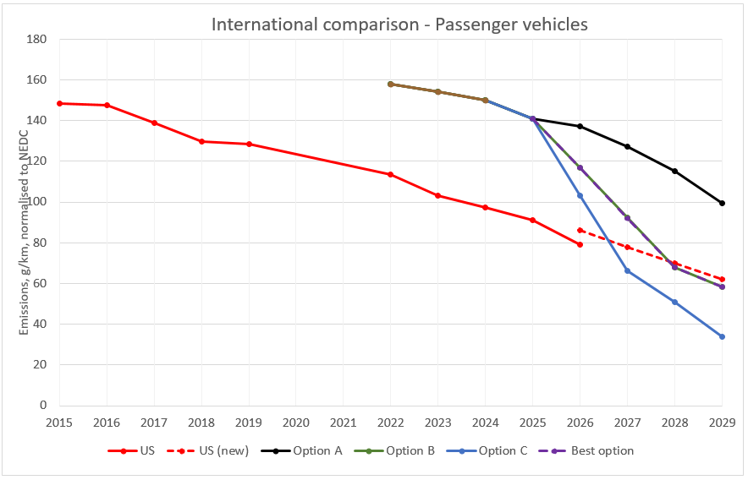
Figure 11 – Passenger vehicle headline targets for options relative to US EPA proposed targets.

Note Option B and the best option are identical, and so are overlaid in this graph.
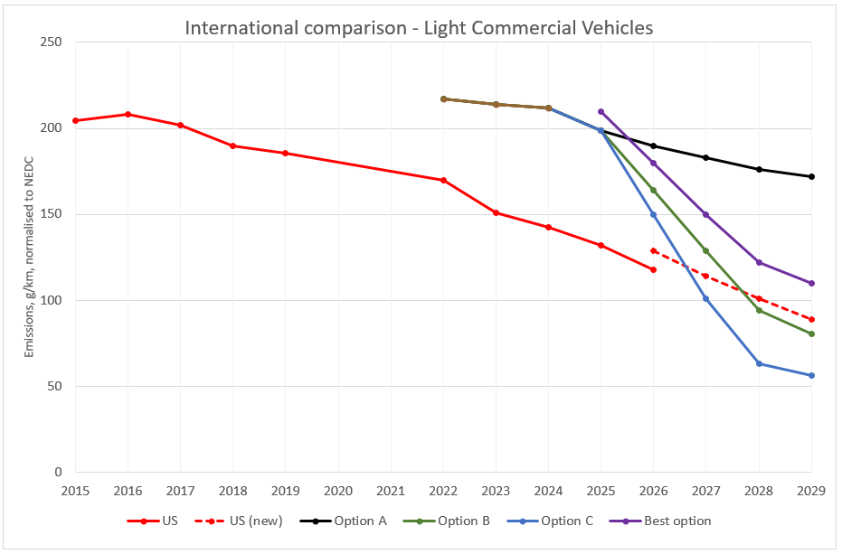
Figure 12 – Light commercial vehicle headline targets for options relative to other country’s targets.

The cumulative abatement for the four options is set out in Figure 13 (below).
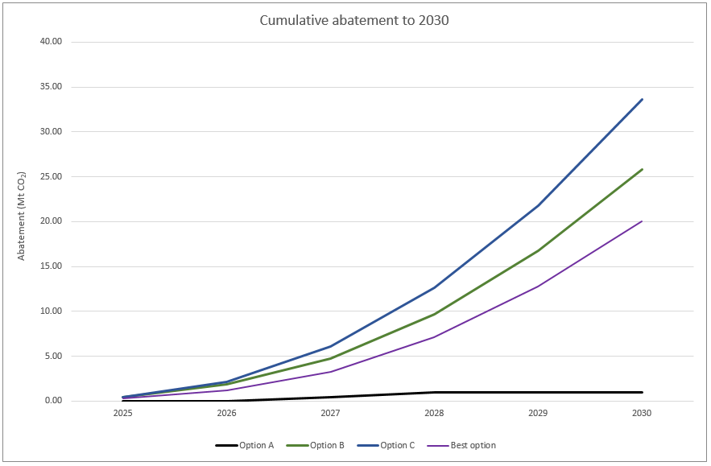
Figure 13 – Cumulative abatement of all options to 2030

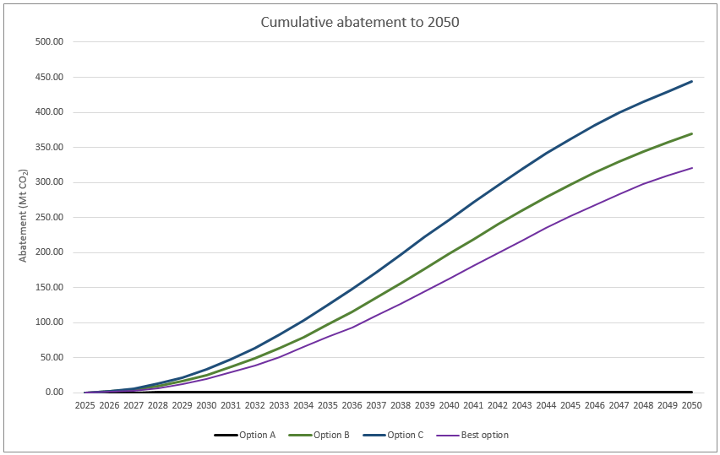
Figure 14 – Cumulative abatement of all options to 2050
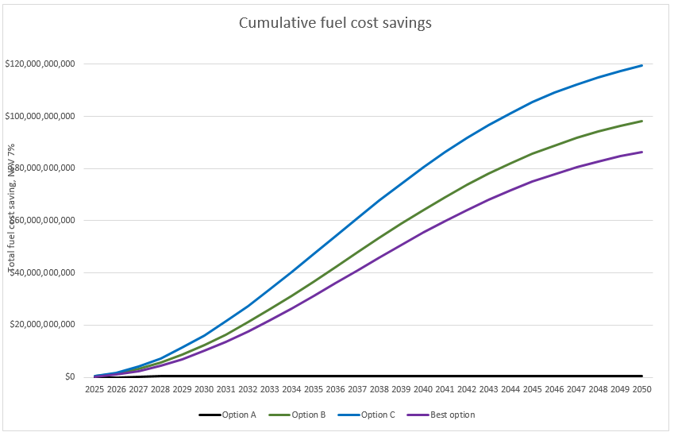
Figure 15 – Cumulative fuel cost saving of all options to 2050

Under all previously considered options (A, B and C), and the best option, targets are only proposed to be set from 2025 to 2029 inclusive, with NVES settings and targets after 2029 to be set following a review in 2026. However, we can forecast what abatement and fuel cost savings might look like on a longer timescale by projecting the modelling further into the future (in this case to 2050). The way that we do this in this figure is by tracking the option against the expected BAU trajectory after 2009.
What this showed for the abatement results for options B and C as considered in February 2024, is that effort to achieve abatement in the short-term, results in a large abatement payoff over the long term. In more technical terms, the abatement after 2029 is partly driven by the inferred CO₂ targets, which assumes the headline targets track parallel with the BAU trajectory in any years in which targets are not set, to a cap of 20g CO₂/km (see Appendix B for a full set of assumptions). Note that Option A would generate minimal abatement and fuel cost saving. This is because the targets under this option involve marginal changes from what we estimate the BAU would deliver.

What changes could be considered?
In this section we provide more detail on what changes following consultation are being considered. The table below presents a set of potential options for amendments to Option B, which the decision maker could choose to adopt, either singly, partially, or collectively whilst substantively retaining alignment with the guiding principles.
These are all presented relative to Option B in the consultation Impact Analysis because Option B was the Government’s best option at the time of publication (February 2024).

Proposed amendment | Rationale and impact
- Revise light commercial vehicle headline limit  Year Revision (change relative to IA Option B)  2025 210  2026 180  2027 150  2028 122  2029 110 | Most vehicle suppliers have argued that the LCV headline limit in Option B would be too steep from commencement, and that there are insufficient lower emissions vehicle options available to adapt to this change in the short term. The revised targets adjust the first year, stretch out the timeframe for the emissions reduction, and reduce the overall level of emissions reduction required to 2029, while still requiring a total reduction from projected 2024 levels to mandated 2029 levels of over 48%.  Note, this interacts with other changes, detailed below.
- Move a small number of 4wds into the light commercial vehicle category  In Options B and C, all 4wds were included in the passenger vehicle category, by virtue of being in the MC category.  This proposal is to retain the vast majority of SUVs in the passenger vehicle category, but move a small number of the heaviest off-road 4wds to the light commercial vehicle category. This would be defined as vehicles constructed as a body-on-frame (also known as ladder frame) that also has a towing capacity of 3 tonnes. | The vehicles proposed to change category are a subset of the MC category. Of the annual 1.1 million vehicles sold in Australia, only about 96,000 would be affected by this change.  The vehicles proposed to change categories are more akin to utes in their construction and ability to tow heavy loads, and have substantial off-road ability.  Note that this interacts with amendment option 1 in a way which is likely to increase the lost abatement from taking both changes. This option also interacts with amendment option 4, detailed below.
- Move the upper break points  Move the PV upper break point from 2,000kg to 2,200kg MIRO.  Move the LCV upper break point from 2,200kg to 2,400kg MIRO. | Revising the PV break point to 2,200kg mass in running order (MIRO) is a better statistical match to the distribution of vehicles, and would mean that large passenger vehicles have a more achievable target. It would also mean that electric vehicles (which are more likely to be above this mass due to the weight of the battery) would generate more credits.  Revising the LCV breakpoint upwards to 2,400kg MIRO would better match the statistical distribution of vehicles and be set at a point that the variants of utes mostly used for work purposes would be below the break point, while luxury and high-performance variants are above the break point.  If amendment (2) and (3) are made together, some of the vehicles that would have benefited from the raised PV break point would instead switch category. This would mean they receive a larger benefit than they would if only this item is adopted, but also likely offsets some of the lost abatement from making this change alone.
- Implementation timing  NVES legislation commences on 1 January 2025.  However adjusting the timing to allow suppliers to generate credits and penalties from 1 July 2025 would offset some implementation risk. | Setting up the regulator, and enabling the vehicle industry to implement compliance frameworks (i.e. IT build, data provision, resourcing of critical planning roles) will be difficult in the time available. The legislation would still start on 1 January 2025, but credits or penalties would not be able to be generated until 1 July 2025.
Table 4 – Considered changes to Option B

What is the likely net benefit of each option?
This chapter considers the net benefits of the options considered by Government. In this chapter we consider:
- All options compared to each of the principles set out in Chapter 3. This analysis is qualitative in nature, and draws on the submissions that were provided in our April consultation process.
- The economic costs and benefits of the options against the baseline.
- The regulatory burden of the options.

Any viable option must compare well against the principles established
As we established in Chapter 3, the department developed a series of principles to inform policy design. In the table below, we have used colours and symbols to assess each option against the baseline and depict if the option, in our analysis, is:
- Superior GREEN

- Moderate AMBER

- Inferior RED

In summary, the principles are:
- Effective: Effective in reducing CO₂ transport emissions from new cars.
- Equitable: All Australians can access the vehicles they need for work and leisure. Intervention needs to be equitable, and not unduly negatively impact any particular group of people or part of Australia.
- Simple and transparent: Intervention emphasises simplicity and transparency, in design and operation.
- Credible and robust: By drawing on expert analysis and experience. Intervention should be designed with the latest and best analysis available, drawing on the expertise of industry, the environmental community, academia and others.
- Enabling: Vehicles with the best emissions and safety technology to be available to Australians. Avoid increasing the average age of vehicles in the fleet so there are no inadvertent safety impacts.
Principle | Baseline | Option A | Option B | Option C | Best Option
Effective: Reduce the average amount of CO₂ emitted by Australia’s new light vehicle fleet over time, consistent with the Government’s emissions reduction and net zero targets and broadly consistent with the NVES in place and fuel savings achieved in other major advanced markets. | Zero abatement | 2030: 1 Mt  2035: 1 Mt  2050: 1 Mt | 2030: 26 Mt  2035: 97 Mt  2050: 369 Mt | 2030: 34 Mt  2035: 125 Mt  2050: 443 Mt | 2030: 20  2035: 80  2050: 321
Equitable: Ensure equitable access to the vehicles Australians need for work and leisure. | Reduced access to EVs, advanced ICE and hybrids. | Reduced access to EVs, advanced ICE and hybrids. | Improved access to EVs, advanced ICE and hybrids. Access to at risk affordable vehicles protected by ‘break point’ providing higher CO₂ target to many small and medium vehicles. | Potential withdrawal or limited sales volumes of some ICE vehicles. Improved access to EVs, advanced ICE and hybrids. | Improved access to EVs, advanced ICE and hybrids. Access to at risk affordable vehicles protected by expanded ‘break point’ providing higher CO₂ target to many small and medium vehicles and a raised upper break point providing more achievable targets for large 4WD drives, and utes.
Simple and transparent: the Australian NVES will emphasise simplicity and transparency in design and operation. The operation and administration of NVESs are complex, which risks greater compliance costs, reduced transparency and unpredictable outcomes, particularly where credit trading markets are established. | No change. There is no reliable source of the emissions from fleets of vehicles. | Public reporting and complete transparency on the number of credits and abatement that is achieved. Complex arrangements in relation to credits risks reduced transparency. | Public reporting and complete transparency on the number of credits and abatement that is achieved.  Absence of technology credits allows the NVES to be predictable and transparent. | Public reporting and complete transparency on the number of credits and abatement that is achieved.  Absence of technology credits allows the NVES to be predictable and transparent. | Public reporting and complete transparency on the number of credits and abatement that is achieved.  Absence of technology credits allows the NVES to be predictable and transparent.
Credible and robust: Draws on expert analysis and experience. Intervention should be designed with the latest and best analysis available. | No change. | Limited abatement impacts on this option’s credibility. | The proposed option has been developed after extensive consultation. Consistent with international arrangements. | Exceeds the stringency of international NVESs. | The proposed option has been developed after extensive consultation. Consistent with international arrangements.
Enabling: vehicles with the best emissions and safety technology to be available to Australians, as good as or better than what is available internationally. | Reduced access to EVs, advanced ICE and hybrids. | Reduced access to EVs, advanced ICE and hybrids. | Improved access to EVs, advanced ICE and hybrids. | Potential reduced access to affordable new vehicles, partially offset by greater availability of relatively affordable low and zero emissions vehicles. | Improved access to EVs, advanced ICE and hybrids.
Table 5 – Assessment of options vs principles

The options analysed all have a net benefit
A benefit-cost analysis is undertaken to estimate how each option performs when we set out all of the costs and benefits. The key indicators of the economic viability of a proposed option are its net benefits and the benefit cost ratio (BCR). If the net benefits are positive, the BCR will be greater than one. In order to assess the net benefits of each option, a range of benefits and costs are quantified based on the best available evidence. The Government then considers this quantitative analysis, alongside the qualitative assessment of the options against the policy principles, to determine the ‘best’ option in line with the Australian Government Guide to Policy Impact Analysis. The best option will have the highest net benefit while also adequately addressing the principles and Government objectives.
The department undertook a detailed benefit-cost analysis of the all options. The analysis found that over the evaluation period of 2025 to 2050 at a discount rate of 7% (a common method which accounts for people placing a greater weight on consumption (i.e. spending) occurring closer to the present), all options presented below have a BCR greater than 1, meaning the policy options have a net benefit to the community. The best option provides the highest BCR of 3.12 with just over $86 billion of net benefit. A detailed breakdown of the costs and benefits is in Table 6, using the central case assumption of a 7% discount rate:
Impacts (AUD billions) Net Present Value Discount Rate 7% - 2025 to 2050
Option: | Option A | Option B | Option C | Best Option
Total costs | $0.41 | $46.49 | $58.75 | $40.55
Total benefits | $0.58 | $142.95 | $173.65 | $126.59
Net benefits | $0.17 | $96.46 | $114.90 | $86.04
Benefits cost ratio: | 1.42 | 3.08 | 2.96 | 3.12
Table 6 – Benefits and costs of options
The key benefits that we have considered are:
Benefit type | Detail | Who it accrues to
Fuel savings | The amount in dollars that consumers save in fuel when they switch to electric vehicles, hybrids and more efficient ICE vehicles | Consumers
Reduced vehicle maintenance | EVs require less maintenance than traditional ICE vehicles | Consumers
Health benefits | The health benefits of cleaner air. This benefit is in addition to other changes (e.g., the implementation of Euro 6 and Euro VI noxious emissions standards) | Australian community
Emissions reductions | Emissions reduction has a societal benefit in assisting to combat climate change. This is forecast at $60 per tonne from 2025, inflated at 3% per annum. | Australia’s community and its future resilience
Table 7 – Key benefits

The costs we have considered are:
Cost type | Detail | Cost to who
Government and compliance costs | This includes setting up a new system internally to interface between Government and OEMs | Cost on suppliers to comply with the regulatory system.
Technology costs | We assume that equivalent ICE and EVs reach price parity by 2030 (note that this is one of the sensitivity tests that we undertook. | The costs to suppliers to adjust production to bring advanced ICE cars, hybrids and EVs to the Australian market.
Electricity costs | The costs to charge an EV/plug-in hybrid. | Consumers
Battery replacement | The cost of replacing batteries for EVs. We note current projections that contemporary EV battery life may lie between 10-18 years, and that some believe the figure to be 20+ years. The analysis assumes that batteries will require replacement every 12 years, 1½ times the average battery warranty period. Given uncertainties and the rapidly evolving battery technology this may overstate the need and inflate the battery replacement costs in the analysis | Consumers
Table 8 – Key costs
Key assumptions used in our analysis are at Appendix B.

Option A – slow start
This option provided the slowest start, and did not seek to catch up to other jurisdictions but looked to keep pace. This caused the least disruption of all the options, with the lowest benefits and also the lowest costs. This option would generate negligible abatement and did not support achievement of the Government’s legislated 2030 emissions reduction targets.
Impacts (AUD billions) Net Present Value Discount Rate 7% - 2025 to 2050
Benefits ($ billion): |  | Costs ($ billion):
Fuel savings | $0.50 | Government and Compliance | $0.21
Reduced vehicle maintenance | $0.001 | Vehicle Technology Costs | $0.19
Health benefits | $0.02 | Electricity costs | $0.004
GHG emissions | $0.05 | Battery replacement costs | $0.00
Total benefits | $0.58 | Total costs | $0.41
Net benefits: | $0.17 billion
Benefit cost ratio: | 1.42
Table 9 – Benefits and costs of Option A

Option B – fast but flexible
Provided a strong, ambitious and achievable policy. The proposed policy settings provided enough flexibility to avoid extremely high costs, with an opportunity for suppliers to invest to support the transition, and delivered considerable abatement and fuel cost savings to Australians. By omitting technology credits (super-credits and off-cycle credits), this option reduced the risk of the NVES not meeting it emissions reduction or fuel cost saving targets, and reduced administrative costs.
Impacts (AUD billions) Net Present Value Discount Rate 7% - 2025 to 2050
Benefits ($ billion): |  | Costs ($ billion):
Fuel savings | $107.6 | Government and compliance | $0.18
Reduced vehicle maintenance | $15.46 | Vehicle technology costs | $7.69
Health benefits | $5.52 | Electricity costs | $29.38
GHG emissions | $14.37 | Battery replacement costs | $9.23
Total benefits | $142.95 | Total costs | $46.49
Net benefits: | $96.46 billion
Benefit cost ratio: | 3.08
Table 10 – Benefits and costs of Option B

Option C – fast start
Proposes the fastest transition, with an accelerated trajectory to catch up to the US in 2027 and then pull forward the CO₂ targets for 2030-32 in the proposed US settings into Australia in 2028-29. This resulted in both a high net benefit and greater abatement, but also higher technology costs. By adopting an aggressive emissions reduction trajectory and more stringent targets, this option risked unavailability of technology and undesirable consumer outcomes.
Impacts (AUD billions) Net Present Value Discount Rate 7% - 2025 to 2050
Benefits ($ billion): |  | Costs ($ billion):
Fuel savings | $129.96 | Government and compliance | $0.17
Reduced vehicle maintenance | $19.65 | Vehicle technology costs | $9.49
Health benefits | $6.75 | Electricity costs | $37.37
GHG emissions | $17.29 | Battery replacement costs | $11.72
Total benefits | $173.65 | Total costs | $58.75
Net benefits: | $114.90 billion
Benefit cost ratio: | 2.96
Table 11 – Benefits and costs of Option C

The best option from those considered
This option continues to provide a strong, ambitious and achievable policy based on Option B but with important adjustments. The retained policy settings provide enough flexibility to avoid extremely high costs, with an opportunity for suppliers to invest to support the transition, and delivers considerable abatement and fuel cost savings to Australians.
Based on consultation feedback and the need to ensure consumers can access the types of vehicles they want and need to drive, this option also includes less stringent targets/headline limits (compared to Option B) for light commercial vehicles like some utes and vans, altered break points, and a delayed start to the generation of credits and application of penalties in the Standard.
This option will maximise abatement while maintaining the vibrancy of the Australian car market and achieve fuel savings for Australian consumers.
Impacts (AUD billions) Net Present Value Discount Rate 7% - 2025 to 2050
Benefits ($ billion): |  | Costs ($ billion):
Fuel savings | $95.08 | Government and compliance | $0.19
Reduced vehicle maintenance | $13.85 | Vehicle technology costs | $6.59
Health benefits | $4.99 | Electricity costs | $25.69
GHG emissions | $12.67 | Battery replacement costs | $8.07
Total benefits | $126.59 | Total costs | $40.55
Net benefits: | $86.04 billion
Benefits cost ratio: | 3.12
Table 12 – Benefits and costs of the best option

How do the different options impact stakeholders?
The options considered impact different groups in different ways, but some trends are clear.
Stakeholder | Definition
Motorists | Australians who drive light vehicles for work, leisure or personal purposes.
Community | The broader Australian community.
Car suppliers | An entity that holds an approval under the Road Vehicle Standards Act 2018 to provide vehicles to the Australian market. This means an entity that supplies cars to the Australian market.
Table 13 – Definition of stakeholders
Fuel savings to motorists are the dominant benefit, accounting for around three quarters of the benefits under the best option as well as options B, C, and most of the benefit in Option A. This is partly offset by electricity costs as the fleet is electrified, but for example, under Option B and the best option, the increased electricity costs are less than one third of the fuel cost savings.
Under Option A electricity costs were negligible at $40 million because under this option our analysis indicated that almost all the emissions reduction required to deliver the targets is provided by advanced ICE technology and hybrids. The health benefits achieved under the best option, as well as options B and C were greater than what could be achieved under Option A where they were comparatively limited. A similar trend occurs for the value of GHG emissions reduction and reduced vehicle maintenance. All of these benefits accrue to motorists or the general community.
The largest forecast cost is electricity costs which is the electricity used to charge electrified vehicles. This affects motorists, but offsets only between a third and a sixth of the fuel cost savings. For example, Option B forecast $107.6 billion in fuel cost savings and $29.38 billion in electricity costs offsetting some of the fuel saving. The best option forecasts $95.08 billion in fuel cost savings and $25.69 billion in electricity costs.
The other main costs are vehicle technology costs (which affect vehicle suppliers) and battery replacement costs (which affect motorists). Both of these are substantially higher under options B, C and the best option, as a result of these options requiring more significant and rapid changes from business as usual activities. Option A has no material battery replacement cost because this option is achievable with only a few thousand additional EV sales above business as usual.

Benefits and costs of implementation, and affected stakeholders
Benefits: | Stakeholder affected | Costs (by 2050) ($ billion)
 |  | Option A | Option B | Option C | Best Option
Fuel savings | Motorists | $0.50 | $107.6 | $129.96 | $95.08
Reduced vehicle maintenance | Motorists | $0.001 | $15.46 | $19.65 | $13.85
Health benefits | Community | $0.02 | $5.52 | $6.75 | $4.99
GHG emissions | Community | $0.05 | $14.37 | $17.29 | $12.67
Total benefits: |  | $0.58 | $142.95 | $173.65 | $126.59
Costs: | Stakeholder affected | Costs (by 2050) ($ billion)
 |  | Option A | Option B | Option C | Best Option
Government and compliance | Community and suppliers | $0.21 | $0.18 | $0.17 | $0.19
Vehicle technology costs | Car suppliers | $0.19 | $7.69 | $9.49 | $6.59
Electricity costs (offset by fuel saving) | Motorists | $0.004 | $29.38 | $37.37 | $25.69
Battery replacement costs | Motorists | $0.0 | $9.23 | $11.72 | $8.07
Total costs: |  | $0.41 | $46.49 | $58.75 | $40.55
Net benefits: |  | $0.17 | $96.46 | $114.9 | $86.04
Benefits cost ratio: |  | 1.42 | 3.08 | 2.96 | 3.12
Table 14 – Stakeholder impacts of options
This illustrates that very significant benefits flow to the community and motorists across the four options considered; a result of reduced fuel costs, reduced health costs as a result of vehicle emissions, and greenhouse gas emissions savings. For motorists, fuel savings and reduced vehicle maintenance more than offset electricity costs and battery replacement, even with our very conservative assumption about EV battery life. Our analysis assumes technology costs for more efficient internal combustion engine technology, hybrid technology and EV technology are applied efficiently to comply with the NVES target, i.e. that the lowest cost option is taken where practical.
These costs were not inconsiderable, ranging from $0.19 billion for Option A, to $9.49 billion for Option C, but are heavily outweighed by the fuel and maintenance cost savings of $0.51 billion for Option A to $149.61 billion for Option C. In the best option, the vehicle technology costs are $6.59 billion, while the fuel and maintenance savings are $108.93 billion.
Distributional analysis
To test the impacts of the NVES on different parts of the country, we undertook a distributional analysis based on state and territory, and on remoteness. This examines the costs and benefits of the NVES for people in different parts of the country.
The state and territory analysis finds that all jurisdictions see a strong positive benefit-to-cost ratio under all options. The largest benefit-to-cost ratio is in the Northern Territory and Tasmania, with the Australian Capital Territory, New South Wales, Victoria and Western Australia having BCRs slightly below the national average, but all still above 3 for the best option.

Benefits and costs for states or territories | Option A | Option B | Option C | Best Option
Reference BCR | 1.42 | 3.08 | 2.96 | 3.12
ACT | 1.34 | 3.02 | 2.90 | 3.06
NSW | 1.41 | 3.06 | 2.94 | 3.10
NT | 1.75 | 3.57 | 3.38 | 3.61
QLD | 1.44 | 3.11 | 2.99 | 3.15
SA | 1.43 | 3.06 | 2.94 | 3.11
TAS | 1.58 | 3.27 | 3.13 | 3.31
VIC | 1.38 | 3.06 | 2.94 | 3.11
WA | 1.43 | 3.06 | 2.95 | 3.11
Table 15 – Benefits and costs for states and territories
The regional analysis similarly finds that the benefit-to-cost ratio increases as the region becomes more remote. Different parts of Australia reflect different car purchasing and driving behaviours, with more remote areas driving greater distances, having higher rates of vehicle ownership and purchasing larger cars, more 4WDs and utes. Our analysis finds that for all options there are higher BCR outcomes for regional and rural locations. In other words, rural, regional and remote areas have a better return on each dollar spent. This is driven by larger fuel cost savings expected for people in areas that drive greater distances and higher rates of vehicle ownership. This isn’t to say there aren’t benefits for major cities – this is where the majority of Australians live and drive, and we see that all motorists will benefit from more fuel-efficient technology.
Benefits and costs for each location | Option A | Option B | Option C | Best Option
Reference BCR | 1.42 | 3.08 | 2.96 | 3.12
Major Cities | 1.37 | 2.99 | 2.88 | 3.04
Inner Regional | 1.45 | 3.27 | 3.13 | 3.31
Outer Regional | 1.61 | 3.43 | 3.26 | 3.46
Remote | 1.90 | 3.75 | 3.52 | 3.79
Very Remote | 2.06 | 3.79 | 3.55 | 3.83
Table 16 – Benefits and costs for different locations

What sensitivity tests were considered?
Sensitivity testing was undertaken across key variables, in particular in relation to discount rates assumed. The table below sets out the net benefits and BCRs for the sensitivity tests that we performed. We have undertaken sensitivity tests on the best option in this case.

Sensitivity test | Net Benefit ($billion) | Benefit Cost Ratio | Directional impact (upwards is an improvement)
Best option | $86.04 | 3.12
Undiscounted (as opposed to 7%) | $341.92 | 3.36
Low Discount Rate (3%) (as opposed to 7%) | $172.90 | 3.27
High Discount Rate (10%) (as opposed to 7%) | $54.48 | 2.99
Price parity between ICE and EVs at 2035 (as opposed to 2030) | $76.28 | 2.52
$120-unit cost for CO₂ (as opposed to $60/tonne) | $98.72 | 3.43
CO₂ reduction benefits excluded (as opposed to $60/tonne) | $73.37 | 2.81
Health cost impacts aligned the with “Health and air pollution in New Zealand 2016 | $88.20 | 3.18
Battery replacement at twice projected cost | $77.98 | 2.60
Battery replacement at half projected cost | $90.08 | 3.47
Higher insurance cost for EVs | $72.20 | 2.78
Fuel and electricity prices kept at 2023 levels (44.8c/kWh for electricity, $2.25/L for diesel and $2.24/L for petrol).  A sensitivity test was undertaken in March 2024 to estimate the outcome if fuel and electricity prices remain at 2023 levels (44.8c/kWh for electricity, $2.25/L for diesel and $2.24/L for petrol).  The 2023 fuel and electricity prices used in the sensitivity test are deliberately higher than what the department anticipates they will be in future years. Further detail is available in Appendix B.  The adjacent figures have been adjusted to account for this. | $87.16 | 2.61
Table 17 – Sensitivity analysis
Possible consumer welfare loss
We also considered the possibility of consumer welfare loss as a sensitivity in our modelling. Consumer welfare loss occurs if a policy intervention would give rise to consumers making different decisions to what they normally would, that gives rise (from the consumer’s perspective) to a loss in enjoyment or utility (i.e. welfare loss). For example, if the Government were to encourage or incentivise consumers to eat apples rather than oranges, consumers that naturally enjoyed oranges would experience loss in welfare when subjected to that intervention. Consumer welfare loss seeks to capture and quantify the individual preferences of consumers even if we, or the consumer, are not able to precisely identify their preferences. In our analysis we sought to estimate the potential welfare loss in both ways – the welfare loss that consumers experience because they can’t presently buy the EV or more efficient ICE vehicle they want because of lack of supply, and the welfare loss that consumers that prefer less efficient ICE vehicles might experience.
The concept of consumer welfare losses is most relevant to simple transactions where consumers cannot find an equivalent product or service. In practice, countries like the US that have NVESs in place still have a full range of vehicle offerings that are designed to meet the full range of consumer needs while being more efficient on average. The myriad of choices available means that consumers benefit from improved efficiency, but do not have to forgo their preferred vehicle type or model. In doing so we estimated consumer welfare loss as a counterfactual. Using the adoption rate that we estimate for our option, the consumers that don’t purchase cost effective EVs or hybrid vehicles must be doing so for a reason despite all of the financial benefits (i.e. fuel savings, lower maintenance costs etc) because of some quality in ICE vehicles that they particularly value. For our calculation of consumer welfare loss for EVs, we estimated the wait times and higher prices that consumers are presently paying for EVs, and projected that down as EV availability improves over time. Table 18 (below) presents our analysis found for the best option.
We consider the consumer welfare loss calculation to be subject to a whole range of variables that may not come to pass, and in particular, that the baseline adoption rate might be exceeded, or that consumers underinvest in fuel efficiency (partly due to incomplete information). However, importantly, even if our highest calculation of consumer welfare loss is included, the BCR is greater than 1, and thus is a net positive option.

 | Full consumer loss ($ bn) | 50% welfare loss ($ bn) | No consumer loss ($ bn)
Total benefits | $126.59 | $126.59 | $126.59
Other costs | $40.55 | $40.55 | $40.55
Consumer welfare loss estimate | $41.87 | $20.94 | $0
Total costs | $82.41 | $61.48 | $40.55
Net benefits | $44.17 | $65.11 | $86.04
BCR | 1.54 | 2.06 | 3.12
Table 18 – Consumer welfare loss analysis

Regulatory burden estimate (RBE) table
The Australian Government Guide to Policy Impact Analysis requires that all new regulatory options are costed in accordance with the Government’s Regulatory Burden Measurement Framework: guidance note. The RBE is a different measure to the full BCA, as it only captures the compliance costs borne by the affected parties and does not capture the benefits of reduced fuel use or CO₂ emissions, for example. The average annual regulatory costs were estimated by calculating the average undiscounted compliance costs over the first ten years. The average annual compliance cost was estimated to be $150,000 for each small volume supplier (27 entities supplying less than 5,000 vehicles per year) and $400,000 for each higher volume supplier (26 entities supplying more than 5,000 vehicles per year).

Individuals | Business | Community organisations | Total change in yearly cost
Nil | Small brands (27): $4 million  Large brands (26): $10.4 million | Nil | $14.4 million across all vehicle suppliers across the whole system.
Table 19 – Regulatory burden estimate

Who did you consult and how did you incorporate their feedback?

In designing the best possible NVES for Australia, it was important to provide the Australian community and industry with opportunity to help shape this landmark reform. Cars are important to Australians, we drive them for work, personal use and leisure, and over one million new vehicles across a range of different car types and brands are sold in Australia every year.
The Government has sought feedback from a wide range of community members, including:

- The general public
- Car manufacturers
- The broader automotive sector
- Non-government organisations focused on the environment, health and social services
- Research institutes, think tanks and other professional membership organisations
- Motoring associations
- Businesses
- The energy sector

Extensive public consultation has informed the design of an Australian NVES

To ensure that the Government’s consultation on the NVES was thorough and effective, three consultation processes were planned, including the consultation for the National Electric Vehicle Strategy. Figure 16 demonstrates the timeline of the three consultation periods.
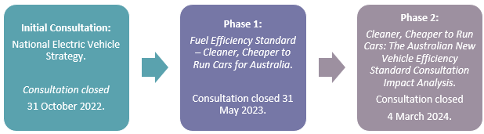
Figure 16 – NVES consultation timeline

Initial consultation for the National Electric Vehicle Strategy - Sep to Oct 2022

In September 2022, the Government consulted the Australian community on the proposed goals, objectives and actions for the National Electric Vehicle Strategy (NEVS), which included questions about the introduction of a New Vehicle Efficiency Standard. That consultation process received over 500 submissions from more than 200 organisations and over 1,500 individuals.

Key feedback we heard was that an Australian vehicle emissions standard is critical to making sure that Australians are able to get access to the cleaner and cheaper vehicles we need, without undue barriers and costs.

Phase 1 consultation on the design of the New Vehicle Efficiency Standard - Apr to May 2023

In April 2023, the Government committed to implementing a standard. This was the central Commonwealth action of Australia’s first National Electric Vehicle Strategy (the National EV Strategy) and followed the overwhelming feedback from stakeholders that Australia needs a mandatory standard. The National EV Strategy seeks to increase the supply of affordable and accessible electric vehicles, and establish the resources, systems and infrastructure to enable rapid EV uptake.

At the same time the Government released the National EV Strategy, it also released a consultation paper (Fuel Efficiency Standard – Cleaner, Cheaper to Run Cars for Australia) (the Cleaner Cars consultation paper) asking for input on how the Government should design a NVES suitable for Australia.

Around 2,700 submissions were received, including submissions from around 120 organisations. The organisations included car manufacturers, climate, environment, health and social service groups, motoring associations, the energy and petroleum industry, unions, research institutions and a range of entities across all levels of government. Figure 17 provides an overview of the categorical spread of organisation responses.
In addition to the release of the consultation paper, a series of individual consultation meetings were held with key stakeholders as well as a face-to-face roundtable on 1 June 2023.
Many submissions to the NVES consultation paper indicated that they could be published. As a result, around 1,200 submissions were published on the cleanercars.gov.au website.

It is important to note that not all submissions from individuals commented on every element of the NVES design. However, as Figure 17 shows, individuals raised a number of themes which further demonstrate the diverse views of the community and those who participated in the Phase 1 consultation.

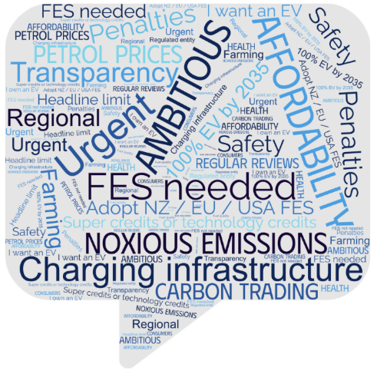

Figure 17 – Key themes from the Phase 1 consultation

A wide range of organisations participated in the Phase 1 consultation, spanning the manufacturing and automotive sectors, to those focused on the environment, health, energy, research, business and consumers. Figure 18 shows the range of organisations by sector and shows the percentage of all submissions according to sector.

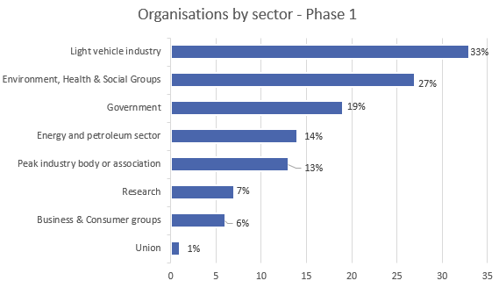
Figure 18 – Organisation category for Phase 1 consultation

Themes emerged
The majority of submissions received from organisations were received from the light vehicle industry (including motoring associations) and climate or health groups. Their responses were analysed, and have been summarised in key themes as follows:

Guiding Principles | There was broad support for the proposed guiding principles. Some environment and health groups suggested the guiding principles should reference emissions reductions and EV uptake targets, as well as health outcomes and vulnerable Australians. We have updated the guiding principles in this document to take account of this input, and have used these as part of the assessment of which is the best model.
Headline targets | Views varied significantly on how headline targets should be designed. The light vehicle industry (with some notable exceptions) generally supported a slow start trajectory, and noted that this would allow it to align its product development cycles to the NVES. Responses from industry bodies varied, ranging from support for a slower start through to a more ambitious NVES that would see Australia catch up to other countries by 2030. The latter sentiment was echoed by environmental and health groups, who also raised concerns with dual targets (for light passenger and light commercial vehicles) resulting in manufacturers adjusting the weight of vehicles in order to shift to a higher target, which would undermine emissions reduction.
Limit curve and break points | The majority of responses broadly support the adoption of limit curves based on average mass rather than vehicle footprint (as per the US). Some environmental and health groups supported vehicle footprint-based limit curve, identifying a risk that vehicle mass may erode emission reduction.
When should the NVES commence | There was broad support the NVES commencing quickly, in 2024 or 2025, as soon as the administrative arrangements have been put in place.
When should the NVES targets start requiring changes to business as usual activities | Views in relation to when the NVES should commence were mixed. The vehicle industry was generally supportive of a long lead time (several years) before substantial changes would be required, to account for normal vehicle design and production timeframes. Climate and environment stakeholders called for a short lead time before requiring emissions reductions, pointing to low and zero emissions technologies and vehicles available today in comparable markets that are not in Australia as a way for regulated entities to quickly reduce emissions and fuel costs.
How far into the future should targets be set | The light vehicle industry suggested targets are set at least five years into the future, with an indication of targets 10 years ahead. Environmental and health groups suggested a three-to-five-year frequency, and greater alignment with national and sectoral emission reduction targets. Regular reviews of the NVES to monitor the progress and set or adjust future targets had very strong support from all stakeholders.
Credit banking, pooling and trading | The inclusion of credit banking, pooling and trading was broadly supported across all stakeholder responses. Responses across the light vehicle industry and environmental and health groups varied in terms of the preferred lifespan of a credit, with the former generally proposing a longer lifespan of 10-years, and the latter preferring a shortened lifespan.
Supercredits | While some responses within the light vehicle industry opposed the inclusion of supercredits, a majority supported the inclusion, and agreed that a gradual withdrawal of supercredits over time would be appropriate. Environmental and health groups generally did not support the inclusion of supercredits, except for some exemptions for targeted, time limited, and capped supercredits for certain segments (e.g. electric utes).
Off-cycle and air conditioning credits | There was some division over the inclusion of off-cycle and air conditioning credits. The majority of the light vehicle industry supported the inclusion of uncapped credits. The majority of environmental and health groups were against the inclusion, noting the current use of low-global warming potential (GWP) refrigerants, and high-GWP refrigerants can be addressed through other legislative measures.
Penalty settings | The need for penalty settings was acknowledged, with the light vehicle industry preferring New Zealand’s penalty unit value of around $50AUD per g CO₂/km over the EU’s penalty unit value of around $200AUD per g CO₂/km, noting that high penalties could result in some vehicles being withdrawn from the market. In contrast, environmental and health groups called for higher penalty unit values in submissions, suggesting Australia should align its penalties unit values with the EU.
Low volume suppliers | While a majority of responses did not include a response on this element, the light vehicle industry was divided in its responses, with varying preference for whether a low volume supplier threshold should be included in the design.
Transparency and accountability | While the light vehicle industry and peak industry bodies supported the use of existing industry reporting methods (VFACTS) for the Australian NVES, environmental and health groups, and research bodies expressed concern with using existing industry-supplied data. Instead there was strong support for an independent, robust and transparent approach with Government collecting data.
Views on the regulator and regulated entity | Stakeholders generally supported the department as the preferred regulator, with some suggestions to adopt the Clean Energy Regulator or Climate Change Authority as possible alternatives. Submissions did not generally address who the regulated entity should be, with the exception of the light vehicle industry which suggested the vehicle supplier should be the regulated entity.
Emissions test results | There was broad preference for transitioning to the Worldwide Harmonised Light Vehicle Test Procedure (WLTP) test results. Stakeholders noted that during transition to WLTP, an interim consistent conversion factor from New European Drive Cycle (NEDC) will be required.
Affordability and access to LZEVs | The light vehicle industry noted an ambitious NVES may lead to an increase in prices of vehicles for consumers, and high penalty costs could result in a withdrawal of some vehicles from the Australian market. Measures to address these issues were suggested in responses from the environmental and health groups.

Phase 2 consultation on the design of the NVES - Feb to Mar 2024
On 4 February 2024, the Government released the Cleaner, Cheaper to Run Cars: The Australian New Vehicle Efficiency Standard Consultation Impact Analysis (Impact Analysis) which set out the options Government considered (options A, B and C) for the design of the New Vehicle Efficiency Standard.
As part of the public consultation methodology, the department developed a questionnaire that was accessible through desktop and mobile devices. The consultation questions (below) were intended to capture individual and organisations views, aiming to identify themes and recommendations to inform Government’s final best option and implementation considerations.
Questions for organisations
- What is your name? (required)
- What organisation do you represent? (required)
- What is your position at the organisation? (required)
- Please rank the proposed options in order of preference (optional)
- Briefly, what are your reasons for your choice? (optional)
- Do you support the Government’s preferred option (Option B)? (optional)
- Do you have any feedback on the analysis approach and key assumptions used? (optional)
- Briefly, describe how the NVES might impact your organisation (optional)
- Who should the regulated entity be? See section 7.2 (optional)
- If you wish to provide any further information, you can upload a submission using the button below (optional)
Questions for individuals
- What is your name? (optional)
- Please rank the proposed options in order of preference (optional)
- Briefly, what are your reasons for your choice? (optional)
- Do you support the Government’s preferred option (Option B)? (optional)
- If you wish to provide any further information, you can upload a submission using the button below (optional)

The questionnaires provided the option to upload a written submission, and free-text responses were available for some questions.
Embedded in the questionnaire was a summary of each proposed option, and a cost benefit analysis table, taken from the Impact Analysis. This summary was designed to ensure that the Governments proposed options were accessible to questionnaire users. The Impact Analysis Consultation was published via the department’s Cleaner Cars consultation hub at cleanercars.gov.au. The consultation hub was open for submissions from 4 February until 4 March 2024.

Raising awareness: early outreach
The department undertook digital outreach to inform the community about the consultation, including:
- A media release to launch the public consultation
- Social media, posting across existing departmental channels to raise awareness.
- Distribution of a stakeholder kit to Government agencies to enable amplification of messaging about the public consultation.
- Other material made available at cleanercars.gov.au, including frequently asked questions.

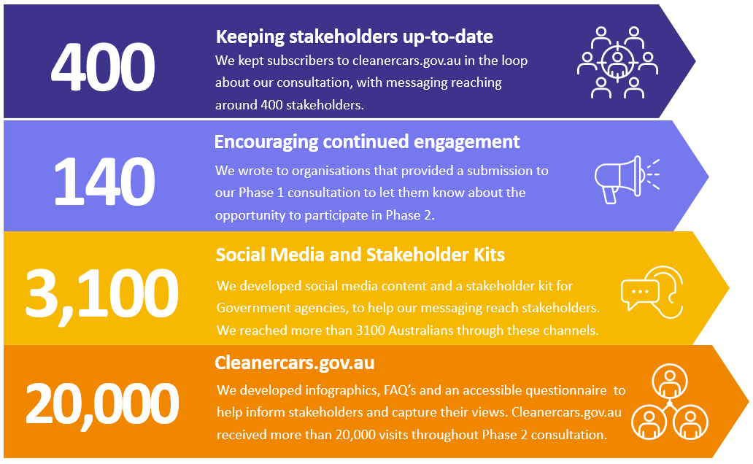
Figure 19 – Digital outreach

Targeted discussions
On 20 February 2024, the department hosted a stakeholder roundtable in Canberra with 26 organisations represented including automotive industry peak bodies, car manufacturers, consumer and vulnerable Australian organisations, environment groups and agricultural organisations. The roundtable provided stakeholders with an opportunity to discuss the Government’s proposed policy and implementation settings and share the views of their organisation and community or industry they represented.
The department also undertook bilateral discussions with a range of organisations as well as industry. This approach ensured that the views of the wider community were captured, and the positions of key stakeholders could be explored in depth.

Who contributed their views to the consultation?
By consultation close, the department had received:
- more than 8,700 submissions from individuals, and
- 198 submissions from organisations.
Participants completed the online questionnaire which enabled free text and some made longer submissions. In this chapter, we provide an overview of what we heard.

So which option was preferred by consultation participants overall?

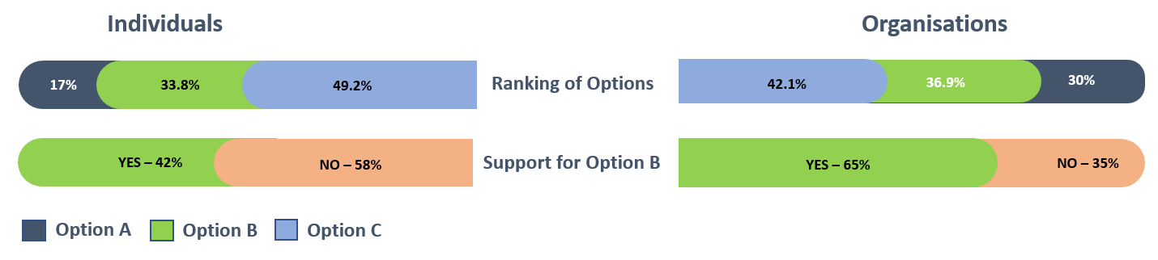
Figure 20 – Phase 2 Consultation – Questionnaire results

- Ranking of Options: Individual respondents showed a strong preference for the implementation of a fast start NVES (Option C), followed by Option B and lastly Option A. Organisations expressed a stronger preference for Option C, followed by Option B, then Option A.

- Yes or no? The response to Option B: The majority of individuals preferred a more ambitious New Vehicle Efficiency Standard than the Government’s preferred Option B. Only 3% of individual submissions preferred Option A as first preference where 65% of organisations preferred Option B.

Submissions from individuals
During the analysis of individual submissions, a number of themes emerged. Figure 21 below illustrates the frequency of these themes.

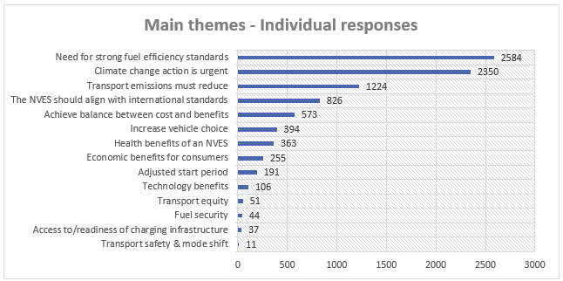
Figure 21 – Individual responses themes

Summary of individual responses
Theme | Summary
Climate change action is urgent | The need to address climate change through a strict New Vehicle Efficiency Standard (NVES) was a strong theme, appearing in around 25% of responses. Example phrases include "climate emergency" and "the time for action is now".
Transport emissions must reduce | Reducing greenhouse gas emissions, particularly from the transport sector, was one of the more frequent themes. Option C, with its faster and stricter approach, was generally favoured for its potential to achieve greater emission reductions.
Achieve balance between cost and benefits | While acknowledging the potential economic benefits of an NVES (fuel savings, health improvements), concerns about upfront costs for consumers and businesses were raised. Finding the right balance between environmental and economic considerations is a recurring theme.
The NVES should align with international standards | Many responses note that Australia is lagging behind other advanced economies in terms of introducing a fuel efficiency standard. Aligning with/catching up to international fuel efficiency standards and abatement targets was seen as important.
Health benefits of an NVES | The potential positive impact on public health due to cleaner air from reduced emissions emerged as something of interest to some respondents.
Transport equity | Some felt that the types of cars incentivised through the NVES could disproportionately impact low-income households who won’t be able to afford this new technology and may hold on to their higher emitting cars for longer.
Need for strong fuel efficiency standards | Many responses advocated for Option C, the fastest and strictest option, highlighting its potential for greater emissions reduction and faster progress towards emissions reduction and a better climate future. Option A, with no change, was generally rejected for its lack of effectiveness.
Economic benefits for consumers | The potential for fuel savings and long-term economic benefits from the introduction of the NVES is mentioned by some, although concerns about upfront transaction/transition costs remain.
Increase vehicle choice | Respondents were welcoming of greater vehicle choice for consumers.
Access to/readiness of charging infrastructure | Some respondents felt that the introduction of an NVES that incentivises the supply and take up of EVs will lead to an increased demand for charging infrastructure. There was some concern that the initial rollout of charging infrastructure might not keep pace with increasing EV take up, potentially causing inconvenience for early adopters.
Technology benefits | An NVES will push car manufacturers to invest in developing more efficient engines and cleaner technologies, potentially leading to advancements in technology (such as batteries, electric motors, and lightweight materials for vehicles.)
Fuel security | An NVES could reduce Australia's reliance on imported oil, potentially improving national fuel security.
Adjusted start period | Automakers and dealerships may need time to adjust their production lines and supply chains to meet the NVES. The abrupt introduction of the NVES could cause disruptions in the industry.  Manufacturers need time to plan and invest in the necessary changes. Allowing sufficient time would minimise disruptions and ensure a smoother transition.
Transport safety & mode shift | Some respondents discussed the increasing size of vehicles and safety impacts they could have on other road users, including pedestrians and cyclists. It was suggested that Government should act to promote active transport as a mechanism for decarbonisation.

Submissions from organisations

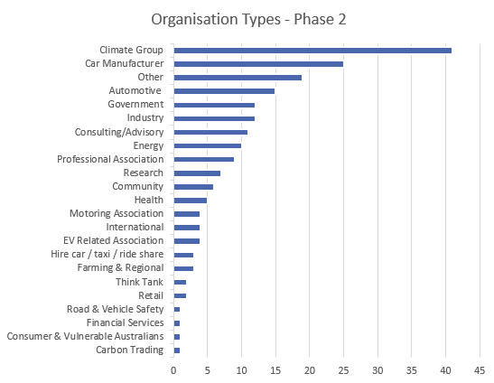
Figure 22 – Organisation types for Phase 2

Submission overview by sector

Sector | Overview
Car Manufacturers | The majority of car manufacturers acknowledge that a New Vehicle Efficiency Standard is needed to reduce CO₂ emissions in Australia, but were divided around the stringency of the scheme and commencement timeframes. Some were clear about their preferred option, where others didn’t explicitly state a preferred option.  Option A – Those that preferred Option A felt that they needed more time to be ready to supply Australia with more fuel efficient, low and zero vehicles. Manufacturing lead times was a common theme, and some felt that changes to the Australian Design Rules would enable a greater supply of vehicles to the Australian market. Views were divided on who the regulator should be.  Option B – There was moderate support for Option B, with some adjustments such as reduced stringency, the inclusion of technology credits, supercredits, modifications to break points, vehicle recategorization and delayed implementation.  Option C – Amongst manufacturers, there was low support for Option C. Those that supported this option were clear that an ambitious NVES was critical and should feature high levels of stringency. Generally, there was no support for supercredits or technology credits. There was support for the department performing the role of regulator.  Manufacturers made additional suggestions include revising vehicle categories, introducing additional technology incentives, credit settings and volume, as well as greater Government support for charging infrastructure and subsidies for consumers.
Automotive & Dealers | Dealerships and representative organisations regarded options B and C as significantly detrimental to dealerships, particularly those who primarily sell light commercial vehicles (LCVs). Their feedback in summary was:  - Changes to vehicle categories: MA category vehicles (passenger vehicles) should be treated as passenger vehicles (PV) and MC (off-road passenger vehicles) and NA (light goods vehicles) category vehicles should be treated as LCVs.  - Early credit boosters: Credit multipliers should be introduced to incentivise early compliance in 2025, 2026, and 2027.  - Target adjustments: Align PV and LCV targets with the current US targets.  - LCV manufacturers should have more lenient targets.  - Regular reviews: Conduct target reviews every two years.  - Credit pooling: Allow manufacturers to pool credits for up to five years, similar to the US system.  - Exemptions: Provide exemptions for rural and regional dealerships, exempt vehicles supplied to essential services and exempt low-volume manufacturers selling less than 2,000 light vehicles annually.  - Financial support for impacted businesses: Develop a mechanism to compensate organisations significantly affected by the NVES.  - The timeline for introduction is not realistic.  - The introduction of a NVES could lead to older, less safe cars on the road.  The fleet management sector supported Option B, noting that it aligns with international fuel efficiency approaches and reduces CO₂ emissions. They noted that Option A would offer minimal progress.  The heavy vehicle industry supported the exemption for heavy vehicles over 4.5 tonnes, and expressed a view that some vehicles (such as light rigid trucks) between 3.5 and 4.5 tonnes should not be in scope.
Environment Groups | This group expressed strong views that Option C is the best choice for the NVES in Australia. These groups viewed Option B as a second preference to Option C.  Option C was favoured among these groups for the following reasons:  - Environmental benefits: Option C has the strongest targets and delivers the most emissions reduction, which is critical to addressing climate change.  - Health Benefits: Option C would result in cleaner air and significant health benefits for Australians, especially for vulnerable groups like children and older adults.  - Cost Savings: Option C would offer the greatest cost savings for consumers in the long term due to lower fuel consumption.  - Technological Innovation: Option C’s strong targets will make Australia a more attractive market for a wider range of low-emission vehicles.  - Urgency: The climate crisis demands rapid action, and Option C offers the fastest transition to a zero-emission fleet.
Carbon Trading | Stakeholders in this sector support the introduction of a NVES to reduce transport emissions. They recommended:  - Adopting Option C in order to achieve the fastest emissions reduction and align with international standards.  - An emissions standard for used cars was suggested for greater transport equality.  - Additional policies should be introduced to address emissions from other transport sectors like aviation and heavy vehicles.  - A coordinated approach that considers the electricity sector and encourages emissions avoidance behaviours should be considered.  - A long-term plan for distance-based road user pricing.
Industry | This varied group includes organisations that interact with the automotive or road using sectors in some way. Some respondents advocated for the stronger options (options C or B), citing faster carbon emissions reduction, the potential for consumer fuel savings and felt that delaying action will see Australians driving less efficient cars for longer than necessary. Others were concerned about increased cost to consumers if the NVES caused vehicle prices to increase.
International | International car manufacturing peak bodies did not explicitly provide a preferred option, however, they made a number of recommendations. This included:  - Timing and Consultation: Concerned that the consultation period was too short and the implementation timeline is too soon. More time should be provided to adjust and align with potential changes in US regulations.  - Testing standards: Concerned that switching from NEDC to WLTP testing will lead to a misleading increase in CO₂ values. They recommended a flexible system like New Zealand's that allows multiple testing cycles.  - Manufacturer impact: Concerned about the impact on carmakers, market dynamics, and exports. They requested policy flexibility and the implementation of potential relief measures.  - Target Adjustments: Current targets are too ambitious and should be modified to provide more time for adaptation.  - Incentives and credits: Recommend supercredits, multipliers and adjustments to penalty levels. Subsidies or investment should be directed towards public charging infrastructure.  - Vehicle categories: Categorise 4WD SUVs as Light Commercial Vehicles (LCVs) instead of Passenger Vehicles (PV), and remove weight-based breakpoints in the targets.
Farming & Regional | The sector acknowledges the importance of reducing CO₂ emissions and supports the NVES so long as it doesn’t disadvantage people who live and work in rural and regional Australia, particularly, those involved in primary production. They suggested exemptions for primary producers, and suggested that some state government exemptions for primary producers could be used to inform primary production exemptions within the NVES.  The limited availability of low and zero emission vehicles (LZEVs) which would meet the specific needs of agriculture sector was acknowledged, as well as other types of LZEVs that would suit the needs of rural and regional communities. They were concerned that the increased cost of non-compliant vehicles may be passed on to consumers.  This group noted that there are unique transport challenges faced by the agricultural, rural and regional communities and that this should be considered by Government when implementing the NVES.
Government | This category summarises the recommendations made by Federal parliamentarians, Government agencies and some state, territory and local governments.  This group supported the two most ambitious options (B and C) and urged their adoption. They noted that a strong NVES is essential to cut transport emissions, improve air quality, achieve better health outcomes and combat climate change. They proposed additional features to strengthen the NVES, such as a target of 100% zero-emission new vehicles by 2030 or 2035, ensuring clear data is available, and including assurance measures to prevent loopholes.  Stakeholders recognise limitations of the NVES, as it only applies to new light vehicles. Stakeholders recommend additional policies to promote electric vehicle charging and prioritise walking and cycling.
Energy | Energy sector stakeholders support the introduction of a NVES, and recommended options B and C for their potential fuel savings and alignment with their own clean vehicle goals. They suggested consideration be given to additional incentives for zero-emission light commercial vehicles to boost availability and consumer uptake and that ways to make zero and low-emission heavy trucks more affordable and widely available should be explored.  They consider that a well-designed standard won't lead to a statistically significant increase in vehicle prices. To further encourage electric vehicle adoption, they recommend a complementary strategy that includes establishing public charging infrastructure and developing national standards for smart charging technology.
Health | This group expressed strong support for Option C, stating that rapid reductions in emissions would have a positive impact on public health and the environment. Some emphasised the economic benefits of Option C, particularly for regional areas which often face high transport costs due to limited public transport and reliance on private vehicles.  Some highlighted the urgent need to address air pollution because of its impact on respiratory health. Respondents acknowledged that Option B was more achievable and noted that it would still deliver significant health and environmental benefits.
Membership-based Professional Associations | Option B was favoured by professional associations; however, it was noted that the potential for limited vehicle supply.  Submissions recommended  - The development of a strong supply chain for fuel-efficient vehicles in Australia, including upskilling technicians and building infrastructure for parts manufacturing, maintenance, and repair.  - Investment in research and training for fire authorities and first responders to handle electric vehicles safely.  - Further incentives for purchase of fuel-efficient light and heavy commercial vehicles.  - Increased EV charging infrastructure, including prioritising regional areas and ensuring compatibility with future technologies.  - Provide ongoing consultation with stakeholders like industry groups to ensure the NVES is effective and well-designed.  - Consider tax concessions for consumers purchasing light commercial vehicles that meet or exceed the standards.  - Implement a 2-year opt-in period to allow for market adjustments and infrastructure development.
Motoring Associations | Submissions from Australian motoring associations generally supported a NVES, but views differed in terms of stringency and timing, and support varied between options A and B.  Recommendations included:  - Separate phased targets for PVs and LCVs.  - Increasing credits in the system through the adoption of supercredits or technology credits.  - Flexibility for manufacturers of LCVs.  - Government support to encourage innovation in the LCV segment and biofuels development.  - Affordability of low-emission vehicles is critical to uptake  - Ongoing review of the NVES is critical to ensure its effectiveness.
EV Related Entities | This group agreed on the need for stricter vehicle emission standards, with most supporting options B or C. They consider that the targets should be set beyond 2029 and should start earlier than 1 January 2025.  Some groups opposed credits for features already built into most vehicles, while others suggest credits be temporary allowed for specific vehicle types. All acknowledged the need for public education to help Australians understand electric vehicles and charging options. Funding a public information campaign about EV technology was a key recommendation.
Road & Safety | ANCAP, the Australasian New Car Assessment Programme, supported the NVES, but also emphasised that vehicle safety should not be compromised. It highlights that measures to modernise our national vehicle fleet will also improve the overall safety performance of that fleet, though this will only occur if it involves new vehicles with high ANCAP ratings.  They recommend adding another performance measure to assess the performance of the NVES, namely, the proportion of vehicles sold in Australia with a current five-star safety rating from ANCAP, rather than simply considering vehicle age.
Research, think tanks & management advisory | - Stakeholders broadly support the introduction of a NVES. The dominant view from these organisations is that options B and C would be most beneficial. Specific recommendations included:  - Eliminating supercredits  - Including SUVs in the PV category.  - WLTP should replace the outdated NEDC for emission tracking.  They also noted the benefits of using electric vehicles used as mobile battery storage for the electricity grid. This vehicle-to-grid (V2X) technology can provide flexibility and cost savings for consumers.
Organisations representing consumers, vulnerable Australians & others | - Views in this group varied. Some prioritised strong emission reduction action, advocating for the most ambitious standard proposed (Option C). Consumer advocates argued that a strong NVES benefits people on low incomes in the long run and that car manufacturers have had sufficient notice to adjust.  - Other views favoured Option B as achievable while aligning with international standards and Australia's climate goals. Submissions acknowledged the challenge of supply, but believed an adjustment period for manufacturers would be adequate.

Consultation outcome by option - what we heard

Those in favour of a fast start NVES (Option C):
- Set ambitious and achievable CO₂ emissions reduction targets.
- Standard should be technology-agnostic.
- Utilise a market-based system with credit trading to encourage competition and lower costs.
- Greater investment in charging infrastructure
- Introduce complementary policies to support EV adoption, including incentives for low-income households.
- Use a more accurate real-world emissions testing standard like WLTP.

Those in favour of a fast but flexible NVES (Option B):
- Provide a longer lead time for manufacturers to comply with the NVES, including the potential for changing the timing of the scheme.
- Ensure that the NVES takes different vehicle types into consideration.
- Be realistic when setting targets and consider technological advancements as well as market responsiveness.
- Consider recategorization of vehicles (4x4 to LCV).
- Focus on the total cost of ownership for consumers, including fuel savings over a vehicle's lifetime.
- Consider the addition of supercredits, off-cycle credits, and air conditioning credits.
- Allow pooling.
- Review the Australian Design Rules to introduce greater supply flexibility for manufacturers
- Consider additional measures, such as training opportunities for electric vehicle mechanics

Those in favour of a slow start NVES (Option A):
- The targets in options B and C are unrealistic and will lead to higher vehicle prices.
- Consider the ability for industry to respond.
- Consider a less stringent headline limit (slow start / fast finish).
- Greater focus should be given to consumer demand.
- The benefits are overestimated and the social costs are underestimated.

What is the best option from those you have considered and how will it be implemented?

Following more than 12 months of extensive public and industry consultation, ongoing economic analysis and adjustment of the options presented within the Consultation Impact Analysis, the Government has developed its best option for the NVES.
In this chapter we set out our rationale as well as a range of implementations details:
- The best option for a NVES;
- What entities should be regulated;
- The regulatory apparatus needed to implement a successful NVES;
- Roles and responsibilities in the system;
- A proposed implementation timeline and transitional arrangements; and
- Implementation challenges.

The best option for a New Vehicle Efficiency Standard

The decision rule for this analysis is that the best option should align to the NVES guiding principles described in this Impact Analysis and consider the results of the cost-benefit analysis.
- Around 321 million tonnes of abatement by 2050.
- Around $95 billion in fuel savings to Australians by 2050.
- EV drivers also save around $350 per year in maintenance.
- Around $5 billion in health savings by 2050.
- Improve Australia's fuel security.
- The types of vehicles Australians like to drive, such as utes and SUVs.

this will deliver
We considered all options against the quantitative cost-benefit analysis and the qualitative assessment of the options against the guiding principles, to determine the final best option. This is consistent with the recommendations of the Australian Government Guide to Policy Impact Analysis (the Guide). The Guide indicates that all else being equal the option with the highest net benefit will be the best option, however the Guide notes that it is rare for all other things to be equal and the recommendation should consider which option is more effective, appropriate, efficient, least costly and has the greatest net benefit for Australia. The Guide also notes that some costs or benefits may not be able to be monetised.
Following consultation and additional economic analysis, we have made a number of small but critical changes to Option B. The primary focus of the changes is to achieve a balance between maximising abatement and consumer benefit, while ensuring the Australian car industry is vibrant and provides consumers with even greater choice of fuel-efficient, low and zero emissions vehicles. The best option supports achievement of the Guiding Principles.
The best option represents an ambitious standard that returns a high net benefit, a strong positive BCR and very large abatement to support achievement of Australia’s commitments under the Paris Agreement and Climate Change Act 2022. The strong abatement generated by this option meets the guiding principle that the NVES should be effective, with a 61% reduction in average new passenger vehicle emissions intensity, and a 49% reduction in average new light commercial vehicle emissions intensity from 2024 to 2029. The effectiveness of this option is further supported by excluding supercredits and off-cycle credits which erode the real emissions reduction and fuel cost savings provided by the NVES.
One of the key features of an NVES is the headline limit, which has the strongest influence over how ambitious, or stringent, a NVES is. After considering the feedback we received, as well as the types of vehicles many Australians need for work, the headline limit has been adjusted for light commercial vehicles, which will enable manufacturers of light commercial vehicles to better meet the NVES while developing new technology for supply in subsequent years.
To further protect small cars that are typically the most affordable vehicles, the best option, consistent with the Consultation Impact Analysis’ Option B, provides a more lenient CO₂ target for vehicles with a mass in running order (MIRO) under 1,500kg. The best option also adjusts the upper break point to better statistically match the distribution of vehicles. The upper break point is lifted to 2,200kg (PVs) and 2,400 (LCVs). This change intends to adjust the impact of the NVES on heavier vehicles which are more difficult to decarbonise and ensure they remain available in the Australian market. Taken together, this supports achievement of the equitable and enabling guiding principles.
A key risk from an ambitious standard is the availability of technology and a vehicle mix to comply with the targets. Given this, and feedback received during the consultation process, a modest number of larger 4WDs will be moved from the passenger vehicle category to the light commercial vehicle category. This will ensure that manufacturers have more flexibility in terms of supplying the types of heavier vehicles that Australians need for work.
Finally, NVES implementation will be timed so that the legislation commences on 1 January 2025, and suppliers can generate credits and penalties from 1 July 2026.
The best option progressively reaches alignment with the headline limit of the standards in the US in the passenger vehicle category around 2028, while the light commercial vehicle category is on a trajectory towards alignment with the US around 2030.

What entities should be regulated
Following consideration of responses to the Phase 1 and Phase 2 consultations, the department has confirmed who would be captured as a regulated entity. As before, we have been guided by two principles:
- The desirability of being integrated into the existing regulatory system, especially the RVSA.
- The desirability of ensuring very good regulatory coverage, and reducing the possibility of avoidance.
The regulated entity that will gain credits or be liable for penalties under the NVES legislation is the type approval holder who first enters a particular vehicle onto the Register of Approved Vehicles (RAV). This leverages the current requirement that a type approval holder must either enter vehicle information on the RAV or authorise another person to do so under section 15 of the RVSA and section 9 of the Road Vehicle Standards Rules 2019, and ensures that all vehicles are captured at entry.

Regulatory apparatus
To achieve implementation of a NVES, two basic elements need to be established:
- The enabling legislation.
- The regulator, along with the systems and processes to:
  - Encourage compliance and undertake enforcement;
  - Undertake awareness-raising in the community and industry;
  - Accept information from industry, and publish information for industry/the public; and
  - Administer the trading platform, where credits units can be transferred.
Implementation will be strongly guided by the outcomes, overall benefits of the NVES and the Government’s objectives.
Enabling Legislation
Implementation of the NVES will require a new, enabling legislation to set out the operational principles, technical aspects for setting NVES standards, and oversight mechanisms, with supporting regulations or legislative instruments as required. We expect that the legislation will be a new Act and will work alongside the RVSA. The enabling legislation will create a regulator, envisaged to be called the New Vehicle Efficiency Standard Regulator (the Regulator), responsible for the day to day management and oversight of the NVES operations.
Regulator
The regulator will be a body operating, at least initially, within the department. As with the any Government regulator, the principles of the Public Governance, Performance and Accountability Act 2013 (PGPA Act) and the Public Governance, Performance and Accountability Rule 2014 (PGPA Rule) will apply.
The Regulator will perform its functions using Australian Government best practice principles, as set out in the Department of Finance’s Resource Management Guide for Regulator Performance 128 (RMG 128). The Regulator will also adopt the NVES guiding principles and meet the objectives to:
- Ensure and promote the integrity of the Australian NVES;
- Ensure a reasonable compliance burden for the NVES;
- Maximise the abatement achieved under a NVES, while maximising the selection of useful vehicles for Australians; and
- Uphold the objectives of the NVES legislation.
The operations of the Regulator are further examined below.
On balance, the preferred approach is to house the Regulator within the department. However, the department’s policy and regulatory functions will be clearly delineated.
Locating the regulator within the department will support:
- Rapid establishment – the Regulator can be established more quickly and cost effectively than stand-alone entities within the Commonwealth, and harness common corporate support;
- Reduced regulatory burden – the department has significant experience and capability in regulating the safety of light vehicles, and administering the RVSA, which it would bring to undertaking the NVES and reduce the regulatory burden on industry.
While the Regulator will initially be located in the department, consideration will be given to this arrangement during the first review of the NVES, to be commenced under law in 2026.

Figure 23 (below) provides an overview of the roles and relationships within the NVES regulatory system.
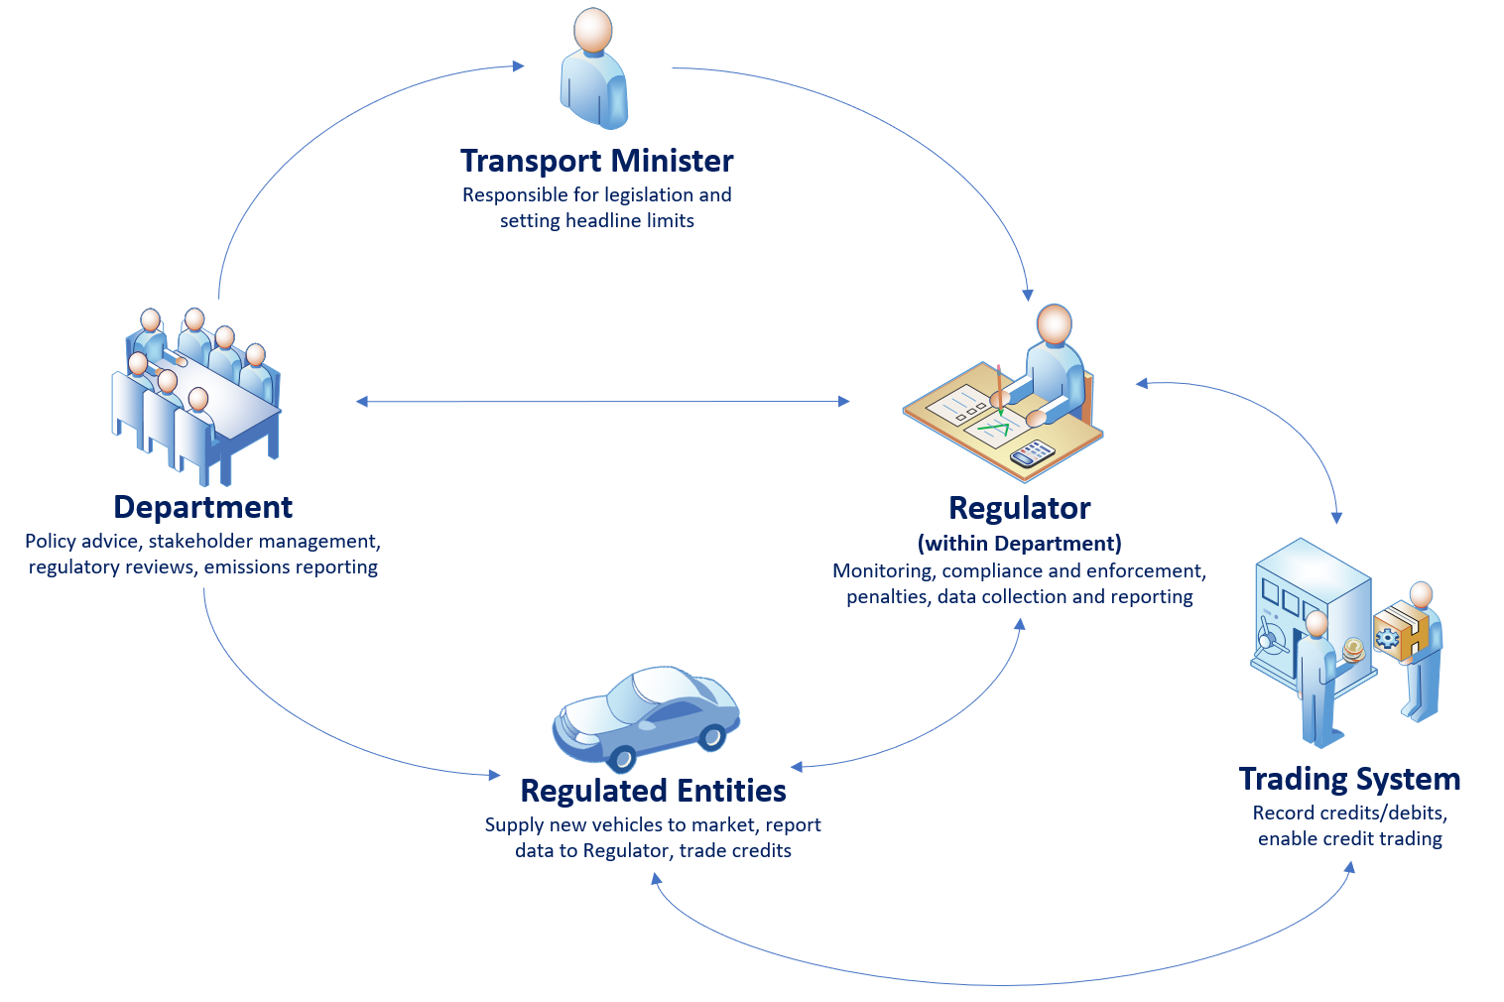Figure 23 – Roles and relationships of the regulatory system
NVES targets would be set by the Minister on a five-yearly basis, with policy advice provided by the department. The key functions of the Regulator would be to assess supplier performance against the NVES targets, and ensure compliance. The Regulator’s activities will be supported by:
- Regulatory data and projections;
- Engagement with industry, the Minister and the department’s policy officials;
- Governance; and
- Operational systems.
The regulator would calculate compliance for each identified regulated entity by:
- Calculating the sales weighted average mass of all vehicles sold by that entity.
- Calculating the sales weighted average CO₂ emissions of all vehicles sold by that entity.
- Comparing the mass and CO₂ level to the limit curve.
- If the regulated entity results are above the limit curve, the entity has not met the target for that year. If the results are below the curve, the entity has met the target for that year. The regulator would alert the relevant supplier (and would make publicly available) the results for the year.

The regulator would have the standard regulatory abilities as specified in the Regulatory Powers (Standard Provisions) Act 2014 modified somewhat. The functions and powers of the Regulator would include:
- Monitoring powers;
- Investigation powers;
- The power to issue written notice to entities requiring them to produce information;
- The power to apply to the court for an order that a person who has contravened any relevant civil penalty provisions pay a pecuniary penalty;
- Issuing infringement notices to entities; and
- Accepting enforceable undertakings.

The Regulator will have obligations to publish information on its website regarding performance against the NVES and the performance of the overall standard. The Regulator will also have obligations to maintain the integrity and security of the credit trading platform. In addition, the penalty amount will be $100 g/CO_{2.} As a matter of course, the Department would issue infringement notices at 50 per cent of the maximum allowed penalty. If paid, no further action would be taken. If the infringement notice was not paid, the department would initiate proceedings in a relevant court. The maximum amount of penalty that the Court could award is $100 g/CO_{2.}

Figure 24 (over) explains the proposed regulatory timeframes, based on the best option.

The diagram below explains what a typical regulatory year would involve in general (top portion) and what the first five years of operation would entail at a more detailed level (bottom portion). 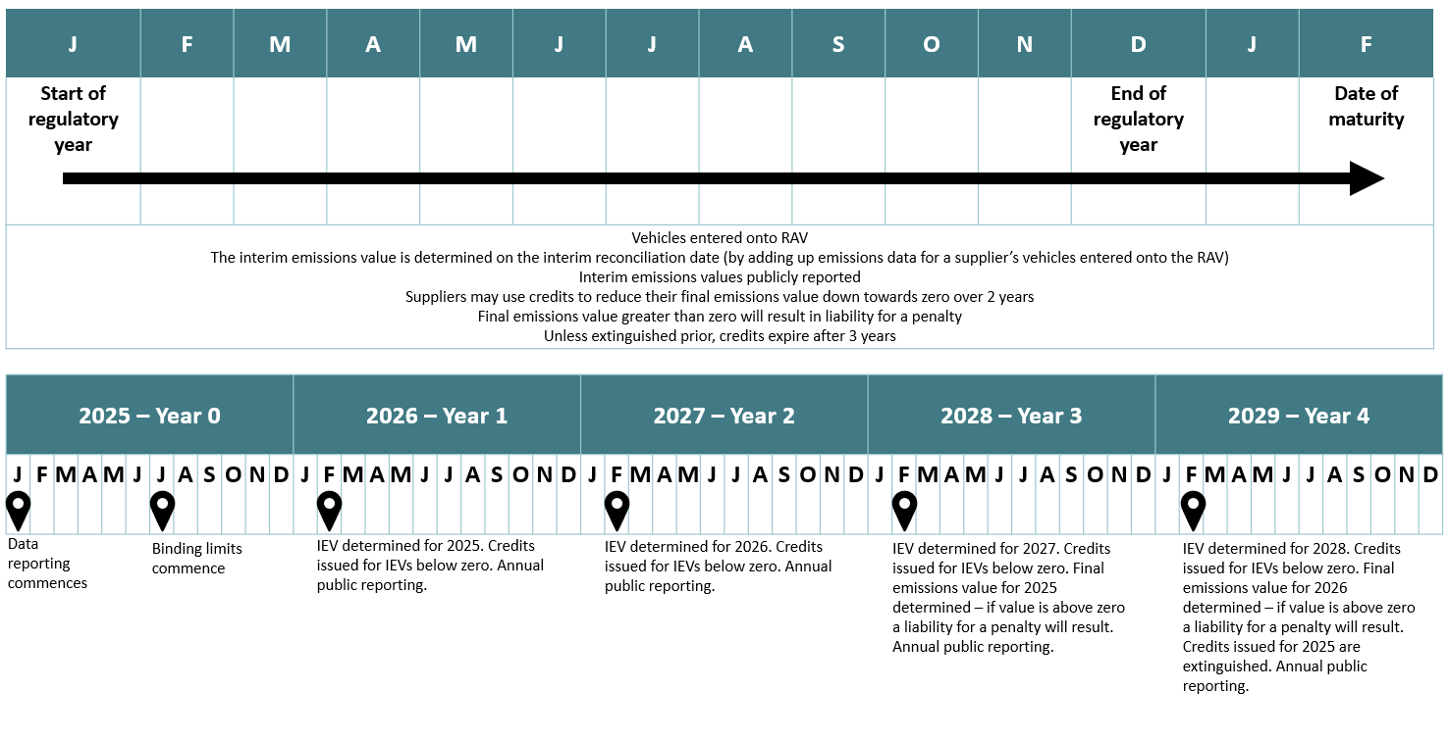
Figure 24 – Proposed regulatory timeframe

Timeline and transitional arrangements
The department aims to ensure an orderly transition for regulated entities to be regulated against the new standards. The best option proposes commencing on 1 January 2025, along with NVES reporting requirements. The regulatory year would continue on a calendar year basis.
The arrangements are:
- Regulated entities will need to register an account on the designated trading platform.
- The IEV will be generated at the end of any given regulatory year, once a vehicle is entered into the Register of Approved Vehicles (RAV).
- The date of reconciliation is 1 February in the next year.
- The IEV will be publicly reported for each regulated entity in the next year
- Once generated:
  - Credits can be traded (transferred) to another registered regulated entity. Terms and conditions of transfers will be a matter for regulated entities. These will not be regulated by the Government under the NVES, though it will have powers to address any transfer issues that may arise.
  - Credits can be used lower a suppliers’ IEV at any time (subject to operational constraints).
  - A positive IEV does not become payable until 2 years after it is generated, which allows time for credits to be acquired and applied to reduce this.

The table below sets out the proposed timetable for implementation of the best option.
Date | Milestone
June 2024 | Setting up the Regulator and the supporting IT systems commences.
~October 2024 | Voluntary regulatory IT testing trial begins.
January 2025 | The NVES-enabling legislation and headline targets commence from 1 January 2025.
July 2025 | Performance against targets assessed for 6-month period only. Regulatory data is collected on an ongoing and continuous basis, subject to IT implementation.
End December 2025 | The first regulatory period ends.
1 January 2026 | The second regulatory period commences on 1 January 2026 and performance against targets assessed for each 12-month calendar period after.
1 February 2026 | First date of reconciliation.  During this month the Department will publish a report showing each supplier’s position for 2025. The Department will issue credits to each entity that has a negative IEV for 2025. To ease the introduction of the scheme, additional units will be issued in 2025. Trading and exchange of credits from 2025 commences.
End December 2026 | Second regulatory period ends.
1 January 2027 | Third regulatory period commences 1 January 2027 and performance against targets assessed for the previous 12 months.
1 February 2027 | Second date of reconciliation.  During this month the Department will publish a report showing each supplier’s position for 2026. The Department will issue credits to each entity that has a negative IEV for 2026. Trading and exchange of credits from 2026 commences.
End December 2027 | Third regulatory period ends.
1 January 2028 | Fourth regulatory period commences 1 January 2028 and performance against targets assessed for the previous 12 months.
1 February 2028 | Third date of maturity. During this month the Department will publish a report showing each supplier’s position for 2026. The Department will issue credits to each entity that has a negative IEV for 2027.  Trading and exchange of credits from 2027 commences.  IEVs from 1 Feb 2026 that remain positive after trading come to fruition (as a Final Emissions Value) and a penalty is determined.
1 February 2029 | Unless extinguished prior, credits that were issued on 1 February 2026, expire.
Table 20 – Proposed timetable for implementation

Implementation challenges and impacts
The implementation of a NVES has a number of associated challenges and impacts. These relate to obtaining regulatory data from a diverse range of stakeholders, design of the regulator, and supporting systems. Implementation timing to achieve a 1 January 2025 commencement is a key constraint. There are also a number of barriers, raised in section 3.1.4, that could give rise to challenges in achieving the Government’s policy objectives. The identified transitional, intermediate and ongoing implementation challenges include:
Immediate transitional challenges
- Implementation will be phased so that IEVs for 2025 only apply from 1 July to 31 December 2025;
- .
- Establishing data needs, appropriate ongoing data collection, storage and access, while minimising burden as much as possible and still meeting NVES requirements;
- Developing new IT systems and redeveloping existing ones, including: integration and testing, integrating them with industry systems, and ensuring their useability – all within a tight timeframe following the passage of legislation;
- Establishing the Regulator with the right settings and functions in a short timeframe after passage of the enabling legislation; and
- Developing solutions to overcome infrastructure limitations that could result in barriers for consumer uptake, including the lack of charging infrastructure for electric vehicles and the limited availability of alternative fuels.

Intermediate and ongoing higher-level challenges
- Achieving positive compliance from regulated entities resulting in improved emissions outcomes;
- Stakeholders trusting the results;
- Regulated entities trusting the fleet limit curve calculations set for them and the Regulator’s capabilities;
- Technology advancements and new innovations provide opportunities for fuel efficiency, and have limited hinderance on progress or existing technologies;
- Managing supply chain complexities for manufacturers in relation to the critical minerals and other resources needed for the production of zero emissions vehicles. Contingency planning for any global instability that may have an adverse impact on supply of all vehicle types imported into Australia;
- The general public has confidence that the benefits will be realised;
- Australian consumers are aware and understand the fuel efficiency of cars as well as new zero emissions technology, without hesitation to take up new technology such as hybrids or electric vehicles; and
- Communicating the long-term savings in fuel costs to consumers, despite an upfront and transitional increase in cost to the consumer in adopting fuel-efficient vehicles and technology.

Support for industry
The implementation of a NVES in Australia will require car manufacturing industries to meet new provisions including data supply to Government, and compliance with the NVES. Ongoing engagement from the Regulator will be undertaken, particularly to support any changes to processes and systems. The department will engage with industry in co-design of the IT systems, prior to their build and testing in late 2024.
Support for consumers
The implementation of NVES in Australia will create greater choice in new fuel-efficient vehicles for consumers. During the implementation of the NVES, the Regulator will work with industry to educate consumers on the changes being introduced. Information on the standards and what they mean for consumers will be made available on the Regulator’s website. The department is exploring how other economies assisted consumers in the transition and adoption of low to zero emissions vehicles and technology.
The key risk is that there could be insufficient integration and testing of regulatory and industry systems. A 2025 IT delivery is ambitious, dependent on delivery partners to validate the delivery schedule, and will require contingency options.

How will you evaluate your chosen option against the success metrics?

In this chapter we set out our proposed plans for program evaluation. To align evaluation metrics against the objectives of the program, these are based on the success measures outlined in Table 1. A broad overview of the evaluation metrics can be found in the table below.
Success measures | Evaluation metrics
The percentage reduction in average CO₂ emissions from Australia's new cars, out to 2050. | This is currently difficult to accurately assess based purely on the data made available by a NVES (g CO₂/km for new vehicles). This is because this data is not currently captured (and therefore no data exists to calculate an exact baseline), and accurately calculating a reduction would require data on real-world fuel usage. As such, assessing the impact of a NVES on this measure may require:  - Undertaking a survey of distances travelled/fuel usage of both new and older vehicles.  - Comparing the average g CO₂/km of new vehicles in the years before and after NVES implementation, and using average distance travelled figures to calculate an approximate reduction in CO₂.  - Undertaking trend analysis over a longer period of time.
A design which does not disadvantage small or affordable vehicles to protect the continued supply of these vehicles to the Australian market. Ensure that people have access to fuel-efficient vehicles. | This measure may require a number of pieces of evaluation to examine success:  - Analysis of the average vehicle weight before and after the implementation of a NVES.  - Analysis of the number of new vehicles added to the RAV in the years before and after implementation of a NVES.  - Cross-sectional analysis of the above three metrics against the proportion of new vehicles that are LZEV.
Design and implement a process which leverages existing regulatory frameworks and touch points with Government, while providing accessible information to both consumers and industry stakeholders. A streamlined NVES design which avoids design features which add complexity, increase administrative complexity, and reduced transparency. | This measure may require a number of distinct evaluation metrics to assess data success, including:  - Comparison of data sharing capacity/volume against pre-implementation baseline.  - Evaluation of non-confidential data made public: volumes, percentages, readability, accessibility.  - System uptime as compared to pre-implementation.  - Success rate of data ingress as compared to pre-implementation.  - Success rate of regularly scheduled activities as compared to pre-implementation, e.g. data backups.  - Whether processing time meets or exceeds existing departmental (DITRDCA), CER and DCCEEW service level agreements.  - Improved data access for state and territory jurisdictions to monitor vehicle information.  Data collection before implementation will be required to establish a baseline for IT system performance. IT system performance may change over the course of implementation, as the various phases are progressed through. Tracking this may require a phased approach to data analysis.  Additionally, some evaluation will also be used to ensure the NVES design features are effectively meeting administrative requirements:  - Review of the costs of implementation and ongoing policy cost recovery options.
Advice on setting NVES limits is of a high quality, and is accepted by the Office of Impact Analysis as relevant. Consultation is broad and includes all key stakeholders. Ongoing opportunity for stakeholders to provide feedback on operational matters, and ability to influence policy settings through reviews. | - Analysis quality will be assessed based on:  - OIA feedback.  - Survey of agency satisfaction with provided data.  - Assessment of data accuracy against pre-implementation baseline.  - Consultation quality will likely be evaluated based on number of responses, and a comparison of responses to those received during previous consultation phases.  - Ongoing opportunity for feedback is difficult to estimate, but will likely be evaluated based on correspondence received regarding a NVES post-implementation.
Consider scrappage rates, and whether the average age of the car parc will increase. | This measure can be evaluated in two key ways:  - Use vehicle registration data to determine the number of cars that have left the road over the course of a year, compared to the number of new vehicles. (This may require factoring into new data sharing agreements being put in place with jurisdictions).  - Use the same data to calculate the average age of the national fleet.
Table 21 – Success Measures and Associated Evaluation Metrics

Program monitoring and evaluation
A robust monitoring and evaluation framework will be a core component of the ongoing success of the NVES. The framework will support continuous improvement and accountability, and ensure that the policy and legislative requirements are being met. Evaluation will need to consider the overarching policy efficiency, as well as looking at aspects of the policy implementation and whether any adjustments to the NVES regulatory framework may be warranted.
The department will undertake periodic reviews of the NVES, starting in 2026, in its implementation plans. There will be a necessary bedding-in period for the new requirements of the NVES, during which time the regulated entities, and the regulator, will be implementing new systems and processes. It is only natural that during this time more effective ways of operating may be identified by the regulator, or by the regulated entities. Reviews offer the opportunity to not only take stock of the policy effectiveness, but also refine the regulatory systems and mechanisms in place to support continuous improvement of the new NVES policy.

8.1.1 Monitoring of ongoing NVES operations
The Regulator will be responsible for undertaking an ongoing regime of quality assurance, monitoring and enforcement for the NVES. See Chapter 7 for the intended powers to underpin these responsibilities.
Key to an effective monitoring regime will also be robust data and reporting and effective use of enabling ICT systems. We anticipate that there will be opportunities to make use of existing technology already in use for reporting for other vehicle compliance purposes, and the department/regulator will aim to create a system with minimal user burden while still ensuring robust data collection. Additionally, the regulator should maintain authority over the key data relevant to assess the implementation and operation of a NVES, rather than requiring other sections or departments to be the primary data holders.

8.1.2 Program evaluation
There are three areas for a review/evaluation to consider: processes, efficiency and impact.
Process evaluation
A policy and process performance review will be undertaken to identify what worked well from an operations perspective, and where there is opportunity to improve. This will likely involve engagement with stakeholders.
Efficiency evaluation
The efficiency evaluation will consider the investment level versus policy outcomes (value for money). This can include comparing the cost of the policy to alternatives or similar initiatives and determining cost-benefit ratios or costs per unit (outcome, participant, group etc.). It can also review whether value for money assumptions made during the policy design process have been borne out.
Methods for efficiency evaluation include social cost effectiveness and ex-post cost-benefit analyses. Social cost effectiveness analysis compares the costs of two or more policies that achieve the same outcome. This method tends to be used where it is difficult to estimate the monetary value of benefits. In contrast, a social cost-benefit analysis values the various costs and benefits of proposed policies to provide a comparison of policies on a cost per unit of change basis. This method is particularly useful for comparing policies that achieve different levels of change.
Impact (effectiveness) evaluation
An impact evaluation will assess the impact of the implemented NVES policy, including the extent of the impact, the achievement of the NVES principles, overall program benefits and outcomes are achieved, and identify any positive or negative unintended consequences. This will be drawn primarily from data gathered through NVES regulatory reporting systems, observing levels of compliance and non-compliance with the NVES targets and assessing the resulting impacts on CO₂ emissions.
The department is proposing a review of the NVES in year two (2026) and regularly thereafter of the policy being in place. Reviews will be conducted by the department, and to the extent possible, final reports will be made publicly available.
Overarching policy objectives and program benefits
A number of key performance indicators (KPIs) will also help measure and track progress against overarching program benefits, as defined under the program logic. Future evaluations will also consider to what extent the operation of the NVES is achieving its intended benefits of:

- CO₂ emissions reduction;
- Reduced fuel consumption;
- Availability and affordability of LZEVs; and
- Improved health outcomes for Australians.
Specific KPIs around these program benefits and other program evaluation measures will be developed further refined during program implementation.

Appendix A: The Australian Car Market
New vs used cars in Australia
70% of Australians buy their car second hand.
Total cars sold in 2023
2023 | Number | %
Passenger vehicles (including most SUVs) | 890,823 | 76.46%
Light commercial vehicles (utes and vans) | 274,185 | 23.54%
Total | 1,165,008 | 100.00%

Size of Australia’s vehicle fleet
In 2022, there were 19.9 million light vehicles and 20.7 million vehicles including heavy vehicles and motorcycles in Australia. Australia’s fleet is sometimes referred to as the ‘car parc.’
Average vehicle age
- 10.7 years for passenger vehicles
- 11.1 years for light commercial vehicles

Average price of a car
- $40,916 (purchase price), source: Canstar
- $50,161 (transaction cost - includes dealer-delivery fees, factory-fitted options and dealer-fitted accessories) source: Drive.com.au

Number of cars sold by type
 | 2017 | 2018 | 2019 | 2020 | 2021 | 2022 | 2023
Passenger cars | 449,987 | 378,470 | 315,932 | 221,103 | 221,556 | 203,056 | 211,361
SUVs | 465,672 | 495,243 | 483,331 | 454,701 | 531,700 | 576,632 | 679,462
Light commercial vehicles (LCV) | 236,608 | 237,972 | 225,635 | 205,597 | 253,254 | 256,382 | 274,185

Top six sellers by brand volume in 2023
Brand | Volume
Toyota | 215,240
Mazda | 100,008
Ford | 87,800
Kia | 76,120
Hyundai | 75,183
Mitsubishi | 63,511

Top sellers by car and by brand in 2023 (total across all variants)
Brand | Type | Volume
Ford Ranger | Ute | 63,356
Toyota Hilux | Ute | 61,111
Isuzu D-Max | Ute | 31,202
Toyota RAV4 | SUV | 29,627
MG ZS | SUV | 29,258
Tesla Model Y | SUV | 28,769
Toyota Landcruiser | 4WD | 26,449
Mitsubishi Outlander | SUV | 24,263
Mazda CX-5 | SUV | 23,083
Hyundai Tucson | SUV | 21,224

Top selling models by car body type in 2023
Brand | Type | Volume
Ford Ranger | Ute | 63,356
Toyota RAV4 | SUV | 29,627
Toyota Landcruiser | 4WD | 26,449
Hyundai I30 | Small car | 20,626
Tesla Model 3 | Sedan | 17,347
Toyota Hiace | Van | 7,133

The table below outlines the fuel systems that the top 35 brands operating in Australia offer, as of December 2022. Since the release of this market summary, further announcements from suppliers have indicated a range of new models are expected to be released in the future. For example, EV Jeep Wrangler, Volkswagen ID 3.
Original Equipment Manufacturer | Company/brand | ICE | BEV | FCEV | HEV | PHEV
BMW Group | BMW | Yes | Yes |  |  | Yes
 | MINI | Yes | Yes |  |  | Yes
BYD | BYD |  | Yes
Daimler | Mercedes-Benz | Yes | Yes |  | Yes | Yes
Ford | Ford | Yes | Yes |  |  | Yes
Geely | Volvo | Yes | Yes |  | Yes | Yes
 | Polestar |  | Yes
GWM | GWM | Yes |  |  | Yes
Honda | Honda | Yes |  |  | Yes
Hyundai Motor Group | Kia | Yes | Yes |  | Yes | Yes
 | Hyundai | Yes | Yes | Yes | Yes | Yes
 | Genesis | Yes | Yes
Isuzu | Isuzu | Yes
Mazda | Mazda | Yes | Yes |  | Yes
Renault Nissan Mitsubishi Alliance | Mitsubishi | Yes |  |  |  | Yes
 | Nissan | Yes | Yes
 | Renault | Yes | Yes
SAIC | MG | Yes | Yes |  |  | Yes
 | LDV | Yes | Yes
Stellantis | Fiat | Yes | Yes
 | Alfa Romeo | Yes
 | Peugeot | Yes |  |  |  | Yes
 | Citroen | Yes
Subaru | Subaru | Yes
Suzuki | Suzuki | Yes
Tata Motors | Jaguar | Yes | Yes |  | Yes
 | Land Rover | Yes |  |  | Yes | Yes
Tesla | Tesla |  | Yes
Toyota | Toyota | Yes |  | Yes | Yes
 | Lexus | Yes | Yes |  | Yes | Yes
Volkswagen | Volkswagen | Yes
 | Audi | Yes | Yes |  | Yes
 | Porsche | Yes | Yes |  |  | Yes
 | CUPRA | Yes | Yes |  |  | Yes
 | Skoda | Yes
Source: departmental analysis, OEM – Brand relationship derived primarily from Whichcar.com

Selection of regulated entity commitments:
Vehicle brand | Commitment  type | Target year | Details/notes
Full Commitment
Volvo | Fully electric | 2030 | Volvo has announced plans to become a fully electric car company by 2030.
MINI | Fully electric | 2030 | MINI's head company, BMW, has announced intentions to make MINI the first all-electric group brand by 2030.
Fiat | Fully electric | 2030 | Fiat has announced that between 2025 and 2030, their product line-up will gradually become electric only.
Mercedes Benz | Fully electric | 2030 | Mercedes-Benz is targeting to become all electric by 2030, where market conditions allow.
Partial Commitment
Mazda | Partially electric | 2030 | Mazda has announced that by 2030, 100% of Mazda products will be electrified and pure-electric vehicles will account for 25 to 40% of those.
Toyota | EV unit sales target | 2030 | Toyota globally plans to release 30 new EVs and lift EV sales to 3.5 million a year by 2030, investing $87 billion in the shift to zero-carbon vehicles over that period
Kia | EV unit sales target | 2030 | Kia announced that as part of the EV transition, the company aims to sell 1.2 million BEVs in 2030. Further, Kia is targeting 100% EV line-up in Europe by 2030 and globally by 2035.
Hyundai | EV unit sales target | 2030 | Hyundai Motors announced that annual BEV sales target is 1.87 million units by 2030, with 560,000 EV units targeted by 2025.
Honda | EV unit sales target | 2030 | Honda announced that the company is targeting to electrify two-thirds of global automobile unit sales in 2030.
Lexus | EV unit sales target | 2030 | Lexus will anticipate 1 million units of BEV sales by 2030 and has committed to 100% EV by 2035.
Mitsubishi | EV unit sales target | 2035 | Mitsubishi is targeting hybrid, plug-in hybrids, and electric vehicles to account for 50% of its sales by 2030, and all its sales by 2035.
Volkswagen | EV unit sales target | 2030 | Volkswagen informally announced intention to reduce the carbon footprint of its passenger cars and light commercial vehicles by 30% per vehicle (compared with 2018) by 2030. Further, all-electric vehicles are expected to exceed 70% of European and 50% of Chinese and US sales volumes by 2030.
Source: IEA, Global EV Outlook 2022: Securing supplies for an electric future, accessed 1 June 2023, https://www.iea.org/reports/global-ev-outlook-2022 ; S&P Global, 2023, Electric Vehicle Trends, accessed 1 June 2023. https://www.spglobal.com/mobility/en/topic/electric-vehicle-trends.html; GHD desktop review

Appendix B: Key assumptions in CBA
The assumptions and data sources below were used to generate the forecasts used in this analysis. In general, these assumptions were held steady for each of the options, with variations noted below.
# | Assumption | Basis for assumption | Value, where possible
1 | Population growth to 2050 | ABS and Treasury forecasts (see next cell) | Detailed historical population by gender by age by remoteness region estimates based on ABS 2021 Census and ABS Estimated Resident Population catalogue numbers 3101 (15 June 2023) and 3235 (30 August 2022). Forecasts from Australian Government Centre for Population (Budget 2023-24: State and Territory Population Projections, 2022-23 to 2026-27, and Budget 2023-24: National Population Projections, 2022-23 to 2033-34) and forecasts thereafter.
2 | Inflation rate | Did not use explicitly, considered as part of other forecasts.
3 | Scrappage rates | Non-linear function, with survival rate of vehicles declining on an ‘s curve’ (see next cell) | Survival rates based on the static scrappage model in the US CAFÉ Model (Shaulov, M., Baskin, D., Clinton, B., Eilbert, A., Garcia-Israel, K., Green, K., Pickrell, D., Saenz, G., & Vargas, A. (2022, April). CAFE model documentation (Report No. DOT HS 813 281). National Highway Traffic Safety Administration) calibrated to match 2022 new vehicle sales.
4 | Battery replacement costs | Assumed to be required at 12 years of use. | Cost of $5,000 for PVs, $8,000 for LCVs and then reducing at 0.9% per annum in line with technology improvements.
5 | Vehicle maintenance costs | Lower maintenance cost of EVs, saving may be up 40% compared to an ICE vehicle, due to fewer moving parts and less brake wear, but this varies considerably between suppliers and models. Sources such as WhichCar. | $350 per annum maintenance saving for an EV compared to an ICE vehicle.
6 | Health benefits | Source: Analysis by ACIL Allen. | Arithmetic average of RON91, RON95, and RON98 was used for petrol health cost.  2025 starting point of $0.1210/km for average petrol and $0.0684/km for diesel.  Projections from 2041 to 2080 is derived using linear trend from estimates between 2025 and 2040 (rate of increase of 0.05% per year).  Update in response to consultation feedback: A sensitivity test was conducted to align the health cost impacts estimated in the “Health and air pollution in New Zealand 2016” (HAPINZ 3.0) study (Kuschel, G., et al. (2022)). This study extrapolated for Australian context in the “Health impacts associated with vehicle emissions in Australia: Melbourne Climate Futures Expert Position Statement.” (Walter C., Say K., Irving L., et al. 2023).
7 | NPV discount rate | In line with Government guidelines | 7% for central case; sensitivities at 3% and 10%.
8 | Inferred headline limit | Headline limits after the initial period (2025-29) are not set, instead an inferred headline limit was created to track parallel to the BAU (to a floor of 20g CO₂/km). | Dynamic adjustment for 25 years, with a floor of 20g CO₂/km.
9 | Oil and fuel prices | IEA World Energy Outlook data 2022 (https://iea.blob.core.windows.net/assets/830fe099-5530-48f2-a7c1-11f35d510983/WorldEnergyOutlook2022.pdf), Accessed July 2023; Australian Petroleum Statistics, March 2023, Provided by DISR;  Fuel Quality Standards Implementation, Cost Benefit Analysis, 2022. Accessed 12 October 2023. | Dynamic adjustment to 2050  2025 petrol $1.76/l  2025 diesel $1.75/l  2050 petrol $3.93/l  2050 diesel $3.99/l  Average rate of change for petrol: 1.59%  Average rate of change for diesel 1.62%  Update following consultation: A sensitivity test was undertaken to estimate the outcome if fuel and electricity prices remain at 2023 levels (44.8c/kWh for electricity, $2.25/L for diesel and $2.24/L for petrol).
10 | Carbon intensity of fuel (petrol and diesel) and forecast changes | DCCEEW, Australia emissions projections and methodology, 2022.  Accessed July 2023 | Data for Figures 2.31 and 2.32 are from Methodology for the 2022 projections, DCCEEW, 2022, Available at:  https://www.dcceew.gov.au/sites/default/files/documents/methodology-for-the-2022-projections.pdf  See Appendix, Table 13 and 14  Data for Figure 2.34 is from Australia’s emissions projections 2022, DCCEEW, 2022, Available at: https://www.dcceew.gov.au/sites/default/files/documents/ageis-projections-chart-data.xlsx  See Tab 15  All data accessed in July 2023
11 | Electricity prices | There is additional electricity demand and consumption, impacting prices, assuming a rapid uptake of EVs  Source: GHD Advisory and ACIL Allen, Economic and Technical Modelling of the ACT Electricity Network Strategic Report; 26 April 2022. Accessed 12 October 2023. | The Economic and Technical Modelling of the ACT Electricity Network Strategic Report includes estimated residential electricity prices from 2023 to 2045.  The 2025 estimate of 27.2 c/kWh is used as the starting value. Estimates for between 2046 and 2080 are derived using exponential smoothing forecasts based on values from 2023 to 2045. The rate of change is estimated to be -0.16% per year.  Update following consultation: A sensitivity test was undertaken to estimate the outcome if fuel and electricity prices remain at 2023 levels (44.8c/kWh for electricity, $2.25/L for diesel and $2.24/L for petrol).
12 | GDP and related macro-economic parameters | Treasury forecasts – 2021 Intergenerational Report (https://treasury.gov.au/publication/2021-intergenerational-report) | Real GDP grows from approximately $2 trillion in 2021-22 by 2.5% per annum.
13 | Value of carbon | Australian Transport Assessment and Planning Guidelines, 2021 | $60 / tonne, increasing by 3% annually.
14 | Light vehicle fleet size | Projections for the number of cars on Australian roads will be driven primarily by population growth, ABS population estimates to 2050 (See #1 for ABS Population reference).  Historical vehicle stock (1990-2022) from 2022 BITRE Infrastructure Yearbook (Road) (https://www.bitre.gov.au/sites/default/files/documents/bitre-yearbook-2022-6-road.xlsx) | Total number of light vehicles is 15.064 million in 2022, with dynamic adjustment based on vehicle ownership rate and population growth.
15 | Vehicle ownership rate and growth | Historical vehicle stock (1990-2022) from 2022 BITRE Infrastructure Yearbook (Road) (https://www.bitre.gov.au/sites/default/files/documents/bitre-yearbook-2022-6-road.xlsx). The figure will be relatively constant, with slow growth. Projections from 2023 to 2050 were estimated by developing a logarithmic trendline. | In 2022, passenger motor vehicles per person was 0.58 growing to around 0.59 passenger motor vehicles per person by 2035 and 0.60 in 2050. The rate of adjustment is logarithmic, the shape of which aligns with international research.
16 | Kilometres driven per passenger vehicle per year | Projects total vehicle kilometres travelled (1990-2022) from 2022 BITRE Infrastructure Yearbook (Road) (https://www.bitre.gov.au/sites/default/files/documents/bitre-yearbook-2022-6-road.xlsx).Trends of decrease in kilometres travelled per vehicle per year to 2030 and 2050. | In 2022, annual kilometres driven per passenger motor vehicles per person was 10.443km. In 2030, this figure is projected to be 11,340 km, falling to 10,027 km in 2050.
17 | Shift to larger vehicles/SUVs | Projects VFACTS and S&P sales data (2012 to 2022) to 2050. Growth in line with current trend to 2028 then plateauing. | In 2022 share of sales of new SUVs was 74%, growing to around 80% by 2028 and continues at this level to 2050.
18 | EV demand/uptake | The approach adopted is based on Bloomberg 2022 data (https://bnef.turtl.co/story/evo-2022/page/1) and Department of Climate Change, Energy, the Environment and Water (DCCEEW) 2022 projections (https://www.dcceew.gov.au/sites/default/files/documents/australias-emissions-projections-2022.pdf) . Bloomberg projections used a conservative option, more benefits could be expected if uptake exceeds these expectations (noting estimates to date have consistently underestimated uptake and the fast transition pace). | Demand for EVs will continue to grow with uptake projections developed to 2050.
19 | EV price parity | EVs currently cost between 20 to 50% more than the equivalent ICE model, however prices are reducing and moving towards price parity. | Linear progression towards price parity in 2030.
20 | EV model choice | ACIL Allen/GHG market analysis found increased consumer choices | Based on VFACTS sales data (2012-2022), the number of EV model variations with positive sales in Australia has increased from 15 in 2012 to 598 in 2022. In August 2021, the EV Council reported (https://electricvehiclecouncil.com.au/wp-content/uploads/2021/08/EVC-State-of-EVs-2021.pdf) that Australians had access to 31 passenger EV models, while in July 2023 (https://electricvehiclecouncil.com.au/wp-content/uploads/2023/07/State-of-EVs_July-2023_.pdf) this number had increased to 74.
21 | Vehicle technology costs | Suppliers will bring more efficient vehicles to the Australian market, resulting in additional costs compared to the BAU. Based on the current average new vehicle transaction price of $50,161 nationally in 2022, the price differential is in the order of $15,000 to $20,000. EV prices continue to reduce. CSIRO research suggests EV and ICE vehicle parity pricing will be achieved in 2030. | The differential cost of deploying EV technology compared to ICE technology narrows from $16,000 in 2022 to parity by 2030 and remains equal thereafter. Suppliers can also deploy more efficient ICE vehicles into the Australian market at an additional cost of $1,625 per vehicle, using current mature technology available in other markets.
22 | 2022 new vehicle fleet emissions intensity | Analysis based on BITRE supplied 2021 figure and VFACTS data sources (2022 VFACTS sales data) | The fleet emissions intensity for new vehicle sales in the projections/modelling is 179.1 gCO₂/km (ADR 81/02, NEDC test) in 2022; equivalent to 248.9 gCO2/km real world:  – Passenger vehicles (MA+MC) 161.9 gCO2/km (ADR 81/02, NEDC test) (225.0 gCO2/km real world equivalent)  – LCVs (NA + part NB1) 230.3 gCO2/km ADR 81/02, NEDC test) (320.1 gCO2/km real world equivalent)
23 | Engine efficiency gains | Small gains projected. Extrapolation of baseline projection used in the Australian Government’s 2016 Draft Regulation Impact Statement for Improving the efficiency of new light vehicles.  https://www.infrastructure.gov.au/sites/default/files/migrated/vehicles/environment/forum/files/Vehicle_Fuel_Efficiency_RIS.pdf  Page 32, Figure 7  Accessed in July 2023. | Passenger vehicle and LCV efficiency gains decrease over time. For passenger vehicles, gains are approximately 2 gCO₂/km year-on-year in 2025, falling to reductions of 0.8 gCO₂/km year-on-year by 2035 (where it remains constant to 2050). For LCV, reductions are 3 gCO₂/km year-on-year in 2025, falling to reductions of 1.6 gCO₂/km year-on-year by 2035 (where it remains constant to 2050).
24 | Government costs | Establishing, monitoring and enforcing the NVES, including its ongoing administration incur costs. Assumes NVES regulatory office will be established within the Department with full-time administrative staffing. Costs will be front end loaded in order to support the establishment of the regulator and associated IT build. | Varies, depending on complexity of option. Generally, Option A was more complex to administer than options B and C. The best option has approximately the same Government costs as Option B.
25 | Compliance costs | OEMs already have some reporting capabilities in place. Additional costs are assumed for suppliers to monitor their fleet’s average emissions intensity to determine and report compliance with the policy. Cost estimates only capture additional reporting effort required over BAU. The cost for each supplier will differ and is proportional to the number of vehicles each sells. | - Large brands (more than 5,000 new vehicles sold annually, based on 2022 data; 26 brands identified in S&P data) the cost per OEM is $400,000 per year from 2025.  - Small brands (equal or less than 5,000 new vehicles sold annually, based on 2022 data; 27 brands identified in S&P data) the cost per OEM is $150,000 per year from 2025.
26 | Light vehicle fleet categorisation | Third Edition Australian Design Rules (ADRs). See page 17. | Passenger vehicles (PVs) include MA vehicle classes; and Light commercial vehicles (LCVs) include MC, NA, NB1 vehicle classes (subject to the option being considered)
27 | Fuel quality standards and Euro 6d | Euro 6 RIS. Any assumed emissions changes based on improvements in fuel quality are a result of assumptions in DCCEEW RIS. | Dynamic adjustment of fuel efficiency gains with adoption of fuel quality standards and Euro 6d.
28 | Testing requirements | Analysis based on announced changes to fuel quality and (Euro 6d) noxious emission standards. Conversion (by vehicle class) between NEDC and WLTP in interim based on EU factors. | Where conversions are required to determine real world emissions outcomes, the following headline adjustment factors are used:  - NEDC to WLTP: 1.2421  - NEDC to real world: 1.389

Appendix C: Outcome calculation methodology and examples

Rolling balance
A rolling balance is a way of operating a NVES where each vehicle has its CO₂ performance calculated against the NVES ‘target value’ for that vehicle mass, and the difference (in g/km) between the vehicle actual CO₂ emissions and target value is added as a credit to the account of the regulated entity on a continuous basis, or if the vehicle does not meet the target, sets in motion the generation of penalties. Sales of vehicles with CO₂ levels over the applicable ‘target value’, accrue a penalty per vehicle for each g/km over the target value, and sales of vehicles with CO₂ levels below the target value accrue a credit. This means the operation of the NVES credit system is inverted – a negative number shows overachievement, and a positive number shows underachievement.
For example, if a regulated entity sells;
- 100 vehicles with a CO₂ value of 3g/km under the target value, these would accrue 300g/km of credits; and
- 200 vehicles with a CO₂ value 2g/km above the target value, these would accrue 400g/km of penalties.
It would have a net position of a 100g/km penalty. This regulated entity would need to purchase credits, or generate credits in future years, or pay the penalty. If the penalty rate is $100 per g/km, the penalty would be $10,000.
Calculating individual vehicle targets is broadly consistent with the approach used in New Zealand, which also captures a stream of data about vehicles entering the market and consequently being covered by the NVES, with a proposed streamlined final result calculation process in Australia.
Formula
The relationship between the headline limits and the mass-based limits curves is defined by the following formula, where each vehicle’s emission limit is defined as:
$$Emissions target_{i,t}=Headline limit_{c,t}+Slope_{c}(MIRO_{i}-MIRO_{0})$$
Where:
$$i=Vehicle \\ c=NVES Class \left(Passenger or LCV\right) \\ t=Year \\ MIRO_{i}=MIRO for vehicle i \\ MIRO_{0}=Reference MIRO$$
For NVES options with breakpoints, and where a vehicle’s MIRO is above or below these breakpoints, the emissions limit is simply calculated using the breakpoint MIRO instead of the vehicle’s MIRO. This means that vehicles with MIRO under 1500kg, their MIRO_{i} in this calculation is 1500kg, and for passenger vehicles over 2,200kg MIRO, their MIRO_{i} is 2,200. For the light commercial vehicle category, all vehicles over 2,400 MIRO, their MIRO_{i} is 2,400kg.

In practice this means that in 2025;
- all type 1 vehicles with a MIRO below 1,500kg, have a CO₂ target of 126g CO₂/km
- all type 1 vehicles with a MIRO above 2,200kg have a CO₂ target of 173g CO₂/km
- all type 2 vehicles with a MIRO below 1,500kg have a CO₂ target of 189g CO₂/km
- all type 2 vehicles with a MIRO above 2,400kg have a CO₂ target of 218 g CO₂/km.
The reference MIRO is a sales weighted average MIRO for each class using 2022 sales data provided by S&P Global. The slope term was calculated by a linear regression of the sales weighted average gCO₂/km at each mass category (50kg intervals) for each class of vehicle.
Element | PV | LCV
Slope | 0.0663 | 0.0324
Reference MIRO (kg) | 1,723 | 2,155
Table 22 – Slope and reference mass

Appendix D: Implementation Program Risk Matrix

ID | Description | Business impact | Owner | Likelihood | Consequence | Rating | Within appetite | Controls | Control effectiveness
1 | Insufficient integration and testing of regulatory and industry systems | Further delays in actual benefits realised and delivery of project outcomes as well as increased costs. | DITRDCA | Possible | Major | Medium | No | Supporting systems build with detailed planning, with early (pre-June 2024) engagement of partners/advisers.  Period of user (beta) testing with a range of companies and end users prior to the regulator’s commencement, to ensure Regulator and industry systems are compatible, ready and secure.  Explore a staged roll out if possible during the design phase, and ensure appropriate budget for ongoing systems maintenance and further development.  In addition, the consideration of delayed commencement for credit generation (1 July 2025) and penalty generation (1 January 2026) in the best option allows sufficient time for testing of regulatory and industry systems. This measure could control the implementation business impact. | 3 – Mostly effective  Risk is likely to be reduced through mitigation however controls will require significant and continuous priority.
2 | Lack of data availability, quality and assurance | Missing or low-quality data will constrict and delay project performance measurement, and the Regulator’s ability to meet its obligations. A lack of data assurance will lower confidence in the program’s overall benefits. | DITRDCA | Likely (especially in the early years of the NVES program) | Moderate | Medium | Yes | Early scoping and developing of relationships, data availability, needs and testing.  Timely data sharing agreements.  Privacy risks will be mitigated and best practice ensured through strong data release agreements.  Layered assurance through the department’s existing mechanisms, including manufacturer testing site inspections and certified audit obligations. | 4 – Very effective
3 | Lack of stakeholder understanding of the Regulatory system | Threat to meeting NVES objectives. Stakeholder consultation identified the importance of transparent, credible and robust standards. | DITRDCA | Possible | Moderate | Medium | Yes | Frequent, ongoing and transparent engagement and development of stakeholder relationships. Targeted industry communication strategies. | 5 – Strong
4 | Lack of solutions to overcome infrastructure limitations resulting in a barrier for consumer uptake | Threat to meeting NVES objectives, in particular, emissions abatement. Lack of infrastructure solutions will impact political reputation and relationships with stakeholders, including local governments and the public. | DITRDCA | Possible | Minor | Low | Yes | Consultation and policy development in collaboration with states and territories to combat infrastructure limitations. | 3 – Mostly effective
5 | Increased supply chain complexities for manufacturers, in relation to the critical minerals and other resources needed for the manufacture of zero emissions vehicles | Threat to meeting NVES objectives, supply of vehicles to Australian market and relationships with stakeholders including industry and the public. | DITRDCA | Unlikely | Major | Medium | Yes | Frequent, ongoing and transparent engagement and development of industry relationships, in line with NVES objectives. | 2 – Gaps exist
6 | Insufficient large-scale consumer awareness and adoption of low to zero emissions vehicles and technology | Threat to meeting NVES objectives, including emissions abatement and international reduction obligations. | DITRDCA | Unlikely | Major | Medium | Yes | Undertake public consultation and education campaign to raise consumer awareness and knowledge. | 5 – Strong

Vehicles in use | International Organization of Motor Vehicle Manufacturers, 2020
By ‘cars’ we mean the sedans, hatchbacks, vans and utes that Australians drive. These are vehicles, generally that are lighter than 3.5 tonnes. Vehicles that are 4.5 tonnes or more are heavy vehicles – i.e. large trucks etc that are freight carrying.
We previously referred to this policy as a ‘Fuel Efficiency Standard’, but based on submissions to our first consultation process we have changed the name to ‘New Vehicle Efficiency Standard’ to better reflect that the standard would only apply to new cars, and applies to cars not fuel.
Australia's emissions projections 2023 (dcceew.gov.au)
MA (passenger cars), MB (forward-control passenger vehicles) and MC (off-road passenger vehicles).
NA (light goods vehicles with a GVM not exceeding 3.5 tonnes) and NB1 (medium goods vehicles with GVM over 3.5 tonnes up to 4.5 tonnes), with exemptions as detailed in this paper
Refer to Chapter 8 for more detail on implementation, including how success will be measured.
Calculated here as an arithmetic percentage decrease from 2019 levels to 2022 levels.
‘Car parc’ is a term used by to all of the vehicles in operation at a given time.
Critical Minerals Strategy 2023–2030 | Department of Industry Science and Resources
The National Electric Vehicle Strategy - DCCEEW
All of these exemptions would apply at the point of import. If a vehicle’s purpose was determined or changed after import then that vehicle would not be exempt. For example, if a van was imported and it was subsequently determined to that the van should be turned into an ambulance, the van would not be retrospectively exempted.
Improving Australia’s fuel and vehicle emissions standards – Final impact analysis, DITRDCA, May 2023
Improving Australia’s fuel and vehicle emissions standards – Final impact analysis, DITRDCA, May 2023
A mechanism will be available to expand the scheme to vehicles in the concessional RAV entry approval pathway (and other pathways if created) if necessary in the future (see sections 15(2)(b) and (c) of the RVSA).
The headline numbers here are expressed under the NEDC test cycle.
The total percentage change is calculated as the percentage reduction from 2024 DCCEEW baseline forecast to 2029 NVES targets. The percentage annual reduction calculated as a simple arithmetic average from the 2024 to 2029 levels, and is designed primarily to support comparisons across the options presented. We agree that there are a range of approaches to calculating percentage change, and that other methods will give different results. Options to bank and trade credits provide flexibility to smooth regulated entities compliance pathway with these emissions trajectories.
See Annex 7 - Appendix 2 of UN Regulation No. 101, Revision 3 - Amendment 8, Supplement 9 to the 01 series of amendments (ECE/TRANS/WP.29/2020/64).
Note that in the graph the US has announced new targets recently. The dotted line in the graph represents an approximation of the new US targets on a like for like comparison.
Note that in the graph the US has announced new targets recently. The dotted line in the graph represents an approximation of the new US targets on a like for like comparison.
Note that the 2050 total fuel cost saving is different to the total NVES forecast fuel cost savings. Fuel cost savings continue to accumulate out to 2080 as cars purchased in the 2040s reduce fuel consumption for the life of the vehicle. Due to the 7% discount rate, and the BAU forecast of very high EV uptake in the 2040s, the magnitude of this saving is a relatively modest.
The dominant risk with this option is that the abatement is lower than forecast due to greater than forecast use of technology credits, and the negative abatement (i.e. above BAU emissions) in the passenger vehicle category being used to offset the small amount of positive abatement forecast in the LCV category.
Note, totals in tables 7-10 may not sum due to rounding.
See (HAPINZ 3.0) study (Kuschel, G., et al. (2022)), extrapolated to Australia context in the “Health impacts associated with vehicle emissions in Australia: Melbourne Climate Futures Expert Position Statement” (Walter C., Say K., Irving L., et al. 2023).
New Vehicle Efficiency Standard—Cleaner, Cheaper to run Cars for Australia | Department of Infrastructure, Transport, Regional Development, Communications and the Arts
Ranking was calculated automatically by the questionnaire technology, assigning a weighted score to each option according to their ranked position (1st, 2nd or 3rd). First preference (1st) was allocated a weight of 3, second preference (2nd) a weight of 2 and third preference (3rd) a weight of 1.
The Minister responsible for the legislation in the Administrative Arrangement Orders – the Transport Minister.
Graham, P. 2022, Electric vehicle projections 2022. CSIRO, Australia. Accessed 21 September 2023. https://aemo.com.au/-/media/files/stakeholder_consultation/consultations/nem-consultations/2022/2023- inputs-assumptions-and-scenarios-consultation/supporting-materials-for-2023/csiro-2022-electric-vehicles-projections-report.pdf
We recognize there are no vehicles in this category that meet this criterion, and it is highly unlikely this will occur in future; however, this has been included for completeness.
ABS (Australian Bureau of Statistics) (2020) Survey of Motor Vehicle Use, Australia, 12 Months ended 30 June 2020, ABS website accessed 10 November 2023
OIA (2023) Australian Government Guide to Policy Impact Analysis, PMC (Department of the Prime Minister and Cabinet) website accessed on 9 October 2023
Electric Vehicle Council; Australian Electric Vehicle Industry Recap 2023, accessed 21 March 2023
Mr Bartsch’s successor, Mr Paul Sansom has made similar public statements, e.g., the Australian, Desire for EVs shifts up a gear, now the law must keep up, published on 4 June 2022, The Australian website accessed on 23 November 2023
Car Sales, Australia a “dumping ground” for old tech, says VW, published on 9 April 2021, Car Sales website accessed on 23 November 2023
ABC News, Car makers say lack of emissions regulations putting handbrake on electric vehicles in Australia, published on 10 November 2021, ABC website accessed on 23 November 2023
Green, D (2010) Why the Market for New Passenger Cars Generally Undervalues Fuel Economy, OECD/ITF Joint Transport Research Centre Discussion Paper No. 2010-6, Paris
ACCC (Australian Competition and Consumer Commission) (2017), New Car Retailing Industry, a market study by the ACCC, ACCC website accessed 4 December 2023
Climate Change Authority (2017) Light Vehicle Emissions Standards for Australia: Research Report, Climate Change Authority website accessed on 30 November 2023
CarExpert, Hyundai 'excited' by chance to shape Australia's national EV plan, published on 7 October 2022, CarExpert website accessed on 23 November 2023
The Driven, VW: If we had fuel standards today, we could bring in electric cars tomorrow, published 19 August 2022, The Driven website accessed on 24 November
See AAA (Australian Automobile Association) (2023) Real-World Testing Program, AAA website accessed on 12 December 2023
For passenger and light commercial vehicles. Survey of Motor Vehicle Use, see https://www.abs.gov.au/statistics/industry/tourism-and-transport/survey-motor-vehicle-use-australia/latest-release
ACCC (Australian Competition and Consumer Commission) (2023) Fuel Prices in regional locations, ACCC website accessed 28 June 2023
AAA (Australian Automobile Association) Transport Affordability index, AAA website accessed 10 January 2024
DCCEEW (2023) Australia's fuel security, DCCEEW website accessed 4 December 2023
ACCC (2022) War in Ukraine and OPEC production limits pushed February petrol prices to eight-year highs, ACCC website accessed 4 December 2023
Consumer Reports (2023) Car Safety and Fuel Efficiency Improvements Aren't Driving Up the Cost of Cars, Consumer Reports website accessed 25 November 2023
ICCT (2017) Addressing misconceptions surrounding light-vehicle fuel efficiency standards, ICCT website accessed on 19 November 2023
European Commission, Directorate-General for Climate Action, Kollamthodi, S., Bonifazi, E., Kirsch, F. et al. (2015) Evaluation of Regulation 443/2009 and 510/2011 on the reduction of CO2 emissions from light-duty vehicles – Final report, Publications Office website accessed 15 November 2023
DCCEEW (Department of Climate Change, Energy, the Environment and Water) (2023) Emissions Projections Report, DCCEEW website accessed 12 December 2023
ABS (2002) Motor Vehicle Census 2002, ABS website accessed 10 November 2023
ABS (2021) Motor Vehicle Census 2021, ABS website accessed 10 November 2023
Vehicle emissions intensity is a measure of vehicle efficiency. In this report, that is the carbon dioxide intensity performance of passenger and light commercial vehicles in Australia. Carbon dioxide emissions intensity for vehicles is calculated using the method required by Vehicle Standard (Australian Design Rule 81/02 – fuel consumption labelling for light vehicles) and expressed in grams of carbon dioxide per kilometre (g CO₂km). The data in this document reflects tailpipe emissions. It does not reflect all aspects of lifecycle emissions for a vehicle, which also include those involved in manufacturing the vehicle, transporting it to the point of sale, and disposing of it. See ICCT (International Council on Clean Transportation) (2022) Working Paper 2022-31 Fuel efficiency standards to decarbonize Australia’s light-duty vehicles, ICCT website accessed on 15 November 2023
NTC (National Transport Commission) (2019), Carbon Dioxide Emissions Intensity for New Australian Light Vehicles 2019, NTC website accessed 16 November 2023
ibid
ibid
ibid
Go Auto, Unsurprisingly, smaller passenger cars in the black, larger vehicles, LCVs in the red, published on 4 April 2023, Go Auto website accessed on 30 November 2023
FCAI (Federal Chamber of Automotive Industries) (2023) Results of 2022 voluntary emissions reduction standard released, FCAI website accessed on 21 November 2023
ibid
DCCEEW (2023) Emissions Projections Report, DCCEEW website accessed 12 December 2023
See section 12 of the Road Vehicle Standards Act (2018).
ICCT (2021) A Global Comparison of The Life-Cycle Greenhouse Gas Emissions of Combustion Engine and Electric Passenger Cars, ICCT website accessed on 5 December 2023
Ricardo for UK Department for Transport (2021) Lifecycle Analysis of UK Road Vehicles, Department of Transport website accessed on 4 December 2023
T&E (Transport & Environment (2022) T&E’s analysis of electric car lifecycle CO₂ emissions, T&T website accessed 5 December 2023
ibid
ICCT (2021) A Global Comparison of The Life-Cycle Greenhouse Gas Emissions of Combustion Engine and Electric Passenger Cars, ICCT website accessed on 5 December 2023
Smit, R and Kennedy, DW (2022) Greenhouse Gas Emissions Performance of Electric and Fossil-Fuelled Passenger Vehicles with Uncertainty Estimates Using a Probabilistic Life-Cycle Assessment, Sustainability 14-3444, Transport Energy/Emission Research website accessed 3 December 2023
UNECE (United Nations Economic Commission for Europe) (2023) UNECE starts regulatory work on automotive life cycle assessment, UNECE website accessed 12 December 2023
ICCT (2023) CO2 emission standards for new passenger cars and vans in the European Union, ICCT website accessed on 12 December 2023
IPCC (Intergovernmental Panel on Climate Change) (2022) Climate Change 2022: Mitigation of Climate Change – Summary for Policymakers, IPCC website accessed 13 December 2023
IEA (International Energy Agency) (2023) Electric Vehicles, IEA website accessed 13 December 2023
OIA (Office of Impact Analysis) (2023) Australian Government Guide to Policy Impact Analysis, PMC website accessed on 9 October 2023
Defined by ABS (2023) Remoteness Areas: Australian Statistical Geography Standard (ASGS) Edition 3, ABS website accessed 15 December 2023
Estimates for ICE and EV insurance costs in Australia vary by provider and vehicle type and will also be influenced by vehicle performance and cost in addition to technology differences which render like-for-like comparisons more complex than a simple average. In this analysis we have used $350 per annum, broadly in line with this survey; Man, H,.2023 Are electric cars more expensive to insure?’, WhichCar online, accessed 21 March 2024.
See DITRDCA (Department of Infrastructure, Transport, Regional Development, Communications and the Arts) (2023) Fuel Efficiency Standard—Cleaner and Cheaper-to-run Cars for Australia consultation paper, DITRDCA website accessed 10 December 2023
OIA (2023) Australian Government Guide to Policy Impact Analysis, PMC website accessed on 9 October 2023
Public Governance, Performance and Accountability Act (2013)
Public Governance, Performance and Accountability Rule (2014)
Regulator Performance (RMG 128)
Regulatory Powers (Standard Provisions) Act (2014)
DITRDCA (2023) Fuel Efficiency Standard—Cleaner and Cheaper-to-run Cars for Australia consultation paper, DITRDCA website accessed 10 December 2023
BITRE (Bureau of Infrastructure and Transport Research Economics) (2022) Australian Infrastructure and Transport Statistics - Yearbook 2022, BITRE website accessed on 16 November 2023
BITRE (2022) Road Vehicles Australia, 31 January 2022 (Re-issue), BITRE website accessed on 16 November 2023
Drive, New-car transaction prices hit record high as discounts disappeared during pandemic, published on 2 February 2023, Drive.com.au website accessed 30 October 2023
Car Expert, https://www.carexpert.com.au/car-news/jeep-wrangler-ev-coming-will-remain-off-road-king
Drive https://www.drive.com.au/reviews/2024-volkswagen-id-3-review-international-first-drive/
Man, H., and O’Kane, T., 2023, Is it time to buy an electric car? Crunching the numbers! https://www.whichcar.com.au/car-advice/electric-cars-do-they-make-financial-sense#running-costs
GHD Advisory and ACIL Allen, Economic and Technical Modelling of the ACT Electricity Network Strategic Report; 26 April 2022. Accessed 12 October 2023. https://acilallen.com.au/projects/energy/economic-andtechnical-modelling-of-the-act-electricity-network-strategic-report-1
https://publications.jrc.ec.europa.eu/repository/bitstream/JRC107662/kjna28724enn.pdf

