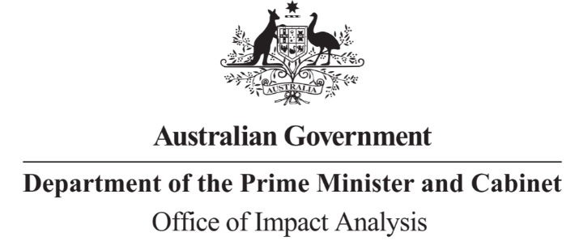

Reference: OBPR22-02252  
Telephone: 6271 6270  
e-mail: [helpdesk-oia@pmc.gov.au](mailto:helpdesk-obpr@pmc.gov.au)

Mr Luke McCann  
Acting Chief Executive Officer  
Sport Integrity Australia  
  
Dear Mr McCann,   
  
**Impact Analysis – Second Pass Final Assessment – Safety in Sport**

Thank you for your letter of 20 September 2023 submitting an Impact Analysis (IA) for formal Second Pass Final Assessment. I note the IA has been formally certified at the Chief Executive Officer level consistent with the Australian Government Guide to Policy Impact Analysis (the Guide).

The Office of Impact Analysis’ (OIA) assessment is that the quality of the analysis in the IA is ‘adequate’. In particular, the IA demonstrates a clear policy problems and the need for Government intervention.

However, to have been assessed as ‘good practice’ under the Guide, the IA would have benefited from:

* Quantifying flow-on and distributional impacts amongst the affected cohorts, particularly CALD communities, women and children.
* Examining all stakeholder views, including potential dissenting views, and how they incorporated into the analysis and the preferred option. Targeted consultations for the cost recovery measures of SIA would have potentially further strengthen the analysis of the considered options.
* Expanding on how the proposed transitional implementation arrangements will impact stakeholders.

The IA may now be provided to the decision-maker to inform their decision.

**Next steps**

We would appreciate you advising us when a final decision has been announced and forwarding a copy of the IA in a Word and PDF format meeting the Government’s accessibility requirements. The OIA will publish the IA, along with your certification letter and this assessment, on OIA’s website, <https://oia.pmc.gov.au/>.

If you have any further queries, please do not hesitate to contact me.

Yours sincerely

Jason Lange  
Executive Director  
Office of Impact Analysis  
27 September 2023

|  |  |  |  |
| --- | --- | --- | --- |
| |  | | --- | |  | | |  | | --- | | 1 National Circuit, Barton ACT 2600 • Telephone 02 6271 6270 • Internet oia.pmc.gov.au | |