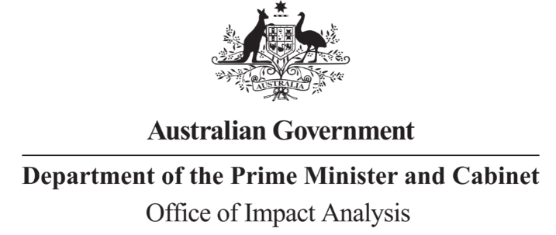

Reference: OBPR22-02515  
Telephone: 6271 6270  
e-mail: [helpdesk-oia@pmc.gov.au](mailto:helpdesk-obpr@pmc.gov.au)

Marisa Purvis-Smith

Deputy Secretary

Transport

Department of Infrastructure, Transport, Regional Development, Communications and the Arts

Simon Duggan  
Deputy Secretary  
Energy  
Department of Climate Change, Energy, the Environment and Water

Dear Ms Purvis-Smith and Mr Duggan  
  
**Impact Analysis – Second Pass Final Assessment – Improving Australia’s fuel and vehicle emissions standards**

Thank you for your letter submitting an Impact Analysis (IA) for formal Second Pass Final Assessment. I note the IA has been formally certified at the Deputy Secretary level consistent with the Australian Government Guide to Policy Impact Analysis (the Guide).

I appreciate your Departments’ constructive engagement on the IA. The Office of Impact Analysis’ (OIA’s) assessment is that the quality of the analysis in the IA is good practice. To have been assessed as ‘exemplary’ under the Guide, the IA would have benefited from:

* Additional data on assumptions, including the expected vehicle profile, government administration costs and incidences of misfueling over the analysis period.
* Quantifying regulatory burden consistent with the Regulatory Burden Measurement framework.
* Further alignment between the assumptions for analysis of options relating to fuel quality standards and vehicle emissions standards
* Additional detail on the evaluation approach, including whether any additional monitoring is required to answer the questions proposed for the 2030 review, and suggested focus for proposed new research.

**Next steps**

After a final decision has been announced, I ask that your agency work with OIA to finalise this material for public release. This includes providing a copy of the IA in Word and PDF format for web accessibility purposes. The IA must be included in any Explanatory Memorandum or Statement giving effect to the proposals in the IA.

If you have any further queries, please do not hesitate to contact me.

Yours sincerely

Jason Lange  
Executive Director  
Office of Impact Analysis  
2 June 2023

|  |  |  |  |
| --- | --- | --- | --- |
| |  | | --- | |  | | |  | | --- | | 1 National Circuit, Barton ACT 2600 • Telephone 02 6271 6270 • Internet oia.pmc.gov.au | |