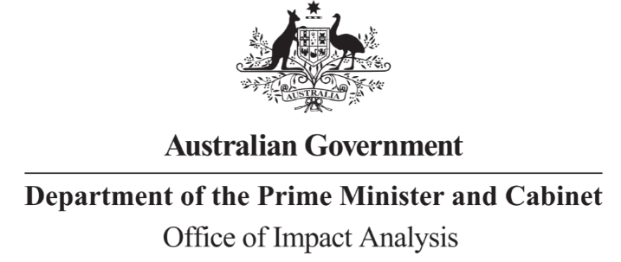

Reference: OBPR23-04044
Telephone: 6271 6270
e-mail: helpdesk-oia@pmc.gov.au
Ms Stephanie Foster
Associate Secretary Immigration
Department of Home Affairs
Dear Ms Foster
Certification of Impact Analysis Equivalent: Review of Australia’s Migration System
Thank you for your letter of 25 August 2023 certifying the Review of Australia’s Migration System as having undertaken a process and analysis equivalent to an Impact Analysis (IA).

The Office of Impact Analysis (OIA) acknowledges the certification as an Impact Analysis Equivalent (IAE). Under the Australian Government Guide to Policy Impact Analysis, the OIA does not assess the adequacy of the analysis contained in an IAE but does assess whether the options analysed in the certified documents are relevant to the policy proposal. The OIA also assesses the IAE for the coverage of the seven IA questions conducted and whether the IAE or certification letter identifies regulatory costs.
In this case, the OIA’s assessment is that the options analysed in the IAE are sufficiently relevant to the regulatory proposal (the Migration Strategy and initial implementation decisions), and the information annexed to your letter explains how the seven IA questions have been covered. I also note the Department’s estimated annual regulatory cost savings for businesses ($203.1 million) are offset (in part) by increased regulatory costs to individuals ($56.5 million), leaving an annual net regulatory cost saving estimate of $146.6 million.
I would appreciate your Department advising the OIA when a final decision has been announced and forwarding a copy of the IAE materials in a form meeting the Government’s accessibility requirements. The OIA will publish the IAE, along with your certification, on the OIA’s website at https://oia.pmc.gov.au.

Further, where a regulation is tabled in Parliament, your IAE needs to be included in the explanatory memorandum (for primary legislation) or the explanatory statement (for legislative instruments), as stipulated in the User Guide to the Australian Government Guide to Policy Impact Analysis.
Yours sincerely
Jason Lange
Executive Director
Office of Impact Analysis
30 August 2023
1 National Circuit, Barton ACT 2600 • Telephone 02 6271 6270 • Internet oia.pmc.gov.au

