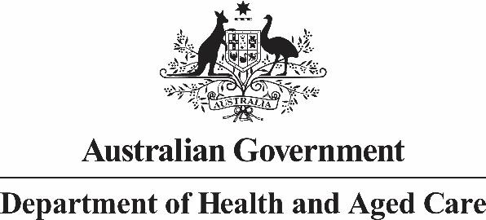

# Deputy Secretary

Mr Jason Lange

Executive Director

Office of Impact Analysis

Department of the Prime Minister and Cabinet

1 National Circuit

BARTON ACT 2600

Email: Helpdesk-OIA@pmc.gov.au

Dear Mr Lange

# Impact Analysis – Proposed reforms to the regulation of vapes – Second Pass Final Assessment

I write in relation to the attached Impact Analysis (IA) prepared for the proposed reforms to the regulation of vapes.

I acknowledge and thank you for your letter of 3 October 2023, and I am satisfied that the IA addresses the concerns raised in your correspondence. Specifically, extensive changes have been made in order to:

* Improve the readability of the document by ensuring the proposed options and measures are clearly identified.
* Outline how the Australian Government has capacity to intervene to achieve its objectives and identify if there are alternatives to government intervention.
* Expand the analysis of the viability, design, costs and benefits of each of the options.
* Explain how stakeholder concerns were considered in designing the proposed options - additional commentary on this has been included throughout the IA (Question 5).
* Strengthen the discussion of the justification, risks, benefit and importance for and importance of allowing patients access to vapes as a tool for smoking cessation or the treatment of nicotine addiction, under the supervision of a health practitioner. This justification includes reference to the reasons for the 2021 nicotine rescheduling and recent scientific research on this issue.
* Include a detailed 5-stage Implementation Plan in Annexure A and outline how we intend to evaluate the success of the proposed measures (Question 7).

Regulatory Burden Estimates have been reviewed. The regulatory costs under Option 3 are $59.46 million per year, plus costs on vaping store closures. These reforms are multi-faceted and complex, so it has been difficult to accurately model the impact of some measures. Therefore, a precautionary approach has been taken in order to avoid underestimation, and the estimates are therefore considered to be on the upper limit of expectations.

Direct cost offsets have not been included, as these reforms have a clear health benefit aspect that exceeds the projected regulatory costs. It is important to note that health professionals and public health experts agree that the true long-term health impacts of vape use, both on individuals and the system as a whole, are as yet unknown, so the benefit of arresting or reversing the current rising trend of vape use is difficult to quantify.

However, as an example, the regulatory expense would be justified if approximately 200 individuals never progressed to tobacco smoking by not taking up vaping in the first place/or by ceasing vaping before they started tobacco smoking (based on data quantified in the recently published IA on the review of the Tobacco Control Legislative Framework). This figure (n=200) represents only 0.015% of the current population of Australian vapers (n=1.3m). Given this very low target there is a high likelihood that the benefits would outweigh the costs for this option.

Accordingly, I am satisfied that the IA is now consistent with the six principles for Australian Government policy makers as specified in the *Australian Government Guide to Policy Impact Analysis*.

I submit the IA to the Office of Impact Analysis for formal final assessment.

Yours sincerely

Professor Anthony Lawler

Health Products Regulation Group

9 October 2023