OFFICIAL

Mr Jason Lange
Executive Director
Office of Impact Analysis
Department of the Prime Minister and Cabinet
1 National Circuit
BARTON ACT 2600

Email: helpdesk-OBPR@pmc.gov.au
Dear Mr Lange

Certification of independent review: review of Australia’s migration system
I am writing to certify that the independent Review of the Migration System has undertaken a process and analysis equivalent to an Impact Analysis (IA). The Final Report 2023 was delivered to the Minister for Home Affairs, the Hon Clare O'Neil MP, on 21 March 2023 by Dr Martin Parkinson AC PSM on behalf of the appointed reviewers.
I certify that this Review process adequately addresses all seven IA questions (Attachment A refers), and is submitted to the Office of Impact Analysis (OIA) to support the Australian Government’s Migration Strategy (the Strategy).
I am satisfied the scope of the problems and the areas for reform directions identified in the certified review are substantially the same as the identified problems and reforms outlined in the Strategy.
I further certify that the diverse range of policy options examined in the Review are based on extensive consultation undertaken by the reviewers. The reviewers consulted widely with Australian, state and territory government departments and agencies, regional councils, Australian business and industry, trade unions, organisations representing migrants and culturally and linguistically diverse (CALD) people and communities, academics, and other interested parties.
As part of the Review process, the reviewers released a discussion paper and considered 559 written submissions, including many from individual migrants and visa applicants. The reviewers also conducted eight roundtable consultations with peak organisations, unions and senior state and territory government officials.
The reviewers subsequently delivered a highly comprehensive 196-page report, which outlines the imperative for migration system reform and examines a range of policy options to support the system’s redesign.
The regulatory burden to business, community organisations or individuals is quantified using the Government’s Regulatory Burden Measurement framework and is provided below. In accordance with the Australian Government’s Regulatory Burden Measurement Framework, there is a total reduction to the regulatory burden associated with the Migration Strategy.
Following the release of the Government’s Final Migration Strategy, the Department will work with OIA to ensure there is appropriate analysis of any regulatory impacts during the development of any policy proposals associated with the Strategy. I understand that this additional analysis will be published by OIA.
Regulatory burden estimate table
Average annual regulatory costs (from business as usual)
Change in costs ($ million) | Business | Community organisations | Individuals | Total change in costs
Total, by sector | -$203,141,641 | $- | $56,523,368 | -$146,618,273

In summary, I am satisfied that the attached Report is consistent with the Australian Government Guide to Regulatory Impacts Analysis in relation to the measures outlined in the Architecture.
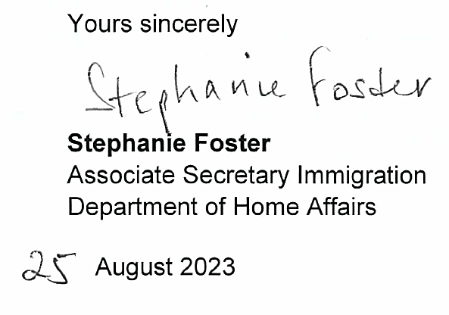
Yours sincerely
Tara Cavanagh
Group Manager
Immigration Policy
Department of Home Affairs

August 2023

Attachment A

Addressing the Impact Analysis questions
Question | Independent Review of the Migration System
- What is the problem you are trying to solve and what data is available? | The Review of the Migration System final report (the Review), Executive Summary (page 1) for a concise definition of the problem. The remainder of the 196-page report breaks this problem down into components providing a data-supported evidentiary base to outline both the problem and the solution.
- What are the objectives, why is government intervention needed to achieve them, and how will success be measured? | Page 3 of the Review outlines five objectives for the reform of Australia’s migration system:  - Building Australia’s prosperity by lifting productivity, meeting labour supply needs and by supporting exports  - Enabling a fair labour market, including by complementing the jobs, wages and conditions of domestic workers  - Building a community of Australians  - Protecting Australia’s interests in the world.  - Providing a fast, efficient and fair system.  The Review repeatedly emphases the migration system is a critical tool, administered by the Department of Home Affairs, to support Australia’s economic prosperity and social cohesion. It outlines the ways in which the system does not meet these objectives, requiring urgent Government intervention to redesign the system. For each of the proposed measures within its 196 pages, it details out a range of qualitative and quantitative measures against which success can be measured.
- What policy options are you considering? | On pages 7-10, the Review provides a table comprising seven possible reform directions and 37 policy measures to support those directions. These direction and measures are explored in detail throughout the report.
- What is the likely net benefit of each option? | For each reform direction, the Review considers both the benefit of the proposed intervention against costs imposed, and provides support measures where the most benefit can be gained.
- Who did you consult and how did you incorporate their feedback? | During the Review process, a discussion paper was released for public comment in November 2022. The Reviewers received 559 submissions (of which 483 public submissions were published on the Department’s website), from individuals, corporations, unions, think tanks and other interested parties. In addition to a number of individual consultation sessions, the Reviewers held eight roundtable discussions at which over 50 organisations and individuals took part, representing state and territory government agencies, unions, community and business groups. Stakeholders’ views were a primary consideration for the Reviewers in considering the policy options. Select views are cited throughout the report.
- What is the best option from those you have considered and how will it be implemented? | The Review outlines 37 preferred policy measures with a supporting evidence base, and includes guidance on how they may be implemented.
- How will you evaluate your chosen option against the success metrics? | Please refer to the answer to question 2; the Government will evaluate success taking into account the qualitative and quantitative measures outlined in the Review.

Published at A Migration System for Australia’s Future (homeaffairs.gov.au)
Published at https://www.homeaffairs.gov.au/reports-and-pubs/files/reviews-and-inquiries/discussion_paper.pdf
Submissions, unless confidential, are published at https://www.homeaffairs.gov.au/reports-and-publications/reviews-and-inquiries/departmental-reviews/migration-system-for-australias-future/public-submissions

