

|  |
| --- |
| Setting heavy vehicle charges to apply from 2023-24 onwards  Supplementary paper to the 2021 heavy vehicle charges determination – decision regulation impact statement – December 2021 |
| December 2022 |

**Discussion paper / Consultation regulation impact statement**

For ITMM consideration

# Report outline

|  |  |
| --- | --- |
| **Title** | Setting heavy vehicle charges to apply from 2023-24 onwards: Supplementary paper to 2021 heavy vehicle charges determination – decision regulation impact statement – December 2021 |
| **Type of report** | Supplementary paper to decision regulation impact statement |
| **Purpose** | For consideration by infrastructure and transport ministers as part of making decisions on implementing the heavy vehicle charges determination from 2023–24 onwards. |
| **Abstract** | This paper outlines options for setting heavy vehicle charges from 2023-24 onwards. These options build on the recommendations contained in the 2021 Heavy Vehicle Charges determination. This paper shows the options considered, and provides a summary of stakeholder feedback received. |
| **Attribution** | This work should be attributed as follows, Source: National Transport Commission, Setting heavy vehicle charges to apply from 2023-24 onwards, supplementary paper to 2021 Heavy Vehicle Charges Determination decision regulation impact statement.  If you have adapted, modified or transformed this work in anyway, please use the following, Source: based on National Transport Commission, Setting heavy vehicle charges to apply from 2023-24 onwards, supplementary paper to 2021 Heavy Vehicle Charges Determination decision regulation impact statement. |
| **Key words** | Heavy vehicle charges, PAYGO, RUC, registration charges |
| **Contact** | Ramon Staheli  Head of Economics  National Transport Commission Level 3/600 Bourke Street Melbourne VIC 3000 Ph: (03) 9236 5028  Email: [rstaheli@ntc.gov.au](mailto:rstaheli@ntc.gov.au)  [www.ntc.gov.au](http://www.ntc.gov.au) |

Contents

Report outline 2

Executive summary 5

1 Introduction 10

1.1 The NTC’s responsibilities 10

1.2 Background 10

1.3 Consultation on the 2021 Determination 10

1.4 Decisions required for 2023-24 and beyond 11

1.5 Temporary Reduction in Fuel Excise 11

1.6 Objectives 11

1.7 Approach and timeline 12

2 Background on heavy vehicle charges 13

2.1 Heavy vehicle charges 13

3 The Heavy Vehicle Cost Base 17

3.1 Limits on available information 17

3.2 Road Expenditure Trends 18

3.3 Expenditure and Revenue over Time 19

3.4 Developing forecast expenditure, usage and vehicle fleet data forecast for 2021-22 onwards 20

3.5 Forecast Heavy Vehicle Cost Base 22

3.6 Stakeholder feedback and submissions 23

3.7 Response to feedback and submissions 23

3.8 Recommended approach 24

4 Single-year or Multi-year Price Path 25

4.1 Historical approach to implementing determinations 25

4.2 Single and multi-year price path explored in the 2021 Determination 26

4.3 Single year price decisions 26

4.4 Three-year fixed price path decisions 26

4.5 Stakeholder feedback and submissions 27

4.6 Conclusion and recommendations 27

5 Options for Setting Charges from 2023-24 Onwards 28

5.1 Applying the pricing principles in practice 28

5.2 Gap between heavy vehicle cost base and estimated heavy vehicle charges revenue 29

5.3 Three options consulted on 29

5.4 Financial and fiscal implications 30

5.5 Estimated RUC rates 32

5.6 Estimated heavy vehicle registration charges 33

5.7 Approach to setting registration charges under options explored in this paper 35

5.8 Stakeholder feedback and submissions 36

5.9 Response to feedback and submissions 36

6 Assessment and final recommendation 38

6.1 Pricing Principles 38

6.1 Relevant considerations 38

6.2 Conclusion and recommendations 43

7 Alternative approaches to rounding heavy vehicle charges 44

7.1 Stakeholder feedback and submissions 46

7.2 Conclusion 46

Glossary 47

References 48

**Appendix A** Summary of submissions 1

# Executive summary

At the December 2021 Infrastructure and Transport Ministers Meeting (ITMM), ministers identified a preference for increasing heavy vehicle charges by 2.75 per cent in 2022-23. At the same meeting, ministers also decided that they would again consider heavy vehicle charges in late 2022, including the possibility of a multi-year price path.

This supplementary paper outlines options for setting heavy vehicle charges from 2023-24 onwards for consideration by ministers, and outlines the feedback received from stakeholders during the consultation process which ran from 14 September 2022 to 12 October 2022.

**Context**

2021 Heavy Vehicle Charges Determination

During 2020 and 2021, the NTC undertook a heavy vehicle charges determination (the 2021 Determination). This process involved the following key phases:

* Research and information gathering
* Publication of Consultation Regulation Impact Statement (C-RIS) for public consultation
* Consultation period from 28 June 2021 to 24 August 2021 with several stakeholder workshops
* Summarising the feedback received from submitters and drafting the Decision Regulation Impact Statement (D-RIS) which included final recommendations
* Consideration of D-RIS and the NTC’s final recommendations by ministers

Purpose and scope of this supplementary paper

At the December 2021 ITMM, ministers considered the D-RIS and the NTC’s final recommendations.

Ministers identified a preference for increasing heavy vehicle charges by 2.75 per cent in 2022-23. At the same meeting, ministers also decided that it would again consider heavy vehicle charges in late 2022, including the technical recommendations for changes to the PAYGO methodology in the D-RIS and the possibility of a multi-year price path.

Effectively, this decision postponed implementation of the 2021 Determination until 2023-24.

The NTC has re-visited and implementation options for the 2021 Determination, provided updated information on these options and consulted with stakeholders. This supplementary paper, and the recommendations contained in it, should be considered in conjunction with the information contained in the 2021 Determination decision regulation impact statement.

Current situation

The heavy vehicle cost base for 2020-21 which underpins heavy vehicle charges for 2022‑23 is $4,302.9 million. Estimated heavy vehicle charges revenue for 2022-23 is $3,727.1 million. This leaves a revenue gap of $575.8 million.

The heavy vehicle cost base for 2021-22 has increased by approximately 20.7% to $5,193.4 million. This is $1,448.1 million more than estimated heavy vehicle charges revenue in 2023‑24 if heavy vehicle charges do not increase above current levels. Heavy vehicle charges revenue[1] would need to increase by approximately 39 per cent to achieve full cost recovery in 2023-24.

**Further significant increases in the heavy vehicle cost base forecast for 2022-23 and 2023-24**

The NTC has developed forecasts of future increases in road expenditure in 2022-23 and 2023-24 in. These forecasts see total road expenditure increase by 20.5 per cent in 2022-23 and reduce by 2.1 percent in 2023-24.

On this basis, the NTC expects the heavy vehicle cost base to increase by 13.0 per cent in 2022-23 and 4.9 per cent in 2023-24.

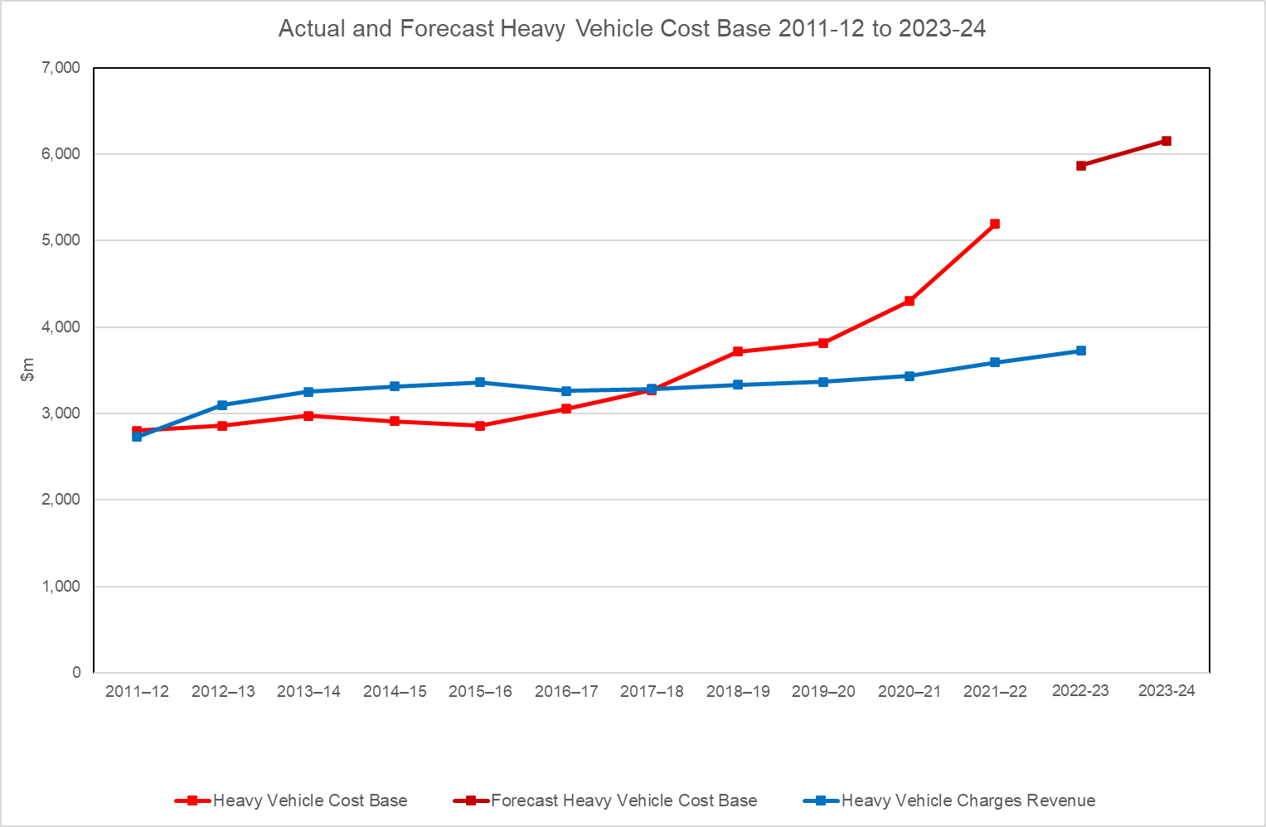

It is important to note that these forecasts are likely to be subject to significant error. However, these forecasts indicate that government expenditure on roads is likely to increase for another year before slowing down in 2023-24. This expenditure pattern is likely to lead to further increases in the heavy vehicle cost base, which will increase the revenue gap above the current level.

**Provisions for automatic adjustment in Heavy Vehicle Charges Model Law**

If no decision is made by ministers, heavy vehicle registration charges will automatically increase by 40.4 per cent in 2023-24 under the annual adjustment formula contained in the Heavy Vehicle Charges Model Law (the Model Law).

**Options consulted on**

Single-year decision or multi-year price path

In the 2021 Determination, the NTC recommended that ministers agree to set a fixed price path for three years. Ministers deferred consideration of this recommendation when they identified a preference to increase heavy vehicle charges by 2.75 per cent for 2022-23. This was confirmed by ministers in April 2022, after a public consultation process. However, the Commonwealth government was in caretaker mode at that time.

Whether to set charges on a yearly basis or whether to set charges for multiple years remains a key decision for ministers when setting heavy vehicle charges to apply for 2023‑24 onwards.

Most submissions on the 2021 Determination C-RIS supported the introduction of a three-year fixed price path. However, informal discussions also indicate that this support is dependent on the specific increases incorporated in the price path. On balance, the NTC recommends that ministers set charges for three years, because this provides both industry and governments with greater certainty and is more administratively efficient.

Heavy vehicle charges options consulted on

The NTC developed three options for setting heavy vehicle charges from 2023-24 onwards. These all apply a series of equal percentage changes to heavy vehicle charges. These options could be used to determine the percentage increases to be applied under both single year or multi-year price setting approaches:

**Option 1: Increase heavy vehicle charges by 2.75 per cent per annum:** This is the same percentage increase as agreed by ITMM for 2022-23 heavy vehicle charges.

**Option 2: Increase heavy vehicle charges by 6 per cent per annum:** This is close to the current rate of consumer price inflation. Consumer price inflation was 6.1 per cent in the year ending June 2022.

**Option 3: Increase heavy vehicle charges by 10 per cent per annum:** This is higher than Option 2 but would still be insufficient to reduce the revenue gap below $1b by Year 3, as shown in Table 1 below.

The options consulted on are all below the level required to keep the revenue gap constant at the 2020-21 level, or eliminate it. The rationale for this is as follows:

1. The pricing principles require the principle of full cost recovery to be weighed against wider considerations such as equity and the impact on regional and remote communities.
2. In recent years, ITMM has consistently approved increases in heavy vehicle charges below the rate of increase in the heavy vehicle cost base.
3. There is some uncertainty surrounding the forecast heavy vehicle cost bases for 2022-23 and 2023-24.
4. It is reasonable to assume that industry feedback on Option 3 would apply equally (or more strongly) to options involving higher percentage increases.

Based on the assumptions outlined above, and the forecasts for the heavy vehicle cost base developed in Section 3.5 of this paper, these options would result in the gaps between the heavy vehicle cost base and heavy vehicle charges revenue shown in Table 1 below:

1. Estimated remaining gap between the heavy vehicle cost base and heavy vehicle charges revenue

|  | **Estimated remaining gap[2] between the heavy vehicle cost base and heavy vehicle charges revenue** | | | | | |
| --- | --- | --- | --- | --- | --- | --- |
| **Year 1**  **$m** | **Year 1**  **%** | **Year 2**  **$m** | **Year 2**  **%** | **Year 3**  **$m** | **Year 3**  **%** |
| Option 1: Increase heavy vehicle charges by 2.75 per cent per annum | 1,337 | 25.7 | 1,870 | 31.9 | 2,013 | 32.7 |
| Option 2: Increase heavy vehicle charges by 6 per cent per annum | 1,213 | 23.4 | 1,617 | 27.6 | 1,614 | 26.2 |
| Option 3: Increase heavy vehicle charges by 10 per cent per annum | 1,062 | 20.5 | 1,286 | 21.9 | 1,073 | 17.4 |

**Stakeholder feedback**

Most submission expressed serious concerns with the rapid increase in the cost base in recent years and that too much of the recent expenditure on roads is stimulus spending in response to challenging economic conditions rather than focused on enhancing productivity. There were also concerns that industry consultation is lacking.

The ATA argued that the existing heavy vehicle cost base should be scrapped and recalculated based on greater transparency, consultation with industry and productivity.

NatRoad commented that government spending plans are often inconsistent with real world requirements (such as road maintenance or sealing) or industry’s ability to pay (which is diminishing for a broad range of economic reasons.)

Most submitters supported the concept of a three-year fixed price implementation pathway including ATA, ALRTA, CCAA and Natroad, due to the certainty it would provide, with support in some cases conditional on a low charge increase outcome. 'The ATA’s support was conditional on the basis that governments intend to move towards a forward-looking cost base or to reinstate the link between a new, more targeted cost base and heavy vehicle charges revenue.

Most submissions raised the issue of affordability in paying for charge increases other than the least amount possible due to high fuel costs, covid impacts, inflation and other cost pressures.

For example, the ATA and Natroad support a zero increase in 2023-24 and 2.75% in the remainder of the three year period. The ALRTA, BIC and MTA (NT/SA) all supported Option 1 at 2.75% per annum over three years.

The ATA submitted that it has previously shown that industry customers do not accept charge increases greater than CPI, if they accept them at all. Accordingly, the NTC should, before providing its final recommendations to ministers, consider:

* the inflation forecasts in the RBA’s November 2022 Statement of Monetary Policy
* the inflation forecasts in the 2022-23 October Budget, to be released on 25 October 2022.

The ATA stated that no charge increases above the consumer price inflation forecasts should be considered, even if ministers do not consider it appropriate to adopt the ATA recommendation.

**Conclusion and recommendations**

Our interpretation of the combined pricing principles in the current environment is that they would favour an implementation pathway that balances the agreed need for full cost recovery over time with keeping yearly increases to heavy vehicle charges within reasonable bounds. The NTC recommends adopting Option 2: Increasing heavy vehicle charges by 6 per cent per annum for three years from 2023-24 to 2025-26.

# Introduction

|  |
| --- |
| Key points   * At the December 2021 ITMM meeting, ministers considered the D-RIS and final recommendations from the 2021 Determination. * Rather than make decisions on the full range of technical and implementation recommendations contained in the D-RIS, ITMM identified a preference to increase heavy vehicle charges by 2.75 per cent in 2022-23. * ITMM agreed to re-consider the technical recommendations from the 2021 Determination and implementation options for heavy vehicle charges to apply from 2023-24 in late 2022, including the possibility of a multi-year price path. * This supplementary paper outlines three options for setting heavy vehicle charges from 2023-24 onwards and summarises the feedback on these options received from stakeholders. This paper needs to be considered as a supplementary paper to the 2021 Determination D-RIS. |

## The NTC’s responsibilities

The National Transport Commission (NTC) has ongoing responsibilities for recommending heavy vehicle charges to ministers. These charges are intended to apply nationally and be set to fully recover the share of road construction and maintenance costs that can be allocated to heavy vehicles.

## Background

On 22 December 2021 the NTC presented the outcome of the 2021 Determination to ministers. Recommendations included a range of technical changes to the PAYGO model, as well as recommendations for heavy vehicle charges to apply from 2022-23.

## Consultation on the 2021 Determination

Following the conclusion of research and investigation phases, the NTC published the 2021 Determination C-RIS on 28 June 2021. The public submission period closed on 24 August 2021. Thirteen submissions were received.

Details of the Determination, including the Determination C-RIS and submissions can be found on the NTC website under:

<https://www.ntc.gov.au/transport-reform/ntc-projects/heavy-vehicle-charges-determination>

In December 2021, ITMM deferred consideration of the technical recommendations and the charges to apply from 2023-24 onwards to late 2022.

Ministers identified a preferred option of increasing heavy vehicle charges by 2.75 per cent in 2022-23. Further consultation on ministers’ preferred option occurred subsequently. Heavy vehicle registration charges in the Model Law and the RUC rate have since increased by 2.75 per cent.

Ministers noted that they would re-consider heavy vehicle charges, including the option of multi-year charge setting, to provide additional certainty to industry on heavy vehicle charges.

## Decisions required for 2023-24 and beyond

The Model Law contains a provision that ensures registration charges are automatically adjusted to reflect the latest heavy vehicle cost base. Unless ministers make a different decision, the annual adjustment formula contained in the Model Law would automatically apply, and the registration charges specified in the Model Law would be increased to fully recover the heavy vehicle cost base.

This formula does not apply to the Road User Charge (RUC) which is set by the Federal Transport Minister by regulatory instrument under the *Fuel Tax Act 2006* (Cth).

Given this background, and the intention of ministers to re-consider heavy vehicle charges in late 2022, it is necessary for ministers to make the following key decisions:

* whether to adopt a multi-year price path; and
* at what level to set heavy vehicle charges to apply from 2023-24 onwards.

The NTC is also asking ministers to re-consider a range of recommendations for technical changes to the PAYGO model contained in the 2021 Determination.

## Temporary Reduction in Fuel Excise

As part of the 2022-23 budget, the Commonwealth government implemented a temporary reduction in the fuel excise rate from 44.2 to 22.1 cents per litre of fuel.[3] This reduction commenced on 30 March 2022. This temporary reduction ended at 11.59pm on 28 September 2022.

This temporary reduction is not considered in this paper as the temporary reduction in fuel excise ended well before 2023-24. None of the financial implications for governments or heavy vehicle operators have been considered in any of the forecasts and options presented in this paper.

## Objectives

The objective of this supplementary paper is to present stakeholder feedback on options for setting heavy vehicle charges from 2023-24 onwards to ministers for consideration, and to outline the NTC’s final recommendations. The options consulted on build upon the 2021 Heavy Vehicle Charges Determination and follow an increase in heavy vehicle charges of 2.75 per cent for 2022-23.

## Approach and timeline

This supplementary paper builds on the work carried out as part of the 2021 Determination.

The Determination was completed after thorough consultation with stakeholders, including a two-month public consultation process.

The C-RIS and stakeholder responses to the C-RIS can be found on the NTC website under:

**https://www.ntc.gov.au/transport-reform/ntc-projects/heavy-vehicle-charges-determination**

# Background on heavy vehicle charges

|  |
| --- |
| Key points   * Heavy vehicle charges apply to all vehicles with a Gross Vehicle Mass (GVM) of above 4.5 tonnes. * The charges consist of a RUC on fuel and a yearly registration charge comprising roads and regulatory components. * Charges are set using the PAYGO model which calculates the heavy vehicle cost base based on historical government road expenditure and road usage data. * Ministers make collective decisions on heavy vehicle charges. The NTC provides advice to ministers to support their decision-making. * The binding pricing principles governing the NTC’s advice have a strong focus on achieving full cost recovery of allocated costs over time. * The RUC is implemented under the Commonwealth *Fuel Tax Act 2006*. It is collected through excise, and a reduced fuel tax credit is then provided on fuel purchased for on road use by heavy vehicles. * Registration charges are implemented through the Model Law. The charges have legislative force once the Model Law is adopted by states and territories. |

## Heavy vehicle charges

What are heavy vehicle charges

Heavy vehicles include all vehicles with a Gross Vehicle Mass (GVM) of above 4.5 tonnes.

There are three components to the charges paid by heavy vehicles:

* the fuel-based RUC, administered by the Commonwealth Government.
* the roads component of the registration charge, as applied by state and territory governments.
* the regulatory component of the registration charge, which is applied to cover the operating cost of the National Heavy Vehicle Regulator (NHVR).

The fuel charge and registration charge are linked to government expenditure on roads. The amount to cover the regulatory cost of the NHVR is designed to reflect the NHVR’s budget, which is approved by ITMM.

NTC’s role

The NTC has ongoing responsibilities for recommending heavy vehicle charges to ministers[4]. These charges are intended to apply nationally and are set to fully recover the share of road construction and maintenance costs that can be allocated to heavy vehicles.

Pricing principles and the importance of cost recovery

A set of guiding principles govern the application of the cost recovery methodology. These pricing principles were agreed by the Australian Transport Council (a predecessor of ITMM) and the Council of Australian Governments (COAG) and are binding on the NTC.

The current pricing principles were designed to guide the NTC towards an outcome that efficiently recovers the cost of providing road infrastructure for heavy vehicles. In addition, the principles also consider issues of relevant public interest, such as fairness and equity.

The COAG principles**[5]** are:

*“ATC direct the NTC, in developing its Determination, to apply principles and methods that*

1. *ensure the delivery of full cost recovery in aggregate,*
2. *further develop indexation adjustment arrangements to ensure the ongoing delivery of full expenditure recovery in aggregate and*
3. *remove cross-subsidisation across different heavy vehicle classes, recognising that transition to any new arrangement may require a phased approach”.*

ATC/SCOTI guiding principles[6]

*“National heavy vehicle road use prices should promote optimal use of infrastructure, vehicles and transport modes. This is subject to the following:*

1. *full recovery of allocated infrastructure costs while minimising both the over and under recovery from any class of vehicle*
2. *cost effectiveness of pricing instruments*
3. *transparency*
4. *the need to balance administrative simplicity, efficiency and equity (e.g. impact on regional and remote communities/access)*
5. *the need to have regard to other pricing applications such as light vehicle charges, tolling and congestion.”*

Both the ATC and COAG principles are standing principles until the relevant authority changes them and are binding on the NTC.

The PAYGO model

Each year, jurisdictions provide the NTC with a completed road expenditure template which covers all road construction and maintenance costs (light and heavy vehicles). Data from the Australian Bureau of Statistics Government Financial Statistics Series is used to account for local government expenditure on roads. A cost base is then established with the heavy vehicle portion recovered via heavy vehicle charges. Figure 1 provides an overview of the existing PAYGO system.

1. Overview of the current PAYGO system

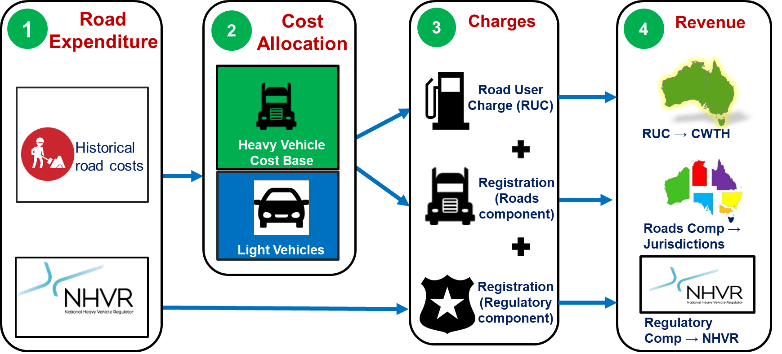

The cost base is calculated by taking a weighted 7-year average of the historic financial costs of providing roads. These costs, which are measured in a number of expenditure categories, are then allocated between vehicle classes on the basis of:

* a cost allocation matrix[7]
* usage data including vehicle kilometres travelled, ESA-kilometres travelled, AGM-kilometres travelled, and PCU-kilometres travelled[8].

Based on the costs allocated to each vehicle class, the NTC then recommends a set of heavy vehicle charges that recovers the heavy vehicle cost base in total while ensuring each vehicle class, on average, pays at least the attributable costs allocated to the vehicle category.

Figure 2 illustrates how the NTC processes this information and makes recommendations to ITMM. The NTC’s advice on heavy vehicle charges is informative and decisions on setting heavy vehicle charges are made by ITMM.

1. Overview of existing PAYGO regulatory process

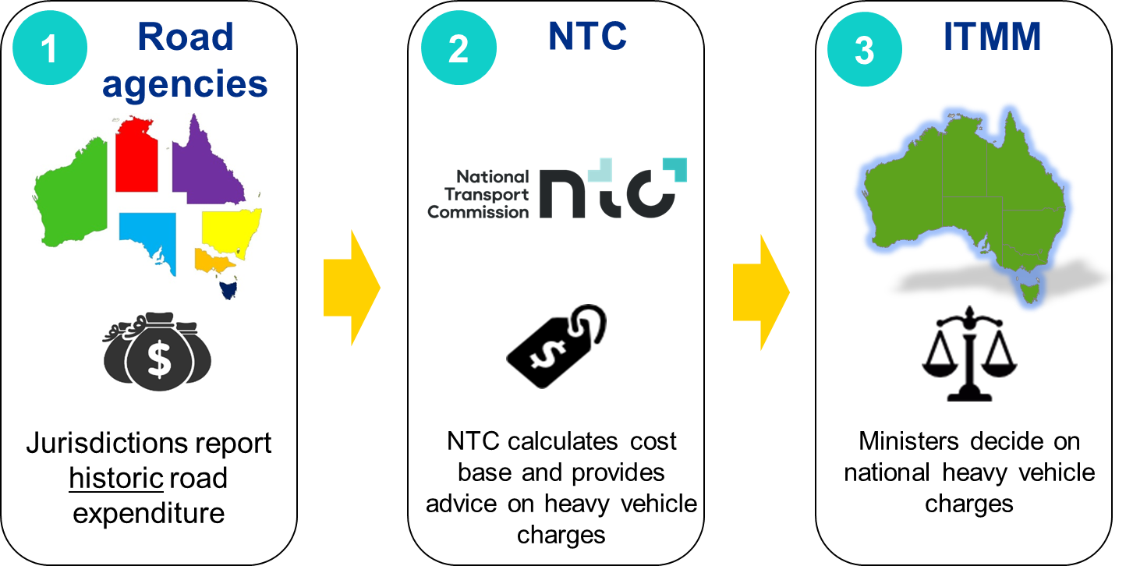

Determinations, where all aspects of the model and the resulting heavy vehicle charges are reviewed (considering the pricing principles and other directions from government), are carried out infrequently. In the years between determinations, an annual adjustment formula is used to ensure that heavy vehicle charges continue to recover the heavy vehicle cost base. This formula is included in the Model Law and is intended to automatically adjust heavy vehicle charges without the need for ITMM to approve the change.

In simple terms, the annual adjustment formula works out a single percentage increase or decrease that is applied to all registration charges and to the RUC rate, which considers the gap between the most recent cost base and the previous year’s cost base, as well as growth in the vehicle fleet and fuel consumption by heavy vehicles.

Legislation

The RUC is implemented under the *Fuel Tax Act 2006* (Cth). An increase in RUC is implemented as a reduction to the fuel tax credit.

The *Fuel Tax Act 2006* provides for the Transport Minister (the Minister) to determine the amount of RUC paid by heavy vehicle operators. The Act requires that the minister conducts a public consultation process before increasing the rate of the RUC.

The consultation period must be at least 60 days and the minister must make available the proposed increased rate of RUC, and any information that was relied on in determining the proposed increased rate.

The *Fuel Tax Act 2006* then requires the minister to consider any comments received, within the period specified by the minister, from the public in relation to the proposed increased rate.

Registration charges are implemented through the Model Law. This contains the schedules of heavy vehicle registration charges agreed by ITMM. The Model Law also provides a formula to calculate an annual adjustment for charges in the years between determinations, should ministers not make a decision on charges. The charges have legislative force once the Model Law is adopted by states and territories.

# The Heavy Vehicle Cost Base

|  |
| --- |
| Key points   * After implementing a 2.75 per cent increase in heavy vehicle charges for 2022-23, there is an estimated gap of $575.8m between the identified heavy vehicle cost base for 2020-21 and the estimated revenue in 2022-23. * This gap has increased significantly and now stands at $1,448.1m or 27.7 per cent of the heavy vehicle cost base in 2023-24. This is because the heavy vehicle cost base for 2021-22 has increased by 20.7 per cent to $5,193.4m. We expect further increases in the heavy vehicle cost base of 13 per cent for 2022-23 and 4.9 per cent 2023-24. * The gap between the heavy vehicle cost base and charges revenue needs to be covered by other government revenue sources. It is effectively funded by taxpayers and represents a subsidy to the heavy vehicle industry. * Without substantial increases in heavy vehicle charges, this gap is likely to increase in the future. * While it is possible that government road expenditure may stabilise at some time in the future, decisions on heavy vehicle charges for 2023-24 and beyond will need to be made against a significant and increasing revenue gap. * Given PAYGO’s role as a cost recovery mechanism, and the requirement to achieve cost recovery in the pricing principles, decisions arguably need to be consistent with a longer-term goal of eliminating, or at least reducing the current under-recovery of the heavy vehicle cost base. |

## Limits on available information

The PAYGO system involves a two-year gap between the time when government road expenditure is measured and when the charges based on that expenditure are implemented.

This is because expenditure is measured on a historic basis and some time is required to collect the data and prepare advice for ministers. Once ministers have decided, time is required to implement the decision. Therefore, in practice, decisions are made in the current year, based on the previous year’s data, to set heavy vehicle charges to apply in future years.

For example, the heavy vehicle charges that apply in 2022-23 were informed by a heavy vehicle cost base calculated based on road expenditure for the seven years ending in 2020-21. This is illustrated by Figure 3 below.

1. Illustration of two-year lag

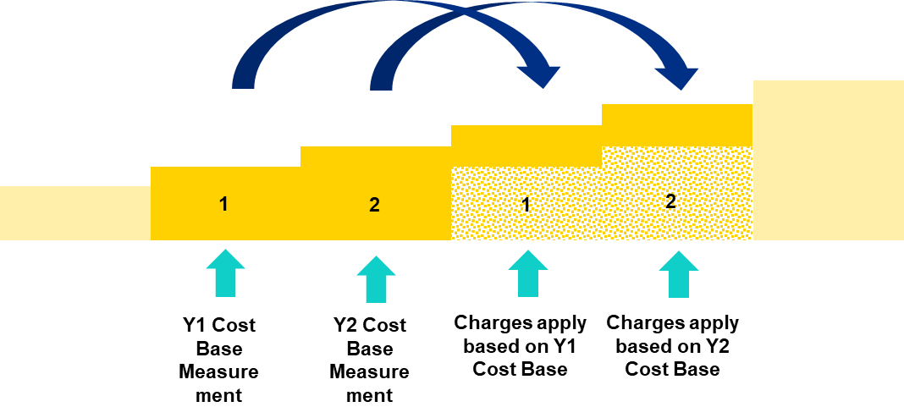

Ministers will need to decide on heavy vehicle charges for 2023-24 based on actual expenditure data for the financial years up to 2021-22. This information is usually provided to the NTC in early September.

To inform this consultation process, the NTC has prepared forecasts of road expenditure data for 2022-23 and 2023-24. Actual expenditure data for 2021-22 has recently become available and has been incorporated into modelling for this report.

## Road Expenditure Trends

Figure 4 and Figure 5 show recent road expenditure by state, territory, and local governments.

1. State and territory actual road expenditure

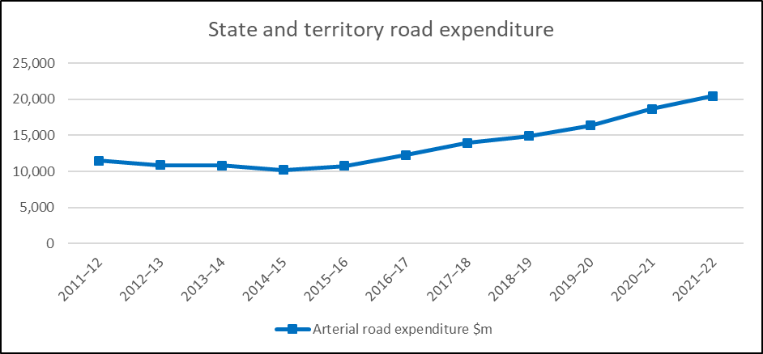

State and territory road expenditure has increased by an average of 5.9 per cent over the last 10 years whereas local government road expenditure has increased by an average of 3.9 per cent over the last 10 years.

1. Local government road expenditure

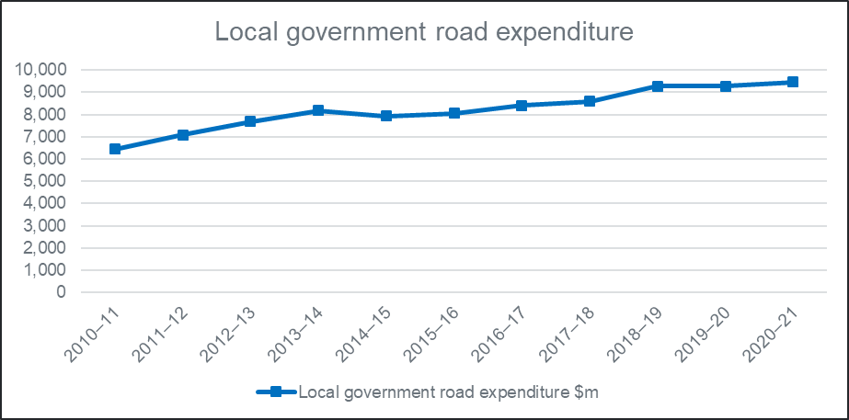

State and territory road expenditure has increased significantly in recent years, partially driven by a number of large projects and stimulus expenditure designed to support economic growth in the face of challenging conditions.

## Expenditure and Revenue over Time

Figure 6 shows the heavy vehicle cost base and heavy vehicle charges revenue from 2012‑13 to 2022-23. In line with increasing government expenditure on roads, the heavy vehicle cost base has increased significantly from 2017-18 onwards.

A contributing factor is that particularly large expenditure increases have occurred in expenditure categories where a higher percentage of costs is allocated to heavy vehicles.

Heavy vehicle charges revenue has been more stable, reflecting ITMM’s decisions to:

* freeze heavy vehicle charges revenue for two years in 2016-17 and 2017-18
* freeze heavy vehicle charges for three years from 2018-19 to 2020-21, and
* increase heavy vehicle charges by 2.5 per cent in 2021-22
* identify a preference to increase heavy vehicle charges by 2.75 per cent for 2022-23

The increase of 2.75 per cent for 2022-23 was confirmed by ITMM in April 2022, following a public consultation process. However, the Commonwealth government was in caretaker mode at that time. The RUC rate increased by 2.75 per cent to 27.2 cents/litre from 13 September 2022.

1. Heavy Vehicle Cost Base and Charges Revenue 2012-13 to 2022-23

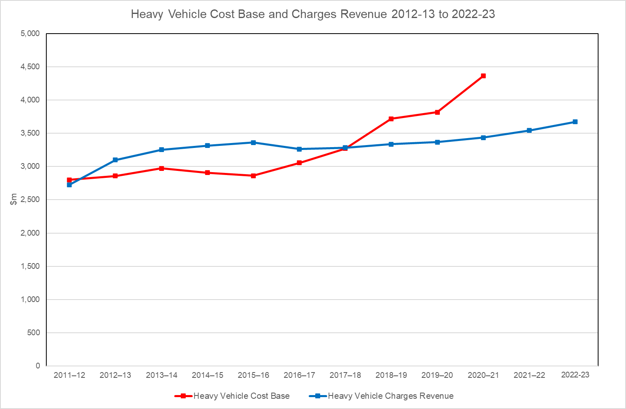

Heavy vehicle charges revenue was higher than the heavy vehicle cost base for several years. Recently, this has reversed and the heavy vehicle cost base for 2020-21 exceeds the estimated heavy vehicle charges revenue for 2022-23 (please note the two-year lag between measuring the heavy vehicle cost base and implementing charges intended to reflect the heavy vehicle cost base).

## Developing forecast expenditure, usage and vehicle fleet data forecast for 2021-22 onwards

Approach

Decisions on future heavy vehicle charges are usually based on a combination of known historic information and forecasts. Actual road expenditure data for 2021-22 is now available. However, it will be necessary to form a view of possible future expenditure levels, usage data and heavy vehicle fleets in 2022-23 and 2023-24, particularly if ministers are to consider the option of a multi-year fixed price path.

Similarly, stakeholders will need to form their views on the advantages and disadvantages of various charges options in the context of unknown future outcomes.

To aid stakeholders, the NTC has developed forecasts for the following:

* road expenditure by states and territories for 2022-23 and 2023-24
* local government road expenditure for 2021-22 and 2022-23
* fuel usage in 2022-23 and 2023-24
* heavy vehicle fleets in, 2022-23 and 2023-24

The following sections outline the assumptions and methodology underpinning these forecasts.

Assumptions for road expenditure forecasts

The road expenditure forecast for states, territories and local government is based on the following assumptions:

* Assumed percentage increases in total road expenditure for 2022-23 and 2023-24 are shown in Table 2.
* The forecast future increases in road expenditure shown in Table 2 were developed in consultation with state and territory road agencies. It is important to note that these forecasts are likely to be subject to significant error.
* The forecast future increases in road expenditure are nominal expenditure in the year it is incurred. These figures have not been adjusted for potential unexpected cost increases or delays.
* The forecast total expenditure for 2022-23 and 2023-24 is allocated to individual expenditure categories using the historical average percentage of total expenditure in each category over the five years from 2016-17 to 2021-22.
* For local government expenditure, the long-term growth rate from 2010-11 to 2020-21 was 3.9 per cent per annum with growth of 4.4 per cent per annum in the rural sector and 3.6 per cent per annum in the urban sector. The long-term growth rate for all local road expenditure (rounded to 4 per cent per annum) is applied for 2021-22 and 2022‑23.
* Forecast expenditure is allocated between vehicle classes using the cost allocation matrix and forecast usage data.

1. Assumed increases in total state and territory road expenditure

|  | **2022-23** | **2023-24** |
| --- | --- | --- |
| Assumed increases in total state and territory road expenditure | 20.5% | -2.1% |

**Assumptions for fuel usage data forecast**

Fuel consumption is assumed to be static at 2020-21 levels for 2021-22, 2022-23, 2023-24, 2024-25 and 2025-26. Total fuel consumption in these years is 7,435,912,622 litres per annum. This assumption reflects recent trends in Survey of Motor Vehicle Use data.

**Assumptions for vehicle fleet data and registration revenue forecasts**

The latest actual vehicle fleet data is for the 2021-22 financial year. It is assumed that the registration charges revenue is calculated based on national registration charges and the forecast vehicle fleet. The forecast is based on vehicle registration data for 2021-22, as provided by each state and territory of registration. Vehicle numbers for 2022-23 and 2023-24 onwards are assumed to increase each year by the average increase in total registered vehicles over the 10 years to 2021-22. This is calculated separately for powered vehicles and trailers and then applied pro-rata to each vehicle class.[9]

The forecast registration revenue in each year is based on the forecast vehicle fleet for that year, multiplied by the charges that would be applicable in that same year for each option.

Departures from national registration charges in NT and WA are not reflected in registration revenue forecasts. Registration charges revenue is stated before any concessions provided by state or territory of registration.

Assumptions for Regulatory Component of Registration Charges

Heavy vehicle registration charges consist of a roads component and a regulatory component. The regulatory component is set to recover the National Heavy Vehicle Regulator’s budget, as approved by ITMM. The regulatory component of registration charges does not vary significantly from year to year. Therefore, we have assumed that the regulatory component remains constant at the 2022-23 level. The estimated registration charges shown in Section 5.6 have been prepared on this basis.

## Forecast Heavy Vehicle Cost Base

On the basis of the assumptions outlined in Section 5.4, the forecast heavy vehicle cost base for 2021-22, 2022-23 and 2023-24 is as shown in Table 3 below.

1. Heavy Vehicle Cost base 2021-22 to 2023-24

|  | **2021-22**  **Actual** | **2022-23**  **Forecast** | **2023-24**  **Forecast** |
| --- | --- | --- | --- |
| Heavy vehicle cost base ($m) (excluding technical changes explored in the 2021 Determination) | 5,193 | 5,867 | 6,153 |
| Increase compared to previous year ($m) | 891 | 674 | 286 |
| Increase compared to previous year (per cent) | 20.7 | 13.0 | 4.9 |

These forecast heavy vehicle cost bases represent a further rapid increase in the heavy vehicle cost base for 2021-22 and 2022-23 followed by slower growth for 2023-24. It is important to note that the figures for 2022-23 and 2023-24 are forecasts only, and that the actual heavy vehicle cost bases will be re-calculated once actual expenditure data for the year is submitted to the NTC.

Figure 7 shows these forecast heavy vehicle cost bases against historical, actual heavy vehicle cost bases.

1. Actual and Forecast Heavy Vehicle Cost Base 2011-12 to 2023-24



## Stakeholder feedback and submissions

Most submission expressed serious concerns with the rapid increase in the cost base in recent years. Stakeholders expressed their concern that too much of the recent expenditure on roads is stimulus spending in response to environmental disasters and Covid-19 impacts on the economy. These were not related to industry productivity and were undertaken without industry consultation.

The ATA states that the existing heavy vehicle cost base should be scrapped and recalculated based on greater transparency, consultation with industry and productivity.

NatRoad commented that government spending plans are often inconsistent with real world requirements (such as road maintenance or sealing) or industry’s ability to pay (which is diminishing for a broad range of economic reasons). There is no qualitative check on that expenditure undertaken by the NTC. Therefore, the industry pays for State and Territory inefficiencies in road construction.

## Response to feedback and submissions

The NTC notes industry concerns about possible issues with the quality and quantity of road expenditure used in the PAYGO cost base. The existing heavy vehicle cost base uses comprehensive arterial and local road expenditure data. The expenditure reporting guidelines are quite specific on the type of expenditure to be included or excluded. In addition, all state and territory road expenditure data is signed off as being compliant with the expenditure reporting guidelines by the CEO (or another authorised senior executive) of the relevant government agency.

A further mitigating factor is that the PAYGO model uses a conservative approach to allocate different types of road expenditure to heavy vehicles.

Unless ministers decide to implement an alternative model, the PAYGO model will remain in use. An alternate model is being investigated as part of the Heavy Vehicle Road Reform project, led by the Commonwealth Department of Infrastructure, Transport, Regional Development, Communications and the Arts. However, this may not become operational during the period covered by this report.

## Recommended approach

While acknowledging stakeholder feedback, the PAYGO model remains the current basis for estimating the heavy vehicle cost base.

# Single-year or Multi-year Price Path

|  |
| --- |
| Key points   * The 2021 Determination C-RIS explored the option of setting heavy vehicle charges for multiple years. * Setting charges on a yearly basis has the advantage of decisions being based on actual data and not requiring decision-makers to take a view of likely future outcomes. However, this approach does not provide industry with sufficient certainty to be able to plan for the medium term. Industry submissions have argued that a lack of advance knowledge of changes makes it difficult to reflect changes in heavy vehicle charges in prices and/or contractual arrangements in a timely manner. * The 2021 Determination C-RIS identified a three-year price path as being the best trade-off between providing certainty to industry and governments, and the risk that prices set under a fixed price path would get out of line with expenditure trends over time. * The NTC recommends that ministers adopt a three-year fixed price pathway. |

## Historical approach to implementing determinations

Historically, a specific set of heavy vehicle charges would be implemented in the financial year following ministers’ approval of the determination. An annual adjustment process then applied between determinations to ensure heavy vehicle charges revenue kept up with changes in government expenditure.

The annual adjustment initially applied only to registration charges. Over time, this led to an increasing proportion of heavy vehicle charges revenue being recovered through registration charges, whereas the proportion recovered through RUC reduced over time. To avoid this occurring, ministers agreed as part of the 2007 Determination that annual adjustments would apply to registration charges and to RUC.

The annual adjustment was calculated and applied automatically, based on a formula outlined in the Model Law.

Under normal circumstances, this would be the most obvious approach to implementing the heavy vehicle charges approved by ministers as part of this determination. However, this approach is not feasible as it would automatically increase heavy vehicle charges to fully recover the identified heavy vehicle cost base, leading to an increase in heavy vehicle charges of 40.4 per cent. Such a significant increase would arguably impose an unreasonable burden on heavy vehicle operators.

## Single and multi-year price path explored in the 2021 Determination

The 2021 Determination C-RIS explored the option of single or multi-year price paths. Section 6.4 outlined the considerations involved in choosing the length of a multi-year price path. The 2021 Determination C-RIS recommended exploring options for a three-year price path as the best compromise between providing certainty and reducing the risk of the gap between the heavy vehicle cost base and heavy vehicle charges revenue widening significantly during the price period. The following sections briefly summarise the advantages and disadvantages of these alternative approaches.

## Single year price decisions

In recent years, ministers have made decisions on heavy vehicle charges on a yearly basis.

Single year decisions give ministers the ability to tailor heavy vehicle charges decisions to the economic environment existing at the time, including:

* Full knowledge of heavy vehicle cost base and reliable forecast of revenue
* The effect on industry of current and recent events such as bushfires, floods, COVID-19, high fuel prices, inflation, etc.

However, there is a risk of short-term considerations crowding out long-term cost recovery goals.

In addition, yearly decisions on heavy vehicle charges give industry limited certainty, and short notice of price changes are difficult for industry to manage. Difficulties from an industry perspective include:

* Freight rates and contracts with customers usually cannot be adjusted rapidly.
* The lack of certainty around the level of heavy vehicle charges can make medium to long-term business planning difficult.

For both industry and governments, setting heavy vehicle charges on a yearly basis involves relatively high administrative effort.

## Three-year fixed price path decisions

Setting prices to cover three-year periods was recommended by the NTC as part of the 2021 Determination C-RIS.

Setting fixed charges in advance for a three-year period would require ministers to make decisions with limited information for the second and third years of the pricing period. Issues include:

* The heavy vehicle cost base for the second and third year is unknown, and ministers would be deciding on the second and third years without full knowledge of the heavy vehicle cost base if they agree to implement a three-year fixed price path. Given the volatility of road expenditure and therefore the heavy vehicle cost base, forecasts will be prone to error.
* Given the current gap between the heavy vehicle cost base and heavy vehicle charges revenue, there is little risk of setting charges at a level that would see the gap completely eliminated over three years. In addition, the NTC would monitor outcomes and provide a report to ministers each year. If these reports highlighted a risk of over-recovery, ministers could always take action to avoid this situation should they wish to do so.

Setting charges for three years in advance would require ministers to take a medium-term view on the likely environment in which the heavy vehicle industry operates. This would be likely to reduce the risk of short-term considerations crowding out long-term cost recovery goals compared to the alternative of single year decision-making.

Setting charges for three-year periods would also have some significant advantages, including:

* Industry and government would both have greater certainty about likely future costs and revenues.
* Industry would be in a better position to implement prices reflecting applicable heavy vehicle charges.

This approach would be expected to be administratively more efficient for both governments and industry.

Most submitters to the 2021 Determination C-RIS supported the concept of a three-year fixed price implementation pathway. However, this support was in many cases conditional on the percentage increases adopted, and the amount of certainty that would be provided to industry.

## Stakeholder feedback and submissions

Most submitters supported the concept of a three-year fixed price implementation pathway due to the certainty it would provide, with support in some cases being conditional on a low charge increase outcome. The ATA’s support was conditional on the basis that governments intend to move towards a forward-looking cost base or to reinstate the link between a new, more targeted cost base and heavy vehicle charges revenue.

## Conclusion and recommendations

Based on the considerations outlined above, the NTC recommends that ministers set heavy vehicle charges for a three-year period beginning in 2023-24.

Setting charges for multiple years could allow prices to be set to commence a longer-term transition to full cost recovery at a measured pace. This needs to recognise both the cost recovery principle underpinning PAYGO and the recognition that moving to full cost recovery immediately would impose an unreasonable burden on heavy vehicle operators.

Agreeing a multi-year price path would also have the potential to reduce administrative and compliance costs for governments and industry.

Recent experience with the need to revisit heavy vehicle charges each year shows this is distracting to both governments and industry and consumes significant administrative resources. These costs could be avoided, at least in part, with a defined multi-year price path.

A three-year price path which is set in advance may offer additional advantages in that it would provide industry with certainty about the heavy vehicle charges that would apply in the medium term, allowing vehicle operators to make better pricing decisions and reflect them in contracts.

# Options for Setting Charges from 2023-24 Onwards

|  |
| --- |
| Key points   * The gap between the heavy vehicle cost base and estimated heavy vehicle charges for 2022-23 is $575.8m, after implementing ITMM’s decision to increase heavy vehicle charges by 2.75 per cent for that year. * Heavy vehicle charges would need to be increased by 17.3 per cent for three consecutive years to eliminate the revenue gap by 2025-26. Increases of 13.5 per cent per annum for three consecutive years would be needed to ensure the remaining gap in 2025-26 was at the current level of $575.8m. * The three options consulted on are:   + Option 1: Increase heavy vehicle charges by 2.75 per cent per annum   + Option 2: Increase heavy vehicle charges by 6 per cent per annum   + Option 3: Increase heavy vehicle charges by 10 per cent per annum * A substantial gap between the heavy vehicle cost base and estimated revenue would remain under all three options. * Most submissions raised the issue of affordability in paying for charge increases The ATA and Natroad support a zero increase in 2023-24 and 2.75% in the remainder of the three year period. The ALRTA, BIC and MTA (NT/SA) all supported Option 1 at 2.75% per annum over three years. |

## Applying the pricing principles in practice

The pricing principles include the principle of fully recovering infrastructure costs while minimising both the over- and under-recovery from any class of vehicle. They also require us to consider administrative simplicity, efficiency and equity (e.g. impact on regional and remote communities/access).

Currently, heavy vehicle charges revenue is below the identified heavy vehicle cost base. It is unlikely that this gap can be closed immediately or over the three-year period from 2023-24 onwards. On the other hand, it is unlikely that any option that would permanently recover less than the identified cost base would comply with the principle of full cost recovery.

The need to consider efficiency and equity means that options that impose an undue burden on vehicle operators, such as large year-on-year changes, are likely to fail to comply with the efficiency and equity principles. Industry submissions on the 2021 Determination C-RIS highlighted that heavy vehicle operators are constrained in their ability to reflect increases in heavy vehicle charges in the rates they charge their customers.

Our interpretation of the combined pricing principles in the current environment is that they would favour an implementation pathway that pays some regard to the calculated heavy vehicle cost base while, at the same time, keeping yearly increases to heavy vehicle charges within reasonable bounds.

## Gap between heavy vehicle cost base and estimated heavy vehicle charges revenue

The gap between the heavy vehicle cost base and estimated heavy vehicle charges for 2022-23 is $575.8m, after implementing ITMM’s decision to increase heavy vehicle charges by 2.75 per cent for that year.

Given the forecast increases in the heavy vehicle cost base presented in Section 3.5, heavy vehicle charges would need to be increased by 17.3 per cent for three consecutive years to eliminate the revenue gap by 2025-26. Increases of 13.5 per cent per annum for three consecutive years would be needed to ensure the remaining gap in 2025-26 was at the current level of $575.8m.

The NTC developed three options for consultation. The reasons these options do not include options for yearly increases of 17.3 per cent or 13.5 per cent include:

## Three options consulted on

As any discussion of heavy vehicle charges needs to be based on uncertain forecasts, as developed in Section 4 of this paper, we have consulted on three options for setting heavy vehicle charges.

For illustration, we have developed these options assuming a three-year fixed price approach. However, should ministers decide to set charges for a single year only, these approaches can easily be used to inform successive single-year price setting decisions.

The three options for setting heavy vehicle charges explored in this paper are:

**Option 1: Increase heavy vehicle charges by 2.75 per cent per annum:** This is the same percentage increase as agreed by ITMM for 2022-23 heavy vehicle charges.

**Option 2: Increase heavy vehicle charges by 6 per cent per annum:** This is close to the current rate of consumer price inflation. Consumer price inflation was 6.1 per cent in the year ending June 2022.

**Option 3: Increase heavy vehicle charges by 10 per cent per annum:** This is higher than Option 2 but would still be insufficient to reduce the revenue gap below $1b by Year 3.

The options consulted on are all below the level required to keep the revenue gap constant at the 2020-21 level. The rationale for this is as follows:

* The pricing principles require the principle of full cost recovery to be weighed against wider considerations such as equity and the impact on regional and remote communities.
* In recent years, ITMM has approved increases in heavy vehicle charges below the rate of increase in the heavy vehicle cost base.
* There is some uncertainty surrounding the forecast heavy vehicle cost bases for 2022-23 and 2023-24.
* It is reasonable to assume that stakeholder views on Option 3 would apply equally (or more strongly) to options involving higher percentage increases.

Each of the options has a different impact on industry and would result in quite different outcomes in terms of the expected remaining gap between the heavy vehicle cost base and heavy vehicle charges revenue. Based on the forecasts for the heavy vehicle cost base shown in Section 3.5 of this paper, the estimated gaps for each option are shown in Table 4 below.

1. Estimated gap under each option

| **Option** | **Year 1**  **$m** | **Year 1**  **%** | **Year 2**  **$m** | **Year 2**  **%** | **Year 3**  **$m** | **Year 3**  **%** |
| --- | --- | --- | --- | --- | --- | --- |
| Option 1: Increase heavy vehicle charges by 2.75 per cent per annum | 1,337 | 25.7 | 1,870 | 31.9 | 2,013 | 32.7 |
| Option 2: Increase heavy vehicle charges by 6 per cent per annum | 1,213 | 23.4 | 1,617 | 27.6 | 1,614 | 26.2 |
| Option 3: Increase heavy vehicle charges by 10 per cent per annum | 1,062 | 20.5 | 1,286 | 21.9 | 1,073 | 17.4 |

The options consulted on are all below the level required to keep the revenue gap constant at the 2020-21 level or to reduce it. The rationale for this is as follows:

1. The pricing principles require the principle of full cost recovery to be weighed against wider considerations such as equity and the impact on regional and remote communities.
2. In recent years, ITMM has consistently approved increases in heavy vehicle charges below the rate of increase in the heavy vehicle cost base.
3. There is some uncertainty surrounding the forecast heavy vehicle cost bases for 2022-23 and 2023-24.
4. It is reasonable to assume that industry feedback on Option 3 would apply equally (or more strongly) to options involving higher percentage increases.

## Financial and fiscal implications

Figure 8 shows the revenue outcomes under the three options consulted on. It illustrates that a substantial gap between the heavy vehicle cost base and estimated revenue would remain under all three options. Only under Option 3 does the revenue gap start to reduce towards the end of the three year period. However, it remains above the 2022-23 level.

1. Heavy Vehicle Charges Revenue Outcomes by Option

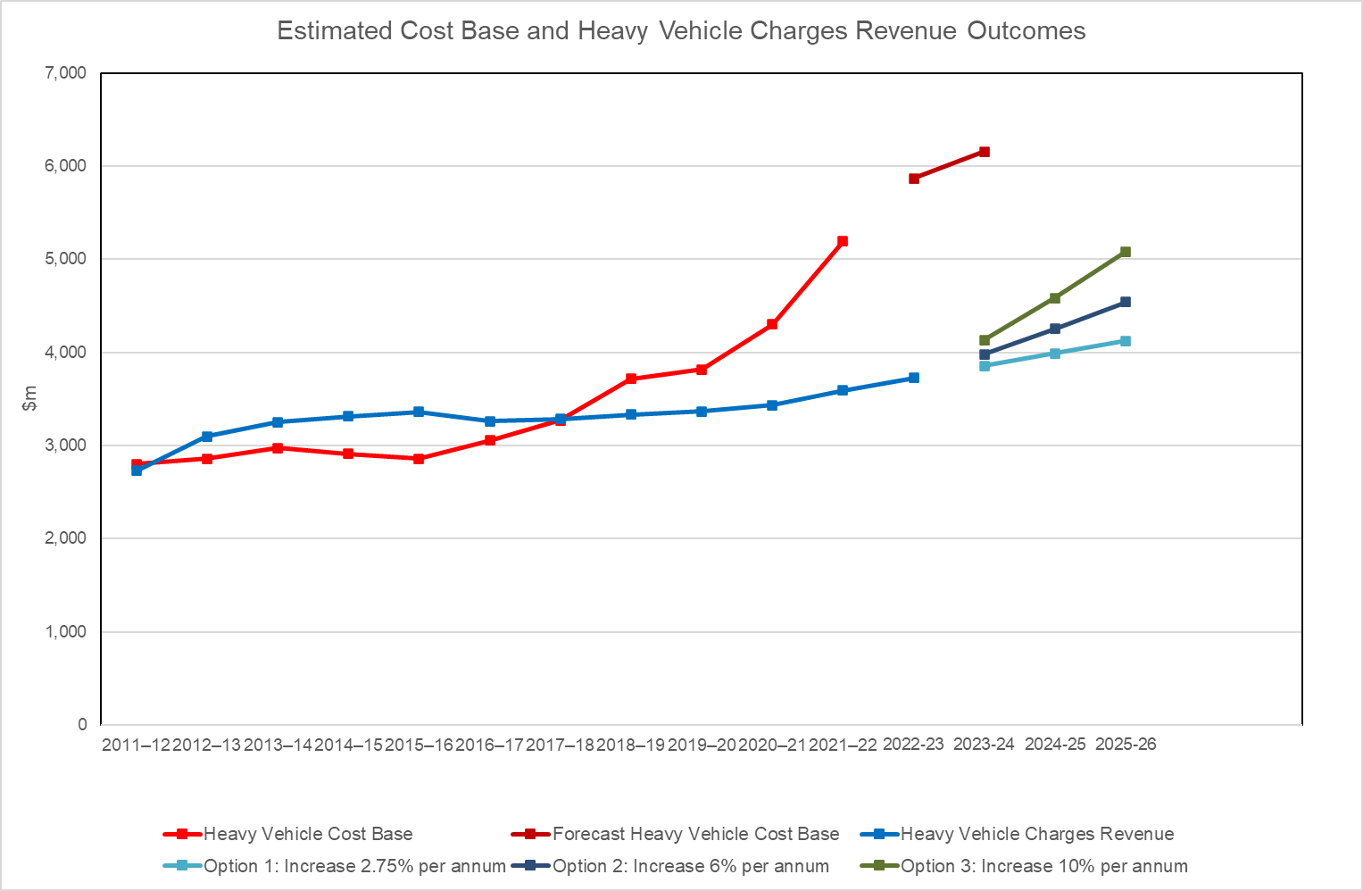

The following tables present the financial and fiscal implications associated with the changes in heavy vehicle charges under each of the three options outlined in Section 5.2. If ministers were to decide to implement heavy vehicle charges for a single year only, then the figures for 2024-25 and 2025-26 should be disregarded.

1. Estimated revenue from the roads component of registration charges and RUC – Option 1: Increase heavy vehicle charges by 2.75 per cent per annum

|  |  |  |  |
| --- | --- | --- | --- |
| **Option 1** | **Registration (roads component only)**  **$m** | **RUC**  **$m** | **Total**  **$m** |
| 2022-23 (Current) | 1,705 | 2,023 | 3,727 |
| 2023-24 | 1,782 | 2,075 | 3,857 |
| 2024-25 | 1,863 | 2,134 | 3,997 |
| 2025-26 | 1,947 | 2,194 | 4,140 |
| Total over pricing period | 5,592 | 6,402 | 11,994 |

1. Estimated revenue from the roads component of registration charges and RUC – Option 2: Increase heavy vehicle charges by 6 per cent per annum

|  |  |  |  |
| --- | --- | --- | --- |
| **Option 2** | **Registration (roads component only)**  **$m** | **RUC**  **$m** | **Total**  **$m** |
| 2022-23 (Current) | 1,705 | 2,023 | 3,727 |
| 2023-24 | 1,839 | 2,142 | 3,980 |
| 2024-25 | 1,983 | 2,268 | 4,251 |
| 2025-26 | 2,137 | 2,402 | 4,539 |
| Total over pricing period | 5,958 | 6,811 | 12,770 |

1. Estimated revenue from the roads component of registration charges and RUC – Option 3: Increase heavy vehicle charges by 10 per cent per annum

|  |  |  |  |
| --- | --- | --- | --- |
| **Option 3** | **Registration (roads component only)**  **$m** | **RUC**  **$m** | **Total**  **$m** |
| 2022-23 (Current) | 1,705 | 2,023 | 3,727 |
| 2023-24 | 1,908 | 2,223 | 4,131 |
| 2024-25 | 2,135 | 2,446 | 4,581 |
| 2025-26 | 2,388 | 2,692 | 5,080 |
| Total over pricing period | 6,431 | 7,362 | 13,793 |

## Estimated RUC rates

Table 8 shows the estimated RUC in cents per litre of diesel fuel that would apply over the three years from 2023-24 to 2025-26 under the four conceptual approaches to setting heavy vehicle charges.

1. Road user charge under each option (cents per litre)

| Option | **Current 2022-23** | **2023-24** | **2024-25** | **2025-26** |
| --- | --- | --- | --- | --- |
| Option 1: Increase heavy vehicle charges by 2.75 per cent per annum | 27.2 | 27.9 | 28.7 | 29.5 |
| Option 2: Increase heavy vehicle charges by 6 per cent per annum | 28.8 | 30.5 | 32.3 |
| Option 3: Increase heavy vehicle charges by 10 per cent per annum | 29.9 | 32.9 | 36.2 |

The RUC rate on gaseous fuels would be increased in parallel with increases in the RUC rate on diesel fuel. Table 10 shows the RUC rate that would apply on gaseous fuels over the three years from 2023-24 to 2025-26 under the four conceptual approaches for setting heavy vehicle charges.

1. RUC rate on gaseous fuels under each conceptual approach (cents per kg)

| Conceptual approach | **Current 2022-23** | **2023-24** | **2024-25** | **2025-26** |
| --- | --- | --- | --- | --- |
| Option 1: Increase heavy vehicle charges by 2.75 per cent per annum | 36.3 | 37.3 | 38.3 | 39.4 |
| Option 2: Increase heavy vehicle charges by 6 per cent per annum | 38.5 | 40.8 | 43.2 |
| Option 3: Increase heavy vehicle charges by 10 per cent per annum | 39.9 | 43.9 | 48.3 |

## Estimated heavy vehicle registration charges

Tables 11, 12 and 13 outline the total registration charge (including both the roads and regulatory components) that would apply to common heavy vehicle classes under each conceptual approach.

1. Registration charges for common vehicle types: Option 1: Increase heavy vehicle charges by 2.75 per cent

| **Vehicle type** | **Mass rating for charging** | **Current (2022–23)** | **2023-24** | **2024-25** | **2025-26** |
| --- | --- | --- | --- | --- | --- |
| Two axle rigid truck | Up to 12.0 t | 629 | 639 | 650 | 661 |
| Over 12.0 t | 1,013 | 1,046 | 1,079 | 1,114 |
| Two axle short combination rigid truck with a two axle trailer | Up to 42.5 t | 2,389 | 2,452 | 2,517 | 2,584 |
| Three axle rigid truck | Up to 16.5 t | 988 | 1,021 | 1,054 | 1,089 |
| Over 16.5 t | 1,185 | 1,222 | 1,260 | 1,300 |
| Three axle rigid truck with a three axle trailer | Up to 42.5 t | 3,211 | 3,293 | 3,379 | 3,467 |
| Over 42.5 t | 12,018 | 12,461 | 12,925 | 13,406 |
| Three axle medium combination rigid truck with a four axle trailer | Over 42.5 t | 12,665 | 13,123 | 13,603 | 14,100 |
| Four axle rigid truck | Up to 20.0 t | 1,003 | 1,036 | 1,069 | 1,104 |
| Over 20.0 t | 1,206 | 1,243 | 1,281 | 1,321 |
| Two axle bus | Up to 12.0 t | 529 | 537 | 545 | 554 |
| Over 12.0 t | 659 | 673 | 688 | 703 |
| Six axle articulated truckThree axle bus |  | 2,794 | 2,895 | 3,001 | 3,111 |
|  |  | 6,530 | 6,680 | 6,830 | 6,984 |
| Double road trainNine axle B-double |  | 15,488 | 15,844 | 16,200 | 16,568 |
|  |  | 15,544 | 15,900 | 16,256 | 16,624 |
| Triple road train |  | 17,400 | 17,801 | 18,199 | 18,612 |

1. Registration charges for common vehicle types: Option 2: Increase heavy vehicle charges by 6 per cent

| **Vehicle type** | **Mass rating for charging** | **Current (2022–23)** | **2023-24** | **2024-25** | **2025-26** |
| --- | --- | --- | --- | --- | --- |
| Two axle rigid truck | Up to 12.0 t | 629 | 654 | 680 | 707 |
| Over 12.0 t | 1,013 | 1,070 | 1,131 | 1,197 |
| Two axle short combination rigid truck with a two axle trailer | Up to 42.5 t | 2,389 | 2,518 | 2,657 | 2,805 |
| Three axle rigid truck | Up to 16.5 t | 988 | 1,045 | 1,106 | 1,172 |
| Over 16.5 t | 1,185 | 1,250 | 1,319 | 1,394 |
| Three axle rigid truck with a three axle trailer | Up to 42.5 t | 3,211 | 3,384 | 3,570 | 3,768 |
| Over 42.5 t | 12,018 | 12,829 | 13,702 | 14,638 |
| Three axle medium combination rigid truck with a four axle trailer | Over 42.5 t | 12,665 | 13,512 | 14,424 | 15,401 |
| Four axle rigid truck | Up to 20.0 t | 1,003 | 1,060 | 1,121 | 1,187 |
| Over 20.0 t | 1,206 | 1,271 | 1,340 | 1,415 |
| Two axle bus | Up to 12.0 t | 529 | 548 | 567 | 588 |
| Over 12.0 t | 659 | 684 | 710 | 738 |
| Three axle bus |  | 2,794 | 2,973 | 3,165 | 3,371 |
| Six axle articulated truck |  | 6,530 | 6,875 | 7,239 | 7,624 |
| Double road trainNine axle B-double |  | 15,488 | 16,309 | 17,176 | 18,093 |
|  |  | 15,544 | 16,365 | 17,232 | 18,149 |
| Triple road train |  | 17,400 | 18,320 | 19,292 | 20,320 |

1. Registration charges for common vehicle types: Option 3: Increase heavy vehicle charges by 10 per cent

| **Vehicle type** | **Mass rating for charging** | **Current (2022–23)** | **2023-24** | **2024-25** | **2025-26** |
| --- | --- | --- | --- | --- | --- |
| Two axle rigid truck | Up to 12.0 t | 629 | 671 | 717 | 767 |
| Over 12.0 t | 1,013 | 1,100 | 1,198 | 1,306 |
| Two axle short combination rigid truck with a two axle trailer | Up to 42.5 t | 2,389 | 2,600 | 2,834 | 3,092 |
| Three axle rigid truck | Up to 16.5 t | 988 | 1,075 | 1,173 | 1,281 |
| Over 16.5 t | 1,185 | 1,284 | 1,395 | 1,518 |
| Three axle rigid truck with a three axle trailer | Up to 42.5 t | 3,211 | 3,496 | 3,811 | 4,159 |
| Over 42.5 t | 12,018 | 13,282 | 14,689 | 16,255 |
| Three axle medium combination rigid truck with a four axle trailer | Over 42.5 t | 12,665 | 13,991 | 15,466 | 17,107 |
| Four axle rigid truck | Up to 20.0 t | 1,003 | 1,090 | 1,188 | 1,296 |
| Over 20.0 t | 1,206 | 1,305 | 1,416 | 1,539 |
| Two axle bus | Up to 12.0 t | 529 | 561 | 595 | 633 |
| Over 12.0 t | 659 | 697 | 739 | 785 |
| Six axle articulated truckThree axle bus |  | 2,794 | 3,068 | 3,373 | 3,713 |
|  |  | 6,530 | 7,120 | 7,765 | 8,469 |
| Double road trainNine axle B-double |  | 15,488 | 16,892 | 18,428 | 20,106 |
|  |  | 15,544 | 16,948 | 18,484 | 20,162 |
| Triple road train |  | 17,400 | 18,975 | 20,697 | 22,576 |

## Approach to setting registration charges under options explored in this paper

As part of the 2021 Determination, it was shown that the allocation of costs to each heavy vehicle class had changed to the point that the average revenue was lower than the attributable cost for some vehicle classes.

One of the pricing principles requires cross subsidies between different heavy vehicle classes to be removed. Based on this pricing principle, it is necessary to adjust the relativities between the registration charges for different heavy vehicle classes. In some cases, the required adjustment could be significant and impose an unreasonable burden for the operators of the affected vehicle classes. The estimated registration charges outlined in this consultation paper have been developed to moderate the adjustments required to eliminate cross-subsidies and introduces them over multiple years where required.

The moderation approach adopted for the charges recommended in this paper is the same as included in the 2021 Determination. It applies differential rates of increase in the estimated charges for different types of powered units and trailers while maintaining the same overall revenue as would be achieved from a uniform percentage charge increase applied to all powered units and trailers.

That is, certain registration charges increase faster (1.5 percentage points higher than the specified annual percentage figure) to help reduce the degree of cross-subsidisation while still retaining some pragmatism about the rate of increase in charges that can be implemented for those vehicle classes.

Charges for other types of vehicles and trailers increase by less than the specified figure Overall, the amount of revenue collected nationally is the same as if the headline increases had been applied uniformly to all powered units and trailers.

This approach is consistent with the approach outlined in Section 6.5 on page 86 and included in the recommended price path in the 2021 Determination RIS.

## Stakeholder feedback and submissions

Most submissions raised the issue of affordability in paying for charge increases other than the least amount possible due to high fuel costs, covid impacts, inflation and other cost pressures.

For example, the ATA and Natroad support a zero increase in 2023-24 and 2.75% in the remainder of the three year period. The ALRTA, BIC and MTA (NT/SA) all supported Option 1 at 2.75% per annum over three years.

The ATA submitted that it has previously shown that industry customers do not accept charge increases greater than CPI, if they accept them at all. Accordingly, the NTC should, before providing its final recommendations to ministers, consider:

* the inflation forecasts in the RBA’s November 2022 Statement of Monetary Policy
* the inflation forecasts in the 2022-23 October Budget, to be released on 25 October 2022.

The ATA stated that no charge increases above the consumer price inflation forecasts should be considered, even if ministers do not consider it appropriate to adopt the ATA recommendation.

## Response to feedback and submissions

The NTC notes the industry’s strong preference for low rate of charge increase over the next three years and acknowledges the many challenges the industry has had including the recent upsurge in fuel prices and sharp rise in inflation.

Given ministers’ previous decisions on heavy vehicle charges, the industry has benefited from zero to low increases in charges for a number of years whilst the cost base has increased significantly. The increases in the cost base over the same period reflect record levels of road expenditure that has benefited all road users.

Industry concerns need to be balanced against governments’ need for revenue to support continued investment in the road network.

# Assessment and final recommendation

## Pricing Principles

When assessing the conceptual approaches developed in Section 5, the NTC is bound by the pricing principles.

The COAG principles**[10]** are:

*“ATC direct the NTC, in developing its Determination, to apply principles and methods that*

1. *ensure the delivery of full cost recovery in aggregate,*
2. *further develop indexation adjustment arrangements to ensure the ongoing delivery of full expenditure recovery in aggregate and*
3. *remove cross-subsidisation across different heavy vehicle classes,*

*recognising that transition to any new arrangement may require a phased approach”.*

ATC/SCOTI guiding principles[11]

*“National heavy vehicle road use prices should promote optimal use of infrastructure, vehicles and transport modes. This is subject to the following:*

1. *full recovery of allocated infrastructure costs while minimising both the over and under recovery from any class of vehicle*
2. *cost effectiveness of pricing instruments*
3. *transparency*
4. *the need to balance administrative simplicity, efficiency and equity (e.g. impact on regional and remote communities/access)*
5. *the need to have regard to other pricing applications such as light vehicle charges, tolling and congestion.”*

Both the ATC and COAG principles are standing principles until the relevant authority changes them and are binding on the NTC.

## Relevant considerations

The pricing principles

Of the pricing principles, the following are most relevant to the options under consideration:

* fully recovering infrastructure costs while minimising both the over- and under-recovery from any class of vehicle
* administrative simplicity, efficiency and equity (e.g. impact on regional and remote communities/access).

Our interpretation of these principles is that cost recovery remains at the centre of heavy vehicle charges, but that other considerations, such as equity and the impact on regional and remote communities need to be taken into account.

**Measuring the heavy vehicle cost base – methodology and implications**

The PAYGO model has been operating, since 1996. The methodology has been thoroughly reviewed as part of determinations in 2000, 2008, 2014 and 2021. Over this time, its fundamental architecture aiming at recovery of road expenditure reported by governments has been unchanged.

Table 13 shows the percentage of total allocable expenditure (expenditure after adjustments such as unsealed travel and community service obligation allowances) over time. This shows that the heavy vehicle cost base has represented a relatively stable proportion of overall expenditure. This shows not only that model outcomes are stable, but also shows that changes in the heavy vehicle cost base are primarily driven by expenditure rather than changes in the model.

1. **Percentage of total allocated road expenditure allocated to heavy vehicles**

|  |  |  |  |  |  |  |  |
| --- | --- | --- | --- | --- | --- | --- | --- |
|  | **2015-16** | **2016-17** | **2017-18** | **2018-19** | **2019-20** | **2020-21** | **2021-22** |
| Percentage share of total allocated road expenditure allocated to heavy vehicles | 21.7% | 21.8% | 21.4% | 22.5% | 22.4% | 21.5% | 23.8% |

Some submitters have argued that the PAYGO model is broken and that the estimated heavy vehicle cost base is excessive. On the other hand, several government agencies have expressed their view that the cost allocation mechanism is overly conservative. For example, the Victorian Department of Transport and Department of Treasury and Finance commissioned research which suggested that a greater proportion of costs should be allocated to heavy vehicles. This issue was considered in detail as part of the 2021 Determination.

While acknowledging some limitations in the input data and methodology used to estimate the heavy vehicle cost base, it is important to note the following:

* PAYGO is designed as a cost recovery mechanism reflecting actual total government expenditure on roads. The NTC has never had the ability, or the mandate to assess the quality of expenditure. PAYGO relies on the established processes where treasuries or independent infrastructure advisory agencies assess the justification for projects.
* The methodology in general, and the approach to cost allocation has been reviewed several times. For example, in 2006, the Productivity Commission described the cost allocation as conservative. An independent review of the cost allocation parameters carried out by Houston Kemp in 2017 found no robust evidence to depart from existing allocators.
* Some of the increases in infrastructure expenditure have been described as economic stimulus and may have been driven by factors other than the exclusive aim of enhancing transport productivity. It is not possible to quantify the extent to which expenditure may have been undertaken on this basis. To the extent this is the case, there would be a reasonable argument that this type of expenditure should not necessarily be fully recovered through heavy vehicle charges.

**Benefits of investment in the road network**

Some submitters have questioned the benefit provided to industry by recent investments in the road network.

One of the challenges with roads is that they are a network which is shared by different types of users. This makes it difficult to directly attribute the benefits of individual investments to users. In networks, enhancements tend to benefit all users to some degree, although the magnitude of benefits can vary significantly between different users. **[12]**

Typically, in networks, costs are shared amongst users based on some type of averaging. For example, the cost of strengthening electricity distribution networks to cope with additional demand from new users tend to be shared across all users.

Given the information available, it is impossible to determine which expenditure has directly benefitted heavy vehicles compared to other types of users. However, it is reasonable to assume that improvements to the road network have provided some benefit to heavy vehicle operators.

**Revenue gap under different future price paths**

If ministers were to decide that achieving full cost recovery by 2025-26 was the primary goal, this would require heavy vehicle charges to be increased by approximately 17.3 per cent in each of the three years from 2023-24 to 2025-26.

If ministers wanted to keep the gap between the heavy vehicle cost base and heavy vehicle charges revenue constant at the 2022-23 level ($575.8m), this would require heavy vehicle charges to be increased by 13.5 per cent in each of the three years from 2023-24 to 2025‑26.

Based in part on the size of historical increases to heavy vehicle charges approved by ITMM, the NTC consulted on three options for setting heavy vehicle charges from 2023-24 onwards that would see the gap between the heavy vehicle cost base and heavy vehicle charges revenue grow above beyond the 2022-23 level of $575.8m by 2025-26.

Table 14 shows the revenue gaps under key scenarios for setting heavy vehicle charges.

1. Revenue gaps compared

| **Option** | **Year 1**  **$m** | **Year 1**  **%** | **Year 2**  **$m** | **Year 2**  **%** | **Year 3**  **$m** | **Year 3**  **%** |
| --- | --- | --- | --- | --- | --- | --- |
| Achieve full cost recovery by 2025-26 | 788 | 15.2 | 661 | 11.3 | 0 | - |
| Keep revenue gap at 2022-23 level of $575.8m by 2025-26 | 930 | 17.9 | 991 | 16.9 | 576 | 9.4 |
| Option 1: Increase heavy vehicle charges by 2.75 per cent per annum | 1,337 | 25.7 | 1,870 | 31.9 | 2,013 | 32.7 |
| Option 2: Increase heavy vehicle charges by 6 per cent per annum | 1,213 | 23.4 | 1,617 | 27.6 | 1,614 | 26.2 |
| Option 3: Increase heavy vehicle charges by 10 per cent per annum | 1,062 | 20.5 | 1,286 | 21.9 | 1,073 | 17.4 |

Unless ministers choose to increase heavy vehicle charges by 17.5 per cent over the three years from 2023-24 to 2025-26, there will be a gap between the heavy vehicle cost base and the revenue provided from heavy vehicle charges.

**Implications of the current revenue gap**

There are two important consequences from the current revenue gap.

First, the shortfall needs to be made up from other sources of revenue. That is, where expenditure on roads related to heavy vehicles is not met from heavy vehicle charges revenue, this effectively results in general taxpayers providing a cross-subsidy to heavy vehicle operators. Given the principle of full cost recovery expressed in the pricing principles and the overall design of the PAYGO model, governments have arguably decided against providing an explicit cross-subsidy to heavy vehicle operators.

Second, the ability of governments to fund ongoing expenditure on the road network depends on having sufficient revenue. Departures from full cost recovery reduce the ability of governments to fund this type of expenditure.

We understand that, in some states and territories, the state of the existing network has deteriorated due to a backlog in maintenance. It would be possible to argue reasonably that governments’ ability to reduce the maintenance backlog is negatively affected by any persistent revenue gaps.

Overall, these considerations support the argument that revenue gaps need to be limited, and ideally eliminated over time.

**Industry affordability**

Industry associations have highlighted that significant increases in heavy vehicle charges would be difficult for operators to manage. Reasons for this include:

* Trading conditions have been challenging for parts of the industry, and the industry is still slowly rebounding from the effects of COVID-19 with conditions still inferior to those that existed before the pandemic. For example, bus passenger loads have fallen with respect to service kilometres.
* The industry is facing significant cost increases for fuel, trucks, tyres, parts and servicing costs. In addition, interest rates have increased significantly, increasing the cost of borrowing. Operators have, in many cases, not been able to reflect cost increases in freight rates.
* There is a significant shortage of drivers.
* Compliance costs are increasing.

Even though industry conditions may be difficult, this does not necessarily indicate that industry would be unable to cope with reasonable increases to heavy vehicle charges. This is because the trucking industry is highly competitive, with a large number of operators, and relatively low entry and exit costs.

Therefore, it would be reasonable to expect that increases in costs due to a rise in heavy vehicle charges would, over time, flow through to the prices charged by operators to their customers. That is not to say that all operators are able to immediately reflect cost increases in their prices. However, it is unlikely that a reasonable increase in heavy vehicle charges would have a major or permanent impact on the overall size and composition of the industry.

**Impact on heavy vehicle operating costs**

From research undertaken as part of the 2021 Determination, we understand that heavy vehicle charges make up between approximately 2 and 8 per cent of total vehicle operating costs. From this perspective, an increase of 6 per cent in heavy vehicle charges would increase total vehicle operating costs by between approximately 0.1 and 0.5 per cent.

Compared to other cost pressures, such as fluctuations in the price of fuel (excluding the fuel excise tax) or vehicle parts, the impact on total vehicle operating costs is likely to be small in most cases.

**Possible impact on regional and remote communities**

Increasing heavy vehicle charges is expected to make transporting people or goods by heavy vehicle more expensive. However, as outlined in the previous section, the increase in costs caused directly by the heavy vehicle charge increases consulted upon are likely to be small.

Against this, it is important to consider the implications that an inability to maintain roads would have on the same communities. If roads cannot be maintained due to a lack of government funding, this would also be expected to have a particularly noticeable effect on regional and remote communities.

Therefore, the NTC considers that increasing heavy vehicle charges sufficiently to maintain governments’ ability to continue investing in the road network would not disadvantage regional and remote communities.

## Conclusion and recommendations

The NTC acknowledges the concerns expressed by submitters about the impact that increasing heavy vehicle charges has on operators and their customers. However, the requirement to achieve full cost recovery remains an important guiding principle which the NTC is required to consider. Neither heavy vehicle operators nor the communities they serve will benefit if heavy vehicle charges fail to provide governments with sufficient revenue to maintain a reasonable level of investment in the road network.

Taking all the relevant and often competing considerations into account, the NTC recommends that ITMM agree to increase heavy vehicle charges by 6 per cent per annum for three years, as outlined in Option 2 in the consultation paper.

# Alternative approaches to rounding heavy vehicle charges

The PAYGO model was originally developed with the overarching objective of determining a combination of nationally consistent RUC and registration charges that would be expected to recover the identified heavy vehicle cost base.

In this model, both RUC and registration charges are calculated to multiple decimals. This is required to ensure estimated revenue precisely recovers the cost base. Heavy vehicle charges have not been set with reference to a specific revenue target since 2017-18.

In recent years, charges have typically been increased by a percentage as approved by ministers, rather than to recover a specific amount. Under this approach, the NTC has applied percentage increases to unrounded heavy vehicle charges, and then rounded the result. The rounded result is then recommended to ministers as a specific charge to approve. Rounding for registration charges is to the next full dollar whereas the RUC rate is rounded to the next 0.1 cent per litre, as required under the Fuel Tax Act 2006 (Cth).

Using RUC as an example, Table 15 shows how percentage increases were applied to the unrounded RUC.

1. Current approach to rounding illustrated

|  |  |  |  |  |
| --- | --- | --- | --- | --- |
| Financial Year | Unrounded RUC rate (cents/litre) | Percentage change applied | Actual, rounded RUC rate | Notes |
| 2015/2016 | 26.13750 | 0.60% | 26.14 | Last year where RUC set to two decimals. Starting point for subsequent calculations. |
| 2016/2017 | 25.90226 | -0.90% | 25.9 | First year where RUC set to single decimal. Overall level of HV charges revenue frozen. |
| 2017/2018 | 25.79865 | -0.40% | 25.8 | Overall level of HV charges revenue frozen |
| Heavy vehicle charges were frozen at 2017-18 levels from 2018-19 to 2020-21 | | | | |
| 2021/2022 | 26.44362 | 2.5 | 26.4 | ITMM agrees to increase charges by 2.5 per cent |
| 2022/2023 | 27.17082 | 2.75 | 27.2 | ITMM agrees to increase heavy vehicle charges by 2.75 per cent |

On the one hand, this approach minimises the cumulative effect of rounding over time. On the other hand, stakeholders may identify that the difference between two RUC rates rounded to the nearest 0.1 cents per litre does not precisely reflect the percentage increase described.

To avoid any doubt, in reports to ministers, the NTC identifies both the headline percentage change and the specific registration charges and RUC rate to be implemented in all consultation papers and reports to ministers.

An alternative would be to apply approved percentage changes to rounded heavy vehicle charges, as approved by ministers, and identified in the Model Law for registration charges and the legislative instrument made by the Federal Transport Minister to set the RUC rate. The end result would then be rounded again to derive the specific rates to be recommended to ministers. Table 16 shows how this could work.

1. Alternative approach to rounding illustrated

|  |  |  |  |  |
| --- | --- | --- | --- | --- |
| Financial Year | Unrounded RUC rate | Percentage change applied | Actual, rounded RUC rate | Notes |
| 2015/2016 | N/A | N/A | 26.14 | Last year where RUC set to two decimals. Starting point for subsequent calculations. |
| 2016/2017 | 25.90474 | -0.90% | 25.9 | First year where RUC set to single decimal. Overall level of HV charges revenue frozen. |
| 2017/2018 | 25.7964 | -0.40% | 25.8 | Overall level of HV charges revenue frozen |
| Heavy vehicle charges were frozen at 2017-18 levels from 2018-19 to 2020-21 | | | | |
| 2021/2022 | 26.445 | 2.5 | 26.4 | ITMM agrees to increase charges by 2.5 per cent |
| 2022/2023 | 27.126 | 2.75 | 27.1 | ITMM agrees to increase heavy vehicle charges by 2.75 per cent |

The advantage of this approach is that the changes in the heavy vehicle charges would be applied to the specific rates set out in the Model Law for registration charges or the legislative instrument for RUC, and then rounded. Year-on-year changes could be easier for the public to understand and reconcile. On the other hand, over multiple years, this approach could lead to a larger cumulative effect of rounding. Over time, it could also slightly change the percentages of total revenue recovered by the Commonwealth and states and territories, respectively.

In addition, this approach would arguably make it more complex to set heavy vehicle charges to recover a specific revenue target again in the future, should ministers wish to pursue this.

## Stakeholder feedback and submissions

Most submissions did not express a preference on the rounding issue. The ATA said there is no reason to depart from the NTC’s current approach, provided that both the headline percentage change and the specific registration charges/RUC rates are identified. The BIC said we see no reason to change the current approach on this matter. However, Natroad preferred the alternative approach as it is easier for the public to understand.

## Conclusion

There was no clear support amongst stakeholders to change the current approach to rounding. Also, the current approach has the advantage that it minimises the cumulative effect of rounding over time. The NTC will therefore continue to apply the current approach to rounding.

Glossary

Include a glossary of terms for complex or technical documents.

|  |  |
| --- | --- |
| **Term** | **Definition** |
| Heavy vehicle cost base | The heavy vehicle cost base is that share of national government road expenditure that can be attributed to the heavy vehicle sector in the PAYGO model. |
| Infrastructure and Transport Ministers Meeting (ITMM) | The Infrastructure and Transport Ministers Meeting (ITMM) brings together Commonwealth, State and Territory Ministers with responsibility for transport and infrastructure issues, as well as the Australian Local Government Association. |
| PAYGO | Pay As You Go (PAYGO) is an approach used to determine the amount to be recovered from heavy vehicles through heavy vehicle charges. Trend levels of road construction and maintenance expenditure and road use is assessed over the past seven years to reflect the annualised costs of providing and maintaining roads. |
| Registration charge | The annual registration charge that applies to heavy vehicles by vehicle and trailer type. |
| Regulatory component of registration charge | The regulatory component of the heavy vehicle registration charge is applied to each heavy vehicle and trailer type and is based on the heavy vehicle fleet and the budget of the National Heavy Vehicle Regulator. |
| Roads component of registration charge | The roads component of the heavy vehicle registration charge is applied to each heavy vehicle and trailer type and is determined by outcomes from the PAYGO model based on heavy vehicle allocated cost and use. |
| Road expenditure | Road expenditure includes all government arterial and local road expenditure that meets NTC guidelines for inclusion in the PAYGO cost base. |
| RUC | Road User Charge. The Road User Charge is the charge that is applied to heavy vehicle fuel use expressed in cents per litre or cents per kilogram. |

References

National Transport Commission 2021, *Heavy vehicle charges determination: consultation regulation impact statement*, NTC,  
Melbourne

1. Summary of submissions

The table below outlines submissions in response to the consultation paper (grouped by question/theme) and the NTC’s responses.

| **Summary of submissions and the NTC’s responses Stakeholder** | **Stakeholder type** | **Question no.** | **Theme** | **Extract** | **NTC Response** |
| --- | --- | --- | --- | --- | --- |
| Australian Livestock and Rural Transporters Assoc. (ALRTA) | Peak bodies | 1 | PAYGO - Developing the cost base | ALRTA continues to fundamentally support fair cost recovery based on an agreed economic model. However, the magnitude of the current gap between revenue and expenditure calculated via the PAYGO model is of grave concern. This gap has now grown so large that it is difficult to imagine a scenario under which it could return to balance without either significantly reduced infrastructure investment (which would be counter-productive in a broader economic sense) or charging increases of a scale that would threaten the viability of road transport businesses. ALRTA asserts that a frank conversation must occur between industry and government to identify a pragmatic approach to achieving balance in the medium term. This is likely to involve a one-off intervention to fix the imbalance under PAYGO or a transition to an entirely new approach to fair cost recovery involving a ‘reset’ such that it could be launched on a cost-neutral basis. | The NTC notes ALRTA’s comments.  Currently, alternative costing approaches are being reviewed as part of the Heavy Vehicle Road Reform project. |
| Australian Trucking Assoc. (ATA) | Peak bodies | 1 | PAYGO - Developing the cost base | 6. There is extensive relevant information available that shows the existing heavy vehicle cost base is meaningless and should be scrapped. The NTC has not considered this information sufficiently. 7. The cost base uses state governments’ road expenditure figures without audit or appraisal, despite the industry’s long held concerns. 8. The spending included in the cost base is entirely driven by governments’ budget decisions. There is no direct and systematic link to the needs of the industry or broader transport policy priorities, such as increasing productivity. 9. Instead, the model requires heavy vehicle operators to pay a share of the cost of road investments that are not freight priorities, such as projects to increase capacity for commuter traffic or for opening up new residential developments. 10. The current system prioritises new projects over road maintenance spending. There is no funding certainty for road authorities to make optimal lifecycle decisions. The recent increase in rain and floods has led to a noticeable decrease in road quality. The impact of weather events is expected to increase due to climate change; the funding system does not prioritise road maintenance appropriately. 11. The consultation paper concedes that the cost base includes stimulus expenditure designed to support economic growth in the face of challenging conditions. No attempt has been made to separate out this expenditure, which is properly a cost that should be borne by the whole community. 12. The cost base is also inflated by poor project estimation and delivery. 13. From 2001 to 2015, governments spent $28 billion more on transport infrastructure projects than originally announced. The main cause of the cost overruns was found to be premature announcements ahead of proper planning and assessment | The NTC notes that the allocation of different types of road expenditure to heavy vehicles has been described by third parties as conservative. Comprehensive arterial and local road heavy vehicle expenditure is obtained from all. As per the NTC’s reporting guidelines, road construction and maintenance expenditure funded by money received from insurance claims and Commonwealth Disaster Recovery Funding Arrangements (DRFA), formerly known as Natural Disaster Recovery and Relief Arrangements (NDRRA) are excluded from the cost base. The expenditure data received from the jurisdictions is reviewed and signed off as being compliant with the expenditure by road agency CEO's or equivalent, and is subject to internal audit within the relevant agencies.  As part of Heavy Vehicle Road Reform, other alternative costing approaches are being reviewed. |
| Australian Trucking Assoc. (ATA) | Peak bodies | 1 | PAYGO - Developing the cost base | Question 1 response continued 15. Consistent with this approach, the PAYGO cost base should be recalculated so that the major projects included— a. are endorsed by an independent infrastructure agency such as Infrastructure Australia b. are based on integrated transport planning, including trucking industry and community consultation c. include rest areas and access improvements in project planning and delivery. 16. Further, there is an urgent and unfulfilled reform priority for governments to improve the transparency of the cost base. Governments should make it clear what road user charges are paying for and how industry priorities will be implemented. 17. The WA Economic Regulation Authority’s recent draft decision about the Western Power electricity network is a model of the approach the NTC and governments should adopt. | The NTC notes the ATA’s recommendations. These recommendations are beyond the scope of the options for implementing heavy vehicle charges from 2023-24 onwards being consulted on. |
| Bus Australia Network (BAN) | Peak bodies | 1 | PAYGO - Developing the cost base | Bus Australia Network (BAN) remains concerned that a narrow view of equity continues to be taken by the Commission, which appears to treat the guidelines example of regional and remote communities as the only particular equity issue of concern. BAN submits that equity is a much broader concept than this and should take account, for example, of differing societal external benefits and costs flowing from different categories of road use/vehicle use (e.g., social exclusion benefits; greenhouse gas impacts; congestion mitigation) and of the relative impacts of COVID on different sectors (the latter being a capacity to pay or affordability consideration). The NTC should commission research into a wider understanding of equity as it relates to road use charging, including how this relates to matters of wider societal external benefits and costs expected from particular classes of vehicle/use. The rapid growth in the HV cost base that is evident in NTC (2022) raises serious issues for sectoral governance and funding. In particular, does the HV sector have sufficient influence over the choice of road expenditure priorities that it is being asked to fund through charges? Given the size and rapid rate of increase in the HV cost base and slow rate of change in institutional governance arrangements, the answer to this question can only be ‘certainly not’. As a matter of governance and process equity, Ministers and the NTC should urgently consider ways in which the HV sector can be provided with a more appropriate level of input on expenditure priorities that it is being asked to fund. We are concerned that the impact of COVID on bus ESA-kms may not have been factored into the cost attribution process. NTC (2022) does not comment on this matter. There is a need for an independent review of the cost attribution formulae used by NTC, particularly relating to ESA-kms. | The issues raised by BAN concerning governance and equity are noted by the NTC.  ESA values for buses are based on an extensive review of all ESA values commissioned by the NTC. These ESA values were consulted on as part of the 2021 Determination. |
| Cement, Concrete and Aggregates Assoc. (CCAA) | Peak bodies | 1 | PAYGO - Developing the cost base | CCAA recognises that the road freight industry is a significant user of the road network and accepts that as such the industry should pay a fair, but not disproportionate, contribution to service the road network. Supports the linking of road user charges to road expenditure, requiring revenue recovered through road users be ear marked for investment back into the road network, provided that: a. There is a clear and transparent link between funds raised and investments made based on clear priorities. b. It should not be simply a revenue-raising exercise for Government and not result in "double dipping" or cross subsidisation. | Noted |
| Motor Trade Assoc. (SA/NT) | Industry Group | 1 | PAYGO - Developing the cost base | The NTC and the ITMM should investigate the sharp increase in road expenditure costs over the past 5 years. If there is a periodical renewal of old roads or government policies on road maintenance shifting to increase the cost base. While road user charges have increased by $1 billion in a decade, the cost base has increased by $3 billion with the majority of growth in the past 5 years. | Noted |
| National Road Transport Assoc. (Natroad) | Peak bodies | 1 | PAYGO - Developing the cost base | NatRoad believes that it is futile to base increased RUC and registration charges on past State and Territory road expenditure. This leads to a situation where charges are driven solely by governments’ spending plans. Those plans are often inconsistent with real world requirements (such as road maintenance or sealing) or industry’s ability to pay (which is diminishing for a broad range of economic reasons.) There is no qualitative check on that expenditure undertaken by the NTC. Industry pays for State and Territory inefficiencies in road construction. | Noted |
| Australian Livestock and Rural Transporters Assoc. (ALRTA) | Peak bodies | 2 | Impl. Opt. - Setting charges for 3 years | ALRTA remains strongly supportive of multi-year price pathing to give certainty to industry and governments in challenging economic circumstances | Noted |
| Australian Trucking Assoc. (ATA) | Peak bodies | 2 | Impl. Opt. - Setting charges for 3 years | 18. 'The ATA supports the recommendation for a three-year pricing period commencing in 2023-24, on the basis that governments intend to move towards a forward-looking cost base or to reinstate the link between a new, more targeted cost base and heavy vehicle charges revenue. | Noted |
| Bus Australia Network (BAN) | Peak bodies | 2 | Impl. Opt. - Setting charges for 3 years | No, we prefer a one-year determination. | BAN's preference for a one year Determination only is noted. |
| Cement, Concrete and Aggregates Assoc. (CCAA) | Peak bodies | 2 | Impl. Opt. - Setting charges for 3 years | Whilst any increase in charges be kept to a minimum, we strongly prefer an outcome that offers as much long term predictability and certainty of charges as possible. | Noted |
| Motor Trade Assoc. (SA/NT) | Industry Group | 2 | Impl. Opt. - Setting charges for 3 years | Further investigation is required on the cost base increases before MTA can make a judgement on behalf of members. Cost increases are minimised and done on a year-on-year bases rather than in a three year period to better respond to economic circumstances. | Noted |
| National Road Transport Assoc. (Natroad) | Peak bodies | 2 | Impl. Opt. - Setting charges for 3 years | A new costing model is needed to underpin the Heavy Vehicle Road Reform (HVRR) process. In the meantime, a zero or a small, fixed price increase is a better outcome than reliance on PAYGO or alternative models to set a recovery amount. | Noted |
| Australian Trucking Assoc. (ATA) | Peak bodies | 3 | Impl. Opt. - Setting charges for 1 or 3 years | 19. The issues relating to the decision about whether to set prices for a single year or three years have now been fully canvassed. | Noted |
| Bus Australia Network (BAN) | Peak bodies | 3 | Impl. Opt. - Setting charges for 1 or 3 years | The current economic climate is uncertain, with slower economic growth being likely. Given that the bus industry has been severely impacted by COVID, affordability considerations suggest that charges should be set for a shorter (rather than longer) time period, to reduce risks of locking industry into future charges that may be excessive in the economic circumstances of the time. BAN believes that a 12-month period is preferrable to 3 years in the current economic climate. | Noted |
| National Road Transport Assoc. (Natroad) | Peak bodies | 3 | Impl. Opt. - Setting charges for 1 or 3 years | We agree with the National Transport Commission’s recommendation that Ministers set heavy vehicle charges for a three-year period beginning in 2023-24. This will give the industry a degree of certainty. | Noted |
| Australian Trucking Assoc. (ATA) | Peak bodies | 4 | Impl. Opt. - Charges rounding | 20. 'There is no reason to depart from the NTC’s current approach, provided that both the headline percentage change and the specific registration charges/RUC rates are identified. | Noted |
| Bus Australia Network (BAN) | Peak bodies | 4 | Impl. Opt. - Charges rounding | Given our recommendation that charges should only be for a one-year period, we see no reason to change the current approach on this matter. | Noted |
| National Road Transport Assoc. (Natroad) | Peak bodies | 4 | Impl. Opt. - Charges rounding | The 2nd alternative is preferred based on applying the percentage increase to a rounded number as it is easier for the public to understand. | Noted |
| Australian Trucking Assoc. (ATA) | Peak bodies | 5 | Impl. Opt. - Ranking of options | 21. 'The ATA does not agree with the NTC’s ranking of options against their ability to achieve full cost recovery over time. Given the fundamental issues with the heavy vehicle cost base it is not fruitful to attempt to compare options against this inflated figure. | Noted |
| Bus Australia Network (BAN) | Peak bodies | 5 | Impl. Opt. - Ranking of options | The criteria are agreed and ranking of options against criteria are agreed but the lack of any discussion of the weight of criteria and the scale of difference between options that are ranked on any criterion (such rankings being ordinal not cardinal) reduces the value of the assessment of options. BAN argues that equity and affordability are particularly important at this time and that these criteria strongly suggest Option 1 as the preferred option. | Noted |
| National Road Transport Assoc. (Natroad) | Peak bodies | 5 | Impl. Opt. - Ranking of options | Registration charges that apply to larger combinations mitigate against other Government objectives, such as encouraging fewer truck trips for the same task and encouraging the uptake of larger, modern low emissions vehicles. That should be a factor in assessing the preferred options. | Noted |
| Australian Livestock and Rural Transporters Assoc. (ALRTA) | Peak bodies | 6 | Impl. Opt. - Which options are preferred | ALRTA considers that NTC Option 1, applied over three years, is the preferred charging option. That heavy vehicle registration and Road User Charges be increased by 2.75 per cent in 2023-24, 2024-25 and 2025-26. While we acknowledge that moderate increases will not reduce the gap between forecast revenue and expenditure, it is important that some level of increase is applied in each of the next three years to reduce the gap growth that would otherwise occur if charges were frozen. The ALRTA also stress the impact on the industry of high fuel costs, covid impacts, inflation, driver shortages etc in selecting Option 1. | Noted |
| Australian Trucking Assoc. (ATA) | Peak bodies | 6 | Impl. Opt. - Which options are preferred | 22. 'The ATA does not support the options considered in the paper. 23. In an ATA survey, 54 per cent of trucking businesses reported they are not able to impose fuel surcharges to pass these costs on to their customers. 24. The previous government’s six month fuel tax cut has added to the difficulties facing trucking businesses. The effective fuel tax reduction for trucking businesses was 4.3 cents per litre rather than the headline tax cut, 22.1 cents per litre. a. customers expected to see a reduction in freight rates based on the 22.1 cents per litre headline figure, not the actual figure of 4.3 cents per litre b. fuel levy and rate review formulas in industry contracts returned the wrong results c. some trucking businesses faced considerable cash flow difficulties. They paid less tax at the pump but did not receive on-road fuel tax credits on their activity statements to offset their other tax liabilities. 25. From 1 April to 18 August 2022, some 2,000 heavy on-road transport operators had to negotiate payment arrangements with the ATO. These businesses should not be further penalised while they get out from under the previous government’s policy decision. | The NTC notes the issues raised by the ATA. The NTC does not anticipate any impacts from a temporary reduction in the fuel excise tax to occur in the period of 2023-24 to 2025-26. |
| Australian Trucking Assoc. (ATA) | Peak bodies | 6 | Impl. Opt. - Which options are preferred | Question 6 continued 27. 'ATA members consider that they are not getting value out of the heavy vehicle charges they currently pay. In particular— a. trucking businesses are not told what their charges are buying and how their needs and priorities will be met. No business or householder would agree to pay a large non-itemised invoice for unspecified services b. in addition to paying heavy vehicle charges, businesses operating high productivity vehicles in the eastern states and South Australia must deal with a complicated and inconsistent system for approving road access. The NHVR issues some 46,000 permits per year. c. more generally, businesses face the cost and difficulty of complying with the Heavy Vehicle National Law, which is 681 pages long and highly prescriptive.14 The HVNL has been under review since January 2019. The review process has not produced a single chamber-ready legislative amendment. 28. Given the high cost and compliance burden faced by trucking businesses, and the failure of governments to address those burdens, the ATA recommends there should be no charge increase in 2023-24. In 2024-25 and 2025-26, charges should increase 2.75 per cent per year | Noted. A breakdown of expenditure by category can be found in NTC annual reports. This provides some information on the types of expenditure recovered through heavy vehicle charges. |
| Bus Australia Network (BAN) | Peak bodies | 6 | Impl. Opt. - Which options are preferred | BAN’s preferred option is Option 1, - which we believe gives some recognition to the current state of economic uncertainty and industry capacity to pay (affordability) in terms of the rate of proposed charge increase (which are the smallest of the 3 options). - some (implicit) recognition of the equity/external benefits from bus use, in terms of the proposed increases in registration charges for 2 axle buses - some (implicit) recognition that full cost recovery may not be an appropriate result to pursue in a context of major macro-economic stimulus, which implies an unrealistic and inappropriate growth in an apparent HV cost base. Our most preferred option is for a 2% p.a. rate of charge increase but we see 2.75% as a reasonable compromise solution for the RUC in the current economic environment, provided the registration charge increase for bus is around 2% p.a. | BAN's preference for Option 1 at 2.75% per annum is noted but with all bus registration charges increasing at 2.0% per annum. However, the BAN submission has incorrectly interpreted why there is a lower percentage increase for some bus types in the Option 1 charges shown in the consultation paper. The lower increases are not a result of equity/external benefit considerations. Instead, the different overall percentage increases across different heavy vehicle types arise because the registration charges listed in the Option 1 table are total registration charges including both the roads and regulatory components, and where the regulatory component was held constant. The increase of 2.75% per annum under Option 1 applies only to the roads component of the registration charge. The changes in the roads component of registration charges was also modified to accommodate a gradual change in registration charges across different vehicle types to avoid cross-subsidies between vehicle classes |
| Cement, Concrete and Aggregates Assoc. (CCAA) | Peak bodies | 6 | Impl. Opt. - Which options are preferred | Whilst obviously the industry prefers smaller charging increases, it is more disposed to options which provide greater predictability and certainty over the longer term. | Noted |
| Motor Trade Assoc. (SA/NT) | Industry Group | 6 | Impl. Opt. - Which options are preferred | The MTA’s position is that there are minimal increases to the cost of businesses in the current economic climate. The NTC should undertake an analysis of the cost base increase over the past 5 years to understand the cause of the large increase so Ministers can appropriately apportion cost recovery to the causes. If there is no other options to consider, option 1 (2.75% p.a.) as it represents the lowest impact to heavy vehicle industry. | Noted |
| National Road Transport Assoc. (Natroad) | Peak bodies | 6 | Impl. Opt. - Which options are preferred | NatRoad remains wedded to its position that if governments are going to increase the road user charge (RUC) and registration charges, a small percentage increase should be adopted at the most. Given industry conditions, particularly record fuel prices, a zero increase at least in the first year is recommended. We prefer a zero increase in the first year and then the balance of Option 1. | Noted |
| Australian Livestock and Rural Transporters Assoc. (ALRTA) | Peak bodies | 7 | Detrm. Opt. - Other information for ministers to consider | That Australian Governments increase the proportion of road expenditure allocated to rural and regional roads and be required to consult with peak road freight associations about the nature and quality of regional roadworks funded by heavy vehicle charges. | Noted |
| Australian Trucking Assoc. (ATA) | Peak bodies | 7 | Detrm. Opt. - Other information for ministers to consider | 29. 'The ATA has previously shown that industry customers do not accept charge increases greater than CPI, if they accept them at all. 30. Accordingly, the NTC should, before providing its final recommendations to ministers, consider— a. the inflation forecasts in the RBA’s November 2022 Statement of Monetary Policy b. the inflation forecasts in the 2022-23 October Budget, to be released on 25 October 2022. 31. No charge increases above the consumer price inflation forecasts should be considered, even if ministers do not consider it appropriate to adopt the ATA recommendation | The NTC notes the inflation forecast sources raised by the ATA. |
| Bus Australia Network (BAN) | Peak bodies | 7 | Detrm. Opt. - Other information for ministers to consider | Comments that are relevant here are included in response to questions 5 and 6. We also reinforce the need for a review of cost attribution parameters, as part of an urgent review of the whole PAYGO approach to charge setting, at a time road spending levels are growing so quickly, and fuel sources are expected to change so substantially. | Noted |
| Cement, Concrete and Aggregates Assoc. (CCAA) | Peak bodies | 7 | Detrm. Opt. - Other information for ministers to consider | The volatility and unpredictably of current business operating and input costs are causing significant difficulties for the construction materials sector, and as such our preference for heavy vehicle charging is that it be clear and predictable. You would be aware that increased charges will be passed onto customers and while it is never easy to pass on additional costs such as these, particularly in these inflationary times, it is exceptionally difficult, if not impossible to recover additional charges that are changed frequently over a drawn out time frame. More specifically, heavy construction materials are an essential component in the infrastructure delivery chain, increased road user charges will impact directly on the industries’ ability to deliver affordable construction materials for infrastructure projects. Road charging reforms for the heavy vehicle sector must be accompanied with or followed by similar reforms for light vehicles. | Noted |
| Motor Trade Assoc. (SA/NT) | Industry Group | 7 | Detrm. Opt. - Other information for ministers to consider | The NTC should consider the current costs of business operators are facing in the heavy vehicle sector. - impact of covid restrictions, increase in fuel costs, driver and equipment shortages and costs of government regulation. | Noted |
| National Road Transport Assoc. (Natroad) | Peak bodies | 7 | Detrm. Opt. - Other information for ministers to consider | Intense cost pressures on the industry including the negative impact of the six month loss of fuel tax credits and high diesel prices because of Russia's war with Ukraine. | Noted |
| Australian Trucking Assoc. (ATA) | Peak bodies |  | Determination options (general) | 3. The problem with all three options is that the PAYGO model is dead. For a time, it was an adequate proxy for broader road pricing reforms. But governments have failed to deliver those reforms. | The National Transport Commission (NTC) has been administering the PAYGO system since 1995. During that time the PAYGO system has refined and NTC has completed several heavy vehicle charges determinations where all aspects of the model were reviwed. Unless ministers decide to implement an alternative model, the PAYGO model will remain in use. An alternate model is being investigated as part of the Heavy Vehicle Road Reform project, led by the Commonwealth Department of Infrastructure, Transport, Regional Development, Communications and the Arts. However, this may not become operational during the period covered by the consultation report. |
| Bus Australia Network (BAN) | Peak bodies |  | Impl. Opt. - Impact on industry | The NTC spreadsheet that accompanied NTC (2021) shows how much worse the impact of COVID-19 has been on operators of 3 axle buses than on operators of most other vehicles. On grounds of affordability then, BIC concludes that registration charges for 3 axle buses under Option 1 should be around 2% p.a. | Noted. The PAYGO model smoothes out annual changes using a 7-year Exponential Moving Average (EMA. The average VKT per vehicle used for this bus type in PAYGO would have been reduced compared to a Business As Usual scenario as the 2019-20 Survey of Motor Vehicle Use (SMVU) captured four months of Covid lockdowns and this year had a 50% weighting in the EMA analysis. |



**National Transport Commission**  
Level 3/600 Bourke Street  
Melbourne VIC 3000  
Ph: (03) 9236 5000   
Email: [enquiries@ntc.gov.au](mailto:enquiries@ntc.gov.au)   
[**www.ntc.gov.au**](http://www.ntc.gov.au)

1. Excluding revenue from the regulatory component of registration charges.
2. The gap is measured as a percentage of the estimated total heavy vehicle cost base.
3. The 2022-23 Budget fact sheet can be found under: https://budget.gov.au/2022-23/content/factsheets/download/factsheet_excise.pdf
4. Under the [Inter-Governmental Agreement for Regulatory and Operational Reform in Road, Rail and Intermodal Transport](http://www.ntc.gov.au/Media/Reports/%280AAD626F-5961-0DFA-6508-258B5697EBBD%29.pdf) 2003, and in accordance with the pricing principles.
5. Endorsed at its meeting of 13 April 2007.
6. Approved by ATC in August 2004 and reaffirmed in May 2007. Note: SCOTI is the Standing Council on Transport and Infrastructure, a predecessor of ITMM.
7. The cost allocation matrix has been developed over time with input from industry and experts and has been subject to consultation. The current matrix was first approved as part of the 2007 Heavy Vehicle Charges Determination.
8. ESA stands for Equivalent Standard Axles, a measure of road wear caused by a vehicle, AGM stands for Average Gross Mass, a measure of vehicle weight, and PCU stands for Passenger Car Unit, a measure of the footprint of a vehicle.
9. This approach is different form that used in the PAYGO model when setting charges to achieve full cost recovery where it is assumed that the vehicle fleet remains unchanged between the year of cost base measurement and the year that the heavy vehicle charges are applied. The methodology used to forecast registration charges revenue in this consultation paper is likely to be more accurate as it reflects historical rates of growth in the heavy vehicle fleet.
10. Endorsed at its meeting of 13 April 2007.
11. Approved by ATC in August 2004 and reaffirmed in May 2007. Note: SCOTI is the Standing Council on Transport and Infrastructure, a predecessor of ITMM.
12. Some benefits are in the nature of ‘option values’ where the benefit lies in the possibility of using parts of the road network at some time in the future, whether this use actually occurs or not.