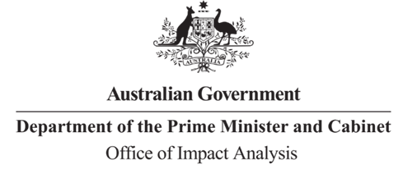

Reference: OBPR22-02555  
Telephone: 6271 6270  
e-mail: [helpdesk-oia@pmc.gov.au](mailto:helpdesk-obpr@pmc.gov.au)

Mr Richard Windeyer  
Deputy Secretary  
Department of Infrastructure, Transport, Regional Development, Communications and the Arts  
  
Dear Mr Windeyer  
  
**Impact Analysis – Second Pass Final Assessment – Australia Post Modernisation and Long Term Financial Sustainability**

Thank you for your letter of 25 October 2023 submitting an Impact Analysis (IA) for formal Second Pass Final Assessment. I note the IA has been formally certified at the Deputy Secretary level consistent with the Australian Government Guide to Policy Impact Analysis.

I appreciate the Department’s constructive engagement on the IA.

The Office of Impact Analysis’ (OIA) assessment is that the quality of the analysis in the IA is adequate. However, I note the very constrained timeframes between the first and second pass assessment of the RIS was not conducive to giving due consideration to feedback on opportunities to improve the RIS to achieve a rating consistent with ‘good practice’

**Next steps**

After a final decision has been announced, I ask that your agency work with OIA to finalise this material for public release. This includes providing a copy of the IA in Word and PDF format for web accessibility purposes. The IA must be included in any Explanatory Memorandum or Statement giving effect to the proposals in the IA.

If you have any further queries, please do not hesitate to contact me.

Yours sincerely

Rob Reilly  
A/g Executive Director  
Office of Impact Analysis  
25 October 2023

|  |  |  |  |
| --- | --- | --- | --- |
| |  | | --- | |  | | |  | | --- | | 1 National Circuit, Barton ACT 2600 • Telephone 02 6271 6270 • Internet oia.pmc.gov.au | |