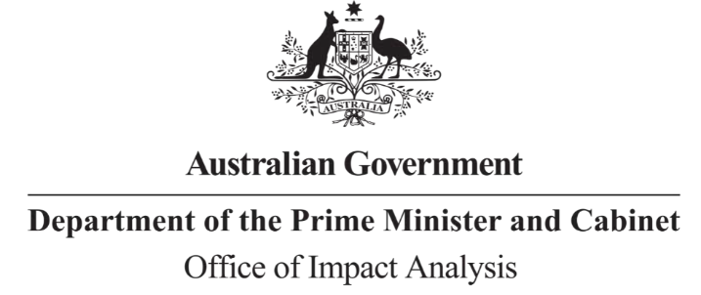

Reference: OIA23-05842

Telephone: 6271 6270 e-mail: [helpdesk-oia@pmc.gov.au](mailto:helpdesk-oia@pmc.gov.au)

Mr Hamish Hansford Deputy Secretary Department of Home Affairs

Dear Mr Hansford

# Impact Analysis – Second Pass Final Assessment – Mandatory security standards and industry-led voluntary cyber security labelling scheme for consumer-grade smart devices

Thank you for your letter of 10 October 2023 submitting an Impact Analysis (IA) for formal Second Pass Final Assessment. I note the IA has been formally certified at the Deputy Secretary level consistent with the *Australian Government Guide to Policy Impact Analysis* (the Guide).

I appreciate the Department’s constructive engagement on the IA. The Office of Impact Analysis’ (OIA’s) assessment is that the quality of the analysis in the IA is ‘Adequate’ and therefore sufficient to inform a decision.

To have been assessed as ‘good practice’ under the Guide, the IA would have benefitted from:

* A clearer outline and discussion on how each option achieves the policy objective
* Additional detail on the assumptions that underpin the regulatory costs, specifically for the costs to retailers
* Further evidence and analysis of the consequences of maintaining the status quo. The IA may now be provided to the decision maker to inform their decision.

# Next steps

After a final decision has been announced, I ask that your agency work with OIA to finalise this material for public release. This includes providing a copy of the IA in Word and PDF format for web accessibility purposes. The IA must be included in any Explanatory Memorandum or Statement giving effect to the proposals in the IA.

If you have any further queries, please do not hesitate to contact me. Yours sincerely

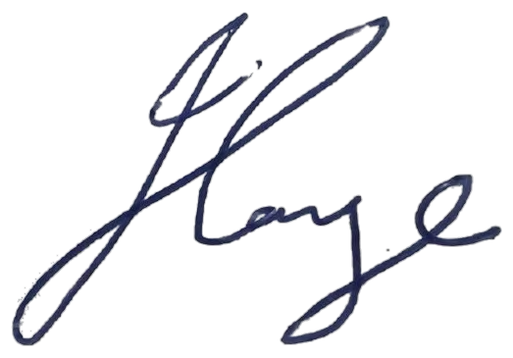

Jason Lange Executive Director

Office of Impact Analysis 11 October 2023