

Our Ref: EC23-005381

Deputy Secretary Tania Rishniw

Mr Rob Reilly

Acting Executive Director

Office of Impact Analysis

Department of the Prime Minister and Cabinet

1 National Circuit

BARTON ACT 2600

[Email: Helpdesk-OIA@pmc.gov.au](mailto:Helpdesk-OIA@pmc.gov.au)   
Dear Mr Reilly

**Impact Analysis – New Voluntary Pre-Employment Service for Parents of Young Children – Second Pass Final Assessment**

I am writing in relation to the attached Impact Analysis (IA) prepared for the new voluntary pre-employment service for parents of young children.

I am satisfied that the IA addresses the concerns raised in the letter from

Mr Jason Lange of 19 October 2023. Specifically, additional information has been

added to:

* clarify the method used to determine which option has the greatest net benefit
* include more information on the elements underpinning the Regulatory Burden Estimate including distinguishing the regulatory costs of the new service from those for the proposed extension to ParentsNext
* refer to the potential impact of the proposed options on particular cohorts
* clarify the status of the IA at each major step in the policy development process.

The estimated regulatory costs are $8.78 million per year on average for the new service and $3.94 million for ParentsNext in 2024-2025. Almost all of these costs relate to compliance costs, primarily record keeping and reporting costs, for organisations that are engaged to deliver these services.

Accordingly, I am satisfied that the IA is now consistent with the six principles for government policy makers as specified in the *Australian Government Guide to Policy Impact Analysis*.

I submit the IA to the Office of Impact Analysis for formal final assessment. Yours sincerely

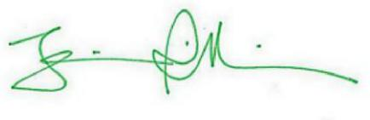

Tania Rishniw

17 / 11 / 2023