**IPEF Supply Chain Agreement Policy Impact Analysis**

**Introduction**

This Impact Analysis (IA) relates to the Indo-Pacific Economic Framework for Prosperity Agreement Relating to Supply Chain Resilience (“the IPEF Supply Chain Agreement”) between Australia, Brunei Darussalam, Fiji, India, Indonesia, Japan, Republic of Korea, Malaysia, New Zealand, Philippines, Singapore, Thailand, the United States, and Viet Nam.

The Indo-Pacific Economic Framework for Prosperity (IPEF) is an initiative to strengthen the Indo-Pacific region’s economic resilience. It represents a new approach to contemporary regional trade and investment issues. IPEF will include a combination of commitments, rules and standards, but unlike traditional free trade agreements, it will not include market access (such as cutting import tariffs or opening up industries to greater foreign participation). In entering into discussions on IPEF, Australia’s objective is to ensure it complements – and does not undermine – work being undertaken in other multilateral institutions and regional agreements, including the World Trade Organization (WTO), International Labour Organisation (ILO), Comprehensive and Progressive Agreement for Trans-Pacific Partnership (CPTPP), the Regional Comprehensive Economic Partnership (RCEP) and the Asia-Pacific Economic Cooperation (APEC) forum.

The IPEF is a new regional economic agreement across four pillars. These pillars are: Pillar I (Trade); Pillar II (Supply Chains); Pillar III (Clean Economy); and Pillar IV (Fair Economy). Each of these pillars is intended to form its own standalone international agreement. Participation in all pillars is not a prerequisite for IPEF membership; India, for example, has to date elected not to participate in negotiations for Pillar I (Trade).

IPEF was initiated by the Biden Administration as an economic pillar under its Indo-Pacific Strategy. In June 2022, Australia advised the United States it would join discussions on all four IPEF pillars, pending the formal commencement of negotiations. On 12 September 2022, the Minister for Trade and Tourism joined 13 other ministers from across the region to launch formal negotiations on IPEF. Final negotiations on the text of Pillar II (Supply Chains) concluded in May 2023, culminating in a ministerial announcement in the margins of the APEC Trade Ministers Meeting in Detroit. This followed four formal in-person negotiation rounds: Brisbane (December 2022); New Delhi (February 2023); Bali (March 2023); and Singapore (May 2023). Rolling intersessional negotiations occurred virtually between rounds and written submissions of negotiation positions were submitted throughout this process.

The text of Pillar II (Supply Chains) has now been “legally scrubbed” to remove errors and ambiguities and is ready for signature as the IPEF Supply Chain Agreement. In accordance with the Australian Government’s Guide to Policy Impact Analysis, the Department of Foreign Affairs and Trade (DFAT) has completed this IA to analyse the impact of the decision to sign the IPEF Supply Chain Agreement.

The remaining three IPEF pillars are subject to ongoing negotiation at this time. Given the divergent timelines, the impact analysis for those pillars will be prepared subsequently.

**Status of the Impact Analysis**

In line with advice from the Office of Impact Analysis (OIA), DFAT submitted an Early Assessment Impact Analysis to support the decision to announce the substantial conclusion of negotiations for the Agreement in May 2023.

In consultation with the Office of Impact Analysis (OIA), DFAT subsequently developed this final Impact Analysis to inform the decision on the concluding mandate and the support the proposal to sign the Agreement.

**Question 1 Problem Identification - What is the problem you are trying to solve and what data is available?**

1. *Supply chain disruptions are increasing in frequency and severity*

There is no universally-accepted definition of what constitutes a “supply chain”. In one commonly referenced definition, “a supply chain includes all the raw materials and parts that are made into a product and distributed up the chain for manufacture and sale” (McKinsey, 2022).

Article 1 of the IPEF Supply Chain Agreement defines a “supply chain disruption” as:

“a severe interruption, delay, or shortage that (a) impacts one or more Parties; and (b) significantly impairs the production of, the cross-border movement of, or access to, materials, articles, or commodities or the delivery of related essential services, as determined by an affected Party”

The IPEF Supply Chain Agreement’s preamble acknowledges that such “supply chain disruptions may be due to, among other causes, pandemics and regional epidemics, weather events, disasters…cyber incidents, logistical interruptions, insufficient supply of raw materials or components, bottlenecks, or armed conflict”.

Supply chains have always been subject to disruption. However, the frequency and severity of disruptions have risen in recent years, driven by increasingly interconnected supply chains and global flows of data, finance, and people that offer more “surface area” for risk to penetrate and ripple across highly-networked economies.[1] Even prior to the COVID-19 pandemic, averaging across industries, companies could expect supply chain disruptions lasting a month or longer to occur every 3.7 years.[2] While businesses are generally adept at adapting to 1-2 supply chain disruptions, concurrent shocks, deeply interconnected risks and eroding resilience are giving rise to the risk of polycrises – where disparate crises interact such that the overall impact far exceeds the sum of each part.[3]

The global COVID-19 pandemic was a significant shock for global supply chains. According to IMF analysis, (pre-Ukraine war) supply chain disruptions subtracted between 0.5 and 1.2 per cent from global value added during the global recovery in 2021, while also adding about 1 per cent to global core inflation that same year.[4] The disruptive impact of COVID-19 on global supply chains is perhaps best captured by the Federal Reserve Bank of New York Global Supply Chain Pressure Index (GSCPI), as shown in Figure 1 below:

Figure 1

While these global bottlenecks have recently begun to reduce, particularly on the back of declining shipping costs, business continues to plan for ongoing supply chain volatility. In a 2023 survey of more than 1000 executives from large global organisations operating complex supply chains, 44% of respondents said they expected more shocks in the coming 24 months, with the primary challenges being price volatility, inflation, shortages in materials and labour, and geopolitical instability.[5]

Australia’s supply chains have generally proven resilient in response to the COVID-19 pandemic, trade restrictions, natural disasters and Russia’s illegal invasion of Ukraine. However, these experiences have highlighted potential vulnerabilities and fragilities in Australia’s supply chains, including for critical goods such as personal protection equipment (PPE), pharmaceuticals, fertilisers and chemicals.[6] According to the Ai Group CEO Survey for 2023, 79 per cent of Australian businesses reported supply chain disruptions in 2022, up from 65 per cent in 2021.[7]

Figure 2

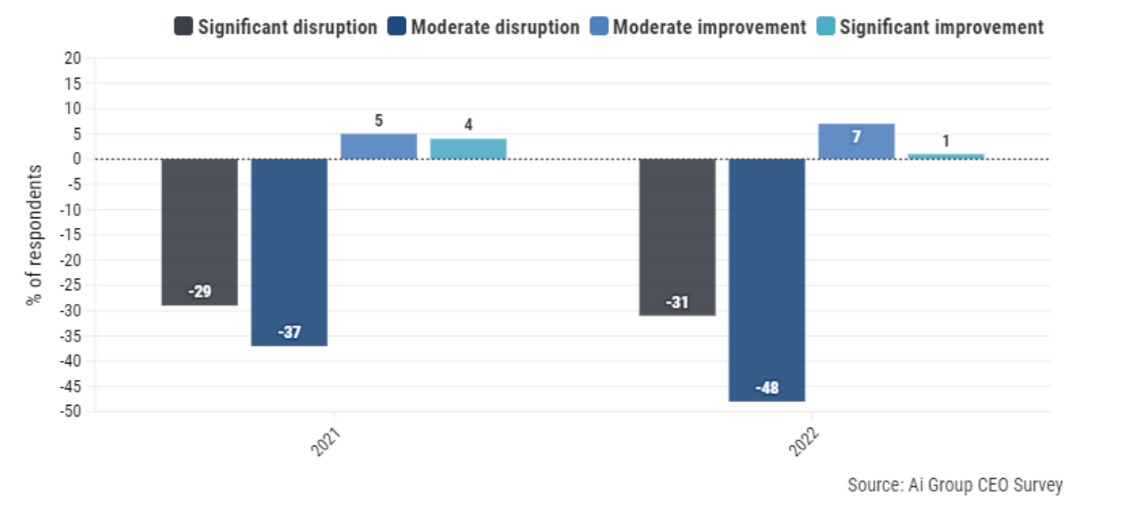

As shown in Figure 3, these disruptions impacted both large businesses (89 per cent) and small businesses (79 per cent), with supply chain disruptions being the top factor shaping Australian business investment plans.[8] While supply chain disruptions appear to have been particularly prevalent in the manufacturing sector (88 per cent of respondents), the fact that nearly four-fifths of all respondents experienced either moderate or significant disruption indicates the generalised nature of the challenge facing Australian business.[9]

Figure 3

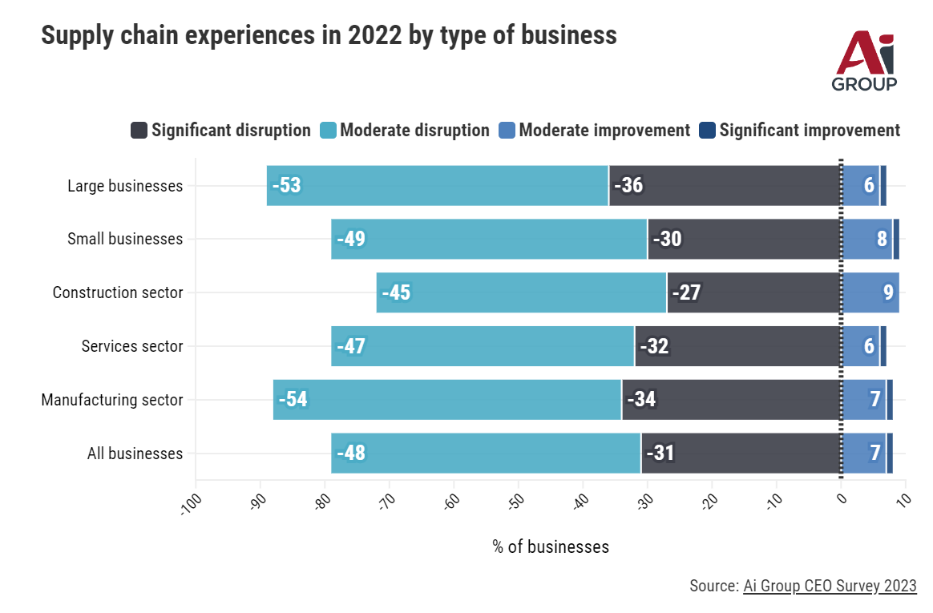

According to one estimate, global supply chain issues cost Australian firms $11 billion in lost sales a year.[10] However, the costs are not limited to industry alone: supply chain disruptions have flow-on implications for Australian consumers. In a survey of 10,000 consumers across eight countries and three continents conducted in late 2022, 89 per cent of Australian consumers reported concerns around shipping delays and product availability – the highest of any of the eight countries surveyed.[11] 39 per cent of Australian consumers said they experience delivery times to be slower than usual, compared to 31 per cent of consumers globally.[12] More than two fifths (41 per cent) of Australian consumers had found products they wanted to purchase were not available at all, and more than one fifth (21%) said they had experienced product availability issues after placing an order.[13] Both figures are higher than the global average. This is broadly consistent with a survey of Australian consumers by McKinsey in August-September 2022, which found that three in five respondents had been unable to make a purchase due to stock unavailability, especially in the groceries and food sector.[14]

**Figure 4**

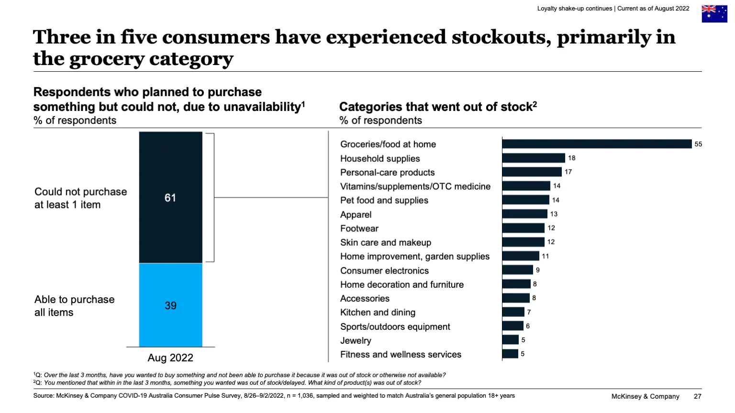

Supply chain disruptions are best managed by the private sector, which is generally best placed to balance the benefits and costs of risk mitigation for different types of disruptions and contexts. Nevertheless, some supply chain disruptions have significant spill over externalities for national security, public health and safety, and overall national economic stability. Such disruptions are therefore of concern for government.

In 2021, in response to disruptions stemming from COVID-19, the Australian Government tasked the Productivity Commission (PC) to conduct a study into Australia’s import supply chains, identify areas of supply concentration, and provide recommendations to bolster resilience. The PC developed a framework to identify supply chains that are vulnerable to disruption, and applied it to Australian imports and exports. Analysis based on the PC framework identified seven critical and vulnerable product categories (pharmaceuticals, personal protective equipment, agricultural production chemicals, water treatment chemicals, semiconductors, telecommunications equipment and plastics).

Following this study, the Office of Supply Chain Resilience (OSCR), now within the Department of Industry, Science and Resources, was established on 1 July 2021 to refine the PC framework and lead whole-of-government coordination to identify and manage vulnerabilities in Australia’s critical supply chains at risk of disruption. OSCR leads the Australian Government’s implementation of the *Framework for Identifying and Mitigating Critical Supply Chain Risks*, which draws on data and expert insights to assess vulnerabilities to the supply of essential imports. It recognises the private sector’s ability to mitigate their own risks and, where needed, identifies targeted and proportionate government actions to improve resilience, where necessary. This framework in turn guides work across government to monitor key supply chains and supports respective departments to manage risks within their portfolio responsibilities, with OSCR’s serving as the point of whole-of-government coordination. The scope of this work is illustrated below in Figure 5. Using this analysis to inform thinking, Australia works internationally through multilateral forums and bilateral relationships to shape rules and norms to reflect Australia’s interest in supply chain resiliency.

**Figure 5**

|  |  |
| --- | --- |
| Departments and Agencies | **Responsibilities** |
| **Department of Agriculture, Fisheries and Forestry** | * Food security * Agricultural production chemicals * Development of Timber Fibre Strategy |
| **Department of Climate Change and Energy, the Environment and Water** | * AdBlue/Diesel Exhaust Fluid * Clean energy supply chains |
| **Department of Defence** | * Critical defence supplies |
| **Department of Employment and Workplace Relations** | * Developing options to address workforce and skills shortages |
| **Department of Foreign Affairs and Trade** | * Trade policy and negotiations * Monitoring global supply chain developments, including via the overseas diplomatic network * Diplomatic partnerships and dialogue |
| **Department of Health and Aged Care** | * Pharmaceutical supply chains, including medicine shortages * National Medical Stockpile |
| **Department of Home Affairs** | * Critical infrastructure * Security of telecommunications * Crisis management and coordination through the National Coordination Mechanism * Australia’s representative to the Quad Critical Technology Working Group |
| **Department of Infrastructure, Transport, Regional Development and Communications and the Arts** | * Freight and transport * Maritime strategic fleet * Telecommunications engagement |
| **The Treasury** | * Economic coercion and implications of supply chain disruptions * Tariff policy |

1. *Concentration and chokepoints in critical supply chains*

A common feature of modern global supply chains is the use of concentrated hubs of suppliers to improve production efficiency and realise comparative advantages. However, these same concentrations can magnify shock propagation and increase the vulnerability of firms and the broader supply chain to disruption.[15] Similarly, countries can become vulnerable when they rely too heavily on imports for the majority of their demand, particularly when the sources of imports are highly concentrated and limited. Excessive geographic clustering can make products particularly vulnerable to a range of possible shocks, from natural disasters through to weaponised trade.

Australia’s whole-of-government *Framework for Identifying and Mitigating Critical Supply Chain Risks*, led by OSCR, assesses vulnerabilities are greater when a supply chain has high import concentration, high global concentration of a supplier, or high import reliance relative to production. OSCR’s approach further identifies *critical* supply chains by filtering those vulnerable imports which, if disrupted, would cause substantial impacts to Australia’s national security, economic stability, and/or public health and safety. Market concentration is a key indicator for critical vulnerabilities, noting that a further holistic qualitive assessment is essential to account for strategic dependencies not apparent in the trade data, while filtering out products that are non-critical. [16]

Supply chain disruptions arising from excessive import concentrations can occur and play out in unexpected ways. An example of this was the 2021-22 shock to Australia’s supply of technical grade urea (TGU), the main ingredient of Diesel Exhaust Fluid (or “AdBlue”). With Australia at the time heavily reliant on China for TGU imports, the disruption raised serious concerns about the potential to shut down the Australian trucking industry, thereby driving up the cost of goods and freezing the movement of products domestically.[17] Domestic prices surged, and market distorting consumer behaviour ensued. The disruption similarly raised the prospect of shortages for some of Australia’s regional partners, notably Japan and the Republic of Korea, with the latter reliant on China for 95 per cent of urea imports.[18] The mobilisation of overseas diplomatic and commercial networks (especially in Japan and Indonesia) to source TGU supplies, combined with significant government support to ramp up domestic AdBlue production, was crucial in averting crisis. This experience of the urea shock regularly proved to be a recurring reference point throughout the IPEF Pillar II (Supply Chains) negotiations, framing disruptions and concentrated supply chains as a common challenge necessitating regional cooperation.

Recent analysis by the Peterson Institute for International Economics highlights the extent to which supply chain concentration and excessive import reliance are increasingly a feature of the Indo-Pacific region. Using the Herfindahl-Hirschman index (HHI) to analyse each IPEF country in both 2010 and 2021, the analysis finds that import (and export) destinations have become less diversified on average for all IPEF countries:

“Overall IPEF countries now rely more heavily on a smaller set of import sources and export destinations than they did a decade ago, and their import and export patterns have become far less diversified across partners, most notably for middle-income countries emerging as alternative sites for production currently located in China.”[19]

As can be seen from Figures 6 and 7 below, Australia sits roughly in the middle of this trend, with import sources becoming 40 per cent less diverse between 2010 and 2021.

Figure 6

Figure 7

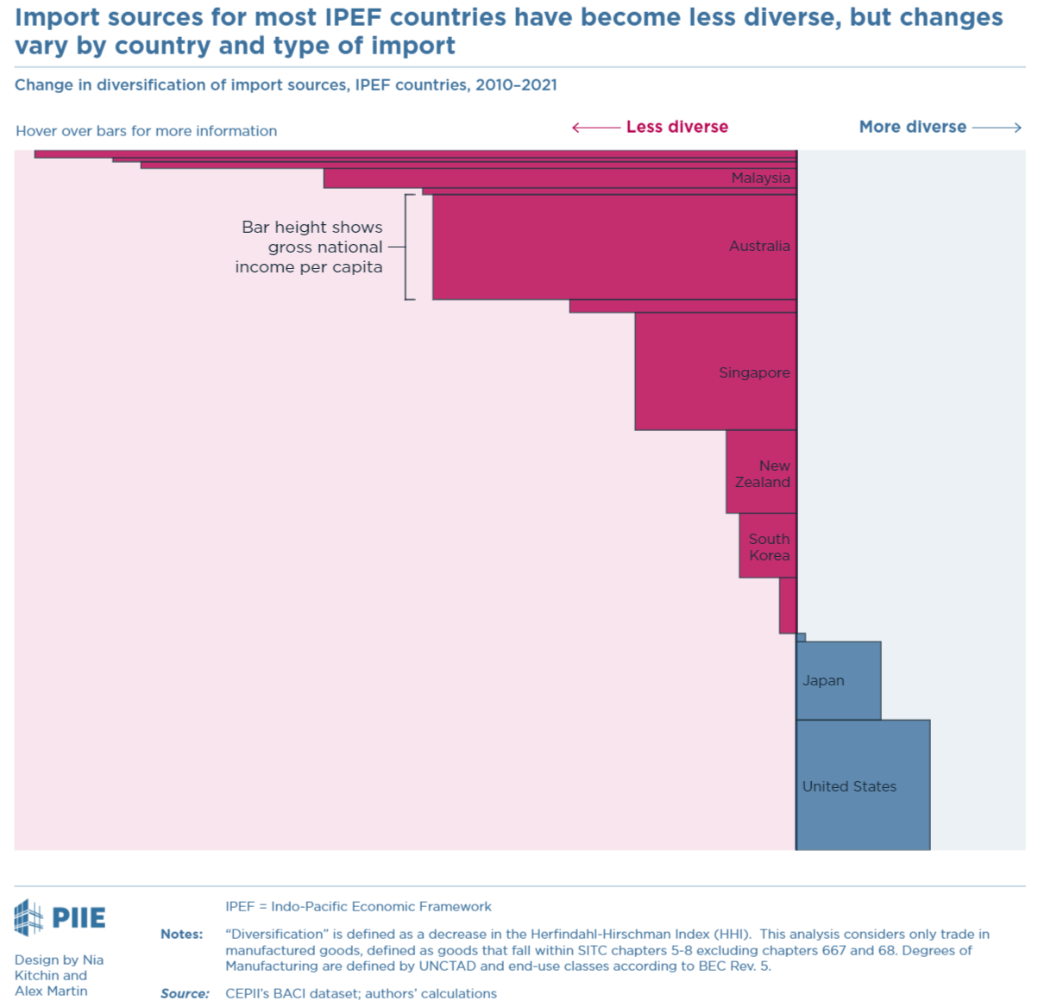

**Question 2 - What are the objectives, why is government intervention needed to achieve them, and how will success be measured?**

Supply chains are the function of private firms in commercial arrangements. Government interventions can cause market distortions and impede the ability of private firms to manage risk, thereby exacerbating supply chain shortages and disruptions. However, governments can play an important supportive role in ensuring firms do not face unnecessary constraints on how they plan for and respond to disruptions.[20] The provision of a trusted and rules-based trading environment, for example, facilitates the ability of firms to diversify their suppliers in preparation for disruptions, and to source alternative supply when disruptions occur.[21]

As identified in Question 1, for a narrow band of critical sectors and goods, normal commercial sourcing practices have led to excessive market concentrations globally that pose unacceptable spill over risks for Australia’s security, public health and overall economic resilience. Profit-maximising private firms may not have the information, capacity or incentives to satisfactorily mitigate these critical risks to broader public goods. While government-supported onshoring of critical supply chains in Australia can play a role in mitigating certain risks, it would be beyond Australia’s capacity or cost tolerance to address all identified supply chain vulnerabilities through onshoring alone. For example, it would not be realistic for Australia to replicate the intricate, highly-globalised and hyper-specialised supply chain networks that underpin the manufacturing of today’s advanced semiconductors.

In determining responsible, targeted and proportionate government action, the *Framework for Identifying and Mitigating Critical Supply Chain Risks* assesses the risk to disruption and existing capacity of the private sector to manage this risk. Potential actions to address the residual risk are considered from lowest to highest cost based on the level of residual risk. Examples of lower cost action, include international collaboration and facilitating international investment.

Many of the product categories identified as vulnerabilities for Australia (e.g. semiconductors, critical pharmaceuticals, agricultural chemicals, water treatment chemicals etc) are also shared by Australia’s partners in the Indo-Pacific region. This creates a strong basis for likeminded countries to cooperate to incentivise new supply chain networks that help mitigate common risks, reducing the need for countries to embark on duplicated onshoring measures or heavy-handed government regulation.

Nevertheless, there are inherent limitations that come with pursuing supply chain resilience objectives in an international setting. While many of Australia’s supply chain vulnerabilities are common across the Indo-Pacific region, each country has its own unique economic, political and security interests that shape how it approaches supply chain challenges. In some sectors, there can exist competition as nations vie for limited investment capital or seek to shore up their industries through measures such as tariffs, export restrictions or subsidies. This can discourage international collaboration and the sharing of information, resources and best practices needed to address common challenges and systemic issues in supply chains.

In this context, Australia’s overarching objective in international supply chain engagement has been to maximally replicate our own carefully-balanced, evidence-based and risk-triaged approach on supply chains, and to establish this as a basis for greater cooperation to strengthen our region’s collective supply chain resilience.

This overarching objective can be broken down into the follow subcomponents:

1. accelerate the diversification of critical supply chains. The core metric to measure this will be import and global market diversification / concentration, such as the Herfindahl-Hirschman index (HHI). While such metrics do not perfectly correlate with the somewhat broader concept of “resilience”, and generally rely on open-source trade data (which has limitations in terms of time lag, aggregation etc), they are nevertheless a useful comparative proxy for overall regional trends. Australia’s supply chain vulnerabilities will continue to be assessed by the Office of Supply Chain Resilience.
2. seek commercial opportunities for Australian industries.Australia’s unique export capabilities, for example in areas such as critical minerals, can make an important contribution to the region’s supply chain resilience. As it is typically not possible to isolate the contribution of a particular international agreement or factor in commercial decision-making, assessing this will mostly rely on qualitative feedback from Australian industry.
3. promote evidence-based supply chain resilience approaches by our international partners so to limit government intervention to where it is genuinely needed. This will be assessed numerically by the increase in the number of countries adopting such methodologies, similar to Australia’s, to publicly identify their national lists of critical supply chains.
4. make regional responses to supply chain disruptions more systematic and coordinated.This can ultimately only be qualitatively assessed after a supply chain crisis or disruption occurs. However, the number of crisis preparation tabletop exercise jointly undertaken, supplemented with qualitative feedback from the Office of Supply Chain Resilience, could be used as a supplementary proxy measurement of regional crisis preparedness.

**Question 3 - What policy options are you considering?**

This Impact Analysis considers two options: to sign or not sign the IPEF Supply Chain Agreement.

**Option 1 – Australia does not sign the IPEF Supply Chain Agreement**

Australia can choose not to sign the IPEF Supply Chain Agreement and can focus on existing bilateral, plurilateral and multilateral efforts in the Indo-Pacific region to deliver on the policy objectives set out in this Impact Analysis.

Further, Australia can leave markets to function without Australian Government signals or action. To some degree the marketplace will slowly accommodate the risks outlined in this IA, although this is likely to be over the medium to long term, unless a disruption forces markets to adjust more immediately.

Australian exporters have preferential market access to most of the economies of IPEF partners and can seek opportunities in these markets. Australia could seek to expand work on supply chain resilience cooperation through existing regional trade agreements such as the Comprehensive and Progressive Agreement for Trans-Pacific Partnership (CPTPP) and the Regional Comprehensive Economic Partnership (RCEP), and through Australia’s various bilateral free trade agreements. Rather than undertaking new work through IPEF, Australia could seek to expand and accelerate existing cooperation on supply chain issues through the various workstreams of the Asia-Pacific Economic Cooperation (APEC). Australia could also look to build on existing international supply chain structures such as the Supply Chain Resilience Initiative (SCRI).

**Option 2 – Australia signs the IPEF Supply Chain Agreement**

If Australia signs the IPEF Supply Chain Agreement, it will be joining a grouping of 14 countries in establishing new regional economic architecture focused specifically on supply chain issues, including in the form of new regional committee structures.

Central to the IPEF Supply Chain Agreement is the development of common criteria, heavily influenced by Australia’s own framework developed by the Productivity Commission and led by the Office of Supply Chain Resilience, that parties commit to use in identifying their “critical sectors or key goods” for the purposes of supply chain cooperation. This is intended to ensure countries nominate as critical only those sectors and goods that genuinely require government attention and/or intervention, and to ensure this is accompanied by a genuine evidence-based attempt at assessing “criticality”.

Given the global nature of supply chains, and associated costs with opening new markets, commonly identified critical sectors and key goods would help reinforce domestic actions to build resilience in Australia’s critical supply chains.

The Productivity Commission developed figure 7 to show the relationship between criticality, essentiality and vulnerability required for Government action.[22] Further details of this framework can be found in Chapter 3 of the Productivity Commission Study Report on Vulnerable Supply Chains July 2021.

Figure 8

Figure 3.2. This is a Venn diagram that shows how the analytical framework is used to assess supply chain vulnerability. There are three circles labelled Vulnerable, Essential, and Critical. The circles are subsets of all goods and services. There are arrows to highlight the Commission’s approach to assessing vulnerable supply chains. First, the goods and services that are vulnerable are found. Second, the overlap between the vulnerable and essential circles is found. In the last step, the overlap between the vulnerable, essential and critical circles is found.

The particapation of multiple countries with different views in the IPEF negotiations meant replicating the approach that Australia uses was not possible in the text of the IPEF Supply Chain Agreement, but the text does set out a method for ‘identifying critical and vulnerable sectors’ in a similar fashion to the current Australian Government approach. See below excerpt from the IPEF Supply Chain Agreement:

***Article 10: Identifying Critical Sectors or Key Goods***

*1. The Parties intend to develop a shared understanding of global supply chain risks, and to support this, each Party shall identify its critical sectors or key goods. Each Party intends to consult with and consider input and recommendations from a diverse set of relevant stakeholders as appropriate, such as the private sector, government authorities, academia, non-governmental organizations, and representative workers’ organizations, to identify critical sectors or key goods.*

*2. In identifying its critical sectors or key goods, each Party intends to consider factors such as:*

*(a) the impact of a potential shortage on its national security, public health and safety, or prevention of significant or widespread economic disruptions;*

*(b) the level of dependence on a single supplier or a single country, region, or geographic location;*

*(c) geographic factors including actual or potential transport constraints, especially for its island or remote regions;*

*(d) the availability and reliability of alternative suppliers or supply locations;*

*(e) the extent of imports required to meet domestic demand;*

*(f) the availability**of domestic production capacity; or*

*(g) the extent of interconnectedness with other critical sectors or key goods.*

When comparing the IPEF Supply Chain Agreement text above with an excerpt from the Productivity Commission Study Report, Australia’s approach to defining criticality and vulnerability is reflected in the IPEF Supply Chain Agreement:

*Productivity Commission Study Report Vulnerable Supply Chains July 2021*

*The Commission has developed a framework to identify supply chains for goods and services that are vulnerable to disruptions and whose absence would jeopardise the functioning of the economy, national security and Australians’ wellbeing.*

*A novel feature of the framework is the development of a ‘data‑with‑experts’ approach (figure 1). It casts a wide net by first identifying those products that are vulnerable to supply chain disruptions using a data scan. Then it identifies which of these vulnerable products are used in essential industries. The final step relies on expert assessment to stress test the data‑driven analysis and to determine, from among the vulnerable products used in essential industries, those which are critical (goods and services that cannot be substituted easily, or the production process cannot be adjusted in the short term to avoid their use).*

Through the IPEF Supply Chain Agreement the following committee structures will be established:

* An IPEF Supply Chains Council focused on delivering Action Plans in identified critical sectors to increase the resilience, efficiency, productivity, sustainability, transparency, diversification, security, fairness, and inclusivity of IPEF supply chains. This will provide new opportunities for Australian exporters to meet the identified needs in critical sectors of international partners in IPEF.
* An IPEF Supply Chain Crisis Response Network to serve as an emergency communications channel in the event of a supply chain disruption to rapidly disseminate relevant information among the Parties of the and facilitate cooperation on responses.
* A Labor Rights Advisory Advisory Board composed of three representatives for each Party: (a) a senior official from the central level of government who is responsible for labor matters; (b) a worker representative; and (c) an employer representative.
* A Subcommittee of the IPEF Labor Rights Advisory Board, consisting of the government representatives of this board.

Also, as outlined in the IPEF Supply Chain Agreement, Australia would do the following things:

* Establish or maintain, consistent with domestic law, a reporting mechanism to receive, including through electronic means, allegations of labour rights inconsistencies at subject facilities located in the territory of another Party.
* Undertake cooperative activities to increase the resilience, efficiency, productivity, sustainability, transparency, diversification, security, fairness, and inclusivity of IPEF supply chains, taking into account the different economic and geographic characteristics and capacity constraints of each Party as well as the individual characteristics of different sectors and goods.
* Work collaboratively across the IPEF membership to minimise unnecessary restrictions or impediments creating barriers to trade affecting the resilience, efficiency, productivity, sustainability, transparency, diversification, security, fairness, and inclusivity of IPEF supply chains.

**Question 4 - What is the likely net benefit of each option?**

In assessing the net benefits of each of the options, DFAT has used a qualitative assessment methodology underpinned by data where possible. This approach was chosen to allow for strategic policy nuances and the anecdotal evidence DFAT has received through stakeholder engagement. DFAT has made qualitative assessments in this discussion using existing foreign and trade policy expertise.

***Option 1 – Australia does not sign the IPEF Supply Chain Agreement***

Should Australia not sign the IPEF Supply Chain Agreement, and the status quo continue, then it is anticipated that supply chains would continue on their long-term trend toward supply chain diversification and adjusting the risk calculation while maintaining some ‘just in time’ supply chains. We would expect that Government’s across the Indo-Pacific region and globally will continue and increase in their use of industrial policies and subsidies to accelerate this trend of diversification and on-shoring. A survey of Chief Financial Officers (CFOs) from across North America showed that most CFOs anticipated increasing the diversification of their supply chains and almost a third said they would reduce their supply chain sourcing from China.[23]

Figure 9

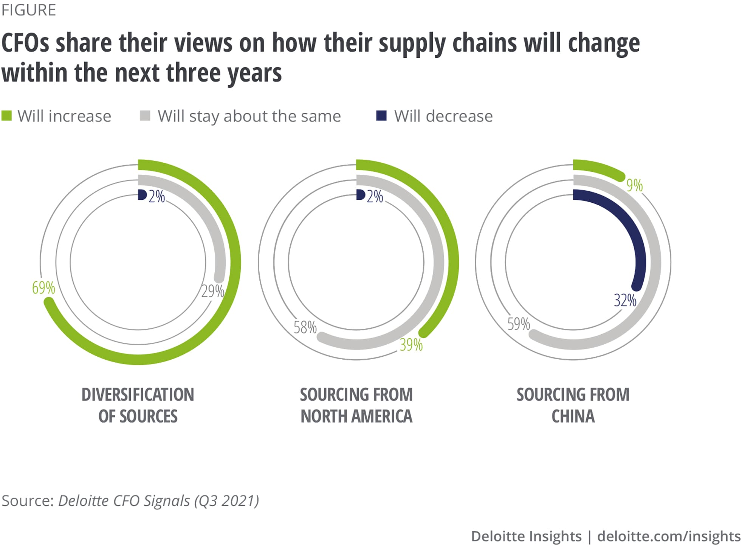

Australia’s supply chain resilience framework led by OSCR would continue to work toward greater supply chain resilience for Australia and Australian industry would continue engaging with OSCR. Australia would seek to mitigate harm of supply chain disruptions caused on industry by continuing to build industry’s capacity to understand and mitigate risks in their supply chains. As an example, the Supply Chain Roundtable, and ongoing industry engagement, would continue to seek to engage early with Australian industry – who usually have the information and means to best manage risks. OSCR would become more involved when there is a supply chain disruption too wide of complex for industry to resolve without Government support. OSCR actions, as part of Government, would in such cases seek to assist and support the actions of industry to manage a disruption.

Australia would also likely ramp up its to work with partners in the region through existing multilateral and bilateral structures to support the diversification and resilience of critical supply chains. This would probably include replicating some of the cooperative initiatives in the IPEF Supply Chains Agreement but in a more ad hoc way and without entering into the full agreement.

***Option 2 – Australia signs the IPEF Supply Chain Agreement***

DFAT’s qualitative assessment is that signing the proposed IPEF Supply Chain Agreement will result in a net benefit for Australia. It will provide Australia with useful supply chain resilience policy levers in the international context, it will send positive signals to the market of the need to diversify critical supply chains, promote evidence-based supply chain resilience approaches by our international partners, and make regional responses to supply chain disruptions more systematic and coordinated.

This assessment is supported by studies. In 2018, DFAT commissioned an independent study on business utilisation of Australia's trade agreements. The Free Trade Agreement Utilisation Study undertaken by PricewaterhouseCoopers (PwC) found Australia's trade agreements, focusing on our FTAs with China, Japan and Korea, were having a positive impact on business confidence, activity, strategy, expansion planning, and international investment, including in services sectors. The PwC research highlighted the 'head turning' effect of Australia's trade agreements with China, Japan and Korea, contributing to the positive perception of Australia as a place to invest and do business.

In the same way that free trade agreements signal government commitment to market liberalisation, DFAT assesses the proposed IPEF Supply Chain Agreement will send an important market signal about the enduring commitment of regional governments to supply chain resilience and diversification. This will promote industry confidence needed to invest and do business in IPEF-identified critical sectors.

Benefits

DFAT assesses that the benefits of Option 2 can be broadly defined as primarily strategic, economic efficiencies and competitiveness, and through information sharing.

When other countries identify their “critical sectors or key goods” for the purposes of supply chain cooperation under IPEF, Australian importers and exporters will have an opportunity to focus production and build opportunities on those specific critical goods, such as critical minerals or clean energy. In addition, identification of “critical sectors or key goods” for Australia will be a signal to other IPEF countries to boost production of those goods, helping to reduce the exposure of the Australian economy to geographic chokepoints in critical supply chains. Australia already has preferential market access with all members of the IPEF Supply Chain Agreement, except for Fiji. This is also an opportunity to attract investment in these critical sectors, to support increased production and export of products to boost supply chain diversification.

Additionally, by signing the Agreement and continuing to be a part of regional economic policy discussions with IPEF international partners, Australia will be able to influence and reduce the likelihood of unilateral, interventionist market-distorting policies, such as what occurred during the COVID-19 pandemic when countries put in place a range of export controls on critical goods.

The IPEF Supply Chain Crisis Response Network provides an emergency mechanism for IPEF countries to draw on to ensure the timely delivery of critical goods during a supply chain disruption or crisis. The mechanism is deliberately flexible about what that support could look like and makes clear that government responses should facilitate private-sector driven solutions and minimise market distortions that could flow from government intervention. Significantly, this mechanism also serves as an early warning information sharing facility. This would provide Australia with early information of supply chain disruptions in the region; information Australia might not receive without this IPEF Supply Chain Agreement. It is difficult to quantity the value this could provide Australia in the event of a crisis but to contextualise the cost of supply chain disruption, supply chain delays cost Australian business $11 billion each year[24]. When the *Ever Given* container ship ran aground in the Suez Canal for six days in 2021 it is estimated it disrupted the movement of $10 billion worth of goods every day by holding up hundreds of cargo ships.

Once commitments under the IPEF Supply Chain Agreement are implemented, Australia would be joining a grouping of countries that represents 40 percent of global GDP and 28 percent of global goods and services trade. Through IPEF, those countries will have committed to improving the diversity, efficiency and resiliency of regional supply chains. By 2030, the productivity and other gains associated with widespread supply chain modernisation could increase Australia’s annual real GDP by 1.4% or $32.6 billion in 2020 dollars, investment by 1.6% ($8.8 billion) and exports by 1.2% ($6.6 billion).[25] While some of these economic gains can be achieved through domestic reform and investment, 70% of international trade involves complex global supply chains[26] which means regional cooperation and integration will be an essential part of Australia’s supply chain modernisation.

The IPEF Supply Chain Agreement encourages the lifting of labour standards within IPEF economies and, through the Labor Rights Advisory Board, includes a reporting mechanism to address modern slavery and labour rights abuses. By lifting labour standards across the region, there may be a marginal increase in Australian employment levels and a contribution to sectoral growth in some industries (especially in manufacturing). This will come about through improved Australian industry competitiveness, over the long-term, as a result of a reduced relative cost of labour in Australia compared to regional countries with improved labour standards.

The implementation of cooperative measures under the IPEF Supply Chain Agreement will allow Australia to prepare for and mitigate volatility in supply chains for critical goods, reducing the risk of the types of shortages which led to panic buying during the COVID-19 pandemic. Recent reports of supply chain disruptions – for example AdBlue (ABC, 2011 / 2022), building materials (AFR, 2022), cooking oil (ABC, 2022), wooden pallets (Sky News, 2022), non-ionic contrast agents (The Guardian, 2022) and carbon dioxide (The Australian, 2023) – demonstrate the ongoing challenge this volatility poses for Australian industry and consumers alike.

In the event of a supply chain disruption in the future, measuring what would happen if Australia were not a member of the IPEF Supply Chain Agreement is complex. Data considered in isolation may not always reveal the full picture. Hypothetical comparisons between possible disruptions and the responses are challenging and can be inaccurate. In addition, it is difficult to identify how the market will diversify and build resilience without the IPEF Supply Chain Agreement in force for Australia.

Finally, by signing the IPEF Supply Chains Agreement, Australia would avoid missing out on the international collaboration in supply chains as we anticipate most or all of the other IPEF countries will proceed to implement the agreement without Australia. Australia will also avoid harming its international reputation amongst IPEF countries (and possibly beyond) as a reliable and supportive trade and investment partner.

Costs

DFAT assesses the overall costs to be low, and primarily absorbed by Government although some minimal costs will be placed on Australian business. The costs can be broadly defined as additional reporting and compliance requirements and the time required for consultations between Government and industry.

Because the IPEF Supply Chain Agreement aligns closely with Australia’s own supply chain resilience framework and work, the burden of engaging with Government on Australian business is likely to be minimal. Australian industry is already engaging with the work being undertaken domestically by the Office of Supply Chain Resilience, and IPEF participation would provide industry with a greater understanding of the regional supply chain risks.

As with any international agreement, the IPEF Supply Chain Agreement will entail reciprocal obligations for Australia. Given ongoing food and energy security challenges in our region, some countries may have unrealistic expectations that the IPEF Supply Chain Agreement will provide greater access to Australian exports of commodities such as wheat and gas. While in some instances this may be possible, in many cases the scope for Australian Government intervention in private sector arrangements is likely to be limited. This will need to be managed carefully with IPEF partners, as well as close and ongoing consultation with the private sector.

The IPEF Supply Chain Agreement establishes a mechanism for IPEF members to increase transparency and address alleged instances of inconsistencies with internationally-recognised labour rights – the rights and principles contained within the International Labour Organization’s Declaration on Fundamental Principles and Rights at Work. It will enable an IPEF member, in instances where that member has a substantiated belief of a labour rights inconsistency in the territory of another IPEF member, to bring forward an allegation against that member. Both parties must then cooperate to resolve the allegation, and in the instance an allegation is not resolved, high-level and factual information relating to the complaint is published online (the date of the allegation, the labour right in question, the relevant sector and IPEF members party to the dispute). The publishing of this information does not pose a reputational risk to individual enterprises because they aren’t identified, but helps maintains pressure on the country to properly resolve the allegation.

DFAT’s assessment is that the operation of this mechanism will have minimal, if any, compliance cost impact on Australia’s private sector. This is due to Australia’s regulatory framework already embodying a high standard of labour rights protection. The Australian Government operation of this mechanism may involve a small additional resource impost on government administration that should be largely absorbed within existing available resources.

An important consideration in DFAT’s preference for *Option 2 – Australia signs the IPEF Supply Chain Agreement* is that the IPEF Supply Chain Agreement does not entail regulatory or legislative changes for Australia. The IPEF Supply Chain Agreement principally sets out non-binding commitments of member governments to cooperate with one another on the initiatives established. Initiatives under the IPEF Supply Chain Agreement will be delivered within existing resources for measures such as sharing best practice, facilitating investment, promoting interoperability, ensuring regulatory transparency (in line with Australia’s existing domestic frameworks), skilling up workers, and monitoring critical supply chains for disruptions.

The IPEF Supply Chain Agreement will not introduce obligations on business or trade unions, but will establish various mechanisms to ensure business and unions are consulted to inform decisions of the IPEF Supply Chain Council and Labor Rights Advisory Board. Australian representative business associations and unions will be asked to participate in some of these forums, which would require some degree of (optional) resourcing for business.

**IPEF Supply Chain Agreement Cost Benefit Analysis**

|  |  |  |  |  |
| --- | --- | --- | --- | --- |
| **Measure** | **Impacted stakeholders** | **Benefit** | **Cost** | **Net Impact of Measure** |
| Agreeing to a common criterion for critical sectors. | Government. | Reduces the space for Government intervention in the market unless necessary. | Nil costs to Australia as Australia already has well-functioning, evidence-based criteria which have effectively been incorporated into the IPEF Supply Chain Agreement. | Net benefit |
| Establishing a Supply Chains Council focused on delivering Action Plans in identified critical sectors. | Government, industry groups and business. | Creates a targeted stream of work to reduce critical supply chain vulnerabilities in the Indo-Pacific. | Industry consultations will be essential in informing this work, and a minimal time cost would be required for meaningful consultations with industry. | Net benefit |
| Establishing a Supply Chain Crisis Response Network. | Government, industry groups and business. | An emergency network to respond more effectively to the next supply chain crisis will benefit business and the Australian community. | Urgent industry consultations will be essential in informing this work, and the requirement for the urgent attention of industry would likely impose some minimal costs in the event of a crisis. | Net benefit |
| Establishing a Labor Rights Advisory Board including a reporting mechanism to address modern slavery and labour rights abuses. | Government, business, unions and Australian workers. | Lifting labour standards in the region helps make Australian labour more competitive. | Reporting can be time consuming and business will need to have visibility throughout their supply chain, imposing some additional costs on business. This is estimated to be minimal as the reporting does not go beyond existing reporting requirements. | Net benefit |
| Undertake cooperative activities to increase the resilience, efficiency, productivity, sustainability, transparency, diversification, security, fairness, and inclusivity of IPEF supply chains. | Businesses that trade internationally will benefit from a more secure and efficient operating environment. Consumers will be able to access goods more cheapy and more quickly. | More efficient and productive supply chains. | Minimal costs on business and the community as these are non-binding commitments that Australia will assess on a case-by-case basis, with the aim of minimising disruption for business and maximising economic efficiencies. | Net benefit |
| Work collaboratively across the IPEF membership to minimise unnecessary restrictions or impediments creating barriers to trade affecting the resilience, efficiency, productivity, sustainability, transparency, diversification, security, fairness, and inclusivity of IPEF supply chains. | Businesses that trade internationally will benefit from a more secure and efficient operating environment. Consumers will be able to access goods more cheaply and quickly. | More efficient and productive supply chains. | Minimal costs on business and the community as these are non-binding commitments that Australia will assess on a case-by-case basis, with the aim of minimising disruption for business and maximising economic efficiencies. | Net benefit |

**Question 5 - Who will you consult about these options and how will you consult them?**

In negotiating the IPEF Supply Chain Agreement, DFAT has consulted extensively across Government, industry and civil society to ensure Australia’s interests were reflected in the final agreement. DFAT consulted extensively with 21 agencies across government and ensured policy matter experts were part of the negotiation process.

Broadly, DFAT found stakeholders were strongly supportive of the strategic intent of the IPEF Supply Chain Agreement, and saw the value in the IPEF Supply Chain Agreement as an ongoing vehicle for strategic economic engagement in the Indo-Pacific region particularly by encouraging ongoing engagement from the United States. Stakeholders were wary of any provisions that could add additional burdens on businesses in meeting regulatory reporting requirements, which the IPEF Supply Chain Agreement has avoided.

Supply chains are managed by the private sector and function through the labour of workers. DFAT placed a priority on engaging with industry peak body groups and trade union representatives early and regularly in seeking to reflect their interests in Australia’s negotiating position on a potential IPEF Supply Chain Agreement. Consultation was an important part of the negotiation process for DFAT. It assisted with DFAT gaining a better understanding of the need to find tangible benefits in negotiations and to guard against the potential costs of excessive additional reporting burdens on business that would reduce the utility of any agreement.

DFAT provided stakeholders the ongoing opportunity to provide written submissions on the IPEF negotiations. Table 2 below outlines submissions received, which are also published on DFAT’s website. Calls for submissions were advertised on DFAT’s website and social media channels.

|  |  |  |
| --- | --- | --- |
| **Stakeholder** | **Key concerns and recommendations relating to supply chains** | **Addressed in IPEF Supply Chain Agreement** |
| Australian Council of Trade Unions | Ensure the supply chain pillar addresses violations of workers’ rights in company supply chains by embedding the requirement for companies in IPEF countries to undertake human rights due diligence to identify, prevent and address risks to worker’s rights, and enable workers in supply chains to seek redress when harm is caused by a company’s failure to conduct due diligence. | Somewhat |
| Ensure IPEF contains commitments to phase out the use of asbestos in supply chains across the region. | Somewhat |
| Australian Fair Trade and Investment Network | IPEF should establish a work program to assist all members to phase out production of, trade in, or use of all forms of asbestos fibres, whether or not bonded. This program should include target dates, education and funding programs to assist developing countries to meet these goals. | Somewhat |
| Australia should maintain its own independent trade and foreign policy in the region and work with others in IPEF to both diversify supply chains and avoid polarisation and instability in the region. | Addressed |
| Consumers Association of Penang | Nil | n/a |
| Microsoft | Security & Integrity: Ensuring components and systems protect against intentional malware, trojans, and defects. Security in critical infrastructure such as financial systems, healthcare systems, and national security systems is rooted in authentication at the layer of underlying hardware. | Somewhat |
| Continuity: Ensuring that bottlenecks in the supply chain have limited exposure to disruptions caused by geopolitical, natural disaster, or other location-specific risks. | Addressed |
| Visibility: Assign/update risk factors like manufacturing output, shipping slowdowns, or other unexpected events that can cause economic harm and then running what/if scenarios. | Addressed |
| Motion Picture Association Asia Pacific | Nil | n/a |
| The Software Alliance | Nil | n/a |
| Trade Justice Education Fund | Nil | n/a |
| Uniting Church in Australia | Nil | n/a |
| Australian Services Roundtable | Nil | n/a |

DFAT sought to reflect stakeholder interests on supply chain issues as much as possible in the negotiations. As noted above, however, DFAT was limited in its ability to fully deliver in the IPEF Supply Chain Agreement on all of the stakeholder recommendations, due to the limitations of the issues covered in negotiations and the give and take of an international multiparty agreement.

Based on stakeholder requests, Australia advocated extensively to incorporate a ‘phase out’ of all forms of asbestos (i.e. including chrysotile asbestos) throughout negotiations. However, this was a significant sensitivity that some international partners were unable to agree to; compromise was ultimately reached on a non-binding commitment to “promote transition from the use of asbestos to safer alternative products in IPEF supply chains” through the use of technical assistance and capacity building. DFAT consulted extensively with relevant agencies, especially the Asbestos Safety and Eradication Agency, to ensure this closely aligned with Australia’s international engagement on the eradication of asbestos. While not the full eradication that some stakeholders were seeking, what we have achieved is a significant outcome that goes beyond existing international commitments.

Stakeholders asked for the IPEF Supply Chain Agreement to require companies to undertake human rights due diligence in their supply chains. This is somewhat addressed in the IPEF Supply Chain Agreement. Negotiations on labour related matters in the IPEF Supply Chain Agreement were some of the most sensitive discussions for international partners. Without the significant economic benefits of market access that are included in a traditional-style FTA, some IPEF partners were reluctant to go as far as some stakeholders were seeking on labour rights. Nevertheless, the labour rights outcomes are among the most comprehensive Australia has concluded in a trade agreement.

Stakeholders called for security and integrity measures in IPEF supply chains and this is somewhat achieved. The IPEF Supply Chain Agreement calls for parties to work cooperatively to lift the security and integrity measures related to supply chains but the IPEF Supply Chain Agreement does not secure specific or hard measures. These kinds of measures are expected to be discussed as part of the committee structures established under the IPEF Supply Chain Agreement.

In addition to receiving written submissions DFAT conducted stakeholder consultations after each negotiation round. This was an opportunity for DFAT to update stakeholders on negotiations, hear the key concerns and recommendations from stakeholders and answer any questions stakeholders had. The following list of stakeholders were invited to these briefings, noting that participation varied from one briefing to another, and stakeholders changed throughout the process.

DFAT also held in-person stakeholder consultations in Sydney (October 2022) and Melbourne (October 2022) and Brisbane (November 2022) and virtually in other states and territories, and ad-hoc briefings to stakeholders on request to discuss any areas of interest or concern.

During the Australia-hosted IPEF Brisbane negotiating round in (December 2022), Australia launched the first in-person stakeholder session, inviting stakeholders from business, academia and civil society, to present views directly to IPEF negotiators. This model has since been replicated at each subsequent round of negotiations by the IPEF country host.

A list of stakeholders can be found under Appendix A.

**Question 6 - What is the best option from those you have considered and how will it be implemented?**

DFAT recommends *Option 2 – Australia signs the IPEF Supply Chain Agreement* because this option provides the greater net benefit, along with the greater achievement of the objectives when compared with Option 1.

The IPEF Supply Chain Agreement broadly adopts a balanced approach of centring supply chain resilience on market principles and open, rules-based trade, but supplements this with a carefully risk-triaged role for governments to identify and act on common supply chain vulnerabilities. Beyond economic disruption, supply chains are increasingly a vehicle for geopolitical influence. The IPEF Supply Chain Agreement and the economic architecture it establishes seeks to position the Indo-Pacific region for the challenges and opportunities of global supply chain restructuring, while maximally preserving the benefits of open markets that have underpinned decades of economic growth in the region. Importantly for Australia, and for much of the IPEF membership, it provides an anchor for long-term US engagement in the region’s supply chain resilience. For these reasons, it is recommended that Australia signs the IPEF Supply Chain Agreement.

A comparison of the two options set out in this Impact Analysis against the objectives is outlined below.

|  |  |  |
| --- | --- | --- |
| **Objectives** | **Option 1 – Australia does not sign the IPEF Supply Chain Agreement** | **Option 2 – Australia signs the IPEF Supply Chain Agreement** |
| Accelerate the diversification of critical supply chains | Somewhat achieved over the medium to long term | Achieved over the medium to long term |
| Seek commercial opportunities for Australian industries | Somewhat achieved over the medium to long term | Achieved over the short term |
| Promote evidence-based supply chain resilience approaches by our international partners so to limit government intervention to where it is genuinely needed | Not achieved | Achieved over the short term |
| Make regional responses to supply chain disruptions more systematic and coordinated | Not achieved | Achieved over the short term |

In line with Australia’s treaty making processes, once signed, the text of the IPEF Supply Chain Agreement will be tabled in Parliament. The Joint Standing Committee on Treaties (JSCOT) will then conduct an inquiry into the IPEF Supply Chain Agreement and report back to the Parliament.

Following the signatures from the parties and the ratification of five parties, entry into force of the IPEF Supply Chain Agreement will be triggered. Should Australia sign the IPEF Supply Chain Agreement, Australia will have the opportunity to participate in some of the IPEF Supply Chain Agreement discussions – regardless of whether our ratification processes have been completed. This will present some administrative costs for Australia.

The IPEF Supply Chain Agreement establishes a number of committees to conduct the work set out in the IPEF Supply Chain Agreement. Australia will be required to nominate senior government officials to be Australia’s representatives in these committees.

|  |
| --- |
| **Committees established in the IPEF Supply Chain Agreement** |
| IPEF Supply Chain Council |
| IPEF Supply Chain Crisis Response Network |
| IPEF Labor Rights Advisory Board and subcommittee |

**Question 7 - How will you evaluate the chosen option against the success metrics?**

DFAT will continue to internally review and evaluate the IPEF Supply Chain Agreement’s implementation in Australia. DFAT’s proposed evaluation plan is set out on the following pages.

In addition, in accordance with Article 27 of the IPEF Supply Chain Agreement, every five years the Parties to the agreement will conduct a general review with a view to updating and enhancing the IPEF Supply Chain Agreement.

DFAT Evaluation Plan

| **Task** | **Description** | **Timing** | **Objectives** | **Data collected to assess against objective** |
| --- | --- | --- | --- | --- |
| Preliminary phase  -Comment upon and endorse Terms of Reference of the Agreement  -Consultation with stakeholders | Following the entry into force of the agreement and the ratification of the agreement, draft Terms of Reference (ToR) for each of the committees created in the Agreement will be circulated by the US. DFAT will assess these ToR, both at the initial stage and following negotiations, as to whether they will allow for the Agreement to meeting Australia’s identified objectives in this IA. DFAT will engage closely with relevant stakeholders to ensure their views form part of this assessment. | 6 months following entry into force. | *(ii)* *The IPEF Supply Chain Agreement creates new commercial opportunities for Australian importers, exporters and investors.* | Qualitative feedback from Australian industry on the relevance and utility of the IPEF Supply Chain Agreement in generating new trade and investment opportunities. |
| Evaluation plan  -Draft evaluation plan including:  *Matrix of questions  *Description of method  *Data gathering tools^  *Detailed work schedule | Following the full operationalisation of the committees and other initiatives of the Agreement, DFAT will draft an evaluation plan to provide an ongoing evaluation of the Agreement. This is designed to assess the effectiveness of the Agreement in achieving what was intended and how successful it is in meeting Australia’s objectives as outlined in this IA. | 24 months following entry into force. | *(i) The supply chains of IPEF members, including Australia, become more resilient to external shocks through new diversification initiatives* | Import and global market diversification / concentration analysis, such as the Herfindahl-Hirschman index (HHI). |
| *(iii) IPEF countries increasingly adopt evidence-based and proportionate approaches to identify, monitor and address critical supply chain vulnerabilities.* | Number of countries adopting a data driven supply chain methodology. |
| Draft evaluation report  -Prepare document outline  -Draft sections of the report  -Consolidate sections into draft  -Stakeholder consultations | DFAT intends to prepare an evaluation report four years following the entry into force of the Agreement. This timing is intended to help inform Australia’s position in preparation for the formal Agreement review process outlined in Article 27 of the Agreement. This evaluation report and consequently Australia’s position in the general view will be informed by trade data indicated whether Australian import concentrations in critical sectors has moved toward a more diversified position. This data will be cross-checked with qualitative data collected from industry consultations with stakeholders. | 48 months following entry into force. | *All objectives* | All metrics |
| IPEF Supply Chain Agreement General Review | A general review of the Agreement will occur as per Article 27 of the Agreement. Details of the review will be finalised in the ToR but the review will take place with a view to updating and enhancing the Agreement in furtherance of its objectives. The review must be completed within six months. | 60 months following entry into force. | *(iv) IPEF countries become more coordinated and effective in responding to supply chain crises and disruptions.* | The number of crisis preparation tabletop exercise jointly undertaken under the Agreement. Qualitative feedback from the Office of Supply Chain Resilience. |

**Appendix A**

|  |
| --- |
| **Stakeholder** |
| 1. A Touch of Madness Studios |
| 1. Accord Australasia Limited |
| 1. ActionAid |
| 1. AFTINET |
| 1. Amazon Web Services |
| 1. American Chamber of Commerce in Australia |
| 1. ANU's Asian Bureau of Economic Research |
| 1. Asia Natural Gas and Energy Association (ANGEA) |
| 1. Asia Pacific Forum on Women, Law, and Development (APWLD) |
| 1. Asia Society Australia |
| 1. Asialink |
| 1. Astryx |
| 1. Ausgold Sport & Tourism Agency |
| 1. Austmine |
| 1. Australasian Supply Chain Institute |
| 1. Australia Fiji/PNG/Pacific Islands Business Councils |
| 1. Australia India Business Council |
| 1. Australia India Chamber of Commerce |
| 1. Australia India Institute |
| 1. Australia Indonesia Business Council |
| 1. Australia Japan Business Co-operation Committee |
| 1. Australia Japan Society |
| 1. Australia Malaysia Business Council |
| 1. Australia Pacific Business Council |
| 1. Australia-India Council |
| 1. Australia-Korea Business Council |
| 1. Australian Aluminium Council |
| 1. Australian APEC Study Centre |
| 1. Australian Centre for International Trade and Investment |
| 1. Australian Chamber of Commerce and Industry |
| 1. Australian Conservation Foundation |
| 1. Australian Council of Trade Unions |
| 1. Australian Digital and Telecommunications Industry Association |
| 1. Australian Food and Grocery Council |
| 1. Australian Grape and Wine |
| 1. Australian Industry Group |
| 1. Australian Institute for International Affairs |
| 1. Australian Logistics Council |
| 1. Australian Manufacturing Workers Union |
| 1. Australian Meat Industry Council |
| 1. Australian Organic Limited |
| 1. Australian Retailers Association |
| 1. Australian Services Roundtable |
| 1. Australian Services Union |
| 1. Australian Sugar Milling Council |
| 1. Australian Sustainable Finance Initiative |
| 1. Australian Sustainable Finance Institute |
| 1. BDO |
| 1. BHP Group |
| 1. BSA | The Software Alliance |
| 1. Business Council of Australia |
| 1. Business Council of Co-operatives and Mutuals |
| 1. Business NSW |
| 1. Canegrowers |
| 1. CapralLimited |
| 1. Carbon Disclosure Project |
| 1. CBH Group |
| 1. CFMEU |
| 1. Chamber of Commerce and Industry Australia Philippines |
| 1. Chamber of Commerce and Industry WA |
| 1. Chartered Institute of Procurement and Supply |
| 1. Cicada Innovation |
| 1. Clean Energy Council |
| 1. Climateworks Australia |
| 1. Community and Public Sector Union |
| 1. Complementary Medicines Australia |
| 1. Consumer Healthcare Products Australia |
| 1. COSBOA |
| 1. Crawford School of Public Policy, ANU |
| 1. Crop Life |
| 1. CSL Behring |
| 1. Dairy Australia |
| 1. Deloitte |
| 1. Entrepreneurs’ Programme, AusIndustry |
| 1. Exemplar |
| 1. Export Council of Australia |
| 1. EY |
| 1. Fairtrade Australia ad New Zealand |
| 1. FinTech Australia |
| 1. Freight & Trade Alliance / Australian Peak Shippers Association |
| 1. Friends of the Earth |
| 1. FundWA |
| 1. Future Battery Industries |
| 1. Gladstone Ports Corporation |
| 1. Global Union Federation, Public Services International (PSI) |
| 1. Grant Thornton |
| 1. Group of Eight |
| 1. H2Q Hydrogen Queensland |
| 1. HH Global |
| 1. Indigenous Network for Investment, Trade and Export |
| 1. InfraBuild Steel (Representing Manufacturers’ Trade Alliance) |
| 1. INSEAD Business School |
| 1. International Forwarders & Customs Brokers Association of Australia Ltd. |
| 1. IQ Energy Australia |
| 1. Lifespace Australia |
| 1. Lowy Institute |
| 1. Manufacturing Australia |
| 1. Maritime Industry Australia |
| 1. Meat and Livestock Australia (MLA) |
| 1. Medical Technology Association of Australia |
| 1. Medtronic |
| 1. MetLife |
| 1. Microsoft |
| 1. Minerals Council of Australia |
| 1. Monash University |
| 1. Murdoch International |
| 1. National Farmers Federation |
| 1. National Foreign Trade Council |
| 1. North Queensland Airports |
| 1. Northstar Public Affairs |
| 1. NSW Indigenous Business Chamber |
| 1. NSW Nurses and Midwives Association; Australian Nursing and Midwifery Federation – NSW Branch |
| 1. OBE Organic |
| 1. Perth US Asia Centra |
| 1. Port of Brisbane |
| 1. Port of Melbourne |
| 1. Ports Australia |
| 1. Qantas Freight |
| 1. Queensland Farmers Federation |
| 1. Queensland Japan Chamber of Commerce & Industry (QJCCI) |
| 1. Queensland Resource Council |
| 1. RegTech Australia |
| 1. Rigby Cooke Lawyers |
| 1. RSPCA Australia |
| 1. Seafood Industry Australia |
| 1. Shipping Australia Limited |
| 1. Standards Australia |
| 1. Stone & Chalk / AustCyber |
| 1. Suncable Energy |
| 1. Supply Nation |
| 1. Synod of Victoria and Tasmania, Uniting Church in Australia |
| 1. TasRex |
| 1. TC Beirne School of Law, University of Queensland |
| 1. Technology Council of Australia |
| 1. The American Association of the Indo-Pacific (AAIP) |
| 1. The Australasian Institute of Mining and Metallurgy |
| 1. The Australian Worker's Union |
| 1. TOLL Group |
| 1. Toowoomba Airport |
| 1. Trade Justice Education Fund |
| 1. Transparency International Australia |
| 1. UnionsWA |
| 1. Universities Australia |
| 1. University of Adelaide |
| 1. US Studies Centre, University of Sydney |
| 1. Victorian Chamber of Commerce and Industry |
| 1. Virgin Australia |
| 1. Vriens & Partners |
| 1. VTara Energy Group |
| 1. Wellcamp Airport |
| 1. Westpac |
| 1. Wine Australia |
| 1. Woodside Energy |
| 1. Wool Industries Australia |
| 1. Wool Producers Australia |
| 1. ZENAIDA GLOBAL |

1. McKinsey Global Institute, Risk Resilience and Rebalancing in Global Value Chains Report, page 2
2. McKinsey Global Institute, Risk Resilience and Rebalancing in Global Value Chains Report, page 5
3. World Economic Forum, The Global Risks Report 2023 Insight Report, page 9
4. International Monetary Fund, Assessing the Impact of Supply Disruptions on the Global Pandemic Recovery Working Paper, page 20
5. Deloitte Centre for Integrated Research, *Is your supply chain trustworthy?* Report, page 5
6. Productivity Commission, Vulnerable Supply Chains Study Report, page 1
7. Ai Group, Australian CEO Expectations for 2023 Report, pages 11 and 12
8. https://www.aigroup.com.au/resourcecentre/research-economics/economics-intelligence/2023/australias-supply-chain-challenges/
9. Ai Group, Australian CEO Expectations for 2023 Report, page 11
10. [Supply chain: Consultancy TMX Global says delays cost Australian companies $11b (afr.com)](https://www.afr.com/companies/infrastructure/supply-chain-delays-cost-australian-companies-11b-20221025-p5bsms)
11. SOTI, The Tech Effect: Strengthening the Omnichannel to Meet Consumer Demans, page 7
12. [Australian supply chains underperforming compared to global average - Supply Management (cips.org)](https://www.cips.org/supply-management/news/2023/april/australian-shoppers-feel-more-let-down-by-supply-chains-than-other-regions/)
13. [Australian supply chains underperforming compared to global average - Supply Management (cips.org)](https://www.cips.org/supply-management/news/2023/april/australian-shoppers-feel-more-let-down-by-supply-chains-than-other-regions/)
14. [Consumer sentiment in Australia during the coronavirus crisis | McKinsey](https://www.mckinsey.com/capabilities/growth-marketing-and-sales/our-insights/survey-australian-consumer-sentiment-during-the-coronavirus-crisis)
15. [Global value chains: Efficiency and risks in the context of COVID-19 (oecd.org)](https://www.oecd.org/coronavirus/policy-responses/global-value-chains-efficiency-and-risks-in-the-context-of-covid-19-67c75fdc/)
16. [Office of Supply Chain Resilience | Department of Industry, Science and Resources](https://www.industry.gov.au/trade/office-supply-chain-resilience)
17. [Australia left ‘swinging’ by China’s export ban of urea | news.com.au — Australia’s leading news site](https://www.news.com.au/technology/motoring/on-the-road/crisis-more-terrifying-than-any-covid-headline-china-ban-threatens-national-standstill/news-story/e2197765c19ba0030ba167911629f241)
18. Asia Society Policy Institute, Strengthening Regional Supply Chain Resiliency through the Indo-Pacific Economic Framework (IPEF), page 4
19. [US-led effort to diversify Indo-Pacific supply chains away from China runs counter to trends | PIIE](https://www.piie.com/blogs/realtime-economics/us-led-effort-diversify-indo-pacific-supply-chains-away-china-runs-counter)
20. Productivity Commission, Vulnerable Supply Chains Study Report, page 8
21. Productivity Commission, Vulnerable Supply Chains Study Report, page 8
22. Productivity Commission, Vulnerable Supply Chains Study Report, page 3
23. [Supply chain diversification | Deloitte Insights](https://www2.deloitte.com/uk/en/insights/topics/strategy/supply-chain-diversification.html)
24. [Supply chain: Consultancy TMX Global says delays cost Australian companies $11b (afr.com)](https://www.afr.com/companies/infrastructure/supply-chain-delays-cost-australian-companies-11b-20221025-p5bsms)
25. [Supply chain digitisation: the case for investment (pwc.com.au)](https://www.pwc.com.au/government/government-matters/supply-chain-digitisation-investment.html#:~:text=By%202030%2C%20the%20productivity%20and,broad%20gains%20for%20industry%20too.)
26. [Global value chains and trade - OECD](https://www.oecd.org/trade/topics/global-value-chains-and-trade/)