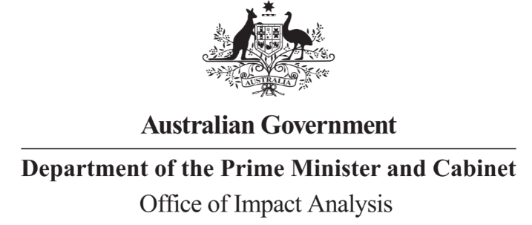

Reference: OBPR21-01048  
Telephone: 6271 6270  
e-mail: [helpdesk-oia@pmc.gov.au](mailto:helpdesk-obpr@pmc.gov.au)

Mr David Hallinan   
Deputy Secretary

Infrastructure Group  
Department of Infrastructure, Transport, Regional Development, Communications and Arts

Dear Mr Hallinan

**Impact Analysis – Second Pass Final Assessment – Safer Freight Vehicles**

Thank you for your letter submitting an Impact Analysis (IA) for formal Second Pass Final Assessment. I note the IA has been formally certified at the Deputy Secretary level consistent with the *Australian Government Guide to Policy Impact Analysis*.

I appreciate the Department’s constructive engagement on the IA. The Office of Impact Analysis’ (OIA) assessment is that the quality of the analysis in the IA is Good Practice.

The IA addresses the seven Impact Analysis questions and follows an appropriate policy

development process commensurate with the significance of the problem and magnitude of

the proposed intervention

**Next steps**

After a final decision has been announced, I ask that your Department works with OIA to finalise this material for public release. This includes providing a copy of the IA in Word and PDF formats for web accessibility purposes. The IA must be included in any Explanatory Memorandum or Statement giving effect to the proposals in the IA.

If you have any further queries, please do not hesitate to contact me.

Yours sincerely

Jason Lange  
Executive Director  
Office of Impact Analysis  
2 August 2023