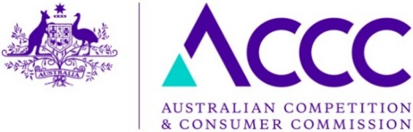OBPR reference:OBPR22-01864

# Our ref: PRJ1002275

Mr Jason Lange

Executive Director

Office of Best Practice Regulation

Department of Premier and Cabinet

1 National Circuit

BARTON ACT 2600

Email: [helpdesk-OBPR@pmc.gov.au](mailto:helpdesk-OBPR@pmc.gov.au)

Dear Mr Lange

# Regulation Impact Statement – Mandatory safety standard for non-refillable helium cylinders – Second Pass Final Assessment

I am writing in relation to the attached Regulation Impact Statement (RIS) prepared for non‑refillable helium cylinders. Thank you for your comments and suggestions as part of the first pass assessment.

After further consideration and modifications to the document I am satisfied that the RIS addresses the concerns raised in your letter of 24 October 2022.

In response to your suggestions, we have specifically added the following:

* Included further information summarising the policy objectives of the proposed standard
* Highlighted the purpose of the proposed standard including the key objective of reducing the number of suicides through the use of non-refillable helium cylinders as well as suggesting a desired target level
* Provided further clarity around flotation times of helium balloons (7 hours) and the possible impact on industry, noting that there are alternatives for consumers to purchase pre inflated balloons (normally filled with 100% helium)
* Provided further information on the review of the proposed standard.

I consider that this proposal is an innovative and cost-effective measure that is expected to have a positive impact on reducing the use of non-refillable helium cylinders as a means of suicide, while causing minimal industry or consumer detriment.

An accurate assessment of actual impacts will not be possible until a suitable period after the introduction of the mandatory standard, however we are confident that our evaluation and monitoring processes will provide useful check points along the way.

As indicated previously, we anticipate that the economic and social cost savings, which are dependent on the number of lives saved, could be in the order of $51-$103 million per year. Costs for industry and suppliers are expected to be minimal (around $40,000). As the market and demand for non-refillable helium cylinders is not being fundamentally impacted, it is expected that modifications requiring a mixture of helium and oxygen may only result in market adjustment rather than any substantial structural change.

Accordingly, I am satisfied that the RIS is now consistent with the six principles for Australian Government policy makers as specified in the *Australian Government Guide to Regulatory Impact Analysis*.

I submit the RIS to the Office of Best Practice Regulation for formal final assessment.

Yours sincerely

Scott Gregson

Chief Executive Officer

2 November 2022