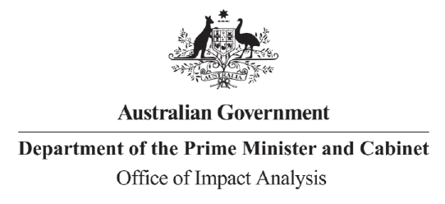

Reference: OBPR23-04188  
Telephone: 6271 6270  
e-mail: [helpdesk-oia@pmc.gov.au](mailto:helpdesk-obpr@pmc.gov.au)

Mr Richard Windeyer

Deputy Secretary

Communications and Media

Department of Infrastructure, Transport, Regional Development, Communications and the Arts

Dear Mr Windeyer

**Certification of the online gambling report as equivalent to an Impact Analysis**

Thank you for your letter certifying the Parliamentary Joint Committee report into Regulation of the use of financial services such as credit cards and digital wallets for online gambling in Australia as a process and analysis equivalent to an Impact Analysis (IA-equivalent document) for the policy proposal to prohibit the use of credit cards for online gambling.

The Office of Impact Analysis (OIA) acknowledges the certification. Under the Government’s Impact Analysis framework, the OIA assesses whether the options analysed in the IA-equivalent document are relevant to the policy proposal and may assess the adequacy of the analysis. The OIA also assesses whether the IA-equivalent document or certification letter identifies regulatory costs. In this case, the OIA’s assessment is that the options analysed in the independent review are sufficiently relevant to the policy proposal. The OIA also notes the Department will provide an estimate of regulatory burden following further stakeholder consultation in mid-2023 but by the time the Minister seeks agreement to bill status in the relevant sittings.

We would appreciate you advising us when a final decision has been announced and forwarding a copy of the independent review in a form meeting the Government’s accessibility requirements. The OIA will publish the report, along with your certification, on the OIA’s website oia.pmc.gov.au/published-impact-analyses-and-reports.

Yours sincerely  
  
  
  
Jason Lange  
Executive Director  
Office of Impact Analysis  
28 March 2023