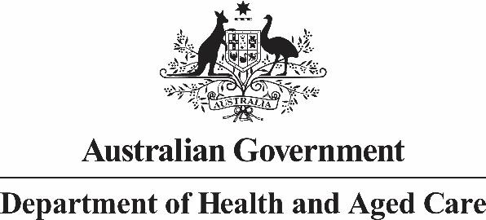

# Chief Medical Officer

Mr Jason Lange

Executive Director

Office of Impact Analysis

Department of the Prime Minister and Cabinet

Email: Helpdesk-OBPR@pmc.gov.au

Dear Mr Lange

**Sunsetting of *National Health Security (SSBA Standards) Determination 2013***

I am writing to the Office of Impact Analysis (OIA) regarding the *National Health Security (SSBA Standards) Determination 2013,* which, as per the *Legislative Instruments Act 2003,* is scheduled to sunset on 1 October 2023. Pending Ministerial consideration, it is intended that the instrument is to be remade without amendment to ensure continuity of the SSBA Regulatory Scheme. A review of the SSBA Standards will then be conducted after   
1 October 2023.

The Department of Health and Aged Care (the department) certifies that the *National Health Security (SSBA Standards) Determination 2013* is operating effectively and efficiently, and therefore, an Impact Analysis is not required for this legislation to be remade.

The assessment that the legislation is operating effectively and efficiently has been informed by a consultation process which involved the Australian Health Protection Principal Committee (AHPPC), Public Health Laboratory Network (PHLN) and the Australian (Counter) Bioterrorism Laboratory Network (ABLN). This consultation was conducted in August 2023 and membership of these committees is comprised of subject matter experts and representatives from each state and territory. Responses were received from all states and territories (except Victoria) which all supported the department’s approach to the re-make of the SSBA Standards.

I also note that the regulatory burden to people, business, or community organisations has been quantified using the Australian Government’s Regulatory Burden Measurement framework. These are provided below.

Table 1: Regulatory burden estimate (RBE) table

|  |  |  |  |  |
| --- | --- | --- | --- | --- |
| **Change in Costs ($ million)** | **Business** | **Community organisations** | **People** | **Total change in costs** |
| Total, by Sector | $0 | $0 | $0 | $0 |

Table 1 describes that there are no changes in the regulatory burden estimate. The Determination is being remade without amendment and therefore, the regulatory costings will remain unchanged.

I acknowledge that OIA will publish this letter for transparency purposes.

If you have any queries about this advice, please contact the Laboratory Health and Security Section on ssba@health.gov.au.

Yours sincerely

Professor Paul Kelly

Chief Medical Officer

August 2023