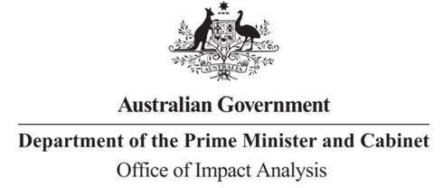

Tim Yeend Associate Secretary

Trade and Investment Group

Department of Foreign Affairs and Trade Dear Mr Yeend

Reference: OBPR22-02548 Telephone: 6271 6270

e-mail: [helpdesk-oia@pmc.gov.au](mailto:helpdesk-oia@pmc.gov.au)

# Impact Analysis – Second Pass Final Assessment – AANZFTA Upgrade

Thank you for your letter submitting an Impact Analysis (IA) for formal Second Pass Final Assessment. I note the IA has been formally certified at the Associate Secretary level consistent with the *Australian Government Guide to Policy Impact Analysis*.

The Office of Impact Analysis’ (OIA) assessment is that the quality of the analysis in the IA is adequate to inform a decision to sign the updated agreement. In order for the analysis to be assessed as good practice it would require:

* more analysis of the potential costs and benefits to businesses and the community
* quantitative evidence of the problem being addressed
* an evaluation plan that will allow for the collection of information to inform future decision making.

# Next steps

After a final decision has been announced, I ask that your agency work with OIA to finalise this material for public release. This includes providing a copy of the IA in Word and PDF format for web accessibility purposes. The IA must be included in any Explanatory Memorandum or Statement giving effect to the proposals in the IA.

If you have any further queries, please do not hesitate to contact me. Yours sincerely

Rob Reilly

A/g Executive Director Office of Impact Analysis 15 August 2023